**Guide to greater glider habitat in Queensland**

Department of Environment and Science



© State of Queensland, 2022.

**Ownership of intellectual property rights**

Unless otherwise noted, copyright (and any other intellectual property rights) in this publication is owned by the State of Queensland.

**Creative Commons licence**

All material in this publication is licensed under a [Creative Commons Attribution-Non Commercial-No Derivatives 4.0 International License](https://creativecommons.org/licenses/by-nc-nd/4.0/) except content supplied by third parties, logos and the Commonwealth Coat of Arms.

Inquiries about the licence and any use of this document should be emailed to [copyright@awe.gov.au](mailto:copyright@awe.gov.au).



**Cataloguing data**

This publication (and any material sourced from it) should be attributed as: Eyre TJ, Smith GC, Venz MF, Mathieson MT, Hogan LD, Starr, C, Winter, J and McDonald, K 2022, *Guide to greater glider habitat in Queensland*, report prepared for the Department of Agriculture, Water and the Environment, Canberra. Department of Environment and Science, Queensland Government, Brisbane. CC BY 4.0.

ISBN 978-1-76003-515-0

This publication is available at <https://www.awe.gov.au/environment/epbc/publications>.

Queensland Herbarium

Brisbane Botanic Gardens Mount Coot-tha

Mt Coot-tha Road

Toowong Qld 4066 Australia

Web [qld.gov.au/environment/plants-animals/plants/herbarium](https://www.qld.gov.au/environment/plants-animals/plants/herbarium)

**Disclaimer**

The views and opinions expressed in this publication do not necessarily represent the views of the Australian Government or the portfolio ministers for the Department of Agriculture, Water and the Environment.

The content of this publication does not constitute advice to any third party. Although due care and skill has been applied in the preparation and compilation of the information and data in this publication, no reliance may be placed on it by any other party. No representation expressed or implied is made as to the currency, accuracy, reliability, completeness or fitness for purpose of the information contained in this publication. The reader should rely on its own inquiries to independently confirm any information and comment on which they may intend to act.

The Commonwealth of Australia, its officers, employees, agents and the other parties involved in creating this report disclaim, to the maximum extent permitted by law, responsibility to any other party for any liability, including liability for negligence and for any loss, damage, injury, expense or cost incurred by any person as a result of accessing, using or relying upon any of the information or data in the publication.

This document is designed to be an additional source of information to the statutory documents. It is not a statutory document or policy statement. If information diverges, the information in the statutory document(s) and policy statement(s) take precedence over this document. This document should be used in parallel with the Significant Impact Guidelines 1.1 – Matters of National Environmental Significance, relevant conservation advices, recovery plans and/or referral guidelines.

**Acknowledgements**

This work was funded by the Australian Department of Agriculture, Water and the Environment. Many thanks to Kate Rodgers, Lucy Porter and Katie Johnston for their assistance during the project. Thanks to Anthea Challis and Simon Barber for comments on an earlier draft, and Ivan Lawler, Ethan Bloom and Sharon Koh for useful comments and edits on later drafts. Many thanks to Melinda Laidlaw for running the Maxent model.

**Acknowledgement of Country**

We acknowledge the Traditional Custodians of Australia and their continuing connection to land and sea, waters, environment and community. We pay our respects to the Traditional Custodians of the lands we live and work on, their culture, and their Elders past and present.

## Summary

The greater glider (Petauroides spp.) is a nocturnal gliding marsupial with a broad distribution throughout mainland eastern Australia. It is a species of conservation concern and is currently listed as vulnerable under the Environment Protection and Biodiversity Conservation Act 1999. Recent evidence suggests there may be 3 species of greater glider throughout its range, all of which may potentially occur within the state of Queensland. Consequently, for the purposes of this report, the Petauroides species complex will be considered together as ‘greater glider’. This report provides an update on available quantitative and qualitative information of greater glider habitat in Queensland, where habitat was defined as:

* Habitat
  + Regional ecosystems with confirmed greater glider records
  + Contains habitat attributes (but not necessarily all attributes), such as live and dead hollow-bearing trees for denning, feed trees, large trees, habitat connectivity across the landscape
* Potential habitat
  + Regional ecosystems that do not have confirmed greater glider records but are identified by experts as potential greater glider habitat
  + Contains habitat attributes (but not necessarily all attributes), such as live and dead hollow-bearing trees for denning, feed trees, large trees, habitat connectivity across the landscape
* Not habitat
  + Regional ecosystems with no confirmed records of greater gliders, and identified by experts as non-habitat
  + Does not contain habitat attributes such as live and dead hollow-bearing trees for denning, feed trees, large trees, habitat connectivity across the landscape.

Queensland’s remnant and pre-clearing regional ecosystem mapping, collated records of verified and relatively high precision (< 300 m) greater glider locations and expert opinion were used to describe and map greater glider habitat and potential habitat in Queensland. Of the 2,859 described regional ecosystems in Queensland, 254 were confirmed as greater glider habitat and 124 regional ecosystems were identified as potential habitat.

Six tree species were identified as dominant or co-dominant species to the majority of greater glider habitat. These six species each have a broad distribution throughout the geographic range of Queensland’s greater glider species. In descending order of extent, these were Corymbia citriodora, Eucalyptus moluccana, E. tereticornis, E. crebra, C. intermedia and E. portuensis. Review of the literature and unpublished feeding records identifies most of these species as preferentially selected for foraging by greater gliders in Queensland. Size of trees is also important for Queensland greater gliders, with trees > 30 cm diameter at breast height (DBH) preferentially selected for foraging and > 50 cm DBH for denning. Trees > 50 cm DBH are more likely to contain suitable hollows for sheltering by greater gliders.

A review of available studies on home range sizes of greater gliders throughout their geographic range revealed substantial variation in methods used to estimate home range, which undermines capacity for direct comparison. Nevertheless, in general, most studies suggest small home ranges < 3 ha. Outliers recorded by some studies suggest that greater gliders are capable of reasonably long-distance movements (that is, > 3 ha), particularly where there are resource shortages and/or fragmented habitats.

Hollow-bearing trees are an essential component of greater glider habitat, and their presence or absence may be used to indicate habitat suitability for greater gliders. However, a brief review of studies on ground-based estimates of hollows in trees concludes that there is high variability and low reliability among observers. This will lead to inconsistent reporting of greater glider habitat or potential habitat if used as a habitat-defining indicator. The demonstrated correlation between tree DBH and presence of hollows is well established and is increasingly used across Australia as a surrogate of tree habitat value. The advantage of using tree size (DBH) as an indicator is that it can be directly and precisely measured. In Queensland, large tree DBH thresholds are available for almost half of the regional ecosystems identified as greater glider habitat, which averaged 46 cm DBH. This estimate concords well with observed average den tree sizes from specific studies of greater glider; it is crucial to note that greater gliders den in smaller trees and that variability can be related in part to tree species.

Five recommendations are provided for future consideration:

* **Recommendation 1** – Support further survey work to confirm greater glider regional ecosystem habitat in under-sampled areas.
* **Recommendation 2** – Densitites of hollow-bearing trees should not be used to define whether an area is greater glider habitat or not habitat.
* **Recommendation 3** – Improve reliability for indicating greater glider habitat or potential habitat by measuring densities of ‘large trees’.
* **Recommendation 4** – Remnant patches of potential greater glider habitat should be valued as habitat regardless of patch size.
* **Recommendation 5** – Support the identification of future refugia for greater gliders through climate change.

Related documents to this report include:

* look-up tables of regional ecosystems representing greater glider habitat and potential habitat, which can be mapped or interrogated by assessors and other stakeholders
* maps and shapefiles of pre-clear and remnant (at 2019) greater glider habitat and potential habitat using regional ecosystems in Queensland
* list of tree species that are the dominant and co-dominant species in greater glider habitat by bioregion in Queensland
* review of greater glider home range studies throughout their Australian geographic range and a summary of approaches and results
* identification of ‘large’ tree size thresholds by bioregion to guide identification of greater glider habitat and potential habitat.

Contents

Summary i

1 Introduction 1

2 Collection and collation of Queensland greater glider records 4

3 Mapping the habitat and potential habitat of greater gliders in Queensland 6

3.1 Regional ecosystems 6

3.2 Tree species characterising greater glider habitat 10

3.3 Modelled distribution of greater gliders in Queensland 13

4 Trees used by greater gliders for shelter and foraging 15

4.1 Tree size 15

4.2 Tree species 17

5 Home range estimates of greater gliders in Queensland 21

6 Fragmentation and use of remnant patches by greater gliders 25

7 Observer bias with determining trees with hollows 27

8 Determining ‘large trees’ within Queensland greater glider habitat 29

9 Summary of deliverables 32

10 Recommendations 33

Appendix A: Example of regional ecosystem greater glider habitat data description 34

Appendix B: Tree species characterising greater glider habitat in Queensland 37

Appendix C: Summary of greater glider home range studies 43

Glossary/acronyms 48

References 49

**Tables**

Table 1 Determining level of dominance for each species within each greater glider habitat regional ecosystem as described in REDD 10

Table 2 Analysis of environmental variable contributions to the greater glider Maxent model 13

Table 3 Summary of den and feed tree usage from tracking studies of greater gliders in Queensland 18

Table 4 Records of tree use by greater gliders in Queensland 19

Table 5 Summary of tracking studies of greater gliders to estimate home range sizes 24

Table 6 Studies documenting occupation of remnant habitat patches by greater gliders 26

Table 7 Available large tree benchmarks for greater glider habitat regional ecosystems by bioregion 30

Table 8 Example of regional ecosystem greater glider habitat data description 34

Table 9 Numbers of R where the species is dominant, co-dominant, sub-dominant or associated, within each bioregion 37

Table 10 Summary of greater glider home range studies 43

**Figures**

Figure 1 Photos of the a) northern, b) possibly central and c) southern greater gliders 2

Figure 2 The number of greater glider assocated regional ecosystems by tree species* for each bioregion 11

Figure 3 Examples of greater glider habitat 12

Figure 4 Tree size (DBH) and species of recorded greater glider den trees in Queensland 16

Figure 5 Size of live trees used by greater gliders for denning and foraging 16

Figure 6 Summary statistics for each bioregion with sufficient data on large tree benchmarks for greater glider habitat regional ecosystems 31

**Boxes**

Box 1 Definition of greater glider habitat 3

Box 2 Derivation of the large tree size threshold in BioCondition 30

## Introduction

The greater gliders (Petauroides spp) are Australia’s largest gliding marsupials. The greater glider species complex has a broad distribution throughout eastern Australia, from central Victoria north to the Windsor Tablelands in northern Queensland. Populations in Queensland are largely patchy, both in the north and south of the state (Eyre 2004; Winter et al. 2004). Until recently, there were 2 subspecies of Petauroides volans recognised: P. volans volans and P. volans minor. The paper by Macgregor et al. (2020) on genetic population structure indicates that there may be 3 species of Petauroides (Figure 1): P. minor (northern greater glider), P. armillatus (central greater glider) and P. volans(southern greater glider). However, there is some work required to clarify the distribution and distinguishing physical characteristics between the 3 species, and particularly between the central and southern greater gliders in southern Queensland. Consequently, for the purposes of this report, the Petauroides species complex in Queensland is considered together as ‘greater glider’.

The greater glider is a species complex of conservation concern. *Petauroides volans* (southern and central populations) are currently listed collectively as vulnerable under the Commonwealth Environment Protection and Biodiversity Conservation Act 1999 and endangered under the Queensland Nature Conservation Act 1992. Following the catastrophic 2019–2020 wildfires which impacted at least 30% of greater glider habitat throughout their range (Ward et al. 2020), the conservation status of the species complex is being re-assessed and divided to consider separately P. minor (from approximately Townsville north) and P. volans(south of Townsville through to Victoria).

The greater glider is a cryptic, strictly arboreal nocturnal species complex that forage primarily on eucalypt leaves, a low nutrient and highly toxic diet which influences its sedentary socio-ecological traits (Kavanagh and Lambert 1990; Foley et al. 2004). The greater glider species are highly reliant on hollow-bearing trees for shelter and breeding, and the loss of this habitat resource has been closely linked to greater glider decline throughout its range (Lindenmayer et al. 2004; Eyre 2006), as has the recent wildfires of 2018 and 2019–2020 (Ward et al. 2020). An emerging threat to greater glider populations is the impact of climate change (Kearney et al. 2010).

Greater gliders have a unique physiology to cope with eating toxic eucalypt leaves, and because of this they can become hyperthermic (overheated) at temperatures > 20°C, at which point they need to use up lots of energy and water to keep cool. Increasing aridity and warmer temperatures therefore play havoc on greater glider physiology, where effectively they lose their appetite and ability to leave their insulated dens to feed. A drying climate, increased night-time temperatures (higher than 20°C), and higher mean annual temperatures (night-time and day-time temperatures) have been directly linked to greater glider decline in the south of their range (Smith and Smith 2018, 2020; Wagner et al. 2020).

Figure Photos of the a) northern, b) possibly central and c) southern greater gliders

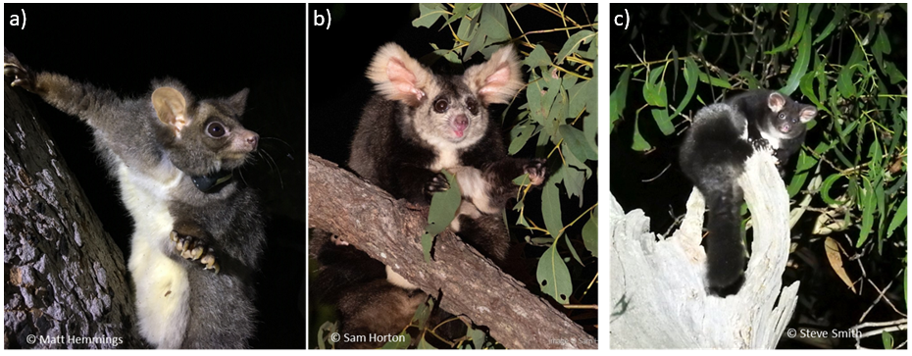

Image credits: northern greater glider © Matt Hemmings, central greater glider © Sam Horton and southern greater glider © Steve Smith

The primary objective of this project was to provide qualitative and quantitative descriptions of greater glider habitat in Queensland. Specific project requirements were to:

* meet with DAWE via remote platform to confirm timeline, proposed methods, current assessment process, discuss potential sources of relevant material for review, document structure and other relevant items
* trawl Queensland wildlife databases and the literature for data on Queensland greater glider distribution and habitat
* determine and map the distribution of greater glider habitat using regional ecosystems in Queensland
* review of home range estimates from greater glider studies throughout their national range
* consult with and collate data from experts on Northern Queensland greater glider populations
* describe habitat, potential habitat, not habitat (see Box 1) and habitat attributes
* address up to 3 rounds of consolidated DAWE comments.

Box Definition of greater glider habitat

Habitat

* Regional ecosystems with confirmed greater glider records
* Contains habitat attributes (but not necessarily all attributes), such as live and dead hollow-bearing trees for denning, feed trees, large trees, habitat connectivity across the landscape.

Potential habitat

* Regional ecosystems that do not have confirmed greater glider records but are identified by experts as potential greater glider habitat
* Contains habitat attributes (but not necessarily all attributes), such as live and dead hollow-bearing trees for denning, feed trees, large trees, habitat connectivity across the landscape.

Not habitat

* Regional ecosystems with no confirmed records of greater gliders, and identified by experts as non-habitat
* Does not contain habitat attributes such as live and dead hollow-bearing trees for denning, feed trees, large trees, habitat connectivity across the landscape.

## Collection and collation of Queensland greater glider records

Information on greater gliders in Queensland was compiled from published literature, unpublished reports and theses. In addition, sighting records were collated from the government databases WildNet (DES 2021) and the Queensland Biodiversity and Environmental Resource Database (QBERD) (Qld Herbarium 2021). Downloads occurred in April 2020. Records were filtered for mentions of tree use, including foraging or denning, or where these could reasonably be inferred from sighting notes. Plant taxonomic nomenclature used in the literature and database records was updated where necessary and cross-referenced with a plant’s known distribution. Records were also solicited from DAWE, CSIRO, WPSQ Glider Network, Australian Wildlife Conservancy (AWC), Ecological consultants, UQ Koala Research, and selected individuals with photo-verified records on the citizen science platform iNaturalist. A total of 3,407 records were collated (after duplicate records were removed). Records dated from 1922 to 2021, although only small numbers of records (that could be attributed to a defined location) were collected prior to the 1970s. Locational precision of the records ranged from 17 km down to 5 m, although the majority of records were < 900 m.

Greater glider records in Queensland were predominantly from within the southeast Queensland, Brigalow, Wet Tropics, Central Mackay Coast, New England Tablelands and Einasleigh Uplands Bioregions (Map 1). A small number of records were also located in the Gulf Plains and Desert Upland bioregions.

Map Distribution of collated records for greater gliders in Queensland

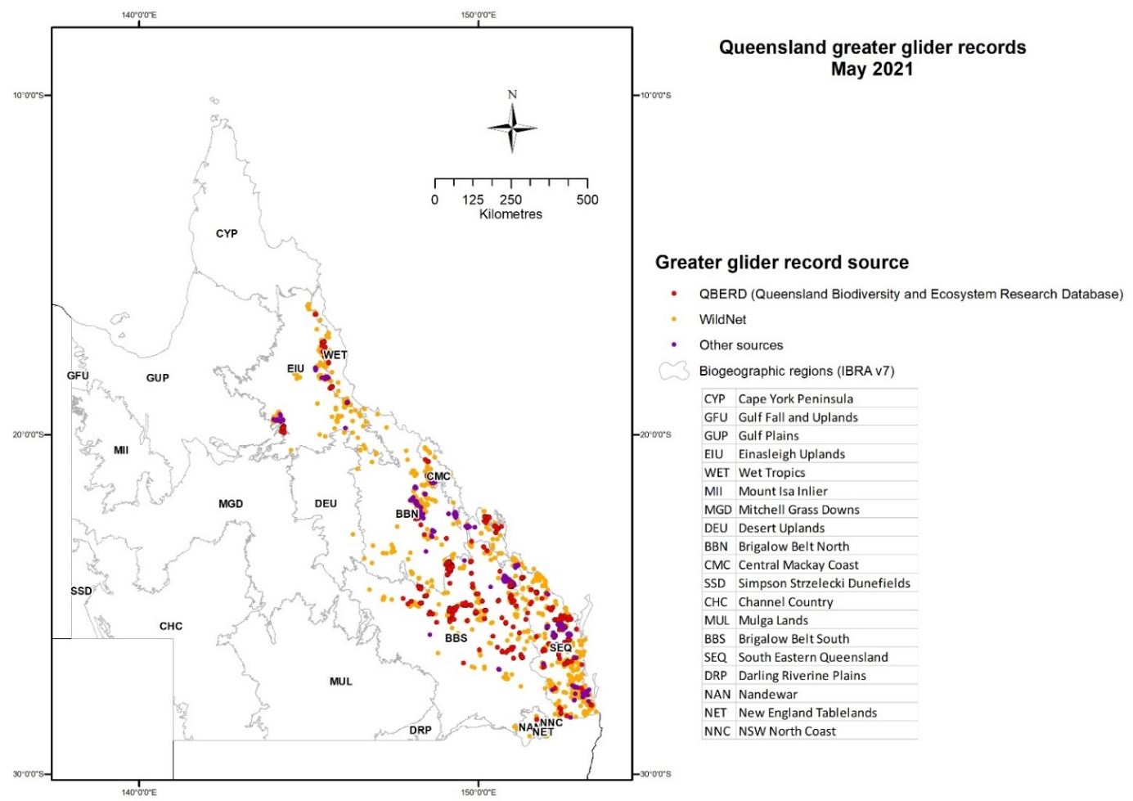

Note: Records were primarily from databases managed by the Department of Environment and Science, supplemented with records from other experts and institutions. This map may not represent all locations where greater gliders may occur in Queensland.

## Mapping the habitat and potential habitat of greater gliders in Queensland

### Regional ecosystems

Queensland’s Regional Ecosystem mapping framework is based on field survey, analysis of aerial photographs and satellite imagery, and assessment of other data such as geology and soil mapping and historical survey plans. The Queensland Herbarium maps both the pre-clearing and remnant extent of regional ecosystems. Information on remnant extent is maintained for the period from 1997 onward and is updated every 2 years (Neldner et al. 2017).

Regional ecosystem vegetation maps for most parts of Queensland are prepared at a scale of 1:100,000. Some areas, including parts of Southeast Queensland (SEQ) and the Wet Tropics bioregions, are mapped at finer scales of 1:50,000 or 1:25,000. Generally mapped polygons are delineated down to 2 to 5 ha, but many polygons are heterogeneous, meaning that more than one regional ecosystem is allocated to the line-work. A maximum of 5 vegetation units can be attributed to a heterogenous polygon if it occupies at least 5% of the polygon, and the relative proportion of each is allocated to the polygon (Neldner et al. 2020).

The associated Regional Ecosystem Description Database (REDD) contains detailed descriptive profiles for each regional ecosystem, listing the dominant, co- and sub-dominant species and species that may be associated with that regional ecosystem. For this report the latest version of the regional ecosystem mapping was used (Version 12; Queensland Herbarium 2021b), which describes and maps the distribution of 2859 vegetation communities throughout the state of Queensland.

To identify the regional ecosystems with a known or possible association with Queensland greater gliders, all regional ecosystems from the bioregions known to contain the broad distribution of the greater glider (SEQ, New England Tablelands, Brigalow, Central Mackay Coast, Desert Uplands, Einasleigh Uplands, Gulf Plains and Wet Tropics) were compiled, and initially attributed as not habitat or potential habitat depending on broad ecosystem type, that is, non-habitat included rainforests, swamps, mangrove, salt pans etc. The regional ecosystems attributed as potential habitat were then refined further if they were intersected by greater glider records with < 900 m location precision and/or were identified by experts as providing habitat resources and/or known important species for greater gliders across Queensland (from Comport et al. 1996; Wormington 2003; Eyre 2004, 2006; Smith et al. 2007; Ferguson et al. 2018; Starr et al 2021; Table 4). This provided an initial list of 503 regional ecosystems of potential habitat for further scrutiny.

The list of 503 regional ecosystems was refined using a 2-step process:

1. All regional ecosystems that had been intersected with high precision greater glider records (300 m or less location precision and verified observation) were identified, which gave a list of 213 potential habitat types for greater gliders. Due to the scale at which regional ecosystems are mapped and the heterogenous nature of mapped polygons, each regional ecosystem was checked by experts familiar with the region, and determined as habitat, potential habitat or not habitat. Of the 213 regional ecosystems associated with high precision greater glider records, 17 regional ecosystems were identified by the experts as not habitat, 26 as potential habitat and the remainder (170) were confirmed as habitat. This list of 170 regional ecosystems we have high confidence in their utility as habitat for greater gliders in Queensland.
2. Each of the remaining 290 regional ecosystems of potential habitat that were not associated with high location precision were again scrutinised by the expert panel. This involved expert knowledge of the regional ecosystem in relation to providing greater glider habitat as well as mapping up each regional ecosystem to check its distribution. Of these, 104 were confirmed as not habitat for greater gliders, 100 as providing potential habitat and 86 as a high likelihood of providing habitat, but with less confidence than the confirmed habitat regional ecosystems (greater glider habitat) identified in step 1.

In all, 254 regional ecosystems were confirmed as greater glider habitat and a further 124 regional ecosystems were identified as potential habitat (see Appendix A for an example of the data table). The habitat and potential habitat regional ecosystems were then mapped up as pre-clear (Map 2) and remnant at 2019 (Map 3). For both remnant and pre-clearing mapping, the relative proportions of regional ecosystems identified as habitat in heterogenous polygons were accumulated and then classified as covering 1-50% of the polygon, 51-80% of the polygon or > 80% of the polygon. This process was repeated for heterogenous polygons with regional ecosystems identified as potential habitat.

Map Distribution of greater glider potential habitat and habitat throughout Queensland, using pre-clear regional ecosystems

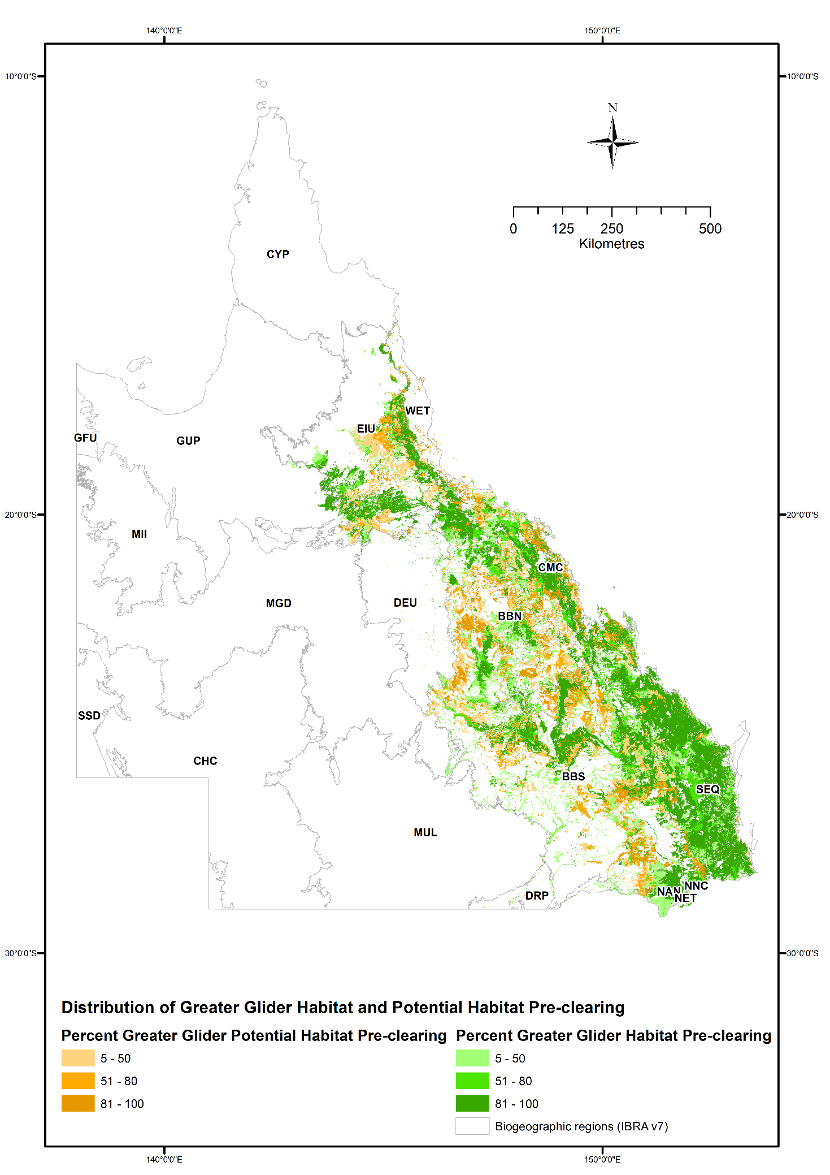

Note: This map may not represent all locations where greater gliders may occur in Queensland, and is subject to change with incorporation of updated greater glider records and regional ecosystem mapping. Source: Qld regional ecosystem mapping (version 12).

Map Distribution of greater glider potential habitat and habitat throughout Queensland, using remnant (at 2019) regional ecosystems

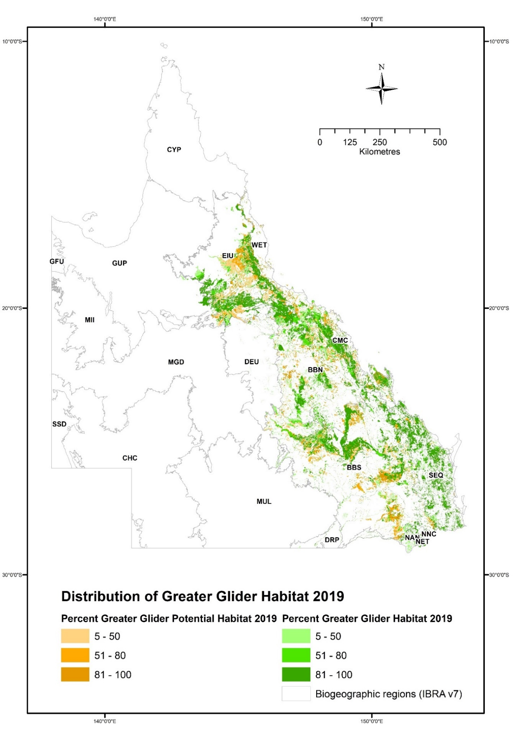

Note: This map may not represent all locations where greater gliders may occur in Queensland, and is subject to change with incorporation of updated greater glider records and regional ecosystem mapping. Source: Qld regional ecosystem mapping (version 12).

### Tree species characterising greater glider habitat

Each regional ecosystem or vegetation community is described in REDD (Version 12) following a general format that lists the characteristic vegetation species in order of dominance, with punctuation that identifies their relative abundance and/or frequency (Neldner et al. 2020). For each of the 254 confirmed greater glider regional ecosystems (greater glider habitat), the level of dominance of each tree species was determined as Dominant, Co-dominant, Sub-dominant or Associated, using the ‘Long Description’ in REDD (Table 1). A total of 120 tree species were identified as characterising greater glider habitat regional ecosystems throughout Queensland (Appendix B). The tree species that each characterised at least 30 greater glider habitat regional ecosystems (that is, broadly distributed throughout Queensland), by number of regional ecosystems within each Bioregion, is provided in Figure 2. Corymbia citriodora featured in greater glider habitat across 7 bioregions, and Eucalyptus moluccana and E. tereticornis were each represented in 6 bioregions (Figure 2). Examples of greater glider habitat featuring some of these species are provided in Figure 3.

Table Determining level of dominance for each species within each greater glider habitat regional ecosystem as described in REDD

| Level of dominance | Description |
| --- | --- |
| Associated | These species are listed in REDD as ‘other species include' or 'characteristic species' or 'emergent'. If numerous species are listed in REDD, include up to maximum of 5 species. |
| Sub-dominant | Species listed in REDD as (+/-) |
| Co-dominant | Species listed in REDD as second, third etc. in list if separated by comma OR 'and/or' OR 'with' |
| Dominant | These species are listed first in REDD unless followed by ‘and/or’. If first listed is one of 2 species e.g. *Eucalyptus saligna* OR *E. grandis; E. acmenoides* OR *E. portuensis*, then use the first species of these species listed only. |

Figure The number of greater glider assocated regional ecosystems by tree species* for each bioregion

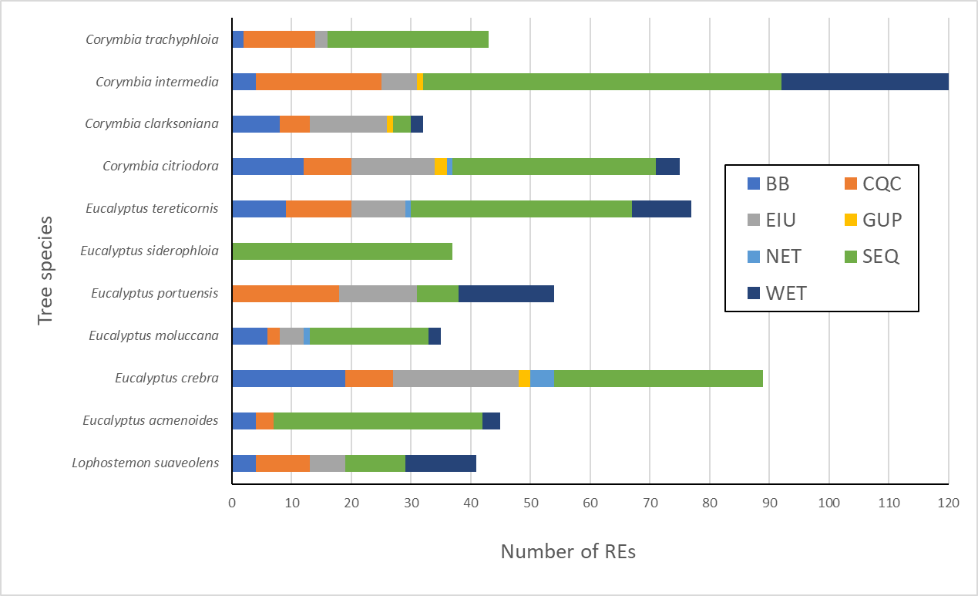

Note: *listed as dominant, co-dominant, sub-dominant and/or associated in more than 30 greater glider habitat regional ecosystems across the state. BB=Brigalow Bioregion; CQC=Central Queensland Coast; EIU=Einasliegh Uplands; NET=New England Tablelands; GUP=Gulf Uplands; SEQ=Southeast Qld; WET=Wet Tropics.

Figure Examples of greater glider habitat

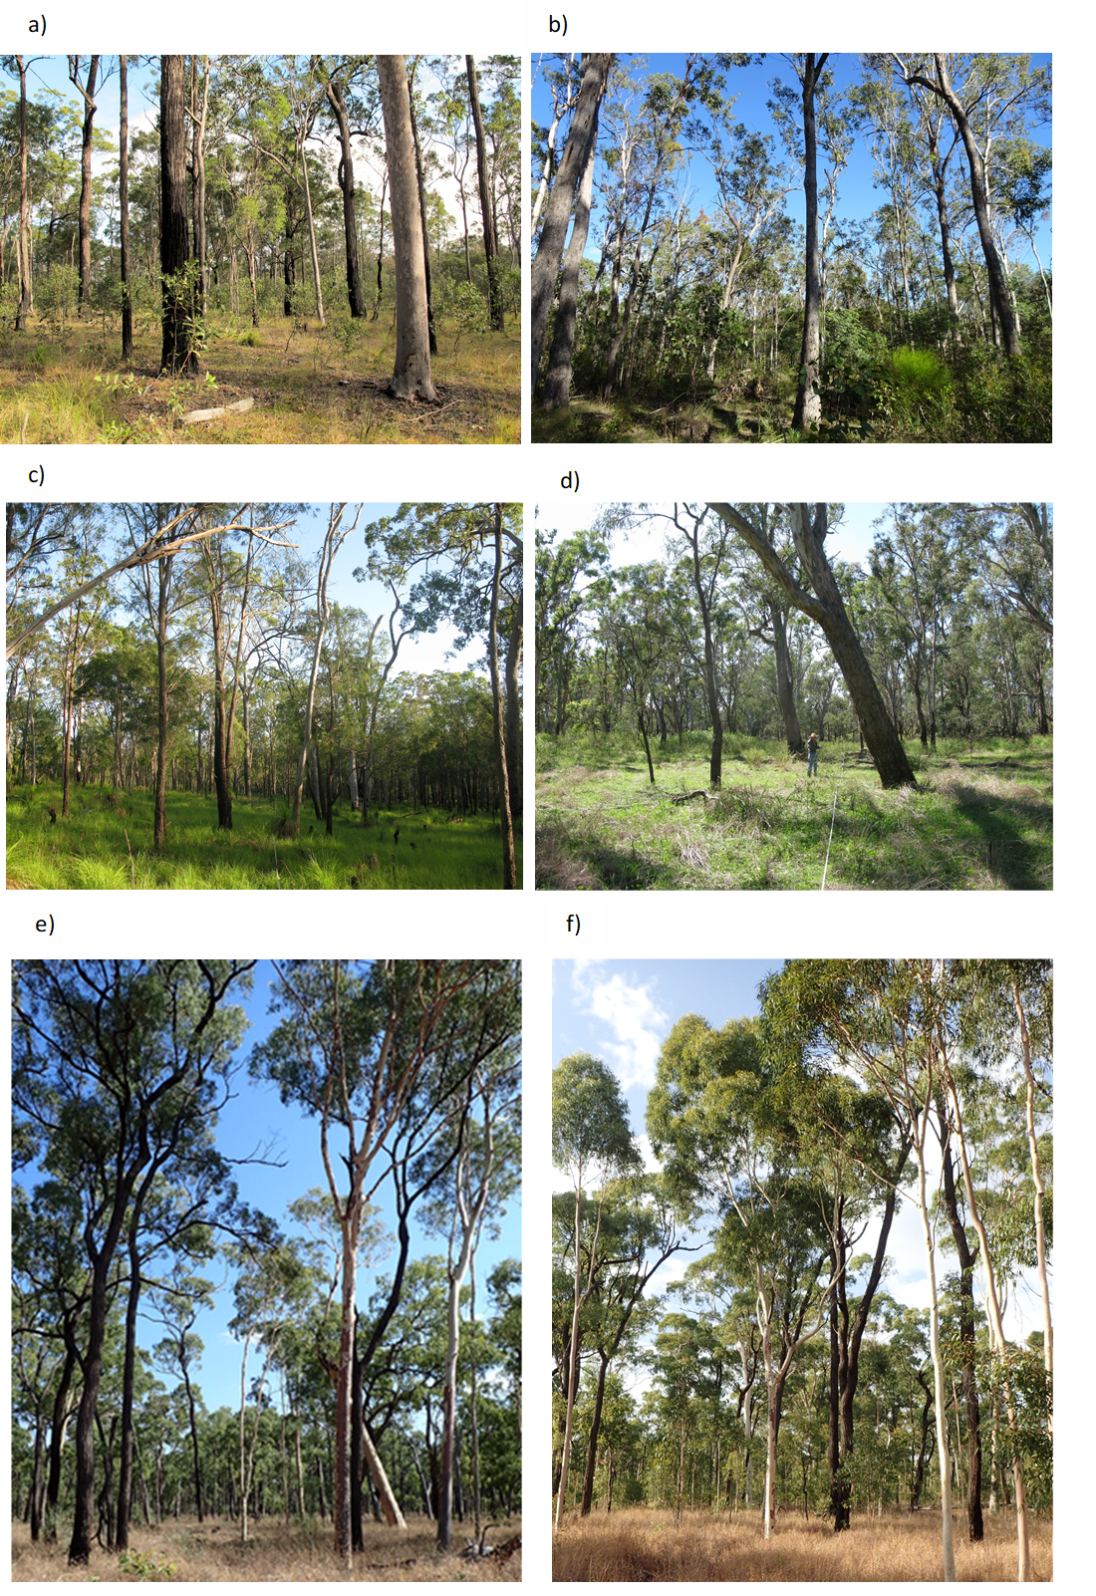

Note: a) Regional Ecosystem 12.5.7 *Corymbia citriodora* subsp. *variegata* +/- *Eucalyptus portuensis* open forest (Southeast Qld); b) regional ecosystem 12.3.3d *Eucalyptus moluccana* open forest (Southeast Qld); c) regional ecosystem 8.11.3b *Eucalyptus portuensis* and/or *Corymbia intermedia* woodland (Central Qld Coast); d) regional ecosystem 11.3.25 *Eucalyptus tereticornis* woodland fringing drainage lines (Brigalow Bioregion); e) and f) Regional Ecosystem 2.5.24a *Corymbia citriodora* and *Eucalyptus crebra* (Gulf Plains). Image credits: a) © Teresa Eyre, b) © Teresa Eyre, c) © Jesse Rowland, d) © Annie Kelly, e) © John Winter, f) © John Winter

### Modelled distribution of greater gliders in Queensland

The potential distribution of the greater glider was modelled for the state of Queensland using Maxent (v 3.3.3k). Maxent is a freeware species distribution modelling package that utilises presence-only data and pseudo-absences (Phillips et al. 2006). Only records less than 50 years old with a locality precision of +/- 2,000 m were used. This meant that a total of 3,105 filtered presence records were used to generate the model. Following Laidlaw and Butler (2012), the model was based on 7 environmental layers; annual mean temperature, temperature seasonality (coefficient of variation), annual precipitation, mean moisture index of the lowest quarter moisture index, pre-clearing Broad Vegetation Group at the 1:1M scale (BVG), land zone and topographic ruggedness. Climate layers were modelled using Anuclim software based on an 83 m digital elevation model. Model performance was assessed by comparing the area under the ROC curve (AUC) with the 95th percentile AUC from 1,000 null models created for greater gliders by randomly selecting locations from within the minimum convex hull of species presence records (Raes and ter Steege 2007). For the greater glider model, thresholds were applied (equal training sensitivity and specificity logistic threshold) so that model outputs could be converted to a prediction of potential habitat and extrapolated spatially.

The AUC achieved by the greater glider model was 0.875, exceeding the 95th percentile AUC for 1,000 null models, suggesting the model for this species had high predictive performance and discrimination capacity. Annual mean temperature was the most important variable in predicting the modelled distribution of greater gliders with temperature seasonality and annual precipitation also being moderately important (Table 2). Two maps of modelled output were produced showing the potential pre-clear (Map 4a) and remnant at 2019 (Map 4b) distribution.

Table Analysis of environmental variable contributions to the greater glider Maxent model

| Variable | Permutation importance (%) |
| --- | --- |
| Annual mean temperature | 28.9 |
| Temperature seasonality | 22.6 |
| Annual precipitation | 20.9 |
| Mean moisture index | 10.3 |
| Preclear BVG 1:1M | 10 |
| Land zone | 4.4 |
| Topographic ruggedness | 3 |

Map Modelled distribution of pre-clear and remnant Queensland greater glider habitat

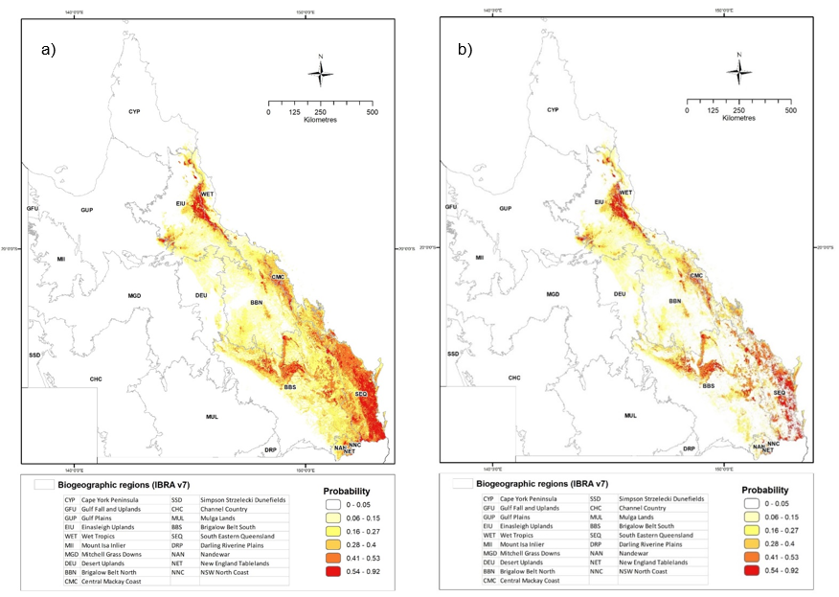

Note: a) pre-clear and b) remnant (at 2019). The warmer the colour the higher the probability that the area supports habitat for greater gliders

## Trees used by greater gliders for shelter and foraging

### Tree size

All available documented data on size of tree species used as den trees by Queensland greater gliders is shown in Map 4. This shows diameter at breast height (DBH) of 125 individual den trees, predominantly from 2 studies, Wongi State Forest in southeast Queensland (Kehl and Borsboom 1984) and Barakula State Forest in the Brigalow bioregion (Smith et al. 2007), with anecdotal data on greater glider use of den trees observed and measured during nocturnal fauna surveys elsewhere in Queensland. Consequently, the information presented should not be viewed as definitive, as survey effort and/or data capture has not been systematically applied across the entire geographic range of the greater glider in Queensland. There is also a bias in survey effort throughout the more populated coastal areas of Queensland (Figure 1). Further, data on species by tree size preference relative to availability was not available to test either. However, data from the radio-tracking study of greater gliders in south-west Queensland by Smith et al. (2007) was reworked to provide an indication of tree size preferences of greater gliders, relative to available tree size. This revealed that greater gliders did preferentially select larger trees in the stand cohort for both feeding and denning, although smaller DBH size classes were selected for foraging (> 30 cm DBH) than those used for denning (> 50 cm DBH; Figure 5).

The information collated indicates that on average, trees greater than 50 cm DBH (mean ± sd = 59.3 ± 19.9 cm) appear to be important for use by greater gliders as den trees (Figure 4; Figure 5a). These trees would represent the older trees in the stand cohort that are more likely to contain hollows. The smallest tree observed to be used for denning by a greater glider was a dead tree 24 cm DBH. From the limited available data collated (study by Smith et al. 2007), it appears trees > 30 cm DBH are preferentially selected by gliders for foraging and may also occasionally be used as den trees, but not in proportion to their availability within their home range (Figure 5b).

Figure Tree size (DBH) and species of recorded greater glider den trees in Queensland

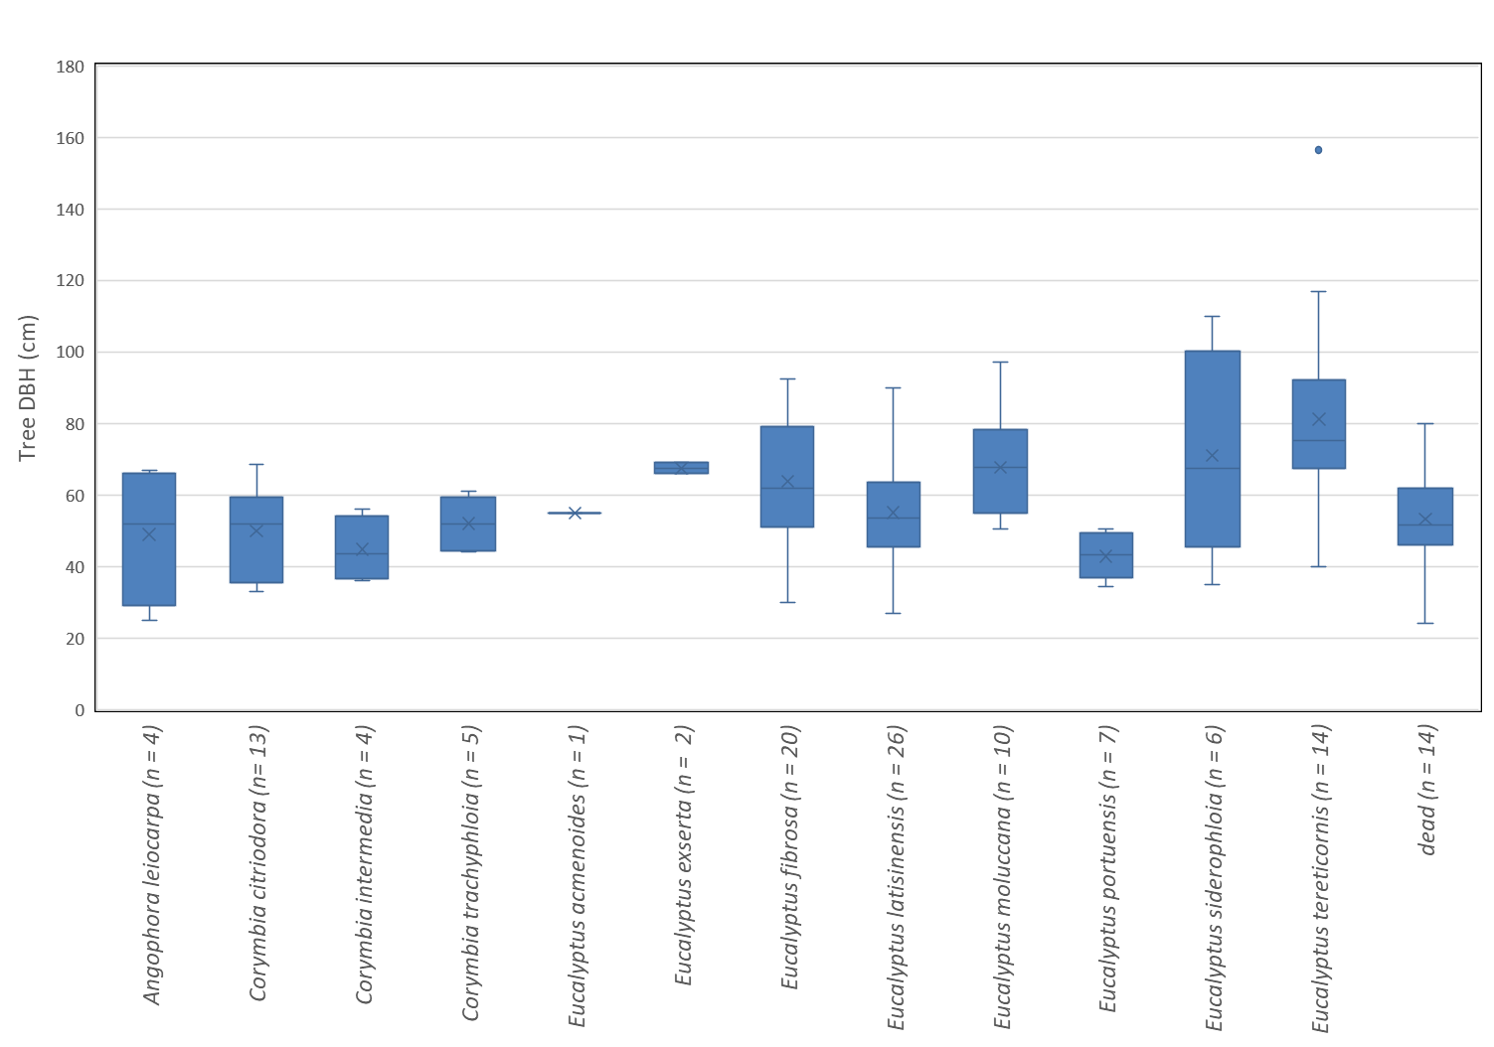

Note: This compilation represents all available data: 2 detailed ecological studies and records from incidental spotlighting surveys. Tree species recorded as den trees but lacking DBH data are not shown. x is the mean; middle line is the median; the box represents the interquartile range and the whiskers show upper and lower range in DBH; dots are outliers; n = 1¬26 trees.

Figure Size of live trees used by greater gliders for denning and foraging

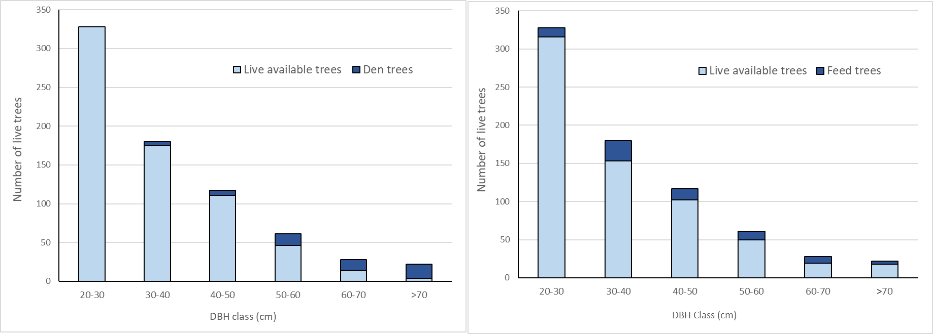

Note: a) denning and b) foraging in southwest Queensland relative to available trees. Data is from Smith et al. (2007), where available trees and trees used by greater gliders were sampled within 10-15% of tracked home ranges of greater gliders across 3 sites (total sample area = 7.7 ha)

### Tree species

Tracking studies of greater gliders within Queensland, although highly localised, provide some insights into tree species preferences of greater gliders for denning and foraging, but the list of species utilised is not a complete inventory and should not be interpreted as such (Table 3). Selection of some tree species over others for denning by greater gliders will foremost depend on the age and senescence stage of the tree and the species inherent propensity to form hollows (Wormington and Lamb 1999; Eyre 2005). Species such as Eucalyptus latisinensis and the bloodwoods (e.g. Corymbia intermedia) tend to form hollows at a younger age / smaller DBH than do Corymbia citriodora and ironbark species (e.g. Eucalyptus siderophloia).

Certain tree species are favoured by greater gliders for foraging and contribute the bulk of the diet in any one area; e.g. Eucalyptus latisinensis was 55% of intake in a site near Maryborough (Foley et al 1990); E. portuensis was favoured near Townsville (Comport 1996). Young foliage is selected if available (Kavanagh and Lambert 1990; Comport 1996), and this can alter the pattern of forage tree selection at different times of the year according to which species has new growth (Kavanagh 1984; Comport 1996). For example, Comport (1996) found that foraging on E. tereticornis and E. crebra was variable, with gliders favouring species in some months and avoiding them in others. Therefore, one-off observations of tree species used for foraging by greater gliders are indicative only.

Foraging is rarely recorded during general spotlighting surveys, as greater gliders typically freeze and focus on the observer when using the white light spotlights (Kehl and Borsboom 1984; Wormington 2003) and hence stop feeding during the observation period. Data from ecological studies, particularly when radiotracking and using red lights are more informative. Kehl and Borsboom (1984) recorded greater gliders feeding in 1–11 individual trees (average 4.6) during a single night, in 1–6 different species. Table 4 provides a summary of species where tree use was recorded – with Corymbia citriodora, C. intermedia, Eucalyptus fibrosa, E. moluccana and E. portuensis being the most frequently recorded feeding observations. However, these records are not systematic across the range of the greater glider in Queensland and may reflect bias in survey localised effort and species availability; it is not a complete list of tree species used by greater gliders for food. Nevertheless, a systematic landscape scale longitudinal study of greater glider habitat selection conducted across southern Queensland revealed that the most important species in greater glider habitat selection were C. citriodora and E. tereticornis (Eyre 2006).

Table Summary of den and feed tree usage from tracking studies of greater gliders in Queensland

| Bioregion | Study duration | Number of gliders | Summary of den use | Summary of feed tree use | Reference |
| --- | --- | --- | --- | --- | --- |
| Southeast Qld | 4 years | 6 | 4-18 den trees per glider; secondary dens continued to be identified over study duration  Favoured spp.: E. latisinensis, E. tereticonis | 6 species (> 96% of feeding records; other species not documented)  Favoured spp.: E. latisinensis (55%), C. intermedia (13%), E. crebra (11%), M. quinquenervia (11%). | Kehl & Borsboom (1984) |
| Southeast Qld | 7 months | 6 minimum | 1 live and 17 stags identified as dens | Tree Use reported as a surrogate for Feed Tree use – C. citriodora and E. crebra used more than available  C. citriodora found to have higher N, P and K compared to other available trees | Wormington (2003) |
| Southeast Qld | 2 weeks | 6 | n/a | 5 species recorded  Favoured spp.: E. latisinensis (70%), C. intermedia (10%), M. quinquenervia (10%) | Foley et al. (1990) |
| Brigalow Bioregion | 18 months | 8 | 4-20 den trees per glider  Den trees: live 84%, stags 16%  Favoured spp.: E. fibrosa, then E. moluccana, C. citriodora | 6 feed species recorded  Favoured spp.: E. fibrosa, E. moluccana, C. citriodora | Smith et al. (2007) |
| Wet Tropics | 36 nights over 10 months | 11 | 4-6 dens per animal in any one month, 1-2 used more frequently.  Most used spp.:, E. portuensis, C. citriodora  Used higher than availability: E. tereticornis, E. crebra | 7 feed species recorded  Young leaves and flower buds eaten most often  Favoured spp.: E. portuensis (48%),  Favoured some months: E. tereticornis (5%), C. intermedia (21%); Selected less than availability: C. citriodora (19%), C. intermedia (21%) | Comport et al. (1996) |
| Wet Tropics | 4 months | 9 | 1-4 dens utilised per glider during study  Favoured spp.: E. tereticornis, E. moluccana | 10 feed species recorded  Favoured spp.: C. intermedia, E. moluccana, then C. citriodora and E. tereticornis. | Starr et al. (2021) |

**n/a** Not applicable. Note: numbers in parentheses are the percentage of total records or observations.

Table Records of tree use by greater gliders in Queensland

| Scientific name | Common name | Feed tree | Den tree | Unspecified tree use |
| --- | --- | --- | --- | --- |
| Allocasuarina torulosa | forest she-oak [Nth Qld, one study] | 14 | n/a | n/a |
| Casuarina cunninghamiana | river she-oak | n/a | n/a | 1 |
| Callitris sp. | unidentified cypress pine species | n/a | n/a | 1 |
| Angophora floribunda | rough-barked apple | 1 | n/a | 4 |
| Angophora leiocarpa | smooth-barked apple | n/a | 4 | 88 |
| Corymbia citriodora | lemon-scented spotted gum | 136 | 28 | 462 |
| Corymbia clarksoniana | long-fruited bloodwood | n/a | n/a | 30 |
| Corymbia dallachiana | Dallachy's ghost gum | n/a | n/a | 4 |
| Corymbia erythrophloia | red bloodwood | n/a | n/a | 1 |
| Corymbia intermedia | pink bloodwood | 147 | 12 | 166 |
| Corymbia peltata | rustyjacket, yellowjacket | n/a | n/a | 2 |
| Corymbia sp. (bloodwood) | unidentified bloodwood | 1 | 1 | 69 |
| Corymbia sp. (yellowjacket) | unidentified yellowjacket | n/a | n/a | 7 |
| Corymbia tessellaris | carbeen, Moreton Bay ash | 8 | n/a | 15 |
| Corymbia trachyphloia | brown bloodwood | n/a | 6 | 67 |
| Corymbia watsoniana | large-fruited yellow jacket | 1 | n/a | n/a |
| Eucalyptus acmenoides | white mahogany | 6 | 1 | 34 |
| Eucalyptus baileyana | Bailey's stringybark | n/a | n/a | 1 |
| Eucalyptus camaldulensis | river red gum | n/a | n/a | 2 |
| Eucalyptus cloeziana | Gympie messmate | n/a | n/a | 2 |
| Eucalyptus coolabah | coolibah | n/a | n/a | 2 |
| Eucalyptus crebra | narrow-leaved red ironbark | 22 | 8 | 90 |
| Eucalyptus decorticans | gum-topped ironbark | n/a | n/a | 1 |
| Eucalyptus drepanophylla | narrow-leaved grey ironbark | 2 | 1 | 10 |
| Eucalyptus exserta | Queensland peppermint | n/a | 2 | 72 |
| Eucalyptus fibrosa | broad-leaved ironbark | 19 | 21 | 29 |
| Eucalyptus grandis | flooded gum, rose gum | n/a | 3 | 9 |
| Eucalyptus granitica | granite ironbark | n/a | n/a | 2 |
| Eucalyptus laevopinea | silvertop stringybark | n/a | n/a | 1 |
| Eucalyptus latisinensis | Wide Bay white mahogany | n/a | 33 | 276 |
| Eucalyptus longirostrata | grey gum | n/a | n/a | 5 |
| Eucalyptus melanophloia | silver-leaved ironbark | 1 | n/a | 3 |
| Eucalyptus microcorys | tallowwood | n/a | n/a | 1 |
| Eucalyptus moluccana | gum-topped box | 64 | 24 | 64 |
| Eucalyptus montivaga | Queensland mountain blackbutt | n/a | 3 | 8 |
| Eucalyptus pilularis | blackbutt | n/a | n/a | 2 |
| Eucalyptus platyphylla | poplar gum | n/a | n/a | 1 |
| Eucalyptus populnea | poplar box | n/a | n/a | 1 |
| Eucalyptus portuensis | Queensland coastal white mahogany | 478 | 23 | 47 |
| Eucalyptus propinqua | small-fruited grey gum | n/a | n/a | 11 |
| Eucalyptus racemosa | scribbly gum | n/a | 1 | 3 |
| Eucalyptus reducta | North Queensland white stringybark | n/a | n/a | 2 |
| Eucalyptus resinifera | red mahogany | 1 | 2 | 2 |
| Eucalyptus robusta | swamp mahogany | n/a | n/a | 1 |
| Eucalyptus saligna | Sydney blue gum | n/a | n/a | 8 |
| Eucalyptus siderophloia | grey ironbark | n/a | 6 | 110 |
| Eucalyptus sp. (grey gum) | unidentified grey gum | n/a | n/a | 5 |
| Eucalyptus sp. (ironbark) | unidentified ironbark species | n/a | 1 | 66 |
| Eucalyptus sp. (red gum) | unidentified red gum species | n/a | 1 | 10 |
| Eucalyptus sp. (stringybark) | unidentified stringybark species | n/a | n/a | 13 |
| Eucalyptus sphaerocarpa | Blackdown stringybark | n/a | n/a | 15 |
| Eucalyptus suffulgens | glossy-leaved ironbark | n/a | n/a | 2 |
| Eucalyptus tereticornis | forest red gum, blue gum | 50 | 76 | 183 |
| Eucalyptus tindaliae | Tindale’s stringybark | 2 | 2 | 7 |
| Eucalyptus woollsiana | narrow-leaved grey box | n/a | n/a | 1 |
| Lophostemon suaveolens | swamp mahogany | 2 | n/a | 12 |
| Melaleuca decora | white-feather honey myrtle | n/a | n/a | 1 |
| Melaleuca quinquenervia | broad-leaved tea-tree | n/a | n/a | 43 |
| Syncarpia glomulifera | turpentine | n/a | n/a | 6 |
| dead | n/a | n/a | 28 | 53 |
| Species unknown | n/a | 2 | 1 | 16 |

**n/a** Not applicable. Note: data combined from collated database sources and Comport et al. (1996), Wormington (2003) Smith et al. (2007) and Starr et al. (2021). Unspecified Tree Use are records where a greater glider was recorded in the tree, but its use was unspecified.

## Home range estimates of greater gliders in Queensland

Greater glider home range has been estimated from ten reported study sites throughout the geographic range of the species. Five of the studies were conducted within Queensland, 3 in southeast NSW and 2 in Victoria (Map 5). Most studies used radio-telemetry devices to locate and track, while others relied on identification of individuals using ear tags and body patterns (Henry 1984) or use of reflective tail tags (Norton 1988). The recording of locations and observation of nocturnal movement patterns have also involved tracking individuals for an entire evening (e.g., Kehl and Borsboom 1984; Norton 1988), while others have opted for periodic location of individuals throughout the night and day (e.g., Smith et al. 2007). Some of the studies have combined both all night tracking and less intensive tracking (e.g., Norton 1988). One study was of a limited data set of individuals adjacent to a road corridor, conducted for the Queensland Department of Transport and Roads (Wormington 2006).

Geometric modelling of home ranges has also been estimated by different methods across the 10 studies and implemented using a variety of computer software packages including Ranges IV (Kenward 1992; Comport et al. 1996) and Ranges 9 (Starr et al. 2021), CALHOME (Kavanagh and Wheeler 2004), and the Animal Movement Package of ESRI Arcview (Hooge et al. 1999; Pope et al. 2004; Smith et al. 2007). Some studies did not mention any computer software, so it is assumed that more long hand methods of calculation were utilised (e.g., Henry 1984; Kehl and Borsboom 1984).

The statistics and models calculated to describe home ranges of greater gliders have included:

* Modified Minimum Convex Polygon (MCP) Area of Harvey and Barbour (1965) (Henry 1984; Kehl and Borsboom 1984; Norton 1988)
* Minimum Convex Polygon (MCP) Area of Hayne (1949) (Kehl and Borsboom 1984)
* 95% MCP (Comport et al. 1996)
* 100% MCP of Mohr (1947) (Kavanagh and Wheeler 2004; Smith et al. 2007)
* 95% MCP using floating arithmetic mean to choose and exclude locational fixes (Wormington 2006)
* 95% Kernel estimate (Comport et al. 1996)
* 95% Adaptive Kernel estimate (Kavanagh and Wheeler 2004)
* 100% Fixed kernel estimate (Smith et al. 2007)
* 95% and 50% isopleth values from Fixed-kernel model estimate using bivariate normal-density kernels (Pope et al. 2004)
* 95% Harmonic estimate (Comport et al. 1996).

Significant differences can occur in calculated home-range area using different estimation techniques, sample size and study duration (Lawson and Rogers 1997; Borger et al. 2006). Consequently, comparing home ranges between different studies require an acknowledgement of the selection of software program, home-range estimators, user-selected options, input values of required parameters and number of animals tracked. The influence of what is selected is exemplified by Harvey and Barbour (1965) who have reported that MCP estimates (no modification of Mohr 1947; Hayne 1949) estimate bigger home range size in the order of 50% compared to estimates using Modified MCP. Harmonic values have been shown to demonstrate some problems in relation to scale and are considered inferior to Kernel estimation methods (Lawson and Rogers 1997). Furthermore Comport et al. (1996) found that the harmonic method failed to produce an asymptote in home range size at the same point as the Kernel method, suggesting the harmonic method underestimates home range size for smaller sample sizes.

The location, methods, sample size and home range estimates determined by each of the ten greater glider home range studies undertaken across eastern Australia are summarised in Table 5, and further details are provided in Appendix C. Excluding home range estimates calculated using the harmonic method (n=140), the mean (± standard deviation) home range from across all studies was 2.7 ± 2.4 ha, and the lower and upper limits of home range area were 0.8 ha (Bombala, southeast NSW; Kavanagh and Wheeler 2004) and 19.3 ha (Brigalow Bioregion Qld, Smith et al. 2007), respectively. Of the 5 Queensland studies, on average male greater gliders tended to have larger home ranges than females, but there was also much greater variation in distances moved (5.8 ± 3.7 ha; 2.9 ± 1.2 ha respectively).

Although this synthesis of greater glider home range studies indicates substantial differences in methods used to estimate home range sizes of the species, most results show greater glider occupy relatively small home ranges < 3 ha throughout their geographic range. Outliers obtained in the studies by Pope et al. (2004), Smith et al. (2007) and Starr et al. (2021 suggest that greater gliders are capable of reasonably long-distance movements, particularly where there are resource shortages and/or fragmented habitats. Factors potentially influencing home range size, apart from estimation techniques, include life history parameters (such as age, sex, polygamy, pregnancy or lactation), vegetation type, bioregion and habitat quality factors (such as geographic features, tree density, foliage quality, tree species composition) and disturbance (Kavanagh and Wheeler 2004; Smith et al. 2007).

Broadly, we would expect home range size to increase with a decrease in hollow availability and quality of leaf nutrition. Certainly, forest productivity was a factor influencing the significantly larger home range sizes observed in greater gliders in Queensland’s Brigalow Bioregion (Smith et al. 2007). Consequently, greater glider population density, as a function of home range size, is closely related to the spatial arrangement and extent of productive habitat (Wallis et al. 2012; Youngentob et al. 2013). For example, in southeast NSW greater glider habitat, greater glider populations can be maintained if at least 40% of the original tree basal area is retained during logging operations (Kavanagh 2000). However, in the less productive forests of southern Queensland, it is estimated that more than twice as much original tree basal area (85%) needs to be retained during logging operations to maintain populations (Eyre 2006).

Map Location of the ten greater glider home range studies throughout eastern Australia

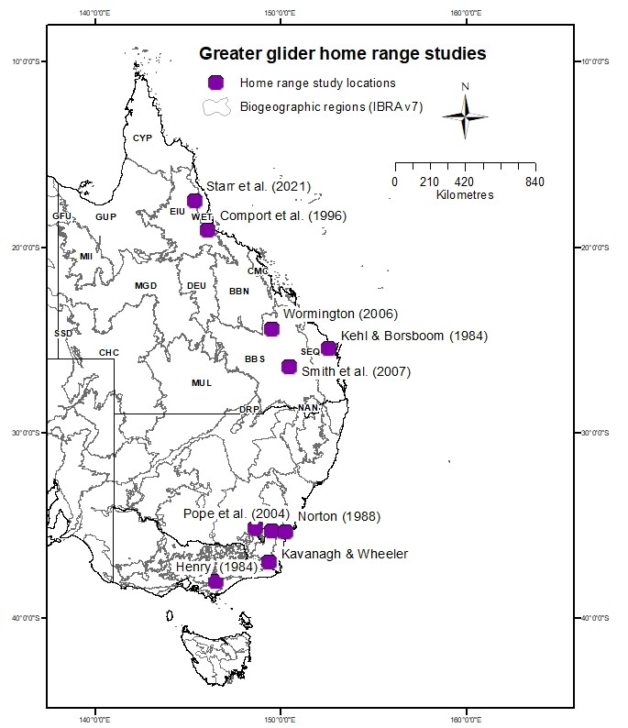

BB=Brigalow Bioregion; CQC=Central Queensland Coast; EIU=Einasliegh Uplands; NET=New England Tablelands; GUP=Gulf Uplands; SEQ=Southeast Qld; WET=Wet Tropics.

Table 5 Summary of tracking studies of greater gliders to estimate home range sizes

| Location | Study duration | Number of gliders | Method used | | Home range estimates (ha) mean ± s.d | | | | | | | Reference |
| --- | --- | --- | --- | --- | --- | --- | --- | --- | --- | --- | --- | --- |
| Male | | | Female | | All | Range |
| Tumoulin, WET, Qld | 5 months | 9 (4 male, 5 female) | Modified Minimum Convex Polygon (MCP) | | 5.5 ± 4.2 | | | 4.1 ± 1.1 | | 5.3 ± 3.1 | 1.1 - 11. 5 | Starr et al. (2021) |
| Taravale Station, WET, Qld | 10 months | 11 (5 male, 6 female) | 95% MCP | | 2.2 ± 1.1 | | | 1.0 ± 0.3 | | 1.6 ± 0.7 | 1.0 - 4.2 | Comport et al. (1996) |
| 95% Kernel | | 2.5 ± 1.1 | | | 1.3 ± 0.3 | | 1.9 ± 0.7 | 1.3 - 4.2 |
| 95% Harmonic | | 0.6 ± 0.1 | | | 0.2 ± 0.1 | | 0.4 ± 0.1 | 0.1 - 0.5 |
| Miriam Vale, SEQ, Qld | 18 months | 2 (2 females) | 100% MCP | n/a | | n/a | | | 2.9 | | 2.2 - 3.6 | Wormington (2006) |
| 95% MCP | n/a | | n/a | | | 1.4 | | 1.1 - 1.8 |
| Maryborough, SEQ, Qld | 4 years | 11 (4 male, 7 female) | MCP area | | 2.6 ± 1.7 | | | 2.5 ± 1.2 | | 2.6 ± 1.5 | 1.1 - 3.9 | Kehl & Borsboom (1984) |
| Barakula, BBS, Qld | 18 months | 7 (3 male, 4 female) | MCP | | 11.5 ± 7.2 | | 3.3 ± 2.1 | | | 6.8 ± 6.2 | 1.4 - 19.3 | Smith et al. (2007) |
| Fixed Kernel | | 10.8 ± 6.7 | | 4.1 ± 2.3 | | | 6.9 ± 5.5 | 1.8 - 17.8 |
| Tumut, NSW | 13 months | 23 (11 male, 12 female) | Fixed Kernel | | 2.6 ± 0.8 | | | 2.0 ± 0.6 | | 2.3 ± 0.7 | 1.3 - 4.1 | Pope et al. (2004) |
| Morton NP, southeast NSW | 23 months | 11 (4 male, 7 female) | Modified MCP | | 1.4 ± 0.1 | | | 1.5 ± 0.1 | | 1.4 ± 0.1 | 0.9 - 1.6 | Norton (1988) |
| Wadbilliga NP, southeast NSW | 23 months | 14 (5 male, 9 female) | Modified MCP | | 1.8 ± 0.1 | | | 1.5 ± 0.2 | | 1.6 ± 0.1 | 0.8 - 1.9 | Norton (1988) |
| Bombala, southeast NSW | 11 months | 11 (4 male, 7 female) | 100% MCP | | 2.03 ± 0.7 | | 0.8 ± 0.2 | | | 1.4 ± 0.8 | 0.47 - 2.9 | Kavanagh & Wheeler (2004) |
| 95% Adaptive Kernel | | 1.92 ± 0.8 | | 0.8 ± 0.2 | | | 1.3 ± 0.8 | 0.46 - 3.1 |
| Glengarry, southeast Vic | 3 years | 15 (6 male, 9 female) | Modified MCP | | 2.1 ± 0.7 | | | 1.3 ± 0.5 | | 1.5 ± 0.6 | 0.7 - 2.94 | Henry (1984) |

**n/a** Not applicable. Note: study areas are listed from north to south. Further detail is in Map 5 and Appendix C. BBS=Brigalow Belt South; SEQ=Southeast Qld; WET=Wet Tropics.

## Fragmentation and use of remnant patches by greater gliders

Patch size is likely to influence greater glider occupancy of habitat. Large patches of suitable habitat have a higher probability of occupancy and persistence of greater glider populations (Possingham et al. 1994). However, small patches (eg. < 20 ha) should not be dismissed as important habitat particularly if connected to other patches which increases the likelihood that greater gliders will utilise smaller patches (Possingham et al. 1994). Simulations suggest that habitat patches as small as 3 ha can contribute to the persistence of greater gliders, depending on the characteristics of landscape context (McCarthy and Lindenmayer 1999). If patches are sufficiently close together then gliders will be able to glide between, but they are also known to come to ground, although this is not a preferred method of dispersal.

The review of greater glider tracking studies revealed that the occupation of small (< 3 ha) home ranges is largely consistent throughout the Australian geographic range of the species complex. This suggests they may be able to occupy small patches of suitable habitat. However, they have also been tracked over reasonable distances, suggesting potential dispersal capacity through fragmented habitat, and even crossing a highway in one study (Wormington 2006). Recent surveys in Queensland are also confirming the presence of greater gliders persisting in small, but connected, patches of remnant habitat, indicating some dispersal capacity as identified by the home range studies of the species. A review of the literature on greater glider distribution in fragmented landscapes provides evidence that the species complex does occupy small patches of suitable habitat (Table 6).

Taking the precautionary principle, we suggest that any Queensland regional ecosystem that has been identified as greater glider habitat, no matter how fragmented, will have value for greater gliders either now (if hollow-bearing trees present), or in the future with restoration. Further research on greater glider dispersal capacity and persistence in fragmented habitat is recommended.

Table Studies documenting occupation of remnant habitat patches by greater gliders

| Location | Size of patch (ha) | Preferred habitat | Connected | Context | Source |
| --- | --- | --- | --- | --- | --- |
| South-east NSW | 964 | Eucalyptus pilularis forest | No | Urban | Vinson et al. 2021 |
| South-east NSW | 9 | E. radiata and E. viminalis forest | No | Pinus radiata | Pope et al. 2004 |
| South-east NSW | 1.6 | E. radiata and E. viminalis forest | No | Pinus radiata | Pope et al. 2004 |
| South-east NSW | 18.2 | E. radiata and E. viminalis forest | No | Pinus radiata | Pope et al. 2004 |
| South-east NSW | 8.3 | E. radiata and E. viminalis forest | No | Pinus radiata | Pope et al. 2004 |
| South-east NSW | 6 | E. radiata and E. viminalis forest | No | Pinus radiata | Pope et al. 2004 |
| Southern Vic | 45 | E. regnans forest | Yes (not old-growth) | Non-old growth | Possingham et al. (1994) |
| Southern Vic | 3 (x 13) | E. regnans forest | Yes (not old-growth) | Non-old growth | Possingham et al. (1994) |
| Southern Vic | 12 | E. regnans forest | Yes (not old-growth) | Non-old growth | Possingham et al. (1994) |
| Southern Vic | 6 (x 2) | E. regnans forest | Yes (not old-growth) | Non-old growth | Possingham et al. (1994) |
| Southern Vic | 24 | E. regnans forest | Yes (not old-growth) | Non-old growth | Possingham et al. (1994) |
| Southern Vic | 9 | E. regnans forest | Yes (not old-growth) | Non-old growth | Possingham et al. (1994) |
| Southern Vic | 21 | E. regnans forest | Yes (not old-growth) | Non-old growth | Possingham et al. (1994) |
| South-east NSW | > 3 | E. radiata and E. viminalis forest | No | Pinus radiata | McCarthy and Lindenmayer (1999) |
| Southern Vic | 3 to 30 | E. regnans and E. delegatensis forest | No | Burnt forest | Berry et al. 2005 |
| Southern Vic | 1 | E. regnans and E. delegatensis forest | No | Burnt forest | Berry et al. 2005 |
| Southern Vic | 3 to 30 | E. regnans and E. delegatensis forest | Yes | Burnt forest | Berry et al. 2005 |
| Armidale NSW | 260 | E. laevopinia; E. nobilis | Partial | Woodland and farmland | Emerson et al. (2019) |

## Observer bias with determining trees with hollows

The assessment of hollow-bearing trees, as defined by ground-based estimate of the presence or number of tree hollows, has been shown to be subject to sampling bias and under- or over-estimation by an increasing number of studies. Double-sampling – where trees are surveyed for hollows from the ground and again from climbing – and tree-felling – where trees are surveyed for hollows from the ground and again post-felling – are 2 methods that have been used to quantify substantial underestimation in the assessment of hollows in trees, particularly in tall forests (Harper et al. 2004; Koch 2008; Rayner et al. 2011; Penton et al. 2020). In woodlands, where the structure is more open and trees are less tall than in forests, accuracy in the ground survey tree hollows appears to be higher than that reported in forest ecosystems, but there is large error associated with the detection of hollows in branches (Rayner et al. 2011). Mistaking fire scars, termite nests, wind damage and sap stains for hollows, and vice versa, all contribute to reduced accuracy of ground-based surveys (Whitford and Williams 2002; Koch 2008; Woolley et al. 2018).

Observer bias, perspective and expertise also contribute to inaccuracies in ground-based assessment of hollow-bearing trees. For example, a study on the selection of hollow-bearing trees by forestry trained managers for retention during timber harvesting activities selected trees with low economic value, whereas conservation biologists selected much larger trees with high production value (Cosyns et al. 2018; 2020).

Training observers in the identification of hollow-bearing trees greatly improves consistency and accuracy of ground-based surveys (Cosyns et al. 2018). However, even with training, the ground-based assessment of hollows in trees remains highly variable among observers. An investigation of observer variability in the measurement of field-based vegetation condition and habitat attributes revealed that, of the 20 attributes measured, hollows in trees was by far the most inconsistently assessed, despite prior training of the observers (Kelly et al. 2011). The level of field experience of observers, particularly in fauna survey of hollow-dependent species, assists in reducing the variability in ground-based assessment of trees with hollows (Kelly et al. 2011), and those who take more time during the surveys are more accurate in their assessments (Harper et al. 2004).

As a consequence of the high variability and low reliability in determining hollows in trees from the ground, hollow-bearing trees is no longer an assessable attribute in condition assessments in Queensland or New South Wales and has been replaced by a ‘large tree’ attribute which is determined by a direct measure of tree diameter (Eyre et al. 2015, Oliver et al. 2021). Size thresholds for what constitutes a ‘large tree’ within a particular ecosystem type is guided by the probability of hollow presence in different tree species where hollow formation can occur at different rates in different tree species in different regions, meaning some species may contain hollows at smaller diameters than other species (Wormington and Lamb 1999; Eyre 2005; Eyre et al., 2015; Koch et al. 2008; Travers et al. 2018).

Greater glider habitat trees are difficult to identify based on the identification of hollows. Size on the other hand can be accurately measured by DBH. Large trees are an appropriate surrogate for habitat trees as they have a higher probability of containing hollows than small trees. Consequently, the probability that greater gliders utilise trees increases with size. Retention of an adequate resource of appropriately large sized trees is critical for maintaining current greater glider populations. The next section identifies a means for identifying which large trees are of an appropriate size for habitat retention. Small trees are also important as recruitment stock and effort is additionally required to maintain a source of recruitment trees that will ensure a future resource for greater gliders.

## Determining ‘large trees’ within Queensland greater glider habitat

Both large trees and hollow-bearing trees are structural elements of mature habitat that provide essential foraging and sheltering resources for greater gliders in Queensland (Eyre 2005, 2006; Eyre et al. 2010). Given the issues of variability in the assessment of trees with hollows across multiple observers, and the demonstrated correlation between tree diameter size and the presence of hollows and other important greater glider habitat attributes (Lindenmayer et al. 2000; Eyre 2005; Smith et al. 2007; Travers et al. 2018), it is recommended that assessors use tree size rather than presence or absence of hollow-bearing trees to determine greater glider habitat. Tree diameter is easy and reliable to measure, but a determination of what constitutes a ‘large tree’ is required. There are few recommended methods available to help determine size thresholds for ‘large’ trees. Lindenmayer and Laurance (2016) recommend defining a ‘large, old’ tree as selecting the typical minimum diameter of a reproductively mature (flowering and fruiting) individual within a species, and then selecting a certain percentile (e.g., the top 5% by diameter) of all reproductive trees. Travers et al. (2018) defined a large tree as the size at which a species has a 50% probability of supporting a 2 cm diameter hollow. Both of these approaches require metanalyses and/or empirical analysis of adequate data on tree species by DBH.

In Queensland, the assessment of regional ecosystem tree diameter thresholds to determine when a tree is ‘large’ is an ongoing, state-wide program undertaken by the Queensland Herbarium for the assessment of vegetation condition, using the BioCondition Vegetation Condition Assessment Framework (Eyre et al. 2015).

The BioCondition framework defines a threshold above which a tree is considered ‘large’ by assessing the average stem size of all live trees over a certain stem size from data collected at reference sites within specific regional ecosystems (see Box 2). The data is used to derive:

* a threshold DBH of what is considered to be a large tree in the ecosystem that is being sampled; and
* a benchmark of the number of large trees (that is, trees that exceed the DBH threshold) per hectare.

The benchmark ‘large’ tree DBH thresholds and densities per ha were collated for all regional ecosystems that were determined as greater glider habitat in Queensland. Of the 254 greater glider habitat regional ecosystems, almost half had benchmarks available with most occurring in the southeast Queensland, Brigalow and New England Tableland bioregions (Table 7). The large tree benchmark data was summarised for each of the 4 bioregions with sufficient data, show there is little variation in the average and median large tree DBH thresholds for greater glider habitat regional ecosystems between bioregions, averaging around 46 cm DBH, but ranging between 35 and 61 cm DBH (Figure 6a). The overall average figure of 46 cm derived from the BioCondition framework concords with the indicative figure of 50 cm DBH derived from studies of greater glider habitat tree use in southern Queensland (Section 4.1, Figure 4 and Figure 5).

The densities of large trees per ha was more variable between the bioregions, with lower densities in the less productive forests and woodlands of the Brigalow bioregion (mean = 14.9 large trees per ha) and high variability in densities of large trees within southeast Queensland (Figure 6b).

This suggests that although we may be able to recommend a DBH threshold that identifies ‘large trees’ as attributes of greater glider habitat in at least the southern and central part of their distribution in Queensland (that is, 46 cm), assessors will still need to take note of densities of large trees within a bioregion, and preferably by regional ecosystem using BioCondition benchmarks. Density of trees less than the average and in the lower quartile of the range of tree sizes that are considered habitat trees should also be considered as important to greater gliders and would ensure greater protection of the range of tree sizes that constitute current habitat (including feed trees > 30 cm DBH; Section 4.1) and would be an appropriate bank to ensure recruitment of habitat trees into the future.

Table Available large tree benchmarks for greater glider habitat regional ecosystems by bioregion

| Bioregion | Number greater glider habitat regional ecosystems | Greater glider habitat regional ecosystems with available BioCondition benchmarks | Large tree DBH (cm) threshold Average (± s.d) | Large tree density ha-1 Average (± s.d) |
| --- | --- | --- | --- | --- |
| Gulf Plains | 2 | 0 | n/a | n/a |
| Wet Tropics | 38 | 2 (5.1%) | 42.5 ± 2.12 | 46.5 ± 33.2 |
| Central Queensland Coast | 24 | 4 (16.6%) | 46.5 ± 5.2 | 27.8 ± 10.3 |
| Einasleigh Uplands | 28 | 1 (3.4%) | 51 | 20 |
| Desert Uplands | 1 | 1 (100%) | 53 | 17 |
| Brigalow | 43 | 23 (53.5%) | 46.5 ± 7.5 | 14.9 ± 5.1 |
| Southeast Queensland | 110 | 76 (69.1%) | 46.2 ± 6.5 | 32.1 ± 11.6 |
| New England Tablelands | 8 | 6 (75%) | 43.8 ± 3.3 | 38 ± 10.7 |
| Total | 254 | 113 (44.1%) | 46.4 ± 5.5 | 29.5 ± 13.7 |

**n/a** Not applicable.

Box Derivation of the large tree size threshold in BioCondition

In BioCondition, the ‘large tree’ size threshold for benchmarking is derived by measuring the DBH of all live eucalypt trees (includes all species in the genera Eucalyptus, Corymbia, Lophostemon, Syncarpia and Angophora) within a 50 x 100 m plot in a regional ecosystem in reference or ‘best on offer’ condition, that are greater than a 30 cm DBH. The median or average DBH is calculated from all trees > 30 cm DBH measured across all reference sample plots within a particular regional ecosystem, to give a DBH size threshold of a ‘large eucalypt tree’ that is specific to a regional ecosystem. The number of eucalypt trees that exceed this threshold are then counted for each plot, standardised to a per ha value, and averaged across the reference sites to give a benchmark value of density of large live eucalypt trees per ha for each regional ecosystem.

Figure Summary statistics for each bioregion with sufficient data on large tree benchmarks for greater glider habitat regional ecosystems

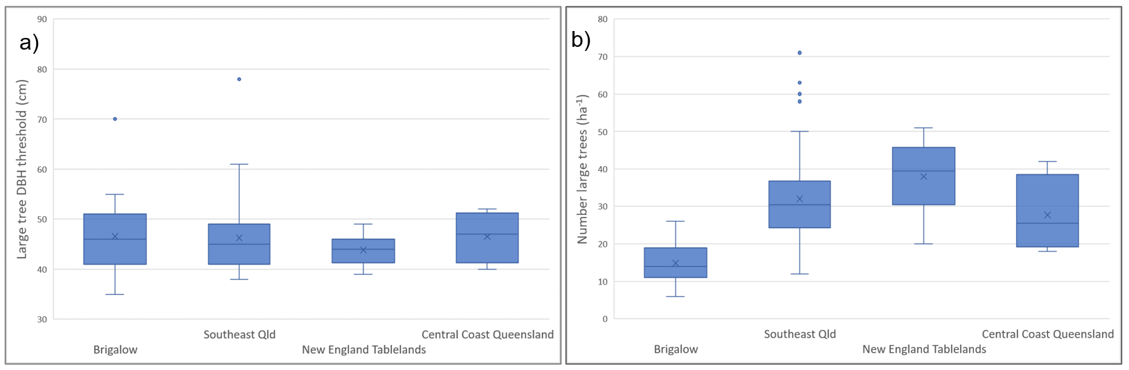

Note: a) large tree diameter thresholds and b) number of large trees per ha. x = mean; middle = median; the box represents the interquartile range, and the whiskers show upper and lower range. Outliers are also shown

## Summary of deliverables

1. Look-up tables of regional ecosystems representing greater glider habitat and potential habitat, which can be mapped or interrogated by assessors and other stakeholders.
2. Maps and shapefiles of greater glider habitat and potential habitat using regional ecosystems in Queensland.
3. List of tree species that are the dominant and co-dominant species in greater glider habitat by bioregion in Queensland.
4. Review of greater glider home range studies throughout their Australian geographic range and a summary of approaches and results.
5. Identification of ‘large’ tree size thresholds by Bioregion to guide identification of greater glider habitat and potential habitat.

## Recommendations

**Recommendation 1: Support further survey work to confirm greater glider regional ecosystem habitat in under-sampled areas**

Further survey work will be needed to confirm greater glider habitat in regional ecosystems within the glider’s broad distribution range within Queensland, particularly for those regional ecosystems defined as Potential habitat, and the area between the northern greater glider (*P. minor*) distribution and the central and southern greater glider distribution (that is, the northern area of the Brigalow bioregion and southern area of the Einasleigh Uplands). In north Queensland, we suggest survey effort along the Gregory Range in habitat greater than 500 m elevation, and also in the fragmented habitat around Undara and where greater gliders have been recorded close to the coast. We encourage the use of Queensland standardised survey approach (eg. Eyre et al. 2018) to capture both greater glider presence and absence data.

**Recommendation 2: Densitites of hollow-bearing trees should not be used to define whether an area is greater glider habitat or not habitat**

Identification of hollow-bearing trees from ground-based surveys is not reliable, particularly in taller forest habitats. We therefore recommend that greater glider habitat is not defined by the presence or absence of hollows in trees. Instead, we recommend that habitat is identified by the appropriate density of ‘large trees’ as a proportion of trees in greater glider habitat and potential habitat. Note that what constitutes a large tree will vary between regional ecosystems.

**Recommendation 3: Improve reliability for indicating greater glider habitat or potential habitat by measuring densities of ‘large trees’**

Densities of ‘large trees’ will vary by regional ecosystem, which can be determined by looking up the benchmark value for the number of large trees for that regional ecosystem. In Queensland this will include Eucalypt, Corymbia, Lophostemon, Syncarpia and Angophora trees > 46 cm DBH. Note that large tree density data is currently only available for some [greater glider habitat regional ecosystems](https://www.qld.gov.au/environment/plants-animals/biodiversity/benchmarks).

**Recommendation 4: Remnant patches of potential greater glider habitat should be valued as habitat regardless of patch size**

As a consequence of historic broadscale clearing of greater glider habitat, particularly in southeast Queensland (> 40% cleared), all habitat and potential habitat should be protected particularly in the fragmented regions. Patches containing small trees that will later be recruited to the large tree class should also be considered as future habitat in deciding offsets.

**Recommendation 5: Support the identification of future refugia for greater gliders through climate change**

The identification of climate change refugia for Queensland greater gliders is out of scope of the current project. However, the work conducted to date for this project may help inform future work to determine climate change refugia.

## Appendix A: Example of regional ecosystem greater glider habitat data description

Table Example of regional ecosystem greater glider habitat data description

| Regional ecosystem | Short description | GG habitat | GG record < 300 | Detailed description | BVG_1M | Habitat | Comments | Structure Code |
| --- | --- | --- | --- | --- | --- | --- | --- | --- |
| 11.10.1 | Corymbia citriodora woodland on coarse-grained sedimentary rocks | Habitat | Yes | Corymbia citriodora predominates and forms a distinct but discontinuous woodland to open forest. On rocky slopes, Eucalyptus crebra and C. hendersonii may be scattered throughout the canopy or locally abundant. On flats and footslopes, scattered E. crebra, C. clarksoniana and C. tessellaris may occur. Corymbia trachyphloia and E. cloeziana often occur on crests and plateaus while E. apothalassica and E. longirostrata sometimes occur in moister microhabitats. Scattered tall to low shrubs, such as Acacia leiocalyx, Acacia spp., Bursaria spinosa subsp. spinosa, Persoonia falcata, Alphitonia excelsa, Petalostigma pubescens and Xanthorrhoea johnsonii are usually present and sometimes form a conspicuous layer. The ground layer varies from sparse to moderately dense (depending on the rockiness) and is dominated by perennial grasses. | 10a | Occurs on hills and ranges, particularly on colluvial lower slopes, formed from medium to coarse-grained sediments (usually sandstone). Associated soils are often texture contrast with a thin sandy or loamy surface horizon and some uniform sandy and litho | regional ecosystem 11.10.1b and 11.10.1c has been amalgamated into this regional ecosystem. | W |
| 11.10.13 | Eucalyptus spp. and/or Corymbia spp. open forest on scarps and sandstone tablelands | Habitat | Yes | Open forest (to woodland) with a range of canopy species including Eucalyptus cloeziana, E. melanoleuca, E. sphaerocarpa, Corymbia bunites, C. hendersonii, C. trachyphloia, E. suffulgens, C. leichhardtii, C. citriodora, E. baileyana. | 12a | Occurs on sandstone scarps and tablelands with shallow soils formed from medium to coarse-grained sediments. | This regional ecosystem merges into regional ecosystem 11.10.1 which is dominated by C. citriodora or E. crebra. | OF |
| 11.10.13a | Eucalyptus spp. and/or Corymbia spp. open forest on scarps and sandstone tablelands | Habitat | Yes | Open forest (to woodland) with a range of canopy species including Eucalyptus cloeziana, E. melanoleuca, E. sphaerocarpa, Corymbia bunites, C. hendersonii, C. trachyphloia, E. suffulgens, C. leichhardtii, C. citriodora, E. baileyana. | 12a | Occurs on sandstone scarps and tablelands with shallow soils formed from medium to coarse-grained sediments. | This regional ecosystem merges into regional ecosystem 11.10.1 which is dominated by C. citriodora or E. crebra. | OF |
| 11.10.1a | Corymbia watsoniana +/- C. citriodora, +/- C. trachyphloia +/- C. hendersonii woodland. | Potential habitat | Yes | Corymbia watsoniana +/- C. citriodora, +/- C. trachyphloia +/- C. hendersonii woodland. | 12a | n/a | n/a | W |
| 11.10.1d | Eucalyptus crebra woodland | Potential habitat | No | Eucalyptus crebra woodland. | 12a | n/a | n/a | W |
| 11.10.2 | Open forest in sheltered gorges on coarse-grained sedimentary rocks | Habitat | Yes | Eucalyptus saligna, Syncarpia glomulifera subsp. glomulifera open forest. Corymbia citriodora, E. major, E. acmenoides and C. trachyphloia occur on drier sites. Often a distinct shrub or secondary tree layer dominated by species such as Livistona spp. and Pittosporum undulatum, particularly in moist habitats, is present. | 8a | Occurs in sheltered gorges in ranges formed from medium to coarse-grained sediments. | n/a | OF |
| 11.10.4 | Eucalyptus decorticans, Lysicarpus angustifolius +/- Eucalyptus spp., Corymbia spp., Acacia spp. woodland on coarse-grained sedimentary rocks | Habitat | Yes | Eucalyptus decorticans predominates forming a distinct but discontinuous canopy (25-30m high). Eucalyptus decorticans usually forms pure stands, however other Eucalyptus spp. often form part of the canopy and may dominate. Other tree species that may be present and/or dominant include Acacia shirleyi, Angophora leiocarpa, Callitris glaucophylla, Eucalyptus apothalassica, Lysicarpus angustifolius, E. exserta, E. fibrosa subsp. nubilis, E. panda, E. tenuipes, Corymbia trachyphloia, and E. virens. On very rocky shallow soils, Eucalyptus bakeri, E. curtisii or E. viridis may occur. Acacia shirleyi is the most frequent tall shrub, although other Acacia spp. May be locally dominant. There is usually a low tree or tall shrub layer dominated by species such as Acacia sparsiflora, A. burrowii, Callitris endlicheri, Allocasuarina inophloia, Acacia spp., Eucalyptus tenuipes, Alphitonia excelsa and Petalostigma pubescens. A low shrub layer is not usually present, however where it occurs Acacia spp. and Dodonaea triangularis usually predominate. The ground layer is sparse to open, and dominated by perennial grasses, usually Aristida spp. or Arundinella nepalensis. | 12a | Occurs on crests, scarps and upper slopes of ranges formed from medium to coarse-grained sediments with shallow soils. | n/a | W |
| 11.10.4a | Eucalyptus crebra, Corymbia aureola, Corymbia clarksoniana and/or Acacia shirleyi woodland | Habitat | Yes | Eucalyptus crebra, Corymbia aureola, C. clarksoniana and/or Acacia shirleyi woodland. Small areas that occur in conjunction with E. decorticans woodland. | 12a | n/a | n/a | W |

**n/a** Not applicable.

## Appendix B: Tree species characterising greater glider habitat in Queensland

Table Numbers of R where the species is dominant, co-dominant, sub-dominant or associated, within each bioregion

| Genus | Species | BB | CQC | DEU | EIU | GUP | NET | SEQ | WET | Total |
| --- | --- | --- | --- | --- | --- | --- | --- | --- | --- | --- |
| Lophostemon | suaveolens | 4 | 9 | n/a | 6 | n/a | n/a | 10 | 12 | 41 |
| Lophostemon | confertus | n/a | 3 | n/a | n/a | n/a | n/a | 18 | n/a | 21 |
| Banksia | integrifolia | n/a | 7 | n/a | n/a | n/a | n/a | 1 | n/a | 8 |
| Banksia | aquilonia | n/a | n/a | n/a | n/a | n/a | n/a | n/a | 2 | 2 |
| Syncarpia | glomulifera | 1 | 5 | n/a | n/a | n/a | n/a | 13 | 11 | 29 |
| Angophora | leiocarpa | 2 | n/a | n/a | n/a | n/a | 1 | 27 | n/a | 30 |
| Angophora | floribunda | 2 | n/a | n/a | n/a | n/a | 1 | n/a | n/a | 3 |
| Angophora | subvelutina | n/a | n/a | n/a | n/a | n/a | n/a | 4 | n/a | 4 |
| Angophora | woodsiana | n/a | n/a | n/a | n/a | n/a | n/a | 9 | n/a | 9 |
| Eucalyptus | acmenoides | 4 | 3 | n/a | n/a | n/a | n/a | 35 | 3 | 45 |
| Eucalyptus | albens | n/a | n/a | n/a | n/a | n/a | 2 | 1 | n/a | 3 |
| Eucalyptus | andrewsii | n/a | n/a | n/a | n/a | n/a | 1 | n/a | n/a | 1 |
| Eucalyptus | apothalassica | 1 | n/a | n/a | n/a | n/a | n/a | n/a | n/a | 1 |
| Eucalyptus | atrata | n/a | n/a | n/a | 2 | n/a | n/a | n/a | 1 | 3 |
| Eucalyptus | baileyana | n/a | n/a | n/a | n/a | n/a | n/a | 5 | n/a | 5 |
| Eucalyptus | bancroftii | n/a | n/a | n/a | n/a | n/a | n/a | 1 | n/a | 1 |
| Eucalyptus | banksii | n/a | n/a | n/a | n/a | n/a | 1 | n/a | n/a | 1 |
| Eucalyptus | biturbinata | n/a | n/a | n/a | n/a | n/a | 1 | 7 | n/a | 8 |
| Eucalyptus | caliginosa | n/a | n/a | n/a | n/a | n/a | 1 | n/a | n/a | 1 |
| Eucalyptus | camaldulensis | 3 | n/a | 1 | 2 | n/a | n/a | n/a | n/a | 6 |
| Eucalyptus | campanulata | n/a | n/a | n/a | n/a | n/a | 1 | 1 | n/a | 2 |
| Eucalyptus | carnea | n/a | n/a | n/a | n/a | n/a | n/a | 17 | n/a | 17 |
| Eucalyptus | cloeziana | 2 | n/a | n/a | 4 | n/a | n/a | 1 | 4 | 11 |
| Eucalyptus | coolabah | 2 | n/a | 1 | n/a | n/a | n/a | n/a | n/a | 3 |
| Eucalyptus | crebra | 19 | 8 | n/a | 21 | 2 | 4 | 35 | n/a | 89 |
| Eucalyptus | cullenii | n/a | n/a | n/a | 3 | n/a | n/a | n/a | n/a | 3 |
| Eucalyptus | dealbata | n/a | n/a | n/a | n/a | n/a | 3 | n/a | n/a | 3 |
| Eucalyptus | deanei | n/a | n/a | n/a | n/a | n/a | 2 | n/a | n/a | 2 |
| Eucalyptus | decolor | n/a | n/a | n/a | n/a | n/a | n/a | 1 | n/a | 1 |
| Eucalyptus | decorticans | 1 | n/a | n/a | n/a | n/a | n/a | 1 | n/a | 2 |
| Eucalyptus | drepanophylla | n/a | 8 | n/a | 4 | n/a | n/a | n/a | 7 | 19 |
| Eucalyptus | dunnii | n/a | n/a | n/a | n/a | n/a | n/a | 1 | n/a | 1 |
| Eucalyptus | dura | n/a | n/a | n/a | n/a | n/a | n/a | 2 | n/a | 2 |
| Eucalyptus | eugenioides | n/a | n/a | n/a | n/a | n/a | n/a | 7 | n/a | 7 |
| Eucalyptus | exilipes | n/a | n/a | n/a | 2 | 1 | n/a | n/a | n/a | 3 |
| Eucalyptus | exserta | 2 | 10 | n/a | 3 | n/a | n/a | 10 | n/a | 25 |
| Eucalyptus | fibrosa | 3 | 1 | n/a | n/a | n/a | n/a | 11 | n/a | 15 |
| Eucalyptus | fibrosa subsp. nubilis | 1 | n/a | n/a | n/a | n/a | 1 | n/a | n/a | 2 |
| Eucalyptus | grandis | n/a | 1 | n/a | n/a | n/a | n/a | 7 | 5 | 13 |
| Eucalyptus | granitica | n/a | n/a | n/a | 6 | n/a | n/a | n/a | 3 | 9 |
| Eucalyptus | helidonica | n/a | n/a | n/a | n/a | n/a | n/a | 9 | n/a | 9 |
| Eucalyptus | howittiana | n/a | n/a | n/a | 2 | n/a | n/a | n/a | n/a | 2 |
| Eucalyptus | laevopinea | 1 | n/a | n/a | n/a | n/a | n/a | n/a | n/a | 1 |
| Eucalyptus | latisinensis | 1 | 1 | n/a | n/a | n/a | n/a | 3 | n/a | 5 |
| Eucalyptus | leptophleba | n/a | n/a | n/a | 1 | n/a | n/a | n/a | n/a | 1 |
| Eucalyptus | lockyeri | n/a | n/a | n/a | n/a | n/a | n/a | n/a | 1 | 1 |
| Eucalyptus | longirostrata | 1 | n/a | n/a | n/a | n/a | n/a | 10 | n/a | 11 |
| Eucalyptus | major | 1 | n/a | n/a | n/a | n/a | n/a | 14 | n/a | 15 |
| Eucalyptus | mediocris | n/a | n/a | n/a | 1 | n/a | n/a | n/a | n/a | 1 |
| Eucalyptus | melanoleuca | 2 | n/a | n/a | n/a | n/a | n/a | n/a | n/a | 2 |
| Eucalyptus | melanophloia | 6 | 1 | n/a | 1 | n/a | 1 | 4 | n/a | 13 |
| Eucalyptus | melliodora | 1 | n/a | n/a | n/a | n/a | 1 | 4 | n/a | 6 |
| Eucalyptus | mensalis | 1 | n/a | n/a | n/a | n/a | n/a | n/a | n/a | 1 |
| Eucalyptus | microcarpa | 1 | n/a | n/a | n/a | n/a | n/a | n/a | n/a | 1 |
| Eucalyptus | microcorys | n/a | n/a | n/a | n/a | n/a | n/a | 28 | n/a | 28 |
| Eucalyptus | moluccana | 6 | 2 | n/a | 4 | n/a | 1 | 20 | 2 | 35 |
| Eucalyptus | montivaga | n/a | 1 | n/a | n/a | n/a | n/a | 6 | n/a | 7 |
| Eucalyptus | orgadophila | 2 | n/a | n/a | n/a | n/a | n/a | n/a | n/a | 2 |
| Eucalyptus | pachycalyx | n/a | n/a | n/a | n/a | n/a | n/a | n/a | 1 | 1 |
| Eucalyptus | pellita | n/a | n/a | n/a | n/a | n/a | n/a | n/a | 3 | 3 |
| Eucalyptus | pilularis | n/a | n/a | n/a | n/a | n/a | n/a | 11 | n/a | 11 |
| Eucalyptus | planchoniana | n/a | n/a | n/a | n/a | n/a | n/a | 3 | n/a | 3 |
| Eucalyptus | platyphylla | 1 | 7 | n/a | 4 | n/a | n/a | n/a | n/a | 12 |
| Eucalyptus | populnea | 3 | n/a | n/a | n/a | n/a | n/a | n/a | n/a | 3 |
| Eucalyptus | portuensis | n/a | 18 | n/a | 13 | n/a | n/a | 7 | 16 | 54 |
| Eucalyptus | prava | n/a | n/a | n/a | n/a | n/a | 1 | n/a | n/a | 1 |
| Eucalyptus | propinqua | n/a | n/a | n/a | n/a | n/a | n/a | 19 | n/a | 19 |
| Eucalyptus | racemosa | n/a | n/a | n/a | n/a | n/a | n/a | 11 | n/a | 11 |
| Eucalyptus | reducta | n/a | n/a | n/a | n/a | n/a | n/a | n/a | 3 | 3 |
| Eucalyptus | resinifera | n/a | 4 | n/a | n/a | n/a | n/a | 11 | 7 | 22 |
| Eucalyptus | robusta | n/a | n/a | n/a | n/a | n/a | n/a | 2 | n/a | 2 |
| Eucalyptus | saligna | 3 | n/a | n/a | n/a | n/a | n/a | 8 | n/a | 11 |
| Eucalyptus | seeana | n/a | n/a | n/a | n/a | n/a | n/a | 6 | n/a | 6 |
| Eucalyptus | shirleyi | n/a | n/a | n/a | 2 | n/a | n/a | n/a | 1 | 3 |
| Eucalyptus | siderophloia | n/a | n/a | n/a | n/a | n/a | n/a | 37 | n/a | 37 |
| Eucalyptus | sideroxylon | n/a | n/a | n/a | n/a | n/a | 1 | n/a | n/a | 1 |
| Eucalyptus | sphaerocarpa | 3 | n/a | n/a | n/a | n/a | n/a | n/a | n/a | 3 |
| Eucalyptus | suffulgens | 1 | 1 | n/a | n/a | n/a | n/a | n/a | n/a | 2 |
| Eucalyptus | taurina | n/a | n/a | n/a | n/a | n/a | n/a | 3 | n/a | 3 |
| Eucalyptus | tenuipes | 2 | n/a | n/a | n/a | n/a | n/a | n/a | n/a | 2 |
| Eucalyptus | tereticornis | 9 | 11 | n/a | 9 | n/a | 1 | 37 | 10 | 77 |
| Eucalyptus | tindaliae | n/a | n/a | n/a | n/a | n/a | n/a | 13 | n/a | 13 |
| Eucalyptus | woollsiana | n/a | n/a | n/a | n/a | n/a | 1 | n/a | n/a | 1 |
| Eucalyptus | youmanii | n/a | n/a | n/a | n/a | n/a | 1 | n/a | n/a | 1 |
| Melaleuca | bracteata | 2 | n/a | n/a | n/a | n/a | n/a | 1 | n/a | 3 |
| Melaleuca | viminalis | 2 | n/a | n/a | n/a | n/a | n/a | 1 | 1 | 4 |
| Melaleuca | trichostachya | 1 | n/a | n/a | n/a | n/a | n/a | 1 | n/a | 2 |
| Melaleuca | viridiflora | 2 | n/a | n/a | 5 | n/a | n/a | 1 | 1 | 9 |
| Melaleuca | nervosa | 1 | n/a | n/a | 2 | n/a | n/a | n/a | n/a | 3 |
| Melaleuca | dealbata | n/a | 2 | n/a | n/a | n/a | n/a | n/a | n/a | 2 |
| Melaleuca | quinquenervia | n/a | n/a | n/a | n/a | n/a | n/a | 7 | n/a | 7 |
| Melaleuca | linariifolia | n/a | n/a | n/a | n/a | n/a | n/a | 2 | n/a | 2 |
| Melaleuca | sieberi | n/a | n/a | n/a | n/a | n/a | n/a | 1 | n/a | 1 |
| Melaleuca | leucadendra | n/a | 2 | 1 | 1 | n/a | n/a | n/a | 1 | 5 |
| Melaleuca | fluviatilis | n/a | n/a | n/a | 1 | n/a | n/a | n/a | 1 | 2 |
| Corymbia | tessellaris | 11 | 4 | 1 | 4 | n/a | n/a | 9 | 1 | 30 |
| Corymbia | citriodora | 12 | 8 | n/a | 14 | 2 | 1 | 34 | 4 | 75 |
| Corymbia | hendersonii | 2 | n/a | n/a | n/a | n/a | n/a | n/a | n/a | 2 |
| Corymbia | clarksoniana | 8 | 5 | n/a | 13 | 1 | n/a | 3 | 2 | 32 |
| Corymbia | bunites | 2 | n/a | n/a | n/a | n/a | n/a | n/a | n/a | 2 |
| Corymbia | trachyphloia | 2 | 12 | n/a | 2 | n/a | n/a | 27 | n/a | 43 |
| Corymbia | leichhardtii | 1 | n/a | n/a | 5 | n/a | n/a | n/a | 1 | 7 |
| Corymbia | erythrophloia | 5 | 2 | n/a | 3 | n/a | n/a | 2 | n/a | 12 |
| Corymbia | xanthope | 1 | n/a | n/a | n/a | n/a | n/a | n/a | n/a | 1 |
| Corymbia | dallachiana | 6 | 2 | n/a | 9 | n/a | n/a | n/a | n/a | 17 |
| Corymbia | intermedia | 4 | 21 | n/a | 6 | 1 | n/a | 60 | 28 | 120 |
| Corymbia | lamprophylla | 1 | n/a | n/a | 1 | n/a | n/a | n/a | n/a | 2 |
| Corymbia | henryi | n/a | n/a | n/a | n/a | n/a | n/a | 5 | n/a | 5 |
| Corymbia | gummifera | n/a | n/a | n/a | n/a | n/a | n/a | 8 | n/a | 8 |
| Corymbia | watsoniana | n/a | n/a | n/a | n/a | n/a | n/a | 1 | n/a | 1 |
| Corymbia | abergiana | n/a | n/a | n/a | 1 | n/a | n/a | n/a | 2 | 3 |
| Corymbia | stockeri | n/a | n/a | n/a | n/a | n/a | n/a | n/a | 1 | 1 |
| Corymbia | leptoloma | n/a | n/a | n/a | n/a | n/a | n/a | n/a | 1 | 1 |
| Corymbia | leichardtii | n/a | n/a | n/a | n/a | 1 | n/a | n/a | n/a | 1 |
| Corymbia | setosa | n/a | n/a | n/a | n/a | 1 | n/a | n/a | n/a | 1 |
| Corymbia | brachycarpa | n/a | n/a | n/a | n/a | 1 | n/a | n/a | n/a | 1 |
| Corymbia | pocillum | n/a | n/a | n/a | 1 | n/a | n/a | n/a | n/a | 1 |
| Corymbia | peltata | n/a | n/a | n/a | 2 | n/a | n/a | n/a | n/a | 2 |
| Grevillea | glauca | n/a | n/a | n/a | 10 | n/a | n/a | n/a | n/a | 10 |

**n/a** Not applicable. BB=Brigalow Bioregion; CQC=Central Queensland Coast; EIU=Einasliegh Uplands; NET=New England Tablelands; GUP=Gulf Uplands; SEQ=Southeast Qld; WET=Wet Tropics.

## Appendix C: Summary of greater glider home range studies

Table Summary of greater glider home range studies

| Location | Site description | Study duration | Method of home range estimation | Mean home range estimate (ha) ± std dev | Range of estimate (ha) | Number of individuals tracked-providing estimate | No. of loci used to estimate HR | Male/female/all | Population density (individuals per ha) | Reference |
| --- | --- | --- | --- | --- | --- | --- | --- | --- | --- | --- |
| Boola Boola SF, Glengarry, SE Victoria | Upland moist and dry sclerophyll forest containing 11 species eucalypts | Apr 1980 - Aug 1983 | Individuals not radio-tracked. Identified from ear tags and body patterns. HR estimated from modified MCP area (Harvey & Barbour 1965) | 2.08 ± 0.66 | 1.34 – 2.94 | 4 | 101, 25, 36, 21 | Polygynous male | n/a | Henry (1984) |
| 1.36 ± 0.19 | n/a | 2 | 25, 33 | Monogamous male | n/a |
| 1.25 ± 0.46 | n/a | 9 | 99, 53, 57, 18, 22, 21, 12, 16, 15 | Female | n/a |
| 1.48 ± 0.59 | 0.7 – 2.94 | 15 | n/a | All | 0.56 |
| SE Qld | Coastal lowland forest | Dec 1977 - Jan 1982 | MCP area (Hayne 1949) for < 65 loci and modified MCP area (Harvey and Barbour 1965) for > 65 loci | 2.6 ± 1.7 | n/a | 4 | n/a | Male | n/a | Kehl and Borsboom (1984) |
| 3.93 ± 0.75 | n/a | 4 | n/a | Male | n/a |
| 2.5 ± 1.2 | n/a | 7 | n/a | Female | n/a |
| 2.6 | 1.1 – 3.96 | n/a | n/a | All | 1.6 – 2.3 |
| Wadbilliga NP, SE NSW | Wadbilliga: *E. radiata, E. fastigata, E. viminalis* dominated sclerophyll | Oct 1984-Apr 1986. Up to 23 months | Individuals were not radio-tagged. Identified from tail tags with reflective tape. Modified MCP of Harvey and Barbour (1965). Intensively tracked: > 9 nights obs of all night tracking spread over 9 mths a minimum. Less intensively tracked: > 15 nights obs (at least one obs per night) required to establish HR | 1.8 ± 0.1 | 1.6 – 1.9 | 3 | 219, 305, 276 | Intensively monitored monogamous males (*except for one bigamous) | n/a | Norton (1988) |
| 1.8 ± 0.1 | 1.7 – 1.9 | 3 | 22, 16, 33 | Other males | n/a |
| 1.4 ± 0.5 | 0.8 – 1.8 | 3 | 312, 402, 257 | Intensively monitored females | n/a |
| 1.5 ± 0.2 | 1.4 – 1.9 | 6 | 30, 28, 33, 32, 17, 35 | Other females | n/a |
| n/a | 0.8 – 1.9 | 14 | n/a | All monogamous adults | 0.88 |
| Morton NP, SE NSW | Morton*: E. gummifera, E. sieberi, Syncarpia glomulifera* dominated sclerophyll | Oct 1984-Apr 1986. Up to 23 months | Less intensively tracked: > 12 nights obs (at least one obs per night) GGs required to establish HR | 1.4 ± 0.1 | 1.3 – 1.4 | 3 | 261, 215, 34 | Monogamous males | n/a | Norton (1988) |
| 1.4 | n/a | 1 | 224 | One male that became bigamous (in different forest type) | n/a |
| 1.5* ± 0.1* | 1.3* – 1.6 | 5 | 483, 263, 17, 16, 26 | Female (*excluding one from different forest type) | n/a |
| n/a | 0.9 – 1.6 | 9 | No. for F6=290 | All | 1.67 |
| Taravale Station, near Paluma, north-east Qld | Tropical sclerophyll forest. *E. acmenoides, E. citriodora, E. intermedia, E. tereticornis, E. crebra* | Mar-Dec 1992, 36 nights | 95% MCP. RANGES IV software | 2.2 ± 1.1 | n/a | 5 | 131, 111, 120, 110, 25 | Male adult | n/a | Comport et al. (1996) |
| 1 ± 0.25 | n/a | 6 | 121, 117, 115, 117, 113, 27 | Female adult | n/a |
| n/a | n/a | 11 |  | All | 3.3 – 3.8 |
| 95% Kernel. RANGES IV software | 2.5 ± 1.1 | 1.3 – 4.2 | 5 | 131, 111, 120, 110, 25 | Male adult | n/a |
| 1.3 ± 0.25 | n/a | 6 | 121, 117, 115, 117, 113, 27 | Female adult | n/a |
| n/a | n/a | 11 | n/a | All | 3.3 – 3.8 |
| 95% Harmonic. RANGES IV software | 0.6 ± 0.12 | n/a | 4 | 131, 111, 120, 110 | Male adult | n/a |
| 0.2 ± 0.04 | n/a | 5 | 121, 117, 115, 117, 113 | Female adult | n/a |
| n/a | n/a | 9 | n/a | All | 3.3 – 3.8 |
| Waratah Creek, Coolangubra NP, SE NSW | *E. ovata, E. viminalis, E. fastigata, E. cypellocarpa, E. obliqua, E. radiata, E. sieberi* | April 1984-March 1985 | 100% MCP of Mohr (1947). Calculated using CALHOME software | 2.03 ± 0.69 | n/a | 4 | 246, 36, 208, 144 | Male | n/a | Kavanagh and Wheeler (2004) |
| 0.81 ± 0.21 | n/a | 5 | 149, 155, 23, 333, 283 | Female | n/a |
| 1.35 ± 0.78 | 0.47 – 2.91 | 9 | n/a | All | n/a |
| 95% adaptive kernel method (Worton 1989) CALHOME software | 1.92 ± 0.83 | n/a | 4 | 246, 36, 208, 144 | Male | n/a |
| 0.76 ± 0.25 | n/a | 5 | 149, 155, 23, 333, 283 | Female | n/a |
| 1.27 ± 0.82 | 0.46 – 3.11 | 9 | n/a | All | n/a |
| Buccleuch SF, near Tumut, NSW | Remnant sclerophyll in pine matrix. Dominated by *E. radiata, E. viminalis* | Sep 1997-Oct 1998 | Fixed-kernel model using bivariate normal-density kernels. 95% isopleth values given here (the paper provides 50% isopleth values as well). Calculated in Animal Movement Program (Vers. 2.04) of ESRI Arcview (Hooge et al. 1999) | 2.6 ± 0.8 | 1.38 – 4.1 | 12 (in the Abstract), 11 (Table 2) | 15, 35, 29, 28, 15, 22, 16, 13, 15, 34 Subadult: 25 | Male | n/a | Pope et al. (2004) |
| 2 ± 0.6 | 1.26 – 2.97 | 11 (in the abstract), 12 (Table 2) | 23, 23, 29, 23, 26, 28, 15, 29, 34, 15, 25 Subadult: 29 | Female | n/a |
| n/a | 1.26 – 4.1 | 23 | n/a | All | 0.24 – 1.66 |
| 10 km south of Miriam Vale, south-east Qld | Vegetated corridor along highway. Eucalyptus tereticornis dominated on the alluvial flats and the associated species were *E. crebra, Corymbia tessellaris, C. intermedia* and *Lophostemon suaveolens* | October 2003-June 2005 | Home Range Extension for ArcView 3.2 used to estimate habitat usage according to Rodgers and Carr (1998). 95% MCP using the Floating Amean method to estimate points to be dropped from the calculations | n/a | n/a | 5 (but only 2 produced estimates that were useful) | 67, 66 | Females | n/a | Wormington (2006) |
| Barakula SF, southern Qld | Dry sclerophyll.: Site 1: *Callitris* spp., *Eucalyptus moluccana*, *E. tereticornis*, *Angophora floribunda*; Site 2: *E. fibrosa* subsp. *nubila*, *Callitris* spp., *C. watsoniana, C. citriodora*; Site 3: *C. citriodora, E. fibrosa, E. crebra* | Aug 2001-Feb 2003. 9-49 days of tracking per individual | MCP. Calculated in ArcGIS | 11.5 ± 7.2 | n/a | 3 | 38, 22, 11 | Male | n/a | Smith et al. (2007) |
| 3.3 ± 2.1 | n/a | 4 | 14, 38, 20, 12 | Female | n/a |
| 6.8 ± 6.2 | 1.4 – 19.3 | 7 | n/a | All | 0.1 – 0.36 |
| Kernel. Fixed kernel model calculated in Arcview using Hooge's algorithm | 10.8 ± 6.7 | n/a | 3 | 38, 22, 11 | Male | n/a |
| 4.1 ± 2.3 | n/a | 4 | 14, 38, 20, 12 | Female | n/a |
| 6.9 ± 5.5 | 1.8 – 17.8 | 7 |  | All | 0.1 – 0.36 |
| Bluff SF, Tumoulin, n. Qld | Site 1 and 2 on basalt floodplain of *Eucalyptus tereticornis* and *E. moluccana* dry sclerophyll forest. Site 3 on free draining granite derived soils, with dominant canopy species *C. citriodora* and *E. portuensis*. | May - Sep 2019 | 95% Kernel contours. Calculated using RANGES 9; default smoothing factor of 1 decreased to 0.95 | 4.1 ± 1.1 | 1.03 – 7.7 | 5 | 35, 38, 39, 49, 48 | Adult females | n/a | Starr et al. (2021) |
| 5.5 ± 4.2 | 4.6 – 11.5 | 4 | 39, 38, 40, 41 | Adult males | n/a |
| 5.3 ± 3.03 | 1.03 – 11.5 | 9 | Norton (1988) | All | 0.38 in dry sclerophyll, 0.24 wet sclerophyll |

**n/a** Not applicable.

## Glossary/acronyms

| Term | Definition |
| --- | --- |
| AWC | Australian Wildlife Conservancy |
| BB | Brigalow Bioregion |
| BVG | Broad Vegetation Group at the 1:1M scale |
| CSIRO | Commonwealth Scientific and Industrial Research Organisation |
| CQC | Central Queensland Coast |
| DAWE | Department of Agriculutre, Water and the Environment |
| DBH | diameter at breast height |
| EIU | Einasliegh Uplands |
| GUP | Gulf Uplands |
| Habitat | Regional ecosystems with confirmed greater glider records, and contains habitat attributes (but not necessarily all attributes), such as live and dead hollow-bearing trees for denning, feed trees, large trees, habitat connectivity across the landscape |
| NET | New England Tablelands |
| Not habitat | Regional ecosystems with no confirmed records of greater gliders, and identified by experts as non-habitat. Does not contain habitat attributes such as live and dead hollow-bearing trees for denning, feed trees, large trees, habitat connectivity across the landscape |
| NP | National Park |
| Potential habitat | Regional ecosystems that do not have confirmed greater glider records but are identified by experts as potential greater glider habitat, and contains habitat attributes (but not necessarily all attributes), such as live and dead hollow-bearing trees for denning, feed trees, large trees, habitat connectivity across the landscape |
| QBERD | Queensland Biodiversity and Environmental Resource Database |
| RE | Regional Ecosystem |
| REDD | Regional Ecosystem Description Database |
| SEQ | Southeast Queensland |
| WET | Wet Tropics |
| WPSQ | Wildlife Preservation Society Queensland |

## References

DAWE 2013, [Matters of National Environmental Significance Significant impact guidelines 1.1 Environment Protection and Biodiversity Conservation Act 1999](https://www.environment.gov.au/system/files/resources/42f84df4-720b-4dcf-b262-48679a3aba58/files/nes-guidelines_1.pdf) (1802KB), Department of Agriculture, Water and the Environment, Canberra.

Berry, L. E., Driscoll, D. A., Banks, S. C., and Lindenmayer, D. B. 2015, The use of topographic fire refuges by the greater glider (Petauroides volans) and the mountain brushtail possum (Trichosurus cunninghami) following a landscape-scale fire. Australian Mammalogy 37, 39-45.

Borger et al. 2006, Effects of sampling regime on the mean and variance of home range estimates. Journal of Animal Ecology 75, 1395–1405.

Comport, S.S., Ward, S.J. and Foley, W.J. 1996, Home ranges, time budgets and food-tree use in a high-density tropical population of greater gliders. Petauroides volans minor (Pseudocheiridae: Marsupialia). Wildlife Research 23, 401-419.

Cosyns, H., Joa, B., Mikoleit, R., Krumm, F., Schuck, A., Winkel G., and Schulz, T. 2020, Resolving the trade-off between production and biodiversity conservation in integrated forest management: comparing tree selection practices of foresters and conservationists. Biodiversity and Conservation 29, 3717–3737.

Cosyns, H., Kraus, D., Krumm, F., Schulz, T. and Pyttel, P. 2018, Reconciling the tradeoff between economic and ecological objectives in habitat-tree selection: a comparison between students, foresters, and forestry trainers. Forest Science 65, 223-234.

Department of Environment and Science 2021, [WildNet database](https://www.qld.gov.au/environment/plants-animals/species-information/wildnet). Queensland Goovernment, Brisbane.

Eyre, T.J. 2004, Distribution and conservation status of the possums and gliders of southern Queensland. In: *The Biology of Australian Possums and Gliders.* (Eds Goldingay, R.L. & Jackson, S.M.), pp. 1-25. Surrey Beatty and Sons: Chipping Norton, NSW.

Eyre, T.J. 2006, Distribution and conservation status of the possums and gliders of southern Queensland. In: The Biology of Australian Possums and Gliders. (Eds Goldingay, R.L. & Jackson, S.M.), pp. 1-25. Surrey Beatty and Sons: Chipping Norton, NSW.

Eyre T.J. 2005, Hollow-bearing trees in large glider habitat in south-east Queensland, Australia: abundance, spatial distribution and management. Pacific Conservation Biology 11, 23–37.

Eyre, T.J. 2006, Regional habitat selection of large gliding possums at forest stand and landscape scales in southern Queensland, Australia. I. Greater Glider (Petauroides volans). Forest Ecology and Management 235, 270-282.

Eyre, T.J., Butler, D.W., Kelly, A.L. and Wang, J. 2010, Effects of forest management on structural features important for biodiversity in mixed-age hardwood forests in Australia’s subtropics. Forest Ecology and Management 259, 534-546.

Eyre, T.J., Kelly, A.L., Neldner, V.J., Wilson, B.A., Ferguson, D.J., Laidlaw, M.J., and Franks, A.J. 2015, [BioCondition: A condition assessment framework for terrestrial biodiversity in Queensland, assessment manual version 2.2](https://www.qld.gov.au/__data/assets/pdf_file/0029/68726/biocondition-assessment-manual.pdf) (6738KB), Queensland Herbarium, Department of Science Information Technology, Innovation and Arts, Brisbane.

Eyre, T.J. Ferguson, D.J., Hourigan C.L., Smith G.C., Mathieson, M.T., Kelly A.L., Hogan L.D and Rowlands, J. 2018, [Terrestrial vertebrate fauna survey guidelines for Queensland](https://www.qld.gov.au/environment/plants-animals/biodiversity/vertebrate-survey). Department of Environment and Science, Brisbane.

Ferguson, D.J., Laidlaw, M.J. and Eyre, T.J. 2018, Greater Glider Habitat Resource Assessment in the Burnet Mary. Department of Environment and Science, Queensland Government, Brisbane.

Foley, W. J., Kehl, J. C., Nagy, K. A., Kaplan, I. R., and Borsboom, A. C. 1990, Energy and water metabolism in free-living greater gliders, Petauroides volans. Australian Journal of Zoology, 38, 1-9.

Foley, W.J., Lawler, I.R., Moore, B.D., Marsh, K.J., Wallis, I.R. 2006, Diet selection in marsupial folivores of Eucalyptus: the role of plant secondary metabolites. In: Goldingay, R.L., Jackson, S.M. (Eds.), The Biology of Possums and Gliders. Surrey Beatty & Sons, Chipping Norton, pp. 207–221.

Harper, M.J., McCarthy, M.A., van der Ree, R. and Fox, J.C. 2004, Overcoming bias in ground-based surveys of hollow-bearing trees using double-sampling. Forest Ecology and Management 190, 291-300.

Harvey, M.J. and Barbour, R.W. 1965, Home range of Microtus ochrogaster as determined by a modified minimum area method. Journal of Mammalogy 46, 398-402.

Hayne, D.W. 1949, Calculation of size of home range. Journal of Mammalogy 30, 1-18.

Henry, S.R. 1984, Social organisation of the greater glider (Petauroides volans) in Victoria. Pp. 221-28, In Possums and Gliders, ed. A.P. Smith and I.D. Hume, Australian Mammal Society, Sydney.

Kavanagh, R. 2000, Effects of variable-intensity logging and the influence of habitat variables on the distribution of the greater glider Petauroides volans in montane forest, southeastern New South Wales. Pacific Conservation Biology 6, 18-30.

Kavanagh, R.P., Lambert, M.J., 1990, Food selection by the greater glider, Petauroides volans: is foliar nitrogen a determinant of habitat quality? Australian Wildlife Research 17, 285–299.

Kavanagh, R.P. and Wheeler, R.J. 2004, Home-range of the greater glider Petauroides volans in tall montane forest of southeastern New South Wales, and changes following logging. Pp.413-25, In The Biology of Australian Possums and Gliders, eds. R.L. Goldingay and S.M. Jackson. Surrey Beatty & Sons, Chipping Norton.

Kearney M.R., Wintle B.A. and Porter W.P. 2010, Correlative and mechanistic models of species distribution provide congruent forecasts under climate change. Conservation Letters 3, 203-213.

Kehl, J. and Borsboom, A. 1984, Home range, den tree use and activity patterns in the greater glider, Petauroides volans. Pp. 229-36, In Possums and Gliders, eds. A.P. Smith and I.D. Hume. Australian Mammal Society, Sydney.

Kelly, A.L., Franks, A.J. and Eyre, T.J. 2011, Assessing the assessors: Quantifying observer variation in vegetation and habitat assessment. Ecological Management and Restoration 12, 144–147.

Kenward, R.E. 1992, Quantity versus quality: programming for collection and analysis of radio tag data. pp. 231-246, In Priede, I.G. & Swift, S.M. (eds) Wildlife telemetry: remote monitoring and tracking of animals. Ellis Horwood, Chichester, UK.

Koch, A.J. 2008, Errors associated with two methods of assessing tree hollow occurrence and abundance in Eucalyptus obliqua forest Tasmania. Forest Ecology and Management 255, 674–685.

Koch, A.J., Munks, S.A., Driscoll, D., and Kirkpatrick, J.B. 2008, Does hollow occurrence vary with forest type? A case study in wet and dry Eucalyptus obliqua forest. Forest Ecology and Management 255, 3938-3951.

Laidlaw, M.J. and Butler, D.W. 2012, [Potential Habitat modelling methodology for Queensland’s threatened flora and fauna](https://data.qld.gov.au/dataset/modelled-potential-habitat-for-selected-threatened-speciesqueensland). Queensland Herbarium, Brisbane. Accessed March 2021.

Lawson, E.J. and Rogers, A.R. 1997, Differences in home range size computed in commonly used software programs. Wildlife Society Bulletin 25(3), 721-729.

Lindenmayer D.B., Cunningham R.B., Pope M.L., Gibbons P., Donnelly C.F. 2000, Cavity sizes and types in Australian eucalypts from wet and dry forest types – a simple of rule of thumb for estimating size and number of cavities. Forest Ecology and Management. 137:139–150.

Lindenmayer, D.B. and Laurance, W.F. 2016, The unique challenges of conserving large old trees. Trends in Ecology and Evolution 31, 416-418.

Lindenmayer, D.B., Pope, M.L., Cunningham, R.B., 2004, Patch use by the greater glider (Petauroides volans) in a fragmented forest ecosystem. II. Characteristics of den trees and preliminary data on den-use patterns. Wildlife Research 31, 569–577.

Macgregor D., Padovan, A., Georges, A., Krockenberger, A., Yoon H-J., Youngentob K.N. 2020, [Genetic evidence supports three previously described species of greater glider, Petauroides volans, *P. minor*, and *P. armillatus*. Scientific Reports](https://www.nature.com/articles/s41598-020-76364-z).

McCarthy M.A. and Lindenmayer, D.B. 1999, Conservation of the greater glider (Petauroides volans) in remnant native vegetation within exotic plantation forest. Animal Conservation 2, 203–209.

Mohr, C.O. 1947, Table of equivalent populations of north American small mammals. The American Midland Naturalist 37, 223-249.

Neldner, V.J., Butler, D.W. and Guymer, G.P. (2017) ‘[Queensland’s Regional Ecosystems. Building and maintaining a biodiversity inventory, planning framework and information system for Queensland’](https://publications.qld.gov.au/dataset/redd/resource/42657ca4-848f-4d0e-91ab-1b475faa1e7d). Queensland Herbarium, Department of Science, Information Technology and Innovation, Brisbane.

Neldner, V.J., Wilson, B.A., Dillewaard, H.A., Ryan, T.S., Butler, D.W., McDonald, W.J.F, Addicott, E.P. and Appelman, C.N. 2020, Methodology for survey and mapping of regional ecosystems and vegetation communities in Queensland. Version 5.1. Updated March 2020. Queensland Herbarium, Queensland Department of Environment and Science, Brisbane.

Norton, T.W. 1988, Ecology of greater gliders, Petauroides volans Kerr 1792, in relation to variations in habitat quality in eucalypt forests in south-easter New South Wales. PhD thesis, Australian National University.

Oliver, I., Dorrough, J. and Seidel, J. 2021, A new Vegetation Integrity metric for trading losses and gains in terrestrial biodiversity value. Ecological Indicators 124, 107341.

Penton, C.E., Woolley L-A., Radford, I.J. and Murphy B.P. 2020, Blocked-off Termitaria cause the overestimation of tree hollow availability by ground-based surveys in northern Australia. Forest Ecology and Management 458, 117707.

Phillips, S.J., Anderson, R.P. and Schapire R.E. 2006, Maximum entropy modelling of species geographic distributions. Ecological Modelling 190, 231- 259.

Pope, M.L., Lindenmayer, D.B. and Cunningham, R.B. 2004, Patch use by the greater glider (Petauroides volans) in a fragmented forest ecosystem. I. Home range size and movements. Wildlife Research 31, 559-568.

Possingham, H. P., Lindenmayer, D. B., Norton, T. W., and Davies, I. 1994, Metapopulation viability analysis of the greater glider Petauroides volans in a wood production area. Biological Conservation, 70, 227-236.

Queensland Herbarium (2021a), [Queensland Biodiversity and Ecological Research Database](https://www.qld.gov.au/environment/plants-animals/plants/ecosystems/about). Queensland Department of Environment and Science, Brisbane.

Queensland Herbarium (2021b), [Regional Ecosystem Description Database (REDD). Version 12 (March 2021)](https://www.qld.gov.au/environment/plants-animals/plants/ecosystems/about#redd), Queensland Department of Environment and Science: Brisbane.

Raes, N. and ter Steege, H. 2007, A null-model for significance testing of presence-only species distribution models Ecography, 30, 727-736.

Rayner, L., Ellis, M. and Taylor, J.E. 2011, Double sampling to assess the accuracy of ground-based surveys of tree hollows in eucalypt woodlands. Austral Ecology 36. 252–260.

Smith, G.C., Mathieson, M. and Hogan, L. 2007, Home range and habitat use of a low-density population of greater gliders, Petauroides volans (Pseudocheiridae: Marsupialia), in a hollow-limiting environment. Wildlife Research 34, 472-483.

Smith, P., and Smith, J. 2018, Decline of the greater glider (Petauroides volans) in the lower Blue Mountains, New South Wales. Australian Journal of Zoology 66, 103–114.

Smith, P., and Smith, J. 2020, Future of the greater glider (Petauroides volans) in the Blue Mountains, New South Wales. Proceedings of the Linnean Society of New South Wales 142, 55–66.

Starr, C.R., Hughes, R.T., Hemmings, M.S., Coase, J.F. and Jess, M.D. 2021, Field studies of a high elevation population of northern greater glider Petauroides volans minor in the Bluff State Forest, far north Queensland. Australian Zoologist 2021.

Travers, S.K., Dorrough, J., Oliver, I., Somerville, M., Watson, C.J., and McNellie, M.J. 2018, Using tree hollow data to define large tree size for use in habitat assessment Australian Forestry 81, 186-195.

Vinson, S., Johnson, A.P., and Mikac, K.M. 2021, Current estimates and vegetation preferences of an endangered population of the vulnerable greater glider at Seven Mile Beach National Park. Austral Ecology 46, 303-314.

Wagner B., Baker, P.J., Stewart, S.B., Lumsden, L.F., Nelson J.L., Cripps J.K., Durkin L.K., Scroggie M.P. and Nitschke C.R. 2020, Climate change drives habitat contraction of a nocturnal arboreal marsupial at its physiological limits. Ecosphere 11 (10).

Wallis, I. R., Edwards, M. J., Windley, H., Krockenberger, A. K., Felton, A., Quenzer, M., Ganzhorn, J. U., and Foley, W. J. 2012, Food for folivores: nutritional explanations linking diets to population density. Oecologia, 169, 281-291.

Ward, M. Tulloch, A.I.T., Radford, J.Q., and Williams B.A 2020, [Impact of 2019–2020 mega-fires on Australian fauna habitat](https://doi.org/10.1038/s41559-020-1251-1). Nature Ecological Evolution.

Whitford, K.R. and Williams, M.R. 2002, Hollows in jarrah (Eucalyptus marginata) and marri (Corymbia calophylla) trees II Selecting trees to retain for hollow dependent fauna. Forest Ecology and Management 160, 215–232.

Winter J.W., Dillewaard H.A., Williams S.E. and Bolitho E.E. 2004, Possums and gliders of north Queensland: distribution and conservation status. In: *The Biology of Australian Possums and Gliders.* (Eds Goldingay, R.L. & Jackson, S.M.), pp. 26-50. Surrey Beatty and Sons: Chipping Norton, NSW.

Woolley, L.A., Murphy, B.P., Radford, I.J. and Westaway, J. 2018, Cyclones, fire, and termites: The drivers of tree hollow abundance in northern Australia’s mesic tropical savanna. Forest Ecology and Management 419, 146-159.

Worton, B.J. 1989, Kernel methods for estimating the utilization distribution in home-range studies. Ecology 70(1), 164-168.

Wormington, K. 2003, The habitat requirements of arboreal marsupials in dry sclerophyll forests of south-east Queensland, Australia. PhD Thesis, School of Biological Sciences, The University of Queensland

Wormington, K. 2006, Management options for possums and gliders living close to highways. A report to the Department of Main Roads Queensland.

Wormington, K. and Lamb, D. 1999, Tree hollow development in wet and dry sclerophyll eucalypt forest in south-east Queensland, Australia. Australian Forestry, 62, 336-345.

Youngentob, K., Wood, J. T., and Lindenmayer, D. B. 2013, The response of arboreal marsupials to landscape context over time: a large-scale fragmentation study revisited. Journal of Biogeography, 40, 2082-2093