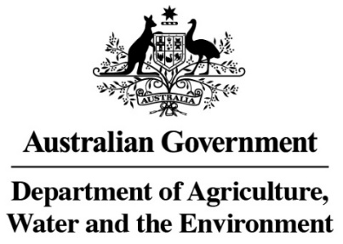

Guide to packaging suitability for performing QPS treatments



Version 1.0

© Commonwealth of Australia 2021

**Ownership of intellectual property rights**

Unless otherwise noted, copyright (and any other intellectual property rights, if any) in this publication is owned by the Commonwealth of Australia (referred to as the Commonwealth).

**Creative Commons licence**

All material in this publication is licensed under a Creative [Commons Attribution 4.0 International Licence](https://creativecommons.org/licenses/by/4.0/legalcode) except content supplied by third parties, logos and the Commonwealth Coat of Arms.

Inquiries about the licence and any use of this document should be emailed to [copyright@agriculture.gov.au](mailto:copyright@agriculture.gov.au).

C:\Documents and Settings\west merryn\Local Settings\Temporary Internet Files\Content.Word\by.png

**Cataloguing data**

This publication (and any material sourced from it) should be attributed as: Department of Agriculture, Water and the Environment 2021, Australian Biosecurity Treatment Assurance Scheme, Canberra. CC BY 4.0.

This publication is available at <https://www.agriculture.gov.au/import/arrival/treatments/treatments-fumigants#methyl-bromide-fumigation>

Department of Agriculture, Water and the Environment

Postal address GPO Box 858 Canberra ACT 2601

Telephone 1800 900 090

Web [agriculture.gov.au](http://agriculture.gov.au/)

The Australian Government acting through the Department of Agriculture, Water and the Environment has exercised due care and skill in preparing and compiling the information and data in this publication. Notwithstanding, the Department of Agriculture, Water and the Environment, its employees and advisers disclaim all liability, including liability for negligence and for any loss, damage, injury, expense or cost incurred by any person as a result of accessing, using or relying on any of the information or data in this publication to the maximum extent permitted by law.

Purpose

This guide provides information to assist application of and compliance with the consignment suitability requirements of the relevant treatment methodology.

Scope

This document applies to the suitability of consignments for fumigation and controlled atmosphere, where the target of treatment is within packaging. Other treatment types may have different suitability requirements.

How to use this document

This document should be read in conjunction with the relevant [treatment methodology and guide](https://www.agriculture.gov.au/import/arrival/treatments/treatments-fumigants).

This document is provided as a guide only, all treatment activities must comply with the relevant import conditions, treatment requirements and local regulations. Images used in this document are provided as examples only and are not intended to cover all packaging types used. All packaging must be assessed prior to treatment to determine suitability.

Where this document refers to ‘fumigant’ when referring to packaging suitability, the guidance should also be considered to refer to the atmospheres and gases associated with controlled atmosphere treatments.

The technical terms used in this guide are defined in the glossary at the back of the relevant methodology. For all terms not defined in the glossary, refer to the definition used by the Macquarie Dictionary.

**Please note:** the commodities used in the photos below are provided only to illustrate the packaging material, not all commodities included in the photos require, or are suitable for, treatment.

Contents

**General Information** 5

**Types of Packaging** 6

**1.** **Plastic or Cellophane** 6

**2.** **Cloth and other woven fabrics** 9

**3.** **Woven plastics** 12

**4.** **Paper and cardboard** 13

**5.** **Foil and metals** 16

**6.** **Glass** 18

Photos

Photo 1 Example of suitable plastic packaging.. 6

Photo 2 Example of suitable plastic packaging.. 7

Photo 3 Close up of the suitable plastic packaging in Photo 2 7

Photo 4 Example of unsuitable packaging.. 8

Photo 5 Example of suitable cloth packaging. 9

Photo 6 Example of unsuitable cloth packaging. 10

Photo 7 Example of suitable cloth packaging. 10

Photo 8 Example of unsuitable cloth packaging. 11

Photo 9 Example of suitable woven plastic packaging. 12

Photo 10 Example of suitable paper packaging. 13

Photo 11 Example of suitable cardboard packaging. 14

Photo 12 Example of unsuitable paper packaging 15

Photo 13 Example of unsuitable foil packaging 16

Photo 14 Example of unsuitable metal packaging 17

Photo 15 Example of unsuitable glass packaging. 18

Treatment Suitability of Packaging Material

# **General Information**

There are a number of factors which must be taken into consideration when assessing the suitability of a consignment for treatment. One of these considerations is the packaging. Impervious materials prevent or impede the fumigant from penetrating into the target of fumigation, negatively impacting treatment effectiveness. Impervious materials or coatings include types of plastic or cellophane including some woven plastics, foils and metals, and glass.

Where impervious shipping packaging/wrappings or commercial packaging/wrappings will impede the fumigant accessing the target of treatment, they must be removed, opened, or slashed prior to treatment or, where available, an alternative biosecurity control must be applied.

Perishable commodities may have additional treatment requirements, including in reference to packaging material.

It is the responsibility of the treatment provider to assess the suitability of each consignment for treatment. The consignment suitability requirements in the relevant methodology must be considered for each treatment. For methyl bromide fumigations, consignment suitability requirements are captured in sections 1.1 through to 1.6 of the Methyl Bromide Fumigation Methodology.

# **Types of Packaging**

## **Plastic or Cellophane**

Consignments wrapped in plastics or cellophane are only suitable for treatment if the wrapping is slashed or perforated in a manner which allows the fumigant to pass through freely. Perforated plastic wraps must meet the following requirements:

* 4 or more holes of 6 mm diameter every 100 mm x 100 mm of surface area *(Photo 1)*
* 5 or more holes of 5 mm diameter for every 100 mm x 100 mm of surface area
* 6 or more pinholes for every 10 mm x 10 mm of surface area *(Photos 2 and 3)*

Perforated plastics must be in a single layer, or be otherwise configured, so that the holes are not blocked to ensure the fumigant can pass through.

Consignments wrapped in non-perforated plastics or cellophane including sheets, bags, pouches and films are **not** suitable for treatment *(Photo 4)*.

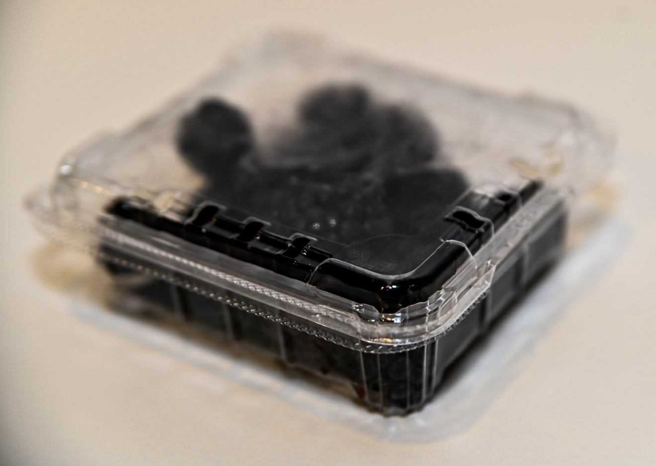

Photo Example of suitable plastic packaging. Otherwise impervious wrapping, perforated with four or more holes, with a diameter larger than 6mm, for every 100mm x 100mm of surface area. Positioning of the holes allows for stacking without blocking.

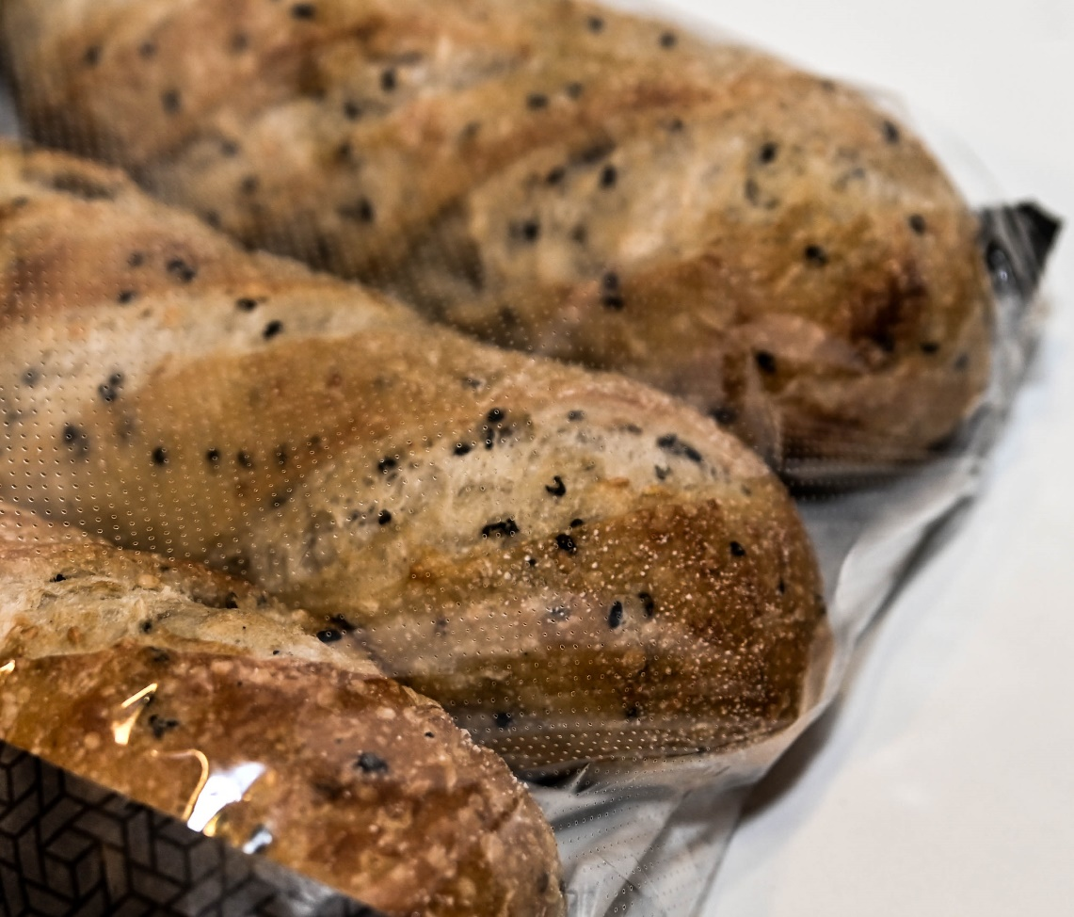

Photo Example of suitable plastic packaging. Otherwise impervious packaging, perforated with 6 or more pinholes for every 10 mm x 10 mm of surface area.

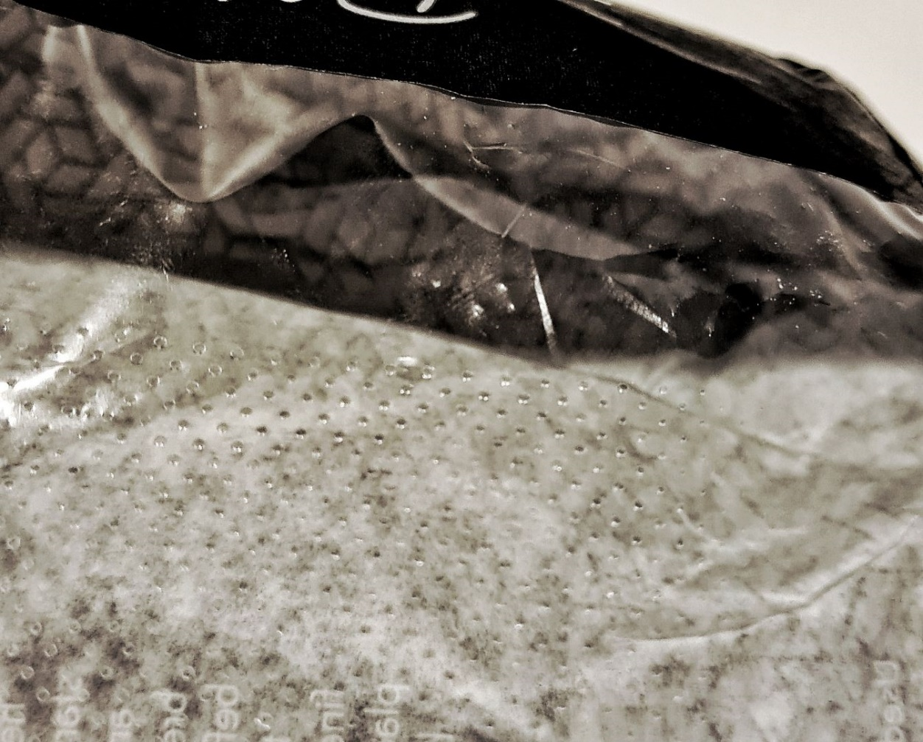

Photo Close up of the suitable plastic packaging in Photo 2.

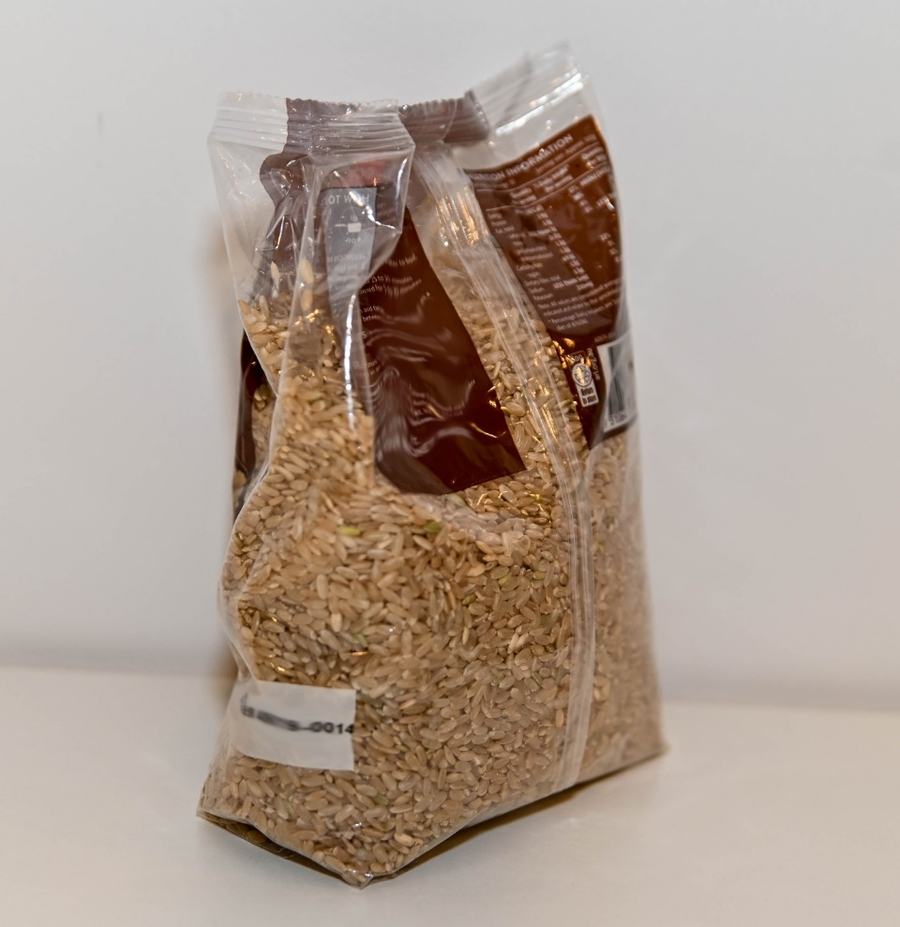

Photo Example of unsuitable packaging. Sealed plastic packaging not open, slashed or removed.

## **Cloth and other woven fabrics**

Consignments wrapped in cloth are only suitable for treatment where the cloth is dry and porous enough to allow the fumigant to pass through freely *(Photos 5 and 7)*.

Cloth or fabric which is lined or laminated with impermeable materials, such as plastic, **are not** suitable for treatment unless the lining can be opened, slashed or removed. *(Photos 6 and 8)*.

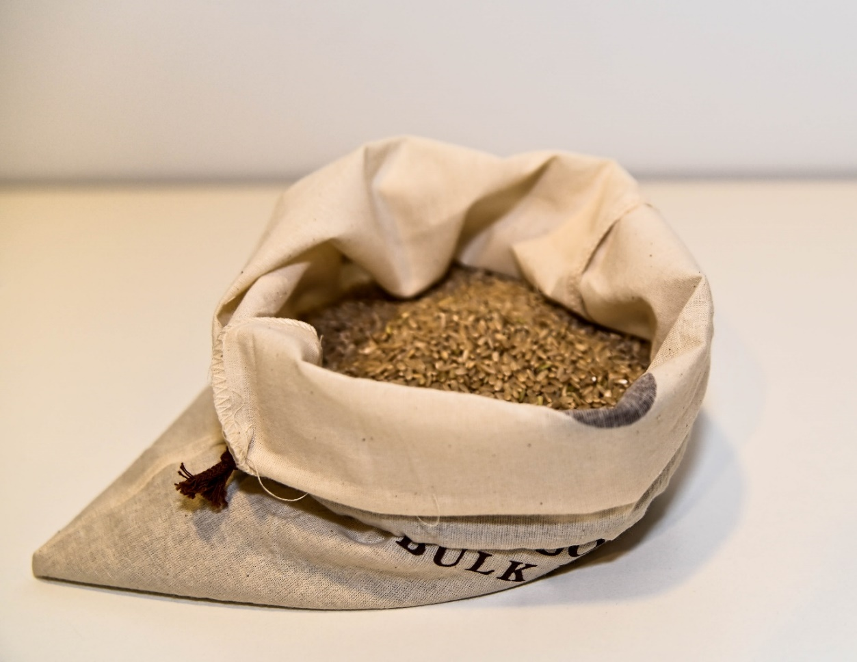

Photo Example of suitable cloth packaging.

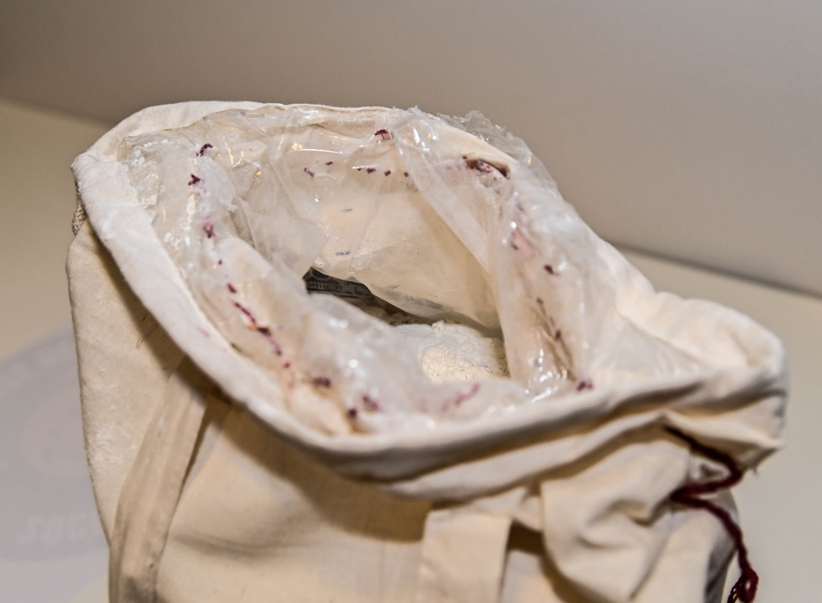

Photo Example of unsuitable cloth packaging due to impervious plastic liner. Liner must be opened (as presented above), slashed or removed to make suitable for fumigation.

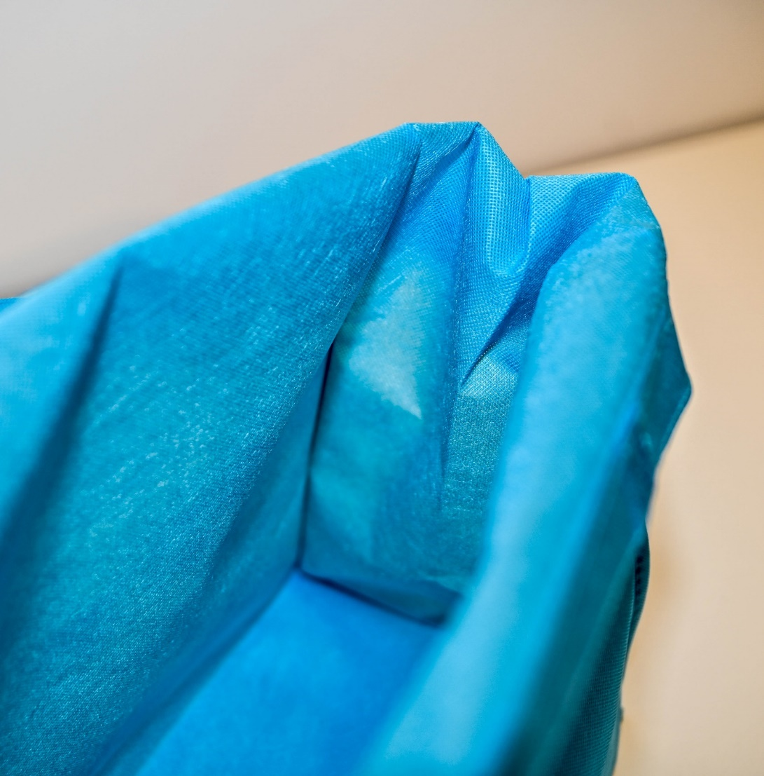

Photo Example of suitable cloth packaging.

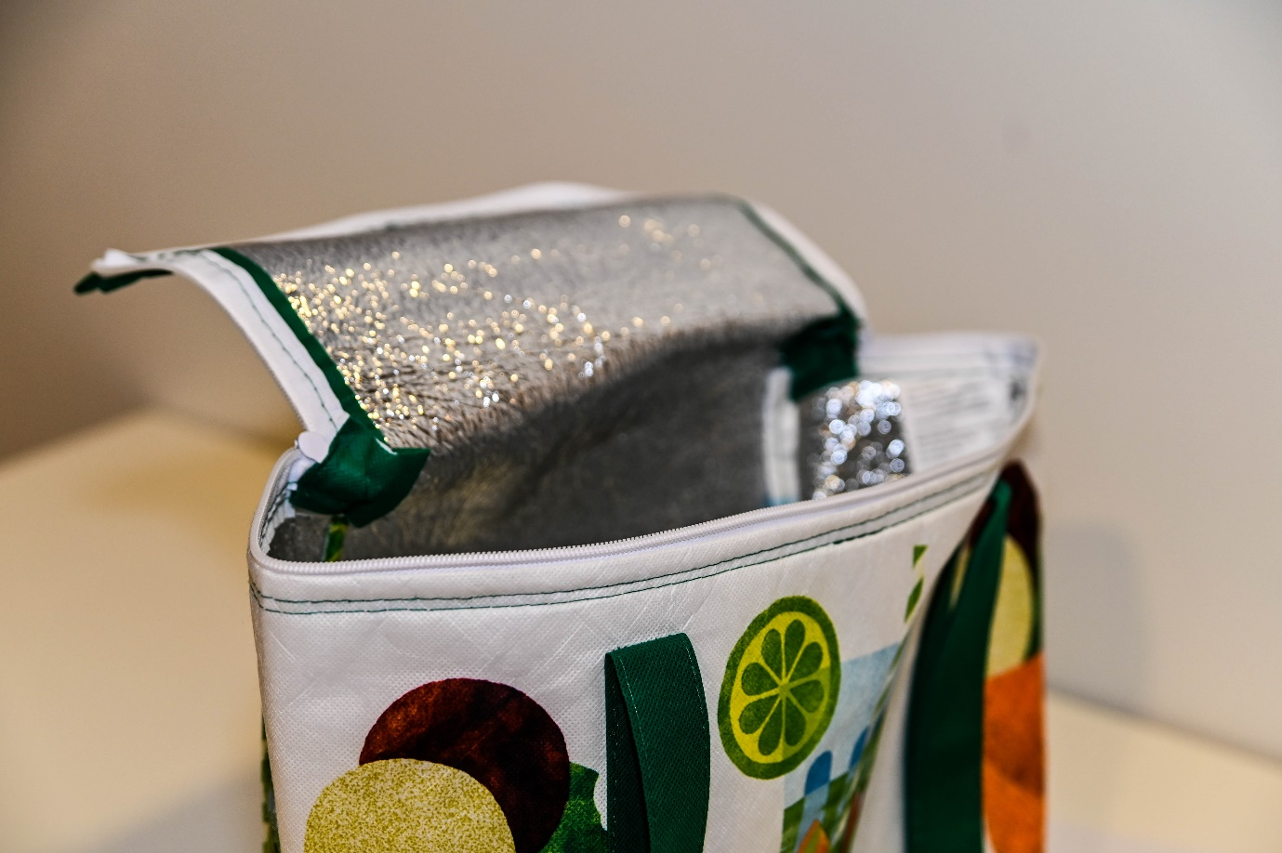

Photo Example of unsuitable cloth packaging due to impervious foil liner. Liner must be opened (as presented above), slashed or removed to make suitable for fumigation.

## **Woven plastics**

Consignments wrapped in woven fabrics and plastics are only suitable for treatment if the wrapping is not lined or laminated with impermeable materials, and porous enough to allow the fumigant to pass through freely *(Photo 9)*.

Woven plastic wrapping which is lined or laminated with impermeable materials, such as plastic, **are not** suitable for fumigation. This includes Biaxially Oriented Polypropylene (BOPP) bags.

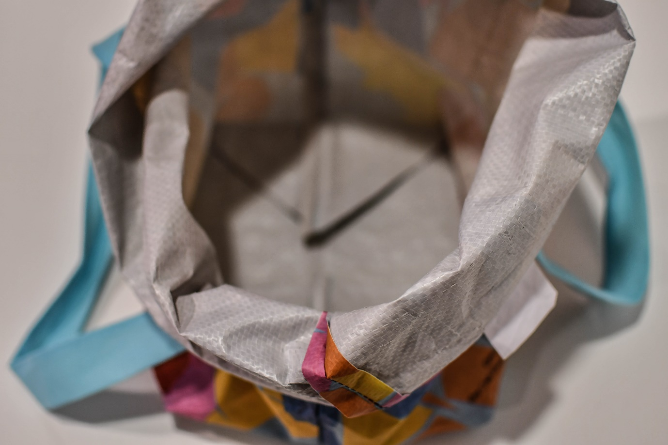

Photo Example of suitable woven plastic packaging.

## **Paper and cardboard**

Consignments wrapped in paper and cardboard are only suitable for treatment if the wrapping is not waxed, lined, laminated, or painted *(Photos 10 and 11)*.

Paper and carboard wrapping which is lined or laminated with impermeable materials, such as plastic foil, **are not** suitable for treatment unless the lining can be opened, slashed or removed *(Photo 12)*.

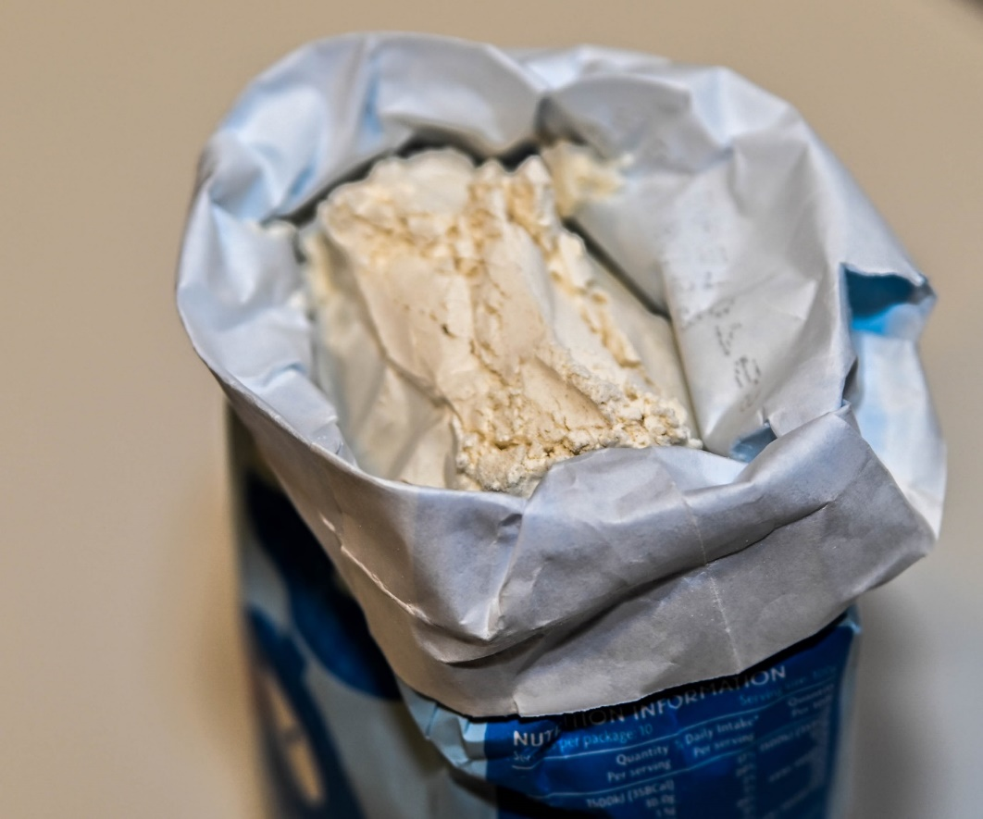

Photo Example of suitable paper packaging.

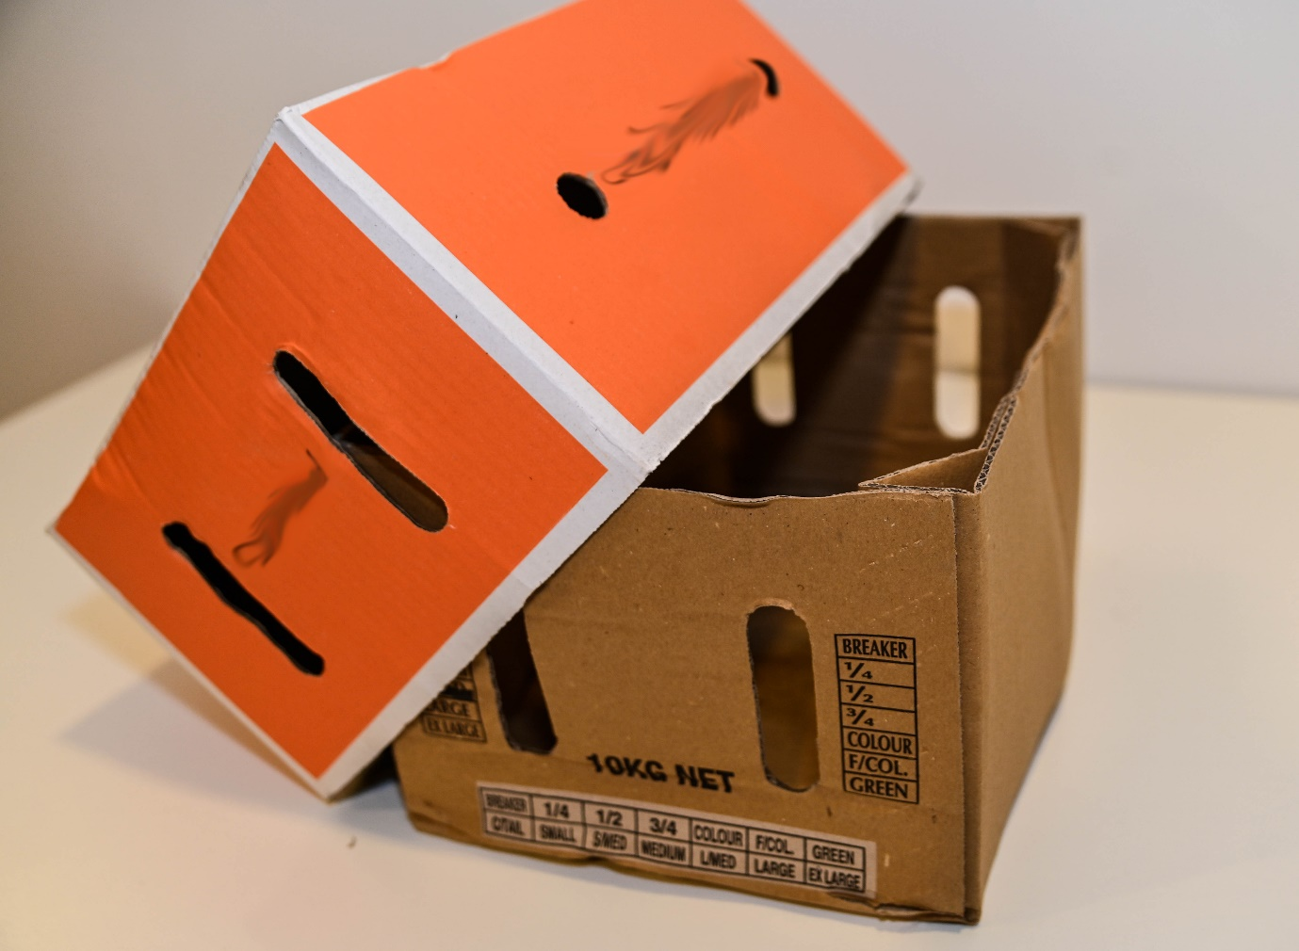

Photo Example of suitable cardboard packaging. Where treating perishable commodities, cardboard boxes must have ventilation holes like the above, or the lid must be removed during treatment.

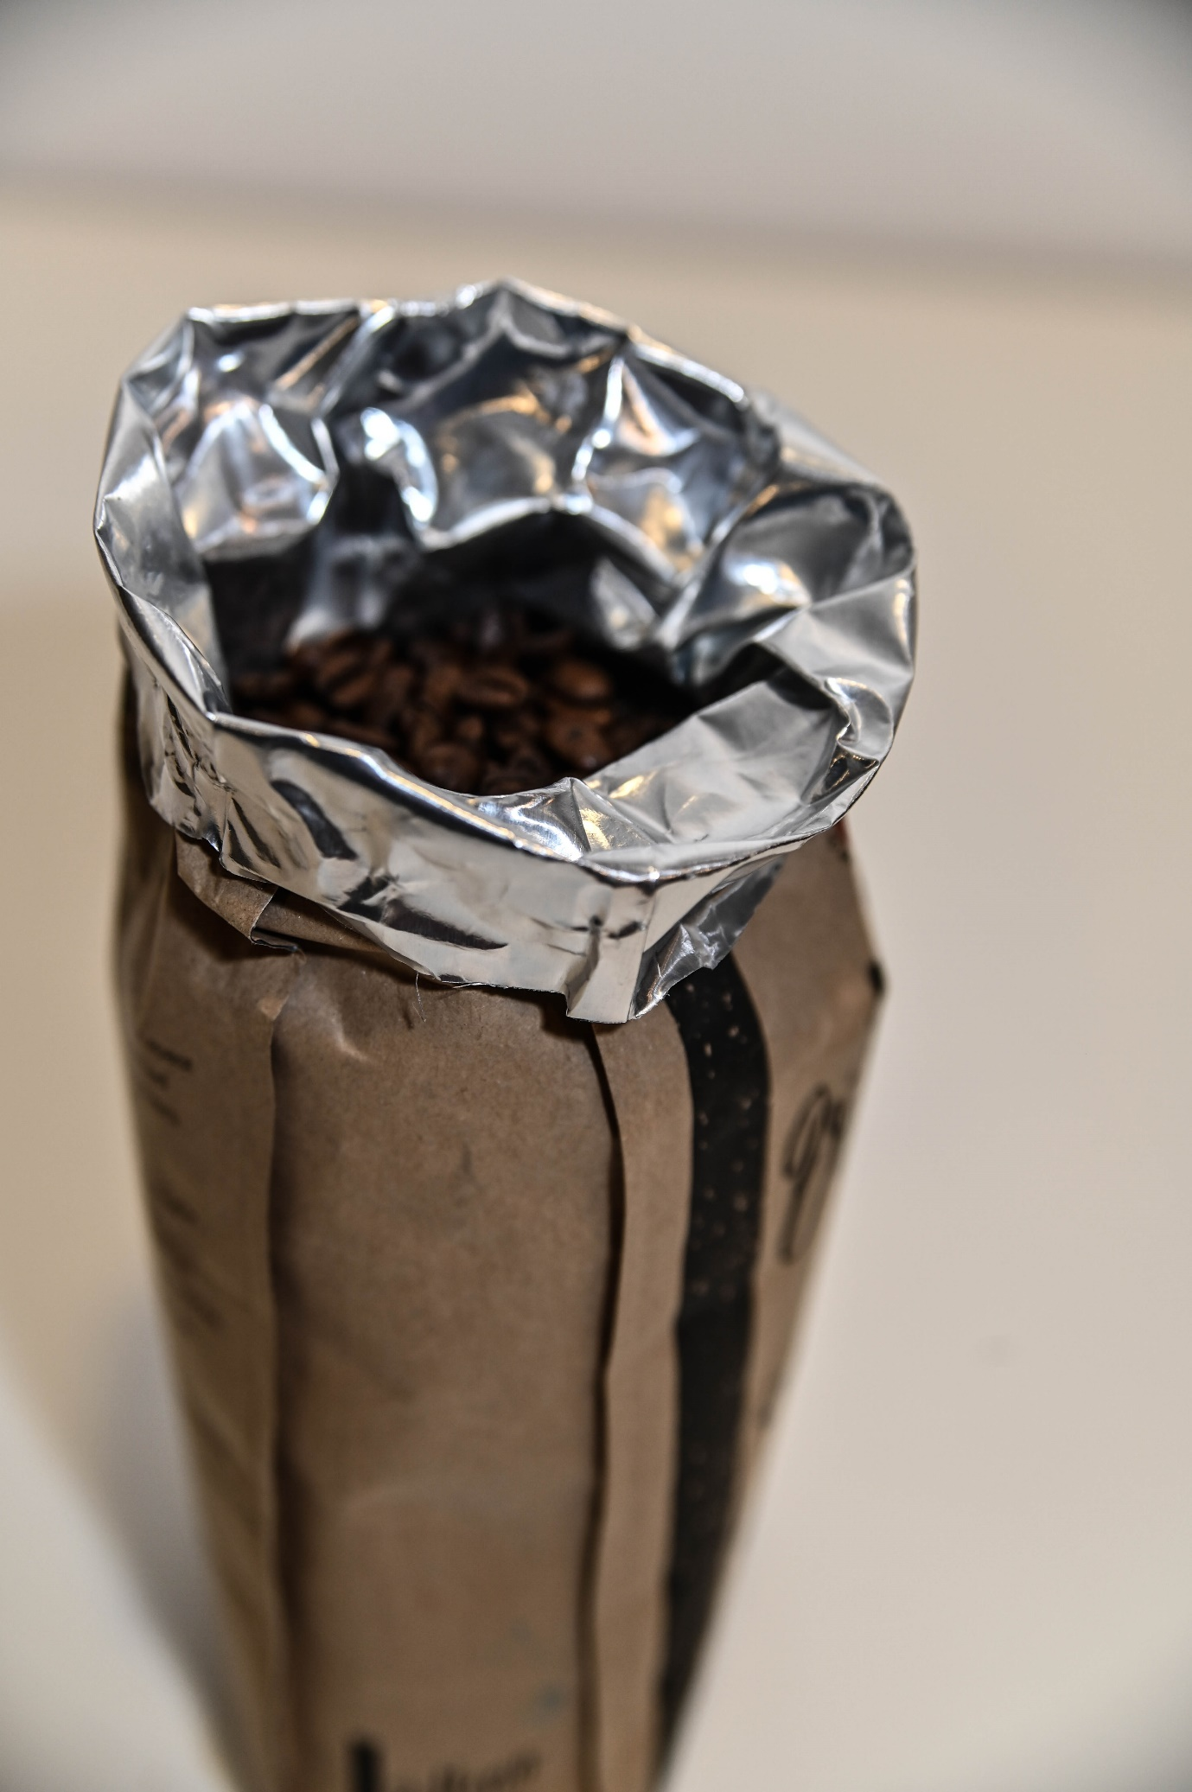

Photo Example of unsuitable paper packaging due to impervious foil liner. Liner must be opened, slashed or removed to make suitable for treatment.

## **Foil and metals**

Consignments in sealed foil pouches, metal tins and or metal cans are **not** suitable for treatment *(Photos 13 and 14)*.

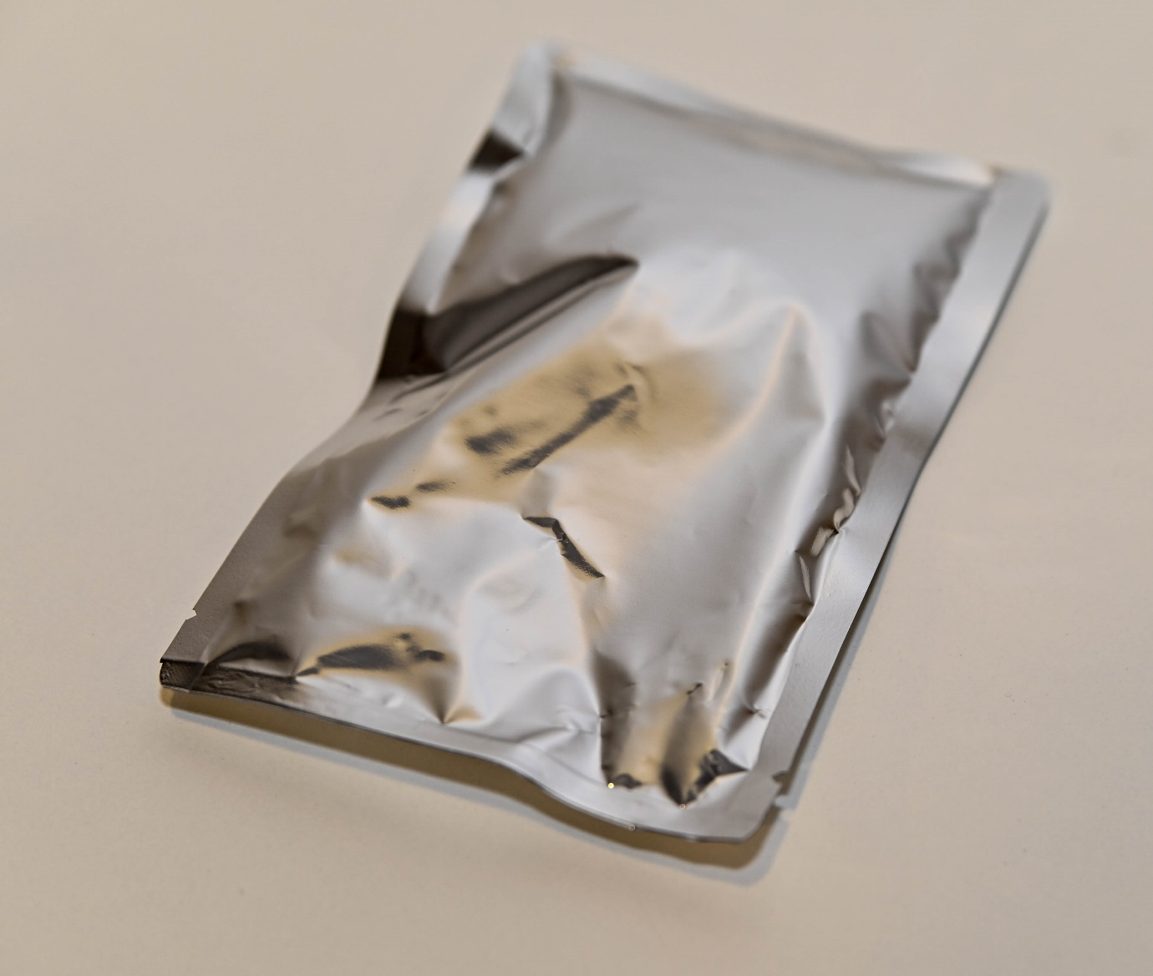

Photo Example of unsuitable foil packaging. Packaging must be opened, slashed or removed to make suitable for treatment.

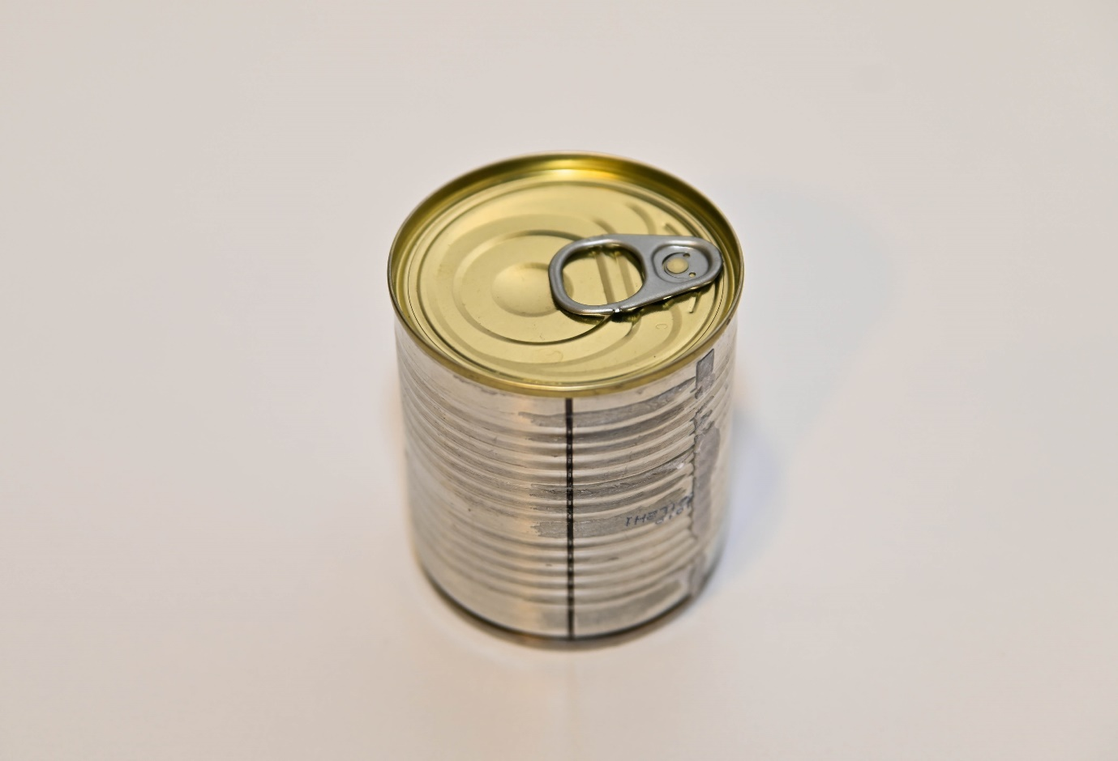

Photo Example of unsuitable metal packaging. Packaging must be opened, slashed or removed to make suitable for treatment.

## **Glass**

Consignments in sealed in glass jars and bottles are **not** suitable for treatment *(Photo 15)*.

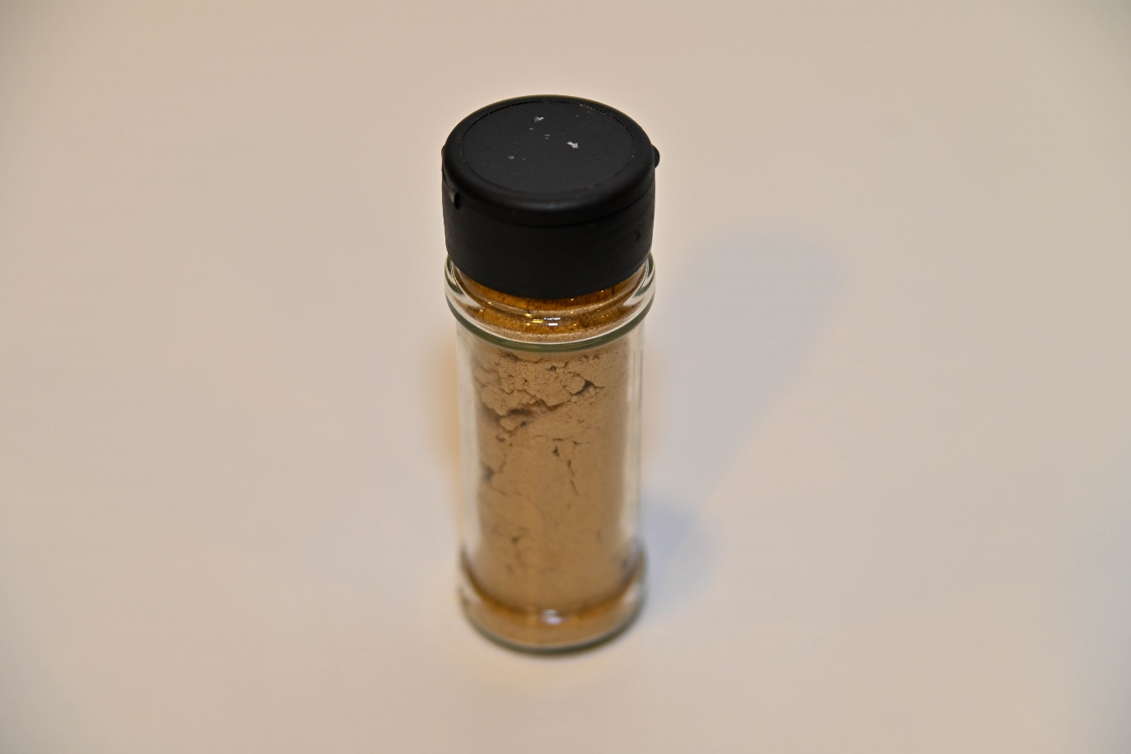

Photo Example of unsuitable glass packaging. Packaging must be opened to make suitable for treatment.