# Recycling Modernisation Fund: regional and remote funding - Guidelines for Commonwealth co-investment

## Introduction

In March 2020, the Prime Minister announced the Australian Government will co-invest in critical recycling infrastructure along with state and territory governments, and industry. The $190 million Recycling Modernisation Fund (RMF) was established to improve recycling infrastructure by addressing infrastructure gaps in Australia’s waste management and resource recovery system. The RMF focuses on the waste streams impacted by the Council of Australian Governments’ Export Waste Ban (on unprocessed glass, mixed and single polymer plastics, tyres, and mixed paper and carboard). The RMF jointly funded with states and territories through the [National Partnership on Recycling Infrastructure](https://www.federalfinancialrelations.gov.au/content/npa/environment/national-partnership/recycling_infrastructure_comb.pdf).

High capital costs to install modern technology, volatile international markets, and long and expensive planning approvals make attracting investment for recycling solutions a challenge. Managing waste in regional and remote locations throughout Australia presents additional challenges. Isolation during the wet season or as a result of natural disasters, lack of connection with major transport routes, no or limited kerbside collection and long distances to recycling and remanufacturing centres all present considerable logistical and financial complexities. Legacy waste, human health and financial impacts to communities are additional issues in regional and remote areas.

A key target of the [2019 *National Waste Policy Action Plan*](https://www.environment.gov.au/protection/waste/publications/national-waste-policy-action-plan) (the National Action Plan) is to achieve an 80 per cent average resource recovery rate from all waste streams following the waste hierarchy by 2030. To achieve this target, the National Action Plan recognises that regional and remote areas require better access to waste management and processing. To help reach this target, under the RMF, the Australian Government will co-fund projects that increase the sorting, processing, and manufacturing or remanufacturing capacity of regional and remote locations. The areas of interest for this funding are all non-metro areas falling under the ABS classifications of inner and outer regional, remote and very remote areas.

To assist with identifying regional and remote areas, the Australian Bureau of Statistics (ABS) uses the Accessibility/Remoteness Index of Australia (ARIA+). A map of the 2016 census data showing Remoteness Areas is outlined in Map 1.

Map 1 - Map of the 2016 Remoteness Areas for Australia

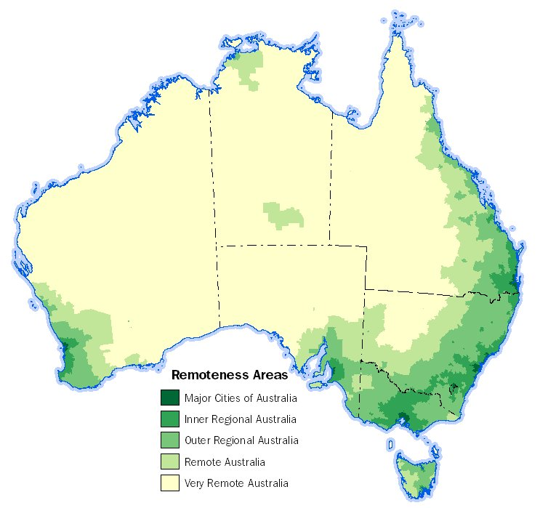

Source: [ABS website](https://www.abs.gov.au/websitedbs/D3310114.nsf/home/remoteness+structure)

### Project Information

Projects that provide local solutions to local problems, seek to increase local employment, provide economic benefit, and solve transport logistic complexities will be highly regarded. The Australian Government will consider proposals for economically viable projects that best address regional pressures. Projects that support connections between local organisations in remote and regional areas and major companies in urban areas of Australia are encouraged to close-the-loop between waste generation, sorting, processing, remanufacturing, and input back into the economy. The Commonwealth suggests that project proponents communicate with their local Regional Development Associations when developing proposals.

The Australian Government encourages involvement from small organisations, such as small and medium businesses, not-for-profits, Local Government, community groups, regional research institutions and Traditional Custodians. Eligible proposals from small organisations may be further assessed through the *Small organisations supporting points assessment*.

## Application process

| Date | Event |
| --- | --- |
| 13 September 2021 | Applications open |
| 31 October 2021 | Applications close – Round 1 assessments |
| End of November 2021 | Commonwealth decision on successful Round 1 projects |
| 31 January 2022 | Applications close – Round 2 assessments |
| End March 2022 | Commonwealth decision on successful Round 2 projects |

Funding will be open to states and territories in two rounds. Round 1 is being made available to fast-track high priority projects that a state or territory may have already identified and assessed.

Incomplete applications will not be accepted.

## Eligibility criteria

Only state and territory Governments are eligible to apply. Proponents may apply for a minimum co-funded grant of $10,000 and a maximum of $1 million. Application forms are attached to these guidelines. Applications will need to meet the following criteria:

1. Must be submitted by a state or territory government and have written support of the responsible minister and must contain a commitment from the state or territory to match Commonwealth funding. Proposals must also include a third party (such as business, local governments, or non-government organisations)
2. Projects must be consistent with [Appendix A of the National Partnership on Recycling Infrastructure](https://www.federalfinancialrelations.gov.au/content/npa/environment/national-partnership/recycling_infrastructure_comb.pdf). Examples of potential projects may include:

* Community sorting stations or baling equipment;
* Install new equipment such as sorting lines, AI or scanning technology, or pulping machinery;
* Breaking down e-waste into plastics and glass for recycling;
* Advanced recycling of hard-to-recycle plastics, such as mixed, multi-layer, flexible or contaminated plastics back into food grade recycled plastics or other products through chemical, thermal or biological processes;
* Recycling of glass and plastics for use in road, footpath, cycleway or rail products;
* Breaking down all components of waste tyres into new tyres and products, or for further recycling;
* Trials for remanufacturing of plastic, glass and other material into building products;
* Recycling of non-hazardous medical waste, such as plastic waste generated by a hospital;
* Projects (including trial projects or multi-location projects) that include improved collection of feedstock, preparing it for collection near main routes, for further processing, recycling and re-manufacturing at a major location;
* Community and local organisations driven projects, with identification of a problematic waste item in their area (for example: bread tags, straws, face masks and other), collection of such items and production of a bench seat (or similar);
* Recycling of agricultural plastics, irrigation pipes and other drought infrastructure which can be recycled.

1. Proposals must seek to deliver a project or trial to build new, or increase existing capacity, in a regional or remote location through:
   1. proposed new fixed or mobile facilities, or expansion of existing fixed or mobile facilities for the processing of recovered unprocessed glass, mixed or single resin/polymer plastics, tyres and/or paper and cardboard; and/or
   2. provide new or upgraded equipment to increase local domestic processing capacity for recyclable materials, including from point of collection to point of remanufacturing; and/or
   3. increase use of recyclable or recycled materials in manufacturing and/or infrastructure.
2. Proposals must demonstrate how the proposed project is expected to be economically viable over its operational life post-RMF.
3. Proposals should support employment and long-term economic growth and development in regional and/or remote location/s. Projects may rely on further infrastructure located in major city areas, but funding must primarily address recycling challenges and create economic benefit in regional and/or remote locations.
4. Any projects partner(s), including local government council or associations, will need to demonstrate the project partner has a current Australian Business Number (ABN), is registered for GST, is not insolvent, has not been convicted of contravening environment protection legislations in the last five (5) years, does not have owners/directors who are an undischarged bankrupt and has a business plan in place for the project proposal.
5. The Australian Government acknowledges that jurisdictions have different policies on energy from waste projects. For the purposes of RMF funding, the Australian Government considers that projects may be eligible if the project primarily produces recovered products that contribute to a circular economy, and energy is a by-product and not a major output of the process. Examples may include advanced recycling projects, which are also referred to as feedstock, molecular, or chemical recycling, and which converts plastic waste into its chemical building blocks and back into plastic, creating high value output for input back into the circular economy. Energy from waste projects are not eligible for funding under the RMF.
6. Project proposals that involve small organisations in remote or very remote areas are especially encouraged. Small organisations include*:* small to medium businesses, Local Governments, not-for-profits, social enterprises, community groups, regional research institutions, Aboriginal Land Councils or similar. Eligible proposals may classify to be further assessed and possibly score additional points through the *Small businesses supporting points assessment*.
7. Projects should be complete by 30 June 2024 to meet the waste export bans as they are phased in.

## Assessment criteria

Applications will be assessed with reference to the weighting against each criterion as outlined on the following table.

| Criterion No. | Criterion | Weighting |
| --- | --- | --- |
|  | Proposed project must demonstrate that it will address regional and/or remote resource recovery challenges,  Proposed project should demonstrate that it is part of a solution for sorting, processing, re-manufacturing or selling, and/or transport of recovered glass, plastics, tyres, and/or paper and cardboard in regional and remote locations.  Proposed project addresses critical gaps in capacity. This includes whether:   * the project is expected to absorb glass, plastics, tyres or paper/cardboard from regional or remote locations that would typically be exported from Australia, or would end up in landfill, and * the project’s location has access to the transportation and distribution networks in the relevant regional and/or remote location. | 30 points |
|  | Proposed project is supported by an overall business case, planning and regulatory requirements to proceed to construction are identified, evidence is provided on the process for gaining approvals, and project is expected to be economically viable over its operational life. | 20 points |
|  | Proposed project will create higher-value feedstock or offtake for remanufacturing products for which a suitable level of demand is expected. Identification of end-markets will be highly regarded. | 15 points |
|  | Proposed project will support small and local businesses, employment and long-term economic growth and development in regional and/or remote location/s. | 15 points |
|  | Project is in *Remote Australia* or in *Very Remote Australia* in accordance with the ABS remoteness classification | 5 Points |
|  | Proposed project is unlikely to proceed without assistance from the Australian Government or will only proceed at a much later date or much lower scale. | 5 points |
|  | Proposed project has a clear and credible plan to fully engage and consult affected stakeholders, traditional custodians and communities. | 5 points |
|  | Projects will be fully operational by 30 June 2024 | 5 points |

### Small Organisations Supporting Points Assessment (only small organisations are eligible to receive points under these criteria)

|  |  |  |
| --- | --- | --- |
|  | Proposed project is a small organisation with experience operating in the location of the proposed projects. | 5 points |
|  | Proposed project will create at least two ongoing jobs. | 5 points |
|  | Project connects local businesses, builds partnerships, and supports local supplier hubs | 5 points |

## Glossary

| Reference | Description |
| --- | --- |
| Legacy waste | Accumulated waste over a long period of time, disposed of on land, with no final destination or purpose. Legacy waste can be unsorted, untreated and stockpiled waste with no environment protection controls applied. |
| Small and medium businesses | The Department of Industry, Science, Energy and Resources identifies small to medium businesses as those businesses who carry on an enterprise in Australia, have less than 200 employees and have an ABN. |