Appendix B: Food Webs
HYDROLOGY | FOOD WEBS | VEGETATION | WATERBIRDS | FISH

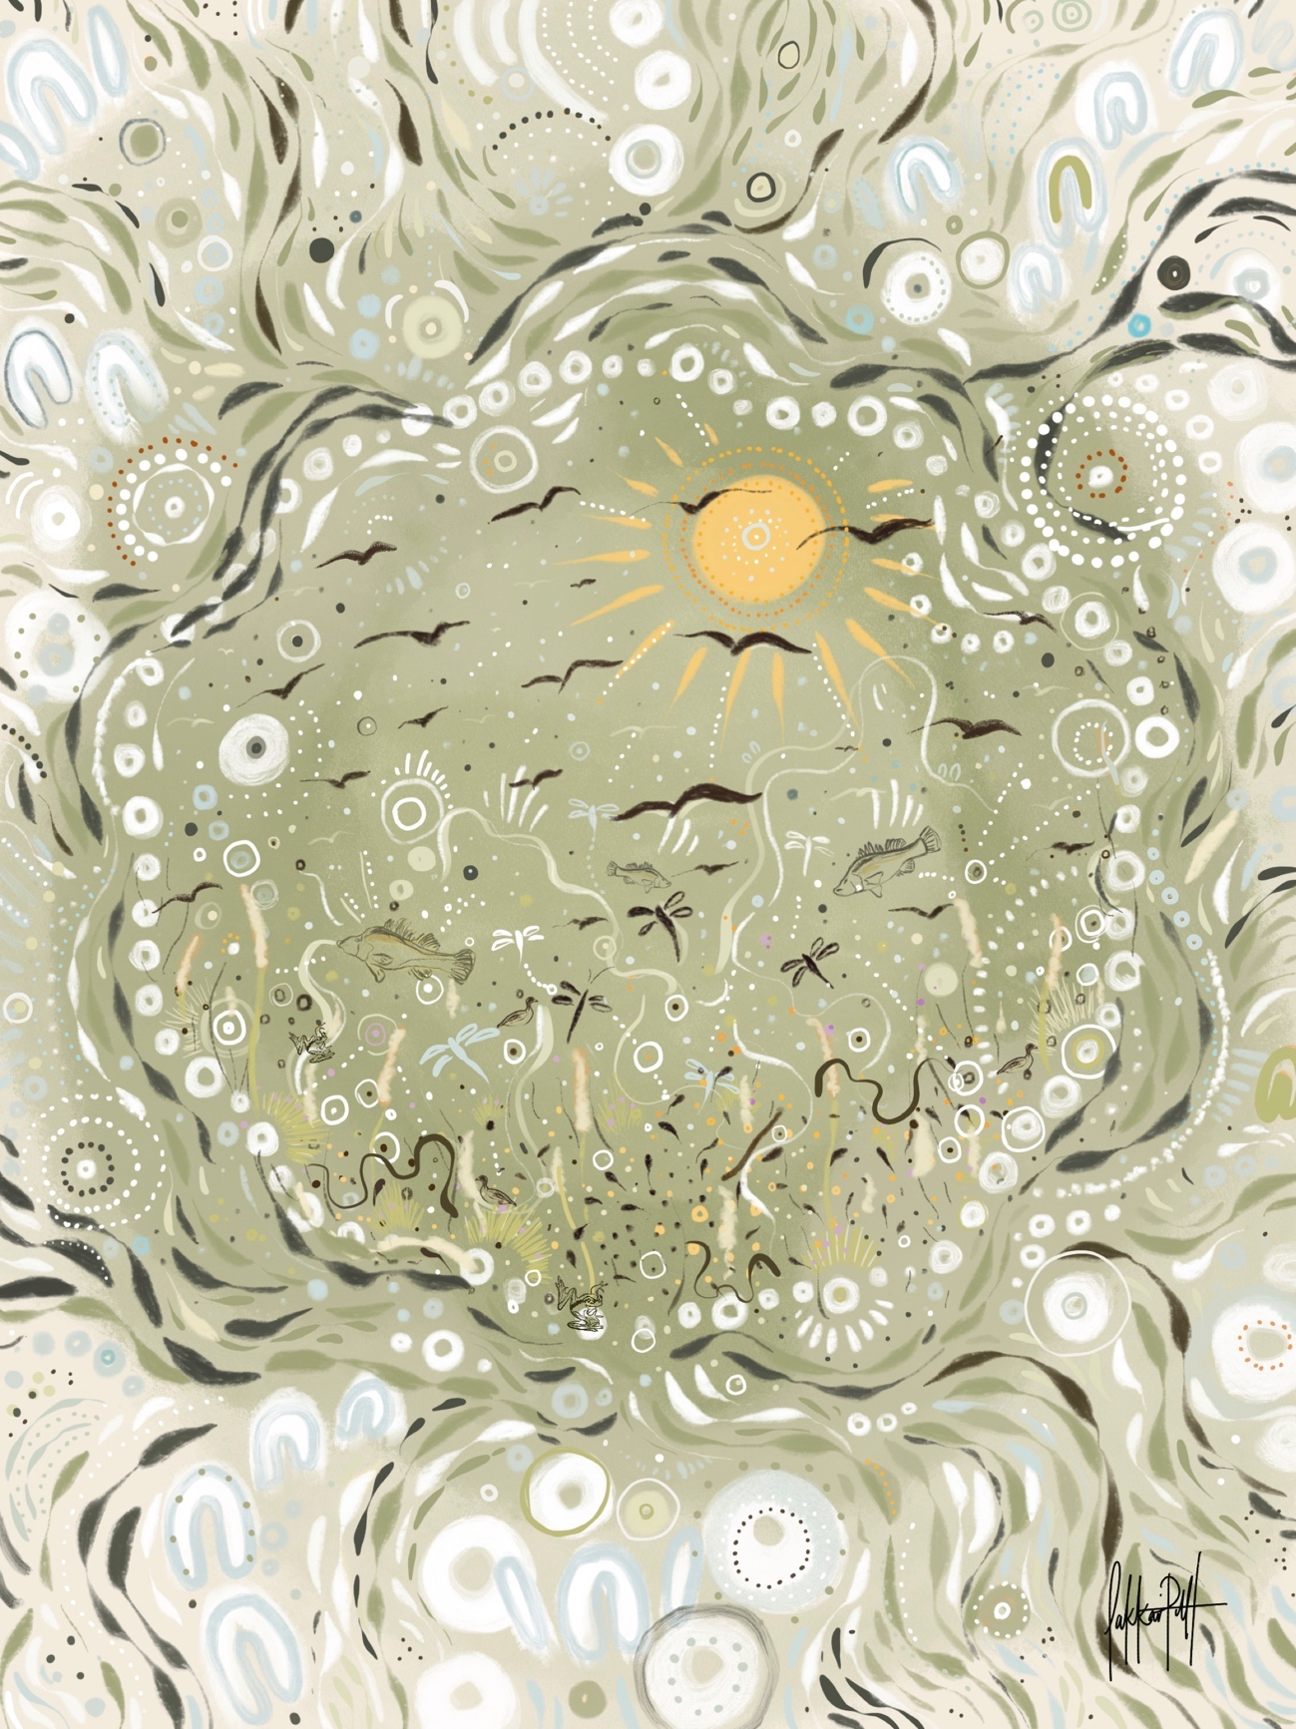

Introduction
The production and transfer of energy within an ecosystem (ecosystem energetics) is a key functional process, fundamental to determining population and community structure and productivity. The production and transfer of energy in an ecosystem begins with nutrient and light availability driving primary production, in turn creating basal resources that are transferred along a myriad of pathways to higher order consumers. Water for the environment influences Water Quality (nutrients, temperature, light, and salinity), which in turn can regulate rates of Metabolism and productivity (carbon and energy availability) and this energy fuels the trophic carrying capacity of Food webs (microinvertebrates and macroinvertebrates) that support key fish and waterbird recruitment. This chapter integrates these fundamental ecosystem processes, linking environmental watering actions to water quality, energy production and understanding the potential food web responses within key habitats of the Gwydir River Selected Area (Gwydir Selected Area, Selected Area).

Specifically, this chapter links the Water Quality, Metabolism, Microinvertebrate and Macroinvertebrate indicators into one integrated chapter. Answering the questions, what did Commonwealth environmental water contribute to:

- Temperature regimes?
- pH levels?
- Turbidity regimes?
- Salinity regimes?
- Dissolved oxygen levels?
- Algal suppression?
- Patterns and rates of primary productivity?
- Patterns and rates of decomposition?
- Microinvertebrate and macroinvertebrate productivity?
- Microinvertebrate and macroinvertebrate diversity?
- Microinvertebrate and macroinvertebrate community composition?
- Connectivity of microinvertebrate and macroinvertebrate communities in floodplain watercourses?

Previous monitoring
Within the Gwydir Selected Area, water quality was generally poor and nutrient concentrations consistently exceeded ANZECC trigger values, yet no detrimental ecological consequences were recorded for aquatic biota from elevated nutrients. The highest nutrient concentrations were recorded during contraction phases in wetlands, suggesting the internal recycling of nutrients from the sediment and water drives aquatic productivity. Hydrology was identified as the primary driver of water quality in both channel and wetland environments. Seasonal change also exerted a strong influence on water temperature, conductivity and nutrients that each responded to receding water levels and evapo-concentration processes. Upstream of the lower Gwydir wetlands, the delivery of environmental water contributed to consistent improvements in water quality; pH and conductivity decreased with increasing discharge to around 5,000 ML/d, then increased with flow. This increase is likely driven by additional inputs of ions and suspended sediment as flows increase and more river channel becomes inundated above this threshold. Similarly, environmental water prolonged the extent and quality of waterhole refuges, allowing iconic species such as Murray cod and golden perch to persist in the lower Gwydir through dry times. However, water quality in the wetlands deteriorated after >50 days inundation and invertebrate taxa with a higher tolerance to poor water quality dominated.
Hydrology and its influence on water quality was the primary driver of invertebrate communities in the Selected Area. High nutrient levels and primary production following inundation correlated with the highest invertebrate diversity and densities, demonstrating the role of inundation with environmental water in stimulating aquatic food webs. Despite the importance of additional primary production from environmental water stimulating food webs, the lower Gwydir was net heterotrophic (consuming more oxygen than it produced) at all sites and times over the five years of observations. This result reflects the dominance of organic matter decomposition from organic rich wetland sediments that regulate the high consumption of oxygen, fuelling a food web driven by microbes rather than water column primary production. Therefore, environmental water can help support this food web through the maintenance of vegetation communities and inundation of organic sediments.

Methods

Field and laboratory methods
Four core monitoring fieldtrips were undertaken in the 2019-20 water year: September 2019, December 2019, January 2020 and April 2020. Loggers were deployed during the December 2019 sampling trip and downloaded in January and April 2020 (Figure 1). In addition, water quality was recorded from disconnected refuge pools in the lower Gwydir in October 2019, January 2020 and April 2020 from the Gwydir River at Tareelaroi, Tyreel and Boolooroo, the Mehi River at Combadello Weir and Moree, and Carole Creek at Round Hole.

Stream metabolism measurements were performed according to the LTIM Standard Methods (Hale et al. 2014), updated to align with the BASEv2 model. For core monitoring, water temperature and dissolved oxygen (DO) were logged every ten minutes at Pallamallawa (GW1) using a PME MiniDOT logger that optically measures dissolved oxygen (DO). Metabolism was not measured in the wetlands during 2019-20 due
to drought conditions and the absence of inundation, although water quality, microinvertebrates and macroinvertebrates were sampled at four sites once the wetlands were inundated in April 2020 (Figure 2). To examine stream metabolism during very low flows, water temperature and DO loggers were deployed in October 2019 and logged every ten minutes at six low-flow refuge sites (Figure 3). Light and atmospheric pressure loggers were deployed at Bunnor and also logged at 10-minute intervals during this period.

Water quality variables were also measured as in situ spot recordings using a Hydrolab Quanta multi-probe (temperature (°C), electrical conductivity (mS/cm), dissolved oxygen (mg/L, % saturation), pH, and turbidity (NTU)) in December 2019, January 2020 and April 2020, following the LTIM Standard Methods (Hale et al. 2014). Water samples were taken for analysis of total nitrogen (TN, µg/L), oxides of nitrogen (NOx, µg/L), total phosphorus (TP, µg/L), filterable reactive phosphorus (FRP, µg/L), Chlorophyll a (Chla, µg/L) and dissolved organic carbon (DOC, µg/L).

Inorganic nutrients were sampled at 0.2 m depth at each site by filling 125 mL thrice-rinsed pre-labelled PET bottles with raw river water. Samples were frozen until analysis. Dissolved inorganic nutrients were filtered through rinsed Whatman GF/C filters (effective pore size 0.7 µm). TN and TP were prepared using a simultaneous persulphate digestion (Hosomi and Sudo 1986). TN, NOx, TP and FRP were determined colorimetrically: TN and NOx at 543 nm after cadmium-copper reduction (Wood et al. 1967), and TP and FRP at 705 nm after using a molybdite-antimony procedure (Murphy and Riley 1962). All absorption spectra were measured using a UC-1700 Pharmaspec UV-visible spectrometer.

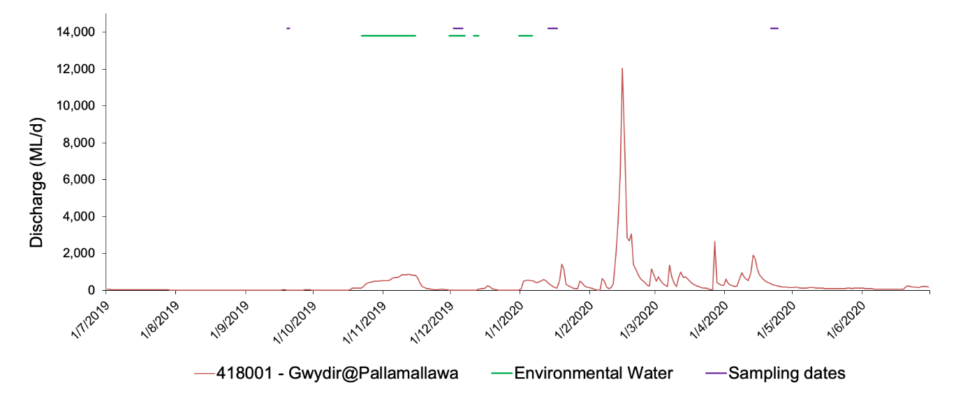
Figure 1 Hydrograph showing total discharge, delivery of water for the environment and sampling dates in the Gwydir River Selected Area for the 2019-20 water year to 1 July 2020. A DO logger was deployed at Pallamallawa in December 2019 indicated by the asterisk.

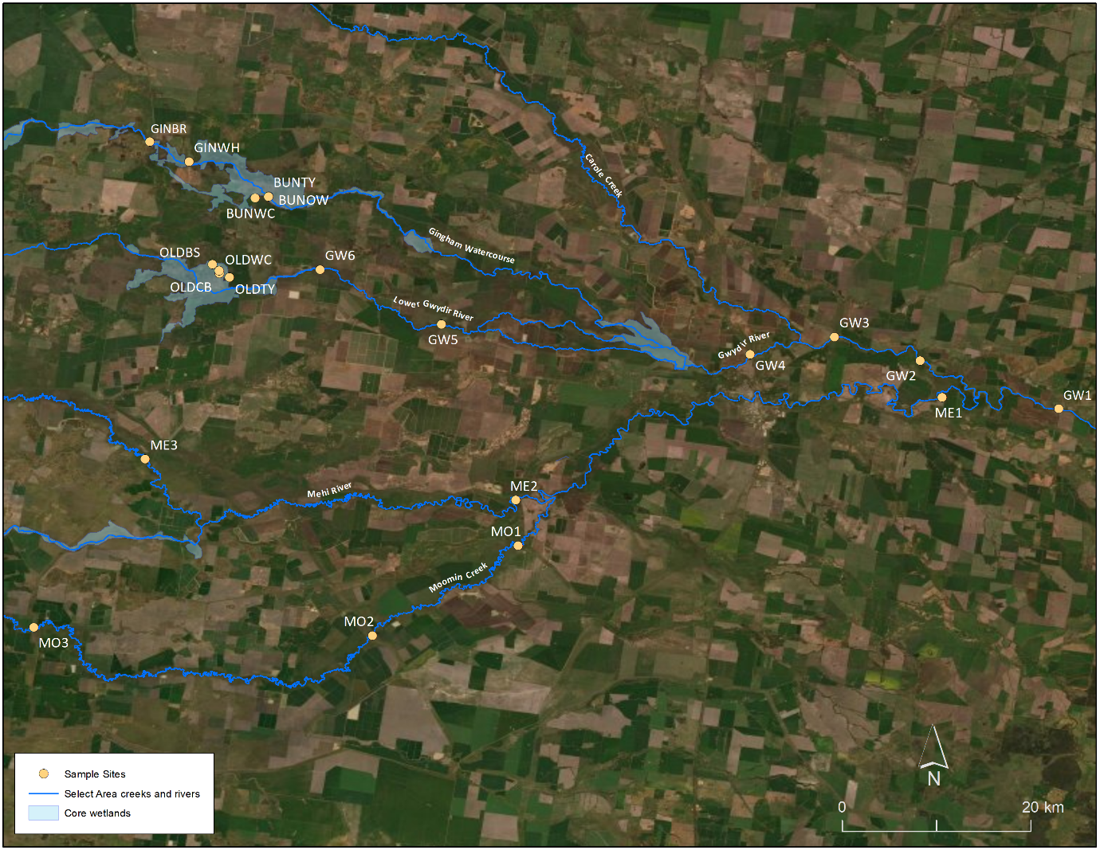
Figure 2 Map of core sampling sites for water quality, stream metabolism and invertebrate parameters in the Lower Gwydir selected area.

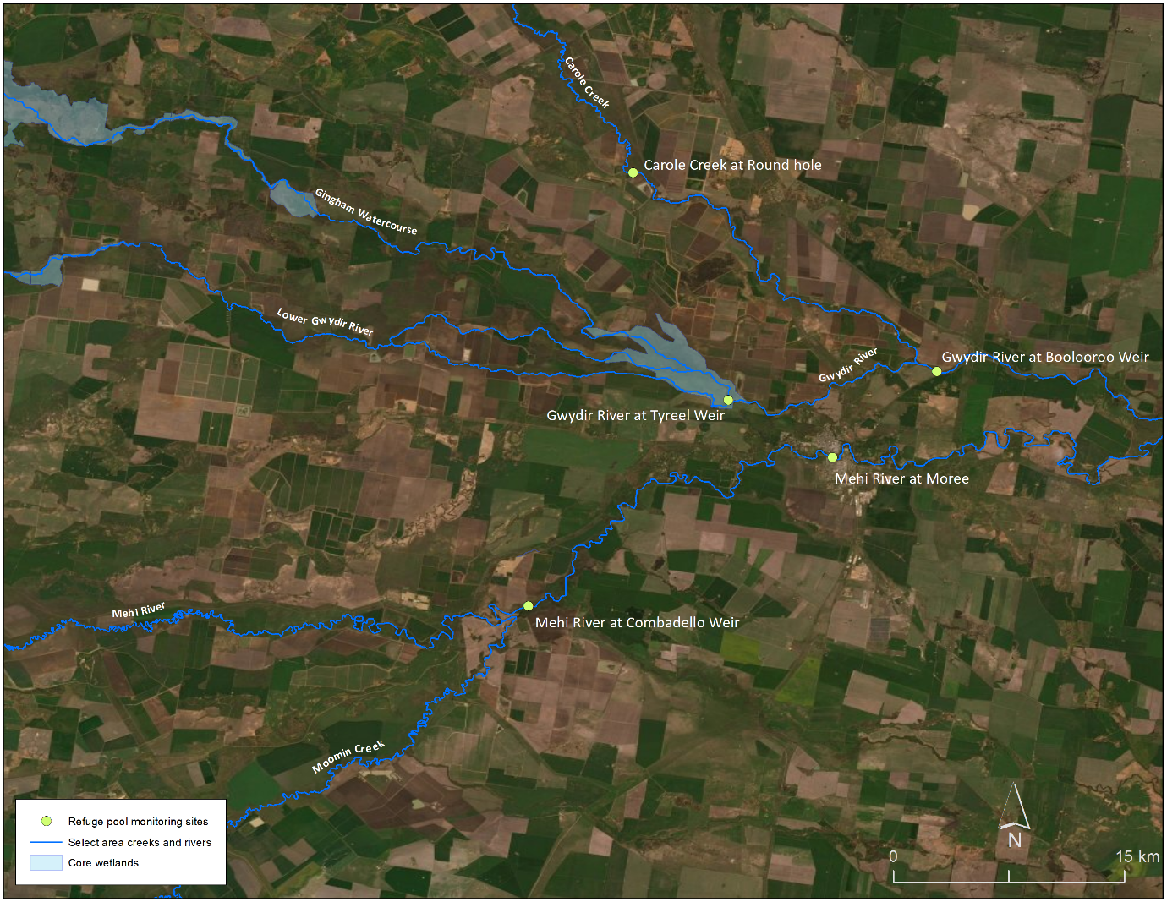
Figure 3 Map of low-flow refuge sampling sites.
Chlorophyll a samples were prepared by filtering as much water as possible
(100-1000 mL) through a Whatman GF/C filter paper (effective pore size 0.7 µm) using an electric vacuum pump (EYELA Tokyo Rakahikai Corporation Aspirator A-35 at approximately 7 PSI). Filter papers were placed into pre-labelled 10 mL vials that were wrapped in aluminium foil and refrigerated below 4 °C. Chlorophyll a was calculated colorimetrically by digesting the sample in 10 mL 90% acetone at 4 °C for 24 hours, centrifuging the samples and reading the absorption spectra at 665 and 750 nm using a UV-1700 Pharmaspec UV-visible spectrometer.

DOC samples were pre-filtered using Whatman glass microfiber GF/C filters (effective pore size 0.7 µm), then through Whatman cellulose acetate filters (0.2 µm pore size), then frozen until analysis. Samples were analysed using the supercritical water oxidation technique (GE Analytical Instruments) using an InnovOx Total Organic Carbon Analyser (GE Analytical Instruments).

Microinvertebrate samples were collected from benthic and pelagic habitats, preserved and identified according to the LTIM Standard Methods (Hale et al. 2014). Benthic microinvertebrates were sampled by compositing five cores (50 mm diameter with 250 mL volume) for each site, leaving to settle for 15 minutes and decanting through a
63 µm sieve. The retained samples were preserved in ethanol (70% w/v with Rose Bengal stain). Pelagic microinvertebrates were sampled from 90 L of water at each site, retained in a 63 µm plankton net and preserved in ethanol (70% w/v with Rose Bengal stain) until identification. Microinvertebrates in homogenised subsamples were identified under stereo microscope at 400x magnification. Identification was to family (rotifers and cladocerans), class (copepods) and ostracods. Subsample totals were scaled up to the total sample volume and reported as density/L. Aquatic macroinvertebrates were sampled, preserved and identified according to the LTIM Standard Methods (Hale et al. 2014).

Data analysis
Water quality and nutrient data (spot measurements) were used to interpret patterns in stream metabolism and invertebrate community composition. DO, conductivity, pH, turbidity, Chlorophyll a, TN, TP, NOx, FRP and DOC were analysed by log (x+1) transforming parameters where appropriate to ensure normality and homogeneity of variances, and analysing two-way ANOVA with Time (with 3 random levels, December 2019, January 2020 and April 2020), Zone (with 5 fixed levels, Gingham, Gwydir, Mehi, Mooman, Old Dromana (Lower Gwydir)) and the Time*Zone interaction.

Water quality and nutrient data (spot measurements) from pool refuge monitoring during low flow periods (DO, conductivity, pH, turbidity, Chlorophyll a, TN, TP, NOx FRP and DOC) were analysed by log (x+1) transforming parameters where appropriate to ensure normality and homogeneity of variances, and analysing two-way ANOVAS with Time (with 3 random levels, October 2019, January 2020 and April 2020) and Site (with 6 fixed levels, Gwydir River at Tareelaroi, Tyreel and Boolooroo, the Mehi River at Combadello Weir and Moree and Carole Creek at Round Hole). There were not enough replicates to determine Site*Time interactions.

The acceptance criteria for the BASE model (Grace et al. 2015) to include daily results in further data analyses are that the fitted model for a day must have an r² value ≥ 0.90, coefficients of variation for the gross primary productivity (GPP), ecosystem respiration (ER) and K < 50%, and reaeration coefficients within the range of 0.1 to 0.9. The BASEv2 model also requires that the model fit parameter (PPfit) must be within the range 0.1 to 0.9. Acceptable daily values of GPP, ER and NPP (net primary production) were analysed by one-way ANOVA with the factor of Time (fixed, with 2 levels, e-water and non e-water).

Metabolic production and consumption of carbon can be extrapolated from GPP, ER and NPP rates, by multiplying each daily rate by daily discharge (>0 ML/day) and a molecular conversion factor (12/32) to exchange carbon for oxygen. Carbon production and consumption were analysed by one-way ANOVA with the factor of Time (with 2 fixed levels, e-water and non e-water).

Richness, density (individuals/L) and Shannon diversity were calculated separately for micro- and macroinvertebrates using the DIVERSE function in PRIMER V7 with PERMANOV+ V1.0.3 package (PRIMER-E 2009); pelagic and benthic microinvertebrate habitats were combined to calculate total microinvertebrate richness, density and diversity. Invertebrate richness for the 2019-20 water year was analysed in R using a two-way analysis of deviance as observations followed a poisson distribution. The two factors were Time (with 4 random levels, September 2019, December 2019, January 2020 and April 2020) and Zone (with 5 fixed levels, Gingham, Gwydir, Mehi, Mooman, Old Dromana (Lower Gwydir)). Density and diversity followed quasipoisson distributions so were analysed using two-way analyses of variance with the same two factors of Time and Zone. Post hoc Tukey HSD tests were used to determine significant differences among Times and Zones where relevant.

Multi-year analyses of microinvertebrate and macroinvertebrate richness followed the same procedure of analyses of deviance for richness and analyses of variance for density and diversity. The main effects for multi-year analyses were Time (with 4 fixed levels, 2015-16, 2016-17, 2017-18 and 2019-20) and Zone (with 5 fixed levels, Gingham, Gwydir, Mehi, Mooman, Old Dromana). Post hoc Tukey HSD tests were used to determine significant differences among the four Times, five Zones and their interactions where relevant.

Bray-Curtis dissimilarity matrices were generated for density and presence-absence data to examine community composition among samples. Nonmetric multidimensional scaling ordinations (nMDS) were used to visualise differences among community compositions and SIMPER analyses were used to determine which taxa contributed to observed community patterns. nMDS outputs with stress <0.2 were considered appropriate for interpretation (Clarke and Warwick 2001).

Multiyear analyses were performed on the 2014-2020 dataset using PERMANOVA, where the factors were among Time (with 5 fixed levels, 2014-15, 2015-16, 2016-17, 2017-18, 2019-20), Zone (with 5 fixed levels, Gingham, Gwydir, Mehi, Mooman, Old Dromana) and Site nested in Zone (with 21 random levels). Up to 999 random permutations estimated the probability of p-values, with significance reported at p<0.05.

Results

2019-2020 water year

Water quality
Core monitoring
Spot measurements of water temperature ranged from 17.3 °C at ME3 to 26.7 °C at GW5 over the 2019-20 water year (Tables 1, 2 and 3). However, the maximum water temperature at Pallamallawa (GW1) measured by the DO logger was 36.5 °C in late December 2019 when pools were disconnected. Water temperatures above 30 °C can be detrimental to aquatic biota, especially fish when combined with low oxygen conditions. Conductivity ranged from 0.211 mS/cm in the lower Gwydir River during December 2019 to 0.524 mS/cm in April (Tables 1, 2 and 3). However, there were no significant patterns in conductivity in time or space. Similarly, DO % saturation ranged from 45% at Old Dromana in April 2020 to 134% at ME1 in April 2020. Spatial and temporal patterns of DO % were not statistically significant, partially due to the mixture of wet and dry sites over the 2019-20 water year. Old Dromana and ME3 both fell below the minimum ANZECC guideline for DO% in April 2020 (Tables 2 and 3). Several sites exceeded the ANZECC maximum guideline of 120 %, and simultaneous high Chlorophyll a concentration at all these sites indicate that supersaturation of DO was due to high phytoplankton biomass.

The pH at all sites remained within the ANZECC trigger value range, but were significantly more alkaline (F_{3,21} = 9.219, p<0.001) in the Gwydir River (8.35 ± 0.28 (SD), p<0.002) and Moomin Creek (8.18 ± 0.18, p<0.001) than the Gingham Watercourse (7.77), and in Moomin Creek (8.18 ± 0.18) than the Mehi River (8.00 ± 0.34, p<0.05). This is likely because of higher concentrations of cations within the water column in the Gwydir River (39 ± 21 NTU) and Moomin Creek (127 ± 31 NTU) linked to sediment types. These two zones also had significantly higher turbidity than the Gingham (1.2 NTU; p<0.005 and p<0.001, respectively), and Moomin Creek than the Mehi River (p<.05) due to an exceptionally high recording following reconnection. Turbidity in the Mehi River
(137 ± 171 NTU) and Moomin Creek consistently exceeded the ANZECC guideline.

TN and TP exceeded ANZECC guidelines at all times across all sites. TN was similar across Zones and Times, and ranged from 602 – 2,577 µg/L. In contrast, TP differed significantly across Zones (F_{3,21} = 5.907, p<0.005), with Moomin Creek (228 ± 93 µg/L) having significantly higher concentrations of TP than the Gingham Watercourse
(140 µg/L, p<0.05) and the Gwydir River (109 ± 43 µg/L, p<0.005). Bioavailable
nitrogen oxides (NOx) also exceeded the ANZECC guideline in all but one
observation (GW5 in April 2020). There were significant differences amongst Zones
(F_{3,21} = 4.734, p<0.011), but not Times. The Gwydir River (284 ± 123 µg/L) and Moomin Creek (331 ± 79 µg/L) contained significantly greater NOx than the Gingham Watercourse (97 µg/L; p<0.005 and p<0.05, respectively). Filterable reactive phosphorus frequently exceeded the ANZECC guideline across sites and times (Tables 1, 2 and 3), ranging from 5.1 µg/L at GW5 in December 2019 to 64.3 µg/L at MO2 in April 2020. FRP concentrations were significantly different among Zones (F_{3,21} = 18.127. p<0.001), with significantly lower concentrations of FRP in the Gwydir River (17 ± 15 µg/L,
p<0.001), the Mehi River (26 ± 11 µg/L, p<0.001) and Moomin Creek (27 ± 22 µg/L,
p<0.001) compared to Gingham Watercourse (135 µg/L).

Dissolved organic carbon (DOC) ranged from 6 µg/L in the Gwydir River at Pallamallawa (GW1) in April 2020, to a very high 69 µg/L in the Mehi River (ME3) in January 2020 associated with receding water levels in refuge pools. Mean DOC was greater in the Gingham Watercourse than the Gwydir River (p<0.05), with mean DOC concentrations similar across all other Zones. However, these concentrations varied significantly within Zones through Time (F_{5,21} = 3.265, p<0.05), mostly due to relatively low DOC in the Gingham Watercourse in April 2020 (Table 3).

Chlorophyll a ranged from 10 µg/L in the Gingham Waterhole in April 2020, through to 404 µg/L in Moomin Creek (MO3) in December 2019. Despite the wide range, high variability of values (85 ± 99 µg/L) meant that there were no clear patterns among Zones or across Time.

Table 1 Spot measurements of water chemistry in the Gwydir River through the 2019-20 water year. Grey cells represent dry sites.
 | GW1 | GW2 | GW3 | GW4 | GW5 | GW6
Temperature (°C)
December 2019 | 24.23 | 25.92 | 25.76 | 24.83 | 25.28 | 24.80
January 2020 | 22.36 | 24.05 | 24.21 | 23.55 | 26.70 | 24.30
April 2020 | 25.90 | 25.60 | 26.20 | 18.30
Conductivity (mS/cm)
December 2019 | 0.265 | 0.222 | 0.216 | 0.211 | 0.222 | 0.320
January 2020 | 0.340 | 0.256 | 0.245 | 0.237 | 0.456 | 0.440
April 2020 | 0.524 | 0.468 | 0.438 | 0.338
Salinity (PSS)
December 2019 | 0.13 | 0.11 | 0.10 | 0.10 | 0.11 | 0.15
January 2020 | 0.16 | 0.12 | 0.12 | 0.11 | 0.22 | 0.21
April 2020 | 0.25 | 0.22 | 0.21 | 0.16
Dissolved Oxygen (%)
December 2019 | 104.1 | 118.0 | 120.6 | 104.7 | 105.8 | 98.6
January 2020 | 108.2 | 113.3 | 108.9 | 108.6 | 122.7 | 97.3
April 2020 | 124.7 | 119.5 | 115.9 | 97.1
DO (mg/L)
December 2019 | 9.36 | 9.62 | 9.86 | 8.73 | 8.74 | 7.44
January 2020 | 9.55 | 9.60 | 9.23 | 9.31 | 9.83 | 8.13
April 2020 | 10.12 | 9.74 | 9.36 | 9.12
pH
December 2019 | 8.40 | 8.80 | 8.84 | 8.35 | 8.31 | 8.09
January 2020 | 7.92 | 8.33 | 8.20 | 8.13 | 8.46 | 8.09
April 2020 | 8.29 | 8.81 | 8.45 | 8.11
Turbidity (NTU)
December 2019 | 16.9 | 25.5 | 25.2 | 30.7 | 47.7 | 70.2
January 2020 | 18.5 | 30.3 | 32.0 | 40.6 | 41.5 | 57.2
April 2020 | 37.9 | 21.7 | 37.2 | 95.6
Chlorophyll a (mg/L)
December 2019 | 28.10 | 139.76 | 88.09 | 50.78 | 14.25 | 15.34
January 2020 | 50.26 | 37.17 | 50.01 | 40.86 | 38.29 | 54.48
April 2020 | 56.98 | 81.68 | 86.84 | 39.36
TN (µg/L)
December 2019 | 782.1 | 1487.2 | 1,102.6 | 717.9 | 846.2 | 1679.5
January 2020 | 819.9 | 842.8 | 805.5 | 832.8 | 803.4 | 695.0
April 2020 | 865.3 | 741.5 | 849.8 | 1144.0
TP (µg/L)
December 2019 | 82.7 | 152.8 | 91.7 | 116.9 | 84.5 | 242.6
January 2020 | 108.4 | 111.5 | 113.0 | 110.1 | 112.8 | 82.1
April 2020 | 103.8 | 56.2 | 109.8 | 58.6
NOx (µg/L)
December 2019 | 300.8 | 375.9 | 300.8 | 112.8 | 150.4 | 488.7
January 2020 | 225.6 | 247.4 | 250.7 | 190.0 | 39.1 | 308.8
April 2020 | 477.0 | 346.0 | 355.3 | 371.0
FRP (µg/L)
December 2019 | 16.0 | 6.5 | 7.0 | 5.6 | 5.1 | 7.9
January 2020 | 30.4 | 17.2 | 14.6 | 24.1 | 9.3 | 16.1
April 2020 | 15.2 | 26.1 | 8.8 | 63.4
DOC (µg/L)
December 2019 | 12.2 | 12.5 | 11.1 | 12.5 | 17.9 | 26.0
January 2020 | 11.3 | 11.2 | 11.4 | 12.6 | 7.3 | 12.2
April 2020 | 6.2 | 11.3 | 8.3 | 7.4

Table 2 Spot measurements of water chemistry in the Mehi River and Moomin Creek through the 2019-20 water year. Grey cells represent dry sites.
 | ME1 | ME2 | ME3 | MO1 | MO2 | MO3
Temperature (°C)
December 2019 |  |  | 23.35 | 24.50 | 23.23 | 21.95
January 2020 | 21.84 |  | 19.25 | 22.91
April 2020 | 21.60 | 17.70 | 17.30 | 21.40 | 20.90 | 19.00
Conductivity (mS/cm)
December 2019 |  |  | 0.244 | 0.238 | 0.388 | 0.400
January 2020 | 0.244 |  | 0.373 | 0.257
April 2020 | 0.349 | 0.355 | 0.168 | 0.328 | 0.366 | 0.385
Salinity (PSS)
December 2019 |  |  | 0.11 | 0.12 | 0.16 | 0.20
January 2020 | 0.12 |  | 0.18 | 0.13
April 2020 | 0.17 | 0.17 | 0.08 | 0.16 | 0.18 | 0.19
Dissolved Oxygen (%)
December 2019 |  |  | 90.9 | 95.8 | 97.7 | 92.9
January 2020 | 100.2 |  | 90.5 | 93.3
April 2020 | 133.8 | 96.0 | 59.3 | 115.0 | 117.7 | 105.1
DO (mg/L)
December 2019 |  |  | 7.80 | 7.17 | 8.39 | 8.21
January 2020 | 8.89 |  | 8.44 | 8.07
April 2020 | 11.78 | 9.13 | 5.69 | 10.16 | 10.51 | 9.73
pH
December 2019 |  |  | 8.14 | 8.16 | 8.40 | 8.36
January 2020 | 7.89 |  | 7.91 | 7.86
April 2020 | 8.44 | 8.11 | 7.52 | 8.17 | 8.25 | 8.07
Turbidity (NTU)
December 2019 |  |  | 43.1 | 87.8 | 95.8 | 111.8
January 2020 | 31.4 |  | 174.1 | 167.8
April 2020 | 64.8 | 38.1 | 467.8 | 141.0 | 120.9 | 161.7
Chlorophyll a (mg/L)
December 2019 |  |  | 267.31 | 166.20 | 83.10 | 403.63
January 2020 | 25.88 |  | 302.69 | 343.86
April 2020 | 33.72 | 31.31 | 73.21 | 98.93 | 23.55 | 35.09
TN (µg/L)
December 2019 |  |  | 1294.9 | 782.1 | 910.3 | 2576.9
January 2020 | 831.6 |  | 920.3 | 919.9
April 2020 | 1,035.6 | 1407.1 | 602.2 | 679.6 | 648.6 | 803.4
TP (µg/L)
December 2019 |  |  | 146.2 | 183.3 | 195.3 | 425.7
January 2020 | 122.9 |  | 176.9 | 226.5
April 2020 | 139.9 | 91.7 | 309.8 | 191.1 | 139.9 | 235.7
NOx (µg/L)
December 2019 |  |  | 188.0 | 488.7 | 338.3 | 338.3
January 2020 | 142.7 |  | 165.5 | 235.4
April 2020 | 79.5 | 344.5 | 150.2 | 282.7 | 335.7 | 300.4
FRP (µg/L)
December 2019 |  |  | 16.4 | 7.5 | 6.0 | 7.9
January 2020 | 18.3 |  | 18.7 | 20.5
April 2020 | 27.5 | 28.8 | 46.5 | 41.1 | 41.5 | 64.3
DOC (µg/L)
December 2019 |  |  | 16.3 | 15.0 | 18.8 | 17.1
January 2020 | 11.5 |  | 68.8 | 27.9
April 2020 | 6.9 | 6.6 | 7.4 | 7.9 | 8.0 | 8.5

Table 3 Spot measurements of water chemistry in the Gingham watercourse and Lower Gwydir wetlands when sites were inundated in April 2020.
 | GINW | GINBR | OLDBS | BUNOW | BUNTY
Temperature (°C) | 19.80 | 19.40 | 21.70 | 18.50 | 18.50
Conductivity (mS/cm) | 0.407 | 0.414 | 0.406 | 0.437 | 0.428
Salinity (PSS) | 0.20 | 0.20 | 0.19 | 0.21 | 0.21
Dissolved Oxygen (%) | 87.8 | 124.3 | 45.0 | 110.4 | 103.2
DO (mg/L) | 8.00 | 11.42 | 3.95 | 10.32 | 9.65
pH | 7.77 | 8.23 | 7.36 | 7.78 | 7.62
Turbidity (NTU) | 1.2 | 1.7 | 7.36 | 7.8 | 8.2
Chlorophyll a (mg/L) | 9.70 | 2.22 | 87.36 | 3.76 | 34.36
TN (µg/L) | 849.8 | 1,314.2 | 849.8 | 1,918.0 | 1,453.6
TP (µg/L) | 139.9 | 144.1 | 63.4 | 79.7 | 141.7
NOx (µg/L) | 97.2 | 79.5 | 197.2 | 132.5 | 97.2
FRP (µg/L) | 135.2 | 107.0 | 7.0 | 57.0 | 53.4
DOC (µg/L) | 12.6 | 13.9 | 93.7 | 11.9 | 11.9

Water quality – refuge pools
As part of the Gwydir Selected Area Contingency monitoring, water quality data were collected from refuge pools from Oct 2019 to January 2020 (Appendix F: Pool Refugia). DO loggers were placed in each of the six sites from December 2019 until April 2020, or until loggers were stolen. The BASEv2 model is best-suited to flowing water environments and as a result did not accept any of the modelled diel DO curves due to nonacceptable reaeration coefficients in non-flowing pools. As such, no metabolism data can be presented and the focus remains on water quality measures summarised below, and available in full in Appendix F (Contingency monitoring: Pool replenishment flows 2019-2020).

Daytime spot measurements of dissolved oxygen (DO) ranged from a minimum of
5.59 mg/L in Carole Creek in January 2020, to a maximum of 11.77 mg/L in the Mehi River at Combadello, also in January 2020. During periods of no flow, pools thermally stratified relatively quickly following the cessation of flow, with layers of hypoxic water forming at the bottom of the remnant pools. However, there were no impacts evident on the aquatic ecology of the pools given higher oxygen environments prevailed in the upper layers of these pools. Dissolved oxygen concentrations in refuge pools showed a marked drop as the first pool refuge flow moved through these systems in October/November. In the Mehi River, reductions were sufficient to create hypoxic conditions throughout the water column that resulted in a localised fish kill. The remaining pool replenishment flow events in December and January maintained water quality for aquatic biota in the monitored pools during the continued dry summer.

Conductivity ranged from a minimum of 0.242 mS/cm in Carole Creek in April 2020, to a maximum of 0.428 mS/cm in the Gwydir River at Boolooroo, also in April 2020. pH ranged from a minimum of 7.54 in Carole Creek in January 2020 to a maximum of 8.66 in the Mehi River at Combadello, also in January 2020. No temporal or spatial patterns in DO, conductivity, or pH were statistically significant. Turbidity was significantly different between sites (F_{5,9} = 25.605, p<0.001) being highest in Carole Creek (98 ± 66 NTU), which was significantly greater than Tareelaroi (13 ± 9 NTU, p<.001), Tyreel (49 ± 41 NTU, p<0.05) or Boolooroo (22 ± 12 NTU, p<0.001). Turbidity in the Mehi River at Combadello (57 ± 44 NTU) was significantly greater than in the Gwydir River at Boolooroo (22 ± 12, p<0.05). Turbidity also differed through time (F_{2,9} = 91.425,
p<0.001), with the highest turbidity observed in April 2020 (85 ± 51 NTU), with significantly lower turbidity in October 2019 (49 ± 30 NTU, p<0.01) and January 2020 (13 ± 11 NTU, p<0.001).

DOC decreased significantly through time (F_{2,9} = 56.837, p<0.001). The maximum mean DOC concentration of 12.38 ± 0.83 µg/L was recorded in October 2019, which was substantially reduced in January 2020. Lowest average DOC concentration was observed in April 2020 (7.35 ± 1.10 µg/L) which was significantly lower than October 2019
(p<0.001) and January 2020 (p<0.001). Sites consistently contained similar concentrations of DOC. TN (786 ± 310 µg/L), TP (122 ± 42 µg/L) and NOx (272 ± 113 µg/L), were similar across sites and times. FRP concentrations were consistent across sites, but increased through time (F_{2,9} = 18.661, p<0.001). The mean concentration in October 2019 (6 ± 2 µg/L) was significantly lower than in January 2020 (21 ± 4 µg/L, p<0.005) and April 2020 (28 ± 13 µg/L, p<0.001). Chlorophyll a ranged from 6.93 µg/L to 146.41 µg/L, but the high variability within sites masked temporal patterns.

Metabolism
The DO logger at GW1 was deployed in December 2019 and downloaded in January 2020 and April 2020, logging for a total of 92 days. The BASEv2 model accepted modelled diel DO curves for 16 days; an acceptance rate of 17%. Three of those accepted days were during the delivery of water for the environment (14-16 January 2020 inclusive) and 13 days were during no augmented flows (25 January to 14 February 2020 inclusive).

Median GPP ranged from 0.27 to 67.41 mg O₂/L/day (± 18.15 mg O₂/L/day, Figure 4), with no significant difference during periods of environmental water delivery (Figure 4)
F_{1,14} = 1.880, p=0.192). Median ER ranged from 10.11 to 68.43 mg O₂/L/day (± 16.28 mg O₂/L/day, Figure 4), also with no significant difference during environmental flow delivery (F_{1,14} = 0.335, p=0.572). In contrast, GW1 was autotrophic during environmental watering periods (with positive NPP of 0.53 ± 7.22 mg O₂/L/day) and heterotrophic after environmental flows ceased (with negative NPP of -18.00 ± 12.19 mg O₂/L/day): this pattern was statistically significant (Figure 4, F_{1,14} = 6.218, p<0.05). Although P:R was higher during environmental flows (0.99 ± 0.27) than after (0.41 ± 0.31, Figure 4) this was not statistically significant (F_{1,14} = 4.446, p=0.053) linked to the small number of data available for analysis.

Carbon production through photosynthesis ranged from 36 to 2,805 kg C/day
(Figure 5), with significantly less carbon produced during environmental flow delivery
(1,808 ± 1,035 kg C/day) than after (2,208 ± 5,945 kg C/day; F_{1,13} = 9.454, p<0.01). In contrast, there was no significant difference during or after environmental water delivery for ER (F_{1,13} = 0.058, p=0.813), due in part to its high variability, ranging from 185 to 4,643 kg C/day (Figure 5). Although GW1 was a carbon source during environmental water delivery (93 ± 375 kg C/day) and a carbon sink afterwards (-1,369 ± 1,182 kg C/day), the pattern was not statistically significant (F_{1,13} = 4.261, p=0.060).

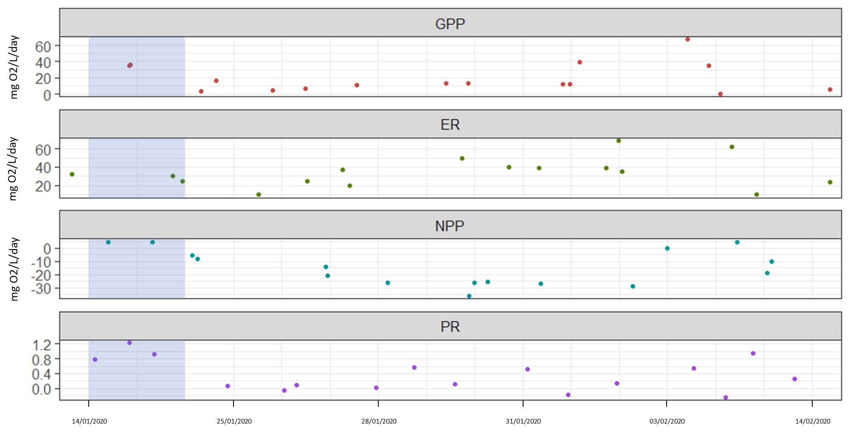
Figure 4 Gross primary productivity (GPP), ecosystem respiration (ER), net primary productivity (NPP) and P:R in the Gwydir River at Pallamallawa. Blue time periods indicate water for the environment.

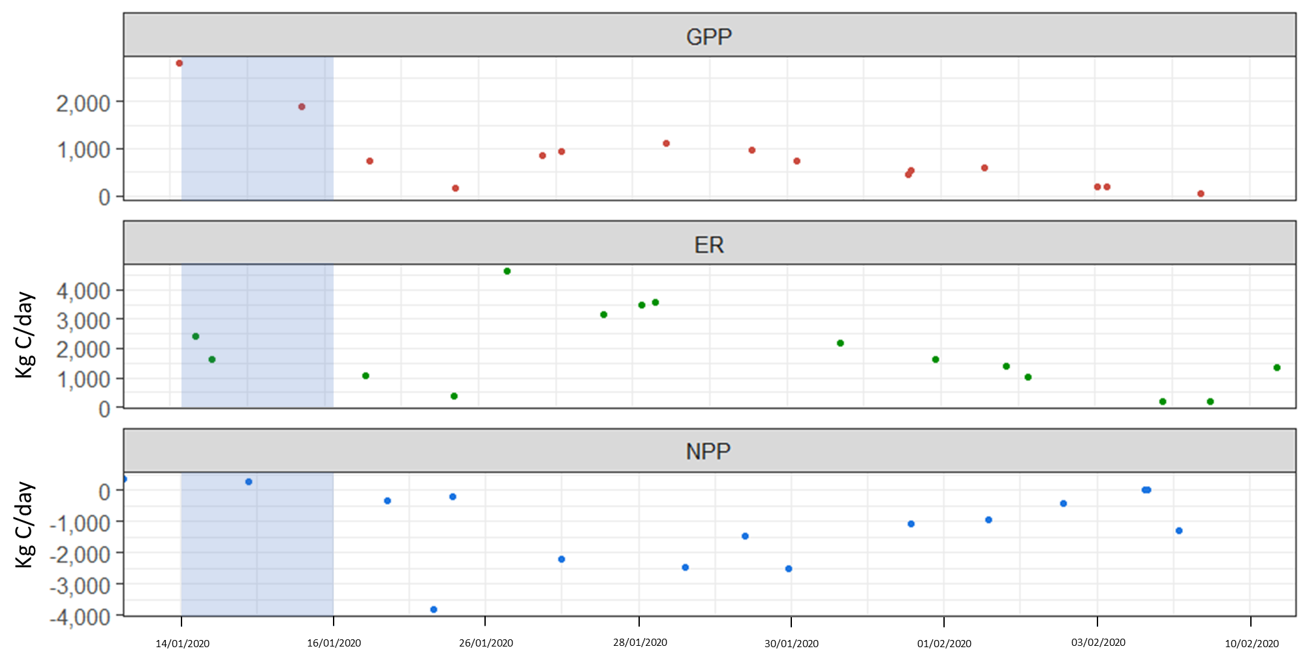
Mg O₂/L/day
Figure 5 Carbon (kg/day) produced through GPP, consumed through ER and net result (NPP) in the Gwydir River at Pallamallawa. Blue time periods indicate water for the environment. Data exist where BASEv2 model outputs coexist for days where discharge was greater than 0 ML/day.

Invertebrates
The total number of microinvertebrate taxa within sites ranged from 5 - 10 and was similar among Zones and consistent through Time (Figure 6). While the abundance of microinvertebrate taxa remained similar, as expected the density of individuals was significantly greater during the contraction phase in September and December 2019 (Gingham Waterhole: 7,865 individuals/L, Gwydir River: 1,274 ± 2,171 individuals/L, and Moomin Creek: 4,081 ± 3,300 individuals/L) than in January 2020 (e.g., Gwydir River: 286 ± 287 individuals/L) once the refuge flow release had reconnected waterholes and increased the volume of available habitat (Figure 7, F_{3,16} = 7.469, p<0.002). Microinvertebrate diversity followed the patterns exhibited by taxa richness, remaining consistent among Zones through Time (Figure 8).

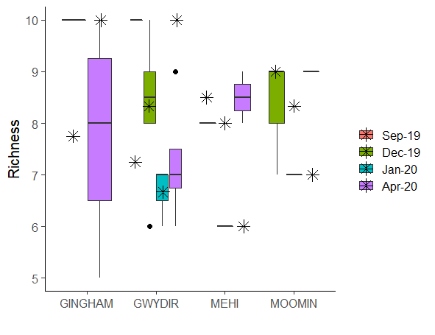
Figure 6 Ranges in microinvertebrate taxa richness per litre in the 2019-2020 water year across the four Zones. Horizontal black lines indicate medians and asterisks means.

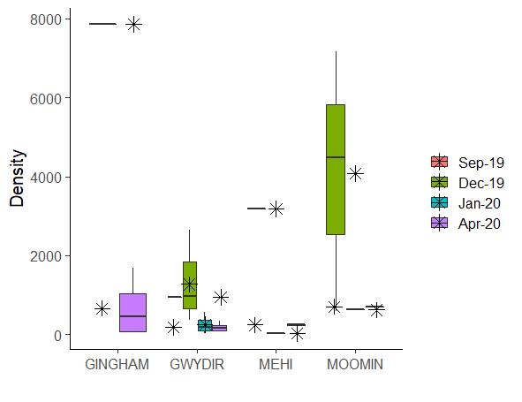
(Individuals/L)
Figure 7 Ranges in microinvertebrate density per litre in the 2019-2020 water year across the four Zones. Horizontal black lines indicate medians and asterisks means.

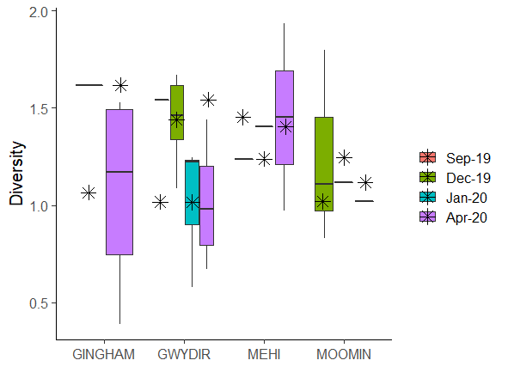
Figure 8 Ranges in microinvertebrate diversity per litre in the 2019-2020 water year across the four Zones. Horizontal black lines indicate medians and asterisks means.
In contrast, macroinvertebrate richness differed among Zones (Figure 9, X²_{3,24} = 20.293, p<0.05), with higher richness in the Mehi River (11 ± 4 taxa) than in the Gwydir River
(7 ± 2 taxa, p<0.030). Although Time was not statistically significant (X²_{3,21} = 13.538,
p=0.080), macroinvertebrate richness at sites increased to 14 ± 1 taxa in the Mehi River in April 2020 once the channels were reconnected by the refuge flow release
(Figure 9). Macroinvertebrate density was similar throughout the four Zones in the
Selected Area (Figure 10), but changed through Time (F_{3,16} = 3.860, p<0.05).
Similar to microinvertebrates, macroinvertebrate density was greatest in September
2019 (1.9 ± 1.5 individuals/L), when pools were in the contraction phase, and
significantly lower in December 2019 (0.3 ± 0.3 individuals/L, p<0.05) and April 2020
(0.2 ± 0.2 individuals/L, p<0.05). It is possible lower densities in December 2019 were a combination of enhanced predation and/or poor water quality, while the lower densities in April 2020 were due to dilution effects from the refuge flow release. The diversity of macroinvertebrates also increased through Time (F_{3,16} = 5.908, p<0.01) but there was no significant difference between Zones (Figure 11, F_{3,16} = 1.128, p=0.367). Diversity was significantly higher in April 2020 once the channel had reconnected, compared with September (p<0.05) or December 2019 (p<0.05).

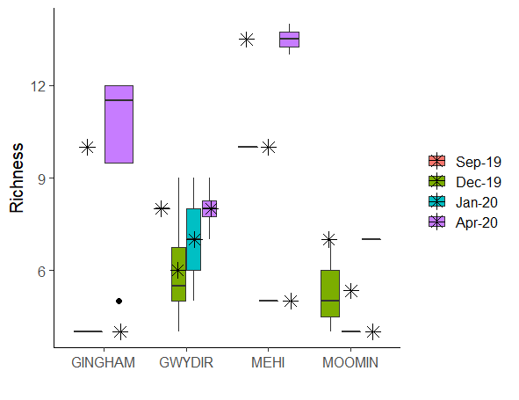
Figure 9 Ranges in macroinvertebrate taxa richness per litre in the 2019-2020 water year across the four Zones. Horizontal black lines indicate medians and asterisks means.

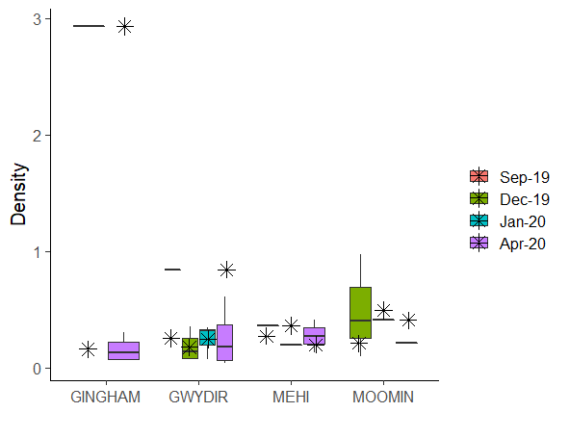Figure 10 Ranges in macroinvertebrate density per litre in the 2019-2020 water year across the four Zones. Horizontal black lines indicate medians and asterisks means.
(Individuals/L)
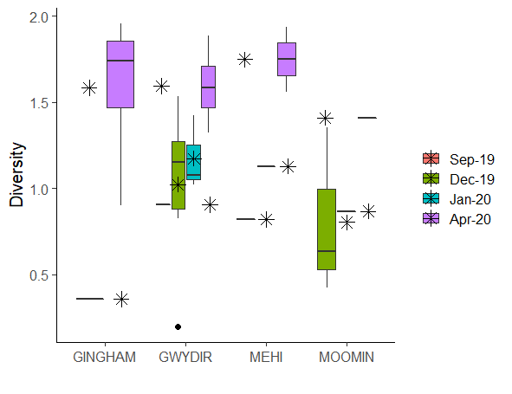
Figure 11 Ranges in macroinvertebrate diversity per litre in the 2019-2020 water year across the four Zones. Horizontal black lines indicate medians and asterisks means.
Invertebrate community composition
Time explained the greatest difference in invertebrate community composition (41%), with density decreasing once sites reconnected (Figure 12, Table 4). Analysis of presence/absence data showed that pelagic taxa such as river shrimp and prawns (Atyidae and Palaemonidae) became more abundant and widespread within the Gwydir River in January and April 2020, as pools were reconnected by environmental water and rainfall events (Figure 13). Harpacticoids, a benthic copepod, became less widespread within the Gwydir during the same time period (Figure 13). Invertebrates including dragonfly nymphs (Hemicorduliidae, Aeshnidae), damselfly nymphs (Coenagrionidae), aquatic snails (Planorbidae) and aquatic worms (Oligochaeta) were more widespread in the Gingham Watercourse during April 2020 than previously, indicating the egg bank survived the preceding dry period and burst into life following inundation.

Table 4 PERMANOVA results for invertebrate communities. (p/a) is presence/absence, ns is non-significant test result. The percentage of variation explained by each significant source of variation is given in brackets after the pseudo F value. ** represents p<0.01 and *** represents p<0.001.
Source of variation | Assemblage  (density) | Assemblage  (p/a)
Time | 3.0* (41%) | 2.7* (37%)
Zone | ns | ns
Site (Zone) | ns | ns
Time x Zone | ns | ns

Figure 12 nmDS of invertebrate density among Sites in the Gwydir River Selected Area in the 2019-20 water year. Taxa driving differences are shown as vectors with density decreasing from right to left.
Figure 13 nMDS of invertebrate presence/absence among Sites in the Gwydir River Selected Area in the 2019-20 water year. Taxa driving differences are shown as vectors.

Multi-year analyses

Metabolism
Given the change in monitoring approach, limited data availability from DO probes at GW1 (Pallamallawa) and the limited acceptance of BASEv2 model outputs, only few additional 2019-20 data points in the Gwydir River were added. Thus, further analyses of metabolism will be conducted in the 2020-21 water year to extend the detailed water quality and stream metabolism findings given in the 2018-19 annual report.

Microinvertebrates
Throughout the LTIM/MER project (2014-2020), no significant differences in microinvertebrate richness amongst Zones were recorded in the Gwydir Selected Area (Figure 14). However, annual differences were significant (F_{5,242} = 4.290, p<0.001), and these were driven by significantly lower average microinvertebrate richness in 2018-19 (6.8 ± 2.0) than 2015-16 (8.3 ± 2.1, p<0.005), 2017-18 (7.8 ± 1.6, p<0.05) and 2019-20 (7.9 ± 1.4, p<0.05). While average microinvertebrate richness was lowest across all zones in 2018-19, it was also extremely variable within zones (Figure 14).

Microinvertebrate density was highly variable through time (Figure 15, F_{4,16} = 9.738,
p<0.001), but variability was clearly lower in 2019-20 (1,354 ± 2,039 individuals/L) than in previous years (Figure 14). Microinvertebrate density was significantly high in 2014-15 (19,909 ± 21,956 individuals/L, p<0.005). The Gingham Watercourse (8,852 ± 4,657 individuals/L) consistently had greater densities (F_{4,16} = 9.738, p<0.001) than the Gwydir River (4,257 ± 5,040 individuals/L, p<0.001) and the Mehi River (5,084 ± 3,511 individuals/L, p<0.022). The Lower Gwydir wetlands (Old Dromana, 25,477 ± 33,128) consistently had greater densities than the Gwydir River (p<0.001) and the Mehi River p<0.05), and Moomin Creek had greater densities (4,821 ± 1,944 individuals/L) than the Gwydir River (p<0.01). Microinvertebrate diversity (Figure 16) remained similar among Zones, but was significantly different between times (F_{5,16} = 3.578, p<0.004) being higher in 2014-15 (1.35 ± 0.28) than 2016-17 (0.99 ± 0.46; p<0.003).

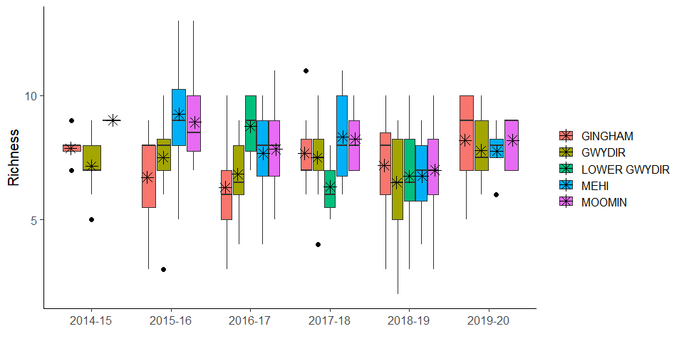
Figure 14 Ranges in microinvertebrate richness over water years across the four Zones in the Gwydir River Selected Area. Horizontal black lines indicate medians and asterisks means.

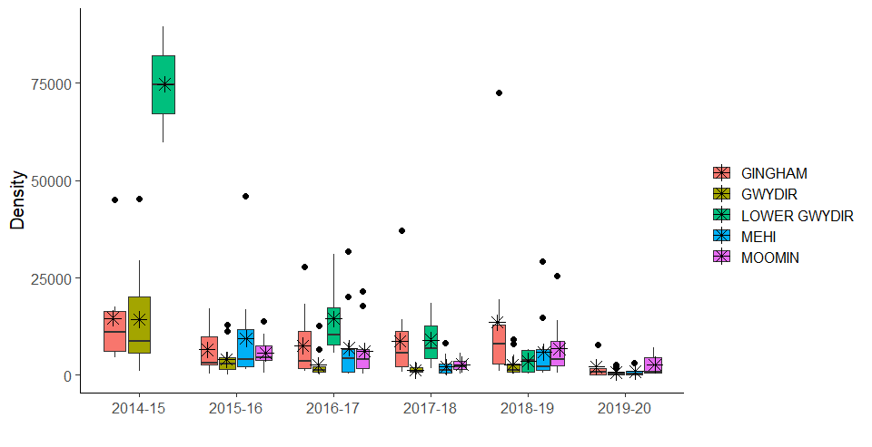
(Individuals/L)
Figure 15 Ranges in microinvertebrate density over water years across the four Zones in the Gwydir River Selected Area. Horizontal black lines indicate medians and asterisks means.

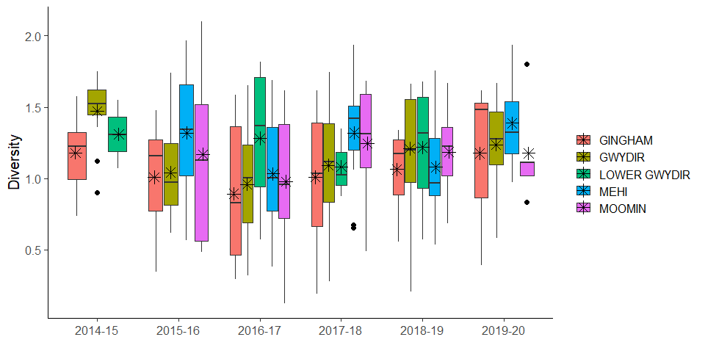
Figure 16 Ranges in microinvertebrate diversity over water years across the four Zones in the Gwydir River Selected Area. Horizontal black lines indicate medians and asterisks means.

Macroinvertebrates
Macroinvertebrate richness was consistently greater in the Lower Gwydir wetlands when inundated (11.6 ± 2.3 taxa) than the Gingham Watercourse (8.9 ± 2.0 taxa, p<0.05) and Moomin Creek (8.2 ± 1.8 taxa, p<0.05) through the LTIM/MER project (Figure 17,
F_{4,247} = 2.639, p<0.05). Time significantly influenced macroinvertebrate richness
(F_{5,242} = 6.529, p<0.001) with 2015-16 and 2017-18 (10.6 ± 1.7 and 10.6 ± 1.8 taxa, respectively), being significantly greater than 2018-19 (7.9 ± 0.9 taxa, p<0.005 and p<0.001, respectively) and 2019-20 (7.9 ± 2.2 taxa, p<0.005 and p<0.01, respectively).

Macroinvertebrate densities varied significantly amongst the four Zones (F_{4,16} = 2.740,
p<0.05) and through water years (F_{5,16} = 4.835, p<0.001). The inter-annual variation within Zones confounded clear spatial patterns among Zones (Figure 18). Overall, macroinvertebrate densities were significantly lower in 2014-15 (0.1 ± 0.0 individuals/L) than 2015-16 (0.3 ± 0.2 individuals/L, p<0.01), 2017-18 (0.2 ± 0.1 individuals/L,
p<0.005), 2018-19 (0.3 ± 0.1 individuals/L, p<0.001) and 2019-20 (0.4 ± 0.2 individuals/L, p<0.005).

Macroinvertebrate diversity (Figure 19) varied significantly amongst the four Zones
(F_{4,16} = 2.837, p<0.05) and through water years (F_{5,16} = 3.877, p<0.005). Diversity in the inundated Lower Gwydir wetlands (1.73 ± 0.30) was consistently greater than in the Gingham Watercourse (1.28 ± 0.29, p<0.05) or Moomin Creek (1.20 ± 0.17, p<0.012). Diversity was lowest in the 2018-19 water year (1.14 ± 0.13), which was significantly less than in 2014-15 (1.59 ± 0.17, p<0.01) or 2015-16 water years (1.41 ± 0.09, p<0.05).

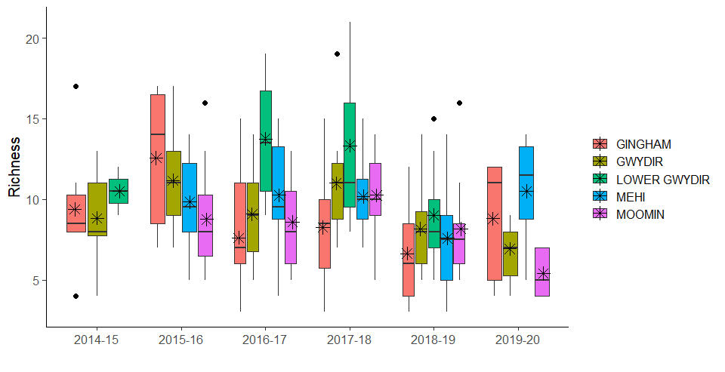
Figure 17 Ranges in macroinvertebrate richness per litre over water years across the four Zones in the Gwydir River Selected Area. Horizontal black lines indicate medians and asterisks means.

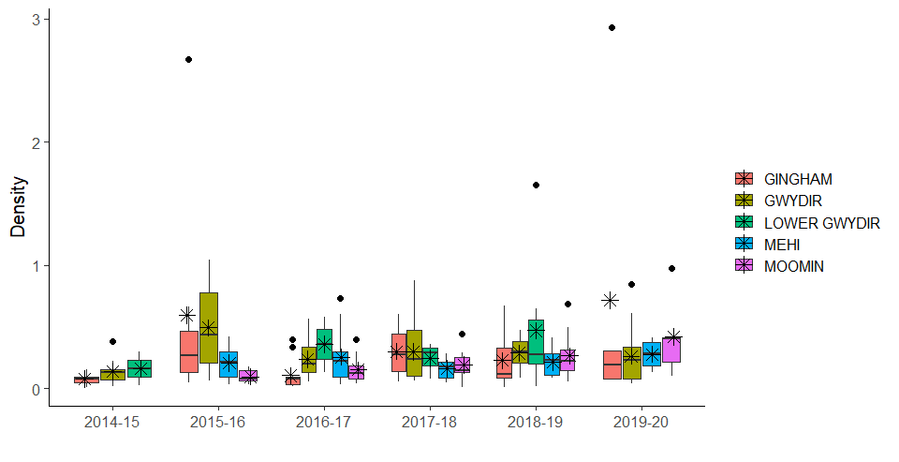
(Individuals/L)
Figure 18 Ranges in macroinvertebrate density per litre over water years across the four Zones in the Gwydir River Selected Area. Horizontal black lines indicate medians and asterisks means.

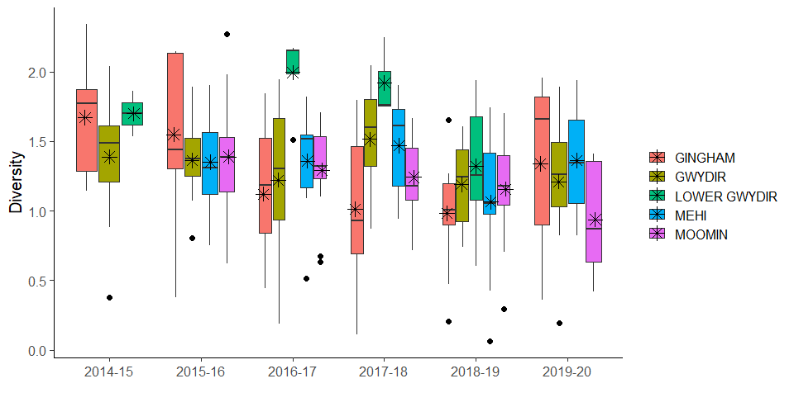
Figure 19 Ranges in macroinvertebrate diversity per litre over water years across the four Zones in the Gwydir River Selected Area. Horizontal black lines indicate medians and asterisks means.

Discussion
River, wetland and watercourse sites in the Gwydir Selected Area were monitored from October 2019 to April 2020 to coincide with four deliveries of water for the environment, with a focus on watering to maintain refuge pool habitats. Most of the lower Gwydir experienced extended dry conditions throughout this period, with wetland and watercourse sites only inundated in April 2020 following rainfall. These dry and disconnected channel conditions in 2019-20 substantially limited our ability to monitor the influence of water or the environment in maintaining water quality. Conductivity and pH remained within ANZECC guidelines despite the region experiencing severe drought. Old Dromana wetlands fell below the minimum ANZECC guideline for DO in April 2020 in response to microbial activity following the rewetting of wetland sediments. Several sites exceeded the maximum ANZECC guideline for DO, with a maximum daytime spot reading of 134% in the Mehi River in April 2020. Simultaneous high concentrations of Chlorophyll a at these sites suggests that this super saturation of DO in the water column was linked to localised high phytoplankton biomass fuelled by the high availability of nutrients. This is a consistent pattern for water quality in wetland and watercourse environments of the lower Gwydir.

Turbidity in the Mehi River and Moomin Creek consistently exceeded ANZECC guidelines. Turbidity was higher in the Gwydir River and Moomin Creek than the Gingham Watercourse, and higher in Moomin Creek than the Mehi River. Very high concentrations of total phosphorus (TP) were likely regulated by increased suspended sediments (turbidity) with the highest TP concentration also in the highly turbid and degraded Moomin Creek. Concentrations of bioavailable nitrogen (NOx) were greatest in the channels of the Gwydir River and Moomin Creek than compared with the Gingham Watercourse. This may be due to the release of nutrients from sediments into layers of hypoxic water at the bottom of pools and waterholes as they contracted and dried, and were then transported downstream in channels once refuge pools were reconnected. In contrast, filterable reactive phosphorus (FRP) was greater in the Gingham Watercourse than the river channels (Gwydir, Mehi and Moomin) identifying that wetland sediments in boom and bust wetland environments remain an important store for phosphorus that drive food web productivity on rewetting.

Metabolism in the Gwydir River at Pallamallawa shifted from autotrophic (GPP:ER >1) during water for the environment delivery to heterotrophic (GPP:ER <1) after environmental water delivery ceased. A decrease in turbidity and an increase in algal biomass associated with this delivery of water for the environment in January 2020, combined with lower ecosystem respiration rates resulted in a net production and supply of carbon during the delivery of water for the environment of 93 kg C/day. Although based on very limited data, this is the only positive net carbon production recorded during the 2019-20 year and suggests environmental water deliveries can play an important role in improving water quality and therefore carbon production to fuel local food webs.

Acceptance rates of data output from the BASEv2 model continue to be very low, hindering the ability to examine long term trends in metabolism. The underwater light climate, high temperatures and low rates of oxygen production confound the model assumptions. In particular, the BASEv2 model that is designed only for flowing systems could not reconcile reaeration coefficients in disconnected refuge pools, preventing us from modelling the metabolic response in these important habitats. Further research during the 2020-21 water year will try to improve model assumptions and data acceptance for northern basin waterways and explore alternative models for predicting carbon production for food webs in these habitats.

Microinvertebrate richness and diversity remained spatially and temporally consistent in the Gwydir Selected Area. As expected, density peaked during the contraction phase as microinvertebrate communities reproduced rapidly in receding volumes of water, and then were reduced through dilution and/or enhanced predation following the reconnection of pool habitats with flow deliveries. In contrast, macroinvertebrate density peaked during the early contraction phase (September 2019), decreased as the drought intensified during December 2019, possibly due to predation pressure in disconnected pools, rather than in response to poor water quality. Macroinvertebrate density decreased further during the reconnection phase through dilution as macroinvertebrates were able to disperse and colonise newly available habitat.

Analyses of presence/absence data of invertebrate community composition showed that pelagic taxa such as river shrimp and prawns (Atyidae and Palaemonidae) extended their range through the Gwydir River in January and April 2020 as pools reconnected in response to the delivery of water for the environment. These taxa are key in the diet of native fish, with the refuge flows both maintaining populations of these taxa during drought periods, and enabling their dispersal to fuel food webs by reconnecting channel environments in the lower Gwydir. As the Gingham Waterhole rewetted, dragonfly (Hemicorduliidae and Aeshnidae) and damselfly (Coenagrionidae) nymphs recolonised highlighting nearby storages as important refuges for aquatic biota, and aquatic snails (Planorbidae) and worms (Oligochaeta) hatched indicating that the egg bank survived the extended preceding dry period.

Core monitoring combined with refuge pool monitoring data throughout the 19-20 water year suggests that food resources for larger predators (fish, frogs, turtles) were not limiting in refuge pools, and although water quality deteriorated it was not lethal to aquatic biota residing in pools. The invertebrate community composition changed over time, with fewer water fleas (an essential food resource for larval fish) present in April 2020 than December 2019, and the complete loss of ostracods (another important larval fish food resource) in refuge pools during the same timeframe. Better understanding the implications of this temporal shift in essential food resources for larval fish with the use of environmental water to reconnect refuge pools is an ongoing component within the Selected Area and Basin scale food web research program.

Long-term patterns in microinvertebrate richness were similar across the Gwydir Selected Area, with clear temporal patterns from peak richness in 2015-16 and lowest richness in 2018-19 associated with antecedent conditions and inundation regimes. Richness improved this water year from the lowest values observed during the extreme drought conditions of 2018-19, but densities were lower in this water year than any previous year. These low densities are likely the result of limited habitat availability and increased predation pressures during the drought, followed by dilution of those communities as river channels reconnected and wetlands were inundated. When inundated, the Gingham Watercourse and Lower Gwydir wetlands continue to support higher densities of invertebrates than river channels, and each wetland system maintained different and unique invertebrate communities. This highlights the importance of inundating both Gingham and Gwydir wetland areas to maintain local invertebrate diversity and the food webs they support.

References
ANZECC (Australian – New Zealand Environment and Conservation Council). 2000. Australian and New Zealand Guidelines for Fresh and Marine Water Quality, vol 1, The Guidelines, pp 314.

Clarke, K. R. W. and Warwick, R. M. 2001. Change in Marine Communities: An Approach to Statistical Analysis and Interpretation. 2nd edition. PRIMER-E.

Grace, M. R., Giling, D. P., Hladyz, S., Caron, V., Thompson, R. M., and Mac Nally, R. 2015. Fast processing of diel oxygen curves: Estimating stream metabolism with BASE (BAyesian Single‐station Estimation). Limnology and Oceanography: Methods, 13(3), 103-114.

Hale J., Stoffels R., Butcher R., Shackleton M., Brooks S. and Gawne B. 2013. Commonwealth Environmental Water Office Long Term Intervention Monitoring Project – Standard Methods. Final Report prepared for the Commonwealth Environmental Water Office by The Murray-Darling Freshwater Research Centre, MDFRC Publication 29.2/2014, January, 182 pp.

Hosomi, M. and Sudo, R. 1986. Simultaneous determination of total nitrogen and total phosphorus in freshwater samples using persulfate digestion, International Journal of Environmental Studies, 27:3-4, 267-275, DOI: 10.1080/00207238608710296.

Murphy, J. and Riley, J.P. 1958. A single-solution method for the determination of soluble phosphate in sea water. Journal of the Marine Biological Association of the UK, 37: 9-14.

