x

HYDROLOGY | FOOD WEBS | VEGETATION | WATERBIRDS | FISH

###### Appendix D: Waterbird diversity

# Introduction

The Gwydir River and its associated wetland system supports significant numbers of nationally and internationally important (JAMBA, CAMBA, ROCAMBA) waterbird species within the Gwydir River Selected Area (Gwydir Selected Area, Selected Area). When inundated, the Gwydir wetlands provide important waterbird habitat that contributes significantly to waterbird biodiversity and abundance in the Murray-Darling Basin. During large scale flooding the wetlands also support nationally significant waterbird colonies (DECCW 2011).

Monitoring waterbird diversity in the Selected Area was undertaken as part of the LTIM project from 2014-2019 with monitoring continuing as part of the MER project. For this monitoring program, raptors, reed-inhabiting passerines and tree kingfishers along with species traditionally known as waterbirds are included under the definition of ‘waterbirds’ as outlined in the LTIM standard method (Hale *et al.* 2014). The objective of monitoring waterbird diversity is to assess the contribution of water for the environment to waterbird survival and diversity by answering the following questions:

* What did Commonwealth water for the environment contribute to waterbird survival?
* What did Commonwealth water for the environment contribute to waterbird populations?
* What did Commonwealth water for the environment contribute to waterbird species diversity?

## Previous monitoring

Across the LTIM project, 29,784 individual waterbirds comprising 94 species were recorded across all sites in the Gwydir wetlands from 2014-19 (Commonwealth of Australia 2019). Peak density and diversity of waterbirds were observed during spring 2018, coinciding with the highest volumes of water for the environment delivered during the LTIM project. The Gingham watercourse had consistently rich and abundant waterbird populations compared with other wetland systems monitored, driven by the presence of more persistant wetland habitats such as Bunnor bird hide and Gingham waterhole. Across the LTIM project, waterbird breeding was low in the Gwydir Selected Area, with recorded waterbird breeding activity most often detected during spring surveys. Breeding activity was highest in the 2016-17 water year with over 10 species of waterbird observed breeding following significant wetland inflows.

# Methods

## Survey area and timing

A total of 26 monitoring sites were surveyed across the 2019-20 year from a broader suite of 29 monitoring sites surveyed during the LTIM/MER project. Bushfire risks affected surveys at some sites in spring 2019, and landowner restrictions for site access prevented the inclusion of some monitoring sites in spring 2019 and/or autumn 2020. Waterbird counts from the Westholme NW site were not included in the analysis due to its close proximity to Goddards Lease site, however, observations from this site did inform overall waterbird richness. Survey sites consisted of channel, floodplain wetland and waterhole habitats within the lower Gwydir and Gingham watercourses, and the Mehi River and Mallowa Channel (Figure 1, Figure 2). Floodplain wetlands were areas of vegetated shallow marsh as opposed to defined waterholes or channels. The 2019-20 water year saw worsening drought through 2019, to the point where many of the Gingham and Lower Gwydir sites were dry in the spring surveys in November 2019. However, a flow event did occur in the Mehi/Mallowa system before the start of the spring survey. The autumn 2020 survey was undertaken in March soon after the initiation of flows in the Gingham and lower Gwydir systems (Table 1, Appendix A: Gwydir River Hydrology).

## Survey methods

Waterbird surveys were conducted in conjunction with staff from NSW Department of Planning Industry and Environment – Environment, Energy and Science (NSW DPIE-EES), which established this survey program in 2007 (Spencer *et al.* 2010). Each site was surveyed by a point scan of the visible surface water and mudflat/edge and fringing vegetation as applicable, sometimes connected by a walking transect between two points, to record any bird species detected (including land or ‘bush’ birds). Birds were detected and identified by visual and aural cues, with the aid of 10x binoculars and a spotting telescope to 45x zoom for larger sites. A minimum of 20 minutes, but up to 1 hour, was spent at each site according to the length of time required to survey the accessible/visible water and margins and for the waterbird species accumulation rate to plateau. The same procedure and routes were undertaken on both sampling occasions (spring 2019 and autumn 2020), by the same team of observers. Each survey site was visited on at least two occasions (over separate days) during each survey period to estimate the maximum number of waterbird species and maximum count of each species per site. Dry sites (less than 10% inundated) were only surveyed once. Bird taxonomy and names follow the latest BirdLife Australia checklist (2019).

All waterbird species observed along with any evidence of breeding activity, i.e. the number of broods or nests was recorded. The maximum count of each species from any one replicate survey were used for the analysis. Site information included percent inundated area, vegetation type and cover, and weather conditions were recorded for each replicate survey. Inundation was determined from the percent inundated area where sites with more than 10% inundation were classified as ‘wet’ (Table 1).

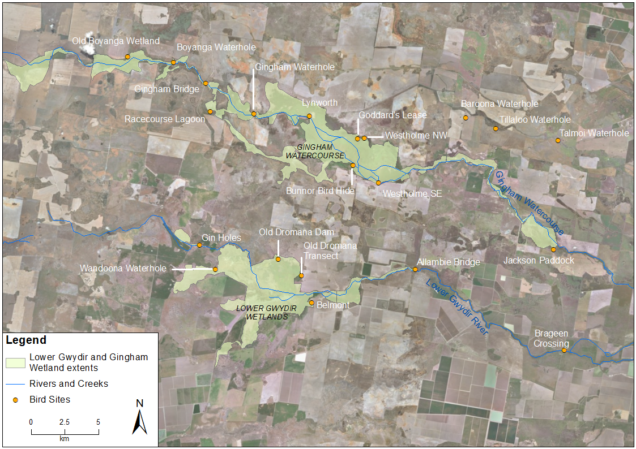

Figure Waterbird diversity monitoring sites within the Lower Gwydir and Gingham watercourse.

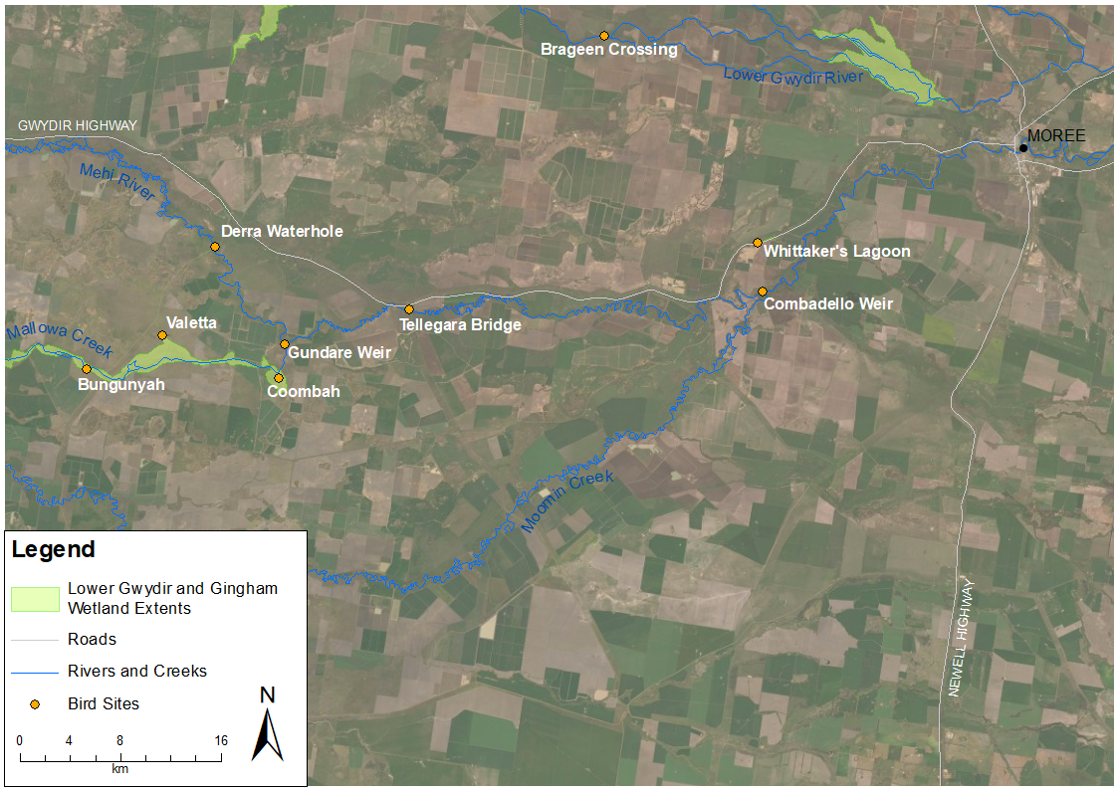

Wetland extent

Figure Waterbird diversity monitoring sites within Mehi River and Mallowa channel.

Table Location and inundation status of waterbird survey sites within the Selected Area. Blue shading represents wet sites and orange shading indicates dry sites (<10% inundation).

| **Monitoring Zone** | **System** | **Site Name** | **Site Type** | **Inundated Area (%)** | |
| --- | --- | --- | --- | --- | --- |
| **Spring 2019** | **Autumn 2020** |
| Lower Gwydir River and Gingham Watercourse | Gingham | Baroona Waterhole* | Waterhole | 0 | 75-94 |
| Boyanga Waterhole* | Waterhole | 0 | 75-94 |
| Bunnor Bird Hide | Floodplain wetland | 0 | 94-100 |
| Old Boyanga Wetland* | Floodplain wetland | 0 | 0 |
| Gingham Bridge | Channel | 0 | 50-74 |
| Gingham Waterhole | Waterhole | 1-9 | 75-94 |
| Goddard’s Lease | Floodplain wetland | 0 | 94-100 |
| Jackson Paddock* | Floodplain wetland | 1-9 | 50-74 |
| Lynworth*a | Floodplain wetland | - | - |
| Racecourse Lagoon*a | Waterhole | 0 | - |
| Talmoi Waterhole* | Waterhole | 0 | 75-94 |
| Tillaloo Waterhole* | Waterhole | 0 | 75-94 |
| Westholme NWa | Floodplain wetland | - | - |
| Westholme SE | Floodplain wetland | 0 | 75-94 |
| Lower Gwydir | Allambie Bridge | Channel | 10-49 | 50-74 |
| Brageen Crossing | Channel | 10-49 | 75-94 |
| Belmont*a | Floodplain wetland | - | - |
| Gin Holes* | Waterhole | 0 | 1-9 |
| Old Dromana Dam | Waterhole | 0 | 10-49 |
| Old Dromana Transect | Floodplain wetland | 0 | 10-49 |
| Wandoona Waterhole* | Waterhole | 0 | 94-100 |
| Mehi River and Moomin Channel | Mallowa | Bungunya* | Floodplain wetland | 1-9 | 0 |
| Coombah*a | Floodplain wetland | 1-9 | - |
| Gundare Weir | Channel | 50-74 | 75-94 |
| Valetta* | Floodplain wetland | 0 | 1-9 |
| Mehi | Combadello Weir | Channel | 1-9 | 75-94 |
| Derra Waterhole | Waterhole | 0 | 75-94 |
| Tellegara Bridge | Channel | 1-9 | 10-49 |
| Whittaker’s Lagoon | Waterhole | 94-100 | 75-94 |

* sites are on private property, a Site not surveyed during one or both survey times.

## Statistical analyses

Waterbird abundance data were converted to density (abundance per hectare) for each site. Diversity was calculated using Simpson’s Diversity Index using the statistical software R (R Core Team 2018). Univariate statistical analyses were performed using R. Poisson regression modelling was conducted in R to determine statistical differences in species richness, density and Simpson’s Diversity based on inundation (wet, dry), system (Gingham, Lower Gwydir, Mallowa, Mehi), and site type (channel, floodplain wetland, waterhole). Multiyear analyses included the factor Year which included 2019-20 and all years of the LTIM project (2014-2019).

Multivariate analyses were performed using PRIMER (Version 7). Density data were log-transformed and converted to a resemblance matrix in PRIMER to analyse patterns in waterbird community composition using non-metric multidimensional scaling (nMDS), permutational multivariate analyses of variance (PERMANOVA, Anderson *et al.* 2008) and similarity percentages (SIMPER).

# Results

## 2019–20 water year data

### Waterbird species richness, density and diversity

A total of 5,660 individual waterbirds from 53 species were recorded during surveys in the 2019-20 year. Grey teal (*Anas gracilis*) were the most abundant species observed by an order of magnitude with 2,545 individuals recorded over both survey periods. A total of 8 Latham’s snipe (*Gallinago hardwickii*) were observed at Old Dromana in March 2020. This species is listed under Japan-Australia Migratory Bird Agreement (JAMBA) and Republic of Korea-Australia Migratory Bird Agreement (ROKAMBA) international migratory bird agreements. In addition, four species (freckled duck (*Stictonetta naevosa*), magpie goose (*Anseranas semipalmata*), brolga (*Grus rubicunda*) and white-bellied sea-eagle (*Haliaeetus leucogaster*) were observed that are listed as vulnerable under the NSW *Biodiversity Conservation Act 2016* (BC Act).

Mean waterbird species richness was significantly greater in autumn 2020 (8.30 ± 8.78 species) than spring 2019 (2.42 ± 3.43 species, p<0.005), with 24 waterbird species recorded across the 26 sites in spring 2019 and 52 species recorded across 24 sites in autumn 2020. The highest waterbird richness within a site was 33 species recorded at Bunnor Bird Hide in autumn 2020, followed by 27 species at Goddard’s Lease and 13 species at Whittaker’s Lagoon (Figure 3). In comparison, the greatest site richness in spring 2019 was 11 species, recorded at both Goddard’s Lease and Whittaker’s Lagoon. Wet sites (8.65 ± 8.29 species) predictably supported significantly more waterbirds species than dry sites (3.33 ± 3.60 species, p<0.05). Species richness was greatest at wet sites in autumn after flows including water for the environment reached sites (Figure 4).

Gingham

Lower Gwydir

Mehi

Mallowa

Figure Species richness by season at waterbird sites during the 2019–20 water year.

Figure Mean species richness (±SD) grouped by season and inundation at sites during the 2019–20 water year.

There were no significant differences in species richness among the Gingham, Lower Gwydir, Mallowa or Mehi systems across the two surveys (Figure 5), but site type was a significant factor (f2,50 = 170.78, p<0.005). Floodplain wetlands (8.79 ± 10.50 species) supported significantly more waterbird species than channels (2.70 ± 1.95 species, p <0.05), driven by very high richness at two floodplain wetlands - Bunnor Bird Hide and Goddard’s Lease – during autumn 2020 (Figure 5). Waterholes showed relatively high richness (8.21 ± 5.38 species) but was not significantly more than at channel sites.

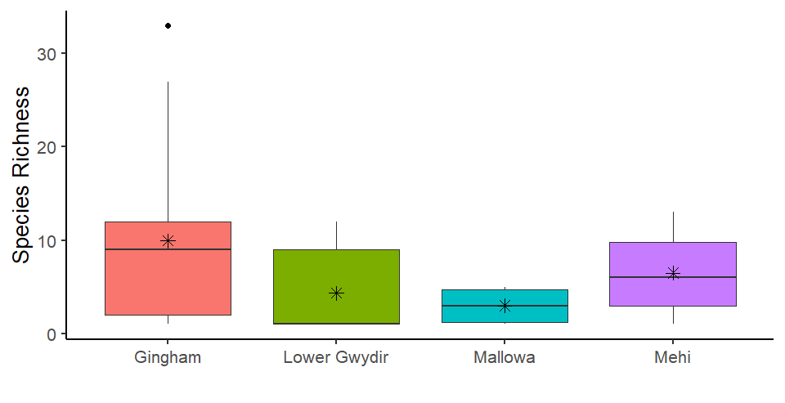

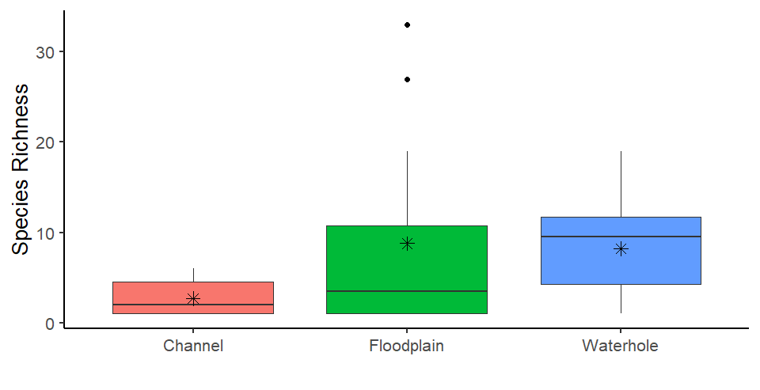

Figure Mean species richness (±SD) observed in the five monitoring zones (top), and three site types (bottom) across the 2019-20 water year. Black lines represent means, asterisks represent medians and dots represent outliers.

Maximum waterbird density at a site during the 2019-20 water year was 325 birds/ha, recorded at Bunnor Bird Hide in autumn 2020 (Figure 6). In spring, Allambie Bridge (channel site) on the Lower Gwydir had the highest waterbird density (80 birds/ha, Figure 6). Waterbird densities were highly variable across individual sites, with densities strongly driven by whether sites were wet (21.84 ± 64.15 birds/ha) or dry (1.43 ± 2.24 birds/ha, *F*1,30 = 11.26, p=0.002, Figure 7). There was litlle significant influence of site types, wetlands (Figure 8) or season observed.

Although densities remained lower than in previous years, waterbird density increased in the Gingham and Lower Gwydir sites in autumn 2020 after widespread rainfall occurred and flows reached the system. The exception was the lower Gwydir channel at Allambie Bridge, which supported a flock of 12 pelicans and 3 black ducks and appeared to offer an aquatic refuge for these species (Figure 6).

*80

*325

Figure Waterbird density by season at waterbird sites during the 2019–20 water year.

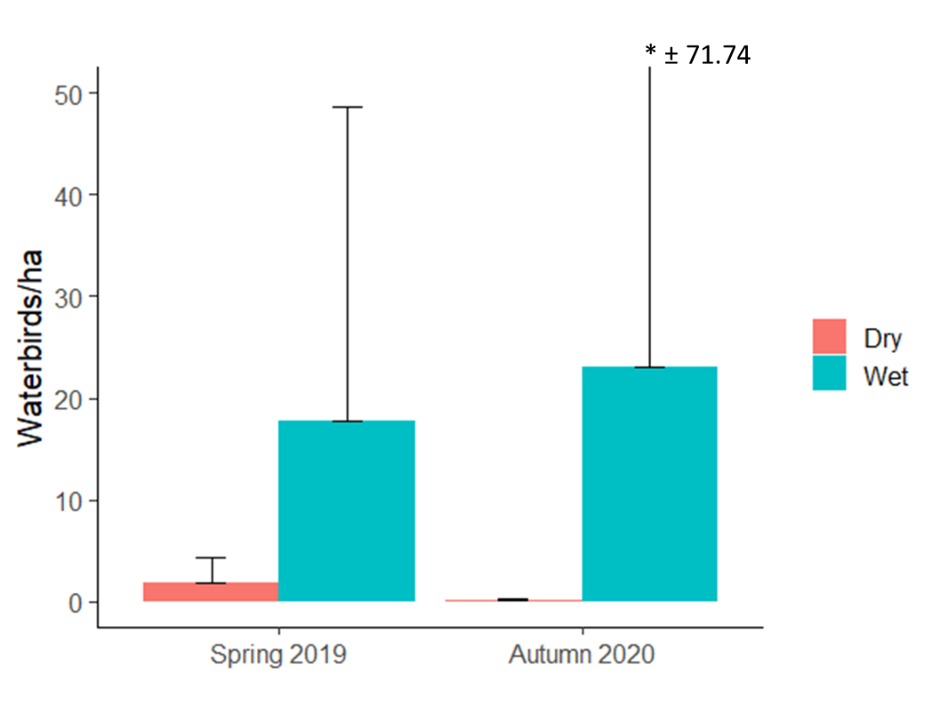

Figure Mean waterbird densities (+SD) at wet and dry sites during the 2019–20 water year.

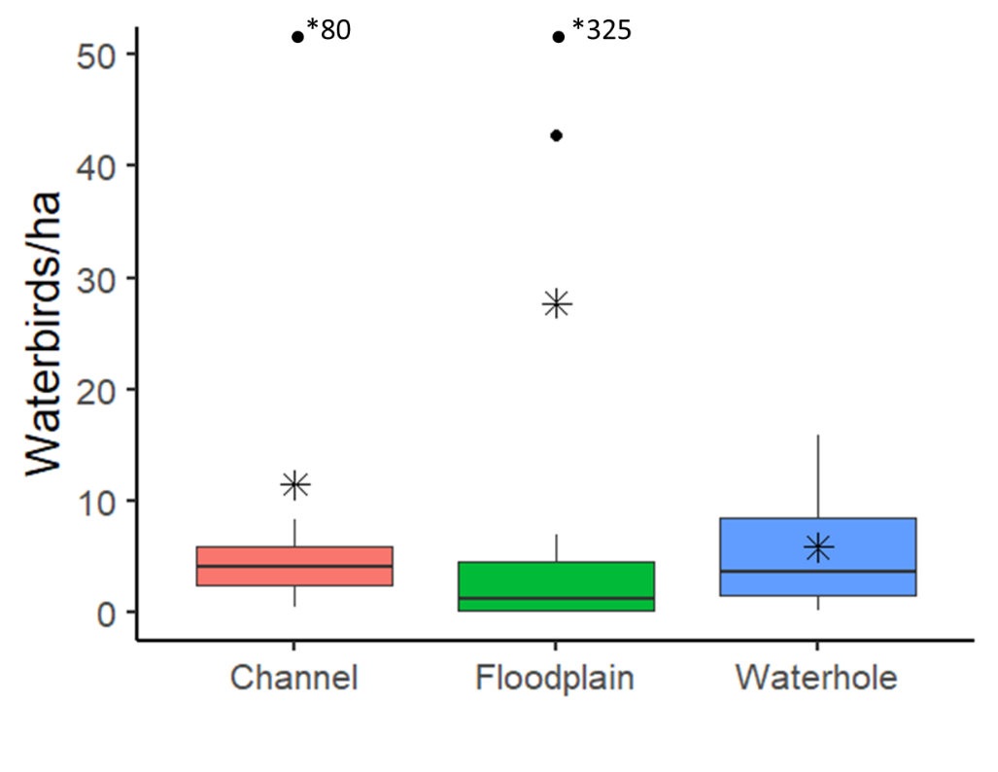

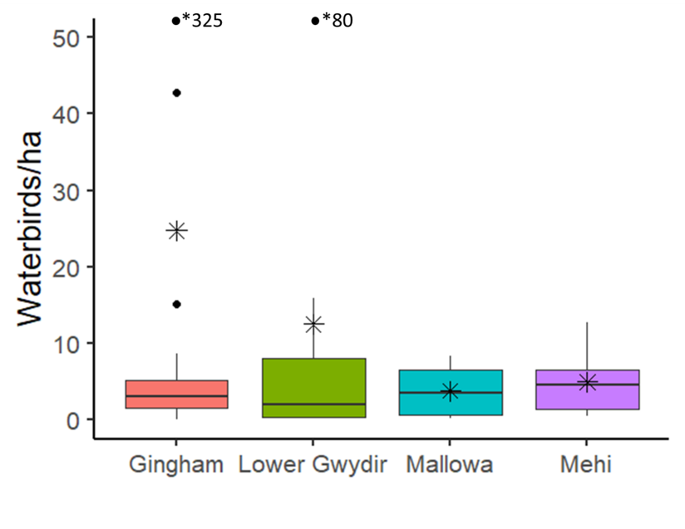

Figure Mean waterbird density (±SD) by site type (top) and wetland (bottom) during the 2019-20 water year. Black lines represent means, asterisks represent medians and dots represent outliers.

Although Shannon Diversity was slightly higher in waterholes than channel or floodplain sites (Figure 9) and wet sites than dry sites (Figure 10), neither were statistically significant. Likewise, Shannon Diversity was slightly higher in the Gingham and Mehi than the lower Gwydir and Mallowa (Figure 10); and in autumn than in spring (Figure 11), but these patterns were also not statistically significant.

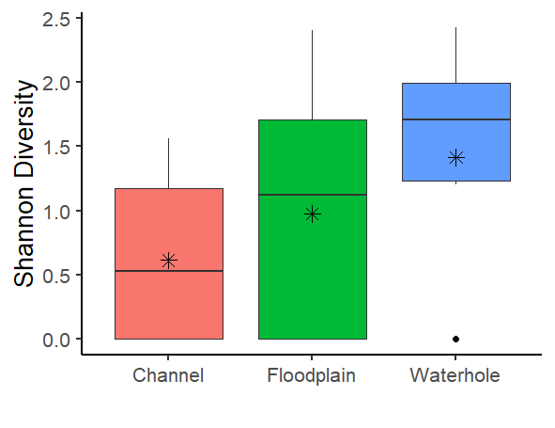

Figure Mean Shannon diversity (±SD) of waterbirds in each site type monitored during the 2019-20 water year. Black lines represent means, asterisks represent medians and dots represent outliers.

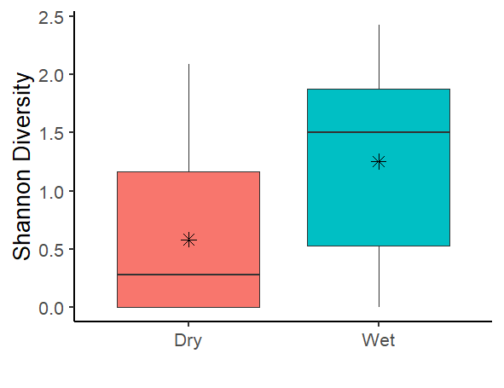

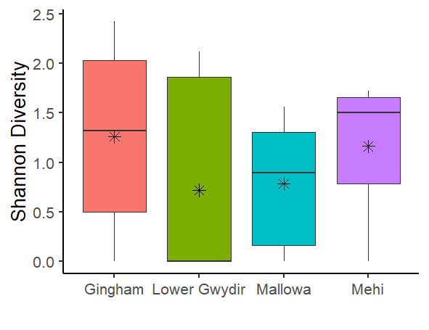

Figure Mean Shannon diversity (±SD) of waterbirds grouped by inundation status (top) and wetland (bottom) measured during the 2019-20 water year. Black lines represent means, asterisks represent medians and dots represent outliers.

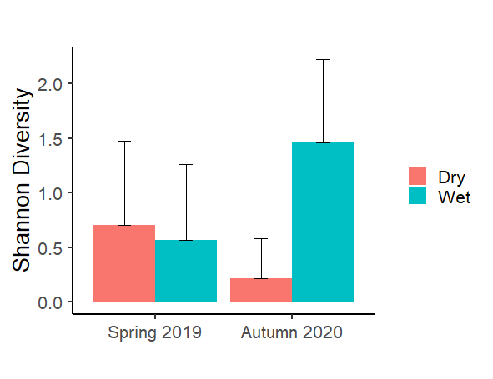

Figure Mean Shannon diversity (±SD) of waterbirds grouped by season measured during the 2019-20 water year. Black lines represent means, asterisks represent medians and dots represent outliers.

### Community composition

ANOSIM results showed that site type was the only factor to significantly influence waterbird community composition during the 2019-20 water year. Pairwise tests indicated channel sites differed from waterholes but floodplain sites were not significantly different from either channel or waterhole sites. Channel sites had a greater density of sacred kingfishers (*Todiramphus sanctus*, Figure 12).



Channel

Figure nMDS ordination of 2019–20 water year waterbird data grouped by site type.

### Waterbird breeding

Evidence of waterbird breeding was scarce during the 2019-20 surveys. One whistling kite was observed sitting on a nest in spring at Tellagara Bridge on the Mehi River, and a juvenile wedge-tailed eagle was observed at Boyanga Waterhole in the Gingham during the autumn 2020 survey.

### Waterbird functional guilds

Eleven functional guilds were represented across the surveyed sites in autumn 2020, with diving ducks, aquatic gallinules and swans; migratory Charadriiform shorebirds; and rails and shoreline gallinules absent from the spring 2019 survey (Figure 13). Grey   
teal, pacific black ducks (*Anas superciliosa*) and pink-eared ducks (*Malacorhynchus membranaceus*) contributed to the high abundances of dabbling and filter-feeding ducks in autumn 2020. Eurasian coots (*Fulica atra*) were by far the most abundant taxa of the diving ducks, aquatic gallinules and swans functional guild. The average number of functional guilds per site was higher in autumn (4.43 ± 2.84 guilds/site) than spring (2.73 ± 2.08 guilds/site).

*Figure 13 Waterbird abundance by functional guild across all sites measured during the 2019-20 water year.*

## Multiyear comparisons

### Waterbird species richness, density and diversity

Species richness in the spring 2019 survey was the lowest recorded across all years of the LTIM/MER project (Figure 14), owing to the extremely dry conditions experienced at the time. Increased availability of inundated habitat at sites during the autumn 2020 survey increased species richness to numbers comparable with previous autumn surveys completed in the 2014-19 period. Waterbird density in spring 2019 was the lowest it has been since 2014, being considerably lower than the 2017 and 2018 spring surveys (Figure 14). In contrast, the autumn 2020 survey had higher mean waterbird density than both 2018 and 2019 autumn surveys. Similar patterns were observed for Shannon Diversity (Figure 15).

Analysis of the full LTIM/MER waterbird dataset confirmed the ongoing influence of wetland, site type and extent of inundation on the richness, density and diversity of waterbird communities within the lower Gwydir. The Gingham Watercourse continues to support the most abundant and diverse waterbird communities of the wetlands surveyed, with floodplain wetland sites being consistently higher in all three measures of waterbird community composition.

These annual and season patterns highlight the transient nature of waterbird communities in the Gwydir, with their ability to move and find other refuges during drier times, and then take advantage of better conditions within the system when inflows provide more inundation and hence favourable conditions.

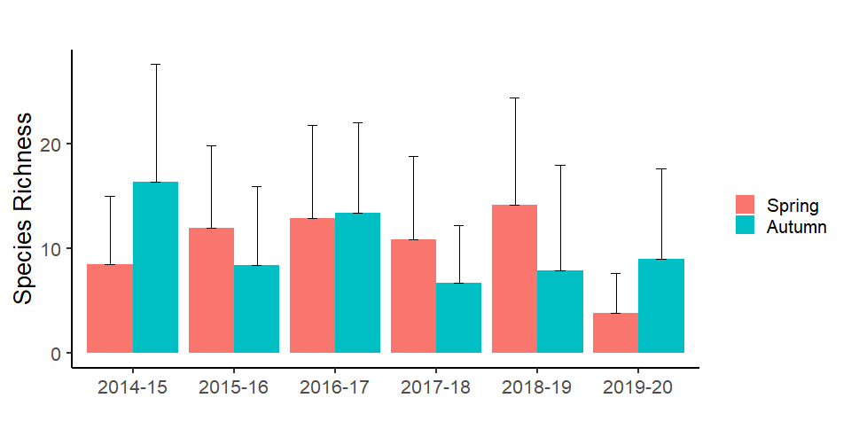

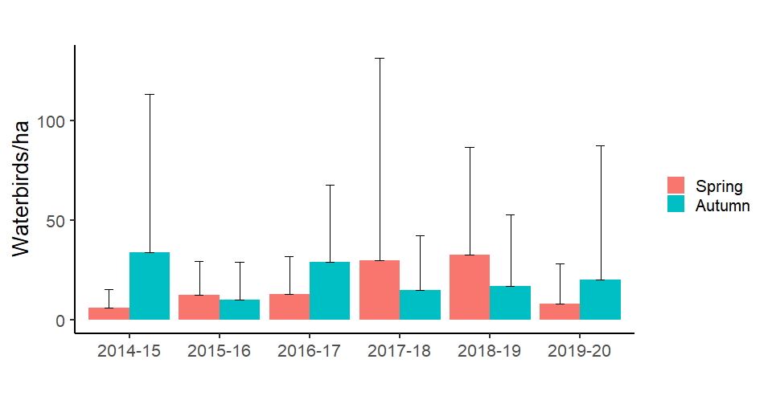

Figure Mean waterbird species richness (± SD; top) and densities (±SD; bottom) measured in each season across years of the LTIM/MER project

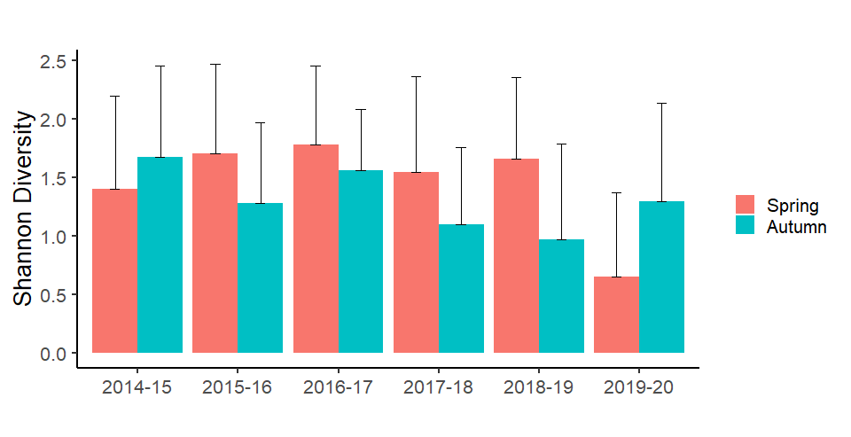

Figure Mean Shannon diversity (± SD) measured in each season across years of the LTIM/MER project.

Analysis of the community composition data from the LTIM/MER project showed that inundation extent had the greatest influence on waterbird community composition explaining 10% of the total variation in the data. Clear separation of sites based on inundation status was evident when data was plotted in ordination space (Figure 16). SIMPER results suggest that higher densities of pacific black duck, grey teal, Australian wood duck (*Chenonetta jubata*) and sacred kingfishers at wet sites were driving this separation (Table 2).



Figure Bootstrapped nMDS ordination showing differences in waterbird community composition between wet and dry inundation states.

Table Species indicated by SIMPER to separate groups based on inundation status and site type. Values are average log densities.

|  |  |  |  |
| --- | --- | --- | --- |
| **Inundation Status** | | | |
| Species | Dry | Wet | % Contribution |
| Pacific Black Duck | 0.18 | 0.95 | 12 |
| Grey Teal | 0.09 | 0.63 | 7 |
| Australian Wood Duck | 0.1 | 0.38 | 6 |
| Sacred Kingfisher | 0.09 | 0.19 | 5 |
| **Site type** | | | |
| Species | Channel | Waterhole | % contribution |
| Pacific Black Duck | 0.91 | 0.67 | 13 |
| Sacred kingfisher | 0.43 | 0.08 | 8 |
| Australian Wood Duck | 0.53 | 0.22 | 7 |
| Grey teal | 0.15 | 0.59 | 6 |
|  | Channel | Floodplain |  |
| Pacific Black Duck | 0.91 | 0.59 | 14 |
| Sacred Kingfisher | 0.43 | 0.08 | 9 |
| Australian Wood Duck | 0.53 | 0.21 | 7 |
|  | Waterhole | Floodplain |  |
| Pacific Black Duck | 0.67 | 0.59 | 8 |
| Grey Teal | 0.59 | 0.48 | 7 |
| Plumed Whistling-Duck | 0.53 | 0.32 | 6 |
| Australian Wood Duck | 0.22 | 0.21 | 5 |

Site type was also shown to significantly influence waterbird community composition explaining 6% of the total variation, and clear separation of site types evident in ordination space (Figure 17). Again, densities of ducks and kingfishers drove these differences (Table 2). Pacific black ducks showed highest density in channel sites, followed by waterholes and floodplain. Sacred kingfishers were most abundant at channel sites and had equal abundances in waterholes and floodplain sites. Australian wood ducks had highest densities at channel sites and similar abundance at waterholes and floodplain sites. Grey teal were most abundant at waterhole sites followed by floodplain and channel sites. Plumed Whistling-Ducks (*Dendrocygna eytoni*) were more abundant at waterhole sites compared with floodplain sites. While the season, year and wetland factors showed significant influences on the data, combined they explained less than 5% of the total variance.



Channel

Figure Bootstrapped nMDS ordination showing differences in waterbird community composition between site type.

# Conclusion

The lower Gwydir system experienced contrasting water availability through the 2019-20 water year, from extremely dry and drought conditions at the beginning of the season, to more widespread wetland inundation and favourable conditions in autumn/winter of 2020. Waterbird abundance and richness reflected these differences in water availability, with waterbird species richness the lowest it has been in 6 years of LTIM/MER monitoring in spring 2019. A noticeable influx of ducks, swans and geese, especially at floodplain wetland sites within the Gingham Watercourse boosted waterbird communities back to average or above average abundance and diversity in autumn 2020 following widespread above average rainfall and wetland inflows. During the 2019-20 year, the Gwydir wetland system also supported at least four vulnerable species and latham’s snipe listed on international migratory bird agreements.

# References

Anderson, M., Gorley R.N. and Clarke R.K. 2008. Permanova+ for Primer: Guide to Software and Statistical Methods. Primer-E Limited.

Anderson, M.J. 2001. Permutation tests for univariate or multivariate analysis of variance and regression. Canadian Journal of Fisheries and Aquatic Sciences **58:** 626–639.

BirdLife Australia checklist. 2019. Database accessed from <http://www.birdlife.org.au/conservation/science/taxonomy/>

Clarke, K.R. 1993. Non‐parametric multivariate analyses of changes in community structure. *Austral Ecology* **18:** 117–143.

Commonwealth of Australia. 2019. *Commonwealth Environmental Water Office Long Term Intervention Monitoring Project Gwydir River system Selected Area –5-year Evaluation Report*. Commonwealth of Australia 2019.

Spencer, J.A., Heagney, E.C. and Porter, J.L. 2010. *Final report on the Gwydir waterbird and fish habitat study*. NSW Wetland Recovery Program. Rivers and Wetlands Unit, Department of Environment, Climate Change and Water NSW and University of New South Wales, Sydney.

# Attachment A: 2019-20 waterbird species list

| Common Name | Scientific name | Bird Type | Functional group |
| --- | --- | --- | --- |
| Australasian Darter | Anhinga novaehollandiae (Gould, 1847) | waterbird | Piscivores |
| Australasian Grebe | Tachybaptus novaehollandiae (Stephens, 1826) | waterbird | Piscivores |
| Australasian Shoveler | Anas (Spatula) rhynchotis Latham, 1801 | waterbird | Raptors |
| Australian Hobby | Falco (Falco) longipennis Swainson, 1838 | raptor | Raptors |
| Australian Pelican | Pelecanus conspicillatus Temminck, 1824 | waterbird | Piscivores |
| Australian Reed-Warbler | Acrocephalus (Acrocephalus) australis (Gould, 1838) | reed-inhabiting passerinces | Reed-inhabiting passerines |
| Australian White Ibis | Threskiornis molucca (Cuvier, 1829) | waterbird | Large wading birds |
| Australian Wood Duck | Chenonetta jubata (Latham, 1801) | waterbird | Grazing ducks and geese |
| Banded Lapwing | Vanellus (Lobivanellus) tricolor (Vieillot, 1818) | waterbird | Australian-breeding Charadriiform shorebirds |
| Black Swan | Cygnus (Chenopis) atratus (Latham, 1790) | waterbird | Diving ducks, aquatic gallinules and swans |
| Black-fronted Dotterel | Elseyornis melanops (Vieillot, 1818) | waterbird | Australian-breeding Charadriiform shorebirds |
| Black-winged Stilt | Himantopus himantopus (Linnaeus, 1758) | waterbird | Australian-breeding Charadriiform shorebirds |
| BrolgaV | Grus (Mathewsia) rubicunda (Perry, 1810) | waterbird | Large wading birds |
| Brown Falcon | Falco (Ieracidea) berigora Vigors & Horsfield, 1827 | raptor | Raptors |
| Cattle EgretJ | Ardea (Bubulcus) ibis Linnaeus, 1758 | waterbird | Piscivores |
| Dusky Moorhen | Gallinula (Gallinula) tenebrosa Gould, 1846 | waterbird | Diving ducks, aquatic gallinules and swans |
| Eastern Great EgretCJ | Ardea (Casmerodius) modesta J.E. Gray, 1831 | waterbird | Piscivores |
| Eurasian Coot | Fulica atra Linnaeus, 1758 | waterbird | Diving ducks, aquatic gallinules and swans |
| Freckled DuckV | Stictonetta naevosa (Gould, 1841) | waterbird | Dabbling and filter-feeding ducks |
| Glossy IbisM | Plegadis falcinellus (Linnaeus, 1766) | waterbird | Large wading birds |
| Great Cormorant | Phalacrocorax (Phalacrocorax) carbo (Linnaeus, 1758) | waterbird | Piscivores |
| Grey Teal | Anas (Nettion) gracilis Buller, 1869 | waterbird | Dabbling and filter-feeding ducks |
| Hardhead | Aythya (Nyroca) australis (Eyton, 1838) | waterbird | Diving ducks, aquatic gallinules and swans |
| Hoary-headed Grebe | Poliocephalus poliocephalus (Jardine & Selby, 1827) | waterbird | Diving ducks, aquatic gallinules and swans |
| Intermediate Egret | Ardea (Mesophoyx) intermedia Wagler, 1829 | waterbird | Piscivores |
| Latham's SnipeJRM | Gallinago (Gallinago) hardwickii (J.E. Gray, 1831) | waterbird | Migratory Charadriiform shorebirds* |
| Little Black Cormorant | Phalacrocorax (Phalacrocorax) sulcirostris (Brandt, 1837) | waterbird | Piscivores |
| Little Grassbird | Megalurus gramineus (Gould, 1845) | reed-inhabiting passerinces | Reed-inhabiting passerines |
| Little Pied Cormorant | Microcarbo melanoleucos (Vieillot, 1817) | waterbird | Piscivores |
| Magpie GooseV | Anseranas semipalmata (Latham, 1798) | waterbird | Grazing ducks and geese |
| Masked Lapwing | Vanellus (Lobipluvia) miles (Boddaert, 1783) | waterbird | Australian-breeding Charadriiform shorebirds |
| Nankeen Kestrel | Falco (Tinnunculus) cenchroides Vigors & Horsfield, 1827 | raptor | Raptors |
| Nankeen Night-Heron | Nycticorax caledonicus (Gmelin, 1789) | waterbird | Piscivores |
| Pacific Black Duck | Anas (Anas) superciliosa Gmelin, 1789 | waterbird | Dabbling and filter-feeding ducks |
| Pied Cormorant | Phalacrocorax (Phalacrocorax) varius (Gmelin, 1789) | waterbird | Piscivores |
| Pink-eared Duck | Malacorhynchus membranaceus (Latham, 1801) | waterbird | Dabbling and filter-feeding ducks |
| Plumed Whistling-Duck | Dendrocygna (Leptotarsis) eytoni (Eyton, 1838) | waterbird | Grazing ducks and geese |
| Purple Swamphen | Porphyrio (Porphyrio) porphyrio (Linnaeus, 1758) | waterbird | Rails and shoreline gallinules |
| Red-kneed Dotterel | Erythrogonys cinctus Gould, 1838 | waterbird | Australian-breeding Charadriiform shorebirds |
| Royal Spoonbill | Platalea (Platalea) regia Gould, 1838 | waterbird | Large wading birds |
| Sacred Kingfisher | Todiramphus (Todiramphus) sanctus (Vigors & Horsfield, 1827) | Kingfisher | Tree Kingfishers |
| Straw-necked Ibis | Threskiornis spinicollis (Jameson, 1835) | waterbird | Large wading birds |
| Swamp Harrier | Circus approximans Peale, 1848 | raptor | Raptors |
| Unidentified Bird of Prey | Unidentified Bird of Prey | raptor | Raptors |
| Unidentified Duck | Unidentified Duck | waterbird | Dabbling and filter-feeding ducks |
| Wedge-tailed Eagle | Aquila (Uroaetus) audax (Latham, 1801) | raptor | Raptors |
| Whiskered Tern | Chlidonias (Pelodes) hybrida (Pallas, 1811) | waterbird | Piscivores |
| Whistling Kite | Haliastur sphenurus (Vieillot, 1818) | raptor | Raptors |
| White-bellied Sea-EagleV | Haliaeetus (Pontoaetus) leucogaster (Gmelin, 1788) | raptor | Raptors |
| White-faced Heron | Egretta novaehollandiae (Latham, 1790) | waterbird | Piscivores |
| White-necked Heron | Ardea (Ardea) pacifica Latham, 1801 | waterbird | Piscivores |
| Yellow-billed Spoonbill | Platalea (Platibis) flavipes Gould, 1838 | waterbird | Large wading birds |

J= listed under JAMBA; C= listed under CAMBA; R= listed under ROKAMBA; V=Vulnerable (NSW BC Act);   
E= Endangered (NSW BC Act); M= Migratory (EPBC Act)