**Fish Category 1-3 (River) Gwydir MER 2020 – Preliminary Findings**

# Introduction

Native fish species in the Murray-Darling Basin (MDB) have suffered considerable declines in both abundance and distribution over the past 50 years (Lintermans 2007). These declines have occurred in all valleys within the MDB including the Gwydir valley, a tributary of the Barwon-Darling in northern New South Wales (NSW). Due to   
natural (e.g. droughts) and anthropogenic factors (e.g. river regulation), the fish community in the Gwydir valley is considered to be under constant stress and has consistently been reported to be in poor health (Gilligan *et al*. in prep.). In recent times, there has been considerable efforts directed towards the use of environmental water to help native fish species recover in the Gwydir and distributaries.

Native fish species within the Gwydir valley rely on a range of hydrological conditions as environmental drivers to complete processes in their lifecycle (Humphries *et al.* 1999, Koehn *et al.* 2014). Increased flows provide spawning cues, disperse fish larvae, allow immigration and emigration between habitat types or habitat patches, and provide access to food sources (Reynolds 1983, Balcombe *et al.* 2006, Rolls & Wilson 2010, Gilligan *et al*. in prep.). Effective management of water for the environment involves improving the health and building resilience into native fish populations (Hanisch *et al.* 2012). In effect, this ensures that species can persist when conditions are less then optimal and then “boom” when conditions are favourable (Gilligan *et al*. in prep.).

The aim of this section of the MER project was to benchmark and describe changes in the fish community abundance, biomass and health within the Gwydir River Selected Area (Selected Area), with a particular emphasis on the outcomes of environmental water delivery. Surveys for this update were undertaken in late May and July 2020 as such detailed analysis will be reported in the 2021 annual report.

# Methods

Data was collected from 16 sites between 25 May to 6 July, 2020 within two monitoring zones across the Selected Area for *Cat III Fish River* analyses; Gwydir and Mehi rivers (Figure 1, Figure 2).

Sampling effort at each site included a combination of electrofishing and bait trapping (Commonwealth of Australia 2014). Electrofishing included small and medium boats (2.5 kW or 5 kW Smith-Root electrofisher units respectively), backpack (Smith Root model LR20) or a combination of boat and backpback. Ten unbaited traps were also deployed for a minimum of two hours at each site. Traps were set haphazardly throughout the site in water depths of 0.5 m to 1 m.

Fyke netting was also undertaken (Figure 3), but on separate trips to the electrofishing as part of the *Cat I Fish River* assessment. Ten double wing small mesh nets (3 mm mesh, Figure 3) were deployed overnight for a minimum of 12 hrs at 10 sites across the lower Gwydir River. All fish were identified to species level, measured to the nearest millimetre and weighed to the nearest gram before being released.

# Preliminary results

* All sites had sufficient water to allow the full suite of sampling methods and effort to be undertaken.
* Nine native and three exotic fish species were captured (Table 1, Figure 3).
* Young-of-year (less than 1 year old) of eight native fish species were collected (Table 1).
* Of the nine native fish sampled, golden perch was the only species of which no young-of-year were captured.
* Young-of-year of three exotic species were also collected (Table 1).
* Generally, reasonable numbers of native fish were sampled at most sites, with some sites returning relatively large catches e.g. fyke netting at Cat 1 Gwydir River Site 4 = >2,500 fish.
* Native crustaceans including the common yabby (*Cherax destructor*), freshwater shrimp (*Paratya australiensis*)and freshwater prawn (*Macrobrachium australiensei*) were also detected at most sampling sites.

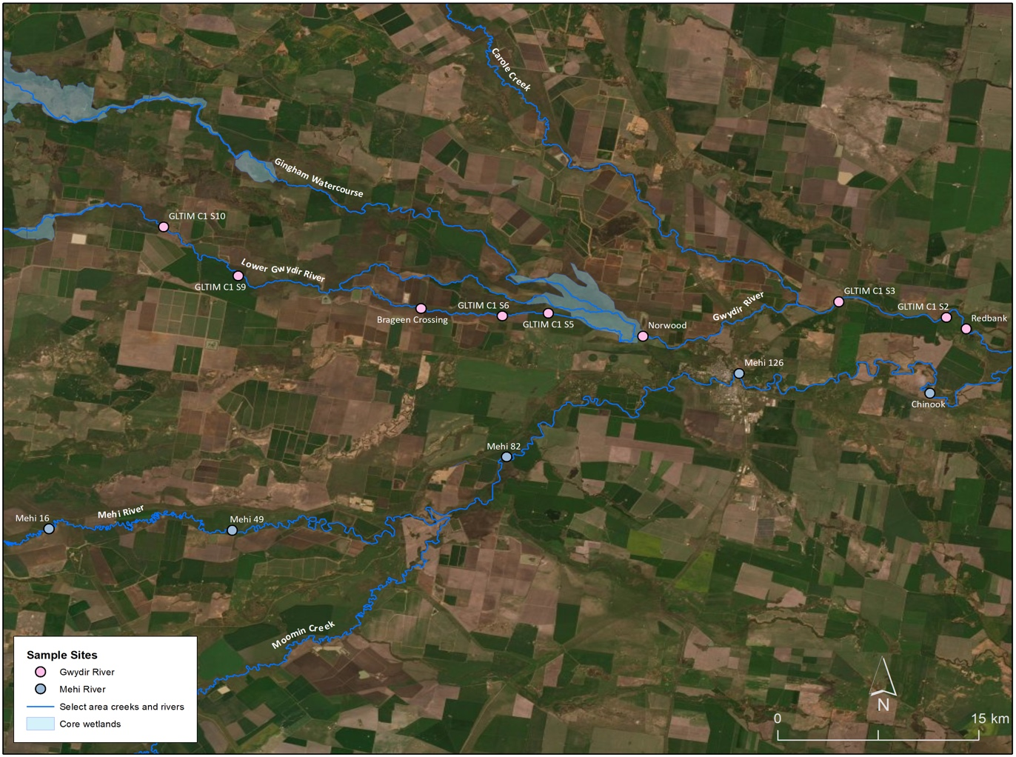

Figure Locations of sampling sites in the lower Gwydir and Mehi rivers surveyed as part of MER Fish (River) monitoring, June 2020.

Figure Sampling site in the lower Gwydir River surveyed as part of MER Fish (River) monitoring, June 2020.

Table Preliminary list of species (native and exotic) collected during MER Fish (River) monitoring, 2020.

|  |  |  |
| --- | --- | --- |
| **Species** | **Sampled during study** | |
| *Native* | Adult | Juvenile |
| Freshwater catfish | ✓ | ✓ |
| Bony herring | ✓ | ✓ |
| Murray-Darling rainbowfish | ✓ | ✓ |
| Unspecked hardyhead | ✓ | ✓ |
| Carp-gudgeon | ✓ | ✓ |
| Murray cod | ✓ | ✓ |
| Australian smelt | ✓ | ✓ |
| Spangled perch | ✓ | ✓ |
| Golden perch | ✓ | 🗶 |
| *Exotic* | | |
| Common carp | ✓ | ✓ |
| Goldfish | ✓ | ✓ |
| Eastern mosquitofish | ✓ | ✓ |

Figure Fyke netting in the lower Gwydir River as part of MER Fish (River) monitoring, May 2020.

*Figure 4 Spangled perch (Leiopotherapon unicolor) collected in the lower Gwydir River as part of MER Fish (River) monitoring, June 2020.*

# Discussion

Water levels across the lower Gwydir valley were higher during the 2020 sampling round compared to those of recent years (Figure 2, Figure 3). Following a number of years of low rainfall and drought, areas of the Gwydir valley experienced a number of large fish kills during 2019, including in a section of the Mehi River upstream of Moree within the sampled river reach. The full impact of these events was unknown but it was assumed that the fish communities would have suffered and that there was likely significant losses among some species. However, the current surveys highlights the resilience of native fish in the Gwydir, as most native species present had spawned and recruited in the past year and, in general, most individuals sampled across all ages and sizes appeared to be in good health (Figure 4).

These preliminary findings emphasise the importance of monitoring our environment, both from an environmental water but also from a general fisheries management perspective. Monitoring and evaluation helps in our understanding of the effects of extreme climatic events as has been experienced across the Gwydir valley over the last few years, and is critical for managing our native fish into the future. The sampling undertaken in 2020 provides information that will assist in the ongoing management of our environment to ensure we protect and preserve the native fish species in the Lower Gwydir and will help to ensure the maximum benefit from releases of water for the environment.

# References

Balcombe, S.R., Arthington, A.H., Foster, N.D., Thoms, M.C., Wilson, G.G. and Bunn, S.E. 2006. Fish assemblages of an Australian dryland river: abundance, assemblage structure and recruitment patterns in the Warrego River, Murray–Darling Basin. *Marine and Freshwater Research*, 57(6), 619-633

Commonwealth of Australia. 2014. Commonwealth Environmental Water Office Long Term Intervention Monitoring Project Gwydir River System Selected Area, Canberra.

Hanisch, S.L., Riley, S.J. and Nelson, M.P. 2012. Promoting wildlife health or fighting wildlife disease: Insights from History, Philosophy, and Science. *Wildlife Society Bulletin*, 36, 477-482.

Humphries P., King A.J. and Koehn J.D. 1999. Fish, flows and flood plains: links between freshwater fishes and their environment in the Murray-Darling River system, Australia. *Environmental Biology of Fishes*, 56, 129-151.

Koehn, J.D., King, A.J., Beesley, L., Copeland, C., Zampatti, B.P. and Mallen‐Cooper, M. 2014. Flows for native fish in the Murray‐Darling Basin: lessons and considerations for future management. *Ecological Management & Restoration*, 15, 40-50.

Lintermans, M. 2007. Fishes of the Murray-Darling Basin: An introductory guide. Murray-Darling Basin Authority. Canberra.

Rolls, R.J., Wilson, G.G. 2010. Spatial and Temporal Patterns in Fish Assemblages Following an Artificially Extended Floodplain Inundation Event, Northern Murray-Darling Basin, Australia. *Environmental Management*, 45, 822–833. 

Reynolds, L.F. 1983. Migration patterns of five fish species in the Murray-Darling River system. *Marine and Freshwater Research*, 34, 857-871.