Appendix F: Pool Refugia (Contingency Monitoring)
HYDROLOGY | FOOD WEBS | VEGETATION | WATERBIRDS | FISH

This report was submitted and reviewed by CEWO in August 2020.
Key results are included in the summary report.

Introduction
Extremely dry and warm conditions in winter and spring of 2019 across the Gwydir valley, combined with very low inflows, resulted in cease-to-flow conditions in the channels across much of the lower Gwydir system in late 2019. By October, all channels had ceased to flow for over 50 days with the Mehi River not having run for more than 90 days. Many pools in these systems had dried with only a small selection of larger pools providing refuge for the aquatic animals in the rivers. In response, the CEWO (Commonwealth Environmental Water Office) and NSW DPIE (Department of Planning, Industry and Environment) worked together, to deliver three low flow release events of water for the environment across the summer. These occurred in October and December 2019 and January 2020. These flows aimed to:
- Maintain and provide access to refuge habitat, increase surface water connectivity and improve water quality in pools, and
- Increase native fish survival.

Based on field observations and trial watering events, NSW agencies with input from the Environmental Contingency Allowance Operations Advisory Committee (ECAOAC) developed a low flow release regime in 2016. The low flow release regime seeks to avoid the drying out of key refuge sites by providing a continuous low flow from Copeton dam 40-60 days after flows have ceased. The delivery of water for the environmental during the 2019/20 summer was informed by the low flow release regime developed in 2016.
Strictly adhering to the principles of the low flow release regime was challenged by the extremely dry condition of the Gwydir system in 2019. The NSW DPIE’s Extreme Events Policy outlines 4 stages of drought. The Gwydir regulated river system commenced the 2019/20 water year in stage 3 water restrictions (Water NSW 2020). Management arrangements applied in the Gwydir under stage 3 required that:
- Any releases from Copeton Dam for General Security licences would be grouped together
- The accounting point for General Security licenses was at Copeton Dam.

This meant that environmental deliveries had to be linked to other flow deliveries through the system, restricting flexibility in the timing of water for the environment deliveries. In addition, because deliveries were accounted for at Copeton Dam, all losses that occurred downstream were accounted against the environmental licences, so a relatively large amount of water had to be ordered to ensure sufficient water made it to the mid Gwydir.
Monitoring of these low flow releases was undertaken as part of the MER contingency monitoring program. This included low flow refuge monitoring at a selection of sites across the Gwydir, Mehi and Carole channels to assess how habitat and food resources change during cease-to-flow periods and following reconnection. In addition, the Gwydir MER team, in collaboration with DPIE undertook two rounds of incident response monitoring to assess current water quality conditions in the Gwydir and Mehi channels during the environmental water deliveries. This allowed for real-time adaptive management of these events.

Antecedent conditions
Annual rainfall at Moree for the 2019 calendar year was 125.4 mm making it the driest year over 54 years of records (1965-2019), and being 152 mm less than the next driest year (2002, Figure 1). Rainfall in 2019 was less than a quarter of the long-term median, 543.5 mm. This had obvious implications for river flows, but also for the health of the riparian trees along the river, with many trees showing signs of stress (dead foliage etc.) during the latter part of 2019.
Cease to flow periods were extensive leading up to the delivery of the first low flow release in October 2019. The Mehi River lost connectivity for 125 days, Carole Creek had stopped running for 104 days, and the Gwydir River for 87 days (Table 1). This is the longest period of disconnection down these systems in over 40 years. No flow periods for the remainder of the season were shorter, being broken by the low flow releases (Table 1).

Figure 1 Annual rainfall measured at the Moree combined station (BOM station no.53048- now closed 1965 – 1995) and Moree Aero (BOM station no.53115 1996 – 2020).
Data accessed from http://www.bom.gov.au/climate/data/

Table 1 Cease to flow periods during summer 2019 in the Selected Area.
Water Course | Gauge | Cease to flow periods (<1 ML/d)
Water Course | Gauge | Prior to Event 1 (Days) | Prior to Event 2 (Days) | Priod to Event 3 (Days)
Gwydir River | Gwydir River at Yarraman (418004) | 87 | 29 | 11
Gingham Channel
Lower Gwydir River
Carole Creek | Carole Creek D/S  Regulator (418011) | 104 | 29 | 13
Mehi River | Mehi River at Moree (418002) | 125 | 25 | 16

Refuge pool maintenance flow deliveries
The first of the three refuge pool maintenance flows occurred during October-November 2019 (Figure 2). During this event, delivery commenced from Tareelaroi Weir on the Gwydir River down the Mehi and lower Gwydir Rivers on 15 October 2019. Deliveries commenced below Tareelaroi at 50 ML/d, ramping up to 150 ML/d in the Mehi and
250 ML/d in the Gwydir River. Additional stock and domestic deliveries were made down the Mehi channel in association with this flow, producing a flow peak at Moree of 512 ML/d on 16 November 2019. A combination of water for the environment and stock and domestic flows was also delivered along Carole Creek, with a flow peak of 292 ML/d occurring on 12 November 2019 (Figure 2). A total of 5,200 ML of environmental water was delivered during this event, being a combination of both State and Commonwealth managed water. This event provided connection down to Gundare Weir on the Mehi River, Tyreel Weir on the Gwydir River and past Garah on Carole Creek.
In response to persistent dry conditions following the first pool maintenance flow
delivery, a second flow began on 10 December 2019. This was a smaller event of
1,800 ML of Commonwealth high security water and lasted for approximately 13 days. During this second event, flows peaked at around 115 ML/d in Carole Creek and
100 ML/d in the Mehi and lower Gwydir systems. This flow again reached Tyreel Weir on the lower Gwydir River and Garah on Carole Creek, but stopped between Moree and Combadello Weir on the Mehi River.
To ensure refuge pools were maintained through the summer, a third pool maintenance flow delivery was made in January 2020 (Figure 2). Deliveries began on 5 January 2020 and continued for 23 days. A total of 5,000 ML was delivered during this event being a combination of State and Commonwealth water. Flows reached Brageen crossing on the lower Gwydir, Tillaloo on the Gingham, downstream of Combardello Weir on the Mehi and to near Garah on Carole Creek. There were small follow-up natural flows down all channels from local rainfall immediately after this environmental flow event (Figure 2).
Event 1 Event 2 Event 3

Figure 2 Flow hydrograph for gauging stations in the Gwydir River, Mehi River and Carole Creek during the Refuge pool maintenance flows in the 2019-20 water year.
In late 2019, there were sporadic and small rainfall events around Moree (Figure 3).
After Christmas 2019, there was more consistent rainfall, with several larger events on
17 January (51 mm) and 24 January (49 mm), followed by additional events in
February and March 2020 (Figure 3). Maximum daily temperatures over the survey period ranged from 19.6–45.9 ºC, with minimum daily temperatures ranging from
7.1–28.1ºC (Figure 3).

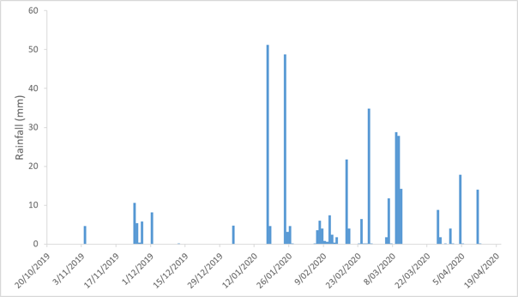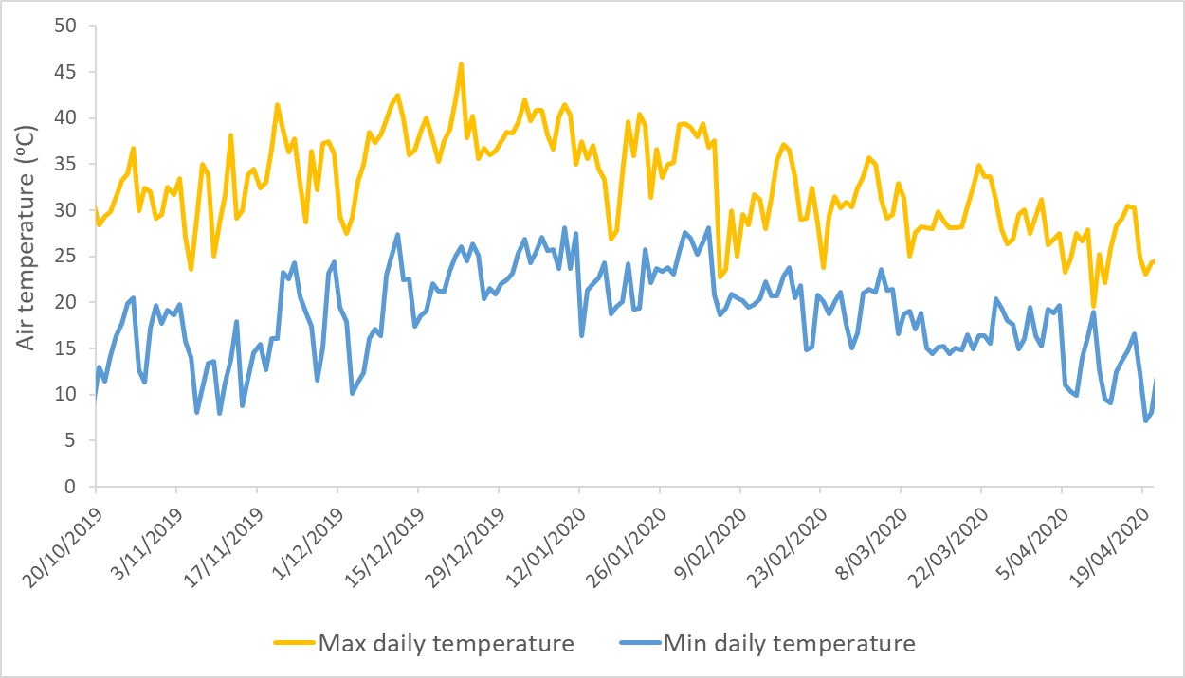
Figure 3 Rainfall (top) and air temperature (bottom) experienced at Moree Airport (BOM Station no: 53115) during the survey period.

Monitoring Methods

Incident monitoring
Incident monitoring was first undertaken during the delivery of the pool maintenance flow 4-5 November 2019, this was in response to poor water quality and fish kills in the Mehi River associated with the flow delivery. Field surveys were concentrated on the Mehi River between Moree and Gundare Weirs (Figure 4). Several sites were also visited on the Gwydir River, Carole and Moomin Creeks. Water quality measurements (temperature ºC, dissolved oxygen (DO) mg/L, specific conductivity µS/cm, salinity ppt, pH, turbidity NTU) were measured using a Hydrolab multi-probe water meter at the surface (0.1 m) and at depth if pools exceeded 1 m depth. Observations and photographs were recorded, and the field team were involved in the collection of dead fish specimens for later otolith removal by DPI Fisheries. Regular communications with staff from DPIE, CEWO and DPI Fisheries were maintained to allow real-time management decisions to be made in light of the findings.
A second incident monitoring survey was undertaken on 10 January 2020 during the release of the third pool maintenance flow, as initial reports from DPIE suggested poor quality water was associated with the flow in the Mehi River upstream of Moree. This survey aimed to identify and monitor the front of the flow pulse in the Mehi River, and assess the condition of residual pools and the river channel downstream of the flow front between Moree and Combardello Weir (Figure 5). Once again, water quality parameters were measured using a Hydrolab multi-probe water meter at various depths at each location, and photographs and field notes compiled of the current conditions.
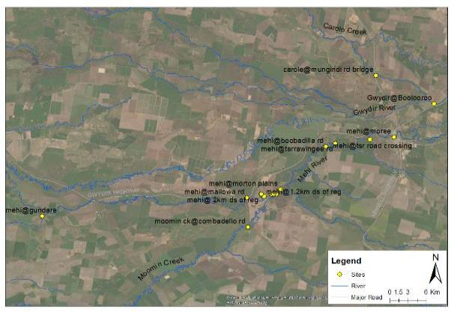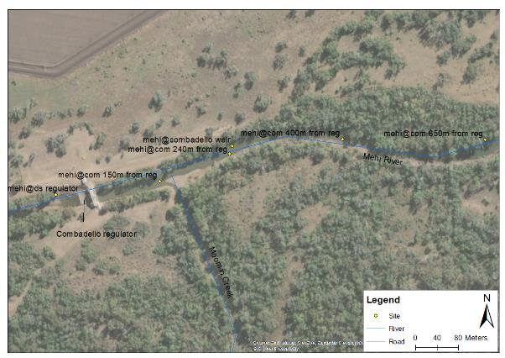
Figure 4 Location of incident response monitoring sites visited on 4-5 November 2019.

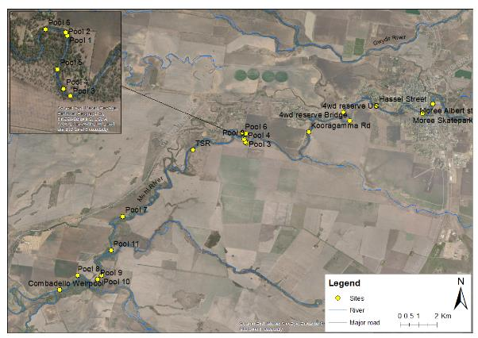
Figure 5 Location of incident response monitoring sites visited on 10 January 2020.

Pool refuge monitoring
Six sites were chosen for pool refuge monitoring in the Gwydir and Mehi rivers, Carole Creek and Gingham Watercourse (Figure 6, Table 2). These represent some of the larger more permanent pools in the lower Gwydir system. Sites were established on 21-22 October 2019, and were visited four times until March 2020 to download loggers and collect data. At each site, spot water quality measurements (temperature ºC, DO mg/L, specific conductivity µS/cm, salinity ppt, pH, turbidity NTU) were taken using a Hydrolab multi-probe water meter. Water samples were also collected for nutrient (nitrogen and phosphorus) analysis in the laboratory. Both macroinvertebrates and microinvertebrates were sampled at each site and later identified in the laboratory following the standard methods presented in Hale et al. (2014). In addition, at each site, time lapse cameras were set with a photo interval of six hours to capture changes in water level and habitat conditions over time. At five sites (Table 2), DO and temperature loggers were deployed at the surface of these pools, recording measurements every 10 minutes, to allow tracking of diurnal and long-term changes in these parameters. A mixture of D-opto and Mini-Dot DO and temperature loggers were deployed and suspended off a buoy using wire and tethered to a besser block to keep them in place at each location (Figure 7). Enough slack was left in the wire during initial deployment to allow for variation in water levels over time. Due to the close proximity to town and the heightened chance of theft, smaller HOBO temperature only loggers were installed at the Mehi River at Moree. Here, one logger was suspended near the surface and a second approximately 20 cm from the river bed by a cord attached to a log in the river. Temperature recordings were logged every 10 minutes. Due to the very low water levels at Gingham Waterhole on the Gingham channel, no loggers were deployed at this site.

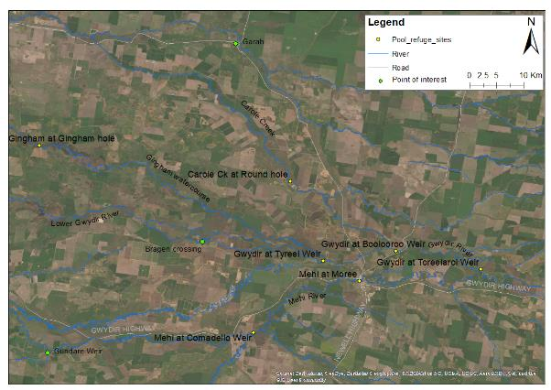
Figure 6 Location of monitoring sites undertaken as part of the pool refuge maintenance flow monitoring.

Table 2 Location and parameters collected at pool refuge monitoring sites within the Gwydir River system (DO=dissolved oxygen).
Site | latitude | longitude | Data collection | Comments
Mehi River at Moree | -29.4692 | 149.8394 | Spot water quality, nutrients, invertebrates, temp loggers, fixed camera | Logger period of record (18/10/19 – 23/4/20)
Gwydir River at Tareelaroi Weir | -29.4496 | 150.0419 | Spot water quality, nutrients, invertebrates, DO and temp loggers, fixed camera | Logger period of record (20/10/19 – 12/12/19). Logger and camera stolen
Gwydir River at Boolooroo Weir | -29.419 | 149.9002 | Spot water quality, nutrients, invertebrates, DO and temp loggers, fixed camera | Logger period of record (20/10/19 – 13/1/20). Logger stolen
Mehi River at Combadello Weir | -29.556 | 149.6618 | Spot water quality, nutrients, invertebrates, DO and temp loggers, fixed camera | Logger period of record (20/10/19 – 22/4/20)
Carole Creek at Round hole | -29.3031 | 149.723 | Spot water quality, nutrients, invertebrates, DO and temp loggers, fixed camera | Logger period of record (20/10/19 – 22/4/20)
Gwydir River at Tyreel Weir | -29.4357 | 149.7785 | Spot water quality, nutrients, invertebrates, DO and temp loggers, fixed camera | Logger period of record (1/11/19 – 15/1/20). Logger stolen
Gingham Watercourse at Gingham hole | -29.2429 | 149.3035 | Spot water quality, nutrients, invertebrates, fixed camera | Site too low to install logger
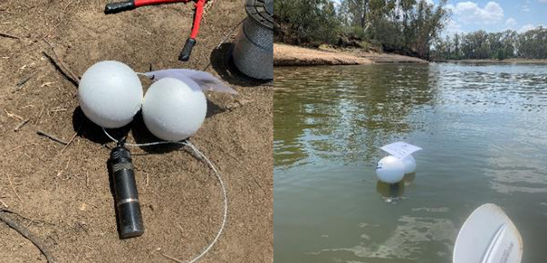
Figure 7 Dopto dissolved oxygen/temperature logger secured under floats by wire (left) and deployed in Tareelaroi weir (right).

Findings

Incident response monitoring

November pool maintenance flow event
Very low dissolved oxygen (0.54 mg/L, Figure 8) was observed at Combadello Weir on the morning of 4 November 2019 following the arrival of the pool maintenance flow into the weir pool the previous night. The water had a distinct black appearance and there were dead fish visible on the surface and schools of smaller fish mouthing for oxygen at the surface of the pool (Figure 9). All other parameters measured were within acceptable ranges (Appendix B: Food Webs). Sampling downstream of the Combadello regulator suggested that dissolved oxygen levels were slightly higher but still relatively low, at 4.26 mg/L directly below the regulator (influenced by localised aeration through the regulator), then dropping to between 1.65 and 2.44 mg/L, 1.2 and 2 km below the regulator respectively (Figure 8). Sampling further upstream towards Moree showed improved dissolved oxygen conditions (5.75–8.56 mg/L, Figure 8) suggesting the poor quality water was confined to the front of the flow pulse around Combadello Weir. Given the low dissolved oxygen concentrations below Combadello, and the improved quality water upstream, Combadello regulator was closed mid-morning on 4 November to allow water in the weir pool to mix and improve in quality before flows were again passed downstream.
4 Nov 2019 5 Nov 2019
Figure 8 Dissolved oxygen readings taken from the Gwydir, Mehi, Carole and Moomin channels during the November 2019 monitoring.
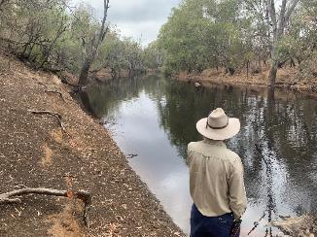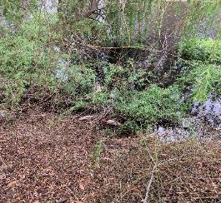
Figure 9 Combadello weir pool at 10am on the 4 November 2019 showing blackwater (left) and dead fish floating on the surface of the pool (right).
To further monitor changes in water quality in Combadello Weir pool, measurements were taken from 4 locations (150 m, 240 m, 400 m and 650 m upstream of the regulator) at around 4 pm on 4 November, and again at 9 am and 12 noon on 5 November. By
4 pm on 4 November, DO levels had increased throughout the weir pool, with
surface concentrations ranging from 2.19 mg/L near the regulator to 4.82 mg/L 650 m
upstream (Figure 10). By 12 noon on 5 November, DO concentrations had risen to between 5.37 – 6.31 mg/L and were relatively consistent throughout the weir pool. By the morning of the 5 November, a large number (200-300) dead fish were observed in the Combadello weir pool. These consisted mainly of Bony herring, but also Murray cod, golden perch and carp of various sizes (Figure 11). No small bodied native fish species were observed. It is likely that these fish were a combination of fish killed by hypoxic water within the weir pool, plus fish that had died upstream and were washed down into the weir pool with the flow.
4 pm 4 Nov 9am 5 Nov 12 pm 5 Nov
Figure 10 Dissolved oxygen concentrations within Combadello weir pool measured on the 4-5 November 2019.
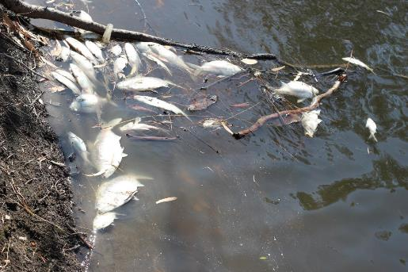
Figure 11 Dead fish that had collected in Combardello weir pool 5 November 2019.

Due to the regulator being closed on 4 November, some of the water that had built up in Combadello Weir flowed down Moomin Creek. Sampling in Moomin Creek on
the Combadello Road crossing on the morning of 5 November showed low DO concentrations of 2.44 mg/L, but there was no evidence of dead fish or other impacted aquatic biota. Sampling in Gundare Weir on the Mehi, and in the Gwydir and Carole Creeks suggested that there were no water quality issues in these systems arising from the water deliveries (Figure 8, Appendix A: Gwydir River Hydrology).

January pool maintenance flow event
Monitoring of the January pool replenishment flow focussed on the flow front was in the reach between Kooragamma Road and Pool 3 upstream of Tarawingee Road (Figure 13). At all monitoring sites upstream of the flow front, dissolved oxygen concentrations fell between 3.15 – 4.8 mg/L, posing reduced stressors for aquatic biota. Other parameters measured were also within acceptable limits (Appendix B: Food Webs).

Figure 12 Dissolved oxygen concentrations measured at locations around Moree in the Mehi River during monitoring of the January pool replenishment flow.
A number of pools downstream of the flow front were sampled to explore the extent and water quality of existing refuge pools in the reach down to the Combadello regulator. The pools surveyed tended to be smaller and more fragmented upstream of the regulator, being less than 30 m in length and 1m deep (Pools 1-6, Table 3), whereas downstream through the Morton Plains property and into Combadello weir pool, pools were longer (>100 m) and generally deeper (0.5–2.6 m, Figure 5, Figure 13).
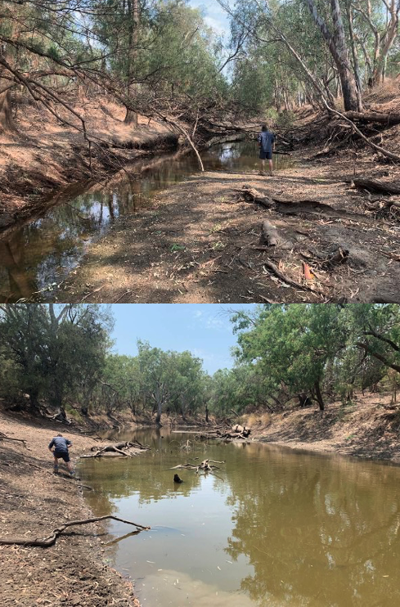
Figure 13 Pool 4 located in the vicinity of Tarawingee Road (top) and Pool 7 located further downstream on the ‘Morton Plains’ property (bottom).
Table 3 Depth and descriptions of existing refugial pools surveyed on the 10 January 2020 between Moree and Combadello regulator.
Site | Maximum Depth (m) | Comment
Pool 1 | 0.6 | Small shallow pool - lots of algae present and clear (6m long)
Pool 2 | 0.2 | Small shallow pool - turbid (5 m long)
Pool 3 | 0.8 | Medium pool - water clear (20 m in length)
Pool 4 | 0.5 | Medium pool - water clear (30 m in length)
Pool 5 | 0.5 | Medium pool - water clear (20 m in length)
Pool 6 | 1 | Medium pool on bend - water clear (15 m in length)
TSR | 1.4 | Large pool >200 m long. Some leaf litter build-up and water green with algae and low turbidity to the eye
Pool 7 | 0.8 | Large continuous pool around both bends. Water looks good.
Pool 8 | 0.5 | Large pool. Sample taken at downstream end of pool. Runs >200 m upstream and continues around bend. Green tinge to water and only shallow (50cm)
Pool 9 | 1.7 | Large pool 100 m long on bend. DO good throughout most of water column but very low near bed (<1 mg/L)
Pool 10 | 2.3 | Pump hole pool - 4-500 m long. Some build-up of leaf litter at downstream end
Pool 11 | 1.2 | Pool over 400 m long, continues upstream around bend. No stratification.
Combadello Weir | 2.6 | Still good water in weir pool, though high algal content (by eye)

Temperatures in the pools ranged from 27.5-32 ºC, highest at the surface of Combadello weir pool. Stratification (distinct changes in water temperature with depth) was evident in all pools sampled (Figure 14), and was most pronounced at Pool 9, 10 and Combadello weir pool that had a 5.1 ºC difference between surface and deeper water (Figure 14). Dissolved oxygen concentrations mimicked patterns in water temperature with anoxic conditions (<1 mg/L DO) present near the bed at Pool 9, 10 and Combadello weir pool (Figure 15). The development of this hypoxic layer is most likely caused by microbial decomposition of organic matter and leaf litter present on the channel bed, and is a natural process in these river systems. While anoxic and hypoxic conditions are toxic to most aquatic fauna including fish, improved oxygen conditions observed in the overlying water at these sites provide a suitable refuge. Other parameters measured were within acceptable ranges (Appendix B: Food Webs).

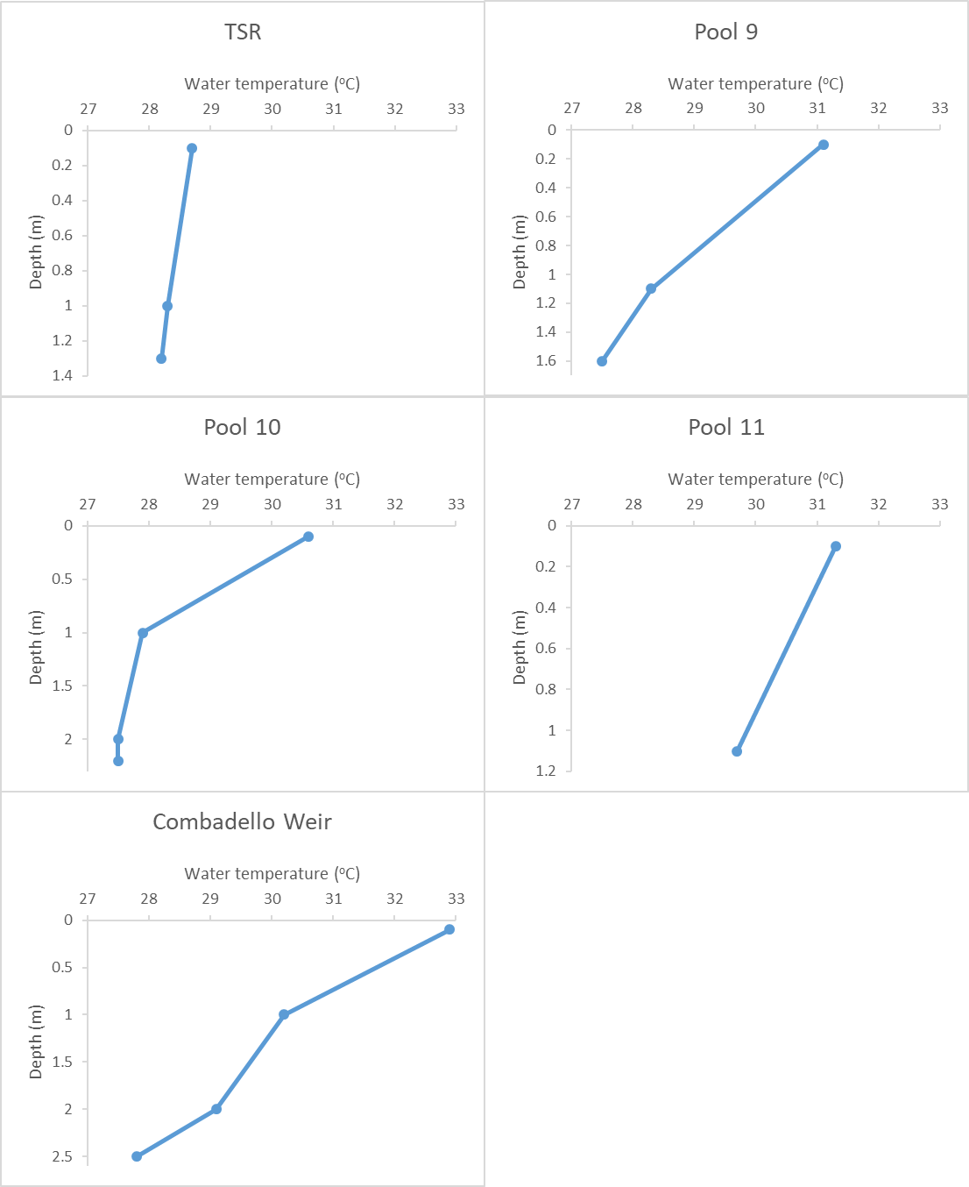
Figure 14 Water temperature (ºC) measured at various depths (m) within pools on the 10 January 2020.
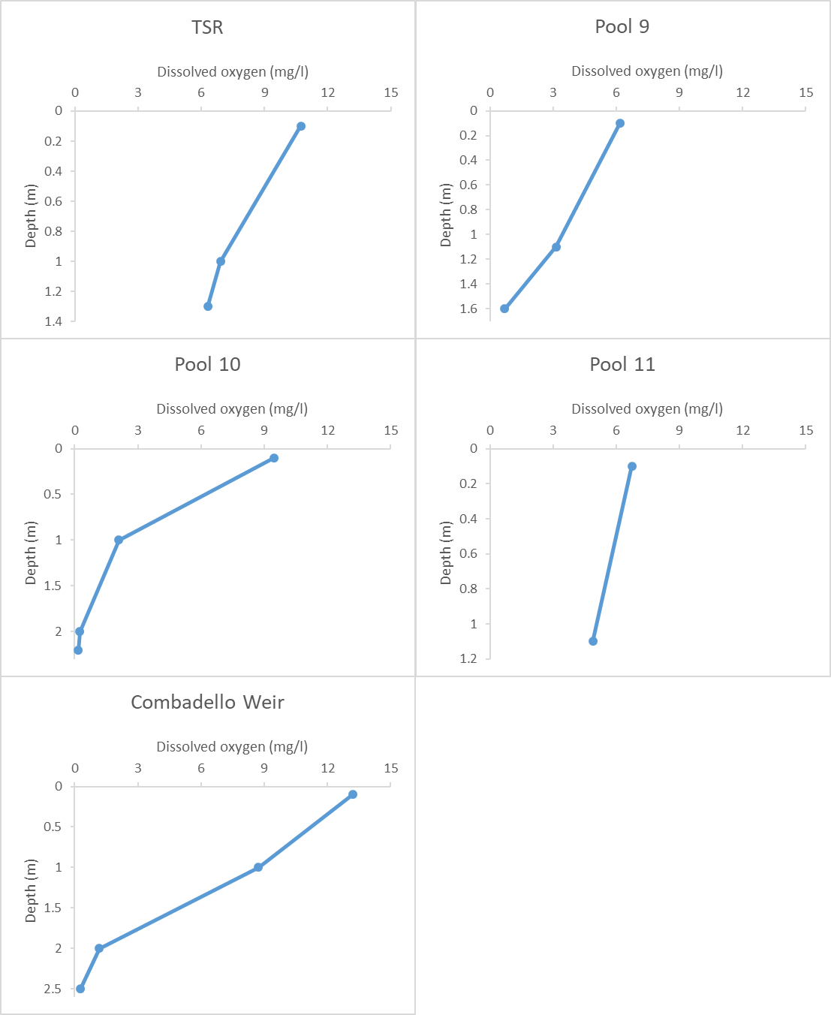
Figure 15 Dissolved oxygen concentration measured at various depths (m) within pools on the 10 January 2020.

Pool refuge monitoring

Habitat condition
During the survey on 21-22 October 2019, all sites were disconnected waterholes (Figure 16). The largest pools surveyed were Tareelaroi and Tyreel Weirs on the Gwydir River and Combadello Weir on the Mehi River. These pools were over 600 m in length and over 2 m in depth. The sites at Boolooroo Weir on the Gwydir and the Mehi River at Moree were medium sized pools up to 200 m in length and between 1-2 m deep (Figure 16), while Round Hole on Carole Creek and the Gingham Waterhole were smaller in size at around 50 m in length and less than 1 m deep.
Available habitat increased at all sites except Gingham Waterhole with the arrival of the November pool replenishment flow. Noticeable changes in the colour of the water were observed at most sites in response to reduced dissolved oxygen associated with leaf litter input, but returned to more normal conditions within several days (Figure 17-Figure 19). Gingham Waterhole was not targeted in the pool replenishment flow as it was unfeasible to deliver water that far down the Gingham system. This site completely dried in late December, before filling again due to a natural flow event in mid-February (Figure 20).

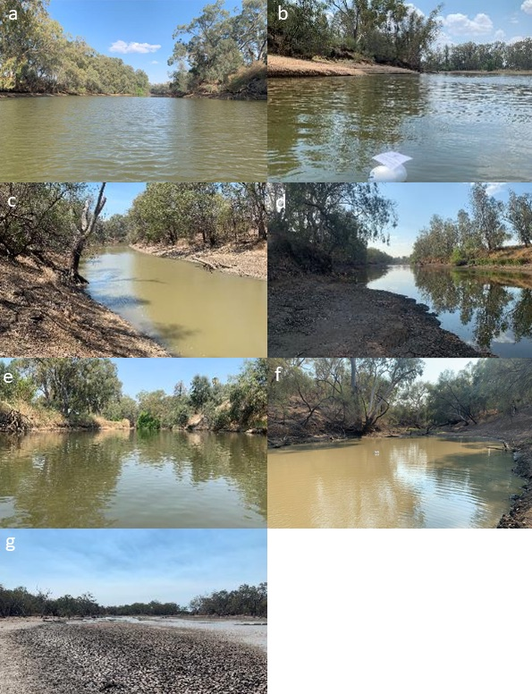

Figure 16 Pool refuge sites on the 21-22 October 2019. a – Tyreel weir, Gwydir River, b – Tareelaroi Weir, Gwydir River, c – Combadello weir, Mehi River, d – Boolooroo weir, Gwydir River, e – Mehi River at Moree, f – Round hole, Carole Creek, g – Gingham Waterhole, Gingham Watercourse.

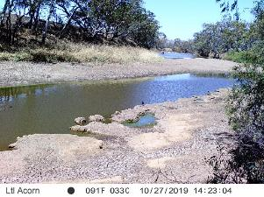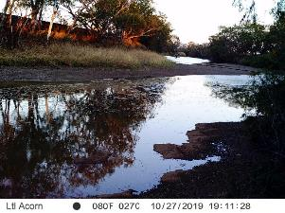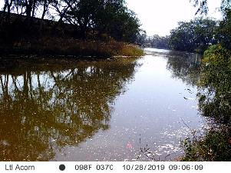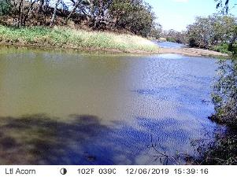
Figure 17 Photo sequence at Boolooroo weir site on the Gwydir River showing the arrival of the November pool replenishment flow on the 27 October 2019.

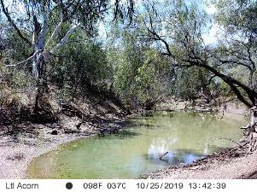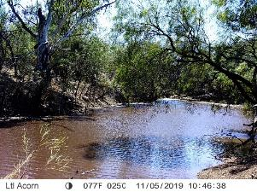
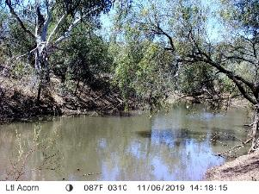
Figure 18 Photo sequence at Round hole on Carole Creek showing the arrival of the pool replenishment flow on the 5 November 2019.

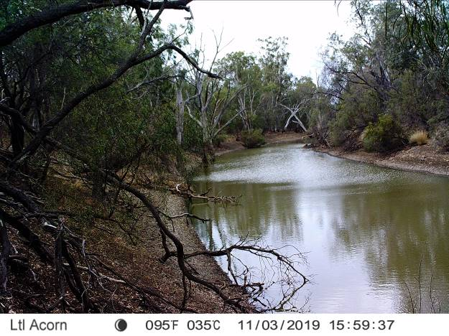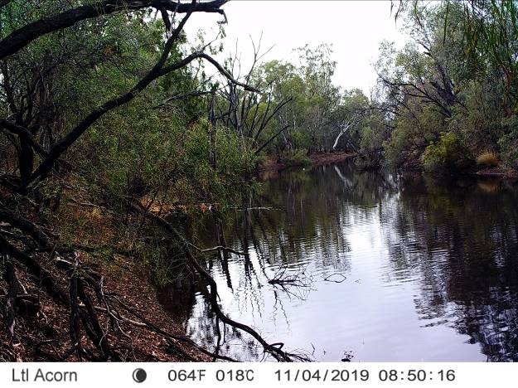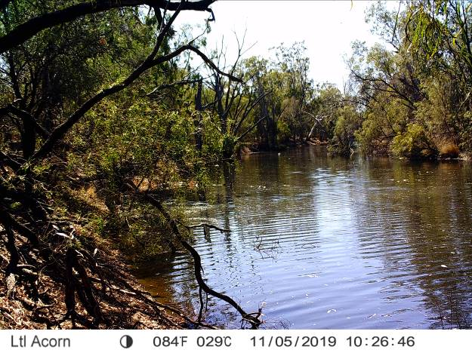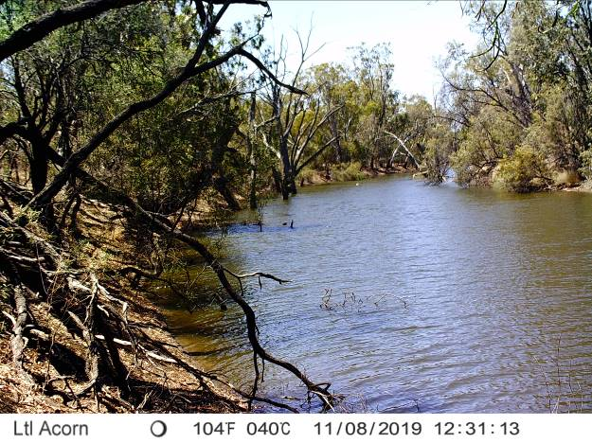
Figure 19 Photo sequence at Combadello weir site on the Mehi River showing the arrival of the pool replenishment flow on the 4 November 2019.
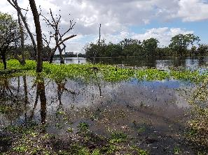
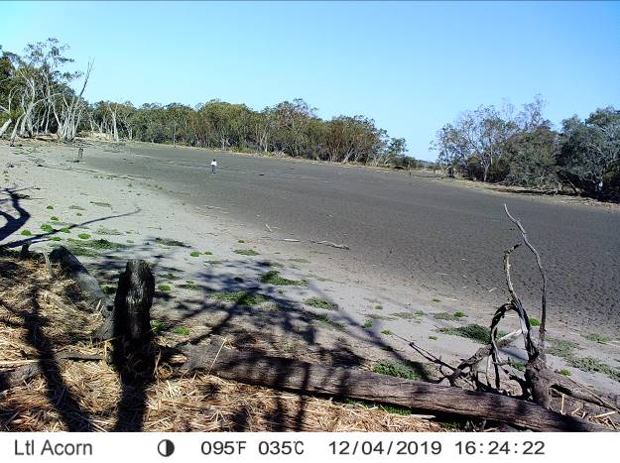
Figure 20 Drying of Gingham Waterhole in December and then full in March from a natural filling event.

Spot sampling was undertaken in October, November and April of 2019 during site visits. For the majority of the time, all parameters were within ranges considered habitable for aquatic biota (Appendix B: Food Webs). Temperatures ranged from 16.2 ºC at Gingham Waterhole in April to 27.5 ºC measured on the surface at Boolooroo Weir on the Gwydir River in April. Dissolved oxygen levels varied greatly between sites and over time, ranging from 5.67 mg/L in the Mehi at Moree in October, to 20.93 mg/L in Gingham Waterhole in October. Supersaturated oxygen levels (>100% or > 8.5 mg/L) were recorded at sites during all sampling visits, but were more prevalent in October 2019 with 5 of the 7 sites visited showing high oxygen levels (Appendix B: Food Webs). This was driven by very high algal biomass, especially at Gingham Waterhole as this pool dried down (Figure 21, Figure 22).

Salinity was high at a number of sites in October and November 2019, with salinity ranging from 0.09 – 0.6 ppt overall. Sites that showed high salinity levels were Gingham Waterhole in October, Moree on the Mehi River in October and November, Boolooroo and Tareelaroi Weirs on the Gwydir in October and Round Hole on Carole Creek during November. pH was generally basic at all sites during October ranging from 9.41–11.31 and was highest at Gwydir River sites (Appendix B: Food Webs). pH was more neutral in April ranging from 7.77–8.54. Turbidity was generally low across all sites and survey times, but did extend to a maximum of 824.5 NTU. Higher turbidity was recorded at Gingham Waterhole in October (244 NTU) and April (164 NTU) and at Tyreel Weir on the Gwydir River in November (824.5 NTU).

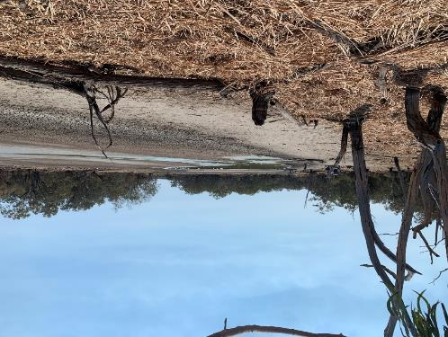
Figure 21 Low water levels remaining at Gingham Waterhole during October 2019 sampling visit.

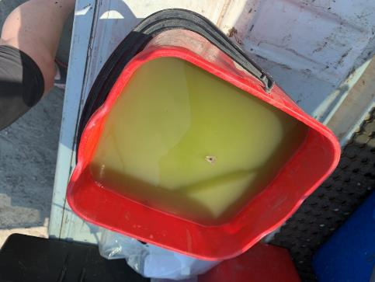
Figure 22 High algal content of the water at Gingham Waterhole during the October 2019 sampling visit.

Temperature and dissolved oxygen concentrations were relatively stable over time at sites in the Gwydir River, but were more variable in the Mehi River and Carole Creek. Changes in river flow appeared to have minimal influence on temperature and dissolved oxygen concentrations within Tareelaroi Weir (Figure 23). Average temperature showed a 5 ºC increase initially then was relatively stable at around 25 ºC before increasing slightly in December. Similarly, average DO concentrations remained between 7.4–10 mg/L until 5 December when they rose to 11 mg/L then dropped to 6.5 mg/L (Figure 23). The high variability in dissolved oxygen concentration was likely a result of diurnal algal production/respiration.
Average water temperature within Boolooroo Weir on the Gwydir River showed similar patterns to those at Tareelaroi Weir, initially showing an increase, then stabilising around 26 ºC (Figure 24). A noticeable drop in water temperature was evident around 4 December 2019, driven by a sudden fall in air temperature (Figure 24). An associated drop in DO concentration was observed at this time, with average concentrations dropping from 11 mg/L on the 3 December, to 3.75 mg/L on 4-5 December. Dissolved oxygen levels rose again on the 7 December to 10.61 mg/L. It is likely that the drop in temperature supressed algal production and led to algal cells sinking to the bottom of the pools, resulting in a rapid lowering of dissolved oxygen in the water column. The influence of the first pool maintenance flow on dissolved oxygen concentrations was also observed at Boolooroo Weir, with a reduction in average concentration from 8.2 mg/L on the 26 October to 4.2 mg/L on the 29 October 2019 as flows entered the pool. This lowering of dissolved oxygen lasted several days before rising again to 7.8 mg/L on 3 November (Figure 24).
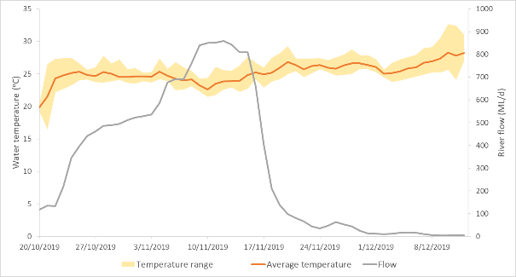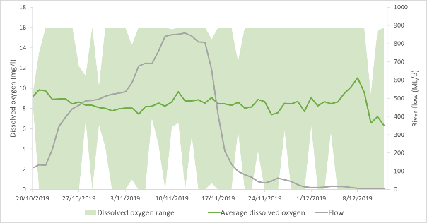
Figure 23 Temperature, dissolved oxygen concentration and flow measured in surface waters over time at Tareelaroi Weir on the Gwydir River in 2019.
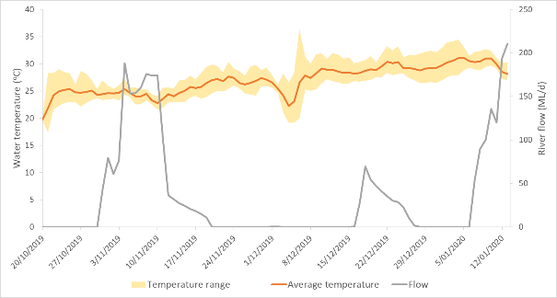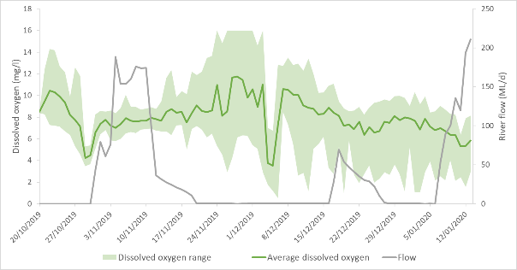
Figure 24 Temperature, dissolved oxygen concentration and flow measured in surface waters over time at Boolooroo Weir on the Gwydir River during the 2019-20 water year.

The influence of antecedent conditions was less pronounced at Tyreel Weir. Here, average water temperature was more stable showing a slight decline as the flow arrived in November, a steady rise through November and early December before another decline as the second flow arrived on 10 December (Figure 25). Similarly, average DO concentrations showed defined troughs as the flow events moved through the weir pool, with around a 3 mg/L decrease in DO concentrations as the flow front moved through. Dissolved oxygen concentrations increased within several days after these events (Figure 25).
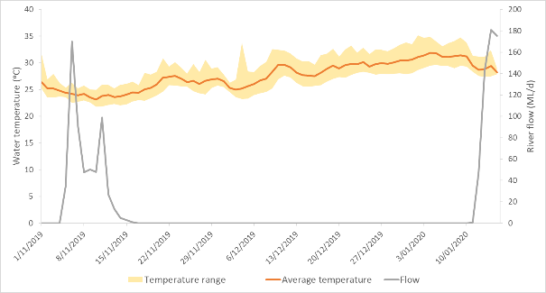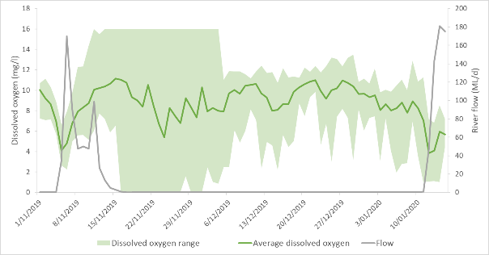
Figure 25 Temperature, dissolved oxygen concentration and flow measured in surface waters over time at Tyreel Weir on the Gwydir River during the 2019-20 water year.

Continuous water temperature monitoring in the Mehi River at Moree showed the development and maintenance of thermal stratification within this pool. Stratification was evident before the first pool refuge flow delivery with 1-1.9 ºC difference between surface and near bed temperatures (Figure 26). The arrival of the flow in November was successful at breaking the stratification, however, it soon redeveloped as flows ceased. Stratification continued until the larger flow event in February, after which time temperatures remained similar through the water column within this pool with more frequent flows (Figure 26).
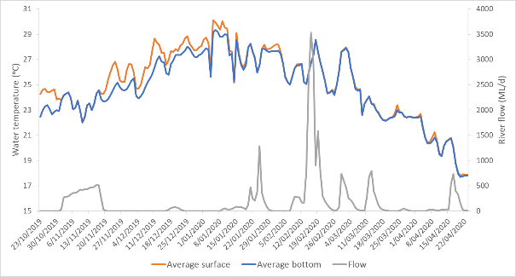
Figure 26 Water temperature measured at the surface and near bed in the Mehi River at Moree over the 2019-20 water year.
Temperature and DO concentrations were more variable in the Mehi River at Combadello, and at Round hole on Carole Creek. Dissolved oxygen concentrations dropped to hypoxic levels as the flow event reached Combardello Weir on 4 November 2019 (Figure 27). Dissolved oxygen concentrations soon increased and remained above 4 mg/L until 11 January 2020, when they again dropped to 3.6 mg/L, coinciding with the start of a small flow event. As before, dissolved oxygen concentrations increased after several days, before dropping over a period of several weeks, as a flow pulse moved through the system. In early February, water temperature dropped by 6 ºC over the period of a week, driven by a sharp drop in air temperature. In response, DO concentrations dropped to hypoxic levels reaching a daily average of just 0.6 mg/L on 7 February 2020 (Figure 27). Again, DO levels improved shortly after, assisted by a larger flow pulse.
Similar patterns were observed at Round Hole on Carole Creek, except DO did not
reach hypoxic concentrations during the November pool replenishment flow, with concentrations dropping to 3.7 mg/L (Figure 28). Through the November – January period water temperature stayed relatively stable at this site, while DO fluctuated in response to the arrival of flow events. Dissolved oxygen dropped to hypoxic levels in early February with average daily concentrations as low as 0.33 mg/L recorded, coinciding with a dramatic drop in both air and water temperature (Figure 28). Dissolved oxygen concentrations improved to around 6 mg/L with the arrival of a flow event in mid-February and remained in an acceptable range until the end of the monitoring in late April (Figure 28).

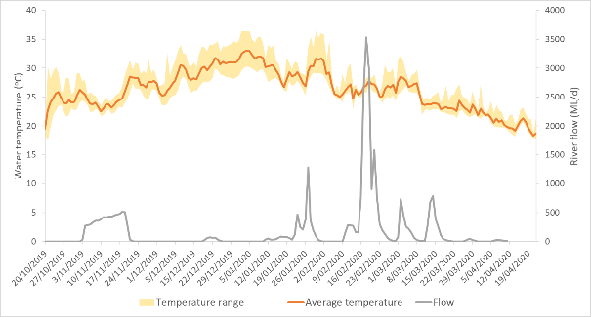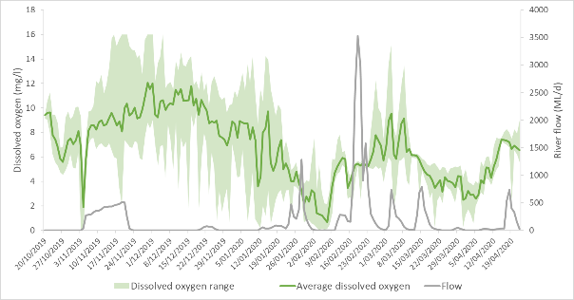
Figure 27 Temperature, dissolved oxygen concentration and flow measured in surface waters over time at Combadello Weir on the Mehi River during the 2019-20 water year.
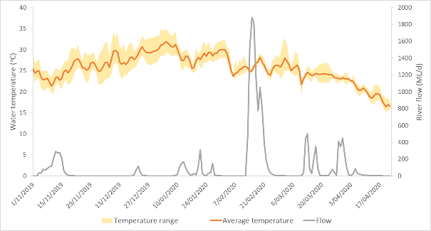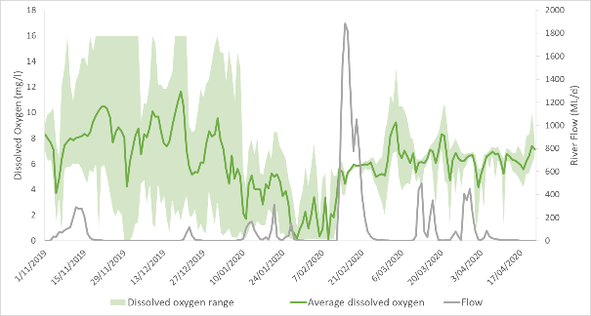
Figure 28 Temperature, dissolved oxygen concentration and flow measured in surface waters over time at Round hole on Carole Creek during the 2019-20 water year.

Food resources

Macroinvertebrates
A total of 14 taxa of macroinvertebrate were collected across the six sites and three sampling times where macroinvertebrates were surveyed (Figure 29). Carole Creek showed the highest richness of the three systems surveyed with an average of 7.33 ± 3.21 taxa surveyed per sampling event, followed by the Mehi River (7 ± 2.74 taxa) then the Gwydir (6 ± 1.41 taxa). Richness showed a general increase over time with average richness increasing from 5.33 ±1.37 taxa per site in December to 7.33 ± 2.80 taxa per site in March. Combadello Weir on the Mehi River and Round Hole on Carole Creek consistently showed higher macroinvertebrate richness than other sites (Figure 29).
Macroinvertebrate density ranged from 41–268 individuals/m², with average densities being greatest in the Gwydir River (178 ± 82 individuals/m²), and during the January sampling event (221 ± 44 individuals/m²). Highest recoded density was at Tareelaroi Weir on the Gwydir River during the January sampling, with Tyreel and Boolooroo Weirs on the Gwydir River, and Combadello Weir on the Mehi River also showing high densities (Figure 30). Atyidae shrimps were the most abundant macroinvertebrate across all sites making up 45% of the total catch, along with Chironomid midges (22%) and Corixids (water boatman, 14%, Figure 30).

Figure 29 Macroinvertebrate richness across all sites and times surveyed for the pool refuge monitoring.

Figure 30 Density of the most abundant macroinvertebrate taxa across all sites and times surveyed during pool refuge monitoring.

Microinvertebrates
A total of 17 microinvertebrate taxa were sampled across all sites, survey times and habitats. Microinvertebrates were sampled from the channel bed (benthic habitat) and within the water column (pelagic habitat). In benthic samples, Carole Creek displayed the highest richness with an average of 7.5 ± 1.29 taxa per sample, while average taxa richness was higher in October and December (7.17 +1.72 and 1.17 ± 0.41 taxa, respectively) than in January (6.50 ± 0.84 taxa) and March (5.4 ± 1.67 taxa). At the site scale, microinvertebrate richness within the benthic habitat was relatively even across sites and times (Figure 31).
Densities of the benthic habitat samples ranged from 25–1,641 individuals/L, with average densities being highest in Carole Creek (1,048 ± 386 individuals/L) and during December (808 ± 544 individuals/L). The greatest density was recorded at the Mehi at Moree site during December and resulted from a high density of the Sidedae family (Figure 32). Rotifers were the most abundant microinvertebrate taxa across all sites and sampling times making up 36% of the total count. They were especially abundant at Round Hole in Carole Creek in the January sample where they represented 86% of individuals in this sample (Figure 32). Sidedae and cyclopoid copepods were the next most abundant taxa each contributing to 18% of the total count.

Figure 31 Microinvertebrate taxa richness in benthic habitats across all sites and times surveyed during pool refuge monitoring.

Figure 32 Density of the most abundant microinvertebrate taxa within benthic habitats across all sites and times surveyed during pool refuge monitoring.

Microinvertebrate communities in the pelagic habitats were generally more diverse than in benthic habitats (Figure 33). Within pelagic habitats highest richness was observed in Gwydir River sites (11 ± 1.61 taxa per sample) and in the December sampling time (11.67 ± 0.82 taxa per sample). Highest richness was observed at Tareelaroi weir on the Gwydir River in October (Figure 33). Density in pelagic habitats ranged from 2–148 individuals/L, and was greatest in Carole Creek (118 ± 24 individuals/L per sample) and in January (80 ± 57 individuals/L per sample). Highest density was observed at Tyreel weir on the Gwydir River in January and this site also showed high densities in October (Figure 34). Rotifers were abundant in pelagic samples (22% of total), along with naupalii (21% of total) and daphnia (12% of total, Figure 34).

Figure 33 Microinvertebrate taxa richness in pelagic habitats across all sites and times surveyed during pool refuge monitoring.

Figure 34 Density of the most abundant microinvertebrate taxa within pelagic habitats across all sites and times surveyed during pool refuge monitoring.

Conclusions and recommendations
Monitoring of refuge pools throughout the spring and summer period of 2019-20 highlighted the variability in water quality both spatially and temporally through the lower Gwydir system. During periods of no flow, pools appeared to thermally stratify relatively quickly following the cessation of flow, with benthic layers of hypoxic water forming at the bottom of the pools. This is similar to how pools operate in other parts of the Barwon-Darling catchment (ELA 2020). This in itself does not appear to negatively impact on the aquatic ecology of the pools, given sufficient good quality water remains in the upper layers of these pools.
Dissolved oxygen concentrations showed a marked drop in the refuge pools as the first pool refuge flow moved through these systems in October/November. In the Mehi River, reductions were sufficient to create hypoxic conditions throughout the water column that resulted in a fish kill. The hypoxic conditions were most likely caused by significant bacterial breakdown of large quantities of leaf litter entrained by the flow consuming available oxygen in the water, similar to the classic blackwater events that occur in the southern rivers of the Murray-Darling Basin. Another possibility is that poor quality water present in remnant pools in the upstream reaches of the Mehi River were transported downstream with the flow front. In any case, the long duration of no flow experienced in the Mehi River before the flow, combined with the drought stressed riparian trees, likely increased leaf litter stores in the channels and remnant pools. This in turn, likely contributed to the poor water quality issues during the pool replenishment flow in October/November. Similar processes occurred in the other channels where the flow was delivered, however flow volumes were likely sufficient to maintain reasonable DO concentrations. The other pool replenishment flow events delivered in December and January maintained water quality in the monitored pools during the continued dry summer.
Hypoxic conditions were also detected in Combadello weir pool and at Round Hole in February which did not appear to be related to flow conditions. Rather, their occurrence appeared to be related to a marked drop in air temperature, likely reducing algal production or possibly killing some of the algae present in these pools, with microbial decomposition of this algae then stripping oxygen from the water. There was no evidence to suggest that this event in these pools had any negative ecological impacts, however, targeted monitoring during this time was not undertaken.
Food resources remained relatively stable over the monitoring period in all pools, with observed densities and richness of both macro and microinvertebrate communities being similar to those previously recorded in LTIM sampling (Commonwealth of Australia 2019). The suit of taxa observed, especially Atyidae shrimps, Chironmonidae midges have been shown to be make up significant proportions of the diets of native fish such as golden perch (Macquaria ambigua), Murray cod (Maccullochella peelii) and western carp gudgeon (Hypseleotris spp.; Sternberg et al. 2008, Growns et al. 2020 and Growns, Ryder and Frost 2020). Therefore, it is likely that food resources would not have been a limiting factor for fish during the monitoring period.
The adaptive management of event 1 down the Mehi River, was effective at minimising the negative impacts of this flow. Initial flow volumes were increased in an attempt to improve conditions and this meant that by the time the flow got below Moree only the flow-front of the flow contained poor quality water. Although the deaths of large bodied fish did occur in Combardello weir pool, small-bodied species and other aquatic fauna did appear to survive long enough for the better quality water to arrive. In addition, the decision to close Combadello Weir and let conditions improve in the weir pool before releasing further downstream also ensured that communities were not impacted downstream. Strategic pumping from the front of the flow into off river storages also likely contributed to the protection of fauna in Gundare Weir downstream of Combardello in the Mehi River.
Several recommendations can be made based on the learnings from this monitoring. Firstly, the pattern of pool refuge flows during 2019/20 water year supports the principles outlined in the low flow release regime developed by NSW Government in 2016 (i.e. protection of key refuge sites during extended dry periods needs to be supported by the delivery of continuous low flow from Copeton Dam 40-60 days after flows have ceased). Secondly, the need to better understand of the role that the leaf litter build up in dry channels plays in water quality issues. This would potentially be an ongoing parcel of work to enhance environmental water managers understanding of the relationship between leaf litter build up and deterioration of water quality in remnant pools along the Mehi system.

References
Commonwealth of Australia. 2019. Commonwealth Environmental Water Office Long Term Intervention Monitoring Project Gwydir River system Selected Area –5-year Evaluation Report. Commonwealth of Australia 2019.
Eco Logical Australia (ELA). 2020. Barwon-Darling Water Quality during the Northern Fish Flow March-August 2019. Prepared for the Commonwealth Environmental Water Office.
Growns, I., Ryder, D., McInerney, P., Bond, N., Holt, G., Lester, R., & Thompson, R. 2020. The use of fatty acids to identify food sources of secondary consumers in wetland mesocosms. Journal of Freshwater Ecology, 35(1), 173-189.
Grown,I., Ryder, D. & Frost, L. 2020. The basal food sources for Murray cod (Maccullochella peelii) in wetland mesocosms. Journal of Freshwater Ecology, 35(1), 235-253
Hale, J., Stoffels, R., Butcher, R., Shackleton, M., Brooks, S. & Gawne, B. 2014. Commonwealth Environmental Water Office Long Term Intervention Monitoring: Standard Methods. Report prepared by the Murray-Darling Freshwater Research Centre, Wodonga.
Sternberg, D., Balcombe, S., Marshall, J. & Lobegeiger, J. 2008. Food resource variability in an Australian dryland river: evidence from the diet of two generalist native fish species. Marine and Freshwater Research 59(2) 137-144
WaterNSW. 2020. Annual Operations Plan Gwydir Valley 2019-20. WaterNSW. Accessed at https://www.waternsw.com.au/__data/assets/pdf_file/0007/150874/AOP_Gwydir_FINAL_18Nov19-NW2.pdf

Attachment 1: Incident response monitoring trip 1 (November 2019) water quality results
Site | Latitude | Longitude | Survey date | Time | Depth (m) | Temperature (°C) | Dissolved Oxygen (%) | Dissolved Oxygen (mg/L) | Specific Conductivity (mS/cm) | Salinity (ppt) | pH | Turbidity (NTU)
gwydir@Boolooroo | -29.41895 | 149.90021 | 4/11/2019 | 8.20 | 0.1 | 23.5 | 83.7 | 7.11 | 0.206 | 0.1 | 8.77 | 7.3
mehi@combadello weir | -29.55625 | 149.66145 | 4/11/2019 | 10.05 | 0.1 | 24.1 | 6.5 | 0.54 | 0.341 | 0.16 | 8.15 | 6.1
mehi@ds regulator | -29.55699 | 149.65851 | 4/11/2019 | 11.11 | 0.1 | 24.3 | 50.9 | 4.26 | 0.34 | 0.16 | 8.29 | 7.1
mehi@2km ds of regulator | -29.55605 | 149.64302 | 4/11/2019 | 11.31 | 0.1 | 24 | 29.1 | 2.44 | 0.267 | 0.13 | 8.39 | 31.5
mehi@tarrawingee rd | -29.47934 | 149.75288 | 4/11/2019 | 12.04 | 0.1 | 23.9 | 93.2 | 7.86 | 0.198 | 0.09 | 9.28 | 7.5
mehi@boobadilla rd | -29.48421 | 149.73943 | 4/11/2019 | 12.26 | 0.1 | 24.1 | 96.2 | 8.07 | 0.203 | 0.1 | 9.13 | 6.2
mehi@tsr road crossing | -29.47326 | 149.8047 | 4/11/2019 | 12.58 | 0.1 | 24.3 | 102.2 | 8.56 | 0.184 | 0.09 | 9.17 | 8.3
mehi@morton plains | -29.54909 | 149.67157 | 4/11/2019 | 15.30 | 0.1 | 25.7 | 70.6 | 5.75 | 0.28 | 0.13 | 9.5 | 4.2
mehi@morton plains | -29.54909 | 149.67157 | 4/11/2019 | 15.31 | 1 | 25.6 | 68.6 | 5.6 | 0.28 | 0.13 | 9.35 | 40.7
mehi@moree | -29.46966 | 149.84024 | 4/11/2019 | 16.51 | 0.1 | 24.7 | 100.3 | 8.33 | 0.18 | 0.8 | 8.98 | 9.2
mehi@1.2km ds reg | -29.55973 | 149.64714 | 4/11/2019 | 11.03 | 0.1 | 23.9 | 19.5 | 1.65 | 0.32 | 0.15 | 8.3 | 18.6
mehi@1.2km ds reg | -29.55973 | 149.64714 | 5/11/2019 | 9.50 | 0.1 | 22.2 | 30.4 | 2.64 | 0.333 | 0.16 | 8.24 | 6.9
mehi@mallowa rd | -29.5619 | 149.62193 | 5/11/2019 | 10.23 | 0.1 | 21.8 | 42 | 3.68 | 0.324 | 0.15 | 8.28 | 8
moomin ck@combadello rd | -29.60655 | 149.62352 | 5/11/2019 | 10.14 | 0.1 | 23.3 | 28.6 | 2.44 | 0.346 | 0.16 | 8.19 | 17.4
mehi@gundare | -29.58959 | 149.31761 | 5/11/2019 | 10.57 | 0.1 | 21.2 | 60.1 | 5.33 | 0.206 | 0.1 | 8.49 | 73.2
mehi@gundare | -29.58958 | 149.31868 | 5/11/2019 | 11.01 | 0.1 | 20.9 | 50 | 4.46 | 0.206 | 0.1 | 8.53 | 79.3
carole@mungindi rd bridge | -29.3762 | 149.81325 | 5/11/2019 | 14.30 | 0.1 | 25.2 | 110.1 | 9.06 | 0.225 | 0.11 | 8.94 | 5.8
mehi@com 150m from reg | -29.55676 | 149.66025 | 4/11/2019 | 16.16 | 0.1 | 25 | 26.4 | 2.19 | 0.328 | 0.16 | 8.62 | -
mehi@com 150m from reg | -29.55676 | 149.66025 | 4/11/2019 | 16.18 | 1.2 | 24.4 | 76.2 | 1.35 | 0.33 | 0.16 | 8.49 | 7.8
mehi@com 150m from reg | -29.55676 | 149.66025 | 5/11/2019 | 9.04 | 0.1 | 23.8 | 54.8 | 4.62 | 0.267 | 0.13 | 8.03 | 3.7
mehi@com 150m from reg | -29.55676 | 149.66025 | 5/11/2019 | 9.05 | 1.5 | 23.8 | 53.9 | 4.55 | 0.264 | 0.12 | 8.18 | 6.2
mehi@com 150m from reg | -29.55676 | 149.66025 | 5/11/2019 | 12.14 | 0.1 | 24.7 | 67.6 | 5.61 | 0.251 | 0.12 | 9.5 | 3.5
mehi@com 150m from reg | -29.55676 | 149.66025 | 5/11/2019 | 12.15 | 1.5 | 23.9 | 62.7 | 5.37 | 0.243 | 0.11 | 9.18 | 13.8
mehi@com 240m from reg | -29.5563 | 149.66142 | 4/11/2019 | 16.25 | 0.1 | 27.5 | 48.8 | 3.85 | 0.324 | 0.15 | 8.43 | 4.3
mehi@com 240m from reg | -29.5563 | 149.66142 | 4/11/2019 | 16.25 | 2.5 | 24.3 | 32.5 | 2.72 | 0.319 | 0.15 | 8.67 | 176.6
mehi@com 240m from reg | -29.5563 | 149.66142 | 5/11/2019 | 9.10 | 0.1 | 23.6 | 65.8 | 5.57 | 0.244 | 0.12 | 8.34 | 3.6
mehi@com 240m from reg | -29.5563 | 149.66142 | 5/11/2019 | 9.11 | 2.8 | 23.6 | 62.6 | 5.31 | 0.245 | 0.12 | 8.32 | 7.6
mehi@com 240m from reg | -29.5563 | 149.66142 | 5/11/2019 | 12.19 | 0.1 | 24.8 | 73.4 | 6.09 | 0.236 | 0.11 | 9.1 | 3.5
mehi@com 240m from reg | -29.5563 | 149.66142 | 5/11/2019 | 12.21 | 2.8 | 23.7 | 65.3 | 5.52 | 0.233 | 0.11 | 9.07 | 4.9
mehi@com 400m from reg | -29.55606 | 149.66331 | 4/11/2019 | 16.31 | 0.1 | 27.8 | 52.6 | 4.12 | 0.322 | 0.15 | 8.37 | 4.1
mehi@com 400m from reg | -29.55606 | 149.66331 | 4/11/2019 | 16.32 | 1.8 | 24.4 | 39.5 | 3.3 | 0.311 | 0.15 | 8.72 | 5
mehi@com 400m from reg | -29.55606 | 149.66331 | 5/11/2019 | 9.16 | 0.1 | 23.6 | 66.5 | 5.63 | 0.241 | 0.11 | 8.32 | 3.6
mehi@com 400m from reg | -29.55606 | 149.66331 | 5/11/2019 | 9.16 | 2.5 | 23.4 | 64.4 | 5.48 | 0.241 | 0.11 | 8.36 | 8.6
mehi@com 400m from reg | -29.55606 | 149.66331 | 5/11/2019 | 12.25 | 0.1 | 24.6 | 73.8 | 6.13 | 0.232 | 0.11 | 8.98 | 3.3
mehi@com 400m from reg | -29.55606 | 149.66331 | 5/11/2019 | 12.26 | 2.5 | 23.7 | 66.9 | 5.66 | 0.23 | 0.11 | 8.92 | 3.7
mehi@com 650m from reg | -29.55607 | 149.6657 | 4/11/2019 | 16.40 | 0.1 | 26.3 | 59.7 | 4.82 | 0.3 | 0.14 | 8.56 | 4
mehi@com 650m from reg | -29.55607 | 149.6657 | 4/11/2019 | 16.41 | 2 | 24.5 | 44.8 | 3.73 | 0.306 | 0.15 | 8.66 | 4.6
mehi@com 650m from reg | -29.55607 | 149.6657 | 5/11/2019 | 9.23 | 0.1 | 23.6 | 66.6 | 5.64 | 0.236 | 0.11 | 8.36 | 3.7
mehi@com 650m from reg | -29.55607 | 149.6657 | 5/11/2019 | 9.24 | 2.5 | 23.6 | 65.8 | 5.58 | 0.236 | 0.11 | 8.4 | 3.9
mehi@com 650m from reg | -29.55607 | 149.6657 | 5/11/2019 | 12.31 | 0.1 | 24.4 | 75.6 | 6.31 | 0.227 | 0.11 | 8.91 | 3.4
mehi@com 650m from reg | -29.55607 | 149.6657 | 5/11/2019 | 12.31 | 2.5 | 23.7 | 68.9 | 5.83 | 0.225 | 0.11 | 8.9 | 3.7

Attachment 2: Incident response monitoring trip 2 (10 January 2020) water quality results
Site | Latitude | Longitude | Depth (m) | Time | Temperature (°C) | Dissolved Oxygen (%) | Dissolved Oxygen (mg/L) | Specific Conductivity (mS/cm) | Salinity (ppt) | pH | Turbidity (NTU)
4wd reserve Bridge | -29.473 | 149.805 | 0.1 | 7.44 | 28.5 | 50.4 | 3.9 | 0.396 | 0.19 | 7.44 | 7.3
Kooragamma Rd | -29.479 | 149.785 | 0.1 | 8.36 | 28.4 | 51.4 | 4.01 | 0.406 | 0.19 | 7.48 | 10.5
Hassel Street | -29.466 | 149.818 | 0.1 | 8.52 | 27.7 | 55 | 4.33 | 0.348 | 0.16 | 7.37 | 8.2
Moree Skatepark | -29.470 | 149.840 | 0.1 | 9.06 | 28.6 | 62 | 4.8 | 0.358 | 0.17 | 7.38 | 7
Moree Albert st | -29.465 | 149.845 | 0.1 | 9.15 | 28.2 | 40.6 | 3.15 | 0.388 | 0.18 | 7.24 | 30
4wd reserve US | -29.469 | 149.802 | 0.1 | 9.31 | 29.2 | 49.1 | 3.76 | 0.379 | 0.18 | 7.4 | 7.8
Pool 1 | -29.480 | 149.754 | 0.1 | 8.06 | 23.6 | 33.1 | 2.79 | 0.478 | 0.23 | 7.46 | 6.9
Pool 2 | -29.480 | 149.754 | 0.1 | 8.15 | 22.4 | 44.8 | 3.87 | 0.477 | 0.23 | 7.88 | 140
Pool 3 | -29.484 | 149.754 | 0.1 | 10.07 | 27.8 | 24.4 | 190 | 0.453 | 0.22 | 7.63 | 7.8
Pool 4 | -29.484 | 149.754 | 0.1 | 10.12 | 25.7 | 36 | 2.94 | 0.453 | 0.22 | 7.39 | 8.2
Pool 5 | -29.482 | 149.753 | 0.1 | 10.18 | 26 | 33.1 | 2.67 | 0.473 | 0.23 | 7.6 | 13.6
Pool 6 | -29.479 | 149.752 | 0.1 | 10.29 | 26.4 | 27.3 | 2.18 | 0.424 | 0.2 | 7.35 | 8.4
TSR | -29.487 | 149.728 | 0.1 | 11.20 | 28.7 | 138.8 | 10.72 | 0.386 | 0.18 | 8.77 | 22.9
TSR | -29.487 | 149.728 | 1 | 11.20 | 28.3 | 88.8 | 6.92 | 0.392 | 0.19 | 8.41 | 24.6
TSR | -29.487 | 149.728 | 1.3 | 11.20 | 28.2 | 80.9 | 6.31 | 0.392 | 0.19 | 8.38 | 28.6
Pool 7 | -29.520 | 149.694 | 0.1 | 12.04 | 30.6 | 84.7 | 6.35 | 0.446 | 0.21 | 7.68 | 21.7
Pool 8 | -29.549 | 149.672 | 0.1 | 12.3 | 29.6 | 107.1 | 8.2 | 0.415 | 0.2 | 8.07 | 40
Pool 9 | -29.551 | 149.682 | 0.1 | 12.42 | 31.1 | 83.5 | 6.17 | 0.425 | 0.2 | 7.65 | 8
Pool 9 | -29.551 | 149.682 | 1.6 | 12.42 | 27.5 | 9 | 0.7 | 0.444 | 0.4 | 6.71 | 16.5
Pool 9 | -29.551 | 149.682 | 1.1 | 12.42 | 28.3 | 41 | 3.15 | 0.422 | 0.1 | 7.25 | 7.5
Pool 10 | -29.549 | 149.684 | 0.1 | 13.06 | 30.6 | 128.6 | 9.48 | 0.423 | 0.2 | 8.22 | 18.5
Pool 10 | -29.549 | 149.684 | 1 | 13.06 | 27.9 | 26.5 | 2.1 | 0.421 | 0.2 | 7.47 | 22.7
Pool 10 | -29.549 | 149.684 | 2 | 13.06 | 27.5 | 3.4 | 0.25 | 0.488 | 0.23 | 6.73 | 32.3
Pool 10 | -29.549 | 149.684 | 2.2 | 13.06 | 27.5 | 2.3 | 0.17 | 0.491 | 0.23 | 6.74 | 46.4
Pool 11 | -29.537 | 149.688 | 0.1 | 13.35 | 31.3 | 91.5 | 6.74 | 0.44 | 0.21 | 7.8 | 13
Pool 11 | -29.537 | 149.688 | 1.1 | 13.35 | 29.7 | 64.4 | 4.89 | 0.438 | 0.21 | 7.62 | 20
Combadello Weir | -29.556 | 149.663 | 0.1 | 14.14 | 32.9 | 183.7 | 13.21 | 0.334 | 0.16 | 8.76 | 12.4
Combadello Weir | -29.556 | 149.663 | 1 | 14.14 | 30.2 | 115.6 | 8.72 | 0.335 | 0.16 | 8.29 | 16
Combadello Weir | -29.556 | 149.663 | 2 | 14.14 | 29.1 | 15.9 | 1.17 | 0.342 | 0.16 | 7.57 | 18.8
Combadello Weir | -29.556 | 149.663 | 2.5 | 14.14 | 27.8 | 3.7 | 0.28 | 0.371 | 0.18 | 6.72 | 21.8

Attachment 3: Spot water quality data collected during 19-20 pool refuge contingency monitoring
Sample Date | Site | Sample depth (m) | Time | Temperature (°C) | Dissolved Oxygen (%) | Dissolved Oxygen (mg/L) | Specific Conductivity (mS/cm) | Salinity (ppt) | pH | Turbidity (NTU)
21/10/2019 | Gwydir @ Tareelaroi | 0.1 | 12:20 | 23.7 | 145.9 | 12.34 | 0.267 | 0.13 | 10.02 | 7.8
21/10/2019 | Gwydir above Tyreel | 0.1 | 16:00 | 25.8 | 256.9 | 20.93 | 0.188 | 0.09 | 11.31 | 12.6
21/10/2019 | Gwydir @ Boolooroo | 0.1 | 17:30 | 26.1 | 196 | 15.89 | 0.226 | 0.11 | 10.95 | 17.3
22/10/2019 | Carole Creek @ Round Hole | 0.1 | 9:00 | 19.5 | 93.8 | 8.56 | 0.257 | 0.12 | 9.41 | 47.7
22/10/2019 | Gingham Waterhole | 0.1 | 10:48 | 22.9 | 308.6 | 26.31 | 1.213 | 0.6 | 10.3 | 244
22/10/2019 | Mehi @ Combadallo | 0.1 | 13:00 | 25.5 | 117.8 | 9.66 | 0.188 | 0.09 | 9.76 | 21.7
22/10/2019 | Mehi @ Moree | 0.1 | 14:20 | 25.9 | 70.1 | 5.67 | 0.545 | 0.26 | 9.43 | 14.1
22/10/2019 | Gwydir @ Boolooroo | 0.1 | 16:14 | 25.2 | 107.2 | 8.81 | 0.683 | 0.33 | * | 4.1
31/10/2019 | Gwydir @ Tareelaroi | 0.1 | 14:09 | 26.1 | 114.1 | 9.24 | 0.372 | 0.18 | * | 5.3
31/10/2019 | Gwydir @ Tareelaroi | 1 | 15:20 | 23 | 69 | 5.9 | 1.168 | 0.58 | * | 18.5
31/10/2019 | Mehi @ Combadallo | 0.1 | 18:14 | 24.3 | 102.1 | 8.54 | 0.394 | 0.19 | * | 32.3
31/10/2019 | Mehi @ Moree | 0.1 | 15:17 | 25.4 | 107.4 | 8.79 | 1.151 | 0.57 | * | 6.8
31/10/2019 | Mehi @ Moree | 1 | 15:20 | 23 | 69 | 5.9 | 1.168 | 0.58 | * | 18.5
1/11/2019 | Gwydir above Tyreel | 0.1 | 13:37 | 22.8 | 66.9 | 5.75 | 0.403 | 0.19 | * | 824.5
1/11/2019 | Gwydir above Tyreel | 1 | 13:36 | 25.1 | 119 | 9.81 | 0.401 | 0.19 | * | 17.8
1/11/2019 | Carole Creek @ Round Hole | 0.1 | 12:14 | 22.9 | 81.7 | 7.01 | 0.567 | 0.27 | * | 99.1
21/04/2020 | Gwydir @ Boolooroo | 0.1 | 14:30 | 27.5 | 129.6 | 10.23 | 0.428 | 0.2 | 8.54 | 34.7
21/04/2020 | Carole Creek @ Round Hole | 0.1 | 13:30 | 19.8 | 87.8 | 8 | 0.407 | 0.2 | 7.77 | 1.2
22/04/2020 | Gwydir above Tyreel | 0.1 | 10:00 | 19 | 79.4 | 7.36 | 0.314 | 0.15 | 7.93 | 90
22/04/2020 | Gingham Waterhole | 0.1 | 8:30 | 16.2 | 82.5 | 8.11 | 0.242 | 0.12 | 8 | 164
22/04/2020 | Mehi @ Combadallo | 0.1 | 17:15 | 18.3 | 81.2 | 7.64 | 0.301 | 0.14 | 7.85 | 101.3
23/04/2020 | Gwydir @ Tareelaroi | 0.1 | 9:15 | 18.9 | 101.5 | 9.42 | 0.355 | 0.17 | 8.23 | 22.4
23/04/2020 | Mehi @ Moree | 0.1 | 8:10 | 16.7 | 75.8 | 7.36 | 0.328 | 0.16 | 7.78 | 98.9

