###### Hydrology (River)

Introduction

The Hydrology (River) indicator provides in-channel hydrological information on the character of Commonwealth environmental water and other environmental water deliveries. This information is directly relevant to a number of other indicators measured in the Gwydir river system Selected Area (Gwydir Selected Area) including Vegetation, Waterbirds, Fish, Microinvertebrates and Macroinvertebrates. The particular influence of hydrology on these indicators will be addressed under their respective sections. The Hydrology (River) indicator will also provide information on the degree of hydrological connectivity maintained through the Gwydir Selected Area during the 2015-16 water year. Monitoring was expanded in the 2015-16 water year to include the Mehi River and Moomin Creek monitoring zone that incorporates the Mallowa wetlands. Two specific questions were addressed in relation to this indicator:

* What did Commonwealth environmental water contribute to hydrological connectivity?
* What did Commonwealth environmental water contribute to hydrological connectivity of the Gwydir Selected Area channels?

Environmental watering in 2015-16

Available Commonwealth environmental water holdings totalled 39,450 ML in the 2015-16 water year. This was complemented by water entitlements held by NSW OEH in the Environmental Contingency Allowance (ECA) of 58,370 ML. Of this, a total of 8,400 ML of Commonwealth water and 4,850 ML of ECA water were delivered in 2015-16 via several events across several channels (Table A‑1).

During 2015-16 environmental water was delivered to a number of assets within the Gwydir river system Selected Area. In November 2015, a flow event occurred down the Mehi River and supplementary water licences owned by the CEWO were triggered. A total of 1300 ML was accounted for with 964 ML of this water flowing down the Mehi River, and 336 ML directed down Mallowa Creek.

Through January 2016, flows were delivered into the Mallowa Creek system to inundate fringing wetlands in association with WaterNSW water bulk water deliveries. Flows were also delivered into the lower Gwydir River and Gingham watercourse in February 2016 to replace flows that were abstracted in a supplementary flow event. While not large in volume, these flows made it into the wetlands, inundating up to 161.81 ha (Appendix B). Due to critically low flows experienced in the lower Gwydir system in March and April 2016, water was delivered to the lower Gwydir, Gingham, Mehi and Carole channels as part of a dry river flow action in early April. This followed a period of 30-40 days of nil flow conditions across the catchment.

Table ‑: Environmental water delivered in the Gwydir river system Selected Area in 2015-16

|  |  |  |
| --- | --- | --- |
| Channel | Commonwealth Environmental Water (CEW) delivered (ML) | NSW ECA Water delivered (ML) |
| Gingham watercourse | 675 | 2,375 |
| lower Gwydir | 675 | 2,375 |
| Carole Creek | 409 |  |
| Mehi River | 3,155 | 100 (Whittaker Lagoon) |
| Mallowa Creek | 3,486 |  |
| Total | 8,400 | 4,850 |

2014-15 Monitoring outcomes

In 2014-15, the Gwydir River channel was connected for 48% of the time, Gingham watercourse 24%, Mehi River 21% and Moomin Creek 15%. Connectivity was largely dominated by environmental water deliveries, although rainfall generated flow events also influenced connectivity in the Gingham watercourse. An analysis of the character of the in-channel flow pulse of Commonwealth environmental water delivered in the Mehi channel in 2014-15 was also undertaken (Commonwealth of Australia 2015). This showed that the delivered flow mimicked the planned flow hydrograph for the most part with a noticeable flow peak with a relatively long recession making it the full length of the Mehi River channel.

Methods

Hydrological connectivity

An assessment of the hydrological connectivity experienced throughout the zones in the Selected Area was undertaken following the methods outlined in Commonwealth of Australia (2014). Here, flow thresholds measured at upstream gauging stations were identified that would ensure flow through the length of channel in each zone. These thresholds were estimated through an analysis of historical flow records (from 1990-2014) whereby corresponding peaks of small flow events were observed at both upstream and downstream gauging sites, suggesting connection throughout the length of the channel (Figure A‑1). These thresholds were then compared with known average stream losses provided by Water NSW. Due to the off river abstraction of flows in some channels, flows passing the downstream gauges were also quantified to confirm connectivity through the system. Here an arbitrary 5 ML/d level was used. The gauging stations used for this analysis are presented in Figure A‑1 and Table A‑2 outlines the thresholds estimated to provide longitudinal connectivity.

Once the thresholds were identified, a spells analysis (Gordon *et al.,* 1992) was undertaken to assess the total duration and frequency of flows passing the gauge. Results for downstream gauges were then subtracted from those at upstream gauges to provide an estimate of full longitudinal connectivity along channels throughout the 2015-16 season.

In 2015-16 monitoring was expanded into the Mallowa Creek system for all indicators. No downstream gauge exists in this system making an assessment of hydrological connectivity impossible. To determine duration of wet and dry spells an arbitrary figure of 5 ML/d entering the system through the Regulator (Figure A‑1) was used to indicate a wet period.

Table ‑ Thresholds at gauging stations used to determine hydrological connectivity

|  |  |  |  |  |
| --- | --- | --- | --- | --- |
| Zone | Channel | Gauging station (upstream or downstream) | Gauging station number | Threshold for longitudinal connectivity |
| Gwydir River | Gwydir | Gwydir DS Copeton Dam (U/S) | 418026 | 100 ML/d |
| Gwydir River @ Pallamallawa (D/S) | 418001 | 5 ML/d |
| Gingham-Gwydir watercourse | Lower Gwydir | Gwydir (south arm) DS Tyreel regulator (U/S) | 418063 | 40 ML/d |
| Gwydir @ Millewa (D/S) | 418066 | 5 ML/d |
| Gingham | Gingham channel @ Teralba (U/S) | 418074 | 50 ML/d |
| Gingham channel @ Gingham bridge (D/S) | 418079 | 5 ML/d |
| Mehi-Moomin | Mehi | Mehi River @ D/S Tareelaroi Regulator (U/S) | 418044 | 300 ML/d |
| Mehi River @ near Collarenebri (D/S) | 418055 | 5 ML/d |
| Moomin | Moomin @ Combadello Cutting (U/S) | 418048 | 30 ML/d |
| Moomin @ Moomin plains (D/S) | 418070 | 5 ML/d |

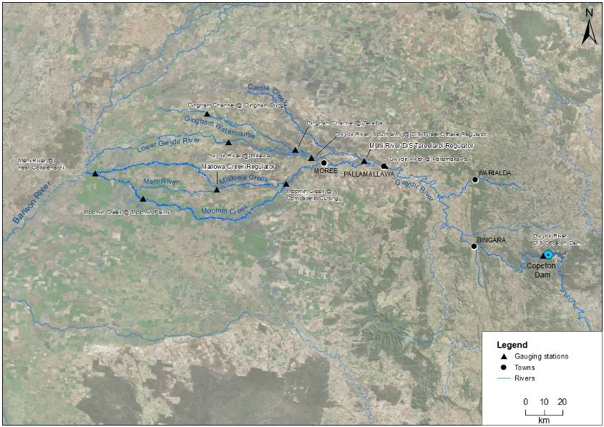

Figure ‑ Location of flow gauging stations used in the hydrological connectivity analysis

Results

Longitudinal connectivity

In 2015-16, hydrological connectivity occurred in all monitored channels in the Gwydir Selected Area (Table A‑3). The Gwydir River had 38% connection (i.e. 38% of days were above the relevant connection threshold at both gauges during 2015-16), the lower Gwydir River 45% connection, Gingham watercourse 13% connection, Mehi River 5% connection and Moomin Creek 12% connection. Mallowa Creek had water flowing into it (was ‘wet’) for 15% of days in 2015-16.

The Gwydir River and lower Gwydir River experienced the longest average duration of connection with 23 and 15 days respectively. Mehi River and Moomin Creek experienced the shortest average duration of connection with 9 and 8 days respectively. Mallowa Creek was ‘wet’ for an average duration of 19 days per event.

Table ‑ Variables describing the duration and character of hydrological connectivity in the channels of the Gwydir river system Selected Area

|  |  |  |  |  |  |  |
| --- | --- | --- | --- | --- | --- | --- |
| Monitoring Zone | Channel | Days connected (%) | No. of times connected | Average duration of connection events (days) | Longest wet (days) | Longest dry (days) |
| Gwydir River | Gwydir River | 38 | 6 | 23 | 71 | 107 |
| lower Gwydir River and Gingham watercourse | lower Gwydir River | 45 | 11 | 15 | 30 | 119 |
| Gingham watercourse | 13 | 4 | 12 | 23 | 287 |
| Mehi River and Moomin Creek | Mehi River | 5 | 2 | 9 | 15 | 150 |
| Moomin Creek | 12 | 6 | 8 | 25 | 120 |
| Mallowa Creek | 15* | 3* | 19* | 26 | 142 |

* Mallowa Creek lacks a downstream gauging station. Connection is described as ‘wet’ periods where >5ML/day water enters the system through the Regulator (refer Methods)

Connection in the Gwydir River channel was dominated by a 71 day connection event over the summer period (Figure A‑2). Three separate environmental flows were released during this period that maintained connectivity. The third flow in this series, delivered in late January, restored connectivity after a brief disconnection of two days to provide another short connection event lasting 11 days. Four other periods of connection, lasting between six and 21 days occurred during the 2015-16 water year, primarily driven by environmental water deliveries. Connectivity in this section occurred through spring, summer and autumn with no connectivity recorded in winter.

Connectivity in the lower Gwydir River channel was characterised by multiple short to moderate periods of connectivity ranging between three and 30 days (Figure A‑3). The longest periods of connectivity occurred during winter and spring (July 2015 – October 2015) with three separate events of 22, 29 and 30 days duration, separated by small disconnection periods of two and three days. The earliest of these connection events was a continuation of a rainfall driven event that occurred in late June 2015. Environmental water contributed to one short period of connectivity in late January to early February 2016 that aimed to reinstate supplementary flow abstracted from this channel.

Figure ‑ River flows down the Gwydir River and the timing of environmental water releases and longitudinal connectivity down this channel

Figure ‑ River flows down the lower Gwydir River and the timing of environmental water releases and longitudinal connectivity down this channel.

There was limited connectivity in the Gingham watercourse during the 2015-16 water year (Figure A‑4). The earliest of five days duration in July 2015 was a continuation of a rainfall driven event that occurred in late June of 2015. Two other periods of connection occurred in late July/August 2015 and late August/September 2015 of 19 and 23 days duration respectively which were also rainfall driven. There was a single environmental release in January 2016 accounted for in the Gingham watercourse. While this didn’t connect the system all the way to Gingham Bridge it increased flow through the system and increased water levels in Gingham Waterhole.

The lack of a gauging station at the furthest downstream extent of the lower Gwydir wetlands precluded analysis of longitudinal connectivity through the entire wetland area using the current methods. However, observations from a monitoring camera at Wandoona Waterhole in the western wetlands suggests that water was flowing into this wetland from July 2015 (a continuation of flows which commenced in April 2015) through to November 2015, and again in late January – early February 2016. This suggests that environmental water released in January 2016 made it through to the western extent of this wetland.

Connectivity in the Mehi River was restricted to two short events of three and 15 days in late August 2015 and late January 2016 respectively (Figure A‑5). Environmental water released in late January 2016 contributed to the second connection event. Other environmental water releases in November 2015 and early January 2016 had no direct impact on full connectivity in the Mehi River, due to diversion of this water into the Mallowa system.

Figure ‑ River flows down the Gingham watercourse and the timing of environmental water releases and longitudinal connectivity down this channel.

Figure ‑ River flows down the Mehi River and the timing of environmental water releases and longitudinal connectivity down this channel.

Connectivity in Moomin Creek was limited in 2015-16 (Figure A‑6). The longest periods of connectivity occurred in late July/early August and late August in response to rainfall (25 and 10 days respectively). Four other brief periods of connection occurred throughout the water year of between two and ten days duration aided by stock and domestic deliveries. No environmental water was delivered into Moomin Creek in the 2015-16 water year.

Figure ‑ River flows down Moomin Creek and the timing of environmental water releases and longitudinal connectivity down this channel.

Environmental water was delivered to Mallowa Creek on three occasions in the 2015-16 water year (Figure A‑7). These environmental flows were the main contribution of flow to the Mallowa system during this water year.

Figure ‑ River flows down Mallowa Creek and the timing of environmental water releases and 'wet' periods in this channel.

Discussion

The environmental watering strategy for the Selected Area employs a multi-year wetting and drying strategy in which 2015-16 was a planned dry year, with the application of environmental water aimed largely at maintaining in-channel flow rather than large-scale wetland inundation. Local rainfall, irrigation and stock and domestic deliveries contributed to flows in all channels except Mallowa Creek in which flow was almost entirely dependent on environmental water releases. Environmental water was targeted at Mallowa Creek and associated wetlands in the 2015-16 water year as part of a watering commitment to support an ongoing rehabilitation project in that system.

Longitudinal connectivity was greatest along the Gwydir and lower Gwydir River reaches during 2015-16, characterised by multiple medium to long duration events. Connectivity in these reaches was seldom dependent on environmental water releases with many connection events associated with rainfall. Connectivity in all other channels was sporadic and generally brief.

Conclusion

Environmental water contributed to connectivity in the Gwydir, lower Gwydir and Mehi River channels and was responsible for all significant flow in Mallowa Creek during 2015-16. Full connectivity in the Gingham watercourse and Moomin Creek was due almost entirely to rainfall events and other water releases associated with stock and domestic use. As expected in a planned dry year, connectivity in 2015-16 was markedly reduced compared to 2014-15 where more frequent and sustained deliveries resulted in longer periods of connectivity across all channels.

References

Commonwealth of Australia. 2014. *Commonwealth Environmental Water Office Long Term Intervention Monitoring Project Gwydir River System Selected Area.* Commonwealth of Australia.

Commonwealth of Australia. 2015. *Commonwealth Environmental Water Office Long Term intervention Monitoring Project Gwydir River System Selected Area – 2014-15 Evaluation Report*. Commonwealth of Australia.

Gordon, N.D., McMahon T.A. and Finlayson, B.L. 1992. *Stream Hydrology - An introduction for Ecologists.* Brisbane, Wiley.

###### Hydrology (Watercourse)

Introduction

The lower Gwydir wetlands have long been targets for environmental water due to their extensive wetland vegetation communities and waterholes that support many important species (DECCW 2011). Watering targets for the wetlands tend to specify the inundation of particular extents and vegetation communities. Therefore, knowledge of the extent and volume of water held in the wetlands throughout each watering season is essential base information from which to evaluate the success of environmental watering. The Hydrology (Watercourse) indicator aims to achieve this, by combining information from a range of sources, to build relationships between inflows, inundation extent and volumes of water in the Gwydir and Gingham wetlands. Monitoring was expanded in the 2015-16 water year to include the Mehi River and Moomin Creek monitoring zone which incorporates the Mallowa wetlands. Specifically, this chapter addresses the following question:

* What did Commonwealth environmental water contribute to hydrological connectivity of the Gingham, lower Gwydir and Mallowa wetlands?

Environmental watering in 2015-16

During 2015-16 Commonwealth environmental water was delivered to a number of assets within the Gwydir River system (Appendix A). In November 2015, a flow event occurred down the Mehi River and supplementary water licences owned by the CEWO were triggered. A total of 1,300 ML were accounted for with 964 ML of this water flowing down the Mehi River, and 336 ML directed down Mallowa Creek.

Through January 2016, flows were delivered into the Mallowa Creek system to inundate fringing wetlands in association with WaterNSW bulk water deliveries. Flows were also delivered into the lower Gwydir River and Gingham watercourse in February 2016, to replace flows that were abstracted in a supplementary flow event. While not large in volume, these flows made it into the wetlands.

Due to critically low flows experienced in the lower Gwydir system in March and April 2016, water was delivered down the lower Gwydir, Gingham, Mehi and Carole channels as part of a dry river flow action in early April. This followed a period of 30-40 days of nil flows conditions across the catchment.

2014-15 monitoring outcomes

Inundation mapping using Landsat imagery showed that inundation in the lower Gwydir wetlands was between 20 ha (July 2014) and 2,433 ha (February 2015) during the 2014-15 water year. Peak inundation followed a period of extended environmental water delivery from October 2015 through to February 2016. Inundation in the Gingham wetlands was between 96 ha (July 2014) and 3,909 ha (February 2015). Peak inundation was also linked to delivery of environmental water through the Gingham watercourse, with an extended delivery to this channel from November 2014 to March 2015.

At the peak of the inundation extent, seven different vegetation communities in the lower Gwydir wetlands and 16 vegetation communities in the Gingham watercourse were inundated. The extent and volume of inundation in these two wetlands was maintained by rainfall induced flows later in the water year and as a result a range of key semi-permanent and floodplain species were inundated for extended periods of time (4-6 months).

Methods

Four data sources were used to build a model of inundation extent and volume in the Gwydir and Gingham systems (Commonwealth of Australia 2015). These included:

* Landsat imagery
* Existing vegetation mapping
* Water level records associated with remote cameras
* Point water level observations throughout the water year

These data sources were scrutinised and combined to produce relationships with inflow, inundation extent and volume. Existing vegetation mapping was used to determine the area and volume of inundation associated with each vegetation community in all three wetland systems (Figure B‑1).

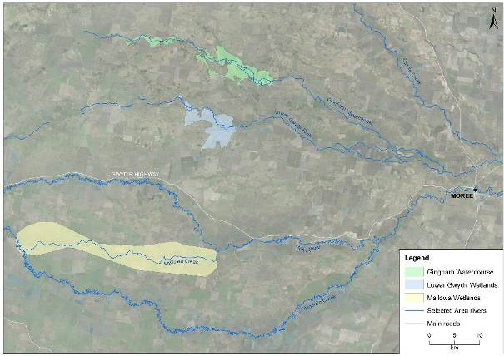

Figure ‑ Extent of lower Gwydir, Gingham and Mallowa wetlands in the Gwydir river system Selected Area

Inundation mapping

All available Landsat 8 images captured during the 2015-16 season were assessed via the USGS Globus website (<http://glovis.usgs.gov/>). Those with no cloud cover or other problems were chosen for further analysis. Six images spanning the season (Figure B‑2) were selected for analysis:   
21 August 2015, 8 October 2015, 24 November 2015, 13 February 2016, 1 April 2016 and 19 May 2016.

The extent of inundation within each image was classified using density slicing of band 6 as described in Frazier and Page (2000). A maximum wetland extent layer was then used to exclude waterbodies such as irrigation storages and farm dams outside of the target wetland area. The final inundation extent for each capture time was then intersected with Gwydir vegetation community layers (Commonwealth of Australia 2015) to determine the extent of inundation within each vegetation community.

21/08/2015

08/10/2015

24/11/2015

13/02/2016

01/04/2016

19/05/2016

Figure ‑ River flows entering the lower Gwydir River, Gingham watercourse and Mallowa Creek during 2015-16. Horizontal lines represent the timing of environmental water in each system. Arrows indicate timing of Landsat image capture.

Calculation of inundation volumes

Volumes of inundation for each vegetation community within the Gwydir and Gingham wetlands were estimated for each of the Landsat image dates. To do this, average inundation depths were estimated for each vegetation community at each image capture time (Table B‑1). This was done using water depth information from level loggers at the Bunnor bird hide and Old Dromana remote camera sites   
(Figure B‑3), and water depth estimates within vegetation plots surveyed during October 2015   
(Appendix G). As point depth measurements were taken at specific points in time, water level data from the remote camera sites were used to adjust these measurements over time. Average depths for each vegetation community were estimated to the nearest 0.1 m, except where minimal depth of inundation was estimated, then a figure of 0.05 m was used. These were then multiplied by the area of each vegetation community to provide an estimate of the volume of surface water contained within each vegetation community. Areas classified as inundated were used to define the inundation extent in each Landsat image. Lack of water depth reference data in the Mallowa wetlands precluded calculation of inundation volumes in this system.

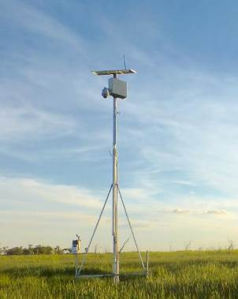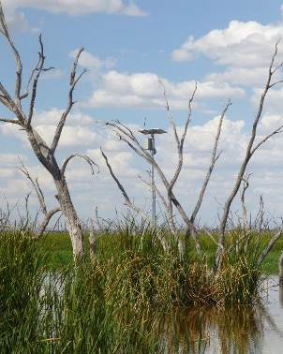

Figure ‑ Remote monitoring stations at Old Dromana wetland (left) and Bunnor birdhide wetland (right)

Table ‑ Average depth (m) of inundation for vegetation communities during the six image capture times.

|  |  |  |  |  |  |  |  |
| --- | --- | --- | --- | --- | --- | --- | --- |
| Wetland | Vegetation Community | Estimated average depth of inundation (m) | | | | | |
| Aug 15 | Oct 15 | Nov 15 | Feb 16 | Apr 16 | May 16 |
| lower Gwydir | common reed - marsh club-rush | 0.05 | 0.05 | 0.05 | 0.05 | 0.05 | 0.05 |
| common reed - tussock sedge | 0.00 | 0.00 | 0.00 | 0.00 | 0.00 | 0.05 |
| coolibah - river red gum association | 0.05 | 0.05 | 0.05 | 0.05 | 0.05 | 0.05 |
| cultivated land | 0.05 | 0.00 | 0.05 | 0.00 | 0.00 | 0.00 |
| cumbungi - marsh club-rush | 0.00 | 0.00 | 0.05 | 0.00 | 0.00 | 0.05 |
| natural water body | 0.4 | 0.5 | 0.00 | 0.00 | 0.5 | 0.00 |
| river cooba - lignum association | 0.1 | 0.05 | 0.1 | 0.05 |  | 0.05 |
| water couch - spike-rush - tussock rush | 0.1 | 0.05 | 0.1 | 0.05 | 0.05 | 0.05 |
| Gingham | baradine red gum shrubby open forest | 0.00 | 0.05 | 0.00 | 0.05 | 0.05 | 0.05 |
| belah grassy woodland | 0.05 | 0.05 | 0.05 | 0.05 | 0.05 | 0.05 |
| carbeen grassy woodland | 0.00 | 0.00 | 0.00 | 0.05 | 0.05 | 0.05 |
| cleared land | 0.05 | 0.05 | 0.00 | 0.00 | 0.00 | 0.00 |
| coolibah - river coobah grassy woodland | 0.05 | 0.05 | 0.05 | 0.05 | 0.05 | 0.05 |
| cultivated land | 0.05 | 0.05 | 0.05 | 0.00 | 0.00 | 0.00 |
| cumbungi swamp rushland | 0.2 | 0.2 | 0.2 | 0.25 | 0.05 | 0.2 |
| derived grasslands | 0.05 | 0.00 | 0.00 | 0.05 | 0.05 | 0.05 |
| dry wetland with rehabilitation potential | 0.05 | 0.05 | 0.00 | 0.00 | 0.00 | 0.00 |
| farm dam | 0.05 | 0.05 | 0.05 | 0.05 | 0.05 | 0.05 |
| myall - rosewood shrubby woodland | 0.05 | 0.00 | 0.00 | 0.00 | 0.00 | 0.00 |
| natural water body | 0.4 | 0.4 | 0.4 | 0.45 | 0.2 | 0.4 |
| paleo-channel: dry wetland with rehabilitation potential | 0.00 | 0.00 | 0.00 | 0.00 | 0.05 | 0.05 |
| paleo-channel: water couch - spike-rush | 0.00 | 0.00 | 0.00 | 0.05 | 0.05 | 0.05 |
| poplar box shrubby woodland | 0.00 | 0.00 | 0.00 | 0.05 | 0.05 | 0.05 |
| river cooba - lignum association | 0.05 | 0.05 | 0.05 | 0.1 | 0.05 | 0.05 |
| river coobah - lignum swamp shrubland | 0.05 | 0.05 | 0.05 | 0.05 | 0.05 | 0.05 |
| river red gum - coolibah open forest | 0.05 | 0.05 | 0.05 | 0.05 | 0.05 | 0.05 |
| spike-rush - cumbungi swamp sedgeland | 0.00 | 0.00 | 0.05 | 0.00 | 0.00 | 0.00 |
| tussock rush swamp rushland | 0.05 | 0.05 | 0.00 | 0.00 | 0.00 | 0.00 |
| water couch - spike-rush - tussock rush marsh grassland/sedgeland | 0.05 | 0.05 | 0.05 | 0.1 | 0.05 | 0.05 |

Results

Inundation extent and volume modelling

Inundation mapping using the Landsat imagery showed that the total extent of inundation varied throughout the water year in all wetlands (Figure B‑4; Figure B‑5). Inundation extent was 149.19 ha in the lower Gwydir at the start of the 2015-16 water year (Figure B‑4). While this followed a period of connectivity in the lower Gwydir that commenced in late June 2015 and continued into October 2015 (Appendix A), the fragmented inundation pattern suggests that the extent of inundation may not have been a result of this flow connection alone, being more reflective of drying down from flooding experienced in 2014-15 (Commonwealth of Australia 2015). Inundation extent dropped slightly in October but increased again in November 2015 to the highest extent recorded for the water year, reaching 161.81 ha. This also followed a period of connection driven by local rainfall in early November 2015, and inundation patterns indicate that channel flow is likely responsible for this increase (Appendix A). Inundation extent dropped through the remainder of the water year, reaching the lowest levels in April 2016. There was a slight increase in inundation area shown in the May 2016 image most likely associated with local rainfall in early May (Figure B‑6).

Similar inundation patterns were observed in the Gingham wetland system with 575.38 ha of inundation at the start of the water year (Figure B‑4). Again, this is likely from residual water from extensive flooding in 2014-15 (Commonwealth of Australia 2015). There was a brief period of connection in the Gingham watercourse in late June – early July 2015 (Appendix A) but inundation patterns suggest that the extent of inundation captured in this image was not influenced greatly by this flow. Inundation extent increased marginally in October 2015 reaching the largest extent for the water year at 592.38 ha. Inundation then declined steadily for the remainder of the water year with the smallest extent (52.34 ha) recorded in April 2016. There was a slight increase in inundation extent in May 2016 most likely associated with local rainfall in early May (Figure B‑6).

Inundation in the Mallowa wetlands at the start of the 2015-16 water year was the lowest recorded at 10.73 ha (Figure B‑5). Inundation extent shown in the October and November images reached a peak in February 2016 with 204.84 ha of inundation. The inundation extent increases observed in the November and February images are related to environmental flows delivered to the Mallowa over the summer period (Appendix A). Flows in Mallowa Creek were almost entirely dependent on environmental water in the 2015-16 water year and when environmental deliveries ceased after February 2016 inundation extent dropped over the remainder of the season.

Patterns in inundation volume generally followed inundation extent with maximum volume and inundation occurring in the lower Gwydir wetlands in November 2015 and in the Gingham wetlands in October 2015 (Table B‑2; Table B‑3). In the 2014-15 water year it was noted that total wetland inundation and volume appeared to reduce to a greater extent in the lower Gwydir wetlands compared to the Gingham wetlands. This pattern was reversed in 2015-16 as inundation extent and volume dropped much more sharply in the Gingham wetlands than the lower Gwydir wetlands from peak inundation to the end of the water year.

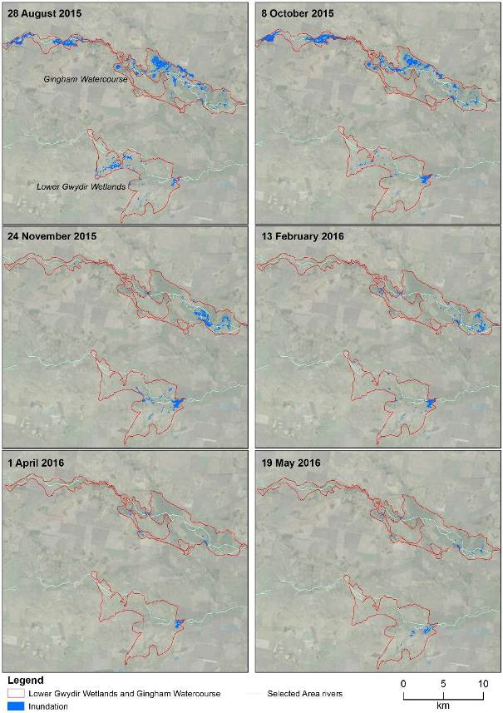

Figure ‑ Wetland inundation within the Gingham and Gwydir wetlands during the 2015-16 water year.

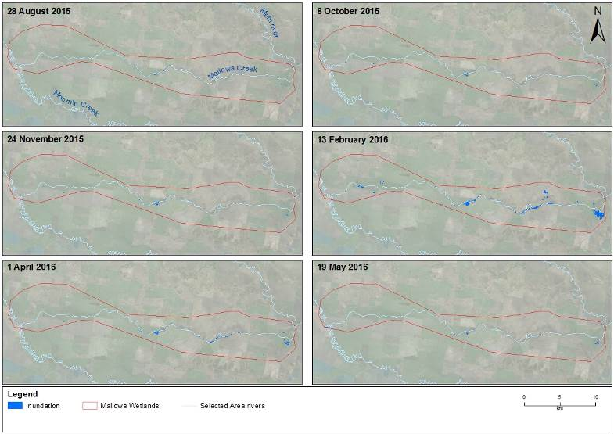

Figure ‑ Wetland inundation within the Mallowa wetlands during the 2015-16 water year.

Table ‑ Inflows, inundation extent and volume of water in the lower Gwydir and Gingham wetlands throughout the 2015-16 water year.

|  |  |  |  |
| --- | --- | --- | --- |
| Wetland | Date | Inundation Extent (ha) | Volume (ML) |
| lower Gwydir | 21/08/2015 | 149.19 | 140 |
| 8/10/2015 | 106.07 | 63 |
| 24/11/2015 | 161.81 | 149 |
| 13/02/2016 | 83.62 | 41 |
| 1/04/2016 | 47.51 | 2 |
| 19/05/2016 | 66.51 | 33 |
| Gingham | 21/08/2015 | 575.38 | 354 |
| 8/10/2015 | 592.38 | 418 |
| 24/11/2015 | 247.27 | 344 |
| 13/02/2016 | 188.38 | 260 |
| 1/04/2016 | 52.34 | 38 |
| 19/05/2016 | 59.65 | 91 |

Figure ‑ Daily rainfall for 2015-16 water year from Moree Aero station (BoM 2016).

Table ‑ Inflows and inundation extent in the Mallowa wetlands throughout the 2015-16 water year.

|  |  |  |  |
| --- | --- | --- | --- |
| Wetland | Date | Cumulative Inflows (ML) | Inundation Extent (ha) |
| Mallowa | 21/08/2015 | 11 | 10.73 |
| 8/10/2015 | 23 | 13.1 |
| 24/11/2015 | 23 | 24.23 |
| 13/02/2016 | 4,406 | 204.84 |
| 1/04/2016 | 4,428 | 64.44 |
| 19/05/2016 | 4,438 | 18.35 |

Vegetation community inundation

In the lower Gwydir wetlands, river coobah – lignum association (0-67% of inundated area) and water couch – spike rush – tussock rush (1-73% of inundated area) were the most commonly inundated vegetation communities throughout the 2015-16 water year (Table B‑4). At the peak inundation extent in November 2015, six different vegetation communities were inundated to some degree (Table B‑4), although this was not the maximum number of inundated vegetation communities. In May 2016, seven communities were inundated, including the same six inundated in November 2015 plus a small area (3 ha) of common reed – tussock sedge.

In the Gingham wetlands, water couch – spike-rush – tussock rush marsh grassland (1-53% of inundated area) and river cooba – lignum swamp shrubland (2-39% of inundated area) were the most commonly inundated vegetation communities (Table B‑5). The river cooba – lignum swamp shrubland vegetation community was extensively inundated early in the water year (169 ha in August 2015 and 230 ha in October 2015) but this extent decreased sharply at all other image capture times (1-7 ha for the remainder of the water year). The low lying water couch – spike rush – tussock rush marsh grassland was inundated for the majority of the year. This community accounted for only 1% of inundated area in April 2016, but at all other times accounted for between 22 and 53% of inundated area. At the peak inundation extent in October 2015, 13 different vegetation communities were inundated (Table B‑5), which was the maximum number of vegetation communities inundated in the Gingham wetlands in the 2015-16 water year.

In the Mallowa wetlands, coolibah – river cooba – lignum association was the most commonly inundated vegetation community, accounting for between 93 and 100% of inundated area across the water year (Table B‑6). At the peak inundation extent in February 2016 four different vegetation communities were inundated. Being fringing wetlands adjacent to the river channel, rather than terminal wetlands such as those in the Gwydir and Gingham systems, inundation along the Mallowa Creek is generally restricted to these areas immediately adjacent the main channel. Therefore, inundation does not tend to be as broad in the landscape and it is to be expected that fewer vegetation communities are affected by inundation.

Table ‑ Wetland inundation extent and volumes, including percentage of total extent and volume, for different vegetation communities in the lower Gwydir wetlands in 2015-16.

|  |  |  |  |  |  |  |  |  |  |  |  |  |  |
| --- | --- | --- | --- | --- | --- | --- | --- | --- | --- | --- | --- | --- | --- |
| Wetland | Vegetation community | Area inundated - ha (%) | | | | | | Volume - ML (%) | | | | | |
| Aug 15 | Oct 15 | Nov 15 | Feb 16 | Apr 16 | May 16 | Aug 15 | Oct 15 | Nov 15 | Feb 16 | Apr 16 | May 16 |
| Gwydir | common reed - marsh club-rush | 0 (0) | 0 (0) | 4 (2) | 5 (5) | 0 (0) | 15 (23) | 0 (0) | 0 (0) | 2 (1) | 2 (6) | 0 (0) | 8 (23) |
| common reed - tussock sedge | 0 (0) | 0 (0) | 0 (0) | 0 (0) | 0 (0) | 3 (4) | 0 (0) | 0 (0) | 0 (0) | 0 (0) | 0 (0) | 1 (4) |
| coolibah - river red gum association | 2 (2) | 9 (9) | 10 (6) | 0 (0) | 3 (5) | 1 (2) | 1 (1) | 5 (7) | 5 (3) | 0 (0) | 1 (1) | 1 (2) |
| coolibah woodland | 8 (5) | 0 (0) | 0 (0) | 0.5 (1) | 0 (0) | 0 (0) | 4 (3) | 0 (0) | 0 (0) | 0.25 (1) | 0 (0) | 0 (0) |
| cumbungi-marsh club rush | 0 (0) | 0 (0) | 7 (4) | 0 (0) | 0 (0) | 1 (1) | 0 (0) | 0 (0) | 3 (2) | 0 (0) | 0 (0) | 0.46 (1) |
| river cooba - lignum association | 28 (19) | 62 (59) | 73 (45) | 56 (67) | 0 (0) | 26 (39) | 28 (20) | 31 (49) | 73 (49) | 28 (68) | 0 (0) | 13 (40) |
| water couch - spike-rush - tussock rush | 102 (68) | 30 (29) | 66 (41) | 21 (25) | 1 (1) | 19 (29) | 102 (73) | 15 (24) | 66 (44) | 10 (26) | 0 (0) | 10 (29) |
| natural water body | 0 (0) | 2 (2) | 0 (0) | 0 (0) | 42 (89) | 0 (0) | 2 (1) | 12 (20) | 0 (0) | 0 (0) | 212 (99) | 0 (0) |
| cultivated land | 7 (5) | 0 (0) | 0 (0) | 0 (0) | 0 (0) | 0 (0) | 4 (3) | 0 (0) | 0 (0) | 0 (0) | 0 (0) | 0 (0) |
| farm dam* | 2 (1) | 2 (2) | 3 (2) | 2 (2) | 2 (4) | 1 (1) | 0 (0) | 0 (0) | 0 (0) | 0 (0) | 0 (0) | 0 (0) |
| **Total** | **149** | **106** | **162** | **84** | **48** | **67** | **140** | **63** | **149** | **41** | **213** | **33** |

Table ‑ Wetland inundation extent and volumes, including percentage of total extent and volume, for different vegetation communities in the Gingham wetlands in 2015-16.

| Wetland | Vegetation community | Area inundated - ha (%) | | | | | | Volume - ML (%) | | | | | |
| --- | --- | --- | --- | --- | --- | --- | --- | --- | --- | --- | --- | --- | --- |
| Aug 15 | Oct 15 | Nov 15 | Feb 16 | Apr 16 | May 16 | Aug 15 | Oct 15 | Nov 15 | Feb 16 | Apr 16 | May 16 |
| Gingham | baradine red gum shrubby open forest | 0 (0) | 2 (0) | 0 (0) | 2 (1) | 8 (16) | 4 (7) | 0 (0) | 1 (0) | 0 (0) | 1 (0) | 4 (11) | 2 (2) |
| belah grassy woodland | 9 (2) | 10 (2) | 1 (0.23) | 2 (1) | 5 (10) | 1 (2) | 5 (1) | 5 (1) | 0 (0) | 1 (0) | 3 (7) | 1 (1) |
| carbeen grassy woodland | 0 (0) | 0 (0) | 0 (0) | 0 (0) | 0 (0) | 0 (0) | 0 (0) | 0 (0) | 0 (0) | 0 (0) | 0 (0) | 0 (0) |
| coolibah - river cooba grassy woodland | 45 (8) | 16 (3) | 1 (1) | 13 (7) | 9 (17) | 6 (11) | 22 (6) | 8 (2) | 1 (0.18) | 7 (3) | 4 (12) | 3 (3) |
| cumbungi swamp rushland | 18 (3) | 46 (8) | 119 (48) | 31 (16) | 12 (22) | 22 (36) | 35 (10) | 92 (22) | 238 (69) | 76 (29) | 6 (15) | 43 (47) |
| derived grasslands | 1 (0.09) | 0 (0) | 0 (0) | 0 (0) | 0 (0) | 0 (0) | 0 (0) | 0 (0) | 0 (0) | 0 (0) | 0 (0) | 0 (0) |
| dry wetland with rehabilitation potential | 36 (6) | 11 (2) | 0 (0) | 0 (0) | 0 (0) | 0 (0) | 18 (5) | 5 (1) | 0 (0) | 0 (0) | 0 (0) | 0 (0) |
| myall - rosewood shrubby woodland | 0 (0) | 0 (0) | 0 (0) | 0 (0) | 0 (0) | 0 (0) | 0 (0) | 0 (0) | 0 (0) | 0 (0) | 0 (0) | 0 (0) |
| poplar box shrubby woodland | 0 (0) | 0 (0) | 0 (0) | 1 (1) | 2 (3) | 0 (0) | 0 (0) | 0 (0) | 0 (0) | 1 (0.28) | 1 (2) | 0 (0) |
| river cooba - lignum association | 1 (0.09) | 3 (0) | 3 (1) | 12 (6) | 0 (0) | 0 (0) | 0 (0) | 1 (0.32) | 1 (0.38) | 12 (5) | 0 (0) | 0 (0) |
| river cooba - lignum swamp shrubland | 169 (29) | 230 (39) | 7 (3) | 6 (3) | 2 (4) | 1 (2) | 84 (24) | 115 (27) | 4 (1) | 3 (1) | 1 (2) | 0.5 (1) |
| river red gum - coolibah open forest | 4 (1) | 8 (1) | 2 (1) | 4 (2) | 4 (8) | 2 (3) | 2 (1) | 4 (1) | 1 (0.27) | 2 (1) | 2 (5) | 1 (1) |
| spike-rush - cumbungi swamp sedgeland | 0 (0) | 0 (0) | 0 (0) | 0 (0) | 0 (0) | 0 (0) | 0 (0) | 0 (0) | 0 (0) | 0 (0) | 0 (0) | 0 (0) |
| tussock rush swamp rushland | 1 (0.1) | 1 (0.15) | 0 (0) | 0 (0) | 0 (0) | 0 (0) | 0 (0) | 0 (0) | 0 (0) | 0 (0) | 0 (0) | 0 (0) |
| water couch - spike-rush - tussock rush marsh grassland | 190 (33) | 185 (31) | 98 (40) | 100 (53) | 1 (1) | 13 (22) | 95 (27) | 92 (22) | 49 (14) | 100 (39) | 0.3 (1) | 7 (7) |
| natural water body | 12 (2) | 16 (3) | 12 (5) | 13 (7) | 8 (16) | 9 (14) | 48 (14) | 63 (15) | 49 (14) | 57 (22) | 17 (44) | 34 (38) |
| cultivated land | 88 (15) | 63 (11) | 3 (1) | 1 (1) | 0 (0) | 0 (0) | 44 (0) | 32 (0) | 1 (0.39) | 0 (0) | 0 (0) | 0 (0) |
| farm dam* | 3 (1) | 4 (1) | 2 (1) | 2 (1) | 1 (2) | 1 (2) | 0 (0) | 0 (0) | 0 (0) | 0 (0) | 0 (0) | 0 (0) |
| **Total** | **575** | **592** | **247** | **188** | **52** | **60** | **354** | **418** | **344** | **260** | **38** | **91** |

Table ‑ Wetland inundation extent, including percentage of total extent, for different vegetation communities in the Mallowa wetlands in 2015-16.

|  |  |  |  |  |  |  |  |
| --- | --- | --- | --- | --- | --- | --- | --- |
| Wetland | Vegetation Community | Aug 15 | Oct 15 | Nov 15 | Feb 16 | Apr 16 | May 16 |
| Mallowa | coolibah - cultivated | 0.1 (1) | 0 (0) | 0.6 (3) | 5.8 (3) | 0.8 (0) | 0.6 (3) |
| coolibah - river cooba - lignum association | 10.7 (99) | 13.1 (100) | 24.0 (96) | 201.6 (96) | 64.1 (98) | 17 (93) |
| coolibah woodlands | 0 (0) | 0 (0) | 0.1 (0) | 2.8 (1) | 0.3 (0) | 0.6 (3) |
| river cooba - lignum association | 1 (0) | 0 (0) | 0.2 (1) | 0.4 (0) | 0 (0) | 0.1 (3) |
| **Total** | **10.8** | **13.1** | **24.9** | **210.7** | **65.3** | **18.4** |

Discussion

Environmental water deliveries produced significant inundation in the lower Gwydir and Gingham wetlands in the 2014-15 water year and inundation estimates show that much of this water persisted through to the early parts of 2015-16. The watering strategy for the Gwydir river system Selected Area employs a multi-year wetting and drying cycle, with 2015-16 a planned dry year for the lower Gwydir River, Gingham watercourse and associated wetlands. As a result, inundation extents in 2015-16 were reduced from those observed in the previous season and are largely attributable to retained flood water and localised rainfall events.

The watering strategy focused on environmental water deliveries to the Mallowa Creek wetlands as part of a commitment to support long-term rehabilitation in that system. The findings of this work suggests that environmental water contributed to relatively small-scale, but important inundation of several wetlands throughout the Mallowa system during the 2015-16 water year.

The number and type of vegetation communities inundated in 2015-16 was very similar to the 2014-15 water year in the lower Gwydir and Gingham wetlands. Key semi-permanent wetland species such as water couch, spike-rush, tussock rush, lignum and river cooba were all well represented in the communities inundated. Floodplain species such as coolibah and river red gum were also reasonably well represented in inundated communities. The limited diversity of vegetation inundated in the Mallowa wetlands is likely a function of the physical template of that system, where inundation is more confined to fringing wetlands along the creek channel.

Conclusion

Environmental water played a key role in inundating the Mallowa wetlands in 2015-16 which resulted in the inundation of important semi-permanent wetland and floodplain species such as coolibah and river cooba. Inundation extent and volume in the lower Gwydir and Gingham wetlands was much lower than in the 2014-15 water year, but retained water from flooding driven by environmental flows in the previous year, plus localised rainfall events maintained some level of inundation throughout the 2015-16 water year.

References

Bureau of Meteorology (BoM). 2016. *New South Wales Weather Observation Stations*. [online]. Available at: <http://www.bom.gov.au/nsw/observations/map.shtml> (July 7, 2016).

Commonwealth of Australia. 2015. *Commonwealth Environmental Water Office Long Term intervention Monitoring Project Gwydir River System Selected Area – 2014-15 Evaluation Report*. Commonwealth of Australia.

Department of Environment, Climate Change and Water (DECCW). 2011. *Gwydir Wetlands Adaptive Environmental Management Plan: Synthesis of information projects and actions*.

Frazier, PS, Page KJ. 2000. Water body detection and delineation with Landsat TM data. *Photogrammetric Engineering and Remote Sensing*, *66*, 1461-1468.

###### Water Quality

Introduction

The category II Water Quality indicator aims to assess the contribution of Commonwealth environmental water to the quality of water entering lower Gwydir ecological assets. As such this indicator is linked to the Vegetation, Waterbird, Fish (River) and Hydrology River and Watercourse) indicators. Several specific questions were addressed through this indicator within the Gwydir River zone of Selected Area during the 2015-16 water year:

* What did Commonwealth environmental water contribute to temperature regimes?
* What did Commonwealth environmental water contribute to pH levels?
* What did Commonwealth environmental water contribute to turbidity regimes?
* What did Commonwealth environmental water contribute to salinity regimes?
* What did Commonwealth environmental water contribute to dissolved oxygen levels?

Environmental watering in 2015-16

During 2015-16 environmental water was delivered to lower Gwydir River system (Appendix A). In November 2015, a flow event occurred down the Mehi River and supplementary water licences owned by the CEWO were triggered. A total of 1300 ML were accounted for with 964 ML of this water flowing down the Mehi River, and 336 ML directed down Mallowa Creek. Through January 2016, flows were delivered into the Mallowa Creek system to inundate fringing wetlands. Flows were also delivered into the lower Gwydir River and Gingham watercourse in February 2016, to replace flows that were abstracted in a supplementary flow event. While not large in volume, these flows made it into the wetlands (Appendix B).

Due to critically low flows experienced in the lower Gwydir system in March and April 2016, water was delivered down the lower Gwydir, Gingham, Mehi and Carole channels as part of a dry river flow action in early April. This followed a period of 30-40 days of nil flows conditions across the catchment. The Gwydir River zone experienced environmental water delivery at various occasions from January to June 2016 as it is the main conduit for environmental delivery to downstream zones (Appendix A).

Previous monitoring

In the 2014-15 water year, the delivery of environmental water significantly reduced mean daily pH, conductivity and dissolved oxygen concentrations when compared to non-environmental water periods of similar discharge (Commonwealth of Australia, 2015). These chemical processes reflect the dilution effects provided by environmental water and changes in water chemistry associated with the increased wetted area of channels with higher volumes delivered as environmental water.

Methods

Water quality parameters were monitored at a single station at Pallamallawa near the DPI Water telemetered gauge (NSW418001) in the Gwydir River between Copeton Dam to Tareelaroi Weir (Commonwealth of Australia, 2015). This single station has permanent surface water connectivity in a defined channel and all environmental water delivered to the lower Gwydir must pass through this reach.

Continuous monitoring of dependant variables temperature (°C), pH, conductivity (mS/cm), turbidity (NTU), dissolved oxygen (mg/L) and chlorophyll-a (µg/L) occurs at this location using a Hydrolab DS5-X logger. The probe was permanently mounted in mid water below the low flow water height at the Pallamallawa Gauge in the Gwydir River. The probe was then connected via a 3-G telemetered system in the hydrometric station to an RMTek website for data monitoring and download. Each water quality variable is logged at a 10 minute interval.

Three non-environmental water periods, immediately before or after environmental water delivery, were used to examine differences in water quality parameters between periods of environmental water delivery and non-environmental water periods (Table C‑1; Figure C‑1). Daily means (midnight to midnight) of each water quality parameter were calculated from 10 minute interval data, with analyses based on the assumption that daily means were temporally independent. Daily means of water quality parameters were analysed using non-parametric Mann-Whitney U test to examine the differences between environmental water periods and non-environmental water periods where the significance level was set at 0.05. Regression analyses were used to explore relationships between discharge (ML/d) and each water quality parameter in an attempt to separate the time/season of delivery from the discharge volume.

Table ‑ Environmental water flow events and non-environmental water flow periods used in the analysis of water quality parameters in 2015-16 water year.

|  |  |  |  |
| --- | --- | --- | --- |
|  | CEW period | non-CEW period | Number of days in each period |
| Event 1 | 24 Dec 15 to 10 Jan 16 | 6 Dec 15 to 23 Dec 15 | 18,18 |
| Event 2 | 19 Jan 16 to 5 Feb 16 | 8 Feb 16 to 23 Feb 16 | 16,16 |
| Event 3 | 13 Apr 16 to 18 May 16 | 10 Mar to 12 Apr 16 | 34,34 |

Results and discussion

The delivery of environmental water led to an increase in the magnitude and variability of flow within all events (Figure C‑1). However, the magnitude of discharge varied between the three environmental water events presumably due to seasonal variability in natural flow conditions prior to the release of environmental water.

Most mean daily water quality parameters were significantly different between environmental water and non-environmental water periods. Mean daily temperature was significantly lower in environmental water periods (*p* < 0.005, Table C‑2) despite periods of environmental water occurring in the same season and month as non-environmental water, indicating that environmental water has a direct effect on water temperature at Pallamallawa. However, temperature had a poor predictive relationship with discharge (Figure C‑3a), suggesting both water source and discharge volume influence water temperature.

Mean daily pH values were consistently alkaline, ranging from 7.56 to 8.55, with no significant difference between environmental water delivery periods and non-environmental water delivery periods (Table C‑2). Mean daily pH during the first environmental water and non-environmental water periods were above the ANZECC guideline trigger value (pH between 6.5 and 8, Figure C‑2a). Regression analyses showed that increases in discharge can increase pH, particularly during periods when environmental water is being delivered (Figure C‑3b).

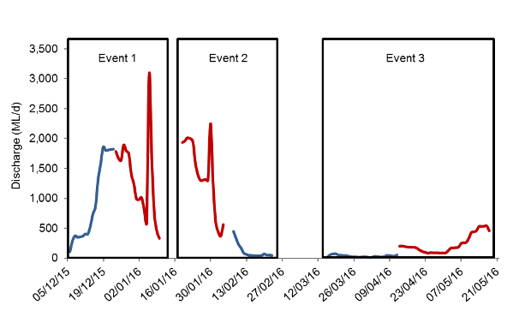

Figure ‑ Mean daily discharge of three Environmental Water and non- Environmental Water periods at Gwydir Pallamallawa gauging station (NSW418001). Red indicates Environmental Water delivery periods. Blue indicates non- Environmental Water delivery periods.

During environmental water delivery periods, mean daily turbidity and conductivity were significantly lower, highlighting the differences with catchment runoff events and potential dilution effects provided by environmental water to the lower Gwydir catchment. Mean daily turbidity, ranged from 2.14 to 81.26 NTU, and was significantly lower (*p* < 0.005, Table C‑2; Figure C‑2b) in the environmental water delivery periods. The highest turbidity recorded of 81 NTU was during the non-environmental water period in event 3, which was well above the ANZECC water quality guideline (6-50 NTU). There was no strong relationship between turbidity and discharge, likely a result of the delivery of relatively non-turbid environmental water from Copeton Dam rather than the volume of water regulating the turbidity response (Figure C‑3).

Mean daily conductivity ranged from 0.2 to 0.77 mS/cm and was within the ANZECC guideline trigger value (conductivity between 0.125 and 2.2 mS/cm). Mean daily conductivity was also significantly lower (*p* < 0.005, Table C‑2; Figure C‑2c) in the environmental water delivery periods. The regression showed that increase in discharge can contribute to decrease in conductivity irrespective of the water source (Figure C‑3d).

Mean daily dissolved oxygen concentration was significantly higher (*p* < 0.005, Table C‑2; Figure C‑2d) in the environmental water delivery period. Similarly, mean daily chlorophyll *a* concentration was also significantly higher (*p* < 0.005, Table C‑2; Figure C‑2e) in the environmental water delivery period. The higher concentrations of these parameters during environmental water events reflect increasing amounts of nutrient transportation in a less turbid water column enhancing primary production. There was no strong relationship between dissolved oxygen and chlorophyll *a* concentrations and discharge, again suggesting that environmental water rather than discharge regulated these responses (Figure C‑3e and f).

Table ‑ Mean ± standard deviation (SD) of measured water quality parameters in Environmental Water delivery periods and non- Environmental Water delivery periods. Mann-Whitney U test and Regression results. * Significant different p <0.05.

|  |  |  |  |  |  |  |  |  |  |
| --- | --- | --- | --- | --- | --- | --- | --- | --- | --- |
| Variable | Unit | EW | | non-EW | | U test | | Regression r2 | |
| mean | ± SD | mean | ± SD | chi-square | p-value | CEW | non-CEW |
| Temperature | oC | 22.63 | ±3.35 | 26.60 | ±1.66 | 48.13 | <0.005* | 0.31 | 0.26 |
| pH | - | 7.90 | ±0.27 | 7.82 | ±0.3 | 1.26 | 0.261 | 0.61 | 0.28 |
| Conductivity | mS/cm | 0.30 | ±0.09 | 0.46 | ±0.12 | 45.45 | <0.005* | 0.48 | 0.11 |
| Turbidity | NTU | 10.32 | ±9.09 | 30.48 | ±22.73 | 12.44 | <0.005* | 0.14 | 0.23 |
| Dissolved Oxygen | mg/L | 7.49 | ±0.81 | 6.96 | ±0.94 | 16.17 | <0.005* | 0.09 | 0.04 |
| Chlorophyll *a* | µg/L | 0.362 | ±0.005 | 0.355 | ±0.004 | 56.37 | <0.005* | 0.05 | 0.00 |

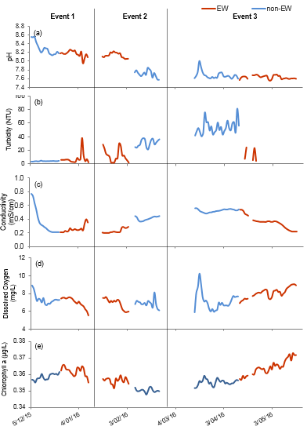

Figure ‑ Mean daily (a) pH, (b) turbidity, (c) conductivity, (d) dissolved oxygen and (e) chlorophyll a concentration near the Pallamallawa gauge (NSW418001) in the Gwydir River.

|  |  |
| --- | --- |
|  |  |
|  |  |
|  |  |

Figure ‑ Regressions between discharge at Gwydir Pallamallawa gauge (NSW418001) and mean daily (a) temperature, (b) pH, (c) turbidity, (d) conductivity, (e) dissolved oxygen and (f) chlorophyll a concentrations. EW represents environmental water.

Conclusion

The delivery of environmental water significantly reduced mean daily temperature, conductivity and turbidity concentrations when compared to non-environmental water delivery periods. In particular, the delivery of environmental water during the natural base flow period led to significant improvement of turbidity levels to below the ANZECC water quality guideline. These processes reflect the dilution effects provided by environmental water, and the changes in water chemistry associated with the increase in discharge and wetted area of channels.

The delivery of environmental water significantly increased mean daily dissolved oxygen and chlorophyll *a* concentrations when compared to non-environmental water delivery periods. These processes are likely to be associated with increased nutrient concentrations and improved light conditions to support water column primary productivity and stimulate pelagic foodwebs.

The delivery of environmental water did not lead to significant differences in pH. However, regression analysis showed an increase in discharge contributed to an increase in pH. Generally (with the exception of conductivity that showed a negative relationship with shift from increasing to decreasing conductivity with increased discharge) there were poor linear relationships between discharge and water quality measures. Understanding the effects of season, discharge and water quality will continue as more complete datasets are collected over the coming water year.

References

Commonwealth of Australia. 2014. *Commonwealth Environmental Water Office Long Term Intervention Monitoring Project Gwydir River System Selected Area.* Commonwealth of Australia.

Commonwealth of Australia. 2015. *Commonwealth Environmental Water Office Long Term intervention Monitoring Project Gwydir River System Selected Area – 2014-15 Evaluation Report*. Commonwealth of Australia.

###### Microinvertebrates

Introduction

The Microinvertebrates indicator aims to assess the contribution of Commonwealth environmental watering to microinvertebrate abundance and diversity. Several specific questions were addressed through this indicator within the Gwydir river system Selected Area during the 2015-16 water year:

Category III – Stream Metabolism indicators and evaluation questions:

* What did Commonwealth environmental water contribute to patterns and rates of primary productivity?
* What did Commonwealth environmental water contribute to patterns and rates of decomposition?

Category III – Microinvertebrates indicators and evaluation questions:

* What did Commonwealth environmental water contribute to microinvertebrate productivity?
* What did Commonwealth environmental water contribute to microinvertebrate community composition?
* What did Commonwealth environmental water contribute to connectivity of microinvertebrate and vegetation communities in floodplain watercourse?

Environmental watering in 2015-16

During 2015-16 Commonwealth environmental water was delivered to a number of assets within the Gwydir River system (Appendix A). In November 2015, a flow event occurred down the Mehi River and supplementary water licences owned by the CEWO were triggered. A total of 1,300 ML were accounted for with 964 ML of this water flowing down the Mehi River, and 336 ML directed down Mallowa Creek.

Through January 2016, flows were delivered into the Mallowa Creek system to inundate fringing wetlands in association with WaterNSW bulk water deliveries. Flows were also delivered into the lower Gwydir River and Gingham watercourse in February 2016, to replace flows that were abstracted in a supplementary flow event. While not large in volume, these flows made it into the wetlands.

Due to critically low flows experienced in the lower Gwydir system in March and April 2016, water was delivered down the lower Gwydir, Gingham, Mehi and Carole channels as part of a dry river flow action in early April. This followed a period of 30-40 days of nil flows conditions across the catchment.

Previous monitoring

In the 2014-15 water year, the delivery of Commonwealth environmental water resulted in a pulse of nitrogen and phosphorus concentrations immediately following inundation in watercourse and wetland sites. The drawdown of water resulted in a second pulse of increased nutrient concentrations with a concomitant spike in water column chlorophyll *a*. All watercourse and river channel systems were net heterotrophic in all hydrologic periods, and acted as carbon sinks throughout the period of inundation. The delivery of Commonwealth environmental water to the Gingham and lower Gwydir increased regional scale abundance and diversity of aquatic microinvertebrates.

Methods

Design

Monitoring took place on four occasions to capture the inundation and contraction cycle of environmental water delivery (Figure D‑1). Hereafter, sampling occasion codes are arranged in chronological order from T1 to T4.

* T1 ‘Pre-environmental water’ phase - During late September sampling (28 September - 1 October 2015), the Selected Area experienced low and stable flow condition after local rainfall events in late August (Figure D‑1a and c). This sampling occasion represents conditions prior to environmental watering actions.
* T2 ‘environmental water Wet’ phase - Early February sampling (4-8 February 2016) captured the ‘wettest’ phase of the Selected Area from ongoing environmental watering actions and local rainfall.
* T3 ‘Contraction I’ phase – Mid March sampling (14-17 March 2016) was in the contraction cycle of residual environmental water. Some of the river channels contracted to disconnected pools.
* T4 ‘Contraction II’ phase – Late April sampling (18-21 April 2016) was designed to capture the base flow condition. During this sampling period, all Mehi River and Moomin Creek channels contracted to disconnected pools and the watercourse water couch sites were dry. However, an environmental water release occurred during the late April sampling period which only affected metabolism in the Gwydir River.

Category III water quality indicators were measured in association with category III stream metabolism indicators and category III microinvertebrate indicators monitoring from September 2015 to April 2016 (Table D‑1; Table D‑2). Sampling sites were located in four zones within the Selected Area: Gingham watercourse, Gwydir River, Mehi River and Moomin Creek (Table D‑2; Figure D‑2). There was insufficient surface water present in the Gwydir wetlands for sampling these indicators.

Field methods

Monitoring of Category III water quality, stream metabolism and microinvertebrate indicators monitoring were conducted following the Standard Operating Procedures outlined in Commonwealth of Australia (2014) (Figure D‑3).

Laboratory methods

Laboratory work for Category III stream metabolism and microinvertebrate indicators laboratory work were conducted following the methods outlined in Commonwealth of Australia (2015).

Water nutrients statistical methods

A mixed-effects general linear model was used to test hypotheses for differences in water quality and water nutrients between time (with 4 random levels, Sep-15, Feb-16, Mar-16 and Apr-16), zone (with 4 fixed levels, Gingham watercourse, Gwydir River, Mehi River and Moomin Creek) and time x zone interaction. Data were checked for normality using the Shapiro-Wilk test and heterogeneity of variances using the Barelett’s test for comparing between two groups and Levene’s test for comparing more than two groups. The natural log (ln) transformation was applied to all water nutrients data to satisfy the assumptions of approximate normality and homogeneous variances.

Figure ‑ River flows down the Gwydir River and the timing of environmental water releases and longitudinal connectivity down this channel

Table ‑ Environmental variables, ecosystem function and microinvertebrate responsive variables measured at each sites and sampling occasions.

|  |  |  |  |  |
| --- | --- | --- | --- | --- |
| Indicators | Variables | | Units | Code |
| Water chemistry | i. | Temperature | °C | Temp |
| ii. | pH | - | ph |
| iii | Conductivity | mS/cm | Cond |
| iv. | Dissolved Oxygen | mg/L | DO |
| v. | Turbidity | NTU | Turb |
| Water nutrient and particulate | i. | Total Nitrogen | µg/L | TN |
| ii. | Total Phosphorus | µg/L | TP |
| iii | Nitrate-nitrite | µg/L | NOx |
| iv. | Filterable Reactive Phosphorus | µg/L | FRP |
| v. | Dissolved Organic Carbon | µg/mL | DOC |
| vi. | Total Suspended Solid | mg/L | TSS |
| Stream metabolism | i. | Chlorophyll a | µg/L | Chla |
| ii. | Gross Primary Production | mg O2/L/day | GPP |
| iii | Ecosystem Respiration | mg O2/L/day | ER |
| iv. | Net Primary Production | mg O2/L/day | NPP |
| Microinvertebrate | i. | Density | individual/L | - |
| ii. | Diversity | - | - |
| iii. | Richness | - | - |
| iv. | community presence-absence | - | - |
| v. | community abundance (square-root) | - | - |

Table ‑ Location of sites on the Gwydir River Selected Area for microinvertebrate surveys.

|  |  |  |  |  |  |  |  |  |  |  |  |
| --- | --- | --- | --- | --- | --- | --- | --- | --- | --- | --- | --- |
| Ecosystem | Sampling Zone | Site | Latitude | Longitude | Inundation | | | | Indicators | | |
| Sep-15 | Feb-16 | Mar-16 | Apr-16 | Water quality and nutrients | Meta-bolism | Micro-invertebrate |
| Wetland | Gingham Wetland | BUNOW | 731410 | 6759165 | Wet | Wet | Wet | Wet | ✓ | ✓ | ✓ |
| BUNWC | 731567 | 6759220 | Wet | Wet | Wet | Dry | ✓ | ✓ | ✓ |
| GINOW | 724103 | 6762962 | Wet | Wet | Wet | Wet | ✓ | ✓ |  |
| River | Gwydir River | GW1 | 803980 | 6735027 | Wet | Wet | Wet | Wet | ✓ |  |  |
| GW2 | 791299 | 6740442 | Wet | Wet | Wet | Wet | ✓ | ✓ | ✓ |
| GW3 | 783417 | 6743136 | Wet | Wet | Wet | Wet | ✓ | ✓ | ✓ |
| GW4 | 775598 | 6741492 | Wet | Wet | Wet | Wet | ✓ | ✓ | ✓ |
| GW5 | 747063 | 6745337 | Wet | Wet | Wet | Dry | ✓ |  |  |
| GW6 | 735918 | 6751398 | Wet | Wet | Wet | Dry | ✓ |  |  |
| Mehi River | ME1 | 793235 | 6736492 | Wet | Wet | Wet | Wet | ✓ |  | ✓ |
| ME2 | 753567 | 6726597 | Wet | Wet | Wet | Wet | ✓ |  | ✓ |
| ME3 | 719420 | 6731644 | Wet | Wet | Wet | Wet | ✓ |  | ✓ |
| Moomin Creek | MO1 | 753679 | 6721789 | Wet | Wet | Wet | Wet | ✓ |  | ✓ |
| MO2 | 740017 | 6712591 | Wet | Wet | Wet | Wet | ✓ |  | ✓ |
| MO3 | 708808 | 6714077 | Wet | Wet | Wet | Wet | ✓ |  | ✓ |

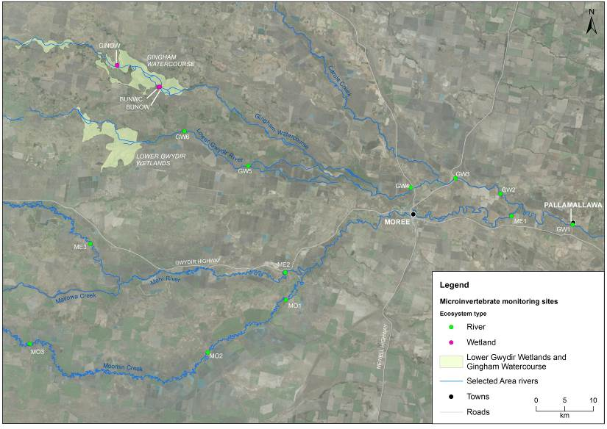

**River and Creeks**

Figure ‑ Location of sites sampled for the Microinvertebrate indicator. See Table D-2 for site codes.

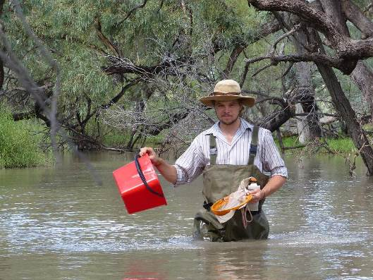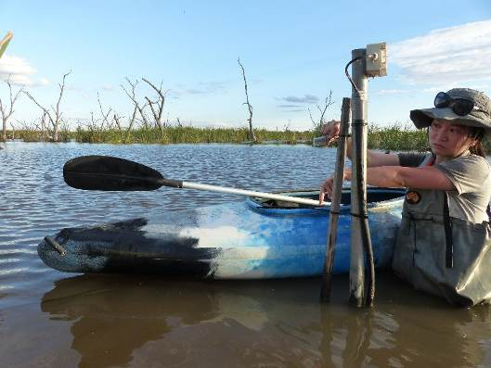

Figure ‑ Sampling for microinvertebrates in the Mallowa wetlands (top) and installing light loggers for metabolism monitoring at Bunnor bird hide in the Gingham watercourse (bottom).

Metabolism statistical methods

A mixed-effects general linear model was used to test hypotheses for differences in metabolism between time (with 4 random levels, Sep-15, Feb-16, Mar-16 and Apr-16) and zone (with 2 fixed levels, Gingham watercourse and Gwydir River) and time x zone interaction. Data were checked for normality using the Shapiro-Wilk test and heterogeneity of variances using the Barelett’s test for comparing between two groups and Levene’s test for comparing more than two groups. The significance level was set at 0.05. Where statistically significant differences were detected, post-hoc Tukey’s Honestly Significant Difference comparisons were used to determine the source of the significant differences. The natural log (ln) transformation was applied to GPP and ER data to satisfy the assumptions of approximate normality and homogeneous variances.

Microinvertebrate statistical methods

To describe and summarize the diversity of microinvertebrate communities, taxa richness (S), Shannon Weiner diversity (d) and density (number of individual/L) were calculated in PRIMER v6.1.13 using the DIVERSE function.

A mixed-effects general linear model was used to test hypotheses for differences in microinvertebrate taxa richness, diversity and density between habitat (with 2 fixed levels, benthic and pelagic), time (with 4 random levels, Sep-15, Feb-16, Mar-16 and Apr-16), zone (with 4 fixed levels, Gingham watercourse, Gwydir River, Mehi River and Moomin Creek) and time x zone interaction. Data were checked for normality using the Shapiro-Wilk test and heterogeneity of variances using the Barelett’s test for comparing between two groups and Levene’s test for comparing more than two groups. The significance level was set at 0.05. Where statistically significant differences were detected, post-hoc Tukey’s Honestly Significant Difference comparisons were used to determine the source of the significant differences. The natural log (ln) transformation was applied to density and diversity data to satisfy the assumptions of approximate normality and homogeneous variances.

Permutational multivariate analysis of variance (PERMANOVA) was used to test the difference in the microinvertebrate community composition between habitat (benthic and pelagic) and ecosystem (Wetland and River). Where PERMANOVA results were significant, four datasets by habitat and ecosystem were developed to further explore the effects of time, zone and time x zone interaction. Then, PERMANOVA analyses were used to test the hypotheses for differences in microinvertebrate community composition between time (with 4 random levels, Sep-15, Feb-16, Mar-16 and Apr-16), zone (with 4 fixed levels, Gingham watercourse, Gwydir River, Mehi River and Moomin Creek) and time x zone interaction. Up to 999 random permutations estimated the probability of p-values, with levels of significance reported as p<0.05.

Abundance data were transformed into two datasets that weigh the contributions of common and rare species differently. (1) Presence-absence data represents actual taxa occurrence in a community. (2) Abundance data (square root transformation to stabilize variance and to improve normality; Clarke & Warwick, 2001) represents relative proportions of taxa occurrence in a community.

For each multivariate analysis, a Bray-Curtis dissimilarity matrix was generated by rank correlating the community structure between samples. Then, nonmetric multidimensional scaling ordinations (nMDS) were used to visualise community patterns and similarity percentages (SIMPER) were used to determine the taxa contributing to the observed community patterns. nMDS output with stress values of less than 0.2 were considered appropriate for interpretation (Clarke & Warwick 2001).

All univariate analyses were performed in SYSTAT v13 (SYSTAT Software Inc., 2009) and multivariate analyses were performed in PRIMER v6.1.13 with the PERMANOVA+ v1.0.3 add-on package (PRIMER-E, 2009).

Wetland scale microinvertebrate density

Wetland scale microinvertebrate densities were calculated for the Gingham watercourse by multiplying the average density observed in each sampling occasion by the estimated volume of water present in the watercourse at the time of sampling. Volume calculation methods are outlined in Appendix B.

Results

Water nutrients

Nutrient and sediment concentrations were highly variable across time and between zones. Total Nitrogen concentrations were remarkably high, with the highest mean of over 6000 µg/L recorded in the Gingham watercourse before the delivery of environmental water. This is twelve times higher than the ANZECC guideline trigger value (Total Nitrogen at 500 µg/L) for lowland river ecosystems. Total Nitrogen concentrations in the Gingham watercourse were consistently higher than in the three River channels (Gwydir, Mehi and Moomin) (F(3,38) =10.956, p<0.005, Figure D‑4a). A consistent temporal pattern was observed across zones with significantly higher Total Nitrogen concentrations in the first two sample periods (F(3,38) =8.045, p<0.05, Figure D‑4a).

Nitrogen oxide concentrations were generally higher than the ANZECC guideline trigger value (Nitrogen oxide at 40 µg/L). The highest mean nitrogen oxide concentration of over 500 µg/L recorded in the Gingham watercourse and Gwydir River at the beginning of the contraction phase was over twelve times higher than the ANZECC value. There was a statistically significant interaction between the effects of zone and time (F(12,36) =2.341, p<0.05, Figure D‑4b). Nitrogen oxide concentrations were generally higher in T3.

|  |  |
| --- | --- |
|  |  |
| Figure ‑ Mean concentrations ± standard deviation (SD) of (a) Total Nitrogen and (b) Nitrate-nitrite | |

Total Phosphorus concentrations were generally higher than the ANZECC guideline trigger value (Total Phosphorus at 50 µg/L) for lowland river ecosystem. The highest mean of over 300 µg/L at the Mehi River and Moomin Creek in T3 (‘Contraction I’ phase) was six times higher than the ANZECC guideline trigger value. There was a statistically significant interaction between the effects of zone and time (F(12,36) =3.307, p<0.005, Figure D‑5a). Total Phosphorus concentrations were consistently higher in T3 across all systems (except the Gwydir River)

Filterable Reactive Phosphorus concentrations were higher than the ANZECC guideline trigger value (20 µg/L) in most sites and sampling occasions. The highest mean of over 130 µg/L was six times higher than the ANZECC trigger value recorded in the Mehi River in T3. There was a statistically significant interaction between the effects of zone and time (F(12,35) =2.624, p<0.05, Figure D‑5b).

|  |  |
| --- | --- |
|  |  |
| Figure ‑ Mean concentrations ± standard deviation (SD) of (a) Total Phosphorus and (b) Filterable Reactive Phosphorus. | |

Dissolved Organic Carbon concentrations ranged from 4.5 µg/mL to 36 µg/mL, with the highest mean of 31.8 µg/mL in the Gingham watercourse when it was contracting to pools. Dissolved Organic Carbon concentrations in wetland sites were consistently higher than in the River sites (F(3,38) =30.113, p<0.005, Figure D‑6a). Dissolved Organic Carbon concentrations were consistently higher in the Contraction phases across all systems (F(3,38) =18.009, p<0.005, Figure D‑6a).

Total Suspended Solid concentrations were also high and generally below 70 mg/L, except for mean concentrations of >95 mg/L recorded in the Gingham watercourse and Moomin Creek as the system dried. Total Suspended Solid concentrations were significantly higher at the end of the environmental water period (F(3,38) =3.907, p<0.05, Figure D‑6b). No significant spatial patterns were observed.

|  |  |
| --- | --- |
|  |  |
| Figure ‑ Mean concentrations ± standard deviation (SD) of Dissolved Organic and Total Suspended Solid | |

Stream Metabolism

Chlorophyll *a* concentrations ranged between 1 and 42 µg/L. Moomin Creek had significantly higher (F(3,35) =3.006, p<0.05,) chlorophyll *a* concentrations compared with Gwydir River. Chlorophyll *a* concentrations were generally higher in T3 and T4 compared with T1 (F(3,35) =3.452, p<0.05, Figure D‑7) and reflected patterns of increased available phosphorus and nitrogen in the water column.

Figure ‑ Mean concentrations ± standard deviation (SD) of Chlorophyll *a*.

The Gingham watercourse had significantly higher rates of GPP (F(1,42), 27.373, p<0.005, Figure D‑8a) and ER (F(1,42),50.888, p<0.005, Figure D‑8b) than the Gwydir River. In the Gingham watercourse, the mean rate of GPP ranged from 1.30 to 36.48 mg O2/L/day and rate of mean ER ranged from 5.17 to 39.49 mg O2/L/day. In the Gwydir River, the mean rate of GPP ranged from 0.63 to 6.05 mg O2/L/day and rate of mean ER ranged from 1.33 to 7.00 mg O2/L/day. A temporal pattern in rates of GPP and ER were also observed across zones with T3 were significantly higher than T1 and T2 (pairwise p<0.05).

In all samples (except BUNOW and GINOW during T4) the rates of ER were consistently higher than rates of GPP (Figure D‑8c), resulting in negative daily respiration exceeding primary production. Most sites were therefore consistently net heterotrophic throughout the period of inundation, despite the often very high rates of GPP. Rates of NPP were significantly different spatially and temporally throughout the study period (F(3,42), 13.779, p<0.005). Rates of NPP in the Gingham watercourse open water habitat (BUNOW and GINOW) at the end of the study period were significantly higher than in the Gingham watercourse in T2 and T3, and the Gwydir River T2 and T3 (pairwise p<0.05).

At the wetland scale, rates of GPP and ER were the highest in the shallow water couch habitat as water levels receded (T3; Figure D‑9). Rates of GPP and ER in the open water habitat were similar across sampling occasions. Mean rates of NPP ranged from -507 to 144 mg O2/m2/day in all sampling occasions.

|  |  |
| --- | --- |
|  |  |
|  |
| Figure ‑ Mean rates (mg O2/L/day) ± standard deviation (SD) of Gross Primary Production, Ecosystem Respiration and Net Primary Production. | |

|  |  |
| --- | --- |
|  |  |
|  |
| Figure ‑ Mean wetland scale rates (mg O2/m2/day) ± standard deviation (SD) of Gross Primary Production, Ecosystem Respiration and Net Primary Production in the Gingham watercourse. | |

Microinvertebrates

A total of 42 taxa were identified (from 86 samples; Figure D‑10). The 18 most abundant taxa (>1% in total abundance) comprised 95% of the total abundance with the most abundant taxa the rotifer Order Bdelloida (24% of the total abundance) and Cladoceran nauplii (13% of the total abundance) that occurred commonly in all sites and sampling occasions. The other most abundant taxa in descending order were the rotifer Family Notommatidae (8%), rotifer Family Brachionidae (8%) and rotifer Family Lecanidae (8%).

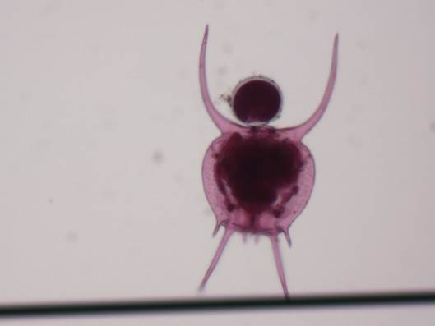

500 µm

0

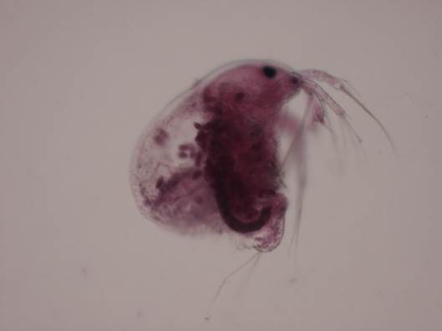

0

3 mm

Figure ‑ Microinvertebrates sampled in 2015-16. Brachionidae (top) and Macrothricidae (bottom)

Density

Microinvertebrate densities in benthic habitats ranged from 114/L to 45120/L and were significantly higher than those in the pelagic habitat (ranged from 9/L to 3504/L) (F(1,69), 209.275, p<0.005, Figure D‑11) across all sites and times. In benthic samples, there was significant temporal change (F(3,27), 4.161, p<0.05). T4 had significantly higher densities than T1 and T2 across all sites. In pelagic samples, there was significant time x zone interaction (F(9,27), 5.218, p>0.005). Microinvertebrate densities in the Gingham watercourse in the last two sample periods were significantly higher than that in Gwydir River at T1 and T2, Mehi River at T2 and Moomin Creek at T2 in pairwise tests (p<0.05). Within the Gwydir River, T3 and T4 had significantly higher densities than T1 and T2 in pairwise test (p<0.05). At the whole-of-wetland scale for the Gingham watercourse, microinvertebrate abundance peaked in benthic communities during T2 sampling, whereas abundance peaked in T4 for pelagic communities (Table D‑3).

|  |  |
| --- | --- |
| 1. Benthic | 1. Pelagic |
|  |  |
| Figure ‑ Mean ± standard deviation (SD) of microinvertebrate density in (a) benthic and (b) pelagic habitats. | |

Table ‑ Total abundance of microinvertebrates scales to whole-of-wetland for the Gingham watercourse in each sample period. Abundances require 109 multiplication.

|  |  |  |  |  |
| --- | --- | --- | --- | --- |
| Microinvertebrate abundance | T1 | T2 | T3 | T4 |
| Benthic habitat | 533 | 798 | 292 | 490 |
| Pelagic habitat | 14 | 53 | 93 | 133 |

Diversity indices

Taxonomic richness ranged from 4 to 19 and was similar between benthic and pelagic habitats within zones. Across all habitats and zones, there was a significant difference in microinvertebrate richness with time (F(3,69), 7.760, p<0.005, Figure D‑12 a & b), with T1 significantly lower than all other sampling occasions in pairwise tests (p<0.05). No significant spatial pattern was observed across sites.

|  |  |
| --- | --- |
|  |  |
| Figure ‑ Mean ± standard deviation (SD) of microinvertebrate richness in (a) benthic and (b) pelagic habitats. | |

Shannon diversity ranged from 0.4 to 1.9 in the benthic habitats (Figure D‑13a) and from 1.5 to 5.2 in the pelagic habitats (Figure D‑13b). There was significantly higher diversity in pelagic habitats than benthic habitats (F(1,69), 36.674, p<0.005). Although both habitats shared a similar number of taxa (measured as taxonomic richness), benthic habitats were dominated by a few taxa (with lower diversity). In benthic samples, there was a significant time x zone difference (F(9,27), 3.116, p<0.05). Microinvertebrate diversity in the Gingham watercourse at T1 was significantly lower than all other samples in pairwise tests (p<0.05). In pelagic samples, there was a significant temporal change in diversity (F(3,27), 6.589, p<0.005) with a significantly higher T2 diversity compared with all other sampling occasions in pairwise tests (p<0.05). No significant spatial pattern was observed.

|  |  |
| --- | --- |
|  |  |
| Figure D‑13 Mean ± standard deviation (SD) of microinvertebrate diversity in (a) benthic and (b) pelagic habitats. | |

Taxonomic composition

Initially, PERMANOVA analysis was used to test if habitat (benthic and pelagic) and ecosystem (Wetland and River) could explain differences in the microinvertebrate community composition. PERMANOVA results indicated that the taxonomic composition was significantly different between benthic and pelagic habitats (Pseudo-F=10.988, p=0.001) and between wetland and river ecosystems (Pseudo-F=2.8068, p=0.012) based on the presence-absence dataset. A similar result was also found based on the abundance dataset with lower significance level. The dissimilarity between benthic and pelagic communities was shown in the nMDS ordination with a stress value of 0.14 (Figure D‑14). Since the taxonomic composition was predominantly driven by habitat and ecosystem, four datasets by habitat and ecosystem were developed to further explore the effects of time and zone.

The community differences between habitats was driven by the higher average abundance of Phylum Nematoda, Cladoceran Family Macrothricidae, subClass Oligochaeta and Cladoceran Family Chydoridae in the benthic habitat and the rotifer Families Synchaetidae, Filiniidae and Asplanchnidae in the Pelagic habitat (Table D‑4). The average abundance of these seven taxa contributed to 32% cumulative dissimilarity between two habitats.

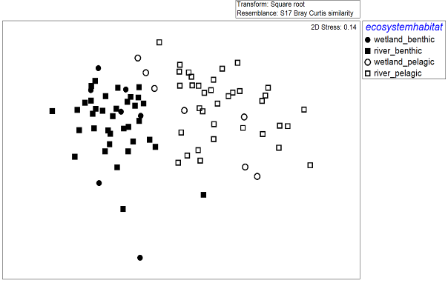

Figure ‑ nMDS ordination of microinvertebrate community composition using the abundance dataset.Table ‑ Microinvertebrate taxa contributing most of the dissimilarities between benthic and pelagic communities based on abundance dataset. Bold numbers represent the higher average abundance.

| Taxa | Average Abundance | | Contribution % | Cumulative % |
| --- | --- | --- | --- | --- |
| Benthic | Pelagic |
| P. Nematoda | **0.95** | 0.40 | 5 | 5 |
| F. Macrothricidae | **0.67** | 0.16 | 5 | 10 |
| C Oligochaeta | **0.67** | 0.19 | 5 | 14 |
| F. Chydoridae | **0.70** | 0.26 | 5 | 19 |
| F. Synchaetidae | 0.35 | **0.70** | 4 | 23 |
| F. Filiniidae | 0.42 | **0.70** | 4 | 27 |
| F. Asplanchnidae | 0.51 | **0.74** | 4 | 32 |

***Wetland***

In the Gingham watercourse there was no significant difference in microinvertebrate community composition between time and veghab (Open Water and Water Couch) for both benthic and pelagic habitats (Table D‑5). The nMDS ordination with stress value of 0.01 based on abundance dataset showed temporal and spatial shift in community compositions (Figure D‑15).

Table ‑ PERMANOVA results for wetland microinvertebrate in each habitat and dataset.

|  |  |  |  |  |  |  |  |  |
| --- | --- | --- | --- | --- | --- | --- | --- | --- |
| Term | Wetland - benthic | | | | Wetland - pelagic | | | |
| presence-absence | | abundance | | presence-absence | | abundance | |
| Pseudo-F | P | Pseudo-F | P | Pseudo-F | P | Pseudo-F | P |
| Time | 2.653 | 0.144 | 1.551 | 0.282 | 2.769 | 0.074 | 3.944 | 0.051 |
| Veghab | 0.589 | 0.631 | 0.805 | 0.619 | 2.091 | 0.212 | 1.229 | 0.420 |

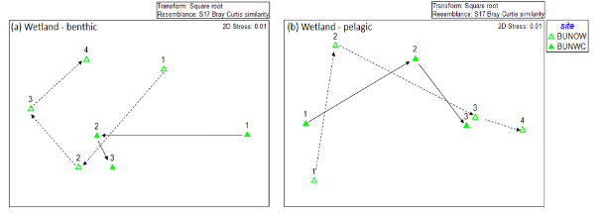

Figure ‑ nMDS ordination of (a) Wetland - benthic and (b) Wetland - pelagic microinvertebrate community composition using abundance dataset. Arrows represent community compositions trajectory along sampling occasions in number. Numbers are sampling occasions: 1=T1, 2=T2, 3=T3 and 4=T4*River*

For the benthic habitat, PERMANOVA analyses revealed significant differences in time based on both presence-absence and abundance datasets (Table D‑6). Community composition was significantly different between T1 and all other sampling occasions across all zone in pairwise tests (p<0.01). There was also a significant spatial pattern in the presence-absence dataset (Table D‑6) with the Gwydir River that received environmental water significantly different from Mehi River and Moomin Creek   
(Figure D‑16). The community difference between T1 and all other sampling occasions was driven by the higher average abundances of Class Ostracoda, Phylum Tardigrada at T1 and higher average abundance of the rotifer Order Bdelloida and Cladoceran nauplii at other sampling occasions (Table D‑5). The average abundance of these four taxa contributed 31% to cumulative dissimilarity between these sampling occasions.

Table ‑ PERMANOVA results (* when P<0.05) for river microinvertebrate in each habitat and dataset.

|  |  |  |  |  |  |  |  |  |
| --- | --- | --- | --- | --- | --- | --- | --- | --- |
| Term | River - benthic | | | | River - pelagic | | | |
| presence-absence | | abundance | | presence-absence | | abundance | |
| Pseudo-F | P | Pseudo-F | P | Pseudo-F | P | Pseudo-F | P |
| Time x Zone | 1.1903 | 0.232 | 1.2177 | 0.147 | 2.1414 | 0.001* | 2.156 | 0.001* |
| Time | 1.7686 | 0.040* | 2.8299 | 0.001* | 1.8439 | 0.030* | 4.6139 | 0.001* |
| Zone | 1.9798 | 0.031* | 1.6315 | 0.053 | 4.4839 | 0.001* | 3.5149 | 0.001* |

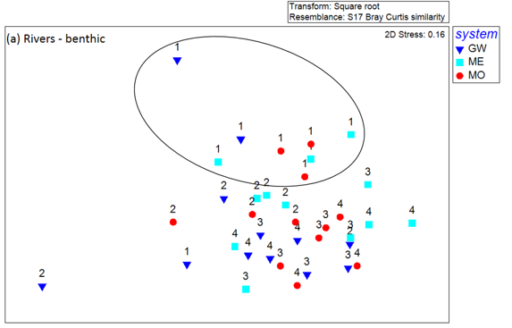

Figure ‑ nMDS ordination of community composition using microinvertebrate abundance data for River sites and benthic habitats. Sampling occasions represented by number.

In the pelagic habitat, PERMANOVA analyses revealed significant differences in the time and zone interaction, where abundance data showed a higher significant level than presence-absence data (Table D‑6). This result suggested that differences in community composition were driven by the absolute abundance of taxa. In both datasets, community composition in the Gwydir River was significantly different from the Mehi River and Moomin Creek. Community composition was significantly different between T1 and all other sampling occasions (Table D‑6; Figure D‑17). The community difference between T1 and all other sampling occasions was driven by the higher average abundance of Cladoceran nauplii, Copepod Family Calanoidae, rotifer Family Filiniidae and Copepod Family Cyclopoida in T1, and higher average abundance of the rotifer Families Synchaetidae and Brachionidae in all other sampling occasions (Table D‑7). The average abundance of these six taxa contributed 52% to the cumulative dissimilarity between the two sampling occasions.

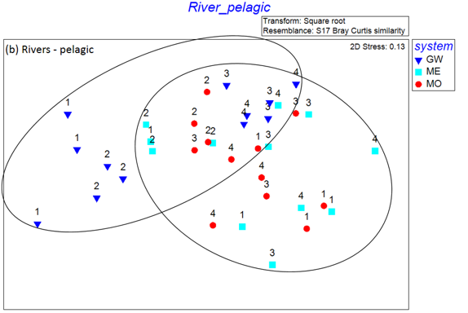

Figure ‑ nMDS ordination of community composition using microinvertebrate abundance data for River sites and pelagic habitats. Sampling occasions represented by number.

Table ‑ Microinvertebrate taxa contributing most of the dissimilarities between T1 and T3&T4 communities in River benthic habitat and in River pelagic habitat based on abundance dataset. Bold number is the higher average abundance.

|  |  |  |  |  |
| --- | --- | --- | --- | --- |
| Benthic Habitat | | | | |
| Taxa | Average Abundance | | Contribution % | Cumulative % |
| River benthic T1 | River benthic T6, T7&T8 |
| O. Bdelloida | 5.0 | **35.3** | 11 | 11 |
| C. Ostracoda | **20.0** | 4.1 | 7 | 18 |
| nauplii | 21.0 | **21.9** | 6 | 25 |
| P. Tardigrada | **14.4** | 0.7 | 6 | 31 |
| F. Lecanidae | 8.3 | **18.4** | 6 | 37 |
| F. Brachionidae | 8.9 | **19.0** | 5 | 42 |
| F. Notommatidae | 12.5 | **24.0** | 5 | 48 |
| F. Macrothricidae | **13.2** | 11.6 | 5 | 53 |
| Pelagic Habitat | | | | |
| Taxa | Average Abundance | | Contribution % | Cumulative % |
| River pelagic T1 | River pelagic T6, T7&T8 |
| nauplii | **6.9** | 6.1 | 13 | 13 |
| F. Synchaetidae | 0.6 | **5.7** | 10 | 22 |
| F. Brachionidae | 2.3 | **6.4** | 9 | 31 |
| O. Calanoida | **4.0** | 1.8 | 8 | 39 |
| F. Filiniidae | **3.2** | 2.9 | 7 | 46 |
| O. Cyclopoida | **2.6** | 2.2 | 6 | 52 |

Discussion

Microinvertebrate sampling in the lower Gwydir successfully captured the inundation and contraction cycle of Commonwealth environmental watering actions as well as local rainfall events in the Selected Area. During late September, the river and wetland systems in the Selected Area experienced low and stable flow condition after local rainfall events in late August, representing conditions prior to environmental watering actions. The early February sampling captured the ‘wet’ phase from ongoing environmental watering actions. Mid-March sampling was in the contraction cycle of residual environmental water when some of the river channel contracted into disconnected pools, and water levels in the Gingham watercourse had begun to recede. The late April sampling captured very low flow conditions in the Selected Area, evidenced by the Mehi River and Moomin Creek contracting to disconnected pools and the edge water couch sites in the Gingham watercourse drying. However, a small environmental water release in late April influenced the water quality, metabolism and microinvertebrates in Gwydir River channel upstream and downstream of Tareelaroi.

All zones within the Selected Area had exceptionally high nitrogen and phosphorus concentrations consistent with observations from the 2014-15 watering year. In particular, total nitrogen and nitrate-nitrite concentrations at the Gingham watercourse were 12 times higher than the ANZECC water quality guideline. Similarly, total phosphorus and filterable reactive phosphorus concentrations in the Mehi River were 6 times higher than the ANZECC water quality guideline. The highest concentrations of nutrients were generally recorded in the contraction phase suggesting the evapoconcentration of nutrients as water levels recede. In contrast, nitrogen concentrations of over 6000 ug/L were recorded in the Gingham watercourse prior to environmental water delivery, identifying the potential for environmental water to also dilute potentially poor water quality. Watercourse nutrient concentrations were consistently higher than in river sites (even those occurring as disconnected pools), reinforcing the role of wetlands as a long term sink for nutrients. The response of algal biomass (measured as chlorophyll *a*) to shifts in nutrient concentrations were less clear, and appear to better reflect short-term changes in hydrology that either dilute or evapoconcentrate nutrients, overlying the-long term patterns of nutrient storage in wetland and watercourse systems.

The increase in rates of GPP and ER correspond to higher carbon and phosphorus availability in the ‘wet’ phase, which are either transported along with the environmental water or released in situ from freshly inundated sediments. This pattern is consistent among sites and suggests the management of carbon or phosphorus concentrations will regulate metabolism in these systems. Consistent with nutrient concentrations, wetland and watercourse habitats had higher rates of GPP and NPP. These shallow and no flow environments with long water residence times in the Gingham watercourse provide ideal conditions to improve light penetration and regenerate inorganic nutrients through anoxic sediment processes to stimulate algal productivity.

All sites and sampling occasions were net heterotrophic as the rates of respiration exceeded primary production (except Gingham watercourse during the contraction phase). It is commonly accepted that large rivers and terminal wetlands are net heterotrophic (Kobayashi et al. 2011), and the lower Gwydir conforms to this model irrespective of water depth or volume, or time of year. This result reflects the dominance of the microbial loop and decomposer pathways either through pelagic decomposition of DOC or benthic decomposition of organic matter deposited from wetland macrophyte productivity. Therefore, environmental water can help to foster these processes through the longitudinal delivery of DOC to wetlands, and promote wetland vegetation growth and inundation of organic sediments.

Microinvertebrate densities in both benthic and pelagic habitats were substantially higher at the end of the sampling period when systems had contracted to remnant pools. In contrast, the diversity of microinvertebrates was enhanced following inundation by environmental water. Densities and diversity were consistently higher in wetlands compared with river sites. Benthic habitats had consistently high abundances but low diversity, compared with pelagic microinvertebrates that had higher diversities and low densities. This highlights the role environmental watering can play to influence both the depth and extent of wetland systems that will each contribute to enhance microinvertebrate density and diversity. Similarly, microinvertebrate community composition was significantly different in T4 (more diversity and density) between the Gwydir receiving environmental water and the Mehi and Moomin Rivers that were contracting to disconnected pools.

Conclusion

The delivery of Commonwealth environmental water to the Gwydir river system Selected Area resulted in a pulse of carbon and phosphorus concentrations that stimulated rates of both primary and microbial productivity, yet resulted in a negative net production that was evident throughout all periods of inundation. Wetland and watercourse systems had significantly higher nutrient and algal levels and microinvertebrate production compared with river sites, reinforcing the importance of environmental water to promote the regional diversity of biota. This increased productivity further supported secondary production measured as microinvertebrate density, with the delivery of Commonwealth environmental increasing microinvertebrate diversity and therefore potential food resources for fish.

References

Clarke, D.R. and Warwick, R.M. 2001. *Changes in marine communities: an approach to statistical analysis and interpretation*. Natural Environmental Research Council, Plymouth, UK.

Commonwealth of Australia. 2014. *Commonwealth Environmental Water Office Long Term Intervention Monitoring Project Gwydir River System Selected Area.* Commonwealth of Australia.

Commonwealth of Australia. 2015. *Commonwealth Environmental Water Office Long Term intervention Monitoring Project Gwydir River System Selected Area – 2014-15 Evaluation Report*. Commonwealth of Australia.

Kobayashi, T., Ryder, D.S., Ralph, T.J., Mazumder, D., Saintilan, N., Iles, J., Knowles, L., Thomas, R. & Hunter, S. 2011. Longitudinal spatial variation in ecological conditions in an in‐channel floodplain river system during flow pulses. *River research and applications*, *27*(4), 461-472.

###### Macroinvertebrates

Introduction

The Macroinvertebrates indicator aims to assess the contribution of Commonwealth environmental watering to macroinvertebrate diversity. A specific question was addressed through this indicator within the Gwydir river system Selected Area during the 2015-16 water year:

* What did Commonwealth environmental water contribute to macroinvertebrate diversity?

Environmental watering in 2015-16

During 2015-16 Commonwealth environmental water was delivered to a number of assets within the Gwydir River system (Appendix A). In November 2015, a flow event occurred down the Mehi River and supplementary water licences owned by the CEWO were triggered. A total of 1,300 ML were accounted for with 964 ML of this water flowing down the Mehi River, and 336 ML directed down Mallowa Creek.

Through January 2016, flows were delivered into the Mallowa Creek system to inundate fringing wetlands in association with WaterNSW water bulk water deliveries. Flows were also delivered into the lower Gwydir River and Gingham watercourse in February 2016, to replace flows that were abstracted in a supplementary flow event. While not large in volume, these flows made it into the wetlands.

Due to critically low flows experienced in the lower Gwydir system in March and April 2016, water was delivered down the lower Gwydir, Gingham, Mehi and Carole channels as part of a dry river flow action in early April. This followed a period of 30-40 days of nil flows conditions across the catchment.

Previous monitoring

In the 2014-15 water year, the delivery of environmental water increased regional scale density and diversity of aquatic macroinvertebrates (Commonwealth of Australia 2015). The significant difference in aquatic macroinvertebrate community composition between the Gingham and lower Gwydir wetlands indicated that each area supports a distinct macroinvertebrate community and highlights the importance of watering both areas.

Methods

Design

Macroinvertebrate sampling took place on four occasions to capture the inundation and contraction cycle of environmental water delivery (Appendix D; Figure D‑1; Table D‑1 ). Hereafter, sampling occasion codes are arranged in chronological order from T1 to T4.

* T1 ‘Pre-environmental water’ phase - During late September sampling (28 September - 1 October 2015), the Selected Area experienced low and stable flow condition after local rainfall events in late August (Figure D‑1a and c). This sampling occasion represents conditions prior to environmental watering actions.
* T2 ‘environmental water Wet’ phase - Early February sampling (4-8 February 2016) captured the ‘wettest’ phase of the Selected Area from ongoing environmental watering actions and local rainfall.
* T3 ‘Contraction I’ phase – Mid March sampling (14-17 March 2016) was in the contraction cycle of residual environmental water. Some of the river channels contracted to disconnected pools.
* T4 ‘Contraction II’ phase – Late April sampling (18-21 April 2016) was designed to capture the base flow condition. During this sampling period, all Mehi River and Moomin Creek channels contracted to disconnected pools and the water couch habitats at the perimeter of the Gingham watercourses were dry. An environmental water release during the late April sampling period affected the Gwydir River channel sites downstream of Tareelaroi.

Sampling sites were located in four Sampling zones within the Selected Area: Gingham watercourse, Gwydir River, Mehi River and Moomin Creek (Table E‑1). The lower Gwydir wetlands (Old Dromana) were not sampled as there was insufficient surface water at all events for sampling.

Table ‑ Location of sites on the Gwydir River Selected Area for macroinvertebrate surveys.

|  |  |  |  |  |  |  |  |  |
| --- | --- | --- | --- | --- | --- | --- | --- | --- |
| Ecosystem | Sampling zone | Site | Latitude | Longitude | Inundation | | | |
| Sep-15 | Feb-16 | Mar-16 | Apr-16 |
|
| Wetland | Gingham watercourse | BUNOW | 731410 | 6759165 | Wet | Wet | Wet | Wet |
| BUNWC | 731567 | 6759220 | Wet | Wet | Wet | Dry |
| GINOW | 724103 | 6762962 | Wet | Wet | Wet | Wet |
| River | Gwydir River | GW1 | 803980 | 6735027 | Wet | Wet | Wet | Wet |
| GW2 | 791299 | 6740442 | Wet | Wet | Wet | Wet |
| GW3 | 783417 | 6743136 | Wet | Wet | Wet | Wet |
| GW4 | 775598 | 6741492 | Wet | Wet | Wet | Wet |
| GW5 | 747063 | 6745337 | Wet | Wet | Wet | Dry |
| GW6 | 735918 | 6751398 | Wet | Wet | Wet | Dry |
| Mehi River | ME1 | 793235 | 6736492 | Wet | Wet | Wet | Wet |
| ME2 | 753567 | 6726597 | Wet | Wet | Wet | Wet |
| ME3 | 719420 | 6731644 | Wet | Wet | Wet | Wet |
| Moomin Creek | MO1 | 753679 | 6721789 | Wet | Wet | Wet | Wet |
| MO2 | 740017 | 6712591 | Wet | Wet | Wet | Wet |
| MO3 | 708808 | 6714077 | Wet | Wet | Wet | Wet |

Field and laboratory methods

Category III macroinvertebrate indicator monitoring was conducted following the Standard Operating Procedures in Hale *et al.* (2013).

Statistical methods

To describe and summarize the diversity of macroinvertebrate community composition, taxa richness (S), Shannon Weiner diversity (d) and density (number of individual/L) were each calculated in PRIMER v6.1.13 using the DIVERSE function.

A mixed-effects general linear model was used to test hypotheses for differences in taxa richness, diversity and density between time (with 4 random levels, Sep-15, Feb-16, Mar-16 and Apr-16), zone (with 4 fixed levels, Gingham watercourse, Gwydir River, Mehi River and Moomin Creek) and time x zone interaction. Data were checked for normality using the Shapiro-Wilk test and heterogeneity of variances using the Barelett’s test for comparing between two groups and Levene’s test for comparing more than two groups. The natural log (ln) transformation was applied to richness and density data to satisfy the assumptions of approximate normality and homogeneous variances.

Permutational multivariate analysis of variance (PERMANOVA) analyses were used to test the hypotheses for differences in macroinvertebrate community composition between time (with 4 random levels, Sep-15, Feb-16, Mar-16 and Apr-16), zone (with 4 fixed levels, Gingham watercourse, Gwydir River, Mehi River and Moomin Creek) and time x zone interaction. Up to 999 random permutations estimated the probability of p-values, with levels of significance reported as p<0.05.

The abundance data were transformed into two datasets that weight the contributions of common and rare species differently: (1) Presence-absence data represents actual taxa occurrence in a community. (2) Abundance data (square root transformation to stabilize variance and to improve normality (Clarke & Warwick, 2001) represents relative proportions of taxa occurrence in a community.

For each multivariate analysis, a Bray-Curtis dissimilarity matrix was generated by rank, correlating the community structure between samples. Then, nonmetric multidimensional scaling ordinations (nMDS) were used to visualise community patterns and similarity percentages (SIMPER) were used to determine the taxa contributing to the observed community patterns. nMDS output with stress values of less than 0.2 were considered appropriate for interpretation (Clarke & Warwick, 2001).

All univariate analyses were performed in SYSTAT v13 (SYSTAT Software Inc., 2009) and multivariate analyses were performed in PRIMER v6.1.13 with the PERMANOVA+ v1.0.3 add-on package (PRIMER-E, 2009).

Results

A total of 58 taxa were identified (from 60 samples; Figure E‑1 and E-2). The 12 most abundant taxa (>1% in total abundance) comprised 94% of the total abundance and included Atyidae (28% of the total abundance), Corixidae (19%), Palaemonidae (12%), Chironnomidae (7%) and Baetidae (7%) commonly occurring in all zones. The other most abundant species in descending order are Hydropsychidae (7%), Notonectidae (5%), Copepoda (4%), and Caenidae (2%) and Gerridae (2%).

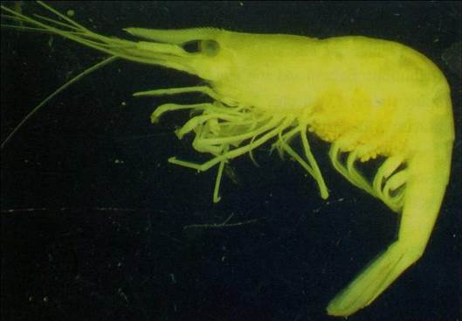

Figure ‑ Microinvertebrates collected in the 2015-16 survey. Freshwater shrimps (Atyidae)

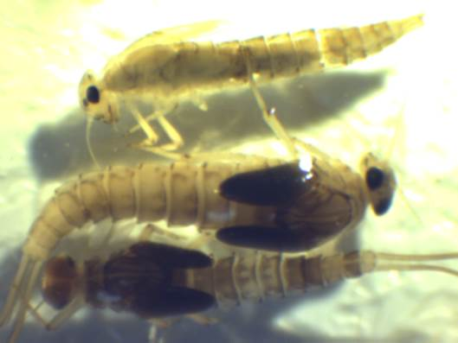

Figure ‑ Microinvertebrates collected in the 2015-16 survey. Mayflies (Beatidae)

Density

Across all sites and sampling occasions, macroinvertebrate densities ranged from 23 per m2 to 2,335 per m2, with the highest density recorded in the Gingham watercourse at Apr-16 with 2,335 per m2 (Figure E‑3). Macroinvertebrate density did not show any significant response to TIME and ZONE factors. This result suggested that there was no consistent temporal (i.e. concentration of macroinvertebrates as water levels receded) and spatial pattern (i.e. differences between river and wetland systems) in macroinvertebrate density during the study period.

Figure ‑ Mean ± standard deviation (SD) of macroinvertebrate density.

Diversity indices

Across all sites and sampling occasions, macroinvertebrate richness ranged from 5 to 19 taxa (Figure E‑4a). Shannon diversity ranged from 0.77 to 3.70 across all samples (Figure E‑4b). Macroinvertebrate family richness and diversity did not show any significant response to time and zone factors. This result suggests that there was no consistent temporal and spatial pattern in taxa richness during the sampling period. Nonetheless, a similar decrease in macroinvertebrate richness and diversity was observed across all sites in the contraction phase.

Figure ‑ Mean ± standard deviation (SD) of macroinvertebrate (a) family richness and (b) diversity

Taxonomic composition

A two-way PERMANOVA analysis revealed significant differences between zone (Pseudo-F=3.1679, d.f.=3, p=0.004) and time (Pseudo-F=3.2252, d.f.=3, p=0.001) based on presence-absence data, and between zone (Pseudo-F=2.755, d.f.=4, p=0.002) and TIME (Pseudo-F=.3.230, d.f.=3, p=0.001) based on taxa abundance. The significant temporal difference (between the 4 inundation phases) was slightly stronger than for the spatial pattern. The dissimilarity between zone (Figure E‑5a) and time (Figure E‑5b) was shown in the 3D nMDS ordination.

Community composition in the Gingham watercourse was significantly different to all river channels sampled (pairwise p<0.05). The community difference between Wetland and River zones was driven by the higher average abundance of Cirolanidae, Gerridae and Caenidae in River zones and higher average abundance of Notonectidae, Hydrophilidae, Ceratopogonidae and Baetidae in the Wetland zone (Table E‑2). The average abundance of these seven taxa contributes 30% to the dissimilarity between the river and watercourse zones.

Across all wetland and river sites, a similar temporal shift in community composition was observed during the sampling period. Community composition at T1 (‘Pre-EW’ phase) was significantly different to all other sampling occasions (pairwise test (p<0.01, Figure E‑5b) across all sites, driven by the higher average abundance of Caenidae, Ceratopogonidae and Hydrophilidae at T1, and Gerridae, Baetidae, Cirolanidae and Notonectidae at all other sampling occasions (Table E‑2). Moreover, community composition at T2 (‘Wet CEW’ phase) was significantly different to T3 and T4 (‘Contraction I &II’ phases) (pairwise test (p<0.01, Figure E‑5b) across all sites. The community composition differences were driven by the higher average abundance of Caenidae and Veliidae at T2, and Notonectidae, Cirolanidae, Hydrophilidae and Corixidae at T3 and T4 (Table E‑2).

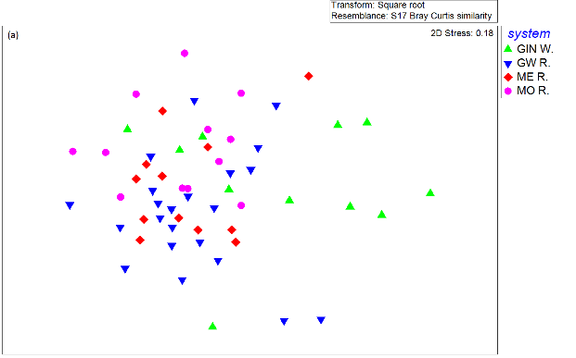

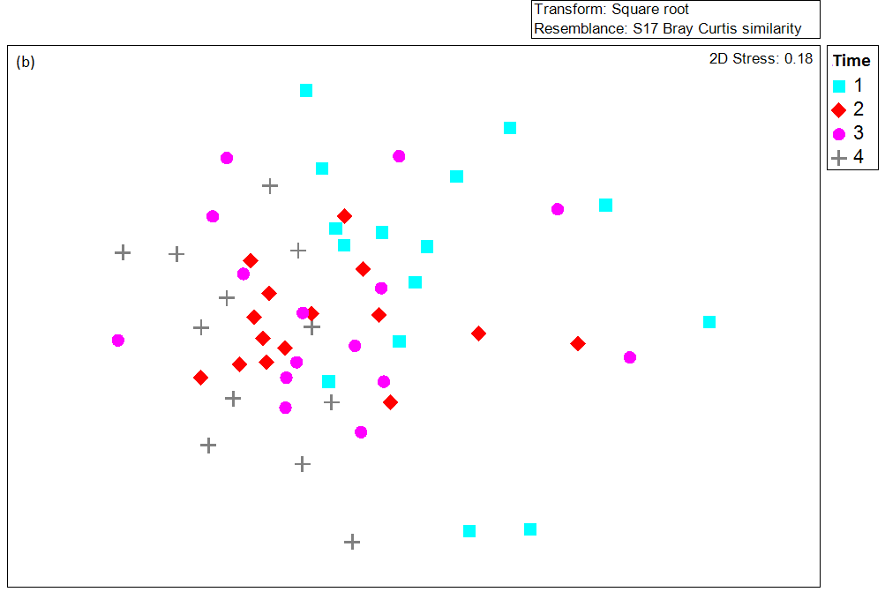

Figure ‑ nMDS ordination of macroinvertebrate community composition using abundance dataset by (a) zones and (b) sampling occasions

Table ‑ Macroinvertebrate taxa contributing most of the dissimilarities between Wetland and River communities in all sampling occasions based on presence-absence data. Bold numbers represent the higher average abundance.

|  |  |  |  |  |
| --- | --- | --- | --- | --- |
| Taxa | Average Abundance | | Contribution % | Cumulative % |
| Gingham watercourse | All Rivers |
| F.Cirolanidae | 0.00 | **0.67** | 5 | 5 |
| F.Gerridae | 0.18 | **0.72** | 5 | 10 |
| F.Caenidae | 0.18 | **0.65** | 5 | 15 |
| F.Hydrophilidae | **0.55** | 0.33 | 4 | 19 |
| F.Notonectidae | **0.73** | 0.59 | 4 | 23 |
| F.Baetidae | **0.73** | 0.70 | 3 | 26 |
| F.Ceratopogonidae | **0.45** | 0.24 | 3 | 30 |
|  | T1 | T2,T3,T4 |  |  |
| F.Gerridae | 0.20 | **0.76** | 6 | 6 |
| F.Baetidae | 0.40 | **0.81** | 5 | 11 |
| F.Cirolanidae | 0.33 | **0.62** | 5 | 16 |
| F.Caenidae | **0.80** | 0.48 | 5 | 20 |
| F.Ceratopogonidae | **0.53** | 0.19 | 4 | 25 |
| F.Notonectidae | 0.60 | **0.62** | 4 | 29 |
| F.Hydrophilidae | **0.47** | 0.33 | 4 | 33 |
|  | T2 | T3,T4 |  |  |
| F.Notonectidae | 0.47 | **0.70** | 6 | 6 |
| F.Caenidae | **0.53** | 0.44 | 6 | 11 |
| F.Cirolanidae | 0.60 | **0.63** | 5 | 17 |
| F.Velliidae | **0.40** | 0.30 | 5 | 22 |
| F.Hydrophilidae | 0.27 | **0.37** | 5 | 26 |
| F.Corixidae | 0.73 | **0.74** | 5 | 31 |

Discussion

The macroinvertebrate sampling successfully captured the inundation and contraction cycle of environmental watering actions in the Selected Area. During late September, the Selected Area experienced low and stable flow conditions after local rainfall events in late August. This was considered the ‘pre’ phase prior to environmental watering actions. Early February sampling captured the ‘wet’ phase of the Selected Area from multiple environmental watering actions. Mid-March sampling was in the contraction cycle of residual environmental water when some of the river channels contracted into disconnected pools. Late April sampling was designed to capture the low flow condition, when the Mehi River and Moomin Creek contracted to disconnected pools and where sites in the lower Gwydir River and the water couch site in the Gingham watercourse were dry. Sites in the Gwydir River channels were inundated by a small environmental water release that occurred during the late April sampling period.

It was likely that the environmental water inundation and contraction cycle provided an opportunity for macroinvertebrates to take advantage of increases in primary productivity that resulted from inundation before declining water levels and associated water quality conditions affected more sensitive macroinvertebrate families. Macroinvertebrates demonstrated a unidirectional shift in community composition through the phases of inundation and contraction across all sites, reflecting community succession due to changes in local physical and chemical environmental conditions.

There was no statistically significant effect of environmental water on macroinvertebrate density, richness or diversity, but there was a significant effect on family level community composition. Macroinvertebrate density was substantially higher and community composition significantly different in the Gingham watercourse and the Gwydir River as these zones were inundated for relatively prolonged periods compared with the contracting pools of the Mehi and Moomin systems. Within the areas receiving environmental water, there were consistent differences between the Gingham watercourse and the Gwydir River throughout the study period. This reinforces the patterns observed during the 2014-15 watering year, suggesting that the promotion of regional scale macroinvertebrate diversity requires the inundation of multiple river and watercourse areas.

Conclusion

During 2015-16, environmental water throughout the Gwydir River and Gingham watercourse increased secondary production measured as macroinvertebrate density. Connectivity provided by environmental water in early January provided an opportunity for macroinvertebrates to take advantage of increases in primary production that resulted from inundation before declining water levels and associated water quality conditions became uninhabitable for some sensitive macroinvertebrate families. The significant difference in macroinvertebrate community composition in different sampling occasions indicates the benefits of delivery of environmental water in maintaining regional level diversity.

References

Clarke, D. R. & Warwick, R. M. 2001. *Changes in marine communities: an approach to statistical analysis and interpretation*. Natural Environmental Research Council, Plymouth, UK.

Commonwealth of Australia. 2015. *Commonwealth Environmental Water Office Long Term intervention Monitoring Project Gwydir River System Selected Area – 2014-15 Evaluation Report*. Commonwealth of Australia.

Hale, J., Stoffels, R., Butcher, R., Shackleton, M., Brooks, S., Gawne, B., & Stewardson, M. 2014. *Commonwealth Environmental Water Office Long Term Intervention Monitoring Project – Standard Methods.* Final Report prepared for the Commonwealth Environmental Water Office by The Murray-Darling Freshwater Research Centre, MDFRC Publication 29.2/2014, January, 175 pp.

###### Ecosystem Type

Introduction

The Ecosystem Type indicator contributes to the broader scale evaluation of Commonwealth environmental waters’ influence on ecosystem diversity. While primarily designed to inform at larger basin scales, information on the types of ecosystems influenced by Commonwealth environmental water is also useful at the Selected Area scale. Several specific questions were addressed by measuring ecosystem type within the Gwydir river system Selected Area during the 2015-16 water year:

* What did Commonwealth environmental water contribute to sustainable ecosystem diversity?
* Were ecosystems to which Commonwealth environmental water was allocated sustained?
* Was Commonwealth environmental water delivered to a representative suite of ecosystem types?

Environmental watering in 2015-16

During 2015-16 Commonwealth environmental water was delivered to a number of assets within the Gwydir River system (Appendix A). In November 2015, a flow event occurred down the Mehi River and supplementary water licences owned by the CEWO were triggered. A total of 1,300 ML were accounted for with 964 ML of this water flowing down the Mehi River, and 336 ML directed down Mallowa Creek.

Through January 2016, flows were delivered into the Mallowa Creek system to inundate fringing wetlands in association with WaterNSW water bulk water deliveries. Flows were also delivered into the lower Gwydir River and Gingham watercourse in February 2016, to replace flows that were abstracted in a supplementary flow event. While not large in volume, these flows made it into the wetlands.

Due to critically low flows experienced in the lower Gwydir system in March and April 2016, water was delivered down the lower Gwydir, Gingham, Mehi and Carole channels as part of a dry river flow action in early April. This followed a period of 30-40 days of nil flows conditions across the catchment.

Methods

The ANAE classification for each sampling site in the Gwydir river system Selected Area was mapped using a process of desk-top identification and field verification (Commonwealth of Australia 2014). Existing ANAE GIS layers (Brooks et al. 2013) were used to assign an ecosystem type to each monitoring site, and this was then verified in the field. Sites where existing ANAE mapping did not provide coverage were assigned an ANAE classification using available desktop information and then verified in the field.

Results

149 survey sites were sampled as part of the Gwydir river system Selected Area LTIM project in the 2015-16 water year. These fell into 10 ANAE ecosystem types, including five Riverine types, three Floodplain types and two Lacustrine types. The Rp1.4: The Permanent lowland streams type was represented by the most sites, with 59 sites classified as this ecosystem type (Table F‑1). Thirty-four sites were classified as the F3.2: Sedge/forb/grassland floodplain type, while 18 sites were classified as the Rt1.4: Temporary lowland stream ecosystem type and 14 sites were classified as the F1.11: River cooba woodland floodplain ecosystem type (Table F‑1). All other types are represented by 10 sites or fewer.

53 survey sites were new for the 2015-16 water year (Figure F‑1). Generally, these sites are used for Fish (Movement) and Vegetation indicators in the Mallowa Wetlands, hence the majority of new sites are represented by Rp1.4: Permanent lowland streams and F1.11: River cooba woodland floodplain ecosystem types (Table F‑2).

Within the Selected Area, most sites (45%) are situated in the lower Gwydir River and Gingham watercourse zone (Figure F‑2). This zone contains all ANAE Ecosystem types present within the Selected Area, except Rp1.3: Permanent high energy upland streams. The F1.10: Coolibah woodland and forest floodplain and Rt1.3: Temporary low energy upland streams types are only found within the lower Gwydir River and Gingham watercourse zone. There are 24 sites within the Mehi River and Moomin Creek zone, and these were classified as Rp1.4: Permanent lowland streams, Rt1.4: Temporary lowland streams, and Lt2.2: Temporary floodplain lake with aquatic beds ecosystem types. Sites within the Gwydir River zone are located within Rp1.4: Permanent lowland streams, Rt1.4: Temporary lowland streams, Rp1.3: Permanent high energy upland streams and Rt1.3 Temporary low energy upland streams ecosystem types. Monitoring of Waterbird and Vegetation indicators within Mallowa Creek commenced in the 2015-16 water year. Sites within this zone are located across three ecosystem types including F1.11: River cooba woodland floodplain, F3.2: Sedge/forb/grassland floodplain and Rt1.4: Temporary lowland streams (Figure F‑2).

Within the Selected Area, a total of 122 sites, accounting for 82% of all sites were inundated during the 2015-16 water year (Figure F‑3 and Figure F‑4). All ecosystem types except F1.11: River cooba woodland floodplain and Lt2.2: Temporary floodplain lake were inundated.

Environmental flows contributed to inundation at ninety sites across all zones (Figure F‑3). All ecosystem types were inundated by environmental flows, except F1.11: River cooba woodland floodplain and Lt2.2: Temporary floodplain lake (Figure F‑5).

Table ‑: ANAE Ecosystem types covered by monitoring sites in the Gwydir river system Selected Area LTIM project.

|  |  |  |
| --- | --- | --- |
| ANAE Typology | Number of sites (All zones) | % of all sites |
| F1.10: Coolibah woodland and forest floodplain | 5 | 3.4 |
| F1.11: River cooba woodland floodplain | 14 | 9.4 |
| F3.2: Sedge/forb/grassland floodplain | 34 | 22.8 |
| Lp2.1: Temporary floodplain lake | 2 | 1.3 |
| Lt2.2: Temporary floodplain lake with aquatic beds | 9 | 6.0 |
| Rp1.1: Permanent high energy upland streams | 1 | 0.7 |
| Rp1.3: Permanent low energy upland streams | 5 | 3.4 |
| Rp1.4: Permanent lowland streams | 59 | 39.6 |
| Rt1.3: Temporary low energy upland streams | 2 | 1.3 |
| Rt1.4: Temporary lowland streams | 18 | 12.1 |
| Total | 149 |  |

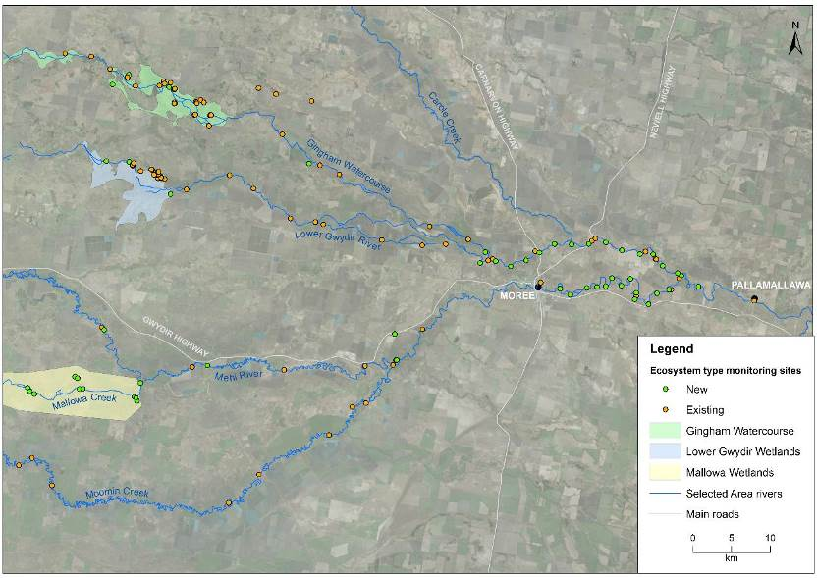

Figure ‑: New and old sites monitored within the Selected Area for the 2105-16 water year

Table ‑: ANAE Ecosystem Types covered by new monitoring sites in the Gwydir river system Selected Area.

|  |  |
| --- | --- |
| ANAE Typology | Number of sites (All zones) |
| F1.11: River cooba woodland floodplain | 10 |
| F3.2: Sedge/forb/grassland floodplain | 3 |
| Lt2.2: Temporary floodplain lake with aquatic beds | 6 |
| Rp1.4: Permanent lowland streams | 30 |
| Rt1.4: Temporary lowland streams | 4 |

Figure ‑: Distribution of ANAE Ecosystem Types represented by sites across the four monitoring zones within the Selected Area.

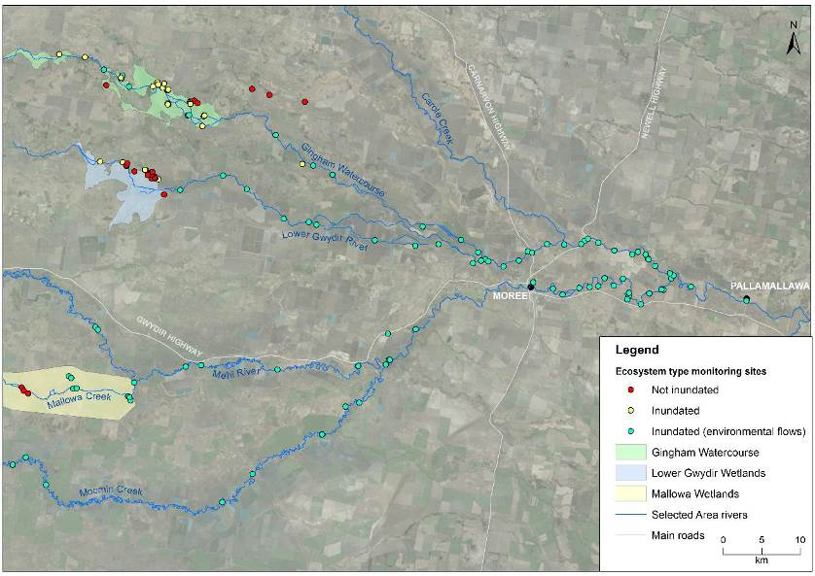

Figure ‑: Inundation status of sites sampled in the Selected Area during the 2015-16 water year

Figure ‑: Distribution of ANAE Ecosystem Types inundated across the four monitoring zones within the Selected Area.

Figure ‑: Proportion of sites inundated at each ANAE ecosystem type influenced by environmental water.

Discussion

The types of ecosystems monitored in this project are a reflection of the nature of the delivery of environmental water, and the indicators being assessed. Given the emphasis on eco-hydrology links in the project, the dominance of Riverine Ecosystem types is self-evident. The large representation of sites within the Sedge/forb/grassland floodplain type is a reflection of the dominance of this type in low lying areas of the lower Gwydir and Gingham watercourse zone that commonly form the target for environmental watering.

References

Brooks, S., Cottingham, P., Butcher, R, & Hale, J. 2013. *Murray Darling aquatic ecosystem classification: Stage 2 report.* Prepared by Peter Cottingham & Associates for the Commonwealth Environmental Water Office and Murray Darling Basin Authority, Canberra.

Commonwealth of Australia. 2014. *Commonwealth Environmental Water Office Long Term Intervention Monitoring Project Gwydir River System Selected Area.* Commonwealth of Australia.

###### Vegetation Diversity

Introduction

The lower Gwydir River and Gingham watercourse support a number of water dependent vegetation communities, including flood dependent woodlands (supporting ecological vegetation communities with dominant tree species such as coolibah and black box), floodplain wetland communities (supporting river red gum, coolibah woodlands and river cooba and lignum shrubland species) and semi-permanent wetlands (supporting species such as water couch, marsh club-rush, spike rush, tussock rushes, sedges and cumbungi) (Bowen and Simpson 2010). The area occupied by these communities has declined since river regulation as a result of both restricted flows and clearing for agriculture (Wilson et al. 2009, Bowen and Simpson 2010). Maintaining the current extent and then improving and maintaining the health of these communities has become a target for environmental water management in the Gwydir catchment (Commonwealth of Australia 2014a). Two specific questions were addressed through the monitoring of vegetation diversity in the 2015-16 water year in the lower Gwydir wetlands:

* What did Commonwealth environmental water contribute to vegetation species diversity?
* What did Commonwealth environmental water contribute to vegetation community diversity?

Environmental watering in 2015-16

During 2015-16, environmental water was delivered to several of the lower Gwydir River channels (Appendix A). In November 2015, a flow event occurred down the Mehi River and supplementary water licences owned by the CEWO were triggered. A total of 1300 ML were accounted for with 964 ML of this water flowing down the Mehi River, and 336 ML directed down Mallowa Creek. Through January 2016, flows were delivered into the Mallowa Creek system to inundate fringing wetlands. Flows were also delivered into the lower Gwydir River and Gingham watercourse in February 2016 to replace flows that were abstracted in a supplementary flow event. Due to critically low flows experienced in the lower Gwydir system in March and April 2016, water was delivered to the lower Gwydir, Gingham, Mehi and Carole channels as part of a dry river flow action in early April. This followed a period of 30-40 days of nil flow conditions across the catchment. These flows were not large in volume (Appendix A), and did not inundate any sites monitored for vegetation diversity.

In the Gingham and lower Gwydir wetlands 48% of the plots surveyed for vegetation diversity in October 2015 were inundated (Table G‑1). This inundation was a result of remnant environmental water and localised rainfall earlier in the 2015-16 water year. Five of the seven plots within the Mallowa wetlands were inundated by environmental water over the summer period, and hence were classed as ‘wet’ in the analysis (Table G‑1). All other plots were dry in March 2016. Of the total 40 plots, all 19 (48%) that were wet in October 2015 were dry in March 2016, 5 (13%) went from dry to wet, and 16 (40%) remained dry between the two survey times.

Previous Monitoring

Vegetation monitoring was undertaken in the 2014-15 water year by Eco Logical Australia and OEH staff as part of the first year of the LTIM project.

The delivery of environmental water into the Gingham and lower Gwydir wetlands during the 2014-15 season influenced all five water dependent vegetation communities surveyed, inundating a total of 25 vegetation plots. While the season was shown to be an influencing factor, the presence of environmental water had the largest influence on vegetation diversity and composition. The application of environmental water decreased the amount of bare ground and increased the diversity of aquatic species. There was also a significant reduction in the cover of the weed species lippia *(Phyla canescens)* in plots that became inundated by environmental water. Native wetland species such as water couch *(Paspalum distinchum)* and flat spike-sedge (*Eleocharis plana*) displayed significantly increased cover in plots inundated by environmental water. It is likely that the increased growth of these species in inundated plots resulted in them out-competing lippia, and led to weed suppression in inundated locations.

Methods

2015-16 water year

Monitoring throughout the lower Gwydir wetlands and Gingham watercourse was undertaken in October 2015 and March 2016 in thirty-three plots at 12 locations (Figure G‑1 and Figure G‑2). These plots were the same as sampled in 2014-15 with the addition of a coolibah woodland site in the Gwydir wetlands which was surveyed in 2015-16 (Old_Dromana_Ramsar_2_1). In addition, seven plots at three locations were monitored in the Mallowa wetlands during both survey periods (Figure G‑3). All plots were located in six broad wetland vegetation communities, and experienced a range of inundation conditions (Table G‑1). Vegetation surveys were completed in conjunction with OEH staff, following OEH data collection protocols (Commonwealth of Australia 2014b), which recorded vegetation diversity and structure within each 0.04 ha plot. A number of environmental variables including the degree of inundation and grazing impact were also noted.

Species richness measures were analysed using a binomial model that estimates the proportion of species present out of the total number of species possible (Venables and Ripley 2002). 221 species were used as the total number possible, based on the species recorded over the four survey periods undertaken in the Gwydir LTIM project. This species list is consistent with monitoring undertaken in the Gwydir system in previous years. The model estimated the influence of inundation, survey time (2015-16), system (Gingham, lower Gwydir, Mallowa) and vegetation community. Plots were considered inundated if water was present at time of survey, or if inundation mapping suggested that they had been inundated between survey times. To further explain changes in diversity, individual species were grouped into the four following functional groups (Brock and Cassanova 1997; Hale et al. 2013):

* Amphibious responders (AmR) – plants which change their growth form in response to flooding and drying cycles (including morphologically plastic (ARp) and floating/stranded (ARf);
* Amphibious tolerators (AmT) – plants which tolerate flooding patterns without changing their growth form;
* Terrestrial damp plants (Tda) – plants which are terrestrial species but tend to grow close to the water margin on damp soils; and
* Terrestrial dry plants (Tdr) - those which are terrestrial species which don’t normally grow in wetlands but may encroach into the area due to prolonged drying.

Changes in these functional groups were then compared between survey times using F-tests to test for equality of variances and then t-tests for differences in means.

Changes in vegetation cover were investigated using multivariate nMDS plots with differences between the presence of environmental water, survey time and vegetation community assessed using PERMANOVA in Primer 6. SIMPER analysis was used to identify species responsible for driving patterns in the data, and followed by descriptive univariate analysis of these species were then undertaken.

### 

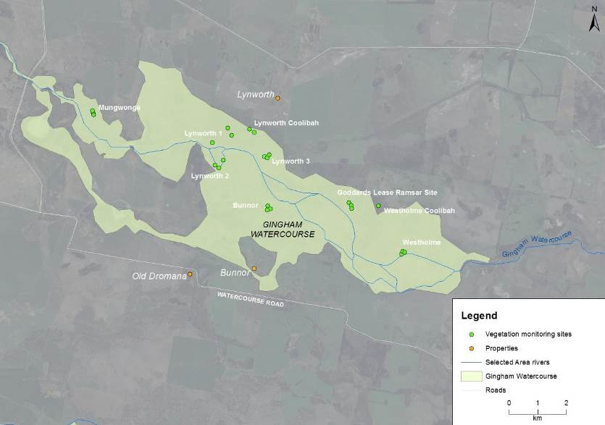

**River and Creeks**

Figure ‑ Location of vegetation monitoring sites within the Gingham watercourse.

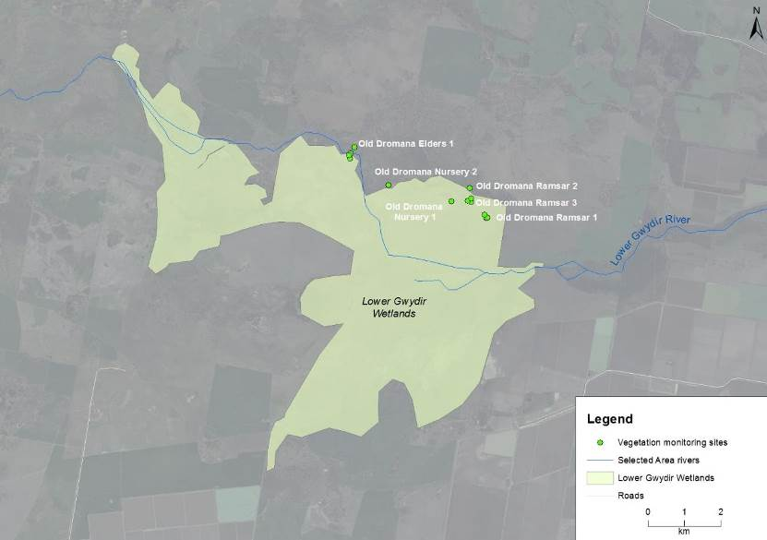

**River and Creeks**

Figure ‑ Location of vegetation monitoring sites within the lower Gwydir wetlands.

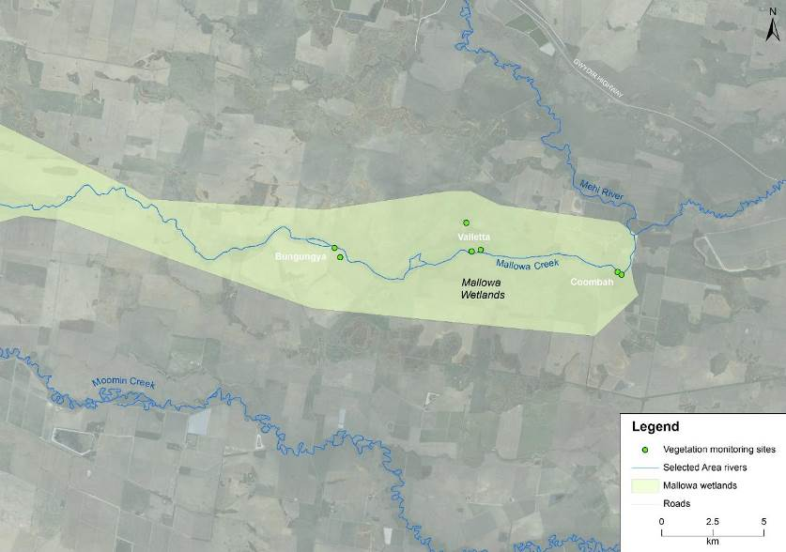

**River and Creeks**

Figure ‑ Location of vegetation monitoring sites within the Mallowa wetlands.

Table ‑ Sites surveyed in October 2015 and March 2016 for vegetation diversity. Map projection GDA94 Zone 55. Sites that were inundated at the time of sampling are coloured blue (‘wet’) and those that were not are coloured yellow (‘dry’).

| Vegetation communities | Sites | System | Northing | Easting | 2015 (Oct) | 2016 (Mar) |
| --- | --- | --- | --- | --- | --- | --- |
| Coolibah - river cooba - lignum | Bungunya_1_1 | Mallowa | 6723793 | 709823 | Dry | Dry |
| Coolibah - river cooba - lignum | Bungunya_1_2 | Mallowa | 6723336 | 710098 | Dry | Dry |
| Water couch marsh grassland | Bunnor_1_1 | Gingham | 6760771 | 728826 | Wet | Dry |
| Water couch marsh grassland | Bunnor_1_2 | Gingham | 6760658 | 728917 | Wet | Dry |
| Water couch marsh grassland | Bunnor_1_3 | Gingham | 6760630 | 728812 | Wet | Dry |
| Coolibah - river cooba - lignum | Coombah_1_1 | Mallowa | 6722614 | 723649 | Dry | Wet |
| Coolibah - river cooba - lignum | Coombah_1_2 | Mallowa | 6722491 | 723849 | Dry | Wet |
| Water couch marsh grassland | Goddards _Lease_Ramsar_1_1 | Gingham | 6760882 | 731652 | Wet | Dry |
| Water couch marsh grassland | Goddards _Lease_Ramsar_1_2 | Gingham | 6760784 | 731738 | Wet | Dry |
| Water couch marsh grassland | Goddards _Lease_Ramsar_1_3 | Gingham | 6760678 | 731749 | Wet | Dry |
| River Cooba - Lignum | Lynworth_1_1 | Gingham | 6763482 | 727443 | Wet | Dry |
| River Cooba - Lignum | Lynworth_1_2 | Gingham | 6763219 | 727574 | Wet | Dry |
| River Cooba - Lignum | Lynworth_1_3 | Gingham | 6762965 | 726906 | Wet | Dry |
| Coolibah Woodland | Lynworth_1_4 | Gingham | 6763330 | 728359 | Wet | Dry |
| Water couch marsh grassland | Lynworth_3_1 | Gingham | 6762487 | 728716 | Wet | Dry |
| Water couch marsh grassland | Lynworth_3_2 | Gingham | 6762446 | 728809 | Wet | Dry |
| Water couch marsh grassland | Lynworth_3_3 | Gingham | 6762544 | 728885 | Wet | Dry |
| Water couch marsh grassland | Mungwonga_1_1 | Gingham | 6764005 | 722759 | Wet | Dry |
| Water couch marsh grassland | Mungwonga_1_2 | Gingham | 6763930 | 722771 | Wet | Dry |
| Water couch marsh grassland | Mungwonga_1_3 | Gingham | 6764083 | 722726 | Wet | Dry |
| Water couch marsh grassland | Old_Dromana_Elders_1_1 | Lower Gwydir | 6752745 | 723443 | Dry | Dry |
| Water couch marsh grassland | Old_Dromana_Elders_1_2 | Lower Gwydir | 6752603 | 723435 | Dry | Dry |
| Water couch marsh grassland | Old_Dromana_Elders_1_3 | Lower Gwydir | 6752706 | 723395 | Dry | Dry |
| Coolibah Woodland | Old_Dromana_Elders_1_4 | Lower Gwydir | 6752918 | 723552 | Dry | Dry |
| Coolibah Woodland | Old_Dromana_Nursery_1 | Lower Gwydir | 6751431 | 726197 | Dry | Dry |
| Coolibah Woodland | Old_Dromana_Nursery_2 | Lower Gwydir | 6751888 | 724473 | Dry | Dry |
| Eleocharis tall sedgelands | Old_Dromana_Ramsar_1_1 | Lower Gwydir | 6750977 | 727152 | Dry | Dry |
| Eleocharis tall sedgelands | Old_Dromana_Ramsar_1_2 | Lower Gwydir | 6750992 | 727184 | Dry | Dry |
| Eleocharis tall sedgelands | Old_Dromana_Ramsar_1_3 | Lower Gwydir | 6751075 | 727098 | Dry | Dry |
| Coolibah Woodland | Old_Dromana_Ramsar_2_1 | Lower Gwydir | 6751800 | 726701 | Dry | Dry |
| Water couch marsh grassland | Old_Dromana_Ramsar_3_1 | Lower Gwydir | 6751426 | 726741 | Dry | Dry |
| Water couch marsh grassland | Old_Dromana_Ramsar_3_2 | Lower Gwydir | 6751456 | 726641 | Dry | Dry |
| Water couch marsh grassland | Old_Dromana_Ramsar_3_3 | Lower Gwydir | 6751515 | 726746 | Dry | Dry |
| Coolibah Woodland | Westholme_Coolibah_1 | Gingham | 6764083 | 722726 | Dry | Dry |
| Water couch marsh grassland | Westhome_1_1 | Gingham | 6759094 | 733487 | Wet | Dry |
| Water couch marsh grassland | Westhome_1_2 | Gingham | 6759189 | 733523 | Wet | Dry |
| Water couch marsh grassland | Westhome_1_3 | Gingham | 6759157 | 733591 | Wet | Dry |
| Coolibah - river cooba - lignum | Valletta_1_1_NE | Mallowa | 6723629 | 716519 | Dry | Wet |
| Coolibah - river cooba - lignum | Valletta_1_2 | Mallowa | 6723681 | 716970 | Dry | Wet |
| Coolibah - river cooba - lignum | Valletta_2_1 | Mallowa | 6725026 | 716262 | Dry | Wet |

Multi-year comparison

To assess longer term trends in vegetation species richness, a binomial model was used to investigate the influence of inundation, survey time (December 2014, March 2015, October 2015, and March 2016), system and vegetation community. This analysis included 32 plots from the lower Gwydir wetland and Gingham watercourse in December 2014 and March 2015, and the sites described in section 2.1 above. Changes in vegetation cover were investigated using multivariate nMDS plots with differences between inundation status, survey time, system and vegetation community assessed using PERMANOVA in Primer 6.

Results

2015-16 water year

Species richness

A total of 164 flora species from 50 families were recorded across all vegetation plots. The mean species richness at each location during each survey period was 14.6, down from the 2014-15 mean of 21.8. The highest mean species richness was 25, recorded at Old Dromana Ramsar 2 in the lower Gwydir wetland in March 2016, and Westholme Coolibah in the Gingham watercourse in October 2015; while the lowest was recorded at Westholme and Bunnor in the Gingham watercourse during March 2016 (7.67) (Figure G‑6).

Binomial model results suggest that system was the most influential factor on species richness, with a significant difference noted between Gingham and the lower Gwydir systems (Pr=0.05). However, no significant difference was observed between the lower Gwydir and Mallowa systems (Pr=0.17), or the Gingham and Mallowa systems (Pr=0.63). Similarly, no significant difference was noted between sampling times (Pr=0.26). The Coolibah woodland vegetation community had a mean species richness of 17.6, while the River Cooba Lignum community had a mean species richness of 16.8. These two communities had significantly higher species richness than both *Eleocharis* tall sedgelands (13.7 species) and water couch marsh grassland (13 species). Sites that were wet during sampling tended to have lower mean species richness (13.8) than those that were dry (15), though these differences were not significant (Pr=0.63).

Sites that were wet during 2015 and then dry in 2016 tended to increase in mean species richness (Figure G‑4) within the terrestrial functional group, including Tdr and Tda species, however this increase was not significant, Tdr (T=0.38, Pr=0.704), Tda (T=1.43, Pr=0.162). Species in the Amphibiousfunctional group including AmR and AmT species decreased with drying, with AmR mean species richness showing a significant decrease (T = -4.21, Pr<0.001) from 4.47 in 2015 to 2.42 in 2016 (Figure G‑5). AmT mean species richness showed a decrease from 3.79 in 2015 to 3.32 in 2016 (Figure G‑5), however this decrease was not significant (T=-1.10, Pr=0.278).

The composition of growth forms changed between sampling periods, with forb species richness displaying a significant reduction in total species from 68 in October 2015 to 58 in March 2016 (T=-2.36, Pr<0.05) (Figure G‑7). This reduction in species richness was driven by reductions in amphibiousfunctional group species (Figure G‑8).

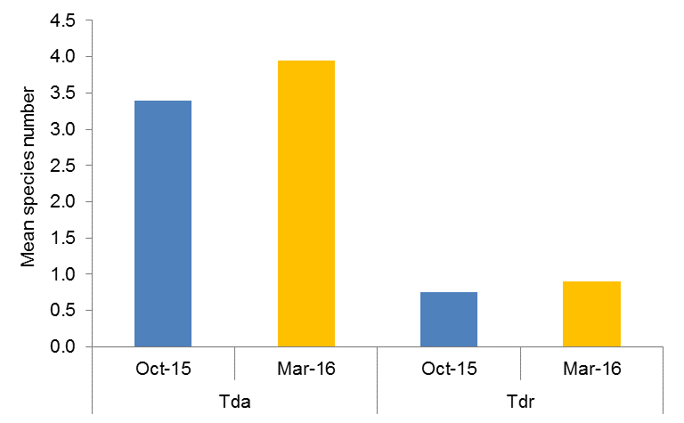

Figure ‑ Mean number of species in Tda and Tdr functional groups at sites that were wet in October 2015 and dry in March 2016.

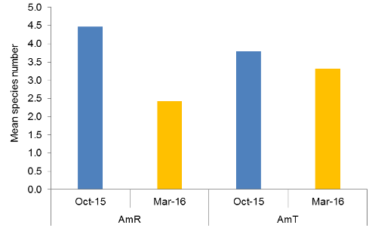

Figure ‑ Mean number of species in AmR and AmT functional groups at sites that were wet in October 2015 and dry in March 2016.

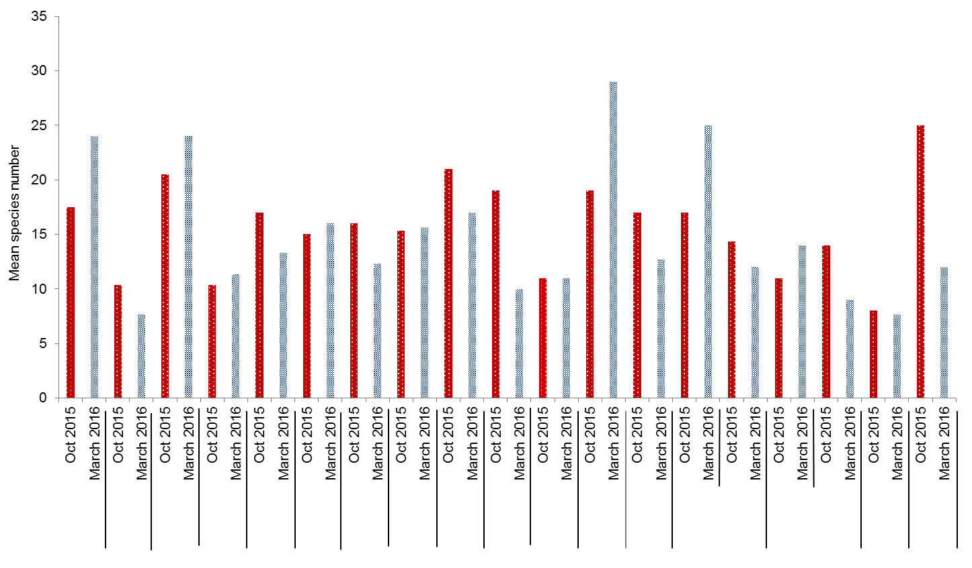

Old Dromana Nursery 1

Bungunya

Westholme

Munwonga

Lynworth 3

Valetta 1

Old Dromana Ramsar 2

Old Dromana Elders 1

Old Dromana Nursery 2

Old Dromana Ramsar 1

Old Dromana Ramsar 3

Valetta 2

Westholme Coolibah

Old Dromana

Lynworth 1_4

Coombah

Goddards

Lynworth 1

Bunnor

Figure ‑ Mean number of species recorded at each site during the October 2015 and March 2016 surveys.

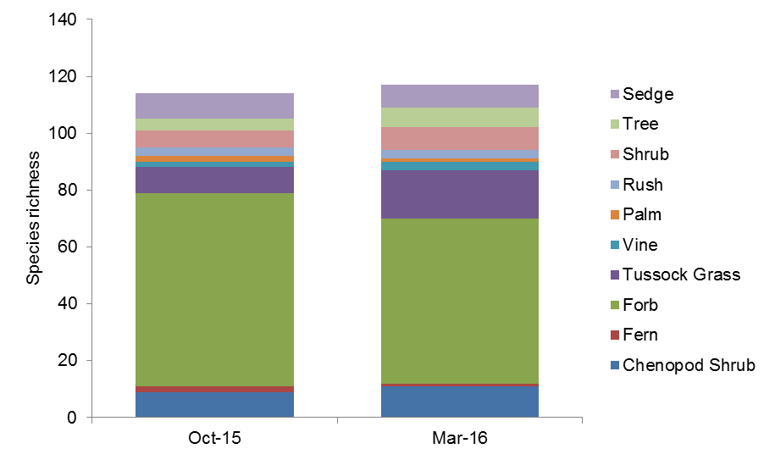

Figure ‑ Total number of species and the proportion of the differing growth forms recorded across all vegetation plots in October 2015 and March 2016 sampling periods.

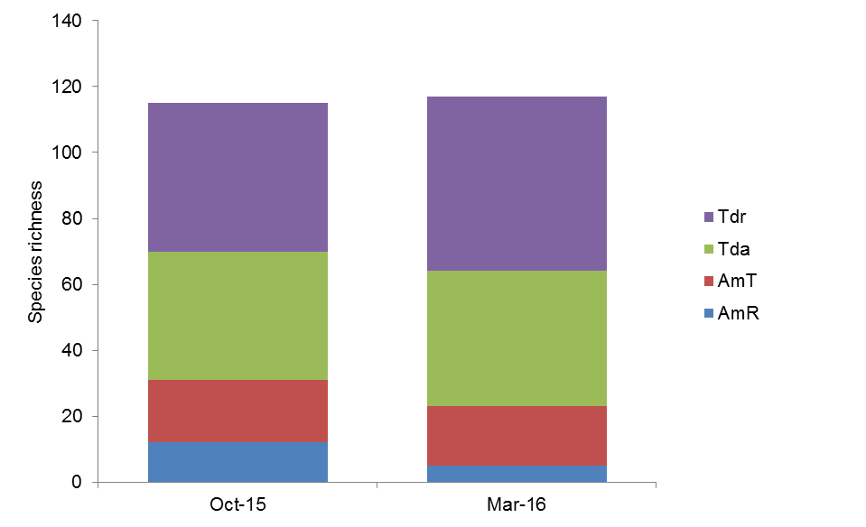

Figure ‑ Total number of species and the proportion of the differing functional groups recorded across all vegetation plots in October 2015 and March 2016 sampling periods.

Vegetation community composition

PERMANOVA tests on vegetation community composition data from all plots surveyed during the 2015-16 water year suggested that vegetation community (Pseudo-F = 4.29, Pr<0.005) and inundation (Pseudo-F = 2.80, Pr<0.05) were exerting an influence on the observed patterns (Figure G‑9). Pairwise tests suggested significant differences between wet and dry sites in water couch marsh grassland (t=1.39, Pr<0.05) vegetation communities, but no differences were noted in the community composition between wet or dry sites within coolibah woodland (Pr=0.66) or river cooba lignum sites (Pr=0.10) (Figure G‑10). Sampling time did not have a significant influence on the grouping of the data in multidimensional space (Pr=0.55)

SIMPER analysis showed that water couch and flat spike-sedge had a large influence on the similarity of survey time and inundation groups (Table G‑2). Additionally, the introduced species lippia influenced the similarity of dry sites, while tussock rush (*Juncus aridicola*) and Pacific azolla (*Azolla filiculoides*) influenced the grouping of wet sites in October 2015, and downs nutgrass (*Cyperus bifax*), budda pea (*Aeschynomene indica*) and river cooba (*Acacia stenophylla*) influenced the similarity of wet sites in March 2015.

Figure ‑ nMDS plot of vegetation community composition data grouped by vegetation community and the presence of water (wet) or not (dry).

Figure ‑ nMDS plot of vegetation community composition data grouped by sampling time and the presence of water (wet) or not (dry) when sampling.

Table ‑ Dominant species and variables contributing to vegetation community composition groupings based on survey time and the presence of water. ‘dry’ means no water was present, ‘wet’ means water was present at the time of surveying. Note: no sites were inundated in March 2016.

| Data grouping | Species Contributing to grouping | Contribution (%) | Cumulative (%) |
| --- | --- | --- | --- |
| October 2015 x Dry | water couch | 14.80 | 14.8 |
| flat spike-sedge | 12.01 | 26.81 |
| swamp buttercup | 8.49 | 35.30 |
| lippia | 8.19 | 43.49 |
| October 2015 x Wet | water couch | 19.33 | 19.33 |
| tussock rush | 14.77 | 34.10 |
| flat spike-sedge | 12.95 | 47.06 |
| Pacific azolla | 7.59 | 54.65 |
| March 2016 x Dry | water couch | 22.72 | 22.72 |
| lippia | 12.28 | 35.00 |
| tussock rush | 10.59 | 45.59 |
| narrow-leaved cumbungi | 8.33 | 53.91 |
| March 2016 x Wet | downs nutgrass | 16.06 | 16.06 |
| budda pea | 15.82 | 31.88 |
| flat spike-sedge | 13.89 | 45.77 |
| river cooba | 13.55 | 59.31 |

The mean percentage of vegetation cover in each plot increased significantly between sampling years from 70.1±6.5% in 2015 to 84.65±-3.2% in 2016 (T=2.76, Pr=0.007; Figure G‑11). Sites that were wet in October 2015 but dry in March 2016 increased in mean percentage of vegetation cover from 83.1±6.1% to 85.6±4% (Figure G‑12), however this was not significant (T=0.42, Pr=0.679). Water couch was the most dominant species recorded for cover across the study area, being found at 31 of 40 (78%) plots surveyed. Mean water couch cover was greater in wet plots, however this difference was not significant (T=-1.27, Pr=0.21) (Figure G‑13). Mean water couch cover was observed to be greater towards the end of the season (2015 vs 2016) but again this increase was not significant (T=-0.55, Pr=0.579) (Figure G‑14). Lippia was most dominant in dry plots, with a higher mean cover (6.3±24.9%) in dry plots compared to wet plots (2.3±-20.4%) (Figure G‑15 and Figure G‑17); similarly, there was a higher mean lippia cover recorded in March 2016 in plots that were wet in October 2015, but were dry in the March 2016 survey period (Figure G‑16), however these differences were not significant (T=1.62, Pr=0.109; and, T=1.18, Pr=0.246 respectively). Flat spike-sedgeshowed a similar trend to lippia, increasing in cover between October 2015 and March 2016 (Figure G‑18). This trend was inconsistent when comparing plots that were wet in October 2015 and dry in March 2016, showing a reduction in mean cover from 5.9±-27.9% in 2015 to 2.3±-49.7% (Figure G‑19).

|  |  |
| --- | --- |
| Figure ‑ Mean vegetation cover (%) at sites in October 2015 and March 2016 sampling periods. | Figure ‑ Mean vegetation cover (%) at sites that were wet in October 2015 and dry in March 2016. |

|  |  |
| --- | --- |
| Figure ‑ Mean cover (%) of water couch at dry and wet sites, regardless of time. | Figure ‑ Mean cover (%) of water couch at sites in October 2015 and March 2016 sampling periods. |
|  |  |
| Figure ‑ Mean cover (%) of lippia at dry and wet sites, regardless of time. | Figure ‑ Mean cover (%) of lippia at sites that were wet in October 2015 and dry in March 2016 |

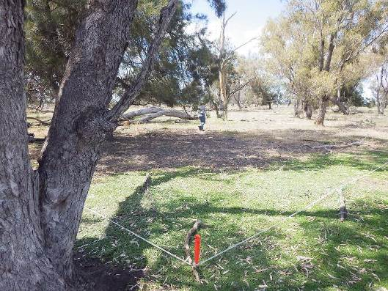

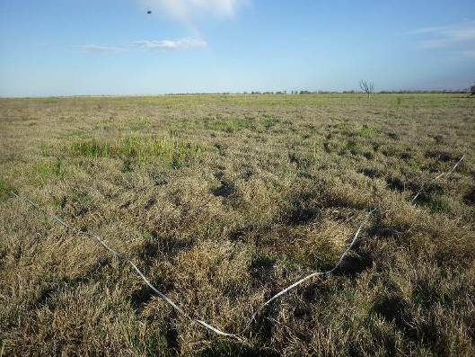

Figure ‑ Vegetation diversity monitoring plots showing greater cover of lippia in a dry site (top foreground) compared to a wet site (bottom)

|  |  |
| --- | --- |
| Figure ‑ Mean cover (%) of flat spike-sedge at sites in October 2015 and March 2016 sampling periods. | Figure ‑ Mean cover (%) of flat spike-sedge at sites that were wet in October 2015 and dry in March 2016. |

Multi-year comparisons

Vegetation species richness

The binomial model for species richness data from both year 1 and 2 suggested that sampling time is having the greatest influence on species number (Pr<0.001), with significantly higher mean richness in December 2014 (25.6 species), compared to March 2015 (17.1 species), October 2015 (15.2 species) and March 2016 (14.2 species)(Figure G‑20). Similarly, system (Pr<0.001) and vegetation community (Pr<0.001) are also significantly influencing species richness data. Overall, the presence of water appears to be only having a weakly significant influence on species richness (Pr<0.05) with dry sites having a mean of 18.1 species and wet sites a mean of 16.7 species.

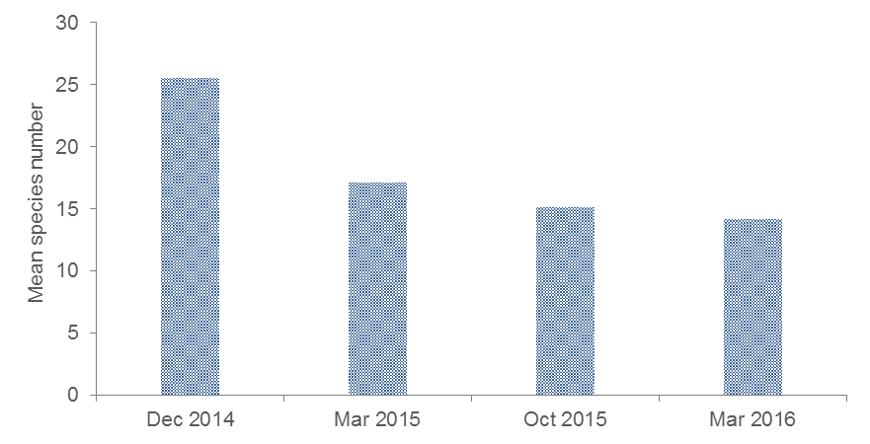

Figure ‑ Mean number of species recorded during surveys in year 1 and 2 of the project.

Vegetation community composition

Separation in the community composition data was observed when grouped by sampling time (including the four sampling times from years 1 and 2 of the project) and inundation (Figure G‑21 ). The clustering of the wet sites suggests that the community composition of the sites is more similar than those in dry sites. A two way multivariate PERMANOVA model was run to assess the influence of sampling time and inundation. This model suggested that both sampling time (Pseudo-F=1.73, Pr<0.05) and inundation (Pseudo-F=4.04, Pr<0.005) were significantly influencing the data. A significant interaction was also apparent (Pseudo-F=3.65, Pr<0.005). Pairwise comparisons suggests that wet and dry plots were significantly different within all years, and that wet and dry plots were generally significantly different between years, except for dry plots in March and October 2015 (Table G‑3). Similarly, significant differences were observed between vegetation communities (Pseudo-F=5.69, Pr<0.005) with wet plots within water couch marsh grassland communities being significantly different to dry plots in these communities (T=2.21, Pr<0.005). No differences were noted between wet and dry plots in other vegetation communities, nor was there a significant influence of wetland (Pr=0.106)

Figure ‑ nMDS plot of vegetation composition data in year 1 and 2 of the project grouped by sampling time and inundation status (wet or dry).

Table ‑ Significant results for PERMANOVA pairwise tests based on sampling time and inundation status.

|  |  |  |  |  |  |  |  |  |  |
| --- | --- | --- | --- | --- | --- | --- | --- | --- | --- |
| Sampling time |  | Dec-14 | | Mar-15 | | Oct-15 | | Mar-16 | |
|  | Water presence | Wet | Dry | Wet | Dry | Wet | Dry | Wet | Dry |
| Dec-14 | Wet |  |  |  |  |  |  |  |  |
| Dry | 0.005 |  |  |  |  |  |  |  |
| Mar-15 | Wet | 0.005 | 0.005 |  |  |  |  |  |  |
| Dry | 0.05 | 0.005 | 0.005 |  |  |  |  |  |
| Oct-15 | Wet |  |  | 0.005 | 0.005 |  |  |  |  |
| Dry |  |  | 0.005 | NS | 0.05 |  |  |  |
| Mar-16 | Wet |  |  |  |  |  |  |  |  |
| Dry |  |  |  |  | 0.005 | 0.05 |  |  |

Discussion

Species richness was relatively low across all sites during 2015-16 compared to surveys carried out in the previous water year. Vegetation monitoring undertaken in the 2014-15 year showed sites in the lower Gwydir wetland had a slightly lower richness than in the Gingham watercourse with a mean richness of between 15 and 39 species (Commonwealth of Australia 2015). In contrast, vegetation monitoring during the 2015-16 season found that the Gingham watercourse had significantly higher species richness than both the lower Gwydir and Mallowa wetlands, which may be a result of the wet plots in the Gingham early in the 2015-16 season leading to strong plant growth and higher species richness throughout the season. Similarly, the slight increase in overall species richness during the 2015-16 water year is likely the result of drying of the Gingham watercourse, allowing for terrestrial plant species to encroach on the previously inundated wetland. Bare ground cover was shown to be significantly different between plots in the lower Gwydir wetlands and Gingham watercourse in 2014-15, with total vegetation cover increasing throughout the season; a trend that was also apparent in the 2015-16 water year. In addition, total vegetation cover percentage in plots across all sites in 2015-16 appeared to increase with drying through the season, especially at sites that were inundated early in the season.

Four vegetation community types surveyed for this project were inundated during the 2015-16 water year. Generally, wetland drying following inundation tended to result in a marginal reduction in species richness but a significant increase in ground cover percentage. This increase in ground cover percentage is likely to have resulted from a shift in functional group composition, with amphibious responder species richness declining and the number of terrestrial dry species increasing, as conditions became favourable for them in areas that were previously inundated. One exception to this trend is the coolibah – river cooba – lignum vegetation community in the Mallowa wetlands, which showed a marginal increase in species richness, accompanied by a large increase in vegetation cover. One plot that was inundated by environmental water between survey times in the Mallowa wetlands had 38 species recorded; much higher than the mean of the other plots in this community that were surveyed following inundation (mean of 17+/-5.39 species). In this vegetation community, inundation appears to have stimulated the growth of understory species, particularly those belonging to terrestrial damp and terrestrial dry functional groups.

Similarly, to the 2014-15 water year, the influence of wetting was also observed in the cover of vegetation species recorded in each plot during 2015-16. The weed species lippia which exploits areas of bare ground during moist or dry conditions showed an increase in coverage in dry plots that were wet at the start of the season. Conversely, lippia cover showed a reduction at plots that were wet at the end of the season, specifically Valletta plots in the Mallowa watercourse where lippia cover dropped from 7.3% to 1.3%. By contrast, native wetland species such as water couch and flat spike-rush displayed greater coverage in wet plots as opposed to dry plots; this trend was also evident between sampling times, with both species showing higher covers towards the end of the season. Despite this increase in these native species, as the extent of flooding decreased across the floodplain, lippia appeared to quickly colonise previously inundated bare ground and increase its cover. This is a typical response of this species in wetland habitats (Mawhinney, 2003). Despite the reductions noted above, overall lippia cover has been consistent for the duration of the project, with as little as 1.3% difference in mean cover between the 2014-15, and 2015-16 water years.

Conclusion

Inundation of sites within the Gwydir, Gingham, and Mallowa systems during the 2015-16 water year influenced three of the four water dependent vegetation communities surveyed. The presence of water as a result of rainfall early in the season in the Gingham watercourse influenced vegetation cover and species richness, with inundation tending to favour wetland species due to their ability to respond to inundation, resulting in increased vegetation cover. Environmental water delivered to the Mallowa system between survey times also increased vegetation cover. Similar to year 1 findings, the mean cover of water couch and flat spike-rush increased to an extent where they appeared to out compete lippia and reduce its coverage at sites that were wet. In general, mean vegetation cover across all sites increased significantly between sampling periods, which is an encouraging sign for the health of these wetland communities.

References

Bowen, S. & Simpson, S.L. 2010. *Changes in Extent and Condition of the Vegetation Communities of the Gwydir Wetlands and Floodplain 1996-2008*: Final Report NSW Wetland Recovery Program. NSW Department of Environment Climate Change and Water, Sydney

Brock, M.A. & Casanova, M.T. 1997. Plant life at the edge of wetlands: ecological responses to wetting and drying patterns. In *Frontiers of Ecology; Building the Links*. *Edited by* N. Klomp and Lunt. Elsevier Science, Oxford. pp. 181-192

Commonwealth of Australia. 2014a. *Commonwealth environmental water use options 2014-15: Gwydir River Valley*. Commonwealth of Australia.

Commonwealth of Australia. 2014b. *Commonwealth Environmental Water Office Long Term Intervention Monitoring Project Gwydir River System Selected Area.* Commonwealth of Australia.

Commonwealth of Australia. 2015. *Commonwealth Environmental Water Office Long Term intervention Monitoring Project Gwydir River System Selected Area – 2014-15 Evaluation Report*. Commonwealth of Australia.

Hale, J., Stoffels, R., Butcher, R., Shackleton, M., Brooks, S. & Gawne, B. 2013*. Commonwealth Environmental Water Office Long Term Intervention Monitoring Project – Standard Methods*. Final Report prepared for the Commonwealth Environmental Water Office by The Murray Darling Freshwater Research Centre.

Mawhinney, W.A. 2003. Restoring Biodiversity in the Gwydir Wetlands through environmental flows. *Water Science and Technology, 48*(7), 73-81.

Venables W.N. and Ripley B.D. 2002. *Modern Applied Statistics with s, 4th edition.* Springer, New York.

Wilson, G.G., Bickel, T.O., Berney, P.J. & Sisson, J.L. 2009. *Managing environmental flows in an agricultural landscape: the lower Gwydir floodplain.* Final Report to the Australian Government Department of the Environment, Water, Heritage and the Arts. University of New England and Cotton Catchment Communities Cooperative Research Centre, Armidale, New South Wales.

###### Small-bodied fish and frogs

Introduction

Small-bodied fish (small fish) and frogs are critical components of the wetland food web, providing a link between micro- and macroinvertebrates, and higher level predators such as larger fish, birds and snakes. Small fish and frogs are able to disperse in relatively shallow water, so can be among the first aquatic vertebrates to colonise areas that have become recently inundated.

In wetlands of the Gwydir river system Selected Area (Gwydir Selected Area), environmental flows can result in small rises in water level that extend the edge of the river across the floodplain to eventually join up with previously isolated wetlands. This connection allows wetland fish to radiate from the wetland, or to enter it from the river. In this way, small fish and frogs are often able to exploit environmental flows before large bodied fish.

Frogs and small fish monitoring was added to the initial LTIM program in 2015-16 to supplement the current suite of indicators surveyed in the Gwydir Selected Area. The aim of this component is to survey wetlands in the Selected Area for small fish and frogs in relation to environmental flows.

In the long-term, the data collected could indicate whether communities increase in diversity in the years when environmental water is delivered to the Selected Area. Several specific questions were addressed through the monitoring of frogs and small fish during the 2015-16 water year in the Gingham and lower Gwydir wetlands:

* What did Commonwealth environmental water contribute to frog and small-bodied fish populations?
* What did Commonwealth environmental water contribute to frog and small-bodied fish species diversity?

Environmental watering in 2015-16

During 2015-16 environmental water was delivered to several of the lower Gwydir River channels (Appendix A). In November 2015, a flow event occurred down the Mehi River and supplementary water licences owned by the CEWO were triggered. A total of 1300 ML were accounted for with 964 ML of this water flowing down the Mehi River, and 336 ML directed down Mallowa Creek. Through January 2016, flows were delivered into the Mallowa Creek system to inundate fringing wetlands. Flows were also delivered into the lower Gwydir River and Gingham watercourse in February 2016, to replace flows that were abstracted in a supplementary flow event. Due to critically low flows experienced in the lower Gwydir system in March and April 2016, water was delivered down the lower Gwydir, Gingham, Mehi and Carole channels as part of a dry river flow action in early April. This followed a period of 30-40 days of nil flows conditions across the catchment.

The December-February environmental flow release, coupled with approximately 98 mm of rain between 24 December and 5 February (measured at Moree Aero Station 053115), caused an increase in water level in the Gwydir River at Millewa between 1 and 14 February 2016 (Appendix A). Flow peaked at the Millewa gauging station with river heights of 1.5 m on 3 February and 1.9 m on 8 February (Figure H‑1). The increase in water level filled a drainage channel that runs roughly east to west from the lower Gwydir River, and north of the three dams on Old Dromana (Eastern, Middle, and Western Dam). The drainage channel comes off the Gwydir River approximately 2.5 km south of eastern dam. Along the channel, Middle Dam is at 6.6 km and Western Dam is at 7 km from the Gwydir River. With the drainage channel filled, all three dams became hydrologically connected.

Water level in Gingham Waterhole was approximately 0.65 m during the survey in December and fell to 0.25 m on 2 January 2016 (Figure H‑2). Environmental water reached the wetland on 2 January 2016 and increased the water level to 0.73 m.

Figure ‑ River height at gauging stations on the lower Gwydir River.

Figure ‑ Water level at gauging stations along the Gingham watercourse.

Methods

Survey sites and timing

Six sites with differing hydrological regimes, different levels of connectivity with environmental water, and different vegetation types, were sampled for frogs and fish. Sampling occurred from 7 to 9 December 2015, and from 10 to 13 February 2016. These survey dates occurred prior to the December-January flow release, and immediately after the January-February release. A third survey of one site, Gingham watercourse, occurred on 22 April during a field day demonstration of fyke netting by Dr Mark Southwell. This survey occurred during a third environmental release that started on 15 April and continued until late May 2016.

The Gwydir River at Allambie Bridge was sampled to provide an indication of river channel small fish and frog communities. This site contained very little aquatic vegetation, but had abundant woody debris in the channel. The riparian zone was sparsely vegetated with ironbark, and the bank was steep and rose to 5 m above the bed. Lateral bars of sand and mud were present on both sides of the river, and the water was shallow throughout the site.

Three dams were sampled on the Gwydir wetlands within the southern Gwydir Wetlands State Conservation Area (Figure H‑3). These were the only accessible bodies of water available for the survey, and likely to act as refugia during periods between environmental water deliveries. Eastern Dam is on the northern edge of the Gwydir wetlands system that is fed by the lower Gwydir River. This dam was surrounded by dense stands of *Typha orientalis*, which prevents ready access to the open water in the centre. Middle Dam and Western Dam are further from the wetland, but connected to it and Eastern Dam by a narrow artificial drainage channel. A shallow basin of inundated *Eleocharis* sedgeland connected the main body of Eastern Dam with the drainage channel. This area formed the sampling focus for this site. Western Dam had an area of open water approximately 40 m diameter, with dense beds of *Myriophylum*spp. around the edges. A small stand of *T. orientalis* was present growing in the water along the north-eastern edge of the dam where the drainage channel enters. This dam was approximately 1.1 m deep during sampling. Middle Dam was shallower, with the entire surface covered with *Myriophylum* spp., and half of the edge fringed with dense stands of *T. orientalis*.

Two wetlands along the Gingham watercourse were also sampled (Figure H‑3). Bunnor Bird Hide was the furthest upstream of these in the eastern side of the State Conservation Area, and Gingham Waterhole is a further 9 km downstream to the west. Both of these sites had extensive stands of *Typha orientalis* and large areas of open water.

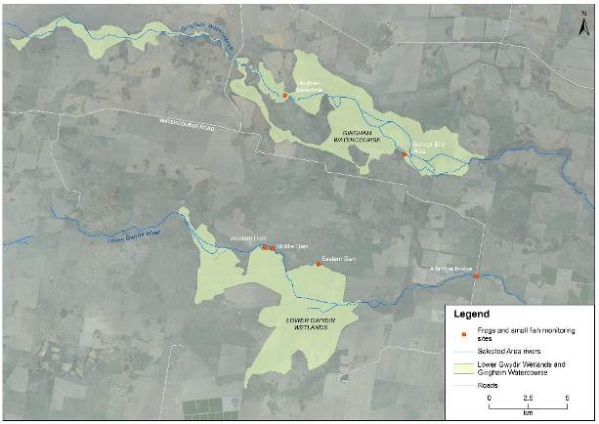

Figure ‑ frog and small fish monitoring sites in the Gwydir river system Selected Area

Survey methods

Fish were collected using seine nets, fyke nets, bait traps, and sweep nets. Fish observed but not collected were also counted, identified where possible and included in the analysis. Not all sites were suited for all methods (Table H‑1). Seine net samples were collected using an 8 m long net with a 1.6 m drop and 5 mm mesh. The net was dragged through the water for 15 m and pulled up onto the bank to collect fish. This method was limited to sites where there was a clear edge and where woody debris and aquatic vegetation were absent from the area dragged. Where woody debris or vegetation prevented dragging, samples were collected with a standard macroinvertebrate net with 250 m-mesh swept through the water amongst habitat features over a 10m length of bank. Bait traps were also deployed overnight at some sites. Where fish captures were large (>200 individuals), total catches were estimated.

Small fyke nets, consisting 10 mm-mesh and having a 5 m single wing and 60 cm diameter hoops, were deployed overnight at sites with sufficient standing water. Nets were set with the tail end extending above the water so that air-breathing by-catch could be released the following morning (Figure H‑4). Two fyke nets were set at both of the Gingham Wetland sites, but only one each at the Eastern and Western Dam sites. No fyke nets were set at Middle Dam because there was too much aquatic vegetation and no open water, and none were set at Allambie Bridge because the water was too shallow.

All fish surveys were conducted under ELAs Scientific Collection Permit Number P09/0038-2.1, issued by NSW Department of Primary Industries under Section 37 of the *Fisheries Management Act 1994*.

Adult frogs were surveyed after dark by two people searching wetland edges for 20 minutes with 400 lumen torches. All frogs observed were identified and counted. Prior to visual searches, a five minute period of static listening was used to identify which species were calling. Call activity for each species was categorised by the number of individuals heard: fewer than 5 was assigned as low activity, 5-20 was assigned as medium activity, and more than 20 was assigned as high.

To complement the site biological data, physico-chemical parameters were measured for each site. Temperature, dissolved oxygen (DO), electrical conductivity (EC) and pH were measured with a YSI-556 meter. EC and pH were calibrated in the laboratory prior to the field survey, and DO was calibrated at the start of each field survey day. Turbidity was measured with a Hach 2100Q Turbidimeter and alkalinity was measured with a Hanna HI755 Freshwater Alkalinity Checker.

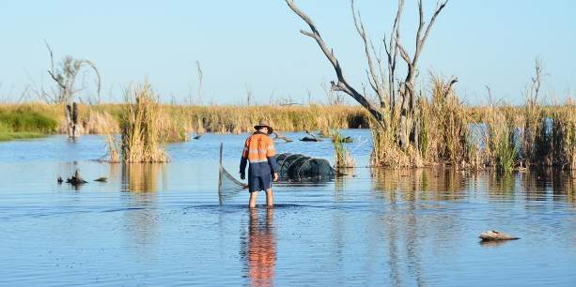

Figure ‑ Checking fyke net at Bunnor Bird Hide

Table ‑: Site locations and survey methods.

| Site | Wetland System | Latitude (°S) | Longitude (°E) | Fish methods | Frog methods |
| --- | --- | --- | --- | --- | --- |
| Eastern Dam | Gwydir Wetland | 29.34024 | 149.32681 | 1 fyke, 3 bait, observation | Nocturnal listening, search |
| Middle Dam | Gwydir Wetland | 29.33169 | 149.29606 | observation | Nocturnal listening, search |
| Western Dam | Gwydir Wetland | 29.33102 | 149.29164 | 1 fyke, sweep, Seine, observation | Nocturnal listening, search |
| Allambie Bridge | Gwydir Wetland | 29.34537 | 149.43085 | observation, sweep | Nocturnal listening, search |
| Bird Hide | Gingham Wetland | 29.27597 | 149.38193 | 2 fyke, Seine, observation | Nocturnal listening, search |
| Gingham | Gingham Wetland | 29.24330 | 149.30242 | 2 fyke, Seine, observation | Nocturnal listening, search |

Results

Physico-chemistry

Water temperature was cooler at all sites in December except for Bunnor Bird Hide, where the February temperature was 9°C lower (Table H‑2). Electrical conductivity was higher at all sites in December than February. December EC was between 0.52 mS/cm and 0.82 mS/cm, while in February it was between 0.32 mS/cm and 0.69 mS/cm.

DO concentration (% saturation) was higher in December than in February at the five wetland sites, exceeding 80% saturation (Table H‑2). The exception was the Gwydir River at Allambie Bridge, where December DO was just 21.8% saturation. Allambie Bridge DO concentration differed to that of other sites in February, increasing four-fold to 86.2% saturation while all other sites showed a decline (Table H‑2). Despite the water being warm, DO concentration at Bunnor was super-saturated when measured in December 2015, but had fallen to just 18.2% when measured in February.

No pH measurements were taken in December 2015 because of a malfunctioning meter, but in February, pH was between 7.28 and 7.88 (Table H‑2). Alkalinity was higher in December 2015 than February 2016 at all sites, and for Eastern and Middle Dams alkalinity declined more than twofold (Table H‑2).

Turbidity was higher in December than February for three sites, and was similar between times at the remaining three (Table H‑2). The wetland sites where turbidity fell were those likely to have received environmental water first. The two Gingham sites were more turbid than the southern three Gwydir sites.

Table ‑: Physico-chemistry for Gwydir and Gingham Wetland sites during the December 2015 and February 2016 sampling times.

| Parameter | Gwydir Wetlands | | | | | | Gingham Wetlands | | | | Gwydir River | |
| --- | --- | --- | --- | --- | --- | --- | --- | --- | --- | --- | --- | --- |
| Eastern Dam | | Middle Dam | | Western Dam | | Bunnor Bird Hide | | Gingham Waterhole | | Allambie Bridge | |
| Dec-15 | Feb-16 | Dec-15 | Feb-16 | Dec-15 | Feb-16 | Dec-15 | Feb-16 | Dec-15 | Feb-16 | Dec-15 | Feb-16 |
| Survey time | 10:40 | 21:14 | 21:20 | 22:45 | 20:11 | 20:00 | 16:45 | 8:06 | 9:20 | 9:22 | 9:10 | n/a |
| Temperature (°C) | 25.9 | 27.4 | 27.8 | 28.7 | 28.4 | 31.3 | 32.1 | 23.8 | 26.7 | 27.4 | 25.2 | 26.4 |
| Electrical conductivity (mS/cm) | 0.77 | 0.41 | 0.81 | 0.36 | 0.52 | 0.32 | 0.60 | 0.41 | 0.82 | 0.69 | 0.55 | 0.36 |
| Dissolved oxygen (% saturation) | 89.0 | 41.0 | 80.2 | 62.3 | 117.7 | 58.4 | 159.4 | 18.2 | 90.3 | 51.0 | 21.8 | 86.2 |
| Dissolved oxygen (mg/L) | 7.14 | 3.20 | 7.02 | 4.89 | 9.18 | 4.21 | 11.55 | 1.52 | 7.20 | 4.00 | 1.78 | 6.39 |
| pH | n/a | 7.28 | n/a | 7.65 | n/a | 7.43 | n/a | 7.67 | n/a | 7.88 | n/a | 7.46 |
| Alkalinity (ppm) | 267 | 92 | 256 | 84 | 97 | 80 | 174 | 114 | 293 | 168 | 167 | 102 |
| Turbidity (NTU) | 13.6 | 9.5 | 16.4 | 9.6 | 10.1 | 10.7 | 66.7 | 20.6 | 67.0 | 67.6 | 67.5 | 69.0 |

Fish

Seven fish species were collected during the 2015-2016 survey periods, including six in December 2015 and seven in February 2016 (Table H‑3; Figure H‑5). Only mosquitofish *(Gambusia holbrooki*)occurred at all sites, while carp (*Cyprinus carpio)* were collected at four sites. The only native species present in large numbers in December was western carp gudgeon (*Hypseleotris klunzingeri)* collected at two sites.

The mosquitofish population was much lower in February than it was in December (Table H‑3). In February, spangled perch *(Leiopotherapon unicolor)* was the only native fish species present in large numbers at Western Dam. Bony bream *(Nematalosa erebi)* were collected at both Gingham watercourse sites and the Gwydir River site. The highest species richness was recorded at Gingham Waterhole where five species and six species were recorded in December and February respectively. This was the only site where olive perchlet *(Ambassis agassizii)* and fly-speckled hardyhead *(Craterocephalus stercusmuscarum)* were sampled.

Fish abundance was greatest at Western Dam with 1502 individuals collected in December and 596 individuals collected in February (Table H‑3); however most of these were mosquitofish, and diversity was low. Despite this, Western Dam had the highest native species abundance for both surveys; 502 individuals in December and 596 individuals in February.

Gingham Waterhole had the highest fish species richness for both survey periods; with five and six species in December and February respectively. Highest native fish richness occurred at Gingham Waterhole, with four species present for both survey periods. Richness varied for all sites between seasons, being higher in February at Eastern Dam, Bunnor Bird Hide, Gingham Waterhole and Allambie Bridge, and lower at Middle Dam and Western Dam (Table H‑3).

During February, a single eel-tailed catfish(*Tandanas tandanas*) was seen in Middle Dam during spotlighting. The catfish was approximately 10 cm long, and was swimming slowly through shallow water between the bank and a stand of *Typha orientalis.*

The opportunistic fish survey conducted in April collected 46 olive perchlet, 3 small carp, 6 bony bream, and 2 spangled perch. Although these fish were not collected as a formal part of the survey, they are worth mentioning principally because of the number of olive perchlet captured.

Figure ‑: Number of fish species at each site

Frogs

Six frog species were present during the 2015-2016 survey periods, including five species in December 2015 and six in February 2016 (Table H‑4; Table H‑5). Bunnor Bird Hide was the only site with all six species, and was the only site with eastern sign-bearing froglet *(Crinia parinsignifera)*.

Frog abundance was greater in December 2015, with 185 individuals observed. In February, only 44 individuals were observed. The most abundant species was barking marsh frog *(Limnodynastes fletcheri)*, which was seen and heard at all sites (Table H‑4; Table H‑5), which had 72 individuals at Middle Dam in December 2015. More spotted marsh frogs *(Limnodynastes tasmaniensis*) were seen at this site than at any of the other sites. Spotted marsh frogs were seen at two of the Gwydir Wetland sites and one of the Gingham sites but were not heard calling during either survey.

Middle Dam had the highest frog abundance for both survey periods; 95 individuals in December and 19 individuals in February. Species richness increased at this site and composition varied (Table H‑5). Frog abundance declined at all sites (except Eastern Dam) between survey periods. Richness differed between seasons; Eastern Dam, Middle Dam and Gingham Waterhole increased between December and February, and declined at Western Dam, Bunnor Bird Hide and Allambie Bridge.

Broad-palmed frog *(Litoria latopalmata)* was not heard calling in these surveys but was seen at four of the sites (Figure H‑6). It was most abundant at Gingham Waterhole, where 34 individuals were spotted along the narrow mud and sand beach (Table H‑5). However, only five individuals were seen in February. Peron’s tree frog *(Litoria peroni)* occurred at four sites in December, and again in February, but few individuals were calling.

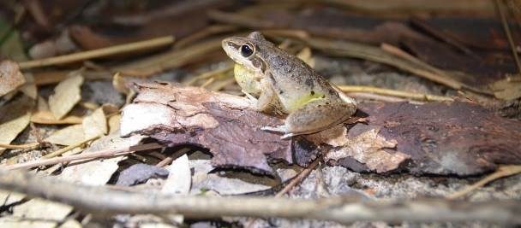

Figure ‑: Broad-palmed frog at Gingham Waterhole in February 2016.

Other observations

Four other aquatic vertebrate species were captured or observed during the December 2015 surveys. A single water rat *(Hydromys chrysogaster)* was seen swimming among reeds at Western Dam during the nocturnal surveys. Two eastern long-necked turtles *(Chelodina longicollis)* were captured in the fyke net at this site. Eastern long-necked turtles were also seen at Bunnor Bird Hide and Eastern Dam. Two other species of turtle were captured during sampling, both at Gingham Waterhole. A single Murray turtle *(Emydura macquarii*) and eleven broad-shelled turtle *(Chelodina expansa*) were collected in fyke nets.

In the February survey, three turtle species were captured or observed. Six broad-shelled turtles, five Murray short-necked turtles and an eastern long-necked turtle were caught in fyke nets at Gingham Waterhole. A single juvenile eastern long-necked turtle was caught in a fyke net at Bunnor Bird Hide.

Table ‑: Fish collected during the 2015-2016 water year.

|  |  |  |  |  |  |  |  |  |  |  |  |  |
| --- | --- | --- | --- | --- | --- | --- | --- | --- | --- | --- | --- | --- |
| Species | Gwydir Wetland | | | | | | Gingham Wetland | | | | Gwydir River | |
| Eastern Dam | | Middle Dam | | Western Dam | | Bird Hide | | Gingham Waterhole | | Allambie Bridge | |
| Dec-15 | Feb-16 | Dec-15 | Feb-16 | Dec-15 | Feb-16 | Dec-15 | Feb-16 | Dec-15 | Feb-16 | Dec-15 | Feb-16 |
| Carp  (*Cyprinus carpio)* |  |  |  |  | 2 |  | 2 | 6 | 3 | 1 |  | 5 |
| Mosquitofish (*Gambusia holbrooki*) | 78 | 23 | 230 | 20 | 1000 |  | 230 | 12 | 100 | 2 | 120 |  |
| Spangled perch (*Leiopotherapon unicolor*) |  |  |  |  |  | 570 |  | 1 | 2 | 7 |  | 20 |
| Fly-specked hardyhead (*Craterocephalus stercusmuscarum*) |  |  |  |  |  |  |  |  | 1 | 8 |  |  |
| Western carp gudgeon (*Hypseleotris klunzingeri*) |  | 8 | 22 |  | 500 | 26 |  | 23 |  |  |  |  |
| Bony bream (*Nematalosa erebi*) |  |  |  |  |  |  |  | 12 | 14 | 35 |  | 120 |
| Olive perchlet (*Ambassis agassizii*) |  |  |  |  |  |  |  |  |  | 2 |  |  |

Table ‑: Frogs observed or heard at Gwydir Wetland sites for the 2015-16 water year.

|  |  |  |  |  |  |  |  |  |  |  |  |  |
| --- | --- | --- | --- | --- | --- | --- | --- | --- | --- | --- | --- | --- |
| Site | Gwydir Wetlands | | | | | | | | | | | |
| Eastern Dam | | | | Middle Dam | | | | Western Dam | | | |
| Dec-15 | | Feb-16 | | Dec-15 | | Feb-16 | | Dec-15 | | Feb-16 | |
| Call activity | No. sighted | Call activity | No. sighted | Call activity | No. sighted | Call activity | No. sighted | Call activity | No. sighted | Call activity | No. sighted |
| Peron’s tree frog  (*Litoria peroni*) |  |  | Low |  |  |  | Low |  | Low | 2 |  |  |
| Broad-palmed rocket frog  (*Litoria latopalmata*) | Nil | 2 | Low |  |  |  |  | 1 |  | 4 |  |  |
| Striped burrowing frog  (*Cyclorana alboguttata)* |  |  | Low |  |  |  |  |  |  |  | Low | 1 |
| Spotted marsh frog  (*Limnodynastes tasmaniensis*) |  |  | Nil | 1 | Nil | 23 |  |  | Nil | 4 |  |  |
| Barking marsh frog *(Limnodynastes fletcheri*) | High | 1 | Low | 9 | Low | 72 |  | 18 | Low | 10 | Nil | 2 |
| Eastern sign-bearing froglet  (*Crinia parinsignifera)* |  |  |  |  |  |  |  |  |  |  |  |  |
| Date | 8/12/2015 | | 11/02/2016 | | 8/12/2015 | | 11/02/2016 | | 8/12/2015 | | 11/02/2016 | |
| Air temperature (°C) | 22 | | 27 | | 24 | | 25 | | 25 | | 25 | |

Table ‑: Frog species observed or heard at Gingham watercourse and Gwydir River sites for the 2015-16 water year.

|  |  |  |  |  |  |  |  |  |  |  |  |  |
| --- | --- | --- | --- | --- | --- | --- | --- | --- | --- | --- | --- | --- |
| Site | Gingham watercourse | | | | | | | | Gwydir River | | | |
| Bunnor Bird Hide | | | | Gingham | | | | Allambie Bridge | | | |
| Dec-15 | | Feb-16 | | Dec-15 | | Feb-16 | | Dec-15 | | Feb-16 | |
| Call activity | No. sighted | Call activity | No. sighted | Call activity | No. sighted | Call activity | No. sighted | Call activity | No. sighted | Call activity | No. sighted |
| Peron’s tree frog (*Litoria peroni*) | High | 1 | Low |  | Low | 2 | Low |  | Low | 1 | Low |  |
| Broad-palmed rocket frog  (*Litoria latopalmata*) | Nil | 2 |  |  | Nil | 34 | Low | 4 |  |  |  |  |
| Striped burrowing frog  (*Cyclorana alboguttata)* |  |  | Low | 1 |  |  | Low | 1 |  |  |  |  |
| Spotted marsh frog  (*Limnodynastes tasmaniensis*) | Nil | 2 |  |  |  |  |  |  |  |  |  |  |
| Barking marsh frog *(Limnodynastes fletcheri*) | High | 12 | Low | 5 | Low | 10 | Low | 4 | Low | 2 |  |  |
| Eastern sign-bearing froglet  (*Crinia parinsignifera)* | Nil | 1 |  |  |  |  |  |  |  |  |  |  |
| Date | 7/12/2015 | | 10/02/2016 | | 7/12/2015 | | 10/02/2016 | | 7/12/2015 | | 10/02/2016 | |
| Air temperature (°C) | 19 | | 24 | | 22 | | 27 | | 20 | | 26 | |

Discussion

Environmental water

Environmental water that was released between December 2015 and February 2016 resulted in consistent patterns in physico-chemistry at the wetland sites, regardless of whether they were connected to the Gwydir River or Gingham Watercourse. The delivery of environmental water lowered alkalinity, EC and DO concentration at all wetland sites. Changes to alkalinity and EC are likely to have been the result of dilution from inflowing water, while the fall in DO concentration may have been due to the combined effects of multiple factors. These include the displacement of static water, highly oxygenated by algae and macrophyte photosynthesis; and the bacterial consumption of dissolved oxygen during the processing of dissolved organic matter being absorbed into the water as it flowed over newly inundated land.

Small bodied fish communities

Two fish species that are listed as Endangered Populations under the Fisheries Management Act (1994) occurred at our sites, both in February. These were the olive perchlet (Figure H‑7), collected from Gingham Waterhole, and the eel-tailed catfish, seen in Middle Dam. The population of these species are listed as endangered in the Murray-Darling Basin.

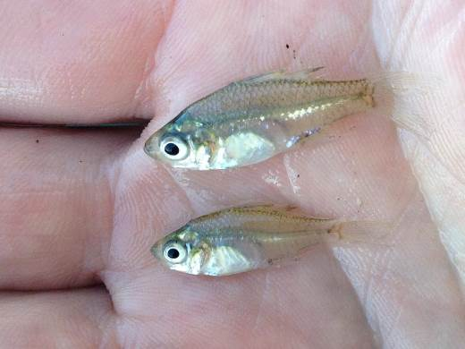

Figure ‑ Several olive perchlet individuals caught from Gingham Waterhole in April 2016.

The two olive perchlet collected in February and 46 collected in April, indicate that Gingham Waterhole contains a healthy population of this species. Olive perchlet were once widespread throughout the Murray-Darling system but is now only restricted to a few sites in the upper Darling Basin (Fisheries Scientific Committee 2009). Olive perchlet were collected from Gingham Waterhole in 2013, and also further downstream in Boyanga Waterhole (Southwell et al. 2015). Although they were not detected in the previous three years (Wilson et al 2009), these earlier records indicate that Gingham Waterhole, at least, may have had a self-sustaining population at least since the 2010 flood event. Southwell et al (2015) suggest that the olive perchlet at Gingham Waterhole may have populated the area during the 2010 floods, and have persisted in suitable sections of the wetlands.

Boyanga Waterhole dried up soon after samples were collected in 2013, but water persisted in Gingham Waterhole. Habitat degradation and rapid fluctuations in water level are two main threats to olive perchlets (Fisheries Scientific Committee 2009). This makes wetlands such as Gingham Waterhole, where water level rises steadily during flooding, an important habitat for olive perchlet, and an important receptor of environmental water. It is likely that the delivery of water to Gingham Waterhole will be to be critical in maintaining a self-sustaining population of olive perchlet in the Gwydir River catchment. The species is not known outside of Gingham Waterhole, so if this dries up the olive perchlet may be lost from the catchment.

Eel-tailed catfish were originally distributed widely throughout the Murray-Darling Basin but have undergone a significant reduction in numbers since the early to mid-1900’s (Fisheries Scientific Committee 2008). Much of this decline was due to commercial harvesting but the catfish population also suffered as a result of habitat loss, river regulation, loss of spawning habitat through siltation, and altered flow and flooding patterns (Fisheries Scientific Committee 2008). A single small catfish was observed during this survey, in Middle Dam in February. The catfish was a juvenile approximately 10 cm long. Catfish are generally a sedentary species, so it is possible that the individual seen in February was spawned in Middle Dam or in one of the dams nearby. In December, Middle Dam was much shallower than it was in February, with an average depth of approximately 40 cm. At this time, the dam appeared to be drying. However, environmental water over subsequent months increased water level by almost 1 m, and created a link to surrounding water bodies.

The fish community of Western Dam was dominated by large populations of mosquitofish and carp gudgeon during December. However, the community had changed substantially when sampled in February, with a large population of spangled perch and few of the smaller species captured. Spangled perch were not collected in December, so appear to have moved in along the drainage channel that links the dam to upstream waterholes and the lower Gwydir River. Spangled perch are a highly dispersive species and often move rapidly along shallow channels, and even wheel ruts, following rainfall (Merrick 1996). The arrival of the perch coincided with a decline in the populations of mosquitofish and carp gudgeon. While spangled perch do eat fish, invertebrates form the main part of their diet until they are large enough to consume fish (Merrick 1996). The spangled perch in Western Dam were between 50 and 110 mm long, so at the larger end of this range, may have preyed on mosquitofish and gudgeon. Spangled perch are also extremely aggressive towards other species, so an alternative scenario is that they drove the smaller species to shelter around the fringes of the dam and into the irrigation channel.

The decline in mosquitofish populations not only occurred at Western Dam, but was a consistent pattern at all of the wetland sites. Mosquitofish appeared to be absent from some sites during February, and reduced by 70-98% at other sites. With an increase in water level, mosquitofish move out from the main water body onto recently inundated areas (Pyke 2008), providing relief for native species that stay in the main channel.

Mosquitofish have the potential to impact frog breeding success, especially if waterholes contract during key breeding periods, through predation, harassment, over-crowding, and chemical suppression (Pyke 2008). Properly timed environmental flows can dilute concentrations of mosquitofish and reduce their impacts to frogs and tadpoles.

Frog communities

Frog abundance fell between survey periods for all sites except Eastern Dam. Heavy rainfall in late January created a landscape mosaic of shallow, vegetation-laden temporary pools and puddles. During February, few frogs were seen or heard at the survey sites, but there were many calling from the puddles that had formed nearby. Frog communities in February appear to have responded to rainfall events and moved into puddles surrounding the permanently wet sites. Temporary, isolated wetlands can be important habitat and breeding areas for frogs, as they are often devoid of predatory fish (Zedler 2003). However, while rainfall-generated puddles may draw frogs to them in the hope of fish-free breeding habitat, they often do not persist long enough for tadpoles to become frogs.

Environmental water is also important for frog communities, inundating the fringing vegetation surrounding waterholes, and saturating previously dry channels (Ocock 2013). Of the species observed in the Gwydir Wetlands, four are known to have a breeding response to environmental water releases. These are broad-palmed rocket frog, spotted marsh frog, barking marsh frog, and eastern sign-bearing froglet, which bred following a release to the Macquarie Marshes (Joanne Ocock 2014, pers comm, cited in Southwell 2015) and the Gwydir wetlands (Southwell et al. 2015). These species need the vegetated areas inundated by environmental water, rather than those inundated by rainfall events because they require at least three months for frogs to develop (Southwell et al. 2015).

Water levels at Gingham Waterhole were declining in the lead up to the December 2015 survey, but increased again for the February 2016 survey following rainfall and the environmental releases. This rise in water level resulted in a long, shallow depression extending approximately 50 m from the northern shore of the waterhole, to become saturated. Grass and sedges, along with fallen sticks and debris, created complex habitat features for frogs. Aquatic vegetation and structural complexity are drivers for frog habitat occupancy patterns and recruitment success, providing shelter for adult frogs, and an important food source for tadpoles by acting as a substrate for biofilm growth (Anstis 2002). Suitable aquatic vegetation cover was present at all sites, except Allambie Bridge on the main channel of the Gwydir River.

The only species that was not detected during the December 2015 survey was the striped burrowing frog. During dry periods, this species aestivates in underground clay chambers for an average of 9 months (but up to several years), until water becomes abundant enough for emergence (Kayes 2009). This species was seen at Bunnor Bird Hide, Gingham Waterhole, and Western Dam, and heard at Eastern Dam in February 2016. The rainfall event in January may have stimulated emergence from parts of the floodplain.

Conclusion

Gingham Waterhole is the only known site in the Gwydir River catchment to contain a significant population of olive perchlet, which is a threated species in the Murray-Darling Basin. The delivery of environmental water to Gingham Waterhole, and the maintenance of habitat features such as fringing vegetation and snags, is likely to be critical for the survival of this species in the lower Gwydir system.

Environmental water helped connect isolated pools, facilitating dispersal of fish between previously isolated populations. Environmental water also increased connectivity between the dam sites, which were potentially exploited by spangled perch to move through the system. These flows also contributed to the persistence of key sites that contain populations or individuals of endangered small-bodied fish species such as eel-tailed catfish and olive perchlet. Maintenance of these habitats is needed for the ongoing survival of these species.

Sampling over the 2015-16 period suggests that a reasonably diverse frog community exists in the wetlands in the lower Gwydir system. Four of the species observed are known to have positive breeding responses to environmental water. Small but important pulses of environmental water during 2015-16, refreshed the potentially longer-term habitat sites sampled. Local rainfall events also appeared to provide conditions suitable for frog feeding and breeding in shallow well vegetated floodplain depressions. However, these temporary isolated wetlands are unlikely to persist long enough for frog development.

References

Anstis, M. 2002. *Tadpoles of South-eastern Australia*: A guide with keys. Reed New Holland, Chatswood.

Fisheries Scientific Committee. 2009. *Recommendation* Ambassis agassizii *(Olive Perchlet)*, Available at: <http://www.dpi.nsw.gov.au/__data/assets/pdf_file/0005/636530/FR17-olive-perchlet.pdf>

Kayes, S. 2009. *Metabolic depression in Cyclorana alboguttata and the potential role of the endogenous opioid system and thyroid axis as regulators of aestivation*. PhD Thesis. University of Queensland, Australia.

Merrick, J.R. 1996. Freshwater grunters or perches. In R.M McDowall (ed) *Freshwater Fishes of South-eastern Australia*. Reed Books Australia, Chatswood.

Ocock, J.F. 2013. *Linking frogs with flow: Amphibian community response to flow and rainfall on a dry floodplain wetland.* PhD Thesis. University of New South Wales, Australia.

Pyke, G.H., 2008. Plague minnow or mosquito fish? A review of the biology and impacts of introduced *Gambusia* species. *Annual Review of Ecology, Evolution and Systematics*, *39*:171-191.

Southwell, M, Wilson, G., Ryder, D., Sparks, P. & Thoms, M. 2015. *Monitoring the ecological response of Commonwealth environmental water delivered in 2013-14 in the Gwydir River system*. Commonwealth of Australia

Zedler, P.H. 2003. Vernal pools and the concept of “isolated wetlands”. *WETLANDS*, *23*, 597-607.

###### Fish River

Introduction

The fish assemblages of the Gwydir Valley are generally considered to be in a severely degraded state (Murray-Darling Basin Authority 2012). Invasion by exotic species such as common carp (*Cyprinus carpio*), eastern mosquitofish (*Gambusia holbrooki*), goldfish (*Carassius auratus*) and redfin perch (*Perca fluviatilis*) and the decline of iconic species such as the Murray cod (*Maccullochella peellii*) and eel-tailed catfish (*Tandanus tandanus*) have left the fish communities of the Gwydir river system Selected Area in poor condition.

The Fish (River) indicator aims to benchmark and describe the fish community in abundance, biomass and community health across four hydrological zones in the lower Gwydir Basin in relation environmental water releases. Several specific questions were posed in relation to this indicator:

* What did Commonwealth environmental water contribute to native fish community resilience?
* What did Commonwealth environmental water contribute to native fish survival?
* What did Commonwealth environmental water contribute to native fish populations?
* What did Commonwealth environmental water contribute to native fish diversity?

Environmental watering in 2015-16

Available Commonwealth environmental water holdings totalled 39,450 ML in the 2015-16 water year. This was complemented by water entitlements held by NSW OEH in the Environmental Contingency Allowance (ECA) of 58,370 ML. Of this, a total of 8,400 ML of Commonwealth water and 4,850 ML of ECA water were delivered in the 2015-16 water year via several events across several channels (Appendix A)

During 2015-16 environmental water was delivered to a number of assets within the Gwydir river system Selected Area. In November 2015, a flow event occurred down the Mehi River and supplementary water licences owned by the CEWO were triggered. A total of 1300 ML were accounted for with 964 ML of this water flowing down the Mehi River, and 336 ML directed down Mallowa Creek.

Through January 2016, flows were delivered into the Mallowa Creek system to inundate fringing wetlands in association with State water bulk water deliveries. Flows were also delivered into the lower Gwydir River and Gingham watercourse in February 2016, to replace flows that were abstracted in a supplementary flow event. Due to critically low flows experienced in the lower Gwydir system in March and April 2016, water was delivered down the lower Gwydir, Gingham, Mehi and Carole channels as part of a dry river flow action in early April. This followed a period of 30-40 days of nil flows conditions across the catchment.

Previous monitoring

The Sustainable Rivers Audit (SRA), conducted at the end of the millennium drought (2008-2010), found that fish in the upper sections (above 400 mASL) of the Gwydir valley were in “Very Poor” condition, the Slopes (201-400 mASL) were in “Moderate” condition, whilst in the Lowland (31-200 mASL) they were classified as “Poor” (Murray-Darling Basin Authority 2012). Overall, the fish community across the Gwydir valley as a whole was classified as “Poor”. The SRA reported that the Gwydir had reduced numbers of species and abundance of native fish, recruitment was variable and generally low, and that there were exotic species at most sites including high abundances of common carp, eastern mosquitofish, goldfish and redfin perch.

Recent sampling of the lower Gwydir fish community was undertaken as part of the Commonwealth Environmental Water Office (CEWO) Short Term (STIM; 2013-14) and Long Term Intervention Monitoring (LTIM; 2015) Programs (Southwell *et al.* 2015; Commonwealth of Australia2015). Ten native species and three exotic species were captured in both programs. Overall, the most abundant species was bony herring (*Nematolosa erebi*) which made up 41.6% of the total catch in 2013-14 and 31% in 2014-15. Other large-bodied species such as Murray cod, golden perch (*Macquaria ambigua*) and freshwater catfish were only caught in relatively low numbers in both studies. Australian smelt (*Retropinna semoni*) and carp gudgeon (*Hypseleotris* sp.) dominated the catch among the small-bodied species. Common carp were the most abundant exotic species sampled in both studies and made up >50% of the biomass of all fish sampled in the 2014-15 LTIM (Commonwealth of Australia2015).

Methods

Sampling sites

Nineteen sites were sampled as part of the 2015-16 sampling round for the Fish (River)assessment between 4 February and 21 April 2016 (Figure I‑1). Eighteen of these sites were consistent with sites sampled during 2014-15 and one site was an alternate due to site access issues. The remaining six sites sampled in 2014-15 were visited but were not sampled because they were either completely dry or there was insufficient water to undertake the required sampling effort within one kilometres upstream or downstream of the designated starting point. Sites were sampled based on protocols for either Category 1 and/or Category 3 Fish indicators (Commonwealth of Australia 2014). Along with sites monitored specifically for the LTIM program, data collected by Fisheries NSW as part of the Murray-Darling Basin Plan monitoring program in the Gingham, Mehi and Moomin channels, was also again utilised in the analysis (Table I‑1). For these sites, 1080 sec of boat or 1200 sec of backpack electrofishing (or where applicable combinations of both) was used as the sampling effort.

Sampling sites in all four channels were typical of the meandering waterways found throughout the lowland reaches of the Murray-Darling Basin. The waters at all sites tended to be turbid and relatively shallow and there were distinct pool/run/riffle zones present within many of the sites (Figure I‑2). In the Gwydir River upstream of Tyreel Weir and in the Mehi River, the river channel tended to be wider, deeper and more permanent in nature, averaging ~30 m in width and ~1.5 m in depth. In the lower Gwydir, Gingham and Moomin, the majority of sites were narrower (~8-16 m) and shallower (~0.5 m) (Figure I‑2). The majority of sites had much less water compared to when they were sampled in 2014-15. This was particularly apparent at sites in the lower sections of all four systems, where the water had either stopped running or there was only a trickle between what could be considered as series of small refugia pools.

In-stream habitat across all four channels was dominated by submerged timber and undercut banks. The substratum at sites was typically mud; however, gravel, sand and silt substrates were also present in some areas. In general, all four channels were highly disturbed as a result of anthropogenic influences such as agriculture, altered flows, and terrestrial and aquatic exotic species. The majority of sites were adjacent to irrigated and dryland cropping land. Most sites were fringed by only a narrow riparian zone, dominated by native trees and exotic shrubs. Notable terrestrial weeds included African boxthorn (*Lycium ferocissimum*), noogoora burr (*Xanthium pungens*) and lippia (*Phyla canescens*).

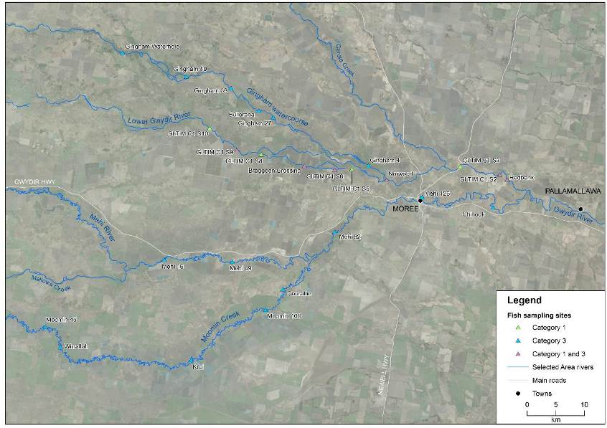

Figure ‑ Location of sampling sites in the Gwydir River, Mehi River, Moomin Creek and Gingham watercourse used in Fish (River) analyses

Table ‑ Locations and details of sites used in the 2015-16 analysis. Red shading indicates sites that were visited but not sampled due to having too little or no water.

| Site Name | Channel | Source | Latitude | Longitude | Altitude | Zone | Effort |
| --- | --- | --- | --- | --- | --- | --- | --- |
| Gingham 27 | Gingham watercourse | LTIM CAT 3 | 750216 | 6751475 | 168 | Lowland | Backpack |
| Gingham 38 | Gingham watercourse | LTIM CAT 3 | 742843 | 6756626 | 168 | Lowland | Backpack |
| Gingham Waterhole | Gingham watercourse | MDBP | 723745 | 6762848 | 173 | Lowland | Small boat |
| Bullerana | Gingham watercourse | LTIM CAT 3 | 747714 | 6752639 | 175 | Lowland | Backpack |
| Gingham 4 | Gingham watercourse | LTIM CAT 3 | 766926 | 6742997 | 208 | Slopes (L) | Medium boat |
| Brageen Crossing | Gwydir River | LTIM CAT 1 | 755712 | 6742946 | 185 | Lowland | Not sampled |
| GLTIM C1 S9 | Gwydir River | LTIM CAT 1 | 743873 | 6745735 | 187 | Lowland | Not sampled |
| GLTIM C1 S6 | Gwydir River | LTIM CAT 1 | 760985 | 6742248 | 198 | Lowland | Not sampled |
| Norwood | Gwydir River | LTIM CAT 1 | 770114 | 6740484 | 201 | Slopes (L) | Medium boat/backpack |
| Redbank | Gwydir River | LTIM CAT 1 | 791183 | 6740528 | 201 | Slopes (L) | Small boat/backpack |
| GLTIM C1 S2 | Gwydir River | LTIM CAT 1 | 789907 | 6741432 | 219 | Slopes (L) | Backpack |
| Mehi 16 | Mehi River | LTIM CAT 3 | 731144 | 6726485 | 165 | Lowland | Not sampled |
| Mehi 49 | Mehi River | LTIM CAT 3 | 743061 | 6726122 | 185 | Lowland | Backpack |
| Mehi 82 | Mehi River | LTIM CAT 3 | 761024 | 6731366 | 184 | Lowland | Small boat |
| Moree | Mehi River | MDBP | 781235 | 6736439 | 201 | Slopes (L) | Small boat |
| Mehi 126 | Mehi River | LTIM CAT 3 | 776309 | 6737446 | 206 | Slopes (L) | Medium boat |
| Chinook | Mehi River | LTIM CAT 3 | 788703 | 6735632 | 217 | Slopes (L) | Small boat |
| Moomin 45 | Moomin Creek | LTIM CAT 3 | 710373 | 6714696 | 155 | Lowland | Backpack |
| Wirrallah | Moomin Creek | LTIM CAT 3 | 712963 | 6711129 | 160 | Lowland | Not sampled |
| Heathfield | Moomin Creek | MDBP | 721360 | 6709590 | 163 | Lowland | Backpack |
| Kiri | Moomin Creek | LTIM CAT 3 | 735879 | 6708851 | 178 | Lowland | Backpack |
| Courallie | Moomin Creek | MDBP | 751908 | 6721288 | 178 | Lowland | Small boat/backpack |
| Moomin 100 | Moomin Creek | LTIM CAT 3 | 748885 | 6717676 | 184 | Lowland | Not sampled |

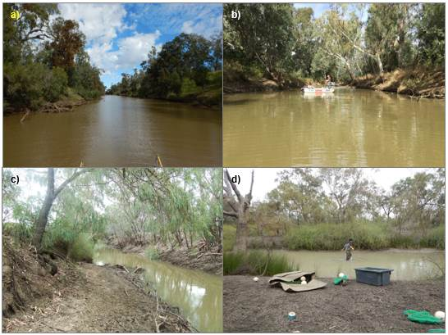

Figure ‑ Examples of sites sampled across the lower Gwydir Catchment: (a) GLTIM S2 Gwydir River; (b) Chinook Gwydir River; (c) GLTIM S6 Gwydir River (c); and (d) Wirrallah Moomin Creek.

Sampling protocols

Sampling effort at each site was a combination of electrofishing and bait trapping (Commonwealth of Australia 2014; Hale *et al.* 2014). Electrofishing included small and medium boats (3.5 kW or 5 kW Smith-Root electrofisher unit respectively), backpack (Smith Root model LR20) or a combination of boat and backpack. Boat electrofishing consisted of 12 x 90 sec power-on operations per site, while backpack electrofishing consisted of 8 x 150 sec operations. At sites where both boat and backpack sampling was required, the number of operations of each method used was proportional to the area of navigable versus wadable habitat. Boat electrofishing involved a series of ~10 sec power-on and power–off operations, with successive operations undertaken on alternate banks while moving in an upstream direction. Backpack electrofishing involved sampling all areas accessible to the stationary operator, before they would progressively move upstream around ~3 m before repeating the process. All boat and backpack electrofishing was undertaken by a minimum of two operators, with three operators used at medium boat sites. Ten unbaited traps were deployed for a minimum of two hours at each site; undertaken at the same times as electrofishing. Traps were set haphazardly throughout the site in water depths of 0.5 – 1 m.

All fish were identified to species level, measured to the nearest mm and released onsite. When an individual or individuals could not be positively identified in the field, a voucher specimen was retained for laboratory identification. Length measurements (to the nearest mm) were taken as fork length for species with forked tails and total length for all other species. Only a sub-sample of individuals were measured and examined for each gear type where large catches of an individual species occurred. The sub-sampling procedure consisted of firstly measuring all individuals in each operation until at least 50 individuals had been measured in total. The remainder of individuals in that operation were also measured but any individuals of that species from subsequent operations of that gear type were only counted. Fish that escaped capture, but could be positively identified were also counted and recorded as “observed”.

Data analyses

Fish community

Electrofishing and bait trapping data were combined for statistical analyses of the fish community. Non-parametric multivariate analysis of variances (PERMANOVA) was used to determine if there were differences between the fish assemblages in each of the four channels within and between years (PRIMER 6 & PERMANOVA; Anderson et al. 2008). Prior to analyses, the data were fourth root transformed and the results used to produce a similarity matrix using the Bray-Curtis resemblance measure. A dummy variable (weight 0.0001) was added to the matrix prior to transformation because of the zero catches recorded at the six dry sites (Vieira and Fonseca 2013). All tests were considered significant at P <0.05. Where differences were identified by PERMANOVA, pair-wise comparisons were used to determine which groups differed. Similarity percentage (SIMPER) tests were used to identify individual species contributions to average dissimilarities among groups.

Non-parametric Kolmogorov-Smirnov Z tests were used to determine if there were differences in the lengths of the six more abundant small- and large-bodied species in each of the four channels both within and between years. Prior to analysis, the data was initially sorted into equal bins of 10 mm for small-bodied and 50 mm for large-bodied species. The results were then transformed to provide relative proportions (%) of each size class of fish for the four individual channels. Only channels where <20 individuals were sampled were included in the analyses. Species included were: large bodied - Murray cod, common carp and bony herring; and small-bodied - Murray-Darling rainbowfish, carp-gudgeon and Australian smelt.

***Health Metrics***

Reference Condition

The predicted pre-European fish community of the lower Gwydir Catchment was derived using the Reference Condition for Fish (RC-F) approach used by the SRA and NSW Monitoring, Evaluation and Reporting (MER) programs (Table I‑2; Table I‑3). The RC-F process involves using available historical and contemporary data, museum collections and expert knowledge to estimate the probability of collecting each species at any randomly selected site within an altitude zone if it were sampled using the standard sampling protocol prior to 1770 (Davies et al. 2008). Rare species were allocated a RC-F probability of capture of 0.1 (collected at 0 < 0.2 of samples), occasional species (collected at 0.21 < 0.7 of samples) an RC-F of 0.45 and common species (collected at 0.71 < 1.0 samples) an RC-F of 0.85 (RC-F scores being the median capture probability within each category) (Table I‑2).

The definition of a recruit was derived using a similar process as that applied in the SRA and MER programs (Dean Gilligan unpublished data). For large-bodied and generally longer living species (>three years), an individual was considered to be a recruit if its body length was less than that of a one-year-old of the same species. For small-bodied and generally short-lived species that reach sexual maturity in less than one year, recruits were considered to be those individuals that were less than the species known average length at sexual maturity. The recruitment lengths used for both large- and small-bodied species were derived from published scientific literature or by expert opinion where that was not available (Table I‑3).

Metrics, Indicators and the Overall Fish Condition Index.

Using the methods described by Robinson (2012), eight fish metrics were derived from the data collected at each site. The eight metrics were then aggregated to produce three fish condition indicators and these indicators were then used to derive an overall Fish Condition Index (SRA ndxFS). Metric and indicator aggregation was done using Expert Rules analysis in the Fuzzy Logic toolbox of MatLab (The Mathworks Inc. USA) using the rules sets developed by Davies et al. (2010).

The Expectedness Indicator (SR-FIe) represents the proportion of native species that are now found within the catchment, compared to that which was historically present. The Expectedness Indicator is derived from two input metrics; the observed native species richness over the expected species richness at each site, and the total native species richness observed within the zone over the total number of species predicted to have existed within the zone historically (Robinson 2012). The two metrics were aggregated using the Expectedness Indicator Expert Rule set (Carter 2012).

The Nativeness Indicator (SR-FIn) represents the proportion of native versus alien fishes within the river. The Nativeness Indicator is derived from three input metrics; proportion native biomass, proportion native abundance and proportion native species (Robinson 2012). The three metrics were aggregated using the Nativeness Indicator Expert Rule set (Carter 2012).

The Recruitment Indicator (SR-Fir) represents the recent reproductive activity of the native fish community within each altitude zone. The Recruitment Indicator is derived from three input metrics; the proportion of native species showing evidence of recruitment at a minimum of one site within a zone, the average proportion of sites within a zone at which each species captured was recruiting (RC-F corrected), and the average proportion of total abundance of each species that are new recruits (Robinson 2012). The three metrics were aggregated using the Recruitment Indicator Expert Rule set (Carter 2012).

The three indicators were combined using the Fish Index Expert Rule set (Carter 2012) to calculate an overall Fish Condition Index (ndxFS). The Fish Index Expert Rules analysis is weighted as SR-FIe > SR-FIr > SR-FIn. The output generated by the Expert Rules analysis is scaled between 0 and 100, with higher values representing a ‘healthier’ fish community. The index was then partitioned into five equal bands to rate the condition of the fish community; “Good” (81-100), “Moderate” (61-80), “Poor” (41-60), “Very Poor” (21-40), or “Extremely Poor” (0-20) (Figure I‑3).

|  |  |  |  |  |  |  |  |  |  |  |
| --- | --- | --- | --- | --- | --- | --- | --- | --- | --- | --- |
| 0 | 10 | 20 | 30 | 40 | 50 | 60 | 70 | 80 | 90 | 100 |
| 0 | 10 | 20 | 30 | 40 | 50 | 60 | 70 | 80 | 90 | 100 |

**Poor**

**Good**

**Moderate**

**Extremely Poor**

**Very Poor**

Figure ‑ Colour scale used to represent results of the health indices calculated for the 19 sites sampled across the lower Gwydir Catchment.Table ‑ Native freshwater fish species predicted to have occurred across the lower Gwydir Catchment prior to European colonisation. Descriptions of predominance (occurrence) correspond to RC-F categories for the Murray Darling Catchments Sustainable Rivers Audit program and are used to generate fish condition metrics.

|  |  |  |
| --- | --- | --- |
| Species | Common name | Occurrence |
| *Ambassis agassizii* | Olive perchlet | Rare |
| *Bidyanus bidyanus* | Silver perch | Occasional |
| *Craterocephalus amniculus* | Darling River hardyhead | Rare |
| *Craterocephalus stercusmuscarum fulvus* | Un-specked hardyhead | Occasional |
| *Hypseleotris* sp. | Carp-gudgeon | Common |
| *Leiopotherapon unicolor* | Spangled perch | Common |
| *Melanotaenia fluviatilis* | Murray-Darling rainbowfish | Common |
| *Mogurnda adspersa* | Southern purple-spotted gudgeon | Rare |
| *Nematolosa erebi* | Bony herring | Common |
| *Maccullochella peelii* | Murray cod | Occasional |
| *Macquaria ambigua* | Golden perch | Common |
| *Retropinna semoni* | Australian smelt | Occasional |
| *Tandanus tandanus* (MDB) | Freshwater catfish | Common |

Table ‑ Sizes used to distinguish new recruits for species likely to be sampled across the lower Gwydir Catchment. Values represent the length at 1 year of age for longer-lived species or the age at sexual maturity for species that reach maturity within 1 year.

|  |  |  |  |
| --- | --- | --- | --- |
| Species | Estimated size at 1 year old or at sexual maturity (fork or total length) | Non-juv. caught | Juveniles caught |
| *Native species* | | | |
| Olive perchlet | 26 mm (Pusey et al. 2004) |  |  |
| Silver perch | 75 mm (Mallen-Cooper 1996) | ✓ |  |
| Darling River hardyhead | 40 mm (expert opinion) |  |  |
| Un-specked hardyhead | 38 mm (Pusey et al. 2004) |  | ✓ |
| Carp gudgeon | 35 mm (Pusey et al. 2004) | ✓ | ✓ |
| Spangled perch | 68 mm (Leggett & Merrick 1987) | ✓ | ✓ |
| Murray-Darling rainbowfish | 45 mm (Pusey et al. 2004: for *M. duboulayi*) | ✓ | ✓ |
| Southern purple-spotted gudgeon | 40 mm (Pusey et al. 2004) |  |  |
| Bony herring | 67 mm (Cadwallader 1977) | ✓ | ✓ |
| Murray cod | 222 mm (Gavin Butler *unpublished data*) | ✓ | ✓ |
| Golden perch | 75 mm (Mallen-Cooper 1996) | ✓ | ✓ |
| Australian smelt | 40 mm (Pusey et al. 2004) |  | ✓ |
| Freshwater catfish | 92 mm (Davis 1977) |  |  |
| *Alien species* | | | |
| Common carp | 155 mm (Vilizzi and Walker 1999) | ✓ | ✓ |
| Eastern mosquitofish | 20 mm (McDowall 1996) | ✓ | ✓ |
| Common goldfish | 127 mm (Lorenzoni et al. 2007) |  | ✓ |

Results

Abundance

In total 2,723 fish were caught (*n* = 2,628) or observed (*n* = 95) across all sites and methods combined (Figure I‑4). Community composition comprised 13 species; ten native species and three exotic species. Unlike Year 1, when only one of the five threatened species that were thought to occur across the lower Gwydir was sampled, three were captured, albeit in low numbers; Murray cod (Vulnerable; EPBC Act) (*n* = 62), silver perch (*Bidyanus bidyanus*; Vulnerable; Fisheries Management Act 1994 (New South Wales)) (*n* = 1) and freshwater catfish (Endangered Population; Fisheries Management Act 1994 (New South Wales)) (*n* = 1). No olive perchlet (*Ambassis agassizii*) or southern purple-spotted gudgeon were sampled. Captures within zones included: 680 (observed = 35) among 11 species from the five sites sampled in the Gingham watercourse, 728 (observed = 18) among eight species from the three sites sampled in the Gwydir, 865 (observed = 35) among 12 species from the five sites sampled in the Mehi, and 355 (observed = 7) among eight species from the five sites sampled in Moomin Creek. Among the large-bodied species (those that grow to <100 mm), the bony herring was generally the most abundant species caught in all channels. Overall, bony herring made up 50% of the total catch of all species and channels combined. Among the small-bodied species (those that don’t grow >100 mm), carp gudgeon (*n* = 683) was the most abundant species sampled, followed by the exotic mosquitofish (*n* = 137) and Murray-Darling rainbowfish (*n* = 58). There were no significant differences in abundance among the fish assemblages across the four channels (Pseudo-F3,19 = 1.26, P = 0.29). Pair-wise comparisons revealed this was also the case between individual channels; Gingham and Gwydir (t = 1.65, *P* = 0.14), Gingham and Mehi ((t= 0.97, P= 0.52), Gingham and Moomin (t= 1.28, P = 0.31), Gwydir and Mehi (t = 1.05, P = 0.48), Gwydir and Moomin (t = 0.87, P = 0.26) and Mehi and Moomin (t = 0.86, P = 0.34).

There was a significant difference in the overall abundances among the fish assemblage between Years 1 and 2 (Pseudo-F1,44 = 5.43, P = <0.01). SIMPER analysis suggested differences were a result of an increase in the average abundance of bony herring (contribution = 14.03%) from Year 1 to Year 2, as well as a decrease in the average abundance of common carp (contribution = 12.27%) and of carp gudgeon (contribution = 11.28 %). There were also significant differences between years in the abundance of species in the Gingham (t = 1.64, P = 0.04) and Gwydir (t = 2.13, P = 0.01) channels. In the Gingham, SIMPER analysis suggested that the main difference was due to an increase in the number of bony herring captured in 2015-16 (contribution = 20.64 %), a decrease in the number of mosquitofish (contribution = 11.89%) and an increase in the number of carp gudgeon (contribution = 11.28 %). In the Gwydir, the differences between years was due to there being no Australian smelt (*Retropinna semoni*) captured in 2015-16 (contribution = 13.98), as well as a decrease in the average abundance of common carp (contribution = 13.28 %), Murray-Darling rainbowfish (contribution = 12.90 %) and carp gudgeon (contribution = 12.78 %). There was no significant difference between years in abundances of individual species in the Mehi (t = 1.02, P = 0.43) or the Moomin (t = 1.31, P = 0.27).

Biomass

Based on estimated and measured weights, in total 388.468 kg of fish were sampled across all sites and for all methods combined. As in Year 1, common carp had the highest overall biomass (162.317 kg) among the 13 species sampled, and also had the highest average (± S.E.) biomass at sites in the Gingham 11.526 ± 6.363 kg and in the Mehi 13.181 ± 9.407 kg (Figure I‑5). In the Gwydir, Murray cod had the highest average biomass 11.526 ± 6.363 kg, whilst in the Moomin, golden perch (*Macquaria ambigua*) had the highest average 0.661 ± 0.660 kg. Murray cod and golden perch also had the second and third highest overall biomass respectively, followed by bony herring. Among the small bodied species, carp gudgeon (n = 170 g), Murray-Darling rainbowfish (n = 106 g) and mosquitofish (n = 36 g), had the first, second and third highest biomass respectively.

Overall, there was no significant difference in biomass among the four channels (Pseudo-F3,19 = 1.40,   
P = 0.2). Pair-wise comparisons revealed this was also the case between each of the channels individually; Gingham and Gwydir (t = 1.69, P = 0.12), Gingham and Mehi ((t = 1.02, P = 0.35), Gingham and Moomin (t = 1.35, P = 0.2), Gwydir and Mehi (t = 0.99, P = 0.53), Gwydir and Moomin (t = 1.02, P = 0.29) and Mehi and Moomin (t = 1.01, P = 0.28).

There was a significant difference in the overall biomass among the fish assemblage between Years 1 and 2 (Pseudo-F1,44 = 4.50, P = <0.01). Differences were primarily a result of a decrease in the biomass of common carp in 2015-16 (contribution = 24.94 %), but also an increase in the biomass of bony herring (contribution = 16.08 %) and a decrease in the biomass of Murray cod (contribution = 14.79 %). Individually, there was no significant difference between years within channels; Gingham (t = 1.53, P = 0.11), Gwydir (t = 1.86, P = 0.57), Mehi (t = 0.71, P = 0.82) and Moomin (t = 1.23, P = 0.31).

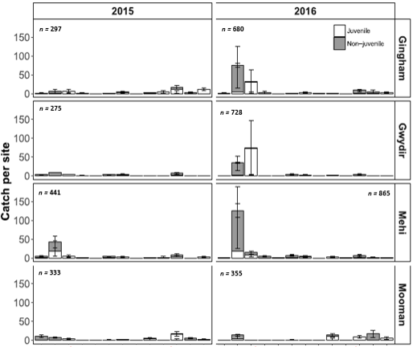

**Australian smelt**

**Bony herring**

**Carp gudgeon**

**Golden perch**

**Freshwater catfish**

**Murray cod**

**M-D rainbowfish**

**Silver perch**

**Spangled perch**

**Un-specked hardyhead**

**Common carp**

**Mosquitofish**

**Goldfish**

**Australian smelt**

**Bony herring**

**Carp gudgeon**

**Golden perch**

**Freshwater catfish**

**Murray cod**

**M-D rainbowfish**

**Silver perch**

**Spangled perch**

**Un-specked hardyhead**

**Common carp**

**Mosquitofish**

**Goldfish**

Figure ‑ Average catch per unit effort (CPUE) ± S.E. for the 13 fish species sampled in the Gingham watercourse, Gwydir River, Mehi River and Moomin Creek. NB*. Juveniles and non-juveniles estimates represent the length at 1 year of age for longer-lived species or the age at sexual maturity for species that reach maturity within 1 year (Table I‑3).

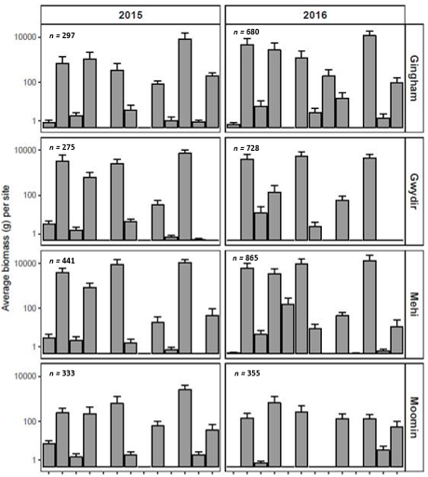

**Australian smelt**

**Bony herring**

**Carp gudgeon**

**Golden perch**

**Freshwater catfish**

**Murray cod**

**M-D rainbowfish**

**Silver perch**

**Spangled perch**

**Un-specked hardyhead**

**Common carp**

**Mosquitofish**

**Goldfish**

**Australian smelt**

**Bony herring**

**Carp gudgeon**

**Golden perch**

**Freshwater catfish**

**Murray cod**

**M-D rainbowfish**

**Silver perch**

**Spangled perch**

**Un-specked hardyhead**

**Common carp**

**Mosquitofish**

**Goldfish**

Figure ‑ Average biomass ± S.E. (log transformed) for the 13 fish species sampled in the Gingham watercourse, Gwydir River, Mehi River and Moomin Creek.

Length frequency

As was the case in 2014-15, in 2015-16 the populations of carp gudgeon and Murray-Darling rainbowfish in most zones tended to be unimodal but asymmetrical, with little evidence of distinct cohort structuring (Figure G‑6). There were, however, significant differences in the length frequency of carp gudgeon between channels where it was caught in sufficient numbers to allow comparisons (Table I‑4). Differences were driven by a greater proportion of adults in the Mehi, a greater number of sub-adults across a wider range of sizes in the Gingham, and a strong cohort of sub-adults in the 20-30 mm range in the Gwydir. Between years, the Gwydir was the only channel where there were significant differences between the length frequencies of carp gudgeon (Table I‑5). Differences were again driven by the dominance of fish in the in 20-30 mm range in the 2015-16 sample. Because Australian smelt and Murray-Darling rainbowfish were caught in such low numbers in the current round of sampling, it was not possible to undertake comparisons between channels either within or between years (Figure I‑6).

There were significant differences in the length frequencies of fish between the majority of channels among all three of the large-bodied species sampled in the current round (common carp, Murray cod, and bony herring) (Figure I‑4) (where tested). The only two exceptions were common carp in the Gingham and Gwydir, where both populations were dominated by a group below 200 mm and a group between 350 and 500 mm, and Murray cod in the Gwydir and Mehi where individuals were similarly distributed across a range of sizes between 150 and 650 mm (Figure I‑7). In the Mehi, the differences in common carp populations lengths were driven by the prevalence of larger adults, whilst the Moomin was the opposite, with almost all individuals juveniles below 150 mm (Figure I‑7 ). Differences in bony herring populations among zones were similarly driven by the presence or absence of smaller individuals. In general, there were larger numbers of individuals < one-year-old in both the Mehi and Moomin compared to the other two channels. Differences between the two channels were driven by the presence of individuals > 120 mm in the Mehi, whilst in the Moomin there were none. In the Gingham, the bony herring population was somewhat different as the majority of the population was distributed between 80 and 230 mm, whilst in the Gwydir the majority of individuals were between 60 and 140 mm but there were also a reasonable number between 250-300 mm. As with 2014-15, among all three species and in most populations there was evidence of bimodel and to a lesser degree, multimodel structuring (Figure I‑7 ).

There were significant differences in the length frequencies between years within channels among all three large-bodied species (Table I‑5). With common carp there were differences in both the Gingham and Mehi populations, driven mainly in both cases by the presence of a larger number of sub one-year-olds in 2014-15. Similarly, differences in bony herring populations in the Gwydir were also a result of there being greater numbers of < one-year-olds in 2014-15 compared to 2015-16. In contrast, differences in the Moomin were due to there being much larger numbers of individuals above and virtually none below 100 mm, in 2014-15. In both Murray cod populations, the differences were a result of a dominance of one or two size classes in both the Gwydir and Mehi in 2014-15.

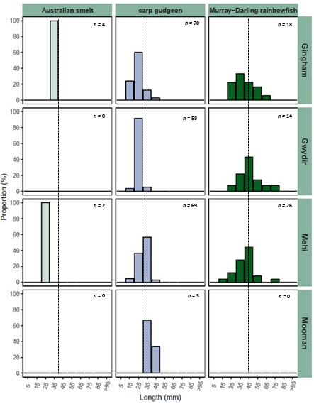

Figure ‑ Length frequency distribution (proportion (%)) of small-bodied fish, Australian smelt, carp gudgeon, and Murray-Darling Rainbowfish sampled in the Gingham watercourse, Gwydir River, Mehi River and Moomin Creek. NB# Dashed line is approximate length at sexual maturity.

Table ‑ Kolmogorov-Smirnov test results of length frequency comparisons between the Gingham watercourse (zone 1), Gwydir River (zone 2), Mehi River (zone 3) and Moomin Creek (zone 4). NB* Dark shading indicates significant difference <0.05. Z represents the K-S model result, P is the confidence value for the result.

|  |  |  |  |  |  |  |  |
| --- | --- | --- | --- | --- | --- | --- | --- |
| Hydrological Zone | | | | | | | |
|  | | 1 V 2 | 1 V 3 | 1 V 4 | 2 V 3 | 2 V 4 | 3 V 4 |
| common carp | *Z* | 0.944 | 2.757 | 6.295 | 3.266 | 6.244 | 6.229 |
| *P* | 0.335 | <0.001 | <0.001 | <0.001 | <0.001 | <0.001 |
| Murray cod | *Z* | -- | -- | -- | 0.792 | -- | -- |
| *P* | -- | -- | -- | 0.558 | -- | -- |
| bony herring | *Z* | 1.588 | 3.562 | 3.572 | 2.703 | 2.475 | 2.003 |
| *P* | 0.013 | <0.001 | <0.001 | <0.001 | <0.001 | 0.001 |
| carp gudgeon | *Z* | 1.520 | 3.270 | -- | 3.876 | -- | -- |
| *P* | 0.020 | <0.001 | -- | <0.001 | -- | -- |
| rainbowfish | *Z* | -- | -- | -- | -- | -- | -- |
| *P* | -- | -- | -- | -- | -- | -- |
| Australian smelt | *Z* | -- | -- | -- | -- | -- | -- |
| *P* | -- | -- | -- | -- | -- | -- |

Table ‑ Kolmogorov-Smirnov test results of length frequency comparisons of fish within hydrological zones (Gingham Watercourse, Gwydir River, Mehi River and Moomin Creek). NB* Dark shading indicates significant difference <0.05. Z represents the K-S model result, P is the confidence value for the result.

|  |  |  |  |  |  |
| --- | --- | --- | --- | --- | --- |
| Hydrological Zone | | | | | |
|  | | Gingham | Gwydir  2 V 3 | Mehi | Moomin |
| common carp | *Z* | 4.495 | 1.014 | 1.960 | 1.352 |
| *P* | <0.001 | 0.255 | 0.001 | 0.052 |
| Murray cod | *Z* | -- | 2.121 | 1.446 | -- |
| *P* | -- | <0.001 | 0.031 | -- |
| bony herring | *Z* | 1.033 | 2.637 | 0.534 | 4.300 |
| *P* | 0.236 | <0.001 | 0.938 | <0.001 |
| carp gudgeon | *Z* | 0.995 | 1.619 | 0.354 | -- |
| *P* | 0.275 | 0.011 | 1.000 | -- |
| rainbowfish | *Z* | -- | -- | -- | -- |
| *P* | -- | -- | -- | -- |
| Australian smelt | *Z* | -- | -- | -- | -- |
| *P* | -- | -- | -- | -- |

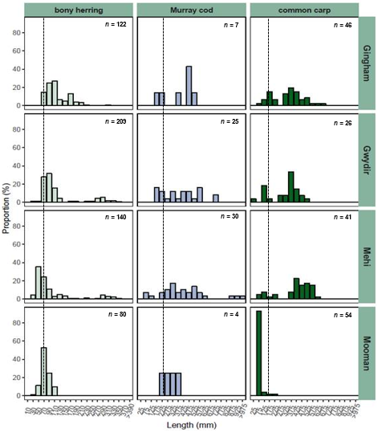

75

175

275

375

475

575

675

775

875

>975

30

70

110

150

190

230

270

310

350

>390

75

175

275

375

475

575

675

775

875

>975

Figure ‑ Length frequency distribution (proportion (%) of large-bodied fish, bony herring, Murray cod and common carp sampled in the Gingham watercourse, Gwydir River, Mehi River and Moomin Creek. NB# Dashed line is approximate length of one-year-old individual.

Health Indicators

***Expectedness***

Of the 13 native fish species that potentially could have been recorded across the lower Gwydir catchment, 10 were caught at a minimum of one site. The three species not caught were olive perchlet, southern purple-spotted gudgeon and Darling River hardyhead (*Craterocephalus amniculus*). All three species are considered to have been “rare” and/or “cryptic” prior to European settlement, and as such would only be expected to be collected at the most up to a maximum of 20% of sites within a zone.

Of the 23 sites sampled as part of the current sampling round, for *Expectedness*,three sites scored a rating of “Good”, four sites scored a rating of “Moderate, seven sites a rating of “Poor”, three sites a rating of “Very Poor” (Table I‑6) and six sites a rating of “Extremely Poor”. Scores ranged from 95 for the Moree site in the Mehi channel, down to 0 for the six dry sites in the Gwydir, Mehi and Moomin (Table I‑6). By channel, the Gingham watercourse had the highest average (± S.E.) rating for *Expectedness*,scoring 67.6 ± 7.41 giving it an overall rating of “Moderate”, whilst Moomin Creek had the lowest average, rating as “Very Poor” with 23.7 ± 9.83. The Gwydir and Mehi rivers had an average rating of “Very Poor” and “Poor” respectively for *Expectedness* (Table I‑6). Although both systems overall scored low, individual sites in the Gwydir rated as high as “Moderate” and in the Mehi two sites scored > 85 giving them an individual rating of “Good” (Table I‑6).

***Nativeness***

Three of the 13 fish species caught in the current sampling round were exotic; common carp, goldfish and Eastern mosquitofish (Figure I‑4). Of these, common carp was the most abundant (n = 167) and also the most widespread, having been caught at all but one of the 17 non-dry sites sampled. As was the case in 2014-15, the highest catches of carp were in Moomin Creek (n = 54), followed by the Gingham watercourse (n = 46), with the Gwydir and Mehi both recording catches of < 45 in total for all sites combined. Eastern mosquitofish were the next most abundant (n = 137) and widespread exotic species sampled, being caught at nine sites and in all channels. Goldfish (n = 48) were the least widespread being caught at only seven sites, however, they were caught in three of the four channels sampled; the Gingham watercourse, Mehi River and Moomin Creek. Overall, catches of common carp and goldfish were lower than in 2014-15, however, nearly three times as many mosquitofish were sampled in 2015-16 compared to 2014-15.

The relatively low abundance of exotic species and in-particular common carp and goldfish, is reflected in the high *Nativeness* scores for most sites. Of the 17 non-dry sites sampled, eight rated as “Good” compared to only four in 2014-15, three as “Moderate” compared to two in 2014-15, five as “Poor” compared to 10 in 2014-15 and only one as “Poor” which was the same in 2014-15 (Table I‑6). Individual site ratings ranged from 98.9 at the Moree site in the Mehi River, down to 0 at the six dry sites. By channel, the Gingham watercourse had the highest average site score at 65.6 ± 11.62, giving it an overall rating of “Moderate” for Nativeness. This is in contrast to the 2014-15 result when the Gingham rated the lowest with an average score of 28.1 ± 11.59. Of the three remaining channels, the Mehi had the next highest average at 64.7 ± 14.81, also giving it an overall rating of “Moderate”, whilst the two remaining zones both scored an overall rating of “Poor” (Table I‑6).

***Recruitment***

The *Recruitment* Indicator scores were generally lower in the current round in comparison to 2014-15 (Table I‑6). *Recruitment* in 2015-16 rated as “Poor” in the Gingham, Mehi and Moomin and as “Very Poor” in the Gwydir (Table I‑6). Recruits made up 54% of the total catch of all the native fish caught, which is considerably higher than in 2014-15 when the overall total of recruits was ~42%. This was mainly due to the capture of large numbers of recruits (95 %) among the 670 carp gudgeon sampled. Among the three remaining small-bodied species sampled, by percentage, recruits were well represented but in overall abundance the numbers were low. Recruits were in relatively low numbers or not present at all among the six large-bodied sampled in the current round. No silver perch or freshwater catfish and only one golden perch recruit were caught, and only 11 or 16 % of all Murray cod caught were recruits. Similarly, only 55 or 9 % of the bony herring caught were recruits. Whilst 66% of the spangled perch sampled were recruits this still only equated to 75 individuals across all sites combined.

There was recruitment evident among all three exotic species sampled in the current round. As in 2014-15, all goldfish sampled were considered as potentially being spawned in the last year. Contrastingly, while there were small numbers of juvenile mosquitofish caught, overall the catch was dominated by adults. There were relatively large numbers of juvenile carp present but not in channels. In the Gingham, Gwydir and Mehi, <1 year olds represented < 20 % of the total number of carp caught, but in Moomin Creek <1 year olds represented 96 % of the total catch. The Moomin was similar to that of 2014-15 where < 80 % of the carp caught were <1 year old. However, there were considerably less juveniles caught in the current round in the Gingham (8%) compared to 2014-15 when they represented <70 % of the total catch. Catches of juvenile carp were also lower than in 2014-15 in the Gwydir and Mehi (~10 %) but to a lesser degree than that of the Gingham.

***Overall score***

The *Overall Fish Condition* (*ndx-FS*) scores for individual sites across the lower Gwydir system varied considerably and were in general lower at both the site and channel scale than in 2014-15. Of the 23 sites sampled (including dry sites), none rated as “Good”, only three rated as “Moderate”, nine as “Poor”, five as “Very Poor” and the six dry sites rated as “Extremely Poor” (Table I‑6). Scores ranged from 69 or “Moderate” for the Gingham 4 site in Gingham watercourse, down to 0 for the six dry sites (Table I‑6). By channel, the Gingham and the Mehi both rated in the high 40’s giving them an overall rating of “Poor”. In general most sites in both channels where there was sufficient water to sample rated as either “Poor” or “Moderate”. In contrast, the Gwydir and Moomin both scored an overall condition rating of “Very Poor”, with average scores of 23.7 ± 10.75 and 22.2 ± 7.74, respectively (Table I‑6). Unlike the Gingham and Mehi, no sites scored a “Moderate” rating in either the Gwydir or Moomin, and excluding those sites that were dry, the majority rated as “Very Poor” in both channels (Table I‑5).

Table ‑ *Recruitment, Nativeness, Expectedness* and *ndxFS* Indicator values for fish at sites sampled in the Gingham watercourse, Gwydir River, Mehi River and Moomin Creek.

|  |  |  |  |  |
| --- | --- | --- | --- | --- |
|  | Health Metrics | | | |
| Site name | Recruitment | Nativeness | Expectedness | ndxFS |
| Gingham Waterhole | 42.5 | 49.8 | 52.2 | 37 |
|  |  |  |  |
| Gingham 38 | 42.5 | 98.3 | 52.2 | 46.8 |
|  |  |  |  |
| Bullerana | 42.5 | 53 | 70.7 | 49.5 |
|  |  |  |  |
| Gingham 27 | 42.5 | 38.9 | 70.7 | 45.1 |
|  |  |  |  |
| Gingham 4 | 42.5 | 88.2 | 92.2 | 69 |
|  |  |  |  |
| **Average (± S.E.)** | NA | 65.6 (11.62) | 67.6 (7.41) | 49.5 (5.31) |
|  |  |  |
|  |  |  |  |  |
| GLTIM C1 S9 | 0 | 0 | 0 | 0 |
|  |  |  |  |
| GLTIM C1 S2 | 28.7 | 90 | 73 | 51.4 |
|  |  |  |  |
| Brageen Crossing | 0 | 0 | 0 | 0 |
|  |  |  |  |
| GLTIM C1 S6 | 0 | 0 | 0 | 0 |
|  |  |  |  |
| Norwood | 28.7 | 92.5 | 73 | 51.6 |
|  |  |  |  |
| Redbank | 28.7 | 94.8 | 54 | 39.1 |
|  |  |  |  |
| **Average (± S.E.)** | NA | 46.2 (20.68) | 33.3 (15.17) | 23.7 (10.75) |
|  |  |  |
|  |  |  |  |  |
| Mehi 16 | 0 | 0 | 0 | 0 |
|  |  |  |  |
| Mehi 49 | 47.3 | 51.1 | 58.6 | 43.3 |
|  |  |  |  |
| Mehi 82 | 47.3 | 69.8 | 54.4 | 46.2 |
|  |  |  |  |
| Mehi 126 | 47.3 | 73 | 54.4 | 47.4 |
|  |  |  |  |
| Moree | 47.3 | 98.9 | 95 | 75 |
|  |  |  |  |
| Chinook | 47.3 | 95.4 | 87.1 | 74.3 |
|  |  |  |  |
| **Average (± S.E.)** | NA | 64.7 (14.81) | 58.3 (13.67) | 47.7 (11.18) |
|  |  |  |

|  |  |  |  |  |
| --- | --- | --- | --- | --- |
|  | Health Metrics | | | |
| Site name | Recruitment | Nativeness | Expectedness | ndxFS |
| Moomin 45 | 41 | 48.4 | 37.3 | 30.3 |
|  |  |  |  |
| Wirrallah | 0 | 0 | 0 | 0 |
|  |  |  |  |
| Heathfield | 41 | 47.1 | 25.5 | 21.1 |
|  |  |  |  |
| Krui | 41 | 77 | 55.5 | 46.1 |
|  |  |  |  |
| Moomin 100 | 0 | 0 | 0 | 0 |
|  |  |  |  |
| Courallie | 41 | 92.4 | 37.3 | 35.4 |
|  |  |  |  |
| **Average (± S.E.)** | NA | 44.2 (15.63) | 25.9 (9.09) | 22.2 (7.74) |
|  |  |  |

Discussion

The most recent drought experienced across much of north-western NSW in 2015-16 has undoubtedly had an effect on the fish across the lower Gwydir catchment. Based on the results of the current round of sampling and on the findings of previous studies (e.g. Murray–Darling Basin Authority 2012; Southwell *et al.* 2015; Commonwealth of Australia2015), the native fish diversity across the lower Gwydir catchment appears to be relatively stable, but the fish community in general is in very poor condition. Among the large-bodied species present, almost all were in relatively low numbers and their distribution could be described as patchy at best. Species such as freshwater catfish, silver perch, golden perch and spangled perch were all reported historically to be highly abundant across the lower Gwydir (Copeland et al.2003)but only relatively low numbers of all four have been recorded in the first two years of the LTIM project.

With the exception of carp gudgeon, all the small-bodied species had declined in number and all were in low abundance compared with 2014-15. This is most likely linked to the dry conditions experienced across the much of the lower Gwydir catchment 2015-16. There were also a number of small-bodied species missing from fish assemblage including the threatened olive perchlet. Recent sampling in the lower Gingham watercourse as part of the wider Gwydir LTIM program (Appendix H) caught a number of olive perchlet using fyke nets. While the lack of numbers in our sample could be attributed to the sampling methods used, it is more likely a reflection on the low abundance and patchy distribution of the species in the system. Additionally, olive perchlet are considered as floodplain or off-channel specialists and have specific spawning habitat requirements, generally in the form of aquatic macrophytes or inundated terrestrial plants (Pusey et al.2004). As such, the chances of catching olive perchlet is relatively remote given that all sampling for the Fish (River) indicator is undertaken within main channel habitats, that the species is in low abundance, and also due to there being far fewer macrophytes than they were pre-river regulation, particularly in the main channel (Wilson et al.2009).

Unlike the majority of species sampled, bony herring and carp gudgeon increased in abundance by orders of magnitude between year 1 and 2 of sampling. Whilst a number of factors may have contributed to this phenomenon, it was most likely a result of the very different flow regimes experienced across the two spring-summer seasons of 2014-15 and 2015-16. In 2014-15, discharge across much of the system tended to be artificially high and stable from October 2014 through to February 2015, whilst in 2015-16 higher discharge events were intermittent and sporadic, interspersed with extended periods of low discharge. Rivers experiencing prolonged and artificially high discharge regimes like that of lower Gwydir during 2015 tend to have reduced stream metabolism due to factors such as increased turbidity, lower water temperatures, higher flow rates and lower nutrient availability (O’Conner et al.2012). Whilst the exact shape of a pre-European hydrograph for the system is unquantifiable for the lower Gwydir catchment, given the summer storm driven nature of the area’s climate and the background drought conditions experienced over the 2015-16 pre-sample period, the 2015-16 hydrograph most likely more closely represents a natural flow regime than that of 2014-15 hydrograph. Both bony herring and carp gudgeon fit within the “generalists” Functional Group, which means as a species they are resilient and may even flourish during extended periods of low in-channel flows (Baumgartner *et al*. 2014; Bice *et al.* 2014). Additionally, Baumgartner et al.(2014) suggested that small in-channel increases in river discharge to inundate benches will mostly likely also result in increased spawning and recruitment among some “generalist” species, which is what appears may have occurred with carp gudgeon.

In comparison to 2014-15, the overall biomass of exotic species was considerably less than in the current 2015-16 sampling round. Common carp were also lower in abundance; however, eastern mosquitofish numbers had increased by orders of magnitude. Similar to carp gudgeon, mosquitofish while classified as “floodplain specialist” in the Northern Murray-Darling Basin (NSW Department of Primary Industries 2015), can boom in times of low flow in the main channel, utilizing backwaters and the slow-flowing habitats to breed and recruit. This can result in large increases in numbers over very short periods of time (Macdonald and Tonkin 2008). Conversely, common carp while considered a “generalist” (NSW Department of Primary Industries 2015), are reported to dramatically increase in number following high discharge events that inundate floodplain and wetland habitats (Stuart and Jones 2006; Southwell *et al.* 2015). While breeding and recruiting of common carp still takes place when discharge is restricted to in-channel only, it is generally at much reduced levels and subsequently the population tends to become dominated by adults. Both the lower overall number and limited recruitment of common carp, and the higher numbers of eastern mosquitofish, is most likely a direct result of the flow regime experienced across the lower Gwydir catchment in 2015-16.

The absence of recruits among a number of the native species sampled in the current round may to some degree be the result of their various life-history strategies of individual species. Long-lived species (> 10 years) such as Murray cod, golden perch, freshwater catfish and silver perch don’t generally recruit in large numbers on an annual basis and effectively can persist by having only small numbers of offspring for any number of years, followed by a year or years of high recruitment when conditions are favourable (e.g. Faulks *et al.* 2010). Similarly, medium-lived species (< 10 years) such as spangled perch and bony herring can also persist by having a number of years of low levels of recruitment followed by “boom” years of high recruitment (Puckridge and Walker 1990). However, while long and medium-lived species can cope with intermittent recruitment, regular recruitment is critical for most small-bodied species. In general, the majority of small-bodied species only live for one to two years, meaning they must recruit annually or even intra-annually to survive. However, while needing to recruit annually, “boom” years of recruitment can also help short-lived species persist across multiple years. During seasons of high river discharge and floodplain inundation, numbers can increase exponentially for some short-lived species, driving dispersal and movement into a multitude of different habitat types (Bond *et al.* 2008). As conditions become drier and the waters contract, small numbers of the original population will persist, breed and recruit in refugia, whilst the remainder may perish. Alternatively, dry years can favour non-flow dependent short-lived species such as carp gudgeon, which can breed and recruit in large numbers by utilizing back-waters and the edges of the main-channels when flows are low. This recruitment paradigm appears to be occurring in the lower Gwydir for at least some species, with examples being species such as bony bream and carp gudgeon, and possibly but to a lesser degree, Murray cod and spangled perch. However, while these few species are at least partially operating as “normal populations”, a number of species such as golden and silver perch, and freshwater catfish may well be below the critical level to take advantage of what for them may be an optimal breeding season when it does occur. As such, complimentary actions such as translocation or restocking may be required to facilitate recovery of these species.

The Fish Health scores for sites in the current sampling round suggest the fish communities in all four zones across the lower Gwydir catchment are in a highly stressed state. The scores for the three indices (*Expectedness*, *Nativeness*, and *Recruitment*) and for *Overall Fish Condition* (*ndx-FS*) were either similar to 2014-15 or had declined, both at the site as well as the zone scale. Whilst the results of the current sampling round could be said to be somewhat influenced by the generally low water levels and by the relatively large number of “dry sites” that could not be sample at all, the similarity of the 2015-16 results to the 2014-15 results (Commonwealth of Australia2015) and the results of previous studies (e.g. Murray–Darling Basin Authority 2012; Southwell *et al.* 2015), suggests that the scores truly reflect the state of the fish communities in the lower Gwydir catchment. As such, the recovery of individual species and of the whole fish community as a whole can at best be expected to be slow.

The effects of river regulation, habitat degradation, and the introduction of exotic species has and continues to inhibit the recovery of native fish across the lower Gwydir catchment. No one native species can be said to be in good or even fair condition across the four hydrological zones as a collective or in most cases, even within a single hydrological zone. As such, whilst the implementation of managed environmental water will assist in maintaining and in some cases possibly enhancing native fish populations or individual species in the lower Gwydir Catchment, as stated in reporting for Year 1 of the Gwydir LTIM program (Commonwealth of Australia2015), complementary actions in conjunction with environmental water will be required to bring about the long-term recovery of fish in the system.

Conclusion

This report documents two years out of a total of five where fish community monitoring will take place for the Gwydir LTIM program. Given the low abundance and restricted distribution of many of the native species present within the system, as well as the absence or virtual absence of a number of large and small-bodied species, suggests that any significant and measurable improvement in the fish community is likely to take some considerable time. Whilst the timeline for this is uncertain, ongoing monitoring is critical to ensure that as recovery actions are put in place, including the release of environmental water, any improvement or detrimental outcomes can be quantified, allowing adaptive management practices to drive future activities.

Major observations and recommendations from the current sampling round in relation to the four specific questions posed:

* What did Commonwealth environmental water contribute to native fish community resilience?

Given the generally dry conditions experienced across much of the lower Gwydir during 2015-16, without environmental water the general condition of the fish community may have been worse. While not seen as a major use for environmental water, this highlights that it can be used to not only enhance activities such as breeding and recruitment, but can also be used to enhance survival during periods of time considered as less than optimal. Managing and using environmental water adaptively and not purely as an enhancement tool will help to future proof fish communities in smaller rivers like those across the lower Gwydir catchment.

* What did Commonwealth environmental water contribute to native fish survival?

Given that the majority of systems across the lower Gwydir catchment had all but ceased to flow by March 2016 and most had contracted to a series of refugia pools, highlights the part that environmental water can play in ensuring survival of native fish during periods of low flow. As a reaction to the prolonged no-flow in the system, CEWH and Water NSW in collaboration with Office of Environment and Heritage (OEH) NSW released a controlled environmental flow in mid-April to the Gwydir and lower Gwydir Rivers, Gingham watercourse, Mehi River and Carole Creek. This preceded a much larger event planned for May. The earlier small event was to ensure that the larger May event would not cause blackwater issues resulting in fish kills. This again highlights the role adaptive management can play in environmental water releases and ultimately the long-term survival and enhancement of the fish community across the lower Gwydir.

* What did Commonwealth environmental water contribute to native fish populations?

Over the period 2015-16, much of the lower Gwydir catchment was dry for long periods, with little natural or environmental water passing through the system. Whilst this was not ideal for ‘flow dependent’ specialists like silver perch and golden perch, the drier conditions suited other species such as bony herring and carp gudgeon, which were both in much higher abundances compared to 2014-15. What this highlights is that environmental flow management is not only about releasing water but also about managing periods of no releases for species that thrive under lower flow conditions. With this said and as discussed above, the release of “crisis” environmental flows in April across the lower Gwydir potentially averted larger issues related to later flows and likely also helped fish in remnant or refugia pools to survive.

* What did Commonwealth environmental water contribute to native fish diversity?

Based on the *Expectedness* values, the native fish diversity in the lower Gwydir is close to pre-European levels, albeit at much reduced abundances. Two species not recorded in 2014-15 were caught in 2015-16, and olive perchlet were also caught in the Gingham as part of the wider Gwydir LTIM program. While there is no direct link between the presence of these species and environmental water, their mere occurrence offers hope for future enhancement activities including e-water releases, in that it shows these species can survive, grow and possibly reproduce in at least some parts of the Gwydir Catchment.

References

Anderson, M.J., Gorley, R.N., & Clarke, K.R. 2008. *PERMANOVA + for PRIMER: Guide to Software and Statistical Methods.* (PRIMER-E: Plymouth.)

Baumgartner, L.J., Conallin, J., Wooden, I., Campbell, B., Gee, R., Robinson, W.A. & Mallen-Cooper, M. 2014. Using flow guilds of freshwater fish in an adaptive management framework to simplify environmental flow delivery for semi-arid riverine systems. *Fish and Fisheries*, *15*, 410-427.

Bice, C.M., Gehrig, S.L., Zampatti, B.P., Nicol, J.M., Wilson, P., Leigh, S.L. & Marsland, K. 2014. Flow-induced alterations to fish assemblages, habitat and fish–habitat associations in a regulated lowland river. *Hydrobiologia*, 722(1), 205-222.

Bond, N., Lake, P. & Arthington, A. 2008. The impacts of drought on freshwater ecosystems: an Australian perspective. *Hydrobiologia*, *600,* 3–16.

Cadwallader, P.L. 1977. *J.O. Langtry’s 1949-50 Murray River investigations.* Fisheries and Wildlife Paper 13. Fisheries and Wildlife Division, Ministry for Conservation, Melbourne.

Carter S. 2012. *Sustainable Rivers Audit 2: Metric Processing System*. Report prepared by Environmental Dynamics for the Murray Darling Basin Authority, Canberra.

Commonwealth of Australia. 2014. *Commonwealth Environmental Water Office Long Term Intervention Monitoring Project Gwydir River System Selected Area.* Commonwealth of Australia.

Commonwealth of Australia. 2015. *Commonwealth Environmental Water Office Long Term intervention Monitoring Project Gwydir River System Selected Area – 2014-15 Evaluation Report*. Commonwealth of Australia.

Copeland, C., Schooneveldt-Reid, E. & Neller, S. 2003. F*ish Everywhere - an oral history of fish and their habitats in the Gwydir Rive*r. New South Wales Fisheries, Ballina.

Davies, P.E., Harris, J.H., Hillman, T.J. & Walker, K.F. 2008. *SRA Report 1: A Report on the Ecological Health of Rivers in the Murray–Darling Basin, 2004–2007*. Independent Sustainable Rivers Audit Group for the Murray–Darling Basin Ministerial Council. MDBC Publication No. 16/08: Canberra.

Davies, P.E., Harris, J.H., Hillman, T.J. & Walker, K.F. 2010. The Sustainable Rivers Audit: assessing river ecosystem health in the Murray-Darling Basin, Australia. *Marine and Freshwater Research*, *61*, 764–777.

Davis, T.L.O., 1977. Age determination and growth of the freshwater catfish, *Tandanus tandanus* Mitchell, in the Gwydir River, Australia. *Marine and Freshwater Research*, *28*(2), pp.119-137.

Faulks L. K., Gilligan, D. M. & Beheregaray, L. B. 2010, Islands of water in a sea of dry land: hydrological regime predicts genetic diversity and dispersal in a widespread fish from Australia’s arid zone, the golden perch (Macquaria ambigua). Molecular Ecology, *19*, 4723–4737.

Leggett, R. & Merrick, J.R., 1987. *Australian native fishes for aquariums*. JR Merrick Publications.

Lorenzoni, M., Corboli, M., Ghetti, L., Pedicillo, G. & Carosi, A., 2007. Growth and reproduction of the goldfish *Carassius auratus*: a case study from Italy. In *Biological invaders in inland waters: Profiles, distribution, and threats* (pp. 259-273). Springer Netherlands.

Macdonald, J. & Tonkin, Z. 2008. A review of the impact of eastern gambusia on native fishes of the Murray-Darling Basin. Arthur Rylah Institute for Environmental Research, Department of Sustainability and Environment, Heidelberg, Victoria.

Mallen-Cooper, M., 1996. Fishways and freshwater fish migration on South-Eastern Australia.

McDowall, R. 1996. *Freshwater Fishes of South-Eastern Australia* (second edition). Reed Books, Chatswood, NSW.

Murray–Darling Basin Authority. (2012). Sustainable Rivers Audit 2: The ecological health of rivers in the Murray–Darling Basin at the end of the Millennium Drought (2008–2010). Murray–Darling Basin Authority, Canberra.

NSW Department of Primary Industries. 2015. *Fish and Flows in the Northern Basin: responses of fish to changes in flow in the Northern Murray-Darling Basin – Valley Scale Report*. Final report prepared for the Murray-Darling Basin Authority. NSW Department of Primary Industries, Tamworth.

O’Connor, B. L., J. W. Harvey, & L.E. McPhillips 2012. Thresholds of flow-induced bed disturbances and their effects on stream metabolism in an agricultural river. *Water Resource Research, 48*, 1-18.

Puckridge, J.T. & Walker, K.F. 1990. Reproductive Biology and Larval development of a Gizzard Shad, *Nematalosa erebi* (Gunther) (Dorosomatinae: Teleostei), in the River Murray, South Australia. Australian Journal of Marine and Freshwater Research, *41*, 695-712.

Pusey, B.J., Kennard, M.J. & Arthington, A.H. 2004. *Freshwater Fishes of North-Eastern Australia*.CSIRO Publishing: Collingwood.

Robinson, W. 2012. *Calculating statistics, metrics, sub-indicators and the SRA Fish theme index. A Sustainable Rivers Audit Technical Report*. Murray-Darling Basin Authority, Canberra.

Southwell, M., Wilson, G., Sparks, P. & Thoms, M. 2015. *Monitoring the ecological response of Commonwealth Environmental Water delivered in 2013-14 in the Gwydir River system: A report to the Department of Environmen*t. University of New England, Armidale.

Stuart, I. G. & Jones, M. J. 2006. Large, regulated forest floodplain is an ideal recruitment zone for non-native common carp (*Cyprinus carpio* L.). *Marine and Freshwater Research*, *57*, 337–347.

Vieira, D. C. & Fonseca, G. 2013. The Importance of Vertical and Horizontal Dimensions of the Sediment Matrix in Structuring Nematodes Across Spatial Scales. *PLoS ONE*, *8*(10), e77704. <http://doi.org/10.1371/journal.pone.0077704>.

Vilizzi, L. & Walker, K.F. 1999. Age and growth of the common carp, *Cyprinus carpio*, in the River Murray, Australia: validation, consistency of age interpretation, and growth models. *Environmental Biology of Fishes*, *54*(1), pp.77-106.

Wilson, G.G., Bickel, T.O., Berney, P.J. & Sisson, J.L. 2009. *Managing environmental flows in an agricultural landscape: the Lower Gwydir floodplain*. Final Report to the Australian Government Department of the Environment, Water, Heritage and the Arts. University of New England and CottonCatchment Communities Cooperative Research Centre, Armidale, New South Wales.

###### Fish Movement

Introduction

Bio-telemetry is used extensively by fisheries scientists across the world to answer a wide range of questions, including many related to fish and their response to changes in river flows. There are currently a number of acoustic bio-telemetry programs underway throughout the Murray-Darling Basin, answering among other questions, those relating to environmental water and fish movement. Unlike these existing programs, the Gwydir Long Term Intervention Monitoring (LTIM) program offers a unique opportunity to utilise bio-telemetry to answer a range of Selected Areaquestions specific to the northern Murray-Darling Basin. The aim of this section of the monitoring program is to assess the effects of water releases on fish residency, survival and movement within the Selected Area. Several specific questions were posed in relation to this indicator:

Short-term (one-year) questions:

* What did Commonwealth environmental water contribute to native fish dispersal?
* Did environmental water stimulate target species to exhibit movement consistent with breeding behaviour?
* Did environmental water facilitate target species to move/return to refuge habitat?

Long-term (five-year) question:

* What did Commonwealth environmental water contribute to native fish populations?

Methods

Study area

The study is being undertaken in the Mehi and Gwydir Rivers within the Selected Area (Figure J‑1a). In the Mehi River the study reach extends from Tareelaroi Weir, where the Mehi diverges from the Gwydir, downstream to the township of Moree. In the Gwydir, the study reach extends from 6 km upstream of Tareelaroi Weir, downstream to immediately below the junction of the Gwydir and Gingham watercourse. Each study reach covers approximately 45 km of their respective river. The Gwydir and Mehi typically do no exceed 25 m in width and 3 m in depth. Both river systems are highly regulated and the surrounding catchment is used for intensive agricultural including large areas under irrigated crops. The system receives environmental water from the main upstream impoundment, Copeton Dam.

The instream environment of both systems includes a variety of mesohabitats, such as woody debris, gravel beds, undercut banks, reed beds, overhanging riparian vegetation and small amounts of aquatic macrophytes. The rivers support a host of native fish species, including an endangered population of freshwater catfish (*Tandanus* sp.) and the threatened Murray cod (*Maccullochella peelii*).

Fine scale acoustic array

Local scale behaviour of tagged fish will be recorded using two fine-scale acoustic telemetry arrays. Sites for the fine scale arrays were selected based on factors such as river curvature and obtrusive structures, while at the same time ensuring consistency in habitats among sites (55J 790973E, 6740855S and 781002E, 6736419S, Figure J‑1a). A range of tests were performed (as described in Espinoza et al. 2011) *in situ* to assess signal strength in relation to receiver position, while at the same time still allowing high precision positioning of multiple fish simultaneously. Once a maximum interval of 50 m was determined, a fine scale array consisting of eight Vemco VR2W 69 KHz receivers were arranged in adjacent equilateral triangles (Figure J‑1b and c) in each of the Gwydir and Mehi Rivers. The arrays were deployed from the 9-13th May 2016 prior to the release of tagged fish. Temperature loggers (OneTemp, Sydney) were also attached to the centre receiver of each array during the installation process.

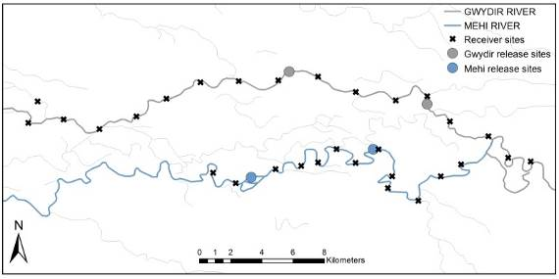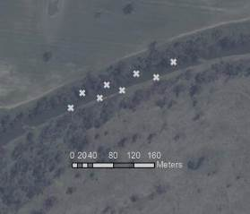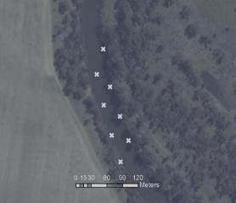

B

C

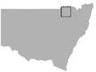

A

Figure ‑ Release site locations at study reaches in the Gwydir and Mehi rivers (a), and the Mehi (b) and Gwydir (c) fine scale array sites.

Extensive acoustic array

Large scale fish movement will be recorded using an extensive linear array of 30 (15 in each system) Vemco VR2W 69 KHz receivers deployed at intervals of 3 km along the Gwydir and Mehi rivers (Figure J‑1; Figure J‑2). This extensive array records binary presence/absence data when a tagged fish enters the reception range of a given receiver. The array was deployed from the 9-13th May 2016 which was prior to the release of tagged fish. Temperature loggers (OneTemp, Sydney) were also deployed at the upper and lower extremes of both arrays on the same dates.

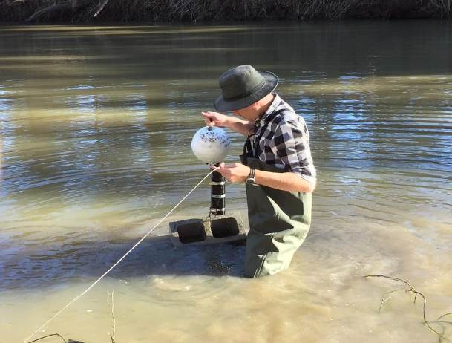

Figure ‑ Deploying receiver in the Gwydir River.

Fish collection

The original intention was to tag five “resident” freshwater catfish and five “resident” Murray cod in each river, and also to translocate 10 catfish from Copeton Dam and release five in each system as well. However, despite exhaustive efforts, riverine catfish proved elusive and had to be supplemented with a greater number of translocated individuals from Copeton Dam (Table J‑1). All resident fish were caught within the confines of the fine scale array to eliminate possible movement away from the array as a result of homing behaviour.

Table ‑ Source and numbers of freshwater catfish and Murray cod tagged and released in the Gwydir and Mehi rivers 2016.

|  |  |  |  |  |
| --- | --- | --- | --- | --- |
|  | Gwydir fine scale | Gwydir extensive | Mehi  fine scale | Mehi  extensive |
| Resident freshwater catfish | 3 | 0 | 0 | 1 |
| Translocated freshwater catfish | 7 | 10 | 10 | 9 |
| Resident Murray cod | 5 | 5 | 5 | 5 |

All fish were collected by electrofishing, gill netting (mesh size 100 mm) or angling from the 23rd May to 1st June 2016. The exact capture location of riverine “resident” fish was recorded and all fish were released within 50 m of their capture site. Freshwater catfish from Copeton Dam were transported to the study sites in aerated 220 L covered drums, with a maximum of five fish per drum. At the study sites, fish from Copeton Dam were kept in a floating cage (mesh size 50 mm) until tag implantation.

Acoustic tag implantation

Fish were anaesthetised in ambient water containing 50 mg per L benzocaine (ethyl-p-aminobenzoate) (Sigma Aldrich, Shanghai) and weighed (g) and measured (mm). Fish were then be transferred to an operating cradle (Figure J‑3), with water containing an equivalent level of anaesthetic (50 mg per L) continually pumped over the gills to maintain anaesthesia. To access the peritoneal cavity, an incision was made through the body wall of the fish, adjacent to the linea alba and anterior of the anal vent. The gonads of the fish were examined through the incision to determine sex before the insertion of the tag. Either a Vemco V9 or V13 69 KHz acoustic telemetry transmitter tag (delay 90-160 secs, approximate battery life of two+ years) was used, with tag size dictated by the recommended maximum of 2.25% of body weight (Jepsen et al. 2002; Butler et al. 2009; Wagner et al. 2011). Passive integrated transponder (PIT) tags were also inserted in the cavity for long-term monitoring. Incisions were closed with two or three sutures using 0.3 mm pseudo-monofilament, absorbable thread (Vetafil Bengen; WdT, Garbsen, Germany). After suturing, the fish were given an intramuscular injection of oxytetracycline hydrochloride (0.25 mL kg−1) (CCD Animal Health and Nutrition, Toowoomba) and then returned to a floating cage to recover.

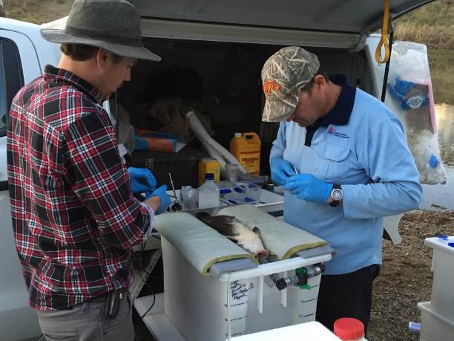

Figure ‑ Freshwater catfish (*Tandanus* sp.) being implanted with acoustic tag.

Monitoring 2016-17

The receivers within the fine scale arrays will be downloaded every three-four months over the coming year. The data from the fine-scale array will be processed by Vemco using the VEMCO Positioning System (VPS) software, where each fish is assigned a continuous metre level position. At this stage it is planned to only deploy the intensive array for up to six months but we are considering leaving it longer depending on the availability of receivers. We will also quantify total available habitat within the fine scale arrays boundaries using a Dual Frequency Identification Sonar (DIDSON) (Sound metrics, Washington). The entirety of the area will be passed over by boat, recording GPS locations and margins of submerged logs, rocks, deep holes, log-jams, macrophyte beds, anthropogenic structures, bank overhangs, root masses and substrate type. These data will allow us to quantify habitat selection under different flow regimes and at different times of the year.

In regards to the broad scale array, data will be downloaded from the 30 receivers and temperature loggers every three-four months. These data will allow us to quantify larger-scale movements in relation to flow releases, water temperature, season and year.

References

Butler, G.L., Mackay, B., Rowland, S.J.& Pease, B.C. 2009. Retention of intra-peritoneal transmitters and post-operative recovery of four Australian native fish species. *Marine and Freshwater Research, 60,* 361-370.

Espinoza, M., Farrugia, T.J., Webber, D.M., Smith, F. & Lowe, C.G. 2011. Testing a new acoustic telemetry technique to quantify long-term, fine-scale movements of aquatic animals. *Fisheries Research, 108*, 364-371.

Jepsen, N., Koed, A., Thorstad, E.B. & Baras, E. 2002. Surgical implantation of telemetry transmitters in fish: how much have we learned? *Hydrobiologia, 483,* 239-248.

Wagner, G.N., Cooke, S.J., Brown, R.S. & Deters, K.A. 2011. Surgical implantation techniques for electronic tags in fish. *Reviews in Fish Biology and Fisheries, 21,* 71-81.

###### Waterbird Diversity

Introduction

The Gingham and lower Gwydir wetlands are recognised as an important area for waterbirds, and support some of the largest waterbird breeding colonies in Australia (DECCW 2011). They also support a number of species listed under international agreements. In addition to the Gingham and lower Gwydir wetlands being an important habitat for waterbirds, the birds themselves constitute a useful indicator of river and wetland health at both regional and local scales, with surveys previously being undertaken in the Gwydir system for a number of years (Spencer et al. 2014). Monitoring for this project in the 2014-15 water year showed that waterbird abundance, diversity and breeding activity all responded positively to the delivery of environmental water into the system. A comparison of sites that were wet against those that were dry (regardless of sampling period) showed a significant increase in both species richness and abundance which indicates that increases in these factors were driven by inundation (Commonwealth of Australia 2015).

Monitoring was expanded in the 2015-16 water year to include several additional sites in the lower Gwydir River and Gingham watercourse, as well as channel and wetland sites within the Mehi River and Moomin Creek which incorporates the Mallowa wetlands. Several specific questions were addressed through the monitoring of waterbird diversity in the 2015-16 water year in the Gingham, lower Gwydir and Mallowa wetlands:

* What did Commonwealth environmental water contribute to waterbird populations?
* What did Commonwealth environmental water contribute to waterbird species diversity?
* What did Commonwealth environmental water contribute to waterbird survival

Environmental watering in 2015-16

During 2015-16, environmental water was delivered to several of the lower Gwydir River channels (Appendix A). In November 2015, a flow event occurred down the Mehi River and supplementary water licences owned by the CEWO were triggered. A total of 1300 ML were accounted for with 964 ML of this water flowing down the Mehi River, and 336 ML directed down Mallowa Creek. Through January 2016, flows were delivered into the Mallowa Creek system to inundate fringing wetlands. Flows were also delivered into the lower Gwydir River and Gingham watercourse in February 2016, to replace flows that were abstracted in a supplementary flow event. Due to critically low flows experienced in the lower Gwydir system in March and April 2016, water was delivered down the lower Gwydir, Gingham, Mehi and Carole channels as part of a dry river flow action in early April. This followed a period of 30-40 days of nil flows conditions across the catchment. While not large in volume (Appendix A), these flows made it into the wetlands (Appendix B), inundating a number of waterbird survey sites (Table K‑1).

Twenty-one of the 29 sites surveyed for waterbirds in November 2015 were inundated, largely as a result of localised rainfall in late October/ early November 2015. The number of sites inundated during the March 2016 survey reduced to 15 sites. The majority of these sites were sustained by environmental flows released between survey times (Table K‑1).

Table ‑: Percentage area inundated for sites surveyed in November 2015 and March 2016. Sites considered as inundated (>5% inundation) are highlighted blue (‘wet’) and those that were not are highlighted yellow (‘dry’).

| Monitoring Zone | System | Site Name | Inundation Area (%) | | Difference Between Seasons (%) |
| --- | --- | --- | --- | --- | --- |
| Nov-15 | Mar-16 |
| lower Gwydir River and Gingham watercourse | Gingham watercourse and wetlands | Baroona Waterhole | 0 | 0 | 0 |
| Boyanga Waterhole | 30 | 5 | -25 |
| Bunnor Bird Hide | 93 | 70* | -23 |
| Three Corners Wetland | 5 | 0 | -5 |
| Gingham Bridge | 0 | 0 | 0 |
| Gingham Waterhole | 30 | 80* | 50 |
| Goddard's Lease | 5 | 40* | 35 |
| Jackson Paddock | 5 | 5* | 0 |
| Racecourse Lagoon | 3 | 0 | -3 |
| Lynworth | 5 | 10* | 5 |
| Talmoi Waterhole | 0 | 0 | 0 |
| Tillaloo Waterhole | 0 | 0 | 0 |
| Westholme SE | 60 | 60* | 0 |
| Westholme NW | 0 | 0 | 0 |
| lower Gwydir River and wetlands | Allambie Bridge | 50 | 5* | -45 |
| Brageen Crossing | 20 | 5* | -15 |
| Belmont | 2 | 1 | -1 |
| Old Dromana Dam | 20 | 30* | 10 |
| Old Dromana Transect | 50 | 0 | -50 |
| Wandoona Waterhole | 20 | 10 | -10 |
| Gin Holes | 30 | 0 | -30 |
| Mehi River and Moomin Creek | Mallowa Creek and wetlands | Bungunya | 0 | 0 | 0 |
| Coombah | 30 | 0 | -30 |
| Gundare Weir | 10 | 40* | 30 |
| Valetta | 70 | 0 | -70 |
| Mehi River | Combadello Weir | 50 | 20* | -30 |
| Derra Waterhole | 10 | 2 | -8 |
| Tellegara Bridge | 20 | 15* | -5 |
| Whittaker's Lagoon | 10 | 5 | -5 |

* Sites marked with an asterisk were influenced by environmental water.

Previous monitoring

Seasonal waterbird ground counts were undertaken by NSW OEH in five wetland regions in NSW, including the lower Gwydir (Spencer et al. 2014; NSW OEH 2014) for several years prior to the commencement of the LTIM project. In the 2014-15 water year, monitoring for the LTIM project commenced which incorporated and expanded upon sites previously monitored in the NSW OEH program.

In 2014-15 a total of 19 sites were surveyed in summer (December 2014) and autumn (March 2015) as part of the LTIM project. These sites were located in the lower Gwydir River and Gingham watercourse monitoring zone and were surveyed in conjunction with NSW OEH staff using ground survey methods (Commonwealth of Australia 2014; Commonwealth of Australia 2015).

The results of previous monitoring indicated that waterbird abundance and diversity corresponded to habitat availability, with greater numbers of waterbirds observed in wetlands that were inundated either via environmental water or from natural flooding (Commonwealth of Australia 2015). In 2014-15, 148 bird species, including 59 waterbird species were recorded in the Gingham and lower Gwydir wetlands, including six waterbird species listed under one or more international migratory bird agreements (JAMBA, CAMBA and ROKAMBA) and two threatened species listed under the NSW TSC Act: brolga (*Grus rubicunda)* and magpie goose (*Anseranas semipalmata*). Waterbird breeding was observed only during the March 2015 surveys and occurred at four sites (Bunnor Bird Hide, Gingham Waterhole, Wandoona Waterhole and Goddard’s Lease) (Commonwealth of Australia 2015).

Methods

A total of 29 sites were surveyed in both November 2015 and March 2016 encompassing creek, floodplain wetland and waterhole sites across the lower Gwydir River and Gingham watercourse, and the Mehi River and Moomin Creek (Figure K‑1; Figure K‑2 Table K‑2). While the majority of sites were consistent with those surveyed in 2014-15 water year, a review by OEH staff in 2016 resulted in some sites being combined to ensure statistical independence. Site area information was also reviewed and updated. 2014-15 data were retrospectively updated to match new site parameters and to include sites in the Mehi River and Moomin Creek monitoring zone that were added to the LTIM program in 2015-16. Multi-year comparisons were conducted on these updated data.

Monitoring for this indicator was done in conjunction with staff from NSW OEH, using ground surveys (Commonwealth of Australia 2015). Replicate surveys were undertaken in the morning and evening at each site, with several sites receiving three visits in order to capture a representative measure of waterbird species richness. Surveys were conducted either as point or transect surveys.

Point surveys involved surveying areas from one or more points located to cover the largest possible area of the survey site. Where multiple points were surveyed for a single site, these points were, as far as possible, out of sight from each other and focussed on different site sections. Each point was surveyed for a minimum of 20 minutes and no more than an hour. At larger sites transect surveys were conducted along a pre-defined transect with fixed starting and finishing points where observers walked the transect for a minimum of 20 minutes but no more than one hour. Any species recorded *en route* to a site were recorded as incidental and, where spatially appropriate, these observations were included in the data for the nearest site.

All species observed along with the maximum count of each species in any one replicate survey were used in the analysis. Site information including inundation percentage, vegetation type and cover and weather conditions were recorded for each replicate survey.

Factorial regressions were undertaken using SYSTAT13 on species richness, waterbird abundance/ha and waterbird functional guild data to compare between systems, survey times, site type and the presence of environmental water. F-tests were used to test for equality of variances, and appropriate t-tests were employed thereafter. The Shannon-Weiner function was calculated for each survey at each site and an evenness index (HE) derived from this. Multivariate nMDS analysis was undertaken on fourth root transformed data in PRIMER 6 to analyse patterns of bird community composition. For this analysis sites which recorded fewer than two species were removed. PERMANOVA tests were performed to compare between systems, survey time and the presence of water. SIMPER analysis was undertaken on functional guild data to determine guilds driving patterns in multi-year site type groupings.

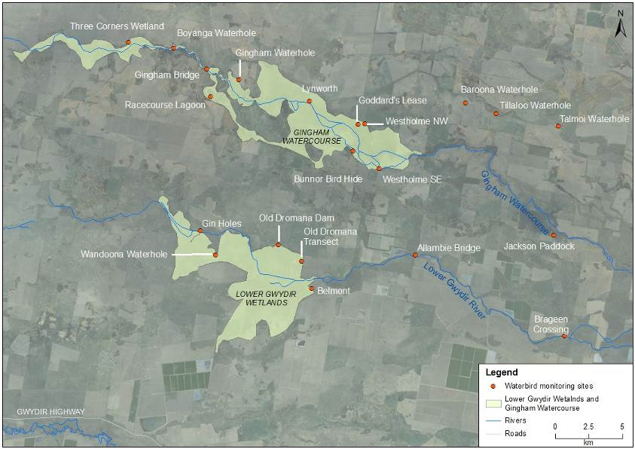

Figure ‑: Waterbird diversity monitoring sites within the lower Gwydir and Gingham watercourse monitoring zone.

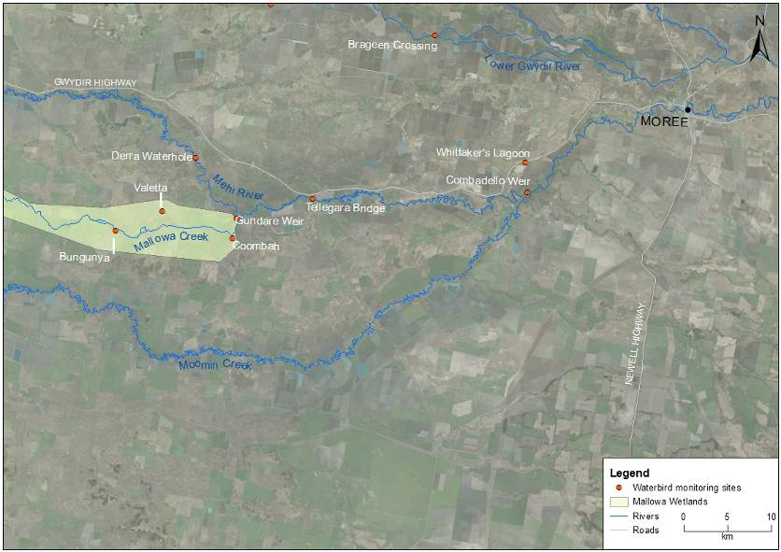

Figure ‑: Waterbird diversity monitoring sites within the Mehi River and Mallowa Creek monitoring zone.

Table ‑: Location of waterbird survey sites within the Gwydir river system Selected Area. All co-ordinates reported in GDA94 zone 55.

| Monitoring Zone | System | Site Name | Site Type | Survey Type | Easting | Northing |
| --- | --- | --- | --- | --- | --- | --- |
| lower Gwydir River and Gingham watercourse | Gingham | Baroona Waterhole | Waterhole | Point | 739764 | 6762643 |
| Boyanga Waterhole | Waterhole | Point | 718064 | 6766759 |
| Bunnor Bird Hide | Floodplain wetland | Point | 731404 | 6759072 |
| Three Corners Wetland | Floodplain wetland | Point | 714691 | 6767141 |
| Gingham Bridge | Creek | Point | 720478 | 6765167 |
| Gingham Waterhole | Waterhole | Point | 722914 | 6764380 |
| Goddard's Lease | Floodplain wetland | Point | 731755 | 6761058 |
| Jackson Paddock | Floodplain wetland | Transect | 746285 | 6752845 |
| Lynworth | Floodplain wetland | Transect | 728151 | 6762769 |
| Racecourse Lagoon | Waterhole | Point | 720813 | 6763103 |
| Talmoi Waterhole | Waterhole | Point | 746631 | 6760958 |
| Tillaloo Waterhole | Waterhole | Point | 742019 | 6761842 |
| Westholme NW | Floodplain wetland | Transect | 732256 | 6761098 |
| Westholme SE | Floodplain wetland | Transect | 733314 | 6757778 |
| lower Gwydir | Allambie Bridge | Creek | Point | 747092 | 6745328 |
| Brageen Crossing | Creek | Point | 728329 | 6748887 |
| Belmont | Floodplain wetland | Point | 720016 | 6753177 |
| Gin Holes | Waterhole | Point | 725856 | 6752106 |
| Old Dromana Dam | Waterhole | Transect | 727574 | 6750877 |
| Old Dromana Transect | Floodplain wetland | Point | 721191 | 6751367 |
| Wandoona Waterhole | Waterhole | Point | 736013 | 6751366 |
| Mehi River and Moomin Creek | Mallowa | Bungunya | Floodplain wetland | Transect | 710667 | 6722986 |
| Coombah | Floodplain wetland | Transect | 723979 | 6722103 |
| Gundare Weir | Creek | Point | 724438 | 6724427 |
| Valetta | Floodplain wetland | Point | 715954 | 6725246 |
| Mehi | Combadello Weir | Creek | Point | 757656 | 6727381 |
| Derra Waterhole | Waterhole | Point | 719732 | 6731304 |
| Tellegara Bridge | Creek | Point | 733130 | 6726664 |
| Whittaker's Lagoon | Waterhole | Point | 757418 | 6730770 |

Results

2015-16 water year

Species richness and abundance

In total 163 bird species, including 59 waterbird species were recorded in the 2015-16 monitoring period (Figure K‑3; Table K‑3). This included seven waterbird species listed under one or more international migratory bird agreements (JAMBA, CAMBA and ROKAMBA) and five bird species listed under the NSW TSC Act: brolga, magpie goose, black-tailed godwit (*Limosa limosa*), black falcon (*Falco subniger*) and black-necked stork (*Ephippiorhynchus asiaticus*). Migratory shorebirds recorded included black-tailed godwit, common greenshank (*Tringa nebularia*), Latham’s snipe (*Gallinago hardwickii*), marsh sandpiper (*Tringa stagnatilis*) and sharp-tailed sandpiper (*Calidris acuminata*).

The maximum count of waterbirds in November 2015 was 314 per ha, comprising 55 species; and in March 2016 was 250 per ha, comprising 44 species (Figure K‑4; Figure K‑5; Table K‑3). As such, although waterbird abundance and species richness were higher in November 2015 (mean abundance 10.8 birds per ha, mean richness per site 10.7) than March 2016 (mean abundance 8.6 birds per ha, mean richness per site 7.1) the difference was not significant (abundance; p=0.282, species richness; p=0.075). Variability across sites was high in both sampling periods. A comparison of sites that were inundated against those which were not showed significantly higher abundance and species richness in inundated sites (mean abundance 17.9 birds per ha; mean richness per site 12.30) than dry sites (mean abundance 2.6 birds per ha; mean richness per site 5.94).

Pairwise comparisons using a single factor analysis of variance showed that mean abundance/ha and richness did not differ among systems for the 2015-16 water year. Comparisons among site types showed that average species richness per site differed between creek sites (4.4) and floodplain wetlands (11.5) although total bird abundance per ha did not. Floodplain wetlands and waterholes did not differ significantly for any indicators tested and it appears they offer functionally similar habitat for waterbirds.

Bunnor bird hide recorded the highest species richness and waterbird abundance for the 2015-16 water year in the March 2016 survey, with an abundance of 94 waterbirds/ha comprised of 27 species. Evenness was moderate in this survey (HE =0.67) and was moderate to high across all surveys. This survey accounted for 17% of the maximum waterbird count/ha in the 2015-16 water year (Figure K‑4; Figure K‑5; Table K‑3). Generally, evenness decreased with increased species richness per site.

Several large flocks of waterbirds were observed during the 2015-16 water year including 100 little pied cormorants (*Microcarbo melanoleucas)* at Westholme South East in March 2016; 100 and 101 glossy ibis (*Plegadis falcinellus*) at Goddard’s Lease in November 2015 and March 2016 respectively; 150 magpie geese near Goddard’s Lease in November 2015 and 107 and 168 cattle egrets (*Ardea ibis*) at Bunnor Bird Hide and Goddard’s Lease respectively in March 2016.

Several sites, that were dry at the time of sampling recorded only woodland birds: Baroona Waterhole in both November 2015 and March 2016; Talmoi and Tillaloo Waterholes in November 2015 and Gingham Bridge and Gin Holes in March 2016. Talmoi and Tillaloo Waterholes were also dry during March 2016 and recorded low waterbird counts, however, the species recorded were from the raptor functional group and as such not strictly dependent on the presence of water at the site. Similarly, Gingham Bridge was dry in November 2015 and recorded a low waterbird count with an Australian pratincole (*Stiltia isabella*) seen *en route* to the site the only waterbird species observed.

The most widespread species recorded in the 2015-16 surveys were the Pacific black duck (*Anas superciliosa*), white-faced heron (*Egretta novaehollandiae*), whistling kite (*Haliastur sphenurus*) grey teal (*Anas gracilis*), sacred kingfisher (*Todiramphus sanctus*) and Australian pelican (*Pelecanus conspicillatus*) which all occurred at more than 15 of the 29 sites surveyed (Table K‑4). Overall, the five most abundant species (Pacific black duck, glossy ibis, grey teal, Australian wood duck and cattle egret) account for 42% of all waterbirds observed in the 2015-16 water year and were observed in both survey periods.

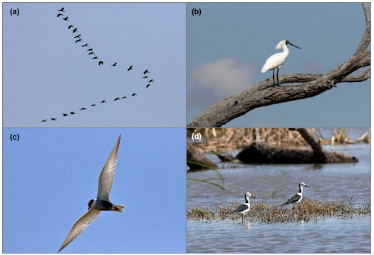

Figure ‑ Waterbirds observed in 2015-2016 water year in the Gwydir River system selected area; (a) glossy ibis; (b) royal spoonbill; (c) whiskered tern; (d) black-winged stilt.

Table ‑ Species richness, abundance and the number of waterbird functional groups recorded at waterbird survey sites within the Gwydir river system Selected Area during 2015-16.

| Monitoring Zone | System | Site Name | Waterbird Species Richness  (Maximum species count per site) | | Waterbird abundance/ ha (maximum waterbird count per site/ ha) | | Waterbird functional guilds | |
| --- | --- | --- | --- | --- | --- | --- | --- | --- |
| Nov-15 | Mar-16 | Nov-15 | Mar-16 | Nov-15 | Mar-16 |
| lower Gwydir River and Gingham watercourse | Gingham | Baroona Waterhole | 0 | 0 | 0.0 | 0.0 | 0 | 0 |
| Boyanga Waterhole | 13 | 8 | 17.6 | 7.0 | 5 | 3 |
| Bunnor Bird Hide | 20 | 27 | 46.2 | 93.8 | 7 | 8 |
| Three Corners Wetland | 7 | 4 | 3.1 | 1.4 | 3 | 3 |
| Gingham Bridge | 1 | 0 | 0.4 | 0.0 | 1 | 0 |
| Gingham Waterhole | 15 | 17 | 8.6 | 17.0 | 6 | 6 |
| Goddard's Lease | 26 | 25 | 5.1 | 7.7 | 7 | 8 |
| Jackson Paddock | 22 | 11 | 3.1 | 1.7 | 7 | 6 |
| Racecourse Lagoon | 21 | 13 | 2.5 | 1.2 | 6 | 4 |
| Lynworth | 15 | 10 | 6.6 | 5.6 | 5 | 4 |
| Talmoi Waterhole | 0 | 1 | 0.0 | 0.2 | 0 | 1 |
| Tillaloo Waterhole | 0 | 1 | 0.0 | 0.4 | 0 | 1 |
| Westholme SE | 13 | 15 | 5.9 | 13.3 | 7 | 5 |
| Westholme NW | 12 | 1 | 0.8 | 0.0 | 4 | 1 |
| lower Gwydir | Allambie Bridge | 1 | 2 | 12.5 | 12.5 | 1 | 1 |
| Belmont | 3 | 2 | 0.7 | 0.3 | 2 | 1 |
| Brageen Crossing | 2 | 5 | 26.7 | 23.3 | 2 | 3 |
| Old Dromana Dam | 12 | 14 | 17.8 | 18.3 | 4 | 8 |
| Old Dromana Transect | 10 | 5 | 1.3 | 1.3 | 6 | 2 |
| Wandoona Waterhole | 25 | 2 | 24.7 | 0.4 | 8 | 2 |
| Gin Holes | 7 | 0 | 5.9 | 0.0 | 3 | 0 |
| Mehi River and Moomin Creek | Mallowa | Bungunya | 3 | 3 | 1.7 | 1.3 | 2 | 1 |
| Coombah | 15 | 4 | 77.9 | 1.9 | 5 | 0 |
| Gundare Weir | 8 | 9 | 12.2 | 26.1 | 4 | 4 |
| Valetta | 19 | 5 | 9.5 | 1.4 | 5 | 3 |
| Mehi | Combadello Weir | 6 | 5 | 9.4 | 3.9 | 3 | 3 |
| Derra Waterhole | 5 | 1 | 2.2 | 0.3 | 2 | 1 |
| Tellegara Bridge | 7 | 7 | 3.1 | 7.3 | 3 | 2 |
| Whittaker's Lagoon | 23 | 8 | 8.4 | 2.8 | 7 | 4 |
| **Average** | | | 10.7 | 7.1 | 10.8 | 8.6 | 4.0 | 2.9 |
| **Std dev** | | | 8.2 | 7.1 | 16.4 | 18.0 | 2.4 | 2.4 |

Figure ‑: Waterbird counts per hectare recorded at survey sites within the Gwydir river system Selected Area in November 2015 and March 2016.

Figure ‑: Species richness recorded at waterbird survey sites within the Gwydir river system Selected Area in November 2015 and March 2016.

Table ‑: Maximum count and percent occurrence across sites for all waterbirds species recorded in the 2015-16 monitoring period.

| Monitoring Zone | | lower Gwydir River and Gingham watercourse | | | | | | | | | | | | | | | | | | | | | Mehi River and Moomin Creek | | | | | | | | |  |
| --- | --- | --- | --- | --- | --- | --- | --- | --- | --- | --- | --- | --- | --- | --- | --- | --- | --- | --- | --- | --- | --- | --- | --- | --- | --- | --- | --- | --- | --- | --- | --- | --- |
| System | | lower Gwydir | | | | | | Gingham | | | | | | | | | | | | | | | Mallowa | | | | | Mehi | | | |
| Functional group (guild) | Common name | Allambie Bridge | Belmont | Brageen Crossing | Gin Holes | Old Dromana Dam | Old Dromana Transect | Wandoona Waterhole | Baroona Waterhole | Boyanga Waterhole | Bunnor Bird Hide | Three Corners Wetland | Goddard's Lease | Gingham Bridge | Gingham Waterhole | Jackson Paddock | Lynworth | Racecourse Lagoon | Talmoi Waterhole | Tillaloo Waterhole | Westholme North West | Westholme SE | Coombah | Bungunya | Gundare Weir | Valetta | Derra Waterhole | | Combadello Weir | Tellegara Bridge | Whittaker's Lagoon | % Occurrence |
| Australian-breeding Charadriiform shorebirds | Australian pratincole |  |  |  |  |  |  |  |  |  |  |  |  | 1 |  |  |  |  |  |  |  |  |  |  |  |  |  | |  |  |  | 3.4 |
| black-fronted dotterel* |  |  |  |  |  |  | 6 |  | 20 |  |  |  |  |  |  |  | 4 |  |  |  |  | 1 |  |  |  |  | | 2 | 1 | 10 | 24.1 |
| black-winged stilt* |  |  |  |  |  |  | 14 |  |  | 4 | 3 | 10 |  |  |  |  | 14 |  |  |  | 1 |  |  |  | 1 |  | |  |  |  | 24.1 |
| masked lapwing* |  |  |  | 4 |  |  | 6 |  |  |  |  | 2 |  |  | 6 |  | 34 |  |  | 4 | 2 | 1 |  |  | 6 |  | |  |  | 2 | 34.5 |
| red-kneed dotterel* |  |  |  |  |  |  | 9 |  |  |  | 2 | 11 |  |  | 4 |  |  |  |  |  |  |  |  |  |  |  | |  |  |  | 13.8 |
| red-necked avocet |  |  |  |  |  |  | 8 |  |  |  |  |  |  |  |  |  | 6 |  |  |  |  |  |  |  |  |  | |  |  |  | 6.9 |
| Dabbling and  filter-feeding ducks | chestnut teal |  |  |  |  |  |  |  |  |  |  |  | 2 |  |  |  |  |  |  |  |  |  |  |  |  |  |  | |  |  | 1 | 6.9 |
| grey teal* |  |  |  | 3 | 5 |  | 24 |  | 21 | 3 | 2 | 11 |  | 4 | 7 |  | 9 |  |  |  |  | 90 |  | 2 | 22 | 2 | | 4 | 2 | 46 | 58.6 |
| Pacific black duck* |  | 1 | 3 | 9 | 12 | 6 | 6 |  | 4 | 53 | 2 | 112 |  | 27 | 30 | 4 |  |  |  |  | 2 | 53 | 1 | 9 | 41 | 2 | | 10 | 9 | 8 | 75.9 |
| pink-eared duck |  |  |  |  |  |  | 11 |  |  |  |  |  |  |  |  |  |  |  |  |  |  |  |  |  |  |  | |  |  | 5 | 6.9 |
| Diving ducks, aquatic gallinules and swans | black swan* |  |  |  |  |  |  |  |  |  | 2 |  |  |  | 3 |  |  |  |  |  |  |  |  |  |  |  |  | |  |  |  | 6.9 |
| dusky moorhen |  |  |  |  | 1 |  |  |  |  | 2 |  |  |  |  |  | 1 |  |  |  | 1 | 4 |  |  | 1 |  |  | |  |  | 1 | 24.1 |
| Eurasian coot |  |  |  |  | 1 |  |  |  |  | 11 |  | 14 |  |  |  |  |  |  |  |  |  |  |  |  |  |  | |  |  | 6 | 13.8 |
| hardhead |  |  |  |  |  |  |  |  |  | 20 |  |  |  |  |  |  |  |  |  |  |  |  |  |  |  | 1 | |  |  | 6 | 10.3 |
| Grazing ducks and geese | Australian wood duck* |  |  | 9 | 3 |  | 15 |  |  |  |  |  | 16 |  | 59 | 37 |  |  |  |  |  |  | 16 | 4 | 12 | 94 |  | |  |  | 10 | 37.9 |
| magpie gooseV |  |  |  |  |  |  | 1 |  |  |  |  | 150 |  |  |  |  |  |  |  |  |  |  |  |  |  |  | |  |  |  | 6.9 |
| plumed whistling-duck |  |  |  | 46 | 11 |  |  |  |  | 80 |  | 2 |  | 11 |  |  |  |  |  |  |  |  |  |  | 42 |  | |  |  |  | 20.7 |
| Large wading birds | Australian white ibis |  |  |  |  |  |  |  |  | 7 | 42 |  | 45 |  | 2 | 17 | 2 | 14 |  |  |  | 5 | 10 |  | 1 | 21 |  | |  |  |  | 37.9 |
| black-necked storkE |  |  |  |  |  |  |  |  |  |  |  |  |  |  |  |  | 1 |  |  |  |  |  |  |  |  |  | |  |  |  | 3.4 |
| brolgaV |  |  |  |  |  |  |  |  |  | 1 |  | 3 |  |  | 2 |  | 2 |  |  |  | 1 |  |  |  |  |  | |  |  |  | 17.2 |
| glossy ibis | 3 | 3 |  |  |  |  | 4 |  |  | 33 |  | 229 |  |  |  | 34 | 16 |  |  |  |  |  |  |  | 27 |  | |  |  |  | 27.6 |
| royal spoonbill |  |  |  |  | 5 |  |  |  | 18 | 34 |  | 9 |  |  | 23 | 1 | 1 |  |  |  | 4 |  |  |  |  |  | |  |  |  | 27.6 |
| straw-necked ibis |  |  |  |  |  |  |  |  |  |  |  | 1 |  |  |  |  | 3 |  |  |  | 116 |  |  |  | 6 |  | |  |  |  | 13.8 |
| yellow-billed spoonbill |  |  |  |  |  |  | 8 |  | 2 | 2 |  | 3 |  |  | 3 |  | 1 |  |  |  | 1 | 1 |  |  |  |  | |  |  | 1 | 31.0 |
| Migratory Charadriiform shorebirds | black-tailed godwitCJRV |  |  |  |  |  |  |  |  |  |  |  | 2 |  |  |  |  |  |  |  |  |  |  |  |  |  |  | |  |  |  | 3.4 |
| common greenshankCJR |  |  |  |  |  |  |  |  |  |  |  | 1 |  |  |  |  |  |  |  |  |  |  |  |  |  |  | |  |  |  | 3.4 |
| Latham's snipeJR |  |  |  |  | 2 | 2 | 2 |  |  | 1 |  |  |  | 1 | 1 |  |  |  |  |  |  |  |  |  |  |  | |  |  |  | 20.7 |
| marsh sandpiperCJR |  |  |  |  |  |  | 5 |  |  |  |  | 25 |  |  |  |  | 31 |  |  |  |  |  |  |  |  |  | |  |  |  | 10.3 |
| sharp-tailed sandpiperCJR |  |  |  |  |  |  |  |  |  |  |  | 19 |  |  |  |  | 20 |  |  |  |  |  |  |  |  |  | |  |  |  | 6.9 |
| Piscivores | Australasian darter |  |  |  |  |  |  |  |  |  | 6 |  |  |  | 8 | 1 | 1 |  |  |  | 2 |  |  |  | 1 |  |  | |  |  |  | 20.7 |
| Australasian grebe* |  |  |  | 1 |  |  |  |  |  |  | 3 |  |  |  |  |  |  |  |  |  |  |  |  |  |  |  | |  |  | 5 | 10.3 |
| Australian pelican |  |  |  |  |  | 1 | 5 |  | 6 | 20 | 2 | 7 |  | 16 | 5 | 2 | 2 |  |  | 1 |  | 1 |  |  | 1 | 2 | |  | 21 |  | 51.7 |
| cattle egretJ |  |  |  |  |  |  |  |  |  | 107 |  | 186 |  |  | 12 |  | 20 |  |  |  |  | 1 |  |  | 5 |  | |  |  |  | 20.7 |
| Eastern great egretJ |  |  |  |  | 1 |  |  |  | 11 | 4 |  | 1 |  |  | 1 | 3 | 3 |  |  |  |  | 1 |  | 1 | 1 |  | |  |  | 1 | 37.9 |
| great cormorant |  |  |  |  |  |  |  |  |  |  |  | 1 |  | 7 |  | 1 |  |  |  |  |  |  |  |  | 2 |  | |  |  |  | 13.8 |
| intermediate egret |  |  |  |  |  |  |  |  | 11 | 6 |  | 10 |  |  | 3 |  | 4 |  |  |  |  | 5 |  |  | 3 |  | |  |  | 1 | 27.6 |
| little black cormorant |  |  |  |  | 1 | 25 | 1 |  |  | 23 |  | 2 |  | 20 |  | 2 |  |  |  |  |  |  |  | 8 |  |  | |  |  |  | 27.6 |
| little pied cormorant |  |  | 1 |  | 6 |  | 1 |  | 1 | 5 |  | 2 |  | 7 | 1 | 6 |  |  |  |  | 100 | 1 |  |  | 1 |  | |  |  | 4 | 44.8 |
| nankeen night-heron |  |  |  |  |  |  |  |  |  |  |  |  |  |  |  |  |  |  |  |  |  |  |  | 2 |  |  | |  |  |  | 3.4 |
| pied cormorant |  |  |  |  |  |  |  |  |  |  |  |  |  | 6 |  |  |  |  |  |  |  |  |  |  | 1 |  | |  |  | 1 | 10.3 |
| sacred kingfisher* |  |  |  |  | 2 |  | 1 |  | 2 | 1 |  |  |  | 5 | 3 | 4 | 1 |  |  | 1 |  | 5 | 4 | 4 |  | 1 | | 3 | 4 | 3 | 55.2 |
| whiskered tern |  |  |  |  |  |  |  |  |  | 1 |  | 2 |  |  |  |  |  |  |  |  |  |  |  |  |  |  | |  |  |  | 6.9 |
| white-faced heron* |  | 3 | 1 | 1 | 2 |  | 1 |  | 16 | 6 | 1 | 6 |  | 3 | 5 | 11 | 6 |  |  | 1 | 3 | 12 | 1 |  | 7 |  | | 3 | 2 | 3 | 72.4 |
| white-necked heron* |  |  |  |  |  | 1 | 1 |  |  |  |  | 2 |  | 13 | 2 |  | 4 |  |  |  | 1 | 6 |  |  | 20 |  | |  |  | 4 | 34.5 |
| Rails and shoreline gallinules | purple swamphen* |  |  |  |  | 2 | 1 | 4 |  |  | 5 |  | 4 |  |  |  | 1 |  |  |  |  | 6 |  |  |  |  |  | |  |  | 1 | 27.6 |
| spotless crake |  |  |  |  |  |  |  |  |  |  |  |  |  |  |  |  |  |  |  |  | 1 |  |  |  |  |  | |  |  |  | 3.4 |
| Raptors | Australian hobby |  |  |  |  |  |  |  |  |  | 1 |  | 1 |  | 1 |  |  |  |  |  |  | 1 |  |  |  |  |  | |  |  |  | 13.8 |
| black falconV |  |  |  |  |  |  |  |  |  |  |  |  |  |  |  |  |  |  |  |  |  | 2 |  | 1 | 1 |  | |  | 1 |  | 13.8 |
| black kite |  |  |  |  |  |  |  |  |  |  |  |  |  |  |  |  |  |  |  | 1 |  |  |  |  |  |  | |  |  | 1 | 6.9 |
| black-shouldered kite* |  | 1 |  |  | 1 | 1 |  |  |  |  |  | 3 |  |  | 2 |  |  |  |  | 1 | 1 |  |  |  | 1 |  | |  |  | 2 | 31.0 |
| brown falcon |  |  |  |  | 1 | 1 |  |  |  |  |  | 1 |  |  |  |  | 3 | 2 |  | 1 | 2 |  |  |  | 1 |  | |  |  |  | 27.6 |
| nankeen kestrel |  |  |  |  |  |  | 1 |  |  |  | 1 | 1 |  |  |  | 1 |  |  |  |  |  |  |  |  |  |  | |  | 1 | 4 | 20.7 |
| swamp harrier |  |  |  |  |  |  |  |  |  | 1 |  |  |  |  |  |  |  |  |  |  | 1 |  |  |  |  |  | |  |  |  | 6.9 |
| wedge-tailed eagle | 1 |  |  |  | 2 | 1 | 1 |  | 2 |  |  |  |  | 1 | 2 | 1 | 2 |  | 2 | 2 |  |  |  |  |  |  | |  | 2 |  | 41.4 |
| white-bellied sea-eagle |  |  |  |  |  |  |  |  |  |  |  |  |  | 1 |  |  |  |  |  |  |  |  |  |  |  |  | |  |  |  |  |
| whistling kite* | 2 | 2 | 1 |  | 1 |  | 2 |  | 1 | 2 |  | 4 |  | 3 |  | 3 | 4 |  |  | 1 | 1 |  |  | 2 | 2 | 1 | | 2 | 4 | 1 | 65.5 |
| Reed-inhabiting passerines | Australian reed-warbler* |  |  |  |  | 16 | 18 | 6 |  | 8 | 12 | 3 | 10 |  | 8 | 10 | 26 | 4 |  |  | 4 | 28 |  | 4 |  |  |  | |  |  |  | 48.3 |
| golden-headed cisticola |  |  |  |  | 6 | 57 | 1 |  |  | 5 | 4 | 10 |  |  | 8 | 18 | 3 |  |  | 4 | 7 |  |  |  |  |  | |  |  |  | 37.9 |
| little grassbird |  |  |  |  | 1 | 3 |  |  |  | 4 |  | 3 |  |  |  |  | 1 |  |  |  | 2 |  |  |  |  |  | |  |  |  | 20.7 |
| **Species richness** | | **3** | **5** | **5** | **7** | **20** | **13** | **25** | **0** | **15** | **31** | **10** | **39** | **1** | **21** | **23** | **19** | **27** | **1** | **1** | **13** | **22** | **16** | **5** | **12** | **22** | **6** | | **6** | **10** | **24** |  |
| **Species abundance** | | **6** | **10** | **15** | **67** | **79** | **132** | **129** | **0** | **130** | **497** | **23** | **923** | **1** | **206** | **185** | **122** | **213** | **2** | **2** | **24** | **290** | **206** | **14** | **44** | **306** | **9** | | **24** | **47** | **127** |  |

J= listed under JAMBA; C= listed under CAMBA; R= listed under ROKAMBA; V=Vulnerable (NSW TSC Act); E= Endangered (NSW TSC Act); *= breeding activity observed

Community Composition

The nMDS plots show that there was some separation in the data based on system (Figure K‑6), and the presence of water. Significant differences were observed between systems (PERMANOVA, pseudo-F=2.21, Pr<0.05) and the presence of water (pseudo-F=2.79, Pr<0.005), however, the interaction between these two factors was non-significant (Pr=0.59). Pairwise tests showed that these trends were driven by significant differences between the Gingham and both the Mallowa (P<0.005) and Mehi (Pr<005), the lower Gwydir and both the Mallowa (P<0.005) and Mehi (P<0.005), and the Mehi and Mallowa (Pr<0.05). Significant differences were also observed between wet and dry sites in the Mallowa system (Pr<0.05). No significant differences were observed between survey periods (Pr=0.66), although sites that were sampled in November tended to show more similarity, especially within wet sites, suggesting more similar community composition within these sites (Figure K‑7). Sites surveyed in March that were dry showed the largest differences in community structure.

Figure ‑6 nMDS plot of waterbird species abundance data in 2015-16 grouped by wetland.

Figure ‑7 nMDS plot of waterbird species abundance data in 2015-16 grouped by sampling season and the presence of water (wet) or not (dry).

Waterbird breeding

Waterbird breeding activity was low across the survey sites. Waterbird breeding activity was observed at 13 sites in November 2015 and 3 sites in March 2016 (Table K‑). Active breeding, or evidence of breeding activity was observed in 16 species in the 2015-16 water year (Table K‑), representing 9 of the 10 functional groups (migratory charadriiform shorebirds are non-breeding migrants to Australia). Piscivores and Australian-breeding charadriiform shorebirds recorded the highest observed breeding activity, followed by raptors, dabbling and filter-feeding ducks and reed-inhabiting passerines. All sites where evidence of breeding activity was recorded had an inundated area of 5% or greater.

Table ‑5 Summary of breeding activity observed over the 2015-16 water year.

| Survey period | Site name | Common name | Breeding activity (# broods or nests) | Notes and additional evidence of breeding |
| --- | --- | --- | --- | --- |
| November 2015 | Boyanga Waterhole | black-fronted dotterel | 1 | 1 juvenile |
| black-fronted dotterel | 1 | 2 juveniles |
| Australian reed-warbler | 1 | with young |
| Combadello Weir | Pacific black duck | 1 | incl 2 juveniles |
| Gin Holes | Pacific black duck | 1 | 4 ducklings |
| masked lapwing | 1 | juvenile |
| Gingham Waterhole | black swan | 1 | Too young to fly |
| Goddard's Lease | red-kneed dotterel | 1 | including young |
| whistling kite | 1 | Nest, bird flew from it |
| Incidental-Gwydir Wetlands | Australasian grebe | 1 | nesting |
| Jackson Paddock | red-kneed dotterel | 1 | 2 were juveniles |
| Old Dromana Dam | Australian reed-warbler | 1 | Incl juvenile |
| Racecourse Lagoon | masked lapwing | 1 | 2 juveniles |
| masked lapwing | 1 | 2 juveniles |
| Australian reed-warbler | 1 | Heard young |
| whistling kite | 1 | Nest on edge of site |
| Three Corners Wetland | black-winged stilt | 1 | incl 1 immature |
| Australasian grebe | 1 | Incl 2 juvenile |
| Wandoona Waterhole | purple swamphen | 1 |  |
| red-kneed dotterel | 1 | 1 juvenile |
| Whittaker's Lagoon | black-shouldered kite | 1 |  |
| Australasian grebe | 1 | Breeding plumage; full size young |
| Australian wood duck | 1 | incl 2 juveniles |
| grey teal | 1 | incl juvenile |
| sacred kingfisher | 1 | Nesting in tree hollow |
| Bunnor Bird Hide | Australian reed-warbler | 1 | heard young too |
| March 2016 | Gundare Weir | Pacific black duck | 1 | 3 ducklings |
| Lynworth | whistling kite | 1 |  |
| Whittaker's Lagoon | grey teal | 1 | 6 ducklings |
| white-faced heron | 1 | nest |
| white-necked heron | 2 | 2 nests 1 with chicks |

Functional guilds

All 10 functional guilds were represented across the sites surveyed in both November 2015 and March 2016 (Figure K‑8). The average number of functional guilds recorded per site was 4.0 in November 2015 and 2.9 in March 2016 with this difference being non-significant (P=0.111). The average number of functional guilds represented at inundated sites (4.7) was significantly higher than at dry sites (2.3; p<0.005). Pairwise comparisons between systems showed no significant difference in the number of functional guilds represented during the 2015-16 water year although there was a significant difference in the mean number of guilds represented between creek (2.3) and floodplain wetland (4.3) sites (P<0.05).

Waterhole sites did not differ significantly from either creek or floodplain wetland sites. Reed-inhabiting passerines, migratory charadriiform shorebirds and rails and shoreline gallinules were absent from creek sites in both November 2015 and March 2016 and diving ducks, aquatic gallinules and swans were absent from creek sites in March 2016. All 10 functional guilds were represented at both floodplain wetland and waterhole sites in both sampling periods.

Three of the functional guilds increased in abundance from November 2015 to March 2016 (grazing ducks and geese, piscivores and raptors) while all others showed a decline. Raptors showed the largest increase in abundance between sampling periods, from 7 birds/ha in November 2015 to 23 birds per ha in March 2016. The largest decline was in dabbling and filter-feeding ducks which dropped from 112 birds per ha in November 2015 to 27 birds per ha in March 2016.

Dabbling and filter-feeding ducks and piscivores were dominant in November 2015 and piscivores and grazing ducks and geese were dominant in March 2016. Overall, piscivores and dabbling and filter-feeding ducks dominated the waterbird community in the 2015-16 water year. Piscivores included little pied cormorants, and cattle egrets; large wading birds included glossy ibis and dabbling and filter-feeding ducks include magpie geese which were all seen in flocks of 100 or more during surveys. Grey teal and Pacific black duck which are dabbling and filter-feeding ducks were also seen in large flocks throughout the surveys.

Figure ‑8 Waterbird count per ha by functional group across all sites in 2015-16 water year.

Multi-year comparison

Species richness and abundance

Species richness and abundance did not differ between sampling periods across year 1 and year 2 (p= 0.11 and p=0.19 respectively). However, both abundance and richness differed consistently in response to the presence of water (p<0.05). Twelve of the 16 possible wet/dry comparisons differed significantly in abundance (p<0.05) and only December 2014 showed no within sampling period variation between wet and dry sites. This is likely due to the even spread of wet vs dry sites in the December 2014 sampling period (12 wet and 12 dry) and the fact that those sites nominated as wet had a generally low estimated inundation compared to other sampling periods. There was no significant interaction between sampling period and the presence of water for either abundance or species richness (p=0.50 and p=0.11 respectively). Richness showed a similar pattern of within sampling period difference, although both November 2015 and December 2014 showed no within period difference. Again, the spread of wet vs dry sites is more even in the November 2015 sampling period (12 dry and 17 wet) which likely explains the similarity in results.

No differences in abundance or richness were accounted for by wet/wet or dry/dry pairs and summer and autumn sampling periods differed between years based on the presence of water. This suggests that seasonality has shown minimal influence on abundance and richness and that all observed differences are driven by inundation for the sampling to date.

Community composition

Considering data collected over both year 1 and 2 of the project, nMDS plots show that there was some separation in community composition based on sampling times and the presence of water (Figure K‑9). PERMANOVA pairwise comparison tests show that these differences were not consistent between survey periods or whether sites were wet or not (Table K‑). Wet and dry sites were significantly different within survey periods, except in March 2015 where no differences were detected. Wet sites sampled in March 15 were significantly different from both wet and dry sites in December 14, and wet and dry sites in November 15. Similarly, dry sites sampled in March 2016, were significantly different to both wet and dry sites in November 2015.

Figure ‑9 nMDS plot of waterbird species abundance data in year 1 and 2 of the project grouped by survey period and the presence of water (wet) or not (dry). Note samples from Gingham waterhole in December 2014 and March 15 were removed from this analysis as they were considered outliers due to highly elevated species counts.

Table ‑6 Significant results for PERMANOVA pairwise tests based on survey period and the presence of water.

|  |  |  |  |  |  |  |  |  |  |
| --- | --- | --- | --- | --- | --- | --- | --- | --- | --- |
| Sampling time |  | Dec-14 | | Mar-15 | | No-15 | | Mar-16 | |
|  | Water presence | Wet | Dry | Wet | Dry | Wet | Dry | Wet | Dry |
| Dec- 4 | Wet |  |  |  |  |  |  |  |  |
| Dry | 0.05 |  |  |  |  |  |  |  |
| Mar-15 | Wet | 0.05 | 0.05 |  |  |  |  |  |  |
| Dry | NS | NS | NS |  |  |  |  |  |
| Nov-15 | Wet |  |  | 0.05 | NS |  |  |  |  |
| Dry |  |  | 0.05 | NS | 0.05 |  |  |  |
| Mar-16 | Wet |  |  |  |  | NS | NS |  |  |
| Dry |  |  |  |  | 0.05 | 0.05 | 0.05 |  |

Functional guilds

There was no significant difference in the representation of functional guilds between year 1 and year 2 of the project. However, nMDS plots show that there was a distinct separation of creek sites from floodplain wetland and waterhole sites when community composition by functional guild (birds per ha) was considered (Figure K‑1). Creek sites in December 2014 and March 2015 separated out strongly compared to floodplain wetland and waterhole sites for all sampling periods. SIMPER analysis showed that this difference was driven largely by the piscivore functional group, explaining 58% of the similarity between creek sites, compared to less than 16% in the floodplain wetland and waterhole site types. Piscivores showed a marked increase from 6.4 birds per ha in November 2015 to 23.5 birds per ha in March 2016, likely driven by an observation of 21 pelicans flying over the Tellegara Bridge site within the Gingham watercourse.

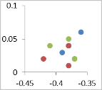

December 2014

March 2015

Figure ‑ nMDS plot of waterbird abundance grouped by site type for data from year 1 and 2 of the LTIM project.

Discussion

The end of the 2014-15 water year saw extensive inundation across the Selected Area with 11 of the 19 survey sites more than 60% inundated by area. This inundation resulted in a boom in productivity which attracted large numbers of waterbirds as observed in the March 2015 survey period, and left the Selected Area in generally good condition (Commonwealth of Australia 2015).

The environmental watering strategy for the Selected Area employs a multi-year wetting and drying cycle in which 2015-16 was a planned dry year, with the application of environmental water aimed largely at maintaining in-channel flow rather than wetland inundation. Local rainfall, irrigation and stock and domestic deliveries and environmental flow ‘top-ups’ ensured that larger wetland sites retained some water, although many smaller wetlands dried almost completely and water levels at other larger sites declined markedly over the course of the water year.

As expected in a drying phase, monitoring results showed a reduction in abundance of waterbirds compared to the 2014-15 water year (although not statistically significant) and a retraction of many remaining species to larger more permanent wetlands. While bird numbers were generally down, wet sites which were in part influenced by environmental water in 2015-16 displayed higher species richness and abundance. Community composition as measured by functional guild representation showed some notable trends between wet and dry sites, habitat types and survey times.

The dabbling and filter feeding ducks functional group, which peaked in abundance with inundation in the December 2014 surveys, showed the largest decline in abundance over 2015-16, returning to numbers similar to that seen in the dry March 2015 surveys. This group feeds on invertebrates and zooplankton which have their peak abundance in an initial wetting phase (Kingsford et al 2010). These waterbirds tend to move between catchments following inundation driven productivity booms (Roshier et al 2002).

Conversely, piscivores and grazing ducks and geese, although lower in abundance than in December 2014, all increased in abundance over the 2015-16 water year which likely reflects the availability of stable habitat and resource bases. Rainfall events and in-channel flows released throughout 2015-16 helped to maintain fish populations and encourage recruitment and provide an established food resource for piscivorous birds. Drying of wetlands encourages growth of terrestrial vegetation into formerly inundated areas which can provide a foraging resource for grazing ducks and geese, as well as nesting habitat and also temporarily increase shoreline foraging habitat (Kingsford et al 2010).

These changes appear to have also supported breeding in Australian-breeding charadriiform shorebirds which, along with piscivores, were observed to have the highest rate of breeding of any of the functional groups in 2015-16. Australian-breeding charadriiform shorebirds were not observed breeding in the 2014-15 water year however juvenile black-fronted dotterel (*Elseyornis melanops*), red-kneed dotterel (*Erythrogonys conctus*) black-winged stilt (*Himantopus leucocephalus*) and masked lapwing (*Vanellus miles*) were all observed in the 2015-16 surveys. Breeding activity was lower overall in 2015-16 than in 2014-15 as would be expected in a drying phase.

Conclusion

Waterbird abundance and community composition generally responded as would be expected in a drying phase, with overall abundance and breeding activity markedly lower compared to the wetter 2014-15 monitoring period. These results support the findings from previous monitoring which indicate that waterbird abundance, richness and breeding are driven by inundation patterns and that the delivery of environmental water to support a broad mosaic of habitats through a planned cycle of wetting and drying is eliciting predictable responses in waterbird community size and composition.

References

Commonwealth of Australia 2015. *Commonwealth Environmental Water Office Long Term intervention Monitoring Project Gwydir River System Selected Area – 2014-15 Evaluation Report.* Commonwealth of Australia.

Department of the Environment, Climate Change and Water (DECCW). 2011. *Gwydir Wetlands Adaptive Environmental Management Plan.*

Kingsford, R.T., Roshier, D.A. & Porter, J.L. 2010. *Australian waterbirds – time and space travellers in dynamic desert landscapes*. *Marine and Freshwater Research, 61*(8), 875-884.

Roshier, D.A., Robertson, A.I. & Kingsford, R.T. 2002. Responses of waterbirds to flooding in an arid region of Australia and implications for conservation*. Biological Conservation, 106*(3), 399-411.

Spencer, J., Hosking, T., Ewin, P., Webster, R., Hutton, K., Allman, R., Thomas, R., Humphries, J., Berney, P. & Mulholland, M. 2014. *Waterbird Monitoring in Inland NSW: Summary Report 2012-13*. NSW Office of Environment and Heritage. Sydney.