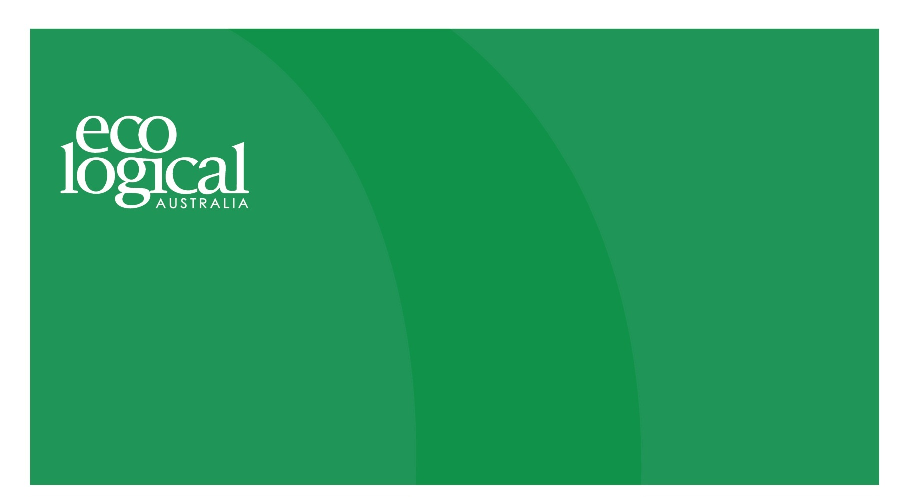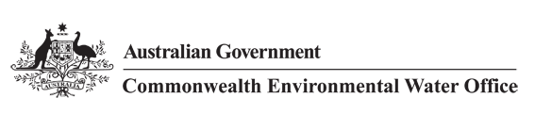



______________________

**A TETRA TECH COMPANY**

**Commonwealth Environmental Water Office**

**Long Term Intervention Monitoring Project**

**GWYDIR RIVER SYSTEM SELECTED AREA**

Five Year Evaluation Report

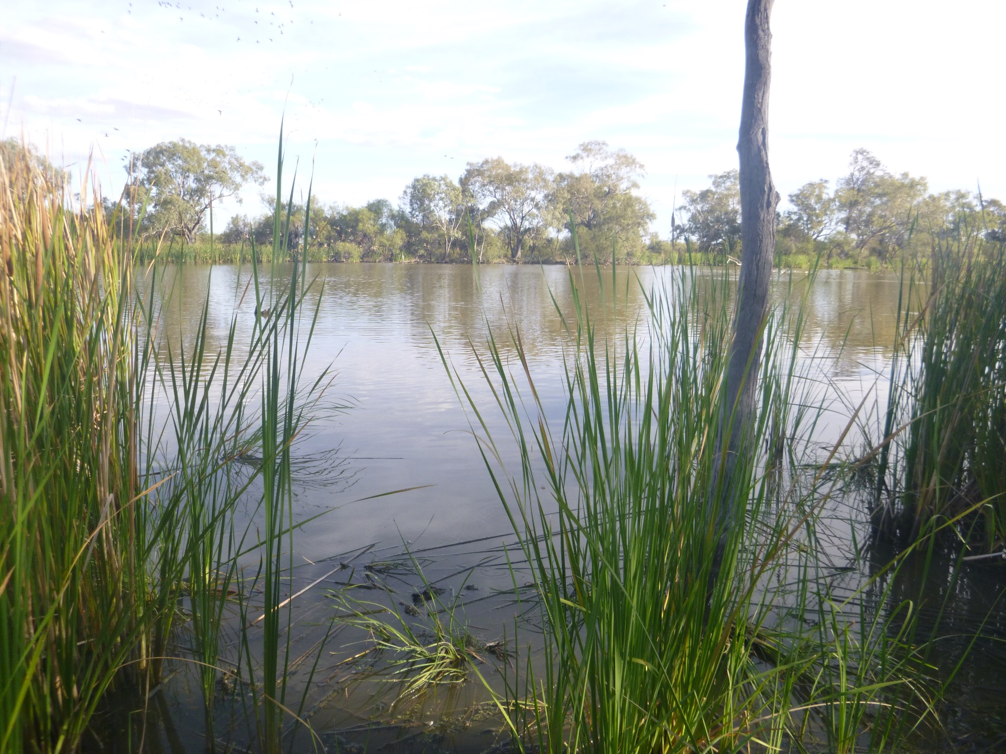

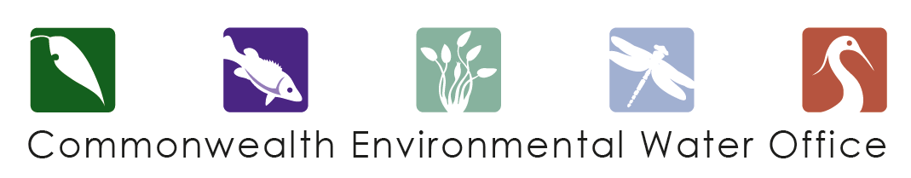

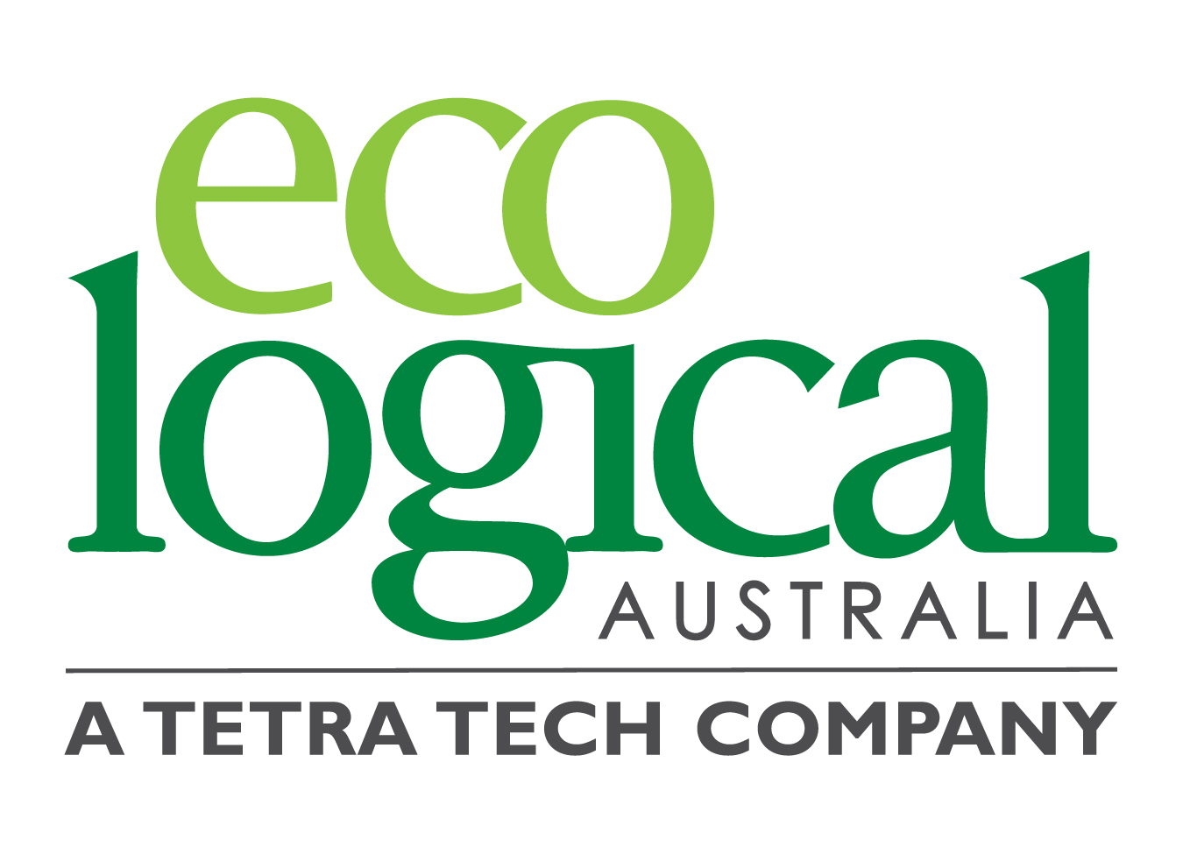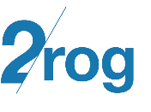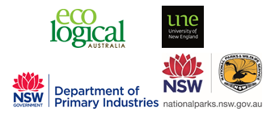

This monitoring project was commissioned and funded by Commonwealth Environmental Water Office, with in-kind support from NSW Office of Environment and Heritage.

**Copyright**

© Copyright Commonwealth of Australia, 2019



Commonwealth Environmental Water Office Long Term Intervention Monitoring Project - Gwydir River system Selected Area, is licensed by the Commonwealth of Australia for use under a Creative Commons By Attribution 3.0 Australia licence, with the exception of the Coat of Arms of the Commonwealth of Australia, the logo of the agency responsible for publishing the report, content supplied by third parties, and any images depicting people. For licence conditions see:

<http://creativecommons.org/licenses/by/3.0/au/>

This report should be attributed as ‘Commonwealth Environmental Water Office Long Term Intervention Monitoring Project Gwydir River system Selected Area – Five Year Evaluation Report, Commonwealth of Australia 2019’.

**Disclaimer**

The views and opinions expressed in this publication are those of the authors and do not necessarily reflect those of the Australian Government or the Minister for the Environment.

While reasonable efforts have been made to ensure that the contents of this publication are factually correct, the Commonwealth does not accept responsibility for the accuracy or completeness of the contents, and shall not be liable for any loss or damage that may be occasioned directly or indirectly through the use of, or reliance on, the contents of this publication.

**DOCUMENT TRACKING**

|  |  |
| --- | --- |
| Item | Detail |
| Project Name | Long Term Intervention Monitoring Project – Gwydir River system Selected Area |
| Project Number | 12235 |
| Project Manager | Dr Mark Southwell  (02) 8081 2688  92 Taylor Street, Armidale NSW 2350 |
| Prepared by | Dr Mark Southwell, Dr Peter Hancock, Ronnie Hill, Linden Burch, Natalie Mace, Matt Elsley, Eliza Biggs, Tom Kelly (ELA)  Assoc. Prof Darren Ryder, Dr Wing Ying Tsoi (UNE)  Dr Gavin Butler, Luke Carpenter-Bundhoo, Tom Davis (NSW DPI)  Dr Paul Frazier (2rog consulting) |
| Reviewed by | Dr Mark Southwell, Assoc. Prof Darren Ryder |
| Approved by | Dr Paul Frazier |
| Status | Final |
| Version Number | 2 |
| Last saved on | 27 February 2020 |
| Cover photo | Gingham Waterhole (photo by Tom Kelly) |

Acknowledgements

This document has been prepared by Eco Logical Australia Pty Ltd with support from Associate Professor Darren Ryder and Dr Wing Ying Tsoi from the University of New England, Dr Paul Frazier from 2rog consulting, Dr Gavin Butler, Luke Carpenter-Bundhoo and Tom Davis from DPI Fisheries, and staff from the NSW Department of Planning, Industry and Environment - Water.

Many sites surveyed as part of the Gwydir Selected Area LTIM Project lie on private land or reserve land managed by NSW National Parks and Wildlife Service (NPWS). The project team acknowledges the cooperation and valuable contribution provided by the individual landholders in allowing access to sites on their properties to undertake monitoring. We are also appreciative to NPWS who allow us access to sites and facilities during field work and provide staff who assist in undertaking monitoring for some indicators.

Acknowledgement of Country

The authors of this report as well as the Commonwealth Environmental Water Office respectfully acknowledge the traditional owners, their Elders past and present, their Nations of the Murray-Darling Basin, and their cultural, social, environmental, spiritual and economic connection to their lands and waters. In particular the Barkindji, Murrawarri, Ngemba and Ngiyampaa peoples, traditional owners of the land on which this publication is focused.

|  |
| --- |
| **Disclaimer** *This document may only be used for the purpose for which it was commissioned and in accordance with the contract between Eco Logical Australia Pty Ltd and the Department of the Environment and Energy. The scope of services was defined in consultation with the Department of the Environment and Energy, by time and budgetary constraints imposed by the client, and the availability of reports and other data on the subject area. Changes to available information, legislation and schedules are made on an ongoing basis and readers should obtain up to date information.*  *Eco Logical Australia Pty Ltd accepts no liability or responsibility whatsoever for or in respect of any use of or reliance upon this report and its supporting material by any third party. Information provided is not intended to be a substitute for site specific assessment or legal advice in relation to any matter. Unauthorised use of this report in any form is prohibited.* |

Template 29/9/2015

**Document control**

|  |  |  |  |
| --- | --- | --- | --- |
| Version | Date | Reviewed by | Approved by |
| 1 | 28/8/2019 | Dr Mark Southwell, Assoc. Prof. Darren Ryder | Dr Paul Frazier |
| 2 | 9/1/2020 | Dr Mark Southwell | Dr Paul Frazier |

|  |  |
| --- | --- |
| Item | Details |
| ELA Project Number | 12235 |
| Project Director/s | Dr Paul Frazier, Assoc. Prof Darren Ryder |
| Project Manager | Dr Mark Southwell |
| Prepared by | Dr Paul Frazier, Assoc. Prof Darren Ryder, Dr Mark Southwell, Dr Wing Ying Tsoi, Dr Gavin Butler, Luke Carpenter-Bundhoo, Ronnie Hill, Linden Burch, Natalie Mace, Eliza Biggs, Matt Elsley, Tom Kelly. |

Contents

Executive Summary vi

1 Monitoring and Evaluation of Environmental Water in the Gwydir River System Selected Area 1

1.1 Introduction 1

1.2 Gwydir River System Selected Area 1

2 Environmental Watering Actions over the LTIM Project 4

3 Key Outcomes from Environmental Water Use 9

3.1 Expected Outcomes 9

3.2 Flows and Ecosystem Functions 15

3.3 Water Quality Responses to Flow 17

3.4 Ecological Response to Flow 17

3.5 Summary 21

4 Implications for Future Management of Environmental Water 22

5 References 24

**Appendix A – Hydrology (River)**

**Appendix B – Hydrology (Watercourse)**

**Appendix C – Category II - Water Quality**

**Appendix D – Category III – Water Quality**

**Appendix E – Microinvertebrates**

**Appendix F – Macroinvertebrates**

**Appendix G – Ecosystem Type**

**Appendix H – Vegetation Diversity**

**Appendix I – Fish (River)**

**Appendix J – Fish (Movement)**

**Appendix K – Waterbird Diversity**

List of figures

Figure 1‑1: The Gwydir River catchment and its location within the Murray-Darling Basin. 2

Figure 1‑2: The Gwydir River system Selected Area with monitoring zones highlighted. 3

Figure 2‑1: Monthly rainfall totals at Moree Airport from July 2014 to June 2019 compared to the long-term mean (Source: BoM, 2019a). 4

Figure 2‑2: Monthly mean maximum temperatures at Moree airport from July 2014 to June 2019 compared to the long-term mean (Source: BoM, 2019b). 5

Figure 3‑1: Inundation in the Gingham and Lower Gwydir wetlands during the 2014-15 water year. 16

Figure 3‑2: Threatened fish species surveyed in the Gwydir River system during the 2015-16 water year. Olive perchlet (left) and Murray cod (right). 19

Figure 3‑3: Waterbirds taking advantage of shallow water habitat. Brolgas in the Gingham wetland (left) and Sharp tailed sandpipers in the Mallowa wetlands (right). 19

Figure 3‑4: Mallowa wetland during the spring 2018 survey, following environmental water deliveries. 20

List of tables

Table 2‑1: Environmental water use in the Gwydir River system during the LTIM Project (2014-19). This includes high security, general security (GS) and supplementary (sup) water managed by both the Commonwealth and NSW state governments. 6

Table 3‑1: Expected outcomes from environmental water use in the Gwydir Selected Area linked to broader Basin Plan objectives. 10

Table 3‑2: Watering actions, target assets and evaluated outcomes implemented in the Gwydir Selected Area during the LTIM Project. 11

Table 4‑2: Thresholds in water quality and ecological variables identified in the Gwydir Selected Area. 23

Executive Summary

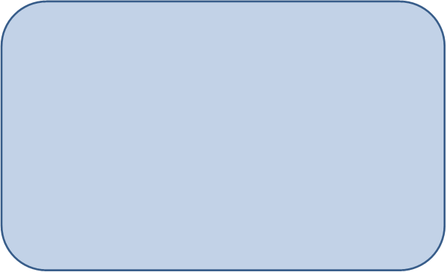

**Contributions of Commonwealth Environmental Water**

The LTIM Project was implemented over a five-year period from 2014-15 to 2018-19. During this period over 301 gigalitres (GL) of Commonwealth and NSW environmental water was delivered to the Gwydir River system contributing to 54% of hydrological connectivity during the project and providing a range of positive environmental outcomes.

***River Channels***

* The Northern Connectivity Event and Northern Fish Flow were critical actions that reconnected channel habitats and promoted fish movement among the channels of the lower Gwydir system.
* Environmental water improved water quality, stimulated primary production and helped maintain local and regional scale aquatic biodiversity, in turn providing a range of habitat and food resources for river food webs.
* Environmental water prolonged the extent and quality of waterhole refuges, allowing iconic species such as Murray cod and golden perch to persist in the lower Gwydir through dry times.

***Wetlands***

* The lower Gwydir wetlands are highly productive systems. Commonwealth environmental water helped inundate over 6,342 hectares (ha) of the lower Gwydir and Gingham systems in a single year supporting the high levels of wetland vegetation (diversity and cover) and stimulating invertebrate food webs that support regionally important frog, fish and waterbird communities.
* The delivery of Commonwealth environmental water during the 2014-15 water year helped reduce lippia cover from 60% to 3% and increased native water couch cover from 10% to 81% in the lower Gwydir wetlands. Water couch dominant communities are fundamental to maintaining the character of the systems Ramsar sites. These communities persisted for the next 4 years following inundation highlighting the long-term benefits of environmental water.
* In the Mallowa wetlands Commonwealth environmental water was the primary water source during the project. This water supported the foraging of migratory waterbird species listed under international agreements and relevant threatened species legislation.

The Gwydir catchment, located in the northern Murray-Darling Basin, extends from the Great Dividing Range west to the Barwon River. Downstream of Moree, the system fans out into a broad alluvial near-terminal floodplain. Numerous anabranches and distributary channels characterise the lower half of the Gwydir catchment, with the Mehi River and Moomin Creek to the south, and the Lower Gwydir River, Gingham Watercourse and Carole Creek to the north. Commonwealth environmental watering targets channel, wetland and floodplain assets including the Lower Gwydir, Gingham and Mallowa wetlands with expected environmental outcomes downstream (west) of Tareelaroi Weir on the Gwydir River.

Climatic conditions were dry for most of the Long Term Intervention Monitoring Project (LTIM Project), especially since 2017 when rainfall has been well below the long-term average. Above average rainfall during August - October 2016 stimulated the largest natural flow event through the system, but since then, flows have been dominated by regulated releases from Copeton Dam.

Commonwealth environmental water was delivered to the channels of the lower Gwydir system and wetlands via a number of watering actions, cooperatively, as a combination of both Commonwealth and State managed water. This report considers the combined influence of both Commonwealth and State managed environmental water sources on hydrologic and environmental responses.

Environmental watering in the Gwydir catchment is delivered under a multi-year wetting and drying strategy to protect and maintain the condition of the wetlands and rivers within the system. During the planned ‘wet’ years, such as 2014-15 and 2018-19, watering aims to inundate core wetland areas and improve their condition and resilience to dry phases. During the intervening ‘dry’ years, environmental watering is more targeted at smaller scale wetland watering and to provide in-stream flows to support native fish populations and protect critical refuge habitat.

The largest inundation event during the project was achieved in the Lower Gwydir and Gingham wetlands in 2014-15 as a result of targeted environmental water deliveries. During this time 6,342 ha of wetland was inundated including key vegetation communities, which remained inundated for four to six months. Maximum measured inundation was observed in the Mallowa system in April 2016 (901 ha) as a result of inflows containing environmental water.

**Key Responses to Flow**

*Water Quality*

* Water quality throughout the Gwydir Selected Area was generally outside the ANZECC guideline trigger values but this did not manifest in any detrimental ecological consequences for river and wetland biota.
* Delivery of environmental water consistently improved water quality in rivers and wetlands, reducing mean pH and conductivity (salinity).
* Warmer temperatures generally increased primary production and dissolved oxygen levels in rivers and wetlands. In rivers, larger flows tended to have increased turbidity that led to reduced dissolved oxygen levels.

*Ecology*

* Hydrology and its influence on water quality is the primary driver of invertebrate communities in the Gwydir wetlands. High nutrient levels and primary production following inundation correlate with the highest invertebrate diversity and densities, demonstrating the role of inundation with environmental water in stimulating aquatic food webs. Water quality deteriorated after >50 days inundation and invertebrate taxa with a higher tolerance to poor water quality dominated.
* Waterbirds took advantage of the increased habitat and food resources following flooding. High average species richness, density and diversity of waterbirds were observed during periods of higher flow/inundation, irrespective of whether it was environmental water (2018-19) or natural flow events in 2016-17.
* The fish community of the lower Gwydir system is under stress. Variations in the native and exotic species composition followed annual variations in flow, with native species increasing in number during the wetter 2016-17 year. While the prolonged dry conditions were not always positive for native fish, the Northern Connectivity Event and Northern Fish Flow were essential actions that reconnected channel habitats, improved water quality and promoted fish movement among the channels of the lower Gwydir system.
* The delivery of environmental water to the Gwydir wetlands during the 2014-15 water year increased the richness and cover of vegetation communities. For example, the delivery of environmental water reduced the cover of the exotic lippia species from 60% to 3% and increased native water couch cover from 10% to 81% in the lower Gwydir wetlands. Water couch dominant communities are fundamental to maintaining the character of the systems Ramsar sites. Water couch dominant communities persisted for the next 4 years following inundation highlighting the long-term benefits of environmental water despite the prevailing dry conditions seen throughout the northern Murray-Darling Basin in recent times.

**Implications for Commonwealth Environmental Water Management**

* The environmental watering strategy employed in the Gwydir Selected Area uses multiple flow types to target a range of wetland and channel outcomes. These include flows targeted at wetland inundation, flows to increase river channel productivity, stimulate food webs and ‘prime’ the system early in the season to promote ecological responses, and flows to improve connectivity and maintain the quality of important low flow refugial habitat during dry times. The LTIM Project has demonstrated that this approach to environmental watering is producing positive environmental outcomes for the lower Gwydir system.
* Through the LTIM Project monitoring, a number of potential thresholds were identified that influence different aspects of the Gwydir Selected Area’s water quality and ecology. These included discharge thresholds that influence water quality variables such as pH, conductivity and dissolved oxygen, discharge thresholds that negatively impact flow sensitive invertebrate taxa, and inundation frequencies that promote native vegetation recruitment and growth.
* The fish population in the Gwydir River system remains under stress, with many native species in low abundance. This may reflect the carrying capacity of the system in its current state. While some species appear to be breeding and recruiting, others, especially some of the more iconic species such as golden perch, freshwater catfish and Murray cod are not recruiting sufficiently for sustainable populations. Along with providing environmental flows, other options such as habitat rehabilitation, restocking and barrier remediation should be considered to improve the fish communities of the Gwydir Selected Area.

# Monitoring and Evaluation of Environmental Water in the Gwydir River system Selected Area

## Introduction

This report presents the monitoring and evaluation results from the Gwydir River system Selected Area (Gwydir Selected Area) five-year program to monitor the outcomes of environmental watering, as part of the Long Term Intervention Monitoring Project (LTIM Project), funded by the Commonwealth Environmental Water Office (CEWO). The LTIM Project was implemented at seven Selected Areas over a five-year period from 2014-15 to 2018-19 to deliver five high-level outcomes (in order of priority):

1. Evaluate the contribution of Commonwealth environmental watering to the objectives of the Murray-Darling Basin Authority’s Environmental Watering Plan.
2. Evaluate the ecological outcomes of Commonwealth environmental watering at each of the seven Selected Areas.
3. Infer ecological outcomes of Commonwealth environmental watering in areas of the Murray-Darling Basin not monitored.
4. Support the adaptive management of Commonwealth environmental water.
5. Monitor the ecological response to Commonwealth environmental watering at each of the seven Selected Areas.

While results specific to the Gwydir Selected Area are reported here, a broader Basin Scale analysis including results from all seven Selected Areas will be produced by the Centre for Freshwater Ecosystems at La Trobe University.

This report describes the Gwydir Selected Area, its environmental condition, and relevant watering actions undertaken, and evaluates the ecological outcomes of the application of Commonwealth environmental water in the Gwydir Selected Area during the LTIM Project. Detailed methods, analyses and results are presented in the Appendices referred to in the main report.

## Gwydir River system Selected Area

The Gwydir catchment, located in the northern Murray-Darling Basin extends from the Great Dividing Range west to the Barwon River, covering an area of 26,600 square kilometres (Green *et al.* 2011). Downstream of Moree, the system fans out into a broad alluvial near-terminal floodplain (DECCW 2011). Numerous anabranches and distributary channels characterise the lower half of the Gwydir catchment, with the Mehi River, Moomin Creek and Mallowa Creek to the south, and the Lower Gwydir River, Gingham Watercourse and Carole Creek to the north. These channels support wetland and floodplain assets including the Lower Gwydir, Gingham (areas of which are declared Ramsar wetlands) and Mallowa wetlands (Figure 1‑1). Commonwealth environmental watering targets assets with expected environmental outcomes downstream (west) of Tareelaroi Weir on the Gwydir floodplain.

The Gwydir River system Selected Area focuses on the reaches of the Lower Gwydir River and distributary channels to the west of Tareelaroi Weir (Commonwealth of Australia 2014). The Gwydir Selected Area (Figure 1‑2) includes three monitoring zones:

* Gwydir River (downstream of Copeton Dam to Pallamallawa).
* Lower Gwydir River and Gingham Watercourse.
* Mehi River and Moomin Creek (including Mallowa Creek).

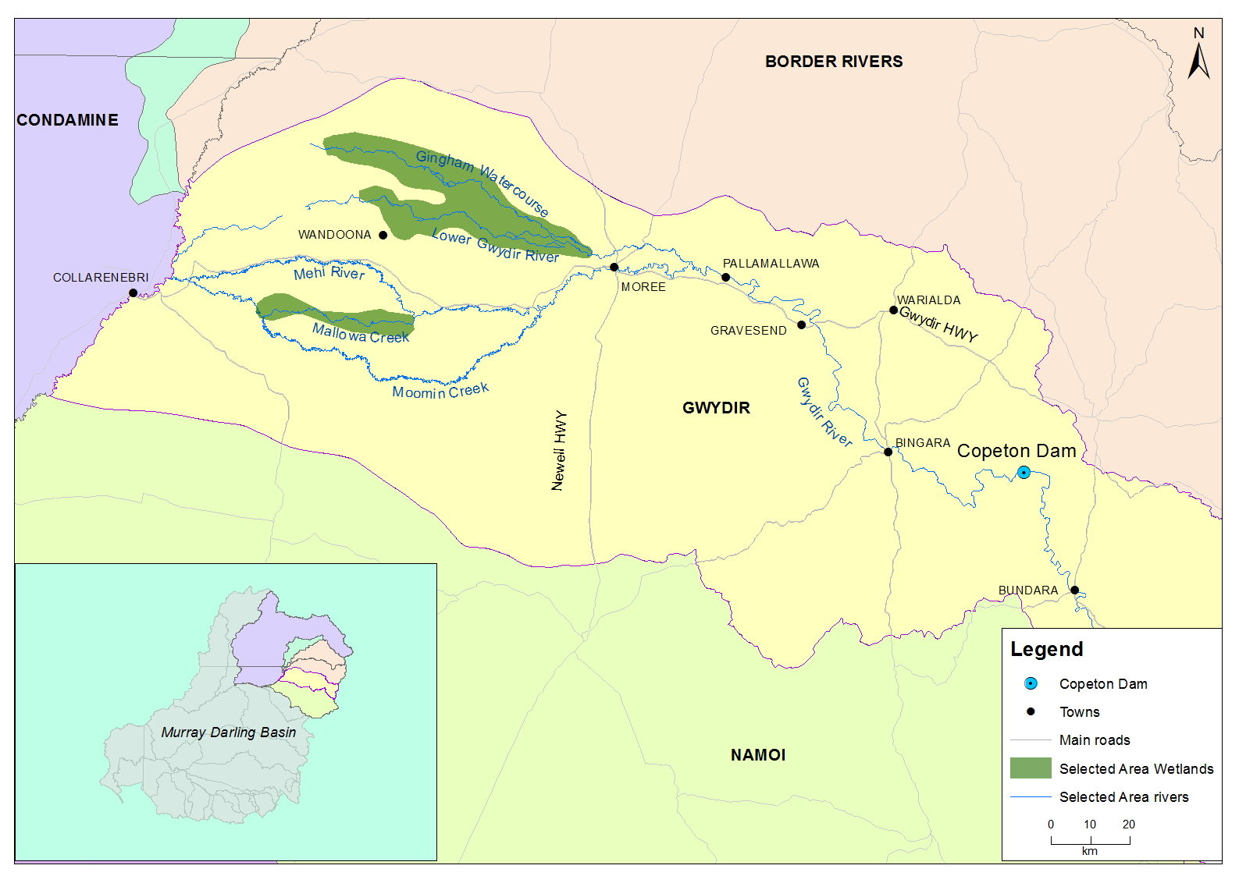

Figure 1‑1: The Gwydir River catchment and its location within the Murray-Darling Basin.

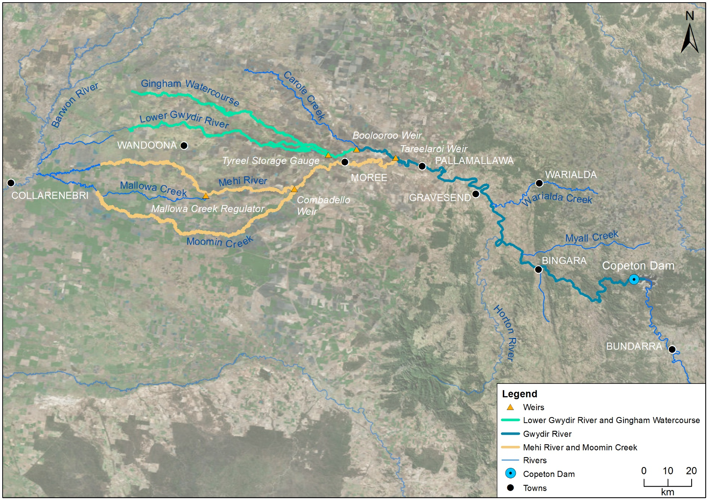

*Gingham waterhole*

Figure 1‑2: The Gwydir River system Selected Area with monitoring zones highlighted.

# Environmental Watering Actions over the LTIM Project

Historically, rainfall in the Gwydir Selected Area is summer-dominated, although rainfall has been variable over the LTIM Project period (Figure 2‑1). During the 2014-15 water year, rainfall was above average in August, January, March, April, May and June. During the 2015-16 water year, rainfall was above average in January, May and June. The 2016-17 water year was the wettest year of the project, with March recording the highest monthly rainfall of the project (156.2 mm). Above average rainfall also occurred in August, September, October, April and May in 2016-17. During the 2017-18 water year, rainfall was above average in October, November, February and March. The 2018-2019 water year was a particularly dry year with an annual total of just 300.2 mm of rainfall, with October being the only month to record above average rainfall (Figure 2‑1).

Mean maximum monthly temperatures have predominately been highest during summer over the LTIM Project, with temperatures often being higher than the long-term average across all water years. The highest average monthly temperature recorded within the entire project duration was in 2016-17 (38.3°C) and the lowest in July 2015-16 water year (16.8°C, Figure 2‑2).

Figure 2‑1: Monthly rainfall totals at Moree Airport from July 2014 to June 2019 compared to the long-term mean (Source: BoM, 2019a).

Figure 2‑2: Monthly mean maximum temperatures at Moree airport from July 2014 to June 2019 compared to the long-term mean (Source: BoM, 2019b).

A total of 301,172 ML of environmental water was delivered through the Gwydir River system during the LTIM Project, making up 23% of the total water that flowed down the Gwydir River channel during that period (Table 2‑1). The highest volume occurred during the 2018-19 water year when 62,150 ML of Commonwealth and 52,000 ML of NSW environmental water was used. The lowest volume was in the 2015-16 water year where 13,250 ML of environmental water was delivered.

During 2014-15 environmental water was delivered to a number of assets within the Gwydir River system. In-channel flow pulses were delivered down the Mehi River and Carole Creek channels to enhance in-stream ecological function, nutrient cycling, water quality and fish spawning conditions. In addition, flows were delivered to the Lower Gwydir, Gingham Watercourse and Mallowa Creek to provide for wetland inundation.

During 2015-16 environmental water was delivered to a number of assets within the Gwydir Selected Area. In November 2015, a flow event occurred down the Mehi River based on supplementary water licences owned by the CEWO being triggered. A total of 1,300 ML was accounted for, with 964 ML of this water flowing down the Mehi River, and 336 ML directed down Mallowa Creek. Through January 2016, flows were delivered into the Mallowa Creek system to inundate fringing wetlands in association with WaterNSW bulk water deliveries. Flows were also delivered into the Lower Gwydir River and Gingham Watercourse in February 2016 to replace flows that were extracted in a supplementary flow event. While not large in volume, these flows made it into the wetlands, inundating up to 161.81 ha (Appendix B). Due to critically low flows experienced in the lower Gwydir system in March and April 2016, water was delivered to the Lower Gwydir, Gingham, Mehi and Carole channels as part of a dry river flow action in early April 2016. This followed a period of 30 to 40 days of nil flow conditions across the catchment.

Table 2‑1: Environmental water use in the Gwydir River system during the LTIM Project (2014-19). This includes high security, general security (GS) and supplementary (sup) water managed by both the Commonwealth and NSW state governments.

| Channel | Commonwealth Environmental Water (CEW) delivered (ML) | NSW ECA/General Security/ Supplementary Environmental Water delivered (ML) | Annual total flow (ML) | Environmental Water (% of total flow) |
| --- | --- | --- | --- | --- |
| **2014-15** | | | | | |
| Gwydir River* | 56,639 | 29,895 | 302,043 | 29 |
| Gingham Watercourse | 15,000 | 14,868 | 46,711 | 64 |
| Lower Gwydir | 15,000 | 15,027 | 41,171 | 73 |
| Carole Creek | 3,656 | - | 48,670 | 8 |
| Mehi River | 13,316 | - | 123,480 | 11 |
| Mallowa Creek | 9,667 | - | 11,281 | 86 |
| ***2014-15 total*** | ***56,639*** | ***29,895*** | ***302,043*** | ***29*** |
| **2015-16** | | | | | |
| Gwydir River* | 8,400 | 4,850 | 184,759 | 7 |
| Gingham Watercourse | 675 | 2,375 | 29,043 | 11 |
| Lower Gwydir | 675 | 2,375 | 20,273 | 15 |
| Carole Creek | 409 | - | 25,318 | 2 |
| Mehi River | 3,155 (incl 964 ML sup) | 100 (Whittaker Lagoon) | 64,505 | 5 |
| Mallowa Creek | 3,486 (incl 336 ML sup) | - | 4,463 | 86 |
| ***2015-16 total*** | ***8,400 (incl 1,300 ML sup)*** | ***4,850*** | ***184,759*** | ***7*** |
| **2016-17** | | | | | |
| Gwydir River* | 22,847 (incl 6,351 sup) | 21,800 (incl 800 sup) | 614,484 | 7 |
| Gingham Watercourse | 4,259 | 13,741 (incl 3,000 GS) | 102,667 | 18 |
| Lower Gwydir | 4,741 | 7,259 | 52,745 | 23 |
| Carole Creek | 1,351 (sup) | - | 112,485 | 1 |
| Mehi River | 5,000 (sup) | - | 205,349 | 2 |
| Mallowa Creek | 7,496 | 800 (sup) | 8,668 | 96 |
| ***2016-17 total*** | ***22,847 (incl 6,351 sup)*** | ***21,800 (incl 800 sup)*** | ***614,484*** | ***7*** |
| **2017-18** | | | | | |
| Gwydir River* | 28,290 | 18,748 (including 15,748 GS) | 434,462 | 11 |
| Gingham Watercourse | 2,000 | 5,534 (including 4,520 GS) | 20,894 | 36 |
| Lower Gwydir | 2,000 | 5,706 (including 4,520 GS) | 19,850 | 39 |
| Carole Creek+ | 3,886 | 2,462 (including 1,662 GS) | 95,341 | 7 |
| Mehi River< | 20,404 | 5,046 GS | 213,134 | 12 |
| Moomin Creek# | 324 | 175 | 104,075 | 0 |
| Mallowa Creek | - | - | 121 | 0 |
| ***2017-18 total*** | ***28,290*** | ***18,748 (incl 15,748 GS)*** | ***434,462*** | ***11*** |
| **2018-19** | | | | | |
| Gwydir River* | 63,416 | 43,941 | 205,520 | 53 |
| Gingham Watercourse | 20,000 | 15,000 | 40,443 | 87 |
| Lower Gwydir | 11,314 | 16,032 | 30,254 | 90 |
| Carole Creek | 300 | 300 | 16,865 | 4 |
| Mehi River^ | 10,430 | 16,545 | 82,262 | 33 |
| Mallowa Creek | 16,950 | - | 17,230 | 98 |
| ***2018-19 total*** | ***63,416*** | ***43,941*** | ***205,520*** | ***52*** |
| **Grand total** | **179,592** | **118,434** | **1,327,700** | **22** |
| * All environmental water delivery to the Gwydir system flows through the Gwydir River. Therefore, volumes for this channel represent total volumes delivered downstream and as such are used to represent the total flow.  < Includes 499 ML that flowed down Moomin Creek but returned to the Mehi downstream. Also includes 14,160 ML delivered as part of the Northern Connectivity Event. The total volume for the NSW component also includes 90 ML NSW General Security water for delivery to Whittaker’s Lagoon.  ^ Includes 600 ML delivered to Ballin Boora system. Also includes 23,051 ML delivered as part of the Northern Fish Flow  +Includes 4,758 ML delivered as part of the Northern Connectivity Event | | | | | |

A flow event occurred down the Mehi River in September 2016 and supplementary water licences owned by the CEWO were triggered. A total of 5,000 ML was accounted for in the Mehi River. Supplementary flows were triggered in the Mallowa system in September 2016, however, very little of the moderate flows were diverted into the Mallowa wetlands. In January - March 2017, planned deliveries of 5,000 ML were increased to 7,496 ML to the Mallowa Creek system to inundate fringing wetlands. Flows were also delivered into the Lower Gwydir River and Gingham Watercourse to build upon moderate winter/spring flows. From January to March 2017, 30,000 ML was delivered, to inundate broad areas of semi-permanent wetland vegetation. During 2016-17, no environmental water was delivered to Moomin Creek.

An early season stimulus flow was triggered by inflows to Copeton Dam in August and September 2017. A total of 10,000 ML was delivered into the main Gwydir River, Mehi and Carole Creek systems as a small fresh during late winter/early spring. Following this, a stable flow release of 10,040 ML was delivered into the main Gwydir River, Mehi and Carole Creek systems in late October to mid-November 2017. These small pulse flows aimed to provide downstream connectivity and allow opportunity for movement, breeding and recruitment of fish, particularly freshwater catfish (*Tandanus tandanus*).

A delivery of 8,000 ML including both State and Commonwealth environmental water was made to the Lower Gwydir and Gingham wetlands from mid-December 2017 to late January 2018 to replace supplementary take from a small flow event that occurred in the previous months. This aimed to maintain wetland habitat quality and support the survival and resilience of wetland flora and fauna. The last environmental delivery was made in late April to May 2018 as part of the Northern Connectivity Event. This flow aimed to provide longitudinal connectivity and refresh/replenish drought refuge for instream life, particularly native fish in the Barwon-Darling as well as improve conditions for native fish populations within the tributary catchments. During this event, a total of 18,908 ML of both State and Commonwealth water was delivered down the Mehi River, Moomin Creek and Carole Creek. No environmental water deliveries were made to Mallowa Creek in 2017-18.

In 2018-19 environmental water made up 53% of the total flow down the Gwydir River channel (Table 2‑1). Sixty gigalitres of environmental water was delivered to the Lower Gwydir and Gingham wetlands to support wetland vegetation and channel processes in the Gwydir River. Deliveries to the wetlands began in July 2018 and finished in February 2019. In both systems deliveries were stopped in October and November to allow farmer access during the winter crop harvest. Over the November 2018 to February 2019 period, environmental water was also delivered to the Mallowa wetlands to support wetland vegetation, waterbirds and native fauna. During this event 16,950 ML of Commonwealth environmental water was delivered. A trial delivery of 600 ML was delivered to the Ballin Boora system in January to February 2019 to support wetland and riparian vegetation. Pool replenishment flows were delivered to the Gwydir, Lower Gwydir, Carole and Mehi channels due to low inflows that caused extended no flow periods throughout the water year. In May to June 2019, 23,051 ML was delivered down the Mehi River channel from Copeton Dam, as part of the Northern Fish Flow. This flow reconnected the lower Mehi River, and once in the Barwon River channel, flowed downstream as far as the Culgoa River junction.

# Key Outcomes from Environmental Water Use

## Expected Outcomes

Environmental watering in the Gwydir catchment is undertaken under a multi-year wetting and drying strategy to protect and maintain the condition of the wetlands and rivers within the system. During the planned ‘wet’ years, such as 2014-15 and 2018-19, broader wetland watering aims to inundate core wetland areas and improve their condition and resilience. During the intervening ‘dry’ years, environmental watering is more targeted at smaller scale wetland watering and to provide in-stream flows to support native fish populations and protect critical refuge habitat (Commonwealth of Australia 2017).

Watering actions undertaken in the Gwydir River system Selected Area were expected to contribute to five specific outcomes in during the LTIM Project.

* Protect and maintain the condition of permanent and semi-permanent wetland vegetation.
* Maintain habitat to support waterbird condition and survival.
* Maintain habitat such as waterholes for fish condition and survival.
* Support fundamental ecosystem function processes of nutrient and carbon cycling and primary production.
* Providing hydrological connectivity including end of system flows

Alignment of the expected outcomes for individual proposed watering with objectives of the Basin Plan’s environmental watering plan and the Murray-Darling Basin Authority’s annual environmental watering priorities (MDBA 2017), are shown in Table 3‑1. A summary of each watering action, its target asset, and outcomes is provided in Table 3‑2.

Table 3‑1: Expected outcomes from environmental water use in the Gwydir Selected Area linked to broader Basin Plan objectives. Shading represents Basin environmental watering priority. Bold Tick represents primary expected outcome.

|  |  |  |  |  |  |  |  |
| --- | --- | --- | --- | --- | --- | --- | --- |
| Expected outcome | Timeframe | Relevant Basin Plan objective | Watering actions: Gwydir | | | | |
| Gwydir, Gingham and Mallowa wetland watering | Early season stimulus and native fish recruitment flows | Extreme dry river contingency flows | Northern Connectivity Event and Fish Flow |
| Vegetation condition and reproduction | < 1 year | Biodiversity (s8.05) | **✓** |  |  |  |
| Fish condition |  | **✓** | ✓ | **✓** |
| Fish recruitment | 1-5 years |  | **✓** |  |  |
| Waterbird survival and condition | < 1 year | ✓ |  |  |  |
| Individual survival and recruitment (individual refuges) | < 1 year | Resilience (s8.07) |  |  | **✓** | **✓** |
| Hydrological connectivity including end of system flows | < 1 year | Ecosystem function (s8.06) | ✓ | ✓ | **✓** | **✓** |
| Biotic dispersal and movement |  | ✓ | ✓ | ✓ |
| Primary productivity | ✓ | **✓** | **✓** |  |
| Nutrient and carbon cycling | ✓ | **✓** | **✓** |  |
| Salinity, dissolved oxygen, dissolved organic carbon, pH, algal blooms | < 1 year | Water quality (s9.04) |  | ✓ | ✓ | **✓** |
| Basin environmental watering priorities | | | *2,3,4* | *1,2* | *1,2* | *1,2* |

Basin environmental watering priorities:

* 1) Improve flow regimes and connectivity to maximise the ecological function of the Barwon-Darling River system for native fish.
* 2) Support viable populations of threatened native fish and maximise opportunities for range expansion and the establishment of new populations.
* 3) Improve the abundance and diversity of the Basin’s waterbird population.
* 4) Enable recruitment of trees and support growth of understorey species within river red gum, black box and coolibah communities on floodplains that received overbank flooding by inundating the floodplains again.

Table 3‑2: Watering actions, target assets and evaluated outcomes implemented in the Gwydir Selected Area during the LTIM Project.

| Water Year | Watering action | Volume (ML) | Target asset | Expected outcomes | Were these outcomes achieved? |
| --- | --- | --- | --- | --- | --- |
| 2014-15 | Delivery of envrironmental water to provide in-channel flow pulse to Carole Creek and Mehi River | 16,972 CEW | Carole Creek and Mehi River | * Reinstate natural small freshes during late winter and early spring * Movement, breeding and recruitment activity of fish, particularly freshwater catfish * Downstream hydrological connectivity including end of system flows | **Yes,** Defined flow pulse tracked throughout the Mehi system. While no direct monitoring of fish response was undertaken, flow likely contributed to diverse fish community in the Mehi River. |
| Delivery of environmental water into the Gingham and Lower Gwydir wetlands | 30,000 CEW,  29,895 NSW ECA | Gingham and Gwydir wetlands | * Protect and maintain the condition of permanent and semi-permanent wetland vegetation * Maintain habitat to support waterbird condition and survival * Support fundamental ecosystem function processes of nutrient and carbon cycling and primary production | **Yes**, these flows provided major inundation in the wetlands (6,342 ha), and additional hydrological connectivity in the Gingham and Lower Gwydir River. Wetland vegetation and waterbirds were sustained in the wetlands as a result of this flow. The flow also stimulated significant invertbrate productions. |
| Delivery of environmental water into the Mallowa wetlands | 9,667 CEW | Mallowa Creek and wetlands | * To support hydrological connectivity between wetlands * To support further recovery of wetland vegetation extent and condition * Provide habitat for a range of waterbirds and native aquatic species | **Yes,** 734 ha of the Mallowa wetlands were inundated as a result of this delivery. Inundation maintained vegetation communities which show high regional richness. |
| 2015-16 | Delivery of environmental water into the Gingham and Gwydir wetlands | 1,350 CEW,  1,350 NSW ECA | Gingham and Gwydir wetlands | * Maintain vegetation condition and reproduction * Provide refuge habitat for waterbirds, fish and other aquatic species * Maintain ecosystem resilience by supporting individual survival and condition * Provide baseflows and freshes to increase lateral and longitudinal hydrological connectivity * Allow for sediment transport, nutrient and carbon cycling. | **Yes**, these flows provided minor inundation in the wetlands, and additional hydrological connectivity in the Gingham and Lower Gwydir River. This flow also contributed to the maintenance of water quality in these channels. |
| Delivery of environmental water into the Mallowa wetlands | 3486 CEW | Mallowa Creek and wetlands | * Support hydrological connectivity between wetlands * Support further recovery of vegetation extent and condition * Provide habitat for waterbirds and native aquatic species * Contribute to improved habitat quality and increased within ecosystem diversity to support survival of native birds, fish and other fauna. | **Yes,** environmental water was responsible for the majority of flow down the Mallowa Creek. In addition, 205 ha of the Mallowa wetlands were inundated as a result of this delivery. Inundation maintained high vegetation cover in the Mallowa system. |
| Replacement of Supplementary take from natural event with environmental water from storage | 964 CEW | Mehi River | * To support in-stream ecological function and nutrient cycling, contributing to the health of in-stream habitat and maintaining water quality. | **Yes,** this delivery improved connectivity in the upper Mehi, but did not provide full connection down the channel. Water quality was maintained throughout the water year. |
| Baseflow to reconnect waterholes following a period of extended drying and disconnection | 2,600 CEW,  3,400 NSW ECA | Gwydir River, Carole Creek, Lower Gwydir River, Mehi River and Gingham Watercourse | * During dry conditions, provide base flows to protect refugial in-stream habitat and mitigate declining water quality | **Yes,** critical connection along these channels was achieved, which improved water quality in refuge pools. |
| 2016-17 | Delivery of environmental water into the Gingham and Lower Gwydir wetlands | 9,000 CEW,  21,000 NSW ECA | Gingham and Lower Gwydir wetlands | * Maintain inundation of broad areas of semi-permanent wetland vegetation following significant natural flooding * Maintain inundation of wetland areas to support bird and frog breeding following significant natural flooding | **Yes,** the condition of core wetland vegetation species was maintained, and inundation was prolonged for several months to support waterbird and frog breeding. |
| Delivery of environmental water into the Mallowa Creek and wetlands | 7,496 CEW | Mallowa Creek and wetlands | * To support hydrological connectivity between wetlands * To support further recovery of wetland vegetation extent and condition * Provide habitat for a range of waterbirds and native aquatic species | **Yes,** 901 ha of the Mallowa wetlands were inundated as a result of this delivery. Inundation maintained high vegetation species richness and cover that was stimulated by winter/spring rainfall and local runoff. |
| Replacement of Supplementary take from natural event with environmental water from storage | 1,351 CEW | Carole – Gil Gil Creek | * Contribute to longitudinal connectivity * Support in-stream ecological function and nutrient cycling * Maintain in-stream habitat and water quality | **Not monitored,** environmental water would have contributed to longitudinal connectivity however, the system falls outside the bounds of the LTIM Project survey area. |
| Replacement of Supplementary take from natural event with environmental water from storage | 5,000 CEW | Mehi River | * Support in-stream ecological function and nutrient cycling * Maintain in-stream habitat and water quality | **Yes**, longitudinal connection increased the diversity of habitat and basal resources intern supporting a more diverse assemblange of invertebrates. |
| 2017-18 | Early season stimulus triggered flow delivered into the Gwydir, Carole, Lower Gwydir, Mehi and Gingham channels | 7,000 CEW,  3,000 NSW ECA | Gwydir River, Carole Creek, Lower Gwydir River, Mehi River and Gingham Watercourse | * Reinstate natural small freshes during late winter and early spring * Movement, breeding and recruitment activity of fish, particularly freshwater catfish * Downstream hydrological connectivity including end of system flows | **Yes**, noticable pulse went down all monitored channels. Significant improvements noted in pH, and increased microinvertebrate density and diversity. Significant movement of Murray cod and freshwater catfish within and between the Gwydir and Mehi channels. |
| Stable fish flow delivered into the Mehi, Gwydir and Carole channels | 5,000 CEW,  5,040 NSW ECA | **Maybe**, small-scale fish recruitment was observered during fish diversity sampling in these systems in 2017-18, however, recrutiment could not be specifically related to this flow event. |
| Replacement of Supplementary take from natural event with environmental water from storage | 4,000 CEW  4,000 ECA | Lower Gwydir wetlands and Gingham Watercourse | * Replace natural inflows removed by irrigation * Maintain wetland habitat quality * Support the survival of flora and fauna, ecosystem diversity and resilience of Gingham and Lower Gwydir wetlands | **Yes**, notable increases in wetland inundation. Inundated the Lower Gwydir wetland to the greatest extent over the 2017-18 water year (119 ha). Inundated a range of vegetation communities within both wetlands. Sustained productive aquatic invertebrate communities in the Lower Gwydir wetland. |
| Northern Connectivity Event release from Copeton dam down Carole and Mehi channels | 12,290CEW  6,618  NSW ECA | Carole Creek  Mehi River | * Provide a connection flow to the Barwon-Darling River * Improve tributary conditions to maintain native fish populations | **Yes**, longitudinal connection was achieved during a low flow period. This flow improved water quality, in particular dissolved oxygen concentrations within the Gwydir and Mehi channels . |
| 2018-19 | Delivery of environmental water into the Gingham and Lower Gwydir wetlands | 30,000 CEW,  30,000 NSW ECA | Gingham and Lower Gwydir wetlands | * Protect and maintain the condition of permanent and semi-permanent wetland vegetation * Maintain habitat for supporting waterbird condition and survival * Support fundamental ecosystem function processes of nutrient and carbon cycling and primary production | **Yes,** in total 2,450 ha of the Lower Gwydir and Gingham wetlands were inundated maintianing the cover and richness of vegetation communities and inundating a range of ecosystem types. Inundated waterholes also supported inertebrate and waterbird populations. |
| Delivery of environmental water into the Mallowa Creek and wetlands | 16,950 CEW | Mallowa Creek and wetlands | * To support hydrological connectivity between wetlands * To support further recovery of wetland vegetation extent and condition * Provide habitat for a range of waterbirds and native aquatic species | **Yes,** in total 817 ha of the Mallowa wetlands were inundated. This supported broad areas of vegetation that maintained condition during an otherwise very dry time. |
| Baseflow to reconnect waterholes following a period of extended drying and disconnection | 4,000 CEW,  4,000 NSW ECA | Carole Creek, Mehi River, Lower Gwydir River | * During dry conditions, provide base flows to protect refugial in-stream habitat and mitigate declining water quality | **Yes,** connectivity was imporved as a result of this flow, which improved the quality of the receiving water. |
| Northern Fish Flow release from Copeton Dam down Mehi channels | 10,600 CEW,  18,000 NSW ECA | Mehi River | * Provide a connection flow to the Barwon-Darling River * Improve tributary conditions to maintain native fish populations | **Yes,** this flow reconnected lower sections of the Mehi River that had dried back to several pools. Significant connection with the Barwon River was also achieved. |

## Flows and Ecosystem Functions

Approximately 301 GL of environmental water was delivered to the Gwydir River system to provide for a range of positive environmental outcomes during the LTIM Project. These deliveries increased hydrological connectivity in channels, with maximum connection achieved through the upstream Gwydir River reach. Connectivity in the Lower Gwydir channel was also relatively high, with environmental flows contributing to channel connectivity for 54% of the project period. Significant delivery of environmental water down the Lower Gwydir in the planned ‘wet’ years of 2014-15 and 2018-19 constituted 73% and 90% of the total flows down this system respectively. Environmental water deliveries along the Gingham Watercourse were of a similar magnitude, however, connectivity through the system was less (25% of days connected). This is due to the downstream gauge (Gingham Channel @ Gingham Bridge (NSW418079) in the Gingham being downstream of the bulk of the wetland areas in this system. On-ground works within these wetlands has been undertaken to slow water flow through the channel and increase the lateral movement of water, which has likely impacted on the longitudinal connectivity in this system. This is not necessarily a negative, given many environmental flows are also targeted at wetland outcomes. During larger-scale inundation events (late 2016), considerable volumes of water still travel to the wetlands in the mid reaches of the Gingham Watercourse to provide connection and inundation of wetland areas downstream. Similarly, environmental water played a significant role in connectivity through the Mallowa Creek system with environmental water contributing between 86 (2015-16) and 96% (2018-19) of the total flow during years when it was delivered.

Environmental water deliveries within all monitored wetlands increased the extent and volume of wetland inundation. The largest inundation event recorded in the project in the Lower Gwydir and Gingham wetlands was achieved in the first year and resulted largely from environmental watering (Figure 3‑1). The influence of this inundation event extended through to October/November of 2015. In the Gingham system, natural inflows during 2016-17 again provided significant wetland inundation. While environmental water delivered to the Lower Gwydir and Gingham wetlands in 2018-19 was of similar magnitude to those delivered in 2014-15, wetland inundation extent was less with the extremely dry conditions experienced throughout the catchment in 2018-19 reducing inundation extent. In the Mallowa wetlands, environmental water deliveries drove wetland inundation with maximum areas of Coolibah – river cooba – lignum communities inundated during the 2016-17 water year.

Pool replenishment flows were delivered during dry times (2017-2019) to reconnect isolated waterholes along channels that had been disconnected for extended periods. While these flows did not always provide full system connection, their importance in connecting and rejuvenating pools was important at the local scale for resident biota. Monitoring of other indicators suggests that as water levels receded and pools became disconnected, water quality deteriorated, with increasing chlorophyll *a*, nutrient concentrations and conductivity during the contraction phase (Appendices C and D). The provision of connecting flows to these pools substantially improved water quality, inundated habitats and stimulated food webs.

In developed catchments such as the Gwydir, hydrology is dominated by regulated deliveries of irrigation and stock and domestic water that are extracted at various distances downstream of large dams. In addition, many unregulated flow events also have water extracted, limiting their potential benefit to connectivity. While these regulated deliveries and flow events provide some connection, and hence ecological benefit for a portion of the channel’s length, environmental flows are critical to connecting the entire system. There have been several environmental flow releases targeted at improving connectivity delivered down the Lower Gwydir channels over the duration of the LTIM Project. Not only have these deliveries improved connectivity, but they have also influenced water levels in downstream catchments. The flow event delivered in October 2014 aimed to stimulate productivity within the Mehi River and Carole Creek. This flow increased connectivity in these channels then continued through to the Barwon River, and a noticeable peak was also tracked as far downstream as Bourke on the Darling River. Two additional flow events – the Northern Connectivity Event and the Northern Fish Flow delivered in 2018 and 2019 respectively, were also successful in improving connectivity through the lower Gwydir channels, and improved flow conditions along the Barwon-Darling River. These flows highlight the additional benefits of delivering targeted flow pulses to the Gwydir, which extend outside of the catchment and into the receiving rivers downstream. Given the propensity of fish and other aquatic animals to migrate through the Murray-Darling Basin (Reynolds 1983; DPI Fisheries 2015), delivering flows such as these should be a focus of environmental flow planning in the future.

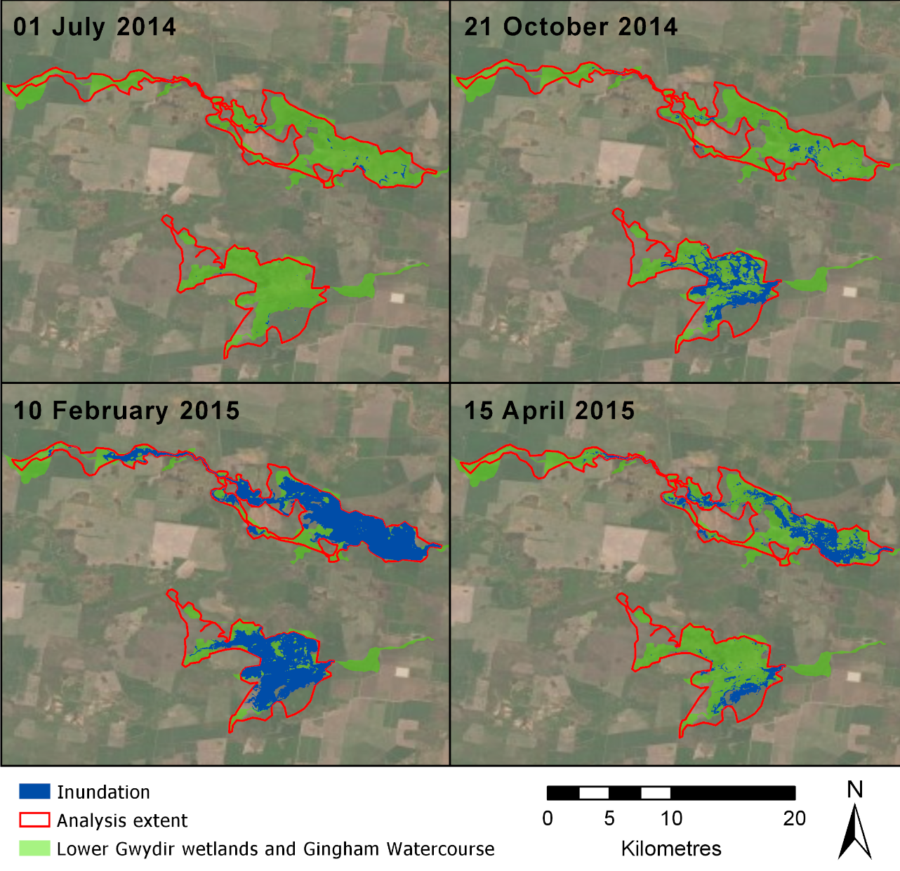

Figure 3‑1: Inundation in the Gingham and Lower Gwydir wetlands during the 2014-15 water year.

## Water Quality Responses to Flow

Within the Gwydir Selected Area, water quality was generally poor and nutrient concentrations generally exceeded ANZECC guideline trigger values, yet no detrimental ecological consequences were recorded for biota. Hydrology was identified as the primary driver of water quality in the channel and wetland environments. Seasonal change also exerted a strong influence on water temperature, conductivity and nutrients that responded to receding water levels and evapoconcentration processes.

Four years of water quality monitoring between 2014 and 2018 within the Gwydir River upstream of Moree showed the delivery of environmental water contributed to consistent improvements in water quality. Along the channels of the lower Gwydir, pH and conductivity appeared to decrease with increasing discharge to around 5,000 ML/d, then increase with flow. This is likely driven by the increased inputs of ions and suspended sediment as flows increase and more river channel becomes inundated above this threshold. Water temperature followed a predictable pattern with seasonal conditions exerting a strong influence on many other water quality parameters. Dissolved oxygen concentrations were highly variable below 2,500 ML/d and declined with increasing discharge up to 25,000 ML/d.

In wetlands, low dissolved oxygen concentrations below 5 mg/L were recorded on multiple occasions, but no hypoxic events were recorded throughout the LTIM Project. Instead, seasonal change in temperature exerted a strong influence on dissolved oxygen. Chlorophyll *a* peaked around 25 days since connection, suggesting there was a lag time for stimulating primary production in response to environmental water actions. Temperature also played a critical role in moderating productivity in this system and highlights the potential ecological significance of the timing of flow events. Nutrient concentrations were consistently high in all channel and wetland environments, reflecting land use throughout the catchment and deposition of transported nutrients in wetland systems. The highest nutrient concentrations were recorded during contraction phases in wetlands, suggesting the internal recycling of nutrients from the sediment and water drives productivity. The flow pulses of environmental water that provided connection between the Gwydir River and the Lower Gwydir and Gingham wetlands led to increases in nutrient concentrations that peaked around 25 days following connection.

It is commonly accepted that large rivers and terminal wetlands are carbon sinks and the lower Gwydir conforms to this model irrespective of water depth or volume, or time of year. This result reflects the dominance of organic matter decomposition from organic rich wetland sediments regulates the high consumption of oxygen. Therefore, environmental water can help to foster these processes through the maintenance of vegetation communities and inundation of organic sediments.

## Ecological Response to Flow

Monitoring throughout the LTIM Project has identified a range of ecological responses to flow in the river channels and wetlands of the Gwydir Selected Area. Our findings demonstrate the importance of longitudinal and lateral connection provided by environmental water events in stimulating macroinvertebrate produtivity and providing basal food resources to support wetland foodwebs. Hydrology is the primary driver of invertebrate patterns in the lower Gwydir system. Spatial patterns in invertebrate indicators were also influenced by water quality (Appendix E). Invertebrate density and composition reflected variations in chlorophyll *a* and DOC concentrations, with higher densities stimulated by increases in algal and microbial food resources. During drying periods, an increase in invertebrate secondary productivity was supported by higher nutrient and carbon concentrations delivered to the lower Gwydir system during wet periods. Temperature played a critical role in primary and secondary productivity, highlighting the potential ecological significance of the timing of flow events. This suggests that flows delivered over the warmer months may further stimulate the productivity of the system.

In channels, invertebrate densities were reduced in discharges over 500 ML/d, suggesting that environmental flows and natural flow events acted as hydrological disturbances through processes of dispersal and drift (Appendix E). For example, benthic invertebrate density was significantly lower during the 2016-17 water year that included the most significant flow pulse (39,500 ML/d) of the project. In wetlands, benthic microinvertebrate community composition shifted with time since connection, regardless of the event size and antecedent conditions. Once inflows had ceased for more than 50 days, reduced water quality conditions with higher nutrient concentrations led to increased numbers of microinvertebrate taxa with higher tolerance to poor water quality.

Water quality was also shown to influence macroinvertebrate communities, mediated by hydrology (Appendix F). Hydrological connection delivered resources to wetland environments that supported macroinvertebrate life cycles. In channels, macroinvertebrate density increased during the post-environmental water period (base flow conditions) following prolonged higher flows, which acted as disturbances, decreasing macroinvertebrate densities. Macroinvertebrate density increased in wetland ecosystems with time since connection and inundation and peaked in the contraction period associated with higher carbon and nutrient concentrations.

Environmental water that contributed to flow variation in channels and wetland inundation and provided an opportunity for long-term community succession due to changes in local physical and chemical environmental conditions. In channels, invertebrate community composition was significantly different between discharge groups with evidence that the <50 ML/d group was most different. Since each of the three monitored channel zones had highly variable flow regimes when compared with wetlands, macroinvertebrate taxa with highly mobile traits and body shape more adapted to flow had higher abundances in higher discharges. In wetlands, community composition consistently shifted along the time since inundation gradient regardless of zone and vegetation habitats. In all zones, macroinvertebrate taxa with higher pollution tolerant ability appeared to have higher abundance with increased time since connection/inundation.

Across all sampling zones, the Lower Gwydir wetlands displayed the highest average density and taxonomic richness for macroinvertebrates. This pattern highlights that longer duration of both longitudinal and lateral connection supported by environmental water can provide periods of improved water quality and increased habitat diversity, stimulating macroinvertebrate productivity in this wetland environment.

Monitoring suggests that the native fish community across the lower Gwydir system is in a constant state of flux, ranging from periods of extreme stress, resulting in low or no recruitment and localised extinctions, through to periods of relative stability when recruitment and mortality are at or near equilibrium (Figure 3‑2; Appendix I). Over the five years, relatively low numbers of native fish and high numbers of exotic species were found. In 2015 the native to exotic fish proportions were lowest followed by a shift in the fish community to one dominated by greater numbers of native fish and less or stable numbers of exotics in 2016 and 2017, before a gradual decline back to one similar to the 2015 fish community in 2018 and 2019. These variations in fish community composition followed annual variations in flow through the system (Appendix A). During the drier years, there were limited opportunities for native fish to move, reproduce and grow. While the conditions were not always positive for native fish, without environmental flows there is no doubt it would have been much worse. Tagged freshwater catfish (*Tandanus tandanus)* and Murray cod *(Maccullochella peelii)* were shown to move through the Mehi and Gwydir River channels and discharge was one of several drivers of this movement (Appendix J). Other factors such as water temperature and the target species life history, also influenced movement.

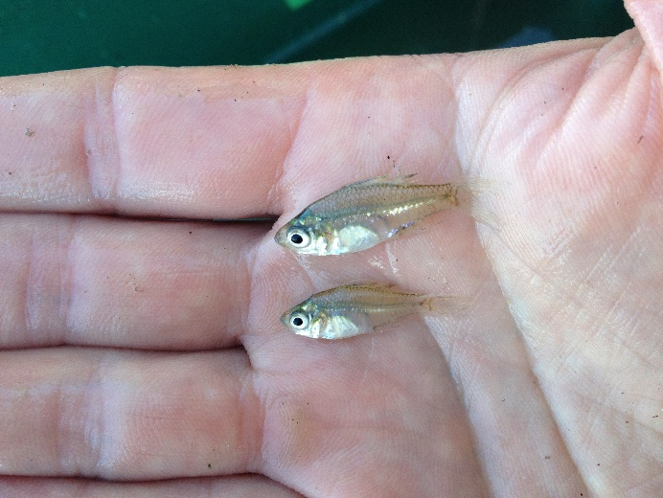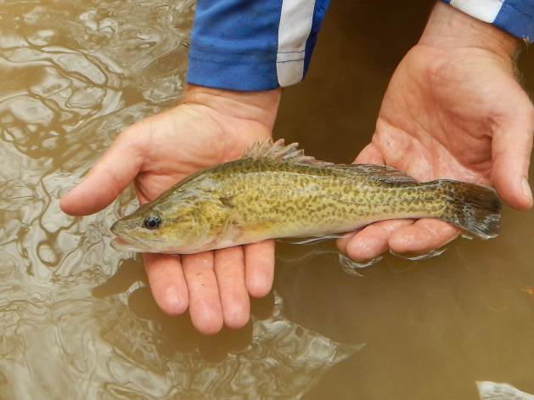

Figure 3‑2: Threatened fish species surveyed in the Gwydir River system during the 2015-16 water year. Olive perchlet (left) and Murray cod (right).

The delivery of environmental water within the Gwydir Selected Area supported a range of habitats, that supported a large variety of waterbirds (Figure 3‑3; Appendix K). The highest average species richness, waterbird density and Shannon Diversity were recorded during spring 2018, which coincided with the largest environmental water delivery to the Gwydir River system during the LTIM Project. High average waterbird diversity and abundance were also recorded across all metrics during the 2016-17 water year, which recorded the highest natural inflows seen during the LTIM Project. These results demonstrate the important contribution of both environmental water and natural inflows to waterbird populations in the Gwydir Selected Area. Piscivorous waterbirds have remained prevalent throughout the LTIM Project, likely due to favourable resource and habitat conditions, such as established fish and invertebrate populations, that develop during periods of inundation (Appendices E and F; Commonwealth of Australia 2016). The 2016-17 water year had a natural flood event in spring that was further supported by environmental water deliveries over summer recording the highest waterbird abundance and diversity of the project.

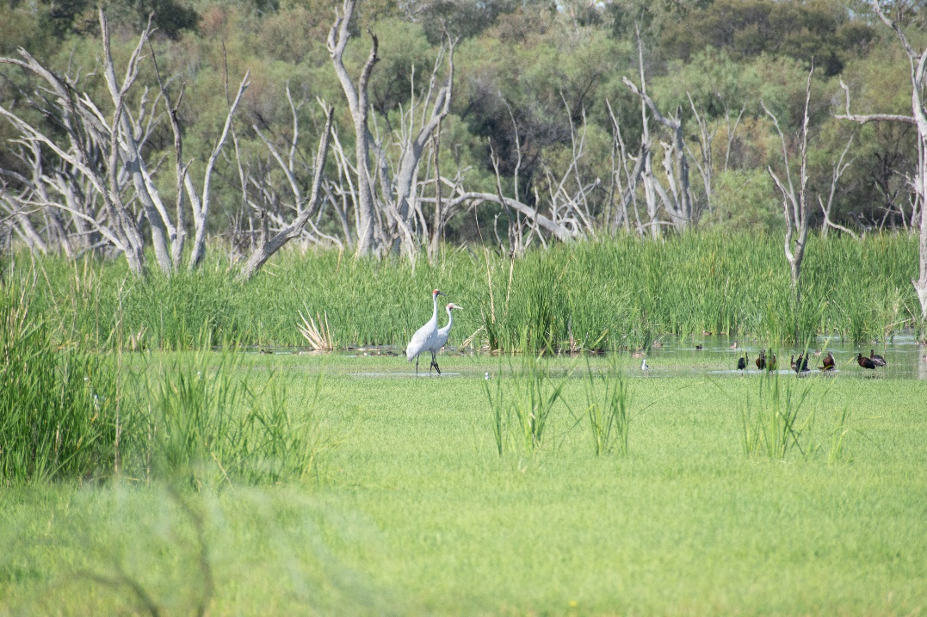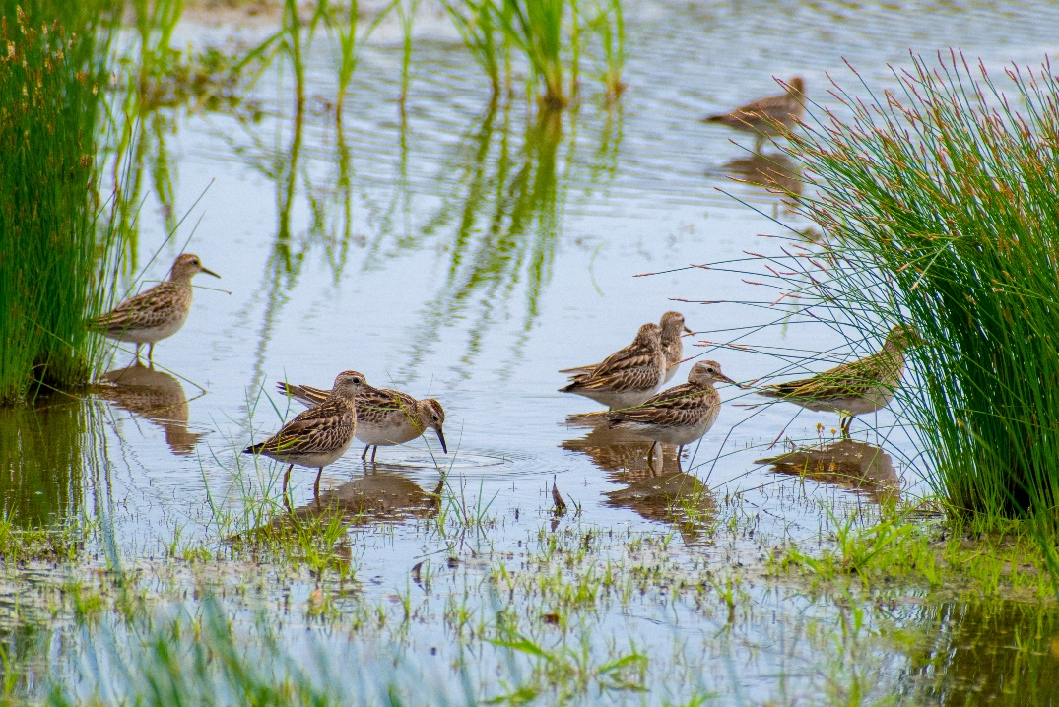

Figure 3‑3: Waterbirds taking advantage of shallow water habitat. Brolgas in the Gingham wetland (left) and Sharp tailed sandpipers in the Mallowa wetlands (right).

Vegetation community condition and plant diversity in the wetlands was driven by patterns of inundation influenced by Commonwealth environmental water (Appendix H). The highest species richness and cover recorded in the Gingham and Lower Gwydir wetlands was recorded in the 2014-15 water year, following a large release of environmental water in early spring 2014. Environmental water delivered to the Mallowa wetlands in the 2018-19 summer period also elicited a positive vegetation response, which is extremely encouraging given the prevailing dry conditions seen throughout the northern Murray-Darling Basin in recent times (Figure 3‑4). Inundation was also observed to be a practical management technique for widespread lippia control, with inundation benefitting native wetland species such as water couch, helping them to outcompete lippia, leading to reduced lippia cover. Annual flooding appears to be key to supporting native water couch to outcompete the exotic species. Tree recruitment was sporadic throughout the project with no clear links to inundation. It is likely that other key factors, such as grazing pressure play a role within the lifecycle of key wetland species of the Gwydir wetlands.

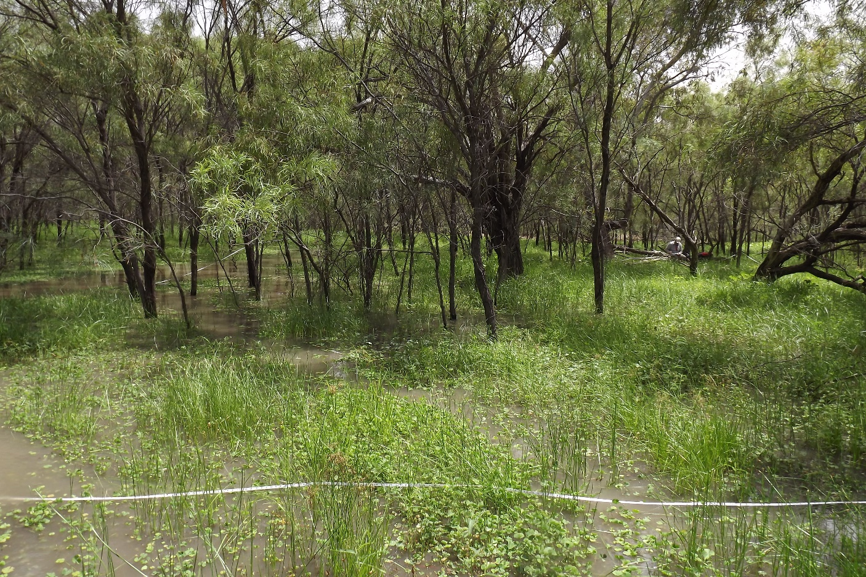

Figure 3‑4: Mallowa wetland during the spring 2018 survey, following environmental water deliveries.

## Summary

A multi-year wetting and drying management strategy is employed to maintain and improve the condition of the wetlands and rivers within the lower Gwydir system. During the LTIM Project, this strategy helped to sustain the ecology of the system, with clear benefits from environmental water. Environmental water was used to provide wetland inundation, stimulate productivity and maintain aquatic refuges in the channels of the lower Gwydir during dry times. Flow events through the system, some containing environmental water, maintained and improved water quality, with thresholds in discharge identified that elicit a different response of pH, conductivity and dissolved oxygen. Water temperature followed a predictable pattern with seasonal changes exerting a strong influence on many other water quality parameters. This has implications for the timing of environmental water delivery with respect to water quality response.

Similarly, invertebrate communities responded over time due to variations in flow and water quality. Flow events in river channels improved water quality and delivered resources, but also acted as disturbances, with flows exceeding 500 ML/d in channels reducing invertebrate densities through dispersal and drift. Following flow events when water levels stabilised, invertebrate densities increased, as they took advantage of the increased resources. In wetlands, invertebrate density increased with time since connection, as water contracted and nutrient concentrations increased, but then decreased as more sensitive taxa were impacted by poor water quality.

Waterbirds took advantage of the increased resources following flooding, occupying a range of wetland habitats. High average species richness, density and diversity of waterbirds were observed during periods of higher flow, irrespective of whether it was environmental water (2018-19), or natural flow events in 2016-17.

The fish community of the lower Gwydir appeared to fluctuate in composition and abundance, with relatively more native species recorded during and after the largest flow event in 2016-17. At other times, exotic species were dominant. Environmental water prolonged the extent and quality of waterhole refuges, allowing iconic species such as Murray cod and Golden perch to persist in the lower Gwydir through dry times. Flow pulses down the Gwydir and Mehi Rivers allowed freshwater catfish and Murray Cod individuals to move throughout both systems to access habitat for breeding and feeding.

The delivery of environmental water to the Gwydir wetlands during the 2014-15 water year, increased the richness and cover of vegetation communities. These communities were maintained throughout the project, which is extremely encouraging given the prevailing dry conditions seen throughout the northern Murray-Darling Basin in recent times.

# Implications for Future Management of Environmental Water

The environmental watering strategy employed in the Gwydir Selected Area uses multiple flow types to target a range of wetland and channel outcomes. These include flows targeted at wetland inundation, flows to increase river channel productivity and ‘prime’ the system early in the season to promote ecological responses, and flows to improve connectivity and maintain the quality of important low flow refugial habitat during dry times. The LTIM Project has demonstrated that this approach to environmental watering is working well in the lower Gwydir system. This is encouraging especially given the drought conditions that have occurred over the past two years of the project.

Through the LTIM Project monitoring, a number of potential thresholds were identified that influence different aspects of the Gwydir Selected Area’s water quality and ecology (Table 4‑1). Along the channels of the lower Gwydir, pH and conductivity appeared to decrease with increasing discharge to around 5,000 ML/d, then increase with flow. This is likely driven by the increased inputs of ions and suspended sediment as flows increase and more river channel becomes inundated above this threshold. There was very high variation in dissolved oxygen levels below 2,500 ML/d that appeared to stabilise between 65% and 100% above this threshold. There was an apparent flow threshold identified for microinvertebrates (500 ML/d) above which microinvertebrate densities reduced with increasing flow. This is likely tied to increased discharge impacting flow sensitive taxa. In wetlands, nutrient concentrations peaked around 25 days after flows into the wetlands ceased, reflecting the peak rates of decomposition and nutrient release from sediments that drive water column algal production. In addition, a link between native water couch growth and suppression of the exotic lippia was identified early in the LTIM Project and was demonstrated consistently over the whole project. From these observations, it appears that annual inundation of the wetlands maintains the condition of water couch and allows it to outcompete lippia.

In addition to the magnitude of flow influencing ecological response, the timing of flow events was shown to influence the nature of the response to flow. Flow events delivered in winter/spring appear to improve water quality and stimulate fish movement but induce only minimal primary and secondary production due to lower water temperatures. Flows delivered over the summer/autumn period improved water quality, and promoted primary and secondary production, thus supporting animals higher up the food chain such as fish, frogs and waterbirds. Thus, the seasonal timing of environmental water deliveries needs to be matched with the desired responses to elicit the best outcome of that water.

The fish population in the Gwydir River system appears to be under stress, with many native species in low abundance. This may reflect the carrying capacity of the system in its current state. While some species appear to be breeding and recruiting, others, especially some of the more iconic species such as golden perch, freshwater catfish and Murray cod, are not recruiting sufficiently to improve their populations. Along with providing environmental flows, other options such as habitat rehabilitation, restocking and barrier remediation should be considered to improve the fish communities of the Gwydir Selected Area.

Table 4‑1: Thresholds in water quality and ecological variables identified in the Gwydir Selected Area.

|  |  |  |
| --- | --- | --- |
| Parameter | Apparent threshold | Description |
| pH and Conductivity | 5,000 ML/d | Change from decreasing to increasing concentrations with discharge. Likely related to increased inputs of ions and suspended sediments from channel wetting. |
| Dissolved oxygen | 2,500 ML/d | DO highly variable at low discharges (0 to 2,500 ML/d) then stabilised with increasing discharge. |
| Wetland nutrient concentrations | 25 days since connection | Peak nutrient (N, C, P) concentrations recorded 25 days after connection, especially when flow was delivered during summer. Suggests internal recycling of nutrients from the sediment and water column. |
| Microinvertebrate density | 500 ML/d | Flows above this impact on microinvertebrate densities through impacts of flow prone taxa |
| Water couch suppression of lippia in wetlands | Annual inundation | Annual inundation appears to favour the establishment of water couch communities, and the ongoing suppression of lippia in wetland environments |

# References

Bureau of Meteorology (BoM). (2019a). *Monthly rainfall: Moree Aero*. Retrieved from <http://www.bom.gov.au/jsp/ncc/cdio/weatherData/av?p_nccObsCode=139&p_display_type=dataFile&p_startYear=&p_c=&p_stn_num=053115>.

Bureau of Meteorology (BoM). (2019b). *Monthly mean maximum temperature: Moree Aero*. Retrieved from [http://www.bom.gov.au/jsp/ncc/cdio/weatherData/av?p_nccObsCode=36&p_display  
_type=dataFile&p_startYear=&p_c=&p_stn_num=053115](http://www.bom.gov.au/jsp/ncc/cdio/weatherData/av?p_nccObsCode=36&p_display_type=dataFile&p_startYear=&p_c=&p_stn_num=053115).

Commonwealth of Australia. (2014). *Commonwealth Environmental Water Office Long Term Intervention Monitoring Project Gwydir River system Selected Area - Monitoring and Evaluation Plan*, Canberra.

Commonwealth of Australia. (2017). *Commonwealth Environmental Water Portfolio Management Plan: Gwydir Valley 2017-18*. Canberra.

Department of Environment, Climate Change and Water (DECCW). (2011). *Gwydir Wetlands Adaptive Environmental Management Plan: Synthesis of information projects and actions*. DECCW, Sydney.

Department of Primary Industries – Fisheries (DPI Fisheries). (2015). *Fish and Flows in the Northern Basin: responses of fish to changes in flow in the Northern Murray-Darling Basin*. Report prepared for the Murray-Darling Basin Authority.

Green D., Burrell M., Petrovic J., & Moss P. (2011). *Water resources and management overview – Gwydir catchment*. NSW Office of Water, Sydney.

Hall Jr., R.O., Yackulic, C.B., Kennedy, T.A., Yard, M.D., Rosi-Marshall, E.J., Voichick, N., & Behn, K.E. (2015). Turbidity, light, temperature, and hydropeaking control primary productivity in the Colorado River, Grand Canyon. *Limnology and Oceanography, 60*(2), 512-526. doi:10.1002/lno.10031

Kingsford, R.T., & Norman, F.J. (2002). Australian waterbirds – products of the continent’s ecology. *Emu 102*, 47-69.

Kobayashi, T., Ryder, D.S., Gordon, G., Shannon, I., Ingleton, T., Carpenter, M., & Jacobs, S.J. (2009). Short-term response of nutrients, carbon and planktonic microbial communities to floodplain wetland inundation. *Aquatic Ecology, 43*(4), 843-858. doi:10.1007/s10452-008-9219-2

MDBA. (2017). *Basin environmental watering priorities 2017-18*. Murray-Darling Basin Authority, Canberra.

Reynolds. L.F. (1983). Migration of Five Fish Species in the Murray-Darling River System. *Aust. J. Mar. Freshw. Res., 34*, 857-71