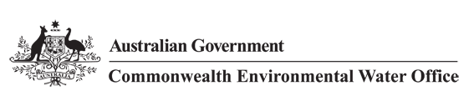

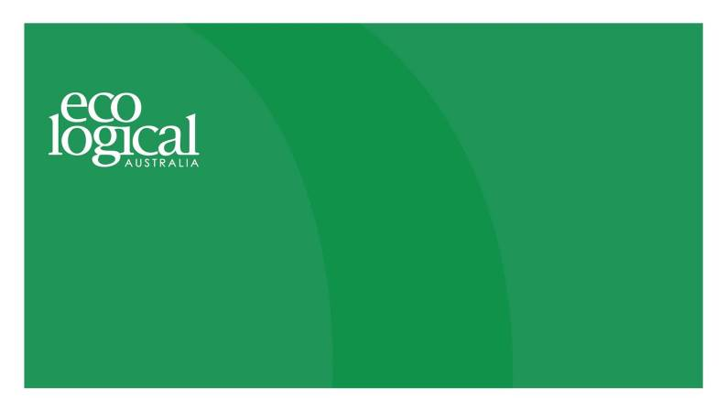



**Commonwealth Environmental Water Office**

**Long Term Intervention Monitoring Project**

**GWYDIR RIVER SYSTEM SELECTED AREA**

2015-16 Evaluation Report, 25 November 2016

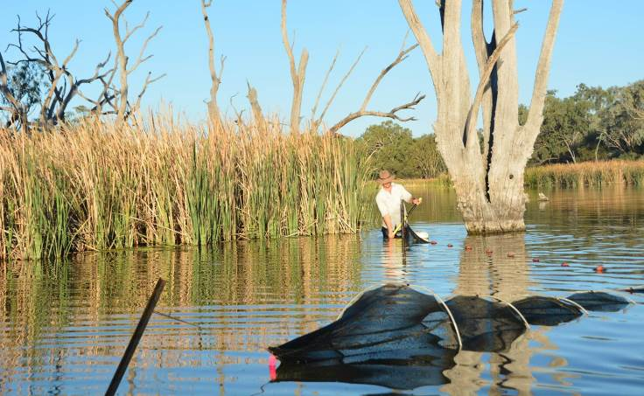



This monitoring project was commissioned and funded by Commonwealth Environmental Water Office, with in-kind support from NSW Office of Environment and Heritage.

**Copyright**

© Copyright Commonwealth of Australia, 2016



Commonwealth Environmental Water Office Long Term Intervention Monitoring Project Gwydir River System Selected Area is licensed by the Commonwealth of Australia for use under a Creative Commons By Attribution 3.0 Australia licence with the exception of the Coat of Arms of the Commonwealth of Australia, the logo of the agency responsible for publishing the report, content supplied by third parties, and any images depicting people. For licence conditions see: <http://creativecommons.org/licenses/by/3.0/au/>

This report should be attributed as ‘Commonwealth Environmental Water Office Long Term Intervention Monitoring Project Gwydir River System Selected Area – 2015-16 Draft Evaluation Report, Commonwealth of Australia 2016’.

**Disclaimer**

The views and opinions expressed in this publication are those of the authors and do not necessarily reflect those of the Australian Government or the Minister for the Environment.

While reasonable efforts have been made to ensure that the contents of this publication are factually correct, the Commonwealth does not accept responsibility for the accuracy or completeness of the contents, and shall not be liable for any loss or damage that may be occasioned directly or indirectly through the use of, or reliance on, the contents of this publication.

**DOCUMENT TRACKING**

|  |  |
| --- | --- |
| Item | Detail |
| Project Name | Long Term Intervention Monitoring Project – Gwydir river system Selected Area |
| Project Number | 2427 |
| Project Manager | Dr Mark Southwell  (02) 8081 2688  92 Taylor Street, Armidale NSW 2350 |
| Prepared by | Dr Mark Southwell, Dr Paul Frazier, Dr Peter Hancock, Ben Martin, Linden Burch, Nathalie van der Veer , Lindsey Frost (ELA)  Assoc. Prof Darren Ryder, Dr Wing Ying Tsoi (UNE)  Dr Gavin Butler (NSW DPI)  Dr Jennifer Spence, Sharon Bowen and Jane Humphries (NSW OEH) |
| Reviewed by | Dr Mark Southwell, Assoc. Prof Darren Ryder, Dr Paul Frazier |
| Approved by | Dr Paul Frazier |
| Status | Final |
| Version Number | 2 |
| Last saved on | 25 November 2016 |
| Cover photo | Fish sampling in the Gingham waterhole in the Gingham Wetlands. Photo: P.Hancock |

Acknowledgements

This document has been prepared by Eco Logical Australia Pty Ltd with support from Associate Professor Darren Ryder and Dr Wing Ying Tsoi from the University of New England, Dr Gavin Butler from the DPI Fisheries, and staff from the NSW Office of Environment and Heritage and NSW Office of Water. The project would like to thank the landholders in the Gwydir River system who have allowed us access to their properties to undertaken fieldwork.

**Acknowledgement of Country**

The authors of this report as well as the Commonwealth Environmental Water Office respectfully acknowledge the traditional owners, their Elders past and present, their Nations of the Murray-Darling Basin, and their cultural, social, environmental, spiritual and economic connection to their lands and waters. In particular the Gomeroi people, traditional owners of the land on which this publication is focussed.

|  |
| --- |
| **Disclaimer** *This document may only be used for the purpose for which it was commissioned and in accordance with the contract between Eco Logical Australia Pty Ltd and the Department of the Environment. The scope of services was defined in consultation with the Department of Environment and Energy, by time and budgetary constraints imposed by the client, and the availability of reports and other data on the subject area. Changes to available information, legislation and schedules are made on an ongoing basis and readers should obtain up to date information.*  *Eco Logical Australia Pty Ltd accepts no liability or responsibility whatsoever for or in respect of any use of or reliance upon this report and its supporting material by any third party. Information provided is not intended to be a substitute for site specific assessment or legal advice in relation to any matter. Unauthorised use of this report in any form is prohibited.* |

emplate 24/07/2015

**Document control**

|  |  |  |  |
| --- | --- | --- | --- |
| Version | Date | Reviewed by | Approved by |
| 1 | 24/8/2016 | Dr Mark Southwell, Assoc. Prof Darren Ryder | Dr Paul Frazier |
| 2 | 25/11/2016 | Dr Mark Southwell, Assoc. Prof Darren Ryder | Dr Paul Frazier |
|  |  |  |  |

|  |  |
| --- | --- |
| Item | Details |
| ELA Project Number | 2427 |
| Project Director/s | Dr Paul Frazier, Assoc. Prof Darren Ryder |
| Project Manager | Dr Mark Southwell |
| Prepared by | Dr Paul Frazier, Assoc. Prof Darren Ryder, Dr Mark Southwell, Dr Gavin Butler, Dr Peter Hancock, Nathalie van der Veer, Linden Burch, Ben Martin, Lindsey Frost |

Contents

Executive summary vii

1 Introduction 1

2 Gwydir river system Selected Area 2

2.1 Environmental water 2014-15 2

3 Watering actions 5

3.1 Environmental condition and watering actions in the Gwydir river system Selected Area 2015-16 5

4 What did Commonwealth Environmental Water do in 2015-16? 7

4.1 Expected Outcomes 7

4.2 Flows and ecosystem function 5

4.3 Water quality 11

4.4 Biodiversity 11

4.5 Resilience 15

4.6 Summary 16

5 Implications for future management of Commonwealth environmental water 17

6 References 18

**Appendix A – Hydrology (River)**

**Appendix B – Hydrology (Watercourse)**

**Appendix C – Water Quality**

**Appendix D – Microinvertebrates**

**Appendix E – Macroinvertebrates**

**Appendix F – Ecosystem Type**

**Appendix G – Vegetation Diversity**

**Appendix H – Small-bodied Fish and Frogs**

**Appendix I –Fish (River)**

**Appendix J – Fish (Movement)**

**Appendix K – Waterbird Diversity**

List of figures

Figure 2‑1 Gwydir River catchment and location within the Murray Darling Basin. 3

Figure 2‑2 The Gwydir river system Selected Area with monitoring zones highlighted. 4

Figure 3‑1 Monthly rainfall totals for 2015-16 and mean totals measured at Moree airport 6

Figure 3‑2 Monthly maximum temperatures for 2015-16 and mean maximum temperatures measured at Moree airport. (Source. http://www.bom.gov.au/climate/data/index.shtml). 6

Figure 4‑1 Wetland inundation within the Gingham and Gwydir wetlands during the 2015-16 water year. 6

Figure 4‑2 Wetland inundation within the Mallowa wetlands during the 2015-16 water year. 10

Figure 4‑3 Permanent lowland stream (top left), River cooba woodland floodplain (top right), Sedge/forb/grassland floodplain (bottom left) and Temporary lowland stream (bottom right) ecosystem types monitoried in the Selected Area. 12

Figure 4‑4 Threatened fish species surveyed in the Gwydir river system during the 2015-16 water year. Olive perchlet (left) and Murray cod (right). 12

Figure 4‑5 Waterbirds surveyed in the Gwydir river Selected Area during the 2015-16 water year. Great egrets (top left), magpie goose (top right), royal spoonbill (bottom left) and plumed whistling-duck (bottom right). 14

Figure 4‑6 Vegetation sampling plot at Munwonga in the Gingham watercourse over the duration of the LTIM project. December 2014 (top left), March 2015 (top right), October 2015 (bottom left) and March 2016 (bottom right) 15

List of tables

Table 3‑1 Comparison between environmental water use and 2015-16 water year flows. Percentage represents the percentage of the total flow made up of environmental water. 5

Table 4‑1 Watering actions, target assets and evaluated outcomes implemented in the Gwydir river Selected Area during 2015-16 5

Table 4‑2 Expected outcomes from environmental water used in the Gwydir river Selected Area linked to broader Basin Plan objectives. 6

Standard abbreviations

|  |  |
| --- | --- |
| Abbreviation | Description |
| ANZECC | Australian and New Zealand Environment Conservation Council |
| ASL | Above Sea Level |
| BoM | Bureau of Meteorology |
| CEWH | Commonwealth Environmental Water Holder |
| CEWO | Commonwealth Environmental Water Office |
| DPI Fisheries | NSW Department of Primary Industries Fisheries |
| ELA | Eco Logical Australia Pty Ltd |
| LTIM Project | Long Term Intervention Monitoring Project |
| MDBA | Murray Darling Basin Authority |
| DPI Water | NSW Department of Primary Industries Water |
| OEH | (NSW) Office of Environment and Heritage |
| The Department | Department of the Environment and Energy (Commonwealth) |
| UNE | University of New England |

Executive summary

**Contributions of Commonwealth environmental water in 2015-16**

***River channels***

* Environmental water increased longitudinal connectivity in Carole Creek and the Gwydir, lower Gwydir, Gingham and Mehi River channels during 2015-16.
* Commonwealth environmental water was responsible for all significant flow in Mallowa Creek during 2015-16.
* Environmental water was released down the lower Gwydir, Gingham, Mehi and Carole channels in April 2016 providing critical connection between isolated refuge pools, sustaining native fish, invertebrate and other aquatic animal communities.
* Environmental water improved water quality, stimulated primary productivity and helped to maintain regional scale aquatic invertebrate diversity.

***Wetlands***

* Environmental water maintained waterholes in the Gingham watercourse and Gwydir wetlands that contain several threatened species of native fish.
* A total area of 472 ha of the Gingham and Gwydir wetlands was inundated in August to October 2015, as a result of residual environmental watering and rainfall the previous water year.
* Residual inundation in the Gingham and Gwydir wetland from environmental water delivered in 2014-15 helped maintain native vegetation communities and provided habitat for waterbirds and frogs early in 2015-16.
* In the Mallowa system, 204 ha of wetlands were inundated with Commonwealth environmental water during 2015-16, promoting the growth of native vegetation communities

The Gwydir catchment, located in the northern Murray Darling Basin, extends from the Great Dividing Range west to the Barwon River. Downstream of Moree, the system fans out into a broad alluvial near-terminal floodplain. Numerous anabranches and distributary channels characterise the lower half of the Gwydir catchment, with the Mehi River and Moomin Creek to the south, and the lower Gwydir River, Gingham watercourse and Carole Creek to the north. These channels support wetland and floodplain assets including the lower Gwydir, Gingham and Mallowa wetlands. Commonwealth environmental watering targeted channel, wetland and floodplain assets with expected environmental outcomes downstream (west) of Tareelaroi Weir on the Gwydir River.

Commonwealth environmental water was delivered to the channels of the lower Gwydir system along with the Mallowa wetlands throughout the water year. While delivery to the Mallowa system was solely Commonwealth water, other channel deliveries were a combination of Commonwealth and State managed ECA water. This report considers the combined influence of both Commonwealth and State managed environmental water.

These flows aimed to consolidate and protect the ongoing environmental recovery achieved over the last three years in anticipation of a potentially low rainfall and inflow period. For the most part, environmental water was used to offset the component of consumptive extraction taken during several supplementary flow events. Environmental water was also delivered to the Mallowa wetlands over the summer period, and to the lower Gwydir, Gingham, Mehi and Carole channels in April 2016 as part of a dry river flow action to reconnect refuge pools within these channels.

**Key Outcomes**

*Ecosystem functioning*

* Environmental water increased longitudinal connectivity in Carole Creek and the Gwydir, lower Gwydir, Gingham and Mehi River channels and was responsible for all significant flow in Mallowa Creek during 2015-16.
* A total area of 472 ha of the Gingham and Gwydir wetlands was inundated in August to October 2015, as a result of residual environmental water and rainfall the previous water year.
* In the Mallowa system, 204 ha of wetlands were inundated with Commonwealth environmental water during 2015-16.
* Semi-permanent wetland vegetation species such as water couch, spike-rush, tussock rush, lignum and river cooba, and floodplain species such as coolibah and river red gum were supported during the 2015-16 water year.

*Water Quality*

* Environmental water deliveries improved water quality through the dilution of variables such as conductivity and turbidity and water nutrients such as nitrogen and phosphorus.
* Increases in dissolved carbon concentrations during environmental water delivery stimulated primary and secondary productivity and as a result promoted diversity within aquatic invertebrate communities.

*Biodiversity*

* Environmental water influenced eight of the ten ecosystem types monitored in the LTIM project in the 2015-16 water year, including five riverine types, two floodplain types and one lacustrine type.
* Environmental flows maintained water levels in the Gingham Waterhole, which contains the only known local population of the olive perchlet, a threatened native fish species.
* Hydrological connections between waterholes within the Gwydir wetlands provided by environmental water allowed native fish such as spangled perch and eel-tailed catfish to move between habitats.
* Residual inundation from environmental water delivered in 2014-15 helped maintain vegetation communities and provided habitat for waterbirds and frogs early in 2015-16.

*Resilience*

* Improvements to the condition of native wetland vegetation communities achieved in 2014-15 have been maintained through the 2015-16 water year.
* The replenishment of refuge pools by environmental water in April 2016 likely supported the survival of fish and other aquatic biota in the channels of the lower Gwydir system.
* Residual inundation from environmental water delivered in 2014-15 allowed small scale waterbird breeding in early 2015-16.

**Implications for Commonwealth environmental water management**

* The positive ecological outcomes achieved in part by environmental water over the duration of the LTIM project suggests that the long-term environmental watering strategy being employed in the Gwydir river system continues to be effective.
* Native vegetation responses to 2014-15 wetland environmental watering were still evident in 2015-16 even with the planned reduced watering in the second year of the project.
* Positive ecological outcomes can be achieved by using relatively small amounts of environmental water delivered at critical times. Deliveries of environmental water that connected refuge pools and maintained water quality helped ensure the survival of aquatic species during low to no flow periods, including several listed native fish species.

# Introduction

This report presents the monitoring and evaluation results from the Gwydir river system Selected Area during the 2015-16 water year. Monitoring is being undertaken as part of the Long-Term Intervention Monitoring Project (LTIM Project) funded by the Commonwealth Environmental Water Office (CEWO). The LTIM Project is being implemented at seven Selected Areas over a five year period from 2014-15 to 2018-19 to deliver five high-level outcomes (in order of priority):

1. Evaluate the contribution of Commonwealth environmental watering to the objectives of the Murray Darling Basin Authority’s (MDBA) Environmental Watering Plan.
2. Evaluate the ecological outcomes of Commonwealth environmental watering at each of the seven Selected Areas.
3. Infer ecological outcomes of Commonwealth environmental watering in areas of the Murray Darling Basin not monitored.
4. Support the adaptive management of Commonwealth environmental water.
5. Monitor the ecological response to Commonwealth environmental watering at each of the seven Selected Areas.

While results specific to the Gwydir river system Selected Area are reported here, a broader Basin Scale analysis including results from all seven Selected Areas will be produced by the Murray Darling Freshwater Research Centre (MDFRC).

The report describes the Gwydir river system Selected Area, its environmental condition, watering actions undertaken in the Selected Area during 2015-16, the expected outcomes of this watering, and evaluates the ecological response to the application of Commonwealth environmental water in 2015-16. Detailed methods, analyses and results are presented in the Appendices referred to in the main report.

# Gwydir river system Selected Area

The Gwydir catchment, located in the northern Murray Darling Basin extends from the Great Dividing Range west to the Barwon River, covering an area of 26,600 square kilometres (Green et al. 2011). Downstream of Moree, the system fans out into a broad alluvial near-terminal floodplain (DECCW 2011). Numerous anabranches and distributary channels characterise the lower half of the Gwydir catchment, with the Mehi River and Moomin Creek to the south, and the lower Gwydir River, Gingham watercourse and Carole Creek to the north (Figure 2‑1). These channels support wetland and floodplain assets including the lower Gwydir, Gingham and Mallowa wetlands (Figure 2‑1). Commonwealth environmental watering targets assets with expected environmental outcomes downstream (west) of Tareelaroi Weir on the Gwydir floodplain.

The Gwydir river system Selected Area (Selected Area) focuses on the reaches of the lower Gwydir River and distributary channels to the west of Tareelaroi Weir (Commonwealth of Australia 2014). The Selected Area (Figure 2‑2) includes three monitoring zones:

* Gwydir River (downstream of Copeton Dam to Pallamallawa)
* Lower Gwydir River and Gingham watercourse
* Mehi River and Moomin Creek

In 2015-16, the planned watering strategy for the Selected Area focussed on providing water to the Mallowa wetlands. Monitoring in the Mehi River and Moomin Creek zone that encompasses these wetlands was expanded in 2015-16 to capture ecological responses from the application of this environmental water.

## Environmental water 2014-15

In 2014-15, Commonwealth environmental water was delivered to the Gwydir, Gingham and Mallowa wetlands throughout the water year. While the delivery to the Mallowa system was solely Commonwealth water, deliveries to the lower Gwydir/Gingham systems were a combination of Commonwealth and State managed ECA water. These flows aimed to maintain the benefits of inundation that occurred during the 2010-13 period, especially vegetation condition and extent. In addition, Commonwealth environmental water was used in combination with irrigation deliveries to support an in-channel flow pulse down the Mehi River and Carole Creek during October 2014. This flow aimed to enhance in-stream ecological function, nutrient cycling and water quality, and provide opportunities for fish to access habitat.

These environmental water deliveries contributed to longitudinal connectivity in the channels of the lower Gwydir, especially during the early and mid-stages of the 2014-15 water year. This connectivity allowed native fish to recruit and survive in the Gwydir system. The environmental water delivered down the Mehi River and Carole Creek produced a defined in-channel flow pulse that reached the Barwon River influencing river levels as far downstream as Bourke (Commonwealth of Australia 2015a).

During 2014-15, 6,342 ha of the Gingham and lower Gwydir wetlands were inundated as a result of environmental water delivery. Within the wetlands this inundation promoted the growth of native wetland vegetation species such as water couch *(Paspalum distinctum)*, allowing them to out-compete weed species like lippia *(Phyla canescens)*. The extended period of wetland inundation also facilitated nutrient cycling, metabolic processes and allowed for successional processes to take place within micro and macroinvertebrate populations to stimulate wetland foodwebs. In addition, environmental water increased the number of waterbirds present within the wetlands and allowed some species to breed (Commonwealth of Australia 2015a).

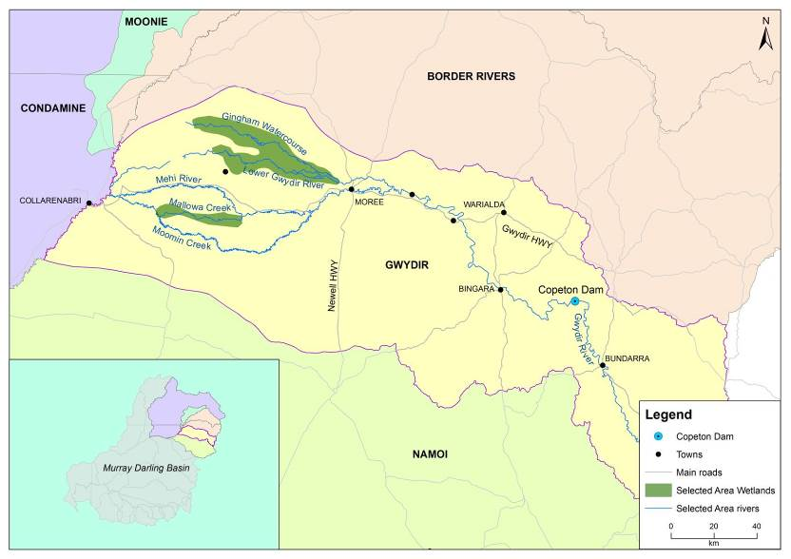

Figure ‑ Gwydir River catchment and location within the Murray Darling Basin.

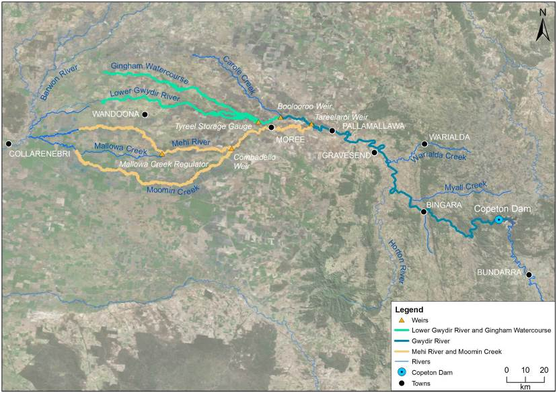

Figure ‑ The Gwydir river system Selected Area with monitoring zones highlighted.

# Watering actions

## Environmental condition and watering actions in the Gwydir river system Selected Area 2015-16

The Gwydir catchment experienced below average rainfall and above average temperatures during the 2015-16 water year (Figure 3‑1, Figure 3‑2). The end of the water year saw above average rainfall in May and June, with below average temperatures recorded in July, August, September January and June. Periodic rainfall events in the catchment particularly in the first half of the water year resulted in flows in many of the channels of the lower Gwydir system.

Available Commonwealth environmental water holdings totalled 39,450 ML in the 2015-16 water year. This was complemented by water entitlements held by NSW OEH in the Environmental Contingency Allowance (ECA) of 58,370 ML. Of this, a total of 8,400 ML of Commonwealth water and 4,850 ML of ECA water were delivered in the 2015-16 water year via several events across several channels (Table 3‑1). This environmental water constituted less than 10% of the total flow through the channels in which it was delivered.

Table ‑ Comparison between environmental water use and 2015-16 water year flows. Percentage represents the percentage of the total flow made up of environmental water.

|  |  |  |  |  |
| --- | --- | --- | --- | --- |
| Channel | Commonwealth Environmental Water (CEW) delivered (ML) | NSW ECA Water delivered (ML) | 2015-16 total flow (ML) | Env. water % of total flow |
| Gingham Watercourse | 675 | 2,375 | 21,636 | 14 |
| Lower Gwydir | 675 | 2,375 | 39,009 | 8 |
| Carole Creek | 409 |  | 25,834 | 2 |
| Mehi River | 3155 | 100 (Whittaker Lagoon) | 64,505 | 5 |
| Mallowa Creek | 3,486 |  | 4,462 | 78 |
| Total | 8,400 | 4,850 | 155,446 | 9 |

During 2015-16 environmental water was used to provide small flow pulses, and longitudinal connection within the Gwydir river system Selected Area at critical times during a predominantly dry summer/autumn period. In November 2015, a flow event occurred down the Mehi River and supplementary water licences owned by the CEWO were triggered. A total of 1300 ML was accounted for with 964 ML of this water flowing down the Mehi River, and 336 ML directed down Mallowa Creek.

Through January 2016, flows were delivered into the Mallowa Creek system to inundate fringing wetlands in association with WaterNSW bulk water deliveries. Flows were also delivered into the lower Gwydir River and Gingham watercourse in February 2016, to replace flows that were abstracted in a supplementary flow event.

Due to critically low flows experienced in the lower Gwydir system in March and April 2016, water was delivered down the lower Gwydir, Gingham, Mehi and Carole channels as part of a dry river flow action in early April. This followed a period of 30-40 days of nil flow conditions across the catchment. These flows aimed to reconnect pools, thereby protecting refuge habitat for native fish, maintain water quality and minimise any potential geomorphic impacts such as erosion and scouring from follow up stock and domestic water deliveries to these channels.

Given the shared outcomes and delivery of both Commonwealth and State held environmental water during the 2015-16 water year, the outcomes reported in this document refer to the combined benefit of Commonwealth and State owned water. Hereafter this will be termed ’environmental water’.

Figure ‑ Monthly rainfall totals for 2015-16 and mean totals measured at Moree airport

(Source. <http://www.bom.gov.au/climate/data/index.shtml>).

Figure ‑ Monthly maximum temperatures for 2015-16 and mean maximum temperatures measured at Moree airport. (Source. <http://www.bom.gov.au/climate/data/index.shtml>).

# What did Commonwealth Environmental Water do in 2015-16?

## Expected Outcomes

The overall aim of Commonwealth environmental water in the Gwydir catchment during 2015-16 was to consolidate and protect the ongoing environmental recovery achieved over the last three years in anticipation of a potentially low rainfall and inflow period. This was to be achieved by following natural flow cues, and activating access to supplementary water to offset a component of the consumptive extraction up to an approved volume withheld environmental water from Copeton Dam (Commonwealth of Australia 2015b).

Watering actions undertaken in the Gwydir river system Selected Area were expected to contribute to achieving the following primary and secondary outcomes:

*Primary expected outcomes*

* Inundate core wetlands in the Gwydir Wetlands for a period of 5-6 months.
* Supporting native fish habitat by increasing availability of and access to suitable fish habitat, promoting fish movement and providing cues and appropriate habitats for spawning, recruitment and migration of native fish.

*Secondary expected outcomes*

* Maintain vegetation condition and reproduction
* Provide refuge habitat for waterbirds, fish and other aquatic species
* Maintain ecosystem resilience by supporting individual survival and condition
* Provide baseflows and freshes to increase lateral and longitudinal hydrological connectivity
* Allow for sediment transport, nutrient and carbon cycling.
  + Protect and maintain the condition of permanent and semi-permanent wetland vegetation
  + Maintain habitat for supporting waterbird condition and survival
  + Maintain habitat such as waterholes for fish condition and survival
  + Support fundamental ecosystem function processes of nutrient and carbon cycling and primary production.

A summary of each watering action, its target asset, and outcomes are provided in Table 4‑1. A fuller explination of the outcomes are provided in the following sections structured around the objectives of the Basin Plan’s environmental watering plan (Table 4‑2).

Table ‑ Watering actions, target assets and evaluated outcomes implemented in the Gwydir river Selected Area during 2015-16

| Watering action | Volume (ML) | Target asset | Expected outcomes | Evaluation of outcomes |
| --- | --- | --- | --- | --- |
| Replacement of Supplementary take from natural event with environmental water from storage (WUM 10043-01) | 2,700 (1,350 CEW, 1,350 NSW ECA) | Gwydir and Gingham wetlands | * Maintain vegetation condition and reproduction * Provide refuge habitat for waterbirds, fish and other aquatic species * Maintain ecosystem resilience by supporting individual survival and condition * Provide baseflows and freshes to increase lateral and longitudinal hydrological connectivity * Allow for sediment transport, nutrient and carbon cycling. | * Watering action insufficient to inundate substantial areas of wetland vegetation.* * Watering action contributed to longitudinal connection through the wetlands, supporting habitat for native bird, invertebrate, frog and fish communities and maintaining water quality. * Rates of primary production and respiration peaked during times of environmental water delivery. |
| Replacement of Supplementary take from natural event with environmental water from storage (WUM 10043-02) | 3486 CEW | Mallowa wetlands | * Support hydrological connectivity between wetlands * Support further recovery of vegetation extent and condition * Provide habitat for waterbirds and native aquatic species * Contribute to improved habitat quality and increased within ecosystem diversity to support survival of native birds fish and other fauna | * A maximum of 204 ha of wetlands were inundated in the Mallowa system as a result of this watering action. * Watering action in the Mallowa system increased vegetation groundcover in general. The cover of the weed species lippia decreased with native species cover increasing. * Watering action maintained suitable habitat for a range of waterbird species. |
| Supplementary take of water during natural flow events as announced by Water NSW (WUM 10043-04) | 964 CEW | Mehi River | * To support in-stream ecological function and nutrient cycling, contributing to the health of in-stream habitat and maintaining water quality. | * Watering action maintained water quality within the Mehi River during periods of delivery and diluted nutrients such as phosphorus and nitrogen that increased to high levels during low flow periods |
| Extreme river drying contingency flows  Waterhole refuge protection (WUM 10043-05) | 6,000 (2600 CEW, 3400 NSW ECA) | Carole Creek, Mehi River, Gwydir River, Lower Gwydir River, Gigham Watercourse. | * During dry conditions, provide base flows to protect refugial in-stream habitat and mitigate declining water quality | * Longitudinal connection provided along target channels * Water quality maintained within these channels within limits acceptable for biota. |

* Permanent and semi-permanent wetland vegetation communities were sustained as a result of residual environmental water delivered in the 2014-15 water year

Table ‑ Expected outcomes from environmental water used in the Gwydir river Selected Area linked to broader Basin Plan objectives.

|  |  |  |
| --- | --- | --- |
| Expected outcome | Timeframe | Relevant Basin Plan objective |
| Vegetation condition and reproduction | < 1 year | Biodiversity (Basin Plan S. 8.05) |
| Fish condition |
| Waterbird survival and condition |
| Individual survival and condition (individual refuges) | < 1 year | Resilience (Basin Plan S. 8.07) |
| Hydrological connectivity including end of system flows | < 1 year | Ecosystem function (Basin Plan  S. 8.06) |
| Biotic dispersal and movement |
| Primary productivity |
| Nutrient and carbon cycling |
| Salinity, dissolved oxygen, pH, dissolved organic carbon, algal blooms | < 1 year | Water quality (Basin Plan S. 9.04) |

## Flows and ecosystem function

Environmental water contributed to connectivity in the Gwydir, lower Gwydir and Mehi River channels and was responsible for all significant flows in Mallowa Creek during in 2015-16 (Appendix A). Full connectivity in the Gingham watercourse and Moomin Creek was due almost entirely to rainfall events and other water releases associated with stock and domestic use. As expected in a planned dry year, connectivity in 2015-16 was markedly reduced compared with 2014-15.

The extent of inundation throughout the Gwydir, Gingham and Mallowa wetlands was mapped using Landsat data (Appendix B). A maximum area of 472 ha was inundated in the Gwydir and Gingham wetlands in August to October 2015 (Figure 4‑1). This followed significant inundation (6,342 ha) in these wetlands as a result of environmental water deliveries in the 2014-15 water year and shows that this water persisted through to the early parts of the next water year with the aid of localised rainfall events in late 2014-15. The watering strategy for the Selected Area employs a multi-year wetting and drying cycle and 2015-16 was a planned dry year for the lower Gwydir River, Gingham watercourse and associated wetlands. This watering strategy acknowledges the naturally variable nature of wetland wetting and drying in the Gwydir system. As a result, inundation extents in 2015-16 were reduced from those observed in the previous season and can be largely attributed to retained flood water and localised rainfall events.

The watering strategy focused on environmental water deliveries to the Mallowa Creek wetlands as part of a commitment to support a long term rehabilitation project in that system. In this system a maximum of 204 ha of wetlands were inundated with Commonwealth environmental water (Figure 4‑2).

The number and type of vegetation communities inundated in 2015-16 was very similar to the 2014-15 water year in the lower Gwydir and Gingham wetlands, though the area inundated was much less. Key semi-permanent wetland species such as water couch *(Paspalum distinchum)*, spike rush (*Eleocharis sphacelata*), tussock rush (*Juncus aridicola*), lignum (*Duma florulenta*) and river cooba (*Acacia stenophylla*) were all well represented in the communities inundated. Floodplain species such as coolibah and river red gum were also reasonably well represented in inundated communities. These findings confirm the intended watering objective of maintaining the permanent and semi-permanent wetland vegetation species in key areas of the Gwydir wetlands during the season.

Environmental water appeared to dilute water nutrients in the lower Gwydir system in 2015-16 (Appendix D). Concentrations of nitrogen and phosphorus were exceptionally high in wetlands being up to 12 times higher than the ANZECC water quality guidelines. Maximum concentrations were observed before and after environmental water moved through the system. Similar to the 2014-15 water year, wetlands had consistently high nutrient concentrations, reinforcing that these wetlands are constituting a longer term nutrient sink in this system. Rates of primarily production and respiration followed patterns of carbon and phosphorus concentrations with peaks during environmental water delivery times. Wetland sites where water residence times and light penetration were highest, appeared to be ideal sites for increased phytoplankton productivity.

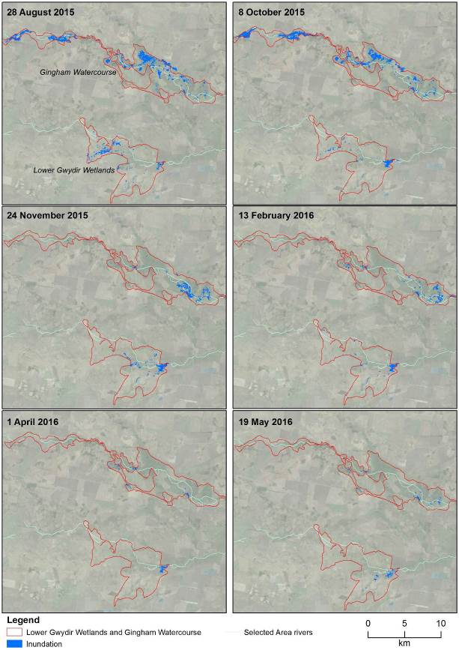

Figure ‑ Wetland inundation within the Gingham and Gwydir wetlands during the 2015-16 water year.

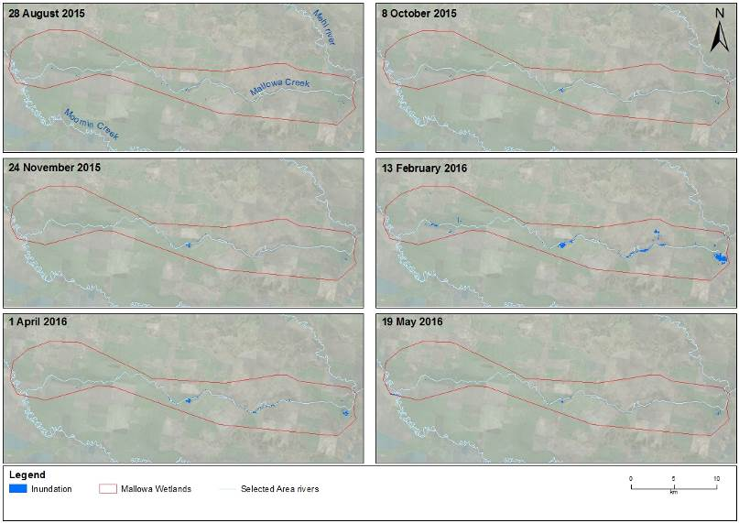

Figure ‑ Wetland inundation within the Mallowa wetlands during the 2015-16 water year.

## Water quality

Water quality variables were measured at Pallamallawa in the Gwydir River zone. The delivery of environmental water significantly reduced mean daily temperature, conductivity and turbidity concentrations when compared to non-environmental water delivery periods (Appendix C). In particular, the delivery of environmental water during the natural base flow period led to significant improvement of turbidity levels to below the ANZECC water quality guideline. These processes reflect the potential dilution effects provided by environmental water and the changes in water chemistry associated with the increase in discharge and wetted area of channels.

The delivery of environmental water also significantly increased mean daily dissolved oxygen and chlorophyll a (algae) concentrations when compared to non-environmental water delivery periods. These processes are likely to be associated with increased nutrient concentrations and improved light conditions to support water column primary productivity.

## Biodiversity

Environmental water influenced eight of the ten ecosystem types monitored in the LTIM project in the 2015-16 water year, including five riverine types, two floodplain types and one lacustrine types as defined by the (Interim) Australian National Aquatic Ecosystem (ANAE) Classification Framework (Brooks et al. 2013) (Figure 4‑3; Appendix F).

During 2015-16, environmental water was used primarily to provide in-channel connectivity in the lower Gwydir river channels and small scale wetland inundation in the Mallowa wetland system. As a result, animals such as macroinvertebrates and fish benefitted the most from environment water use this water year. Nevertheless, inundation remaining in the Gingham and Gwydir wetlands as a result of extensive watering of these areas last year influenced vegetation communities and provided habitat for waterbirds early in the 2015-16 water year.

In 2015-16, fish were monitored in the lower Gwydir system channels, as well as in a number of floodplain waterholes in the Gingham and Gwydir wetlands (Appendices H and I). Four threatened fish species were observed during the surveys this water year; Murray cod (*Maccullochella peelii)*, silver perch (*Bidyanus bidyanus*), freshwater catfish (*Tandanus tandanus)* and olive perchlet (*Ambassis agassizi)* (Figure 4‑4)*.* While catches of silver perch and freshwater catfish were of only single individuals, a reasonable number (approx. 50 individuals) of olive perchlet were surveyed in the Gingham Waterhole. This is the first time since 2013 that this species has been observed in the lower Gwydir system, with the previously surveyed population in 2013 being found in Boyanga Waterhole that dried completely after the survey. The recording of this species in the Gingham Waterhole suggests that this site may be a target for environmental water to maintain critical habitat for this endangered species.

While the diversity of fish communities remained close to that of pre-European conditions, abundances continued to be very low at sites sampled in 2015-16. However, there were some improved catches of small bodied fish such as bony herring (*Nematolosa erebi*) and carp gudgeon (*Hypseleotris* sp.), suggesting that the low flow conditions experienced throughout the year were suitable for spawning and recruitment of these species. Given the very dry conditions and low water levels experienced in early 2016 across the lower Gwydir system, the provision of environmental water in the dry river flow action in April helped sustain the fish populations of the lower Gwydir system. This replenishment of refuge pools supported the survival of fish in these systems.

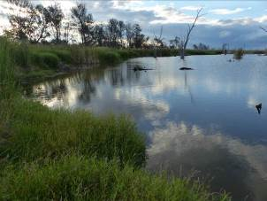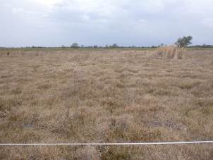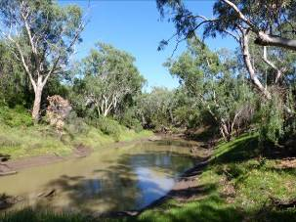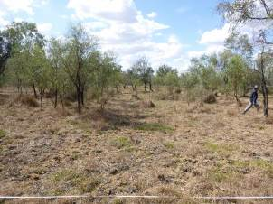

Figure ‑ Permanent lowland stream (top left), River cooba woodland floodplain (top right), Sedge/forb/grassland floodplain (bottom left) and Temporary lowland stream (bottom right) ecosystem types monitoried in the Selected Area.

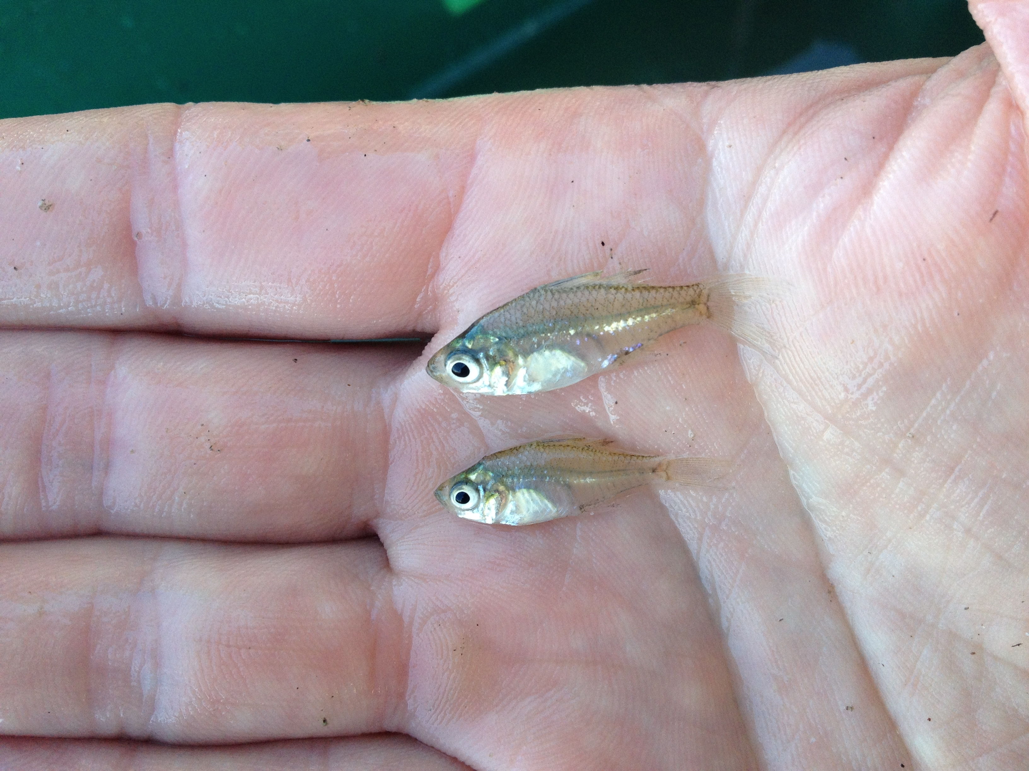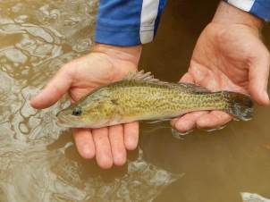

Figure ‑ Threatened fish species surveyed in the Gwydir river system during the 2015-16 water year. Olive perchlet (left) and Murray cod (right).

Environmental water delivered to the Gingham watercourse and Gwydir River influenced the diversity and community composition of invertebrate communities. While the densities of microinvertebrates was highest when water levels were contracting, the diversity of microinvertebrates was enhanced following inundation by environmental water, especially in wetland sites (Appendix D). Different trends in diversity and density were observed between benthic (streambed) and pelagic (water column) communities. The composition of macroinvertebrate communities differed between river channels and over time, with communities tending to be less diverse towards the end of the season as water levels receded (Appendix E). The differences in community composition between the study channels suggests that the delivery of environmental water in the Gingham and Gwydir channels was important for maintaining regional scale macroinvertebrate diversity.

Six frog species were recorded in the wetlands of the lower Gwydir system (Appendix H). Four of the species are known to have positive breeding responses to environmental water. Small but important pulses of environmental water during 2015-16, refreshed the potentially longer-term habitat sites sampled. Local rainfall events also appeared to provide conditions suitable for frog feeding and breeding in shallow well vegetated floodplain depressions.

Responses observed in waterbird and wetland vegetation communities were consistent with that expected in a wetland drying phase. Small-scale waterbird breeding continued for some species during the 2015-16 water year where sufficient resources remained, but overall abundance and breeding activity was reduced markedly compared with the wetter 2014-15 monitoring period. These results support the findings from previous monitoring that indicate waterbird abundance, richness and breeding are driven by inundation patterns, and that the delivery of environmental water to support a broad mosaic of habitats through a planned cycle of wetting and drying is eliciting predictable responses in waterbird community size and composition.

In total 163 bird species, including 59 waterbird species were recorded (Appendix K; Figure 4‑5). This included seven waterbird species listed under one or more international migratory bird agreements (JAMBA, CAMBA and ROKAMBA) and five species listed under the NSW TSC Act: brolga (*Grus rubicunda)*, magpie goose (*Anseranas semipalmata*), black-tailed godwit (*Limosa limosa*), black falcon (*Falco subniger*) and black-necked stork (*Ephippiorhynchus asiaticus*). Migratory shorebirds recorded included black-tailed godwit, common greenshank (*Tringa nebularia*), Latham’s snipe (*Gallinago hardwickii*), marsh sandpiper (*Tringa stagnatilis*) and sharp-tailed sandpiper (*Calidris acuminata*). Waterbird breeding activity was observed at 13 sites in November 2015 and 3 sites in March 2016. Active breeding, or evidence of breeding activity was observed in 16 species in the 2015-16 water year, representing 9 of the 10 functional groups present.

Overall, piscivores and dabbling and filter-feeding ducks dominated the waterbird community in the 2015-16 water year. Piscivores included little pied cormorants (*Microcarbo melanoleucas)*, and cattle egrets (*Ardea ibis*); large wading birds included glossy ibis (*Plegadis falcinellus*), and dabbling and filter-feeding ducks included magpie geese which were all seen in flocks of 100 or more during surveys. Grey teal (*Anas gracilis*) and Pacific black duck (*Anas superciliosa*) which are dabbling and filter-feeding ducks were also seen in large flocks throughout the surveys.

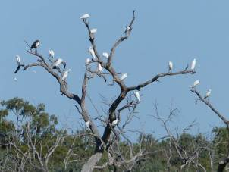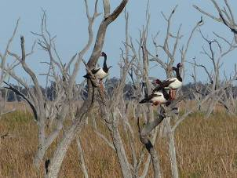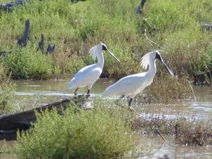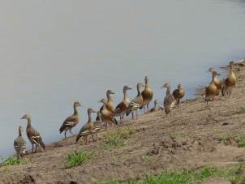

Figure ‑ Waterbirds surveyed in the Gwydir river Selected Area during the 2015-16 water year. Great egrets (top left), magpie goose (top right), royal spoonbill (bottom left) and plumed whistling-duck (bottom right).

Inundation of sites within the Gwydir, Gingham, and Mallowa wetlands during the 2015-16 water year influenced three of the four water dependent vegetation communities surveyed including water couch marsh grasslands, coolibah - river cooba – lignum shrublands, and coolibah woodlands (Appendix G). The presence of water as a result of residual inundation from the previous year and rainfall early in the season in the Gingham watercourse influenced vegetation cover and species richness, with inundation tending to favour wetland species due to their ability to respond to inundation, resulting in increased vegetation cover. Environmental water delivered to the Mallowa system in between survey times also increased vegetation cover. Similar to year 1 findings, the mean cover of water couch and flat spike-rush (*Eleocharis plana*) increased to an extent where they appeared to out compete lippia and reduced its coverage at sites that were inundated (Figure 4‑6). In general, mean vegetation cover across all sites increased significantly between sampling periods.

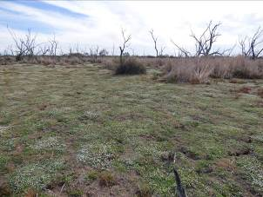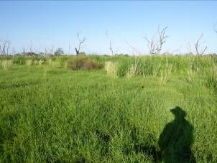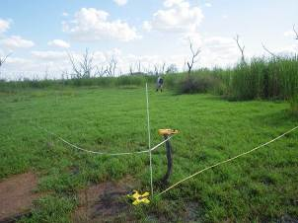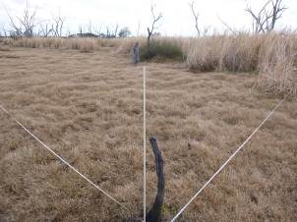

Figure ‑ Vegetation sampling plot at Munwonga in the Gingham watercourse over the duration of the LTIM project. December 2014 (top left), March 2015 (top right), October 2015 (bottom left) and March 2016 (bottom right)

## Resilience

While no direct monitoring of the survival or condition of individual organisms was undertaken in this project, some broader inferences can be made as to the contribution of environmental water and its management on the resilience of the Selected Area over the first two years of the LTIM project. The significant area of wetland inundation provided by environmental water during 2014-15 was shown to increase the coverage and condition of key wetland vegetation species at the expense of exotic species. Even though conditions in the second year of the project have been drier the vegetation communities have remained in a healthy state, with continued high cover of native species. Similarly, the use of environmental water later in the 2015-16 water year as part of the dry river flow action, helped to sustain fish and other aquatic communities in the channels of the lower Gwydir River. These flows helped ensure the recruitment of several small-bodied native fish species, which were observed to have spawned as a result of the favourable low flow conditions experienced over the summer period.

## Summary

Environmental water use in the Gwydir river system during 2015-16 was reduced compared with the previous year, in line with the long-term watering strategy. For the most part, environmental water was used to offset the component of consumptive extraction taken during several supplementary flow events. Environmental water was also delivered to the Mallowa Creek wetlands over the summer period, and to the lower Gwydir, Gingham, Mehi and Carole channels in April 2016 as part of a dry river flow action to reconnect pools along these channels.

Environmental water increased the hydrological connection of channels within the Selected Area during 2015-16. This connectivity helped to maintain refuge pools for native fish in the system along with a number of threatened species including the Olive Perchlet. While some native species recruited during low flow periods, connecting flows delivered during the year allowed fish to move between habitats in the wetlands. Environmental water deliveries also improved water quality through the dilution of variables such as conductivity, turbidity and water nutrients such as nitrogen and phosphorus. Increases in dissolved carbon concentrations during environmental water delivery stimulated primary and secondary productivity and as a result promoted diversity within aquatic invertebrate communities.

Wetland inundation was greatest at the start of the 2015-16 water year as a result of residual flooding from environmental water in 2014-15 and rainfall. This influenced three vegetation community types that included key species such as water couch, coolibah, river cooba and lignum. Vegetation cover and species richness of native taxa were greatest in inundated plots, within both the Gingham and Mallowa wetlands. Vegetation cover remained high throughout the 2015-16 year, which is an encouraging sign for the health of these wetland communities. Waterbird abundance and diversity was reduced when compared to the wetter 2014-15 year, with the retraction of most species back to the larger more permanent wetland sites during 2015-16. Small-scale waterbird breeding was observed at a reduced number of sites during 2015-16.

# Implications for future management of Commonwealth environmental water

The positive ecological outcomes achieved in part by environmental water delivery over the duration of the LTIM project suggest that the long-term environmental watering strategy being employed in the Gwydir river system continues to be effective. While wetland inundation was minimal in 2015-16, the positive native vegetation responses to wider scale wetland inundation observed in 2014-15 appear to have been supported through to the conclusion of the 2015-16 water year with continued good coverage of native species. Above average winter rainfall in 2016 is an encouraging sign for the upcoming water year, and we would support the approach of environmental water use being dependent on natural flow cues in the year ahead.

The combined deliveries of both Commonwealth and State environmental water helped ensure the survival of aquatic species through habitat provision and maintenance of water quality during periods of low to no river flow. In addition, small inputs of environmental water to wetland waterholes maintained these refugia for several listed fish species including the olive perchlet. This highlights the positive ecological outcomes that can be achieved by using relatively small amounts of environmental water delivered at critical times.

# References

|  |
| --- |
| Brooks S., Cottingham P., Butcher R., & Hale J. 2013. *Murray Darling Basin aquatic ecosystem classification: Stage 2 report*. Peter Cottingham & Associates report to the Commonwealth Environmental Water Office and Murray Darling Basin Authority, Canberra.  Department of Environment, Climate Change and Water (DECCW). 2011. *Gwydir Wetlands Adaptive Environmental Management Plan: Synthesis of information projects and actions*. DECCW, Sydney.  Green D., Burrell M., Petrovic J., & Moss P. 2011. *Water resources and management overview – Gwydir catchment*. NSW Office of Water, Sydney.  Commonwealth of Australia (2014) *Commonwealth Environmental Water Office Long Term Intervention Monitoring Project Gwydir River System Selected Area*, Canberra.  Commonwealth of Australia (2015a*) Commonwealth Environmental Water Office Long Term Intervention Monitoring Project Gwydir River System Selected Area – 2014-15 evaluation report*, Canberra.  Commonwealth of Australia (2015b) *Integrated planning for the use, carryover and trade of Commonwealth environmental water*: Gwydir River Valley 2015–16, Canberra. |
|  |
|  |