Hydrology (River)

Introduction
The Hydrology (River) indicator provides in-channel hydrological information on the character of Commonwealth environmental water and other environmental water deliveries. This information is directly relevant to a number of other indicators measured in the Gwydir river system Selected Area (Selected Area) including Vegetation, Waterbirds, Fish, Microinvertebrates and Macroinvertebrates. The particular influence of hydrology on these indicators will be addressed under their respective sections. The Hydrology (River) indicator will also provide information on the degree of hydrological connectivity maintained through the Gwydir Selected Area during the 2016-17 water year. Monitoring was expanded in the 2015-16 water year to include the Mehi River and Moomin Creek monitoring zone that incorporates the Mallowa wetlands. Two specific questions were addressed in relation to this indicator:
- What did Commonwealth environmental water contribute to hydrological connectivity?
- What did Commonwealth environmental water contribute to hydrological connectivity of the Gwydir Selected Area channels?

Environmental watering in 2016-17
Available Commonwealth environmental water holdings totalled 39,451 ML in the 2016-17 water year. This was complemented by water entitlements held by NSW OEH in the Environmental Contingency Allowance (ECA) of 21,000 ML. Of this, a total of 22,847 ML of Commonwealth water (including supplementary take) and 21,000 ML of NSW water (including ECA, General security and Supplimatary take) were delivered in 2016-17 via several events across several channels (Table A-1).
During 2016-17 environmental water was delivered to a number of assets within the Gwydir River system. In September 2016, a flow event occurred down the Mehi River and supplementary water licences owned by the CEWO were triggered. A total of 5,000 ML was accounted for in the Mehi River.
Supplementary flows were triggered in the Mallowa in September 2016, however very little of the moderate flows were diverted into the Mallowa wetlands. In January - March 2017, planned deliveries of 5,000 ML were increased to 10,000 ML to the Mallowa Creek system to inundate fringing wetlands. Flows were also delivered into the lower Gwydir River and Gingham watercourse to build upon moderate winter/spring flows. From January - March 2017, 30,000 ML was delivered, aiming to inundate broad areas of semi-permanent wetland vegetation.
During 2016-17, no environmental water was delivered to the Moomin Creek.

Table A-1: Environmental water delivered in the Gwydir river system Selected Area in 2015-16.
Channel | Commonwealth Environmental Water (CEW) delivered (ML) | NSW ECA/General Security/Supplementary Water delivered (ML)
Gingham watercourse | 4,259 | 13,741 (including 3,000 General Security)
lower Gwydir | 4,741 | 7,259
Carole Creek | 1,351 (Supplementary) | -
Mehi River | 5,000 (Supplementary) | -
Mallowa Creek | 7,496 | 800 (Supplementary)
Total | 22,847 (6,351 Supplementary) | 21,800 (including 800 supplementary)

2015-16 Monitoring outcomes
In 2015-16, the Gwydir River channel was connected for 38% of the time, lower Gwydir River 45%, Gingham watercourse 13%, Mehi River 5%, Moomin Creek 12% and Mallowa Creek 15%. Environmental water contributed to connectivity in the Gwydir, lower Gwydir and Mehi River channels and was responsible for all significant flow in Mallowa Creek during 2015-16. Full connectivity in the Gingham watercourse and Moomin Creek was due almost entirely to rainfall events and other water releases associated with stock and domestic use. As expected in a planned dry year, connectivity in 2015-16 was markedly reduced compared to 2014-15 where more frequent and sustained deliveries resulted in longer periods of connectivity across all channels.

Methods

Hydrological connectivity
An assessment of the hydrological connectivity experienced throughout the zones in the Selected Area was undertaken following the methods outlined in Commonwealth of Australia (2014). Here, flow thresholds measured at upstream gauging stations were identified that would ensure flow through the length of channel in each zone. These thresholds were estimated through an analysis of historical flow records (from 1990-2014) whereby corresponding peaks of small flow events were observed at both upstream and downstream gauging sites, suggesting connection throughout the length of the channel (Figure A-1). These thresholds were then compared with known average stream losses provided by Water NSW. Due to the off-river abstraction of flows in some channels, flows passing the downstream gauges were also quantified to confirm connectivity through the system. Here an arbitrary 5 ML/d level was used to indicate through flow connection. The gauging stations used for this analysis are presented in Figure A-1 and Table A-2 outlines the thresholds estimated to provide longitudinal connectivity.
Once the thresholds were identified, a spells analysis (Gordon et al. 1992) was undertaken to assess the total duration and frequency of flows passing the gauge. Results for downstream gauges were then subtracted from those at upstream gauges to provide an estimate of full longitudinal connectivity along channels throughout the 2016-17 season.
In 2015-16 monitoring was expanded into the Mallowa Creek system for all indicators. No downstream gauge exists in this system, making an assessment of hydrological connectivity impossible. To determine duration of wet and dry spells an arbitrary minimum figure of 5 ML/d entering the system through the Regulator (Figure A-1) was used to indicate a wet period.
Table A-2: Thresholds at gauging stations used to determine hydrological connectivity.
Zone | Channel | Gauging station (upstream or downstream) | Gauging station number | Threshold for longitudinal connectivity
Gwydir River | Gwydir | Gwydir DS Copeton Dam (U/S) | 418026 | 100 ML/d
 |  | Gwydir River @ Pallamallawa (D/S) | 418001 | 5 ML/d
Gingham-Gwydir watercourse | Lower Gwydir | Gwydir (south arm) DS Tyreel regulator (U/S) | 418063 | 40 ML/d
 |  | Gwydir @ Millewa (D/S) | 418066 | 5 ML/d
 | Gingham | Gingham channel @ Teralba (U/S) | 418074 | 50 ML/d
 |  | Gingham channel @ Gingham bridge (D/S) | 418079 | 5 ML/d
Mehi-Moomin | Mehi | Mehi River @ D/S Tareelaroi Regulator (U/S) | 418044 | 300 ML/d
 |  | Mehi River @ near Collarenebri (D/S) | 418055 | 5 ML/d
 | Moomin | Moomin @ Combadello Cutting (U/S) | 418048 | 30 ML/d
 |  | Moomin @ Moomin plains (D/S) | 418070 | 5 ML/d

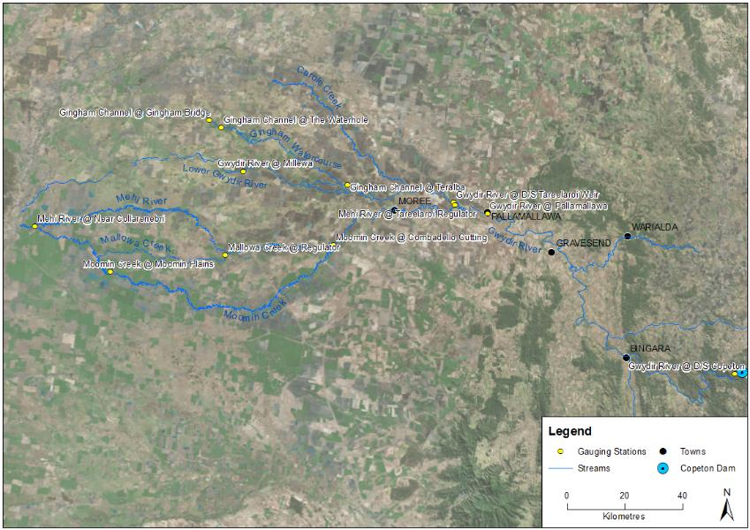
Figure A-1: Location of flow gauging stations used in the hydrological connectivity analysis.

Results

Longitudinal connectivity
In 2016-17, hydrological connectivity occurred in all monitored channels in the Gwydir Selected Area (Table A-3). The Gwydir River had 29% connection (i.e. 29% of days were above the relevant connection threshold at both gauges during 2016-17), the lower Gwydir River 73% connection, Gingham watercourse 40% connection, Mehi River 28% connection and Moomin Creek 29% connection. Mallowa Creek had water flowing into it (was ‘wet’) for 32% of days in 2016-17.
The Gwydir River experienced the longest average duration of connection with 53 days, while Moomin Creek experienced the shortest average duration with 8 days. Mallowa Creek was ‘wet’ for an average duration of 44 days per event.
Table A-3: Variables describing the duration and character of hydrological connectivity in the channels of the Gwydir river system Selected Area.
Monitoring Zone | Channel | Days connected (%) | No. of times connected | Average duration of connection events (days) | Longest wet (days) | Longest dry (days)
Gwydir River | Gwydir River | 29 | 2 | 53 | 101 | 129
Lower Gwydir River and Gingham watercourse | Lower Gwydir River | 78 | 15 | 19 | 79 | 16
 | Gingham watercourse | 43 | 11 | 14 | 114 | 132
Mehi River and Moomin Creek | Mehi River | 28 | 5 | 21 | 49 | 99
 | Moomin Creek | 30 | 14 | 7 | 22 | 85
 | Mallowa Creek | 32 | 4 | 50 | 101 | 113
* Mallowa Creek lacks a downstream gauging station. Connection is described as ‘wet’ periods where >5ML/day water enters the system through the Regulator (refer Methods)
Connection in the Gwydir River channel was dominated by a 101 day connection event over the summer period (Figure A-2). Two separate environmental flows were released during this period that maintained connectivity. A brief period of connectivity of four days was experienced in mid-July, however this was due to localised rainfall rather than environmental flows. While significant flows occurred in the mid and lower reaches of the Gwydir River due to high tributary inputs in August-October 2016, this did not show up as full hydrological connectivity as flows below Copeton Dam remained below the threshold used. Regardless, substantial connection was observed in the downstream reaches of the Gwydir in winter and spring 2016.
Connectivity in the lower Gwydir River channel was characterised by multiple short to long periods of connectivity ranging between one and 79 days (Figure A-3). The longest periods of connectivity occurred during winter and spring (July – November 2016) with two separate events of 79 and 67 days duration, separated by a small disconnection period of three days. A third long period of connectivity occurred during summer (December 2016 – February 2017) for 62 days. In this period, environmental water contributed to connectivity in late December 2016 to early February 2017 for two periods that aimed to maintain water levels in the Gingham/Gwydir wetlands.
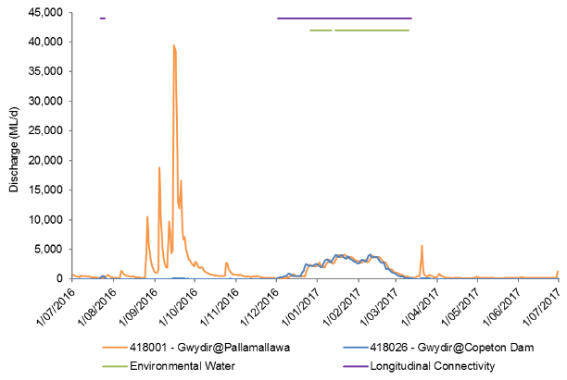
Figure A-2: River flows in the Gwydir River and the timing of environmental water releases and longitudinal connectivity down this channel.

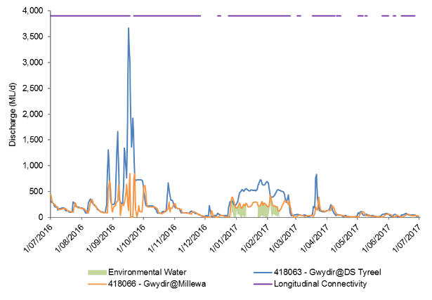
Figure A-3: River flows in the lower Gwydir River and the timing of environmental water releases and longitudinal connectivity down this channel.
Connectivity in the Gingham watercourse in the 2016-17 water year was characterised by a 114 day long period of connection (August 2016 – November 2016) and nine short periods in April and June 2017 (Figure A-4). In autumn, periods of connection ranged from two days to six days, separated by small disconnection periods of one to 11 days. All periods of connection were rainfall driven and no connection was recorded during December 2016 and February 2017 when environmental water was delivered to the Gingham watercourse. There were two environmental releases in December 2016 and January 2017 accounted for in the Gingham watercourse. While this didn’t connect the system all the way to Gingham Bridge it increased flow through the system and increased water levels in Gingham Waterhole.
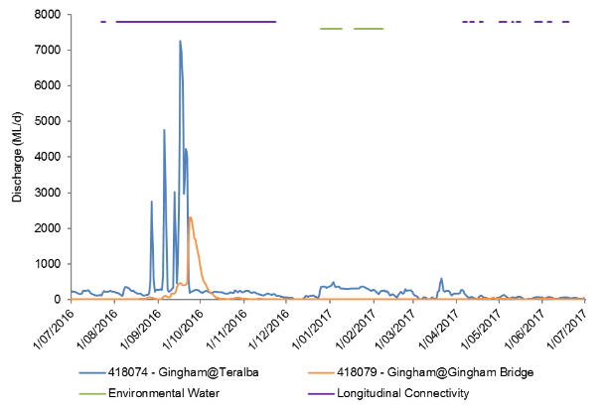
Figure A-4: River flows in the Gingham Watercourse and the timing of environmental water releases and longitudinal connectivity down this channel.

Connectivity in the Mehi River occurred in spring and again in summer and autumn (Figure A-5). In late August 2016 to late October 2016 the Mehi River was connected for three periods of 15, 30 and 6 days each. Following 83 days of disconnection the Mehi River was again connected in January 2017 to March 2017 for two periods of 49 days and 4 days, separated by 9 days of disconnection. Whilst environmental water was released in mid-January 2017 it did not have a direct impact on full connectivity of the Mehi River as it was diverted into Mallowa Creek at the Gundare Regulator.

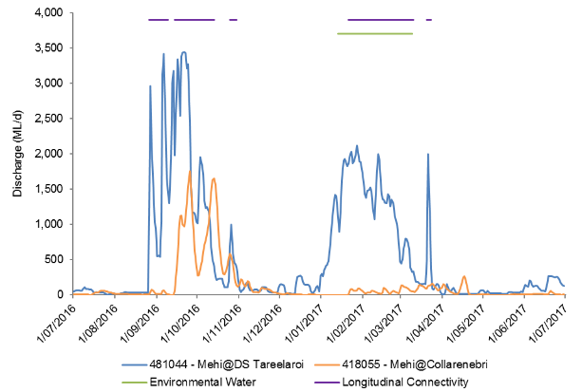
Figure A-5: River flows in the Mehi River and the timing of environmental water releases and longitudinal connectivity down this channel.

Connectivity in Moomin Creek was characterised by sporadic, short to moderate periods of connection throughout the 2016-17 water year (Figure A-6). In winter and spring connectivity was in response to rainfall and diversion of flow from the Mehi River to allow for work on the Gundare Weir, as well as diversion of supplementary flows from the Gingham and Gwydir channels. Longitudinal connectivity in early 2017 was aided by irrigation deliveries, and ranged between one and 22 days duration and were less sporadic. No environmental water was delivered into Moomin Creek in the 2016-17 water year.
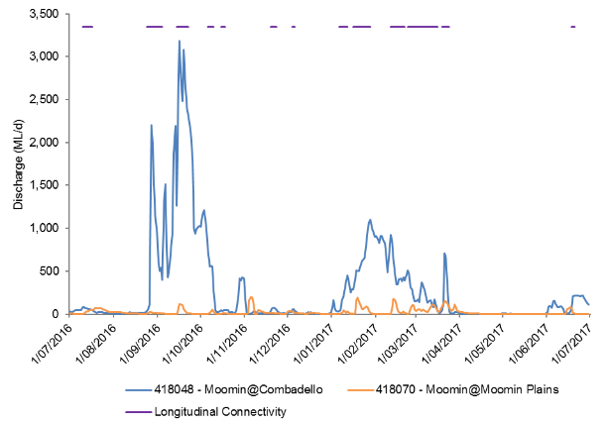
Figure A-6: River flows in Moomin Creek and the timing of environmental water releases and longitudinal connectivity down this channel.

Mallowa Creek was connected for two short periods in September 2016 for two and four days duration. A long period of connectivity occurred from December 2016 to May 2017 for 101 days, followed by a 10 day connection period. Environmental water was delivered to Mallowa Creek on one occasion in the 2016-17 water year (Figure A-7). These environmental flows were the main contribution of flow to the Mallowa system in December 2016 to March 2017. Other periods of connection including the last event in the 2016-17 water year were rainfall driven.

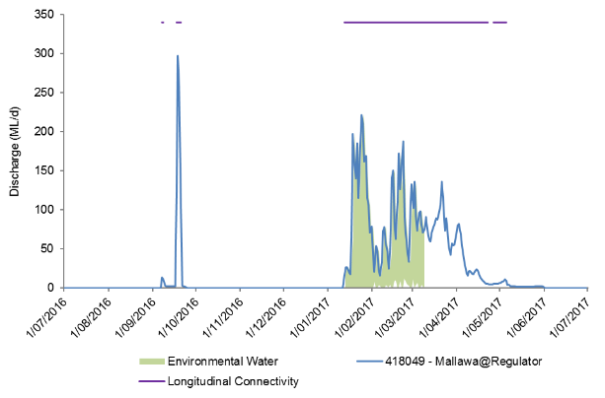
Figure A-7: River flows in Mallowa Creek and the timing of environmental water releases and 'wet' periods in this channel.

Discussion
The environmental watering strategy for the Selected Area employs a multi-year wetting and drying strategy in which 2016-17 was a planned dry year, with the application of environmental water was aimed largely at maintaining in-channel flow rather than large-scale wetland inundation. However, following flooding in spring that inundated the Gingham and Gwydir wetlands, priorities were changed to maintain water levels in the wetlands for birds and frogs. Environmental water was delivered to all channels, except Moomin Creek in the 2016-17 water year. Local rainfall and stock and domestic deliveries contributed to flows in Moomin Creek.
In the first half of the water year, longitudinal connectivity was not dependent on environmental water releases, with all events associated with catchment rainfall. In the latter half of the year, environmental releases contributed to full channel connectivity in all zones, except in the Gingham watercourse and Moomin Creek, however shorter periods of connectivity were associated with localised rainfall. Longitudinal connectivity was greatest along the lower Gwydir River reaches during 2016-17, and was characterised by both long and short periods of connection. Unlike other channels in the Selected Area, Moomin Creek connectivity was short and sporadic throughout the water year, and was influenced by rainfall and later stock and domestic releases. Whilst environmental water was delivered in the Gingham watercourse it did not contribute to full longitudinal connectivity, with environmental water travelling through the wetlands to Gingham waterhole only.

Conclusion
Environmental water contributed to connectivity in the Gwydir, lower Gwydir and Mehi River channels and Mallowa Creek during 2016-17. Full connectivity in the Gingham watercourse and Moomin Creek was due to rainfall events and other water releases associated with irrigation, stock and domestic use. Connectivity in 2016-17 was greater than in 2015-16. Both water years were planned dry years, however, environmental watering priorities were changed in response to flooding in spring 2016 to maintain bird and frog breeding habitat in the wetlands. Long periods of connectivity in the first half of the water year were attributed to rainfall, while environmental water releases contributed to long periods of connectivity in summer and autumn 2017. Short periods of connectivity in all channels resulted from localised rainfall.

References
Commonwealth of Australia. 2014. Commonwealth Environmental Water Office Long Term Intervention Monitoring Project Gwydir River System Selected Area. Commonwealth of Australia.
Commonwealth of Australia. 2015. Commonwealth Environmental Water Office Long Term intervention Monitoring Project Gwydir River System Selected Area – 2014-15 Evaluation Report. Commonwealth of Australia.
Gordon, N.D., McMahon T.A. and Finlayson, B.L. 1992. Stream Hydrology - An introduction for Ecologists. Brisbane, Wiley.

Hydrology (Watercourse)

Introduction
The Lower Gwydir wetlands have long been targets for environmental water due to their extensive wetland vegetation communities and waterholes that support many important species (DECCW 2011). Watering targets for the wetlands tend to specify the inundation of particular extents and vegetation communities. Therefore, knowledge of the extent and volume of water held in the wetlands throughout each watering season is essential base information from which to evaluate the success of environmental watering. The hydrology (watercourse) indicator aims to achieve this, by combining information from a range of sources, to build relationships between inflows, inundation extent and volumes of water in the Lower Gwydir, Gingham and Mallowa wetlands. Specifically, this chapter addresses the following question:
- What did Commonwealth environmental water contribute to hydrological connectivity of the Gingham, Gwydir and Mallowa wetlands?

Environmental watering in 2016-17
During 2016-17 environmental water was delivered to a number of assets within the Gwydir River system (Table B-1). In September 2016, a flow event occurred down the Mehi River and supplementary water licences owned by the CEWO were triggered. A total of 5,000 ML was accounted for in the Mehi River.
Supplementary flows were triggered in the Mallowa in September 2016, however, only moderate flows were diverted into the Mallowa wetlands. In January - March 2017, planned deliveries of 5,000 ML were increased to 10,000 ML to the Mallowa Creek system to inundate fringing wetlands. Flows were also delivered into the lower Gwydir River and Gingham watercourse to build upon moderate winter/spring flows. In January - March 2017, 30,000 ML was delivered, aiming to inundate broad areas of semi-permanent wetland vegetation.

Table B-1: Environmental water delivered in the Gwydir river system Selected Area in 2016-17.
Channel | Commonwealth Environmental Water (CEW) delivered (ML) | NSW ECA/General Security/Supplementary Water delivered (ML)
Gingham watercourse | 4,259 | 13,741 (including 3,000 General Security)
lower Gwydir | 4,741 | 7,259
Carole Creek | 1,351 (Supplementary) | -
Mehi River | 5,000 (Supplementary) | -
Mallowa Creek | 7,496 | 800 (Supplementary)
Total | 22,847 (6,351 Supplementary) | 21,800 (including 800 supplementary)

Previous monitoring outcomes
Environmental water played a key role in inundating the Mallowa wetlands in 2015-16 that resulted in the inundation of important semi-permanent wetland and floodplain species such as coolabah and river cooba. Inundation extent and volume in the Lower Gwydir and Gingham wetlands was much lower in 2015-16 than in the 2014-15 water year, but some water was retained from flooding driven by environmental flows in the previous year. Localised rainfall events also helped maintain some level of inundation throughout the 2015-16 water year.

Methods
Four data sources were used to build a model of inundation extent and volume in the Gwydir, Gingham and Mallowa systems (Commonwealth of Australia 2015). These included:
- Landsat imagery
- Existing vegetation mapping
- Water level records associated with remote cameras
- Point water level observations throughout the water year.
These data sources were scrutinised and combined to produce relationships with inflow, inundation extent and volume. Existing vegetation mapping was used to determine the area and volume of inundation associated with each vegetation community in all three wetland systems (Figure B-1).

Inundation mapping
All available Landsat 8 images captured during the 2016-17 season were accessed via the USGS Glovis website (http://glovis.usgs.gov/). Those with minimal cloud cover and no other problems were chosen for further analysis. Seven images spanning the season (Figure B-2) were selected for analysis (22 July 2016, 7 August 2016, 10 24 September 2016, October 2016, 17 November 2016, 13 December 2016 and 15 February 2017). The image captured on 24 September 2016 had extensive cloud cover over the Mallowa Wetlands, analysis for this date was only undertaken for the Gingham Watercourse and the Lower Gwydir Wetlands. Given the later period of environmental water delivery to the Mallowa system, an additional image on 4 April 2017 was analysed.
The extent of inundation within each image was classified using density slicing of band 6 as described in Frazier and Page (2000). A maximum wetland extent layer was then used to exclude waterbodies such as irrigation storages and farm dams outside of the target wetland area. The final inundation extent file for each capture time was then intersected with Gwydir vegetation community layers (Commonwealth of Australia 2015) to determine the extent of inundation within each vegetation community.
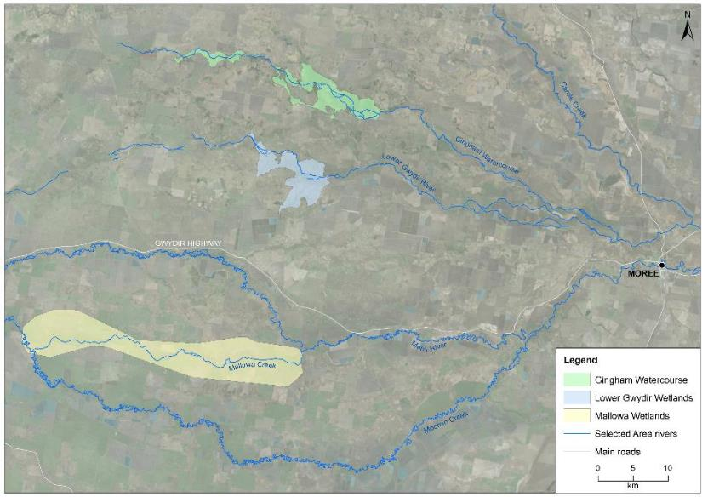
Figure B-1: Extent of Lower Gwydir, Gingham and Mallowa wetlands in the Gwydir river system Selected Area.

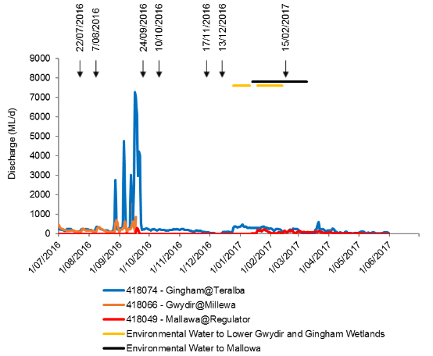
4/04/2017
Figure B-2: River flows entering the lower Gwydir River, Gingham Watercourse and Mallowa Creek during 2016-17. Horizontal lines represent the timing of environmental water in each system. Arrows indicate timing of Landsat image capture.

Calculation of inundation volumes
Volumes of inundation for each vegetation community within the Lower Gwydir and Gingham wetlands were estimated for each of the Landsat image dates (Table B-2). This was done using water depth information from level loggers at the Bunnor bird hide and Old Dromana remote camera sites (Figure B-3) and water depth estimates within vegetation plots surveyed in late October 2016 and early March 2017 (Appendix G). Point depth measurements were taken at specific points in time, so water level data from the remote camera sites were used to adjust these measurements and provide average depth estimates for each image capture date. Average depths for each vegetation community were estimated to the nearest 0.05 m. These were then multiplied by the area of each vegetation community to provide an estimate of the volume of surface water contained within each vegetation community. Lack of water depth reference data in the Mallowa wetlands precluded calculation of inundation volumes in this system.
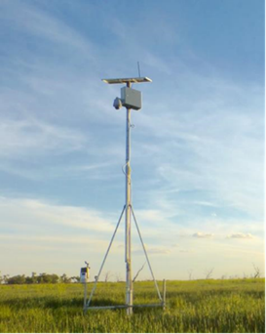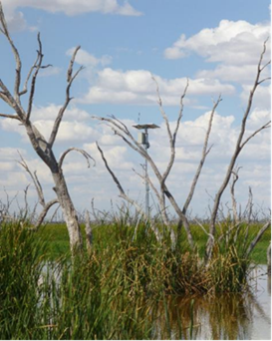
Figure B-3: Remote monitoring stations at Old Dromana wetland (left) and Bunnor birdhide wetland (right).

Table B-2: Average depth (m) of inundation for vegetation communities during the seven image capture times.
Wetland | Vegetation community | Estimated average depth of inundation (m)
 |  | 22-Jul-16 | 7-Aug-16 | 24-Sep-16 | 10-Oct-16 | 17-Nov-16 | 13-Dec-16 | 15-Feb-17
lower Gwydir | Common Reed - Marsh Club-rush | 0.00 | 0.15 | 0.20 | 0.20 | 0.10 | 0.05 | 0.15
 | Common Reed - Tussock Sedge | 0.00 | 0.00 | 0.00 | 0.20 | 0.10 | 0.05 | 0.00
 | Coolibah - River Red Gum Association | 0.05 | 0.05 | 0.10 | 0.10 | 0.05 | 0.05 | 0.10
 | Coolibah woodland | 0.00 | 0.05 | 0.10 | 0.10 | 0.15 | 0.05 | 0.10
 | Cumbungi - Marsh Club-rush | 0.15 | 0.15 | 0.20 | 0.20 | 0.10 | 0.05 | 0.15
 | River Cooba - Lignum Association | 0.00 | 0.00 | 0.00 | 0.15 | 0.10 | 0.05 | 0.10
 | Water Couch - Spike-rush - Tussock Rush | 0.15 | 0.15 | 0.20 | 0.20 | 0.15 | 0.05 | 0.15
 | Natural Water Body | 0.45 | 0.45 | 0.50 | 0.50 | 0.40 | 0.40 | 0.45
 | Cultivated Land | 0.05 | 0.05 | 0.10 | 0.10 | 0.05 | 0.05 | 0.10
 | Farm Dam | 0.90 | 0.90 | 1.00 | 1.00 | 0.80 | 0.80 | 0.90
Gingham | Baradine Red Gum shrubby open forest | 0 | 0 | 0 | 0 | 0.10 | 0 | 0
 | Belah grassy woodland | 0 | 0.05 | 0.2 | 0.05 | 0.10 | 0.15 | 0.05
 | Carbeen grassy woodland | 0 | 0 | 0 | 0 | 0.10 | 0 | 0
 | Cleared land | 0 | 0.05 | 0.15 | 0.05 | 0.10 | 0 | 0.05
 | Coolibah - River Coobah grassy woodland | 0 | 0.05 | 0.20 | 0.05 | 0.10 | 0.15 | 0.05
 | Cultivated land | 0.05 | 0.05 | 0.20 | 0.05 | 0.10 | 0.15 | 0.05
 | Cumbungi swamp rushland | 0.10 | 0.15 | 0.35 | 0.20 | 0.20 | 0.30 | 0.20
 | Derived grasslands | 0 | 0.05 | 0.05 | 0.10 | 0.05 | 0 | 0
 | dry wetland with rehabilitation potential | 0.05 | 0.05 | 0.25 | 0.10 | 0.05 | 0.20 | 0.10
 | Marsh Club-rush swamp sedgeland | 0 | 0 | 0.25 | 0.10 | 0.05 | 0.20 | 0
 | Myall - Rosewood shrubby woodland | 0 | 0 | 0.20 | 0.05 | 0.10 | 0.15 | 0
 | Paleo-channel: Coolibah - River Coobah woodland | 0 | 0 | 0.20 | 0.05 | 0.10 | 0.15 | 0
 | Paleo-channel: cultivated land | 0 | 0 | 0.20 | 0.05 | 0.10 | 0.15 | 0
 | Paleo-channel: dry wetland with rehabilitation potential | 0 | 0 | 0.25 | 0.10 | 0.05 | 0.20 | 0.10
 | Paleo-channel: Water Couch - Spike-rush | 0 | 0 | 0.25 | 0.10 | 0.05 | 0.20 | 0.10
 | Poplar Box shrubby woodland | 0 | 0 | 0.15 | 0.05 | 0.10 | 0 | 0
 | River Coobah - Lignum Association | 0 | 0 | 0.25 | 0.10 | 0.05 | 0.20 | 0.10
 | River Coobah - Lignum swamp shrubland | 0.05 | 0.05 | 0.25 | 0.10 | 0.05 | 0.20 | 0.10
 | River Red Gum - Coolibah open forest | 0 | 0.05 | 0.20 | 0.10 | 0.05 | 0.15 | 0.10
 | Spike-rush - Cumbungi swamp sedgeland | 0 | 0 | 0 | 0 | 0.15 | 0 | 0
 | Tussock Rush swamp rushland | 0 | 0.05 | 0.25 | 0.10 | 0.05 | 0.20 | 0.10
 | Water Couch - Spike-rush - Tussock Rush marsh grassland/sedgeland | 0.05 | 0.05 | 0.25 | 0.10 | 0.05 | 0.20 | 0.10
 | Natural water body | 0.30 | 0.35 | 0.5 | 0.40 | 0.40 | 0.60 | 0.40
 | Farm dam | 0.80 | 0.90 | 1.10 | 1.00 | 1.00 | 1.10 | 0.80

Average monthly rainfall
Rainfall in the two months leading up to the start of the 2016-17 water year was slightly higher than average. July, September and October rainfall was also higher than the long-term average, with September receiving more than triple the monthly average. Below average rainfall from November through to February was followed by more than double the long-term average in March (Figure B-4).
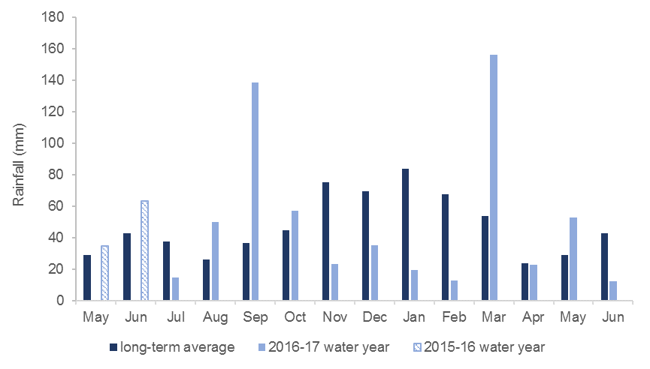
Figure B-4: Monthly rainfall for 2016-17 water year from Moree Aero station (BoM 2016).

Results and Discussion

Inundation extent and volume modelling
Inundation mapping using LANDSAT imagery showed that the total extent of inundation varied throughout the water year in all wetlands (Figure B-5, Figure B-6).
Inundation extent in the Gingham watercourse for the 2016-17 water year was lowest in July (42.72 ha), while maximum mapped inundation occurred in September (2,844.12 ha). Inundation extent retreated steadily throughout the rest of the year to 291.75 ha by December 2016. Inundated area then increased to 321.80 ha in February following the environmental flow delivery (Table B-3, Figure B-2).
Inundation extent in the Lower Gwydir for the 2016-17 water year was lowest in July (6.20 ha) and increased to its maximum in August with 796.23 ha. Inundation extent fluctuated in September and October in response to local rainfall events, before decreasing to 90.37 ha in December. Inundated extent increased to 126.70 ha in February after the delivery of environmental water (Table B-3, Figure B-2).
Rainfall contributed to inundation extent in the Lower Gwydir and the Gingham wetlands during late winter and early to mid-spring, particularly the 139 mm received in September (Figure B-4).
Inundation in the Mallowa wetlands was below 10 ha for most of the 2016-17 water year, except for November (66.95 ha) and February (167.62 ha) and April (901.62 ha), with inundation in February and April resulting from environmental water delivery (Table B-3, Figure B-2).
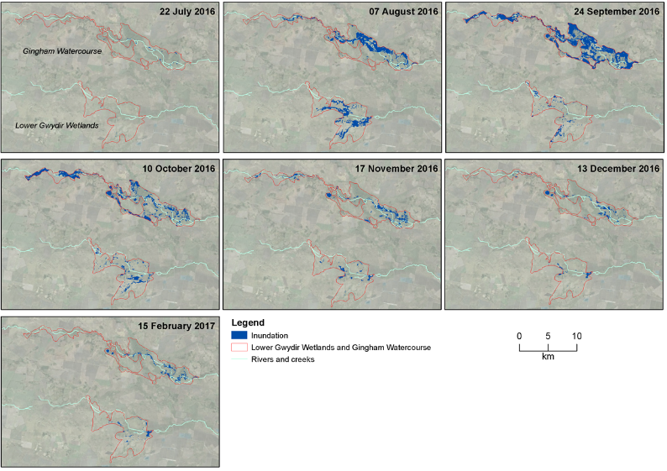
Figure B-5: Wetland inundation within the Gingham and Lower Gwydir Wetlands during the 2016-17 water year.

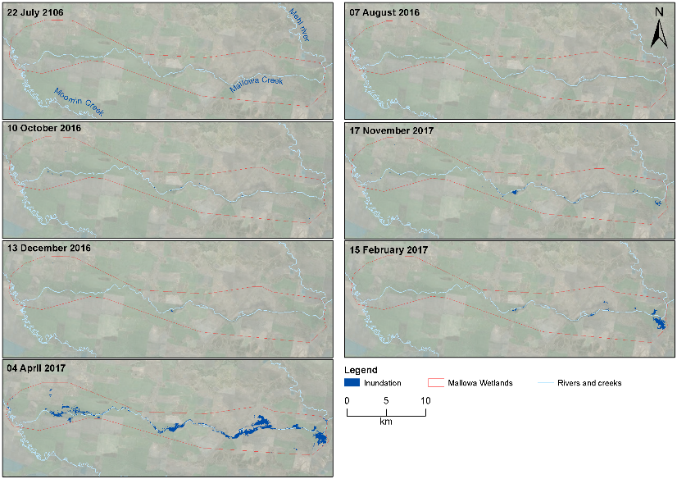
Figure B-6: Wetland inundation within the Mallowa Wetlands during the 2015-16 water year.

Table B-3: Cumulative inflows, inundation extent and volume of water in the Lower Gwydir and Gingham wetlands throughout the 2016-17 water year.
Wetland | Date | Cumulative inflows (ML) | Inundation Extent (ha) | Volume (ML)
Lower Gwydir | 22/07/2016 | 4,135.69 | 6.20 | 10.74
 | 7/08/2016 | 6,824.35 | 796.23 | 1,020.07
 | 24/09/2016 | 19,840.94 | 278.83 | 482.08
 | 10/10/2016 | 23,881.87 | 389.51 | 742.28
 | 17/11/2016 | 29,938.96 | 172.71 | 227.13
 | 13/12/2016 | 30,299.04 | 90.37 | 49.43
 | 15/02/2017 | 43,215.07 | 126.70 | 160.47
Gingham | 22/07/2016 | 4,021.88 | 42.72 | 34.09
 | 7/08/2016 | 7,215.28 | 1055.81 | 563.73
 | 24/09/2016 | 65,406.01 | 2844.12 | 6,602.62
 | 10/10/2016 | 69,014.19 | 1444.76 | 1,379.69
 | 17/11/2016 | 77,649.75 | 2123.48 | 843.22
 | 13/12/2016 | 78,141.84 | 291.75 | 688.51
 | 15/02/2017 | 94,712.98 | 321.80 | 418.71
Mallowa | 22/07/2016 | 0.02 | 0.09 | water depth reference data unavailable
 | 7/08/2016 | 0.02 | 0.81
 | 10/10/2016 | 832.37 | 8.18
 | 17/11/2016 | 832.52 | 66.95
 | 13/12/2016 | 832.52 | 5.84
 | 15/02/2017 | 3,984.87 | 167.62
 | 4/04/2017 | 8,168.02 | 901.62

Vegetation community inundation
In the Gingham watercourse, water couch – spike-rush – tussock rush marsh grassland and river cooba – lignum swamp shrubland were the most commonly inundated vegetation communities (Table B-4). Water couch – spike-rush – tussock rush marsh grassland had the largest area and greatest volume of inundation mapped for all image capture dates, with the maximum being in September (1004 ha, 2510.26 ML; Table B-4, Table B-5). During maximum inundation in September (2844.12 ha), 19 of 24 vegetation communities were inundated; while in July that had the least inundation (42.72 ha), only five vegetation communities were inundated (≥0.1 ha; Table B-4).
In the Lower Gwydir wetlands, water couch – spike rush – tussock rush marsh grassland was the most frequently inundated vegetation community. It also had the largest area and greatest volume of inundation mapped for all image capture dates, with the maximum being in August (607 ha, 910 ML; Table B-4, Table B-5). During August (the period with the largest extent of inundation) all eight vegetation communities mapped in the Lower Gwydir wetlands were inundated (≥0.1 ha; Table B-4). During July (the period with the smallest extent of inundation) only three communities were inundated (≥0.1 ha; Table B-4).
In the Mallowa wetlands, coolibah – river cooba – lignum association was the most frequently inundated of the four mapped vegetation communities. It also had the largest area and greatest volume of inundation mapped for all image capture dates, with the maximum in April (774.49 ha; Table B-6). This was followed by coolibah woodlands with an area of 82.42 ha being inundated in April.
Table B-4: Area inundated, including percentage of total extent inundated at the time, for different vegetation communities in the Lower Gwydir and Gingham wetlands in 2016-17.
Wetland | Vegetation community | Area inundated - ha (% of mapped community)
 |  | 22-Jul-16 | 7-Aug-16 | 24-Sep-16 | 10-Oct-16 | 17-Nov-16 | 13-Dec-16 | 15-Feb-17
Lower Gwydir | Common Reed - Marsh Club-rush | 0 | 27 (3%) | 0 | 1 (0%) | 0 | 0 | 0
 | Common Reed - Tussock Sedge | 0 | 4 (0%) | 0 | 0 | 0 | 0 | 0
 | Coolibah - River Red Gum Association | 0 | 4 (0%) | 0 | 1 (0%) | 5 (3%) | 4 (4%) | 4 (3%)
 | Coolibah woodland | 0 | 21 (3%) | 4 (1%) | 4 (1%) | 4 (2%) | 1 (1%) | 7 (5%)
 | Cumbingi-Marsh Club Rush | 0.2 (4%) | 14 (2%) | 1 (0%) | 9 (2%) | 9 (5%) | 9 (10%) | 2 (1%)
 | River Cooba - Lignum Association | 0 | 66 (8%) | 0 | 20 (5%) | 36 (21%) | 42 (46%) | 51 (40%)
 | Water Couch - Spike-rush - Tussock Rush | 4.98 (80%) | 607 (76%) | 193 (69%) | 331 (85%) | 114 (66%) | 29 (32%) | 59 (46%)
 | Natural Water Body | 1 (10%) | 3 (0%) | 3 (1%) | 2 (0%) | 1 (0%) | 2 (2%) | 2 (1%)
 | Cultivated Land | 0.27 (4%) | 46 (6%) | 78 (28%) | 16 (4%) | 0 | 0 | 0
 | Farm Dam* | 0.1 (1) | 5 (1%) | 1 (0%) | 6 (1%) | 4 (2%) | 3 (4%) | 2 (2%)
 | Total (ha) | 6.2 | 796.2 | 278.8 | 389.5 | 172.7 | 90.4 | 126.7
Gingham | Baradine Red Gum shrubby open forest | 0 | 0 | 0 | 0 | 0 | 0 | 0
 | Belah grassy woodland | 0 | 22 (2%) | 62 (2%) | 13 (1%) | 1 (0%) | 1 (0%) | 0
 | Carbeen grassy woodland | 0 | 0 | 0 | 0 | 0 | 0 | 0
 | Cleared land | 0 | 63 (6%) | 287 (10%) | 131 (9%) | 0 | 0 | 0
 | Coolibah - River Coobah grassy woodland | 0 | 98 (9%) | 280 (10%) | 85 (6%) | 10 (2%) | 4 (1%) | 2 (0%)
 | Cultivated land | 0.1 | 5 (0%) | 115 (4%) | 55 (4%) | 4 (1%) | 2 (1%) | 3 (1%)
 | Cumbungi swamp rushland | 7 (17%) | 9 (1%) | 64 (2%) | 64 (4%) | 64 (11%) | 58 (20%) | 63 (20%)
 | Derived grasslands | 0 | 3 (0%) | 21 (1%) | 15 (1%) | 0 | 0 | 0
 | dry wetland with rehabilitation potential | 1 (2%) | 73 (7%) | 310 (11%) | 76 (5%) | 6 (1%) | 0 | 0
 | Marsh Club-rush swamp sedgeland | 0 | 0 | 0 | 0 | 0 | 0 | 0
 | Myall - Rosewood shrubby woodland | 0 | 0 | 7 (0%) | 2 (0%) | 0 | 0 | 0
 | Paleo-channel: Coolibah - River Coobah woodland | 0 | 0 | 1 (0%) | 5 (0%) | 41 (7%) | 0 | 0
 | Paleo-channel: cultivated land | 0 | 0 | 53 (2%) | 49 (3%) | 0 | 4 (1%) | 0
 | Paleo-channel: dry wetland with rehabilitation potential | 0 | 5 (1%) | 64 (2%) | 47 (3%) | 0 | 40 (14%) | 18 (6%)
 | Paleo-channel: Water Couch - Spike-rush | 0 | 0 | 46 (2%) | 36 (2%) | 2 (0%) | 0 | 0
 | Poplar Box shrubby woodland | 0 | 1 (0%) | 2 (0%) | 0 | 61 (11%) | 0 | 0
 | River Coobah - Lignum Association | 0 | 0 | 44 (2%) | 4 (0%) | 3 (0%) | 1 (0%) | 10 (3%)
 | River Coobah - Lignum swamp shrubland | 5 (13%) | 416 (39%) | 450 (16%) | 229 (16%) | 0 | 38 (13%) | 53 (16%)
 | River Red Gum - Coolibah open forest | 0 | 9 (1%) | 10 (0%) | 2 (0%) | 1 (0%) | 4 (1%) | 2 (1%)
 | Spike-rush - Cumbungi swamp sedgeland | 0 | 0 | 0 | 0 | 333 (59%) | 0 | 0
 | Tussock Rush swamp rushland | 0 | 2 (0%) | 3 (0%) | 2 (0%) | 15 (3%) | 1 (0%) | 1 (0%)
 | Water Couch - Spike-rush - Tussock Rush marsh grassland/sedgeland | 25 (59%) | 332 (31%) | 1,004 (35%) | 608 (42%) | 4 (1%) | 121 (41%) | 152 (47%)
 | Natural water body | 4 (9%) | 11 (1%) | 15 (1%) | 15 (1%) | 20 (4%) | 15 (5%) | 13 (4%)
 | Farm dam* | 1 (1%) | 4 (0%) | 6 (0%) | 5 (0%) | 0 | 4 (1%) | 3 (1%)
 | Total (ha) | 42.7 | 1,055.7 | 2,844.1 | 1,444.8 | 567.1 | 291.7 | 321.8

Table B-5: Inundation volume, including percentage of total volume, for different vegetation communities in the Lower Gwydir and Gingham wetlands in 2016-17.
Wetland | Vegetation community | Volume - ML
 |  | 22-Jul-16 | 7-Aug-16 | 24-Sep-16 | 10-Oct-16 | 17-Nov-16 | 13-Dec-16 | 15-Feb-17
Lower Gwydir | Common Reed - Marsh Club-rush | 0 | 40 | 0 | 2 | 0 | 0 | 0
 | Common Reed - Tussock Sedge | 0 | 0 | 0 | 0 | 0 | 0 | 0
 | Coolibah - River Red Gum Association | 0 | 2 | 0 | 1 | 2 | 2 | 4
 | Coolibah woodland | 0 | 11 | 4 | 4 | 6 | 1 | 7
 | Cumbingi-Marsh Club Rush | 0 | 21 | 2 | 19 | 9 | 4 | 2
 | River Cooba - Lignum Association | 0 | 0 | 0 | 30 | 36 | 21 | 51
 | Water Couch - Spike-rush - Tussock Rush | 7 | 910 | 385 | 662 | 171 | 14 | 88
 | Natural Water Body | 3 | 13 | 13 | 9 | 2 | 7 | 8
 | Cultivated Land | 0 | 23 | 78 | 16 | 0 | 0 | 0
 | Farm Dam* | 1 | 42 | 8 | 58 | 30 | 28 | 22
 | Total (ML) | 10.7 | 1,020.1 | 482.1 | 742.3 | 227.1 | 49.4 | 160.5
Gingham | Baradine Red Gum shrubby open forest | 0 | 0 | 0 | 0 | 0 | 0 | 0
 | Belah grassy woodland | 0 | 11 | 125 | 6 | 1 | 1 | 0
 | Carbeen grassy woodland | 0 | 0 | 0 | 0 | 0 | 0 | 0
 | Cleared land | 0 | 32 | 430 | 66 | 0 | 0 | 0
 | Coolibah - River Coobah grassy woodland | 0 | 49 | 559 | 43 | 10 | 6 | 1
 | Cultivated land | 0 | 2 | 230 | 28 | 4 | 2 | 2
 | Cumbungi swamp rushland | 7 | 14 | 224 | 128 | 128 | 175 | 126
 | Derived grasslands | 0 | 2 | 10 | 15 | 0 | 0 | 0
 | dry wetland with rehabilitation potential | 0 | 37 | 774 | 76 | 3 | 1 | 0
 | Marsh Club-rush swamp sedgeland | 0 | 0 | 0 | 0 | 0 | 0 | 0
 | Myall - Rosewood shrubby woodland | 0 | 0 | 15 | 1 | 0 | 0 | 0
 | Paleo-channel: Coolibah - River Coobah woodland | 0 | 0 | 2 | 2 | 41 | 0 | 0
 | Paleo-channel: cultivated land | 0 | 0 | 105 | 25 | 0 | 6 | 0
 | Paleo-channel: dry wetland with rehabilitation potential | 0 | 0 | 160 | 47 | 0 | 79 | 18
 | Paleo-channel: Water Couch - Spike-rush | 0 | 0 | 116 | 36 | 1 | 0 | 0
 | Poplar Box shrubby woodland | 0 | 0 | 3 | 0 | 61 | 0 | 0
 | River Coobah - Lignum Association | 0 | 0 | 110 | 4 | 1 | 2 | 10
 | River Coobah - Lignum swamp shrubland | 3 | 208 | 1,125 | 229 | 0 | 75 | 53
 | River Red Gum - Coolibah open forest | 0 | 5 | 21 | 2 | 1 | 5 | 2
 | Spike-rush - Cumbungi swamp sedgeland | 0 | 0 | 0 | 0 | 500 | 0 | 0
 | Tussock Rush swamp rushland | 0 | 1 | 7 | 2 | 7 | 2 | 1
 | Water Couch - Spike-rush - Tussock Rush marsh grassland/sedgeland | 13 | 166 | 2,510 | 608 | 2 | 242 | 152
 | Natural water body | 11 | 38 | 75 | 62 | 81 | 92 | 53
 | Farm dam* | 5 | 36 | 65 | 50 | 1 | 40 | 25
 | Total (ML) | 34.1 | 563.7 | 6,602.6 | 1,379.7 | 843.2 | 688.5 | 418.7
* Farm dams were not included in volume calculations

Table B-6: Wetland inundation extent, including percentage of total extent, for different vegetation communities in the Mallowa wetlands in 2016-17.
Vegetation community | Area inundated - ha (% of mapped community)
 | 22-Jul-16 | 7-Aug-16 | 10-Oct-16 | 17-Nov-16 | 13-Dec-16 | 15-Feb-17 | 4-Apr-17
Coolibah - cultivated | 0 | 0.09 (11%) | 0.63 (8%) | 0.45 (1%) | 0 | 23.6 (14%) | 40.3 (5%)
Coolibah - River Cooba - Lignum Association | 0.09 (100%) | 0.36 (44%) | 5.79 (71%) | 64.27 (96%) | 5.3 (91%) | 133.62 (80%) | 774.49 (86%)
Coolibah woodlands | 0 | 0.27 (33%) | 1.76 (22%) | 1.7 (3%) | 0.27 (5%) | 10.41 (6%) | 82.42 (9%)
River Cooba - Lignum Association | 0 | 0.09 (11%) | 0 | 0.53 (1%) | 0.27 (5%) | 0 | 3.87 (0.5%)
Total (ha) | 0.09 | 0.81 | 8.18 | 66.95 | 5.84 | 167.62 | 901.02

Comparison with previous years
Inundation in the Gingham and Lower Gwydir wetlands during the 2016-17 water year were the largest since early 2015. Inundation was more widespread in the Gingham watercourse, with local rainfall and higher catchment inflows resulting in a maximum area of 2844 ha becoming inundated. In comparison to 2015, the total area inundated/cumulative inflows relationship was lower. In 2015, 3,909 ha of the Gingham watercourse was inundated by 25,152 ML of inflows (Commonwealth of Australia 2015) compared to 2,844 ha inundated by 65,406 ML of inflows this year (Table B-3). This is likely the result of the contrasting nature of inflows in each year. In 2015, environmental water was delivered consistently over a four-month period, allowing water to steadily build up in the wetlands. By comparison, inflows in 2016 occurred over a much shorter period (mid-August to mid-September 2016). This pulse was followed by low inflows and below average rainfall that did not sustain widespread inundation throughout the season. However, inundation was sustained in core wetland areas using environmental water delivered over summer.
Twenty-one of the 22 vegetation communities inundated in the Gingham watercourse in 2015-16 were also inundated during the 2016-17 water year (Table B-7). Water couch – spike rush – tussock rush marsh grassland/sedgeland and river coobah – lignum swamp shrubland were the most extensively inundated vegetation communities in both years and are the third and fifth most extensive communities in the wetlands, covering 11.76 and 5.79% of total vegetated area. Coolabah – river coobah grassy woodland, cumbungi swamp rushland and dry wetland with rehabilitation potential were also reasonably well represented in inundated communities.
In the Lower Gwydir wetlands, all eight vegetation communities mapped were inundated to varying extents during each of the last three monitoring years (Table B-7). Water couch – spike rush – tussock rush marsh grassland is mapped as the most dominant vegetation community in the Lower Gwydir wetlands, covering 3,098 ha (66%) of 4661 ha; therefore, it is the most extensively and frequently inundated (Table B-7).
All four vegetation communities mapped in the Mallowa wetlands were inundated to varying extents during the 2015-16 and 2016-17 water years. Being fringing wetlands, rather than near terminal wetlands such as those in the Gwydir and Gingham systems, inundation along the Mallowa Creek is generally restricted to three areas immediately adjacent the main channel. Therefore, inundation extent is not as broad in the landscape and it is to be expected that inundation extent of vegetation communities will be relatively small. Never-the-less, flows into the Mallowa during 2016-17 were nearly twice as large as flows into the system in 2015-16 driven predominantly by the delivery of Commonwealth environmental water (7,496 ML delivered). This produced over four times more wetland area inundated in 2016-17 (maximum of 902 ha in 2016-17 compared to 204 ha in 2015-16) with the majority of this inundated area being coolibah – river cooba – lignum association.

Table B-7: Maximum area of inundation for each vegetation community the 2014-15, 2015-16 and 2016-17 water years.
Wetland | Vegetation community | Maximum area inundated (ha)
 |  | 2016-17 | 2015-16 | 2014-15
Lower Gwydir | Common Reed - Marsh Club-rush | 26.95 | 15.34 | 55.68
 | Common Reed - Tussock Sedge | 3.67 | 2.78 | 44.37
 | Coolibah - River Red Gum Association | 4.83 | 9.03 | 15.68
 | Coolibah woodland | 21.34 | 7.59 | 66.74
 | Cultivated Land | 78.17 | 7.29 | 264.07
 | Cumbungi - Marsh Club-rush | 14.05 | 6.70 | 31.02
 | River Cooba - Lignum Association | 66.06 | 72.85 | 165.18
 | Water Couch - Spike-rush - Tussock Rush | 606.75 | 101.70 | 1848.91
Gingham | Baradine Red Gum shrubby open forest | 0.18 | 8.49 | 37.13
 | Belah grassy woodland | 62.46 | 9.61 | 299.02
 | Carbeen grassy woodland |  | 0.03 | 1.28
 | Cleared land | 286.69 | 87.53 | 119.55
 | Coolibah - River Coobah grassy woodland | 279.71 | 44.84 | 432.31
 | Cultivated land | 114.92 | 2.66 | 106.27
 | Cumbungi swamp rushland | 64.04 | 119.01 | 274.44
 | Derived grasslands | 20.86 | 0.51 | 11.49
 | dry wetland with rehabilitation potential | 309.78 | 36.08 | 279.22
 | Marsh Club-rush swamp sedgeland | 0.11 |  | 9.62
 | Myall - Rosewood shrubby woodland | 7.44 | 0.24 | 12.90
 | Paleo-channel: Coolibah - River Coobah woodland | 41.29 |  | 0.83
 | Paleo-channel: cultivated land | 52.56 |  | 1.80
 | Paleo-channel: dry wetland with rehabilitation potential | 64.17 | 0.04 | 1.09
 | Paleo-channel: Water Couch - Spike-rush | 46.43 | 0.16 | 42.73
 | Poplar Box shrubby woodland | 60.77 | 1.70 | 1.20
 | River Coobah - Lignum Association | 43.95 | 11.74 | 42.48
 | River Coobah - Lignum swamp shrubland | 450.05 | 230.01 | 688.99
 | River Red Gum - Coolibah open forest | 10.31 | 7.60 | 21.06
 | Spike-rush - Cumbungi swamp sedgeland | 333.34 | 0.14 | 7.57
 | Tussock Rush swamp rushland | 14.83 | 0.87 | 4.13
 | Water Couch - Spike-rush - Tussock Rush marsh grassland/sedgeland | 1,004.10 | 189.94 | 1,483.84
Mallowa | Coolibah - cultivated | 40.31 | 5.82 | N/A
 | Coolibah - River Cooba - Lignum Association | 774.49 | 201.63 | N/A
 | Coolibah woodlands | 82.42 | 2.77 | N/A
 | River Cooba - Lignum Association | 3.87 | 0.44 | N/A
Total (ha) |  | 4990.90 | 1185.14 | 6370.6

Conclusion
Significant areas of the Gingham and Lower Gwydir wetlands were inundated due to above average rainfall and high catchment inflows in August/September 2016. This is the most widespread inundation in both systems since early 2015. Inundation retracted until February 2017 when the delivery of environmental water into both systems prolonged inundation in core wetland areas. As with the 2015-16 water year, environmental water played a key role in inundating the Mallowa wetlands in 2016-17 that resulted in the inundation of important semi-permanent wetland and floodplain species such as coolabah and river cooba. In 2016-17 this area was over four times more than was inundated in the Mallowa wetlands in 2015-16.

References
Bureau of Meteorology (BoM). 2016. New South Wales Weather Observation Stations. [online]. Available at: http://www.bom.gov.au/nsw/observations/map.shtml (July 7, 2016).
Commonwealth of Australia. 2015. Commonwealth Environmental Water Office Long Term intervention Monitoring Project Gwydir River System Selected Area – 2014-15 Evaluation Report. Commonwealth of Australia.
Department of Environment, Climate Change and Water (DECCW). 2011. Gwydir Wetlands Adaptive Environmental Management Plan: Synthesis of information projects and actions.
Frazier, PS, Page KJ. 2000. Water body detection and delineation with Landsat TM data. Photogrammetric Engineering and Remote Sensing, 66, 1461-1468.

Water Quality

Introduction
The category II Water Quality indicator aims to assess the contribution of Commonwealth environmental water to the quality of water entering lower Gwydir ecological assets. As such this indicator is linked to the Vegetation, Waterbird, Fish (River) and Hydrology River and Watercourse indicators. Several specific questions were addressed through this indicator within the Gwydir River zone of Selected Area during the 2016-17 water year:
- What did Commonwealth environmental water contribute to temperature regimes?
- What did Commonwealth environmental water contribute to pH levels?
- What did Commonwealth environmental water contribute to turbidity regimes?
- What did Commonwealth environmental water contribute to salinity regimes?
- What did Commonwealth environmental water contribute to dissolved oxygen levels?

Environmental watering in 2016-17
During 2016-17 environmental water was delivered to several assets within the Gwydir river system. In September 2016, a flow event occurred down the Mehi River and supplementary water licences owned by the CEWO were triggered. A total of 5,000 ML was accounted for in the Mehi River.
Supplementary flows were triggered in the Mallowa in September 2016, however very little of the flow was diverted into the Mallowa wetlands. In January - March 2017, planned deliveries of 5,000 ML were increased to 10,000 ML to the Mallowa Creek system to inundate fringing wetlands. Flows were also delivered into the lower Gwydir River and Gingham watercourse to build upon moderate winter/spring flows. In January - March 2017, 30,000 ML was delivered, aimed at inundating broad areas of semi-permanent wetland vegetation.
During 2016-17, no environmental water was delivered to the Moomin Creek.

Previous monitoring
In 2014-15, the delivery of environmental water significantly reduced mean daily pH, conductivity, dissolved oxygen and chlorophyll a concentrations when compared with periods without environmental water. In 2015-16, the delivery of environmental water significantly reduced mean daily temperature, and conductivity and turbidity concentrations when compared with non-environmental water delivery periods. The delivery of environmental water during the natural base flow period led to a significant reduction in turbidity levels to below the ANZECC water quality triggers. These processes reflect the dilution effects provided by environmental water, and the changes in water chemistry associated with the increase in discharge and wetted area of channels. In 2015-16, the delivery of environmental water significantly increased mean daily dissolved oxygen and chlorophyll a concentrations, which are likely to be associated with increased nutrient concentrations and improved light conditions that support water column primary productivity and stimulate pelagic foodwebs. Spot water quality samples at a range of channel and watercourse sites throughout the lower Gwydir in 2014-16 showed that the delivery of environmental water resulted in a pulse of carbon and nutrients that stimulated rates of primary and microbial productivity.

Methods

Gwydir River continuous monitoring
Water quality indicators were monitored at a single station at Pallamallawa near the DPI Water telemetered gauge (NSW418001) in the Gwydir River between Copeton Dam and Tareelaroi Weir (Commonwealth of Australia, 2015). This single station has permanent surface water connectivity in a defined channel and all environmental water delivered to the lower Gwydir must pass through this reach.
Continuous monitoring of dependant indicators temperature (°C), pH, turbidity (NTU), conductivity (mS/cm), and dissolved oxygen (mg/L) occurs at this station using a Hydrolab DS5-X logger. The probe was permanently mounted in mid water below the low flow water height at the Pallamallawa gauge in the Gwydir River. The probe was then connected via a 3-G telemetered system in the hydrometric station to an RMTek website for data monitoring and download. Each water quality indicator is logged at 10 minute intervals. There was no turbidity data available due to instrument failure this year.
Environmental water delivered to the Gingham, Gwydir and Mallowa wetlands over January - March 2017 occurred as two events separated by several days (Appendix A). To assess the influence of environmental water delivery on water quality, these two periods of environmental water delivery, were compared with non-environmental water periods of similar length that occurred immediately before and after environmental water delivery (Figure C-1 and Table C-1). Event one included 14 days each of environmental and non-environmental water delivery, and event 2 included 39 days each of environmental and non-environmental water delivery (Table C-1). Daily means (midnight to midnight) of each water quality indicator were calculated from 10 minute interval data, with analyses based on temporally independent mean values. Daily means of water quality indicators were analysed using non-parametric Mann-Whitney U test to examine the differences between environmental water periods and non-environmental water periods where the significance level was set at 0.05. Regression analyses were used to explore relationships between discharge (ML/d) and each water quality indicator to separate the time/season of delivery from the discharge volume.
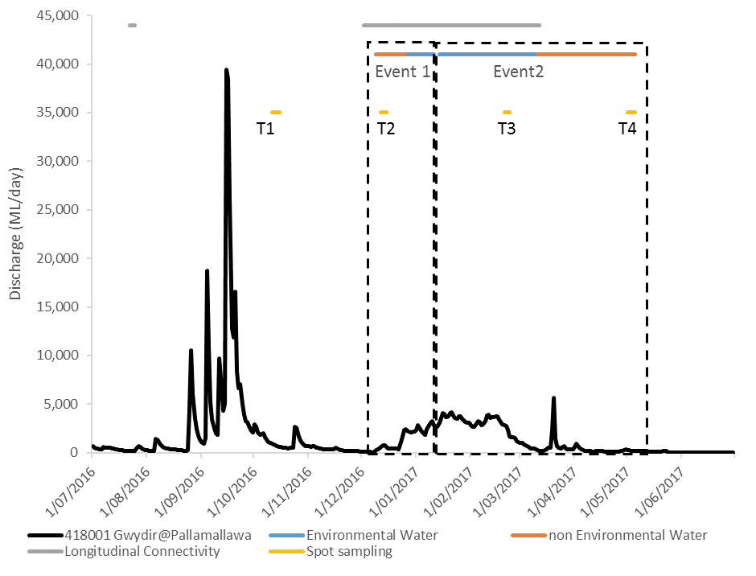
Figure C-1: Mean daily discharge of two environmental water and non-environmental water periods at Gwydir Pallamallawa gauging station (NSW418001) and four spot sampling periods. Orange indicates Environmental Water delivery periods. Blue indicates non- Environmental Water delivery periods.

Table C-1: Summary of water quality data records used in the analysis in 2016-17. EW represents Environmental Water.
Event | EW period | non-EW period | Number of days in each period
1 | 26 Dec 16 to 8 Jan 17 | 8 to 11 Dec 16 and 15 to 25 Dec 16 | 14, 14
2 | 31 Jan 17 to 10 Mar 17 | 11 Mar 17 to 18 Apr 17 | 39, 39

Short term sampling
Water quality and nutrient indicators were measured in association with microinvertebrate indicators (Table C-2). Sampling sites were located in five sampling zones within the Selected Area: Gingham Watercourse, Lower Gwydir Wetlands, Gwydir River, Mehi River and Moomin Creek (Table C-3). Sampling took place on four occasions in Oct 2016, December 2016, February 2017 and May 2017 to capture the inundation and contraction cycle of environmental water delivery as well as local rainfall events (Figure C-1). Hereafter, sampling occasion codes are arranged in chronological order from T1 to T4 (Figure C-1). Hydrological conditions within the Selected Area during four sampling periods are described as follows:
T1 ‘Post-natural flood’ period
This spring sampling period (11th -14th October 2016) represents conditions one month after peak flooding resulting from upstream inflow and localised rainfall. All river systems were influenced by the falling limb (average 750 ML/d in the Gwydir River) following a large natural flow pulse in mid-September with peak flow of 39,400 ML/d in the Gwydir River and 7,700 ML/d in the Mehi River. The Gingham and Lower Gwydir watercourses experienced the largest and deepest inundation area of this watering year. Longitudinal connectivity between the Gwydir River and both watercourses occurred from August 2016 driven by rainfall events.
T2 ‘Pre-EW’ period
This summer sampling period (12th -15th December 2016) represents post flooding conditions and was prior to environmental watering actions. All river systems experienced three months of low and stable flow conditions since the previous sample period with an average discharge of 670 ML/d in the Gwydir River. The Gingham watercourse was in a contraction phase and the Lower Gwydir wetlands was predominantly dry.
T3 ‘EW’ period
This late summer sampling period (20th -23rd February 2017) captures the ‘rewetting’ phase of the Selected Area due to ongoing environmental watering actions since late December, creating a flow event for two months with Commonwealth environmental water contributions. All river systems were longitudinally connected with an average discharge of 3,000 ML/d for 60 days in the Gwydir River. The environmental water delivered also aimed to maintain water levels in the watercourses. Thus, water levels in the Gingham and Lower Gwydir wetlands rose from the previous sample period in December and maintained surface water presence.
T4 ‘EW contraction’ period
This autumn sampling period (1st – 4th May 2017) was designed to capture the contraction cycle of residual environmental water. All river systems were in base flow condition with no longitudinal connectivity. Discharge in the Gwydir River was around 220 ML/d. The Gingham watercourse water level dropped while the lower Gwydir wetlands had contracted to a few disconnected pools.
Samples were collected and analysed following the methods in 2015-16 report Appendix D, Figure C-2). To identify dominant environmental indicators in the study area, a principal components analysis (PCA) was performed to summarise indicators into axes (components).

Table C-2: Water quality and water nutrient indicators measured in spot sampling in 2016-17.
Indicators | Variables | Units | Code
Water quality | Temperature | °C | temp
 | pH | - | ph
 | Turbidity | NTU | turb
 | Conductivity | mS/cm | cond
 | Dissolved Oxygen | mg/L | do
 | Chlorophyll a | µg/L | Chla
Water nutrients | Total Nitrogen | µg/L | tn
 | Total Phosphorus | µg/L | tp
 | Nitrate-nitrite | µg/L | nox
 | Filterable Reactive Phosphorus | µg/L | frp
Table C-3: Location of sites within the Gwydir River Selected Area for water quality and water nutrient spot sampling surveys.
Ecosystem | Sampling Zone | Site | Easting | Northing | Inundation
 |  |  |  |  | Oct-16  (T1) | Dec-16  (T2) | Feb-17  (T3) | May-17  (T4)
Wetland | Gingham  Watercourse | BUNOW | 731409 | 6759165 | Wet | Wet | Wet | Wet
 |  | BUNWC | 730157 | 6759022 | Wet | Dry | Dry | Dry
 |  | BUNTY | 731394 | 6759148 | Wet | Wet | Wet | Wet
 |  | GINOW | 724103 | 6762962 | Wet | Wet | Wet | Wet
 | Lower Gwydir  Wetland | OLDWC | 726664 | 6751404 | Wet | Dry | Dry | Dry
 |  | OLDBS | 726067 | 6752088 | Wet | Dry | Wet | Wet
River | Gwydir River | GW2 | 209205 | 6740455 | Wet | Wet | Wet | Wet
 |  | GW3 | 783417 | 6743135 | Wet | Wet | Wet | Wet
 |  | GW4 | 775597 | 6741491 | Wet | Wet | Wet | Wet
 | Mehi River | ME1 | 211342 | 6736610 | Wet | Wet | Wet | Wet
 |  | ME2 | 753566 | 6726591 | Wet | Wet | Wet | Wet
 |  | ME3 | 719420 | 6731644 | Wet | Wet | Wet | Wet
 | Moomin Creek | MO1 | 753679 | 6721789 | Wet | Wet | Wet | Wet
 |  | MO2 | 740017 | 6712590 | Wet | Wet | Wet | Wet
 |  | MO3 | 708808 | 6714077 | Wet | Wet | Wet | Wet
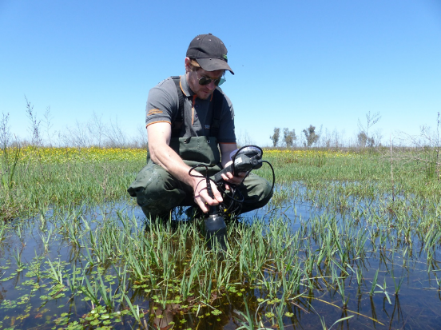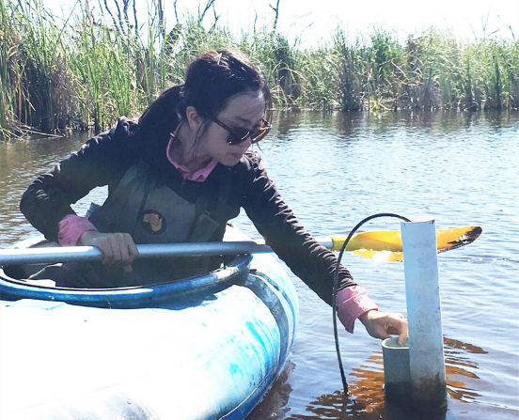
Figure C-2: Spot sampling for water quality indicators in the Lower Gwydir wetland (top) and the Gingham watercourse (bottom).

Results

C.3.1 Gwydir River long-term station
Mean daily temperature increased steadily from July to January consistent with seasonal patterns (Figure C-3a). Mean daily temperature was not significantly different between environmental water delivery periods and non-environmental water delivery periods (Table C-4). Temperature did not have strong predictable linear relationship with discharge (Figure C-4a), suggesting seasonal change exerts a stronger influence on temperature than magnitude of flows.
Like previous years, mean daily pH values were consistently alkaline, ranging from 7.3 to 8.4. They were significantly lower during the environmental water delivery periods (Figure C-3b and Table C-4). Mean daily pH was above the ANZECC guideline trigger value (pH between 6.5 and 8; Figure C-3b) during non-environmental periods. The regression identifies that an increase in discharge was correlated with a decrease in pH irrespective of the water source (Figure C-4b).
Mean daily conductivity ranged from 0.15 to 0.79 mS/cm and was consistently within the ANZECC guideline trigger values (0.125 and 2.2 mS/cm; Figure C-3c) throughout the year. During environmental water delivery periods, mean daily conductivity was significantly lower, highlighting the potential dilution effects provided by environmental water to the lower Gwydir catchment (Table C-4). Discharge was negatively correlated with conductivity irrespective of the water source (Figure C-4c). Conductivity ranges have been similar across all water years (2014-17) (Figure C-5, Commonwealth of Australia 2016).
The range of mean daily dissolved oxygen concentrations (52% - 123%) was greater than the range for the ANZECC water quality guideline (85-110% in dissolved oxygen, Figure C-3d). There was no significant difference in dissolved oxygen concentrations between environmental water delivery periods and non-environmental water delivery periods (Table C-4). Dissolved oxygen concentration had a poor correlation with discharge (Figure C-4d), and was more variable this year compared with previous years (Figure C-5).

Table C-4: Mean ± standard deviation (SD) of measured water quality indicators in Environmental Water delivery periods (CEW) and non-Environmental Water delivery periods (non-CEW). Mann-Whitney U test and Regression results with significant different at p <0.05 *.
Indicator | Unit | CEW |  | non-CEW |  | U test |  | Regression r²
 |  | Mean | ±SD | Mean | ±SD | chi-square | p-value
Temperature | °C | 24.7 | 1.3 | 24.6 | 2.6 | 0.001 | 0.977 | 0.018 (linear)
pH | - | 7.4 | 0.0 | 7.8 | 0.2 | 62.733 | <0.005* | 0.211 (polynomial)
Conductivity | mS/cm | 0.19 | 0.03 | 0.45 | 0.13 | 77.821 | <0.005* | 0.354 (polynomial)
Dissolved Oxygen | % | 82 | 5 | 81 | 9 | 0.014 | 0.907 | 0.030 (linear)
Discharge | ML/day | 2274 | 1036 | 579 | 859 | 56.395 | <0.005* | -


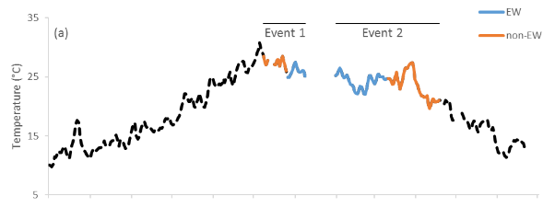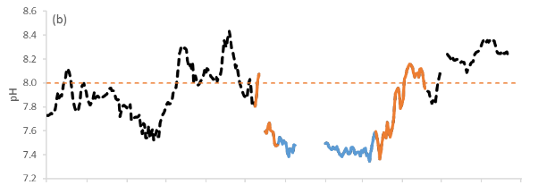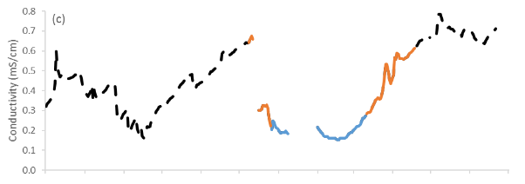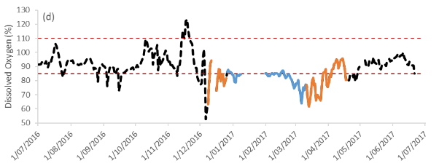
Figure C-3: Mean daily (a) temperature, (b) pH, (c) conductivity and (d) dissolved oxygen concentrations. EW represents environmental water. Black dotted line represents all available data from this watering year and red dotted line represents ANZECC guideline trigger value.

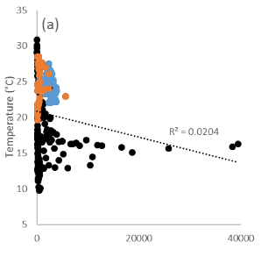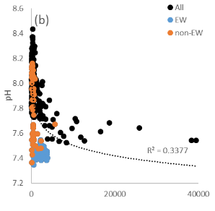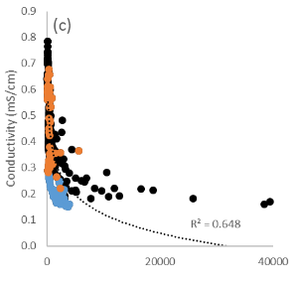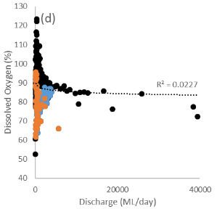
Figure C-4: Regressions between discharge at Gwydir Pallamallawa gauge (NSW418001) and mean daily (a) temperature, (b) pH, (c) conductivity and (d) dissolved oxygen concentrations. All represents all available data outside of the periods of comparison from this watering year and EW represents environmental water.

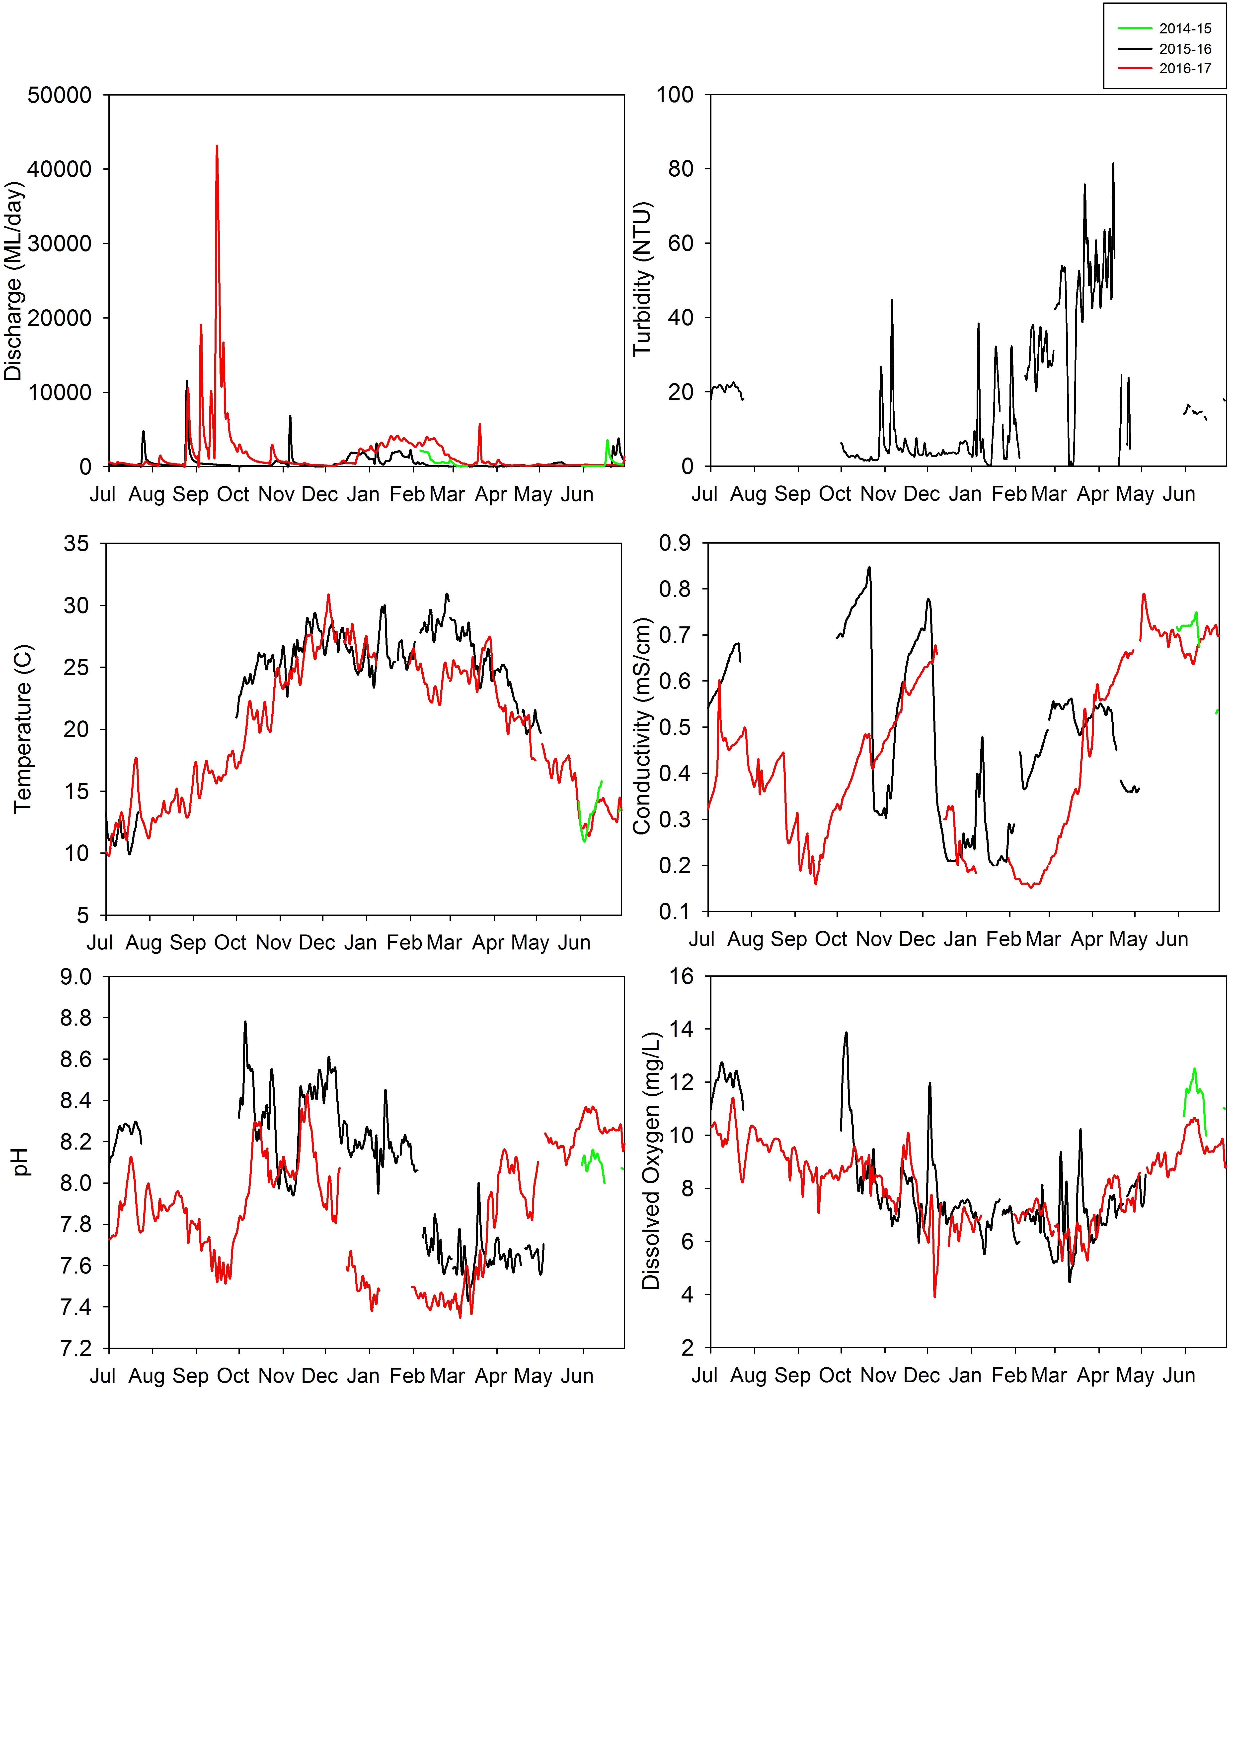Figure C-5: Mean daily discharge and water quality indicators at Gwydir Pallamallawa gauging station (NSW418001) in 2014-17.

C.2.2 Short term sampling
All sites exhibited highly variable water quality conditions across the four sampling periods. Water temperature ranged from 16.5°C to 29.4°C, and was higher in summer than other periods as expected (Figure C-6a). The pH ranged from 6.89 to 8.51, and was slightly lower in wetland habitats compared with river channels. All river sites were consistently alkaline, with pH above the ANZECC guideline trigger value (pH between 6.5 and 8) during T1 and T4 (Figure C-6b). Turbidity in wetland sites was consistently within the ANZECC guideline trigger values (6-50 NTU). On the other hand, turbidity in river sites increased with time, with the highest turbidity of 156 NTU recorded in Moomin Creek (Figure C-6c). Conductivity was within the ANZECC water quality guideline (conductivity between 0.125 and 2.2 mS/cm) at all sites and sampling periods (Figure C-6d). Dissolved oxygen concentrations ranged from 55% to 113% (4.77mg/L to 10.35mg/L, (Figure C-6e)). Wetland and watercourse dissolved oxygen concentrations were generally lower than the ANZECC water quality guideline (dissolved oxygen percent between 85% and 110%). All river sites experienced dissolved oxygen concentrations below the ANZECC guideline during T2 with receding flows following spring flooding.
TN concentrations were generally higher than the ANZECC guideline trigger value (TN at 500 µg/L) across all sites during T1 (Figure C-7a). NOx concentrations were higher than the ANZECC guideline trigger value (Nitrate-nitrite at 40 µg/L) in all sites and sampling occasions (Figure C-7b). Across all sites, TN and NOx were generally higher during T1 immediately following inundation, and had decreased by periods T3 and T4. TP concentrations were higher than the ANZECC guideline trigger value (TP at 50 µg/L) at all sites and sampling occasions (Figure C-7c). The highest concentration of 695 µg/L was recorded in the Lower Gwydir wetland during T1. Filterable reactive phosphorus (FRP) concentrations were also consistently higher than the ANZECC guideline trigger value (FRP at 20 µg/L, Figure C-7d), with wetland sites consistently higher in TP and SRP than river sites. Chlorophyll a concentrations ranged between 1 and 51 µg/L (Figure C-7e). In general, all wetland and watercourse sites had higher chlorophyll a than river sites, except Moomin Creek during T3.
As environmental variables do not operate independently, and temporal and spatial patterns in environmental data may be complex, the suite of measured variables was further explored using PCA to search for multiple environmental drivers influencing water quality. PC1 (axis-x) explained 24.8% of the variation and the vector overlay suggested that nutrients and conductivity were strongly associated (Figure C-8a). PC2 (axis-y) explained 19% of the variation with dissolved oxygen and pH positively aligned, and temperature negatively aligned along the axis (Figure C-8a). The PCA plot suggests that environmental conditions were predominantly driven by temporal change across the study sites (zones and sites; Figure C-8b). On the other hand, ‘zone’ did not show any distinctive pattern.
Furthermore, the PCA ordination showed increased scatter (water quality variability among sites) for T1, suggesting that environmental conditions were variable among sites under the flooded conditions irrespecive of their location in the wetlands or river channels (Figure C-8b). On the other hand, sites in periods T2, T3 and T4 were clustered closely together, suggesting that the environmental conditions were more similar among these sampling occasions when water levels and flow were reduced.
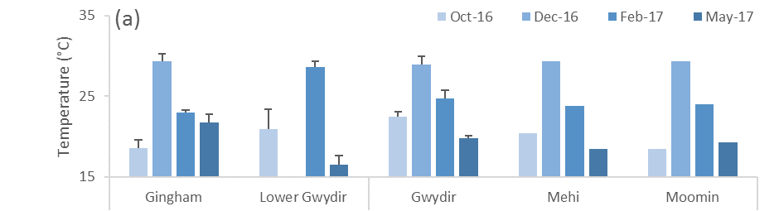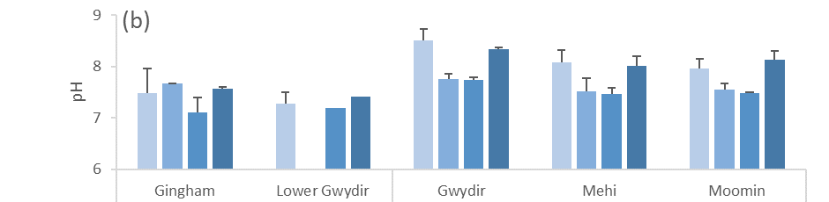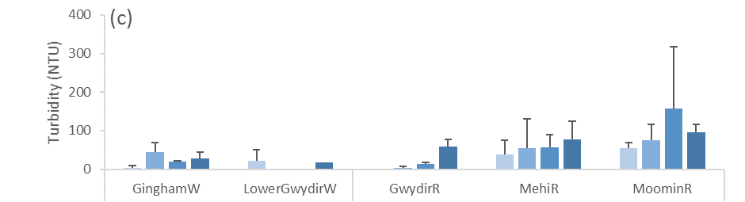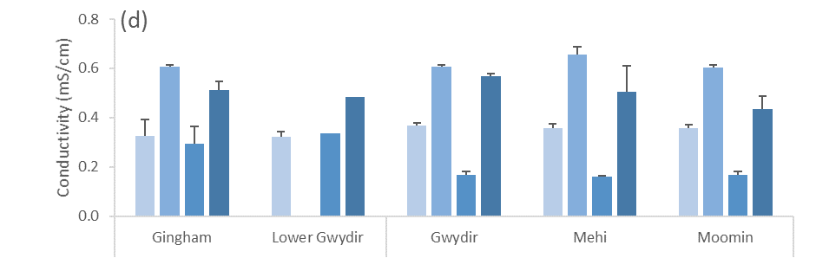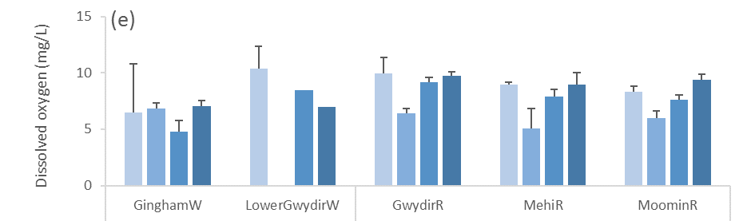
Wetland River channel
Gingham Lower Gwydir Gwydir Mehi Moomin
Gingham Lower Gwydir Gwydir Mehi Moomin

Figure C-6: Mean ± standard deviation (SD) of (a) temperature, (b) pH, (c) turbidity, (d) conductivity and (e) dissolved oxygen concentration.
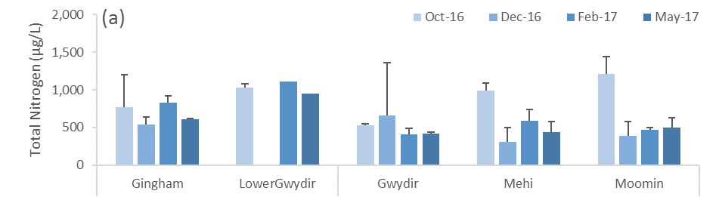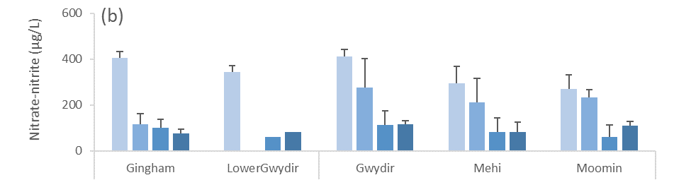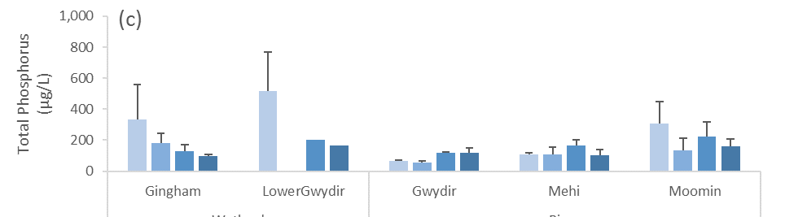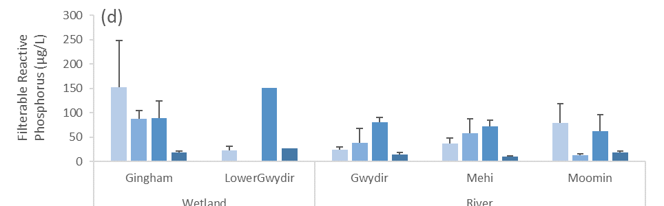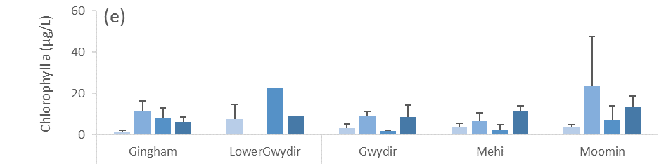
Wetland River channel

Figure C-7: Mean ± standard deviation (SD) of (a) total nitrogen, (b) nitrate-nitrite, (c) total phosphorus, (d) filterable reactive phosphorus and (e) chlorophyll a concentration.
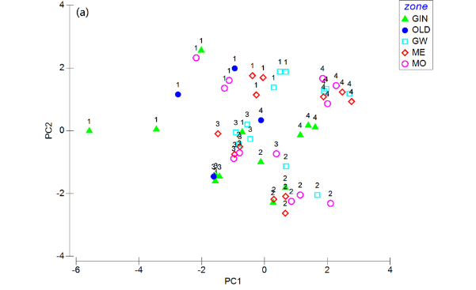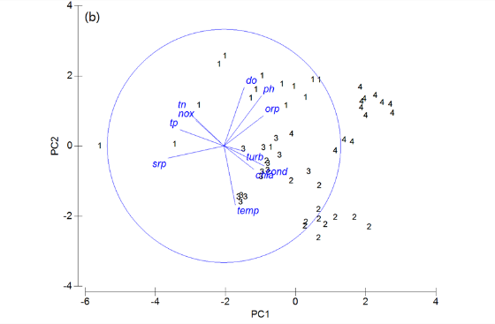
Figure C-8: Principal components analysis (PCA) bi-plot of water quality and nutrient indicators showing (a) time and zone and (b) time and vectors of environmental variables (normalised data, Spearman correlation) which underlie the environmental patterns among samples. Sampling occasions 1=Oct-16, 2=Dec-16, 3=Feb-17 and 4=May-17.

Discussion

Gwydir River continuous monitoring
In this water year, two separate environmental flow events were released to maintain connectivity and prolong wetland inundation for about two months in summer following a natural flow event in early spring. Like previous years, the delivery of environmental water significantly reduced mean pH and conductivity when compared to non-environmental water periods. In particular, the delivery of environmental water led to significant improvement of pH levels to below the ANZECC water quality guideline. These processes reflect the dilution effects provided by environmental water, and the changes in water chemistry associated with the increase in discharge and wetted area of channels.
Flow events in 2016-17 (peak flow around 39,400 ML/d) were much higher in magnitude than in 2015-16 (peak flow around 11,400 ML/d). Most water quality values were lower with reduced variability during 2016-17 in response to the higher magnitude flows. The delivery of environmental water in 2016-17 did not lead to significant differences in dissolved oxygen. This contrasts with 2015-16 where a significant increase in dissolved oxygen was observed with the delivery of environmental water, and likely reflects less responsive biological activity during higher flows.

Short term sampling
Four spot sampling occasions successfully captured the inundation and contraction cycle of environmental watering actions and the influence of local rainfall events in 2016-17. In this water year, a large natural flow pulse occurred in early spring followed by two consecutive environmental water actions to create a sustained flow event through summer in the Selected Area.
Water temperature during the four sampling occasions responded to broader regional climate patterns rather than flow or other environmental conditions. All zones in the Selected Area had exceptionally high nitrogen and phosphorus concentrations consistent with observations from the previous two years of the project. Changes in environmental conditions were predominantly driven by temporal changes in water column physicochemical conditions and nutrient concentrations in both river and wetland ecosystems. As expected, water quality differed between river channels and wetland environments evidenced by marked differences in pH, turbidity and conductivity.
In general, all river systems experienced similar hydrologic rates of rise and fall, with the peak in the Gwydir River (around 39,400 ML/d) significantly higher than in the Mehi River and Moomin Creek (7,700 ML/d peak). River systems tended to be alkaline with higher turbidity and more variable conductivity than the wetlands due to the stronger influence of hydrological variation. Turbidity in Moomin Creek was consistently higher than in the Mehi and Gwydir Rivers, likely reflecting catchment influences such as local landuse and sediment types.
In all river systems, the highest concentrations of NOx and TN, and the lowest turbidity were recorded one month after the natural flow event, reflecting longitudinal and lateral inputs of nutrients (Bayley & Sparks, 1989). However, productivity measured as chlorophyll a did not respond to these increases in nitrogen, suggesting that either cooler temperatures limited water column primary production, expanses of emergent macrophytes were using the nutrients for growth, or nitrogen is not the limiting nutrient regulating production.
Environmental water actions in late December created longitudinal connection and persistent inundation for up to two months following the natural flow event. Conductivity was lowest during this period due to dilution from upstream sources, matching the trend observed at the Gwydir River continuous monitoring station. During this environmental water period, smaller increases in concentrations of TN, TP, FRP and dissolved oxygen were observed relative to the pre-environmental water period. Nutrient inputs to the Lower Gwydir from environmental water sources in T3 were smaller than those from the natural flood event (T1) suggesting that environmental water and natural flood water may lead to differing water quality and therefore differing biological responses, with lower productivity resulting from environmental water events that diluted nutrients.
Conductivity levels were higher in the pre-environmental water period and post-environmental water contraction period, likely due to evapo-concentration. In particular, pH exceeded the ANZECC guideline in T4 during the post environmental water contraction period. Increases in chlorophyll a concentrations were also observed in these two sampling periods, reflecting increased primary productivity during high temperature and low flow periods among all river sites. This suggests that these patterns were predominantly controlled by decreased flow and season.
In the wetlands, the highest concentrations of TP and NOx as well as high TN were recorded one month after the natural flow event, reflecting longitudinal (and lateral) inputs of nutrients. However, similarly to the river sites, primary productivity did not follow increased nutrients, suggesting that cooler temperature limit primary producer metabolism rate and postpone the primary production boom. As temperature rose to around 30 °C in sampling period T2, chlorophyll a concentrations increased to peak levels.
In late summer, environmental water actions longitudinally connected the Gwydir River to the lower Gwydir and maintained water levels in the Gingham watercourse. During this period, dissolved oxygen and chlorophyll a concentrations decreased in the Gingham watercourse but increased in the Lower Gwydir wetlands, showing independent wetland responses to the same flow event. Decreases in NOx, TP and FRP concentrations were observed in the pre-environmental water period affected by the natural flow event and post-environmental water contraction period, likely due to longitudinal disconnection with the Gwydir River preventing the import of nutrients from upstream flows.

Conclusion
In the Gwydir River, continuous monitoring identified that, similarly to 2015-16, higher magnitude events and contributions of environmental water reduced pH and conductivity through dilution. In contrast to 2015-16, the delivery of environmental water in 2016-17 did not lead to significant differences in dissolved oxygen and chlorophyll a concentrations. This suggests that inter-annual hydrological variability and antecedent flow condition play important roles in water quality variability, highlighting the importance of long-term monitoring in highly dynamic systems.
In general, nutrient concentrations exceeded ANZECC guideline trigger values at all sites and times. Spot sampling demonstrated that river systems were more alkaline and turbid with lower nutrient concentrations than the wetland and watercourse systems. The environmental water delivered from December 2016 created a flow event with prolonged discharge that resulted in a decrease in conductivity throughout the Selected Area, following the dilution effect that was also observed at the long-term monitoring station. It is plausible that the environmental water transported excess nutrients through the river channels while it diluted very high nutrient concentrations in wetland systems in the lower Gwydir.

References
Bayley, P. B., & Sparks, R. E. 1989. The flood pulse concept in river-floodplain systems. Paper presented at the Proceedings of the International Large River Symposium. Dodge, DP (Ed). Can. Spec. Publ. Fish. Aquat. Sci.
Commonwealth of Australia. 2015. Commonwealth Environmental Water Office Long Term Intervention Monitoring Project Gwydir River System Selected Area – 2014-15 Evaluation Report. Commonwealth of Australia.
Commonwealth of Australia. 2016. Commonwealth Environmental Water Office Long Term Intervention Monitoring Project Gwydir River System Selected Area – 2015-16 Evaluation Report. Commonwealth of Australia.

Microinvertebrates

Introduction
The category III microinvertebrate indicator aims to assess the contribution of Commonwealth environmental watering to microinvertebrate abundance and diversity. Several specific questions were addressed through this indicator within the Gwydir river system (Selected Area) during the 2016-17 water year:
- What did Commonwealth environmental water contribute to microinvertebrate productivity?
- What did Commonwealth environmental water contribute to microinvertebrate community composition?
- What did Commonwealth environmental water contribute to connectivity of microinvertebrate communities in floodplain watercourse?

Environmental watering in 2016-17
During 2016-17 environmental water was delivered to several assets within the Selected Area. In September 2016, a flow event occurred down the Mehi River and supplementary water licences owned by the CEWO were triggered. A total of 5000 ML was accounted for in the Mehi River.
Supplementary flows were triggered in the Mallowa in September 2016, however very little of the flow was diverted into the Mallowa wetlands. In January - March 2017, planned deliveries of 5,000 ML were increased to 10,000 ML to the Mallowa Creek system to inundate fringing wetlands. Flows were also delivered into the lower Gwydir River and Gingham watercourse to build upon moderate winter/spring flows. In January - March 2017, 30,000 ML was delivered, aiming to inundate broad areas of semi-permanent wetland vegetation.
During 2016-17, no environmental water was delivered to the Moomin Creek.

Previous monitoring
In 2014-16, the delivery of environmental water to the Selected Area resulted in a pulse of carbon and nutrients that stimulated rates of both primary and microbial productivity. This increased productivity further supported secondary production measured as microinvertebrate density, with the delivery of environmental water increasing microinvertebrate diversity and therefore potential food resources for fish, frogs and waterbirds. In particular, wetland systems had significantly higher nutrient and algal levels and microinvertebrate production compared with river sites in 2015-16, reinforcing the importance of environmental water delivery throughout the lower Gwydir to promote the regional scale abundance and diversity of aquatic microinvertebrates.

Methods

Design
Microinvertebrates sampling took place on four occasions to capture the inundation and contraction cycle of environmental water delivery as well as local rainfall events (Table D-1, Table D-2 and Figure D-1). Hereafter, sampling occasion codes are arranged in chronological order from T1 to T4.
T1 ‘Post-flood’ period
This spring sampling period (11th -14th October 2016) represents conditions one month post peak flood resulting from upstream inflow and localised rainfall. All river systems were influenced by the falling limb (average 750 ML/d in the Gwydir River) following a large natural flow pulse in mid-September with peak flow of 39,400 ML/d in the Gwydir River and 7,700 ML/d in the Mehi River. The Gingham and lower Gwydir watercourses experienced the largest area and deepest inundation of this watering year. Longitudinal connectivity between the Gwydir River and both watercourses occurred since August 2016 driven by rainfall events.
T2 ‘Pre-EW’ period
This summer sampling period (12th -15th December 2016) represents post-flooding conditions and was prior to environmental watering actions. All river systems experienced three months of low and stable flow condition since the previous sample period with average discharge of 670 ML/d in the Gwydir River. The Gingham watercourse was in a contraction phase and the Lower Gwydir wetlands was predominantly dry.
T3 ‘EW’ period
This late summer sampling period (20th -23rd February 2017) captured the ‘rewetting’ phase of the Selected Area due to ongoing environmental watering actions since late December, creating a flow event for two months with environmental water contributions. All river systems were longitudinally connected with an average discharge of 3,000 ML/d for 60 days in the Gwydir River. The environmental water delivered also aimed to maintain water levels in the watercourses. Thus, water levels in the Gingham and Lower Gwydir wetlands rose from the previous sample period in December and maintained surface water presence.
T4 ‘EW contraction’ period
This autumn sampling period (1st – 4th May 2017) was designed to capture the contraction cycle of residual environmental water. All river systems were in base flow condition with no longitudinal connectivity. Discharge in the Gwydir River was around 220 ML/d. The Gingham watercourse water levels dropped while the Lower Gwydir wetlands had contracted to a few disconnected pools.

Table D-1: Microinvertebrate, water quality and water nutrients indicators measured at each sites and sampling occasions in 2016-17.
Indicators | Variables | Units | Code
Microinvertebrate | Density | individual/L | -
 | Diversity | - | -
 | Richness | - | -
 | community presence-absence | - | -
 | community abundance (sq root) | - | -
Water quality | Temperature | °C | temp
 | pH | - | ph
 | Turbidity | NTU | turb
 | Conductivity | mS/cm | cond
 | Dissolved Oxygen | mg/L | do
 | Chlorophyll a | µg/L | Chla
 | Redox potential | mV | orp
Water nutrients | Total Nitrogen | µg/L | tn
 | Total Phosphorus | µg/L | tp
 | Nitrate-nitrite | µg/L | nox
 | Filterable Reactive Phosphorus | µg/L | frp

Table D-2: Location of sites within the Gwydir River Selected Area for category III microinvertebrate surveys.
Ecosystem | Sampling Zone | Site | Eastings | Northing | Inundation
 |  |  |  |  | Oct 16  (T1) | Dec 16  (T2) | Feb 17  (T3) | May 17  (T4)
Wetland | Gingham Watercourse | BUNOW | 731409 | 6759165 | Wet | Wet | Wet | Wet
 |  | BUNWC | 730157 | 6759022 | Wet | Dry | Dry | Dry
 |  | BUNTY | 731394 | 6759148 | Wet | Wet | Wet | Wet
 |  | GINWH | 724103 | 6762962 | Wet | Wet | Wet | Wet
 | Lower Gwydir Wetland | OLDWC | 726664 | 6751404 | Wet | Dry | Dry | Dry
 |  | OLDBS | 726067 | 6752088 | Wet | Dry | Wet | Wet
River | Gwydir River | GW2 | 209205 | 6740455 | Wet | Wet | Wet | Wet
 |  | GW3 | 783417 | 6743135 | Wet | Wet | Wet | Wet
 |  | GW4 | 775597 | 6741491 | Wet | Wet | Wet | Wet
 | Mehi River | ME1 | 211342 | 6736610 | Wet | Wet | Wet | Wet
 |  | ME2 | 753566 | 6726596 | Wet | Wet | Wet | Wet
 |  | ME3 | 719420 | 6731644 | Wet | Wet | Wet | Wet
 | Moomin Creek | MO1 | 753679 | 6721789 | Wet | Wet | Wet | Wet
 |  | MO2 | 740017 | 6712590 | Wet | Wet | Wet | Wet
 |  | MO3 | 708808 | 6714077 | Wet | Wet | Wet | Wet

Field and laboratory methods
Benthic microinvertebrates were sampled by compositing five cores (50 mm diameter x 120 mm long with 250 mL volume) for each site. Replicates were separated by a minimum of 20 linear metres. The composite sample was allowed to settle for a minimum of 15 minutes and then the supernatant was poured through a 63 μm sieve. The retained sample was washed into a labelled jar and stored in ethanol (70 % w/v with Rose Bengal stain) until laboratory analysis.
Pelagic microinvertebrates were sampled by sampling 100 L of the water column at each site. Samples were poured through a plankton net (63 μm). Retained samples were stored in ethanol (70 % w/v) with Rose Bengal stain until laboratory analysis.
Samples were thoroughly mixed, and divided into 12 equal subsamples. Once subsamples was sorted on a Bogorov tray under a stereo microscope at up to 400x magnification. Microinvertebrates were identified to family level (rotifers and cladocerans), class (copepods) and ostracods. The volumes of the total samples were recorded and subsample totals were scaled up to each total sample volume and reported as density/L. Samples were stored in 70% ethanol with Rose Bengal for auditing purposes.

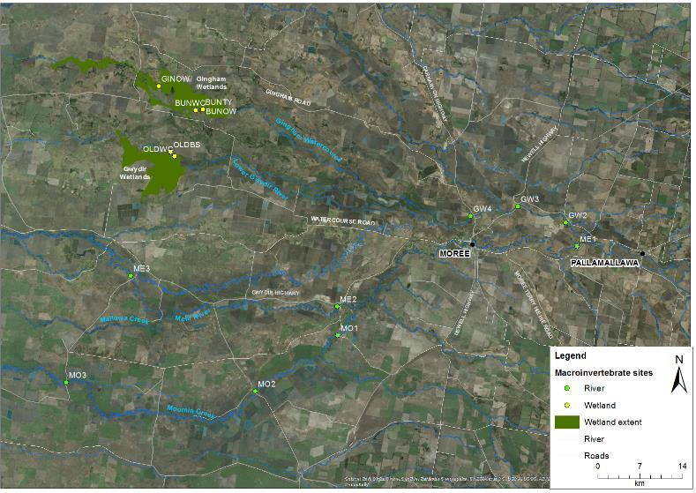
Figure D-1: Location of microinvertebrate sites within the Selected Area in 206-17. See Table D-2 for site codes.
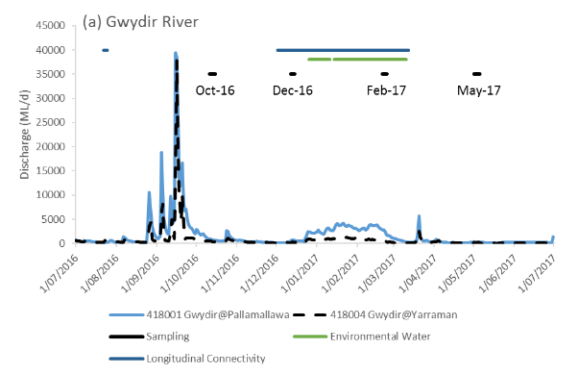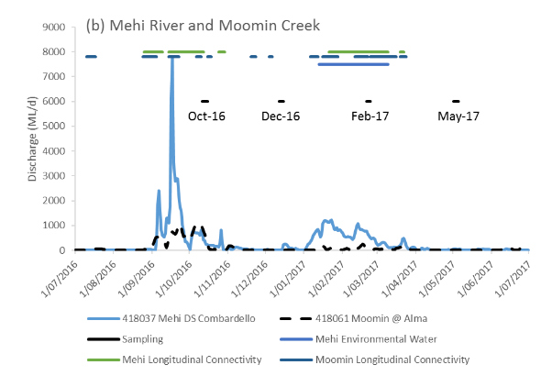
Figure D-2: River flows in the (a) Gwydir River and (b) Mehi River and Moomin Creek and the timing of environmental water releases and longitudinal connectivity down this channel.

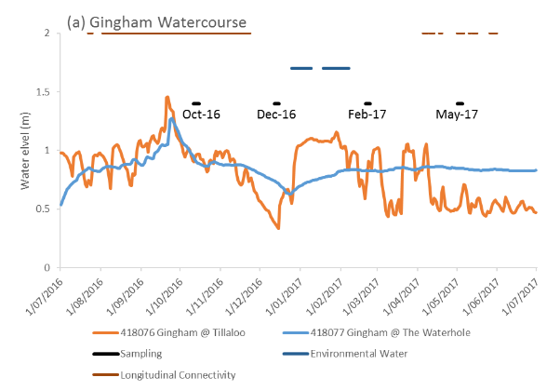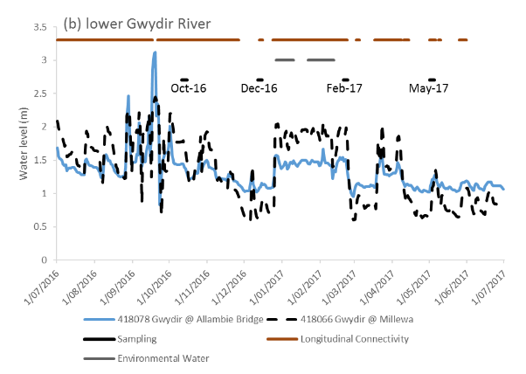
Figure D-3: River flows in the (a) Gingham watercourse and (b) lower Gwydir river and the timing of environmental water releases and longitudinal connectivity down this channel.

Statistical methods
To describe and summarize the diversity of microinvertebrate community composition, taxa richness (S), Shannon Weiner diversity (d) and density (number of individual/L) were calculated in PRIMER v6.1.13 using the DIVERSE function. PERMANOVA routine was used to test the difference in S, d and density between HABITAT (with 2 fixed levels, benthic and pelagic), TIME (with 4 random levels, Oct 16, Dec 16, Feb 17 and May 17), ZONE (with 5 fixed levels, Gingham watercourse, Lower Gwydir wetlands, Gwydir River, Mehi River and Moomin Creek) and TIME x ZONE interactions.
The community composition data were transformed into two datasets that weigh the contributions of common and rare species differently. (1) Presence-absence data represents actual taxa occurrence in a community. (2) Abundance data (square root transformation to stabilize variance and to improve normality; Clarke and Warwick, 2001) represents relative proportions of taxa occurrence in a community. Since different sampling methods were used in benthic and pelagic habitats, a permutational multivariate analysis of variance (PERMANOVA) analysis was used to test the difference in the microinvertebrate community composition between HABITAT (with 2 fixed levels, benthic and pelagic), TIME (with 4 random levels, Oct 16, Dec 16, Feb 17 and May 17), ZONE (with 5 fixed levels, Gingham watercourse, Lower Gwydir wetland, Gwydir River, Mehi River and Moomin Creek) and TIME x ZONE interactions. Up to 999 random permutations estimated the probability of p-values, with levels of significance reported as p<0.05. Where PERMANOVA results were significant, two datasets by habitat (benthic and pelagic) were developed to further explore the effects of time, zone and interaction.
A Bray-Curtis dissimilarity matrix was generated by rank correlating the community structure between samples. Then, nonmetric multidimensional scaling ordinations (nMDS) were used to visualise community patterns and similarity percentages (SIMPER) were used to determine the taxa contributing to the observed community patterns. NMDS output with stress values of less than 0.2 were considered appropriate for interpretation (Clarke and Warwick, 2001).
Water quality and nutrient indicators reported in Appendix C were used to relate environmental indicators to microinvertebrate patterns. BIOENV analysis was used to examine which water quality and nutrient indicators are link to the patterns of microinvertebrate community composition in PRIMER-E (2009). All analyses were performed in PRIMER v6.1.13 with the PERMANOVA+ v1.0.3 add-on package (PRIMER-E, 2009).
Wetland scale microinvertebrate densities were calculated for both Gingham and Lower Gwydir wetlands by multiplying the density observed in each sampling occasion by the estimated volume of water present in the different vegetation communities for each sampling occasions. Wetland scale estimated volume calculation methods are outlined in Appendix B.

Results
A total of 50 taxa were identified (from 106 samples). The 19 most abundant taxa (>1% in total abundance) comprised 94% of the total abundance with the most abundant taxa being the rotifer Family Filiniidae (16% of the total abundance) and Genus Polyarthra (10%). The other most abundant taxa in descending order were Cladoceran nauplii (10%) and rotifer Order Bdelloida (9%) that were common in all sites and sampling periods.

Density
Microinvertebrate densities in wetland systems (from 1,178/L to 15,664/L) were consistently higher than those in river systems (from 201/L to 7,448/L) and were similar between benthic and pelagic habitats (Figure D-8). There was a significant interaction between the effects of time and zone (Pseudo-F=3.03, p<0.005) in microinvertebrate densities. In Oct 16, there was significantly higher densities in the Lower Gwydir wetlands than all other sites (pairwise test p<0.05). In Dec 16, microinvertebrate densities were highest across all sites (except for Lower Gwydir wetland sites which were dry) with a significant difference in pairwise tests (p<0.05). In Feb 17, all wetland systems had significantly higher microinvertebrate densities than all river systems in pairwise test (p<0.05).
Peak microinvertebrate density was observed in the Gingham watercourse in Dec 16 during the contraction phase of the natural flood event (Table D-3). In contrast, microinvertebrate density in the Lower Gwydir wetlands, was two times higher in Feb 17 with the influence of environmental water maintaining water levels than in Oct 16 (Table D-3).
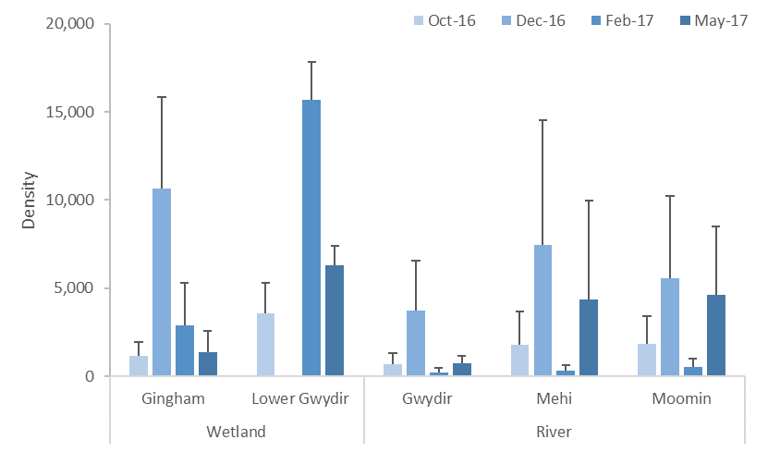
Figure D-4: Mean ± standard deviation (SD) of microinvertebrate density (individuals/L).

Table D-3: Whole system scale microinvertebrate density (number of individual/m²) in the Gingham and Gwydir wetlands in 2016-17. ‘-‘ represents no data collected due to dry sites and “n/a” represents no wetland estimated volume available to scale density data.
Wetland | Site | Vegetation community | Oct 16 | Dec 16 | Feb 17 | May 17
Gingham | BUNOW | Natural water body | 720,000 | 17,100,000 | 940,000 | n/a
 | BUNTY | Cumbungi swamp rushland | 450,000 | 5,500,000 | 750,000 | n/a
 | BUNWC | Water Couch - Spike-rush - Tussock Rush marsh grassland/sedgeland | 380,000 | - | - | -
 | GINWH | Natural water body | 720,000 | 10,970,000 | 4,610,000 | n/a
Gwydir | OLDBS | Cumbingi-Marsh Club Rush | 1,250,000 | - | 3,140,000 | n/a
 | OLDWC | Water Couch - Spike-rush - Tussock Rush | 1,670,000 | - | - | -
Subtotal (Gingham watercourse) |  |  | 2,270,000 | 33,570,000 | 6,300,000 | n/a
Subtotal (Lower Gwydir wetland) |  |  | 2,920,000 | - | 3,140,000 | n/a
Total (Two wetlands) |  |  | 5,160,000 | 33,570,000 | 9,420,000 | n/a

Diversity indices
Taxonomic richness ranged from 5 to 23 and there was a significant interaction between the effects of time and habitat (Pseudo-F=4.5529, p<0.05). In the benthic habitat, richness peaked in May 2017 and was significantly higher than Oct 2016 in pairwise test (p<0.05, Figure D-5a). In the pelagic habitat, richness peaked in Feb 2017 and was significantly higher than Oct 2016 and May 2017 (pairwise test; p<0.05, Figure D-5b).

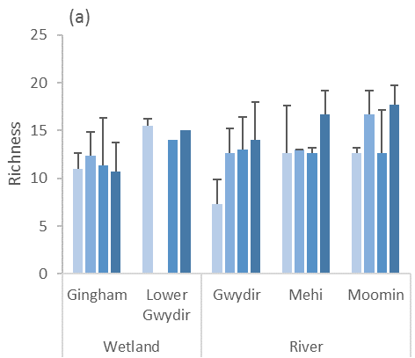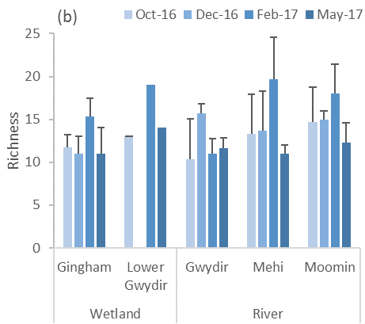
Figure D-5: Mean ± standard deviation (SD) of microinvertebrate taxonomic richness in (a) benthic habitat and (b) pelagic habitat.

Shannon diversity ranged from 1.27 to 1.89 in the wetland systems and from 1.23 to 2.29 in the river systems (Figure D-6), and was similar between benthic and pelagic habitats. There was a significant interaction between the effects of time and zone (Pseudo-F=3.276, p<0.005). In the Gwydir and Mehi River systems, diversity was significantly lower in Oct 2016 compared with all other sampling periods (p<0.05). In the Gingham watercourse, diversity was significantly lower than all other sites in Feb 2017 and May 2017 (p<0.05).
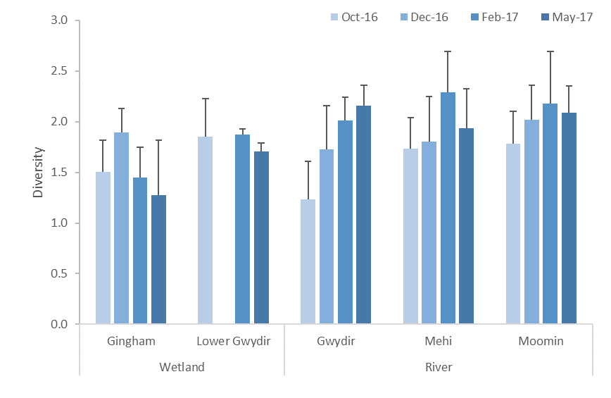
Figure D-6: Mean ± standard deviation (SD) of microinvertebrate diversity.

Taxonomic composition
PERMANOVA results indicated that the taxonomic composition was significantly different between wetland and river ecosystems (Pseudo-F=6.7411, p=0.0001), and between benthic and pelagic habitats (Pseudo-F=10.988, p=0.001) based on abundance. A similar result was also found based on species presence-absence. The dissimilarity between communities from different ecosystems and habitats are shown in the nMDS ordination with a stress value of 0.16 (Figure D-7). Since the taxonomic composition was predominantly driven by ecosystem and habitat, four individual datasets of ecosystem and habitat were developed to further explore the effects of time and zone.
The community difference between habitats was driven by the higher average abundance of Phylum Nematoda, rotifer Order Bdelloida, and Copepod nauplii in the benthic habitat and the higher average abundance of rotifer Family Filiniidae in pelagic habitats (Table D-4). The community difference between ecosystems was driven by the higher average abundance of Copepod nauplii, rotifer Order Bdelloida and Genus Polyarthra in the wetland ecosystem and the rotifer Family Filiniidae in river ecosystem (Table D-4).
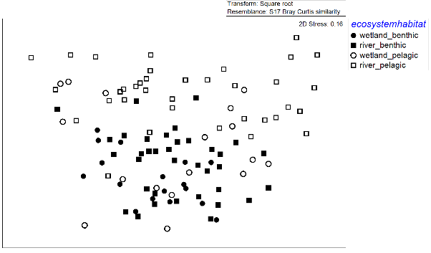
Figure D-7: NMDS ordination of microinvertebrate community composition by ecosystem (wetland and river) and habitat (benthic and pelagic) using the abundance dataset.
Table D-4: Microinvertebrate taxa contributing most of the dissimilarities between ecosystems and habitats based on abundance. Bold numbers represent the higher average abundance group.
Taxa | Average Abundance |  | Contribution % | Cumulative %
 | Benthic | Pelagic
P. Nematoda | 16.9 | 1.3 | 9.2 | 9.2
O. Bdelloida | 18.3 | 6.0 | 7.8 | 17.0
F. Filiniidae | 8.4 | 14.3 | 7.5 | 24.5
nauplii | 15.4 | 13.2 | 7.3 | 31.9
 | Wetland | River
nauplii | 22.5 | 10.4 | 9.5 | 9.5
O. Bdelloida | 18.1 | 9.3 | 7.8 | 17.4
F. Filiniidae | 9.5 | 12.3 | 7.4 | 24.8
G.Polyarthra | 12.1 | 8.9 | 7.0 | 31.8

D.3.3.1 Wetland
In the wetland ecosystem, two-way PERMANOVA analyses showed significant time and zone differences based on abundance in both benthic and pelagic habitats (Table D-5). The nMDS ordination with stress value of 0.14 in the benthic habitat (Figure D-8a) and 0.11 in the pelagic habitat (Figure D-9a) based on abundance data showed temporal and spatial shifts in community composition.
Microinvertebrate community composition was significantly different between all sampling periods in both habitats (p<0.05, Figure D-8a, Figure D-9a). The community difference between sampling periods was driven by an increasing abundance of rotifer Genus Brachionus, Family Filiniidae and Genus Polyarthra from Oct 16 to Dec 16 and then reduced in abundance in May 17 (Table D-6). There was also a significant difference between the Lower Gwydir wetland and the Gingham watercourse for both habitats (Figure D-8b and Figure D-9b). This spatial difference was driven by higher abundance of Copepod nauplii, rotifer Genus Lecane and Genus Polyarthra in the Lower Gwydir wetland (Table D-7).
All environmental indicators were subsequently fitted into the ordination space as vectors to show those indicators correlated to community patterns (Figure D-8c and Figure D-9c). The BIOENV result showed that community composition was highly correlated to increased chlorophyll a, temperature and conductivity during Dec 16 and Feb 17 in both habitats (Table D-8). This community compositional shift in time was also strongly correlated to higher densities in Dec 16 and Feb 17 (Figure D-8d and Figure D-9d).
Table D-5: PERMANOVA results of microinvertebrate community composition by ecosystem (wetland and river) and habitat (benthic and pelagic) using the abundance dataset. (*significant level at P<0.05).
Ecosystem | Term | Benthic |  | Pelagic
 |  | Pseudo-F | P | Pseudo-F | P
Wetland | Time | 5.1561 | 0.0001* | 4.3832 | 0.0003*
 | Zone | 4.1103 | 0.0041* | 4.4603 | 0.0033*
 | Time*Zone | 1.2394 | 0.2355 | 1.5084 | 0.1169
River | Time | 4.7229 | 0.001* | 9.5617 | 0.0001*
 | Zone | 2.3529 | 0.008* | 2.2151 | 0.0065*
 | Time*Zone | 1.103 | 0.290 | 1.5476 | 0.0138*
Table D-6: Microinvertebrate taxa contributing most of the dissimilarities in wetland ecosystems between times based on abundance dataset. Bold numbers represent the higher average abundance group.
Taxa | Average Abundance |  |  |  | Contribution %
 | T1 | T2 | T3 | T4 | T1 vs T2 | T2 vs T3 | T3 vs T4
G. Brachionus | 3.9 | 46.4 | 12.8 | 2.6 | 13.6 | 11.8 | 4.9
F. Filiniidae | 0.0 | 39.6 | 9.4 | 1.2 | 12.6 | 11.1 | 5.1
G.Polyarthra | 0.0 | 34.6 | 12.8 | 12.9 | 10.7 | 8.6 | 8.5
Table D-7: Microinvertebrate taxa contributing most of the dissimilarities in wetland ecosystem between zones based on abundance dataset. Bold numbers represent the higher average abundance group.
Taxa | Average Abundance |  | Contribution % | Cumulative %
 | Gingham | Lower Gwydir
Copepod nauplii | 18.5 | 35.6 | 8.8 | 8.8
G.Lecane | 2.5 | 27.0 | 8.4 | 17.2
G.Polyarthra | 10.8 | 16.5 | 7.9 | 25.1
O. Bdelloida | 16.5 | 23.2 | 7.0 | 32.1
Table D-8: BIOENV results of microinvertebrate community composition in each ecosystem (wetland and river) and habitat (benthic and pelagic) based on abundance dataset. “v” represents significant environmental variables.
Community | Rho | p | Environmental variables
 |  |  | Temp | Cond | Turb | DO | ORP | NOx | Chl a
Wetland - benthic | 0.556 | 0.001 | v | v |  |  | v | v | v
Wetland - pelagic | 0.576 | 0.001 | v | v | v |  |  |  | v
River - benthic | 0.399 | 0.001 |  |  |  | v |  | v | v
River - pelagic | 0.504 | 0.001 |  | v |  | v | v | v | v

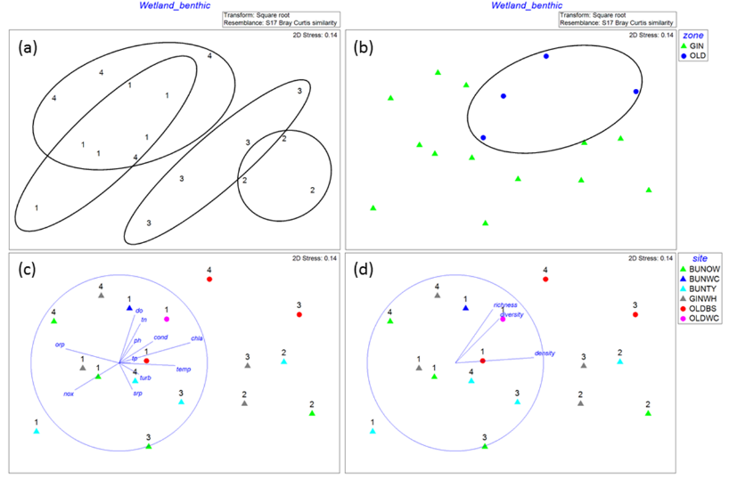
Figure D-8: NMDS ordination of wetland benthic microinvertebrate community composition using abundance dataset by (a) by time, (b) by zone, (c) time x site with vectors of environmental variables (normalised data, Spearman correlation) that underlie the environmental patterns and (d) time x site with vectors of microinvertebrate density and biodiversity indices (normalised data, Spearman correlation). 1=Oct 16, 2=Dec 16, 3=Feb 17 and 4=May 17 while GIN=Gingham Watercourse and OLD=Lower Gwydir wetland.
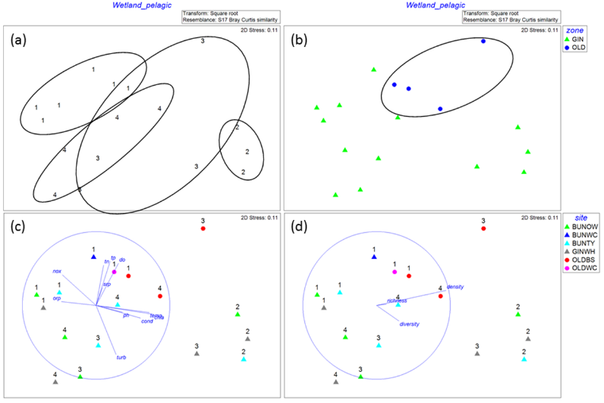
Figure D-9: NMDS ordination of wetland pelagic microinvertebrate community composition using abundance by (a) time, (b) zone, (c) time x site with vectors of environmental variables (normalised data, Spearman correlation) that underlie the environmental patterns and (d) time x site with vectors of microinvertebrate density and biodiversity indices (normalised data, Spearman correlation). 1=Oct 16, 2=Dec 16, 3=Feb 17 and 4=May 17 while GIN=Gingham Watercourse and OLD=Lower Gwydir wetland.

D.3.3.2 River
In river ecosystems, two-way PERMANOVA analyses showed significant time and zone differences in the benthic habitat and time-zone interactions in the pelagic habitat (Table D-5) based on abundance. The nMDS ordination with stress value of 0.14 in the benthic habitat (Figure D-10a) and 0.10 in the pelagic habitat (Figure D-11a) showed temporal and spatial shifts in community composition. Microinvertebrate community composition was significantly different between all sampling periods in both habitats (p<0.05, Figure D-10a and Figure D-11a). The community difference between sampling periods was driven by increasing abundance of rotifer Family Filiniidae, Family Hexarthridea, Genus Polyarthra and Phyla Nematoda from Oct 16 to Dec 16, and then reduced in abundance in Feb 17 (Table D-9).
Table D-9: Microinvertebrate taxa contributing most of the dissimilarities in river ecosystem between times based on abundance. Bold numbers represent the higher average abundance group.
Taxa | Average Abundance |  |  |  | Contribution %
 | T1 | T2 | T3 | T4 | T1 vs T2 | T2 vs T3 | T3 vs T4
F. Filiniidae | 1.6 | 24.9 | 1.4 | 21.2 | 10.0 | 10.6 | 12.8
F. Hexarthridae | 0.0 | 17.6 | 0.8 | 4.2 | 8.3 | 8.6 | 2.4
G.Polyarthra | 1.4 | 17.6 | 2.4 | 14.2 | 7.7 | 8.1 | 8.7
P. Nematoda | 7.3 | 12.1 | 6.7 | 7.3 | 5.8 | 6.1 | 6.2

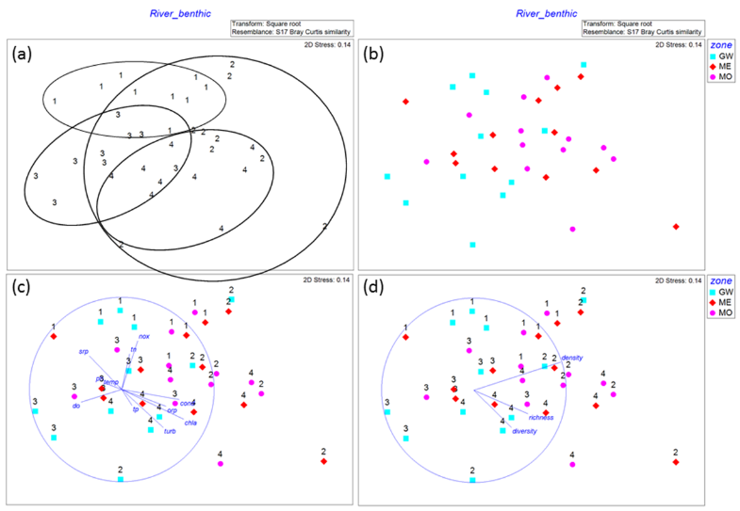
Figure D-10: NMDS ordination of river benthic microinvertebrate community composition using abundance by (a) time, (b) by zone, (c) time x site with vectors of environmental variables (normalised data, Spearman correlation) that underlie the environmental patterns and (d) time x site with vectors of microinvertebrate density and biodiversity indices (normalised data, Spearman correlation). 1=Oct 16, 2=Dec 16, 3=Feb 17 and 4=May 17.
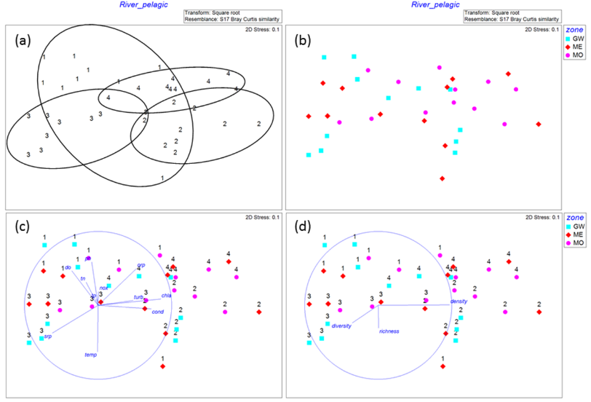
Figure D-11: NMDS ordination of river pelagic microinvertebrate community composition using abundance by (a) time, (b) zone, (c) time x site with vectors of environmental variables (normalised data, Spearman correlation) that underlie the environmental patterns and (d) time x site with vectors of microinvertebrate density and biodiversity indices (normalised data, Spearman correlation). 1=Oct 16, 2=Dec 16, 3=Feb 17 and 4=May 17
In the benthic habitat, there was also a significant difference in taxonomic composition between the Gwydir and Mehi Rivers, and Moomin Creek (Figure D-10b). The community difference was driven by lower abundance in Family Filiniidae, Phyla Nematoda, Order Bdelloida, and Copepod nauplii in the Gwydir River compared with the Mehi River and Moomin Creek (Table D-10).
All environmental variables were subsequently fitted into the ordination space as vectors to show those variables correlated to community patterns (Figure D-10c and Figure D-11c). The BIOENV result showed that community composition was highly correlated with increased chlorophyll a, and lower dissolved oxygen and NOx concentrations during Dec 16 and May 17 (Table D-8). This community composition shift was also strongly correlated to relatively higher densities in Dec 16 and May 17 (Figure D-10d and Figure D-11d).
Table D-10: Microinvertebrate taxa contributing most of the dissimilarities in river ecosystem benthic habitat between Rivers based on abundance dataset. Bold numbers represent the higher average abundance group.
Taxa | Average Abundance |  |  | Contribution %
 | GW | ME | MO | GW vs ME | GW vs MO
F. Filiniidae | 3.0 | 15.4 | 18.3 | 8.2 | 9.5
P. Nematoda | 6.8 | 9.9 | 8.4 | 7.4 | 6.6
O. Bdelloida | 8.7 | 8.9 | 10.3 | 7.0 | 6.0
Copepod nauplii | 7.9 | 10.2 | 13.2 | 5.9 | 6.2
G.Anuraeopsis | 7.4 | 3.9 | 2.6 | 5.8 | 4.4
G.Polyarthra | 3.8 | 9.1 | 13.8 | 5.6 | 7.3
F. Notommatidae | 7.7 | 8.8 | 10.3 | 5.3 | 5.2

D.3.3.3 Multi-year comparison
Data combined from eight surveys conducted between 2015 and 2017 shows macroinvertebrate density, richness and diversity variation over time (Figure D-12). The densities and richness of microinvertebrates recorded in this period are similar to those reported in previous studies from the Murray and Ovens Rivers and the Macquarie Marshes floodplain (Kobayashi et al. 2011; Ning et al. 2013). Wetland ecosystems generally had higher densities than river ecosystems. The highest microinvertebrate densities were recorded during wetland contraction periods in April 2016 and December 2016, highlighting the importance of prolonged inundation in wetlands to support secondary productivity. Microinvertebrate richness and diversity were lowest in September 2015 when both wetland and river systems experienced low and stable flow condition.
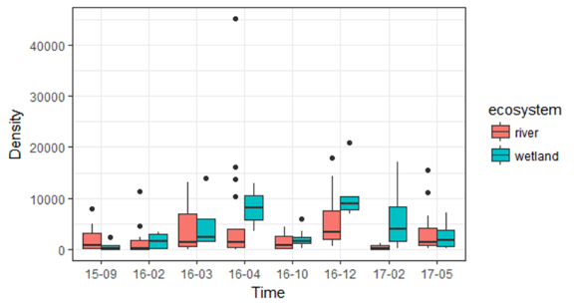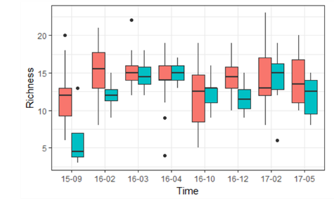
Sept 15 Feb 16 Mar 16 Apr 16 Oct 16 Dec 16 Feb 17 May 17
Sept 15 Feb 16 Mar 16 Apr 16 Oct 16 Dec 16 Feb 17 May 17
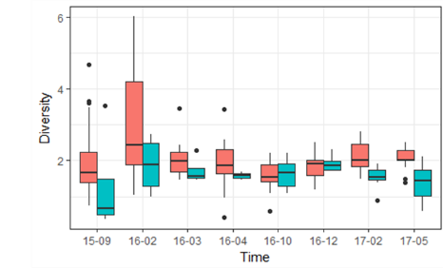
Sept 15 Feb 16 Mar 16 Apr 16 Oct 16 Dec 16 Feb 17 May 17
Figure D-12: Multi-year comparison of microinvertebrate density, richness and diversity in the Selected Area.

Discussion
Microinvertebrate sampling successfully captured the inundation and contraction cycle of environmental watering actions as well as local rainfall events. In this watering year, a large natural flow pulse event occurred in early spring and two consecutive environmental water actions created flow events to maintain connectivity and water levels throughout summer in the Selected Area. The Lower Gwydir wetlands were the only system to dry during this water year.
Microinvertebrate density and composition link to variation in chlorophyll a concentrations across ecosystems and habitats, with higher density in the pre-EW period, suggesting that secondary production followed water column primary production. In all river systems, microinvertebrate densities were reduced in both wet periods (post-flood and EW periods) suggesting that flow acted as a hydrological disturbance and initiated taxonomic replacement through longitudinal displacement regardless of the water source. During the contraction period, increased microinvertebrate secondary productivity was supported by nutrients delivered during wet periods and hydrological conditions conducive to growth and reproduction.
The highest richness recorded in pelagic habitats was during the environmental water period in all river and wetland systems, highlighting that both longitudinal and lateral connection provided increased diversity of habitats and supply of nutrients from inflow, and in turn, supported a more diverse range of microinvertebrate taxa.
Temporal changes in flow condition still had stronger influence in structuring community composition in both benthic and pelagic habitats. Among all measured environmental variables, temperature, chlorophyll a and conductivity concentrations explained microinvertebrate taxonomic composition.
At river channel sites, similar temporal shifts in microinvertebrate community composition were observed irrespective of zones in both benthic and pelagic habitats. This suggests that patterns in community composition were predominantly controlled by hydrological regime. The transition from the two wet periods (post-flood and EW periods) to two dry periods showed similar community compositional changes (pre-EW and post-EW), which highly correlated with increased chlorophyll a, and decreased dissolved oxygen and NOx concentrations from wet to dry, along with increased microinvertebrate density.
The magnitude and pattern of flows this watering year (peaking at around 39,000 ML/d) was much higher than the 2015-16 watering year (peak flow of around 1,300 ML/d) due to generally high rainfall in the upstream catchments. Benthic microinvertebrate density in this watering year was lower than 2015-16. It is likely due to larger inflow acting as a disturbance force (i.e. shear stress) in the benthic habitat, compared with six times higher pelagic density in the 2015-16 water year due to influx of nutrients and stable hydrologic conditions from prolonged and larger inflow.
The pattern of water delivery in 2016-17 resulted in the Lower Gwydir wetlands experiencing a dry phase in December 2016, while the Gingham watercourse were inundated to some degree for the whole year. As such the Gwydir wetlands experienced a wet-dry-wet-dry cycle compared with a more stable inundation pattern in the Gingham. This difference in wetting, created divergent responses in microinvertebrate density between these wetland systems. The highest microinvertebrate densities (with a comparable diversity) in the 2016-17 water year were recorded following the rewetting of sediments for a second time in the Lower Gwydir wetlands. This cycle of multiple wetting and drying events within a water year appears to have stimulated microinvertebrate productivity and wetland food webs.

Conclusion
Monitoring during 2016-17 revealed significant influences of environmental water and natural inflow on microinvertebrate communities at both wetland and river channel sites. In the Lower Gwydir wetland, the cycle of wetting and drying experience throughout the year, assisted by the delivery of environmental water, triggered secondary productivity with high microinvertebrate densities recorded following the second wetting event in December 2016 – February 2017. This increased productivity, is likely to have provided food resources of native fish, waterbirds and frogs. In the River zones, longitudinal connectivity with high discharge acted as disturbance for microinvertebrates reflecting lower densities following the natural inflow and environmental watering actions.
Higher longitudinal connection between the Gwydir River and the two wetlands and lateral connection within the wetlands themselves appeared to increase the diversity of habitats and basal resources, thus supporting a more diverse assemblage of microinvertebrate taxa.

References
Clarke, D.R. and Warwick, R.M. 2001. Changes in marine communities: an approach to statistical analysis and interpretation. Natural Environmental Research Council, Plymouth, UK.
Commonwealth of Australia. 2014. Commonwealth Environmental Water Office Long Term Intervention Monitoring Project Gwydir River System Selected Area. Commonwealth of Australia.
Commonwealth of Australia. 2015. Commonwealth Environmental Water Office Long Term intervention Monitoring Project Gwydir River System Selected Area – 2014-15 Evaluation Report. Commonwealth of Australia.
Kobayashi, T., Ryder, D.S., Ralph, T.J., Mazumder, D., Saintilan, N., Iles, J., Knowles, L., Thomas, R. & Hunter, S. 2011. Longitudinal spatial variation in ecological conditions in an in‐channel floodplain river system during flow pulses. River research and applications, 27(4), 461-472.
Ning, N. S., Gawne, B., Cook, R. A., & Nielsen, D. L. 2013. Zooplankton dynamics in response to the transition from drought to flooding in four Murray–Darling Basin rivers affected by differing levels of flow regulation. Hydrobiologia, 702(1), 45-62.

Macroinvertebrates

Introduction
The Macroinvertebrates indicator aims to assess the contribution of Commonwealth environmental watering to macroinvertebrate diversity. A specific question was addressed through this indicator within the Gwydir river system (Selected Area) during the 2016-17 water year:
- What did Commonwealth environmental water contribute to macroinvertebrate diversity?

Environmental watering in 2015-16
During 2016-17 environmental water was delivered to several assets within the Selected Area. In September 2016, a flow event occurred down the Mehi River and supplementary water licences owned by the CEWO were triggered. A total of 5,000 ML was accounted for in the Mehi River.
Supplementary flows were triggered in the Mallowa in September 2016, however very little of the flow was diverted into the Mallowa wetlands. In January - March 2017, planned deliveries of 5,000 ML were increased to 10,000 ML to the Mallowa Creek system to inundate fringing wetlands. Flows were also delivered into the lower Gwydir River and Gingham watercourse to build upon moderate winter/spring flows. In January - March 2017, 30,000 ML was delivered, aiming to inundate broad areas of semi-permanent wetland vegetation.
During 2016-17, no environmental water was delivered to the Moomin Creek.

Previous monitoring
In the first two years of the project, the delivery of environmental water increased the density and regional scale diversity of aquatic macroinvertebrates. Connectivity provided by environmental water provided an opportunity for macroinvertebrates to take advantage of increases in primary production resulting from inundation, before declining water levels and associated water quality conditions became uninhabitable for some sensitive macroinvertebrate families. Significant differences in aquatic macroinvertebrate community composition between the Gingham and Lower Gwydir wetlands indicated that each area supports a distinct macroinvertebrate community and highlights the importance of watering both wetlands in maintaining regional level diversity.

Methods

Design
Macroinvertebrate sampling took place on four occasions to capture the inundation and contraction cycle of environmental water delivery as well as local rainfall events (Table E-1 and Figure E-1).
T1 ‘Post-flood’ period
This spring sampling period (11th -14th October 2016) represents post-flood conditions one month after a flood peak that resulted from upstream inflow and localised rainfall. All river systems were influenced by the flood that peaked in mid-September at 39,400 ML/d in the Gwydir River and 7,700 ML/d in the Mehi River. Longitudinal connectivity between the Gwydir River and both the Lower Gwydir and Gingham watercourses had been occuring since August 2016 driven by rainfall events.
T2 ‘Pre-EW’ period
This summer sampling period (12th -15th December 2016) occurred as the previous flooding continued to subside, but was prior to environmental watering actions. All river systems experienced three months of low and stable flow conditions since the previous sample period with average discharge of 670 ML/d in the Gwydir River. The Gingham watercourse was in a contraction phase and the Lower Gwydir wetland was predominantly dry.
T3 ‘EW’ period
This late summer sampling period (20th -23rd February 2017) captured the ‘rewetting’ phase of the Selected Area due to environmental watering actions which commenced in late December, creating a flow event for two months with environmental water contributions. All river systems were longitudinally connected with an average discharge of 3,000 ML/d for 60 days in the Gwydir River. The environmental water delivered also aimed to maintain water levels in wetlands. Thus, water levels in the Gingham and Lower Gwydir wetlands rose from the previous sample period in December and maintained surface water presence.
T4 ‘EW contraction’ period
This autumn sampling period (1st – 4th May 2017) was designed to capture the contraction cycle of residual environmental water. All river systems were in base flow condition with no longitudinal connectivity. Discharge in the Gwydir River was around 220 ML/d. Water levels in the Gingham watercourse had dropped while the Lower Gwydir wetlands had contracted to a few disconnected pools.

Table E-1: Location of sites within the Selected Area for macroinvertebrate surveys.
Ecosystem | Sampling Zone | Site | Latitude | Longitude | Inundation
 |  |  |  |  | Oct 16  (T1) | Dec 16  (T2) | Feb 17  (T3) | May 17  (T4)
Wetland | Gingham Watercourse | BUNOW | 731409 | 6759165 | Wet | Wet | Wet | Wet
 |  | BUNWC | 730157 | 6759022 | Wet | Dry | Dry | Dry
 |  | BUNTY | 731394 | 6759148 | Wet | Wet | Wet | Wet
 |  | GINWH | 724103 | 6762962 | Wet | Wet | Wet | Wet
 | Lower Gwydir Wetland | OLDWC | 726664 | 6751404 | Wet | Dry | Dry | Dry
 |  | OLDBS | 726067 | 6752088 | Wet | Dry | Wet | Wet
River | Gwydir River | GW2 | 209205 | 6740455 | Wet | Wet | Wet | Wet
 |  | GW3 | 783417 | 6743135 | Wet | Wet | Wet | Wet
 |  | GW4 | 775597 | 6741491 | Wet | Wet | Wet | Wet
 | Mehi River | ME1 | 211342 | 6736610 | Wet | Wet | Wet | Wet
 |  | ME2 | 753566 | 6726596 | Wet | Wet | Wet | Wet
 |  | ME3 | 719420 | 6731644 | Wet | Wet | Wet | Wet
 | Moomin Creek | MO1 | 753679 | 6721789 | Wet | Wet | Wet | Wet
 |  | MO2 | 740017 | 6712590 | Wet | Wet | Wet | Wet
 |  | MO3 | 708808 | 6714077 | Wet | Wet | Wet | Wet

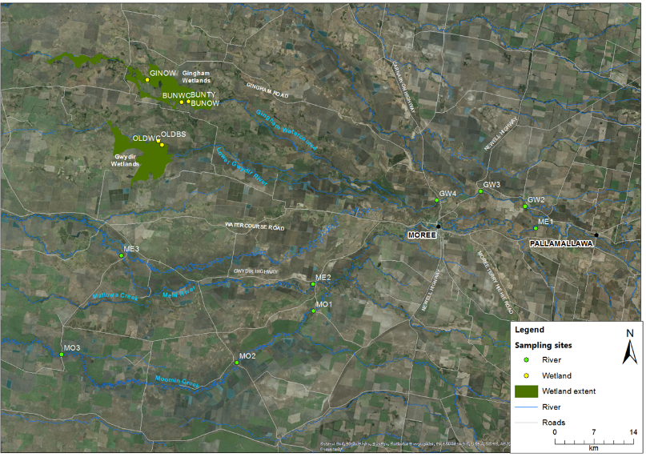
Figure E-1: Location of macroinvertebrate sites within the Selected Area in 2016-17. See Table E-1 for site codes.

Field and laboratory methods
Macroinvertebrate indicator monitoring was conducted following the Standard Operating Procedures in Hale et al. (2013).

Statistical methods
To describe and summarize the diversity of macroinvertebrate community composition, taxa richness (S), Shannon Weiner diversity (d) and density (number of individual/m²) was calculated in PRIMER v6.1.13 using the DIVERSE function. PERMANOVA routine was used to test the difference in S, d and density between TIME (with 4 random levels, Oct 16, Dec 16, Feb 17 and May 17), ZONE (with 5 fixed levels, Gingham watercourse, Lower Gwydir wetland, Gwydir River, Mehi River and Moomin Creek) and TIME x ZONE interactions.
Community composition data were transformed into two datasets that weigh the contributions of common and rare species differently. (1) Presence-absence data represents actual taxa occurrence in a community. (2) Abundance data (square root transformation to stabilize variance and to improve normality; Clarke and Warwick 2001) represents relative proportions of taxa occurrence in a community. Since different sampling methods were used in benthic and pelagic habitats, a permutational multivariate analysis of variance (PERMANOVA) analysis was used to test the difference in the macroinvertebrate community composition. Differences were assessed between ECOSYSTEM (Wetland and River), TIME (with 4 random levels, Oct 16, Dec 16, Feb 17 and May 17), ZONE (with 5 fixed levels, Gingham watercourse, Lower Gwydir wetland, Gwydir River, Mehi River and Moomin Creek) and TIME x ZONE interactions. Up to 999 random permutations estimated the probability of p-values, with levels of significance reported as p<0.05.
A Bray-Curtis dissimilarity matrix was generated by rank correlating the community structure between samples. Then, nonmetric multidimensional scaling ordinations (nMDS) were used to visualise community patterns and similarity percentages (SIMPER) were used to determine the taxa contributing to the observed community patterns. NMDS output with stress values of less than 0.2 were considered appropriate for interpretation (Clarke and Warwick 2001).
Water quality and nutrients indicators reported in Appendix C were used to relate macroinvertebrate patterns. BIOENV analyses was used to examine those water quality and nutrient indicators link to patterns of macroinvertebrate community composition in PRIMER-E (2009). All analyses were performed in PRIMER v6.1.13 with the PERMANOVA+ v1.0.3 add-on package (PRIMER-E, 2009)

Results
A total of 73 taxa were identified (from 51 samples). The 19 most abundant taxa (>1% in total abundance) comprised 89% of the total abundance with the most abundant taxa being Cladocera (18% of the total abundance), followed by Family Atyidae (11%), Genus Micronecta (10%) and Family Baetidae (9%) that occurred in more than 50% sites and sampling occasions.

Density
Across all sites and sampling occasions, mean macroinvertebrate density ranged from 21 to 1,948 individuals per m² (Figure E-2). This range is similar to the that observed in the 2015-16 water year (Table E-2). The highest mean density was recorded in the Mehi River in Dec 16 with 975 individuals per m². Macroinvertebrate density did not show any significant response to time and zone factors. This suggests that there was no consistent temporal and spatial pattern in macroinvertebrate density in this water year.
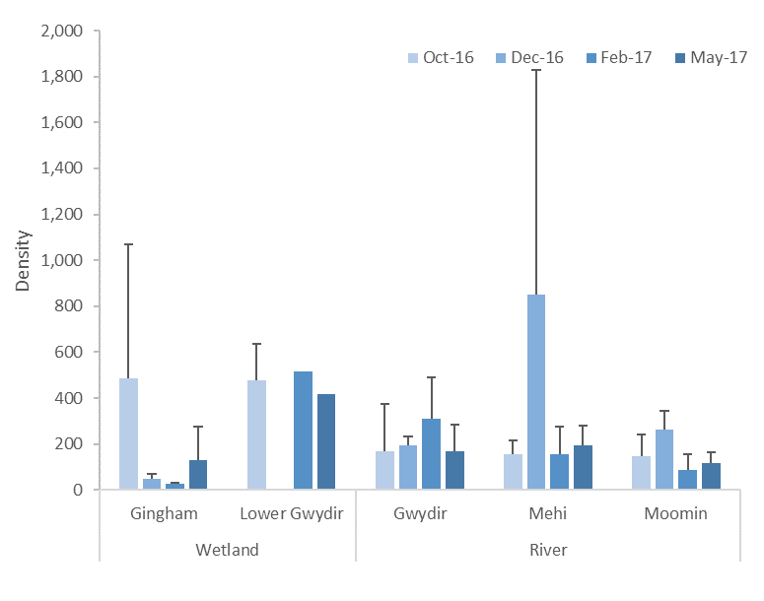
Figure E-2: Mean ± standard deviation (SD) of macroinvertebrate density (individuals/m²).
Table E-2: Mean macroinvertebrate density, richness and diversity in 2014-17.
Year | Ecosystem | Mean density | Mean richness | Mean diversity
2014-15 | Wetland | 144 | 14.2 | 1.93
 | River (GW only) | 120 | 9.9 | 1.46
2015-16 | Wetland | 239 | 12.7 | 2.35
 | River | 235 | 10.8 | 2.06
2016-17 | Wetland | 262 | 12.4 | 1.58
 | River | 234 | 12.5 | 1.56

Diversity indices
Taxonomic richness ranged from 3 to 27 taxa and there was a significant different between time (Pseudo-F=4.0783, p<0.01,Figure E-3a) and zone (Pseudo-F=7.8174, p<0.0001). Taxonomic richness was significantly lower in Feb 17 than in Dec 16 and May 17 (pairwise test; p<0.05). The Lower Gwydir wetland had significantly higher taxonomic richness than all other zones in all sampling occasions (pairwise test; p<0.05). Diversity ranged from 0.36 to 2.60 with significant differences between zones (Pseudo-F=3.6275, p<0.01, Figure E-3b). Like taxonomic richness, the Lower Gwydir wetland had significantly higher diversity than all other zones in all sampling occasions (pairwise test; p<0.05). Macroinvertebrate taxonomic richness in this water year were similar to the 2015-16 water year, while diversity was lower (Table E-2).
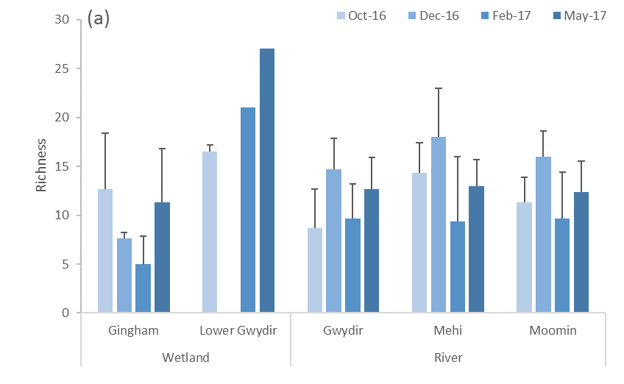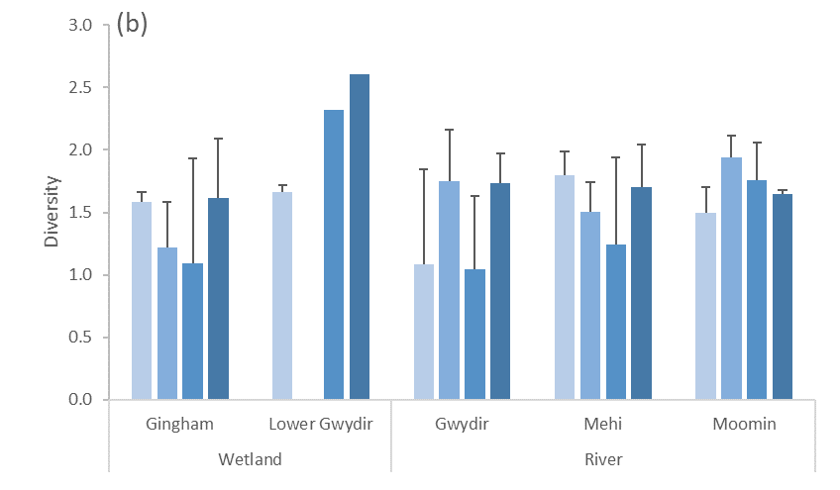
Figure E-3: Mean ± standard deviation (SD) of macroinvertebrate (a) taxonomic richness and (b) diversity.

Taxonomic composition
PERMANOVA results indicated that the taxonomic composition was significantly different between wetland and river ecosystems (Pseudo-F=4.4413, p<0.001) based on abundance. A similar result was also found based on taxa presence-absence. The dissimilarity between wetland and river is shown in the nMDS ordination with a stress value of 0.21 (Figure E-4). Since the taxonomic composition was predominantly driven by ecosystem, two datasets by ecosystem type were developed to further explore the effects of time and zone
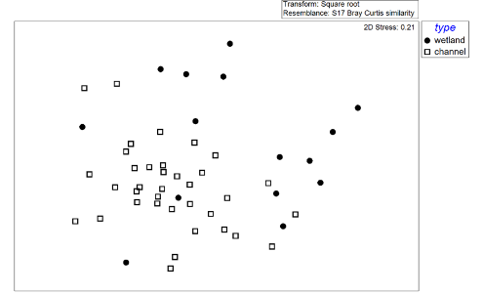
Figure E-4: NMDS ordination of macroinvertebrate community composition by ecosystem type (wetland and river channel) using the abundance dataset.

E.3.3.1 Wetland
Two-way PERMANOVA analyses showed significant time and zone differences based on abundance (Table E-3). The nMDS ordination with stress value of 0.15 (Figure E-5a) showed temporal and spatial shifts in community composition.
Macroinvertebrate community composition was significantly different between Oct 16 and all other sampling periods (pairwise tests; p<0.05,Figure E-5b). The community taxonomic differences between sampling periods was driven by reductions in abundance of Ostracoda, Cladocera, Corixidae nymphs, Chironominae, Planorbidae, Hydrophilidae larve and increased abundance of Micronecta (Table E-4).
There was also a significant difference between the Lower Gwydir wetland and the Gingham Watercourse (Figure E-5a). This spatial difference was driven by higher abundances of Ostracoda, Planorbidae, Cladocera, Notonectidae, Hydrophilidae larve, Lestidae, Coenagrionidae, Micronecta and Corixidae nymphs in the Lower Gwydir wetland and higher abundances of Chironominae in the Gingham Watercourse (Table E-5).
All environmental variables were subsequently fitted into the ordination space as vectors to show those variables that were correlated to community patterns (Figure E-5c). The BIOENV result showed that the community composition was positively correlated to higher temperature, turbidity and conductivity, and lower TN during Feb 17 and May 17 (Table E-6). This shift in community composition is also strongly correlated to higher macroinvertebrate density and richness (Table E-7 and Figure E-5d).
Table E-3: PERMANOVA results of macroinvertebrate community composition by ecosystem (wetland and river) using the abundance dataset (*significant level at P<0.05).
Term | Wetland |  | River
 | Pseudo-F | P | Pseudo-F | P
Time | 2.392 | 0.0006 | 2.8608 | 0.0001
Zone | 2.6234 | 0.0152 | 2.9091 | 0.0008
Time x Zone | 1.1596 | 0.3058 | 0.90894 | 0.6885
Table E-4: Macroinvertebrate taxa contributing most of the dissimilarities in wetland ecosystems between times based on abundance dataset. Bold numbers represent the higher average abundance group.
Taxa | Average Abundance |  | Contribution %
 | Oct 16 | Dec16, Feb 17, May 17 | Oct 16 vs Dec16, Feb 17, May 17
C.Ostracoda | 11.7 | 0.5 | 15.6
O.Cladocera | 10.7 | 0.5 | 14.1
F.Corixidae nymphs | 2.6 | 0.9 | 5.3
sF.Chironominae | 3.8 | 2.7 | 4.2
F.Planorbidae | 2.6 | 1.4 | 4.0
F.Hydrophilidae larve | 3.0 | 1.4 | 3.7
G.Micronecta | 0.9 | 2.1 | 3.2
Table E-5: Macroinvertebrate taxa contributing most of the dissimilarities in wetland ecosystems between zones based on abundance dataset. Bold numbers represent the higher average abundance group.
Taxa | Average Abundance |  | Contribution %
 | GIN | OLD | GIN vs OLD
C.Ostracoda | 2.5 | 9.0 | 11.0
F.Planorbidae | 0.1 | 6.5 | 7.6
O.Cladocera | 3.4 | 5.2 | 7.0
F.Notonectidae | 0.4 | 4.5 | 5.2
F.Hydrophilidae larve | 1.1 | 4.3 | 5.2
F.Lestidae | 0.4 | 3.1 | 3.8
F.Coenagrionidae | 0.3 | 3.2 | 3.7
G.Micronecta | 1.5 | 2.2 | 3.1
sF.Chironominae | 3.4 | 2.3 | 3.0
F.Corixidae nymphs | 1.4 | 1.5 | 2.5
Table E-6: BIOENV results of macroinvertebrate community composition in wetland and river ecosystems based on abundance dataset. “v” represents significant environmental variables.
Community | Rho | p | Environmental variables
 |  |  | Temp | pH | Turbidity | Conductivity | Dissolved Oxygen | TN | TP | NOx
Wetland | 0.477 | 0.01 | v |  | v | v |  | v
River | 0.339 | 0.041 |  | v |  |  | v | v | v | v

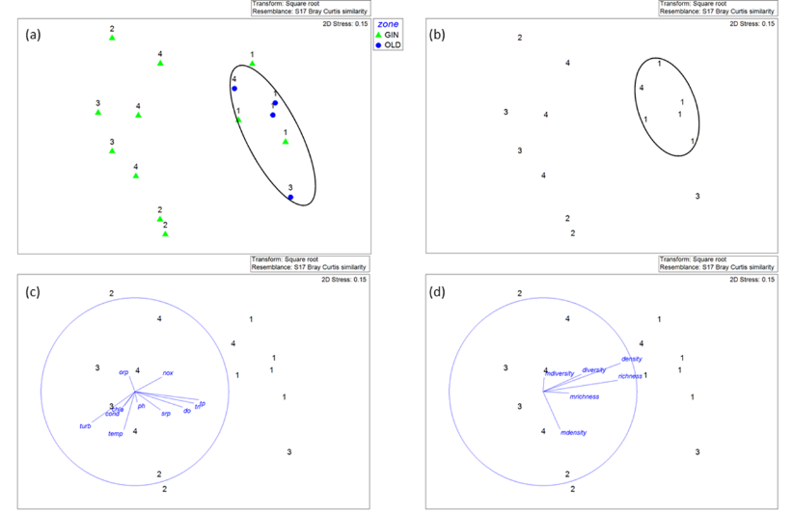
Figure E-5: NMDS ordination of wetland macroinvertebrate community composition using abundance showing (a) by time and zone, (b) by time, (c) by time with vectors of environmental variables (normalised data, Spearman correlation) that underlie the environmental patterns and (d) by time with vectors of microinvertebrate and macroinvertebrate density and biodiversity indices (normalised data, Spearman correlation). 1=Oct 16, 2=Dec 16, 3=Feb 17 and 4=May 17 while GIN=Gingham Watercourse and OLD=Lower Gwydir wetland.
Table E-7: BIOENV results of macroinvertebrate community composition in wetland and river ecosystems based on abundance. “v” represents significant density and diversity variables. “Macro” represents macroinvertebrate while “Micro” represents microinvertebrate.
Community | Rho | p | Density and diversity variables
 |  |  | Macro  richness | Macro  diversity | Macro  density | Micro richness | Micro diversity | Micro density
Wetland | 0.406 | 0.01 | v |  | v | v |  | v
River | 0.33 | 0.03 | v | v | v | v

E.3.3.2 River
Two-way PERMANOVA analyses showed significant time and zone differences based on the abundance dataset (Table E-3). The nMDS ordination with stress value of 0.19 based on abundance showed a temporal and spatial shift in community composition (Figure E-6a and b).
Macroinvertebrate community composition was significantly different between all sampling periods (pairwise tests; p<0.05). Differences in community composition between times was driven by changes in abundance of ten macroinvertebrate taxa (Table E-8). There was also a significant difference between the Gwydir River and Moomin Creek. This difference was driven by higher abundances of Atyidae, Beatidae, Orthocladiinae and Simuliidae and lower abundance in G. Micronecta, Chironominae and Corixidae nymphs in the Gwydir River (Table E-9).
All environmental variables were subsequently fitted into the ordination space as vectors to show those variables that correlated to community patterns (Figure E-6c and d). The BIOENV result showed that the community composition was correlated the changes in pH, dissolved oxygen, TN, TP and NOx concentrations (Table E-6). This shift in taxonomic community also correlated with higher macroinvertebrate density and richness (Figure E-6d and Table E-7).
Table E-8: Macroinvertebrate taxa contributing most of the dissimilarities in river ecosystem between times based on abundance dataset. Bold numbers represent the higher average abundance group.
Taxa | Average Abundance
 | Oct 16 | Dec 16 | Feb 17 | May 17
G.Micronecta | 1.0 | 8.3 | 1.7 | 2.1
F.Atyidae | 2.2 | 4.9 | 4.9 | 5.7
O.Cladocera | 2.7 | 4.0 | 0.0 | 0.2
F.Baetidae | 1.0 | 4.4 | 6.4 | 3.8
F.Corixidae nymphs | 3.0 | 4.2 | 1.6 | 0.2
sF.Tanypodinae | 0.6 | 3.4 | 0.9 | 0.9
sF.Chironominae | 2.0 | 3.0 | 3.0 | 3.5
Simuliidae | 2.6 | 0.0 | 0.1 | 1.5
F.Caenidae | 0.7 | 2.5 | 0.2 | 0.8
F.Palaemonidae | 1.3 | 2.5 | 3.5 | 3.3

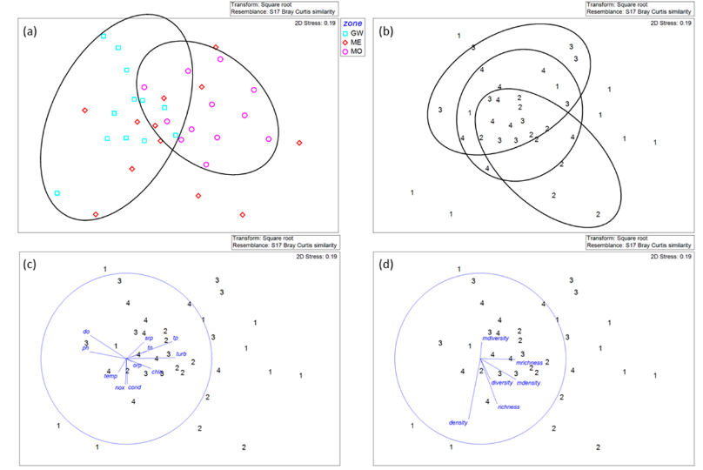
Figure E-6: NMDS ordination of river macroinvertebrate community composition using abundance showing (a) by time and zone, (b) by time, (c) by time with vectors of environmental variables (normalised data, Spearman correlation) that underlie the environmental patterns and (d) by time with vectors of microinvertebrate and macroinvertebrate density and biodiversity indices (normalised data, Spearman correlation). 1=Oct 16, 2=Dec 16, 3=Feb 17 and 4=May 17.
Table E-9: Macroinvertebrate taxa contributing most of the dissimilarities in river ecosystem between zones based on abundance dataset. Bold numbers represent the higher average abundance group.
Taxa | Average Abundance |  | Contribution %
 | GW | MO | GW vs MO
F.Atyidae | 7.4 | 2.5 | 12.9
F.Baetidae | 4.7 | 2.3 | 8.8
G.Micronecta | 1.2 | 4.3 | 8.6
sF.Chironominae | 1.8 | 4.3 | 7.2
F.Corixidae nymphs | 0.8 | 3.4 | 7.1
sF.Orthocladiinae | 2.3 | 1.5 | 5.0
Simuliidae | 2.0 | 0.0 | 4.3

Discussion
The Lower Gwydir wetland had higher density, taxonomic richness and diversity than all other zones across all sampling occasions. In particular, taxonomic richness and diversity were higher during the environmental water period (Feb 17) than post-flood natural event (Oct 16), highlighting that the longer duration of both longitudinal and lateral connection supported by environmental water provided habitat diversity as well as a supply of nutrients from inflow, in turn, supporting a more diverse range of macroinvertebrate taxa. The highest richness and diversity found in the contraction period (May 17) may be linked to highly diverse habitats and basal resources that in turn, support a more diverse assemblage of macroinvertebrate taxa. Therefore, the effects of environmental water on macroinvertebrate diversity can persistent through time and contribute to higher diversity for at least five months.
All river systems had the lowest macroinvertebrate taxonomic richness during the environmental water period (Feb 17) when all river systems were longitudinally connected. These results suggest that environmental water initiated taxonomic replacement through longitudinal displacement and favoured flow-resistant taxa. As a result, flow-resistant taxa such as Baetidae which has a streamlined body shape were in higher relative abundance than flow-prone taxa such as Caenidae during this period (Gooderham and Tsyrlin 2002).
Environmental water that contributed to an inundation and contraction cycle combined with local rainfall events provided an opportunity for long term community succession due to changes in local physical and chemical environmental conditions. Macroinvertebrate community composition were significantly different between four sampling occasions, between rivers and wetlands, and between the lower Gwydir and Gingham watercourses, suggesting that the promotion of regional scale macroinvertebrate diversity requires the inundation of river and wetland areas.

Conclusion
During 2016-17, environmental water released from late December 2016 to maintain hydrologic connection and water levels in the Gingham and Lower Gwydir wetlands increased the diversity of habitats and basal resources that in turn, supported a more diverse assemblage of macroinvertebrate taxa. The significant difference in macroinvertebrate community composition across the four sampling occasions indicates the benefits of delivery of environmental water in maintaining regional level diversity.

References
Clarke, D. R. & Warwick, R. M. 2001. Changes in marine communities: an approach to statistical analysis and interpretation. Natural Environmental Research Council, Plymouth, UK.
Commonwealth of Australia. 2015. Commonwealth Environmental Water Office Long Term intervention Monitoring Project Gwydir River System Selected Area – 2014-15 Evaluation Report. Commonwealth of Australia.
Hale, J., Stoffels, R., Butcher, R., Shackleton, M., Brooks, S., Gawne, B., & Stewardson, M. 2014. Commonwealth Environmental Water Office Long Term Intervention Monitoring Project – Standard Methods. Final Report prepared for the Commonwealth Environmental Water Office by The Murray-Darling Freshwater Research Centre, MDFRC Publication 29.2/2014, January, 175 pp.

Ecosystem Type

Introduction
The Ecosystem type indicator contributes to the broader scale evaluation of Commonwealth environmental water’s influence on ecosystem diversity. While primarily designed to inform at larger basin scales, information on the types of ecosystems influenced by Commonwealth environmental water is also useful at the Selected Area scale. Several specific questions were addressed by measuring ecosystem type within the Gwydir River Selected Area during the 2015-16 water year:
- What did Commonwealth environmental water contribute to sustainable ecosystem diversity?
- Were ecosystems to which Commonwealth environmental water was allocated sustained?
- Was Commonwealth environmental water delivered to a representative suite of ecosystem types?

Environmental watering in 2015-16
During 2016-17 environmental water was delivered to a number of assets within the Gwydir River system (Selected Area). In September 2016, a flow event occurred down the Mehi River and supplementary water licences owned by the CEWO were triggered. A total of 5,000 ML was accounted for in the Mehi River.
Supplementary flows were triggered in the Mallowa in September 2016, however very little of the flow was diverted into the Mallowa wetlands. In January - March 2017, planned deliveries of 5,000 ML were increased to 10,000 ML to the Mallowa Creek system to inundate fringing wetlands. Flows were also delivered into the lower Gwydir River and Gingham watercourse to build upon moderate winter/spring flows. In January - March 2017, 30,000 ML was delivered, aiming to inundate broad areas of semi-permanent wetland vegetation.
During 2016-17, no environmental water was delivered to the Moomin Creek.

Methods
The ANAE classification for each sampling site in the Selected Area was mapped using a process of desk-top identification and field verification (Commonwealth of Australia 2014). Existing ANAE GIS layers (Brooks et al. 2013) were used to assign an ecosystem type to each monitoring site, and this was then verified in the field. Sites where existing ANAE mapping did not provide coverage were assigned an ANAE classification using available desktop information and then verified in the field. Field based verification was undertaken following a dichotomous key (Brooks et al. 2013).

Results
146 survey sites were sampled as part of the Gwydir River Selected Area LTIM project in the 2016-17 water year (Figure F-1). These fell into 10 ANAE ecosystem types, including five Riverine types, three Floodplain types and two Lacustrine types, all of which were inundated in the 2016-17 water year (Figure F-1). The Rp1.4: The Permanent lowland streams type was represented by the most sites, with 62 sites classified as this ecosystem type (Table F-1). Thirty-four sites were classified as the F3.2: Sedge/forb/grassland floodplain type, while 18 sites were classified as the Rt1.4: Temporary lowland stream ecosystem type and 14 sites were classified as the F1.11: River cooba woodland floodplain ecosystem type (Table F-1). All other types are represented by 10 sites or fewer.
Within the Selected Area, most sites (54%) are situated in the Gingham-Gwydir watercourse zone. This zone contains all ANAE Ecosystem types present within the Selected Area, except Rp1.1: Permanent high energy upland streams. The F1.10: Coolibah woodland and forest floodplain, Lp2.1: Temporary floodplain lake and Rt1.3: Temporary low energy upland streams types are only found within the Gingham-Gwydir Zone. There are 40 sites within the Mehi-Moonin zone, and these were classified as Rp1.4: Permanent lowland streams, Rt1.4: Temporary lowland streams, and Lt2.2: Temporary floodplain lake with aquatic beds ecosystem types. Sites within the Gwydir River zone are classified as Rp1.3: Permanent high energy upland streams, Rp1.4: Permanent lowland streams and Rp1.3: Permanent high energy upland streams ecosystem types. Sites within the Mallowa zone are located across three ecosystem types including F1.11: River cooba woodland floodplain, F3.2: Sedge/forb/grassland floodplain and Rt1.4: Temporary lowland streams (Figure F-2).
Environmental water contributed to inundation at 87 (68%) sites across all zones (Figure F-2; Figure F-3). All ecosystem types were inundated by environmental flows, except F1.10: River cooba woodland floodplain and Lt2.2: Temporary floodplain lake.
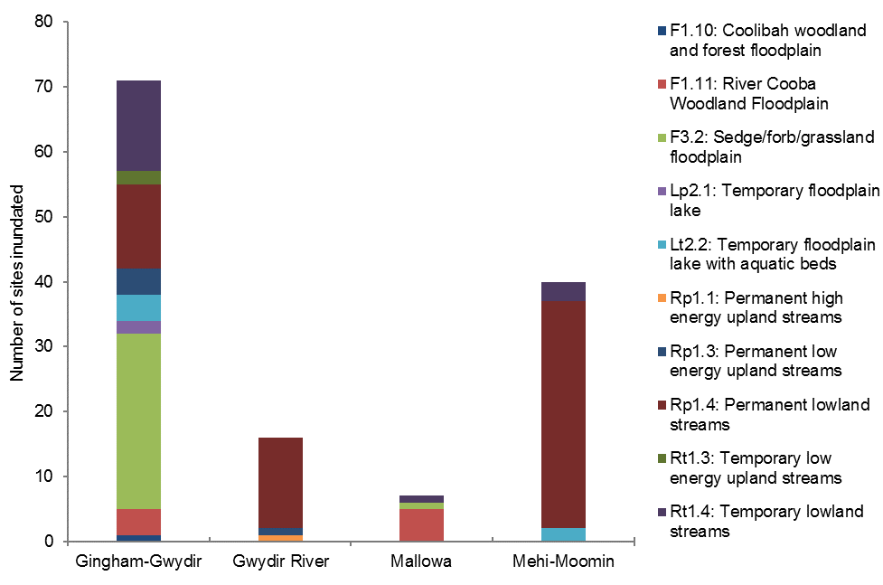
Figure F-1: Distribution of ANAE ecosystem types inundated across the four monitoring zones within the Selected Area.

Table F-1: ANAE Ecosystem types covered by monitoring sites in the Gwydir River Selected Area LTIM project.
ANAE Typology | Number of sites (All Zones) | Proportion of sites inundated
F1.10: Coolibah woodland and forest floodplain | 2 | 1
F1.11: River cooba woodland floodplain | 14 | 9
F3.2: Sedge/forb/grassland floodplain | 34 | 28
Lp2.1: Temporary floodplain lake | 2 | 2
Lt2.2: Temporary floodplain lake with aquatic beds | 6 | 6
Rp1.1: Permanent high energy upland streams | 1 | 1
Rp1.3: Permanent low energy upland streams | 5 | 5
Rp1.4: Permanent lowland streams | 62 | 62
Rt1.3: Temporary low energy upland streams | 2 | 2
Rt1.4: Temporary lowland streams | 18 | 18
Total | 146 | 134

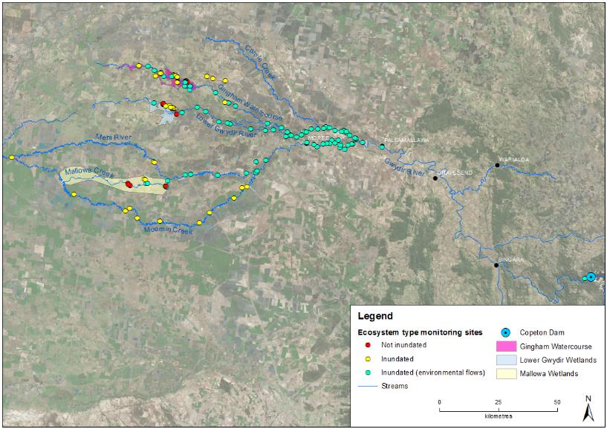
Figure F-2: Inundation status of sites sampled in the Selected Area during the 2016-17 water year.

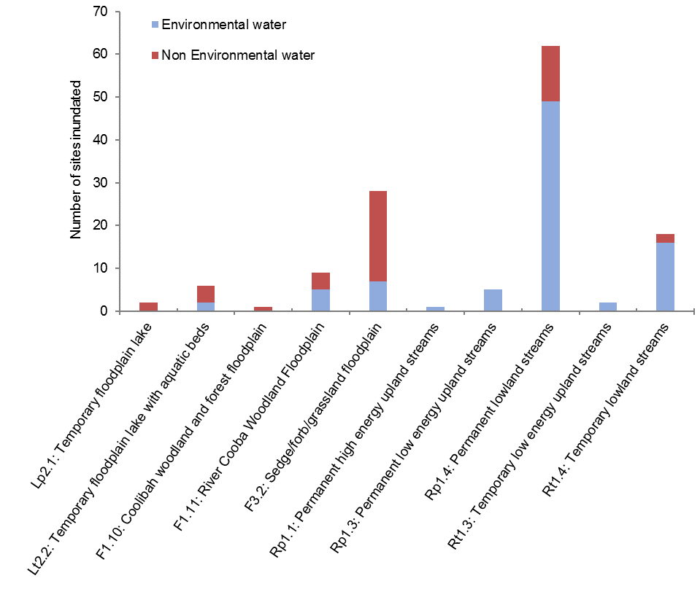
Figure F-3: Proportion of sites inundated at each ANAE ecosystem type influence by environmental water.

Discussion
The types of ecosystems monitored in this project reflect the nature of the delivery of environmental water, and the indicators being assessed. Given the emphasis on eco-hydrologic links in the project, the dominance of Riverine Ecosystem types is self-evident. The large representation of sites within the Sedge/forb/grassland floodplain type reflects the dominance of this type in low lying areas of the Gwydir and Gingham Watercourse zone. These ecosystems commonly form the target for environmental watering in this system.
In 2015-16, 122 sites were inundated (including 3 sites that were not surveyed in 2016-17), compared to 126 sites in 2016-17. Of these, environmental water contributed to 74% of all sites inundated in 2015-16, compared to 68% of inundated sites in 2016-17.

References
Brooks, S., Cottingham, P., Butcher, R, & Hale, J. 2013. Murray Darling aquatic ecosystem classification: Stage 2 report. Prepared by Peter Cottingham & Associates for the Commonwealth Environmental Water Office and Murray Darling Basin Authority, Canberra.
Commonwealth of Australia. 2014. Commonwealth Environmental Water Office Long Term Intervention Monitoring Project Gwydir River System Selected Area. Commonwealth of Australia.

Vegetation Diversity

Introduction
The lower Gwydir River and Gingham watercourse support a number of water dependent vegetation communities, including flood dependent woodlands (supporting ecological vegetation communities with dominant tree species such as coolibah and black box), floodplain wetland communities (supporting river red gum, coolibah woodlands and river cooba and lignum shrubland species) and semi-permanent wetlands (supporting species such as water couch, marsh club-rush, spike rush, tussock rushes, sedges and cumbungi) (Bowen and Simpson 2010). The area occupied by these communities has declined since river regulation due to both restricted flows and clearing for agriculture (Wilson et al. 2009, Bowen and Simpson 2010). Maintaining the current extent and then improving and maintaining the health of these communities has become a target for environmental water management in the Gwydir catchment (Commonwealth of Australia 2014a). Two specific questions were addressed through the monitoring of vegetation diversity in the 2015-16 water year in the Lower Gwydir wetlands:
- What did Commonwealth environmental water contribute to vegetation species diversity?
- What did Commonwealth environmental water contribute to vegetation community diversity?

Environmental watering in 2016-17
During 2016-17, environmental water was delivered to several assets within the Gwydir river system Selected Area. In September 2016, a flow event occurred down the Mehi River and supplementary water licences owned by the CEWO were triggered. A total of 5,000 ML was accounted for in the Mehi River.
Supplementary flows were triggered in the Mallowa in September 2016, however, only moderate flows were diverted into the Mallowa wetlands. In January - March 2017, planned deliveries of 5,000 ML were increased to 10,000 ML to the Mallowa Creek system to inundate fringing wetlands (Figure G-1). Flows were also delivered into the lower Gwydir River and Gingham watercourse to build upon moderate winter/spring flows (Figure G-2). In January - March 2017, 30,000 ML was delivered, aiming to inundate areas of semi-permanent wetland vegetation.
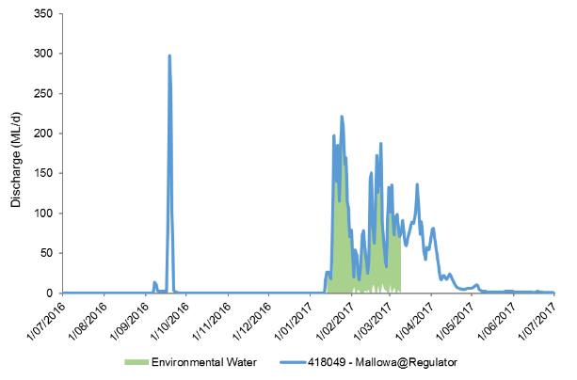
Figure G-1: Flows into the Mallowa System during 2016-17 including the delivery of environmental water.

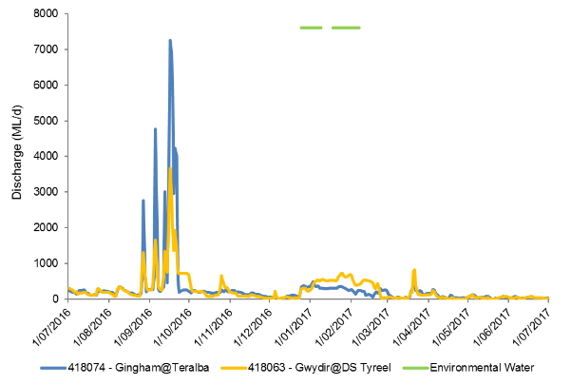
Figure G-2: Flows into the Gingham and lower Gwydir systems during 2016-17 including the delivery of environmental water.

Previous Monitoring
Vegetation monitoring as part of this project has been undertaken since December 2014 by Eco Logical Australia and OEH staff.
During the 2014-15 water year, the delivery of environmental water into the Lower Gwydir and Gingham wetlands influenced all five water dependent vegetation communities surveyed (Commonwealth of Australia 2015). While season was shown to be an influencing factor, the presence of environmental water had the largest influence on vegetation diversity and composition. The application of environmental water decreased the amount of bare ground and increased the diversity of aquatic species. There was also a significant reduction in the cover of the weed species lippia (Phyla canescens) in plots that became inundated by environmental water. Native wetland species such as water couch (Paspalum distinctum) and flat spike-sedge (Eleocharis plana) displayed significantly increased cover in plots inundated by environmental water.
During the following year (2015-16) these wetlands experienced less inundation, with species richness differing significantly between sites in the Gingham and Lower Gwydir (Commonwealth of Australia 2016). No significant differences were noted between sampling times or between sites that were inundated and those that remained dry. However, wet sites tended to have an increased number of water tolerant native species. Covers of native species such as water couch persisted during this year, with a corresponding lower cover of lippia.

Methods

2016-17 water year
Monitoring throughout the Lower Gwydir and Gingham wetlands was undertaken in October 2016 and March 2017. Thirty-three plots were surveyed at 12 locations in October 2016 (Table G-1, Figure G-3,Figure G-4), but due to restricted site access in March 2017, only 24 plots at nine locations were surveyed. In addition, seven plots at three locations were monitored within the Mallowa wetlands management unit during both survey periods (Figure G-5). All plots were in four broad wetland vegetation communities, and experienced a range of inundation conditions (Table G-1). Vegetation surveys were completed in conjunction with OEH staff, following OEH data collection protocols (Commonwealth of Australia 2014b), which recorded vegetation diversity and structure within each 0.04 ha plot. A number of environmental variables including the degree of inundation and grazing impact were also noted.
Species richness and dominance measures were analysed using a Poisson regression on count data that investigated the influence of inundation, survey time (2016-17), system (Gingham, Lower Gwydir, Mallowa) and vegetation community. To further explain changes in diversity, individual species were grouped into the following four functional groups (Brock and Cassanova 1997; Hale et al. 2013):
- Amphibious responders (AmR) – plants which change their growth form in response to flooding and drying cycle, including morphologically plastic (ARp) and floating/stranded (ARf) groups;
- Amphibious tolerators (AmT) – plants which tolerate flooding patterns without changing their growth form;
- Terrestrial damp plants (Tda) – plants which are terrestrial species but tend to grow close to the water margin on damp soils; and
- Terrestrial dry plants (Tdr) - those which are terrestrial species which don’t normally grow in wetlands but may encroach into the area due to prolonged drying.

Changes in these functional groups were then compared between survey times using F-tests to test for equality of variances and then t-tests to test for differences in means.
Changes in total vegetation cover, and the cover of key species (water couch, lippia) were analysed using ANOVA or f-tests/t-tests in Systat 13, to assess the influence of inundation, survey time, system and vegetation community. Total vegetation cover for each plot was calculated by adding together the cover of lower and mid strata types. Therefore, it was possible to get >100% total cover.
Changes in vegetation community composition data were investigated using multivariate nMDS plots with differences between the presence of environmental water, survey time and vegetation community assessed using PERMANOVA in Primer 6. SIMPER analysis was used to identify the species that were most responsible for driving patterns in the data, and follow up descriptive univariate analysis of these species were then undertaken.

Multi-year comparison
To assess longer term trends in vegetation species richness, a Poisson regression model on count data was used to investigate the influence of inundation, survey time (December 2014, March 2015, October 2015, March 2016, October 2016, March 2017), system and vegetation community. This analysis included 32 plots from the Lower Gwydir and Gingham systems in December 2014 and March 2015, and the sites described in section 2.1 above. Changes in total vegetation cover, and the cover of key species (water couch, lippia) were analysed using ANOVA or f-tests/t-tests in Systat 13, to assess the influence of inundation, survey time, system and vegetation community. Changes in community composition were investigated using multivariate nMDS plots with differences between inundation status, survey time, system and vegetation community assessed using PERMANOVA in Primer 6.
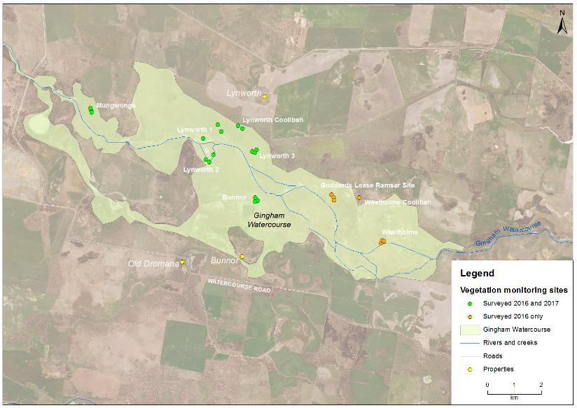
Figure G-3: Location of vegetation monitoring sites within the Gingham system.
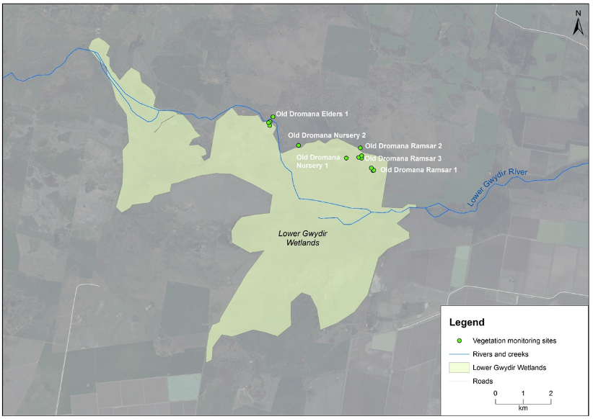
Figure G-4: Location of vegetation monitoring sites within the Lower Gwydir system.
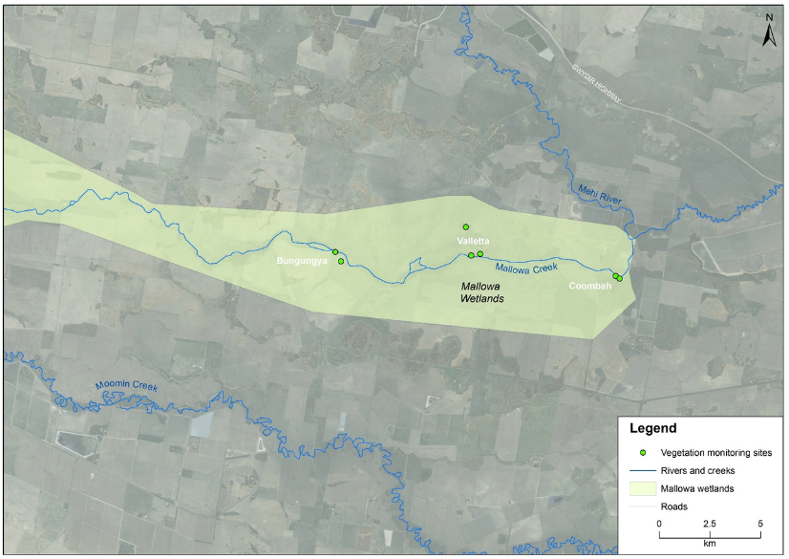
Figure G-5: Location of vegetation monitoring sites within the Mallowa system.
Table G-1: Sites surveyed in October 2016 and March 2017 for vegetation diversity. Map projection AGD94 Zone 55. Sites that were inundated at the time of sampling are coloured blue (‘wet’) and those that were not are coloured yellow (‘dry’). Sites not surveyed in March 2017 are greyed.
Vegetation communities | Sites | Management unit | Northing | Easting | 2016  (Oct) | 2017  (Mar)
Coolibah - river cooba - lignum | Bungunya_1_1 | Mallowa | 6723793 | 709823 | Dry | Dry
Coolibah - river cooba - lignum | Bungunya_1_2 | Mallowa | 6723336 | 710098 | Dry | Dry
Water couch marsh grassland | Bunnor_1_1 | Gingham | 6760771 | 728826 | Wet | Wet
Water couch marsh grassland | Bunnor_1_2 | Gingham | 6760658 | 728917 | Wet | Wet
Water couch marsh grassland | Bunnor_1_3 | Gingham | 6760630 | 728812 | Wet | Wet
River Cooba - Lignum | Coombah_1_1 | Mallowa | 6722614 | 723649 | Dry | Wet
River Cooba - Lignum | Coombah_1_2 | Mallowa | 6722491 | 723849 | Dry | Dry
Water couch marsh grassland | Goddards _Lease_Ramsar_1_1 | Gingham | 6760882 | 731652 | Wet
Water couch marsh grassland | Goddards _Lease_Ramsar_1_2 | Gingham | 6760784 | 731738 | Wet
Water couch marsh grassland | Goddards _Lease_Ramsar_1_3 | Gingham | 6760678 | 731749 | Wet
River Cooba - Lignum | Lynworth_1_1 | Gingham | 6763482 | 727443 | Wet | Wet
River Cooba - Lignum | Lynworth_1_2 | Gingham | 6763219 | 727574 | Wet | Wet
River Cooba - Lignum | Lynworth_1_3 | Gingham | 6762965 | 726906 | Wet | Wet
Coolibah Woodlands | Lynworth_1_4 | Gingham | 6763330 | 728359 | Wet | Dry
Water couch marsh grassland | Lynworth_3_1 | Gingham | 6762487 | 728716 | Wet | Dry
Water couch marsh grassland | Lynworth_3_2 | Gingham | 6762446 | 728809 | Wet | Dry
Water couch marsh grassland | Lynworth_3_3 | Gingham | 6762544 | 728885 | Wet | Dry
Water couch marsh grassland | Mungwonga_1_1 | Gingham | 6764005 | 722759 | Wet | Wet
Water couch marsh grassland | Mungwonga_1_2 | Gingham | 6763930 | 722771 | Wet | Wet
Water couch marsh grassland | Mungwonga_1_3 | Gingham | 6764083 | 722726 | Wet | Dry
Water couch marsh grassland | Old_Dromana_Elders_1_1 | Lower Gwydir | 6752745 | 723443 | Dry | Dry
Water couch marsh grassland | Old_Dromana_Elders_1_2 | Lower Gwydir | 6752603 | 723435 | Dry | Dry
Water couch marsh grassland | Old_Dromana_Elders_1_3 | Lower Gwydir | 6752706 | 723395 | Dry | Dry
Coolabah Woodland - wet understorey | Old_Dromana_Elders_1_4 | Lower Gwydir | 6752918 | 723552 | Dry | Dry
Coolabah Woodland - wet understorey | Old_Dromana_Nursery_1 | Lower Gwydir | 6751431 | 726197 | Dry | Wet
Coolabah Woodland - wet understorey | Old_Dromana_Nursery_2 | Lower Gwydir | 6751888 | 724473 | Wet | Dry
Eleocharis tall sedgelands | Old_Dromana_Ramsar_1_1 | Lower Gwydir | 6750977 | 727152 | Wet | Wet
Eleocharis tall sedgelands | Old_Dromana_Ramsar_1_2 | Lower Gwydir | 6750992 | 727184 | Wet | Wet
Eleocharis tall sedgelands | Old_Dromana_Ramsar_1_3 | Lower Gwydir | 6751075 | 727098 | Wet | Wet
Coolabah Woodland - wet understorey | Old_Dromana_Ramsar_2_1 | Lower Gwydir | 6751800 | 726701 | Wet | Wet
Water couch marsh grassland | Old_Dromana_Ramsar_3_1 | Lower Gwydir | 6751426 | 726741 | Wet | Wet
Water couch marsh grassland | Old_Dromana_Ramsar_3_2 | Lower Gwydir | 6751456 | 726641 | Wet | Wet
Water couch marsh grassland | Old_Dromana_Ramsar_3_3 | Lower Gwydir | 6751515 | 726746 | Wet | Wet
Coolabah Woodland - wet understorey | Westholme_Coolibah_1 | Gingham | 6764083 | 722726 | Dry
Water couch marsh grassland | Westhome_1_1 | Gingham | 6759094 | 733487 | Wet
Water couch marsh grassland | Westhome_1_2 | Gingham | 6759189 | 733523 | Wet
Water couch marsh grassland | Westhome_1_3 | Gingham | 6759157 | 733591 | Wet
Coolibah - river cooba - lignum | Valletta_1_1_NE | Mallowa | 6723629 | 716519 | Wet | Wet
Coolibah - river cooba - lignum | Valletta_1_2 | Mallowa | 6723681 | 716970 | Dry | Wet
Coolibah - river cooba - lignum | Valletta_2_1 | Mallowa | 6725026 | 716262 | Wet | Wet

Results

2015-16 water year

Vegetation species richness, dominance and cover
A total of 162 taxa from 45 families were recorded across all vegetation plots. Mean species richness at each location during each survey period was 16.4, up from the 2015-16 mean of 14.6. The highest mean species richness was 33, recorded at Bungunya and Old Dromana Nursery in March 2017; while the lowest was 5.6 recorded at Bunnor in March 2016 (Figure G-6).
Poisson model results suggest that inundation status was the most influential factor on species richness, with dry sites having significantly more species (21.8 + 7.8 species) than wet sites (13.7 + 6.8 species, Pr<0.001). Significant differences were also observed between systems (Pr<0.001), vegetation communities (Pr<0.001) and sample times (Pr<0.005). Sites in the Mallowa system had significantly higher richness (25 + 7.4 species, Figure G-7) than sites in the Gingham (12 + 4.8 species; P<0.05) and Lower Gwydir (17.5 + 7.8 species; p<0.001). Coolibah Woodland (22.8 + 7.3 species) and River Cooba Lignum sites (22 + 7.8 species) has significantly more species than either Watercouch marsh grassland (12.2 + 5.6 species) or Eleocharis tall sedgeland sites (11.5 + 3.6 species). Sites sampled in October 2016 (15.5 + species) had more species than in March 2017 (15 + 7.0 species).
Predicable patterns were observed when species were grouped into their functional groups. Wet sites had a greater number of species from the Amphibious functional group including AmR and AmT, than dry sites (Figure G-8), with this difference being significant for AmR species (p<0.01). In contrast, the number of species in the terrestrial functional group, including Tdr and Tda species, was significantly higher in dry sites than wet sites (p<0.001). Differences in vegetation growth forms were also noted in the 2016-17 water year. The mean number of forb species was significantly higher in dry sites (12.4 species) than wet sites (7.4 species; p<0.001). Similarly, higher numbers of chenopod shrub, tussock grass, shrub and tree species were observed in dry sites (Figure G-8). The only growth form that was more abundant in wet plots was the rush growth form, which had mean number of species of 1.58 and 1.1 species for wet and dry sites respectively.
The mean cover of the dominant species in each plot was 43 + 18%. This ranged from 20% at Bungunya during October 2016, to 81% at Bunnor in March 2017 (Figure G-10, Figure G-11). Inundation status was also the most influential factor on mean species dominance (p<0.005), followed by sampling occasion (p<0.05) and then system (p<0.05). No significant influence of vegetation community was observed (p=0.74). Wet sites had significant higher mean dominance (47 + 17.2%) than dry sites (34 + 17.5%). Mean dominance was higher in March 2017 (46 + 18.0%) than in October 2016 (40.0 + 17.9%). Plots in the Gingham watercourse (50 + 19.3%) had significantly higher mean dominance than both Gwydir (37 + 14.6%) and Mallowa (37.0 + 15.8%) plots.

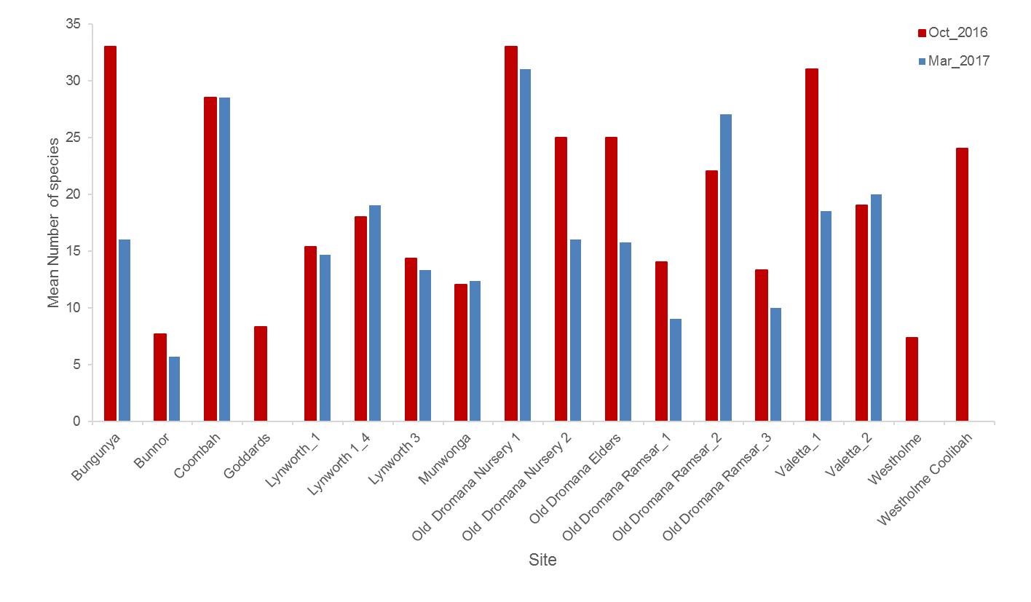
Figure G-6: Mean number of species recorded at each site during the October 2016 and March 2017 surveys.
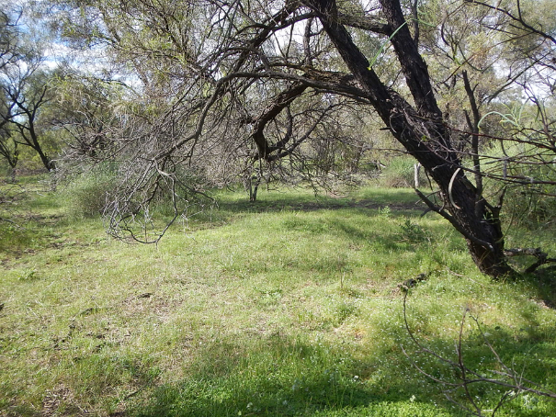
Figure G-7: Vegetation plot at Valetta in the Mallowa Wetlands in March 2017.

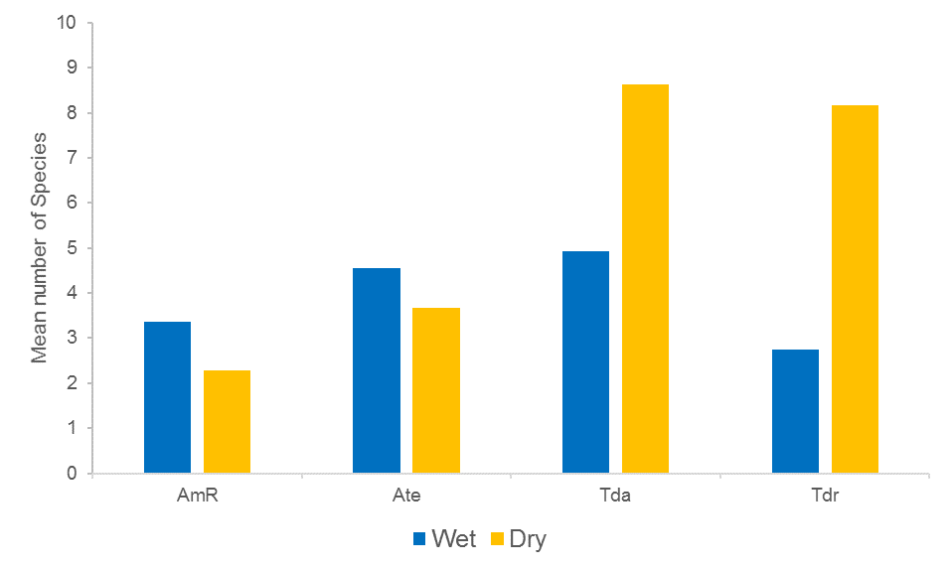
Figure G-8: Mean number of species in functional groups present when grouped by inundation status.
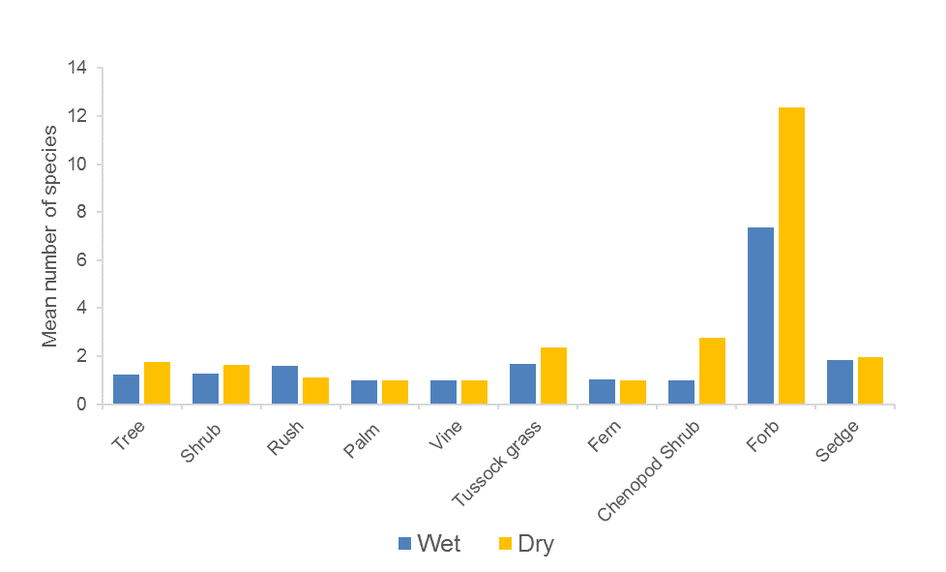
Figure G-9: Mean number of species in each of the different growth forms present in the Gwydir River system in the 2016-17 water year.

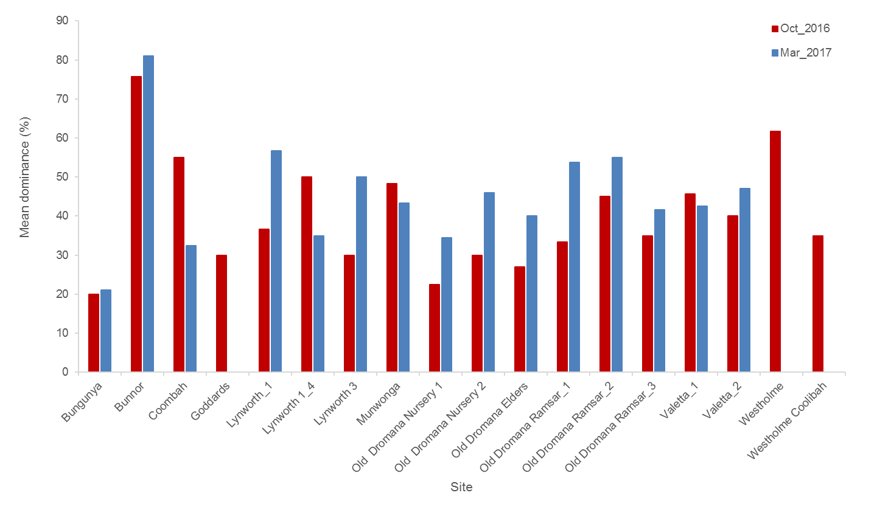
Figure G-10: Mean dominance (%) recorded at each site during the October 2016 and March 2017 surveys. (Note: no data was collected at the Westholme sites in March 2017 due to the loss of access).

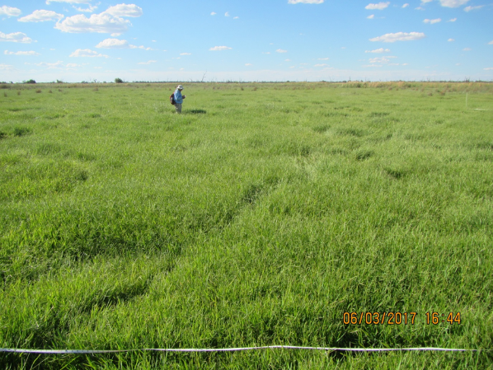
Figure G-11: Dominance of water couch as the Bunnor survey site in March 2017.
Small variations were noted in mean vegetation cover based on inundation status (Figure G-10) and sampling time (Figure G-11) during the 2016-17 water year, but these were not significant. Water couch was the most dominant species recorded in terms of cover across the study area, being found at 34 of 40 (85%) plots surveyed. Mean water couch cover was significantly greater in wet plots (24.88%), than dry plots (9.71; T=-3.099, Pr=0.003;
Figure G-15). Mean water couch cover was also greater during March 2017 (23.51%) than October 2016 (16.91%; Figure G-13), but this increase was not significant (T=1.131, Pr=0.263). The cover of the weed species lippia varied between wet and dry plots (Figure G-17) and also between sampling times (Figure G-17), though these differences were not significant.
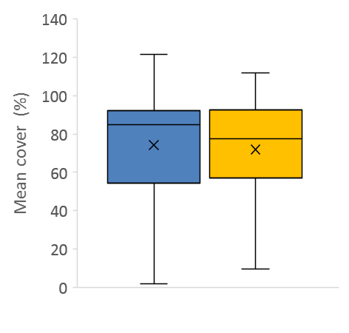
Wet Dry
Figure G-12: Mean vegetation cover (%) at sites that were Wet and Dry in the 2016-17 water year.
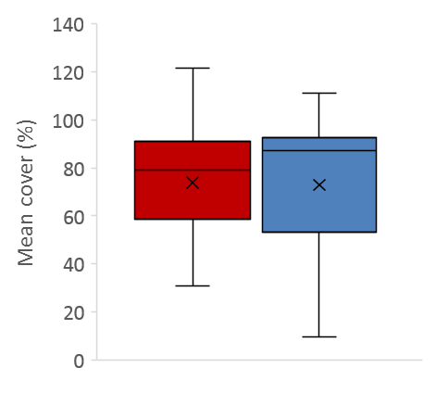
Oct 2016 Mar 2017
Figure G-13: Mean vegetation cover (%) at sites surveyed in October 2016 and March 2017.
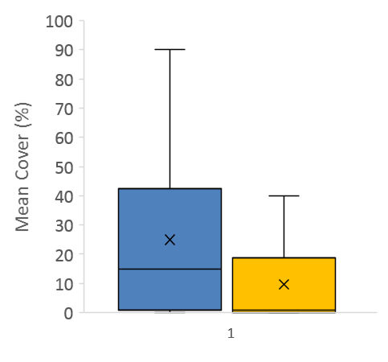
Wet Dry
Figure G-14: Mean water couch cover (%) at sites that were Wet and Dry in the 2016-17 water year.

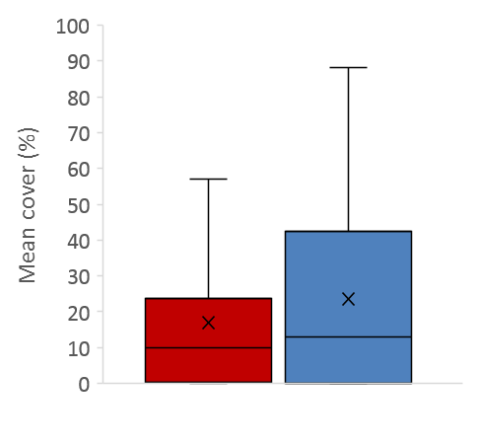
Oct 2016 Mar 2017
Figure G-15: Mean water couch cover (%) at sites surveyed in October 2016 and March 2017.
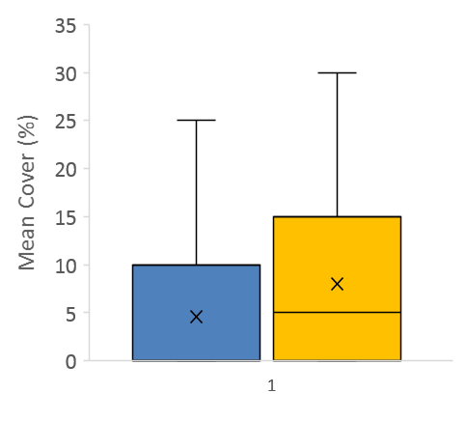
Wet Dry
Figure G-16: Mean lippia cover (%) at sites that were Wet and Dry in the 2016-17 water year.
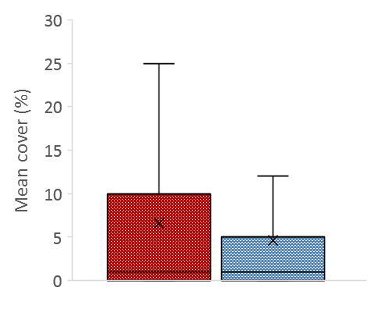
Oct 2016 Mar 2017
Figure G-17: Mean lippia cover (%) at sites surveyed in October 2016 and March 2017.

Vegetation community composition
PERMANOVA tests undertaken on the vegetation community composition data from all plots surveyed during the 2015-16 water year suggested that vegetation community (Pseudo-F = 2.54, Pr<0.01) and inundation status (Pseudo-F = 7.34, Pr<0.005) were exerting an influence on the observed patterns in the data (Figure G-18). The interaction of these factors was also significant (Pseudo-F = 3.29, Pr<0.005). Pairwise tests suggested that significant differences occurred between wet and dry sites in water couch marsh grassland (t=2.64, Pr<0.005) and river cooba lignum (t=2.58, Pr<0.005) vegetation communities, but no differences were noted in the community composition data between wet or dry sites within coolabah woodland sites (Pr=0.20). Sampling time did not have a significant influence on the grouping of the data in multidimensional space (Pr=0.52)
SIMPER analysis showed that flat spike-sedge (Eleocharis plana; 12.3%) and lippia (9.78%) had the largest influence on the grouping of wet sites (Table G-2). For wet sites, water couch (18.16%), flat spike sedge (14.25%) and tussock rush (Juncus aridicola; 10.12%) had the greatest influence on the grouping of sites.
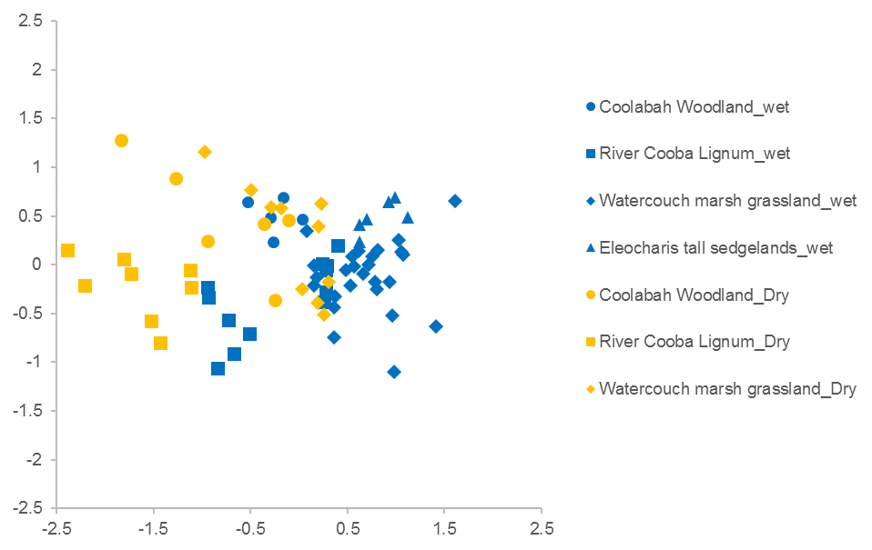
Figure G-18: nMDS plot of vegetation community composition data grouped by vegetation community and the presence of water (wet or dry).

Table G-2: Dominant species and variables contributing to vegetation community composition groupings based on inundation status.
Data grouping | Species | Contribution (%) | Cumulative (%)
Dry | flat spike-sedge | 12.3 | 12.3
 | lippia | 9.78 | 22.08
 | water couch | 6.47 | 28.55
 | common nardoo | 6.39 | 34.94
 | coolabah | 5.61 | 40.55
Wet | water couch | 18.16 | 18.16
 | flat spike-sedge | 14.25 | 32.41
 | tussock rush | 10.12 | 42.53
 | narrow-leaved cumbingi | 8.14 | 50.67
 | swamp buttercup | 7.84 | 58.51

Multi-year comparisons

Vegetation species richness, dominance and cover
A poisson model run on species richness data from years 1-3 of the project suggested that inundation status was having the greatest influence on species number (p<0.001), followed by system (p<0.001), sampling time (p<0.001) and vegetation community (p<0.001). Significant interactions between inundation status and sampling time (p<0.001) and wetland and sampling time (p<0.05) were also detected. Mean richness was highest in December 2014 (25.9 species) and both wet and dry sites generally reduced in richness through to March 2017 (Figure G-19). The exception to this was dry sites in October 2016, which increased to the highest mean richness measured (27.8 species) before reducing again in March 2017. Similarly, mean species richness at sites within all systems generally reduced from December 2014 (Figure G-20), except for sites in the Gingham and Mallowa which showed a spike in October 2016.
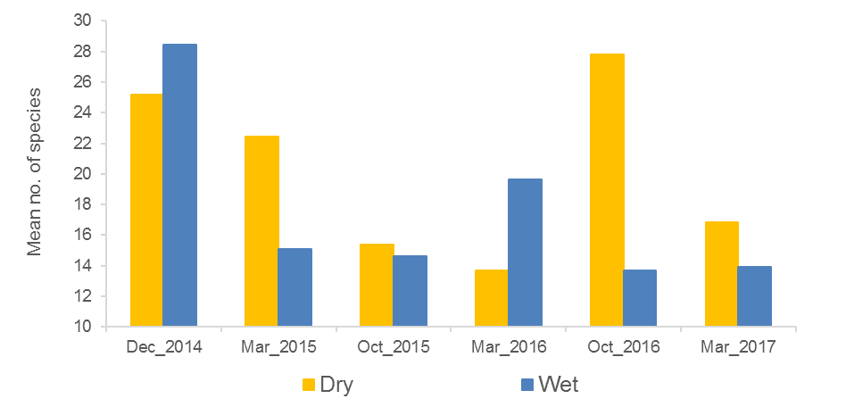Figure G-19: Mean species richness in wet and dry sites over year 1-3 of the project.
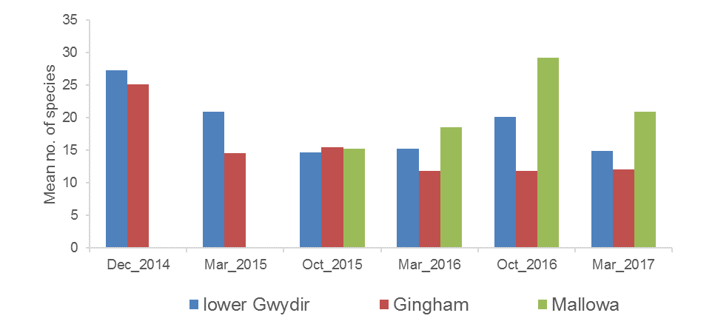
Figure G-20: Mean species richness in sites from the thee systems monitored in years 1-3 of the project.
Similar patterns were observed in the dominance data over year 1-3 of the project, with inundation status (p<0.001), sampling period (p<0.001), system (p<0.001) and vegetation community (p<0.001) all having a significant influence on patterns of mean species dominance. Again, significant interactions between sampling time and inundation status (p<0.001) and sampling time and wetland (p<0.05) were observed. Both wet and dry sites generally reduced in mean dominance over the life of the project, although Wet sites did peak in March 2015 at 71% cover (Figure G-21). Sites in the Gingham system have displayed higher dominance than those in the Lower Gwydir and Mallowa for all times except October 2014 and March 2015 (Figure G-22).
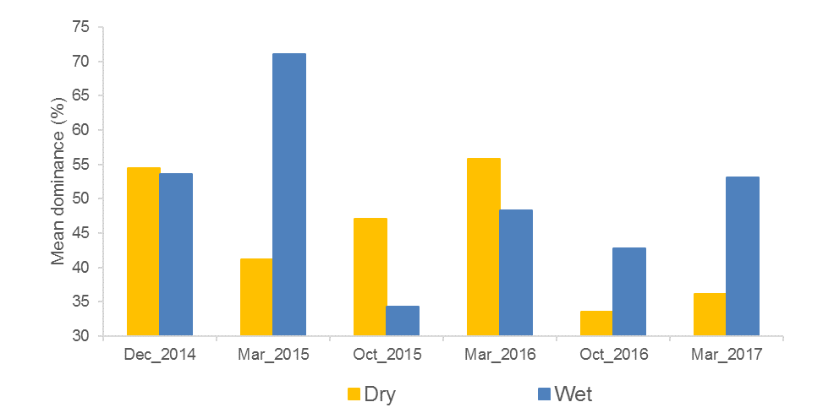
Figure G-21: Mean dominance (%) in wet and dry sites over year 1-3 of the project.
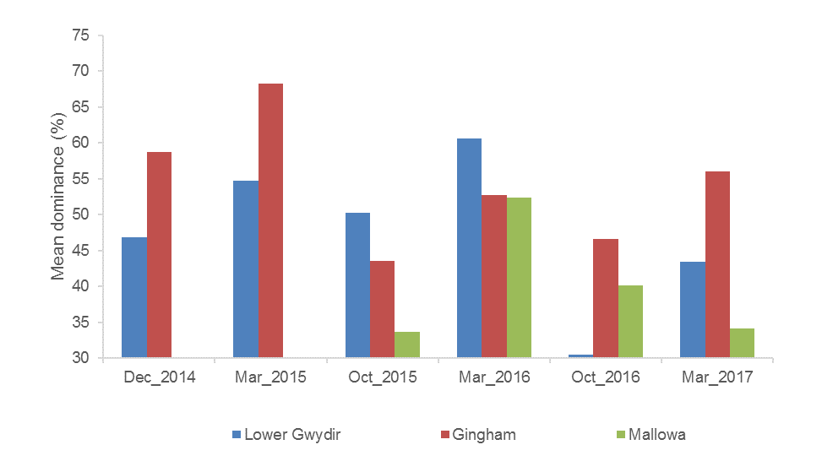
Figure G-22: Mean dominance (%) in sites from the thee systems monitored in years 1-3 of the project.
Mean vegetation cover was significantly influenced by sampling time (p<0.005) and system (p<0.001) over years 1-3 of the project, and there was a significant interaction for the years where all three wetlands were surveyed (p<0.001). The Lower Gwydir and Gingham systems followed a similar trend in mean vegetation cover until March 2017 (Figure G-23). The Mallowa showed an increase until October 2016 (96%) in October 2016, before reducing in March 2017. Differences between wet and dry sites, and vegetation communities were non-significant (inundation status p=0.29. Vegetation community p=0.21) although the interaction between sampling time and vegetation community was significant (p<0.001). Here, Coolibah woodland sites showed much less vegetation cover in December 2014 (57%), whereas, River cooba lignum showed reduced cover in October 2015, and Eleocharis tall sedgeland had lowest cover in March 2017 (Figure G-24).
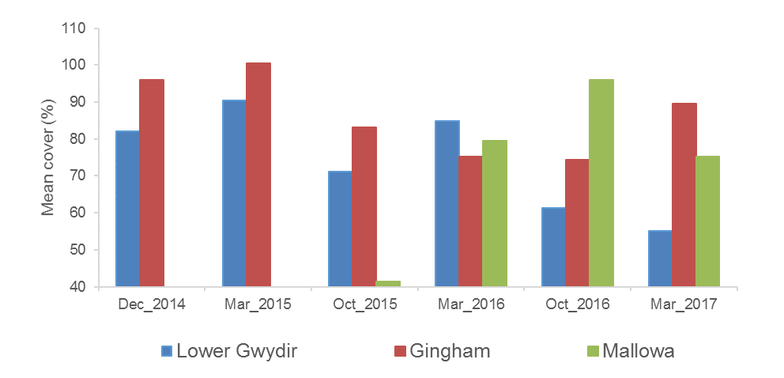
Figure G-23: Mean vegetation cover in sites from different systems surveyed in years 1-3 of the project.
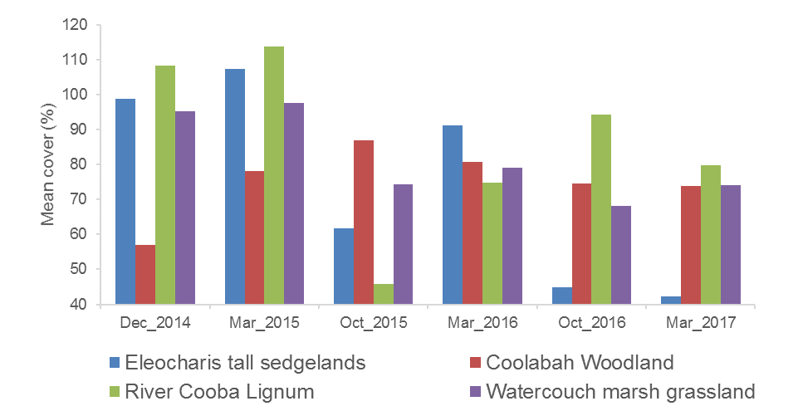
Figure G-24: Mean vegetation cover in sites from different vegetation communities surveyed in years 1-3 of the project.
Mean cover of water couch varied significantly over time (p<0.001), but not with inundation status (p=0.21). However, there was a significant interaction between survey time and inundation status (p<0.005). Mean cover of water couch has generally decreased over time for both wet and dry sites (Figure G-25). Wet sites did show a significant peak in water couch cover in March 2015 (65%). Over years 1-3 of the project mean lippia cover has differed significantly between wet and dry sites (p<0.001), but has shown no significant trend over time (p<0.005). Lippia cover was consistently higher in dry sites for all times surveyed (Figure G-26).
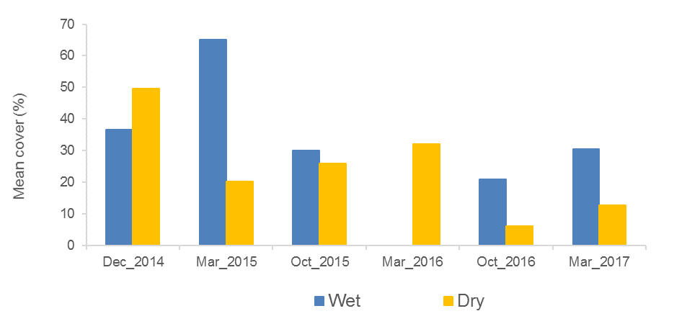
Figure G-25: Mean cover of water couch surveyed at wet and dry plots in years 1-3 of the project. Note: no wet plots contained water couch in March 2016.

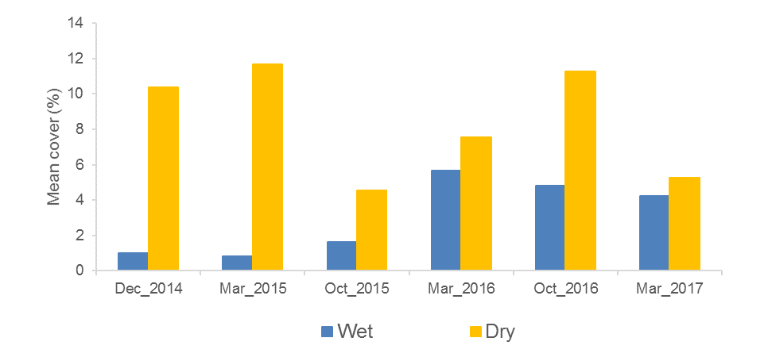
Figure G-26: Mean cover of lippia surveyed at wet and dry plots in years 1-3 of the project.

Vegetation community composition
Separation in the community composition data was observed when grouped by sampling time (including the six sampling times from years 1-3 of the project) and inundation (Figure G-27). The closer clustering of the wet sites suggests that the community composition of the sites is more similar than those occurring in dry sites. PERMANOVA analysis suggests that significant differences occurred based on inundation status (Pseudo-F=4.54, Pr<0.05) and vegetation community (Pseudo-F=12.48, Pr<0.01), but not sampling time (p=0.17). The interaction between sampling time and inundation status was significant (Pseudo-F=4.08, Pr<0.01), with October 2015 being the only time where wet and dry sites were not significantly different (p=0.46). Wet and dry sites within water couch marsh grassland communities were significantly different (t=2.38, p<0.001) as were wet and dry sites within Coolibah woodland sites.
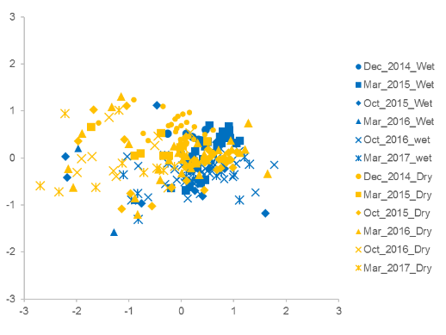
Figure G-27: nMDS plot of vegetation composition data in year 1 and 2 of the project grouped by sampling time and inundation status (wet or dry).

Discussion
In August-September 2016, the Gingham Watercourse experienced the most significant flooding since 2015, with around 2,855 ha becoming inundated (Appendix B). This inundated all but one vegetation diversity monitoring plot in the Gingham system, and stimulated a positive response in vegetation growth. There was an increase in the number of wetland (amphibious) species and an increase in vegetation cover including water couch, which likely contributed to an increase in species dominance in this system. The response in the Gwydir wetlands was less pronounced, with a reduced area of this wetland system being flooded. The added benefit of the environmental water delivered to the Gingham and Gwydir wetlands over the Christmas period on vegetation communities is hard to decipher from the larger influence of natural flooding, but it is likely to have prolonged the benefits of flooding in the core wetland areas that remained inundated.
The influence of environmental water was greater on vegetation communities in the Mallowa wetlands with this system receiving very little of the natural early season flooding (Appendix B), although high local rainfall and runoff did occur in September 2016 stimulating the growth of a relatively high number of species and increasing vegetation cover. Environmental flows in this system were delivered in January-March 2017 inundating over half of the study sites. These sites continued to show high species richness when compared to the other systems studied, and mean vegetation cover also remained high when compared to the previous watering year.
The response of vegetation to inundation has been variable in the first three years of the project. Inundation status has consistently influenced species richness and dominance, but these have also varied in time, across wetlands and for different vegetation communities. For example, mean species richness has typically been reduced by flooding, through its effects on terrestrial species, except within the March 2016 survey, where species richness was higher in inundated sites. The significant peak in richness at dry sites in the October 2016 survey, was most likely due to above average rainfall stimulating the growth of terrestrial species at sites, especially in the Mallowa and Lower Gwydir systems that were not inundated by floodwater.
Inundation appears to be having less influence on total vegetation cover over the long term, though it is having an influence on certain key species, such as water couch and lippia, with inundation favouring the native water couch. Even so, cover of water couch has reduced over time from a high of 65% in wet sites following flooding in March 2015, to an average of 35% in sites inundated in 2016. This may reflect the relatively dry year that was experience in 2015-16, reducing the cover of water couch, coupled with the early winter/spring flooding in 2016, inundating sites before the preferred growing season. However, sites that were inundated over the summer period by follow up deliveries of environmental water in the Gingham, maintained high water-couch growth (Figure G-11).

Conclusion
Environmental water that was delivered into the Gingham and Lower Gwydir wetlands in 2016-17 was used to prolong inundation in core wetland areas following significant winter/spring flooding in 2016. While most patterns in vegetation response appear to be reflective of the broader flooding, environmental water maintaind high cover of some native wetland species such as water couch throughout the season. Similarly, environmental water delivered to the Mallowa system appeared to maintain high species richness and vegetation cover that were stimulated by the good winter/spring rainfall and local runoff.

References
Bowen S. and Simpson, S.L. 2010. Changes in Extent and Condition of the Vegetation Communities of the Gwydir Wetlands and Floodplain 1996-2008: Final Report NSW Wetland Recovery Program. NSW Department of Environment Climate Change and Water: Sydney
Brock, M.A. and Casanova, M.T. 1997. Plant life at the edge of wetlands: ecological responses to wetting and drying patterns. In Frontiers of Ecology; Building the Links. Edited by N.Klomp and Lunt. Elsevier Science, Oxford. Pp. 181-192
Commonwealth of Australia. 2014a. Commonwealth environmental water use options 2014-15: Gwydir River Valley, Commonwealth of Australia.
Commonwealth of Australia. 2014b. Commonwealth Water Office Long Term Intervention Monitoring Project; Gwydir River System Selected Area, Commonwealth of Australia.
Commonwealth of Australia. 2015. Commonwealth Environmental Water Office Long Term Intervention Monitoring Project Gwydir River System Selected Area – 2014-15 Draft Evaluation Report, Commonwealth of Australia 2015.
Commonwealth of Australia. 2016. Commonwealth Environmental Water Office Long Term Intervention Monitoring Project Gwydir River System Selected Area – 2015-16 Draft Evaluation Report, Commonwealth of Australia 2015.
Wilson, G.G., Bickel, T.O., Berney, P.J. & Sisson, J.L. 2009. Managing environmental flows in an agricultural landscape: the Lower Gwydir floodplain. Final Report to the Australian Government Department of the Environment, Water, Heritage and the Arts. University of New England and Cotton Catchment Communities Cooperative Research Centre, Armidale, New South Wales. 17

Fish (River)

Introduction
The fish assemblages of the Gwydir Valley are generally considered to be in a severely degraded state (Murray-Darling Basin Authority 2012). The Sustainable River Audit (SRA) No. 2 Report stated that the fish in the upper sections (above 400 mASL) of the Valley were in “Very Poor” condition, the Slopes (201-400 mASL) were in “Moderate” condition, whilst in the Lowland (31-200 mASL) they were classified as “Poor” (Murray-Darling Basin Authority 2012). Overall the fish community across the valley classified as “Poor”. The SRA reported that the Gwydir in general had reduced numbers of species and abundance among the native fish, recruitment was variable and generally low on a site by site basis, and that there were exotic species sampled at most sites including high abundances of common carp (Cyprinus carpio), eastern mosquitofish (Gambusia holbrooki), goldfish (Carassius auratus) and redfin perch (Perca fluviatilis).
The aim of this section of the Gwydir river system Selected Area LTIM project was to benchmark and describe the fish community in abundance, biomass and community health across four monitoring zones in the lower Gwydir system in relation environmental water releases. Several specific questions were posed in relation to this indicator:
- What did Commonwealth environmental water contribute to native fish community resilience?
- What did Commonwealth environmental water contribute to native fish survival?
- What did Commonwealth environmental water contribute to native fish populations?
- What did Commonwealth environmental water contribute to native fish diversity?

Environmental watering in 2016-17
During 2016-17 environmental water was delivered to a number of assets within the Gwydir river system Selected Area (Selected Area, Appendix A). In September 2016, a flow event occurred down the Mehi River and supplementary water licences owned by the CEWO were triggered. A total of 5,000 ML was accounted for in the Mehi River.
Supplementary flows were triggered in the Mallowa in September 2016, however, very little of the moderate flows were diverted into the Mallowa wetlands. In January - March 2017, planned deliveries of 5,000 ML were increased to 10,000 ML to the Mallowa Creek system to inundate fringing wetlands. Flows were also delivered into the lower Gwydir River and Gingham watercourse to build upon moderate winter/spring flows. In January - March 2017, 30,000 ML was delivered, aiming to inundate broad areas of semi-permanent wetland vegetation.
During 2016-17, no environmental water was delivered to the Moomin Creek.

Previous monitoring
Recent sampling of the lower Gwydir fish community was undertaken as part of the Commonwealth Environmental Water Office (CEWO) Short Term (STIM; 2013-14) and Long Term Intervention Monitoring (LTIM; 2015 & 2016) Projects (Southwell et al. 2015; Commonwealth of Australia 2015, 2016). Ten native species and three exotic species were captured in both programs combined. Overall, the most abundant species sampled was bony herring (Nematolosa erebi) which made up 41.6% of the total catch in 2013-14, 31% in 2014-15 and 50% in 2015-16. Other large-bodied species such as Murray cod (Maccullochella peelii), golden perch (Macquaria ambigua) and freshwater catfish (Tandanus sp.) were only caught in relatively low numbers in both studies. Australian smelt (Retropinna semoni) and carp gudgeon (Hypseleotris sp.) dominated the catch among the small-bodied species. Common carp (Cyprinus carpio) were the most abundant exotic species sampled in both studies, making up >50% of the biomass of all fish sampled in the 2014-15 and 42% in 2015-16 (Commonwealth of Australia 2015, 2016).

Methods
Data was collated from 23 sites within four monitoring zones across the lower Gwydir Basin for Cat 3 Fish River analyses; the Gingham Watercourse, Gwydir River, Mehi River and Moomin Creek zones. Sampling was undertaken between 11th January 2017 and 1st June 2017. Fifteen sites were sampled solely as part of the Gwydir LTIM Cat 3 program; five each in the Mehi, Mooman and Gingham sub-catchments. A sub-set of the data from six (randomly chosen) of the 10 LTIM Cat 1 Fish River sites from the lower Gwydir River was also used in the analyses. For these sites, the first 1080 sec of boat or 1200 sec of backpack electrofishing (or where applicable combinations of both) was used as the sampling effort. Along with sites monitored specifically for the LTIM program, data collected by Fisheries NSW as part of the Murray-Darling Basin Plan monitoring program at one site in the Moomin Creek zone, was again utilised in the analysis (Table H-1).
Sampling sites in all four sub-catchments were typical of the meandering waterways found throughout the lowland reaches of the Murray-Darling Basin. The water at all sites was turbid and relatively shallow and there were distinct pool/run/riffle zones present within many of the sites (Figure H-3). In the Gwydir River upstream of Tyreel Weir and in the Mehi River, the river channel was wider, deeper and more permanent in nature, averaging ~30 m in width and ~1.5 m in depth. In the lower Gwydir, Gingham and Moomin, the majority of sites were narrower (~8-16 m) and shallower (~0.5 m). Depths and flow were similar to that of 2014-15 but compared to 2015-16 there was much more water, with visible flow apparent at the majority of sites in all four systems.
In-stream habitat across all four sub-catchments was dominated by submerged timber and undercut banks. The substratum at sites was typically mud; however, gravel, sand and silt substrates were also present in some areas. In general, all four river systems were highly disturbed as a result of anthropogenic influences such as agriculture, altered flows, and terrestrial and aquatic exotic species. The majority of sites were adjacent to irrigated and dryland cropping land. Most sites were fringed by only a narrow riparian zone, dominated by native trees and exotic shrubs. Notable terrestrial weeds included African boxthorn (Lycium ferocissimum), noogoora burr (Xanthium pungens) and lippia (Phyla canescens).

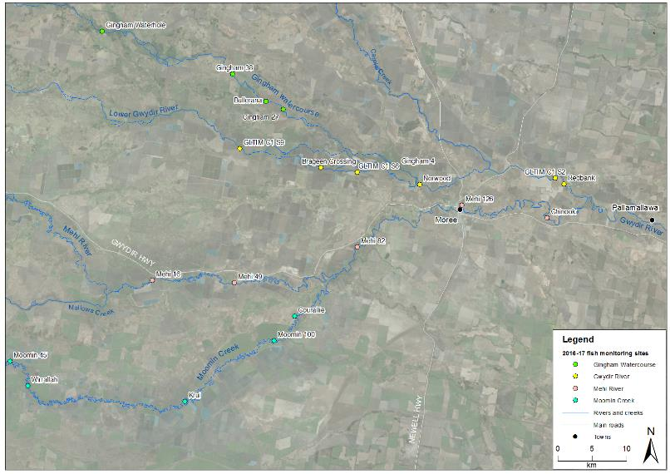
Figure H-1: Location of sampling sites in the Gwydir, Mehi, Moomin and Gingham water courses used in Gwydir LTIM Category 3 Fish River analyses.
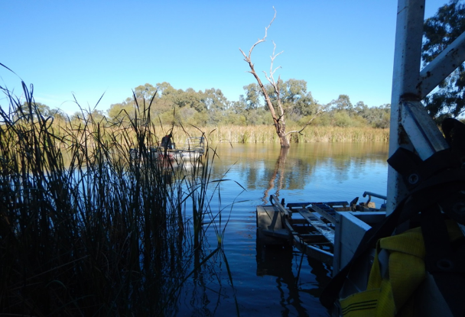
Figure H-2: Gingham Waterhole survey site on Gingham Watercourse sampled as part Gwydir LTIM Category 3 Fish River 2016-17 assessment.
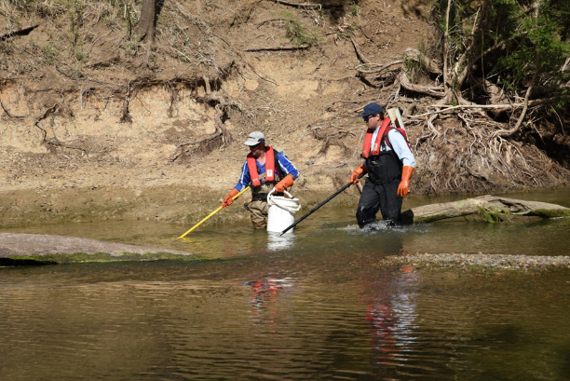
Figure H-3: Sampling site on the upper section of Gwydir River, sampled as part Fish River sampling 2016-17.
Table H-1: Sampling sites used in the analysis of Gwydir LTIM Category 3 Fish River 2016-17 assessment.
Site Name | River | Source | Latitude | Longitude | Altitude | Zone | Effort
Gingham 27 | Gingham Watercourse | LTIM CAT 3 | -29.34100 | 149.57700 | 168 | Lowland | Backpack
Gingham 38 |  | LTIM CAT 3 | -29.29600 | 149.50000 | 168 | Lowland | Backpack
Gingham Waterhole |  | LTIM CAT 3 | -29.24342 | 149.30227 | 173 | Lowland | Small boat
Bullerana |  | LTIM CAT 3 | -29.33100 | 149.55100 | 175 | Lowland | Backpack
Gingham 4 |  | LTIM CAT 3 | -29.41400 | 149.75100 | 208 | Slopes (L) | Medium boat
Brageen Crossing | Gwydir River | LTIM CAT 1 | -29.41679 | 149.63554 | 185 | Lowland | Backpack
GLTIM C1 S9 |  | LTIM CAT 1 | -29.39400 | 149.51300 | 187 | Lowland | Backpack
GLTIM C1 S6 |  | LTIM CAT 1 | -29.42200 | 149.69000 | 198 | Lowland | Backpack
Norwood |  | LTIM CAT 1 | -29.43597 | 149.78444 | 201 | Slopes (L) | Medium boat
Redbank |  | LTIM CAT 1 | -29.43086 | 150.00138 | 201 | Slopes (L) | Small boat/backpack
GLTIM C1 S2 |  | LTIM CAT 1 | -29.42300 | 149.98800 | 219 | Slopes (L) | Small boat/backpack
Mehi 16 | Mehi River | LTIM CAT 3 | -29.57000 | 149.38600 | 165 | Lowland | Backpack
Mehi 49 |  | LTIM CAT 3 | -29.57100 | 149.50900 | 185 | Lowland | Backpack
Mehi 82 |  | LTIM CAT 3 | -29.52010 | 149.69300 | 184 | Lowland | Backpack
Moree |  | LTIM CAT 3 | -29.46958 | 149.89977 | 201 | Slopes (L) | Medium boat
Mehi 126 |  | LTIM CAT 3 | -29.46200 | 149.84900 | 206 | Slopes (L) | Medium boat
Chinook |  | LTIM CAT 3 | -29.47556 | 149.97713 | 217 | Slopes (L) | Small boat
Moomin 45 | Moomin Creek | LTIM CAT 3 | -29.68000 | 149.17400 | 155 | Lowland | Backpack
Wirrallah |  | LTIM CAT 3 | -29.71172 | 149.20145 | 160 | Lowland | Backpack
Heathfield |  | MDBP | -29.72413 | 149.28851 | 163 | Lowland | Backpack
Krui |  | LTIM CAT 3 | -29.72811 | 149.43867 | 178 | Lowland | Backpack
Courallie |  | LTIM CAT 3 | -29.61283 | 149.60136 | 178 | Lowland | Backpack
Moomin 100 |  | LTIM CAT 3 | -29.64600 | 149.57100 | 184 | Lowland | Backpack

Sampling protocols
Sampling effort at each site was a combination of electrofishing and bait trapping (Commonwealth of Australia 2014, Hale et al. 2014). Electrofishing included small and medium boats (3.5 kW or 5 kW Smith-Root electrofisher unit respectively), backpack (Smith Root model LR20) or a combination of boat and backpack. Boat electrofishing consisted of 12 x 90 sec power-on operations per site, while backpack electrofishing consisted of 8 x 150 sec operations. At sites where both boat and backpack sampling was required, the number of operations of each method used was proportional to the area of navigable versus wadable habitat. Boat electrofishing involved a series of ~10 sec power-on and power–off operations, with successive operations undertaken on alternate banks while moving in an upstream direction. Backpack electrofishing involved sampling all areas accessible to the stationary operator, before they would progressively move upstream around ~3 m before repeating the process. All boat and backpack electrofishing was undertaken by a minimum of two operators, with three operators used at medium boat sites. Ten unbaited traps were deployed for a minimum of two hours at each site; undertaken at the same times as electrofishing. Traps were set haphazardly throughout the site in water depths of 0.5 – 1 m. All fish were identified to species level, measured to the nearest mm and released onsite. When an individual or individuals could not be positively identified in the field, a voucher specimen was retained for laboratory identification. Length measurements (to the nearest mm) were taken as fork length for species with forked tails and total length for all other species. Only a sub-sample of individuals were measured and examined for each gear type where large catches of an individual species occurred. The sub-sampling procedure consisted of firstly measuring all individuals in each operation until at least 50 individuals had been measured in total. The remainder of individuals in that operation were also measured but any individuals of that species from subsequent operations of that gear type were only counted. Fish that escaped capture, but could be positively identified were also counted and recorded as “observed”.

Data analyses
Fish community
Electrofishing and bait trapping data were combined for statistical analyses of the fish community. Non-parametric multivariate analysis of variances (PERMANOVA) was used to determine if there were differences between the fish assemblages in each of the four hydrological zones within and between years (PRIMER 6 & PERMANOVA; Anderson et al. 2008). Prior to analyses, the data were fourth root transformed and the results used to produce a similarity matrix using the Bray-Curtis resemblance measure. A dummy variable (weight 0.0001) was added to the matrix prior to transformation because of the zero catches recorded at the six dry sites (Vieira and Fonseca 2013). All tests were considered significant at P <0.05. Where differences were identified by PERMANOVA, pair-wise comparisons were used to determine which groups differed. Similarity percentage (SIMPER) tests were used to identify individual species contributions to average dissimilarities among groups.
Non-parametric Kolmogorov-Smirnov Z tests were used to determine if there were differences in the lengths of the six most abundant small- and large-bodied species in each of the four sub-catchments both within and between years. Only zones where >20 individuals were sampled were included in the analyses. P-values were adjusted to account for increasing experiment-wise error rates associated with multiple comparisons (Ogle 2015). Species included were: large bodied - Murray cod, common carp and bony herring; and small-bodied - Murray-Darling rainbowfish, carp-gudgeon and Australian smelt.
Health Metrics
Reference Condition
The predicted pre-European fish community of the lower Gwydir system was derived using the Reference Condition for Fish (RC-F) approach used by the Sustainable Rivers Audit (SRA) and NSW Monitoring, Evaluation and Reporting (MER) programs (Tables 2 and 3). The RC-F process involves using available historical and contemporary data, museum collections and expert knowledge to estimate the probability of collecting each species at any randomly selected site within an altitude zone if it were sampled using the standard sampling protocol prior to 1770 (Davies et al. 2008). Rare species were allocated a RC-F probability of capture of 0.1 (collected at 0 < 0.2 of samples), occasional species (collected at 0.21 < 0.7 of samples) an RC-F of 0.45 and common species (collected at 0.71 < 1.0 samples) an RC-F of 0.85 (RC-F scores being the median capture probability within each category) (Table H-2).
The definition of a recruit was derived using a similar process as that applied in the SRA and MER programs (Dean Gilligan unpublished data). For large-bodied and generally longer living species (>three years), an individual was considered a recruit if its body length was less than that of a known one-year-old of that species. For small-bodied and generally short-lived species that reach sexual maturity in less than one year, recruits were considered to be those individuals that were less than the species known average length at sexual maturity. The recruitment lengths used for both large- and small-bodied species were derived from published scientific literature or by expert opinion where that was not available (Table H-3).
Metrics, Indicators and the Overall Fish Condition Index.
Using the methods described by Robinson (2012), eight fish metrics were derived from the data collected at each site. The eight metrics were then aggregated to produce three fish condition indicators and these indicators were then used to derive an overall Fish Condition Index (SRA ndxFS). Metric and indicator aggregation was done using Expert Rules analysis in the Fuzzy Logic toolbox of MatLab (The Mathworks Inc. USA) using the rules sets developed by Davies et al. (2010).
The Expectedness Indicator (SR-FI_{e}) represents the proportion of native species that are now found within the basin, compared to that which was historically present. The Expectedness Indicator is derived from two input metrics; the observed native species richness over the expected species richness at each site, and the total native species richness observed within the zone over the total number of species predicted to have existed within the zone historically (Robinson 2012). The two metrics were aggregated using the Expectedness Indicator Expert Rule set (Carter 2012).
The Nativeness Indicator (SR-FI_{n}) represents the proportion of native versus alien fishes within the river. The Nativeness Indicator is derived from three input metrics; proportion native biomass, proportion native abundance and proportion native species (Robinson 2012). The three metrics were aggregated using the Nativeness Indicator Expert Rule set (Carter 2012).
The Recruitment Indicator (SR-Fi_{r}) represents the recent reproductive activity of the native fish community within each altitude zone. The Recruitment Indicator is derived from three input metrics; the proportion of native species showing evidence of recruitment at a minimum of one site within a zone, the average proportion of sites within a zone at which each species captured was recruiting (RC-F corrected), and the average proportion of total abundance of each species that are new recruits (Robinson 2012). The three metrics were aggregated using the Recruitment Indicator Expert Rule set (Carter 2012).
The three indicators were combined using the Fish Index Expert Rule set (Carter 2012) to calculate an overall Fish Condition Index (ndxFS). The Fish Index Expert Rules analysis is weighted as SR-FI_{e} > SR-FI_{r} > SR-FI_{n}. The output generated by the Expert Rules analysis is scaled between 0 and 100, with higher values representing a ‘healthier’ fish community. The index was then partitioned into five equal bands to rate the condition of the fish community; “Good” (81-100), “Moderate” (61-80), “Poor” (41-60), “Very Poor” (21-40), or “Extremely Poor” (0-20).

Table H-2: Native freshwater fish species predicted to occur across the lower Gwydir system prior to European colonisation. Descriptions of predominance (occurrence) correspond to RC-F categories for the Murray Darling Basins Sustainable Rivers Audit program and are used to generate fish condition metrics.
Species | Common name | Occurrence
Ambassis agassizii | Olive perchlet | Rare
Bidyanus bidyanus | Silver perch | Occasional
Craterocephalus amniculus | Darling River hardyhead | Rare
Craterocephalus stercusmuscarum fulvus | Un-specked hardyhead | Occasional
Hypseleotris sp. | Carp-gudgeon | Common
Leiopotherapon unicolor | Spangled perch | Common
Melanotaenia fluviatilis | Murray-Darling rainbowfish | Common
Mogurnda adspersa | Southern purple-spotted gudgeon | Rare
Nematolosa erebi | Bony herring | Common
Maccullochella peelii | Murray cod | Occasional
Macquaria ambigua | Golden perch | Common
Retropinna semoni | Australian smelt | Occasional
Tandanus tandanus | Freshwater catfish | Common
Table H-3: Sizes used to distinguish new recruits for species likely to be sampled across the lower Gwydir system. Values represent the length at 1 year of age for longer-lived species or the age at sexual maturity for species that reach maturity within 1 year.
Species | Estimated size at 1 year old or at sexual maturity (fork or total length) | Non-juv. caught | Juveniles  caught
Native species
Olive perchlet | 26 mm (Pusey et al. 2004)
Silver perch | 75 mm (Mallen-Cooper 1996)
Darling River hardyhead | 40 mm (expert opinion)
Un-specked hardyhead | 38 mm (Pusey et al. 2004)
Carp gudgeon | 35 mm (Pusey et al. 2004)
Spangled perch | 68 mm (Leggett & Merrick 1987)
Murray-Darling rainbowfish | 45 mm (Pusey et al. 2004: for M. duboulayi)
Southern purple-spotted gudgeon | 40 mm (Pusey et al. 2004)
Bony herring | 67 mm (Cadwallader 1977)
Murray cod | 222 mm (Gavin Butler unpublished data)
Golden perch | 75 mm (Mallen-Cooper 1996)
Australian smelt | 40 mm (Pusey et al. 2004)
Freshwater catfish | 92 mm (Davis 1977a)
Alien species
Common carp | 155 mm (Vilizzi and Walker 1999)
Eastern mosquitofish | 20 mm (McDowall 1996)
Common goldfish | 127 mm (Lorenzoni et al. 2007)

Results

Abundance
In total 2,772 fish were caught (n = 2,204) or observed (n = 568) across all sites and for all methods combined in Year 3 (Figure H-4). Community composition comprised 13 species in total; ten native species and three exotic species. Of the five threatened species that were thought to occur across the lower Gwydir system, three were captured, albeit in low numbers; Murray cod (Vulnerable; EPBC Act) (n = 44), olive perchlet (Endangered Population; Fisheries Management Act 1994 (New South Wales)) (n = 1) (Figure H-5) and freshwater catfish (Endangered Population; Fisheries Management Act 1994 (New South Wales)) (n = 3). No silver perch or southern purple-spotted gudgeon were sampled. Captures within zones included: 447 individuals (observed = 163) from 13 species at five sites sampled in the Gingham Watercourse, 608 individuals (observed = 108) from 11 species at six sites sampled in the Gwydir, 417 individuals (observed = 108) from 11 species at six sites sampled in the Mehi, and 732 individuals (observed = 189) from eight species at six sites sampled in Moomin Creek. As in previous years, bony herring was the most abundant native large-bodied species (those that grow to <100 mm) caught in all four zones. Overall, bony herring made up 45% of the total catch of all native species and zones combined. Among the small-bodied species (<100 mm in maximum body length), Murray-Darling rainbowfish (n = 379) was the most abundant species sampled, followed by carp gudgeon (Hypseleotris sp.) (n = 156) and Australian smelt (n = 153).

Overall, there was a significant difference in abundance among the fish assemblages between the four hydrological zones (Pseudo-F_{3,19} = 2.32, P = 0.04). Pair-wise comparisons revealed no significant differences between any of the zones except the Mehi and Moomin (t = 2.04, P = 0.04). SIMPER analysis suggested differences were primarily a result of the greater abundances of goldfish (contribution = 14.98 %) and eastern mosquitofish (contribution = 11.68%) in the Moomin, and greater numbers of carp gudgeon (contribution = 11.91%), Murray-Darling rainbowfish (contribution = 11.60%) and common carp (contribution = 10.63 %) in the Mehi.
There was a significant difference in the overall abundances among the fish assemblage between years across the lower Gwydir system (Pseudo-F _{2,66} = 3.15, P = <0.01). Pair-wise comparisons revealed all years were also significantly different from each other (Year 1 V Year 2 t = 1.92, P = <0.01; Year 1 V Year 3 t = 1.79, P = 0.02; Year 2 V Year 3 t = 1.59, P = 0.03). SIMPER analysis suggested differences between Year 1 and 2 were primarily a result of an increase in the abundance of bony herring (contribution = 16.09%) and carp gudgeon (contribution = 10.80%) in Year 2. Similarly, differences between Year 1 and Year 3 were again primarily related to greater numbers of bony herring in the later year (contribution = 15.54%), as well as an increase the abundance of Murray-Darling rainbowfish (contribution = 11.19%) and goldfish (contribution = 11.12 %). The main factor driving differences between Year 2 and 3 was again bony herring (contribution = 13.1 %) but related to a decrease in the average abundance in 2017. Murray-Darling rainbowfish (contribution = 12.14 %) and goldfish (contribution = 10.96 %) were again in greater numbers in 2017 compared to 2015, whilst carp gudgeon (contribution = 11.12 %) were more abundant in 2015.

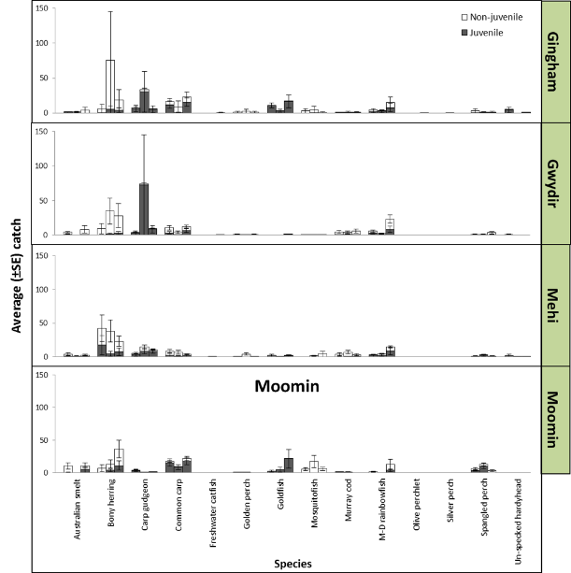
Figure H-4: Average catch ± S.E. per site per year (sequential) for the 14 fish species sampled in the Gingham Watercourse, Gwydir River, Mehi River and Moomin Creek as part of the Gwydir Long Term Intervention Monitoring Program, 2014-17. NB*Juveniles and non-juveniles based on the length at 1 year of age for longer-lived species or the age at sexual maturity for species that reach maturity within 1 year (Table 3).

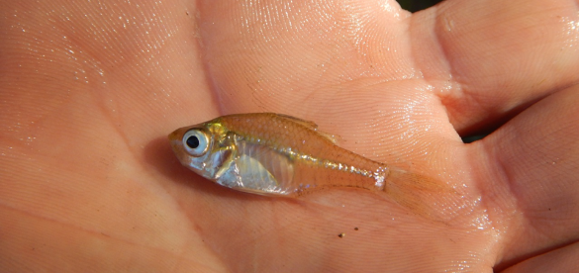
Figure H-5: Olive perchlet (Ambassis agassizii) caught in the lower Gingham Watercourse during Gwydir LTIM fish sampling 2016-17.

Biomass
Based on estimated and measured weights, in total 311.084 kg of fish were sampled across all sites and for all methods combined in year 3. As in Year 1 and 2, common carp had the highest overall biomass (n = 11.147 kg) among the 13 species sampled, and also had the highest average (± S.E.) biomass at sites in the Gingham 15.259 ± 9.651 kg, Mehi 4.194 ± 1.841 kg (Figure H-6) and Moomin 1.054 ± 0.471 kg. Similarly to years 1 and 2, Murray cod in the Gwydir maintained the highest average biomass 10.617 ± 5.847 kg. Murray cod and bony herring had the second and third highest overall biomass respectively across all zones combined, followed by golden perch. Among the small bodied species, Murray-Darling rainbowfish (n = 493 g), Australian smelt (n = 159 g), and carp gudgeon (n = 65 g), had the highest biomass.
Overall, there was no significant difference in biomass between the four hydrological zones (Pseudo-F_{3,19} = 1.85, P = 0.07) in Year 3. Pair-wise comparisons revealed this was also the case between the Gingham and Gwydir (t = 1.11, P = 0.31), Gingham and Mehi ((t = 1.39, P = 0.12), Gingham and Moomin (t = 1.06, P = 0.35) and the Gwydir and Mehi (t = 0.50, P = 0.91). However, there were significant differences between the Gwydir and Moomin (t = 1.83, P = 0.04) and the Mehi and Moomin (t = 1.8, P = 0.04). Simper analysis suggested the differences between the Gwydir and Moomin were driven by the greater average abundance of Murray cod (contribution = 23.06 %), common carp (contribution = 15.19 %) and bony herring (contribution = 13.3 %) in the Gwydir. Similarly, Murray cod (contribution = 18.6 %), common carp (contribution = 18 %) and bony herring (contribution = 15.03 %) were in greater abundances in the Mehi compared to the Moomin, whilst there were greater average numbers of goldfish (contribution = 15.97 %) at sites in the Moomin.
There was a significant difference in the overall biomass among the fish assemblage between years across the lower Gwydir system (Pseudo-F_{2,66} = 2.73, P = <0.01). Pair-wise comparisons revealed all years were also significantly different from each other (Year 1 V Year 2 t = 1.64, P = 0.04; Year 1 V Year 3 t = 1.58, P = 0.049; Year 2 V Year 3 t = 1.72, P = 0.02). Differences were primarily a result of a decrease or increase in the biomass of common carp (2015>2016, 2015<2017, 2016<2017), bony herring (2015<2016, 2015<2017, 2016>2017) and Murray cod (2015>2016, 2015<2017, 2016<2017).

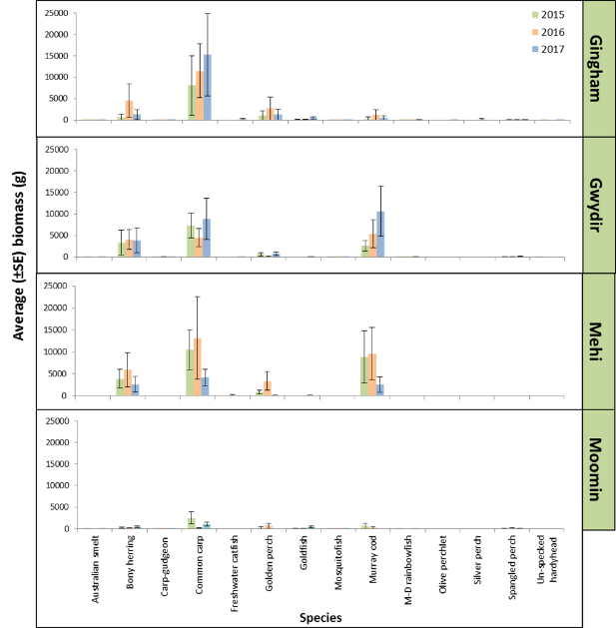
Figure H-6: Average biomass ± S.E. for the 14 fish species sampled to date in the Gingham Watercourse, Gwydir River, Mehi River and Moomin Creek as part of the Gwydir Long Term Intervention Monitoring Program, 2014-15 ( ), 2015-16 ( ) and 2016-17 ( ).

Length frequency
Overall, the population structure of the three most abundant small-bodied species has remained consistent across years in most hydrological zones (Figure H-7). This is particularly the case with carp gudgeon and Murray-Darling rainbowfish, with carp gudgeon populations in all zones where they are reasonably abundant dominated by juveniles, whilst there was more of a skew towards adults among Murray-Darling rainbowfish populations. The apparent consistency between catchments and years is somewhat supported by no significant difference between carp gudgeon populations in the current sampling year (Table H-4), and if 2015-16 is ignored because of the extremely dry conditions experienced during that year, there was no difference between years either (Table H-5). Murray-Darling rainbowfish were somewhat similar, with no significant differences between many of the hydrological zones in the current year and similarities between some years as well. Of the three species, Australian smelt tended to be the most sporadic in occurrence and structure, with virtually no individuals caught in the 2015-16 sample year and only low numbers in all zones in the other two years. However, whilst numbers were low, Australian smelt populations within the Gwydir, Mehi and Moomin in 2014-15 and 2016-17 were similar in structure, with all three populations dominated by adult fish and small numbers of juveniles.
As with the small-bodied species, the structure of the three most abundant large-bodied species populations tended to be consistent within hydrological zones across years, but there was less consistency between zones (Figure H-8). For bony herring, both the Gingham and Moomin populations were consistently dominated by individuals <150 mm, whilst in the Gwydir and Mehi there were greater numbers of larger adults and the population structure tended to be not as uniform year on year (Figure H-8). This variation between populations was supported by there being significant differences between zones in the current sampling year as well as for all zones combined, across years (Table H-5). In contrast to bony herring, Murray cod population structures in the Gwydir and Mehi were generally consistent between the two zones as well as across years (Figure H-8). Both populations were dominated by small numbers of young-of-year, the greatest numbers between 250 and 600 mm TL, and small numbers of individuals >600 mm. This consistency is supported by the lack of significant differences between years (Table H-5) Common carp varied the most, both within the majority of zones but also across years (Figure H-8). The Gingham and Moomin populations tended to be dominated by juveniles in most years, whilst the opposite was the case in the other two zones with many of the fish caught <350 mm FL in the Gwydir and Mehi. Of the four hydrological zones, the Moomin also appeared to consistently produce the most recruits, whilst the other three zones also had recruits present but mainly in Years 1 and 3. Overall there were significant differences between all zones except the Gwydir and Mehi in the current sampling year, as well as differences between all three years (Table H-5).

Table H-4: Kolmogorov-Smirnov test results of length frequency comparisons between the Gingham Watercourse (Zone 1), Gwydir River (Zone 2), Mehi River (Zone 3) and Moomin Creek (Zone 4) sampled as part of the Gwydir Long Term Intervention Monitoring Program, Year 3, 2016-17. NB* Dark shading indicates significant difference <0.05.
 |  |  | Hydrological Zone
 |  |  | 1 V 2 | 1 V 3 | 1 V 4 | 2 V 3 | 2 V 4 | 3 V 4
Common carp |  | P | <0.001 | <0.001 | <0.001 | 0.728 | <0.001 | <0.001
Murray cod |  | P | -- | -- | -- | -- | -- | --
Bony herring |  | P | <0.001 | <0.001 | <0.001 | <0.001 | <0.001 | <0.001
Carp gudgeon |  | P | 0.209 | 0.123 | -- | 0.528 | -- | --
Rainbowfish |  | P | 0.319 | 0.341 | 0.028 | <0.001 | 0.341 | <0.001
Australian smelt |  | P | <0.001 | -- | <0.001 | -- | 0.012 | --

Table H-5: Kolmogorov-Smirnov test results for length frequency comparisons of fish between years for all hydrological zones combined (Gingham Watercourse, Gwydir River, Mehi River and Moomin Creek), sampled as part of the Gwydir Long Term Intervention Monitoring Program 2014-17. NB* Dark shading indicates significant difference <0.05.
 |  |  | Year
 |  |  | 1 V 2 | 1 V 3  2 V 3 | 2 V 3  Moomin
Common carp |  | P | <0.001 | <0.001 | <0.001
Murray cod |  | P | 0.737 | 0.999 | 0.999  --
Bony herring |  | P | <0.001 | <0.001 | <0.001
Carp gudgeon |  | P | 0.001 | 0.793 | 0.002  --
Rainbowfish |  | P | 0.567 | 0.009 | 0.048  --
Australian smelt |  | P | -- | 0.001 | --  --

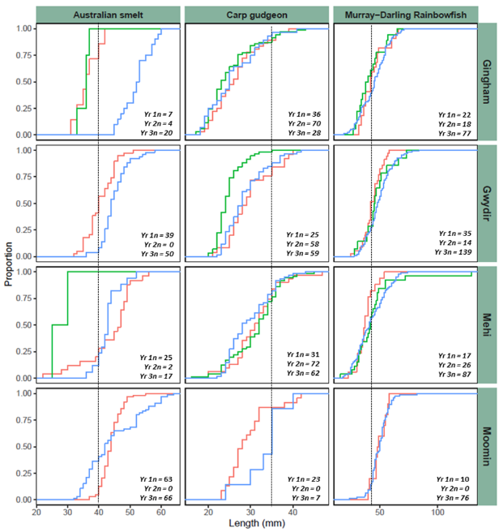
Figure H-7: Length frequency distribution (proportion (%)) of small-bodied fish, Australian smelt (Retropinna semoni), carp gudgeon (Hypseleotris sp.) and Murray-Darling Rainbowfish (Melanotaenia fluviatilis) sampled in the Gingham Watercourse, Gwydir River, Mehi River and Moomin Creek as part of the Gwydir Long Term Intervention Monitoring Program, 2014-15 ( ), 2015-16 ( ) and 2016-17 ( ). NB# Dashed line is approximate length at sexually maturity.

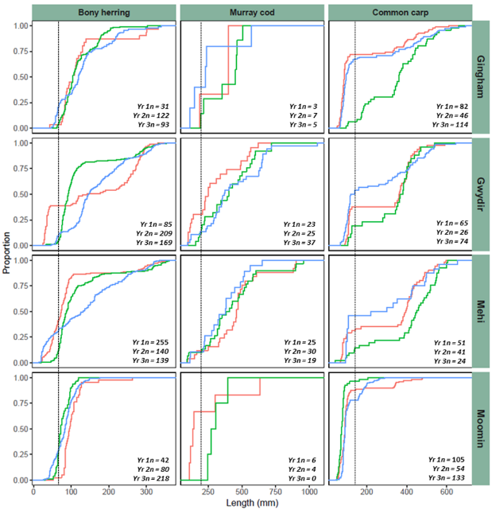
Figure H-8: Length frequency distribution (proportion (%)) of large-bodied fish, bony herring (Nematolosa erebi), Murray cod (Maccullochella peelii) and common carp (Cyprinus carpio) sampled in the Gingham Watercourse, Gwydir River, Mehi River and Moomin Creek as part of the Gwydir Long Term Intervention Monitoring Program, 2014-15 ( ), 2015-16 ( ) and 2016-17 ( ). NB# Dashed line is approximate length of one-year-old individual.

Health Indicators
Expectedness
Of the 13 native fish species that potentially could have been sampled across the lower Gwydir system, 10 were caught at a minimum of one site in the current sampling round. The three species not caught were silver perch, southern purple-spotted gudgeon and Darling River hardyhead. All three species are considered to have been “rare” or “occasional” prior to European settlement and as such would only be expected to be collected from a maximum of 20% and 45% of sites within a zone, respectively (Table H-2).
For Expectedness, of the 23 sites sampled as part of the current sampling round, 10 sites scored a rating of “Good”, three sites scored a rating of “Moderate”, six sites a rating of “Poor”, two sites a rating of “Very Poor” and two sites a rating of “Extremely Poor”. Scores ranged from 99.3 for the Gingham 4 site in the Gingham hydrological zone, down to 17 for the Moomin 45 and Wirralah sites in the Moomin hydrological zone. By zone, the Gingham Watercourse had the highest average (± S.E.) rating for Expectedness, scoring 82.9 ± 7.69 giving it an overall rating of “Good”, whilst Moomin Creek had the lowest average, rating as “Very Poor” with 33.16 ± 6.29 (Figure H-9). The Gwydir and Mehi rivers both had an average rating of “Moderate” for Expectedness (Figure H-9). Although both systems overall scored low, individual sites in the Gwydir rated as high as “Moderate” and in the Mehi two sites scored > 85 giving them an individual rating of “Good” (Figure H-9).
Nativeness
As in previous sampling years, the exotic species common carp, goldfish and eastern mosquitofish were caught across the lower Gwydir system (Figure H-4). Of these, common carp was again the most abundant (n = 167) and were caught at all but one site in the Mehi hydrological zone. As was the case in years 1 and 2, the highest catches of carp were in Moomin Creek (n = 133), followed again by the Gingham Watercourse (n = 114), the Gwydir (n = 74) and the Mehi (n = 24). Unlike previous years, goldfish were caught in relatively high numbers (n = 276) in year 3, particularly in the Moomin Creek (n = 177) and Gingham Watercourse (n = 87) zones. Eastern mosquitofish (n = 71) were caught in all four hydrological zones but were in relatively low numbers.
The increase in the number of exotic species sampled in the current year is reflected in the lower Nativeness scores for many sites compared to previous years, particularly in the Gingham and to a lesser degree in the Moomin. Of the 23 sites sampled, six rated as “Good” compared to eight in 2015-16, five as “Moderate” compared to three in 2015-16, seven as “Poor” compared to five in 2015-16, and two as “Poor” compared to one in 2015-16, whilst the remaining three sites rated as “Extremely Poor”. Individual site ratings ranged from ‘100’ at the Mehi 82 site in the Mehi River where no exotics were sampled, down to ‘2.1’ at the Gingham 38 site where only one native fish in total was caught. The Mehi River had the highest average site score at 78.1 ± 9.28, giving it an overall rating of “Moderate” for Nativeness. This contrasts with the 2015-16 result when the Gingham rated the highest of the four zones with an average score of 65.6 ± 11.62, whilst in the current sample year it rated the lowest at 37.5 ± 12.22 (Figure H-9). Both the Mehi and Moomin were similar to past years, scoring a rating of “Moderate” and “Poor” respectively (Figure H-9).

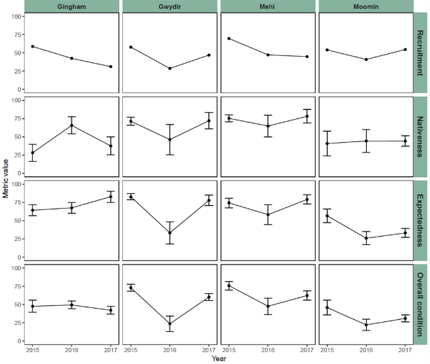
Figure H-9: Recruitment, Nativeness, Expectedness and ndxFS Indicator values for fish at sites sampled in the Gingham Watercourse, Gwydir River, Mehi River and Moomin Creek as part of the Gwydir Long Term Intervention Monitoring Program, 2014-17.
Recruitment
The Recruitment Indicator scores had generally improved or remained the same as last year in all hydrological zones except the Gingham (Figure H-9). Recruitment in 2015-16 rated as “Poor” in the Gwydir, Mehi and Moomin and as “Very Poor” in the Gingham. Overall, recruits made up 35% of the total catch of all the native fish caught, which is considerably lower than in 2015-16 at ~54% and 2014-15 at ~42%. Recruits were caught among all the small-bodied species sampled except olive perchlet, whilst among the large-bodied species no recruits of freshwater catfish and golden perch were caught.
Whilst no freshwater catfish recruits were recorded during Cat 3 sampling, a small number were caught as part of Cat 1 sampling in the Gwydir hydrological zone (Figure H-10). Whilst, recruits were caught amongst the three remaining native large-bodied species, as in previous years they were in relatively low numbers. By count, the same numbers of Murray cod recruits were caught this year as in 2015-16 (n = 11) which is only slightly lower than 2014-15 when 15 were caught. Contrastingly, bony herring recruit numbers were up considerably at 150 or 24 % of the total catch compared to 2015-16 (n = 55 or 9%), but were similar to 2014-15 when recruit numbers were 140 or 33% of the total catch of the species. Spangled perch recruitment was again low at 16% of the 54 individual sampled.
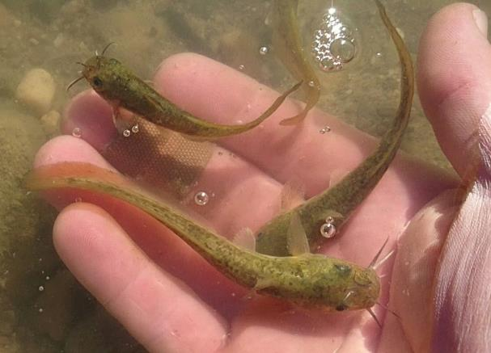
Figure H-10: Freshwater catfish (Tandanus tandanus) recruits caught in the lower Gwydir River during Gwydir Long Term Intervention Monitoring (Cat 1) sampling 2017.
There was a general increase in recruitment among common carp and goldfish sampled in the current round compared to previous years. As in both previous sampling years, most goldfish sampled, spawned in the last year but numbers had increased by 270% compared to 2014-15 and 460% compared to 2015-16. Similarly, common carp recruits were also the highest in the current year compared to previous years, both in number and by percentage (2014-15 = 188 (66%); 2015-16 = 67 (40%); 2016-17 = 233(67%)). As in previous years Moomin Creek was again a “hotspot” for juvenile common carp, as was the Gingham watercourse where on average 16 ± 6.2 recruits were caught per site. This was much higher than the Gwydir and Mehi where only 7 ± 2.5 and 2 ± 1.8 recruits respectiviy were caught per site during the current sampling round. Adult eastern mosquitofish again dominated the catch across all sites where they were sampled.
Overall score
The Overall Fish Condition (ndx-FS) scores in general had improved in all zones but the Gingham compared to the 2015-16 sampling round (Figure H-9). Of the 23 sites sampled, eight rated as “Moderate” compared to three in 2015-16, nine as “Poor” which is the same as 2015-16, four as “Very Poor” compared to five in 2015-16, whilst the remaining two sites rated as “Extremely Poor” compared to the six dry sites in 2015-16. Scores ranged from 75 or “Moderate” for the Redbank site in Gwydir zone, down to 13.5 for the Moomin 45 and Wirralah sites in the Moomin. By zone, the Gwydir and Mehi rated slightly over 60 giving them and overall rating of “Moderate”, whilst the Gingham sites averaged 42.2 ± 5.34 across the zone resulting an overall rating of “Poor”. Of the four zones the Moomin was by far in the worst overall condition, averaging only 30.9 ± 4.79 giving it a rating of “Very Poor”.

Discussion
The increased flows during 2016-17 resulted in at least some recovery amongst native species in the lower Gwydir following the extended dry period experienced throughout 2015-16. Whilst numbers were similar for most species compared to 2015-16 and considerably higher than 2014-15, in general, the majority of species sampled tended to more widespread throughout most of the four systems sampled than in 2015-16. The use of refugia is well documented in river systems that regularly go through cycles of flow varability. During dry periods, fish tend to contract back into a small number of deeper pools along the stream’s length, switching from normal life-history strategies of breeding and growth to one of survival (Rayner et al. 2009). The timeline for survival in these pools is dictated by many factors including depth of pools, photo-period, riparian integrity, sediment loads and water quality (Bond et al. 2008; Bunn et al. 2006). Across the lower Gwydir system the majority of refugial pools carry high benthic sediment loads, meaning that pools that may have been 1-2 m deep in the past are now as shallow as 30 cm in many places. This not only means that the carrying capacity of pools is reduced but also their persistence, meaning they would dry-up sooner than in the past. The Moomin system is by far the most affected by sedimentation of the four systems sampled across the lower Gwydir, with soft sediments over one metre deep in spots, whilst water levels may be as low as 30 cm during a normal year in the same pool. These conditions most likely resulted in low survival over the dry period in 2015-16, with this hypothesis supported by how few native fish were caught in the current sampling round at most sites in the Moomin Creek zone.
Whilst there was some evidence of recovery within native populations following the dry period experienced in 2015-16, there was also a dramatic increase in the abundance of exotic species, including both common carp and goldfish. Both species are known to utilize increased flows to access wetlands to breed and recruit before moving back into the mainstream as juveniles or young adults (Koehn et al. 2016; Brumely 1996). The high flows experienced in early spring throughout the lower Gwydir most likely created ideal conditions for both species to move into the wetlands/floodplains to breed and recruit (Koehn et al. 2016). The large numbers of juvenile carp and goldfish at the lower ends of the Gingham and Moomin, and to a lesser degree the Gwydir are evidence of this, all of which are directly associated with terminal or offstream wetlands and floodplains (Department of Environment, Climate Change and Water NSW 2011). In the Moomin Creek for example, downstream sites had greater numbers of goldfish sampled. Given the various risks imposed by exotic species to native fish, the effects of the natural flow event experienced in the current year highlights the need for the management of any future controlled releases to carefully consider the timing and extent of releases.
The length-frequency analysis continues to provide evidence that most native species present are recruiting in at least some sections of the system, all be it in low numbers. One species of which no recruits were caught in previous years but a number were captured in 2016-17, was the threatened freshwater catfish. Freshwater catfish are considered as belonging to the “foraging generalist” guild, in that they are considered to not benefit from large-sustained in-channel flow pulses. Instead they are more resilient to prolonged low-flow conditions, and will generally breed and recruit successfully across a wide range of hydrological conditions including low flows (Baumgartner et al. 2013). Given the contrast in flow regimes experienced across the lower Gwydir in years 1-3 of the current study, it could therefore be expected that freshwater catfish should have recruited in every year. However, this was not the case, with the main apparent difference in the current year being the relatively large natural flow event experienced during September and October 2016 across the whole lower sections of the system. This period coincides with the lead up to the known breeding season for freshwater catfish of October-November (Davis 1977b), with the flows potentially allowing fish to move to locate partners and suitable breeding habitat (Appendix I), as well as providing a boost to instream metabolism via the wetting of benches and subsequent release of carbon into the system. The resulting boost to primary production and subsequent zooplankton production (Appendix D) would have increased the chances of larval survival of a number of fish species including freshwater catfish.
Whilst species not as dependent on flow such as freshwater catfish and Murray cod are breeding and recruiting in the parts of the system, the continued absence and/or low abundance of several flow-dependent species remains of concern for the long-term recovery of native fish across the lower Gwydir system. Species such as golden perch and silver perch were once considered abundant throughout much of the Gwydir system (Copeland et al. 2003). To date, very few adults and no or few recruits of golden perch or silver perch have been recorded in any of the four catchments sampled, suggesting that neither species is breeding and or recruiting across the lower Gwydir. Altered flow regimes, coldwater pollution and artificial barriers have been suggested as having a major impact on the breeding and recruitment of both species (Koster et al. 2014; King et al. 2008; Gehrke et al. 1995). However, both golden and silver perch have also been noted as breeding and recruiting under low flow conditions in the mid Murray River, allbeit at lower numbers when compared to high flow years (King et al. 2008; Mallen-Cooper and Stuart 2003). Given that both species aggregate to some degree to spawn, it may well be as much a density issue, in conjunction with other factors such as river regulation, that is preventing successful breeding, with too few adults of either species present within the system to bring about a significant recruitment event. As was trialled in the previous year with freshwater catfish as part of the Cat 3 Fish Movement indicator (Appendix I), restocking and translocation is likely required to help bring back both species.
The Fish Health scores for sites in the current sampling round suggest that for most metrics there was some recovery in most systems during 2016-17 compared to 2015-16, but that in general the fish community remains in a very depressed state. Of the three primary metrics, Expectedness improved in varying degrees in all four systems, with the Moomin showing the least improvement. Complimentary actions such as sediment control and riparian re-vegetation must be incorporated in any long-term plan for the Moomin as well as across the lower Gwydir system. High sediment loads in aquatic ecosystems potentially alter water chemistry, increase turbidity, limit light penetration and decrease water temperature, leading to reduced primary production with the effect cascading up the food chain (Velero et al. 2017; Kjelland et al. 2015). High soft sediment loads also potentially affect the ability of nesting species such as Murray cod and freshwater catfish to successfully construct and tend nest sites. This along with other environmental issues such as coldwater pollution and altered flow regimes, and the fact that some species appear below the critical mass required to induce successful breeding, continue to suppress breeding and recruitment, resulting in the ongoing low Recruitment scores. The large number of common carp and goldfish recruits caught in the current sampling round, as well as consistent numbers of common carp adults present in all four systems in all years, continues to keep the Nativeness scores low. Whilst careful water management may help to control breeding events in both species, to see a marked improvement will require activities such as the release of the Cyprinid herpesvirus (CyHV-3 or carp herpesvirus) and other complimentary measures as part of the National Carp Control Plan.
The fish across the lower Gwydir continue to remain under extreme stress and appear to be somewhat in a state of equilibrium in what is almost a holding pattern of survival, with few significant signs of recovery apparent for most native species. To bring about noticeable change will require an almost total change in thinking regarding water management and a move toward incorporating a raft of complimentary measures that must include habitat restoration. This will not only require managers to be united in their efforts but will also require willingness and significant input from landowners and other stakeholders along the rivers length to ensure change occurs.

Conclusion
This chapter reports on the third out of a total of five years on the fish community in the lower Gwydir system as part of the Gwydir LTIM project. As stated in previous years, given the ongoing low abundance and restricted distribution of most native species present within the system, as well as the absence of a number of large and small-bodied species, any significant and measurable improvement in the fish community is likely to take some considerable time. However, ongoing monitoring is critical to ensure that as recovery actions are implemented, including the release of environmental water, improvements or detrimental outcomes can be quantified, which will allow adaptive management practices to drive future activities.
Major observations and recommendations from the current sampling round in relation to the four specific questions posed are outline below:
- What did Commonwealth environmental water contribute to native fish community resilience?
As with previous years, because the majority of rivers within the Gwydir selected area are little more than small stream, environmental water most likely helped to sustain and maintain native fish populations by keeping the system flowing and ensuring the fish did not suffer a similar fate to that of 2015-16 when large parts of all four systems (Mehi, Moomin, Gwydir and Gingham) dried significantly. Using environmental water adaptively to minimise drydown will help to future proof fish communities in smaller rivers like those within the Gwydir selected area.
- What did Commonwealth environmental water contribute to native fish survival?
Because of the almost ephemeral nature of the lower Gwydir system, any water that is released down the system, directly and indirectly helps native fish to survive. By its very nature, most of the system is naturally shallow, meaning water quality can deteriorate quickly increasing stress on fish leading to issues such as a loss in condition and reduced reproductive output. Constant monitoring to ensure flow is maintained throughout the system as much as possible is essential for the both survival and enhancement of fish populations across the lower Gwydir region.
- What did Commonwealth environmental water contribute to native fish populations?
While it is difficult to tease out the exact influence of environmental water on fish populations in the Gwydir system in 2016-17, delivering flows including the natural flow event that occurred in September-October 2016 undoubtedly resulted in a benefit for some native species. This included the endangered population of freshwater catfish, with the first recruits caught this year in the three years of LTIM sampling to date. Breeding and recruitment in other species such as spangled perch, bony herring, Murray cod was also likely enhanced by the flows that moved through the system in Spring and Summer.
- What did Commonwealth environmental water contribute to native fish diversity?
Based on the Expectedness values for 2016-17, native fish diversity in the lower Gwydir is close to that of pre-European levels. However, numbers remain low for most species, including a number of the threatened species currently found within the system. Olive perchlet (Ambassis agassizii) were again caught in the lower Gingham, and targeted flows to help them to breed and disperse should be considered in future watering activities. Also, flows to mimic that of the Spring-Summer natural event may also result in further freshwater catfish breeding, which overtime may start to see the species more widely dispersed throughout the system, as was the case in the past.

References
Anderson, M.J., Gorley, R.N., & Clarke, K.R. 2008. PERMANOVA + for PRIMER: Guide to Software and Statistical Methods. (PRIMER-E: Plymouth.)
Baumgartner, L.J., Conallin, J., Wooden, I., Campbell, B., Gee, R., Robinson, W.A. & Mallen-Cooper, M. 2014. Using flow guilds of freshwater fish in an adaptive management framework to simplify environmental flow delivery for semi-arid riverine systems. Fish and Fisheries, 15, 410-427.
Bice, C.M., Gehrig, S.L., Zampatti, B.P., Nicol, J.M., Wilson, P., Leigh, S.L. & Marsland, K. 2014. Flow-induced alterations to fish assemblages, habitat and fish–habitat associations in a regulated lowland river. Hydrobiologia, 722(1), 205-222.
Bond, N., Lake, P. & Arthington, A. 2008. The impacts of drought on freshwater ecosystems: an Australian perspective. Hydrobiologia, 600, 3–16.
Cadwallader, P.L. 1977. J.O. Langtry’s 1949-50 Murray River investigations. Fisheries and Wildlife Paper 13. Fisheries and Wildlife Division, Ministry for Conservation, Melbourne.
Carter S. 2012. Sustainable Rivers Audit 2: Metric Processing System. Report prepared by Environmental Dynamics for the Murray Darling Basin Authority, Canberra.
Commonwealth of Australia. 2014. Commonwealth Environmental Water Office Long Term Intervention Monitoring Project Gwydir River System Selected Area. Commonwealth of Australia.
Commonwealth of Australia. 2015. Commonwealth Environmental Water Office Long Term intervention Monitoring Project Gwydir River System Selected Area – 2014-15 Evaluation Report. Commonwealth of Australia.
Commonwealth of Australia. 2016. Commonwealth Environmental Water Office Long Term intervention Monitoring Project Gwydir River System Selected Area – 2015-16 Evaluation Report. Commonwealth of Australia.
Copeland, C., Schooneveldt-Reid, E. & Neller, S. 2003. Fish Everywhere - an oral history of fish and their habitats in the Gwydir River. New South Wales Fisheries, Ballina.
Davies, P.E., Harris, J.H., Hillman, T.J. & Walker, K.F. 2008. SRA Report 1: A Report on the Ecological Health of Rivers in the Murray–Darling Basin, 2004–2007. Independent Sustainable Rivers Audit Group for the Murray–Darling Basin Ministerial Council. MDBC Publication No. 16/08: Canberra.
Davies, P.E., Harris, J.H., Hillman, T.J. & Walker, K.F. 2010. The Sustainable Rivers Audit: assessing river ecosystem health in the Murray-Darling Basin, Australia. Marine and Freshwater Research, 61, 764–777.
Davis, T.L.O., 1977. Age determination and growth of the freshwater catfish, Tandanus tandanus Mitchell, in the Gwydir River, Australia. Marine and Freshwater Research, 28(2), pp.119-137.
Faulks L. K., Gilligan, D. M. & Beheregaray, L. B. 2010, Islands of water in a sea of dry land: hydrological regime predicts genetic diversity and dispersal in a widespread fish from Australia’s arid zone, the golden perch (Macquaria ambigua). Molecular Ecology, 19, 4723–4737.
Leggett, R. & Merrick, J.R., 1987. Australian native fishes for aquariums. JR Merrick Publications.
Lorenzoni, M., Corboli, M., Ghetti, L., Pedicillo, G. & Carosi, A., 2007. Growth and reproduction of the goldfish Carassius auratus: a case study from Italy. In Biological invaders in inland waters: Profiles, distribution, and threats (pp. 259-273). Springer Netherlands.
Macdonald, J. & Tonkin, Z. 2008. A review of the impact of eastern gambusia on native fishes of the Murray-Darling Basin. Arthur Rylah Institute for Environmental Research, Department of Sustainability and Environment, Heidelberg, Victoria.
Mallen-Cooper, M., 1996. Fishways and freshwater fish migration on South-Eastern Australia.
McDowall, R. 1996. Freshwater Fishes of South-Eastern Australia (second edition). Reed Books, Chatswood, NSW.
Murray–Darling Basin Authority. (2012). Sustainable Rivers Audit 2: The ecological health of rivers in the Murray–Darling Basin at the end of the Millennium Drought (2008–2010). Murray–Darling Basin Authority, Canberra.
NSW Department of Primary Industries. 2015. Fish and Flows in the Northern Basin: responses of fish to changes in flow in the Northern Murray-Darling Basin – Valley Scale Report. Final report prepared for the Murray-Darling Basin Authority. NSW Department of Primary Industries, Tamworth.
O’Connor, B. L., J. W. Harvey, & L.E. McPhillips 2012. Thresholds of flow-induced bed disturbances and their effects on stream metabolism in an agricultural river. Water Resource Research, 48, 1-18.
Puckridge, J.T. & Walker, K.F. 1990. Reproductive Biology and Larval development of a Gizzard Shad, Nematalosa erebi (Gunther) (Dorosomatinae: Teleostei), in the River Murray, South Australia. Australian Journal of Marine and Freshwater Research, 41, 695-712.
Pusey, B.J., Kennard, M.J. & Arthington, A.H. 2004. Freshwater Fishes of North-Eastern Australia. CSIRO Publishing: Collingwood.
Robinson, W. 2012. Calculating statistics, metrics, sub-indicators and the SRA Fish theme index. A Sustainable Rivers Audit Technical Report. Murray-Darling Basin Authority, Canberra.
Southwell, M., Wilson, G., Sparks, P. & Thoms, M. 2015. Monitoring the ecological response of Commonwealth Environmental Water delivered in 2013-14 in the Gwydir River system: A report to the Department of Environment. University of New England, Armidale.
Stuart, I. G. & Jones, M. J. 2006. Large, regulated forest floodplain is an ideal recruitment zone for non-native common carp (Cyprinus carpio L.). Marine and Freshwater Research, 57, 337–347.
Vieira, D. C. & Fonseca, G. 2013. The Importance of Vertical and Horizontal Dimensions of the Sediment Matrix in Structuring Nematodes Across Spatial Scales. PLoS ONE, 8(10), e77704. http://doi.org/10.1371/journal.pone.0077704.
Vilizzi, L. & Walker, K.F. 1999. Age and growth of the common carp, Cyprinus carpio, in the River Murray, Australia: validation, consistency of age interpretation, and growth models. Environmental Biology of Fishes, 54(1), pp.77-106.
Wilson, G.G., Bickel, T.O., Berney, P.J. & Sisson, J.L. 2009. Managing environmental flows in an agricultural landscape: the Lower Gwydir floodplain. Final Report to the Australian Government Department of the Environment, Water, Heritage and the Arts. University of New England and Cotton Catchment Communities Cooperative Research Centre, Armidale, New South Wales.

Fish (Movement)

Introduction
Movement allows organisms the opportunity to locate new resources (e.g. nesting sites, food), escape unfavourable conditions, avoid competition with other biota for food and space, or avoid breeding with closely related individuals that could lead to inbreeding depression (Nathan et al. 2008). Many organisms use environmental cues to guide their movement behaviours, such as photoperiod, changes in temperature or rainfall events (Winkler et al. 2014). In rivers, variations in river flow can be strong determinants of movement (Bilton et al. 2001). Variation in river flow and hydraulic conditions is a key determinant of the nature, timing and extent of fish movement, for both long range migrations (Reynolds 1983; Simpson & Mapleston 2002; Koehn 2004; Butler et al. 2009; Young et al. 2010; Reinfelds et al. 2013) and fine scale movements (Korman & Campana 2009; Cocherell et al. 2011). Biological factors such as fish size, sex and, evolutionary history may also be important determinants of movement behaviour and responses to variations in flow and habitat.
In many river systems, fish populations are supplemented by translocation (Douglas & Brown 2000; Ebner & Thiem 2009; Hammer et al. 2012; Lintermans 2013). Due to inherent differences in source population behaviours (Kaya 1991; Coombs & Grossman 2006) and stress effects of translocation (Dickens et al. 2010; Olden et al. 2011), different movement behaviours may be observed in translocated individuals compared with resident fish. However, to date, there has been no study involving the translocation of fish from lacustrine to riverine habitats, especially in a regulated system where the fish may have their homing movements restricted by infrastructure. It is also unclear how differences in flow regimes of release sites influence short-term behaviour and likelihood of successful establishment over the longer term.
Bio-telemetry is used extensively by fisheries scientists across the globe to answer a wide range of questions, including many related to fish and their response to changes in river flows. There are currently a number of acoustic bio-telemetry programs underway throughout the Murray-Darling Basin, answering among other questions, those relating to environmental flows and fish movement. Unlike these existing programs, the Gwydir Long Term Intervention Monitoring (LTIM) project offers a unique opportunity to utilise bio-telemetry to answer a range of questions specific to the northern Murray-Darling Basin. We here report preliminary findings of short-term (~6 months) local scale movements of Murray cod (Maccullochella peelii) and freshwater catfish (Tandanus tandanus). We evaluate how fish movement characteristics varied between two fine scale arrays in response to changing environmental conditions and how this varied between resident riverine and translocated lacustrine fish, sex and size. We also describe the movements of the two species at larger scales across the broader acoustic array (~ 12 months).
Several specific questions were posed in relation to this indicator:
Short-term (one-year) questions:
- What did Commonwealth environmental water contribute to native fish dispersal?
- Did environmental water stimulate target species to exhibit movement consistent with breeding behaviour?
- Did environmental water facilitate target species to move/return to refuge habitat?
Long-term (five-year) question:
- What did Commonwealth environmental water contribute to native fish populations?

Methods

Study area
The current study is located in the Mehi and Gwydir river zones within the Gwydir River system (Figure I-1). In the Mehi River, the study reach extends from Tareelaroi Weir, where the Mehi diverges from the Gwydir, downstream to the township of Moree. In the Gwydir, the study reach extends from 6 km upstream of Tareelaroi Weir, downstream to immediately below the junction of the Gwydir and Gingham Watercourse at Tyreel Weir. Each study reach covers approximately 45 km of their respective river. The Gwydir and Mehi typically do no exceed 25 m in width and 3 m in depth. Both river systems are highly regulated and the surrounding catchment is used for intensive agricultural including large areas under irrigated croping. The system receives environmental flows from the main upstream impoundment, Copeton Dam.
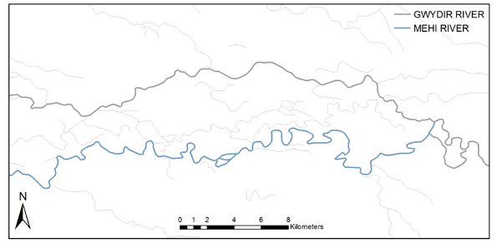
Tyreel Weir
Moree
Tareelaroi Weir
Figure I-1: Mehi and Gwydir Rivers, NSW, Australia.
The instream environment of both systems includes a variety of mesohabitats, such as woody debris, gravel beds, undercut banks, reed beds, overhanging riparian vegetation and small amounts of aquatic macrophytes (Figure I-2). The rivers support a host of native fish species, including an endangered population of freshwater catfish and the threatened Murray cod.

Fine scale acoustic array
Local scale behavior of tagged fish was recorded using two fine-scale acoustic telemetry arrays. Sites for the fine scale arrays were selected based on factors such as river curvature, obtrusive structures, etc., while at the same time ensuring consistency in habitats among sites (149.99913 E, 29.42796 S and 1479.89761 E, 29.47022 S, Figure I-3a). A range of tests were performed (as decribed in Espinoza et al. 2011) in situ to assess signal strength in relation to receiver position, while at the same time still allowing high precision positioning of multiple fish simultaneously. Once a maximum interval of 50 m was determined, a fine scale array consisting of eight Vemco VR2W 69 KHz receivers were arranged in adjacent equilateral triangles (Figure I-3b, c) in each of the Gwydir and Mehi rivers. The arrays were deployed from the 9-13th May 2016 which was prior to the release of tagged fish. Temperature loggers (OneTemp, Sydney) were also attached to the centre receiver of each array during the installation process.
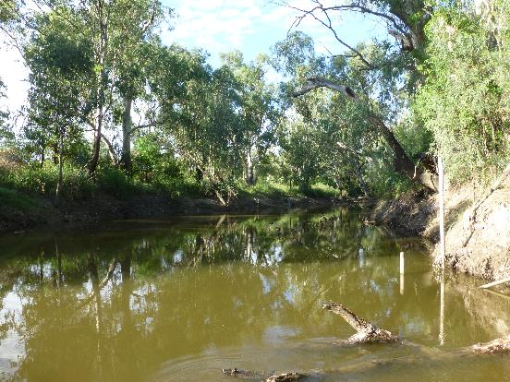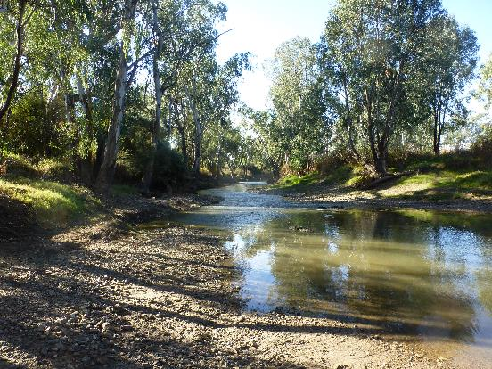
Figure I-2: Mehi River at ‘Chinook’ within the study reach.
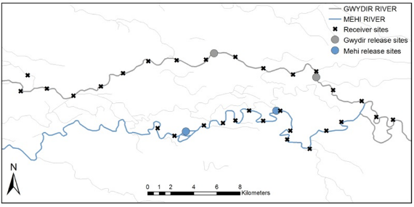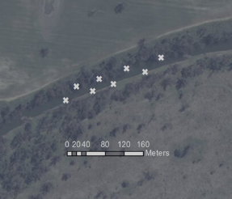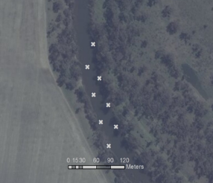
(c)
(b)
(a)
Moree
Tyreel Weir
Tareelaroi Weir
Figure I-3: Release site locations at study reaches in the Gwydir and Mehi rivers (a), and the Mehi (b) and Gwydir (c) fine scale array sites; Gwydir Long-term Intervention Monitoring Cat 3 Fish Movement.

Extensive acoustic array
Large scale fish movement was recorded using an extensive linear array of 30 (15 in each system) Vemco VR2W 69 KHz receivers deployed at intervals of 3 km along the Gwydir and Mehi rivers (Figure I-3a). This extensive array recorded binary presence/absence data when a tagged fish entered the reception range of a given receiver. The array was deployed from the 9-13th May 2016 which was prior to the release of tagged fish (Figure I-4). Temperature loggers (OneTemp, Sydney) were also deployed at the upper and lower extremes of both arrays on the same dates.
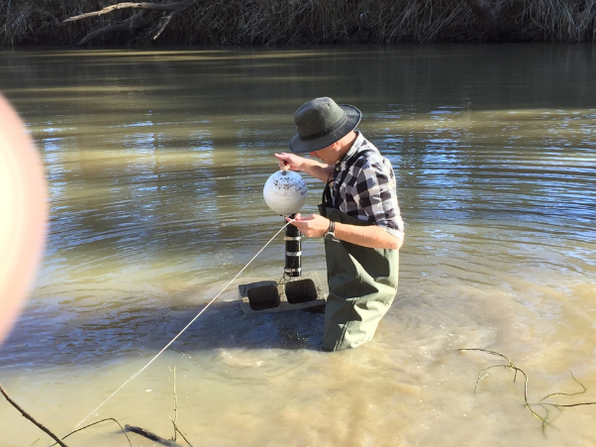
Figure I-4: Deploying receiver in the Gwydir River; Gwydir Long-term Intervention Monitoring Cat 3 Fish Movement.

Fish collection
The intention originally was to tag five “resident” freshwater catfish and five “resident” Murray cod in each river, and to translocate 10 catfish from Copeton Dam and release five in each system. However, despite exhaustive efforts, riverine catfish proved elusive and were supplemented with a greater number of translocated individuals (Table I-1). All resident fish were caught within the confines of the fine scale array to eliminate possible movement away from the array due to homing behaviour.
Table I-1: Source and numbers of freshwater catfish and Murray cod tagged and released in the Gwydir and Mehi rivers May 2016; Gwydir Long-term Intervention Monitoring Cat 3 Fish Movement.
 | Gwydir fine scale | Gwydir extensive | Mehi  fine scale | Mehi  extensive
Resident fw catfish | 3 | 0 | 0 | 1
Translocated fw catfish | 7 | 10 | 10 | 9
Resident Murray cod | 5 | 5 | 5 | 5

Fish were collected by electrofishing, gill netting (mesh size 100mm) or angling from the 23rd May to 1st June 2016. The exact capture location of riverine “resident” fish was recorded and all fish were released within 50 m of their capture site. Freshwater catfish from Copeton Dam were transported to the study sites in aerated 220 L covered drums, with a maximum of five fish per drum. At the study sites, fish from Copeton Dam were kept in a floating cage (mesh size 50 mm) until tag implantation.

Acoustic tag implantation
Fish were anaesthetised in ambient water containing 50 mg L⁻¹ benzocaine (ethyl-p-aminobenzoate) (Sigma Aldrich, Shanghai) and weighed (g) and measured (mm). Fish were then transferred to an operating cradle, with water containing an equivalent level of anaesthetic (50 mg L⁻¹) continually pumped over the gills to maintain anaesthesia (Figure I-5). To access the peritoneal cavity, an incision was made through the body wall of the fish, adjacent to the linea alba and anterior of the anal vent. The gonads of the fish were examined through the incision to determine sex before the insertion of the tag. Either a Vemco V9 or V13 69 KHz acoustic telemetry transmitter tag (delay 90-160 secs, approximate battery life of two+ years) was used, with tag size dictated by the recommended maximum of 2.25% of body weight (Jepsen et al. 2002; Butler et al. 2009; Wagner et al. 2011). Passive integrated transponder (PIT) tags were also inserted in the cavity for long-term monitoring. Incisions were closed with two or three sutures using 0.3 mm pseudo-monofilament, absorbable thread (Vetafil Bengen; WdT, Garbsen, Germany). After suturing, the fish were given an intramuscular injection of oxytetracycline hydrochloride (0.25 mL kg⁻¹) (CCD Animal Health and Nutrition, Toowoomba) and then returned to a floating cage to recover.
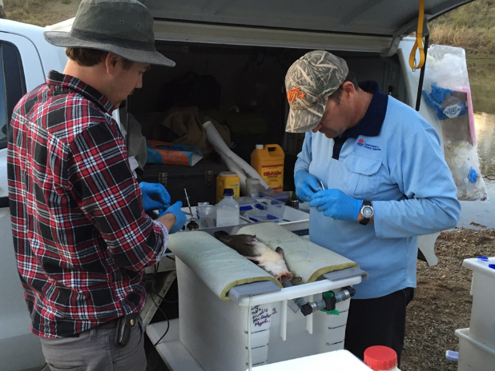
Figure I-5: Freshwater catfish (Tandanus sp.) being implanted with acoustic tag; Gwydir Long-term Intervention Monitoring Cat 3 Fish Movement.

Statistical analyses (fine-scale)
Of the fish tagged in the previously mentioned linear array telemetry study, only Murray cod (n = 10) and freshwater catfish (n = 10) released directly into the fine-scale array sites were used in the analysis. Only freshwater catfish tagged in the Gwydir River were used in this analysis, as both resident and translocated individuals were tagged at only this location.
We summarised fish movement in terms of average hourly rate of movement (ROM), generated using the adehabitatLT package in R (Calenge 2006). ROM was defined as the step length between two consecutive positions of an individual, divided by the time between the two consecutive positions. ROM was compared to population source (only T. tandanus), hourly flow release (Mehi regulator 418044 and Tareelaroi weir 418042 for respective rivers), water temperature, diel period (day/night), moon phase, sex and length using a penalised qausi-likelihood generalized linear mixed model in the MASS package in R (Venables & Ripley 2002), with fish ID as a random effect.

Results

Fine-scale
Freshwater catfish
Only individuals with more than 40 positions were included in the analysis (resident n = 3, translocated n = 5). Within the first 24 hours, both population source (SE = 0.01, df = 6, P = 0.036) and hourly flow release (SE = 0.014, df = 70, P = 0.008) were found to have a significant effect on the ROM of freshwater catfish in the Gwydir River. Riverine freshwater catfish were less active than lacustrine individuals and as hourly flow release increased, individuals moved more. In the first week, again both population source (SE = 0.002, df = 6, P = 0.003) and hourly flow release (SE = 0.002, df = 415, P = 0.002) were found to have a significant effect on the ROM of freshwater catfish in the Gwydir River. Riverine freshwater catfish were less active than lacustrine individuals and as hourly flow release increased, individuals moved more. Within the first month, only water temperature was found to have a significant effect on the ROM of freshwater catfish in the Gwydir River (SE = 0.011, df = 1114, P = 0.037). As water temperature increased, individuals became more active. And finally, over the entire 170 days of study, hourly flow release, water temperature and diel period were found to have a significant effect on the ROM of freshwater catfish in the Gwydir River. Individuals were more active during the night (SE = 0.001, df = 4704, P<0.001), during higher flows (SE = 0.003, df = 4704, P<0.028) and during warmer water temperature (SE<0.001, df = 4704, P<0.001).
Murray cod
As with freshwater catfish, only individuals with more than 40 positions were included in the analysis (Mehi n = 3, Gwydir n = 5). In the first 24 hours, Murray cod ROM was only significantly affected by water temperature (SE = 0.089, df = 70, P = 0.01), where individuals moved more with increasing water temperatures. In the first week, ROM was only significantly affected by flow release (SE = 0.01, df = 790, P< 0.001), where individuals moved less with increasing water released. Within the first month, both flow release (SE = 0.001, df = 3285, P <0.001) and diel period (SE = 0.001, df = 3285, P = 0.001) had a significant effect on ROM. Individual movements were less with increasing water released and ROM increased during the night. Throughout the entire study, flow release (SE<0.001, df = 10992, P<0.001), water temperature (SE<0.001, df = 10992, P<0.001), and diel period (SE = 0.001, df = 10992, P<0.001) had a significant effect on ROM. Individual movements were greater with higher levels of water released and increasing temperatures and ROM increased during the night

Broad-scale movements.
Overall, 37 of the 40 freshwater catfish and 19 of the 20 Murray cod tagged in May 2016 were detected at least once within the broader array during the period May 2016 to May 2017. Total individual distance moved within the array ranged from 0 to 241.5 km (average (±SE) = 33.1 ± 7.79 km) for freshwater catfish, and 0 to 131 km (average (±SE) = 38.1 ± 9.33 km) for Murray cod. Very little large-scale movement was recorded for either species for four months post-release (Figure I-6). However, individuals amongst both species increased activity during early September-October during a large natural discharge event that moved through both systems during this time (Figure I-6). These movements tended to be somewhat individualistic in nature, with some fish moving very little, some only moving back-and-forth between one or two receivers, whilst others moved quite large distances both upstream and downstream within and between systems. Of the fish that changed systems, three freshwater catfish went from the Mehi into the Gwydir and proceeded upstream out of the array. Similarly, a small number also moved out of the downstream end of both the Gwydir and Mehi arrays, with some returning whilst others were not detected again. Murray cod also moved from the Mehi into the Gwydir as discharge allowed, with two moving upstream out of the array, one moving into the Gwydir only briefly before returning to the Mehi, and one moving into the Gwydir before moving downstream and taking up residency in the mid sections of the system. A series of smaller discharge events in January and March also resulted in increased activity among freshwater catfish, and to a lesser degree among small numbers of Murray cod (Figure I-6). These events were a result of both environmental water flows as well as increased flow following small rainfall events across March.
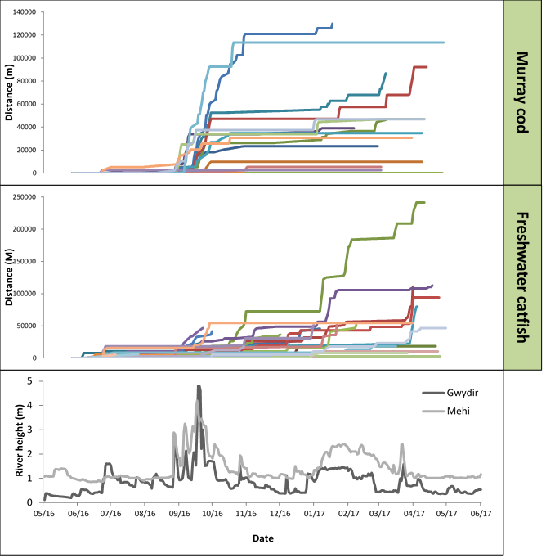
Figure I-6: Broad-scale cumulative distance moved by Murray cod (Maccullochella peelii) and freshwater catfish (Tandanus tandanus) in the Gwydir and Mehi rivers May 2016 to May 2017. Coloured lines represent individual fish. Gauges used are Gwydir Rier DS Tareelaroi (418042), Mehi River @ Moree (418002).

Discussion
Within the fine-scale array, over both the first day and first week riverine freshwater catfish were less active than lacustrine individuals translocated from Copeton Dam and their movement increased as higher hourly flow release increased. As noted in other studies (Kaya 1991; Coombs & Grossman 2006; Taylor & Peterson 2015), adaptations for the habitat of source populations may have resulted in their higher activity observed in lacustrine individuals. Within the first month and over the remaining five months, population source was no longer a significant influence on the ROM. This may be due to translocated lacustrine individuals establishing new home ranges within their new habitat as time passed, as observed in Crook (2004). Over the entire study, freshwater catfish were found to be more active during the nocturnal period, during higher water temperatures and during periods of higher flow release. Freshwater catfish is a well know nocturnal species (Davis 1977a; Koster et al. 2015), and they are known to spawn at temperatures over 24 °C (Davis 1977b), and it may be that this is responsible for the increase in movement. However, increases in flow has not been associated with freshwater catfish spawning (Davis 1977b). It is possible that translocated individuals are receiving stronger olfactory cues from their upstream former habitat, causing increased arousal and driving relocations.
Murray cod within the intensive array in the first 24 hours moved more with higher water temperatures, possibly with an accelerated metabolisation of the anaesthetic (Jepsen et al. 2002; Taylor et al. 2011; Wagner et al. 2011). Within a week, individuals moved less as flow increased. Increased flow outside of the known breeding season (Simpson & Mapleston 2002; Humphries 2005; Koehn et al. 2009; Koehn & Nicol 2016) isn’t likely to incite an increase in fine scale or long-range migration movement. Murray cod are also known to be nocturnal feeders (Allen‐Ankins et al. 2012), as supported by the increased ROM during the diel period during the first month and over the entire study. Interestingly, Murray cod ROM increased in response to increased flow release and water temperature when including the spawning season in the analysis.
Whilst the importance of maintaining natural flow regimes is well documented as being important for highly mobile species such as golden perch (Macquaria ambigua) and silver perch (Bidyanus bidyanus) (e.g. Koehn et al. 2014, Koster et al. 2017), the sporadic increases in activity and relatively large-scale relocations by both freshwater catfish and Murray cod in the current study highlights the importance that river discharge has in the life-history of potamodromous fishes that have been traditionally considered as more sedentary. Potamodromous fishes are those that spend their entire life in freshwater in rivers but quite often need to relocate to different parts of the system to complete their life-history (Koehn and Crook 2013). Freshwater catfish and Murray cod are known to undertake non-obligatory relocations to find suitable spawning habitat and possibly mates during late winter and spring each year (Gavin Butler unpublished data). Given that the lower Gwydir and its tributaries are highly regulated, and that winter and spring are also the seasons with the least discharge across the region, it is critical that natural flows are protected and mimicked where possible over this period to facilitate relocations and breeding. This should include the protection of natural spring flushes, but could also incorporate the use of supplementary environmental water to enhance smaller natural rises or in dry years create “artificial” rises. Whilst winter and spring are critical times for both species, individuals of both species also used increases in river discharge to roam at other times of the year. These non-breeding movements to access resources such as food or shelter, are equally as critical in the life-history of freshwater fishes, and further highlight the importance of protecting and managing river discharge throughout the entire year in regulated river systems like those of the lower Gwydir.

Conclusion
This report encompasses Year 1 of a two-year study to understand the movement patterns of two key species in relation to river discharge across the lower Gwydir system. The movement patterns within the intensive array provided detailed information regarding localised behaviour over a period of six months and revealed that complimentary measures such as relocating fish into areas where populations had declined to critical numbers can be a successful strategy. At broader scales, both species used increases in river discharge to move throughout both the Mehi and Gwydir and in some cases to change location from one system to another. This included times when environmental water was being delivered in the system. This highlights the importance of flow to riverine fishes in the smaller river systems of the Murray-Darling Basin and provides an insight into the important role that environmental water can play in ensuring the long-term persistence of species such as freshwater catfish and Murray cod in such rivers.

References
Allen‐Ankins, S., Stoffels, R., Pridmore, P. & Vogel, M. 2012. The effects of turbidity, prey density and environmental complexity on the feeding of juvenile Murray cod Maccullochella peelii. Journal of Fish Biology, 80, 195-206.
Bilton, D.T., Freeland, J.R. & Okamura, B. 2001. Dispersal in freshwater invertebrates. Annual Review of Ecology and Systematics, 159-181.
Butler, G.L., Mackay, B., Rowland, S.J. & Pease, B.C. 2009. Retention of intra-peritoneal transmitters and post-operative recovery of four Australian native fish species. Marine and Freshwater Research, 60, 361-370.
Calenge, C. 2006. The package “adehabitat” for the R software: A tool for the analysis of space and habitat use by animals. Ecological Modelling, 197, 516-519.
Cocherell, S., Cocherell, D., Jones, G., Miranda, J., Thompson, L., Cech, J., Jr. & Klimley, A.P. 2011. Rainbow trout Oncorhynchus mykiss energetic responsesto pulsed flows in the American River, California, assessed by electromyogram telemetry. Environmental biology of fishes, 90, 29-41.
Coombs, S. & Grossman, G.D. 2006. Mechanosensory based orienting behaviors in fluvial and lacustrine populations of mottled sculpin (Cottus bairdi). Marine and Freshwater Behaviour and Physiology, 39, 113-130.
Crook, D.A. 2004. Is the home range concept compatible with the movements of two species of lowland river fish? Journal of Animal Ecology, 73, 353-366.
Davis, T. 1977a. Food habits of the freshwater catfish, Tandanus tandanus, Mitchell, in the Gwydir River, Australia, and effects associated with inpoundment of this river by the Copeton Dam. Marine and Freshwater Research, 28, 455-465.
Davis, T. 1977b. Reproductive biology of the freshwater catfish, Tandanus tandanus, in the Gwydir River, Australia. II. Gonadal cycle and fecundity. Marine and Freshwater Research, 28, 159-169.
Dickens, M.J., Delehanty, D.J. & Romero, L.M. 2010. Stress: An inevitable component of animal translocation. Biological Conservation, 143, 1329-1341.
Douglas, J.W. & Brown, P. 2000. Notes on successful spawning and recruitment of a stocked population of the endangered Australian freshwater fish, trout cod, Maccullochella macquariensis (Cuvier) (Percichthyidae). Proceedings of the Linnean Society of New South Wales, 122, 143-147.
Ebner, B.C. and Thiem, J.D. 2009. Monitoring by telemetry reveals differences in movement and survival following hatchery or wild rearing of an endangered fish. Marine and Freshwater Research, 60, 45-57.
Espinoza, M., Farrugia, T.J., Webber, D.M., Smith, F. & Lowe, C.G. 2011. Testing a new acoustic telemetry technique to quantify long-term, fine-scale movements of aquatic animals. Fisheries Research, 108, 364-371.
Hammer, M., Barnes, T., Piller, L. & Sortino, D. 2012. Reintroduction plan for the purplespotted gudgeon in the southern Murray–Darling Basin. MDBA Publication.
Humphries, P. 2005. Spawning time and early life history of Murray cod, Maccullochella peelii (Mitchell) in an Australian river. Environmental biology of fishes, 72, 393-407.
Jepsen, N., Koed, A., Thorstad, E.B. & Baras, E. 2002. Surgical implantation of telemetry transmitters in fish: how much have we learned? Hydrobiologia, 483, 239-248.
Kaya, C.M. 1991. Rheotactic differentiation between fluvial and lacustrine populations of Arctic grayling (Thymallus arcticus), and implications for the only remaining indigenous population of fluvial "Montana Grayling". Canadian Journal of Fisheries and Aquatic Sciences, 48, 53-59.
Koehn, J.D. 2004. Carp (Cyprinus carpio) as a powerful invader in Australian waterways. Freshwater Biology, 49, 882-894.
Koehn, J.D., McKenzie, J.A., O’Mahony, D.J., Nicol, S.J., O’Connor, J.P. & O’Connor, W.G. 2009. Movements of Murray cod (Maccullochella peelii peelii) in a large Australian lowland river. Ecology of Freshwater Fish, 18, 594-602.
Koehn, J.D. & Crook, D.A. 2013. Movements and migration. In ‘Ecology of Australian freshwater fishes’. (Eds. P. Humphries and K.F. Walker), pp. 105-130. (CSIRO Publishing: Collingwood, Victoria).
Koehn, J. D., King, A. J., Beesley, L., Copeland, C., Zampatti, B. P. & Mallen-Cooper, M. 2014. Flows for native fish in the Murray-Darling Basin: lessons and considerations for future management. Ecological Management and Restoration, 15, 40–50.
Koehn, J.D. & Nicol, S.J. 2016. Comparative movements of four large fish species in a lowland river. Journal of Fish Biology, 88, 1350–1368.
Korman, J. & Campana, S.E. 2009. Effects of hydropeaking on nearshore habitat use and growth of age-0 rainbow trout in a large regulated river. Transactions of the American Fisheries Society, 138, 76-87.
Koster, W.M., Dawson, D.R., Clunie, P., Hames, F., McKenzie, J., Moloney, P.D. & Crook, D.A. 2015. Movement and habitat use of the freshwater catfish (Tandanus tandanus) in a remnant floodplain wetland. Ecology of Freshwater Fish, 24, 443-455.
Koster, W. M., Dawson, D. R., Liu, C., Moloney, P. D., Crook, D. A. & Thomson, J. R. 2017. Influence of streamflow on spawning-related movements of golden perch (Macquaria ambigua) in south-eastern Australia. Journal of Fish Biolgy, 90, 93–108.
Lintermans, M. 2013. The rise and fall of a translocated population of the endangered Macquarie perch, Macquaria australasica, in south-eastern Australia. Marine and Freshwater Research, 64, 838-850.
Nathan, R., Getz, W.M., Revilla, E., Holyoak, M., Kadmon, R., Saltz, D. & Smouse, P.E. 2008. A movement ecology paradigm for unifying organismal movement research. Proceedings of the National Academy of Sciences, 105, 19052-19059.
Olden, J.D., Kennard, M.J., Lawler, J.J. & Poff, N.L. 2011. Challenges and opportunities in implementing managed relocation for conservation of freshwater species climate-change effects and species translocation. Conservation Biology, 25, 40-47.
Reinfelds, I.V., Walsh, C.T., van der Meulen, D.E., Growns, I.O. & Gray, C.A. 2013. Magnitude, frequency and duration of instream flows to stimulate and facilitate catadromous fish migrations: Australian bass (Macquaria novemaculeata Perciformes, Percichythidae). River Research and Applications, 29, 512-527.
Reynolds, L. 1983. Migration patterns of five fish species in the Murray-Darling River system. Marine and Freshwater Research, 34, 857-871.
Simpson, R. & Mapleston, A. 2002. Movements and habitat use by the endangered Australian freshwater Mary River cod, Maccullochella peelii mariensis. Environmental biology of fishes, 65, 401-410.
Taylor, A.T. & Peterson, D.L. 2015. Movement, Homing, and Fates of Fluvial-Specialist Shoal Bass Following Translocation into an Impoundment. Southeastern Naturalist, 14, 425-437.
Taylor, M.K., Cook, K.V., Lewis, B., Schmidt, D. & Cooke, S.J. 2011. Effects of Intracoelomic Radio Transmitter Implantation on Mountain Whitefish (Prosopium williamsoni). Northwest Science, 85, 542-548.
Venables, W.N. & Ripley, B.D. 2002. Modern applied statistics with S, 4th edn. Springer, New York.
Wagner, G.N., Cooke, S.J., Brown, R.S. & Deters, K.A. 2011. Surgical implantation techniques for electronic tags in fish. Reviews in Fish Biology and Fisheries, 21, 71-81.
Winkler, D.W., Jørgensen, C., Both, C., Houston, A.I., McNamara, J.M., Levey, D.J., Partecke, J., Fudickar, A., Kacelnik, A., Roshier, D. & Piersma, T. 2014. Cues, strategies, and outcomes: how migrating vertebrates track environmental change. Movement Ecology, 2, 1-15.
Young, R.G., Hayes, J.W., Wilkinson, J. & Hay, J. 2010. Movement and mortality of adult brown trout in the Motupiko River, New Zealand: effects of water temperature, flow, and flooding. Transactions of the American Fisheries Society, 139, 137-146.

Waterbird Diversity

Introduction
Waterbirds are dynamic animals that constitute a useful indicator of river and wetland health, due to their responsive movements to changing patterns of resource distribution (Kingsford et al. 2010). The Gingham and Lower Gwydir wetlands are recognised as an important area for waterbirds, which support some of the largest breeding colonies in Australia (DECCW 2011). The breeding cycles rely heavily on extended periods of large-scale wetland flooding, which is being abetted by strategic environmental watering (NSW OEH, 2015). LTIM monitoring in previous water years indicates that waterbird abundance, richness and breeding periods are driven by inundation patterns and that the delivery of environmental water is supporting local and regional waterbird populations.
Several specific questions were addressed through the monitoring of waterbird diversity in the 2016-17 water year in the Gingham, Lower Gwydir and Mallowa wetlands:
- What did Commonwealth environmental water contribute to waterbird populations?
- What did Commonwealth environmental water contribute to waterbird species diversity?
- What did Commonwealth environmental water contribute to waterbird survival?

Environmental watering in 2016-17
During 2016-17 environmental water was delivered to a number of assets within the Gwydir river system Selected Area (Selected Area). In September 2016, a flow event occurred down the Mehi River and supplementary water licences owned by the CEWO were triggered. A total of 5,000 ML was accounted for in the Mehi River.
Supplementary flows were triggered in the Mallowa in September 2016, however only moderate flows were diverted into the Mallowa wetlands. In January - March 2017, planned deliveries of 5,000 ML were increased to 10,000 ML to the Mallowa Creek system to inundate fringing wetlands. Flows were also delivered into the lower Gwydir River and Gingham watercourse to build upon moderate winter/spring flows. In January - March 2017, 30,000 ML was delivered, aiming to inundate broad areas of semi-permanent wetland vegetation.
During 2016-17, no environmental water was delivered to the Moomin Creek.
Twenty-four of the 29 sites surveyed for waterbirds were inundated in November 2016, because of significant inflows to the Gingham and Lower Gwydir wetlands in September/October 2016. The number of sites inundated during the March 2017 survey reduced to 22 sites, although access was not possible to two sites during the March surveys, so their inundation status was not considered. Seventeen of these sites were sustained by environmental flows released between survey times (Table J-1).

Table J-1: Percentage area inundated for sites surveyed in November 2016 and March 2017. Sites considered as inundated (>5% inundation) are highlighted blue (‘wet’) and those that were not are highlighted yellow (‘dry’).
Monitoring Zone | Management Unit | Site Name | Average Inundation Area (%)
 |  |  | Nov-16 | Mar-17
lower Gwydir River and Gingham Watercourse | Gingham Watercourse and wetlands | Baroona Waterhole | 82 | 70
 |  | Boyanga Waterhole | 14 | 3
 |  | Bunnor Bird Hide | 75 | 21*
 |  | Three Corners | 80 | 5
 |  | Gingham Bridge | 3 | 20*
 |  | Gingham Waterhole | 34 | 33*
 |  | Goddard's Lease | 14 | N/A
 |  | Jackson Paddock | 4 | 10*
 |  | Racecourse Lagoon | 12 | 50*
 |  | Lynworth | 17 | 31*
 |  | Talmoi Waterhole | 85 | 21
 |  | Tillaloo Waterhole | 60 | 25
 |  | Westholme SE | 100 | 50*
 |  | Westholme NW | 35 | N/A
 | lower Gwydir River and wetlands | Allambie Bridge | 30 | 24*
 |  | Brageen Crossing | 30 | 6*
 |  | Belmont | 7 | 3
 |  | Old Dromana Dam | 35 | 37*
 |  | Old Dromana Transect | 56 | 100*
 |  | Wandoona Waterhole | 27 | 28*
 |  | Gin Holes | 34 | 33*
Mehi River and Moomin Creek | Mallowa Creek and wetlands | Bungunya | 0 | 15*
 |  | Coombah | 0 | 21*
 |  | Gundare Weir | 27 | 4
 |  | Valetta | 1 | 92*
 | Mehi River | Combadello Weir | 28 | 51*
 |  | Derra Waterhole | 26 | 10
 |  | Tellegara Bridge | 25 | 20*
 |  | Whittaker's Lagoon | 7 | 0

Previous years monitoring
Seasonal ground counts were undertaken by NSW OEH in five wetland regions in NSW, including the Lower Gwydir wetlands (Spencer et al. 2014, NSW OEH 2014) for several years prior to the commencement of the LTIM project. In the 2014-15 water year, monitoring for the LTIM project commenced that incorporated sites previously monitored in the NSW OEH program. Monitoring was expanded in the 2015-16 water year to include several additional sites in the lower Gwydir River and Gingham Watercourse monitoring zone, as well as channel and wetland sites across the Mehi River and Moomin Creek monitoring zone which incorporates the Mallowa wetlands. These sites had been previously monitored by NSW OEH.
As part of the LTIM project a total of 19 sites were surveyed in the 2014-15 water year in summer (December 2014) and autumn (March 2015). Several additional sites were then included in both the 2015-16 and 2016-17 water year surveys which accrued to 29 sites. These sites are in the lower Gwydir River and Gingham Watercourse monitoring zone and were surveyed in conjunction with NSW OEH staff using ground survey methods (Commonwealth of Australia 2014, Commonwealth of Australia 2015).
Fifty-nine waterbird species were observed in the 2014-15 and 2015-16 water years, including seven waterbird species listed under one or more international migratory bird agreements (JAMBA, CAMBA and ROKAMBA). Five species that have been recorded are listed under the NSW TSC Act: brolga (Grus rubicunda), magpie goose (Anseranas semipalmata), black-tailed godwit (Limosa limosa), black falcon (Falco subniger) and black-necked stork (Ephippiorhynchus asiaticus).
Both abundance and breeding activity were lower in 2015-16 when compared to the previous water year. Although, this corresponded to 2015-16 following a natural drying-phase with environmental water delivered for in-channel flow events rather than large-scale wetland inundation. These findings illustrate how waterbird species richness, abundance and breeding cycles are closely linked to patterns of inundation (Kingsford and Norman 2002).
Analysis of functional guild data has revealed trends that accommodate the waterbirds to niche habitat requirements. The dabbling and filter-feeding duck’s abundance and richness peaked during December 2014 through inundation. This group feeds on invertebrates and zooplankton which are most abundant during the initial wetting phase (Kingsford et al. 2010). These waterbirds tend to move between catchments following inundation driven productivity booms (Roshier et al. 2002). Conversely, the piscivores and grazing ducks and geese peaked during the 2015-16 water year which reflects the availability of stable habitat and resource bases such as fish that have developed over a longer period of inundation.

Methods
A total of 29 sites were surveyed in both November 2016 and March 2017 encompassing creek, floodplain wetland and waterhole sites across the lower Gwydir River and Gingham Watercourse, and the Mehi River and Moomin Creek monitoring zones (Figure J-1; Figure J-2 ,Table J-2). A review by OEH staff in 2016 resulted in some sites from the 2014-15 year being combined to ensure statistical independence. Site area information was also reviewed and updated. 2014-15 data was retrospectively updated to match new site parameters and to include sites in the Mehi River and Moomin Creek monitoring zone that were added to the LTIM program in 2015-16. The new sites and parameters remain equivalent for the 2016-17 surveys, although due to restricted access to Goddard’s Lease and Westholme NW, these sites were not surveyed during the March 2017 period. Multi-year comparisons were conducted on the updated data.
Monitoring for this indicator was done in conjunction with staff from NSW OEH, using ground surveys (Commonwealth of Australia 2015). Surveys were undertaken for a minimum of 20 minutes but no more than one hour at each survey point, resulting in a representative count of birds at the site. Replicate surveys were undertaken in the morning and evening at each site, with several sites receiving three visits in order to capture a representative measure of waterbird species richness. Surveys were conducted either as point or transect surveys. Fifteen of these sites were located on private property (Table J-2) and we achnowledge the landholders for allowing us access to sample these sites.
Point surveys involved surveying areas from one or more points located so as to cover the largest possible area of the survey site. Where multiple points were surveyed for a single site, these points were, as far as possible, out of sight from each other and focussed on different site sections. Each survey point was surveyed for a minimum of 20 minutes and no more than an hour. At larger sites, transect surveys were conducted along a pre-defined transect with fixed starting and finishing points where observers walked the transect for a minimum of 20 minutes but no more than one hour. Any species recorded en route to a site were recorded as incidental and, where spatially appropriate, these observations were included in the data for the nearest site.
All species observed along with the maximum count of each species in any one replicate survey were used in the analysis. Site information including percent inundated area, vegetation type and cover and weather conditions were recorded for each replicate survey.
Factorial regressions were undertaken using SYSTAT13 on species richness, waterbird abundance/ha and waterbird functional guild data to compare between management units (Gingham, lower Gwydir, Mallowa, Mehi; Table J-2), survey times, site type (waterhole, creek, floodplain wetland; Table J-2) and the presence of water (Table J-1). F-tests were used to test for equality of variances, and appropriate t-tests were employed thereafter. Multivariate nMDS analysis was undertaken on fourth root transformed data in PRIMER 6 to analyse patterns of bird community composition. For this analysis sites which recorded fewer than two species were removed. PERMANOVA tests were performed to compare between management units, survey time and the presence of water. SIMPER analysis was undertaken on functional guild data to determine guilds driving patterns in multi-year site type groupings.
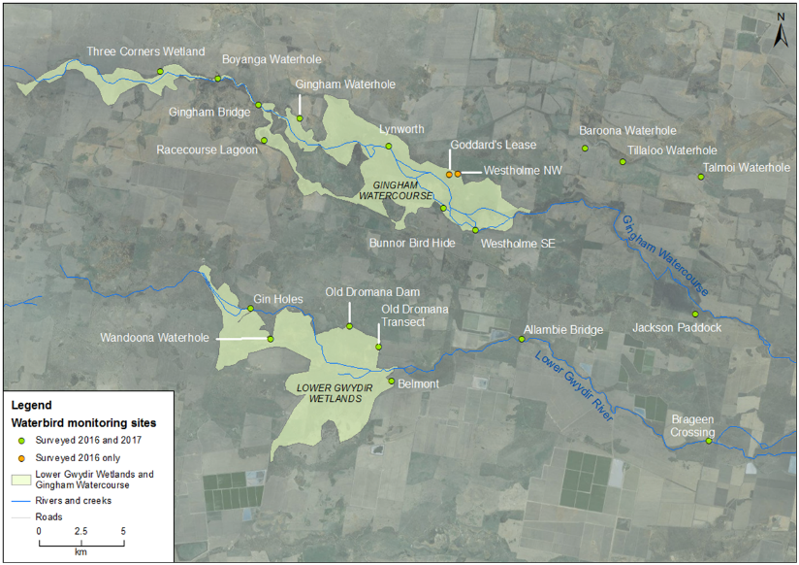
Figure J-1: Waterbird diversity monitoring sites within the lower Gwydir and Gingham Watercourse monitoring zone.
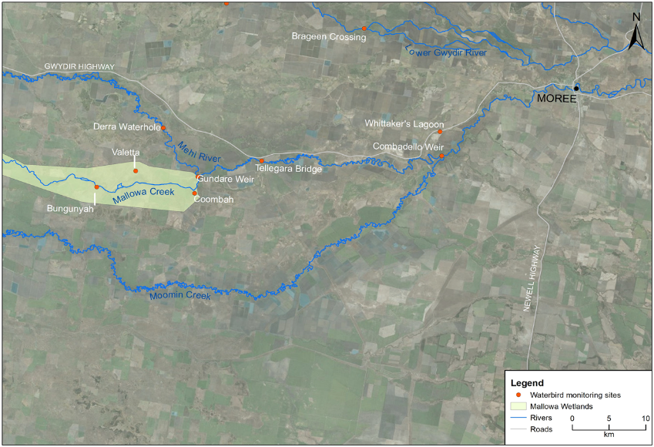
Figure J-2: Waterbird diversity monitoring sites within the Mehi River and Mallowa Creek monitoring zone.
Table J-2: Location of waterbird survey sites within the Gwydir river system Selected Area. All co-ordinates reported in GDA94 zone 55.
Monitoring Zone | Management Unit | Site Name | SiteType | Survey Type
lower Gwydir River and Gingham Watercourse | Gingham | Baroona Waterhole* | Waterhole | Point
 |  | Boyanga Waterhole* | Waterhole | Point
 |  | Bunnor Bird Hide | Floodplain wetland | Point
 |  | Three Corners* | Floodplain wetland | Point
 |  | Gingham Bridge | Creek | Point
 |  | Gingham Waterhole | Waterhole | Point
 |  | Goddard's Lease | Floodplain wetland | Point
 |  | Jackson Paddock* | Floodplain wetland | Transect
 |  | Lynworth* | Floodplain wetland | Transect
 |  | Racecourse Lagoon* | Waterhole | Point
 |  | Talmoi Waterhole* | Waterhole | Point
 |  | Tillaloo Waterhole* | Waterhole | Point
 |  | Westholme NW | Floodplain wetland | Transect
 |  | Westholme SE | Floodplain wetland | Transect
 | lower Gwydir | Allambie Bridge | Creek | Point
 |  | Brageen Crossing | Creek | Point
 |  | Belmont* | Floodplain wetland | Point
 |  | Gin Holes* | Waterhole | Point
 |  | Old Dromana Dam | Waterhole | Transect
 |  | Old Dromana Transect | Floodplain wetland | Point
 |  | Wandoona Waterhole* | Waterhole | Point
Mehi River and Moomin Creek | Mallowa | Bungunya* | Floodplain wetland | Transect
 |  | Coombah* | Floodplain wetland | Transect
 |  | Gundare Weir | Creek | Point
 |  | Valetta* | Floodplain wetland | Point
 | Mehi | Combadello Weir | Creek | Point
 |  | Derra Waterhole | Waterhole | Point
 |  | Tellegara Bridge | Creek | Point
 |  | Whittaker's Lagoon | Waterhole | Point
* Sites located on private land

Results

2016-17 water year

Species richness and abundance
In total 71 waterbird species were recorded in the 2016-17 monitoring period (Figure J-3, Figure J-4, Table J-3). This included eight species listed under one or more international migratory bird agreements (JAMBA, CAMBA and ROKAMBA) and six species listed under the NSW TSC Act: brolga, magpie goose, black falcon (Falco subniger), Australasian bittern (Botaurus poiciloptilus), spotted harrier (circus assimilis), little eagle (Hieraaetus morphnoides), comb-crested jacana (Irediparra gallinacea) and black-necked stork (Ephippiorhynchus asiaticus). Migratory shorebirds recorded included Latham’s snipe (Gallinago hardwickii), red-necked stint (Calidris ruficollis), marsh sandpiper (Tringa stagnatilis) and sharp-tailed sandpiper (Calidris acuminata).
The maximum density of waterbirds in November 2016 was 99 birds/ha, comprising 32 species, and in March 2017 was 154 birds/ha, comprising 29 species (Table J-3). The most widespread species recorded in the 2016-17 surveys were the Pacific black duck (Anas superciliosa), white-faced heron (Egretta novaehollandiae), whistling kite (Haliastur sphenurus) grey teal (Anas gracilis), sacred kingfisher (Todiramphus sanctus) and Australian wood duck (Chenonetta jubata) which all occurred at more than 21 of the 29 sites surveyed (Table J-4). Bunnor Bird Hide recorded the highest species richness and waterbird abundance for the 2016-17 water year in both survey periods, with an abundance of 99 birds/ha comprised of 32 species in November 2016 and 154 birds/ha consisting of 29 species in March 2017.
Waterbird mean abundance and species richness per survey period varied, with abundance being higher in March 2017 (31.90 birds/ha in March, 12.89 birds/ha in November) and species richness being higher in November 2016 (13.58 species/site in November, 12.62 species/site March). Although results were not statistically significant (abundance/ha; p=0.084, species richness; p=0.689). Variability in both measures across sites was high in both sampling periods (Figure J-5, Figure J-6). A comparison of sites which were inundated against those which were not showed significantly higher species richness (p<0.001) occurring at inundated sites (mean richness per site 15.21) compared to dry sites (mean richness per site 5.00). Whereas, there was no significant relationship between total bird abundance/ha and site inundation (p=0.063).
Pairwise comparisons using a single factor analysis of variance showed that mean abundance/ha did not differ significantly between management units (p=0.212) or site types (p=0.931) for the 2016-17 water year. However, Gingham sites had significantly more species present per site (mean= 17.57) than both Mallowa sites (mean= 6.37; p=<0.05) and Mehi sites (mean= 7.13; p=<0.05; Figure J-7). In addition, creek sites had significantly less species present per site (mean= 5.17) than either floodplain sites (mean= 15.86; p=<0.05) or waterhole sites (mean= 15.86; p=<0.05, Figure J-8). Floodplain wetlands and waterholes did not differ significantly for any measures tested and it both provided habitat for a diverse bird community.
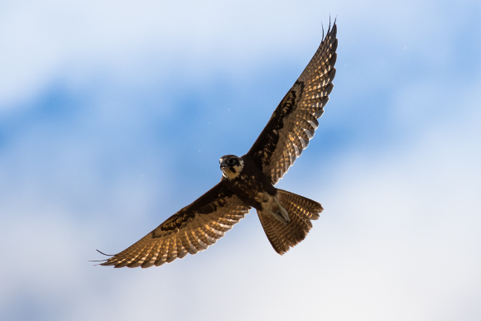
Figure J-3: Brown falcon seen in the Gwydir river system selected area in the 2016-17 water year.
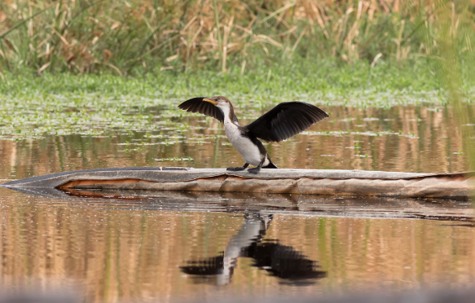
Figure J-4 Little pied cormorant seen in the Gwydir river system selected area in the 2016-17 water year.
Table J-3: Species richness, abundance and the number of waterbird functional groups recorded at waterbird survey sites within the Gwydir river system Selected Area during 2016-17 (NS = Not Surveyed).
Monitoring Zone | Management Unit | Site Name | Waterbird Species Richness  (Maximum species count per site) |  | Waterbird abundance/ ha (maximum waterbird count per site/ ha) |  | Waterbird functional guilds
 |  |  | Nov-16 | Mar-17 | Nov-16 | Mar-17 | Nov-16 | Mar-17
lower Gwydir River and Gingham Watercourse | Gingham | Baroona Waterhole | 15 | 13 | 7.57 | 13.41 | 6 | 6
 |  | Boyanga Waterhole | 23 | 11 | 22.62 | 4.56 | 9 | 4
 |  | Bunnor Bird Hide | 32 | 29 | 99.15 | 154.09 | 9 | 9
 |  | Three Corners | 27 | 4 | 15.22 | 0.36 | 10 | 2
 |  | Gingham Bridge | 8 | 3 | 8.26 | 1.73 | 4 | 2
 |  | Gingham Waterhole | 25 | 17 | 18.88 | 55.15 | 7 | 6
 |  | Goddard's Lease | 29 | NS | 2.74 | NS | 8 | NS
 |  | Jackson Paddock | 6 | 26 | 0.83 | 4.66 | 5 | 7
 |  | Racecourse Lagoon | 23 | 35 | 7.73 | 25.56 | 7 | 10
 |  | Lynworth | 21 | 21 | 23.94 | 20.02 | 9 | 8
 |  | Talmoi Waterhole | 12 | 15 | 4.82 | 13.52 | 5 | 6
 |  | Tillaloo Waterhole | 10 | 14 | 12.71 | 16.45 | 4 | 5
 |  | Westholme SE | 24 | 21 | 31.03 | 30.44 | 9 | 9
 |  | Westholme NW | 20 | NS | 4.47 | NS | 9 | NS
 | lower Gwydir | Allambie Bridge | 3 | 5 | 12.5 | 241.67 | 2 | 3
 |  | Belmont | 3 | 14 | 0.52 | 6.02 | 3 | 5
 |  | Brageen Crossing | 3 | 5 | 13.33 | 130 | 2 | 4
 |  | Old Dromana Dam | 12 | 23 | 26.94 | 64.38 | 6 | 9
 |  | Old Dromana Transect | 16 | 16 | 2.53 | 6.79 | 8 | 7
 |  | Wandoona Waterhole | 19 | 23 | 19.06 | 66.93 | 8 | 10
 |  | Gin Holes | 14 | 12 | 7.52 | 13.20 | 7 | 6
Mehi River and Moomin Creek | Mallowa | Bungunya | 3 | 1 | 1.46 | 0.21 | 1 | 1
 |  | Coombah | 1 | 16 | 1.15 | 23.25 | 1 | 5
 |  | Gundare Weir | 6 | 5 | 9.57 | 5.22 | 3 | 3
 |  | Valetta | 5 | 14 | 0.68 | 4.30 | 5 | 7
 | Mehi | Combadello Weir | 5 | 11 | 5.55 | 19.44 | 4 | 6
 |  | Derra Waterhole | 11 | 7 | 7.31 | 3.25 | 5 | 4
 |  | Tellegara Bridge | 6 | 2 | 1.16 | 0.44 | 4 | 2
 |  | Whittaker's Lagoon | 12 | 3 | 3.99 | 0.27 | 6 | 2
Average |  |  | 13.58 | 12.62 | 12.87 | 31.90 | 5.72 | 5.10
Std dev |  |  | 8.88 | 9.08 | 18.33 | 54.16 | 2.58 | 2.85

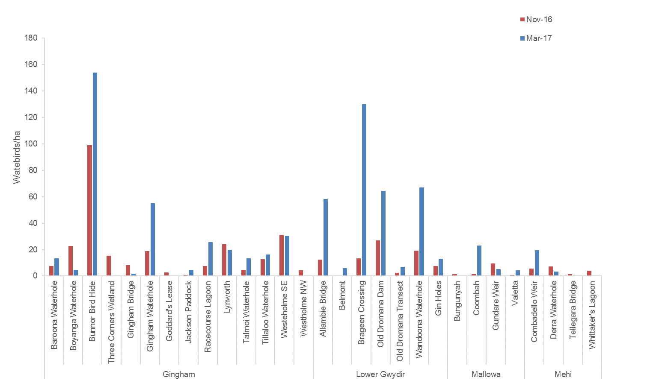
Figure J-5: Waterbird counts per hectare recorded at survey sites within the Gwydir river system Selected Area in November 2016 and March 2017. Note: Goddard’s lease and Westholme NW could not be surveyed in March 2017.
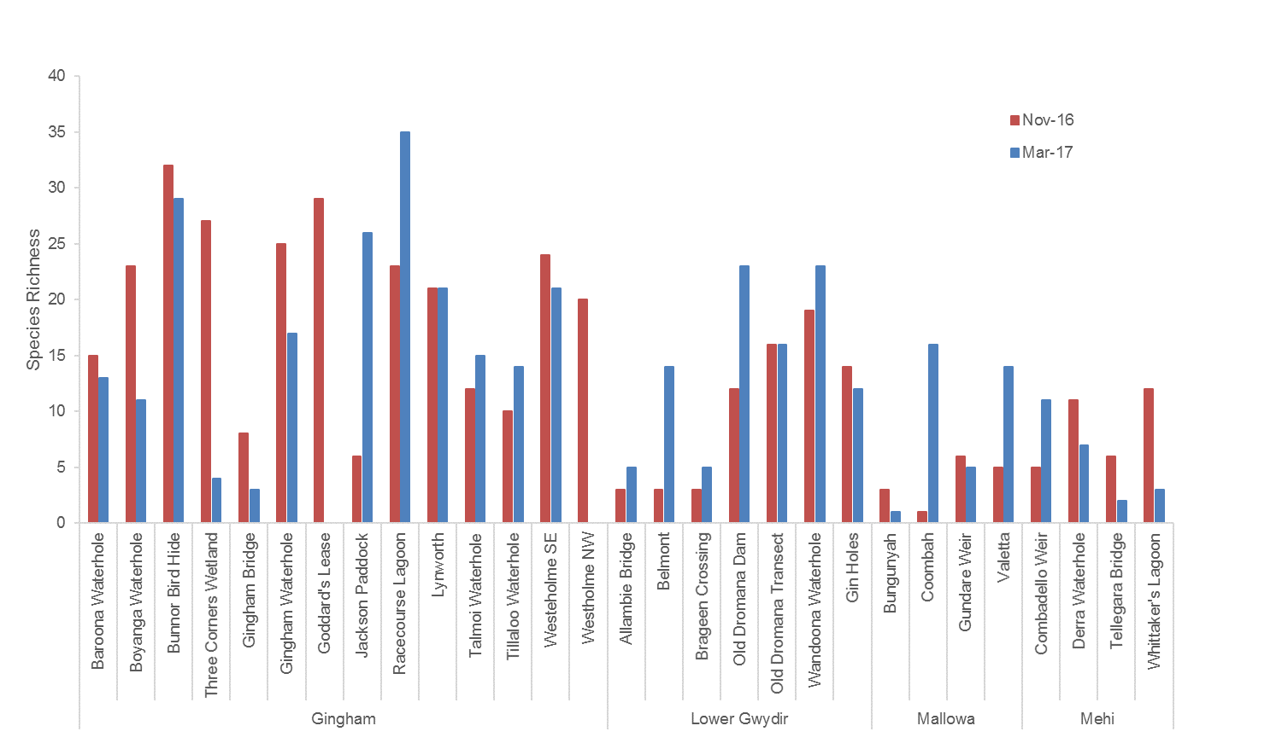
Figure J-6: Species richness recorded at waterbird survey sites within the Gwydir river system Selected Area in November 2016 and March 2017. Note: Goddard’s lease and Westholme NW could not be surveyed in March 2017.

Table J-4: Maximum count and percent occurrence across sites for all waterbirds species recorded in the 2015-16 monitoring period.
Monitoring Zone |  | lower Gwydir River and Gingham Watercourse |  |  |  |  |  |  |  |  |  |  |  |  |  |  |  |  |  |  |  |  | Mehi River and Moomin Creek
Management Unit |  | lower Gwydir |  |  |  |  |  |  | Gingham |  |  |  |  |  |  |  |  |  |  |  |  |  | Mallowa |  |  |  | Mehi
Functional group (guild) | Common name | Allambie Bridge | Belmont | Brageen Crossing | Gin Holes | Old Dromana Dam | Old Dromana Transect | Wandoona Waterhole | Baroona Waterhole | Boyanga Waterhole | Bunnor Bird Hide | Three Corners | Goddard's Lease | Gingham Bridge | Gingham Waterhole | Jackson Paddock | Lynworth | Racecourse Lagoon | Talmoi Waterhole | Tillaloo Waterhole | Westholme North West | Westholme SE | Coombah | Bungunya | Gundare Weir | Valetta | Derra Waterhole | Combadello Weir | Tellegara Bridge | Whittaker's Lagoon
Australian-breeding Charadriiform shorebirds | banded Lapwing |  |  | 20
 | black-fronted dotterel |  |  |  |  |  |  |  | 5 |  | 3 | 3 |  |  |  |  |  | 18 | 5 | 5 |  |  |  |  |  |  |  | 1 |  | 3
 | black-winged stilt |  |  |  |  |  | 1 |  | 9 | 1 | 10 |  |  |  |  |  |  | 178 | 3 | 3 |  | 7
 | masked lapwing |  |  |  | 2 |  | 10 | 2 | 2 |  | 6 |  |  |  |  |  | 4 | 15 | 2 | 2 |  | 3 |  |  |  | 2
 | red-kneed dotterel |  |  |  |  |  |  |  |  |  |  |  |  |  |  |  |  | 16
 | red-necked avocet |  |  |  |  |  |  |  |  |  |  |  |  |  |  |  |  | 4
Dabbling and  filter-feeding ducks | Australian Shoveler |  |  |  |  |  |  |  |  |  |  |  |  |  |  |  |  | 7
 | grey teal* |  | 2 |  | 22 | 3 |  | 26 | 151 |  | 44 | 41 | 2 | 3 | 3 | 2 | 10 | 208 | 39 | 61 | 1 | 145 | 1 |  | 2 | 7 | 5 |  |  | 13
 | pacific black duck* | 8 | 11 | 1 | 46 | 16 | 75 | 77 | 34 | 5 | 68 | 21 | 16 |  | 10 | 7 | 12 | 61 | 12 | 12 | 14 | 231 | 4 |  | 4 | 2 | 4 | 14 | 1 | 10
 | pink-eared duck* |  | 32 |  |  |  |  |  | 14 |  |  | 16 |  |  |  |  |  | 22 | 8 | 11
Diving ducks, aquatic gallinules and swans | black swan* |  |  |  |  |  |  | 1 |  |  | 15 |  | 1 |  | 7 |  |  | 10 |  |  |  | 2
 | comb-crested Jacana^{V} |  |  |  |  |  |  |  |  |  |  |  |  |  |  |  |  | 1
 | dusky moorhen* |  |  |  | 1 | 1 |  | 2 | 1 | 3 | 7 | 1 | 2 | 2 | 5 |  | 10 | 2 |  | 2 | 5 | 4 |  |  |  |  | 2 | 1 |  | 3
 | eurasian coot* |  |  |  | 21 | 3 | 2 | 43 | 17 | 12 | 20 | 4 | 5 |  | 3 | 8 | 25 | 32 | 5 | 7 |  | 8
 | hardhead* |  |  |  | 6 | 6 |  | 4 | 7 | 8 | 6 | 2 | 1 | 1 | 3 | 1 | 9 | 55 | 3 |  | 2 | 82
Grazing ducks and geese | Australian wood duck* | 3 | 2 | 16 | 45 | 2 | 8 | 3 | 39 |  | 2 | 18 | 5 |  | 12 | 32 |  |  | 13 |  | 32 | 6 |  |  |  | 11 | 4 | 2 | 122 | 1
 | magpie goose^{V*} |  |  |  |  |  |  | 2 |  | 1 | 129 | 1 | 1 |  | 4 |  | 53 | 5 |  |  |  | 7
 | plumed whistling-duck* |  |  | 2 | 69 | 65 |  | 108 | 6 | 8 | 381 | 151 |  |  | 468 |  | 101 | 1 | 57 | 6 |  | 21 |  |  |  |  | 4
 | wandering whistling-duck |  |  |  |  |  |  | 2 |  |  |  |  |  |  |  |  |  |  |  |  |  | 4
Large wading birds | australian white ibis |  | 4 |  | 2 | 1 | 8 | 10 |  | 1 | 7 | 26 | 64 |  |  | 4 | 3 | 21 |  |  | 17 | 5 | 1 |  |  |  |  | 6
 | black-necked stork^{E} |  |  |  |  |  |  |  |  |  |  |  |  |  |  |  |  | 2
 | brolga^{V} |  |  |  |  |  |  |  |  |  | 2 |  |  |  | 1 | 2 |  | 4 |  |  |  | 12
 | glossy ibis^{C} |  |  |  |  | 40 | 176 | 16 |  |  | 2 | 1 |  |  | 1 | 31 |  | 901 | 2 |  |  | 50 | 3 |  |  | 73
 | royal spoonbill |  |  |  |  |  | 1 |  |  |  | 2 | 10 | 2 |  |  |  |  | 10 |  |  | 2 | 1 |  |  |  |  | 1
 | straw-necked ibis |  | 21 |  |  | 1 | 17 | 9 |  | 4 |  | 2 | 11 |  |  | 1 |  | 6 |  |  |  | 180 | 14 |  |  | 5
 | yellow-billed spoonbill |  |  |  |  |  |  | 1 | 5 |  |  |  |  |  |  |  |  | 6 |  |  |  |  |  |  |  | 1 | 1 | 7
Migratory Charadriiform shorebirds | latham's snipe^{JR} |  |  |  |  | 12 | 4 | 8 |  |  |  | 1 |  |  |  |  |  |  |  |  | 8 |  | 1 |  |  | 3
 | marsh sandpiper^{CJR} |  |  |  |  |  |  |  |  |  |  |  |  |  |  |  |  | 22
 | red-necked stint^{JCR} |  |  |  |  |  |  |  |  |  |  |  |  |  |  |  |  | 8
 | sharp-tailed sandpiper^{CJR} |  |  |  |  |  | 2 |  |  |  |  |  |  |  |  |  |  | 46
Piscivores | Australasian bittern^{E} |  |  |  |  |  |  |  |  |  | 1
 | Australasian darter | 1 |  |  |  | 2 |  |  | 1 | 5 | 6 | 4 | 6 |  | 12 | 1 | 3 | 13 | 2 |  |  |  |  |  |  |  | 1 | 1
 | Australasian grebe* |  |  |  | 10 | 15 | 4 | 32 | 59 | 17 | 8 | 10 |  | 3 | 4 |  |  | 66 | 20 | 17 |  | 4 | 1 |  |  | 2 | 8 |  |  | 5
 | Australin gull-billed tern |  | 29 |  |  |  |  |  |  |  |  |  |  |  |  |  |  | 5 |  |  |  |  |  |  |  |  |  | 3
 | Australian pelican |  |  |  |  |  |  |  |  |  | 16 |  | 2 |  |  |  |  | 42
 | caspian tern |  | 47
 | cattle egret^{J} |  |  |  |  |  | 37 | 4 |  | 19 | 14 |  | 26 |  | 12 | 64 | 15 | 1 |  |  |  |  | 1 |  | 2
 | eastern great egret^{J} |  | 1 |  |  | 5 | 39 | 5 |  | 2 | 18 | 14 | 5 |  | 13 | 10 | 63 | 2 |  |  | 1 | 7 | 6 |  |  | 7
 | great cormorant |  |  |  |  |  |  |  |  | 5 |  |  |  |  |  |  |  | 6
 | great crested grebe* |  |  |  |  |  |  |  |  |  | 4 |  | 1 |  | 2 |  |  | 11 | 1
 | intermediate egret |  | 7 |  | 2 |  |  | 48 |  | 2 | 11 |  | 1 |  | 1 | 12 | 2 | 3 | 1 | 1 | 7 | 10 | 13 |  |  | 7
 | little black cormorant |  |  |  |  |  |  |  |  |  | 20 | 18 | 2 |  | 6 | 4 | 3 | 26 |  |  | 1 |  |  |  | 1
 | little egret |  | 2 |  |  |  |  |  | 1 |  | 3 |  |  |  |  | 1 |  | 12 |  | 1 |  | 4
 | little pied cormorant |  |  |  |  | 1 |  | 1 |  | 12 | 18 | 1 | 12 | 4 | 4 | 3 | 14 | 11 |  |  | 8 | 5 | 3 |  | 1
 | nankeen night-heron | 1 |  |  |  | 1 |  |  |  |  | 1 |  | 1 |  | 2 | 2 | 2 |  |  | 1 |  | 2 |  | 1 | 1 |  | 1
 | pied cormorant |  |  |  |  | 1 |  | 1 |  |  | 2 | 2 |  |  | 2 | 2 | 1 | 3
 | sacred kingfisher | 2 | 1 | 1 | 3 | 3 | 2 | 3 | 1 | 4 | 5 | 1 | 2 | 3 | 7 | 2 | 2 | 2 | 1 | 2 | 2 |  | 8 | 6 | 3 | 1 | 4 | 3 | 2 | 2
 | whiskered tern |  | 10 |  |  |  |  |  |  |  | 18
 | white-faced heron |  | 1 |  | 4 | 1 | 8 | 6 | 4 | 4 | 1 | 2 | 1 | 3 | 1 | 4 | 8 | 2 | 4 | 1 | 5 |  | 3 |  |  | 7 | 1 | 2 | 2 | 2
 | white-necked heron* | 1 |  |  |  |  | 9 | 5 |  |  | 2 |  | 1 |  | 3 | 4 | 1 | 2 | 1 | 2 |  | 1 | 2 | 1 |  | 9 |  |  |  | 4
Rails and shoreline gallinules | buff-banded Rail |  |  |  |  |  | 1 | 1 |  |  |  |  |  |  |  |  |  |  |  |  | 1
 | purple swamphen* |  |  |  | 1 | 2 | 3 | 3 |  | 6 | 6 | 3 | 4 |  |  |  | 4 | 2 |  |  | 1 | 5
Raptors | Australian hobby |  |  | 1 | 1 |  |  |  |  |  |  |  |  | 1 | 1
 | black falcon^{V} |  |  |  |  |  |  |  |  |  | 1 |  |  |  |  |  |  |  |  |  |  |  |  |  |  |  |  |  |  | 1
 | black-shouldered kite |  |  |  |  |  |  |  |  |  | 1 | 2 |  |  |  | 2 |  |  |  |  |  | 2
 | brown falcon |  | 1 |  |  |  | 2 |  |  |  |  | 4 | 2 |  |  | 1 |  |  |  |  |  |  | 1 |  |  | 1
 | little eagle^{V} |  |  |  |  |  |  |  |  |  |  |  |  |  |  |  |  | 1
 | nankeen kestrel |  |  |  | 1 |  |  |  |  |  |  | 2 |  | 1 |  |  |  |  |  |  | 4 |  |  |  |  |  |  |  |  | 2
 | southern boobook |  |  |  |  |  |  |  |  |  |  |  |  |  |  |  |  |  |  |  |  |  |  |  |  |  |  |  | 1
 | spotted harrier^{V} |  |  |  | 1
 | swamp harrier |  |  |  |  |  |  |  |  |  |  |  |  |  |  |  |  |  |  |  |  | 3
 | tawny frogmouth | 1 |  |  |  |  |  |  |  | 2 |  |  |  |  | 1 |  | 2
 | wedge-tailed eagle |  |  |  |  |  | 1 | 1 |  | 1 |  |  |  |  |  | 3 | 1 | 2 |  |  |  |  |  |  | 3 |  | 1 | 1
 | whistling kite |  | 2 | 2 |  | 1 | 2 | 1 | 1 | 2 | 2 |  | 1 |  | 3 | 1 | 1 | 4 |  |  | 1 | 2 |  |  | 1 | 1 | 2 | 3 | 2 | 2
 | white bellied sea-eagle |  |  |  |  |  | 1 |  |  | 3 |  | 1 |  | 2 |  |  |  | 1 |  |  |  | 3 |  |  | 1 |  |  | 1
Reed-inhabiting passerines | Australian reed-warbler* |  |  |  |  | 9 | 31 | 12 |  | 13 | 27 | 21 | 13 |  | 5 | 4 | 43 |  |  |  | 10 | 13
 | golden-headed cisticola |  | 3 |  |  | 4 | 20 | 5 |  | 1 | 4 | 1 | 4 |  |  | 2 | 3 | 1
 | little grassbird |  |  |  |  | 3 | 4 |  |  | 2 | 6 | 1 | 3 |  |  |  | 10 |  |  |  | 1 | 7
Species richness  (max total species) |  | 7 | 17 | 7 | 17 | 24 | 26 | 31 | 18 | 26 | 40 | 31 | 29 | 10 | 28 | 27 | 27 | 49 | 18 | 16 | 21 | 31 | 15 | 3 | 10 | 16 | 14 | 13 | 6 | 12
^{J}= listed under JAMBA; ^{C}= listed under CAMBA; ^{R}= listed under ROKAMBA; ^{V}=Vulnerable (NSW TSC Act); ^{E}= Endangered (NSW TSC Act); *= breeding activity observed

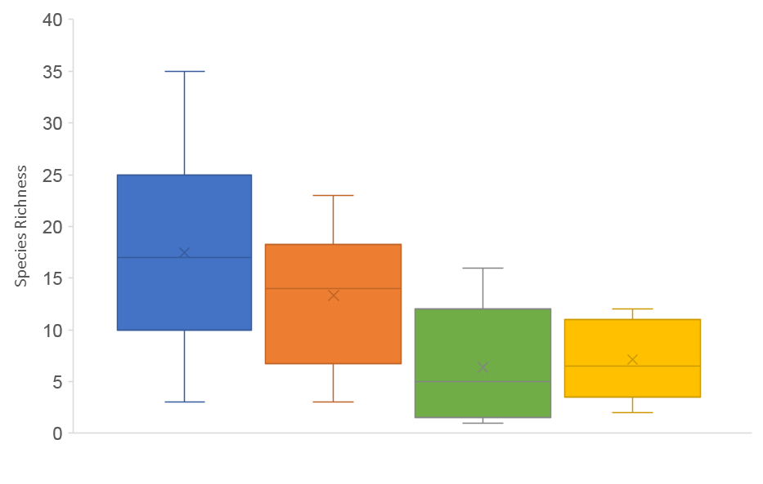
Gingham lower Gwydir Mallowa Mehi
Figure J-7: Comparison of species richness between wetland management units.
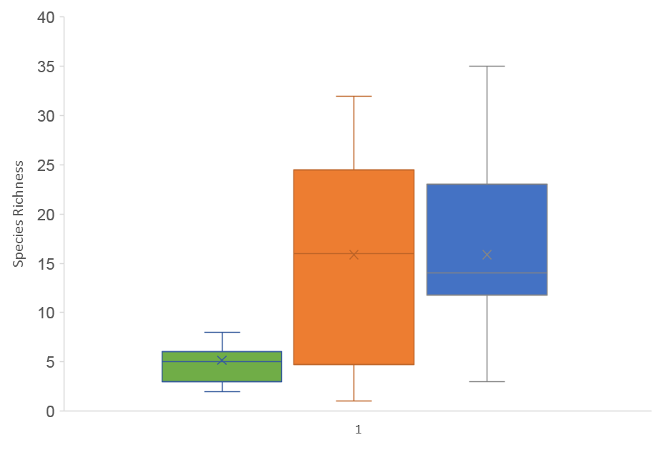
Creek Floodplain Waterhole
Figure J-8: Comparison of species richness between site type.

Community Composition
nMDS plots show that there was little to no separation in the data based on system, and the presence of water (Figure J-9). PERMANOVA analysis supported this close clustering with no significant differences being observed between management units and wet/dry sites (p=0.105). nMDS plots also show little variation in the data based on sampling period and wet/dry sites. This was confirmed by a non-significant result between sampling periods and wet/dry sites (p=0.463). A significant difference was found between species abundance data and wet/dry sites (p<0.05). SIMPER analysis of wet and dry sites found that the Pacific black duck and sacred kingfisher had the largest contribution to wet sites (15.06% and 11.83% respectively) whilst the sacred kingfisher and grey teal contributed most to the dry sites (42.03% and 13.09% respectively).
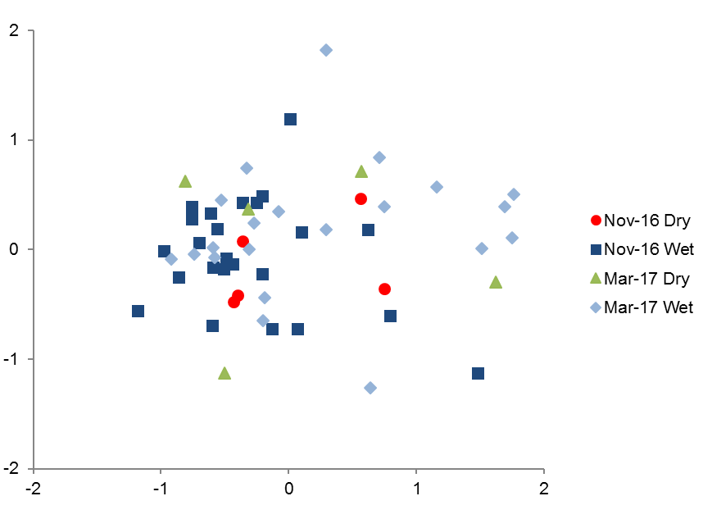
Figure J-9: nMDS plot of waterbird species abundance data in 2016-17 grouped by sampling season and the presence of water (wet or dry).

Waterbird breeding
Waterbird breeding activity was observed at 16 sites in November 2016 and four sites in March 2017. Some evidence of breeding was observed in 13 species in November 2016 representing five guilds and three species in March 2017 representing one guild (Table J-5). Species found to be breeding in November 2016 belonged to the functional groups: piscivores, dabbling and filter-feeding ducks, diving ducks, aquatic gallinules and swans, grazing ducks and geese, rails and shoreline gallinules, whilst species observed breeding in March 2017 belong to the piscivore functional guild. The greater inundation extent observed at most sites in November 2016, coupled with the fact that this was the first larger floodplain inundation event in several years, likely explains the increased breeding activity observed.

Table J-5: Summary of breeding activity observed over the 2016-17 water year.
Survey period | Site name | Common name | Breeding activity  (# broods or nests) | Notes and additional evidence of breeding
Nov-16 | Baroona Waterhole | Australasian grebe | 3 | 1x2, 1x3, 1x5 chicks
 |  | Pacific black duck | 1 | 10 chicks
 |  | pink-eared duck | 1 | 7 chicks
 | Boyanga Waterhole | Australasian grebe | 2 | 2x4 chicks
 |  | hardhead | 1 | 7 chicks
 | Bunnor Bird hide | black swan | 1 | 2 chicks
 |  | purple swamphen | 1 | 1 chick
 | Gin Holes | Eurasian coot | 1 | 6 chicks
 |  | hardhead | 1 | 4 chicks
 |  | Pacific black duck | 1 | 6 ducklings
 |  | plumed-whistling duck | 1 | 1 chick
 | Gingham Bridge | Australasian grebe | 1 | 1 chick
 | Gingham Waterhole | black swan | 1 | 6 chicks
 | Lynworth | Australian wood duck | 1 | 10 ducklings
 | Old Dramana dam | Australasian grebe | 1 | 2 chicks
 |  | grey teal | 1 | 6 chicks
 |  | plumed-whistling duck | 1 | 10 ducklings
 | Racecourse Lagoon | Australasian grebe | 9 | 1x4, 2x1, 4x2, 1x3, 1x5 chicks, 1 nest
 |  | black swan | 2 | 6 chicks, 1 nest
 |  | grey teal | 1 | 10 ducklings
 |  | hardhead | 2 | 1x4, 1x10 ducklings
 |  | Pacific black duck | 1 | 10 ducklings
 | Talmoi Waterhole | Pacific black duck | 1 | 9 ducklings
 | Three Corners | Australasian grebe | 1 | 6 chicks
 |  | Australian wood duck | 1 | 8 ducklings
 |  | Eurasian coot | 1 | 3 chicks
 |  | grey teal | 1 | 1 chick
 |  | pink-eared duck | 2 | 1x5, 1x7 ducklings
 | Tillaloo Waterhole | Australasian grebe | 1 | 1 chick
 |  | grey teal | 1 | 11 chicks
 | Wandoona Waterhole | Australasian grebe | 1 | 1 chick
 |  | Eurasian coot | 3 | 3x2, 1x3 chicks, 1 nest
 | Westholme NW | Austalian wood duck | 1 | 6 ducklings
 | Westholme SE | Austalian wood duck | 1 | 3 chicks
 |  | black swan | 1 | nest with 2 eggs
 |  | dusky moorhen | 1 | 2 chicks
 |  | eurasian coot | 1 | 5 chicks
 |  | magpie goose | 1 | 4 gooslings
 | Whittakers Lagoon | grey teal | 1 | 6 ducklings
 |  | Pacific black duck | 0 | 1 chick
 |  | white-necked heron | 2 | 2 nests, one with 2 chicks
Mar-17 | Bunnor Bird hide | great-crested grebe | 1 | 1 nest
 | Old Dramana dam | Australasian grebe | 2 | 7 chicks total
 | Whittakers Lagoon | white-necked heron | 1 | 1 nest

Functional guilds
All ten functional guilds were represented across the sites surveyed in both November 2016 and March 2017, although total numbers of Migratory Charadriiforms shorebirds and Rails and Shoreline Gallinule were very low (Figure J-10). The average number of functional guilds recorded per site did not differ significantly (P=0.398) falling from 5.7 in November 2016 to 5.1 in March 2017. The average number of functional guilds represented at inundated sites (6.13) was significantly higher than at dry sites (2.67, p<0.001). Pairwise comparisons between management units showed a significant difference between Gingham (6.03) and Mallowa (3.6, p=<0.05). Significant differences in mean number of guilds present were found between floodplain (5.7) and creek sites (3.4, p<0.05) and waterhole (6.3) and creek sites (3.4, p<0.05).
Six of the functional guilds increased in abundance/ha from November 2016 to March 2017 (Australian-breeding Charadriiform shorebirds, Dabbling and filter-feeding ducks, Piscivores, Grazing ducks and geese, Large wading birds, Migratory Charadriiform shorebirds) while all others decreased. However, most guilds that decreased only did so by a small amount (Figure J-10). Grazing ducks and geese showed the largest increase in abundance between sampling periods, from 131 birds/ha in November 2016 to 298 birds/ha in March 2017. The largest decline was in reed-inhabiting passerines which dropped from 31 birds/ha in November 2016 to 8 birds/ha in March 2016.
Overall, the grazing ducks and geese, piscivores and dabbling and filter-feeding ducks dominated the waterbird community in the 2016-17 water year. The grazing ducks and geese guild consisted of four species which were often seen in large flocks with the highest observation being in March 2017 at Gingham waterhole with an estimated 410 plumed whistling-ducks (Dendrocygna eytoni) (Table J-4). The piscivores group was made up of 21 species and remained relatively stable throughout the year, only increasing by 7 birds/ha between November 2016 and March 2017. Three species contributed to the dabbling and filter-feeding ducks guild, all of which were frequently observed in large flocks with the largest sighting being the Pacific black duck at Westholme SE in March 2017 consisting of 215 individuals.
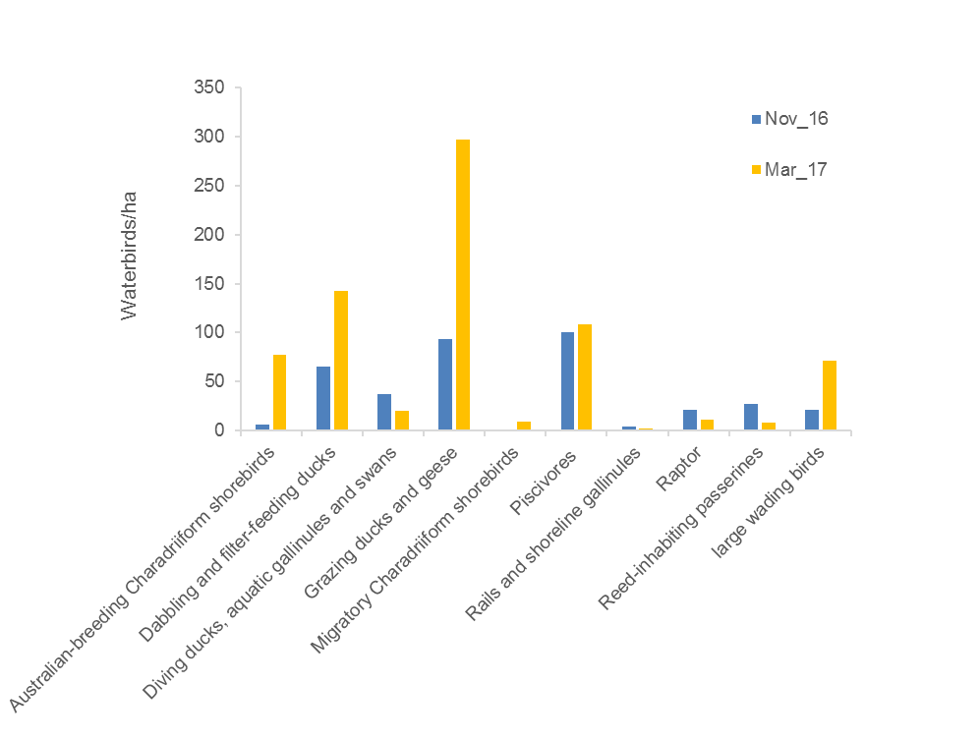
Figure J-10: Waterbird count/ha by functional group across all sites in 2016-17 water year.

Multi-year comparison

Species richness and abundance
Abundance/ha did not differ between sampling periods across years 1 (2014-15), 2 (2015-16) and 3 (2016-17) (p= 0.218), however, species richness did differ between water years (p=0.046). Both abundance and richness differed significantly in response to the presence of water (p<0.05). Although there was no interaction found between sampling periods and the presence of water (p=0.729, p=0.161). This suggests that abundance/ha and species richness data is being driven by inundation.
No significant difference was noted between species richness and season (spring, autumn) over all survey periods. Although, abundance/ha was found to be significantly different between seasons (p=0.04) with autumn surveys typically having higher abundances (Figure J-11).
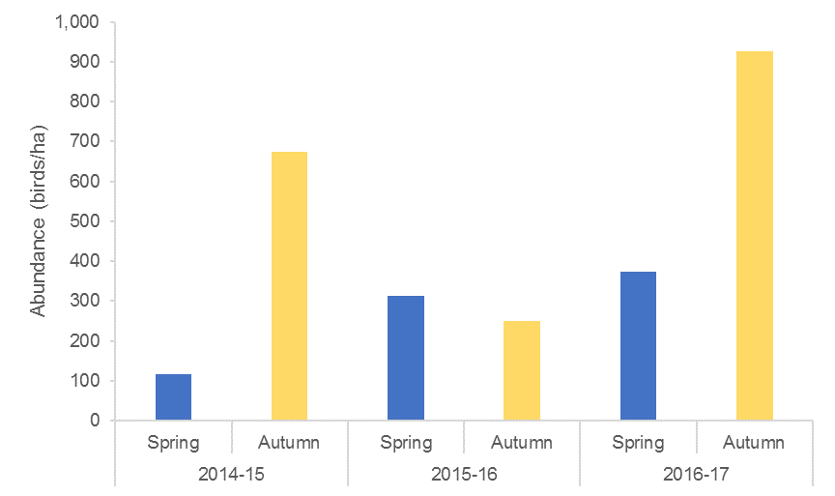
Figure J-11: Waterbird abundance/ha observed in Spring and Autumn across the three survey years.

Community composition
Considering data collected over years 1, 2 and 3 of the project, nMDS plots show that there was considerable overlap in community composition when grouped by sampling time and the presence of water (Figure J-12). PERMONOVA tests suggested a significant difference in community composition between wet and dry sites (p=0.003), but no difference between sampling periods alone (p=0.717). The interaction of these terms was also non-significant (p=0.729).
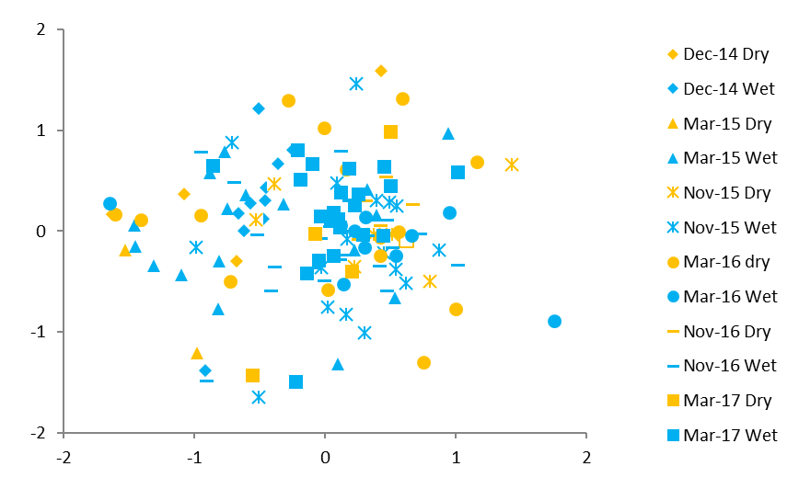
Figure J-12: nMDS plot of waterbird species abundance data in years 1, 2 and 3 of the project grouped by survey period and the presence of water (wet) or not (dry). Note samples from Gingham waterhole in December 2014 and March 15 were removed from this analysis as they were considered outliers due to highly elevated species counts.

Functional guilds
There was no significant difference in the representation of functional guilds between sample periods in years 1, 2 and 3 of the project. However, there was a distinct separation of creek sites from floodplain wetland and waterhole sites when community composition by functional guild (birds/ha) was considered (Figure J-13). PERMANOVA analysis confirmed there was a significant interaction between site type and functional guild (birds/ha, p=<0.001). PAIRWISE tests confirmed a significant difference between creek and floodplain sites (p=0.006), and waterhole and creek sites (p=0.004). Floodplain and waterhole sites have hosted similar functional guilds across all surveys. Creek sites in December 2014 and March 2015 separated out strongly compared to floodplain wetland and waterhole sites for all sampling periods. SIMPER analysis showed that this difference was driven largely by the piscivore and dabbling and filter feeding ducks functional groups, explaining 39.93% and 23.44% of the similarity between creek sites, compared to less than 16% and 14% in the floodplain wetland and waterhole site types. The floodplain and waterhole sites host a larger range of functional guilds (all nine appearing over the project) whilst the creek sites have only seen five of the functional guilds over the course of this project.
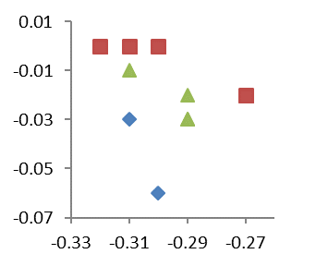
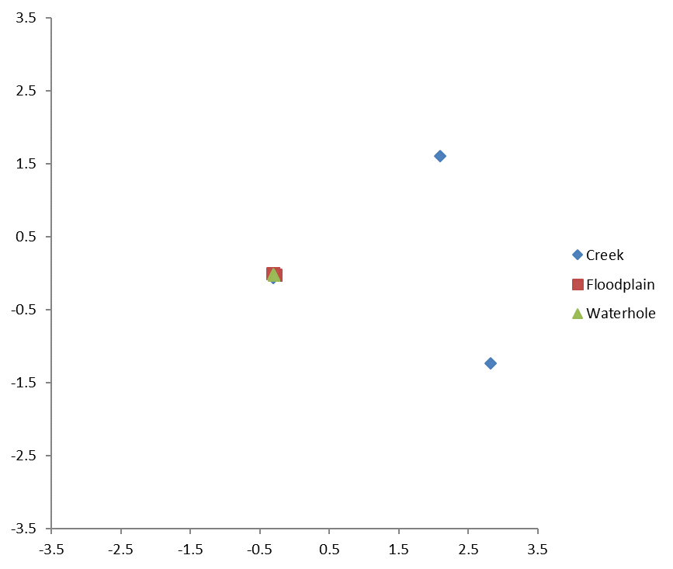
Figure J-13: nMDS plot of waterbird functional guild (birds/ha) grouped by site type for data from year 1, 2 and 3 of the LTIM project.

Discussion
The environmental watering strategy for the Selected Area employs a multi-year wetting and allowing of a natural drying cycle in which 2015-16 was a naturally dry year, with the application of environmental water aimed largely at maintaining in-channel flow rather than large-scale wetland inundation. However, during the 2016-17 water year, higher natural river flows resulted in larger scale wetland and floodplain inundation in the Gingham and lower Gwydir zone in October/November 2016. This was followed by environmental water deliveries from late December 2016 to February 2017, to maintain inundation throughout early 2017. This appears to have resulted in an increase in waterbird diversity and abundance from the previous monitoring years.
Many of the functional guilds that have been observed follow trends that relate to the dynamic environment around them. The abundance of piscivores increased from the 2015-16 water year and remained stable across the 2016-17 water year surveys. This is likely a reflection of the stable habitat and resource base through established fish and invertebrate populations that have developed over long periods of inundation in the wetlands (Commonwealth of Australia, 2016). Grazing ducks and geese was the largest guild observed, and experienced the largest increase in abundance over the 2016-17 year surveys. This may have been in response to greater inundated area in this water year relative to the previous two years of monitoring. The grazing ducks and geese guild feeds primarily on terrestrial vegetation which would have thrived due to the receding water following the relatively long period of inundation. Species in the dabbling and filter feeding functional guild feed primarily on the surface of shallow waters. Microinvertebrates are the key prey in floodplain river food webs for filter-feeding ducks, and macroinvertebrates are important food sources for other ducks and shorebirds and can respond rapidly to newly flooded areas of habitat (Timms 1996; Briggs et al. 1985). This observation is supported by the increase in microinvertebrate densities and macroinvertebrate diversity noted at the end of the water (Appendix D and E).
An increase in the number of dabbling ducks, and small and large waders was observed in the March 2017 surveys compared to the November 2016 surveys. Increases in these functional groups followed the delivery of environmental water to wetland habitats in the Gingham and Lower Gwydir wetlands over summer which allowed for a gradual draw-down of wetland habitats providing muddy edges and shallow wading habitat favoured by these species. The depth of water is important for many dabbling duck and shorebird species, which feed on the water’s edge and water depth determines the accessibility of invertebrate prey. The March surveys also coincided with the migratory period for Migratory Charadriiforms shorebirds species including sharp-tailed sandpipers and marsh sandpipers detected during the 2016-17 surveys. The delivery of environmental water to the lower Gwydir Wetlands during summer and autumn months can provide foraging habitat for these migratory shorebirds which migrate north during the February-May period. Juvenile straw-necked ibis (a large wader species) were observed during the March 2017 surveys and although they did not breed in the Gwydir Wetlands in 2016-17, these individuals may have dispersed to feed in the Gwydir Wetlands following large-scale breeding events in the Macquarie Marshes and southern catchments in 2016-17 (Spencer et al. 2017).
Although no colonial waterbird breeding activity was detected during the spring and autumn ground surveys in 2016-17, complementary monitoring by the University of New South Wales (MDBA funded annual aerial surveys) and NSW OEH in mid November 2016 detected a small egret and heron colony on the Gingham watercourse (Spencer et al. 2017). Over the course of the project breeding activity has been consistently higher during the November surveys opposed to the March surveys. This has been consistent with the commencement of flooding events. Observations have shown that waterbirds seem to respond rapidly at the start of an inundation event due to the newly created resources and habitat. Breeding activity then subsides throughout the inundation cycle. These findings are supported by Kingsford et al. (2010) and Kingsford and Norman (2002), who concluded that Australian waterbirds typically show opportunistic patterns of breeding activities which relate to flooding events.
Wetland waterbird diversity is not only influenced by the spatial availability of water but also by temporal measures (Kingsford et al. 2010). Over the course of the LTIM project there has been on average higher species richness and abundance with the presence of water, however this is not portraying the entire ‘story’. The different functional guilds display responsive movements which are influenced by their own niche habitat requirements. These habitat requirements are directly influenced by the current stage of the wetting cycle of the wetland (Figure J-14), and also by habitat availability elsewhere in the landscape.
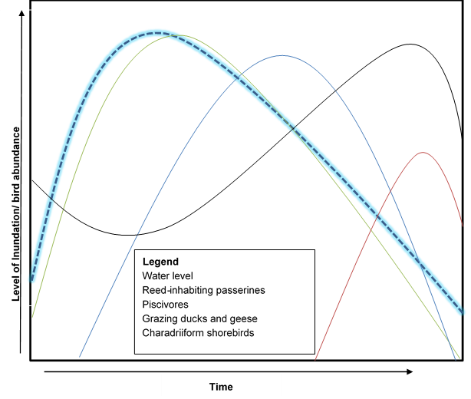
Figure J-14: Conceptual model of 4 functional guilds that displayed responses in abundance due to environmental factors that are influenced by the spatial and temporal stages of an inundation cycle of the Gwydir wetlands Selected Area.

Conclusion
Waterbird diversity, abundance and breeding activity increased in the wetter 2016-17 year compared to the previous two years of monitoring. Delivering environmental water to floodplain habitats can benefit a range of wetland-dependent species and extend the benefit from earlier natural inflow events. Where consideration is given to timing, extent and rate of drawn down, and appropriate wetting and drying intervals this can maximise outcomes for waterbirds and other wetland-dependent species.

References
Briggs, SV, Maher, MT and Palmer, RP (1985). Bias in Food Habits of Australian Waterfowl. Australian Wildlife Research 12, 507–514.
Commonwealth of Australia 2015. Commonwealth Environmental Water Office Long Term intervention Monitoring Project Gwydir River System Selected Area – 2014-15 Evaluation Report.
Department of the Environment, Climate Change and Water (DECCW) 2011. Gwydir Wetlands Adaptive Environmental Management Plan.
Kingsford, R.T., and Norman, F.J. (2002). ‘Australian waterbirds – products of the continent’s ecology’. Emu 102, 47-69.
Kingsford, R.T., Roshier, D.A. and Porter, J.L. 2010. ‘Australian waterbirds – time and space travellers in dynamic desert landscapes’. Marine and Freshwater Research (61)
NSW Office of Environment and Heritage. 2015. Environmental water use in New South Wales. Outcomes 2014-15.
Roshier, D.A., Robertson, A.I. and Kingsford, R.T. 2002. ‘Responses of waterbirds to flooding in an arid region of Australia and implications for conservation’. Biological Conservation (106)
Spencer, J., Hosking, T., Ewin, P., Webster, R., Hutton, K., Allman, R., Thomaws, R., Humphries, J., Berney, P. and Mulholland, M. 2014. Waterbird Monitoring in Inland NSW: Summary Report 2012-13. NSW Office of Environment and Heritage. Sydney.
Spencer, J., Ocock, J., Amos, C., Borrell, A., Suter, S., Preston, D., Hosking, T., Humphries, J., Keyte, P., Hutton, K., and Berney, P. (2017). Monitoring Waterbird Outcomes in NSW: Summary Report 2016-17. Unpublished report. NSW Office of Environment and Heritage, Sydney. September 2017.
Timms, B.V. (1996). A comparison between saline and freshwater wetlands on Bloodwater Station, the Paroo, Australia, with special reference to their use by waterbirds. International Journal of Salt Lake Research 5(4), 287-313.

