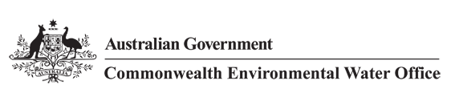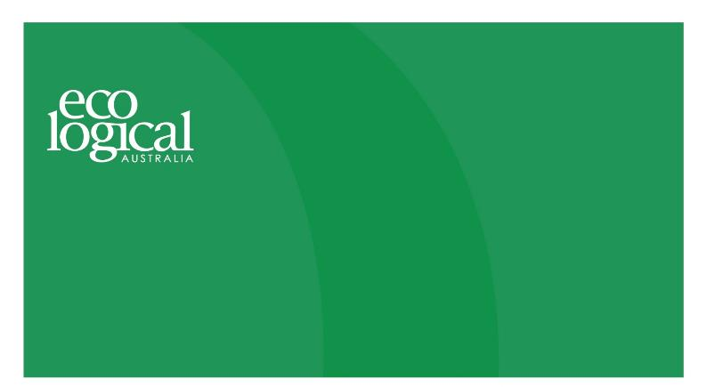



**Commonwealth Environmental Water Office**

**Long Term Intervention Monitoring Project**

**GWYDIR RIVER SYSTEM SELECTED AREA**

2016-17 Annual Evaluation Report

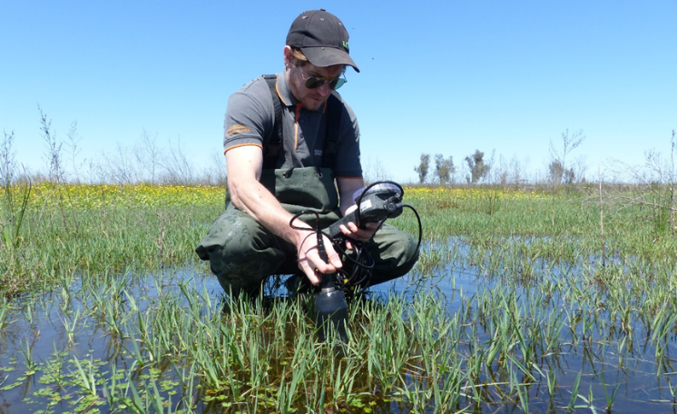



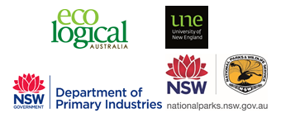

This monitoring project was commissioned and funded by Commonwealth Environmental Water Office, with in-kind support from NSW Office of Environment and Heritage.

**Copyright**

© Copyright Commonwealth of Australia, 2017



Commonwealth Environmental Water Office Long Term Intervention Monitoring Project Gwydir River System Selected Area is licensed by the Commonwealth of Australia for use under a Creative Commons By Attribution 3.0 Australia licence with the exception of the Coat of Arms of the Commonwealth of Australia, the logo of the agency responsible for publishing the report, content supplied by third parties, and any images depicting people. For licence conditions see:

<http://creativecommons.org/licenses/by/3.0/au/>

This report should be attributed as ‘Commonwealth Environmental Water Office Long Term Intervention Monitoring Project Gwydir River System Selected Area – 2016-17 Annual Evaluation Report, Commonwealth of Australia 2017’.

**Disclaimer**

The views and opinions expressed in this publication are those of the authors and do not necessarily reflect those of the Australian Government or the Minister for the Environment and Energy.

While reasonable efforts have been made to ensure that the contents of this publication are factually correct, the Commonwealth does not accept responsibility for the accuracy or completeness of the contents, and shall not be liable for any loss or damage that may be occasioned directly or indirectly through the use of, or reliance on, the contents of this publication.

**DOCUMENT TRACKING**

|  |  |
| --- | --- |
| Item | Detail |
| Project Name | Long Term Intervention Monitoring Project – Gwydir River System Selected Area |
| Project Number | 5304 |
| Project Manager | Dr Mark Southwell  (02) 8081 2688  92 Taylor Street, Armidale NSW 2350 |
| Prepared by | Dr Mark Southwell, Ronnie Hill, Linden Burch, Nathalie van der Veer, Nathalie Mace (ELA)  Assoc. Prof Darren Ryder, Dr Wing Ying Tsoi (UNE)  Dr Gavin Butler, Luke Carpenter-Bundhoo (NSW DPI)  Dr Paul Frazier (2rog consulting)  Dr Jennifer Spencer, Sharon Bowen and Jane Humphries (NSW OEH) |
| Reviewed by | Dr Mark Southwell, Assoc. Prof Darren Ryder |
| Approved by | Dr Paul Frazier |
| Status | FINAL |
| Version Number | 2 |
| Last saved on | 16 May 2018 |
| Cover photo | Water quality monitoring in the Gingham wetlands (Photo: W.Tsoi) |

Acknowledgements

This document has been prepared by Eco Logical Australia Pty Ltd with support from Associate Professor Darren Ryder and Dr Wing Ying Tsoi from the University of New England, Dr Paul Frazier from 2rog consulting, Dr Gavin Butler and Luke Carpenter-Bundhoo from the DPI fisheries, and staff from the NSW Office of Environment and Heritage and NSW Office of Water.

Many sites surveyed as part of the Gwydir Selected Area LTIM project lie on private land or reserve land managed by NSW National Parks and Wildlife Service (NPWS). The project team acknowledges the cooperation and valuable contribution provided by the individual landholders in allowing access to sites on their properties to undertake monitoring. We are also appreciative to NPWS who allow us access to sites and facilities during field work and also provide staff who assist in undertaking monitoring for some indicators.

Acknowledgement of Country

The authors of this report as well as the Commonwealth Environmental Water Office respectfully acknowledge the traditional owners, their Elders past and present, their Nations of the Murray-Darling Basin, and their cultural, social, environmental, spiritual and economic connection to their lands and waters. In particular the Barkindji, Murrawarri, Ngemba and Ngiyampaa peoples, traditional owners of the land on which this publication is focused.

|  |
| --- |
| **Disclaimer** *This document may only be used for the purpose for which it was commissioned and in accordance with the contract between Eco Logical Australia Pty Ltd and the Department of the Environment and Energy. The scope of services was defined in consultation with the Department of the Environment and Energy, by time and budgetary constraints imposed by the client, and the availability of reports and other data on the subject area. Changes to available information, legislation and schedules are made on an ongoing basis and readers should obtain up to date information.*  *Eco Logical Australia Pty Ltd accepts no liability or responsibility whatsoever for or in respect of any use of or reliance upon this report and its supporting material by any third party. Information provided is not intended to be a substitute for site specific assessment or legal advice in relation to any matter. Unauthorised use of this report in any form is prohibited.* |

Template 29/9/2015

**Document control**

|  |  |  |  |
| --- | --- | --- | --- |
| Version | Date | Reviewed by | Approved by |
| 1 | 30 August 2017 | Dr Mark Southwell, Assoc. Prof Darren Ryder | Dr Paul Frazier |
| 2 | 13 December 2017 | Dr Mark Southwell, Assoc. Prof Darren Ryder | Dr Paul Frazier |

|  |  |
| --- | --- |
| Item | Details |
| ELA Project Number | 5304 |
| Project Director/s | Dr Paul Frazier, Assoc. Prof Darren Ryder |
| Project Manager | Dr Mark Southwell |
| Prepared by | Dr Paul Frazier, Assoc. Prof Darren Ryder, Dr Mark Southwell, Dr Wing Ying Tsoi, Dr Gavin Butler, Luke Carpenter-Bundhoo, Ronnie Hill, Nathalie van der Veer, Linden Burch, Nathalie Mace |

Contents

Executive summary vi

1 Introduction 1

2 Gwydir River system Selected Area 2

3 Water actions 5

3.1 Environmental condition and watering actions in the Gwydir river system Selected Area 2016-17 5

4 What did Commonwealth environmental water do in 2016-17 7

4.1 Expected Outcomes 7

4.2 Flows and ecosystem functions 10

4.3 Water Quality 13

4.4 Biodiversity 13

4.5 Resilience 18

4.6 Summary 18

5 Implications for Future Management of Commonwealth environmental water 19

6 References 20

**Appendix A – Hydrology (River)**

**Appendix B – Hydrology (Watercourse)**

**Appendix C – Water Quality**

**Appendix D – Microinvertebrates**

**Appendix E – Macroinvertebrates**

**Appendix F – Ecosystem Type**

**Appendix G – Vegetation Diversity**

**Appendix I – Fish (River)**

**Appendix J – Fish (Movement)**

**Appendix K – Waterbird Diversity**

List of figures

Figure 2‑1: Gwydir River catchment and location within the Murray Darling Basin. 3

Figure 2‑2: The Gwydir river system Selected Area with monitoring zones highlighted. 4

Figure 3‑1: Monthly rainfall totals for 2016-17 and mean totals measured at Moree airport 6

Figure 3‑2: Monthly maximum temperatures for 2016-17 and mean maximum temperatures measured at Moree airport. (Source. http://www.bom.gov.au/climate/data/index.shtml). 6

Figure 4‑1: Wetland inundation within the Gingham and Gwydir wetlands during the 2016-17 water year. 11

Figure 4‑2: Wetland inundation within the Mallowa wetlands during the 2016-17 water year. 12

Figure 4‑3: Sedge/forb/grassland floodplain (top left), Temporary lowland stream (top right), Permanent lowland stream (bottom left) Coolibah woodland and forest floodplain (bottom right) ecosystem types monitoried in the Selected Area. 14

Figure 4‑4: Freshwater catfish (Tandanus tandanus) recruits caught in the lower Gwydir River during fish diversity sampling in 2017. 14

Figure 4‑5: Water couch meadow at Bunnor in the Gingham Wetlands in March 2017 following inundation by environmental water (top) Floodplain vegetation in the Mallowa Wetlands in October 2016 (bottom). 16

Figure 4‑6: Plumbed Whistling Ducks (Dendrocygna eytoni) in the Gingham wetlands (top), Black-necked stork (Ephippiorhynchus asiaticus) feeding on a floodplain waterhole (bottom) 17

List of tables

Table 3‑1: Comparison between environmental water use and 2016-17 water year flows. Percentage represents the percentage of the total flow made up of environmental water. 5

Table 4‑1: Watering actions, target assets and evaluated outcomes implemented in the Gwydir river system Selected Area during 2016-17. 8

Table 4‑2: Expected outcomes from environmental water use in the Gwydir river system Selected Area linked to broader Basin Plan objectives. 9

Executive summary

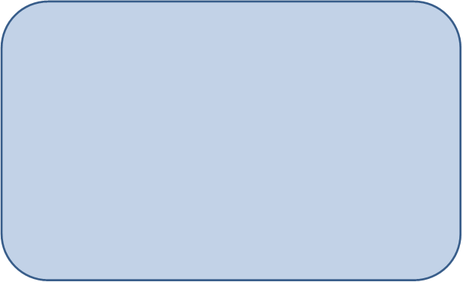

**Contributions of Commonwealth environmental water in 2016-17**

***River channels***

* Environmental water increased longitudinal connectivity in the Gwydir, lower Gwydir and Mehi River channels during 2016-17
* Commonwealth environmental water was responsible for all significant flow in Mallowa Creek during 2016-17
* Environmental water improved water quality, stimulated primary productivity and helped to maintain regional scale aquatic invertebrate diversity
* Environmental water stimulated the movement of fish species within and between the Mehi and Gwydir river channels.

***Wetlands***

* Environmental water maintained waterholes in the Gingham watercourse and Gwydir wetlands that contain several threatened species of native fish
* Environmental water prolonged inundation in core areas of the Gingham and Lower Gwydir wetlands, maintaining wetland vegetation and promoting waterbird and frog breeding
* Environmental water inundated over four times more wetland area in the Mallowa system than in 2015-16
* Environmental water helped to increase invertebrate densities in wetland sites, providing food resources of native fish, waterbirds and frogs.

The Gwydir catchment, located in the northern Murray Darling Basin, extends from the Great Dividing Range west to the Barwon River. Downstream of Moree, the system fans out into a broad alluvial near-terminal floodplain. Numerous anabranches and distributary channels characterise the lower half of the Gwydir catchment, with the Mehi River and Moomin Creek to the south, and the lower Gwydir River, Gingham watercourse and Carole Creek to the north. These channels support wetland and floodplain assets including the Lower Gwydir, Gingham and Mallowa wetlands. Commonwealth environmental watering targets channel, wetland and floodplain assets with expected environmental outcomes downstream (west) of Tareelaroi Weir on the Gwydir River.

Commonwealth environmental water was delivered to the channels of the lower Gwydir system and wetlands throughout the water year. While delivery to the Gingham and Lower Gwydir wetlands were a combination of both Commonwealth and State managed Environmental Contingency Allowance (ECA) water, in channel deliveries and deliveries to the Mallowa system were solely Commonwealth environmental water. This report considers the combined influence of both Commonwealth and State managed environmental water.

These flows aimed to consolidate and protect the ongoing environmental recovery achieved to date in anticipation of a potentially low rainfall and inflow period. Environmental water was used to offset the component of consumptive extraction taken during several supplementary flow events and was also delivered to the Gingham and Lower Gwydir wetlands following natural flooding to maintain water levels, vegetation health and support waterbird and frog breeding. Environmental water was also delivered to the Mallowa system to provide connection and associated aquatic habitat and support vegetation communities.

**Key Outcomes**

*Ecosystem functioning*

* Environmental water increased longitudinal connectivity in the Gwydir, lower Gwydir and Mehi River channels and was responsible for all significant flow in Mallowa Creek during 2016-17
* A total area of 3,234 ha of the Gingham and Gwydir wetlands was inundated in Spring 2016 as a result of a large unregulated flow event
* In the Mallowa system, 901 ha of wetland was inundated with Commonwealth environmental water during 2016-17
* Semi-permanent wetland vegetation species such as water couch, spike-rush, tussock rush, lignum and river cooba, and floodplain species such as coolibah and river red gum were maintained during the 2016-17 water year.

*Water Quality*

* Environmental water deliveries improved water quality through the dilution of variables such as pH and conductivity and water nutrients such as nitrogen and phosphorus
* Water column primary production appeared to be driven by temperature rather than high nutrient concentrations during 2016-17.

*Biodiversity*

* Environmental water influenced eight of the ten ecosystem types monitored in the LTIM project in the 2016-17 water year, including five riverine types, two floodplain types and one lacustrine type
* Environmental flows maintained water levels in the Gingham Waterhole, which contains the only known local population of the olive perchlet, a threatened native fish species
* Breeding and recruitment of native fish species was evident, with the threatened freshwater catfish recruiting for the first time in the LTIM project. Large scale breeding and recruitment of exotic species, carp and goldfish were also noted
* Environmental water helped to increase invertebrate diversity and densities in wetland sites, providing food resources of native fish, waterbirds and frogs
* 72 waterbird species were surveyed in 2016-17 across the lower Gwydir system. This represents the highest waterbird richness recorded in the project to date.

*Resilience*

* Environmental water helped maintain the condition of core wetland vegetation and conditions suitable for waterbirds and frogs to complete their breeding cycle
* Low flow watering actions in March 2016 supported fish communities which had recovered during the wetter condition in 2016-17.

**Implications for Commonwealth environmental water management**

* The findings from the 2016-17 water year suggest that the current practice of using environmental water based on natural flow cues is working in the lower Gwydir river system, and more broadly that the long-term environmental watering strategy being employed in the Gwydir river system continues to be effective
* A viable population of the threatened olive perchlet exists in the Gingham waterhole. This population should present a target for future environmental water delivery to try and maintain suitable conditions in the waterhole and promote their dispersal to other nearby waterholes if possible
* Invertebrate communities and primary production respond to flow differently in the Gingham and Lower Gwydir wetlands. Both systems should be targeted with environmental water to promote regional scale biodiversity and productivity. Repeated wet-dry cycles in the Gwydir wetlands stimulated microinvertebrate productivity to densities 15 times higher than the permanently inundated Gingham sites. This suggests multiple dry phases within the water year can stimulate microinvertebrates as an important food source for larval fish.
* The association shown between increased river discharge and activity of freshwater catfish and Murray cod during the 2016-17 monitoring period provides an opportunity to inform a different approach to environmental water management in the lower Gwydir Basin. In future years, environmental water may be able to be released to stimulate and facilitate similar patterns of fish movement during August to November (breeding season). Releases could take the form of a short sharp stimulus flow pulse (below bankfull) in mid-August followed by a gradual decline in flow to a point where the main channel and primary benches remain inundated. This would provide a stimulus for fish breeding and allow access to breeding habitat.

# Introduction

This report presents the monitoring and evaluation results from the Gwydir river system Selected Area (Selected Area) during the 2016-17 water year. Monitoring is being undertaken as part of the Long-Term Intervention Monitoring Project (LTIM Project) funded by the Commonwealth Environmental Water Office (CEWO). The LTIM Project is being implemented at seven Selected Areas over a five-year period from 2014-15 to 2018-19 to deliver five high-level outcomes (in order of priority):

1. Evaluate the contribution of Commonwealth environmental watering to the objectives of the Murray Darling Basin Authority’s (MDBA) Environmental Watering Plan.
2. Evaluate the ecological outcomes of Commonwealth environmental watering at each of the seven Selected Areas.
3. Infer ecological outcomes of Commonwealth environmental watering in areas of the Murray Darling Basin not monitored.
4. Support the adaptive management of Commonwealth environmental water.
5. Monitor the ecological response to Commonwealth environmental watering at each of the seven Selected Areas.

While results specific to the Gwydir river system Selected Area are reported here, a broader Basin Scale analysis including results from all seven Selected Areas will be produced by the Murray Darling Freshwater Research Centre (MDFRC).

The report describes the Gwydir river system Selected Area, its environmental condition, watering actions undertaken in the Selected Area during 2016-17, the expected outcomes of this watering, and evaluates the ecological response to the application of Commonwealth environmental water in 2016-17. Detailed methods, analyses and results are presented in the Appendices referred to in the main report.

# Gwydir River system Selected Area

The Gwydir catchment, located in the northern Murray Darling Basin extends from the Great Dividing Range west to the Barwon River, covering an area of 26,600 square kilometres (Green et al. 2011). Downstream of Moree, the system fans out into a broad alluvial near-terminal floodplain (DECCW 2011). Numerous anabranches and distributary channels characterise the lower half of the Gwydir catchment, with the Mehi River and Moomin Creek to the south, and the lower Gwydir River, Gingham watercourse and Carole Creek to the north (Figure 2‑1). These channels support wetland and floodplain assets including the Lower Gwydir, Gingham and Mallowa wetlands (Figure 2‑1). Commonwealth environmental watering targets assets with expected environmental outcomes downstream (west) of Tareelaroi Weir on the Gwydir floodplain.

The Gwydir river system Selected Area (Selected Area) focuses on the reaches of the lower Gwydir River and distributary channels to the west of Tareelaroi Weir (Commonwealth of Australia 2014). The Selected Area (Figure 2‑2) includes three monitoring zones:

* Gwydir River (downstream of Copeton Dam to Pallamallawa)
* Lower Gwydir River and Gingham watercourse
* Mehi River and Moomin Creek (including Mallowa Creek)

In 2015-16, the planned watering strategy for the Selected Area focussed on providing water to the Mallowa wetlands. Monitoring in the Mehi River and Moomin Creek zone that encompasses these wetlands was expanded in 2015-16 to capture ecological responses from the application of this environmental water. Monitoring within the Mallowa wetlands was continued in the 2016-17 water year.

In 2015-16, Commonwealth environmental water was delivered to the channels of the lower Gwydir system along with the Mallowa wetlands throughout the water year. While delivery to the Mallowa system was solely Commonwealth water, other channel deliveries were a combination of Commonwealth and State managed ECA water. These flows aimed to consolidate and protect the ongoing environmental recovery achieved over the last three years in anticipation of a potentially low rainfall and inflow period. For the most part, environmental water was used to offset the component of consumptive extraction taken during several supplementary flow events. Environmental water was also delivered to the Mallowa wetlands over the summer period, and to the lower Gwydir, Gingham, Mehi and Carole channels in April 2016 as part of a dry river flow action to reconnect refuge pools within these channels. The replenishment of refuge pools by environmental water in April 2016 supported the survival of fish and other aquatic biota in the channels of the lower Gwydir system.

Environmental water increased longitudinal connectivity in the Gwydir, lower Gwydir, Gingham and Mehi River channels and was responsible for all significant flow in Mallowa Creek during 2015-16. 472 ha of the Gingham and Gwydir wetlands remained inundated from previous flow events, and this supported a range floodplain and wetland vegetation species. In addition, environmental flows maintained water levels in the Gingham Waterhole, which contains the only known local population of the olive perchlet, a threatened native fish species. Hydrological connections between waterholes within the Gwydir wetlands provided by environmental water also allowed native fish such as spangled perch and eel-tailed catfish to move between habitats, and maintained habitat for waterbirds and frogs.

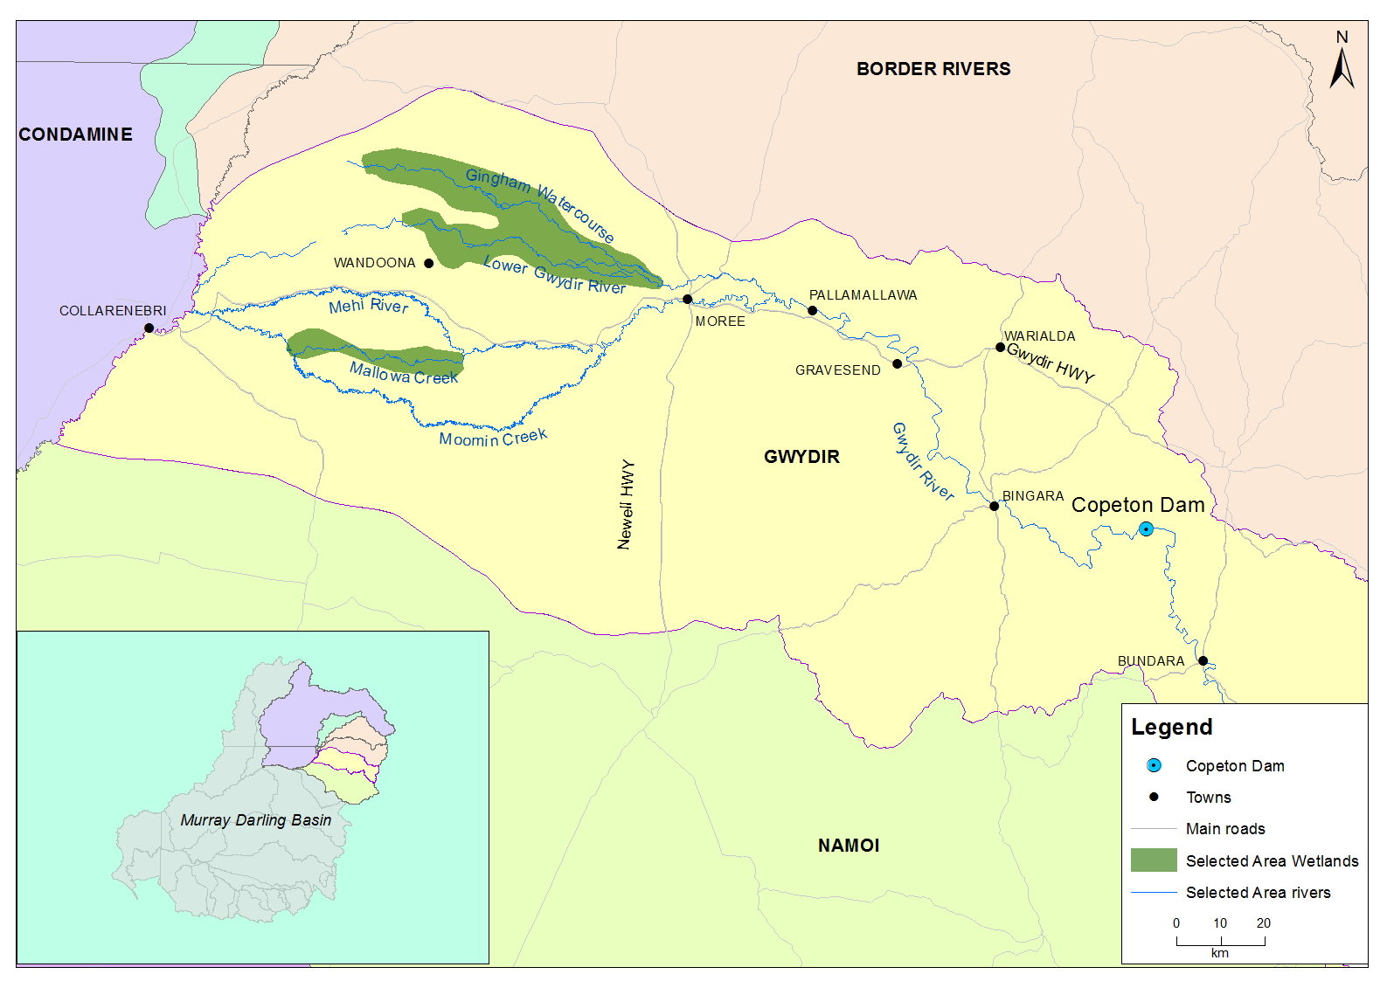

Figure ‑: Gwydir River catchment and location within the Murray Darling Basin.

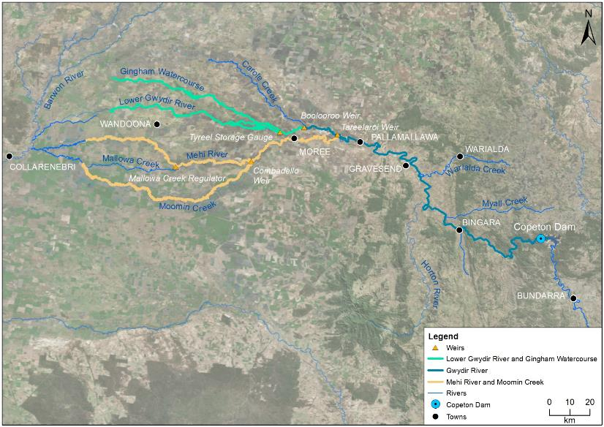

*Gingham waterhole*

Figure ‑: The Gwydir river system Selected Area with monitoring zones highlighted.

# Water actions

## Environmental condition and watering actions in the Gwydir river system Selected Area 2016-17

The Gwydir catchment experienced below average rainfall and above average temperatures during the 2016-17 water year (Figure 3‑1, Figure 3‑2). The 2016-17 year saw above average rainfall in August, September, October, March and May with below average temperatures recorded in August, September October and April. November through to March saw an extended period of well above average temperatures.

Available Commonwealth environmental water holdings totalled 39,451 ML in the 2016-17 water year. This was complemented by water entitlements held by NSW OEH in the Environmental Contingency Allowance (ECA) of 21,000 ML. Of this, a total of 22,847 ML of Commonwealth water and 21,800 ML of NSW ECA (including supplementary) water were delivered in the 2016-17 water year via several events across several channels (Table 3‑1). This environmental water constituted 29% of the total flow through the channels in which it was delivered.

Table ‑: Comparison between environmental water use and 2016-17 water year flows. Percentage represents the percentage of the total flow made up of environmental water.

|  |  |  |  |  |
| --- | --- | --- | --- | --- |
| Channel | Commonwealth Environmental Water (CEW) delivered (ML) | NSW ECA/General Security/Supplementary Water delivered (ML) | 2016-17 total flow (ML) | Env. water % of total flow |
| Gingham Watercourse | 4,259 | 13,741 (including 3,000 General Security) | 107,064 | 16 |
| lower Gwydir | 4,741 | 7,259 | 94,459 | 17 |
| Carole Creek | 1,351 (Supplementary) | - | 118,294 | 1 |
| Mehi River | 5,000 (Supplementary) | - | 205,349 | 2 |
| Mallowa Creek | 7,496 | 800 (Supplementary) | 8,671 | 86 |
| Total | 22,847 (including 6,351 supplementary) | 21,800 (including 800 supplementary) | 155,446 | 29 |

During 2016-17 environmental water was delivered to several assets within the Selected Area. In September 2016, a flow event occurred down the Mehi River and supplementary water licences owned by the CEWO were triggered. A total of 5,000 ML was accounted for in the Mehi River.

Supplementary flows were triggered in the Mallowa in September 2016, however very little of the moderate flows were diverted into the Mallowa wetlands. In January - March 2017, planned deliveries of 5,000 ML were increased to 10,000 ML to the Mallowa Creek system to inundate fringing wetlands. Flows were also delivered into the lower Gwydir River and Gingham Watercourse during to build upon moderate winter/spring flows. In December 2016 - February 2017, 30,000 ML was delivered, aiming to inundate broad areas of semi-permanent wetland vegetation.

During 2016-17, no environmental water was delivered to Moomin Creek.

Given the shared outcomes and delivery of both Commonwealth and State held environmental water during the 2015-16 water year, the outcomes reported in this document refer to the combined benefit of Commonwealth and State-owned water. Hereafter this will be termed ‘environmental water’.

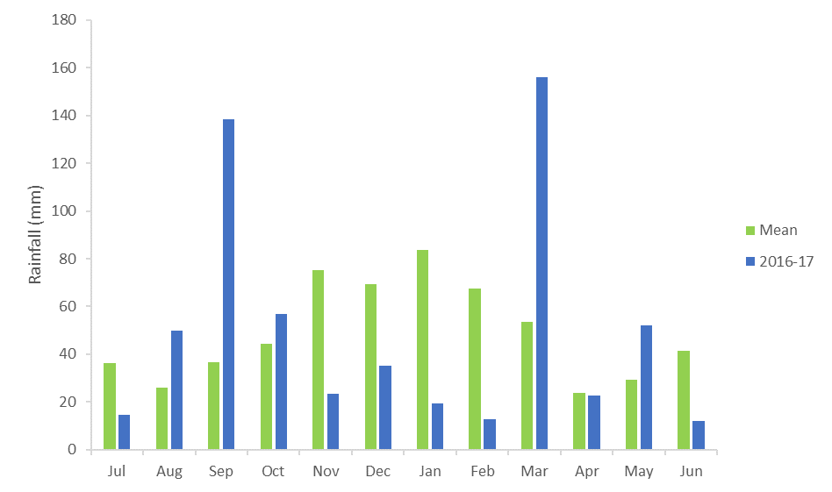

Figure ‑: Monthly rainfall totals for 2016-17 and mean totals measured at Moree airport

(Source. <http://www.bom.gov.au/climate/data/index.shtml>).

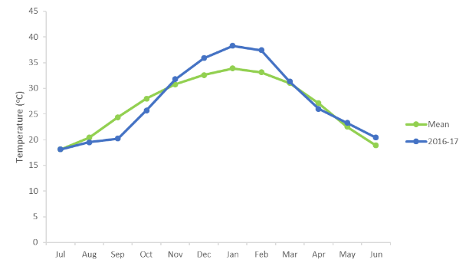

Figure ‑: Monthly maximum temperatures for 2016-17 and mean maximum temperatures measured at Moree airport. (Source. <http://www.bom.gov.au/climate/data/index.shtml>).

# What did Commonwealth environmental water do in 2016-17

## Expected Outcomes

The overall aim of Commonwealth environmental water in the Gwydir catchment during 2016-17 was to consolidate and protect the ongoing environmental recovery achieved to date in anticipation of a potentially low rainfall and inflow period. This was to be achieved by following natural flow cues, and activating access to supplementary water to offset a component of the consumptive extraction up to an approved volume withheld environmental water from Copeton Dam (Commonwealth of Australia 2015).

Watering actions undertaken in the Selected Area were expected to contribute to achieving the following outcomes (Commonwealth of Australia 2016).

Overall, contribute to:

* flow variability and hydrological connectivity
* in-stream habitat condition and diversity
* water quality and primary productivity
* native aquatic species condition and reproduction
* under sustained low inflows provide connectivity and ensure the persistence of refuge pools.

Biodiversity:

* Improve the condition and maintain extent of wetland vegetation communities
* Contribute to riparian vegetation diversity, extent and condition
* Maintain habitat including refuge sites and food sources to support waterbird populations
* Support waterbird breeding events to successful completion
* Improve survival of native fish by enhancing and protecting refuge habitat
* Contribute to flows that increase fish habitat availability and support fish condition, breeding and dispersal
* Support recruitment and maintain macroinvertebrate diversity and habitat.

Processes, contribute to:

* mobilisation and dispersal of biotic and abiotic material
* primary production, decomposition and nutrients and carbon cycling.

A summary of each watering action, its target asset, and outcomes are provided in Table 4‑1. A more complete explanation of the outcomes are provided in the following sections structured around the objectives of the Basin Plan’s environmental watering plan (Table 4‑2).

Table ‑: Watering actions, target assets and evaluated outcomes implemented in the Gwydir river system Selected Area during 2016-17.

| Watering action | Volume (ML) | Target asset | Expected outcomes | Were these outcomes achieved in 2016-17? |
| --- | --- | --- | --- | --- |
| Delivery of environmental water into the Gingham and Lower Gwydir wetlands (WUM10057-01) | 9,000 CEW, 21,000 NSW ECA | Gingham and Lower Gwydir Wetlands | * Maintain inundation of broad areas of semi-permanent wetland vegetation following significant natural flooding * Maintain inundation of wetland areas to support bird and frog breeding following significant natural flooding | **Yes**, the condition of core wetland vegetation species was maintained, and inundation was prolonged for several months to support waterbird and frog breeding. |
| Delivery of environmental water into the Mallowa Creek and wetlands (WUM10057-02) | 7,496 CEW | Mallowa Creek and wetlands | * To support hydrological connectivity between wetlands * To support further recovery of wetland vegetation extent and condition * Provide habitat for a range of waterbirds and native aquatic species | **Yes**, 901 ha of the Mallowa wetlands were inundated as a result of this delivery. Inundation maintained high vegetation species richness and cover that was stimulated by winter/spring rainfall and local runoff. |
| Replacement of Supplementary take from natural event with environmental water from storage (WUM 10057-03) | 1,351 CEW | Carole – Gil Gil Creek | * Contribute to longitudinal connectivity * Support in-stream ecological function and nutrient cycling * Maintain in-stream habitat and water quality | **Not monitored**, environmental water would have contributed to longitudinal connectivity however, the system falls outside the bounds of the LTIM projects survey area. |
| Replacement of Supplementary take from natural event with environmental water from storage (WUM 10057-04) | 5,000 CEW | Mehi River | * Support in-stream ecological function and nutrient cycling * Maintain in-stream habitat and water quality | **Yes**, longitudinal connection increased the diversity of habitat and basal resources intern supporting a more diverse assemblange of invertebrates. |

Table ‑: Expected outcomes from environmental water use in the Gwydir river system Selected Area linked to broader Basin Plan objectives.

|  |  |  |
| --- | --- | --- |
| Expected outcome | Timeframe | Relevant Basin Plan objective |
| Vegetation condition and reproduction | < 1 year | Biodiversity (Basin Plan S. 8.05) |
| Fish condition |
| Waterbird survival and condition |
| Individual survival and condition (individual refuges) | < 1 year | Resilience (Basin Plan S. 8.07) |
| Hydrological connectivity including end of system flows | < 1 year | Ecosystem function (Basin Plan S. 8.06) |
| Biotic dispersal and movement |
| Primary productivity |
| Nutrient and carbon cycling |
| Salinity, dissolved oxygen, pH, dissolved organic carbon, algal blooms | < 1 year | Water quality (Basin Plan S. 9.04) |

## Flows and ecosystem functions

Environmental water contributed to connectivity in the Gwydir, lower Gwydir and Mehi River channels and Mallowa Creek during 2016-17 (Appendix A). Full connectivity in the Gingham watercourse and Moomin Creek was due to rainfall events and other water releases associated with irrigation and stock and domestic use. Connectivity in 2016-17 was greater than in 2015-16. Both water years were planned dry years in the ECA Operations Advisory Committee’s long-term watering plan. However, environmental watering priorities were changed in response to flooding in spring 2016 to maintain bird and frog breeding habitat in the wetlands. Long periods of connectivity in the first half of the water year were attributed to rainfall, while environmental water releases contributed to extended connectivity in summer and autumn 2017. Short periods of connectivity in all channels resulted from localised rainfall.

The extent of inundation throughout the Gwydir, Gingham and Mallowa wetlands was mapped using Landsat data (Appendix B). Significant areas of the Gingham (2,844 ha) and Lower Gwydir wetlands (390 ha) were inundated because of above average rainfall and high catchment inflows in August/September 2016. This is the most widespread inundation in both systems since early 2015. Inundation retracted until February 2017 when the delivery of environmental water into both systems prolonged inundation in core wetland areas. As with the 2015-16 water year, environmental water played a key role in inundating the Mallowa wetlands in 2016-17 that resulted in the inundation of 901 ha of important semi-permanent wetland and floodplain species such as coolibah (*Eucalyptus coolabah*) and river cooba (*Acacia stenophylla*).

Twenty-one of the 22 vegetation communities inundated in the Gingham and Lower Gwydir wetlands in 2015-16 were also inundated during 2016-17. Core wetland communities such as water couch – spike rush – tussock rush marsh grassland/sedgeland and river coobah – lignum swamp shrubland were the most extensively inundated communities. Floodplain species such as coolibah and river red gum (*Eucalyptus camaldulensis*) were also reasonably well-represented in inundated communities. These findings confirm the intended watering objective of maintaining the permanent and semi-permanent wetland vegetation species in key areas of the lower Gwydir during the season.

Environmental water appeared to dilute nutrients in the lower Gwydir system in 2016-17 compared to periods that were influenced by significant natural inflows (Appendix D). Concentrations of nitrogen and phosphorus were highest one month after maximum inundation extents occurred in wetland sites. However, little response to these increased nutrient loads was observed in water column primary production, presumably due to the cooler temperatures limiting primary producer metabolic rates. Once temperatures rose in summer, chlorophyll a concentration peaked. In late summer, environmental water actions connected the Gwydir River to the lower Gwydir and maintained water levels in the Gingham watercourse. During this period, dissolved oxygen and chlorophyll *a* concentrations decreased in the Gingham watercourse but increased in the Lower Gwydir wetlands, showing independent wetland responses to the same flow event.

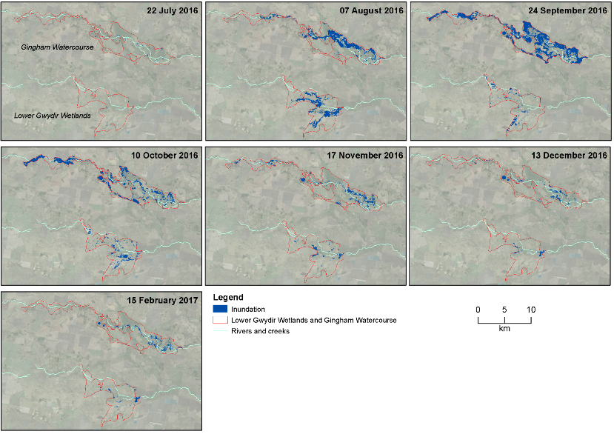

Figure ‑: Wetland inundation within the Gingham and Gwydir wetlands during the 2016-17 water year.

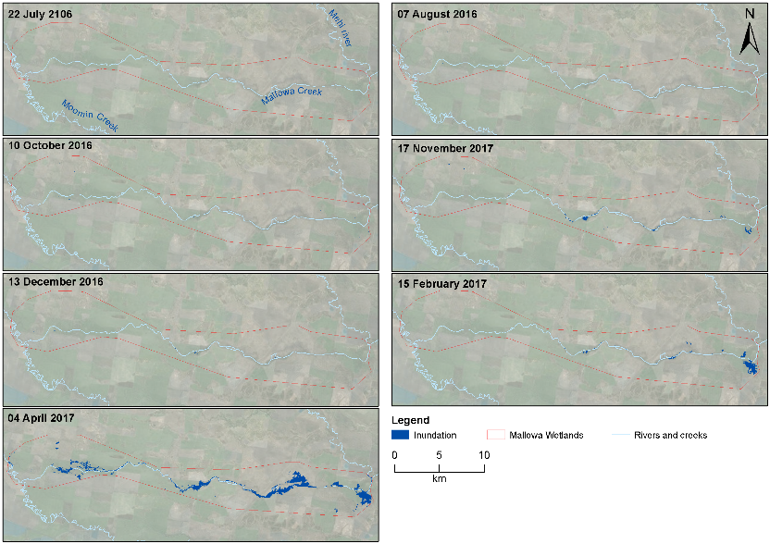

Figure ‑: Wetland inundation within the Mallowa wetlands during the 2016-17 water year.

## Water Quality

Water quality variables were measured at Pallamallawa in the Gwydir River zone (Appendix C). Like previous years, higher magnitude events and contributions of environmental water reduced pH and conductivity through dilution. In contrast to 2015-16, the delivery of environmental water in 2016-17 did not lead to significant differences in dissolved oxygen and chlorophyll *a* concentrations. This suggests that inter-annual hydrological variability and antecedent flow condition play important roles in water quality variability, highlighting the importance of long-term monitoring in highly dynamic systems.

## Biodiversity

Environmental water influenced eight of the ten ecosystem types monitored in the LTIM project in the 2015-16 water year, including five riverine types, two floodplain types and one lacustrine types as defined by the (Interim) Australian National Aquatic Ecosystem (ANAE) Classification Framework (Brooks et al. 2013, Figure 4‑3, Appendix F).

Generally, the amount of environmental water delivered in the Gwydir system in 2016-17 was much smaller than the natural flows that inundated the system in winter/spring 2016. During 2016-17, environmental water was used primarily to replace water extracted during supplementary flow events, and to extend natural inundation in the Gingham and Lower Gwydir wetlands. Environmental water was also delivered to the Mallowa system to increase connectivity, sustain vegetation and provide habitat for aquatic biota.

In 2016-17, the diversity of fish communities in the lower Gwydir system remained close to that of pre-European conditions (Appendix H). However, as in previous years, abundances continued to be very low at sites sampled in 2016-17. The increased flows during this water year resulted in partial recovery of native species in the lower Gwydir following the extended dry period experienced throughout 2015-16. Whilst numbers were similar for most species compared to 2015-16 and considerably higher than 2014-15, in general, most species were more widespread throughout the four systems. This is likely a reflection of the higher flows in 2016-17 allowing fish to disperse throughout the system. The movement of tagged fish including Freshwater Catfish (*Tandanus tandanus*) and Murray cod (*Maccullochella peelii*) was tracked as part of the fish movement indicator (Appendix I). Tagged fish of both species moved broadly throughout the monitoring array in the Gwydir and Mehi Rivers stimulated by increases in river discharge. At smaller scales, other factors such as temperate and time of day, played a part in determining how far tagged fish were moving.

Three threatened fish species were observed during the surveys this water year; Murray cod, freshwater catfish (Figure 4‑4) and olive perchlet (*Ambassis agassizi*). Olive perchlet were again caught in the Gingham waterhole, and represent the only known population of this threatened species in the lower Gwydir system. This is reflective of the Gingham channels generally ‘good’ rating for Nativeness (Appendix H). Targeted flows to help this species to breed and disperse should be considered in future watering activities. Juvenile freshwater catfish were also recorded for the first time in the LTIM project from the Gwydir River zone and juvenile Murray Cod were again caught in 2016-17 in similar numbers to previous years. Flows to mimic that of the spring-summer natural event may also result in further freshwater catfish breeding, which overtime may start to see the species more widely dispersed throughout the system, as was the case in the past. While native fish species bred and recruited during the year, it appears that large numbers of carp and goldfish also bred in the lower reaches of the Gingham watercourse and Moomin Creek. The management of future controlled environmental flow releases need to carefully consider their timing and extent to try and minimize breeding opportunities for these exotic species.

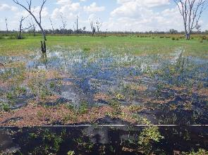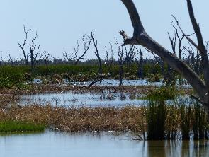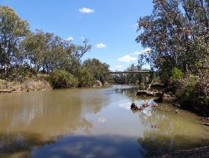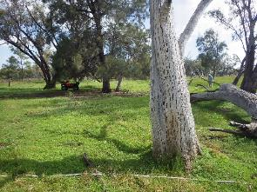

Figure ‑: Sedge/forb/grassland floodplain (top left), Temporary lowland stream (top right), Permanent lowland stream (bottom left) Coolibah woodland and forest floodplain (bottom right) ecosystem types monitoried in the Selected Area.

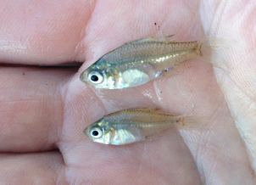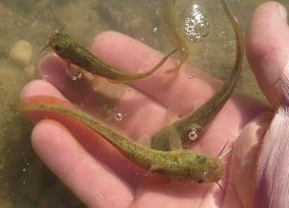

Figure ‑: Freshwater catfish (*Tandanus tandanus*) recruits caught in the lower Gwydir River during fish diversity sampling in 2017 (left) and olive perchlet (*Ambassis agassizi*) sampled at Gingham Waterhole (right).

Environmental water delivered to the Gingham watercourse and Gwydir River influenced the diversity and community composition of invertebrate communities (Appendix D and Appendix E). In the Lower Gwydir wetland, the cycle of wetting and drying experienced throughout the year, assisted by the delivery of environmental water, triggered secondary productivity, with high microinvertebrate densities recorded following the second wetting event in December 2016 – February 2017. This increased productivity is likely to have provided food resources for native fish, waterbirds and frogs. In contrast, in the river channels, longitudinal connectivity acted as a disturbance for microinvertebrates with lower densities observed following the natural inflow and environmental watering actions. Spatial differences were noted in macroinvertebrate communities between systems, with the Lower Gwydir wetland having higher density, taxonomic richness and diversity than all other zones across all sampling occasions. Higher longitudinal connection down the river channels, along with lateral connection within the wetlands, in part provided by the delivery of environmental water, increased the diversity of habitats and basal resources, thus supporting a more diverse assemblage of invertebrate taxa that in turn support aquatic food webs.

Patterns in vegetation response in the Gingham and Lower Gwydir wetlands was driven primarily by the significant inundation resulting from the large winter/spring flooding event. In the Gingham, there was an increase in the number of wetland (amphibious) species and vegetation cover including water couch, which contributed to an increase in wetland species dominance in this system. The response in the Gwydir wetlands was less pronounced, with a reduced area of this wetland system being flooded. Environmental water prolonged inundation in core wetland areas maintaining high cover of some native wetland species such as water couch throughout the season (Figure 4‑5). Environmental water delivered to the Mallowa system in January-March 2017 inundated over half of the vegetation study sites. These sites continued to show high species richness when compared to the other systems studied, and mean vegetation cover also remained high when compared to the previous watering year (Figure 4‑5).

In total 72 waterbird species were recorded in the 2016-17 monitoring period, which represents the highest richness in the first three years of the project (Appendix J). This included eight species listed under one or more international migratory bird agreements (JAMBA, CAMBA and ROKAMBA) and seven species listed under the NSW TSC Act: brolga (*Grus rubicunda)*, magpie goose (*Anseranas semipalmata*), black falcon (*Falco subniger*), spotted harrier (C*ircus assimilis*) comb-crested jacana (*Irediparra gallinacea*) white-bellied sea-eagle (*Haliaeetus* leucogaster) and black-necked stork (*Ephippiorhynchus asiaticus*). Migratory shorebirds recorded included Latham’s snipe (*Gallinago hardwickii*), red-necked stint (*Calidris ruficollis*), common sandpiper (*Actitis hypoleucos*) marsh sandpiper (*Tringa stagnatilis*) and sharp-tailed sandpiper (*Calidris acuminata*). All ten waterbird functional guilds were represented across the sites surveyed in both November 2016 and March 2017 (Figure 4‑6), although Migratory Charadriiform shorebirds and Rails and Shoreline Gallinule numbers were very low. Patterns in functional guilds differed in both space and time, related to habitat preferences as water levels in the wetlands changed throughout the season. Floodplain and waterholes sites continued to host a more diverse range of functional guilds compared to Creek sites. This highlights the more diverse array of habitats present in the wetlands as opposed to river channel sites.

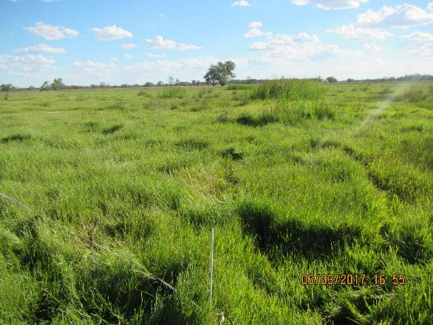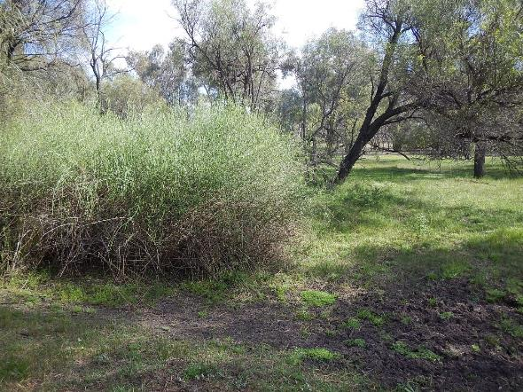

Figure ‑: Water couch meadow at Bunnor in the Gingham Wetlands in March 2017 following inundation by environmental water (top) Floodplain vegetation in the Mallowa Wetlands in October 2016 (bottom).

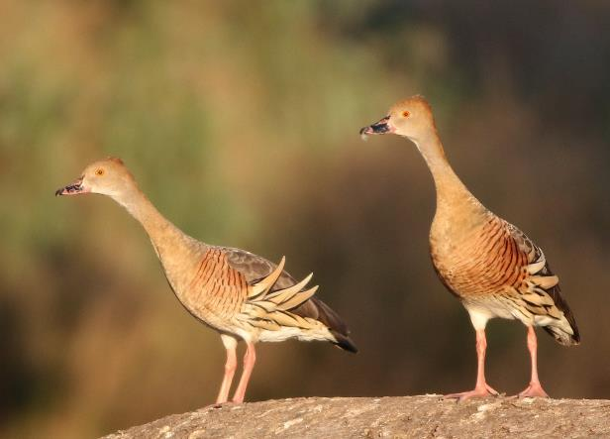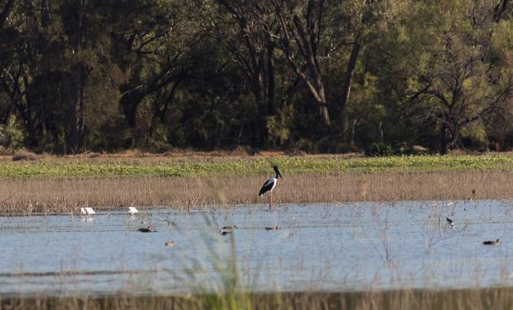

Figure 4‑6: Plumbed whistling ducks (*Dendrocygna eytoni*) in the Gingham wetlands (top), black-necked stork (*Ephippiorhynchus asiaticus*) feeding on a floodplain waterhole (bottom)

## Resilience

While no direct monitoring of the survival or condition of individual organisms was undertaken in this project, some broader inferences can be made as to the contribution of environmental water and its management on the resilience of the Selected Area in 2016-17. The large winter/spring flooding event in the Gingham and Lower Gwydir wetlands had a significant influence on the ecological response during the year, but inundation extents receded relatively quickly due to lower than average rainfall and high temperatures in late spring/summer. The delivery of environmental water over the summer period was successful in maintaining inundation in core wetland areas, and continued the benefits of the previous flooding to vegetation communities in these locations, maintaining their health and condition. It would have also likely maintained conditions suitable for waterbirds and frogs to complete their breeding cycles stimulated by the previous larger flood even, though these were not directly measured in this project.

Environmental water was released down several of the channels in the lower Gwydir system in April 2016 to provide critical connection between isolated refuge pools to maintain habitat and water quality due to the dry conditions. Fish sampling in 2016-17 suggests that the fish community was in a similar state to surveys in the previous year, with evidence of some additional breeding in some native species. This suggests that the connecting flows in April 2016 were successful in maintaining the fish community that was then able to disperse and recover in the wetter condition in this water year. Being able to recover successfully from disturbances such as drought is a characteristic of resilient communities.

## Summary

Environmental water constituted a relatively small proportion of the total flow down many of the river channels of the lower Gwydir system during 2016-17 due to significant unregulated flows that occurred in winter/spring 2016. An exception to this was in Mallowa Creek, where environmental water made up 86% of the total flow. Environmental water was used to offset the component of consumptive extraction taken during several supplementary flow events, and to maintain and enhance inundation in the Gingham, Lower Gwydir and Mallowa wetlands.

During periods of environmental water delivery, water quality variables such as pH and conductivity were lowered through dilution. Increased longitudinal and lateral connection which provided a diversity of habitats and basal resources, in turn promoted the diversity and biomass of invertebrate communities. Fish communities also showed some recovery from the dry conditions experienced in early 2016, with many native species breeding, including freshwater catfish which bred and recruited for the first time in the project. Increases in discharge were also linked to increased movement of tagged freshwater catfish and Murray cod, with individuals moving up to 241 km over the season, within and between the Gwydir and Mehi rivers.

Inundation within the Gingham and Lower Gwydir wetlands was driven by significant unregulated inflows in August/September 2016. This inundated up to 2,844 ha in the Gingham, and 390 ha in the Lower Gwydir wetlands. Follow up environmental water deliveries maintained water levels in core wetland areas and continued to keep vegetation communities in good condition. The cycle of wetting and drying experienced in the Gwydir wetlands resulted in the highest microinvertebrate densities recorded during the LTIM program following environmental water deliveries over summer. Environmental water delivered to the Mallowa system inundated over four times the area of wetland vegetation communities than during the previous water year. This inundation maintained high species richness at sites sampled within this wetland system.

# Implications for Future Management of Commonwealth environmental water

The delivery of environmental water during the 2016-17 water year was effective in maintaining the ecological benefits delivered through the significant unregulated flow event in winter/spring 2016, especially in the wetlands, where vegetation communities and condition conducive to bird and frog breeding were maintained. Deliveries of environmental water were also linked to improvements in water quality in the river channels and appeared to stimulate movement in fish species. These findings suggest that the current practice of using environmental water based on natural flow cues is working in the lower Gwydir river system, and more broadly that the long-term environmental watering strategy being employed in the Gwydir river system continues to be effective.

Several specific findings from the monitoring undertaken in 2016-17 may prove useful to the future planning of environmental water in the Gwydir system. The repeated capture of Olive perchlet in the Gingham waterhole over the past two years suggests that a viable population exists. This population should present a target for future environmental water delivery to try and maintain suitable conditions in the waterhole and promote their dispersal to other nearby waterholes if possible. However, given the location of this waterhole at the end of the Gingham system, it is recognised that the delivery of environmental water to this site should be timed with natural flow cues where possible. In addition, the different response of invertebrate communities and primary production between the Gingham and Lower Gwydir wetlands, highlights the importance of inundating these systems. Repeated wet-dry cycles in the Gwydir wetlands stimulated microinvertebrate productivity to densities 15 times higher than the permanently inundated Gingham sites. This suggests multiple dry phases within the water year can stimulate microinvertebrates as an important food source for larval fish. This highlights role of inundation from natural and environmental water in driving microinvertebrate diversity and food webs in these systems.

The association between increased river discharge and activity of freshwater catfish and Murray cod during the 2016-17 monitoring period provides an opportunity for a different approach to water management in the lower Gwydir Basin. The most consistent increases in activity occurred between August and October, the known breeding period for Murray cod, and September to November for freshwater catfish. These movements and relocations were most likely individuals seeking mates or those searching for suitable breeding sites or areas. Whilst most water passing through the system during this period was from natural inflows following considerable rainfall across the catchment, in future years there is an opportunity to stimulate and facilitate similar movements by releasing environmental water. Following the general profile of the 2016-17 hydrograph, this could be of a short sharp stimulus flow pulse (below bankfull) in mid-August with a gradual decline in discharge to a point where the main channel remains connected and there is sufficient depth to inundate the primary benches. Keeping water on the benches will not only promote food webs to support recruitment but will also allow greater access to breeding habitat for both freshwater catfish (sandy/cobble areas) and Murray cod (undercut banks and woody debris).

# References

Brooks S., Cottingham P., Butcher R., & Hale J. 2013. *Murray Darling Basin aquatic ecosystem classification: Stage 2 report*. Peter Cottingham & Associates report to the Commonwealth Environmental Water Office and Murray Darling Basin Authority, Canberra.

Commonwealth of Australia. 2014. *Commonwealth Environmental Water Office Long Term Intervention Monitoring Project Gwydir River System Selected Area*, Canberra.

Commonwealth of Australia. 2015. *Commonwealth Environmental Water Office Long Term Intervention Monitoring Project Gwydir River System Selected Area – 2014-15 evaluation report*, Canberra.

Commonwealth of Australia 2016. Commonwealth Environmental Water Portfolio Management Plan: Gwydir Valley 2016-17. Canberra.

Department of Environment, Climate Change and Water (DECCW). 2011. *Gwydir Wetlands Adaptive Environmental Management Plan: Synthesis of information projects and actions*. DECCW, Sydney.

Green D., Burrell M., Petrovic J., & Moss P. 2011. *Water resources and management overview – Gwydir catchment*. NSW Office of Water, Sydney.