Hydrology (River)

Introduction
The Hydrology (River) indicator provides in-channel hydrological information on the character of Commonwealth environmental water and other environmental water deliveries. This information is directly relevant to several other indicators measured in the Gwydir River system Selected Area (Selected Area) including Water Quality, Vegetation, Waterbirds, Fish, Microinvertebrates and Macroinvertebrates. The influence of hydrology on these indicators will be addressed under their respective sections. The Hydrology (River) indicator will also provide information on the degree of hydrological connection maintained through the Gwydir Selected Area during the 2017-18 water year. Two specific questions were addressed in relation to this indicator:
- What did Commonwealth environmental water contribute to hydrological connectivity?
- What did Commonwealth environmental water contribute to hydrological connectivity of the Gwydir Selected Area channels?

Environmental watering in 2017-18
During 2017-18, environmental water was delivered to both in-channel and wetland assets in the Gwydir River system (Table A-1). An early season stimulus flow was triggered by inflows to Copeton Dam in August/September 2017. A total of 10,000 ML was delivered into the main Gwydir River, Mehi and Carole Creek systems as a small fresh during late winter/early spring. Following this, a stable flow release of 10,040 ML was delivered into the main Gwydir River, Mehi and Carole Creek systems in late October to mid-November 2017. These small pulse flows were aimed at providing downstream connectivity and allowing opportunity for movement, breeding and recruitment of fish, particularly freshwater catfish (Tandanus tandanus).
A delivery of 8,000 ML including both State and Commonwealth environmental water was made to the lower Gwydir and Gingham wetlands from mid-December 2017 to late January 2018, to replace supplementary take from a small flow event that occurred in the previous months. This aimed to maintain wetland habitat quality and support the survival and resilience of flora and fauna in the wetlands. The last environmental delivery was made in late April/May 2018 as part of the Northern Connectivity Event. This flow aimed to provide longitudinal connectivity and refresh/replenish drought refuge for instream life, particularly native fish in the Barwon-Darling as well as improving conditions to maintain native fish populations within the tributary catchments. During this event, a total of 18,908 ML of both State and Commonwealth water was delivered down the Mehi River, Moomin Creek and Carole Creek. No environmental water deliveries were made to Mallowa Creek in 2017-18.

Table A-1: Environmental water delivered in the Gwydir River system Selected Area in 2017-18. Percentage represents the percentage of the total flow made up of environmental water.
Channel | Commonwealth Environmental Water (CEW) delivered (ML) | NSW ECA/General Security/Supplementary environmental Water delivered (ML) | 2017-18 total flow (ML) | Environmental Water % of total flow
Gwydir River* | 28,290 | 18,748 (including 15,748 General Security) | 412,705 | 11
Gingham watercourse | 2,000 | 5,534 (including 4,520 General Security) | 22,984 | 33
Lower Gwydir | 2,000 | 5,706 (including 4,520 General Security) | 19,831 | 39
Carole Creek | 3,886 | 2,462 (including 1,662 General Security) | 95,341 | 7
Mehi River< | 20,404 | 5,046 general security | 91,067 | 28
Moomin Creek# | 324 | 175 | 104,075 | 0.5
Mallowa Creek | 0 | 0 | 121 | 0
Total | 28,290 | 18,748 (including 15,748 General Security) | 412,705 | 11
* All environmental water delivery to the Gwydir system flowed through the Gwydir River in 2017-18. Therefore, volumes for this channel represent total volumes delivered downstream and as such are not included in the total.
< Includes 499 ML that flowed down Moomin Creek but returned to the Mehi downstream. Also includes 90 ML NSW General Security water for delivery to Whittaker’s Lagoon.
# Not included in total as accounted in return flows to Mehi.

Previous monitoring outcomes
In 2016-17, the Gwydir River channel was connected for 29% of the time, the lower Gwydir River 73%, Gingham watercourse 40%, Mehi River 28%, Moomin Creek 29% and Mallowa Creek 32% of the time. Environmental water contributed to connectivity in the Gwydir, lower Gwydir, and Mehi River channels and was responsible for all significant flow in Mallowa Creek during 2016-17. Connectivity in the Gingham Watercourse and Moomin Creek was due almost entirely to local rainfall events and other water releases associated with stock and domestic use. Connectivity in 2016-17 was greater than in 2015-16. Both water years were planned dry years, however, environmental watering priorities were changed in response to flooding in spring 2016 to maintain bird and frog breeding habitat in the wetlands. Long periods of connectivity in the first half of the water year were attributed to rainfall, while environmental water releases contributed to long periods of connectivity in summer and autumn 2017. Short periods of connectivity in all channels resulted from localised rainfall.

Methods

Hydrological connectivity
An assessment of the hydrological connectivity experienced throughout the monitoring zones of the Selected Area was undertaken following the methods outlined in Commonwealth of Australia (2014). Here, flow thresholds measured at upstream gauging stations were identified that would ensure flow through the length of channel in each zone. These thresholds were estimated through an analysis of historical flow records (from 1990-2014) whereby corresponding peaks of small flow events were observed at both upstream and downstream gauging sites, suggesting connection throughout the length of the channel (Figure A-1). These thresholds were then compared with known average stream losses provided by Water NSW. Due to the off-river abstraction of flows in some channels, flows passing the downstream gauges were also quantified to confirm connectivity through the system. Here an arbitrary 5 ML/d level was used to indicate through flow connection. The gauging stations used for this analysis are presented in Figure A-1 and Table A-2 outlines the thresholds estimated to provide longitudinal connectivity.
Once the thresholds were identified, a spells analysis (Gordon et al. 1992) was undertaken to assess the total duration and frequency of flows passing the gauge. Results for downstream gauges were then subtracted from those at upstream gauges to provide an estimate of full longitudinal connectivity along channels throughout the 2017-18 season.
No downstream gauge exists in the Mallowa system, making an assessment of hydrological connectivity impossible. To determine duration of wet and dry spells an arbitrary minimum figure of 5 ML/d entering the system through the Regulator (Figure A-1) was used to indicate a connected period.
Table A-2: Thresholds at gauging stations used to determine hydrological connectivity.
Zone | Channel | Gauging station (upstream or downstream) | Gauging station number | Threshold for longitudinal connectivity
Gwydir River | Gwydir | Gwydir DS Copeton Dam (U/S) | 418026 | 100 ML/d
 |  | Gwydir River @ Pallamallawa (D/S) | 418001 | 5 ML/d
Gingham-Gwydir watercourse | Lower Gwydir | Gwydir (south arm) DS Tyreel regulator (U/S) | 418063 | 40 ML/d
 |  | Gwydir @ Millewa (D/S) | 418066 | 5 ML/d
 | Gingham | Gingham channel @ Teralba (U/S) | 418074 | 50 ML/d
 |  | Gingham channel @ Gingham bridge (D/S) | 418079 | stable or rising water levels*
Mehi-Moomin | Mehi | Mehi River @ D/S Tareelaroi Regulator (U/S) | 418044 | 300 ML/d
 |  | Mehi River @ near Collarenebri (D/S) | 418055 | 5 ML/d
 | Moomin | Moomin @ Combadello Cutting (U/S) | 418048 | 30 ML/d
 |  | Moomin @ Moomin plains (D/S) | 418070 | 5 ML/d
 | Mallowa | Mallowa @ Regulator (U/S) | 418049 | 5 ML/d
* Discharge data was not available for download from WaterNSW for Gingham @ Gingham Bridge (418074). The threshold for this gauge was based on water level data, whereby connectivity was assumed if flow levels were stable or rising.

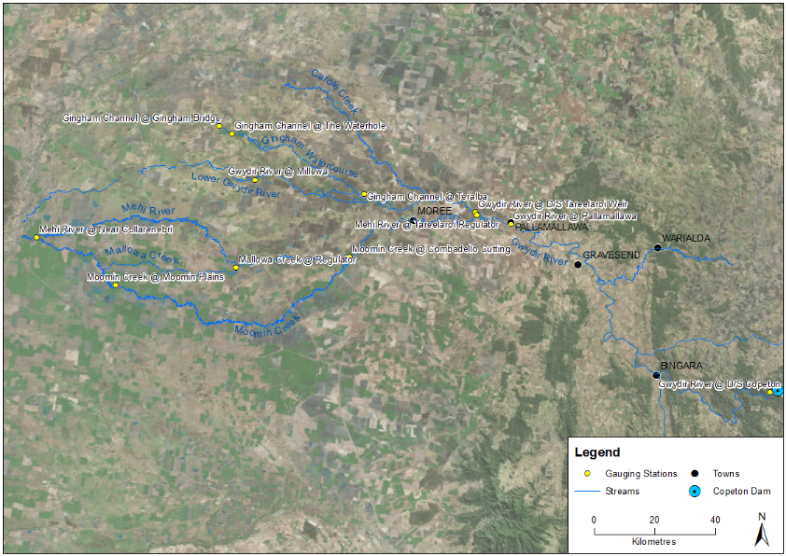
Figure A-1: Location of flow gauging stations used in the hydrological connectivity analysis.

Results

Longitudinal connectivity
In 2017-18, hydrological connectivity occurred in all monitored channels in the Gwydir River system Selected Area (Table A-3). The Gwydir River had 64% connection (i.e. 64% of days were above the relevant connection threshold at both gauges during 2017-18), the lower Gwydir River 51% connection, Gingham watercourse 21% connection, Mehi River 34% connection and Moomin Creek 25% connection. Mallowa Creek had water flowing into it (i.e. was ‘wet’) for only two days during 2017-18.
The Gwydir River experienced the longest average connection duration of 47 days, while Moomin Creek experienced the shortest average duration with 20 days.
Table A-3 Variables describing the duration and character of hydrological connectivity in the channels of the Gwydir River system Selected Area
Monitoring Zone | Channel | Days connected (%) | No. of times connected | Average duration of connection events (days) | Longest wet (days) | Longest dry (days)
Gwydir River | Gwydir River | 64 | 5 | 47 | 136 | 55
Lower Gwydir River and Gingham watercourse | Lower Gwydir River | 51 | 14 | 13 | 70 | 129
 | Gingham watercourse | 21 | 2 | 38 | 44 | 257
Mehi River and Moomin Creek | Mehi River | 34 | 10 | 12 | 42 | 81
 | Moomin Creek | 25 | 10 | 9 | 20 | 60
 | Mallowa Creek | <1 | 2 | n/a | 2 | 300

Connection in the Gwydir River channel was dominated by a nearly continuous 185 day connection event over the spring-summer period (Figure A-2). Three separate environmental flows were released during this period that maintained connectivity. A brief period of connectivity of eight days was experienced in mid-March, due to localised rainfall rather than environmental flows. Connectivity was recorded again in early-April and was sustained until early-May by environmental flows delivered to the Barwon River. Whilst flow between Copeton Dam and Pallamallawa was consistent for most of the 2017-18 water year, a flow peak recorded downstream at Pallamallawa in mid-October was due to unregulated inflows from Myall Creek and Warialda Creek entering the Gwydir River upstream of Gravesend. During this time flows immediately downstream of Copeton Dam had declined to 6.31 ML/d, below the connectivity threshold used in this analysis.
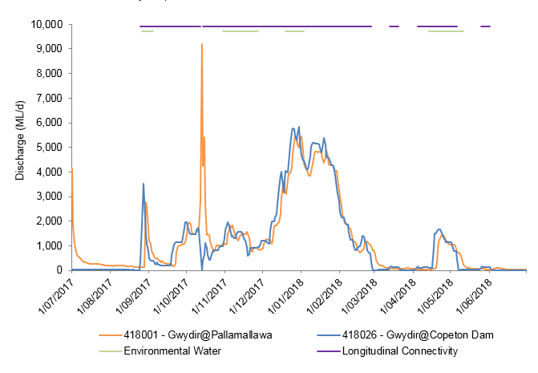
Figure A-2 River flows down the Gwydir River and the timing of environmental water releases and longitudinal connectivity down this channel
Connectivity in the Lower Gwydir River channel was characterised by multiple periods of connectivity ranging between one and 70 days (Figure A-3). The longest periods of connectivity occurred during spring and summer (September 2017 – January 2018) with three separate events of eight to 74 days duration, separated by three small disconnection periods of one and two days. This was preceded by a 25 day period of connection in June, and followed by another long period of connectivity during summer (December 2017 – January 2018) of 34 days. Environmental water contributed to connectivity in November 2017, and late December to mid-January 2018 delivered after an announced Supplementary Flow event under the “Restoring Natural Flows’ planning principle that seeks to return the portion of natural flows extracted from upstream irrigation.
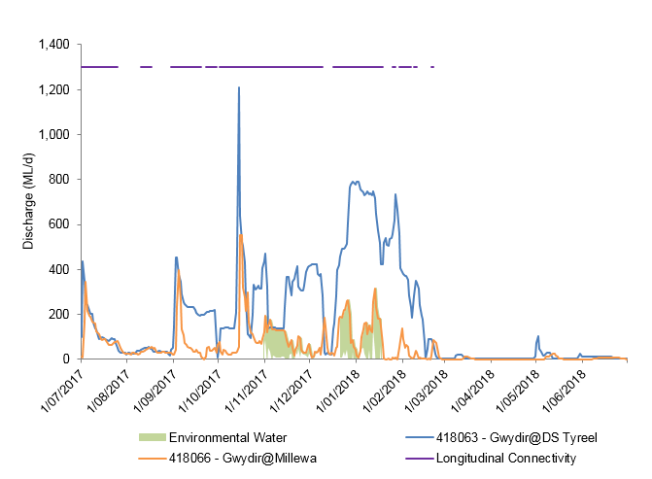
Figure A-3 River flows down the lower Gwydir River and the timing of environmental water releases and longitudinal connectivity down this channel.
Connectivity in the Gingham watercourse in the 2017-18 water year was characterised by two moderate periods of connection (Figure A-4). The first period of 44 days connection (July – August 2017) was rainfall driven. However, the second period of connection was for 31 days and was influenced by environmental water released in early September of which 1014 ML was delivered to the Gingham watercourse. Two environmental water releases occurred in November and December 2017 that were accounted for in the Gingham Watercourse, however these events did not connect the system all the way to Gingham Bridge.
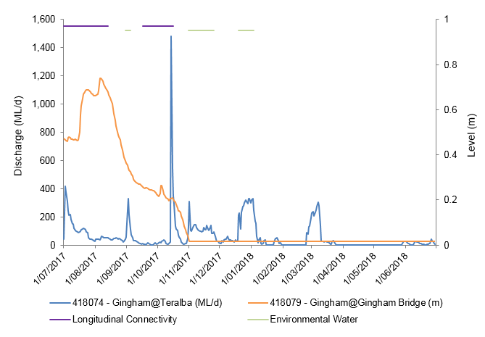
Figure A-4 River flows down the Gingham watercourse and the timing of environmental water releases and longitudinal connectivity down this channel.
Connectivity in the Mehi River occurred predominantly in spring and again in summer and autumn (Figure A-5). In late September to late December 2017, the Mehi River was connected for five periods ranging in length from one to 42 days. Following 29 days of disconnection, the Mehi River was again connected in January 2018 to late-February for three short periods of up to 22 days, separated by several days of disconnection. In late October 2017, 10,000 ML of environmental water was delivered into the Gwydir River, Mehi and Carole Creek systems to provide conditions conducive for fish spawning and recruitment. This flow event contributed to connectivity during late spring and early summer, however, connectivity in late summer was driven by stock and domestic releases from Copeton Dam. Environmental water released as part of the Northern Connectivity event in April – May 2018 resulted in longitudinal connection for nine days.
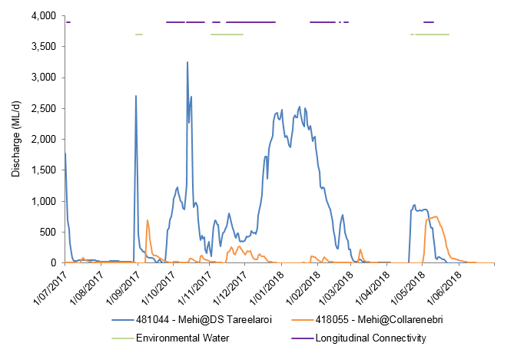
Figure A-5 River flows down the Mehi River and the timing of environmental water releases and longitudinal connectivity down this channel.
Connectivity in Moomin Creek was characterised by sporadic, short to moderate periods of connection between October 2017 and March 2018, and again in May 2018 (Figure A-6). A small amount of environmental water (380 ML) went down this channel during delivery of the northern connectivity event in late-April 2017. At other times, connectivity was driven by local rainfall, stock and domestic deliveries, and a natural flow event in the upper Gwydir catchment moving down the system in October 2017.
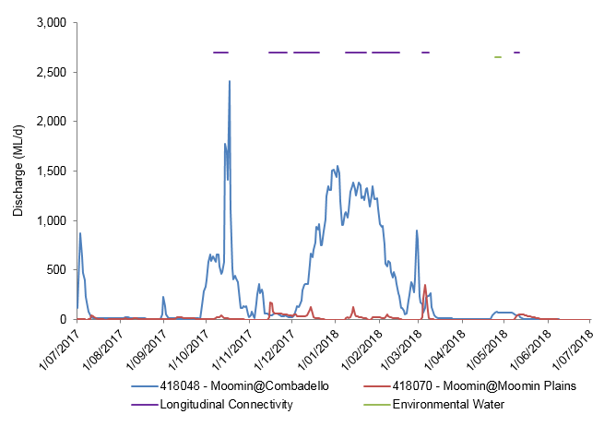
Figure A-6 River flows down Moomin Creek and the timing of environmental water releases and longitudinal connectivity down this channel.
Mallowa Creek was connected for two consecutive days in early-September 2017. This unusually short connection event which peaked at 10.78 ML/d on September 2017, was the result of limited diversion from the Mehi River. No environmental water was delivered to Mallowa Creek in the 2017-18 water year (Figure A-7).
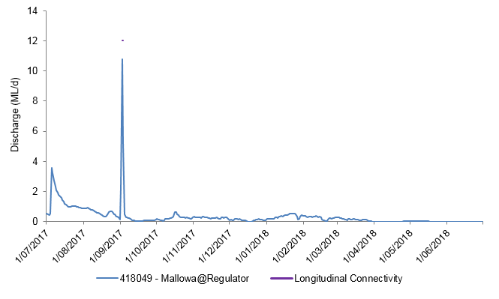
Figure A-7 River flows down Mallowa Creek and the timing of environmental water releases and 'wet' periods in this channel.

Discussion
The Environmental Contingency Allowance Operations Advisory Committee’s (ECA OAC) environmental watering strategy for the Selected Area employs a multi-year wetting and drying strategy in which 2017-18 was a planned dry year, with the application of environmental water aimed largely at maintaining in-channel flow rather than broad-scale wetland inundation. Due to low water availability and generally dry conditions, a reactive approach for environmental water delivery was taken, that used natural flow triggers to form the basis for water delivery. There were only two natural flows sufficient to trigger licensed ‘Supplementary Access’ for irrigation in 2017-18. This extracted water was replaced by environmental water in deliveries following these events. Environmental water was delivered to all channels other than Mallowa Creek in the 2017-18 water year.
Longitudinal connectivity was greatest along the Gwydir River channel during 2017-18, and was characterised by both long and short periods of connection. Unlike other channels in the Selected Area, connectivity along Moomin Creek was short and sporadic, and was predominantly influenced by rainfall and stock and domestic releases. Connectivity in Mallowa Creek occurred for two consecutive days and was the result of limited diversion from the Mehi River. Whilst environmental water was delivered in the Gingham Watercourse over three events, in the last two events it did not contribute to full longitudinal connectivity, with environmental water travelling through the wetlands to Gingham waterhole.

Conclusion
Environmental water contributed to connectivity in the Gwydir River, lower Gwydir River, Mehi River Moomin Creek and Gingham watercourse during 2017-18, during a year when inflows were low. Flows down Mallowa Creek were extremely low during 2017-18 with only 2 days of connection. This was substantially lower than in all previous years, and was due to low natural inflows and no delivery of environmental water. In other channels, connectivity in 2017-18 was less than in 2016-17, but similar to the first two years of the LTIM project (2014-15, 2015-16). The 2015-18 period was a planned dry period in the Gwydir system, however, in 2016-17 environmental watering priorities were changed in response to flooding in spring 2016 to maintain bird and frog breeding habitat in the wetlands. In contrast, connectivity in 2017-18 was sporadic in most zones, driven by environmental water flows and maintained by stock and domestic release and local rainfall. As in previous drier years, environmental water played an important role in providing connectivity through the channels of the Gwydir system, maintaining and improving water quality and access to habitat for aquatic animals.

References
Commonwealth of Australia. 2014. Commonwealth Environmental Water Office Long Term Intervention Monitoring Project Gwydir River system Selected Area. Commonwealth of Australia.
Commonwealth of Australia. 2015. Commonwealth Environmental Water Office Long Term Intervention Monitoring Project Gwydir River system Selected Area – 2014-15 Evaluation Report. Commonwealth of Australia.
Gordon, N.D., McMahon T.A. and Finlayson, B.L. 1992. Stream Hydrology - An introduction for Ecologists. Brisbane, Wiley.

Hydrology (Watercourse)

Introduction
The lower Gwydir wetlands have long been a target for environmental water due to their extensive wetland vegetation communities and waterholes that support many important species (DECCW 2011). Watering targets for the wetlands tend to specify the inundation of particular extents and vegetation communities. Therefore, knowledge of the extent and volume of water held in the wetlands throughout each watering season is essential base information from which to evaluate the success of environmental watering. The hydrology (watercourse) indicator aims to achieve this by combining information from a range of sources to build relationships between inflows, inundation extent and volumes of water in the lower Gwydir, Gingham and Mallowa wetlands. Specifically, this chapter addresses the following question:
- What did Commonwealth environmental water contribute to hydrological connectivity of the Gingham, Gwydir and Mallowa wetlands?

Environmental watering in 2017-18
During 2017-18, environmental water was delivered to both in-channel and wetland assets in the Gwydir River system (Error! Reference source not found.). An early season stimulus flow was triggered by inflows to Copeton Dam in August/September 2017. A total of 10,000 ML was delivered into the main Gwydir River, Mehi and Carole Creek systems as a small fresh during late winter/early spring. Following this, a stable flow release of 10,040 ML was delivered into the main Gwydir River, Mehi and Carole Creek systems in late October to mid-November 2017. These small pulse flows were aimed at providing downstream connectivity and allowing opportunity for movement, breeding and recruitment of fish, particularly freshwater catfish (Tandanus tandanus).
A delivery of 8,000 ML including both State and Commonwealth environmental water was made to the lower Gwydir and Gingham wetlands from mid-December 2017 to late January 2018, to replace supplementary take from a small flow event that occurred in the previous months. This aimed to maintain wetland habitat quality, and support the survival and resilience of flora and fauna in the wetlands. The last environmental delivery was made in late April/May 2018 as part of the Northern Connectivity Event. This flow aimed to provide longitudinal connectivity and refresh/replenish drought refuge for instream life, particularly native fish in the Barwon-Darling as well as improving conditions to maintain native fish populations within the tributary catchments. During this event, a total of 18,908 ML of both State and Commonwealth water was delivered down the Mehi River, Moomin Creek and Carole Creek. No environmental water deliveries were made to Mallowa Creek in 2017-18.

Table B-1 Environmental water delivered in the Gwydir River system Selected Area in 2017-18. Percentage represents the percentage of the total flow made up of environmental water.
Channel | Commonwealth Environmental Water (CEW) delivered (ML) | NSW ECA/General Security/Supplementary environmental Water delivered (ML) | 2017-18 total flow (ML) | Environmental Water % of total flow
Gwydir River* | 28,290 | 18,748 (including 15,748 General Security) | 412,705 | 11
Gingham watercourse | 2,000 | 5,534 (including 4,520 General Security) | 22,984 | 33
Lower Gwydir | 2,000 | 5,706 (including 4,520 General Security) | 19,831 | 39
Carole Creek | 3,886 | 2,462 (including 1,662 General Security) | 95,341 | 7
Mehi River< | 20,404 | 5,046 general security | 91,067 | 28
Moomin Creek# | 324 | 175 | 104,075 | 0.5
Mallowa Creek | 0 | 0 | 121 | 0
Total | 28,290 | 18,748 (including 15,748 General Security) | 412,705 | 11
* All environmental water delivery to the Gwydir system flowed through the Gwydir River in 2017-18. Therefore, volumes for this channel represent total volumes delivered downstream and as such are not included in the total.
< Includes 499 ML that flowed down Moomin Creek, but returned to the Mehi downstream. Also includes 90 ML NSW General Security water for delivery to Whittaker’s Lagoon.
# Not included in total as accounted in return flows to Mehi.

Previous monitoring outcomes
The extent and duration of inundation in the lower Gwydir and Gingham wetlands in 2015-16 was much lower than in 2014-15. However, some water was retained from flooding driven by environmental flows in 2014-15 and localised rainfall events also helped maintain inundation throughout the 2015-16 water year. During 2016-17, significant areas of the Gingham and lower Gwydir wetlands were inundated due to above average rainfall and high catchment inflows in August/September 2016. Environmental water was used to prolong inundation in the wetlands following this natural event. This was the most widespread inundation in either system since early 2015.
Environmental water played a key role in inundating the Mallowa wetlands in 2015-16 inundating important semi-permanent wetland and floodplain species such as coolibah and river cooba. Environmental water also played a key role in inundating the Mallowa wetlands in 2016-17 with substantially more inundated wetland area than the previous water year.

Methods
Four data sources were used to describe inundation extent and volume in the Gwydir, Gingham and Mallowa systems (Commonwealth of Australia 2015). These included:
- Landsat imagery.
- Existing vegetation mapping.
- Water level records associated with remote cameras.
- Point water level observations throughout the water year.
These data sources were scrutinised and combined to produce relationships with inflow, inundation extent and volume. Existing vegetation mapping was used to determine the area and volume of inundation associated with each vegetation community in all three wetland systems (Figure B-1).

Inundation mapping
All available Landsat 8 images captured during the 2017-18 season were accessed via the USGS Glovis website (http://glovis.usgs.gov/). Those with minimal cloud cover and no other problems were chosen for further analysis. Six images spanning the season (Figure B-2) were selected for analysis, four for the lower Gwydir and Gingham wetlands (10 August 2017, 16 December 2017, 17 January 2018, 18 February 2018) and four for the Mallowa wetlands (29 October 2017, 16 December 2017, 17 January 2018, 23 April 2018).
The extent of inundation within each image was classified using density slicing of band 6 as described in Frazier and Page (2000). A maximum wetland extent layer was then used to exclude waterbodies such as irrigation storages and farm dams outside of the target wetland area. The final inundation extent file for each capture time was then intersected with Gwydir vegetation community layers (Commonwealth of Australia 2015) to determine the extent of inundation within each vegetation community.
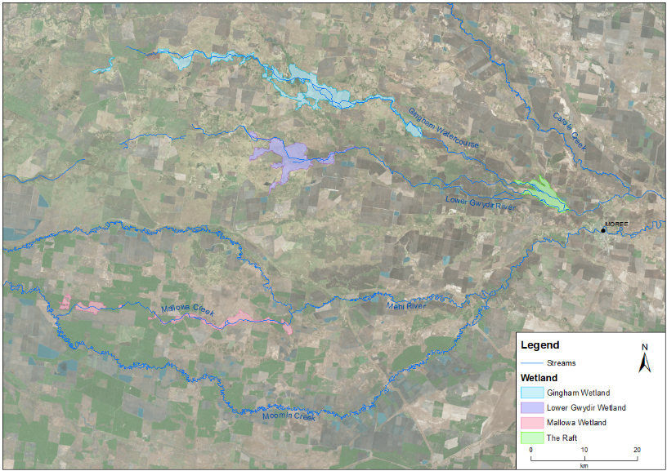
Figure B-1 Extent of Lower Gwydir, Gingham and Mallowa wetlands in the Gwydir River system Selected Area.

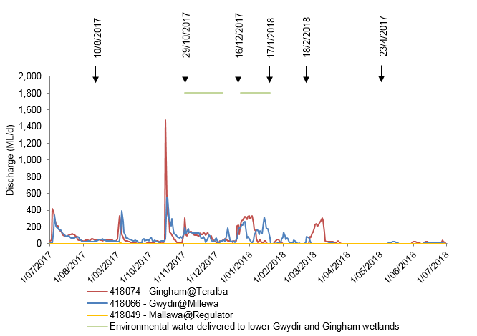
Figure B-2 River flows entering the lower Gwydir River, Gingham Watercourse and Mallowa Creek during 2017-18. Horizontal lines represent the timing of environmental water in each system. Arrows indicate timing of Landsat image capture.

Calculation of inundation volumes
Volumes of inundation for each vegetation community within the lower Gwydir and Gingham wetlands were estimated for each of the Landsat image dates (Table B-2). This was done using water depth information from a level logger at the Old Dromana remote camera site in the Gwydir wetlands
(Figure B-3) and water depth estimates within vegetation plots surveyed in late October 2017
(Appendix G). Due to technical difficulties, in 2017-18 water depths were not monitored at Bunnor bird hide. Point depth measurements were taken at specific points in time, so water level data from the remote camera site were used to adjust these measurements and provide average depth estimates for each image capture date. Average depths for each vegetation community were estimated to the nearest 0.05 m. These were then multiplied by the area of each vegetation community to provide an estimate of the volume of surface water contained within each vegetation community. Lack of water depth reference data in the Mallowa wetlands precluded calculation of inundation volumes in this system.
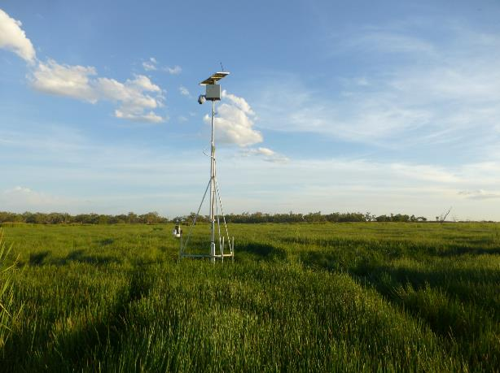
Figure B-3 Remote monitoring station at Old Dromana wetland.

Table B-2 Average depth (m) of inundation for vegetation communities during the four image capture times in the Lower Gwydir and Gingham wetlands zone.
Wetland | Vegetation community | Estimated average depth of inundation (m)
 |  | 10-Aug-17 | 16-Dec-17 | 17-Jan-18 | 18-Feb-18
Lower Gwydir | Common Reed - Marsh Club-rush | 0.00 | 0.15 | 0.20 | 0.20
 | Common Reed - Tussock Sedge | 0.00 | 0.00 | 0.00 | 0.20
 | Coolibah - River Red Gum Association | 0.05 | 0.05 | 0.10 | 0.10
 | Coolibah woodland | 0.00 | 0.05 | 0.10 | 0.10
 | Cumbungi - Marsh Club-rush | 0.15 | 0.15 | 0.20 | 0.20
 | River Cooba - Lignum Association | 0.00 | 0.00 | 0.00 | 0.15
 | Water Couch - Spike-rush - Tussock Rush | 0.15 | 0.15 | 0.20 | 0.20
 | Natural Water Body | 0.45 | 0.45 | 0.50 | 0.50
 | Cultivated Land | 0.05 | 0.05 | 0.10 | 0.10
 | Farm Dam | 0.90 | 0.90 | 1.00 | 1.00
Gingham | Baradine Red Gum shrubby open forest | 0 | 0 | 0 | 0
 | Belah grassy woodland | 0 | 0.05 | 0.2 | 0.05
 | Carbeen grassy woodland | 0 | 0 | 0 | 0
 | Cleared land | 0 | 0.05 | 0.15 | 0.05
 | Coolibah - River Cooba grassy woodland | 0 | 0.05 | 0.20 | 0.05
 | Cultivated land | 0.05 | 0.05 | 0.20 | 0.05
 | Cumbungi swamp rushland | 0.10 | 0.15 | 0.35 | 0.20
 | Derived grasslands | 0 | 0.05 | 0.05 | 0.10
 | dry wetland with rehabilitation potential | 0.05 | 0.05 | 0.25 | 0.10
 | Marsh Club-rush swamp sedgeland | 0 | 0 | 0.25 | 0.10
 | Myall - Rosewood shrubby woodland | 0 | 0 | 0.20 | 0.05
 | Paleo-channel: Coolibah - River Cooba woodland | 0 | 0 | 0.20 | 0.05
 | Paleo-channel: cultivated land | 0 | 0 | 0.20 | 0.05
 | Paleo-channel: dry wetland with rehabilitation potential | 0 | 0 | 0.25 | 0.10
 | Paleo-channel: Water Couch - Spike-rush | 0 | 0 | 0.25 | 0.10
 | Poplar Box shrubby woodland | 0 | 0 | 0.15 | 0.05
 | River Cooba - Lignum Association | 0 | 0 | 0.25 | 0.10
 | River Cooba - Lignum swamp shrubland | 0.05 | 0.05 | 0.25 | 0.10
 | River Red Gum - Coolibah open forest | 0 | 0.05 | 0.20 | 0.10
 | Spike-rush - Cumbungi swamp sedgeland | 0 | 0 | 0 | 0
 | Tussock Rush swamp rushland | 0 | 0.05 | 0.25 | 0.10
 | Water Couch - Spike-rush - Tussock Rush marsh grassland/sedgeland | 0.05 | 0.05 | 0.25 | 0.10
 | Natural water body | 0.30 | 0.35 | 0.5 | 0.40
 | Farm dam | 0.80 | 0.90 | 1.10 | 1.00

Average monthly rainfall
Rainfall in May 2017, leading up to the start of the 2017-18 water year was higher than average, while the winter of 2017 was well below average (Figure B-4). October, November, February and March were all above average, with other months having below average rainfall. No rainfall was recorded at all in May 2018 (Figure B-4).
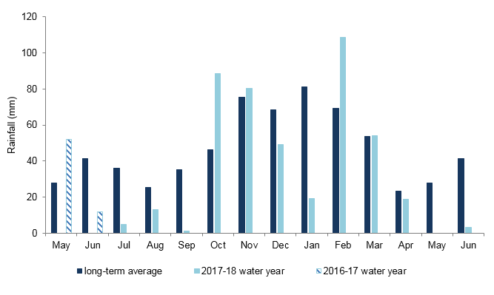
Figure B-4 Monthly rainfall for 2017-18 water year from Moree Aero station (BoM 2018).

Results and Discussion

Inundation extent and volume modelling
Inundation mapping using Landsat imagery showed that the total extent of inundation varied throughout the water year in all wetlands (Figure B-5, Figure B-6).
Inundation extent in the Gingham watercourse for the 2017-18 water year was lowest in February 2018 (6.69 ha), while maximum mapped inundation occurred in August (363.81 ha). Inundation extent was greatest in August presumably because of early season natural inflows and residual water from 2016-17. This inundation had retreated in December to 80.90 ha, before deliveries of environmental water increased inundation in the eastern Gingham to 266.72 ha in January (Figure B-2, Table B-3).
Inundation extent in the lower Gwydir for the 2017-18 was below 35 ha in all images analysed except for January, where 118.51 ha was inundated following environmental water deliveries (Figure B-2,
Table B-3). This inundation was confined to the eastern and central parts of the lower Gwydir wetlands (Figure B-5).
Cumulative inflows to the Mallowa wetlands system were very low in 2017-18 with no environmental water delivered to this system (Table B-3). As a result, mapped inundation in all images analysed was very low, being less than 20 ha throughout the year. Maximum inundation was detected in December (18.05 ha), with inundation patterns suggesting this was the result of remnant water in farm dams and rainfall generated inundation away from the river channel (Figure B-6).
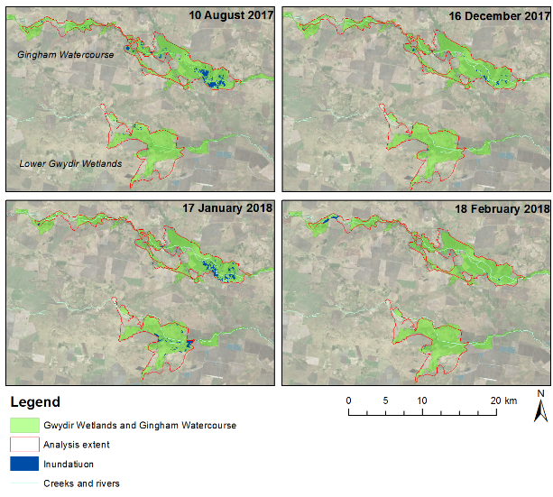
Figure B-5: Wetland inundation within the Gingham and lower Gwydir Wetlands during the 2017-18 water year.

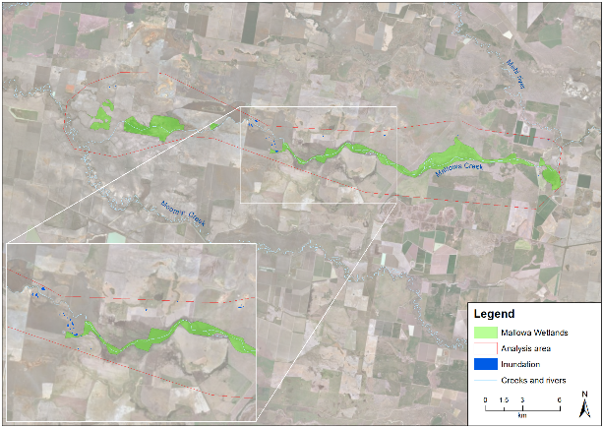
Figure B-6: Wetland inundation within the Mallowa Wetlands mapped on the 16 December 2017.

Table B-3: Cumulative inflows, inundation extent and volume of water in the Selected Area throughout the 2017-18 water year.
Wetland | Date | Cumulative inflows (ML) | Inundation Extent (ha) | Inundation volume (ML)
Gingham | 10/08/2017 | 4,457 | 363.81 | 639.35
 | 16/12/2017 | 14,141 | 80.90 | 89.44
 | 17/01/2018 | 19,242 | 266.72 | 477.96
 | 18/02/2018 | 19,485 | 55.03 | 38.54
Lower Gwydir | 10/08/2017 | 3,434.84 | 32.27 | 15.15
 | 16/12/2017 | 13,800.44 | 7.03 | 6.84
 | 17/01/2018 | 18,237.09 | 118.51 | 147.00
 | 18/02/2018 | 19,157.22 | 6.69 | 0.77
Mallowa | 29/10/2017 | 49.62 | 11.37 | water depth reference data unavailable
 | 16/12/2017 | 98.32 | 18.05
 | 17/01/2018 | 103.86 | 7.76
 | 23/04/2018 | 115.33 | 2.16

Vegetation community inundation
In the Gingham watercourse, water couch – spike-rush – tussock rush marsh grassland and cumbungi swamp rushland were the most commonly inundated vegetation communities (Table B-4). Water couch – spike-rush – tussock rush marsh grassland had the largest area of inundation mapped for all image capture dates, with the maximum being in July (172 ha; Table B-4), whereas cumbungi swamp rushland had the greatest volume of inundation, also in July (284 ML; Table B-5). During maximum inundation in July (363.81 ha), 12 of 24 vegetation communities in the Gingham watercourse were inundated; while in February with the least inundation (55.03 ha), only six vegetation communities were inundated (Table B-4).
In the lower Gwydir wetlands, water couch – spike rush – tussock rush marsh grassland was the most frequently inundated vegetation community. It also had the greatest volume of inundation mapped for all image capture dates, with the maximum in January (75 ML; Table B-5). River-Cooba lignum association had the largest area inundated in any single image capture date with 51 ha mapped in January (Table B-4). During January (the period with the largest extent of inundation) six of the eight vegetation communities mapped in the lower Gwydir wetlands were inundated (Table B-4). During February (the period with the smallest extent of inundation) only two communities were inundated (Table B-4).
Since no environmental water was delivered into the Mallowa, no inundation was caused by environmental water and further analysis was not undertaken.
Table B-4 Area inundated, including percentage of total extent inundated at the time, for different vegetation communities in the lower Gwydir and Gingham wetlands in 2017-18.
Wetland | Vegetation community | Area inundated - ha (% of mapped community)
 |  | 10-Aug-17 | 16-Dec-17 | 17-Jan-18 | 18-Feb-18
Gingham | Baradine Red Gum shrubby open forest | 0 | 0 | 0 | 0
 | Belah grassy woodland | 0 | 0 | 0 | 0
 | Carbeen grassy woodland | 0 | 0 | 0 | 0
 | Cleared land | 6 (2%) | 0 | 0 | 0
 | Coolibah - River Cooba grassy woodland | 4 (1%) | 0 | 0 | 1 (1%)
 | Cultivated land | 17 (5%) | 1 (2%) | 8 (3%) | 5 (9%)
 | Cumbungi swamp rushland | 95 (26%) | 28 (35%) | 108 (40%) | 8 (15%)
 | Derived grasslands | 0 | 0 | 0 | 0
 | dry wetland with rehabilitation potential | 8 (2%) | 0 | 1 (0%) | 13 (23%)
 | Marsh Club-rush swamp sedgeland | 9 (2%) | 0 | 0 | 0
 | Myall - Rosewood shrubby woodland | 0 | 0 | 0 | 0
 | Paleo-channel: Coolibah - River Cooba woodland | 0 | 0 | 0 | 0
 | Paleo-channel: cultivated land | 0 | 0 | 0 | 0
 | Paleo-channel: dry wetland with rehabilitation potential | 20 (6%) | 0 | 0 | 0
 | Paleo-channel: Water Couch - Spike-rush | 0 | 0 | 0 | 0
 | Poplar Box shrubby woodland | 0 | 0 | 0 | 0
 | River Cooba - Lignum Association | 0 | 0 | 0 | 0
 | River Cooba - Lignum swamp shrubland | 21 (6%) | 1 (2%) | 1 (0%) | 0
 | River Red Gum - Coolibah open forest | 1 (0%) | 0 | 0 | 0
 | Spike-rush - Cumbungi swamp sedgeland | 0 | 0 | 0 | 0
 | Tussock Rush swamp rushland | 0 | 0 | 0 | 0
 | Water Couch - Spike-rush - Tussock Rush marsh grassland/sedgeland | 172 (47%) | 40 (49%) | 137 (51%) | 27 (48%)
 | Natural water body | 10 (3%) | 9 (11%) | 10 (4%) | 1 (2%)
 | Farm dam* | 1 (0%) | 2 (2%) | 2 (1%) | 0 (0%)
 | Total | 363.8 | 80.9 | 266.7 | 55.0
Lower Gwydir | Common Reed - Marsh Club-rush | 0 | 0 | 1 (1%) | 0
 | Common Reed - Tussock Sedge | 0 | 0 | 0 | 0
 | Coolibah - River Red Gum Association | 0 | 0 | 5 (4%) | 0
 | Coolibah woodland | 0 | 0 | 0 | 0
 | Cumbungi-Marsh Club Rush | 0 | 0 (3%) | 10 (9%) | 0
 | River Cooba - Lignum Association | 0 | 0 | 51 (43%) | 0
 | Water Couch - Spike-rush - Tussock Rush | 30 (94%) | 6 (79%) | 50 (42%) | 2 (23%)
 | Natural Water Body | 0 | 1 (13%) | 0 | 0
 | Cultivated Land | 0 | 0 | 0 | 0
 | Farm Dam* | 2 (6%) | 0 (6%) | 2 (1%) | 5 (77%)
 | Total | 32.3 | 7.0 | 118.5 | 6.7

Table B-5 Inundation volume, including percentage of total volume, for different vegetation communities in the lower Gwydir and Gingham wetlands in 2017-18.
Wetland | Vegetation community | Volume - ML
 |  | 10-Aug-17 | 16-Dec-17 | 17-Jan-18 | 18-Feb-18
Gingham | Baradine Red Gum shrubby open forest | 0 | 0 | 0 | 0
 | Belah grassy woodland | 0 | 0 | 0 | 0
 | Carbeen grassy woodland | 0 | 0 | 0 | 0
 | Cleared land | 3 | 0 | 0 | 0
 | Coolibah - River Cooba grassy woodland | 6 | 0 | 0 | 0
 | Cultivated land | 25 | 1 | 8 | 3
 | Cumbungi swamp rushland | 284 | 42 | 269 | 13
 | Derived grasslands | 0 | 0 | 0 | 0
 | dry wetland with rehabilitation potential | 12 | 0 | 1 | 6
 | Marsh Club-rush swamp sedgeland | 13 | 0 | 0 | 0
 | Myall - Rosewood shrubby woodland | 0 | 0 | 0 | 0
 | Paleo-channel: Coolibah - River Cooba woodland | 0 | 0 | 0 | 0
 | Paleo-channel: cultivated land | 0 | 0 | 0 | 0
 | Paleo-channel: dry wetland with rehabilitation potential | 20 | 0 | 0 | 0
 | Paleo-channel: Water Couch - Spike-rush | 0 | 0 | 0 | 0
 | Poplar Box shrubby woodland | 0 | 0 | 0 | 0
 | River Cooba - Lignum Association | 0 | 0 | 0 | 0
 | River Cooba - Lignum swamp shrubland | 42 | 1 | 2 | 0
 | River Red Gum - Coolibah open forest | 1 | 0 | 0 | 0
 | Spike-rush - Cumbungi swamp sedgeland | 0 | 0 | 0 | 0
 | Tussock Rush swamp rushland | 0 | 0 | 0 | 0
 | Water Couch - Spike-rush - Tussock Rush marsh grassland/sedgeland | 172 | 20 | 137 | 13
 | Natural water body | 60 | 26 | 61 | 3
 | Farm dam* | 13 | 12 | 16 | 1
 | Total (ML) | 639 | 89 | 478 | 39
Lower Gwydir | Common Reed - Marsh Club-rush | 0 | 0 | 1 | 0
 | Common Reed - Tussock Sedge | 0 | 0 | 0 | 0
 | Coolibah - River Red Gum Association | 0 | 0 | 5 | 0
 | Coolibah woodland | 0 | 0 | 0 | 0
 | Cumbungi-Marsh Club Rush | 0 | 0 | 15 | 0
 | River Cooba - Lignum Association | 0 | 0 | 51 | 0
 | Water Couch - Spike-rush - Tussock Rush | 15 | 3 | 75 | 1
 | Natural Water Body | 0 | 4 | 0 | 0
 | Cultivated Land | 0 | 0 | 0 | 0
 | Farm Dam* | 16 | 3 | 15 | 41
 | Total (ML) | 15 | 7 | 147 | 1
* Farm dams were not included in volume calculations

Comparison with previous years
Wetland inundation in the lower Gwydir in 2017-18 was the lowest recorded since the LTIM project commenced. This year, inflows into the Gingham watercourse were around 5 times less than in 2016-17, and much less in the lower Gwydir. In 2017-18 no environmental water was released into the Mallowa system. This resulted in around 5 times less wetland inundation overall in 2017-18 compared to the previous water year (Table B-6)
While the area of inundation was low during 2017-18, a large range of vegetation communities were inundated. In the Gingham, 16 of the 22 vegetation communities that were inundated in 2016-17 were again inundated this water year (Table B-6). Interestingly in 2017-18, more cumbungi swamp rushland was inundated than in the previous year, likely a reflection of variable inundations patterns between year. As in previous years water couch – spike rush – tussock rush marsh grassland/sedgeland and river cooba – lignum swamp shrubland were again all partially inundated in 2017-18.
In the lower Gwydir wetlands, six of the eight vegetation communities mapped were inundated to varying extents during each of the last three monitoring years (Table B-6), though the area inundated in 2017-18 was much less than in previous years. In 2017-18, river cooba - lignum association made up a greater proportion of the total area inundated, being 44% of the total inundated area. This was due to the reduced area of water couch – spike rush – tussock rush marsh grassland inundated in 2016-17, which in this water year constituted 43% of the total area compared to 74% in the previous water year (Table B-6).
Table B-6: Maximum area of inundation for each vegetation community during the LTIM project.
Wetland | Vegetation community | Maximum area inundated (ha)
 |  | 2017-18 | 2016-17 | 2015-16 | 2014-15
Lower Gwydir | Common Reed - Marsh Club-rush | 0.75 | 26.95 | 15.34 | 55.68
 | Common Reed - Tussock Sedge | 0.19 | 3.67 | 2.78 | 44.37
 | Coolibah - River Red Gum Association | 4.55 | 4.83 | 9.03 | 15.68
 | Coolibah woodland |  | 21.34 | 7.59 | 66.74
 | Cultivated Land |  | 78.17 | 7.29 | 264.07
 | Cumbungi - Marsh Club-rush | 10.15 | 14.05 | 6.70 | 31.02
 | River Cooba - Lignum Association | 51.30 | 66.06 | 72.85 | 165.18
 | Water Couch - Spike-rush - Tussock Rush | 49.86 | 606.75 | 101.70 | 1848.91
Gingham | Baradine Red Gum shrubby open forest |  | 0.18 | 8.49 | 37.13
 | Belah grassy woodland | 0.03 | 62.46 | 9.61 | 299.02
 | Carbeen grassy woodland |  |  | 0.03 | 1.28
 | Cleared land | 5.52 | 286.69 | 87.53 | 119.55
 | Coolibah - River Cooba grassy woodland | 3.80 | 279.71 | 44.84 | 432.31
 | Cultivated land | 16.84 | 114.92 | 2.66 | 106.27
 | Cumbungi swamp rushland | 107.79 | 64.04 | 119.01 | 274.44
 | Derived grasslands |  | 20.86 | 0.51 | 11.49
 | dry wetland with rehabilitation potential | 12.85 | 309.78 | 36.08 | 279.22
 | Marsh Club-rush swamp sedgeland | 8.69 | 0.11 |  | 9.62
 | Myall - Rosewood shrubby woodland | 0.16 | 7.44 | 0.24 | 12.90
 | Paleo-channel: Coolibah - River Cooba woodland |  | 41.29 |  | 0.83
 | Paleo-channel: cultivated land |  | 52.56 |  | 1.80
 | Paleo-channel: dry wetland with rehabilitation potential | 20.29 | 64.17 | 0.04 | 1.09
 | Paleo-channel: Water Couch - Spike-rush | 0.01 | 46.43 | 0.16 | 42.73
 | Poplar Box shrubby woodland |  | 60.77 | 1.70 | 1.20
 | River Cooba - Lignum Association | 0.09 | 43.95 | 11.74 | 42.48
 | River Cooba - Lignum swamp shrubland | 21.17 | 450.05 | 230.01 | 688.99
 | River Red Gum - Coolibah open forest | 0.57 | 10.31 | 7.60 | 21.06
 | Spike-rush - Cumbungi swamp sedgeland | 0.32 | 333.34 | 0.14 | 7.57
 | Tussock Rush swamp rushland | 0.28 | 14.83 | 0.87 | 4.13
 | Water Couch - Spike-rush - Tussock Rush marsh grassland/sedgeland | 171.85 | 1,004.10 | 189.94 | 1,483.84
Total (ha) |  | 487.07 | 4089.81 | 974.48 | 6370.6

Conclusion
Reduced inflows to the Gingham and lower Gwydir wetlands during the 2017-18 water year resulted in reduced wetland inundation. In the Gingham, maximum inundation was observed early in the water year. Inundation extent then decreased before a small delivery of environmental water over the summer period further increased inundation in February. The system then dried for the remainder of the year. In the lower Gwydir wetlands, maximum inundation was recorded following the delivery of environmental water. In both the Gingham and lower Gwydir wetlands the delivery of environmental water over the summer period inundated a range of core wetland habitats which is likely to be critical to maintaining la diversity of habitats for animals, and allowing these areas to respond positively when broader inundation occurs in future. There were minimal inflows to the Mallowa wetlands during 2017-18 with no environmental water. As a result, inundation in this system was confined to farm dams and some small areas of rainfall induced inundation in isolated areas.

References
Bureau of Meteorology (BoM). 2018. New South Wales Weather Observation Stations. [online]. Available at: http://www.bom.gov.au/nsw/observations/map.shtml (July 4, 2018).
Commonwealth of Australia. 2015. Commonwealth Environmental Water Office Long Term Intervention Monitoring Project Gwydir River system Selected Area – 2014-15 Evaluation Report. Commonwealth of Australia.
Department of Environment, Climate Change and Water (DECCW). 2011. Gwydir Wetlands Adaptive Environmental Management Plan: Synthesis of information projects and actions.
Frazier, PS, Page KJ. 2000. Water body detection and delineation with Landsat TM data. Photogrammetric Engineering and Remote Sensing, 66, 1461-146

Water Quality

Introduction
The category II Water Quality indicator aims to assess the contribution of environmental water to the quality of water entering the Gwydir River system Selected Area (Selected Area). It also assesses patterns of metabolism at sites within the Gwydir and Mehi Rivers. Information presented in this appendix is linked to the Vegetation, Waterbird, Fish (River) and Hydrology River and Watercourse indicators. Several specific questions were addressed through this indicator within the Selected Area during the 2017-18 water year:
- What did Commonwealth environmental water contribute to temperature regimes?
- What did Commonwealth environmental water contribute to pH levels?
- What did Commonwealth environmental water contribute to turbidity regimes?
- What did Commonwealth environmental water contribute to salinity regimes?
- What did Commonwealth environmental water contribute to dissolved oxygen levels?
- What did Commonwealth environmental water contribute to patterns and rates of decomposition?
- What did Commonwealth environmental water contribute to patterns and rates of primary productivity?

Environmental watering in 2017-18
During 2017-18, environmental water was delivered to both in-channel and wetland assets in the Gwydir River system (Error! Reference source not found.). An early season stimulus flow was triggered by inflows to Copeton Dam in August/September 2017. A total of 10,000 ML was delivered into the main Gwydir River, Mehi and Carole Creek systems as a small fresh during late winter/early spring. Following this, a stable flow release of 10,040 ML was delivered into the main Gwydir River, Mehi and Carole Creek systems in late October to mid-November 2017. These small pulse flows were aimed at providing downstream connectivity and allowing opportunity for movement, breeding and recruitment of fish, particularly freshwater catfish (Tandanus tandanus).
A delivery of 8,000 ML including both State and Commonwealth environmental water was made to the lower Gwydir and Gingham wetlands from mid-December 2017 to late January 2018, to replace supplementary take from a small flow event that occurred in the previous months. This aimed to maintain wetland habitat quality, and support the survival and resilience of flora and fauna in the wetlands. The last environmental delivery was made in late April/May 2018 as part of the Northern Connectivity Event. This flow aimed to provide longitudinal connectivity and refresh/replenish drought refuge for instream life, particularly native fish in the Barwon-Darling as well as improving conditions to maintain native fish populations within the tributary catchments. During this event, a total of 18,908 ML of both State and Commonwealth water was delivered down the Mehi River, Moomin Creek and Carole Creek. No environmental water deliveries were made to Mallowa Creek in 2017-18.

Table C-1: Environmental water delivered in the Gwydir River system Selected Area in 2017-18. Percentage represents the percentage of the total flow made up of environmental water.
Channel | Commonwealth Environmental Water (CEW) delivered (ML) | NSW ECA/General Security/Supplementary environmental Water delivered (ML) | 2017-18 total flow (ML) | Environmental Water % of total flow
Gwydir River* | 28,290 | 18,748 (including 15,748 General Security) | 412,705 | 11
Gingham watercourse | 2,000 | 5,534 (including 4,520 General Security) | 22,984 | 33
Lower Gwydir | 2,000 | 5,706 (including 4,520 General Security) | 19,831 | 39
Carole Creek | 3,886 | 2,462 (including 1,662 General Security) | 95,341 | 7
Mehi River< | 20,404 | 5,046 general security | 91,067 | 28
Moomin Creek# | 324 | 175 | 104,075 | 0.5
Mallowa Creek | 0 | 0 | 121 | 0
Total | 28,290 | 18,748 (including 15,748 General Security) | 412,705 | 11
* All environmental water delivery to the Gwydir system flowed through the Gwydir River in 2017-18. Therefore, volumes for this channel represent total volumes delivered downstream and as such are not included in the total.
< Includes 499 ML that flowed down Moomin Creek, but returned to the Mehi downstream. Also includes 90 ML NSW General Security water for delivery to Whittaker’s Lagoon.
# Not included in total as accounted in return flows to Mehi.

Previous monitoring
Three years of water quality monitoring between 2014 and 2017 at the Gwydir Pallamallawa station has shown that the delivery of environmental water drives consistent patterns in water quality indicators. The delivery of environmental water significantly reduced mean daily pH, conductivity and turbidity when compared with periods without environmental water. These results reflect the dilution effects provided by environmental water, and the changes in water chemistry associated with the increase in discharge and wetted channel habitats. The delivery of environmental water during the natural base flow period in 2015-16 led to a significant reduction in turbidity levels to below the ANZECC water quality guideline. In 2015-16, the delivery of environmental water significantly increased mean daily dissolved oxygen and chlorophyll a concentrations, which are likely to be associated with increased nutrient concentrations and improved light conditions (due to reduced turbidity) to support water column primary productivity and stimulate pelagic foodwebs. Single point water quality samples at a range of channel and watercourse sites throughout the Gwydir Selected Area in 2014-17 showed that environmental water consistently delivered pulses of carbon and nutrients that stimulated rates of primary and microbial productivity to support river and wetland foodwebs.

Methods

Gwydir River long-term station
The category II Water Quality indicators were monitored at a single station at Pallamallawa near the DPI Water telemetered gauge (NSW418001) in the Gwydir River between Copeton Dam and Tareelaroi Weir (Commonwealth of Australia, 2015). This single station has permanent surface water connectivity in a defined channel and all environmental water delivered to the lower Gwydir must pass through this reach. It has been labelled GW1 in the following analysis.
Continuous monitoring of dependant indicators temperature (°C), pH, turbidity (NTU), conductivity (mS/cm), and dissolved oxygen (%) occurs at this station using a Hydrolab DS5-X logger. The probe was permanently mounted in mid water below the low flow water height at the Pallamallawa gauge in the Gwydir River. The probe was then connected via a 3-G telemetered system in the hydrometric station to an RMTek website for data monitoring and download. Each water quality indicator is logged at a 10-minute interval. Due to issues with instrument failure, datasets were available from 1st July to 26th December 2017 and no turbidity data was available in the 2017-18 water year.
Environmental water that was delivered to the Selected Area occurred in four events (Appendix A). Four non-environmental water periods, immediately before or after environmental water delivery were used to examine differences in water quality indicators between periods of environmental water delivery and non-environmental water (Table C-2 and Figure C-1).
Daily means (midnight to midnight) of each water quality indicator were calculated from the 10-minute interval data, with analyses based on temporally independent mean values. Daily means of water quality indicators were analysed using the non-parametric Mann-Whitney U test to examine the differences between environmental water periods and non-environmental water periods where the significance level was set at 0.05. Regression analyses were used to explore relationships between discharge (ML/d) and each water quality indicator to separate the time/season of delivery from the discharge volume.
Table C-2: Summary of the Gwydir River long-term station water quality data records in 2017-18. EW represents Environmental Water and CEW represents Commonwealth Environmental Water.
Event | Event name (CEW contribution) | EW period | Non-EW period | Number of days in each period
1 | Early Season Stimulus Flow 10GL (7GL) | 26 August 17 to 4 September 17 | 16 August 17 to 25 August 17 | 10, 10
2 | Stable Fish Flow 10GL (5GL) | 30 October 17 to 20 November 17 | 21 November 17 to 12 December 17 | 22, 22
3 | Supplementary event 8 GL (4GL) | 19 December 17 to 3 January 18 | 4 January 18 to 19 January 18 | 16, 16
4 | Barwon Darling Connection Flow 18.9 GL (12GL) | 20 April 18 to 23 May 18 | 17 March 18 to 19 April 18 | 34, 34

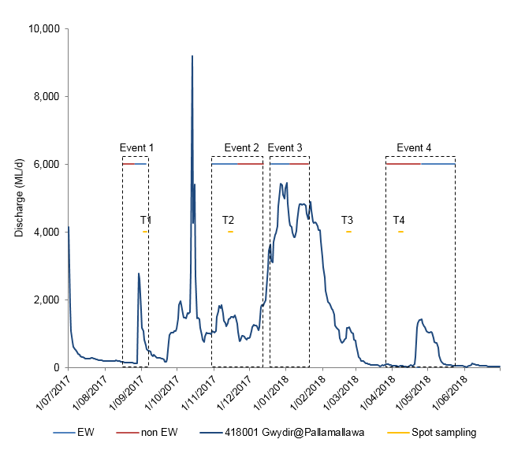
Figure C-1: Mean daily discharge of four Environmental Water (EW) and non-Environmental Water (non EW) periods at Gwydir Pallamallawa gauging station (NSW418001) and four short term spot sampling periods.

Stream metabolism monitoring in four additional sites
To explore the patterns and rates of stream metabolism within the Selected Area, four additional sites were selected from category III microinvertebrate sites along the Gwydir and Mehi Rivers to monitor temperature (°C) and dissolved oxygen (%) at a 10-minute interval using D-Opto loggers from September 2017 (Table C-3). Photosynthetically active radiation (PAR) and barometric pressure were also logged at 10-minute intervals.
Daily means (midnight to midnight) of dissolved oxygen (DO) were calculated from 10-minute interval data, with analyses based on temporally independent mean values. Daily rates of gross primary production (GPP), ecosystem respiration (ER) and net primary production (NPP) in mg O₂/L/day were calculated using the BASE v2 modelling package (Grace et al., 2015). Daily means were analysed using the non-parametric Mann-Whitney U test to examine the differences between environmental water periods and non-environmental water periods where the significance level was set at 0.05. Regression analyses were used to explore relationships between discharge (ML/d) and each water quality indicator to separate the time/season of delivery from the discharge volume.
A new metric to estimate the amount of organic carbon produced per day per one-kilometre stream reach (kg C/km/day) was calculated by multiplying the daily rate of GPP (mg O₂/L/day) by the cross-sectional stream area (m²) at the nearest gauge station with a conversion factor of 12/32 to convert oxygen gas (O₂) molecular mass to carbon (C) atomic mass.
Table C-3: Four additional sites and the nearest gauge stations within the Gwydir Selected Area for stream metabolism monitoring in 2017-18. Sites details in Table C-4.
Site | DPI Water gauge station | Distance from gauge station
GW2 | 418042 (Gwydir D/S Tareelaroi) | 6 km downstream
GW4 | 418004 (Gwydir @ Yarraman Br) | 0 km
GW6 | 418078 (Gwydir @ Allambie Br) | 0 km
ME1 | 418044 (Mehi D/S Tareelaroi) | 3 km downstream

Short-term spot sampling
Water quality and nutrient indicators were measured in association with Category III microinvertebrate indicators (Table C-4; Figure C-2). Sampling sites were located in five Sampling Zones within the Selected Area: Gingham watercourse, lower Gwydir wetlands, Gwydir River, Mehi River and Moomin Creek (Table C-4). Sampling took place on four occasions in September 2017, November 2017, February 2018 and April 2018 to capture the inundation and contraction cycle of environmental water delivery (Table C-4). Hereafter, sampling occasion codes are arranged in chronological order from T1 to T4 (Figure C-1). Hydrological conditions within the selected Area during four sampling periods are described as follows.
T1 Early Season Stimulus Triggered Flow
This late winter sampling (2nd - 5th September 2017) was conducted during the Early Season Stimulus Triggered Flow (26th August - 4th September 2017) with 7 GL from CEWO and 3 GL from NSW EWA. This event was planned to provide an early small fresh and with a low steady flow during late winter into spring targeting in-stream and native fish outcomes in the Gwydir River, Mehi River and Carole Creek. The lower Gwydir wetlands and Gingham watercourse received small inflows of upstream environmental water delivery during this period.
T2 Stable Fish Flow
This early summer sampling (13th - 16th November 2017) was designed to capture the Stable Fish Flow event that ran for 3 weeks (30th October - 20th November 2017) during a pause in irrigation deliveries. This event aimed to provide small stable in-channel low flows and to avoid rapid rates of water level rise and fall in the Gwydir River, Mehi River and Carole Creek, with 5 GL from CEWO and 5.04 GL from NSW AEW. The stable flow delivery was targeted on supporting native fish outcomes including recruitment. This event also aimed to deliver environmental water into the lower Gwydir wetlands (2.37GL) and the Gingham watercourse (2.52GL). As a result, the upper and eastern sections of the lower Gwydir wetlands and Gingham watercourse received inflows.
T3 Post EW condition in the Gwydir channels and Wetlands
This late summer sampling (21st – 23rd February 2018) captured post environmental water conditions with the latest supplementary environmental water release (8GL in total, 4GL from CEWH) into the lower Gwydir wetlands and Gingham watercourse during 19th December 2017 to 3rd January 2018. Residual environmental water maintained surface water in the lower Gwydir wetlands and Gingham watercourse one month after the event. The Gwydir River was in the falling flow limb with average discharge of 1,100 ML/d (418001 Gwydir @ Pallamallawa) while the Mehi River experienced a pulse of irrigation water delivery during this sampling occasion.
T4 Base flow period
Autumn sampling (6th – 10th April 2018) represents a natural dry condition of the system. All river systems were in base flow condition with discontinuous longitudinal connectivity. Discharge in the Gwydir River was below 150 ML/d (418001 Gwydir @Pallamallawa) and the Mehi River was below 60 ML/d (418044 Mehi D/S @ Tareelaroi) for one month. The Gingham watercourse was in a contraction phase and the lower Gwydir wetlands were predominantly dry.
Samples were collected and analysed following the methods in 2015-16 report Appendix D (Commonwealth of Australia, 2016). To identify dominant water quality indicators in the study area, a principal components analysis (PCA) was performed to summarise indicators into several axes (components).
Table C-4: Water quality and water nutrients indicators measured in spot sampling in 2017-18.
Indicators | Variables |  | Units | Code
Water quality | i. | Temperature | °C | temp
 | ii. | pH | - | pH
 | iii. | Turbidity | NTU | turb
 | iv. | Conductivity | mS/cm | cond
 | v. | Dissolved Oxygen | % | do
 | vi. | Chlorophyll a | µg/L | Chla
Water nutrients | i. | Total Nitrogen | µg/L | tn
 | ii. | Total Phosphorus | µg/L | tp
 | iii | Nitrate-nitrite | µg/L | nox
 | iv. | Filterable Reactive Phosphorus | µg/L | frp

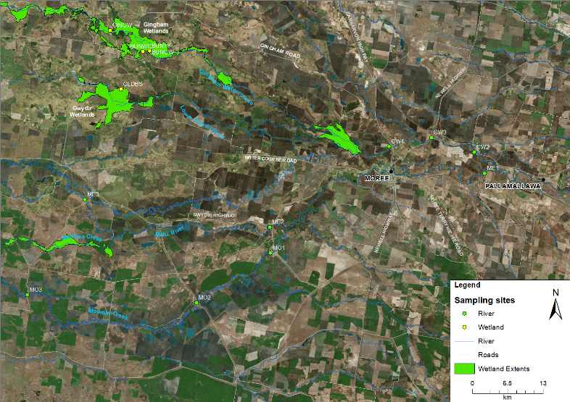
Figure C-2: Location of water quality sampling sites in the Selected Area in 2017-18. See Table C-5 for site codes.

Table C-5: Location of sites within the Gwydir River Selected Area for water quality and water nutrients spot sampling surveys.
Ecosystem | Sampling Zone | Site | Easting | Northing | Inundation
 |  |  |  |  | Sep-17  (T1) | Nov-17  (T2) | Feb-18  (T3) | Apr-18  (T4)
Wetland | Gingham watercourse | BUNOW | 731409 | 6759165 | Wet | Wet | Wet | Wet
 |  | BUNTY | 731394 | 6759148 | Wet | Wet | Wet | Wet
 |  | GINWH | 724103 | 6762962 | Wet | Wet | Wet | Wet
 | Lower Gwydir Wetland | OLDBS | 726067 | 6752088 | Wet | Wet | Wet | Dry
River | Gwydir River | GW2 | 209205 | 6740455 | Wet | Wet | Wet | Wet
 |  | GW3 | 783417 | 6743135 | Wet | Wet | Wet | Wet
 |  | GW4 | 775597 | 6741491 | Wet | Wet | Wet | Wet
 | Mehi River | ME1 | 211342 | 6736610 | Wet | Wet | Wet | Wet
 |  | ME2 | 753566 | 6726596 | Wet | Wet | Wet | Wet
 |  | ME3 | 719420 | 6731644 | Wet | Wet | Wet | Wet
 | Moomin Creek | MO1 | 753679 | 6721789 | Wet | Wet | Wet | Wet
 |  | MO2 | 740017 | 6712590 | Wet | Wet | Wet | Wet
 |  | MO3 | 708808 | 6714077 | Wet | Wet | Wet | Wet

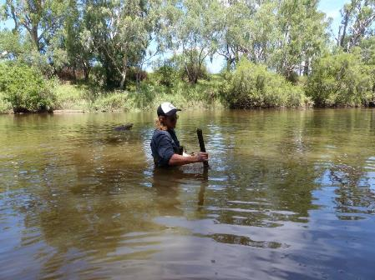
Figure C-3: Accessing the water quality logger at in the Gwydir River at Pallamallawa gauge station (NSW418001).

Results

Gwydir River long-term station
Water quality data at Pallamallawa were available from July to December 2017, covering EW events 1 and 2 in the 2017-18 water year (Figure C-4a). Mean daily temperature increased steadily from July to December in line with seasonal variations (Figure C-4b). Mean daily temperature was significantly lower during environmental water delivery periods (Table C-6). Like previous years, temperature did not have a strong predictable linear relationship with discharge (Figure C-5a and Figure C-6a), suggesting season exerts a stronger influence on temperature than magnitude or delivery of flows.
Similar to previous years, mean daily pH values were consistently alkaline (Figure C-6b), ranging from 7.8 to 8.4 pH and were significantly lower during the environmental water delivery periods (Table C-6). In EW event 1 and 2, mean daily pH decreased to within the ANZECC guideline trigger value (pH between 6.5 and 8; Figure C-4c) four and six days after both events started. The regression analysis suggested that an increase in discharge was correlated with a decrease in pH (Figure C-5b).
Mean daily conductivity ranged from 0.15 to 0.74 mS/cm and was consistently within the ANZECC guideline trigger value (0.125 and 2.2 mS/cm; Figure C-4d) throughout the period of available data. During environmental water delivery periods, mean daily conductivity was significantly lower, highlighting the potential dilution effects provided by environmental water to the Gwydir River (Table C-6). An increase in discharge was negatively correlated with conductivity (Figure C-5c). Conductivity ranges have been similar across the four years of the LTIM project (Figure C-6d; Commonwealth of Australia, 2016).
Mean daily dissolved oxygen concentrations range from 64 – 105%. Recorded values were outside the ANZECC water quality guideline (85-110% in dissolved oxygen percent) after a natural rainfall event in mid-October 2017 and on a few other occasions (Figure C-4e). There was a significant difference in dissolved oxygen concentrations between environmental water delivery periods and non-environmental water delivery periods (Table C-6). Dissolved oxygen concentration has a poor correlation with discharge (Figure C-5d), and was within a similar range of concentrations compared with previous years (Figure C-6e).
Table C-6: Mean ± standard deviation (SD) of measured water quality indicators in Environmental Water delivery periods (EW) and non-Environmental Water delivery periods (non-EW) at the Pallamallawa Station. Mann-Whitney U test and Regression results with significant different at p <0.05 *.
Variable | Unit | EW |  | non-EW |  | U test |  | Regression r²
 |  | Mean | ±SD | Mean | ±SD | chi-square | p-value
Discharge | ML/day | 1328 | 579 | 815 | 531 | 11.72 | 0.001* | -
Temperature | °C | 20.1 | 4.6 | 21.7 | 5.7 | 8.49 | 0.004* | 0.204 (linear)
pH | - | 8.0 | 0.1 | 8.2 | 0.1 | 21.21 | <0.001* | 0.435 (polynomial)
Conductivity | mS/cm | 0.27 | 0.17 | 0.40 | 0.22 | 20.35 | <0.001* | 0.535 (polynomial)
Dissolved Oxygen | % | 88 | 2 | 89 | 4 | 5.52 | 0.019* | 0.398 (polynomial)

Event 2
Event 1

Figure C-4: Mean daily (a) discharge, (b) temperature, (c) pH, (d) conductivity and (e) dissolved oxygen concentrations. EW represents environmental water. Black line represents all available data from this watering year and red dotted line represents ANZECC guideline trigger value.

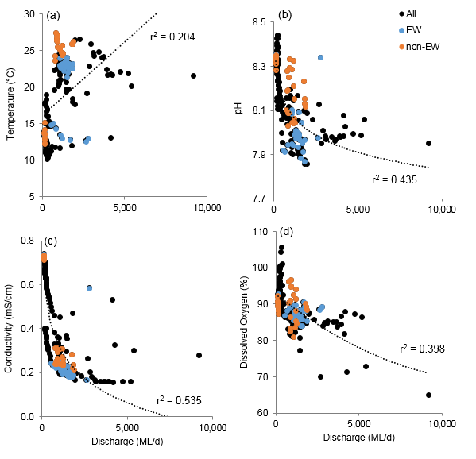
Figure C-5: Regressions between discharge in the Gwydir @ Pallamallawa gauge (NSW418001) and mean daily (a) temperature, (b) pH, (c) conductivity and (d) dissolved oxygen concentrations. All represents all available data from this watering year and EW represents environmental water.

Figure C-6: Mean daily (a) temperature, (b) pH, (c) turbidity, (d) conductivity and (e) dissolved oxygen concentrations water quality indicators measured in the Gwydir River at Pallamallawa in 2014-18.

Spot sampling for water chemistry
Stream metabolism data were collected in the 2017-18 water year covering EW event 2, event 3 and event 4 in four additional sites (Table C-2 and Table C-3). All four additional sites experienced a similar rise and fall in discharge of different magnitude, with a short time lag for downstream flow (Figure C-7a-d). Like the long-term station, mean daily temperature increased steadily from September to March due to seasonal variation (Figure C-8), and temperature did not have a strong predictable linear relationship with discharge, suggesting seasonal change exerts a stronger influence on temperature than the magnitude of flows. This suggests that there is no detectable influence of the delivery of colder water from Copeton Dam on water temperatures below Pallamallawa.
Mean daily dissolved oxygen concentrations ranged from 12.7% - 110.9%) was greater than the range of ANZECC water quality guidelines (85% - 110% in dissolved oxygen, Figure C-7 a-d). There was a significant difference in dissolved oxygen concentrations between environmental water delivery periods and non-environmental water delivery periods, although the differences varied between sites and EW events (Table C-7). Environmental water delivered within EW event 4 during the natural base flow period, contributed to an increase in dissolved oxygen across all sites to within the ANZECC guideline trigger value. Dissolved oxygen in GW2 and ME1 increased 20% within two days and remained consistently high during the event (Figure C-7a and d). During the variable flow period including EW event 2 and 3, dissolved oxygen concentrations showed no consistent patterns across sites, mirroring the observation of EW event 1 and 2 in the Gwydir River long-term station. Dissolved oxygen had a poor correlation with discharge (Table C-7), being more variable during periods of low discharge, however, higher discharge periods led to higher dissolved oxygen concentrations (Figure C-9a-d). Dissolved oxygen decreased after the natural peak flow across all sites in mid-October (peak flow around 4,200 ML/d at gauge station 418042 Gwydir D/S Tareelaroi) (Figure C-7a-d). During natural base flow period pre-EW event 4, there was a short period of exceptionally low dissolved oxygen recorded in early April 2017 at GW2 (lowest 12.7%, 1.05 mg/L) and GW6 (lowest 30.3%, 2.57 mg/L) while the logger at GW4 was exposed to air due to low water levels.
Table C-7: Minimum, Mean and Maximum dissolved oxygen concentrations, GPP, ER and NPP. Mann-Whitney U test and Regression results with significant different at p <0.05 *. Bold text for Dissolved Oxygen indicates concentrations that are outside of ANZECC guidelines.
Variable | Site | Annual |  |  | U test |  | Regression r²
 |  | Minimum | Mean | Maximum | chi-square | p-value
DO | GW2 | 12.7 | 93.1 | 110.9 | 1.405 | 0.236 | 0.062 (polynomial)
 | GW4 | 60.9 | 82.6 | 101.8 | 14.517 | <0.001* | 0.106 (polynomial)
 | GW6 | 27.3 | 64.5 | 113.5 | 0.022 | 0.883 | 0.158 (polynomial)
 | ME1 | 62.3 | 89.5 | 106.8 | 6.708 | <0.01* | 0.094 (polynomial)
GPP | GW2 | 0.1 | 2.9 | 9.1 | 12.033 | 0.001* | 0.477 (polynomial)
 | GW4 | 0.7 | 1.9 | 4.7 | 2.306 | 0.129 | 0.488 (polynomial)
 | GW6 | 0.2 | 1.7 | 5.2 | 0.833 | 0.361 | 0.371 (polynomial)
 | ME1 | 0.1 | 1.1 | 3.5 | 3.527 | 0.060 | 0.388 (polynomial)
ER | GW2 | 0.0 | 4.3 | 16.1 | 0.052 | 0.819 | 0.404 (polynomial)
 | GW4 | 2.0 | 5.1 | 13.0 | 1.424 | 0.233 | 0.030 (polynomial)
 | GW6 | 4.1 | 8.4 | 31.4 | 1.633 | 0.201 | 0.000 (polynomial)
 | ME1 | 0.4 | 3.5 | 22.7 | 4.860 | 0.027* | 0.260 (polynomial)
NPP | GW2 | -12.2 | -1.4 | 1.8 | 4.408 | 0.036* | 0.106 (polynomial)
 | GW4 | -11.8 | -3.3 | -0.1 | 8.576 | 0.003* | 0.000 (polynomial)
 | GW6 | -30.6 | -6.7 | -1.2 | 2.133 | 0.144 | 0.000 (polynomial)
 | ME1 | -19.8 | -2.4 | 0.2 | 13.500 | <0.001* | 0.153 (polynomial)

Figure C-7: Mean daily dissolved oxygen concentrations monitored in 2017-18 at (a) GW2, (b) GW4, (c) GW6 and (d) ME1. EW represents environmental water. Black dotted line represents discharge (ML/day) data from the nearest gauge station of each sites (see Table C-1) and black line represents all available data from this watering year.
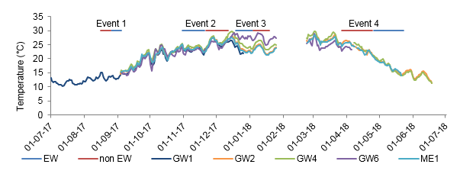
Figure C-8: Mean daily temperature (C) at the Gwydir @ Pallamallawa gauging station (GW1) and four additional stations monitored in 2017-18. EW represents environmental water.
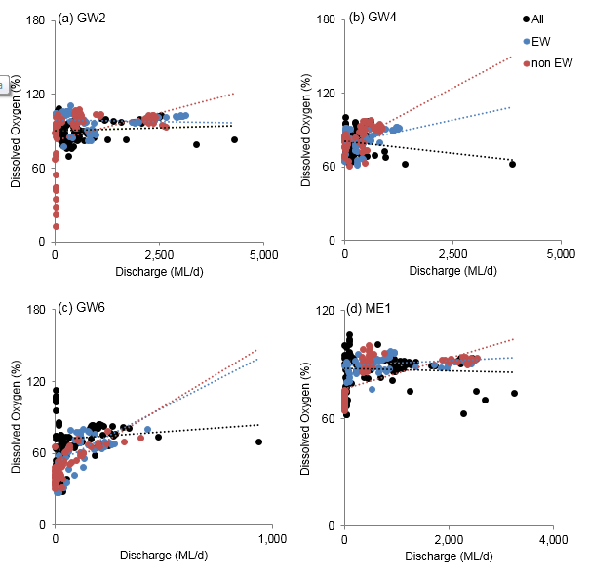
Figure C-9: Regressions between discharge and mean daily dissolved oxygen concentrations monitored in 2017-18 at (a) GW2, (b) GW4, (c) GW6 and (d) ME1. All represents all available data from this watering year and EW represents environmental water.

Stream metabolism monitoring in four additional channel sites
The stream metabolism dataset was discontinuous due to the high percentage (56% to 91%) of data that was not suitable for input into the BASE v2 model (Table C-8). Rates of mean GPP ranged from 0.1 to 9.1 mg O2/L/d and rates of ER ranged from 0 to 31.4 mg O2/L/d across four additional stream metabolism sites (Table C-7, Figure C-10a-d and Figure C-11a-d). At GW2, with 44% of available data, the highest rates of GPP were recorded (average 5.3 mg O₂/L/day) between 25th February and 22nd March 2018 during a natural base flow period while the highest rates of ER (above 10 mg O₂/L/day) were recorded between 15th and 30th September 2017 and on two occasions during EW event 2 in November 2017. The delivery of environmental water did not produce significant differences in rates of GPP and ER across sites (Table C-7). The regression identifies that an increase in discharge was correlated with a decrease in GPP and ER (Figure C-13a and c).
The estimated amount of carbon produced ranged from 0.2 to 138.8 kg C/km/day and carbon consumed ranged from 0.4 to 493.7 kg C/km/day assuming a 100% efficiency in conversion of oxygen to carbon (Figure C-13b). GW2 and GW4 stations had relatively high carbon production compared to GW6 and ME1 stations due to these sites having a wider channel.
NPP was predominantly net heterotrophic ranging from -30.6 to 1.8 mg O2/L/d across four channel sites (Table C-7). NPP occasionally switched to net autotrophic from November to March during variable flow periods in GW2 and ME1 (Figure C-12a-d). There was significantly lower NPP during environmental water delivery periods, with a range of responses between sites and CEW events (Table C-7). However, NPP had a poor correlation with discharge (Figure C-13).
Table C-8: Summary of Stream Metabolism data records 2017-18. *Pass represents BASE2 outputs with acceptance criteria of R2>0.7, R-hat<1.1, PPP between 0.1 and 0.9, pD is positive and CV of GPP<50.
Site | Period of record | Days with metabolism data (%)
 |  | Pass | Fail | Total
GW2 | 3/9/2017 - 17/06/2018 | 113 (44%) | 145 (56%) | 258
GW4 | 3/9/2017 - 17/06/2018 | 26 (11%) | 219 (89%) | 245
GW6 | 4/9/2017 - 17/06/2018 | 17 (9%) | 165 (91%) | 182
ME1 | 4/9/2017 - 17/06/2018 | 35 (14%) | 216 (86%) | 251

Figure C-10: Mean daily gross primary production monitored in 2017-18 at (a) GW2, (b) GW4, (c) GW6 and (d) ME1. EW represents environmental water. Black dotted line represents discharge (ML/d) data from the nearest gauge station of each sites (see Table C-1) and all represents all available data from this watering year.

Figure C-11: Mean daily ecosystem respiration monitored in 2017-18 at (a) GW2, (b) GW4, (c) GW6 and (d) ME1. EW represents environmental water. Black dotted line represents discharge (ML/d) data from the nearest gauge station of each sites (see Table C-1) and all represents all available data from this watering

Figure C-12: Mean daily net primary production monitored in 2017-18 at (a) GW2, (b) GW4, (c) GW6 and (d) ME1. EW represents environmental water. Black dotted line represents discharge (ML/d) data from the nearest gauge station of each sites (see Table C-1) and all represents all available data from this watering year.
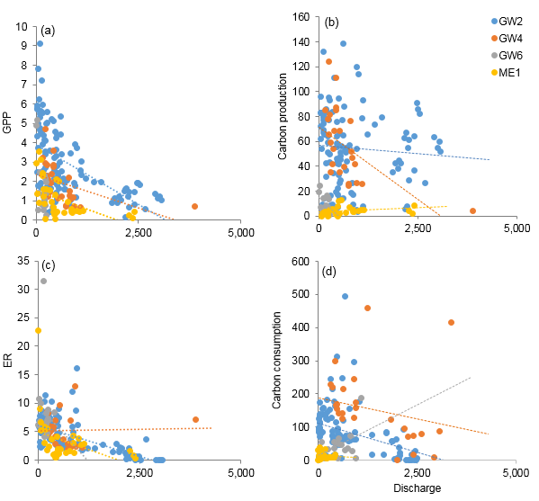
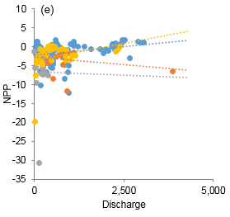
Figure C-13: Regressions between discharge and daily (a) GPP, (b) carbon production, (c) ER, (d) carbon consumption and (e) NPP monitored in 2017-18 at GW2, GW4, GW6 and ME1.

Short-term spot sampling of water chemistry
All sites exhibited highly variable water quality conditions during the four spot sampling periods. Water temperature ranged from 13.5°C to 33.6°C, and was higher in the late summer months (February and April 2018) as expected due to seasonal variation (Figure C-14a). The pH values ranged from 6.66 to 9.92, and were consistently alkaline except a single record of slightly acidic pH value in the lower Gwydir wetlands at February 2018 (Figure C-14b). In the Gingham watercourse, pH values were above the ANZECC guideline trigger value (pH between 6.5 and 8) in February and April 2018. All river sites had the highest pH values in April 2018 that were close to exceeding the ANZECC guideline value (pH 8).
Turbidity was highly variable in the four sampling periods, ranging from 0 to 660 NTU. All wetland sites had turbidity above the ANZECC guideline trigger values (6-50 NTU) at February 2018 and April 2018. In the Mehi River and Moomin Creek, turbidity was consistently above the guideline trigger value, with the highest mean turbidity of 622 NTU recorded in Moomin Creek during base flow condition with discontinuous longitudinal connectivity (Figure C-14c). Conductivity was within the ANZECC guideline (conductivity between 0.125 and 2.2 mS/cm) in all sites and sampling periods with predominantly higher conductivity in wetland sites than river sites (Figure C-14d). Dissolved oxygen concentrations ranged from 20% to 279% (1.83mg/L to 19.975mg/L, (Figure C-14e). The lower Gwydir wetlands dissolved oxygen concentrations were lower than the ANZECC guideline (dissolved oxygen percent between 85% and 110%) in September 2017 and February 2018, while the Gingham watercourse had very high dissolved oxygen concentrations in February and April 2018. All river sites had relatively consistent dissolved oxygen across all sampling periods, with the highest dissolved oxygen recorded at April 2018.
Measured nutrient (TN, NOx, TP and FRP) concentrations were generally higher than the ANZECC guideline trigger values (TN at 500 µg/L, Nitrate-nitrite at 40 µg/L, TP at 50 µg/L and FRP at 20 µg/L) across all sites and sampling periods (Figure C-15a-d). Wetland sites had higher TN and TP concentrations than river sites, with the Gingham sites showing exceptionally high concentrations in February and April 2018. Conversely, river sites had consistently higher NOx than wetland sites while the lower Gwydir wetlands had consistently higher FRP than all other sites.
Chlorophyll a concentrations ranged between 4 and 268 µg/L (Figure C-15e). In general, wetland sites had higher chlorophyll a than all river sites. The highest chlorophyll a concentrations in the Gingham watercourse during February and April 2018 were coincided with exceptionally high TN and TP concentrations. The lower Gwydir wetlands and all other river sites also had the highest chlorophyll a levels during the contraction period in February and April 2018. The highest Chlorophyll a level coincided with the high GPP period (average 5.3 mg O₂/L/day) between 25th February and 22nd March 2018 at the additional metabolism site GW2.
As environmental variables do not operate independently, and temporal and spatial patterns in environmental data may be complex, the suite of measured variables was further explored using PCA to search for multiple environmental drivers influencing water quality. PC1 (axis-x) explained 38.2% of the variation and the vector overlay suggested that chlorophyll a, nutrients and pH were strongly associated. The Gingham watercourse water quality during February and April 2018 increased dispersal along PC1 reflecting the exceptionally high concentrations of chlorophyll a, TN and TP and high pH (green triangles in Figure C-16 a and b). The dispersal along PC1 also suggesting water quality in the Gingham watercourse was more variable among sampling occasions and highly depending on vegetation types (open water and typha).
PC2 (axis-y) explained 16.4% of the variation with turbidity being positively aligned, and conductivity being negatively aligned along the axis (Figure C-16c). PC2 suggests that environmental conditions were driven by temporal changes across all site with turbidity levels increasing and conductivity levels decreasing between the four sampling periods.
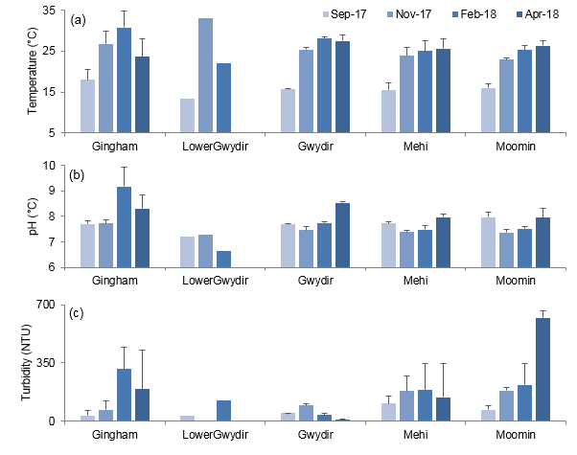
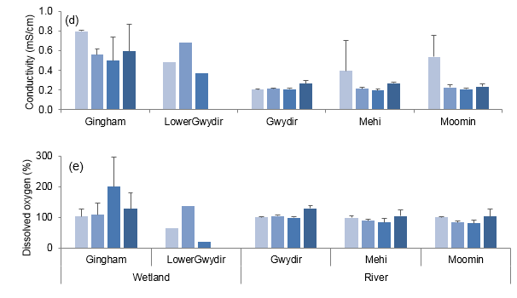
Figure C-14: Mean ± standard deviation (SD) of (a) temperature, (b) pH, (c) turbidity, (d) conductivity and (e) dissolved oxygen concentrations. No SD reported in the Lower Gwydir as only one site was surveyed.
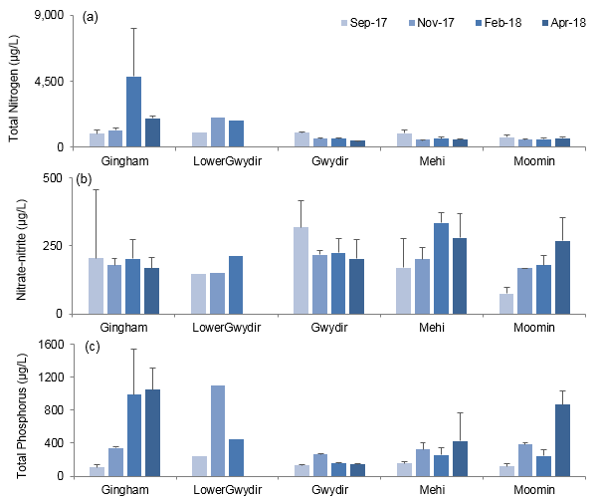
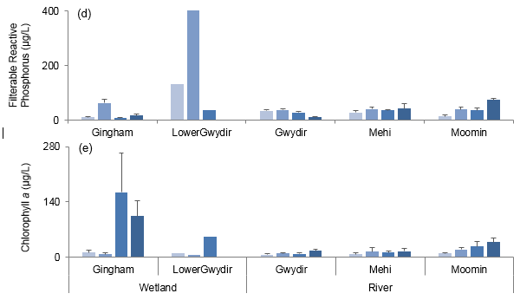
Figure C-15: Mean ± standard deviation (SD) of (a) total nitrogen, (b) nitrate-nitrite, (c) total phosphorus, (d) filterable reactive phosphorus and (e) chlorophyll a concentrations. No SD reported in the Lower Gwydir as only one site was surveyed.
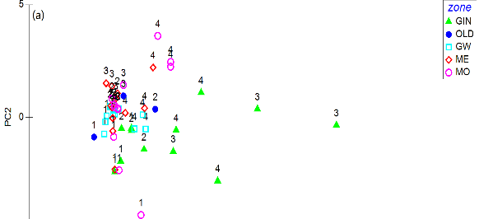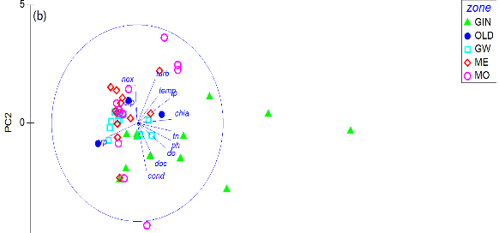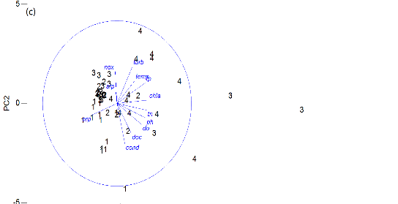
Figure C-16: Principal components analysis (PCA) bi-plot of water quality and nutrient indicators showing (a) time and zone, (b) zone and vectors of environmental variables (normalised data, Spearman correlation) which underlie the environmental patterns among samples and (c) time and vectors of environmental variables. Sampling occasions 1=Sep-17, 2=Nov-17, 3=Feb-18 and 4=Apr-18.

Discussion

Gwydir River continuous monitoring
In this water year, the early season stimulus flow (event 1) and stable fish flow (event 2) environmental water events significantly reduced pH and conductivity when compared with non-environmental water periods. This is consistent with observations made in previous years of the LTIM project. The delivery of environmental water in the two low steady flow events led to significant change of pH levels to within the ANZECC water quality guideline. These processes reflect the dilution effects provided by environmental water, and the changes in water chemistry associated with the increase in discharge and wetted area of channels.
Flow conditions in 2017-18 (peak flow around 9,200 ML/d) were similar in magnitude with 2015-16 (peak flow around 11,400 ML/d), lower in magnitude than 2016-17 (peak flow around 39,400 ML/d) and higher in magnitude than 2014-15 (peak flow around 5,400 ML/d). Four years of water quality monitoring at the Pallamallawa station on the Gwydir River have showed the delivery of environmental water has consistently produced significant improvements of pH, conductivity and turbidity regardless of the annual flow magnitude. On the other hand, the response of dissolved oxygen has been variable with the delivery of environmental water over the different water years. We suggest that inter-annual hydrological variability and antecedent flow condition play important roles in dissolved oxygen variability, highlighting the importance of long-term monitoring in highly dynamic systems. The mechanism driving changes in dissolved oxygen concentrations and stream metabolism will become clearer with data from newly added additional sites in the coming water year.

Stream metabolism monitoring in four additional sites
Four additional stream metabolism sites located in channel habitats were added in 2017-18 to improve detection of longitudinal trends in water quality and metabolism. These sites experienced a similar discharge pattern. The delivery of environmental water in the Northern Connectivity Event (event 4) during the base flow period led to significant improvement of dissolved oxygen within two days of the event commencing. This improvement in dissolved oxygen was maintained throughout the whole environmental water event for at least another 26 days (until the last available data point). However, dissolved oxygen had an inconsistent response to the delivery of environmental water in the other three monitored events. From observations in 2015-16, it appears that changes in dissolved oxygen concentrations during environmental water releases undertaken during naturally variable flow periods (defined as discharge less than 5,000 ML/d at Pallamallawa) are likely to be the response to complex interactions between multiple factors such as nutrient concentrations and turbidity.
The stable fish flow (event 2) and supplementary event (event 3) led to a decrease in the rate of NPP but did not show significant change in the rates of GPP and ER. From all available data in this water year, increased discharge generally led to decreasing rates of GPP and ER. This suggests that increased discharge stimulated a shift toward a more heterotrophic system.
During the natural flow pulse event (4,200 ML/d at gauge station 418042 Gwydir D/S Tareelaroi) in mid- October 2017, dissolved oxygen decreased 10-20% in a few days after the peak flow without creating adverse conditions for aquatic biota. This likely resulted from the flow pulse transporting nutrients which stimulated productivity and subsequently reduced oxygen concentrations through respiration. During the natural base flow period in March 2018, dissolved oxygen concentrations decreased to critically low levels in GW2 and GW6. This is consistent with the natural cycle of water quality which deteriorates in the system during contraction phases. During these phases, evapoconcentration and internal nutrient cycling boosts primary productivity and increases microbial productivity which subsequently reduces oxygen concentrations through respiration. However, due to low data quality during these events, we do not have sufficient GPP, ER and NPP data to conclude the responses of metabolism.

Short term sampling
In this water year, spot sampling over four occasions successfully captured the inundation and contraction cycle of environmental watering actions in the Selected Area. September and November 2017 sampling captured two environmental flow events aiming to create low steady flows in the Gwydir and Mehi Rivers. In contrast, sampling in February 2018 captured post environmental water conditions while April 2018 represented natural base flow conditions in the Selected Area.
Water temperature during the four sampling occasions responded to broader regional climatic patterns rather than flow or other environmental conditions. All zones in the Selected Area had exceptionally high nitrogen and phosphorus concentrations consistent with previous observations during the LTIM project. As expected, water quality differed between the river channels and watercourse environments evidenced by marked differences in water column pH, turbidity, conductivity and nutrient concentrations.
In general, the Gwydir and Mehi River systems experienced similar rates of rise and fall during the four environmental flow events. The Early Season Stimulus Flow peaked in the Gwydir River around 2,800 ML/d, which was slightly higher than in the Mehi River (2,200 ML/d). In all river systems during this flow, the highest concentrations of TN, and lowest turbidity of any monitored flow were recorded, reflecting longitudinal nutrient inputs (Bayley & Sparks, 1989) and the dilution effects of ions provided by environmental water. However, productivity measured as chlorophyll a did not respond in a similar way to TN concentrations, suggesting that cooler temperatures may have limited water column primary production, or that nitrogen is not the limiting nutrient regulating production.
During the natural base flow and contraction periods, pH reached the upper limit of the ANZECC guideline, mirroring the trend observed in the Gwydir River continuous monitoring station. Increases in chlorophyll a concentrations were also observed in this sampling period, reflecting water quality deterioration in the system during the contraction phase. Increases in primary productivity during low flow periods were observed among all river sites suggesting these patterns were predominantly controlled by decreased flow and longitudinal disconnection. The river systems tended to be alkaline with higher turbidity than the wetlands due to the stronger influence of hydrological variation. Similarly, to 2016-17, turbidity in Moomin Creek was consistently higher than in the Mehi and Gwydir Rivers, suggesting that broader catchment influences such as local geology and sediment types may be influencing local scale responses.
In the wetlands, the Early Season Stimulus Flow in late winter and Stable Fish Flow in early summer connected the Gwydir River to the lower Gwydir wetlands and maintained water levels in the Gingham watercourse. During these two periods, pH and turbidity decreased in both wetland systems. However, as in the river channels, primary productivity did not mirror increased nutrients. Again, it may be that the cooler temperatures limited primary producer metabolism rates in the wetlands, postponing the primary production response. As temperature rose over summer and autumn, chlorophyll a concentrations increased to peak levels and coincided with exceptionally high TN and TP concentrations, as flow levels in the wetlands reduced.

Conclusion
In the Gwydir River, continuous monitoring in 2017-18 showed that the two smaller environmental flow pulses in late winter and early summer, reduced pH and conductivity through dilution. This is a similar trend to that found in previous years of the LTIM project, and suggests a predictable relationship exists between these variables and flow delivery in this system. The Northern Connectivity Event delivered environmental water during the base flow period in autumn and led to significant improvements in dissolved oxygen concentrations within two days. However, similar responses in dissolved oxygen were not observed in the other flow periods monitored. It is proposed that antecedent flow condition and inter-annual hydrological variability play important roles in dissolved oxygen variability within the Selected Area.
In general, nutrient concentrations exceeded ANZECC guideline trigger values in all sites and times. The two flow pulses of environmental water early in the season provided connection between the Gwydir River and the lower Gwydir and Gingham watercourses and led to decreases in nutrient concentrations in all watercourses sampled. On the other hand, the same events increased longitudinal transport of nutrients in all rivers. It is plausible that the environmental water transported excess nutrients to river systems while it diluted very high nutrient concentrations in wetland systems in the Selected Area. The increase in chlorophyll a did not occur immediately during environmental water actions. Instead, a spike in chlorophyll a occurred with the onset of warmer temperatures. This suggests temperature plays a critical role in moderating productivity in this system, and highlights the potential ecological significance of the timing of flow events. In an environmental flow delivery context, if flow releases are aimed at increasing productivity in the system, then they should be delivered over the warmer months of the year, to elicit a response.

References
Bayley, P. B., & Sparks, R. E. 1989. The flood pulse concept in river-floodplain systems. Paper presented at the Proceedings of the International Large River Symposium. Dodge, DP (Ed). Can. Spec. Publ. Fish. Aquat. Sci.
Commonwealth of Australia. 2015. Commonwealth Environmental Water Office Long Term Intervention Monitoring Project Gwydir River system Selected Area – 2014-15 Evaluation Report. Commonwealth of Australia.
Commonwealth of Australia. 2016. Commonwealth Environmental Water Office Long Term Intervention Monitoring Project Gwydir River system Selected Area – 2015-16 Evaluation Report. Commonwealth of Australia.

Microinvertebrates

Introduction
The category III Microinvertebrate indicator aims to assess the contribution of environmental watering to microinvertebrate abundance and diversity within the Gwydir River system Selected Area (Selected Area). Several specific questions were addressed through this indicator within the Selected Area during the 2017-18 water year:
- What did Commonwealth environmental water contribute to microinvertebrate productivity?
- What did Commonwealth environmental water contribute to microinvertebrate community composition?
- What did Commonwealth environmental water contribute to connectivity of microinvertebrate communities in floodplain watercourse?

Environmental watering in 2017-18
During 2017-18, environmental water was delivered to both in-channel and wetland assets in the Gwydir River system (Error! Reference source not found.). An early season stimulus flow was triggered by inflows to Copeton Dam in August/September 2017. A total of 10,000 ML was delivered into the main Gwydir River, Mehi and Carole Creek systems as a small fresh during late winter/early spring. Following this, a stable flow release of 10,040 ML was delivered into the main Gwydir River, Mehi and Carole Creek systems in late October to mid-November 2017. These small pulse flows were aimed at providing downstream connectivity and allowing opportunity for movement, breeding and recruitment of fish, particularly freshwater catfish (Tandanus tandanus).
A delivery of 8,000 ML including both State and Commonwealth environmental water was made to the lower Gwydir and Gingham wetlands from mid-December 2017 to late January 2018, to replace supplementary take from a small flow event that occurred in the previous months. This aimed to maintain wetland habitat quality, and support the survival and resilience of flora and fauna in the wetlands. The last environmental delivery was made in late April/May 2018 as part of the Northern Connectivity Event. This flow aimed to provide longitudinal connectivity and refresh/replenish drought refuge for instream life, particularly native fish in the Barwon-Darling as well as improving conditions to maintain native fish populations within the tributary catchments. During this event, a total of 18,908 ML of both State and Commonwealth water was delivered down the Mehi River, Moomin Creek and Carole Creek. No environmental water deliveries were made to Mallowa Creek in 2017-18.

Table D-1: Environmental water delivered in the Gwydir River system Selected Area in 2017-18. Percentage represents the percentage of the total flow made up of environmental water.
Channel | Commonwealth Environmental Water (CEW) delivered (ML) | NSW ECA/General Security/Supplementary environmental Water delivered (ML) | 2017-18 total flow (ML) | Environmental Water % of total flow
Gwydir River* | 28,290 | 18,748 (including 15,748 General Security) | 412,705 | 11
Gingham watercourse | 2,000 | 5,534 (including 4,520 General Security) | 22,984 | 33
Lower Gwydir | 2,000 | 5,706 (including 4,520 General Security) | 19,831 | 39
Carole Creek | 3,886 | 2,462 (including 1,662 General Security) | 95,341 | 7
Mehi River< | 20,404 | 5,046 general security | 91,067 | 28
Moomin Creek# | 324 | 175 | 104,075 | 0.5
Mallowa Creek | 0 | 0 | 121 | 0
Total | 28,290 | 18,748 (including 15,748 General Security) | 412,705 | 11
* All environmental water delivery to the Gwydir system flowed through the Gwydir River in 2017-18. Therefore, volumes for this channel represent total volumes delivered downstream and as such are not included in the total.
< Includes 499 ML that flowed down Moomin Creek, but returned to the Mehi downstream. Also includes 90 ML NSW General Security water for delivery to Whittaker’s Lagoon.
# Not included in total as accounted in return flows to Mehi.

Previous monitoring
Three years of microinvertebrate monitoring between 2014 and 2017 in the Gwydir Selected Area has shown the delivery of environmental water has contributed to consistent patterns in microinvertebrate density, diversity and community composition. The delivery of Commonwealth environmental water to the Gwydir Selected Area has resulted in a pulse of carbon and nutrients that stimulated rates of both primary and microbial productivity. This increased productivity further supported secondary production as microinvertebrate density and subsequent wetland foodwebs, with the delivery of environmental water increasing microinvertebrate density and therefore potential food resources for higher order animals. Wetland systems had significantly higher nutrient and algal levels and microinvertebrate production compared with river sites, reinforcing the importance of environmental water delivery throughout the lower Gwydir to promote the regional scale abundance and diversity of aquatic microinvertebrates.

Methods

Design
Category III microinvertebrates sampling took place on four occasions to capture the inundation and contraction cycle of environmental water delivery (Figure D-1 and Table D-2). Hereafter, sampling occasion codes are arranged in chronological order from T1 to T4. Hydrological conditions within the selected Area during four sampling periods are described below (Figure D-2 and Figure D-3):
T1 Early Season Stimulus Triggered Flow
This late winter sampling (2 – 5 September 2017) was conducted during the Early Season Stimulus Triggered Flow (26 August – 4 September 2017) with 7 GL from CEWO and 3 GL from NSW EWA. This event was planned to provide an early small fresh and with a low steady flow during late winter into spring targeting in-stream and native fish outcomes in the Gwydir River, Mehi River and Carole Creek. The lower Gwydir wetlands and Gingham watercourse received small inflows of upstream environmental water delivery during this period.
T2 Stable Fish Flow
This early summer sampling (13 – 16 November 2017) was designed to capture the Stable Fish Flow event that ran for 3 weeks (30 October – 20 November 2017) during a pause in irrigation deliveries. This event aimed to provide small stable in-channel low flows and to avoid rapid rates of water level rise and fall in the Gwydir River, Mehi River and Carole Creek, with 5 GL from CEWO and 5.04 GL from NSW AEW. The stable flow delivery was targeted on supporting native fish outcomes including recruitment. This event also aimed to deliver environmental water into the lower Gwydir wetlands (2.37GL) and the Gingham watercourse (2.52GL). As a result, the upper and eastern sections of the lower Gwydir wetlands and Gingham watercourse received inflows.
T3 Post EW condition in the Gwydir channels and Wetlands
This late summer sampling (21 – 23 February 2018) captured post environmental water conditions with the latest supplementary environmental water release (8GL in total, 4GL from CEWH) into the lower Gwydir wetlands and Gingham watercourse during 19 December 2017 to 3 January 2018. Residual environmental water maintained surface water in the lower Gwydir wetlands and Gingham watercourse one month after the event. The Gwydir River was in the falling flow limb with average discharge of 1,100 ML/d (418001 Gwydir @ Pallamallawa) while the Mehi River experienced a pulse of irrigation water delivery during this sampling occasion.
T4 Base flow period
Autumn sampling (6 – 10 April 2018) represents a natural dry condition of the system. All river systems were in base flow condition with discontinuous longitudinal connectivity. Discharge in the Gwydir River was below 150 ML/d (418001 Gwydir @ Pallamallawa) and the Mehi River was below 60 ML/d (418044 Mehi D/S @ Tareelaroi) for one month. The Gingham watercourse was in a contraction phase and the lower Gwydir wetlands were predominantly dry.

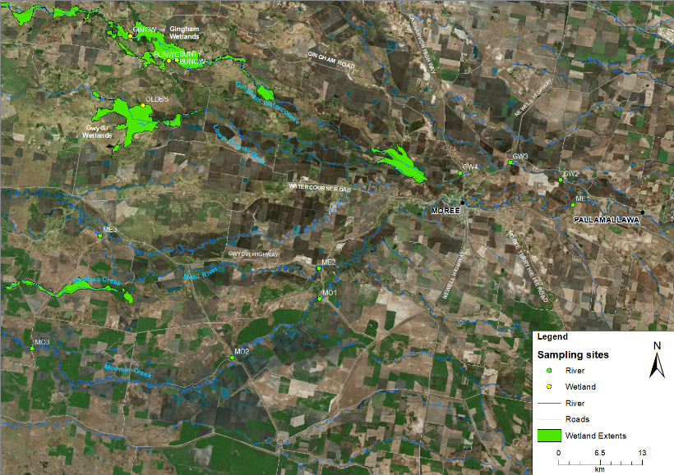
Figure D-1: Location of microinvertebrate sites within the Selected Area in 2017-18. See Table D-1 for site codes.

Table D-2: Location of sites within the Gwydir River Selected Area for category III microinvertebrate surveys.
Ecosystem | Sampling Zone | Site | Easting | Northing | Inundation
 |  |  |  |  | Sep-17  (T1) | Nov-17  (T2) | Feb-18  (T3) | Apr-18  (T4)
Wetland | Gingham watercourse | BUNOW | 731409 | 6759165 | Wet | Wet | Wet | Wet
 |  | BUNTY | 731394 | 6759148 | Wet | Wet | Wet | Wet
 |  | GINWH | 724103 | 6762962 | Wet | Wet | Wet | Wet
 | lower Gwydir wetland | OLDBS | 726067 | 6752088 | Wet | Wet | Wet | Dry
River | Gwydir River | GW2 | 209205 | 6740455 | Wet | Wet | Wet | Wet
 |  | GW3 | 783417 | 6743135 | Wet | Wet | Wet | Wet
 |  | GW4 | 775597 | 6741491 | Wet | Wet | Wet | Wet
 | Mehi River | ME1 | 211342 | 6736610 | Wet | Wet | Wet | Wet
 |  | ME2 | 753566 | 6726596 | Wet | Wet | Wet | Wet
 |  | ME3 | 719420 | 6731644 | Wet | Wet | Wet | Wet
 | Moomin Creek | MO1 | 753679 | 6721789 | Wet | Wet | Wet | Wet
 |  | MO2 | 740017 | 6712590 | Wet | Wet | Wet | Wet
 |  | MO3 | 708808 | 6714077 | Wet | Wet | Wet | Wet

Figure D-2: River flows down the (a) Gwydir River and (b) Mehi River and Moomin Creek and the timing of environmental water (EW) releases.

EW

Figure D-3: River flows down the (a) Gingham watercourse and (b) lower Gwydir wetland and the timing of environmental water (EW) releases.

Field and laboratory methods
Benthic microinvertebrates were haphazardly sampled by combining five cores (50 mm diameter x 120 mm long with 250 mL volume of water from immediately above the sediment surface) for each site. Replicates were separated by a minimum of 20 linear metres. The composite sample was allowed to settle for a minimum of 15 minutes and then the supernatant was poured through a 63 μm sieve. The retained sample was washed into a labelled jar and stored in ethanol (70% w/v with Rose Bengal stain) until laboratory analysis.
Pelagic microinvertebrates were sampled by haphazardly sampling 100 L of the water column at each site (Figure D-4). Samples were poured through a plankton net (63 μm). Retained samples were stored in ethanol (70% w/v with Rose Bengal stain) until laboratory analysis.
Samples were thoroughly mixed and a subsample was sorted on a Bogorov tray under a stereo microscope at up to 400x magnification. Microinvertebrates were identified to family level (rotifers and cladocerans), class (copepods) and ostracods. The volumes of the total samples were recorded and subsample totals were scaled to each total sample volume and reported as density/L. Samples were stored in 70% ethanol with Rose Bengal for auditing purposes.
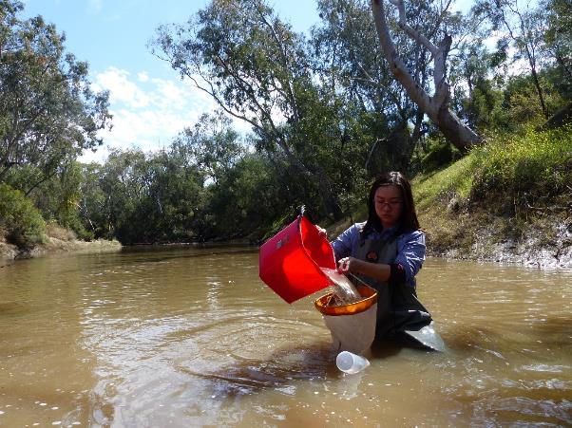
Figure D-4: Pelagic microinvertebrate sampling in the Mehi River.

Statistical methods
To describe and summarize the diversity of microinvertebrate community composition, taxa richness (S), Shannon Weiner diversity (d) and density (number of individual/L) were calculated in PRIMER v6.1.13 using the DIVERSE function. PERMANOVA routine was used to test the difference in S, d and density between habitat (with 2 fixed levels, benthic and pelagic), time (with 4 fixed levels, Sept-17, Nov-17, Feb-18 and Apr-18), zone (with 5 fixed levels, Gingham watercourse, lower Gwydir wetlands, Gwydir River, Mehi River and Moomin Creek) and time x zone interactions.
The community composition data were transformed into two datasets that weigh the contributions of common and rare species differently. (1) Presence-absence data represents actual taxa occurrence in a community. (2) Abundance data (square root transformation to stabilize variance and to improve normality; Clarke and Warwick, 2001) represents relative proportions of taxa occurrence in a community. Since different sampling methods were used in benthic and pelagic habitats, a permutational multivariate analysis of variance (PERMANOVA) analysis was used to test the difference in the microinvertebrate community composition between habitat (with 2 fixed levels, benthic and pelagic), time (with 4 fixed levels, Sept-17, Nov-17, Feb-18 and Apr-18), zone (with 5 fixed levels, Gingham watercourse, lower Gwydir wetlands, Gwydir River, Mehi River and Moomin Creek) and time x zone interactions. Up to 999 random permutations estimated the probability of p-values, with levels of significance reported as p<0.05. Where PERMANOVA results were significant, two datasets by habitat (benthic and pelagic) were developed to further explore the effects of time, zone and interaction.
A Bray-Curtis dissimilarity matrix was generated by rank correlating the community structure between samples. Then, nonmetric multidimensional scaling ordinations (nMDS) were used to visualise community patterns and similarity percentages (SIMPER) were used to determine the taxa contributing to the observed community patterns. nMDS output with stress values of less than 0.2 were considered appropriate for interpretation (Clarke and Warwick, 2001).
Water quality and nutrient indicators reported in Appendix C were used to relate environmental indicators to microinvertebrate patterns. BIOENV analysis was used to examine which water quality and nutrient indicators are link to the patterns of microinvertebrate community composition in PRIMER-E (2009). All analyses were performed in PRIMER v6.1.13 with the PERMANOVA+ v1.0.3 add-on package (Clarke and Warwick, 2006).
Wetland scale microinvertebrate densities were calculated for both Gingham watercourse and the lower Gwydir wetlands by multiplying the density observed in each sampling occasion by the estimated volume of water present in the different vegetation community in wetlands around each sampling occasions. Wetland scale estimated volume calculation methods are outlined in Appendix B.

Results
A total of 29 taxa were identified (from 102 samples). The 13 most abundant taxa (>1% in total abundance) comprised 94% of the total abundance with the most abundant taxa the rotifer family Brachionidae (28% of the total abundance) and Cladoceran nauplii (14%). The other most abundant taxa were the rotifer order Bdelloida (13%) and rotifer family Notommatidae (9%) that were common at all sites.

Density
Microinvertebrate densities from the benthic habitat (from 98/L to 36160/L) were consistently higher than those in pelagic habitats (from 51/L to 4644/L). There was a significant interaction between the effects of habitat and zone (Pseudo-F=3.20, p<0.05) on microinvertebrate densities. In benthic habitats, there was significantly higher densities in both the lower Gwydir wetlands and Gingham watercourse than all river sites (p<0.05, Figure D-5a). In pelagic habitats, both the lower Gwydir wetlands and Gingham watercourse had significantly higher densities than all river sites while the Gwydir River had significantly lower densities than Moomin Creek (p<0.05, Figure D-5b). Pelagic microinvertebrate density has a positive correlation with water column primary production measured as chlorophyll a concentration (Figure D-6). Wetland scale peak microinvertebrate density was observed in the post-EW phase (February 2018) in the Gingham watercourse and the lower Gwydir wetlands (Table D-3).
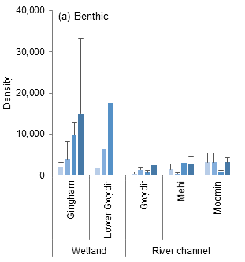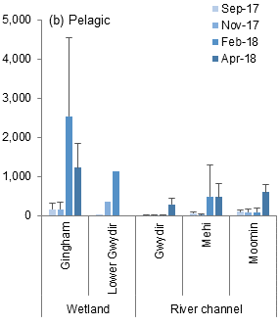
Figure D-5: Mean ± standard deviation of microinvertebrate density (individuals/L) in (a) benthic habitat and (b) pelagic habitat. No SD reported in the Lower Gwydir as only one site was surveyed.

Figure D-6: Regression between water column primary production measured as chlorophyll a concentration and secondary production measured as pelagic microinvertebrate density in 2017-18 water year.
Table D-3: Whole system scale microinvertebrate abundance in the Gingham watercourse and lower Gwydir wetland in 2017-18.
Wetland | Site | Vegetation community | Sep-17 | Nov-17 | Feb-18
Gingham | BUNOW | Natural water body | 1,502,000 | 463,000 | 3,349,000
 | BUNTY | Cumbungi swamp rushland | 931,000 | 197,000 | 2,315,000
 | GINWH | Natural water body | 85,000 | 941,000 | 1,180,000
lower Gwydir | OLDBS | Water Couch-Spike-rush-Tussock Rush | 86,000 | 346,000 | 930,000
Gingham watercourse Total |  |  | 2,518,000 | 1,601,000 | 6,844,000
lower Gwydir wetland Total |  |  | 86,000 | 346,000 | 930,000
Total |  |  | 2,603,000 | 1,947,000 | 7,774,000

Diversity indices
Taxonomic richness ranged from 6 to 18 species with a significant difference between zones (Pseudo-F=3.073, p<0.05, Figure D-7). The Gingham watercourse had significantly lower taxonomic richness than the Mehi River and Moomin Creek (p<0.05). There was no influence of habitat or time detected for taxonomic richness.
Shannon diversity ranged from 0.60 to 2.78 and there were significant differences between time (Pseudo-F=2.5818, p=0.05) and zone (Pseudo-F=7.6238, p<0.005), which was consistent between benthic and pelagic habitats (Figure D-8). In Apri-18, microinvertebrate diversity was significantly lower in all river zones, compared to other survey times (p<0.05). Similar to taxonomic richness, the Gingham watercourse had significantly lower diversity than all other river zones (p<0.05).
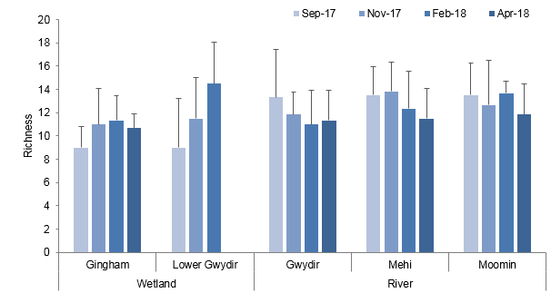
Figure D-7: Mean ± standard deviation of microinvertebrate taxonomic richness.

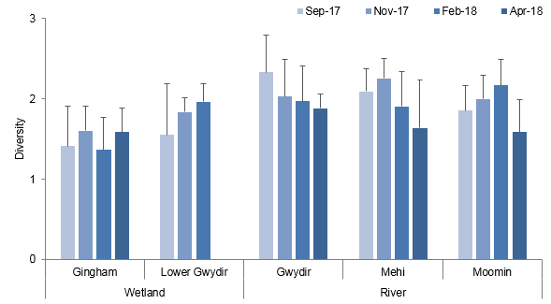
Figure D-8: Mean ± standard deviation of microinvertebrate diversity.

Taxonomic composition
PERMANOVA results indicated that the taxonomic composition was significantly different between wetland and river ecosystems (Pseudo-F=5.4193, p=0.002), and between benthic and pelagic habitats (Pseudo-F=36.352, p=0.001) based on abundance. A similar result was also found based on presence-absence data. The dissimilarity between ecosystems and habitats communities are shown in the nMDS ordination (Figure D-9). Since the taxonomic composition was predominantly driven by ecosystem and habitat, four individual datasets of ecosystem and habitat were developed to further explore the effects of time and zone.
The community-level difference between habitats was driven by the higher average abundance of Copepod nauplii, rotifer Order Bdelloida, rotifer Family Brachionidae and Phylum Nematoda in the benthic habitat (Table D-5). The community difference between ecosystems was driven by the higher average abundance of rotifer Family Brachionidae, Copepod nauplii, rotifer Order Bdelloida and rotifer Family Filiniidae in the wetland ecosystem (Table D-5).
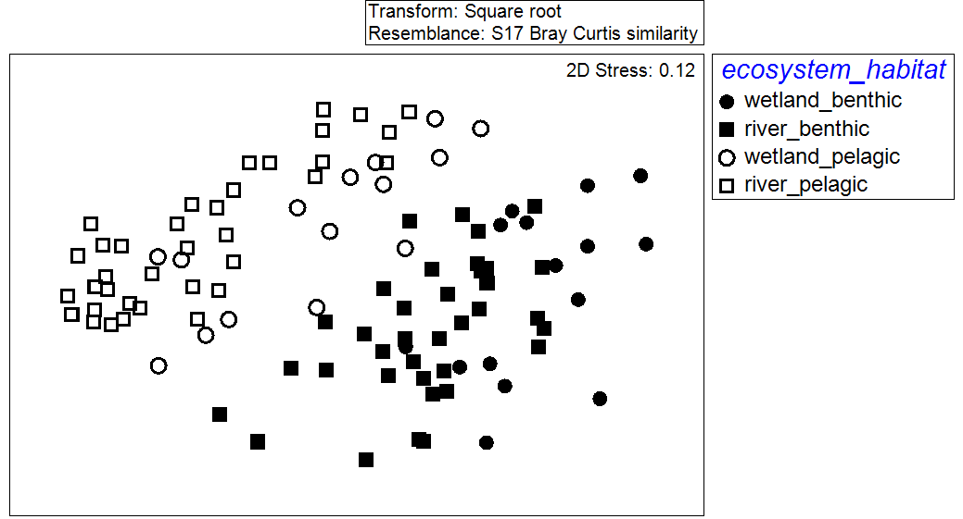
Figure D-9: nMDS ordination of microinvertebrate community composition by ecosystems (wetland and river) and habitats (benthic and pelagic) using the abundance dataset.

Table D-4: Microinvertebrate taxa contributing most of the dissimilarities between ecosystems and habitats based on abundance dataset. Bold numbers represent the higher average abundance group.
Taxa | Average Abundance |  | Contribution % | Cumulative %
 | Benthic | Pelagic
nauplii | 19.0 | 5.7 | 11.7 | 11.7
O. Bdelloida | 16.2 | 2.0 | 10.0 | 21.7
F. Brachionidae | 16.8 | 6.0 | 9.7 | 31.4
P. Nematoda | 12.4 | 0.6 | 9.5 | 40.9
 | Wetland | River
F. Brachionidae | 24.1 | 7.4 | 13.5 | 13.5
nauplii | 18.6 | 10.4 | 11.8 | 25.3
O. Bdelloida | 14.4 | 7.4 | 8.6 | 33.9
F. Filiniidae | 10.2 | 2.7 | 7.3 | 41.3

Wetland
In the wetland ecosystem, two-way PERMANOVA analyses detected a significant time difference based on abundance in both benthic and pelagic habitats (Table D-5). The nMDS ordinations for benthic (Figure D-10) and pelagic (Figure D-11) habitats, based on abundance, showed both temporal and spatial shifts in community composition.
Microinvertebrate community composition was significantly different between T1 and T2 sampling periods, and T3 and T4 sampling periods in both habitats (p<0.05, Figure D-10a, Figure D-11a). The community difference between sampling periods was driven by an increasing abundance of Brachionidae, Filiniidae and Bdelloida rotifers, and nauplii and Synchaetidae copepods during T3 and T4 (Error! Reference source not found.).
There was also a significant difference between the lower Gwydir wetlands and the Gingham watercourse within pelagic habitats (Figure D-11b). This spatial difference was driven by a higher abundance of nauplii copepods, Brachionidae rotifers, and a lower abundance of Cyclopodia copepods and Lecanidae rotifers in the Gingham watercourse (Table D-7).
All environmental indicators were subsequently fitted to the ordination space as vectors to show those indicators correlating to community composition patterns (Figure D-10c and Figure D-11c). The BIOENV results showed that community composition was highly correlated to increased dissolved organic carbon concentrations at T3 and T4 in benthic habitats, and increased TN concentrations within pelagic habitats at T3 and T4 (Table D-8). Moreover, the community compositional shift in time also strongly correlated to higher microinvertebrate densities in T3 and T4 in both habitats (Figure D-10d and Figure D-11d).

Table D-5: PERMANOVA results of microinvertebrate community composition by ecosystems (wetland and river) and habitats (benthic and pelagic) using the abundance dataset. (*significant level at P<0.05).
Ecosystem | Term | Benthic |  | Pelagic
 |  | Pseudo-F | P | Pseudo-F | P
Wetland | Time | 2.2185 | 0.027* | 4.3236 | 0.002*
 | Zone | 1.5585 | 0.187 | 2.4138 | 0.042*
 | Time*Zone | 1.4543 | 0.159 | 1.777 | 0.076
River | Time | 3.1169 | 0.002* | 8.1304 | 0.001*
 | Zone | 2.6521 | 0.004* | 3.6783 | 0.001*
 | Time*Zone | 1.5547 | 0.023* | 1.5727 | 0.029*

Table D-6: Microinvertebrate taxa contributing most of the dissimilarities in wetland ecosystem between times based on abundance dataset. Bold numbers represent the higher average abundance group.
Taxa | Average Abundance |  |  |  | Contribution % | Cumulative %
 | T1 | T2 | T3 | T4 | T1, T2 vs T3, T4
F. Brachionidae | 2.0 | 9.5 | 44.7 | 45.4 | 21.3 | 21.3
F. Filiniidae | 0.3 | 1.7 | 21.1 | 20.2 | 12.2 | 33.5
O. Bdelloida | 7.1 | 12.0 | 18.2 | 22.4 | 8.4 | 41.9
nauplii | 16.8 | 20.0 | 18.9 | 18.6 | 7.7 | 49.6
F. Synchaetidae | 1.7 | 4.7 | 12.0 | 16.0 | 7.3 | 56.9

Table D-7: Microinvertebrate taxa contributing most of the dissimilarities in wetland pelagic ecosystem between zones based on abundance dataset. Bold numbers represent the higher average abundance group.
Taxa | Average Abundance |  | Contribution % | Cumulative %
 | Gingham | Lower Gwydir
O. Cyclopoida | 3.1 | 5.9 | 14.4 | 14.4
nauplii | 9.9 | 7.7 | 14.3 | 28.8
F. Lecanidae | 0.6 | 5.8 | 9.3 | 38.0
F. Brachionidae | 14.9 | 9.4 | 8.6 | 46.7

Table D-8: BIOENV results of microinvertebrate community composition in each ecosystems (wetland and river) and habitats (benthic and pelagic) based on abundance dataset. “v” represents significant environmental variables.
Community | Rho | p | Environmental variables
 |  |  | Temp | pH | Turb | DO | TN | TP | DOC | Chla
Wetland - benthic | 0.350 | 0.013 |  |  |  |  |  |  | v
Wetland - pelagic | 0.411 | 0.004 |  |  |  |  | v
River - benthic | 0.263 | 0.011 | v |  |  | v | v | v |  | v
River - pelagic | 0.584 | 0.001 |  | v | v |  |  | v

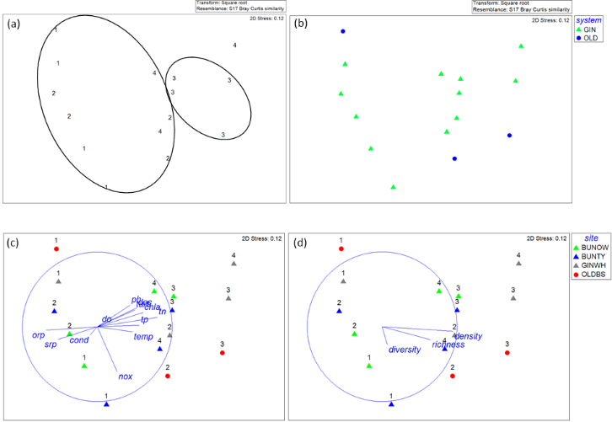
Figure D-10: nMDS ordination of wetland benthic microinvertebrate community composition using abundance dataset by (a) by time, (b) by zone, (c) time x site with vectors of environmental variables (normalised data, Spearman correlation) which underlie the environmental patterns and (d) time x site with vectors of microinvertebrate density and biodiversity indices (normalised data, Spearman correlation). 1=Sep-17, 2=Nov-17, 3=Feb-18 and 4=Apr-18 while GIN=Gingham watercourse and OLD=Lower Gwydir wetland.
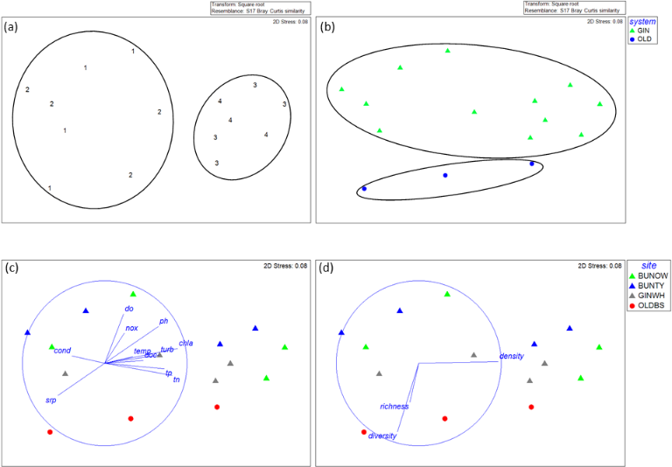
Figure D-11: nMDS ordination of wetland pelagic microinvertebrate community composition using abundance dataset by (a) by time, (b) by zone, (c) time x site with vectors of environmental variables (normalised data, Spearman correlation) which underlie the environmental patterns and (d) time x site with vectors of microinvertebrate density and biodiversity indices (normalised data, Spearman correlation). 1=Sep-17, 2=Nov-17, 3=Feb-18 and 4=Apr-18 while GIN=Gingham watercourse and OLD=Lower Gwydir wetland.

River
In river ecosystems, two-way PERMANOVA analyses showed a significant time-zone interaction in both benthic and pelagic habitats (Table D-6) based on abundance. The nMDS ordinations for benthic (Figure D-12) and pelagic (Figure D-13) habitats showed temporal and spatial shifts in community composition. Microinvertebrate community composition was significantly different between T1, T2+T3 and T4 in both habitats (p<0.05, Figure D-12a and Figure D-13a). The community difference between sampling periods was driven by increasing abundance of nauplii copepods, Brachionidae, Bdelloida and Synchaetidae rotifers and reduced abundance of Tardigrade and Nematoda from T1 to T4 (Table D-9).
In both benthic and pelagic habitats, there was also a significant difference in taxonomic composition between the Gwydir River, and Moomin Creek (Figure D-12b and Figure D-13b). The community difference between Rivers was driven by lower abundances of Synchaetidae and Brachionidae rotifers, nauplii copepods and Nematoda and higher abundances of Bdelloida and Notommatidae rotifers in the Gwydir River compared with Moomin Creek (Table D-10).
All environmental variables were subsequently fitted into the ordination as vectors to show those variables correlated to community patterns (Figure D-12c and Figure D-13c). The BIOENV results showed that community composition was highly correlated with increased TP, chlorophyll a and temperature and decreased TN and dissolved oxygen in benthic habitat (Table D-8). In the pelagic habitat, community composition was highly correlated with increased TP, pH and turbidity (Table D-8). The community composition difference between the Gwydir River and Moomin Creek was strongly correlated to relatively high chlorophyll a, as well as higher microinvertebrate densities in Moomin Creek (Figure D-12d and Figure D-13d).
Table D-9: Microinvertebrate taxa contributing most of the dissimilarities in river ecosystem between times based on abundance dataset. Bold numbers represent the higher average abundance group.
Taxa | Average Abundance |  |  |  | Contribution %
 | T1 | T2 | T3 | T4 | T1 vs T2+T3 | T2+T3 vs T4
P. Tardigrada | 8.7 | 0.5 | 0.0 | 0.7 | 8.7 | 6.2
P. Nematoda | 7.4 | 5.5 | 4.7 | 4.5 | 8.6 | 6.1
nauplii | 7.8 | 7.9 | 6.1 | 16.8 | 8.6 | 12.7
F. Brachionidae | 6.4 | 5.7 | 6.5 | 12.2 | 7.8 | 9.4
O. Bdelloida | 5.2 | 7.8 | 6.7 | 9.3 | 7.4 | 6.9
F. Synchaetidae | 2.8 | 3.6 | 5.1 | 11.9 | 5.8 | 9.9

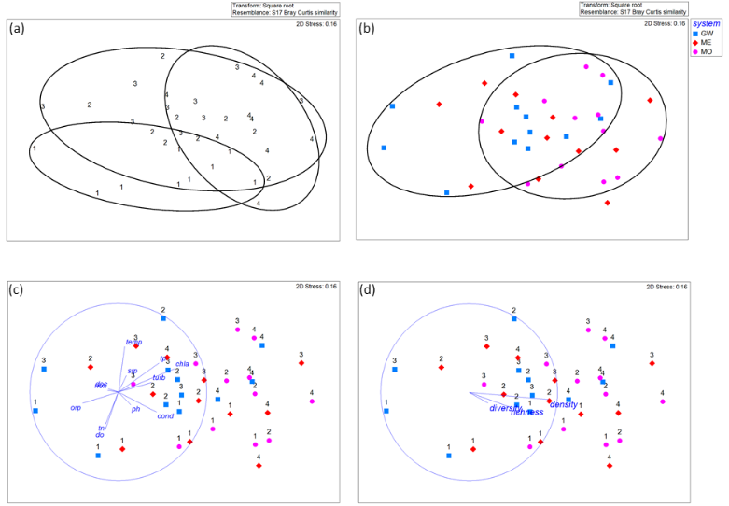
Figure D-12: nMDS ordination of river benthic microinvertebrate community composition using abundance dataset by (a) by time, (b) by zone, (c) time x zone with vectors of environmental variables (normalised data, Spearman correlation) which underlie the environmental patterns and (d) time x zone with vectors of microinvertebrate density and biodiversity indices (normalised data, Spearman correlation). 1=Sep-17, 2=Nov-17, 3=Feb-18 and 4=Apr-18.
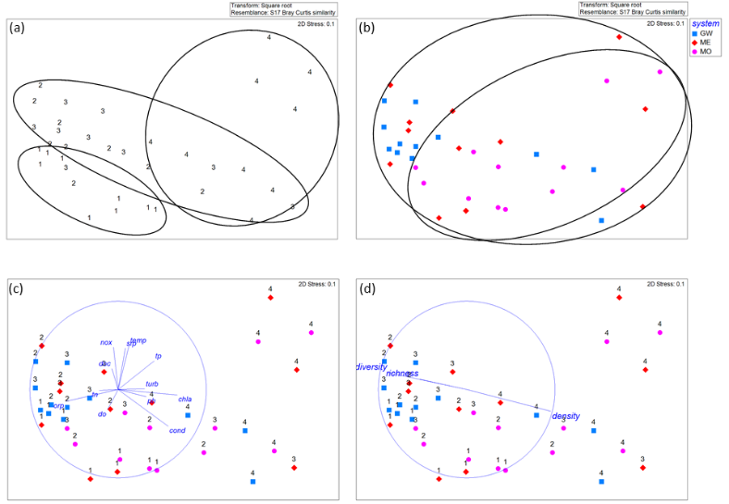
Figure D-13: nMDS ordination of river pelagic microinvertebrate community composition using abundance dataset by (a) by time, (b) by zone, (c) time x zone with vectors of environmental variables (normalised data, Spearman correlation) which underlie the environmental patterns and (d) time x zone with vectors of microinvertebrate density and biodiversity indices (normalised data, Spearman correlation). 1=Sep-17, 2=Nov-17, 3=Feb-18 and 4=Apr-18.

Table D-10: Microinvertebrate taxa contributing most of the dissimilarities in river ecosystem in both benthic and pelagic habitats between Rivers based on abundance dataset. Bold numbers represent the higher average abundance group.
Taxa | Average Abundance |  |  | Contribution % | Cumulative %
 | GW | ME | MO | GW vs MO
F. Synchaetidae | 3.6 | 3.6 | 10.3 | 10.9 | 10.9
nauplii | 7.0 | 9.4 | 12.6 | 10.6 | 21.5
F. Brachionidae | 4.7 | 8.9 | 9.5 | 8.5 | 29.9
O. Bdelloida | 8.2 | 6.4 | 7.1 | 8.4 | 38.3
F. Notommatidae | 7.2 | 6.3 | 6.7 | 7.7 | 46.0
P. Nematoda | 4.7 | 5.8 | 6.1 | 6.8 | 52.8

Multi-year comparison
Data collated over the four years of the LTIM project shows that microinvertebrate density, richness and diversity have varied over time (Figure D-14, Commonwealth of Australia, 2015 and Commonwealth of Australia, 2016). Microinvertebrate densities were consistently higher in wetlands compared with river zones. The densities and richness of microinvertebrates recorded during the project in the Selected Area are similar to those reported in previous studies from the Murray and Ovens Rivers and the Macquarie Marshes floodplain (Kobayashi et al. 2011; Ning, et al. 2013). The highest microinvertebrate densities recorded consistently occurred during wetland contraction periods in 2017-18 and 2015-16, highlighting the importance of prolonged inundation in wetlands to support secondary productivity and provide the eggbank for the next generation of zooplankton. Like the 2015-16 findings, the delivery of environmental water led to higher diversity of microinvertebrates, highlighting that both longitudinal and lateral connection provided increased diversity of habitats and supply of nutrients from inflow, and in turn, supported a more diverse range of microinvertebrate taxa.
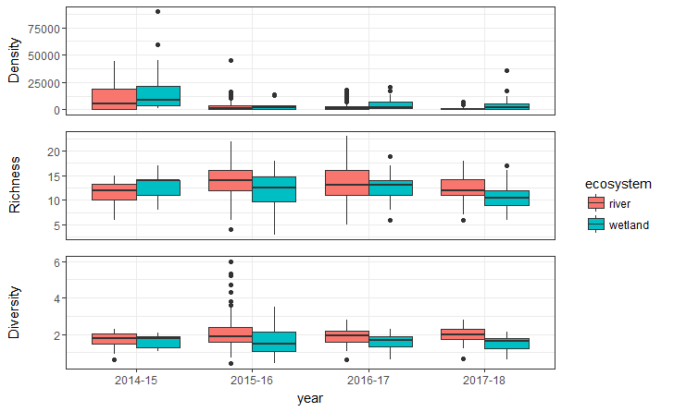
Figure D-14: Multi-year comparison of microinvertebrate density, richness and diversity in the Gwydir River Selected Area.
Data collated from 2016-18 shows the highest microinvertebrate density in whole wetland system scale was recorded in December 2016 during the contraction phase in the Gingham watercourse while the lower Gwydir wetlands were predominantly dry (Figure D-15). Differences in wetland scale microinvertebrate density were found during environmental water period that aimed to maintain water levels in the Gingham watercourse and lower Gwydir wetlands in February 2017, September 2017 and November 2018, suggesting that antecedent flow condition and inter-annual hydrological variability play important roles in secondary productivity. The nMDS ordination with a stress value of below 0.20 in multi-year comparison based on abundance showed both temporal and spatial shifts in community compositions (Figure D-16).

Figure D-15: Multi-year comparison of whole system scale microinvertebrate density in the Gwydir River Selected Area.

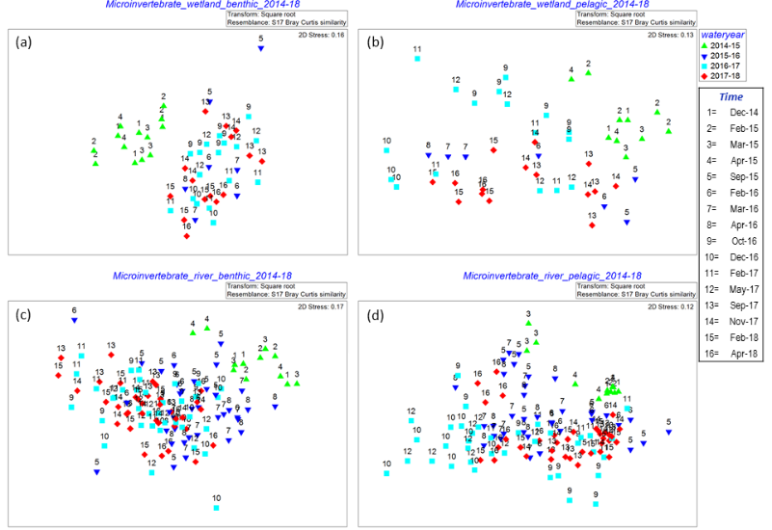
Figure D-16: nMDS ordination of microinvertebrate community composition using abundance dataset by sampling occasions and water year in (a) wetland benthic habitat, (b) wetland pelagic habitat, (c) river benthic habitat and (d) river pelagic habitat in 2014-18.

Discussion
In this water year, microinvertebrate sampling successfully captured the inundation and contraction cycle delivered by environmental watering actions in the Selected Area. The September and November 2017 sampling periods captured two environmental flow events aimed at creating low steady flows in the Gwydir and Mehi Rivers. Sampling in February 2018 captured post environmental water conditions while sampling in April 2018 was during natural base flow conditions in the Selected Area.
Microinvertebrate density and composition appeared to reflect variations in chlorophyll a concentrations across ecosystems and habitats, with higher microinvertebrate density in post environmental water and natural base flow periods, suggesting secondary production was stimulated by increases in water column primary production. During the contraction periods, an increase in microinvertebrate secondary productivity was supported by higher nutrient and carbon concentrations delivered to wetland environments during wet periods and hydrological conditions conducive for their growth and reproduction. In comparison, microinvertebrate densities were relatively low in the two flow pulses in September and November 2017. As reported in Appendix C, primary productivity measured as chlorophyll a did not respond to high TN input from these events, suggesting that cooler temperatures earlier in the season may limit water column primary production, and not support the same rates of secondary production. Temperature seems to play a critical role in primary and secondary productivity, highlighting the potential ecological significance of the timing of flow events. The other possible explanation for the relatively low density of microinvertebrates is that the environmental flows acted as hydrological disturbances and initiated taxonomic replacement and dilution through longitudinal displacement.
In the Gwydir and Mehi Rivers, higher richness and diversity was observed during the 2017 flow events in both benthic and pelagic habitats. Among all measured environmental variables, lower pH and turbidity during these two periods showed the highest correlation with microinvertebrate taxonomic composition. It is postulated that the longitudinal and lateral connection provided by these environmental water events provided improved water quality conditions and increased diversity of habitats, which led to the more diverse range of microinvertebrate taxa present.
Flow conditions in 2017-18 (peak flow around 9,200 ML/d) were similar in magnitude to 2015-16 (peak flow around 11,400 ML/d). The delivery of environmental water in the current water year contributed to similar patterns in microinvertebrate density, diversity and community composition compared to those observed in 2015-16. Firstly, microinvertebrate densities in both habitats and zones were substantially higher when the system had contracted to remnant pools. Secondly, the diversity of microinvertebrates was enhanced following inundation by environmental water. In contrast, the multiple wetting and drying regime experienced in 2016-17 with peak flow around 39,400 ML/d led to the highest microinvertebrate densities occurring after sediments were inundated for a second time in the lower Gwydir wetlands. This cycle of multiple wetting and drying events within a water year may stimulate microinvertebrate productivity and wetland food webs. It is proposed that inter-annual hydrological variability and antecedent flow condition play important roles in microinvertebrate community, highlighting the potential ecological significance of the frequency and magnitude of flow events.

Conclusion
Monitoring during 2017-18 revealed significant influences on microinvertebrates in both wetland and river systems from two environmental water events that planned to provide small freshes with low and steady flow in late winter and early summer. In the River zones, these two environmental water actions provided steady longitudinal and lateral connection and increased diversity of habitats with improved water quality, in turn, supporting a more diverse range of microinvertebrate taxa. Increases in microinvertebrate density did not occur during these two environmental water actions. Instead, increases coincided with warmer temperatures during the post environmental water and natural base flow period, supported by increased nutrient loads delivered from upstream during environmental water periods. These increased microinvertebrate densities would have provided food resources of native fish, waterbirds and frogs. This suggests that while flows delivered earlier in the water year increase the diversity of microinvertebrates present in the system, that to improve secondary productivity in the system, measured as microinvertebrate densities, flows should be delivered over the warmer months in Summer and Autumn.

References
Clarke, D.R. and Warwick, R.M. 2001. Changes in marine communities: an approach to statistical analysis and interpretation. Natural Environmental Research Council, Plymouth, UK.
Clarke, K.R. & Gorley, R.N., 2006. PRIMER v6: User Manual/Tutorial. PRIMER-E, Plymouth, UK. 192pp.
Commonwealth of Australia. 2015. Commonwealth Environmental Water Office Long Term Intervention Monitoring Project Gwydir River system Selected Area – 2014-15 Evaluation Report. Commonwealth of Australia.
Commonwealth of Australia. 2016. Commonwealth Environmental Water Office Long Term Intervention Monitoring Project Gwydir River system Selected Area - 2015-16 Evaluation Report. Commonwealth of Australia.
Kobayashi, T., Ryder, D. S., Ralph, T. J., Mazumder, D., Saintilan, N., Iles, J., Hunter, S. 2011. Longitudinal spatial variation in ecological conditions in an in‐channel floodplain river system during flow pulses. River Research and Applications, 27(4), 461-472.
Ning, N. S., Gawne, B., Cook, R. A., & Nielsen, D. L. (2013). Zooplankton dynamics in response to the transition from drought to flooding in four Murray–Darling Basin rivers affected by differing levels of flow regulation. Hydrobiologia, 702(1), 45-62.

Macroinvertebrates

Introduction
The Macroinvertebrates indicator aims to assess the contribution of environmental watering to macroinvertebrate abundance and diversity within the Gwydir River system Selected Area (Selected Area). A specific question was addressed through this indicator within the Selected Area during the 2017-18 water year:
- What did Commonwealth environmental water contribute to macroinvertebrate diversity?

Environmental watering in 2017-18
During 2017-18, environmental water was delivered to both in-channel and wetland assets in the Gwydir River system (Error! Reference source not found.). An early season stimulus flow was triggered by inflows to Copeton Dam in August/September 2017. A total of 10,000 ML was delivered into the main Gwydir River, Mehi and Carole Creek systems as a small fresh during late winter/early spring. Following this, a stable flow release of 10,040 ML was delivered into the main Gwydir River, Mehi and Carole Creek systems in late October to mid-November 2017. These small pulse flows were aimed at providing downstream connectivity and allowing opportunity for movement, breeding and recruitment of fish, particularly freshwater catfish (Tandanus tandanus).
A delivery of 8,000 ML including both State and Commonwealth environmental water was made to the lower Gwydir and Gingham wetlands from mid-December 2017 to late January 2018, to replace supplementary take from a small flow event that occurred in the previous months. This aimed to maintain wetland habitat quality, and support the survival and resilience of flora and fauna in the wetlands. The last environmental delivery was made in late April/May 2018 as part of the Northern Connectivity Event. This flow aimed to provide longitudinal connectivity and refresh/replenish drought refuge for instream life, particularly native fish in the Barwon-Darling as well as improving conditions to maintain native fish populations within the tributary catchments. During this event, a total of 18,908 ML of both State and Commonwealth water was delivered down the Mehi River, Moomin Creek and Carole Creek. No environmental water deliveries were made to Mallowa Creek in 2017-18.

Table E-1 Environmental water delivered in the Gwydir River system Selected Area in 2017-18. Percentage represents the percentage of the total flow made up of environmental water.
Channel | Commonwealth Environmental Water (CEW) delivered (ML) | NSW ECA/General Security/Supplementary environmental Water delivered (ML) | 2017-18 total flow (ML) | Environmental Water % of total flow
Gwydir River* | 28,290 | 18,748 (including 15,748 General Security) | 412,705 | 11
Gingham watercourse | 2,000 | 5,534 (including 4,520 General Security) | 22,984 | 33
Lower Gwydir | 2,000 | 5,706 (including 4,520 General Security) | 19,831 | 39
Carole Creek | 3,886 | 2,462 (including 1,662 General Security) | 95,341 | 7
Mehi River< | 20,404 | 5,046 general security | 91,067 | 28
Moomin Creek# | 324 | 175 | 104,075 | 0.5
Mallowa Creek | 0 | 0 | 121 | 0
Total | 28,290 | 18,748 (including 15,748 General Security) | 412,705 | 11
* All environmental water delivery to the Gwydir system flowed through the Gwydir River in 2017-18. Therefore, volumes for this channel represent total volumes delivered downstream and as such are not included in the total.
< Includes 499 ML that flowed down Moomin Creek, but returned to the Mehi downstream. Also includes 90 ML NSW General Security water for delivery to Whittaker’s Lagoon.
# Not included in total as accounted in return flows to Mehi.

Previous monitoring
Three years of macroinvertebrate monitoring in the Selected Area showed the delivery of environmental water contributed to consistent patterns in macroinvertebrate density, diversity and community composition. The delivery of environmental water increased secondary production measured as density and regional scale diversity of aquatic macroinvertebrates. Connectivity provided by environmental water provided an opportunity for macroinvertebrates to take advantage of increased primary production resulting from inundation, before declining water levels and associated water quality created unsuitable conditions for some sensitive macroinvertebrate families. Significant differences in aquatic macroinvertebrate community composition between the Gingham and lower Gwydir wetlands indicated that each area supports a distinct macroinvertebrate community and highlights the importance of watering both wetlands to maintain regional level diversity.

Methods

Design
Macroinvertebrates sampling took place in association with Category III microinvertebrate indicators. Sampling sites were located in five Sampling Zones within the Selected Area: Gingham watercourse, lower Gwydir wetlands, Gwydir River, Mehi River and Moomin Creek (Figure E-1). Sampling took place on four occasions to capture the inundation and contraction cycle of environmental water delivery to wetlands (Table E-2, Appendix A). Hereafter, sampling occasion codes are arranged in chronological order from T1 to T4. Hydrological conditions within the Selected Area during four sampling periods are described as follows.
T1 Early Season Stimulus Triggered Flow
This late winter sampling (2nd - 5th September 2017) was conducted during the Early Season Stimulus Triggered Flow (26th August - 4th September 2017) with 7 GL from CEWO and 3 GL from NSW EWA. This event was planned to provide an early small fresh and with a low steady flow during late winter into spring targeting in-stream and native fish outcomes in the Gwydir River, Mehi River and Carole Creek. The lower Gwydir wetlands and Gingham watercourse received small inflows of upstream environmental water delivery during this period.
T2 Stable Fish Flow
This early summer sampling (13th - 16th November 2017) was designed to capture the Stable Fish Flow event that ran for 3 weeks (30th October - 20th November 2017) during a pause in irrigation deliveries. This event aimed to provide small stable in-channel low flows and to avoid rapid rates of water level rise and fall in the Gwydir River, Mehi River and Carole Creek, with 5 GL from CEWO and 5.04 GL from NSW AEW. The stable flow delivery was targeted on supporting native fish outcomes including recruitment. This event also aimed to deliver environmental water into the lower Gwydir wetlands (2.37GL) and the Gingham watercourse (2.52GL). As a result, the upper and eastern sections of the lower Gwydir wetlands and Gingham watercourse received inflows.
T3 Post EW condition in the Gwydir channels and Wetlands
This late summer sampling (21st – 23rd February 2018) captured post environmental water conditions with the latest supplementary environmental water release (8GL in total, 4GL from CEWH) into the lower Gwydir wetlands and Gingham watercourse during 19th December 2017 to 3rd January 2018. Residual environmental water maintained surface water in the lower Gwydir wetlands and Gingham watercourse one month after the event. The Gwydir River was in the falling flow limb with average discharge of 1,100 ML/d (418001 Gwydir @ Pallamallawa) while the Mehi River experienced a pulse of irrigation water delivery during this sampling occasion.
T4 Base flow period
Autumn sampling (6th – 10th April 2018) represents a natural dry condition of the system. All river systems were in base flow condition with discontinuous longitudinal connectivity. Discharge in the Gwydir River was below 150 ML/d (418001 Gwydir @Pallamallawa) and the Mehi River was below 60 ML/d (418044 Mehi D/S @ Tareelaroi) for one month. The Gingham watercourse was in a contraction phase and the lower Gwydir wetlands were predominantly dry.

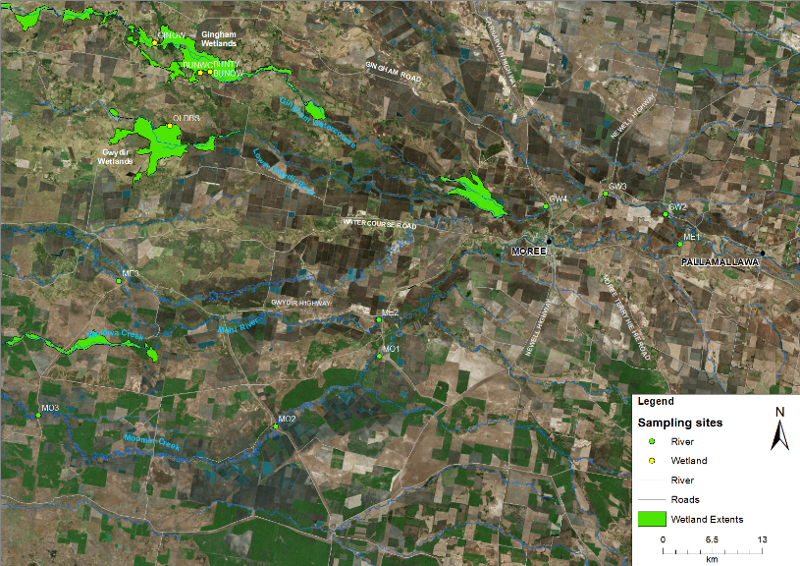
Figure E-1: Location of macroinvertebrate sites within the Selected Area in 2017-18. See Table E-2 for site codes.

Table E-2: Location of sites within the Gwydir River Selected Area for macroinvertebrate surveys.
Ecosystem | Sampling Zone | Site | Easting | Northing | Inundation
 |  |  |  |  | Sep-17  (T1) | Nov-17  (T2) | Feb-18  (T3) | Apr-18  (T4)
Wetland | Gingham watercourse | BUNOW | 731409 | 6759165 | Wet | Wet | Wet | Wet
 |  | BUNTY | 731394 | 6759148 | Wet | Wet | Wet | Wet
 |  | GINWH | 724103 | 6762962 | Wet | Wet | Wet | Wet
 | lower Gwydir wetlands | OLDBS | 726067 | 6752088 | Wet | Wet | Wet | Dry
River | Gwydir River | GW2 | 209205 | 6740455 | Wet | Wet | Wet | Wet
 |  | GW3 | 783417 | 6743135 | Wet | Wet | Wet | Wet
 |  | GW4 | 775597 | 6741491 | Wet | Wet | Wet | Wet
 | Mehi River | ME1 | 211342 | 6736610 | Wet | Wet | Wet | Wet
 |  | ME2 | 753566 | 6726596 | Wet | Wet | Wet | Wet
 |  | ME3 | 719420 | 6731644 | Wet | Wet | Wet | Wet
 | Moomin Creek | MO1 | 753679 | 6721789 | Wet | Wet | Wet | Wet
 |  | MO2 | 740017 | 6712590 | Wet | Wet | Wet | Wet
 |  | MO3 | 708808 | 6714077 | Wet | Wet | Wet | Wet

Field and laboratory methods
Macroinvertebrate indicator monitoring was conducted following the Standard Operating Procedures in Hale et al. (2013).

Statistical methods
To describe and summarize the diversity of macroinvertebrate community composition, taxa richness (S), Shannon Weiner diversity (d) and density (number of individual/m²) were calculated in PRIMER v6.1.13 using the DIVERSE function. PERMANOVA routine was used to test the difference in S, d and density between time (with 4 random levels, Sept-17, Nov-17, Feb-18 and Apr-18), zone (with 5 fixed levels, Gingham watercourse, lower Gwydir wetlands, Gwydir River, Mehi River and Moomin Creek) and time x zone interactions.
Community composition data were transformed into two datasets that weigh the contributions of common and rare species differently. (1) Presence-absence data represents actual taxa occurrence in a community. (2) Abundance data (square root transformation to stabilize variance and to improve normality; Clarke and Warwick, 2001) represents relative proportions of taxa occurrence in a community. Since different sampling methods were used for benthic and pelagic habitats, a permutational multivariate analysis of variance (PERMANOVA) analysis was used to test the difference in the macroinvertebrate community composition between time (with 4 fixed levels, Sept-17, Nov-17, Feb-18 and Apr-18), zone (with 5 fixed levels, Gingham watercourse, lower Gwydir wetlands, Gwydir River, Mehi River and Moomin Creek) and time x zone interactions. Up to 999 random permutations estimated the probability of p-values, with levels of significance reported as p<0.05.
A Bray-Curtis dissimilarity matrix was generated by rank correlating the community structure between samples. Then, nonmetric multidimensional scaling ordinations (nMDS) were used to visualise community patterns and similarity percentages (SIMPER) were used to determine the taxa contributing to the observed community patterns. nMDS output with stress values of less than 0.2 were considered appropriate for interpretation (Clarke and Warwick, 2001).
Water quality and nutrient indicators reported in Appendix C were used to relate environmental indicators to macroinvertebrate patterns. BIOENV analysis was used to examine which water quality and nutrient indicators are link to the patterns of macroinvertebrate community composition in PRIMER-E (2009). All analyses were performed in PRIMER v6.1.13 with the PERMANOVA+ v1.0.3 add-on package (Clarke and Warwick, 2006).

Results
A total of 72 taxa were identified from 51 samples. The 13 most abundant taxa (>1% in total abundance) comprised 90% of the total abundance with the most abundant taxa family Corixidae (23% of the total abundance). The other most abundant taxa were Atyidae (16%), Chironomidae (12%) and Baetidae (10%) that occurred in more than 60% of sites and sampling occasions.

Density
Across all sites and sampling occasions, macroinvertebrate density ranged from 9 to 765 individuals/m² (Figure E-2) with a significant interaction between time and zone (Pseudo-F=3.306, p<0.005). Macroinvertebrate density was significantly lower in T1 and T2 than in T4 (p<0.05). Both wetlands and the Gwydir River had significantly higher densities than the Mehi River and Moomin Creek (p<0.05). Average macroinvertebrate densities recorded in this water year were similar to those found in previous years (Table E-3).

Figure E-2: Mean ± standard deviation (SD) of macroinvertebrate density (individuals/m²). No SD reported in the Lower Gwydir as only one site was surveyed.
Table E-3: Mean macroinvertebrate density, richness and diversity in 2014-18.
Year | Ecosystem | Mean density | Mean richness | Mean diversity
2014-15 | Wetland | 144 | 14.2 | 1.93
 | River (GW only) | 120 | 9.9 | 1.46
2015-16 | Wetland | 239 | 12.7 | 2.35
 | River | 235 | 10.8 | 2.06
2016-17 | Wetland | 262 | 12.4 | 1.58
 | River | 234 | 12.5 | 1.56
2017-18 | Wetland | 307 | 12.7 | 1.52
 | River | 190 | 11.7 | 1.49

Diversity indices
Taxonomic richness ranged from 5 to 28 taxa (Figure E-3a). Taxonomic richness was significantly lower in T1 and T2 than in T3 (p<0.05). The lower Gwydir wetlands had significantly higher taxonomic richness than all rivers (p<0.05). There was also a significant interaction between time and zone (Pseudo-F=2.7221, p<0.01,) with the highest richness record in the lower Gwydir wetlands in February 2018. Diversity ranged from 0.68 to 2.45 with no consistent temporal or spatial pattern observed in the 2017-18 data. Like macroinvertebrate taxonomic richness, the lower Gwydir wetlands had the highest diversity recorded in Feb-18. Macroinvertebrate taxonomic richness and diversity observed in this water year were similar to the 2016-17 water year (Table E-3).

Figure E-3: Mean ± standard deviation (SD) of macroinvertebrate (a) taxonomic richness and (b) diversity. No SD reported in the Lower Gwydir as only one site was surveyed.

Taxonomic composition
PERMANOVA results indicated that the taxonomic composition was significantly different between wetland and river ecosystems (Pseudo-F=6.8552, p=0.001) based on both macroinvertebrate abundance and presence-absence datasets. The dissimilarity between wetland and river is shown in the nMDS ordination (Figure E-4). Since the taxonomic composition was predominantly driven by ecosystem, two datasets by ecosystem type were developed to further explore the effects of time and zone.
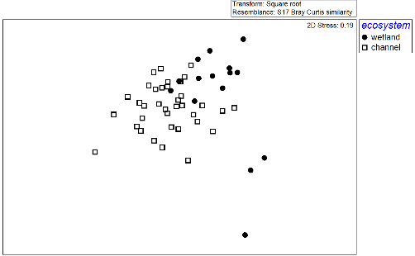
Figure E-4: nMDS ordination of macroinvertebrate community composition by ecosystem type (wetland and river channel) using the abundance dataset.

Wetlands
Two-way PERMANOVA analyses showed a significant time and zone interaction based on wetland macroinvertebrate abundance (Table E-4). The nMDS ordination (Figure E-5a) showed temporal and spatial patterns in community composition. Macroinvertebrate community composition was significantly different between T1 and T3 (p<0.05, Figure E-5b). The community taxonomic differences between sampling periods were driven by higher abundance of Corixidae, Corixidae nymphs, Ostracoda and Ceratopogonidae and lower abundance of Collembola during T3 (Table E-5).
There was also a significant difference between the community composition of the lower Gwydir wetlands and Gingham watercourse (Figure E-5b). This spatial difference was driven by higher abundances of Collembola, Dytiscidae, Dytiscidae nymphs and Chironominae and lower abundance of Corixidae and Corixidae nymphs in the lower Gwydir wetlands (Table E-6).
All environmental variables were subsequently fitted into the ordination space as vectors to show those variables that were correlated to community patterns (Figure E-5c). The BIOENV result showed that the community composition was correlated to higher SRP concentrations and lower conductivity in the lower Gwydir wetland (Table E-7). This spatial community composition difference was also strongly correlated to higher macroinvertebrate density in the lower Gwydir wetlands (Figure E-5d).
Table E-4: PERMANOVA results of macroinvertebrate community composition by ecosystems (wetland and river) using the abundance dataset (*significant level at P<0.05).
Term | Wetland |  | River
 | Pseudo-F | P | Pseudo-F | P
Time | 1.4669 | 0.063 | 4.0865 | 0.001*
Zone | 7.3632 | 0.003* | 1.8756 | 0.017*
Time x Zone | 1.9164 | 0.021* | 1.0524 | 0.387
Table E-5: Macroinvertebrate taxa contributing most of the dissimilarities in wetland ecosystem between times based on abundance dataset. Bold numbers represent the higher average abundance group.
Taxa | Average Abundance |  |  |  | Contribution %
 | T1 | T2 | T3 | T4 | T1 vs T3
F.Corixidae | 3.7 | 5.2 | 11.0 | 13.3 | 12.3
F.Corixidae nymphs | 2.1 | 3.8 | 7.4 | 5.9 | 9.6
C. Ostracoda | 0.4 | 0.3 | 5.6 | 0.6 | 7.6
sC. Collembola | 5.9 | 0.0 | 0.5 | 0.0 | 7.3
F.Ceratopogonidae | 2.2 | 0.0 | 3.2 | 0.0 | 5.4

Table E-6: Macroinvertebrate taxa contributing most of the dissimilarities in wetland ecosystem between zones based on abundance dataset. Bold numbers represent the higher average abundance group.
Taxa | Average Abundance |  | Contribution %
 | GIN | OLD | GIN vs OLD
F.Corixidae | 9.8 | 0.5 | 10.5
sC. Collembola | 0.1 | 8.2 | 9.7
F.Corixidae nymphs | 5.9 | 0.0 | 6.7
F.Dytiscidae | 0.7 | 4.1 | 4.6
F.Dytiscidae nymphs | 0.1 | 4.0 | 4.3
F.Chironomidae | 4.2 | 4.5 | 4.3

Table E-7: BIOENV results of macroinvertebrate community composition in wetland and river ecosystems based on abundance dataset. “v” represents significant environmental variables.
Ecosystem | Rho | p | Environmental variables
 |  |  | Temperature | Conductivity | Turbidity | TN | SRP | Chla
Wetland | 0.512 | 0.015 |  | v |  |  | v
River | 0.443 | 0.001 | v | v | v | v |  | v

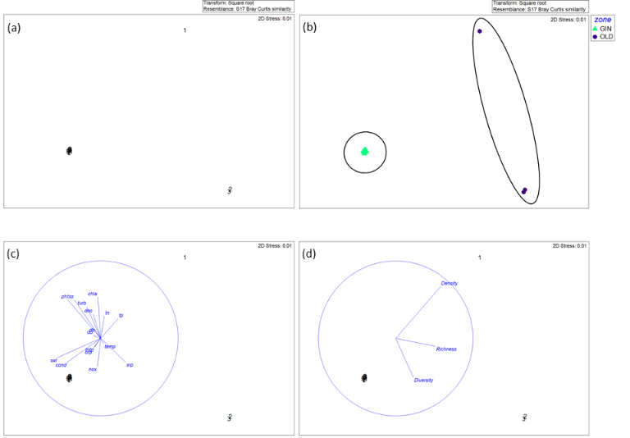
Figure E-5: nMDS ordination of wetland macroinvertebrate community composition using abundance dataset showing (a) by time, (b) by zone, (c) by time with vectors of environmental variables (normalised data, Spearman correlation) which underlie the environmental patterns and (d) by time with vectors of macroinvertebrate density and biodiversity indices (normalised data, Spearman correlation). 1=Sep-17, 2=Nov-17, 3=Feb-18 and 4=Apr-18 while GIN=Gingham watercourse and OLD=Lower Gwydir wetland.

River
Two-way PERMANOVA analyses showed significant time and zone differences based on macroinvertebrate abundance (Table E-4). The nMDS ordination showed a temporal and spatial shift in community composition (Figure E-6a and b). Macroinvertebrate community composition was significantly different between T1 and T2 sampling periods, and T3 and T4 sampling periods (p<0.05). Differences in community composition between times was driven by changes in abundance of five macroinvertebrate taxa (Table E-8). There was also a significant difference between the Moomin Creek and Gwydir and Mehi Rivers. The community difference was driven by higher abundance in Palaemonidae, Beatidae, Chironomidae and lower abundance in Corixidae in the Gwydir and Mehi Rivers (Table E-9).
All environmental variables were subsequently fitted into the ordination space as vectors to show those variables that correlated to community patterns (Figure E-6c). The BIOENV result showed that the community composition at river sites was correlated with changes in temperature, conductivity, tubidity, TN and chlorophyll a concentrations (Table E-7). In contrast, differences in spatial and temporal community composition was not strongly correlated to macroinvertebrate density and biodiversity indices (Figure E-6d).
Table E-8: Macroinvertebrate taxa contributing most of the dissimilarities in river ecosystem between times based on abundance dataset. Bold numbers represent the higher average abundance group.
Taxa | Average Abundance |  |  |  | Contribution %
 | T1 | T2 | T3 | T4 | T1 vs T3,T4 | T2 vs T3,T4
F.Corixidae | 5.2 | 5.0 | 3.3 | 3.6 | 9.1 | 12.2
F.Atyidae | 3.3 | 5.8 | 4.9 | 6.3 | 9.8 | 11.8
F.Baetidae | 2.4 | 3.7 | 5.0 | 4.0 | 8.8 | 8.9
F.Chironomidae | 4.9 | 2.5 | 5.7 | 5.2 | 6.5 | 9.2
F.Palaemonidae | 0.0 | 1.7 | 5.7 | 7.0 | 14.3 | 13.8

Table E-9: Macroinvertebrate taxa contributing most of the dissimilarities in river ecosystem between zones based on abundance dataset. Bold numbers represent the higher average abundance group.
Taxa | Average Abundance |  | Contribution %
 | GW, ME | MO | GW,ME vs MO
F.Corixidae | 3.8 | 5.3 | 12.6
F.Atyidae | 5.1 | 5.1 | 12.2
F.Palaemonidae | 3.9 | 3.1 | 10.5
F.Baetidae | 4.8 | 1.8 | 9.1
F.Chironomidae | 4.9 | 4.0 | 7.5

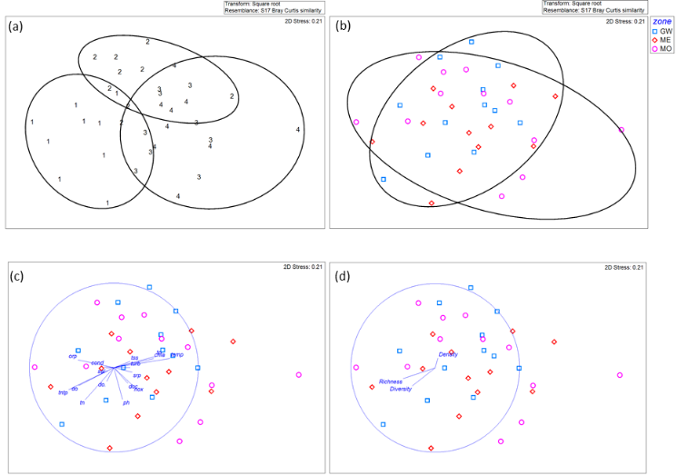
Figure E-6: nMDS ordination of river macroinvertebrate community composition using abundance dataset showing (a) by time, (b) by zone, (c) by zone with vectors of environmental variables (normalised data, Spearman correlation) which underlie the environmental patterns and (d) by zone with vectors of macroinvertebrate density and biodiversity indices (normalised data, Spearman correlation). 1=Sep-17, 2=Nov-17, 3=Feb-18 and 4=Apr-18.

Discussion
The lower Gwydir wetlands displayed a higher density and taxonomic richness than all other zones during the first three flow events. This pattern highlights that longer duration of both longitudinal and lateral connection supported by environmental water provides improved water quality and increased inundated habitat diversity, stimulating macroinvertebrate productivity in this wetland environment. The highest richness and diversity within the lower Gwydir wetlands was found during sampling following environmental water deliveries in December/January 2018 and may be linked to the presence of diverse habitats and basal resources that in turn supported a more diverse assemblage of macroinvertebrate taxa. The influence of environmental water on macroinvertebrate diversity can persist through time and contribute to high diversity for at least two months following environmental water delivery.
In the Gwydir and Mehi Rivers, the first two flow events of the season led to the lowest macroinvertebrate density and taxonomic richness when all river systems were longitudinally connected with an average discharge of 3,000 ML/d for 50 days. These results suggest that environmental water initiated taxonomic replacement through longitudinal displacement that favoured flow-resistant taxa. As a result, flow-resistant taxa such as Baetidae which have streamlined body shapes, were in higher relative abundance than flow-prone taxa such as Caenidae during this period (Gooderham and Tsyrlin, 2002). Macroinvertebrate density and community composition appeared to link to variations in chlorophyll a concentration and temperature in the Gwydir and Mehi Rivers, with higher densities observed during the post-Supplementary environmental water period and natural base flow period. This suggests secondary production followed water column primary production and increased temperature. During the contraction periods, macroinvertebrate secondary productivity increased, supported by nutrients delivered during environmental periods and hydrological conditions conducive for growth and reproduction. This pattern in river zones mimics the findings of microinvertebrate density (Appendix D), and suggests flows that are delivered to increase invertebrate productivity, should be delivered during the warmer months of the year.
Environmental water that contributed to the cycle of inundation and contraction over the 2017-18 water year, provided an opportunity for long term community succession due to changes in local physical and chemical environmental conditions. Macroinvertebrate community composition was significantly different between sampling occasions, between and within rivers and wetlands, suggesting that the promotion of regional scale macroinvertebrate diversity within the Selected Area requires the inundation of both river and wetland areas. Continuing the multi event watering strategy as has been employed in the Gwydir system will encourage a productive microinvertebrate community across the system, which will provide benefits for higher order consumers such as fish, frogs and waterbirds.

Conclusion
During the 2017-18 water year, the lower Gwydir wetlands received inflows from several environmental flow events. These three environmental water actions provided longer duration of residual environmental water and maintained surface water presence in the lower Gwydir wetlands until February 2018, in turn, supporting higher macroinvertebrate density and taxonomic richness than all other zones. In the Gwydir and Mehi Rivers, peak macroinvertebrate density did not occur during the environmental flow deliveries. Instead, increases in macroinvertebrate density occurred later, when warmer temperatures during base flow periods coincided with peak chlorophyll a concentrations, in turn supporting food resources for native fish, waterbirds and frogs. This highlight the potential ecological significance of the timing of environmental flow events. The significant differences in macroinvertebrate community composition between rivers and wetlands, and between the four sampling occasions indicates the benefits of delivering environmental water to multiple assets within the Selected Area throughout the season, to maintain regional level diversity.

References
Clarke, K. R. & Warwick, R. M. 2001. Changes in marine communities: an approach to statistical analysis and interpretation. Natural Environmental Research Council, Plymouth, UK.
Clarke, K.R. & Gorley, R.N., 2006. PRIMER v6: User Manual/Tutorial. PRIMER-E, Plymouth, UK. 192pp.
Gooderham, J. and Tsyrlin, E., 2002. The waterbug book: a guide to the freshwater macroinvertebrates of temperate Australia. CSIRO publishing.
Hale, J., Stoffels, R., Butcher, R., Shackleton, M., Brooks, S., Gawne, B., & Stewardson, M. 2014. Commonwealth Environmental Water Office Long Term Intervention Monitoring Project – Standard Methods. Final Report prepared for the Commonwealth Environmental Water Office by The Murray-Darling Freshwater Research Centre, MDFRC Publication 29.2/2014, January, 175 pp.

