Ecosystem Type

Introduction
River systems, such as the Gwydir River system are known for containing a diverse array of different ecosystems which support many processes and organisms. These ecosystems have been defined by the (Interim) Australian National Aquatic Ecosystem (ANAE) Classification Framework (Brooks et al. 2013). In the Gwydir system, 10 ANAE ecosystem types are monitored as part of the LTIM project, across riverine, floodplain and lacustrine types.
The Ecosystem Type indicator contributes to the broader scale evaluation of Commonwealth environmental water’s influence on ecosystem diversity. While primarily designed to inform at larger basin scales, information on the types of ecosystems influenced by Commonwealth environmental water is also useful at the Selected Area scale. Several specific questions were addressed by measuring ecosystem type within the Gwydir River Selected Area during the 2017-18 water year:
- What did Commonwealth environmental water contribute to sustainable ecosystem diversity?
- Were ecosystems to which Commonwealth environmental water was allocated sustained?
- Was Commonwealth environmental water delivered to a representative suite of ecosystem types?

Previous monitoring findings
Generally, a high proportion (between eight and 10) of ecosystem types that are monitored have been inundated over the previous three years of the project, with environmental water influencing the majority. In 2016-17 68% of sites were influenced by environmental water from all ecosystem types except F1.10: River cooba woodland floodplain and Lt2.2: Temporary floodplain lake. In 2015-16, 60% of all sites were inundated by environmental water from the same eight ecosystem types as were inundated in 2016-17.

Environmental watering in 2017-18
During 2017-18, environmental water was delivered to both in-channel and wetland assets in the Gwydir River system (Table F-1). An early season stimulus flow was triggered by inflows to Copeton Dam in August/September 2017. A total of 10,000 ML was delivered into the main Gwydir River, Mehi and Carole Creek systems as a small fresh during late winter/early spring. Following this, a stable flow release of 10,040 ML was delivered into the main Gwydir River, Mehi and Carole Creek systems in late October to mid-November 2017. These small pulse flows were aimed at providing downstream connectivity and allowing opportunity for movement, breeding and recruitment of fish, particularly freshwater catfish (Tandanus tandanus).
A delivery of 8,000 ML including both State and Commonwealth environmental water was made to the lower Gwydir and Gingham wetlands from mid-December 2017 to late January 2018, to replace supplementary take from a small flow event that occurred in the previous months. This aimed to maintain wetland habitat quality, and support the survival and resilience of flora and fauna in the wetlands. The last environmental delivery was made in late April/May 2018 as part of the Northern Connectivity Event. This flow aimed to provide longitudinal connectivity and refresh/replenish drought refuge for instream life, particularly native fish in the Barwon-Darling as well as improving conditions to maintain native fish populations within the tributary catchments. During this event, a total of 18,908 ML of both State and Commonwealth water was delivered down the Mehi River, Moomin Creek and Carole Creek. No environmental water deliveries were made to Mallowa Creek in 2017-18.
Table F-1 Environmental water delivered in the Gwydir River system Selected Area in 2017-18. Percentage represents the percentage of the total flow made up of environmental water.
Channel | Commonwealth Environmental Water (CEW) delivered (ML) | NSW ECA/General Security/Supplementary environmental Water delivered (ML) | 2017-18 total flow (ML) | Environmental Water % of total flow
Gwydir River* | 28,290 | 18,748 (including 15,748 General Security) | 412,705 | 11
Gingham watercourse | 2,000 | 5,534 (including 4,520 General Security) | 22,984 | 33
Lower Gwydir | 2,000 | 5,706 (including 4,520 General Security) | 19,831 | 39
Carole Creek | 3,886 | 2,462 (including 1,662 General Security) | 95,341 | 7
Mehi River< | 20,404 | 5,046 general security | 91,067 | 28
Moomin Creek# | 324 | 175 | 104,075 | 0.5
Mallowa Creek | 0 | 0 | 121 | 0
Total | 28,290 | 18,748 (including 15,748 General Security) | 412,705 | 11
* All environmental water delivery to the Gwydir system flowed through the Gwydir River in 2017-18. Therefore, volumes for this channel represent total volumes delivered downstream and as such are not included in the total.
< Includes 499 ML that flowed down Moomin Creek, but returned to the Mehi downstream. Also includes 90 ML NSW General Security water for delivery to Whittaker’s Lagoon.
# Not included in total as accounted in return flows to Mehi.

Methods
The ANAE classification for each sampling site in the Gwydir river system Selected Area was mapped using a process of desk-top identification and field verification (Commonwealth of Australia 2014). Existing ANAE GIS layers (Brooks et al. 2013) were used to assign an ecosystem type to each monitoring site, and this was then verified in the field. Sites where existing ANAE mapping did not provide coverage were assigned an ANAE classification using available desktop information and then verified in the field. No new sites were added to the Gwydir LTIM project in the 2017-18 water year. Inundation status at each site was assessed using a combination of gauged flow data, inundation mapping (Appendix B) and field observations.

Results
Monitoring was undertaken at 135 sites within the Selected Area in 2017-18. Within the Selected Area, a total of 99 sites (73% of all sites), were inundated during the 2017-18 water year (Figure F-1 and Figure F-2). These fell into 9 ANAE ecosystem types, including five Riverine types, two Floodplain types and two Lacustrine types (Figure F-1). Not all sites within the F1.11: River cooba woodland floodplain, F3.2: Sedge/forb/grassland floodplain and Rt1.4: Temporary lowland streams and no sites within F1.10: Coolibah woodland and forest floodplain were inundated. All sites within the remaining ecosystem types were inundated (Table F-2).
Environmental flows contributed to inundation at 73 sites across all zones. Seven ecosystem types were inundated by environmental flows, with F1.10: Coolibah woodland and forest floodplain, F1.11: River cooba woodland floodplain and Lt2.2: Temporary floodplain lake being the ecosystem types that were not inundated by environmental flows.

Figure F-1: Distribution of ANAE ecosystem types inundated across the four monitoring zones within the Selected Area in 2017-18.

Table F-2: ANAE Ecosystem types covered by monitoring sites in the Gwydir River Selected Area LTIM project in 2017-18, and the sites which were inundated by both natural and environmental flows.
ANAE Typology | Number of sites (All Zones) | Number of sites inundated (All Zones)
F1.10: Coolibah woodland and forest floodplain | 2 | 0
F1.11: River cooba woodland floodplain | 14 | 4
F3.2: Sedge/forb/grassland floodplain | 36 | 13
Lp2.1: Temporary floodplain lake | 2 | 2
Lt2.2: Temporary floodplain lake with aquatic beds | 5 | 5
Rp1.1: Permanent high energy upland streams | 1 | 1
Rp1.3: Permanent low energy upland streams | 5 | 5
Rp1.4: Permanent lowland streams | 49 | 48
Rt1.3: Temporary low energy upland streams | 3 | 3
Rt1.4: Temporary lowland streams | 18 | 18
Total | 135 | 99

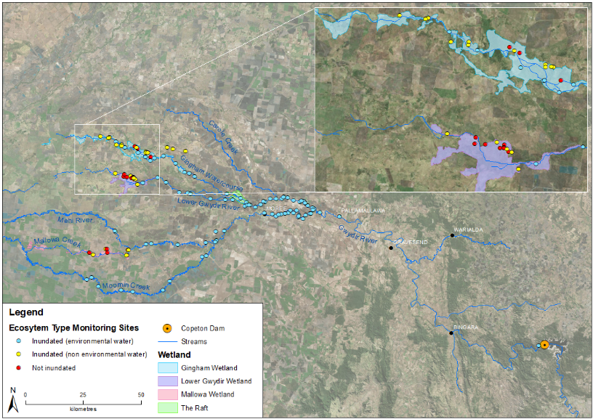
Figure F-2: Inundation status of sites sampled in the Selected Area during the 2017-18 water year.

Discussion
The types of ecosystems monitored in this project reflect the nature of the delivery of environmental water, and the indicators being assessed. Given the emphasis on eco-hydrologic links, the dominance of Riverine Ecosystem types is self-evident. The large representation of sites within the Sedge/forb/grassland floodplain type reflects the dominance of this type in low lying areas of the Gwydir and Gingham watercourse zone. These ecosystems commonly form the target for environmental watering in this system.
In 2017-18, 73% of sites across eight of the 10 ecosystem types monitored in the Selected Area were inundated. This is compared to 93% of sites across all ten ecosystem types in 2016-17. Of these, environmental water contributed to 74% of all sites inundated in 2018-17, compared to 65% of inundated sites 2016-17. During the 2016-17 water year, Commonwealth environmental water influenced sites within the Gingham-Gwydir, Gwydir River, Mallowa and Mehi-Moomin zones. In the 2017-18 water year, Commonwealth environmental water influenced sites within all zones except the Mallowa. Whilst monitoring sites in the Mallowa may have been inundated in the 2017-18 water year, inundation was due to localised rainfall pooled in floodplain depressions or existing farm dams. Ecosystem types that were not inundated during the year by Commonwealth environmental water included coolibah woodland and forest floodplain, river cooba woodland floodplain and temporary floodplain lake in the Gingham-Gwydir and Mallowa zones.

Conclusion
The results from the ecosystem type indicator suggest that even in dry years, as was experienced in 2017-18, a reasonable suite of Riverine, Floodplain and lacustrine ecosystem types were influenced by the delivery of environmental water, helping to maintain ecosystem diversity across the Selected Area.

References
Brooks, S., Cottingham, P., Butcher, R, & Hale, J. 2013. Murray Darling aquatic ecosystem classification: Stage 2 report. Prepared by Peter Cottingham & Associates for the Commonwealth Environmental Water Office and Murray Darling Basin Authority, Canberra.
Commonwealth of Australia. 2014. Commonwealth Environmental Water Office Long Term Intervention Monitoring Project Gwydir River System Selected Area. Commonwealth of Australia.

Vegetation Diversity

Introduction
The wetlands of the lower Gwydir system support a number of water dependent vegetation communities, including flood dependent woodlands (supporting vegetation communities with dominant tree species such as coolibah (Eucalyptus coolabah) and black box (Eucalyptus largiflorens), floodplain wetland communities (supporting river red gum (Eucalyptus camaldulensis), coolibah woodlands and river cooba (Acacia stenophylla) and lignum (Duma florulenta) shrubland species and semi-permanent wetlands (supporting species such as water couch (Paspalum distichum), marsh club-rush (Bolboschoenus fluviatilis), spike rush (Eleocharis sp.), tussock rushes (Juncus aridicola), sedges (Carex sp.) and cumbungi (Typha sp.) (Bowen and Simpson 2010). The area occupied by these communities has declined since river regulation due to both restricted flows and clearing for agriculture (Wilson et al. 2009, Bowen and Simpson 2010). Maintaining the current extent and then improving and maintaining the health of these communities has become a target for environmental water management in the Gwydir catchment (DECC 2011, Commonwealth of Australia 2014a). Two specific questions were addressed through the monitoring of vegetation diversity in the 2017-18 water year in the Gwydir wetlands:
- What did Commonwealth environmental water contribute to vegetation species diversity?
- What did Commonwealth environmental water contribute to vegetation community diversity?

Environmental watering in 2017-18
During 2017-18, environmental water was delivered to both in-channel and wetland assets in the Gwydir River system (Table G-1). An early season stimulus flow was triggered by inflows to Copeton Dam in August/September 2017. A total of 10,000 ML was delivered into the main Gwydir River, Mehi and Carole Creek systems as a small fresh during late winter/early spring. Following this, a stable flow release of 10,040 ML was delivered into the main Gwydir River, Mehi and Carole Creek systems in late October to mid-November 2017. These small pulse flows were aimed at providing downstream connectivity and allowing opportunity for movement, breeding and recruitment of fish, particularly freshwater catfish (Tandanus tandanus).
A delivery of 8,000 ML including both State and Commonwealth environmental water was made to the lower Gwydir and Gingham wetlands from mid-December 2017 to late January 2018, to replace supplementary take from a small flow event that occurred in the previous months (Figure G-1). This aimed to maintain wetland habitat quality, and support the survival and resilience of flora and fauna in the wetlands. The last environmental delivery was made in late April/May 2018 as part of the Northern Connectivity Event. This flow aimed to provide longitudinal connectivity and refresh/replenish drought refuge for instream life, particularly native fish in the Barwon-Darling as well as improving conditions to maintain native fish populations within the tributary catchments. During this event, a total of 18,908 ML of both State and Commonwealth water was delivered down the Mehi River, Moomin Creek and Carole Creek. No environmental water deliveries were made to Mallowa Creek in 2017-18 (Figure G-2).

Table G-1: Environmental water delivered in the Gwydir River system Selected Area in 2017-18. Percentage represents the percentage of the total flow made up of environmental water.
Channel | Commonwealth Environmental Water (CEW) delivered (ML) | NSW ECA/General Security/Supplementary environmental Water delivered (ML) | 2017-18 total flow (ML) | Environmental Water % of total flow
Gwydir River* | 28,290 | 18,748 (including 15,748 General Security) | 412,705 | 11
Gingham watercourse | 2,000 | 5,534 (including 4,520 General Security) | 22,984 | 33
Lower Gwydir | 2,000 | 5,706 (including 4,520 General Security) | 19,831 | 39
Carole Creek | 3,886 | 2,462 (including 1,662 General Security) | 95,341 | 7
Mehi River< | 20,404 | 5,046 general security | 91,067 | 28
Moomin Creek# | 324 | 175 | 104,075 | 0.5
Mallowa Creek | 0 | 0 | 121 | 0
Total | 28,290 | 18,748 (including 15,748 General Security) | 412,705 | 11
* All environmental water delivery to the Gwydir system flowed through the Gwydir River in 2017-18. Therefore, volumes for this channel represent total volumes delivered downstream and as such are not included in the total.
< Includes 499 ML that flowed down Moomin Creek, but returned to the Mehi downstream. Also includes 90 ML NSW General Security water for delivery to Whittaker’s Lagoon.
# Not included in total as accounted in return flows to Mehi.

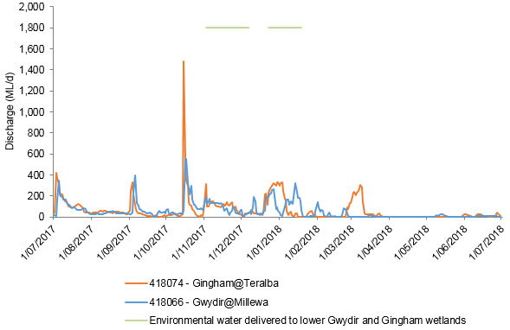
Figure G-1: Flows into the Gingham and lower Gwydir systems during 2016-17 including the delivery of environmental water.

Figure G-2: Flows into the Mallowa System during 2017-18 including the delivery of environmental water.

Previous monitoring
Vegetation monitoring for the LTIM project has been undertaken since December 2014 by Eco Logical Australia and NSW OEH at 40 sites within the Gingham, lower Gwydir and Mallowa wetlands.
During the 2014-15 water year, the delivery of environmental water into the Gwydir wetlands positively influenced all water dependent vegetation communities surveyed (Commonwealth of Australia 2015). While season was shown to be an influencing factor, the presence of environmental water had the largest influence on vegetation diversity and composition. The application of environmental water decreased the amount of bare ground and increased the diversity of aquatic species. There was also a significant reduction in the cover of the weed species lippia (Phyla canescens) in plots that became inundated by flows including environmental water. Native wetland species such as water couch and flat spike-sedge (Eleocharis plana) displayed significantly increased cover in plots inundated by flows including environmental water.
During 2015-16 these wetlands experienced less inundation, with species richness differing significantly between sites in the Gingham and lower Gwydir (Commonwealth of Australia 2016). No significant differences were noted between sampling times or among sites that were inundated and those that remained dry. However, wet sites tended to have an increased number of water tolerant native species. Covers of native species such as water couch persisted during this year, with a corresponding lower cover of lippia compared to previous years.
Environmental water that was delivered into the Gingham and lower Gwydir wetlands in 2016-17 was used to prolong inundation in core wetland areas following moderate flooding in winter\spring 2016. Patterns in vegetation response reflected the broad-scale flooding. For example, environmental water helped to maintain high cover of some native wetland species such as water couch throughout the season. Similarly, environmental water delivered to the Mallowa system helped to maintain high species richness and vegetation cover after they were stimulated by widespread winter/spring rainfall and local runoff.

Methods

2017-18 water year
Monitoring throughout the lower Gwydir, Gingham and Mallowa wetlands was undertaken in spring 2017 and autumn 2018 (Figure G-3, Figure G-4). Due to restricted site access in the Gingham wetlands, only 19 plots were surveyed at eight locations in October 2017 (Table G-2), whilst 33 pots at 17 locations were surveyed in March 2018. In addition, seven plots at three locations were monitored within the Mallowa wetlands during both survey periods (Table G-2, Figure G-5). All plots were in four broad wetland vegetation communities, and experienced a range of inundation conditions (Table G-2). Vegetation surveys were completed in conjunction with NSW OEH staff, following NSW OEH data collection protocols (Commonwealth of Australia 2014b). In addition to vegetations parameters, a range of environmental variables including the degree of inundation and grazing impact were noted. Sites were classed as ‘wet’ if they were inundated at the time of survey, or had been inundated since the previous survey time, and ‘dry’ if they were not.
Species richness and vegetation cover were analysed using a Poisson regression on count data that investigated the influence of inundation, survey time (Spring 2017, Autumn 2018), Wetland (Gingham, lower Gwydir, Mallowa) and vegetation community. Vegetation cover for each plot was calculated by adding together the cover of lower and mid strata types. Therefore, it was possible to get >100% cover.
To further explain changes in diversity, individual species were grouped into the following four functional groups (Brock and Casanova 1997; Hale et al. 2014):
- Amphibious responders (AmR) – plants that change their growth form in response to flooding and drying cycle, including morphologically plastic (ARp) and floating/stranded (ARf) groups;
- Amphibious tolerators (AmT) – plants that tolerate flooding patterns without changing their growth form, including low growing (AtI) and woody growth form (Atw).
- Terrestrial damp plants (Tda) – plants that are terrestrial species but tend to grow close to the water margin on damp soils; and
- Terrestrial dry plants (Tdr) - plants that are terrestrial species which don’t normally grow in wetlands but may encroach into the area due to prolonged drying.

Changes in these functional groups were then compared between the Spring 2017 and Autumn 2018 using a Poisson regression model on count data.
The cover of key species (water couch, lippia) were analysed using a Poisson regression model on count data to assess the influence of inundation, survey time, wetland and vegetation community.
Changes in vegetation community composition data were investigated using multivariate nMDS plots with differences between due to inundation, survey time, wetland and vegetation community assessed using PERMANOVA in Primer 6. SIMPER analysis was used to identify the species that were most responsible for driving patterns in the data, and follow up descriptive univariate analysis of these species were then undertaken.

Table G-2: Sites surveyed in spring 2017 and autumn 2018 for vegetation diversity. Map projection AGD94 Zone 55. Sites that were inundated at the time of sampling or since previous sampling are coloured blue (‘wet’) and those that were not are coloured yellow (‘dry’). Sites not surveyed in are greyed.
Vegetation communities | Sites | Wetland | Spring 2017 | Autumn 2018
River Cooba - Lignum | Bungunya_1_1 | Mallowa | Dry | Dry
River Cooba - Lignum | Bungunya_1_2 | Mallowa | Dry | Dry
Water couch marsh grassland | Bunnor_1_1 | Gingham | Wet | Dry
Water couch marsh grassland | Bunnor_1_2 | Gingham | Wet | Dry
Water couch marsh grassland | Bunnor_1_3 | Gingham | Wet | Dry
River Cooba - Lignum | Coombah_1_1 | Mallowa | Dry | Dry
River Cooba - Lignum | Coombah_1_2 | Mallowa | Dry | Dry
Water couch marsh grassland | Goddards _Lease_Ramsar_1_1 | Gingham |  | Dry
Water couch marsh grassland | Goddards _Lease_Ramsar_1_2 | Gingham |  | Dry
Water couch marsh grassland | Goddards _Lease_Ramsar_1_3 | Gingham |  | Dry
River Cooba - Lignum | Lynworth_1_1 | Gingham |  | Dry
River Cooba - Lignum | Lynworth_1_2 | Gingham |  | Dry
River Cooba - Lignum | Lynworth_1_3 | Gingham |  | Dry
Coolibah Woodlands | Lynworth_1_4 | Gingham |  | Dry
Water couch marsh grassland | Lynworth_3_1 | Gingham |  | Dry
Water couch marsh grassland | Lynworth_3_2 | Gingham |  | Dry
Water couch marsh grassland | Lynworth_3_3 | Gingham |  | Dry
Water couch marsh grassland | Mungwonga_1_1 | Gingham | Dry | Dry
Water couch marsh grassland | Mungwonga_1_2 | Gingham | Dry | Dry
Water couch marsh grassland | Mungwonga_1_3 | Gingham | Dry | Dry
Water couch marsh grassland | Old_Dromana_Elders_1_1 | lower Gwydir | Dry | Dry
Water couch marsh grassland | Old_Dromana_Elders_1_2 | lower Gwydir | Dry | Dry
Water couch marsh grassland | Old_Dromana_Elders_1_3 | lower Gwydir | Dry | Dry
Coolibah Woodland - wet understorey | Old_Dromana_Elders_1_4 | lower Gwydir | Dry | Dry
Coolibah Woodland - wet understorey | Old_Dromana_Nursery_1 | lower Gwydir | Dry | Dry
Coolibah Woodland - wet understorey | Old_Dromana_Nursery_2 | lower Gwydir | Dry | Dry
Eleocharis tall sedgelands | Old_Dromana_Ramsar_1_1 | lower Gwydir | Dry | Dry
Eleocharis tall sedgelands | Old_Dromana_Ramsar_1_2 | lower Gwydir | Dry | Dry
Eleocharis tall sedgelands | Old_Dromana_Ramsar_1_3 | lower Gwydir | Dry | Dry
Coolibah Woodland - wet understorey | Old_Dromana_Ramsar_2_1 | lower Gwydir | Dry | Dry
Water couch marsh grassland | Old_Dromana_Ramsar_3_1 | lower Gwydir | Dry | Dry
Water couch marsh grassland | Old_Dromana_Ramsar_3_2 | lower Gwydir | Dry | Dry
Water couch marsh grassland | Old_Dromana_Ramsar_3_3 | lower Gwydir | Dry | Dry
Coolibah Woodland - wet understorey | Westholme_Coolibah_1 | Gingham |  | Dry
Water couch marsh grassland | Westhome_1_1 | Gingham |  | Dry
Water couch marsh grassland | Westhome_1_2 | Gingham |  | Dry
Water couch marsh grassland | Westhome_1_3 | Gingham |  | Dry
River Cooba - Lignum | Valletta_1_1 | Mallowa | Dry | Dry
River Cooba - Lignum | Valletta_1_2 | Mallowa | Dry | Dry
River Cooba - Lignum | Valletta_2_1 | Mallowa | Dry | Dry

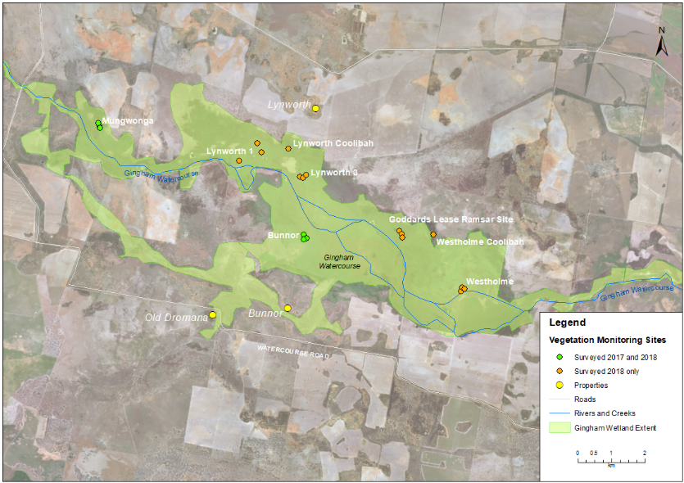
Figure G-3: Location of vegetation monitoring sites within the Gingham wetland.
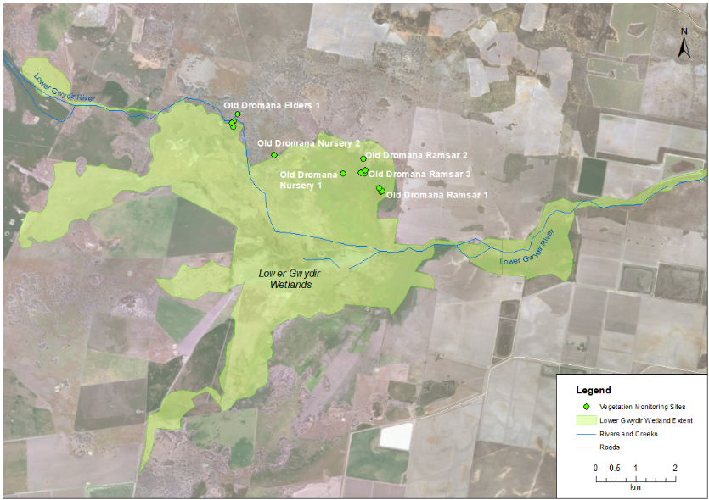
Figure G-4: Location of vegetation monitoring sites within the lower Gwydir wetland.
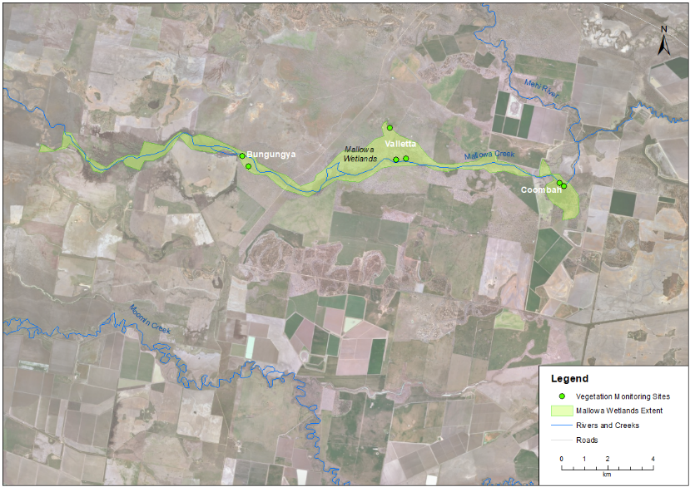
Figure G-5: Location of vegetation monitoring sites within the Mallowa wetland.

Multi-year comparison
To assess longer term trends in vegetation species richness and vegetation cover, a Poisson regression model on count data was used to investigate the influence of inundation, survey time (eight times from December 2014 to March 2018), wetland and vegetation community. This analysis included 32 plots from the lower Gwydir and Gingham wetlands in December 2014 and March 2015, 40 plots in October 2016, 34 plots in March 2017 and the sites described in section 2.1 above. Changes in the cover of key species (water couch, lippia) were analysed using ANOVA or f-tests/t-tests in Systat 13, to assess the influence of inundation, survey time, wetland and vegetation community. Changes in community composition were investigated using multivariate nMDS plots with differences between inundation status, survey time, wetland and vegetation community assessed using PERMANOVA in Primer 6. For nMDS analyses that had large numbers of data points, the ‘distance among centroids’ function was used to group the data by the appropriate factor to aid interpretation of the nMDS plots. This was done for all multi-year nMDS comparisons.

Results

2017-18 water year

Vegetation species richness, dominance and cover
A total of 146 taxa from 44 families were recorded across all vegetation plots. Mean species richness in 2017-18 was 15, down from 16.4 in 2016-17. The highest species richness was 30 species, recorded at Bungunya and Old Dromana Nursery sites in Spring 2017; while the lowest was 1 species, recorded at Westholme in Autumn 2018 (Figure G-6).
Poisson model results suggest that vegetation community (p<0.001), and wetland (p<0.001; Figure G-8) were the two factors influencing species richness in the 2017-18 water year. Sites in the coolibah woodland (16.90 ± 5.76 (± SD) species, p<0.005), river cooba - lignum (16.76 ± 5.80 species; p<0.005), and water couch marsh grassland (12.54 ± 6.17 species; p<0.05) communities were all significantly higher in species richness than sites in the Eleocharis tall sedgeland (10.5 ± 4.03 species; Figure G-7) community. Sites in the Mallowa system had significantly higher mean species richness (16.85 ± 6.40) than both the lower Gwydir (14.61 ± 5.20 species), and the Gingham (12.11 ± 6.45 species; Figure G-8). There were no significant effects from either inundation (p>0.08) or season (p=0.07) on total species richness.
Functional group species richness exhibited variation when grouped by inundation. The Amt, Tda and Tdr functional groups all recorded higher species richness at dry sites (4.13 ± 2.28 species, 4.72 ± 2.88 species, 4.64 ± 3.86 species respectively) when compared to wet sites (3.6 ± 1.51 species, 3.2 ± 3.19 species, 1.4 ± 2.60 species respectively). Whilst the AmR functional group recorded a higher species richness at wet sites (2.2 ± 1.09 species) over dry sites (1.61 ± 1.19 species, Figure G-9).
Growth form species richness showed mixed results with chenopod shrubs, rushes and ferns recording a higher diversity at wet sites, while all other growth forms recorded higher species richness at dry sites (Figure G-10).
Mean vegetation cover (± SD) in 2017-18 was 78 ± 32%, down from the 2016-17 mean of 94 ± 23%. The highest mean vegetation cover of112% noted at Old Dromana Ramsar 2 in Autumn 2018, whilst the lowest was recorded at Bungunya in Autumn 2018 (33 ± 6%, Figure G-11). Mean vegetation cover at each site was significantly influenced by vegetation community (p<0.012) and wetland (p<0.001), but not by either inundation (p=0.66) or season (p=0.058). Sites in the Gingham wetland recorded a significantly higher mean vegetation cover (100 ± 13%) than sites in the lower Gwydir (74 ± 31%, p<0.001) and Mallowa (54 ± 29%, p<0.001, Figure G-12). Coolibah woodland (85 ± 26%) and water couch marsh grassland (87 ± 26%) sites recorded higher mean vegetation cover than sites in eleocharis tall sedgelands (73 ± 38%) and river cooba - lignum (66 ± 37%; Figure G-13) communities. However, due to small sample sizes, pairwise comparisons failed to reveal significant differences between any of the communities. A significant interaction was detected between wetland and inundation, where the Gingham (103 ± 12%) recorded a significantly higher mean vegetation cover than the lower Gwydir (73 ± 31%) when dry (p<0.001, Figure G-14).

Figure G-6: Mean number of species recorded at each site during the spring 2017 and autumn 2018 surveys. Missing values for some site in Spring 2017 indicate sites were not surveyed.

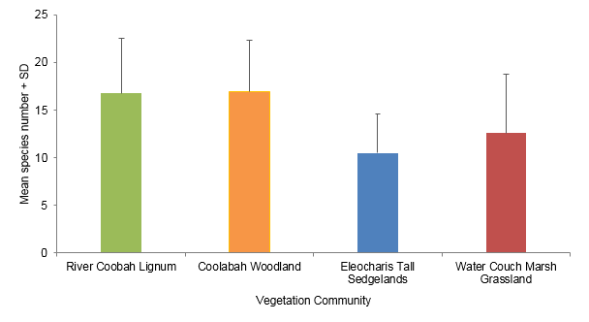
Figure G-7: Mean species richness of the four different vegetation communities in the 2017-18 water year.

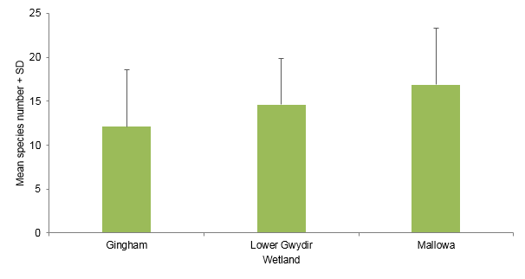
Figure G-8: Mean species richness of the three wetlands surveyed in the 2017-18 water year.
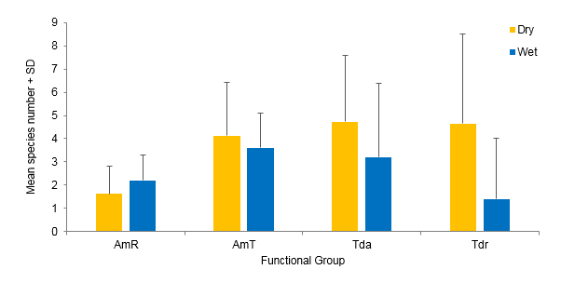
Figure G-9 Mean number of species in functional groups present when grouped by inundation.

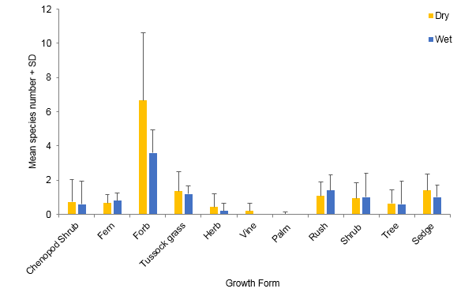
Figure G-10 Mean number of species in each of the different growth forms when grouped by inundation.

Figure G-11: Mean vegetation cover recorded at each site during the Spring 2017 and Autumn 2018 surveys. Missing values for some site in Spring 2017 indicate non-surveyed sites.

Figure G-12 Mean vegetation cover of the three wetlands surveyed in the 2017-18 water year.

Figure G-13 Mean vegetation cover of the four vegetation communities surveyed in the 2017-18 water year.
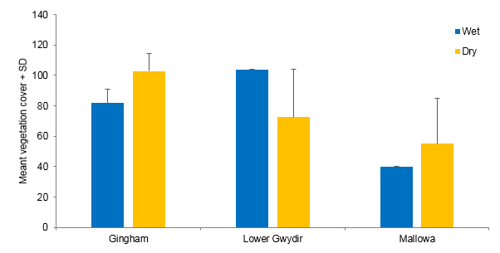
Figure G-14 Mean vegetation cover of the three wetlands when grouped by inundation in the 2017-18 water year. The lack of standard deviations for lower Gwydir and Mallowa ‘wet’ reflects only one site falling into each of these groupings.

Water couch was the most dominant species recorded in terms of cover across the study area, being found at 79% plots surveyed in Spring and 76% in Autumn 2018. The average water couch total cover across all plots surveyed in the 2017-18 water year was 22 ± 33%. Water couch recorded a higher mean total cover at wet sites (42 ± 36.16%) than dry sites (21 ± 33%), though this difference was non-significant (P=0.46, Figure G-15).
The mean cover of the weed species lippia exhibited some variation when grouped by inundation. Although this was also non-significant (P=0.24, Figure G-16). Dry sites (11 ± 17%) recorded a higher mean cover than wet sites (4 ± 5%).

Figure G-15 Mean cover of water couch when grouped by inundation surveyed in the 2017-18 water year.

Figure G-16 Mean cover of lippia when grouped by inundation surveyed in the 2017-18 water year.

Vegetation community composition
PERMANOVA tests undertaken on vegetation community composition from all plots surveyed during the 2017-18 water year suggested that vegetation community (P<0.001), sampling time (P<0.01) and wetland (p<0.001) all influenced observed patterns (Figure G-17). Significant interactions were found between sampling periods and vegetation communities (p<0.001) and to a lesser extent, among sampling periods and wetlands (p<0.005). Pairwise tests revealed that the water couch marsh grassland (P<0.005) and river cooba - lignum (P<0.05) were causing the difference among vegetation communities across the sampling periods (Figure G-17). SIMPER analysis showed that flat spike-sedge (20.95%) and tussock rush (12.21%) contributed most to the grouping of sites in Spring 2017. Whilst water couch (14.56%) and lippia (9.99%) had the greatest influence on grouping of sites in Autumn 2018 (Table G-3).

Figure G-17: nMDS plot of vegetation community composition date grouped by survey periods (Stress 0.16).

Table G-3: Dominant species and variables contributing to vegetation community composition groupings based on survey periods in 2017-18.
Data grouping | Species | Contribution (%) | Cumulative (%)
Spring 2017 | flat spike-sedge (Eleocharis plana) | 20.95 | 20.95
 | tussock rush (Juncus aridicola) | 12.21 | 33.16
 | lippia (Phyla canescens) | 10.23 | 43.39
 | water couch (Paspalum distichum) | 10.06 | 53.46
 | swamp buttercup (Ranunculus undosus) | 10.05 | 63.51
Autumn 2018 | water couch (Paspalum distichum) | 14.56 | 14.56
 | lippia (Phyla canescens) | 9.99 | 24.55
 | common nardoo (Marsilea drummondii) | 9.91 | 34.46
 | Cumbungi (Typha domingensis) | 9.18 | 43.63
 | wild aster (Aster subulatus) | 7.39 | 51.02

Multi-year comparisons

Vegetation species richness and cover
A Poisson model run on species richness data from years 1 – 4 suggest vegetation community (p<0.001), wetland (p<0.001) and inundation (p<0.001) all exerted a significant effect on species richness (Figure G-18, Figure G-19). Dry sites (17.71 ± 7.53 species) recorded a higher species richness than wet sites (14.39 ± 7.10 species) over the course of the project, apart from the Spring 2014 and Autumn 2016 survey periods (Figure G-18). Significant interactions were detected between vegetation community and inundation (p<0.001), wetland and inundation (p<0.01), and vegetation community and wetland (p=0.012). Pairwise comparisons of the interaction between vegetation community and inundation indicated that water couch marsh grassland had significantly lower mean species richness at wet sites (12 ± 4.40 species) than dry sites (16 ± 7.18 species, p<0.001, Figure G-19). Coolibah woodland (25 ± 11.60 species) sites when wet showed significantly higher species richness than water couch marsh grassland (12 ± 4.4 species) sites when wet (p<0.05; Figure G-19). There were no significant differences between seasonal sampling periods (Spring and Autumn) over the four years of the project (p>0.05).

Figure G-18: Mean species richness when grouped by inundation over years 1-4 of the project.

Figure G-19: Mean species richness from four different vegetation communities based on the inundation from years 1-4 of the project.
Mean vegetation cover showed significant differences between wetlands (p<0.001) and inundation (p<0.002) over years 1-4 of the project. Wet sites recorded a higher mean vegetation cover (98 ± 19%) than dry sites (86 ± 29%, Figure G-20). All three wetlands had significantly different mean vegetation cover with the Gingham (97 ± 20%) displaying greater cover than the lower Gwydir (86 ± 29%, p<0.01), which in turn had significantly more cover than sites in the Mallowa (75 ± 35%, p<0.05). A significant interaction was also noted between inundation and vegetation community (p=0.006). Here, wet sites in coolibah woodland (121 ± 14%) and river cooba - lignum (104 ± 20%) communities displaying significantly higher total covers than wet sites in the water couch marsh grassland (94 ± 18%) community (Figure G-21). These differences likely reflect the grouping of low and mid strata types for this analysis, with coolibah woodland and river cooba-lignum sites typically displaying a greater coverage of the mid strata type.

Figure G-20: Mean vegetation cover when grouped by inundation over years 1-4 of the project.

Figure G-21 Mean vegetation cover from the four different vegetation communities when grouped by inundation over years 1-4 of the project.
Over all survey times, water couch recorded a higher mean cover at wet sites (38 ± 32%) when compared to dry sites (25 ± 31%). Water couch total cover peaked during the Autumn 2015 survey period (53 ± 34%) and has remained relatively stable right through to year four of the project (Figure G-22). This trend has predominately been established by sites in the Gingham which has recorded relatively high mean water couch cover during the project. In contrast, sites in the lower Gwydir and Mallowa have shown a decline in mean water couch cover over time (Figure G-23).

Figure G-22 Mean water couch cover across all sites from years 1 – 4 of the project.

Figure G-23 Mean water couch cover grouped by wetland across years 1 – 4 of the project.

In contrast, lippia recorded a higher mean total cover at dry sites (9 ± 14%) when compared to wet sites (3 ± 6%). It has also increased in mean cover from spring 2017 to autumn 2018 to its highest mean cover recorded in the project (12 ± 19%, Figure G-24).

Figure G-24: Mean cover of lippia at sites across years 1-4 of the project.

Vegetation community composition
Separation in the community composition data was observed when grouped by sampling time (including the six sampling times from years 1-4 of the project) and inundation (Figure G-25). The clustering of data based on inundation suggests that community composition is more similar within inundation groups (wet or dry). PERMANOVA analysis detected significant differences based on inundation (P=0.001), wetland (P<0.001), survey period (P<0.001) and vegetation community (P<0.001). The interaction between sampling time and inundation was significant (P=0.001), with Spring 2015 and Spring 2017 being the only time where wet and dry sites were not significantly different (P=0.46, P=0.28). A weaker interaction was revealed between vegetation community and inundation (P<0.05).

Figure G-25: nMDS plot of vegetation composition data in all 4 years of the project grouped by sampling time and inundation (Stress: 0.1).

Discussion
Inundation has been shown to positively influence vegetation communities within the Gwydir wetlands in previous years of the LTIM project. However, during 2017-18, inundation did not appear to influence vegetation patterns to the same degree. The 2017-18 water year was a particularly dry year, with only five of the 26 sites monitored in Spring 2017 being wet and all sites being dry during the Autumn 2018 survey period. The small number of wet observations reduced the statistical power of comparisons between wet and dry sites and no significant effects of inundation on vegetation patterns were detected during the 2017-18 water year. In addition, the three Old Dromana Ramsar sites which were wet in Spring had recently been affected by fire, reducing both cover and species richness at these sites (Figure G-26). This likely confounded any positive influence of inundation. However, when all years of the LTIM project were considered, the influence of inundation on species richness and vegetation cover was more apparent. Two of the vegetation communities have shown consistent responses based on inundation. The water couch marsh grassland community has reduced in overall species richness and increased in total cover under wet conditions. Water couch grows strongly under wet conditions, dominating cover at these sites. This helps these communities resist the establishment of exotic species, and also provides ideal foraging habitat for waterbird species and productive grazing areas for native animals and livestock on private property. Sites in coolibah woodland communities have shown an increase in both species richness and total cover during wet times, due to a large increase in understory and ground cover growth.
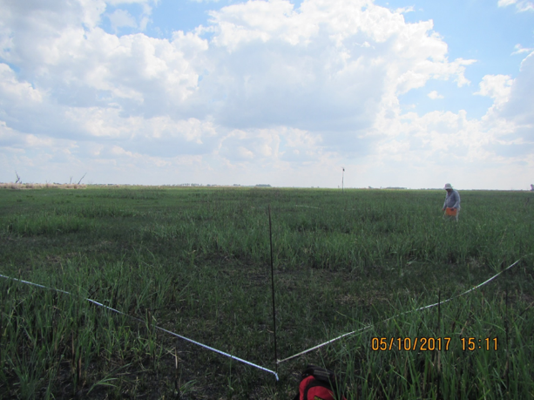
Figure G-26 Old Dromana Ramsar site affected by recent fire shortly before the October 2017 survey.

The species richness of different functional groups showed consistent trends during years 1 – 3 of the project. Amphibious functional groups (AmR and AmT) have displayed higher mean species richness at wet sites than dry sites. In contrast, terrestrial functional groups (Tda and Tdr) have recorded a higher mean species richness at dry sites. Year 4 results show higher mean species richness for all four functional groups at dry sites. These results are most likely due to the dominance of water couch within inundated couch marsh grassland sites, and fires affecting other inundated sites before the Spring survey, reducing the diversity of the amphibious functional groups.
Longer term trends in the cover of individual species and their response to the drier conditions in 2017-18 have emerged. The cover of lippia in survey plots decreased to its lowest levels of the project in 2015 following the widespread inundation during the preceding summer (Commonwealth of Australia 2015). Lippia cover has increased since then, with a three-fold increase in mean cover since Autumn 2017, to its highest mean cover noted in the project in Autumn 2018. This is likely the result of the dry conditions during 2017-18 providing lippia with a competitive advantage over native species that are better adapted to wetter soil conditions (Price et al. 2011). In contrast, water couch has shown an overall reduction in cover since peaking in Autumn 2015 following flooding. The cover of water couch has been relatively stable in the Gingham watercourse plots; however, in the lower Gwydir and Mallowa wetlands, its cover has shown a marked reduction (Figure G-23).

Conclusion
The 2017-18 water year has been the driest the lower Gwydir wetlands have experienced since the start of the LTIM project. This has led to a steady decline in species richness and total cover at vegetation plots across the wetlands, especially in more western areas that did not receive water in 2016-17 water year. While the cover of water couch has remained consistent, especially in the Gingham system, the weed species lippia has increased three-fold due to dry conditions that favour its growth. This in part strengthens the conclusion that inundation strongly influences vegetation patterns within the Gwydir wetlands. How the vegetation communities response following increased environmental watering targeting broader-scale wetland inundation extents in 2018-19 will help to inform the effectiveness of the longer term 3 year wet/dry management strategy being employed in the Gwydir. It is expected that a concurrent improvement in the vegetation cover and the diversity of aquatic species will be observed.

References
Bowen S. and Simpson, S.L. 2010. Changes in Extent and Condition of the Vegetation Communities of the Gwydir Wetlands and Floodplain 1996-2008: Final Report NSW Wetland Recovery Program. NSW Department of Environment Climate Change and Water: Sydney
Brock, M.A. and Casanova, M.T. 1997. Plant life at the edge of wetlands: ecological responses to wetting and drying patterns. In Frontiers of Ecology; Building the Links. Edited by N.Klomp and Lunt. Elsevier Science, Oxford. Pp. 181-192
Commonwealth of Australia. 2014a. Commonwealth environmental water use options 2014-15: Gwydir River Valley. Commonwealth of Australia.
Commonwealth of Australia. 2014b. Commonwealth Water Office Long Term Intervention Monitoring Project; Gwydir River system Selected Area. Commonwealth of Australia.
Commonwealth of Australia. 2015. Commonwealth Environmental Water Office Long Term Intervention Monitoring Project Gwydir River system Selected Area – 2014-15 Draft Evaluation Report. Commonwealth of Australia 2015.
Commonwealth of Australia. 2016. Commonwealth Environmental Water Office Long Term Intervention Monitoring Project Gwydir River system Selected Area – 2015-16 Draft Evaluation Report. Commonwealth of Australia 2015.
Department of Environment and Climate Change NSW. 2011. Gwydir Wetlands Adaptive Environmental Management Plan.
Hale, J., Stoffels, R., Butcher, R., Shackleton, M., Brooks, S. and Gawne, B. 2014. Commonwealth Environmental Water Office Long Term Intervention Monitoring: Standard Methods. Report prepared by the Murray Darling Freshwater Research Centre, Wodonga.
Price, J.N., Berney, P.J., Ryder, D., Whalley, R.D.B. and Gross, C.L. 2011. Disturbance Governs Dominance of an Invasive Forb in a Temporary Wetland. Oecologia. doi: 10.1007//s00442-011-2027-8
Wilson, G.G., Bickel, T.O., Berney, P.J. & Sisson, J.L. 2009. Managing environmental flows in an agricultural landscape: The lower Gwydir floodplain. Final Report to the Australian Government Department of the Environment, Water, Heritage and the Arts. University of New England and Cotton Catchment Communities Cooperative Research Centre, Armidale, New South Wales.

Fish (River)

Introduction
The fish assemblages of the Gwydir valley are generally considered to be in a severely degraded state (Murray-Darling Basin Authority 2012). The Sustainable River Audit (SRA) No. 2 Report stated that the fish in the upper sections (above 400 mASL) of the valley were in “Very Poor” condition, the slopes (201-400 mASL) were in “Moderate” condition, and the lowlands (31-200 mASL) were in “Poor” condition (Murray-Darling Basin Authority 2012). Overall the fish community across the valley was classified as “Poor”. The SRA reported that the Gwydir in general had reduced numbers of species and abundance among the native fish, recruitment was variable and generally low on a site by site basis, and that there were exotic species sampled at most sites including high abundances of common carp (Cyprinus carpio), eastern mosquitofish (Gambusia holbrooki), goldfish (Carassius auratus) and redfin perch (Perca fluviatilis).
The aim of the fish river indicator is to benchmark and describe the fish community in abundance, biomass and community health across four hydrological zones within the Gwydir River system Selected Area (Selected Area) in relation environmental water releases. Several specific questions were posed in relation to this indicator:
- What did Commonwealth environmental water contribute to native fish community resilience?
- What did Commonwealth environmental water contribute to native fish survival?
- What did Commonwealth environmental water contribute to native fish populations?
- What did Commonwealth environmental water contribute to native fish diversity?

Environmental watering in 2017-18
During 2017-18, environmental water was delivered to both in-channel and wetland assets in the Gwydir River system (Table H-1). An early season stimulus flow was triggered by inflows to Copeton Dam in August/September 2017. A total of 10,000 ML was delivered into the main Gwydir River, Mehi and Carole Creek systems as a small fresh during late winter/early spring. Following this, a stable flow release of 10,040 ML was delivered into the main Gwydir River, Mehi and Carole Creek systems in late October to mid-November 2017. These small pulse flows were aimed at providing downstream connectivity and allowing opportunity for movement, breeding and recruitment of fish, particularly freshwater catfish (Tandanus tandanus).
A delivery of 8,000 ML including both State and Commonwealth environmental water was made to the lower Gwydir and Gingham wetlands from mid-December 2017 to late January 2018, to replace supplementary take from a small flow event that occurred in the previous months. This aimed to maintain wetland habitat quality, and support the survival and resilience of flora and fauna in the wetlands. The last environmental delivery was made in late April/May 2018 as part of the Northern Connectivity Event. This flow aimed to provide longitudinal connectivity and refresh/replenish drought refuge for instream life, particularly native fish in the Barwon-Darling as well as improving conditions to maintain native fish populations within the tributary catchments. During this event, a total of 18,908 ML of both State and Commonwealth water was delivered down the Mehi River, Moomin Creek and Carole Creek. No environmental water deliveries were made to Mallowa Creek in 2017-18.
Table H-1 Environmental water delivered in the Gwydir River system Selected Area in 2017-18. Percentage represents the percentage of the total flow made up of environmental water.
Channel | Commonwealth Environmental Water (CEW) delivered (ML) | NSW ECA/General Security/Supplementary environmental Water delivered (ML) | 2017-18 total flow (ML) | Environmental Water % of total flow
Gwydir River* | 28,290 | 18,748 (including 15,748 General Security) | 412,705 | 11
Gingham watercourse | 2,000 | 5,534 (including 4,520 General Security) | 22,984 | 33
Lower Gwydir | 2,000 | 5,706 (including 4,520 General Security) | 19,831 | 39
Carole Creek | 3,886 | 2,462 (including 1,662 General Security) | 95,341 | 7
Mehi River< | 20,404 | 5,046 general security | 91,067 | 28
Moomin Creek# | 324 | 175 | 104,075 | 0.5
Mallowa Creek | 0 | 0 | 121 | 0
Total | 28,290 | 18,748 (including 15,748 General Security) | 412,705 | 11
* All environmental water delivery to the Gwydir system flowed through the Gwydir River in 2017-18. Therefore, volumes for this channel represent total volumes delivered downstream and as such are not included in the total.
< Includes 499 ML that flowed down Moomin Creek, but returned to the Mehi downstream. Also includes 90 ML NSW General Security water for delivery to Whittaker’s Lagoon.
# Not included in total as accounted in return flows to Mehi.

Previous monitoring
Sampling of the lower Gwydir fish community has been undertaken since 2013, as part of the Commonwealth Environmental Water Office Short Term (STIM; 2013-14) and Long Term (LTIM; 2015, 2016 & 2017) Intervention Monitoring Projects (Southwell et al. 2015; Commonwealth of Australia 2015, 2016, 2017). Ten native species and three exotic species were captured in both programs combined. Overall, bony herring (Nematolosa erebi) was consistently the most abundant species caught, making up 41.6% of the total catch in 2013-14, 31% in 2014-15, 50% in 2015-16 and 45% in 2016-17. Other large-bodied species such as Murray cod (Maccullochella peelii), golden perch (Macquaria ambigua) and freshwater catfish (Tandanus tandanus) were caught in relatively low numbers in both studies. Australian smelt (Retropinna semoni) and carp gudgeon (Hypseleotris sp.) dominated the catch among the small-bodied species. Common carp (Cyprinus carpio) were the most abundant exotic species sampled in both studies, making up >50% of the biomass of all fish recorded in 2014-15, 42% in 2015-16 and 41% in 2016-17 (Commonwealth of Australia 2015, 2016, 2017).

            - Methods
              - Sampling sites
Data were collated from 23 sites within four sub-catchments or hydrological zones within the Selected Area for Cat 3 Fish River analyses; the Gingham watercourse, Gwydir River, Mehi River and Moomin Creek (Commonwealth of Australia 2014; Figure H-1, Table H-2). Sampling was undertaken between 11th January 2018 and 1st June 2018. Seventeen sites were sampled solely as part of the Gwydir LTIM Cat 3 program; six each in the Mehi and Moomin sub-catchments and five in the Gingham. A sub-set of the data from six (originally randomly chosen in Year 1) of the 10 LTIM Cat 1 Fish River sites from the lower Gwydir River was also used in the analyses. For these sites, the first 1,080 sec of boat or 1,200 sec of backpack electrofishing (or where applicable combinations of both) was used as the sampling effort.
Sampling sites in all four sub-catchments were typical of the meandering waterways found throughout the lowland reaches of much of the Murray-Darling Basin. The water at all sites was turbid and relatively shallow and there were distinct pool/run/riffle zones present within many of the sites (Figure H-2, Figure H-3). In the Gwydir River upstream of Tyreel Weir and in the Mehi River, the river channel was wider, deeper and more permanent in nature, averaging ~30 m in width and ~1.5 m in depth. In the lower Gwydir, Gingham and Moomin, most sites were narrower (~8-16 m) and shallower (~0.5 m). Depths and flow were below that of 2014-15 and 2016-17 but compared to 2015-16 there was more water, with connection along the main channel apparent at most sites in all four systems.
In-stream habitat across all four sub-catchments was dominated by submerged timber and undercut banks. The substratum at sites was typically mud; however, gravel, sand and silt substrates were also present in some areas. In general, all four river systems were highly disturbed from anthropogenic influences such as agriculture, altered flows, and terrestrial and aquatic exotic species. Most sites were adjacent to irrigated and dryland cropping land. Most sites were fringed by only a narrow riparian zone, dominated by native trees and exotic shrubs. Notable terrestrial weeds included African boxthorn (Lycium ferocissimum), noogoora burr (Xanthium pungens) and lippia (Phyla canescens).
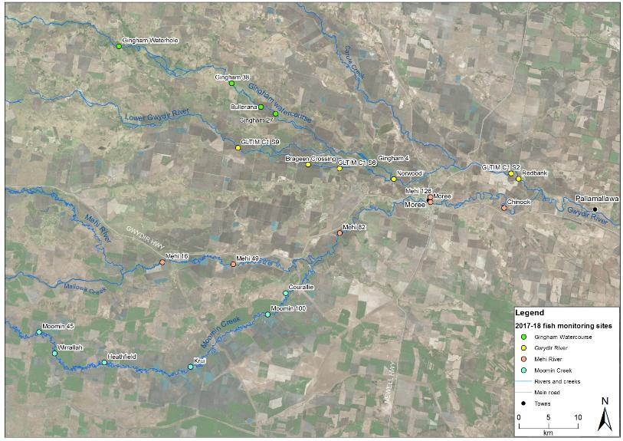
Figure H-1: Location of sampling sites in the Gwydir Selected Area used in the Fish (River) indicator.
Table H-2: Sampling sites used in the analysis of the Fish (River) 2017-18 assessment
Site Name | River | Source | Easting | Northing | Altitude | Zone | Effort
Gingham 27 | Gingham Watercourse | LTIM CAT 3 | 750215 | 6751475 | 168 | Lowland | Backpack
Gingham 38 | Gingham Watercourse | LTIM CAT 3 | 742843 | 6756625 | 168 | Lowland | Backpack
Gingham Waterhole | Gingham Watercourse | LTIM CAT 3 | 723836 | 6762846 | 173 | Lowland | Small boat
Bullerana | Gingham Watercourse | LTIM CAT 3 | 747714 | 6752639 | 175 | Lowland | Backpack
Gingham 4 | Gingham Watercourse | LTIM CAT 3 | 766926 | 6742996 | 208 | Slopes (L) | Medium boat
Brageen Crossing | Gwydir River | LTIM CAT 1 | 755711 | 6742946 | 185 | Lowland | Backpack
GLTIM C1 S9 | Gwydir River | LTIM CAT 1 | 743872 | 6745735 | 187 | Lowland | Backpack
GLTIM C1 S6 | Gwydir River | LTIM CAT 1 | 760984 | 6742247 | 198 | Lowland | Backpack
Norwood | Gwydir River | LTIM CAT 1 | 770114 | 6740483 | 201 | Slopes (L) | Medium boat
Redbank | Gwydir River | LTIM CAT 1 | 209084 | 6740534 | 201 | Slopes (L) | Small boat/backpack
GLTIM C1 S2 | Gwydir River | LTIM CAT 1 | 789906 | 6741432 | 219 | Slopes (L) | Small boat/backpack
Mehi 16 | Mehi River | LTIM CAT 3 | 731144 | 6726484 | 165 | Lowland | Backpack
Mehi 49 | Mehi River | LTIM CAT 3 | 743061 | 6726122 | 185 | Lowland | Backpack
Mehi 82 | Mehi River | LTIM CAT 3 | 761023 | 6731365 | 184 | Lowland | Small boat
Moree | Mehi River | LTIM CAT 3 | 776288 | 6736605 | 201 | Slopes (L) | Medium boat
Mehi 126 | Mehi River | LTIM CAT 3 | 776308 | 6737446 | 206 | Slopes (L) | Small boat
Chinook | Mehi River | LTIM CAT 3 | 788702 | 6735632 | 217 | Slopes (L) | Small boat
Moomin 45 | Moomin Creek | LTIM CAT 3 | 710372 | 6714695 | 155 | Lowland | Backpack
Wirrallah | Moomin Creek | LTIM CAT 3 | 712962 | 6711129 | 160 | Lowland | Backpack
Heathfield | Moomin Creek | MDBP | 721359 | 6709589 | 163 | Lowland | Backpack
Krui | Moomin Creek | LTIM CAT 3 | 735879 | 6708851 | 178 | Lowland | Backpack
Courallie | Moomin Creek | LTIM CAT 3 | 751907 | 6721287 | 178 | Lowland | Backpack
Moomin 100 | Moomin Creek | LTIM CAT 3 | 748885 | 6717676 | 184 | Lowland | Backpack

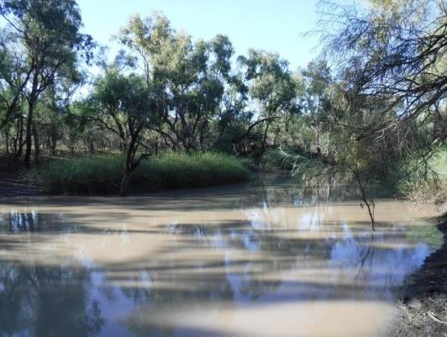
Figure H-2: Moomin 100 survey site on Moomin Creek sampled as part Gwydir LTIM Category 3 Fish River 2017-18 assessment.

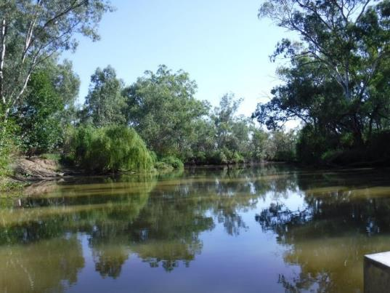
Figure H-3: Gingham 4 survey site on the Gingham Watercourse, sampled as part Gwydir LTIM Category 3 Fish River 2017-18 assessment
              - Sampling protocols
Sampling effort at each site was a combination of electrofishing and bait trapping (Commonwealth of Australia 2014, Hale et al. 2014). Electrofishing included small and medium boats (3.5 kW or 5 kW Smith-Root electrofisher units respectively), backpack (Smith Root model LR20) or a combination of boat and backpack. Boat electrofishing consisted of 12 x 90 sec power-on operations per site, while backpack electrofishing consisted of 8 x 150 sec operations. At sites where both boat and backpack sampling was required, the number of operations of each method used was proportional to the area of navigable versus wadable habitat. Boat electrofishing involved a series of ~10 sec power-on and power–off operations, with successive operations undertaken on alternate banks while moving in an upstream direction. Backpack electrofishing involved sampling all areas accessible to the stationary operator, before they would progressively move upstream around ~3 m before repeating the process (Figure H-4). All boat and backpack electrofishing was undertaken by a minimum of two operators, with three operators used at medium boat sites. Ten unbaited traps were deployed for a minimum of two hours at each site; undertaken at the same times as electrofishing. Traps were set haphazardly throughout the site in water depths of 0.5 – 1 m.
All fish were identified to species level, measured to the nearest millimetre and released onsite. When an individual or individuals could not be positively identified in the field, a voucher specimen was retained for laboratory identification. Length measurements (to the nearest millimetre) were taken as fork length for species with forked tails and total length for all other species. Only a sub-sample of individuals were measured and examined, for each gear type, where large catches of an individual species occurred. The sub-sampling procedure consisted of firstly measuring all individuals in each operation until at least 50 individuals had been measured in total. The remainder of individuals in that operation were also measured, but any individuals of that species from subsequent operations of that gear type were only counted. Fish that escaped capture, but could be positively identified were also counted and recorded as “observed”.
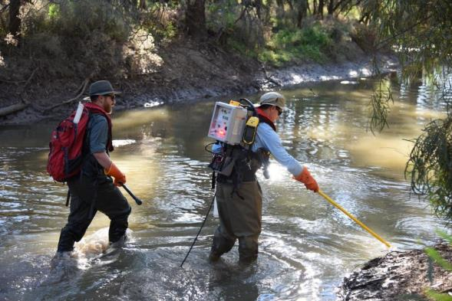
Figure H-4: Backpack electrofishing in the lower Gwydir Basin.
              - Data Analyses
                - Fish community
Electrofishing and bait trapping data were combined for statistical analyses of the fish community. Non-parametric multivariate analysis of variances (PERMANOVA) was used to determine if there were differences between the fish assemblages in each of the four hydrological zones within and between years (PRIMER 6 & PERMANOVA; Anderson et al. 2008). Prior to analyses, the data were fourth root transformed and the results used to produce a similarity matrix using the Bray-Curtis resemblance measure. All tests were considered significant at P <0.05. Where differences were identified by PERMANOVA, pair-wise comparisons were used to determine which groups differed. Similarity percentage (SIMPER) tests were used to identify individual species contributions to average dissimilarities among groups.
Non-parametric Kolmogorov-Smirnov Z tests were used to determine if there were differences in the lengths of the six more-abundant small- and large-bodied species in each of the four sub-catchments both within and between years. Only zones and years where >20 individuals were sampled were included in the analyses. P-values were adjusted to account for increasing experiment-wise error rates associated with multiple comparisons (Ogle 2015). Species included in this analysis were: large bodied - Murray cod, common carp and bony herring; and small-bodied - Murray-Darling rainbowfish (Melanotaenia fluviatilis), carp-gudgeon and Australian smelt.
                - Health Metrics
Reference Condition
The predicted pre-European fish community of the lower Gwydir Basin was derived using the Reference Condition for Fish (RC-F) approach used by the Sustainable Rivers Audit (SRA) and NSW Monitoring, Evaluation and Reporting (MER) programs (Table H-3, Table H-4). The RC-F process involves using available historical and contemporary data, museum collections and expert knowledge to estimate the probability of collecting each species at any randomly selected site within an altitude zone if it were sampled using the standard sampling protocol prior to 1770 (Davies et al. 2008). Rare species were allocated a RC-F probability of capture of 0.1 (collected at 0 < 0.2 of samples), occasional species (collected at 0.21 < 0.7 of samples) an RC-F of 0.45 and common species (collected at 0.71 < 1.0 samples) an RC-F of 0.85 (RC-F scores being the median capture probability within each category) (Table H-4).
The definition of a recruit was derived using a similar process as that applied in the SRA and MER programs (Dean Gilligan unpublished data). For large-bodied and generally longer living species (>three years), an individual was considered to be a recruit if its body length was less than that of a one-year-old of the same species. For small-bodied and generally short-lived species that reach sexual maturity in less than one year, recruits were considered to be those individuals that were less than the species known average length at sexual maturity. The recruitment lengths used for both large- and small-bodied species were derived from published scientific literature or by expert opinion where that was not available (Table H-4).
Metrics, Indicators and the Overall Fish Condition Index.
Using the methods described by Robinson (2012), eight fish metrics were derived from the data collected at each site. The eight metrics were then aggregated to produce three fish condition indicators and these indicators were then used to derive an overall Fish Condition Index (SRA ndxFS). Metric and indicator aggregation was done using Expert Rules analysis in the Fuzzy Logic toolbox of MatLab (The Mathworks Inc. USA) using the rules sets developed by Davies et al. (2010).
The Expectedness Indicator (SR-FI_{e}) represents the proportion of native species that are now found within the basin, compared to that which was historically present. The Expectedness Indicator is derived from two input metrics; the observed native species richness over the expected species richness at each site, and the total native species richness observed within the zone over the total number of species predicted to have existed within the zone historically (Robinson 2012). The two metrics were aggregated using the Expectedness Indicator Expert Rule set (Carter 2012).
The Nativeness Indicator (SR-FI_{n}) represents the proportion of native versus alien fishes within the river. The Nativeness Indicator is derived from three input metrics; proportion native biomass, proportion native abundance and proportion native species (Robinson 2012). The three metrics were aggregated using the Nativeness Indicator Expert Rule set (Carter 2012).
The Recruitment Indicator (SR-Fi_{r}) represents the recent reproductive activity of the native fish community within each altitude zone. The Recruitment Indicator is derived from three input metrics; the proportion of native species showing evidence of recruitment at a minimum of one site within a zone, the average proportion of sites within a zone at which each species captured was recruiting (RC-F corrected), and the average proportion of total abundance of each species that are new recruits (Robinson 2012). The three metrics were aggregated using the Recruitment Indicator Expert Rule set (Carter 2012).
The three indicators were combined using the Fish Index Expert Rule set (Carter 2012) to calculate an overall Fish Condition Index (ndxFS). The Fish Index Expert Rules analysis is weighted as SR-FI_{e} > SR-FI_{r} > SR-FI_{n}. The output generated by the Expert Rules analysis is scaled between 0 and 100, with higher values representing a ‘healthier’ fish community. The index was then partitioned into five equal bands to rate the condition of the fish community; “Good” (81-100), “Moderate” (61-80), “Poor” (41-60), “Very Poor” (21-40), or “Extremely Poor” (0-20).
Table H-3: Native freshwater fish species predicted to occur across the lower Gwydir Basin prior to European colonisation. Descriptions of predominance (occurrence) correspond to RC-F categories for the Murray Darling Basins Sustainable Rivers Audit program and are used to generate fish condition metrics.
Species | Common name | Occurrence
Ambassis agassizii | Olive perchlet | Rare
Bidyanus bidyanus | Silver perch | Occasional
Craterocephalus amniculus | Darling River hardyhead | Rare
Craterocephalus stercusmuscarum fulvus | Un-specked hardyhead | Occasional
Hypseleotris sp. | Carp-gudgeon | Common
Leiopotherapon unicolor | Spangled perch | Common
Melanotaenia fluviatilis | Murray-Darling rainbowfish | Common
Mogurnda adspersa | Southern purple-spotted gudgeon | Rare
Nematolosa erebi | Bony herring | Common
Maccullochella peelii | Murray cod | Occasional
Macquaria ambigua | Golden perch | Common
Retropinna semoni | Australian smelt | Occasional
Tandanus tandanus | Freshwater catfish | Common
Table H-4: Sizes used to distinguish new recruits for species likely to be sampled across the lower Gwydir Basin. Values represent the length at 1 year of age for longer-lived species or the age at sexual maturity for species that reach maturity within 1 year.
Species | Estimated size at 1 year old or at sexual maturity (fork or total length) | Non-juv. Caught  2017-18 | Juveniles  Caught  2017-18
Native species
Olive perchlet | 26 mm (Pusey et al. 2004)
Silver perch | 75 mm (Mallen-Cooper 1996)
Darling River hardyhead | 40 mm (expert opinion)
Un-specked hardyhead | 38 mm (Pusey et al. 2004)
Carp gudgeon | 35 mm (Pusey et al. 2004)
Spangled perch | 68 mm (Leggett & Merrick 1987)
Murray-Darling rainbowfish | 45 mm (Pusey et al. 2004: for M. duboulayi)
Southern purple-spotted gudgeon | 40 mm (Pusey et al. 2004)
Bony herring | 67 mm (Cadwallader 1977)
Murray cod | 222 mm (Gavin Butler unpublished data)
Golden perch | 75 mm (Mallen-Cooper 1996)
Australian smelt | 40 mm (Pusey et al. 2004)
Freshwater catfish | 92 mm (Davis 1977)
Alien species
Common carp | 155 mm (Vilizzi and Walker 1999)
Eastern mosquitofish | 20 mm (McDowall 1996)
Common goldfish | 127 mm (Lorenzoni et al. 2007)

Results

Abundance
In total 3,398 fish were caught (n = 1,909) or observed (n = 1489) across all sites during 2017-18, considering all methods combined (Figure H-5). Community composition comprised 11 species in total; eight native species and three exotic species. Of the five threatened species that were thought to occur in the past or present in the lower Gwydir Basin, only the Murray cod (Vulnerable; EPBC Act) was captured and only in relatively low numbers (n = 73). No silver perch (Bidyanus bidyanus), olive perchlet (Ambassis agassizii; Endangered Population; Fisheries Management Act 1994 (New South Wales)), freshwater catfish (Endangered Population; Fisheries Management Act 1994 (New South Wales)), or southern purple-spotted gudgeon (Mogurnda adspersa) were caught as part of Cat 3 sampling. However, a low number of freshwater catfish (n = 4) were caught in the Gwydir River as part of Cat 1 sampling (GLTIM C1 S2, S3 and S5) (Figure H-6). Captured individuals and those that were observed but not captured within zones included: 769 individuals (observed = 904) among 11 species from the five sites sampled in the Gingham Watercourse, 545 individuals (observed = 171) among 11 species from the six sites sampled in the Gwydir, 370 individuals (observed = 402) among 11 species from the six sites sampled in the Mehi, and 225 individuals (observed = 12) among eight species from the six sites sampled in Moomin Creek. Bony herring was the most abundant native large-bodied species (those that grow to >100 mm) caught in all four zones. As in previous years of sampling, bony herring made up ~50% of the total catch of all native species and zones combined. Among the small-bodied species (those that don’t grow >100 mm), carp gudgeon (n = 297) was the most abundant species sampled, followed by Murray-Darling rainbowfish (n = 206) and Australian smelt (n = 71).
There was a significant difference in abundance among the fish assemblages across the four hydrological zones as a whole (Pseudo-F_{3,19} = 2.70, P < 0.01). Pair-wise comparisons revealed no significant differences between any of the zones except the Mehi and Moomin (t = 2.11, P < 0.01) and Gwydir and Moomin (t = 2.36, P < 0.01). SIMPER analysis suggested differences in the Mehi and Moomin communities were primarily a result of greater abundances of eastern mosquitofish (contribution = 14.48%), spangled perch (contribution = 13.03%), goldfish (contribution = 12.83%) in the Moomin, and greater numbers of bony herring (contribution = 11.52 %) in the Mehi. Differences between the Gwydir and Moomin were a result of greater numbers of Murray-Darling rainbowfish (contribution = 13.73%), Murray cod (contribution = 12.04%), carp gudgeon (contribution = 11.99%) and bony herring (contribution = 11.22%) in the Gwydir, and greater numbers of goldfish (contribution = 11.58 %) in the Moomin.
There was a significant difference in the overall abundance among the fish assemblage between years within the Selected Area (Pseudo-F _{3,88} = 2.44, P < 0.01). As reported previously, pair-wise comparisons revealed all years 2015, 2016 and 2017 were significantly different from each other (Commonwealth of Australia 2017). However, there was no significant difference between the overall abundance of fish in 2018 compared to any other year (Year 1 vs. Year 4 t = 1.45, P = 0.09; Year 2 vs. Year 4 t = 1.47, P = 0.06; Year 3 vs. Year 4 t = 1.01, P = 0.41).

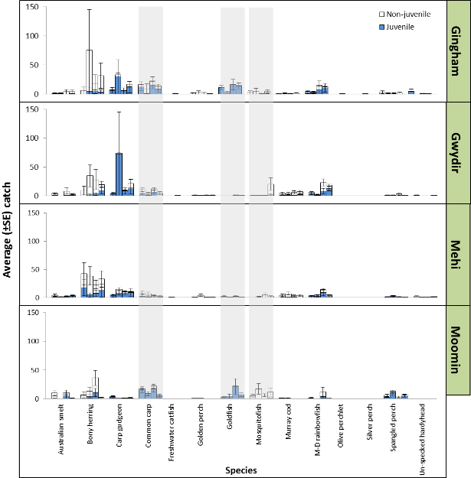
Figure H-5: Average catch ± S.E. per site per year (sequential) for the 14 fish species sampled in the Gingham watercourse, Gwydir River, Mehi River and Moomin Creek as part of the Gwydir LTIM project, 2014-18. Juveniles and non-juveniles based on the length at 1 year of age for longer-lived species or the age at sexual maturity for species that reach maturity within 1 year (Table H-4). Grey shaded lines highlight exotic species.

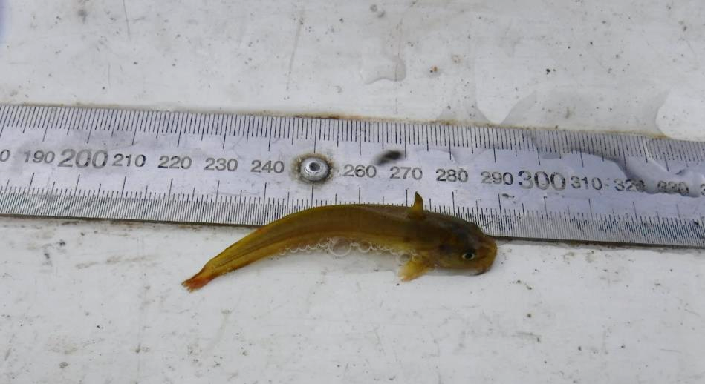
Figure H-6: Juvenile freshwater catfish (<70 mm) caught at GLTIM C1 S3 during Gwydir LTIM (Cat 1) sampling 2017-18.

Biomass
Based on estimated and measured weights, a total of 278.477 kg of fish were sampled across all sites and for all methods combined (Figure H-7). As in all previous years, common carp had the highest overall biomass (n = 11.289 kg) among the 11 species sampled, and also had the highest average (± S.E.) biomass at sites in the Gingham 6.639 ± 2.881 kg, and Moomin 0.273 ± 0.132 kg. Murray cod maintained the highest average biomass in the Gwydir 10.369 ± 5.115 kg but unlike in previous years, surpassed common carp in the Mehi as the species with the highest average biomass with 5.630 ± 2.498 kg compared to 3.994 ± 1.381 kg. Murray cod and bony herring had the second and third highest overall biomass respectively across all zones combined, followed by golden perch. Among the small bodied species carp gudgeon (189 g), Murray-Darling rainbowfish (189 g) and Australian smelt (64 g) had the first, second and third highest biomasses respectively.
There was a significant difference in the overall biomass of species among the four hydrological zones (Pseudo-F_{3,19} = 2.67, P = 0.02). Pair-wise comparisons revealed that the difference was a result of dissimilarities in biomass between the Gingham and Moomin (t = 1.56, P = 0.03), the Gwydir and Moomin (t = 2.27, P < 0.01) and the Mehi and Moomin (t = 2.19, P < 0.01). Simper analysis suggested the differences between the Gingham and Moomin were driven by the greater average abundance of common carp (contribution = 25.13%) and bony herring (contribution = 17.23%) in the Gingham, and greater numbers of spangled perch (contribution = 13.51%) in the Moomin. Differences between the Gwydir and Moomin were driven by the greater average abundance of Murray cod (contribution = 24.35%), common carp (contribution = 17.97%) and bony herring (contribution = 14.65%) in the Gwydir. Similarly, Murray cod (contribution = 21.99%), common carp (contribution = 19.05%) and bony herring (contribution = 15.8%) were in greater abundances in the Mehi compared to the Moomin.
There was a significant difference in the overall biomass among the fish assemblage among years across the Selected Area (Pseudo-F_{3,88} = 1.92, P < 0.03). As reported previously (Commonwealth of Australia 2017), pair-wise comparisons revealed Years 1–3 were all significantly different from each other. However, there was no significant difference between Year 4 and Year 1 (P = 0.52), Year 2 (P = 0.13) or Year 3 (P = 0.53).
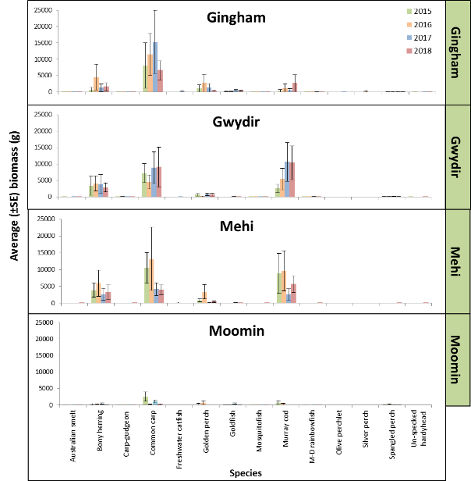
Figure H-7: Average biomass ± S.E. for the 14 fish species sampled to date in the Gingham watercourse, Gwydir River, Mehi River and Moomin Creek as part of the Gwydir LTIM Project 2014-18.

Length frequency
Temporal variation in the population structure of the three most abundant small-bodied species has varied little for some species, whilst for others it has varied annually within and in some cases, among hydrological zones (Figure H-8). For Murray-Darling rainbowfish, with the ratio of recruits and adults within the Gingham, Gwydir and Mehi has remained similar across all years. The only years where there was a significant difference were Year 1 vs. Year 3 and Year 3 vs. Year 4, with the differences likely related to a proportionally greater number of fish >50 mm surveyed during higher flows in Year 3 compared to the other two years. In contrast, carp gudgeon populations in most zones where they are reasonably abundant have tended to shift on a year by year basis. This is particularly apparent in the Gingham and Gwydir, where the overall numbers of individuals has increased along with the number of adults in the population (Figure H-8). Of the three species, Australian smelt has tended to be the most sporadic in occurrence and in population structure, with very few being consistently caught in any zone in any of the four years sampled (Figure H-8).
Among the three more-abundant large-bodied species, the structure of populations has been consistent within some hydrological zones across years, whilst other populations have alternated between being dominated by juveniles, to being made up largely of adults (Figure H-9). For bony herring, both the Gingham and Moomin populations are consistently dominated by individuals <150 mm, whilst in the Gwydir and Mehi there were greater numbers of larger adults in most years and less uniformity among years (Figure H-9). These variations resulted in significant differences between all eligible zones in the current sampling year (Table H-5), as well as for all zones combined among all years (Table H-6). In contrast to bony herring, Murray cod populations in the Gwydir and Mehi were generally consistent between the two zones, across years (Figure H-9). Both populations are dominated by small numbers of young-of-year, the greatest numbers between 250 and 600 mm TL, and small numbers of individuals >600 mm. This consistency is supported by there being no significant difference between years (Table H-6). Of the three, common carp varied the most, both within zones but also across years (Figure H-9). The Gingham and the Moomin populations tended to be dominated by juveniles in most years, whilst the opposite occurred in the other two zones, with many of the fish caught <350 mm FL in the Gwydir and Mehi. Of the four hydrological zones, the Moomin and Gingham have consistently produced common carp recruits in all years, except for the Gingham in 2015-16. The other two zones were more variable, with the most recruits occurring in Years 1 and 3. Overall there were significant differences between all eligible zones in the current sampling year, as well as overall differences between all years except 2015-16 vs. 2017-18 (Table H-6).
Table H-5: Kolmogorov-Smirnov test results of length frequency comparisons between the Gingham watercourse (Zone 1), Gwydir River (Zone 2), Mehi River (Zone 3) and Moomin Creek (Zone 4) sampled as part of the Gwydir LTIM project, 2017-18. Blue shading indicates significant difference <0.05.
 |  |  | Hydrological Zone
 |  |  | 1 vs. 2 | 1 vs. 3 | 1 vs. 4 | 2 vs. 3 | 2 vs. 4 | 3 vs. 4
Common carp |  | P | <0.001 | -- | 0.003 | -- | <0.001 | --
Murray cod |  | P | -- | -- | -- | 0.049 | -- | --
Bony herring |  | P | <0.001 | <0.001 | -- | 0.049 | -- | --
Carp gudgeon |  | P | 0.209 | 0.123 | -- | 0.528 | -- | --
Rainbowfish |  | P | 0.150 | <0.001 | -- | 0.061 | -- | --
Australian smelt |  | P | -- | 0.113 | -- | -- | -- | --
Table H-6: Kolmogorov-Smirnov test results for length frequency comparisons of fish between years for all hydrological zones combined (Gingham watercourse, Gwydir River, Mehi River and Moomin Creek), sampled as part of the Gwydir LTIM project, 2014-18. 2014-15 = 1, 2015-16 = 2, 2016-17 = 3, 2017-18 = 4. Blue shading indicates significant difference <0.05.
 |  |  | Year
 |  |  | 1 vs. 2 | 1 vs. 3 | 1 vs. 4 | 2 vs. 3 | 2 vs. 4 | 3 vs. 4
Common carp |  | P | <0.001 | 0.011 | <0.001 | <0.001 | 0.251 | <0.001
Murray cod |  | P | 0.737 | 0.999 | 0.999 | 0.999 | 0.999 | 0.999
Bony herring |  | P | <0.001 | <0.001 | <0.001 | <0.001 | <0.001 | <0.001
Carp gudgeon |  | P | 0.002 | 0.793 | 0.008 | 0.003 | <0.001 | 0.003
Rainbowfish |  | P | 0.567 | 0.014 | 0.096 | 0.096 | 0.516 | <0.001
Australian smelt |  | P | -- | 0.003 | 0.157 | -- | -- | 0.089
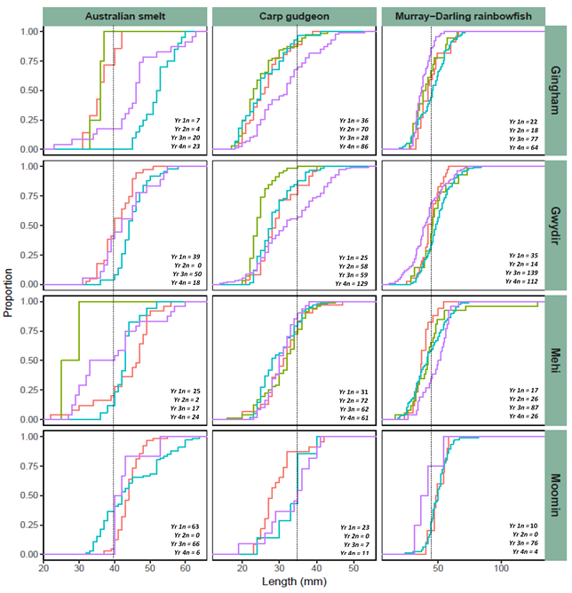
2014-15 2015-16 2016-17 2017-18

Figure H-8: Length frequency distribution (proportion (%)) of small-bodied fish, Australian smelt (Retropinna semoni), carp gudgeon (Hypseleotris sp.) and Murray-Darling Rainbowfish (Melanotaenia fluviatilis) sampled in the Gingham watercourse, Gwydir River, Mehi River and Moomin Creek. Dashed line is approximate length at one year old.

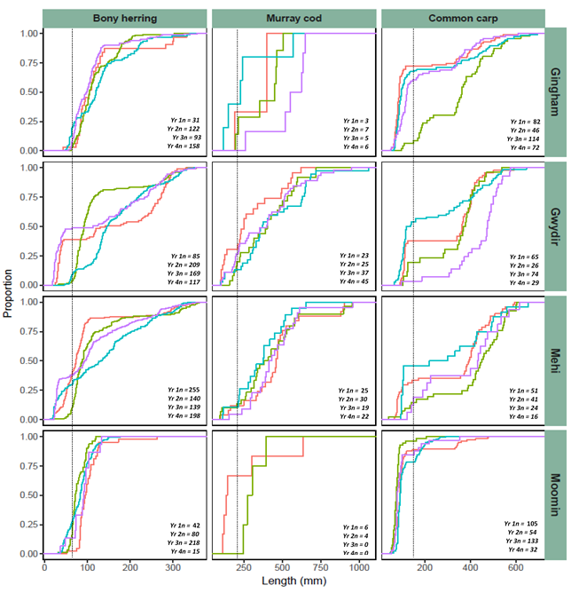
2014-15 2015-16 2016-17 2017-18

Figure H-9: Length frequency distribution (proportion (%)) of large-bodied fish, bony herring (Nematolosa erebi), Murray cod (Maccullochella peelii) and common carp (Cyprinus carpio) sampled in the Gingham watercourse, Gwydir River, Mehi River and Moomin Creek. Dashed line is approximate length of one-year-old individual.

Health indicators
Recruitment
The Recruitment Indicator scores for 2017-18 generally improved or remained similar to that of last year’s scores in all hydrological zones (Figure H-10). Recruitment was rated as “Moderate” in the Moomin, “Poor” in the Gwydir and Mehi, and “Very Poor” in the Gingham. Overall, recruits made up 47% of the total catch of all the native fish caught, which is comparable to 2015-16 at ~54% and 2014-15 at ~42% and considerably higher than last year at 35%. Recruits were caught amongst all the small-bodied species sampled and generally in all four hydrological zones, whilst among the large-bodied species, as in previous years, no golden perch recruits were caught. While no freshwater catfish adults or recruits were recorded during Cat 3 sampling, a small number of both were caught as part of Cat 1 sampling in the Gwydir hydrological zone. Recruits were also caught amongst the three remaining large-bodied native species, and as in previous years, these were in relatively low overall numbers. By count, around the same numbers of Murray cod recruits were caught as in previous years (2017-18 n = 16; 2016-17 n = 11; 2015-16 n = 11; and 2014-15 n = 15). Similarly, the number of bony herring recruits sampled in the current round (n = 152 or 31% of the total number caught) was around the same as in previous years except 2015-16 (n = 55 or 9% of the total number caught) when conditions were extremely dry. Spangled perch recruits were caught in slightly higher numbers than in previous years (n = 29 or 46% of the total number caught). While this is a positive sign, the overall low catch suggests that the spangled perch population remains in a depauperate state across the lower Gwydir system.
Common carp and goldfish recruits were much lower in total numbers compared to last year, at ~32% and 43% respectively. However, compared to 2014-15 and 2015-16 their total population is in high abundance. As in all previous sampling years, most goldfish sampled were recruits, with 97% of the 119 sampled less than one-year-old. Common carp recruits also remained relatively abundant, both in number (2014-15 = 188; 2015-16 = 67; 2016-17 = 233; 2017-18 = 75) and by overall ratio between adults and recruits (2014-15 = 66%; 2015-16 = 40%; 2016-17 = 67%; 2017-18 = 50%). As in previous years, Moomin Creek and the Gingham Watercourse were the common carp and goldfish recruitment “hotspots”, with 94% and 98% of the total number of recruits of each species respectively caught in these two catchments combined. Adult eastern mosquitofish again dominated the catch across all sites where they were sampled, making up 93% of the total numbers caught.
Nativeness
As in previous sampling years, the exotic species common carp, goldfish (and eastern mosquitofish were caught consistently at sites across the lower Gwydir Basin, with all three occurring in all four hydrological zones at a minimum of two sites (Figure 4). Of these, eastern mosquitofish (n = 165) were the most abundant, with the highest catches in Moomin Creek (n = 69) and in the Gwydir River (n = 61). Common carp was again relatively abundant (n = 149), and was also widespread, having been caught at 87% of the sites sampled. By hydrological zone, the highest catches of common carp were in the Gingham watercourse (n = 72), followed by Moomin Creek (n = 32) and the Gwydir River (n = 29), whilst as in previous years, only low numbers were caught in the Mehi River (n = 16). Goldfish numbers were lower than in 2016-17, with less than half the number sampled in the current round compared to last year. As in 2016-17, most goldfish were sampled in the Gingham watercourse (n = 74) and Moomin Creek (n = 43), with only one each caught in the other two zones.
Overall, the Nativeness scores for most zones remained stable or improved marginally compared to 2016-17 (Figure H-10). Of the 23 sites sampled, eight rated as “Good” compared to six in 2016-17, five as “Moderate”, which was the same as 2016-17, four as “Poor” compared to seven in 2016-17, three as “Very Poor” compared to two in 2016-17, and three sites rated as “Extremely Poor”, which was the same as 2016-17. Individual site ratings ranged from a score of 100 at the Mehi 16 site in the Mehi River where no exotic species were sampled, down to 4.4 at the Gingham 38 site, which also had the lowest score for Nativeness in 2016-17. By hydrological zone, the Mehi River again had the highest average site score at 85.1 ± 4.84, giving it an overall rating of “Good” compared to a rating of “Moderate” in 2016-17. Similarly, the Gwydir progressed from an overall rating of “Moderate” to “Good”, averaging 82.3 ± 14.10 across sites. The Moomin and Gingham remained similar to the previous year, scoring the same rating of “Poor” and “Very Poor” respectively (Figure H-10).

Expectedness
Of the 13 native fish species that could have been recorded across the lower Gwydir Basin, eight were caught at a minimum of one site in the Year 4 Cat 3 sampling. The five species not caught were silver perch, southern purple-spotted gudgeon, Darling River hardyhead (Craterocephalus amniculus), olive perchlet and freshwater catfish. Of these species, four are considered to have been “rare” or “occasional” prior to European settlement and, as such, would only be expected to be collected at up to 20% and 45% of sites within a zone (Table 2). The only “common” species not caught during the current round of Cat 3 sampling was freshwater catfish but a small number were caught as part of the wider Gwydir LTIM sampling in 2017-18.
Of the 23 sites sampled as part of the current sampling round, for Expectedness, seven sites scored a rating of “Good”, eight sites scored a rating of “Moderate”, four sites a rating of “Poor” and four sites a rating of “Very Poor”. Scores ranged from 92.2 for the Gingham 4 site in the Gingham watercourse, down to 25.5 for the Moomin 100 and Heathfield sites in Moomin Creek. By zone, the Gwydir had the highest average (± S.E.) rating for Expectedness, scoring 80.8 ± 7.23 giving it an overall rating of “Good”, whilst Moomin Creek had the lowest average, rating as “Very Poor” at 34.5 ± 5.36 (Figure H-10). The Gingham watercourse and Mehi Rivers both had an average rating of “Moderate” for Expectedness (Figure H-10). These results are similar to previous years, with consistently low scores in the Moomin and higher scores for the remaining three sub-catchments (Figure H-10).
Overall score
The Overall Fish Condition (ndx-FS) scores have improved in the Gwydir and Moomin compared to 2016-17 after a low recorded in 2015-16. They have changed little in the Mehi and have continued to decline post 2015-16 in the Gingham (Figure H-10). Of the 23 sites sampled, three had an overall rating of “Good” compared to none in 2016-17, five had a rating of “Moderate” compared to eight in 2016-17, seven had a rating of “Poor” compared to nine in 2016-17, eight had a rating of “Very Poor” compared to four in 2016-17 and there were no “Extremely Poor” ratings, compared to two in 2016-17. Scores ranged from 85 or “Good” for the Norwood site in Gwydir zone, down to 20.8 or “Extremely Poor” for the Gingham 38 site in the Gingham zone. By zone, the Gwydir and Mehi both rated as “Moderate”, whilst the Gingham sites were on average lower than 2016-17 at 35.5 ± 6.69 across the zone resulting in the overall rating declining from “Poor” to ‘Very Poor”. In contrast, the Moomin slightly improved in overall condition, but still scored a rating of “Very Poor” averaging only 38.3 ± 5.05 across the five sites sampled.
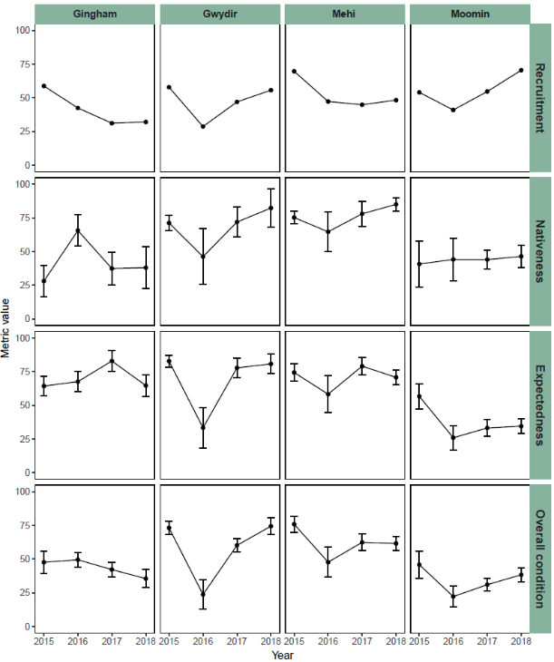
Figure H-10: Recruitment, Nativeness, Expectedness and ndxFS Indicator values for fish at sites sampled in the Gingham watercourse, Gwydir River, Mehi River and Moomin Creek as part of the Gwydir Long Term Intervention Monitoring Program, 2014-18.

Discussion
The generally drier conditions experienced across 2017-18 compared to last year resulted in stabilisation of the fish community across the Selected Area, with only a small decline in the total number of fish captured and approximately the same number of species caught in each hydrological zone as in previous years. Based on the four sampling years to date, it appears that the fish community across the Selected Area is in a constant state of flux, ranging from times of extreme stress and retraction leading to localised extirpations, through to periods of relative stability when recruitment and mortality are at or near equilibrium. This may be reflective of what occurs in a true ephemeral river system where fish communities experience a “boom and bust” cycle in good and bad times respectively (Balcombe et al. 2006; Bond et al. 2008). However, while fish numbers have increased since 2015-16, the Selected Area is not in effect ‘booming’ despite there being an extended wet period across much of the system in 2016-17. In highly degraded rivers like the Gwydir and its tributaries, the expectation of what a fish community should be may be orders of magnitudes away from what can be realistically achieved in the short-term (years). What we may be seeing now is the system at or near its carrying capacity in its current state as far as the fish community is concerned and as such, native fish numbers will stay low and will most likely take longer to recover each time a flooding event.
As with the native fish community, common carp and goldfish numbers either remained stable or declined across the four hydrological zones in 2017-18. As reported previously, both species are known to utilise increased flows to access wetlands to breed and recruit before moving back into the mainstream as juveniles and/or young adults (Brumely 1996; Koehn et al. 2016). As such, the generally lower flow conditions across much of the Gwydir in 2017-18 were most likely less conducive to a large-scale breeding event for either species compared to 2016-17. Those juveniles that were present were most likely a result of “in-channel” breeding, a life-history strategy which both species utilise when conditions are drier. In contrast, mosquitofish increased markedly in overall number, due mainly to a large increase in abundance in the Gwydir River zone. Mosquitofish are considered a threat to biodiversity via predation and competition, including inter-specific interactions with both small and large bodied fish, and with many other native aquatic fauna as well (Komak and Crossland 2000; Harris 2013). The species can tolerate wide-ranging environmental conditions, but prefers warm, slow flowing or still waters (Harris 2013). A prolific breeder, females on average give birth to around 50 live young per brood and can produce up to nine broods a year (McDowall 1996). This means that populations can increase over very short periods of time when conditions are favourable, including during periods of low flow (Harris 2013).
The length-frequency of fish sampled continues to demonstrate that most native species present across the Selected Area are recruiting in at least some sections of the system, albeit in low numbers. As expected, differing flow regimes across years favour some species. Over the 2017-18 period it could be expected that the flows experienced would favour “low-flow” specialists, with generally low and stable flows experienced throughout much of the year, contributed to by the delivery of the stable fish flow during October/November 2017. For some low-flow species this was the case, with carp gudgeon, for example, being recorded in the highest abundance of any of the four rounds of sampling undertaken to date. Carp gudgeon are among a guild of species that Baumgartner et al. (2014) described as “foraging generalists”, which are those species that are resilient to prolonged periods of low flow, require no flow stimuli to spawn, and may in some cases increase in numbers during dry periods and drought. Other species in the generalist guild that behaved similarly in at least some zones during 2017-18 included bony herring and the exotic species, mosquitofish. However, conditions appeared to have an opposite effect on some of the other longer-lived species in this guild, such as freshwater catfish, with only one recruit caught in the current round of sampling compared to more than ten in 2016-17. This appears to support the hypothesis posed previously in this project, that while freshwater catfish can survive, breed and recruit during low-flow periods, timely and large flooding events may also be critical for the long-term conservation of the species in highly regulated systems like the Gwydir basin (Commonwealth of Australia 2017).
While non-flow dependent species appear to be consistently, or at least sporadically, breeding and recruiting in sections of the lower Gwydir, the ongoing low abundance of several flow-dependent species remains of concern for the long-term recovery of native fish within the Selected Area. Species such as golden perch, silver perch and spangled perch were once considered plentiful throughout much of the Gwydir Basin (Copeland et al. 2003). To date, very few adults and very few recruits of any of these three species have been recorded during sampling, suggesting poor or absent breeding and or recruiting across the lower Gwydir Basin. Altered flow regimes, cold water pollution and artificial barriers restricting movement have been suggested as having had a major impact on the breeding and recruitment of all three species (Koster et al. 2014; King et al. 2009; Gehrke et al. 1995). However, both golden and silver perch have also been noted as breeding and recruiting under low flow conditions in the mid Murray River, albeit at lower numbers when compared to high flow years (King et al. 2009; Mallen-Cooper and Stuart 2003). Similarly, spangled perch have been noted as spawning in impoundments (Pusey et al. 2004) and in rivers in relatively low flow years, as has been seen in the current study. Given that all three species are known to aggregate to spawn (Pusey et al. 2004), it may be low densities, in combination with restricted movement due to barriers impacting these species. In the Gwydir, the chances of a significant recruitment event for these species may be limited by the low overall number of adults and by the restrictions placed on those that are present to freely move about the system to interact.
The Fish Health scores for sites in the current sampling round suggest that in general the fish community in the Selected Area remains stable. Expectedness or the measure of what species would most likely be expected to be in the Gwydir if it was undisturbed, along with Nativeness and Recruitment, declined or changed little across all four hydrological zones in 2017-18 compared to 2016-17. In some cases, complementary actions such as translocation and the stocking of hatchery bred fish may be required to re-establish species that may be below what could be considered a critical population threshold. However, stocking alone will be of limited success if other issues such as sedimentation, the loss of riparian vegetation and the negative impacts of exotic species are not also addressed. In addition, water managers must continue to strive to re-establish ‘normative’ flow regimes across as much of the system as possible. ‘Normative’ flows refer specifically to the natural patterns of discharge amplitude and frequency that existed prior to river alteration and more specifically, river regulation (Hauer et al. 2003). This not only includes allowing flooding and the overtopping of the rivers banks onto the floodplain, but also must include allowing the river to dry down at times as would have happened naturally in the past.

Conclusion
The native fish population across the lower Gwydir continues to remain under extreme stress. Given the ongoing low abundance and restricted distribution of most native species present within the system, as well as the apparent absence of several large and small-bodied species, any significant and measurable improvement in the fish community is likely to take some considerable time. Water management within the Selected Area, including the management of environmental water, appears to be contributing to the maintenance of the fish population, but other management actions such as barrier removal, cold-water flow mitigation, re-stocking of key species and reinstating ‘normative’ flow regimes must all be considered to elicit improvements in the fish population.

References
Anderson, M.J., Gorley, R.N., and Clarke, K.R. 2008. 'PERMANOVA + for PRIMER: Guide to Software and Statistical Methods.' (PRIMER-E: Plymouth.)
Balcombe, S.R., Arthington, A.H., Foster, N.D., Thoms, M.C., Wilson, G.G. and Bunn, S.E. 2006. Fish assemblages of an Australian dryland river: abundance, assemblage structure and recruitment patterns in the Warrego River, Murray–Darling Basin. Marine and Freshwater Research, 57(6), 619-633.
Baumgartner, L.J., Conallin, J., Wooden, I., Campbell, B., Gee, R., Robinson, W.A. and Mallen-Cooper, M. 2014. Using flow guilds of freshwater fish in an adaptive management framework to simplify environmental flow delivery for semi-arid riverine systems. Fish and Fisheries, 15, 410-427.
Bond, N., Lake, P. and Arthington, A. 2008. The impacts of drought on freshwater ecosystems: an Australian perspective. Hydrobiologia, 600, 3–16.
Brumley, A.R. (1996) Cyprinids. In: Freshwater Fishes of south-eastern Australia. (Ed. R. McDowall) pp. 99-106. Reed Books: Sydney.
Cadwallader, P.L. 1977. “J.O. Langtry’s 1949-50 Murray River investigations”. Fisheries and Wildlife Paper 13. Fisheries and Wildlife Division, Ministry for Conservation, Melbourne.
Cairns, Jr., J. (Ed.), Franklin, J., Bruns, D., Daniels, W., Ehrlich, A., Gore, J., Grunwald, C., Inouye, D., Klose, P., Louda, S., Maguire, L., Shabman, L., Toth, L., Willard, D., Zedler, J., Jordan, III, W., Bradshaw, A. 1994. Rehabilitating Damaged Ecosystems. Boca Raton: CRC Press.
Carter S. 2012. Sustainable Rivers Audit 2: Metric Processing System. Report prepared by Environmental Dynamics for the Murray Darling Basin Authority, Canberra.
Commonwealth of Australia 2014. Commonwealth Environmental Water Office Long Term Intervention Monitoring Project Gwydir River system Selected Area, Canberra.
Commonwealth of Australia 2015. Commonwealth Environmental Water Office Long Term Intervention Monitoring Project: Gwydir River system Selected Area 2014-15 Evaluation Report. Available online: https://www.environment.gov.au/ water/cewo/publications
Commonwealth of Australia 2016. Commonwealth Environmental Water Office Long Term Intervention Monitoring Project: Gwydir River system Selected Area 2015-16 Evaluation Report. Available online: https://www.environment.gov.au/ water/cewo/publications
Commonwealth of Australia 2017. Commonwealth Environmental Water Office Long Term Intervention Monitoring Project: Gwydir River system Selected Area 2016-17 Evaluation Report. Available online: https://www.environment.gov.au/water/cewo/ publications
Copeland, C., Schooneveldt-Reid, E. and Neller, S. 2003. Fish Everywhere - an oral history of fish and their habitats in the Gwydir River. New South Wales Fisheries, Ballina.
Davies P.E., Harris J.H., Hillman T.J. and Walker K.F. 2008. SRA Report 1: A Report on the Ecological Health of Rivers in the Murray–Darling Basin, 2004–2007. Independent Sustainable Rivers Audit Group for the Murray–Darling Basin Ministerial Council. MDBC Publication No. 16/08: Canberra.
Davies P.E., Harris J.H., Hillman T.J. and Walker K.F. 2010. The Sustainable Rivers Audit: assessing river ecosystem health in the Murray-Darling Basin, Australia. Marine and Freshwater Research, 61, 764–777.
Davis, T.L.O., 1977. Age determination and growth of the freshwater catfish, Tandanus tandanus Mitchell, in the Gwydir River, Australia. Marine and Freshwater Research, 28(2), 119-137.
Gehrke, P. C., Brown, P., Schiller, C. B., Moffatt, D. B. and Bruce, A. M. 1995. River regulation and fish communities in the Murray-Darling river system, Australian Regulated. Rivers: Research and Management, 11, 363–375.
Harris J.H. 2013. Fishes from elsewhere. The Ecology of Australian Freshwater Fishes. In: ‘Ecology of Australian Freshwater Fish'. (Eds. P. Humphries and K. Walker) pp. 259-282.CSIRO Publishing: Collingwood, Victoria.
Hauer, F.R., Dahm, C.N., Lamberti, G.A. and Stanford, J.A. 2003. Landscapes and Ecological Variability of Rivers in North America: Factors Affecting Restoration Strategies. In: Strategies for Restoring River Ecosystem: Sources of Variability and Uncertainty in Natural and Managed Systems. (eds. R.C. Wissmar and P.A. Bisson) pp. 81-106. American Fisheries Society, Bethesda, Maryland.
Hudon, C., Cattaneo, A., Tourville Poirier, A.M., Philippe Brodeur, P., Dumont, P., Mailhot, Y., Amyot, J.P., Despatie, S.P. and de Lafontaine, Y. 2012. Oligotrophication from wetland epuration alters the riverine trophic network and carrying capacity for fish, Aquatic Sciences, 74, 495-511.
Huntington, C., Nehlsen, W. and Bowers, J. 1996. A Survey of Healthy Native Stocks of Anadromous Salmonids in the Pacific Northwest and California, Fisheries, 21 (3), 6-14.
King, A.J., Tonkin, Z. and Mahoney, J. 2009. Environmental flow enhances native fish spawning and recruitment in the Murray River, Australia. River Research and Applications, 25, 1205–1218.
Koehn, J.D. and Nicol, S.J. (2016). Comparative movements of four large fish species in a lowland river. Journal of Fish Biology, 88, 1350–1368.
Komak S. and Crossland M.R. 2000. An assessment of the introduced mosquitofish (Gambusia affinis holbrooki) as a predator of eggs, hatchlings and tadpoles of native and non-native anurans. Wildlife Research, 27, 185–189.
Koster, W.M., Dawson, D.R., Clunie, P., Hames, F., McKenzie, J., Moloney, P.D. and Crook, D.A. (2014). Movement and habitat use of the freshwater catfish (Tandanus tandanus) in a remnant floodplain wetland. Ecology of Freshwater Fish, 24, 443-455.
Leggett, R. and Merrick, J.R., 1987. Australian native fishes for aquariums. JR Merrick Publications.
Lorenzoni, M., Corboli, M., Ghetti, L., Pedicillo, G. and Carosi, A., 2007. Growth and reproduction of the goldfish Carassius auratus: a case study from Italy. In Biological invaders in inland waters: Profiles, distribution, and threats (pp. 259-273). Springer Netherlands.
Mallen-Cooper, M., 1996. Fishways and freshwater fish migration on South-Eastern Australia.
Mallen-Cooper, M. and Stuart, I. G. 2003. Age, growth and non-flood recruitment of two potamodromous fishes in a large semi-arid/temperate river system. River Research and Applications, 19, 697–719.
McDowall R. 1996. Freshwater Fishes of South-Eastern Australia (second edition). Reed Books, Chatswood, NSW.
Murray–Darling Basin Authority. 2012. Sustainable Rivers Audit 2: The ecological health of rivers in the Murray–Darling Basin at the end of the Millennium Drought (2008–2010). Murray–Darling Basin Authority, Canberra.
Ogle, D. (2016). Introductory Fisheries Analyses with R. New York: Chapman and Hall/CRC.
Pusey B.J., Kennard M.J. and Arthington A.H. 2004. Freshwater Fishes of North-Eastern Australia. CSIRO Publishing: Collingwood.
Robinson W. 2012. Calculating statistics, metrics, sub-indicators and the SRA Fish theme index. A Sustainable Rivers Audit Technical Report. Murray-Darling Basin Authority, Canberra.
Southwell, M., Wilson, G., Sparks, P. and Thoms, M. 2015. Monitoring the ecological response of Commonwealth Environmental Water delivered in 2013-14 in the Gwydir River system: A report to the Department of Environment. University of New England, Armidale.
Vilizzi, L. and Walker, K.F. 1999. Age and growth of the common carp, Cyprinus carpio, in the River Murray, Australia: validation, consistency of age interpretation, and growth models. Environmental Biology of Fishes, 54(1), 77-106.

Fish (Movement)

Introduction
Movement allows organisms the opportunity to locate new resources (e.g. nesting sites, food), escape unfavourable conditions, avoid competition with other biota for food and space, or avoid breeding with closely related individuals which could lead to inbreeding depression (Nathan et al. 2008). Many organisms use environmental cues to guide their movement behaviours, such as photoperiod, changes in temperature or rainfall events (Winkler et al. 2014). In rivers, variations in river flow can be strong determinants of movement (Bilton et al. 2001). Variation in river flow and hydraulic conditions is a key determinant of the nature, timing and extent of fish movement, for both long range migrations (Reynolds 1983; Simpson & Mapleston 2002; Koehn 2004; Butler et al. 2009; Young et al. 2010; Reinfelds et al. 2013) and fine scale movements (Korman & Campana 2009; Cocherell et al. 2011). Biological factors such as size, sex and, evolutionary history may also be important determinants of movement behaviour and responses to variations in flow and habitat.
In many river systems, fish populations are supplemented by translocation (Douglas & Brown 2000; Ebner & Thiem 2009; Hammer et al. 2012; Lintermans 2013). Due to inherent differences in source population behaviours (Kaya 1991; Coombs & Grossman 2006) and stress effects of translocation (Dickens et al. 2010; Olden et al. 2011), different movement behaviours may be observed in translocated individuals compared with resident riverine fish. However, to date, there has been no study involving the translocation of fish from lacustrine to riverine habitats, especially in a regulated system where the fish may have their homing movements restricted by infrastructure. It is also unclear how differences in flow regimes of release sites influence short-term behaviour and likelihood of successful establishment over the longer term.
Bio-telemetry is used extensively by fisheries scientists across the globe to answer a wide range of questions, including many related to fish and their response to changes in river flows. There are currently several active acoustic bio-telemetry programs throughout the Murray-Darling Basin, answering among other questions, those relating to environmental flows and fish movement. Unlike these existing programs, the Gwydir River system Long Term Intervention Monitoring (LTIM) project offers a unique opportunity to utilise bio-telemetry to answer a range of questions specific to the northern Murray-Darling Basin. Here we report preliminary findings of short-term (~ 5 months) local scale movements of Murray cod (Maccullochella peelii) and freshwater catfish (Tandanus tandanus). We evaluate how fish movement characteristics varied between two fine-scale arrays in response to changing environmental conditions and how this varied between resident riverine and translocated lacustrine fish, sex and size. We also describe the movements of the two species over a longer period (~ 24 months), across a broad-scale acoustic array.
Several specific questions were posed in relation to this indicator:
Short-term (one-year) questions:
- What did Commonwealth environmental water contribute to native fish dispersal?
- Did environmental water stimulate target species to exhibit movement consistent with breeding behaviour?
- Did environmental water facilitate target species to move/return to refuge habitat?
- What did Commonwealth environmental water contribute to native fish community resilience?
- What did Commonwealth environmental water contribute to native fish survival?
Long-term (five-year) question:
- What did Commonwealth environmental water contribute to native fish populations?

Environmental watering in 2017-18
During 2017-18, environmental water was delivered to both in-channel and wetland assets in the Gwydir River system (Table I-1). An early season stimulus flow was triggered by inflows to Copeton Dam in August/September 2017. A total of 10,000 ML was delivered into the main Gwydir River, Mehi and Carole Creek systems as a small fresh during late winter/early spring. Following this, a stable flow release of 10,040 ML was delivered into the main Gwydir River, Mehi and Carole Creek systems in late October to mid-November 2017. These small pulse flows were aimed at providing downstream connectivity and allowing opportunity for movement, breeding and recruitment of fish, particularly freshwater catfish (Tandanus tandanus).
A delivery of 8,000 ML including both State and Commonwealth environmental water was made to the lower Gwydir and Gingham wetlands from mid-December 2017 to late January 2018, to replace supplementary take from a small flow event that occurred in the previous months. This aimed to maintain wetland habitat quality, and support the survival and resilience of flora and fauna in the wetlands. The last environmental delivery was made in late April/May 2018 as part of the Northern Connectivity Event. This flow aimed to provide longitudinal connectivity and refresh/replenish drought refuge for instream life, particularly native fish in the Barwon-Darling as well as improving conditions to maintain native fish populations within the tributary catchments. During this event, a total of 18,908 ML of both State and Commonwealth water was delivered down the Mehi River, Moomin Creek and Carole Creek. No environmental water deliveries were made to Mallowa Creek in 2017-18.

Previous monitoring
Fish movement monitoring in the 2016-17 year showed that at broader scales, tagged individuals of both Murray cod and freshwater catfish used increases in river discharge to move throughout the Mehi and Gwydir channels and, in some cases, change from one system to another. This included times when environmental water was being released.
Table I-1 Environmental water delivered in the Gwydir River system Selected Area in 2017-18. Percentage represents the percentage of the total flow made up of environmental water.
Channel | Commonwealth Environmental Water (CEW) delivered (ML) | NSW ECA/General Security/Supplementary environmental Water delivered (ML) | 2017-18 total flow (ML) | Environmental Water % of total flow
Gwydir River* | 28,290 | 18,748 (including 15,748 General Security) | 412,705 | 11
Gingham watercourse | 2,000 | 5,534 (including 4,520 General Security) | 22,984 | 33
Lower Gwydir | 2,000 | 5,706 (including 4,520 General Security) | 19,831 | 39
Carole Creek | 3,886 | 2,462 (including 1,662 General Security) | 95,341 | 7
Mehi River< | 20,404 | 5,046 general security | 91,067 | 28
Moomin Creek# | 324 | 175 | 104,075 | 0.5
Mallowa Creek | 0 | 0 | 121 | 0
Total | 28,290 | 18,748 (including 15,748 General Security) | 412,705 | 11
* All environmental water delivery to the Gwydir system flowed through the Gwydir River in 2017-18. Therefore, volumes for this channel represent total volumes delivered downstream and as such are not included in the total.
< Includes 499 ML that flowed down Moomin Creek, but returned to the Mehi downstream. Also includes 90 ML NSW General Security water for delivery to Whittaker’s Lagoon.
# Not included in total as accounted in return flows to Mehi.

Methods

Study area
The current study was in the Mehi and Gwydir Rivers within the Selected Area (Selected Area; Figure I-1). In the Mehi River, the study reach extended from Tareelaroi Weir, where the Mehi diverges from the Gwydir, downstream to the township of Moree. In the Gwydir, the study reach extended from 6 km upstream of Tareelaroi Weir, downstream to immediately below the junction of the Gwydir and Gingham watercourse. Each study reach covered approximately 45 km of their respective river. The Gwydir and Mehi typically do no exceed 25 m in width and 3 m in depth. Both river systems are highly regulated and the surrounding catchment is used for intensive agricultural including large areas under irrigated crops. The system receives environmental flows from the main upstream impoundment, Copeton Dam. The in-stream environment of both systems includes a variety of mesohabitats, such as woody debris, gravel beds, undercut banks, reed beds, overhanging riparian vegetation and small amounts of aquatic macrophytes. The rivers support a host of native fish species, including populations of the endangered freshwater catfish and the threatened Murray cod.
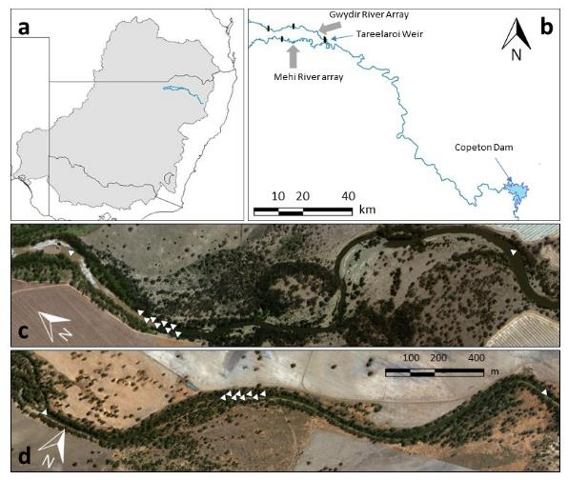
Figure I-1: (a) Location of Gwydir River system (blue lines) in the Murray-Darling Basin (grey area), with state borders. (b) Study area and upper catchment of the Gwydir River system, showing Copeton Dam (upstream), weirs within the study reach (vertical black bars) and fine-scale acoustic array locations (grey arrows). Locations of the Gwydir River (c) and Mehi River (d) arrays, with acoustic receivers denoted by ∆.

Fine-scale acoustic array
Local-scale behavior of tagged fish was recorded between 24 May and 01 November 2016 using two fine-scale acoustic telemetry arrays consisting of eight Vemco VR2W 69 KHz receivers arranged in adjacent equilateral triangles in the Gwydir River (149.99913 E, 29.42796 S, Figure I-1c) and Mehi River (149.89761 E, 29.47022 S, Figure I-1d). The arrays were deployed prior to the release of tagged fish from 9-13 May 2016, with sites selected for consistency in habitats among sites. A range of tests were performed in situ, as described in Espinoza et al. 2011, to assess signal strength in relation to receiver position and provide high precision positioning of multiple fish simultaneously. Temperature loggers (OneTemp, Sydney) were attached to the center receiver of each array during the installation process.

Broad-scale acoustic array
Broad-scale fish movements were recorded between 24 May 2016 – 20 May 2018, using an extensive linear array of 30 (15 in each system) Vemco VR2W 69 KHz receivers deployed at intervals of ~3 km along the Gwydir and Mehi rivers (Figure I-2). This broad-scale array recorded binary presence/absence data when a tagged fish entered the reception range of a given receiver. The array was deployed prior to the release of tagged fish from 9-13 May 2016 (Figure I-3). Temperature loggers (OneTemp, Sydney) were also deployed at the upper and lower extremes of both arrays on the same dates.
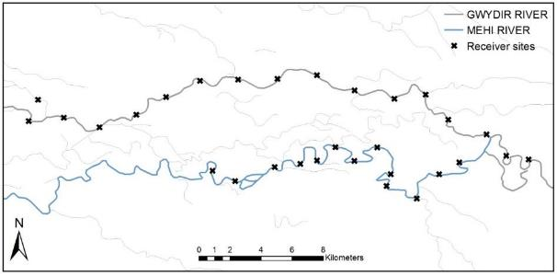
Figure I-2: Broad-scale array receivers in the Gwydir and Mehi rivers
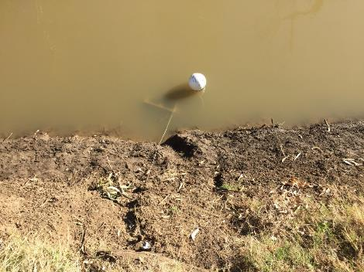
Figure I-3: Deployed fine-scale receiver in the Gwydir River 2016

Fish collection
The original intention was to tag five “resident” freshwater catfish and five “resident” Murray cod in each river, and to also translocate 10 catfish from Copeton Dam and release five in each system as well. However, despite exhaustive efforts, riverine catfish proved elusive and were supplemented with a greater number of translocated individuals (Table I-2). All resident fish were caught within the confines of the fine-scale array to eliminate possible movement away from the array due to homing behaviour.
Table I-2: Source and numbers of freshwater catfish and Murray cod tagged and released in the Gwydir and Mehi rivers May 2016
 | Gwydir fine-scale | Gwydir broad-scale | Mehi fine-scale | Mehi broad-scale
Resident freshwater catfish | 3 | 0 | 0 | 1
Translocated freshwater catfish | 7 | 10 | 10 | 9
Resident Murray cod | 5 | 5 | 5 | 5

All fish were collected by electrofishing, gill netting (mesh size 100mm) or angling from 23 May – 1 June 2016. The exact capture location of riverine “resident” fish was recorded and all fish were released within 50 m of their capture site. Freshwater catfish from Copeton Dam were transported to the study sites in aerated 220 L containers, with a maximum of five fish per container. Fish from Copeton Dam were kept in a floating cage (mesh size 50 mm) until tag implantation.

Acoustic tag implantation
Fish were anaesthetised in ambient water containing 50 mg L−1 benzocaine (ethyl-p-aminobenzoate) (Sigma Aldrich, Shanghai), weighed (g) and measured (mm). Fish were then transferred to an operating cradle (Figure I-4), with water containing an equivalent level of anaesthetic (50 mg L−1) continually pumped over the gills to maintain anaesthesia. To access the peritoneal cavity, an incision was made through the body wall of the fish, adjacent to the linea alba and anterior of the anal vent. The gonads of the fish were examined through the incision to determine sex before the insertion of the tag. Either a Vemco V9 or V13 69 KHz acoustic telemetry transmitter tag (delay 90-160 secs, approximate battery life of two+ years) was used, with tag size dictated by the recommended maximum of 2.25% of body weight (Jepsen et al. 2002; Butler et al. 2009; Wagner et al. 2011). Passive integrated transponder (PIT) tags were also inserted in the cavity for long-term identification. Incisions were closed with two or three sutures using 0.3 mm pseudo-monofilament, absorbable thread (Vetafil Bengen; WdT, Garbsen, Germany). After suturing, the fish were given an intramuscular injection of oxytetracycline hydrochloride (0.25 mL kg−1) (CCD Animal Health and Nutrition, Toowoomba) and then returned to a floating cage to recover.
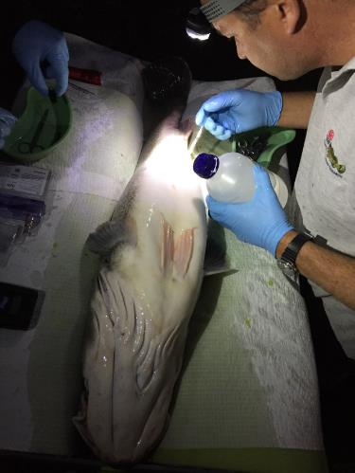
Figure I-4: Murray cod (Maccullochella peelii) being implanted with acoustic tag.

Statistical analyses (fine-scale)
Only Murray cod and freshwater catfish released directly into the fine-scale arrays were used in the fine-scale analyses. Fish presence / absence within arrays were inspected for possible transmitter errors and to identify individuals to include in analyses, with individual fish detected at least once within an array, on a given day, recorded as present and fish not detected recorded as absent. First detections at the terminal receivers of the fine-scale arrays, for each individual, were also inspected to determine the magnitude, direction and frequency of fish movements outside of the arrays. In subsequent analyses, only individuals with more than 40 position detections were included in analyses (Murray cod: Mehi n = 4, Gwydir n = 5; freshwater catfish: resident n = 3, translocated n = 15).
Fish movements were summarised in terms of average hourly rate of movement (ROM), generated using the adehabitatLT package in R (Calenge 2006). ROM was calculated by dividing the distance between two consecutive fish locations by the time taken to move between the locations (expressed as m/min). To avoid underestimating ROM, only consecutive position detections less than 160 seconds apart (the maximum time between transmitter pings) were included in the analyses (as per Furey et al. (2013)).
ROM was compared to population source (only T. tandanus), hourly flow rate (Mehi regulator gauge (418044) and Tareelaroi weir gauge (418042) for respective rivers), water temperature, diel period (day/night), moon phase, sex and length using a penalised qausi-likelihood generalized linear mixed model in the MASS package in R (Venables & Ripley 2002), with fish ID as a random effect.
In addition, habitat selection was assessed using Euclidean distance-based analysis (EDA) as per Conner and Plowman (2001). First, discrete habitat types for the study area were interpolated using universal kriging, from sampled transect points within ArcGIS (ESRI, California). Within the area of detection for each fine-scale array, 1000 random points were generated and distances between each habitat type and each random point were calculated. For each fish location, a vector of mean distances to each habitat type was then created, with a distance of 0 to the habitat occupied by the fish at the time of detection. EDA ratios were calculated as the mean observed distance, from fish locations, divided by the mean expected distance (from random points) to each habitat type. A unique EDA ratio was calculated for each habitat type for each fish, retaining the individual as the experimental unit. If habitat use was random, all EDA ratios should equal one, with values >1 indicating positions farther from a habitat type than expected (avoidance) and values <1 indicating positions closer to a habitat type than expected (preference). For each habitat parameter, differences in EDA ratios between rivers as well as source, was evaluated for each species using non-parametric 1-way analysis of variance (Kruskal-Wallace tests).

Statistical analyses (broad-scale)
Data from all tagged Murray cod and freshwater catfish were used in the broad-scale analyses of fish movements. Fish movements were summarised as total distance travelled by each fish and maximum distance (upstream or downstream) that each fish moved away from its release site in each month. In addition, the average distance moved by fish of each species, in each month, was calculated for all fish still being detected in the broad-scale array in that month.

Results

Fine-scale

Freshwater catfish movement in the Gwydir and Mehi rivers
All 20 tagged freshwater catfish were detected within their respective fine-scale arrays, within the five-month study period. Resident catfish were detected, on average, in the array for longer periods than translocated catfish (mean 126 days ± 6 S.E. vs. 22 ± 4, respectively). All translocated freshwater catfish in the Gwydir River and the majority in the Mehi River were detected by the downstream terminal receiver first (Figure I-5). Most translocated catfish were also detected by the terminal upstream receiver in their respective rivers, with several translocated catfish detected moving between both terminal receivers on the same day, sometimes within a period as little as two hours apart. Only one resident catfish was detected by a terminal receiver.
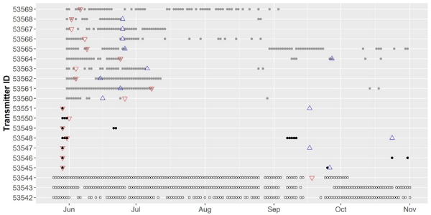
Figure I-5: Daily detections for freshwater catfish (T. tandanus) in fine-scale arrays in 2016. Dots represent at least one detection in a given day (∘ Gwydir resident, • Gwydir translocated and • Mehi translocated). First upstream terminal receiver detection denoted by △ and first downstream terminal receiver detection denoted by ▽.
Factors influencing movements of freshwater catfish varied at a range of temporal scales. In the first week, both population source (SE = 0.002, df = 6, P = 0.003) and hourly flow rate (SE = 0.002, df = 415, P = 0.002) were found to have a significant effect on ROM in the Gwydir River. Resident freshwater catfish were less active than translocated individuals and as hourly flow release increased, individuals moved more. Within the first month, only water temperature was found to have a significant effect on ROM (SE = 0.011, df = 1114, P = 0.037), individuals became more active as water temperature increased. Over the entire study, hourly flow release, water temperature and diel period were found to have a significant effect on ROM. Individuals were more active during the night (SE = 0.001, df = 4704, P<0.001), during higher levels of flow (SE = 0.003, df = 4704, P<0.028) and during warmer water temperature (SE<0.001, df = 4704, P<0.001).

Murray cod movement in the Gwydir and Mehi Rivers
All 10 tagged Murray cod were detected within their respective fine-scale arrays within the five-month study period. Murray cod were detected within the arrays, on average, for 85 ± 18 days (mean ± S.E.). Murray cod showed no pattern in first detections at upstream or downstream terminal receivers in the Mehi River (Figure I-6). Both fish 53601 and 53597 were not detected within the fine-scale array for several weeks before being detected by a terminal receiver, suggesting that these fish were resident in the small length of river between the array and the terminal receiver for the periods between detections. All five Murray cod in the Gwydir River were detected by a terminal receiver in the period from August–October 2016, indicating that fish underwent substantial movements during this period (40-120km).
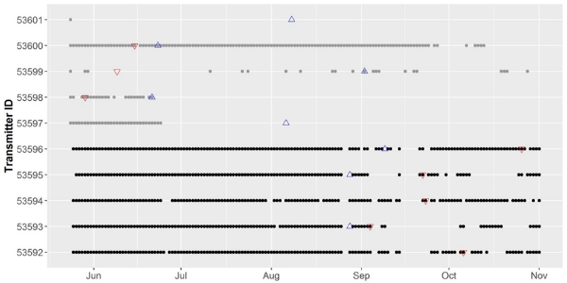
Figure I-6: Daily detections for Murray cod (M. peelii) in fine-scale arrays in 2016. Dots represent at least one detection in a given day (• Gwydir and • Mehi). First upstream terminal receiver detection denoted by △ and first downstream terminal receiver detection denoted by ▽.

Factors influencing movements of Murray cod varied at a range of temporal scales. In the first week, Murray cod ROM was only significantly influenced by changes in flow (SE = 0.01, df = 790, P< 0.001), with individuals moving less as flow increased. Within the first month, both flow rate (SE = 0.001, df = 3285, P <0.001) and diel period (SE = 0.001, df = 3285, P = 0.001) had a significant effect on ROM. Individuals moved less as flow increased and ROM increased during the night. Throughout the entire study, flow (SE<0.001, df = 10992, P<0.001), water temperature (SE<0.001, df = 10992, P<0.001), and diel period (SE = 0.001, df = 10992, P<0.001) all had significant effects on ROM. Individual Murray cod movements were greater with higher levels of flow, increasing temperatures and during the night. These results suggest that initially Murray cod did not to move on higher flows, but over the whole study period (12 months) they showed a tendency to move on higher flows.

Habitat use by freshwater catfish and Murray cod
Habitat use, based on EDA ratios, indicated non-random selection of some habitat types by both freshwater catfish and Murray cod (Figure I-7). Freshwater catfish showed significant differences between populations in selection of most habitat types (Figure I-7a). For example, fish translocated to the Gwydir and Mehi showed greater selection (i.e. EDA <1) for deeper waters, whereas riverine fish selected shallower areas. All catfish showed greater selection for higher riparian canopy cover, submerged over hanging vegetation and the lowest water velocities. Murray cod tended to actively select deeper waters and areas of lower velocity and preferred higher riparian canopy cover, with different behaviours between rivers in terms of habitat selection (Figure I-7b).
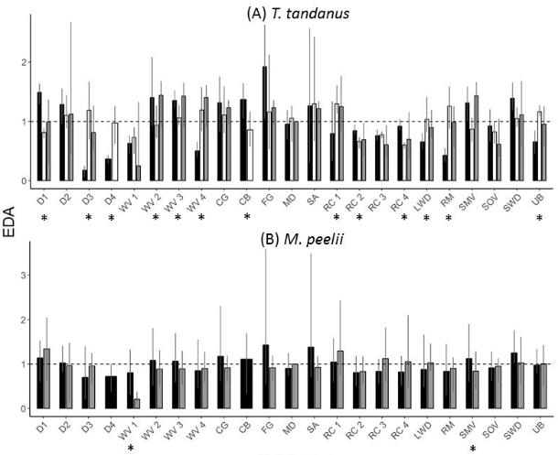
Figure I-7: Habitat type selection (Mean ± s.d.) for different population sources (riverine and lacustrine) of (A) Freshwater catfish (T. tandanus, ∘ Gwydir resident, • Gwydir translocated and • Mehi translocated) and (B) Murray cod (M. peelii, • Gwydir and • Mehi). Habitat type selection based on Euclidean distance analysis (EDA) ratios of microhabitat types available. Values < 1 indicate increased use relative to availability, while values > 1 indicate avoidance. EDA ratios for each habitat type that were signiﬁcantly different between rivers and population sources (p < 0.01) are indicted by *. D1 = 0-1 m depth, D2 = 1-2 m depth, D3 = 2-3 m depth, D4 = 3 m + depth, WV1 = water velocity 0-25%, WV2 = 25-50%, WV3 = 50-75%, WV4 = 75-100%, CG = coarse gravel, CB = cobble, FG = fine gravel, MD = mud, SA = sand, RC1 = riparian cover 0 – 25%, RC2 = 25 – 50%, RC3 = 50 – 75%, RC4 = 75 – 100%, LWD = large woody debris, RM = root mass, SMV = submerged marginal vegetation, SOV = submerged overhanging vegetation, SWD = small woody debris, UB = undercut bank.

Broad-scale movement

Freshwater catfish
Overall, 37 of the 40 freshwater catfish tagged in May 2016 were detected at least once within the broad-scale array during the period May 2016 – May 2018. Very little broad-scale movement occurred for the four months post-release, however, subsequent total individual movements ranged from 0 to 294.1 km (average ±SE = 38.5 ± 9.4 km, Figure I-8a). The degree of movement varied amongst fish from different sources and between release locations, with largest movements occurring for translocated fish from Copeton Dam released into the Mehi River, while movements were generally smaller for resident fish released in situ (Figure I-8a). Movements tended to be individualistic, with some fish moving very little, some only moving back-and-forth between one or two receivers, whilst others moved large distances from their release locations (Figure I-8b). Movements occurred both upstream and downstream within and between systems (Figure I-8c). Of the fish that changed systems, five freshwater catfish went from the Mehi into the Gwydir and proceeded upstream out of the array. Similarly, a small number moved out of the downstream end of both the Gwydir and Mehi arrays, with some returning whilst others were not detected again.
a)

Figure I-8: Broad-scale movements by freshwater catfish (Tandanus tandanus) in the Gwydir and Mehi rivers, May 2016 – May 2018. In (b), positive results indicate upstream movement, while negative results indicate downstream movement.

Murray cod
All 20 Murray cod tagged in May 2016 were detected at least once within the broad-scale array during the period May 2016 – May 2018. Very little broad-scale movement was recorded for the four months post-release, however, subsequent total individual movements ranged from 0.2 to 176.4 km (average ± SE = 47.4 ± 11.5 km, Figure I-9a). Movements tended to be individualistic, with some fish moving very little, some only moving back-and-forth between one or two receivers, whilst others moved large distances (Figure I-9b). Movement occurred both upstream and downstream (Figure I-9c) within and between systems. Murray cod were detected moving from the Mehi into the Gwydir as discharge allowed, but primarily during the larger natural flow pulse in September 2016. One cod (53589) moved between these systems twice; starting in the Mehi, moving into the Gwydir briefly in September 2016, returning to the Mehi, and then moving into the upstream section of the Gwydir in October 2017, where detections ceased. Two other fish (53597, 53601) were detected moving from the Mehi into the Gwydir and then moving downstream, taking up residency in the mid sections of this system, while a third fish (53588) moved into the Gwydir and then moved downstream out of the array.

Figure I-9: Broad-scale movements by Murray cod (Maccullochella peelii) in the Gwydir and Mehi rivers, May 2016 – May 2018. In (b), positive results indicate upstream movement, while negative results indicate downstream movement.

Effect of river flows on fish movement
Individuals amongst both species increased activity during early September–October 2016 (Figure I-8c, Figure I-9c) during a large natural discharge event that moved down through both systems during this time (Figure I-10a). A series of smaller discharge events in January, March and September 2017 (Figure I-10a) also resulted in increased activity among freshwater catfish (Figure I-8c), and to a lesser degree among small numbers of Murray cod (Figure I-9c). These discharge events were a result of both irrigation flows and increased flow following small amounts of rainfall in September 2016 and across March 2017 (Figure I-10c). The flow pulse in September 2017 was a result of a managed early season stimulus environmental flow.
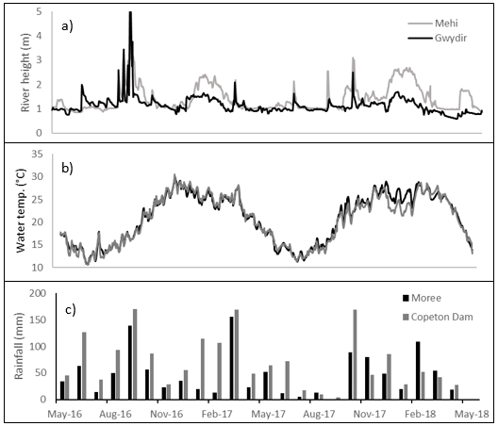
Figure I-10: River heights (a) and water temperatures (b) in the Gwydir and Mehi rivers and monthly rainfall (c) from Bureau of Meteorology weather stations at Moree and Copeton Dam, May 2016 – May 2018.

Reductions in tagged fish detections within the broad-scale array over time
While 11 Murray cod and 13 freshwater catfish were still being detected within the broad-scale array after one year, after two years the number of fish being detected within the array was very low (Murray cod = 1, freshwater catfish = 1). Causes for these reductions cannot be determined, however, some fish were detected moving upstream and downstream out of the array. It is also possible that some fish became resident between listening stations and, therefore, could no longer be detected. In addition, some acoustic tags will have ceased to function towards the end of the study, with tags having an operational life of ~2 years. The decline in numbers of tagged fish detected over the course of the study does, however, indicate that some mortality may have occurred, either naturally, or through fishing pressure with both study species targeted by anglers.

Discussion
The current study provides valuable new insights into the behaviour and movements of both resident and translocated freshwater catfish and resident Murray cod. Significant differences in habitat selection were observed between rivers and fish population sources (i.e. resident and translocated). Murray cod tended to select deeper areas and areas with some woody structures. Similar preferences have been reported previously for Murray cod in the Murray River in the southern Murray-Darling Basin (Koehn 2009). Murray cod in both rivers displayed a preference for the highest and lowest areas of water velocity, over intermediate areas. This behaviour may reflect the increased foraging potential of higher river flow (Smith and Li 1983). Cod may seek the slowest water as part of non-foraging behaviours and the fastest water when foraging.
Freshwater catfish displayed considerable differences in habitat utilization between rivers and population sources. Resident catfish actively selected undercut banks and root masses, significantly more so than translocated fish. Koster et al. (2015) found that riverine and palustrine individuals made extensive use of macrophytes and wood structures. Macrophytes are rare within the study reach, however, they are abundant at the capture site of the translocated fish and as such, translocated individuals may have adopted different habitat preferences due to differences in habitat availability in their former range. Similarly, translocated catfish preferred deeper areas of the water column, compared to resident catfish, potentially reflecting the greater availability of deeper habitats within their former range, although freshwater catfish have been observed predominately inhabiting shallow, littoral habitats (Koster et al. 2015). Given the utilisation of a broad range of habitats by both Murray cod and freshwater catfish, using environmental water to maintain water levels to provide connectivity among different habitats throughout the year, should be considered to ensure the sustainability of these populations.
Over the first week, within the fine-scale array, resident freshwater catfish were less active than translocated individuals and their movement increased as flow increased. Differences in the behaviour of translocated fish, due to adaptations to source habitats, has been noted in other studies (Kaya 1991; Coombs & Grossman 2006; Taylor & Peterson 2015) and may have contributed to the higher activity levels observed in translocated catfish. Within the first month and over the remaining five months, population source was no longer a significant influence on the ROM. This may be due to translocated individuals establishing new home ranges and adapting to their new habitats as time passed, as observed in Crook (2004). Over the entire study, freshwater catfish were found to be more active during the nocturnal period, during periods of higher water temperatures and in periods of higher flow. The freshwater catfish is well known as a nocturnal species (Davis 1977a; Koster et al. 2015) and is known to spawn at temperatures of over 24°C (Davis 1977b). These behaviours may explain the increases in movement during late spring and summer, with temperatures exceeding 24°C in both river systems in this period (Figure 10b).
During the first week, Murray cod moved less with increased flow within the fine-scale array, potentially due to flows outside the breeding season not inciting fine-scale or long-range movements, as shown in other studies of the species as well as with like species (Simpson & Mapleston 2002; Humphries 2005; Koehn et al. 2009; Koehn & Nicol 2016). Murray cod are also known to be nocturnal feeders (Allen‐Ankins et al. 2012) and this potentially drove the increased nocturnal ROM recorded during the first month and over the entire study. Murray cod ROM increased in response to increased flow release and water temperature when spawning season (spring) was included in the analysis, indicating the importance of water flow during this period for this species.
Whilst maintaining natural flow regimes is well documented as being important for highly mobile species such as golden perch (Macquaria ambigua) (e.g. Koster et al. 2017) and silver perch (Bidyanus bidyanus) (e.g. Koehn et al. 2014), the sporadic increases in activity and relatively large-scale relocations by both freshwater catfish and Murray cod in the current study highlights the importance that river discharge has in the life-history of potamodromous fishes. Potamodromous fishes are those that spend their entire life in freshwater in rivers but quite often need to relocate to different parts of the system to complete their life-history (Koehn and Crook 2013). Freshwater catfish and Murray cod are known to undertake non-obligatory relocations to find suitable spawning habitat and possibly mates during late winter and spring each year (Gavin Butler unpublished data). The results of the current study support these findings, with large movements detected in spring for both species. The greatest movement was noted during the unregulated flow pulse in September- October 2016, but smaller flow pulses also elicited movement and relocation of both species. During the 2017-18 water year, the greatest movement of both species was observed during the early season stimulus flow in August/September 2017. Given that the lower Gwydir and its tributaries are highly regulated, and that winter and spring are also the seasons with the least discharge across the region, protecting natural flows and using environmental water in a similar way to the early season stimulus flow to provide smaller flow pulses would allow fish to move during this period to facilitate relocation and breeding. Whilst winter and spring are critical times for both species, individuals of both species also used increases in river discharge to roam at other times of the year. These non-breeding movements, most likely to access resources such as food or shelter, are equally as important in the life-history of freshwater fishes. These movements further highlight the importance of protecting and managing river discharge throughout the entire year in highly regulated river systems like those of the lower Gwydir.

Conclusion
This report details the results of a two-year study to understand the movement patterns of two key species in relation to river discharge across the lower Gwydir Basin. The data collected has provided detailed information regarding localised behaviour over a period of five months and revealed that complementary measures such as relocating fish into areas where populations had declined to critical numbers can be a successful strategy, especially given that both species, and in particular freshwater catfish are only recruiting in small numbers in this system (Commonwealth of Australia 2017). At broader scales, both species used increases in river discharge to move throughout both the Mehi and Gwydir and in some cases to change location from one system to another. This occurred during both natural flow events and during environmental water deliveries such as the early season stimulus flow. This highlights the importance of flow to riverine fishes in the smaller river systems of the Murray-Darling Basin and provides an insight into the important role that environmental water can play in ensuring the long-term persistence of species such as freshwater catfish and Murray cod in such rivers.

References
Allen‐Ankins, S., Stoffels, R., Pridmore, P. and Vogel, M. 2012. The effects of turbidity, prey density and environmental complexity on the feeding of juvenile Murray cod Maccullochella peelii. Journal of Fish Biology, 80, 195-206.
Bilton, D.T., Freeland, J.R. and Okamura, B. 2001. Dispersal in freshwater invertebrates. Annual Review of Ecology and Systematics, 32, 159-181.
Butler, G.L., Mackay, B., Rowland, S.J. and Pease, B.C. 2009. Retention of intra-peritoneal transmitters and post-operative recovery of four Australian native fish species. Marine and Freshwater Research, 60, 361-370.
Calenge, C. 2006. The package “adehabitat” for the R software: A tool for the analysis of space and habitat use by animals. Ecological Modelling, 197, 516-519.
Cocherell, S., Cocherell, D., Jones, G., Miranda, J., Thompson, L., Cech, J., Jr. and Klimley, A.P. 2011. Rainbow trout Oncorhynchus mykiss energetic responses to pulsed flows in the American River, California, assessed by electromyogram telemetry. Environmental biology of fishes, 90, 29-41.
Coombs, S. and Grossman, G.D. 2006. Mechanosensory based orienting behaviours in fluvial and lacustrine populations of mottled sculpin (Cottus bairdi). Marine and Freshwater Behaviour and Physiology, 39, 113-130.
Commonwealth of Australia 2017. Commonwealth Environmental Water Office Long Term Intervention Monitoring Project: Gwydir River system Selected Area 2016-17 Evaluation Report. Available online: https://www.environment.gov.au/water/cewo/ publications
Conner, L.M. & Plowman, B.W. 2001. Chapter 10 - Using Euclidean Distances to Assess Nonrandom Habitat Use A2 - Millspaugh, Joshua J. In: Marzluff, J.M., ed. Radio Tracking and Animal Populations. San Diego: Academic Press, pp. 275-290.
Crook, D.A. 2004. Is the home range concept compatible with the movements of two species of lowland river fish? Journal of Animal Ecology, 73, 353-366.
Davis, T. 1977a. Food habits of the freshwater catfish, Tandanus tandanus, Mitchell, in the Gwydir River, Australia, and effects associated with impoundment of this river by the Copeton Dam. Marine and Freshwater Research, 28, 455-465.
Davis, T. 1977b. Reproductive biology of the freshwater catfish, Tandanus tandanus, in the Gwydir River, Australia. II. Gonadal cycle and fecundity. Marine and Freshwater Research, 28, 159-169.
Dickens, M.J., Delehanty, D.J. and Romero, L.M. 2010. Stress: An inevitable component of animal translocation. Biological Conservation, 143, 1329-1341.
Douglas, J.W. and Brown, P. 2000. Notes on successful spawning and recruitment of a stocked population of the endangered Australian freshwater fish, trout cod, Maccullochella macquariensis (Cuvier) (Percichthyidae). Proceedings of the Linnean Society of New South Wales, 122, 143-147.
Ebner, B.C. and Thiem, J.D. 2009. Monitoring by telemetry reveals differences in movement and survival following hatchery or wild rearing of an endangered fish. Marine and Freshwater Research, 60, 45-57.
Espinoza, M., Farrugia, T.J., Webber, D.M., Smith, F. and Lowe, C.G. 2011. Testing a new acoustic telemetry technique to quantify long-term, fine-scale movements of aquatic animals. Fisheries Research, 108, 364-371.
Furey, N.B., Dance, M.A. & Rooker, J.R. 2013. Fine-scale movements and habitat use of juvenile southern flounder Paralichthys lethostigma in an estuarine seascape. Journal of Fish Biology 82, 1469-1483.
Hammer, M., Barnes, T., Piller, L. and Sortino, D. 2012. Reintroduction plan for the purple spotted gudgeon in the southern Murray–Darling Basin. MDBA Publication.
Humphries, P. 2005. Spawning time and early life history of Murray cod, Maccullochella peelii (Mitchell) in an Australian river. Environmental Biology of Fishes, 72, 393-407.
Jepsen, N., Koed, A., Thorstad, E.B. and Baras, E. 2002. Surgical implantation of telemetry transmitters in fish: how much have we learned? Hydrobiologia, 483, 239-248.
Kaya, C.M. 1991. Rheotactic differentiation between fluvial and lacustrine populations of Arctic grayling (Thymallus arcticus), and implications for the only remaining indigenous population of fluvial "Montana Grayling". Canadian Journal of Fisheries and Aquatic Sciences, 48, 53-59.
Koehn, J.D. 2004. Carp (Cyprinus carpio) as a powerful invader in Australian waterways. Freshwater Biology, 49, 882-894.
Koehn, J.D. 2009. Multi-scale habitat selection by Murray cod, Maccullochella peelii peelii, in two lowland rivers. Journal of Fish Biology 75: 113-129.
Koehn, J.D., McKenzie, J.A., O’Mahony, D.J., Nicol, S.J., O’Connor, J.P. and O’Connor, W.G. (2009). Movements of Murray cod (Maccullochella peelii peelii) in a large Australian lowland river. Ecology of Freshwater Fish, 18, 594-602.
Koehn, J.D. and Crook, D.A. (2013). Movements and migration. In ‘Ecology of Australian freshwater fishes’. (Eds. P. Humphries and K.F. Walker), pp. 105-130. (CSIRO Publishing: Collingwood, Victoria).
Koehn, J. D., King, A. J., Beesley, L., Copeland, C., Zampatti, B. P. and Mallen-Cooper, M. (2014). Flows for native fish in the Murray-Darling Basin: lessons and considerations for future management. Ecological Management and Restoration, 15, 40–50.
Koehn, J.D. and Nicol, S.J. (2016). Comparative movements of four large fish species in a lowland river. Journal of Fish Biology, 88, 1350–1368.
Korman, J. and Campana, S.E. (2009). Effects of hydropeaking on nearshore habitat use and growth of age-0 rainbow trout in a large regulated river. Transactions of the American Fisheries Society, 138, 76-87.
Koster, W.M., Dawson, D.R., Clunie, P., Hames, F., McKenzie, J., Moloney, P.D. and Crook, D.A. (2015). Movement and habitat use of the freshwater catfish (Tandanus tandanus) in a remnant floodplain wetland. Ecology of Freshwater Fish, 24, 443-455.
Koster, W. M., Dawson, D. R., Liu, C., Moloney, P. D., Crook, D. A. and Thomson, J. R. (2017). Influence of streamflow on spawning-related movements of golden perch (Macquaria ambigua) in south-eastern Australia. Journal of Fish Biology, 90, 93–108.
Lintermans, M. (2013). The rise and fall of a translocated population of the endangered Macquarie perch, Macquaria australasica, in south-eastern Australia. Marine and Freshwater Research, 64, 838-850.
Nathan, R., Getz, W.M., Revilla, E., Holyoak, M., Kadmon, R., Saltz, D. and Smouse, P.E. (2008). A movement ecology paradigm for unifying organismal movement research. Proceedings of the National Academy of Sciences, 105, 19052-19059.
Olden, J.D., Kennard, M.J., Lawler, J.J. and Poff, N.L. (2011). Challenges and opportunities in implementing managed relocation for conservation of freshwater species climate-change effects and species translocation. Conservation Biology, 25, 40-47.
Reinfelds, I.V., Walsh, C.T., van der Meulen, D.E., Growns, I.O. and Gray, C.A. (2013). Magnitude, frequency and duration of instream flows to stimulate and facilitate catadromous fish migrations: Australian bass (Macquaria novemaculeata Perciformes, Percichythidae). River Research and Applications, 29, 512-527.
Reynolds, L. (1983). Migration patterns of five fish species in the Murray-Darling River system. Marine and Freshwater Research, 34, 857-871.
Simpson, R. and Mapleston, A. (2002). Movements and habitat use by the endangered Australian freshwater Mary River cod, Maccullochella peelii mariensis. Environmental Biology of Fishes, 65, 401-410.
Smith, J.J. & Li, H.W. (1983). Energetic factors influencing foraging tactics of juvenile steelhead trout, Salmo gairdneri. In: Noakes, D.L.G., Lindquist, D.G., Helfman, G.S. & Ward, J.A., eds. Predators and prey in fishes: Proceedings of the 3rd biennial conference on the ethology and behavioural ecology of fishes, held at Normal, Illinois, U.S.A., May 19–22, 1981. Dordrecht: Springer Netherlands, pp. 173-180.
Taylor, A.T. and Peterson, D.L. (2015). Movement, Homing, and Fates of Fluvial-Specialist Shoal Bass Following Translocation into an Impoundment. South-eastern Naturalist, 14, 425-437.
Venables, W.N. and Ripley, B.D. (2002). Modern applied statistics with S, 4th edn. Springer, New York.
Wagner, G.N., Cooke, S.J., Brown, R.S. and Deters, K.A. (2011). Surgical implantation techniques for electronic tags in fish. Reviews in Fish Biology and Fisheries, 21, 71-81.
Winkler, D.W., Jørgensen, C., Both, C., Houston, A.I., McNamara, J.M., Levey, D.J., Partecke, J., Fudickar, A., Kacelnik, A., Roshier, D. and Piersma, T. (2014). Cues, strategies, and outcomes: how migrating vertebrates track environmental change. Movement Ecology, 2, 1-15.
Young, R.G., Hayes, J.W., Wilkinson, J. and Hay, J. (2010). Movement and mortality of adult brown trout in the Motupiko River, New Zealand: effects of water temperature, flow, and flooding. Transactions of the American Fisheries Society, 139, 137-146.

Waterbird Diversity

Introduction
Waterbirds can be highly responsive to changing patterns of resource distribution and therefore, their occurrence in wetland systems can be a useful indicator of system health (Kingsford et al. 2010). The Gwydir wetlands located to the west of Moree are recognised as an important area for waterbirds and support some of the largest breeding colonies in Australia (DECCW 2011). The breeding cycles rely heavily on extended periods of large-scale wetland flooding, which is being augmented through strategic environmental watering (NSW OEH 2015). LTIM monitoring in previous water years indicates that waterbird abundance, species richness and periods of breeding are driven by inundation patterns and that the delivery of environmental water is supporting local and regional waterbird populations. For the purposes of this report, raptors, reed-inhabiting passerines along with traditionally know waterbirds have been included under the definition of ‘waterbirds’ as outlined in the LTIM standard method (Hale et al. 2014).
Several specific questions were addressed through the monitoring of waterbird diversity in the 2017-18 water year in the Gingham, lower Gwydir and Mallowa wetlands:
- What did Commonwealth environmental water contribute to waterbird populations?
- What did Commonwealth environmental water contribute to waterbird species diversity?
- What did Commonwealth environmental water contribute to waterbird survival?

Environmental watering in 2017-18
During 2017-18, environmental water was delivered to both in-channel and wetland assets in the Gwydir River system (Table J-1). An early season stimulus flow was triggered by inflows to Copeton Dam in August/September 2017. A total of 10,000 ML was delivered into the main Gwydir River, Mehi and Carole Creek systems as a small fresh during late winter/early spring. Following this, a stable flow release of 10,040 ML was delivered into the main Gwydir River, Mehi and Carole Creek systems in late October to mid-November 2017. These small pulse flows were aimed at providing downstream connectivity and allowing opportunity for movement, breeding and recruitment of fish, particularly freshwater catfish (Tandanus tandanus).
A delivery of 8,000 ML including both State and Commonwealth environmental water was made to the lower Gwydir and Gingham wetlands from mid-December 2017 to late January 2018, to replace supplementary take from a small flow event that occurred in the previous months. This aimed to maintain wetland habitat quality, and support the survival and resilience of flora and fauna in the wetlands. The last environmental delivery was made in late April/May 2018 as part of the Northern Connectivity Event. This flow aimed to provide longitudinal connectivity and refresh/replenish drought refuge for instream life, particularly native fish in the Barwon-Darling as well as improving conditions to maintain native fish populations within the tributary catchments. During this event, a total of 18,908 ML of both State and Commonwealth water was delivered down the Mehi River, Moomin Creek and Carole Creek. No environmental water deliveries were made to Mallowa Creek in 2017-18.

Table J-1: Environmental water delivered in the Gwydir River system Selected Area in 2017-18. Percentage represents the percentage of the total flow made up of environmental water.
Channel | Commonwealth Environmental Water (CEW) delivered (ML) | NSW ECA/General Security/Supplementary environmental Water delivered (ML) | 2017-18 total flow (ML) | Environmental Water % of total flow
Gwydir River* | 28,290 | 18,748 (including 15,748 General Security) | 412,705 | 11
Gingham watercourse | 2,000 | 5,534 (including 4,520 General Security) | 22,984 | 33
Lower Gwydir | 2,000 | 5,706 (including 4,520 General Security) | 19,831 | 39
Carole Creek | 3,886 | 2,462 (including 1,662 General Security) | 95,341 | 7
Mehi River< | 20,404 | 5,046 general security | 91,067 | 28
Moomin Creek# | 324 | 175 | 104,075 | 0.5
Mallowa Creek | 0 | 0 | 121 | 0
Total | 28,290 | 18,748 (including 15,748 General Security) | 412,705 | 11
* All environmental water delivery to the Gwydir system flowed through the Gwydir River in 2017-18. Therefore, volumes for this channel represent total volumes delivered downstream and as such are not included in the total.
< Includes 499 ML that flowed down Moomin Creek, but returned to the Mehi downstream. Also includes 90 ML NSW General Security water for delivery to Whittaker’s Lagoon.
# Not included in total as accounted in return flows to Mehi.

Previous years monitoring
In the 2014-15 water year, monitoring for the LTIM project commenced and 19 sites previously monitored for waterbirds in the NSW OEH program were surveyed (Spencer et al. 2014, NSW OEH 2014). Monitoring was expanded to 29 sites in the 2015-16 water year to include several additional sites in the lower Gwydir River and Gingham watercourse monitoring zone, as well as channel and wetland sites across the Mehi River and Moomin Creek monitoring zone which incorporates the Mallowa Creek and wetlands (Commonwealth of Australia 2016). These same 29 sites were again surveyed in 2016-17 (Commonwealth of Australia 2017). All sites were surveyed in conjunction with NSW OEH staff using ground survey methods outlined in Commonwealth of Australia (2014).
Fifty-nine waterbird species were observed in the 2014-15 and 2015-16 water years, and 71 species in the 2016-17 water year, including seven waterbird species listed under one or more international migratory bird agreements (JAMBA, CAMBA and ROKAMBA). Five bird species that have been recorded are listed under the NSW TSC Act: Brolga (Grus rubicunda), magpie goose (Anseranas semipalmata), black-tailed godwit (Limosa limosa), black falcon (Falco subniger) and black-necked stork (Ephippiorhynchus asiaticus).
Both abundance and breeding activity were lower in 2015-16 when compared to the previous water year. This corresponded to 2015-16 following a natural drying-phase with environmental water delivered for in-channel flow events rather than widespread wetland inundation. In 2016-17 higher natural river flows resulted in wetland and widespread floodplain inundation in the Gingham and lower Gwydir systems in September/October 2016. This was followed by environmental water deliveries from late December 2016 to February 2017, which maintained inundation in eastern wetland areas throughout early 2017. This inundation event resulted in an increase in waterbird species richness and abundance in 2016-17 compared to previous years of LTIM monitoring.

Methods

Survey area and timing
A total of 25 and 28 sites were surveyed in November 2017 and March 2018 respectively, encompassing creek, floodplain wetland and waterhole sites across the lower Gwydir River and Gingham watercourse, and the Mehi River and Moomin Creek monitoring zones (Figure J-1; Figure J-2 ,Table J-2). A review by OEH staff in 2016 resulted in some sites from the 2014-15 year being combined to ensure statistical independence. 2014-15 data were retrospectively updated to match new site parameters and to include sites in the Mehi River and Moomin Creek monitoring zone that were added to the LTIM program in 2015-16. The new sites and parameters remain equivalent for the 2016-17 surveys. Multi-year comparisons were conducted on the updated data.

Survey approach
Monitoring for waterbirds was done in conjunction with staff from NSW OEH and North West LLS. Surveys were undertaken for a minimum of 20 minutes but no more than one hour in each survey site, resulting in a representative count of birds at the site. At larger sites, transect surveys were conducted along a pre-defined transect with fixed starting and finishing points. Any species recorded en route to a site were recorded as incidental and, where spatially appropriate, these observations were included in the data for the nearest site. Replicate surveys were undertaken in the morning and evening of a different day at each site, with several sites receiving three visits to capture a representative measure of waterbird species richness. Fifteen of these sites were located on private property and we acknowledge the landholders for allowing us access to sample these sites (Table J-2).
All species observed along with the maximum count of each species in any one replicate survey were used in the analysis. Site information including percent inundated area, vegetation type and cover and weather conditions were recorded for each replicate survey. Inundation was determined based on the percent inundated area with sites with more than 5% inundation classed as wet. In Spring 2017, 18 of the 25 surveyed sites were classified as inundated (wet), while in Autumn 2018, 12 of the 28 surveyed sites were classified as inundated; the remainder being classified as ‘dry’ (Table J-2).

Statistical analysis
Waterbird abundance data was converted into density (abundance per hectare) for each site. Diversity was calculated as a Simpson’s Diversity Index using the statistical software R. Statistical analyses were performed using R and the statistical package PRIMER (Version 6). Poisson regression modelling was conducted in R to determine statistical differences in species richness, abundance and Simpson’s Diversity based on inundation (wet, dry), system (Gingham, lower Gwydir, Mallowa, Mehi) and site type (creek, floodplain, waterhole). Density data was fourth-root transformed and converted into a resemblance matrix in PRIMER to analyse patterns in waterbird community composition using non-metric multi-dimensional scaling (nMDS), permutational multivariate analysis of variance (PERMANOVA) and similarity percentages (SIMPER). Pairwise PERMANOVA tests were also conducted in PRIMER to describe interactions in more detail. For nMDS analyses that had large numbers of data points, the ‘distance among centroids’ function was used to group the data by the appropriate factor to aid interpretation of the nMDS plots. This was done for all multi-year nMDS comparisons. Sites that had a density of 0 were omitted prior to PRIMER analysis.
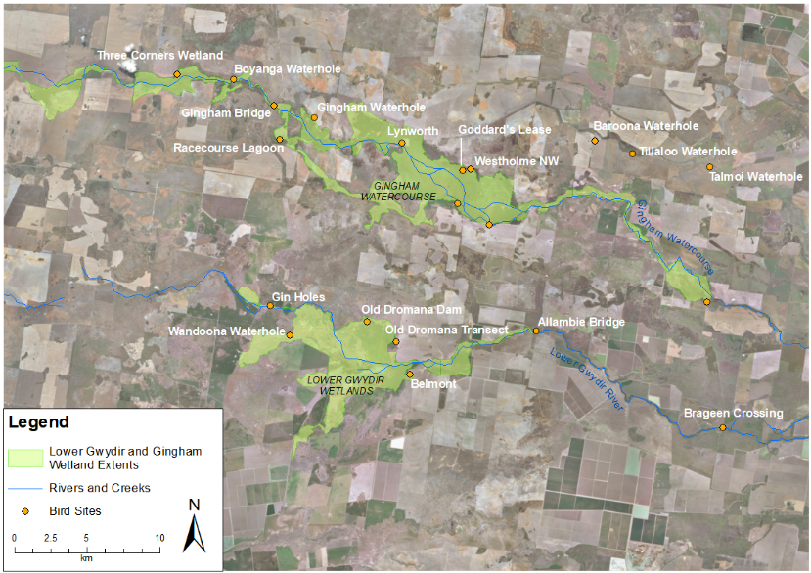
Figure J-1: Waterbird diversity monitoring sites within the lower Gwydir and Gingham watercourse monitoring zone.
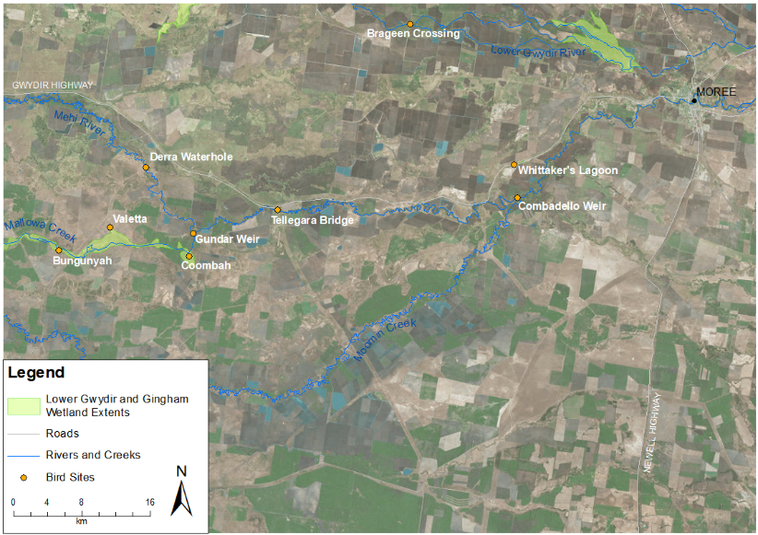
Figure J-2: Waterbird diversity monitoring sites within the Mehi River and Mallowa Creek monitoring zone

Table J-2: Maximum inundation area (%) of waterbird survey sites within the Gwydir River system Selected Area. Blue indicates wet sites, orange indicates dry sites (> 5% inundation).
Monitoring Zone | System | Site Name | Site Type | Inundation area (%)
 |  |  |  | Spring | Autumn
lower Gwydir River and Gingham watercourse | Gingham | Baroona Waterhole* | Waterhole | 80 | 0
 |  | Boyanga Waterhole* | Waterhole | 80 | 0
 |  | Bunnor Bird Hide | Floodplain wetland | 80 | 85
 |  | Old Boyanga Wetland* | Floodplain wetland | 1 | 0
 |  | Gingham Bridge | Creek | 5 | 0
 |  | Gingham Waterhole | Waterhole | 40 | 50
 |  | Goddard's Lease | Floodplain wetland | - | 5
 |  | Jackson Paddock* | Floodplain wetland | 15 | 5
 |  | Lynworth* | Floodplain wetland | 50 | 0
 |  | Racecourse Lagoon* | Waterhole | 0 | 0
 |  | Talmoi Waterhole* | Waterhole | 5 | 0
 |  | Tillaloo Waterhole* | Waterhole | 0 | 0
 |  | Westholme NW | Floodplain wetland | - | 0
 |  | Westholme SE | Floodplain wetland | 90 | 0
 | Lower Gwydir | Allambie Bridge | Creek | 80 | 30
 |  | Brageen Crossing | Creek | 0 | 30
 |  | Belmont* | Floodplain wetland | - | -
 |  | Gin Holes* | Waterhole | 30 | 50
 |  | Old Dromana Dam | Waterhole | 70 | 35
 |  | Old Dromana Transect | Floodplain wetland | 70 | 0
 |  | Wandoona Waterhole* | Waterhole | 80 | 0
Mehi River and Moomin Creek | Mallowa | Bungunya* | Floodplain wetland | 0 | 0
 |  | Coombah* | Floodplain wetland | - | 0
 |  | Gundare Weir | Creek | 25 | 30
 |  | Valetta* | Floodplain wetland | 2 | 0
 | Mehi | Combadello Weir | Creek | 50 | 20
 |  | Derra Waterhole | Waterhole | 30 | 10
 |  | Tellegara Bridge | Creek | 15 | 10
 |  | Whittaker's Lagoon | Waterhole | 0 | 0
* Sites located on private land

Results

2017-18 water year
In total, 61 waterbird species were recorded in the 2017-18 monitoring period (Table J-3). Three recorded species are listed under one or more international migratory bird agreement (JAMBA, CAMBA, ROKAMBA); brolga, lathams snipe (Gallinago hardwickii) and marsh sandpiper (Tringa stagnatilis). In addition, seven species recorded in the 2017-18 surveys are listed as vulnerable or endangered under the NSW BC Act 2016; Australian painted snipe (Rostratula australis), black-necked stork, brolga, freckled duck (Stictonetta naevosa), magpie goose, spotted harrier (Circus assimilis) and white-bellied sea-eagle (Haliaeetus leucogaster). The Australian painted snipe is also listed as endangered under the Environment Protection and Biodiversity Conservation Act 1999 (EPBC Act).

Species diversity and abundance
Bunnor Bird Hide recorded the highest waterbird species richness with 30 individual species observed over both survey times, followed by Old Dromana Transect (28 species) and Wandoona Waterhole with 27 species (Table J-3). Species richness was higher in Spring than in Autumn for most sites, however, it remained consistently high in Autumn for Bunnor Bird Hide and Old Dromana Transect (Figure J-3). During the Spring surveys, 55 waterbird species were recorded. In the Autumn surveys 42 waterbird species were recorded. Average species richness was significantly higher in Spring (10.67 ± 7.92 species) than in Autumn (6.75 ± 5.50 species; P < 0.01). There was a significant difference in the average species richness between site types (P < 0.01) with floodplain sites recording the highest average richness (10.47 ± 8.20 species) followed by waterhole sites (9.53 ± 6.97 species) and creek sites (4.38 ± 2.56 species; Figure J-5a). There was also a significant difference between systems (P < 0.001) with average species richness highest in the lower Gwydir (14.44 ± 8 species) and Gingham (9.40 ± 6.94 species) systems and lower in the Mehi (4.43 ± 3.46 species) and Mallowa (3.50 ± 2.89 species) systems (Figure J-5b). The Mallowa Creek and wetlands did not receive any significant inflows to provided inundation during the 2017-18 season and this is reflected in the lower species richness and density. Average species richness was significantly higher in sites that were inundated (9.78 ± 7.26 species) compared to sites that were dry (2.25 ± 4.11 species; P < 0.001; Figure J-7a).
Maximum waterbird density during Spring was 459 birds/ha, recorded at Bunnor Bird Hide and included approximately 1,000 magpie geese and 500 little black cormorants (Phalacrocorax sulcirostris) (Figure J-4; Table J-3). In Autumn, maximum waterbird density was 106 birds/ha, recorded at Old Dromana Dam and included 200 plumed whistling-ducks (Dendrocygna eytoni). There was high variability in density between sites, influenced mainly by the presence of these large flocks of birds (Figure J-4; Table J-3). This large variation was evident in the average density of waterbirds in Spring which was 29.22 ± 98.92 waterbirds/ha, which was significantly higher than diversity in Autumn (15.17 ± 27.13 waterbirds/ha; P < 0.001). There were significant differences in average waterbird density between site types (P < 0.001), which was highest in the floodplain sites (35.91 ± 117.95 waterbirds/ha) followed by creek sites (15.53 ± 16.64 waterbirds/ha) and waterhole sites (14.88 ± 25.58 waterbirds/ha; Figure J-6a). However, density in the floodplain sites were skewed by several outliers caused by large numbers of individual birds at Bunnor Bird Hide. Similarly, there was a significant difference in waterbird density between systems (P < 0.001), also heavily influenced by Bunnor Bird Hide within the Gingham wetland. Gingham recorded the highest waterbird density (32.03 ± 101.76 waterbirds/ha), followed by lower Gwydir (24.97 ± 32.92 waterbirds/ha), Mallowa (7.92 ± 10.05 waterbirds/ha) and Mehi (2.71 ± 3.67 waterbirds/ha; Figure J-6b). Average waterbird density was significantly higher in inundated sites (2.93 ± 18.63 waterbirds/ha) than in dry sites (0.21 ± 0.39 waterbirds/ha; P < 0.001) with large variations in density noted between individual inundated sites (Figure J-7b).
Simpson’s Diversity was significantly higher in inundated sites (0.64 ± 0.30) than in dry sites (0.27 ± 0.36; P < 0.001; Figure J-7c), and was also slightly higher in Spring (0.69 ± 0.3) than in Autumn (0.57 ± 0.29), however, this difference was non-significant (P = 0.207). There were no significant differences in Simpson’s Diversity between site types (P = 0.896) or systems (P = 0.225).
Table J-3: Maximum count and sites for all waterbirds species recorded in the 2017-18 monitoring period.
Monitoring Zone |  | Gingham Watercourse and Lower Gwydir River |  |  |  |  |  |  |  |  |  |  |  |  |  |  |  |  |  | Mehi and Moomin Creek
System |  | Gingham |  |  |  |  |  |  |  |  |  |  |  | Lower Gwydir |  |  |  |  |  | Mallowa |  |  | Mehi
Functional Guild | Common Name | Baroona Waterhole | Boyanga Waterhole | Bunnor Bird Hide | Old Boyanga Wetlands | Gingham Bridge | Gingham Waterhole | Goddard's Lease | Jackson Paddock | Lynworth | Racecourse Lagoon | Talmoi Waterhole | Westholme N-W | Allambie Bridge | Brageen Crossing | Gin Holes | Old Dromana Dam | Old Dromana Transect | Wandoona Waterhole | Coombah | Gundare Weir | Valetta | Combadello Weir | Derra Waterhole | Tellegara Bridge | Whittaker's Lagoon
Australian-breeding Charadriiform shorebirds | Australian painted snipe^{V} |  |  |  |  |  |  |  |  |  |  |  |  |  |  | 2 |  | 1
 | Australian pratincole |  |  |  |  |  |  |  |  |  |  |  | 1
 | black-fronted dotterel | 5 | 2 |  |  |  |  |  |  |  |  | 3
 | black-winged stilt | 2 |  | 7 |  |  |  |  |  |  |  | 21 |  |  |  |  |  | 15 | 1
 | masked lapwing | 1 |  | 2 |  |  | 5 |  | 11 | 2 | 2 | 2 |  |  |  | 5 |  | 13 | 2 |  |  |  |  | 2
 | red-kneed dotterel | 7 |  | 2 |  |  |  |  |  |  |  | 17 | 2
 | red-necked avocet |  |  |  |  |  |  |  |  |  |  | 26
Dabbling and filter-feeding ducks | Australasian shoveler |  |  |  |  |  |  |  |  |  |  |  |  |  |  | 1
 | freckled duck^{V} |  |  |  |  |  |  |  |  |  |  |  |  |  |  |  |  |  | 5
 | grey teal |  |  | 150 |  |  |  |  | 2 |  |  | 190 | 3 |  |  | 80 |  |  | 18 |  |  |  | 2
 | pacific black duck |  | 7 | 75 |  |  | 8 |  | 4 |  |  | 24 | 4 | 4 |  | 21 | 32 | 72 | 5 |  | 6 |  | 5 |  | 2
 | pink-eared duck | 9 |  | 2 |  |  |  |  |  |  |  | 37 |  |  |  | 2 |  |  | 8
Diving ducks, aquatic gallinules and swans | black swan |  |  | 2 |  |  | 2 |  |  |  |  |  |  |  |  |  |  | 2 | 1
 | dusky moorhen |  | 6 |  |  |  |  |  | 1 |  |  |  | 1 |  |  |  |  |  | 2 |  | 2
 | eurasian coot |  | 15 | 5 |  |  | 5 |  |  |  |  |  | 2 |  |  |  | 3 |  | 6
 | hardhead |  |  |  |  |  |  |  |  |  |  |  |  |  |  |  | 3
Grazing ducks and geese | Australian wood duck |  |  |  |  |  |  | 4 | 37 | 2 |  |  |  |  | 8 | 35 |  | 2 |  |  | 14 |  | 6 | 2
 | magpie goose^{V} |  |  | 1000 |  |  |  |  |  |  |  |  | 5
 | plumed whistling-duck |  |  | 2 |  |  | 1 |  |  |  |  |  |  |  |  | 32 | 200
Large wading birds | Australian white ibis |  | 15 | 27 | 2 |  | 5 |  |  |  |  |  | 2 |  |  | 1 |  | 16
 | black-necked stork^{E} |  | 2
 | brolga |  |  | 2 |  |  |  |  |  |  |  |  | 1 |  |  | 2 |  |  | 5
 | glossy ibis |  |  | 2 |  |  | 10 |  |  | 2 |  |  | 4 |  |  |  |  | 100 | 7
 | royal spoonbill |  |  | 4 |  |  | 2 |  |  |  |  |  |  |  |  |  |  | 9 | 2 |  |  |  |  | 4
 | straw-necked ibis |  |  |  |  |  | 3 |  |  | 1 |  |  |  |  |  |  |  | 5 | 1
 | yellow-billed spoonbill |  |  | 1 |  |  |  |  | 1 | 2 |  | 2 |  |  |  | 1 |  | 3 | 2 |  | 3 |  |  | 1
Migratory Charadriiform shorebirds | latham's snipe^{JR} |  |  | 1 |  |  |  |  |  |  |  |  |  |  |  |  | 1 | 3
 | marsh sandpiper^{CJR} |  |  |  |  |  |  |  |  |  |  |  |  |  |  |  |  | 1
Piscivores | Australasian darter |  |  | 3 |  |  | 8 |  |  |  |  |  | 2 |  |  | 2 |  |  |  |  |  |  | 1 | 2
 | Australasian grebe |  | 5 | 2 |  |  |  |  |  |  |  | 2 | 1 |  |  | 4 |  |  | 3
 | Australian pelican |  | 1 | 6 |  |  | 45 | 3 | 1 |  |  |  | 1 |  | 1 |  | 2 | 8 | 1 |  |  | 2 |  |  |  | 3
 | cattle egret^{J} |  |  |  |  |  |  |  | 5 |  |  |  | 2 |  |  |  |  | 2 |  |  |  |  |  | 1
 | eastern great egret |  | 5 |  |  | 1 |  |  |  |  |  |  |  |  |  | 2 | 1 | 17 | 1 |  | 1 |  |  | 1
 | great cormorant |  |  |  |  |  | 1 |  | 1
 | intermediate egret |  | 2 |  |  |  |  |  | 1 |  |  |  |  |  |  |  | 1 | 7 | 21
 | little black cormorant |  |  | 502 |  |  | 7 |  | 10 | 7 |  |  |  |  |  |  | 3 |  | 1
 | little egret |  |  |  |  |  |  |  | 4
 | little pied cormorant |  | 2 | 1 |  |  | 3 |  | 1 |  |  |  | 1 |  |  | 2 | 3 | 2 | 12 |  |  |  |  | 2
 | nankeen night-heron |  |  | 3 |  |  |  |  |  | 1 |  |  |  |  |  |  |  |  |  |  | 2
 | pied cormorant |  | 5 | 13 |  |  | 1 |  |  |  |  |  |  |  |  |  |  |  |  |  |  |  |  | 1
 | sacred kingfisher |  | 2
 | white-faced heron |  | 2 |  | 1 | 1 | 1 |  | 1 | 2 | 3 |  |  |  | 1 | 4 | 2 | 16 |  |  | 2 |  | 1 | 1
 | white-necked heron |  | 7 |  |  |  |  |  | 3 |  |  |  |  |  |  |  | 1 | 1 | 1 |  | 1 |  |  | 1 |  | 1
Rails and shoreline gallinules | Australian spotted crake |  |  |  |  |  |  |  |  |  |  |  |  |  |  |  |  |  | 1
 | baillon's crake |  | 5
 | black-tailed native-hen |  |  |  |  |  |  |  | 1 |  |  |  |  |  |  | 22
 | buff-banded rail |  |  |  |  |  |  |  |  | 1 |  |  |  |  |  |  |  | 1
 | purple swamphen |  | 3 | 6 |  |  | 3 |  |  |  |  |  | 4 |  |  |  | 6 | 1 | 2
Raptor | Australian hobby |  |  |  |  |  |  |  |  |  |  |  |  |  |  |  |  | 1
 | black-shouldered kite |  |  |  |  |  |  |  |  |  |  |  |  |  |  |  | 2
 | brown falcon |  |  |  |  |  |  | 1 | 2 | 1 |  |  |  |  |  |  |  |  |  |  |  |  | 1
 | nankeen kestrel |  |  |  |  |  |  |  |  |  |  |  |  | 2 |  |  |  |  | 2
 | spotted harrier |  |  |  |  |  |  |  |  |  |  |  | 1
 | swamp harrier^{V} |  |  | 1
 | wedge-tailed eagle | 1 | 2 |  | 2 |  |  |  | 4 |  |  |  | 2 | 1 | 2 |  | 3 | 1 |  | 2 |  |  | 1 | 1 | 1
 | whistling kite |  | 2 | 4 |  |  | 2 | 1 |  | 2 | 1 |  | 1 | 1 |  |  | 1 | 3 |  |  |  |  | 1 |  | 1
 | white-bellied sea-eagle^{V} |  |  | 2 |  |  |  |  |  |  |  |  |  |  |  |  |  |  |  |  |  |  | 1
Reed-inhabiting passerines | Australian reed-warbler |  | 7 | 1 |  |  |  | 1 | 1 | 16 | 1 |  | 10 |  |  |  | 5 | 13 | 20
 | golden-headed cisticola |  |  | 4 |  |  |  | 2 |  | 3 | 2 |  | 2 |  |  |  | 1 | 25 | 1
 | little grassbird |  |  | 2 |  |  |  | 1 |  | 2 |  |  | 5 |  |  |  | 1 | 3 | 1
Species Richness |  | 6 | 20 | 30 | 3 | 2 | 18 | 7 | 19 | 14 | 5 | 10 | 22 | 4 | 4 | 17 | 19 | 28 | 27 | 1 | 8 | 1 | 9 | 12 | 3 | 2
^{J}= listed under JAMBA; ^{C}= listed under CAMBA; ^{R}= listed under ROKAMBA; ^{V}=Vulnerable (NSW BC Act); ^{E}= Endangered (NSW BC Act); *= breeding activity observed
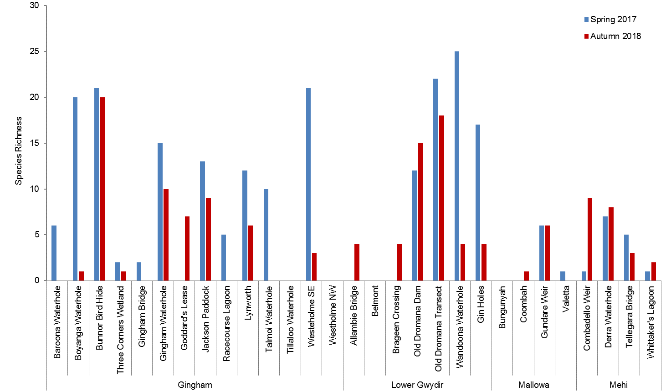
Old Boyanga Wetland
Figure J-3: Waterbird species richness recorded at survey sites within the Gwydir River system Selected Area in November 2017 and March 2018.

Old Boyanga Wetland
Figure J-4: Waterbird density recorded at survey sites within the Gwydir River system Selected Area in November 2017 and March 2018. *indicates large values beyond

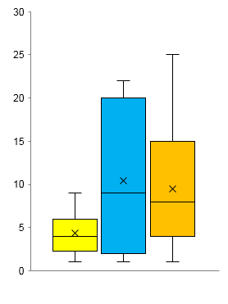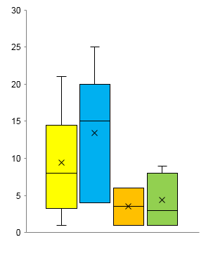
Species Richness
Species Richness
Ging L Gwy Mal Meh
Creek Floodplain Waterhole
b)

a)

Figure J-5 Comparison of average species richness between (a) site type and (b) systems. Cross symbol represents the mean.
b)

a)

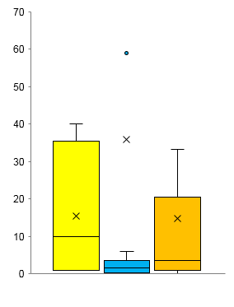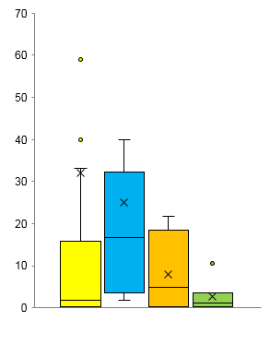
Waterbirds/ha
Ging L Gwy Mal Meh
Creek Floodplain Waterhole
Waterbirds/ha
Figure J-6 Comparison of average waterbird density between (a) site type and (b) systems. Cross symbol represents the mean.
a)
Species Richness
b) | ± 18.63  ± 10.47  ± 21.45
Waterbirds/ha
c)
Simpsons Diversity
Figure J-7: Average (a) species richness, (b) waterbird density and (c) Simpson’s Diversity for inundated and dry sites in the 2017-18 water year. Lines represent one standard deviation from the mean.

Community Composition
The nMDS plot of waterbird community composition suggested there was some separation in the data based on systems and inundation (Figure J-8). This was confirmed by PERMANOVA which showed a significant difference in waterbird community composition between inundated and dry sites (P < 0.001), and a significant interaction between inundation and system (P < 0.01; Figure J-8). There was a significant difference in community composition between site types (P < 0.01), but no significant interaction between inundation and site type (P = 0.375). There was no significant difference in community composition between sampling periods (P = 0.271) or the interaction between inundation and sampling period (P = 0.368). Pairwise comparison of the interaction between inundation and wetland system showed that Gingham sites were driving the patterns in this data. SIMPER analysis revealed that the pacific black duck (Anas superciliosa) and white-faced heron (Egretta novaehollandiae) contributed the most to similarity within inundated sites with 23% and 12% contribution respectively. For dry sites, whistling kite (Haliastur sphenurus), golden-headed cisticola (Cisticola exilis), Australian pelican (Pelecanus conspicillatus), wedge-tailed eagle (Aquila audax), masked lapwing (Vanellus miles) and white-necked heron (Ardea pacifica) all contributed more than 10% of the similarity in the data individually.

Figure J-8: nMDS plot of waterbird community composition in 2017-18 grouped by system and inundation (wet or dry). Stress: 0.19.

Waterbird breeding
Evidence of waterbird breeding was observed at seven sites in Spring 2017 and one site in Autumn 2018 (Table J-4). Evidence of breeding included the presence of juveniles as well as several active nests, including a White-bellied Sea-eagle nest at Bunnor Bird Hide during Spring 2017 (Table J-4). The higher breeding activity recorded in Spring 2017 correlates to greater inundation present during the surveys.
Table J-4: Summary of breeding activity observed during the 2017-18 water year.
Survey | Site | Inundation % | Common Name | Broods/  Nests | Breeding Notes
Spring | Boyanga Waterhole | 80 | white-necked heron | 1 | 1 fledgling
 | Bunnor Bird Hide | 80 | white-belied sea-eagle | 1 | On nest
 | Gin Holes | 30 | white-faced heron | 1 | Nest
 | Gingham Waterhole | 40 | sacred kingfisher | 1 | Nest
 |  |  | black swan | 1 | 2 cygnets
 | Gundare Weir | 25 | nankeen night-heron | 0 | 1 juvenile
 | Little Lagoon | 20 | black-winged stilt | 0 | 1 juvenile
 | Whittaker's Lagoon | 0 | white-necked heron | 1 | On nest
Autumn | Old Dromana Transect | 0 | whistling kite | 1 | Nest

Functional guilds
All ten functional guilds were represented across the surveyed sites in Spring 2017 and Autumn 2018, with dabbling and filter-feeding ducks, grazing ducks and geese, and piscivores being the more dominant guilds present (Figure J-9). Pacific black ducks and grey teals (Anas gracilis) contributed to the high density of dabbling and filter-feeding ducks, while the high densities of grazing ducks and geese were due to the large flock of magpie geese in Spring and plumed whistling-ducks in Autumn. The average number of functional guilds per site was significantly higher in Spring (4.90 ± 2.68 guilds/site) than in Autumn (3.85 ± 2.37 guilds/site; P < 0.05), and significantly higher at inundated sites (4.96 ± 2.21 guilds/site) than dry sites (1.74 ± 2.31guilds/site; P < 0.001). However, there were no significant differences in the number of functional guilds between site types (P = 0.189) or between systems (P = 0.052). In addition, PERMANOVA showed there was a significant difference in functional guild community composition between inundation and sampling period (P < 0.02; Figure J-10). SIMPER analysis revealed that piscivores contributed the most to similarity of functional guild abundance in Spring 2017 (37%), while raptors (38%) and piscivores (27%) contributed the most in Autumn 2018.

Figure J-9: Waterbird density (abundance/ha) by functional guild across all sites in the 2017-18 water year.

Figure J-10: nMDS plot of waterbird functional guild species density data in 2017-18 grouped by season and inundation (wet or dry). Stress: 0.1.

Multi-year comparison

Species diversity and abundance
Average species richness was significantly different among the four survey years (P < 0.001), with richness greatest in the 2016-17 water year (12.48 ± 8.89 species; Figure J-11a). Species richness was also significantly higher in inundated sites than in dry sites across the four years (P < 0.001; Figure J-12a). Average species richness was significantly different between site types (P < 0.001), which was greatest in the floodplain (13.04 ± 11.68 species) and waterhole (10.09 ± 8.36 species) sites, and lowest in the creek sites (3.09 ± 3.12). There was a significant difference in species richness between systems (P < 0.001), with richness greatest in the Gingham (11.55 ± 11.45 species) and lower Gwydir (10.14 ± 7.77 species) units. There was a significant difference in waterbird density among the four survey years (P < 0.001), with density greatest in the 2016-17 water year (11.89 ± 45.01 waterbirds/ha; Figure J-11b). Waterbird density was significantly higher in inundated sites (11.32 ± 43.47 waterbirds/ha) than in dry sites (4.15 ± 6.72 waterbirds/ha) across the four years (P < 0.001; Figure J-12b). Average Simpson’s Diversity was significant among survey years (P < 0.01), and it was also greatest in the 2016-17 water year (0.74 ± 0.24; Figure J-11c). In addition, average Simpson’s Diversity was significantly higher at inundated sites across the four survey years (P < 0.001; Figure J-12c).

Community Composition
When grouped by inundation and season, some separation in the data was evident in the nMDS plot with inundated sites in each year plotting close together and dry sites within each year showing more scatter (Figure J-13). PERMANOVA revealed significant differences between inundation (P < 0.01), site types (P < 0.001) and systems (P < 0.01), but no significant difference between survey year (P = 0.387) or season (P = 0.733). Significant interactions were detected between inundation and site type (P < 0.001; Figure J-14) and inundation and system (P < 0.01; Figure J-15). Pairwise comparisons revealed that the presence of water was the main driving factor in the significant interactions between inundation and site type, and between inundation and wetland. SIMPER analysis revealed pacific black ducks (21%) and white-faced herons (10%) contributed the most to the similarity of inundated sites across the four years. Whistling kites (24%) and both white-faced and white-necked herons (23% and 12%, respectively) contributed the most to the similarity within dry sites.

Functional guilds
For functional guild community composition over the four years, PERMANOVA revealed that there was a significant difference between inundation (P < 0.001), sites types (P < 0.01) and wetland system (P < 0.001), however no significant differences between survey year (P = 0.543). The interaction between inundation and site types was significant (P < 0.001), while the interaction between inundation and wetland system was not significant (P = 0.272). There was also no significant interaction between inundation and survey year (P = 0.972). Pair-wise comparison of the interaction between inundation and site type showed that functional guild community composition had significantly different interactions between sites types that were inundated (all interactions P < 0.05), but no significantly different interactions between site types that were dry (all interactions P > 0.05). This indicates that differences between inundated site types are driving the significant interaction between inundation and site type. SIMPER analysis revealed that piscivores contributed the most to functional guild community composition similarity for each survey year, inundation, site type and system.

a)
Species Richness
b)
Waterbirds/ha
c)
Simpsons Diversity
Figure J-11: Average (a) species richness, (b) waterbird density and (c) Simpson’s Diversity for spring and autumn over the four water years. Lines represent one standard deviation from the mean.

a)
Species Richness
b)
Waterbirds/ha
c)
Simpsons Diversity
Figure J-12: Average (a) species richness, (b) waterbird density and (c) Simpson’s Diversity for inundated and dry sites over the four water years. Lines represent one standard deviation from the mean.

Figure J-13: nMDS plot of average waterbird species density data for the four survey years, grouped by season and inundation (wet or dry). Stress: 0.07.

Figure J-14: nMDS plot of average waterbird species density data for the four survey years, grouped by site type and inundation (wet or dry). Stress: 0.1.

Figure J-15: nMDS plot of average waterbird species density data for the four survey years, grouped by system and inundation (wet or dry). Stress: 0.16

Discussion
The presence and diversity of waterbirds can be a useful indicator of wetland and river health, due to their responsive behaviours to changing patterns of resource distribution, both spatially and temporally (Kingsford et al. 2010). The lower Gwydir and Gingham wetlands are important refuges for waterbirds, especially migratory and vulnerable species and breeding colonies. The previous three LTIM water monitoring years have indicated that inundation patterns heavily influence waterbird species richness, and abundance, highlighting the importance of environmental water in supporting waterbird populations.
As in previous years, occurrence of waterbirds during the 2017-18 water year was driven by patterns of inundation. Spring 2017 had 29% more inundated (wet) sites than Autumn 2018, which correlated with higher waterbird species richness, density, diversity and observed breeding. In addition, inundated sites had significantly higher waterbird numbers than dry sites. This is an indication of the strong influence inundation has on the presence and total numbers of waterbird species. This is further highlighted by pacific black ducks’ high contribution to community composition within inundated sites, while several raptor species that are less reliant on the presence of water, contributed most to the composition of dry site bird communities.
The high abundance of piscivores and grazing ducks and geese in Spring 2017 is likely a reflection of increased habitat and resource base provided by periods of long inundation prior to 2017-18 water year. Conversely, all functional guilds except raptors decreased in Autumn 2018, with raptors contributing the most to species composition across the sites later in the water year. This suggests that habitat conditions required by piscivores and grazing ducks and geese decreased with the drying conditions. The spring and autumn surveys coincide with the non-breeding season for migratory charadriiforms shorebirds species including Latham’s snipe and marsh sandpiper, which were detected in low numbers in 2017-18. The delivery of environmental water to the lower Gwydir wetlands during Spring, Summer and Autumn months can provide foraging habitat for these migratory shorebirds which migrate north through central Australia to breeding habitat in the northern hemisphere during the February-May period (Bamford et al. 2008).
The addition of the 2017-18 water year monitoring results has shown that variations in waterbird species richness and density is strongly linked to inundation. The diversity of waterbird populations also appears to be driven by the presence of water, with inundated sites recording higher diversity than dry sites during each survey year. It is not uncommon that variations in the abundance and diversity of waterbirds occur in wetlands, as the presence of birds is typically driven by resources and spatial and temporal availability of wetlands (Halse et al. 1998; Roshier et al. 2001). Piscivores have remained prevalent over the last four years likely due to favourable resource and habitat conditions such as established fish and invertebrate populations that have developed during periods of inundation (Commonwealth of Australia, 2016). Flooding in inland rivers produces ‘boom’ conditions, resulting in massively increased habitat availability (Kingsford et al. 2001). Shallow waters of floodplains may only last a few months but can be extremely productive for all guilds of waterbirds and encourage breeding (Kingsford and Norman 2002). This was best displayed during 2016-17 water year in the Gwydir, following a natural flood event in Spring that was then supported by environmental water deliveries over Summer. The 2016-17 water year had the highest waterbird abundance and diversity of the four years of the project.
Many Australian waterbirds can breed at any time of the year, with breeding typically associated with high habitat availability and food resources (Kingsford and Norman 2002). Over the last four years, recorded breeding has consistently been higher in the spring surveys, which has often coincided with inundation events a few months prior to surveys. This pattern of breeding supports Kingsford et al. (2010) and Kingsford and Norman (2002), which indicate opportunistic patterns of waterbird breeding in relation to flooding events. Over the LTIM project, breeding activity was also highest in 2016-17, where over 10 species of waterbird were observed breeding following significant wetland inflows.
The presence of migratory waterbird species, as well as vulnerable species (including evidence of a breeding white-bellied sea-eagle in Spring 2017) in this water year highlights the importance of the lower Gwydir, Mallowa and Gingham wetlands. Delivery of environmental water to floodplain habitats can benefit a range of wetland-dependent species and can also extend the benefits of earlier natural inflow events. Many waterbird species have varying degrees of habitat and resource requirements (Roshier et al. 2001). Therefore, when consideration is given to the timing, extent and rate of flows, and appropriate wetting and drying cycles, environmental flows can maximise the positive outcomes for waterbirds and other wetland-dependent species such as frogs and turtles. There is a diversity of habitats present within the Gwydir wetlands, and the delivery of environmental water to support this range of habitats is important for the variety of waterbirds that use these habitats. The waterbird monitoring undertaken for the LTIM project continues to demonstrate the contribution of environmental water has had on waterbird populations by maintaining healthy wetland systems.

Conclusion
The diversity of habitats present within the Gwydir River system Selected Area, and the delivery of environmental water to support this range of habitats is important for a range of waterbird species that use these habitats. The four years of LTIM waterbird monitoring has shown that inundation enhances the diversity of waterbirds as well as waterbird breeding within the Gwydir system. During this time, environmental water has been an important contributor, along with natural inflow, in maintaining a healthy wetland system for foodwebs and the waterbirds they support.

References
Bamford M, Watkins D, Bancroft W, Tischler G and J Wahl. 2008. Migratory Shorebirds of the East Asian - Australasian Flyway; Population Estimates and Internationally Important Sites. Wetlands International - Oceania. Canberra, Australia.
Commonwealth of Australia 2014. Commonwealth Environmental Water Office Long Term Intervention Monitoring Project Gwydir River system Selected Area - Monitoring and Evaluation Plan. Commonwealth of Australia.
Commonwealth of Australia 2016. Commonwealth Environmental Water Office Long Term Intervention Monitoring Project Gwydir River system Selected Area – 2015-16 Evaluation Report. Commonwealth of Australia.
Commonwealth of Australia 2017. Commonwealth Environmental Water Office Long Term Intervention Monitoring Project Gwydir River system Selected Area – 2016-17 Evaluation Report. Commonwealth of Australia.
Hale, J., Stoffels, R., Butcher, R., Shackleton, M., Brooks, S. and Gawne, B. 2014. Commonwealth Environmental Water Office Long Term Intervention Monitoring: Standard Methods. Report prepared by the Murray Darling Freshwater Research Centre, Wodonga.
Halse, S.A., Pearson, G.B., and Kay, W.R. (1998). Arid zone networks in time and space: waterbird use of Lake Gregory in north-western Australia. International Journal of Ecology and Environmental Sciences 24, 207-222.
Kingsford, R.T. (1996). Wildfowl (Anatidae) movements in arid Australia. Gibier Faune Sauvage 13, 141-155.
Kingsford, R.T., Thomas, R.F., and Curtin, A.L. (2001). Conservation of wetlands in the Paroo and Warrego catchments in arid Australia. Pacific Conservation Biology 7, 21-33.
Kingsford, R.T., and Norman, F.J. (2002). ‘Australian waterbirds – products of the continent’s ecology’. Emu 102, 47-69.
Kingsford, R. T., Roshier, D. A. and Porter, J. L. 2010, Australian waterbirds: time and space travellers in dynamic desert landscapes, Marine and freshwater research, vol. 61, no. 8, pp. 875-884, doi: 10.1071/MF09088.
Roshier, D.A., Whetton, P. H., Allan, R.J., and Robertson, A. I. (2001) Distribution and persistence of temporary wetland habitats in arid Australia in relation to climate. Austral Ecology 26, 371-384
Roshier, D.A., Robertson, A.I. and Kingsford, R.T. (2002). Responses of waterbird to flooding in an arid region of Australia and implications for conservation. Biological Conservation 106, 399-411.

