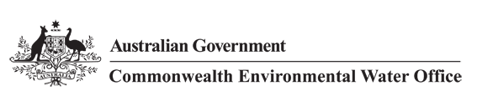



**Commonwealth Environmental Water Office**

**Long Term Intervention Monitoring Project**

**GWYDIR RIVER SYSTEM SELECTED AREA**

2017-18 Annual Evaluation Report

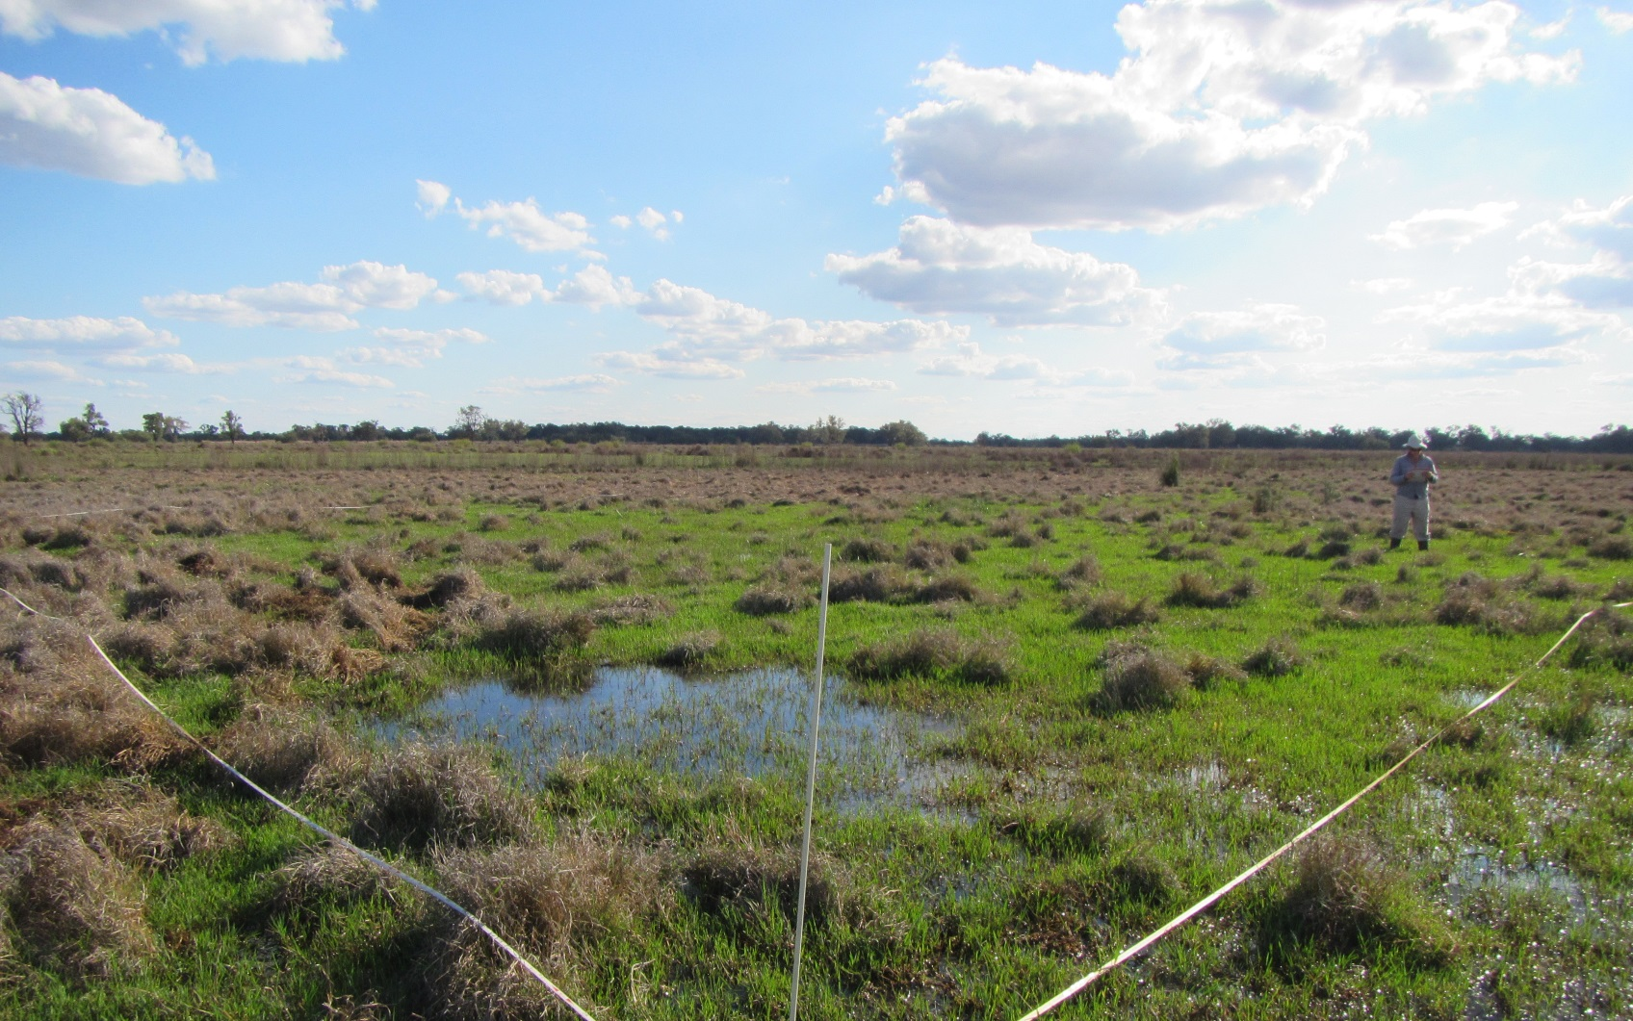

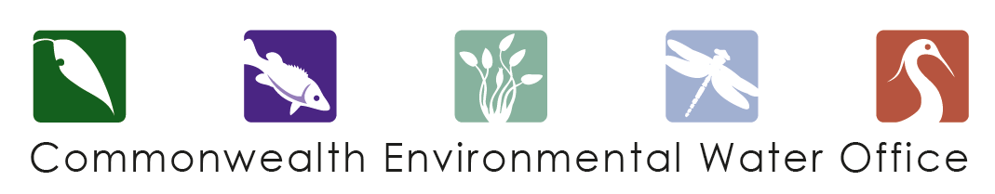

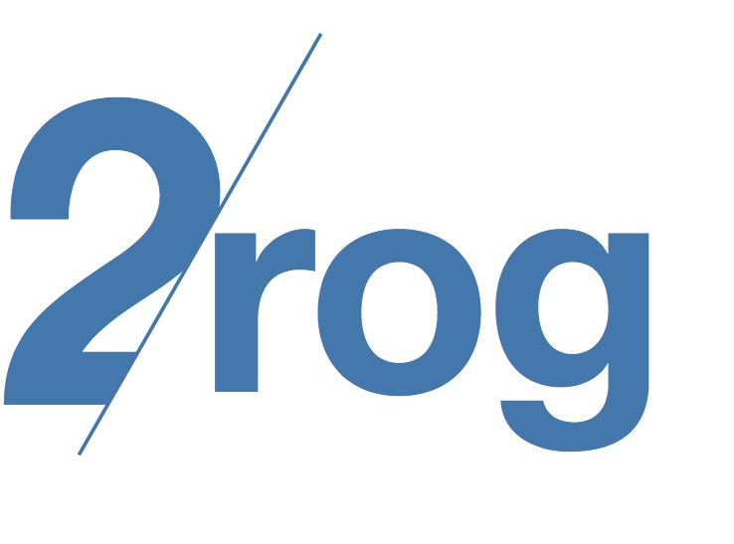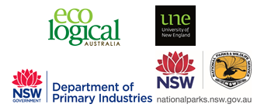

This monitoring project was commissioned and funded by Commonwealth Environmental Water Office, with in-kind support from NSW Office of Environment and Heritage.

**Copyright**

© Copyright Commonwealth of Australia, 2018



Commonwealth Environmental Water Office Long Term Intervention Monitoring Project Gwydir River system Selected Area is licensed by the Commonwealth of Australia for use under a Creative Commons By Attribution 3.0 Australia licence with the exception of the Coat of Arms of the Commonwealth of Australia, the logo of the agency responsible for publishing the report, content supplied by third parties, and any images depicting people. For licence conditions see:

<http://creativecommons.org/licenses/by/3.0/au/>

This report should be attributed as ‘Commonwealth Environmental Water Office Long Term Intervention Monitoring Project Gwydir River system Selected Area – 2017-18 Annual Evaluation Report, Commonwealth of Australia 2018’.

**Disclaimer**

The views and opinions expressed in this publication are those of the authors and do not necessarily reflect those of the Australian Government or the Minister for the Environment and Energy.

While reasonable efforts have been made to ensure that the contents of this publication are factually correct, the Commonwealth does not accept responsibility for the accuracy or completeness of the contents, and shall not be liable for any loss or damage that may be occasioned directly or indirectly through the use of, or reliance on, the contents of this publication.

**DOCUMENT TRACKING**

|  |  |
| --- | --- |
| Item | Detail |
| Project Name | Long Term Intervention Monitoring Project – Gwydir River system Selected Area |
| Project Number | 8325 |
| Project Manager | Dr Mark Southwell  (02) 8081 2688  92 Taylor Street, Armidale NSW 2350 |
| Prepared by | Dr Mark Southwell, Ronnie Hill, Linden Burch, Tim Henderson, Natalie Mace (ELA)  Assoc. Prof Darren Ryder, Dr Wing Ying Tsoi (UNE)  Dr Gavin Butler, Luke Carpenter-Bundhoo, Tom Davis (NSW DPI)  Dr Paul Frazier (2rog consulting)  Dr Jennifer Spencer, Sharon Bowen and Jane Humphries (NSW OEH) |
| Reviewed by | Dr Mark Southwell, Assoc. Prof Darren Ryder |
| Approved by | Dr Paul Frazier |
| Status | Final |
| Version Number | 2 |
| Last saved on | 20 March 2019 |
| Cover photo | Inundated water couch marshland at Bunnor in the Gingham Watercourse (Photo: R.Hill) |

Acknowledgements

This document has been prepared by Eco Logical Australia Pty Ltd with support from Associate Professor Darren Ryder and Dr Wing Ying Tsoi from the University of New England, Dr Paul Frazier from 2rog consulting, Dr Gavin Butler, Luke Carpenter-Bundhoo and Tom Davis from the DPI fisheries, and staff from the NSW Office of Environment and Heritage and NSW Office of Water.

Many sites surveyed as part of the Gwydir Selected Area LTIM project lie on private land or reserve land managed by NSW National Parks and Wildlife Service (NPWS). The project team acknowledges the cooperation and valuable contribution provided by the individual landholders in allowing access to sites on their properties to undertake monitoring. We are also appreciative to NPWS who allow us access to sites and facilities during field work and provide staff who assist in undertaking monitoring for some indicators.

Acknowledgement of Country

The authors of this report as well as the Commonwealth Environmental Water Office respectfully acknowledge the traditional owners, their Elders past and present, their Nations of the Murray-Darling Basin, and their cultural, social, environmental, spiritual and economic connection to their lands and waters. In particular the Barkindji, Murrawarri, Ngemba and Ngiyampaa peoples, traditional owners of the land on which this publication is focused.

|  |
| --- |
| **Disclaimer** *This document may only be used for the purpose for which it was commissioned and in accordance with the contract between Eco Logical Australia Pty Ltd and the Department of the Environment and Energy. The scope of services was defined in consultation with the Department of the Environment and Energy, by time and budgetary constraints imposed by the client, and the availability of reports and other data on the subject area. Changes to available information, legislation and schedules are made on an ongoing basis and readers should obtain up to date information.*  *Eco Logical Australia Pty Ltd accepts no liability or responsibility whatsoever for or in respect of any use of or reliance upon this report and its supporting material by any third party. Information provided is not intended to be a substitute for site specific assessment or legal advice in relation to any matter. Unauthorised use of this report in any form is prohibited.* |

Template 29/9/2015

**Document control**

|  |  |  |  |
| --- | --- | --- | --- |
| Version | Date | Reviewed by | Approved by |
| 1 | 24/8/2018 | Dr Mark Southwell, Assoc. Prof. Darren Ryder | Dr Paul Frazier |
| 2 | 26/11/2018 | Dr Mark Southwell | Dr Paul Frazier |

|  |  |
| --- | --- |
| Item | Details |
| ELA Project Number | 8325 |
| Project Director/s | Dr Paul Frazier, Assoc. Prof Darren Ryder |
| Project Manager | Dr Mark Southwell |
| Prepared by | Dr Paul Frazier, Assoc. Prof Darren Ryder, Dr Mark Southwell, Dr Wing Ying Tsoi, Dr Gavin Butler, Luke Carpenter-Bundhoo, Ronnie Hill, Linden Burch, Tim Henderson, Nathalie Mace |

Contents

Executive summary vi

1 Monitoring and evaluation of environmental water in the Gwydir River system Selected Area 1

1.1 Introduction 1

1.2 Gwydir River system Selected Area 1

1.3 Watering actions and outcomes in the previous water year (2016-17) 2

2 Environmental watering actions in the Gwydir River system during 2017-18 5

2.1 Environmental condition and watering actions in the Gwydir River system Selected Area 2017-18 5

3 Key Outcomes from environmental water use 8

3.1 Expected Outcomes 8

3.2 Flows and ecosystem functions 11

3.3 Water Quality 12

3.4 Biodiversity 13

3.5 Resilience 18

3.6 Summary 18

4 Implications for Future Management of environmental water 20

5 References 22

**Appendix A – Hydrology (River)**

**Appendix B – Hydrology (Watercourse)**

**Appendix C – Water Quality**

**Appendix D – Microinvertebrates**

**Appendix E – Macroinvertebrates**

**Appendix F – Ecosystem Type**

**Appendix G – Vegetation Diversity**

**Appendix I – Fish (River)**

**Appendix J – Fish (Movement)**

**Appendix K – Waterbird Diversity**

List of figures

Figure 1‑1: Gwydir River catchment and location within the Murray-Darling Basin. 3

Figure 1‑2: The Gwydir River system Selected Area with monitoring zones highlighted. 4

Figure 2‑1: Monthly rainfall totals for 2017-18 and mean totals measured at Moree airport 5

Figure 2‑2: Monthly maximum temperatures for 2017-18 and mean maximum temperatures measured at Moree airport. (Source. http://www.bom.gov.au/climate/data/index.shtml). 5

Figure 3‑1: Wetland inundation within the Gingham and lower Gwydir wetlands during the 2017-18 water year. 12

Figure 3‑2: Sedge/forb/grassland floodplain (top), Temporary lowland stream (bottom left) and Permanent lowland stream (bottom right) ecosystem types monitoried in the Selected Area. 13

Figure 3‑3: Freshwater catfish (Tandanus tandanus) recruit, likely spawned in 2017-18 caught in the lower Gwydir River during fish diversity sampling in 2018. 15

Figure 3‑4: Latham’s snipe (Gallinago hardwickii) at Bunnor in the Gingham watercourse (top), Australasian Darter (Anhinga novaehollandiae) sunning at Gingham waterhole (bottom). 17

List of tables

Table 2‑1: Comparison between environmental water use and 2017-18 water year flows. Percentage represents the percentage of the total flow made up of environmental water. 6

Table 3‑1: Expected outcomes from environmental water use in the Gwydir River system Selected Area linked to broader Basin Plan objectives. 9

Table 3‑2: Watering actions, target assets and evaluated outcomes implemented in the Gwydir River system Selected Area during 2017-18. 10

Executive summary

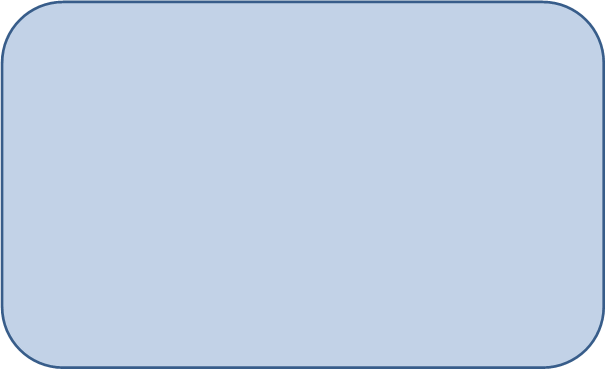

**Contributions of Commonwealth environmental water in 2017-18**

***River channels***

* Environmental water contributed to connectivity in the Gwydir River, lower Gwydir River, Mehi River, Moomin Creek and Gingham watercourse during 2017-18, in what was a dry year in the system.
* Environmental water improved water quality, stimulated primary production and helped to maintain local and regional scale aquatic invertebrate diversity, and thus provide a range of food sources for other animals.
* Environmental water stimulated the movement of fish species within and between the Mehi and Gwydir River channels.

***Wetlands***

* Wetland inundation within the Selected Area during 2017-18 was the lowest recorded in the previous four years of the LTIM project.
* Environmental water increased the level of inundation in the lower Gwydir wetlands.
* Inundation maintained a diverse and abundant invertebrate community within the lower Gwydir wetlands.
* Inundated sites supported many threatened and migratory waterbird species in 2017-18.

The Gwydir catchment, located in the northern Murray Darling Basin, extends from the Great Dividing Range west to the Barwon River. Downstream of Moree, the system fans out into a broad alluvial near-terminal floodplain. Numerous anabranches and distributary channels characterise the lower half of the Gwydir catchment, with the Mehi River and Moomin Creek to the south, and the lower Gwydir River, Gingham watercourse and Carole Creek to the north. These channels support wetland and floodplain assets including the lower Gwydir, Gingham and Mallowa wetlands. Commonwealth environmental watering targets channel, wetland and floodplain assets with expected environmental outcomes downstream (west) of Tareelaroi Weir on the Gwydir River.

The 2017-18 year saw below average rainfall in July, August, September, December, January, April, May and June with above average temperatures in every month except November. Rainfall within the Selected Area for the last three months of the water year (April-May) totalled 22.4 mm.

Commonwealth environmental water was delivered to the channels of the lower Gwydir system and wetlands via a number of watering actions throughout the water year. These were a combination of both Commonwealth and State managed water. This report considers the combined influence of both Commonwealth and State managed environmental water.

These flows aimed to protect and maintain wetland vegetation conditions, maintain habitat for waterbirds and fish and support fundamental ecosystem function processes within the Gwydir River System Selected Area (Selected Area). Two early season environmental flows were delivered to the channels of the Selected Area to provide conditions conducive to fish spawning and recruitment. Environmental water was used to offset the component of consumptive extraction taken during a supplementary flow event to provide inflows into the Gingham and lower Gwydir wetlands. Environmental water was also delivered through the Mehi, Moomin and Carole channels as part of the Northern Connectivity Event, later in the water year.

**Key Outcomes**

*Ecosystem functioning*

* Environmental water contributed to connectivity in the Gwydir River, lower Gwydir River, Mehi River, Moomin Creek and Gingham watercourse during 2017-18.
* 119 ha of the lower Gwydir wetlands was inundated because of environmental water. Maximum inundation within the Gingham Watercourse (364 ha) occurred early in the year due to residual water from the previous water year.
* Semi-permanent wetland vegetation species such as water couch, spike-rush, tussock rush, lignum and river cooba were inundated during the 2016-17 water year.

*Water Quality*

* Environmental water deliveries improved water quality through the dilution of variables such as pH and conductivity, and water nutrients such as nitrogen and phosphorus.
* Delivery of environmental water during the Northern Connectivity Event significantly increased dissolved oxygen concentrations in the Mehi and Gwydir Rivers.
* As in 2016-17, water column primary production during 2017-18 appeared to be driven by temperature rather than high nutrient concentrations.

*Biodiversity*

* Environmental water influenced seven of the ten ecosystem types monitored in the LTIM project in the 2017-18 water year, including five riverine types, one floodplain type and one lacustrine type.
* Environmental flows maintained water levels in the lower Gwydir wetlands, which continued to support the most diverse and abundant macroinvertebrate community in the Selected Area.
* Environmental water deliveries were correlated with a spike in microinvertebrate diversity and richness within the river channels of the Selected Area.
* The largest movements of Murray cod and freshwater catfish were observed during the early season stimulus flow, where individuals moved within and between the Gwydir and Mehi Rivers.
* The generally lower flow conditions across much of the Gwydir in 2017-18 were less conducive to a large-scale breeding event for common carp or goldfish compared to 2016-17.
* The cover and species richness of wetland and floodplain vegetation communities within survey plots declined in 2017-18, due to a relatively small area of inundation and generally dry conditions. While the cover of native water couch appears to have remained relatively stable, the cover of the weed species lippia has increased.
* Waterbird numbers were lower in 2017-18 than in 2016-17, but higher than in the previous two drier years (2014-16). Higher diversity and abundance was noted at inundated sites. The lower Gwydir supported both threatened and migratory species during 2017-18.

*Resilience*

* The fish community in the Selected Area is under extreme stress, with low numbers of adults and barriers to movement hampering recruitment success. Fish movement monitoring suggest that fish move during environmental water deliveries, which may increase the chances of important recruitment events in between larger flooding events.
* Consistent with the dry conditions, waterbird numbers and vegetation cover and richness decreased in 2017-18. Small volumes of environmental water inundated a range of vegetation communities and maintained macroinvertebrate communities which provided a food source for higher consumers during this dry year.

**Implications for Commonwealth environmental water management**

* The findings from the 2017-18 water year suggest that the current practice of using environmental water based on natural flow cues is working in the lower Gwydir River system, and more broadly that the long-term environmental watering strategy being employed in the Gwydir river system continues to be effective for maintaining ecological communities within the Selected Area.
* Flow events delivered earlier in the water year (winter/spring) improve water quality, stimulate fish to move through the system and encourage the development of diverse invertebrate communities. Primary and secondary production during flows at this time of year are limited by colder water temperatures.
* Flows delivered over the summer/autumn period tend to improve water quality, and promote primary and secondary production, thus supporting animals further up the food chain such as fish, frogs and waterbirds.
* Providing flows to the wetlands has been shown to promote invertebrate production, waterbird populations and vegetation condition.
* The fish population in the Gwydir River system remains under stress, with many native species in low abundance. This may reflect the carrying capacity of the system in its current state. While some species appear to be breeding and recruiting, others, especially some of the more iconic species such as golden perch, freshwater catfish and Murray cod, are not recruiting sufficiently to improve their populations. Along with providing environmental flows, other options such as habitat rehabilitation, restocking and barrier remediation should be considered to improve the fish communities of the Selected Area.

# Monitoring and evaluation of environmental water in the Gwydir River system Selected Area

## Introduction

This report presents the monitoring and evaluation results from the Gwydir River system Selected Area (Selected Area) during the 2017-18 water year. Monitoring is being undertaken as part of the Long-Term Intervention Monitoring Project (LTIM Project) funded by the Commonwealth Environmental Water Office (CEWO). The LTIM Project is being implemented at seven Selected Areas over a five-year period from 2014-15 to 2018-19 to deliver five high-level outcomes (in order of priority):

1. Evaluate the contribution of Commonwealth environmental watering to the objectives of the Murray Darling Basin Authority’s (MDBA) Environmental Watering Plan.
2. Evaluate the ecological outcomes of Commonwealth environmental watering at each of the seven Selected Areas.
3. Infer ecological outcomes of Commonwealth environmental watering in areas of the Murray Darling Basin not monitored.
4. Support the adaptive management of Commonwealth environmental water.
5. Monitor the ecological response to Commonwealth environmental watering at each of the seven Selected Areas.

While results specific to the Gwydir River system Selected Area are reported here, a broader Basin Scale analysis including results from all seven Selected Areas will be produced by the Centre for Freshwater Ecosystems at La Trobe University.

The report describes the Gwydir River system Selected Area, its environmental condition, watering actions undertaken in the Selected Area during 2017-18, the expected outcomes of this watering, and evaluates the ecological response to the application of Commonwealth environmental water in 2017-18. Detailed methods, analyses and results are presented in the Appendices referred to in the main report.

## Gwydir River system Selected Area

The Gwydir catchment, located in the northern Murray Darling Basin extends from the Great Dividing Range west to the Barwon River, covering an area of 26,600 square kilometres (Green *et al*. 2011). Downstream of Moree, the system fans out into a broad alluvial near-terminal floodplain (DECCW 2011). Numerous anabranches and distributary channels characterise the lower half of the Gwydir catchment, with the Mehi River, Moomin Creek and Mallowa Creek to the south, and the lower Gwydir River, Gingham watercourse and Carole Creek to the north. These channels support wetland and floodplain assets including the lower Gwydir, Gingham and Mallowa wetlands (Figure 1‑1). Commonwealth environmental watering, targets assets with expected environmental outcomes downstream (west) of Tareelaroi Weir on the Gwydir floodplain.

The Gwydir River system Selected Area focuses on the reaches of the lower Gwydir River and distributary channels to the west of Tareelaroi Weir (Commonwealth of Australia 2014). The Selected Area (Figure 1‑2) includes three monitoring zones:

* Gwydir River (downstream of Copeton Dam to Pallamallawa).
* Lower Gwydir River and Gingham watercourse.
* Mehi River and Moomin Creek (including Mallowa Creek).

## Watering actions and outcomes in the previous water year (2016-17)

In 2016-17, Commonwealth environmental water was delivered to the channels and wetlands of the lower Gwydir system throughout the water year (Commonwealth of Australia 2017a). These flows aimed to consolidate and protect the ongoing environmental recovery achieved to date in anticipation of a potentially low rainfall and inflow period. Environmental water was also used to offset the component of consumptive extraction taken during several supplementary flow events and was delivered to the Gingham and lower Gwydir wetlands following natural flooding to maintain water levels, vegetation health and support waterbird and frog breeding. Environmental water was also delivered to the Mallowa system to provide connection and associated aquatic habitat and support vegetation communities.

Environmental water increased longitudinal connectivity in the Gwydir, lower Gwydir and Mehi River channels and was responsible for all significant flow in Mallowa Creek during 2016-17. These flows helped to support breeding and recruitment of native fish species, with the threatened freshwater catfish (*Tandanus tandanus*) recruiting for the first time in the LTIM project. Large scale breeding and recruitment of exotic species, carp (*Cyprinus carpio*) and goldfish (*Carassius auratus*) were also noted. Environmental water deliveries improved water quality through the dilution of variables such as pH and conductivity and water nutrients such as nitrogen and phosphorus.

A total area of 3,234 ha of the Gingham and lower Gwydir wetlands was inundated in Spring 2016 because of a large unregulated flow event. This flooding helped maintain the condition of core wetland vegetation and provided conditions suitable for waterbirds and frogs to complete their breeding cycle. It also supported the highest waterbird richness recorded in the LTIM project to date and maintained water levels in Gingham waterhole which contains the only known local population of the olive perchlet (*Ambassis agassizii)*, a threatened native fish species. In the Mallowa system, 901 ha of wetlands were inundated with Commonwealth environmental water during 2016-17. This inundation maintained high vegetation species richness and cover that was stimulated by winter/spring rainfall and local runoff.

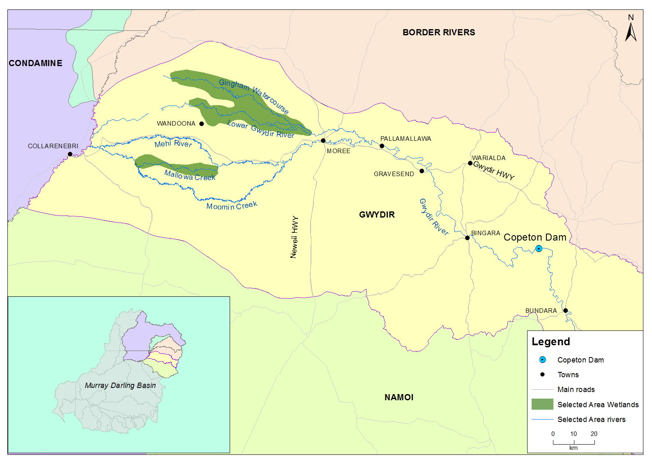

Figure 1‑1: Gwydir River catchment and location within the Murray-Darling Basin.

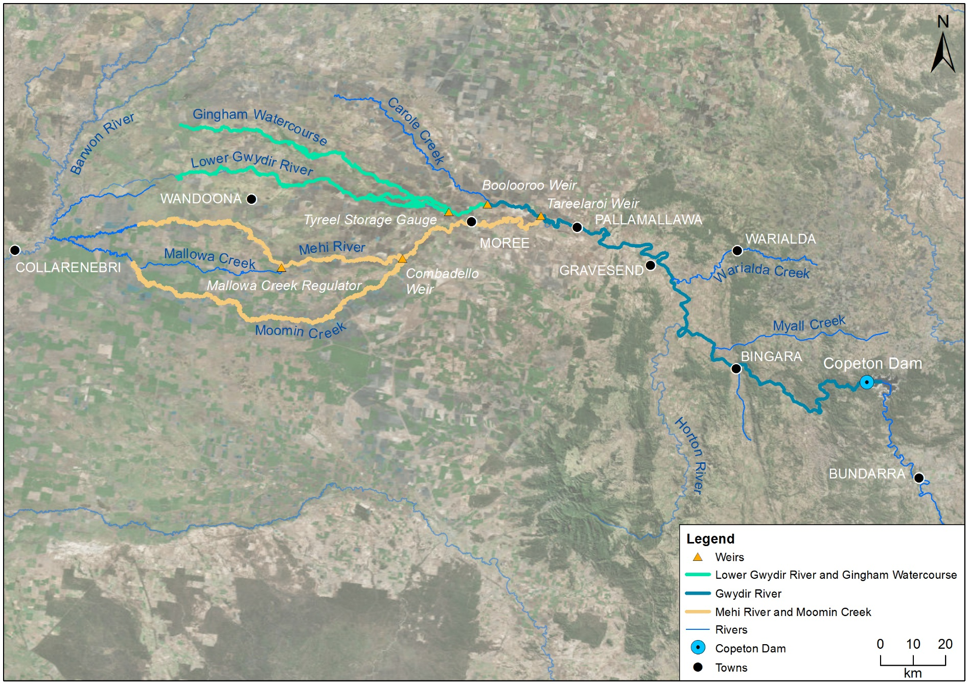

*Gingham waterhole*

Figure 1‑2: The Gwydir River system Selected Area with monitoring zones highlighted.

# Environmental watering actions in the Gwydir River system during 2017-18

## Environmental condition and watering actions in the Gwydir River system Selected Area 2017-18

The Gwydir catchment experienced below average rainfall and above average temperatures during the 2017-18 water year (Figure 2‑1, Figure 2‑2). The 2017-18 year saw below average rainfall in July, August, September, December, January, April, May and June with above average temperatures in every month except November. Rainfall for the last three months of the water year (April-May) totalled 22.4 mm.

Figure 2‑1: Monthly rainfall totals for 2017-18 and mean totals measured at Moree airport

(Source. <http://www.bom.gov.au/climate/data/index.shtml>).

Figure 2‑2: Monthly maximum temperatures for 2017-18 and mean maximum temperatures measured at Moree airport. (Source. <http://www.bom.gov.au/climate/data/index.shtml>).

Available Commonwealth environmental water holdings totalled 104,220 ML in the Gwydir River system for the 2017-18 water year. This was complemented by NSW OEH General Security water entitlements and the NSW Environmental Contingency Allowance (ECA) of 21,200 ML. Of this, a total of 28,290 ML of Commonwealth water and 18,748 ML of NSW ECA and General Security water was delivered in the 2017-18 water year via several watering actions in multiple channels (Table 2‑1). These watering actions are detailed in Section 3. This environmental water constituted between 0.5 and 39% of the total flow through the channels in which it was delivered.

Table 2‑1: Comparison between environmental water use and 2017-18 water year flows. Percentage represents the percentage of the total flow made up of environmental water.

|  |  |  |  |  |
| --- | --- | --- | --- | --- |
| Channel | Commonwealth Environmental Water (CEW) delivered (ML) | NSW ECA/General Security/Supplementary environmental Water delivered (ML) | 2017-18 total flow (ML) | Environmental Water % of total flow |
| Gwydir River* | 28,290 | 18,748 (including 15,748 General Security) | 412,705 | 11 |
| Gingham watercourse | 2,000 | 5,534 (including 4,520 General Security) | 22,984 | 33 |
| Lower Gwydir | 2,000 | 5,706 (including 4,520 General Security) | 19,831 | 39 |
| Carole Creek | 3,886 | 2,462 (including 1,662 General Security) | 95,341 | 7 |
| Mehi River< | 20,404 | 5,046 general security | 91,067 | 28 |
| Moomin Creek# | 324 | 175 | 104,075 | 0.5 |
| Mallowa Creek | 0 | 0 | 121 | 0 |
| **Total** | **28,290** | **18,748 (including 15,748 General Security)** | **412,705** | **11** |

* All environmental water delivery to the Gwydir system flowed through the Gwydir River in 2017-18. Therefore, volumes for this channel represent total volumes delivered downstream and as such are not included in the total.

< Includes 499 ML that flowed down Moomin Creek but returned to the Mehi downstream. Also includes 90 ML NSW General Security water for delivery to Whittaker’s Lagoon.

# Not included in total as accounted in return flows to Mehi.

During 2017-18, environmental water was delivered to both in-channel and wetland assets in the Gwydir River system (Table 2‑1). An early season stimulus flow was triggered by inflows to Copeton Dam in August/September 2017. A total of 10,000 ML was delivered into the main Gwydir River, Mehi and Carole Creek systems as a small fresh during late winter/early spring. Following this, a stable flow release of 10,040 ML was delivered into the main Gwydir River, Mehi and Carole Creek systems in late October to mid-November 2017. These small pulse flows were aimed at providing downstream connectivity and allowing opportunity for movement, breeding and recruitment of fish, particularly freshwater catfish.

A delivery of 8,000 ML including both State and Commonwealth environmental water was made to the lower Gwydir and Gingham wetlands from mid-December 2017 to late January 2018, to replace supplementary take from a small flow event that occurred in the previous months. This delivery aimed to maintain wetland habitat quality and support the survival and resilience of flora and fauna in the wetlands. The last environmental delivery was made in late April/May 2018 as part of the Northern Connectivity Event. This flow aimed to provide longitudinal connectivity and refresh/replenish drought refugia for instream life, particularly native fish in the Barwon-Darling as well as improving conditions to maintain native fish populations within the tributary catchments. During this event, a total of 18,908 ML of both State and Commonwealth water was delivered down the Mehi River, Moomin Creek and Carole Creek. No environmental water deliveries were made to Mallowa Creek in 2017-18.

# Key Outcomes from environmental water use

## Expected Outcomes

The overall aim of environmental watering in the Gwydir catchment during 2017-18 was to mimic natural cycles of drying and wetting by contributing to wetland watering, and to provide in-stream flows across the catchment to support native fish populations and to make water available to protect critical refuge habitat during extreme dry river conditions (Commonwealth of Australia 2017b). This water year constituted the third-year in the drying cycle of the three year wetting and drying management strategy employed in the Gwydir system.

Watering actions undertaken in the Selected Area were expected to contribute to four specific outcomes in 2017-18.

* Protect and maintain the condition of permanent and semi-permanent wetland vegetation.
* Maintain habitat to support waterbird condition and survival.
* Maintain habitat such as waterholes for fish condition and survival.
* Support fundamental ecosystem function processes of nutrient and carbon cycling and primary production.

Alignment of the expected outcomes for individual proposed watering with objectives of the Basin Plan’s environmental watering plan and MDBA annual environmental watering priorities for 2017-18 (MDBA 2017), are shown in Table 3‑1. A summary of each watering action, its target asset, and outcomes is provided in Table 3‑2.

Table 3‑1: Expected outcomes from environmental water use in the Gwydir River system Selected Area linked to broader Basin Plan objectives.

|  |  |  |  |  |  |  |  |  |
| --- | --- | --- | --- | --- | --- | --- | --- | --- |
| Expected outcome | | Timeframe | Relevant Basin Plan objective | Proposed watering 2017-18 watering actions: Gwydir | | | | |
| Gwydir and Mallowa wetlands reactive watering | Early season stimulus flow and Native fish recruitment flow | Extreme dry river contingency flow Gwydir, Mehi | Carole Creek reactive watering | Northern Connectivity Event |
| Vegetation condition and reproduction | | < 1 year | Biodiversity (s8.05) | **✓** |  |  |  |  |
| Fish condition | |  | **✓** | ✓ | ✓ | **✓** |
| Fish recruitment | | 1-5 years |  | **✓** |  |  |  |
| Waterbird survival and condition | | < 1 year | ✓ |  |  |  |  |
| Individual survival and recruitment (individual refuges) | | < 1 year | Resilience (s8.07) |  |  | **✓** |  | **✓** |
| Hydrological connectivity including end of system flows | | < 1 year | Ecosystem function (s8.06) | ✓ | ✓ | ✓ | ✓ | **✓** |
| Biotic dispersal and movement | |  | ✓ |  | ✓ | ✓ |
| Primary productivity | | ✓ | **✓** |  | **✓** |  |
| Nutrient and carbon cycling | | ✓ | **✓** |  | **✓** |  |
| Salinity, dissolved oxygen, pH, dissolved organic carbon, algal blooms | | < 1 year | Water quality (s9.04) |  | ✓ | ✓ | ✓ | **✓** |
| 2017-18 Basin environmental watering priorities | |  |  | *2,3,4* | *1,2* | *2* | *1,2* |  |
| Shading represents Basin environmental watering priority | | | | **Bold Tick** represents primary expected outcome | | | |

Basin environmental watering priorities:

* 1) Improve flow regimes and connectivity to maximise the ecological function of the Barwon-Darling river system for native fish.
* 2) Support viable populations of threatened native fish and maximise opportunities for range expansion and the establishment of new populations.
* 3) Improve the abundance and diversity of the Basin’s waterbird population.
* 4) Enable recruitment of trees and support growth of understorey species within river red gum, black box and coolibah communities on floodplains that received overbank flooding during 2016 by inundating the floodplains again.

Table 3‑2: Watering actions, target assets and evaluated outcomes implemented in the Gwydir River system Selected Area during 2017-18.

| Watering action | Volume (ML) | Target asset | Expected outcomes | Were these outcomes achieved in 2017-18 |
| --- | --- | --- | --- | --- |
| Early season stimulus triggered flow delivered into the Gwydir, Carole, Lower Gwydir, Mehi and Gingham channels (WUM10069-04; August-September 2017) | 7,000 CEW, 3,000 NSW ECA | Gwydir River, Carole Creek, lower Gwydir River, Mehi River and Gingham watercourse | * Reinstate natural small freshes during late winter and early spring * Movement, breeding and recruitment activity of fish, particularly freshwater catfish * Downstream hydrological connectivity including end of system flows | **Yes**, a noticable pulse went down all the monitored channels. Significant improvements noted in pH, and increased microinvertebrate density and diversity. Significant movement of Murray cod and freshwater catfish within and between the Gwydir and Mehi channels |
| Stable fish flow delivered into the Mehi, Gwydir and Carole channels (WUM10069-04; August-September 2017) | 5,000 CEW, 5,040 NSW ECA | Gwydir River, Carole Creek, lower Gwydir River, Mehi River and Gingham watercourse | **Maybe**, small-scale fish recruitment was observered during fish diversity sampling in these systems in 2017-18, however, recrutiment could not be specifically related to this flow event. |
| Replacement of Supplementary take from natural event with environmental water from storage (WUM 10069-01; December 2017 – January 2018) | 4,000 CEW | Lower Gwydir wetlands and Gingham Watercourse | * Replace natural inflows removed by irrigation * Maintain wetland habitat quality * Support the survival of flora and fauna, ecosystem diversity and resilience of Gingham and lower Gwydir wetlands | **Yes**, Notable increases in wetland inundation. Inundated the lower Gwydir wetland to the greatest extent over the 2017-18 water year (119 ha). Inundated a range of vegetation communities within both wetlands. Sustained productive aquatic invertebrate communities in the lower Gwydir wetland. |
| Northern Connectivity Event release from Copeton dam down Carole and Mehi channels (WUM 10072-02; April – May 2018) | 5,000 CEW | Carole Creek  Mehi River | * Provide a connection flow to the Barwon-Darling River * Improve tributary conditions to maintain native fish populations | **Yes**, longitudinal connection was achieved during a low flow period. This flow improved water quality, in particular dissolved oxygen concentrations within the Gwydir and Mehi channels . |

## Flows and ecosystem functions

Environmental water contributed to connectivity in the Gwydir River, lower Gwydir River, Mehi River, Moomin Creek and Gingham watercourse during 2017-18 (Appendix A). Flows down Mallowa Creek were extremely low during 2017-18 with only 2 days of connection. This was substantially lower than in all previous years and reflected the dry catchment conditions and no environmental water delivery to this channel. In other channels, connectivity in 2017-18 was less than in 2016-17, but similar to the first two years of the LTIM project (2014-15, 2015-16). Both 2016-17 and 2017-18 were planned dry years in the Gwydir system, however, in 2016-17 environmental watering priorities were changed in response to flooding in spring 2016 to maintain bird and frog breeding habitat in the wetlands. In contrast, connectivity in 2017-18 was sporadic in most zones, driven by environmental water flows and maintained by stock and domestic release and local rainfall.

Reduced inflows to the Gingham and lower Gwydir wetlands during the 2017-18 water year resulted in reduced wetland inundation compared to 2016-17 (Appendix B). In the Gingham, maximum inundation (363.81 ha) was observed early in the water year as a result of residual flooding from the previous year which included environmental water (Figure 3‑1). This is compared to the largest inundation extent recorded during this project of 2,844 ha in 2016-17. Inundation extent then decreased before a small delivery of environmental water over the summer period increased inundation in February 2017. This system then dried for the remainder of the year. In the lower Gwydir wetlands, maximum inundation (118.51 ha) was noted following the delivery of environmental water into this system. In both the Gingham and lower Gwydir wetlands the delivery of environmental water over the summer period inundated core wetland areas. There were minimal inflows to the Mallowa wetlands during 2017-18 including no environmental water. As a result, inundation in this system was confined to farm dams and some small areas of rainfall induced isolated inundation.

While the area of inundation was low during 2017-18, a considerable suite of vegetation communities was inundated. Inundating a range of communities during drier periods is important for maintaining both vegetation and habitat diversity across the wetland landscape. In the Gingham, 16 of the 22 vegetation communities that were inundated in 2016-17 were again inundated this water year. Interestingly in 2017-18, more Cumbungi swamp rushland was inundated than in the previous year. As in previous years water couch – spike rush – tussock rush marsh grassland/sedgeland and river cooba – lignum swamp shrubland were again inundated to some extent in 2017-18. In the lower Gwydir wetlands, six of the eight vegetation communities mapped were inundated during each of the last three monitoring years, though the area inundated in 2017-18 was much less than in previous years. In 2017-18, river - cooba lignum association made up a greatest proportion of the total area inundated, being 44% of the total inundated area. This is because of the reduced area of water couch – spike rush – tussock rush marsh grassland inundated in 2016-17, which in this water year constituted 43% of the total area compared to 74% in the previous water year. These patterns reflect the distribution of this vegetation community relative to the movement of water in the system in each year.

In general, nutrient concentrations exceeded ANZECC guideline trigger values in all sites and times. The two flow pulses of environmental water early in the season provided connection between the Gwydir River and the lower Gwydir and Gingham watercourses and led to decreases in nutrient concentrations in all wetlands. These events also increased longitudinal transport of nutrients in all channels. It is plausible that the environmental water transported the nutrient load within river systems while it diluted very high nutrient concentrations in wetland systems in the Selected Area. An increase in chlorophyll *a* did not occur immediately during environmental water actions. Instead, a spike in chlorophyll *a* occurred with the onset of warmer temperatures. This suggests temperature plays a critical role in moderating productivity in this system and highlights the potential ecological significance of the timing of flow events.

The environmental flow events in November and December 2017 led to a decrease in the rate of net primary production (NPP) but did not show a significant change in the rates of gross primary production (GPP) and ecosystem respiration (ER). From all available data in this water year, increased discharge generally led to decreasing rates of GPP and ER. This suggests that increased discharge stimulated a shift toward a more heterotrophic system, in which the food web relies on external sources of energy, rather than producing carbon through photosynthesis in the water column.

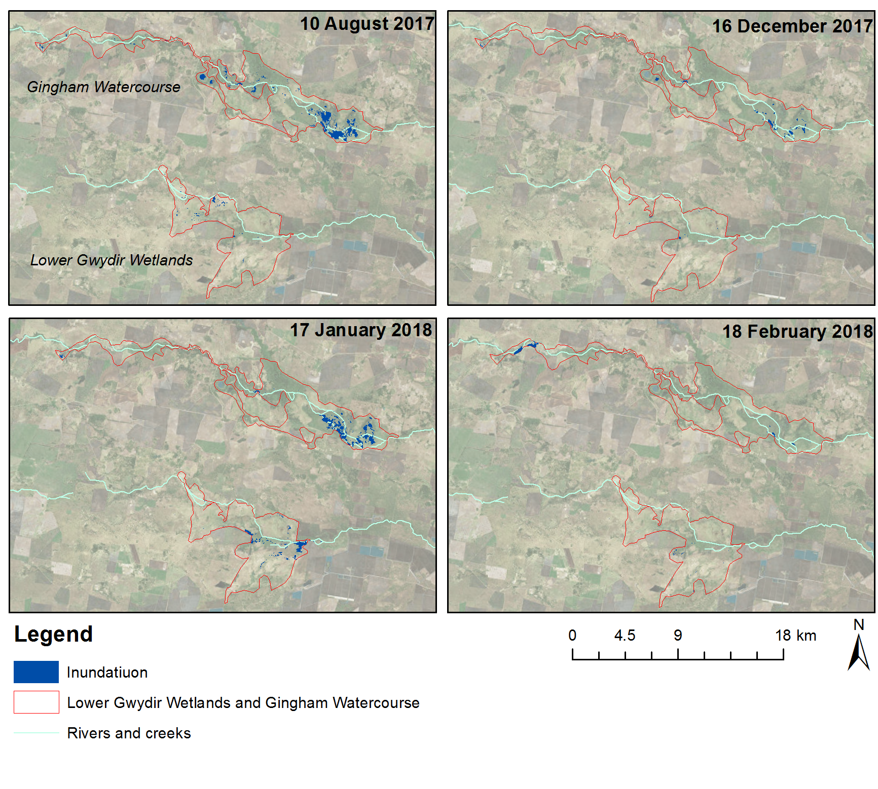

Figure 3‑1: Wetland inundation within the Gingham and lower Gwydir wetlands during the 2017-18 water year.

## Water Quality

In this water year, the two environmental flows delivered in September and November 2017 significantly reduced pH and conductivity when compared with non-environmental water periods (Appendix C). This is consistent with observations made in previous years of the LTIM project. The delivery of environmental water in these two flow events led to significant improvement of pH levels, lowering levels to within ANZECC water quality guidelines. These processes highlight the dilution effects that can be provided by environmental water, and the changes in water chemistry associated with the increase in discharge and wetted area of channels. The Northern Connectivity Event delivered environmental water during the base flow period in autumn and led to significant increases in dissolved oxygen concentrations within two days of flow delivery. However, similar responses in dissolved oxygen were not observed in the other flow periods monitored.

Four years of water quality monitoring at the Pallamallawa station on the Gwydir River have showed the delivery of environmental water has consistently produced significant improvements in pH, conductivity and turbidity regardless of annual flow magnitudes. However, dissolved oxygen levels have shown a variable response to environmental watering over the different water years. We suggest that inter-annual hydrological variability, antecedent flow conditions and seasonal effects (warmer temperatures increase primary production) play important roles in dissolved oxygen variability, highlighting the importance of long-term monitoring in highly dynamic systems.

Spot sampling undertaken at both river and wetland sites throughout the Selected Area (Appendix C) showed that water temperature during the four sampling occasions responded to broader regional climatic patterns rather than flow or other environmental conditions. All zones in the Selected Area had exceptionally high nitrogen and phosphorus concentrations consistent with previous observations during the LTIM project. As expected, water quality differed between river channels and watercourse environments as shown by by marked differences in water column pH, turbidity, conductivity and nutrient concentrations.

## Biodiversity

In the 2017-18 water year, environmental water influenced sites within all zones of the Selected Area, except the Mallowa, inundating seven of the ten ecosystem types monitored as defined by the (Interim) Australian National Aquatic Ecosystem (ANAE) Classification Framework (Brooks *et al*. 2013, Figure 3‑2, Appendix F). Maintenance of a range of ecosystem types in the wetlands provides a diversity of habitats and helps to maintain species (plant and animal) diversity.

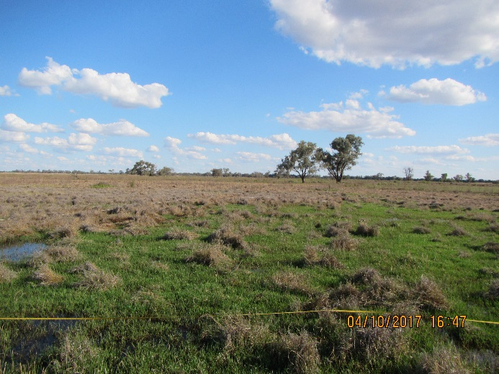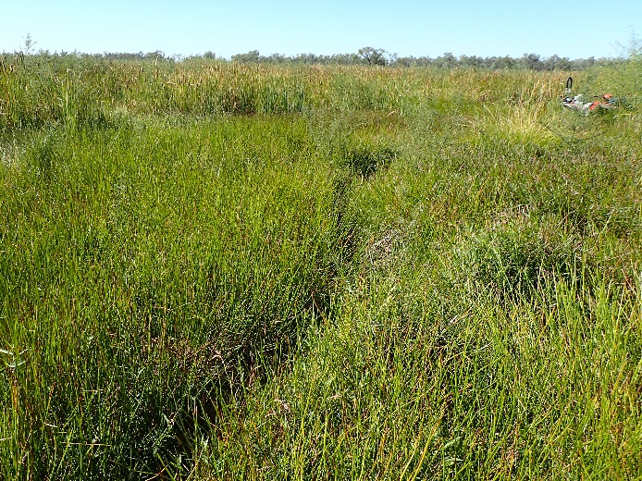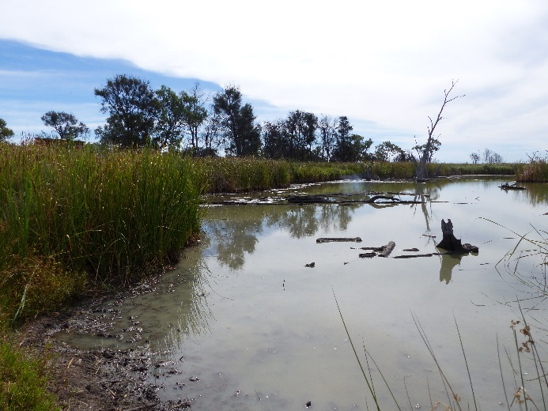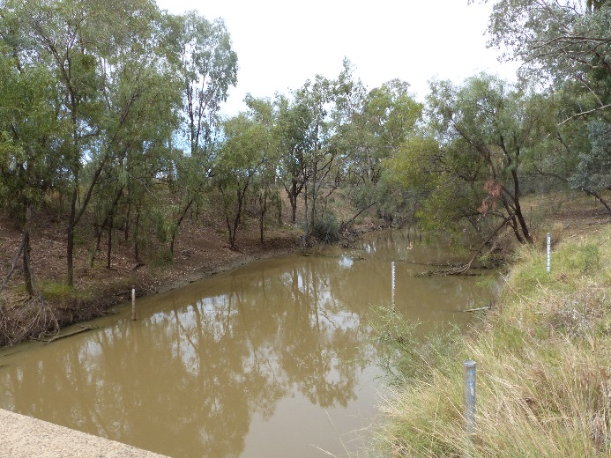

Figure 3‑2: Sedge/forb/grassland floodplain (top), Temporary lowland stream (bottom left) and Permanent lowland stream (bottom right) ecosystem types monitoried in the Selected Area.

Environmental water delivered to the Selected Area influenced the diversity, abundance and community composition of invertebrate communities in 2017-18 (Appendix D and Appendix E). As in previous years, the lower Gwydir wetland had the highest macroinvertebrate density and taxonomic richness of all the zones monitored, related to the increased amount of high quality habitat present. Environmental water deliveries had contrasting effects on micro and macroinvertebrate channel communities, with the density and richness of macroinvertebrates reducing in the Gwydir and Mehi Rivers during flow periods. This is likely the result of the flows creating a disturbance for flow-prone taxa that were less able to withstand higher flow velocities. In contrast, higher microinvertebrate diversity and richness was observed during these flow events. We postulate that the longitudinal and lateral connection from environmental water events improved water quality conditions and increased habitat diversity, which led to a more diverse range of microinvertebrates sampled. The density of invertebrates was highest during periods of lower flow towards the end of the 2017-18 water year. These periods also coincided with high chlorophyll a, nutrient and carbon concentrations and water temperatures, which likely boosted water column primary production, in turn supporting increased secondary productivity for wetland food webs. Our findings suggest that temperature seems to play a critical role in primary and secondary productivity, highlighting the ecological significance of the timing of flow events.

Vegetation monitoring in the Gingham, lower Gwydir and Mallowa wetlands during 2017-18 suggests that there has been a steady decline in species richness and total cover at vegetation plots across the wetlands during the 2016-17 water year, because of minimal inundation and dry conditions (Appendix G). While the cover of water couch has remained consistent, especially in the Gingham system, the weed species lippia has increased due to the favourable dry conditions. Of the few sites that were inundated during the 2017-18 water year, some were also affected by fire, confounding the ability to measure the potential benefits of this inundation.

The generally drier conditions experienced across 2017-18 compared to 2016-17 resulted in stabilisation of the fish community across the Selected Area, with only a small decline in the total number of fish captured and approximately the same number of species caught in each hydrological zone as in previous years (Appendix H). Based on sampling over the last four years, it appears that the fish community across the Selected Area is in a constant state of flux, ranging from times of extreme stress and retraction leading to localised community collapse, through to periods of relative stability when recruitment and mortality are at or near equilibrium. The Fish Health scores for sites in the current sampling round suggest that, in general, the fish community in the Selected Area remains stable. *Expectedness* (the measure of what species most likely occurred in the Gwydir if it was undisturbed), *Nativeness* and *Recruitment*, declined or changed little across all four hydrological zones in 2017-18 compared with 2016-17. Two of the five threatened fish species known to occur in the Gwydir were recorded in 2017-18, being the Murray cod (*Maccullochella peelii*), and freshwater catfish.

Fish monitoring suggests that most native species present across the Selected Area are recruiting in at least some sections of the system, albeit in low numbers. Over the 2017-18 period it could be expected that the flows experienced favour “low-flow” specialists, with generally low and stable flows experienced throughout much of the year. For some low-flow species this was the case, with carp gudgeon (*Hypseleotris* sp.), for example, being recorded in their highest abundance of any of the four rounds of sampling undertaken to date. Carp gudgeon are among a guild of species that Baumgartner *et al*. (2014) described as species that are resilient to prolonged periods of low flow, require no flow stimuli to spawn, and may in some cases increase in numbers during dry periods and drought. Other species in the generalist guild that behaved similarly in at least some zones during 2017-18 included bony herring (*Nematolosa erebi*) and the exotic species, mosquitofish (*Gambusia holbrooki*). However, conditions appeared to have an opposite effect on some of the other longer-lived species in this guild, such as freshwater catfish, with only one recruit recorded compared with more than ten in 2016-17 (Figure 3‑3). This appears to support the previous finding that while freshwater catfish can survive, breed and recruit during low-flow periods, timely and large flooding events may also be critical for the long-term conservation of the species in highly regulated systems like the Gwydir.

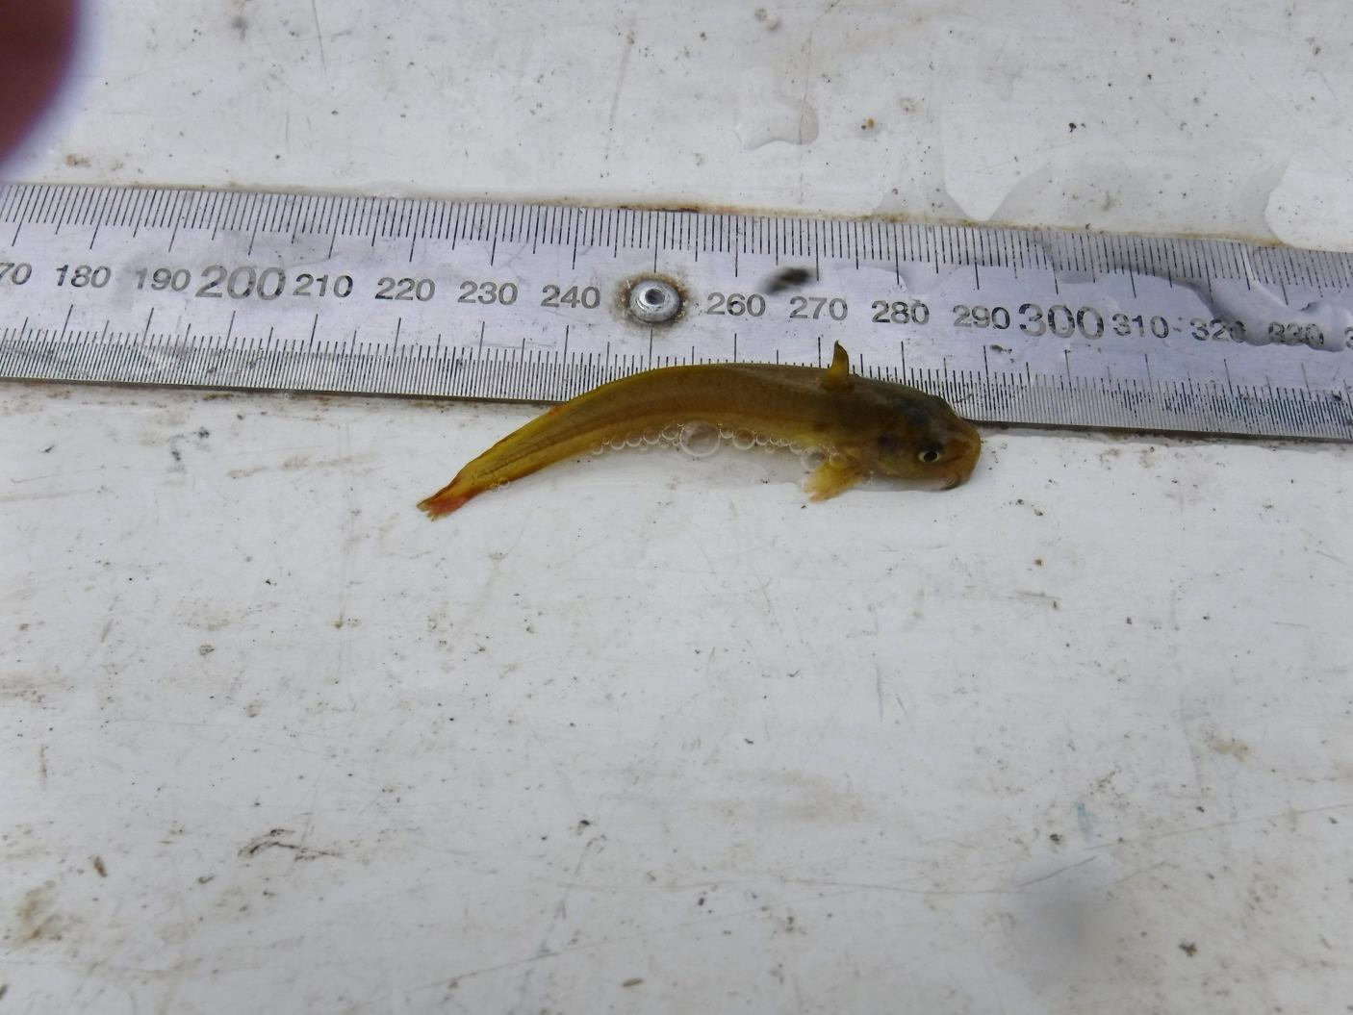

Figure 3‑3: Freshwater catfish recruit, likely spawned in 2017-18 caught in the lower Gwydir River during fish diversity sampling in 2018.

While non-flow dependent fish species appear to be breeding and recruiting in sections of the Selected Area, the ongoing low abundance of several flow-dependent fish species remains of concern for the long-term recovery of native fish. Species such as golden perch (*Macquaria ambigua*), silver perch (*Bidyanus bidyanus*) and spangled perch (*Leiopotherapon unicolor*) were once considered plentiful throughout much of the Gwydir Basin (Copeland *et al.* 2003). To date, very few adults and almost no recruits of any of these three species have been recorded, suggesting breeding or recruitment has been low across the lower Gwydir Basin. While golden and silver perch have been noted to spawn in low numbers during low flows, altered flow regimes, cold water pollution and artificial barriers that restrict movement both within the Gwydir and between the Gwydir and Barwon Rivers, have been suggested as having a major impact on the breeding and recruitment of all three species (King *et al*. 2009; Mallen-Cooper and Stuart 2003). Given that all three species are known to aggregate to spawn (Pusey *et al.* 2004), the chances of a significant recruitment event for these species may be limited by the low overall number of adults and by the restrictions placed on those that are present to freely move about the system to interact.

As with the native fish community, common carp and goldfish numbers either remained stable or declined across the four hydrological zones in 2017-18. Similar reduced numbers of these exotic species were found in previous drier years of the project. This is likely due to both species utilising increased flows to access wetlands to breed and recruit before moving back into the mainstream as juveniles and/or young adults (Brumely 1996; Koehn and Nicol 2016). As such, the generally lower flow conditions across much of the Gwydir in 2017-18 were most likely less conducive to a large-scale breeding event for either species compared to 2016-17. Common carp had the highest overall biomass on any species recorded, and had the highest average biomass at sites in the Gingham and Moomin systems. Murray Cod maintained the highest average biomass in the Gwydir River, and in 2017-18 surpassed carp as the species with the highest biomass in the Mehi River.

Murray cod and freshwater catfish were also monitored via the fish movement indicator (Appendix I). Due to low numbers of resident freshwater catfish, ~50 were translocated from Copeton Dam into the study reaches in 2016-17. Tagged individuals of both species moved throughout the Mehi and Gwydir channels in 2017-18 and in some cases changed location from one system to another. Fish showed a preference for moving at night, during periods of higher temperature and in periods of higher flow. The movement of fish was greatest during the early season stimulus flow in August/September 2017, which was designed to provide increased opportunities for access to habitat and food. This highlights the benefit of providing flow pulses at this time of year. Habitat preferences for each species were also quantified, with Murray cod tending to select deeper areas and areas where woody structures occurred. They also displayed a preference for the highest and lowest areas of water velocity, likely seeking the slowest water as part of non-foraging behaviours and the fastest water when foraging. Resident catfish actively selected undercut banks and root masses, significantly more so than those translocated from Copeton Dam. Translocated catfish preferred deeper areas potentially reflecting the greater availability of deeper habitats within their former range.

In total, 61 waterbird species were recorded in the 2017-18 monitoring period, down from 71 species in 2016-17, but more than in other drier years of the LTIM project (59 species in both 2014-15 and 2015-16; Appendix J; Figure 3‑4). Three recorded species are listed under one or more international migratory bird agreement (JAMBA, CAMBA, ROKAMBA); brolga (*Grus rubicunda*), Latham’s snipe (*Gallinago hardwickii*) and marsh sandpiper (*Tringa stagnatilis*). In addition, seven recorded species are listed as vulnerable under the NSW *Biodiversity Conservation Act 2016* (BC Act); Australian painted snipe (*Rostratula australis*), black-necked stork (*Ephippiorhynchus asiaticus)*, brolga, freckled duck (*Stictonetta naevosa*), magpie goose (*Anseranas semipalmata*), spotted harrier (*Circus assimilis*) and the white-bellied sea-eagle (*Haliaeetus leucogaster*). The Australian painted snipe is also listed as endangered under the Environment Protection and Biodiversity Conservation Act 1999 (EPBC Act). Again, all functional guilds were represented across the surveyed sites in Spring 2017 and Autumn 2018, with dabbling and filter-feeding ducks, grazing ducks and geese, and piscivores being the more dominant guilds present. Pacific black ducks (*Anas superciliosa*) and grey teals (*Anas gracilis*) contributed to the high density of dabbling and filter-feeding ducks, while the high densities of grazing ducks and geese resulted from the large flock of magpie geese in Spring and plumed whistling-ducks (*Dendrocygna eytoni*) in Autumn. As in previous years, occurrence of waterbirds during the 2017-18 water year was driven by patterns of inundation. Spring 2017 had 29% more inundated (wet) sites than Autumn 2018, which correlated with higher waterbird species richness, density, diversity and observed breeding. In addition, inundated sites had significantly higher waterbird occurrence than dry sites. This is an indication of the strong influence tht inundation has on the presence and diversity of waterbird species. This is further highlighted by pacific black ducks’ high contribution to community composition within inundated sites, while several raptor species that are less reliant on the presence of water, contributed most to the composition of dry site bird communities.

A high abundance of piscivores and grazing ducks and geese was noted in Spring 2017. This is linked to the increased habitat and resource base that was provided by long periods of inundation in the previous water year. Conversely, all functional guilds except raptors decreased in Autumn 2018, with raptors contributing the most to species composition across the sites later in the water year. This suggests that habitat conditions required by piscivores and grazing ducks and geese decreased with the drying conditions. The autumn surveys coincided with the migratory period for migratory shorebirds species including Latham’s snipe and marsh sandpiper, which were detected in low numbers. The delivery of environmental water to the lower Gwydir wetlands during summer and autumn months can provide foraging habitat for these migratory shorebirds which migrate north during the February-May period (Bamford *et al*. 2008).

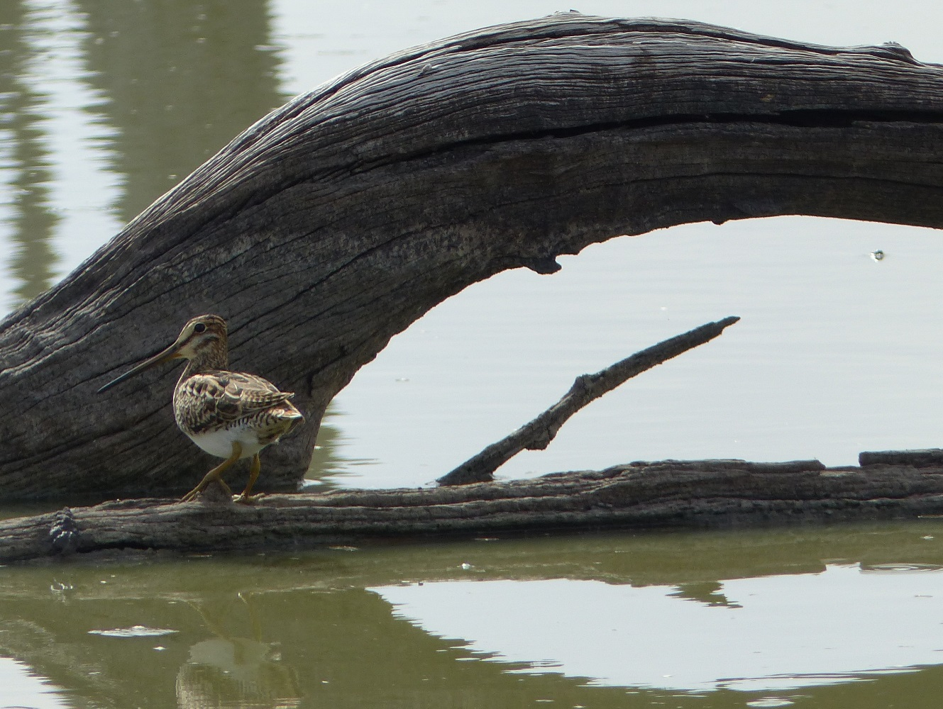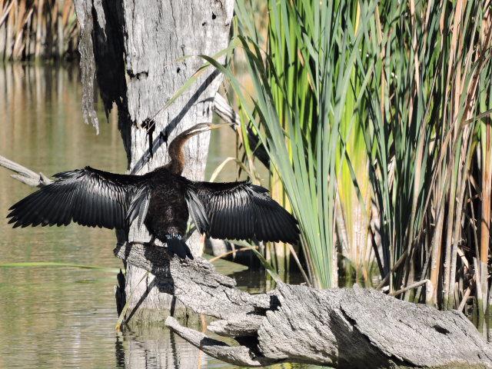

Figure 3‑4: Latham’s snipe (*Gallinago hardwickii*) at Bunnor in the Gingham watercourse (top), Australasian Darter (*Anhinga novaehollandiae*) sunning at Gingham waterhole (bottom).

## Resilience

While no direct monitoring of the survival or condition of individual organisms was undertaken in this project, some broader inferences can be made as to the contribution of environmental water and its management on the resilience of the Selected Area in 2017-18. Fish diversity monitoring undertaken to date through the LTIM project, has shown that the fish population is stressed but stable. Therefore, the resilience of the fish community could be considered low. For some species like golden perch, silver perch and spangled perch, the low numbers of adult fish present, along with various barriers found throughout the system may be preventing any significant recruitment opportunities. However, findings from the fish movement indicator suggest that even modest environmental flow deliveries, such as the early season stimulus flow that was delivered during 2017-18, can trigger significant movements among individuals both within and between channels within the Selected Area. These may increase the chances of low but important instances of recruitment between larger flood events which can exert a greater breeding response from flow dependent fish species.

The 2017-18 water year was the last of a planned 3-year dry period for the lower Gwydir wetlands and Gingham watercourse. As expected, the diversity and abundance of waterbirds, as well as the cover and richness of vegetation communities was lower this year than the previous wetter years. The relatively small quantities of environmental water provided to the wetlands sustained macroinvertebrate communities within the lower Gwydir wetlands which remains as a hotspot in the Selected Area in terms of macroinvertebrate productivity. This suggests that the base of the food chain, supported by environmental water, remains productive within this system, and should respond positively to subsequent inundation. The higher numbers and diversity of waterbirds found at inundated sites indicates that these animals were taking advantage of this inundation and resultant productivity to sustain their populations within the wetlands during the dry conditions. Monitoring in the next year of the LTIM project, through what is a planned wet year for the wetlands, will provide further evidence of the effectiveness of the multi-year wetting/drying management regime being employed to build ecological resilience within the wetlands.

## Summary

2017-18 was a relatively dry year in the Selected Area, with flows down most channels enhanced by environmental water deliveries. Mallowa Creek was the exception as no environmental water was delivered down this channel. The two small environmental water releases in September and November 2017, stimulated the movement of Murray cod and freshwater catfish throughout and between the Mehi and Gwydir river channels. They also improved water quality through dilution, and transported nutrients through the system which resulted in an increase in the density and diversity of riverine invertebrate communities. Over summer and autumn, lower water levels, and increased water temperature, led to higher concentrations of chlorophyll a in the river channels that in turn stimulated a spike in macroinvertebrate densities. Carp gudgeon also recruited in the highest levels observed in the LTIM project during this lower flow period.

Inundation within the Gingham wetlands was more than 5 times less in 2017-18 than the previous year with a maximum of 364 ha inundated early in the water year. Maximum inundation in the lower Gwydir wetlands was driven by environmental water, with a maximum of 119 ha being inundated in the eastern sections of the wetland. Even with low inundation extents a range of habitat types were inundated and invertebrate communities were supported in the wetlands. The inundated wetlands were also utilised by waterbirds, to help maintain their populations through these drier conditions. This should allow these populations to respond positively when environmental water is delivered to the wetlands in the upcoming planned wet year in the Gwydir.

The four years of monitoring during the LTIM project has identified a range of ecological responses to the delivery of environmental water in the Gwydir Selected Area. Some of these responses have been consistent through time, while others appear to be more variable, mediated by factors other than watering. For example, the delivery of environmental water has consistently improved pH, turbidity and conductivity through dilution, irrespective or flow magnitude. Similarly, microinvertebrate communities tend to increase in diversity and richness during the delivery of flows, linked to an increase in available habitat. When environmental water is delivered over the warmer months of the year, primary productivity increases and drives an increase in invertebrate density. The movement of Murray cod and freshwater catfish has been shown to be stimulated by flow pulses delivered through the system especially flow events that occur in spring during the lead up to their breeding season. While these species appear to be moving in association with breeding, there has been little evidence of widespread breeding and recruitment of these species or any that rely on flow triggers to induce spawning. Other fish species that are not as reliant on flows to spawn (e.g. carp gudgeon and bony herring) appear to be breeding and recruiting more consistently each year. Even so, fish populations remain under stress in the Gwydir system, and have shown minimal improvements over the LTIM project. In wetland environments, waterbird diversity and density are highly associated with inundated sites, that provide feeding, resting and breeding habitat. Wetland inundation has also been shown to improve the cover and richness of wetland vegetation species, allowing wetland species to out compete exotic species.

# Implications for Future Management of environmental water

The past three years (2015 – 2018) have fallen within the dry phase of the planned three-year wetting and drying management strategy for the Gwydir system. In these years, an adaptive watering strategy has been employed, based on natural flow triggers within the catchment. In 2017-18, four environmental flows events were delivered, a small fresh flow in August/September 2017 (early season stimulus flow), a stable flow release in October/November 2017, a flow into the Gwydir and Gingham wetlands in December 2017 to replace supplementary take from a small flow event in previous months, and a larger fresh flow released down Mehi, Moomin and Carole creek as part of the Northern Connectivity Event in April/May 2018 (Section 2.1).

The early season stimulus flow improved water quality and increased microinvertebrate diversity and richness in the channels of the lower Gwydir, likely through an increase in available habitat. Total Nitrogen also increased during this flow, but a related increase in productivity was not observed. It is likely that lower water temperatures limited water column productivity at this time of year. In response, river channel microinvertebrate densities did not increase during this flow. Murray cod and freshwater catfish showed increased movement through and between the Mehi and Gwydir River channels during this early season flow event. This reflects their inherent drive to find suitable spawning habitat and possibly mates during this late winter and spring period. While recruitment of these species in the Gwydir system is still considered low, providing opportunities for these fish to move through the system to prepare for breeding is strongly supported. These findings suggest that the delivery of the early season stimulus flow was successful in improving water quality and was of a magnitude and duration that stimulated fish to move throughout the channel network. However, river channel primary and secondary productivity did not show a noticeable response, likely due to reduced temperatures limiting productivity.

As with the early season stimulus flow, the stable flow release delivered in October/November 2017, improved water quality parameters, increased nutrient transport and stimulated a shift to a more heterotrophic system, or one which was driven by external inputs of energy. In this water year, recruitment of carp gudgeon was noted with the highest abundance of this species recorded in 2017-18 compared to the previous 3 years of LTIM sampling. Given this species is a low-flow specialist, stable flows like that provided by the environmental water delivery in October/November 2017 likely contributed to the success of this and other similar low-flow specialist fish species this year.

The delivery of environmental water to the Gwydir and Gingham wetlands during the summer period inundated core wetland areas. Although the area of inundation was lower than in previous years, a relatively broad range of vegetation communities was inundated, providing a range of habitats for wetland species. As in previous years, wetland inundation stimulated invertebrate productivity, with the Gwydir wetlands remaining as an invertebrate hotspot in the system. This productivity benefitted waterbirds, with increased waterbird richness and abundance being noted at inundated sites. Watering actions that are triggered by natural inflows and aim to replace water that would have flowed to the wetlands but was extracted as supplementary take, are likely to be crucial in sustaining these wetland areas during dry conditions, such as those experienced in 2017-18. Maintaining the condition of small but vital areas of the wetlands will promote an ecological response when the wetlands fill in future years.

The Northern Connectivity Event delivered in March/April 2018 to the Mehi River, Moomin Creek and Carole Creek, ended a period of very low flows in these channels. This flow provided connection through these channels and improved water quality that had deteriorated due to low flows and concentration of some variables such as salt levels.

The findings from LTIM monitoring to date in the Gwydir Selected Area suggest that providing multiple watering events, especially in low flow years, is a useful approach to elicit a range of ecological responses. Flow events delivered in winter/spring appear to improve water quality and stimulate fish movement, but induce only minimal primary and secondary production due to lower water temperatures. Flows delivered over the summer/autumn period tend to improve water quality, and promote primary and secondary production, thus supporting animals higher up the food chain such as fish, frogs and waterbirds. Providing flows to the wetlands has been shown to promote invertebrate production, waterbird populations and vegetation condition. While the cover of the weed species lippia has increased this year in the dry conditions, given observations made in 2014-15, it is expected that inundation in the upcoming planned wet year will reduce lippia cover and increase native water couch cover. The fish population in the Gwydir River system appears to be under stress, with many native species in low abundance. This may reflect the carrying capacity of the system in its current state. While some species appear to be breeding and recruiting, others, especially some of the more iconic species such as golden perch, freshwater catfish and Murray cod, are not recruiting sufficiently to improve their populations. Along with providing environmental flows, other options such as habitat rehabilitation, restocking and barrier remediation should be considered to improve the fish communities of the Selected Area.

# References

Bamford M, Watkins D, Bancroft W, Tischler G and J Wahl. 2008. Migratory Shorebirds of the East Asian - Australasian Flyway; Population Estimates and Internationally Important Sites. Wetlands International - Oceania. Canberra, Australia.

Brumley, A.R. (1996) Cyprinids. In: Freshwater Fishes of south-eastern Australia. (Ed. R. McDowall) pp. 99-106. Reed Books: Sydney.

Brooks S., Cottingham P., Butcher R., & Hale J. 2013. *Murray Darling Basin aquatic ecosystem classification: Stage 2 report*. Peter Cottingham & Associates report to the Commonwealth Environmental Water Office and Murray Darling Basin Authority, Canberra.

Commonwealth of Australia. 2014. *Commonwealth Environmental Water Office Long Term Intervention Monitoring Project Gwydir River system Selected Area - Monitoring and Evaluation Plan*, Canberra.

Commonwealth of Australia. 2017a. *Commonwealth Environmental Water Office Long Term Intervention Monitoring Project Gwydir River system Selected Area – 2016-17 evaluation report*, Canberra.

Commonwealth of Australia 2017b. Commonwealth Environmental Water Portfolio Management Plan: Gwydir Valley 2017-18. Canberra.

Copeland, C., Schooneveldt-Reid, E. and Neller, S. 2003. Fish Everywhere - an oral history of fish and their habitats in the Gwydir River. New South Wales Fisheries, Ballina.

Department of Environment, Climate Change and Water (DECCW). 2011. *Gwydir Wetlands Adaptive Environmental Management Plan: Synthesis of information projects and actions*. DECCW, Sydney.

Green D., Burrell M., Petrovic J., & Moss P. 2011. *Water resources and management overview – Gwydir catchment*. NSW Office of Water, Sydney.

King, A.J., Tonkin, Z. and Mahoney, J. 2009. Environmental flow enhances native fish spawning and recruitment in the Murray River, Australia. River Research and Applications, **25**, 1205–1218.

Koehn, J.D. and Nicol, S.J. (2016). Comparative movements of four large fish species in a lowland river. *Journal of Fish Biology*, **88**, 1350–1368.

Mallen-Cooper, M. and Stuart, I. G. 2003. Age, growth and non-flood recruitment of two potamodromous fishes in a large semi-arid/temperate river system. River Research and Applications, **19**, 697–719.

MDBA 2017. Basin environmental watering priorities 2017-18. Murray Darling Basin Authority, Canberra.