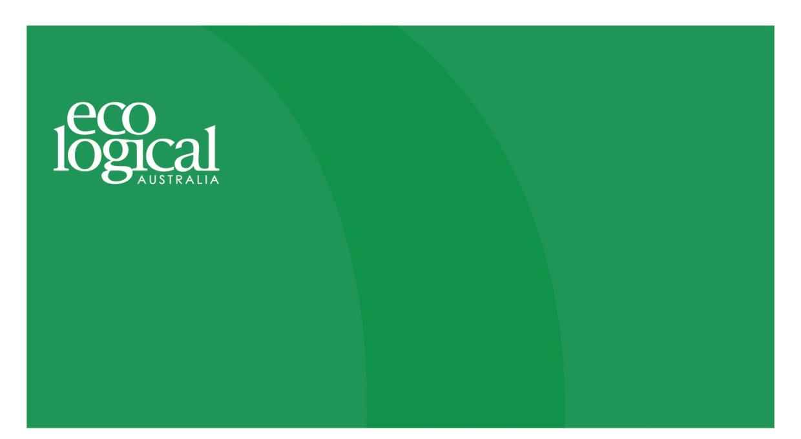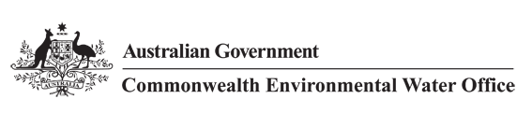



**Commonwealth Environmental Water Office**

**Long Term Intervention Monitoring Project**

**GWYDIR RIVER SYSTEM SELECTED AREA**

2014-15 Evaluation Report, 3 February 2016

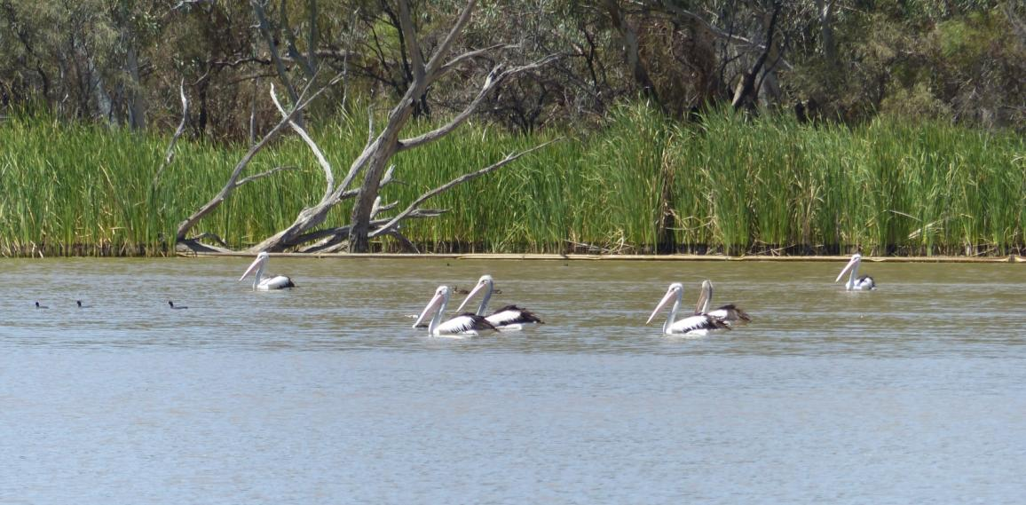



This monitoring project was commissioned and funded by Commonwealth Environmental Water Office, with in-kind support from NSW Office of Environment and Heritage.

**Copyright**

© Copyright Commonwealth of Australia, 2015



Commonwealth Environmental Water Office Long Term Intervention Monitoring Project Gwydir River System Selected Area is licensed by the Commonwealth of Australia for use under a Creative Commons By Attribution 3.0 Australia licence with the exception of the Coat of Arms of the Commonwealth of Australia, the logo of the agency responsible for publishing the report, content supplied by third parties, and any images depicting people. For licence conditions see: <http://creativecommons.org/licenses/by/3.0/au/>

This report should be attributed as ‘Commonwealth Environmental Water Office Long Term Intervention Monitoring Project Gwydir River System Selected Area – 2014-15 Draft Evaluation Report, Commonwealth of Australia 2015’.

**Disclaimer**

The views and opinions expressed in this publication are those of the authors and do not necessarily reflect those of the Australian Government or the Minister for the Environment.

While reasonable efforts have been made to ensure that the contents of this publication are factually correct, the Commonwealth does not accept responsibility for the accuracy or completeness of the contents, and shall not be liable for any loss or damage that may be occasioned directly or indirectly through the use of, or reliance on, the contents of this publication.

**DOCUMENT TRACKING**

|  |  |
| --- | --- |
| Item | Detail |
| Project Name | Long Term Intervention Monitoring Project – Gwydir River System Selected Area |
| Project Number | 14ARMNRM-0001 |
| Project Manager | Dr Mark Southwell  (02) 8081 2688  92 Taylor Street, Armidale NSW 2350 |
| Prepared by | Dr Mark Southwell, Dr Paul Frazier , Rebecca McCue, Linden Burch, Nathalie van der Veer , Emily Southwell (ELA)  Assoc. Prof Darren Ryder (UNE)  Dr Gavin Butler (NSW DPI)  Dr Jennifer Spence, Sharon Bowen and Jane Humphries (NSW OEH) |
| Reviewed by | Dr Mark Southwell, Assoc. Prof Darren Ryder, Dr Paul Frazier |
| Approved by | Dr Paul Frazier |
| Status | FINAL |
| Version Number | 2 |
| Last saved on | 3 February 2016 |
| Cover photo | Pelicans on Gingham Waterhole, 29 October 2014. Photo: D Ryder |

Acknowledgements

This document has been prepared by Eco Logical Australia Pty Ltd with support from Associate Professor Darren Ryder from the University of New England, Dr Gavin Butler from the DPI fisheries, and staff from the NSW Office of Environment and Heritage and NSW Office of Water. The project would like to thank the landholders of the Gwydir River wetlands who have allowed us access to their properties to undertaken fieldwork.

|  |
| --- |
| **Disclaimer** *This document may only be used for the purpose for which it was commissioned and in accordance with the contract between Eco Logical Australia Pty Ltd and the Department of the Environment. The scope of services was defined in consultation with the Department of the Environment, by time and budgetary constraints imposed by the client, and the availability of reports and other data on the subject area. Changes to available information, legislation and schedules are made on an ongoing basis and readers should obtain up to date information.*  *Eco Logical Australia Pty Ltd accepts no liability or responsibility whatsoever for or in respect of any use of or reliance upon this report and its supporting material by any third party. Information provided is not intended to be a substitute for site specific assessment or legal advice in relation to any matter. Unauthorised use of this report in any form is prohibited.* |

Template 08/05/2014

**Document control**

|  |  |  |  |
| --- | --- | --- | --- |
| **Version** | **Date** | **Reviewed by** | **Approved by** |
| 1 | 26/8/2015 | Dr Mark Southwell, Assoc. Prof Darren Ryder | Dr Paul Frazier |
| 2 | 09/11/2015 | Dr Mark Southwell, Assoc. Prof Darren Ryder | Dr Paul Frazier |

|  |  |
| --- | --- |
| **Item** | **Details** |
| ELA Project Number | 14ARMNRM-0001 |
| Project Director/s | Dr Paul Frazier, Assoc. Prof Darren Ryder |
| Project Manager | Dr Mark Southwell |
| Prepared by | Dr Paul Frazier, Assoc. Prof Darren Ryder, Dr Mark Southwell, Dr Gavin Butler, Nathalie van der Veer, Linden Burch, Rebecca McCue, Emily Southwell |

Contents

Executive Summary xi

1 Introduction 1

2 Gwydir River Selected Area 2

3 Watering actions in 2014-15 5

4 What did Commonwealth Environmental Water do in 2014-15? 7

5 Implications for future management of Commonwealth environmental water 16

6 References 17

**Appendix A Ecosystem Type**

**Appendix B Hydrology (River)**

**Appendix C Fish (River)**

**Appendix D Vegetation Diversity**

**Appendix E Waterbird Diversity**

**Appendix F Water Quality**

**Appendix G Hydrology (Watercourse)**

**Appendix H Macroinvertebrates**

**Appendix I Microinvertebrates**

List of Figures

Figure 2‑1 Gwydir River catchment and location within the Murray Darling Basin 3

Figure 2‑2: The Gwydir River Selected Area with monitoring zones highlighted. 4

Figure 3‑1: 2014-15 monthly rainfall totals for 2014-15 and mean totals measured at Moree airport 5

Figure 3‑2: 2014-15 monthly maximum temperatures for 2014-15 and mean maximum temperatures measured at Moree airport. (Source. http://www.bom.gov.au/climate/data/index.shtml). 6

Figure 4‑1 Upstream (Mehi River DS Combadello Weir) and downstream (Mehi River @ Near Collarenebri) flow hydrographs compared to the planned hydrograph for the Commonwealth in-channel environmental water delivered within the Mehi River channel. 8

Figure 4‑2 Inundation extents mapped in the Gingham and Lower Gwydir wetlands at four occasions throughout the 2014-15 water year. 9

Figure 4‑3 River Cooba woodland floodplain (top left), Coolibah woodland and forest floodplain (top right), Permanent lowland stream (bottom left) and Temporary floodplain lake with aquatic beds (bottom right) ecosystem types monitored in the Selected Area 11

Figure 4‑4 Aquatic invertebrates sampled in the Selected Area. Mayfly nymph (*Ephemeroptera*; left) and a seed shrimp (*Ostracod*; right). 12

Figure 4‑5 Plumed whistling-duck (*Dendrocygna eytoni*; left) and Australasian darter (*Anhinga novaehollandiae;* right) observed breeding at Bunnor waterhole in the Gingham watercourse during 2014-15 12

Figure 4‑6 Vegetation cover in monitoring plots between December 2014 (left) and March 2015 (right) in the Gingham watercourse (bottom). Photo on right taken by S.Bowen NSW OEH. 13

Figure 4‑7 Murray cod (left) and bony herring (right) caught as part of the LTIM fish sampling undertaken in the Gwydir during 20014-15 14

List of Tables

Table 3‑1 Comparison between environmental water and 2014-15 water year flow. Percentage represents the percentage of the total flow made up by environmental water. 6

Table 4‑1 Expected outcomes from environmental water used in the Gwydir Selected Area linked to broader Basin Plan objectives 7

Abbreviations

|  |  |
| --- | --- |
| Abbreviation | Description |
| ANAE | (Interim) Australian National Aquatic Ecosystems (Classification Framework) |
| ASL | Above Sea Level |
| BoM | Bureau of Meteorology |
| CEWH | Commonwealth Environmental Water Holder |
| CEWO | Commonwealth Environmental Water Office |
| DPI Fisheries | NSW Department of Primary Industries Fisheries |
| ELA | Eco Logical Australia Pty Ltd |
| LTIM Project | Long-Term Intervention Monitoring Project |
| MDBA | Murray Darling Basin Authority |
| DPIWater | NSW Department of Primary Industries Water |
| OEH | (NSW) Office of Environment and Heritage |
| STIM | Short-term Intervention Monitoring |
| The Department | Department of the Environment (Commonwealth) |
| UNE | University of New England |

Blank page

# Executive Summary

**Contributions of Commonwealth environmental water in 2014-15**

***Lower Gwydir river channels***

* Environmental water contributed to longitudinal connectivity in the channels of the Lower Gwydir, especially during the early and mid-stages of the water year.
* The in-channel environmental flow delivered down the Mehi River and Carole Creek produced a defined flow pulse that reached the Barwon River influencing river levels as far downstream as Bourke.
* Commonwealth environmental water contributed to flow regimes that allowed native fish to recruit and survive in the Gwydir system.

***Gingham and Gwydir wetlands***

* 6,342 ha of wetland were inundated as a result of environmental water delivery.
* Environmental water promoted the growth of native wetland vegetation species such as water couch, allowing them to out-compete weed species like lippia.
* Environmental water increased the number of waterbirds present within the wetlands and allowed some species to breed.
* The extended period of wetland inundation was important for facilitating nutrient cycling, metabolic processes and allowing for successional processes to take place within micro and macroinvertebrate populations to stimulate wetland foodwebs.

The Gwydir catchment, located in the northern Murray Darling Basin, extends from the Great Dividing Range west to the Barwon River. Downstream of Moree, the system fans out into a broad alluvial near-terminal floodplain. Numerous anabranches and distributary channels characterise the lower half of the Gwydir catchment, with the Mehi River and Moomin Creek to the south, and the Lower Gwydir River, Gingham watercourse and the Carole-Gil Gil Creek system to the north. Commonwealth environmental watering targeted channel, wetland and floodplain assets with expected environmental outcomes downstream (west) of Tareelaroi Weir on the Gwydir River.

Commonwealth environmental water was delivered to the Gwydir, Gingham and Mallowa Creek wetlands throughout the water year. While the delivery to the Mallowa system was solely Commonwealth water, deliveries to the Lower Gwydir/Gingham systems were a combination of Commonwealth and State managed ECA water. These flows aimed to maintain the benefits of inundation that occurred during the 2010-13 period especially vegetation condition and extent. In addition, Commonwealth environmental water was used in combination with irrigation deliveries to support an in-channel flow pulse down the Mehi River and Carole Creek during October 2014. This flow aimed to enhance in-stream ecological function, nutrient cycling and water quality, and provide opportunities for fish to access habitat.

Given the shared outcomes and delivery of both Commonwealth and State held environmental water during the 2014-15 water year, the outcomes reported in this document refer to the combined benefit of Commonwealth and State owned water. Hereafter this will be termed ’environmental water’.

**Key Outcomes**

*Ecosystem functioning*

* Environmental water contributed to longitudinal connectivity in the Gwydir, Lower Gwydir, Gingham and Mehi channels through the 2014-15 water year. In all of these channels, environmental water was a major source of flows in the early and mid-stages of the year, with some rainfall generated flow events providing connection towards the end of the water year.
* The in-channel environmental flow pulse provided in the Mehi River produced a noticeable flow peak down the full length of the channel to the Barwon River.
* Environmental water produced 6,342 ha of inundation within the Gingham and Lower Gwydir wetlands, inundating a range of key semi-permanent and floodplain vegetation species for extended periods of time (4-6 months).
* The extended periods of inundation in the wetlands as a result of environmental water delivery facilitated nutrient cycling, metabolic processes and allowed successional processes to take place within micro and macroinvertebrate populations.

*Water Quality*

* The water quality parameters measured were within normal ranges for a system such as the Gwydir, and no water quality related stress was observed in any other indicators measured.

*Biodiversity*

* Environmental water influenced all 10 ecosystem types monitored in the LTIM project, including five riverine types, three floodplain types and two lacustrine types.
* Environmental water was the primary source of water to the wetlands within the Gingham and Lower Gwydir systems during 2014-15 and it contributed significantly to the aquatic invertebrate, bird and vegetation communities in these ecosystems. In addition, findings from fish sampling suggest that environmental water delivered throughout the system maintained native fish communities during 2014-15.
* Significant increases were observed in both waterbird species diversity and total abundance at sites that received environmental water. In addition, breeding of several species was observed, contributing to the continued survival of these species in this system.
* A diverse range of vegetation communities were inundated, with increased coverage of native species observed, producing competition for key weed species such as lippia.
* Adult and juvenile fish of a range of species were observed in the channels during monitoring of the lower Gwydir system, which suggests that flow conditions were suitable for fish to recruit and survive in this system.

*Resilience*

* The improved condition of native vegetation communities in the wetlands should result in these communities being more resilient to future dry weather conditions should they occur.
* Continued recruitment such as that observed for waterbirds and fish within the Selected Area during 2014-15 is an important larger scale function of resilient biotic communities.

**Implications for Commonwealth environmental water management**

* The results of Year 1 of the LTIM project in the Gwydir River Selected Area suggest that the use of environmental water in 2014-15 had a positive influence on the ecology of the system.
* The positive ecological outcomes observed in the Gingham and Lower Gwydir wetlands for the 2014-15 water year suggest that the current multi-year drying and wetting strategy being employed in the wetlands is effective and should be continued in the future.
* In-channel flow strategies that aim to effectively ‘charge’ the system with resources to facilitate recruitment may be of more benefit than those that target flow releases purely at stimulating breeding and/or dispersing larvae.
* Whilst native fish are recruiting and surviving to adults, future environmental watering strategies must consider the cost/benefit of releases to ensure the current high biomass of exotic fish species is not further exacerbated.
* Multi-disciplinary approaches should be considered to improve native fish diversity across the lower Gwydir. This would include environmental water but also other measures such as habitat restoration and the reintroduction of species that are absent or at critically low numbers.

Blank page

# Introduction

This report presents the monitoring and evaluation results from the Gwydir River Selected Area during the 2014-15 water year. Monitoring is being undertaken as part of the Long-Term Intervention Monitoring Project (LTIM Project) funded by the Commonwealth Environmental Water Office (CEWO). The LTIM Project is being implemented at seven Selected Areas over a five year period from 2014-15 to 2018-19 to deliver five high-level outcomes (in order of priority):

1. Evaluate the contribution of Commonwealth environmental watering to the objectives of the Murray Darling Basin Authority’s (MDBA) Environmental Watering Plan
2. Evaluate the ecological outcomes of Commonwealth environmental watering at each of the seven Selected Areas
3. Infer ecological outcomes of Commonwealth environmental watering in areas of the Murray Darling Basin not monitored
4. Support the adaptive management of Commonwealth environmental water
5. Monitor the ecological response to Commonwealth environmental watering at each of the seven Selected Areas

While results specific to the Gwydir River Selected Area are reported here, a broader Basin Scale analysis including results from all seven Selected Areas will be produced by the Murray Darling Freshwater Research Centre (MDFRC).

The report describes the Gwydir River Selected Area, environmental condition of the Gwydir River Selected Area, watering actions undertaken in the Selected Area during 2014-15, the expected outcomes of this watering, and evaluates the ecological response to the application of Commonwealth environmental water in 2014-15. Detailed methods, analyses and results are presented in the Appendices referred to in the main report.

# Gwydir River Selected Area

The Gwydir catchment, located in the northern Murray Darling Basin, extends from the Great Dividing Range west to the Barwon River, covering an area of 26,600 square kilometres (Green et al. 2011). Downstream of Moree, the system fans out into a broad alluvial near-terminal floodplain (DECCW 2011). Numerous anabranches and distributary channels characterise the lower half of the Gwydir catchment, with the Mehi River and Moomin Creek to the south, and the Lower Gwydir River, Gingham watercourse and the Carole-Gil Gil Creek system to the north (Figure 2‑1). Commonwealth environmental watering targets assets with expected environmental outcomes downstream (west) of Tareelaroi Weir on the Gwydir floodplain.

The Gwydir River Selected Area focuses on the reaches of the Gwydir Watercourse and distributary channels to the west of Tareelaroi Weir (Commonwealth of Australia 2014a). The Gwydir River Selected Area () includes three monitoring zones:

* The Gwydir River (downstream of Copeton Dam to Pallamallawa)
* The Gingham-Gwydir Watercourse
* Mehi River and Moomin Creek

During 2013-14 the Gwydir/Gingham watercourses received low inflows in response to minimal rainfall during most of the season. However, significant localised rainfall was recorded towards the end of the water year in late March 2014 with falls in excess of 160 mm in the lower Gwydir catchment (OEH 2014). It was expected that this rainfall charged the wetland complexes and soil moisture and facilitated positive outcomes in the 2014-15 water year (OEH 2014).

A significant fire event occurred 16–18 March 2014, burning an estimated 1600 ha of the Lower Gwydir wetlands. The abovementioned rainfall events fell in the following week and helped to extinguish the fire and also wet and refill the root zone, thus provided good conditions for vegetation recovery.

During 2013-14 environmental water was delivered to the Mehi River and Carole Creek to achieve outcomes associated with native fish. This flow resulted in full longitudinal connectivity through the Mehi River to the Barwon River, and increased levels of dissolved nutrients and carbon along these channels. Increased abundances of microinvertebrates and zooplankton were observed throughout the season, and these were considered likely to support native fish breeding events that were stimulated by environmental water (Southwell et al. 2015).

The Mallowa Creek system was under a three consecutive year restoration program aimed at building ecological resilience in these wetland. 2013-14 was the second year of environmental water delivery to this area and these deliveries resulted in significant hydrological connectivity and inundation of key vegetation communities, promoting the growth of fast growing native forb and sedge species and increasing vegetation biomass (Southwell et al. 2015). Frog breeding was also observed related to the delivery of Commonwealth environmental water. During the summer of 2013-14, the Mallowa wetlands were the only large wetland north of the Macquarie Marshes to receive Commonwealth environmental water.

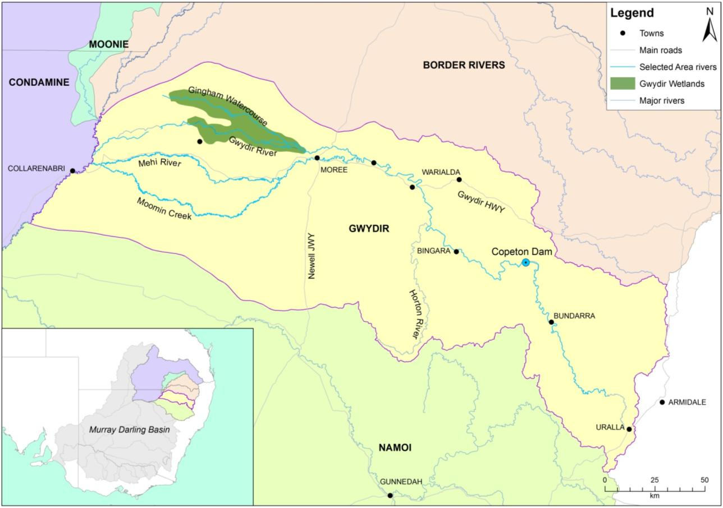

Figure 2‑1 Gwydir River catchment and location within the Murray Darling Basin

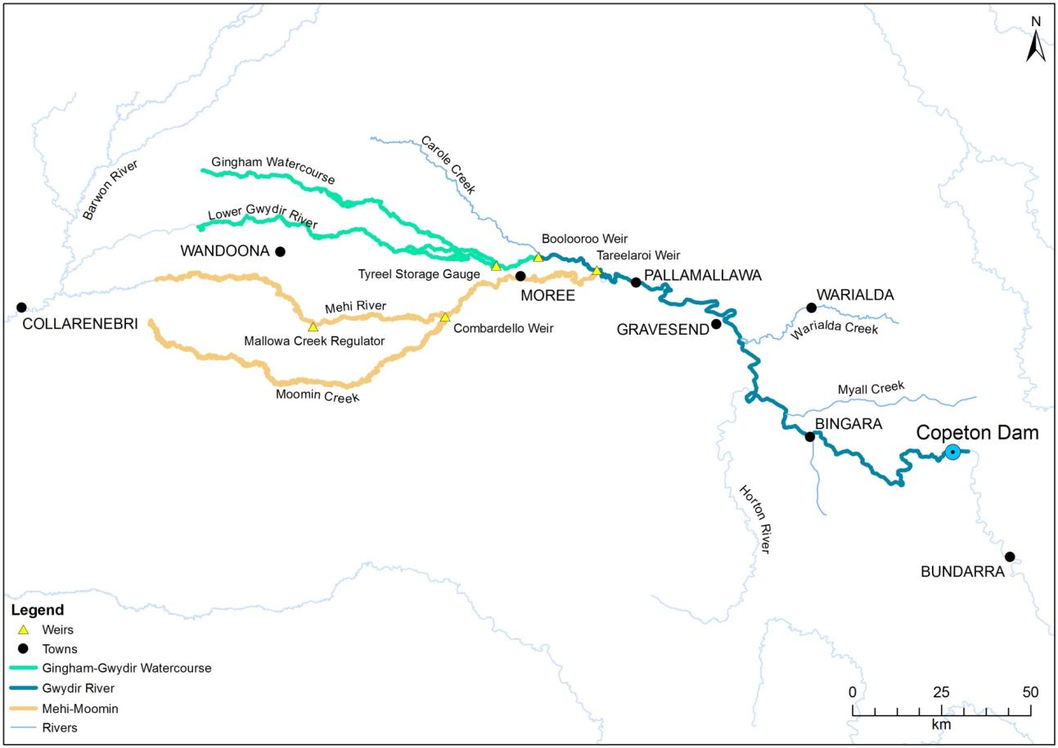

Figure 2‑2: The Gwydir River Selected Area with monitoring zones highlighted.

# Watering actions in 2014-15

## Environmental condition of the Gwydir River Selected Area

The Gwydir catchment experienced below average rainfall and above average temperatures during the 2014-15 water year (, ). The second half of the watering season saw above average rainfall in January, April, May and June, with below average temperatures in January, April and May. Rainfall events in the catchment from April through to June caused flows in many of the lower Gwydir channels.

Available Commonwealth environmental water holdings totalled 79,784 ML in the 2014-15 water year. This was complemented by water entitlements held by NSW OEH in the Environmental Contingency Allowance (ECA) of 89,260 ML. Of these holdings, 56,639 ML of Commonwealth and 29,895 ML of ECA water were delivered in the 2014-15 season, via several events across several channels (Table 3‑1).

Commonwealth environmental water was used in combination with irrigation deliveries to support an in-channel flow pulse down the Mehi River and Carole Creek during October 2014 (Figure 4‑1). This flow aimed to enhance in-stream ecological function, nutrient cycling and water quality, and provide opportunities for fish to access habitat (Commonwealth of Australia 2014b). This occurred at the beginning of October with flows peaking at 1300 ML/d in the Mehi and 500 ML/d in Carole Creek with a gentle (10% reduction per day) recession to base flows. These flows constituted 11% percent of the total annual flow down the Mehi River and Carole Creek.

Figure 3‑1: 2014-15 monthly rainfall totals for 2014-15 and mean totals measured at Moree airport

**(Source.** [**http://www.bom.gov.au/climate/data/index.shtml**](http://www.bom.gov.au/climate/data/index.shtml)**).**

Figure 3‑2: 2014-15 monthly maximum temperatures for 2014-15 and mean maximum temperatures measured at Moree airport. (Source. <http://www.bom.gov.au/climate/data/index.shtml>).

Table 3‑1 Comparison between environmental water and 2014-15 water year flow. Percentage represents the percentage of the total flow made up by environmental water.

|  |  |  |  |  |
| --- | --- | --- | --- | --- |
| Channel | Commonwealth environmental water delivered (ML) | NSW Water delivered (ML) | 2014-15 total flow (ML) | CEW % of total flow |
| Gingham Watercourse | 30,000 | 14,868 | 40,231 | 74 |
| Lower Gwydir | 15,027 | 68,093 | 44 |
| Carole Creek | 3,656 | n/a | 33618 | 11 |
| Mehi River | 13,316 | n/a | 118,798 | 11 |
| Mallowa Creek | 9,667 | n/a | 11,279 | 86 |
| Total | 56,534 | 30,000 | 272,019 | 32 |
|  | | | | |

Commonwealth environmental water was also delivered to the Gwydir, Gingham and Mallowa Creek wetlands throughout the water year. While the delivery to the Mallowa system was solely Commonwealth water, deliveries to the Lower Gwydir/Gingham systems were a combination of Commonwealth and State managed ECA water. These flows were aimed at maintaining the benefits of inundation that occurred during the 2010-13 period including vegetation condition and extent (Commonwealth of Australia 2014b). Total environmental water delivered along these channels constituted 44%, 74% and 86% of the total annual flow for the Gwydir, Gingham and Mallowa channels respectively.

Given the shared outcomes and delivery of both Commonwealth and State held environmental water during the 2014-15 water year, the outcomes reported in this document refer to the combined benefit of Commonwealth and State owned water. Hereafter this will be termed ’environmental water’.

# What did Commonwealth Environmental Water do in 2014-15?

## Expected Outcomes

The overall aim of Commonwealth environmental water in the Gwydir catchment during 2014-15 was to consolidate and protect the ongoing environmental recovery achieved over the last three years in anticipation of a potentially low rainfall and inflow period. Base flows, freshes, and overbank/terminal wetlands flows formed the planned flow types used to achieve the expected outcomes for 2014-15 in the Gwydir catchment (Commonwealth of Australia 2014b).

Watering actions undertaken in the Gwydir were expected to contribute to achieving the following outcomes:

* Protect and maintain the condition of permanent and semi-permanent wetland vegetation
* Maintain habitat for supporting waterbird condition and survival
* Maintain habitat such as waterholes for fish condition and survival
* Support fundamental ecosystem function processes of nutrient and carbon cycling and primary production.

These outcomes were consistent with the objectives of the Basin Plan’s environmental watering plan (Table 2). The evaluation of environmental water in the Selected Area during 2014-15 is structured around these broader objectives.

Table 4‑1 Expected outcomes from environmental water used in the Gwydir Selected Area linked to broader Basin Plan objectives

|  |  |  |
| --- | --- | --- |
| **Expected outcome** | **Timeframe** | **Relevant Basin Plan objective** |
| Vegetation condition and reproduction | < 1 year | Biodiversity (Basin Plan S. 8.05) |
| Fish condition |
| Waterbird survival and condition |
| Individual survival and condition (individual refuges) | < 1 year | Resilience (Basin Plan S. 8.07) |
| Hydrological connectivity including end of system flows | < 1 year | Ecosystem function (Basin Plan S. 8.06) |
| Biotic dispersal and movement |
| Primary productivity |
| Nutrient and carbon cycling |
| Salinity, dissolved oxygen, pH, dissolved organic carbon, algal blooms | < 1 year | Water quality (Basin Plan S. 9.04) |

## Flows and ecosystem function

Environmental water contributed to longitudinal connectivity in the Gwydir, Lower Gwydir, Gingham and Mehi channels through the 2014-15 water year. In all of these channels, environmental water was a major source of flows in the early and mid-stages of the year, with some rainfall generated flow events providing connection towards the end of the water year. Connection in the Lower Gwydir and Gingham channels through to the wetlands was largely a result of environmental water, although the break in delivery during October and November, limited the effectiveness of the earlier water deliveries especially in terms of connection through the Gingham channel.

The in-channel environmental flow pulse provided in the Mehi River produced a noticeable flow peak down the full length of the channel to the Barwon River. The timing of delivery of this flow resulted in a flow event that better mimicked the planned hydrograph (Figure 4‑1), compared to the previous year, where irrigation water deliveries impacted the falling limb of the flow pulse (Southwell et al. 2015).

Figure 4‑1 Upstream (Mehi River DS Combadello Weir) and downstream (Mehi River @ Near Collarenebri) flow hydrographs compared to the planned hydrograph for the Commonwealth in-channel environmental water delivered within the Mehi River channel.

The extent of inundation throughout the Gwydir and Gingham wetlands was mapped using Landsat data (Appendix G). Inundation in both wetland systems peaked around February 2015 with 6,342 ha mapped as being inundated across both systems (Figure 4‑2). Temporal patterns of inundation differed between the two wetland systems; the Gwydir system filled faster and earlier in the season due to increased inflows (September-February), but then the Gingham retained relatively more water towards the end of the water year. Loggers installed in each of the wetlands suggest that surface water levels were maintained in both systems through to the end of the water season as a result of a ‘top-up’ from local rainfall and natural inflows from upstream. This wetland inundation resulted in a range of key wetland and floodplain vegetation species being inundated for extended periods of time (4-6 months). These findings confirm the intended watering objectives in the Gingham and Lower Gwydir wetlands for prolonged inundation of key areas during the season.

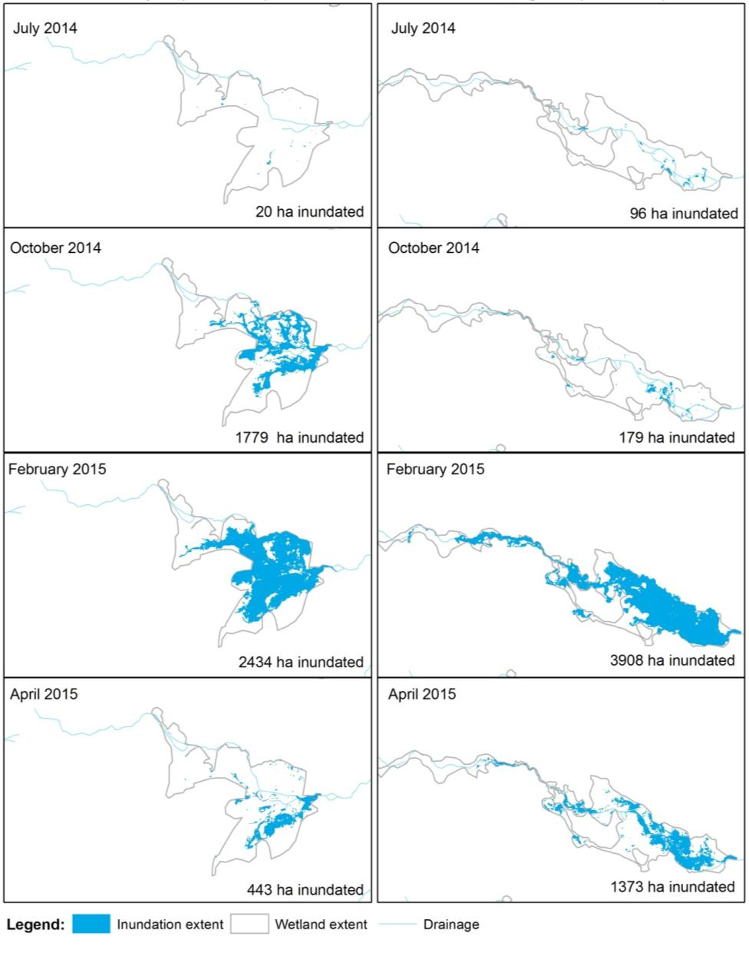

Figure 4‑2 Inundation extents mapped in the Gingham and Lower Gwydir wetlands at four occasions throughout the 2014-15 water year.

The extended periods of inundation in the wetlands as a result of environmental water delivery facilitated nutrient cycling, metabolic processes and allowed for successional processes to take place within micro- and macroinvertebrate populations that would stimulate foodwebs. Delivery of environmental water to wetland systems resulted in a pulse of nitrogen and phosphorus concentrations immediately following inundation. The drawdown of environmental water delivery in March 14 resulted in a second pulse of increased nutrient concentrations with a concomitant spike in water column chlorophyll *a*. All sites monitored were acting as net consumers of carbon and therefore acted as carbon sinks throughout the 2014-15 year. Rates of carbon consumption were highest in heavily vegetated wetland sites with high amounts of organic matter for microbial processing in the sediments.

## Water quality

Water quality variables were measured at Pallamallawa in the Gwydir River zone. Environmental water delivery reduced average pH, conductivity, and dissolved oxygen (DO) concentrations primarily through dilution effects of the increased water flows in the channel. Lower DO concentrations were associated with reduced water column chlorophyll *a* (algae) concentrations during periods of environmental water deliveries. The water quality parameters measured were within normal ranges for a system such as the Gwydir, and no water quality related stress was observed in any other indicators measured.

The delivery of environmental water also influenced total suspended solid concentrations in the river channels and wetlands. The Gwydir River channel had significantly higher total suspended solid (TSS) concentrations compared to wetland sites with peak TSS coinciding with reduced discharge. This peak in TSS was transported longitudinally causing a peak in TSS in the Gingham and Lower Gwydir wetland sites during March 2015.

## Biodiversity

Environmental water influenced all 10 ecosystem types monitored in the LTIM project, including five riverine types, three floodplain types and two lacustrine types as defined by the Australian National Aquatic Ecosystem (ANAE) Classification Framework (Brooks et al. 2013) (Figure 4‑3; Appendix A).

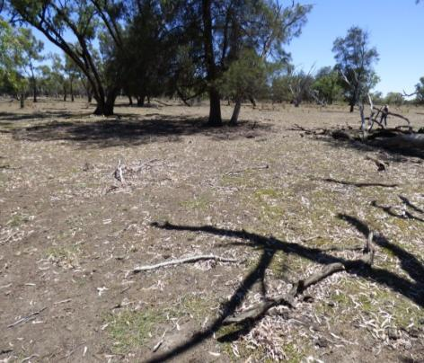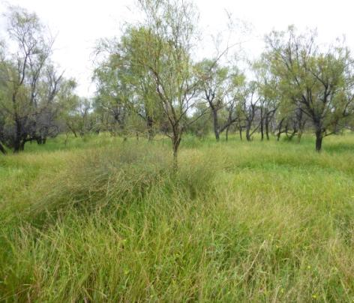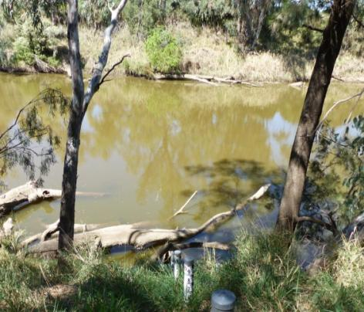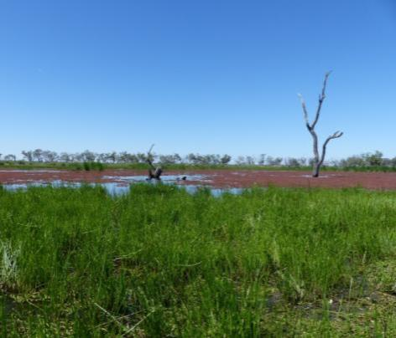

Figure 4‑3 River Cooba woodland floodplain (top left), Coolibah woodland and forest floodplain (top right), Permanent lowland stream (bottom left) and Temporary floodplain lake with aquatic beds (bottom right) ecosystem types monitored in the Selected Area

Environmental water was the primary source of water to the wetlands within the Gingham and Lower Gwydir systems during 2014-15 and it contributed significantly to the aquatic invertebrate, bird and vegetation communities in these ecosystems. In addition, findings from fish sampling suggest that environmental water delivered throughout the system helped to maintain native fish communities.

Delivery of environmental water to the Gingham and Gwydir wetlands increased regional scale density and diversity of aquatic micro- and macroinvertebrates (). Differences in the composition of aquatic macroinvertebrate communities were found between the Gingham and Gwydir wetlands. Ensuring the delivery of environmental water and maintenance of water levels in both systems promoted regional level macroinvertebrate diversity. Within each wetland, the delivery of environmental water inundated a mosaic of vegetative habitats (Appendix G) significantly increasing the density and diversity of aquatic invertebrates. In addition, the long-term (over 5 month) duration of inundation in both the Gingham and Gwydir wetlands contributed to the development and succession of different aquatic invertebrate communities between wetland systems.

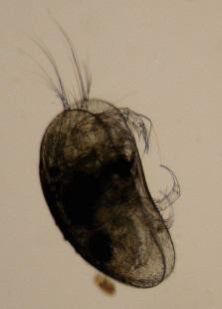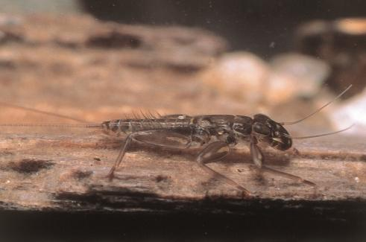

Figure 4‑4 Aquatic invertebrates sampled in the Selected Area. Mayfly nymph (*Ephemeroptera*; left) and a seed shrimp (*Ostracod*; right).

In total, 148 bird species, including 59 waterbird species were recorded in the Gingham and Lower Gwydir wetlands during the survey periods. This included seven waterbird species listed under international migratory bird agreements (JAMBA, CAMBA and ROKAMBA) and two threatened species listed under the NSW TSC Act: Brolga (*Grus rubicunda*) and Magpie goose (*Anseranas semipalmata*). Migratory shorebirds recorded included Common greenshank (*Tringa nebularia*), Latham’s snipe (*Gallinago hardwickii*) and Sharp-tailed sandpiper (*Calidris acuminata*). A relatively large flock of Latham’s snipe (19 birds) was recorded in the flooded sedgeland within the upper Gingham Watercourse.

Environmental water was the primary source of inundation for the Gingham and Lower Gwydir wetlands between waterbird surveys in December 2014 and March 2015. Thus, changes as a result of increased inundation are attributed directly to the delivery of this water. Significant increases were observed in both waterbird species diversity and total abundance at sites that received environmental water. In addition, breeding of several species was observed at a number of sites (Figure 4‑5), contributing to the continued survival of these species in this system. There was no evidence of larger scale colonial waterbird breeding this water year. Additional natural inflows that occurred into the wetlands towards the end of the season prolonged the duration of inundation in these areas, lengthening the availability of suitable habitat for many waterbird species.

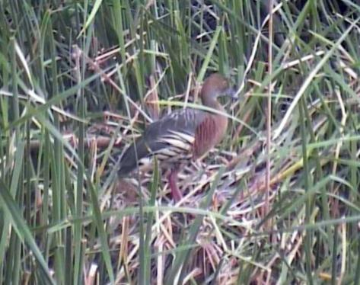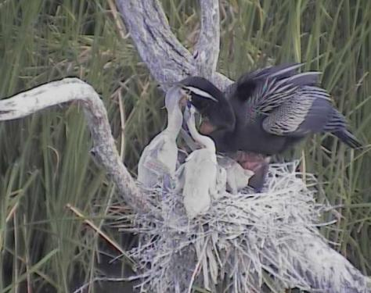

Figure 4‑5 Plumed whistling-duck (*Dendrocygna eytoni*; left) and Australasian darter (*Anhinga novaehollandiae;* right) observed breeding at Bunnor waterhole in the Gingham watercourse during 2014-15

The delivery of environmental water into the Gingham and Lower Gwydir wetlands during the 2014-15 season influenced all five water dependent vegetation communities surveyed. While season was shown to be an influencing factor, the presence of environmental water had the largest influence on vegetation diversity and composition. The application of environmental water decreased the amount of bare ground and increased the diversity of aquatic species. There was also a significant reduction in the cover of the weed species lippia *(Phyla canescens)* in plots that became inundated by environmental water. Native wetland species such as water couch *(Paspalum distinctum)* and flat spike-sedge (*Eleocharis plana*) displayed significantly increased cover in plots inundated by environmental water (Figure 4‑6). It is likely that the increased growth of these species in inundated plots resulted in them out-competing Lippia, and led to weed suppression in inundated locations.

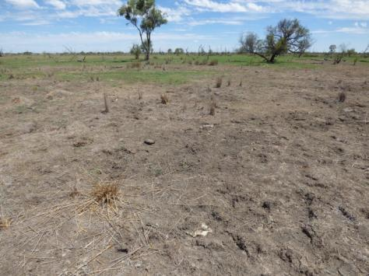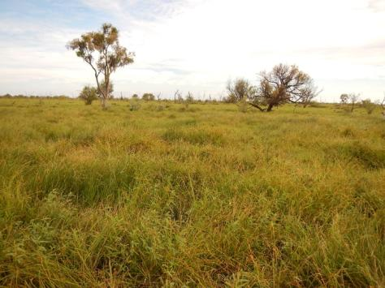

Figure 4‑6 Vegetation cover in monitoring plots between December 2014 (left) and March 2015 (right) in the Gingham watercourse (bottom). Photo on right taken by S.Bowen NSW OEH.

Fish sampling in 2014-15 found that native fish diversity at some sites within the lower Gwydir was close to predicted pre-European diversity (Figure 4‑7). However, a number of the native species present were in relatively low abundances and some of the ‘rarer’ species such as silver perch (*Bidyanus bidyanus*) and freshwater catfish (*Tandanus* sp.) were not recorded in the surveys. Other sites were dominated by exotic species, especially within the Gingham Watercourse and Moomin Creek, where high numbers of juveniles suggest that these systems may be acting as recruitment hotspots for exotic fish. Future environmental watering strategies must consider the cost/benefit of releases to ensure the existing high biomass of exotic taxa (particularly carp - *Cyprinus carpio*) in these systems is not further exacerbated.

While no evidence was found for native fish spawning as a result of the in-channel pulse of Commonwealth environmental water released down the Mehi River in October 2014, the presence of <1 year old bony herring (*Nematolosa erebi)* individuals in the Mehi suggests that recent conditions have been suitable for breeding and recruitment. Flow strategies that aim to effectively ‘charge’ the system with resources to facilitate recruitment may be of more benefit than those that target flow releases purely at stimulating breeding and/or dispersing larvae. The Commonwealth environmental flow event delivered to the Mehi River and Carole Creek was likely to have achieved this.

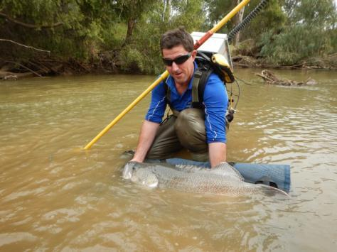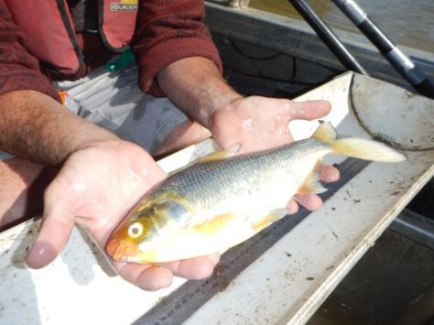

Figure 4‑7 Murray cod (left) and bony herring (right) caught as part of the LTIM fish sampling undertaken in the Gwydir during 20014-15

***Resilience***

While no direct monitoring of the survival or condition of individual organisms was undertaken in this project, some broader inferences can be made as to the contribution of environmental water and its management on the resilience of the Selected Area in 2014-15. The significant area of wetland inundation provided by environmental water was shown to increase the coverage and condition of key wetland vegetation species at the expense of exotic species. This was particularly evident in areas of the Gwydir wetlands that were affected by wildfire in early 2014. Rainfall over most of the area later in the season has prolonged inundation within the wetlands, and helped to maintain the improved vegetation community during the year. Given this improved condition, these communities should be more resilient into the future should drier weather conditions occur. Similarly, water bird breeding was observed in the wetlands and juvenile fish were sampled in the channels of the Selected Area suggesting that environmental water contributed to recruitment and succession of these animals. Continued recruitment is an important larger scale function of resilient animal communities.

## Summary

Environmental water delivered to the lower Gwydir system during 2014-15 had multiple ecological benefits. Deliveries to the Gingham, Gwydir and Mehi channels improved longitudinal connectivity through these systems, facilitating full connection down the Mehi River to the Barwon River during October 2014. These connections are important for in-stream environments as they maintain water quality, facilitate the transport of nutrients and organic matter, and provide movement opportunities for biota. Adult and juvenile fish of a range of species were observed in the channels, suggesting that flow conditions were suitable for fish to recruit and survive in this system. Native fish diversity was found to be close to that expected for a pre-European state, however there were relatively high numbers of exotic species and an absence of some rarer species leading to an overall poor condition.

Environmental water constituted the main source of water to the Gingham and Gwydir wetlands during 2014-15, and provided inundation of large areas of the wetlands for extended periods of the water year. This was shown to stimulate the release of nutrients, and invertebrate communities boomed with significant increases in densities following inundation and the development of successional processes evident in changes in community composition over time. A diverse range of vegetation communities were inundated, with increased coverage of native species observed, producing competition for key weed species such as lippia. Waterbird communities also responded with significant increases in waterbird numbers towards the end of the season. Several waterbird species were also observed breeding within the inundated wetlands.

# Implications for future management of Commonwealth environmental water

The results from Year 1 of the LTIM project in the Gwydir River Selected Area show that the use of environmental water in 2014-15 had a positive influence on the environment of the system. The extent and duration of flooding achieved in the Gingham and Lower Gwydir wetlands was sufficient to influence a range of communities that rely on periodic inundation to remain resilient. Different responses were observed in most indicators between the Gingham and Lower Gwydir wetlands, suggesting that different ecological outcomes may be achieved by watering each wetland system. Positive responses were seen in vegetation with increased cover of semi-permanent wetland species, especially in the Lower Gwydir wetlands which were impacted by wildfire in early 2014. Extended duration of inundation not only allowed invertebrate communities to establish in the wetlands, but also to progress through successional stages to contribute to regional scale diversity. The inundation of multiple vegetation communities in the Gingham and Lower Gwydir wetlands increased the density and diversity of aquatic invertebrates and the biogeochemical processes that support them. This boom in productivity at the base of the food chain increased food availability for organisms at higher levels such as frogs, reptiles and waterbirds. Indeed, waterbird numbers increased and breeding was observed in a number of species throughout the season.

The in-channel flow delivered to the Mehi River resulted in longitudinal connectivity down this entire system and beyond, with water flowing to the Barwon River and influencing flows as far downstream as Bourke. While this release mimicked the targeted hydrograph, there was no obvious fish breeding response recorded by the fish monitoring. Instead, age structures for many fish species suggest that fish are successfully recruiting and surviving throughout the Lower Gwydir system given the right flow conditions. In-channel flow pulses such as the one delivered to the Mehi River are important for stimulating productivity and the growth of aquatic invertebrates that allow fish and other aquatic species to successfully sustain their populations. Flow strategies that aim to effectively ‘charge’ the system to facilitate fish recruitment may be of more benefit than those that target flow releases purely at stimulating breeding and/or dispersing larvae.

The fish sampling undertaken in this project also suggest that whilst native fish are recruiting and surviving to adults, future environmental watering strategy should consider the cost/benefit of releases to ensure the current high biomass of exotic fish species is not further exacerbated. In addition, multi-disciplinary approaches should be considered to improve native fish diversity across the lower Gwydir. This would include environmental water but also other measures such as habitat restoration and the reintroduction of species that are absent or at critically low numbers.

The positive ecological outcomes observed in the Gingham and Lower Gwydir wetlands for the 2014-15 water year suggest that the current multi-year drying and wetting strategy being employed in the wetlands is effective and should be continued in the future. However, the current delivery constraints in the Gingham system are reducing the efficiency of environmental water delivery. The need to suspend deliveries mid-watering for the harvesting of floodplain crops results in reduced extent and duration of flooding in this system.

# References

|  |
| --- |
| Brooks S., Cottingham P., Butcher R., & Hale J. 2013. *Murray Darling Basin aquatic ecosystem classification: Stage 2 report*. Peter Cottingham & Associates report to the Commonwealth Environmental Water Office and Murray Darling Basin Authority, Canberra.  Department of Environment, Climate Change and Water (DECCW). 2011. *Gwydir Wetlands Adaptive Environmental Management Plan: Synthesis of information projects and actions*. DECCW, Sydney.  Green D., Burrell M., Petrovic J., & Moss P. 2011. *Water resources and management overview – Gwydir catchment*. NSW Office of Water, Sydney.  Commonwealth of Australia (2014a) Commonwealth Environmental Water Office Long Term Intervention Monitoring Project Gwydir River System Selected Area, Canberra.  Commonwealth of Australia (2014b) Commonwealth environmental water use options 2014-15: Gwydir River Valley. |
| NSW Office of Environment and Heritage (OEH) (2014) Gwydir Valley Annual Environmental Watering Plan (2014-15). NSW OEH, Sydney. |
| Southwell, M., Wilson, G., Ryder, D., Sparks, P and Thoms, M. (2015) Monitoring the ecological response of Commonwealth environmental water delivered in 2013-14 in the Gwydir River system. A report to the Department of Sustainability, Environment, Populations and Communities. Canberra. |