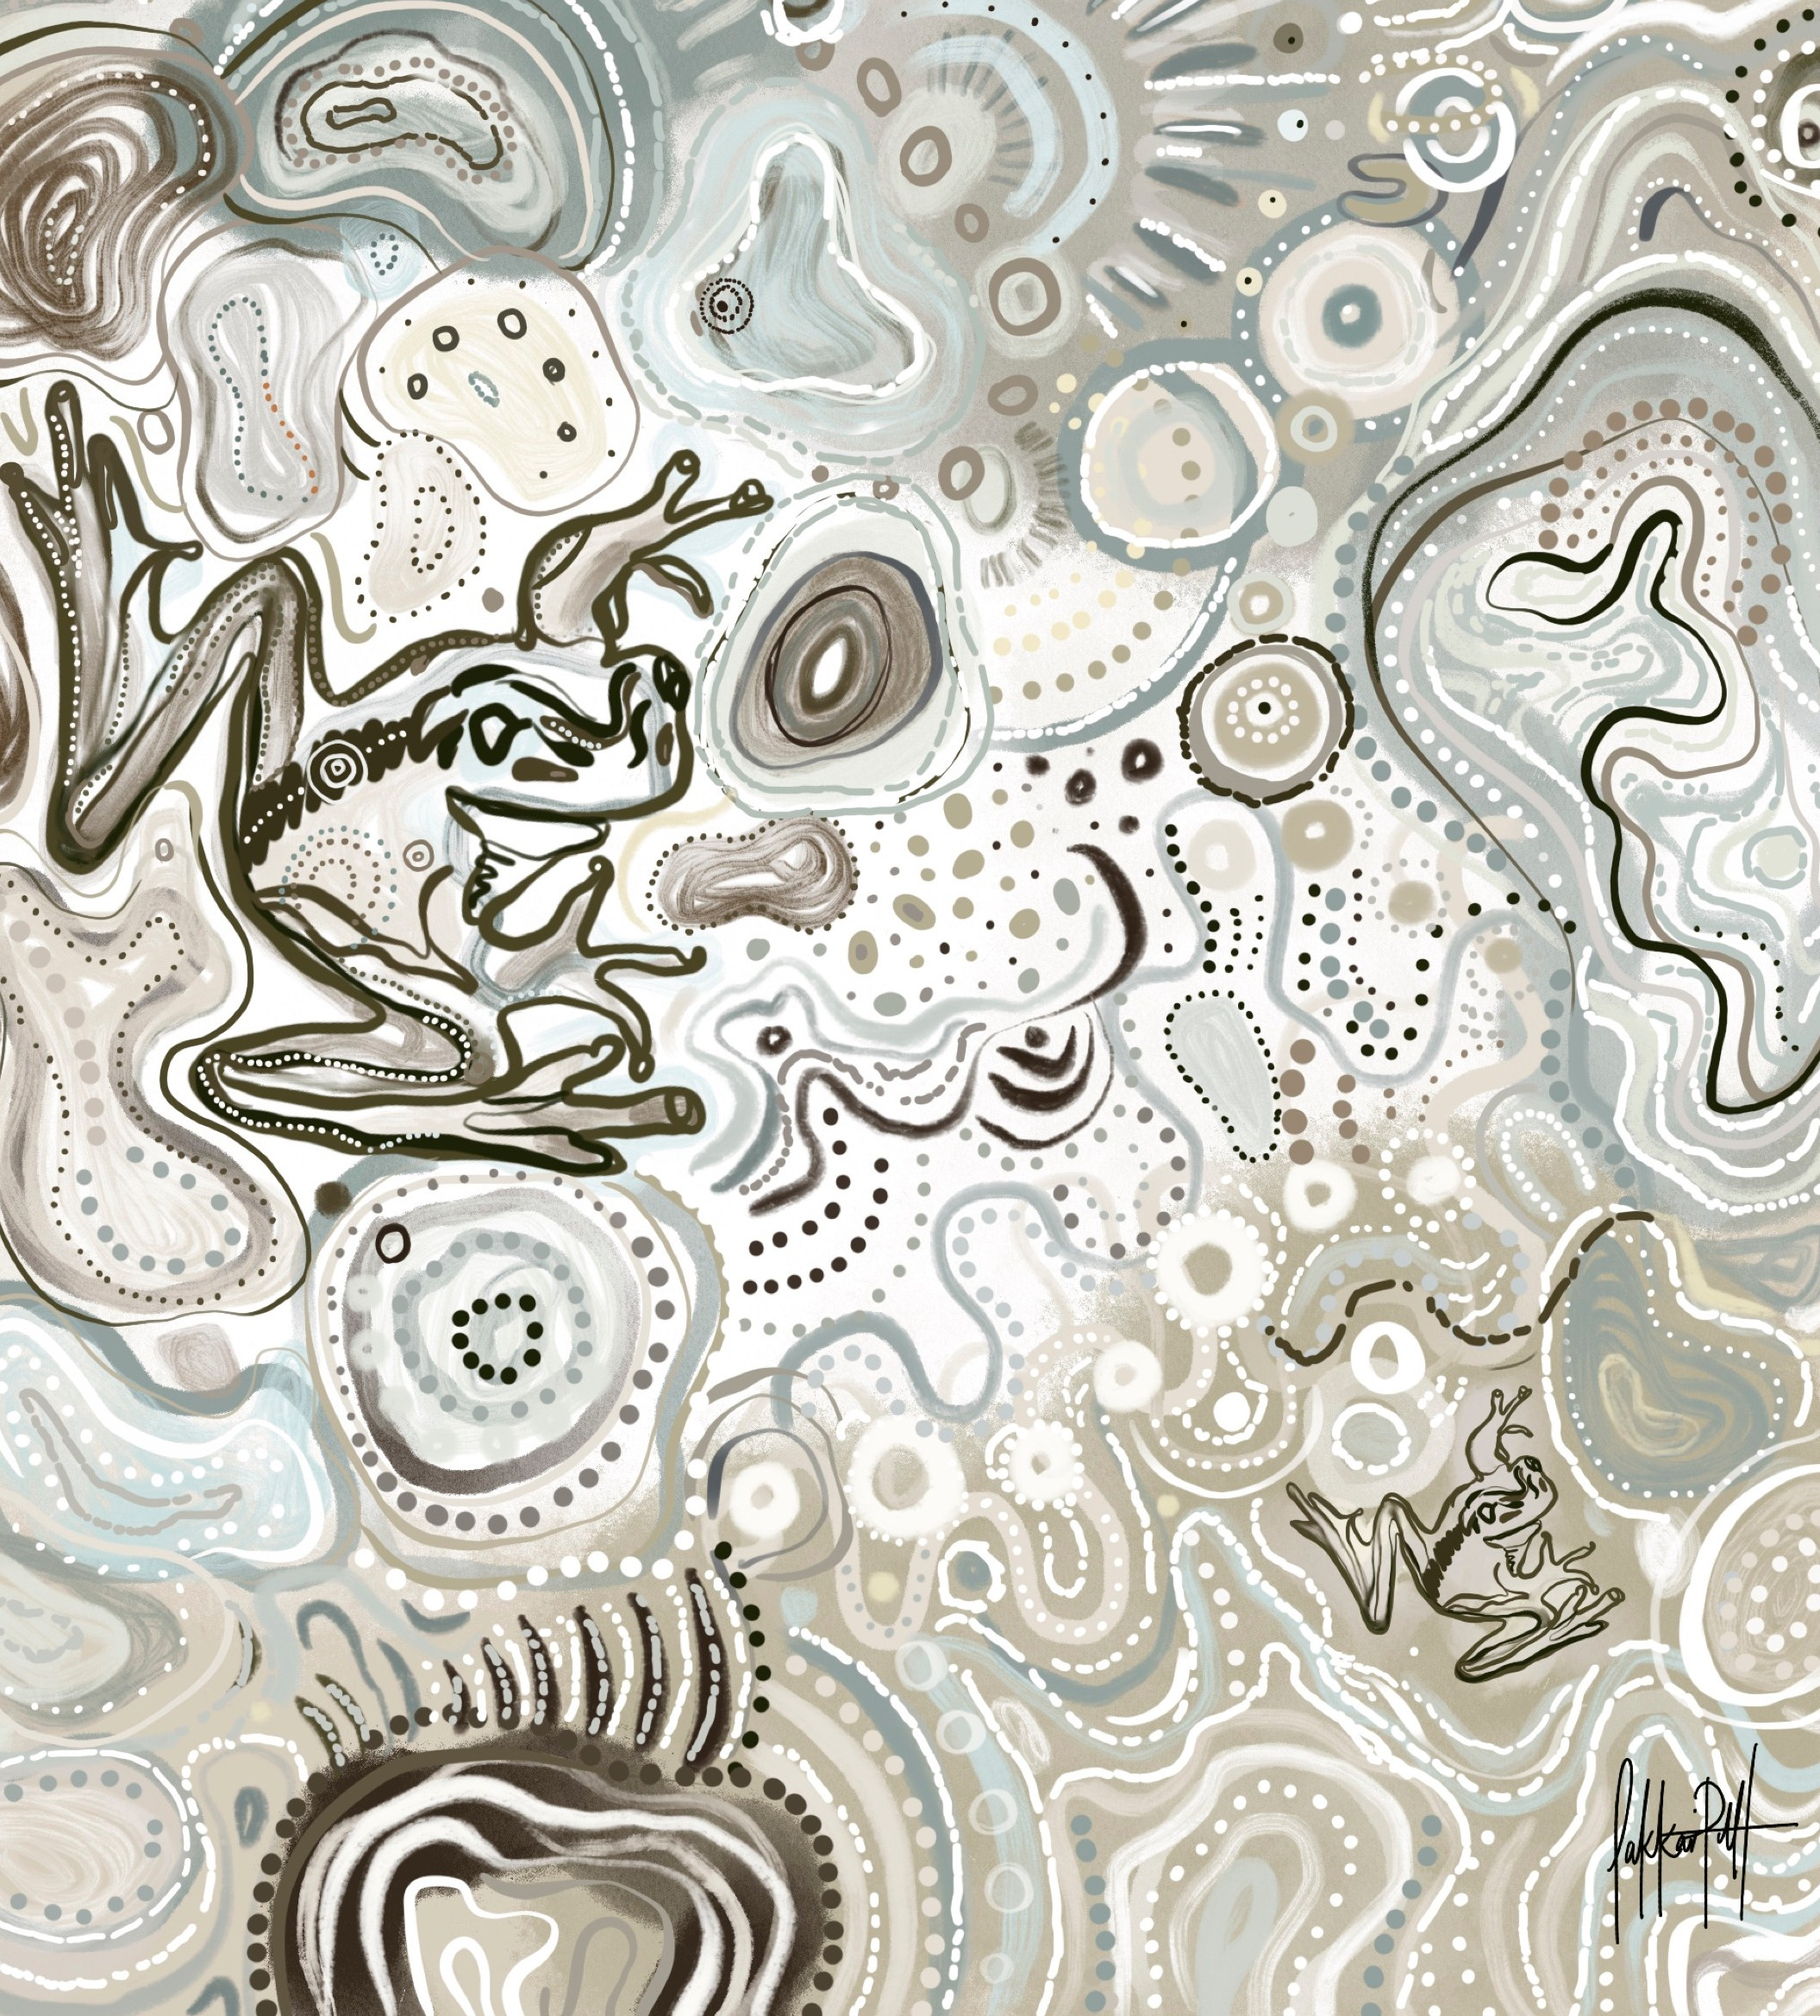
THE GWYDIR

Quarterly Outcomes Newsletter for the Gwydir River Selected Area

Q1 July - September 2021

We would like to acknowledge the Gomeroi/Gamilaroi/ Kamilaroi People, the Traditional Owners of the Gwydir wetlands and its surrounds.

Thank you for sharing your Country and knowledge of its land, water and life with us.

We pay respects to Elders past, present and emerging.

Traditional language in this newsletter has been sourced from Certificate I in Aboriginal Languages Gamilaraay/Yuwaalaraay Elizabeth wright from NSW Tafe & Bush Tucker, Boomerangs & Bandages (harry White and Michelle Mckeney, 2011)

Artwork © Lakkari Pitt

THE GWYDIR

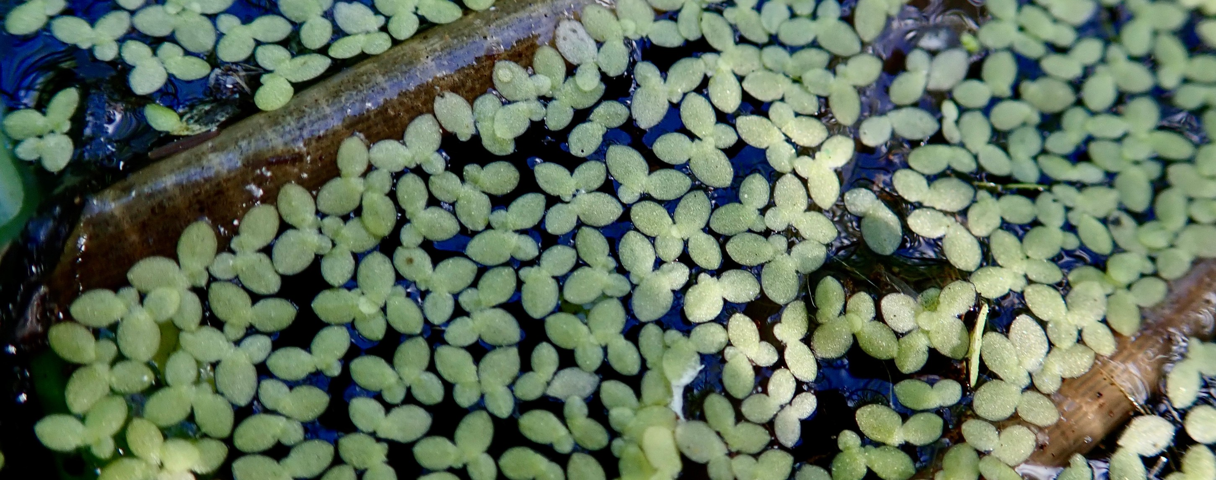

In a nutshell...

Moree received a total of 94.2 mm while Pallamallawa received 142.2 mm in Q1, 2021- 2022.
Temperature at Moree has ranged from 12.5 -
29.5 °C.
March 2021 flood largest In LTIM/MER project and the largest since February 2012. More than 100,000 ha of floodplain was inundated including the core wetlands in the Gingham/Lower Gwydir and Mallowa systems. Peak wetland inundation on 2 April 2021. At least 9,024 ha and 2,283 ha of core wetland inundation at Gingham/Lower Gwydir and Mallowa, respectively.
Overall, water quality was good, led to boost in productivity.
Evidence of generalist waterbird breeding during spring 2020 and small-scale colonial nesting during autumn 2021 surveys.
Native fish populations while diverse are under stress with low numbers and little evidence of breeding in some species.
Highest vegetation cover in LTIM/MER project. Feature story: Meet Liz Taylor.
CONTENTS

Catchment conditions 2020-21 water year
water for the environment wetland inundation
water quality and foodwebs waterbirds
fish diversity vegetation inundation mapping
implication for future e-water management
Communication and engagement What's next?
Enquiries

Water for the environment is used to improve environmental values of river and wetland systems and its use can provide social and cultural benefits too. It can be either water entitlements that are left in the river, or a specified amount of water that has been set aside in storages that is released into natural waterways when needed.

Either way, the aim is to improve river and wetland health.

Rainfall
Moree and Pallamallawa rainfall was above the long-term average this quarter, before the end of September. Rainfall was higher-than-average at each location in July and August with more rain accumulating at Pallamallawa than Moree for each of those months.

Moree aero (053115) monthly rainfall totals: July = 40.8 mm
Aug = 34.6 mm Sep = 18.8* mm

Pallamallawa (053033) monthly rainfall totals:
75

50
Rainfall (mm)

25

0


Jul Aug Sep

July = 67 mm Aug = 58.4 mm
Moree Pallamallawa
Moree long-term mean  Pally long-term mean


Sep = 16.8* mm
Total monthly rainfall (mm)

Temperature
The monthly average temperature in Moree this quarter was just shy of the long-term average (right). The highest temperature of 29.5°C occurred in September and the lowest of 12.5°C in July.
30
20
10
0
Apr May Jun Jul Aug Sep

Jul: range 12.5-23°C; mean 17.5°C Aug: range 14-28.2°C; mean 21.2°C Sep*: range 15.1-29.5°C; mean 23°C
Temperature (°C)
*to 26/9/21

Long-term mean 2020-21 daily maximum mean

Moree mean maximum monthly temperature (°C)

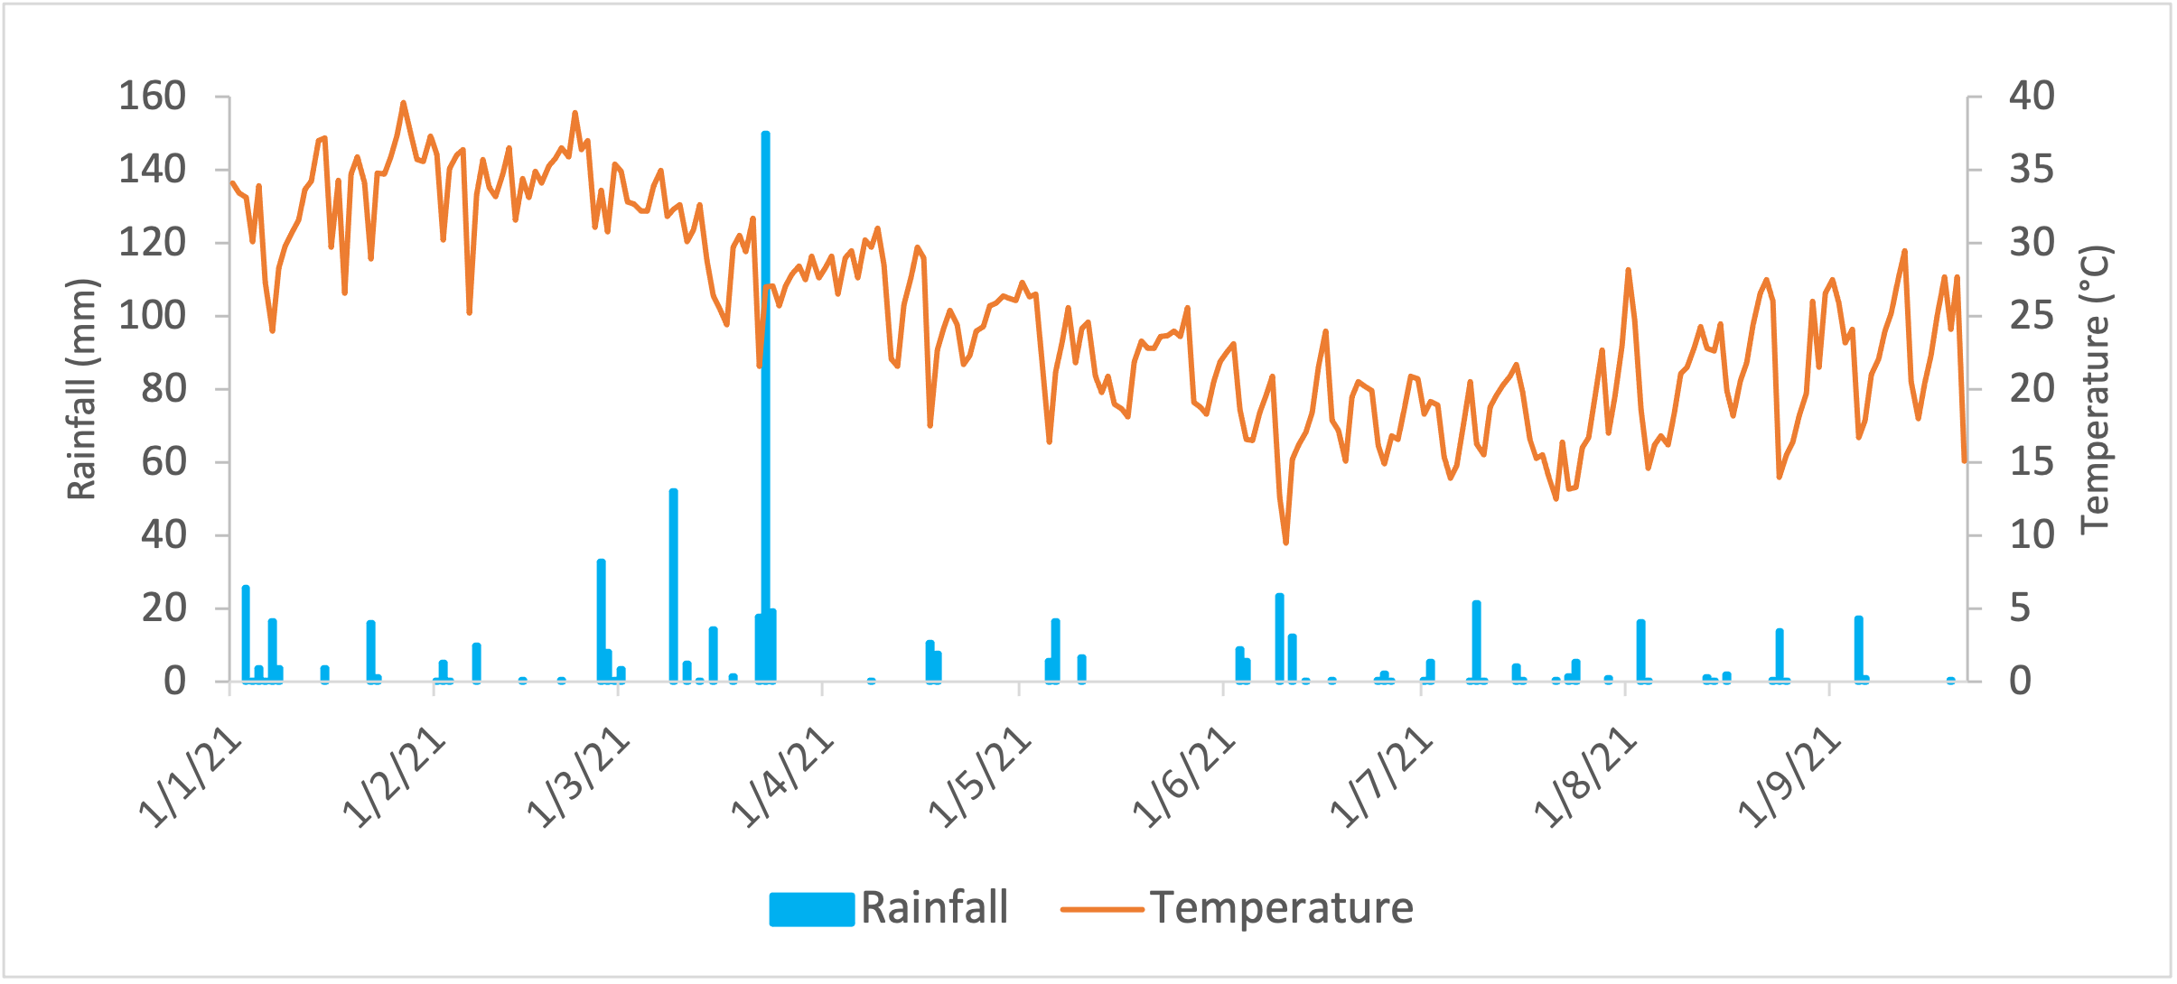
2021 (YTD) rainfall and temperature at Moree (053115)

Hydrological patterns in the 2020-21 water year reflect two distinct periods. The first part of the year contained some of the driest weather on record with very low flows. Above average rainfall in December 2020 allowed some supplementary water for the environment to be delivered to the Mallowa Creek (which requires large flooding to be naturally inundated), providing the first significant flow down this system since March 2020. As a result of ongoing dry conditions in the Barwon (Bawaan) River, Commonwealth water for the environment was released from Copeton Dam, down the Gwydir to the Carole/Gil Gil system as part of the Northern Waterhole Top-up flow in early
January 2021.
Some localised rainfall events in mid-January 2021 resulted in improved river flows and inundation of at least 853 ha of core wetland area in the Gingham and Lower Gwydir wetlands. Both Commonwealth and NSW water for the environment was delivered in January/February to prolong this inundation of core wetland areas and to also support a small bird breeding event in the Gingham watercourse in February 2021.

Table 1 shows a break down of e-water use in the Gwydir Selected Area during the 2020-21 water year.

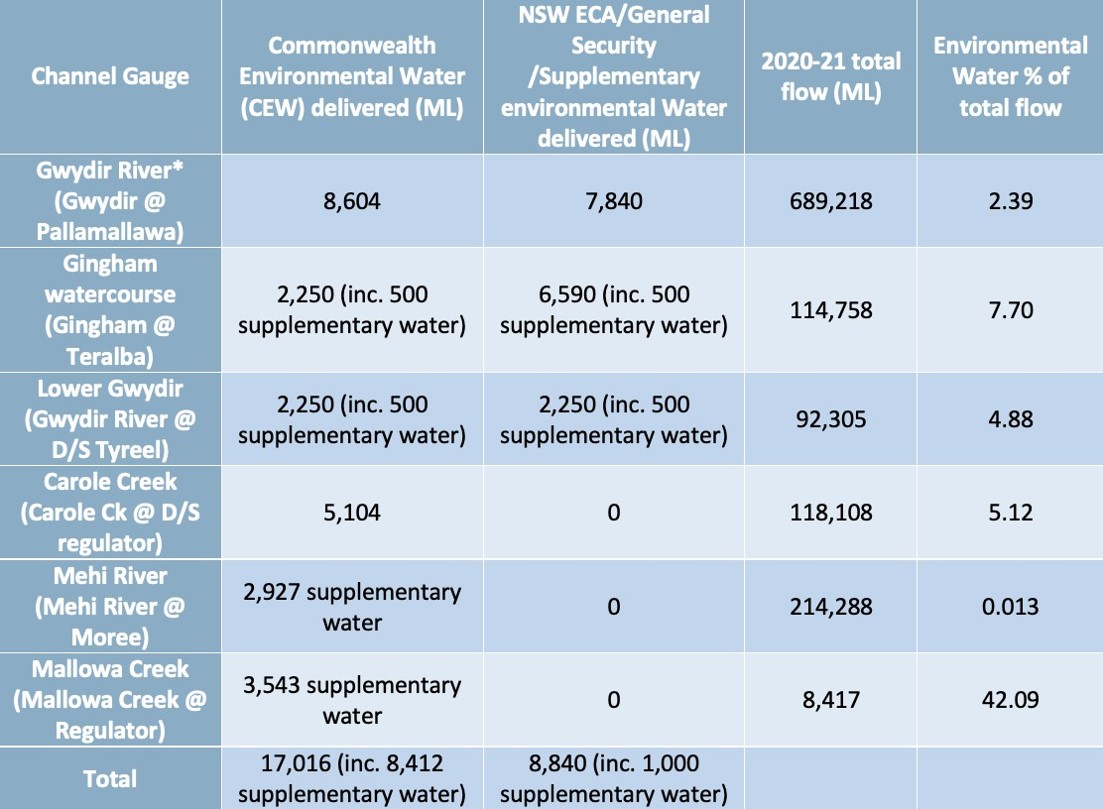
Table 1. Use of environmental water in the Gwydir Selected Area during the 2020-21 water year.
*All environmental water delivered (except supplementary) to the Gwydir system flowed through the Gwydir River in 2020-21. Therefore, volumes for this channel represent total volumes delivered downstream and as such are not included in the total.

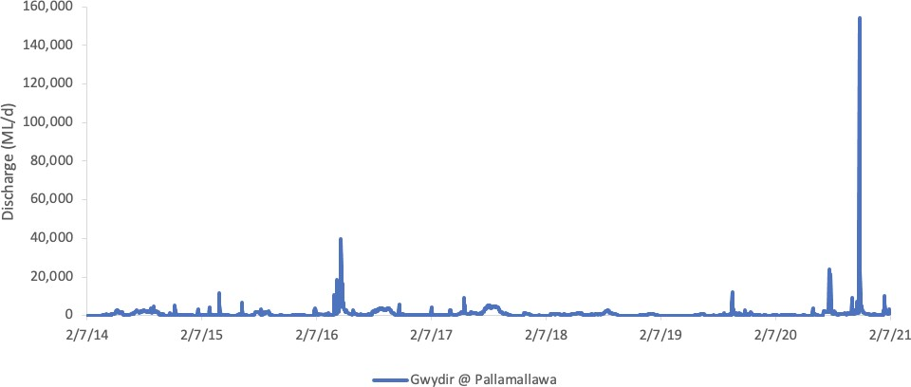In the first six years of LTIM/MER monitoring the largest flow to pass through the Gwydir River at Pallamallawa peaked at 39,457 ML/d on 16 September 2016 (red asterisks in hydrograph below). Outside of this event, flows did not exceed around 12,000 ML/d during that six-year period. In March 2021 a flood that peaked at approximately 160,000 ML/d at Pallamallawa occurred (blue asterisks in hydrograph below). This March 2021 flood was a 1-in-83-year event at Pallamallawa and was by far the largest in the 7-year study period.
*
*

2020-21 water year: water for the environment

The Upper Gwydir
In the Upper Gwydir, longitudinal connectivity was achieved for the majority of the 2020-21 water year with disconnection occurring on three occasions in September, October and November 2020. Water for the environment was delivered in January and February 2021.
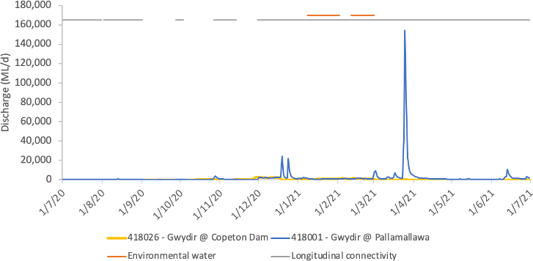

The Lower Gwydir
In the Lower Gwydir, longitudinal connectivity to Millewa was intermittent throughout 2020. Conversely, connectivity was maintained for the majority of 2021. Water for the environment was delivered in January 2021.

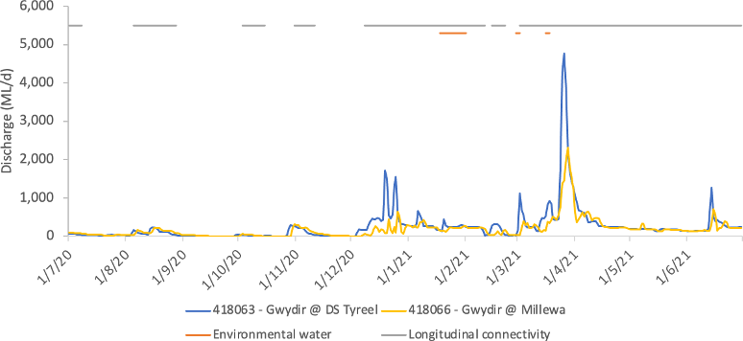

The Gingham
While some flows did occur in the upper and middle sections of the Gingham Watercourse during the start of the 2020-21 water year, full connection (through to the Gingham Bridge) didn’t occur until March. Water for the environment was delivered in January, February and March 2021.

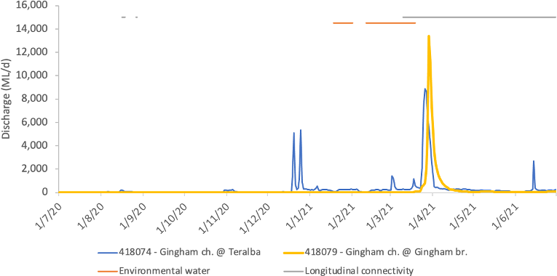

Gingham Waterhole
Gingham Waterhole experienced a rise in water level in early May 2020 that plateaued at approximately 0.8 m until late September 2020. Recession of Gingham Waterhole then occurred until mid-January 2021 when it was rapidly replenished to is previous level of 0.8 m. This level persisted for most of 2021 except for a peak of approximately 1.6 m in March 2021 as flood flows passed.
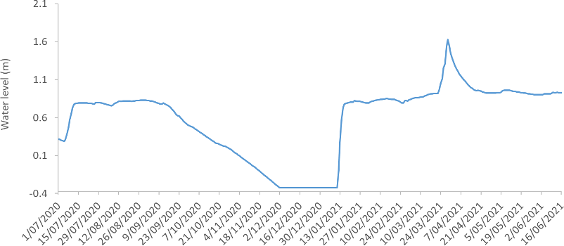

Mehi River
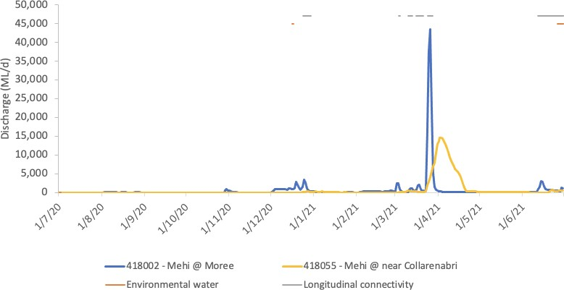
The Mehi River was connected with the Barwon for around 40% of the 2020-21 water year. Several small connection events occurred in January, March and June 2021 when flows peaked above approximately 2,000 ML/d. Water for the environment was delivered in December 2020 and June 2021.

Moomin Creek
Longitudinal connection was achieved in Moomin Creek on three occasions during the 2020-21 water year. A short connection event occurred in early January 2021 which was followed by approximately two months of disconnection. A longer connection event began in mid-March and ceased in mid-April, while the third event saw connection from June until the end of the study period. There was no delivery of water for the environment in this reach of the Selected Area.
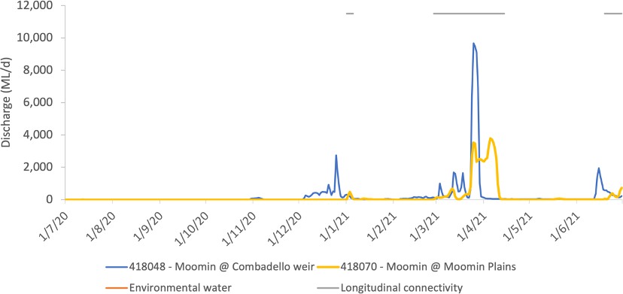

Mallowa Creek
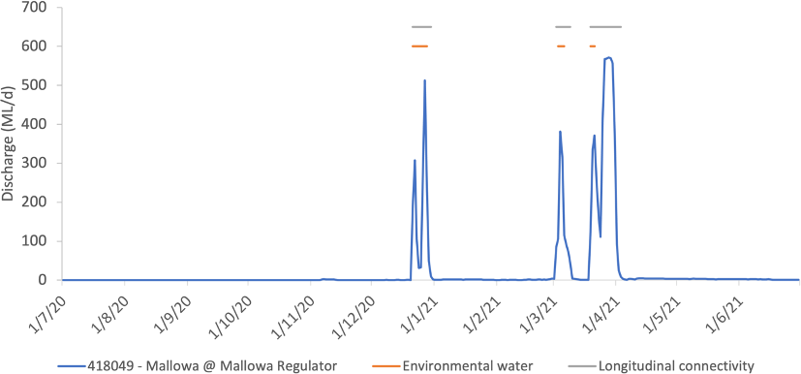
Three flow events occured down Mallowa Creek in 2020-21 in late December, late March and early April. The December and April events included a portion of Commonwealth water for the environment, as a result of Supplementary access in the Mehi River. The April flow was augmented with flood water from the larger flooding event through the system. Flows down Mallowa Creek during this flow are likely to be greater than that represented on the gauge due to the poor performance of this gauge during higher flood flows, and significant local inflows from local rainfall below the gauge.

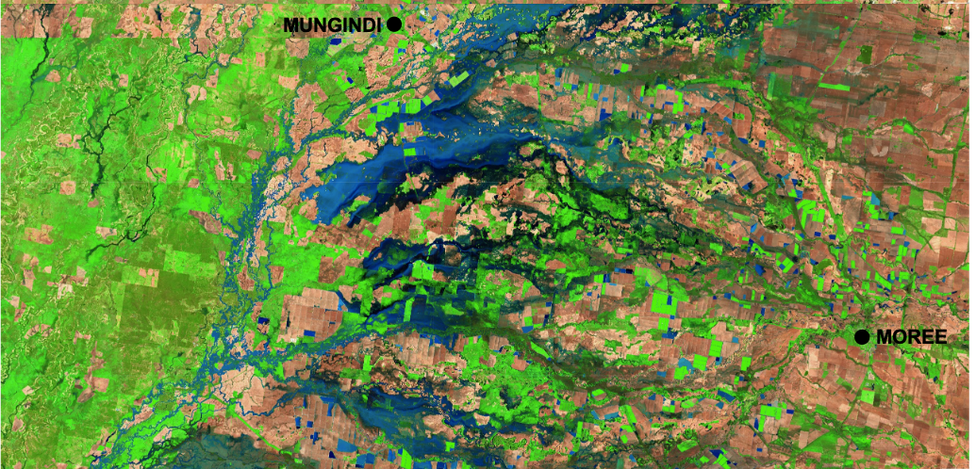
COLLARENEBRI
During the large flood event in April 2021, at least 100,000 ha of the Gwydir River floodplain was inundated including the majority of core semi-permanent wetland habitat in the Gingham/Lower Gwydir and Mallowa wetlands. As a result, many wetland vegetation communities including cumbungi rushland, lignum shrubland and marsh club-rush sedgelands had their whole mapped extent inundated during the event.

2 April 2021

Fig 1. Imagery showing inundation extent of peak floods (2 April) across the Gwydir. Flows in the top of the image are from the Border Rivers.

Water quality
During the 2020-21 water year water quality was highly variable across all sites, though, it should be noted that monitoring was undertaken before the March 2021 floods. Following these floods, the Gwydir State Conservation Area remained highly sodden for some time so our team was not able to access our study sites for post-flood monitoring. Overall, water quality was generally good despite nutrient levels measuring higher than guideline recommendations. These increased nutrient levels were likely the result of the dry conditions experienced during the sampling period.

Foodwebs
We found water quality to improve and productivity to increase following the movement of freshes through the Gwydir system. Our results showed benthic microinvertebrates to be in higher density than pelagic microinvertebrates, likely caused by the reduction of habitat available for pelagic species as water levels receded.
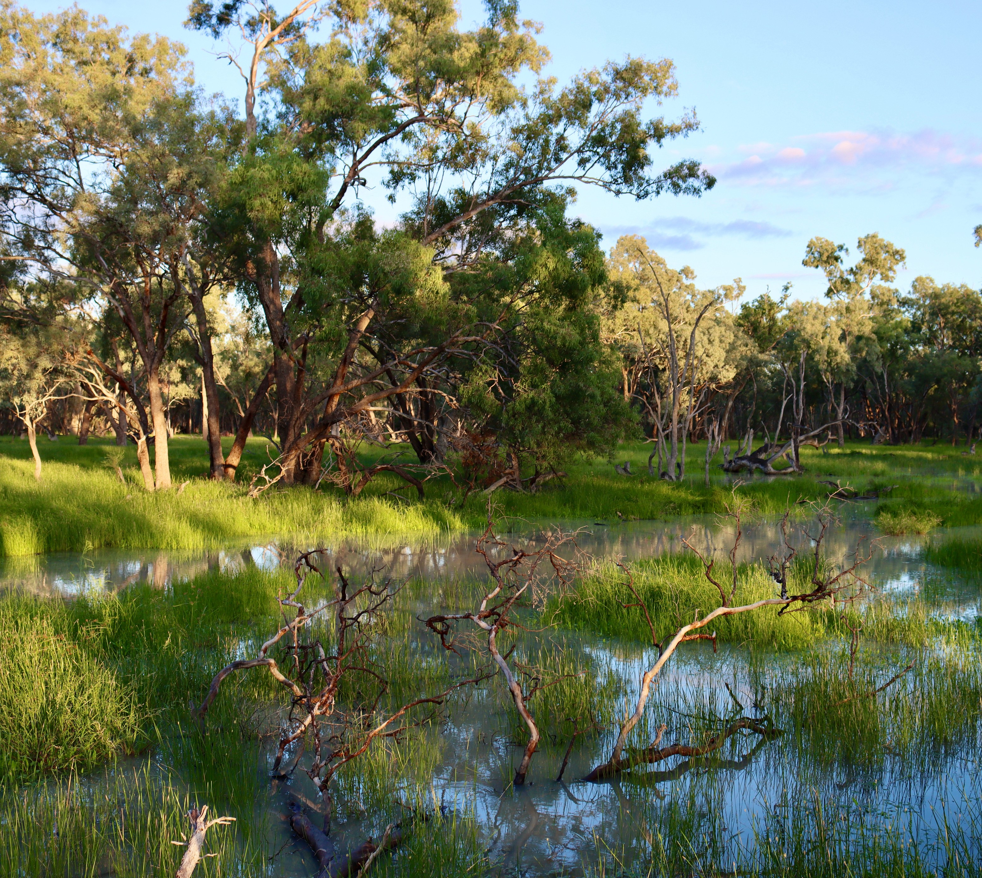
Near Old Dromana and Bunnor in the
Gwydir Wetlands State Conservation
Area (SCA). Credit - UNE

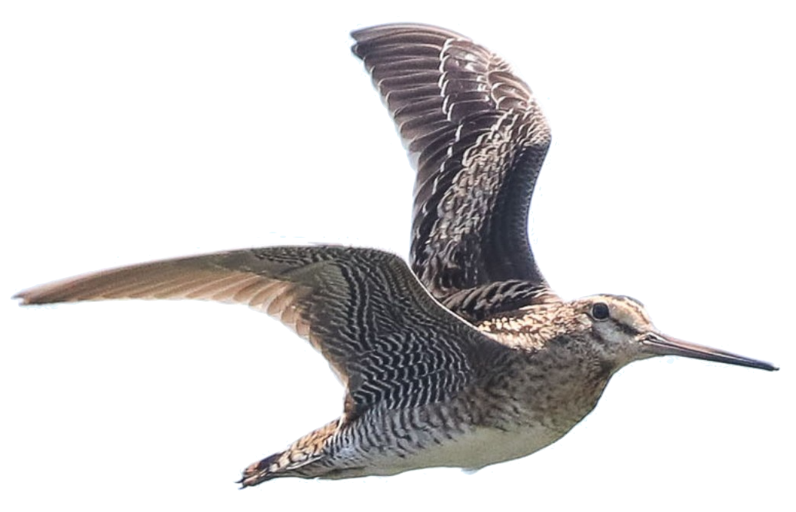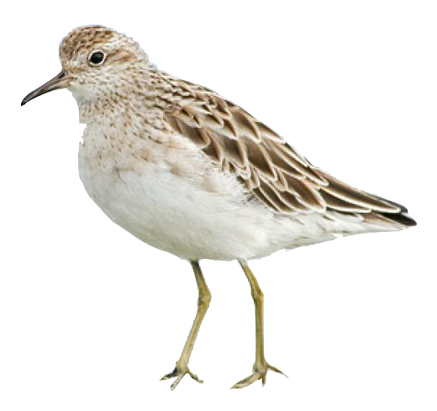We conducted waterbird surveys jointly with NSW DPIE-EES in spring 2020 (Nov) and autumn 2021 (Feb). This is what we found:

8,625
waterbirds from 63

species

4 migratory species
Latham's snipe at Old Dromana (Feb)
15

30 sharp-tailed sandpipers
5

Latham's snipe (credit - ebird)

vulnerable species Sharp-tailed sandpiper
(credit - NZbirds online)

Evidence of waterbird breeding
We found that waterbird abundance and richness was closely tied to patterns of inundation during the 2020- 21 water year. Excitingly, we observed widespread evidence of breeding during our surveys. Seven species of waterbird appeared to be breeding in spring 2020, while 11 species appeared to be breeding during autumn 2021. The main species that were breeding included swans, ducks, rails and cormorants.
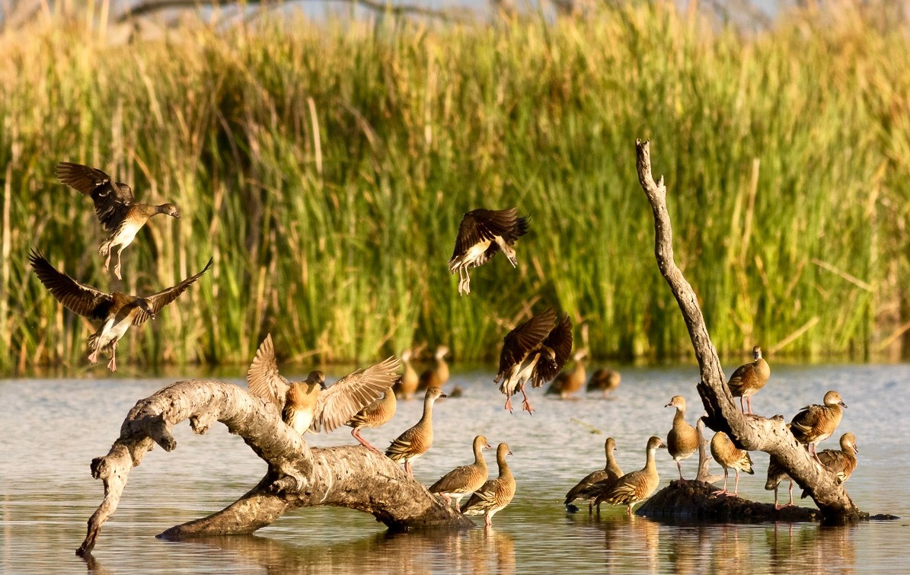
Whistling ducks at golden hour in the Gwydir Wetlands
State Conservation Area (SCA). Credit - ELA

Fish diversity sampling was conducted in the Gwydir and Mehi channels in 2020. These surveys revealed the lowest numbers of most native species recorded throughout the duration of the LTIM and MER projects. Bony herring and Murray cod (guduu) were the most abundant large bodied species present, with carp-gudgeon and Murray-Darling Rainbowfish the most common small bodied fish. In terms of biomass, this is what we found:

41% carp

Murray cod (guduu)
35%
20%

bony herring

Calculation of the SRA condition metrics showed that fish communities in both channels were in poor to very poor condition in 2020. This was driven by low recruitment and a greater dominance of non native species relative to previous years.
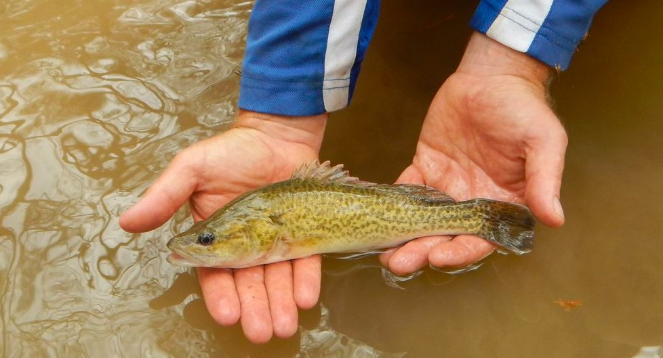

Juvenile Murray cod caught during surveys in the Gwydir River. Credit - NSW Fisheries.

Why harp on about carp?
Over recent decades carp have spread across most of eastern Australia and the waterways of the Gwydir are no exception. They are now one of the most abundant freshwater fish in some areas, and have contributed to the degradation of our natural aquatic ecosystems.

Carp are usually found in still or slowly flowing waters, especially in areas where there is abundant aquatic vegetation. They are well known as a pest because of their destructive bottomfeeding habits, which stir up sediments and muddy the water.

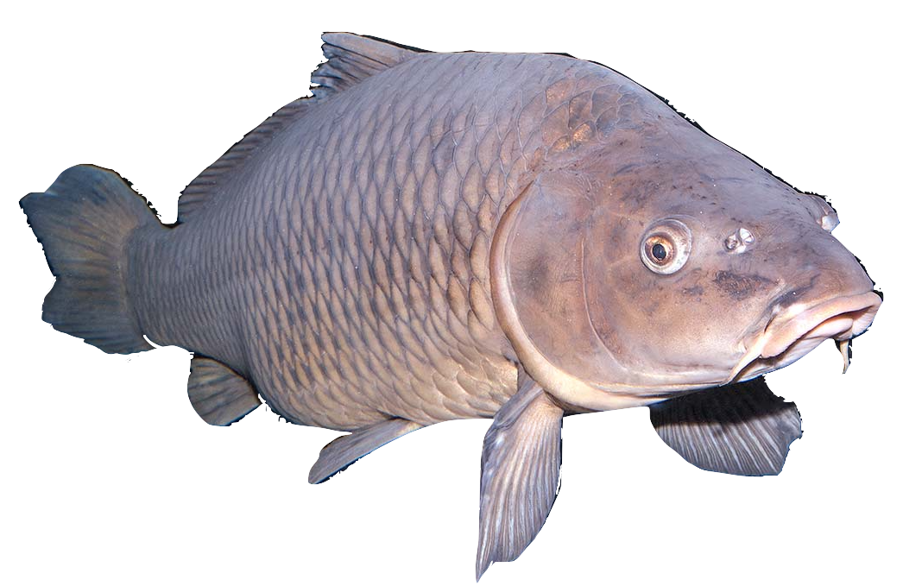Carp have a higher tolerance of low oxygen levels, pollutants and turbidity than most native fish, and are often associated with degraded habitats, including stagnant waters. Reduced water quality in our rivers allows carp to outcompete native species. Water for the environment aims to improve water quality which may help native species to persist in their natural habitat.

Common carp. Credit - The Fisherman

Vegetation surveys were conducted jointly with NSW DPIE EES in November 2020 and June 2021. During these surveys we observed the highest species richness in water couch, coolibah and river cooba community sites since the beginning of the LTIM and MER projects. To add to this, ground cover was also at it's highest since the commencement of LTIM/MER, with 'wetland' plants particularly dominating ground cover. Such wetland species included; spike-rushes, water couch, nardoo (bal) and swamp buttercup. Widespread coolibah (gulabaa) recruitment was also noted in Gingham Waterhole and at Old Dromana.

Surveys over the 7 years of the LTIM/MER project at water couch community sites, suggests that consistent changes to the composition of these communities is occurring. At these sites, the proportion of water couch is decreasing and other species such as typha, awnless barnyard grass, flat spike sedge and lippia becoming more dominant.

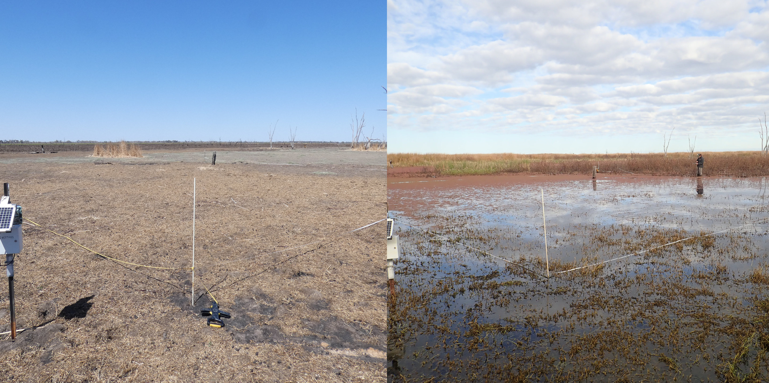
These results show the added benefit of widespread and prolonged inundation in these wetland systems. While there was no water for the environment in the latest flooding event in March 2021, water for the environment has been used in previous years to sustain core wetland vegetation during the relatively dry period experienced in the LTIM/MER project over the last 7 years. Maintaining wetland vegetation during dry times has allowed these communities to boom this water year.
Goddard's Lease in spring 2019 (left) and winter 2021 (right). Credit - UNE.
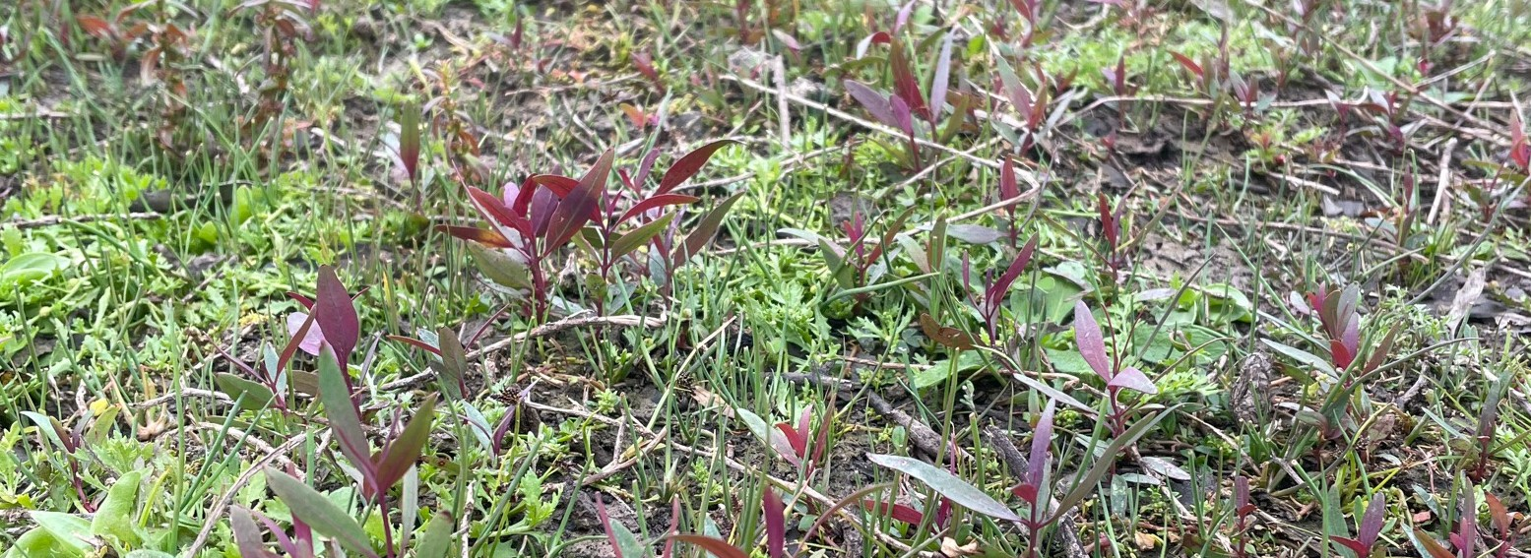

Sentinel-2 imagery has been providing environmental insights for the last six years. Through the application of specialised indices to Sentinel imagery, we can deduce very useful information such as the extent and duration of inundation in the landscape more accurately than has previously been possible. While traditional methods favour open water mapping, methods to determine extent within heavily vegetated areas are also in development and are more feasible with Sentinel-2 imagery.

We tested eight common water mapping indices on Sentinel-2 imagery against known field validation points.

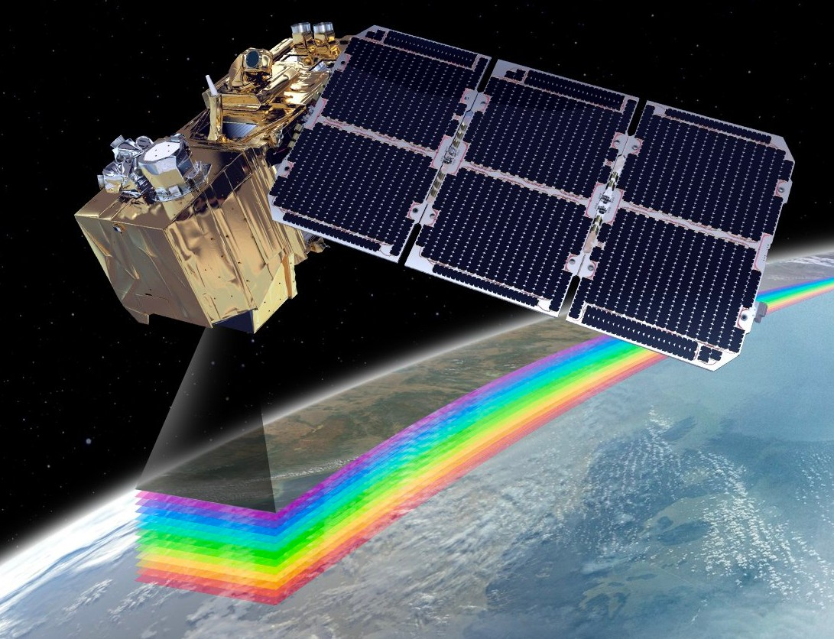
Results
Each of the eight indices gave high accuracy results, ranging from 72-98%, with the Modified Normalised Difference Water Index (MNDWI) providing the highest accuracy at 98%.

Sentinel-2 imagery provides a much higher frequency assessment of inundation patterns than its predecessor, Landsat.

Sentinel-2 images are taken every 5 days and have a resolution of 10 metres, allowing us to undertake inundation behaviour assessment that was previously unachievable with earlier versions of the technology.
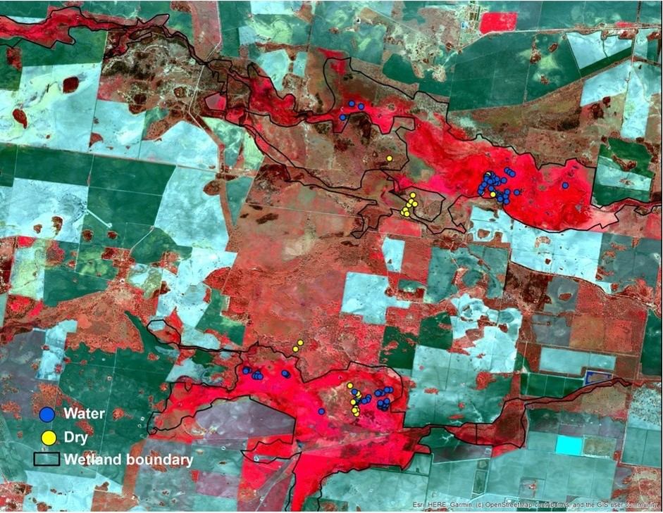
The Sentinel-2A satellite. Credit - Airbus.

As mentioned earlier in this newsletter, water couch communities in core wetland areas of the Gwydir appear to be changing in species composition. More work is needed to better understand these changes, what might be driving them, and their implications for the wetlands. Further surveys this year will also show how water couch communities have responded to large-scale inundation.

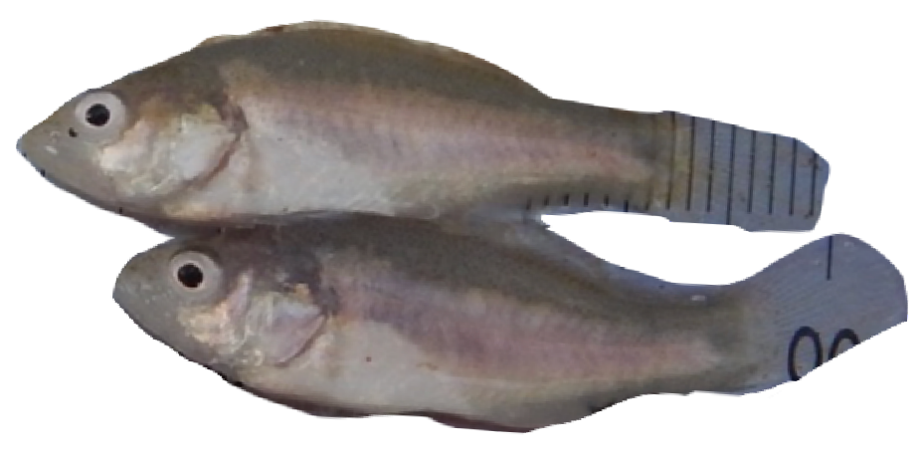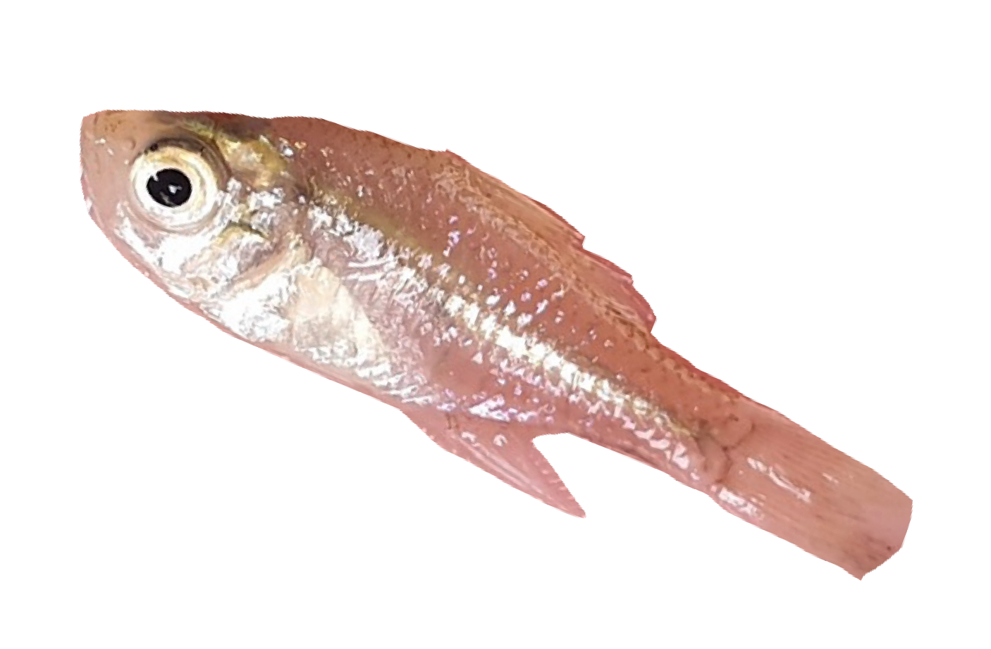The state of the native fish community in the Gwydir River system is of concern. The future for several species once common in the Gwydir system including silver perch, freshwater catfish, olive perchlet, Darling River hardyhead and the southern purple-spotted gudgeon is uncertain, with few or none captured during the LTIM/MER project. Continuing to provide water for the environment to support fish in the Gwydir is a priority, but other interventions such as stocking need to be considered.
Golden perch (dhagaay) (credit - NSW Fisheries)

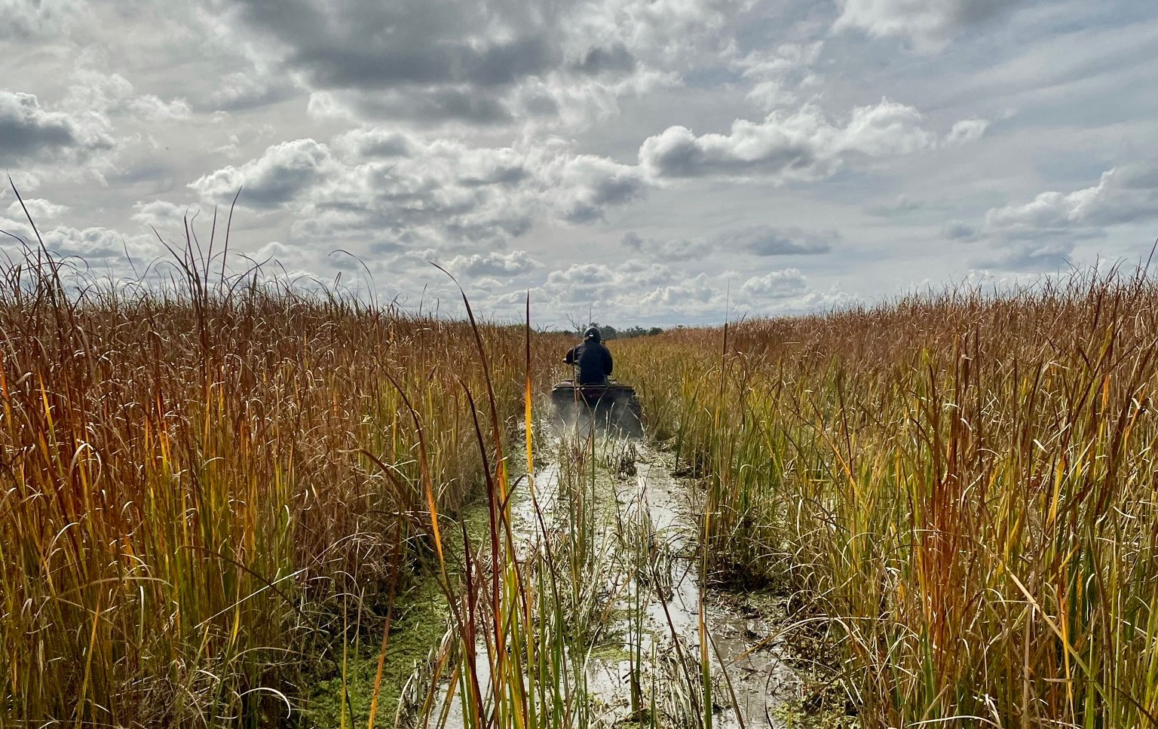

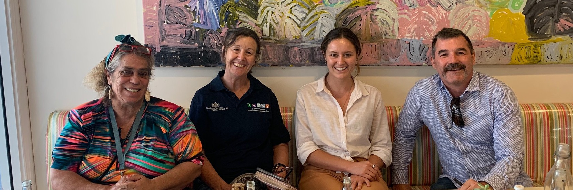
(from left to right): Liz Taylor, Jane Humphries - CEWO, Shjarn Winkle and Paul Frazier - 2rog, Moree November 2020.

Meet Liz Taylor - A passionate Gomeroi Woman

Liz Taylor is our newly appointed Gwydir Selected Area Cultural Advisor. This role is part of a pilot project to help guide communication and engagement with Traditional Owners in the land of the Gomeroi People.

Liz is a proud Gomeroi First Nation woman, born in Moree, who is deeply passionate about Indigenous People’s rights, their land, water, and their cultural heritage being maintained and passed on.

"We must share our knowledge and science and work in collaboration to - heal our country and waterways - to educate and engage our future caretakers"
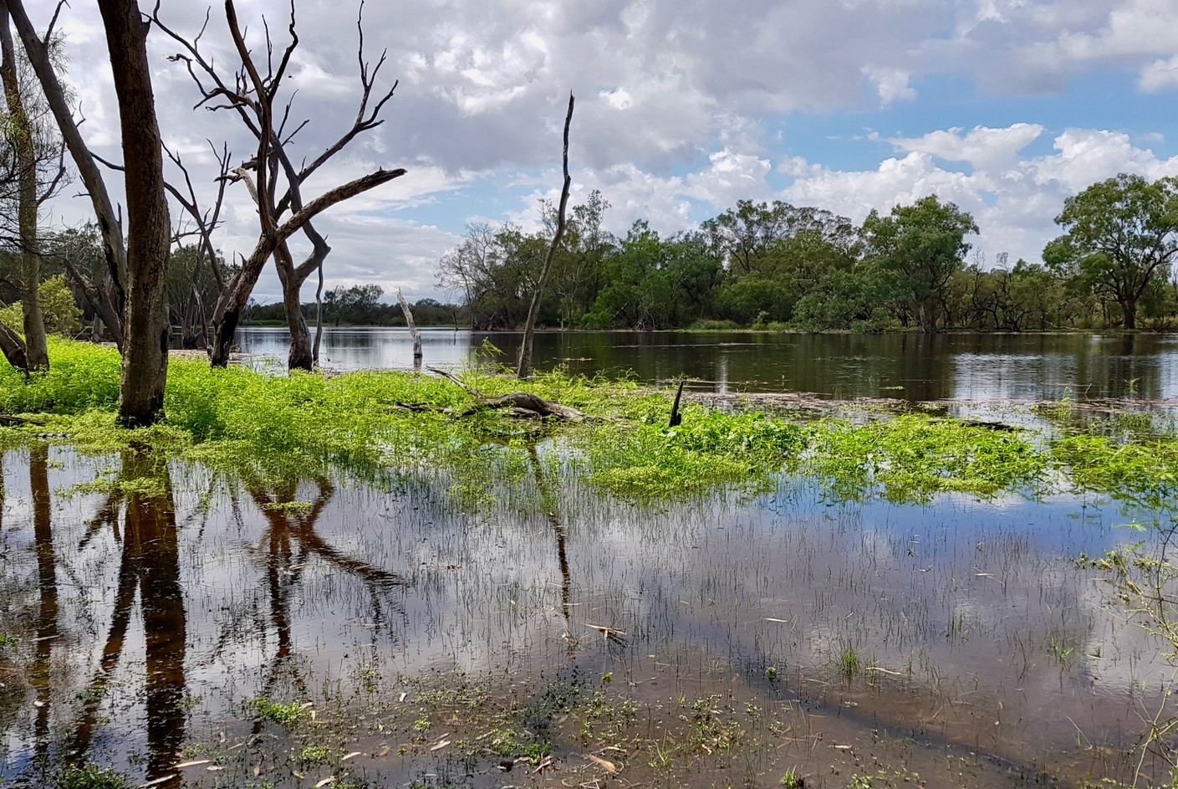
Gingham Waterhole in the Gwydir State Conservation Area (SCA). Credit - UNE

Throughout her lifetime, Liz travelled and connected with Elders from Redfern to Broken Hill, absorbing knowledge from many different First Nations. Having been on country in the wetlands for cultural heritage assessments, cultural education and wetland conservation programs, Liz emphasises the value of reconnecting the Gomeroi people with the wetlands. Liz will help us to listen and learn from the Traditional Owners.

"Our country and our water sustained Aboriginal people since time immemorial and are crucial for our health, our spirit and our web of life, thus survival of all species”

Liz dreams of bringing the collective knowledge of her country back home - for that knowledge to be built upon and engaged with. We can't wait to work alongside Liz to produce an education resource and to (one day soon) be able to participate in on country events. We strive to learn more about our study sites - our "Warrambools", the waterholes and wetlands of the Gwydir and continually build on the relationship between science and traditional knowledge.
Hear from Liz here

Submit 2020-21 annual report

Monitoring
Fish diversity - when we can travel Foodwebs - spring
Vegetation - November Waterbirds - November Hydrology - ongoing

Communication and engagement Work more with Liz Taylor and hopefully meet on site soon CEWO presentation of 2020-21 results in November
More 2rog website and social media sharing

Enquiries

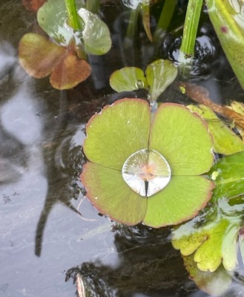
Marsilea drummondii (Nardoo) (bal) at Munwonga, June 2021. Credit - 2rog.

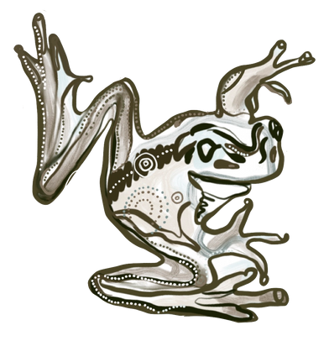
Gamilaraay Glossary

dhagaay = Golden perch bal ("barl") = nardoo
gulabaa = coolibah

guduu ("good-oo") = Murray cod

For more information and a free Flow-MER newsletter head to www.flow-mer.com.au.
Also, stay up to date with news on the Gwydir and Warrego-Darling Selected Areas at www.2rog.com.au/latestnews. For questions or comments please email:

Jason Wilson
Local Engagement Officer - Walgett (CEWO) jason.wilson@awe.gov.au

Jane Humphries
Local Engagement Officer - Moree (CEWO) jane.humphries@awe.gov.au

Dr Mark Southwell Project Manager (2rog)
msouthwell@2rog.com.au

Sally Dickinson
Local Engagement Officer - Goondiwindi (CEWO) sally.dickinson@awe.gov.au

