# Water for the environment

Water for the environment is used to improve environmental values of river and wetland systems and its use can provide social and cultural benefits, too. It can be either water entitlements that are left in the river, or a specified amount of water that has been set aside in storages that is released into natural waterways when needed.

Either way, the aim is to improve river and wetland health.

[Learn more](https://www.environment.nsw.gov.au/topics/water/water-for-the-environment/about-water-for-the-environment/what-is-it#%3A~%3Atext%3DWater%20that%20is%20allocated%20and%2Cas%20water%20for%20the%20environment.%26text%3DThey%20provide%20connections%20across%20the%2Cwell%20beyond%20the%20river%20bank)



# This quarter in a nutshell

The lower Gwydir system has experienced good river flows and prolonged wetland inundation for the majority of the 2021 calendar year, and this was capped off by a series of flow pulses through the system this quarter. These flow pulses were a combination of tributary inflows and controlled releases from Copeton Dam which filled for the first time in 9 years in November. This has meant good things for the wetlands, with prolonged inundation of several Ramsar sites in the Gingham and Lower Gwydir systems, continued good vegetation condition and the presence of endangered, threatened and migratory waterbird species.

Colonial nesting waterbirds including Ibis and Spoonbills also appear to be preparing to nest. Fish sampling in the channels found murray cod and golden perch recruits along with loads of yabbies and shrimp.

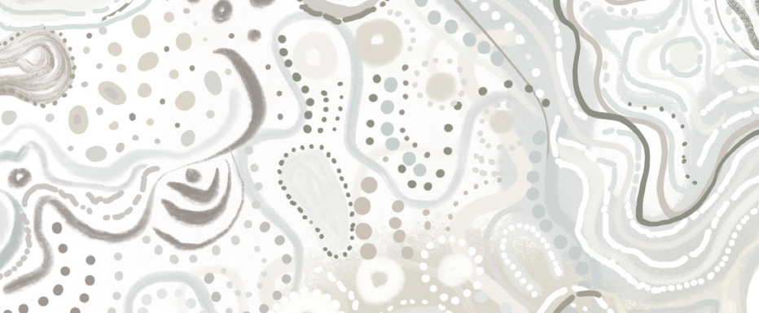

THE GWYDIR

Quarter 2 | Oct - Dec 2021

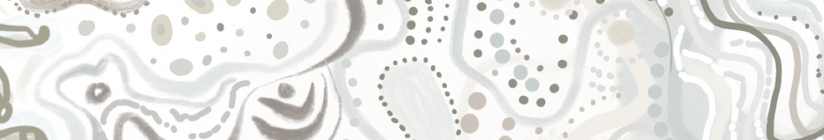

**We would like to acknowledge the Gomeroi/Gamilaroi/Kamilaroi People, the Traditional Owners of the Gwydir wetlands and its surrounds. Thank you for sharing your Country and knowledge of its land, water and life with us.**

**We pay respects to Elders past, present and emerging.**

Artwork © Lakkari Pitt

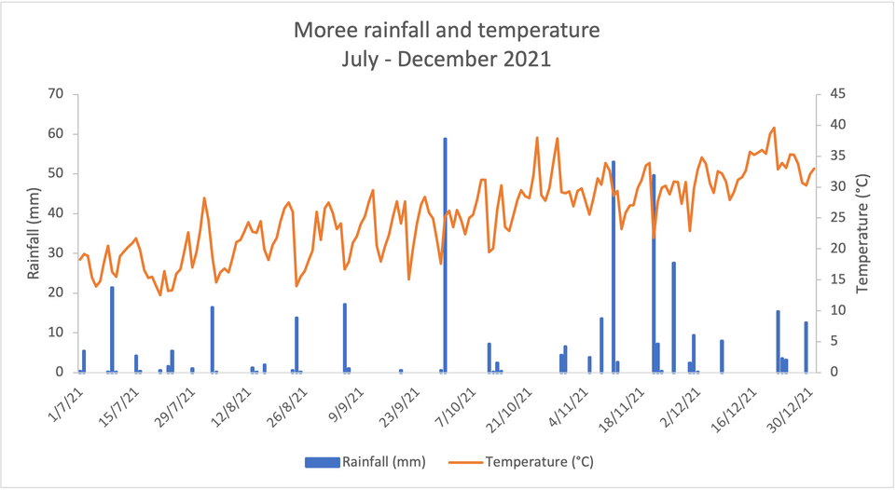Moree received a total of 233.8 mm this quarter which is 49.9 mm greater than the long-term average rainfall for this time of year. This quarter temperatures at Moree ranged between a low of 19.5 ºC (11/10/2021) and a high of 39.6 ºC (21/12/2021).

## Hydrology

The Horton River at Rider experienced a flow peak of approximately 20,650 ML/d on 23 November (blue asterisk below). These flows, combined with those from Myall and Halls creeks, contributed an approximate volume of 200 GL to the upper Gwydir River from October to December, 2021.

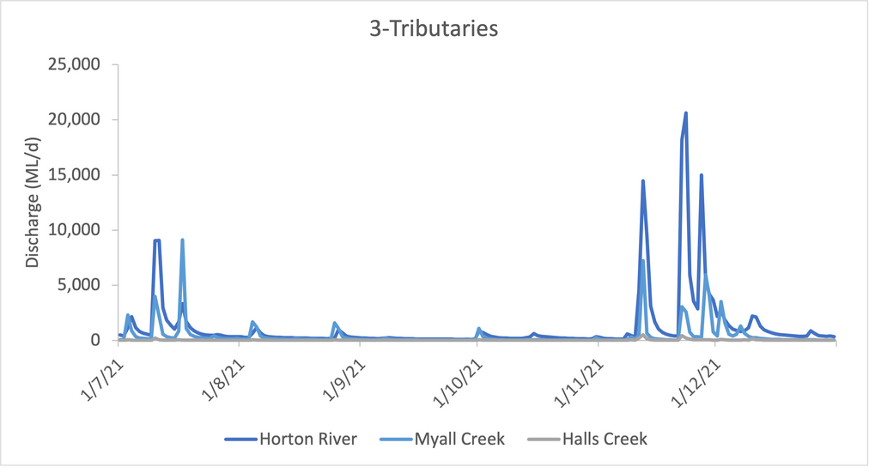

*

-

The Gwydir River's second largest flow event this year occurred late this quarter. A peak of

49,000 ML/d (blue asterisks) was observed at Pallamallawa on 14 November which was followed by an additional three peaks, each greater than 20,000 ML/d, before the end of the year. A total volume of 767 GL moved through the Gwydir River, via Pallamallawa, between October and December, 2021.

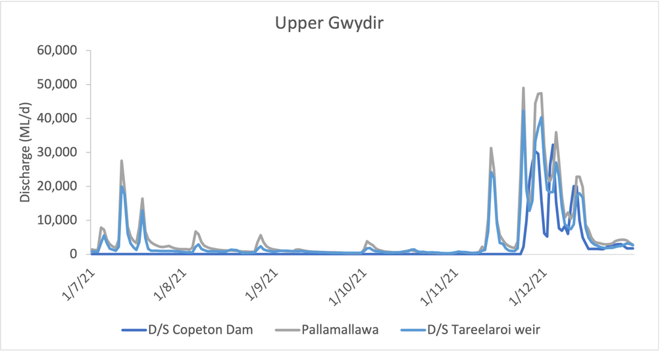

*

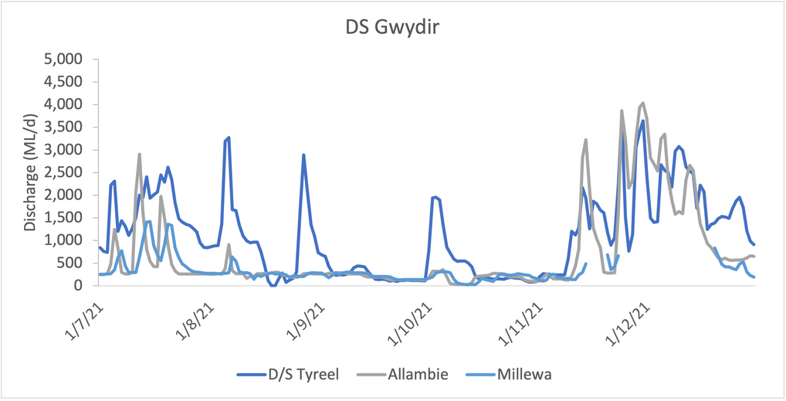The hydrology of the downstream Gwydir River was characterised by a series of consecutive peaks from mid-November to the end of 2021. Allambie saw the largest peak this quarter at 4,000 ML/d in early December. From October to December, a total of 93 GL flow via the gauge at downstream Tyreel.

-

In mid-December the Mehi River near Collarenabri experienced its largest event of this water year when a peak of approximately 13,000 ML/d (blue asterisks) travelled through the system. This event contributed to a total of 251 GL of water moving through the Mehi River, measured near Collarenabri, this quarter.

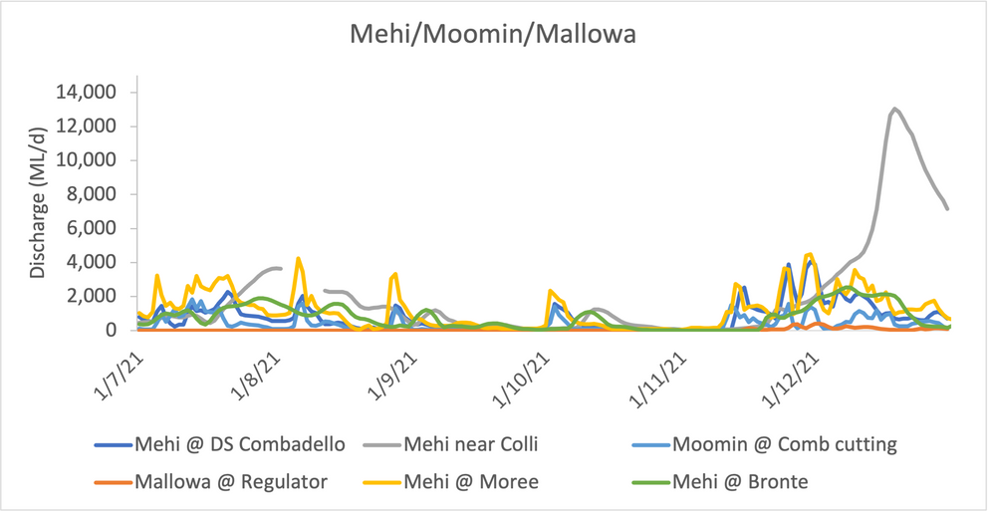

*

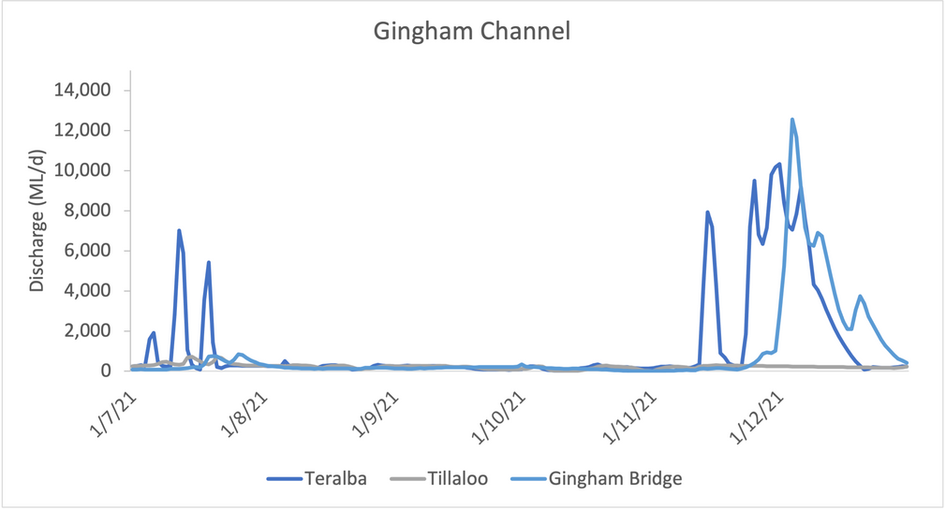The Gingham Channel's largest flows of the 2021 calendar year were observed during this quarter. A peak of 10,300 ML/d was observed at Teralba on 1 December while a peak of 12,500 ML/d passed the Gingham Bridge gauge on 4 December, 2021. A total of 141 GL of water passed Gingham Bridge between October and December, 2021.

-

The peak of the November/December flow event had passed via Moree and the Gingham Waterhole by 13 December as indicated by the Sentinel-2 imagery below. The imagery also shows the initial mixing of waters from the Gwydir and Barwon systems at the confluence of these rivers during this time.

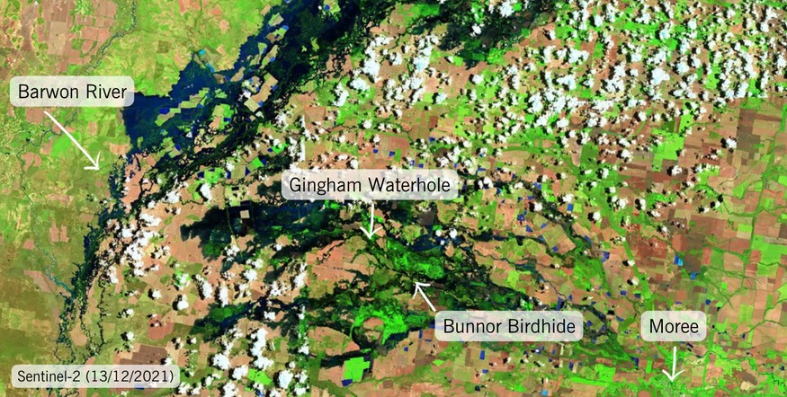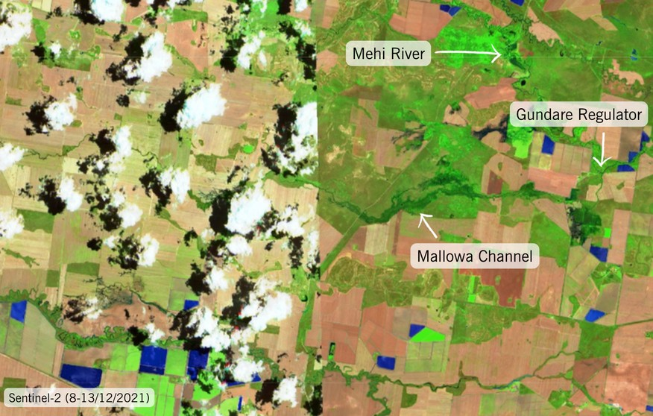

Our team conducted vegetation surveys in mid-December and noted that the Mallowa wetlands appeared to be in a particularly healthy state. Our site at Valetta (map below) had the greatest persistent inundation of all sites at 10 cm depth with vegetation in great condition. Sites at Bungunyah were dry and predominantly supporting terrestrial (land) species while the sites at Coombah were supporting both water and land species as it area consisted of wet and dry patches.

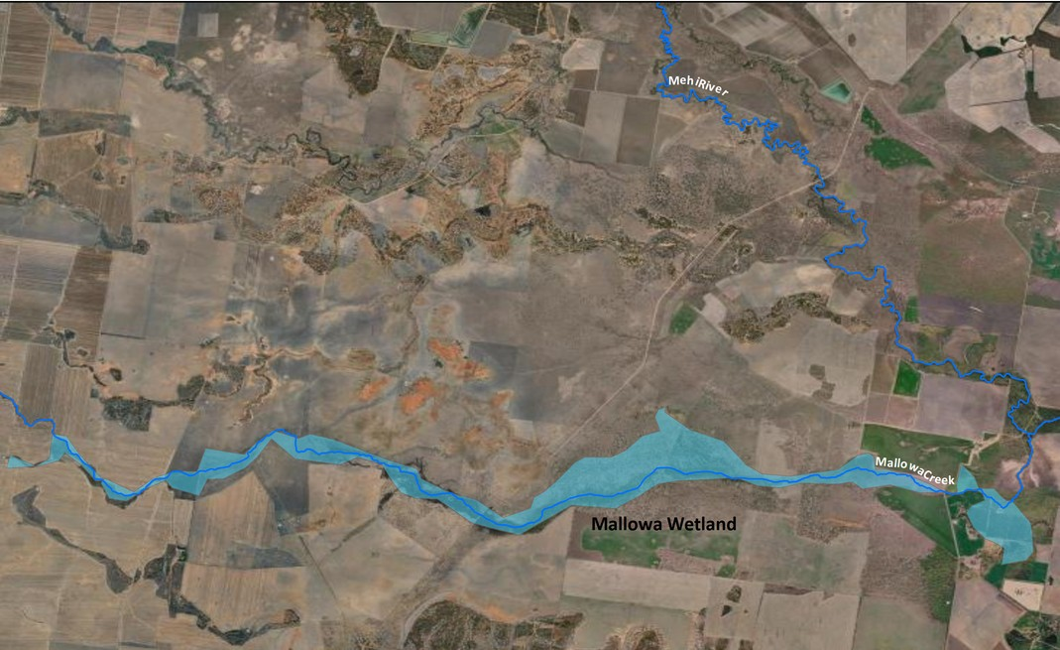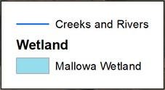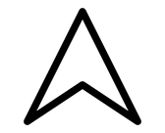

Valetta

Coombah

Bungunya

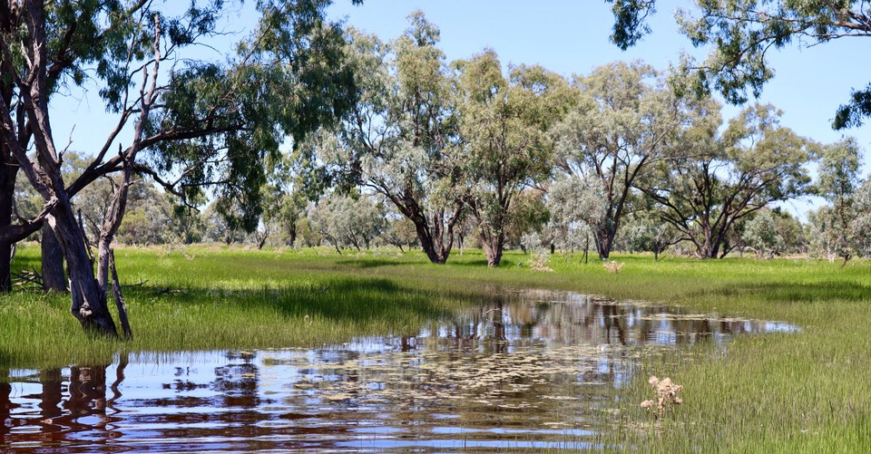

*Thriving woodland in the Mallowa Wetlands Credit: University of New England.*

### Fish diversity

Murray cod and golden perch recruits were surveyed in the Mehi during the November 2021 survey although it is currently unknown whether these recruits were natural or stocked. Carp recruits were observed in both the Mehi and Gwydir Rivers while crayfish were caught in the 100’s – more than caught in previous years! Very high numbers of shrimp observed indicated to us that the system surveyed is in a highly productive phase.

### Fish movement

To better understand how golden perch respond to flow pulses through the Gwydir system we tagged 25 individuals back in February 2021 and released them into the Gwydir and Mehi channels near Moree. Because we couldn't catch enough in the river, some fish were caught in Copeton Dam and translocated into these reaches to boost the number of fish in the study. This study adds to our previous work monitoring the movement of Murray cod and freshwater catfish through the LTIM project.

We went out and downloaded the receiver data in November 2021 and this told us that most of the fish were still alive and that they had survived the large floods that occurred through the system recently. We will need to spend some time to analyse this data before we determine how the fish use the system and where they like to hang out. This information will help us to provide environmental water releases that are more tailored to the needs of golden perch to sustain this species in the Gwydir.

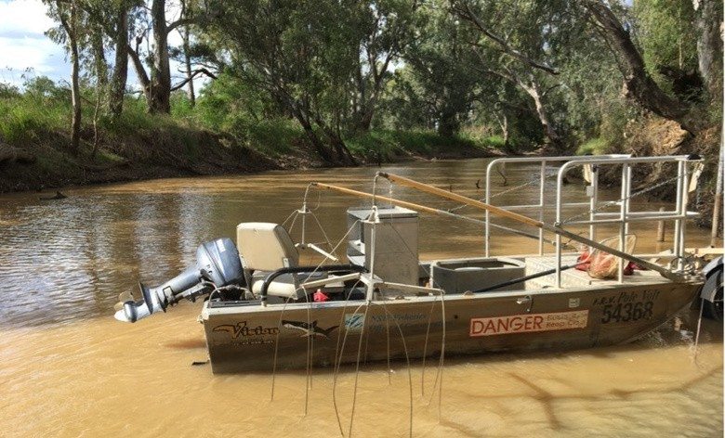

*Electrofishing the Gwydir River in 2021. Credit: University of New England*

Our Gwydir MER team were in the field in November surveying waterbirds with others from DPIE-EES and NPWS. They made some pretty cool observations including individuals from the following species:

Nationally endangered species Australian painted snipe

Migratory species Latham's snipe

Sharp-tailed sandpiper Marsh sandpiper

Threatened species (NSW) Australian painted snipe Black-necked stork Brolga

Magpie goose

On the back of some great Spring flows and wetland inundation, breeding was noted in darters, grebes, ibis, ducks, cormorant and spoonbills. Colonial nesting activity was also noted in the Gingham and Lower Gwydir wetlands with birds observed making nests. If these colonies establish we will undertake monitoring to establish the size of the colonies, their species composition and breeding progression. This will inform if any water for the environment is required to maintain water levels necessary to support the breeding event to its conclusion.

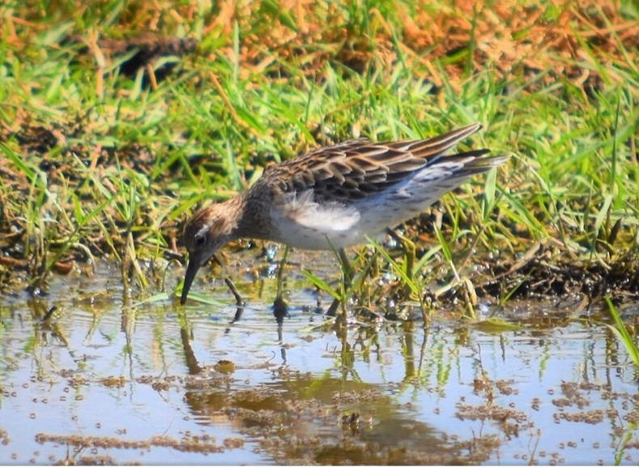

*Sharp-tailed sandpiper (Calidris acuminata). Credit: University of New England.*

We produce several communications each quarter to help tell the story of the wetlands we study, the people that study them and the cultures that depend on and care for them. All our stories can be found [here](https://2rog.com.au/latestnews/)

## What's next?

In the upcoming quarter we will be surveying for a range of indicators including: Fish diversity and movement

Food webs Vegetation

Waterbirds diversity and breeding

We will be also keeping a close eye on flows in the system and wetlands inundation

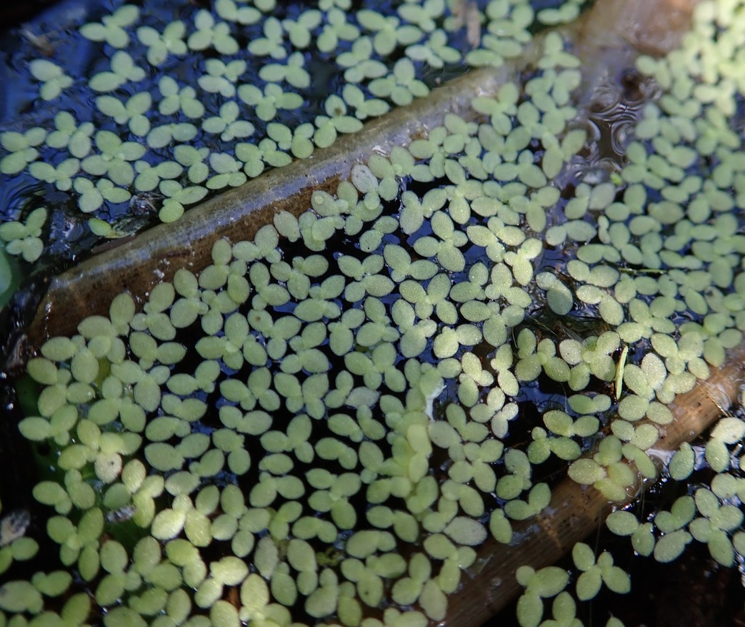

*Duckweed (Lemna disperma) at Old Dromana. Credit: University of New England.*