###### **Gwydir River Selected Area**

###### 2019-20 Annual Summary Report

HYDROLOGY | FOOD WEBS | VEGETATION | WATERBIRDS | FISH

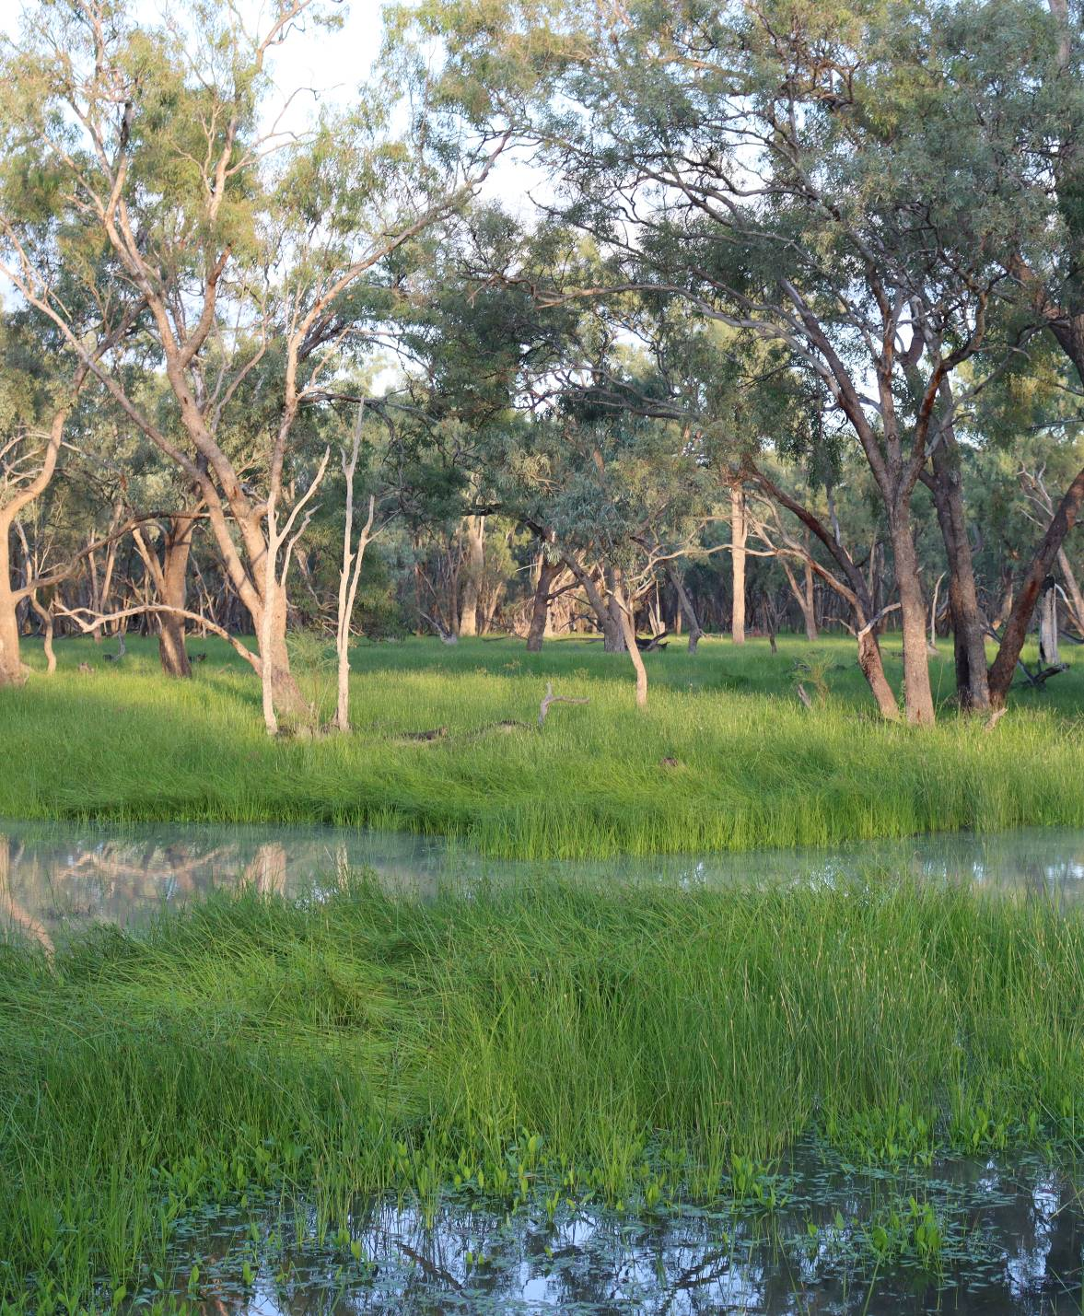

This monitoring project was commissioned and funded by the Commonwealth Environmental Water Office.

**Copyright**

© Copyright Commonwealth of Australia, 2020



Commonwealth Environmental Water Office Monitoring, Evaluation and Research Program: Gwydir River Selected Area 2019-20 Annual Summary Report is licensed by the Commonwealth of Australia for use under a Creative Commons By Attribution 3.0 Australia licence with the exception of the Coat of Arms of the Commonwealth of Australia, the logo of the agency responsible for publishing the report, content supplied by third parties, and any images depicting people. For licence conditions see: <http://creativecommons.org/licenses/by/3.0/au/>

This report should be attributed as ‘Commonwealth Environmental Water Office Monitoring, Evaluation and Research Program: Gwydir River Selected Area 2019-20 Annual Summary Report, Commonwealth of Australia 2020’.

The Commonwealth of Australia has made all reasonable efforts to identify content supplied by third parties using the following format ‘© Copyright, [name of third party]’.

**Disclaimer**

The views and opinions expressed in this publication are those of the authors and do not necessarily reflect those of the Australian Government or the Minister for the Environment.

While reasonable efforts have been made to ensure that the contents of this publication are factually correct, the Commonwealth does not accept responsibility for the accuracy or completeness of the contents, and shall not be liable for any loss or damage that may be occasioned directly or indirectly through the use of, or reliance on, the contents of this publication.

**Document control**

|  |  |  |  |
| --- | --- | --- | --- |
| **Version** | **Date** | **Reviewed by** | **Approved by** |
| 1 | 23/9/2020 | Dr Mark Southwell, Dr Sarah Mika | Dr Paul Frazier, Prof Darren Ryder |
|  | 20/10/2020 | Neal Foster, Gavin Pryde, Hilary Rossow, Brooke Sargent |  |
| 2 | 26/11/2020 | Shjarn Winkle, Dr Mark Southwell | Dr Paul Frazier |
|  |  |  |  |
|  |  |  |  |

|  |  |
| --- | --- |
| **Item** | **Details** |
| UNE Project Number | A19/467 |
| Project Director/s | Dr Paul Frazier, Prof Darren Ryder |
| Project Manager | Dr Sarah Mika, Dr Mark Southwell |
| Prepared by | Dr Sarah Mika, Dr Paul Frazier, Dr Darren Ryder, Dr Mark Southwell, Dr Ivor Growns, Dr Steve Debus, Dr Debbie Bower, Dr Gavin Butler, Dr Leo Cameron, Luke Carpenter-Bundoo, Shjarn Winkle, Josh Oxley, Ben Vincent, Sam Lewis |

**Cover image:** Coolibah Woodland wetland in the Lower Gwydir system. Photo Ben Vincent UNE

**Contents**

Executive Summary i

1 Monitoring and evaluation of environmental water in the Gwydir River Selected Area 1

1.1 Introduction 1

1.2 Gwydir River Selected Area 1

2 Environmental watering in the Gwydir Selected Area in 2019-20 4

3 Key Outcomes from environmental water use 7

3.1 Monitoring 7

3.1.1 Expected Outcomes 7

3.2 Flows and Ecosystem Functions 10

3.3 Water quality responses to flow 13

3.4 Ecological Response to Flow 13

3.5 Summary 17

3.6 Research 17

3.7 Communications and Engagement 18

4 Implications for future management of Commonwealth environmental water 19

5 References 20

**List of Figures**

Figure 1 The Gwydir River catchment and its location within the Murray-Darling Basin. 2

Figure 2 The Gwydir River Selected Area with monitoring zones highlighted. 3

Figure 3 Monthly rainfall at Moree Airport (BOM station – 53115) during the 2019-20 water year compared to the long-term average 4

Figure 4 Annual rainfall measured at the Moree combined station (BOM station no.53048- now closed 1965 – 1995) and Moree Aero (BOM station no.53115 1996 – 2020) 5

Figure 5 Mean maximum and minimum temperatures at Moree Airport (BOM station – 53115) over the 2019-20 water year compared to the long-term average 5

Figure 6 Gwydir channel hydrology and connectivity, Copeton Dam to Pallamallawa, 2019-20 water year. 10

Figure 7 Flow hydrograph for gauging stations in the Gwydir River, Mehi River and Carole Creek during the refuge pool maintenance flows in the 2019-20 water year. 11

Figure 8 Gingham and lower Gwydir inundation map sequence over the 2019-20 water year. 12

Figure 9 Spangled perch (Leiopotherapon unicolor) collected in the lower Gwydir River as part of MER Fish (River) monitoring, June 2020. 14

Figure 10 Latham’s snipe (*Gallinago hardwickii*) a migratory species listed under multiple international agreements (top) and magpie goose (*Anseranas semipalmata*) listed as Vulnerable under the BC Act 2016 (bottom), both observed in the Gwydir Selected Area during MER surveys in 2019-20. 15

Figure 11 Drought conditions observed in spring 2019 (top) and following autumn inundation (bottom) at both Goddards Lease Ramsar (top and bottom left) and Old Dromana Elders (top and bottom right) vegetation monitoring sites in the lower Gwydir Wetlands. 16

Figure 12 A story focused on yellowbelly or Dhagaay, published on the 2rog website, was a very effective communication product during 2019-20 (https://2rog.com.au/latestnews/). 18

**List of Tables**

Table 1 Environmental water use during the 2019-20 water year. 6

Table 2 Summary of objectives being targeted by environmental watering in the Gwydir River Valley (Commonwealth of Australia 2019a). 7

Table 3 Watering actions, target assets and evaluated outcomes implemented in the Gwydir Selected Area during 2019-20. 9

**Abbreviations**

|  |  |
| --- | --- |
| Abbreviation | Description |
| ANAE | Australian National Aquatic Ecosystem classification |
| CEWO | Commonwealth Environmental Water Office |
| ECAOAC | Environmental Contingency Allowance Operation Advisory Committee |
| GL | gigalitre |
| GPP | Gross Primary Production |
| NPP | Net Primary Production |
| ER | Ecosystem Respiration |
| ha | hectare |
| km | kilometre |
| LTIM Project | Long-Term Intervention Monitoring Project |
| MER Project | Monitoring, Evaluation and Research Project |
| MDBA | Murray-Darling Basin Authority |
| ML/d | Megalitres per day |
| mS/cm | millisiemens per centimetre |
| NP | National Park |
| NSW | New South Wales |
| SCA | State Conservation Area |
| Selected Area | The Gwydir River Selected Area |

# 

# Executive Summary

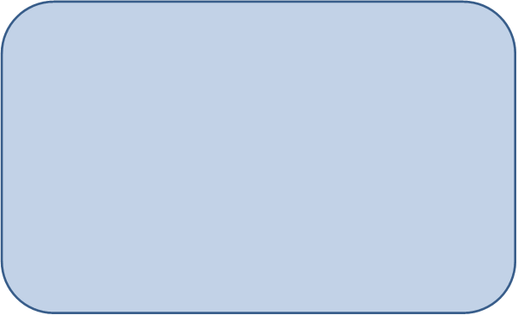

**Contributions of Commonwealth Environmental Water**

***River channels***

* Environmental water delivered in November-January helped to maintain refuge pools and improve water quality. However, a blackwater event associated with the first refuge pool maintenance flow occured in the upper Mehi River, likely as a result of high leaf litter loads accumulating in dry channels.
* The long-term fish community in the Gwydir remains depauperate, yet relatively good fish abundances were observed in the Gwydir and Mehi systems at the end of 2019-20. There was evidence of recruitment in most native species across the water year.

***Wetlands***

* Ecological communities of the lower Gwydir wetlands showed high levels of resilience during 2019-20.
* Inflows into the wetlands including water for the environment, and above average rainfall in late summer-autumn drove a positive response in both waterbird and vegetation communities. This represented a substantial recovery from the spring 2019 surveys when vegetation and waterbirds showed the poorest condition (richness, total count and cover) since the monitoring project begun (July 2014).
* Turtle populations at Gingham Waterhole were able to use different strategies (dispersal and waterhole refuge) to survive waterhole drying over summer, with the majority of individuals studied surviving until flow again filled the waterhole and surrounding habitat***.***

The Gwydir catchment, located in the northern Murray-Darling Basin, extends from the Great Dividing Range west to the Barwon River. Downstream of Moree, the system fans out into a broad alluvial near-terminal floodplain. Numerous anabranches and distributary channels characterise the lower half of the Gwydir catchment, with the Mehi River and Moomin Creek to the south, and the lower Gwydir River, Gingham Watercourse and Carole Creek to the north. These channels support wetland and floodplain assets including the lower Gwydir, Gingham and Mallowa wetlands. Commonwealth environmental watering targets channel, wetland and floodplain assets with expected environmental outcomes downstream (west) of Tareelaroi Weir on the Gwydir River.

Conditions in the first half of the 2019-20 water year were exceptionally dry with record low rainfall and no flow periods in many channels. This was coupled with above average temperatures throughout most of 2019-20. A wildfire that burnt around 1,300 ha in the Gingham Watercourse in September 2019, placed extra pressure on the local wetland and floodplain communities. Rainfall within the Gwydir River Selected Area was above average from January-April 2020 with good falls occurring in unregulated sections of the upper catchment as well as in the lower catchment wetland and watercourse areas.

A combination of Commonwealth and State managed environmental water was delivered to the channels of the lower Gwydir system through three refuge pool replenishment flows in November–January (Appendix A). Small amounts of supplementary Commonwealth and NSW environmental water were also delivered to the Gingham, Lower Gwydir and Mallowa wetlands in March-April 2020. This report considers the combined influence of both Commonwealth and State managed environmental water. These flows aimed to protect refugial in-stream habitat and mitigate declining water quality, and to support the condition of wetland vegetation and fundamental ecosystem processes in the wetlands.

Environmental water contributed to connectivity in the Gwydir River and in the upper reaches of the lower Gwydir River, Mehi River, Moomin Creek and Gingham Watercourse during 2019-20 (Appendix A). In addition, 1,500 ha of the Lower Gwydir and Gingham wetlands were inundated with inflows containing a proportion of water for the environment. In the Mallowa system, 400 ha of wetlands was inundated in February 2020 as a result of local runoff. Semi-permanent wetland vegetation species such as water couch, spike-rush, tussock rush, lignum and river cooba were inundated during the 2019-20 water year.

**Key Responses to Flow**

*Water Quality and Metabolism*

* Water quality declined in refuge pools as the drought and disconnection progressed and environmental water deliveries were used to maintain water quality in most systems (Appendix B). A short period of poor water quality (blackwater) occurred in the Mehi River during a flow delivery in November that led to a localised fish kill (Appendix F). It is likely that increased leaf litter inputs accumulated in dry channels contributed to this poor water quality through the leaching of dissolved organic matter and the microbial decomposition of leaves. Both of these processes led to decreased levels of dissolved oxygen. The outcomes of the water deliveries over the extended dry period have contributed to our understanding of critical time periods for disconnection and improved flow delivery mechanisms to mitigate potential poor water quality outcomes.

*Ecology*

* Food resources remained relatively stable in all refuge pools monitored over spring and summer when pool maintenance flows were delivered. Invertebrate species present have been shown to make up significant proportions of the diets of several native fish species (Appendix F).
* The Gwydir fish community, although depauperate, showed resilience over the 2019-20 water year, with relatively high abundances of fish recorded towards the end of the year, and evidence of breeding success in several large- and small-bodied native species Appendix E1).
* In spring 2019, when conditions were dry, waterbird species richness was the lowest it has been in 6 years of LTIM/MER monitoring. A noticeable influx of ducks, swans and geese, especially at floodplain sites within the Gingham Watercourse boosted waterbird communities towards average or above average abundance and diversity in autumn 2020 following inundation (Appendix D).
* Similarly, spring 2019 surveys recorded the lowest vegetation species richness in the six years of LTIM/MER project monitoring, due to a combination of drought conditions and wildfire at some sites (Appendix C). However, following inundation and above average rainfall, less than five months later, very high vegetation cover was observed along with the second highest species richness observed across all years of the project.
* Turtle tracking research at the Gingham Waterhole identified contrasting survival strategies used by the two turtle species studied. Eastern long-necked turtles tended to leave the drying waterhole and take refuge in surrounding forests, whereas Murray River turtles remained in the damp and dry mud following waterhole drying. The majority of individuals studied survived three months of complete waterhole drying, returning to the waterhole and surrounding aquatic habitats when the waterhole filled again in February 2020.

**Communications**

* A broad range of products and strategies were used to communicate the findings from the MER project.
* The short stories posted on the 2rog website were well received by a range of stakeholders. Personal and cultural stories tended to receive more attention and positive feedback.

**Implications for Commonwealth environmental water management**

* Monitoring of pool refuge maintenance flows suggests that these water deliveries were generally successful at maintaining the water quality and habitat within the refuge pools that persisted through the drought. Therefore, the principles outlined in the low flow release regime developed by NSW Government in 2016, i.e. protection of key refuge sites during extended dry periods should be supported by the delivery of continuous low flow from Copeton Dam; 40-60 days after flows have ceased as an effective strategy in this water year.
* A pulse of poor water quality down the Mehi River highlights the need to obtain a better understanding of the role that the leaf litter build up in dry channels plays in dissolved oxygen and water quality, and their subsequent impacts on biota. This could potentially be an ongoing project to enhance the understanding of environmental water managers of the relationship between leaf litter build up, volume and timing of flow deliveries and the deterioration of water quality in remnant pools in the lower Gwydir.
* The ecological communities of the Gwydir River Selected Area displayed a high level of resilience over the 2019-20 water year. This has been, and continues to be, a long term target for the use of water for the environment throughout the system. The strategic management and delivery of environmental water in the river channels, wetlands and watercourses of the lower Gwydir in the past years has likely contributed to the current resilience of the system to recent drought, wildfire and other disturbances.

# Monitoring and evaluation of environmental water in the Gwydir River Selected Area

## Introduction

This report presents the monitoring and evaluation results from the first year of the Monitoring, Evaluation and Research (MER) project at the Gwydir River Selected Area (Gwydir Selected Area, Selected Area). The project was undertaken as part of a larger project funded by the Commonwealth Environmental Water Office (CEWO) to monitor and evaluate water for the environment across the Murray-Darling Basin. The MER project is an extension of the Long-Term Intervention Monitoring (LTIM) Project, with both projects being implemented at seven Selected Areas since 2014-15. These projects aimed to deliver five high-level outcomes:

1. Evaluate the contribution of Commonwealth environmental watering to the objectives of the Murray-Darling Basin Authority’s (MDBA) Environmental Watering Plan
2. Evaluate the ecological outcomes of Commonwealth environmental watering at each of the seven Selected Areas
3. Infer ecological outcomes of Commonwealth environmental watering in areas of the Murray-Darling Basin not monitored
4. Support the adaptive management of Commonwealth environmental water
5. Monitor the ecological response to Commonwealth environmental watering at each of the seven Selected Areas.

This report describes the Gwydir Selected Area watering actions and the ecological outcomes of the application of Commonwealth environmental water in the Gwydir Selected Area during the first year of the MER project. In addition, comparisons over the past 6 years of LTIM/MER have also been made. Detailed analysis, methods and results are presented in the Appendices referred to in the summary report.

## Gwydir River Selected Area

The Gwydir catchment, located in the northern Murray-Darling Basin extends from the Great Dividing Range west to the Barwon River, covering an area of 26,600 km2 (Green *et al.* 2011). Downstream of Moree, the system fans out into a broad alluvial near-terminal floodplain (DECCW 2011). Numerous anabranches and distributary channels characterise the lower half of the Gwydir catchment, with the Mehi River, Moomin Creek and Mallowa Creek to the south, and the Lower Gwydir River, Gingham Watercourse and Carole Creek to the north. These channels support wetland and floodplain assets including the Lower Gwydir, Gingham (areas of which are declared Ramsar wetlands) and Mallowa wetlands (Figure 1). Commonwealth environmental watering targets environmental outcomes downstream (west) of Tareelaroi Weir on the Gwydir floodplain. The Gwydir Selected Area MER focuses on the reaches of the Lower Gwydir River and distributary channels to the west of Tareelaroi Weir (Commonwealth of Australia 2014). This Selected Area (Figure 2) includes three monitoring zones:

* Gwydir River (downstream of Copeton Dam to Pallamallawa)
* Lower Gwydir River and Gingham Watercourse
* Mehi River and Moomin Creek (including Mallowa Creek).

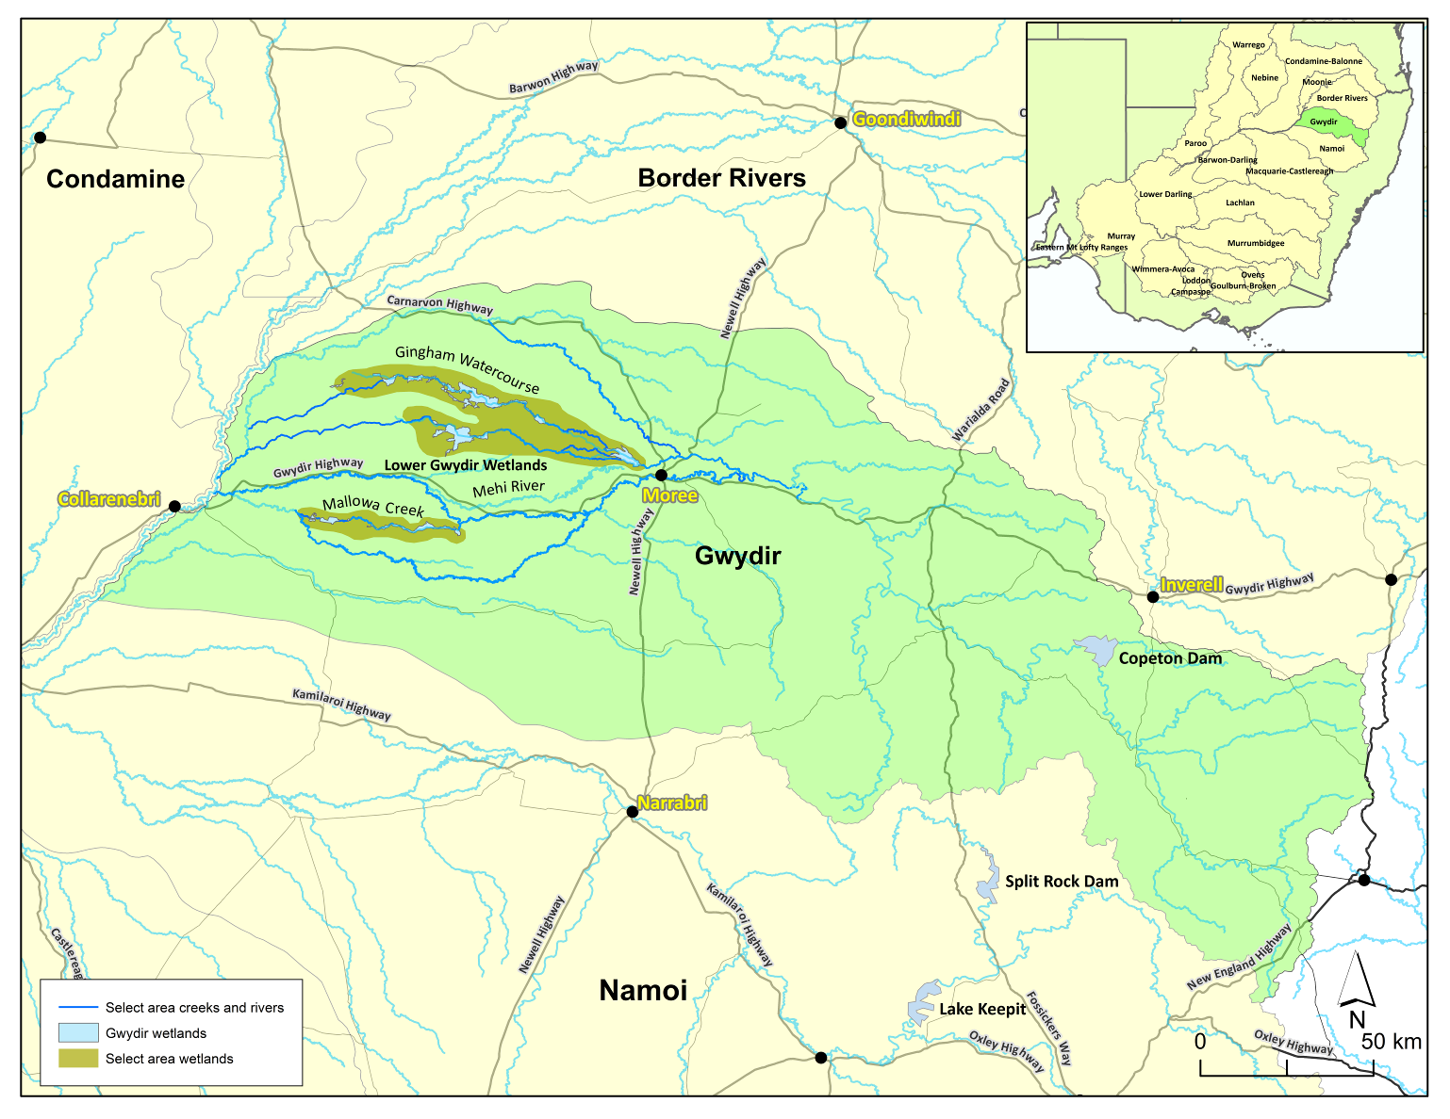

Figure The Gwydir River catchment and its location within the Murray-Darling Basin.

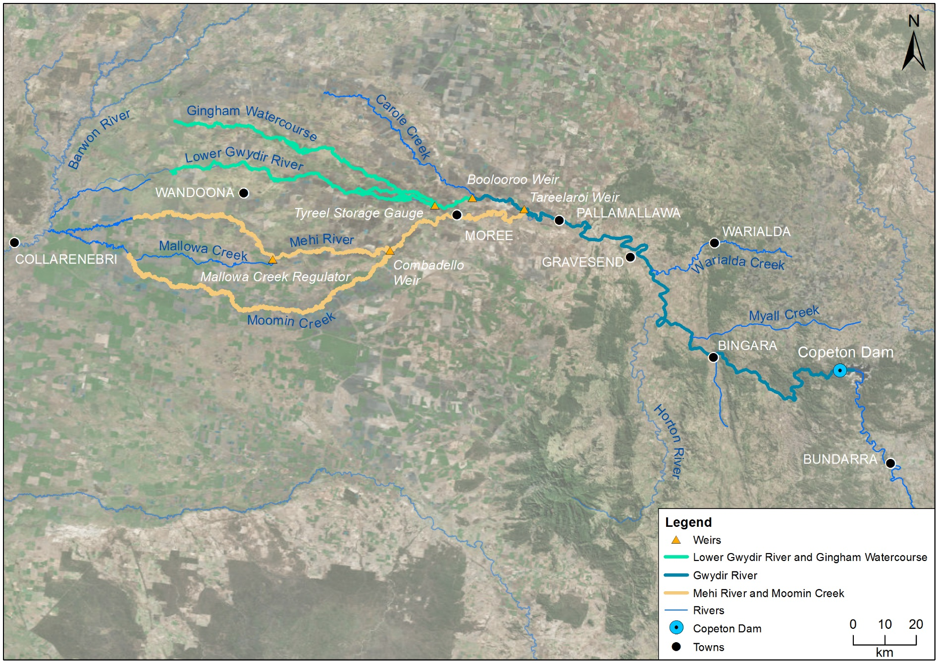

*Gingham waterhole*

Figure The Gwydir River Selected Area with monitoring zones highlighted.

# Environmental watering in the Gwydir Selected Area in 2019-20

Rainfall was highly variable in the Selected Area during the 2019-20 water year (Figure 3). Very low falls occurred in the first six months of the water year (49 mm in total), which contributed to the 2019 calendar year being the driest year over the 54 year record (1965-2019) and 152 mm less than the next driest year (2002, Figure 4). Above average rainfall occurred in January-April which had a significant influence on river flows and antecedent conditions throughout the lower Gwydir valley. Total rainfall for the year was 428 mm compared to the long-term average of 558 mm.

Mean monthly maximum temperatures were above average throughout 2019-20 (Figure 5). Similarly, mean monthly minimum temperatures were above average in October   
and December-February. Consistent with the average, the highest average maximum temperature was recorded in January (37.9 ºC) and the lowest average minimum temperature recorded in July (4.9 ºC).

Figure Monthly rainfall at Moree Airport (BOM station – 53115) during the 2019-20 water year compared to the long-term average (Source: BoM, 2020).

Figure Annual rainfall measured at the Moree combined station (BOM station no.53048- now closed 1965 – 1995) and Moree Aero (BOM station no.53115 1996 – 2020) (Source: BoM, 2020).

Figure Mean maximum and minimum temperatures at Moree Airport (BOM station – 53115) over the 2019-20 water year compared to the long-term average (Source: BoM, 2020).

During 2019-20, environmental water was delivered to in-channel assets in the Gwydir River system (Table 1), primarily for dry river protection given the very low inflows experienced in the early parts of the year. In late October/November, 5,200 ML of both Commonwealth and NSW environmental water was released from Copeton Dam to connect multiple channels in the lower Gwydir. This flow was accounted at the Copeton Dam wall, hence only 3,800 ML of environmental water flowed into the Gwydir, Gingham, Mehi and Carole Creek channels below Tareelaroi Weir. Due to deteriorating water quality in the Mehi River associated with this flow release, 100 ML was abstracted into storage downstream of Combadello Weir, and an additional 128 ML was diverted down the Mallowa Creek system to improve water quality and minimise ecological impacts in the Mehi River. As dry conditions continued, two additional pulses of NSW and Commonwealth water for the environment were delivered to the Gwydir, Gingham, Mehi and Carole channels to maintain refugial water holes. These flow pulses occurred in December (1,800 ML) and January (5,000 ML).

Table 1 Environmental water use during the 2019-20 water year.

|  |  |  |  |  |
| --- | --- | --- | --- | --- |
| Channel | Commonwealth Environmental Water (CEW) delivered (ML) | NSW ECA/General Security /Supplementary environmental Water delivered (ML) | 2019-20 total flow (ML) | Environmental Water % of total flow |
| Gwydir River* | 4,589 | 4,339 | 121,796 | 7.33 |
| Gingham watercourse | 1,984 (inc. 1,410 supplementary water) | 1,140 (inc. 314 supplementary water) | 23,161 | 12.13 |
| Lower Gwydir | 2,714 (inc. 1,410 supplementary water) | 1,260 (inc. 314 supplementary water) | 19,718 | 18.56 |
| Carole Creek | 709 | 591 | 20,062 | 6.48 |
| Mehi River< | 2,002 | 1,976 | 35,426 | 11.23 |
| Mallowa Creek | 250 supplementary water | 128 | 763 | 49.52 |
| **Total** | **7,659 (inc. 3,070 supplementary water)** | **5,095 (inc. 628 supplementary water)** |  |  |

* All environmental water delivery (except supplementary) to the Gwydir system flowed through the Gwydir River in 2019-20. Therefore, volumes for this channel represent total volumes delivered downstream and as such are not included in the total.

< Also includes 100 ML NSW General Security water for delivery to Whittaker’s Lagoon.

Increased catchment inflows in February and March triggered two periods of supplementary access (3,698 ML). In the first period, two days of supplementary access were announced in mid-February resulting in 3,448 ML of NSW and Commonwealth supplementary water accounted for in the lower Gwydir and Gingham channels. This along with some 3T water provided inflows to the downstream wetlands. A second period of supplementary access was announced in mid-March in response to inflows into the Mehi River from Tycanna and Washpool Creeks. During this time, a further 250 ML of Commonwealth supplementary water was delivered down the Mallowa Creek.

# 

# Key Outcomes from environmental water use

## Monitoring

### Expected Outcomes

The CEWO have defined several long-term expected outcomes from the use of Commonwealth environmental water in the Gwydir River valley (Table 2) that link to the outcomes of the Basin-wide Environmental Watering Strategy developed by the Murray-Darling Basin Authority (Commonwealth of Australia 2019a).

Table Summary of objectives being targeted by environmental watering in the Gwydir River Valley (Commonwealth of Australia 2019a).

| BASIN-WIDE OUTCOMES  (Outcomes in red link to the Basin-wide Environmental Watering Strategy) | EXPECTED OUTCOMES FOR GWYDIR ASSETS | | | | | |
| --- | --- | --- | --- | --- | --- | --- |
| IN-CHANNEL ASSETS | | | OFF-CHANNEL ASSETS | | |
| Mehi River | Carole Creek | Lower Gwydir river channel | Gingham Wetlands | Gwydir Wetlands | Mallowa Wetlands |
| OVERALL | Contribute to flow variability, hydrological connectivity, in-stream habitat condition and diversity, water quality, primary productivity, native aquatic species condition and reproduction.  In response to extended periods of sustained nil or very low inflows, provide deliveries for low flow hydrological connectivity to in-stream habitat, to ensure the persistence of pools as refuge; and to reduce the risk of degrading water quality conditions (particularly low dissolved oxygen levels). | | | Promote recovery of wetland vegetation, provide habitat for threatened species as well as survival and reproduction opportunities for a range of waterbird and native aquatic species (e.g. fish, frogs, turtles, invertebrates). | | |
| VEGETATION | Contributed to native riparian vegetation diversity, extent and condition. | | | Support the condition and extent of core wetland vegetation communities including water couch and spike rush marshlands, cumbungi and marsh club-rush tall meadows and lignum and river cooba wetland shrublands, including colonial nesting waterbird breeding habitat and feeding areas.  Enable recruitment and survival of trees and support growth of understorey species within river red gum, and wetland coolibah communities in wetland on lower floodplains areas that can be supported at least partially by deliveries of water for the environment. | | |
| WATERBIRDS | Improve the abundance and diversity of the Basin’s waterbird population  Support waterbird breeding events (reproduction and fledging) to successful completion. | | | | | |
| FISH | Improve flow regimes and connectivity to maximise the ecological function of the Gwydir system rivers and occasionally contribute to the Barwon-Darling river system for native fish  Support viable populations of threatened native fish and maximise opportunities for range expansion and the establishment of new populations. | | | | | |
| MACRO-INVERTEBRATES | Support recruitment and maintain macroinvertebrate diversity and habitat. | | | | | |
| PROCESSES | Hydrological connectivity, including end of system flows  Mobilisation and dispersal of biotic and abiotic materials  Primary production, decomposition, nutrient and carbon cycling. | | | Primary production, decomposition, nutrient and carbon cycling. | | |
| WATER QUALITY | Maintain good water quality within channels and pools, including dissolved oxygen. | | | | | |
| RESILIENCE | Provide drought refuge habitat (particularly for fish and other aquatic fauna). | | | | | |

The evaluation of environmental water, and its management in the Gwydir Selected Area during 2019-20, is structured around these broader objectives and priorities, with the specific outcomes associated with each Commonwealth environmental watering event provided in Table 3.

Table Watering actions, target assets and evaluated outcomes implemented in the Gwydir Selected Area during 2019-20.

| Watering action | Volume (ML) | Target asset | Expected outcomes | Were these outcomes achieved? |
| --- | --- | --- | --- | --- |
| Refuge pool maintenance flow to reconnect waterholes following a period of extended drying and disconnection | 4,560 CEW,  4,370 NSW ECA | Carole Creek, Mehi River, Lower Gwydir River | During dry conditions, provide base flows to protect refugial in-stream habitat and mitigate declining water quality | **Yes,** connectivity was improved as a result of this flow, which maintained the quality of the receiving water and the aquatic communities within them. |
| Delivery of environmental water into the Gingham Lower Gwydir and Mallowa wetlands | 3,070 CEW  628 NSW HEW | Gingham, Lower Gwydir and Mallowa wetlands | Support the condition of permanent and semi-permanent wetland vegetation  Support fundamental ecosystem function processes of nutrient and carbon cycling and primary production | **Yes,** in total 1,900 ha of the Lower Gwydir, Gingham and Mallowa wetlands were inundated significantly improving the cover and richness of vegetation communities from earlier in the season. Inundated waterholes also supported inertebrate, frog, turtle and waterbird populations. |

## Flows and Ecosystem Functions

The hydrology of the 2019-20 water year can be considered as two separate periods (Appendix A: Gwydir River Hydrology, Figure 6). The first part of the year contained some of the driest weather on record and flows were either very low or zero. The second period commencing in February 2020 contained several months of above average rainfall and periods of relatively high flow, connectivity and wetland inundation. Environmental water was used to achieve low flow connectivity in the dry period and to extend wetland inundation in the wetter period. A total of 7,659 ML of Commonwealth and 5,095 ML of state environmental water was delivered in the water year.

Figure Gwydir channel hydrology and connectivity, Copeton Dam to Pallamallawa, 2019-20 water year.

From November 2019 – January 2020, three periods of connectivity were provided by water for the environment along the upper lengths of the Gwydir, Gingham, Mehi and Carole Channels (Figure 7) in-line with the Gwydir Environmental Contingency Allowance Operations Advisory Committee (ECAOAC’s) low flow release regime (Appendix F: Pool Refugia). The November 2019 environmental water delivery interrupted the extended no flow periods in these channels of between 87-125 days, which is the longest observed in these systems in over 40 years of record.

Figure Flow hydrograph for gauging stations in the Gwydir River, Mehi River and Carole Creek during the refuge pool maintenance flows in the 2019-20 water year.

A moderate inundation event commenced in February 2020 in the Gingham and Lower Gwydir wetlands inundating around 1,500 ha (Figure 8). This event included a small amount of water for the environment from supplementary water access. Inundation decreased from the February peak although over 300 ha remained inundated at the end of June 2020. Peak inundation in the Mallowa of around 400 ha similarly occurred in February 2020 but did not coincide with inflows into this channel. It is likely that this inundation was driven by local rainfall and runoff below the Mallowa Regulator gauge. The influence of the delivery of supplementary water for the environment in March 2020 may have prolonged this inundation in the Mallowa system.

The inundation events in the Gingham, Lower Gwydir and Mallowa areas wet key wetland vegetation communities including substantial areas of Coolabah - River Coobah - Lignum woodland and rush, sedge and grassland communities. Overlay of the inundation extent with the mapped Australian National Aquatic Ecosystem (ANAE) classes showed that large areas of temporary sedge/grass/forb marsh, coolibah riparian zone or floodplain and river cooba riparian zone or floodplain all received water.

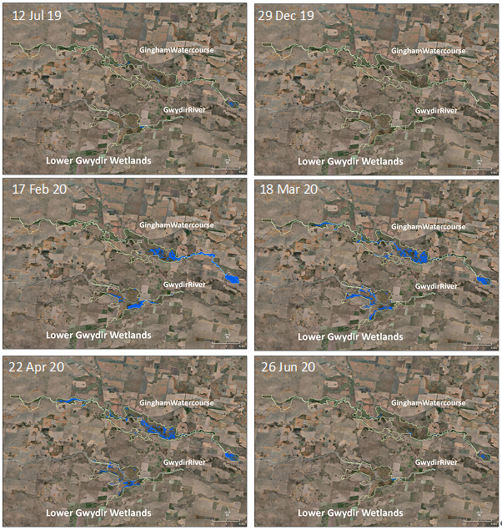

Figure Gingham and lower Gwydir inundation map sequence over the 2019-20 water year.

## Water quality responses to flow

Monitoring of refuge pools throughout the spring and summer period of 2019-20 highlighted the variability in water quality both spatially and temporally through the lower Gwydir system (Appendix F: Pool Refugia). During periods of no flow, pools appeared to thermally stratify relatively quickly following the cessation of flow, with benthic layers of hypoxic water forming at the base of pools. This is similar to how pools operate in other parts of the Barwon-Darling catchment (ELA 2020). These stratification events do not appear to impact on the aquatic ecology of the pools, given sufficient good quality water remains in the upper layers of these pools.

Dissolved oxygen concentrations showed a marked drop in the refuge pools as the first flow moved through these systems in October/November. In the Mehi River, reductions were sufficient to create hypoxic conditions throughout the water column that resulted in a localised fish kill. The hypoxic conditions were most likely caused by significant bacterial breakdown of large quantities of leaf litter entrained by the flow consuming available oxygen in the water, similar to the classic blackwater events that occur in the southern rivers of the Murray-Darling Basin. Another possibility is that poor quality water present in remnant pools in the upstream reaches of the Mehi River was transported downstream with the flow front. In any case, the long duration of no flow experienced in the Mehi River before the refuge flow release, combined with the drought stressed riparian trees, likely increased leaf litter stores in the channels and remnant pools. This in turn, likely contributed to the poor water quality issues during the initial pool replenishment flow in October/November. Similar processes occurred in the other channels where the flow was delivered, however flow volumes were likely sufficient to maintain reasonable dissolved oxygen concentrations. The subsequent pool replenishment flow events delivered in December and January maintained water quality for ecosystem functioning in the monitored pools during the continued dry summer.

Broader water quality monitoring throughout the channels of the lower Gwydir system over the 2019-20 year did not detect any concerning water quality issues and no associated detrimental impacts on biota (Appendix B: Food Webs). Generally, turbidity decreased over time in disconnected pools due to settling, and dissolved oxygen remained above 80% saturation at the surface at most sites, driven by high concentration of phytoplankton. Nitrogen and phosphorus concentrations remained high at all sites at levels consistent with previous LTIM/MER project monitoring results.

## Ecological Response to Flow

Food resources remained relatively stable in all pools over spring and summer when refuge pool maintenance flows were delivered (Appendix F: Pool Refugia). Observed densities and richness of both microinvertebrate and macroinvertebrate communities were similar to those previously recorded in LTIM sampling (Commonwealth of Australia 2019). The suite of taxa observed, especially Atyidae shrimps and Chironmonid midge larvae have been shown to make up significant proportions of the diets of native fish such as golden perch (*Macquaria ambigua*), Murray cod (*Maccullochella peelii*) and western carp gudgeon (*Hypseleotris* spp.; Sternberg *et al.* 2008, Growns *et al.* 2020 and Growns, Ryder and Frost 2020). Therefore, it is likely that food resources would not have been a limiting factor for fish during the monitoring period.

Results from the fish monitoring undertaken in May-July 2020 highlight the resilient nature of native fish in the Gwydir (Appendix E: Fish). Most native species present had spawned and recruited in the past year and, in general, most individuals sampled across all ages and sizes appeared to be in good health (Figure 9). Native fish were found in the upper Mehi River, a channel that experienced the poor water quality and fish kill earlier in the year, which is a very encouraging sign for the resilience and recovery of the fish community in this channel.

Figure Spangled perch (Leiopotherapon unicolor) collected in the lower Gwydir River as part of MER Fish (River) monitoring, June 2020.

Waterbird abundance and richness reflected the contrasting water availability across the system in 2019-20 (Appendix D: Waterbirds). Waterbird species richness was the lowest it has been in 6 years of LTIM/MER monitoring in spring 2019 when conditions were dry. During this time, the reach of the lower Gwydir River at Allambie Bridge appeared to support a relatively large number of birds, providing important refuge habitat. A noticeable influx of ducks, swans and geese, especially at floodplain sites within the Gingham Watercourse boosted waterbird communities back to average or above average abundance and diversity in autumn 2020 following widespread above average rainfall and wetland inflows. During the 2019-20 year, the lower Gwydir wetlands also supported a number of vulnerable and migratory species listed on international agreements (Figure 10).

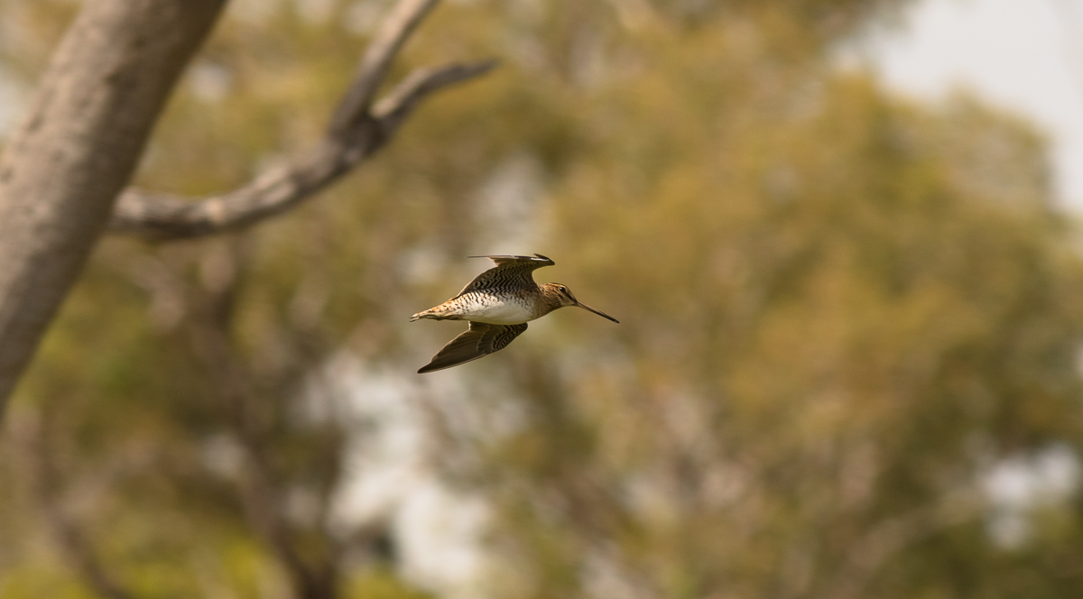

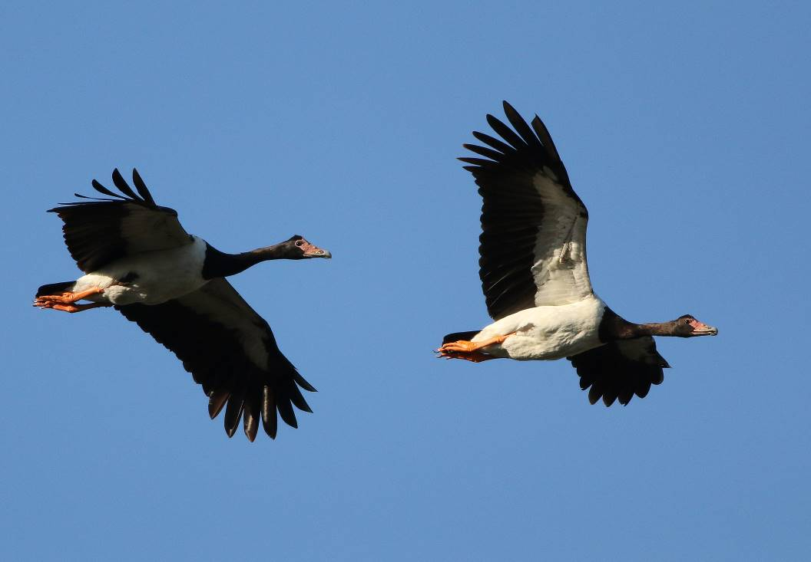

Figure Latham’s snipe (Gallinago hardwickii) a migratory species listed under multiple international agreements (top) and magpie goose (Anseranas semipalmata) listed as Vulnerable under the BC Act 2016 (bottom), both observed in the Gwydir Selected Area during MER surveys in 2019-20.

The condition of wetland and floodplain vegetation was also variable between surveys during 2019-20 (Appendix C: Vegetation). Spring 2019 recorded the lowest mean species richness in the six years of LTIM/MER project monitoring within the Selected Area, highlighting the severity and intensity of the drought conditions experienced during 2019 (Figure 11). Some sites in the Gingham Watercourse were also impacted by wildfire in September 2019, putting additional pressure on vegetation cover and condition. However, following inundation and above average rainfall, less than five months later very high vegetation cover was observed along with the second highest species richness observed across all years of the project. This increase in richness was driven by terrestrial species that respond well to damp conditions, rather than true amphibious wetland plants.

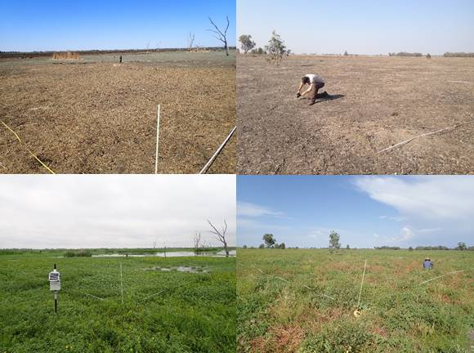

Figure Drought conditions observed in spring 2019 (top) and following autumn inundation (bottom) at both Goddards Lease Ramsar (top and bottom left) and Old Dromana Elders (top and bottom right) vegetation monitoring sites in the lower Gwydir Wetlands.

The abrupt decline in both water couch and lippia cover recorded in spring 2019 is further testament to the severity of the drought conditions experienced. The autumn 2020 survey highlights the resilience of lippia and its ability to persist during extreme dry and ‘bounce-back’ after wetting. While McCosker (1994) notes that lippia cannot tolerate long periods of inundation greater than 20 cm depth, the wetting during 2019-20 was seemingly insufficient to supress lippia populations. This suggests that inundation depths were not sufficient to supress lippia, but instead may have enhanced its growth (McCosker *et al*. 1999). Water couch cover was the lowest recorded across the 6 years of LTIM/MER monitoring. Despite this, water couch is known to respond vigorously to inundation (Wilson *et al*. 2009), and so it is possible that following autumn inundation and winter rainfall during 2020, the spring 2020 survey may show increased water couch cover.

## Summary

Contrasting climatic conditions were experienced in the Gwydir River valley during 2019-20 - from drought and very low flows from July-December 2019 to above average rainfall and improved river flows from January to June 2020. Pool refuge and incident monitoring undertaken in November 2019 – January 2020 showed that water quality in the refuge pools was variable over time but was generally within acceptable limits for aquatic biota. Food resources in the waterholes also remained relatively high during this period. The exception was in the Mehi River, where high levels of leaf litter in this   
systems appeared to drive a blackwater event which caused a localised fish kill in November. Encouragingly, fish surveys undertaken the following May-June 2020 found a relatively good population of native fish still existed in the Mehi, a testament to the resilient nature of fish in the system. There was evidence that native fish throughout the Mehi and Gwydir channels had recruited over the 2019-20 year.

Inflows into the wetlands, including water for the environment, and above average rainfall in late summer-spring drove a positive response in both waterbird and vegetation communities. After falling to their lowest richness and abundance (cover) measured for the 6 years of LTIM/MER monitoring in spring 2019, both these indicators displayed resilience to bounce back to above average levels during the autumn 2020 surveys.

## Research

The research component of the MER project in the Gwydir Selected Area aims to build understanding of floodplain inundation patterns, food webs, vegetation (lignum) condition and biodiversity responses to fire and flow. Many projects are in their infancy or progress on their field-based components was slowed by COVID-19 related travel restrictions.

Turtle tracking research undertaken at Gingham Waterhole highlights the resilience of turtles to waterhole drying and the contrasting survival strategies used by the two turtle species studied. The propensity of eastern long-necked turtles (*Chelodina longicollis*) to retreat into the surrounding floodplain forests emphasises the need for the protection of these fringing refugial habitats. Murray River turtles remained in the damp and dry mud following waterhole drying. Most individuals were able to survive the 3 months of wetland drying, before moving back into the waterhole and surrounding inundated wetland area post re-wetting.

Analysis of a five year frog dataset collected by Department of Planning, Industry and Environment (NSW DPIE) has identified a positive relationship between the abundance of spotted marsh frogs (*Limnodynastes tasmaniensis*) and eastern sign bearing froglets (*Crinia parinsignifera*) and the delivery of water for the environment.

Protocols and methods have been generated for the inundation modelling and lignum condition projects, and these are currently being implemented to add to the suite of monitoring occurring for the MER project. Initial study design and site selection has been undertaken for the ecosystem response to fire project with fieldwork due to begin for this project in spring 2020.

## Communications and Engagement

A range of products and strategies were used to communicate the findings from the Gwydir MER project in 2019-20. These included face-to-face meetings and presentations, teleconferences, newsletters, reports, stories and interviews. Post COVID-19, the focus turned to non-face-to-face communication strategies. Regular teleconferences between MER project staff and CEWO Local Engagement Officers and MDBA Regional Engagement Officers helped to foster a collegiate approach to water for the environment communications across the northern basin. In terms of engaging a broader audience, the short stories posted on the [2rog website](https://2rog.com.au/latestnews/) were extremely well received from a range of stakeholders. In this context, personal and cultural stories tended to receive more attention and positive feedback on social media platforms where they were advertised. One particular story that focused on the cultural value of Yellowbelly, “Dhagaay”, touched on people, culture and fish and provoked the strongest in-person response of all the stories posted (Figure 12).

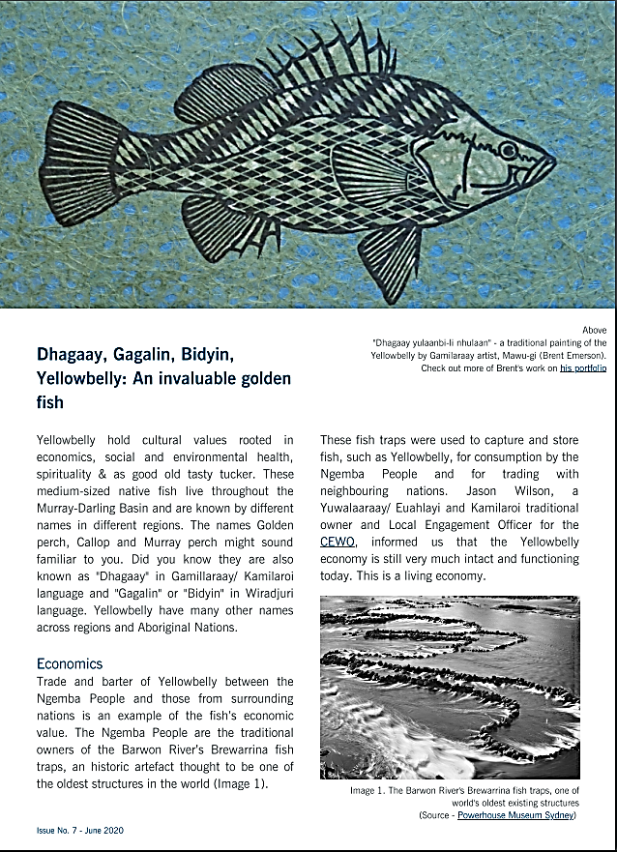

Figure A story focused on yellowbelly or Dhagaay, published on the 2rog website, was a very effective communication product during 2019-20 (https://2rog.com.au/latestnews/).

# Implications for future management of Commonwealth environmental water

Monitoring of the delivery of the pool refuge maintenance flows suggests they were generally successful at maintaining the water quality and habitat within the remaining refuge pools. Therefore, the principles outlined in the low flow release regime developed by NSW Government in 2016, i.e. protection of key refuge sites during extended dry periods needs to be supported by the delivery of continuous low flow from Copeton Dam 40-60 days after flows have ceased was effective in this case. The development of a poor quality pulse of water down the Mehi River highlights the need to obtain a better understanding of the role that the leaf litter build up in dry channels played in the observed water quality issues. This would potentially be an ongoing parcel of work to enhance environmental water manager understanding of the relationship between leaf litter build up and deterioration of water quality in remnant pools along the Mehi system.

The ecological communities of the Gwydir Selected Area displayed a high level of resilience over 2019-20 water year. This has been and continues to be a long-term target for the use of water for the environment throughout the system. The range of flows experienced in both the river channels and wetlands in the past years, including water for the environment has no doubt contributed to this. Both waterbirds and wetland vegetation communities increased from their lowest levels of richness and abundance (or cover) in spring 2019 to above average levels following wetland inflows and rainfall over the summer and autumn period. This was the case even in sites that were also affected by fire in spring 2019. The turtle population at Gingham waterhole was able to use different strategies to survive waterhole drying over summer, with the majority of individuals studied, surviving until flow again filled the waterhole and surrounding habitat. Although fish communities remain depauperate in the Gwydir, they also showed resilience with relatively good numbers of fish found in the Mehi and Gwydir channels late in the season and evidence of breeding in most native species over the year. The presence of native fish in the Mehi following the fish kills in spring 2019 suggest the presence of low dissolved oxygen refuges along this reach, or the movement of fish back into this reach from downstream or upstream. This is an encouraging sign for the fish communities in the upper Mehi River.

# References

Bureau of Meteorology (BoM). 2020. Climate data sourced from <http://www.bom.gov.au/climate/data/>

Commonwealth of Australia. 2019a. Commonwealth Environmental Water Portfolio Management Plan: Gwydir River Valley 2019–20. Commonwealth of Australia, Canberra.

Commonwealth of Australia. 2019b. *Commonwealth Environmental Water Office Long Term Intervention Monitoring Project Gwydir River system Selected Area –5-year Evaluation Report*. Commonwealth of Australia 2019.

Department of Environment, Climate Change and Water (DECCW). 2011. *Gwydir Wetlands Adaptive Environmental Management Plan: Synthesis of information projects and actions*. DECCW, Sydney.

Eco Logical Australia (ELA) .2020. *Barwon-Darling Water Quality during the Northern Fish Flow March-August 2019*. Prepared for the Commonwealth Environmental Water Office.

Green D., Burrell M., Petrovic J., & Moss P. 2011. *Water resources and management overview – Gwydir catchment*. NSW Office of Water, Sydney.

Growns, I., Ryder, D. & Frost, L. 2020. The basal food sources for Murray cod (*Maccullochella peelii*) in wetland mesocosms. *Journal of Freshwater Ecology*, *35*(1), 235-253

Growns, I., Ryder, D., McInerney, P., Bond, N., Holt, G., Lester, R., & Thompson, R. 2020. The use of fatty acids to identify food sources of secondary consumers in wetland mesocosms. *Journal of Freshwater Ecology*, *35*(1), 173-189.

McCosker, R.O. 1994. Lippia (*Phyla nodiflora*): An invasive plant of floodplain ecosystems in the Murray-Darling Basin. University of New England, Armidale, New South Wales.

McCosker, R.O., Brizga, S.O., Arthington, A. A. & Macfarlane, W. 1999. Gwydir environmental scan. Other publication details unavailable.

Sternberg, D., Balcombe, S., Marshall, J. & Lobegeiger, J. 2008. Food resource variability in an Australian dryland river: evidence from the diet of two generalist native fish species. *Marine and Freshwater Research* 59(2) 137-144

Wilson, G.G., Bickel, T.O., Berney, P.J. & Sisson, J.L. 2009. *Managing environmental flows in an agricultural landscape: The lower Gwydir floodplain.* Final Report to the Australian Government Department of the Environment, Water, Heritage and the Arts. University of New England and Cotton Catchment Communities Cooperative Research Centre, Armidale, New South Wales