# Gwydir Wetlands watering event update #1

This is the first update for the 2018–19 Gwydir Wetlands environmental watering event. Water releases from Copeton Dam began on 10 July with water for the environment flowing into the Gingham and Lower Gwydir wetlands since mid-July. This water is supporting wetland vegetation, waterbirds, and habitat health. The water is also supporting native fish populations, including the endangered olive perchlet. Water is being provided by NSW and Commonwealth governments.

## About the gwydir wetlands

The Gwydir River flows west past the north of Moree into the Gwydir Wetlands. There are two parts to the system where it splits at Tyreel into the Gingham and Lower Gwydir.

The Gwydir Wetlands are one of the largest remaining semi-permanent wetland systems in inland Australia. The wetlands have one of the biggest colonial waterbird breeding sites in Australia including four sites in the Gwydir Wetlands listed under the internationally significant Ramsar agreement (for more information on Ramsar wetlands refer to website link on page4). The wetlands provide breeding habitat and food for a range of waterbirds, including egrets, magpie geese, brolga, black-necked stork (jabiru) and ibis species. The Gwydir Wetlands are also important breeding grounds for native fish, frogs and other aquatic plants and animals.

**Map of the target area for this water delivery**

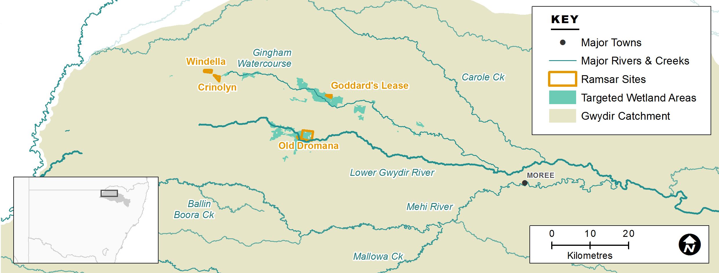

## Why deliver water for the environment into the gwydir wetlands now?

This watering event aims to help maintain the health and resilience of the Gwydir Wetlands during the current dry conditions. The delivery will support habitat and food sources for native fish, frogs, turtles, and waterbirds. Water for the environment has been provided to the Gwydir Wetlands in recent decades to support the long-term health of the river and wetland system. The current 3-year watering strategy considers a range of seasonal conditions from dry to wet.

**Aims of this event:**

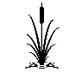Plants – improve the condition and resilience of wetland plant communities including, water couch, spike rush, river cooba, lignum and marsh-club rush, to avoid further decline that would result in a longer recovery time.

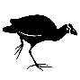Waterbirds – improve and maintain waterbird habitat for foraging and support the condition of breeding habitats.

## Water Delivery Details

Up to 60,000 megalitres (ML) of water for the environment has been ear-marked for the Gingham and Lower Gwydir wetlands in 2018-19.

**What the water delivery will look like**

Approximately 20,000 ML of water will be delivered to the Gingham and 20,000 ML to the Lower Gwydir wetlands. This delivery is expected to be complete by mid to late October to allow for harvest. Once harvest is complete environmental flows will likely resume during summer to build on outcomes from the current spring event. Up to 10,000 ML each will be allocated to both the Gingham and Lower Gwydir wetlands for the summer event. The delivery will be managed to ensure water achieves the environmental outcomes efficiently, including for the Gwydir River.

The hydrograph below shows how much water (in megalitres per day) has moved past the Millewa and Teralba gauges entering the Gwydir Wetlands since the spring event began.



**Inflows for plant growth and to provide foraging areas for waterbirds**

## Event update

On July 10, releases from Copeton Dam began with a flow rate of 600 to 700 megalitres (ML) per day. The water reached the Gingham and Lower Gwydir Wetlands in mid-July, moving through the river anabranches and into the lower lying wetland areas.

As the water flows through the river system to the Gingham and Lower Gwydir wetlands there is natural seepage and evaporation. This changes the flows rates along the system. Flows into the Lower Gwydir Wetlands (measured at Millewa gauge) have been around 220 ML/day and in the Gingham (measured at Teralba) were 280 ML/day and are currently around 100 ML/day. This first part of the spring flow helped to wet the system, filling channels and wetlands.

## Ecological monitoring

A range of monitoring activities are underway for the flow event. Remote cameras are recording the level of inundation in the Gwydir Wetlands and photo points are used to compare changes over time.

NSW Office of Environment and Heritage (OEH)are monitoring frogs, waterbirds and vegetation in the wetlands. Jo Ocock NPWS provided the following update from the September frog survey - *‘The frog response was better than expected, with more species calling more abundantly: this may be due to warmer temperatures than usual in September during the week. Eastern-sign bearing froglets and salmon-striped frogs were two of the widespread and abundant species. Follow-up surveys take place in November to assess recruitment success. We also saw good numbers of waterbirds including several flocks of 100+ ducks (Pacific black duck, grey teal, plumed whistling ducks and pink-eared ducks), 70+ black-winged stilts in a group, and small groups of red-kneed dotterels.’*

|  |  |
| --- | --- |
|  |  |
| Eastern sign-bearing froglet calling next to a foam nest from a spotted marsh frog. | Salmon-striped frog. Photos: Joanne Ocock OEH. |

Since 2014–15 the Commonwealth Long Term Intervention Monitoring Project (LTIM) team led by Eco Logical Australia has monitored hydrology, fish populations and movement, water quality, vegetation diversity, waterbird diversity and macroinvertebrates. For more information about this project visit <http://www.environment.gov.au/water/cewo/catchment/gwydir/monitoring>

|  |  |
| --- | --- |
|  | Above: Olive perchlet were sampled in 2017. Left: Commonwealth Environmental Water Holder Jody Swirepik (on the right) assisted with recent fish sampling in the Gingham Waterhole. |

## Government and community working together

Government and the community are working together to care for our rivers and wetlands. OEH and the Commonwealth Environmental Water Office work with the Gwydir Environmental Water Advisory Group to plan the delivery of water for the environment in the Gwydir catchment. The committee includes members from local interest groups and government, and provides advice on planning, management and monitoring of water for the environment*.* We will also work with other agencies, such as the Natural Resource Access Regulator and the Murray-Darling Basin Authority, that have roles in monitoring and compliance. Regular updates will be provided to the community as the flows continue into the system.

## Contacts

|  |  |
| --- | --- |
| **NSW OEH:** | **CEWO Local Engagement Officers:** |
| **Daryl Albertson Senior Wetlands & Rivers Conservation Officer**  0407 071 985  [daryl.albertson@environment.nsw.gov.au](mailto:daryl.albertson@environment.nsw.gov.au)  **Jane Humphries Wetlands & Rivers Conservation Officer**  0448 442 434  [jane.humphries@environment.nsw.gov.au](mailto:daryl.albertson@environment.nsw.gov.au) | **Neal Foster**  0437 141 495  [neal.foster@environment.gov.au](mailto:daryl.albertson@environment.nsw.gov.au)  **Jason Wilson**  0418 210 389  [jason.wilson@environment.gov.au](mailto:jason.wilson@environment.gov.au) |
| **NSW OEH website**  <http://www.environment.nsw.gov.au/topics/water/water-for-the-environment/about-water-for-the-environment> | **CEWO media line** [media@environment.gov.au](mailto:media@environment.gov.au)   02 6275 9880 |
| **Ramsar website**  <https://www.environment.nsw.gov.au/topics/water/wetlands/internationally-significant-wetlands/gwydir-wetlands> |  |