# Gwydir Wetlands watering event update #2

This is the second update for the 2018–19 Gwydir Wetlands watering event. The Gingham and Lower Gwydir Wetlands started to receive water for the environment in mid-July. Wetland vegetation, waterbirds and frogs are responding well to inflows over the past three months. The water delivery has now been paused until watercourse landholders have completed winter crop harvest.

## Event update

For 2018-19, up to 60,000 megalitres (ML) of water for the environment has been allocated to the Gingham and Lower Gwydir Wetlands. Since releases began in mid-July approximately 41,000ML of water has been delivered. The satellite images below show an area of the Gingham watercourse (of approximately 3000 hectares) receiving water. The darker green areas indicate vegetation growing following inundation of the area.

Imagery Source: European Space Agency – ESA

|  |  |
| --- | --- |
| C:\Users\A24500\AppData\Local\Microsoft\Windows\Temporary Internet Files\Content.Outlook\P84KKHF0\Sentinel-2 image on 2018-08-16 (002).jpgC:\Users\A24500\AppData\Local\Microsoft\Windows\Temporary Internet Files\Content.Outlook\P84KKHF0\Sentinel-2 image on 2018-07-17 (002).jpg |  |

16 August – water spreading

17 July – before water arrived

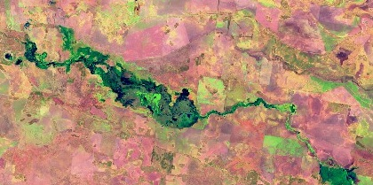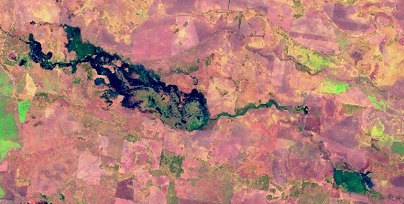

15 October –

greening up

of wetted area

15 September – water spreading further

The total volume delivered to each of the Lower Gwydir and Gingham Wetlands has been similar. The areas wet to date are the lower lying country which is particularly important as drought refuge in dry times and bird breeding habitat in wetter times.

Much of the upstream and downstream watercourses are privately owned. The farming activities of landholders are considered when designing flow events and at times there can be flexibility with timing of water delivery for wetlands. For example, to assist with harvest, water for the environment delivery has paused for a period.

## Ecological monitoring

|  |  |
| --- | --- |
|  | Regular observations and monitoring is being conducted during the flow event. Recent monitoring shows the wetland vegetation is responding well to the water. There has been extensive growth of water couch and spike rush meadows, marsh club-rush and cumbungi marshlands.  A part of Old Dromana wetlands (photo to left) is listed under the Ramsar convention. Old Dromana and the surrounding properties support marsh club-rush tall sedgeland, which is rare and listed as a threatened ecological community. |

The improved vegetation condition and growth of wetland plants will provide essential food and habitat for the waterbirds that live in and those that visit the Gwydir Wetlands. Waterbird surveys will be conducted mid-November and we look forward to sharing these results in the next Gwydir update.

## Government and community working together

Government and the community are working together to care for our rivers and wetlands. OEH and the Commonwealth Environmental Water Office work with the Gwydir ECAOAC (the Environmental Water Advisory Group) to plan the delivery and management of water for the environment in the Gwydir catchment. Providing water and monitoring, are joint efforts between NSW and the Commonwealth.

## Contacts

|  |  |
| --- | --- |
| **NSW OEH:** | **CEWO Local Engagement Officers:** |
| **Daryl Albertson Senior Wetlands & Rivers Conservation Officer**  0407 071 985  [daryl.albertson@environment.nsw.gov.au](mailto:daryl.albertson@environment.nsw.gov.au)  **Jane Humphries Wetlands & Rivers Conservation Officer**  0448 442 434  [jane.humphries@environment.nsw.gov.au](mailto:daryl.albertson@environment.nsw.gov.au) | **Neal Foster**  0437 141 495  [neal.foster@environment.gov.au](mailto:daryl.albertson@environment.nsw.gov.au)  **Jason Wilson**  0418 210 389  [jason.wilson@environment.gov.au](mailto:jason.wilson@environment.gov.au) |
| **NSW OEH website**  <https://www.environment.gov.au/water/cewo>  <http://www.environment.nsw.gov.au/topics/water/water-for-the-environment/about-water-for-the-environment> | **CEWO website** |

## Further information

The first update and further updates as the flows progress are available at: <http://environment.gov.au/water/cewo/catchment/gwydir/catchment-updates>.

OEH has recently released a draft Long Term Water Plan for the Gwydir, which is available at: <https://www.environment.nsw.gov.au/topics/water/water-for-the-environment/planning-and-reporting/long-term-water-plans/gwydir-consultation>. Feedback is invited.