# GINGHAM AND LOWER Gwydir Wetlands watering event update #3

The delivery of water for the environment commenced in mid-July from Copeton Dam, with water flowing down the Gwydir River and into the Gingham and Lower Gwydir Wetlands. The watering focuses on maintaining the health of vegetation important for a range of waterbirds. More details about the Gingham and Lower Gwydir Wetlands watering event can be found in previous event updates.

|  |
| --- |
| **Gingham Wetland area (*Photo: Terry Korn 2018*)** |

## Event update

Since releases began in mid-July approximately 41,000ML of water for the environment has flowed into the Gingham and Lower Gwydir Watercourses and Wetlands. Water delivery to the Lower Gwydir Wetlands is expected to be complete by mid-December. Water deliveries to the Gingham system paused in late October to allow harvest activities.

To ensure lagoons and wetland areas are topped up over late summer, flows into the Gingham Wetlands will recommence in late December and will continue until late January.

Once complete, around 60,000 ML of water will have been delivered across the Lower Gwydir and the Gingham.

The Lower Gwydir and Gingham Watercourses include nationally and internationally important wetlands. Four areas within the wetlands are listed as internationally significant under the Ramsar Convention and have a combined area of 823 hectares. These areas include ‘Windella’, ‘Crinolyn’ and ‘Goddard’s Lease’ in the Gingham and ‘Old Dromana’ in the Lower Gwydir.

The Gingham and Lower Gwydir, along with the Mallowa, provide important breeding and feeding habitat for a diverse range of waterbird species. Maintaining the health of the wetlands, including the four areas listed under the Ramsar Convention is a focus for the Gingham and Lower Gwydir watering event. Flows delivered as part of the event will also top up pools and waterholes helping endangered native fish such as olive perchlet survive the drought in refuges like the Gingham (Yarrol) Waterhole.

Of the four Ramsar areas, the ‘Old Dromana’ is the largest covering 600 hectares or nearly three quarters of the Ramsar sites area. An example of the response of wetland vegetation communities to the delivery of water for the environment on ‘Old Dromana’ Ramsar site is shown in the images below.

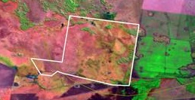 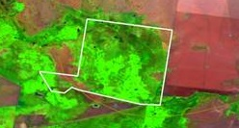

**30 October 2018**

**‘Old Dromana’**

**17 July 2018**

**‘Old Dromana’**

**‘Old Dromana’ Ramsar site parcel within the Lower Gwydir Wetland area before and during watering.**

## Ecological monitoring

Water for the environment has filled many lagoons and core wetland areas in the Gingham and Lower Gwydir Wetlands, providing important habitat and food for a range of waterbirds. A total of 47 different waterbird and 60 woodland bird species were recorded around the Gingham and Lower Gwydir wetlands by NSW Office of Environment and Heritage (OEH) and Commonwealth Long Term Intervention Monitoring during the on-ground spring waterbird surveys.

As part of the spring waterbird surveys, good numbers of grey teal, Pacific black duck, Australian wood duck, yellow- billed and royal spoonbills, egrets, brolgas, glossy ibis, plumed whistling duck, pink-eared ducks, Latham’s snipe, terns and sandpipers were identified. Smaller numbers of black-necked stork (jabiru), white and straw-necked ibis and other waterbirds were also seen. Survey staff also noted the good condition of wetland areas receiving water for the environment.*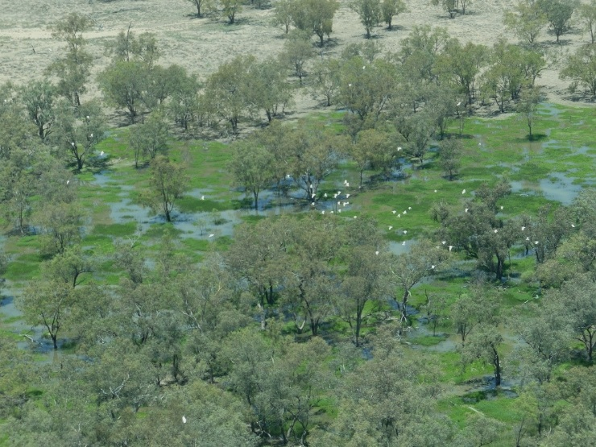***Waterbirds flying over recently flooded parts of the Gingham Wetland area (*Photo: Terry Korn 2018*)**

The University of NSW recently completed aerial spring waterbird surveys including surveys over the Gwydir wetlands. Details of the University of NSW survey including images and video can be found here: [www.ecosystem.unsw.edu.au/logs/eastern-australian-waterbird-survey/aerial-survey-12th-november-2018](http://www.ecosystem.unsw.edu.au/logs/eastern-australian-waterbird-survey/aerial-survey-12th-november-2018)

In addition to waterbird surveys, on-ground monitoring by OEH and NPWS field scientists found good responses from frogs with breeding success confirmed in four flow-responsive species across Gwydir sites.

## community and Government working together

The community and government work together to care for our rivers and wetlands. OEH staff work with landholders across the Lower Gwydir and Gingham watercourse areas to ensure water for the environment achieves maximum benefits.

The Gwydir Environmental Contingency Allowance Operational Advisory Committee (ECAOAC), which comprises landholders, irrigation, science, Aboriginal, community, environmental and governmental representatives, works with OEH and CEWO to plan and manage the delivery of water for the environment in the Gwydir catchment.

A site visit to the Gingham wetlands was undertaken by Gwydir Valley Irrigators Association (GVIA) members as well as staff from OEH and the Commonwealth Environmental Water Office (CEWO). The tour occurred in mid-November and included visits to a number of sites within the Gingham Watercourse system in the NPWS Gwydir Wetlands State Conservation Area. Tour stops included wetlands and lagoons on “Bunnor” and “Munwonga” as well as the Gingham Waterhole (on Munwonga and Yarrol). Tour participants were able to see firsthand how wetlands, lagoons and billabongs within the Gingham area had responded to the delivery of water for the environment.

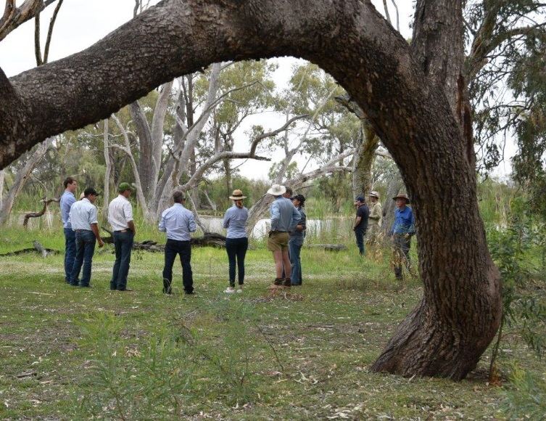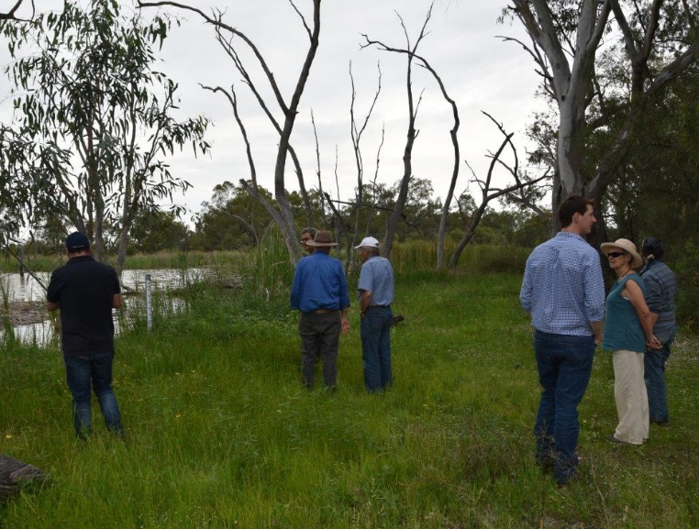

**Tour of Gingham waterhole (Photo: Lou Gall - GVIA)**

Zara Lowien, Executive Officer of the GVIA said that “It’s our view that the CEWO and OEH are water users, just like our members but that they’re growing a different type of crop that has different challenges and water requirements”.

Following the tour Zara said, “It was great to hear about the sophisticated tools and techniques used to determine how much water the environment needs and how CEWO and OEH are monitoring the results of watering”. She said it was also great to “see the actions on the ground” and that “the scale and complexity of environmental water delivery cannot be fully appreciated from a report, it needs to be seen on the ground and from the air”. Zara’s final thought from the tour was that “the evolution of environmental water management was a good news story for our region and an example, of what is possible when all parties work together”.

## Contacts

|  |  |
| --- | --- |
| **NSW OEH Senior Wetlands & Rivers Conservation Officer:** | **CEWO Local Engagement Officer:** |
| **Daryl Albertson**  0407 071 985  [daryl.albertson@environment.nsw.gov.au](mailto:daryl.albertson@environment.nsw.gov.au) | **Jason Wilson**  0418 210 389  [jason.wilson@environment.gov.au](mailto:jason.wilson@environment.gov.au) |
| **NSW OEH website**  <http://www.environment.nsw.gov.au/topics/water/water-for-the-environment/about-water-for-the-environment> | **CEWO website**  <https://www.environment.gov.au/water/cewo> |
| Further information for Gwydir catchment updates for 2018-19 can be found here: <http://environment.gov.au/water/cewo/catchment/gwydir/catchment-updates> | |