Habitat and flow requirements of freshwater mussels in the northern Murray-Darling Basin.

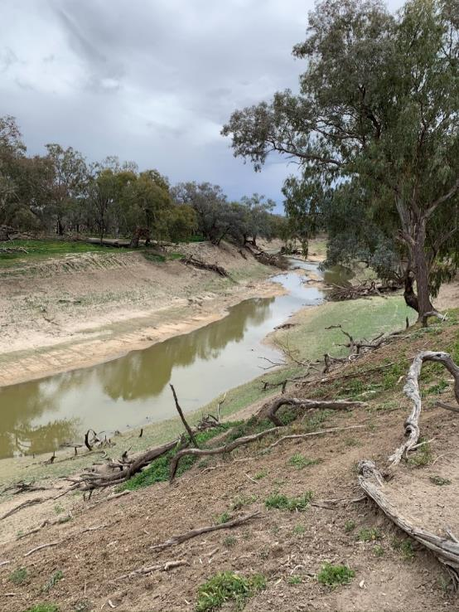
Wolkara, Darling River (Barka), between Brewarrina and Bourke, 25 July 2020
Refugial waterhole where freshwater mussels persisted.

Report to the Commonwealth Environmental Water Office
November 2020

Fran Sheldonª and Nicole McCasker^{b}
Co-authors: Michelle Hobbsª, Paul Humphries^{b}, Hugh Jones, Michael Klunzingerª and Mark Kennardª
ªAustralian Rivers Institute, Griffith University
^{b}Institute of Land, Water and Society, Charles Sturt University
Acknowledgement

The authors respectfully acknowledge the Traditional Owners of the lands and waters of the Murray-Darling Basin, particularly those whose lands we walked on in this study, across the Darling, Barwon, Macquarie, Namoi, Gwydir and MacIntyre rivers. We acknowledge that Aboriginal peoples have cared for the rivers for millennia, and pay our respects to the Elders, past and present.
We also thank all other landowners for access to the river for sampling and the Commonwealth Environmental Water Holder for showing an interest in freshwater mussels. Further appreciation goes to Deanna Duffy, Spatial Analysis Unit at Charles Sturt University, for mapping support. We hope this survey of freshwater mussels across the northern part of Australia’s largest river basin would have made the late Keith F. Walker smile, although we are sure he would have been saddened to see the extent of the mortality of his favourite river mussel.

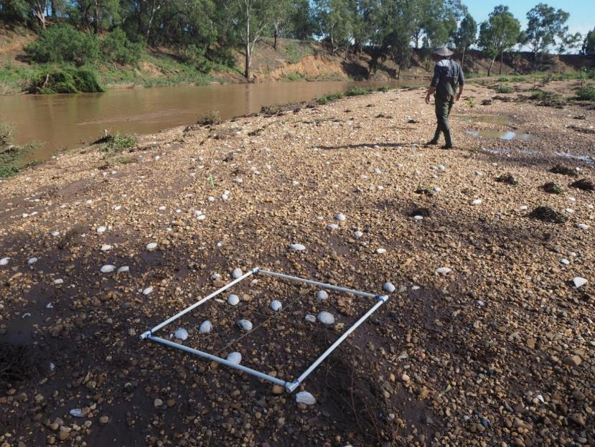
Sampling mussels, Macquarie River, Mumble Peg, 8 Mar 2020

Executive Summary
Freshwater mussels are considered ecosystem engineers of rivers; they modify substrates through burrowing, mediate water quality through filtration, provide food and habitat for other organisms and play a significant role in the biogeochemical cycling of nutrients and are also seriously threatened globally. The rivers of the northern Murray-Darling Basin (MDB) are home to three species of freshwater mussel – the large ‘river mussels’ Alathyria jacksoni and Alathyria condola and the smaller ‘floodplain/billabong mussel’ Velesunio ambiguus. As sedentary, long-lived organisms, obtaining an understanding of the habitat requirements of resident freshwater mussels will provide insights into the natural hydrology of Australia’s inland rivers, and the potential role healthy populations of freshwater mussels could play in influencing water quality through biofiltration. This project was conceived in response to the extensive drought in the northern Murray-Darling Basin between 2017 and early 2020 and the reports of extensive mussel mortality. The specific aims were to review existing knowledge and identify knowledge gaps in relation to environmental water requirements, life history, physiological tolerances and habitat requirements and cultural significance of freshwater mussels in the Murray-Darling Basin, improve baseline understanding of distribution and structure of freshwater mussels in the Northern Basin and make recommendations for land and water management to protect freshwater mussel populations. This was achieved through a predictive analysis of mussel distribution, and analysis of the hydrological conditions during the drying event and a field survey to establish the extent of mussel mortality at sites across the northern Murray-Darling Basin.
A boosted regression tree model (BRT model) was developed to predict the likely distrbution of A. jacksoni, and the broad environmental drivers explaining this distribution. The model predicted that A. jacksoni was likely to occur broadly across the mid to lowland reaches of the Barwon-Darling River and its associated north-eastern and eastern tributaries, absent from westerly the Warrego and Paroo Rivers. The most influential environmental variables on the prediected distribution of A. jacksoni the were upstream catchment area, average catchment slope and average saturated hydraulic conductivity; these variables all relate to runoff and water availability, suggesting A. jacksoni tends to occur in streams with catchments above a certain size. The model also identified that annual average primary production, average stream elevation, catchment relief and stream forest cover had some influence on distribution.
Our hydrological analysis suggested that at nearly all gauges analysed the duration of cease to flow (CTF) events in the hydrological drought of 2018-2020 was longer, and sometimes more than double the duration, of the maximum CTF length for the preceeding 37 years, with the lower gauges on the tributary rivers and the gauges on the Barwon-Darling having the greatest difference. This increase in drying duration likely had a significant impact on mussel populations.
Of the 90 sampled sites, 53 contained evidence of freshwater mussels with three species dectected, Velesunio ambiguus (17 sites), Alathyria jacksoni (45 sites) and Alathyria condola (3 sites). There was evidence of A. jacksoni in reasonable abundance in all rivers except the Gwydir and Macintyre. In these two systems evidence of V. ambiguus was more obvious (Appendix 7.3). Despite the evidence of A. jacksoni throughout most tributaries most records were of deceased mussels and at no site were only live mussels observed. The greatest abundance of A. jacksoni, both alive and dead, was observed in the lower Darling below Menindee. At some sites thousands of dead mussels were surveyed with site mortality estimates of between 20-100% across the nothern Basin.

The combination of rapid and quantitative surveys used in this study suggest that the loss of mussel populations across the northern Murray-Darling Basin resulting from the drying conditions of 2017-2019 is significant and widespread. This is a cause for concern given the longevity of mussel individuals and the poor evidence of widespread recent recruitment. Based on our analyses we make the following five (5) broad recommendations:
Recommendation 1: that further research needs to be undertaken to understand the biology of freshwater mussels in the northern Murray-Darling Basin, including their reproduction, recruitment, growth patterns and diets, as well as their role in the ecosystem of the northern Murray-Darling Basin Rivers – not least because, besides fish, they were historically the dominant animal by weight in these rivers.
Recommendation 2: that a focus be made on monitoring freshwater mussel recovery in both the short- and long-term. This should include an understanding of which fish species act as hosts and what conditions are required for successful recruitment and establishment of juveniles.
Recommendation 3: that the importance of low flows and refugial habitats, reaches and waterholes, be formally recognised for freshwater mussels in the northern Murray-Darling Basin and the flow requirements of freshwater mussels be incorporated into flow management plans.
Recommendation 4: that the role of refugial reaches and waterholes in the landscape persistence of mussels and fish be recognised and the flow required to maintain the integrity of these physical places in the channel network be understood and incorporated into flow management plans. This would require a basin- wide perspective of the Water Sharing Plans and Water Resource Plans to ensure the critical area of the Barwon-Darling River has adequate flows for long-term population survival.
Recommendation 5: that a specific Freshwater Mussel Recovery Plan be developed in consultation with the communities of the northern Murray-Darling Basin and this plan articulate with Fish Recovery Plans.

Contents
1 Introduction 6
1.1 Freshwater mussels of the northern Murray-Darling Basin 6
1.2 What do we know about habitat requirements? 8
1.3 What do we know about their biology? 9
1.4 What do we know about their cultural significance? 11
1.5 Project Significance and Aims 12
2 Methods 13
2.1 Predictive model methods 13
2.2 Hydrological analysis 17
2.3 Mussel survey methods 20
2.3.1 Site selection 20
2.3.2 Site description 21
2.3.3 Mussel surveys 21
2.4 Population and mortality estimates 24
2.5 Size frequency 24
3 Results 25
3.1 Predictive model of mussel distribution in the northern Murray-Darling Basin 25
3.2 Hydrological setting of the northern Basin 29
3.3 Presence – absence of mussels across the northern Murray-Darling Basin 2020 33
3.4 Estimates of mussel mortality, Summer 2020 36
3.5 Size frequency 42
4 Discussion 44
5 Recommendations 46
6 References 48
7 Appendices 53
7.1 Appendix 1: Bibliography of journal publications for the Australian Hyriidae found in the northern Murray-Darling Basin 53
7.2 Appendix 2: Details of sites sampled and mussel abundance 55
7.3 Appendix 3: Raw count data from mussel surveys across 90 sites in the northern Murray-Darling Basin. 57

Introduction

Freshwater mussels of the northern Murray-Darling Basin
Freshwater mussels are considered ecosystem engineers of rivers; they modify substrates through burrowing, mediate water quality through filtration, provide food and habitat for other organisms and play a significant role in the biogeochemical cycling of nutrients (Vaughn et al. 2008, Vaughn 2018). Many freshwater mussel species are also seriously threatened globally (Lopes-Lima et al. 2018) and Australia is no exception (Walker et al. 2014). Their decline is driven by habitat modification, altered flow regimes, water quality degradation, climate change, introduction of non-native species, declines in host fishes (i.e. those which support the parasitic mussel larval stages) and over-exploitation (Ferreira-Rodríguez et al. 2019). Compared to other areas of the world, however, our understanding of Australian freshwater mussel (Mollusca: Bivalvia: Unionida) ecology is limited. There is limited published information on historic diversity or abundance of freshwater mussels (Walker et al. 2014), making quantifiable declines and resulting changes in ecosystem function difficult to ascertain.
The rivers of the northern Murray-Darling Basin (MDB) are home to three species of freshwater mussel – the large ‘river mussels’ Alathyria jacksoni and Alathyria condola and the smaller ‘floodplain/billabong mussel’ Velesunio ambiguus (Walker et al. 2014). The large river mussel, A. jacksoni, was an abundant component of the benthic fauna of the Barwon-Darling River (see Jones 2007) where it likely played a key role in riverine food webs, through its feeding behaviour resulting in biofiltration as well as being an important component of aquatic and terrestrial vertebrate diets (Fisher 1973; Vestjens 1973; Woollard et al. 1978; van Tets 1994; DPIPWE 2009; Shannon & Mendyk 2009). Taxonomic reviews suggest A. jacksoni and A. condola are endemic to the Murray-Darling Basin, not occurring in any other catchments, while V. ambiguus has a wide distribution across eastern Australia (Walker 1981). Records in the South Australian Museum (reference) of A. jacksoni from around Innamincka on Cooper Creek in the Lake Eyre Basin, and one a site in the Dawson catchment (QLD) are likely poor identifications. The Cooper Creek mussels may be one of the species of Velesunio identified from the Lake Eyre Basin (Balker et al. 2003; 2004) and the mussels from the Dawson catchment are likely Alathyria pertexta.
Accounts of the abundance and ubiquity of river mussels throughout the Murray-Darling Basin were common in the diaries and journals of inland explorers like Oxley, Hume and Hovell, Mitchell, Sturt and Hawdon and the reminiscences of early settlers. Near present-day Albury in 1824, William Hovell noted that “the lagoons are literally crowded with wild ducks, and in the muddy bottom near the banks, is plenty of muscles (sic)” (Andrews, 1981).These early colonial chroniclers also noted the importance of river mussels as food for the Aboriginal people they encountered, the use of mussel shells as fish hooks and as cutting implements, as well as the widespread presence of shell middens on the banks of the rivers along which they travelled. Indeed, mussels were considered so abundant even into early 20th Century, that New South Wales fisheries scientist David Stead thought that they could be a commercial industry, commenting “mussels, too, exist in great quantity, and it is thought that they will find favour with the public as a canned product.” (Fishery Report, NSW Parliamentary Papers, 1910). Furthermore, descriptions of the diet of Murray cod by colonial natural historians at the time emphasized the significance of river mussels in the diet of Murray cod (Bennett, 1834). And this was taken up by commercial fishermen in South Australia, Victoria and New South Wales, who routinely used them as bait on their set lines (Wallace-Carter, 1987).
A literature search using the Scopus database identified 27 unique publications relating specifically to the species of freshwater mussel found in the northern Murray-Darling Basin (Appendix 7.1). Of these a majority of the publications were related to the more commonly distributed Velesunio ambiguus, the quite rare Alathyria condola was the subject of only three publications and there were three publications dealing with the general biogeography of Australian Hyriidae (Figure 1-1a). In terms of research areas, the majority (36%) of publications related to the broad theme of “ecology” with most of these also related to V. ambiguus while 26% of the publications focused on “ecotoxicology”, mostly metals accumulation (Figure 1-1b).

(a) | (b)
Figure 1-1. Pie-diagrams showing the proportion of manuscripts from the Scopus search related to (a) each species within the northern Murray-Darling Basin and (b) research areas.

Despite a dearth of research on the freshwater mussels of the northern Murray-Darling Basin, and the recognised importance of freshwater mussels in riverine ecology (Ferreira-Rodríguez et al. 2019), there is evidence to suggest the populations in the northern Murray-Darling Basin are threatened; however, the threats are not entirely clear. A recent discussion paper prepared for the NSW Natural Resources Commission’s report on the Barwon-Darling Water Sharing Plan (NSW NRC, 2019) reported "Site visits (across the Barwon-Darling River) conducted in 2019 indicated large numbers of dead river mussels varying in number from a few to thousands, with live mussels only found in one location near Tilpa. These surveys appeared to encompass most of the river mussel population of the Barwon-Darling, representing a far greater impact on riverine biota than the fish kills that triggered two independent reports. The decline in river mussels is indicative of a broader, longer-term decline in river health that affects endangered species including Murray Cod and Silver Perch." (see p 5 NRC BD WSP Draft 2019). Current responses to drought and the mass fish deaths (see Vertessy et al. 2019; Academy of Science, 2019) have focused on protecting either specific fish species (e.g. Murray Cod) or more broadly, fish populations (e.g. those around Menindee Lakes) and have occurred largely from within a fish management framework; preserving genetic and breeding stock for when the drought ends. These responses, while vitally important, exclude other important and conspicuous aquatic species like freshwater mussels, which no doubt play a vital role in ecosystem functioning in our inland rivers. The following literature review focusses on what is known about the ecology of the freshwater mussels of the northern Murray-Darling Basin.

What do we know about habitat requirements?
Freshwater mussels are sedentary and long-lived (Walker 1981; Klunzinger et al. 2014; Herath et al. 2019), so their ecology is intrinsically linked to their aquatic habitat with the nature of the immediate flowing water environment shaping their growth, survival and reproduction (Humphrey & Simpson 1985; Balla & Walker 1991; Allan et al. 2013; Sheldon 2017). For many rivers and streams, the disappearance of freshwater mussels reflects ecosystem degradation (Brainwood et al. 2006; Brainwood et al. 2008; Allen et al. 2013; Randklev et al. 2018), reminiscent of the proverbial ‘canary in the coal mine’ scenario.
Specific details of habitat requirements of the freshwater mussels of the northern Murray-Darling basin are not known. However, the common names of the two dominant species, the river mussel Alathyria jacksoni and the floodplain mussel Velesunio ambiguus, are indicative of the broad habitats that they occupy (Walker 2017), while Alathyria condola has a geographically restricted distribution and is likely only found in river channels with relatively strong flow conditions (Walker 1981). The river mussels (Alathyria spp.) are restricted to the permanent channels of rivers where they require well-oxygenated conditions (Sheldon & Walker 1989), preferably in flowing water, whereas the floodplain mussel occupies a wide range of habitats including temporary flowing creeks, backwaters and billabongs and artificial environments such as farm dams and irrigation channels (Jones 2011). The floodplain mussel is uncommon in major river channels where it is exposed to strong water currents, but it is well adapted to drought conditions and can burrow into the mud where it may aestivate for some years (Walker 1981). Using these broad habitat distinctions as a guide Alathyria jacksoni is likely restricted to the main channels of the Barwon-Darling and its associated tributaries, with Velesunio ambiguus likely occurring more frequently in the lower, floodplain wetland regions of the tributaries and restricted floodplain habitats along the Barwon-Darling mainstem. What is unknown, however, is the micro-habitat requirements of either species: are they locally restricted to specific regions of the channel based on substrate or localised flow conditions?

What do we know about their biology?
The family Hyriidae, of which both A. jacksoni and V. ambiguus are members, are part of the broader superfamily Unionoidea within the Order Unionoida. These freshwater mussels have specialised life cycles which involve a parasitic stage (Figure 1-2). Fertilised eggs are moved into specialised portions of the female’s inner gills, known as marsupia, where they develop into a hooked parasitic stage called a glochidium (Jones et al. 1986). Mature glochidia are then released into the water column, usually on strings of mucous, where they await to eventually attach to a vertebrate host, mostly fish (Walker 1981). Once a suitable host is attained the glochidium anchors itself by closing its teeth shut around a pinch of its host’s skin; after which it becomes encysted by its host’s epidermis and begins its approximate three-week metamorphosis into a juvenile mussel (Walker 1981).
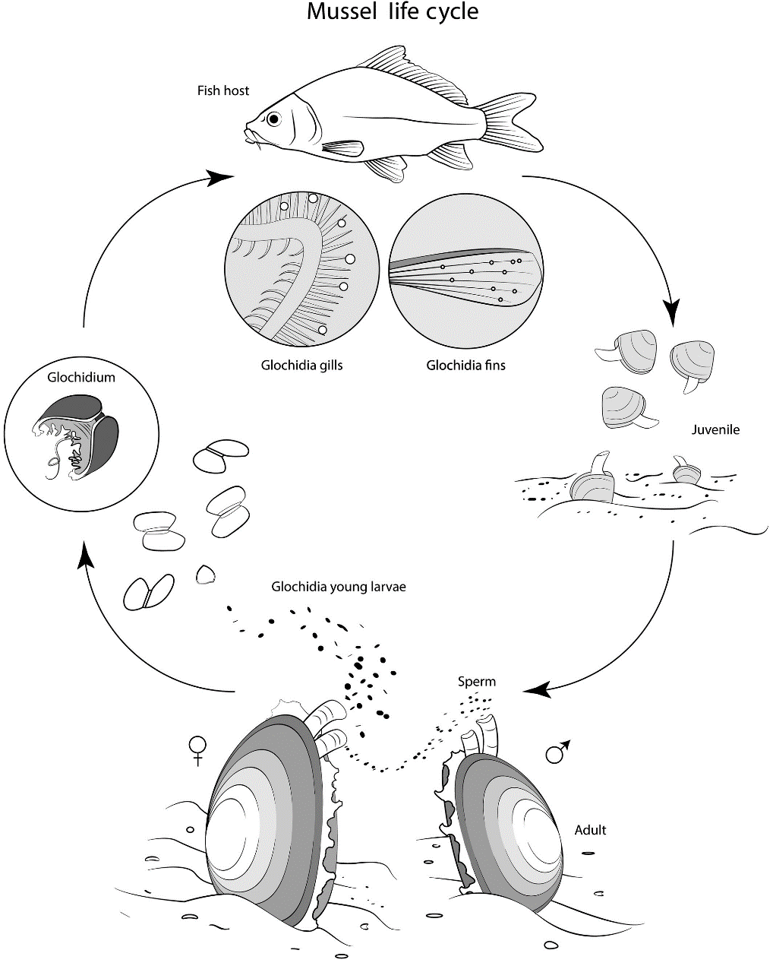
Figure 1-2: General scheme of the freshwater mussels’ life cycle. From Modesto et al. (2018).

Information on specific aspects of life histories of Australian freshwater mussels is limited to a handful of studies conducted over the last 40-50 years, mostly from outside of the MDB (Atkins 1979; Humphrey & Simpson 1985; Jones et al. 1986; Jupiter & Byrne 1997; Widarto 1993; Byrne 1998; Jones 2014; Klunzinger et al. 2012, 2013, 2014; Klunzinger 2020), although host fishes, glochidia morphology and reproductive phenology were elucidated for river and lake populations of V. ambiguus and A. jacksoni from the River Murray by Walker (1981, 2017). In general, Australian freshwater mussels appear to be host fish ‘generalists’ with most fish species (including several introduced species) able to support metamorphosis of glochidia to free-living juvenile mussels; however, some studies have shown introduced carp (Cyprinus carpio) and goldfish (Carassius auratus) consistently rejecting Australian glochidia across a wide geographic range in several species of mussel (Walker 1981; Humphrey & Simpson 1985; Widarto 1993; Klunzinger et al. 2012; Jones 2014). In the Murray-Darling Basin, where common carp now dominate fish communities in many parts of the river, their predominance could present significant recruitment challenges for freshwater mussel populations if they are unable to act as host species.
There are also limited Australian studies on freshwater mussel reproductive biology. Walker (2017) followed the gonadal cycles of both A. jacksoni and V. ambiguus across four years (1982-1986) which included periods of low flow and moderate flooding in the lower River Murray, South Australia. Female A. jacksoni produced glochidia seasonally, brooding embryos in the spring and releasing in the spring and summer. In contrast, female V. ambiguus had glochidia present most of the year with peak releases in spring and summer. The study was undertaken in the lower Murray, at the end of the Murray-Darling Basin where temperatures are very seasonal. In the coastal rivers of southeastern Australia, seasonality in the reproductive cycles of three species of Hydridella and Cucumerunio novaehollandiae has also been observed (Atkins 1979; Jones et al. 1986; Jones 2014). The only other long-term reproductive study of unionids in Australia was for V. angasi in the wet-dry tropics (Humphrey and Simpson, 1985) where spawning was observed year-round with little seasonality. Based on these studies, it is likely that there would be some seasonal signal in reproduction of mussels in the northern Murray-Darling Basin where water temperatures show a seasonal signal, particularly for Alathyria jacksoni.
There is also limited information on the growth of Australian freshwater mussels from metamorphosis to adult, however, most field surveys have noted very few juveniles and small mussels in shoals; whether this is the result of poor recruitment or specific growth patterns is unknown. Some studies of growth in Velesunionine mussels indicate that mussels initially grow rapidly in the first several years of life followed by a rapid tapering of growth (Walker 1981; Humphrey & Simpson 1985; Herath et al. 2019) – this suggests they may be “shooters” (initially grow rapidly and then slow down) with the lack of small mussels in field populations not reflective of poor recruitment. However, this is yet to be verified. A study of growth in A. jacksoni from several locations along the River Murray (Walker 1981) showed that growth and age varied widely in populations over several locations, with adults of over 30 years old evident in some populations. It should be noted that age determination was from analysis of externally visible annuli which can give unreliable estimates of growth in older specimens. Sexual maturity in A. jacksoni is attained at about 4 years age (Walker 2017). The juvenile survival and growth of mussels in the northern Murray-Darling Basin is unknown and represents a large knowledge gap.
Like much of their biology, information on the role of freshwater mussels in riverine foodwebs in Australia is limited. Freshwater mussels are filter feeders, with their feeding action shown to remove seston, bacteria and algae from the water column with varying degrees of clearance rates (particles removed from a volume of water), positively affecting water quality (Vaughn 2018). An Honours study of filtration rates in A. jacksoni as measured in the laboratory, suggested the total mussel population in the lower Ovens River, Victoria, could clear 2.1 ML day⁻¹ and transfer around 10.5 kg of organic material to the sediment (Brouwer 2019). The same study also suggested that increased suspended sediment in the water column had negative impacts on filtration rates. Estimates of filtration rates for A. jacksoni (mean size 94 mm) ranged from 0.03-0.39 L mussel⁻¹ h⁻¹ (Brouwer 2019). How these filtration rates compare to those of mussels in the northern Murray-Darling Basin is unclear, but these results do suggest that large shoals of freshwater mussels in remnant refugial pools likely play a significant role in mediating water quality and reducing phytoplankton biomass.

What do we know about their cultural significance?
Freshwater mussels have a long history of human use in Australia as a food source, in fishing, as tools and in cultural practices. Aboriginal shell middens in the Murray-Darling are comprised primarily of mussel shells, with many snail shells and the remains of other aquatic animals (Mulvaney 1960; Balme & Hope 1990; Garvey 2017). Velesunio ambiguus and Alathyria jacksoni are both common in the middens, with the oldest in the Darling dating back to around 27,000 years ago (Balme 1995; Balme & Hope 1990; Mallen-Cooper & Zampatti 2020), and mussel shell tools from the area date back to up to 50,000 years ago (Weston et al. 2017). They have been an important food item in the past, a reliable food source when other food was scarce (Mulvaney 1960; Aboriginal Victoria 2019). There are references to Aboriginal women digging for mussels in the Darling, cooking mussels on their fires, and using mussels as bait, particularly for cod (Langloh-Parker 1905). It is not clear if mussels are still consumed in the Murray-Darling basin, as lack of access to river areas and poorer water quality are likely limiting factors.
Aboriginal peoples also used mussel shells in the past as scraper tools, for trade, and are still used for art and cultural practices. For example, contemporary Wiradjuri artist Jonathan Jones used mussel shells in his 2018 work untitled (giran) which featured contemporary hand-made tools, including bindu-gaany, freshwater mussel scrapers (Jones 2020). Barkandji artist Badger Bates has also used freshwater mussel shells in his 2018 exhibition Barka, the forgotten river to highlight concerns over impacts of lack of flows on mussels (Volkofsky & Bates 2018). While the cultural significance of mussels has received little attention relative to other aquatic organisms such as fish and turtles, there is evidence of their spiritual significance in complex totemic and kinship systems (Langloh-Parker 1905), and their continued use indicates they remain important to Aboriginal peoples of the Murray-Darling. The concept of ‘river health’ for Aboriginal peoples is multi-faceted, and importantly includes freshwater mussels (DNRME 2019).

Project Significance and Aims
As sedentary, long-lived organisms, obtaining an understanding of the habitat requirements of resident freshwater mussels will provide insights into the natural hydrology of Australia’s inland rivers, and the potential role healthy populations of freshwater mussels could play in influencing water quality through biofiltration. Senior Barkandji have indicated their strong support for research on mussels because there is evidence to suggest mussel abundance in the Barwon-Darling River has declined dramatically in the last two decades, reflecting impacts from water resource development and potentially an increase in flow variability associated with climate change. These conditions have seen a reduction in low and medium flows combined with two serious hydrological droughts, the Millenium Drought (2001-2009) and the more recent drying event of 2017-19. These events have likely placed the freshwater mussels in the Barwon-Darling River in a vulnerable position with impacts on population abundance, this will have significant impacts on river recovery and long-term ecosystem function, and on Aboriginal traditional owners and other community members.
This project was conceived in response to the extensive drought in the northern Murray-Darling Basin between late 2017 and early 2020 (referred to in the remainder of this report as 2017-2019) and the reports of extensive mussel mortality. The specific aims were to:
- Review existing knowledge and identify knowledge gaps in relation to environmental water requirements, life history, physiological tolerances and habitat requirements and cultural significance of freshwater mussels in the Murray-Darling Basin
- Improve baseline understanding of distribution and structure of freshwater mussels in the Northern Basin is covered by:
  - generating a predictive model to get provide a better understanding of distribution and environmental preferences for the endemic mussel of the MDB, Alathyria jacksoni;
  - conducting a broad-scale survey across Barwon-Darling and its major northern tributaries (Macintyre, Gwydir, Namoi and Macquarie rivers) to establish current distributions of the three known species A.jacksoni, A. condola and V. ambiguus within main channel habitats, and
  - assessing the impact of the drying event of 2017-2019 on these populations.
- Make recommendations for land and water management

Methods

Predictive model methods
Predictive models can assist in explaining the factors that are driving the distribution of a species. Freshwater mussel populations appear to be declining in the Murray-Darling Basin, yet there is significant uncertainty around their specific threats and needs. By building a model using all known occurrences for mussel species and linking their presence to environmental data, we can identify the most important environmental factors associated with known mussel distribution, and predict the likelihood of them occurring in a given area based on its environmental attributes. From this we can make deductions about what threatening processes may influence their populations on a landscape-scale.
Boosted regression trees (BRT) are a robust method of modelling species distribution; the method has been used to model aquatic species distributions in Australia (Elith et al. 2008; Rose et al. 2016) and internationally (Cerasoli et al. 2017; Murray-Stoker and Murray-Stoker 2020). It combines two types of algorithms: regression trees and boosting. Regression links a response to a predictor variable, but tends to be oversimplistic for complex ecological data. Boosting is a method of combining many simple models (regressions) in a step-wise fashion to give more accurate predictions for ecological data, which overcomes the limitations of regression alone (Elith et al. 2008).
The focus species of the distribution model was A. jacksoni, given its endemic status in the Murray-Darling Basin and the significant reduction in abundances as a result of the recent drought. Though the focus of this project is the northern Murray-Darling Basin, data from the entire Murray-Darling Basin has been included to ensure model robustness and make the best use of the limited number of available data.
Data Collation
Data were sourced from online museum databases, Atlas of Living Australia (ALA 2020), which includes Online Zoological Collections of Australian Museums (OZCAM), and from MUSSELp (Graf & Cummings 2020). Unpublished data were also contributed by Dr Hugh Jones (NSW Department of Planning, Industry and Environment), Associate Professor Paul Humphries and Dr Nicole McCasker (Charles Sturt University) and Dr Michael Klunzinger (Griffith University). Museum data were checked to confirm species identification where photographs were provided. All data were checked to ensure coordinates and geographical locations given were located on or adjacent to waterways.
The presence data spans from the late 1800s through to 2020, though sampling effort has been much higher since the 1950s and spiked between 2000-2009 (Figure 2-1). Presence data had good geographical coverage of the Basin, though some northern tributaries, e.g. the Condamine, and much of the southern basin have not been sampled within the last decade (Figure 2-2). Presence records for 203 unique ‘sites’ were included for A. jacksoni. As presence-absence data is desirable in building BRT models, other mussel taxa records were included as ‘pseudo-absences’, including 266 records for V. ambiguus and 18 records for A. condola. These provide suitable proxies for absence data where true absence data are limited or not available (Elith et al. 2008; Cerasoli et al. 2017). Each presence record was allocated a reach code using Geofabric, the national stream and nested catchment framework (Stein et al. 2014). Where there were multiple records in different years in the same stream reach or segment, the most recent presence record was retained for input into the model.

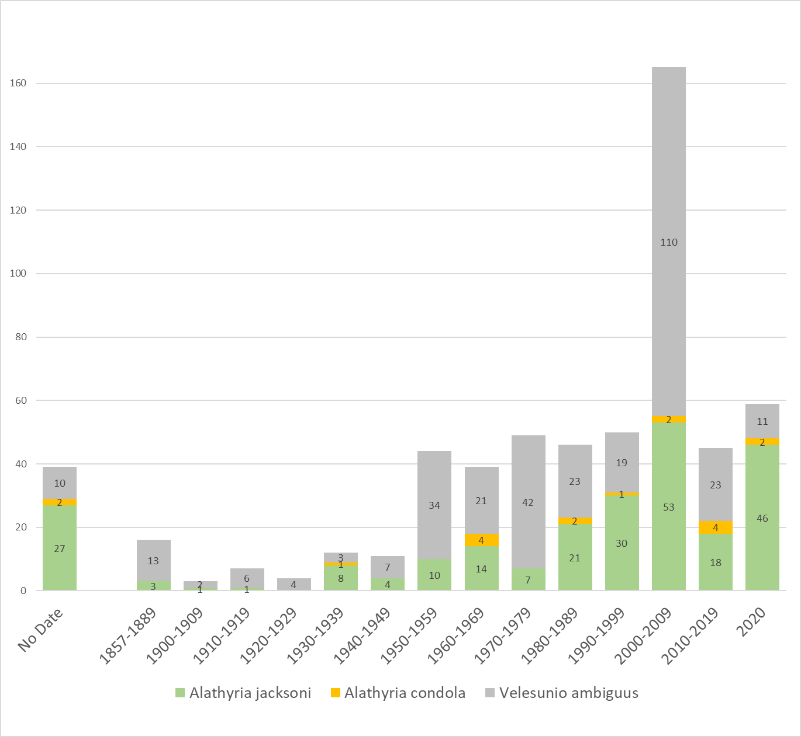
Figure 2-1: Frequency of mussel records in the Murray Darling basin for A. jacksoni, A. condola and V. ambiguus
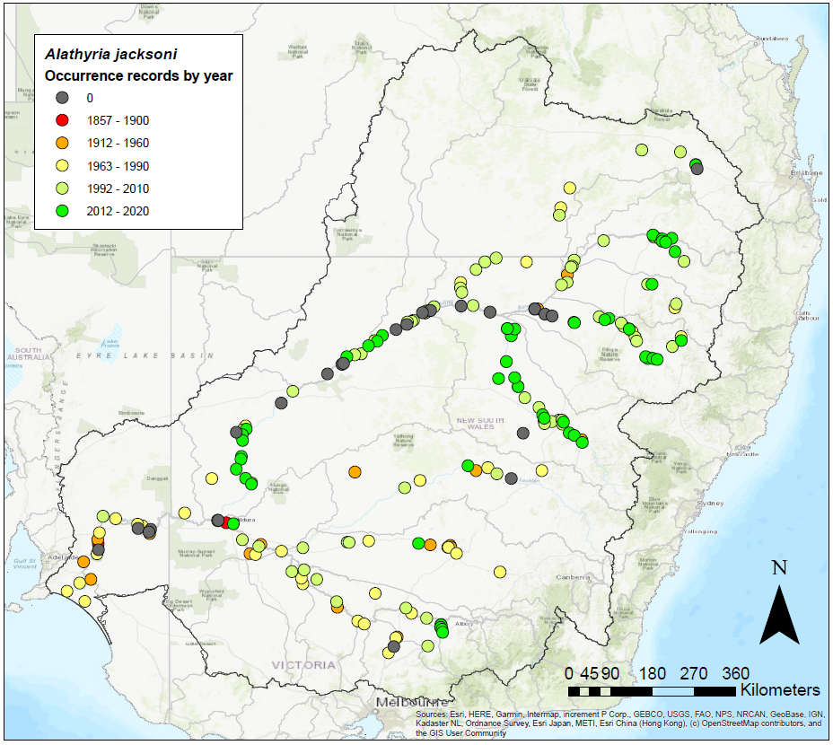
Figure 2-2: Spatial distribution of A. jacksoni occurrence records in the Murray Darling Basin used for development of species distribution model (0 = no date for that record).

Environmental predictor variables
A broad range of environmental predictor variables was selected from Geofabric (Stein et al. 2014) on the basis of those that were likely to be ecologically relevant to mussels. Variables were selected as those relating to terrain, climate, vegetation, substrate, primary productivity, catchment connectivity and disturbance (Table 2-1). Selected variables were assessed for correlations to avoid duplication (Pearson’s r < 0.7).
The model outputs then enabled the prediction of likely spatial occurrence of A. jacksoni across the basin, based on the predictors (important environmental attributes) identified by the BRT model, combined with the database of environmental attributes within the stream and nested catchment framework (Stein et al. 2014).

Table 2-1: Environmental attributes used as predictor variables in the BRT model (Stein et al. 2014).
Code | Definition | Units
Terrain
STRELEMEAN | Mean segment elevation | m
CATAREA | Catchment Area | km²
CATRELIEF | Catchment relief
RELIEFRATIO | Catchment relief ratio
CONFINEMENT | Indicator of valley confinement | %
DOWNMAXSLP | Maximum slope in downstream flow path | %
D2OUTLET | Distance to outlet | km
CATSLOPE | Catchment average slope | °
CATSTORAGE | Catchment storage | %
STRAHLER | Strahler stream order
Climate
STRANNRAD | Stream and environs annual mean solar radiation | MJ/m²/day
STRANNTEMP | Stream and environs annual mean temperature | °C
STRANNRAIN | Stream and environs average annual mean rainfall | mm
SUBEROSIVITY | Sub-catchment average rainfall erosivity R factor | (MJ mm)/(ha hr yr)
Vegetation (extant)
STRSHRUBS | Stream and valley percentage extant shrub cover | %
STRWOODLANDS | Stream and valley percentage extant woodland cover | %
STRGRASSES | Stream and valley percentage extant grasses cover | %
STRFORESTS | Stream and valley percentage extant forests cover | %
Substrate
CAT-SOLPAWHC | Catchment average Solum Plant Available Water Holding Capacity | mm
STR-KSAT | Stream and valley average saturated hydraulic conductivity | mm/h
STR-CLAYA | Stream and valley average percent clay in the soil A horizon | %
STR-CLAYB | Stream and valley average percent clay in the soil B horizon | %
STR-SANDA | Stream and valley average percent sand in the soil A horizon | %
STR-UNCONSOLDTED | Stream and valley percentage unconsolidated rocks | %
STR-SILICSED | Stream and valley percentage siliciclastic/undifferentiated sedimentary rocks | %
Net Primary Productivity
NPPBASEANN | Annual mean Net Primary Productivity (Raupach et al. 2002) | tC/ha
Network
STRDENSITY | Stream density | km/km²
Connectivity
DISTUPDAMW | Maximum barrier free flow path length upstream (dam walls, spillways or large dams) | km
D2DAMWALL | Unrestricted (no dam walls, spillways or large dams) distance downstream | km
Disturbance
CDI | Catchment Disturbance Index (Stein et al. 2002) | Dimensionless
FRDI | Flow Regime Disturbance Index (Stein et al. 2002) | Dimensionless

Boosted Regression Tree Model
Using ArcMap 10, the presence-absence locations were intersected with the selected ecologically relevant predictor variables from Geofabric (Stein et al. 2014). These data were built into a model using boosted regression tree techniques in the R package ‘dismo’ (Hijmans & Elith 2017). A random subset of data was used to train the model, and remaining data used to evaluate the model performance. Model performance was assessed with built-in evaluation statistics generated with the ‘SDMTools’ package in R. A step-wise process of simplifying the model by removing unimportant variables was done using the ‘gbm.step’ package in R. The most important predictor variables were then able to be identified in the model outputs.

Hydrological analysis
To better understand the context of the 2017-2019 drought compared with the background hydrology of the northern Murray-Darling Basin rivers over the last 40 years, daily river discharge data were obtained from a number of gauging stations within the MacIntyre, Gwydir, Namoi, Macquarie and Barwon-Darling Rivers for the maximum period 1 Jan 1980 – 1 June 2020 (Table 2-2) note the length of data varied between gauges) (Table 2-2). Using the time series of daily discharge, we calculated several drought-related hydrologic indices for each of the gauging stations using the R package ‘Hydrostats’ (v.0.2.7 Bond 2019). Specifically, we calculated the timing and duration of all zero-flow spells for the available period of record between 1980 and 2020, for which we defined zero-flow as flows less than 5 ML/day. We used independence criteria in these calculations to allow for up to 20 continuous days of flows >5 ML/day before a zero-flow spell would be considered independent from a previous spell. To compare the hydrological drought conditions during 2017-2019 to the prevailing 40 years, we calculated cease-to-flow (CTF) spell statistics for the period 2018-2020, and then across the 1980-2017 time series. As the onset of the low flow conditions occurred late in 2017 and finished early 2020 the period of 2018-2020 was used to analyse the hydrological signal of the drought. CTF statistics calculated included the proportion of time that cease to flow occurred, mean cease-to-flow duration (days), median cease-to-flow duration (days), and maximum cease to flow duration (days). The variation in the start date for which discharge data was available across the gauges was not seen to impact the assessment of the timing and duration of zero flow spells, therefore, rather than excluding these gauges with incomplete time series, we depict the start of the time series for each flow gauge.

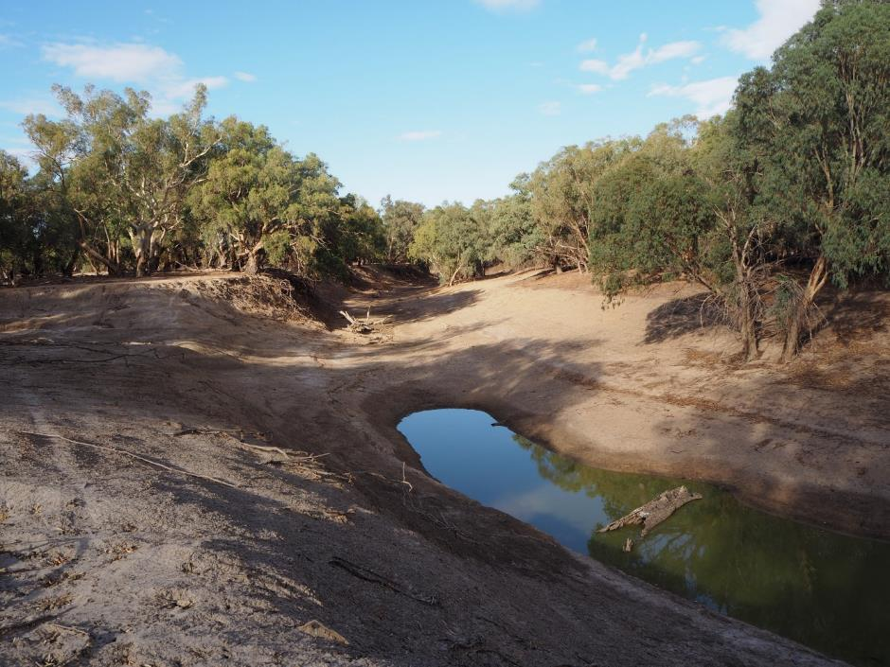
Lower Darling River, DS Menindee, Bono Station, 25 March 2020

Table 2-2: Summary of the 28 gauging stations used to obtain daily river discharge data (ML/day) from the northern Murray-Darling Basin rivers studied for this report. Within each river, gauging stations are ordered upstream to downstream. Data was obtained from waterNSW on 15 September 2020, https://realtimedata.waternsw.com.au/)
River | Gauge no. | Gauge name | Latitude, longitude | Time series start date
MacIntyre | 416068 | Tintot | -29.4216, 150.9822 | 1988-03-18
 | 416010 | Wallangra | -29.2626, 150.8995 | 1980-01-01
 | 416002 | Boggabilla | -28.5895, 150.3622 | 1982-04-23
 | 416047 | Terrewah | -28.6078, 149.8747 | 1985-01-19
 | 416048 | Kanowna | -28.6961, 149.3880 | 1998-03-18
Gwydir | 418026 | downstream Copeton dam | -29.9123, 150.9076 | 1980-01-01
 | 418012 | Pinegrove | -29.8938, 150.6283 | 1980-01-01
 | 418013 | Gravesend road bridge | -29.5819, 150.3666 | 1980-01-01
 | 418042 | downstream Tareelaroi weir | -29.4472, 150.0336 | 1980-01-01
 | 418053 | Brageen crossing | -29.3973, 149.5465 | 1982-10-23
Namoi | 419007 | Downstream Keepit dam | -30.8912, 150.4961 | 1980-01-01
 | 419001 | Gunnedah | -30.9720, 150.2556 | 1980-01-01
 | 419012 | Boggabri | -28.5895, 150.3622 | 1980-01-01
 | 419021 | Bugilbone (Riverview) | -30.2735, 148.8208 | 1980-01-01
 | 419091 | upstream Walgett | -30.0278, 148.1537 | 1998-08-02
Macquarie | 421040 | Downstream Burrendong dam | -32.6332, 149.0811 | 1980-01-01
 | 421031 | Gin Gin | -31.9082, 148.0910 | 1980-01-02
 | 421004 | Warren weir | -31.7350, 147.8668 | 1980-01-01
 | 421022 | Oxley station | -31.1175, 147.5693 | 1980-01-01
 | 421135 | Miltara | -30.5602, 147.5970 | 1989-11-03
Barwon | 422003 | Collarenebri main channel | -29.5471, 148.5761 | 1980-11-01
 | 422001 | Dangar bridge (Walgett) | -30.0153, 148.0607 | 1980-01-01
 | 422002 | Brewarrina | -29.9472, 146.8637 | 1980-01-01
Darling | 425003 | Bourke Town | -30.0879, 145.9367 | 1980-01-01
 | 425004 | Louth | -30.5347, 145.1150 | 1980-01-01
 | 425900 | Tilpa | -30.9344, 144.4188 | 1995-05-11
Lower Darling | 425012 | Menindee u/s weir 32 | -32.4353, 142.3799 | 1980-01-01
 | 425005 | Pooncarie | -33.3864, 142.5678 | 1980-01-01

Mussel survey methods

Site selection
One hundred and fifty (150) random sites were initially identified across the northern MDB as potential locations for surveys of mussel populations. The position of these randomly selected sites was used to guide the selection of sampling sites, of which the Macinytre, Gwydir, Namoi, Macquarie and Barwon-Darling Rivers were targeted (Figure 2-3). Of the 150 sites identified as potential survey locations, 90 were visited between February – July 2020. Sites were limited to those that were downstream of the major tributary storages, and upstream of the influence of the Murray on the Darling River (i.e. upstream of Pooncarie). Each sample ‘site’ consisted of a 500 m reach.
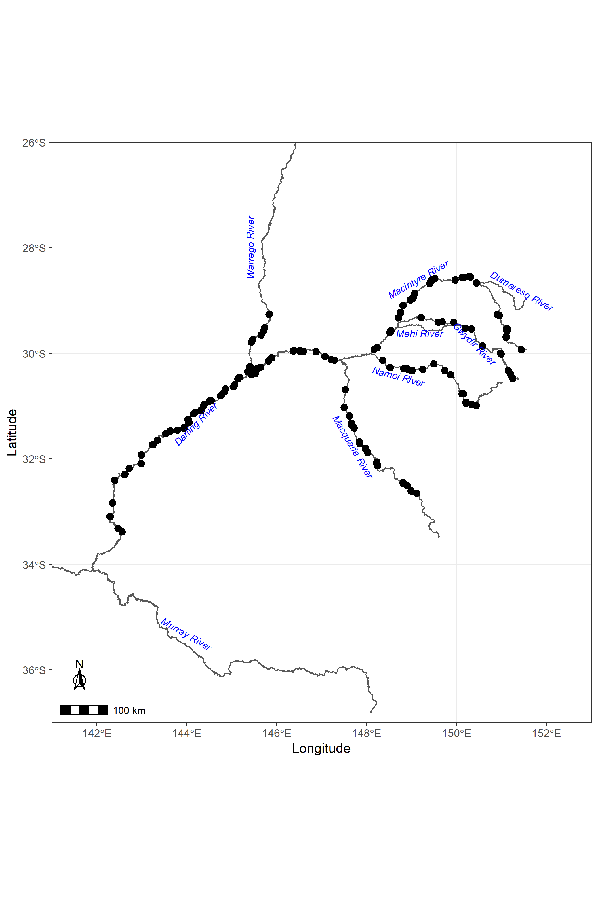
Figure 2-3: Random survey points to be targeted for surveys of freshwater mussels in the northern Murray-Darling Basin.

Site description
At each site a description of the reach was compiled. This included recording the Site ID, date and time of sampling, and the GPS location of the upstream and downstream ends of the reach. Along the 500 m reach the following features were noted: natural features (such as rocky outcrops, snags etc), presence of dead mussels on the dry riverbanks, presence of any dense shoals of mussels and estimation of the river width at about 3 or 4 places. If water was present an estimate of the approximate surface area of the pool(s) was made by estimating the width and length. A rough sketch of the reach with features marked was made.
Qualitative descriptions were also made of several reach features. The extent of riparian vegetation was assessed using a rank score from 0-5 (0 = no riparian trees at a site, 1-2 = individual trees with lots of gaps; 3-4 = close trees but not thick; 5 = continuous riparian cover along the reach), the dominant riparian form was noted (e.g. Eucalypt, willow, acacia). Substrate was also assessed using percentage across the substrate categories of ‘silt’, ‘sand’, ‘cobble’ and ‘gravel’. The extent of in-channel woody debris was also assessed using a rank score from 0-5 (0 = no snags in a reach, 1-2 = sparsely placed snags; 3-4 = moderately dense; 5 = very dense woody debris). The position of mussel shells was also noted with respect to the position of channel bends and benches.

Mussel surveys
Assessment of mussel populations at the 90 sites took place between February and July 2020. The timing of surveys coincided with the onset of a La Niña event. This resulted in above average rainfall and the resumption of flows down the northern Basin tributaries and Barwon-Darling River for the first time since 2017. Consequently, initial methods for assessing mussel populations on primarily dry riverbeds had to be adapted to allow for the variety of flowing conditions encountered across the sampling period. The range of survey methods used could be categorised into five main survey types (Table 2-3).
Quantitative assessments
At sites that were either characterised by either having a dry river bed (where water refugia may or may not have still been present), or the presence of a base flow that was wadable throughout, quantitative methods were used to estimate the number of mussels present within the 500 m reach for each species, and the proportion that were alive vs dead. Where the survey reach was dry, all exposed shells throughout the entire 500 m reach were identified and counted. If water holes were present in these same reaches, mussels were counted where water was wadable, and recorded as live or dead. The proportion of reach that consisted of water holes also estimated (Table 2-3, survey type 1a). Species were identified following conchology of McMichael & Hiscock (1958) and taxonomy of Walker et al. (2014).
Where wadable, base flows or extensive shallow pools were present throughout a survey reach, we assessed mussel population using transect surveys (Table 2-3, survey type 1b). There were two types of transect surveys that we were able to deploy. For the first approach, five equally spaced transects spanning the river were sampled. Two 1 x 1 m quadrats were placed side by side along the transect line and progressively moved across the channel (continuously) as sampling progressed so that a 2 m wide belt transect was sampled. This set of 5 transects formed a primary unit in systematic sampling and each transect was termed a secondary unit. The numbers of mussels were summed for the secondary units, giving a single total count for each primary unit. Three primary units, each placed at a random starting point between 0-100 m of the downstream end of the reach were deployed. For the second approach, this method was simplified and between 10-15 transects (0.5 wide) positioned perpendicular to the riverbank were conducted throughout a 500m reach, with mussels identified, counted, and recorded as either alive or dead. In total there were 21 sites across the northern Murray-Darling Basin for which quantitative data was collected.
Rapid assessments
Where flows were present at the survey sites when visited, we used rapid assessment approaches to characterise the physical attributes of the reach, while walking the exposed part of the river to look for evidence of mussel shells or shell fragments. While we were not able to quantify the number of live and dead mussels at these sites, we were still able to collect valuable presence/absence data for the three target species using this approach. There were three variations in rapid assessments conducted depending on river height levels. For sites where the river was flowing, but wadable sections of the river were still present, we searched the riverbank slopes and bank tops for mussel shells, and if mussel shells were found, we conducted rapid surveys with wadable parts of the river, to search for evidence of live mussels either using timed searches (up to 20 mins), random quadrats (up to 15 x m²) or waded along the river's edge (1-2 m band up to 100 m long) (Table 2-3, survey type 2). If no mussels were observed on either the dry riverbank or within quadrats in remnant pools it was assumed none were present at the site. When river flow restricted access to viewing riverbed, and water levels were too high to allow water searches to take place, riverbanks and tops of bank searched for mussel shells as an indication of their presence/absence at a site (survey type 3). In some instances, river heights were >¾ bankfull, and therefore only the very top of banks could be searched for evidence of mussels (survey type 4). Of the 90 sites visited, 16 of these when visited could not be accessed, either due to wet weather access issues, or flows too high to permit any rapid assessment taking place. In total, there were 53 sites across the northern Murray-Darling Basin for which rapid assessments were conducted.

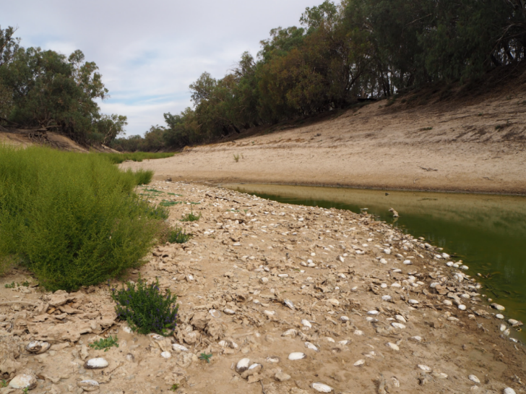
Lower Darling River, downstream of Menindee. Appin Station, 24 March 2020.
Large shoal of A. jacksoni. Live A. jacksoni were found persisting in the water hole pictured.

Table 2-3: Summary of the survey methods employed across the study reaches. Survey methods were adapted to the flow conditions present at the site at the time of the survey.
Survey code | Flow conditions | Survey Type | Description | Sites surveyed
1a | Dry channel | Quantitative assessment | Survey reach was dry, and all exposed shells throughout the reach were counted. If water holes present, mussels were counted where water was wadable and recorded as live or dead. Proportion of reach that consisted of water holes calculated. | 10
1b | Base flow present, wadable throughout | Quantitative assessment | Water present throughout the survey reach, but water levels low enough to allow transect surveys to be conducted. Here, belt transects (0.5-1m wide) positioned perpendicular to the river bank were carried out, mussels were counted and recorded as live or dead. | 11
2 | Flow present, only river edges wadable | rapid assessment | Riverbank slopes and bank tops searched, rapid surveys look in the wadable areas, either using i) timed search or ii) random quadrats or iii) section of the river's edge was searched where permitted. | 31
3 | Flows present | rapid assessment | flow restricted access to viewing riverbed, but river banks and tops of bank searched. Water levels too high to allow water searches to take place. | 11
4 | Flows present | rapid assessment | High flows restricted access to river bed and bank slopes, only top of banks could be searched for evidence of mussels. Water searches not conducted. (>3/4 bank full). Water levels too high to allow water searches to take place. | 11
5 | Flows present | Could not be assessed | Survey reach could not be assessed, either restricted access to water levels too high. | 16

Population and mortality estimates
Abundance and mortality estimates were calculated for Alathyria jacksoni at the 21 sites for which quantitative data was collected. Neither abundance nor mortality estimates were calculated for Alathyria condola and Velesunio ambiguus due to their absence or low abundance at these sites. For sites assessed using dry river bed counts (survey type 1a,1b), the total number of mussels counted was expressed as total abundance of mussels in the 500 m reach, with the proportion of live to dead mussels calculated. For sites surveyed using transects, estimates of the number of A. jacksoni within a 500 m reach was scaled up based on the proportion of reach area sampled. Here, individual transects were treated as replicates, and so estimates of total mussel abundance and percent mortality were calculated with 95 % confidence intervals. As no estimate of the population size of A. jacksoni has been reported to date, we used these estimates to calculate the potential size of the A. jacksoni population along the length of the Barwon-Darling River prior to the 2018-20 drought by multiplying the mean number of mussels (live + dead) per 500 m reach by the number of river km between Walgett (Barwon River) and Pooncarie (Lower Darling). Using the mean mortality estimate derived across the 21 sites surveyed quantitatively, we then estimated the size of the surviving population in the Barwon-Darling post 2017-2019 drought.

Size frequency
To better understand the population structure of northern Murray-Darling Basin mussels, live and sham (empty shells) freshwater mussels (Unionida: Hyriidae) were hand collected from riverbanks and submerged habitats to a maximum water depth of 1 m or less during the study period. Where possible, we retained a minimum sample size of 30 shells (either whole or individual valves). Samples were retained in sealed, labelled plastic bags and transported to the laboratory for measurement. Shells were measured to the nearest 0.10 mm using digital callipers for maximum length (ML), maximum height (MH) and width (W) following Walker (1981), Jones (2007), Klunzinger et al. (2014) and Sheldon (2017), as shown in Figure 2-4.

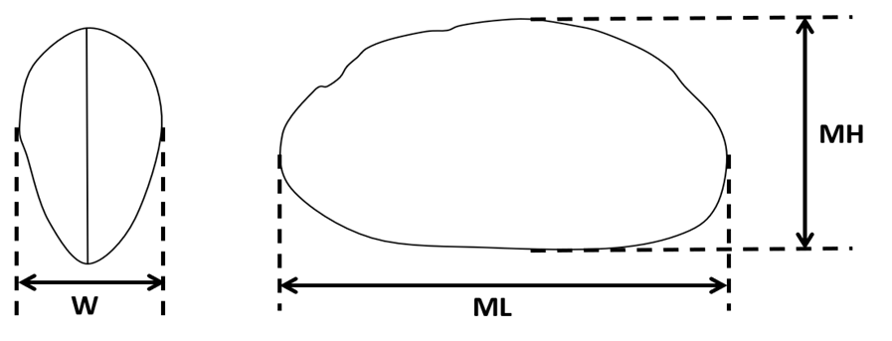
Figure 2-4: Diagram of freshwater mussel shell measurements taken on collections of live and sham mussels in the northern Murray-Darling Basin: Maximum length (ML), maximum height (MH) and width (W).

Results

Predictive model of mussel distribution in the northern Murray-Darling Basin
The boosted regression tree model (BRT model) developed using all available data for A. jacksoni achieved acceptable results with cross-validation diagnostic tests. BRT model diagnostics showed:
Cross-validated deviance = 0.855 ± 0.055 (s.e.)
Cross-validated correlation = 0.676 ± 0.031 (s.e.)
Cross-validated AUC = 0.879 ± 0.016 (s.e.)
This means that the deviance (error within the model) was relatively low, model ‘fit’ was high when cross-validated with a subset of data, and comparable to other studies using BRT for ecological applications (Cerasoli et al. 2017).
For the BRT model with the best fit, the most influential environmental attributes were catchment area (CATAREA, 25.40%), average catchment slope (CATSLOPE, 9.90%) and average saturated hydraulic conductivity (STR_A_KSAT, 5.35%) (Figure 3-1). Catchment area was related to runoff and water availability, suggesting A. jacksoni tends to occur in streams with catchments above a certain size. Average catchment slope reflects position within the catchment, meaning A. jacksoni is associated with particular parts of the catchment. Saturated hydraulic conductivity is also likely related to availability and permanence of water, with A. jacksoni presence being more likely in areas of catchments with lower hydraulic conductivity. These are also associated with the slow-draining finer sediments of the mid to lowland areas, whereas the upland catchment areas tend to have coarser gravel/cobble substrates that drain faster and also have smaller catchment areas, making water levels more variable. The model also identified that annual average primary production (NPPBASEANN, 4%), average stream elevation (STRELEMEAN, 4%), catchment relief (CATFELIEF, 3%) and stream forest cover (STRFORESTS, 3%) had some influence on model results. These attributes, like average catchment slope, also relate to position within the catchment, again reflecting that A. jacksoni is associated with mid to lowland areas. The weak association with annual average primary productivity (NPPBASEANN) may reflect a relationship with food availability, as it is a broad measure of net plant photosynthesis (Stein et al. 2016), however this variable is also associated with rainfall, and may too reflect the importance of water availability. The association with stream forest cover (STRFORESTS), which is the stream and valley percentage of natural forest cover, may indicate an association with stream shading and better water quality.

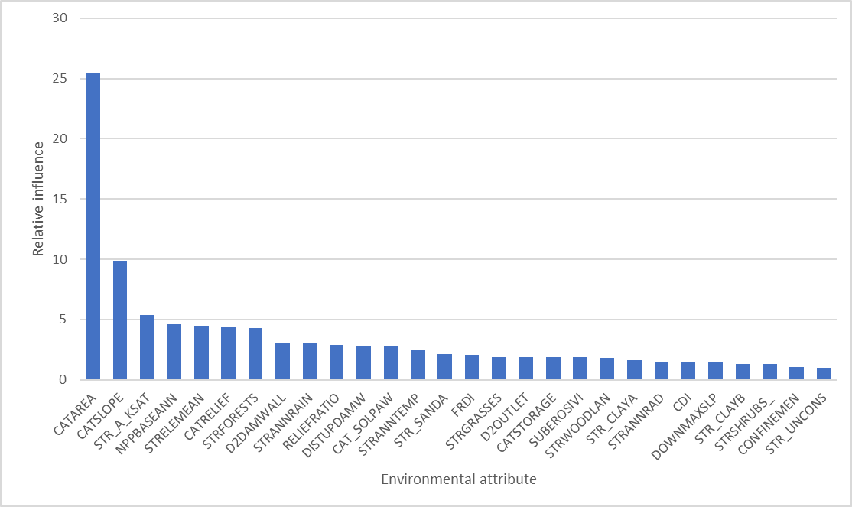
Figure 3-1: Relative influence of environmental attributes in predicting presence of A. jacksoni in the Murray-Darling Basin, as identified by BRT model.

The areas predicted to be highly likely (>0.75) to be inhabited by A. jacksoni are concentrated in the perennial river channels, extending upstream into many of the tributaries (Figure 3-2). This generally aligns well with the distribution of the existing records, which are overlaid on the predictions in Figure 3-2, and with current understanding that this species prefers flowing riverine waters over still, backwater or wetland areas. The more recent records (displayed in green) highlight that many areas in the northern Basin have not been sampled in the last 20 years, including some parts of the Macintyre, Namoi and Darling rivers that have very high likelihood of A. jacksoni occurring. There are also parts of the Darling River that have never been sampled with very high likelihood of A. jacksoni occurring. An additional map of predictions without presence records is included in 7.4 Appendix 4.
The key areas of high likelihood for A. jacksoni presence in the northern Basin are:
- The majority of the Darling River from the junction of the Macquarie to around Pooncarie, with downstream of Menindee lakes being a particular hotspot;
- The mid to upper parts of the Macquarie River;
- The majority of the Namoi River;
- Upper sections of the Gwydir River;
- Macintyre River upstream and downstream of Goondiwindi;
- Dumaresq River; and
- Some lower parts of the Culgoa River.
There are a small number of presence records in the upper tributaries that occur in areas this model predicts low probability (<0.25) of occurrence. This suggests that although the environmental factors in this area are not strongly associated with A. jacksoni presence, they evidently can occur in these areas at times when conditions have been suitable. It is not currently clear what factors determine presence of this species in the upper tributaries, aside from continuous water availability and connectivity for suitable fish hosts.
Similarly, the likelihood of A. jacksoni occurring in the lowland lake areas close to the mouth of the river has a low to moderate probability (0.25-0.35), which is consistent with our understanding of this species preferring flowing riverine waters over still and wetland areas. There are a small number of records from this area from the 1980s, indicating they can survive in lacustrine environments at times while suitable conditions persist, but this probably doesn’t constitute a breeding population. This area was formerly estuarine, but the installation of several barrages between 1935-1940 (MDBA 2021) separating Lake Alexandrina from the Coorong has maintained fresh waters in the lakes, which likely makes is possible for A. jacksoni to persist in these areas, though they have not been targeted for sampling in more recent decades.
As most (>80%) presence records for A. jacksoni were collected in the last 70 years, it is noted the model results may have some bias towards the distribution of mussels following the development of water-infrastructure or other major changes to catchments prior to the 1950s. As such the model results likely do not reflect pre-development conditions, but instead reflect the likely suitable habitat extent under average conditions experienced over the last several decades. A. jacksoni has a widespread distribution within the Basin, and does not appear to have had a substantial reduction in spatial distribution in recent years based on historical and more recent records (Figure 2-2). The model results can be interpreted as broad catchment or landscape-scale indicators for probable A. jacksoni occurring in the suitable habitat areas within those river reaches.
While this model does not predict abundances, high abundances of A. jacksoni are more likely to be in the areas with highest probability of occurrence, such as in many parts of the Darling River, particularly downstream of Menindee Lakes. Their broad spatial distribution may be important in ensuring the species is able to recover from unfavourable periods, increasing the chances of enough individuals surviving in catchments with sufficient water to enable repopulation elsewhere.
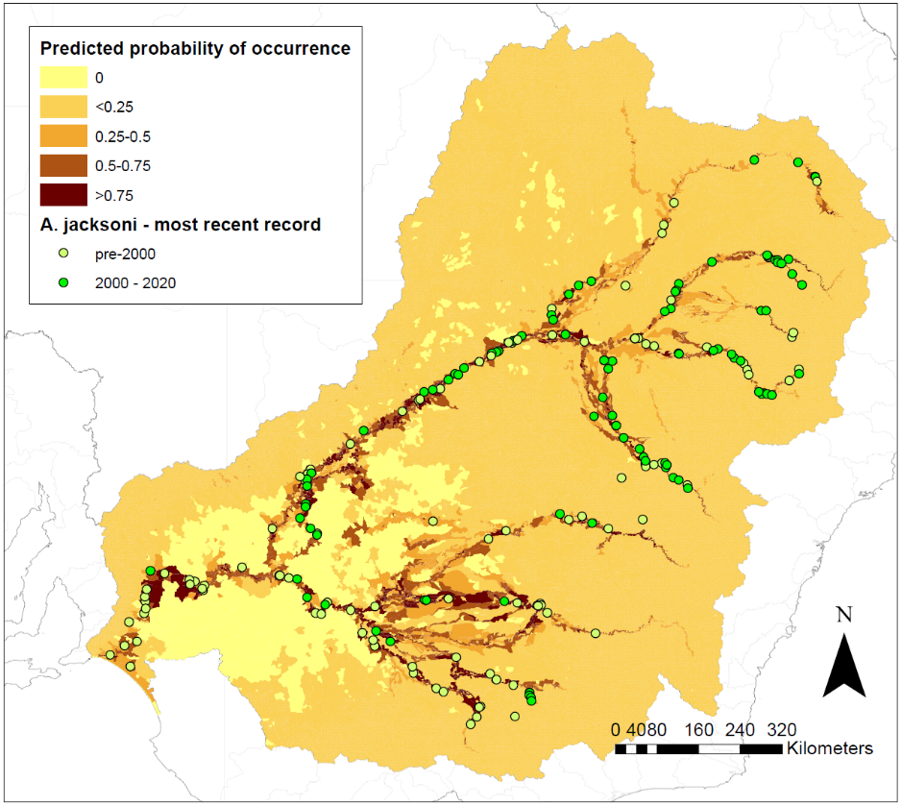
Figure 3-2: Predicted probability of occurrence for A. jacksoni in the Murray-Darling Basin, derived from the BRT model. Presence records for A. jacksoni that were used in the model are indicated by circles.

Hydrological setting of the northern Murray-Darling Basin
To understand the nature of the 2017-2019 hydrological drought in the northern Murray-Darling Basin the low flow conditions for the period 2018-2020 were compared with the previous 37 year period (1980-2017) (Table 3-1). As the onset of the low flow conditions occurred late in 2017 and finished early 2020 the period of 2018-2020 was used to analyse the hydrological signal of the drought. At nearly all gauges the duration of CTF in the hydrological drought of 2018-2020 was longer, sometimes more than double the duration, of the maximum CTF length for the preceeding 37 years. Interestingly the lower gauges on the tributary rivers and the gauges on the Barwon-Darling had the greatest difference; for example the maximum CTF duration at Bourke over the 37 year period (1980-2017) was 200 days compared with 450 days in the 2018-2020 hydrological drought (Table 3-1). These durations are depicted graphically in Figure 3-3.

Table 3-1: Cease to flow (CTF) duration (days), comparing the current 2018-2020 hydrological drought to long-term preceding conditions (1980-2017). Daily time series data was obtained from waterNSW on 15 September 2020, https://realtimedata.waternsw.com.au/)
 |  | 1980-2017 |  |  |  | 2018-2020
River | Gauge | % CTF | Mean CTF | Median CTF | Max CTF | Max CTF
Macintyre River | TINTOT | 0.2093 | 26 | 7 | 128 | 402
Macintyre River | WALLANGRA | 0.2169 | 32 | 16 | 150 | 458
Macintyre River | BOGGABILLA | 0.0295 | 9 | 4 | 59 | 127
Macintyre River | TERREWAH | 0.0383 | 17 | 7 | 82 | 245
Macintyre River | KANOWNA | 0.0778 | 16 | 7 | 190 | 228
Gwydir River | D/S COPETON DAM | 0.0004 | 2 | 2 | 3 | 0
Gwydir River | PINEGROVE | 0.0000 | 0 | 0 | 0 | 0
Gwydir River | GRAVESEND ROAD BRIDGE | 0.0002 | 3 | 3 | 3 | 9
Gwydir River | D/S TAREELAR0I WEIR | 0.0111 | 5 | 3 | 39 | 59
Gwydir River | BRAGEEN CROSSING | 0.0991 | 9 | 4 | 89 | 127
Namoi River | DOWNSTREAM KEEPIT DAM | 0.1372 | 12 | 5 | 168 | 455
Namoi River | GUNNEDAH | 0.0575 | 13 | 8 | 66 | 280
Namoi River | BOGGABRI | 0.0802 | 19 | 10 | 77 | 272
Namoi River | BUGILBONE (RIVERVIEW) | 0.1151 | 20 | 6 | 147 | 275
Namoi River | U/S WALGETT | 0.2885 | 24 | 7 | 187 | 378
Macquarie River | D/S BURRENDONG DAM | 0.0003 | 4 | 4 | 4 | 0
Macquarie River | GIN GIN | 0.0070 | 4 | 2 | 23 | 0
Macquarie River | WARREN WEIR | 0.0040 | 2 | 2 | 11 | 130
Macquarie River | OXLEY STATION | 0.0417 | 7 | 3 | 76 | 184
Macquarie River | MILTARA | 0.1858 | 20 | 6 | 207 | 307
Barwon River | COLLARENEBRI MAIN CHANNEL | 0.0773 | 19 | 6 | 174 | 194
Barwon River | DANGAR BRIDGE (WALGETT) | 0.0785 | 31 | 17 | 170 | 341
Barwon River | BREWARRINA | 0.0138 | 32 | 16 | 114 | 196
Darling River | BOURKE TOWN | 0.0786 | 32 | 5 | 200 | 450
Darling River | LOUTH | 0.1410 | 36 | 16 | 248 | 261
Darling River | TILPA | 0.1338 | 40 | 13 | 250 | 264
Lower Darling River | MENINDEE U/S WEIR 32 | 0.0233 | 39 | 33 | 78 | 406
Lower Darling River | POONCARIE | 0.0380 | 48 | 24 | 213 | 438

(a)
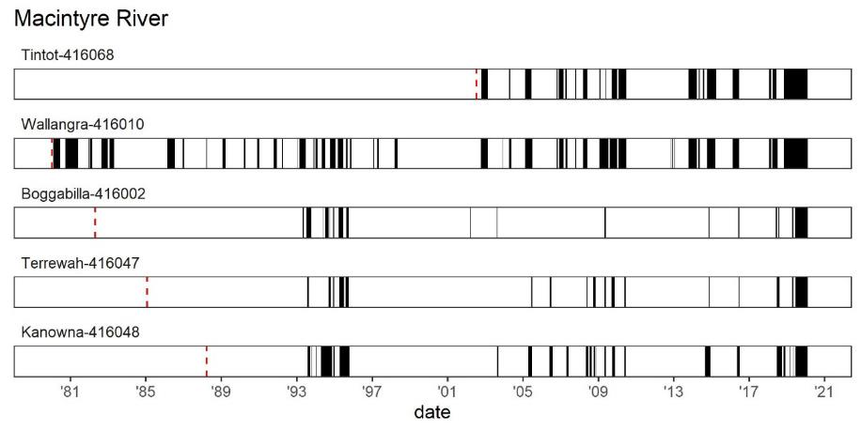
(b)
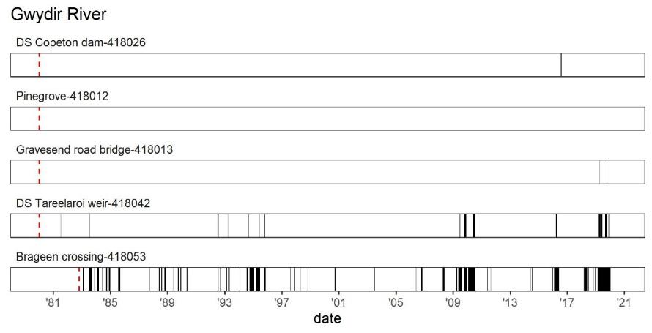

(c)
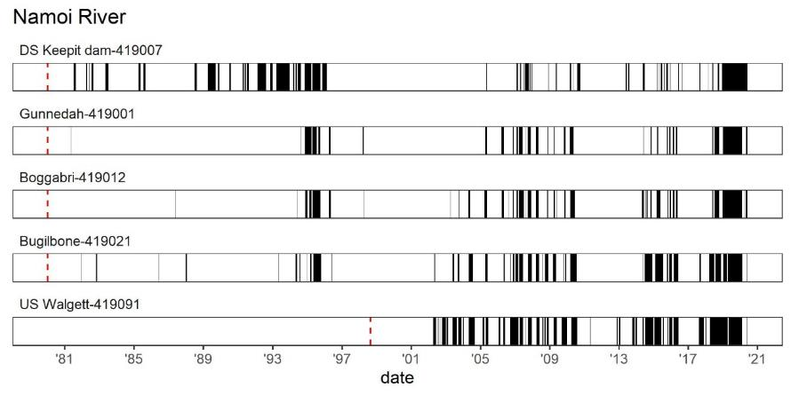
(d)
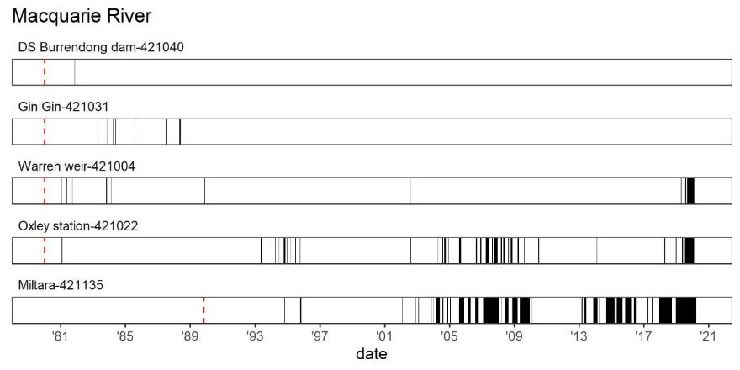
(e)
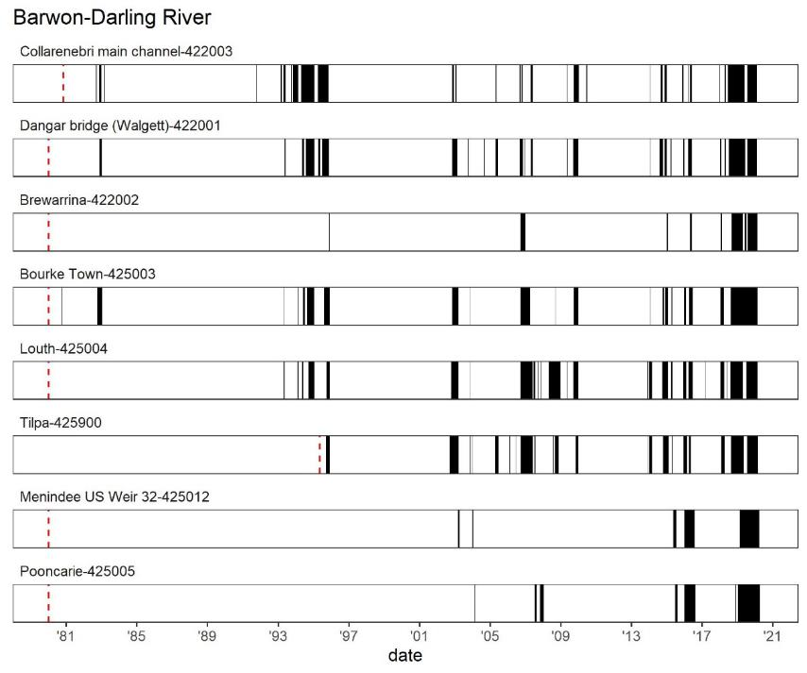
Figure 3-3: Graphical representations of the cease to flow (CTF) data for gauges in the tributaries (a) Macintyre River, (b) Gwydir River, (c) Namoi River, (d) Macquarie River and (e) the Barwon-Darling River. Black lines denote the CTF events and durations. Red dashed line denotes the start of the daily discharge time series.

Presence – absence of mussels across the northern Murray-Darling Basin 2020
Of the 90 sampled sites (see Appendix 7.2), 53 contained evidence of freshwater mussels, as observed as either the presence of shells, or live mussels. Three species were dectected, Velesunio ambiguus, Alathyria jacksoni and Alathyria condola. Alathyria condola (either as live or as empty shells) were detected at 3 sites (Figure 3-5a; Table 3-2), while Alathyria jacksoni were detected 45 sites (Figure 3-5b; Table 3-2), and Velesunio ambiguus at 17 sites (Figure 3-5c; Table 3-2).
There was evidence of A. jacksoni in reasonable abundance in all rivers except the Gwydir and Macintyre. In these two systems evidence of V. ambiguus was more obvious (Appendix 7.3). Despite the evidence of A. jacksoni throughout most tributaries most records were of deceased mussels and at no site were only live mussels observed. The greatest abundance of A. jacksoni, both alive and dead, was observed in the lower Darling below Menindee. At some sites thousands of dead mussels were surveyed with site mortality estimates of between 91-100% in this section of the Darling (see Section 3.4).

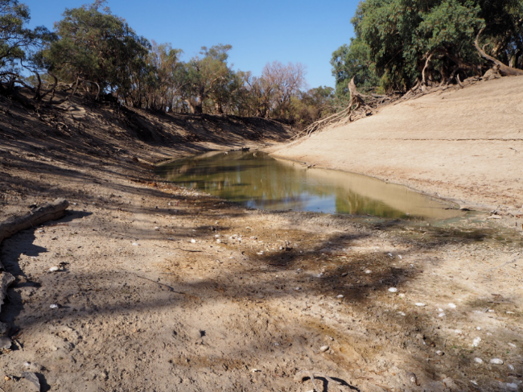
Lower Darling River, DS Menindee, Wyamar, 25 March 2020

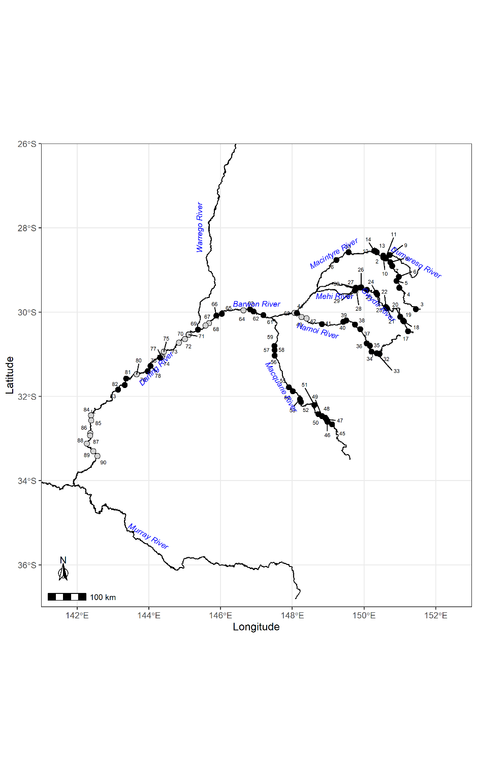
Figure 3-4: Map of mussel survey locations in the northern Murray-Darling Basin, conducted between Feb-July 2020. Site numbers correspond to Appendix 1. Black circles correspond to rapid assessment sites, while grey circles are sites where quantitative surveys took place

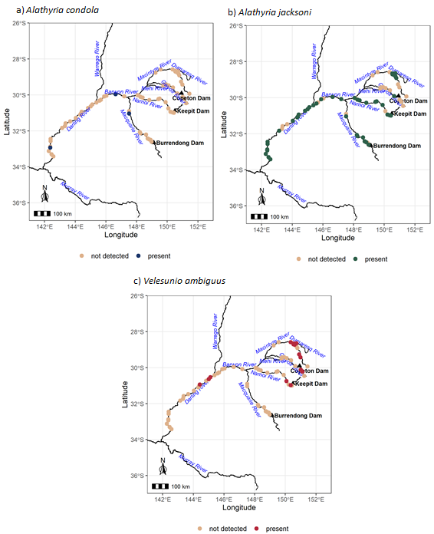

Figure 3-5: Presence of (a) Alathyria condola, (b) Alathyria jacksoni and (c) Velesunio ambiguus in the northern Murray-Darling Basin. Rivers targeted include the Barwon-Darling, Warrego, Gwydir, McIntyre, Namoi and Macquarie Rivers. Dots represent all sites surveyed. Presence was defined as the presence of either sham (empty shells) or live mussels.

Table 3-2: Summary of presence/absence of freshwater mussels across the northern Murray-Darling Basin with raw data given in Appendix 7.3. Presence was based on observation of live and/or dead shells.
River (no. sites surveyed) | Site Nos | No. of sites containing  Velesunio ambiguus | No. of sites  containing  Alathyria jacksoni | No. of sites containing  Alathyria condola
Dumaresq River (n=2) | 1-2 | 2 | 2 | 0
Macintyre River (n=14) | 3-16 | 6 | 5 | 0
Gwydir River (n=14) | 17-30 | 3 | 1 | 0
Mehi River (n=1) | 31 | 0 | 0 | 0
Namoi River (n=13) | 32-44 | 2 | 9 | 0
Macquarie River (n=15) | 45-59 | 1 | 7 | 1
Barwon River (n=3) | 60-64 | 0 | 3 | 1
Darling River (n=19) | 65-83 | 3 | 11 | 0
Lower Darling (n=7) | 84-90 | 0 | 7 | 1

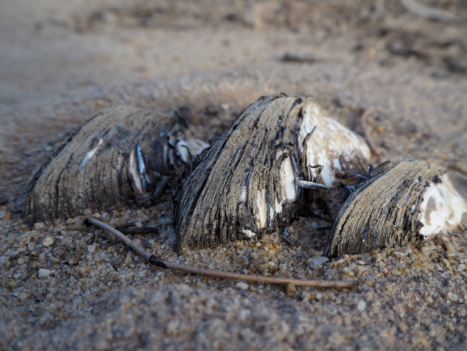
Alathyria jacksoni in the drying river bed of the Darling River, Tilpa, 25 Feb 2020

Estimates of mussel mortality, Summer 2020
Where mussels were abundant detailed estimates of mortality were made (Table 3-3). These detailed estimates were only made for A. jacksoni as it was the dominant species present at all sites. These quantitative measures of mussel abundance were then used to estimate the overall mussel population of the Barwon-Darling River (Table 3-4). Median number of mussels per river km in the Barwon-Darling from Table 3-3 (excluding Namoi sites) was 2262 (Min=0, max=14334, average=4246). The median number of mussels was multiplied by the number of river kilometres between Walgett and Pooncarie = 2262 individuals x 1510 km = 3,415,620 mussels (3.4 million mussels). With average loss of 83.5% of mussels in each river this suggests roughly 2.9 million mussels were impacted by the drying. Estimates of survival, however, are likely to be much greater in reaches containing water holes and refugia that did not dry out during the drought.

Table 3-3: Summary of counts of Alathyria jacksoni at sites were quantitative surveys took place (survey type 1a & 1b), including total number of mussels, the number live and dead, and the % mortality estimated
River | River segment | Site | Survey type | Total | Live | Dead | Mortality (%)
Namoi | Wee Waa to Walgett | Goangra Bridge | dry bed count | 268 | 0 | 268 | 100
 |  | TSR upstream Walgett | dry bed count | 100 | 0 | 100 | 100
Barwon | Walgett to Culgoa River | Dangar Bridge | transects (19 x 0.5 m wide) | 684 | 0 | 684 | 100
 |  | Wolkara | transects (14 x 0.5 m wide) | 6000 | 0 | 6000
Darling | Bourke to Louth | Yanda campground | transects (22 x 0.5 m wide) | 136 | 0 | 136 | 100
 | Louth to Tilpa | US Louth Bridge | transects | 7133  (2023, 12236) | 800 (66,1534) | 6,333 (1965,10702) | 88.8
 |  | Louth opp. Shindies Inn | transects
 |  | Dunlop’s weir | transects
 |  | 40 km south Louth | transects |  |  |  | 25-58
 |  | DS Tilpa Bridge | transects | 7167 | 5900 (4913,12887) | 1,267 | 17.7
 | Tilpa to Wilcannia | Pelican Bend | transects (29 x 0.5 m wide) | 0 | 0 | 0
 |  | Becker | transects (26 x 0.5 m wide) | 39 | 39 | 0
 |  | East of Coach and horse campground | dry count | 0 | 0 | 0
Lower Darling | Menindee to Pooncarie | Appin Station |  | 2551 | 88 | 2463 | 96.5
 |  | Bono Station | dry bed count | 860 | 19 | 841 | 97.7
 |  | US Karoola Reach | dry bed count | 2043 | 170 | 1873 | 91.7
 |  | Karoola Reach | dry bed count | 1340 | 17 | 1323 | 98.7
 |  | Wyamar | dry bed count | 2229 | 38 | 2191 | 98.3
 |  | Mullingar | dry bed count | 1131 | 37 | 1094 | 96.7
 |  | Pooncarie Bridge | dry bed count | 538 | 7 | 531 | 98.7

Table 3-4: Estimation of potential mussel populations in river segments where quantitative surveys were undertaken
River | River segment | River Km | No reaches surveyed | Mean mussel abundance 500 m ⁻¹ (±SE) | Est. mussel population in river segment (no. of inds) | Est. % Mean mortality  (±SE)
Namoi | Wee Waa to Walgett | 200 | 2 | 184 | 73 600 | 100
Barwon | Walgett to Culgoa River | 330 | 2
Darling | Bourke to Louth | 200 | 1 | 136 | 6 400 | 100
Darling | Louth to Tilpa | 120 | 5 | 7140 | 1 171 600 | 47
Darling | Tilpa to Wilcannia | 250 | 3 | 39 | 19 500 | 33
Lower Darling | Menindee to Pooncarie | 280 | 7 | 1527.4 ± 285.5 | 855 360 | 97 ± 1

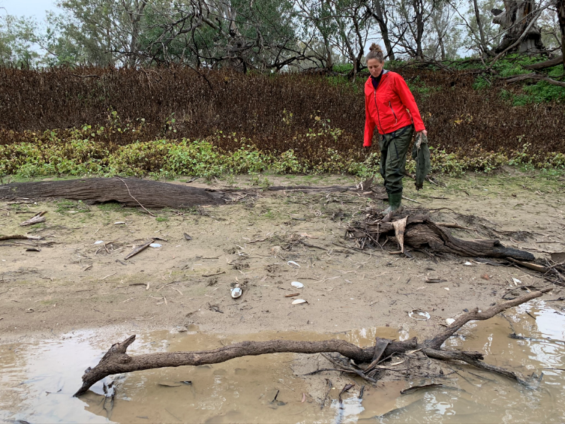
Sampling in the Namoi River, upstream of Walgett.

Using data from all surveys an approximate mortality was calculated for each sampled site for all species observed (Table 3-5). For A. jacksoni, this approximate mortality suggests only one site on the Gwydir River (Site 20 - Bingara Road) and one site on the Darling River (Site 69 - Rose Isle Station) had estimated mortality of less than 50%. Across the northern Murray-Darling Basin, 65% of sites with A. jacksoni shells present had 100% estimated mortality. While V. ambiguus was observed at few sites (12) 50% of these sites had an estimated mortality of 100% (Table 3-5).

Table 3-5: Summary of percent mortality of Alathyria jacksoni, Alathyria condola and Velesunio ambiguus across all sites sampled in the northern Murray-Darling Basin. Absence of mussels at a site is depicted by grey shading. Raw abundances are given in Appendix 7.3
river | Site no. | site.name | Survey Type | Confidence | Alathyria jacksoni | Alathyria condola | Velesunio ambiguus
Dumaresq River | 1 | Keetah | Rapid | Low | 100.0 |  | 100.0
 | 2 | Yellowbank | Rapid | Low | 100.0 |  | 88.9
Macintyre River | 3 | Querra | Rapid | Low
 | 4 | TSR @ Graman | Rapid | Low | 100.0
 | 5 | US of Kwiambal NP | Rapid | Low | 100.0
 | 6 | Kwiambal NP | Rapid | Low
 | 7 | Yetman | Rapid | Low | 100.0
 | 8 | Holdfast TSR | Rapid | Low | 100.0
 | 9 | TSR US of Boonal | Rapid | Low | 100.0 |  | 100.0
 | 10 | Boonal at Pump | Rapid | Low | 100.0
 | 11 | Boonal US of Junction | Rapid | Low | 100.0 |  | 100.0
 | 12 | Bondi Beach | Rapid | Low |  |  | 100.0
 | 13 | Goondiwindi @ Goondawindi Bridge | Rapid | Low
 | 14 | Goondiwindi @ Corcoran Drive | Rapid | Low
 | 15 | North of Boomi | Rapid | Low
 | 16 | Budelah | Rapid | Low
Gwydir River | 17 | Torryburn Road | Rapid | Low
 | 18 | Swan Reach Reserve | Rapid | Low |  |  | 96.2
 | 19 | Thunderbolts Camp Site | Rapid | Low |  |  | 78.6
 | 20 | Bingara Road | Rapid | Low |  |  | 25.2
 | 21 | Bora Crossing | Rapid | Low | 100.0
 | 22 | Caloola TSR | Rapid | Low
 | 23 | Gwydir Hwy @ Gravesend | N/A
 | 24 | North of Gravesend | Rapid | Low
 | 25 | Gum Flat | Rapid | Low
 | 26 | TSR opposite Santis | Rapid | Low
 | 27 | Moree Motocross club | N/A | Low
 | 28 | Norwood @ Tyreel Weir | Rapid | Low
 | 29 | Norwood DS of Weir 1 | N/A
 | 30 | Norwood DS of Weir 2 | N/A
Mehi River | 31 | Mehi near Norwood | Rapid | Low
Namoi River | 32 | Carroll's Reserve | Rapid | Low | 100.0
 | 33 | Bennies Road | Rapid | Low | 100.0 |  | 100.0
 | 34 | Blue Vale Road | Rapid | Low | 62.5
 | 35 | Nonda Road | N/A
 | 36 | 4 km south Boggabri | Rapid | Low |  |  | 100.0
 | 37 | Turruwan Rd | Rapid | Low | 100.0
 | 38 | 2 km north Narrabri | N/A
 | 39 | Cotton Lane | Rapid | Low | 100.0
 | 40 | Wee Waa @ Rail Bridge | Rapid | Low | 100.0
 | 41 | Bugilbone | Rapid | Low | 100.0
 | 42 | Goangra Bridge | Quant | High | 100.0
 | 43 | TSR US Walgett | Quant | High | 100.0
 | 44 | Walgett | Rapid | Low
Macquarie River | 45 | Lake Burrendong outflow | N/A
 | 46 | Apsley | Rapid | Low | 100.0
 | 47 | Wellington Riverside Caravan Park | Rapid | Low
 | 48 | Maryvale Reserve | Rapid | Low
 | 49 | Ponto Falls Reserve | Rapid | Low | 100.0
 | 50 | Brilbral Reserve | Rapid | Low | 64.3
 | 51 | Dubbo @ Troys Reserve | Rapid | Low | 100.0
 | 52 | Timbrebongie Falls | Rapid | Low | 100.0
 | 53 | Mumble Peg | Rapid | Low | 100.0
 | 54 | 30 km south Warren | N/A
 | 55 | 12 km south Warren | N/A
 | 56 | Macquarie Marshes - Horeshoe Lagoon | Rapid | Low | 100.0
 | 57 | Macquarie Marshes - Old Buckinguy | Rapid | Low | 100.0
 | 58 | Macquarie Marshes - Gibson Way Bridge | N/A
 | 59 | Macquarie Marshes - Cresswell | N/A
Barwon River | 60 | Dangar Bridge | Quant | High | 100.0
 | 61 | Collwaroy | Rapid | Low | 80.0
 | 62 | Four mile camping reserve | N/A
 | 63 | Brewarrina DS weir | N/A
 | 64 | Wolkara | Quant | High | 100.0 | 100.0
Darling River | 65 | May's Bend | Rapid | Low
 | 66 | DS Bourke Weir | Rapid | Low | 100.0
 | 67 | Border Toorale NP | Quant | High
 | 68 | Yanda campground | Quant | High | 100.0
 | 69 | Rose Isle Station | Rapid | Low | 44.4
 | 70 | US Louth Bridge | Quant | High | 88.8 |  | 50.0
 | 71 | Louth opp. Shindies Inn | Quant | High
 | 72 | Dunlop's Weir | Quant | High | 70.6
 | 73 | 40 km South Louth | Quant | High | 89.0
 | 74 | Pelican bend | Quant | High
 | 75 | DS Tilpa Bridge | Quant | High | 54.2 |  | 83.3
 | 76 | 22 km west Tilpa | Rapid | Rapid | 0.0
 | 77 | Becker | Quant | High | 66.7
 | 78 | US Acres Billabong | Rapid | Low | 100.0
 | 79 | River Road | Rapid | Low
 | 80 | East of Coach and Horse campground | Quant | High
 | 81 | Wilcannia Cemetery | Rapid | Low
 | 82 | Ellendale | Rapid | Low
 | 83 | Billilla | Rapid | Low | 100.0
Lower Darling River | 84 | Appin Station | Quant | High | 96.6
 | 85 | Bono Station | Quant | High | 97.8
 | 86 | US Karoola Reach | Quant | High | 91.7
 | 87 | Karoola Reach | Quant | High | 98.7 | 100.0
 | 88 | Wyamar | Quant | High | 98.3
 | 89 | Mullingar | Quant | High | 96.7
 | 90 | Pooncarie Bridge | Quant | High | 98.7

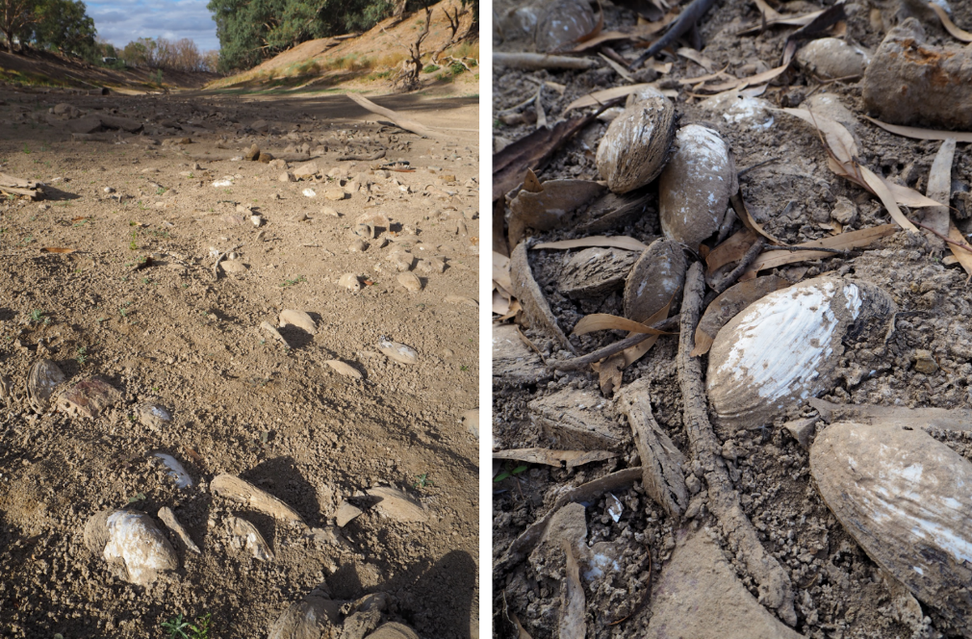
Darling River, Tilpa, 25 Feb 2020

Size frequency
Using rapid survey methodology, shells from three species of freshwater mussel (Alathyria condola, A. jacksoni and V. ambiguus) were collected from sites in the Darling, Macquarie, Namoi, Gwydir, MacIntyre and Dumaresq Rivers. A total of 927 shells were measured. Some shells were broken, but still measured for Maximum length (ML). Overall, ranges in species shell lengths were 54.3 - 190.3 mm for A. jacksoni and 23.1 – 120.3 mm for V. ambiguus; a single specimen of A. condola from ‘Old Buckiinguy’, Macquarie River measured 137.2 mm. Length-frequency distributions for A. jacksoni within each river are provided in Figure 3-6 and for V. ambiguus in Figure 3-7. Size frequency histograms for both species suggest limited number of small shells which may imply limited recruitment. For A. jacksoni this is particularly evident in the histogram from the Darling River, where the peak was very narrow and dominated by large individuals. Length frequency distributions were more even in the tributary rivers (Figure 3-6).
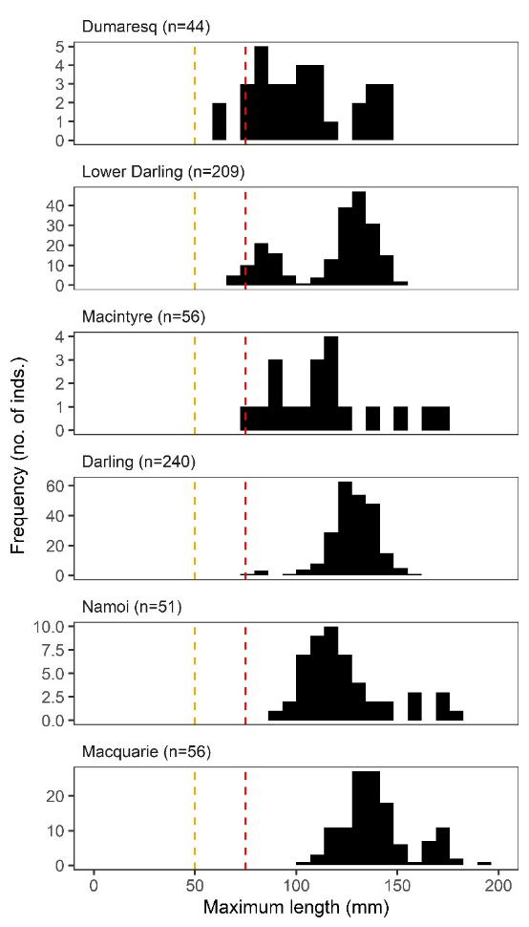
Figure 3-6: Alathyria jacksoni size frequency. 50 mm orange dashed line = indicates realistic size threshold to indicate young recruits. 75 mm red dashed line = indicates conservative estimate of recruitment.

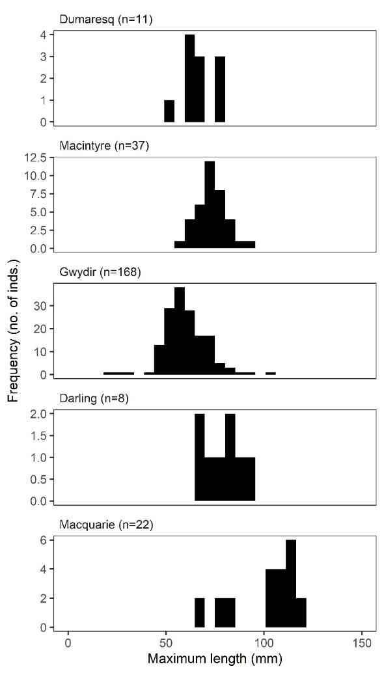
Figure 3-7: Velesunio ambiguus size frequency. Lines for estimates of young recruits and recruitment into the population are not included due to limited data on growth profiles in V. ambiguus.

Discussion
Our predictive model suggested the most important environmental attributes influencing the broad distribution of A. jacksoni were upstream catchment area, stream size, mean stream elevation and flow regime disturbance. These landscape variables likely reflected the availability and permanence of water across the landscape; mussels only occur where there is water. Attributes that explained less of the landscape scale variation but were still significant included stream forest cover, annual stream temperature and woodlands. While the scale of our predictive model was broad, the significance of these more “site” specific variables possibly highlights the importance of riparian vegetation in localised distribution. It is unlikely that riparian vegetation, per se, is the driving variable here, rather the importance of riparian vegetation likely reflects places within the channel network of permanent water (refugial reaches and waterhole) and potentially appropriate substrate, the presence of riparian vegetation may also reflect places of reduced erosion and more stable water temmperatures, and therefore dissolved oxygen levels when flows are low. The distribution of A. jacksoni within the channel network was not uniform and further research to understand the localised drivers of distribution and abundance is required.
Using both the predictive model and the precious records of abundance A.jacksoni was clearly very widespread across the northern Murray-Darling Basin under pre drought conditions. Data from the rapid surveys showed evidence of abundant mussel shoals, from the cobble, clear waters of the midslope habitats of the tributaries directly downstream of the storage dams, all the way to the sandy lowland, typically turbid, waters of the lower Darling. This suggest that A. jacksoni is a fairly generalist species within the riverine network, with strong evidence of the historical presence of A. jacksoni at a majority of the sites visited. This is important as genetic studies have suggested that A. jacksoni is endemic to the Murray-Darling Basin (Walker et al. 2014). Unlike Velesunio ambiguus, which is widespread across eastern Australia, A. jacksoni is found nowhere else.
In contrast to the broad distribution and dominant presence A. jacksoni, we found relatively few records of V. ambiguus. This, however, may not be a surprise or cause for concern. The patterns in species distributions from this survey appear to match with those previously described. Alathyria jacksoni was prevalent in all main channels, while the occasional off channel habitat that was surveyed, was when Velesunio ambiguus was observed (e.g. Macquarie marshes, Menindee lakes). A broader survey of all riverine and wetland habitats would be required to gain a good understanding of the distribution of V. ambiguus, however, given its comparatively greater tolerance to drying and broader geographic distribution compared with A. jacksoni, this may not be as urgent a priority.
Previous laboratory studies (see Sheldon & Walker, 1989) and distributional observations (Walker 1981) have suggested that A. jacksoni was not tolerant of poor oxygen conditions or drying. Evidence from this survey, however, suggested that A. jacksoni, at least northern Murray-Darling Basin populations, did have the capacity to persist in isolated water holes, despite the lack of water flow, and often poor water quality of these refugia. This suggests that A. jacksoni may be more resilient to low flow conditions than perhaps has been appreciated to date. However, the study did confirm the inability of this species to withstand drying. Therefore, changes in hydrology that see an increase in the duration of low/no flow spells, will have continued impact on populations of A. jacksoni in the northern Murray-Darling Basin.
The combination of rapid and quantitative surveys used in this study suggest that the loss of mussel populations across the northern Murray-Darling Basin resulting from the drying conditions of 2017-2019 is significant and widespread. This is a cause for concern given the longevity of mussel individuals and the poor evidence of widespread recent recruitment. The long-term hydrological time series for all tributaries sampled across the northern Murray-Darling Basin, and the main section of the Barwon-Darling river itself, suggest that the duration of this drying event was unprecedented at many sites. The persistence of water holes/refugia is known to be closely related to the duration of no flow periods (Bunn et al. 2006), and so the contraction in the size and availability of suitable refugia for mussels to persist in isolated pools throughout the catchment will have been potentially at its most severe during the 2017-2019 drought.
Given the extent of the population mortality across the northern Murray-Darling Basin, protection of minimum base flows is going to be crucial for the persistence of this species in both the short and long term, and the only opportunity for A. jacksoni to recover from the major contraction in population size as evidenced by these surveys. The life history traits of A. jacksoni, suggest recovery potential may be complicated. These mussels do not reach sexual maturity until 4 years of age, and as adults are sedentary, therefore, the opportunity for the species to recolonise long stretches of river channel that have experienced 100% mortality due to this recent drying event, is totally dependent on the recovery and movement of native fish populations throughout these areas. So for any chance of population recovery it is important that not only the minimal flow requirements to protect the mussels are met, but also the flow conditions required for fish population recovery for the next 4+ years in order to facilitate successful spawning, recolonisation and survival of mussel recruits until they reach sexual maturity.
There is also a broader landscape consideration with regard to flow management for mussel population persistence. It is apparent from both the predictive model and the survey data that the persistence of healthy populations of A. jacksoni is reliant on permanent river reaches and waterholes. These physical persistence of these in-channel environments require flows at the other end of the hydrological spectrum: they require the bankfull and overbank flows that provide the velocities required to scour sediment from the waterholes and maintain depth.
The survey of mussel populations across the northern Murray-Darling Basin has highlighted a species under threat. Alathyria jacksoni is endemic to the Murray-Darling Basin and the widespread mortality of this species in the northern Murray-Darling Basin during the recent drying event (2017-2019) has left populations in large sections of the channel network decimated. It will be important that recovery plans are developed and implemented, and flow management provides adequate protection of low flows to enable the remaining populations to persist and provide source populations for the remainder of northern Murray-Darling Basin.
Finally, our initial intention was to include the Barwon-Darling River community in the sampling of mussel populations. The emergence of COVID-19, subsequent lockdowns and travel restrictions and then a sequence of very high flows in the tributaries that made their way down the Barwon-Darling made this impossible. It is out hope that the “Great Barka Mussel Survey” can be launched in 2021 and we can engage the broader community in understanding the importance of freshwater mussels in the ecology of the rivers of the northern Murray-Darling Basin.

Recommendations
Our recommendations from the survey of the impact of the 2017-2019 drying event on freshwater mussels are simple and broad and are made recognising that freshwater mussels have been a dominant component of the freshwater biomass in the northern Murray-Darling Basin rivers for millennia, and that the decimation of their populations from the 2017-2019 drying event, and potentially previously in the Millenium Drought, will have broad ecosystem consequences for the northern Basin.
Recommendation 1: that further research needs to be undertaken to understand the biology of freshwater mussels in the northern Murray-Darling Basin, including their reproduction, recruitment, growth patterns and diets, as well as their role in the ecosystem of the northern Murray-Darling Basin Rivers – not least because, besides fish, they were historically the dominant animal by weight in these rivers.
Recommendation 2: that a focus be made on monitoring freshwater mussel recovery in both the short- and long-term. This should include an understanding of which fish species act as hosts and what conditions are required for successful recruitment and establishment of juveniles.
Recommendation 3: that the importance of low flows and refugial habitats, reaches and waterholes, be formally recognised for freshwater mussels in the northern Murray-Darling Basin and the flow requirements of freshwater mussels be incorporated into flow management plans. This would include:
- Ensuring the Water Resource Plans and relevant Water Sharing Plans include protection of very low flows and baseflows (as per the Barwon-Darling Long Term Water Plan (DPIE, 2020a) in areas of refugial habitats to ensure remaining populations persist and provide source populations;
- Protecting the first flows (first flush) after periods of low flow to allow persistence of refugial habitats and improve water quality in downstream reaches, this is consistent with the NSW Government proposed management of first flush events (DPIE 2020b) and when rules are agreed for managing first flush events the maintenance of freshwater mussel populations need to be included as a target.
Recommendation 4: that the landscape role of refugial reaches and waterholes, and their persistence, across the whole of the northern Murray-Darling Basin for both mussels and fish be recognised and the flow required to maintain the integrity of these physical places in the channel network be understood and incorporated into future revisions of flow management and water sharing plans. This would require a basin- wide perspective of the Water Sharing Plans and Water Resource Plans to ensure the critical area of the Barwon-Darling River below Bourke has adequate flows for long-term population survival.
Recommendation 5: that a specific Freshwater Mussel Recovery Plan be developed in consultation with the communities of the northern Murray-Darling Basin and this plan articulate with Fish Recovery Plans

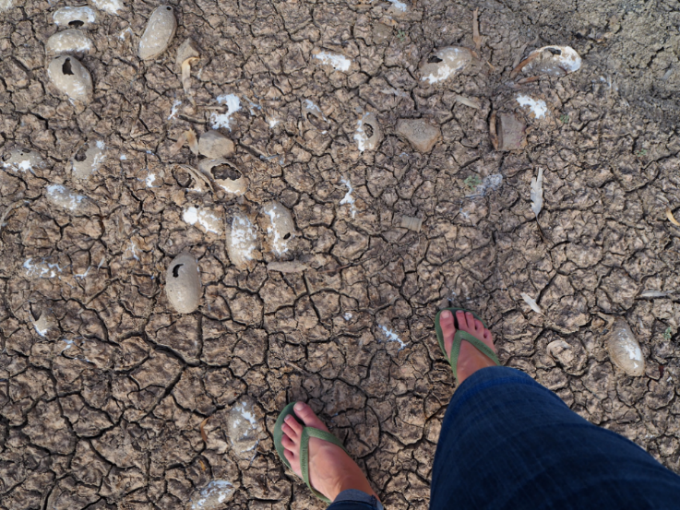
Darling River, Tilpa, 25 Feb 2020

References
Aboriginal Victoria (2019). “Fact sheet: Aboriginal freshwater middens.” Accessed 26/11/2020 at: https://www.aboriginalvictoria.vic.gov.au/fact-sheet-aboriginal-freshwater-middens
Atlas of Living Australia (2020) Open access to Australia’s biodiversity data. Database accessed at: https://www.ala.org.au/ on 8 April 2020.
Australian Academy of Science (2019). Investigation of the causes of mass fish kills in the Menindee Region NSW over the summer of 2018–2019.
Allen, DC, Galbraith HS, Vaughn CC & Spooner DE (2013) A tale of two rivers: implications of water management practices for mussel biodiversity outcomes during droughts. Ambio 42: 881–891.
Atkins L (1979) Observations on the glochidial stage of the freshwater mussel Hyridella drapeta Iredale (Mollusca: Pelecypoda). Australian Journal of Marine and Freshwater Research 30:411-416
Andrews, A. E. J. (1981). Hume and Hovell 1824. Hobart: Blubber Head Press.
Balla SA & Walker KF (1991) Shape variation in the Australian freshwater mussel Alathyria jacksoni Iredale (Bivalvia, Hyriidae). Hydrobiologia 220: 89-98.
Balme J (1995) 30,000 years of fishery in western New South Wales. Archaeology in Oceania 30: 1-21.
Balme J, & Hope J (1990) Radiocarbon dates from midden sites in the lower Darling River area of western New South Wales. Archaeology in Oceania 25(3): 85-101.
Bennett G (1834) Wanderings in New South Wales, Batavia, Pedir Coast, Singapore, and China; being the journal of a naturalist in those countries during 1832, 1833, and 1834. 2 Volumes. London: Richard Bentley.
Byrne M (1998) Reproduction of river and lake populations of Hyridella depressa (Unionacea: Hyriidae) in New South Wales: implications for their conservation. Hydrobiologia 389: 29-43.
Bond N (2019) Hydrostats: Hydrologic Indices for Daily Time Series Data. R package version 0.2.7. https://CRAN.R-project.org/package=hydrostats
Brouwer, S. (2019). Effects of suspended sediment concentration on filtration rates and biodeposition of the Australian Hyriid river mussel Alathyria jacksoni. Honours Thesis, Charles Sturt University.58 pp.
Bunn SE, Thoms MC, Hamilton SK & Capon SJ (2006). Flow variability in dryland rivers: Boom, bust and the bits in between. River Research and Applications 22: 179-186.
Cerasoli F, Iannella M, D’Alessandro P, Biondi M (2017) Comparing pseudo-absences generation techniques in Boosted Regression Trees models for conservation purposes: A case study on amphibians in a protected area. PLOS One 12(11):e0187589.
DPIPWE (2009) Status of fish communities and observations on South Esk freshwater mussel (Velesunio moretonicus) populations in the Macquarie River catchment upstream of Lake River. Report No. WA 09/02, Department of Primary Industries, Parks, Water and Environment, Hobart, TAS.
DPIE (2020a) Barwon–Darling Long Term Water Plan Part A. NSW Department of Planning, Industry and Environment. https://www.environment.nsw.gov.au/topics/water/water-for-the-environment/planning-and-reporting/long-term-water-plans/barwon-darling
DPIE (2020b) The Independent Panel Assessment of the Management of the 2020 Northern Basin First Flush Event. NSW Department of Planning, Industry and Environment PUB 20/968. https://www.industry.nsw.gov.au/__data/assets/pdf_file/0005/341078/government-response.pdf
Elith J, Leathwick JR, & Hastie T (2008) A working guide to boosted regression trees. Journal of Animal Ecology 77:802-803.
Ferreira-Rodriguez N, Akiyama YB, Aksenova OV, Araujo R, Barnhart CM, Bespalaya YV, Bogan AE, Bolotov IN, Budha PB, Clavijo C, Clearwater SJ, Darrifran G, Do VT, Douda K, Froufe E, Gumpinger C, Henrikson L, Humphrey CL, Johnson NA, Klishko O, Klunzinger MW, Kovitvadhi S, Kovitvadhi U, Lajtner J, Lopes-Lima M, Moorkens EA, Nagayama S, Nagel K, Nakano M, Negishi JN, Ondina P, Oulasvirta P, Prié V, Riccardi N, Rudzīte M, Sheldon F, Sousa R, Strayer DL, Takeuchi M, Taskinen J, Teixeira A, Tiemann JS, Urbańska M, Varandas S, Vinarski MV, Wicklow BJ, Zając T & Vaughn CC (2019) Research priorities for freshwater mussel conservation assessment. Biological Conservation 231: 77-87.
Fisher A (1973) Some predators on the freshwater mussel. Mid-Murray Field Naturalists Trust Report 6: 10-11.
DNRME (2019) Water Connections: Aboriginal People’s water needs in the Queensland Murray-Darling Basin. April 2019, State of Queensland.
Garvey J (2017) Australian Aboriginal freshwater shell middens from late Quaternary northwest Victoria: Prey choice, economic variability and exploitation. Quaternary International 427, Part A: 85-102.
Geddes M, Sheldon F, Hillman T, Zampatti B & Williams C (2019) Advances in the study of River Murray ecology and the legacy of Keith Forbes Walker (1946−2016). Transactions of the Royal Society of South Australia 141: 87-91.
Graf D & Cummings K (2020) Musselp Database. Accessed at: http://mussel-project.uwsp.edu/ on 13 May 2020.
Herath D, Jacob DE, Jones H & Fallon SJ (2019) Potential of shells of three species of eastern Australian freshwater mussels (Bivalvia: Hyriidae) as environmental proxy archives. Marine and Freshwater Research 70:255-269.
Hijmans RJ & Elith R (2017) Species distribution modelling with R. Available at https://rspatial.org/raster/sdm/index.html
Humphrey CL & Simpson RD (1985) The biology and ecology of Velesunio angasi (Bivalvia: Hyriidae) in the Magela Creek, Northern Territory (4 parts). Open File Record 38, Office of the Supervising Scientist for the Alligator Rivers Region, Canberra.
Humphries P & Walker K (2013) Ecology of Australian Freshwater Fishes. CSIRO Publishing: Collingwood.
Jones HA (2007) The influence of hydrology on freshwater mussel (Bivalvia: Hyriidae) distributions in a semi-arid river system, the Barwon-Darling River and Intersecting Streams. In Dickman C, Lunney D & Burgin S (eds) The Animals of Arid Australia: out on their own? Royal Zoological Society of New South Wales: Mossman, NSW, Australia, Pp. 132-142.
Jones HA (2011) Crustaceans and molluscs. In Rogers, K & Ralph, TJ (Eds). Floodplain Wetland Biota in the Murray-Darling Basin: Water and Habitat Requirements. CSIRO Publishing, Melbourne, Pp. 275-310.
Jones HA (2014) Distribution of freshwater mussels (Unionida: Hyriidae) in coastal southeastern Australian rivers and impacts of landscape modification on conservation status. PhD thesis, University of Sydney, Camperdown.
Jones HA & Byrne M (2010) The impact of catastrophic channel change on freshwater mussels in the Hunter river system, Australia: a conservation assessment. Aquatic Conservation: Marine and Freshwater Ecosystems 20: 18–30.
Jones HA & Byrne M (2013) Changes in the distributions of freshwater mussels (Unionoida: Hyriidae) in coastal south-eastern Australia and implications for their conservation status. Aquatic Conservation: Marine and Freshwater Ecosystems 24: 203-2017.
Jones HA, Simpson RD & Humphrey CL (1986). The reproductive cycles and glochidia of freshwater mussels (Bivalvia: Hyriidae) of the Macleay River, northern New South Wales, Australia. Malacologia 27: 185–202.
Jones J (2020) Untitled (giran). Visual Communication 19(3):415-428.
Jupiter SD & Byrne M (1997) Light and scanning electron microscopy of the embryos and glochidia larvae of the Australian freshwater bivalve Hyridella depressa (Hyriidae). Invertebrate Reproduction & Development 32: 177–186.
Klunzinger MW (2020) Description of the glochidia of Alathyria pertexta pertexta Iredale, 1934 (Bivalvia: Hyriidae) from south-eastern Queensland. Australian Journal of Zoology 67: 1-8.
Klunzinger MW, Morgan DL, Lymbery AJ, Ebner, BC, Beatty SJ, & Thomson GL (2010) Discovery of a host fish for glochidia of Velesunio angasi (Sowerby, 1867) (Bivalvia: Unionoida: Hyriidae) from the Fortescue River, Pilbara, Western Australia. Australian Journal of Zoology 58: 263-266.
Klunzinger MW, Beatty SJ, Morgan DL, Lymbery AJ & Thomson GJ (2012) Glochidia ecology in wild fish populations and laboratory determination of competent host fishes for an endemic freshwater mussel of south-western Australia. Australian Journal of Zoology 60: 26–36.
Klunzinger MW, Thomson GJ, Beatty SJ, Morgan DL & Lymbery AJ (2013) Morphological and morphometrical description of the glochidia of Westralunio carteri Iredale, 1934 (Bivalvia: Unionoida: Hyriidae). Molluscan Research 33: 104–109.
Klunzinger MW, Beatty SJ, Morgan DL, Lymbery AJ & Haag WR (2014) Age and growth in the Australian freshwater mussel, Westralunio carteri, with an evaluation of the fluorochrome calcein for validating the assumption of annulus formation. Freshwater Science 33: 1127–1135.
Klunzinger MW, Beatty SJ, Morgan DL, Pinder AM & Lymbery AJ (2015) Range decline and conservation status of Westralunio carteri Iredale, 1934 (Bivalvia: Hyriidae) from south-western Australia. Australian Journal of Zoology 63: 127–135.
Langloh-Parker K (1905) The Euahlayi Tribe. Archibald Constable and Company Ltd., London.
Lopes-Lima M, Burlakova LE, Karatayev AY, Mehler K, Seddon M, Sousa R (2018) Conservation of freshwater bivalves at the global scale: diversity, threats and research needs. Hydrobiologia 810: 1–14.
Lymbery A, Ma L, Lymbery S, Klunzinger M, Beatty S & Morgan D (2020). Burrowing behaviour protects a threatened freshwater mussel in drying rivers. Hydrobiologia
Mallen-Cooper M, Zampatti B (2020) Restoring the ecological integrity of a dryland river: Why low flows in the Barwon–Darling River must flow. Ecological management & restoration 21(3):218-228.
Markich SJ (2017) Sensitivity of the glochidia (larvae) of freshwater mussels (Bivalvia: Unionida: Hyriidae) to cadmium, cobalt, copper, lead, nickel and zinc: Differences between metals, species and exposure time. Science of the Total Environment 601-602: 1427-1436.
McMichael, DF & Hiscock ID (1958). A monograph of the freshwater mussels (Mollusca: Pelecypoda) of the Australian region. Australian Journal of Marine and Freshwater Research 9: 372–508.
Modesto V, Ilarri M, Souza AT, Lopes-Lima M, Douda K, Clavero M & Sousa, R. (2018). Fish and mussels: Importance of fish for freshwater mussel conservation. Fish and Fisheries 19(2): 244-259.
Mulvaney DJ (1960) Archaeological excavations at Fromm’s Landing on the lower Murray River, South Australia. Proceedings of the Royal Society of Victoria 72(2):53-86.
Murray Darling Basin Authority (2021) Lower Lakes barrages. Accessed at: https://www.mdba.gov.au/water-management/infrastructure/lower-lakes-barrages on 20/01/2021.
Murray-Stoker D, Murray-Stoker KM (2020) Consistent metacommunity structure despite inconsistent drivers of assembly at the continental scale. Journal of Animal Ecology 00:1-12. https://doi.org/10.1111/1365-2656.13220
NSW NRC, (2019) Final report Review of the Water Sharing Plan for the Barwon-Darling Unregulated and Alluvial Water Sources 2012. https://www.nrc.nsw.gov.au/publications
Playford TJ & Walker KF (2008) Status of the endangered Glenelg River mussel Hyridella glenelgensis (Dennant 1898) (Unionoida: Hyriidae) in Australia. Aquatic Conservation: Marine and Freshwater Ecosystems 18: 679–691.
Ponder WF & Walker KF (2003) From Mound Springs to mighty rivers: the conservation status of freshwater molluscs in Australia. Aquatic Ecosystem Health and Management 6: 19–28.
Randklev CR, Tsakris ET, Johnson MS, Popejoy T, Hart MA, Khan J, Geeslin D, & Robertson CR (2018) The effect of dewatering on freshwater mussel (Unionidae) community structure and the implications for conservation and water policy: A case study from a spring-fed stream in the southwestern United States. Global Ecology and Conservation 16: e00456
Rose PM, Kennard MJ, Moffatt DB, Sheldon F, Butler GL (2016) Testing three species distribution modelling strategies to define fish assemblage reference conditions for stream bioassessment and related applications. PLOS One 11(1):e0146728.
Shannon R & Mendyk RW (2009) Aquatic foraging behavior and freshwater mussel (Velesunio sp.) predation by Varanus panoptes panoptes in Central-Western Queensland. Biawak 3: 85-87.
Sheldon F (2017) Variable plasticity in shell morphology of some Australian freshwater mussels (Unionoida, Hyriidae). Transactions of the Royal Society of South Australia 141: 193-208.
Sheldon F & Walker KF (1989) Effects of hypoxia on oxygen consumption by two species of freshwater mussel (Unionacea: Hyriidae) from the River Murray. Australian Journal of Marine and Freshwater Research 40: 491-499.
Smyth RB (1878) The Aborigines of Victoria: with notes relating to the habits of the natives of other parts of Australia and Tasmania compiled from various sources for the Government of Victoria. R. Brough Smyth. J. Ferres, Gov't Printer, Melbourne.
Stein JL, Hutchinson MF, Stein JA (2014) A new stream and nested catchment framework for Australia. Hydrology and Earth System Sciences 18:1917-1933.
Van Tets GM (1994) Do cormorants eat freshwater mussels - if not what does? Emu 94: 127-128.
Vaughn CC, Nichols SJ & Spooner DE (2008) Community and foodweb ecology of freshwater mussels. Journal of the North American Benthological Society 27: 409–423.
Walker KF, Byrne M, Hickey CW & Roper DS (2001) Freshwater mussels (Hyriidae) of Australasia. In: Bauer G & Wächtler K (eds) Ecology and Evolution of the Freshwater Mussels Unionoida. Springer: Berlin, 5–31.
Vaughn CC (2018) Ecosystem services provided by freshwater mussels. Hydrobiologia 810: 15–27.
Vertessy, R., Sheldon, F., Baumgartner, L., Bond, N. and Mitrovic, S. (2019). Independent assessment of the 2018-19 fish deaths in the lower Darling: Final Report. MDBA, Australia.
Vestjens WJM (1973) Feeding of white ibis on freshwater mussels. Emu 72: 71-72.
Volkofsky A & Bates A (2018) ‘Let us have our water back’: Darling River mourned and celebrated in new art exhibition. Accessed 26/11/2020 at: https://www.abc.net.au/news/2018-07-23/forgotten-darling-river-exhibition/10014866
Wallace-Carter, E. (1987). For they were fishers: the history of the fishing industry in South Australia / Evelyn Wallace-Carter. Adelaide: Amphitrite Publishing House.
Walker KF (1981) Ecology of freshwater mussels in the River Murray. Australian Water Resource Council Technical Paper 63, 119 pp.
Walker KF (2017) Reproductive phenology of river and lake populations of freshwater mussels (Unionida: Hyriidae) in the River Murray. Molluscan Research 37: 31-44.
Walker KF, Jones HA & Klunzinger MW (2014) Bivalves in a bottleneck: taxonomy, phylogeography and conservation of freshwater mussels (Bivalvia: Unionoida) in Australasia. Hydrobiologia 735: 61–79.
Weston E, Szabo K, & Stern N (2017) Pleistocene shell tools from Lake Mungo lunette, Australia: identification and interpretation drawing on experimental archaeology. Quaternary International 427 229-242.
Widarto TH (1993) Aspects of the biology of Velesunio ambiguus Philippi from a tropical freshwater environment, Ross River, Townsville, Australia. M.Sc. Thesis, James Cook University of North Queensland, Townsville.
Woollard P, Vestjens WJM & MacLean L (1978) The ecology of the eastern water rat Hydromys chrysogaster at Griffith, NSW: food and feeding habits. Australian Wildlife Research 5: 59-73.

Appendices

Appendix 1: Bibliography of journal publications for the Australian Hyriidae found in the northern Murray-Darling Basin
Agbaje, O. B. A., et al. (2018). "Biomacromolecules within bivalve shells: Is chitin abundant?" Acta Biomaterialia 80: 176-187.
Baker, A. M., et al. (2003). "Cryptic species and morphological plasticity in long-lived bivalves (Unionoida: Hyriidae) from inland Australia." Molecular Ecology 12(10): 2707-2717.
Baker, A. M., et al. (2004). "Mitochondrial DNA phylogenetic structuring suggests similarity between two morphologically plastic genera of Australian freshwater mussels (Unionoida: Hyriidae)." Molecular Phylogenetics and Evolution 32(3): 902-912.
Balla, S. A. and K. F. Walker (1991). "Shape variation in the Australian freshwater mussel Alathyria jacksoni Iredale (Bivalvia, Hyriidae)." Hydrobiologia 220(2): 89-98.
Brainwood, M., et al. (2006). "Is the decline of freshwater mussel populations in a regulated coastal river in south-eastern Australia linked with human modification of habitat?" Aquatic Conservation: Marine and Freshwater Ecosystems 16(5): 501-516.
Brainwood, M., et al. (2008). "The impact of small and large impoundments on freshwater mussel distribution in the Hawkesbury-Nepean River, southeastern Australia." River Research and Applications 24(10): 1325-1342.
Brainwood, M., et al. (2008). "The role of geomorphology in substratum patch selection by freshwater mussels in the Hawkesbury-Nepean River (New South Wales) Australia." Aquatic Conservation: Marine and Freshwater Ecosystems 18(7): 1285-1301.
Colville, A. E. and R. P. Lim (2003). "Microscopic structure of the mantle and palps in the freshwater mussels velesunio ambiguus and hyridella depressa (Bivalvia: Hyriidae)." Molluscan Research 23(1): 1-20.
Graf, D. L. and D. Ó. Foighil (2000). "Molecular phylogenetic analysis of 28s rDNA supports a gondwanan origin for Australasian hyriidae (Mollusca: Bivalvia: Unionoida)." Vie et Milieu 50(4): 245-254.
Graf, D. L., et al. (2015). "Molecular phylogenetic analysis supports a Gondwanan origin of the Hyriidae (Mollusca: Bivalvia: Unionida) and the paraphyly of Australasian taxa." Molecular Phylogenetics and Evolution 85: 1-9.
Hughes, J., et al. (2004). "Past and present patterns of connectivity among populations of four cryptic species of freshwater mussels Velesunio spp. (Hyriidae) in central Australia." Molecular Ecology 13(10): 3197-3212.
Jeffree, R. A., et al. (1993). "Comparative accumulation of alkaline-earth metals by two freshwater mussel species from the nepean river, australia: Consistencies and a resolved paradox." Marine and Freshwater Research 44(4): 609-634.
Jenkin, C. and D. Rowley (1970). "Immunity in invertebrates. The purification of a haemagglutinin to rat and rabbit erythrocytes from the haemolymph of the Murray mussel (Velesunio ambiguus)." The Australian journal of experimental biology and medical science 48(2): 129-137.
Jones, H. A. and M. Byrne (2014). "Changes in the distributions of freshwater mussels (Unionoida: Hyriidae) in coastal south-eastern Australia and implications for their conservation status." Aquatic Conservation: Marine and Freshwater Ecosystems 24(2): 203-217.
Jones, W. G. and K. F. Walker (1979). "Accumulation of Iron, Manganese, Zinc and Cadmium by the Australian Freshwater Mussel Velesunio ambiguus (Phillipi) and its Potential as a Biological Monitor." Marine and Freshwater Research 30(6): 741-751.
Markich, S. J. (2017). "Sensitivity of the glochidia (larvae) of freshwater mussels (Bivalvia: Unionida: Hyriidae) to cadmium, cobalt, copper, lead, nickel and zinc: Differences between metals, species and exposure time." Science of the Total Environment 601-602: 1427-1436.
Markich, S. J., et al. (2001). "Divalent metal accumulation in freshwater bivalves: An inverse relationship with metal phosphate solubility." Science of the Total Environment 275(1-3): 27-41.
Markich, S. J. and R. A. Jeffree (1994). "Absorption of divalent trace metals as analogues of calcium by Australian freshwater bivalves: an explanation of how water hardness reduces metal toxicity." Aquatic Toxicology 29(3-4): 257-290.
Millington, P. J. and K. F. Walker (1983). "Australian freshwater mussel velesunio ambiguus (Philippi) as a biological monitor for zinc, iron and manganese." Marine and Freshwater Research 34(6): 873-892.
Negri, A. P. and G. J. Jones (1995). "Bioaccumulation of paralytic shellfish poisoning (PSP) toxins from the cyanobacterium Anabaena circinalis by the freshwater mussel Alathyria condola." Toxicon 33(5): 667-678.
Sheldon, F. (2017). "Variable plasticity in shell morphology of some australian freshwater mussels (Unionoida, hyriidae)." Transactions of the Royal Society of South Australia 141(2): 193-208.
Sheldon, F. and K. F. Walker (1989). "Effects of hypoxia on oxygen consumption by two species of freshwater mussel (Unionacea: Hyriidae) from the river murray." Marine and Freshwater Research 40(5): 491-499.
Walker, K. F. (1981). "Ecology of freshwater mussels in the River Murray." Australian Water Resources Council Technical Paper 63.
Walker, K. F. (2017). "Reproductive phenology of river and lake populations of freshwater mussels (Unionida: Hyriidae) in the River Murray." Molluscan Research 37(1): 31-44.
Walker, K. F., et al. (2014). "Bivalves in a bottleneck: Taxonomy, phylogeography and conservation of freshwater mussels (Bivalvia: Unionoida) in Australasia." Hydrobiologia 735(1): 61-79.
Widarto, T. H. (2007). "Shell Form Variation of a Freshwater Mussel Velesunio ambiguus Philippi from the Ross River, Australia." HAYATI Journal of Biosciences 14(3): 98-104.

Appendix 2: Details of sites sampled and mussel abundance
Location of survey reaches for the Northern Basin Mussel Mussel Project. Latitude and Longitude points represent the US end of each 500 m survey reach. Survey sites where quantitative surveys took place are highlighted in grey. Dry/flowing: dry= dry river channel, water holes may/may not have been present; flowing= water present throughout entire reach. Survey type defined in Table 2-2

River | Site no. | Site name | Survey date | Latitude | Longitude | Dry/ flowing | Survey type
Dumaresq | 1 | Keetah | 21/03/2020 | -28.64258 | 150.72014 | flowing | 3
 | 2 | Yellowbank | 19/03/2020 | -28.65542 | 150.53150 | flowing | 3
Macintyre | 3 | Querra | 21/03/2020 | -29.92837 | 151.44090 | flowing | 2
 | 4 | TSR @ Graman | 21/03/2020 | -29.42123 | 150.98095 | flowing | 3
 | 5 | US of Kwiambal NP | 21/03/2020 | -29.25867 | 150.90145 | flowing | 4
 | 6 | Kwiambal NP | 21/03/2020 | -29.15851 | 150.96888 | flowing | 2
 | 7 | Yetman | 20/03/2020 | -28.90136 | 150.78169 | flowing | 2
 | 8 | Holdfast TSR | 20/03/2020 | -28.81549 | 150.72983 | flowing | 3
 | 9 | TSR US of Boonal | 20/03/2020 | -28.72485 | 150.60672 | flowing | 3
 | 10 | Boonal at Pump | 20/03/2020 | -28.69969 | 150.53098 | flowing | 2
 | 11 | Boonal US of Junction | 20/03/2020 | -28.71526 | 150.59679 | flowing | 2
 | 12 | Bondi Beach | 20/03/2020 | -28.57720 | 150.35059 | flowing | 3
 | 13 | Goondiwindi @ Goondawindi Bridge | 20/03/2020 | -28.54938 | 150.30576 | flowing | 5
 | 14 | Goondiwindi @ Corcoran Drive | 20/03/2020 | -28.54123 | 150.28417 | flowing | 5
 | 15 | North of Boomi | 19/03/2020 | -28.57508 | 149.56387 | flowing | 3
 | 16 | Budelah | 19/03/2020 | -28.76169 | 149.22881 | flowing | 2
Gwydir | 17 | Torryburn Road | 17/03/2020 | -30.45304 | 151.22378 | flowing | 2
 | 18 | Swan Reach Reserve | 17/03/2020 | -30.21634 | 151.10960 | flowing | 2
 | 19 | Thunderbolts Camp Site | 17/03/2020 | -30.19635 | 151.07965 | flowing | 2
 | 20 | Bingara Road | 17/03/2020 | -30.10742 | 151.00790 | flowing | 2
 | 21 | Bora Crossing | 17/03/2020 | -29.91289 | 150.64074 | flowing | 2
 | 22 | Caloola TSR | 17/03/2020 | -29.88163 | 150.60995 | flowing | 2
 | 23 | Gwydir Hwy @ Gravesend | 18/03/2020 | -29.58161 | 150.36714 | flowing | 4
 | 24 | North of Gravesend | 18/03/2020 | -29.53681 | 150.33154 | flowing | 5
 | 25 | Gum Flat | 18/03/2020 | -29.46936 | 150.07792 | flowing | 3
 | 26 | TSR opposite Santis | 18/03/2020 | -29.40914 | 149.91958 | flowing | 3
 | 27 | Moree Motocross club | 18/03/2020 | -29.41440 | 149.88653 | flowing | 5
 | 28 | Norwood @ Tyreel Weir | 18/03/2020 | -29.43525 | 149.77806 | flowing | 3
 | 29 | Norwood DS of Weir 1 | 18/03/2020 | -29.42651 | 149.77464 | flowing | 5
 | 30 | Norwood DS of Weir 2 | 18/03/2020 | -29.41917 | 149.76712 | flowing | 5
Mehi | 31 | Mehi near Norwood | 18/03/2020 | -29.48437 | 149.73949 | flowing | 2
Namoi | 32 | Carroll's Reserve | 9/03/2020 | -30.99041 | 150.43159 | flowing | 2
 | 33 | Bennies Road | 9/03/2020 | -30.97345 | 150.35006 | flowing | 2
 | 34 | Blue Vale Road | 9/03/2020 | -30.93881 | 150.20865 | flowing | 2
 | 35 | Nonda Road | 9/03/2020 | -30.79371 | 150.16176 | flowing | 5
 | 36 | 4 km south Boggabri | 10/03/2020 | -30.74031 | 150.07115 | flowing | 2
 | 37 | Turruwan Rd | 10/03/2020 | -30.40376 | 149.89303 | flowing | 2
 | 38 | 2 km north Narrabri | 10/03/2020 | -30.29321 | 149.74677 | flowing | 5
 | 39 | Cotton Lane | 10/03/2020 | -30.19787 | 149.49927 | flowing | 4
 | 40 | Wee Waa @ Rail Bridge | 10/03/2020 | -30.22675 | 149.41990 | flowing | 2
 | 41 | Bugilbone | 11/03/2020 | -30.28341 | 148.82480 | flowing | 4
 | 42 | Goangra Bridge | 26/07/2020 | -30.14746 | 148.39729 | dry | 1a
 | 43 | TSR US Walgett | 26/07/2020 | -30.11215 | 148.25604 | dry | 1a
 | 44 | Walgett | 11/03/2020 | -30.01996 | 148.12527 | flowing | 4
Macquarie | 45 | Lake Burrendong outflow | 6/03/2020 | -32.65970 | 149.10492 | flowing | 5
 | 46 | Apsley | 7/03/2020 | -32.60399 | 148.97818 | flowing | 2
 | 47 | Wellington Riverside Caravan Park | 6/03/2020 | -32.54381 | 148.94444 | flowing | 4
 | 48 | Maryvale Reserve | 7/03/2020 | -32.50346 | 148.91651 | flowing | 4
 | 49 | Ponto Falls Reserve | 7/03/2020 | -32.46606 | 148.82131 | flowing | 2
 | 50 | Brilbral Reserve | 7/03/2020 | -32.42156 | 148.72634 | flowing | 2
 | 51 | Dubbo @ Troys Reserve | 7/03/2020 | -32.20530 | 148.61575 | flowing | 2
 | 52 | Timbrebongie Falls | 7/03/2020 | -32.13076 | 148.24430 | flowing | 4
 | 53 | Mumble Peg | 8/03/2020 | -32.06558 | 148.21242 | flowing | 2
 | 54 | 30 km south Warren | 8/03/2020 | -31.87524 | 148.01400 | flowing | 5
 | 55 | 12 km south Warren | 8/03/2020 | -31.78458 | 147.90513 | flowing | 5
 | 56 | Macquarie Marshes - Horeshoe Lagoon | 8/03/2020 | -31.02490 | 147.50110 | flowing
 | 57 | Macquarie Marshes - Old Buckinguy | 8/03/2020 | -31.03199 | 147.50640 | flowing | 2
 | 58 | Macquarie Marshes - Gibson Way Bridge | 8/03/2020 | -30.89793 | 147.50616 | flowing | 5
 | 59 | Macquarie Marshes - Cresswell | 9/03/2020 | -30.80179 | 147.49912 | flowing | 5
Barwon | 60 | Dangar Bridge | 26/07/2020 | -30.01352 | 148.06142 | flowing | 1b
 | 61 | Collwaroy | 25/07/2020 | -30.07164 | 147.18910 | flowing | 2
 | 62 | Four mile camping reserve | 25/07/2020 | -29.98449 | 146.91689 | flowing | 5
 | 63 | Brewarrina DS weir | 25/07/2020 | -29.93184 | 146.81800 | flowing | 5
 | 64 | Wolkara | 25/07/2020 | -29.95538 | 146.63246 | flowing | 1b
Darling | 65 | May's Bend | 24/07/2020 | -30.03918 | 146.03479 | flowing | 2
 | 66 | DS Bourke Weir | 24/07/2020 | -30.08172 | 145.88031 | flowing | 2
 | 67 | Border Toorale NP | 24/07/2020 | -30.26250 | 145.67560 | flowing | 1b
 | 68 | Yanda campground | 24/07/2020 | -30.31524 | 145.57699 | flowing | 1b
 | 69 | Rose Isle Station | 23/07/2020 | -30.41504 | 145.37112 | flowing | 2
 | 70 | US Louth Bridge | 24/03/2020 | -30.52667 | 145.10547 | dry | 1b
 | 71 | Louth opp. Shindies Inn | 23/03/2020 | -30.53561 | 145.11412 | dry | 1b
 | 72 | Dunlop's Weir | 23/03/2020 | -30.63998 | 145.00632 | dry | 1b
 | 73 | 40 km South Louth | 24/03/2020 | -30.72581 | 144.83601 | dry | 1b
 | 74 | Pelican bend | 23/07/2020 | -31.02556 | 144.37580 | flowing | 1b
 | 75 | DS Tilpa Bridge | 25/03/2020 | -30.93775 | 144.41689 | dry | 1b
 | 76 | 22 km west Tilpa | 22/07/2020 | -31.08567 | 144.31965 | flowing | 2
 | 77 | Becker | 23/07/2020 | -31.06556 | 144.34940 | flowing | 1b
 | 78 | US Acres Billabong | 22/07/2020 | -31.27715 | 144.04088 | flowing | 2
 | 79 | River Road | 22/07/2020 | -31.39944 | 143.97000 | flowing | 3
 | 80 | East of Coach and Horse campground | 22/07/2020 | -31.47358 | 143.65985 | flowing | 1a
 | 81 | Wilcannia Cemetry | 22/07/2020 | -31.57795 | 143.36689 | flowing | 4
 | 82 | Ellendale | 22/07/2020 | -31.73079 | 143.32489 | flowing | 4
 | 83 | Billilla | 22/07/2020 | -31.83645 | 143.14135 | flowing | 4
lower Darling | 84 | Appin Station | 24/03/2020 | -32.45039 | 142.38868 | dry | 1a
 | 85 | Bono Station | 25/03/2020 | -32.56709 | 142.39370 | dry | 1a
 | 86 | US Karoola Reach | 25/03/2020 | -32.87372 | 142.36994 | dry | 1a
 | 87 | Karoola Reach | 24/03/2020 | -32.92726 | 142.36349 | dry | 1a
 | 88 | Wyamar | 25/03/2020 | -33.11985 | 142.27058 | dry | 1a
 | 89 | Mullingar | 26/03/2020 | -33.29904 | 142.45002 | dry | 1a
 | 90 | Pooncarie Bridge | 26/03/2020 | -33.41464 | 142.56739 | dry | 1a

Appendix 3: Raw count data from mussel surveys across 90 sites in the northern Murray-Darling Basin.
Counts of Alathyria condola, Alathyria jacksoni and Velesunio ambiguus from the 90 sites surveyed, recorded as alive or dead.
River | Site | Survey type | Alathyria condola |  | Alathyria jacksoni |  | Velesunio ambiguus
 |  |  | alive | dead | alive | dead | alive | dead
Dumaresq | Keetah | 3 | 0 | 0 | 0 | 6 | 0 | 1
 | Yellowbank | 3 | 0 | 0 | 0 | 33 | 1 | 8
Macintyre | Querra | 2 | 0 | 0 | 0 | 0 | 0 | 0
 | TSR @ Graman | 3 | 0 | 0 | 0 | 0 | 0 | 5
 | US of Kwiambal NP | 4 | 0 | 0 | 0 | 0 | 0 | 47
 | Kwiambal NP | 2 | 0 | 0 | 0 | 0 | 0 | 0
 | Yetman | 2 | 0 | 0 | 0 | 8 | 0 | 0
 | Holdfast TSR | 3 | 0 | 0 | 0 | 3 | 0 | 0
 | TSR US of Boonal | 3 | 0 | 0 | 0 | 6 | 0 | 1
 | Boonal at Pump | 2 | 0 | 0 | 0 | 5 | 0 | 0
 | Boonal US of Junction | 2 | 0 | 0 | 0 | 3 | 0 | 4
 | Bondi Beach | 3 | 0 | 0 | 0 | 0 | 0 | 3
 | Goondiwindi @ Goondawindi Bridge | 5 | 0 | 0 | 0 | 0 | 0 | 0
 | Goondiwindi @ Corcoran Drive | 5 | 0 | 0 | 0 | 0 | 0 | 0
 | North of Boomi | 3 | 0 | 0 | 0 | 0 | 0 | 0
 | Budelah | 2 | 0 | 0 | 0 | 0 | 0 | 0
Gwydir | Torryburn Road | 2 | 0 | 0 | 0 | 0 | 0 | 0
 | Swan Reach Reserve | 2 | 0 | 0 | 0 | 0 | 1 | 25
 | Thunderbolts Camp Site | 2 | 0 | 0 | 0 | 0 | 3 | 11
 | Bingara Road | 2 | 0 | 0 | 0 | 0 | 98 | 33
 | Bora Crossing | 2 | 0 | 0 | 0 | 1 | 0 | 0
 | Caloola TSR | 2 | 0 | 0 | 0 | 0 | 0 | 0
 | Gwydir Hwy @ Gravesend | 4 | 0 | 0 | 0 | 0 | 0 | 0
 | North of Gravesend | 5 | 0 | 0 | 0 | 0 | 0 | 0
 | Gum Flat | 3 | 0 | 0 | 0 | 0 | 0 | 0
 | TSR opposite Santis | 3 | 0 | 0 | 0 | 0 | 0 | 0
 | Moree Motocross club | 5 | 0 | 0 | 0 | 0 | 0 | 0
 | Norwood @ Tyreel Weir | 3 | 0 | 0 | 0 | 0 | 0 | 0
 | Norwood DS of Weir 1 | 5 | 0 | 0 | 0 | 0 | 0 | 0
 | Norwood DS of Weir 2 | 5 | 0 | 0 | 0 | 0 | 0 | 0
Mehi | Mehi near Norwood | 2 | 0 | 0 | 0 | 0 | 0 | 0
Namoi | Carroll's Reserve | 2 | 0 | 0 | 0 | 2 | 0 | 0
 | Bennies Road | 2 | 0 | 0 | 0 | 10 | 0 | 1
 | Blue Vale Road | 2 | 0 | 0 | 6 | 10 | 0 | 0
 | Nonda Road | 5 | 0 | 0 | 0 | 0 | 0 | 0
 | 4 km south Boggabri | 2 | 0 | 0 | 0 | 0 | 0 | 1
 | Turruwan Rd | 2 | 0 | 0 | 0 | 177 | 0 | 0
 | 2 km north Narrabri | 5 | 0 | 0 | 0 | 0 | 0 | 0
 | Cotton Lane | 4 | 0 | 0 | 0 | 3 | 0 | 0
 | Wee Waa @ Rail Bridge | 2 | 0 | 0 | 0 | 4 | 0 | 0
 | Bugilbone | 4 | 0 | 0 | 0 | 1 | 0 | 0
 | Goangra Bridge | 1a | 0 | 0 | 0 | 268 | 0 | 0
 | TSR US Walgett | 1a | 0 | 0 | 0 | 100 | 0 | 0
 | Walgett | 4 | 0 | 0 | 0 | 0 | 0 | 0
Macquarie | Lake Burrendong outflow | 5 | 0 | 0 | 0 | 0 | 0 | 0
 | Apsley | 2 | 0 | 0 | 0 | 1 | 0 | 0
 | Wellington Riverside Caravan Park | 4 | 0 | 0 | 0 | 0 | 0 | 0
 | Maryvale Reserve | 4 | 0 | 0 | 0 | 0 | 0 | 0
 | Ponto Falls Reserve | 2 | 0 | 0 | 0 | 12 | 0 | 0
 | Brilbral Reserve | 2 | 0 | 0 | 5 | 9 | 0 | 0
 | Dubbo @ Troys Reserve | 2 | 0 | 0 | 0 | 1 | 0 | 0
 | Timbrebongie Falls | 4 | 0 | 0 | 0 | 1 | 0 | 0
 | Mumble Peg | 2 | 0 | 0 | 0 | 1430 | 0 | 0
 | 30 km south Warren | 5 | 0 | 0 | 0 | 0 | 0 | 0
 | 12 km south Warren | 5 | 0 | 0 | 0 | 0 | 0 | 0
 | Macquarie Marshes - Old Buckinguy | 2 | 0 | 0 | 0 | 200 | 0 | 0
 | Macquarie Marshes - Horeshoe Lagoon | 0 | 0 | 0 | 0 | 0 | 0 | 300
 | Macquarie Marshes - Gibson Way Bridge | 5 | 0 | 0 | 0 | 0 | 0 | 0
 | Macquarie Marshes - Cresswell | 5 | 0 | 0 | 0 | 0 | 0 | 0
Barwon | Dangar Bridge | 1b | 0 | 0 | 0 | 13 | 0 | 0
 | Collwaroy | 2 | 0 | 0 | 3 | 12 | 0 | 0
 | Four mile camping reserve | 5 | 0 | 0 | 0 | 0 | 0 | 0
 | Brewarrina DS weir | 5 | 0 | 0 | 0 | 0 | 0 | 0
 | Wolkara | 1b | 0 | 1 | 0 | 84 | 0 | 0
Darling | May's Bend | 2 | 0 | 0 | 0 | 0 | 0 | 0
 | DS Bourke Weir | 2 | 0 | 0 | 0 | 4 | 0 | 0
 | Border Toorale NP | 1b | 0 | 0 | 0 | 0 | 0 | 0
 | Yanda campground | 1b | 0 | 0 | 0 | 3 | 0 | 0
 | Rose Isle Station | 2 | 0 | 0 | 5 | 4 | 0 | 0
 | US Louth Bridge | 1b | 0 | 0 | 48 | 380 | 1 | 1
 | Louth opp. Shindies Inn | 1b | 0 | 0 | 0 | 0 | 0 | 0
 | Dunlop's Weir | 1b | 0 | 0 | 5 | 12 | 0 | 0
 | 40 km South Louth | 1b | 0 | 0 | 54 | 439 | 0 | 0
 | Pelican bend | 1b | 0 | 0 | 0 | 0 | 0 | 0
 | DS Tilpa Bridge | 1b | 0 | 0 | 269 | 318 | 1 | 5
 | 22 km west Tilpa | 2 | 0 | 0 | 1 | 0 | 0 | 0
 | Becker | 1b | 0 | 0 | 1 | 2 | 0 | 0
 | US Acres Billabong | 2 | 0 | 0 | 0 | 3 | 0 | 0
 | River Road | 3 | 0 | 0 | 0 | 0 | 0 | 0
 | East of Coach and Horse campground | 1a | 0 | 0 | 0 | 0 | 0 | 0
 | Wilcannia Cemetry | 4 | 0 | 0 | 0 | 0 | 0 | 0
 | Ellendale | 4 | 0 | 0 | 0 | 0 | 0 | 0
 | Billilla | 4 | 0 | 0 | 0 | 2 | 0 | 0
lowerDarling | Appin Station | 1a | 0 | 0 | 88 | 2463 | 0 | 0
 | Bono Station | 1a | 0 | 0 | 19 | 841 | 0 | 0
 | US Karoola Reach | 1a | 0 | 0 | 170 | 1873 | 0 | 0
 | Karoola Reach | 1a | 0 | 1 | 17 | 1323 | 0 | 0
 | Wyamar | 1a | 0 | 0 | 38 | 2191 | 0 | 0
 | Mullingar | 1a | 0 | 0 | 37 | 1094 | 0 | 0
 | Pooncarie Bridge | 1a | 0 | 0 | 7 | 531 | 0 | 0

Appendix 4: Boosted regression tree model results – prediction of likelihood of A. jacksoni occurrence

