May 2026

NEXDOC

Halal Certification changes – FAQs
Purpose
This document explains the key changes to Halal certification under the NEXDOC system, including the introduction of QR-coded certificates, the removal of blue security paper, and the transition to plain paper certificates.
Q1: When will meat and meat products transition onto NEXDOC?
Monday 15 June 2026 will be the first day exporters will use NEXDOC to lodge their export documents.
Q2: Why is the Australian Government updating its export certification system?
The Department of Agriculture, Fisheries and Forestry is upgrading its certification system, ensuring it is streamlined and adaptable to meet future needs. The new system is called the Next Export Documentation (NEXDOC) System, and it includes enhanced certification features.
Q3: What changes are there to the certification?
The new certificates contain unique Quick Response (QR) codes. The QR codes provide consignment-specific information that border officials can use to confirm the authenticity of a certificate in real-time.
This feature means that the blue security paper will no longer be required, and all NEXDOC issued certificates will be issued on plain paper.
To verify the QR code, border officials scan the code through their smart phone camera. More detailed instructions are included in the appendices.
There are no other changes to the format or wording of the certificates.
Q4: What do Approved Islamic Organisations need to do to prepare?
There is no change to halal certification operations for Approved Islamic Organisations (AIOs). The lodgement, endorsement and signing procedures for halal certification will remain the same.
There are minimal actions required. To ensure a smooth transition, Approved Islamic Organisations should:
- Monitor transition dates: Keep an eye on official timelines and any key milestones announced by the department in relation to NEXDOC transition.
- Subscribe to Meat notices: sign up for updates to stay informed about any transition requirements on certification.
Q5: When will NEXDOC be implemented?
NEXDOC is being released incrementally by commodity. Currently Dairy, Eggs, Fish, Wool, Skins, Hides, Other Goods, Inedible Meat and some Honey product certification is being issued through NEXDOC. The next release into NEXDOC is Meat on Monday 15 June 2026.
Q6: Have importing countries been notified of the changes?
The department works closely with importing countries ahead of the release of NEXDOC certificates. Depending on the structure of the release, this can include direct correspondence to the importing countries including copies of the NEXDOC certificates as well as World Trade Organisation notifications.
The department is also working with importing countries on transition requirements for certification issued in the previous system EXDOC. Advice on this will be issued via Meat notices - DAFF.
Q7: How can you help?
Despite the department’s best efforts, some border officials may not be aware of the transition to NEXDOC certificates. You can assist by working with your importer to make them aware of the NEXDOC certificates using points from this FAQ guide and the published Meat notices - DAFF.
Changes to certification are included in Appendix A.
The process for border officials verifying QR codes is included in Appendix B.

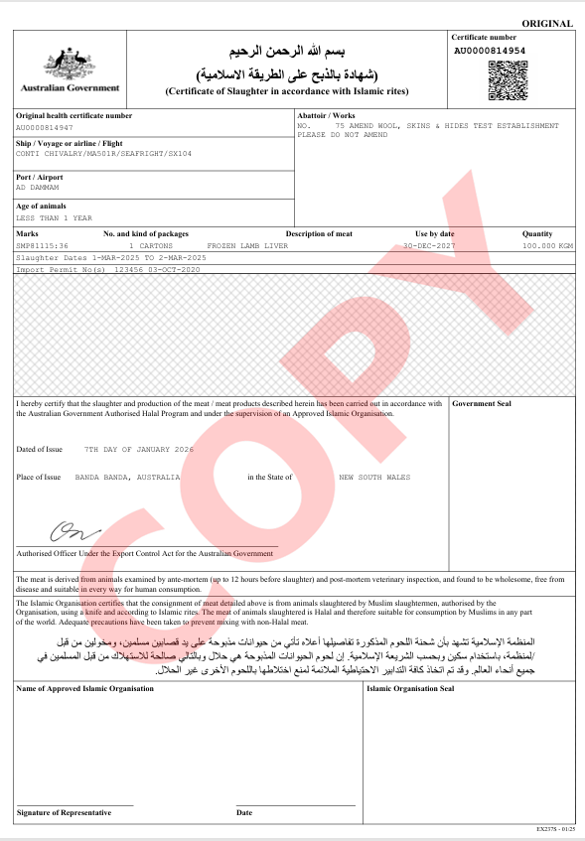
Appendix A – sample NEXDOC Halal Certificate
Appendix B – Process for border officials verifying QR codes

Verifying certificates using the QR code
Step 1. Certificate presented at port and official wishes to validate authenticity.  Step 2. Official can use smart phone camera to scan code. | 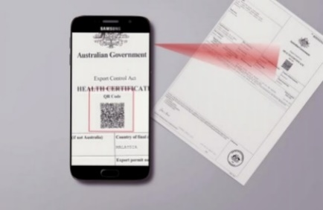
Step 3. Important certificate information is displayed and can be matched to document. | 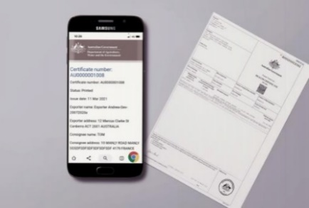
Step 4. The web address will confirm the certificate’s authenticity.  https://api.agriculture.gov.au/ | 