  - Final

Hazardous Waste in Australia 2017
30 May 2017

PREPARED FOR
Department of the Environment and Energy

PREPARED IN ASSOCIATION WITH


Report title | Hazardous Waste in Australia 2017
Client | Department of the Environment and Energy
Status | Final
Author(s) | Geoff Latimer, Ascend Waste and Environment Pty Ltd
Reviewer(s) | Joe Pickin, Luke Richmond
Project number | P726
Report date | 30 May 2017
Contract date | 30 May 2016
Information current to | 30 June 2017
Copyright | Department of Environment and Energy and Blue Environment Pty Ltd
Disclaimer
This report has been prepared for Department of the Environment and Energy in accordance with the terms and conditions of appointment dated 30 May 2016, and is based on the assumptions and exclusions set out in our scope of work. Information in this document is current as of 30 June 2017. While all professional care has been undertaken in preparing this report, Blue Environment Pty Ltd cannot accept any responsibility for any use of or reliance on the contents of this report by any third party.
The mention of any company, product or process in this report does not constitute or imply endorsement by Blue Environment Pty Ltd.
© Department of Environment and Energy and Blue Environment Pty Ltd

Blue Environment Pty Ltd
ABN 78 118 663 997
Suite 208, 838 Collins St, Docklands Vic 3008
Email: blue@blueenvironment.com.au
Web: www.blueenvironment.com.au
Phone: +61 3 9081 0440 / +61 3 5426 3536

Contents
At a glance ix
Summary and conclusions xii
1. Introduction 1
1.1 Project background and context 1
1.2 Project outputs 1
1.3 Report structure 2
2. Project approach 3
2.1 Changes since the 2015 version 3
2.2 Key terms and definitions 4
2.3 Data sources and limitations 13
3. Hazardous waste market overview 19
3.1 The Australian market 19
3.2 Waste pathways: from generation to final fate 21
3.3 Geographic flows – what wastes go where? 22
3.4 Broad market trends 25
4. Data analysis - overview 28
4.1 Overall waste generation and arisings 28
4.2 Sources of waste arisings 34
4.3 Historical trends in waste arisings 36
4.4 Management of hazardous wastes (NSW, Vic, Qld and WA) 37
5. Current and emerging challenges 42
5.1 Hazard protection versus resource value 42
5.2 Persistent organic pollutants (POPs) waste 44
5.3 Biosolids 50
5.4 Coal seam gas industry wastes 57
5.5 The appropriateness of composting for some hazardous wastes 61
5.6 End of life lithium ion batteries 62
5.7 Stockpiled legacy wastes 63
5.8 Underlying data quality remains an issue 65
6. Key messages 69
6.1 Overall hazardous waste arisings continue to increase 69
6.2 What constitutes a hazardous waste is dynamic and requires regular review 69
6.3 Infrastructure is inadequate for some current and emerging hazardous wastes 70
6.4 Major legacy waste problems persist due to infrastructure, technology, regulatory or market-economic shortcomings 70
6.5 Jurisdictional tracking data quality is problematic but can be significantly improved 70
6.6 Tracking data is a largely untapped resource 71
6.7 Qld-specific waste issues 72
7. Recommendations 73
7.1 Relevant recommendations from HWiA 2015 75
8. Data analysis – by waste group 77
8.1 A. Plating and heat treatment 77
8.2 B. Acids 79
8.3 C. Alkalis 81
8.4 D110. Inorganic fluorine (spent potliner) – new to HWiA 2017 83
8.5 D120. Mercury & compounds 85
8.6 D220. Lead & compounds 87
8.7 D230. Zinc compounds – new to HWiA 2017 90
8.8 D300. Non-toxic salts (including coal seam gas wastes) 92
8.9 Other D. Other inorganic chemicals 94
8.10 E. Reactive chemicals 96
8.11 F. Paints, resins, inks, organic sludges 97
8.12 G. Organic solvents 98
8.13 H. Pesticides 100
8.14 J100 & J160. Oils – new to HWiA 2017 103
8.15 J120. Waste oil/water mixtures – new to HWiA 2017 106
8.16 K110. Grease trap wastes 108
8.17 Other K. Other putrescible/ organic wastes – new to HWiA 2017 110
8.18 M100. PCB wastes – new to HWiA 2017 111
8.19 M160. Other organic halogen compounds – new to HWiA 2017 113
8.20 Other M. Other organic chemicals 115
8.21 N120. Contaminated soils 117
8.22 N205a. Biosolids 119
8.23 N205b. Other industrial treatment residues 120
8.24 N220. Asbestos containing material 122
8.25 Other N. Other soils/ sludges 124
8.26 R. Clinical and pharmaceutical waste 126
8.27 T140. Tyres 128
8.28 Other T. Other miscellaneous 129
References 131

Appendices
Appendix A: Underlying data to this report…………………………………………………………………………………...135
Appendix B: Waste groups used in this report………………………………………………………………………….……142
Appendix C: Case study: Classifying ‘contaminated biosolids’ – a comparison of contaminants and assessment criteria…………………………………………………………………………………………………....145

Figures
Figure 1: A simplified schematic of annual flows of hazardous waste 21
Figure 3: Historical national arisings of all hazardous wastes tracked in Australia 25
Figure 2: Major wastes and flows, Australia 2014-15 26
Figure 4: National hazardous waste generation, 2014-15 (tonnes) – by waste group and jurisdiction (excluding biosolids) 31
Figure 5: National hazardous waste generation, 2014-15 (tonnes) – by NEPM ‘75’ waste types (top half of chart: liner display; bottom half: logarithmic display) 32
Figure 6: National hazardous waste generation, 2014-15 (tonnes) – by jurisdiction 33
Figure 7: National hazardous waste generation, 2014-15 (tonnes) – by jurisdiction (excluding biosolids) 33
Figure 8: Historical arisings of all hazardous wastes tracked in Australia 36
Figure 9: Management of tracked hazardous waste in NSW, Qld, Vic and WA, 2014-15 (tonnes) 39
Figure 10: Management of tracked hazardous waste in NSW, Qld, Vic and WA, 2014-15 (percentages) 39
Figure 11: The management of tracked hazardous waste in NSW, 2014-15 (tonnes) 40
Figure 12: The management of tracked hazardous waste in Qld, 2014-15 (tonnes) 40
Figure 13: The management of tracked hazardous waste in Vic, 2014-15 (tonnes) 41
Figure 14: The management of tracked hazardous waste in WA 2014-15 (tonnes) 41
Figure 15: The hazardous waste ‘recover’ versus ‘protect’ dilemma 43
Figure 16: Water-based drilling fluids - chemical components, by weight (%) 58
Figure 17: Historic and proposed cumulative CSG wells 60
Figure 18: Historical arisings of plating and heat treatment waste 79
Figure 19: Historical arisings of acids waste 80
Figure 20: Historical arisings of alkalis waste 82
Figure 21: Historical arisings of inorganic fluorine (SPL) waste 84
Figure 22: Historical arisings of mercury waste 86
Figure 23: Historical arisings of lead waste 88
Figure 24: Historical arisings of zinc waste 91
Figure 25: Historical arisings of non-toxic salts waste 92
Figure 26: Historical arisings of other inorganic chemical waste 95
Figure 27: Historical arisings of reactive chemicals waste 96
Figure 28: Historical arisings of paint, ink, resin and organic sludge wastes 98
Figure 29: Historical arisings of organic solvents wastes 99
Figure 30: Historical arisings of Pesticide wastes 101
Figure 31: Historical arisings of waste oils 104
Figure 32: Historical arisings of waste oil/ water mixtures 107
Figure 33: Historical arisings of grease trap waste 109
Figure 34: Historical arisings of other putrescible/ organic wastes 111
Figure 35: Historical arisings of PCB waste 112
Figure 36: Historical arisings of PCB waste in Qld – Qld certificate anomaly removed 112
Figure 37: Historical arisings of other organic halogen compound wastes 115
Figure 38: Historical arisings of other organic halogen compound wastes – corrected 115
Figure 39: Historical arisings of other organic chemicals waste 116
Figure 40: Historical arisings of contaminated soils 117
Figure 41: Historical arisings of other industrial treatment residues 120
Figure 42: Historical arisings of Qld other industrial treatment residues reported in HWiA 2015 121
Figure 43: Historical arisings of asbestos containing material 123
Figure 44: Historical arisings of other soil/ sludges waste 125
Figure 45: Historical arisings of Qld other soil/sludges reported in HWiA 2015 126
Figure 46: Historical arisings of clinical and pharmaceutical wastes 128
Figure 47: Historical arisings other miscellaneous waste 130
Tables
Table 1: National reporting of hazardous waste data 6
Table 2: Waste groups used for Hazardous Waste in Australia 2017 11
Table 3: Data collection approach for HWiA 2017 14
Table 4: Quality characteristics of jurisdictionally-supplied data 16
Table 5: Gaps and weaknesses in jurisdictional tracking system data and methods for adjusting them 17
Table 6: Comparison of hazardous waste sub-market types, 2014-15 23
Table 7: Adjusted generation of hazardous waste by waste group, Australia 2014-15 (tonnes by jurisdiction) 29
Table 8: Arisings of hazardous waste by waste group, Australia 2014-15 (tonnes by jurisdiction) 30
Table 9: Total percentage of tonnes for which source sector is known 34
Table 10: The management fate of tracked hazardous waste in NSW, Qld, Vic and WA, 2014-15 (tonnes) 38
Table 11: Estimated baseline year arisings of ‘new’ POP-wastes 46
Table 12: Concentrations of HBCD, PFOS, POP-BDEs & deca-BDE in biosolids reported in the literature 47
Table 13: Possible PFOS-contaminated biosolids arisings under stringent regulatory scenarios 49
Table 14: Summary of contaminants listed in Australian biosolids guidelines 52
Table 15: Contaminants assessed by waste classification frameworks in Australia 52
Table 16: Identified data quality issues by waste group 66
Table 17: Plating and heat treatment summary source analysis 2014-15 78
Table 18: Acids summary source analysis 2014-15 79
Table 19: Alkalis summary source analysis 2014-15 81
Table 20: Inorganic fluorine (SPL) summary source analysis 2014-15 84
Table 21: Mercury & compounds summary source analysis 2014-15 86
Table 22: Lead & compounds summary source analysis 2014-15 87
Table 23: Zinc & compounds summary source analysis 2014-15 91
Table 24: Non-toxic salts summary source analysis 2014-15 92
Table 25: Other inorganic chemicals summary source analysis 2014-15 95
Table 26: Reactive chemicals summary source analysis 2014-15 96
Table 27: Paint, ink, resin and organic sludge summary source analysis 2014-15 97
Table 28: Organic solvents summary source analysis 2014-15 99
Table 29: Pesticides summary source analysis 2014-15 101
Table 30: J100 & J160 (oils) summary source analysis 2014-15 103
Table 31: J100 & J160 arisings by major management category and jurisdiction, 2014-15 (percent) 104
Table 32: Oil/water mixtures summary source analysis 2014-15 106
Table 33: Grease trap waste summary source analysis 2014-15 108
Table 34: Other putrescible/ organic waste summary source analysis 2014-15 110
Table 35: PCB waste summary source analysis 2014-15 111
Table 36: M100 arisings by major management categories and jurisdiction, 2014-15 (percent) 113
Table 37: Other organic halogen compound wastes summary source analysis 2014-15 114
Table 38: Other organic chemical wastes summary source analysis 2014-15 116
Table 39: Contaminated soil wastes summary source analysis 2014-15 117
Table 40: Dewatered’ biosolids produced in Australia over the last 3 survey collection periods 119
Table 41: N205a arisings going to biosolids-specific management categories, 2014-15 (percent) 119
Table 42: Other industrial treatment residues waste summary source analysis 2014-15 120
Table 43: Asbestos containing material waste summary source analysis 2014-15 122
Table 44: Other industrial treatment residues waste summary source analysis 2014-15 124
Table 45: Clinical and pharmaceutical waste summary source analysis 2014-15 127
Table 46: Other miscellaneous waste summary source analysis 2014-15 130
Abbreviations & glossary
AFFF | Aqueous film forming foams
ANZSIC | Australia and New Zealand Standard Industry Codes
Basel Convention | The Basel Convention on the Control of Transboundary Movements of Hazardous Wastes and their Disposal. The Convention puts an onus on exporting countries to ensure that hazardous wastes are managed in an environmentally sound manner in the country of import.
Controlled Waste | Waste that falls under the control of the National Environment Protection (Movement of Controlled Waste between States and Territories) Measure 1998. Generally equivalent to hazardous waste, although definitional differences of the latter exist across jurisdictions.
Controlled Waste NEPM | National Environment Protection (Movement of Controlled Waste between States and Territories) Measure 1998
CPT | Chemical or physical treatment (facility)
CSG | Coal Seam Gas - a form of natural gas (generally 95 to 97% pure methane, CH₄) typically extracted from permeable coal seams at depths of 300 to 1,200 m. Also called coal seam methane (CSM) or coalbed methane (CBM).
DoEE | The Australian Government Department of the Environment and Energy
EPS | Expanded polystyrene
Hazardous waste | A hazardous waste, as defined in the Australian Government’s National Waste Policy: Less waste, more resources (2009), is a substance or object that exhibits hazardous characteristics, is no longer fit for its intended use and requires disposal. According to the Act, hazardous waste means:  (a) waste prescribed by the regulations, where the waste has any of the characteristics mentioned in Annex III to the Basel Convention; or  (b) wastes covered by paragraph 1(a) of Article 1 of the Basel Convention; or  (c) household waste; or  (d) residues arising from the incineration of household waste; but does not include wastes covered by paragraph 4 of Article 1 of the Basel Convention.
HWiA 2015 | Blue Environment, Ascend Waste and Environment, and Randell Environmental Consulting (2015) Hazardous Waste in Australia, prepared for the Department of the Environment
HWiA 2017 | This report
HWIDP Project | The Hazardous Waste Infrastructure and Data Project, carried out in 2014-15 by Blue Environment, Ascend Waste and Environment and Randell Environmental Consulting for the Department of the Environment, which includes two key reports: Hazardous waste infrastructure needs and capacity assessment (HWIN) and Hazardous waste in Australia (HWiA 2015),
Interstate data | Data collected about hazardous waste generated in one jurisdiction and treated in another, through cross-border transport under the Controlled Waste NEPM.
Intrastate data | Data collected about hazardous waste generated, transported and treated within the one jurisdiction.
kt | Kilotonnes (thousands of tonnes)
LPCL | Low POP concentration limit
Mt | Megatonnes (millions of tonnes)
ng/g | Nanograms per gram. A unit of measurement identical to micrograms per kilogram (μg/kg)
NEPM | National Environment Protection (Movement of Controlled Waste between States and Territories) Measure 1998
PCB | Polychlorinated biphenyl
PFOS | Perfluorooctane sulfonate
POP | Persistent organic pollutant
POP-BDE | Persistent organic pollutants - bromodiphenyl ethers (various forms)
SPL | Spent potliner (a waste from the aluminium smelting industry)
Standard | Australian hazardous waste data and reporting standard
Tracking system | Jurisdiction-based hazardous waste tracking systems, which are in place in NSW, Qld, SA, WA and Vic. These tracking systems can be either online, paper-based, or a combination of both these mechanisms.
Tracked data | Hazardous waste collected under the arrangements of a tracking system.
Treatment | Treatment of waste is the removal, reduction or immobilisation of a hazardous characteristic to enable the waste to be reused, recycled, sent to an energy-from-waste facility or disposed.
Waste | (For data collation purposes) is materials or products that are unwanted or have been discarded, rejected or abandoned. Waste includes materials or products that are recycled, converted to energy, or disposed. Materials and products that are reused (for their original or another purpose without reprocessing) are not waste because they remain in use.
Waste arisings | Hazardous waste is said to ‘arise’ when it causes demand for processing, storage, treatment or disposal infrastructure.
Waste code | Three-digit code typically used by jurisdictions to describe NEPM-listed wastes. These are also referred to as ’NEPM codes’ although it is noted that the actual codes do not appear in the NEPM itself.
Waste fate | Waste fate refers to the ultimate destination of the waste within the management system. Types of fate may include recycling, energy recovery, long-term storage and disposal, each of which categories can be divided into more specific fates. Treatment, transfer and short-term storage are not fates, but are rather part of the pathway leading to a fate.
Waste generation | The process of creating a waste. In this report generation is expressly different to arisings because it seeks to exclude the potential for double-counting, by subtracting the following (to the extent the relevant tonnes can be identified):  1. hazardous waste sent to facilities for short-term storage or transfer  2. hazardous waste outputs of hazardous waste infrastructure – only inputs are counted.
Waste groups | The classification system adopted for wastes outlined in this report (closely follows the NEPM categories. Waste groups have also been referred to as ‘projection groups’ in previous projects where the context refers projections of hazardous waste arisings for the purpose of assessing demand on infrastructure).
Waste management | For the purposes of this report, management of hazardous waste comprises the activities through which it is dealt within infrastructure approved to receive it. The types of management are recycling, energy recovery, long-term storage, disposal, treatment and short-term storage. The first four of these are a type of fate; the last two are a type of pathway. Therefore, for hazardous waste, tonnes ‘managed’ = tonnes sent to pathway infrastructure + tonnes sent to fate infrastructure.
Waste pathway | The pathway of hazardous waste covers the various steps in the route between hazardous waste generation and fate, potentially including transfer, storage and/or treatment.
Waste source | The source of a waste describes and categorises where it is generated, which could be the location (i.e., the geographical source), the company, industry sector, or in some circumstances the jurisdiction that produced it.
WTP | Western Treatment Plant (in Victoria)

At a glance
In 2014-15 Australia produced around 5.6 million tonnes of hazardous waste, which is about 9% of all waste generated (64 million tonnes) in this period.

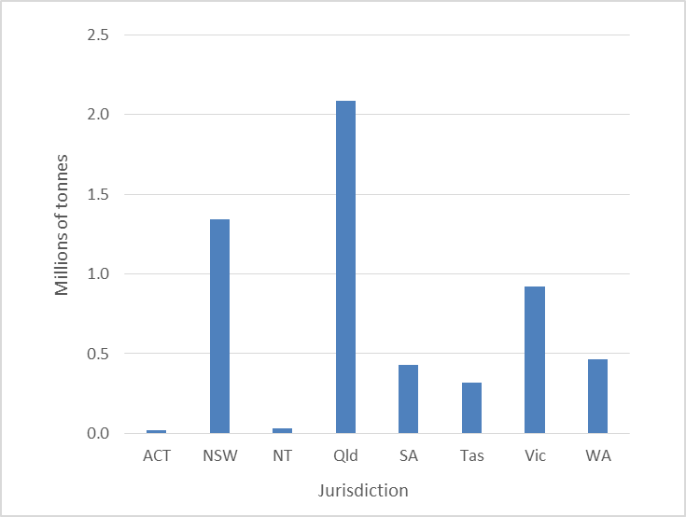
Classified into more than 70 detailed waste types, these include:
- contaminated soils and asbestos from development and demolition projects
- wastes from the chemicals and heavy manufacturing industry
- mining wastes such as coal seam gas mining (CSG wastes) and
- a range of wastes with hazardous characteristics that arise from more everyday sources, such as:
- tyres/oils/oily waters (motor vehicles)
- grease trap waste (commercial cooking) and
- lead-containing wastes such as lead acid batteries (motor vehicles again) and leaded glass from used TVs and computers and
- spent industrial catalysts and other residual wastes, contaminated with heavy metals.

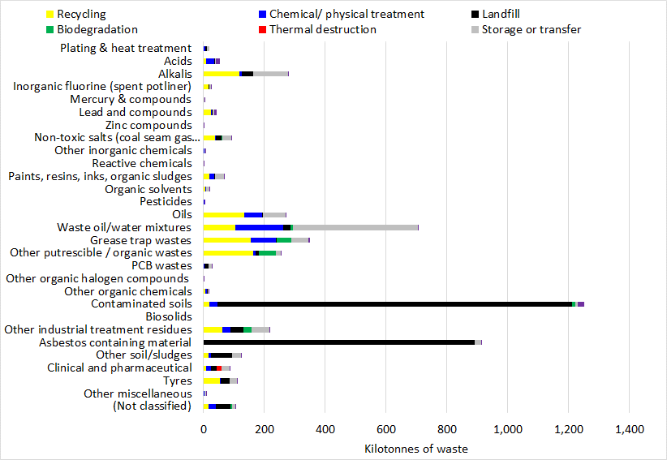
The top 10 wastes¹ produced by weight in 2014-15, were:
1. Contaminated soils [26%]
2. Asbestos [18%]
3. Grease trap wastes [10%]
4. Tyres [7%]
5. Animal effluent & residues [6%]
6. Oil/water mixtures [5.5%]
7. Non-toxic salts [4.1%]
8. Lead waste [3.9%]
9. Residues from industrial treatment [3.7%]
10. Waste oils [3.6%]

The majority of these wastes were sent to landfill (51%). Another 16% was recycled, 14% underwent specific treatment (to reduce or remove the hazard) and 13% was stored for accumulation and later release into management infrastructure.
Hazardous waste in Australia moves in three sub-markets, each focused on different wastes with distinct scales and issues of interest: 94% of waste is generated in, and managed by, infrastructure located within a state/territory border; 5% crosses interstate borders; and 1% is exported to or imported from overseas for management in specialised infrastructure not available (or economic) within the generating jurisdiction.

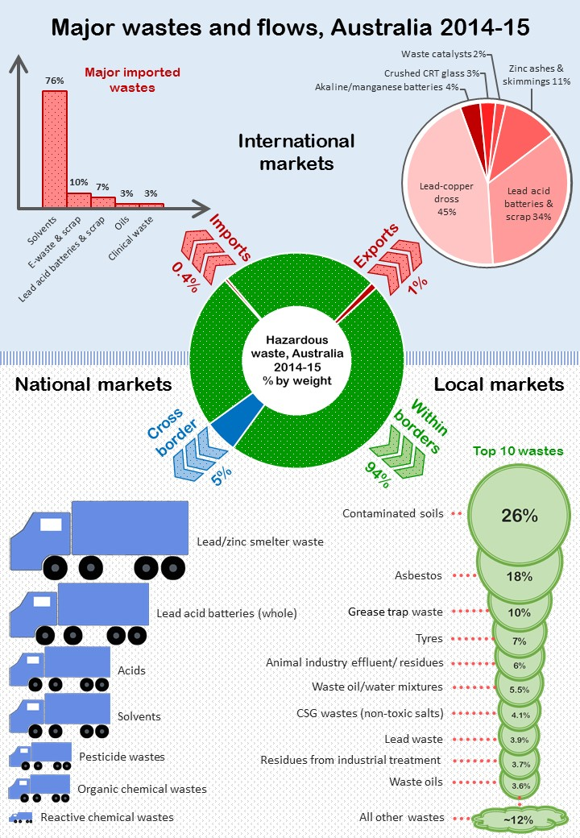
Hazardous wastes trended strongly upwards in the five years to 2014-15, increasing at a rate of approximately 9% per year.
- This is despite downturns in traditional industries like types of heavy manufacturing and aluminium smelting, leading to declining volumes of traditional wastes like acids, alkalis and various organic and inorganic chemical residues.
- Apart from steady increases (in line with population growth) of wastes aligned more directly to domestic activities and the broader economy, continued waste growth is underpinned by sectoral shifts in the industrial mix, with the emergence of new wastes and industries, most markedly in the case of the coal seam gas (CSG) industry in Queensland, and the large volumes of high-salinity waste that arise from it.

Like the CSG industry of the last decade, new wastes are emerging due to changes in technology and consumer products, and increased regulatory understanding of the hazards of entrained chemicals in the wastes that they become or create. These new wastes may arise in significant volumes and there is limited domestic infrastructure to treat them. The issues include:
- persistent organic pollutant (POP) wastes
- new concerns about the contaminants in biosolids (due to upstream chemical use)
- changing battery technologies (such as the prevalence of lithium-ion).

Old, intractable waste problems persist in Australia due to infrastructure, technology, regulatory or market-economic shortcomings. These so-called ‘legacy wastes’ remain present (often stockpiled) in very large volumes that dwarf annual waste generation figures. They include approximately:
- 0.7 million tonnes of the aluminium industry’s spent potliner (SPL) waste
- 7.5 million tonnes of dewatered contaminated biosolids at Melbourne’s Western (sewage) Treatment Plant
- 225 million tonnes of fly ash from coal fired power stations
- 500 million tonnes of so-called red mud from alumina refining.

Summary and conclusions
Hazardous Waste in Australia 2017 (HWiA 2017) was commissioned by the Australian Government Department of the Environment and Energy (DoEE) and conducted by Blue Environment Pty, in association with Ascend Waste and Environment Pty Ltd. Building on the inaugural version of the report (BE et al. 2015a), it seeks to provide:
- an authoritative and current snapshot of hazardous waste generation and management in Australia that includes sources, amounts, trends, types, pathways and fates of hazardous waste in 2014-15
- analysis and commentary on issues with particular wastes and their management to improve understanding of what works well and where barriers may lie to more effective management of Australia’s hazardous wastes.

In 2014-15 Australia produced around 5.6 million tonnes of hazardous waste, which is about 9% of all waste generated (64 million tonnes) in this period. A snapshot of national hazardous waste generation in Australia in 2014-15, by waste group for each jurisdiction, is given in Table ES1.

A range of wastes that are not neatly captured in annual generation estimates present complex challenges for the hazardous waste market, regulators and the community. These wastes include:
- persistent organic pollutants (POPs) waste
- (potentially contaminated) biosolids
- coal seam gas (CSG) wastes
- end of life lithium ion batteries
- legacy wastes, such as:
- spent pot lining (SPL) waste (from aluminium smelting)
- fly ash (from coal-fired power stations)
- red mud wastes (from alumina refining).

The complexities arise because these wastes are potentially large in volume, lack sufficient management infrastructure or end-markets (which drives recurrent stockpiling) and carry potential risks and liabilities due to their inherent hazards.

Key messages
- Overall hazardous waste arisings continue to increase:
- 4.59 million tonnes in 2010-11
- 5.34 million tonnes in 2011-12 (16% increase on previous year)
- 5.45 million tonnes in 2012-13 (2% increase on previous year)
- 6.01 million tonnes, in 2014-15 (10% increase from 2012-13)
- 30% total increase in arisings since 2010-11 with an annual average of 9% p.a³.

Table ES1: Adjusted generation of hazardous waste by waste group, Australia 2014-15 (tonnes by jurisdiction)
Code | Description | ACT | NSW | NT | Qld | SA | Tas | Vic | WA | AUSTRALIA
A | Plating & heat treatment | 45 | 0 | 0 | 5,243 | 111 | 0 | 0 | 4,744 | 10,143
B | Acids | 0 | 962 | 0 | 17,619 | 641 | 3 | 30,183 | 1,595 | 51,002
C | Alkalis | 231 | 376 | 120 | 153,583 | 15,169 | 2 | 6,825 | 3,772 | 180,079
D110 | Inorganic fluorine (spent potliner) | 0 | 12,980 | 0 | 12,540 | 3 | 3,960 | 6,688 | 14 | 36,185
D120 | Mercury & compounds | 61 | 733 | 12 | 95 | 51 | 0 | 127 | 537 | 1,616
D220 | Lead and compounds | 916 | 7,652 | 233 | 22,173 | 21,001 | 144,149 | 18,692 | 3,634 | 218,448
D230 | Zinc compounds | 0 | 0 | 0 | 412 | 16,079 | 112,896 | 171 | 549 | 130,108
D300 | Non-toxic salts (inc. coal seam gas wastes) | 0 | 29,034 | 34 | 19,533 | 110 | 3,580 | 5,812 | 8,211 | 66,314
Other D | Other inorganic chemicals | 0 | 50 | 5 | 2,242 | 25 | 0 | 1,361 | 261 | 3,945
E | Reactive chemicals | 0 | 7 | 0 | 203 | 36 | 25 | 16 | 107 | 394
F | Paints, resins, inks, organic sludges | 209 | 4,347 | 45 | 26,469 | 2,518 | 24 | 15,998 | 6,204 | 55,813
G | Organic solvents | 26 | 384 | 0 | 2,394 | 188 | 1,427 | 2,631 | 5,079 | 12,128
H | Pesticides | 0 | 123 | 0 | 630 | 330 | 32 | 429 | 2,036 | 3,581
J100 & J160 | Oils | 698 | 22,471 | 2,015 | 46,208 | 3,482 | 64 | 26,194 | 99,762 | 200,895
J120 | Waste oil/water mixtures | 570 | 52,737 | 2,463 | 158,729 | 1,395 | 270 | 58,962 | 34,174 | 309,302
K110 | Grease trap wastes | 5,788 | 174,885 | 5,633 | 128,058 | 39,150 | 11,933 | 119,309 | 58,771 | 543,529
Other K | Other putrescible / organic wastes | 0 | 90,288 | 2,875 | 165,999 | 19,978 | 6,089 | 42,390 | 31,172 | 358,790
M100 | PCB wastes | 27 | 1,592 | 3 | 8,221 | 76 | 33 | 5,550 | 452 | 15,955
M160 | Other organic halogen compounds | 0 | 3 | 0 | 4 | 1 | 0 | 30 | 2 | 40
Other M | Other organic chemicals | 0 | 10,504 | 0 | 1,749 | 2,597 | 7 | 469 | 762 | 16,089
N120 | Contaminated soils | 599 | 453,630 | 12,065 | 418,739 | 204,422 | 5,629 | 358,930 | 11,820 | 1,465,834
N205a | Biosolids | 73,810 | 339,524 | 14,762 | 295,238 | 132,857 | 73,810 | 428,095 | 118,095 | 1,476,190
N205b | Other industrial treatment residues | 0 | 12,311 | 0 | 137,223 | 49,238 | 0 | 4,464 | 4,911 | 208,147
N220 | Asbestos containing material | 5,856 | 306,465 | 2,000 | 507,159 | 13,477 | 15,473 | 80,069 | 77,160 | 1,007,659
Other N | Other soil/sludges | 4 | 14,133 | 12 | 50,472 | 2,936 | 133 | 27,952 | 2,026 | 97,669
R | Clinical and pharmaceutical | 443 | 23,734 | 76 | 42,756 | 4,467 | 21 | 12,270 | 2,905 | 86,674
T140 | Tyres | 3,830 | 110,185 | 5,004 | 92,353 | 30,789 | 10,100 | 92,846 | 70,192 | 415,300
Other T | Other miscellaneous | 125 | 1,599 | 26 | 1,183 | 174 | 19 | 494 | 464 | 4,084
Other | (Not classified) | 0 | 10,528 | 0 | 62,091 | 0 | 0 | 1,156 | 35,029 | 108,805
Totals (inclusive of biosolids) |  | 93,237 | 1,681,238 | 47,384 | 2,379,320 | 561,303 | 389,679 | 1,348,113 | 584,444 | 7,084,717
 |  | 1.3% | 24% | 0.7% | 34% | 8% | 6% | 19% | 8%
Totals (exclusive of biosolids) |  | 19,427 | 1,341,714 | 32,622 | 2,084,082 | 428,446 | 315,869 | 920,018 | 466,349 | 5,608,527
 |  | 0.3% | 24% | 0.6% | 37% | 8% | 6% | 16% | 8%

- What constitutes a hazardous waste is dynamic and requires regular review
This report details some emerging waste streams that are not always considered hazardous waste. Biosolids are an example. In that case, there is an emerging recognition of the hazards of potential contaminants due to advances in environmental and health science. This is occurring long after the relevant chemical substances were in widespread used in various products and processes.

- Infrastructure is inadequate for some current and emerging hazardous wastes
Better hazardous waste infrastructure planning was identified as a critical issue by the authors in the Hazardous waste infrastructure needs and capacity assessment report (BE et al 2015b). This issue is further highlighted in this report; for some hazardous wastes such as coal seam gas (CSG) wastes and asbestos there are problems with infrastructure adequacy or economics (due to source locations far from higher-standard management facilities, for example), while emerging problems such as POP-wastes, biosolids (in a potentially more stringent regulatory environment) and lithium ion batteries could, and in some cases already are, changing the landscape of what constitutes a hazardous waste and what types of management are acceptable.

- Major legacy waste problems persist due to infrastructure, technology, regulatory or market-economic shortcomings
These include approximately:
- 0.7 million tonnes of the aluminium industry’s SPL waste which, given the declining trend of the industry in Australia, represents a current and future clean-up liability for smelters (open and closed), local communities and governments alike.
- 1.5 million ‘dry tonnes’ of biosolids (equivalent to 7.5 million tonnes on an average dewatered basis of 21% solids) at Melbourne’s Western Treatment Plant, known to be contaminated (in heavy metals) to the extent that they are unacceptable for land application.
- 225 million tonnes of fly ash from coal fired power stations. In 2015 only 20% of annual fly ash production (approximately 2 million tonnes out of 10 million tonnes produced) was beneficially used, plus a similar amount from historical stores. This leaves most of the material stockpiled indefinitely, probably due to limitations in market need, unsustainable economics or restrictive levels of contaminants.
- 500 million tonnes of so called red mud from alumina refining, stockpiled throughout Australia’s six alumina refineries.

- The quality of the data from state hazardous waste tracking systems is problematic but can be significantly improved
Hazardous waste tracking systems are in place in NSW, Qld, SA, Vic and WA. These systems provided most of the data used in this report. It is apparent that the quality of some of this data is lower than the data used for HWiA 2015. The data quality issues arise through a mix of systemic weaknesses, poor quality assurance (QA), system-user knowledge gaps and ambiguity in coding and definitional conventions. In summary:
- source industry identification coding is absent or unreliable in all five state tracking systems
- management type identification is absent from the SA dataset
- user choices of waste codes and management codes are sometimes incorrect and often inconsistent
- incorrect use of units (e.g. m³ instead of kg) has a major impact on annual estimates
- there are major differences in the tonnages reported as arising in Qld for this report and for HWiA 2015
- management type data is missing from Vic data for wastes sent interstate
- NSW tracking exemptions result in under-reporting of some wastes (except where other data collection methods are used).

These challenges in the data quality weaken some aspects of the analysis in this report.

Fundamental to improvement of these problems is better jurisdictional quality assurance prior to release of the data, consistent with the procedures set out in the Australian hazardous waste data and reporting standard. Most of the apparent errors in tonnage arisings uncovered through this project could have been identified and corrected with better quality assurance.

- Tracking data is a largely untapped resource
State electronic tracking systems record hundreds of thousands of vehicle movements, showing waste production, pathways and fates in great detail and representing a data resource of encyclopaedic proportions. This report (and its predecessor) show that the data can facilitate new observations about hazardous waste and the industry dealing with it. The data sets have limitations but most are correctable through data cleansing effort. The framework architecture is of high quality, particularly when observed from an overall compilation level.

- Qld-specific waste issues
Beyond issues of data quality, Qld is a unique hazardous waste jurisdiction. The coal seam gas (CSG) industry provides enormous waste management challenges not present in other states and territories. CSG wastes make up around 11% of apparent Qld waste generation in 2014-15, but if apparent waste generation is adjusted for obvious reporting errors (such as those identified for oily waters (J120), asbestos (N220) and other smaller volume wastes), this CSG figure is closer to 20%. These figures include only what has been subject to hazardous waste tracking. Vast volumes of salty extraction waters, which either do not arise into offsite management infrastructure or are not regulated as hazardous waste, are not tracked but have been estimated to be around 25 million tonnes per annum (in 2009) in the Surat Basin alone. One of the smaller CSG projects in the Bowen Basin is expected to produce up to 0.6 ML of brine a day, and some 60 000 tonnes of salts and heavy metals over the life of the project (Origin 2017).

As a large state with distributed population centres, Qld suffers economies of scale pressures that make it hard to locate ideal-world infrastructure within accessible distance to waste generation. This leads to decisions of practicality. Composting or related biodegradation processes appear to be a prevailing infrastructure type in Qld for a range of wastes that offer no benefit to efficiency of the composting process and either small benefit or lack of clear dis-benefit to end products. This may be an acceptable practicality so long as standards and guidelines are adhered to, such as Beneficial Use Approval conditions (and the ‘end of waste codes’ set to replace them), environmental authority (licence) conditions and, ultimately, output product quality standards such as the Australian Standard AS4454 for composts, mulches and soil conditioners (SAI 2003).
Recommendations
The recommendations below may help to address some of the issues identified above. They are coded to show those related to government policy improvements (P1 – P5), and those related to tracking data improvements (D6 – D10). They are provided in full in Section 7.
- Recommendation P1: A number of emerging wastes, such as those containing persistent organic pollutants and related organohalogen compounds, should be assessed for inclusion in hazardous waste frameworks.
- Recommendation P2: Strategic work programs to better manage high volume/ risk legacy wastes, such as spent potliner (SPL), fly ash, red mud, contaminated biosolids and intractable wastes such as Orica’s hexachlorobenzene (HCB) stockpile, should be prioritised.
- Recommendation P3: The hazard characteristics of Australian biosolids should be examined through an extensive analytical program that is broad and future-focused.
- Recommendation P4: Based on these test results, Australian jurisdictional biosolids guidelines should be modernised to reflect the breadth of relevant hazards.
- Recommendation P5: Guidance on the use of the waste hierarchy in a hazardous waste context is needed.
- Recommendation D6: Jurisdictions should subject hazardous waste tracking system data to appropriate quality assurance checks, as described in the Australian hazardous waste data and reporting standard (Item 25)
- Recommendation D7: Independent validation of jurisdictional hazardous waste data on a routine basis should be considered.
- Recommendation D8: States with tracking systems should review their historical annual data in the National Hazardous Waste Data Collation (the data record for this project) and sign off on its veracity for indefinite reuse. This would enable a subsequent ‘back casting’ of the annual compilation set of Australian hazardous waste data (2010-2015), using current adjustment methods, resulting in a ‘locked-down’, consistent time-series record of hazardous waste data.
- Recommendation D9: A cut-off value of waste truck payload size should be agreed, as a means of vetting out gross errors that can vastly over-estimate waste tonnages.
- Recommendation D10: Designs of a future national tracking system should incorporate systemic improvements as suggested in this report, to improve data quality.

Relevant recommendations from HWiA 2015
Two of HWiA 2015’s recommendations are also pertinent to the latest compilation:
- Recommendation HWiA 2015-2: The impact of regulatory exemptions on arisings data needs to be better understood:
“Transport certificate exemptions such as those for lead acid batteries, oils and other wastes in NSW need to be further explored to ascertain their potential to result in under-reported arisings data. This will ensure future Basel reports and other national data collations of hazardous waste reflect accurate arisings and may result in a requirement for further data adjustments to future data collation methods.”
- Recommendation HWiA 2015-3: Jurisdictions should work together to improve fate (management) categories and use them consistently.
“Fate (management) allocations in tracking systems, including the underlying D and R codes, should be a very important topic of shared discussion between current and potential jurisdictional tracking systems. The current categories and how they are used in industry are highly inconsistent, ambiguous and unhelpful ...”

Introduction

Project background and context
Hazardous Waste in Australia 2017 (HWiA 2017) was commissioned by the Australian Government Department of the Environment and Energy (DoEE) and conducted by Blue Environment Pty, in association with Ascend Waste and Environment Pty Ltd. Building on the inaugural 2015 version of the report, it seeks to provide:
- an authoritative and current snapshot of hazardous waste generation and management in Australia that includes sources, amounts, trends, types, pathways and fates of hazardous waste in 2014-15
- analysis and commentary on issues with particular wastes and their management to improve understanding of what works well and where barriers may lie to more effective management of Australia’s hazardous wastes.

With a common thread of an extensive current and historical national data collection, compilation and analysis requirement, DoEE’s engagement also required the delivery of the Basel report 2015, Australia’s hazardous waste generation data from all jurisdictions reported to the Basel Secretariat in Geneva Switzerland for the reporting year 2015. Common data was used for both reporting requirements, in different formats, and is provided as Appendix A to this report.

Australia signed the Basel Convention on the Control of Transboundary Movements of Hazardous Wastes and their Disposal (referred to hereafter as the Basel Convention) in 1992. The Convention regulates the movement of hazardous wastes across international boundaries and puts an onus on exporting countries to ensure that hazardous wastes are managed in an environmentally sound manner in the country of import, as well as in their own country. One hundred and fifty other countries have ratified the Basel Convention as at December 2002.

The Australian Government is obliged to submit an annual report to the Basel Secretariat containing the tonnages of hazardous wastes generated in the country each calendar year. This data provides a baseline and backdrop to discussions about Australia’s progress with efforts to better manage its hazardous waste. The data must be reported using the Basel Convention’s classification system known as Y-codes. State and territory governments collect this data as part of their regulatory role in managing hazardous waste and its potential for impact on the environment and human health.

Project outputs
As required, this report includes:
- data on hazardous waste sources (e.g. ANZSIC codes)
- data on hazardous waste management, a newly adopted term from the Australian hazardous waste data and reporting standard (hereafter referred to as ‘the Standard’), that includes both fates and pathways (as defined in Section 2.2 of this report)
- historical trend analysis of hazardous waste arisings
- commentary on the data.

The analysis is underpinned by the Microsoft Excel data file, National hazwaste data collation 2014-15. This compilation contains hazardous waste data from all states and territories including:
- tonnes by waste type and financial year covering at least 2014-15 and, in some cases, historical data spanning several years (Qld’s data set is the most extensive, reaching back to 1999-2000)
- data on the source industries that generated the hazardous waste (NSW, Qld, SA and Vic only)
- data on the ways hazardous waste was managed (NSW, Qld, Vic and WA only).

The state codes for waste type, source and management vary. The collation file transforms them to a common platform for analysis. The common platform and transformation methods are described in the Standard.

Report structure
This report is structured as follows:
- An introduction to the project, its scope and context amongst the other related data-projects (Section 0).
- A summary (in Section 2) of:
- the project’s differences from its predecessor HWiA 2015
- method
- key definitions that are critical to understanding of the data and interpretation applied to this project, as well as key limitations to the approach.
- A national overview of the hazardous waste market, including players, pathways, waste flows and trends (Section 3)
- A national overview of hazardous waste arisings, sources and management for 2014-15 data, plus summary-level historical trends ranging as far back as jurisdictional data allows (Section 4)
- Investigation into wastes with current and emerging challenges, which may not be well-covered by tracking systems, that have unique management challenges (Section 5).
- Summary of findings (Section 6).
- Recommendations (Section 7).
- Analysis of each waste group in detail: describing the waste, its major sources, arisings, historical arisings trends, fate and analysis and commentary to provide insight into issues that this data may uncover (Section 8).

Project approach
Data from jurisdictional tracking systems was used extensively where it was present. Waste tracking systems in Qld, NSW, SA, Vic and WA require companies generating, transporting and managing hazardous waste to provide a record to government of each transaction to which they are a party. These systems were established to ensure that hazardous waste is appropriately managed.

Data from these systems was collected, collated and analysed, together with other jurisdictional waste data. Data on quantities, sources and management were collated for 2014-15. Historical quantity data was also collected.

Details about data, terminology, waste groupings and how they have been applied are discussed in Section 2.2, while Section 2.3 discusses data sources used and their respective limitations.

Changes since the 2015 version
Hazardous Waste in Australia was first published in 2015 (HWiA 2015). This report represents the second version, in accordance with the Department’s planned biennial release schedule.

Since 2015, a number of improvements and changes to data collection, classification, analysis and compilation methods and definitional approaches have been adopted. These are discussed in detail in Sections 2.2 and 2.3 and are highlighted in brief immediately below.

Changes arising from the Australian hazardous waste data and reporting standard
- Data collection method – tonnes of waste managed rather than generated in a jurisdiction were requested. This was felt to better capture interstate transfers in particular, since receiving jurisdictions appear to keep better records than sending jurisdictions in such a transaction.
- Data compilation method – tonnes of waste generated were deduced from tonnes of waste arising, by subtracting short term storages and accumulation practices, to better account for multiple counts into and out of management infrastructure. This would have the effect of lowering tonnages reported compared to previous years.
- Apart from trends analysis, ‘adjusted generation’ (for multiple counting) was used throughout the report to discuss tonnages produced in 2014-15, as opposed to ‘arisings’ in 2012-13 data.
- An extensive set of unit conversions were developed and used for 2014-15 data, mainly to convert from m³ to tonnes, but also to better handle unique wastes such as near-empty drums reported in number of drums and low-density wastes such as clinical waste. These were applied to historical arisings trend datasets as well.
- Item 12 of the standard envisaged collecting data on ‘significant and quantifiable additions’ to large onsite stockpiles. None appear to be been explicitly captured in 2014-15 data available, but this report discusses such legacy wastes in depth.
- The term ‘management’ was adopted throughout this report in place of ‘fate’, due to the fact that fate is an end-destination, and hazardous waste routinely goes through intermediate ‘pathways’ such as treatment (to reduce hazard), short term storage or accumulation. Management describes both fates and pathways.

Changes from HWiA 2015 lessons learnt
- The collection method at the management end of the waste transaction allowed for interstate movements that had previously been allocated to the receiving jurisdiction to be netted out and placed into the sending jurisdiction’s arisings, resulting in better accountability for waste generation and a more reliable set of generation figures, cleansed of another potential form of double-counting. This change arose from the recommendation in HWiA 2015 to make a better account of interstate transport data.
- HWiA 2015’s waste groups were expanded from 23 to 28 to better isolate wastes of significant concern.
- A more forensic approach to uncovering data errors such as incorrect unit choice was applied in the development of this report.

Other changes
- This report places a greater focus than its predecessor on the emerging problems with the hazardous waste industry in Australia, regardless of whether such wastes are currently tracked or even considered hazardous.
- In particular, biosolids have been examined more closely than last year and, while they have been routinely removed from some data analysis due to the swamping effect that their volume creates, they are transparently included in total hazardous waste compilations such as those reported to the Basel Convention.
- SPL waste is now calculated from aluminium production figures, as a more accurate measure of generation due to the propensity of onsite shed storage of this waste by the alumina industry, which does not appear in tracking data.
- All ACT data was provided from the collation of paper interstate waste transport certificates, rather than through the inferior estimation techniques (from NEPM reported figures) previously used.

Key terms and definitions

Hazardous waste
Hazardous waste is waste that, by its characteristics, poses a threat or risk to public health, safety or to the environment. In national reporting this term is taken to correspond with:
- wastes that cannot be imported or exported from Australia without a permit under the Hazardous Waste (Regulation of Exports and Imports) Act 1989
- wastes that any jurisdiction regulates as requiring particularly high levels of management and control, namely: regulated waste (Qld); trackable waste (NSW); prescribed waste (Vic); listed waste (SA and NT); or controlled waste (ACT, Tas and WA)
- additional wastes nominated as hazardous by the Australian Government.
NSW (along with the ACT, due to their adoption of NSW classification procedures) uses the term ‘hazardous waste’ in a specific regulatory sense. The NSW Protection of the Environment Operations (Waste) Regulation 2005 and associated guidance defines ‘hazardous waste’ as one of six classes of waste – and it typically cannot be disposed at landfill without hazard reduction treatment such as immobilisation. ‘Hazardous waste’ in this strict NSW (and ACT) regulatory interpretation is equivalent only to those hazardous wastes (in national reporting terminology) that would be categorised at the higher hazard end of the range.

Regulating and tracking hazardous waste in Australia
Whereas the Australian Government has responsibilities in relation to hazardous waste under the Hazardous Waste (Regulation of Exports and Imports) Act 1989 (the Act) and the National Waste Policy, regulation of hazardous waste management is mainly the responsibility of the states and territories (the jurisdictions). In order to ensure appropriate management of these wastes, the five largest jurisdictions (NSW, Qld, SA, Vic and WA) operate systems for ‘cradle to grave’ tracking of the movement of each consignment of hazardous waste from point of generation to treatment or disposal. Tracking certificates include the type and quantity of waste, the dates, and the producer, transporter and details of the receiving facility. A copy is sent to the government. The jurisdictions agreed to allow the use of the large data sets generated by their tracking systems in this study, under confidentiality agreements.

The reporting year used for data in this report
The Standard identifies five purposes for reporting quantities of hazardous waste at a national level in Australia. These are reproduced as Table 1 overleaf. Basel and OECD reporting use calendar year format while the National Waste Report (which incorporates hazardous waste), reporting under the National Environment Protection (Movement of Controlled Waste between States and Territories) Measure (hereafter referred to as the NEPM) and Hazardous Waste in Australia all use financial year format.
The reporting year used in this report is the 2014-15 financial year, the most recent financial year for which data was provided or available for all jurisdictions.
Appendix A (A.1) includes hazardous waste generation data at the ‘NEPM 75’ level, presented to enable either financial year or calendar year viewing.
Appendix A (A.2) includes hazardous waste generation data in Y code format (as required by Basel) submitted for the Basel report for calendar year 2015, alongside the two six-monthly blocks it was collected in.

The meaning of waste ‘arising’
The term ‘arise’ is used in relation to hazardous waste data derived from tracking systems. Waste ‘arises’ when it is delivered to hazardous waste processing, storage, treatment, or disposal infrastructure. This is distinct from ‘generation’, a term commonly used in waste reporting, in that if waste is transported to more than one site it may ‘arise’ more than once in the tracking system data.

The majority of data presented in this report is of waste arising, which is consistent with data from the jurisdictional tracking systems. This differs for the Basel report (Appendix A), which specifically requires waste ‘generation’ as defined below.

It should be noted that until a waste is moved offsite, it does not arise. Waste that is created on a site and remains stored there has not arisen.

Table 1: National reporting of hazardous waste data
Report | Rationale | Period | Frequency | State & territory data needed by | Content
Report to the Basel Secretariat | Requirement of the Basel Convention | Calendar year | Annually | By end of previous calendar year | Quantities generated nationally by waste type
Hazardous Waste in Australia | Government commitment | Financial year | Every two years | Not yet fixed | Quantities, trends in quantities, sources, pathways and fates, potentially with sub-analyses by jurisdiction
National waste reports | Government commitment | Financial year | Not yet fixed | Not yet fixed | Quantities, pathways and fates by jurisdiction
OECD reports | Requirement of OECD membership | Calendar year | Various | Varied | Various
NEPM reports | Requirement of under the NEPM and its implementation agreement | Financial year | Annual | Not fixed | Collated summary information on the:  (i) movement of controlled waste into each jurisdiction, indicating jurisdiction of origin, waste code and quantity of waste;  (ii) level of discrepancies (e.g. non-arrival of a consignment) as a percentage of total authorised controlled waste movements; and  (iii) benefits arising from the implementation of the Measure.
Source: Blue Environment, Ascend Waste and Environment & Randell Environmental Consulting (2016). Australian hazardous waste data and reporting standard, prepared for the Australian Government Department of the Environment for distribution to the Australian states and territories, Appendix H Table 6.

The meaning of waste ‘generation’
Waste generation is the process of creating a waste. For data purposes, generation of non-hazardous waste is normally taken as the sum of waste disposed of, recycled or sent for energy recovery. Generation of hazardous waste is more difficult to estimate because data on the tonnages to each of these fate types is not always readily available, and additional pathways, such as storage or treatment, may be taken by hazardous waste on route to its final fate. Inclusion of tonnages to these additional pathways would result in multiple counting of the same waste, which was generated only once.

In using arisings data to estimate hazardous waste generated for the purpose of Basel reporting, the following is subtracted (to the extent the relevant tonnes can be identified):
- hazardous waste sent to facilities for short-term storage or transfer
- hazardous waste outputs of hazardous waste infrastructure – only inputs are counted.
This method seeks to avoid multiple counting in waste generation. Conversely, waste arisings have no adjustments applied for multiple counting.

The meaning of waste ‘source’
The source of waste is where it is generated, which could be the location (geographical source) or the company or industry sector that produced it. This report, like others, describes geographical source at the jurisdictional level. However, to provide a greater level of understanding of the data, this report focuses on the industry source sector where possible. Reporting industry source is not always possible due to the need to protect the commercial confidentiality of individual waste-producing companies and due to limitations in the level of detail recorded in jurisdictional tracking systems.

Industry sectors are shown in this report using the Australian and New Zealand Standard Industry Code (ANZSIC) system where quantitative data exists. Jurisdictional tracking systems typically allow for inclusion of ‘waste origin’ in transport certificates, which is generally equivalent to ANZSIC code, but both provision of this information and its accuracy is typically limited.

The meaning of waste ‘fate’
Waste fate refers to the ultimate destination of the waste within the management system. Types of fate may include recycling, energy recovery, long-term storage and disposal, each of which categories can be divided into more specific fates. Treatment, transfer and short-term storage are not fates, but are rather part of the pathway leading to a fate.

The meaning of waste ‘pathway’
The pathway of hazardous waste covers the various steps in the route between hazardous waste generation and fate, potentially including transfer, storage and/or treatment.

The meaning of waste ‘management’
For the purposes of this report, management of hazardous waste comprises the activities through which it is dealt with in infrastructure approved to receive it. The types of management are recycling, energy recovery, long-term storage, disposal, treatment and short-term storage. The first four of these are a type of fate; the last two are a type of pathway.

Therefore, for hazardous waste, tonnes ‘managed’ = tonnes sent to pathway infrastructure + tonnes sent to fate infrastructure.

In this report, management data was only available from NSW, Vic and Qld, and the categories of management used were not entirely consistent. Consequently a lowest common denominator approach was taken to decide management categories, to allow comparative analysis between these states. The categories applied to enable all three states’ data to be used were:
- recycling
- chemical/ physical treatment
- landfill
- biodegradation
- incineration
- storage or transfer.

This approach, and the way primary data is recorded in these tracking systems, introduces a level of ambiguity that limits the value of the management/ fate assessment. For example:
- Recycling includes resource recovery, reclamation and energy recovery, since there is no ‘energy recovery’ category. This can lead to mapping of an incineration process, for example, not to incineration but to recycling, because the thermal treatment process may either recover energy or use the waste (in some small or large part) as recovered fuel.
- Biodegradation is a category on its own, but composting of organic material could be coded as either biodegradation or recycling, because the biodegradative process produces another beneficial use for the waste.
- Chemical/ physical treatment processes typically describe chemical processes (e.g. oxidation, reduction, precipitation, neutralisation, etc.) and physical treatments (e.g. sedimentation, filtration, adsorption, immobilisation, etc.). If the outputs from simple chemical/ physical treatment find a further use, the management/ fate could also be described as recycling.
- Incineration is an unnecessarily narrow categorisation – thermal destruction would have been more useful – because POPs destruction facilities such as those that use plasma arc are left without an accurate fate category – under the current headings they could be deemed to reside in chemical/ physical treatment, which is not the purpose of that category.

These are limitations of the tracking system data and its interpretation. The Standard seeks to address and unify these different jurisdictional approaches to recording management types, over time as systems are reviewed and updated.

International imports and exports of waste
Waste arisings/ generation data should include:
- waste that is generated within a jurisdiction and destined for management infrastructure located within that jurisdiction
- waste that is generated within a jurisdiction and destined for management infrastructure located outside that jurisdiction, in another Australian state or territory
- waste that is generated within a jurisdiction and destined for management infrastructure located out of the country, via international export under the permit system of the Hazardous Waste (Regulation of Exports and Imports) Act 1989 (the Hazardous Waste Act).

The first two types of arisings are intended to be captured by this project. Internationally exported wastes, via the Hazardous Waste Act’s permitting system, are not included in this project explicitly because they are generally not captured in underlying jurisdictional tracking data. Similarly, imports of waste into Australia under the same permitting system are not explicitly recorded in jurisdictional fate data. It is possible (depending on the route of transport) that movements by road to/ from a port from/to a facility within Australia could be somewhat ‘hidden’ but captured within current reported interstate/ intrastate data.

Regardless, the relative contributions of imports and exports to Australia’s hazardous waste tonnages are very small.

The NEPM and its waste classification systems
Hazardous waste produced in a particular jurisdiction may move to another for storage, treatment or disposal. The National Environment Protection (Movement of Controlled Waste between States and Territories) Measure 1998 (the NEPM) was established to ensure that hazardous wastes transported between jurisdictions are properly identified, transported, and otherwise handled. Among other things, the NEPM established a coding system to be used for these wastes. Many of the jurisdictions’ own waste classification systems have been subsequently updated to fully or mostly mirror the NEPM list. The NEPM classification system has two levels:
- the ‘NEPM 75 list contained in Schedule A, List 1 of the NEPM
- the ‘NEPM 15’ list, which aggregates the NEPM 75 and is used for reporting purposes.

The NEPM 15 and 75 lists provide the foundation for the waste groups used in this project (see Classifications of waste applied in this project below).

Basel Convention Y-codes
Basel Y-codes (see Appendix A.2) are a pre-determined waste classification system for reporting under the Basel Convention. For Australian data, which is collected by states and territories first using their own classification systems, this must undergo a two-stage translation: to NEPM codes (common Australian system) and then further to Basel Y-codes. This translation process was established by the authors in a 2012 project for the Department and is further described in jurisdictional guidance developed as part of that work (BE et al., 2014).

After the ‘translation’ process outlined in this guidance was applied, a number of NEPM codes remained that were suitable for reporting but could not be readily mapped to Basel Y-codes. The answer was to create eight new descriptions for reporting to the Basel Secretariat, referred to as ‘Y+8’ codes (Y+1 through to Y+8), made up from groupings of the outstanding NEPM codes as described in Appendix A.3.

Two Basel Y-codes stand out as different from the rest, in the context of Australia’s report:
- Y46 Wastes collected from households is not considered in this report’s analysis, although it has been estimated by the authors of this report and is included at Appendix A.2 for completeness.
- Y47 Residues arising from the incineration of household wastes has not been either estimated or included in any part of this report. ‘Energy-from-waste’ based incineration technologies (of mixed waste) are only in their infancy in Australia, and while they should generate volumes for Y47, this data is likely to be captured amongst NEPM codes such as N205 (residues arising from industrial waste treatment/disposal operations) and N150 (fly ash, excluding fly ash generated from Australian coal fired power stations) which makes it difficult to isolate.

Currently volumes of such waste generated in Australia, particularly if the ‘household waste’ definition is to be taken literally, would be very small.

Classifications of waste applied in this project
Hazardous waste data could be grouped or codified for analysis purposes in a number of ways. Fundamental is the most detailed level of disaggregation, such as the ‘NEPM 75’ levels or the ‘Y codes’ adopted by the Basel Convention. Since Australian data is routinely captured in NEPM-like codes and descriptions, this is used by data underlying this report.

However, in compiling HWiA 2015 (the predecessor to this report), it became apparent that the NEPM 75 approach was too detailed for useful analysis. Consequently, HWiA 2015 used a more condensed classification system, defining 23‘waste groups’ that were mostly consistent with the ‘NEPM 15’ heading level list, but with some categories disaggregated where a component waste was likely to arise in large or highly uncertain amounts, had particular management requirements, or was of particular interest for some other reason.

As discussed in Section 2.1 above (Changes since the 2015 version), these waste groups have been improved for use in HWiA 2017 (this report), and are shown in Table 2 (overleaf). The newly disaggregated groups for HWiA 2017 are shown in blue font.

Data presentation and analysis for this project follows the structure of these waste groups, with underlying NEPM 75 detail in Appendix A.1. These groups are expounded in Table 2 to show their connection to relevant NEPM 75 codes that they collapse to.

Data analysis in Hazardous Waste in Australia 2017 follows both the detailed (NEPM 75) and condensed (waste groups) categorisations, as follows:
- Waste arisings
- Sections 4 and 8 of this report list waste arisings by the waste groups of Table 2.
- Appendix A.1 provides 2014-15 national hazardous waste data, broken down in a detailed NEPM 75 level of collation. All data analysis is carried out is on foundation NEPM code data, with aggregation to the ‘condensed’ waste groups as described above for management (fate and pathway) analysis and waste trends.
- Appendix A.2 provides the 2015 Basel report data, in Basel Y-codes. This report does not conduct further analysis of this data in the Basel Y-code format.

Table 2: Waste groups used for Hazardous Waste in Australia 2017
Waste groups summarised
A | Plating & heat treatment
B | Acids
C | Alkalis
D110 | Inorganic fluorine (spent potliner)
D120 | Mercury & compounds
D220 | Lead and compounds
D230 | Zinc compounds
D300 | Non-toxic salts (including coal seam gas wastes)
Other D | Other inorganic chemicals
E | Reactive chemicals
F | Paints, resins, inks, organic sludges
G | Organic solvents
H | Pesticides
J100 & J160 | Oils
J120 | Waste oil/water mixtures
K110 | Grease trap wastes
Other K | Other putrescible / organic wastes
M100 | PCB wastes
M160 | Other organic halogen compounds
Other M | Other organic chemicals
N120 | Contaminated soils
N205a | Contaminated biosolids
N205b | Other industrial treatment residues
N220 | Asbestos containing material
Other N | Other soil/sludges
R | Clinical and pharmaceutical
T140 | Tyres
Other T | Other miscellaneous
Other | (Not classified)

- Waste sources
- Where source data is available, this is described for each waste at the waste group level.
- Fate and pathway (management) of wastes
- Management is presented in this report based under the six fate and pathway headings described in ‘The meaning of waste ‘management’’ above, and by the waste group.
- Waste trends
- Where data exists, historical trends are provided in this report based on the waste group level by jurisdiction.

Waste groups strike a sensible balance for this analysis between complexity (the 75 NEPM classifications) and overly aggregated simplicity (the 15 NEPM headings).

Biosolids in a hazardous waste context
Biosolids are a product of sewage sludge (the sludge collected from wastewater treatment) once it has undergone further treatment to reduce disease causing pathogens and volatile organic matter, producing a stabilised product. Biosolids may be contaminated above guideline levels or recovered as a resource for various beneficial uses.

The concepts of ‘biosolids’ and ‘contaminated biosolids’, and how they fit into the context of hazardous waste have the potential to be confusing. The following describes how biosolids have been differently interpreted and applied in related DoEE projects:
- Basel Reporting (see Appendix A.2): All biosolids are reported as a hazardous waste (as a subsection of ‘Y+4 Putrescible/ organic waste’), as a conservative measure in line with reporting of other wastes not typically deemed ‘hazardous’ in Australia, such as (Basel code) Y46 Wastes collected from households.
- National Waste Report: All biosolids are included in the hazardous waste tonnages, in line with the conservative Basel reporting protocol.
- Hazardous Waste in Australia 2015 (previous HWiA project): Biosolids were discussed in the context of hazardous waste, as a subsection of N205 ‘industrial treatment residues’, but were typically isolated out or removed from presentation of the data. More specifically:
- Arisings: did not include biosolids (either total or contaminated), as they are not regulated as hazardous in jurisdictional tracking systems (however, to provide a NEPM code dataset directly comparable with Basel 2013 data, total biosolids were included in Appendix A.2 as a subsection of N205 ‘industrial treatment residues’).
- Historical trends of arisings: did not include biosolids, as they are not regulated as hazardous in jurisdictional tracking systems.
- Fate: Actual fate data (from Vic, NSW and Qld) did not include biosolids, therefore attributions of arisings to fate do not include biosolids.
- Hazardous Waste in Australia 2017 (this report): Typically includes biosolids in hazardous waste arisings and generation, using the N205a ‘biosolids’ waste group, other than for:
- Historical trends of arisings: which does not include biosolids, as they are not regulated as hazardous in jurisdictional tracking systems.
- Management: Actual fate and pathway data (from Vic, NSW and Qld) did not include biosolids, therefore attributions of arisings to fate do not include biosolids.

Section 5.2 of this report explores potential resource and hazard aspects of biosolids from a range of angles, due to some emerging issues, uncertainties and complexities that need to be considered in its environmental management from both operational and regulatory perspectives.

Confidential and commercial-in-confidence information
The tracking system data used in this project was submitted to the jurisdictions under legal commitments to protect confidentiality. The jurisdictions, in turn, agreed to provide tracking system data for this project under agreements that required the project team to maintain commercial confidences. Tracking system data was analysed to examine tonnages of waste arisings by waste code, year and jurisdiction – if this was made publicly available, in some cases companies might be able to work out the scale of rival’s operations.

Strategies used to prevent this were:
- The presentation of arisings, historical trends, sources and fates at the waste group level, which is definitionally aggregated more broadly than what has been published in past years’ Basel reporting and related data projects.
- This report breaks down national hazardous waste data to a level of source information that identifies industry sectors, although in most cases data quality limits quantitative assessment at this level. This largely qualitative approach further protects confidentiality (it is noted that the Standard states that “state and territory data collated by NEPM or Basel Y-code is not considered confidential” (p.21)).

Data sources and limitations
‘Data dumps’ encompassing hundreds of thousands of transactions for the relevant periods plus historical datasets were received from the tracking systems of Qld, NSW, Vic and WA. Additional data from landfill reports was provided in some cases where a hazardous waste is not tracked, such as for contaminated soil and asbestos in NSW. The ACT, NT and Tas provided completed Basel data workbooks, the method of collection for those years outside the biennial HWiA report cycle.

Improvement of the data collection method
Recommendation #1 from HWiA 2015 requested more attention to including interstate transport data in jurisdictional arisings figures used for Basel reporting, because this data appeared to be unreliable. Discussion with jurisdictions post project suggested that hazardous waste arising in one jurisdiction and managed in another may generally be better represented in the tracking system data of the managing jurisdiction than the arising jurisdiction.

Consequently, the Standard item 11 addressed this:
"For the collection of data from 2015, the Australian Government will ask states and territories to provide data on the tonnes of waste managed in their jurisdiction rather than generated in their jurisdiction. If this process works easily and the resulting data set is of sufficiently high quality, this process will be used for collecting data in subsequent years."

A ‘waste receival end’ approach, instead of a ‘waste arising end’ approach to collating waste data was trialled in this project, because it offered potential data quality improvements such as:
- more reliable capture of interstate movement data, which could subsequently be apportioned back to the jurisdiction that generated it
- easier elimination of double-counting, through subtraction of tonnages going into short-term storage or transfer management infrastructure
- better alignment with NEPM implementation reporting, which also reports hazardous waste received into its borders from other jurisdictions, on a calendar year basis
- a theoretically easier compilation task for jurisdictions.

This approach had several jurisdiction-specific limitations that turned it into a more complex task, involving a ‘patchwork’ of data collection methods to arrive at what the project team felt was the highest data quality outcome. The approach taken in each jurisdiction and relevant characteristics of the data provided in each case are analysed in Table 3 below.

Table 3: Data collection approach for HWiA 2017
 | Expected data status in relation to inter-jurisdictional transfers | Main receiving jurisdiction(s) based on NEPC 14-15 ann. rpt. | Comments on the corresponding data in jurisdictions receiving or exporting waste | Issues | Conclusions and adjustments to data received from this jurisdiction
ACT | Assumed to receive no waste from outside ACT. All ACT data except asbestos is from NEPM transport certificates so should be represented in data of receiving jurisdiction. | NSW (based on NEPC data and ACT staff advice) | NSW 2014-15 data shows only 757t from ACT, but ACT data shows 13,000t excl. asbestos. | Data from receiving state is not more useful. | ACT data to be used. Subtract ACT waste recorded in other jurisdictions' data.
NSW | Data identifies jurisdiction where waste is produced and jurisdiction where it is managed. |  |  |  | Subtract waste recorded in NSW data as produced elsewhere. Add data from other states recorded as produced in NSW.
NT | Assumed to receive no waste from outside NT. All NT data except asbestos is from NEPM transport certificates and so should be represented in data of receiving jurisdiction. | Qld, SA, WA | SA data does not show source, so NT data cannot be identified. | Data from receiving states not analysable. | NT data to be used. Subtract NT waste recorded in other jurisdictions' data.
Qld | Data identifies jurisdiction where waste is produced and jurisdiction where it is managed. |  |  |  | Subtract waste recorded in Qld data as produced elsewhere. Add data from other states recorded as produced in Qld.
SA | Data does not identify jurisdiction where waste is produced or jurisdiction where it is managed. |  |  | Risk of double-counting ACT, NT and Tas waste. | For ACT, ignore (immaterial).
 |  |  |  |  | For NT, subtract from each waste type the proportion of NT waste shown by NEPC 2014-15 ann. rpt. as exported to SA = 27%
 |  |  |  |  | For Tas, subtract from D120 and D220 the proportion of D code materials shown by NEPC 2014-15 ann. rpt. as imported into SA from Tas = 790%
Tas | Assumed to receive no waste from outside Tas. All Tas data except asbestos is from NEPM transport certificates and so should be represented in data of receiving jurisdiction. | SA | SA data does not show source, so Tas waste no identifiable. Main exports to SA are D120 and D220. Quantities are much greater than totals reported in SA. |  | Tas data to be used. Subtract Tas waste recorded in other jurisdictions' data. Estimate this amount for SA as shown above.
Vic | Data identifies jurisdiction where waste is produced and jurisdiction where it is managed. |  |  |  | Subtract waste recorded in Vic data as produced elsewhere. Add data from other states recorded as produced in Vic.
WA | Data does not identify jurisdiction where waste is produced or managed. |  |  |  | Add data from other states recorded as produced in WA.

Data quality
Item 25 of the Standard states (with respect to jurisdictional validation of the quality of hazardous waste data it submits to the Australian Government for various reporting purposes):
“Prior to provision to the Australian Government, states and territories should ensure hazardous waste data is validated through data quality checks and cleaning. The checks should consider completeness, accuracy, consistency and reasonableness. In particular, checks should be made to look for:
- unit errors (such as mistaking kilograms for tonnes)
- inconsistent coding of wastes from the same company or of the same type
- major gaps (for example, hazardous wastes that are not included in tracking systems)
- major differences from previous years (e.g. in the quantity of a particular waste type
- use of historical reporting codes (these should be converted to modern codes).
Significant errors should be identified and removed, and significant gaps should be filled to the extent practicable. Suspect data should be identified in the submission.”

The reliability of the data presented varies by jurisdiction. Data quality is discussed in Section 6, which reviews several issues that emerged through the detailed waste data analysis reported in Sections 8.1 – 8.28. Table 4 summarises changes in the quality of jurisdictional data supplied since the collection exercise was last undertaken for this report’s predecessor, HWiA 2015. Shortcomings in waste source codes, the weakest aspect of the national dataset, are explored in greater detail in Section 4.2.

Data gaps
Although generically similar, there is some variation in hazardous waste classification, tracking and data collection throughout the states and territories. This leads to significant gaps in hazardous waste data, particularly where tracking systems alone are used for input data, that need to be filled in collating a credible national dataset. In accordance with the Standard, the project’s team’s approach in this, and previous annual data collations, has been to fill these gaps where possible, using alternative data sources and estimation methods. Expertise, judgement and potentially consultation are needed to determine whether a jurisdictional datum or an empty cell should be adjusted with data from an alternative source. In undertaking the assessment, the following principles were considered:
- Is a waste for which no data is provided likely to have been generated in significant quantities?
- Are there other reasons, such as policy priorities, existing programs or particular hazards posed, that justify seeking data that a jurisdiction was not able to provide?
- Is a reasonable data source or estimation method available (such as a nationally consistent data set or average quantity per capita) that is likely to produce a more accurate or more consistent national figure than the data (or blank entry) collected from a jurisdiction?

Various adjustments are provided for in the Basel data workbook, in the ‘Gap data’ worksheet based on:
- Using figures from various sources and reports to estimate waste quantities (tyres, biosolids and wastes collected from households [Basel code Y46])
- Calculating the average quantity of the waste generated per capita in jurisdictions providing the data. This figure is applied to population data to estimate the quantity generated in a jurisdiction that did not provide data for that waste type.

Various adjustments have been applied by the project team to 2014-15 (and 2015) data, while other gaps are left uncorrected, due to a lack of reasonable estimation method. These are summarised by jurisdiction in Table 5, along with some suggested reasons as to why the data gaps and weaknesses still prevail.
Table 4: Quality characteristics of jurisdictionally-supplied data
Data type | Strengths | Weaknesses
General | Qld, NSW, Vic, SA and WA have tracking systems which provides exceptionally rich detail of data. Tas, ACT and NT use data from interstate transport certificates, which is quite accurate given the lack of hazardous waste facilities in these jurisdictions.  Qld, NSW: Complete dataset supplied – allows ‘full window’ for interpretation, finding anomalies.  Vic tightly controls data integrity through pre-set user-fields where possible (for e-certificates).  ACT and NT data supplied in full from collated interstate paper tracking dockets. | Tas, ACT and NT do not have tracking systems, making compilation labour-intensive.  SA, WA, Vic deny access to key data details  Vic have poor control of data integrity when paper certificates are used.  Qld, NSW, SA do not use pre-set user fields as routinely, which allows for inconsistency and errors (although free-entry fields can pick up unlicensed and therefore potentially unlawful operators).
Waste arisings | NSW data sometimes contains descriptive fields which helps in assessing the waste type.  NSW data contains reliable records of wastes imported from other jurisdictions.  ACT supplied accurate asbestos data. | Qld data contains many errors apparently due to users choosing incorrect units.  Qld data contains a number of waste coding errors.  WA did not supply asbestos data (asbestos is not tracked in WA and landfill data was not supplied due to confidentiality concerns).  NSW regulatory exemptions results in under-reporting, particularly of D220 and J100.
Source data |  | Vic source data coverage has dropped from 80% to 16% of all tonnes making it unusable.  Qld source data coverage is good (69% of all tonnes) but allocations are typically incorrect and often nonsensical, making it unusable.  NSW source data continues to be unusable (2% of all tonnes).  SA source data is not very usable (despite 34% of all tonnes) because good coverage only available for limited wastes.  WA source data is absent.
Management data | Qld and Vic management codes are based on Basel so are more detailed than NSW and WA, allowing clearer identification of management types | SA management data is absent.  NSW and WA management codes are narrow which leads to confusing allocations.
Historical arisings trends |  | Qld data includes some gross increases in historical trend data around mid-2000s compared to previously supplied data.

Table 5: Gaps and weaknesses in jurisdictional tracking system data and methods for adjusting them
Waste | Adjusted? | Adjustment method | Possible reason for gap
All jurisdictions
Biosolids (N205a) | Yes | Remove tracking data where reported and replace with estimations from biosolids data (latest ANZBP survey) reported on a ‘wet’ basis | The state-based K130 is unreliably tracked in WA, Qld, SA and Tas and not at all in the remaining jurisdictions. This is not an official NEPM code – biosolids are not uniformly recognised across jurisdictions as hazardous (or trackable) waste.
Tyres (T140) | Yes | Remove tracking data where reported and replace with estimates from Hyder 2015 | Unreliably tracked since tyres are not uniformly recognised across jurisdictions as hazardous (or trackable) waste.
Several jurisdictions: NSW, Vic, Qld, Tas
Spent pot lining (D110) | Yes | Derived as a proportion of aluminium produced in NSW, Qld, Tas and Vic (22kg/t Al produced based on Holywell et al 2013) | Onsite stockpiling is commonplace, so tracking only shows sporadic releases from these stockpiles, which is a poor guide to annual generation. Estimation method is more reliable.
Several jurisdictions: NSW, SA, NT
Animal effluent and residues (K100) | Yes | Use average of data reported by other states to obtain a t/capita figure. Multiply t/capita by population in NSW, SA and NT respectively | Wastes not tracked in these jurisdictions – probably due to perception that hazard is not as acute as other tracked wastes
Grease trap waste (K110) | Yes
Tannery wastes (K140) | No | No estimates made - no defensible principle-based method available | Limited tannery and wool scouring operations in Australia – largely historical industry so waste not as relevant today.
Wool scouring wastes (K190) | No
NSW
Acids (B100) | No | No defensible principle-based method to estimate so data reporting in tracking is used. | This waste (in the specific form of spent pickle liquor that is destined for reuse) is not tracked in NSW, on account of a regulatory exemption (from tracking).
Lead and compounds (D220) | No | No defensible principle-based method to estimate so data reporting in tracking is used. It is suggested that NSW examine non-tracking approaches to data gathering as this waste is large and important. | This waste (only in the specific form of lead acid batteries that are destined for reuse) is not tracked in NSW, on account of a regulatory exemption (from tracking).
Zinc compounds (D230) | No | No defensible principle-based method to estimate so data reporting in tracking is used. | This waste (only in the specific form of zinc wastes destined for reuse) is not tracked in NSW, on account of a regulatory exemption (from tracking).
Waste oils (J100) | No | No defensible principle-based method to estimate so data reporting in tracking is used. It is suggested that NSW examine non-tracking approaches to data gathering as this waste is large and important. | This waste (only in the specific form of non-hazardous waste hydrocarbon oil destined for reuse) is not tracked in NSW, on account of a regulatory exemption (from tracking).
Clinical and related wastes (R100) | Yes | Use average of data reported by other states to obtain a t/capita figure. Multiply t/capita by population in NSW | This waste is not tracked in NSW, on account of a regulatory exemption (from tracking).
Waste pharms., drugs and medicines (R120) | Yes
Qld
Cobalt compounds (D200) | No | No defensible method to estimate. | No information to suggest this waste is generated in Qld
Ceramic-based fibres (N230) | No | No defensible method to estimate. | No information to suggest this waste is generated in Qld
NT
Contaminated soils (N120) | Yes | Use average of data reported by other states to obtain a t/capita figure. Multiply t/capita by population in NT | Like NSW and Qld, NT does not track contaminated soils. Unlike NSW and Qld, the NT does not have other more specific data collection methods for this waste.
Tas and WA
Asbestos (N220) | N220 | Use average of data reported by other states to obtain a t/capita figure. Multiply t/capita by population in Tas and WA respectively. | Tas and WA do not track or otherwise record asbestos waste generation.
Note: 1. No data gaps specific to the ACT and Victoria were identified so they are not included in Table 5.

Hazardous waste market overview
The Australian hazardous waste market comprises:
- Generators of hazardous waste: typically, but not exclusively, industrial and mining operations. This is a diverse and geographically distributed group.
- Managers of hazardous waste: Those companies that manage certain hazardous wastes, either through:
- intermediate activities, or pathways, en route to a fate, such as: transfer, storage and/or treatment
- fate infrastructure, the ultimate destination of the waste within the management system, where types of fate may include recycling, energy recovery, long-term storage and disposal, with each of these categories divisible into more specific fates.
- Transporters of hazardous waste: made up of:
- primarily, the logistics fleets of major hazardous waste management companies
- distinct waste logistics operators, of typically smaller fleets and, on occasion, single vehicle operators.

Government regulators shape behaviours and structures through regulatory controls such as licensing waste producing and receiving facilities, licensing/ permitting waste transport vehicles, operating waste tracking and consignment authorisation systems and, in the case of the Australian Government, authorising hazardous waste movements into and out of the country.

This section introduces the Australian hazardous waste market, structures within it, key waste flow mechanisms and high-level trends in the nature, volume and management of these wastes. Section 4 has some overlapping themes with this section, but focuses on the waste data aspects of market activity.

The Australian market
Four major waste companies manage most of the hazardous waste generated in Australia, and tend to offer services for a broad range of wastes:
- Cleanaway Waste Management (formerly Transpacific Industries)
- Toxfree
- Veolia Environmental Services (Australia)
- SUEZ Recycling & Recovery (formerly SITA).

Cleanaway has the most operations with approximately 30 facilities that can receive hazardous wastes, mostly covering transfer and storage, chemical/physical treatment and some recycling (typically of oils/ oily waters). Cleanaway also operates the Ravenhall landfill, Melbourne’s largest (non-hazardous waste) landfill, which accepts large quantities of low hazard waste of the ‘N’ category (mainly low level contaminated soils and asbestos). They operate one of the largest liquid (hazardous) waste facilities in Australia at Homebush Bay.

Toxfree is next in terms of numbers of facilities nationally, with approximately 17 sites that, like Cleanaway, mostly cover transfer/storage and chemical/physical treatment. Toxfree also has specialist infrastructure such as a POPs (persistent organic pollutants) destruction facility and an e-waste reprocessor that can handle mercury.

Veolia has approximately 12 facilities nationally with hazardous waste management capability, with a focus on liquid waste treatment plants for oils/ oily waters, grease trap waste and other industrial liquid wastes such as those from the food and meat processing industries. Veolia’s sites are spread between chemical/physical treatment, transfer/ storage, landfills (both hazardous and low-hazard wastes), clinical waste treatment and organics (biological treatment).

SUEZ has approximately six facilities equipped to specifically manage hazardous waste nationally. Importantly, these include the two largest dedicated hazardous waste landfills in Australia: Kemps Creek in NSW and Lyndhurst in Victoria. They also have some relatively small chemical/physical treatment capacity, two dedicated clinical waste facilities and are a major player in non-hazardous wastes, operating seven advanced resource recovery facilities and eight major composting operations.

All four major waste management companies operate large fleets of waste transport vehicles.

In approximate terms, these four major companies receive in the order of 80% of national waste flows (by tonnage) into their facilities. While they also account for a similar percentage of all waste management infrastructure in Australia (in terms of number of facilities), the hazardous waste market has sufficient variability in waste types/technologies and geographical spread that there are also a relatively large number of (specifically) hazardous waste-capable facilities owned outside of the ‘big four’. Previous work by the authors (BE et al 2015c) suggest that, when focusing on hazardous waste receiving facilities nationally, the big four cover just 30% of the number of sites (and 80% of the hazardous waste) while the remaining 70% of sites receive the remaining 20% of the total hazardous waste.

Next tier (medium sized) operators tend to be either location-specific or technology/waste specific and include:
- JJ Richards, which has multiple sites managing various wastes, including major waste oil re-refining capabilities
- large private landfill operators such as Hanson and Remondis
- specialised companies such as SteriHealth and Ace Waste (clinical waste), Geocycle (solvents, paints, oils, other liquid organics recycling into fuels), Renex (contaminated soils remediation), Regain and Weston Aluminium (SPL and other aluminium smelting wastes), smaller waste oil re-refining and treatment companies (Hydrodec, Wren Oil, etc.), various large composters, specialist lead recovery facilities (from used lead acid batteries and leaded glass from e-waste) such as Nyrstar, Hydromet and ARA, and smaller specialists such as CMA Ecocycle (mercury recovery) and solvents/ paints recovery facilities such as Solveco, Planet Paints and Resolve Waste.

The remainder of the market is made up of many small players, with either specific niches (such as hazardous waste packaging recyclers, which deals largely in steel drums) or niche geographic coverages (such as the large number of small regional landfills, that typically may take limited hazard wastes, such as low level contaminated soils or asbestos).

The e-waste recycling industry contains players of varying sizes, and exists on the periphery of hazardous waste management. This is because Intact equipment is typically not considered hazardous waste but separated or shredded components may be, because they contain hazardous materials, and also because the industry is responsible for generating hazardous wastes, such as lead (at high concentrations in so called ‘leaded’ or ‘CRT’ glass, used in cathode ray tubes for long superseded televisions and computer monitors). E-waste recyclers are being considered for inclusion in facility licensing regimes in some jurisdictions at present, in recognition of these potential hazards.

Other types of industry important in hazardous waste management are those that exist for one purpose but their infrastructure also has the potential to either destroy hazard in a waste and/or recover benefit from it. These include cement kilns, metal smelters, clinical waste incinerators and potentially steel and brick works, utilising various wastes for fuel value such as SPL, pesticide wastes, off-spec paints and even tyres. These are examples of so-called industrial ecology at work, or part of the ‘circular economy’, a term more recently used to describe extracting maximum value from resources whilst in use, then recovering and regenerating products and materials at the end of each service life.

Waste pathways: from generation to final fate
Hazardous waste differs from non-hazardous waste in that entrained hazard can require treatment via an additional step, or steps, in the path to its end fate. The stratified nature of waste producers and management infrastructure can also lead to storage and accumulation points along the way.

Generic hazardous waste flows in the market are explained by the Sankey diagram of Figure 1. (The diagram is simplified – only ‘treatment’ is shown as producing hazardous waste outputs and waste tonnages are supplied as a relative example.) The thickness of flow lines indicates at a glance the relative significance of each flow and their interconnectivity, from a waste’s generation through its journey to a final fate, which may include intermediate steps such as storage/accumulation or treatment to reduce hazard, separate sub-components for further recycling or immobilise the waste.
Figure 1: A simplified schematic of annual flows of hazardous waste
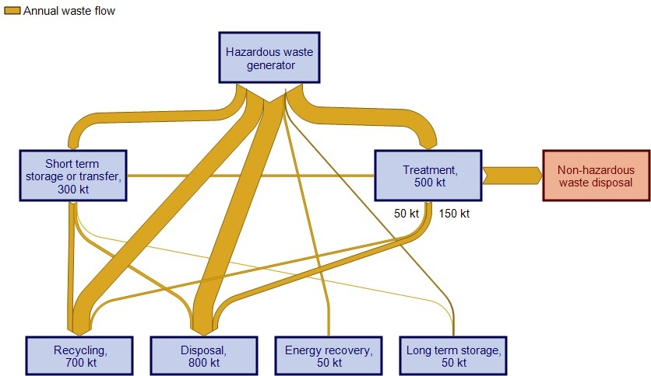
Pathway steps
Fates
Source: BE, REC, AWE: Australian hazardous waste data and reporting standard (2016)
Pathways for some particular wastes are fixed, such as high-hazard wastes in NSW in Victoria, which cannot be placed in landfill until their hazard has suitably been reduced or contained, via treatment. In other cases, though, pathways are fluid and may be influenced by cost, available infrastructure, or a lack of awareness of alternatives by key decision-makers. Examples of wastes for which varied paths are available include:
- Mineral (lubricating) oils: Through the Australian Government’s Product Stewardship for Oil (PSO) program, waste vehicle oils that are re-refined for reuse can attract a rebate for the refiner, to encourage oil recycling. While this results in large volumes of recycled oil, there are still significant quantities going to more rudimentary oil treatment facilities or energy recovery, options lower on the wastes hierarchy.
- Wastes resulting from used cooking oils and fats: Otherwise known as grease trap waste, these materials can be treated and reused or even composted, but poor mixing/ contamination practices (such as with mineral oils) can remove these options, leaving only lower hierarchy (and lower value) alternatives such as energy recovery.
- Solvents: Similar to the above examples, waste solvents can be economically recycled through distillation/ regeneration if kept segregated, but when inappropriately combined with other solvent and oil wastes this path may be closed, leaving only energy recovery or other forms of stabilisation available.
- Asbestos: Waste asbestos-containing materials can be safely and relatively inexpensively stabilised, handled and managed in landfill. However, segregation difficulties or historical management can see asbestos materials contaminate excavated soils or other demolition waste, rendering them all asbestos-contaminated waste. For example, soils contaminated with low levels of petroleum, and suitable for remediation at a low cost, would then become treated as more intractably contaminated, filling up valuable space in hazardous waste landfill.
- Flame retardant chemicals in plastics: Brominated flame retardants (BFRs) are added to hard plastic product casings (such as TVs and computers) at high concentrations, to protect against fire. While plastic recycling is an otherwise high-hierarchy choice, if those plastics containing BFRs are mixed with non-BFR plastics and on-sold as recyclate for new (completely different) product manufacturing, re-entrainment of BFRs can inadvertently occur back into products where flame retardancy is not required, such as infant toys (DiGangi 2015), creating human health problems and perpetuating the cycle of environmental pollution.

In each of these examples, management is influenced by decisions at different stages of their path to a final fate. Poor choices, in some cases before the waste even enters the hazardous waste management ‘system’, can unnecessarily lock out higher waste hierarchy options from later adoption. These poor choices result in lost opportunity and additional overall waste management cost. These examples are examined in the individual waste-specific analyses of Section 8.

Geographic flows – what wastes go where?
The hazardous waste market, for some wastes, can be national or even international, due to stringent regulatory management requirements, or the niches of technology or scale that do not lend themselves to local replication. This means that hazardous waste may require transport in the following ways to reach its required management destination:
- within jurisdictional borders
- across jurisdictional borders
- via shipment to international facilities, both as exports out of Australia and imports into Australia.

This creates three hazardous waste sub-markets, with distinct scales and issues of interest in each case. Approximate volumes and the nature of each are shown in Table 6.
Table 6: Comparison of hazardous waste sub-market types, 2014-15
Sub-market type | Approx tonnes & % of reported total | Major wastes in sub-market [approx. % of sub-market type]
Cross international borders
Imports | 13,945 t  (0.2%) | Halogenated solvents (G150) [72%]  Non-halogenated solvents (G110) [4%]  Waste electrical & electronic equipment/ scrap [10%]  Used lead acid batteries waste/scrap (D220) [7%]  Waste oils (J100) [2%]  Clinical waste (R100) [2%]
Exports | 57,299 t  (1.0%) | Lead-copper dross (D220) [45%]  Used lead acid batteries waste/scrap (D220) [34%]  Crushed, mixed CRT glass (D220) [3%]  Zinc ashes and skimmings (D230) [11%]  Waste alkaline and manganese batteries (C100) [4%]  Waste catalysts (various D codes) [2%]
Cross state/territory borders
Total cross-border | 289,658 t  (5.1%) | Major contributing state/territories [% of all cross-border waste]:  Tas [39%]  Vic [22%]  NSW [20%]
Into NSW | 85,166 t | Used lead acid batteries (D220) [~55%] – from all jurisdictions  Grease trap waste (K110) [~14%] – from ACT & Vic  Acids (B100) [13%] - from Vic  Waste oils/oily waters (J100/J120) [5%] – from Qld & Vic  Used containers/drums (N100) [~2%] - from Qld & Vic  Filter cake (N190) [~2%] – from Qld
Into Vic | 24,290 t | D code waste (specifics uncertain) [27%] – from NSW  Waste oils (J100) [18%] – from NSW, Qld, others (small)  Grease trap waste (K110) [17%] – from NSW  Solvents (various G codes) [12%] – from NSW, Tas, others (small)  Paints (F100/F110) [8%] – from NSW, Qld, WA  Pesticides (H codes) [8%] – mostly from WA
Into Qld | 33,570 t | Waste oils (J100) [31%] – from NSW, NT, SA  Organic chemicals (G codes) [18%] – from NSW  Grease trap waste (K110) [18%] – from NSW  Residues from industrial treatment (N205) [~16%] – from NSW  Contaminated soils (N120) [5%] – from NSW  Encapsulated wastes (N160) [4%] – from NSW
Into WA | 607 t | D code waste (specifics uncertain) [52%] – from NT  N code waste (specifics uncertain) [48%] – from NT
Into SA | 140,431 t | Lead and zinc smelter waste (D220 & D230) [75%] – from Tas  Other D code wastes (specifics uncertain) [20%] – from NSW & Vic
Into Tas | 3,948 t | D code waste (specifics uncertain) [94%] – from Vic
Into ACT | 1,098 t | Waste oils (J100) [36%] – from Vic, NSW, Qld  Grease trap waste (K110) [35%] – from NSW  Clinical waste (R100) [24%] – from NSW
Into NT | 548 t | Waste oils (J100) [100%] – from WA
Within state/territory borders
All states/ territories | 5,318,869 t  (94%) | Top 10 wastes by volume (excluding biosolids) from Table 6, adjusting for inconsistent coal seam gas (CSG) waste classification:  1. Contaminated soils (N120) [26%]  2. Asbestos (N220) [18%]  3. Grease trap wastes (K110) [10%]  4. Tyres (T140) [7%]  5. Animal effluent and residues (K100) [6%]  6. Waste oil/water mixtures (J120) [5.5%]  7. Non-toxic salts (CSG wastes) (D300) [4.1%]  8. Lead waste (D220) [3.9%]  9. Residues from industrial treatment (N205) [3.7%]  10. Waste oils (J100) [3.6%]

Table 6 shows that the bulk of the market volume (94%) is managed within the Australian jurisdiction that the waste is generated. However, each sub-market type is different, with distinct scales and issues of interest in each case. Each can be summarised as:
- International imports:
- small overall and includes a narrow group of wastes (typically from regional neighbours, where suitable management facilities aren’t present).
- International exports:
- relatively small overall but the interesting feature is that most the wastes for export rarely show up in the domestic market at all (a key reason they are approved for export is a lack of specific domestic management infrastructure)
- individually, these can be sizeable: 25,500t of lead/copper dross, 6,000t of zinc ashes and skimmings and 2,500t of waste alkaline and manganese batteries.
- Cross state/territory borders:
- only 5% of domestic waste volumes but clear national market pathways exist for some wastes
- large volumes of lead and zinc smelter wastes are sent from Tas to SA – these dwarf within-state management for these wastes and represent nearly 40% of all hazardous wastes that move across borders in Australia
- NSW infrastructure dominates the management of used lead acid batteries generated nationally
- a significant proportion of (un-stored) acid wastes are exported from Vic to NSW
- outside of WA, national arisings of waste solvents are almost exclusively managed in Vic infrastructure
- the majority of pesticide waste arising in Australia is sent to Vic
- there is a specific pathway for waste organic chemical flows from NSW to Qld
- reactive chemicals arisings are small in Australia but predominantly arise in NSW and are sent to be managed in Qld.
- Within state/territory borders:
- this market mechanism applies for virtually all other wastes (than those dominated by cross-border management)
- the top 10 wastes by volume are, in the main, managed within the borders where they were generated
- infrastructure for these wastes are more locally available, probably because of the economics of high volume.

These characteristics are summarised in the infographic of Figure 3 overleaf.

Broad market trends
Section 4.3 discusses data trends in terms of reported national hazardous waste arisings over the last five years, inclusive of key waste gap data, and it appears that they are increasing year on year. (While some jurisdictions have data that goes much further back, this period represents the point from which reasonable confidence in the national dataset can be assured.) A summarised view of this national trend is provided in Figure 2.
Figure 2: Historical national arisings of all hazardous wastes tracked in Australia
The arisings of Figure 2 are quoted from tracking system data only, which means that data from those jurisdictions that do not have tracking systems (Tas, ACT and NT) is not included. Also absent are obvious gaps in data not well collected by tracking systems – such as tyres, grease trap waste and biosolids. However, Figure 2 serves the purpose of illustrating the increasing trend over the period. Despite this rising overall trend, sectoral shifts are emerging, as industry mixes change.

Heavy manufacturing industries have declined in Australia during this period, leading to declining volumes of traditional wastes like acids, alkalis and inorganic chemicals. The slow decline of domestic aluminium smelting too, including smelter closures in Victoria and NSW, has resulted in declining waste volumes from the sector (such as spent pot lining).

Figure 3: Major wastes and flows, Australia 2014-15
Steady increases in wastes aligned more directly to domestic activities and the broader economy, such as grease trap waste (from commercial kitchens), waste oils (from vehicle and other engine use), tyres and biosolids (noting their respective absences from Figure 2) are illustrative of the rate of population growth.

As discussed throughout this report, one of the more transformative aspects of the hazardous waste market concerns the rapid rise of the coal seam gas industry, almost exclusively in south-west and central Qld. While volumes reported to tracking systems heavily underestimate this new industry’s overall waste footprint, due to factors discussed in Sections 5.4 and 8.8, there is no doubt of its significant impact on the nature of hazardous waste generation in Australia. By national generation tonnage, CSG wastes (in terms of the just the proportion reported as hazardous and moving offsite) rank seventh behind contaminated soils, asbestos, grease trap, tyres, animal industry wastes and oily waters for 2014-15. This is notable because all of the top six wastes arise in proportion and geographic distribution with population, as distinct from CSG wastes that occur primarily in one jurisdiction and, more to the point, one area, the overlapping Surat and Bowen Basins. This is the most significant example of a ‘new’ waste stream disrupting the market in terms of location of the waste and traditional location of the infrastructure built to manage it.

Also growing but on a completely different scale is mercury wastes, in part due to the increased attention arising from the Minamata Convention on Mercury and also due to increasing mercury in e-wastes such as fluorescent globes and flat panel screen backlight lamps.

The near-future market is likely to see significant further change due to emerging wastes emanating from changes in technology and consumer products, increased awareness of health and environmental impacts of entrained chemicals in these wastes and a tightening regulatory setting in response. Persistent organic pollutant (POP) wastes, new concerns about the contaminants in biosolids (due to upstream chemical use) and changing battery technologies (such as the prevalence of lithium-ion) may arise in significant volumes and there is limited domestic infrastructure to treat them. These emerging waste issues are discussed at length in Section 5.

Data analysis - overview
The primary data for this report is provided in the following Microsoft Excel data file, which was compiled from jurisdictional data submitted from tracking systems (NSW, Qld, SA, Vic WA) and Basel workbook templates (ACT, NT and Tas). The National hazwaste data collation 2014-15 was submitted with this report.

Data was collected in six-monthly blocks, allowing aggregation by either 2014-15 financial year or 2015 calendar year. The bulk of the analysis in this report is based on the 2014-15 financial year data set, to align with historical trend data and to be consistent with the other financial year data needs laid out in Table 1. The difference between calendar year collation and financial year collation is typically minor overall, but can vary from waste to waste.

This section presents 2014-15 data collated for waste generation, waste sources and waste management (fate and pathway infrastructure), plus historical trends in arisings, in a national overview style. Detailed investigation of these data for individual waste groups is provided in Section 8.

Overall waste generation and arisings
Hazardous waste arisings data for Australia has been collected, collated and presented in detail, against individual NEPM and Basel classification systems, in the appendices to this report as follows:
- Appendix A.1 provides 2014-15 national hazardous waste generation data, at the detailed NEPM 75 classification level, as well as in six-monthly blocks to allow calendar year disaggregation.
- Appendix A.2 provides the 2015 Basel report data, in Basel Y-codes, as well as in six-monthly blocks to allow financial year disaggregation.

A snapshot of national hazardous waste generation in Australia in 2014-15, by waste group for each jurisdiction, is given in Table 7. Biosolids are included in the table but, given the large tonnage they contribute and the unresolved and variable nature of their hazard classification, the totals at the bottom of the table are provided both inclusive and exclusive of biosolids contribution. Table 6, 2014-15 hazardous waste arisings, is also provided for context, particularly since all previous year’s data compilations used hazardous waste arisings rather than adjusted generation to estimate annual waste production figures. Figure 4 reproduces the information of Table 7 (excluding biosolids) in graphical form, allowing easier identification of the relative scale and contribution of each waste group, including jurisdiction proportions.
Figure 2 provides a similar graphical breakdown but at the finer grained level of NEPM 75 waste type. Figure 6 and Figure 7 also present tabulated data in graphical form, as total hazardous waste generation per jurisdiction, both including and excluding biosolids.

Table 7: Adjusted generation of hazardous waste by waste group, Australia 2014-15 (tonnes by jurisdiction)
Code | Description | ACT | NSW | NT | Qld | SA | Tas | Vic | WA | AUSTRALIA
A | Plating & heat treatment | 45 | 0 | 0 | 5,243 | 111 | 0 | 0 | 4,744 | 10,143
B | Acids | 0 | 962 | 0 | 17,619 | 641 | 3 | 30,183 | 1,595 | 51,002
C | Alkalis | 231 | 376 | 120 | 153,583 | 15,169 | 2 | 6,825 | 3,772 | 180,079
D110 | Inorganic fluorine (spent potliner) | 0 | 12,980 | 0 | 12,540 | 3 | 3,960 | 6,688 | 14 | 36,185
D120 | Mercury & compounds | 61 | 733 | 12 | 95 | 51 | 0 | 127 | 537 | 1,616
D220 | Lead and compounds | 916 | 7,652 | 233 | 22,173 | 21,001 | 144,149 | 18,692 | 3,634 | 218,448
D230 | Zinc compounds | 0 | 0 | 0 | 412 | 16,079 | 112,896 | 171 | 549 | 130,108
D300 | Non-toxic salts (inc. coal seam gas wastes) | 0 | 29,034 | 34 | 19,533 | 110 | 3,580 | 5,812 | 8,211 | 66,314
Other D | Other inorganic chemicals | 0 | 50 | 5 | 2,242 | 25 | 0 | 1,361 | 261 | 3,945
E | Reactive chemicals | 0 | 7 | 0 | 203 | 36 | 25 | 16 | 107 | 394
F | Paints, resins, inks, organic sludges | 209 | 4,347 | 45 | 26,469 | 2,518 | 24 | 15,998 | 6,204 | 55,813
G | Organic solvents | 26 | 384 | 0 | 2,394 | 188 | 1,427 | 2,631 | 5,079 | 12,128
H | Pesticides | 0 | 123 | 0 | 630 | 330 | 32 | 429 | 2,036 | 3,581
J100 & J160 | Oils | 698 | 22,471 | 2,015 | 46,208 | 3,482 | 64 | 26,194 | 99,762 | 200,895
J120 | Waste oil/water mixtures | 570 | 52,737 | 2,463 | 158,729 | 1,395 | 270 | 58,962 | 34,174 | 309,302
K110 | Grease trap wastes | 5,788 | 174,885 | 5,633 | 128,058 | 39,150 | 11,933 | 119,309 | 58,771 | 543,529
Other K | Other putrescible / organic wastes | 0 | 90,288 | 2,875 | 165,999 | 19,978 | 6,089 | 42,390 | 31,172 | 358,790
M100 | PCB wastes | 27 | 1,592 | 3 | 8,221 | 76 | 33 | 5,550 | 452 | 15,955
M160 | Other organic halogen compounds | 0 | 3 | 0 | 4 | 1 | 0 | 30 | 2 | 40
Other M | Other organic chemicals | 0 | 10,504 | 0 | 1,749 | 2,597 | 7 | 469 | 762 | 16,089
N120 | Contaminated soils | 599 | 453,630 | 12,065 | 418,739 | 204,422 | 5,629 | 358,930 | 11,820 | 1,465,834
N205a | Biosolids | 73,810 | 339,524 | 14,762 | 295,238 | 132,857 | 73,810 | 428,095 | 118,095 | 1,476,190
N205b | Other industrial treatment residues | 0 | 12,311 | 0 | 137,223 | 49,238 | 0 | 4,464 | 4,911 | 208,147
N220 | Asbestos containing material | 5,856 | 306,465 | 2,000 | 507,159 | 13,477 | 15,473 | 80,069 | 77,160 | 1,007,659
Other N | Other soil/sludges | 4 | 14,133 | 12 | 50,472 | 2,936 | 133 | 27,952 | 2,026 | 97,669
R | Clinical and pharmaceutical | 443 | 23,734 | 76 | 42,756 | 4,467 | 21 | 12,270 | 2,905 | 86,674
T140 | Tyres | 3,830 | 110,185 | 5,004 | 92,353 | 30,789 | 10,100 | 92,846 | 70,192 | 415,300
Other T | Other miscellaneous | 125 | 1,599 | 26 | 1,183 | 174 | 19 | 494 | 464 | 4,084
Other | (Not classified) | 0 | 10,528 | 0 | 62,091 | 0 | 0 | 1,156 | 35,029 | 108,805
Totals (inclusive of biosolids) |  | 93,237 | 1,681,238 | 47,384 | 2,379,320 | 561,303 | 389,679 | 1,348,113 | 584,444 | 7,084,717
 |  | 1.3% | 24% | 0.7% | 34% | 8% | 6% | 19% | 8%
Totals (exclusive of biosolids) |  | 19,427 | 1,341,714 | 32,622 | 2,084,082 | 428,446 | 315,869 | 920,018 | 466,349 | 5,608,527
 |  | 0.3% | 24% | 0.6% | 37% | 8% | 6% | 16% | 8%
Table 8: Arisings of hazardous waste by waste group, Australia 2014-15 (tonnes by jurisdiction)
Code | Description | ACT | NSW | NT | Qld | SA | Tas | Vic | WA | AUSTRALIA
A | Plating & heat treatment | 45 | 0 | 0 | 13,042 | 272 | 0 | 6 | 5,603 | 18,967
B | Acids | 0 | 11,493 | 0 | 18,895 | 674 | 3 | 21,022 | 2,211 | 54,299
C | Alkalis | 231 | 817 | 120 | 173,718 | 17,122 | 2 | 6,932 | 97,190 | 296,131
D110 | Inorganic fluorine (spent potliner) | 0 | 12,980 | 0 | 12,540 | 3 | 3,960 | 6,688 | 16 | 36,187
D120 | Mercury & compounds | 61 | 892 | 12 | 685 | 203 | 0 | 130 | 466 | 2,449
D220 | Lead and compounds | 916 | 33,623 | 233 | 19,243 | 96,711 | 144,149 | 7,988 | 1,548 | 304,409
D230 | Zinc compounds | 0 | 39 | 0 | 498 | 86,552 | 112,896 | 171 | 604 | 200,760
D300 | Non-toxic salts (inc. coal seam gas wastes) | 0 | 34,429 | 34 | 45,784 | 247 | 3,580 | 3,830 | 8,609 | 96,513
Other D | Other inorganic chemicals | 0 | 40 | 5 | 2,482 | 29 | 0 | 1,446 | 459 | 4,461
E | Reactive chemicals | 0 | 12 | 0 | 325 | 60 | 25 | 46 | 107 | 575
F | Paints, resins, inks, organic sludges | 209 | 8,801 | 45 | 27,785 | 3,434 | 24 | 24,961 | 8,103 | 73,362
G | Organic solvents | 26 | 1,492 | 0 | 3,089 | 340 | 1,427 | 6,896 | 8,649 | 21,919
H | Pesticides | 0 | 100 | 0 | 973 | 381 | 32 | 1,452 | 1,322 | 4,262
J100 & J160 | Oils | 698 | 29,261 | 2,015 | 89,465 | 6,090 | 64 | 28,950 | 123,436 | 279,980
J120 | Waste oil/water mixtures | 570 | 63,311 | 2,463 | 531,367 | 4,152 | 270 | 61,706 | 57,015 | 720,856
K110 | Grease trap wastes | 5,788 | 174,885 | 5,633 | 162,774 | 39,150 | 11,933 | 119,795 | 79,607 | 599,566
Other K | Other putrescible / organic wastes | 0 | 90,288 | 2,875 | 178,542 | 19,978 | 6,089 | 44,948 | 33,059 | 375,779
M100 | PCB wastes | 27 | 2,237 | 3 | 8,252 | 30 | 33 | 18,154 | 129 | 28,864
M160 | Other organic halogen compounds | 0 | 4 | 0 | 53 | 2 | 0 | 32 | 9 | 100
Other M | Other organic chemicals | 0 | 4,330 | 0 | 9,330 | 2,794 | 7 | 566 | 1,332 | 18,360
N120 | Contaminated soils | 599 | 452,084 | 12,065 | 420,626 | 209,556 | 5,629 | 365,802 | 13,341 | 1,479,702
N205a | Biosolids | 73,810 | 339,524 | 14,762 | 295,238 | 132,857 | 73,810 | 428,095 | 118,095 | 1,476,190
N205b | Other industrial treatment residues | 0 | 14,755 | 0 | 192,130 | 73,034 | 0 | 3,725 | 6,529 | 290,173
N220 | Asbestos containing material | 5,856 | 305,621 | 2,000 | 529,944 | 14,517 | 15,473 | 80,204 | 77,160 | 1,030,775
Other N | Other soil/sludges | 4 | 22,961 | 12 | 51,283 | 3,155 | 133 | 45,827 | 3,411 | 126,787
R | Clinical and pharmaceutical | 443 | 23,734 | 76 | 67,377 | 6,810 | 21 | 15,592 | 2,975 | 117,029
T140 | Tyres | 3,830 | 110,185 | 5,004 | 92,353 | 30,789 | 10,100 | 92,846 | 70,192 | 415,300
Other T | Other miscellaneous | 125 | 3,257 | 26 | 1,585 | 433 | 19 | 1,927 | 713 | 8,085
Other | (Not classified) | 0 | 13,776 | 0 | 68,031 | 30 | 0 | 0 | 35,029 | 116,867
Totals (inclusive of biosolids) |  | 93,237 | 1,754,934 | 47,384 | 3,017,409 | 749,407 | 389,679 | 1,389,739 | 756,920 | 8,198,707
 |  | 1.1% | 21% | 0.6% | 37% | 9% | 5% | 17% | 9%
Totals (exclusive of biosolids) |  | 19,427 | 1,415,410 | 32,622 | 2,722,171 | 616,550 | 315,869 | 961,643 | 638,824 | 6,722,517
 |  | 0.3% | 21% | 0.5% | 40% | 9% | 5% | 14% | 10%

Figure 4: National hazardous waste generation, 2014-15 (tonnes) – by waste group and jurisdiction (excluding biosolids)
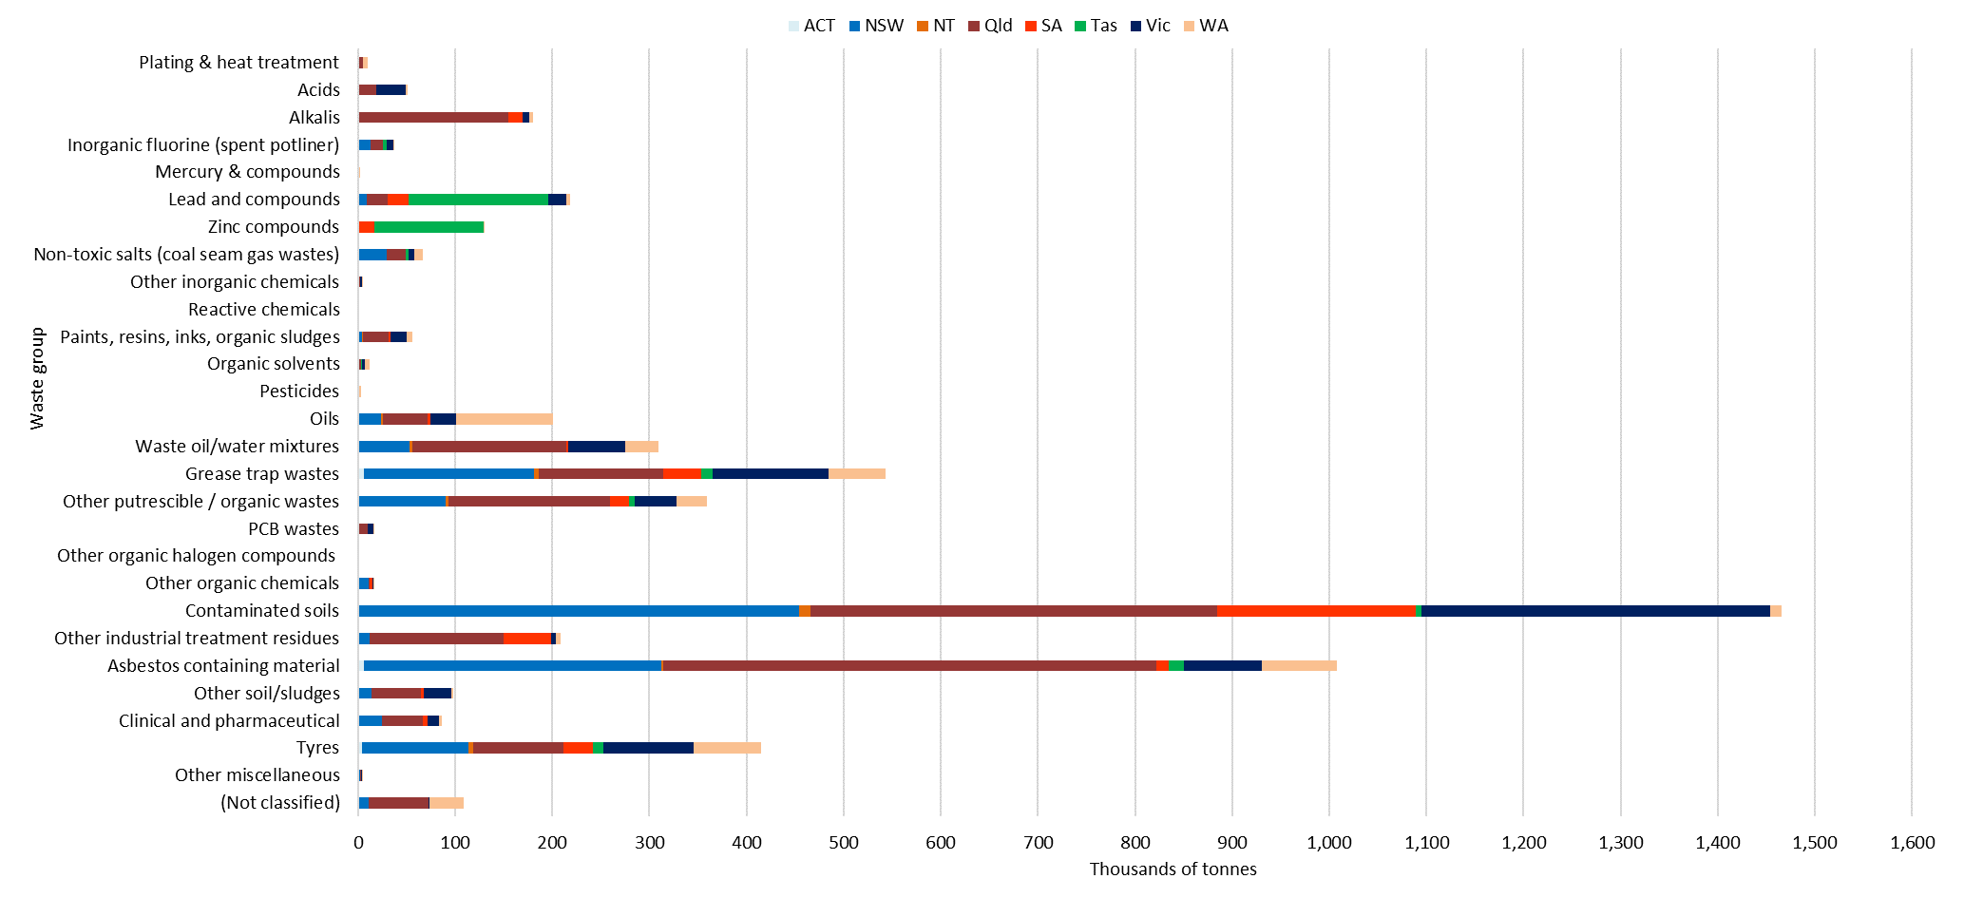

Figure 5: National hazardous waste generation, 2014-15 (tonnes) – by NEPM ‘75’ waste types (top half of chart: liner display; bottom half: logarithmic display)
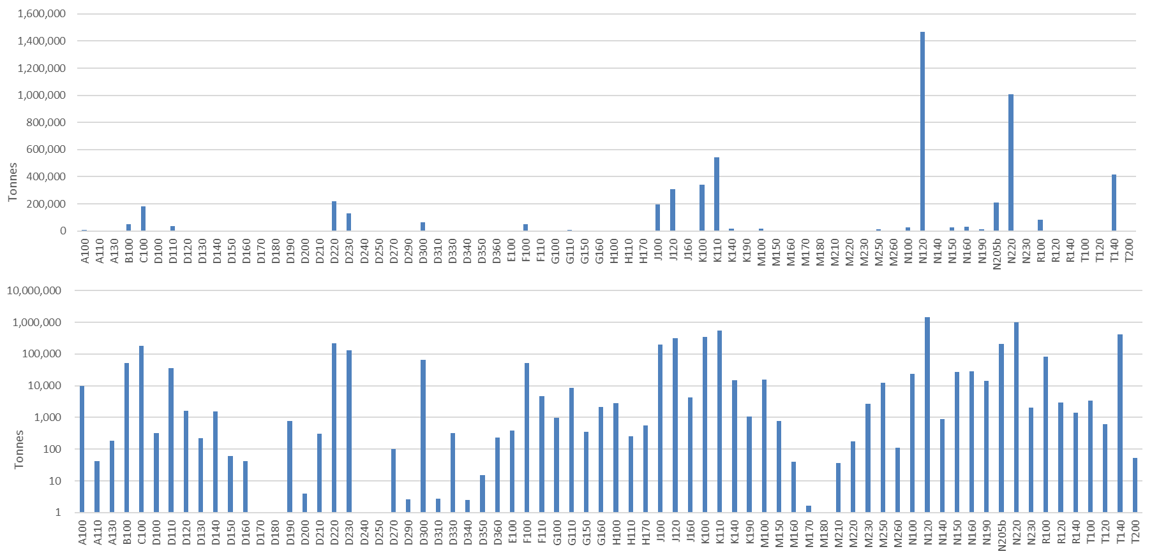

Figure 6: National hazardous waste generation, 2014-15 (tonnes) – by jurisdiction
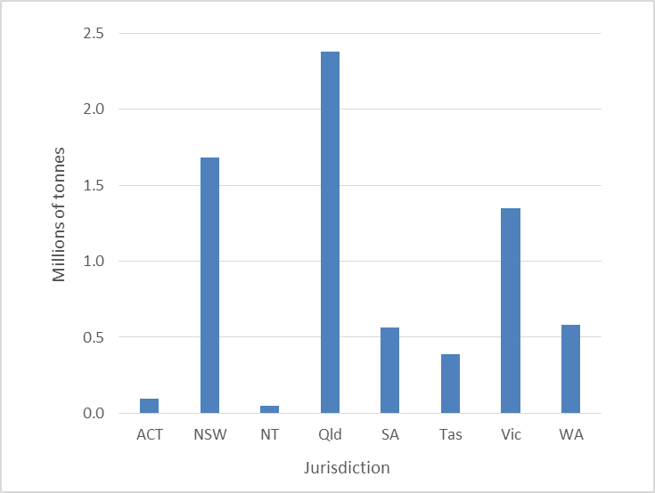
Figure 7: National hazardous waste generation, 2014-15 (tonnes) – by jurisdiction (excluding biosolids)

Sources of waste arisings
Source industry sector data, in the form of Australia and New Zealand Standard Industry Codes (ANZSIC), generally called ‘waste origin codes’ on waste transport certificates, was sparingly provided according to Table 9.
Table 9: Total percentage of tonnes for which source sector is known
Jurisdiction | % tonnes that has source data | Comment
ACT | N/A | No tracking system
NSW | 2 | Limited qualitative analysis possible on raw data received
NT | N/A | No tracking system
Qld | 69 | Best jurisdictional coverage of source sector data available for 2014-15
SA | 34 | Reduced coverage from 38% in HWiA 2015, but 2014-15 data allows limited qualitative analysis on raw data received
Tas | N/A | No tracking system
Vic | 16 | Major data quality decrease from HWiA 2015 (was 83%) – source sector data insufficiently populated to be useable
WA | 0 | No source data supplied

Only Qld data was of sufficient coverage to attempt quantitative analysis in 2014-15, with 69% of all tonnes generated provided with an ANZSIC code identifier. Vic data was well-populated with ANZSIC codes in HWiA 2015 (83%), but 2014-15 data (for HWiA 2017) was of insufficient coverage to be useable (16%). This major decrease in data quality with respect to ANZSIC codes has impacted the overall quality of national source analysis possible for 2014-15 data. Like in HWiA 2015, NSW tracking data has poorly populated ANZSIC codes (2%) because they are not reliably filled out by certificate users, rendering them unusable. SA’s source data quality has slightly declined from coverage of 38% of all tonnage data to 34%. WA did not supply any breakdown of waste by source whatsoever in provided data.

Raw data files for Qld, NSW and SA were all supplied at sufficient detail to allow limited qualitative analysis for major sources of hazardous waste, by perusing generator company names and/or ANZSIC code sector data where provided. However, despite Qld’s high coverage rate of 69%, closer analysis showed that users of waste transport certificates complete this field poorly, with most ‘waste origin’ code fields containing misleading and inaccurate information. Qld waste origin code I670 ‘Storage’, for example, accounts for close to 50% of all tonnes covered by source data, but analysis of generator companies shows that very few would be described as a waste storage provider.

SA source sector data on the other hand appears to be very reliable where it is present, which suggests that it has either had intelligence added by SA EPA in the compilation process or there is a pre-set approach in the tracking system to identifying waste generators. Either way SA’s gain in quality of source information is let down by the fact that only 34% of all tonnes have it recorded, which also makes it difficult to rely upon for quantitative analysis.

In the context of these limitations, and most notably the decline in Vic source data quality, source sector data has been compiled and analysed using the following semi-quantitative/ qualitative method:
- For Qld data: semi-quantitative analysis of waste transport certificate raw data, with a focus on correlating waste generating company names with their likely industry sectors, listing industry sources in approximate order of highest to lowest generation tonnages.
- For NSW data: qualitative analysis of waste transport certificate raw data, with a focus on correlating waste generating company names with their likely industry sectors, listing the major industry source contributors loosely estimated from highest to lowest generation tonnages.
- For SA data: semi-quantitative analysis of waste transport certificate raw data, with a focus on industry sectors where provided, listing industry sources in approximate order of highest to lowest generation tonnages.
- For Vic data: Since no new source data is available, using 2012-13 data from HWiA 2015, listing industry sources in order of highest to lowest generation tonnages.
- National summary: A collation of the four state source sector lists, with indicative ordering of relative tonnages between jurisdictions.

A full quantitative analysis of source data for NSW, Qld and SA is out of scope for this project, given the complexity and volume of waste transport certificate data that would need expansive and relatively manual analysis.

Since Tas, NT and the ACT do not have tracking data there is no breakdown of their data by source at all.

Sections 8.1 – 8.28 provides detailed analysis on a waste group by waste group basis and uses this state-based approach to list main sources, in tabular form. An example for C. Alkali waste is shown below.

Summary source analysis 2014-15
Qld | NSW | SA | Vic 2012-13 | National summary
Oil & gas extraction (CSG/ LNG) | <0.5% of national total for waste group | Cement and lime man. | - Petroleum refining  - Metal coating and finishing  - Motor vehicle parts manufacturing | - Oil & gas extraction (CSG/ LNG)  - Cement and lime manufacturing  - Petroleum refining  - Metal coating and finishing  - Motor vehicle parts manufacturing

ANZSIC code sources of arisings data at the ANZSIC division, sub-division and group levels, as recorded in jurisdictional tracking systems, are provided for NSW, Qld, SA and Vic in the underlying data file, National hazwaste data collation 2014-15, worksheet ‘Sources’. However, as noted in the discussion in this section, jurisdictional input industry source data is variously unreliable, and as such has not been presented in this report.

Historical trends in waste arisings
A high-level summary of hazardous waste arisings data for the four-year period that has been subject to a national compilation, starting with the 2010-11 compilation undertaken by KMH Environmental (KMH 2013), is provided below. Detailed trends for each individual waste group, over much longer time series (where data is available) are shown throughout Section 8.

National hazardous waste annual arisings datasets for the last five years, excluding biosolids, total the following respectively (noting that 2013-14 was not compiled, since it was outside the 2-year HWiA report cycle adopted in 2016):
- 4.59 million tonnes in 2010-11
- 5.34 million tonnes in 2011-12 (16% increase on previous year)
- 5.45 million tonnes in 2012-13 (2% increase on previous year)
- 6.72 million tonnes in 2014-15 (23% increase on 2012-13)
- 46% total increase in arisings since 2010-11 with an annual average of 14%.

2014-15 was the first year that the compilation method attempted to exclude short-term storage and accumulation management types, in an attempt to correct for multiple counting of the same waste in and out of management infrastructure, to enable a more accurate estimate of waste generation to be made. Since this will have the effect of reducing 2014-15 reported tonnages compared to previous years, 2014-15 arisings (rather than generation) has been chosen for consistency with previous years, noting that there have been other modifications to the compilation method as discussed in Recommendation D8.

Figure 8 traces annual arisings using tracking data for each waste group (from Section 8) summed to a jurisdictional total (for those five jurisdictions that operate electronic tracking systems), for the number of years that available data allows.
Figure 8: Historical arisings of all hazardous wastes tracked in Australia
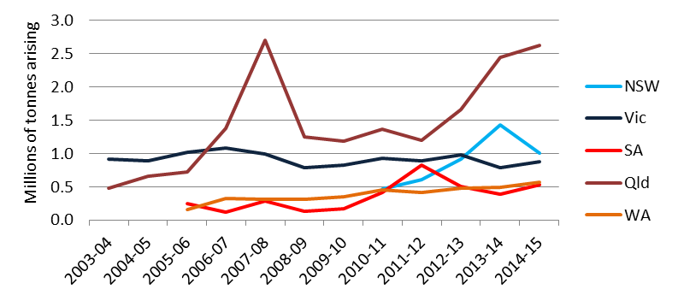

While there is fluctuation evident, overall arisings have increased significantly since 2010-11, although probably not to the extent of a 23% increase in 2014-15 over 2012-13 (and 46% overall in the period). This increase has been driven almost entirely by an apparent doubling in Qld arisings, with Qld by far the highest of all jurisdictions in tonnage terms, while Vic, SA and WA have stayed relatively steady. NSW also had an apparent doubling in arisings in the period but this is an artefact of the data – contaminated soils (the largest contributor) were not included in the NSW dataset until 2013-14.

Throughout the report, mention is made of data quality issues with Qld reported data, in particular apparent gross unit reporting errors for waste groups J120, Other K, N220, Other N and R, plus some double counting for N205b. Adjusting for these gross errors reduces 2014-15 national arisings to:
- 6.01 million tonnes in 2014-15 (10% increase on previous year)
- 30% total increase in arisings since 2010-11 with an annual average of 9% pa.

A more rigorous re-analysis of Qld 2014-15 (and 2013-14) data to exclude identifiable errors could reveal a larger quantum of over-estimation. We believe the adjusted national arisings figure of 6,010,119 tonnes in 2014-15 is more reliable than the submitted data (6,722,517 tonnes in 2014-15).

Management of hazardous wastes (NSW, Vic, Qld and WA)
The project team analysed jurisdictional tracking system data to determine the ‘management types’ (fates and pathways to them) recorded for each waste group in the tracking system data. Management data was comprehensively available from NSW, Qld, Vic and WA. The overall tonnes by management in these jurisdictions was compiled for 2014-15 and is presented in Table 10 and Figure 9. These tonnages, in relative percentage terms within each waste group, are charted in Figure 10 .

Although assembled at a much greater level of detail, some manipulation of Qld and Vic data was needed to establish uniform categories (based on the NSW system, the lowest common denominator of categories tracked). These management categories do not align neatly with those reported in national waste reporting (waste reuse, recycling, energy recovery and disposal).

Overall, the quantity presented represents 100% of arisings reported by these four jurisdictions’ tracking systems, and 90% of all waste tracked in Australia (the remaining 10% is SA data that it tracks but destinations are not recorded). This is a major improvement on HWiA 2015, where management data was present for just 50% of arisings in Australia. The potential for multiple counting within the data should be considered in interpreting the data. For example, waste that is sent to chemical/physical treatment may be landfilled after treatment and the tonnage would be included under both management categories in the figure below. From an infrastructure capacity assessment perspective, both the CPT and landfill tonnages are relevant and need to be considered.

Figure 11, Figure 12, Figure 13 and Figure 14 plot overall tonnage by management for each of the four jurisdictions where such data is tracked, compiled for 2014-15.

Management data is examined in more detail by waste group in Section 8, where a greater understanding can be gained about the management of each waste for Qld and Vic in particular, which track management type to a much finer degree of categorisation.

Table 10: The management fate of tracked hazardous waste in NSW, Qld, Vic and WA, 2014-15 (tonnes)
Code | Description | Recycling | Chemical/ physical treatment | Landfill | Biodegradation | Thermal destruction | Storage or transfer | Other
A | Plating & heat treatment | 683 | 4,815 | 4,422 | 31 | 33 | 8,654
B | Acids | 8,031 | 27,309 | 2,097 | 36 | 14 | 3,278 | 12,757
C | Alkalis | 116,749 | 9,657 | 36,294 | 330 | 825 | 113,950 | 178
D110 | Inorganic fluorine (spent potliner) | 17,239 | 153 | 1,414 |  |  | 5,709 | 2,064
D120 | Mercury & compounds | 206 | 1,098 | 102 |  | 0 | 669 | 67
D220 | Lead and compounds | 25,132 | 1,635 | 3,300 |  |  | 5,162 | 8,075
D230 | Zinc compounds | 518 | 240 | 348 |  |  | 145 | 25
D300 | Non-toxic salts (inc. coal seam gas wastes) | 37,293 | 2,397 | 20,327 | 2,355 | 1 | 27,216 | 3,060
Other D | Other inorganic chemicals | 582 | 1,580 | 1,504 | 115 |  | 566 | 74
E | Reactive chemicals | 188 | 119 | 19 |  | 1 | 157 | 6
F | Paints, resins, inks, organic sludges | 18,236 | 16,189 | 2,005 | 189 | 2,166 | 28,297 | 1,741
G | Organic solvents | 4,710 | 3,722 | 16 | 5 | 257 | 10,122 | 519
H | Pesticides | 1,312 | 855 | 235 | 143 | 6 | 470 | 186
J100 & J160 | Oils | 133,471 | 57,897 | 2,384 | 97 | 34 | 75,200 | 1,690
J120 | Waste oil/water mixtures | 103,354 | 159,334 | 22,478 | 7,488 | 411 | 410,285 | 3,664
K110 | Grease trap wastes | 155,920 | 80,898 | 3,418 | 49,039 | 58 | 54,367 | 5,879
Other K | Other putrescible / organic wastes | 162,104 | 8,275 | 12,194 | 55,253 | 80 | 15,530 | 2,819
M100 | PCB wastes | 542 | 2,595 | 12,018 | 4 | 35 | 12,890 | 663
M160 | Other organic halogen compounds | 3 | 3 | 32 |  | 0 | 60 | 0
Other M | Other organic chemicals | 6,252 | 5,935 | 1,098 | 3 | 3 | 2,119 | 106
N120 | Contaminated soils | 17,579 | 26,696 | 1,167,696 | 9,189 |  | 8,738 | 21,952
N205a | Biosolids
N205b | Other industrial treatment residues | 61,705 | 25,308 | 44,207 | 25,993 | 75 | 58,199 | 1,581
N220 | Asbestos containing material |  | 381 | 890,842 |  |  | 22,191 | 1,833
Other N | Other soil/sludges | 16,439 | 8,435 | 67,643 | 487 | 43 | 28,880 | 1,314
R | Clinical and pharmaceutical | 8,969 | 14,017 | 19,507 | 30 | 15,625 | 28,159 | 756
T140 | Tyres | 53,744 | 2,714 | 29,896 | 43 | 289 | 22,554 | 1,681
Other T | Other miscellaneous | 943 | 2,059 | 162 | 142 | 20 | 4,085 | 48
Other | (Not classified) | 15,277 | 24,474 | 49,234 | 3,576 | 171 | 10,409 | 4,636
Total |  | 967,422 | 488,791 | 2,394,619 | 154,578 | 20,669 | 958,061 | 77,374
Yellow shaded cells highlight where more than 50% of the proportion of that waste is treated by a particular method

Figure 9: Management of tracked hazardous waste in NSW, Qld, Vic and WA, 2014-15 (tonnes)
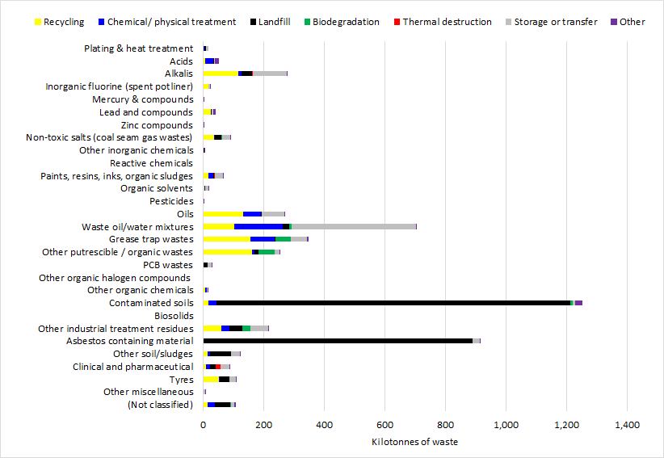
Figure 10: Management of tracked hazardous waste in NSW, Qld, Vic and WA, 2014-15 (percentages)
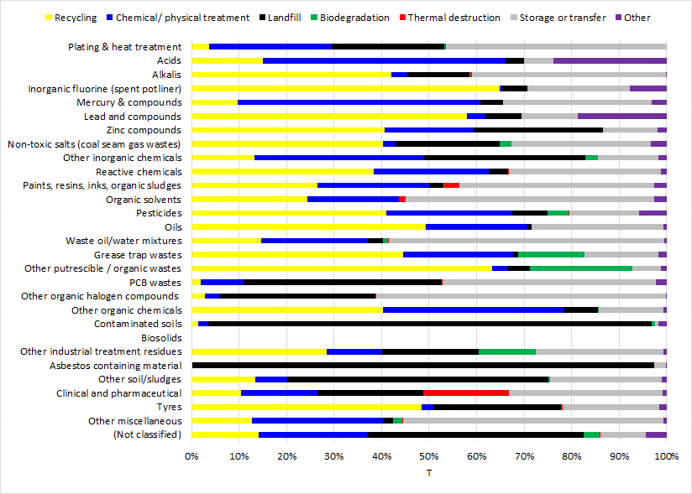
Figure 11: The management of tracked hazardous waste in NSW, 2014-15 (tonnes)
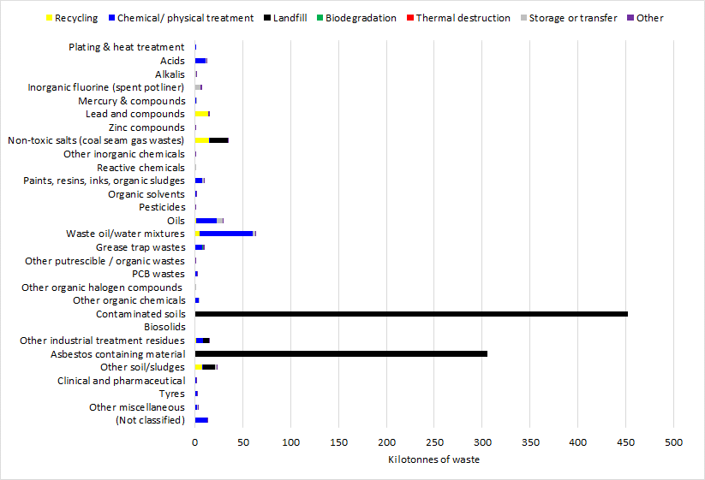
Figure 12: The management of tracked hazardous waste in Qld, 2014-15 (tonnes)

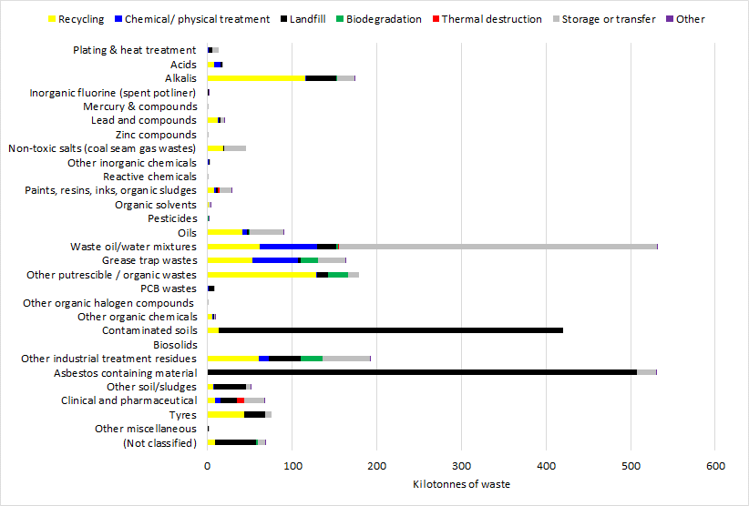
Figure 13: The management of tracked hazardous waste in Vic, 2014-15 (tonnes)
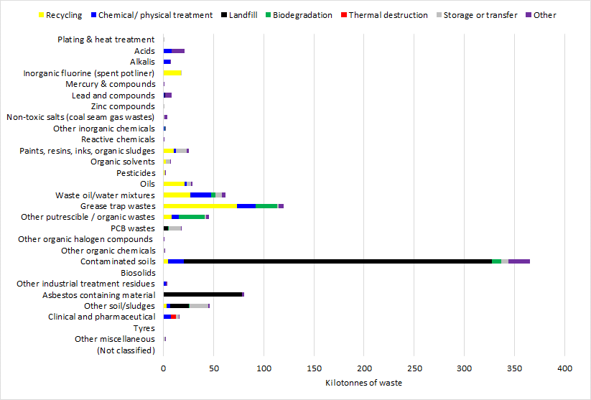
Figure 14: The management of tracked hazardous waste in WA 2014-15 (tonnes)
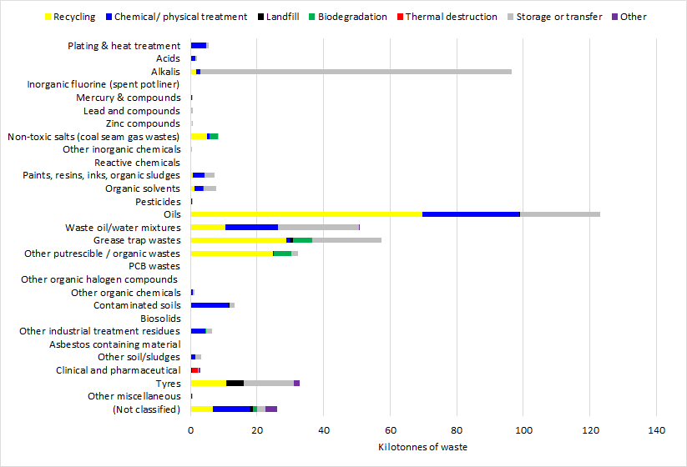

Current and emerging challenges
A range of wastes are not neatly captured by waste tracking systems due to issues such as inconsistent classification, large-scale onsite or offsite storage (stockpiling), historical consideration outside of the hazardous waste framework or simply because the waste has only recently started to arise in significant quantities.

Changes in consumer products or technologies can lead to new wastes emerging – e-waste brominated flame retardants (POPs) are a good example; changing lighting technology (mercury filaments) or changing battery technologies (such as the prevalence of lithium-ion) are others. Or it could simply be the rise of new industries with inherent waste issues, such as the coal seam gas extraction industry. These can be problem wastes because mature waste treatment processes and infrastructure may not yet have developed to manage them appropriately.

Another type of problem waste is historically known but unresolved; maybe it is a problem that has long been difficult to deal with such as SPL or Sydney’s Orica HCB stockpile. Wastes that are stored onsite are absent from arisings reported via tracking systems and have historically been absent from Basel reports of waste generation.

This section discusses both current and future challenges that some of these wastes of particular interest may pose, as a complement to Section 8’s assessment of wastes more traditionally suited to waste regulators’ tracking and monitoring systems.

Hazard protection versus resource value
A common theme for many of the individual wastes discussed in Sections 5.2– 5.6 is that consideration of two sometimes opposing properties is required in determining their most appropriate environmental management. This is because there is a competing tension between hazard protection and resource efficiency that is not the case with non-hazardous wastes – which one should outweigh the other in an integrated environmental assessment? This dilemma is represented in Figure 15 (overleaf).

The wastes hierarchy promotes recycling and energy recovery above hazard treatment and containment approaches, but is silent on the issue of protection from harm, which makes it limited as a single decision tool for management of hazardous wastes. This limitation is recognised by the Department Environment Food and Rural Affairs (DEFRA) in the UK, through specific guidance on applying the waste hierarchy to hazardous waste (DEFRA 2011), which has been written to assist compliance with the Waste (England and Wales) Regulations 2011.

Figure 15: The hazardous waste ‘recover’ versus ‘protect’ dilemma

DEFRA’s advice and the regulations themselves require waste management that “takes into account the resource value of the hazardous wastes and the need for health and safety to be maintained”, which “may result in a lower option in the hierarchy being chosen but results in a better overall environmental outcome.” Clause 12(3) of the Regulations also require “technical feasibility (such as lack of infrastructure availability) and economic viability” to be considered when applying the hierarchy.

In the Australian context, this dilemma is evident for some of the more problematic wastes discussed in this section:
- Biosolids (nutrient resource value for agricultural soil beneficiation, versus unmitigated inorganic and organic chemical hazards that may be present within the waste).
- E-waste plastics that contain brominated flame retardant (BFR) chemicals. Material (plastic) recycling would sit highly on the wastes hierarchy, yet use of BFR-containing plastic recyclate in products that do not require flame retardancy can result in unintentional exposure to significant levels of the chemical (i.e. in plastic baby toys) and also re-entrain a persistent and damaging chemical back into the environment for a further product to waste lifecycle. Indeed, the Stockholm Convention requires (under Article 6(1)(d)(iii)) that POPs are generally not to be recovered, recycled, or reused etc.
- Fly ash from combustion processes, particularly coal fired power generation, due to the volumes involved. A proportion of coal power station produced fly ash is either currently used or could be used in applications such as cement and concrete products, structural fills and soils amendments in Australia. Since fly ash is the output of pollution control devices, used to ‘mop-up’ pollutants such as heavy metals and polycyclic aromatic hydrocarbons from the combustion gas stream, it contains these chemical contaminants and is predominantly of very fine particle size.
- SPL has similar cementitious value to fly ash, with the added benefit of high carbon content that makes it feasible to be recycled in industries like cement, but also contains significant chemical hazards – some of which can be thermally destroyed in the recycling process and others not.

There is no doubt that environmental regulators would like to manage hazardous wastes both to protect from the hazard as well as retain/ utilize inherent resource value. As the hazard of a waste increases, the more important the protection from its hazard becomes, compared to recovering resource value, if both can’t be done together. Protection from harm is fundamental to hazardous waste management.

Persistent organic pollutants (POPs) waste
This waste group is captured in tracking systems under the generic heading M160 Organo halogen compounds—other than substances referred to in this Table or Table 2, but only very limited quantities (if any) are recorded in tracking systems.

Australia is a party to the Stockholm Convention on Persistent Organic Pollutants (POPs), which aims to protect human health and the environment from the effects of these chemicals. Australia is currently in the process of deciding whether to ratify new chemicals added to the Convention since 2009. Should it decide to do so, new wastes contaminated with elevated levels of POPs might need to be managed as hazardous, some of which are not currently managed in this way. The ‘new Stockholm’ hazardous wastes of most interest are:
- polybrominated diphenyl ethers (PBDEs), also known as POP-BDEs
- hexabromocyclododecane (HBCD)
- perfluorooctane sulfonic acid (PFOS), its salts (perfluorooctane sulfonates) and perfluorooctane sulfonyl fluoride (PFOSF).

(It is noted that PFOS is likely to arise in waste with other PFASs (per- and polyfluoroalkyl substances), such as PFOA (Perfluorooctanoic acid), which is under review for potential listing on the Convention.)

POPs are hazardous and environmentally persistent substances which can be transported between countries by the earth's oceans and atmosphere. POPs accumulate in living organisms. Many have been traced in the fatty tissues of humans and other animals, while PFOS has been traced in organs such as the liver. There is general international agreement that they require global action to reduce their impact on humans and the environment. Both the POP-BDEs and HBCD are brominated flame retardant chemicals, while PFOS has been used in various mist dispersal and surface coating applications, including (significantly) firefighting foams.

A fourth key waste belongs in this waste group, and while it is potentially ‘emerging’ in terms of tracked hazardous waste arisings and (more importantly) Australian fate infrastructure, it is actually a legacy problem waste. This is the hexachlorobenzene (HCB) waste stockpile at Orica’s Port Botany facility in Sydney. No acceptable management solution – whether destruction or more appropriate storage – has been identified many decades since this material began accumulating in the 1960s.

The common property of this waste group is that it contains organic chemicals that contain halogen elements (usually fluorine, chlorine, bromine) as significant components in their structure. This waste type shares commonality with other waste types such as dioxins and furans (M170 and M180), PCB-like compounds (M100) and organochlorine pesticides (H100). The presence of the halogen species is usually the reason for the property of interest – and the reason for the toxicity.

Apart from the scientific consensus around their environmental impacts, POPs wastes are problematic for other reasons:
- They have been historically added at high (percentage) levels in products or ‘articles’ such as flame retardants in hard plastics and foams. At the end of their useful life, these articles are typically discarded to landfill, although there is substantial recycling of e-waste, which can contain these treated hard plastics. Such end-of-life articles are not currently treated or managed as hazardous waste, particularly since Australian ratification of the Stockholm listing of these chemicals is yet to occur.
- The ubiquitous nature of POPs means that they are not only present in waste articles, but can also present as waste from their broader use and dispersal, such as in landfill leachate, wastewater treatment plant discharge and, most importantly, in sewage sludge, which, after dewatering, is known as biosolids (discussed in Section 5.3).
- Strong drivers exist for recycling end-of-life articles such as e-waste. However, if hazardous chemicals such as POPs are present in the recycled plastic commodity (recyclate) then the problem of exposure and dispersal is perpetuated through re-entrainment, albeit generally at lower concentrations than in the original product.

The Stockholm Convention requires POP-containing wastes to be destroyed or, at the very least, managed in an environmentally sound manner. From a fate perspective, ratification of the new Stockholm POPs would increase the demand on infrastructure capacity that already appears to be inadequate for destruction of current organohalogen wastes, such as PCBs and the Orica HCB waste stockpile, in terms of technology, scale and cost.

The extent of strain on such infrastructure is dependent on a) when Australia makes decisions on the chemical listings on the Convention and the nature of those decisions and b) the levels of these POPs in waste which, if exceeded, will trigger Stockholm Convention management requirements. These levels are called Lower POP Concentration Limits or LPCLs.

BE et al. (2015b) projected POP-wastes on the basis of three scenarios of possible arisings LCPL settings:
- For PFOS: High (1 mg/kg), Best (10 mg/kg) and Low (100 mg/kg)
- For POP-BDEs and HBCD: High (10 mg/kg), Best (50 mg/kg) and Low (200 mg/kg)

These settings were based on extensive EU work that recommended adoption of this range of limits. However, soon after completion of this project, the following LCPLs were provisionally adopted in 2015 (UNEP 2015a):
- PFOS, its salts and PFOSF: 50 mg/kg
- Hexabromodiphenyl ether, heptabromodiphenyl ether, tetrabromodiphenyl ether and pentabromodiphenyl ether (collectively the POP-BDEs): 1000 mg/kg as a sum
- HBCD: 1000 mg/kg

Applying these provisional LPCLs to the estimation method used by the HWIDP project gives rise to the indicative annual waste arisings shown in Table 11.

Table 11: Estimated baseline year arisings of ‘new’ POP-wastes
POP Waste | POP Waste stream | Waste Arising Scenario (tonnes in year one after ratification)
PFOS |  | LCPL = 50 mg/kg
 | Biosolids | Neg.¹
 | AFFF conc. for destruction | 38
 | Fire waters | 3,767
 | Total | 3,805
POP-BDEs |  | LCPL = 1,000 mg/kg
 | Biosolids | Neg.¹
 | WEEE (for disposal) | 131²
 | Total | 131
HBCD |  | LCPL = 1,000 mg/kg
 | Biosolids | Neg.¹
 | End of Life EPS³ | 7,200
 | Total | 7,200
TOTAL POP WASTE (as M160)³ |  | 11,136 t
Notes:
- Neg. = Negligible
- Conservatively assume WEEE (t) above 200 mg/kg LCPL = WEEE (t) above 1,000 mg/kg LCPL, on the basis that residual POP-BDEs in future WEEE will be solely from contaminated recyclate, which tends to be > 1,000 mg/kg.
- Assume the HBCD-containing biosolids are a subset of the PFOS-containing biosolids

In managing PFOS-containing wastes in particular, it is possible that more stringent regulatory arrangements could come into place in Australia than Stockholm’s LCPL regime. This is evidenced by the draft Commonwealth Environmental Management Guidance on Perfluorooctane Sulfonic Acid (PFOS) and Perfluorooctanoic Acid (PFOA) (DoEE 2016). This may have further implications for biosolids, beyond the ‘negligible’ estimates in the table above. This is further discussed in the section immediately following.

While 11,136t of new POP-wastes are significantly less than what would be the case under the originally mooted (lower) LPCLs and, more topically, much lower than if biosolids-only regulatory limits were introduced, it still dwarfs current M160 arisings (40t in 2014-15 nationally) and is in the same order as national PCB waste arisings, a similar waste that already exceeds current (Stockholm-compliant) management capacity.

These issues indicate an emerging potential problem in relation to management of POP waste in the set of current infrastructure available to treat it in an environmentally sound manner.

POPs in biosolids
Biosolids are a product of sewage sludge (the sludge collected from wastewater treatment) once it has undergone further treatment to reduce disease causing pathogens and volatile organic matter, producing a stabilised product. Biosolids are typically 75-80% water in their ‘wet’ state, compared to sewage sludge which is approximately 97% water. Biosolids have significant potential for beneficial reuse, which currently occurs throughout Australia as discussed in Section 8.22.

Biosolids are considered in detail in Section 5.3, but are discussed here specifically in relation to (Stockholm Convention) POPs, because of the unique and complex issues involved.

The three ‘new’ Stockholm Convention POPs listed above are potentially problematic in biosolids because of its propensity to act as a ‘sink’ for pollutants that are non-polar or hydrophobic (tending to repel or fail to mix with water); in other words, these POPs have a strong tendency to avoid water and adhere to organic solids in the wastewater stream. There is further complexity in the properties of these chemicals; for example PFOS is not ‘non-polar’ per se, because the perfluorinated group is both hydrophobic and lipophobic (tending to repel or fail to mix with oils). The mechanism by which PFOS bioaccumulates is unique through its tendency to bind to proteins – the most likely mode of adherence to biosolids.

These attractive forces cause biosolids to act like a sponge to these pollutants, concentrating them in a similar manner to how they bioaccumulate in the environment. While limited Australian data is available, there is sufficient evidence both in Australia and around the world to suggest that all of the three types of new POPs are likely to be present in Australian biosolids. Recent studies are summarised in Table 12.

Table 12: Concentrations of HBCD, PFOS, POP-BDEs & deca-BDE in biosolids reported in the literature
Location | HBCD  mg/kg | PFOS  mg/kg | POP-BDEs  mg/kg | Deca-BDE  mg/kg
Sweden  (n = 50), Law et al., 2006 | 0.004 – 0.65  (0.045) | - | 0.006 – 1.0  (0.12) | -
England  (n = 5), Morris et al., 2004 | 0.53 – 2.7  (1.4) | - | - | -
Ireland  (n = 6), Morris et al., 2004 | 0.15 – 9.  (3.3) | - | - | -
USA  (n = 84), TNSS (2007) | - | ND – 5.4 | 0.14 – 9.1 | 0.15 - 17
USA  (n = 7), Davis et al., 2011 | - | - | 1.3 – 2.6  (1.7) | 0.65 – 3.1  (1.6)
Australia  (n=16), Clarke et al., 2008 | - | - | 0.005 – 0.45  (0.12) | 0.003 – 3.8  (1.13)
Australia  (n=16), Gallen et al., 2016 | 0.0001 – 0.129  (0.032) | 0.01 – 0.38  (0.078) | 0.001 – 0.184  (0.1) | <0.0004 – 2.3  (0.51)
Notes:
1. Reported on a dry weight basis
2. Means are reported in parentheses
3. ND = not detected

Australia’s ratification of all new POPs (should this occur), could have consequences for the wastewater and biosolids industry. Under the Convention, no recycling, recovery or reuse options are allowed for POP-containing wastes, except where there is a specific exemption, such as for recycling of articles (like e-waste) containing bromodiphenyl ethers. Disposal of these wastes generally needs to be in a manner which either destroys the chemical or irreversibly transforms it.

However, the Convention allows wastes to be “… otherwise disposed of in an environmentally sound manner when destruction or irreversible transformation does not represent the environmentally preferable option…”. The vast majority of biosolids in Australia are either applied to land for agricultural purposes, stockpiled or composted. None of these fates represent destruction, irreversible transformation or environmentally sound management of the POPs component.

The Convention’s requirements do not apply to wastes with POPs present below Low POP Concentration Limits (LPCLs), which have been recently set on a provisional basis at higher levels than anticipated, as discussed in the preceding section. Overlaying these LCPLs with the limited biosolids data of Table 12 would suggest the industry has little to fear, as the data suggests concentrations orders of magnitude lower than LCPLs.

But industry risk assessments with respect to POPs liability should take a more strategic view. Despite the high levels set as LCPLs. There has been discussion in the literature for some time about a much lower limit specifically for PFOS in biosolids. The Basel and Stockholm Convention’s decision making body itself documents the following in their Technical guidelines for the environmentally sound management of wastes consisting of, containing or contaminated with perfluorooctane sulfonic acid (PFOS), its salts and perfluorooctane sulfonyl fluoride (PFOSF) (UNEP 2015b):
“It is estimated that the concentration of PFOS and its related substances found in sewage sludge from wastewater treatment plants is generally in the order of 0.1 mg/kg to 1 mg/kg of PFOS and its related substances (ESWI Consortium 2011). Although the POP content in sewage sludge is low, the high volumes of this waste stream could present a situation of higher risk to the environment and human health when applied to agricultural land. Some countries have set specific contaminant thresholds for land application of sewage sludge. In Germany, for example, a limit of 0.1 mg/kg has been set for PFOS concentration in fertilizers.”

In addition, (Gallen et al. 2016) reports that the “UK’s limit for PFOS in biosolids used for land application purposes is 46 ng/g (dry weight)”, where ng/g (nanograms per gram) is identical to micrograms per kilogram (μg/kg), and 46 ng/g = 0.046 mg/kg.

Envisaging a more stringent regulatory future for POPs could see these sorts of levels adopted in Australia. There is some evidence that such a future may not be too far away.

Qld has already adopted a regulatory framework that considers the risks of PFOS contamination of the environment from land application of biosolids. The General Beneficial Use Approval for biosolids (Qld DEHP 2016) outlines a maximum contaminant level for Total Organic Fluorine of 0.39 mg/kg that must be met for land application of biosolids. (Gallen et al. 2016) reported average biosolids concentrations of 0.138 mg/kg for all fluorinated organics combined and samples at the maximum end of the range would be above the Qld guideline.

While only technical drafts published for guidance purposes at this stage, the recently released draft Commonwealth Environmental Management Guidance on Perfluorooctane Sulfonic Acid (PFOS) and Perfluorooctanoic Acid (PFOA) (DoEE 2016) quotes particularly stringent environmental water guideline values for PFOS (ANZECC 2017), on account of its high water-species ecotoxicity compared to other POPs. The ANZECC (2017) technical draft default guideline value for 99% species protection is near the limit of laboratory detection at 0.00023 µg/L. DoEE (2016) quotes both the German and UK biosolids limits mentioned above and highlights the critical nature of waterway PFOS measurements in assessing potential site contamination, due to this water-borne sensitivity and the unique feature of PFOS that exhibits high water-mobility when compared to other POPs. It recommends that, in the absence of comprehensive monitoring data for nearby waterways and/or groundwater, stringent Canadian guidelines for soil (which take account for the potential for water transport) should be applied. For agricultural, residential and park land, this investigation level is just 0.01 mg/kg in soil.

Even if the Qld level of 0.39 mg/kg was adopted more broadly in Australia as a maximum contaminant limit for land application of biosolids, this would almost certainly have implications for biosolids, beyond the ‘negligible’ estimates in Table 46 above.

If Germany’s limit of 0.1 mg/kg was adopted in Australia, four out of 16 Australian wastewater treatment plants measured by Gallen (Table 12) would have biosolids with PFOS levels too high for land application; adopting the UK’s would result in seven out of 16 sites over the limit. Under these two most stringent regulatory scenarios, Table 13 estimates the possible quantities of PFOS-containing biosolids waste in Australia.

Table 13: Possible PFOS-contaminated biosolids arisings under stringent regulatory scenarios
Estimated annual tonnes arising (dewatered basis)
Total biosolids | 1,350,246
German PFOS limit scenario (0.1mg/kg) = 25% of Aust. biosolids | 370,000
UK PFOS limit scenario (0.046 mg/kg) = 44% of Aust. biosolids | 650,000

Applying these two simple proportions would result in approximately 370,000 tonnes and 650,000 tonnes of biosolids respectively, contaminated with PFOS above these two theoretical stringent limits, and consequentially requiring a form of management that does not currently exist for Australian biosolids. Using data from a single study is obviously not reliable but provides some insight into possible futures that would fundamentally change how biosolids are legally allowed to be managed in Australia.

In summary:
- The emergence of POPs-waste could change the landscape of hazardous waste management in Australia, not just the biosolids industry. Ratification of the new Stockholm POPs could massively increase the demand on (Stockholm-compliant) waste management infrastructure capacity that either does not exist in Australia, or is already inadequate.
- No biosolids guidelines in Australia consider the new POPs amongst the list of chemical contaminants, although Qld’s recently released General beneficial use approval for biosolids (Qld DEHP 2016) does. Threshold concentrations in biosolids, defining appropriate uses for each of these POPs, should be developed and, if ratification occurs, must be developed.
- Routine monitoring of biosolids, wastewaters, treatment plant influent and landfill leachate for these POPs should be accelerated, so the extent of any future environmental regulatory liability for Australian biosolids is better understood.

Biosolids
Biosolids production and management is discussed in section 8.22. This section extends that analysis to focus on some of the broader questions pertinent to biosolids:
- Should biosolids be considered a hazardous waste?
- Are biosolids’ potential hazards well-understood, its beneficial uses well-regulated and its resultant environmental impacts well-managed?
- Are Australian biosolids managers, management guidelines and agricultural users of appropriate grade biosolids well-enough equipped to balance the hazard versus resource value consideration?

Beneficial use of biosolids is managed according to biosolids guidelines developed and applied at the state/ territory government level. Australian guidelines were largely based on the US EPA’s 40CFR503 rule (USEPA 2017), supported by local research. Australian guidelines are all based strongly on the NSW EPA’s guideline (EPA NSW 2000), which was the first comprehensive biosolids guideline to be released in Australia (Darvodelsky 2012).

Biosolids may be contaminated above guideline levels, which relate to both microbiological (treatment, T) hazard or chemical (contaminant, C) hazard. If levels of contamination are below acceptable limits (specified by each State and Territory in respective biosolids guidelines), biosolids can be recovered as a resource for various beneficial uses, such as agriculture (application to land), landscaping (of composted biosolids) and plantation forestry application.

The concepts of ‘biosolids’ and ‘contaminated biosolids’, and how they fit into the context of hazardous waste have the potential to be confusing. Past Australian Government projects conducted by this project team have applied the following approaches in classifying biosolids as hazardous waste:
- HWIDP project (2014), for waste projections: estimated that a proportion of total national biosolids arisings were hazardous (introducing the term ‘contaminated’ biosolids). This was based on definitive data from Vic’s Western Treatment Plant (WTP), which showed that historical stockpiles were contaminated in heavy metals at levels that did not allow any form of resource recovery. A 2010 Melbourne Water document (Melbourne Water 2010) forecast that new WTP biosolids arisings “will trend to T1 C2 classification” which would mean they could be reused in most land application end uses in future. Since WTP’s contamination was due to an industrial history of trade waste input, population and ‘relative industrialisation’ factors were applied to estimate ‘contaminated biosolids’ in other jurisdictions.
- Basel Reporting (year 2014 and 2015): All biosolids were reported as a hazardous waste (Y18 Residues arising from industrial waste disposal operations, translated directly from NEPM code N205 Residues from industrial waste treatment/disposal operations), as a conservative measure in line with reporting of other wastes not typically deemed ‘hazardous’ in Australia, such as (Basel code) Y46 Wastes collected from households. This was also the case for Basel 2013 data, and was a position taken by DOEE on the basis that without data confirming otherwise all biosolids should be considered as hazardous waste for Basel reporting purposes.
- National Waste Data System workbook (2015): Quoting from the specification of this assumption in the NWDS workbook, the position was: “In the absence of comprehensive data, all biosolids are assumed to be contaminated”.

In considering how biosolids, or a proportion of nationally produced biosolids, should be classified or perceived in a product resource waste hazardous waste continuum, relevant considerations are the health and environment measures most appropriate – biosolids guidelines and waste guidelines applied in Australia. Biosolids have the potential to be hazardous, based on the potential for presence of pathogens, odour amenity issues or the presence of chemical contaminants above acceptable levels.

Pathogens are well-managed by the ‘T’ grading in biosolids guidelines which is designed to ensure only appropriately (microbiologically) treated biosolids can be beneficially used.

Almost all biosolids products have a recognisable level of sewage odour (Darvodelsky 2012). Odour amenity is not assessed directly in either biosolids guidelines or hazard characterisation frameworks. However, there are a small number of examples of reportable and trackable hazardous wastes that have been classified as hazardous due to (some extent) similar amenity-related concerns, such as:
- K100 Animal effluent and residues (abattoir effluent, poultry and fish processing wastes) (pathogens and odour)
- K110 Grease trap waste (odour)
- T140 Tyres (fire and mosquito-breeding risk)
- while not considered hazardous by the NEPM, WA and Qld have historically tracked K130 Sewage sludge itself in their hazardous waste frameworks.

Wastewater treatment is downstream of domestic sewer and greywater inputs and, in some cases, a number of industrial trade waste inputs, including landfill leachate discharge. Biosolids act as a collector and concentrator of those chemical species resident in the various input streams that partition to the solid phase and are not destroyed through the treatment process. This includes trace metals, nutrients and other substances of potential benefit (particularly to agricultural uses) but it can also include chemicals that have harmful or potentially harmful impacts on human health and the environment, such as heavy metals and various organic chemicals. These chemical contaminants of concern are the subject of assessment against contaminant graded thresholds in jurisdictional biosolids guidelines.

The contaminants regulated by each jurisdiction’s biosolids guidelines vary to some degree. Table 14 below is sourced from Darvodelsky (2012) and compares contaminants listed in Australian and overseas guidelines. Individual organochlorine pesticides listed by Darvodelsky have been grouped together, as they are typically assessed as a total sum, and updates to the data have occurred since 2012 such as WA’s updated guidelines (WA DEC 2012) and new legislation in individual European countries, such as Germany’s Sewage Sludge Ordinance (German Federal Environment Ministry 2016).

Table 14: Summary of contaminants listed in Australian biosolids guidelines
Contaminant | NSW, Qld, Tas, Vic | WA | SA | EU | USA
Arsenic | Y | - | - | - | Y
Cadmium | Y | Y | Y | Y | Y
Chromium | Y | Y | Y | - | Y
Copper | Y | Y | Y | Y | Y
Lead | Y | - | - | Y | Y
Mercury | Y | - | - | Y | Y
Nickel | Y | - | - | Y | Y
Selenium | Y | - | - | - | Y
Zinc | Y | Y | Y | Y | Y
Organochlorine pesticides | Y | Y | Y | Y | -
PCB Total | Y | - | - | Y | -
Source: Updated from Darvodelsky (2012)

SA and WA are notable in that they have a reduced list of contaminants than other states. SA removed arsenic, lead, mercury, nickel and selenium following a review of the levels of these contaminants in Australian biosolids and the potential risk these contaminants posed to human and environmental health. WA followed suit in 2012. Overall, Australian guidelines have a distinct focus on heavy metals, and the inclusion of PCBs and organochlorine pesticides is consistent with environmental and waste concerns that resulted in the broader regulation of these chemicals in the 1990s.

However, if biosolids were viewed from a waste perspective, the list of applicable contaminants to be assessed is much greater. Table 15 lists chemicals covered by various Australian state and territory hazardous waste contaminant classification frameworks.

Table 15: Contaminants assessed by waste classification frameworks in Australia
Contaminant | ACT | NSW | SA | Tas | Vic | WA
Aldrin + Dieldrin | x | x |  | ✓ | ✓ | ✓
Aluminium | x | x | x | x | x | ✓
Antimony | x | x | ✓ | x | ✓ | x
Arsenic | ✓ |  | ✓ | ✓ | ✓ | ✓
Barium | x | x |  | ✓ | ✓ | ✓
Benzene | ✓ |  | ✓ | ✓ | ✓ | ✓
Benzo(a)pyrene | ✓ | ✓ | ✓ | ✓ | ✓ | x
Beryllium | ✓ | ✓ | ✓ | ✓ | ✓ | ✓
Boron | x | x |  | x | ✓ | ✓
Cadmium | ✓ |  | ✓ | ✓ | ✓ | ✓
Carbon tetrachloride | ✓ | ✓ | ✓ | x | ✓ | x
Chlordane | x | x | ✓ | x | ✓ | ✓
Chloride | x | x | x | x | ✓ | x
Chlorobenzene | ✓ | ✓ | ✓ | x | ✓ | x
Chloroform | ✓ | ✓ | ✓ | x | ✓ | x
2-Chlorophenol | x | x |  | x | ✓ | x
Chlorpyrifos | ✓ |  | x | x | x | x
Chromium (III) | x | x |  | ✓ | x | x
Chromium (VI) | ✓ |  | ✓ | ✓ | ✓ | ✓
Cobalt | x | x |  | ✓ | x | ✓
Copper | x | x |  | ✓ | ✓ | ✓
m-Cresol | ✓ |  | x | x | x | x
o-Cresol | ✓ | ✓ | x | x | x | x
p-Cresol | ✓ | ✓ | x | x | x | x
Cresol (total) | ✓ | ✓ |  | x | ✓ | ✓
Cyanide (amenable) | ✓ | ✓ | ✓ | x | ✓ | ✓
Cyanide (total) | ✓ | ✓ | ✓ | x | ✓ | ✓
2,4-D | ✓ | ✓ | ✓ | ✓ | ✓ | x
DDT (+DDD+DDE) | x | x |  | x | ✓ | ✓
Di (2 ethylhexyl) phthalate | x | x | ✓ | ✓ | ✓ | x
1,2- Dichlorobenzene | ✓ |  | ✓ | x | ✓ | x
1,4- Dichlorobenzene | ✓ | ✓ | ✓ | x | ✓ | x
1,2- Dichloroethane | ✓ | ✓ | ✓ | x | ✓ | x
1,1-Dichloro- ethylene | ✓ | ✓ | ✓ | x | ✓ | x
1,2- Dichloroethene | x | x | x | x | ✓ | x
Dichloromethane | ✓ | ✓ | ✓ | x | ✓ | x
2,4 - Dichlorophenol | x | x | x | x | ✓ | x
2,4-Dinitrotoluene | ✓ | ✓ | ✓ | x | ✓ | x
Endosulfan | ✓ | ✓ | x | x | x | x
Endrin | x | x |  | x | x | ✓
Ethylbenzene | ✓ |  | ✓ | ✓ | ✓ | ✓
EDTA (Ethylene diamene tetra acetic acid) | x | x |  | x | ✓ | x
Formaldehyde | x | x | ✓ | x | ✓ | x
Fluoride | ✓ |  | ✓ | ✓ | ✓ | ✓
Fluroxypyr | ✓ | ✓ | x | x | x | x
Heptachlor | x | x |  | x | ✓ | ✓
Hexachlorobenzene | x | x | ✓ | x | x | x
Hexachloro-1,3- butadiene | x | x | ✓ | x | ✓ | x
Hexachlorocyclohexane isomers | x | x | ✓ | x | x | x
Hexachlorophene | x | x | ✓ | x | x | x
Iodide | x | x | ✓ | x | ✓ | x
Iron | x | x | ✓ | x | x | x
Isodrin | x | x | ✓ | x | x | x
Lead | ✓ | ✓ | ✓ | ✓ | ✓ | ✓
Lindane | x | x |  | x | x | x
Manganese | x | x | ✓ | ✓ | x | ✓
Methyl Mercury | x | x | ✓ | x | x | x
Mercury | ✓ | ✓ | ✓ | ✓ | ✓ | ✓
Methyl ethyl ketone | ✓ | ✓ | ✓ | x | ✓ | x
Moderately harmful pesticides(total) | ✓ | ✓ | x | x | x | x
Molybdenum | ✓ | ✓ | ✓ | ✓ | ✓ | ✓
Nickel | ✓ | ✓ | ✓ | ✓ | ✓ | ✓
Nitrate (as nitrogen) | x | x |  | x | ✓ | x
Nitrite (as nitrogen) | x | x | ✓ | x | ✓ | x
Nitrobenzene | ✓ | ✓ | ✓ | x | ✓ | x
Organochlorine pesticides (Total) | x | x |  | x | x | ✓
Pentachloronitrobenzene (quintozene) | x | x | ✓ | x | x | x
Pentachlorophenol | x | x | ✓ | x | x | x
C6-C9 petroleum hydrocarbons | ✓ | ✓ | ✓ | ✓ | ✓ | ✓
C10-C36 petroleum hydrocarbons | ✓ | ✓ | ✓ | ✓ | ✓ | ✓
Phenol (non- halogenated) | ✓ | ✓ | ✓ | ✓ | ✓ | ✓
Picloram | ✓ | ✓ | x | x | x | x
Plasticiser compounds | ✓ | ✓ | x | x | x | x
Polychlorinated biphenyls | ✓ | ✓ | ✓ | ✓ | ✓ | ✓
Polycyclic aromatic hydrocarbons (total) | ✓ | ✓ | ✓ | ✓ | ✓ | ✓
Scheduled chemicals | ✓ | ✓ | x | x | x | x
Selenium | ✓ | ✓ | ✓ | ✓ | ✓ | ✓
Silver | ✓ | ✓ | ✓ | ✓ | ✓ | ✓
Styrene (vinyl benzene) | ✓ | ✓ | ✓ | x | ✓ | ✓
Tebuconazole | ✓ | ✓ | x | x | x | x
Tin | x | x | x | ✓ | x | ✓
1,2,3,4- Tetrachloro- benzene | ✓ | ✓ | x | x | x | x
1,1,1,2- Tetrachloro- ethane | ✓ | ✓ | ✓ | x | ✓ | x
1,1,2,2- Tetrachloro- ethane | ✓ | ✓ | ✓ | x | ✓ | x
Tetrachloro- ethylene | ✓ | ✓ | ✓ | x | ✓ | x
Toluene | ✓ | ✓ | ✓ | ✓ | ✓ | ✓
Tributyl tin oxide | x | x |  | ✓ | ✓ | x
Trichlorobenzene (total) | x | x | ✓ | x | ✓ | x
1,1,1- Trichloroethane | ✓ | ✓ | ✓ | x | ✓ | x
1,1,2- Trichloroethane | ✓ | ✓ | ✓ | x | ✓ | x
Trichloroethylene | ✓ | ✓ | ✓ | x | ✓ | x
2,4,5-T | x | x |  | x | ✓ | x
2,4,5- Trichlorophenol | ✓ | ✓ | ✓ | x | ✓ | x
2,4,6- Trichlorophenol | ✓ | ✓ | ✓ | x | ✓ | x
Triclopyr | ✓ | ✓ | x | x | x | x
Vanadium | x | x | x | x | x | ✓
Vinyl chloride | ✓ | ✓ | ✓ | x | ✓ | x
Xylenes (total) | ✓ | ✓ | ✓ | ✓ | ✓ | ✓
Zinc | x | x |  | ✓ | ✓ | ✓
Total listed contaminants | 59 | 59 | 82 | 32 | 68 | 33

Since hazardous wastes are more often from industrial sources, contaminant lists have historically been based on likely industrial chemical usage. However, the nature of hazardous waste sources is changing with the reduction in Australian manufacturing, the increasing concern in domestic sources of pharmaceutical and household chemicals and the rise in end of life wastes with hazardous characteristics. Perhaps more notable in the context of biosolids is that wastewater treatment plants are industrial sources anyway, with ready-made hazardous waste categories such as N205 Residues from industrial waste treatment/disposal operations.

Looking at biosolids in the context of Table 15, many of the contaminants could be deemed quite specific to some industries, such as petroleum refineries, forms of mining or solvent-based applications, and, dependant on practices in these industries with respect to trade waste disposal, may not be a relevant consideration for biosolids. Yet the breadth of substances of concern, compared to the relatively simplistic biosolids guideline approach of heavy metals and two types of historically relevant but less currently significant organohalogens, is hard to ignore.

Outside of heavy metals, hazardous waste contaminants considered in waste classification include types of anions, petroleum hydrocarbons and volatile organic compounds of petroleum fuel origin, PAHs, volatile and semi-volatile chlorinated hydrocarbons, phenols, nitroaromatics and ketones, and phthalates. These frameworks also measure leachable levels of these contaminants alongside ‘total’ levels.

Australian (Luo et al. 2014) and European (Wiechmann et al. 2013) literature on wastewater and biosolids-specific hazards of emerging concern cite yet more types of organic chemicals that may be present in significant concentrations in biosolids, in addition to those POPs discussed in section 5.2:
- chlorophenols such as triclosan
- the so called ‘polycyclic musks’ such as galaxolide, a commonly used ingredient found in household cleaning products, cosmetics and perfumes that is responsible for ‘musky’ odours, but is also highly persistent, bioaccumulative and has aquatic toxicity properties
- dioxins and furans
- B(a)P, a specific PAH of concern
- all forms of perfluorinated surfactants (in addition to PFOS and its salts), sometimes called perfluorinated tensides (PFTs) typically from laundering products
- a long list of pharmaceuticals and steroid hormones (via human excretion).

Nanoparticles (to a lesser extent) and pathogens are also mentioned, with a novel strain of E.coli (O104:H4, which caused a major epidemic in Germany in 2011) causing concern due to its potential to survive for long periods in different environments. There is also some literature discussion about the potential for pharmaceutical residues such as antibiotics interacting with non-resistant bacteria in the wastewater treatment plant and beyond to transmit such resistance more widely (Wiechmann et al. 2013).

European biosolids concentration data suggests that some of these organic chemical levels could be of concern, and potentially above land application limits, such as those recently adopted in Germany. A comprehensive study by the European Commission’s Joint Research Centre (Gawlik et al. 2012) shows maximum B(a)P and total PAH levels above respective guideline values in Germany, Denmark and Sweden (the only countries in the EU that include PAHs) and polycyclic musk galaxolide was as high as 51 mg/kg which, while no limit is currently set, is well above the proposed 6 mg/kg PAH limit (Inglezakis et al. 2011) for updates to EU legislation (Directive 86/278/EEC) (PAHs are structurally related to the polycyclic musks).

DEHP (a phthalate already regulated in hazardous waste frameworks) was found to be as high as 57.5 mg/kg in a German biosolids study (Fragemann et al. 2006), which would be equivalent to Category B prescribed industrial waste in Vic’s current regulatory framework.

Germany’s Sludge Ordinance also includes an upper limit of 400 mg/kg for AOX, which stands for adsorbable organic halides, which is a generic term for any halogenated organic species not otherwise identified. While this level is quite high, it has the potential to be relevant where multiple organic compounds like non-POP brominated flame retardants are present.

Finally, returning to the heavy metals, it is clear from perusal of German, Danish, Swedish and proposed updates to EU regulations for land application of biosolids that Australian guidelines permit land application at much higher levels of these metals, and may therefore be due to be tightened as they have been or are in the process of being in Europe.

A case study of a set of ‘contaminated’ biosolids, historically stockpiled at Western Treatment Plant (WTP), where heavy metal levels are compared to selected jurisdictional criteria, is provided in Appendix C. This serves to place a known stockpile from historical industrial activity in the context of both biosolids and waste classification criteria across Australia, to illustrate a ‘worst case’ with respect to metals.

Summary of biosolids-specific classification issues
Biosolids have a strong management regime in place in Australia, in the form of various guidelines applied throughout Australian jurisdictions. In addition to contaminant and pathogenic assessment grading, these guidelines also place controls on placement of biosolids near sensitive land areas and water resources via buffer distances, and generally require limiting of reapplication or at least soil testing prior to doing so.

They have clear nutrient resource value, particularly in the form of nitrogen and phosphorus, and land application (the major use of biosolids in Australia) is likely to be the most cost efficient of available methods to recover resource value. On the flipside, biosolids act as a sink for pollutants and pathogens that can have deleterious environmental and health effects. When applied to land, persistent pollutants accumulate in the food chain, whereas the environmental objective is to remove them from it. These concerns have driven Germany to regulate that large-scale land application of biosolids will cease by 2025, with their focus turning to extraction and removal of phosphorus and increased incineration of the remainder.

Returning to the key question: should biosolids be considered a hazardous waste? On the basis of amenity pathogenic issues alone probably not, because there are many examples of manure or other putrescible waste material that is not. The answer comes down to the levels of contaminants present, which is what the industry’s management regime is set up to measure, on a batch by batch basis. But the other key question asked whether biosolids’ potential hazards were well-understood. On the basis of the paucity of contaminants various Australian guidelines consider, combined with the range of ‘new’ concerns about a broad range of what might be called ‘micro-pollutants’, pathogenic implications for its use on soil and the much wider range of contaminants that would have to be assessed in a waste classification framework, it is clear that for Australian biosolids (and no doubt much of the world’s) the answer is no.

The last question posed was whether the industry and its management frameworks were ‘well-enough equipped to balance the hazard versus resource value consideration’. On the basis of these emerging concerns about the ‘pollutant sink’ properties of biosolids, particularly from organic chemical residues, this answer is perhaps the most emphatic ‘no’ of those posed. This is because there is a vastly wider set of contaminant questions on the regulatory table now and in the emerging future which must first be tackled through a revamped testing regime in the industry and, ultimately, a more modern set of regulatory frameworks (guidelines) that consider as a minimum:
- tighter limits on heavy metals, in line with European directions
- a much broader approach to regulating organic chemical residues, informed by the findings of an analytical testing program, that would likely include:
- PAHs such as B(a)P
- POP-BDEs, with particular reference to PFOS or related compounds more generally
- potentially other organohalogen compounds.

Logically, biosolids testing should cover off on the same hazardous contaminants that are required for classification of hazardous waste in Australia, at least as a preliminary measure, to enable a better understanding of what substances can practically be eliminated from further consideration due to their lack of relevance. This levels the playing field with other ‘wastes’ that may be subject to testing and assessment before regulatory reuse ‘exemptions’ or classifications pave the way for their better management as a resource.

The wastewater treatment industry in Australia appears well-managed but not regulated as broadly as the hazardous waste management industry from a chemical hazard contaminant perspective. Given the potential for the presence of hazards of similar scale to those in hazardous wastes, biosolids should be viewed through a similar lens.

There are clear resource-value arguments that could classify biosolids as not hazardous waste, or waste at all. But until test data is available for a much broader range of potential biosolids contaminants, which can be compared against acceptable management guideline levels, a cautious approach that views them generically as a potential hazardous waste is justified. The reality is that it won’t be a blanket answer; like hazardous waste it will be a batch by batch question that will probably result in some biosolids streams being contaminated similar to categories of hazardous waste and others (perhaps the majority) below threshold levels of concern that would not. Revamped modern guidelines would continue to be the best tool to make that determination.

Coal seam gas industry wastes
CSG mining occurs predominantly in Qld, in the Bowen and Surat Basins. CSG in Qld is usually liquefied to allow easier transport, such as by ship, which means it is also referred to as LNG. The CSG industry is often placed within the ANZSIC category Oil and gas extraction.

The CSG extraction process produces a range of hazardous wastes as described under various headings throughout Section 8:
- C100 Alkalis (Section 8.3)
- D300 Non-toxic salts (Section 8.8)
- N205b Other residues from industrial waste treatment/disposal operations (Section 8.23)
- D120 Mercury; mercury compounds (Section 8.5)

Whether these four types of classification reflect four distinct waste types is unlikely but, apart from mercury wastes, they are likely to represent solids and liquids from ‘drilling muds’ (or drilling fluids) and CSG extraction waters (of sufficient salinity or containing other contaminants to be classified as regulated waste), or a combination of both.

Drilling muds
Drilling is required to access the coal seams, typically 300-1,200m underground, which is facilitated by the use of drilling muds. Drilling muds are a mixture of water, clays, fluid loss control additives, density control additives and viscosifiers (IPIECA 2009). Water Based Drilling Fluids (WBDFs) are used exclusively in the Qld CSG industry. Indicative composition for WBDFs are shown in Figure 16, where barite is barium sulphate and the clay/ polymer is typically bentonite in Australia.

Figure 16: Water-based drilling fluids - chemical components, by weight (%)
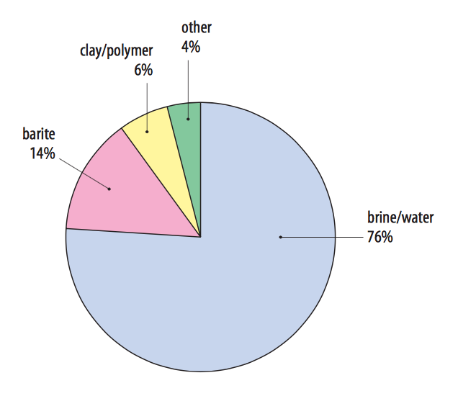
Source: IPIECA 2009.

The term 'mud' is used because of the thick consistency of the fluid system. Wastes from drilling fluids occur during drilling of the well, through the overburden material en-route to accessing the coal seam. Once this is complete the well goes into an operational stage where the task is no longer about drilling but extraction, which is essentially a pumping process (see CSG extraction waters below). This means that drilling muds are only a relevant waste during the initial establishment of a well. The other drilling mud source relevant to the CSG industry is the process of drilling to build pipelines for the transport of extracted gas, as occurs for Santos’ GLNG project in Qld, which is constructing a 420 km pipeline from the Surat and Bowen Basins to its LNG plant on Curtis Island, Gladstone.

Drilling muds are subject to the Qld Department of Environment and Heritage Protection’s (EHP’s) Beneficial Use Approvals scheme (BUAs) under their Waste Reduction and Recycling Act 2011. A specific BUA applies to drilling mud (Qld EHP 2015). This beneficial use approval allows various uses such as composting (both addition to manufactured compost and as feedstock in manufacturing compost) and manufacturing a ‘general purpose soil’ and defines drilling mud as:
“A mixture of naturally occurring rock, soil, and water based drilling fluid, generated by drilling through overburden (as opposed to coal seam formations) during coal seam gas drilling operations at a coal seam gas project.”

The approval lists maximum contaminant levels that must be complied with for these uses to be allowed and specifically defines drilling mud as being ‘in a solid form that is generally able to be picked up by a spade or shovel.’ The latter condition means that drilling muds presenting in liquid form must first be dewatered, either at the generation site or at the waste management site.

CSG extraction waters
Water is extracted as part of the CSG mining process because the gas – methane – is in the coal seam and held there at great pressure by water and other sediment layers. To release the gas, the water needs to be pumped out of this coal seam and up to the surface in a process known as 'dewatering'. The water that is pumped out as part of the CSG mining process is salty and may contain a range of petroleum and mineral based chemical compounds, such as heavy metals and hydrocarbons.
Like drilling muds, CSG waters are subject to EHP’s BUA regime with their own specific BUA (Qld EHP 2014). This beneficial use approval allows various uses such as aquaculture and domestic use at one end of the spectrum (based on stringent requirements such as those provided in the Australian and New Zealand Guidelines for Fresh and Marine Water Quality (ANZECC 2016) and dust suppression and construction at the other end.

Qld’s Coal Seam Gas Water (CSG) Management Policy 2012 (Qld EHP 2012) describes CSG water as “a waste as defined under section 13 of the EP Act”. The policy also identifies brine (defined as saline water greater than 40,000mg/L in total dissolved salts) and crystallised salts (from produced water) as regulated wastes. Further, under future government actions, the policy states that the government will “establish water quality standards to ensure that CSG water that is of a suitable quality (or has been treated to a suitable quality) is not a regulated waste, and give effect to this through amendment of the Environmental Protection Regulation 2008”.

Regardless of the status of regulation amendment, it seems that the CSG waters are intended to be ‘regulated wastes’ only when they are above limits of salinity and, given the 2014 BUA for CSG waters makes no mention of the term ‘regulated waste’, it is assumed that this limit is 40,000mg/L (brine). The very large quantities of CSG extraction waters are therefore likely to be barely visible in (hazardous) waste tracking data.

Total quantities of tracked CSG waste
The total quantity of Qld CSG hazardous wastes reported in 2014-15 (not including the industry’s contribution to D120 mercury waste or waste outside of the tracking framework, such as large volumes of extraction waters), using arisings as a more accurate indicator of generation (as discussed in Section 8.8), was approximately:
- 79% of 173,718 = 137,237 tonnes from C100 alkalis
- 45,784 tonnes from D300 non-toxic salts
- 25% of 192,130 = 48,033 tonnes from N205b
- 231,054 tonnes in total, which is around 4% of national tonnages reported in 2014-15.

This ranks CSG wastes only behind (biosolids), contaminated soils, asbestos, tyres, grease trap, other K wastes and oily waters in national waste generation for 2014-15. This is notable in scale because all of these wastes arise in proportion and geographic distribution with population, as distinct from CSG wastes that occur primarily in one jurisdiction and, more to the point, one area, the overlapping Surat and Bowen Basins.

CSG wastes are reported in higher tonnages than either used oils or used lead acid batteries, two major hazardous wastes that are also produced in a population-distributed fashion.

What are the wastes reported in tracking data?
Tracking data does not give enough information to definitively characterise these wastes, beyond the fact that they arise from the CSG industry. However, review of waste transport certificates for CSG based C100, D300 and N205 show that:
- C100 and D300 appear indistinguishable as virtually all liquid waste going to either storage or to what appears to be composting operations.
- N205 appears to be both liquid and solids – the solids may be drill ‘cuttings’, the solid component of the drilling waste:
- N205 solid wastes not going to storage are recorded as undergoing management code R5 Recycling/reclamation of other inorganic materials or R11 Uses of residual materials obtained from any of the operations numbered R1-R10 at composting-type operations. These could be interpreted as additional to compost (with presumably some pre-treatment) on the basis of the potential end-product benefit of bentonite clay due to properties such as high water holding capacity, odour modification, supply of plant nutrients, improved cation exchange capacity (GHD 2013).
- N205 liquid wastes not going to storage are also recorded as undergoing R5 and R11, which is likely to involve dewatering followed by blending of the solids/ sludge in compost material, for the same reasons as above.

Tracking data is not sufficiently descriptive to identify wastes as either CSG extraction water, drilling muds, or combinations thereof, but the prevalence of its management in composting facilities suggests the majority could be drilling muds, which are specifically covered by the BUA regime. This is supported by indications in Qld policy documents that CSG waters, unless highly saline, are potentially not classified as regulated waste and therefore not required to be tracked.

Various estimates are available to test this theory. Qld EHP’s fact sheet on drilling fluids (Qld EHP 2013) says: “one company estimates that for a single coal seam gas well, there will be 45 – 55 cubic metres of cuttings and 200 cubic metres of fluids (Australia Pacific LNG Pty Limited & Worley Parsons 2010)”. Figure 17 indicates the rapid growth predictions for numbers of CSG wells drilled in Qld, both historically and projected out to 2020. The slope of the graph from 2014 to 2015 is approximately equal to 1,000 wells in that year. This would (very roughly) equate to 50,000 m³ (or tonnes) of solid cuttings and 200,000 m³ (or tonnes) of liquid/ sludge mud, which is 250,000 tonnes in total.

Figure 17: Historic and proposed cumulative CSG wells
Source: Australian Government Geoscience Australia (2014), Figure 2.4.
In terms of CSG waters, a detailed 2014 report by the Office of the NSW Chief Scientist and Engineer quoted an estimate of 25 gigalitres of CSG waters extracted from Surat Basin in 2009. This equates to 25,000,000 tonnes, and was projected by the same source to rise to 300,000,000 tonnes per year by 2030.

Based on these bounding estimates, a figure of 231,054 tonnes of CSG wastes in 2014-15 is probably reflective of mostly drilling muds, with the much vaster volume of salty CSG waters contained in onsite storages (and therefore not registering in state waste tracking systems) or managed on or off site through the BUA process as waste, rather than regulated waste.

While not captured well (or perhaps at all) by tracking systems, CSG (waste) waters consist of a mix of anthropogenic and geogenic substances. They generally comprise a combination of formation groundwater, small amounts of drilling and hydraulic fracturing chemicals, various types of salts, a wide range of heavy metals and various hydrocarbon related substances.

A common thread though is salt – both as part of the drilling mud composition and inherent in large extracted water volumes. There are other potential hazardous components, such as those described above, but salt is the big issue visible in tracking data because of its potential to limit beneficial uses of the liquid waste component. This is not because of acute hazard per se, but more to do with the large volumes and the risk of seepage into groundwater and other waterbodies, resulting in contamination and reduction in water quality and its associated uses.

Salts, like heavy metals, do not biodegrade and are difficult to remove other than through expensive desalination processes. Tracking data suggests treatment of salty waters by desalination to enable reuse occurs only in a minority of cases. However, this process still leaves a salt brine or solid salt waste as a by-product.

As discussed in the previous version of this report, on a treatment-difficulty and sheer scale basis, CSG waste is a current and future management challenge.

The appropriateness of composting for some hazardous wastes
Composting (or other similar processing) is a recurrent theme in Qld data in particular. It appears to be a significant means of waste management for:
- CSG wastes, most likely in the form of drilling muds, recorded in tracking data as C100, D300 and N205
- grease trap waste and ‘other K’ wastes
- biosolids and sewage sludges
- power station or incinerator fly ash or similar Coal Combustion Products (CCPs)
- pesticide wastes.

As discussed in Section 5.4, CSG wastes such as drilling muds are subject to the BUA regime in Qld, which contains quality criteria and contaminant limits to which compliance must be demonstrated. While the management tools themselves look sound, there remains a question about how much ‘benefit’ is provided to either compost end products or the composting process itself, by adding the CSG waste material. GHD (2013) reported that drilling muds “pose a low risk (to the composting process, human health or the environment), unless salinity or hydrocarbons exceed the recommended criteria”. This is different from the waste providing additional benefit to the composting process or the end product. GHD also report that bentonite clays are the only component of drilling muds that are likely to be beneficial, due to their soil conditioning and water-holding capacity, but note that bentonite “can reduce bacterial numbers, and hence may reduce microbial activity to the extent of slowing processing”. It would appear that most of the CSG waste going into composting facilities is in liquid form, so has to be dewatered before being blended into compost product (most likely) or added to the composting process (less likely). Bentonite is only in the order of 6% by weight of the muds received, so the scale of the benefit would seem marginal, compared to the management requirements that come with the remaining salty liquids and their potential to detrimentally impact land and groundwater in the vicinity of the waste management facility.

Grease trap, other K wastes and biosolids/ sewage sludges are good candidates for composting and so the prevalence of this management is unsurprising. Like land application though, there is potential for review of this practice in the future, should some proportion of the biosolids stream be deemed to be contaminated with persistent chemicals such as the POPs discussed in Section 5.2.

GHD’s 2013 review of regulated non-organic wastes in composting also investigated the use of CCPs in composting, as occurs in limited cases currently. It found that CCPs “can be expected to pose a medium risk (to the composting process, human health or the environment), depending on the composition of the coal and its variability.” GHD also conclude that there is no apparent benefit to the composting process from adding CCPs, but like with drilling muds, there could be benefit as a soil conditioner, particularly for acidic soils.

It is noted that current usage of fly ash in composting is from biomass and hospital waste combustion/ incineration rather than coal combustion, which may have advantages in terms of lower heavy metals content. Fly ash from incinerated medical waste would be expected to be landfilled however, rather than composted.

Perhaps the most unexpected application of composting in 2014-15 data is the case of a relatively small quantity of H100 pesticides waste going to what appears to be composting facilities in Qld. It is not clear how composting, or similar biological decomposition processes, could reduce the hazard from a pesticide-containing liquid waste.

End of life lithium ion batteries
Lithium-ion batteries are the most prevalent rechargeable battery technology used today in applications ranging from handheld batteries (typically 5kg or less), such as those used in home electronics and power tools, to electric vehicle automotive batteries through to domestic and industrial applications of large batteries for grid storage.

They are not currently regulated as hazardous waste in Australia but are an example of an emerging waste with inherent hazard in waste handling, within non-existent specific management infrastructure in Australia that is projected to increase rapidly in volume. The hazard is one of flammability; explosions or fire can occur in non-specific waste management if waste batteries retaining sufficient charge have their terminals crossed onto each other, particularly in a violent impact situation such as compaction or being run over by haulage machinery. This is of particular concern due to the impact this could have in current non-specific infrastructure. Fires are particularly problematic in a landfill environment due to the presence of methane gas, but are also a problem for collection infrastructure where other batteries are collected for recovery of lead and other metals.

Waste lithium-ion batteries are projected by the authors (BE et al. 2015b) to increase at an average growth rate of 12% per year in Australia. Sales of rechargeable lithium-ion batteries account for about 24% of all batteries by weight and 7% by unit (NC & SRU 2014). They have grown strongly since 2003–04, and are forecast to continue to do so as they enable new applications and replace other chemistries in existing applications (NC & SRU 2014).

Recommendation 2 of the Hazardous waste infrastructure needs and capacity assessment states:
“The potential hazards posed by lithium-ion batteries, and the best means of managing these hazards, needs further assessment. Following the assessment of hazard, assessment of the collection and processing infrastructure needs for lithium-ion batteries in Australia should be completed.”
The question of whether lithium-ion batteries should be regulated as hazardous waste, given their hazard profile and large future volume, combined with their lack of dedicated management infrastructure, is similar to that of tyres, which is currently tracked as a controlled waste and therefore deemed to be hazardous waste for national purposes. Management of this future waste stream could be a candidate for a product stewardship program. These questions currently face regulators. The emergence of lithium-ion batteries is a good example of why a ‘list’ of hazardous wastes should never be considered static, and that emerging hazardous waste issues need a coordinated national mechanism for regular review and consideration.

Stockpiled legacy wastes
At the jurisdictional level where government regulation of waste predominantly occurs, hazardous waste management is built around the risks associated with transport. However, a substantial quantity of hazardous waste is generated and managed onsite in industrial settings that is unrecognised in tracking data, despite that fact the characteristics that cause a material to be hazardous exist regardless. These ‘legacy wastes’ that are ‘missing’ from tracking data can be present (often stockpiled) in very large volumes and, should regulatory or market conditions change, they could represent major risks and also opportunities for stockpile owners, regulators and the broader waste management market.

Some major legacy wastes, significant by both volume and hazard, are discussed below.

Spent potliner waste
SPL is a waste material generated from aluminium smelters, of which there are four still operational in Australia and two that have relatively recently closed. Aluminium smelting is the extraction of aluminium metal from aluminium oxide (also known as alumina). The process takes place in electrolytic cells that are known as pots. The pots are made up of steel shells with two linings, an outer insulating or refractory lining (known as ‘second cut’ potliner waste) and an inner carbon lining that acts as the cathode (known as ‘first cut’ potliner waste). During the operation of the cell, substances, including aluminium, fluorides and cyanides, are absorbed into the cell lining. After some years of operation, the pot lining fails and is removed. The removed material is SPL, a hazardous waste due to:
- the presence of fluoride and cyanide compounds that are leachable in water
- its corrosiveness – it exhibits high pH due to the presence of alkali metals and oxides
- its reactivity with water – its reduced species oxidise, which can produce inflammable, toxic and explosive gases.

The toxic, corrosive and reactive nature of SPL means that particular care must be taken in its handling, transportation and storage. SPL has been recognised as a major environmental concern for the industry for decades, but has recovery potential because of its fluoride, energy and, to a lesser extent, aluminium content.

While poor management practices such as landfilling of SPL date back to the decades prior to the early 1990’s, SPL has been stored onsite in covered shedding since then. While this may be appropriate for safe (short-term) storage, onsite stockpiling in sheds is not a long-term solution for SPL management, where the SPL remains exposed to risks such as extreme weather events.

The Hazardous waste infrastructure needs and capacity assessment report identified that a significant SPL stockpile had accumulated in Australia and concluded that:
“The storage of large quantities of spent potliner from aluminium smelting should be a social concern, especially given the recent decline of this industry.”
That report recommended that the Australian Government “consult with the aluminium industry and NSW, Vic, Qld, Tas State Governments to develop a nationally agreed approach to the management of SPL stockpiles that ensures their eventual removal and ongoing recovery or treatment”.

Subsequently the Australian Government DoEE commissioned a project to investigate possible solutions to the problem of SPL stockpiles in Australia in 2016. While not published at the time of writing, this report indicates that approximately 700,000 tonnes of SPL are stockpiled in either above ground or below ground storages (landfills) around Australia. Work on long-term improved management of SPL and the drawdown of these stockpiles is continuing.

Fly ash
Fly ash is a residue generated from combustion comprising of fine particles that mix and rise with combustion flue gases in chimneys and post-combustion chambers of thermal plants, and are captured by particle filtration equipment such as electrostatic precipitators or fabric baghouse filters. Fly ash usually refers to ash produced during combustion of coal, the bulk of which arises in power stations. However, this is specifically excluded from the relevant NEPM hazardous waste classification N150 fly ash, excluding fly ash generated from Australian coal fired power stations.

Fly ash often contains hazardous materials such as heavy metals at low concentrations, which still may be sufficient to classify it as a hazardous waste. Such heavy metals derive from their composition in input fuel – and arrive in fly ash either as constituent of fine combustion particles or as gaseous combustion products themselves that condense in the cooling process. The major constituents are crystalline silica and oxides of iron and calcium.

Fly ash is identified through tracking data as having been produced quite consistently at a rate of 5,000 – 7,000 tonnes per year nationally over the last few years, with almost all of that reported in Qld, although it is noted that in 2014 some of this was fly ash exported from Vic to Qld landfill. However, the quantities of fly ash generated from coal-fired electricity generation in Australia dwarf this figure by more than three orders of magnitude.

Australian fly ash generation volumes were estimated by the Ash Development Association of Australia to be 10.74 million tonnes in 2015 (ADAA 2016), with 20% of this (2.10 million tonnes) utilised in value-added applications such as cements, road base and structural fill. A further 2.32 million tonnes was removed from historical storages for similar uses, bringing the total beneficially used to 4.42 million tonnes or 41% of 2015’s generation. Fly ash from coal-fired power stations not beneficially used is currently managed in onsite landfills, storage ponds and stockpiles.

ADAA report that 45 million tonnes of fly ash has been used in cementitious applications or concrete manufacture in the 40 years from 1975 to 2015, which averages 2.25 million tonnes per year. Assuming this 45 million tonnes equates to 20% of the total fly ash produced over those 40 years (based on the 2015 figure being 20% of this year’s generation), and also assuming that the remaining 80% over the period was stored, that equates to an estimate of historical stockpiles of fly ash in the order of 225,000,000 tonnes. The ADAA report states that 8,642,938 tonnes went into onsite storage in 2015 alone, more than all other hazardous wastes put together.

Clearly, this is a large quantity to be definitionally ‘missing’ from national estimates of hazardous waste. This material potentially has hazardous characteristics, since it is often disposed in ‘permanent isolation’ such as geological repository in the UK, Europe and the US. But it also has potential resource-value, particularly in the context of cementitious uses.

Red mud
Red mud is the fine-grained residue left after alumina has been extracted from aluminium-containing ores (bauxite) in alumina (aluminium oxide) refining. Red mud is a legacy waste – very large volumes are stored at Australia’s six alumina refineries, many of which have been in place for decades. Qld Alumina’s 1,000 hectare residual disposal area at Boyne Island has been in operation since 1967.

A 2005 review (Envirorad 2005) estimated that approximately 26 million tonnes of red mud is produced in Australia each year. Using a conservative estimate of only 20 years of red mud generation (at this rate), there would be approximately 500 million tonnes stockpiled in Australia.

Stockpiles of contaminated biosolids
As discussed in Section 5.3, Vic’s Western Treatment Plant in particular has large stockpiles of biosolids contaminated in heavy metals above levels that would allow beneficial uses of the material.

Underlying data quality remains an issue
While the focus of this report is on the data from the standpoint of what it tells us about the state of hazardous waste production and management in Australia, a commentary regarding the quality of the data underlying that cannot be avoided. HWiA 2015 discussed data quality as one of its ‘Key messages’, with a focus on the negative quality impacts that arise from jurisdictional differences in how hazardous waste data is classified, tracked and managed. Section 2.2 of HWiA 2015 and Section 2.3 of this report both introduce data sources and their limitations, with the latter introducing the reader to some broader issues relevant to data for HWiA 2017, including both positive improvements and flaws compared to the previous compilation.

The detailed investigations presented in Section 8 show that some underlying data is of lower quality than HWiA 2015. However, it is important to remember that state electronic tracking systems record hundreds of thousands of vehicle movements, showing waste production, pathways and fates in great detail and representing a data resource of encyclopaedic proportions. The framework architecture of the system is of high quality. For example, the tonnages of waste picked up and deposited are likely to be quite accurate from an overall compilation level. However, classification of producing industries and specification of treatment/ management end can be of variable quality. In the case of source industry sector identification, data quality is very poor, often because it is not a priority for certificate users or regulators, who are more concerned with controlling the safe delivery to an appropriate destination.

Table 16 highlights the extent of identified data quality problems per waste group and a brief summation of each. More detail is provided in the individual waste group analyses in Sections 8.1 – 8.28.
Table 16: Identified data quality issues by waste group
Waste group |  | Data quality issue | Jurisdiction affected
A | Plating & heat treatment | None identified. | -
B | Acids | Qld treatment (management) code R3 Recycling/reclamation of organic substances which are not used as solvents appears to have been erroneously used when better options exist (either Qld code R6 or R5, depending on the actual process used). | Qld
B | Acids | ‘Other’ is the major management code used. This appears to be a symptom of an interstate movement-specific problem – no management type data is recorded for these certificates. Should be R6. | Vic
B | Acids | Management type recorded as ‘CPT’ should be recycling, since it goes to a spent acid regeneration facility (R6 Regeneration of acids or bases). | NSW
C | Alkalis | Spent potliner waste is classified as D110 by other jurisdictions but appears to be recorded as C100 in Qld data. If this is correct it will be double-counted with the Qld estimate for D110. | Qld
C | Alkalis | CSG industry wastes under C100 inconsistently assigned management codes – use of R3 is not logical. | Qld
D110 | Inorganic fluorine (spent potliner) | Recycling an inorganic substance (fluoride), use as fuel or incineration are all codes that have been used and each could be justified – ‘lowest common denominator’ current management options are not helpful. | NSW, Qld, Vic
D120 | Mercury & compounds | Uncertainty about how Hg lamps are being managed. Same NSW facility is recorded as ‘recycling’ in NSW records and ‘CPT’ in WA records (sent to NSW). | NSW & WA
D220 | Lead and compounds | NSW tracking exemption results in under-reporting for this waste. | NSW
D220 | Lead and compounds | 77% of this waste recorded in Vic data as ‘other’ management type. This appears to be a symptom of an interstate movement-specific problem – no management type data is recorded for these certificates. | Vic
D230 | Zinc compounds | None identified. | -
D300 | Non-toxic salts (including coal seam gas wastes) | Apparently inconsistent coding of CSG industry wastes in Qld – C100, D300 & N205. | Qld
D300 | Non-toxic salts (including coal seam gas wastes) | CSG industry wastes under D300 inconsistently assigned management codes – use of R3 is not logical. | Qld
Other D | Other inorganic chemicals | None identified. | -
E | Reactive chemicals | Virtually all Qld E100 data appears to be incorrectly coded SPL waste (should be D110). | Qld
F | Paints, resins, inks, organic sludges | Many misleading source codes – obvious paint or ink companies are listed as food manufacturers, line- marking on roads is recorded as a bakery and printers are identified as meat manufacturers. | Qld
G | Organic solvents | Same facility recorded as CPT and recycling, when it is probably all recycling. | NSW
H | Pesticides | Unclear how pesticide wastes (of reasonable quantity) could be generated from companies as recorded in certificates – may be waste coding user error. | Qld
H | Pesticides | Use of R3 is illogical – not clear how a facility such as this could ‘recycle’ liquid pesticide waste. | Qld
H | Pesticides | Data suggests 14% of pesticide waste may be going to composting – it is not clear how composting could reduce the hazard from a pesticide-containing liquid waste. | Qld
J100 & J160 | Oils | NSW tracking exemption results in under-reporting for this waste. | NSW
J100 & J160 | Oils | Vic exemptions (related to reuse of low hazard wastes) could result in under-reporting for this waste, to a lesser extent. | Vic
J120 | Waste oil/water mixtures | A large number of waste transport certificates record well above the legal or even physical payload such vehicles are likely to be able to carry – likely user units error results in possibly 200,000t incorrectly reported. | Qld
K110 | Grease trap wastes | Lack of clarity in management type coding applied – recycling, CPT and composting used for the same management facility. | Vic, Qld
Other K | Other putrescible / organic wastes | Some waste transport certificates record well above the legal or even physical payload such vehicles are likely to be able to carry – likely user units error results in possibly 30,000t incorrectly reported. | Qld
M100 | PCB wastes | Single waste transport certificate records well above the legal or even physical payload such vehicles are likely to be able to carry – likely user units error results in possibly 6,000t incorrectly reported. | Qld
M160 | Other organic halogen compounds | Virtually all Qld M160 data appears to be incorrectly coded contaminated soil (with pesticide residues). | NSW & Qld
Other M | Other organic chemicals | None identified. | -
N120 | Contaminated soils | Vic management code R15 is specifically for treatment of contaminated soils but it is virtually unused. | Vic
N205a | Biosolids | Not applicable – not derived from tracking data. | -
N205b | Other industrial treatment residues | Large change in historical data (2006-07) from HWiA 2015 without obvious reason. | Qld
N205b | Other industrial treatment residues | Apparently inconsistent coding of CSG industry wastes in Qld – C100, D300 & N205. | Qld
N205b | Other industrial treatment residues | Inclusion of sewage sludge from Councils may result in double-counting with biosolids in the order of 30,000t. | Qld
N220 | Asbestos containing material | A large number of waste transport certificates record well above the legal or even physical payload such vehicles are likely to be able to carry – likely data manager units error results in possibly 400,000t incorrectly reported. | Qld
Other N | Other soil/sludges | Large change in historical data (2006-07) from HWiA 2015 without obvious reason. | Qld
Other N | Other soil/sludges | Single waste transport certificate records well above the legal or even physical payload such vehicles are likely to be able to carry – likely data manager units error that results in the order of 10,000t incorrectly reported. | Qld
R | Clinical and pharmaceutical | Large change in historical data (2006-07) from HWiA 2015 without obvious reason. | Qld
R | Clinical and pharmaceutical | 79 waste transport certificate records well above the legal or even physical payload such vehicles are likely to be able to carry – both user and data manager units errors that result in the order of 42,398t incorrectly reported in 2014-15. | Qld
T140 | Tyres | Not applicable – not derived from tracking data. | -
Other T | Other miscellaneous | Likely error in T100 waste, potentially to do with incorrect choice of reporting units. | SA
All |  | Source industry sector identification is absent or unreliable. | All
All |  | Management type identification is absent in all data. | SA

These data quality concerns can be summarised as:
- source industry identification coding is absent or unreliable in all five state tracking systems
- management type identification is absent from the SA dataset
- user choices of waste codes and management codes are sometimes incorrect and often inconsistent
- incorrect use of units (e.g. m³ instead of kg) in filling out waste transport certificates has a major impact on annual estimates
- there are major differences in Qld historical tonnages between this report and HWiA 2015
- management type data is missing from Vic data for wastes sent interstate
- NSW tracking exemptions result in under-reporting of some wastes (except where other data collection methods are used).

The data quality issues are a mix of systemic weaknesses, poor QA systems, system-user knowledge gaps and ambiguity in coding and definitional conventions. Suggestions to improve data quality are provided in Recommendations D6 – D10.

Key messages
Section 8 provides analysis and commentary on individual waste groups. Most of these wastes tell a story, but often one that is revealed only through forensic interrogation of the tracking system data. For example, M160 Other organo halogen compounds in Qld shows a long-term trend of very low arisings (less than 50 tonnes per year) but spikes to over 1,400 tonnes in 2013-14. Certificate-level inspection revealed this to be from a series of waste movements from another state which, with further research, was shown to be soils contaminated due to the land’s previous use by a turf research organisation in testing the effectiveness of herbicides and pesticides.

The analysis of generation, sources and management (fates and pathways) of hazardous wastes arising in 2014-15, together with analysis of historical arisings trends, and an evaluation of some other wastes that are not well-represented in tracking systems, has drawn out the following key messages.

Overall hazardous waste arisings continue to increase
National hazardous waste annual arisings datasets for the last five years, excluding biosolids, total the following respectively (noting that 2013-14 was not compiled, since it was outside the two-year HWiA report cycle adopted in 2016):
- 4.59 million tonnes in 2010-11
- 5.34 million tonnes in 2011-12 (16% increase on previous year)
- 5.45 million tonnes in 2012-13 (2% increase on previous year)
- 6.01 million tonnes, in 2014-15 (10% increase from 2012-13)
- 30% total increase in arisings since 2010-11 with an annual average of 9%²².

While fluctuation is evident, overall arisings have increased significantly since 2010-11. This increase has been driven by Qld arisings, the highest of all jurisdictions in tonnage terms, while Vic, SA and WA have stayed relatively steady. NSW also had an apparent doubling in arisings in the period but this is an artefact of the data – contaminated soils (the largest contributor) were not included in the NSW dataset until 2013-14.

What constitutes a hazardous waste is dynamic and requires regular review
This report details some emerging waste streams that are not always considered hazardous waste: biosolids, various POPs wastes, lithium-ion batteries and CSG drilling muds, for example. Biosolids are an example. In that case, there is an emerging recognition of the hazards of potential contaminants due to advances in environmental and health science. This is occurring long after the relevant chemical substances were in widespread used in various products and processes. The POP-BDE flame retardants illustrate this; concerns regarding their environmental impacts have been an issue of the current decade but their use as flame retardants in products goes back to the 1970s.

Infrastructure is inadequate for some current and emerging hazardous wastes
Better hazardous waste infrastructure planning was identified as a critical issue by the authors in the Hazardous waste infrastructure needs and capacity assessment report (BE et al 2015b). This issue is further highlighted in this report; for some hazardous wastes such as coal seam gas wastes and asbestos there are problems with infrastructure adequacy or economics (due to source locations far from higher standard management facilities, for example), while emerging problems such as POP-wastes, biosolids (in a potentially more stringent regulatory environment) and lithium ion batteries could, and in some cases already are, changing the landscape of what constitutes a hazardous waste and what types of management are acceptable.

Major legacy waste problems persist due to infrastructure, technology, regulatory or market-economic shortcomings
So called ‘legacy wastes’, those wastes that have arisen historically and still await management in a final (environmentally acceptable) fate, remain present (often stockpiled) in very large volumes. Should regulatory or market conditions change, they could represent major risks and also opportunities for stockpile owners, regulators and the broader waste management market. These legacy wastes include (but are not restricted to):
- 0.7 million tonnes of the aluminium industry’s SPL waste which, given the declining trend of the industry in Australia, represents a current and future clean-up liability for smelters (open and closed), local communities and governments alike.
- 1.5 million ‘dry tonnes’ of biosolids (equivalent to 7.5 million tonnes on an average dewatered basis of 21% solids) at Melbourne’s Western Treatment Plant, known to be contaminated (in heavy metals) to the extent that they are unacceptable for land application.
- 225 million tonnes of fly ash from coal fired power stations. In 2015 only 20% of annual fly ash production (approximately 2 million tonnes out of 10 million tonnes produced) was beneficially used, plus a similar amount from historical stores. This leaves most of the material stockpiled indefinitely, probably due to limitations in market need, unsustainable economics or restrictive levels of contaminants.
- 500 million tonnes of so called red mud from alumina refining, stockpiled throughout Australia’s six alumina refineries.

Jurisdictional tracking data quality is problematic but can be significantly improved
It is apparent that the quality of some of this data is lower than the data used for HWiA 2015. The data quality issues arise through a mix of systemic weaknesses, poor quality assurance (QA), system-user knowledge gaps and ambiguity in coding and definitional conventions. In summary:
- source industry identification coding is absent or unreliable in all five state tracking systems
- management type identification is absent from the SA dataset
- user choices of waste codes and management codes are sometimes incorrect and often inconsistent
- incorrect use of units (e.g. m³ instead of kg) in filling out waste transport certificates has a major impact on annual estimates
- there are major differences in historical years’ tonnages reported as arising in Qld for this report and for HWiA 2015
- management type data is missing from Vic data for wastes sent interstate
- NSW tracking exemptions result in under-reporting of some wastes (except where other data collection methods are used).

These challenges in the data quality weaken some aspects of the analysis in this report.

Fundamental to improvement of these problems is better jurisdictional quality assurance prior to release of the data, consistent with the procedures set out in the Standard. Most of the apparent errors in tonnage arisings uncovered through this project could have been identified and corrected with better quality assurance.

Systemic weaknesses can be tackled through things like designing tracking systems with tighter controls over what can be entered by the user, such as constraining the choice of management type to those carried out by companies licensed to manage the particular waste, pre-setting ANZSIC code identifiers of waste producers already recorded in systems, pre-setting waste types allowed for producers already in the system, or pre-programming intelligence about physically maximum transport vehicle payloads that can be entered as waste quantities.

System-user errors can be reduced through more education and engagement to help users understand their regulatory requirements and the appropriate use of tracking data systems.

Ambiguities that exist in classification and coding conventions can be tackled as part of more regular dialogue between jurisdictions with common interests, about short term pragmatic and longer term aspirational classification conventions, such as those described in the data and reporting standard. Updates of jurisdictional tracking systems, or even through rationalisation of such systems into common platforms, are opportunities for these longer-term structural conventions and systemic improvements to be incorporated.

Tracking data is a largely untapped resource
Perhaps a reason behind the issues of data quality is that tracking systems appear to have been little used by jurisdictions retrospectively, for the purposes of understanding and interpreting hazardous waste data trends, so QA at this level may not be done routinely. A tracking system’s purpose has already been met by virtue of the individual environmental risk being discharged due to safe delivery of the hazardous waste to its appropriate destination on a truck by truck, load by load basis.
State electronic tracking systems record hundreds of thousands of vehicle movements, showing waste production, pathways and fates in great detail and representing a data resource of encyclopaedic proportions. This report (and its predecessor) show that the data can facilitate new observations about hazardous waste and the industry dealing with it. The data sets have limitations but most are correctable through data cleansing effort. The framework architecture is of high quality, particularly when observed from an overall compilation level.

Qld-specific waste issues
Qld data has proven to be a subject of interest on its own for HWiA 2017. Although there are significant data quality issues described throughout this document, this is in part due to the unfettered access to detail provided in their dataset which, if provided as openly by other jurisdictions, may reveal more of the same. It is only possible to find errors or ambiguities if the assembled dataset is thorough enough to find them.

Beyond issues of data quality, Qld is a unique hazardous waste jurisdiction. The coal seam gas (CSG) industry provides enormous waste management challenges not present in other states and territories. CSG wastes make up around 11% of apparent Qld waste generation in 2014-15, but if apparent waste generation is adjusted for obvious reporting errors (such as those identified for oily waters (J120), asbestos (N220) and other smaller volume wastes), this CSG figure is closer to 20%. These figures include only what has been subject to hazardous waste tracking. Vast volumes of salty extraction waters, which either do not arise into offsite management infrastructure or are not regulated as hazardous waste, are not tracked but have been estimated to be around 25 million tonnes per annum (in 2009) in the Surat Basin alone. One of the smaller CSG projects in the Bowen Basin is expected to produce up to 0.6 ML of brine a day, and some 60 000 tonnes of salts and heavy metals over the life of the project (Origin 2017).

As a large state with distributed population centres, Qld suffers economies of scale pressures that make it hard to locate ideal-world infrastructure within accessible distance to waste generation. This leads to decisions of practicality. Composting or related biodegradation processes appear to be a prevailing infrastructure type in Qld for a range of wastes that offer no benefit to efficiency of the composting process and either small benefit or lack of clear dis-benefit to end products. This may be an acceptable practicality so long as standards and guidelines are adhered to, such as Beneficial Use Approval conditions (and the ‘end of waste codes’ set to replace them), environmental authority (licence) conditions and, ultimately, output product quality standards such as the Australian Standard AS4454 for composts, mulches and soil conditioners (SAI 2003).

Recommendations
Below are recommendations that may assist in addressing some of the key issues identified in Section 6. Recommendations P1 to P5 relate to government policy; D6 to D11 relate to tracking system data.

Recommendation P1: A number of emerging wastes should be assessed for their inclusion in hazardous waste frameworks
Assuming Australia ultimately ratifies the addition of POP-BDEs, PFOS and related compounds and HBCD to the Stockholm Convention, there is likely to be an emerging problem in relation to management of POP waste in the set of current infrastructure available to treat it in an environmentally sound manner. Wastes not currently managed as hazardous, such as fire-fighting foams, fire waters, a proportion of e-waste (or WEEE) and, most significantly, building insulation wastes from demolitions and renovations could require management in specific hazardous waste infrastructure which either does not currently exist or has insufficient capacity to handle this potential need. In potentially more stringent future regulatory scenarios, volumes of POP-contaminated biosolids could dwarf volumes of other POP-wastes.

Given projected future volumes, their inherent fire hazard and the lack of local infrastructure to specifically manage them, end of life lithium-ion batteries present problems similar to existing wastes currently managed as hazardous.

These emerging wastes need a coordinated national mechanism for review and consideration as to whether they should be managed as hazardous.

Recommendation P2: Strategic work programs to tackle better management of high volume/ risk legacy wastes should be prioritised
National and jurisdictional governments should continue to identify opportunities to gather better data and pursue nationally-harmonised approaches to current legacy hazardous waste problems, on a strategic basis, prioritised by risk of environmental impact from inferior management. These include stockpiles of SPL, fly ash, red mud, contaminated Vic biosolids and intractable wastes such Orica’s HCB stockpile.

Recommendation P3: The hazard characteristics of Australian biosolids should be examined through an extensive analytical program that is broad and future-focused
The hazards of Australian biosolids should be characterised in terms of a much broader suite of possible contaminants, through a program of laboratory testing. Such testing should consider as a minimum:
- PAHs such as B(a)P
- POPs, with particular reference to PFOS and related compounds
- potentially other organohalogen compounds.

This testing should encompass the same hazardous contaminants required for classification of hazardous waste in Australia, at least as a preliminary measure, to enable a better understanding of what substances can practically be eliminated from further consideration due to their lack of relevance. Without this data, which can be compared against acceptable management guideline levels, a cautious approach to their potential hazard is justified.

Recommendation P4: Based on these test results, Australian jurisdictional biosolids guidelines should be modernised to reflect the breadth of relevant hazards
If biosolids were viewed from a waste perspective, the list of applicable contaminants to be assessed would be far greater than those required by jurisdictional biosolids guidelines. These guidelines should be reviewed in line with the results of a broader-contaminant testing program (recommendation P3). Such modernised guidelines should consider:
- tighter limits on heavy metals, in line with European directions
- a much broader approach to regulating organic chemical residues, informed by the findings of the analytical program.

Recommendation P5: Guidance on the use of the wastes hierarchy in a hazardous waste context is needed
The wastes hierarchy promotes recycling and energy recovery above hazard treatment and containment approaches, but is silent on the issue of protection from harm, which makes it less relevant as a decision tool for hazardous wastes. This limitation is recognised by the Department Environment Food and Rural Affairs (DEFRA) in the UK, through specific guidance on applying the waste hierarchy to hazardous waste, which has been written to assist compliance with the Waste (England and Wales) Regulations 2011. Consideration should be given to the development of similar guidance for the Australian hazardous waste context.

Recommendation D6: Jurisdictions should subject hazardous waste tracking system data to appropriate quality assurance checks, as described in the Australian hazardous waste data and reporting standard (Item 25)

States and territories should ensure hazardous waste data for national reporting purposes is validated through data quality checks and cleaning. The checks should consider completeness, accuracy, consistency and reasonableness, as described by ‘Item 25 Data validation’ from the Standard. This process should be completed before data is used or provided for use in any data analyses such as reported here.

Recommendation D7: Independent validation of jurisdictional hazardous waste data on a routine basis should be considered
In light of problems in the quality of submitted hazardous waste data from some jurisdictions, consideration should be given to independent verification, perhaps in increments of data (such as quarterly). Such validation could extend to recent historical data, to allow a time series to be ‘locked-in’ for trend analysis purposes.

Recommendation D8: States with tracking systems should review their historical annual data in the National Hazardous Waste Data Collation (the data record for this project) and sign off on its veracity for indefinite reuse. This would enable a subsequent ‘back casting’ of the annual compilation set of Australian hazardous waste data (2010-2015), using current adjustment methods, resulting in a ‘locked-down’, consistent time-series record of hazardous waste data.

Historical data from jurisdictional tracking systems was provided to enable trend analysis in this report, as it was previously provided to the HWiA 2015 project, for the same purpose. However, there were numerous instances of previous years’ data being different this time to what was previously supplied, without an obvious reason for such differences. Those States with tracking systems should review their historical annual data in the National Hazardous Waste Data Collation (the data record for this project) and sign off on its veracity for indefinite reuse, so the dataset remains consistent for trend analysis in future years.

In addition, since the 2010-11 dataset, there has been an evolution in the method of nationally collecting, collating, enhancing and adjusting data concerning hazardous wastes. Annual compilation sets are difficult to compare across the years of 2010-11 to 2014-15, due to method changes across this time-series. Consideration should be given to ‘back casting’ the annual compilation set of Australian hazardous waste data (2010-2015) using current methods, once the jurisdictional verification of the historical record has occurred.

Recommendation D9: A cut-off value of waste truck payload size should be agreed, as a means of vetting out gross errors that can vastly over-estimate waste tonnages
A large number of Qld waste transport certificates record well above the legal or even physical payload waste vehicles are likely to be able to carry. According to Qld legislation, the largest axle B-double trucks (the assumed largest likely carrier type) can legally take a payload mass of up to 62.5 tonnes. NSW J120 data shows that 99.92% of all certificates are less than 50 tonnes per truckload, while a typical maximum in all data appears to be below 40 tonnes.

A cut-off value of waste truck payload size should be agreed, as a means of vetting out gross errors that can vastly over-estimate waste tonnages. 50 tonnes is a reasonable round number based on typical reported data, but 62.5 tonnes could also be chosen to be in line with legal allowances.

Recommendation D10: Designs of the national tracking system should incorporate systemic improvements as suggested in this report, to improve data quality
Functional design of the national Hazardous Waste Data Tracking System, an IT development project being led by the Australian Government DoEE, should incorporate systemic improvements as suggested in this report where possible, to improve data quality for reporting and analysis purposes. These include tighter controls over what can be entered by the user, such as constraining the choice of management to those carried out by companies licensed to manage the particular waste, pre-setting ANZSIC code identifiers of waste producers, pre-setting waste types allowed for producers already in the system, and pre-programming intelligence about physical maximum transport vehicle payloads that can be entered as waste quantities, as well as a series of automated validation checks.

Relevant recommendations from HWiA 2015
In addition to recommendations mentioned above a number of HWiA 2015’s recommendations are also relevant to the latest compilation. Those particularly pertinent are:

Recommendation HWiA 2015-2: The impact of regulatory exemptions on arisings data needs to be better understood
“Transport certificate exemptions such as those for lead acid batteries, oils and other wastes in NSW need to be further explored to ascertain their potential to result in under-reported arisings data. This will ensure future Basel reports and other national data collations of hazardous waste reflect accurate arisings and may result in a requirement for further data adjustments to future data collation methods.”

Recommendation HWiA 2015-3: Jurisdictions should work together to improve fate (management) categories and use them consistently
“Fate (management) allocations in tracking systems, including the underlying D and R codes, should be a very important topic of shared discussion between current and potential tracking system jurisdictions. The current categories and how they are used in industry are highly inconsistent, ambiguous and unhelpful to everyone concerned. The way this data is currently collected makes sensible use of fate data very difficult.”

This recommendation was tackled in detail in the Standard. It is still a current recommendation however, because the ambiguities persist - implementation of the Standard will take time.

Data analysis – by waste group
The section analyses and comments on the data presented in Section 0, and detailed in Appendix A (A.1) National hazardous waste data 2014-15 and 2015 – by NEPM code, for each of the waste groups.

The summary source analysis tables listed for each waste group (for each state) show contributing industry sectors in approximate order of highest to lowest contributing tonnages. WA is not listed as it did not provide any level of source identification in its data, and the other jurisdictions (ACT, NT and Tas) do not have source data breakdown as they do not maintain electronic tracking systems.

Similarly, management data is collated and discussed below for NSW, Qld, Vic and WA. SA did not supply data on management types, and ACT, NT and Tas do not record management data due to the absence of electronic tracking systems in these jurisdictions.

Where 2014-15 analysis figures are quoted, such as percentage contributions by jurisdiction or waste type, waste generation figures have been used. When discussing trends, arisings data is typically used – unadjusted to generation because the information required to make such ‘multiple-count’ adjustments is not always available for the historical record. This approach allows trends to be viewed consistently over time.

Although biosolids are presented in the waste group analysis below (Section 8.22), national percentages (waste group to total waste) quoted in the respective discussions of each waste group exclude biosolids; due to the swamping effect of their size and the fact that biosolids are not expressly captured by jurisdictional hazardous waste regulations (although they may exhibit hazardous characteristics).

A. Plating and heat treatment
This group includes:
- A100 Waste resulting from surface treatment of metals and plastics: Overspray of coating materials together with excess material removed in cleaning of equipment – the latter includes sandblast cleaning and surface protection of metal surfaces, including shipping hulls.
- A110 Waste from heat treatment and tempering operations containing cyanides: Molten inorganic salts used to ‘case harden’ or ‘face harden’ iron or low-carbon steel or to control temperature in the tempering process.
- A130 Cyanides (inorganic): Solutions of sodium and potassium cyanides are used in processes that do not result in their complete transformation or destruction and they are present in wastes from such processes.

Sources
Table 17: Plating and heat treatment summary source analysis 2014-15
Qld (A100 only) | NSW (A130 only) | SA (A100 only) | Vic | National summary
- Shipyards & slipways  - Metal coating and finishing  - Oil & gas extraction (CSG/ LNG)  - Petroleum refining  - Waste Collection, Treatment and Disposal Services  - Coal mining  - Fossil fuel electricity generation | <0.1% of national total for waste group | - Metal coating and finishing  - Oil & gas extraction  <2% of national total for waste group | Zero tonnes reported in 2014-15 | - Shipyards & slipways  - Metal coating and finishing  - Oil & gas extraction (CSG/ LNG)  - Petroleum refining  - Waste Collection, Treatment and Disposal Services  - Coal mining  - Power stations

Virtually all the source data presented in Table 17 is generated in Qld as A100 from the following sources:
- shipyards and slipways (from ship hull cleaning and protective coating)
- metal coating, finishing and surface blasting; such as electroplaters, galvanisers and metal cleaning via sandblasting
- smaller amounts are generated from coal seam gas extraction, oil refineries and coal mining (presumably via cleaning of metal plant and equipment in these sectors).

The other notable feature of 2014-15 data for this waste group is that WA contributed 47% of the national total, along with Qld’s 52%, leaving only 1% coming from all other jurisdictions combined. No source data is available for WA. Vic does not recognise this waste group, incorporating the relevant wastes within the ‘D’ group codes (inorganic chemicals).

Analysis
This waste group is small by volume in Australia, making up only 0.2% of the national total in 2014-15. It is dominated by A100 Waste resulting from surface treatment of metals and plastics and derives from overspray of coating materials together with excess material removed in cleaning of equipment. Historically some of this waste would have come from plastics manufacturing industries through plastic powder coatings and surface treatment. While still present, a greater proportion of this waste appears to come from metal surface cleaning and protection, such as barnacle removal from ship hulls and industrial cleaning and protection of heavy equipment, such as is used for mining applications.

Historical trends in arisings for this waste group, predominantly for Qld and WA, are shown in Figure 18. Viewed from around 2008-09 onwards, Qld and WA data indicate an inclining and curiously parallel trend, including a sharp upswing in arisings for 2014-15.

Figure 18: Historical arisings of plating and heat treatment waste
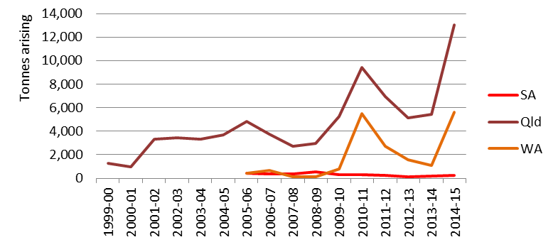

Management
Management approaches for this waste group differ between Qld and WA. In Qld, 34% goes to landfill and 60% to storage while in WA 84% is recorded as going to chemical/ physical treatment, with 15% to storage. This difference is likely to be attributable to the different types of materials used in these differing surface treatment processes. Marine anti-fouling technologies are likely to use quite different approaches and materials to land steel applications.

Rapid rises followed by falls in arisings around 2010-11 and 2014-15 could indicate storage and release spike activity, particularly in Qld where storage is such a high proportion of management.

B. Acids
This group comprises the single NEPM code B100 Acidic solutions or acids in solid form. It can take a large variety of forms including, but not limited to: sulfuric acid, hydrochloric acid, nitric acid, phosphoric acid, chromic acid, hydrofluoric acid, mixed inorganic and organic acids.

Sources
Table 18: Acids summary source analysis 2014-15
Qld | NSW | SA | Vic | National summary
- Copper refining  - Metal coating and finishing  - Coal mining  - Alumina refining  - Waste Collection, Treatment and Disposal Services | - Waste Collection, Treatment and Disposal Services  - Petroleum refining  <2% of national total for waste group | - Metal coating and finishing  - Fabricated metal product manufacturing  - Electrical equipment manufacturing  <2% of national total for waste group | - Petroleum refining  - Primary metal and metal product man.  - Chemical product manufacturing | - Petroleum refining  - Primary metal and metal product man.  - Metal coating and finishing  - Copper refining  - Chemical product manufacturing  - Coal mining  Alumina refining
Vic produced the largest quantities of acid wastes in 2014-15 (59%) followed by Qld with 35%. Their main sources are metal related industries such as foundries, metal product manufacturers, electroplaters, galvanisers, metal refiners and other metal product manufacturing industries, as well as petroleum refineries. Table 18 provides a summary of the main sources of waste in each jurisdiction.

Analysis
This waste group is relatively small by volume in Australia, making up just under 1% of the national total in 2014-15. Analysis of Qld data shows around 60% to be liquid waste.

Historical trends in arisings for this waste group are shown in Figure 19. Vic, Qld and WA trends have fluctuated both up and down to some extent over the last decade but Vic and Qld have had a more recent upswing. NSW however has declined sharply this year, while SA has shown a declining trend for the last decade.

Figure 12, like all graphs in this section, uses unadjusted arisings data from tracking systems. NSW generation of B100 waste, shown in Table 7, has declined even more rapidly (from HWiA 2015) than arisings – 13,258t in 2012-13 to 962t in 2014-15. This is largely due to an improved method of allocating interstate movements more accurately as generated in the state they arose from, as recommended in HWiA 2015 (Recommendation #1). Further inspection of NSW tracking data shows a significant amount of B100 (11,368t according to the National Environment Protection Council annual report, 2014-15 – NEPC 2016, p.136) was imported from Vic into NSW in 2015. Allocating this quantity as waste generated in Vic (rather than what may have been previously counted as NSW arisings) accounts for the apparent large drop in NSW generation of B100 and also a significant part of the rapid increase in Vic B100 generation from 9,244t in 2012-13 to 30,183t (from Table 7).
Figure 19: Historical arisings of acids waste
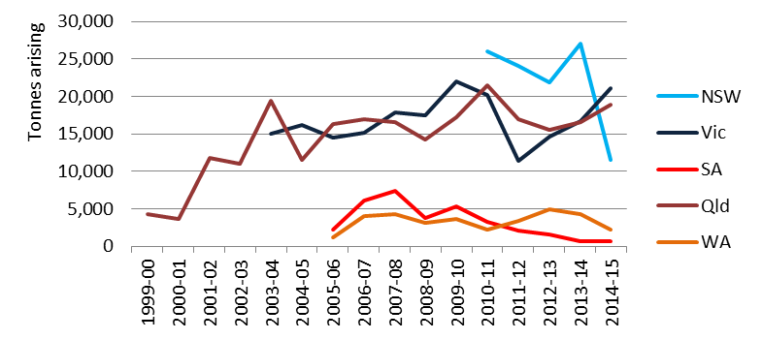

Management
The management of this waste group is listed as:
- 94% chemical/ physical treatment in NSW
- 42% recycling and 39% chemical/ physical treatment in Qld
- 37% chemical/ physical treatment and 60% ‘Other’ in Vic
- 66% chemical/ physical treatment in WA.

While neutralisation via chemical/ physical treatment is an historically typical pathway, analysis of NSW tracking data shows that less than a handful of Vic companies send their B100 waste to spent-acid regeneration infrastructure in NSW. These waste transport certificates record the management as ‘chemical/ physical treatment’ although it would appear to more accurately be recorded as (the Basel disposal operation) R6 Regeneration of acids or bases, a form of Recycling in NSW management type language.

Closer inspection of Qld ‘Recycling’ fates listed for B100 does not shed much light either, with R5 Recycling/reclamation of other inorganic materials the main fate followed by R3 Recycling/reclamation of organic substances which are not used as solvents, a regularly but mistakenly used management type given that organic substances are unlikely to be either present or recovered from an acid solution. Oddly, the most likely Qld management type, R6 Recycling or reclaiming an acid or base, is not used.

These apparent Qld and NSW management type anomalies may be examples of recurrent certificate user error – also the case with Qld industry source codes.

C. Alkalis
This group comprises the single NEPM code C100 Basic solutions or bases in solid form.

Sources
Table 19: Alkalis summary source analysis 2014-15
Qld | NSW | SA | Vic 2012-13 | National summary
- Oil & gas extraction (CSG/ LNG)  - Aluminium smelting | <0.5% of national total for waste group | - Cement and lime man. | - Petroleum refining  - Metal coating and finishing  - Motor vehicle parts manufacturing | - Oil & gas extraction (CSG/ LNG)  - Cement and lime manufacturing  - Aluminium smelting

Qld produced the largest quantities by far of alkali wastes in 2014-15 (85%) followed by SA with 8%. The main Qld sources were CSG extraction (79%) and aluminium smelting (5%), while SA was almost entirely recorded as cement and lime manufacturing. C100 is also produced in small quantities across Australia as waste from surface cleaning/ degreasing in a range of industries as diverse as metal coating and finishing to fast food. Table 19 provides a summary of the main sources of waste in each jurisdiction.

Analysis
Historical trends in arisings for this waste group are shown in Figure 20 below. This waste is moderately significant nationally, at around 3% of all hazardous waste arising in 2014-15. Since about 2009 there has been strong growth in Qld arisings which, given a similar trend for non-toxic salts (the primary classification for CSG waste), is likely to be reflective of the rise of the CSG extraction industry in Qld. However, 2014-15 saw a sharp drop-off, with arisings down 52% from the previous year. This is possibly due to the potential for reduced extractive activity on the back of the plunge in global liquefied natural gas (LNG) price, linked closely to the plunge in oil price, which fell sharply in mid-2014.

Alternatively, CSG wastes are renowned for being difficult to manage in traditional waste infrastructure, which leads to large scale ‘temporary’ storage in ponds and dams, many of which are onsite. Such onsite storage does not appear in tracking data, although it is not clear why such management would have specifically increased in 2014-15. Notably, over 80% of CSG industry-produced C100 is a liquid or sludge waste.

Other reasons for the sharp decline could be the fact that the largest volumes of CSG water are primarily recovered in the early stages of CSG production, decreasing exponentially over time or that this waste is predominantly drilling mud rather than extraction waters and, since these muds are only used in the creation of new wells, there may been a slowdown in well growth.

Qld C100 data contains a significant quantity of what appears to be SPL waste, which is recorded under the more appropriate code D110 Inorganic fluorine compounds excluding calcium fluoride in other jurisdictions that house aluminium smelters. While SPL is alkaline in nature, its chemical hazards are more pointedly fluoride and cyanide, and the former is the convention used for reporting purposes elsewhere. This is an example of waste coding that should be consistent, because if the incorrectly coded SPL assertion is correct, this amount will be double counted with the Qld estimates of SPL under D110, shown as 12,540t in Table 7.
Figure 20: Historical arisings of alkalis waste
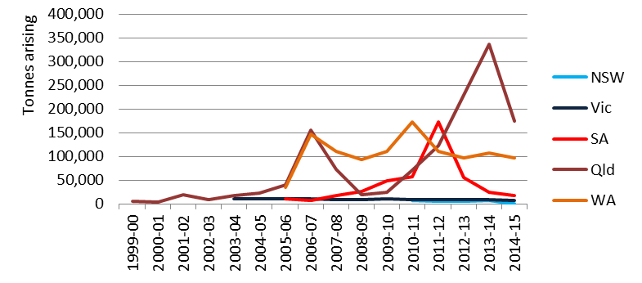

Management
Qld data indicates that 66% of alkali waste is recycled, 21% is landfilled and 12% is sent to offsite storage. From the CSG waste perspective, these management types seem unusual. Closer analysis of the certificate movements for C100 CSG waste arisings shows:
- ‘Recycling’ is made up of:
- R11 Uses of residual materials obtained from any of the operations numbered R1-R10
- R3 Recycling/reclamation of organic substances which are not used as solvents
- R5 Recycling/reclamation of other inorganic materials
- ‘Landfill’ is made up of:
- D1 Deposit into or onto land (e.g. landfill etc.)
- D4 Surface impoundment (e.g. placement of liquid or sludge discards into pits, ponds or lagoons, etc.)
- ‘Storage’ is made up of:
- D15 Storage pending any of the operations in Section A.

Although it is not clear exactly what these wastes are, landfilling of CSG liquid wastes with high salt content is not an acceptable management approach. These waste movements may have gone to landfill facilities but it is possible that pond structures along the lines of D4 Surface impoundment… are holding such liquids. ‘Landfill’ in this case would probably be more correctly described as surface impoundment, which in itself is also unlikely to be a secure management fate for salty liquids, so is probably better described as temporary storage.

‘Recycling’ is unlikely to be an accurate description for C100 going to R11 or R3, since certificate data show both to be made up of composting facilities as waste recipients. Like landfilling, composting of CSG liquid wastes (if they are high in salt) is a questionable management approach. It is quite possible that salty liquids are separated from the waste at the composting facility and the residual solids are actually used in composting, but it raises the question of what happens to the liquids.

Of the recycling codes, only entries going to R5 appear to have been correctly used (and going to an appropriate management), since they are being sent to specific brine water treatment facilities. However, this accounts for only ~1% of C100 wastes in Qld.

In summary for C100 wastes in 2014-15:
- CSG wastes dominate, and they appear to have been sent to either inappropriate or incorrectly described management fates such as composting (incorrectly coded as recycling), landfill and lagoon-based storage
- absent from all arisings tonnages are those CSG wastes that are managed in onsite storage infrastructure, which may be significant
- SPL waste appears to have been incorrectly coded as C100, which should more accurately be recorded as D110.

D110. Inorganic fluorine (spent potliner) – new to HWiA 2017
This group comprises the single NEPM code D110 Inorganic fluorine compounds excluding calcium fluoride, previously not provided as its own waste group in HWiA 2015, but presented within the broader catch-all group ‘Other D – Other inorganic compounds’. This NEPM code is used in the Australian dataset virtually exclusively to describe SPL, a waste material generated from aluminium smelters, of which there are four in current operation (in Vic, NSW, Qld and Tas) and two recently closed (in Vic and NSW).

SPL can exhibit the following hazards:
- toxicity – leachable fluoride and cyanide compounds, with fluoride levels often around 10%
- corrosiveness – high pH due to the presence of alkali metals and oxides
- reactivity with water – producing toxic, explosive, and inflammable gases.

SPL is sometimes heat-treated prior to transport to recycling/ re-processing fates to remove cyanides and flammability risk, but not fluorides, hence the convention to record it in tracking systems as D110 Inorganic fluorine compounds excluding calcium fluoride. Table 20 provides a summary of the main sources of waste in each jurisdiction.

Sources
Table 20 provides a national summary of the main sources of waste.
Table 20: Inorganic fluorine (SPL) summary source analysis 2014-15
National summary (in Vic, NSW, Qld & Tas only)
Aluminium smelting, ANZSIC code 2132

Analysis
This waste group is relatively small by volume in Australia, making up only 0.6% of the national total in 2014-15. However it is a good example of why volume (tonnage) is not an accurate indicator of the significance of a waste, particularly based on annual arisings. SPL is problematic because it contains a number of different (and significant) hazards, is produced from a declining industry sector in Australia (which increases the risk of stranded infrastructure with legacy environmental liabilities), has a long history of intractable environmental management (with some specific successes) and, most of all, is currently stored in large stockpiles around Australia. Since management solutions have proved difficult for decades, there are approximately 700,000t of SPL held in either above-ground (shed) or below-ground (landfill) storages around Australia (REC et al. 2016), which dwarfs the 36,185t annual arisings estimates in Table 7.
Figure 21: Historical arisings of inorganic fluorine (SPL) waste
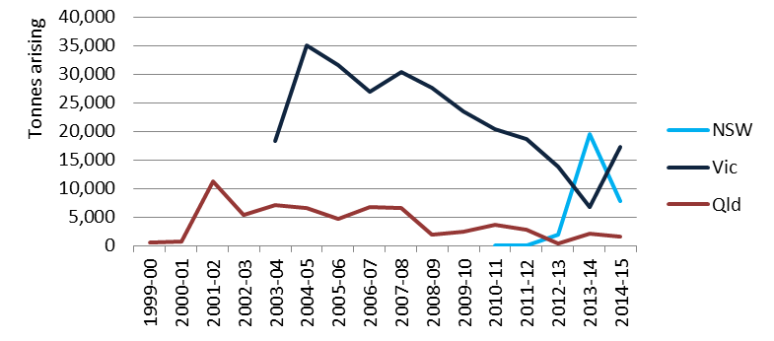
Historical trends in arisings for this waste group are shown in Figure 21 which provides some value from an indicative trend perspective, but is limited by three key issues:
- 2014-15 is the first year that aluminium industry annual production figures have been used to derive ‘generation’ figures instead of tracking system data, on the basis that it is a better estimate of annual arisings, due to the prevalence of onsite storage (that is not visible in tracking systems) and spike-like intermittent releases of SPL that may be included in tracking systems sporadically. The arisings trends in Figure 21 are based on tracking systems, even in the current year (2014-15).
- As pointed out in Section 8.3, Qld aluminium smelting facilities appear to use the waste code C100 to track SPL (as well as smaller usage of D110), which means that the majority of Qld’s SPL tonnages are absent from Figure 21.
- The other state with an operational aluminium smelter (Tas) is not represented because it does not have a tracking system.
However, Figure 21 does indicate that:
- Vic’s SPL arisings have been declining over the last decade, culminating in a low when Alcoa Point Henry closed down in February 2014 and rebounding up the year after that. This possibly reflects the acceptance of D110 to the SPL re-processing plant located at the Point Henry site, from Alcoa Portland smelter’s shed storages, due to the newly available capacity created by Alcoa Point Henry’s cessation.
- NSW shows a spike of SPL taken out of onsite storage in 2013-14.

Management
Tracking data shows that SPL in Vic is almost exclusively recycled when it arises, noting that onsite storages, or historically in Alcoa Point Henry’s case, onsite recycling, are not captured in tracking data. NSW arisings are sent to Storage or transfer, or Other management types, which also masks the case of Tomago Aluminium which, like Alcoa Point Henry, manage SPL through a third-party processor that operates onsite, thus avoiding the need for tracking.

Qld management data is not relevant when drawn from D110 in tracking data. However, looking specifically at the assumed SPL coded as C100 (see Section 8.3), two management codes have been used to describe management fate:
- R1 Use as a fuel (other than in direct incineration) or other means to generate energy
- D10 Incineration on land.

Both follow inherent logic but together demonstrate the limitations of the current lowest common denominator of management types used across Australian tracking systems, as highlighted in HWiA 2015 and further explored in the Standard. If we assume that this source of C100 is, in fact, SPL waste, it has high calorific value due to the electrodes’ carbon construction, and as such is sent to thermal purposing like cement clinker production where both fuel and other value can be utilised. While a cement kiln is not specifically an incinerator, it offers thermal destructive capacity in a kiln and, given the lack of D and R management type code options available to describe non-incinerator thermal destruction, it is logical that this code has been chosen.

To illustrate further how limiting the seven national hazardous waste management types are, the thermal processing of SPL within a cement kiln is similar to the thermal processing that occurs in Australian SPL reprocessing, which is quite reasonably called ‘recycling’ in Vic and NSW. On the basis of the discussion above, arguments can be made that SPL is recycled, used as fuel or incinerated (thermally treated) in Australia and that all describe essentially the same thing. D110 management highlights the need to shift to a much more coherent management typology, such as the long-term hazardous waste management codes suggested in Item 22 of the Standard.

D120. Mercury & compounds
This group comprises the single NEPM code D120 Mercury; mercury compounds. While volumes are small, this waste has been singled out due to its inherent hazard, as evidenced by the Minamata Convention on Mercury.

Sources
Table 21: Mercury & compounds summary source analysis 2014-15
Qld | NSW | SA | Vic 2012-13 | National summary
- Oil & gas extraction (CSG/ LNG)  - Metal manufacturing  - Coal mining  - Lighting (retail)  - Petroleum refining  - Medical and dentistry | - Waste Collection, Treatment and Disposal Services  - Metal manufacturing  - Lighting (retail) | - Electricity supply  - Waste Collection, Treatment and Disposal Services  - Hospitals | - Fossil fuel electricity generation  - Chemical product manufacturing | - Waste Collection, Treatment and Disposal Services  - Metal manufacturing  - Lighting (retail)  - Oil & gas extraction (CSG/ LNG)  - Coal mining  - Petroleum refining  - Medical and dentistry

NSW produced 45% of mercury waste in Australia in 2014-15, followed by WA with 33%, Vic with 8% and Qld with 6%. The main sources were the waste collection industry, metal manufacturing and lighting (retail), although the waste industry and the lighting retailers could probably be grouped together as one group of end of life fluorescent lamp collectors, which would make such lamps the largest national mercury waste source. The CSG industry produces almost 40% of Qld’s relatively small quantity of mercury waste. Table 21 provides a summary of the main sources of waste in each jurisdiction.

Analysis
This waste is very small nationally by tonnage, at around 0.03% of all hazardous waste generated in 2014-15. Historical trends in arisings for this waste group are shown in Figure 22.

NSW data over recent years continues to show quite sharp variation from year to year. The spike of 2013-14, in particular, was due to the unusual situation of mercury-contaminated demolition waste removed from one particular site over a period of time which, being mostly concrete, was heavy although likely to be quite low in actual mercury.
Figure 22: Historical arisings of mercury waste
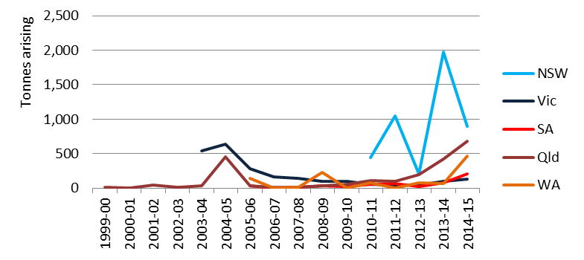
Lower level variations are reflective of releases from accumulated storage from the waste industry, the highest generating source in NSW. The waste industry’s contribution appears to be dominated by collection and segregation of mercury-containing lamps, like the more obvious lamp collection sites. This makes sense, as lamps will be bulked up before being sent to specific mercury separation and recycling management infrastructure.

While only a small number of individual shipments, around 12% of mercury waste produced in NSW is from the metals manufacturing industry, and is sent for recycling. Similar to the contaminated concrete example above, this bulk metal material is heavy but must contain levels of mercury sufficient to classify it as D120.

HWiA 2015 observed Qld’s “steady but slow inclining trend” in mercury arisings over the last decade. In light of the observation in this year’s data that a surprising 40% arises from the CSG extraction industry, this upswing could simply be a mirror of the growth of this industry.

Management
NSW management data is confusing in that the majority of the tonnage is listed as going to landfill for chemical/ physical treatment, despite the fact that it is noted as “mercury from crushed fluorescent tubes”. Given the volumes involved it is unlikely to be separated mercury-rich material. It is possibly crushed fluorescent tubes that contain traces of mercury in the form of phosphor powder and, if so, represents a lost opportunity for mercury separation and recycling. In NSW 19% of D120 is recorded as recycled.

In Qld 83% of mercury waste is sent to storage and in Vic storage is also the major management type, with recycling surprisingly absent. WA sends 93% of its mercury waste to chemical/ physical treatment, although a proportion of this may actually be recycling since it is recorded as going to the same NSW infrastructure that is recorded as ‘recycling’ from other mercury (lamp) generation sources.

D220. Lead & compounds
This group comprises the single NEPM code D220 Lead; lead compounds. Australia has the world’s largest deposits of both lead and zinc and as a result, both are mined and used locally and exported (Geoscience Australia 2015).

Sources
Table 22: Lead & compounds summary source analysis 2014-15
Qld | NSW | SA | Vic 2012-13 | National summary
- Lead acid battery collection  - Scrap metal collectors and recyclers  - Iron and steel manufacturing  - Waste Collection, Treatment and Disposal Services | - Lead acid battery collection  - Coal mining  - Scrap metal collectors and recyclers  - e-waste recycling | Only 4% of source data recorded – too small to interpret. | - Lead acid battery collection  - Copper, silver, lead and zinc smelting and refining  - Metal mining;  - e-waste recycling  - Petroleum refining  - Metals manufacturing | - Zinc smelting & refining (Tas)  - Lead acid battery collection  - Scrap metal collectors and recyclers  - Iron and steel manufacturing  - e-waste recycling  - Glass and Glass Product Manufacturing
Lead waste arisings in Australia can be essentially viewed two ways – that emanating from Tas and everything else.

The Tas-produced lead waste comes exclusively from zinc smelting and refining.

The ‘everything else’ case heavily reflects end-of-life lead acid batteries typically bound for recycling/ recovery and (to a lesser extent) glass from e-waste recycling of Cathode ray tube (CRT) screens that contains high concentrations of lead (CRT glass). The former originally comes from a broad range of industries, including vehicle intensive ones such as mining and transport-related businesses, but usually via collection programs facilitated by metal and other resource recovery companies. The latter comes from e-waste dismantlers/ recyclers, and may arise through intermediate storage facilities. There are also smaller more specific arisings of lead waste from smelting and refining of metals, mining and non-e-waste specific scrap metal recyclers.

Table 22 provides a summary of the main sources of waste in each jurisdiction.

Analysis
This waste was quite significant nationally by tonnage in 2014-15, at just under 4% of all hazardous waste generated. The majority of this was generated in Tas (66%), with 10%, 10% and 9% generated in Qld, SA and Vic respectively, while 3.5% was generated in NSW and half as much again from WA. Historical trends in arisings for this waste group are shown in Figure 23.

Following on from the approach taken for lead wastes in HWiA 2015, a state by state discussion is used below as the best way to describe different stories the data tells in different states.
Figure 23: Historical arisings of lead waste
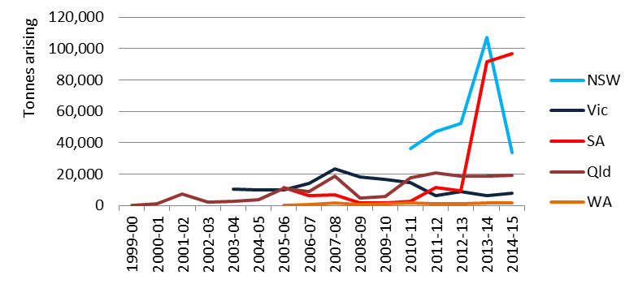

New South Wales
HWiA 2015 highlighted that NSW generation of lead waste in the tracking system-generated data set was unreliable as an indicator of waste generation due to:
- two obvious certificate mistakes, amounting to a 45,000 tonne over-estimation (shown as the 2013-14 spike in Figure 17 above)
- a very high proportion of imports from other states and territories into NSW battery recycling infrastructure, visible on further inspection in the NSW dataset (but not necessarily elsewhere), which appeared initially to be coming from NSW
- the NSW waste transport certificate exemption, for spent lead acid batteries destined for reuse, which results in under-reporting of NSW lead acid battery waste generation.

The tracking system recorded figure for 2012-13 of 1,686 tonnes generated in NSW was replaced with a figure of 32,085 tonnes, estimated by population surrogate on the assumption that most was lead acid battery waste, and this waste was assumed to arise at the same rate as elsewhere. This figure was corroborated by national estimates of end of battery arisings published by DoEE (Mohr et al. 2014).

Largely as a result of the anomaly in the second dot point above, HWiA 2015 recommended an improved method for distinguishing arisings from one jurisdiction that are managed in another (as highlighted earlier in section 8.2 Acid wastes), and this has been applied to waste generation figures in this report. Applying this method, lead wastes managed in NSW infrastructure in 2014-15 can be apportioned as:
- Total arisings = 33,623 tonnes
- NSW produced arisings of D220 managed in NSW = 7,592 tonnes (23%)
- Qld produced arisings of D220 managed in NSW = 7,393 tonnes (22%)
- SA produced arisings of D220 managed in NSW = 3,694 tonnes (11%)
- Vic produced arisings of D220 managed in NSW = 10,916 tonnes (32%)
- WA produced arisings of D220 managed in NSW = 2,634 tonnes (8%)
- Other jurisdictions’ produced arisings of D220 managed in NSW = 1,395 tonnes (4%).

Allocation of the D220 waste generated in non-NSW jurisdictions but managed in NSW to their rightful place of generation has resulted in tonnages that correlate well with HWiA 2015 (once lead data was corrected), which is an endorsement of the value of the new method for capturing interstate waste. However it still leaves a quandary in terms of what the NSW-only generation should be, because of the tracking exemption.

The reported generation figure of 7,652 tonnes in 2014-15 (very slightly adjusted from the figure above to account for NSW exports of D220) is higher than reported in 2012-13 certificate data but much lower than the 2012-13 estimate of 32,085 tonnes. While the latter is likely to be closer to the truth, the original figure has been left unaltered in 2014-15 data, because there appears to be increased use of certificates despite the exemption, which may be due to the prevalence of national-business certificate users (who are less familiar with the exemption), or users simply taking a conservative regulatory compliance approach.

The only way to obtain reliable NSW-specific generation of D220 is to source data from the major battery recyclers and add that to other (non-battery) generation of lead waste recorded in the NSW tracking system.

Tasmania
While not present in the data of Figure 23 due to its lack of a tracking system, Tas generated the largest tonnage of lead waste in Australia from the zinc smelting & refining industry in that state, and what appears to be a process of drawing down its historical stockpiles. A massive 144,149 tonnes of D220 was generated from Tas in 2014-15.

South Australia
The arisings trend for SA shows an apparent large jump from 9,259 tonnes in 2012-13 to 91,417 tonnes in 2013-14 and 96,711 tonnes in 2014-15. This would have been reported as SA generation in the past but the method for capturing interstate movements in HWiA 2017 has been able to deduce that the reason for this spike is Tas D220 waste from zinc smelting & refining, the bulk of which is sent to recycling in metal smelting infrastructure in SA.

By not duplicating Tas lead exports to SA as arisings into SA infrastructure, HWiA 2017 ameliorates the double-counting risk and gives an example of how ‘generation’ can be starkly different to ‘arisings’:
- SA’s D220 arisings in 2014-15 were 96,711 tonnes
- SA’s D220 generation in 2014-15 was 22,173 tonnes.

Other
Vic, Qld and WA remain significant exporters of lead acid batteries into NSW reprocessing infrastructure. Generation of lead waste for all three jurisdictions has remained steady from 2012-13 to 2014-15.

Management
As expected recycling dominates the management of arisings of lead waste in Australia, particularly for used lead acid batteries within infrastructure located in NSW. In Qld, storage is the second biggest percentage management type behind recycling, and in WA storage accounts for 78% of tonnes arising (noting that WA’s exported D220 tonnages to NSW (for recycling) do not appear in WA data, so are not accounted for in WA waste management data). Storage in Qld and WA are examples of accumulation for later sending of bulk volumes in interstate shipments, a fact borne out in the certificate data where individual movement tonnages are large and very similar each time, probably reflecting the maximum payload of the vehicle used.

Vic shows something of an anomaly in that ‘Other’ is the largest management type receiving lead waste at 77% of all arisings. This probably describes interstate movements to NSW, because even more surprising is the fact that zero tonnes are recorded against ‘Recycling’, the management fate for which Vic battery wastes bound for NSW are destined. It appears that the Vic tracking system in this case partially records the interstate movement by setting the certificate up but not closing it out with receipt details, including what infrastructure it ended up in. This is an extension of the problems with interstate transport recording in the state of origin’s tracking system identified in HWiA 2015. Both then and now Vic provides examples such as these of recording partial information – in the case of other states it is likely that no information on the exported waste movement is recorded in the sending state at all. This limitation is likely to emerge for other wastes where exports across borders make up a large proportion of a jurisdiction’s arisings.

One last interesting feature of lead waste data in NSW is the presence of certificates that amount to a significant proportion of all lead waste recorded as generated in NSW – specifically for export of leaded glass, most likely to a Korean lead smelter.

D230. Zinc compounds – new to HWiA 2017
This group comprises the single NEPM code D230 zinc compounds and has been separated out from the ‘Other D’ group for HWiA 2017 because of the significant tonnage generated.

Sources
Table 23: Zinc & compounds summary source analysis 2014-15
Qld | NSW | SA | Vic | National summary
<0.5% of national total for waste group | <0.5% of national total for waste group | - Iron Smelting and Steel Manufacturing | No data available | - Zinc smelting & refining (Tas)  - Iron Smelting and Steel Manufacturing

This waste was quite significant nationally by tonnage in 2014-15, at 2.3% of all hazardous waste generated. The vast majority of this was generated in Tas (87%), with the only other significant generation from SA at 12%. Table 23 provides a summary of the main sources of waste in each jurisdiction.

Analysis
The Tas-produced lead waste comes exclusively from zinc smelting and refining. Historical trends in arisings for this waste group are shown in Figure 24.

The most notable aspect of Figure 24 is the SA (red) line, which shows large growth from 2010-11 onwards. Like lead waste this is not about SA at all but entirely about Tas. That state’s zinc smelting and refining industry has been sending large shipments of zinc waste (like lead waste) to smelting infrastructure in SA for recycling. These show up as SA arisings in raw SA tracking system numbers, because they have arisen in the SA waste management system. Because Tas has no tracking system, it is not obvious that this comes from Tas exports, but this fact is borne out through reference to SA’s Controlled NEPM annual report for 2014-15, which shows that a combined NEPM D code total of 105,558 tonnes was received into SA from other jurisdictions.
Figure 24: Historical arisings of zinc waste
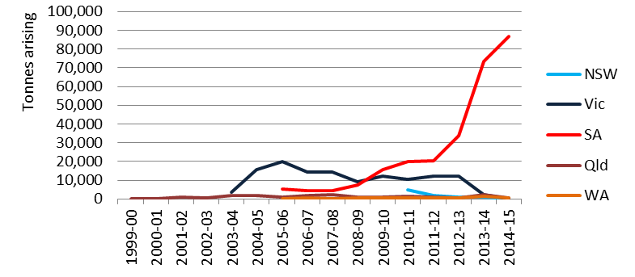

Management
As described above, 99% of zinc waste is received into metal smelting infrastructure in SA for recycling.

D300. Non-toxic salts (including coal seam gas wastes)
This group comprises the single NEPM code D300 Non-toxic salts. In Qld, in particular, this equates to highly saline solids, liquids and sludges that are by-products of coal seam gas (CSG) extraction.

Sources
Table 24: Non-toxic salts summary source analysis 2014-15
Qld | NSW | SA | Vic 2012-13 | National summary
Oil & gas extraction (CSG/ LNG) | - Aluminium smelting  - Aluminium product manufacturing  - Other non-ferrous metal smelting and refining | <0.5% of national total for waste group | Aluminium smelting | - Oil & gas extraction (CSG/ LNG)  - Aluminium smelting

Non-toxic salts in Australia is a tale of three quite different wastes:
- CSG brine waters and sludges, exclusively from the CSG extraction industry in Qld.
- Non-CSG industry wastes generated in NSW, consisting of two basic types:
- Aluminium smelting industry wastes, mostly aluminium dross but also other salty wastes (often called salt cake) from ingot rolling in the final production process. These are exclusively fine-powdered solid wastes
- Other metal smelting and refining industry slags, mostly furnace slags from lead acid battery recycling processes.

Table 24 provides a summary of the main sources of waste in each jurisdiction.

Analysis
Historical trends in arisings for this waste group are shown in Figure 25.
Figure 25: Historical arisings of non-toxic salts waste
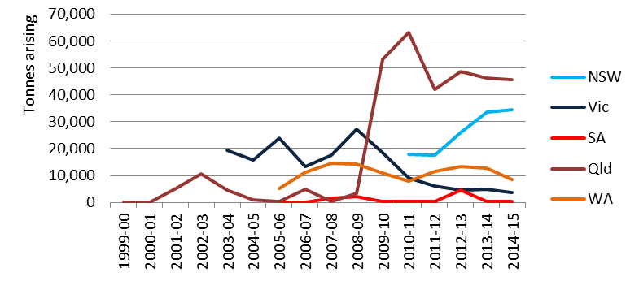

In total this waste makes up 1% of all hazardous waste generated nationally by tonnage in 2014-15, with NSW generating 44% and Qld 29%. However, this simplified analysis does not mean much because:
- CSG wastes in Qld are also represented by C100 (in the main), otherwise known as C Alkalis and N205b to a lesser extent. A better estimate of CSG waste brine waters, sludges and solids would be to add these three Qld-generated wastes together, as they relate to CSG industry generators.
- D300 CSG generation in Qld for 2014-15, according to Table 7, is 19,533 tonnes, but arisings are 45,784 tonnes. This discrepancy is discussed below, and it applies equally to C100 and N205 CSG waste, so the CSG waste arisings figure is the most accurate measure of what was produced in Qld in 2014-15. Further to dot point one, then, CSG brine waters, sludges and solids generated in Qld in 2014-15 would be best estimated by summing C100, D300 and N205 arisings coming from the CSG industry.
- CSG and non-CSG generated D300 are completely different wastes from different sources – it makes more sense to separate out these into these two categories, combining aluminium smelting and other non-ferrous metal smelting and refining together into non-CSG based D300.

Waste ‘generation’ attempts to take waste ‘arisings’ and adjust them to account for two types of double-counting that could lead to misleading conclusions being drawn from arisings alone: waste received from other jurisdictions (and therefore not generated in the receiving jurisdiction, but counted as if it was) and wastes that go into storage and accumulation pathways only to re-emerge on route to other management fates to be counted again in tracking systems. To adjust for these types of double-counting, waste sent to storage codes (other than long-term storage) are netted out on the assumption that storage is temporary, and that these arisings will be counted as ‘generated’ when they come out of storage in a subsequent year. Similarly, wastes sent interstate are netted out of the receiving jurisdiction’s generation data and added into the sending jurisdiction’s generation data, so they only appear once in the national context.

For CSG wastes generated and managed in Qld, interstate imports are not relevant and adjusting for ‘double-counting’ is misleading in itself, on account of the inaccuracy of management D code that is used to denote storage – D15 Storage pending any of the operations in Section A – the problem with these CSG wastes is that they do not appear to be coming out of so called ‘temporary’ storage in subsequent years, in the main. Consequently, applying the generation method to CSG-based D300 waste hides the extent of true generation in that year, which is better represented by arisings in this case.
Re-analysis based on this intelligence tells us:
- D300-reported CSG brine waters and sludges arisings in Australia (Qld) in 2014-15 was approximately 45,784 tonnes
- D300 wastes from aluminium and other non-ferrous metal smelting/refining (dross and furnace slag) add up to approximately 29,034 tonnes generated (the NSW proportion), which is small but somewhat significant, given the limited industry sources it comes from.

The theme from Qld data is the rapid rise in growth of the CSG industry around 2008-09, which is similar to the trend seen for Qld in C100. NSW arisings have increased from 3-4 years earlier and Vic’s have declined, probably reflecting the decline of the state’s aluminium industry, most notably via the closure of Alcoa’s Point Henry smelter in 2014.

Management
Aluminium dross is recycled in specific aluminium recovery/ recycling infrastructure, with subsequent low value (secondary) dross material sent to hazardous waste landfill. Furnace slag from lead acid battery reprocessing and related metal smelting operations is also sent to hazardous waste landfill. Management data for Qld CSG wastes, however, paints a less certain picture.

CSG industry-produced D300 wastes are recorded as entering storage infrastructure (57%) and recycling (40%). Similar to the Management discussion for C100 waste in Section 8.3, the latter is made up incorrect data such as R code R3 Recycling/ reclamation of organic substances which are not used as solvents, which does not seem logical in relation to an inorganic salty liquid or sludgy material. If there is significant organic chemical based contaminants in the liquid waste, for example from infiltration of oil-based drilling muds into extracted CSG waters, then this could theoretically explain the use of management code R3. However:
- such drilling fluids should not be used in Qld
- if the main concern is organic chemical or oil contamination rather than salt it should not be coded as non-toxic salts D300
- if the focus of the management facility is on reclamation of ’organic substances’ in the waste then how is the salt hazard managed?

The majority of receiving facilities for CSG D300 waste listed in waste transport certificate data appear to be composting operations. If this is the case, how does composting manage salt-based hazard? There are detailed regulatory requirements in Qld regarding proper management of CSG waters, including cases where CSG waters can be beneficially reused. It is possible that some of the liquids represented as D300 hazardous waste are in fact low enough in salt content to be used in the composting process.

If the waste is in fact brine or high salt waters and sludges, management of such wastes in composting infrastructure has the potential to cause salt intrusion into groundwater or surface runoff, and reduce the quality of composted output products. This risk is presumably managed within Qld’s Beneficial Use Approvals (BUA) regime, outlined in Section 5.4.

One thing is certain – management fate data on CSG wastes collected through the Qld waste tracking system raises a number of questions.

Other D. Other inorganic chemicals
This group includes waste and wastes contaminated with: metal carbonyls; inorganic sulphides; perchlorates; chlorates; arsenic, cadmium, beryllium, antimony, thallium, selenium and tellurium; compounds of copper, cobalt, nickel, vanadium, boron, barium (excl. barium sulphate), chromium (hexavalent & trivalent) and phosphorus (excl. mineral phosphates).

Sources
Table 25: Other inorganic chemicals summary source analysis 2014-15
Qld | NSW | SA | Vic 2012-13 | National summary
- Variety of sources, similar to Vic | - Only 1% of national total for waste group | <0.5% of national total for waste group | - Fossil fuel electricity generation;  - motor vehicle parts manufacturing;  - petroleum refining;  - leather tanning, fur dressing and leather product manufacturing;  - chemical product manufacturing  - metal coating and finishing;  - port and water transport terminal operations;  - professional, scientific and technical services | - Fossil fuel electricity generation;  - motor vehicle parts manufacturing;  - petroleum refining;  - leather tanning, fur dressing and leather product manufacturing;  - chemical product manufacturing  - metal coating and finishing;  - port and water transport terminal operations;  - professional, scientific and technical services

After separating D230 Zinc compounds and D110 Inorganic fluorine compounds (SPL) from this waste group (compared to HWiA 2015), the remaining mix of D-code wastes is small nationally by tonnage, at around 0.07% of all hazardous waste generated in 2014-15. Table 25 provides a summary of the main sources of waste in each jurisdiction.

Analysis
Qld generated 57% of this waste and Vic 34% in 2014-15. Historical trends in arisings for this waste group are shown in Figure 26.

Figure 26: Historical arisings of other inorganic chemical waste
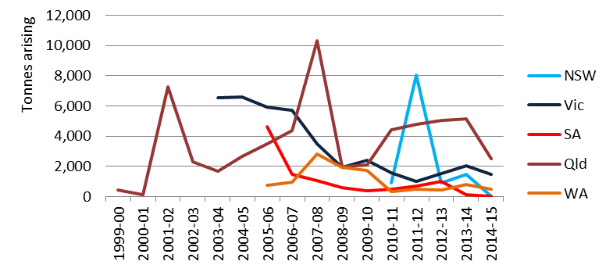

No decipherable trends exist in the arisings data, which appears to show what may be storage release spikes for Qld in 2007-08 and NSW in 2011-12.

Management
Management data are as varied as the wastes themselves with the majority in Qld listed as going to hazardous waste landfill. Interestingly in Vic the major management is listed as chemical/ physical treatment, which may result in some of these wastes being further sent to hazardous waste landfill after that, in line with Vic’s solid waste hazard characterisation and categorisation regime.

E. Reactive chemicals
This waste group comprises the single NEPM code: E100 Waste containing peroxides other than hydrogen peroxide, although it shares similar strong oxidising properties to D340 Perchlorates and D350 Chlorates, which were not grouped together in this category to preserve NEPM E reporting alignment and because the contributions from D340 and D350 are similarly small.

Sources
Table 26 provides a summary of the main sources of waste in each jurisdiction.
Table 26: Reactive chemicals summary source analysis 2014-15
Qld | NSW | SA | Vic 2012-13 | National summary
- Aluminium smelting | <0.5% of national total for waste group | Insufficient source information available | Limited sources in Vic (other than waste industry storages) | - Aluminium smelting

Analysis, including management
This waste was extremely small nationally by tonnage in 2014-15, at 0.007% of all hazardous waste generated. The majority of this was generated in Qld (52%) and WA (27%). Historical trends in arisings for this waste group are shown in Figure 27.
Figure 27: Historical arisings of reactive chemicals waste
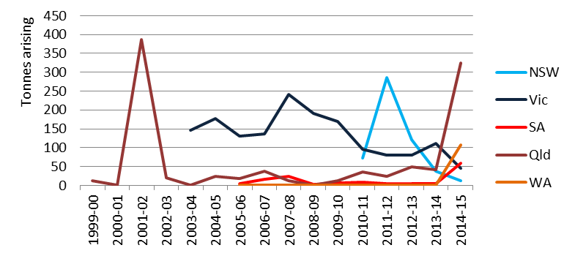

Close inspection of Qld data, the only window into the sources of this waste, shows these arisings to be from the aluminium smelting industry, at a volume per truckload identical to SPL waste (previously coded as C100) and going into cement kiln management infrastructure as R1 Use as a fuel (other than in direct incineration) or other means to generate energy. Therefore E100 waste arisings in Qld are probably zero, due to likely miscoded SPL waste. This reduces an already low tonnage waste to lower still, with the majority arising in WA.

F. Paints, resins, inks, organic sludges
This group includes:
- F100 Waste from the production and use of inks, dyes, pigments, paints, lacquers & varnish
- F110 Waste from the production & use of resins, latex, plasticisers, glues and adhesives.

The former includes polymeric material such as polyacrylates and methacrylates, together with pigments and small quantities of substances like plasticizers and anti-oxidants. The latter includes monomers used in production of polymers, waste products from the production site, or waste generated in or after use of the products.

Sources
Qld produced the largest quantities of these wastes in 2014-15 (47%) followed by Vic with 29%. As has been the case other waste groups, the Qld industry source coding is unreliable, making it difficult to discern the major waste producers. For this waste group, the source coding is highly misleading; for example, obvious paint or ink companies are listed as food manufacturers, line-marking on roads is recorded as a bakery and printers are identified as meat manufacturers. Rather than isolated examples, these errors are commonplace within the certificates for this group.

Given Vic’s poor coverage of source codes in this year’s data, along with the above Qld source data quality problem, the source summary analysis draws directly from data reported in HWiA 2015 (2012-13 reporting year) for these two states.

Table 27 provides a summary of the main sources of waste in each jurisdiction.
Table 27: Paint, ink, resin and organic sludge summary source analysis 2014-15
Qld | NSW | SA | Vic 2012-13 | National summary
- Paint, ink and resin manufacturing  - Chemical and chemical product manufacturing  - Printing  - Metal product manufacturing  - Pulp and paper manufacturing  - Aircraft manufacturing | - Paint, ink and resin manufacturing  - Chemical and chemical product manufacturing  - Printing | - Motor Vehicle Manufacturing  - Paint, ink and resin manufacturing  - Printing | - Motor vehicle manufacturing  - Chemical and chemical product manufacturing  - Printing  - Machinery and equipment manufacturing  - Furniture manufacturing | - Paint, ink and resin manufacturing  - Chemical and chemical product manufacturing  - Printing  - Motor vehicle manufacturing  - Machinery and equipment manufacturing

Analysis
This waste group is relatively small by volume in Australia, making up 1% of the national total in 2014-15. Historical trends in arisings for this waste group are shown in Figure 28.
Figure 28: Historical arisings of paint, ink, resin and organic sludge wastes
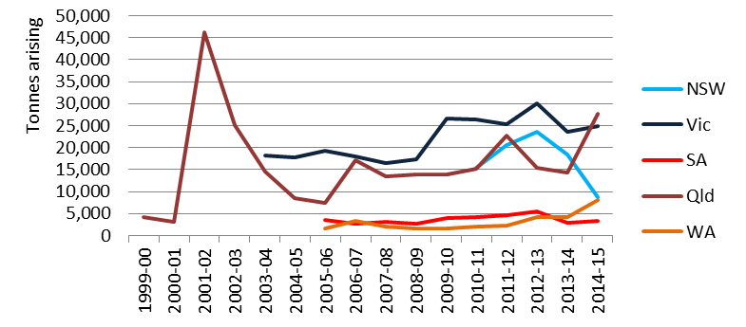
Figure 28 shows a jump in Qld arisings of similar magnitude to NSW’s sharp fall in arisings. These trends may be connected but the available data does not allow any conclusions to be drawn as to the reasons for these precipitous movements.

Management
Qld and Vic both show storage as the most common form of management for these wastes, and some export to NSW does occur. Such storage is likely to be for volume accumulation prior to on-sending to end fate, so could explain the spiking trends in Qld and NSW.

After storage, Qld’s main fate is recycling, as is Vic’s, while 84% of NSW’s F group waste goes to chemical/ physical treatment.

G. Organic solvents
This waste group includes:
- G100 ethers
- G110 organic solvents excluding halogenated solvents
- G150 halogenated organic solvents
- G160 waste from the production, formulation and use of organic solvents.

Solvents have three principal areas of use; as cleaning agents, as a raw material or feedstock in the production and manufacture of other substances, and as a carrying and/or dispersion medium in chemical synthetic processes. They are often distinguished on the basis of halogenation in their chemical structure, with halogenated organic solvents more of a health and environmental concern than non-halogenated organic solvents. As a result, both usage and waste from halogenated organic solvents tend to be declining in favour of non-halogenated alternatives.

Sources
Table 28: Organic solvents summary source analysis 2014-15
Qld | NSW | SA | Vic 2012-13 | National summary
- Automotive and other machinery servicing  - Waste Collection, Treatment and Disposal Services  - Dry cleaning  - Oil refining  - Asphalt production  - Motor vehicle manufacturing  - Defence  - Paint manufacturing | - Automotive and other machinery servicing  - Dry cleaning  - Printing  - Chemical and chemical product manufacturing | - Dry cleaning  - Waste Collection, Treatment and Disposal Services  - Motor Vehicle Manufacturing  - Printing | - Chemical and chemical product manufacturing  - Oil and gas extraction  - Printing | - Automotive and other machinery servicing  - Waste Collection, Treatment and Disposal Services  - Dry cleaning  - Chemical and chemical product manufacturing  - Printing  - Asphalt production  - Motor vehicle manufacturing  - Defence  - Paint manufacturing

WA generates the bulk of this waste nationally at 42%, followed by Vic at 22% and Qld at 20%. The major sources are typically automotive and other machinery servicing as well as the waste industry. Table 28 provides a summary of the main sources of waste in each jurisdiction.

Analysis
This waste group is small by volume in Australia, making up 0.2% of the national generation total in 2014-15. However, it accounts for double this volume of arisings, because a large proportion of it goes to storage, which is discounted so as to minimise double-counting in the generation estimate. Historical trends in arisings for this waste group are shown in Figure 29.
Figure 29: Historical arisings of organic solvents wastes
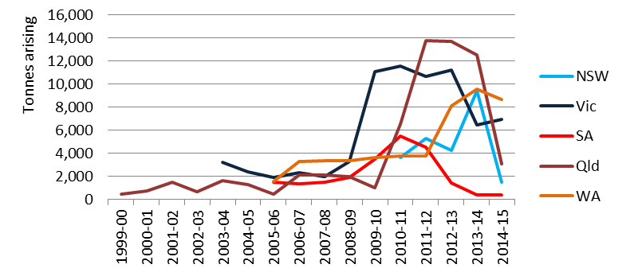

The main features from Figure 29 are the rapid falls in 2014-15 arisings from NSW and Qld, compared to the previous year, after similarly rapid rises in Qld from 2010-11 onwards, Vic in 2009-10 and NSW in 2013-14. It is not clear from the tracking data what may be behind these abrupt movements. However, the fact that storage is such a prevalent management type may have something to do with it. One of the main producers of G wastes is auto repair retailers which, given their disparate nature, often involves large number of small volume transactions. These pick-ups are often serviced in multiple collection runs by waste companies which then combine, store and accumulate as the management data indicates. The nature of this type of short-term storage/ accumulation is that it comes back out again, in larger ‘lumps’ or storage release spikes, which could well explain some of the rapid fluctuations. The source data also indicates that the waste industry is a highly represented industry source (35% in Qld), which are examples of these storage releases.

WA has had its own rapid growth in arisings in 2011-12 but with no source information the reasons for this are not known. SA has also followed a declining trend but in contrast to other states this has been gradual from 2010-11.

Management
Storage is the major management recorded for G wastes nationally, at 52% followed by recycling. Although their actual generation is 2% of national tonnages, which is a massive drop-off from the previous year, NSW is unusual in that its highest management type is chemical/ physical treatment (47%), closely followed by storage at 40%. Perusal of waste transport certificates suggests that the same waste receiving facilities (that are known to do solvent recovery by distillation) are recorded by different producers as chemical/ physical treatment and recycling, suggesting that all of it is probably recycling, in line with national management figures. This could be another example of certificate user-created inaccuracies in the data.

H. Pesticides
This group includes three potentially diverse types of waste:
- H100: waste from the production, formulation and use of biocides and phytopharmaceuticals
- H110: organic phosphorous compounds
- H170: waste from manufacture, formulation and use of wood-preserving chemicals.

H100 is the major pesticide heading (biocide means pesticide) although it also includes the relatively unrelated phytopharmaceuticals, which are plant derived pharmaceutical products such as alkaloids.

H110 includes wastes from organic phosphorus compounds used as lubricants, plasticisers, flame retardants and, most notably, organophosphate pesticides.

H170 is different again in that it covers wastes from timber preservation which in Australia has historically been dominated by chromated copper arsenate (CCA) treatment. Its overlap in this NEPM category is presumably due to the function of CCA preservation of timber, where the copper acts as a fungicide, the arsenic an insecticide (both types of biocide) and the chromium chemically fixes these to the wood to stabilise them.

Over 8,000 pesticide and veterinary products have been registered for use in Australian agriculture, horticulture, livestock, forestry, commercial premises, parks, homes and gardens (Immig 2010). Pesticide wastes can arise due to historical activities where the active ingredients may be mixed or perhaps unknown, due to weathered container labelling. It also arises from manufacturing and formulating of these chemicals, such as agricultural chemical suppliers, wood preserving chemical supply and chemical manufacturing.

Sources
Table 29: Pesticides summary source analysis 2014-15
Qld | NSW | SA | Vic 2012-13 | National summary
- Iron and steel manufacturing  - Local Govt.  - Dept. of Defence  - Wood product manufacturing  - Waste Collection, Treatment and Disposal Services | - Electricity supply  Only 3% of national total for waste group | - Insufficient source information available | - Services to agriculture  - wood product manufacturing  - Waste Collection, Treatment and Disposal Services | - Iron and steel manufacturing  - Local Govt.  - Electricity supply  - Dept. of Defence  - Wood product manufacturing  - Services to agriculture

WA generates the bulk of this waste nationally at 57%, although its sources are not known, followed by Qld at 18% and Vic at 12%. The major sources are quite disparate, except for large (relatively-speaking) contributions from two single companies. The waste sector is mentioned as a source possibly due to their role in household or farm collection program wastes; the waste sector is the collector rather than the true ‘generator’, which is individual homes and farms. Table 29 provides a summary of the main sources of waste in each jurisdiction.

Analysis
This waste was very small nationally by tonnage in 2014-15, at 0.06% of all hazardous waste generated. Historical trends in arisings for this waste group are shown in Figure 30.
Figure 30: Historical arisings of Pesticide wastes
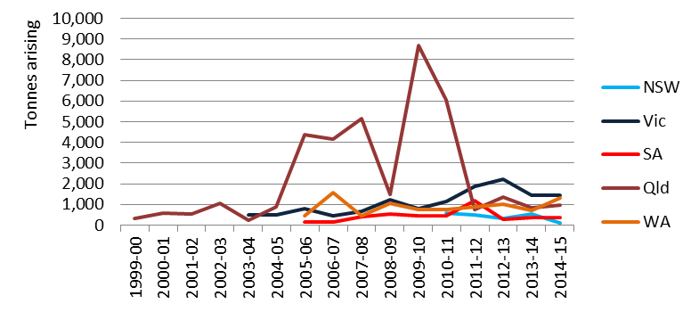

Sources of this waste are quite specific in the case of H170, which arises from the wood preservation chemicals used by the wood product manufacturing industry. For H100 and H110 sources are more variable.

Large-area occupying industries, such as those that maintain infrastructure, are likely to use pesticides to manage and protect their assets (such as fencing or railway sleepers). Defence facilities probably generate pesticide waste for similar reasons as would local government, although the latter could also be generating this waste along with the waste industry through household and farm chemical collection programs run by councils and implemented on the ground using waste industry collection expertise.

Historically, the dominant feature of the graph is Qld data, particularly with its major peak in 2009-10. The jump from 2008-09 to 2009-10 could be explained by storage releases, but since a sustained rise occurred from 2004-05 through to 2009-10 it may be a reflection of regulatory change, such as the implementation of the requirements for pesticide management technicians in the Pesticide Management Act and Pesticide Management Regulations (the latter came into place in 2003).

The other is the possible effect of chemical collection programs like drumMUSTER and ChemClear, which have been prevalent throughout Australia in the last 10-15 years. Closer inspection of the Vic and SA data also suggests a rising trend over the period of these collection programs, noting the latter’s 2010-11 spike was from wood-preservation chemicals, which may have been a storage release.

Management
The reported management for H Pesticides is mostly ‘recycling’ – 71% in Vic and 29% in Qld, with a significant amount of WA’s H waste going to Vic for recycling. On the surface this might seem illogical, since much of the waste is based on highly hazardous chemicals designed to kill various target organisms. The logical fate is destruction for these chemicals, usually through some form of thermal means. Despite ‘thermal destruction’ being a management fate category available for waste transport certificate users, there is close to zero thermal destruction of H wastes reported in 2014-15.

In reality, destruction of the pesticide waste occurs, in particular in Vic, but the major fate is recycling because the waste is blended into a fuel and burnt for energy recovery in industrial processes, hence the use of the recycling management code R1 Use as a fuel (other than in direct incineration) or other means to generate energy. Current jurisdictional management typology places energy recovery under the recycling heading, because it does not exist as a management type on its own. For example, the category ‘incineration’ is too narrow, because it does not describe a thermal process that in essence is incineration but the material being incinerated acts as a fuel resource for another manufacturing process, such as the case with fuel substitution in cement kilns.

The Qld management data throws up a couple of unusual observations. Recycling is almost entirely made up of R3 Recycling/reclamation of organic substances which are not used as solvents, and this recycling occurs at a wastewater treatment plant. It is unclear how a wastewater treatment plant would ‘recycle’ liquid pesticide waste. Chemical/ physical treatment is not far behind in terms of Qld management practices at 24%, followed by landfill at 21% and, of most concern, ‘biodegradation’ at 14%. Biodegradation is described by Qld management code D8 biological treatment in a way not otherwise mentioned in this part, and the sending and receiving facilities are the same as those listed for R3. It is not clear how D8 – essentially composting or similar form of non-thermal biological treatment – could reduce the hazard from a pesticide-containing liquid waste.

J100 & J160. Oils – new to HWiA 2017
This waste group comprises two NEPM codes:
- J100 Waste mineral oils unfit for their original intended use
- J160 Waste tarry residues arising from refining, distillation and any pyrolytic treatment.

J100 is dominated by used oil from vehicles, while a small proportion of (mostly Vic) data also includes the used oil filters themselves. J160 is a much smaller contributor, produced in the refining of petroleum, re-refining of lubricating oils, production of metallurgical coke or town gas by pyrolysis of coal.

In HWiA 2015 these two codes were collected together with J120 Waste oil/water, hydrocarbons/water mixtures or emulsions, but this led to conflating a number of issues with the visibility of waste oils generation in the context of the large volumes of oily waters.

Sources
Table 30 provides a national summary of the main sources of waste.
Table 30: J100 & J160 (oils) summary source analysis 2014-15
National summary
- Mining
- Manufacturing (various, including food, petroleum & metal coating)
- Transport
- Retail (vehicle servicing shops)
- Waste sector

Oily wastes arisings are distributed across industries in jurisdictions quite similarly, with differences being more to do with jurisdictional industrial mix variations, such as the prevalence of mining in WA and Qld.

The Product Stewardship for Oil Program was introduced by the Australian Government in 2001 to provide incentives to increase used oil recycling. The program aims to encourage the environmentally sustainable management and re-refining of used oil and its reuse. The arrangements comprise a levy-benefit system, where an 8.5 cents per litre levy on new oil, helps fund benefit payments to used oil recyclers. These arrangements provide incentives to increase used oil recycling in the Australian community.

Analysis (including Management)
This waste was quite significant nationally by tonnage in 2014-15, at 3.6% of all hazardous waste generated. The majority of this was generated in WA (50%), followed by Qld at 23%, Vic at 13% and NSW at 11%. Historical trends in arisings for this waste group are shown in Figure 31.

Figure 31: Historical arisings of waste oils
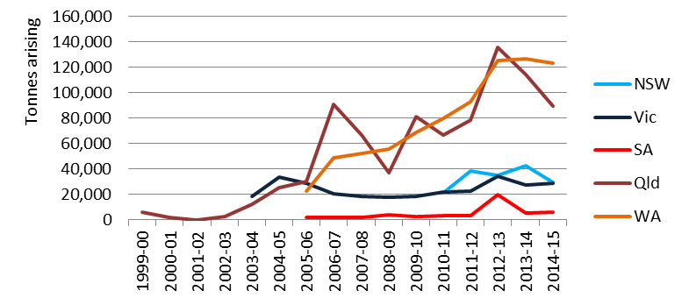

HWiA 2015 contains a lengthy discussion about J100 Oils, on the basis that the arisings numbers alone do not sufficiently describe the fate of used oils in Australia. When looking at arisings figures alone (not adjusted generation) WA has over 120,000 tonnes in 2014-15 and Qld almost 90,000 tonnes, compared with NSW and Vic at close to 29,000 tonnes each. HWiA 2015 attempted to explain why the more populous states would generate relatively little when oils are generated relatively evenly with population-proportionate vehicle use across the country. Could machinery-intensive industries like the various types of mining in WA and Qld really make that much difference?

HWiA 2015 concluded that WA and Qld were not necessarily over-reported as the trend graph suggests. Rather:
- J100 oils were significantly under-reported in NSW, on account of their waste tracking exemption for used oil going to re-refining (recycling)
- J100 oils were probably under-reported in Vic as well, although perhaps to a lesser extent, due to tracking exemptions for so-called Accredited Agents, the name given to licensed transporters who use a ‘milk run’ style approach to large numbers of small (same waste) pick-ups, such as occurs with motor repair shop used oils/ filters.

2014-15 data has similarities to 2012-13 data, but there may be a number of contributing factors that continue this WA/Qld v NSW/Vic discrepancy. These are discussed in the numbered points below. To help with this discussion, it is worth also looking at how these arisings are managed, which is summarised for the major management categories relevant to J100 and J120 waste, for the jurisdictions that record this information, in Table 31.

Table 31: J100 & J160 arisings by major management category and jurisdiction, 2014-15 (percent)
Jurisdiction | Recycling (%) | Chemical/ physical treatment (%) | Storage (%)
NSW | 4 | 73 | 22
Qld | 46 | 6 | 45
Vic | 72 | 8 | 15
WA | 57 | 24 | 20

- WA and Qld follow a similar strong upward trend from around 2005-06, which may be tracing mining growth of different types in each jurisdiction, both of which show a slowdown since 2012-13.
- WA’s incline is steady while Qld’s is jagged. The latter often describes a pattern of high volumes into storage one year followed by large releases out again in a subsequent year. Table 31 shows that Qld has by far the highest proportion of arisings going into storage of the states that report management fate data, which is consistent with its arisings pattern.
- Like lead acid batteries, NSW has an exemption from the use of transport certificates for internal movements of used oil, but only if it is going to a re-refining fate (called reuse in the exemption). By this definition, except where the certificate system is used incorrectly, tracking data should contain only movements of used oil going to non-reuse fates, such as storage and chemical/ physical treatment. Table 31 above indicates that 95% of NSW arisings goes to non-recycling categories of management, and only 3% to recycling. Like the conclusions of HWiA 2015, this supports the notion that NSW oils arisings destined for reuse are not captured in tracking data, as should be the case.
- HWiA 2015 reported that J100 generation tonnages supplied for Basel reporting 2012 for NSW were strikingly higher – 137,000 tonnes. This report was not compiled by consultants directly from tracking system records but by the EPA’s hazardous waste section. It is likely that this compilation drew on other intelligence, such as gate receipt records from the oil re-refiners themselves (of which there is a strong industry in NSW). The much higher reported generation figure probably includes recycling data missing from tracking certificates.
- Tracking of oils arisings for Vic has been quite consistent over the entire period of data. However, like NSW, Vic has a form of tracking exemption (for accredited agents) that could be applied to this waste category and, more specifically, there is a statutory ‘classification’ of used oil filters (a subset of waste oils unfit for their original intended use) that requires them to be recycled. Consequently, Vic tracking data shows 75% of oils go to recycling. While Vic tracking data includes significant amounts of oil recycling (unlike NSW), the issue with Vic is that there is likely to be more recycling from accredited agent pickups that falls under tracking exemption and there is a further issue in that Vic exports significant quantities of waste oil to NSW for recycling. The latter has been shown to be poorly covered by the tracking system of the state of generation (in this case Vic) however, the method of adjusted generation used in this report better captures that export.
- HWiA 2015 concluded that NSW and Vic could be under-reporting oils by as much as 175,000 tonnes annually, referencing the Department’s independent review of the Product Stewardship (Oil) Act 2000, commissioned and prepared by Professor Neil Byron of Aither (Byron 2013), which estimates total oil collected nationally in that program at 315,000 tonnes in 2011-12.
- HWiA 2015 calculated generation from arisings without correction for multiple-counting via storage and accumulation, whereas HWiA 2017 generation data contains this adjustment. As Table 31 data shows, this is a waste with a relatively high rate of storage, making national generation data in this report intrinsically lower than previously reported.

In summary, for waste oils:
- It remains almost certain that NSW J100 data is under-reported by a substantial margin, and Vic probably is as well, although perhaps not to the same extent in 2014-15.
- Countering this under-reporting effect is the fact that storage is commonly employed for this waste, which would have led to over-reported arisings in 2012-13, particularly in Qld, because storage ‘ins’ and ‘outs’ would have been double-counted.
- The double-counting effect has been adjusted for in 2014-15 figures, but there is no definitive data to supplant NSW or Vic data for 2014-15 for their respective exemption-caused likely shortfalls in arisings/generation. Consequently, no change to data has been made, other than to note the likely under-reporting in NSW and, to a lesser extent, Vic.

J120. Waste oil/water mixtures – new to HWiA 2017
This waste group comprises the NEPM code J120 Hydrocarbons/water mixtures or emulsions and, like its ‘oilier’ counterpart waste J100, is dominated by used oil/ water mixtures from vehicles or, more specifically, vehicle washwater pump-out liquids.

In HWiA 2015 this code was collected together with J100 Waste mineral oils unfit for their original intended use, but this led to conflating a number of issues with the visibility of waste oils generation in the context of the very large volumes of oily waters.

Sources
Table 32 provides a national summary of the main sources of waste.
Table 32: Oil/water mixtures summary source analysis 2014-15
National summary
- Mining
- Manufacturing (various, including food, petroleum & metal coating)
- Retail fuel forecourts and servicing
- Vehicle wash-bays
- Retail (vehicle servicing shops)
- Waste sector

Sources for this waste are similar to J100 – places that handle lubricating oils through vehicle and other machinery servicing and cleaning. The difference between J120 and J100 is that the former also has large contributions from dedicated vehicle washing facilities, such as commercial car washes and truck bays, as well as similar forecourt wash-down collection systems found on retail vehicle refuelling stations. Qld data is unusual in that there are a large number of waste transport certificates with no waste generating source company recorded.

Analysis
This waste was significant nationally by tonnage in 2014-15, at 5.5% of all hazardous waste generated. The majority of this was generated in Qld (51%), followed by Vic’s 19%, NSW’s 17% and WA’s 11%. Historical trends in arisings for this waste group are shown in Figure 32

Figure 32: Historical arisings of waste oil/ water mixtures
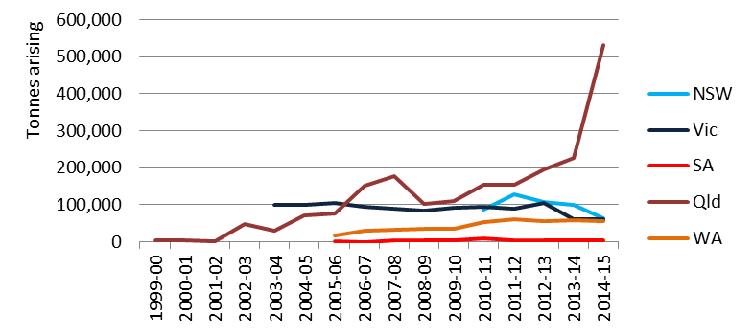

The standout feature from Figure 32 is Qld’s massive increase in arisings from 225,808 tonnes in 2013-14 to 531,367 tonnes in 2014-15, up 135%.

In addition, there are two unusual declines - NSW’s sudden decline of 37% in arisings from the previous year and Vic’s similar decline from 2012-13 down to 2013-14, followed by stable arisings in 2014-15.

The cause of the massive increase in Qld oily water arisings appears to be data quality again. A large number of waste transport certificates record well above the legal or even physical payload such vehicles are likely to be able to carry. Thirty tonnes is probably close to a maximum likely payload so, using 50 tonnes as a conservative cut-off, this total comes to approximately 200,000 tonnes that are likely to be incorrectly reported – which would account for most of the massive spike.

Such user errors are related to units – in these cases the likely correct unit of measure would be either litres or kilograms, both of which are essentially the same thing given the waste’s density would be close to 1kg/L – about 1,000 times lower than the reported m³. The example of J120 waste begs the question of whether there are other examples of incorrect unit usage for other Qld wastes – there is no compelling reason why J120 would be unique in this regard.

A comparative check with NSW data shows that only nine waste transport certificates out of 10,598 recording J120 movements in NSW are above 50 tonnes; in other words 99.92% of all certificates are less than 50 tonnes per truckload, which validates the 50 tonne Qld threshold used above.

The respective causes of the NSW and Vic declines is unclear from the data available.

Management
Qld sends 71% of its J120 arisings to storage along with 48% in WA, while Vic and NSW only send 10% and 5% to storage respectively. The adjustment method for double-counting will therefore subtract much of the apparently spurious arisings data to give a more reliable generation figure. The high storage proportions in WA and Qld probably reflect the distributed area of generation in these large states with widely dispersed industries such as mining.

Major management fates for J120 in other states are: chemical/ physical treatment in NSW (88%) and recycling (43%) and chemical/ physical treatment (34%) in Vic. Next highest after storage in WA is chemical/ physical treatment at 31% and for Qld chemical/ physical treatment at 13% plus recycling at 12%.

The prevalence of chemical/ physical treatment correlates with the large numbers of simple oil separation and storage facilities identified in the Department’s earlier Hazardous Waste Infrastructure Needs and Capacity Assessment.

K110. Grease trap wastes
K110 Grease trap waste, or grease interceptor trap waste, is waste from a grease interceptor used for the capture of food, grease and solids before entry to the sewer. These wastes include any solids that are derived from the treatment of this waste. It is primarily sourced from retail food business, such as restaurants and fast food outlets.

Sources
Table 33 provides a national summary of the main sources of waste.
Table 33: Grease trap waste summary source analysis 2014-15
National summary
- Food product manufacturing
- Cafes and restaurants
- Supermarkets and grocery stores
- Waste sector (as collectors and aggregators from cafes and restaurants)

Like other K wastes, grease trap is not tracked in NSW or SA.

Analysis
This waste was the third highest national contributor of hazardous waste by tonnage in 2014-15, when biosolids are not included, at 10% of all hazardous waste generated. However, from a hazard perspective, it poses risks at the lower end of the scale. Impacts could include odour and environmental impacts similar to the more viscous and solid petroleum fractions, such as waste mineral oils and waste tarry residues. Primarily though, large amounts of oil and grease create congealment on the surface of tanks and clog pipes, due to their insolubility in water, as well as hampering effective treatment at wastewater treatment plants. These indirect potential ‘environmental’ impacts, in a related vein to tyres, are the reason some jurisdictions do not view them as ‘hazardous’ waste.

Generation follows population-style proportions per jurisdiction and the waste is produced by food retail and manufacturing activities and are essentially used cooking oils or fats. Historical trends in arisings for this waste group are shown in Figure 33.

Figure 33: Historical arisings of grease trap waste
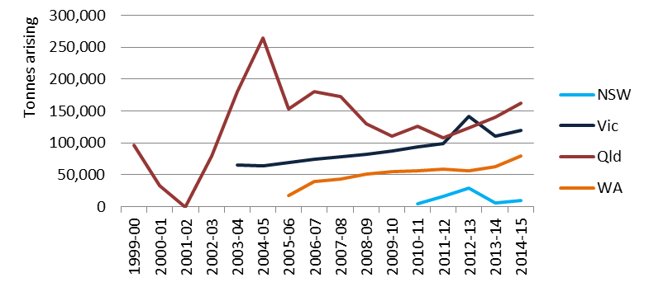

Trends of the last five years or so typically mirror population growth.

Management
Fate data for grease trap waste is only available for Vic, Qld and WA. In Vic recycling is listed as the primary fate, while in Qld recycling and chemical/ physical treatment are equal highest, with significant contribution also from biodegradation. WA also has recycling as the highest at 50% of all arisings, but the other major management type is storage at 36%.

Vic has a regulatory ‘classification for reuse’ in place (like used oil filters) which essentially requires grease trap not to be mixed with other similar wastes to ensure recycling and reuse outcomes, which are mandatory. Consequently, Vic’s major management fate is recycling, at 61%, followed by biodegradation (which in Vic’s case is composting) at 17% and chemical/ physical treatment at 16%. In the language of the statutory classification, which allows recycling, reuse or energy recovery, the first two management types could be grouped together under the recycling banner, bringing it to 78%. Even the latter 16% may describe where the more solid fractions of the waste stream go for “solidification” (in Vic regulatory language) to perhaps be further reused, which would push recycling up to 94%, the remainder made up of unclassified management and a small amount of storage.

It is likely that assignment of this waste to chemical/ physical treatment is an example of the lack of clarity defining the waste fates applied in tracking data. The Hazardous waste infrastructure needs and capacity assessment report defines chemical/ physical treatment as processes that ‘can include all chemical treatments (e.g. oxidation, reduction, precipitation, neutralisation, etc.) and physical treatments (e.g. sedimentation, filtration, adsorption, immobilisation, etc.).’ It is likely that chemical/ physical treatment in the context of grease trap involves separation and clarification techniques at the lower end of the physical treatment scale, and if its outputs are used for further value then it could arguably be defined as recycling.

Qld’s non-storage management types of recycling, chemical/ physical treatment and biodegradation all total 91%. Closer examination of certificates shows that a number of facilities appear in all management categories, which accords with the lack of clarity in fate/ management categories previously highlighted in HWiA 2015 and further investigated in the Standard. These may all be related forms of composting, of varying levels of sophistication and may be loosely defined as recycling.

Other K. Other putrescible/ organic wastes – new to HWiA 2017
Unlike HWiA 2015, this waste group aggregates together the non-grease trap K wastes:
- K100 Animal effluent and residues (abattoir effluent, poultry and fish processing wastes)
- K140 Tannery wastes (including leather dust, ash, sludges and flours)
- K190 Wool scouring wastes

This approach removes potential commercial confidentiality issues with tanneries and wool scourers, of which there are only a few individual operators in Australia. This protection is afforded because 90-100% of the waste arising in this group across the major jurisdictions was K100.

Sources
Table 34 provides a national summary of the main sources of waste.
Table 34: Other putrescible/ organic waste summary source analysis 2014-15
National summary
- Meat and meat product manufacturing
- Leather and leather product manufacturing
- Textile product manufacturing

Analysis
As described above this waste group is almost completely dominated by K100, comprising wastes from the meat and seafood processing industries, which are typically high in organic material content. It is significant by tonnage at 6% of all hazardous waste generated in Australia in 2014-15.

NSW and SA arisings are derived from national per capita average arisings, since their respective tracking systems do not track these wastes. Of the remaining jurisdictions, Vic, Qld and WA track K100 while K140 and K190 require supplementation by the same national averaging technique in some cases. Historical trends in arisings for this waste group are shown in Figure 34.

As has been the case throughout the data set, Other K wastes are dominated by Qld arisings and the dominant feature of the graph below is the growth in Qld from 2013-14 figures. Part of the most recent 12 months of growth may be attributable to the same erroneous units recording as described for J120, where some entries appear to be 1,000 fold too high, particularly when entered as m³. Using the indicative 50 tonne maximum truck capacity as a guide, this would account for approximately 30,000 tonnes of apparently spurious arisings in Qld, which would bring the 2014-15 arisings figure down to around 130,000 tonnes and would be reasonably in line with the 5-year pattern of steady growth.

Figure 34: Historical arisings of other putrescible/ organic wastes
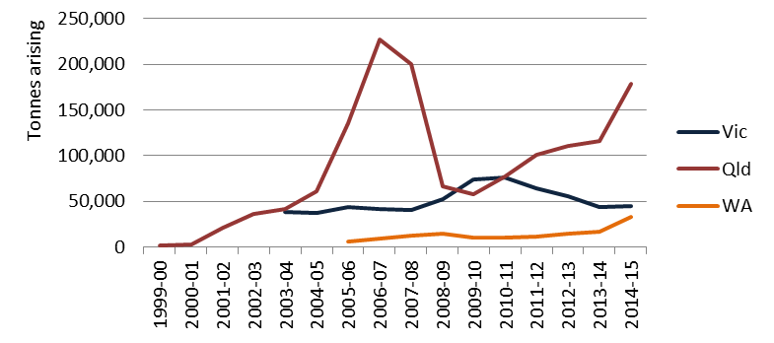

Management
Management of Other K wastes in Vic, Qld and WA is dominated by recycling and biodegradation as you would expect given the nutrient organic nature of the wastes, with composting the major activity.

M100. PCB wastes – new to HWiA 2017
This group comprises the single NEPM code M100 Waste substances and articles containing or contaminated with polychlorinated biphenyls, polychlorinated napthalenes, polychlorinated terphenyls and/or polybrominated biphenyls and has been separated out from the ‘Other M’ group for HWiA 2017 (compared to HWiA 2015) because of the hazard interest and specific regulatory management requirements for PCBs. It consists of any materials contaminated with PCBs and is dominated by waste oils.

PCBs were removed from service in the 1980s and 1990s, but there remained paraffin oil contaminated with commercial PCB mixtures. Polychlorinated terphenyls (PCTs) and polybrominated biphenyls (PBBs) are not known to have been used in Australia.

Sources
Table 35: PCB waste summary source analysis 2014-15
Qld | NSW | SA | Vic | National summary
- Electricity supply  - Waste Collection, Treatment and Disposal Services | - Electricity supply | Insufficient source information available  <0.5% of national total for waste group | No data available | - Electricity supply  - Waste Collection, Treatment and Disposal Services

PCB-containing wastes are typically used transformer oils from the electricity supply industry, or waste industry collection of same. Table 35 provides a summary of the main sources of waste in each jurisdiction.

Analysis
This waste was small nationally by tonnage in 2014-15, at 0.3% of all hazardous waste generated. The majority of this was generated in Qld (52%), followed by Vic (35%) and NSW (10%).

Historical trends in arisings for this waste group are shown in Figure 35.
Figure 35: Historical arisings of PCB waste
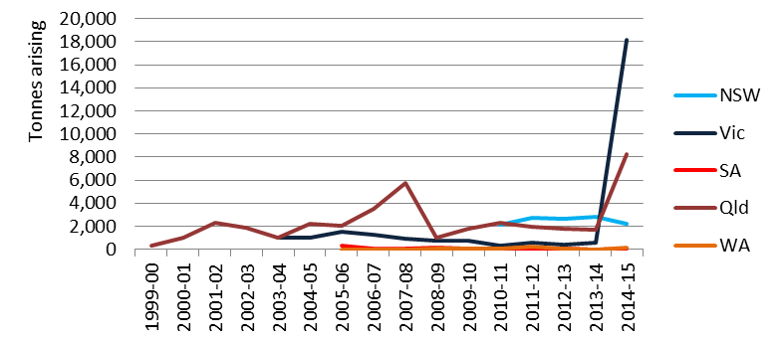

There are two notable trends in Figure 35: the massive Vic spike and similar Qld spike in 2014-15 arisings.

Investigation of Qld certificates shows that a single entry on 1 December 2014 has been recorded as 6,460m³, which is likely to be an error. Assuming this should read 6,460kg, arisings reduce to 1,792 tonnes which is similar to arisings reported over the last five years. Figure 36 illustrates what happens when this adjustment is made.

Further investigation of the Vic data spike indicates that there were a number of large contaminated site clean-ups in the analysis period that involved large amounts of soils contaminated with PCBs, which would have otherwise been expected to be coded to N120 contaminated soils. Since Vic certificate data is not available this has not been corrected graphically as per Qld in Figure 30 but, suffice to say, the Vic spike would be likely to drop accordingly if this correction was made.
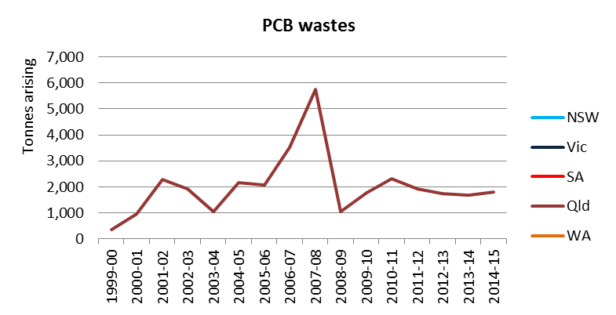
Figure 36: Historical arisings of PCB waste in Qld – Qld certificate anomaly removed

Management
PCBs in oils, at significant concentrations, are managed in Australia through separation and destruction technologies, the latter to destroy the chlorinated nature of the hazard. Both Vic and NSW closely control movements of these wastes through PCB-specific notification legislative instruments. However, management data does not appear to reflect this. Table 36 shows the major management categories recorded in tracking data for the fate of PCBs.

Table 36: M100 arisings by major management categories and jurisdiction, 2014-15 (percent)
Jurisdiction | Landfill (%) | Chemical/ physical treatment (%) | Storage (%)
NSW | 11 | 86 | 22
Qld | 86 | 7 | 1
Vic | 26 | - | 70
WA | - | 48 | 52

The lack of management by thermal treatment recorded throughout the tracking jurisdictions is puzzling, given that such facilities exist, at least in Qld and Vic. The high landfill figure in Qld is of particular concern, although it is noted that tracking data does not reveal the degree of PCB contamination in the waste, nor the type of material the waste is. For example, similar to the observation regarding Vic’s high PCB waste generation in 2014-15, is possible that much of Qld’s waste could be (relatively low) PCB-contaminated soils (which would be better classified as N120) a much different proposition to transformer oils contaminated with significant levels of PCBs.

NSW’s chemical/ physical treatment code probably describes a specific PCB-removal technology used in that state for separating PCBs from such transformer oils. Given the appropriateness and specificity of this type of treatment for PCBs, this may be an example of the limitations of NSW’s relatively simplistic system of only six management types (plus ‘other’ which makes seven), when used alone in data interpretation.

M160. Other organic halogen compounds – new to HWiA 2017
M160 Organic halogen compounds—other than substances referred to in this Table or Table 2, is waste that contains some form of organohalogen compound not elsewhere mentioned on the NEPM list.

The common property of this waste type is that it contains organic chemicals that contain halogen elements (usually fluorine, chlorine, bromine) as significant components in their structure. This waste type shares commonality with other waste types such as chlorophenols (M150), halogenated solvents (G150), dioxins and furans (M170 and M180), PCB-like compounds (M100) and organochlorine pesticides (within H100).

The presence of the halogen species is usually the reason for the property of interest – and the reason for the toxicity. Examples of organohalogen active ingredients are the Stockholm Convention listed pollutants; the brominated flame retardants (BFR) polybrominated diphenyl ethers (PBDEs) and hexabromocyclododecane (HBCD), and PFOS and related chemicals (while not part of this category, many of the organochlorine pesticides are also listed on the convention). PFOS is likely to appear with other PFASs (per- and polyfluoroalkyl substances), such as PFOA (Perfluorooctanoic acid), which is under review for potential listing on the Convention – all of which would be described by the M160 category.

Banned since 2004, PBDEs have been historically added at percentage levels to ABS plastics in a range of products including electrical and electronic equipment, furniture upholstery, automobile interiors, mattresses and carpet underlay. HBCD has been added to extruded and expanded polystyrene foams used in building insulation and PFOS, a fluorinated surfactant, has been primarily as a dispersant in firefighting foams, but has also been used (along with PFOA) in multiple product settings, such as treated textiles, carpets and paper, all of which would have already entered the landfill stream.

These substances are not currently regarded as hazardous wastes in Australia when present in end of life products, such as waste electronic equipment. This is because Australia is still undertaking its assessment processes to determine whether to ratify these new additions to the Stockholm Convention.
Another waste that could be described by this category is HCB, a substantial and intractable stored quantity of which has been under close management by Orica at its Port Botany site for the last couple of decades.

Sources
Table 37 provides a summary of the main sources of waste in each jurisdiction.
Table 37: Other organic halogen compound wastes summary source analysis 2014-15
Qld | NSW | SA | Vic 2012-13 | National summary
- Various – small no. of certificates | - Air conditioning degassing | <0.5% of national total for waste group | No data available | - Air conditioning degassing

This waste comes from a small set of individual waste movements. The only identifiable source sector is the degassing of air conditioning systems, exclusive to NSW data, where hydrochlorofluorocarbons (HCFCs) such as R22 are used in air-conditioning.

Analysis, including management
This waste was very small nationally by tonnage in 2014-15, at 0.001% of all hazardous waste generated. This is expected given that much of the potential wastes that may fall into this category are not yet known or recognised as hazardous, given that Australia has not yet ratified the newer additional chemicals to the Stockholm Convention.

The majority of this was generated in Vic (75%). Historical trends in arisings for this waste group are shown in Figure 37 (overleaf).

The notable spike in the Qld data in Figure 37 is actually a NSW data issue. A series of waste loads were sent from a site in NSW in May 2014 to a storage facility in Qld. Further investigation reveals that the site was identified as a contaminated site in 2012, due to the land’s previous use by a turf research organisation in testing the effectiveness of herbicides and pesticides. This means that these certificates are in error, as they would be better classified as contaminated soils, N120.

Reassigning these certificate quantities to contaminated soils code N120 results in the corrected trend graph shown in Figure 38 (overleaf).

Figure 37: Historical arisings of other organic halogen compound wastes
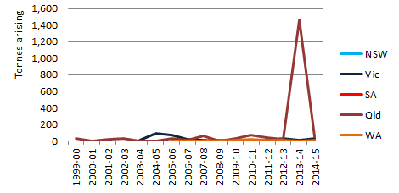
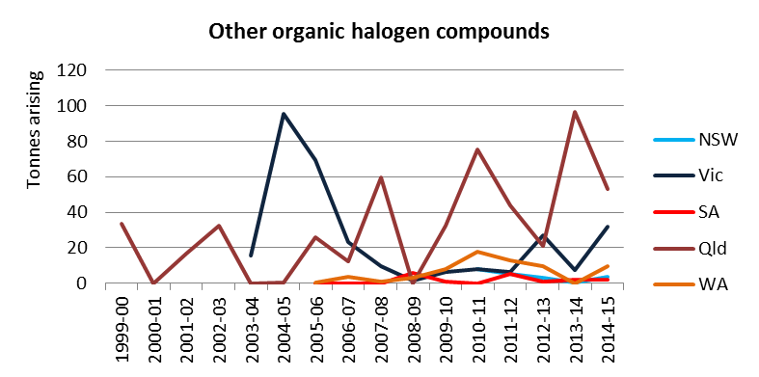
Figure 38: Historical arisings of other organic halogen compound wastes – corrected

The zoomed effect of removing the outlier shows the dataset to be variable and small in quantity.

Other M. Other organic chemicals
This waste group includes the broad catch-all of:
- M150 phenols, phenol compounds including chlorophenols
- M170 & M180 polychlorinated dibenzo-furan and polychlorinated dibenzo-p-dioxin, respectively
- M210 cyanides (organic)
- M220 isocyanate compounds
- M230 triethylamine catalysts for setting foundry sands
- M250 surface active agents (surfactants) containing principally organic constituents
- M260 highly odorous organic chemicals (including mercaptans and acrylates).

Sources
Table 38: Other organic chemical wastes summary source analysis 2014-15
Qld | NSW | SA | Vic 2012-13 | National summary
- Iron and steel manufacturing  - Various other manufacturing | - Soap and detergent manufacturing  - Airline industry  - Chemical manufacturing | No data available | - Airline industry  - Chemical manufacturing  - Oil and gas extraction  - Various other manufacturing | - Soap and detergent manufacturing  - Airline industry  - Iron and steel manufacturing  - Chemical manufacturing

The majority of this was generated in NSW (65%), followed by SA (16%) and Qld (11%). Soap and detergent manufacturing, the airline industry and iron and steel manufacturing were the main sources, and the waste was almost exclusively M250 surface active agents (surfactants) containing principally organic constituents, in Qld and NSW. Table 38 provides a summary of the main sources of waste in each jurisdiction.

SA contributes almost all of the triethylamine catalyst waste (M230), but the industry source is not clear.

Analysis
This waste was small nationally by tonnage in 2014-15, at 0.3% of all hazardous waste generated. Historical trends in arisings for this waste group are shown in Figure 39.
Figure 39: Historical arisings of other organic chemicals waste
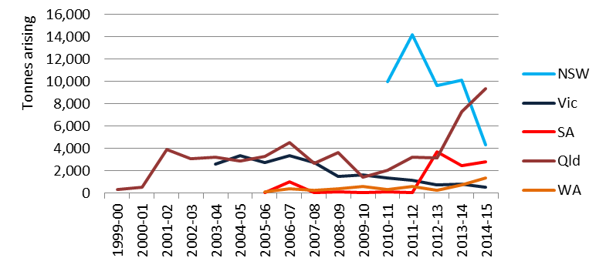

Vic’s long-term trend appears to be slow decline, while NSW has had more rapid decline. There is no data-related explanation for these features. Qld shows a rapid rise over the last two years but there were no obvious data errors so the reasons are unclear.

Management
Management for the waste group is reported as primarily chemical/ physical treatment (96%) in NSW and recycling (65%) in Qld.

N120. Contaminated soils
This group comprises N120 Soils contaminated with a controlled waste. NSW and Qld do not specifically track contaminated soils, but both were able to report data from landfill records. Qld is unique in Australia in including acid sulphate soils in this category, although it makes up little of their volume.

Sources
Table 39 provides a summary of the main sources of waste in each jurisdiction.
Table 39: Contaminated soil wastes summary source analysis 2014-15
Qld | NSW | SA | Vic 2012-13 | National summary
- Construction  - Property development  - Retail trade  - Electricity supply  - Mining | - Construction  - Property development  - Retail trade  - Electricity supply  - Mining | - Construction  - Cement and lime manufacturing | - Construction  - Property development  - Retail trade  - Electricity supply  - Mining | - Construction  - Property development  - Retail trade  - Electricity supply  - Mining

Analysis
Contaminated soils are the largest hazardous waste in national data, making up 26% of the tonnages in 2014-15. NSW is the highest contributor of arisings at 31%, followed by Qld at 29%, Vic at 24% and SA at 14%. WA is comparatively low at only 0.8%. Historical trends in arisings for this waste group are shown in Figure 40.
Figure 40: Historical arisings of contaminated soils
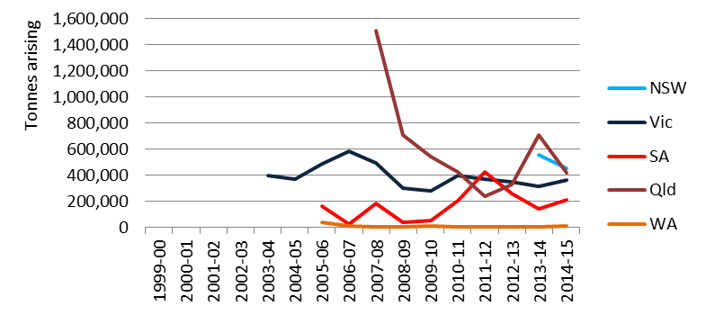

Contaminated soils are a result of construction and development (including demolition) activities that require the excavation of contaminated material. The level of contamination is almost wholly an historical legacy issue, whereas the quantity produced in any given year fluctuates with the level of development activity in contaminant-prone geographical areas.

With the exception of asbestos, the drivers for contaminated soil arisings differ from virtually all other hazardous waste categories. Other wastes are more directly related to consumption patterns, and therefore reflect current rather than historical activity. Contaminated soil quantities are large and can vary widely from year to year. Caution needs to be exercised in interpreting the data to avoid misleading messages about trends and broader waste producer behaviours.

Trend data analysis, in light of these influences, is difficult to decipher. Vic and SA have reliable medium-term data sets; the former remaining relatively consistent over the last decade while SA has fluctuated more. The remaining jurisdictions have no tracking system or do not track this material per se.

The large Qld arisings in 2007-08 and to a lesser extent 2008-09 could be influenced by very large development projects or clean-up exercises. Whatever the reason, 2007-08 is an example of the wild variations that contaminated soils can throw up, since 1.5 million tonnes is of similar magnitude to the entire soils national dataset in 2014-15.

SA has experienced rises and falls typical of the fluctuating influences mentioned above. The 2011-12 tonnage for example (and perhaps the years either side of it) is probably heavily influenced by two major projects in Adelaide – the redevelopment of Adelaide Oval and, more significantly, the new Royal Adelaide Hospital construction on railyards at the west end of Adelaide.

WA’s low arising in 2014-15 (11,820 tonnes) can be attributed to the fact that only highly contaminated soils that do not meet the contaminant thresholds for acceptance at Class I (inert), Class II (putrescible) or Class III (putrescible) landfills is considered controlled waste and tracked. Contaminated soil suitable for Class I, II or III landfill is not tracked or included in the data provided for Basel reporting.

Management
Landfill is the dominant fate recorded for contaminated soil throughout Australia, at 93%. While the dominance of landfill is not surprising, it would appear that soil remediation facilities do not feature significantly in the data. There are probably two reasons for this:
- Some remediation technologies are mobile enough to be installed onsite. This means that most of the post-treatment material can be re-emplaced resulting in minimal soil hitting the tracking system.
- Contaminated soil is made up of a wide variety of contamination levels. Vic is the only state that distinguishes the soil’s level of contamination in tracking data, through the use of a 3-tier hazard classification system. Long-term Vic data shows that the high and medium level contaminated soil – which is the component of the waste group that would require remediation/ treatment - is typically only 8% of all soils by weight. The massive volume of low level contaminated soil, which goes to landfill, therefore obscures the quantities with remediation fates; fates that under the current clumsy jurisdictional fate categories could be either biodegradation, chemical/ physical treatment or even recycling.
Brief analysis of Vic management data for contaminated soils shows R3 Recycling/reclamation of organic substances which are not used as solvents and D9A/D9B/D9C (all treatment codes) are used extensively, and have probably been intended to describe soil remediation or treatment. Summing these together gives a figure for contaminated soils treated at specific remediation facilities of about 26,000 tonnes which, at over 7% of annual Vic soils managed, agrees well with the high-medium contamination level soils estimate of 8% above. Oddly, Vic has a code specifically for treatment of contaminated soils, R15, but it is barely used.

N205a. Biosolids
Biosolids are only currently considered hazardous waste in annual data reported to Basel, as a precautionary approach, and coded to N205. Consequently, there is a split in this code:
- N205a: Biosolids
- N205b: Other industrial treatment residues.

This NEPM group considers N205a biosolids in totals that are produced in Australia. A detailed discussion from a hazard classification perspective is provided in Section 5.3.

Sources
Wastewater treatment plants around Australia are the sole source of biosolids.

Biosolids generation is not collated from tracking systems but provided from a biennial survey of wastewater treatment plants conducted by the Australian and New Zealand Biosolids Partnership (ANZBP). This survey data pertains to the 2015 calendar year but has been used as reflective of 2014-15.

Analysis, including management
Biosolids are the equal largest hazardous waste along with contaminated soils in national data, making up 21% of the tonnages in 2014-15, when biosolids are included in the total. Arisings follow population, with Vic the highest contributor at 29%, followed by NSW at 23% and Qld at 20%.

Historical trends in arisings for this waste group are not available as they are not taken from tracking records. However, when adjusted for an assumed national average solids content of 21% for ‘dewatered’ biosolids (their equilibrium state of water retention), national figures can be estimated in line with how other water-containing wastes are reported. Total figures from the last three ANZBP national surveys, adjusted to a ‘dewatered’ (not dry) basis, are shown in Table 40.
Table 40: Dewatered’ biosolids produced in Australia over the last 3 survey collection periods
Time-series (survey reporting year) | 2010 | 2013 | 2015
Total biosolids (t) | 1,350,246 | 1,409,565 | 1,476,190
Source: Australia and New Zealand Biosolids Partnership (2015)

Management categories collected in detail by the ANZBP survey are provided in Table 41.
Table 41: N205a arisings going to biosolids-specific management categories, 2014-15 (percent)
Management options | ACT | NSW | NT | Qld | SA | Tas | Vic | WA | National
Stockpile | 2% | 2% | 14% | - | - | 1% | 24% | 14% | 9%
Agriculture | 69% | 69% | 63% | 98% | 100% | 93% | 22% | 63% | 65%
Land rehabilitation | 4% | 4% | - | - | - | - | 49% | - | 15%
Landfill | 2% | 2% | 9% | 2% | - | 1% | - | 9% | 2%
Landscaping (compost) | 20% | 20% | 14% | - | - | - | 2% | 14% | 7%
Ocean discharge | 3% | 3% | - | - | - | - | - | - | 1%
Other | 0% | 0% | - | - | - | 5% | 3% | - | 1%
Table 41 indicates that the majority (65%) of biosolids are managed through application to agricultural land in Australia, with 80% directly applied to land (when land rehabilitation is also included).

N205b. Other industrial treatment residues
This category covers the single NEPM code N205 Residues from industrial waste treatment/disposal operations. For this project, we rebadge this material as N205b. Other industrial treatment residues to distinguish it from biosolids, which are not typically reported in jurisdictional tracking systems, and which we characterise as N205a. Therefore, this NEPM group considers N205b, industrial treatment residues, not including biosolids.

Sources
Table 42 provides a summary of the main sources of waste in each jurisdiction.
Table 42: Other industrial treatment residues waste summary source analysis 2014-15
Qld | NSW | SA | Vic 2012-13 | National summary
- Oil & gas extraction (CSG/ LNG)  - Waste treatment and disposal services  - Electricity supply  - Wastewater treatment plants  - Other manufacturing  - Petroleum refining | - Electricity supply | Insufficient source information available | - Waste treatment and disposal services  - Organic chemical manufacturing  - Other manufacturing | - Oil & gas extraction (CSG/ LNG)  - Waste treatment and disposal services  - Electricity supply  - Wastewater treatment plants  - Other manufacturing  - Petroleum refining

Analysis, including management
This waste was significant nationally by tonnage in 2014-15, at 4% of all hazardous waste generated. Qld is by far the largest contributor to national generation with 66% of industrial treatment residues in 2014-15, followed by SA with 24%.

Historical trends in arisings for this waste group are shown in Figure 41.
Figure 41: Historical arisings of other industrial treatment residues
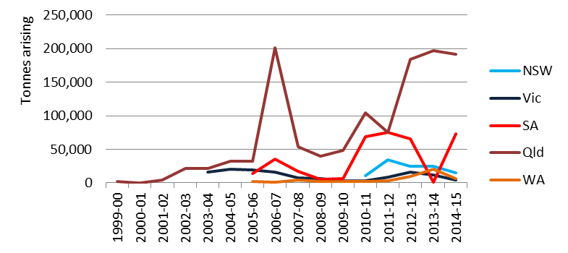
Qld historical data throws up an anomaly. HWiA 2015 showed a consistent trend line to Figure 41 for most years except 2006-07, where the current dataset shows a large spike above 200,000 tonnes. Figure 42 shows data reported in HWiA 2015 for comparison. It is not clear why this data has changed but the sharp spiking nature of the HWiA 2017 reported 2006-07 data point suggests it may not be reliable.
Figure 42: Historical arisings of Qld other industrial treatment residues reported in HWiA 2015
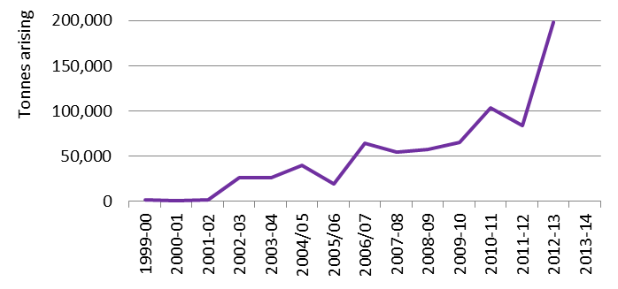

N205b is catch-all in nature, and seems to include a variety of industrial residues. National management fate data, or even just Qld’s for that matter, are spread between management categories, with recycling and storage the largest. However, several quite different wastes are tracked under the N205 banner, so grouping them together to assess management outcomes is pointless. Focusing on each type of waste within the category is more useful, as described below.

Qld’s generation N205b can be summarised as:
- 38% from the waste industry, made up of:
- mostly solids going to landfill
- liquids going to composting
- liquids and sludges, which are probably septic pump-outs, going to sewage treatment plants
- 25% from the CSG industry, made up of:
- mostly liquids going to composting
- solids and sludges going to composting
- 16% from power generation (solid waste) going to be ‘blended’ at composting operations
- 12% from Council facility liquid wastes (probably sewage sludge) going to composting
- the rest: various industrial sources.

It would appear that the 12% from Qld Councils is undried sewage sludge/ wastewater, which creates a small double-counting issue considering that biosolids, the processed version of sewage sludge, is separated out of this dataset (as N205a).

The 16% from power generation is from Qld’s biomass power generation industry, where ash (probably fly-ash but also possibly bottom ash) is sent to composters for blending, presumably to enhance fertiliser value through increasing key minerals.

Probably of most interest in this category though is the fact that such a large proportion comes from the Qld CSG industry, in addition to significant wastes reported elsewhere in the document (C100 alkalis, D300 non-toxic salts and D220 mercury wastes). The liquid wastes are likely to be so-called ‘drilling muds’, or ‘drilling fluids’, which are used to aid the drilling of CSG wells. The data is notable in that almost 30% of all Qld N205b waste is stored, which is a characteristic of CSG waste recorded in other categories, because of the large volumes generated and difficulties with its management. Of most concern though is that liquid CSG wastes, presumably high in salts, are being sent to composting facilities for dewatering and mixing with organic substrates to create compost products.

N220. Asbestos containing material
This waste group captures the single NEPM code of N220 Asbestos, including products that contain asbestos and wastes contaminated with them. Asbestos is the name given to a group of naturally occurring minerals found in rock formations. Inhalation of asbestos fibres can cause respiratory problems that can be fatal. Asbestos-containing building products are classified as either ‘friable’ (soft, crumbly) or ‘bonded’ (solid, rigid, non-friable). Friable asbestos products may be as much as 100% asbestos fibres and can become airborne and inhalable very easily. Bonded products such as asbestos cement sheet (otherwise known as ‘fibro’) contain approximately 15% asbestos fibres, bonded with cement and do not normally release fibres into the air when in good condition.

Houses built before the mid-1980s are highly likely to have asbestos- containing products, between mid-1980s and 1990 likely, and after 1990 unlikely.

Asbestos is one of the largest flows of hazardous waste in Australia and poses significant health risks. Asbestos waste includes both end-of-life asbestos-containing building materials as well as soil that has been tested to demonstrate asbestos contamination. Since the latter may involve very low asbestos fibre concentrations and very high soil volumes, this greatly contributes to reported asbestos waste volumes.

Sources
Table 43 provides a national summary of the main sources of waste.
Table 43: Asbestos containing material waste summary source analysis 2014-15
National summary
- Construction and demolition (including asbestos removal services)
- Property development
- Hospitals
- Schools
- Defence
- Numerous sectors involved in asbestos removal from their buildings

Jurisdictional tracking systems do not currently differentiate between asbestos-containing building materials and asbestos-contaminated soils. Sources of asbestos are construction/ demolition related as well as any residential, commercial or industrial buildings that are involved in removal of asbestos containing material.

Analysis
Asbestos is a large contributor to national hazardous waste volumes, making up 18% of generation tonnages in Australia in 2014-15. Asbestos is only tracked in Vic, Qld and SA, but NSW supplied landfill acceptance data as an alternative data source in 2014-15. Asbestos estimates for WA, NT and Tas were done on a per-capita basis by the project team, assuming that generation correlates with population. The ACT provided defensible asbestos tonnages from interstate tracking certificates for the first time in the five years of increased rigour in collecting hazardous waste data.

Qld reports the highest arisings of asbestos with 50% of national volumes, followed by NSW with 18% and Vic and WA both with 8%. Historical trends in arisings for this waste group are shown in Figure 43.

Figure 43: Historical arisings of asbestos containing material
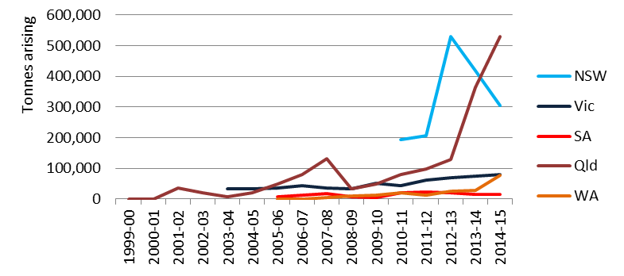

Qld and NSW show rapid rises in asbestos arisings in recent years and, in the case of NSW, rapid falls as well. Since NSW data has been supplied separately from landfill acceptance data there is no ‘meta-data’ accompanying the annual numbers to make further comment.

Qld, on the other hand, provided a detailed certificate-by-certificate dataset, which enables closer inspection. Detailed review of 2014-15 Qld data shows a large number of certificate entries with m³ unit errors that result in a degree of over-estimation of arisings unprecedented in tonnage terms in the national data set. Seventy-six percent of all tonnes reported in 2014 alone were recorded as greater than 50m³ each – which is not physically possible for a truck to carry – and amounts to an over-estimation of asbestos containing material in the order of 400,000 tonnes for the 2014-15 period. This would bring 2014-15 arisings down from 529,944 tonnes to around 130,000 tonnes, which is similar to the 2012-13 figure.

This quantum of error is likely to be applicable for 2013-14 data as well, since it has been submitted under the same QA protocols of 2014-15.

WA trend data suggests a rise in asbestos generation in 2014-15. This reflects the change in calculation method adopted in 2014-15. Landfill data was supplied in previous years but not in 2014-15, hence the use of the project team’s ‘gap-filling’ method of taking Australian average per-capita generation of asbestos and multiplying by WA population.

Management
97% of asbestos waste is disposed of at landfills licensed by environmental regulators to receive asbestos waste. The remainder is stored.

Other N. Other soils/ sludges
This waste group collects those remaining N group codes including:
- N100 containers & drums contaminated with residues of substances referred to in the NEPM 15 list
- N140 fire debris and fire wash waters
- N150 fly ash, excluding fly ash generated from Australian coal fired power stations
- N160 encapsulated, chemically-fixed, solidified or polymerised wastes in the NEPM 15 list
- N190 filter cake contaminated with residues of substances referred to in the NEPM 15 list
- N230 ceramic-based fibres with physico-chemical characteristics similar to those of asbestos.

Sources
Table 44 provides a summary of the main sources of waste in each jurisdiction.
Table 44: Other industrial treatment residues waste summary source analysis 2014-15
Qld | NSW | SA | Vic 2012-13 | National summary
- Waste industry  - Chemical product manufacturing  - Metals manufacturing  - Petroleum refining  - Paper & paper product manufacturing  - Hospitals & nursing  - Meat industry  - Water supply & sewerage | - Waste industry  - Chemical product manufacturing  - Metals manufacturing  - Petroleum refining  - Paper & paper product manufacturing  - Hospitals & nursing  - Meat industry  - Water supply & sewerage | - Waste industry  - Motor vehicle manufacturing | - Waste industry  - Chemical product manufacturing  - Paper & paper product manufacturing  - Machinery and equipment manufacturing | - Waste industry  - Chemical product manufacturing  - Metals manufacturing  - Petroleum refining  - Paper & paper product manufacturing  - Hospitals & nursing  - Meat industry  - Water supply & sewerage

N160 Encapsulated waste is waste that has been treated to reduce its hazard by various chemical/ physical treatment facilities in the waste industry. Chemical product and related manufacturing and petroleum refining contribute to drums arisings (N100) and N190 filter cake is a waste from a variety of industrial processes, including chemical product manufacturing, metals manufacturing, paper and paper product manufacturing and machinery and equipment manufacturing.

N150 fly ash in contributed from various forms of thermal processing, including from incineration, alumina refining, meat processing, cement kilns, coal-fired power stations (despite the waste classification name), non-coal power stations, asphalt plants, iron and steel manufacturing and petroleum refining.

Analysis
On a national basis, N160 encapsulated waste is the primary contributor of arisings, followed by N100 containers and drums, then N190 filter cake, with the remainder in much lower proportions. The whole group makes a moderate contribution to national figures at 2% combined. Historical trends in arisings for this waste group are shown in Figure 44.

Figure 44: Historical arisings of other soil/ sludges waste
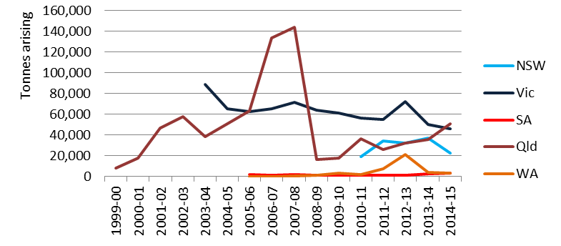

N150 fly ash (excluding fly ash from electricity generation) is identified through tracking data as having been produced quite consistently at a rate of 5,000 – 7,000 tonnes per year nationally over the last few years, with almost all of that reported in Qld, although it is noted that in 2014 some of this was fly ash exported from Vic to Qld landfill. However, Qld tracking data shows a significant increase in 2014-15. Close inspection of certificate data traces two errors responsible for this:
- One certificate has been incorrectly entered by the user as 1,000m³ instead of the more likely 1,000 kg.
- Another certificate has been correctly entered as 10,000kg by the user but transcribed incorrectly as 10,000 m³ in the compilation provided to the project team. This latter mistake makes up most of the apparent increase in national arisings for this code.

It is notable that outside of Qld, fly ash is not reported above 500 tonnes per jurisdiction and NSW reports zero arisings of this waste.

Similar to N205b, Qld historical ‘Other N’ data throws up an anomaly. HWiA 2015 showed a trend line which is inconsistent with Figure 44 for most years, particularly 2006-07 and 2007-08, where the current dataset shows arisings approximately 80,000 tonnes greater. Figure 45 shows this HWiA 2015 data for comparison. It is not clear why this data has changed.

Figure 45: Historical arisings of Qld other soil/sludges reported in HWiA 2015
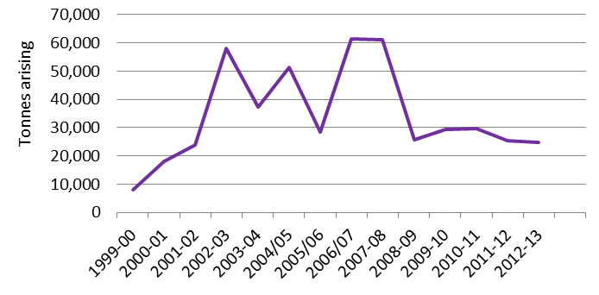

Management
The dominant management in 2014-15 tracking data for this whole waste group is landfill (55%), which, for N160 waste, logically follows on as the fate subsequent to treatment to ameliorate hazard. Storage follows at 23% then recycling at 13% and chemical/ physical treatment at 7%.

A curious footnote to the data is the fact that 32% of Qld fly ash goes to either R3 or R11 recycling, in what looks like composting facilities. Ten percent of this is from (presumably thermal processes at) meat processing facilities and 7% from coffee roasting, neither of which would envisaged as sources of what is typically described as fly ash. The other 15% that goes to composting raises more questions – it is from a major hospital.

R. Clinical and pharmaceutical waste
This waste group is made up of:
- R100 Clinical and related wastes
- R120 Waste pharmaceuticals, drugs and medicines
- R140 Waste from the production and preparation of pharmaceutical products.

Clinical and related wastes are wastes arising from medical, nursing, dental, veterinary, laboratory, pharmaceutical, podiatry, tattooing, body piercing, brothels, emergency services, blood banks, mortuary practices and other similar practices, and wastes generated in healthcare facilities or other facilities during the investigation or treatment of patients or research projects, which have the potential to cause disease, injury, or public offence, and includes: sharps and non-sharps clinical waste.

Other wastes are also generated within health care settings. Waste pharmaceuticals, drugs and medicines are waste pharmaceutical products that have: passed their recommended shelf life; been discarded as off-specification batches; been returned by patients or been discarded. These wastes are often generated directly from pharmacies, hospitals, medical centres and hospital dispensaries.

A particularly notable pharmaceutical waste is waste cytotoxic drugs, or waste (including sharps) contaminated by cytotoxic drugs. A cytotoxic drug has carcinogenic (cancer-causing), mutagenic (increase mutations of genetic material) or teratogenic (birth defect) potential, and is commonly used in the treatment of cancer.
Lastly, waste from the production and preparation of pharmaceutical products is similar to R120, the key difference is the setting that it is generated – at the pharmaceutical product manufacturing stage rather than the point in the lifecycle where the product is sold, administered or used (pharmacy or health care facility). Another difference is that as a manufacturing waste, there will be process wastes that may be raw materials-based rather than wastes of final manufactured products.

Sources
Table 45 provides a national summary of the main sources of waste.
Table 45: Clinical and pharmaceutical waste summary source analysis 2014-15
National summary
- Hospitals, health care centres and clinics
- Nursing homes and aged care facilities
- Dentists
- Pharmacies

NSW does not track any of the R group wastes. National data includes estimates of NSW arisings derived from per capita comparison with other jurisdictional arisings.

The R Clinical and pharmaceutical waste group made up 1.5% of Australia’s hazardous waste in 2014-15, with R100 clinical and related waste making up almost all of it. Historical trends in arisings for this waste group are shown in Figure 46 overleaf.

There is a general slowly increasing trend evident for most jurisdictions over the last five years, presumably as hospital bed days grow. Historical arisings for both Vic and WA are lower than their respective populations would indicate. For Vic this may have been achieved through the results of better hospital waste management planning and waste segregation in the last decade or so – one of the drivers may have been the increasing hazardous waste levy and the high costs of incineration, which is required in Vic for some clinical waste streams, such as cytotoxics, human tissue and body parts and pharmaceutical waste.

WA tonnages are particularly low in comparison to SA, for example. Since both states provide limited detail in their data the reason for this is unknown.

Analysis
SA’s arisings appear to have dropped around 2012-13, after consistent but slow growth since the mid-2000s. There is insufficient information in the data supplied to explain this trend. Qld is the most prominent trend, showing a more than three-fold increase in arisings from 2013-14 to 2014-15.

Unfortunately this is another data quality error. Inspection of certificate data shows that 98% of all data recorded in m³ for the Qld 2014-15 dataset should probably have been reported as kg, taking the reported arisings figure down from around 67,000 tonnes to just 23,649 tonnes, which around the level of arisings seen consistently since 2011-12.

Figure 46: Historical arisings of clinical and pharmaceutical wastes
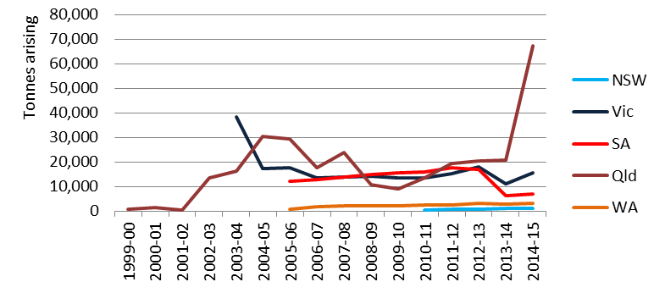

Management
For this type of waste the following management techniques are routinely carried out in Australia:
- Incineration
- Autoclaving and shredding
- Chemical disinfection and shredding.

Management data gathered for 2014-15 is mixed. Qld’s highest management type is storage at 36% followed by landfill at 19%, the former undesirable (due to the potential for multiplication of pathogens, particularly in the Qld heat) and the latter inappropriate without at least some form of treatment of the infectious hazard. However, given the lack of integrity in arisings data, this may not be representative of what actually occurs in Qld, and may be related to data quality (potential incorrect choice of management type by the certificate user). If storage is indeed happening, it is likely to be refrigerated. Landfill appears to be dominated by a clinical waste treatment company, which indicates that it is probably re-arisen clinical waste after treatment, such as by autoclave and shredding, in which case landfill is a safe and acceptable management.

Vic’s R waste is predominately managed through chemical/ physical treatment (46%) with thermal destruction recorded next (31%). It is unclear whether autoclaving and shredding would be reported as thermal treatment or CPT, since it is primarily the former but a mixture of both.

Sixty-six percent of WA’s R waste undergoes thermal destruction.

T140. Tyres
This group is the sole NEPM category T140 Tyres. Tyres or ‘waste tyres’ are used, discarded or rejected tyres that have reached the end of their useful life, i.e., when they can no longer be used for their original purpose, and are subsequently removed from a vehicle.

Tyres are tracked in Qld and WA only, and the recorded arisings indicate that they are significantly under-reported in tracking data, when compared with credible recent estimates of arisings produced by Hyder Consulting (2015). Consequently, in reporting to Basel and the 2014-15 dataset for this report, data from the Hyder report was used to estimate arisings.

Sources
Only Qld provided source data for tyres. This data indicates the bulk of the waste are produced from tyre and motor vehicle retailing and motor vehicle servicing industries.

Analysis
Using Hyder Consulting data, tyres are a large national waste, making up 7% of national hazardous waste generation. The bulk of jurisdictions do not track tyres, but the Controlled Waste NEPM does include them, and NSW and Vic have taken significant steps over the last 2-3 years to more closely regulate them, due to the prevalence of tyre stockpiles and the risks, particularly from uncontrollable fires, associated with these storages.

Management
Only Qld and WA track tyres and the reported quantities are significantly lower than the Hyder figures used in national data compilation. This data shows that 48% of tyres are recycled, 27% landfilled and 20% stored. Tyres have gained the more recent attention of regulators due to the number of illegal stockpiles, which undoubtedly grew through arisings that occurred outside the regulatory system. That being the case, it is likely that the recycling percentage quoted is a gross overestimate. Vic data confirms this, quoting a rate of tyre recycling in Australia around 20%, with another 26% exported and 54% unaccounted for and presumed to be either stockpiled or illegally dumped.

Other T. Other miscellaneous
This waste group includes:
- T100 waste chemicals from research and development or teaching activities
- T120 waste from the production & use of photographic chemicals and processing materials
- T200 waste of an explosive nature not subject to other legislation.

This waste group is a collection of relatively unrelated wastes that are produced in small quantities and are made up of mostly T100, with smaller quantities of T200 and T120.

Sources
Table 46 provides a summary of the main sources of waste in each jurisdiction.

T100 waste is, as the name suggests, contributed by laboratories of teaching or research institutions, but is often a result of numerous mixed load small pick-ups by waste transporters, and recorded in tracking systems as coming from the waste sector. T120 is a specialty waste from the printing industry, but also includes x-ray photography activities such as dentists and other health practitioners, that would fit into the ‘public administration’ heading above. T200 is produced by the mining industry from the use of mine explosives, but also from manufacturers and suppliers of these explosives.
Table 46: Other miscellaneous waste summary source analysis 2014-15
Qld | NSW | SA | Vic 2012-13 | National summary
- Waste sector  - Public administration & other education  - Mining  - Explosives manufacturing  - Printing  - Water supply, sewerage & drainage services | - Waste sector  - Public administration & other education  - Mining  - Explosives manufacturing  - Printing  - Water supply, sewerage & drainage services | - Variety of very small source industries | - Waste sector  - Printing  - Public administration & other education | - Waste sector  - Public administration & other education  - Mining  - Explosives manufacturing  - Printing  - Water supply, sewerage & drainage services

Analysis
Other T miscellaneous wastes made up just 0.07% of all hazardous waste generation nationally in 2014-15. Historical trends in arisings for this waste group are shown in Figure 47.

Figure 47: Historical arisings other miscellaneous waste
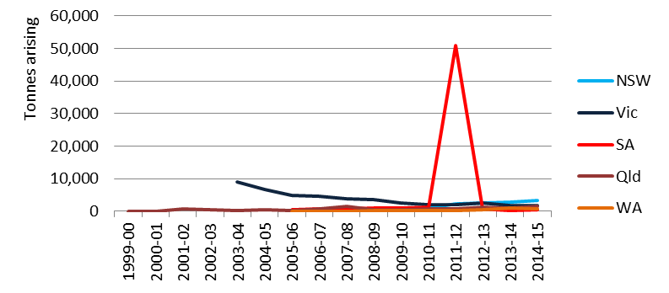

The most striking trend is the massive spike in SA data in 2011-12, which is due to T100 Waste chemical substances arising from research and development or teaching activities including those which are not identified and/or are new and whose effects on human health and/or the environment are not known. This could be a storage release but, given how large and conspicuous it is, it is very likely that it is a units error (recorded as m³ instead of kg), although the lack of transparency in certificate level detail does not allow confirmation of this suspicion. However, 2014-15 data shows only 73 individual certificate movements occurred, and the largest of these was two tonnes. This suggest that an error is the likely explanation.

Management
Storage is the largest management type nationally for this group, at 55% of all arisings. Since the total national storage in 2014-15 is only 4,000 tonnes, for the SA figure to be a storage release would require it to be equivalent to over 12-times all of the waste generated per year across the whole country. This is further evidence of a mistake in the data.

References
Ash Development Association of Australia (2015) Annual membership survey results 2014, HBM Group Pty Ltd, Wollongong, available from: www.adaa.asn.au/resource-utilisation/ccp-utilisation
Ash Development Association of Australia (2016) Annual membership survey results 2015, HBM Group Pty Ltd, Wollongong, available from: http://www.adaa.asn.au/uploads/default/files/adaa_mship_report_20162.pdf
Australian and New Zealand Environment and Conservation Council and the Agriculture and Resource Management Council of Australia and New Zealand. (2016), Australian and New Zealand Guidelines for Fresh and Marine Water Quality, available from: http://www.agriculture.gov.au/water/quality/guidelines
Australian Government Department of the Environment and Energy, DoEE (2017a), Coal and coal seam gas – Resources (website). Available from: http://www.environment.gov.au/water/coal-and-coal-seam-gas/resources
Australian Government Department of the Environment and Energy, DoEE (2017b),
Australian Government Department of the Environment and Energy, DoEE (2016), Commonwealth Environmental Management Guidance on Perfluorooctane Sulfonic Acid (PFOS) and Perfluorooctanoic Acid (PFOA) draft, available from: https://www.environment.gov.au/system/files/pages/dfb876c5-581e-48b7-868c-242fe69dad68/files/draft-environmental-mgt-guidance-pfos-pfoa.pdf
Australian Government Geoscience Australia (2014), Upstream Petroleum and Resources Working Group Report to COAG Energy Council on Unconventional Reserves, Resources, Production, Forecasts and Drilling Rates, available from: http://www.coagenergycouncil.gov.au/sites/prod.energycouncil/files/publications/documents/Unconventional%20Reserves%20Resources%20Production%20Forecasts%20and%20Drilling%20Rates%202014_0.docx
Blue Environment in partnership with Ascend Waste and Environment and Randell Environmental Consulting (2014). Reporting hazardous waste under the Basel Convention - guidance to states, territories and the Commonwealth. http://www.environment.gov.au/protection/publications/basel-reporting-guide-2014-data
Blue Environment, Ascend Waste and Environment, and Randell Environmental Consulting (2015a) Hazardous Waste in Australia, prepared for the Department of the Environment, available from: http://www.environment.gov.au/system/files/resources/9ae68d42-d52e-4b1d-9008-111ad8bacfea/files/hazardous-waste-australia.pdf
Blue Environment, Ascend Waste and Environment, and Randell Environmental Consulting (2015b) Hazardous waste infrastructure needs and capacity assessment, prepared for the Department of the Environment, available from: http://www.environment.gov.au/protection/publications/hazardous-waste-infrastructure-needs-capacity-assessment
Blue Environment, Ascend Waste and Environment, and Randell Environmental Consulting (2015c) Hazardous waste infrastructure needs and capacity assessment data (Microsoft Excel workbook), prepared for the Department of the Environment, available from: http://www.environment.gov.au/protection/publications/hazardous-waste-infrastructure-needs-capacity-assessment
Blue Environment, Ascend Waste and Environment & Randell Environmental Consulting (2016) Australian hazardous waste data and reporting standard, prepared for the Australian Government Department of the Environment for distribution to the Australian states and territories.
Blue Environment, Ascend Waste and Environment, and Randell Environmental Consulting (2016) Reporting hazardous waste under the Basel Convention – guidance to states, territories and the Commonwealth (2014 data), prepared for the Department of the Environment, June, available from: https://www.environment.gov.au/system/files/resources/74c62aad-77c0-4663-9838-1ebdcf38732a/files/basel- reporting-guide-2014-data.pdf
Byron, N, Aither (2013), for the Department of the Environment. Third independent review of the Product Stewardship (Oil) Act 2000 Final Report, available from: http://www.environment.gov.au/resource/third-independent-review-product-stewardship-oil-act-2000
Darvodelsky P, Pollution Solutions and Designs (2015), Biosolids Production in Australia 2015, ANZBP 2015 biosolids survey, prepared for the Australia and New Zealand Biosolids Partnership (ANZBP)
Darvodelsky P, Pollution Solutions and Designs (2012), Biosolids Snapshot, a report for the Australian Government Department of Sustainability, Environment, Water, Population and Communities
DEFRA (2011), Guidance on applying the waste hierarchy to hazardous waste, available from: https://www.gov.uk/government/publications/guidance-on-applying-the-waste-hierarchy-to-hazardous-waste
DiGangi J, IPEN, and Strakova J, ARNIKA (2015), Toxic toy or toxic waste: recycling POPs into new products, Summary for Decision-Makers, available from: http://ipen.org/sites/default/files/documents/toxic_toy_or_toxic_waste_2015_10-en.pdf
Environment ACT (2000) ACT Environmental Standards: Assessment and Classification of Liquid & Non-liquid Wastes, June, available from: http://www.environment.act.gov.au/__data/assets/pdf_file/0005/585500/wastestandards.pdf
Environment Protection Authority NSW (2000), Environmental Guidelines: Use and Disposal of Biosolids Products, available from: http://www.epa.nsw.gov.au/resources/water/BiosolidsGuidelinesNSW.pdf
EPA Vic (2009), INDUSTRIAL WASTE RESOURCE GUIDELINES — CLASSIFICATION FOR REUSE Grease interceptor trap waste, available from: http://www.epa.vic.gov.au/~/media/Publications/IWRG421.pdf
EnviroRad Services (2005), A Report prepared for the Radiation Health and Safety Advisory Council. Naturally Occurring Radioactive Materials (NORM) in Australian Industries - Review of Current Inventories and Future Generation available from: http://citeseerx.ist.psu.edu/viewdoc/summary?doi=10.1.1.553.5905
Fragemann, Dr. Dietmar Barkowski; Klärschlammbelastungen mit organi- schen Schadstoffen – Ergebnisse der landesweiten Untersuchungen in Nordrhein-Westfalen; Vortrag auf Expertentagung in Bonn am 6. Dezember 2006, [BMU] Bundesministerium für Umwelt, Naturschutz und Reaktorsicherheit; Klärschlammverwertung in der Landwirtschaft; Internetseite; available from: http://www.bmu.de/abfallwirtschaft/doc/40230.php
Gawlik B et al, European Commission Joint Research Centre, Institute for Environment and Sustainability, 21027 Ispra, Italy (2012), Occurrence and levels of selected compounds in European Sewage Sludge Samples, available from: https://ec.europa.eu/jrc/sites/jrcsh/files/jrc76111_lb_na_25598_en_n.pdf
Geoscience Australia (2015). Zinc-Lead-Silver, available from http://www.ga.gov.au/scientific-topics/minerals/mineral-resources/aimr/zinc-lead-silver
German Federal Environment Ministry (2016), Sewage Sludge Ordinance (AbfKlärV), available from: http://www.bmub.bund.de/en/topics/water-waste-soil/waste-management/details-waste-management/artikel/sewage-sludge-ordinance-abfklaerv/?tx_ttnews%5BbackPid%5D=608
GHD (2013), Review of regulated non-organic wastes in composting, Technical Report, prepared for the Qld Department of Environment and Heritage Protection, available from: http://www.wriq.com.au/wp-content/uploads/2014/05/FINAL_GHD_Rpt_December_2013.pdf
Holywell G, Breault R, Almagi Inc and Rio Tinto Alcan - Research and Development Centre (2013) An Overview of Useful Methods to Treat, Recover, or Recycle Spent Potlining, The Journal of The Minerals, Metals & Materials Society (JOM), Volume 65, Issue 11, p.1441
Hyder Consulting (2015), Stocks and Fate of End of Life Tyres - 2013-14 Study, prepared for the National Environment Protection Council, available from: http://www.nepc.gov.au/resource/stocks-and-fate-end-life-tyres-2013-14-study
Immig J. WWF-Australia and National Toxics Network (2010). A list of Australia’s most dangerous pesticides, available from:
http://awsassets.wwf.org.au/downloads/fs025_a_list_of_australias_most_dangerous_pesticides_1jul10.pdf
Inglezakis, Zorpas, Karagianides, Samaras and Voukalli (2011), European Union legislation on sewage sludge management, Proceedings of the 3rd International CEMEPE & SECOTOX Conference 475 Skiathos, June 19-24, 2011, ISBN 978-960-6865-43-5, available from: http://www.srcosmos.gr/srcosmos/showpub.aspx?aa=15711
International Petroleum Industry Environmental Conservation Association, IPIECA (2009), Drilling fluids and health risk management. Available from: http://www.ogp.org.uk/pubs/396.pdf
KMH Environmental (2013), Hazardous waste data assessment, prepared for the Department of the Environment, available from: http://www.environment.gov.au/protection/national-waste-policy/publications/hazardous-waste-data-assessment
Luo, Y., Guo, W., Ngo, H. Hao., Nghiem, L. Duc., Hai, F. Ibney., Zhang, J. & Liang, S. (2014). A review on the occurrence of micropollutants in the aquatic environment and their fate and removal during wastewater treatment. Science of the Total Environment, 473-474 (March), 619-641, available from: http://ro.uow.edu.au/cgi/viewcontent.cgi?article=2861&context=eispapers
Melbourne Water (2010), Expressions of Interest: Implementation of a research and development projects for energy, nutrient, metal, fuel or chemical extraction, geotechnical reuse, building material extender, decontamination, stabilisation, or other conversion leading to ‘Beneficial Use’ of biosolids, available from: http://www.icnvic.org.au/media/documents/water%20industry/melb%20water%20-%20eoi%20-%20beneficial%20use%20of%20biosolids.pdf
Minamata Convention on Mercury, available from: http://www.mercuryconvention.org/Convention
Mohr, S., Fyfe, J. and Giurco, D., (2014), A review of data on lead-acid batteries entering Australia and arising as waste, prepared for the Department of the Environment by the Institute for Sustainable Futures, University of Technology, Sydney
National Environment Protection Council (2016), National Environment Protection Council annual report, 2014-15, available from: http://www.nepc.gov.au/publications/annual-reports/nepc-annual-report-2014-15
Nolan Consulting & SRU (Nolan Consulting and Sustainable Resource Use 2014) Study into stocks and flows, market analysis and processing capacity of waste paint, prepared for the National Environment Protection Council Service Corporation, available from: http://www.sustainability.vic.gov.au/-/media/resources/documents/services-and-advice/business/paint-product-stewardship/study-into-stocks-and-flows_-market-analysis-and-processing-capacity-of-waste-paint-in-australia.pdf?la=en
Office of the NSW Chief Scientist and Engineer (2014), Coal Seam Gas: Produced Water and Solids, available from: http://www.chiefscientist.nsw.gov.au/__data/assets/pdf_file/0017/44081/OCSE-Final-Report-Stuart-Khan-Final-28-May-2014.pdf
Origin (2017), Spring Gully North-West and North-East Development - Referral, EPBC referral 2017/7881. Referred by Origin Energy on behalf of Asia Pacific LNG, Brisbane. Available from: http://epbcnotices.environment.gov.au/publicnoticesreferrals/#
Qld Government Department of Environment and Heritage Protection website, accessed 3 January 2017, available from: https://www.ehp.qld.gov.au/management/non-mining/csg-water.html
Qld Government Department of Environment and Heritage Protection (2013), Characterisation and Management of Drilling Fluids and Cuttings in the Petroleum Industry, available from: https://www.ehp.qld.gov.au/assets/documents/regulation/rs-is-characterisation-management-drilling-fluids-petroleum.pdf
Qld Government Department of Environment and Heritage Protection (2012), Coal Seam Gas Water (CSG) Management Policy 2012, available from: https://www.ehp.qld.gov.au/management/non-mining/documents/csg-water-management-policy.pdf
Qld Government Department of Environment and Heritage Protection (2013), Characterisation and management of drilling fluids and cuttings in the petroleum industry, available from: https://www.ehp.qld.gov.au/assets/documents/regulation/rs-is-characterisation-management-drilling-fluids-petroleum.pdf
Qld EHP (2014a), General beneficial use approval, associated water (including coal seam gas water), available from: https://www.ehp.qld.gov.au/assets/documents/regulation/wr-ga-associated-water.pdf
Qld Government Department of Environment and Heritage Protection (2014b), General Beneficial Use Approval—Irrigation of Associated Water (including coal seam gas water), available from: https://www.ehp.qld.gov.au/assets/documents/regulation/wr-ga-irrigation-associated-water.pdf
Qld Government Department of Environment and Heritage Protection (2015), General beneficial use approval for drilling mud, available from: https://www.ehp.qld.gov.au/assets/documents/regulation/wr-ga-drilling-mud.pdf
Qld Government Department of Environment and Heritage Protection (2016), General beneficial use approval for biosolids, available from: https://www.ehp.qld.gov.au/assets/documents/regulation/wr-ga-biosolids.pdf
Randell Environmental Consulting and Ascend Waste and Environment (2016) Spent potlining project (feasibility of an agreement based approach to clear stockpiles), final national summary report, prepared for the Department of the Environment and Energy.
Standards Australia International (2003), AS 4454—2003 Australian Standard Composts, soil conditioners and mulches, State of Queensland (2016) Heavy Vehicle (Mass, Dimension and Loading) National Regulation, available from: https://www.legislation.qld.gov.au/LEGISLTN/CURRENT/H/HeavyVehMDLNR.pdf
UNEP (2009), The Stockholm Convention on Persistent Organic Pollutants (POPs), available from: http://chm.pops.int/TheConvention/Overview/TextoftheConvention/tabid/2232/
UNEP (2015a), UNEP/CHW.12/5/Add.2, Technical guidelines: updated general technical guidelines for the environmentally sound management of wastes consisting of, containing or contaminated with persistent organic pollutants, available from: http://www.basel.int/TheConvention/ConferenceoftheParties/Meetings/COP12/tabid/4248/mctl/ViewDetails/EventModID/8051/EventID/542/xmid/13027/Default.aspx
UNEP (2015b), UNEP/CHW.12/INF/10 (2015) Technical guidelines for PFOS, available from: http://www.basel.int/TheConvention/ConferenceoftheParties/Meetings/COP12/tabid/4248/ctl/Download/mid/13277/Default.aspx?id=13&ObjID=12379
US EPA (2017) 40 CFR Part 503 (the Rule or Regulation), Standards for the Use or Disposal of Sewage Sludge, available from: http://www.ecfr.gov/cgi-bin/retrieveECFR?gp=2&SID=3ba5c96eb4bfc5bfdfa86764a30e9901&ty=HTML&h=L&n=pt40.30.503&r=PART
Waste (England and Wales) Regulations 2011, available from: http://www.legislation.gov.uk/ukdsi/2011/9780111506462/contents
WA Government Department of Environment and Conservation (2012), Western Australian guidelines for biosolids management, available from: https://www.der.wa.gov.au/images/documents/our-services/approvals-and-licences/western-australian-guidelines-for-biosolids-management-dec-2012.pdf
Wiechmann B, Dienemann C, Kabbe, C, Brandt S, Vogel I and Roskosch A (2013). Sewage sludge management in Germany, available from: https://www.umweltbundesamt.de/sites/default/files/medien/378/publikationen/sewage_sludge_management_in_germany.pdf

- : Underlying data to this report

A.1 National hazardous waste data 2014-15 and 2015 – by NEPM code
Adjusted generation by NEPM code, six-monthly blocks (tonnes)
NEPM group | Waste group | NEPM code | NPEM code description | 2014-15 | 2015
A | Plating and heat treatment | A100 | Waste resulting from surface treatment of metals & plastics | 9,915 | 7,473
A | Plating and heat treatment | A110 | Waste from heat treatment & tempering operations containing cyanides | 42 | 16
A | Plating and heat treatment | A130 | Cyanides (inorganic) | 186 | 167
B | Acids | B100 | Acidic solutions or acids in solid form | 51,002 | 62,701
C | Alkalis | C100 | Basic solutions or bases in solid form | 180,079 | 266,674
D | Inorganic chemicals | D100 | Metal carbonyls | 328 | 226
D | Inorganic chemicals | D110 | Inorganic fluorine compounds excluding calcium fluoride | 36,185 | 36,178
D | Inorganic chemicals | D120 | Mercury; mercury compounds | 1,616 | 461
D | Inorganic chemicals | D130 | Arsenic; arsenic compounds | 227 | 289
D | Inorganic chemicals | D140 | Chromium compounds (hexavalent & trivalent) | 1,535 | 1,515
D | Inorganic chemicals | D150 | Cadmium; cadmium compounds | 62 | 71
D | Inorganic chemicals | D160 | Beryllium; beryllium compounds | 42 | 25
D | Inorganic chemicals | D170 | Antimony; antimony compounds | 1 | 0
D | Inorganic chemicals | D180 | Thallium; thallium compounds | 0 | 0
D | Inorganic chemicals | D190 | Copper compounds | 765 | 569
D | Inorganic chemicals | D200 | Cobalt compounds | 4 | 7
D | Inorganic chemicals | D210 | Nickel compounds | 300 | 604
D | Inorganic chemicals | D220 | Lead; lead compounds | 218,448 | 323,510
D | Inorganic chemicals | D230 | Zinc compounds | 130,108 | 221,599
D | Inorganic chemicals | D240 | Selenium; selenium compounds | 0 | 0
D | Inorganic chemicals | D250 | Tellurium; tellurium compounds | 0 | 0
D | Inorganic chemicals | D270 | Vanadium compounds | 102 | 90
D | Inorganic chemicals | D290 | Barium compounds (excluding barium sulphate) | 3 | 7
D | Inorganic chemicals | D300 | Non-toxic salts | 66,314 | 39,083
D | Inorganic chemicals | D310 | Boron compounds | 3 | 1
D | Inorganic chemicals | D330 | Inorganic sulfides | 325 | 810
D | Inorganic chemicals | D340 | Perchlorates | 3 | 2
D | Inorganic chemicals | D350 | Chlorates | 15 | 25
D | Inorganic chemicals | D360 | Phosphorus compounds excluding mineral phosphates | 233 | 382
E | Reactive chemicals | E100 | Waste containing peroxides other than hydrogen peroxide | 394 | 185
F | Paints, resins, inks, organic sludges | F100 | Waste from production, formulation & use of inks, dyes, pigments, paints, lacquers & varnish | 51,182 | 67,271
F | Paints, resins, inks, organic sludges | F110 | Waste from the production, formulation & use of resins, latex, plasticisers, glues & adhesives | 4,631 | 4,444
G | Organic solvents | G100 | Ethers | 960 | 820
G | Organic solvents | G110 | Organic solvents excluding halogenated solvents | 8,665 | 6,867
G | Organic solvents | G150 | Halogenated organic solvents | 346 | 196
G | Organic solvents | G160 | Waste from the production, formulation & use of organic solvents | 2,158 | 1,267
H | Pesticides | H100 | Waste from the production, formulation & use of biocides & phytopharmaceuticals | 2,766 | 5,518
H | Pesticides | H110 | Organic phosphorous compounds | 255 | 49
H | Pesticides | H170 | Waste from manufacture, formulation & use of wood-preserving chemicals | 560 | 871
J | Oils | J100 | Waste mineral oils unfit for their original intended use | 196,566 | 204,136
J | Oils | J120 | Waste oil/water, hydrocarbons/water mixtures or emulsions | 309,302 | 339,481
J | Oils | J160 | Waste tarry residues arising from refining, distillation, & any pyrolytic treatment | 4,329 | 3,372
K | Putrescible/ organic waste | K100 | Animal effluent & residues (abattoir effluent, poultry & fish processing wastes) | 342,458 | 327,222
K | Putrescible/ organic waste | K110 | Grease trap waste | 543,529 | 574,954
K | Putrescible/ organic waste | K140 | Tannery wastes (incl. leather dust, ash, sludges & flours) | 15,257 | 6,991
K | Putrescible/ organic waste | K190 | Wool scouring wastes | 1,076 | 1,299
M | Organic chemicals | M100 | Waste substances & articles containing or contaminated with polychlorinated biphenyls, polychlorinated napthalenes, polychlorinated terphenyls and/or polybrominated biphenyls | 15,955 | 3,014
M | Organic chemicals | M150 | Phenols, phenol compounds including chlorophenols | 790 | 813
M | Organic chemicals | M160 | Organo halogen compounds—other than substances referred to in this Table or Table 2 | 40 | 5
M | Organic chemicals | M170 | Polychlorinated dibenzo-furan (any congener) | 2 | 1
M | Organic chemicals | M180 | Polychlorinated dibenzo-p-dioxin (any congener) | 0 | 8
M | Organic chemicals | M210 | Cyanides (organic) | 36 | 5
M | Organic chemicals | M220 | Isocyanate compounds | 179 | 160
M | Organic chemicals | M230 | Triethylamine catalysts for setting foundry sands | 2,747 | 1,478
M | Organic chemicals | M250 | Surface active agents (surfactants), containing principally organic constituents & which may contain metals & inorganic materials | 12,226 | 12,479
M | Organic chemicals | M260 | Highly odorous organic chemicals (including mercaptans & acrylates) | 109 | 11
N | Soil/ sludge | N100 | Containers & drums that are contaminated with residues of substances referred to in this list | 24,158 | 21,141
N | Soil/ sludge | N120 | Soils contaminated with a controlled waste | 1,465,834 | 1,670,049
N | Soil/ sludge | N140 | Fire debris & fire wash waters | 869 | 1,056
N | Soil/ sludge | N150 | Fly ash, excluding fly ash generated from Australian coal fired power stations | 27,436 | 4,747
N | Soil/ sludge | N160 | Encapsulated, chemically-fixed, solidified or polymerised wastes referred to in this list | 28,802 | 32,044
N | Soil/ sludge | N190 | Filter cake contaminated with residues of substances referred to in this list | 14,383 | 22,930
N | Soil/ sludge | N205b | Other industrial treatment residues (excludes biosolids) | 208,147 | 346,926
N | Soil/ sludge | N220 | Asbestos | 1,007,659 | 828,726
N | Soil/ sludge | N230 | Ceramic-based fibres with physico-chemical characteristics similar to those of asbestos | 2,022 | 188
R | Clinical and pharmaceutical | R100 | Clinical & related wastes | 82,368 | 73,686
R | Clinical and pharmaceutical | R120 | Waste pharmaceuticals, drugs & medicines | 2,904 | 3,022
R | Clinical and pharmaceutical | R140 | Waste from the production & preparation of pharmaceutical products | 1,402 | 1,406
T | Miscellaneous | T100 | Waste chemical substances arising from research & development or teaching activities, including those which are not identified and/or are new & whose effects on human health and/or the environment are not known | 3,430 | 3,042
T | Miscellaneous | T120 | Waste from the production, formulation & use of photographic chemicals & processing materials | 601 | 506
T | Miscellaneous | T140 | Tyres | 415,300 | 446,328
T | Miscellaneous | T200 | Waste of an explosive nature not subject to other legislation | 52 | 133
Other |  | Other |  | 108,805 | 194,470
TOTALS |  |  |  | 5,608,527 | 6,175,802
Notes
1. | The 2015 data set does not subtract or add inter-jurisdictional transfers. Due to flaws in the underlying data, this is likely to skew the total quantity upwards relative to the 2014-15 data set. The total tonnes in 2014-15 when inter-jurisdictional transfers are unadjusted is 5,780,737 tonnes, i.e. 3.1% higher.
2. | The Basel data ignores 'other'. The 2015 data set presented includes 'other'.
3. | Biosolids data is reported to Basel but excluded in the table above.

A.2 2015 Basel data (in Y codes)
Basel Convention |  | Tonnes generated |  | National totals, 2015
Code | Waste description (Annex 1) | Jan-Jun | Jul-Dec | National totals, 2015
Total amount of hazardous wastes under Art. 1 (1)a (Annex I: Y1-Y45) generated |  |  |  | 4,167,835
Total amount of hazardous wastes under Art. 1 (1)b generated |  |  |  | 7,294,918
Total amount of other wastes (Annex II: Y46 - Y47) |  |  |  | 12,092,993
Y1 | Clinical wastes from medical care in hospitals, medical centres and clinics | 44,022 | 29,664 | 73,686
Y2 | Wastes from the production and preparation of pharmaceutical products | 858 | 548 | 1,406
Y3 | Waste pharmaceuticals, drugs and medicines | 1,412 | 1,609 | 3,022
Y4 | Wastes from the production…... of biocides and phytopharmaceuticals | 1,125 | 4,392 | 5,518
Y5 | Wastes from the manufacture…... of wood preserving chemicals | 527 | 344 | 871
Y6 | Wastes from the production, formulation and use of organic solvent | 653 | 536 | 1,189
Y7 | Wastes from heat treatment and tempering operations containing cyanides | 1 | 2 | 3
Y8 | Waste mineral oils unfit for their originally intended use | 88,857 | 115,279 | 204,136
Y9 | Waste oils/water, hydrocarbons/water mixtures, emulsion | 133,140 | 206,341 | 339,481
Y10 | Waste substances … containing or contaminated with PCBs, PCTs, PBBs | 1,457 | 1,557 | 3,014
Y11 | Waste tarry residues ... from refining, distillation and any pyrolytic treatment | 2,079 | 1,293 | 3,372
Y12 | Wastes from production…... of inks, dyes, pigments, paints, etc | 30,554 | 36,717 | 67,271
Y13 | Wastes from production……resins, latex, plasticizers, glues, etc | 2,363 | 2,081 | 4,444
Y14 | Waste chemical substances arising …. environment not known | 1,705 | 1,336 | 3,042
Y15 | Wastes of an explosive nature not subject to other legislation | 110 | 157 | 267
Y16 | Wastes from production, formulation and use of photographic chemicals… | 286 | 220 | 506
Y17 | Wastes resulting from surface treatment of metals and plastics | 3,994 | 3,479 | 7,473
Y18 | Residues arising from industrial waste disposal operations | 848,442 | 849,228 | 1,697,670
Wastes having as constituents …
Y19 | Metal carbonyls | 153 | 73 | 226
Y20 | Beryllium; beryllium compounds | 21 | 4 | 25
Y21 | Hexavalent chromium compounds | 868 | 647 | 1,515
Y22 | Copper compounds | 289 | 281 | 569
Y23 | Zinc compounds | 95,914 | 125,686 | 221,599
Y24 | Arsenic; arsenic compounds | 167 | 123 | 289
Y25 | Selenium; selenium compounds | 0 | 0 | 0
Y26 | Cadmium; cadmium compounds | 46 | 25 | 71
Y27 | Antimony; antimony compounds | 0 | 0 | 0
Y28 | Tellurium; tellurium compounds | 0 | 0 | 0
Y29 | Mercury; mercury compounds | 285 | 175 | 461
Y30 | Thallium; thallium compounds | 0 | 0 | 0
Y31 | Lead; lead compounds | 160,615 | 162,895 | 323,510
Y32 | Inorganic fluorine compounds excluding calcium fluoride | 18,086 | 18,092 | 36,178
Y33 | Inorganic cyanides | 148 | 19 | 167
Y34 | Acidic solutions or acids in solid form | 26,919 | 35,782 | 62,701
Y35 | Basic solutions or bases in solid form | 121,363 | 145,311 | 266,674
Y36 | Asbestos (dust and fibres) | 414,917 | 413,810 | 828,726
Y37 | Organic phosphorus compounds | 4 | 45 | 49
Y38 | Organic cyanides | 5 | 0 | 5
Y39 | Phenols; phenol compounds including chlorophenols | 408 | 405 | 813
Y40 | Ethers | 490 | 330 | 820
Y41 | Halogenated organic solvents | 112 | 84 | 196
Y42 | Organic solvents excluding halogenated solvents | 3,884 | 2,982 | 6,867
Y43 | Any congenor of polychlorinated dibenzo-furan | 0 | 0 | 0
Y44 | Any congenor of polychlorinated dibenzo-p-dioxin | 0 | 0 | 0
Y45 | Organohalogen compounds other than …(e.g. Y39, Y41, Y42, Y43, Y44) | 3 | 2 | 5
Categories of wastes requiring special consideration (Annex II)
Y46 | Wastes collected from households | 6,026,501 | 6,066,492 | 12,092,993
Y47 | Residues arising from the incineration of household wastes | 0 | 0 | 0
Additional waste categories not included in Y-Codes
1 | Other metal compounds | 246 | 462 | 708
2 | Other inorganic chemicals | 23,850 | 16,426 | 40,276
3 | Other organic chemicals | 7,551 | 6,577 | 14,128
4 | Putrescible/ organic waste | 474,073 | 436,393 | 910,466
5 | Waste packages and containers containing Annex 1 substances in concentrations sufficient to exhibit Annex III hazard characteristics | 9,399 | 11,742 | 21,141
6 | Soils contaminated with residues of substances in Basel Y-codes 19-45 | 796,156 | 873,894 | 1,670,049
7 | Sludges contaminated with residues of substances in Basel Y-codes 19-45 | 7,166 | 16,820 | 23,986
8 | Tyres | 207,650 | 238,678 | 446,328

A.3 Adopted Y-code translations from additional NEPM codes (Basel ‘Y+8’)
Additional waste categories not included in Y-Codes (Y+8 codes) |  | NEPM code | NEPM Description
Y+1 | Other metal compounds | D200 | Cobalt compounds
Y+1 | Other metal compounds | D210 | Nickel compounds
Y+1 | Other metal compounds | D270 | Vanadium compounds
Y+1 | Other metal compounds | D290 | Barium compounds (excluding barium sulphate)
Y+2 | Other inorganic chemicals | D300 | Non-toxic salts
Y+2 | Other inorganic chemicals | D310 | Boron compounds
Y+2 | Other inorganic chemicals | D330 | Inorganic sulfides
Y+2 | Other inorganic chemicals | D360 | Phosphorus compounds excluding mineral phosphates
Y+3 | Other organic chemicals | M220 | Isocyanate compounds
Y+3 | Other organic chemicals | M230 | Triethylamine catalysts for setting foundry sands
Y+3 | Other organic chemicals | M250 | Surface active agents (surfactants), containing principally organic constituents and which may contain metals and inorganic materials
Y+3 | Other organic chemicals | M260 | Highly odorous organic chemicals (including mercaptans and acrylates)
Y+4 | Controlled putrescible/ organic wastes | K100 | Animal effluent and residues (abattoir effluent, poultry and fish processing wastes)
Y+4 | Controlled putrescible/ organic wastes | K110 | Grease trap waste
Y+4 | Controlled putrescible/ organic wastes | K140 | Tannery wastes (including leather dust, ash, sludges and flours)
Y+4 | Controlled putrescible/ organic wastes | K190 | Wool scouring wastes
Y+5 | Waste packages and containers containing Annex 1 substances in concentrations sufficient to exhibit Annex III hazard characteristics | N100 | Containers and drums that are contaminated with residues of substances referred to in this list
Y+6 | Soils contaminated with residues of substances in Basel Y-codes 19-45 | N120 | Soils contaminated with a controlled waste
Y+7 | Sludges contaminated with residues of substances in Basel Y-codes 19-45 | N140 | Fire debris and fire wash waters
Y+7 |  | N190 | Filter cake contaminated with residues of substances referred to in this list
Y+8 | Tyres | T140 | Tyres

- : Waste groups used in this report

Waste groups map
NEPM code | Waste group | Waste group description
A100 | A | Plating & heat treatment
A110 | A | Plating & heat treatment
A130 | A | Plating & heat treatment
B100 | B | Acids
C100 | C | Alkalis
D100 | Other D | Other inorganic chemicals
D110 | D110 | Inorganic fluorine (spent potliner)
D120 | D120 | Mercury & compounds
D130 | Other D | Other inorganic chemicals
D140 | Other D | Other inorganic chemicals
D150 | Other D | Other inorganic chemicals
D160 | Other D | Other inorganic chemicals
D170 | Other D | Other inorganic chemicals
D180 | Other D | Other inorganic chemicals
D190 | Other D | Other inorganic chemicals
D200 | Other D | Other inorganic chemicals
D210 | Other D | Other inorganic chemicals
D220 | D220 | Lead and compounds
D230 | D230 | Zinc compounds
D240 | Other D | Other inorganic chemicals
D250 | Other D | Other inorganic chemicals
D270 | Other D | Other inorganic chemicals
D290 | Other D | Other inorganic chemicals
D300 | D300 | Non-toxic salts (including coal seam gas wastes)
D310 | Other D | Other inorganic chemicals
D330 | Other D | Other inorganic chemicals
D340 | Other D | Other inorganic chemicals
D350 | Other D | Other inorganic chemicals
D360 | Other D | Other inorganic chemicals
E100 | E | Reactive chemicals
F100 | F | Paints, resins, inks, organic sludges
F110 | F | Paints, resins, inks, organic sludges
G100 | G | Organic solvents
G110 | G | Organic solvents
G150 | G | Organic solvents
G160 | G | Organic solvents
H100 | H | Pesticides
H110 | H | Pesticides
H170 | H | Pesticides
J100 | J100 & J160 | Oils
J120 | J120 | Waste oil/water mixtures
J160 | J100 & J160 | Oils
K100 | Other K | Other putrescible / organic wastes
K110 | K110 | Grease trap wastes
K140 | Other K | Other putrescible / organic wastes
K190 | Other K | Other putrescible / organic wastes
M100 | M100 | PCB wastes
M150 | Other M | Other organic chemicals
M160 | M160 | Other organic halogen compounds
M170 | Other M | Other organic chemicals
M180 | Other M | Other organic chemicals
M210 | Other M | Other organic chemicals
M220 | Other M | Other organic chemicals
M230 | Other M | Other organic chemicals
M250 | Other M | Other organic chemicals
M260 | Other M | Other organic chemicals
N100 | Other N | Other soil/sludges
N120 | N120 | Contaminated soils
N140 | Other N | Other soil/sludges
N150 | Other N | Other soil/sludges
N160 | Other N | Other soil/sludges
N190 | Other N | Other soil/sludges
N205 | N205b | Other industrial treatment residues
N220 | N220 | Asbestos containing material
N230 | Other N | Other soil/sludges
R100 | R | Clinical and pharmaceutical
R120 | R | Clinical and pharmaceutical
R140 | R | Clinical and pharmaceutical
T100 | Other T | Other miscellaneous
T120 | Other T | Other miscellaneous
T140 | T140 | Tyres
T200 | Other T | Other miscellaneous
Other | Other | (Not classified)

- : Case study: Classifying ‘contaminated biosolids’ – a comparison of contaminants and assessment criteria

Case study: Classifying ‘Contaminated biosolids’ – a jurisdictional comparison of contaminants and assessment criteria
Vic Western Treatment Plant (WTP) biosolids have been stockpiled onsite over a long period of time due to the exceedance of Vic biosolids guideline contaminant grade levels that would permit various beneficial resource uses. This is due to the historical presence of heavy industrial trade waste discharges which combine with domestic sewer inputs from the western suburbs of Melbourne.

Since good public data records exist for heavy metal contaminant levels in WTP stockpiled biosolids, this has been used as a model profile for ‘contaminated biosolids’, used in previous projections modelling carried out by the authors. This case study takes average WTP biosolids heavy metal compositions and overlays them with both biosolids and hazardous waste regulatory contaminant levels to determine how they would be classified if they arose in different jurisdictions, using respective jurisdictional hazardous waste and biosolids frameworks.

Table C1 shows the highest jurisdictional biosolids, waste or contaminated soil classification criteria that, if used, would be exceeded by WTP stockpiled biosolids. These levels are used along with the detailed referenced documents shown below Table C1 to compile a preliminary assessment of ‘contaminated biosolids’ in Table C2, primarily against jurisdictional biosolids guidelines, but also jurisdictional waste and contaminated soil classification systems for reference and perspective, noting that biosolids may not be classified in the context of the latter two systems.

Table C1: Highest jurisdictional biosolids, waste or contaminated soil classification criteria
Juris. | Guidelines/ standards | Ref. | Arsenic | Cadmiun | Chromium | Copper | Lead | Mercury | Nickel | Selenium | Zinc
Vic | Observed ‘contaminated’ biosolids. Average conc. from large sampling program on WTP stockpile | A | 24 | 17.5 | 847 | 834 | 525 | 5.6 | 142 | 5.1 | 1542
Vic | Solid Industrial Waste Hazard Categ. & Mgt (Category C waste – TC1 = Cat C soil) | B | 500 | 100 | 500 | 5000 | 1500 | 75 | 3000 | 50 | 35000
Vic | Soil Hazard Categ. & Mgt (Lowest category TC0 – Fill Material) | C | 20 | 3 | 1²⁵ | 100 | 300 | 1 | 60 | 10 | 200
Vic | Guidelines for Environmental Mgt – Biosolids Land Application (Grade C2 biosolids – dry weight) | D | 60 | 10 | 3000 | 2000 | 500 | 5 | 270 | 50 | 2500
NSW | Waste Class. Guidelines Part 1: Classifying Waste (Restricted solid waste – CT2) | E | 400 | 80 | 400²⁵ | - | 400 | 16 | 160 | 80 | -
NSW | Environmental Guidelines: Use and Disposal of Biosolids Products (Grade D biosolids – dry weight) | F | 30 | 32 | 600 | 2000 | 500 | 19 | 300 | 90 | 3500
WA | Landfill Waste Classification and Waste Definitions (Contaminated solid waste destined for secure landfill – CT4) | G | 1400 | 40 | - | 200000 | 200 | 20 | 400 | 200 | 200000
WA | WA guidelines for biosolids mgt. (Grade C1 biosolids – dry weight) | H | - | 1 | 1²⁵ | 100 | - | - | - | - | 200
ACT | Assessment & Class. of Liquid & Non-Liquid Waste (Industrial Waste CT3) | I | 400 | 80 | 400²⁵ | - | 400 | 16 | 160 | 80 | -
ACT | (NSW) Environmental Guidelines: Use and Disposal of Biosolids Products (Grade D biosolids – dry weight) | F | 30 | 32 | 600 | 2000 | 500 | 19 | 300 | 90 | 3500
Tas | Class. & Mgt. of Contam. Soil for Disposal (Low Level Contaminated soil – L.2) | J | 200 | 40 | 500 | 2000 | 1200 | 30 | 600 | 50 | 14000
Tas | Tas Biosolids Reuse Guidelines (Grade B biosolids – dry weight) | K | 20 | 20 | 500 | 1000 | 420 | 15 | 270 | 50 | 2500
Qld | Waste Tracking Guideline: Seeking an exemption for trackable waste | L | 20 | 20 | 100 | 300 | 100 | 1 | 100 | 20 | 500
Qld | (NSW) Environmental Guidelines: Use and Disposal of Biosolids Products (Grade D biosolids – dry weight) | F | 30 | 32 | 600 | 2000 | 500 | 19 | 300 | 90 | 3500
SA | Current criteria for the class. of waste (2010) (Waste Fill) | M | 20 | 3 | - | 60 | 300 | 1 | 60 | - | 200
SA | SA biosolids guideline for the safe reuse of biosolids (Grade B biosolids – dry wt) | N | - | 11 | 1²⁵ | 750 | - | - | - | - | 1400
CW | Whether wastes containing metals or metal compounds are regulated under the Hazardous Waste Act (2002) | O | 14 | 4 | - | - | 20 | 2 | - | 20 | -
Note:
Yellow highlight: indicates where Vic WTP biosolids would exceed jurisdictional upper limits
All values are in mg/kg
Note that all jurisdictional waste classification frameworks also include leachability criteria. Given only total contaminants data is available for the Vic WTP biosolids stockpile, then any waste classification inferred from the table above is only preliminary and would be subject to further leachability testing results.

References:
A: http://www.icnvic.org.au/media/documents/water%20industry/melb%20water%20-%20eoi%20-%20beneficial%20use%20of%20biosolids.pdf (Appendix C)
B: http://www.epa.vic.gov.au/~/media/publications/iwrg631.pdf
C: http://www.epa.vic.gov.au/~/media/Publications/IWRG621.pdf
D: http://www.epa.vic.gov.au/~/media/Publications/943.pdf
E: http://www.epa.nsw.gov.au/wasteregulation/classify-guidelines.htm
F: http://www.epa.nsw.gov.au/resources/water/BiosolidsGuidelinesNSW.pdf
G: http://www.der.wa.gov.au/images/documents/our-services/approvals-and-licences/landfillwasteclassificationandwastedefinitions1996.pdf
H: http://www.public.health.wa.gov.au/cproot/1335/2/WAGuidelines-for-biosolids-management-dec-2012[1].pdf
I: http://www.environment.act.gov.au/__data/assets/pdf_file/0005/585500/wastestandards.pdf
J: http://epa.tas.gov.au/epa/document?docid=55
K: http://epa.tas.gov.au/epa/document?docid=37
L: http://www.ehp.qld.gov.au/waste/pdf/seeking-an-exemption.pdf
M: http://www.epa.sa.gov.au/files/4771346_current_waste_criteria.pdf
N: http://www.epa.sa.gov.au/files/4771362_guidelines_biosolids.pdf
O: http://catalogue.nla.gov.au/Record/3583292

Table C2: Preliminary¹ classification of Vic WTP (contaminated) biosolids
Classification type | Vic | NSW | WA | ACT | Tas | Qld | SA | CW
Biosolids (contaminant grade) | C3 | E | C2 | E | C | E | C | -
Waste | Cat C² | RSW³ | Haz; Class IV⁴ | IW⁵ | - | T⁶ | L⁷ | Haz
Contaminated soil | Cat C² | - | - | - | Lvl 3 | - | - | -

Notes:
- Classification based on total concentration assessment only. Leachate testing results are not available, which is critical for definitive classification of waste or contaminated soil (but not for biosolids).
- Likely Cat C. Could also be Cat B and potentially Cat A (based on high lead levels only), dependant on leachability test results.
- RSW = Restricted Solid Waste (likely, subject to leachability of lead).
- Haz = hazardous waste; likely to be acceptable to Class IV landfill (subject to leachability of lead)
- IW = Industrial Waste
- T = Trackable waste
- L = Listed waste, based on lead (likely to be above ‘low level contaminated’ waste for lead)

With the exception of WA, Vic WTP biosolids, which are being used in projections as an example of ‘contaminated biosolids’, would be classified as the most contaminated grade of biosolids in all jurisdictions. WA’s biosolids grading approach is notable in that it excludes lead and mercury from assessment, two of the most problematic contaminants in WTP biosolids. SA also excludes these two heavy metals from assessment, although WTP biosolids would fall into its Grade C level, which is the most contaminated.

It is difficult to make an assessment of the category that would be applied to ‘contaminated biosolids’ in a waste or contaminated soil classification context, due to the lack of WTP data on leachability test results. These categorisation systems typically require leachability testing (along with contaminant testing) to make definitive classifications. However, using the contaminant data available for WTP, it is likely that it would be classified as a waste to be controlled (or tracked) in all jurisdictions, if it was assessed solely on the heavy metal contaminant levels present.

The most appropriate hazardous waste fate infrastructure that they would be theoretically required to be sent to, on the basis of these levels of contamination only, is most likely to be landfill in all jurisdictions. The levels of lead in particular, if shown to exceed jurisdictional leachability criteria for waste, could elevate the risk from contaminated biosolids to require treatment first, prior to landfill of the immobilised/ stabilised waste.

Excluding biosolids
6.01 million tonnes differs from 5.6 million tonnes mentioned above and in ‘At a glance’ because the former is ‘arisings’, which includes all waste volumes that enter waste infrastructure, while the latter is ‘adjusted generation’, which takes arisings and attempts to net out potential double-counts of volume (such as could occur from inputs to, and outputs from, accumulative storage infrastructure, for example) to obtain a more accurate estimate.
Adjusted for likely errors in submitted jurisdictional data, as described in Section 4.3.
Office of the NSW Chief Scientist and Engineer (2014)
Queensland’s Beneficial Use Approval (BUA) framework was replaced by End of Waste Codes in late 2016. However, existing BUAs will continue to apply until their expiry date.
For example, the Australian Government has considered waste lithium ion batteries as hazardous in assessing the adequacy of hazardous waste infrastructure.
Environment ACT (2000) ACT Environmental Standards: Assessment and Classification of Liquid & Non-liquid Wastes, June, available from: http://www.environment.act.gov.au/__data/assets/pdf_file/0005/585500/wastestandards.pdf
There are 75 ‘waste categories’ listed in Schedule A List 1 of the NEPM. The alpha-numeric codes (A100 for example) do not actually exist in the NEPM but have been adopted to represent the NEPM’s Schedule A in practical terms, and do not include “oxidising agents”, “reducing agents” and “reactive chemicals” (presumably because these descriptions are generic and better covered by existing more specific categories, such as perchlorates or peroxides, for example). Also, oxidising and reducing agents could be grouped as types of reactive chemicals, which introduces another level of overlap. Therefore, in reality, there are only 72 coded wastes used in NEPM tracking, and therefore in this and other reports, but ‘NEPM 75’ language has been chosen to describe the longer list (of 72 wastes), since it reflects what the NEPM actually prescribes.
In the past, some Queensland operators may have used unlawful ‘paper manifests’, where one certificate can contain multiple waste movements. The data on the paper manifest is not individually listed, instead only the total is used. This may account for a small proportion of situations where maximum vehicle capacity appears to have been exceeded in a waste movement.
A set of priorities for the efficient use of resources, where avoidance of the waste is the most preferable and disposal of the waste is the least preferable. The Waste(s) Hierarchy is applied is the policies of environmental regulators throughout Australia.
Some jurisdictions include cross-border data in reported arisings, some do not. Since such movements are intended to be included in jurisdictional data, total 2014-15 adjusted generation (in this report) is assumed to already include cross-border waste volumes. Consequently, the total reported market volume for the purpose of Table 5 is calculated as Total 2014-15 adjusted generation (from Table 6) + 2015 exports + 2015 imports = 5,679,771 tonnes.
Data supplied by DoEE for the 2015 year (as part of Australia’s annual report to the Basel Convention)
Data taken from the National Environment Protection Council (NEPC) 2014-15 Annual Report, available from: http://www.nepc.gov.au/publications/annual-reports/nepc-annual-report-2014-15
http://www.mercuryconvention.org
6.72 million tonnes differs from 5.6 million tonnes mentioned in ‘Summary and Conclusions’ and ‘At a glance’ because the former is ‘arisings’, which includes all waste volumes that enter waste infrastructure, while the latter is ‘adjusted generation’, which takes arisings and attempts to net out potential double-counts of volume (such as could occur from inputs to, and outputs from, accumulative storage infrastructure, for example) to obtain a more accurate estimate.
The wastes hierarchy is represented in environmental literature around the world. EPA Victoria’s application of the wastes hierarchy is described at: http://www.epa.vic.gov.au/your-environment/waste
Queensland’s Beneficial Use Approval (BUA) framework was replaced by End of Waste Codes in late 2016. However, existing BUAs (such as this one) will continue to apply until their expiry date (31 December 2018 for this BUA).
Women’s Voices for the Earth (2016): http://www.womensvoices.org/wp-content/uploads/2016/04/GreenScreen_FS.pdf
http://www.santosglng.com/the-project.aspx
Office of the NSW Chief Scientist and Engineer (2014), Coal Seam Gas: Produced Water and Solids, available from: http://www.chiefscientist.nsw.gov.au/__data/assets/pdf_file/0017/44081/OCSE-Final-Report-Stuart-Khan-Final-28-May-2014.pdf
6.01 million tonnes differs from 5.6 million tonnes mentioned in ‘Summary and Conclusions’ and ‘At a glance’ because the former is ‘arisings’, which may includes all waste volumes that enter waste infrastructure, while the latter is ‘adjusted generation’, which takes arisings and attempts to net out potential double-counts of volume (such as could occur from inputs to and outputs from accumulative storage infrastructure, for example) to obtain a more accurate estimate.
Adjusted for likely errors in submitted jurisdictional data, as described in Section 4.3.
Office of the NSW Chief Scientist and Engineer (2014)
Queensland’s Beneficial Use Approval (BUA) framework was replaced by End of Waste Codes in late 2016. However, existing BUAs will continue to apply until their expiry date.
In the past, some Queensland operators may have used unlawful ‘paper manifests’, where one certificate can contain multiple waste movements. The data on the paper manifest is not individually listed, instead only the total is used. This may account for a small proportion of situations where maximum vehicle capacity appears to have been exceeded in a waste movement.
Heavy Vehicle (Mass, Dimension and Loading) National Regulation (2016), State of Queensland. Available from: https://www.legislation.qld.gov.au/LEGISLTN/CURRENT/H/HeavyVehMDLNR.pdf
Queensland Government Department of Environment and Heritage Protection website, accessed 3 January 2017: https://www.ehp.qld.gov.au/management/non-mining/csg-water.html
See http://www.epa.nsw.gov.au/wasteregulation/lead-acid-battery.htm
http://www.nepc.gov.au/publications/annual-reports/nepc-annual-report-2014-15, p.145
“The Department of Environment and Heritage Protection (EHP), as the environmental regulator of petroleum activities in Queensland, typically does not permit the use of oil and synthetic-based fluids via conditions on environmental authorities (EA) for petroleum activities issued under the Environmental Protection Act 1994 (EP Act).” Source: Queensland Government Department of Environment and Heritage Protection (2013)
Queensland Government Department of Environment and Heritage Protection (2014), General Beneficial Use Approval—Irrigation of Associated Water (including coal seam gas water), available from: https://www.ehp.qld.gov.au/assets/documents/regulation/wr-ga-irrigation-associated-water.pdf
Also including compounds containing these elements.
See http://www.epa.nsw.gov.au/wasteregulation/hydrocarbon-oil.htm
See http://www.epa.vic.gov.au/~/media/Publications/IWRG421.pdf
Table 2, Hyder Consulting (2015) Stocks and Fate of End of Life Tyres - 2013-14 Study, prepared for the National Environment Protection Council, available from: http://www.nepc.gov.au/resource/stocks-and-fate-end-life-tyres-2013-14-study
EPA Victoria Storage of waste tyres – Regulatory impact statement (RIS) (2014). Publication number 1576.
Melbourne Water, 2010 (Reference A)
Limit is for Chromium VI

