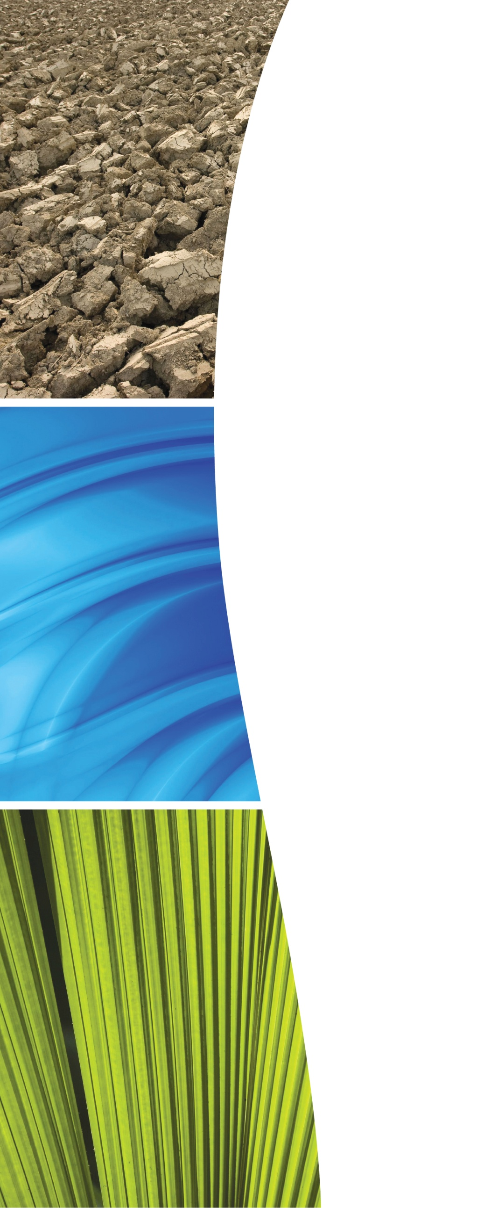

|  |
| --- |
| Hazardous Waste Data Assessment |

Final Report

**Department of Sustainability, Environment, Water,**

**Population and Communities**

**April 2013**

**Project No. 5012.086**

**Hazardous Waste Data Assessment**Final Report

Prepared for:  
**Department of Sustainability, Environment, Water, Population and Communities**

Prepared by:  
**KMH Environmental**  
Level 4  
180 Albert Road  
South Melbourne VIC 3205

Phone: (03) 8640 6200  
Fax: (02) 8008 1600

Document Control Log

|  |  |  |  |  |  |
| --- | --- | --- | --- | --- | --- |
| **Revision No.** | **Amendment** | **Date** | **Prepared By** | **Checked By** | **Approved By** |
| Rev0 | Draft Report | 21.12.2012 | T Bloomfield | G Latimer | G Latimer |
| Rev1 | Complete Draft | 21.01.2013 | T Bloomfield | G Latimer | G Latimer |
| Rev 2_0 | Final Report | 07.03.2013 | G Latimer | D Garner | G Latimer |
| Rev 2_1 | Revised Final Report | 14.03.2013 | G Latimer | D Garner | G Latimer |
| Rev 2_2 | Revised Final Report after State/ Territory comments | 22.04.2013 | G Latimer | G Latimer | G Latimer |
|  |  |  |  |  |  |

© KMH Environmental 2011

The information contained in this document produced by KMH Environmental is solely for the use of the Client identified on the cover sheet for the purpose for which it has been prepared and KMH Environmental undertakes no duty to or accepts any responsibility to any third party who may rely upon this document.

All rights reserved. No section or element of this document may be removed from this document, reproduced, electronically stored or transmitted in any form without the written permission of KMH Environmental.

**TABLE OF CONTENTS**

Glossary and Abbreviations v

Executive Summary viii

1. Introduction 12

1.1. Purpose of this report 12

1.2. Report structure 13

1.3. Consultation 13

1.4. Background 13

2. Hazardous Waste Data Systems 16

2.1. Jurisdictional Data Collection and Reporting Arrangements 16

2.2. International reporting obligations 20

2.3. The Proximity Principle 20

3. Approach to data collection 22

3.1. Official (Tracked) versus Non-tracked Hazardous Waste Streams 22

3.2. Data Collection 23

3.3. Assessment of Hazardous Waste Data Systems 24

4. Hazardous Waste Data Compilation and Assessment 25

4.1. New South Wales 25

4.2. Victoria 30

4.3. Queensland 35

4.4. Western Australia 39

4.5. South Australia 42

4.6. Tasmania 45

4.7. Australian Capital Territory **Error! Bookmark not defined.**

4.8. Northern Territory 51

4.9. Hazardous contamination of other waste streams 53

4.10. National Data Summary 59

5. Cost of Hazardous Waste Management 63

5.1. New South Wales 66

5.2. Victoria 70

5.3. Queensland 71

5.4. Tasmania 74

5.5. South Australia 78

5.6. Western Australia 79

5.7. Australian Capital Territory 80

5.8. Northern Territory 81

6. Integration of Waste Data Systems 84

6.1. National Waste Management Sites Spatial Database 84

7. International Approaches to Hazardous Waste Data Collection and Reporting 85

7.1. Europe 85

7.2. North America 87

7.3. Asia 87

**FIGURES**

Figure 1—Hazardous waste treatment/ disposal (New South Wales 2010–11) 26

Figure 2—Waste generated, imported and exported by NEPM category (New South Wales 2010–11) 28

Figure 3—Hazardous waste treatment/disposal (Victoria 2010–11) 31

Figure 4—‘N’ category wastes generated in Victoria 30

Figure 5—Waste generated, imported and exported by NEPM category (Victoria 2010–11) 34

Figure 6—Hazardous waste treatment/disposal Queensland 2010–11) 35

Figure 7—Waste generated, imported and exported by NEPM category (Queensland 2010–11) 38

Figure 8—Waste generated, imported and exported by NEPM category (Western Australia 2010–11) 41

Figure 9—Waste generated, imported and exported by NEPM category (South Australia 2010–11) 44

Figure 10—Waste generated, imported and exported by NEPM category (Australian Capital Territory 2010–11) 50

Figure 11—New South Wales *Household Hazardous Clean-Out* waste composition summary (March 2003 to June 2011) 54

Figure 12—C&I waste composition based on audit of 195 Central Queensland businesses 57

Figure 13—Hazardous waste generation by state and territory in 2010–11 (tracked/reported waste data) 59

Figure 14—Total tracked hazardous waste generation by waste category (national total 2010–11) 60

Figure 15—Hazardous waste treatment/disposal (national total 2010–11) 60

Figure 16—Summary of hazardous waste management cost components across Australian states and territories 63

Figure 17—Hazardous waste generated per capita in Europe in 2008 by country/region (Eurostat 2012) 86

**TABLES**

Table 1—Summary of jurisdictional NEPM implementation frameworks (NEPC 2009) 15

Table 2—Example of waste classification codes used in Western Australia 18

Table 3—Waste tracking data summary NSW (2010–11) 27

Table 4—Prescribed industrial waste hazard categories 32

Table 5—Waste tracking data summary Victoria (2010–11) 33

Table 6—Waste tracking data summary Queensland (2010–11) 37

Table 7—Waste tracking data summary Western Australia (2010–11) 40

Table 8—Waste tracking data summary South Australia (2010–11) 43

Table 9—Waste data summary Tasmania (2010–11) 46

Table 10—Waste tracking data summary Australian Capital Territory Australian Capital Territory (2010–11) 49

Table 11—Waste data summary Northern Territory (2010–11) 52

Table 12—Hazardous wastes estimated in the MSW stream by NEPM waste category for each jurisdiction 55

Table 13—Total hazardous waste within the C&D waste stream by jurisdiction for 2008–09 (Hyder 2011) 58

Table 14—Tracked and MSW derived hazardous waste generation (national total 2010–11) 62

Table 15—Comparison of jurisdictional hazardous waste management costs 64

Table 16—Landfill levy rates in New South Wales 66

Table 17—Method by which the New South Wales landfill levy is calculated and applied 66

Table 18—Extract from Schedule 1, New South Wales *Protection of the Environment Operations (General) Regulation 2009* 68

Table 19—Victorian Prescribed Industrial Waste levies 70

Table 20—EPA Victoria method for calculating Prescribed Waste Fees 71

Table 21—Industry Waste Disposal Levies with regard to regulated waste management from Queensland’s former Waste Reduction and Recycling Strategy 2010–20 71

Table 22—Extract from Queensland Department of Environment and Heritage Protection Summary of annual fees for environmentally relevant activities 73

Table 23—SIA 2008 Estimates of Disposal Costs for Controlled Waste in Tasmania 75

Table 24—South Australia waste disposal levies 78

Table 25—Licence fee calculation method for waste transporter businesses in South Australia 79

Table 26—Western Australia landfill levies 79

Table 27—Western Australia controlled waste licence/approval application fees 80

Table 28—Australian Capital Territory Waste Disposal Charges 80

Table 29—Australian Capital Territory Environment Authorisation Fees 81

Table 30—Northern Territory Waste Management and Pollution Control Australian Capital Territory Fees Payable 83

**Appendices**

Appendix A—NEPM Hazardous Waste Categories

Appendix B—Tracked and Non-tracked Wastes by Jurisdiction

Glossary and Abbreviations

|  |  |
| --- | --- |
| Basel Convention | *The Basel Convention on the Control of Transboundary Movements of Hazardous Wastes and their Disposal*. The Convention puts an onus on exporting countries to ensure that hazardous wastes are managed in an environmentally sound manner in the country of import. |
| C&D | Construction and Demolition (waste) |
| C&I | Commercial and Industrial (waste) |
| Companion report | This report—the *Hazardous Waste Data Summary*—as a companion to the Data Report. |
| Controlled Waste | Waste that falls under the control of the Controlled Waste National Environment Protection Measure. Generally equivalent to hazardous waste, although definitional differences of the latter exist across jurisdictions. |
| Controlled Waste NEPM | *National Environment Protection (Movement of Controlled Waste between States and Territories) Measure* |
| Data report | *Hazardous Waste Data Assessment* |
| EfW | Energy from Waste |
| Hazardous waste | A hazardous waste, as defined in the Australian Government’s *National Waste Policy: Less waste, more resources* (2009), is a substance or object that exhibits hazardous characteristics, is no longer fit for its intended use and requires disposal.  Hazardous waste means:  (a) waste prescribed by the regulations, where the waste has any of the characteristics mentioned in Annex III to the Basel Convention; or  (b) wastes covered by paragraph 1(a) of Article 1 of the Basel Convention; or  (c) household waste; or  (d) residues arising from the incineration of household waste; but does not include wastes covered by paragraph 4 of Article 1 of the Basel Convention. |
| Interstate data | Data collected about hazardous waste generated in one jurisdiction and treated in another, through cross-border transport under the Controlled Waste NEPM. |
| Intrastate data | Data collected about hazardous waste generated, transported and treated within the one jurisdiction. |
| Liquid waste | Any waste that:  (a) has an angle of repose of less than five degrees above horizontal, or  (b) becomes free-flowing at or below 60 degrees Celsius or when it is transported, or  (c) is generally not capable of being picked up by a spade or shovel. |
| MSW | Municipal Solid Waste |
| NEPC | National Environment Protection Council |
| NEPM  NOS | National Environment Protection Measure  Not otherwise specified |
| Non-tracked data | Hazardous waste not collected under the arrangements of a formal tracking system. This may include material with no arrangement for any kind of tracking or measurement as well as material tracked, measured, estimated or otherwise covered by parallel or shadow systems. |
| Recovery of energy | (from solid waste) is the process of recovering the energy that is embodied in solid wastes. The amount of solid waste recovered by recovery of energy processes is net of any materials recycled and/or disposed. |
| Recycling | A series of activities by which solid wastes are collected, sorted, processed (including composting), and converted into raw materials to be used in the production of new products. |
| Resource recovery | The sum of materials sent to recycling and energy recovery facilities minus contaminants/residual wastes sent to disposal. Resource recovery = recycling + recovery of energy. |
| Reuse | The use of products or materials for the same or a different purpose without reprocessing or remanufacture. These products or materials may also be repaired to extend their use. |
| Solid waste | Any waste that:  (a) has an angle of repose of greater than five degrees above horizontal, or  (b) does not become free-flowing at or below 60 degrees Celsius or when it is transported, or  (c) is generally capable of being picked up by a spade or shovel. |
| Solid waste disposal | Solid waste that is deposited in a landfill net of recovery of energy. |
| Tracked data | Hazardous waste collected under the arrangements of a tracking system. |
| Tracking system | Jurisdiction-based hazardous waste tracking systems, which are in place in New South Wales, Queensland, South Australia, Western Australia and Victoria. These tracking systems can be either online, paper-based, or a combination of both these mechanisms. |
| Treatment | Treatment of waste is the removal, reduction or immobilisation of a hazardous characteristic to enable the waste to be reused, recycled, sent to an EfW facility or disposed. |
| Waste | (For data collation purposes) is materials or products that are unwanted or have been discarded, rejected or abandoned. Waste includes materials or products that are recycled, converted to energy, or disposed. Materials and products that are reused (for their original or another purpose without reprocessing) are not solid waste because they remain in use. |
| Waste Code | Three-digit code typically used by jurisdictions to describe NEPM-listed wastes. These are also referred to as ’NEPM codes’ although it is noted that the actual codes do not appear in the NEPM itself. |
| Waste generation | Typically, waste generation = resource recovery (recycling + energy recovery) + disposal. For the purposes of this report however, waste generation means what has been reported by jurisdictional data providers as waste generation. |
| Waste reuse | The reuse of a product or material that has entered a waste management facility (e.g. the sale of goods from a landfill or transfer station ‘tip shop’) for the same or a different purpose. These products or materials may also be repaired to extend their use. |
|  |  |
|  |  |
|  |  |
|  |  |
|  |  |
|  |  |
|  |  |
|  |  |
|  |  |
|  |  |

Executive Summary

To support work under the National Waste Policy, KMH Environmental Pty Ltd (KMH) was engaged by The Department of Sustainability, Environment, Water, Population and Communities (DSEWPaC) to produce a compilation of data and information on hazardous waste generation in Australia, including the hazardous waste that crosses state, territory or national borders and hazardous waste that is generated and remains within a single jurisdiction.

While data on the movement of hazardous waste between states has been available for many years, historically little data has been collated and published on intra-state hazardous waste generation. This report aims to address the current lack of public information on hazardous waste generated in states and territories by providing a compilation of available data and information on hazardous waste volumes in Australia. This report addresses the following:

* the hazardous waste that is generated, transported, recovered, treated, recycled and disposed of, by jurisdiction and nationally, for a common base year (2010–11), collected from both interstate and intrastate hazardous waste tracking systems (tracked data)
* an estimate of the hazardous content of mixed waste within the three waste streams used as general categories in Australian waste data and reporting (MSW, C&I, C&D), referred to as stream ‘contamination’, and the extent to which hazardous waste volumes are currently reported within those waste streams
* the hazardous waste management fees imposed across Australian jurisdictions.

The processes and systems for collecting waste data vary amongst the jurisdictions, often depending on the waste type that is being measured. The majority of intrastate data is collected through jurisdiction-based hazardous waste tracking systems, which are in place in New South Wales, Queensland, South Australia, Western Australia and Victoria. These tracking systems can be either online, paper-based, or a combination of both these mechanisms. The Australian Capital Territory, the Northern Territory and Tasmania do not have tracking systems, although one is reportedly under development in Tasmania (*Hyder Liquid Waste Assessment 2012*).

Since 1998–99, interstate data has been captured annually under the *National Environment Protection (Movement of Controlled Waste between States and Territories) Measure as varied 2010* (theControlled Waste NEPM) [1] and reported via its annual public report, while international data is provided at the national level under the Basel Convention and centrally published by the Basel Convention Secretariat in a similar manner.

This report sources hazardous waste data supplied by jurisdictional agencies from their ‘official’ waste tracking systems, which are a combination of systems that track movements within jurisdictions (where they exist) and systems for authorising and tracking interstate transport of hazardous waste. The companion report—the *Hazardous Waste Data Summary*—attempts to address the limitations of this data, by identifying key gaps and inconsistencies and filling these using data from other sources.

The other aspect of data compiled by this section, the identification of hazardous waste that is generated from MSW, C&I and C&D sources, applies estimation methods based on publicly available information and literature reports.

Hazardous waste data, compiled across Australia from both inter- and intrastate tracking systems, and estimated to be contributed from the MSW stream, is detailed in Table E1.

Table E1—Tracked and MSW derived hazardous waste generation (national total 2010–11)

|  |  |  |  |  |  |  |  |
| --- | --- | --- | --- | --- | --- | --- | --- |
| **Hazardous Waste Classification** | | **Waste generated (tonnes)** | | | | | |
| **Code** | **Waste description** | **Intrastate tracking systems** | **Interstate tracking systems** | **Total tracked** | **From MSW** | **Total (all tracked + MSW)** | **% MSW of total** |
| A | Cyanides | 7,917 | 35 | 7,952 | 0 | 7,952 | 0% |
| B | Acids | 37,165 | 11,996 | 49,162 | 37,073 | 86,234 | 43% |
| C | Alkaline wastes | 266,759 | 849 | 267,608 | 1,823 | 269,430 | 1% |
| D | Inorganic chemicals | 295,807 | 35,361 | 331,168 | 1,724 | 332,892 | 1% |
| E | Reactive chemicals | 1,462 | 8 | 1,470 | 20,820 | 22,290 | 93% |
| F | Paints, lacquers, varnish, resins, inks, dyes, pigments, adhesives | 44,441 | 3,917 | 48,358 | 166,535 | 214,893 | 77% |
| G | Organic solvents, solvent residues | 27,985 | 2,309 | 30,295 | 454 | 30,749 | 1% |
| H | Pesticides (includes herbicides and insecticides) | 2,606 | 1,294 | 3,901 | 5,552 | 9,453 | 59% |
| J | Oils, hydrocarbons, emulsions | 601,848 | 12,041 | 613,889 | 49,666 | 663,555 | 7% |
| K | Putrescible/organic wastes | 1,424,792 | 8,695 | 1,433,488 | 0 | 1,433,488 | 0% |
| L | Industrial washwaters | 88,698 | 7 | 88,705 | 0 | 88,705 | 0% |
| M | Organic chemicals | 18,553 | 1,603 | 20,156 | 453 | 20,609 | 2% |
| N | Solid/sludge wastes requiring special handling | 1,062,490 | 13,359 | 1,075,849 | 4,101 | 1,079,949 | 0% |
| R | Clinical and pharmaceutical wastes | 59,946 | 909 | 60,856 | 2,046 | 62,902 | 3% |
| T | Miscellaneous | 63,655 | 536 | 64,191 | 11,590 | 75,781 | 15% |
| **Total** |  | **4,004,126** | **92,921** | **4,097,047** | **301,836** | **4,398,883** | **7%** |

A total of 4,398,883 tonnes of hazardous waste was generated in Australia in 2010–11 from:

* jurisdictional intrastate tracking systems (4,004,126 tonnes)
* jurisdictional interstate tracking systems (92,921 tonnes)
* estimates from ‘contamination’ of the MSW stream (301,836 tonnes).

A total of 4,097,047 tonnes of hazardous waste was generated in 2010–11 from both jurisdictional intrastate and interstate tracking systems, with only 2% of all tracked data coming from interstate movements under the Controlled Waste NEPM. Figure E1 below shows how hazardous waste generation was distributed across each state and territory.

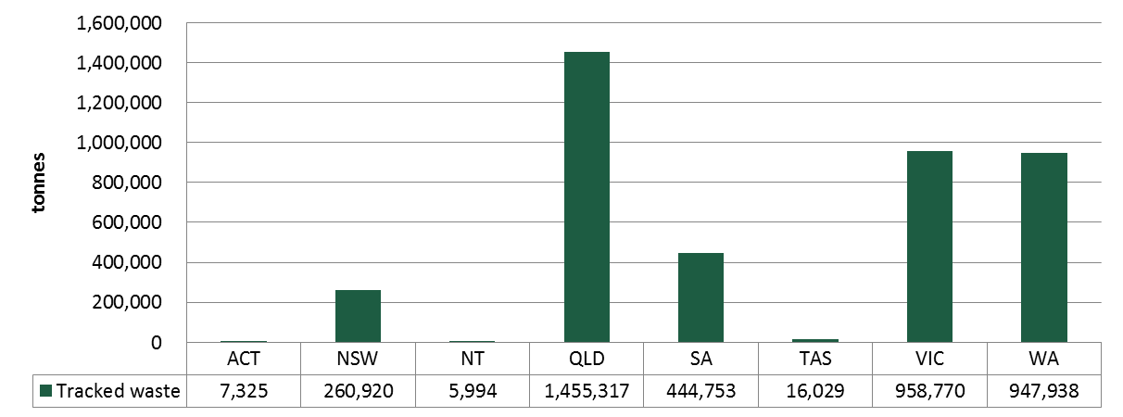

Figure E1—Hazardous waste generation by jurisdiction in 2010–11 (tracked/reported waste data)

Given the relative populations[2] of New South Wales (7,222,000), Victoria (5,540,000) and Queensland (4,506,000), the latter jurisdiction’s large contribution appears unexpected relative to the others. Similarly NSW appears surprisingly low. The Hazardous Waste Data Summary report investigates this and other issues, fills major data gaps from non-tracked data sources and re-casts these estimates of hazardous waste.

Figure E2 provides a breakdown of the total tracked hazardous waste generated in 2010–11 by NEPM waste category.

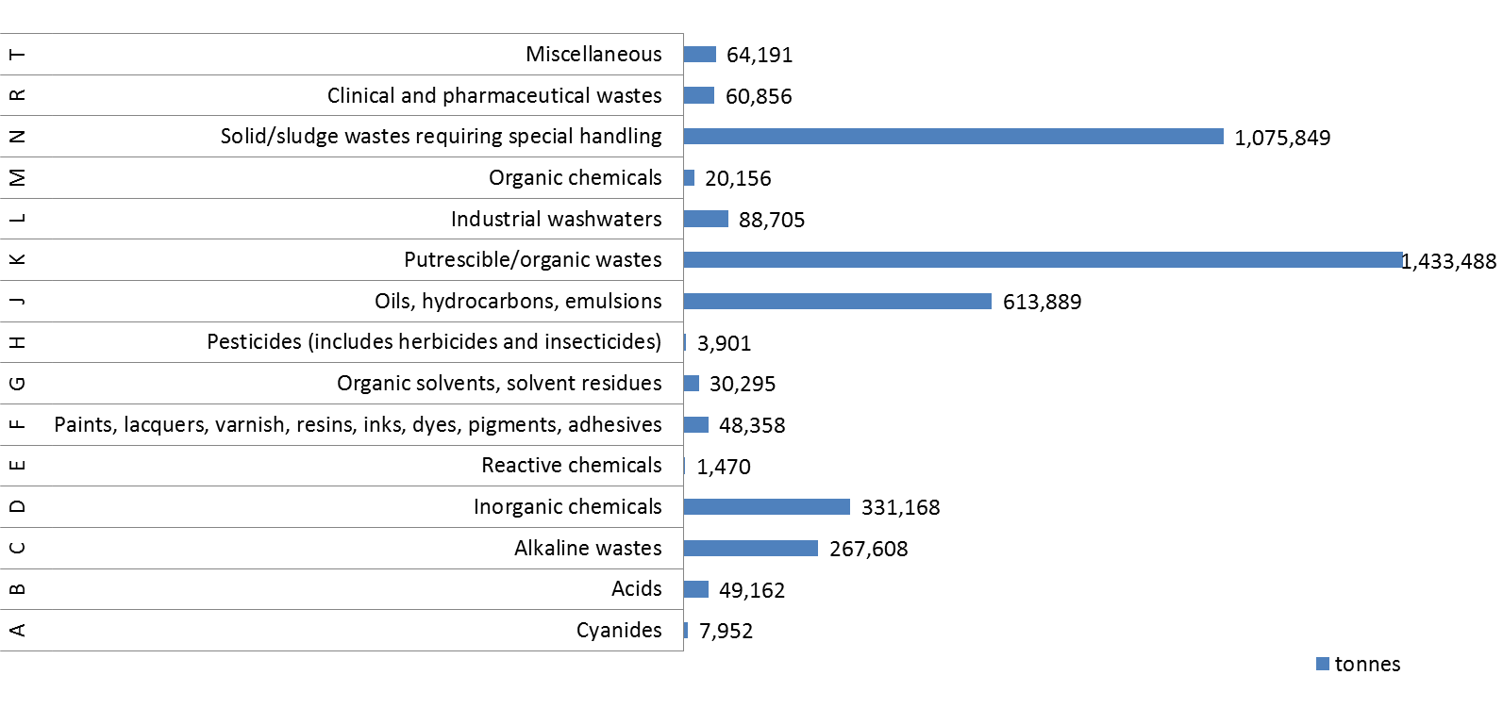

Figure E2—Total tracked hazardous waste generation by waste category (national total 2010–11)

Data on the hazardous ‘contamination’ component of the commercial and industrial (C&I) waste stream is limited to a couple of waste audit data sets, which capture a snapshot of waste from a particular locality or industry sector. This is not considered to be strong enough evidence to produce a robust estimate of the hazardous waste component of C&I waste that is not already captured in waste tracking systems.

The hazardous component of construction and demolition (C&D) waste comprises contaminated soils and asbestos in the main. It is noted that in those jurisdictions that classify these wastes as hazardous they are captured within their tracking system, should they have one.

KMH’s estimate of hazardous waste in the municipal solid waste (MSW) stream of 301,836 tonnes corresponds to 7% of the combined total of tracked and MSW-contributed hazardous waste (4,398,883 tonnes).

Figure E3 provides a breakdown of the method of treatment/disposal for the total tracked hazardous waste generated in 2010–11. Due to the extensive gaps in treatment/disposal data—for some jurisdictions there is no information available at the destination end—and the potential for double-counting where wastes undergo primary treatment before secondary treatment/disposal, it is difficult to draw broader conclusions on the treatment side of hazardous waste at a national level.

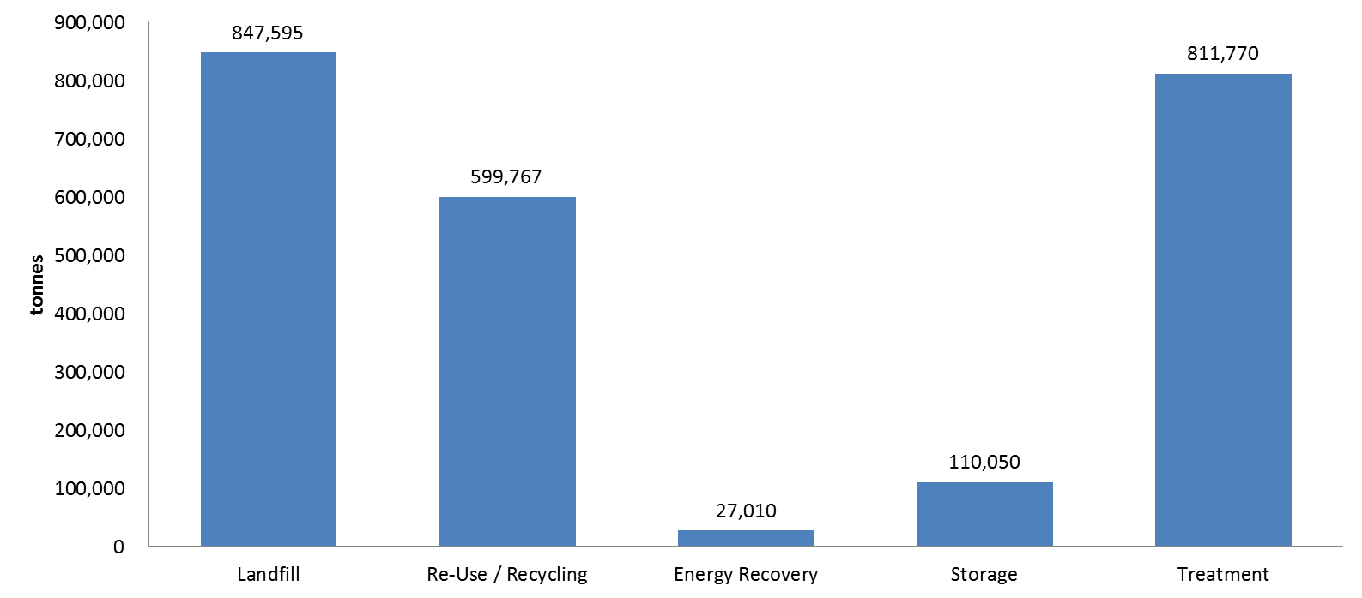

Figure E3—Hazardous waste treatment/disposal (national total 2010–11)

1. Introduction

The Australian Government DSEWPaC is the lead Australian Government agency responsible for the implementation of the *National Waste Policy:* *Less waste, more resources* (National Waste Policy).

To support work under the National Waste Policy, KMH was engaged by DSEWPaC to produce a compilation of data and information on hazardous waste generation in Australia, including the hazardous waste that crosses state, territory or national borders and hazardous waste that is generated and remains within a single jurisdiction.

Purpose of this report

Materials and products containing hazardous substances are found in all waste streams, including municipal solid waste (MSW), commercial and industrial (C&I) waste, construction and demolition (C&D) waste, as well as the ‘formal’ hazardous waste stream itself, which is captured ‘officially’ as part of state-based hazardous waste tracking systems.

There is currently a lack of public information on hazardous waste generated in states and territories that is not transported across jurisdictional boundaries. Accurate and more comprehensive data are needed to better quantify the level of hazardous waste generated in the different waste streams and to inform the choice of appropriate strategies to manage the hazardous waste.

This report aims to address this knowledge gap by providing a high-quality compilation of available data and information on hazardous waste volumes in Australia which includes:

* the hazardous waste that is generated, transported, recovered, treated, recycled and disposed of, by jurisdiction and nationally, for a common base year
* the materials composition of Australian flows of hazardous waste, including flows within a jurisdiction, across jurisdictional boundaries and across national borders
* the extent to which hazardous wastes are treated and recovered or disposed of close to their point of generation
* the hazardous content of mixed waste within the three waste streams used as general categories in Australian waste data and reporting (MSW, C&I, C&D) and the extent to which hazardous waste volumes are currently reported within those waste streams
* the hazardous waste management fees imposed across Australian jurisdictions.

This report also provides a review of the hazardous waste data collection (tracking) systems currently used by Australian jurisdictions to collect and report data on hazardous waste generation, transport, recovery, treatment, recycling and disposal, and how these hazardous waste data/systems could potentially be integrated with other data, such as the National Waste Management Sites Spatial Database (refer to Section 6.1).

Approaches taken in other countries to national collection and disclosure of hazardous waste data and information are also discussed.

Report structure

The report has been divided into the following sections:

* hazardous waste data collection and reporting arrangements (Section 2)
* the approach used in obtaining hazardous waste data and assessing the underlying jurisdictional data systems (Section 3)
* compilation and assessment of hazardous waste data (Section 4)
* the cost of hazardous waste management (Section 5)
* integration of hazardous waste data/ systems with other data (Section 6)
* international approaches to hazardous waste data collection and reporting (Section 7).

Consultation

Consultation with several state and territory departments and agencies was essential in obtaining the necessary data for this review and in gaining a thorough understanding of the hazardous waste data systems operated in each jurisdiction. KMH would like to thank the following for their valuable input and on this project:

* Environment Protection Authority (EPA) New South Wales
* EPA Victoria
* Department of Environment and Heritage Protection (DEHP), Queensland
* EPA Tasmania
* Department of Environment and Conservation (DEC), Western Australia
* EPA South Australia
* Department of Land, Planning and Environment (DLPE), Northern Territory
* Environment Protection and Water Regulation (EPWR), Australian Capital Territory

Background

An assessment of the existing jurisdictional waste data systems in Australia was conducted by Net Balance in 2009. Whilst not directly focussed on hazardous waste, Net Balance reported the following findings:

* there is a general lack of support for national waste reporting
* datasets suffer from inconsistent waste classification and terminology
* problems exist with data collection
* there is a limited understanding of waste’s life cycle impacts
* there are problems with the alignment of national waste data reporting[3].

Similarly, Hyder Consulting’s report on *Waste Classifications in Australia* (2011) has provided background into the inconsistencies in waste classification approaches that currently exist between jurisdictions. Whilst there is general consistency in the application of the Movement of Controlled Waste NEPM, jurisdictional approaches can vary significantly, such that:

*‘Even where jurisdictions adopt comparable approaches to classifications, different terms may be applied to comparable wastes. For example, ‘hazardous waste’ is designated as ‘regulated waste’ in Queensland, ‘listed waste’ in South Australia, ‘controlled waste’ in Tasmania and Western Australia, and as ‘prescribed industrial waste’ in Victoria.’*[4]

It was also found that jurisdictions varied in their use of classifications such that:

*‘Victoria’s approach focuses primarily on prescribed industrial waste while Queensland’s classifications serve primarily to drive wastes toward specific treatment paths.’*4

* + 1. National Environmental Protection Measure

The interstate movement of hazardous waste is regulated by the Controlled Waste NEPM. This NEPM establishes a national protocol for tracking controlled waste and aims to ensure that controlled wastes that are to be moved between states and territories are properly identified, transported, and handled in ways that are consistent with environmentally sound practices.

The National Environment Protection Council (NEPC) produces an annual report on the Controlled Waste NEPM containing a summary of the quantities of hazardous waste transported between each of the states and territories. The NEPM categorises hazardous wastes into 75 different waste types which are summarised under 15 broader categories listed below. The 75 individual waste categories are also listed in Appendix A to this report.

By convention, states report on the 15 summary categories for NEPM reporting, however, international reporting requirements under the Basel Convention requires data on 75 categories.

The 15 NEPM summary categories are as follows:

* **Plating and heat treatmen**t (wastes from heat/surface treatment of metals and plastics, including cyanides)
* **Acids** (acidic solutions or acids in solid form)
* **Alkalis** (basic solutions or bases in solid form)
* **Inorganic chemicals** (e.g. waste containing heavy metals such as mercury, arsenic, lead)
* **Reactive chemicals** (waste containing peroxides other than hydrogen peroxide)
* **Paints, resins, inks, organic sludges** (waste from the production, formulation and use of inks, dyes, pigments, paints, lacquers and varnish, resins, latex, plasticisers, glues and adhesives)
* **Organic solvents** (e.g. ethers)
* **Pesticides** (waste from the production, formulation and use of biocides, phytopharmaceuticals and wood-preserving chemicals, and organic phosphorous compounds)
* **Oils** (includes waste oil/water, hydrocarbons/water mixtures or emulsions)
* **Putrescible/organic waste** (animal effluent and residues, grease trap waste, sewage sludge and residues, tannery wastes and wool scouring wastes)
* **Industrial wash water**
* **Organic chemicals** (includes phenols, organo halogen compounds, organic cyanides, isocyanate compounds, surfactants)
* **Soil/sludge** (includes contaminated soils, containers and drums, fire debris and wash waters, fly ash, filter cake, asbestos)
* **Clinical & pharmaceutical** (clinical wastes, waste pharmaceuticals)
* **Miscellaneous** (includes waste from production, formulation and use of photographic chemicals and processing materials, waste tyres and waste of an explosive nature not subject to other legislation).

The means of implementation of the NEPM by each jurisdiction are shown in Table 1.

Table 1—Summary of jurisdictional NEPM implementation frameworks (NEPC 2009)

| **Jurisdiction** | **Summary of implementation frameworks** |
| --- | --- |
| Commonwealth | The NEPM is implemented administratively. |
| New South Wales | The key legislative instruments are the *Protection of the Environment Operations Act 1997* and the Protection of the Environment Operations (Waste) Regulation 2005. |
| Victoria | The key legislative instruments are the *Environment Protection Act 1970*, the Environment Protection (Industrial Wastes Resource) Regulations 2009, and the Industrial Waste Management Policy (Movement of Controlled Waste between States and Territories) 2001. |
| Queensland | The key legislative instruments are the *Environmental Protection Act 1994* and the Environmental Protection (Waste Management) Regulation 2000. Requirements for the licensing of controlled waste transporters are included in the Environmental Protection Regulation 2008. |
| Western Australia | The primary legislative instruments are the Environmental Protection (Controlled Waste) Regulations 2004. |
| South Australia | The NEPM operates as an *Environment Protection Policy under the Environment Protection Act 1993* and is implemented through conditions of licences. |
| Tasmania | The NEPM is a state policy under the *State Policies and Projects Act 1993.* The NEPM is implemented under the *Environmental Management and Pollution Control Act 1994.* |
| Australian Capital Territory | The key legislative instruments are the *Environment Protection Act 1997* and the Environment Protection Regulations 2005. |
| Northern Territory | The key legislative instruments are the *Waste Management and Pollution Control Act and the Dangerous Goods (Road and Rail Transport) Act*. |

1. Hazardous Waste Data Systems

This chapter of the report examines the current hazardous waste data collection systems used by each Australian jurisdiction for recording data on the generation, movement (both within a jurisdiction and across jurisdictional boundaries), treatment and disposal of hazardous wastes.

Jurisdictional Data Collection and Reporting Arrangements

The majority of intrastate data is collected through jurisdiction-based hazardous waste tracking systems, which are in place in New South Wales, Queensland, South Australia, Western Australia and Victoria. These tracking systems can be either online, paper-based, or a combination of both these mechanisms. The Australian Capital Territory, the Northern Territory and Tasmania do not have tracking systems, although one is reportedly under development in Tasmania (*Hyder Liquid Waste Assessment 2012*).

Since 1998-99, interstate data has been captured annually under the Controlled Waste NEPM and reported via their annual public report, while international data is provided at the national level under the Basel Convention and centrally published by the Basel Convention Secretariat in a similar manner.

The processes and systems for collecting waste data vary between the jurisdictions. The following section provides a description of the current data collection and reporting arrangements for each jurisdiction.

* + 1. New South Wales

Hazardous waste tracking in New South Wales is regulated under the Protection of the Environment Operations (Waste) Regulation 2005 which came into effect on 1 March 2006. The New South Wales EPA operates a mandatory online waste tracking system which can be used for tracking waste transported within New South Wales or into New South Wales from other states or territories. The tracking system uses the NEPM waste categorisation codes.

In New South Wales, waste is classified as hazardous or non-hazardous taking into account the hazard characteristics of the waste according to the activity being carried out. Regulated activities include generation, transport, storage, treatment and disposal of hazardous and liquid waste.

Responsibilities for tracking of waste movements fall on the waste producer, waste transporter and the receiving waste treatment or disposal facility. Each waste load must be issued with a consignment authorisation certificate by the EPA prior to transport. The transport certificate contains information about the waste, the consignor, transporter and receiving facility and must accompany the waste load during transport. Waste that is to be transported out of New South Wales requires a consignment authorisation from the destination jurisdiction.

Tracking of waste movements both within New South Wales and interstate is required for the majority of the hazardous waste categories. Nine of the waste categories however require tracking for interstate movements only. These wastes are:

* Animal effluent and residues (abattoir effluent, poultry and fish processing wastes) (K100)
* Asbestos (N220)
* Containers and drums that are contaminated with residues of waste (N100)
* Grease trap waste (K110)
* Sewage sludge and residues including nightsoil and septic tank sludge (K130)
* Soils contaminated with a substance or waste referred to in this Table (N120)
* Tannery wastes including leather dust, ash, sludges and flours (K140)
* Tyres (T140)
* Wool scouring wastes (K190).

**Reporting**

Interstate waste data is compiled and provided to the NEPC for inclusion in their annual public report. Intrastate waste data including generation, movement and disposal figures for each waste category is not publically reported. The annual *State of the Environment* report[5] makes limited mention of hazardous waste but notes that *‘data on the generation of hazardous waste in New South Wales is not available*’.

* + 1. Victoria

Hazardous waste tracking in Victoria is regulated under the Environment Protection (Industrial Waste Resource) Regulations 2009. Hazardous, or ‘prescribed’ wastes as they are known in Victoria, are identified both by their physical state (i.e. liquid = L, sludge = P, solid = S, or a mixture or assortment = M) and a four character code corresponding to the particular type of waste. The four character codes used are United Nations (UN) numbers which are internationally recognised numbers identifying or describing various dangerous goods. They are designated by the United Nations and are adopted in the Australian Dangerous Goods Code (ADG Code). The NEPM codes are also used to identify the broader waste type.

The regulations require prescribed waste to be transported using a vehicle with an EPA permit and with a waste transport certificate accompanying the load. Prescribed wastes can only be transported to treatment/disposal facilities with EPA approval. Exemption from these requirements exists for wastes destined for a beneficial reuse opportunity. In this case the waste does not require a waste transport certificate or EPA-permitted vehicle.

Responsibility for ensuring that a certificate is completed for each consignment of prescribed industrial waste falls on the waste producer, transporter and receiver. Certificates can either be obtained via the online lodgement system (WasteCert) or a paper-based system. According to EPA Victoria approximately 40 per cent of waste movements are currently tracked using the online system. Infrequent users of the tracking system appear to be reluctant to use the electronic system as registration to the system is perceived to require greater effort than simply completing a paper certificate.

The Victorian intrastate tracking system has an extensive list of disposal/ treatment options from which the waste receiver is required to identify and select the most relevant type of disposal or treatment on the paper-based waste transport certificates.

Interstate movements of prescribed wastes into Victoria are managed under the Controlled Waste NEPM. Movement of waste out of Victoria to other jurisdictions is managed under both the Industrial Waste Management Policy (Movement of Controlled Waste between States and Territories) and the Environment Protection (Industrial Waste Resource) Regulations 2009.

**Reporting**

Interstate waste data is compiled and provided to the NEPC for inclusion in their annual public report. Intrastate waste data including generation, movement and disposal figures for each waste category is not publically reported, apart from quarterly and annual summaries, plus trend reports for key wastes such as asbestos and contaminated soil, which are published on EPA’s website.

* + 1. Queensland

Hazardous (or ‘regulated’) waste tracking in Queensland is regulated under the Environmental Protection (Waste Management) Regulation 2000. Under the regulation waste handlers are required to submit waste tracking information to the DEHP as part of the system for tracking wastes. A waste transport certificate (WTC) must be completed for each load of ‘trackable’ waste. Regulated wastes are categorised by the NEPM waste categorisation codes but do not include acid sulphate soils and contaminated soils.

Several exemptions apply to the waste transport certificate requirements including non-commercial transportation of less than 250 kg of trackable waste and waste that is transported in a pipeline.

Interstate transport of regulated waste is subject to the provisions of the NEPM, discussed previously in section 1.4.1.

**Reporting**

Interstate waste data is compiled and provided to the NEPC for inclusion in their annual public report. Intrastate waste data including generation, movement and disposal figures for each waste category is not publically reported.

* + 1. Western Australia

Hazardous (or ‘controlled’) waste tracking in Western Australia is regulated under the Environmental Protection (Controlled Waste) Regulations 2004 (the Regulations).

The Regulations apply to a controlled waste that is produced by, or as a result of:

* An industrial or commercial activity
* A medical, nursing, dental, veterinary, pharmaceutical or other related activity
* Activities carried out on or at a laboratory

or

* An apparatus for the treatment of sewage.

Controlled Waste is defined as all liquid waste, and any waste that cannot be disposed as a Class I, II or III landfill site. Asbestos, clinical or related waste, tyres and waste that has been immobilised or encapsulated are all classified as controlled wastes.

Controlled wastes are classified by Western Australian Controlled Waste Categories which for the most part can be matched with the UN codes and broader UNEP categories. There are a number of differences however, as demonstrated by the example in Table 2.

Table 2—Example of waste classification codes used in Western Australia

|  |  |  |  |  |
| --- | --- | --- | --- | --- |
| **Waste description type**  **(UNEP category)** | **Western Australia controlled waste category description** | **Western Australia controlled waste category** | **Waste code (UNEP)** | **UN number** |
| Cyanide-containing wastes | Inorganic and organic cyanide Wastes resulting from the surface treatment of metals and plastics | 12.01, 12.02 & 15.04 | A100 | 1935 |

The Western Australia DEC have recently undertaken a review and reform of the Regulations with a view to improving environmental outcomes and streamlining the tracking process. The revised tracking system will utilise the 75 NEPM categories and UN numbers to better align the system with other jurisdictions.

**Reporting**

Interstate waste data is compiled and provided to the NEPC for inclusion in their annual public report. Intrastate waste data including generation, movement and disposal figures for each waste category is not publically reported.

* + 1. South Australia

Hazardous (or ‘listed’) waste tracking in South Australia is regulated under the *Environmental Protection Act 1993*.

A waste transport certificate (WTC) and waste tracking form (WTF) are required for intrastate transportation of all hazardous wastes listed under the Act.

For interstate movements of hazardous wastes the NEPM provisions apply.

**Reporting**

Interstate waste data is compiled and provided to the NEPC for inclusion in their annual public report. Intrastate waste data including generation, movement and disposal figures for each waste category is not publically reported.

* + 1. Tasmania

Hazardous (or ‘controlled’) waste tracking in Tasmania is regulated under the Environmental Management and Pollution Control (Controlled Waste Tracking) Regulations 2010.

Tasmania’s controlled waste tracking system for intrastate waste movements is currently at developmental stage and therefore intrastate waste movements are not recorded at present.

Interstate hazardous waste movements are recorded under the NEPM waste categories for annual reporting to the NEPC. Interstate movements are few in number and are mainly in the form of metallic wastes received from South Australia and international waste loads received from Antarctica. Section 4.6 discusses these waste imports in more detail.

**Reporting**

Interstate waste data is compiled and provided to the NEPC for inclusion in their annual public report. Intrastate waste data is not currently recorded or reported.

* + 1. Northern Territory

All hazardous waste generated in the Northern Territory is transported interstate for disposal as there are no facilities in the Northern Territory that are licensed to treat or dispose of hazardous materials. There is currently no formal hazardous waste tracking system in the NT, however, discussions with the Northern Territory EPA indicate that a tracking system has been proposed and is in the early stages of development. This is likely to involve implementation of the New South Wales electronic data system rather than development of a new system[6].

**Reporting**

Interstate waste data is compiled and provided to the NEPC for inclusion in their annual public report.

* + 1. Australian Capital Territory

Hazardous waste tracking in the Australian Capital Territory is regulated under the *National Environment Protection Act 1994* which is given effect through the *National Environment Protection Council Act 1994.* The Australian Capital Territory does not track intrastate waste movements however it does report intrastate waste movements annually through the controlled waste NEPM.

**Reporting**

Interstate waste data is compiled and provided to the NEPC for inclusion in their annual public report.

International reporting obligations

Australia is a party to the Basel Convention on the Control of Trans-boundary Movements of Hazardous Wastes and their disposal, which regulates the movement of hazardous wastes across international boundaries. The *Hazardous Waste (Regulation of Exports and Imports) Act 1989* implements Australia’s obligations under the Basel Convention by regulating the export, import and transit of hazardous waste to ensure that exported, imported or transited waste is managed in an environmentally sound manner. The Australian Government provides an annual report to the Secretariat of the Basel Convention on the details of the trans-boundary movements of hazardous wastes from Australia. This information is not publicly available.

The Proximity Principle

The proximity principle is one of the four key guiding principles of the Basel Convention that underpin the way hazardous wastes should be managed.

The Basel Convention is a global agreement, ratified by some 178 member countries to address the problems and challenges posed by hazardous waste. It is used internationally as a guide for hazardous waste legislation on a national scale and for developing guidelines and codes of practice.

The four principles of the Basel Convention are:

(i) the polluter pays principle

(ii) the user pays principle

(iii) the proximity principle

(iv) the product stewardship principle.

The proximity principle recommends that treatment and disposal of hazardous waste take place at the closest possible location to its source in order to minimise the risks involved in its transport. Whilst this is a logical approach to managing hazardous waste, in practice there are several factors driving the way hazardous waste is managed that can run the proximity principle. These are largely legislative drivers, cost of required treatment/ disposal and the location or availability of treatment/disposal options.

Legislation acts as the main driver in each jurisdiction for what is permitted to be done with a particular hazardous waste. The Queensland *Waste Reduction and Recycling Act 2011* is an example of recent Australian legislation that has expressly adopted the proximity principle, such that hazardous wastes should, where possible, be treated and recovered or disposed of close to their point of generation.

Whilst this is essential in ensuring that the waste is appropriately managed it also has the effect of reducing the treatment/ disposal options that are available. The impact of this can be that waste generated within a particular jurisdiction or in a particular location can only be treated or disposed of at a facility in another state or one that requires significant transport distance. This is particularly relevant for wastes generated in smaller quantities that require a specific form of treatment whereby the cost implications of providing a treatment facility near to the source of the waste are prohibitive.

The cost of treatment or disposal of hazardous waste can also have a significant influence over where wastes are disposed of or treated. Differences in waste management costs vary considerably between jurisdictions (refer to Section 5) and as a consequence it is in some cases more cost-effective to transport waste to another jurisdiction where the lower cost of disposal outweighs the transportation costs. An example of this is non-hazardous waste generated in northern New South Wales being transported to Queensland (much further than local waste management options) where it is exempt from New South Wales’s waste landfill levy.

The data sourced for this assessment does not include geographical information regarding the source and destination of individual movements of hazardous wastes beyond jurisdictional level information. Whilst this information often exists within waste tracking systems it was not provided for use in this assessment for confidentiality reasons. At a jurisdictional lever however, data that could be viewed spatially would assist in measuring the implementation of the proximity principle with regard to hazardous waste.

1. Approach to data collection

This chapter describes the approach taken to data collection and analysis, as well as key concepts that underpin how that data is presented throughout the report.

Official (tracked) versus non-tracked hazardous waste streams

Hazardous wastes that are tracked as part of a state or territory’s tracking system are referred to in this report as the ‘tracked’ or in some cases ‘official’ hazardous waste stream. Conversely, ‘non-tracked’ hazardous wastes are those that are listed in the NEPM waste list but are not tracked by the formal waste tracking system in a particular jurisdiction. These ‘non-tracked’ wastes may be managed and recorded by separate data systems, although such systems have not been identified or used in this report. Alternately and more commonly, the arisings, movements and fates of these wastes may not be tracked by any system.

Hazardous waste materials that are generated in MSW, C&I and C&D waste sources (or streams), and not captured by formal tracking systems, are hereby referred to as ‘contamination’ of these streams. This is because, for the purposes of management of waste at these sources, the streams are treated as non-hazardous.

However, because MSW, C&I and C&D refer to the source of waste, while *Hazardous* (the ‘fourth’ category) refers to the nature of the waste, there is significant overlap. For example most of the hazardous waste contributed by the C&D sector is likely to be contaminated soil and asbestos, which is tracked as hazardous in many jurisdictions. Similarly C&I sector companies make up the majority of generators recorded in hazardous waste tracking systems, while disposal of hazardous waste from household chemical collection programs is recorded in jurisdictional waste tracking systems.

The types of contaminating wastes commonly found in the MSW and C&I waste streams include the following:

* paint
* batteries
* gas cylinders
* fluorescent lamps and tubes
* pesticides
* oils
* solvents.

Because the hazardous waste contamination of these streams is not tracked or recorded, this presents a challenge when it comes to quantifying the amount of hazardous waste generated and disposed of within these streams.

In order to quantify the hazardous component of these waste streams it has been necessary to review the existing data and literature relating to waste items and materials that are classified as hazardous but are disposed of amongst non-hazardous waste. These data sources are sporadic and typically include both bespoke and program-driven MSW audits, waste studies and material flow estimations.

Data collection

Data templates were provided to each jurisdiction for the purpose of obtaining data in a consistent format. Wastes were listed by the 75 NEPM waste descriptions/codes and for each waste type the jurisdictions were requested to input data under the following column headings:

* Waste generated within jurisdiction
* Waste imported
* Waste exported
* Waste treatment/disposal:
* Storage—waste is stored pending treatment or disposal.
* Treatment—waste undergoes some form of treatment to render it non-hazardous or of reduced hazard level so that it may be re-used, recycled or disposed of, or so that energy may be recovered from the waste.
* Recycling—waste is recycled following treatment.
* Reuse—waste is reused following treatment to reduce its hazard level.
* Energy recovery—processes or opportunities to recover energy from waste materials, usually thermal processes.
* Landfill—waste is disposed of in a licensed landfill.

Where jurisdictions operate intrastate hazardous waste tracking systems this ‘tracked’ data has been sourced from the relevant state or territory organisation. Intrastate data from jurisdictions that do not have a hazardous waste tracking system has been sourced, where available, from waste facility data. Data has been presented individually for each state and territory in summary form due to the extensive number of NEPM categories, and also as a combined national total. The expanded list of NEPM waste codes are provided in Appendix A.

Due to the variability in data collection processes between the tracked hazardous stream (data obtained via tracking systems) and the non-tracked (‘contamination’) hazardous streams, data for each of the waste streams have been collated separately for each state and territory as well as a combined total.

Interstate waste data for the large part has been available for all jurisdictions due to the requirements of each state and territory to report annually the interstate hazardous waste movements under the NEPM arrangements. Where waste generation figures have not been available the import and export figures have been used to estimate waste generation figures for each waste category such that:

Waste generated = waste treated or disposed + waste exported – waste imported.

Waste exported

Waste generated

Waste imported

Waste treated/disposed

Assessment of hazardous waste data systems

Assessment of each jurisdiction’s hazardous waste data system has been conducted using six common principles of reporting quality for data systems.

* **Transparency**—is the data documented and verifiable?
* **Comparability**—is data produced/sourced using the same methodologies and can it be compared across jurisdictions?
* **Accuracy**—has uncertainty in data values been minimised?
* **Completeness**—Are all data sources within a jurisdiction identified and accounted for?
* **Clarity**—Is information clear and easily understood?
* **Timeliness**—Does reporting occur on a regular basis to allow for analysis and inform decision making?

For each principle a rating has been assigned as follows:

* **High**—sound, mature and robust reporting system, scope for error is negligible.
* **Medium**—satisfactory however some potential exists for error and/or loss of data.
* **Low**—data is questionable with limited logical or structured approach to data or record keeping. High potential for error and/or loss of data. Data may appear to differ from those initially reported.

1. Hazardous waste data compilation and assessment

This chapter presents the compilation of the available data and information on hazardous waste quantities in Australia for the financial year 2010–11, both by jurisdiction and as an overall national comparison.

This chapter, and in turn this report, sources hazardous waste data supplied by jurisdictional agencies from their ‘official’ waste tracking systems, which are a combination of systems that track movements within jurisdictions (where they exist) and systems for authorising and tracking interstate transport of hazardous waste. The limitations of this data and subsequent attempts to improve its quality by identifying gaps and inconsistencies and supplementing these through alternative data sources where possible has been tackled in the companion report, the Hazardous Waste Data Summary.

The other aspect of data compiled by this section, the identification of hazardous waste that is generated from MSW, C&I and C&D sources, applies estimation methods based on publicly available information and literature reports.

The data compilation provides information on the following:

* the quantity of hazardous waste that is generated, transported, recovered, treated, recycled and disposed of, by jurisdiction and nationally, for a common base year
* the composition of Australian flows of hazardous waste including flows within a jurisdiction, across jurisdictional boundaries and across national borders
* the hazardous content of mixed waste within the three waste streams used as general categories in Australian waste data and reporting (MSW, C&I, C&D) and the extent to which this waste is monitored and reported.

New South Wales

* + 1. Tracked hazardous waste

The waste tracking data received from EPA New South Wales for 2010–11 is presented in summary form in Table 3. New South Wales’s hazardous waste tracking system recorded 260,920 tonnes of hazardous waste generated within the state in 2010–11. No waste export data was provided and 64,079 tonnes of waste was imported from other jurisdictions for treatment and/ or disposal.

**Waste composition**

The composition of hazardous waste generated, exported and imported in New South Wales is shown at Figure 2.

**Waste treatment and disposal**

Figure 1 below provides a summary of the waste treatment and disposal of hazardous wastes in New South Wales. A more detailed breakdown of waste treatment and disposal by waste type is at Table 3.

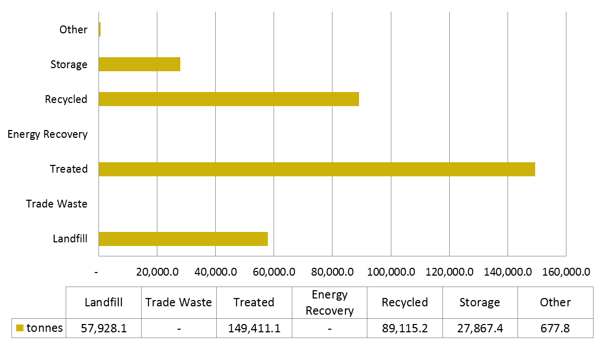

Figure 1—Hazardous waste treatment/disposal (New South Wales 2010–11)

Note: The ’other’ treatment category is a catch-all for waste transport certificates that were filled out incorrectly and as a result contain errors or omissions in the treatment category.

Table 3—Waste tracking data summary New South Wales (2010–11)

|  |  |  |  |  |  |  |  |  |  |  |  |
| --- | --- | --- | --- | --- | --- | --- | --- | --- | --- | --- | --- |
| **Hazardous waste classification** | | **Waste generation (tonnes)** | **Interstate waste movements (tonnes)** | | **Waste treatment/disposal (tonnes)** | | | | | | |
| **Code** | **Waste description** | **Within state** | **Exported** | **Imported** | **Landfill** | **Trade waste** | **Treated** | **Energy recovery** | **Recycled** | **Storage** | **Other** |
| A | Cyanides | 3 | - | - | - | - | - | - | - | 3 | - |
| B | Acids | 9,101 | - | 10,969 | - | - | 19,990 | - | 22 | 58 | - |
| C | Alkaline wastes | 2,071 | - | 548 | 10 | - | 2,200 | - | 0.0 | 62 | 347 |
| D | Inorganic chemicals | 30,339 | - | 28,895 | 2,894 | - | 6,323 | - | 49,377 | 611 | 30 |
| E | Reactive chemicals | 4 | - | 5 | - | - | 5 | - | 0.02 | 3 | - |
| F | Paints, lacquers, varnish, resins, inks, dyes, pigments, adhesives | 6,517 | - | 1,628 | - | - | 6,194 | - | 359 | 1,359 | 233 |
| G | Organic solvents, solvent residues | 1,335 | - | 638 | - | - | 950 | - | 469 | 554 | 1 |
| H | Pesticides (includes herbicides and insecticides) | 189 | - | 41 | 111 | - | 68 | - | - | 50 | - |
| J | Oils, hydrocarbons, emulsions | 104,036 | - | 8,753 | 4 | - | 62,652 | - | 28,044 | 22,081 | 8 |
| K | Putrescible/organic wastes | 237 | - | 9,024 | - | - | 8,137 | - | 1,063 | 4 | 57 |
| L | Industrial washwaters | - | - | - | - | - | - | - | - | - | - |
| M | Organic chemicals | 8,883 | - | 1,285 | - | - | 9,474 | - | 612 | 82 | - |
| N | Solid/sludge wastes requiring special handling | 84,499 | - | 2,000 | 54,909 | - | 21,388 | - | 9,043 | 1,158 | 2 |
| R | Clinical and pharmaceutical wastes | 11,801 | - | 186 | - | - | 11,882 | - | 4 | 100 | - |
| T | Miscellaneous | 1,904 | - | 106 | 0.2 | - | 147 | - | 122 | 1,742 | - |
|  |  |  |  |  |  |  |  |  |  |  |  |
| **Total** |  | **260,920** | **-** | **64,079** | **57,928** | **-** | **149,411** | **-** | **89,115** | **27,867** | **678** |

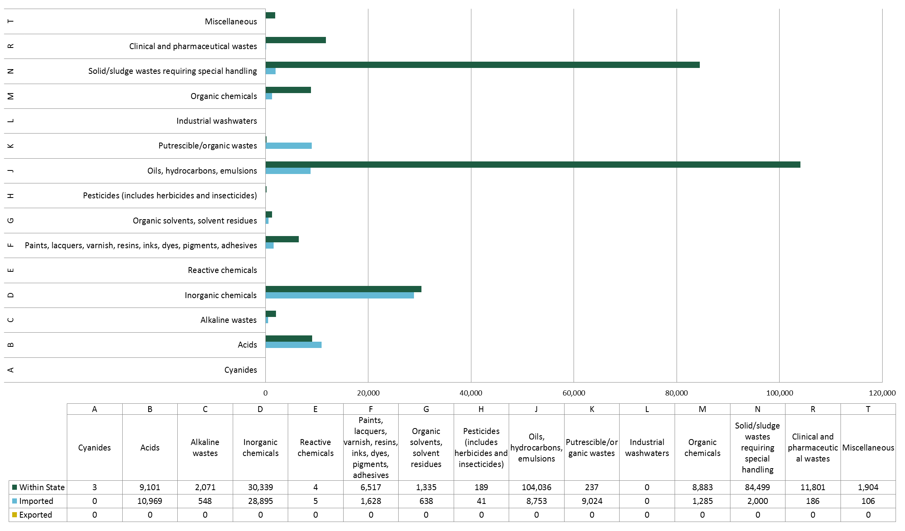

Figure 2—Waste generated, imported and exported by NEPM category (New South Wales 2010–11)

* + 1. Assessment of waste tracking system data

|  |  |  |
| --- | --- | --- |
| **Principles** | **Assessment** | **Score** |
| **Transparency**—Is the data documented and verifiable? | Data is well documented and verified by data records. | High |
| **Comparability**—Is data produced/ sourced using the same methodologies and can it be compared across jurisdictions? | Use of NEPM codes and descriptions and system of tracking allows comparison with other jurisdictions. However there are significant waste categories that are not tracked (missing) which hinders proper data comparison with other jurisdictions. | Medium |
| **Accuracy—**Has uncertainty in data values been minimised? | All waste categories balance. | High |
| **Completeness—**Are all data sources within a jurisdiction identified and accounted for? | No waste export figures provided, however NEPM report shows that waste was exported.  Significant waste categories not formally tracked (missing) which impacts completeness. | Low |
| **Clarity—**Is information clear and easily understood? | Information provided is clear and easily understood. | High |
| **Timeliness—**Does reporting occur on a regular basis to allow for analysis and inform decision making? | Interstate waste data reported annually to NEPC. Intrastate waste data aggregated in annual report. | High |

* + 1. Non-tracked hazardous waste

The following waste types are tracked for interstate movements only and are not tracked within the state:

* Group K (Putrescible/ Organic) wastes such as sewage sludge (K130), animal effluent wastes (K100), tannery wastes (K140) and wool scouring wastes (K190)
* Prescribed waste residues (N100)
* Contaminated soils (N120)
* Asbestos (N220)
* Tyres (T140).

In addition some wastes are exempt from tracking requirements in New South Wales. The New South Wales EPA publishes the following exemptions (from waste tracking) in accordance with clause 51 of the Protection of the Environment Operations (Waste) Regulation 2005:

* Number 2006-E-1: Zinc wastes destined for re-use (D230)
* Number 2006-E-2: Waste batteries (that are classified as hazardous or industrial waste) destined for re-use (D220)
* Number 2006-E-3: Spent pickle liquor destined for re-use (B100)
* Number 2006-E-4: Non-hazardous waste hydrocarbon oil destined for recycling (J100)
* Number 2001–E–01: Tracking of clinical and other specified wastes (R100).

These untracked and exempt waste categories are either completely absent from tracked data in New South Wales or present in low tonnages. The latter is most likely a result of mistaken use of waste transport certification beyond legal requirements, by players in the waste transport process.

All other NEPM waste categories are included within the intrastate tracking system.

The companion Hazardous Waste Data Summary report identifies, discusses and fills these gaps using data from other sources, such as the *Waste and Recycling in Australia 2011*, which presents national and state totals for 2008–09[7].

Victoria

* + 1. Tracked hazardous waste

The waste tracking data received from EPA Victoria for 2010–11 is presented in summary form in Table 5. Victoria’s hazardous waste tracking system recorded 958,770 tonnes of hazardous waste generated within the state in 2010–11. Of this, 43,725 tonnes was exported and 35,752 tonnes was imported from other jurisdictions for treatment and/or disposal.

**Waste composition**

The composition of hazardous waste generated, exported and imported in Victoria is shown at  
Figure 5 .

Approximately 56% (greater than 500,000 tonnes) of hazardous waste generated in Victoria is Category N ‘Solid/sludge wastes requiring special handling’. This waste category includes the category A, B and C contaminated soils of which category C contaminated soils account for the vast majority of this waste. A breakdown of the Category N waste is shown in Figure 3. Definitions of Category A, B and C wastes are provided in Table 4.

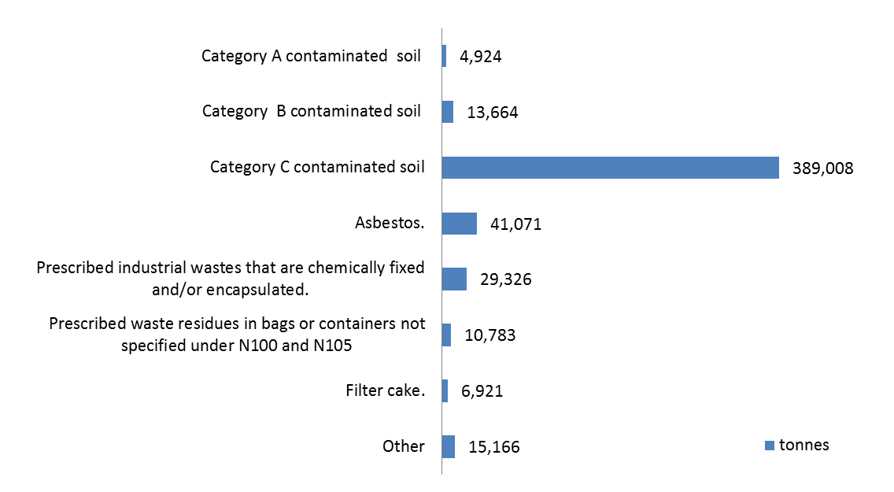

Figure 3—‘N’ category wastes generated in Victoria

**Waste treatment and disposal**

Figure 1 below provides a summary of the waste treatment and disposal of hazardous wastes in Victoria. A more detailed breakdown of waste treatment and disposal by waste type is shown in  
Table 3.

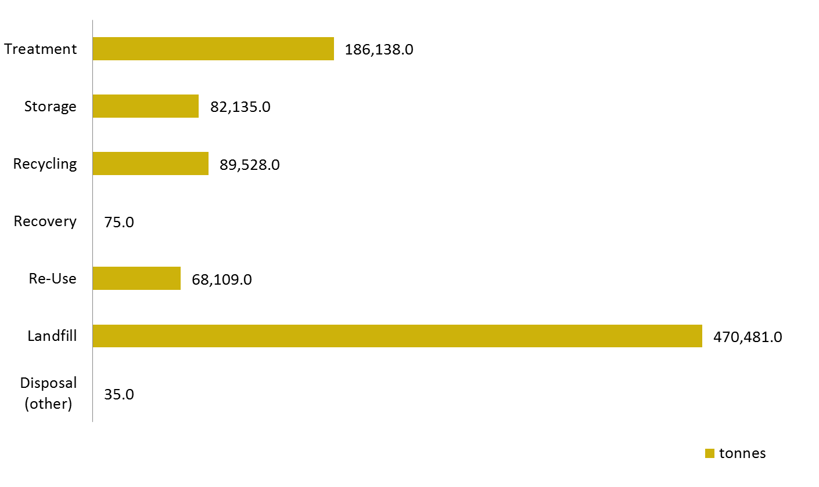

Figure 4—Hazardous waste treatment/disposal (Victoria 2010–11)

Notes:

1. The ‘other’ treatment category is a catch-all for waste transport certificates that were filled out incorrectly and as a result contain errors or omissions in the treatment category.
2. Victoria is the only jurisdiction to report tonnages for re-use as a treatment pathway.

The Victorian intrastate tracking system has an extensive list of disposal/ treatment options from which the waste receiver is required to identify the most relevant type of disposal or treatment option on the paper-based waste transport certificates. The options have been grouped here into the broader disposal/ treatment categories used in this data assessment to provide consistency and allow comparison between each jurisdiction. For example, options D1 (Landfill disposal of Category C waste) and D5 (Landfill disposal of Category B and C waste) from the Victorian waste disposal/treatment codes are listed under ‘landfill‘. The other codes are similarly grouped as follows:

* Landfill = D1, D5
* Recycling = R3, R4, R5, R6, R14, R15
* Recovery = R7, R8
* Storage = D4, D12, D15, R13
* Incineration = D10, D11
* Re-Use = D2, R1, R2, R9, R10, R11
* Disposal (Other) = D3, D6, D7
* Treatment = D8, D9A, D9B, D9C, D13, D14, R16.

Landfill receives the largest proportion of hazardous waste, as shown in Table 5**Error! Reference source not found.**, which can be attributed to the large quantity of Category C (low hazard) contaminated soil generated.

Victoria has 35 landfills licensed to accept Category C wastes and one Category B landfill at Lyndhurst. There are currently no landfills in the state licensed to accept Category A wastes due to the management requirements imposed by the legislation (refer to Table 4) that require Category A wastes to be treated to reduce their hazard prior to disposal.

Table 4—Prescribed industrial waste hazard categories

|  |  |  |
| --- | --- | --- |
| **Hazard Category** | **Definition** | **Management Requirements** |
| A | Category A waste is prescribed industrial waste as defined in Schedule 2 of the Environment Protection (Industrial Waste Resource) Regulations 2009. | Category A waste must not be disposed directly to landfill without prior treatment to reduce its hazard. |
| B | Category B waste is prescribed industrial waste as defined in Schedule 2 of the Environment Protection (Industrial Waste Resource) Regulations 2009. | Category B waste must be sent to facilities licensed to accept Category B waste. |
| C | Category C waste is prescribed industrial waste as defined in Schedule 2 of the Environment Protection (Industrial Waste Resource) Regulations 2009. | Category C waste must be sent to facilities licensed to accept Category C waste. |

* + 1. Assessment of waste tracking system data

|  |  |  |
| --- | --- | --- |
| **Principles** | **Assessment** | **Score** |
| **Transparency—**Is the data documented and verifiable? | Data is well documented and verified by data records. | High |
| **Comparability—**Is data produced/sourced using the same methodologies and can it be compared across jurisdictions? | Use of NEPM codes and descriptions allows comparison with other jurisdictions. | High |
| **Accuracy—**Has uncertainty in data values been minimised? | Several waste categories do not balance. Risk of double-counting of wastes that are treated prior to disposal. | Medium |
| **Completeness—**Are all data sources within a jurisdiction identified and accounted for? | Data appears to be reasonably complete. | High |
| **Clarity—**Is information clear and easily understood? | Information provided is clear and easily understood. | High |
| **Timeliness—**Does reporting occur on a regular basis to allow for analysis and inform decision making? | Interstate waste data reported annually to NEPC. Key intrastate waste data such as contaminated soils and asbestos are regularly reported on EPA’s website. | High |

* + 1. Non-tracked hazardous waste

Waste tyres are tracked for interstate movements only and waste generation figures are therefore not available.

Like New South Wales and South Australia, Victoria does not track sewage sludge (K130).

All other NEPM category wastes are tracked for both intrastate and interstate movements.

The companion report *Hazardous Waste Data Summary* identifies, discusses and fills these gaps using data from other sources, such as the *Waste and Recycling in Australia 2011*, which presents national and state totals for 2008–09[8].

Table 5—Waste tracking data summary Victoria (2010–11)

|  |  |  |  |  |  |  |  |  |  |  |  |  |
| --- | --- | --- | --- | --- | --- | --- | --- | --- | --- | --- | --- | --- |
| **Hazardous waste classification** | | **Waste generation (tonnes)** | **Interstate waste movements (tonnes)** | | **Waste treatment/disposal (tonnes)** | | | | | | |  |
| **Code** | **Waste description** | **Within state** | **Exported** | **Imported** | **Disposal (other)** | **Landfill** | **Re-Use** | **Energy recovery** | **Recycling** | **Storage** | **Treatment** | **Not recorded** |
| A | Cyanides | 15 | - | 8 | - | - | 8 | - | - | 15 | - | - |
| B | Acids | 9,939 | 11,368 | 86 | - | - | 1 | - | - | 394 | 9,538 | 11,461 |
| C | Alkaline wastes | 8,614 | 469 | 36 | - | 436 | 13 | - | - | 130 | 7,998 | 542 |
| D | Inorganic chemicals | 15,166 | 18,010 | 20,858 | - | 4,250 | 3 | 69 | 15,425 | 765 | 1,597 | 31,944 |
| E | Reactive chemicals | 104 | - | 2 | - | - | - | - | - | 104 | - | 2 |
| F | Paints, lacquers, varnish, resins, inks, dyes, pigments, adhesives | 21,071 | 1,953 | 2,919 | - | 28 | 5,488 | - | 32 | 9,040 | 7,338 | 4,017 |
| G | Organic solvents, solvent residues | 8,388 | 288 | 1,766 | - | - | 5,285 | - | 18 | 1,995 | 61 | 1,563 |
| H | Pesticides (includes herbicides and insecticides) | 366 | - | 684 | - | 8 | 788 | - | - | 128 | 42 | 84 |
| J | Oils, hydrocarbons, emulsions | 104,795 | 4,233 | 5,591 | - | 9 | 31,707 | 5 | 5,502 | 38,135 | 30,393 | 8,867 |
| K | Putrescible/organic wastes | 162,782 | 5,063 | 2,806 | 35 | 3,912 | 24,171 | 1 | 61,676 | 9,212 | 55,645 | 15,952 |
| L | Industrial washwaters | 55,656 | 4 | 120 | - | - | 251 | - | 4,717 | 6,495 | 43,307 | 1,014 |
| M | Organic chemicals | 2,041 | 44 | 58 | - | - | 122 | - | 25 | 1,330 | 535 | 131 |
| N | Solid/sludge wastes requiring special handling | 510,863 | 2,084 | 99 | - | 461,666 | 150 | - | 1,897 | 10,222 | 21,085 | 18,105 |
| R | Clinical and pharmaceutical wastes | 11,158 | 197 | 704 | - | - | 12 | - | - | 2,937 | 6,261 | 2,846 |
| T | Miscellaneous | 4,087 | 12 | 15 | - | 172 | 110 | - | 236 | 1,233 | 2,338 | 123 |
| **Total** |  | **915,045** | **43,725** | **35,752** | **35** | **470,481** | **68,109** | **75** | **89,528** | **82,135** | **186,138** | **96,651** |

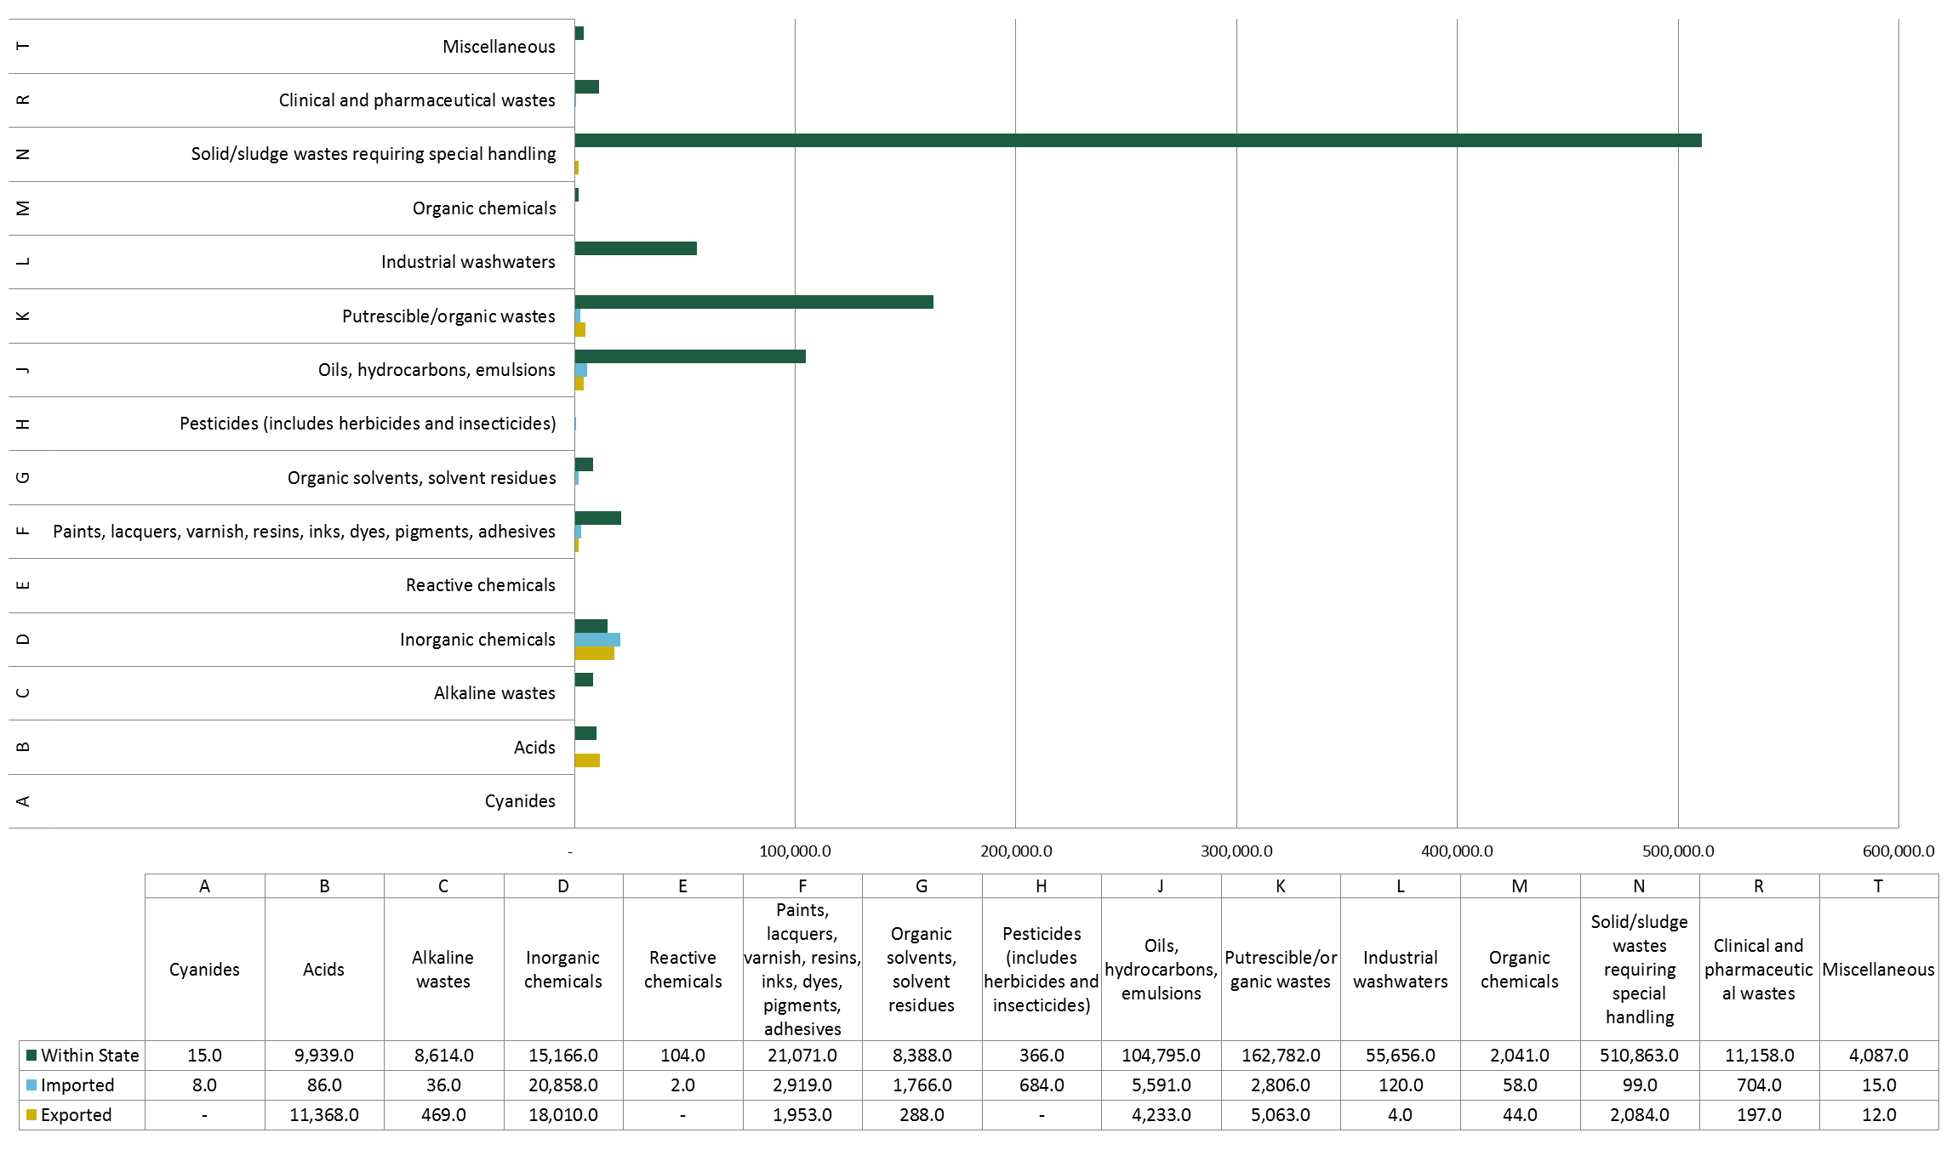

Figure 5 —Waste generated, imported and exported by NEPM category (Victoria 2010–11)

Queensland

* + 1. Tracked hazardous waste

The waste tracking data received from DEHP Queensland for 2010–11 is presented in summary form in Table 6. Queensland’s hazardous waste tracking system recorded 1,455,316.9 tonnes of hazardous waste generated within the state in 2010–11. Of this, 6,505 tonnes of waste was exported and 14,186 tonnes was imported from other jurisdictions for treatment and/ or disposal.

**Waste composition**

The composition of hazardous waste generated, exported and imported in Queensland is shown in the chart in Figure 6 on page 38.

**Waste treatment and disposal**

Figure 6 below provides a summary of how hazardous waste was treated and disposed of in 2010–11. A more detailed breakdown of waste treatment and disposal by waste type is shown in Table 6.

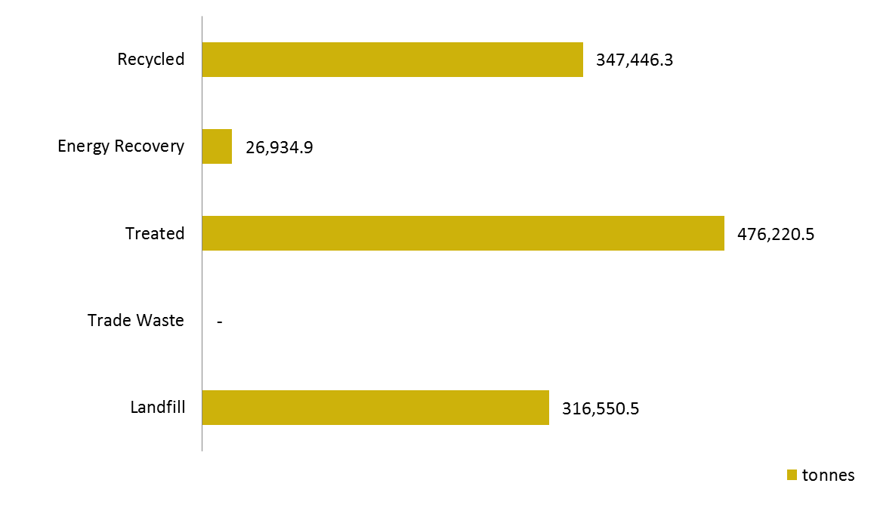

Figure 5—Hazardous waste treatment/disposal (Queensland 2010–11)

* + 1. Assessment of waste tracking system data

|  |  |  |
| --- | --- | --- |
| **Principles** | **Assessment** | **Score** |
| **Transparency—**Is the data documented and verifiable? | Data is well documented and verified by data records. | High |
| **Comparability—**Is data produced/ sourced using the same methodologies and can it be compared across jurisdictions? | Use of NEPM codes and descriptions allows comparison with other jurisdictions. | High |
| **Accuracy—**Has uncertainty in data values been minimised? | Several waste categories do not balance. | Medium |
| **Completeness—**Are all data sources within a jurisdiction identified and accounted for? | Data appears to be complete. | High |
| **Clarity—**Is information clear and easily understood? | Information provided is clear and easily understood. | High |
| **Timeliness—**Does reporting occur on a regular basis to allow for analysis and inform decision making? | Interstate waste data reported annually to NEPC. Not known if intrastate waste data is reported. | Medium |

* + 1. Non-tracked hazardous waste

With the notable exception of contaminated soil (for intrastate movements), all NEPM category wastes are classed as regulated waste in Queensland and are included within the state hazardous waste tracking system for interstate and intrastate waste movements as ‘trackable’ wastes. Contaminated soil is covered by specific approval arrangements administered by DEHP.

The companion Hazardous Waste Data Summary report identifies, discusses and fills these gaps using data from other sources, such as the *Waste and Recycling in Australia 2011*, which presents national and state totals for 2008–09[9].

Table 6—Waste tracking data summary Queensland (2010–11)

|  |  |  |  |  |  |  |  |  |  |
| --- | --- | --- | --- | --- | --- | --- | --- | --- | --- |
| **Hazardous waste classification** | | **Waste generation (tonnes)** | **Interstate waste movements (tonnes)** | | **Waste treatment/disposal (tonnes)** | | | | |
| **Code** | **Waste description** | **Within state** | **Exported** | **Imported** | **Disposed to landfill** | **Disposed to trade waste** | **Treated** | **Energy recovery** | **Recycled** |
| A | Cyanides | 5,891 | 35 | 14 | 4,071 | - | 324 | 20 | 764 |
| B | Acids | 13,701 | 17 | 730 | 1,372 | - | 1,780 | 310 | 9,353 |
| C | Alkaline wastes | 92,279 | 27 | 382 | 1,610 | - | 1,671 | 12,582 | 13,243 |
| D | Inorganic chemicals | 49,791 | 1,444 | 173 | 8,398 | - | 4,868 | 498 | 4,364 |
| E | Reactive chemicals | 1,352 | - | - | 807 | - | 40 | 62 | 283 |
| F | Paints, lacquers, varnish, resins, inks, dyes, pigments, adhesives | 12,611 | 1,239 | 257 | 776 | - | 3,403 | 277 | 6,430 |
| G | Organic solvents, solvent residues | 14,012 | 223 | 13 | 565 | - | 426 | 85 | 12,386 |
| H | Pesticides (includes herbicides and insecticides) | 773 | 933 | 50 | 319 | - | 134 | 617 | 193 |
| J | Oils, hydrocarbons, emulsions | 238,004 | 1,904 | 7,085 | 15,024 | - | 86,622 | 1,023 | 71,456 |
| K | Putrescible/organic wastes | 749,657 | 375 | 1,823 | 99,597 | - | 349,880 | 10,302 | 181,765 |
| L | Industrial washwaters | 153 | - | - | 8 | - | 33 | - | 66 |
| M | Organic chemicals | 4,303 | 54 | 706 | 2,114 | - | 1,741 | 147 | 481 |
| N | Solid/sludge wastes requiring special handling | 212,198 | 166 | 1,313 | 168,989 | - | 13,696 | 1,012 | 22,539 |
| R | Clinical and pharmaceutical wastes | 18,809 | 68 | 799 | 7,649 | - | 10,080 | - | 5 |
| T | Miscellaneous | 35,276 | 20 | 841 | 5,252 | - | 1,523 | 1 | 24,118 |
|  |  |  |  |  |  |  |  |  |  |
| **Total** |  | **1,448,812** | **6,505** | **14,186** | **316,551** | **-** | **476,220** | **26,935** | **347,446** |

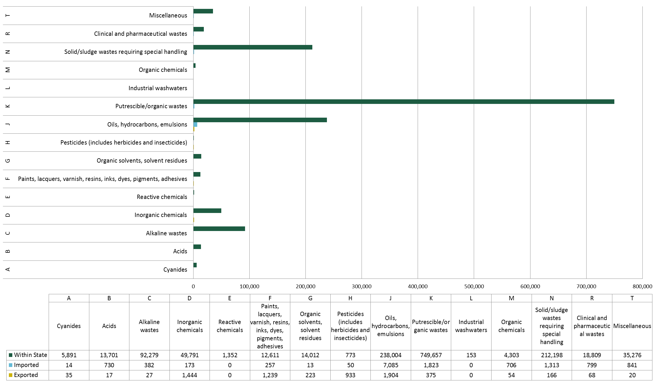

Figure 6—Waste generated, imported and exported by NEPM category (Queensland 2010–11)

Western Australia

* + 1. Tracked hazardous waste

The waste tracking data received from DEC Western Australia for 2010–11 is presented in summary form in Table 7. Western Australia’s hazardous waste tracking system recorded 947,938 tonnes of hazardous waste generated within the state in 2010–11. Of this, 8,142 tonnes of waste was exported and 2,100 tonnes was imported from other jurisdictions for treatment and/ or disposal.

**Waste composition**

The composition of hazardous waste generated, exported and imported in Western Australia is shown at Figure 7.

**Waste treatment and disposal**

Waste treatment and disposal data was not available from Western Australia’s waste tracking system.

* + 1. Assessment of waste tracking system data

|  |  |  |
| --- | --- | --- |
| **Principles** | **Assessment** | **Score** |
| **Transparency—**Is the data documented and verifiable? | Data sourced from waste tracking system however not all data has been validated. | Medium |
| **Comparability—**Is data produced/ sourced using the same methodologies and can it be compared across jurisdictions? | WA uses its own Controlled Waste Category List and has several additional waste categories, therefore data not as easily comparable with other states that use NEPM codes. | Low |
| **Accuracy—**Has uncertainty in data values been minimised? | Risk of double-counting of wastes that are stored prior to disposal. Waste disposal data not accurately recorded therefore not provided. | Medium |
| **Completeness—**Are all data sources within a jurisdiction identified and accounted for? | Waste disposal data not accurately recorded therefore not provided. | Low |
| **Clarity—**Is information clear and easily understood? | Information provided is clear and easily understood. | High |
| **Timeliness—**Does reporting occur on a regular basis to allow for analysis and inform decision making? | Interstate waste data reported annually to NEPC. Intrastate waste data not publically reported but may be used internally. | Medium |

* + 1. Non-tracked hazardous waste

Asbestos is not tracked in Western Australia as part of the state hazardous waste tracking system. The *Waste and Recycling in Australia 2011*, which presents national and state totals for 2008–09[10], was unable to provide a tonnage for asbestos in Western Australia.

Table 7—Waste tracking data summary Western Australia (2010–11)

|  |  |  |  |  |  |  |  |  |  |
| --- | --- | --- | --- | --- | --- | --- | --- | --- | --- |
| **Hazardous waste Classification** | | **Waste generation (tonnes)** | **Interstate waste movements (tonnes)** | | **Waste treatment/disposal (tonnes)** | | | | |
| **Code** | **Waste description** | **Within state** | **Exported** | **Imported** | **Disposed to landfill** | **Disposed to trade waste** | **Treated** | **Energy Recovery** | **Recycled** |
| A | Cyanides | 1,758 | - | - | - | - | - | - | - |
| B | Acids | 2,025 | 63 | - | - | - | - | - | - |
| C | Alkaline wastes | 105,741 | - | - | - | - | - | - | - |
| D | Inorganic chemicals | 89,123 | 4,702 | - | - | - | - | - | - |
| E | Reactive chemicals | 1 | - | - | - | - | - | - | - |
| F | Paints, lacquers, varnish, resins, inks, dyes, pigments, adhesives | 1,892 | 444 | - | - | - | - | - | - |
| G | Organic solvents, solvent residues | 3,533 | 1,036 | - | - | - | - | - | - |
| H | Pesticides (includes herbicides and insecticides) | 851 | 322 | - | - | - | - | - | - |
| J | Oils, hydrocarbons, emulsions | 147,974 | 125 | 400 | - | - | - | - | - |
| K | Putrescible/organic wastes | 512,117 | - | - | - | - | - | - | - |
| L | Industrial washwaters | 32,889 | - | - | - | - | - | - | - |
| M | Organic chemicals | 3,181 | 1,096 | 600 | - | - | - | - | - |
| N | Solid/sludge wastes requiring special handling | 14,458 | 354 | 1,100 | - | - | - | - | - |
| R | Clinical and pharmaceutical wastes | 2,837 | - | - | - | - | - | - | - |
| T | Miscellaneous | 21,416 | - | - | - | - | - | - | - |
|  |  |  |  |  |  |  |  |  |  |
| **Total** |  | **939,797** | **8,142** | **2,100** | **-** | **-** | **-** | **-** | **-** |

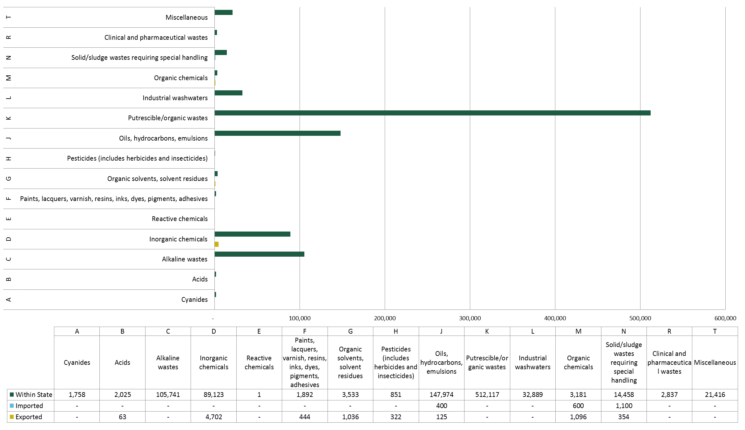

Figure 7—Waste generated, imported and exported by NEPM category (Western Australia 2010–11)

South Australia

* + 1. Tracked hazardous waste

The waste tracking data received from EPA South Australia for 2010–11 is presented in summary form in Table 6. South Australia’s hazardous waste tracking system recorded 444,753 tonnes of hazardous waste generated within the state in 2010–11. Of this, 5,200 tonnes of hazardous waste was exported and 37,991 tonnes was imported from other jurisdictions for treatment and/ or disposal.

Waste export figures were not able to be sourced from the tracking system as it is not possible to distinguish between movements within the state and those exported due to the way in which the certificate numbers are coded. Export data from the 2010–11 NEPM report were sourced for this report.

**Composition**

The composition of hazardous waste generated, exported and imported in South Australia is shown at Figure 8. The major waste types generated in the state are solid/ sludge wastes requiring special handling and inorganic chemicals.

**Waste treatment and disposal**

South Australia’s waste tracking system does not record data on the treatment or disposal of wastes. This information is contained within consignment notes for interstate movements but not for intrastate movements.

* + 1. Assessment of waste tracking system data

|  |  |  |
| --- | --- | --- |
| **Principles** | **Assessment** | **Score** |
| **Transparency**—Is the data documented and verifiable? | Interstate data comparable with NEPM report data. | Medium |
| **Comparability—**Is data produced/ sourced using the same methodologies and can it be compared across jurisdictions? | Use of NEPM codes and descriptions allows comparison with other jurisdictions. Lack of disposal data limits comparability. | Low |
| **Accuracy—**Has uncertainty in data values been minimised? | Discrepancies between waste data provided and NEPM reporting data suggest inaccuracies. | Low |
| **Completeness—**Are all data sources within a jurisdiction identified and accounted for? | No waste export data available from tracking system. | Low |
| **Clarity—**Is information clear and easily understood? | Assumptions made around waste exports. Otherwise clear. | Medium |
| **Timeliness—**Does reporting occur on a regular basis to allow for analysis and inform decision making? | Interstate waste data reported annually to NEPC. Intrastate waste data not publically reported but may be used internally. | Medium |

* + 1. Non-tracked hazardous waste

South Australia’s hazardous waste tracking system is closely aligned with the full list of NEPM waste codes. However, like New South Wales, South Australia does not track Group K (Putrescible/ Organic) wastes such as sewage sludge (K130), animal effluent wastes (K100), tannery wastes (K140) and wool scouring wastes (K190).

Table 8—Waste tracking data summary South Australia (2010–11)

|  |  |  |  |  |  |  |  |  |  |
| --- | --- | --- | --- | --- | --- | --- | --- | --- | --- |
| **Hazardous Waste Classification** | | **Waste generation (tonnes)** | **Interstate waste movements (tonnes)** | | **Waste treatment/disposal (tonnes)** | | | | |
| **Code** | **Waste description** | **Within state** | **Exported**  **(NEPM data)** | **Imported** | **Disposed to landfill** | **Disposed to trade waste** | **Treated** | **Energy recovery** | **Recycled** |
| A | Cyanides | 250 | - | - | - | - | - | - | - |
| B | Acids | 2,399 | 58.8 | 786 | - | - | - | - | - |
| C | Alkaline wastes | 58,054 | 1.4 | 122 | - | - | - | - | - |
| D | Inorganic chemicals | 111,387 | 3,951.6 | 20,826 | - | - | - | - | - |
| E | Reactive chemicals | 1 | - | 9 | - | - | - | - | - |
| F | Paints, lacquers, varnish, resins, inks, dyes, pigments, adhesives | 2,350 | 235.0 | 1,666 | - | - | - | - | - |
| G | Organic solvents, solvent residues | 718 | 294.2 | 3,563 | - | - | - | - | - |
| H | Pesticides (includes herbicides and insecticides) | 427 | 26.7 | 0.3 | - | - | - | - | - |
| J | Oils, hydrocarbons, emulsions | 7,039 | 74.9 | 4,682 | - | - | - | - | - |
| K | Putrescible/organic wastes | - | 4.5 | - | - | - | - | - | - |
| L | Industrial washwaters | - | 3.0 | - | - | - | - | - | - |
| M | Organic chemicals | 145 | 163.4 | 23 | - | - | - | - | - |
| N | Solid/sludge wastes requiring special handling | 240,472 | 54.1 | 5,905 | - | - | - | - | - |
| R | Clinical and pharmaceutical wastes | 15,341 | 333.0 | 133 | - | - | - | - | - |
| T | Miscellaneous | 972 | - | 277 | - | - | - | - | - |
|  |  |  |  |  |  |  |  |  |  |
| **Total** |  | **439,553** | **5,200.7** | **37,991** | **-** | **-** | **-** | **-** | **-** |

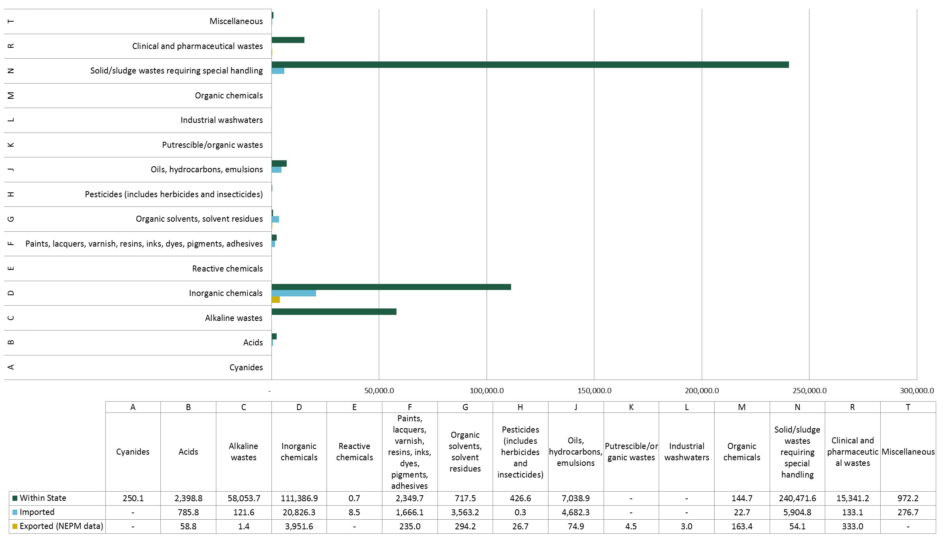

Figure 8—Waste generated, imported and exported by NEPM category (South Australia 2010–11)

Tasmania

* + 1. Tracked hazardous waste

Tasmania does not have a formal hazardous waste tracking system and therefore no waste data was provided for this study. Instead, data was sourced from the NEPC Annual Report 2010/11 which contains data on jurisdictional interstate waste movements provided under the Controlled Waste NEPM. The interstate waste data obtained for Tasmania for 2010–11 is presented in summary form in Table 9. Tasmania exported 16,029 tonnes of waste and imported 133 tonnes of waste from other jurisdictions in 2010–11.

**Waste composition**

The composition of hazardous waste exported and imported in Tasmania is also shown in  
Table 9.

**Waste treatment and disposal**

Waste treatment and disposal data is not recorded in Tasmania.

* + 1. Assessment of waste tracking system data

|  |  |  |
| --- | --- | --- |
| **Principles** | **Assessment** | **Score** |
| **Transparency—**Is the data documented and verifiable? | Tasmania has no formal waste tracking system. Data therefore not available. | Low |
| **Comparability—**Is data produced/ sourced using the same methodologies and can it be compared across jurisdictions? | No tracking system. Cannot be compared to other jurisdictions. | Low |
| **Accuracy—**Has uncertainty in data values been minimised? | Not applicable | Low |
| **Completeness—**Are all data sources within a jurisdiction identified and accounted for? | No | Low |
| **Clarity—**Is information clear and easily understood? | Not applicable | Low |
| **Timeliness—**Does reporting occur on a regular basis to allow for analysis and inform decision making? | Interstate waste movements reported annually to NEPC. Intrastate data not recorded. | Medium |

* + 1. Non-tracked hazardous waste

All hazardous waste generated within Tasmania is considered to be non-tracked hazardous waste due to the absence of a formal waste tracking system.

The companion report *Hazardous Waste Data Summary* identifies, discusses and fills key gaps using data from other sources, such as the *Waste and Recycling in Australia 2011*, which presents national and state totals for 2008–09[11].

Table 9—Waste data summary Tasmania (2010–11)

|  |  |  |  |  |  |  |  |  |  |  |
| --- | --- | --- | --- | --- | --- | --- | --- | --- | --- | --- |
| **Hazardous waste classification** | | **Waste generation (tonnes)** | **Interstate waste movements (tonnes)** | |  | **Waste treatment/disposal (tonnes)** | | | | |
| **Code** | **Waste description** | **Within state** | **Exported** | **Imported** | **Delivered to transfer stations** | **Disposed to landfill** | **Disposed to trade waste** | **Treated** | **Energy recovery** | **Recycled** |
| A | Cyanides | - | - | - | - | - | - | - | - | - |
| B | Acids | - | 2 | 52 | - | - | - | - | - | - |
| C | Alkaline wastes | - | 1 | - | - | - | - | - | - | - |
| D | Inorganic chemicals | - | 6,440 | 0.1 | - | - | - | - | - | - |
| E | Reactive chemicals | - | - | - | - | - | - | - | - | - |
| F | Paints, lacquers, varnish, resins, inks, dyes, pigments, adhesives | - | 0.1 | - | - | - | - | - | - | - |
| G | Organic solvents, solvent residues | - | 367 | 27 | - | - | - | - | - | - |
| H | Pesticides (includes herbicides and insecticides) | - | 0.2 | - | - | - | - | - | - | - |
| J | Oils, hydrocarbons, emulsions | - | 360 | 10 | - | - | - | - | - | - |
| K | Putrescible/organic wastes | - | - | 27 | - | - | - | - | - | - |
| L | Industrial washwaters | - | - | - | - | - | - | - | - | - |
| M | Organic chemicals | - | 64 | - | - | - | - | - | - | - |
| N | Solid/sludge wastes requiring special handling | - | 8,758 | 17 | - | - | - | - | - | - |
| R | Clinical and pharmaceutical wastes | - | 26 | - | - | - | - | - | - | - |
| T | Miscellaneous | - | 12 | - | - | - | - | - | - | - |
|  |  |  |  |  |  |  |  |  |  |  |
| **Total** |  | **-** | **16,029** | **133** | **-** | **-** | **-** | **-** | **-** | **-** |

Australian Capital Territory

* + 1. Tracked hazardous waste

The Australian Capital Territory has no formal hazardous waste tracking system. Waste data provided by the Australian Capital Territory Department of Environment Protection and Water Regulation for this study was only for interstate movements, submitted to the NEPC under the hazardous waste NEPM reporting requirements. The Australian Capital Territory recorded 7,325 tonnes of hazardous waste generated within the state in 2010–11, for subsequent treatment/ disposal interstate. 7,325 tonnes of waste was exported and 924.9 tonnes of waste was imported from other jurisdictions. The data is presented in summary form in Table 10. It is assumed that the waste generation figures have been estimated using the waste export figures due to the tonnes of waste generated being exactly equal to the tonnes of waste exported for each waste category.

**Waste composition**

The composition of hazardous waste generated, exported and imported in Australian Capital Territory is shown in the chart in Figure 9. The largest waste types by generation figures are type ‘K’ (putrescible/ organic wastes), type ‘N’ (solid/ sludge wastes requiring special handling) and type ‘J’ (oils, hydrocarbons and emulsions).

**Waste treatment and disposal**

Waste treatment and disposal figures for Australian Capital Territory are shown in Table 10. These figures relate to the ultimate treatment or disposal route of each waste type following exportation to other jurisdictions. The Australian Capital Territory has no licensed facility for hazardous waste treatment or disposal therefore most hazardous wastes generated within the Australian Capital Territory are exported to New South Wales for disposal/ treatment.

**Interstate waste movements**

All hazardous wastes generated within the Australian Capital Territory are exported for treatment, mainly to New South Wales. Imported wastes are organic chemicals and clinical and pharmaceutical wastes from New South Wales and Victoria.

* + 1. Assessment of waste tracking system data

|  |  |  |
| --- | --- | --- |
| **Principles** | **Assessment** | **Score** |
| **Transparency—**Is the data documented and verifiable? | The Australian Capital Territory has no formal waste tracking system. Data therefore not available. | Low |
| **Comparability—**Is data produced/ sourced using the same methodologies and can it be compared across jurisdictions? | No tracking system. Cannot be compared to other jurisdictions. | Low |
| **Accuracy—**Has uncertainty in data values been minimised? | Not applicable | Low |
| **Completeness—**Are all data sources within a jurisdiction identified and accounted for? | No | Low |
| **Clarity—**Is information clear and easily understood? | Not applicable | Low |
| **Timeliness—**Does reporting occur on a regular basis to allow for analysis and inform decision making? | Interstate waste movements reported annually to NEPC. Intrastate data not recorded. | Medium |

* + 1. Non-tracked hazardous waste

All hazardous waste generated within the Australian Capital Territory is considered to be non-tracked hazardous waste due to the absence of a formal waste tracking system.

The companion report *Hazardous Waste Data Summary* identifies, discusses and fills key gaps using data from other sources, such as the *Waste and Recycling in Australia 2011*, which presents national and state totals for 2008–09[12].

Table 10—Waste tracking data summary Australian Capital Territory (2010–11)

|  |  |  |  |  |  |  |  |  |  |  |
| --- | --- | --- | --- | --- | --- | --- | --- | --- | --- | --- |
| **Hazardous waste classification** | | **Waste generation (tonnes)** | **Interstate waste movements (tonnes)** | |  | **Waste treatment/disposal (tonnes)** | | | | |
| **Code** | **Waste description** | **Within the Australian Capital Territory** | **Exported** | **Imported** | **Delivered to transfer stations** | **Disposed to landfill** | **Disposed to trade waste** | **Treated** | **Energy recovery** | **Recycled** |
| A | Cyanides | - | - | - | - | - | - | - | - | - |
| B | Acids | 471.5 | 471.5 | - | 0.1 | - | - | - | - | - |
| C | Alkaline wastes | 1.1 | 1.1 | - | 0.1 | - | - | - | - | - |
| D | Inorganic chemicals | 30.8 | 30.8 | - | 1.7 | - | - | - | - | 30.7 |
| E | Reactive chemicals | - | - | - | - | - | - | - | - | - |
| F | Paints, lacquers, varnish, resins, inks, dyes, pigments, adhesives | 34.6 | 34.6 | - | 27.0 | - | - | - | - | - |
| G | Organic solvents, solvent residues | 16.9 | 16.9 | - | 9.5 | - | - | - | - | - |
| H | Pesticides (includes herbicides and insecticides) | 0.3 | 0.3 | - | - | - | - | - | - | - |
| J | Oils, hydrocarbons, emulsions | 1,604.0 | 1,604.0 | - | 0.9 | - | - | - | - | 1,604.0 |
| K | Putrescible/organic wastes | 3,104.0 | 3,104.0 | - | - | - | - | - | - | 3,104.0 |
| L | Industrial washwaters | - | - | - | - | - | - | - | - | - |
| M | Organic chemicals | 172.4 | 172.4 | 657.0 | - | - | - | - | - | 829.0 |
| N | Solid/sludge wastes requiring special handling | 1,655.9 | 1,655.9 | - | 1.0 | 1,655.0 | - | - | - | 0.9 |
| R | Clinical and pharmaceutical wastes | 143.7 | 143.7 | 267.9 | - | 267.9 | - | - | - | - |
| T | Miscellaneous | 90.1 | 90.1 | - | 7.5 | - | - | - | - | - |
|  |  |  |  |  |  |  |  |  |  |  |
| **Total** |  | **7,325.4** | **7,325.4** | **924.9** | **47.7** | **1,922.9** | **-** | **-** | **-** | **5,568.6** |

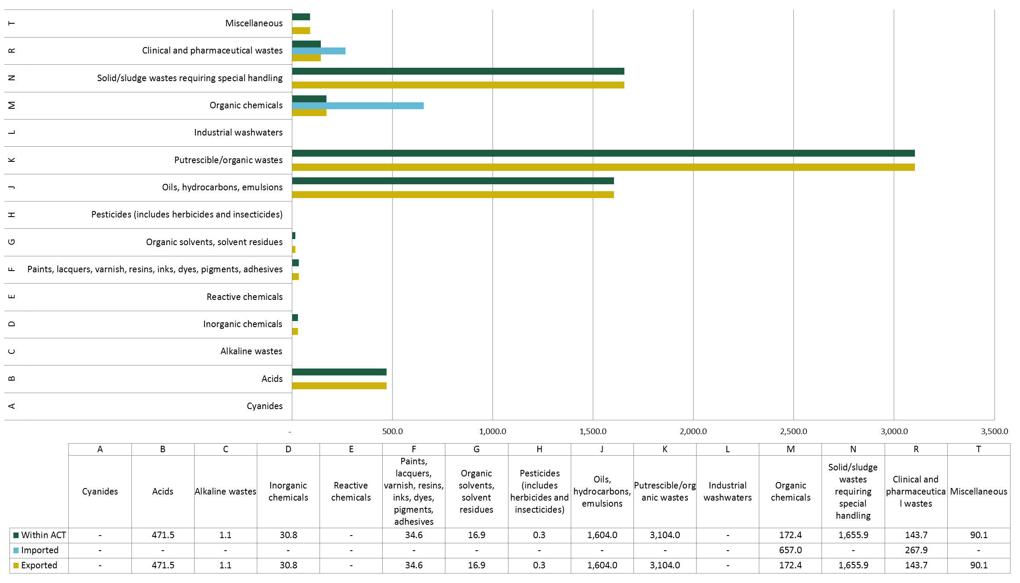

Figure 9—Waste generated, imported and exported by NEPM category (Australian Capital Territory 2010–11)

Northern Territory

* + 1. Tracked hazardous waste

The Northern Territory does not have a formal hazardous waste tracking system and therefore no waste data was provided for this study. Instead, data was sourced from the NEPC Annual Report 2010/11 which contains data on interstate waste movements provided by jurisdictions under the Controlled Waste NEPM. The interstate waste data obtained for the Northern Territory for 2010–11 is presented in summary form in Table 11. The Northern Territory exported 5,994 tonnes of hazardous waste in 2010–11.

**Waste treatment and disposal**

No waste treatment or disposal data has been sourced for the NT. This is due to all hazardous wastes generated in the Northern Territory being either stored or exported for treatment in other jurisdictions.

* + 1. Assessment of waste tracking system data

|  |  |  |
| --- | --- | --- |
| **Principles** | **Assessment** | **Score** |
| **Transparency—**Is the data documented and verifiable? | The Northern Territory has no hazardous waste tracking system. Data therefore not available. | Low |
| **Comparability—**Is data produced/ sourced using the same methodologies and can it be compared across jurisdictions? | No tracking system. Cannot be compared to other jurisdictions. | Low |
| **Accuracy—**Has uncertainty in data values been minimised? | Not applicable | Low |
| **Completeness—**Are all data sources within a jurisdiction identified and accounted for? | No | Low |
| **Clarity—**Is information clear and easily understood? | Not applicable | Low |
| **Timeliness—**Does reporting occur on a regular basis to allow for analysis and inform decision making? | No reporting occurs. | Low |

* + 1. Non-tracked hazardous waste

All hazardous waste generated within the Northern Territory is considered to be non-tracked hazardous waste due to the absence of a formal waste tracking system.

The companion report *Hazardous Waste Data Summary* identifies, discusses and fills key gaps using data from other sources, such as the *Waste and Recycling in Australia 2011*, which presents national and state totals for 2008–09[13].

Table 11—Waste data summary Northern Territory (2010–11)

|  |  |  |  |  |  |  |  |  |  |  |
| --- | --- | --- | --- | --- | --- | --- | --- | --- | --- | --- |
| **Hazardous waste classification** | | **Waste generation (tonnes)** | **Interstate waste movements (tonnes)** | |  | **Waste treatment/disposal (tonnes)** | | | | |
| **Code** | **Waste description** | **Within state** | **Exported** | **Imported** | **Delivered to transfer stations** | **Disposed to landfill** | **Disposed to trade waste** | **Treated** | **Energy recovery** | **Recycled** |
| A | Cyanides | - | - | - | - | - | - | - | - | - |
| B | Acids | - | 16 | - | - | - | - | - | - | - |
| C | Alkaline wastes | - | 349 | - | - | - | - | - | - | - |
| D | Inorganic chemicals | - | 783 | - | - | - | - | - | - | - |
| E | Reactive chemicals | - | 8 | - | - | - | - | - | - | - |
| F | Paints, lacquers, varnish, resins, inks, dyes, pigments, adhesives | - | 12 | - | - | - | - | - | - | - |
| G | Organic solvents, solvent residues | - | 85 | - | - | - | - | - | - | - |
| H | Pesticides (includes herbicides and insecticides) | - | 12 | - | - | - | - | - | - | - |
| J | Oils, hydrocarbons, emulsions | - | 3,741 | - | - | - | - | - | - | - |
| K | Putrescible/organic wastes | - | 149 | - | - | - | - | - | - | - |
| L | Industrial washwaters | - | - | - | - | - | - | - | - | - |
| M | Organic chemicals | - | 9 | - | - | - | - | - | - | - |
| N | Solid/sludge wastes requiring special handling | - | 286 | - | - | - | - | - | - | - |
| R | Clinical and pharmaceutical wastes | - | 142 | - | - | - | - | - | - | - |
| T | Miscellaneous | - | 403 | - | - | - | - | - | - | - |
|  |  |  |  |  |  |  |  |  |  |  |
| **Total** |  | **-** | **5,994** | **-** | **-** | **-** | **-** | **-** | **-** | **-** |

Hazardous ‘contamination’ of other waste streams

In addition to the known quantities of hazardous waste determined from formal waste tracking, a poorly monitored source of hazardous waste is that disposed of within the MSW, C&I and C&D waste streams. The following section provides a summary of the available information and data surrounding these wastes.

Despite these wastes accounting for a minor proportion of the total hazardous waste generated in Australia it was considered important to account for hazardous waste in these streams as far as practically possible in order to gain a complete picture.

* + 1. Municipal Solid Waste

According to waste audit data obtained from New South Wales Government audits in 2007/08 of domestic waste bins, approximately 1.9% of MSW is hazardous content. If we apply this figure to the total MSW generated in Australia annually (12.7 million tonnes per annum in 2010/11) it equates to a total of 241,000 tonnes of hazardous waste per annum generated from Australian households. Consequently, none of this material is accounted for in state and territory tracking system data. It is also noted that this volume does not account for the amount that is disposed to sewer.

Types of hazardous waste commonly found within municipal solid waste include the following:

* acids
* aerosols (CFC-based, paints, lacquers, pesticides etc.)
* alkalis
* batteries (lead acid and dry cell)
* compact fluorescent lamps and fluorescent tubes
* cyanides
* engine coolants and glycols
* fire extinguishers
* flammable liquids (e.g. hydrocarbons and fuels)
* flammable solids
* flares
* gas cylinders
* general household chemicals (e.g. cleaning products)
* heavy metal compounds
* inorganic oxidising agents (e.g. pool chlorine)
* low level radioactive substances (e.g. smoke detectors)
* mercury (e.g. thermometers)
* organic peroxides
* paint
* PCB materials
* pesticides
* solvents.

In recognition of this problem, several jurisdictions have implemented hazardous waste drop-off programs whereby designated hazardous waste drop-off points have been provided for the public to dispose of hazardous waste materials that are generated domestically. The *Detox Your Home* schemein Victoria and the *Household Hazardous Clean-Out* program in New South Wales are examples of such programs. Both initiatives have been operating for several years and have acquired a significant amount of data on the quantity and composition of hazardous waste generated within the home.

Waste data obtained from the New South Wales *Household Hazardous Clean-Out* program has been used in this report as it contains both waste composition data and a generation rate per household for waste collected between 2003 and 2011. A summary of the waste composition from data obtained over this period is presented in Figure 10.



Figure 10—New South Wales *Household Hazardous Clean-Out* waste composition summary (March 2003 to June 2011)[14]

The New South Wales data has been used in this report to provide an average quantity and composition of hazardous waste generated per household which has in turn been used to estimate total hazardous waste generated for each of the other jurisdictions. In the absence of similar data for the other states and territories it has been considered appropriate to estimate the amount of domestically sourced hazardous waste using the New South Wales report data as household waste compositions are not expected to vary significantly between jurisdictions. Each waste material has been matched to the corresponding NEPM waste category to allow direct comparison with the tracked waste data. Population figures for each jurisdiction as well as average household occupancy rates have been sourced from the Australian Bureau of Statistics website[15].

Table 12 below presents a full list of hazardous wastes, presented under the NEPM code categories, that are known contaminants within the MSW waste stream and for each waste type provides an average per-household figure and total annual figures for each jurisdiction and Australia as a whole.

Each household produces an average of 35 kg of hazardous waste per year of which more than half (54%) is estimated to be paint. Other significant components are oils (4.2%), lead acid batteries (4.0%), gas cylinders (2.3%) and household chemicals (1.4%).

Data from the Victorian *Detox Your Home* scheme paints a similar picture with an average of 45 kg of hazardous waste generated per household over a period of five years[16].

Table 12—Hazardous wastes estimated in the MSW stream by NEPM waste category for each jurisdiction

| **NEPM category** | **Waste items within category** | **Waste per household (kg/annum)** | **State/territory totals (tonnes/annum)** | | | | | | | | **National total (tonnes/annum** |
| --- | --- | --- | --- | --- | --- | --- | --- | --- | --- | --- | --- |
| **New South Wales** | **Victoria** | **Queensland** | **South Australia** | **Western Australia** | **Tasmania** | **Northern Territory** | **Australian Capital Territory** |
| B100 | Acids | 0.3 | 829.8 | 636.6 | 517.8 | 188.9 | 263.2 | 58.3 | 26.3 | 41.3 | 2,562.10 |
| B100/ D220 | Lead acid batteries | 4 | 11,177.50 | 8,574.20 | 6,973.90 | 2,544.40 | 3,545.80 | 784.7 | 354.4 | 555.6 | 34,510.50 |
| C100 | Alkalis | 0.2 | 590.3 | 452.8 | 368.3 | 134.4 | 187.3 | 41.4 | 18.7 | 29.3 | 1,822.60 |
| D120 | Fluorescent tubes | 0 | 129.8 | 99.5 | 81 | 29.5 | 41.2 | 9.1 | 4.1 | 6.5 | 400.7 |
| D130 | Arsenic-based products | 0 | 41.1 | 31.5 | 25.6 | 9.3 | 13 | 2.9 | 1.3 | 2 | 126.8 |
| D150/ D210 | Nickel cadmium batteries | 0 | 51.5 | 39.5 | 32.1 | 11.7 | 16.3 | 3.6 | 1.6 | 2.6 | 159.1 |
| D210 | Nickel hydride batteries | 0 | 13.5 | 10.4 | 8.4 | 3.1 | 4.3 | 0.9 | 0.4 | 0.7 | 41.8 |
| D261 | Photographic chemicals | 0.1 | 297.4 | 228.1 | 185.6 | 67.7 | 94.3 | 20.9 | 9.4 | 14.8 | 918.3 |
| D390 | Heavy metals | 0 | 25 | 19.2 | 15.6 | 5.7 | 7.9 | 1.8 | 0.8 | 1.2 | 77.3 |
| E100 | Oxidising agents | 0.1 | 264.9 | 203.2 | 165.3 | 60.3 | 84 | 18.6 | 8.4 | 13.2 | 817.8 |
| E120 | Gas cylinders (inc. propane), aerosols, flares, ammunition | 2.3 | 6,453.50 | 4,950.50 | 4,026.50 | 1,469.10 | 2,047.20 | 453 | 204.6 | 320.8 | 19,925.20 |
| E130 | Reactives | 0 | 24.8 | 19 | 15.5 | 5.6 | 7.9 | 1.7 | 0.8 | 1.2 | 76.5 |
| F100 | Water-based paints | 12.4 | 34,317.90 | 26,325.30 | 21,411.80 | 7,812.00 | 10,886.50 | 2,409.20 | 1,088.20 | 1,705.90 | 105,956.80 |
| F100/ F120 | Paints (other) | 0.4 | 1,062.00 | 814.7 | 662.6 | 241.8 | 336.9 | 74.6 | 33.7 | 52.8 | 3,279.00 |
| F120 | Oil-based paints | 6.7 | 18,558.30 | 14,236.10 | 11,579.00 | 4,224.60 | 5,887.20 | 1,302.80 | 588.5 | 922.5 | 57,299.00 |
| G150 | Halogenated solvents | 0 | 138.2 | 106 | 86.2 | 31.5 | 43.8 | 9.7 | 4.4 | 6.9 | 426.7 |
| G160 | Organo peroxides | 0 | 8.9 | 6.8 | 5.5 | 2 | 2.8 | 0.6 | 0.3 | 0.4 | 27.5 |
| H160 | Pesticides (liquid and solid forms) | 0.6 | 1,798.30 | 1,379.50 | 1,122.00 | 409.4 | 570.5 | 126.2 | 57 | 89.4 | 5,552.20 |
| J100 | Oils | 4.2 | 11,539.90 | 8,852.20 | 7,200.00 | 2,626.90 | 3,660.70 | 810.1 | 365.9 | 573.6 | 35,629.40 |
| J110 | Hydrocarbons and fuels | 1.3 | 3,705.00 | 2,842.10 | 2,311.70 | 843.4 | 1,175.30 | 260.1 | 117.5 | 184.2 | 11,439.30 |
| J170 | Automotive products | 0.3 | 841.3 | 645.3 | 524.9 | 191.5 | 266.9 | 59.1 | 26.7 | 41.8 | 2,597.40 |
| M160 | Fire extinguishers containing halons | 0.1 | 146.7 | 112.5 | 91.5 | 33.4 | 46.5 | 10.3 | 4.7 | 7.3 | 452.8 |
| N260 | Inert solids (bricks, rubble, etc.) | 0.5 | 1,328.10 | 1,018.80 | 828.7 | 302.3 | 421.3 | 93.2 | 42.1 | 66 | 4,100.60 |
| R100 | Pharmaceuticals | 0 | 41.2 | 31.6 | 25.7 | 9.4 | 13.1 | 2.9 | 1.3 | 2 | 127.2 |
| R130 | Toxics | 0.2 | 621.5 | 476.8 | 387.8 | 141.5 | 197.2 | 43.6 | 19.7 | 30.9 | 1,918.90 |
| T170 | General household chemicals and 'unknown' liquid/solid wastes | 1.4 | 3,753.90 | 2,879.60 | 2,342.20 | 854.5 | 1,190.80 | 263.5 | 119 | 186.6 | 11,590.20 |
| N/A | Non-hazardous wastes | 0.2 | 633.2 | 485.7 | 395.1 | 144.1 | 200.9 | 44.5 | 20.1 | 31.5 | 1,954.90 |
| **Total** | | **35.4** | **98,393.40** | **75,477.60** | **61,390.30** | **22,398.10** | **31,212.90** | **6,907.40** | **3,119.90** | **4,891.10** | **303,790.70** |

* + 1. Commercial and Industrial Waste

Due to the highly variable nature of wastes arising from the commercial and industrial (C&I) sector it is difficult to quantify the hazardous ‘contamination’ component of the C&I waste stream.

Data on this waste stream is limited to a number of C&I waste audit data sets which capture a snapshot of waste from a particular locality or industry sector. This is not considered to be strong enough evidence to produce a robust estimate of the hazardous waste component of C&I waste that is not already captured in waste tracking systems.

An audit conducted by A Prince Consulting in 2007 of C&I waste in Central Queensland found that approximately 0.3% of the C&I waste audited from 195 businesses was classed as hazardous or special waste[17]. The audit included businesses from a range of industries including the educational, agricultural, accommodation, manufacturing and retail sectors. The overall composition of waste from all businesses audited is shown at Figure 11 below. The composition of the hazardous waste fraction was not recorded in the audit.

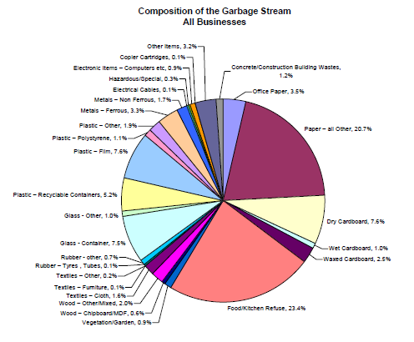

Figure 11—C&I waste composition based on audit of 195 Central Queensland businesses

Landfill-based audits of the C&I and C&D waste streams conducted in 2007 for the Western Australian Department of Environment and Conservation found that approximately 1% of these combined waste streams received at the audited sites was classed as hazardous material[18].

* + 1. Construction and Demolition Waste

The hazardous component of construction and demolition waste comprises of contaminated soils and asbestos. It is noted that in those jurisdictions that classify these wastes as hazardous they are captured within their tracking system, should they have one.

Table 13 presents a data summary of the C&D Waste Status Report conducted by Hyder Consulting for materials recovered and disposed in each Australian jurisdiction for the 2008–09 financial year.

Table 13—Total hazardous waste within the C&D waste stream by jurisdiction for 2008–09 (Hyder 2011)

|  |  |  |  |  |  |  |  |  |
| --- | --- | --- | --- | --- | --- | --- | --- | --- |
| **Waste type** | **New South Wales** | **Queensland** | **Victoria** | **Western Australia** | **South Australia** | **Tasmania** | **Northern Territory** | **Australian Capital Territory** |
| Contaminated soils | 313,269 | 370,576 | 291,665 | 7,022 | 55,068 | 9,803 | unknown | 8,394 |
| Asbestos | 221,046 | 261,485 | 205,803 | - | 27,679 | 6,917 | unknown | 5,547 |
| Total hazardous waste | 534,315 | 632,061 | 497,468 | 7,022 | 82,747 | 16,720 | unknown | 13,941 |
| Total C&D waste | 6,717,051 | 3,448,494 | 3,624,168 | 2,895,767 | 1,833,551 | 68,073 | 195,339 | 215,117 |
| % hazardous | 8% | 18% | 14% | 0% | 5% | 25% | - | 6% |

* + 1. Reporting of hazardous waste within the MSW, C&I and C&D waste streams

The extent to which hazardous waste volumes are currently reported within the MSW, C&D and C&I waste streams has to date been minimal due to the lack of data available. The *National Waste Report 2010* did not include hazardous waste for this reason. Reporting of hazardous waste within the MSW, C&I and C&D waste streams instead of separately as a ‘hazardous waste’ stream would require separating the hazardous waste stream into its constituent parts based on the likely source of each waste category (i.e. the C&I, MSW or C&D sector). This would increase the total waste generation figures for each of these streams with the greatest impact being on the C&I and C&D waste streams.

National Data Summary

Sections 4.10.1 to 4.1.3 collate jurisdictional data into a national summary of the hazardous waste generated and disposed/ treated in Australia for 2010–11, as sourced from interstate and intrastate tracking systems. Section 4.10.4 combines this tracked data with the stream contamination data estimated in Section 4.9, to allow a comparative analysis.

The table in Appendix B provides a summary of the waste categories that are tracked by each jurisdiction and the form of tracking implemented for each category. Waste categories that are tracked under a jurisdiction’s formal waste tracking system are labelled as ‘tracked’. Wastes that are not tracked under any form of system are either labelled as ‘not tracked’ or where they are only tracked when transported interstate as ‘interstate only’. Certain waste categories may not be relevant to a particular jurisdiction and these are labelled ‘not applicable’ (N/A).

* + 1. Hazardous waste generation (tracked)

According to the data obtained from each of the eight jurisdictions, the total tracked hazardous waste generated across Australia during 2010–11 is estimated to be 4,097,047 tonnes, of which only 92,921 tonnes (2%) was recorded in interstate (NEPM) tracking systems. The chart in Figure 12 below shows how hazardous waste generation was distributed across each state and territory.



Figure 12—Hazardous waste generation by state and territory in 2010–11 (tracked/reported waste data)

Given the relative populations[19] of New South Wales (7,222,000), Victoria (5,540,000) and Queensland (4,506,000), the latter jurisdiction’s large contribution appears unexpected relative to the others. Similarly, New South Wales appears surprisingly low. Observation, analysis and interpretation of possible data anomalies such as these are provided in the companion document, the *Hazardous Waste Data Summary*.

Figure 13 provides a breakdown of the total tracked hazardous waste generated in 2010–11 by NEPM waste category.



Figure 13—Total tracked hazardous waste generation by waste category (national total 2010–11)

* + 1. Hazardous waste treatment and disposal

Figure 14 provides a breakdown of the method of treatment/ disposal for the total tracked hazardous waste generated in 2010–11. Due to the extensive gaps in treatment/disposal data—for some jurisdictions there is no information available at the destination end—and the potential for double-counting where wastes undergo primary treatment before secondary treatment/disposal, it is difficult to draw broader conclusions on the treatment side of hazardous waste at a national level.



Figure 14—Hazardous waste treatment/ disposal (national total 2010–11)

* + 1. Interstate waste movements

The interstate waste data provided by jurisdictions for this report was limited to total tonnages of waste imported and exported for each jurisdiction. Geographical information including the destination of waste loads has not been provided and therefore it has not been possible to determine the ultimate destinations of waste loads exported from each state and territory using the data. Instead, the NEPM report data has been used to understand the major waste types that are transported interstate and the origin and destination of these wastes.

* + 1. Comparison of hazardous waste—tracked versus MSW stream

Hazardous waste data, compiled across Australia from both inter- and intrastate tracking systems, and estimated to be contributed from the MSW stream, is detailed in Table 14.

A total of 4,398,883 tonnes of hazardous waste was generated in Australia in 2010–11 from:

* jurisdictional intrastate tracking systems (4,033,475 tonnes)
* jurisdictional interstate tracking systems (63,572 tonnes)
* estimates from ‘contamination’ of the MSW stream (301,836 tonnes).

A total of 4,097,047 tonnes of hazardous waste was generated in 2010–11 from both jurisdictional intrastate and interstate tracking systems, with only 2% of all tracked data coming from interstate movements under the Controlled Waste NEPM.

KMH’s estimate of hazardous waste in the MSW of 301,836 tonnes corresponds to 7% of the combined total of tracked and MSW-contributed hazardous waste (4,398,883 tonnes).

While a figure of 7% is not insignificant for MSW, the following wastes are estimated to contribute a significant amount to their own national totals compared with tracked contributions of the same waste:

* B Acids (43%), made up predominantly of lead acid batteries
* E Reactive chemicals (93%), made up predominantly of gas cylinders
* F Paints (77%)
* H Pesticides (includes herbicides and insecticides) (59%).

The companion *Hazardous Waste Data Summary* takes the data presented in this section, fills key gaps in tracking data using data from other sources (such as the *Waste and Recycling in Australia 2011*) and recasts these national and state totals for 2010–11.

Table 14—Tracked and MSW derived hazardous waste generation (national total 2010–11)

|  |  |  |  |  |  |  |  |
| --- | --- | --- | --- | --- | --- | --- | --- |
| **Hazardous Waste Classification** | | **Waste generated (tonnes)** | | | | | |
| **Code** | **Waste description** | **Intrastate tracking systems** | **Interstate tracking systems** | **Total tracked** | **From MSW** | **Total (all tracked + MSW)** | **% MSW of total** |
| A | Cyanides | 7,917 | 35 | 7,952 | 0 | 7,952 | 0% |
| B | Acids | 37,165 | 11,996 | 49,162 | 37,073 | 86,234 | 43% |
| C | Alkaline wastes | 266,759 | 849 | 267,608 | 1,823 | 269,430 | 1% |
| D | Inorganic chemicals | 295,807 | 35,361 | 331,168 | 1,724 | 332,892 | 1% |
| E | Reactive chemicals | 1,462 | 8 | 1,470 | 20,820 | 22,290 | 93% |
| F | Paints, lacquers, varnish, resins, inks, dyes, pigments, adhesives | 44,441 | 3,917 | 48,358 | 166,535 | 214,893 | 77% |
| G | Organic solvents, solvent residues | 27,985 | 2,309 | 30,295 | 454 | 30,749 | 1% |
| H | Pesticides (includes herbicides and insecticides) | 2,606 | 1,294 | 3,901 | 5,552 | 9,453 | 59% |
| J | Oils, hydrocarbons, emulsions | 601,848 | 12,041 | 613,889 | 49,666 | 663,555 | 7% |
| K | Putrescible/organic wastes | 1,424,792 | 8,695 | 1,433,488 | 0 | 1,433,488 | 0% |
| L | Industrial washwaters | 88,698 | 7 | 88,705 | 0 | 88,705 | 0% |
| M | Organic chemicals | 18,553 | 1,603 | 20,156 | 453 | 20,609 | 2% |
| N | Solid/sludge wastes requiring special handling | 1,062,490 | 13,359 | 1,075,849 | 4,101 | 1,079,949 | 0% |
| R | Clinical and pharmaceutical wastes | 59,946 | 909 | 60,856 | 2,046 | 62,902 | 3% |
| T | Miscellaneous | 63,655 | 536 | 64,191 | 11,590 | 75,781 | 15% |
| **Total** |  | **4,004,126** | **92,921** | **4,097,047** | **301,836** | **4,398,883** | **7%** |

1. Cost of hazardous waste management

The following section provides a summary of the costs associated with hazardous waste management in Australia presented on a state-by-state basis.

Hazardous waste management costs in Australia for the **waste generator** can include:

* a landfill levy component
* special fees for the treatment of waste before disposal
* special fees for the transport of waste before disposal.

Hazardous waste management costs in Australia for **waste facilities accepting hazardous wastes** can include:

* licence application and annual fees
* additional licence fees based on the ‘load’ of pollutants in the hazardous material
* special fees for the treatment of waste before disposal
* special fees for the transport of waste before disposal.

This information has been summarised in Figure 15 below.

Figure 15—Summary of hazardous waste management cost components across Australian states and territories

Fees for hazardous waste management differ in value across the states and territories, but also differ in the types of waste streams to which the hazardous waste management fees are applied. Table presents a comparison of the hazardous waste management costs for each jurisdiction.

Table 5 demonstrates landfill levies apply for hazardous waste disposed in:

* New South Wales
* Victoria
* South Australia
* Western Australia.

However, all states and territories have licensing and some other special fees for organisations that store, transport, treat, process, recycle and dispose of hazardous waste. The following analysis of hazardous waste management costs, however, does not take into account the costs for the states’ and territories’ EPAs and the economic, social and environmental externalities created through the management of hazardous waste as was analysed in the EPA Victoria March 2009 *Draft Environment Protection (Industrial Waste Resource) Regulations* Regulatory Impact Statement (RIS)[20]. In this RIS, the costs for the Environment Protection Agencies included staff incomes and overhead costs and the economic, social and environmental externalities included the costs of:

* inappropriate disposal
* reuse/recycling
* prescribed industrial waste used as an energy source
* prescribed industrial waste disposed at Lyndhurst landfill[21]
* prescribed industrial waste disposed at a municipal or public landfill.

Table 15—Comparison of jurisdictional hazardous waste management costs

| **State/territory** | **Landfill levy charges/hazardous waste management costs** | |
| --- | --- | --- |
| **New South Wales** | **Levy category** | **Levy rates 2011–12 ($/tonne)** |
| Sydney metropolitan area (solid and other wastes) | 82.20 |
| Extended regulated area (solid and other wastes) | 78.60 |
| Regional regulated area (solid and other wastes) | 31.10 |
| Trackable liquid waste | 64.50 |
| **Victoria** | **Prescribed industrial waste disposed to landfill** | **Amount as at 1 July 2011 ($/tonne)** |
| Category A | Prohibited from disposal to landfill — levy does not apply |
| Category B—includes waste from manufacturing industries and contaminated soils | 250 |
| Category C—includes wastes which pose a low hazard from manufacturing industries and contaminated soils | 70 |
| Packaged waste asbestos—levy remains as previously scheduled to encourage safe handling and disposal of asbestos | 30 |
| **Queensland** | **Type of waste** | **Amount ($/tonne) until 30 June 2012** |
| *Leviable waste delivered to a site* | |
| Regulated waste—other | 35 |
| Regulated waste—low hazard | 50 |
| Regulated waste—high hazard | 150 |
| *Waste delivered from resource recovery areas* | |
| Regulated waste—low hazard | 50 |
| Regulated waste—high hazard | 150 |
| *Stockpiled waste disposed of as landfill* | |
| Regulated waste—low hazard | 50 |
| Regulated waste—high hazard | 150 |

|  |  |  |
| --- | --- | --- |
| **Tasmania** | No state waste levies | |
| **South Australia** | **Type of waste** | **Amount as of 2011–12 ($/tonne)** |
| Solid waste—*for a non-metropolitan depot disposing of non-metropolitan waste (non-metro rate)* | 17.50 |
| Solid waste—*for a metropolitan depot disposing of non-metropolitan waste brought to the depot by or on behalf of a wholly non-metropolitan council (non-metro rate)* | 17.50 |
| Solid waste— *metro rate* | 35.00 |
| Liquid waste | 11.25 |
| **Western Australia (only applied to metropolitan waste loads)** | **Facility type** | **Amount as of 01/01/2010** |
| Inert landfills—*Category 63* | $12/cubic metre |
| Putrescible landfills—*Category 64 (putrescible) and Category 65 (hazardous)* | $28/tonne |
| **Australian Capital Territory**  **(no territory waste levies)** | **Landfill fees for special waste** | **Amount as of 01/07/2011** |
| Asbestos or products containing asbestos (by arrangement) from commercial sources—less than 0.25 tonnes | $34.20 |
| Asbestos or products containing asbestos (by arrangement)— 0.25 tonne or more; or arriving at the landfill in a package larger than 80 cm x 80 cm | $ 136.80/ tonne |
| Burials requiring special arrangements less than 0.5 tonnes (e.g. product destruction, supervised or immediate burial including meat, fish or other animal processing wastes, low level radioactive waste, sewage ash or grit, asbestos, hydrocarbons) | $76.60 |
| Burials requiring special arrangements 0.5 tonnes or more (e.g. product destruction, supervised or immediate burial including meat, fish or other animal processing wastes, low level radioactive waste, sewage ash or grit, asbestos, hydrocarbons) | $153.20/ tonne |
| **Northern Territory**  **(no territory waste levies)** | **Weighbridge fees and charges at Shoal Bay Waste Disposal Site - commercial** | **Amount as of 2011-12** |
| Special waste | $135/tonne |

New South Wales

In New South Wales, the same landfill levy rate applies for all types of wastes, except trackable liquid wastes and coal wash reject, which is charged at a different rate, as shown in Table 16—6. The landfill levy rate applied depends on the geographical area of the source and reception point for the waste as indicated in Table 157.

Table 16—Landfill levy rates in New South Wales[22]

|  |  |
| --- | --- |
| **NSW landfill levy category** | **Levy rates 2012–13**  **(per tonne)** |
| Sydney Metropolitan Area (SMA) | $ 95.20 |
| Extended Regulated Area (ERA) | $ 93.00 |
| Regional Regulated Area (RRA) | $ 42.40 |
| Trackable liquid waste | $ 66.60 |
| Coal washery reject | $ 16.20 |

Table 157—Method by which the New South Wales landfill levy is calculated and applied[23]

|  |  |  |
| --- | --- | --- |
| **Waste source** | **Waste received in** | **Applicable levy rate** |
| SMA | SMA | SMA |
| SMA | ERA | SMA |
| SMA | RRA | SMA |
| SMA | Rest of New South Wales | SMA |
| ERA | SMA | SMA |
| ERA | ERA | ERA |
| ERA | RRA | ERA |
| ERA | Rest of New South Wales | ERA |
| RRA | SMA | SMA |
| RRA | ERA | ERA |
| RRA | RRA | RRA |
| RRA | Rest of New South Wales | RRA |
| Rest of New South Wales | SMA | SMA |
| Rest of New South Wales | ERA | ERA |
| Rest of New South Wales | RRA | RRA |

Other costs involved in the management of hazardous wastes are licensing fees that need to be paid based on the type of waste generated, transport, stored, treated or disposed. Apart from annual administrative fees on these licenses, some licenses will also require payment of annual load-based fees. The administrative fee is calculated according to the nature, size and/or capacity of the activity undertaken. Further load-based fees only apply to those activities that have assessable pollutants. Determining the load-based fee involves understanding the:

* amount of assessable pollutants
* types of pollutants an activity releases into the environment
* conditions in the receiving environment[24].

Load-based licensing fees are calculated according to

Equation 1 below[25].

Equation 1—Load fee calculation formula

$$Pollutant load fee=\frac{Assessable Load ×Pollutant Weighting×Critical Zone×Pollutant Fee Unit}{10,000}$$

Or where the assessable load is greater than the free rate threshold:

$$Pollutant load fee= \frac{\begin{aligned}\left(\left(2×Assessable Load\right)-Free Rate Threshold\right)×Pollutant Weighting \\ ×Critical Zone×Pollutant Fee Unit\end{aligned}}{10,000}$$

Each component of these equations is explained in more detail on the NSW EPA Website[26].

Schedule 1 of the New South Wales Protection of the Environment Operations (General) Regulation 2009 lists all the licensed activities and the associated administrated and load-based licensing fees. The fees related to hazardous waste management are detailed in Table 168 below. The cost per fee unit is $113, as of 1 July 2012[27] and KMH has calculated the total administrative fee for each selected activity shown in the table.

Table 168—Extract from Schedule 1, New South Wales Protection of the Environment Operations (General) Regulation 2009

| **Activity** | **Units of measure** | **Administrative fee** | | | **Load-based fee** | | | |
| --- | --- | --- | --- | --- | --- | --- | --- | --- |
| **Annual capacity/ Type of material recovered** | **Administrative fee units** | **Administrative fee cost** | **Air pollutants** | **Threshold factor** | **Water pollutants** | **Threshold factor** |
| **Energy recovery from hazardous and other waste** | Tonnes | Any capacity | 65 | $7,345.00 | Arsenic | 0.00005 | Nil | N/A |
| Benzene | 0.0000011 |
| Benzo(a)pyrene | 0.00002 |
| Fine particulates | 0.7 |
| Lead | 0.035 |
| Mercury | 0.003 |
| Nitrogen oxides and nitrogen oxides (summer) | 2.5 |
| Sulfur oxides | 0.07 |
| **Recovery of hazardous and other waste** | N/A | Hazardous and other waste | 32 | $3,616.00 | There are no assessable pollutants and therefore no load-based fee in relation to this activity. | | | |
| **Recovery of waste oil** | Tonnes | Not more than 1,000 tonnes recovered | 25 | $2,825.00 | Lead | 0.2 | Oil and grease | 4.8 |
| More than 1,000 tonnes recovered | 65 | $7,345.00 | VOCs and VOCs (summer) | 0.05 |
| **Recovery of waste tyres** | N/A | Waste tyres | 12 | $1,356.00 | There are no assessable pollutants and therefore no load-based fee in relation to this activity. | | | |
| **Thermal treatment of hazardous and other waste** | N/A | Any capacity | 65 | $7,345.00 | Arsenic | 0.00005 | Nil | N/A |
| Benzene | 0.0000011 |
| Benzo(a)pyrene | 0.00002 |
| Fine particulates | 0.7 |
| Lead | 0.035 |
| Mercury | 0.003 |
| Nitrogen oxides and nitrogen oxides (summer) | 2.5 |
| Sulfur oxides | 0.07 |
| **Non-thermal treatment of hazardous and other waste** | N/A | Hazardous and other waste | 32 | $3,616.00 | There are no assessable pollutants and therefore no load-based fee in relation to this activity. | | | |
| **Waste storage** | N/A | Hazardous waste, restricted solid waste, liquid waste, clinical and related waste and asbestos | 32 | $3,616.00 | There are no assessable pollutants and therefore no load-based fee in relation to this activity. | | | |
| Waste tyres | 12 | $1,356.00 |
| Other types of waste | 16 | $1,808.00 |

Victoria

The Victorian Government’s *Environment Protection (Amendment) Act 2006* introduced differential levies for the disposal of prescribed industrial waste (PIW) to landfill, to reflect the hazard level of the different waste categories. Levy revenues are being reinvested in EPA programs to encourage industry to find safe reuse alternatives to disposal. The differential PIW levies are detailed in Table 19—19 below.

Table 19—Victorian Prescribed Industrial Waste levies[28]

|  |  |
| --- | --- |
| **Prescribed industrial waste disposed to landfill** | **Amount as at 1 July 2011 (per tonne)** |
| **Category A** | Prohibited from disposal to landfill—levy does not apply |
| **Category B—**includes waste from manufacturing industries and contaminated soils | $ 250 |
| **Category C—**includes wastes which pose a low hazard from manufacturing industries and contaminated soils | $ 70 |
| **Packaged waste asbestos—**levy remains as previously scheduled to encourage safe handling and disposal of asbestos | $ 30 |

In addition, facilities that accept prescribed industrial waste need to pay an annual licence fee for prescribed waste received specifically. Annual licence fees for discharges to the atmosphere, water and land are calculated and charged separately. Table 170 below details the method used to calculate these prescribed waste fees for waste facilities.

Table 17—EPA Victoria method for calculating Prescribed Waste Fees[29]

|  |  |  |  |  |  |
| --- | --- | --- | --- | --- | --- |
| **Step** | **Component** | **Units** | **Ref.** | **Calculation** | **Ref.** |
| 1.1 | **Weight of prescribed industrial waste received in the previous financial year** | tonnes | **Wp** | $  (Wp x 0.103 x 12.22) | **Wp1** |
| 1.2 | **Weight of prescribed industrial waste processed for re-use in the previous financial year**  If prescribed industrial waste was not processed for reuse or Wp1 is less than $818.10 go to 1.4. | tonnes | **WR** | $  (WR x 0.103 x 12.22) | **WR1** |
| 1.3 | **Reduced fee due to reuse**  Is WR1 greater than 50% of Wp1?   * Yes = greater than 50% of Wp1 or $818.10 * No = greater of Wp1-WR1 or $818.10 | $ | **RF** |  |  |
| 1.4 | **Total assessed fee** = Wp1 or RF for re-use rounded to the nearest 10 cents | $ | **F** |  |  |
| 1.5 | **Environment Protection Levy** = 0.03 x F  rounded to the nearest 10 cents | $ | **L** |  |  |
| 1.6 | **Estimated amount payable** = F + L | $ |  |  |  |

Queensland

The former Queensland State Government had proposed an industry waste disposal levy in Queensland’s Waste Reduction and Recycling Strategy 2010–20[30]. As a part of this Strategy, the levies detailed in Table 181 below were due to be charged for various hazardous waste streams. In Queensland, regulated waste classified as lower-hazard for levy collection purposes would have included household and business organic wastes. Higher-hazard regulated waste would include asbestos or chemical residues from industrial processes[31].

Table 18—Industry waste disposal levies with regard to regulated waste management from Queensland’s former Waste Reduction and Recycling Strategy 2010–20

|  |  |
| --- | --- |
| **Waste stream** | **Levy $/tonne disposed** |
| **Contaminated and acid sulphate soils** | $35 |
| **Lower hazard regulated waste** | $50 |
| **Higher hazard regulated waste** | $150 |

The current Queensland State Government repealed this industry waste disposal levy on 30 June 2012. However, license fees for facilities that carry out Environmentally Relevant Activities” of recycling, processing, storing, transporting, treatment and/or disposal of regulated waste still apply. These annual licence fees are detailed in

Table 2 below.

Table 22—Extract from Queensland Department of Environment and Heritage Protection summary of annual fees for Environmentally Relevant Activities[32]

| **Activity** | **Annual Fee** |
| --- | --- |
| **Regulated waste recycling or reprocessing** |  |
| (1) Operating a facility for receiving, and recycling or reprocessing less than 10 tonnes of regulated waste per day with no ‘environmental’ release | $1,987.20 |
| (2) Operating a facility for receiving and recycling or reprocessing regulated waste other than threshold (1) (above) | $18,768.00 |
| **Regulated waste storage** |  |
| (1) Receiving and storing 5 tonnes or more or 500 or more equivalent passenger units (EPU) of tyres of parts of tyres (9.5kg is equivalent to 1 EPU) | $1,987.20 |
| (2) Receiving and storing regulated waste (other than tyres) | $4,636.80 |
| **Regulated waste transport** |  |
| (1) Regulated waste transport—transporting tyres | $551.00 |
| (2a) Regulated waste transport (other than tyres) in 1–5 vehicles | $1,545.60 |
| (2b) Regulated waste transport (other than tyres) in 6-–35 vehicles | $4,636.80 |
| (2c) Regulated waste transport (other than tyres) in 36 or more vehicles | $9,273.60 |
| **Regulated waste treatment** |  |
| Operating a facility for receiving and treating regulated waste | $19,872.00 |
| **Tyre recycling** |  |
| Operating a commercial facility for receiving, and recycling or reprocessing 1000 or more equivalent passenger units—or tyres or parts of tyres in a year (9.5kg of tyre parts per EPU) | $551.00 |
| **Waste disposal** |  |
| (1a) Waste disposal facility (any combination of regulated waste, general waste and limited regulated waste—and <5 tonnes untreated clinical wastes if in a scheduled area): <50,000 tonnes/year | $11,040.00 |
| (1b) Waste disposal facility (any combination of regulated waste, general waste and limited regulated waste—and <5 tonnes untreated clinical waste if in a scheduled area): 50,000–100,000 tonnes/year | $18,105.60 |
| (1c) Waste disposal facility (any combination of regulated waste, general waste and limited regulated waste—and <5 tonnes untreated clinical wastes if in a scheduled area): >100,000–200,000 tonnes/year | $22,080.00 |
| (1d) Waste disposal facility (any combination of regulated waste, general waste and limited regulated waste—and <5 tonnes untreated clinical wastes if in a scheduled area): >200,000 tonnes/year | $24,288.00 |
| (2a) Waste disposal facility (any combination of general waste and no more than 10% limited regulated waste): 50–2,000 tonnes/year | $2,870.40 |
| (2b) Waste disposal facility (any combination of general waste and no more than 10% limited regulated waste): >2,000–5,000 tonnes/year | $4,416.00 |
| (2d) Waste disposal facility (any combination of general waste and no more than 10% limited regulated waste): >10,000–20,000 tonnes/year | $9,052.80 |
| (2e) Waste disposal facility (any combination of general waste and no more than 10% limited regulated waste): >20,000–50,000 tonnes/year | $11,702.40 |
| (2f) Waste disposal facility (any combination of general waste and no more than 10% limited regulated waste): >50,000–100,000 tonnes/year | $12,806.40 |
| (2g) Waste disposal facility (any combination of general waste and no more than 10% limited regulated waste): >100,000–200,000 tonnes/year | $16,118.40 |
| (2h) Waste disposal facility (any combination of general waste and no more than 10% limited regulated waste): >200,000 tonnes/year | $21,196.80 |
| **Waste incineration and thermal treatment** |  |
| (3b) Incinerating or thermally treating regulated waste | $9,052.80 |

Tasmania

Tasmania currently has no state-based landfill levies. However, certain groups of Councils in the state may apply a waste levy on all waste disposed to landfill. One such regional waste levy is implemented by the Northern Tasmanian Waste Management Group. This group of Councils applies a $5/tonne (excluding GST) waste levy for all types of waste[33].

In January 2008, the Tasmanian Government commissioned Sustainable Infrastructure Australia (now KMH Environmental) to assess the current status and commercial viability of controlled (hazardous) waste management facilities and practices in Tasmania, as part of a state-wide controlled waste management strategy. Apart from environmental protection licensing fees, this study contains the only comprehensive list of costs related to controlled waste management in Tasmania. Table 193 provides the costs detailed in this study, as per waste type.

Table 19SIA 2008 Estimates of disposal costs for controlled waste in Tasmania[34]

| **Waste type** | **Estimated cost per kilogram (CN)** | **+/-%** | **Explanation** |
| --- | --- | --- | --- |
| **A100** | $20/kg | 30% | By hypochlorite treatment. |
| Waste resulting from surface treatment of metals and plastics |
| **A110** | $20/kg | 30% | By thermal destruction of waste containing 5% cyanide. |
| Waste from heat treatment and tempering operations containing cyanides |
| **A130** | $5/kg | 30% | By thermal destruction of waste containing 2% cyanide. |
| Cyanides (inorganic) |
| **B100, C100, T100, T120** | $6-$9/kg | - | Includes transport and handling to mainland. |
| Acids, bases, laboratory/photography chemicals |
| **D100-D350** | $6-$9/kg | - | Includes transport and handling to mainland. |
| Inorganic chemicals |
| **E100, E120** | $6-9/kg | - | Includes transport and handling to mainland. |
| Reactive chemicals |
| **F100, F110, H100, H110, H170** | $2-$9/kg | - | Includes transport and handling to mainland. |
| Paints, lacquers, varnish, resins, inks, dyes, pigments, adhesives; Pesticides |
| **G100, G110, G150, G160** | $3 - $4/L | - | Includes transport and handling to mainland. |
| Organic solvents/solvent residues | ($3300 - $4450/t) |
| **J100, J120, J160, J200** | $0 - $0.31/L | - | Includes transport locally. |
| Oils, hydrocarbons, emulsions and tars | (up to $350/t) |

| **Waste type** | **Estimated cost per kilogram (CN)** | **+/-%** | **Explanation** |
| --- | --- | --- | --- |
| **K100** | $30 - $100/m3 | - | - |
| Animal effluent and residues |
| **K10** | - | - | - |
| Grease trap waste |
|  |
| **K130** | - | - | - |
| Sewage sludge and residues including nightsoil and septic tank sludge |
| **M100** | $15–$25/ kg small loads e.g. capacitors | - | Includes transport and handling to mainland. Chemical, biological or thermal destruction, or re-use in management of other wastes. |
| PCB (scheduled) waste |
| **Category M** | $650/t drummed waste | - | Includes transport and handling to mainland (Weight for charging includes containers). |
| Non-scheduled waste (organic) chemicals |
| **Category N** | $30–$350/t | - | Chemical fixation and secure disposal. |
| Solid/sludge waste requiring special handling |
| **N220** | $50–$120/t | - | Delivered double bagged and buried securely at landfill. |
| Asbestos |
| **R100, R120, R140** | $50–$65/m3 | - | - |
| Clinical and pharmaceutical wastes | At 120 kg/m3= $420–$550/t |
|  | At 90 kg/m3 = $560–$720/t |

| **Waste type** | **Estimated cost per kilogram (CN)** | **+/-%** | **Explanation** |
| --- | --- | --- | --- |
| **T140** | •         Car/motorcycle $3.50–$8.50/tyre | 30% | - |
| Tyres | •         Light truck/4WD $5.50-$7/tyre |
|  | •         Truck $11–$22/tyre |
|  | •         Heavy vehicle $16–$33/tyre |
|  | •         Tractor $26–$55/tyre |
|  | •         Shredded $45–$60/tonne |
| Security materials | - | - | Escorted transport and supervised burning and burial. |
| Quarantine waste | Up to $100/t | - | Inclusive of transport. |

South Australia

In South Australia, levies are payable by the licence-holder of a waste depot for all waste received that is to be disposed of at that depot. The levies for the financial year 2012–13 are as shown in Table 204 below.

Table 204—South Australia waste disposal levies[35]

|  |  |
| --- | --- |
| **Type of waste** | **Levies for 2012–2013 (per tonne)** |
| Solid waste—*for a non-metropolitan depot disposing of non-metropolitan waste (non-metro rate)* | $ 21 |
| Solid waste—*for a metropolitan depot disposing of non-metropolitan waste brought to the depot by or on behalf of a wholly non-metropolitan council (non-metro rate)* | $ 21 |
| Solid waste - *metro rate* | $ 42 |
| **Type of waste** | **Levy for 2012–13 (per kilolitre)** |
| Liquid waste | $ 11.64 |

These levies are subject to increases each financial year, based on the Consumer Price Index (CPI).

A search for addition costs in regards to listed waste only brought up costs for licence fees for waste transporter businesses. The calculation method used to determine licence fees for waste transporter businesses that transport listed wastes in South Australia is detailed in Table 215 below. In relation to these fees:

* Category A refers to listed waste and liquid waste in Part B of Schedule 1 of the *South Australia Environment Protection Act 1993*, for example, asbestos
* Category B refers to domestic waste, industrial or commercial waste (other than building or demolition waste), septic tank effluent or contaminated soil.

Table 215—Licence fee calculation method for waste transporter businesses in South Australia[36]

|  |  |  |  |  |
| --- | --- | --- | --- | --- |
| **Fee component** | **Fee unit** | **Fee unit value** | **Multiplier for number of trucks** | **Fee** |
| **Flat minimum fee** | - | - | - | *A flat minimum fee of $57.50 is applied to all licences and covers the minimum administration common to all licences.* |
| **Environment management fee** | **0.3** (for all Category B wastes and if the Category A waste is 40 litres or less of medical waste)  **0.9** (in all other cases) | $605 | <No. of vehicles owned by the business> | *A waste transporter may use the same vehicle to transport Category A and Category B wastes, or may use different vehicles depending on a number of factors including vehicle suitability. The environment management fee is based on the category of waste that attracts the highest fee per vehicle.*  *Information to determine which fee level applies to a particular waste transport business and the value of the fee units is available at:* [*www.epa.sa.gov.au/licensees/licence_fee_system*](http://www.epa.sa.gov.au/licensees/licence_fee_system) *.* |
| **Resource efficiency fees** (made up of pollutant based fees and a water reuse fee) |  | - | - | *Resource efficiency fees are not applicable to waste transport businesses because the emissions do not exceed specified thresholds.* |

Western Australia

The *Waste Avoidance and Resource Recovery Amendment Bill* brought into effect a landfill levy increase announced by the Western Australian Government in May 2009. The landfill levies detailed in Table 226 below will apply to waste disposed to landfill from 1 January 2010.

Table 22—Western Australia landfill levies[37]

|  |  |
| --- | --- |
| **Facility type** | **Amount as at 1 January 2010** |
| Inert landfills—*Category 63* | $12/cubic metre |
| Putrescible landfills—*Category 64 (putrescible) and Category 65 (hazardous)* | $28/tonne |

In addition to these landfill levies, hazardous waste management costs in Western Australia include controlled waste licences. Fees for each of these types of licences are detailed in Table 237 below. All these licence fees are subject to change.

Table 237—Western Australia controlled waste licence/approval application fees[38]

|  |  |  |
| --- | --- | --- |
| **Type of application** | **Application fee** | **Annual fee** |
| Licence for a controlled waste carrier | $225 | $165 |
| Licence for Drivers to Transport Bulk Controlled Waste | $225 | $60 |
| Licence for a Vehicle/Tank to Transport Bulk Controlled Waste | $225 | $60 |
| Amendment to a controlled waste licence | $105 |  |
| Pre-approval of truck-to-transfer operations | $105 (application fee for a condition of a controlled waste licence to be changed or amended) |  |
| Designation of a transit zone for temporary storage of controlled waste | $105 (application fee for a condition of a controlled waste licence to be changed or amended) |  |

Australian Capital Territory

The Australian Capital Territory does not place levies on waste disposal. However, waste disposal fees are charged at each of the Territory’s Resource Management Centres[39]. Table 248 details these types of charges[40].

Table 248—Australian Capital Territory waste disposal charges

|  |  |
| --- | --- |
| **Waste type** | **Charge including GST as at 1 July 2011** |
| **Asbestos** or products containing asbestos (by arrangement) from commercial sources—**less than 0.25 tonnes** | $34.20 minimum |
| **Asbestos** or products containing asbestos (by arrangement)—**0.25 tonne or more**; or arriving at the landfill in a package larger than 80 cm x 80 cm | $ 136.80/ tonne |
| **Burials requiring special arrangements less than 0.5 tonnes** (e.g. product destruction, supervised or immediate burial including meat, fish or other animal processing wastes, low level radioactive waste, sewage ash or grit, asbestos, hydrocarbons) | $76.60 minimum |
| **Burials requiring special arrangements 0.5 tonnes or more** (e.g. product destruction, supervised or immediate burial including meat, fish or other animal processing wastes, low level radioactive waste, sewage ash or grit, asbestos, hydrocarbons) | $153.20/ tonne |

Further, under Section 47 of the *Environment Protection Act 1997*, an Environmental Authorisation is required for activities listed as ‘Class A’ activities in Schedule 1 of the Act. Fees for these environmental authorisations are determined by the *Environment Protection (Fees) Determination 2011*. The fees most relevant to hazardous waste management are listed in Table 2529 below.

Table 25—Australian Capital Territory Environment Authorisation Fees[41]

|  |  |  |
| --- | --- | --- |
| **Description of activity for which fees is payable** | **Application fees payable** | **Annual authorisation fees** |
| Commercial incineration | $2,203.49 | N/A |
| Commercial incineration of cytotoxic, clinical or quarantine waste where the amount incinerated is 0 to 1,000 tonnes per year | $ 3,324.95 |
| Commercial incineration of cytotoxic, clinical or quarantine waste where the amount incinerated is >1,000 tonnes per year | $8,645.09 |
| Sterilisation of clinical waste | $2,118.02 | $4,162.35 |
| Operation of a commercial landfill where the amount of waste received is >5,000 to 20,000 tonnes per year | $2,203.49 | $3,723.82 |
| Operation of a commercial landfill where the amount of waste received is >20,000 to 100,000 tonnes per year | $4,787.94 |
| Operation of a commercial landfill where the amount of waste received is >100,000 tonnes per year | $5,852.07 |
| Transport of controlled waste | $439.33 | N/A |
| Transport of controlled waste where the number of vehicles authorised to transport waste is 0 to 3 | $531.92 |
| Transport of controlled waste where the number of vehicles authorised to transport waste is >3 to 7 | $1,063.89 |
| Transport of controlled waste where the number of vehicles authorised to transport waste is >7 to 11 | $1,595.87 |
| Transport of controlled waste where the number of vehicles authorised to transport waste is >11 | $2,128.54 |
| Transportation from 1 place in the Australian Capital Territory to another place in the Australian Capital Territory, of 200 kg or more of regulated waste or 2 tonnes or more of used, rejected, or unwanted tyres | $439.33 | $2,128.54 |
| Waste oil recovery where the amount processed is 20 to 1,000 tonnes per year | $439.33 | $3,324.95 |
| Waste oil recovery where the amount processed is >1,000 tonnes per year | $1,468.43 | $8,645.09 |
| Commercial collection of waste from commercial premises | $219.61 | $219.61 |

Northern Territory

Currently, there are no landfill levies in the Northern Territory, though landfills in major cities do charge landfill fees for the disposal of wastes such as tyres, chemicals and e-waste[42]. However, the Northern Territory *Waste Management Pollution Control Act* requires businesses that collect, transport, store, recycle, treat or dispose of ‘listed waste’ on a commercial or a fee for service basis must not operate without a licence[43]. Further, an approval is required for the construction, installation or carrying out of works in relation to premises, other than sewerage treatment plants, for the storage, recycling, treatment or disposal of listed waste on a commercial or fee for service basis[44].

Businesses are charged application fees (depending on the type of waste handled and the type of waste management activity) for licenses and approvals, as well as recurring annual fees. Table 30 below outlines these costs. According to the *Revenue Units Act 2009*, 1 revenue unit = $1.02 (effective 1 July 2011 to 30 June 2012).

Table 260—Northern Territory *Waste Management and Pollution Control Act* Fees Payable[45]

|  |  |  |  |
| --- | --- | --- | --- |
| **Description** | **Revenue units** | **Per unit** | **Amount payable** |
| **Application for Environment Protection Licence**  This fee is payable for:  Each activity and  Each premises that each activity is conducted | 345 | $1.02 | $351.90 |
| **Application for Environment Protection Approval**  Non-Hydrocarbons | 345 | $1.02 | $351.90 |
| **Application for Environment Protection Approval**  Hydrocarbons | 345 | $1.02 | $351.90 + Hydrocarbons |
| N/A | $0.00575 per tonne of hydrocarbons proposed to be handled in the first year |
| **Application to Amend or Revoke Condition of Licence or Approval** | 115 | $1.02 | $117.30 |
| **Application to Transfer Licence or Approval** | No fee payable | | |
| **Application for Renewal of a Licence** | 345 | $1.02 | $351.90 |
| **Application to be placed on the register for Environment Auditors** | 1495 | $1.02 | $1524.90 |
| **Annual Fee for Environment Protection Licence**  Landfill | 345 | $1.02 | $351.90 + Fee serviced (invoice sent to Licensee by NTG Agency) |
| N/A | $0.0575 per person of population to be serviced |
| **Annual Fee for Environment Protection Licence**  Listed Waste  This fee is payable for:  Each activity and  Each premises that each activity is conducted | 345 | $1.02 | $351.90 + Listed Waste Handled (invoice sent to Licensee by NTG Agency) |
| N/A | $0.0575 per tonne/kilolitre that was handled |
| **Annual Fee for Environment Protection Licence**  Hydrocarbons | N/A | $0.00575 per tonne of hydrocarbons handled in 12 months | Hydrocarbons handled calculation  (invoice sent to Licensee by NTG Agency) |

1. Integration of waste data systems

National Waste Management Sites Spatial Database

The National Waste Management Database presents the spatial locations of Australia's known landfills, waste transfer stations and a large number of waste reprocessing facilities. The data are a compilation of Australian, jurisdictional government, council and industry databases. The database is hosted by Geoscience Australia.

The National Waste Management Sites Spatial Database could possibly be incorporated with jurisdictional tracking data; however it would involve the integration and processing of large amounts of information. Further investigation would be required to understand the data model used so that format, fineness and rules are understood.

Assuming such integration was possible; this would allow conclusions to be drawn about the distances between hazardous waste sources and its eventual disposal at landfill.

While integration of this data could involve significant cost to existing jurisdictional waste tracking systems, the benefits could be significant and include:

* assist compliance and enforcement
* rapidly find data entry mistakes, such as incorrect treatment sites
* identify areas to reduce transport and therefore overall waste management costs
* identify traffic management issues
* identify inefficiencies in the waste transport system
* spatial layer could provide practical assistance to potential diversion projects
* applying the proximity principle during planning for new waste treatment/disposal sites.

Public information demonstrating incorporation of the database outside of the Geoscience Australia site has not been found. However, a recent KMH project undertook for a regional waste management group identified and mapped the commercial asbestos receiving points in and near to the region of interest. Another KMH project used geographic information system data to inform a business case for appropriate siting of a recycling facility. These are perfect examples of how landfill spatial data can be used in a waste management/planning context, such as applying the proximity principle.

1. International approaches to hazardous waste data collection and reporting

The following section describes some of the approaches taken in other countries with regard to national collection and disclosure of hazardous waste data and information.

Europe

* + 1. The Hazardous Waste List

The creation of the European Waste Catalogue (EWC) in 1993 and the subsequent Hazardous Waste List (HWL) in 1994 were the first attempts towards establishing a harmonised system of waste production and management and a common waste classification system for both hazardous and non-hazardous wastes in Europe. The HWL contains a subset of the EWC waste categories that are classified as hazardous wastes. Both lists have undergone several revisions since their introduction.

* + 1. European Topic Centre on Resource and Waste Management

As part of the European Environment Agency work program the European Topic Centre on Resource and Waste Management (ETC/RWM) published a report in 2002 reviewing existing data on hazardous waste in Europe and assessing its comparability. In the first stage of the project conducted in 2000, hazardous waste data from the 15 ETC/RWM member countries was obtained in order to establish a comparable hazardous waste dataset and a common waste classification system. The classification system formed the revised HWL. The second stage involved a hazardous waste survey of all the EEA member countries seeking information on the quantity of hazardous waste generated, classified according to the HWL.

* + 1. Eurostat

The European Commission’s Eurostat website database contains data on the hazardous waste generation for each of the participating European member states for 2004, 2006 and 2008. Data is collected every two years with 2010 figures to be released in 2012. Data includes total hazardous waste generated and per capita hazardous waste generation for each country. Figure 16 shows the per capita hazardous waste generation figures for each country and region based on 2008 data.



Figure 16—Hazardous waste generated per capita in Europe in 2008 by country/region (Eurostat 2012)

Hazardous waste generation publication (2007) is available from the European Environment Agency. It is compiled from the following data sources:

* Waste Statistics Regulation: <http://www.eea.europa.eu/data-and-maps/figures/hazardous-waste-generation>
* EEA, ETC/RWM, 2006b. European Topic Centre on Resource and Waste Management's electronic waste database: <http://waste.eionet.europa.eu/wastebase>
* European Commission, 2006. Environmental Impact of Products (EIPRO), Analysis of the life cycle environmental impacts related to the final consumption of the EU-25. Main report. IPTS/ESTO
* Basel Convention, 2006. Website of the Basel Convention, national reporting. <http://www.basel.int/natreporting/index.html> UN (United Nations), 2006. 'Survey of waste generation in the EECCA and SEE countries 2006', United Nations Statistical Department (not published yet)
* SOE (State of the Environment), the Russian Federation, 2004. State of the Environment in Russia, 2004. Ministry of Natural resources of the Russian Federation. <http://www.mnr.gov.ru/>.

Specific hazardous waste statistics for Europe are also available from the European Commission Eurostat website <http://epp.eurostat.ec.europa.eu/statistics_explained/index.php/Waste_statistics#Hazardous_waste_generation>

* + 1. United Kingdom

Hazardous waste in the United Kingdom is managed under the Waste (England and Wales) Regulations 2011. Under the Regulations any entity responsible for moving or receiving of hazardous waste is required to maintain a register of waste records. This includes removal from a premises, transport, intermediate storage and disposal or recovery of the hazardous waste material. Consignment details are recorded either electronically or as paper-based records and are submitted to the United Kingdom Environment Agency.

As a party to the Basel Convention the United Kingdom reports its hazardous waste generation figures to the Basel Secretariat annually.

North America

* + 1. United States of America

In the United States of America, hazardous waste is regulated under the *Resource Conservation and Recovery Act* (RCRA) Subtitle C. In regulatory terms, a RCRA hazardous waste is a waste that appears on one of the four hazardous wastes lists (F-list, K-list, P-list, or U-list), or exhibits at least one of four characteristics—ignitability, corrosiveness, reactivity, or toxicity46.

The Hazardous Waste Manifest System is a set of forms, reports, and procedures designed to seamlessly track hazardous waste from the time it leaves the generator facility where it was produced, until it reaches the off-site waste management facility that will store, treat, or dispose of the hazardous waste. Hazardous waste generators, transporters, treaters, storers and disposers of hazardous waste are required to provide information on their activities to state environmental agencies. These agencies then provide the information to regional and national United States of America EPA offices through the RCRA Information (RCRAInfo) System[46]. Information on cleaning up after accidents or other activities that result in a release of hazardous materials to the water, air or land must also be reported through RCRAInfo.

As a party to the Basel Convention, the United States of America reports its hazardous waste generation figures to the Basel Secretariat annually.

Asia

* + 1. Japan

The Japanese Ministry of the Environment (MOE) publishes annual hazardous waste import and export figures on its website.

Appendix A

NEPM Hazardous Waste Categories

|  |  |  |  |
| --- | --- | --- | --- |
| **NEPM 15** | | **NEPM 75** | |
| A | Plating and heat treatment | A100 | Waste resulting from surface treatment of metals and plastics |
| A110 | Waste from heat treatment and tempering operations containing cyanides |
| A130 | Cyanides (inorganic) |
| B | Acids | B100 | Acidic solutions or acids in solid form |
| C | Alkalis | C100 | Basic solutions or bases in solid form |
| D | Inorganic chemicals | D100 | Metal carbonyls |
| D110 | Inorganic fluorine compounds excluding calcium fluoride |
| D120 | Mercury; mercury compounds |
| D130 | Arsenic; arsenic compounds |
| D140 | Chromium compounds (hexavalent and trivalent) |
| D150 | Cadmium; cadmium compounds |
| D160 | Beryllium; beryllium compounds |
| D170 | Antimony; antimony compounds |
| D180 | Thallium; thallium compounds |
| D190 | Copper compounds |
| D200 | Cobalt compounds |
| D210 | Nickel compounds |
| D220 | Lead; lead compounds |
| D230 | Zinc compounds |
| D240 | Selenium; selenium compounds |
| D250 | Tellurium; tellurium compounds |
| D270 | Vanadium compounds |
| D290 | Barium compounds (excluding barium sulphate) |
| D300 | Non-toxic salts |
| D310 | Boron compounds |
| D330 | Inorganic sulfides |
| D340 | Perchlorates |
| D350 | Chlorates |
| D360 | Phosphorus compounds excluding mineral phosphates |
| E | Reactive chemicals | E100 | Waste containing peroxides other than hydrogen peroxide |
| F | Paints, resins, inks, organic sludges | F100 | Waste from the production, formulation and use of inks, dyes, pigments, paints, lacquers and varnish |
| F110 | Waste from the production, formulation and use of resins, latex, plasticisers, glues and adhesives |
| G | Organic solvents | G100 | Ethers |
| G110 | Organic solvents excluding halogenated solvents |
| G150 | Halogenated organic solvents |
| G160 | Waste from the production, formulation and use of organic solvents |
| H | Pesticides | H100 | Waste from the production, formulation and use of biocides and phytopharmaceuticals |
| H110 | Organic phosphorous compounds |
| H170 | Waste from manufacture, formulation and use of wood-preserving chemicals |
| J | Oils | J100 | Waste mineral oils unfit for their original intended use |
| J120 | Waste oil/water, hydrocarbons/water mixtures or emulsions |
| J160 | Waste tarry residues arising from refining, distillation, and any pyrolytic treatment |
| K | Putrescible/ organic waste | K100 | Animal effluent and residues (abattoir effluent, poultry and fish processing wastes) |
| K110 | Grease trap waste |
| K130 | Sewage sludge and residues including nightsoil and septic tank sludge |
| K140 | Tannery wastes including leather dust, ash, sludges and flours |
| K190 | Wool scouring wastes |
| L | Industrial washwater | - | - |
| M | Organic chemicals | M100 | Waste substances and articles containing or contaminated with polychlorinated biphenyls, polychlorinated napthalenes, polychlorinated terphenyls and/or polybrominated biphenyls |
| M150 | Phenols, phenol compounds including chlorophenols |
| M160 | Organo halogen compounds—other than substances referred to in this Table or Table 2 |
| M170 | Polychlorinated dibenzo-furan (any congener) |
| M180 | Polychlorinated dibenzo-p-dioxin (any congener) |
| M210 | Cyanides (organic) |
| M220 | Isocyanate compounds |
| M230 | Triethylamine catalysts for setting foundry sands |
| M250 | Surface active agents (surfactants), containing principally organic constituents and which may contain metals and inorganic materials |
| M260 | Highly odorous organic chemicals (including mercaptans and acrylates) |
| N | Soil/ sludge | N100 | Containers and drums that are contaminated with residues of waste referred to in this Table |
| N100 | Containers and drums that are contaminated with residues of substances referred to in this list |
| N120 | Soils contaminated with a substance or waste referred to in this Table |
| N120 | Soils contaminated with a substance or waste referred to in this Table |
| N140 | Fire debris and fire wash waters |
| N150 | Fly ash |
| N160 | Encapsulated, chemically-fixed, solidified or polymerised wastes |
| N190 | Filter cake |
| N205 | Residues from industrial waste treatment/disposal operations |
| N220 | Asbestos |
| N230 | Ceramic-based fibres with physico-chemical characteristics similar to those of asbestos |
| R | Clinical and pharmaceutical | R100 | Clinical and related wastes |
| R120 | Waste pharmaceuticals, drugs and medicines |
| R140 | Waste from the production and preparation of pharmaceutical products |
| T | Miscellaneous | T100 | Waste chemical substances arising from research and development or teaching activities, including those which are not identified and/or are new and whose effects on human health and/or the environment are not known |
| T120 | Waste from the production, formulation and use of photographic chemicals and processing materials |
| T140 | Tyres |
| T200 | Waste of an explosive nature not subject to other legislation |

Appendix B

Tracked and non-tracked wastes by jurisdiction

| **Hazardous waste classification** | | | **Waste tracking status/jurisdiction** | | | | | | | |
| --- | --- | --- | --- | --- | --- | --- | --- | --- | --- | --- |
| **NEPM Code** | **NEPM Code (Detailed)** | **Waste description** | **Australian Capital Territory** | **New South Wales** | **Northern Territory** | **Queensland** | **South Australia** | **Tasmania** | **Victoria** | **Western Australia** |
| **A** |  | **Cyanides** |  |  |  |  |  |  |  |  |
|  | A100 | Cyanide-containing wastes | Interstate only | Tracked | Interstate only | Tracked | Tracked | Interstate only | Tracked | Tracked |
|  | A110 | Waste from heat treatment and tempering operations containing cyanides | Interstate only | Tracked | Interstate only | N/A | Tracked | Interstate only | N/A | Tracked |
|  | A130 | Cyanides (inorganic) | Interstate only | Tracked | Interstate only | Tracked | Tracked | Interstate only | N/A | Tracked |
| **B** |  | **Acids** |  |  |  |  |  |  |  |  |
|  | B100 | Acids in a solid form or acidic solution with pH value of 4 or less | Interstate only | Tracked | Interstate only | Tracked | Tracked | Interstate only | Tracked | Tracked |
| **C** |  | **Alkaline wastes** |  |  |  |  |  |  |  |  |
|  | C100 | Alkaline solids or alkaline solutions with pH value of 9 or more (includes, but is not limited to: caustic soda, alkaline cleaners and waste lime) | Interstate only | Tracked | Interstate only | Tracked | Tracked | Interstate only | Tracked | Tracked |
| **D** |  | **Inorganic chemicals** |  |  |  |  |  |  |  |  |
|  | D100 | Metal carbonyls | Interstate only | Tracked | Interstate only | Tracked | Tracked | Interstate only | Tracked | Tracked |
|  | D110 | Inorganic fluorine compounds (excluding calcium fluoride) | Interstate only | Tracked | Interstate only | Tracked | Tracked | Interstate only | Tracked | Tracked |
|  | D120 | Mercury and mercury compounds | Interstate only | Tracked | Interstate only | Tracked | Tracked | Interstate only | Tracked | Tracked |
|  | D121 | Equipment and articles containing mercury | Interstate only | Tracked | Interstate only | N/A | N/A | Interstate only | Tracked | Tracked |
|  | D130 | Arsenic and arsenic compounds | Interstate only | Tracked | Interstate only | Tracked | Tracked | Interstate only | Tracked | Tracked |
|  | D140 | Chromium compounds (hexavalent and trivalent) | Interstate only | Tracked | Interstate only | Tracked | Tracked | Interstate only | Tracked | Tracked |
|  | D141 | Tannery wastes containing chromium | Interstate only | Tracked | Interstate only | N/A | N/A | Interstate only | Tracked | Tracked |
|  | D150 | Cadmium and cadmium compounds | Interstate only | Tracked | Interstate only | Tracked | Tracked | Interstate only | Tracked | Tracked |
|  | D160 | Beryllium and beryllium compounds | Interstate only | Tracked | Interstate only | Tracked | Tracked | Interstate only | Tracked | Tracked |
|  | D170 | Antimony and antimony compounds | Interstate only | Tracked | Interstate only | N/A | Tracked | Interstate only | Tracked | Tracked |
|  | D180 | Thallium; thallium compounds | Interstate only | N/A | Interstate only | N/A | Tracked | Interstate only | N/A | Tracked |
|  | D190 | Copper compounds | Interstate only | Tracked | Interstate only | Tracked | Tracked | Interstate only | Tracked | Tracked |
|  | D200 | Cobalt and cobalt compounds | Interstate only | Tracked | Interstate only | N/A | Tracked | Interstate only | Tracked | Tracked |
|  | D210 | Nickel compounds | Interstate only | Tracked | Interstate only | Tracked | Tracked | Interstate only | Tracked | Tracked |
|  | D220 | Lead and lead compounds | Interstate only | Tracked | Interstate only | Tracked | Tracked | Interstate only | Tracked | Tracked |
|  | D230 | Zinc compounds | Interstate only | Tracked | Interstate only | Tracked | Tracked | Interstate only | Tracked | Tracked |
|  | D240 | Selenium and selenium compounds | Interstate only | Tracked | Interstate only | N/A | Tracked | Interstate only | Tracked | Tracked |
|  | D250 | Tellurium; tellurium compounds | Interstate only | N/A | Interstate only | N/A | Tracked | Interstate only | N/A | Tracked |
|  | D261 | Waste from the production, formulation and use of photographic chemicals and processing materials (containing silver) | Interstate only | Tracked | Interstate only | Tracked | N/A | Interstate only | Tracked | Tracked |
|  | D270 | Vanadium compounds | Interstate only | N/A | Interstate only | N/A | Tracked | Interstate only | N/A | Tracked |
|  | D290 | Barium compounds | Interstate only | Tracked | Interstate only | N/A | Tracked | Interstate only | Tracked | Tracked |
|  | D300 | Non-toxic salts (e.g. sodium chloride, calcium chloride) | Interstate only | Tracked | Interstate only | Tracked | Tracked | Interstate only | Tracked | Tracked |
|  | D310 | Boron compounds | Interstate only | Tracked | Interstate only | Tracked | Tracked | Interstate only | Tracked | Tracked |
|  | D330 | Inorganic sulfur-containing compounds | Interstate only | Tracked | Interstate only | Tracked | Tracked | Interstate only | Tracked | Tracked |
|  | D340 | Perchlorates | Interstate only | N/A | Interstate only | Tracked | Tracked | Interstate only | N/A | Tracked |
|  | D350 | Chlorates | Interstate only | N/A | Interstate only | Tracked | Tracked | Interstate only | N/A | Tracked |
|  | D360 | Phosphorus compounds, excluding mineral phosphates | Interstate only | Tracked | Interstate only | Tracked | Tracked | Interstate only | Tracked | Tracked |
|  | D390 | Inorganic chemicals, NOS | Interstate only | Tracked | Interstate only | N/A | N/A | Interstate only | Tracked | Tracked |
|  | D400 | Smelter waste containing prescribed waste | Interstate only | Tracked | Interstate only | N/A | N/A | Interstate only | Tracked | Tracked |
| **E** |  | **Reactive chemicals** |  |  |  |  |  |  |  |  |
|  | E100 | Oxidising agents, including peroxides, NOS | Interstate only | Tracked | Interstate only | Tracked | Tracked | Interstate only | Tracked | Tracked |
|  | E120 | Waste of an explosive nature not subject to other legislation, including azides | Interstate only | Tracked | Interstate only | Tracked | Tracked | Interstate only | Tracked | Tracked |
| **F** |  | **Paints, lacquers, varnish, resins, inks, dFT, pigments, adhesives** |  |  |  |  |  |  |  |  |
|  | F100 | Aqueous-based wastes from the production, formulation and use of inks, dFT, pigments, paints, lacquers and varnish | Interstate only | Tracked | Interstate only | Tracked | Tracked | Interstate only | Tracked | Tracked |
|  | F110 | Aqueous-based wastes from the production, formulation and use of resins, latex, plasticisers, glues and adhesives | Interstate only | Tracked | Interstate only | Tracked | Tracked | Interstate only | Tracked | Tracked |
|  | F120 | Solvent-based wastes from the production, formulation and use of inks, dFT, pigments, paints, lacquers and varnish | Interstate only | Tracked | Interstate only | N/A | N/A | Interstate only | Tracked | Tracked |
|  | F130 | Solvent-based wastes from the production, formulation and use of resins, latex, plasticisers, glues and adhesives | Interstate only | Tracked | Interstate only | N/A | N/A | Interstate only | Tracked | Tracked |
|  | F160 | Solvent based waste (FP<61C combustible) from the production, formulation and use of paints, lacquer | Interstate only | N/A | Interstate only | Tracked | N/A | Interstate only | N/A | N/A |
| **G** |  | **Organic solvents, solvent residues** |  |  |  |  |  |  |  |  |
|  | G100 | Ethers and highly flammable hydrocarbons, such as petrol and jet fuel | Interstate only | Tracked | Interstate only | Tracked | Tracked | Interstate only | Tracked | Tracked |
|  | G110 | Non-halogenated organic solvents | Interstate only | Tracked | Interstate only | Tracked | Tracked | Interstate only | Tracked | Tracked |
|  | G120 | Non-halogenated organic solvents FP<61C, NOS (flammable) | Interstate only | N/A | Interstate only | Tracked | N/A | Interstate only | N/A | N/A |
|  | G130 | Dry-cleaning wastes containing organic solvents, such as perchloroethylene | Interstate only | N/A | Interstate only | Tracked | N/A | Interstate only | Tracked | Tracked |
|  | G150 | Halogenated organic solvents | Interstate only | Tracked | Interstate only | Tracked | Tracked | Interstate only | Tracked | Tracked |
|  | G160 | Wastes from the production, formulation and use of organic solvents, NOS | Interstate only | Tracked | Interstate only | Tracked | Tracked | Interstate only | Tracked | Tracked |
|  | G180 | Organic solvents, sovlent residues NOS | Interstate only | N/A | Interstate only | Tracked | N/A | Interstate only | N/A | N/A |
| **H** |  | **Pesticides (includes herbicides and insecticides)** |  |  |  |  |  |  |  |  |
|  | H100 | Waste from the production, formulation and use of biocides and phytopharmaceuticals, NOS | Interstate only | Tracked | Interstate only | Tracked | Tracked | Interstate only | Tracked | Tracked |
|  | H110 | Organophosphorus pesticides | Interstate only | Tracked | Interstate only | Tracked | Tracked | Interstate only | Tracked | Tracked |
|  | H120 | Nitrogen-containing pesticides (liquid) | Interstate only | N/A | Interstate only | Tracked | N/A | Interstate only | N/A | N/A |
|  | H160 | Mixed pesticide residue | Interstate only | Tracked | Interstate only | Tracked | N/A | Interstate only | Tracked | Tracked |
|  | H170 | Copper-chrome-arsenic (CCA) | Interstate only | Tracked | Interstate only | Tracked | Tracked | Interstate only | Tracked | Tracked |
|  | H190 | Organic wood preserving compounds | Interstate only | N/A | Interstate only | Tracked | N/A | Interstate only | N/A | N/A |
| **J** |  | **Oils, hydrocarbons, emulsions** |  |  |  |  |  |  |  |  |
|  | J100 | Waste oils unfit for their original intended use (lubricating, hydraulic) | Interstate only | Tracked | Interstate only | Tracked | Tracked | Interstate only | Tracked | Tracked |
|  | J110 | Waste hydrocarbons | Interstate only | Tracked | Interstate only | Tracked | N/A | Interstate only | Tracked | Tracked |
|  | J120 | Waste oils and water mixtures or emulsions, and hydrocarbon and water mixtures or emulsions | Interstate only | Tracked | Interstate only | Tracked | Tracked | Interstate only | Tracked | Tracked |
|  | J160 | Tarry residues arising from refining, distillation and any pyrolytic treatment | Interstate only | Tracked | Interstate only | Tracked | Tracked | Interstate only | Tracked | Tracked |
|  | J170 | Used oil filters (Note: this waste must be reused or recycled and is prohibited from disposal to landfill) | Interstate only | Tracked | Interstate only | Not Tracked | Not Tracked | Interstate only | Tracked | Tracked |
| **K** |  | **Putrescible/organic wastes** |  |  |  |  |  |  |  |  |
|  | K100 | Animal effluent and residues (eg abattoir wastes, poultry wastes, fish and shellfish wastes) | Interstate only | Interstate only | Interstate only | Tracked | Tracked | Interstate only | Tracked | Tracked |
|  | K110/120 | Grease trap waste | Interstate only | Interstate only | Interstate only | Tracked | Tracked | Interstate only | Tracked | Tracked |
|  | K130 | Sewage sludge and residues including nightsoil and septic tank sludge | Interstate only | N/A | Interstate only | Tracked | N/A | Interstate only | N/A | Tracked |
|  | K140 | Tannery wastes (not containing chromium) and wool scouring wastes | Interstate only | Interstate only | Interstate only | Tracked | Tracked | Interstate only | Tracked | Tracked |
|  | K170 | Animal oils and derivatives (eg tallow) | Interstate only | N/A | Interstate only | Tracked | N/A | Interstate only | N/A | N/A |
|  | K190 | Wool scouring wastes | Interstate only | N/A | Interstate only | Tracked | Tracked | Interstate only | N/A | N/A |
|  | K200 | Food and beverage processing wastes, including animal and vegetable oils and derivatives. | Interstate only | Interstate only | Interstate only | Tracked | Not Tracked | Interstate only | Tracked | Tracked |
| **L** |  | **Industrial washwaters** |  |  |  |  |  |  |  |  |
|  | L100 | Car and truck washwaters | Not Tracked | Tracked | Not Tracked | Tracked* | Not Tracked | Not Tracked | Tracked | Tracked |
|  | L150 | Industrial washwaters from cleaning, rinsing or washing operations, NOS (eg textile cleaning/processing effluent NOS, industrial plant and machinery washwaters, cooling tower washwaters) | Not Tracked | Tracked | Not Tracked | N/A | Not Tracked | Not Tracked | Tracked | Tracked |
| **M** |  | **Organic chemicals** |  |  |  |  |  |  |  |  |
|  | M100 | Polychlorinated biphenyls (PCBs) (PCBs >50 mg per kg) | Interstate only | Tracked | Interstate only | Tracked | Tracked | Interstate only | Tracked | Tracked |
|  | M110 | Waste substances and articles containing or contaminated with polychlorinated biphenyls (PCBs) ([PCBs] >50 mg per kg) | Interstate only | Tracked | Interstate only | N/A | N/A | Interstate only | Tracked | Tracked |
|  | M120 | Solvents, oils and materials contaminated with PCBs ([PCBs] >2 mg per kg and [PCBs] <50 mg per kg) | Interstate only | Tracked | Interstate only | Tracked | N/A | Interstate only | Tracked | Tracked |
|  | M130 | Non-halogenated organic chemicals (non-solvent), NOS (eg glycol coolant, radiator fluid, brake fluid) | Interstate only | Tracked | Interstate only | N/A | N/A | Interstate only | Tracked | Tracked |
|  | M150 | Phenol and phenol compounds, including halogenated phenols | Interstate only | Tracked | Interstate only | Tracked | Tracked | Interstate only | Tracked | Tracked |
|  | M160 | Halogenated organic chemicals, NOS | Interstate only | Tracked | Interstate only | Tracked | Tracked | Interstate only | Tracked | Tracked |
|  | M170 | Polychlorinated dibenzo-furan (any cogener) | Interstate only | Tracked | Interstate only | Tracked | Tracked | Interstate only | Tracked | Tracked |
|  | M180 | Polychlorinated dibenzo-p-dioxin (any cogener) | Interstate only | Tracked | Interstate only | Tracked | Tracked | Interstate only | Tracked | Tracked |
|  | M210 | Cyanides (organic) | Interstate only | Tracked | Interstate only | Tracked | Tracked | Interstate only | Tracked | Tracked |
|  | M220 | Isocyanate compounds (organic) | Interstate only | Tracked | Interstate only | Tracked | Tracked | Interstate only | Tracked | Tracked |
|  | M230 | Amines and other nitrogen compounds | Interstate only | Tracked | Interstate only | Tracked | Tracked | Interstate only | Tracked | Tracked |
|  | M250 | Detergents and surface active agents (surfactants) | Interstate only | Tracked | Interstate only | Tracked | Tracked | Interstate only | Tracked | Tracked |
|  | M260 | Highly odorous organic chemicals (including mercaptans and acrylates) | Interstate only | Tracked | Interstate only | Tracked | Tracked | Interstate only | Tracked | Tracked |
| **N** |  | **Solid/sludge wastes requiring special handling** |  |  |  |  |  |  |  |  |
|  | N100 | Containers and drums that are contaminated with residues of substances referred to in this list | Interstate only | Interstate only | Interstate only | Tracked | Tracked | Interstate only | Tracked | Tracked |
|  | N105 | Prescribed waste residues in rigid steel or plastic containers with an original volume greater than or equal to 200 litres (hazardous substances to be specified) (Note: this waste must be reused or recycled and is prohibited from disposal to landfill) | Interstate only | Tracked | Interstate only | N/A | N/A | Interstate only | Tracked | Tracked |
|  | N110 | Prescribed waste residues in bags or containers not specified under N100 and N105 (hazardous substances to be specified) | Interstate only | Tracked | Interstate only | Tracked | N/A | Interstate only | Tracked | Tracked |
|  | N120 | Soils contaminated with a substance or waste referred to in this Table | Interstate only | Interstate only | Interstate only | Tracked | Tracked | Interstate only | Tracked | Tracked |
|  | N130 | Spent catalysts (must specify contaminants) | Interstate only | Tracked | Interstate only | Tracked | N/A | Interstate only | Tracked | Tracked |
|  | N140 | Fire debris and fire washwaters | Interstate only | Tracked | Interstate only | Tracked | Tracked | Interstate only | Tracked | Tracked |
|  | N150 | Fly ash | Interstate only | Tracked | Interstate only | Tracked | Tracked | Interstate only | Tracked | Tracked |
|  | N160 | Encapsulated, chemically fixed, solidified or polymerised wastes | Interstate only | Tracked | Interstate only | Tracked | Tracked | Interstate only | Tracked | Tracked |
|  | N170 | Prescribed industrial wastes that are chemically fixed and/or encapsulated | Interstate only | Tracked | Interstate only | Tracked | N/A | Interstate only | Tracked | Tracked |
|  | N180 | Prescribed industrial wastes that are solidified or polymerised | Interstate only | Tracked | Interstate only | Tracked | N/A | Interstate only | Tracked | Tracked |
|  | N190 | Filter cake | Interstate only | Tracked | Interstate only | Tracked | Tracked | Interstate only | Tracked | Tracked |
|  | N200 | Ion-exchange column residues | Interstate only | Tracked | Interstate only | Tracked | N/A | Interstate only | Tracked | Tracked |
|  | N205 | Residues from industrial waste treatment/disposal operations | Interstate only | Tracked | Interstate only | Tracked | Tracked | Interstate only |  |  |
|  | N210 | Residues from pollution control operations, NOS. Examples: activated carbon, baghouse dust, residues from industrial waste disposal operations | Interstate only | Tracked | Interstate only | N/A | N/A | Interstate only | Tracked | Tracked |
|  | N220 | Asbestos | Interstate only | Interstate only | Interstate only | Tracked | Tracked | Interstate only | Tracked | Interstate only |
|  | N230 | Ceramic-based fibres with physicochemical characteristics similar to those of asbestos | Interstate only | Tracked | Interstate only | N/A | Tracked | Interstate only | Tracked | Interstate only |
|  | N250 | Absorbents contaminated with prescribed waste residues, such as rags contaminated with oils, hydrocarbons and organic solvents (must specify contaminants) | Interstate only | Tracked | Interstate only | N/A | N/A | Interstate only | Tracked | Tracked |
|  | N260 | Solid wastes contaminated with prescribed waste residues, NOS (must specify contaminants). Examples: contaminated bricks and concrete, contaminated steel, shredder floc | Interstate only | Tracked | Interstate only | N/A | N/A | Interstate only | Tracked | Tracked |
| **R** |  | **Clinical and pharmaceutical wastes** |  |  |  |  |  |  |  |  |
|  | R100 | Clinical and related wastes, NOS (biomedical waste) | Interstate only | Tracked | Interstate only | Tracked | Tracked | Interstate only | Tracked | Tracked |
|  | R110 | Pathogenic substances and quarantine wastes | Interstate only | Tracked | Interstate only | N/A | N/A | Interstate only | Tracked | Tracked |
|  | R120 | Waste from the use of pharmaceutical products, NOS | Interstate only | Tracked | Interstate only | Tracked | Tracked | Interstate only | Tracked | Tracked |
|  | R130 | Cytotoxic substances | Interstate only | Tracked | Interstate only | N/A | N/A | Interstate only | Tracked | Tracked |
|  | R140 | Waste from the production of pharmaceutical products and cosmetics, NOS | Interstate only | Tracked | Interstate only | Tracked | Tracked | Interstate only | Tracked | Tracked |
| **T** |  | **Miscellaneous** |  |  |  |  |  |  |  |  |
|  | T100 | Waste chemical substances arising from laboratories, research and development, or teaching activities | Interstate only | Tracked | Interstate only | Tracked | Tracked | Interstate only | Tracked | Tracked |
|  | T120 | Waste from the production, formulation and use of photographic chemicals and processing materials (which do not contain silver) | Interstate only | Tracked | Interstate only | Tracked | Tracked | Interstate only | Tracked | Tracked |
|  | T130 | Inert sludges or slurries, such as clay or ceramic suspensions, drilling mud, and pit water with negligible hydrocarbon contamination | Interstate only | Tracked | Interstate only | Tracked | N/A | Interstate only | Tracked | Tracked |
|  | T140 | Tyres | Interstate only | Interstate only | Interstate only | Tracked | Tracked | Interstate only | Not tracked | Tracked |
|  | T160 | Foundry sands | Interstate only | Tracked | Interstate only | N/A | N/A | Interstate only | Tracked | Tracked |
|  | T170 | Waste chemicals in small quantities, NOS, such as collected household chemicals | Interstate only | Tracked | Interstate only | N/A | N/A | Interstate only | Tracked | Tracked |

1. Review of the National Environment Protection (Movement of Controlled Waste between States and Territories) Measure, Discussion Paper, September 2009
2. ABS, 2010
3. Net Balance 2009
4. Hyder 2011, *Australian Waste Classifications – Roles in Decision Making*
5. <http://www.environment.nsw.gov.au/soe>
6. NEPC Annual Report 2010-11
7. http://www.environment.gov.au/wastepolicy/publications/waste-recycling2011.html
8. <http://www.environment.gov.au/wastepolicy/publications/waste-recycling2011.html>
9. <http://www.environment.gov.au/wastepolicy/publications/waste-recycling2011.html>
10. <http://www.environment.gov.au/wastepolicy/publications/waste-recycling2011.html>
11. <http://www.environment.gov.au/wastepolicy/publications/waste-recycling2011.html>
12. <http://www.environment.gov.au/wastepolicy/publications/waste-recycling2011.html>
13. <http://www.environment.gov.au/wastepolicy/publications/waste-recycling2011.html>
14. NSW EPA, 2012, *Household Chemical Clean-Out* Program Annual Report
15. <http://www.abs.gov.au/ausstats>
16. Sustainability Victoria, 2011, *Detox Your Home*—Strategic Review
17. A Prince Consulting, 2007, Commercial and Industrial Waste Audit for the Central Queensland Government
18. Golder Associates, 2007, Disposal based audits of the C&I and C&D waste streams
19. ABS, 2010
20. PricewaterhouseCoopers for EPA Victoria. (2009), *Draft Environment Protection (Industrial Waste Resource) Regulations Regulatory Impact Statement*, Publication 1275, March 2009.
21. SITA’s Taylors Road Landfill (sometimes referred to as TRL or Lyndhurst Landfill) is the only facility in Victoria license to receive a broad range of solid prescribed industrial waste classified as Category B in accordance to EPA Victoria’s *Industrial Waste Resource Guidelines.* As detailed at: [www.sita.com.au/facilities/landfills/taylors-road-landfill/](http://www.sita.com.au/facilities/landfills/taylors-road-landfill/)
22. New South Wales EPA. (2012), ‘Waste and environment levy’, New South Wales EPA Website, available: [www.environment.nsw.gov.au/wr/index.htm](http://www.environment.nsw.gov.au/wr/index.htm) [19.10.2012]
23. New South Wales EPA. (2009), *Waste and Environment Levy – Operational Guidance Notes*, Version 2.1, December 2009, available: [www.environment.nsw.gov.au/resources/waste/09813wastelevyguide.pdf](http://www.environment.nsw.gov.au/resources/waste/09813wastelevyguide.pdf) [19.10.2012]
24. New South Wales EPA. (2012), ‘Licence fees’, New South Wales EPA Website, available: [www.environment.nsw.gov.au/licensing/licencefees.htm](http://www.environment.nsw.gov.au/licensing/licencefees.htm) [19.10.2012]
25. New South Wales EPA. (2012), ‘Load fee calculation formula’, New South Wales EPA Website, available: [www.environment.nsw.gov.au/licensing/lbl/feeformula.htm](http://www.environment.nsw.gov.au/licensing/lbl/feeformula.htm) [19.10.2012]
26. New South Wales EPA. (2012), ‘Load fee calculation formula’, New South Wales EPA Website, available: [www.environment.nsw.gov.au/licensing/lbl/loadfeecalc.htm](http://www.environment.nsw.gov.au/licensing/lbl/loadfeecalc.htm) [19.10.2012]
27. New South Wales EPA. (2012), *Guide to Licensing – Under the Protection of the Environment Operations Australian Capital Territory 1997 – Part A*, available:[www.environment.nsw.gov.au/resources/licensing/09719licenceguideA.pdf](http://www.environment.nsw.gov.au/resources/licensing/09719licenceguideA.pdf) [19.10.2012]
28. EPA Victoria. (2012), ‘Landfill and prescribed waste levies’, EPA Victoria Website, available: [www.epa.vic.gov.au/your-environment/waste/landfills/landfill-and-prescribed-waste-levies](http://www.epa.vic.gov.au/your-environment/waste/landfills/landfill-and-prescribed-waste-levies) [19.10.2012]
29. EPA Victoria. (2001), ‘Prescribed Waste Fee Calculation Form’, pursuant to regulation 11 of the *Environment Protection (Fees) Regulations 2001*, available: [www.epa.vic.gov.au/en/business-and-industry/forms/~/media/Files/forms/Docs/prescribedwastefeecalculation.pdf](http://www.epa.vic.gov.au/en/business-and-industry/forms/~/media/Files/forms/Docs/prescribedwastefeecalculation.pdf) [19.10.2012]
30. Queensland Department of Environment and Resource Management. (2010), Queensland’s Waste Reduction and Recycling Strategy 2010-2020, December 2010, available: www.ehp.Queensland.gov.au/waste/pdf/waste-strategy.pdf [19.10.2012]
31. Ibid.
32. Queensland Department of Environment and Heritage Protection. ‘Summary of annual fees for environmentally relevant activities (ERAs)’, *Information Sheet—Environmentally relevant activities*, available: [www.ehp.Queensland.gov.au/licences-permits/business-industry/pdf/is-bi-summary-of-fees-eras-em389.pdf](http://www.ehp.qld.gov.au/licences-permits/business-industry/pdf/is-bi-summary-of-fees-eras-em389.pdf) [19.10.2012]
33. Northern Tasmanian Waste Management. ‘About Us’, Northern Tasmanian Waste Management Website, available: [www.northtaswaste.com.au/?page=about_us](http://www.northtaswaste.com.au/?page=about_us) [19.10.2012]
34. Sustainable Infrastructure Australia. (2008), *Draft Report- Current and Future Controlled Waste Practices in Tasmania*, January 2008, prepared for the Tasmanian State Government, available: epa.tas.gov.au/Documents/Controlled_Waste_Management_Strategy_Draft_Report_January_2008.pdf [19.10.2012]
35. EPA South Australia. (2012), ‘Waste levy regulations’, *Waste Guidelines*, June 2012, available: [www.epa.sa.gov.au/xstd_files/Waste/Guideline/guide_levy.pdf](http://www.epa.sa.gov.au/xstd_files/Waste/Guideline/guide_levy.pdf) [19.10.2012]
36. EPA South Australia. (2010), ‘How to calculate licence fees for waste transporter businesses’, *Licence fee structure Guidelines*, available: [www.epa.sa.gov.au/xstd_files/Licensing/Guideline/guide_lfs_transporters.pdf](http://www.epa.sa.gov.au/xstd_files/Licensing/Guideline/guide_lfs_transporters.pdf) [19.10.2012]
37. Government of Western Australia Waste Authority. (2012), ‘Levy’, Zero Waste Website, available: [www.zerowaste.wa.gov.au/about/levy](http://www.zerowaste.wa.gov.au/about/levy) [31.10.2012]
38. Western Australia Government. ‘Business Licence Finder’ tool, Western Australia Small Business Development Corporation Website, available: [www.licence.smallbusiness.wa.gov.au/BusinessLicenceFinder/prod/quick_search](http://www.licence.smallbusiness.wa.gov.au/BusinessLicenceFinder/prod/quick_search) [31.10.2012]
39. Australian Capital Territory Government Territory and Municipal Services. (2006), ‘Recycling and Waste Centres’, Australian Capital Territory Government Website, available: [www.tams.act.gov.au/live/Recycling_and_Waste/centres](http://www.tams.act.gov.au/live/Recycling_and_Waste/centres) [19.10.2012]
40. Ibid.
41. Australian Capital Territory. (2011), *Environment Protection (Fees) Determination 2011 (No 1)*, available: [www.legislation.act.gov.au/di/2011-148/20110701-48248/pdf/2011-148.pdf](http://www.legislation.act.gov.au/di/2011-148/20110701-48248/pdf/2011-148.pdf) [19.10.2012]
42. Alice Springs Town Council. ‘Fees and Charges’, Alice Springs Town Council Website, available: [www.alicesprings.nt.gov.au/fee/list/id/5](http://www.alicesprings.nt.gov.au/fee/list/id/5) [19.10.2012]. City of Darwin. ‘Shoal Bay Waste Management Facility’, City of Darwin Website, available: [www.darwin.nt.gov.au/live/your-home/recycling-and-waste-management/shoal-bay-waste-disposal-site/weighbridge-fees-and-charges](http://www.darwin.nt.gov.au/live/your-home/recycling-and-waste-management/shoal-bay-waste-disposal-site/weighbridge-fees-and-charges) [19.10.2012]
43. Northern Territory Government. (2012), ‘Licences for Listed Waste Handlers’, Northern Territory Government Website, available: [www.nretas.nt.gov.au/environment-protection/waste/register/handlers#.UIR-nsWkpFs](http://www.nretas.nt.gov.au/environment-protection/waste/register/handlers#.UIR-nsWkpFs) [19.10.2012]
44. Northern Territory Government. (2012), ‘Licences and Approvals Information’, Northern Territory Government Website, available: [www.nretas.nt.gov.au/environment-protection/licences/licences#.UISGjMWkpFs](http://www.nretas.nt.gov.au/environment-protection/licences/licences#.UISGjMWkpFs) [19.10.2012]
45. Northern Territory Government Department of Natural Resources, Environment, the Arts and Sport. *Waste Management and Pollution Control Act* Fees Payable’, available: [www.nretas.nt.gov.au/__data/assets/pdf_file/0013/14035/fees_payable.pdf](http://www.nretas.nt.gov.au/__data/assets/pdf_file/0013/14035/fees_payable.pdf) [19.10.2012]
46. United States of America EPA 2012