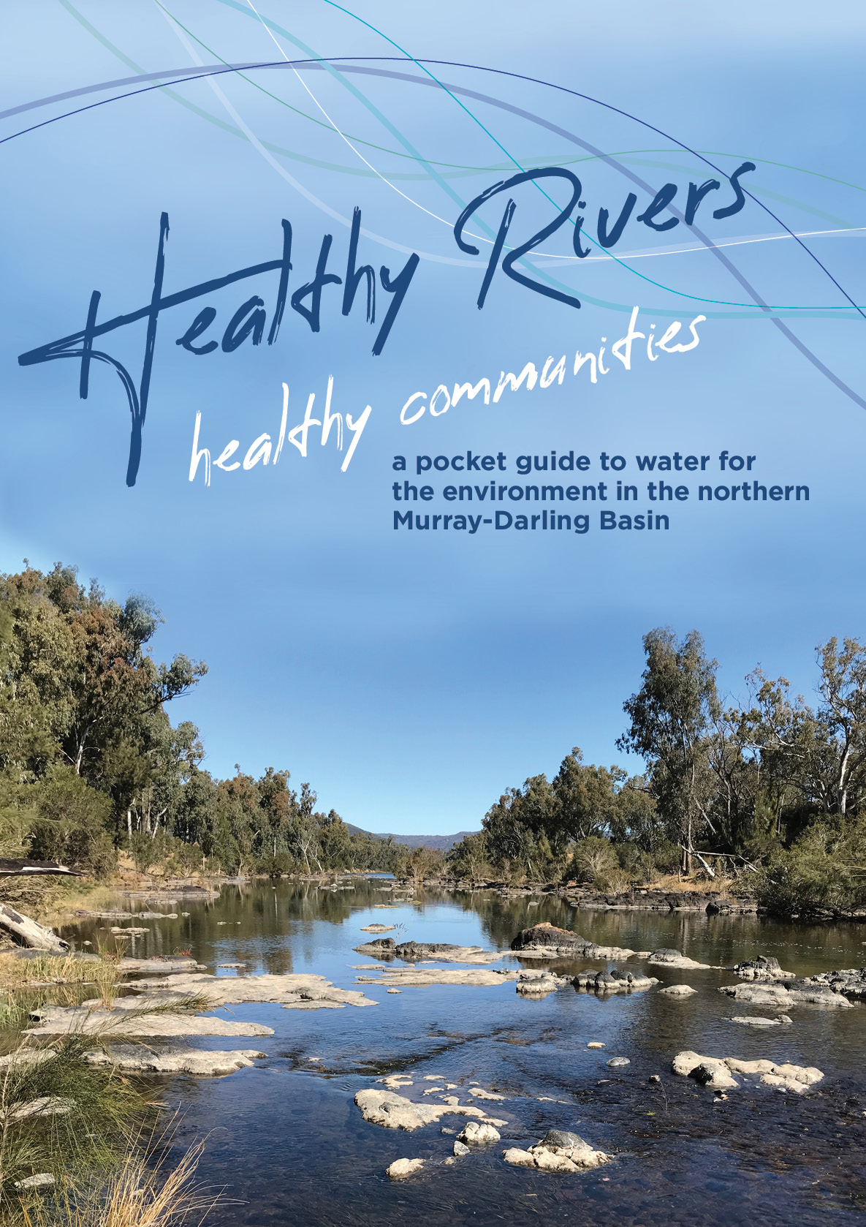

**Front cover:**   
The Dumaresq River (CEWO)

**Back cover:**   
Sunset at Narran Lakes (Jo Ocock, National Parks and Wildlife Service)

© Commonwealth of Australia, 2021.

This publication is licensed by Commonwealth of Australia under a Creative Commons Attribution 4.0 International licence. The views and opinions expressed in this publication are those of the authors and do not necessarily reflect those of the Australian Government or the Portfolio Ministers for the Department of Agriculture, Water and the Environment.

# Respect

The Commonwealth Environmental Water Office pays respect to the Traditional Owners of the Murray-Darling Basin and their Nations.

We acknowledge their enduring cultural, social, environmental, spiritual and economic connection to the rivers, wetlands and floodplains of the Basin.

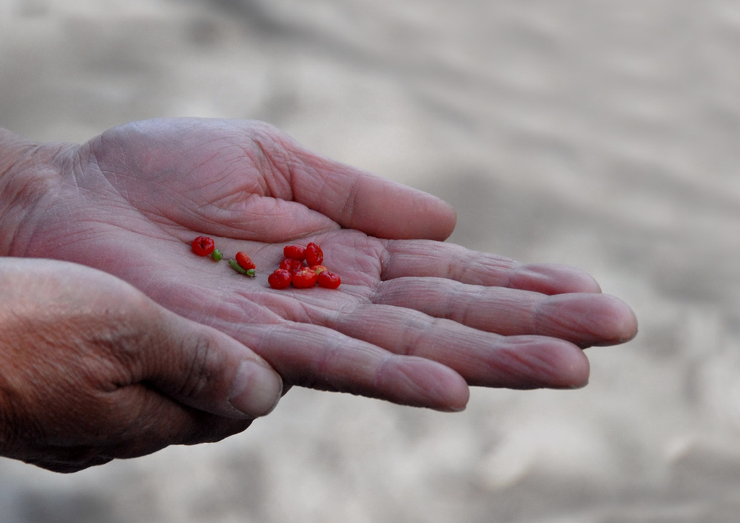

Image right: Saltbush berries in the Macquarie (CEWO)

# The Northern Murray-darling basin Map

The northern Basin covers 44% of the Murray-Darling Basin and contains over 9,100km of   
river channels.

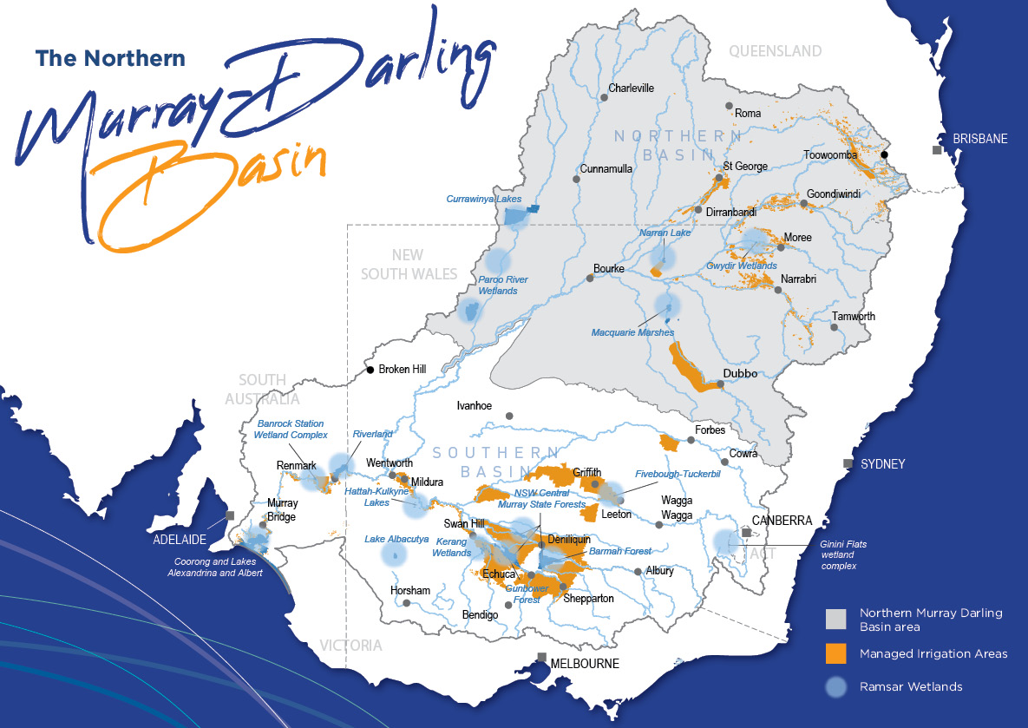

# Healthy rivers healthy communities

The northern Murray-Darling Basin has a unique climate and is home to a complex network of people and places, industries and organisations with many and varied needs.

The northern Basin’s rivers, floodplains and wetlands are vital for sustaining healthy communities and economies. The government’s world-leading investment in water for the environment is critical to ensuring rivers can support future generations.

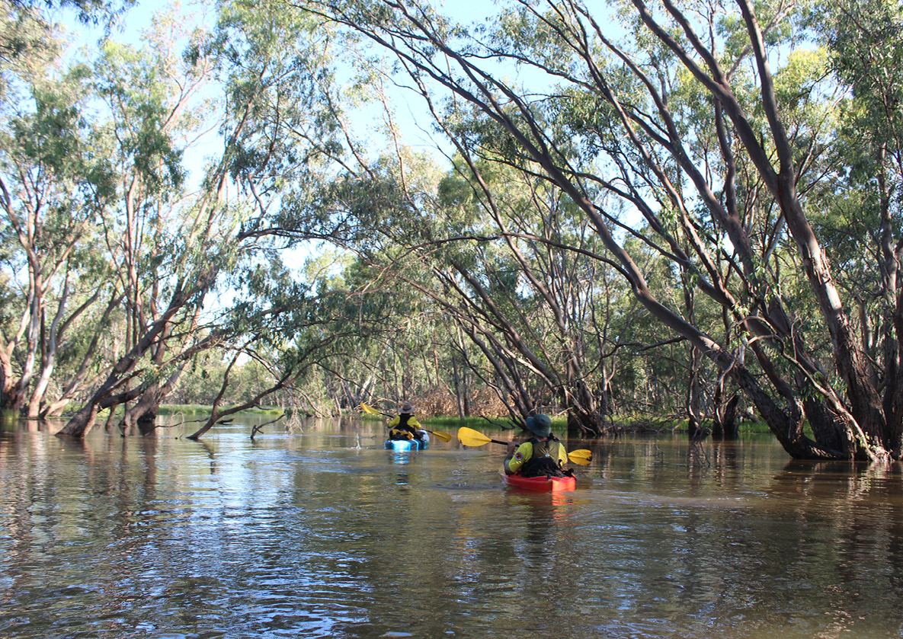

Checking waterbird breeding sites in the Macquarie Marshes (CEWO)

# What is water for the environment?

Rivers and wetlands have been changed. Water that once would have flowed naturally in rivers is now stored in dams or removed directly to provide water for towns, food and fibre production.

Some rivers now dry up more often, and for longer. Many wetlands and creeks are disconnected from rivers more frequently. This has interrupted the natural flow of water that river and wetland plants and animals need to survive.

Water allocated to keep rivers healthy by restoring some of these natural flows is known as ‘water for the environment’. Water for the environment also provides relief to river communities.

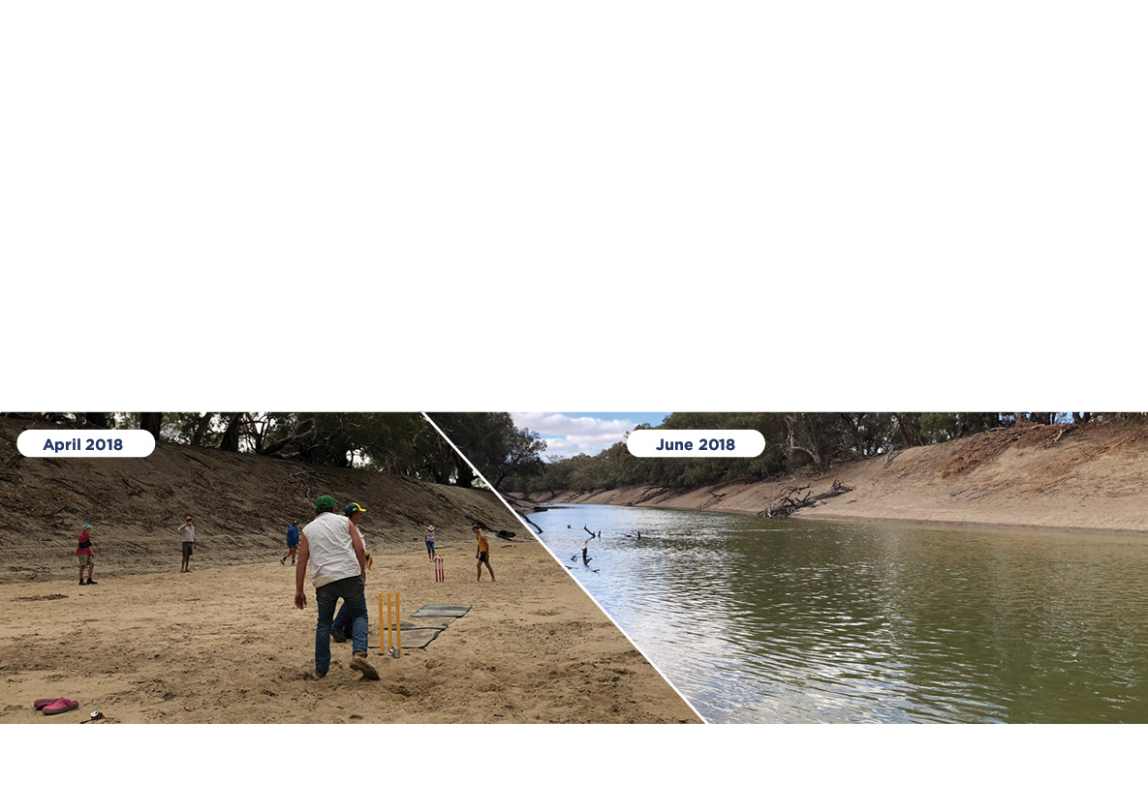

Darling River at Tilpa, NSW, before and after environmental flows. Locals were able to play cricket on the dry river bed before flows came through (Left: Tim Lee, ABC. Right: CEWO)

# Keeping the environment healthy when its dry

Droughts are tough on both people and the environment. Just like other water users, the environment receives less water during dry times.

When water allocations are low, only the highest priority sites receive water for the environment. These refuge areas help our native plants and animals hang on so they can bounce back when the drought breaks - a bit like a farmer maintaining breeding stock for better times.

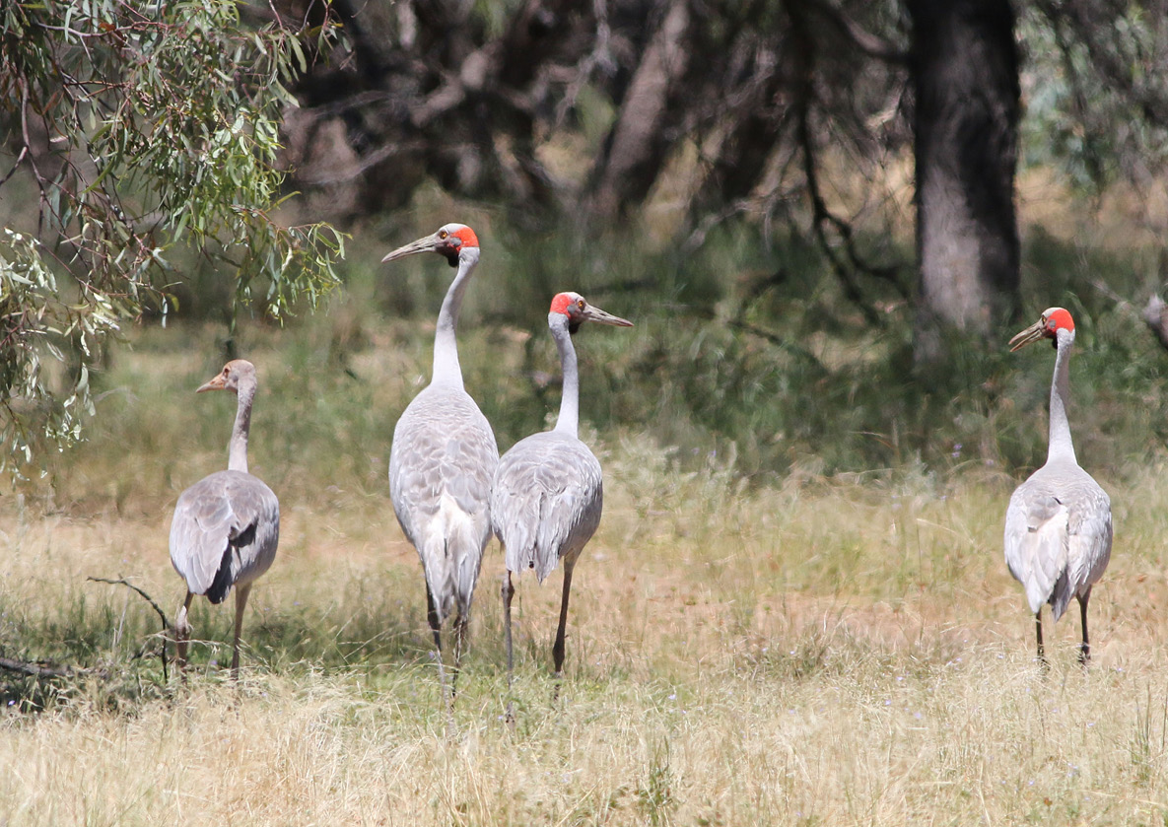

Family of brolgas in the Gwydir (P Knox)

# Delivering water for the environment

Water for the environment can be provided through water licenses or through rules under state water sharing plans.

Water licenses can work in two ways. Some licenses allow environmental water holders to place an order for water to be released from a dam so it flows on to a river or wetland. Other licenses protect natural inflows from being pumped so water stays in the river and flows to where plants and animals most need it.

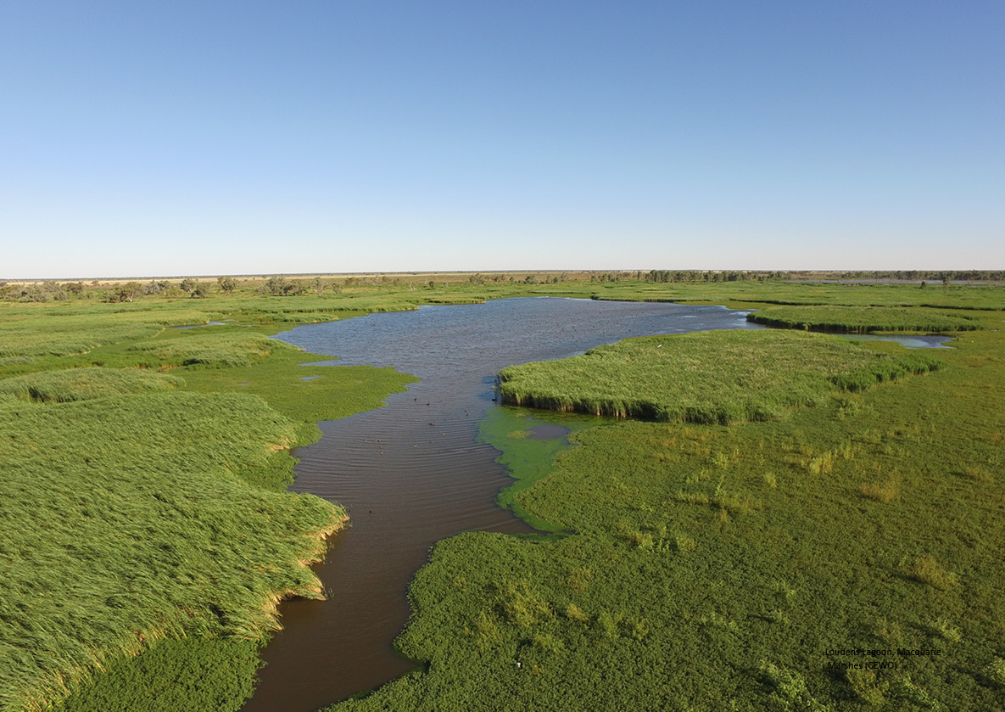

Loudens Lagoon, Macquarie Marshes (CEWO)

# How much water is for the environment?

The Murray-Darling Basin Plan sets the amount of water that can be used for towns, irrigation and other uses, including water for the environment.

The environmental water entitlements held under the Basin Plan yield on average almost 2,100 GL a year. This is 15% of the water entitlements issued by states for use in the Basin. The amount varies from catchment to catchment.

Water entitlements for the environment are subject to the same rules, allocations, and fees as those held by others. The amount of water available through entitlements varies each year, with less water available in droughts and more in wet years.

**Water entitlements held in the Murray-Darling Basin**

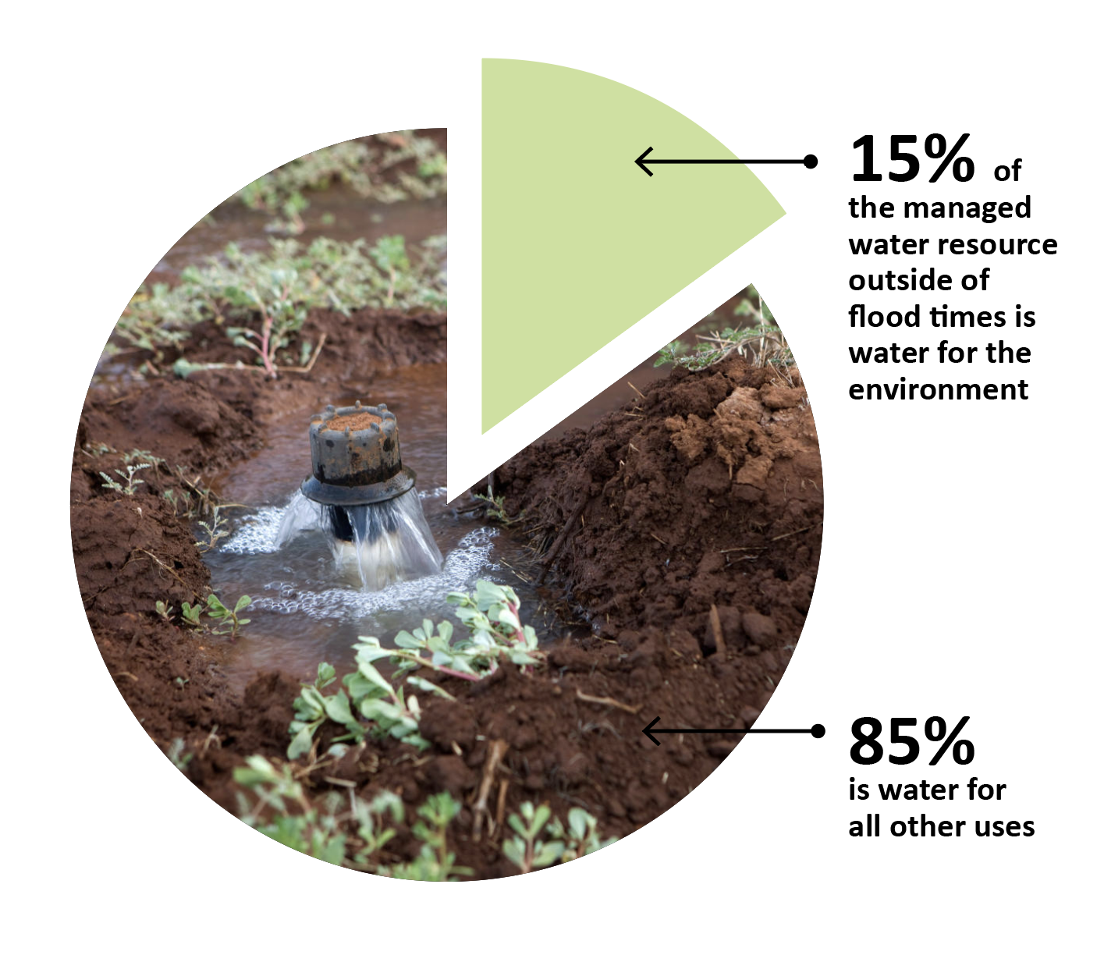

# People come first

People are looked after first. Water is allocated by state governments for essential human needs - for drinking, household, and town water supplies. These needs are met before water is allocated for any other use.

During the record breaking drought of 2017-2020, these needs were not always met from the rivers of the northern Basin. Water reforms are intended to protect and increase low flows to buffer against future droughts. In the face of increasingly hot and dry conditions, this is an ongoing challenge for Basin governments.

.

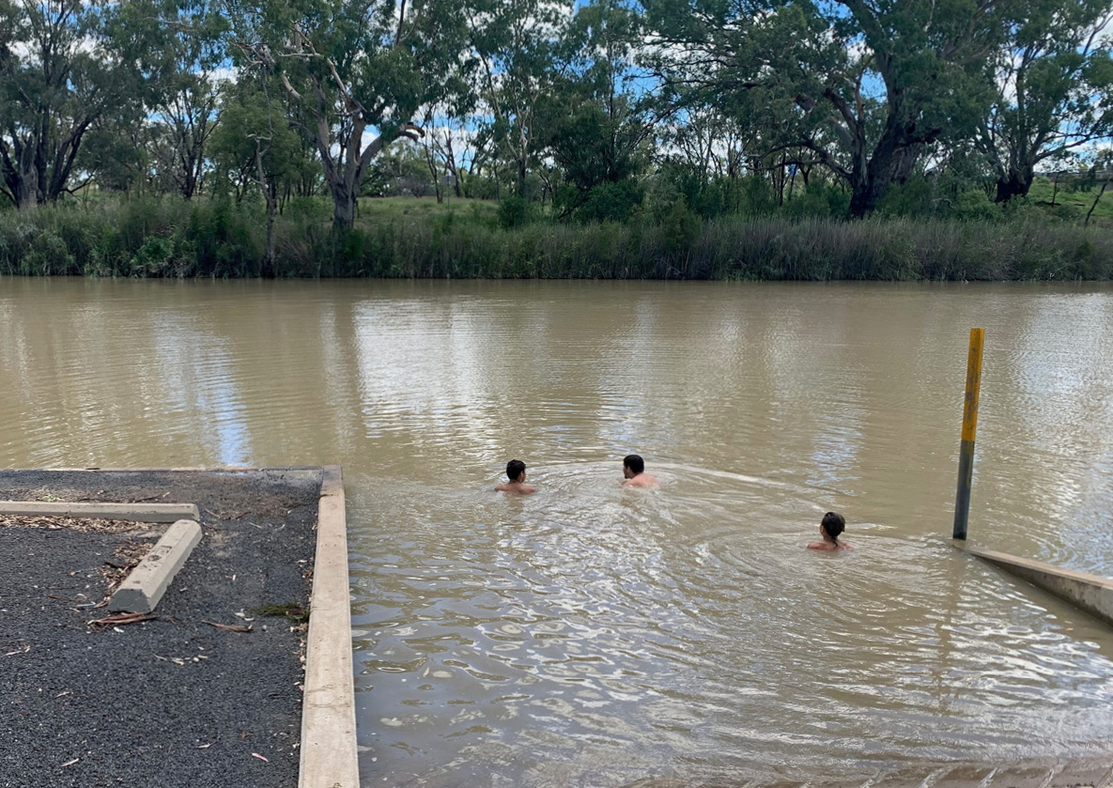

Local kids swimming in Collarenebri weir pool, 2021 (CEWO)

# Who does what?

## Public

Scientists research and monitor how best to use water to help the environment

First Nations people provide guidance on how environmental flows can meet cultural objectives

Local communities and interest groups input into how, when and where water is delivered

## State

State government agencies, including environmental water holders, work with the Commonwealth Environmental Water Holder to plan and manage environmental   
flows at local sites

State governments allocate water to entitlements and set the water sharing rules

## State/Federal

River operators run the rivers including flow planning, monitoring, and delivery

## Federal

Commonwealth Environmental Water Holder (CEWH) decides when and where to deliver environmental flows in collaboration with states and communities

Murray-Darling Basin Authority sets limits on water use through the Murray-Darling Basin Plan and provides advice on Basin-wide priorities

Australian Government agencies have recovered water for the environment, through   
both direct purchase of entitlements and investment in water savings

# Deciding when and where to water

The Basin’s weather is variable, particularly in the northern Basin. This influences how much water is allocated to water users, including the environment. In dry years, there is less water available for allocation.

To decide when, where and why to water, environmental water managers consider how much water is available and what the environment needs. We also consider the needs of communities, irrigators and the physical limitations of the river.

Environmental water managers aim to help rivers flow, keep native plants healthy, and support native animals, birds, fish and frogs. We plan for water to have multiple environmental benefits, and in some systems, to be reused as it flows down the river. Water may also be saved or ‘carried over’ from one year to the next to use when the environment needs it.

Every year is different. What we aim to achieve depends on how much water is available and what the environment needs.

## Very dry

### Main aim: Protect

• Avoid critical loss

• Maintain key refuges

• Avoid catastrophic events

## Dry

### Main aim: Maintain

• Maintain river functioning

• Maintain key functions of high priority wetlands

## Moderate

### Main aim: Recover

• Improve ecological health and resilience

• Improve opportunities for plants and animals to breed, move and thrive

## Wet to very wet

### Main aim: Enhance

• Restore key floodplain and wetland linkages

• Enhance opportunities for plants and animals to breed, move and thrive

# Working with First Nations

There are more than 40 First Nations in the Basin with many distinct cultures and practices.

Traditional knowledge has been used to manage Country for thousands of years.

The Commonwealth Environmental Water Office recognises the values and knowledge of First Nations peoples in how water for the environment is used.

We work with First Nations to identify ways to support cultural values alongside environmental outcomes.

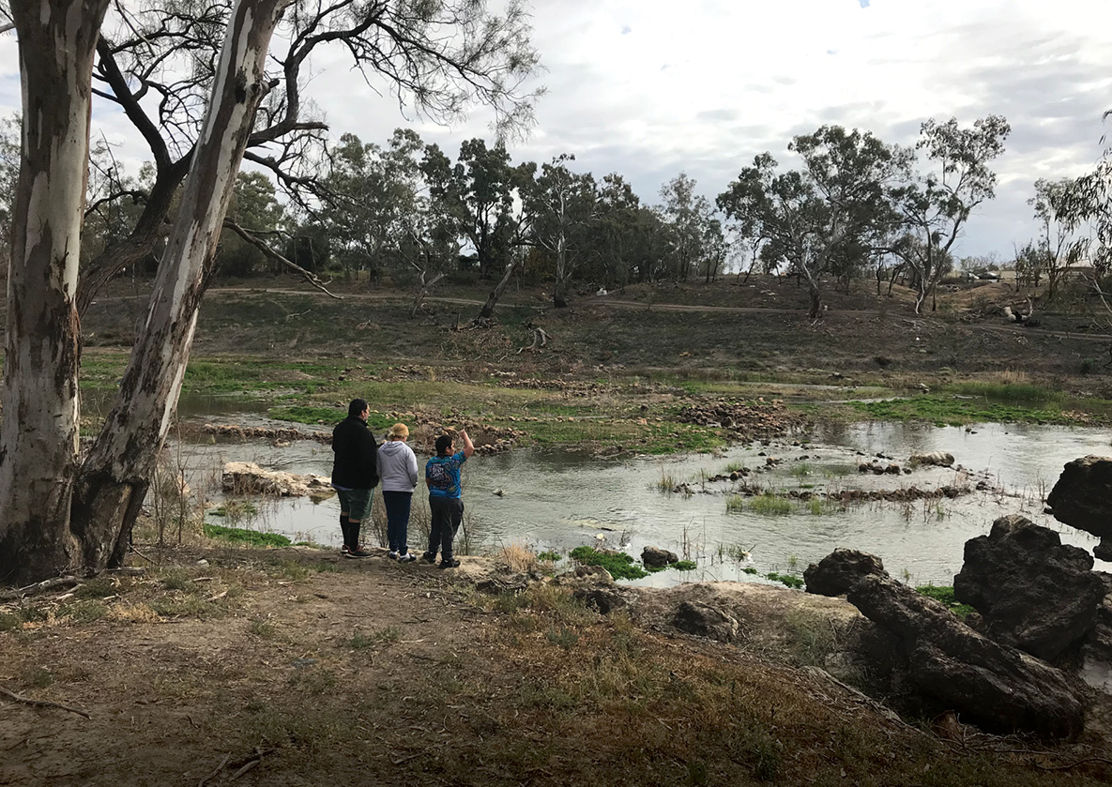

Brewarrina fish traps on the Barwon River are one of the oldest human-made structures on earth (CEWO)

# Environmental flows are backed by science

Deliveries of water for the environment are planned using the best available science.

The Commonwealth Environmental Water Office works with local communities, First Nations, scientists, and state partners to monitor the effectiveness of water for the environment.

Monitoring helps us understand how plants and animals respond to environmental flows and how we can best support them. The Commonwealth now has over ten years of robust scientific results.

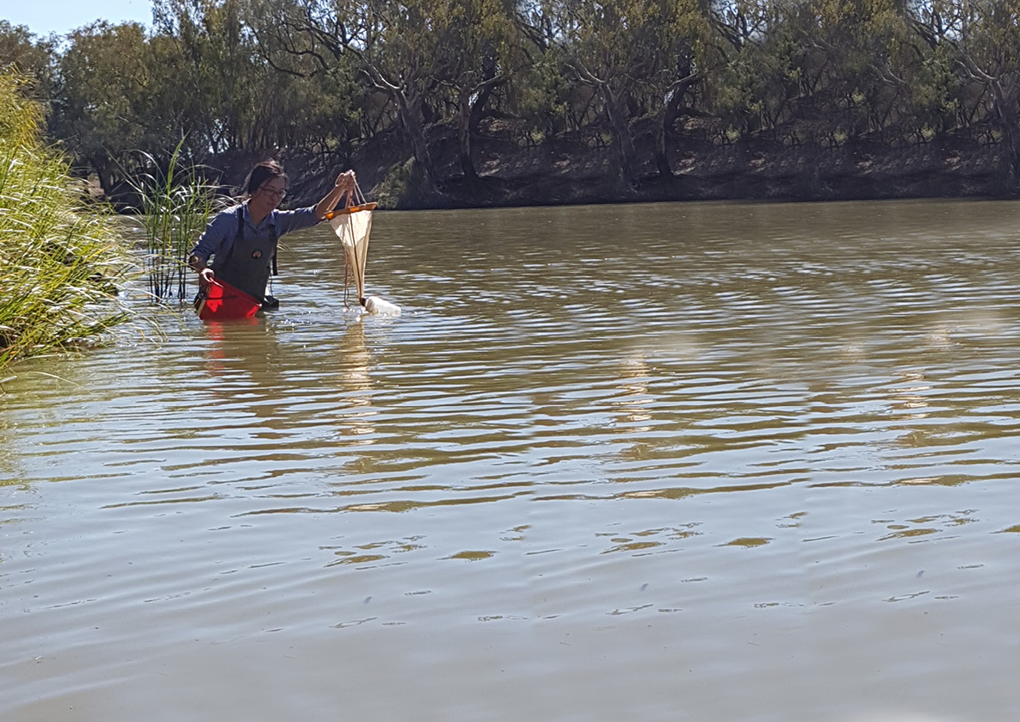

Sampling water bugs in the Barwon River, 2018 (EcoLogical)

# Success stories

**Relief for fish and communities**

In dry times, many northern Basin rivers stop flowing making it tough for communities and the environment. Native fish shelter in remaining waterholes, waiting until the rivers flow again. If the dry lasts too long, water quality declines and fish struggle to stay alive.

During the record breaking drought of 2017-2020, the Barwon River stopped flowing.

Water for the environment was used to top up waterholes and replenish food and oxygen in the water to help fish survive.

The release of water for the environment was timed to combine with releases for irrigation which meant more water flowing through the river system, boosting benefits to native fish and river communities.

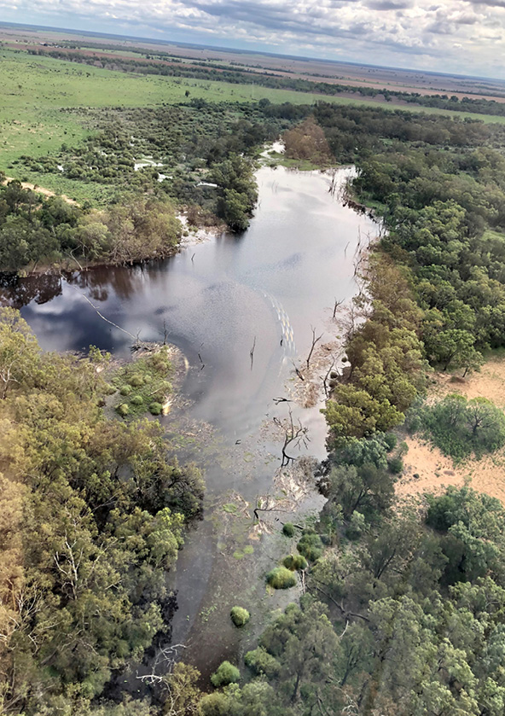

Flows filling Gingham waterhole, 2020 (Annabelle Guest, MDBA)

# Helping native fish bounce back

Water for the environment is used to get conditions just right to help native fish breed so they bounce back after long periods of dry.

Reconnecting flowing rivers and creeks means young fish can swim through the river system to complete their lifecycle. In the spring of 2020, water for the environment was delivered in the Macquarie River to help Murray cod recover after three years of extreme drought.

The timing and pattern of water releases supported Murray cod nesting during the warmer spring conditions. Flows were maintained for long enough to ensure nests were not exposed or disturbed. Monitoring of the flows indicated that Murray cod were provided with the right conditions to breed, and baby cod were given their best chance for survival and growth.

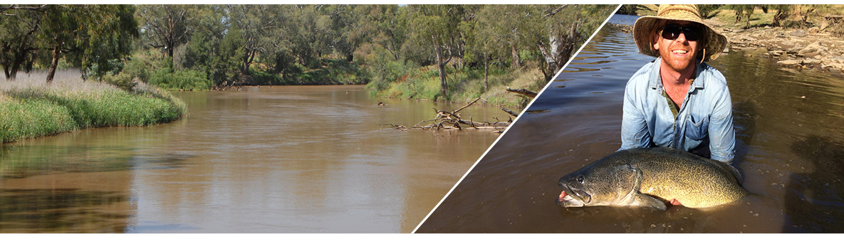

Left: Macquarie River during flows in 2020 (CEWO) Right: Murray cod in the Macquarie River (Jerom Stocks, NSW DPI-Fisheries)

# Reconnection wetlands

Wetlands are home to a diverse range of frogs, fish, waterbirds and other critters.

As a wetland dries out, plants start to die, and food and habitat for animals is reduced. If it stays dry too long, many plant species die out completely.

Narran Lakes (Dharriwaa) is of immense cultural significance for First Nations peoples and is a waterbird breeding site of national and international importance.

After seven years without decent inflows, water for the environment was used in 2020 and again in 2021 to boost river flows. This ensured water reached the stressed wetland, giving thirsty plants a drink and helping to restore important bird breeding and foraging habitat.

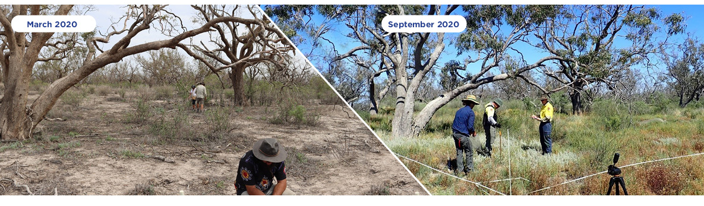

Vegetation monitoring at Narran Lakes (University of New England)

# Supporting nesting waterbirds

Wetlands in the northern Basin are key nesting sites for many waterbirds, some of which travel thousands of kilometres each year to breed.

Deliveries of water for the environment to the internationally significant Macquarie Marshes, Gwydir Wetlands and Narran Lakes have kept wetland plants alive through dry times and provided waterbirds with food and places to nest.

Water deliveries have also been used to extend periods of natural flooding to stop wetlands drying out too soon. This improves breeding success by maintaining a source of food for growing chicks. It also makes it harder for predators (such as foxes and pigs) to reach the nests.

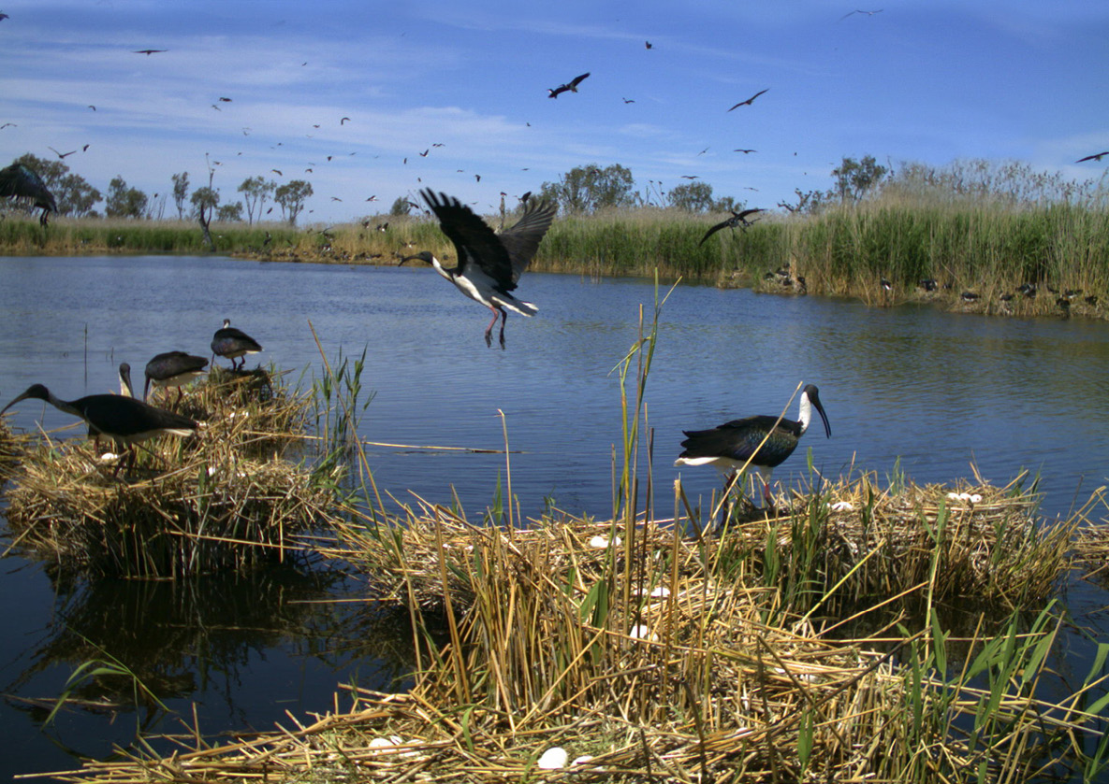

Waterbirds in the Macquarie during the 2016 -17 waterbird breeding event (Heather McGinness, CSIRO)

# Working together

Local knowledge and experience are critical to effectively deliver water for the environment.

Delivering water for the environment is a collaborative effort and relies on strong relationships between a range of groups and organisations.

The Commonwealth Environmental Water Office has Local Engagement Officers working alongside Traditional Owners, scientists, land managers and other government organisations to ensure water for the environment is delivered using the best available knowledge and meets local needs.

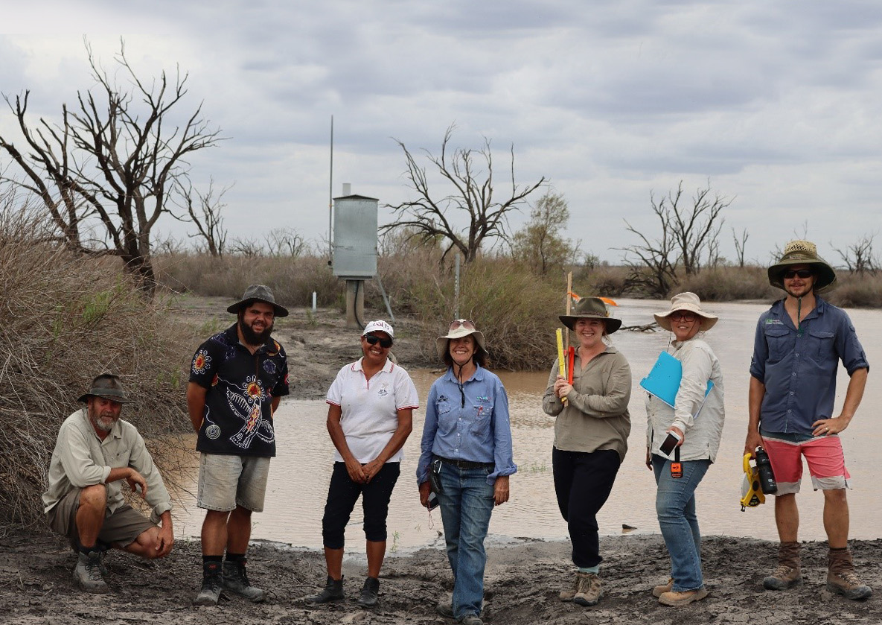

CEWO Local Engagement Officer (middle) with scientists, Traditional Owners and NSW government officials at Narran Lakes in 2020 (CEWO).

