**
Healthy rivers healthy communities: a pocket guide to water for the envi-ronment 
Healthy Rivers Healthy communities: a pocket guide to water for the environment**

**Front cover:**Fishing on the River Murray (CEWO)

**Back cover:**Sunset over Warrego River, NSW (CEWO)

© Commonwealth of Australia, 2020.

This publication is licensed by Commonwealth of Australia under a Creative Commons Attribution 4.0 International licence. The views and opinions expressed in this publication are those of the authors and do not necessarily reflect those of the Australian Government or the Portfolio Ministers for the Department of Agriculture, Water and the Environment.

**Image right:** Smoking ceremony celebrating partnerships with First Nations to deliver environmental flows (Nature Foundation of South Australia, M. Turner)

# Respect

The Commonwealth Environmental Water Office pays respect to the Traditional Owners and First Nations of the Murray-Darling Basin.

We acknowledge their enduring cultural, social, environmental, spiritual and economic connection to the rivers, wetlands and floodplains of the Basin.



# Murray-darling basin Map

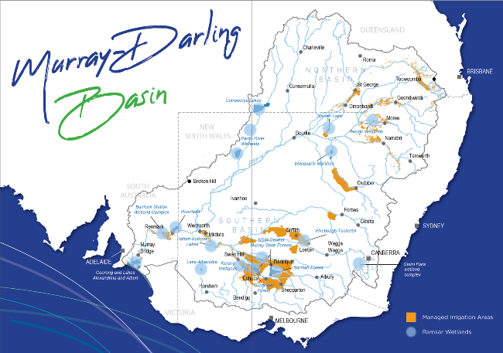

# Healthy rivers healthy communities

The Murray-Darling Basin’s rivers, floodplains and wetlands are vital for sustaining healthy communities and economies.

More than 2.6 million people call the Basin home and 3 million people access drinking water from its rivers. The government’s world-leading investment in water for the environment is critical to ensuring our rivers are able to support future generations.

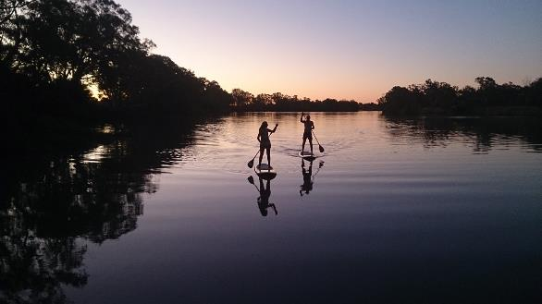

# What is water for the environment?

Rivers and wetlands have been changed to provide water for towns, industry and food production.

This has interrupted the natural flow of water that plants and animals need to survive. With natural runoff from rainfall now captured in dams, rivers need to be actively managed to keep them healthy.

Water allocated to keep the river healthy is known as water for the environment. This water is carefully managed to ensure it delivers the best environmental outcomes, while benefitting river communities.

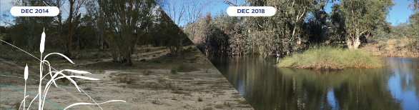

Banrock Station, South Australia, before and after receiving environmental flows   
(Tim Field, Accolade Wines)

# Keeping the environment healthy when its dry

Droughts are tough on everyone, including the environment. Just like other water users, the environment receives less water during dry times.

When water allocations are low, only the highest priority sites receive environmental flows. These refuge areas help our native plants and animals bounce back when the drought breaks - a bit like a farmer maintaining breeding stock for better times.

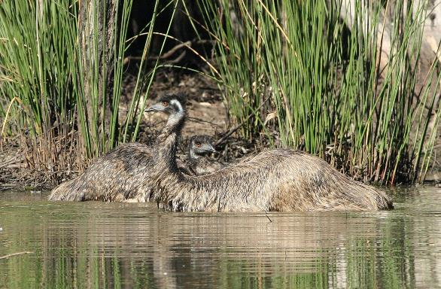

# How much water is for the environment?

The Murray-Darling Basin Plan sets the amount of water each year that can be used for irrigation and other uses, while leaving enough to keep the environment healthy.

The environmental water entitlements held under the Basin Plan on average yield almost 2,100 GL a year.  This is 15% of the water entitlements issued by states for use in the Basin.

The amount of water available through entitlements varies each year, depending on how much is allocated by state governments. In times of drought, allocations to entitlements are reduced the same way for all water users—including environmental water holders.

Water entitlements for the environment are subject to the same allocations, fees, rules and carryover arrangements as all other uses.

15% of the managed water resource outside of flood times is our environmental water.

85% is water for all other uses


# People come first

People are always looked after first. Water is allocated by state governments for critical human needs- for drinking, household and stock water supplies – before being allocated for any other use.

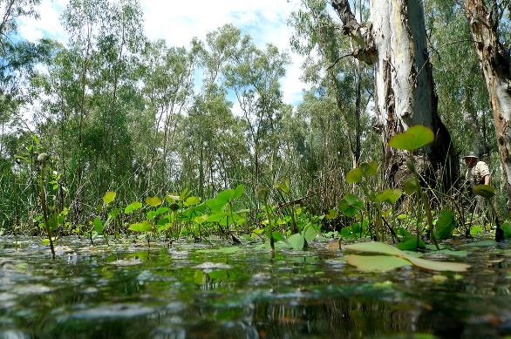

# Who does what?

## Public

Scientists research and monitor how best to use water to help the environment

First Nations peoples provide guidance on how environmental flows can meet cultural objectives

Local communities and interest groups input into how, when and where water is delivered

## State

State government land managers and environmental water holders work with the Commonwealth Environmental Water Holder to deliver environmental flows at local sites

State governments allocate water to entitlements

## State/Federal

River operators run the rivers including flow planning and delivery.

## Federal

Commonwealth Environmental Water Holder (CEWH) decides when and where to deliver environmental flows in collaboration with states and communities

Murray-Darling Basin Authority sets limits on water use through the Murray-Darling Basin Plan, provides advice on Basin-wide priorities and runs the River Murray system.

Australian Government recovers water for the environment, either through direct purchase of entitlements or investment in water savings

# Deciding when and where to water

Our weather is variable and influences how much water is allocated to users across the Basin, including the environment. In dry years, there is less water available.

In deciding why, when and where to water, managers consider how much water they have and what the environment needs. They also consider the needs of communities, irrigators and the physical limitations of the river.

Environmental water managers aim to help rivers flow, keep native plants healthy, and support native animals, birds, fish and frogs. They plan for water to be reused as it flows down the river. Water may be saved or ‘carried over’ to use when the environment needs it.

Every year is different. What we aim to achieve depends on how much water is available and what the environment needs.

## Very dry

### Main aim: Protect

• Avoid critical loss

• Maintain key refuges

• Avoid catastrophic events

## Dry

### Main aim: Maintain

• Maintain river functioning

• Maintain key functions of high priority wetlands

## Moderate

### Main aim: Recover

• Improve ecological health and resilience

• Improve opportunities for plants and animals to breed, move and thrive

## Wet to very wet

### Main aim: Enhance

• Restore key floodplain and wetland linkages

• Enhance opportunities for plants and animals to breed, move and thrive

# A small part of the river

Water for the environment is released when our native plants and animals need it most.

Typically, water for the environment makes up only a small part of the water flowing down the river. Other water in the river is for towns, cities, irrigators and industry.

In a Southern Basin river such as the Murray, most environmental flows are released in spring and autumn when wetlands and floodplains need it.

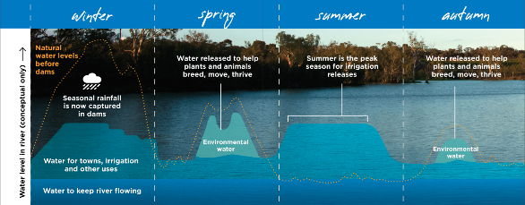

# Working with First Nations

There are more than 40 First Nations in the Basin with many distinct cultures, practices and governance systems.

Traditional knowledge has been used to manage Country for thousands of years.

We recognise the values and knowledge of First Nations peoples in how we use water for the environment.

We work with First Nations to deliver water to support cultural values alongside environmental outcomes.

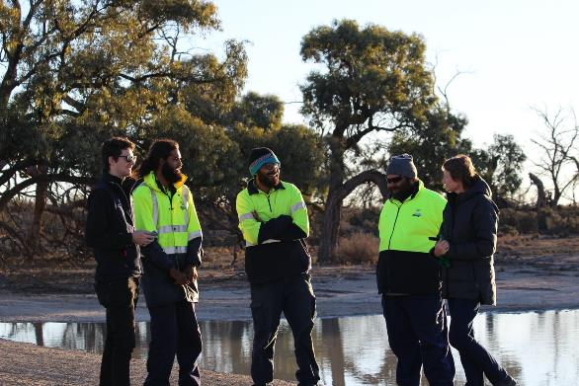

# Environmental flows are backed by science

We plan all our flows using the best available science. We also work with local communities, First Nations, scientists and state partners to monitor the effectiveness of water for the environment.

Monitoring helps us understand how plants and animals respond to environmental flows and how we can best support them. The Commonwealth now has over ten years of robust scientific results.

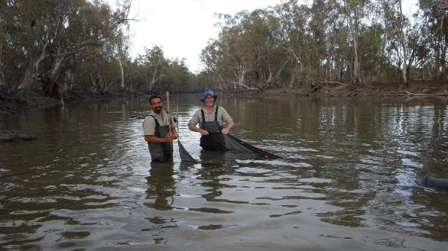

# Some of our success stories

## Helping waterbirds

There are many occasions where water for the environment has helped nesting birds. One example is in 2016, when floods triggered breeding of thousands of straw-necked ibis in wetlands along the Lachlan River in NSW.

Governments and scientists used environmental flows to stop the wetlands drying out over summer, saving almost 9000 ibis chicks from starvation.

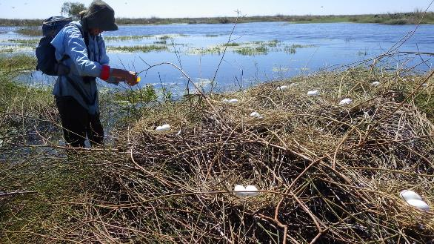

# Partnerships

## Award-winning partnership with irrigators

In South Australia, Renmark Irrigation Trust is partnering with us to deliver water using their irrigation pipes. Water can flow to where it’s needed to keep the floodplain healthy, while maintaining irrigation infrastructure in the off-season.

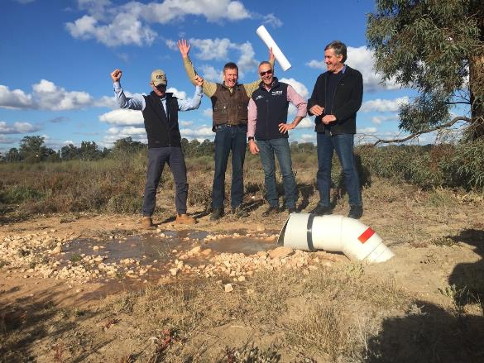

# The Coorong

## Supporting native fish in the Coorong

Local community, scientists and water managers worked together to deliver environmental flows in spring and summer 2017-18 to support black bream breeding in the Coorong for the first time since the Millennium Drought. Monitoring showed this important native fish had survived throughout the estuary.

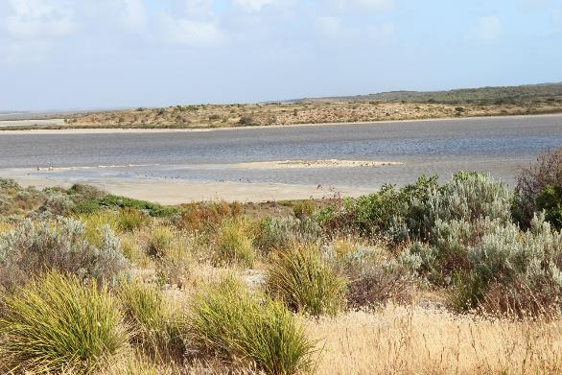

# Working together

## Working together to achieve more

In winter and spring 2019, governments and local communities worked together to deliver water.

This water travelled over 2000 kilometres along the River Murray, from Hume Dam in NSW to the Coorong in South Australia - providing food for fish, water for native plants like the iconic River Red Gum and flushed salt out of the river system.

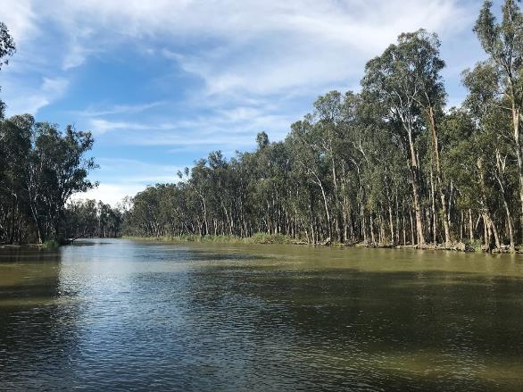

# Relief for Communities

## Providing relief for fish and river communities

Water for the environment has been used in the northern Basin to replenish the Barwon-Darling and Gwydir river systems.

In 2018 environmental flows connected multiple river systems from upstream of Goondiwindi to Menindee Lakes.

In 2019, another flow to help native fish travelled 1500 kilometres, topping up water holes along the Barwon River. Before this release, water had not flowed over the weir on the Barwon River near Walgett for 330 days.

Darling River at Tilpa, NSW, before and after receiving environmental flows. Locals were able to play cricket on the dry river bed before the flows came through. (Tim Lee, ABC)

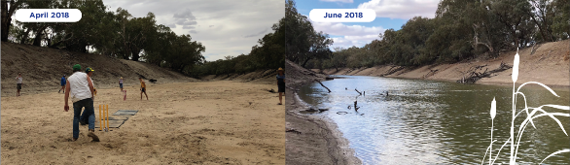

**Connect with us
E: ewater@awe.gov.au
W: environemnt.gov.au/water/cewo
P: 1800 803 772**