September 2025

# Entering an Entity Identifier (AEI) into the Integrated Cargo System

This help card provides a guide on how to search and enter an Entity Identifier (AEI) when lodging an import declaration in the Integrated Cargo System (ICS). The AEI is used to track and manage offshore treatment certification that accompanies consignments entering Australia.

The screen shots used in this help card are from the Customs Connect Facility. If using 3rd party software, the screens may appear visually different however the field titles should be the same.

## Step 1

When adding tariff line information click the ‘**Add AQIS Information**’ button.

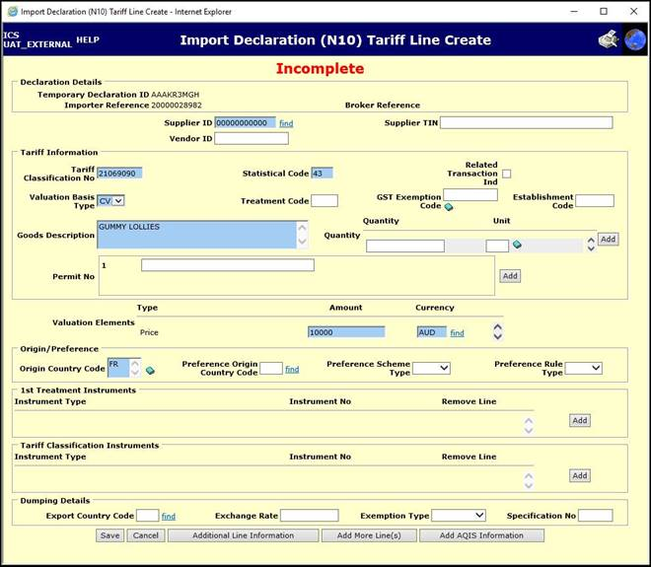

## Step 2

Click the **book icon** next to the ‘**AQIS Entity ID**’ field.

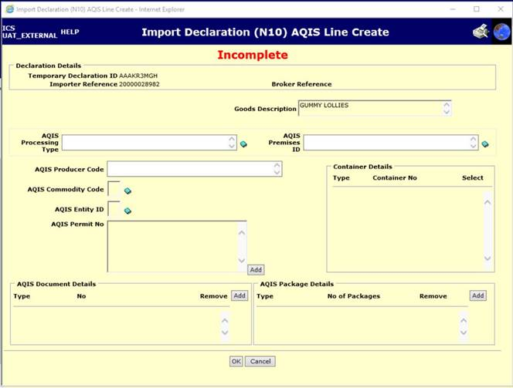

## Step 3

Select the AEI(s) for the offshore treatment provider(s) and click the ‘**OK**’ button. Multiple AEIs can be selected.

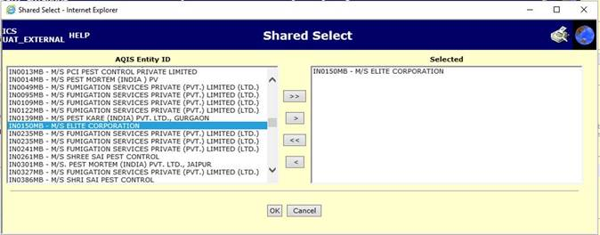

## Step 4

Complete all other required fields of the import declaration.

Note: AQIS Entity Identifier continues to be used in the ICS environment as it has been hard coded in the system and is unable to be changed.

### More information

For further information and contact details visit the [Entity Identifier (AEI)](https://www.agriculture.gov.au/biosecurity-trade/import/arrival/clearance-inspection/documentary-requirements/entity-identifier) webpage.

**Acknowledgement of Country**

We acknowledge the continuous connection of First Nations Traditional Owners and Custodians to the lands, seas and waters of Australia. We recognise their care for and cultivation of Country. We pay respect to Elders past and present, and recognise their knowledge and contribution to the productivity, innovation and sustainability of Australia’s agriculture, fisheries and forestry industries.

© Commonwealth of Australia 2025

Unless otherwise noted, copyright (and any other intellectual property rights) in this publication is owned by the Commonwealth of Australia (referred to as the Commonwealth).

All material in this publication is licensed under a [Creative Commons Attribution 4.0 International Licence](https://creativecommons.org/licenses/by/4.0/legalcode) except content supplied by third parties, logos and the Commonwealth Coat of Arms.

The Australian Government acting through the Department of Agriculture, Fisheries and Forestry has exercised due care and skill in preparing and compiling the information and data in this publication. Notwithstanding, the Department of Agriculture, Fisheries and Forestry, its employees and advisers disclaim all liability, including liability for negligence and for any loss, damage, injury, expense or cost incurred by any person as a result of accessing, using or relying on any of the information or data in this publication to the maximum extent permitted by law.