January 2026
Industry reporting help card

How to access Industry reporting

Introduction
This help card is designed to assist approved arrangement class 19 accredited persons on how to sign in to the Biosecurity Portal using myID with a digital identity or by using an email address and password to navigate to Industry Reporting.

Access methods
There are two registration methods available to sign in to the Biosecurity Portal:
- Method 1: myID with a digital identity
- Method 2: email and password
The services available via the portal are determined by the sign in method. Both Method 1 and Method 2 offer access to Industry Reporting.
About Method 1: MyID – Digital Identity
The portal uses Digital Identity, governed by the Digital Transformation Agency (DTA), as an authenticated and secure way of signing in to government services.
Prerequisites
To sign in using digital identity, you must:
- have a government digital identity through myID
- have an identity strength of at least ‘Standard’ or ‘Strong’ for principal authorities
- be linked to a business (using an Australian Business Number (ABN)) in the Relationship Authorisation Manager (RAM).
About Method 2: Email and password
The Biosecurity portal uses an email address and password as another authenticated and secure way to log in if the user prefers not to use their myID to access the portal.
Prerequisites
To sign in using email address, you must:
- be both an accredited person and site contact to gain access to the reporting
- have access to a personal or official email address that matches the email associated to your organisation/s
- Authenticator app should be installed in your mobile device for Multifactor Authentication (MFA).

Sign up to the Biosecurity Portal
Note: If you are not a first-time Biosecurity Portal user, please skip to the Sign in to the Industry Reporting Tool section.
- Open the Biosecurity Portal home page.
- Select Sign in with your email address to access tile.
Screenshot 1 Biosecurity Portal home page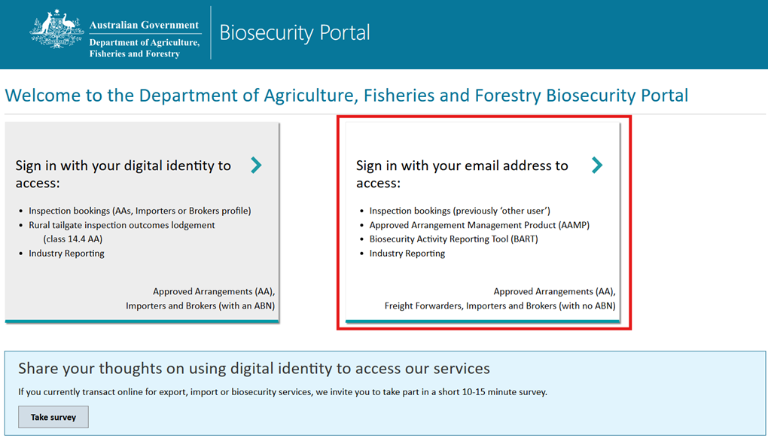
- Click on the Sign up link.
Screenshot 2 Sign in with your local account page
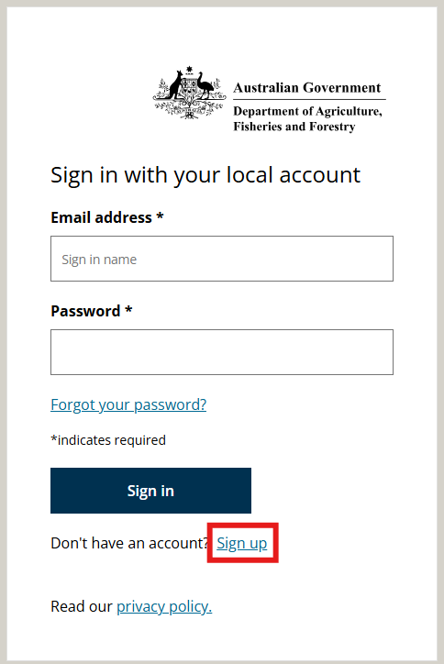
- Type in your email address into the Email address*field and click on Send verification code button. You will receive an email to your nominated email address with a verification code.
Screenshot 3 Sign up page
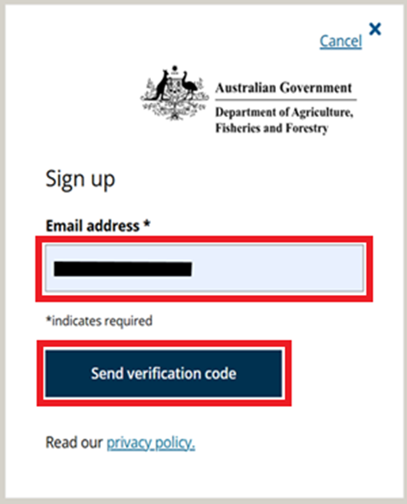
- Type the verification code into the Enter your email verification code field and click on the Submit button.
Screenshot 4 Code Verification page
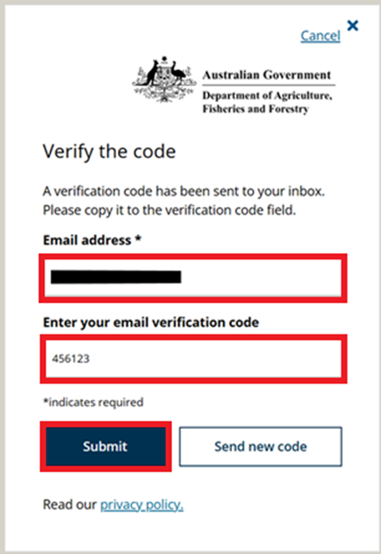
- Type in all asterisks (*) compulsory section details and click on the Create account button.
Screenshot 5 Create an account page
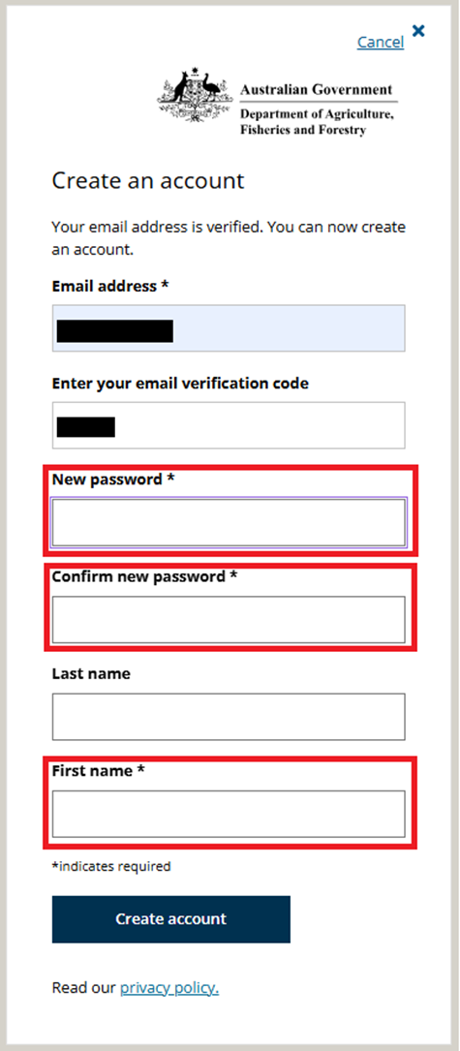
- As a first-time portal user, you will then be redirected to the Biosecurity Portal My profile page. Continue to the next step to complete your profile.

Complete personal profile
Note: Mandatory questions are marked with an Asterix (*). You must enter a response to each mandatory question and tick the Privacy Notice check box. If you do not tick the check box, you will be unable to submit the form, and an error message will display.
- Type in your contact details then tick the Privacy Notice check box.
- Click on the Submit button to continue.
- If you are a first-time user and an administrator, you will be redirected to the Biosecurity Portal My organisation page. Continue to the next section of this help card to complete your profile. Otherwise, return to the Biosecurity Portal home page by clicking on the Home option in the top left corner of your profile screen.
Screenshot 6 My profile contact details within Biosecurity Portal
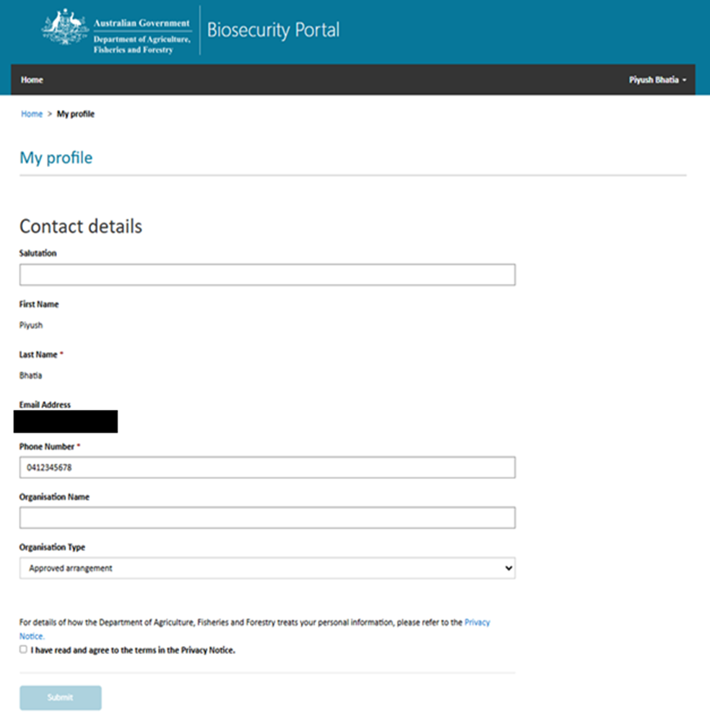

Tip -- Using a saved bookmarked link.
If you have saved a link to Industry Reporting using your browser, when you open the link, you will first be redirected to the Biosecurity Portal sign in page where you can sign in with your digital identity/email address. You will then be redirected to the Industry Reporting page.
NOTE: Users can on only view the ABN information that has been selected and can only see the cargo status related to the selected ABN. While your saved URL can be shared with another user, they can still only sign in to their respective ABN.

Sign in to the Industry Reporting Tool for the first time
Once you have set up your account, navigate to the Biosecurity Portal home page to sign in.
- Open the Biosecurity Portal home page.
- Select Sign in with your email address to access: tile.
Screenshot 7 Biosecurity Portal home page
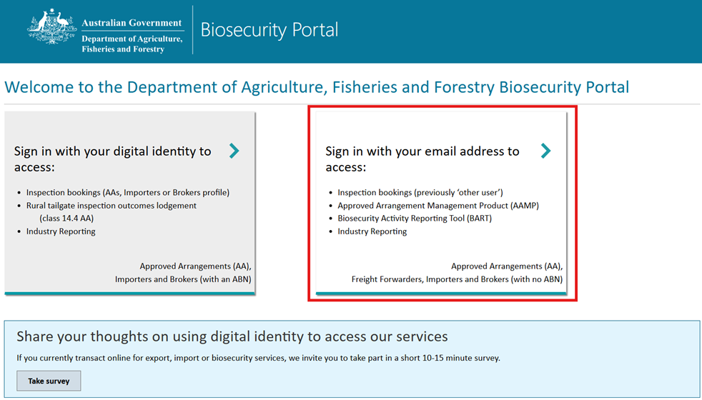
- Type in your Email address* and Password* and click on the Sign in button.
Screenshot 8 Sign in with your local account page
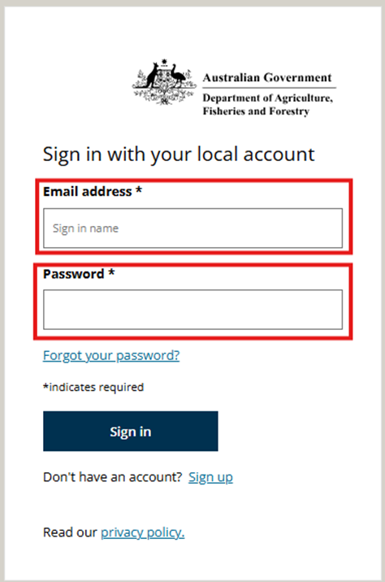

- The Welcome to the Department of Agriculture, Fisheries and Forestry Biosecurity Portal home page will then be displayed.
- Select the Industry reporting tile and you will be asked to set up an MFA using a QR code. Refer to New Users – How do I sign up and login user guide for instructions (See points 1.12 to 1.25).
Screenshot 9 Welcome page after signing in
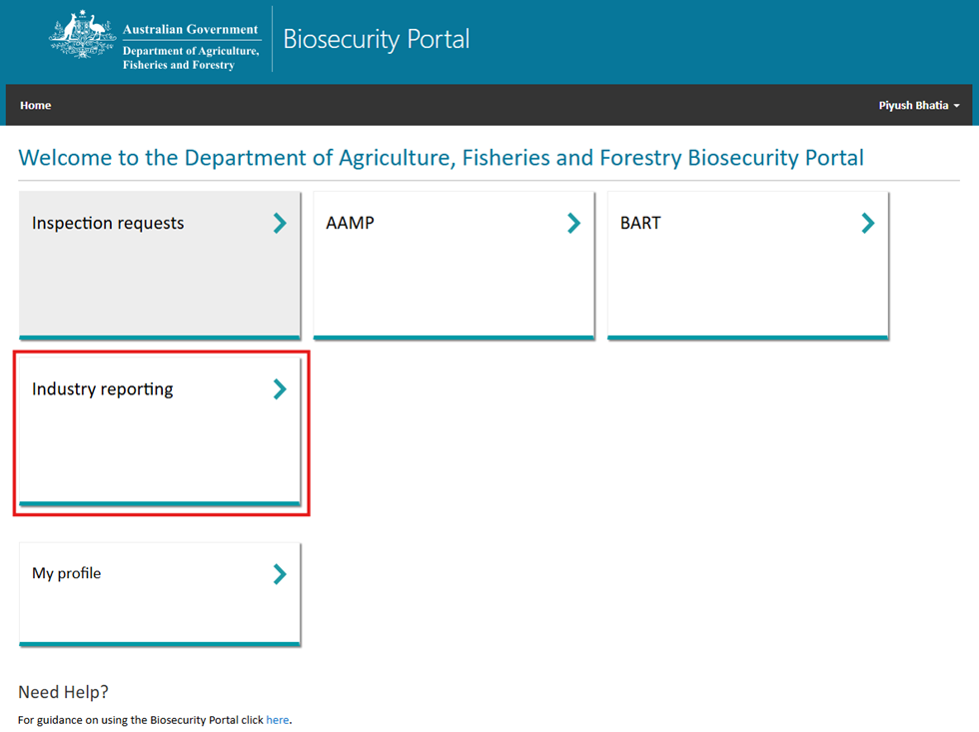
Screenshot 10 QR code to setup Multifactor Authentication first time
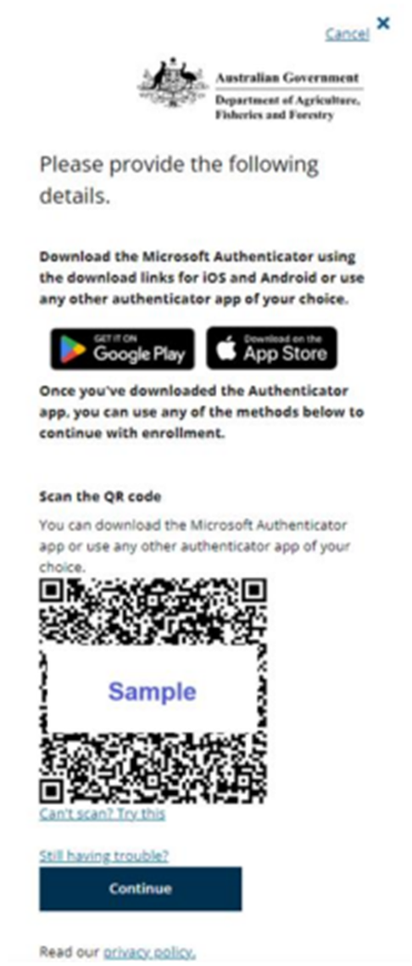

- Scan the QR code using an authenticator app (such as Microsoft Authenticator) on your mobile device and click on the Continue button to go to the next step.
- Type in the verification code received from your authenticator app then click on the Verify button.
Screenshot 11 Multifactor authentication for access to industry reporting
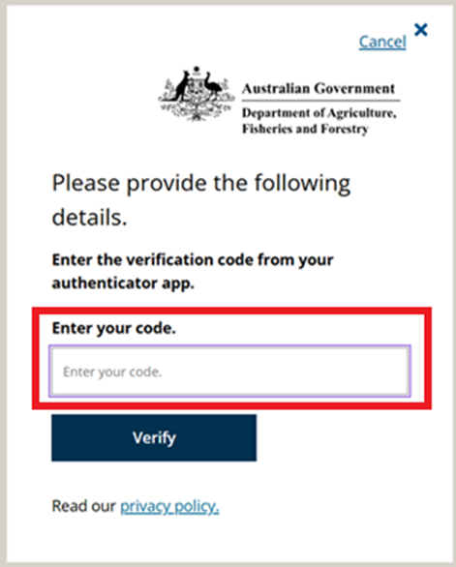
- If you are a representative of multiple ABNs, select the Organisation (ABN) you are representing. otherwise, proceed to Step 10.
Screenshot 12 Industry reporting home page with multiple ABNs
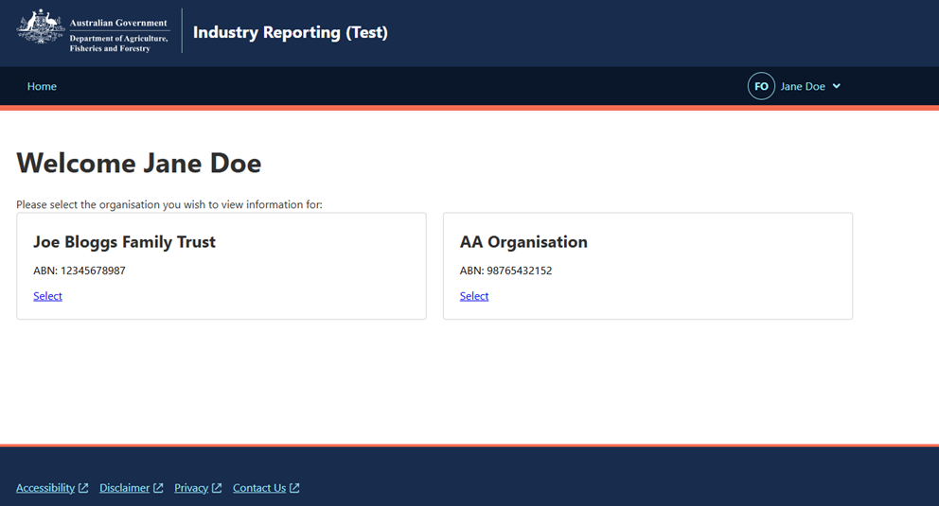
- Once you have selected an organisation (ABN), the Industry Reporting home page will refresh and display the following screen:
Screenshot 13 Industry reporting home page when an ABN is selected
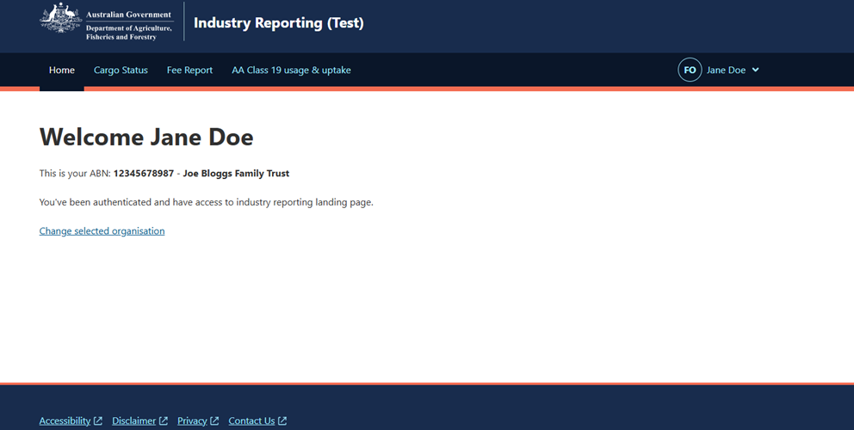
- Select the report tabs on the industry reporting page to access the relevant reporting information.
Screenshot 14 Industry reporting home page when a reporting tab is selected
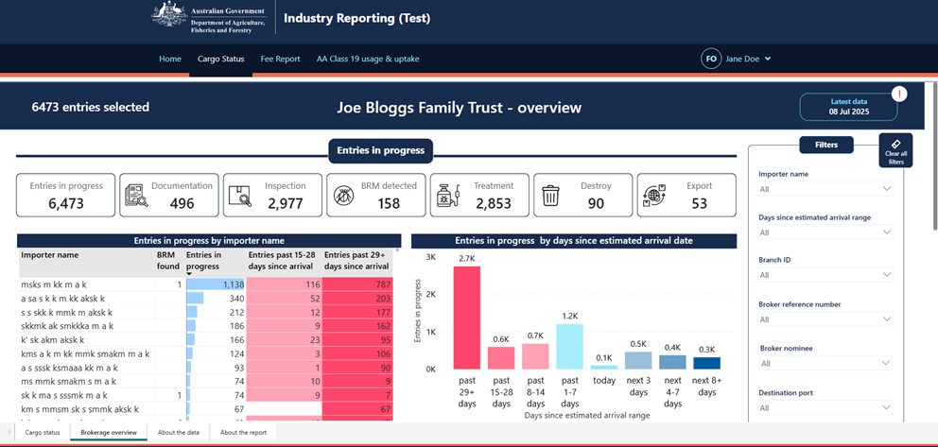

Changing organisations within the Industry Reporting Tool
- After selecting an organisation (ABN) and you decide to change your selection, click on the Change selected organisation link on the industry reporting home page and you will be redirected to the multiple organisation (ABN) page as displayed below:
Screenshot 15 Industry reporting home page with multiple ABNs
- Alternatively, you can change the organisation by selecting from dropdown arrow next to your username as displayed below:
Screenshot 16 Drop-down where user can change the organisations
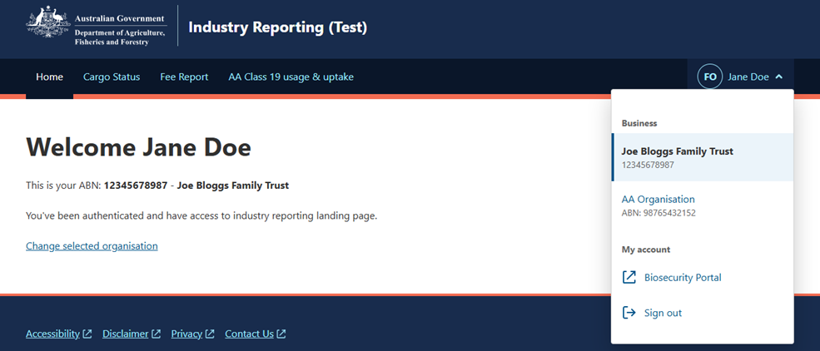

Screenshot 17 Homepage updated with Organisation name as Prefix
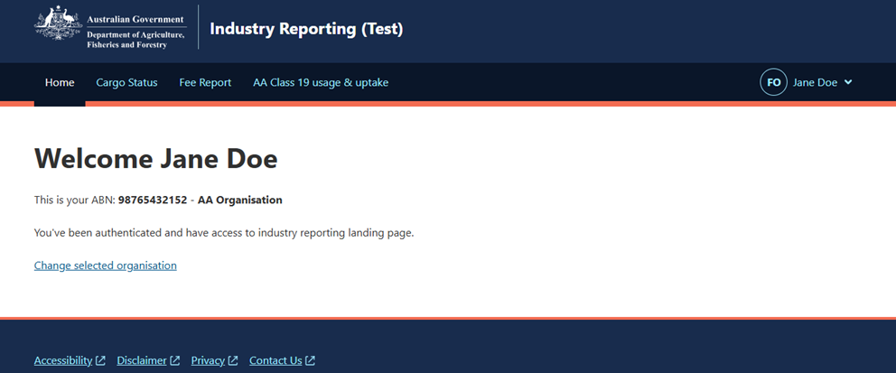

Close or sign out of the Industry Reporting Tool
- Select the dropdown arrow next to your username.
- Select Biosecurity Portal in the drop-down menu to return to the main Biosecurity Portal home page without signing out of the industry reporting page.
- Alternatively, select the Sign out option from the drop-down menu to sign out of industry reporting page.
Screenshot 18 Drop-down to navigate to Biosecurity Portal home page and sign out
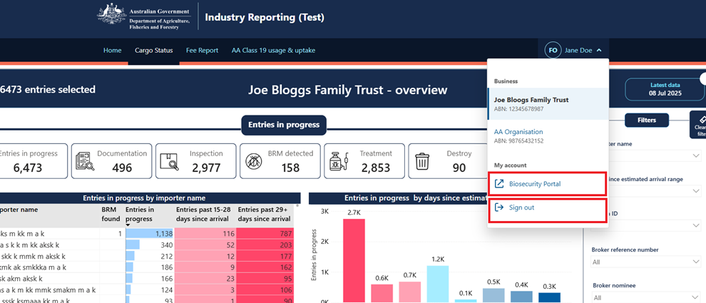

More information
Learn more about setting up a Digital Identity and linking a business (ABN) in the Relationship Authorisation Manager refer to the following links:
- About Digital Identity – an overview of digital identity
- Steps to set up your Digital Identity – a step-by-step guide to download the myID App and establish your identity
- Verifying your identity – a guide on how to verify your identity
- About the principal authority – information on the principal authority and linking a business online in Relationship Authorisation Manager (RAM)
- About authorised users and administrators – Information about roles in RAM
- Steps to setup MFA app on mobile device – a step-by-step guide to download the authenticator app. See points 1.12 to 1.25
For more information on the Biosecurity Portal or the Simplified Targeting and Enhanced Processing Systems (STEPS) program refer to the following links or email STEPS@aff.gov.au:
- Biosecurity Portal or STEPS program
Acknowledgement of Country
We acknowledge the continuous connection of First Nations Traditional Owners and Custodians to the lands, seas and waters of Australia. We recognise their care for and cultivation of Country. We pay respect to Elders past and present, and recognise their knowledge and contribution to the productivity, innovation and sustainability of Australia’s agriculture, fisheries and forestry industries.
© Commonwealth of Australia 2026
Unless otherwise noted, copyright (and any other intellectual property rights) in this publication is owned by the Commonwealth of Australia (referred to as the Commonwealth).
All material in this publication is licensed under a Creative Commons Attribution 4.0 International Licence except content supplied by third parties, logos and the Commonwealth Coat of Arms.
The Australian Government acting through the Department of Agriculture, Fisheries and Forestry has exercised due care and skill in preparing and compiling the information and data in this publication. Notwithstanding, the Department of Agriculture, Fisheries and Forestry, its employees and advisers disclaim all liability, including liability for negligence and for any loss, damage, injury, expense or cost incurred by any person as a result of accessing, using or relying on any of the information or data in this publication to the maximum extent permitted by law.

