September 2026

Accessing and logging in to the Approved arrangement class 19 Learnhub

Purpose
This help card explains how approved arrangement class 19 accredited persons can access and log in to the Class 19 Learnhub using the manual login option.
Learnhub is only available to accredited persons who have an active Learnhub account with the department.
Learnhub provides access to Continued Biosecurity Competency (CBC) activities and other training materials to help accredited persons meet their education and accreditation requirements.

Access the approved arrangement class 19 Learnhub

Step 1: Open Learnhub
Visit the approved arrangement class 19 Learnhub by using the link below and save it as a bookmark for future access.
Learnhub: https://learnhub.agriculture.gov.au.
Important:
- If you already have an approved arrangement class 19 Learnhub account, select the Manual login option.
- Do not select ‘Register for an external tenancy’. This option is for Accredited Veterinarians and First Point of Entry (FPOE) users only and cannot be used to access the approved arrangement class 19 Learnhub.

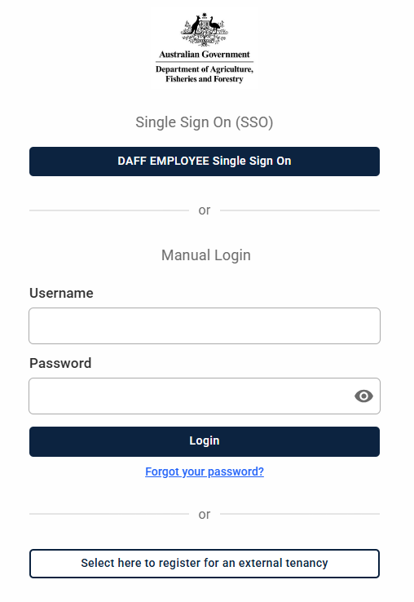

Step 2: Log in to Learnhub
- Under the Manual login, enter your username (email address).
- Enter your password.
- Select Login.
Note: Accredited persons cannot use the DAFF Employee Single Sign-On (SSO) option.

Step 3: Verify your identity/email address (First-time login only)
The first time you log in using the Manual login option, you will be asked to verify your email address. An email containing a verification link will be sent to your registered Learnhub email address.
- Select the link to verify your email address. Once your email address has been verified, a One-time Password (OTP) will be sent to your email address.

Step 4: Enter Your One-time Password (OTP)
- Open the email containing your OTP.
- Enter the OTP in the Enter code field.
- Select Verify.
Note: You only need to verify your email address the first time you log in. However, you will need an OTP each time you access Learnhub.

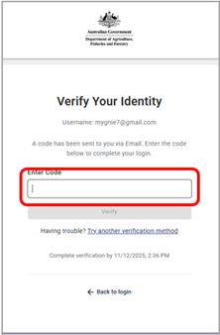

Reset Your Password
If you have forgotten your password or need to create one for the first time, select Forgot your password under the Manual login section.

Step 1: Request a Password Reset
- Select Forgot your password.
- Enter your email address.
- Confirm your email address.
- Select Send reset email.
Use the email address registered to your Learnhub account.

Step 2: Check Your Email
A password reset email will be sent to your registered Learnhub email address. Select the password reset link and follow the instructions to create a new password. You will have 20 minutes to complete the process. If you cannot find the email, check your junk or spam folder.

Step 3: Log in with Your New Password
- Return to the Learnhub login page.
- Enter your registered email address.
- Enter your new password.
- Select Login.

Keep Your Details Up to Date
If your email address, employer or contact details change, you must notify the department by completing the Change of details for approved arrangement class 19 accredited persons form. If you are unsure which email address is registered to your Learnhub account, contact the department for assistance.

Need to Update Your Details
Complete the Change of details for approved arrangement class 19 accredited persons form.
Change of details for accredited persons class 19

Need Help?
Email: Class19@aff.gov.au

Acknowledgement of Country
We acknowledge the continuous connection of First Nations Traditional Owners and Custodians to the lands, seas and waters of Australia. We recognise their care for and cultivation of Country. We pay respect to Elders past and present, and recognise their knowledge and contribution to the productivity, innovation and sustainability of Australia’s agriculture, fisheries and forestry industries.
© Commonwealth of Australia 2026
Unless otherwise noted, copyright (and any other intellectual property rights) in this publication is owned by the Commonwealth of Australia (referred to as the Commonwealth).
All material in this publication is licensed under a Creative Commons Attribution 4.0 International Licence except content supplied by third parties, logos and the Commonwealth Coat of Arms.
The Australian Government acting through the Department of Agriculture, Fisheries and Forestry has exercised due care and skill in preparing and compiling the information and data in this publication. Notwithstanding, the Department of Agriculture, Fisheries and Forestry, its employees and advisers disclaim all liability, including liability for negligence and for any loss, damage, injury, expense or cost incurred by any person as a result of accessing, using or relying on any of the information or data in this publication to the maximum extent permitted by law.

