4.0 Skills Needs Analysis: Summary and Interpretation of Results

4.1 About the Survey
The initial web-based survey undertaken for this project was designed (using the ‘Survey Monkey’ tool) in Australia to provide information for the HCOANZ about the current and future training needs of the heritage sectors in both countries. The survey aimed to provide a ‘snapshot’ of the skill sets that respondents are most commonly using in the sector, and whether these skills were developed through formal and/or on-the-job and short course training.
For the purposes of this project, ‘heritage training’ was defined as limited to ‘historical cultural heritage or place based heritage (excluding Indigenous and natural heritage)’. The information gathered from the survey will be used by the HCOANZ primarily to inform heritage training policy and to contribute to solutions for identified training gaps.
The survey was designed to capture the experiences of people working in the management and conservation of historic heritage places, in allied trades or in educational institutions in Australia and Aotearoa/New Zealand according to five key areas:
- the industry sector in which they work;
- the nature of their employment;
- their primary tasks;
- past training; and
- training requirements.
The information gathered during this initial survey also provides a snapshot of the age and education of people working in historic heritage management and conservation and the sector of the industry in which they work.
The questionnaire consisted of four sections:
- Section A—was to be completed by all respondents and provided information as to the location of individual respondents and their role within the heritage industry;
- Section B—was to be completed by individual respondents working within the heritage industry;
- Section C—was to be completed by those responding on behalf of a government heritage agency, organisation or private company; and
- Section D—provided a free text space for respondents to provide comment or feedback on the survey content and the issues it was designed to address.
Appendix C contains the data set of the ‘Skills Needs Analysis Survey’ questionnaire including the responses received in the free text section.
The survey was available for completion online in Australia and Aotearoa/New Zealand from 1–16 October 2009. People were alerted to the survey through the newsletters of professional organisations, email chat groups, government agencies involved in heritage management and through word of mouth. All raw data was organised electronically.
Wording changes were made to the survey to ensure consistency and, in summarising the results, it became evident that some Aotearoa/New Zealand respondents had already completed the survey before the wording of some questions was modified to reflect the NZ context.
The survey did not include in its lists of heritage skills and knowledge those related to Maori heritage building craft. This limits the scope of information obtained for NZ purposes, especially given that Maori heritage buildings, archaeological and heritage sites are fundamental and integral to NZ national identify and are ubiquitous in society. Furthermore, Aotearoa/New Zealand agencies have a duty to address Maori priorities and issues in any exercise of this nature.
A total of 456 people began the questionnaire and 336 completed it. An ‘incomplete’ questionnaire, is one in which the respondent skipped one or more questions. For example, 25 respondents skipped Question 1—‘Location and Postcode’ and 43 respondents did not identify the state in which live (Question 2). ‘Incomplete’ questionnaires were included in the data for analysis. Of the 456 respondents, 91 are located in Aotearoa/New Zealand.
A substantial amount of feedback was received through the ‘free text’ section of the questionnaire where respondents were asked to comment. A number of the respondents’ written submissions suggested alternative key words and questionnaire structure. In particular, a number felt that too little emphasis had been given to specific technical and specialist trades within the heritage industry and to the skills involved in assessing the state of conservation of built heritage, the writing of condition reports and the identification of conservation requirements.

4.2 Significant Findings

4.2.1 Formal Education and Industry Skills Training—Australia
Overall, people working in the conservation and management of historic heritage places have a high level of education and most of it is gained through tertiary education. Sixty-six percent of the respondents have a post-graduate degree or award (including 23 doctorates). Ninety-one percent of respondents to the survey have a university education. Sixty-three percent have also undertaken professional short courses or workshops.
Despite a very high level of formal education across the industry, the survey results show that the great majority of industry-specific skills are being learnt (or have been learnt) informally, ‘on-the-job’. Only in the case of skills used in archaeology and in historical research are those skills identified, on the basis of the number of individual responses, as having been learnt through formal education.
In interpreting these findings it should be noted that the age range of the people who completed the survey primarily reflects the training situation in universities and elsewhere some time ago, nearly 70% of respondents having completed their formal education prior to 2000. The survey thus primarily captures the perceptions of people who have been in the industry for some time.
Notwithstanding the age profile of the respondents, although formal tertiary education appears a prerequisite for employment in the heritage industry, it does not appear from the survey results to be the primary vehicle through which the skills most in use in the workplace are learnt.
With the exception of archaeology, most skills-based training appears to be occurring in the work place. The survey does not provide information about the nature of work place training, that is, whether it is systematic or organised or experiential. Interestingly, the majority of responses from heritage agencies, organisations or companies indicated that they only occasionally ran professional development training, suggesting that work place training was more likely to be ad hoc.

Preferred Mode for Future Training
Individual respondents to the survey were asked to identify one or more preferred modes for the training in the future. Most people identified Intensive short courses and/or on-the-job training as their preference/s. This may reflect the age and education profile of the respondents. Most having completed tertiary education would be unlikely to select full or part time study as their preference

Priority Training Areas
The findings of the survey in relation to the skills most in use in the industry and those that are a priority for training in the future are discussed in detail below. These findings have been summarised below in three tables according to the frequency with which particular skills were identified as ‘most used’ and ‘priorities for future training’ (Section B of the survey) or ‘priority skills for staff in future’ (Section C of the survey).

4.2.2 Formal Education and Industry Skills Training—Aotearoa/New Zealand
From the survey results, some tentative interpretations are noted regarding current gaps and issues in heritage trades and professional training, as indicated by the respondents. Given the small numbers of respondents and non-representative sampling, these interpretations are tentative and require further exploration, triangulation or testing.
At the end of the survey, just under one quarter (25%) of the 91 NZ respondents added other short comments ‘to help … identify the needs for and training in heritage trades and professional skills’.
One person noted that ‘ICOMOS NZ is currently surveying training opportunities for new entrants to the profession and will probably be mounting assessments on the web site’.
Other comments varied from short phrases to very full statements about training priorities, issues, and/or characteristics of the heritage sector in NZ to be taken into account when developing policies and/or on-the-job, short informal training, and any formal courses.
Tentative observations regarding current trends, gaps and issues in each of the eight areas of heritage trades and professional skills and knowledge have been noted in each section of the summary of responses.
More general conclusions can only be drawn with caution in the context of the survey limitations noted. These limitations include the small number of NZ responses, per question and overall, and also that the profile of NZ respondents as a group that may not be representative of the actual profile of the heritage sector ‘workforce’. For example, the majority of NZ respondents were university graduates, in the 30–50 year old age range, employed full-time by a heritage agency or consultancy company based in a metropolitan area, and with a management and/or archaeological focus. Trades personnel were significantly unrepresented, and it is not clear whether any practitioners of Maori building crafts participated in the survey.
The interpretation of responses to a few specific questions has been limited by the impact of the Australian-specific wording and/or the changes to wording made in the last week the survey was available online. Furthermore, the skills and knowledge sets listed for selection by respondents did not include those integral to Maori heritage building and places, such as whakairo (carving), tukutuku (woven panels) and kowhaiwhai (patterns), as well as tikanga (lore).

Skills and Knowledge Needs and Gaps
One of the survey aims was to develop a ‘snapshot’ of the skill sets that respondents are most commonly using in the sector and any current or future gaps they noted in skills and knowledge. The most used skills and identified gaps (reported as training priorities) are detailed in this report.
If of relevance to this project and, with more time, another layer of analysis could be undertaken to identify any common themes or patterns among and across these most used and prioritised gaps in skills and knowledge sets.

Training Contexts
Another survey aim was to gather information about the main contexts in which respondents had developed their skills and knowledge sets—formal training and/or on-the-job and short course training.
While the majority of NZ respondents had formal university qualifications, the context in which they had most commonly developed their more specific heritage-related skills and knowledge was through on-the-job experience and short courses.
These contexts were also most common for many generic skills and knowledge sets (eg stakeholder engagement and public speaking). This was in addition to having sometimes accessed heritage training overseas (Australia and UK were mentioned), through either formal or short courses, as New Zealanders or before migrating to NZ.

Issues
Respondents noted that lack of available time amongst heritage personnel (the majority of whom are in their middle years with family and work commitments), compounded with costs associated with training, relatively low numbers of persons employed in this sector, and relative remoteness from centres of expertise, as key issues to be addressed when planning training opportunities. Employer support was also cited as important.
More information is required directly from trades persons and Maori working in heritage in the formulation of NZ heritage training priorities and the most realistic strategies to address the priorities. A different methodology may be required, for example using key informant interviews and/or focus groups.

Ways Forward
These themes suggest that collaboration, both within the NZ heritage sector and with overseas counterparts, and between employing organisations, education agencies and training providers, will be required to develop targeted, affordable, and mainly on-the-job (including apprenticeships), short course and web-based training opportunities to meet heritage-specific priorities identified.
In addition, offering bonded scholarships to support key personnel to develop specialist skills and knowledge, identified as a priority for NZ respondents and only accessible though longer, tertiary-level formal qualifications overseas, could also be required as part of a strategic training plan for NZ heritage.
Developing ways to ‘recognise’ the skills and knowledge acquired on-the-job and through other less formal training are also important. This recognition should also extend to generic courses with relevance to built heritage, for example history, governance and management, interpretation, research and evaluation skills, tourism, carving and construction, etc.

4.2.3 A—Industry Wide Generic Skills (Australia and Aotearoa/New Zealand)
These are skills that were identified as ‘most used’ by a large number of respondents to the survey. They tend to be generic skills, used across the various sub-disciplines or specialist areas in the heritage industry. In some cases, as indicated, they were also identified as a priority for training but this was not always the case. Regardless of perceived need or priority, there will always be a need for training in these generic skills, although not necessarily for those already working in the industry.
The generic nature of these skills and their common use throughout the heritage industry lend them to be taught through university undergraduate and/or postgraduate courses.
Industry Area or Sub-discipline | Skill or Knowledge | Individual Responses |  | Agency/Organisation/ Company Responses
Industry Area or Sub-discipline | Skill or Knowledge | ‘Most Used’ | Priority for Training | ‘Most Used’ | Priority Skills for Staff in Future
Physical Conservation | Architectural analysis | ✓✓ | ✓ | ✓✓ | ✓
Recording | Historical research | ✓✓✓ |  | ✓✓ | ✓
Recording | Site survey (general) | ✓✓✓ |  | ✓✓ | ✓
Recording | Photography | ✓✓✓ |  | ✓✓
Recording | Archival research | ✓✓✓ | ✓ | ✓✓ | ✓
Management | Significance assessment | ✓✓✓ |  | ✓✓ | ✓
Management | Conservation management planning | ✓✓✓ | ✓ | ✓✓ | ✓✓
Management | Legislative/statutory context | ✓✓✓ | ✓ | ✓ | ✓✓
Management | Conservation strategy | ✓✓ | ✓ | ✓ | ✓
Management | Policy development | ✓✓✓ |  | ✓
Management | Site analysis | ✓✓✓
Consultation | Stakeholder engagement | ✓✓✓ | ✓ | ✓✓ | ✓✓
Consultation | Recording information (consultation) | ✓✓✓ |  | ✓✓
Consultation | Communication skills | ✓✓✓ |  | ✓ | ✓
Consultation | Historical themes | ✓✓ |  | ✓
Interpretation | Interpretation strategies and plans | ✓✓ | ✓✓ | ✓ | ✓✓
Archaeology | Report writing | ✓✓ |  | ✓
Archaeology | Archaeological site survey | ✓✓ |  |  | ✓
Archaeology | Research design | ✓✓
Historic landscape management | Historic map/plan analysis | ✓✓ | ✓ | ✓ | ✓
Historic landscape management | Landscape assessment | ✓✓ | ✓✓ | ✓ | ✓✓
Legislation and Policy | State heritage legislation | ✓✓✓ | ✓ | ✓✓ | ✓✓
Legislation and Policy | Burra Charter | ✓✓✓ | ✓ | ✓✓ | ✓
Legislation and Policy | State planning legislation | ✓✓ | ✓ | ✓
Legislation and Policy | OH&S requirements | ✓✓ |  | ✓

4.2.4 B—Specific Skills or Knowledge
These are skills or knowledge that received fewer responses for ‘most used’ but a relatively large number of responses to being a ‘priority for training’. They tend to be skills that are more specific to particular aspects of the heritage management process and/or to particular sectors of the industry.
The relatively low numbers of respondents regularly using these skills, assuming this reflects the industry as a whole, and the specific skills they entail, mean they are less likely to fit an undergraduate university model of education but may be appropriate in postgraduate course work or in intensive short course professional development.
INDUSTRY AREA OR SUB-DISCIPLINE | SKILL OR KNOWLEDGE | INDIVIDUAL RESPONSES |  | AGENCY/ORGANISATION/ COMPANY RESPONSES
INDUSTRY AREA OR SUB-DISCIPLINE | SKILL OR KNOWLEDGE | ‘Most Used’ | Priority for Training | ‘Most Used’ | Priority Skills for Staff in Future
Recording | GIS | ✓ | ✓✓ | ✓ | ✓✓
Recording | Data management | ✓ | ✓ | ✓ | ✓
Management | Thresholds | ✓ |  |  | ✓
Consultation | Public speaking | ✓✓ | ✓
Consultation | Survey development and analysis | ✓✓ |  |  | ✓
Interpretation | Audience analysis |  | ✓ |  | ✓
Interpretation | Content development | ✓ | ✓ | ✓✓ | ✓
Interpretation | Visitor Management |  |  |  | ✓
Interpretation | Plain English publication | ✓✓ |  | ✓ | ✓
Interpretation | Multimedia skills |  | ✓ |  | ✓
Archaeology | Artefact conservation |  | ✓ |  | ✓
Archaeology | Artefact analysis | ✓✓ |  |  | ✓✓
Historic landscape management | Curtilage analysis | ✓ | ✓ | ✓✓ | ✓
Historic landscape management | Landscape architecture |  | ✓ | ✓ | ✓
Historic landscape management | View analysis |  | ✓ | ✓
Legislation and policy | Building codes | ✓ |  | ✓ | ✓
Legislation and policy | Aboriginal heritage legislation | ✓ | ✓✓
Legislation and policy | EPBC Act | ✓ | ✓ | ✓

4.2.5 C—Specialist Skills
These skills are represented by only small number of responses to all questions, but a relatively high number in the questions around priorities for future training or staffing. The overall numbers of people in the industry with specialist training in these areas will continue to be small but they (and other specialist skills) are essential to the industry and will be overlooked in assessing industry training needs if this is based purely on numbers. Appropriate models for training in specialist areas are likely to be those of TAFE colleges, short courses, post-graduate courses, apprenticeships or internships with mentoring and a significant component of on-the-job training.
INDUSTRY AREA OR SUB-DISCIPLINE | SKILL OR KNOWLEDGE | INDIVIDUAL RESPONSES |  | AGENCY/ORGANISATION/ COMPANY RESPONSES
INDUSTRY AREA OR SUB-DISCIPLINE | SKILL OR KNOWLEDGE | ‘Most Used’ | Priority for Training | ‘Most Used’ | Priority Skills for Staff in Future
Physical conservation | Stone masonry |  | ✓ |  | ✓
Physical conservation | Carpentry |  |  |  | ✓
Physical conservation | Mortar analysis |  | ✓
Physical conservation | Engineering |  | ✓
Physical conservation | Traditional tool making or use |  | ✓
Physical conservation | Traditional mechanical skills |  | ✓
Recording | Photogrammetry |  | ✓
Archaeology | Underwater survey and recording |  | ✓
Historic landscape management | Landscape architecture |  | ✓ | ✓ | ✓
Historic landscape management | Aboriculture |  | ✓
Historic landscape management | Horticulture |  | ✓

4.3 About the Respondents

4.3.1 Location
The states of Victoria and New South Wales were each represented by approximately 30% of the 320 Australian respondents. All other states and territories were represented by between 5% and 10% except the Northern Territory, with less than 1%.
Twenty percent of the total respondents (91) were based in Aotearoa/New Zealand. Of the 91 NZ respondents who answered the question about their location, 81 provided a postcode and 90 a ‘city’ location.

4.3.2 City/Rural
The large majority of the Australian respondents are located in capital cities. Only 45 respondents (14%) are located in non-capital cities or rural centres. The extent to which this reflects the geographic distribution of people in the heritage industry in Australia, or simply those who responded to the survey, is unclear.
Almost 50% of the 90 NZ respondents to this question were located in the two largest metropolitan centres of the North Island—Auckland (20) and Wellington (23). Thirteen were in the two largest cities of the South Island—Christchurch (8) and Dunedin (5). Twelve respondents were based in provincial cities—Tauranga (3), New Plymouth (3), Hamilton (2), Invercargill (2), Napier (1) and Wanganui (1). Nine were based in region of Northland—Kerikeri (5) and Whangarei (2). Four were on the West Coast of the South Island—Greymouth (3) and Hokitika (1). There was one respondent each in the smaller towns of Hunterville (1), Picton (1), Rangiora (1), Lyttleton (1) and Oamaru (1). No NZ respondents were based in more remote rural locations.

4.3.3 Individual vs Organisation or Company
Respondents were given the option of responding either as an individual working in the heritage industry or as the representative of a heritage organisation or private company or consultancy.
A total of 177 individuals responded to the survey in Australia and 52 in Aotearoa/New Zealand. One hundred and twelve people responded as representing their company or organisation in Australia and 29 in Aotearoa/New Zealand (31 Australians and 10 from Aotearoa/New Zealand did not respond to this question). The high number of responses (112) representing companies or organisations in Australia suggests that in some cases companies or organisations may be represented by more than one survey.
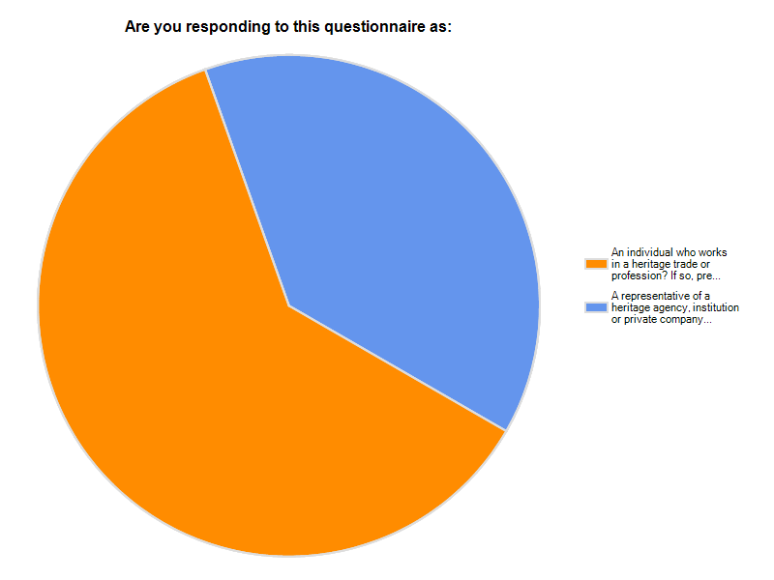
Figure 4.1 Australian respondents profile—individuals vs representative of an organisation.
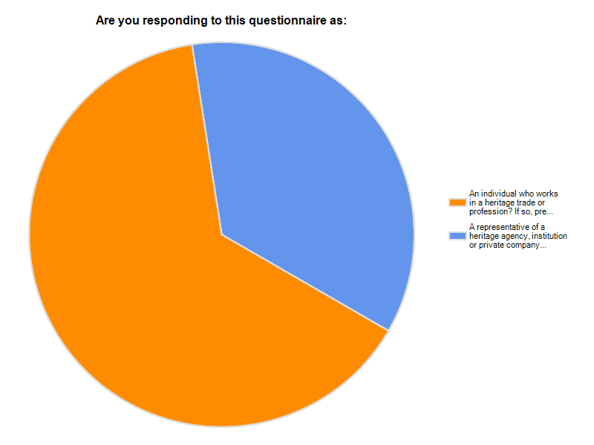
Figure 4.2 NZ respondents profile—individuals vs representative of an organisation.

4.4 Analysis of the Survey Results
The following is a discussion of the results of the survey and their analysis, separated into responses from Australia and Aotearoa/New Zealand.

4.4.1 Individual Respondents (Section B)

Number of Respondents
- Australian Respondents—177 surveys were completed by individuals.
- Aotearoa/New Zealand—52 surveys (64.2%) were completed by individuals.

Nature of Employment

Australian Respondents
Of the Australian respondents, 50% described themselves as full time paid employees and 30% as consultants/freelance workers. The remainder consisted of part-time employees (10%), volunteers (5%), and students, retired people and company directors (5%).

Aotearoa/New Zealand Respondents
Almost two-thirds (36) of the individual NZ respondents to this question described themselves as full-time paid employees, and about a quarter (14) as consultants/freelance workers. The remainder consisted of five part-time/casual paid employees, three volunteers, one retiree, and two ‘other’: a company director and an expert member of an ICOMOS NZ committee. No one identified as an apprentice or student.
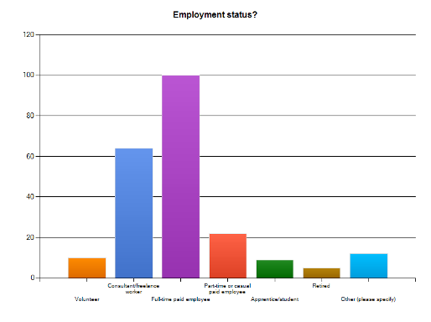
Figure 4.3 Employment status of Australian respondents.
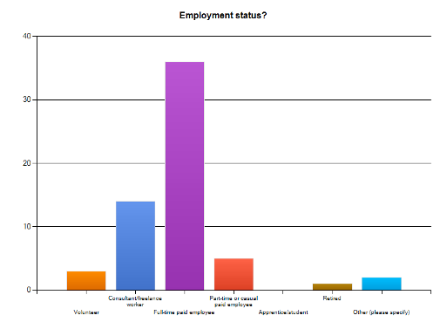
Figure 4.4 Employment status of NZ respondents.

Age Range
Fifty percent of Australian Respondents were aged between 30 and 50 years of age, 40% were over 50 years and 10% under 30 years.
Just over half (56% or 32) of the NZ Respondents were between 30 and 50 years of age, just over a third (20) were over 50 years (one over 66 years), and five (8.8%) were under 30 years.

Place of Work

Australian Respondents
Nearly 50% of individual respondents from Australia identified their place of work as being a private practice or consultancy and nearly 30% as being a state government agency. Commonwealth Government agencies, local government agencies, heritage sites, educational Institutions, non-government agencies and trade companies were each represented by between 5 and 15 individual responses.

Aotearoa/New Zealand Respondents
More than a third (23) of the NZ respondents defined their work place as a central government agency, this is assuming that the 16 (28%) who ticked either the ‘State’ or ‘Commonwealth’ government category understood both to mean ‘central government/crown entity’ in the NZ context. Also, seven had ticked their work place as ‘other’ and listed it as a central government department or crown entity. Just over one-third (37% or 21) of the 57 NZ respondents to this question identified their place of work as a private practice or consultancy.
Five listed local government agency (8.8%) as their work place, four listed heritage sites (7%), two education institutions, and only one worked for a trades company. No one indicated they worked in a non-government organisation. The remaining ‘other’ worked from home.
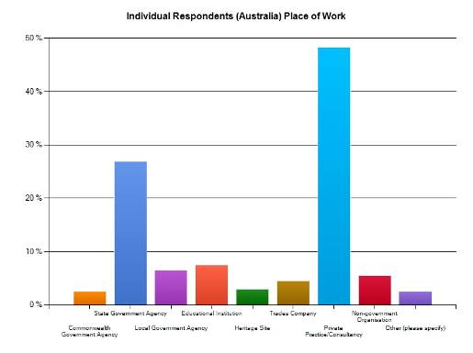
Figure 4.5 Place of work responses (Australia).
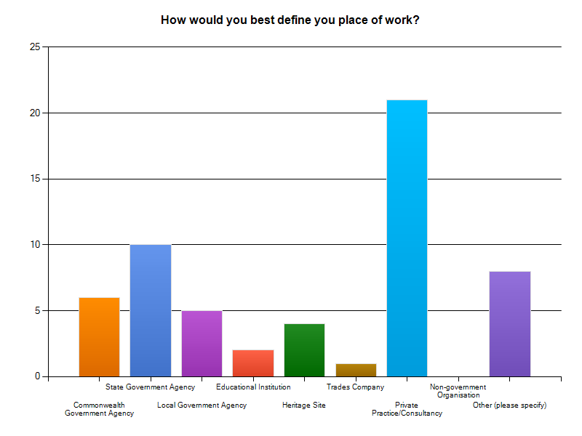
Figure 4.6 Place of work responses (Aotearoa/New Zealand).

Trade or Profession

Australian Respondents
Twenty-five percent of Australian respondents identified their profession as ‘heritage management’, 22% as archaeologists and 23% as architects. Fourteen respondents identified themselves as tradespeople.
Forty-nine Australian respondents specified ‘other’ in response to this question, meaning they considered the categories offered in the survey did not fit the title of their trade or profession. These included five planners, six conservators, eight consultants, nine engineers (some retired) and four curators. Other professions with only one response included photographer, architectural historian, ‘heritage believer’, scientist, lawyer, industrial designer/interior architect, and housewife.

Aotearoa/New Zealand Respondents
A quarter (25%) of the NZ respondents defined their trade or profession as archaeologist (4) and another 25% as heritage manager (14). The next most commonly mentioned were historian (8) and architect (6). Only two defined themselves as tradespersons, one as bureaucrat and one as academic/teacher.
Twenty-two (40%) of NZ respondents considered the categories offered in the survey did not fit the title of their trade or profession, thus listed their occupations under ‘other’. Of these people, six use the term ‘planner’ solely or as part of the description of their trade or profession. Six defined themselves as covering several types of work, for example ‘heritage policy advisor, planner, writer, researcher, lecturer, funding advisor and advocate’. Four respondents used more general titles like urban designer/cultural heritage expert, and heritage or museums consultant /professional (4).
Three were architects (one conservation-focused and two were heritage landscape-focused) and one a heritage engineer. One respondent was a manager of cultural heritage database and provision of information and another was an administrator. Other professions or trades listed by a person included curator/collection manager, interpreter/project manager, conservation ranger, technical advisor, and contract manager for maintenance service provider.

Level of Education
Individual respondents were asked to indicate their highest level of education.

Australian Respondents
Twenty-three (11%) respondents have a Doctorate. Fifty-five percent of respondents have, or are completing, a postgraduate award. Twenty-five percent have an undergraduate degree and the remainder have completed a TAFE, polytechnic or vocational education certificate, an apprenticeship or secondary school. The five responses in the ‘other’ category include two undergraduate and two postgraduate awards.
Nearly 60% of respondents had completed this education prior to 2000. This is likely to reflect the very large majority of respondents who are over the age of 30.

Aotearoa/New Zealand Respondents
The majority of NZ respondents (93%) have university degrees. Of these, just under three-quarters (72%, 41) of the NZ individual respondents have a postgraduate award. Five (8.8%) hold doctorates (the one response marked ‘other’ has a masters degree). Twenty-one percent (12) have an undergraduate degree. Of the remainder, one held a trade certificate and two have polytechnic certificates. For one person, secondary school is their highest level of education.
Just over half (57.3%, 33) had completed this study at least nine years ago (before 2000). The remainder were spread fairly evenly across completing in 2001–03 (6), 2004–06 (9), or 2007–09 (8), with one currently studying for their highest qualification.
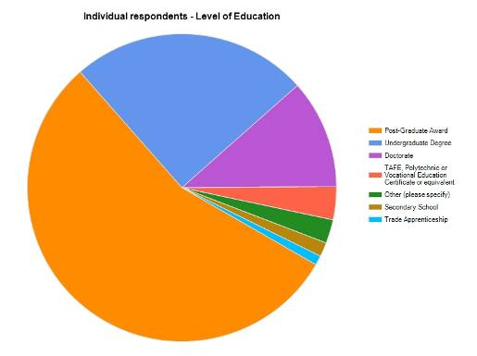
Figure 4.7 Levels of education (Australia).

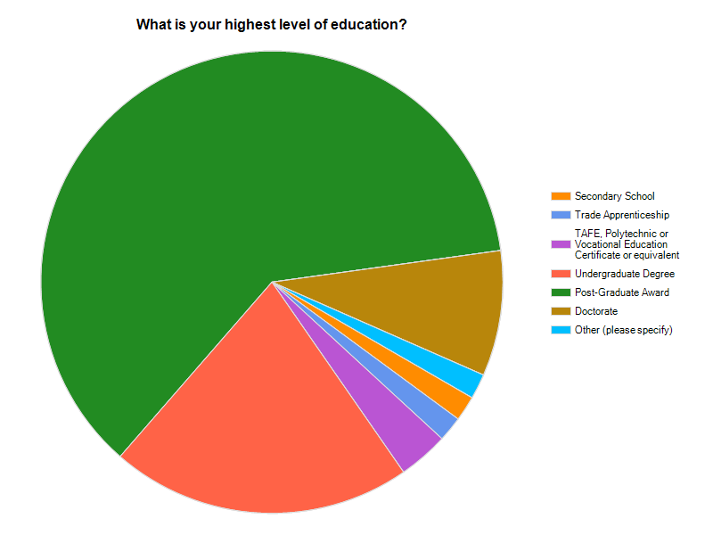
Figure 4.8 Levels of education (Aotearoa/New Zealand).

Field of Expertise
The survey asked individual respondents to identify any area of specialisation in their studies.

Australian Respondents
One hundred and twenty-six people responded to this question as follows:
- Archaeology (including historic, Indigenous)—34
- Cultural heritage management—19
- Architectural history and/or conservation—19
- History—17
- Materials conservation—10
- Architecture—6
- Archaeology maritime—5
- Visual Arts—4
- Museum Studies—3
- Planning—2
- Classical studies—2
- Anthropology—1
- Natural resource management—1
- Landscape management—1

Aotearoa/New Zealand Respondents
Thirty-three NZ respondents had specialised in a particular heritage field during their formal education, listed as:
- Archaeology (Maori archaeology, archaeology of standing buildings, and industrial archaeology)—13
- Museums and heritage studies—5
- Conservation (building conservation, heritage/built heritage conservation, architectural conservation)—3
- Anthropology—3
- Heritage management (funding, planning and business administration)—3
- Architecture—2
- History—2
- Collection management—2
- Heritage buildings—1

Other Training in Heritage Management or Conservation
Respondents were asked to identify types of heritage training that they have undertaken aside from formal education.

Australian Respondents
One hundred and forty-seven people have had informal or on-the-job training, 122 have undertaken professional short courses or workshops, 76 have some skills or knowledge that was self taught and 18 have undertaken internships.

Aotearoa/New Zealand Respondents
Other types of heritage training undertaken most commonly included informal or on-the-job training (46, 3 specified under ‘other’) and professional short courses or workshops (40). Nineteen had been self taught, and four had undertaken a heritage training internship. One person had been taught skills by their family. Two persons specified conferences as heritage training under ‘other’.

4.4.2 Individual Respondents Under 30 Years of Age
Of particular interest are the respondents under the age of 30 years who will become the mainstay of the heritage and allied professions over the next decade. Only 29 of the respondents are under 30 years and, of these, nearly 50% are in Victoria and 20% from Aotearoa/New Zealand. All bar one responded as individuals rather than as representatives of an organisation or business.
Respondents representing companies or organisations were asked only to identify the age range of the majority of their workers and therefore in those organisations where younger workers are a minority their presence will not be reflected in the results unless they also responded as individuals. Despite this, the comparatively low number of young respondents suggests a potential skills shortage in heritage conservation and management in the coming years.
Over half (52%) the respondents under 30 years of age are in full time paid employment. Nearly 50% work in government agencies and 24% in private practice or consultancies. Archaeologists and heritage managers each make up roughly 30% of respondents; only one respondent under 30 years is an architect and two are tradespeople.
The majority (55%) have a postgraduate award. Only one respondent identified as having a specialist skill (in stained glass). Twenty-five of the 29 young respondents have had informal on-the-job training and nearly half (44%) have undertaken professional short courses or attended workshops. This suggests a well educated profession, although within a limited range of fields in the heritage industry.
In response to the question ‘Do you know of training opportunities that would provide the skills and knowledge you have identified as a priority?’ 85% of respondents less than 30 years of age answered ‘no’. To the question of their preferred mode of training, the great majority identified short courses and on-the-job training as their preferred mode of training

4.4.3 Representatives of Heritage Agencies, Organisations or Companies (Section C)

Number of Respondents
A total of 112 responses were received from representatives of heritage agencies, organisations or companies in Australia. As discussed above, this is a relatively high number and may reflect in some cases more than one response on behalf of an agency, company, or organisation.
Twenty-nine (35.8%) NZ respondents answered the survey on behalf of a heritage agency, organisation or company. As with the Australian responses, this may reflect more than one response on behalf of an agency, company or organisation.

Nature of the Organisation or Company

Australian Respondents
The majority of respondents identified their organisations or companies as state government agencies (50%), private practices or consultants (30%) and non-government organisations (11%). Commonwealth government agencies, local government agencies, heritage sites, educational institutions and museums were each represented by 11 or less surveys. Ten surveys were completed by representatives of trade companies.

Aotearoa/New Zealand Respondents
More than 50% (16) of the 28 NZ respondents to this question identified their organisation or company as a central government agency (assuming the 11 (39%) who ticked the ‘state’ or ‘commonwealth’ government categories to mean ‘central’ government in the NZ context, and including five of the six who specified crown/central government agencies as ‘other’). Fourteen percent (4) represented a private practice or consultancy, and 14% (4) represented a local government agency.
The remaining four respondents were divided between education institutions (7%, 2), and non-government organisations (7%, 2—plus the remaining ‘other’ who manages a voluntary organisation). No NZ respondents said they represented a trades company nor a heritage site.
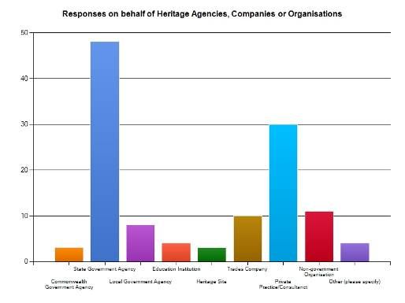
Figure 4.9 Nature of organisations (Australia).
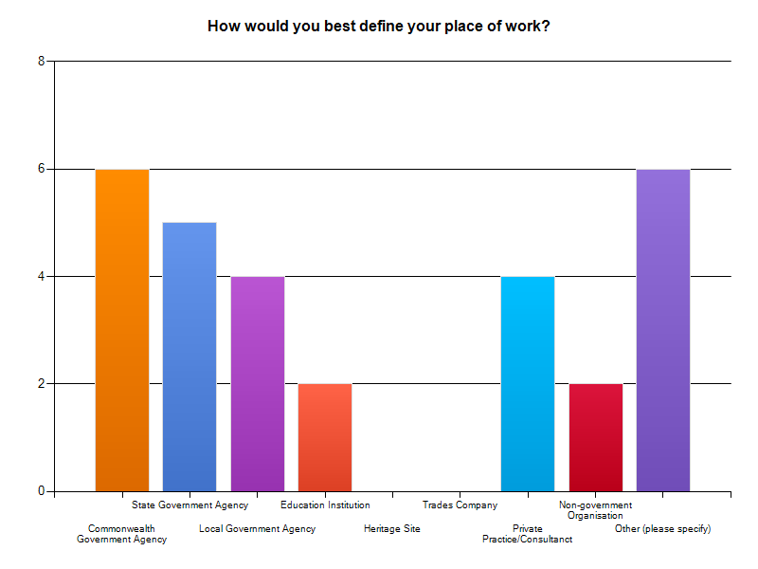
Figure 4.10 Nature of organisations (Aotearoa/New Zealand).

Number of Employees

Australian Respondents
Fifty percent of the agencies, organisations or companies employ more than 20 people, reflecting the large number of state government organisations represented in the survey. Thirty percent employ less than 10 people and the remainder employ between 10 and 20 people.

Aotearoa/New Zealand Respondents
Just over half (55.6%, 15) of these NZ organisations or companies employ more than 20 people. This reflects the higher percentage of government organisations and private practices amongst the respondents. A quarter (25.9%, 7) employ less than 10 people and the remainder (18.5%, 5) employ between 10 and 20 people.

Nature of Employment
The vast majority (85%) of Australian Respondents are employed on a full-time basis. Around 10% are volunteers.
All but one of the NZ organisations (96.3%) employed personnel on a full-time basis. The one ‘other’ specified that the organisation employed four full-time and four part-time/casual persons. None of personnel in the respondents’ organisations were volunteers or student/apprentices.

Age of Employees
In 80% of the Australian agencies, companies and organisations represented, the average age of employees is 30–50 years. Twelve percent were over 50 and only 4% under 30 years of age.
In all but one of the NZ organisations or companies the average age of employees is 30–50 years (96.3%, 26). The average age was under 30 in the only other organisation represented.

Trade or Primary Professional Activities

Australian Respondents
Thirty percent of respondents identified the primary professional role of their organisation or company as ‘heritage management’ and 20% as archaeologist. Thirty-nine respondents used the ‘other’ category to identify their role. These included five conservators, three planners, two horticulturalists, one archivist and several specialist decorators.

Aotearoa/New Zealand Respondents
Eleven of the 28 NZ respondents to this question used the ‘other’ category to identify their role. These included two conservators (including an architectural conservation specialist), two planners, one structural engineer, and one trainer.
Ten respondents could be grouped as heritage manager/administrators (five of these specified in ‘other’ as a media manager, support-fund-raiser, administrator, and team leader urban design and heritage). Five identified as architects, nine as heritage managers and five as bureaucrats. Three were archaeologists, two were historians, and no one responding was a tradesperson.

‘In-house’ Training Opportunities
When asked whether their company or organisation provided ‘in-house’ training opportunities, two thirds of Australian respondents answered ‘occasionally’, 25% ‘regularly’ and 10% ‘never’.
When NZ respondents were asked whether their company or organisation provided ‘in-house’ training opportunities, just over half (57%, 16) of respondents answered ‘occasionally’, just over one-third (36%, 10) ‘regularly’, and one answered ‘never’.

4.4.4 Summary of Skills in Use and Priorities for Future Training
The primary aim of the survey was to identify skills needs and priorities for future training in the heritage industry. Respondents to the survey were provided with a list of key words (skills) under these broad areas or sub-disciplines within heritage conservation and management: physical conservation; recording; management; consultation; interpretation; archaeology; historic landscape; and legislation and policy (see Table 4.1).
Full survey data is provided in Appendix D.

4.5 Individual Responses (Section B)
Against each keyword individual respondents were asked to identify the:
- skills that are most used by them in the work place;
- skills in which they have received formal training;
- skills in which they have received informal or on-the-job training; and
- skills that they see as a priority for training in future.

Number of Australian respondents in each area or sub-discipline of heritage management and conservation
Physical conservation | 112
Recording | 162
Management | 164
Consultation | 161
Interpretation | 148
Archaeology | 85
Historic Landscape Management | 111
Legislation and Policy | 159

Number of Aotearoa/New Zealand respondents in each area or sub-discipline of heritage management and conservation
Physical conservation | 28
Recording | 47
Management | 45
Consultation | 46
Interpretation | 45
Archaeology | 26
Historic Landscape Management | 35
Legislation and Policy | 45

The numbers of responses for individual key words are discussed below.
Table 4.1 Keyword breakdown.
Physical Conserv-ation | Recording | Management | Consultation | Interpret-ation | Archaeology | Historic Landscape Management | Legislation and Policy
Thatching | Fabric survey | Significance assessment | Stakeholder engagement | Communica-tion skills | Research design | Landscape assessment | ICOMOS Charter (NZ and AUS)
Bricklaying | Site survey | Thresholds | Public speaking | Multimedia skills | Archaeologic-al site survey | Aboriculture | Resource Management Act (NZ)
Mortar analysis | Mapping | Policy development | Recording information | Tour guiding | Archaeologic-al excavation | Horticulture | Historic Places Act (NZ)
Paint analysis | GIS | Risk management | Survey development and analysis | Visitor management | Permit applications | Landscape architecture | EPBC Act
Gilding | Inventory preparation | Issues analysis | Plain English publication | Historical themes | Artefact analysis | Historic map/plan analysis | State heritage legislation
Traditional tool making and or use | Cata-loguing | Implementa-tion |  | Content development | Artefact conservation | Curtilage analysis | State planning legislation
Painting and decorating | Data manage-ment | Tolerance for change |  | Audience analysis | Report writing | View analysis | International agreements and conventions
Interior finishes | Photo-graphy | Legislative/ statutory context |  | Interpretation strategies/ plans | Diving |  | OH&S requirements
Glass conservation and/or replacement | Sketching | Comparative analysis |  |  | Underwater survey and recording |  | Building codes
Stone masonry | Photo-grammetry | Legislative compliance |  |  |  |  | Natural heritage legislation
Metalwork/ forging/ blacksmithing | Measured drawing | Conservation strategy |  |  |  |  | Aboriginal heritage legislation
Roofing | Oral history | Conservation management planning |  |  |  |  | Burra Charter
Plastering | Historical research | Site analysis
Carpentry | Archival research
Joinery
Engineering
Traditional mechanical skills
Architectural analysis

4.5.1 Physical Conservation

Australian Respondents (112 Respondents)
Included within the area or sub-discipline of ‘Physical Conservation’ were the traditional trades commonly used in the conservation of historic structures plus architectural analysis, mortar analysis and paint analysis (see Table 4.1). There was a total of 112 respondents.
Although only 14 respondents identified themselves as tradespeople, many more respondents indicated that they use trades such as stone masonry (35), roofing (29), joinery (26) and plastering (26) in their work.
Under physical conservation:

Skills Most Used
1. Architectural analysis (62)
2. Paint analysis (37)
3. Stone masonry (35)

Priority Areas for Further Training (based on number of respondents)
1. Architectural analysis (30)
2. Stone masonry (26)
3. Mortar analysis (23)

Aotearoa/New Zealand Respondents (28 Respondents)

Skills Most Used
1. Architectural analysis (12)
2. Carpentry (10) and joinery (8)
3. Stone masonry (8) and roofing (8)

Priority Areas for Further Training (based on number of respondents)
1. Architectural analysis (13)
2. Mortar analysis (6)
3. Stone masonry (5)

Skills Training—Formal or Informal
In Australia, for all skills included in Physical Conservation, training is far more likely to have taken place on-the-job than through formal (institutional) training. In most cases there was roughly twice the number of responses for on-the-job training as compared to formal training.
Training in the area of physical conservation in Aotearoa/New Zealand was equally as likely to have taken place in a formal course as in an ‘informal’ context or on-the-job.

Findings/Issues

Australian Respondents
- For all keywords (except mortar analysis) only around half the number of respondents who identified a particular skill indicated that further training was a priority. Although this was the case for ‘architectural analysis’, the large number of respondents who use this skill suggests it is a priority for future training.
- In three skills areas—mortar analysis, gilding and traditional mechanical skills—the number of respondents who see these as priorities for future training is greater than the numbers of respondents who identify them as ‘most used’, possibly indicating a perceived future skills need in these areas.

Aotearoa/New Zealand Respondents
- Architectural analysis was identified by respondents as the most used skill and also as the top priority for future training.
- All other ‘most used’ skills were also listed as priorities for further training, suggesting that those working in physical conservation are all interested in further training opportunities specific to their heritage work.
- Whilst no one indicated that they use thatching or gilding skills in their work, nor had any training in these areas, two respondents did indicate both these as a priority to enhance their current work.
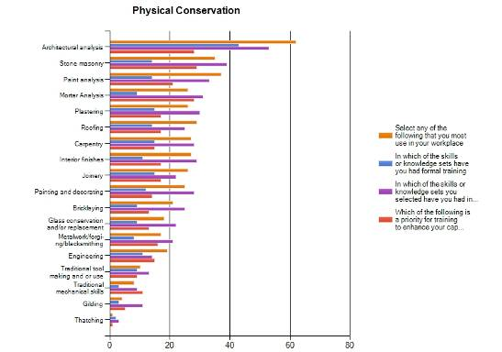
Figure 4.11 Keyword responses (Section B)—physical conservation (Australia).
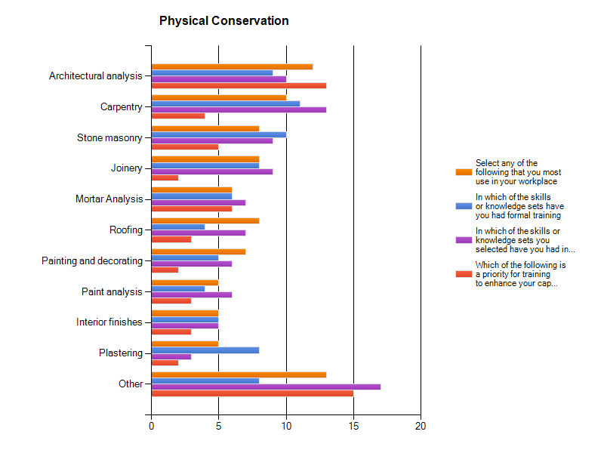
Figure 4.12 Keyword responses (Section B)—physical conservation (Aotearoa/New Zealand).

4.5.2 Recording

Australian Respondents (162 Respondents)
Included within the area or sub-discipline of ‘Recording’ are generic skills including survey, mapping, cataloguing and historical research that are used throughout the heritage industry (see Table 4.1). The large response to each keyword (with the exception of photogrammetry) reflects the generic nature of theses skills.

Skills Most Used
1. Historical research (139)
2. Photography (136)
3. Site survey (125)

Priority Areas for Further Training
1. Historical research (40)
2. Archival research (37)
3. GIS (35)

Aotearoa/New Zealand Respondents (47 Respondents)

Skills Most Used
1. Photography (37) and historical research (35)
2. Archival research (32)
3. Site survey (26) and inventory preparation (21)

Priority Areas for Further Training
1. Geographic Information System (GIS) (19)
2. Fabric survey (11); mapping, data management and archival research (all 10)
3. Historical research (9) and oral history (8)

Skills Training—Formal or Informal
Although in general Australian respondents have had more training on-the-job than in a formal capacity in almost all of the skills in this section (the exceptions being measured drawing and historical research, fabric survey, inventory preparation, data management, photography and oral history) the extent to which training is informal rather than formal is quite marked and suggests that these skill sets are not being catered for through established formal education. Although in none of these areas is there a significant need for training identified.
In Aotearoa/New Zealand, ‘recording’ training was equally as likely to have taken place in a formal course as informally or on-the-job. There was about one-and-a-half to twice the number of on-the-job training responses to formal training responses for the recording skills of: GIS (8 formal, 15 informal), photography (12 and 22), inventory preparation (11 and 15), cataloguing (11 and 16), data management (10 and 14) and archival research (18 and 23). In contrast, formal training was more likely for the remaining five recording skills (about one-and-a-half to twice the number of formal training responses to on-the-job training), that is for: fabric survey (12 formal and 9 informal), site survey (21 and 13), photogrammetry (3 and 1), measured drawing (15 and 12), oral history (15 and 10).

Findings/Issues

Australian Respondents
- Although photography was one of three skills most used, relatively few respondents saw training as a priority, possible reflecting the adequacy of informal training and/or self-taught skills.
- Relatively few respondents identified GIS as a skill most used but the largest number of respondents identified it as a priority, suggesting respondents see the need for skills in GIS as increasing in the future.

Aotearoa/New Zealand Respondents
- Although photography was one of three skills most used, relatively few respondents had formal training (12, 33%) and very few (3, under 10%) rated training as a priority. This may suggest that current patterns of learning on-the-job and current formal training is adequate.
- In contrast, a similar number of respondents identified historical research as a skill most used but approximately equal numbers had both formal and informal training in this, and such skills were also a mid-range training priority.
- Relatively few respondents identified GIS as a skill most used, amongst whom training was twice as likely to have been on-the-job, and the largest number of respondents identified GIS as a training priority.
- Both ‘other’ skills listed were electronic/digital recording skills (high definition digital survey, and electronic measured drawing training), probably a reflection of technological directions.
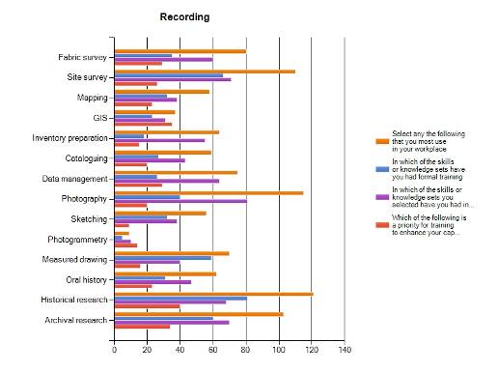
Figure 4.13 Keyword responses (Section B)—recording (Australia).
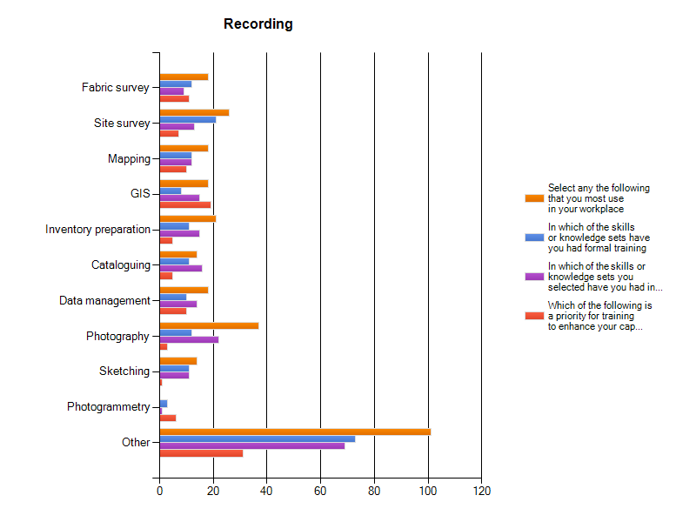
Figure 4.14 Keyword responses (Section B)—recording (Aotearoa/New Zealand).

4.5.3 Management
Included within ‘management’ are a number of skills including risk management, comparative analysis and issues analysis. There were a relatively high number of responses to all the keywords in this section.

Australian Respondents (164 Respondents)

Skills Most Used
1. Significance assessment (147)
2. Conservation management planning (132)
3. Legislative/statutory context (123)

Priority Areas for Further Training
1. Conservation management planning (53)
2. Conservation strategy (45)
3. Significance assessment (43)

Aotearoa/New Zealand Respondents (46 Respondents)

Skills Most Used
1. Significance assessment (35)
2. Legislative/statutory context (29) and site analysis (29)
3. Conservation management planning (27) and legislative compliance (26)

Priority Areas for Further Training
1. Conservation management planning (17) and significance assessment (16)
2. Policy development (12)
3. Conservation strategy (11)

Skills Training—Formal or Informal
For all skills listed under ‘management’ (with the narrow exception of significance assessment) more than twice the Australian respondents have had informal, on-the-job training as compared to formal training.
Almost all training in management skills in Aotearoa/New Zealand were equally as likely to have taken place in a formal course and informally/on-the-job. The only exceptions were for: thresholds skills which were almost one-and-a-half to twice as likely to be learnt on-the-job (4 formal, 7 informal), legislative compliance (12 and 19), and Conservation management planning (13 and 18).

Findings/Issues

Australian Respondents
- Although significance assessment is the most used skill in this section, it does not stand out to the same extent in the training priorities, suggesting current formal and informal, ‘in house’ training is adequate.
- Conservation management planning, conservation strategy and risk management have the highest number of responses for future training priorities relative to skills most used. Although not highly significant this does suggest a greater need for training in these areas as compared to the other skills in management

Aotearoa/New Zealand Respondents
- Significance assessment is the most used management skill amongst respondents, and also is one of two top training priorities.
- The other top training priorities included conservation management planning and conservation strategy skills, which were also almost amongst some of the more used skills, along with site analysis and legislative skills and knowledge.
- Policy development also featured as a high training priority.
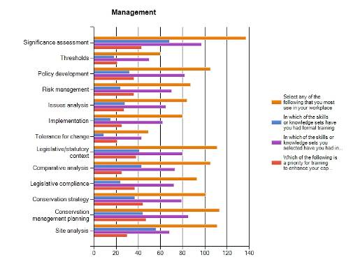
Figure 4.15 Keyword responses (Section B)—management (Australia).
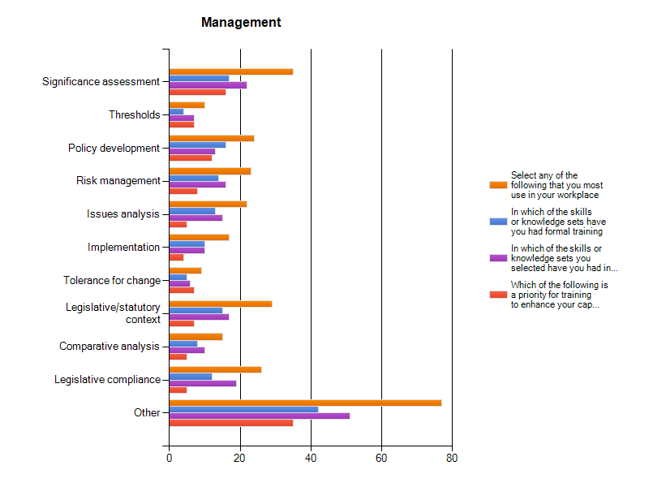
Figure 4.16 Keyword responses (Section B)—management (Aotearoa/New Zealand).

4.5.4 Consultation
The section on ‘consultation’ includes only five skills or sub-disciplines such as public speaking and survey development and analysis. Again these are generic and to a varying extent used across a range of heritage professions and trades. The large number of responses indicates the importance of consultation.

Australian Respondents (161 Respondents)

Skills Most Used
1. Stakeholder engagement (133)
2. Recording information (131)
3. Public speaking (121)

Priority Areas for Further Training
1. Stakeholder engagement (47)
2. Public speaking (40)
3. Plain English publication (35)

Aotearoa/New Zealand Respondents (46 Respondents)

Skills Most Used
1. Public speaking (37)
2. Stakeholder engagement (34)
3. Recording information (31)
4. Plain English publication(27)

Priorities for Further Training
1. Stakeholder engagement (16)
2. Public speaking (13) and plain English publication (12)
3. Recording information (11) and survey development and analysis (10)

Skills Training—Formal or Informal
More Australian respondents have had informal or on-the-job training than formal training in all of these skills; however, this is most marked in relation to stakeholder engagement.
The number of Aotearoa/New Zealand respondents with on-the-job training rather than formal training was 1.5 to 2.5 times more likely for stakeholder engagement, public speaking, and plain English publication skills. Training was more common in both contexts for: recording information (17 formal and 18 informal) and survey development and analysis skills (13 and 10).

Findings/Issues

Australian Respondents
More respondents identified ‘stakeholder engagement’ as a skill most used than any of the other keyword skills under consultation. Three times the number of respondents identified that their training in stakeholder engagement was informal rather than formal. A relatively high number also identified this as a priority for future training. While training in stakeholder consultation is obviously occurring in the workplace, this does not appear to meet current training needs.

Aotearoa/New Zealand Respondents
- Just over two times the number of respondents identified on-the-job training (21) in stakeholder engagement than formal training (10), and this was also the top priority for future training (16).
- Responses regarding public speaking skills indicated a similar pattern. Public speaking was the other most used skill, learnt predominantly on-the-job and respondents’ second highest priority for further training.
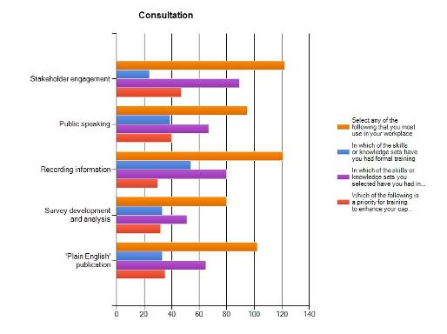
Figure 4.17 Keyword responses (Section B)—consultation (Australia).
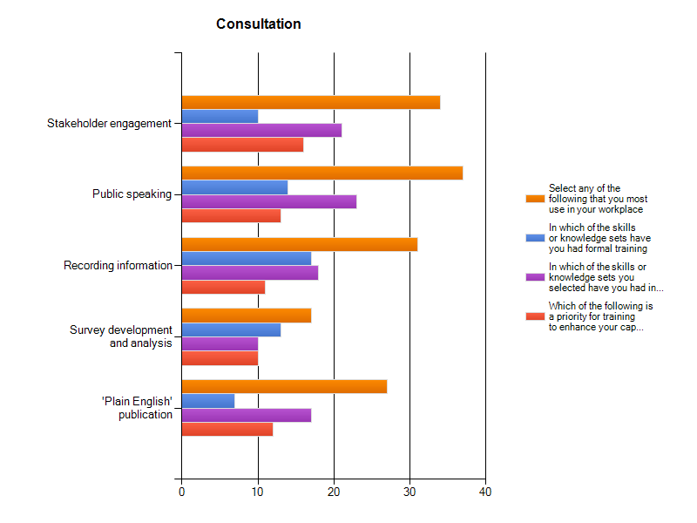
Figure 4.18 Keyword responses (Section B)—consultation (Aotearoa/New Zealand).

4.5.5 Interpretation
The section covering skills under the heading of ‘interpretation’ include those specifically associated with tourism activities such as ‘audience analysis’ and ‘tour guiding’ and those more generally associated with interpretation and presentation of information such as ‘content development’. The wide range in the number of responses to individual keywords in this section reflects the specificity of some skills and the generic nature of others.

Australian Respondents (148 Respondents)

Skills Most Used
1. Communication skills (129)
2. Interpretation strategies/plans (102)
3. Historical themes (97)

Priority Areas for Further Training
1. Interpretation strategies/plans (51)
2. Multimedia skills (35)
3. Content development (32)

Aotearoa/New Zealand Respondents (45 Respondents)

Skills Most Used
1. Communication skills (40)
2. Historical themes (28) and multimedia skills (27)
3. Interpretation strategies/plans (23) and content development (19)

Priority Areas for Further Training
1. Multimedia skills (14) and communication skills (13)
2. Historical themes (11) and interpretation strategies/plans (11)
3. Audience analysis (10) and content development (9)

Skills Training—Formal or Informal
In Australia, with the exception of ‘historical themes’, informal or on-the-job training received at least twice the number of responses to that of formal training for the skills under ‘interpretation’. ‘Historical themes’ is more likely to have been taught on-the-job than through formal training.
In Aotearoa/New Zealand, all but two of the skills (communication and historical themes) had more than 1.5 to 2 or 3 times the number of respondents, indicating they had on-the-job training rather than formal training.

Findings/Issues

Australian Respondents
- ‘Multimedia skills’ and ‘content development’ received relatively few responses as skills ‘most used’ but both are clearly identified as priorities for training, perhaps indicating the future direction for the industry.
- Although ‘communication skills’ were identified as most used by the greatest number of respondents this skill is, relatively, the least identified as a priority for future training. It is also an area that is well served in both formal and informal training.
- The overall number of responses in relation to ‘audience analysis’ was low; however, the number of responses indicating this is a priority for future training is relatively high.

Aotearoa/New Zealand Respondents
- The more specific interpretation skills have been most commonly learnt on-the-job to date.
- Multimedia skills are not identified as the most used (27) but are identified as of equivalent priority for training as the most used skill (communication, 40), possibly in response to the current increase in use of multimedia in heritage interpretation.
- Visitor management (10) and audience analysis (7) are the least used skill sets, have the least ‘formal training’ responses, and are lower priorities in training.
- The lowest training priority is tour guiding (3), which is also the skill most likely to be learnt on-the-job, and one of the lesser used skills (12).
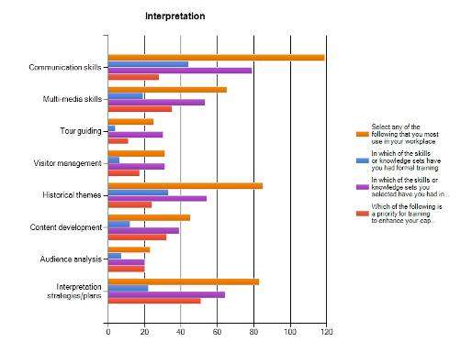
Figure 4.19 Keyword responses (Section B)—interpretation (Australia).
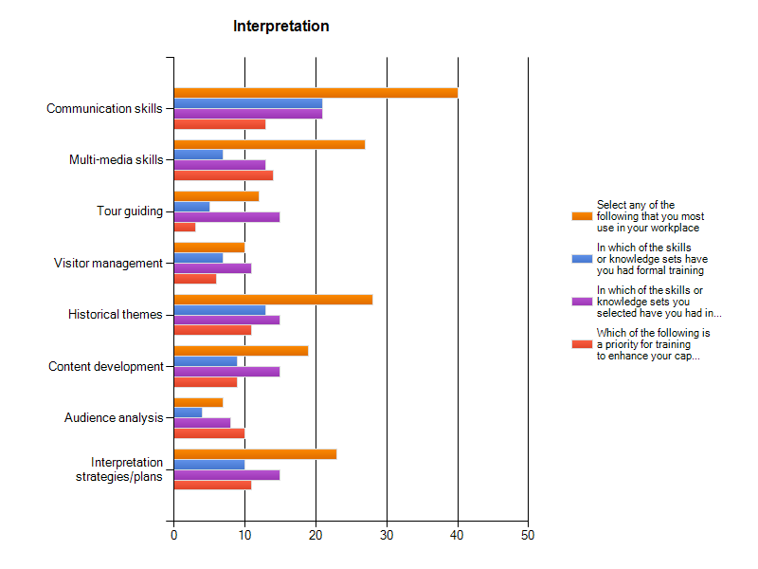
Figure 4.20 Keyword responses (Section B)—interpretation (Aotearoa/New Zealand).

4.5.6 Archaeology
Archaeology is a specialist discipline within the heritage industry, with particular skills not captured in the other areas or sub-disciplines. Archaeologists represent a significant proportion of the total number of individual respondents to the survey. 39 respondents indicated that they had specialised in archaeology (historic, Indigenous or maritime) in their formal education.

Australian Respondents (85 Respondents)

Skills Most Used
1. Report writing (61)
2. Archaeological site survey (51)
3. Research design (46)

Priority Areas for Further Training
1. Artefact conservation (20)
2. Research design (18)
3. Artefact analysis (17)

Aotearoa/New Zealand Respondents (26 Respondents)

Skills Most Used
1. Archaeological site survey (16) and permit applications (16)
2. Report writing (14) and archaeological excavation (13)
3. Research design (10) and artefact analysis (10)
(Remainder ≤3, with no respondents using diving, or underwater survey and recording skills)

Priority Areas for Further Training
1. Research design (7) and archaeological site survey (7)
2. Artefact analysis (5)
3. Archaeological excavation (4)

Skills Training—Formal or Informal
With exception of ‘permit applications’ and ‘artefact conservation’, skills were learned in formal training more than on-the-job training, reflecting the specialist university training required for archaeologists to be able to work as consultants in the Australian heritage industry.
In Aotearoa/New Zealand, only archaeological excavation skills were more likely to be learnt in formal courses. All other skills used by respondents were learned either about equally in both formal and informal contexts (archaeological site survey, artefact analysis, artefact conservation), or 1.5 to 4.5 times more often on-the-job (research design, permit applications, report writing). Permit applications skills were more than 4.5 times more likely to be learnt on-the-job.

Findings/Issues

Australian Respondents
- Low numbers of responses to skills used in underwater archaeology probably reflect the small number of maritime archaeologists in the heritage industry.
- With the exception of ‘artefact conservation’, the overall low number of responses to ‘priority for future training’ in relation to ‘skills most used’ suggests that current training in the archaeological skills listed is generally adequate.
- Archaeology differs markedly to the other sections in that, with the exception of ‘permit applications’ and ‘artefact conservation’, skills were more likely to have been learnt through formal education or training.
- Training in ‘artefact conservation’ was identified as a priority by 20 respondents but only 28 identified it as a skill most used. This may suggest a perception that this skill may increase in importance in future or that its current limited use is an outcome of a lack of training opportunities.

Aotearoa/New Zealand Respondents
- Archaeology differs markedly to the other areas in that, with the exception of permit applications and artefact conservation (just), all skills had more responses to formal than on-the-job training. This may suggest that formal archaeology courses are covering the industry needs, or it could mean that there is very little on-the-job training in archaeology.
- Training in artefact conservation was identified as a priority by 22 respondents but only 29 of the respondents identified it as a skill most used. This may suggest this is anticipated as an area of future need.
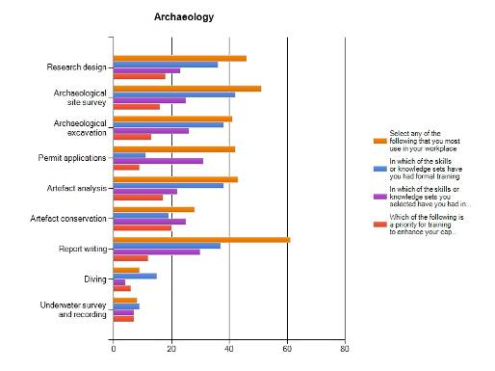
Figure 4.21 Keyword responses—archaeology (Australia).
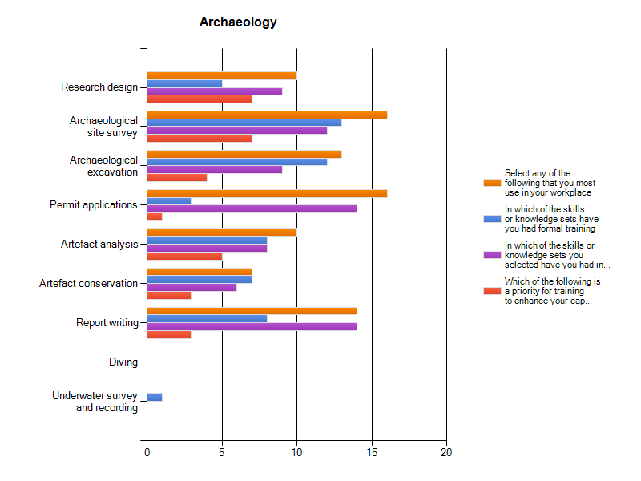
Figure 4.22 Keyword responses (Section B)—archaeology (Aotearoa/New Zealand).

4.5.7 Historic Landscape Management
The sub-discipline or area of historic landscape management received a relatively high number of responses although only a single respondent to the survey identified landscape management as the area in which they specialised in their studies—indicating that historic landscapes are being assessed and managed by people across the heritage industry, without necessarily any formal specialist training in the field.

Australian Respondents (111 Respondents)

Skills Most Used
1. Historic map/plan analysis (76)
2. Landscape assessment (61)
3. Curtilage analysis (50)

Priority Areas for Further Training
1. Landscape assessment (37) and historic map/plan analysis (37)
2. Landscape architecture (27) and curtilage analysis (27)

Aotearoa/New Zealand Respondents (35 Respondents)

Skills Most Used
1. Historic map/plans (26) and landscape assessment (23)
2. Curtilage analysis (12) and landscape architecture (11)
3. View analysis (8)

Priority Areas for Further Training
1. Landscape assessment (14)
2. Historic map/plan analysis (11), curtilage analysis (10) and landscape architecture (9)
3. View analysis (7)

Skills Training—Formal or Informal
Similarly to all other sections or sub-disciplines in the survey, the training in skills listed under ‘historic landscape management’ in Australia has been primarily informal, even for the specialist areas of ‘horticulture’ and ‘aboriculture’.
Without exception, all NZ respondents were more likely to have developed their historic landscape management skills on-the-job, with the greatest likelihood being for curtilage analysis (1 formal, 10 informal).

Findings/Issues

Australian Respondents
- Overall ‘historic landscape management’ has a relatively high number of responses against ‘priority for training’ as compared to ‘skills most used’. This is particularly marked for ‘aboriculture’, ‘horticulture’, ‘landscape architecture’ and to a slightly lesser extent for ‘landscape assessment’, ‘curtilage analysis’ and view analysis’. In each of these skills the formal training responses are relatively very low.

Aotearoa/New Zealand Respondents
- The most used skills (landscape assessment, historic map/plan analysis) were also more likely to be associated with some formal training as well as more on-the-job training, and were two of the highest training priorities.
- Landscape architecture and curtilage analysis were the second most-used skills and also amongst the training priorities.
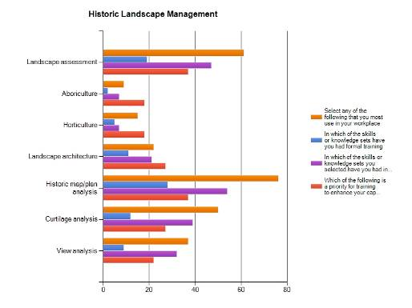
Figure 4.23 Keyword responses (Section B)—historic landscape management (Australia).
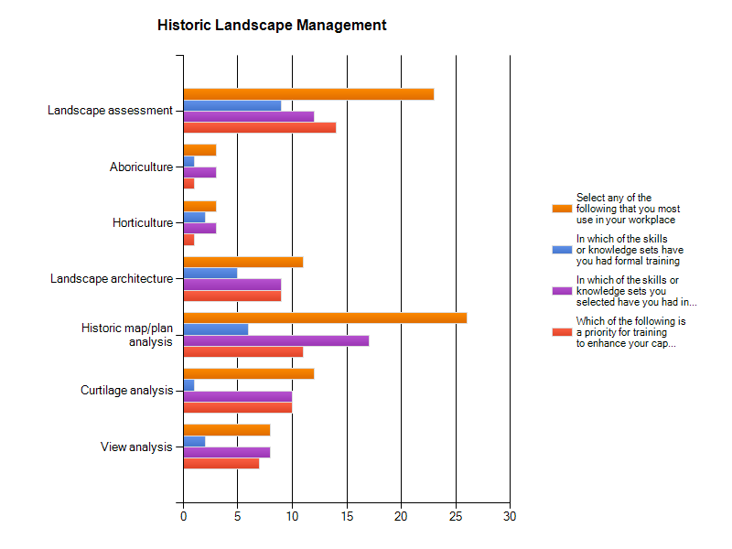
Figure 4.24 Keyword responses (Section B)—historic landscape management (Aotearoa/New Zealand).

4.5.8 Legislation and Policy
The keyword skills included under ‘legislation and policy’ relate to the use and therefore knowledge of various legislation and policy that governs and frames professional heritage management in Australia and Aotearoa/New Zealand, which is reflected in the large number of respondents to this section.

Australian Respondents (159 Respondents)

Skills Most Used
1. State heritage legislation (141)
2. Burra Charter (145)
3. State planning legislation (112)

Priority Areas for Further Training
1. State heritage legislation (40)
2. Aboriginal heritage (39) and Burra Charter (39)
3. State planning legislation (37)

Aotearoa/New Zealand Respondents (45 Respondents)

Skills Most Used
1. Historic Places Act (NZ) (28)
2. Resource Management Act (NZ) (24)
3. Building Codes (19)

Priority Areas for Further Training
1. Historic Places Act (NZ) (14)
2. Resource Management Act (NZ) (13)
3. International agreements and conventions (10)

Skills Training—Formal or Informal
There is a similar pattern to the other section or sub-disciplines, except archaeology, with informal or on-the-job training receiving a far larger number of responses than formal training. For the more recent legislation such as the EPBC Act and the building codes this may reflect the age of the respondents to the survey, over 60% of Australian respondents having completed their formal training prior to 2000.
The NZ Respondents have for most sections of the question undertaken informal or on-the job training. Areas in which respondents have undertaken formal training include the Resource Management Act (NZ), OH&S requirements and the Burra Charter.

Findings/Issues

Australian Respondents
- Although identified as skills ‘most used’, the number of responses for ‘priority for training’ in ‘state heritage legislation’, ‘Burra Charter’, ‘state planning legislation’ or ‘OH&S requirements’ is relatively low. Once legislation or policy has been learnt—on-the-job or formally—there will not be a need for up grading knowledge of the legislation or policy unless it changes or new legislation is introduced, at which point it is likely to become a priority.
- The overall number of responses to ‘natural heritage legislation’ and ‘Aboriginal heritage legislation’ is low compared to most other keyword skills in this section, while the priority for training for both is relatively high.

Aotearoa/New Zealand Respondents
- During the course of the survey the keyword breakdown in this section was altered slightly to better reflect the NZ Context. It seems that some respondents undertook the survey before this occurred and this may have slightly skewed the results.
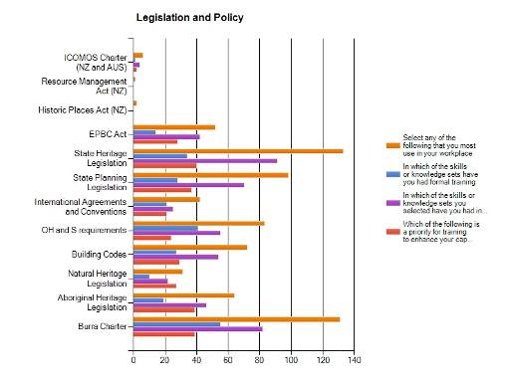
Figure 4.25 Keyword responses (Section B)—legislation and policy (Australia).
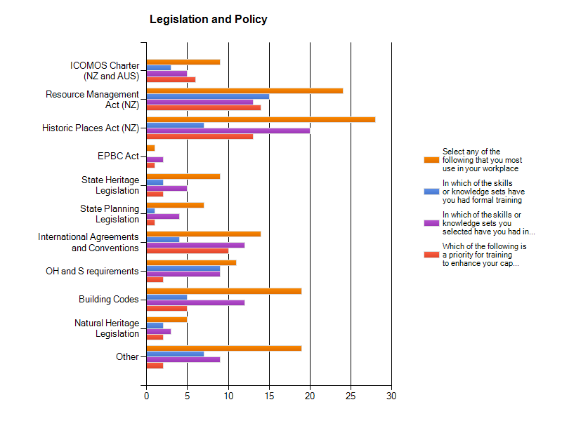
Figure 4.26 Keyword responses (Section B)—legislation and policy (Aotearoa/New Zealand).

4.6 Representatives of a Heritage Agency, Institution or Private Company (Section C)
Against each keyword (see Table 4.1) people responding on behalf of a heritage agency, company or organisation were asked to identify the:
- skills that are most used by the heritage agency, company or organisation they represent;
- skills they consider lacking in their agency, company or organisation; and
- skills that they see as a priority for staff training in future.

Number of Australian Respondents/Section
Physical conservation | 21
Recording | 24
Management | 24
Consultation | 23
Interpretation | 21
Archaeology | 14
Historic landscape | 16
Legislation and policy | 24

Number of Aotearoa/New Zealand Respondents/Section
Physical conservation | 10
Recording | 14
Management | 16
Consultation | 14
Interpretation | 12
Archaeology | 9
Historic landscape | 8
Legislation and policy | 12

Note: In general, in Section C the number of responses to individual keywords is small, limiting the interpretation of results. The findings of the survey should be seen in this light.

4.6.1 Physical Conservation

Australian Respondents (21 Respondents)

Skills Most Used in your Institution
1. Architectural analysis (17)
2. Paint analysis (11)
3. Painting and decorating (9) and roofing (9)

Skills Lacking in your Institution
1. Bricklaying (5), plastering (5), glass conservation/replacement (5) and roofing (5)

Priority Skills or Knowledge for Staff in your Workplace Now and/or in the Near Future
1. Architectural analysis (10)
2. Stone masonry (7) and carpentry (7)

Aotearoa/New Zealand Respondents (10 Respondents)

Skills Most Used in your Institution
1. Architectural analysis (7)
2. Carpentry (5)
3. Roofing (4)

Skills Lacking in your Institution
1. Mortar analysis (4)
2. Paint analysis (3), traditional tool making/use (3), metalwork/forging/blacksmithing (3) and engineering (3)

Priority Skills or Knowledge for Staff in your Workplace Now and/or in the Near Future
1. Architectural analysis (4)

Findings/Issues

Australian Respondents
- Few respondents indicated that skills in architectural analysis were lacking but a significant number of respondents indicated that this is a priority for future training.
- A number of skills or trades such as ‘glass conservation’, ‘interior finishes’, ‘roofing’ and ‘engineering’ were identified by four or more respondents as lacking but these are not identified as a priority for the future.
- ‘Stone masonry’, ‘carpentry’, ‘mortar analysis’ and ‘joinery’ were identified as both lacking in the organisation and as priority skills for their company or organisation’s staff in future, although it should be noted that the responses to each are small in number.

Aotearoa/New Zealand Respondents
- Thatching and gilding were identified as lacking, but were not identified as priority training areas.
- As in the Australian results, architectural analysis was identified as being commonly used, but lacking—it was also identified as a priority training area.

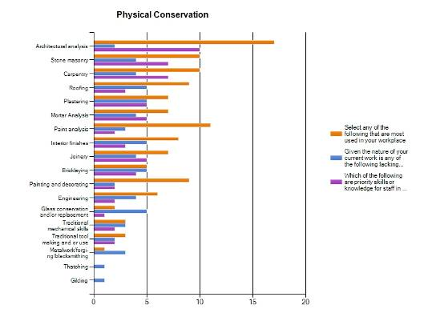
Figure 4.27 Keyword responses (Section C)—physical conservation (Australia).
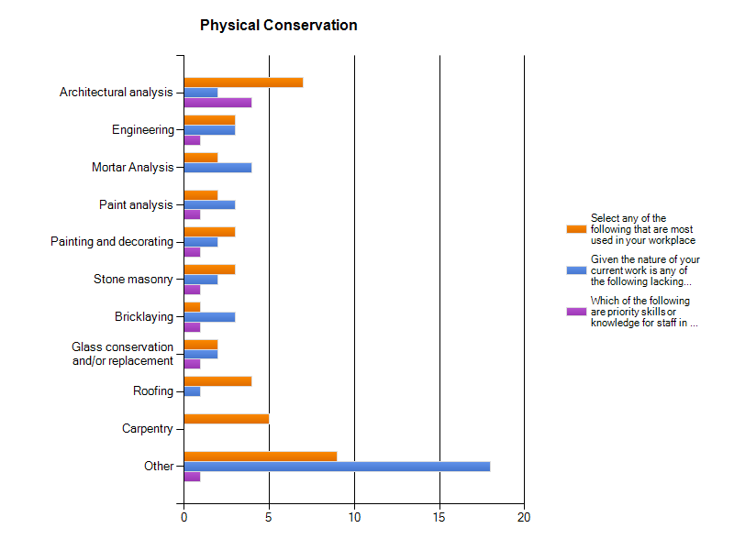
Figure 4.28 keyword responses (Section C)—physical conservation (Aotearoa/New Zealand).

4.6.2 Recording

Australian Respondents (24 Respondents)

Skills Most Used in your Institution
1. Historical research (21)
2. Site survey (20)
3. Photography (19)

Skills Lacking in your Institution
1. GIS (6)
2. Oral history (4), historical research (4) and archival research (4)

Priority Skills or Knowledge for Staff in your Workplace Now and/or in the Near Future
1. Site survey (10) and historical research (10)
2. Data management (9) and archival research (9)

Aotearoa/New Zealand Respondents (14 Respondents)

Skills Most Used in your Institution
1. Historical research (9) and photography (9)
2. Archival Research (8) and site survey (8)
3. Data Management (7) and inventory preparation (7)

Skills Lacking in your Institution
1. GIS (4)
2. Sketching (3), cataloguing (3) and fabric survey (3)

Priority Skills or Knowledge for Staff in your Workplace Now and/or in the Near Future
1. Historical research (8)
2. Archival research (6) and GIS (6)
3. Fabric survey (5)

Findings/Issues

Australian Respondents
- Overall the number of responses identifying skills lacking in the work place is small.
- With the exception of GIS, the priority skills or knowledge for staff in the future are the generic skills identified as most commonly used in the workplace.
- Although the number of responses is low, GIS appears to be both currently lacking and a priority skill for staff in the future.

Aotearoa/New Zealand Respondents
- Although the number of responses is low, GIS, fabric survey and cataloguing appear to be both currently lacking and priority skills for staff in the future.
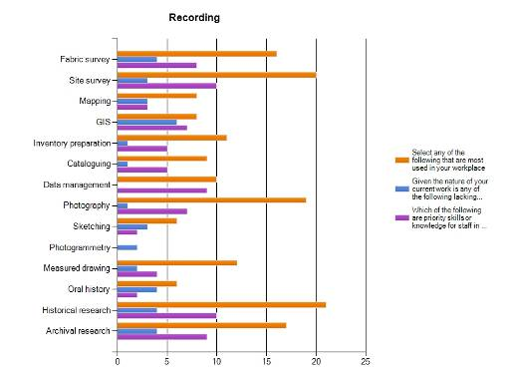
Figure 4.29 Keyword responses (Section C)—recording (Australia).
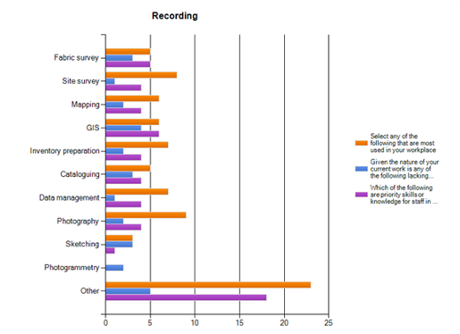
Figure 4.30 Keyword responses (Section C)—recording (Aotearoa/New Zealand).

4.6.3 Management

Australian Respondents (24 Respondents)

Skills Most Used in your Institution
1. Conservation management planning (21) and significance assessment (21)
2. Legislative compliance (19) and conservation strategy (19)

Skills Lacking in your Institution
All keyword skills received ≤5 responses to this question

Priority Skills or Knowledge for Staff in your Workplace Now and/or in the Near Future
1. Conservation management planning (13)
2. Significance assessment (11) and conservation strategy (11)
3. Legislative/statutory context (10)

Aotearoa/New Zealand Respondents (16 Respondents)

Skills Most Used in your Institution
1. Significance assessment (21), issues analysis (9) and legislative/statutory context (9)
2. Policy development (8) and conservation management planning (8)
3. Legislative compliance (7) and risk management (7)

Skills Lacking in your Institution
1. Conservation strategy (5)
2. Risk management (4)

Priority Skills or Knowledge for Staff in your Workplace Now and/or in the Near Future
1. Significance assessment (7)
2. Risk management (5), issues analysis (5), conservation strategy (5) and conservation management planning

Findings/Issues

Australian Respondents
- There are relatively fewer responses to ‘skills lacking’ in the management section that in any other section.
- The generic skills in ‘significance assessment’, ‘conservation management planning’, ‘conservation strategy’ and ‘legislative statutory context’ stand out as priority knowledge or skills for staff in future.

Aotearoa/New Zealand Respondents
- Significance assessment received only one response as a skill that is lacking, but received the highest number of responses for priority future training—a strange anomaly.
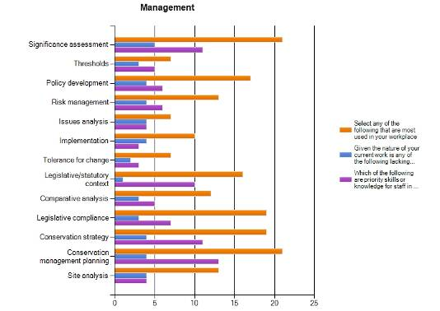
Figure 4.31 Keyword responses (Section C)—management (Australia).
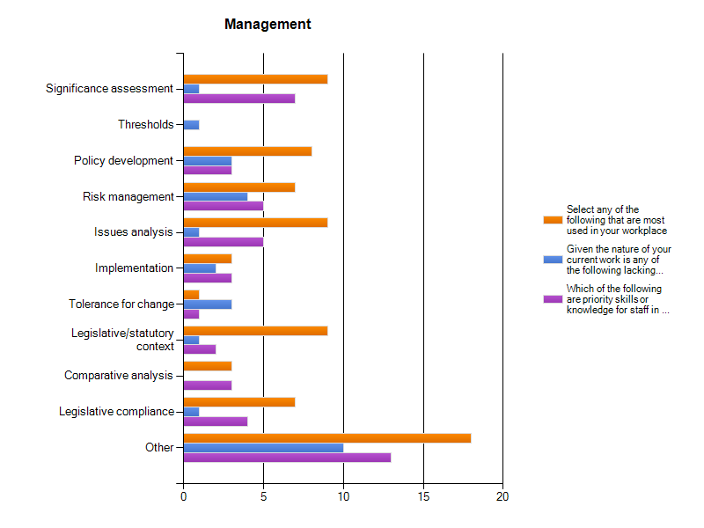
Figure 4.32 Keyword responses (Section C)—management (Aotearoa/New Zealand).

4.6.4 Consultation

Australian Respondents (23 Respondents)

Skills Most Used in your Institution
1. Stakeholder engagement (18)
2. Recording information (15)
3. Public speaking (11) and survey development and analysis (11)

Skills Lacking in your Institution
1. Public speaking (6)
2. Plain English publication (5)
3. Survey development and analysis (4)

Priority Skills or Knowledge for Staff in your Workplace Now and/or in the Near Future
1. Stakeholder engagement (11)
2. Plain English publication (10)

Aotearoa/New Zealand Respondents (14 Respondents)

Skills Most Used in your Institution
1. Stakeholder engagement (10) and public speaking (10)
2. Recording information (7)

Skills Lacking in your Institution
1. Survey development and analysis (6)
2. Plain English publication (2)

Priority Skills or Knowledge for Staff in your Workplace Now and/or in the Near Future
1. Survey development and analysis (7)
2. Stakeholder engagement (7)

Findings/Issues

Australian Respondents
- Skills in plain English publication appear to be a priority for future staff, albeit in a relatively small number of respondents

Aotearoa/New Zealand Respondents
- Skills in survey development and analysis are identified as lacking and of high priority for future training.
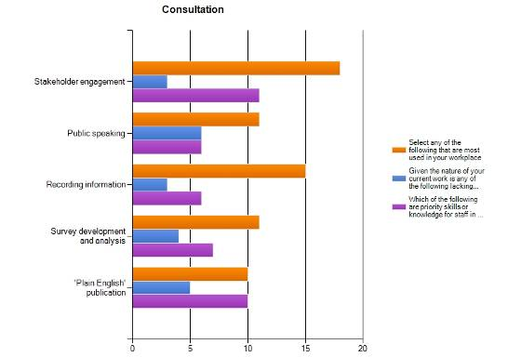
Figure 4.33 Keyword responses (Section C)—consultation (Australia).
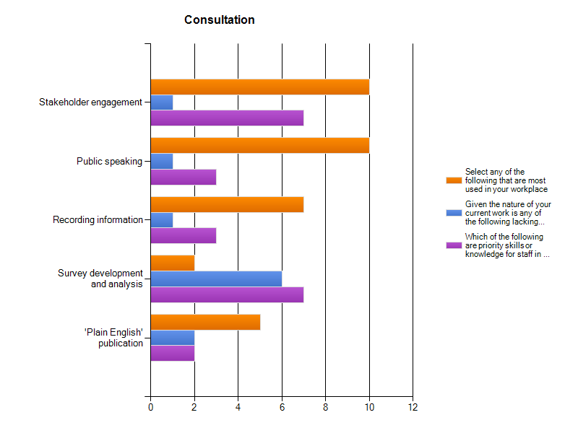
Figure 4.34 Keyword responses (Section C)—consultation (Aotearoa/New Zealand).

4.6.5 Interpretation

Australian Respondents (21 Respondents)

Skills Most Used in your Institution
1. Communication skills (17)
2. Interpretation strategies/plans (15)
3. Historical themes (11) and content development (11)

Skills Lacking in your Institution
1. Multimedia (5) and audience analysis (5)
2. Visitor management (4)
Remainder ≤3

Priority Skills or Knowledge for Staff in your Workplace Now and/or in the Near Future
1. Interpretation strategies/plans (10)
2. Communications skills (9) and multimedia (9)

Aotearoa/New Zealand Respondents (21 Respondents)

Skills Most Used in your Institution
1. Communication skills (11)
2. Multimedia skills (7) and visitor management (7)
3. Content development (6) and interpretation strategies/plans (6)

Skills Lacking in your Institution
1. Audience analysis (3)
2. Interpretation strategies/plans (3)

Priority Skills or Knowledge for Staff in your Workplace Now and/or in the Near Future
1. Interpretation strategies/plans (4)
2. Communications skills (4)

Findings/Issues

Australian Responses
- The number of responses that identify ‘visitor management’ and ‘audience analysis’ as priority skills for staff in future is higher than for skills ‘most used’.

Aotearoa/New Zealand Respondents
- The highest number of respondents identified ‘communication skills’ as the most commonly used in their workplace, and there is no identification of a lack in this area—although it also received the highest number of responses for priority future training
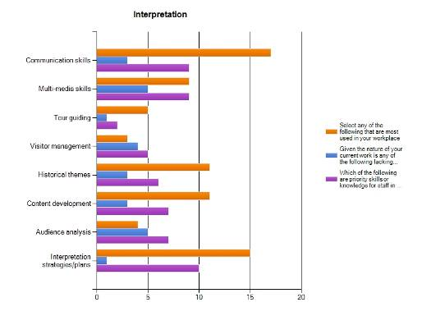
Figure 4.35 Keyword responses (Section C)—interpretation (Australia).
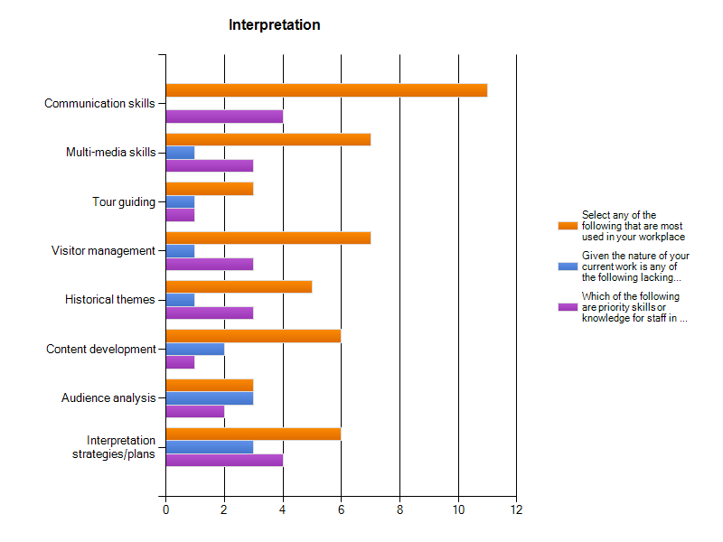
Figure 4.36 Keyword responses (Section C)—interpretation (Aotearoa/New Zealand).

4.6.6 Archaeology

Australian Respondents (14 Respondents)

Skills Most Used in your Institution
1. Permit applications (9)
2. Report writing (6) and archaeological site survey (6)
3. Research design (5) and artefact analysis (5)

Skills Lacking in your Institution
1. Archaeological excavation (6)
2. Archaeological site survey (5), artefact analysis (5) and artefact conservation (5)

Priority Skills or Knowledge for Staff in your Workplace Now and/or in the Near Future
1. Artefact analysis (6)
2. Research design (4)
Remainder ≤3

Aotearoa/New Zealand Respondents (9 Respondents)

Skills Most Used in your Institution
1. Permit applications (6)
2. Report writing (5)
3. Archaeological site survey (4)

Skills Lacking in your Institution
1. Archaeological site survey (3)
2. Archaeological excavation (2)

Priority Skills or Knowledge for Staff in your Workplace Now and/or in the Near Future
1. Archaeological site survey (3)
2. Archaeological excavation (3)
3. Report writing (2)

Findings/Issues

Australian Respondents
- Artefact analysis was seen as a priority skill for future staff by more respondents than any other archaeological skill included in this section.

Aotearoa/New Zealand Respondents
- Archaeology received the second lowest number of responses from NZ respondents and therefore the data is difficult to extrapolate.
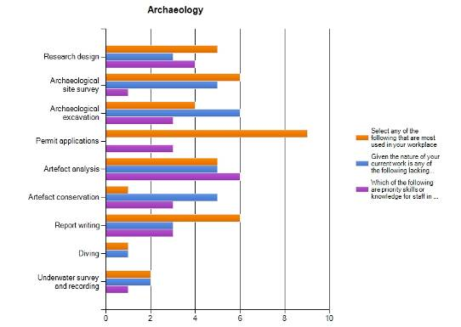
Figure 4.37 Keyword responses (Section C)—archaeology (Australia).
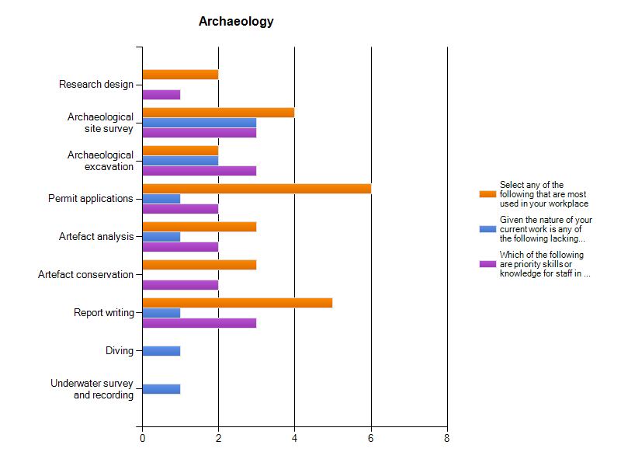
Figure 4.38 Keyword responses (Section C)—archaeology (Aotearoa/New Zealand).

4.6.7 Historic Landscape Management

Australian Respondents (16 Respondents)

Skills Most Used in your Institution
1. Curtilage analysis (13)
2. Landscape assessment (11)
3. Historic map/plan analysis (10)

Skills Lacking in your Institution
1. Landscape assessment (7)
2. Landscape architecture (5) and view analysis (5)

Aotearoa/New Zealand Respondents (8 Respondents)

Skills Most Used in your Institution
1. Landscape assessment (4), curtilage analysis (4) and historic map/plan analysis (4)
2. Landscape architecture (5) and view analysis (5)

Skills Lacking in your Institution
2. Landscape architecture (5) and view analysis (5)

Priority Skills or Knowledge for Staff in your Workplace Now and/or in the Near Future
1. Landscape architecture (4)
2. Landscape assessment (3)
3. Historic map/plan analysis (2)

Findings/Issues

Australian Respondents
- Responses indicate skills in landscape assessment are both currently lacking and a priority for future staff.

Aotearoa/New Zealand Respondents
- As with ‘archaeology’ the low number of responses to this section makes the data difficult to analyse.
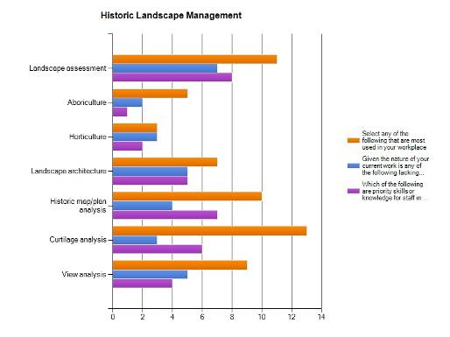
Figure 4.39 Keyword responses (Section C)—historic landscape management (Australia).
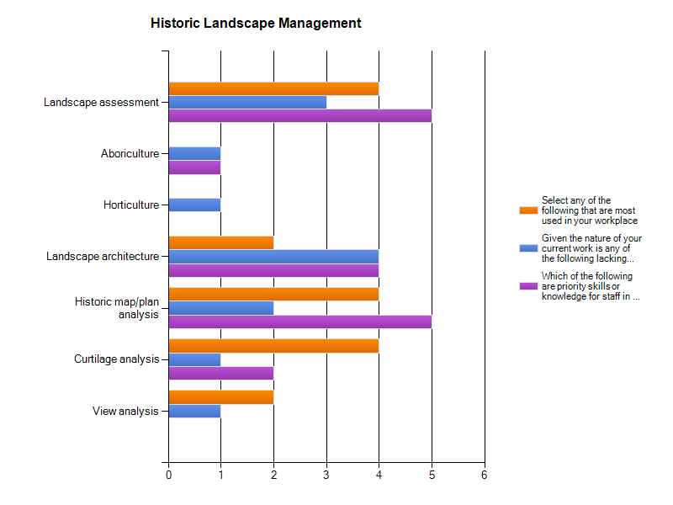
Figure 4.40 Keyword responses (Section C)—historic landscape management (Aotearoa/New Zealand).

4.6.8 Legislation and Policy

Australian Respondents (24 Respondents)

Skills Most Used in your Institution
1. State heritage legislation (22)
2. Burra Charter (21)
3. State planning legislation (19)

Skills Lacking in your Institution
All ≤4

Priority Skills or Knowledge for Staff in your Workplace Now and/or in the Near Future
1. State heritage legislation (14)
2. Burra Charter (11)
3. State planning legislation (9)

Aotearoa/New Zealand Respondents (12 Respondents)

Skills Most Used in your Institution
1. Historic Places Act (NZ) (11)
2. Resource Management Act (NZ) (8) and building codes (8)
3. ICOMOS Charter (NZ) (5)

Skills Lacking in your Institution
1. Building codes (2)

Priority Skills or Knowledge for Staff in your Workplace Now and/or in the Near Future
1. Historic Places Act (NZ) (6)
2. Resource Management Act (NZ) (5) and building codes (5),
3. Burra Charter (3)

Findings/Issues

Australian Respondents
- The generic keyword skills or knowledge of state legislation and the Burra Charter in this section are most used and are not lacking in the organisations or companies but are still considered priorities for future staff.

Aotearoa/New Zealand Respondents
- Top ranking skills identified in the ‘most used’ section of this question matched those identified for priority future training, demonstrating that although the skills are used commonly, the industry is keen for further training in these areas.
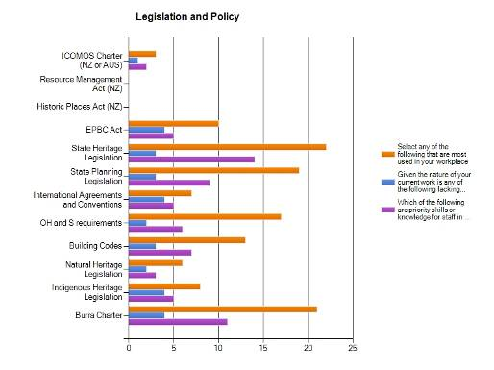
Figure 4.41 Keyword responses (Section C)—legislation and policy (Australia).
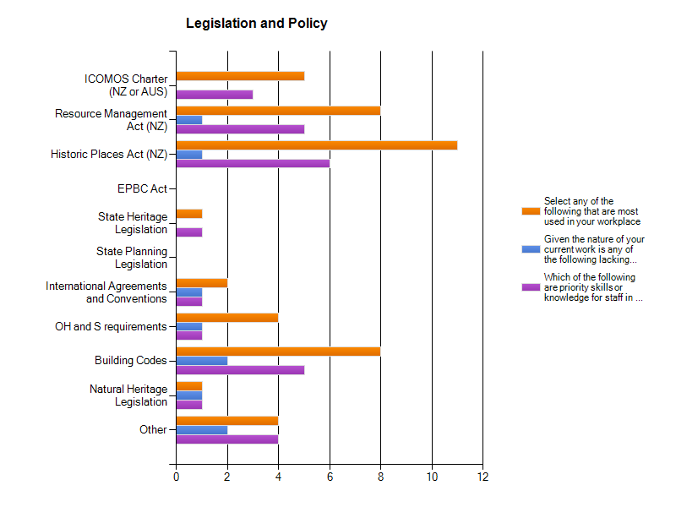
Figure 4.42 Keyword responses (Section C)—legislation and policy (Aotearoa/New Zealand).

5.0 Physical Conservation Supplementary Surveys: Summary and Analysis of Results

5.1 Background
Following the initial Skills Needs Analysis survey (see Section 4.0) the project team received representations from key stakeholders in the heritage industry who felt the survey did not adequately address the diversity of skills and knowledge that may be considered within ‘physical conservation’ and that the results of this survey may therefore not provide a clear picture of the conservation skills and knowledge in use in Australia or current or future skills needs.
The experiences of these stakeholders and anecdotal evidence within the heritage industry suggested that in Australia there is a growing lack of people with specialist skills in physical conservation and a need for training in traditional trades commonly used in the conservation of traditional buildings and structures.
However, this need was not reflected in the findings of the Skills Needs Analysis which indicated training in specialist skills or trades required in physical conservation was not a priority. Given that only 14 respondents to the Skills Needs Analysis identified themselves as tradespeople; it seemed likely that the initial survey had not reached many people working in trades such as plastering and woodwork who are involved in work on traditional buildings and structures.
To ensure that the industry as a whole—and its training needs—is represented in the study, two supplementary targeted surveys were developed by Steering Committee in consultation with a group of experienced practitioners and professionals. The surveys are based on models successfully used in the United Kingdom, and aim to assess the skills and needs in professional physical and technical conservation and in heritage trades. The data generated by these surveys is not directly comparable with that of the Skills Needs Analysis survey.
These targeted surveys were sent to recipients identified by the reference group and included heritage professionals, individual tradespeople, organisations or companies working in the physical conservation of traditional buildings and structures. Because of time and resource constraints, the supplementary surveys were mostly targeted at those based in NSW and Victoria.
Survey 1. Professional Physical and Technical Conservation Survey was intended for specifiers of works to traditional buildings and structures such as architects and structural engineers.
Survey 2. Trades Physical and Technical Conservation Survey, was intended for those involved in physical construction works (eg trades, builders and building company project managers). Along with those people identified by the Steering Committee and reference group this survey was also forwarded to the Master Builders Association of NSW who sent it out to their membership, significantly increasing the number of respondents to this survey.
Both surveys are similarly structured to provide information about the respondents location and type of work and/or profession; details of their training and experience; the size and type of business in which they work; issues in recruitment of staff and staff training; the specialist skills they use in their work and the ease or otherwise of locating people with these skills.
Initial analysis of the survey results included data from all respondents to each survey. At the request of a member of the reference group the analysis was extended to look specifically at the responses of those respondents for who more that 50% of their work is with traditional buildings and structures. A filter was applied to the data to provide this information.
The results each survey are discussed below.
Note: On the advice of the Steering Committee and reference group the term ‘traditional buildings and structures’ is used in these surveys to denote buildings and structures dating prior to World War II.

5.2 Survey 1: Professional Physical and Technical Conservation Survey
A total of 34 respondents began the survey and 25 (73%) of these respondents indicated that they undertake over 50% of their work on traditional buildings and structures.
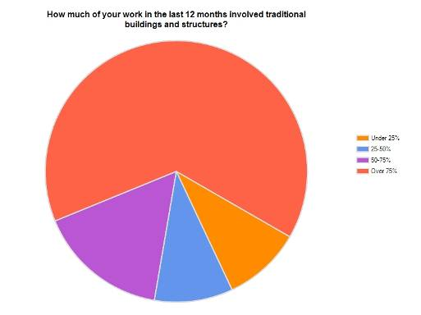
No significant differences were identified in the responses of those with more than 50% of their work being on traditional buildings and structures as compared to the respondents as a whole (average variance of 2-4%).
Given this, the results of Survey 1 discussed reflect the total number of respondents unless otherwise stated.

5.2.1 General Observations and Key Issues
- The majority of respondents are from NSW and Victoria and the results of the survey best reflect the situation in these two states. The majority of respondents live and work in capital cities. No responses to Supplementary Survey 1 were received from Aotearoa/New Zealand.
- Half the respondents are over the age of 45, half have been working on traditional buildings and structures for more than 20 year and half completed their formal training over 20 years ago. Assuming the respondents reflect the range of professionals working in building conservation, then the results of the survey suggest an aging of the profession and a lack of professionals in the 30–45 year age range.
- A large proportion of respondents consider their formal education did not adequately prepare them for work on traditional buildings and structures and most consider that their skills in this area were learnt on ‘on the job’ (most received formal training more than 20 years ago).
- Almost all those respondents with responsibilities for recruiting staff felt recruits are poorly prepared for work on traditional buildings and structures, pointing to a lack of appropriate training and a missing link between education providers and the industry. The majority of these respondents offer their staff training on average 10-20 days per year; however, almost all found it difficult to access specialist training for their staff owing to cost and lack of availability.
- Qualified people have difficulty in finding people who want to learn their skills, particularly in specialist trades; however, people also noted that specialist ‘in service’ training is difficult to access.
- In relation to the availability of, and needs for, specific skills referred to in the survey, in general there is a high level of ‘in-house’ skills and moderate demand for training in key skill areas of physical conservation, while a higher demand is identified in trade skills.

5.2.2 The Respondents
- Of the total respondents, 45% are from NSW (14) and almost 26% are from Victoria (8). The remaining respondents represent all other Australian states except Western Australia and Tasmania. A similar distribution is seen in those respondents who work more than 50% of their time on traditional buildings or structures. 48% are from NSW (13), 28% are from Victoria (7). The remaining five respondents represent all other Australian states except Western Australia and Tasmania.
- 51% of total respondents are undertaking the majority of their work in NSW and almost 28% in Victoria, indicating that the work of nearly all respondents is within the state in which they reside. A similar pattern is evident in the respondents who work more than 50% of their time on traditional buildings or structures.
- 84% of respondents are located in capital cities, 6.5% in rural centres of more than 20,000 and almost 10% in rural areas. Again, a similar pattern is evident in the respondents who work more than 50% of their time on traditional buildings or structures.
- 61% (19) of respondents were between 45-60 years of age. Only one of the respondents was under 30, 25% of respondents were over 60% and just under 10% were aged between 30 and 45 years.
- Over 60% of respondents stated ‘architect’ as their occupation, with 13% structural engineers and other stating ‘other’ including consultant, historian and conservator. In the free text responses 29% (9) respondents identified their occupations as: heritage adviser, historian, historian and heritage consultant, writer and conservation advisor, architectural historian, some material conservation, stained glass artist and restorer, building/grounds maintenance, architectural conservator, consultant—materials conservation. Of those respondents who work more than 50% of their time on traditional buildings or structures, 64% gave ‘architect’ as their occupation, 8% as ‘structural engineer’ and 32% stating ‘other’.
- The majority of the applicants (61%) have been undertaking work on traditional buildings and structures for over 20 years. Only one respondent had been working on traditional buildings and structures for less than 5 years.
- All respondents had at least an undergraduate degree, with 42% having undertaken postgraduate study and almost 10% with a doctorate. The percentage of respondents who work more than 50% of their time on traditional buildings or structures who have undertaken postgraduate study was slightly higher 48%; however, the percentage who have a doctorate (4%) is lower than for the total number of respondents.
- 53% of both the total number of respondents and the subset of those who work more than 50% of their time on traditional buildings or structures completed their education over 20 years ago.
- Of the 27 respondents who answered question 8—regarding their professional memberships and affiliations 17 were members of ICOMOS, 8 are members of the National Trust, 8 members of the Australian Institute of Architects. 10 respondents are members of Association of Preservation Technology, 3 members of the NSW Technical Advisory Group. Other memberships included the Engineering Heritage Committee, Building Limes Forum, Traditional Paint Forum and the Professional Historians Association.

5.2.3 Training and Experience (31 Respondents)
- Over 77% of respondents indicated that their formal education did not adequately prepare them for work on traditional buildings and structures. Free text additional information confirms that degree courses were not focused on this kind of skill and knowledge development, but on theory and ‘modern’ or contemporary construction.
- 26 of the 31 respondents (84%) stated that they learnt the majority of their skills ‘on the job’
- Almost half of the respondents to this survey had completed the previous heritage training skills needs analysis survey

5.2.4 The Respondents’ Businesses (29 Respondents)
- Almost 38% of respondents’ business had less than 5 staff members, over 27% had 5-10 staff members, and the remaining percentage (almost 35%) had more than 10 (and up to 50 or more) staff members. For those respondents who work more than 50% of their time on traditional buildings or structures, nearly 44% of their businesses have less than 5 staff members.
- In the case of almost 42% of respondents, fewer than 25% of their staff members undertake work on traditional buildings and structures (as expected this percentage was slightly lower at 30% for those respondents who work more than 50% of their time on traditional buildings or structures). 8 of the 29 respondents (27.6%) said that 75% of their staff undertake work on traditional buildings and structures. 7% of respondents specified that no other staff members (besides them) undertake work on traditional buildings and structures, and 20.7% stated they were sole practitioners.
- Over 82% of respondents stated that their staff obtained their knowledge about traditional buildings and structures informally (on the job, or via colleagues).
- Of the total respondents, 41% stated that more than 75% of their business’ work was on traditional buildings and structures, 75% with more than 50% of their work traditional buildings and structures and 17% have under 25% of their work involved traditional buildings and structures. These results reflect the targeted nature of the survey.
- Over 65% of the total respondents anticipate their workload on traditional buildings and structures will remain the same over the next three years and 35% anticipate their workload will increase. For those respondents with more than 50% of their work traditional buildings and structures, 74% of anticipate their workload on traditional buildings and structures will remain the same over the next three years and 26% anticipate their workload will increase. No respondent anticipated a decrease in their workload on traditional buildings and structures.
- 51.7% of respondents stated that the majority of their work on traditional buildings and structures is undertaken in NSW, 28% in Victoria, 13.8% in ACT and Northern Territory (NT) and 10% in QLD and less than 7% in SA and Tasmania (TAS), and 1 respondent answered ‘Hong Kong’. No respondents specified undertaking work in New Zealand or WA.
- 93% of respondents work on traditional buildings or structures located in capital cities.

5.2.5 Recruitment and Training (12 Respondents)
Only 12 respondents answered questions in this section as they undertake recruitment and employment of new staff.
- Over 91% believed newer recruits were poorly prepared for work on traditional buildings and structures.
- Over 46% of respondents stated they ‘always’ have difficulty recruiting staff that are adequately prepared for work on traditional buildings and structures, over 30% said they ‘usually’ have difficulty and over 15% say they occasionally have difficulty recruiting adequately prepared staff. Only one respondent stated that they ‘never’ have difficulty recruiting adequately prepared staff.
- When asked how they deal with this difficulty in recruiting adequately prepared staff respondents answers included cyclical recruitment, mentoring and on the job training, upskilling through short courses and seminars and simply not employing new staff.
- 61.5% of respondents stated they had a training strategy in place for their staff and 38.5% stated they did not have a training strategy in place.
- The respondents stated that in the last 12 months they and their staff have undertaken between 1 and 45 days of training. Most respondents stated an average of 10-20 days per year that their staff are participating in training activities (1 firm 45 days, 1 firm 20-30 days, 1 firm 25 days, 3 firms 10 days, 4 firms 2-10 days.)
- Respondents stated that they pass on their knowledge to their employees on a project-by-project basis, through mentoring, site visits, informal discussions/sessions and by recommended reading.
- 90% of respondents stated that they have difficulty locating accessible specialist training for their employees, stating that these courses are expensive, rare and often not repeated.

5.2.6 Specialist Skills (27 Respondents)
In this section, respondents were given a list of skills in a matrix asking them to identify if each skill is needed in their work, is easily accessible, is already accessible in their workplace or is a priority for future training.
As noted above, the responses to each question in the Specialist Skills section were very similar, if not identical, regardless of whether the responses are considered in total or the information is filtered to identify only those respondents with more than 50% of their work traditional buildings and structures.
Note: Owing to the small number of respondents, the results in this section are difficult to interpret.

Materials Investigation, Testing, Diagnosis and Analysis
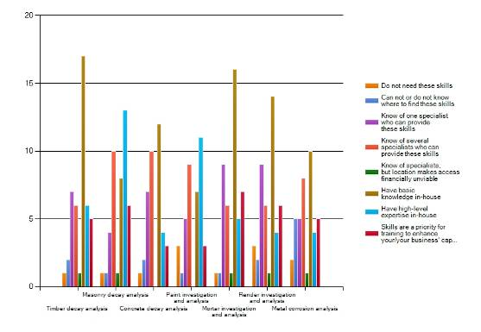
- 63% of respondents have in-house knowledge of timber decay analysis, with 18.5% identifying this as a priority for future training.
- 11.5% of respondents identified that they do not need skills in render or paint investigation and analysis, with 27% and 54% of respondents respectively having these skills in house.
- 19% of respondents can not, or do not know where to find skills in metal corrosion analysis.
- 26% of respondents identified mortar investigation and analysis as a priority for future training.
- The following skill/knowledge areas were identified in the free text responses: close analysis of glass, glass paints, lead calmes and other structural materials would be really useful to have access to metallurgist rather than metals conservator, glass defects, sealant deterioration and waterproof membrane deterioration.

Specification and Documentation
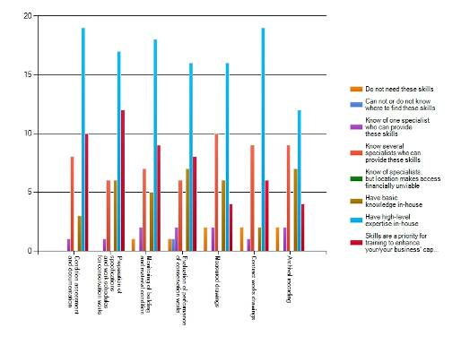
- 70% of respondents have in-house expertise in condition assessment and documentation and contracts works drawings.
- 37% of respondents felt that condition assessment and documentation was a priority for future training.
- 37% of respondents knew several providers who can prepare measured drawings.

Materials Conservation
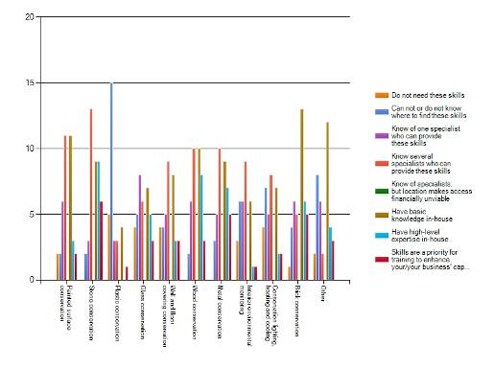
- 19% of respondents stated they do not need skill in plastic conservation, and 15% stated that they do not need skills in wall and floor covering conservation or conservation lighting, heating and cooling.
- Over 40% of respondents knew several specialists who could provide services in painted surface conservation, stone conservation and metal conservation. This figure was slightly higher at 55% in those respondents with more than 50% of their work traditional buildings and structures.
- 39% of respondents had basic level in-house knowledge of wood conservation, with 31% having high level expertise in-house.
- 22.2% of respondents see stone conservation as a priority for future training.

Availability of Other Specialist Skills
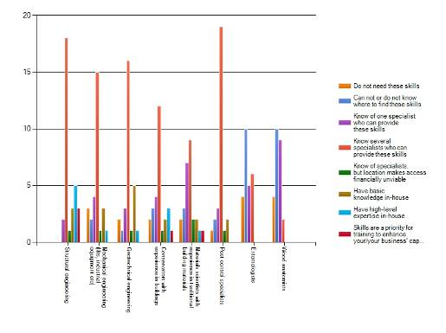
- 67% of respondents knew several specialists who could provide service in structural engineering, 56% knew several specialists in mechanical engineering and 62% knew several specialists in geotechnical engineering.
- 11% of respondents identified structural engineering as a priority for future training. Only 5% of those respondents with more than 50% of their work traditional buildings and structures identified structural engineering as a priority for future training.
- 40% of respondents could not, or did not know where to find skills in entomology or wood anatomy.

Heritage Trades
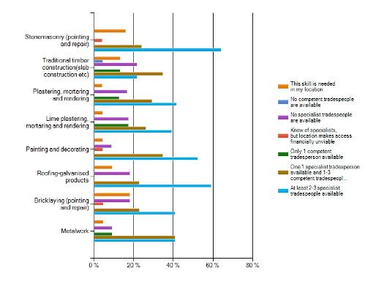
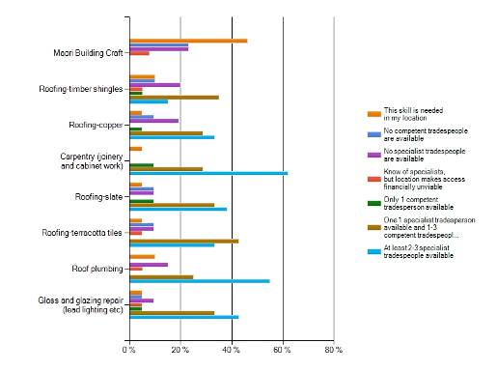
This matrix asked respondents to identify the availability and necessity of heritage trades skills in their location.
- 64% of total respondents know of 3-4 specialists available in stonemasonry, 62% in carpentry and 52% in painting and decorating. Interestingly, only 50% of those respondents with more than 50% of their work traditional buildings and structures knew of 2-3 specialists available in stonemasonry.
- 13% of respondents identified the need for traditional timber construction skills in their location, with 22% of respondents stating there were no tradespeople available to undertake this work in their area.
- 13 respondents stated reasons for their difficulty in locating competent or specialist tradespeople, these included that there is simply not enough qualified people, that those who claim to be qualified lack the appropriate knowledge ‘they don’t know what they don’t know’, that as these are only few qualified people, they are very busy and not readily available, location of tradespeople can make accessibility difficult and qualified people come at a high cost.
- When writing specifications for work on traditional buildings and structures, 60% of respondents include requirements to have appropriately qualified specialists be used. Almost 35% state they usually specify the use of specialist tradespeople and 4% only do this occasionally. 71% of respondents with more than 50% of their work traditional buildings and structures include requirements to have appropriately qualified specialists be used. Free-text responses mention requirements to supply evidence of competency, training, past experience and qualifications.
- In stating how they specify these requirements, responses included that a tenderer should demonstrate their experience on similar projects, show previous examples of their work and include recommendations for approval by project architects. One respondent stated the difficulty in specifying the use of a ‘specialist’ as Australia does not have an accreditation scheme for work of this nature. Free-text comments refer to context dependent specification of traditional materials.
- 68% of respondents answered that they ‘usually’ specify the use of traditional materials when preparing specification. 24% stated they ‘always’ specify the use of traditional materials and 12% say they do this ‘occasionally’.
- In specifying the use of traditional materials, respondents stated that: these are only used when they are appropriate as newer materials often offer better results, they use materials dependant on the nature of the work and they often specify the mutual use of old and new materials for the best outcome.
- When not specifying the use of traditional materials, the majority responded stated that this is due to the inability to source materials and the inability of builders to use the materials properly. Other highly chosen options included the high cost of traditional materials (40%) and regulatory issues.
- Respondents answered that their clients are ‘usually’ (52%) aware of the importance of using traditional materials (and the danger of using inappropriate substitutes), with 40% stating they are ‘occasionally’ aware of this. Some respondents stated that they ensure they inform the client of the importance of using traditional materials.
- 48% of respondents stated that they have difficulty locating information on traditional materials and 52% stated they do not have difficulty. For respondents with more than 50% of their work traditional buildings and structures, 58% have difficulty locating information on traditional materials. Respondents noted that many of the best sources of relevant information are older and not easily accessible online.
- Respondents experienced difficulty in locating information on areas where information on traditional materials has been difficult to obtain, control of drainage in traditional buildings, carpentry and joinery, brickwork—tuckpointing, brickwashes, mortars for stonework and brickwork, use of galvanized roofing products over time, timber shingles, timber, render, stone, glass, painting, stained glass, metals, paint on metal, papier mache, wrought iron, encaustic tiling.
- 68% of respondents stated that the lack of knowledge on how to guide tradespeople makes it difficult to specify their use.

5.2.7 Additional Comments from Respondents
The survey offered the opportunity for respondents to comment on the survey and/or their experiences. These included the following:
- Short courses, particularly with hands-practical applications of methods showing different stages of applied conservation solutions/products, or workshops with small numbers of attendee would increase the knowledge gained as well as the skills.
- Your survey did not seem relevant to me as I have mainly done heritage assessment reports (and these are a minor part of my overall professional work as a regular architect) and very rarely done specs for physical work.
- I see a frequent poverty of skill in the preparation of contract documents for work on traditional buildings. It is not possible to go from a Conservation Management Plan directly to site works without the careful preparation of what work is required, at what quality and where. If this does not occur, the quality of the resulting work is almost always poor.
- Good to see surveys of this type being done. In our field of stained glass restoration we have often felt like voices crying in the wilderness.
- This questionnaire is unaware of the real world of the contemporary construction industry; head contractors, sub-contractors, suppliers sourcing their materials from any cheap source.
- Our office has the knowledge and know enough traditional tradespeople to be able to address most of our needs, but most architectural firms do not. The greatest danger is that they are not aware that they do not know enough.

5.3 Survey 2: Trades—Physical and Technical Conservation Survey
A total of 285 responses were received for Survey 2. Trades—Physical and Technical Conservation Survey. As noted in the introduction, the Master Builders Association of NSW sent this survey out to its membership, significantly increasing the number of respondents to this survey and providing a broad snapshot of the construction industry albeit primarily in NSW from where 256 or nearly 90% of respondents are located.
As for Survey 1, the results of this survey were filtered to provide a subset of data from those respondents who spend more than 50% of their time working on traditional buildings and structures, in this case, 60 of the total 285 respondents or 21%.
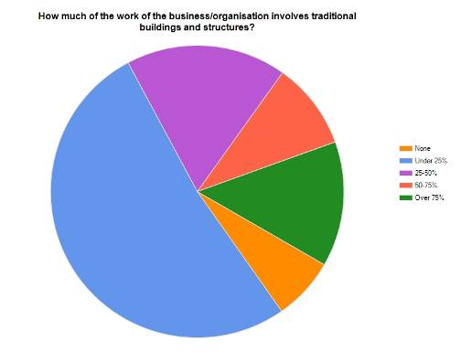
In some sections of the survey the responses of those who spend more than 50% of their time working on traditional buildings and structures differed significantly from the total respondents but overall there was a general similarity between the results.
Where there are significant differences between the results, these are discussed below.

5.3.1 General Observations and Key Issues
- The majority of respondents are from NSW and Victoria and the results of the survey best reflect the situation in these two states. The majority of respondents live and work in capital cities.
- Over 60% of respondents are over 45 years of age. Less than 2% of the respondents are under 30. The majority completed their training more than 20 years ago. This proportion was even higher for those respondents who spend more than 50% of their time working on traditional buildings and structures. Assuming the respondents reflect the range of tradespeople working in building conservation, then the results suggest an aging of the profession and a lack of skilled tradespeople in the 30–45 year age range.
- Only one third of the total respondents received training in building conservation work as part of their trades training. However, the large majority of these respondents felt their formal training adequately prepared them for work on traditional buildings and structures. Similar results were found for those respondents who spend more than 50% of their time working on traditional buildings and structures, suggesting that where training is provided it is adequate, although it should be noted that the majority received their training more than 20 years ago and this may not reflect current training. This is also suggested by over 60% of the respondents who recruit staff, who consider that the majority of the apprentices do not receive adequate information about traditional buildings and structures in their training.
- Over 70% of respondents received training in traditional buildings and structures ‘on the job’.
- In relation to the availability of specialist skills, in almost all skills listed in the survey, some skills appear to be available, being either in house or through respondents knowledge of tradespeople with these skills. However, as is discussed below, there are some difficulties in interpreting the data as elicited from the survey.
- In relation to priorities for training to enhance the business’ capacity, all the skills listed are of low priority—each being considered a priority by less than 17% of respondents and most by under 10% of respondents.

5.3.2 The Respondents

All Respondents
- Nearly 90% of the respondents are from NSW (246), 10% are from Victoria (29). The remaining 2% represent all other Australian states and one respondent is from Aotearoa/New Zealand. The survey results therefore reflect the situation in NSW, but the extent to which these may be generalised to the other states is unclear. These statistics are virtually mirrored in responses to where people work, that is, the work of nearly all respondents the is within the state in which they reside.
- Half of the respondents are located in capital cities, primarily Sydney, 30% in rural centres of more than 20,000 and 20% in rural areas.
- 65% (181) of respondents are over 45 years of age. Less than 25% of the respondents are under 30.

Respondents with more than 50% of work on traditional buildings and structure
- 21% (60) respondents undertake more than 50% of their work on traditional buildings and structure
- 76% of these respondents are from NSW (45), 22% are from Victoria (13). The remaining respondents represent SA, QLD and TAS. No respondents are from WA, ACT, NT or New Zealand. These statistics are virtually mirrored in responses to where people work, that is, the work of nearly all respondents work is within the state in which they reside. The geographical spread of these respondents is wider than for the total respondents, reflecting the respondents targeted in the survey in contrast to the respondents who are members of the Master Builders Association of NSW.
- 52% of these respondents are located in capital cities, 23% in rural centres of more than 20,000 and 27% in rural areas.
- 52% of these respondents are over 45 years of age. Less than 2% of the these respondents are under 30.

5.3.3 Training and Experience

All Respondents
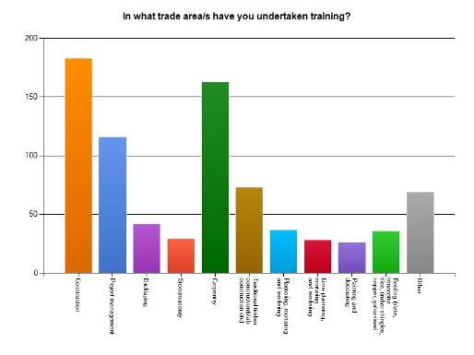
- Respondents also identified a range of other trade areas in which they have had training including:
- Tuckpointing
- Use of lime mortars
- Scagliola (plaster marble)
- Heritage wallpapers/ Hanging
- Heritage Colours
- Asbestos
- OH&S
- Site safety management
- Waterproofing
- Adze work
- Joinery replica and restoration including traditional Asian construction methods
- Carpentry and joinery
- Stonemasonry
- Traditional style building specialising in timber and earth
- Straw bale construction
- Electrical work
- Engineering (civil design)
- Surveying
- Traffic control design
- Scaffolding and rope access
- Architectural drafting
- French polishing/revival of old polish
- Cleaning of fire-damaged brickwork, stonework
- Leadpaint and asbestos removal
- Commercial swimming pools and water features
- Demolition
- Air-conditioning and ventilation
- Fencing
- Landscape Gardening
- Kitchens and bathrooms
- The highest qualification gained by the majority of respondents is a trade licence (68%) and 42% have a received a TAFE or Polytechnic certificate or diploma.
- For 53% of respondents, their highest qualification was reached over 20 years ago, reflecting the age range of respondents (see above).
- 32% of respondents have had training in building conservation work as part of their trades training. 67% of these respondents felt their formal training adequately prepared them for work on traditional buildings and structures. 52 respondents provided further information on why they felt their formal training did not prepare them for work on traditional buildings and structures—most responses stated that their instruction focused on contemporary practice, that traditional construction did not make up a large part of the market and therefore was not a focus for instruction—several mentioned the importance ‘of on the job’ or tradesperson to tradesperson learning of traditional skills.
- When asked about professional memberships or affiliations, of the 201 respondents who answered this question 181 belong to Master Builders Associations in various states. Other organisations cited include: Housing Industry Association, Architectural Glass Design Association, American Glass Guild, The Guild of Master Craftsmen UK, British Society of Master Glass Painters, AICCM, Building Limes Forum Ireland, Building Limes Forum UK, Building Commission, Building Practitioners Board, Institute of Management, Institute of Arbitrators and Mediators, Building Consultants, Australian Institute of Building, Australian Concrete Repair Association, Australasian Corrosion Association, Australian Institute of Steel, Master Painters, Green Woodworkers Association, regional Furniture Society UK, Australian Professional Engineers and Scientists Managers Association, ICOMOS, Mawson’s Huts Foundation, National Trust, LCA, CIOB, AIQS, RICS, FMA.
- Most people (72% of respondents) have had ‘on the job’ training in traditional buildings and structures. 51% have been self taught (given the numbers of respondents to these questions, most people are likely to have had both). The relative percentages of staff in the respondents’ businesses who have obtained informal on the job training and formal training are the same as for individual respondents.

Respondents with more than 50% of work on traditional buildings and structure
- The highest qualification gained by 76% of these respondents is a trade licence, 10% higher than for the total number of respondents, and 47% have a received a TAFE or Polytechnic certificate or diploma.
- For 65% of these respondents, their highest qualification was reached over 20 years ago.
- 40% have had training in building conservation work as part of their trades training. 72% of these respondents felt their formal training adequately prepared them for work on traditional buildings and structures. These percentages are similar to those for the total number of respondents.
- Most people (76% of respondents) have had ‘on the job’ training in traditional buildings and structures. 53% of respondents have been self taught. The relative percentages of staff in the respondents’ businesses who have obtained informal on the job training and formal training are the same as for individual respondents. In both cases these figures are very similar to those from the total number of respondents.

5.3.4 The Respondents’ Businesses

All Respondents
- 72% of the total respondents are in businesses with less than five employees.
- 37% are in businesses that specialise in traditional building and structures. Despite this, only 14% (36) of the respondents said their businesses are engaged in work involving traditional buildings and structures for 75% or more of the time. Over half of businesses (53%) are engaged in work on traditional buildings or structures for less that 25% of their time.
- 20% of businesses do not have staff engaged in working on traditional buildings and structures and 43% have less than 25% of their staff engaged in such work. In only 20% of businesses are over 75% of staff engaged in working on traditional buildings and structures.
- When asked what evidence what evidence of experience is required when tendering on traditional and heritage buildings nearly 50% said they were not required to show any evidence of their experience or training as they have an established reputation. The remaining categories of training records (10%), qualifications (23%) and experience on traditional or heritage buildings (38%) were not mutually exclusive and respondents may have selected more than one answer. 121 respondents skipped this question, so the results are difficult to interpret.
- 46% of businesses employ apprentices. Of these, 87% send their apprentices to formal training. 74% of these (ie 63 businesses) responded that the apprentices do not receive adequate information about traditional buildings and structures in their training.
- 37 businesses send their staff to short training sessions on traditional skills, 85% of which are at TAFE/Polytechnics. The remainder are provided by a heritage organisation (9) or university (2). ‘Other’ training sources include MBA, HIA, ISS, Earth Building Association of Australia, and Master Painters Association. 93% of these 37 respondents were happy with the short training sessions on traditional skills their staff received through these providers, however those who added free text comments (8) suggested that training tended to be theoretical not practical.

Respondents with more than 50% of work on traditional buildings and structures
(Please note: ‘more than 50% of work on traditional buildings and structures’ refers to the individual not to their business)
- 70% of these respondents are in businesses with less than five employees.
- 80% of these businesses have over 50% of staff engaged in working on traditional buildings and structures. 7% have less than 25% of their staff engaged in such work.
- When asked what evidence of experience is required when tendering on traditional and heritage buildings 51% said they were not required to show any evidence of their experience or training as they have an established reputation. The remaining categories of training records (15%), qualifications (32%) and experience on traditional or heritage buildings (54%) were not mutually exclusive and respondents may have selected more than one answer. These percentages are similar to those from the total respondents. However, as noted above, 121 respondents skipped this question. The results are therefore difficult to interpret.
- 50% of businesses employ apprentices. Of these, 83% send their apprentices to formal training. 59% of these responded that the apprentices do not receive adequate information about traditional buildings and structures in their training. The percentage of these respondents whose businesses employ apprentices and who send their apprentices to formal training are similar to those for the total number of responses are similar however a slightly lower percentage of these respondents with more than 50% of their work on traditional buildings and structures feel the apprentices do not receive adequate information about traditional buildings and structures in their training.
- 12 businesses send their staff to short training sessions on traditional skills, 89% of which are at TAFE/Polytechnics. The remainder are provided by a heritage organisation (4) or university (1).
- In relation to priorities for training to enhance the business’ capacity, all the skills listed are of low priority—each being considered a priority by less than 17% of respondents and most by under 10% of respondents.

5.3.5 Specialist Skills
In this section, respondents were given a list of skills in a matrix asking them to identify if each skill is needed in their work, is easily accessible, is already accessible in their workplace or is a priority for future training.
As noted above, the responses to each question in the Specialist Skills section were similar regardless of whether the responses are considered in total or the information is filtered to identify only those respondents with more than 50% of their work traditional buildings and structures. In interpreting these results it should be noted that the results relate primarily to NSW and that the questions asked in the survey in relation to each skill are not mutually exclusive and therefore a respondent could, for example, for one skill select both ‘know of a specialist who can provide these skills’ and ‘have basic knowledge in house’.
- In relation to priorities for training to enhance the business’ capacity, all the skills listed are of low priority–each being considered a priority by less than 12% of respondents and most by under 5% of respondents. Training in carpentry (12%) and joinery (9%) were considered a priority by the greatest number of respondents. For respondents with more than 50% of their work being traditional buildings and structures, no specific skill was identified as a priority for training to enhance the respondent’s business by more than 20% (12) of these respondents. Only carpentry, roofing—copper lead and zinc flashing, stonemasonry, joinery and solid plastering and rendering were seen as a priority by more than 10% (6) of these respondents.
- In relation to the availability of skills, for 13 of the 20 skills listed respondents ‘know several specialists who can provide these skills’. Where this was not the case, ie for carpentry and joinery-repairs and reproduction, the highest number of responses were ‘have high level expertise in house’ and for tuck pointing and painting, decorating etc. most respondents ‘know of one specialist who can provide these skills’.
- In relation to the need for particular skills, between 20% and 25% of respondents do not need timber slab and round pole construction; painting and decorating; roofing-slate; roofing-timber shingles; glass conservation of plain glazing; glass lead-light and stained glass conservation; metal repairs and conservation. Timber slab and round pole construction and glass conservation—plain glazing were the only skills identified as ‘not needed’ by more than 20% of those respondents with more than 50% of work on traditional buildings and structures (Maori building craft is not need by more than 75% of respondents).
- The skill sets that respondents appear to have least knowledge of how to access and least in-house skills are (excluding Mori building craft) timber slab and round pole construction, roofing—timber shingles and metal—conservation and repairs, although more that 15% of respondents also indicated that they do not need these three skills.
- Skill sets mentioned in the ‘other’ free text category include rammed earth, mud brick, wattle and daub, scaffolding including difficult access solutions, repair maintenance and reproduction of traditional details, classical renovation of swimming pools and run mouldings in plaster, cement, GRC and epoxy, sandstone to match existing.

All Respondents
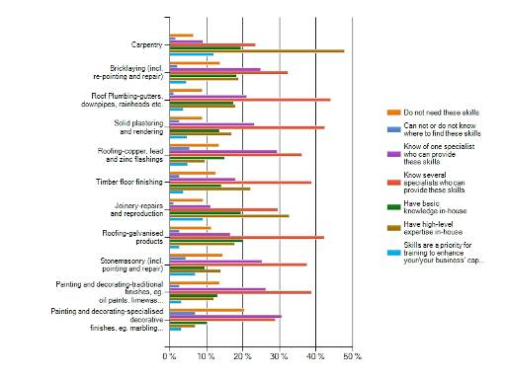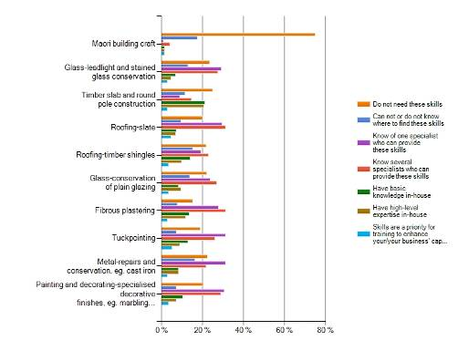

Respondents with more than 50% of work on traditional buildings and structure
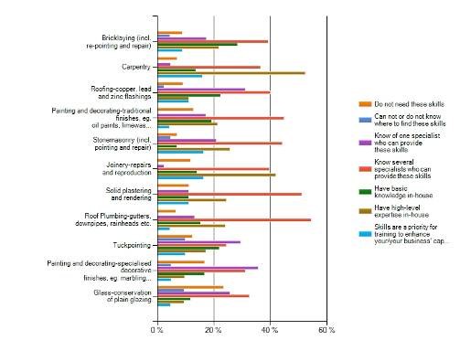
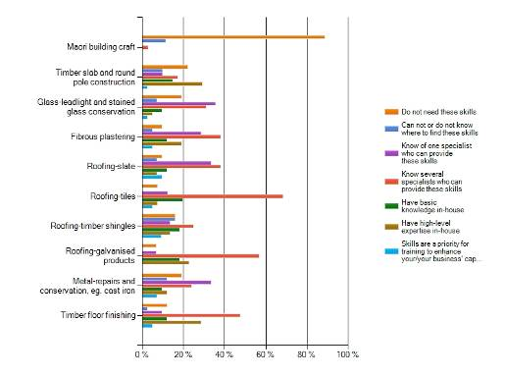

5.3.6 Using Traditional Methods and Materials

All Respondents
- 50% of the total respondents use traditional tools some of the time, 20% always use them and 16% use them when this is specified.
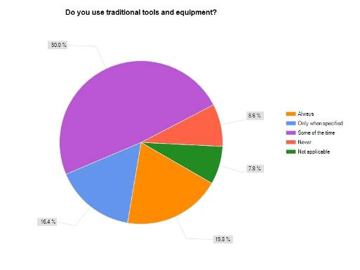
- The response to use of traditional materials is similar to that of traditional tools. 38% of respondents only use traditional materials when specified. 30% use traditional materials some of the time.
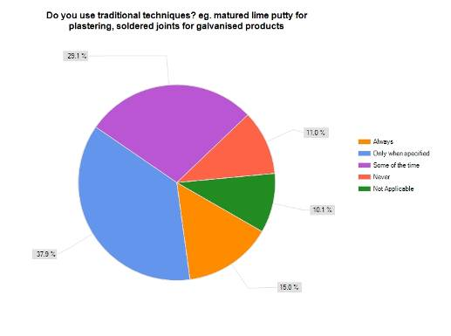
- The extent to which these statistics relate only to work on traditional buildings and structures is unclear. For both of the above questions, the ‘some of the time’ response may reflect the proportion of overall work on traditional structures rather than the proportion of work on traditional structures using traditional tools and/or materials.
- 46% of respondents only replace ‘like with like’ when this is specified. 25% always replace ‘like with like’.
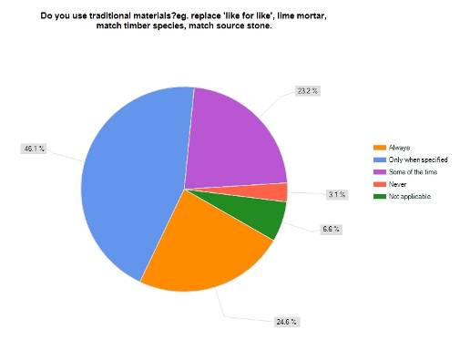
- Over half of respondents (55%) receive detailed documentation that directs the work required in less than 25% of their work on traditional buildings and structures. 44% of respondents consider the quality of these specifications to be ‘satisfactory’ , 20% to be ‘good’ and 20% to be ‘poor’. When such specifications are received, 65% of respondents noted that the work is closely or very closely supervised.

Respondents with more than 50% of work on traditional buildings and structures
- 46% of these respondents use traditional tools some of the time, 46% always use them and 6% use them when this is specified. The relatively high percentage of these respondents (46%) who always use traditional tools is to be expected given that more than 50% of their work is on traditional buildings and structures.
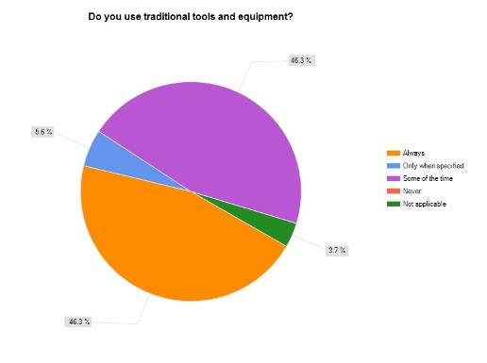
- The response to use of traditional materials is similar to that of traditional tools. 40% of these respondents only use traditional materials when specified. 32% used traditional materials some of the time. This mirrors the results for the total number of respondents.
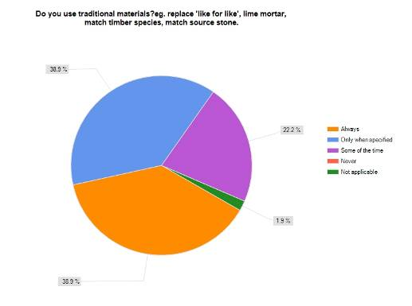
- 39% of these respondents only replace ‘like with like’ when this is specified, 39% always replace ‘like with like’.
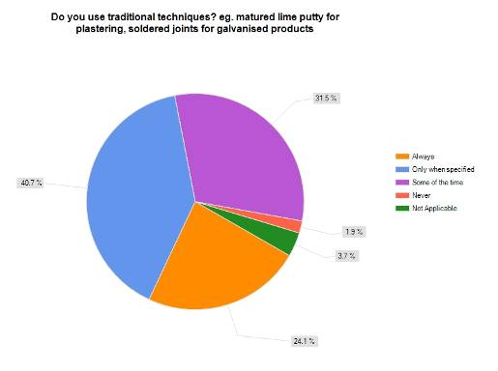
- 37% of these respondents say they receive detailed documentation that directs the work required in less than 25% of their work on traditional buildings and structures. 56% of respondents consider the quality of these specifications to be ‘satisfactory’, 25% to be ‘good’ and 12% to be ‘poor’. When such specifications are received, 47% of respondents noted that the work is closely or very closely supervised.

5.3.7 Additional Comments from Respondents
The survey offered the opportunity for respondents to comment on the survey and/or their experiences. These included the following:
- Traditional stained glass painting takes many years to learn but the training opportunities are not available other than short hobby courses. These skills are being lost.
- Emphasis has to be put on the development and the testing of techniques for heritage repair work. Too often we are reliant on theories that are untried in the Australian context or for which there is not general agreement.
- I still do not get enough work in my specialist field, despite being one of only a few in NSW and having a web site. My feelings are that some clients are still not well enough informed about the destructive result of using materials unsuitable for heritage buildings, e.g. using cement instead of lime mortar or using lime mortar incorrectly.
- Due to the financial downturn I had to retrench one tradesman and two apprentices. As well as attending TAFE College, I gave them on the job training regards lime mortar but sometimes felt they were confused between the TAFE information, the commercial aspect of the trade and what I was relating to them.
- Long overdue, we hope you are successful with upskilling trades. We hope people will realise the importance of preserving the existing stock of buildings and the long term sustainable benefits we gain from restoring existing stock which often is (skilled) labour intensive as opposed to the enormous environmental costs of demolish and rebuild.
- We work in an unusual area, there are not many renovations of traditional pools, but they do come up and we have the trades able to handle such projects.
- Would like to see more courses done at local TAFEs where possible.
- Most work is domestic renovations and are the ideas and specification of owners. Most structures are in poor condition or badly renovated previously.
- Heritage works is a lost trade in Sydney. Modern houses are created with a short life span. If we could go back to the heritage ways building as they did then would last for 100s of years and not just 20.
- The better documented projects tend to be those associated with government as few private property owners will under their own volition undertake authentic works.
- I would like to see extra training at TAFE in the use of hand tools for this type of work most carpenters have no idea what to do.
- It concerns me overall that building qualifications are being fast tracked in order to cover a trade shortage. I've noticed particularly in Sydney that the standard of trade work is already poor and fast tracking training can only increase the problem across all facets of construction.
- I mostly deal with the carpentry and joinery aspects and this usually requires looking at the surrounding neighbourhood to replicate features. Patience is also needed but can not be taught.

5.4 Endnotes
David Young (24/3/10).

6.0 Gap Analysis

6.1 Introduction
The aim of the analysis in this section is to identify apparent gaps or over supply of training opportunities in Australasia, as well as other trends and issues which emerge from a comparison of the survey data presented in Sections 4.0 and 5.0 and the audit data presented in Section 3.0.

6.2 Summary of Specialist Heritage Professional Training Opportunities in Australia
Table 6.1 summarises the results of the audit of professional heritage training opportunities (discussed in Section 3.0) in Australia, in terms of the coverage of the key skill areas defined in the skills needs surveys (discussed in Sections 4.0 and 5.0). The table shows that there is a concentration of training opportunities in the ACT and Victoria—where all skill areas are taught. Few training opportunities exist in Tasmania or the Northern Territory; (those identified are heritage interpretation taught in tourism courses). South Australia has the highest number of training opportunities (57) because of the high number of specialist heritage management, historical and maritime archaeology degree and short courses run at Flinders University. South Australia is closely followed by the ACT (55) with a concentration of specialist heritage, materials conservation and archaeology degrees and short courses offered by the University of Canberra and the ANU. Victoria also features a concentration of training opportunities (46) based on the number of specialist heritage postgraduate and short courses at Deakin University, heritage architecture and materials conservation courses at Melbourne University and the specialist heritage and historical archaeology focus of the archaeology degree at La Trobe University. New South Wales features only about half (24) the number of training opportunities in the key skill areas compared to those offered in Victoria (46), followed by Western Australia with 16 opportunities and only 9 identified opportunities in Queensland. A number of these courses are offered as distance education, making the training more accessible.
The physical conservation data summarised in Figure 6.1 contrast with the results from supplementary survey 1 (for which 70% of respondents were from New South Wales and Victoria), which suggest that 90% of those responsible for recruiting found it difficult to locate accessible training for their staff. This indicates a mismatch between the nature of the courses being offered and the market demand.

Table 6.1 Keyword hits—number by state—professional training only—degree, diploma, certificate and short courses
State | Physical Conserv-ation | Record-ing | Manage-ment | Consulta-tion | Interpret-ation | Archae-ology | Historic Land-scape Manage-ment | Legis-lation and Policy | Totals
NSW | 3 | 9 | 4 |  | 1 | 2 |  | 5 | 24
VIC | 10 | 8 | 10 | 4 | 5 | 1 | 2 | 8 | 46
QLD |  |  | 3 |  |  | 4 |  | 2 | 9
SA |  | 10 | 12 |  | 8 | 15 |  | 12 | 57
WA |  |  | 4 |  | 5 | 3 |  | 4 | 16
TAS |  |  |  |  | 1 |  |  |  | 1
NT |  |  |  |  | 1 |  |  |  | 1
ACT | 4 | 6 | 11 | 1 | 6 | 8 | 7 | 8 | 55
Total | 17 | 33 | 34 | 5 | 27 | 33 | 9 | 39

6.3 Generic Skills—Gaps
These are the skills identified as both ‘most used’ and ‘in use’ by a large number of respondents to the surveys, as well the highest priorities for future training. These generic skills are used across the specialist subfields of the heritage industry and lend themselves to being taught through university undergraduate or postgraduate courses. Table 6.2 set outs the generic skills identified by survey respondents as priority training areas and comments upon the training and education options identified for these areas in the audit of training and education opportunities set out in Section 3.0.

Table 6.2 Priority training areas for generic skills.
INDUSTRY AREA OR SUB-DISCIPLINE | SKILL OR KNOWLEDGE | Priority for Training (Individuals) | Priority Skills for Staff in Future (Agencies etc) | Courses/Training Currently Available & Comments
Physical Conservation | Architectural analysis | ✓ | ✓ | Currently training opportunities available in NSW, VIC and ACT only. Undergrad, postgrad and short courses available.  No identified training opportunities in QLD, SA, WA, NT or TAS.
Recording | Historical research |  | ✓ | Currently training opportunities in these areas available in NSW, VIC, ACT and SA in specialist university heritage undergraduate and postgraduate courses.  Currently not taught in identified short courses.
Recording | Site survey (general) |  | ✓
Recording | Archival research | ✓ | ✓
Recording | Archaeological site survey |  | ✓
Management | Significance assessment |  | ✓ | Training opportunities exist in all states except TAS and NT. Undergrad, postgrad and short courses available.
Management | Conservation management planning | ✓ | ✓✓
Management | Legislative/statutory context | ✓ | ✓✓
Management | Conservation strategy | ✓ | ✓
Consultation | Stakeholder engagement | ✓ | ✓✓ | Few training opportunities in this area, as not widely taught in specialist heritage courses. Identified opportunities—postgraduate courses in VIC and a short course in ACT.
Consultation | Communication skills |  | ✓
Interpretation | Interpretation strategies and plans | ✓✓ | ✓✓ | Training opportunities identified in all states except QLD. Undergrad, postgrad and short courses available.
Historic Landscape Management | Historic map/plan analysis | ✓ | ✓ | Does not appear to be widely taught in the context of specialist heritage courses. Undergraduate, postgraduate and short course opportunities available in the ACT and VIC.
Historic Landscape Management | Landscape assessment | ✓✓ | ✓✓
Legislation and Policy | State heritage legislation | ✓ | ✓✓ | Most widely taught generic skill area. Undergraduate, postgraduate and short course opportunities available in all states except TAS and NT. However still high priority for training.
Legislation and Policy | Burra Charter | ✓ | ✓
Legislation and Policy | State planning legislation | ✓

Summary of Issues—Generic Skills
This analysis reveals geographic gaps in the provision of training in these generic skills, as well as a possible under supply of training in particular skill areas. The data does not illuminate the issue of over supply of training—presumably if training is oversupplied it will be withdrawn as not economically sustainable for the provider, owing to lack of market demand.
- Physical/technical building conservation skills—are taught in only a small number of courses/degrees in New South Wales, Victoria and the ACT.
- Historic landscape management and consultation skills—are the least taught of the generic skill areas and are offered in Victoria and ACT only. Stakeholder engagement and historic landscape assessment are two areas which received high priority ratings for skills in demand but there are few training opportunities in these areas.
- Legislation and policy—is the most taught of the generic skills but remains a constant need in terms of training because of frequent change.
- Archaeology—is more likely to be taught in a heritage management focused or specialist course than the other relevant heritage discipline areas of engineering, architecture, history geography and so on. This means there are more opportunities for students studying archaeology to receive training in the generic heritage skills in their undergraduate and postgraduate university courses. Other discipline areas, therefore, must tend to rely more heavily on specialist postgraduate degrees and/or short courses.

6.4 Specific Skills—Gaps
Specific skills are those skills which are less widely used across the industry but are identified as a high priority for training. These skills are more specialised than the generic skills discussed above, and are therefore less likely to be taught within a generalist heritage undergraduate or postgraduate university course. The audit of training opportunities is not fine grained enough to identify comprehensively where these specialist skills might be taught within the scope of existing courses; however, a number of comments can be made on each area based on the information collated as part of the audit exercise. Further, these specific skills tend to be skills which are of growing importance in the heritage industry, but were not commonly taught when most of the survey respondents were educated, ie prior to 2000. These specific skills are more likely to need to be delivered through intensive short courses or specialist postgraduate courses as they are not as widely used as the generic skills above.
Table 6.3 Priority training areas for specific skills.
INDUSTRY AREA OR SUB-DISCIPLINE | SKILL OR KNOWLEDGE | Priority for Training (Individuals) | Priority Skills for Staff in Future (Agencies) | Courses/Training Currently Available and Comments
Recording | GIS | ✓✓ | ✓✓ | Undergraduate and postgraduate geography and archaeology degrees are tending to offer more opportunities for training in GIS and other forms of data management and analysis. Tailored courses tend to be more useful to heritage practitioners than generic courses. GIS courses for archaeologists are sporadically offered—none were documented as current by the audit.
Recording | Data management | ✓ | ✓
Management | Thresholds |  | ✓ | A specialist heritage management concept which is generally specific to a particular legislative and policy regime.
Consultation | Public speaking | ✓ |  | As with GIS, training in these areas is available outside the heritage industry; however, tailored short courses tend to be more desirable and accessible.
Consultation | Survey development and analysis |  | ✓
Interpretation | Audience analysis | ✓ | ✓ | Training in most of these areas is available in a number of specialist heritage postgraduate courses that include interpretation. Training in some of these areas is available outside the heritage industry; however, tailored short courses tend to be more desirable and accessible.
Interpretation | Content development | ✓ | ✓
Interpretation | Visitor management |  | ✓
Interpretation | Plain English publication |  | ✓
Interpretation | Multimedia skills | ✓ | ✓
Archaeology | Artefact conservation | ✓ | ✓ | Undergraduate and postgraduate training in these areas is currently offered in a number of archaeology and materials conservation undergraduate and postgraduate degrees. Demand for skills in this area is likely to be perceived because they were less likely to be taught in the past and existing professionals would like access to ‘catch up’ courses. Therefore, intensive short courses, as well as continued integration in established university curricula, would be most likely to service this need.
Archaeology | Artefact analysis |  | ✓✓
Historic landscape management | Curtilage analysis | ✓ | ✓ | Landscape architecture courses are widely available but this perceived training need probably reflects the need for heritage practitioners with skills and knowledge in historic landscape, design, assessment and management more generally, as well as to attract more professionals with these skills to the area of heritage management.  As discussed above in generic skills, historic landscape management is currently the least frequently taught skill area along with consultation skills. This gap probably reflects the fact that landscapes have risen in importance as a category of heritage place over the past decades leading to a commensurate rise in the numbers of skilled practitioners needed for assessment and management.
Historic landscape management | Landscape architecture | ✓ | ✓
Historic landscape management | View analysis | ✓
Legislation and policy | Building codes |  | ✓ | While legislation and policy is the most frequently taught of the generic skills, legislation and policy change frequently, leading to constant need for updating skills and knowledge in these areas. Building codes, Aboriginal heritage legislation and the EPBC Act are areas of relatively new legislation, or codes which have undergone significant change in recent years. While most new heritage professionals will gain grounding in legislation and policy at university this specific skill area needs to be serviced with access to frequent refresher courses.
Legislation and policy | Aboriginal heritage legislation | ✓✓
Legislation and policy | EPBC Act | ✓

Summary of Issues—Specific Skills
This analysis clearly reveals gaps in the provision of training, as well as growth in the demand for skills in a number of key areas which tend to reflect recent (or at least evolving) change in the nature of heritage industry in Australia.
- GIS and data management—most large scale or regionally based heritage projects will now require some form of GIS based mapping and data management in order to facilitate analysis of large quantities of data in a manner that is compatible with government and other researchers’ databases. Training in these skills is quite readily available; however, courses tailored to heritage management would be more accessible to most heritage professionals who wish to gain a baseline of expertise in this area.
- Significance thresholds, building codes, Aboriginal heritage legislation and the EPBC Act—these are all areas of public policy subject to recent change in the Australian context. Training in these areas can be partly seen as the responsibility of the government agency responsible for the administration of the legislation, especially in the area of Aboriginal heritage legislation where there is a responsibility to educate communities in legislation which affects them.
- Artefact conservation and analysis—the fact that this specific skill area has been identified as a priority for future training reflects changing practice in archaeological heritage management. A growth in emphasis on the conservation and management of excavated collections has occurred in some jurisdictions, while more exacting standards of artefact analysis are required as a result of increased research, publication and regulation in this area.
- Interpretation skills—the need for training in this area may respond to an increasing requirement by regulators, the growth in the use of new technologies for heritage interpretation (such as multimedia), and to a growing need for more rigorous evaluation and visitor management methodologies and techniques. It also appears that heritage interpretation has become a more specialised set of skills within the broader heritage industry over the course of recent decades.
- Consultation skills—this is another area of the heritage industry that has become more closely regulated and more critically researched in recent years. All heritage practitioners active in community-based projects need to develop (or develop access to) specialist skills and knowledge in this area. The audit clearly shows that this is one of the least frequently taught skill areas. These skills could be taught more frequently in undergraduate and postgraduate courses as well as through professional development courses.

6.5 Specialist Skills—Gaps
These skills are less frequently used in the heritage industry than those discussed above, but constitute a crucial aspect of conservation practice. Training options need to be developed to address gaps in these areas, despite the low numbers of practitioners involved.
Table 6.4 Priority training areas for specialist skills.
INDUSTRY AREA OR SUB-DISCIPLINE | SKILL OR KNOWLEDGE | Priority for Training (Individuals) | Priority Skills for Staff in Future (Agencies) | Courses/Training Currently Available and Comments
Physical conservation | Stone masonry | ✓ | ✓ | Discussion of these skill areas is deferred pending ongoing discussions with the client and stakeholders on how to strengthen the project data collection and findings in this area.
Physical conservation | Carpentry |  | ✓
Physical conservation | Mortar analysis | ✓
Physical conservation | Engineering | ✓
Physical conservation | Traditional tool making or use | ✓
Physical conservation | Traditional mechanical skills | ✓
Recording | Photogrammetry | ✓ |  | Current computer technology makes this previously highly specialist cartographic skill more accessible to heritage practitioners. Training could be delivered through online modes.
Archaeology | Underwater survey and recording | ✓ |  | This specialist skill may require a large component of on-the-job training and mentoring, which may be difficult in commercial contexts.
Historic landscape management | Landscape architecture | ✓ | ✓ | As discussed above, landscape architecture, horticulture and arboriculture courses are widely available but this perceived training need probably reflects the need to attract more professionals with these skills to the area of heritage management as well as the need to allow heritage practitioners to train in this area as a specialisation.  As discussed above, historic landscape management is currently the least frequently taught skill area along with consultation skills. This skills gap probably reflects the fact that landscapes have risen in importance as a category of heritage place over the past decades leading to a commensurate rise in the numbers of skilled practitioners needed for assessment and management.
Historic landscape management | Aboriculture | ✓
Historic landscape management | Horticulture | ✓

Summary of Issues—Specialist Skills
- Historic landscape management—as discussed above historic landscape management is the least frequently taught skill area after consultation. There is a need to work co-operatively in this area with other professions to supply skill needs, but this does not obviate the need for increased training opportunities for perhaps already qualified landscape architects, horticulturalists and arborists who may be interested in extending part of their practice into the historic heritage arena. However, the first hurdle in this area may be in attracting these professionals to heritage work.
- Photogrammetry and underwater survey—there is unlikely to be a huge demand for these highly specialised skills. The first need may be met through access to online training while the latter may reflect a need for on-the-job mentoring of graduates.

6.6 Heritage Trades Skills—Gaps
The skills gaps in heritage trades are derived from the data collected during the supplementary survey (2) (March 2010), and the subsequent analysis (Section 5.0), as there was relatively low representation from the trades sector in the initial skills needs analysis survey (October 2009).
As the supplementary survey was not structured in the same way as the skills needs analysis, the information gathered and analysed did not translate into tabular format (as provided in tables 6.1-6.4). The primary gaps are therefore summarised in text below.

Summary of Issues—Trade Skills
- Geographic gaps in the provision of training for heritage trades skills are difficult to analyse, owing to the likely bias created by the high number of NSW respondents to the survey. No survey response data was provided from Aotearoa/New Zealand.
- There is a good supply of generic trades training in Australia. However, the inclusion of traditional (‘heritage’) trade skills in these courses is rare. Only one third of the total respondents to the supplementary survey received training in building conservation work as part of their generic trades training.
- Notwithstanding a large percentage of respondents indicating a lack of training in heritage trades, a large percentage of respondents nevertheless considered themselves adequately prepared to undertake work on traditional buildings and structures. This could be linked to high quality ‘on the job’ training, or a misconception on how prepared one must be to undertake this work (ie ‘they don’t know what they don’t know’).
- Specific courses on heritage trades are not at all common, with only 3 core courses offered in Australia and 9 in New Zealand (all in Maori building craft).
- Carpentry, joinery, stonemasonry, roofing and tuck pointing are the skills identified as a high priority for training to enhance the capacity of businesses. Other skills only received responses from less than 5% of respondents.
- The age of those with skills in heritage trades is high and demonstrates an upcoming issue in the supply of these skills as practitioners retire.
- A large proportion of practitioners who posses skills in heritage trades gained their qualification more than 20 years ago; not only does this demonstrate the high age of the workforce, but also a definite shortage of training for new practitioners, or refresher training for those in the industry.
- Most training on heritage trades is administered on the job, demonstrating a gap in tertiary or accredited training courses.
- Almost all heritage trades skills listed in the survey appear to be ‘available’, with practitioners being either in house or accessible through respondents’ knowledge of tradespeople with these skills.
- A large proportion of business owners suggest that new staff recruits and apprentices do not receive adequate training, and are therefore on the whole unprepared to undertake work on traditional buildings and structures.

6.7 Conclusions
This gap analysis has revealed some clear trends in the perceived training needs in the heritage industry in Australasia and in the availability of training and education on both a skills needs and geographic basis. Trends derived from the changing and evolving nature of heritage practice are also revealed. Key findings include the following.

Heritage Professional Training
- Training opportunities, in the form of specialist heritage related courses, are clustered in the southeast of Australia in Canberra and Melbourne, with another significant cluster in South Australia owing to the wide range of historical and maritime archaeology and heritage related courses offered by Flinders University. This does not appear to mirror the distribution of active heritage practices and the requirements of the active management of heritage places, and one would expect greater concentrations of opportunities in Sydney and Brisbane at least.
- The need for improved skills in consultation and historic landscape management is also reflected clearly in the data. These skills are not widely taught and their identification as priority needs for training clearly reflects the growth in importance and specialisation of these skills over recent decades.
- The need for access to GIS is also clearly borne out, and while many organisations and companies may buy in specialist skills in this area, the data still seems to reflect the desire of some heritage practitioners to be a ‘jack of all trades’ and develop a baseline of skills in this area themselves.
- The fact that the specific skill area of artefact conservation and analysis has been identified as a priority for future training reflects changing practice in archaeological heritage management. A growth in emphasis on the conservation and management of excavated collections has occurred in some jurisdictions, while more exacting standards of artefact analysis are required as a result of increased research, publication and regulation in this area.
- Legislation and policy is the most taught of the generic skills but remains a constant need in terms of training because of frequent change. Training in these areas can be partly seen as the responsibility of the government agency responsible for the administration of the legislation, especially in the area of Aboriginal heritage legislation where there is a responsibility to educate communities in legislation which affects them.
- Specialist skills in building conservation and architectural analysis are in high demand. Training in these areas exists, but only in New South Wales, Victoria and the ACT in undergraduate and postgraduate courses. Two short courses in this area are also available, one in Canberra and the other in Melbourne. Very few specialist courses in heritage trades exist in the TAFE/Polytechnic system.
- Short courses struggle to maintain numbers, it is difficult to determine whether issues such as the geographic location of these courses and their cost prevent broader participation in professional development in this area.

Heritage Trades Training
- Standards of practice in the heritage trades are recognised as poor by senior experts in the field, presenting significant risks for the conservation and retention of heritage buildings and places. However, there is not widespread recognition of the low level of practice standards and the relative lack of specialist skills by younger practitioners. Indeed, anecdotal evidence suggests that the more ‘experienced and specialised’ the practitioner is, the more concern he or she has about inadequate standards and training. This lack of awareness creates a systemic problem for the stimulation of specialist skills acquisition.
- There is a limited ‘demand’ for true specialists, arising from a combination of the quantum of available heritage trades work, value perceptions on the part of clients and builders and absence of any contractual or legal requirement for practitioners to have such skills. These factors appear to have combined to cause a substantial drop off in the number of younger specialist heritage trades practitioners.
- High quality technical skill derives from a combination of both high quality formal and informal 'on the job' training.
- The difficulty faced in the use of traditional materials is a lack of knowledge on how to guide tradespeople in the use of traditional materials, resulting in difficulty specifying them.
- There is a high demand for skills in specification and schedule writing; condition assessment and documentation as well as materials investigation and conservation.
- Over the last 20 years there have been a number of attempts to re-introduce specialist curricula and training courses in the heritage trades. These courses have all failed owing to lack of demand, creating a major continuing gap and looming crisis for heritage conservation in Australasia.
- Survey data suggests that specialist trade skills for heritage practices are now concentrated in a few hands and that expert heritage trades professionals are ageing (as a population); many will retire in the next 10 years. This will leave a major gap in future opportunities for ‘on the job’ training, as well as a vastly diminished pool of resources to ‘do the job’.
- Available skills and experts who can mentor heritage trades practitioners are geographically concentrated—in urban areas on the east coast of Australia.
- Despite the availability of courses in physical conservation in New South Wales and Victoria, survey respondents report difficulty in locating available specialist training.
- Maori building craft is widely taught in Aotearoa/New Zealand.

7.0 Findings

7.1 Introduction
This section of the project report outlines the range of issues identified in the various research processes undertaken for this study (including the audit of education and training, the skills needs analysis survey, the two supplementary surveys on trades and professional conservation and the stakeholder workshop). The key findings of the study are discussed in detail in the sections below, with a summary table provided at 7.4 Key Findings.

7.2 Building a Sustainable Heritage Conservation Sector
In policy terms, a range of systemic factors make it impossible to recommend any ‘quick fix’ responses to the issues identified in this study, in terms of the availability of training and education, and perceptions of gaps in skills and future training priorities. These systemic issues are discussed below, including the lack of:
- overarching policy;
- industry benchmarks for education and training outcomes;
- appropriate models for training in various sectors and at different career stages; and
- quality standards and mechanisms for their enforcement.
Building a sustainable heritage management and conservation sector relies not only on developing these critical support mechanisms, but also the continued promotion and celebration of heritage as an irreplaceable aspect of environment and culture. Drawing talented practitioners to the heritage industry and keeping them gainfully employed, relies on continued emphasis on building the profile of cultural heritage in Australasia and the perceived prestige of high quality conservation and management of cultural heritage. This includes recognition of the ‘intangible heritage’ value of some of the practices which are used to maintain and conserve aspects of significant built cultural heritage.

7.2.1 Heritage Training and Education Policy
A key conclusion of the Industry Expert’s Workshop (March 2010) was the need for a national/Australasian policy for setting and maintaining standards in conservation practice. Heritage education and training will be an important part of implementing such a policy. The Australian National Cultural Heritage Forum’s Vision Statement of 2004 also identified the urgent need for a ‘National Heritage Training Strategy’. Training and education for the heritage sector lacks any co-ordination at the national/transnational level and there are no endorsed industry standards or benchmarks against which the quality of training and education can be measured or audited. There are also no identified and agreed core competencies or core knowledge areas for cultural heritage professionals and tradespeople.
This situation puts Australasia’s cultural heritage at risk:
- Students of heritage education and training have no formal indication of the adequacy and standard of current educational products in the cultural heritage sector.
- A large proportion of respondents consider their formal education did not adequately prepare them for work on traditional buildings and structures and most consider that their skills in this area were learnt on ‘on the job’ (most received formal training more than 20 years ago).
- Potential employers have no assurance that graduates and trainees possess core competencies or knowledge areas relevant to their area of heritage work.
- Government and the broader community have no mechanisms to ensure best practice standards are maintained in heritage conservation, management and research.
- Cultural heritage research, conservation, interpretation and management will stagnate and be ineffective without a sustainable educational foundation.
The following key areas need to be addressed in an overarching heritage training and education policy:
- Accreditation of Training and Education—identifying core competencies/knowledge areas and accrediting educational products which deliver these learning outcomes.
- Standards and Quality—developing benchmarks against which standards of practice/quality can be measured and evaluated.
- Guidance—availability of high quality advisory material to support best practice. Development of a range of online or published products which support best practice.
- Research and Development—formulating a research agenda and strategy for cultural heritage which stimulates and informs the development of standards and best practice.
- Compliance and Incentives—supporting the use of statutory approval processes and permits which require accredited or appropriately qualified practitioners, as well as conditions on grant and funding, which reinforce standards of practice and expertise.
- Audit and Evaluation—supporting an ongoing policy for the collection of data about education and training in the heritage sector and the development of tools to evaluate whether or not industry objectives are being met.

7.2.2 Standard, Quality and Quantity of Training and Education
This study could not critique the quality, depth or content of the identified education and training programs relevant to cultural heritage, nor could it comment on the skills needs identified as priorities in the surveys in terms of the core skills requirements of an appropriately qualified heritage practitioner. This is because no accreditation or benchmarking of heritage conservation and management education and training, and no process for registration of appropriately qualified practitioners, currently exist in the Australasian context.
The Australasian heritage industry is a small one by comparison with, for instance, the United Kingdom, Canada and the USA, which may provide a benchmark for comparative policy. Indeed, the size of the heritage industry has not yet been adequately quantified (but is discussed broadly in Section 3.0). However, it is clear from the industry discussions, workshops and survey data, that some form of accreditation is required for heritage sector professional and trades training as a matter of high priority.
Accreditation must be driven by professional bodies but must also be supported by government and the tertiary sector. It is anticipated that there will be problems surrounding courses which cover educational areas that straddle a range of professional or trades organisations and their accreditation will not be straightforward. Further, professional bodies are typically volunteer organisations, so financial and in-kind support from the government would be vital to the success of an accreditation framework for heritage professional and trades training.
Registration of appropriately trained heritage practitioners is generally considered to be a less urgent priority, and indeed should logically only be developed once benchmarks are in place for required training, skills, competencies and knowledge areas for heritage professionals.
The HCOANZ should adopt a support and advocacy role in promoting accreditation for heritage training and education. HCOANZ should invite professional bodies such as ICOMOS, Australian Institute of Architects (AIA), the Australian Institute of Energy, the Master Builder’s Association (MBA) and other relevant professional and trades organisations and training providers in Australia and New Zealand to form a heritage training and education accreditation taskforce, with the aim of identifying and adopting core competencies/knowledge areas and accrediting educational products which deliver these learning outcomes.

7.2.3 Need for Co-ordination Among Training and Education Providers

Co-ordination of Education and Training Providers
The need for accreditation, liaison and negotiation across the sector provides a vehicle for increased co-operation and co-ordination on heritage related training and education in the tertiary sector, and for training/education providers to work together towards providing complementary, accessible and appropriate training products and delivery methods. A model for this approach might be the Australia and New Zealand Association of Planning Schools, which is a coalition of training and education bodies that is separate from, although closely allied with, the Planning Institute of Australia. The aim of this body is to provide a forum for research and development into the educational needs in the planning sector. Such a forum for dialogue for heritage education and training does not currently exist and this fact contributes to the fragmentation of the sector and a lack of co-ordination and co-operation between competing training providers.
HCOANZ should support and encourage, through its national policy and its heritage training and education accreditation taskforce, the formation of a body which promotes co-ordination between heritage education and training providers in Australia and New Zealand.

7.2.4 Training and Education Options and Models
The current profile of professional heritage practitioners reflected in the skills needs survey and analysis, is 91% tertiary educated, 66% with postgraduate awards and 63% have also undertaken professional short course training. However, training for the skills identified as most used in heritage workplaces was most likely to have occurred in the workplace. The preferred mode of future training for these respondents was through intensive short courses or ‘on the job’ training. This suggests that existing formal education programs and curricula do not provide key workplace skills.
While there appears to be a steady demand for broad ranging tertiary training, responsive to changing industry imperatives and standards, the best model for professional development training is not yet clear. Universities do not provide a flexible platform for responding quickly to perceived industry training needs. University curricula are developed through formal processes involving bodies such as Australian Universities Quality Association (AUQA), University Academic Boards and other forms of scrutiny and approval, as is appropriate for education delivered through the university system. University curricula are often professionally recognised. Curricula can take more than a year to be approved, and must subsequently be re-submitted for approval if any changes are required. University based training/education needs to be long term, sustainable and financially viable—all units/subjects offered usually need a minimum of twenty (and sometimes more) participants each time they are offered. Distance education can vary these requirements but not all heritage skills/competencies can be taught through distance or online education.

How does the market demand for new training compare to the industry’s demand for improved skills and standards?
Interviews with practitioners involved in developing and delivering heritage short courses all confirm that is difficult to run short courses on an economically viable basis. The market is unreliable—demand can be low, despite the widespread perception that such training is required. The Holmesglen TAFE established the Specialist Centre for Heritage Trades with support from Skills Victoria in 2006; however, its funding was withdrawn in 2007 after less than 12 months in operation. Demand for its courses was insufficient to support the Centre and those courses which did run tended to have low numbers. Another example is the NSW Heritage Trades Training Strategy, which was developed and offered though the TAFE system between 2000 and 2003. A series of modules were developed conveying bricklaying, carpentry and joinery, painting and decorating, stone masonry, plastering and roof plumbing. However, most modules were never offered, because the numbers were below the level that TAFE could sustain on a cost-recovery basis and none are offered now. David Young has run intensive summer schools at the University of Canberra for 19 years. They are aimed at professional development for people already working in the sector. While these summer schools have been successful, demand has been just sufficient to support a specialist course on building conservation and a more general course on heritage management, run in alternate years.
The audit and survey has identified that building conservation skills are taught in a small number of courses/degrees in NSW, Victoria and the ACT only. A submission to this project made by the Association of Preservation Technology, Australia Chapter, recommended that the current short course on Traditional Building Conservation at the University of Canberra be offered annually, rather than every 2 years. However, this course has not been able to attract sufficient numbers to be offered so frequently. Varying the location of the course from year to year may be an option for attracting required numbers, however this would also mean duplication of the administrative burden, development of new curriculum for site visits etc—all adding to the recurring costs of delivering the course.
Professional development courses provided on a not-for-profit basis by professional organisations may be another means of delivering professional development courses to the heritage sector—and perhaps in the future completion of accredited short courses could be linked to professional registration requirements or grant funding. Participation in the delivery of such training could also be promoted as an appropriate form of industry contribution for senior professionals, in the way that mentoring programs are currently used by ICOMOS, AIA and other professional organisations. Government agencies could lead by example in providing professional development staff training and in the recognition of expert, well trained staff.

How can on the job training be managed, supported and recognised?
It seems likely that a range of training especially for the heritage trades is best delivered on the job. How can the heritage sector support on the job training for both private and public sector employers?
On the job professional development requires a process for recognition. Professional bodies, through the proposed accreditation taskforce and education and training provider network, should develop an ‘on the job’ learning framework which includes incentives for employers to provide training; incentives to employees to have their training recognised; includes a means to evaluate and audit on the job training; and a way to make information about on the job training publicly accessible.

The sporadic need cycle
Aging of building stock, trends in cultural heritage management and interpretation, (such as growing requirement for in situ conservation of archaeological remains, conservation of modernist structures and WWII defence structures, for example), gives rise to peaks in demand for new or rare technical skills in these areas. Sometimes this can be experienced as a rolling cycle. For example, a peak in the need for dry-stone walling repair may occur every ten years or so, as walls repaired during the previous peak in this specialist area of conservation again need attention. These peaks and troughs in demand for conservation skills make sustaining university and TAFE based courses difficult and also challenge attempts to run training courses on a commercial basis.
The variable nature of the natural demand for specialist skills means that external mechanisms are needed to create a ‘demand-lead’ market for heritage training. To create sustainable demand, specialist training needs to be tied to compliance requirements for statutory approvals and heritage grants for works (using the English Heritage model). Professional/trade bodies and heritage agencies also need to respond to this sporadic or rolling need cycle by developing flexible, low cost training modules and self-learning tools.

Heritage trades training issues
This study has highlighted some systemic problems relating to supply and demand for specialist heritage trade skills. Survey data collected from the trades sector was counterintuitive: while it highlighted issues of the perceived inadequacy of training for new apprentices in relation to work on traditional buildings and structures, it did not identify current gaps in skills or future training priorities. This appears to be, in part, explained by a perceived lack of market demand for traditional trade skills. Obtaining and maintaining such skills is not seen to be matched by financial reward nor by rewards in terms of job satisfaction through regular access to challenging projects on traditional buildings and structures.
This situation is contrasted with data collected from the small numbers of professional materials/technical conservation specialists and through discussion at the expert workshop, which focused on the lack of availability of adequately trained or experienced trades specialists and the resulting low standards of building conservation works. This phenomenon was described by interviewees and workshop participants in terms of mismatched expectations between heritage specialists and some parts of the trades sector—conservation specialists have a perception about what constitutes best practice standards or high quality work by tradespeople, but this perception is not shared by all trades practitioners who, it is argued, may not be aware of how their specialist knowledge or the quality of their work falls short. In short-hand terms this was referred to as the ‘they don’t know what they don’t know’ factor. This disparity between skill level perception and skill level reality applies to professional heritage practice as well as to trades. Differences may also arise between the cost of what heritage professionals deem to be appropriate and what clients, developers or builders are prepared to spend on diagnostic processes or physical conservation. These differences can create a predisposition towards engaging practitioners with lesser skill sets.
This situation points to a potential market failure in the area of traditional building trades and conservation skills—that is normal market demand has failed to support the maintenance of traditional building techniques and trades. This situation ideally requires further specialist research to investigate the perceived market failure of traditional trades training, and to demonstrate conclusively the resulting lack of capacity for appropriate traditional buildings conservation and the low standards in building conservation works. Such research would require the articulation of benchmarks for the evaluation of quality standards, and this step may in itself go someway towards solving the perceived problem with quality. Clear quality standards could be broadly promoted, publicised and linked to compliance regimes for approvals for works and grant conditions for the conservation of traditional buildings. In this way it may be possible to manage this problem as part of a quality management regime with which the industry is already familiar, such as the introduction of an Australian Standard, use of ISO:9001 to document performance against objectives, or a standard heritage section of a Quality Management Plan/works plan.
Discussion at the Industry Experts Workshop also highlighted that the maintenance of these traditional trades practices is an issue of intangible heritage conservation in itself, as highlighted in the UNESCO Convention for the Protection of Intangible Cultural Heritage. Further investigation of methods used to promote and ensure the maintenance of traditional trades practices in other parts of the world could provide relevant methodologies for application in Australasia. In Section 3.0, the relatively high availability of training opportunities in Maori building craft was noted. Doubtless the link between the maintenance of these craft skills with cultural identity and cultural heritage is well understood within the Maori community. It seems that this understanding of the link between traditional building skills, cultural identity and cultural heritage has not been maintained in the non-indigenous, settler communities of Australasia. Promotion of an understanding of the links between traditional skills, cultural diversity and cultural heritage may be a required trigger to maintain this niche within the overall trades sector.

7.3 Research and Development
While professional heritage practitioners undertake substantial amounts of research, ‘cultural heritage conservation and management’ is itself not a well developed research area in Australasia. Efforts to address training and skills needs should also include the commensurate need to sustain a viable research program to promote the growth and vitality of heritage as a relatively new discipline. In particular, efforts to develop heritage education and training need to give equal consideration to the development of the necessary infrastructure for research. These might include industry scholarships, awards and prizes, promotion of industry research agendas or identification of government and industry resources for heritage related research. Heritage training will also undoubtedly benefit from greater cross-disciplinary teaching, practice and research, for instance museum conservators have a wealth of skills and knowledge that can be applied to buildings and archaeological sites, while cultural heritage research needs to be nourished through strong academic and professional links with history, architecture, landscape architecture and a range of relevant disciplines.
The project team is aware of the development of two Cooperative Research Centre bids related to heritage conservation at the time of writing (Heritage Futures CRC bid led by Flinders University and the Cultural Material Conservation CRC bid led by the University of Melbourne). If these bids are successful they may provide a timely injection of research and development capital into the sector. It is recommended that the HCOANZ should seek appropriate representation within the structure of any successful CRC bid.

7.4 Key Findings
Research Area | Finding
Professional Physical and Technical Conservation Survey | Potential lack of professionals in the 30-45 years age bracket.
 | Most skills learnt on the job; formal education received more than 20 years ago.
 | New recruits poorly prepared for work on traditional buildings and structures, suggesting missing link between education providers and the industry.
 | Apparent willingness from employers to provide professional development training but difficult to access relevant courses and cost issues.
 | Specialists have difficulty in finding people to whom they may pass on their skills.
 | Moderate demand expressed for training in physical conservation skills with a high level of current in-house skills.
 | Higher demand expressed in this survey for future training in specialist trade skills such as: traditional timber construction skills.
 | General finding from this sector was that there is a lack of specialist trade skills available and that trades people ‘don’t know what they don’t know’ ie they are not aware of the requirements for specialist traditional knowledge/skills if they have not been taught these skills. A predisposition towards lesser-skilled practitioners can also arise from differences in perception and value of the cost of conservation.
Trades Physical and Technical Conservation Initial Survey | Data from this survey contrasted distinctly with the data collated from the Professional Physical and Technical Conservation Survey, which pointed to a lack of specialist trades people/skills.  In the initial survey all skill areas were seen as low priorities for future training and gaps in skill areas were not clearly delineated in the survey data.
 | The question concerning ‘priorities for future training to enhance business capacity’ resulted in all skills being seen as low priority—each considered a priority by less than 17% of respondents and most by less than 10% of respondents. This possibly reflects the perception that the skills listed were not in demand in the marketplace and therefore their acquisition would not enhance business capacity.
 | Results suggest an ageing professional group with a lack of skilled tradespeople in the 30-45 year age range. This is a critical issue for future conservation in Australasia.
 | Most current practitioners feel that their training was good preparation for their work (NB training received more than 20 years ago in the majority of cases). However they also feel that the majority of new apprentices do not receive adequate information about traditional buildings and structures in their training.
 | Over 70% of respondents received training in traditional buildings and structures ‘on the job’.
Tertiary Heritage Education | The audit identified:  9 specialist heritage degrees from Bachelor to Masters level across Australia and New Zealand;  9 discipline specific (including architecture, materials conservation and archaeology) heritage degrees from Bachelor to Masters level across Australia and New Zealand;  A further 68 courses with significant heritage content in Australia and 16 in New Zealand.
 | 20 short courses were identified offering professional development programs in heritage professional and trades skills/knowledge areas.
 | Significant training opportunities exist in Maori building craft in New Zealand.
 | Audit of TAFE sector, institutes of technology, polytechnics and training providers of trades training revealed that many courses touched only briefly on traditional trade skills; the depth of treatment difficult to gauge through the audit.
Gaps in Professional Training/Education | Concentration of professional heritage training and education opportunities in South Australia, ACT and Victoria. NSW offers only half (24) the number of training/education opportunities offered in Victoria (46). Tasmania and NT offer very limited training opportunities only in heritage interpretation.
 | No physical conservation/architectural conservation training opportunities were identified in Qld, SA, WA, NT or Tas.
 | Historic landscape management and community consultation skills are the least taught of the generic heritage management skill areas and these skills also rated as high priorities for future training.
 | Legislation and policy is the most taught of the generic skill areas but remains a high priority for future training.
 | Archaeology is more likely to be taught in a heritage management focused or specialist course than the other relevant discipline areas such as architecture, history, engineering etc.
 | GIS is identified as a high priority for future training. This skill is widely taught but there may be a need for courses ‘tailored’ to heritage practitioners.
 | Significance thresholds, building codes, Aboriginal heritage legislation and the EPBC Act were all identified as training priorities. These all relate to areas of public policy and legislation administered by government and the responsibility for training in these areas can be seen to partly lie with the responsible agency.
 | Future demand for training in artefact conservation and analysis can be seen to derive from changing practice in archaeological heritage management.
Heritage Trades Training—Supplementary Surveys and Expert Workshop | Specialist trade skills for heritage practices are now concentrated in a few hands. Expert heritage trades professionals are ageing (as a population); many will retire in the next 10 years. This will leave a major gap in future opportunities for ‘on the job’ training, as well as a vastly diminished pool of resources to ‘do the job’
 | High quality technical skill derives from both formal and informal 'on the job' training.
 | Available skills and experts who can mentor heritage trades practitioners are geographically concentrated - in urban areas on the east coast of Australia.
 | Standards of practice in the heritage trades are recognised as poor by senior experts in the field, presenting significant risks for the conservation and retention of heritage buildings and places.
 | There is limited recognition of the low level of practice standards and the relative lack of specialist skills by younger practitioners. The more ‘experienced and specialised’ the practitioner is, the more concern he or she has about inadequate standards and training.
 | There have been a number of attempts to re-introduce specialist curricula and training courses in the heritage trades. These courses have all failed because demand was below the minimum class size needed to recover costs, thus creating a major continuing gap and looming crisis for heritage conservation in Australasia.

7.5 Endnotes

1 Personal communications between the project team and David Young, University of Canberra, Linda Young, Deakin University and Alexandra Mannell, Holmesglen TAFE.
2 Pers comm., Alexandra Mannell, 10/12/09.
3 Pers comm., David Young 9/12/09 and Elisha Long 2/6/10.
4 Pers comm., David Young 9/12/09 8.0 Recommendations 8.1 Introduction This section outlines the key recommendations coming from the findings of the report (outlined in Section 7.0). Recommendations are made about policy responses to address the education and skills needs of the heritage sector, as well as the identified gaps in training and educational options. This section concludes with an ‘Indicative—Heritage Training Policy’ for consideration by HCOANZ. 8.2 Recommendations 8.2.1 Specific Recommendations to the HCOANZ - The HCOANZ should establish and adopt a policy for heritage training and education in Australia and New Zealand which addresses the key findings of this project. An ‘Indicative Heritage Training Policy’ is provided in Section 8.2.3 (below). - The HCOANZ should instigate development of a policy for setting and maintaining standards in conservation practice. - The HCOANZ should take a lead role in national/Australasian technical conservation advice and facilitation / co-ordination of heritage professional and trades training, possibly through the appointment of a national technical officer. - The HCOANZ should develop a centralised online location for promoting and recording short courses and masterclasses provided by heritage agencies. - The HCOANZ should adopt a support and advocacy role in promoting accreditation for heritage training and education. HCOANZ should invite ICOMOS, AIA, AIE, MBA, NTQA and other relevant professional and trades organisations and training providers in Australia and NZ to form a heritage training and education accreditation taskforce, with the aim of identifying and adopting core competencies/knowledge areas and accrediting educational products which deliver these learning outcomes. (Allocation of resources to provide short term secretariat support to this taskforce would increase the prospects of timely and effective instigation of accreditation programs and other desirable outcomes, as outlined below.) - The HCOANZ should support and encourage, through its heritage training and education accreditation taskforce, the formation of a complementary body which promotes co-ordination between heritage education and training providers in Australia and New Zealand. - The HCOANZ should support and encourage, through its heritage training and education accreditation taskforce, the development of a process for recognition of ‘on the job’ training. Professional bodies, through the auspices of the proposed accreditation taskforce, should develop an on the job learning framework which includes incentives for employers to provide training; incentives to employees to have training recognised; means to evaluate and audit on the job training; and to make information on the job training publicly accessible. - The HCOANZ should support and encourage, through its heritage training and education accreditation taskforce, a research agenda covering: - The relative size of the heritage industry in Australasia; - collection of data on heritage building stock and place types; - ongoing collection of data on the demand for skills for heritage works; - identified training and skills needs in the heritage sector; and - promotion of opportunities for interdisciplinary cross fertilisation in research, training and practice. - The HCOANZ should also seek appropriate representation within the structure of any successful CRC bid related to heritage conservation. - The HCOANZ should instigate consistent statutory approval and compliance practice among heritage regulators, at all levels of government across Australia and New Zealand, which requires professionals and tradespeople involved in work on heritage buildings and places to hold relevant specialist qualifications and/or demonstrate appropriate specialist skill levels. - The HCOANZ should instigate consistent practice among heritage regulators, at all levels of government across Australia and New Zealand, which makes grant funding for works on heritage buildings and places conditional on use of professionals and tradespeople with relevant specialist qualifications and/or experience who can demonstrate appropriate specialist skill levels. Ideally, aligned subject areas for grant funding and training (such as ‘plastering’, for example), should be selected, so that training providers can be alerted to the likely demand created by grant funding conditions. (English Heritage and their National Heritage Training Group (NTHG) provide a benchmark model for this approach). - The HCOANZ should instigate further investigation of the perceived market failure of professional physical conservation and traditional trades training. This research would require the articulation of benchmarks for the evaluation of quality standards for traditional trades work. - The HCOANZ should recommend to each of its constituent agencies that they should: - note the findings of this report; - adopt a consistent ‘Heritage Training Policy’ (once it has been adopted by HCOANZ); and - adopt and implement relevant recommendations of this report. 8.2.2 General Recommendations - Professional/trade/training organisations need to respond to the sporadic or rolling need cycle of the heritage industry by developing flexible, low-cost training modules and self-learning tools. - Professional/trade/training organisations should be encouraged to develop professional development courses provided on a not-for-profit basis, including the potential for pro bono training by senior professionals as community service. - Government heritage agencies should lead by example in providing professional development staff training and in the recognition of expert, well trained staff. - A priority for heritage related research should be the maintenance of traditional trades practices as an issue of intangible heritage conservation, as highlighted in the UNESCO Convention for the Protection of Intangible Cultural Heritage. Investigation of methods used to promote and ensure the maintenance of traditional trade practices in other parts of the world may provide relevant methodologies for application in Australasia. - Heritage education and training providers should form their own liaison group to promote dialogue and co-ordination between heritage education and training providers across Australia and New Zealand. - This report (or an amended version which excludes these recommendations) should be published on line, along with the skills and training audit data. 8.2.3 Indicative Heritage Training Policy This indicative policy statement is provided for consideration by the Heritage Chairs and Officials of Australia and New Zealand. Conservation of the vast array of culturally significant buildings and places in Australia and New Zealand relies on a body of heritage professionals and tradespeople with relevant specialist skills. These skills are acquired through both formal and ‘on the job’ training. The number of practitioners with these skills has declined in recent years and the population of appropriately skilled practitioners is ageing–leading to a looming crisis in cultural heritage conservation. Heritage agencies, at all levels of government, are able to influence heritage training and the essential skill set that appropriate training creates through a range of initiatives, including: pro-active liaison with training organisations, facilitating professional accreditation, statutory approval requirements and conditional grant funding. The Heritage Chairs and Officials of Australia and New Zealand (HCOANZ) accept the need for leadership in setting and maintaining standards for heritage practice and training in the following areas: - National Co-ordination—HCOANZ will seek to co-ordinate heritage professional and trades training in Australia and New Zealand, as well as provision of technical conservation advice, publications and research. - Accreditation of Training and Education—HCOANZ will act to facilitate the identification and adoption of core competencies/knowledge areas and accreditation of educational products which deliver these learning outcomes by relevant industry-based professional organisations. - Standards and Quality—HCOANZ will develop national/international benchmarks against which standards of practice/quality can be measured and evaluated. - Guidance — HCOANZ will co-ordinate and promote the supply of high quality advisory material to support best conservation practice, by liaising with heritage agencies and encouraging the development of a range of online or published products. - Research and Development—HCOANZ will support development of a research agenda and strategy for cultural heritage which stimulates and informs the development of standards and best practice. This agenda will include: collection of data on the heritage industry, heritage building stock and place types, demand for heritage trade skills, training and skills needs in the heritage sector; and promotion of opportunities for interdisciplinary cross fertilisation in research, training and practice. - Compliance and Incentives—HCOANZ will encourage the use of statutory approval processes, permits and incentives which require accredited or appropriately qualified practitioners, as well as conditions on grant and funding, to reinforce standards of practice and expertise. - Audit and Evaluation—HCOANZ will support collection of data about education and training in the heritage sector and ongoing evaluation of the effectiveness of heritage professional and trades training. - Consistency—HCOANZ will encourage all of its constituent agencies to adopt and implement this policy.

