HFC Consumption in Australia in 2013 and an Assessment of the Capacity of Australian Industry to Transition to Zero or Low GWP Alternative Refrigerant Gases

The Australian Government Department of the Environment engaged the Expert Group to assess the Australian industry’s capacity to adapt to a global agreement to phase-down HFCs. The assessment was based on the 2013 North American HFC Amendment (NAA) proposal. Similar proposals have been considered by the parties to the Montreal Protocol on Substances that Deplete the Ozone Layer since 2009. Even though HFC emissions are managed under the Kyoto Protocol, proponents of the NAA proposal reason that production and imports of HFCs should be managed under the Montreal Protocol as HFCs have been the main replacement for ozone depleting substances that are being phased out and the Montreal Protocol has established mechanisms to manage a phase down.

The Expert Group’s report focused on a wide range of available and emerging lower global warming technologies in seven different industry sectors. An overview of the main alternatives for each industry sector is summarised in the table below.

|  |  |
| --- | --- |
| Industry sector | Alternatives (zero or low GWP) |
| Domestic refrigeration | Hydrocarbons, HFO blends, HFO-1234yf |
| Refrigerated cold food chain | Ammonia, CO2, cascade systems (HFO/CO2), HFO1234yf HFO blends, hydrocarbons |
| Stationary air conditioning | HFO-1234, HFO-1233zd, HFO blends, HFC-32, hydrocarbons, ammonia, absorption chillers, CO2 |
| Mobile air conditioning | HFO-1234yf, HFO blends, CO2, HFC-152a, hydrocarbons |
| Foam | HFO-1234ze(E), HFO-1233zd, hydrocarbons, HFO blends, CO2 and water |
| Fire protection | Fluoroketone and a range of inert gases: Novec 1230, IG-01 (argon), IG-100 (nitrogen), IG-55 (nitrogen and argon), IG-541 (nitrogen, argon and CO2) |
| Aerosols | HFO-1234ze, HFC-152a, hydrocarbons |

The Expert Group assessed a number of low GWP synthetic refrigerants that are nearing commercialisation or are still under development. While a phase down of HFCs is in the early stages of negotiation, gas manufacturers report testing of approximately 50 new substances to deliver replacement gases for all of the main uses of HFCs.

The report further develops projections of demand for HFCs across all the major applications out to 2025. The projection is based on a stock model of all refrigeration and air conditioning equipment in the economy. Existing trends in the migration of technology to new or alternative refrigerant gases were then combined with the assessment of the rate of market adoption of emerging alternatives to produce a model of changes to the bank of gas in the economy.

Overall the total bank of refrigerant gases is expected to grow as demand for refrigerating and air conditioning services continues to grow at least as fast as the economy. The study predicts that the total bank of gases employed will grow by more than 23% over the projection period, increasing from a 2013 bank of approximately 46,500 tonnes to 57,200 tonnes in 2025. Figure 1, below, illustrates these changes as new gases are adopted and their share of the market grows over the decade ahead.

Figure 1 HFC bank transition from 2013 to 2025 by gas species in tonnes based on model assumptions.

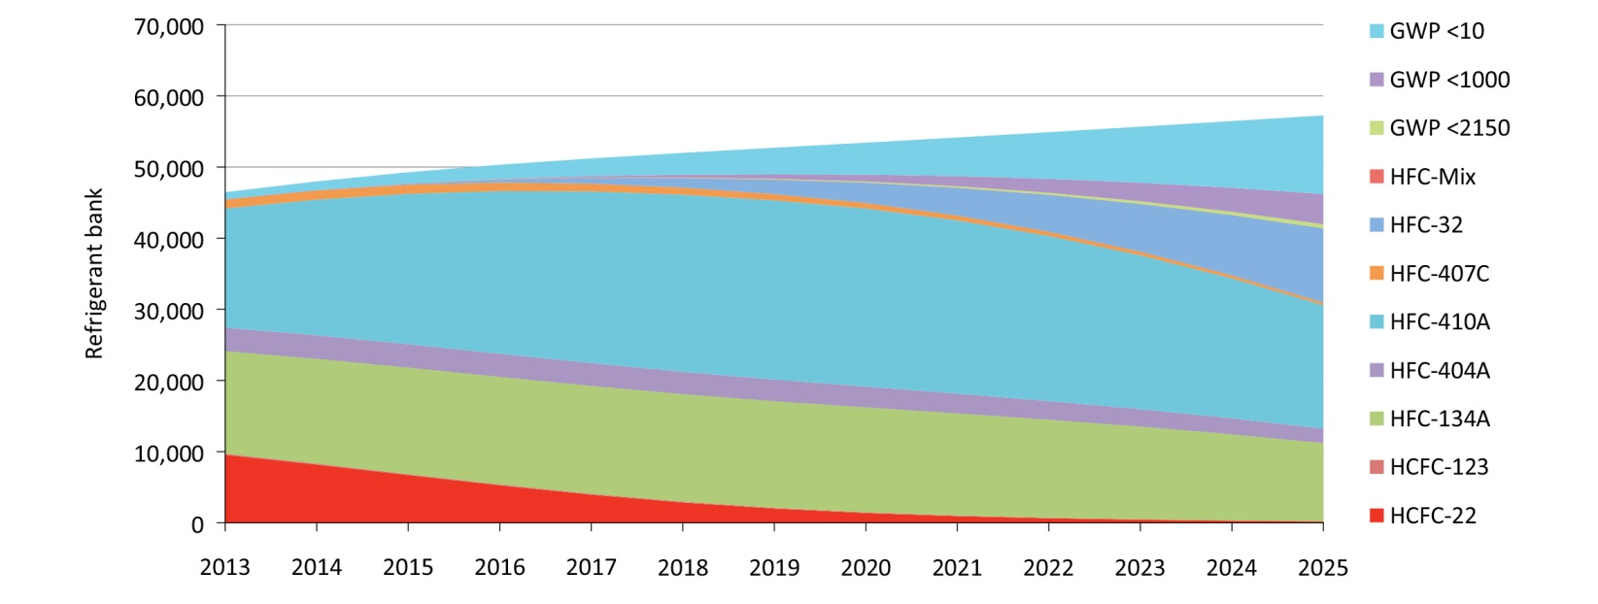

However the changing composition of the bank, and the increasing share of zero and low GWP gases employed, results in changes to annual bulk import of gases for manufacture and servicing by significantly reducing the aggregate GWP of bulk gases imported. Projections for Australian bulk HFC imports, expressed in million tonnes of CO2 equivalent, are charted below against the cap on imports that would be in place under the NAA proposal.

Figure 2 Australian HFC Imports and the NAA Proposal by gas species in Mt CO2-e based on AR4.

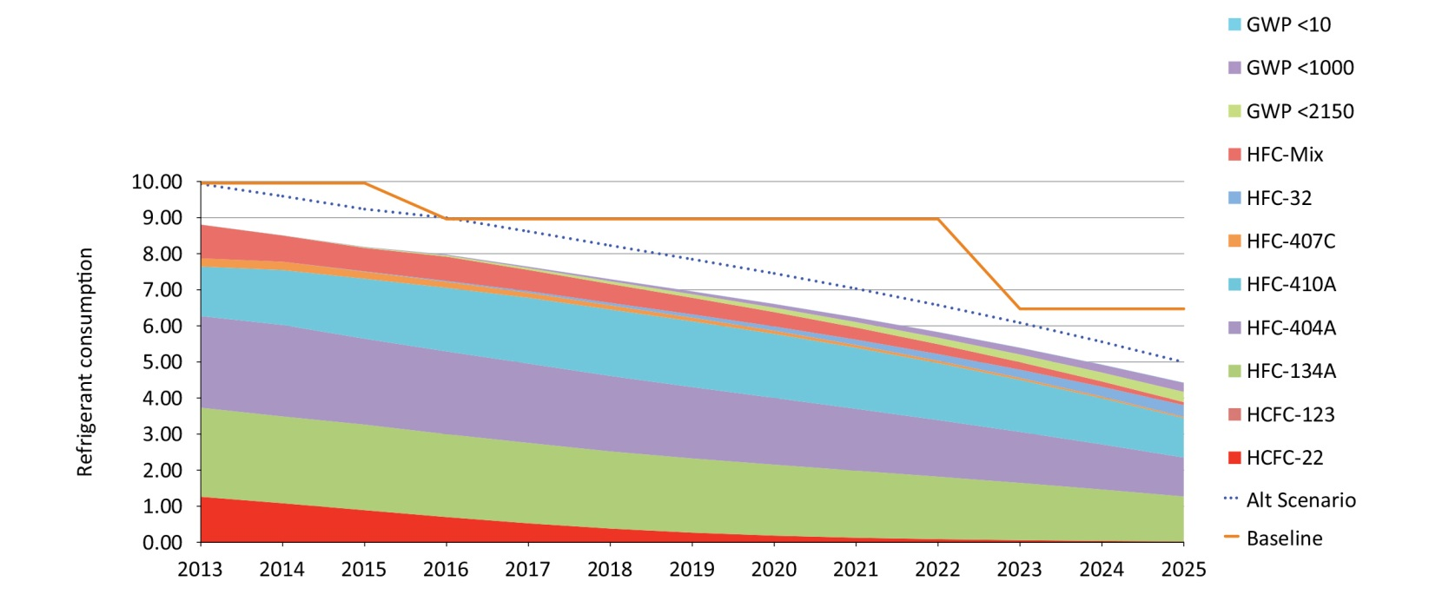

This analysis was also conducted on a sector by sector basis. The ‘alternative scenario’ visible as the dotted blue line, represents a higher starting point for annual imports that was discussed during consultation with leading members of the Australian industry and supply chains.

The primary conclusion of the study is that there are viable lower and zero GWP alternatives available now, or being developed for commercial release in the near future, for the majority of present day applications of HFCs. There are a small number of uses where no immediate options are available. Technical work will be needed to adapt low GWP alternatives for these uses. Despite the assessed technical capacity to meet a HFC phase down, there are industry standards, human resource and economic issues that need attention to support a transition to low GWP alternatives.

Expert Group’s full report can be accessed on the Department’s website: [www.environment.gov.au/protection/ozone/publications/hfc-consumption-australia-2013](http://www.environment.gov.au/protection/ozone/publications/hfc-consumption-australia-2013)