High resolution monitoring of waterbird colonies in the Macquarie Marshes

FINAL REPORT

June 2017

Report prepared for the Commonwealth Environmental Water Office


K. Brandis

Centre for Ecosystem Science, University of New South Wales


Table of contents

Executive Summary 3
Introduction 5
Water management September 2016 – February 2017 7
Colonial waterbird breeding in the Macquarie Marshes 8
Methods 10
Results 14
Zoo Paddock colony 14
Colonial waterbird breeding 16
Straw-necked ibis 16
Royal spoonbills 18
Glossy ibis 20
Monkeygar colony 22
Colonial waterbird breeding 24
Straw-necked ibis 24
Royal spoonbills 26
Species diversity 29
Nest counts 29
Aerial Survey 31
Water quality 31
Bird Health 34
Colonial waterbird breeding in the Murray-Darling Basin 2016-2017 35
Discussion 37
Acknowledgments 40
References 40
Appendix 1: Water quality data 42
Appendix 2: List of bird species observed in the Macquarie Marshes at Monkeygar, Pilllicawarrina and Zoo Paddock. 43

Executive Summary
Following above average rainfall in the Macquarie catchment, Burrendong Dam reached capacity in early September 2016. Flow releases from the dam under Flood Mitigation Zone airsprace operation, coupled with upper catchment tributary flow and local rainfall resulted in widespread flooding including, 154,000 ha (NSW OEH) of the Macquarie Marshes. Supplementary water orders were lodged by the Commonwealth Environmental Water Office, once nuisance flooding in the mid-Macquarie had receded (December 2016), with the aim of maximising water levels during the nesting period. Further managed environmental flows (NSW and Commonwealth water) were delivered in late January 2017 through to mid-February 2017 to maintain water levels in waterbird colony sites.
High resolution monitoring of colonial waterbird colonies in the Macquarie Marshes was undertaken from October 2016-January 2017. The objective of this monitoring was to report on the reproductive success of ibis and royal spoonbills in relation to hydrological conditions and the need for environmental water to maintain water levels during the breeding period.
Key results of the high resolution monitoring included:
Monkeygar colony:
- Two species of colonially breeding waterbirds were monitored: Straw-necked ibis (Threskiornis spinicollis) and royal spoonbill (Platalea regia).
- Monkeygar colony had higher average water depths at nests between 35-88 cm.
- Straw-necked ibis had an overall success rate for offspring of 63.28%.
- Royal spoonbill had an overall success rate for offspring of 77%.
Zoo Paddock colony:
- Three species of colonially breeding waterbirds were monitored: Straw-necked ibis, glossy ibis (Plegadis falcinellus), and royal spoonbill.
- Average water depths at nest sites were low, 21-40 cm.
- Straw-necked ibis had an overall success rate for offspring of 65.81% and 49% for a smaller second nesting event.
- Glossy ibis had an overall success rate for offspring of 13.96%.
- Royal spoonbill had had an overall success rate for offspring of 12.66%.
- Glossy ibis and royal spoonbill nested in mid-December, later in the flooding period when inundation was receding and water levels were lower than the peak in October 2016 when straw-necked ibis began nesting.

The response of waterbirds to suitable breeding condition in the Macquarie Marshes during 2016-2017 demonstrates that this wetland system continues to be an important site for colonial waterbird breeding. However breeding success is influenced by a number of factors including, hydrological conditions (timing, duration), water depth at the colony site, and availability of nesting habitat, availability of foraging habitat and sufficient food resources and predation. The results of this monitoring have shown:
- Straw-necked ibis reproductive success at Monkeygar and Zoo Paddock was comparable for birds that nested in October 2016.
- Reproductive success rates early nesting straw-necked ibis in the Macquarie Marshes were comparable to other colonies it the Murray-Darling Basin.
- Late nesting birds at Zoo Paddock, straw-necked ibis, glossy ibis and royal spoonbill suffered significant (>80%) losses to predation from ground based predators as flooding receded and water levels dropped.
- Environmental water delivery in late January maintained water levels at Monkeygar colony supporting late nesting royal spoonbills and provided foraging habitat to fledged ibis.

Introduction
The Macquarie Marshes are an extensive wetland system (200 000 ha) on the lower reaches of the Macquarie River in western New South Wales, 30 km west of Quambone (Figure 1). They are a complex system of lagoons and braided streams supporting a large diversity of flora and fauna (Kingsford and Auld, 2003). About 17% (21,927 ha) of the area is Nature Reserve and is Ramsar listed (1986), a further 583 ha of ‘Wilgara’ a privately owned grazing property within the Marshes was Ramsar listed in 2000 and ‘U-Block’ was also listed in 2012. Criterion for listing included that the Macquarie Marshes represents highly significant habitat for colonially breeding waterbirds (Criterion 4), and that it regularly supports more than 20,000 waterbirds and over 500,000 in large floods (Criterion 5) (Ramsar, 1986).
The Macquarie Marshes provide important waterbird habitat, both breeding and foraging, and regularly supports large numbers of birds. Seventy-seven waterbird species have been recorded, including 17 migratory species listed on JAMBA, CAMBA and ROKAMBA international agreements and nine species listed under the NSW Threatened Species Conservation Act 1995 (NSW OEH 2012).
Breeding opportunities for colonial waterbirds are often triggered by flood events at key wetlands. Forty-six per cent of all wetland sites throughout Australia that are used for colonial waterbird breeding occur in the Murray-Darling Basin. Of these, relatively few wetlands (<5% recorded) support large colonial waterbird breeding events (Brandis 2010). The Macquarie Marshes (Figure 1) is one of the most important breeding sites for colonial waterbirds in the Murray-Darling Basin and possibly Australia, with up to five different colony sites capable of initiation of large scale colonies in a breeding season (Kingsford and Auld 2003).
Following above average rainfalls, both locally (Figure 2) and in the upper catchment (Figure 3) during May – September 2016 there was widespread flooding in the Macquarie Marshes. In September 2016, two ibis colonies, composed predominantly of straw-necked ibis (Threskiornis spinicollis), Australian white ibis (T. molluca), glossy ibis (Plegadis falcinellus), and royal spoonbills (Platelea regia) established at Zoo Paddock and Monkeygar (Figure 1). These were the largest two ibis colonies in the Marshes of a total of 21 colonial waterbird nesting sites in 2016/2017. Colony monitoring of Zoo Paddock and Monkeygar by UNSW staff and students began on the 7th October and continued until the 31st January 2017.
Zoo Paddock and Monkeygar are traditional colony sites (Kingsford and Auld 2003). In Zoo Paddock the last recorded straw-necked ibis breeding event was in 2000 while, Australian white ibis bred in small numbers (n=30 nests) in 2010-11. The last recorded straw-necked ibis breeding at Monkeygar was 2011, and Australian white ibis (n=800 nests) in 2012-13.
The objective of high resolution monitoring of these waterbirds colonies was to report on the reproductive success of ibis and royal spoonbills in relation to hydrological conditions and the need for environmental water to maintain water levels during the breeding period.
In addition to the high resolution, on ground monitoring, complimentary data was collected through the Eastern Australian Aerial Waterbird Survey (UNSW) and the use of remote cameras (CSIRO).

Figure 1 Two large-scale ibis colonies in the Macquarie Marshes in 2016 monitored by UNSW (Monkeygar and Zoo Paddock). Maximum inundation extent June 2016 – April 2017 GIS layer supplied by NSW OEH.
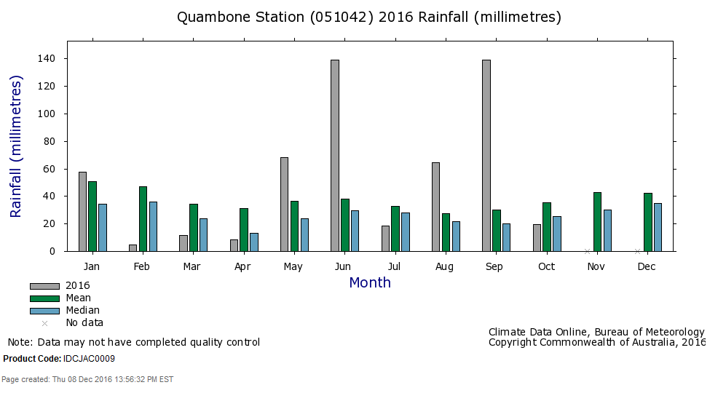
Figure 2 Monthly rainfall records (2016 and long term average and median) for Quambone Station local to the Macquarie Marshes: Source Climate Data Online, Bureau of Meteorology.

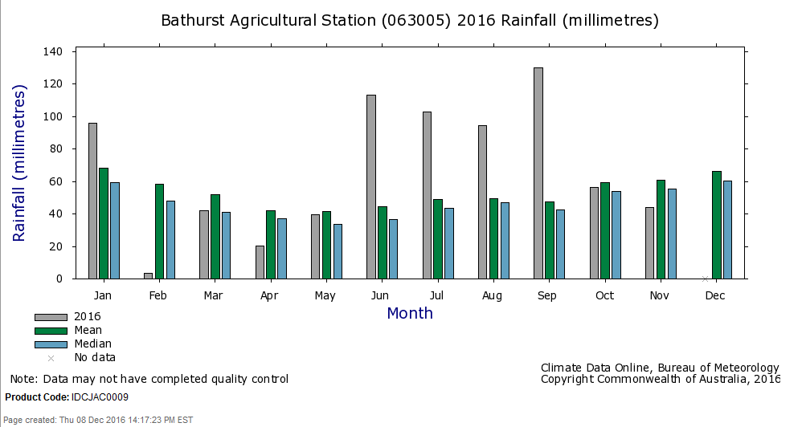
Figure 3 Monthly rainfall records (2016 and long term average and median) for Bathurst Agricultural Station in the upper Macquarie River catchment: Source Climate Data Online, Bureau of Meteorology.

Water management September 2016 – February 2017
Following above average rainfall in the catchment, Burrendong Dam reached capacity in early September 2016 (Figure 4). Flow releases from the dam under Flood Mitigation Zone airspace operation, coupled with upper catchment tributary flow and local rainfall resulted in widespread flooding including 154,000 ha (NSW OEH) of the Macquarie Marshes. Supplementary water orders were lodged by the Commonwealth Environmental Water Office, once nuisance flooding in the mid-Macquarie had receded (December), with the aim of maximising water levels during the nesting period. Further managed environmental flows (NSW and Commonwealth water) were delivered in late January through to mid-February to maintain water levels in waterbird colony sites.
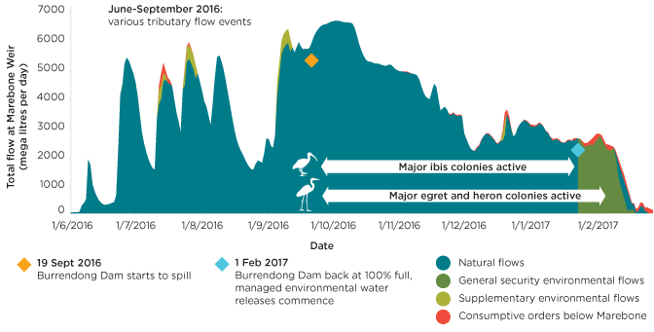
Figure 4 Flow type releases from Burrendong Dam and flow volumes at Marebone Wier in relation to waterbird breeding in the Macquarie Marshes. Source NSW OEH http://www.environment.nsw.gov.au/environmentalwater/macquarie-news.htm.

Colonial waterbird breeding in the Macquarie Marshes
The Macquarie Marshes are one of Australia’s key colonial waterbird breeding sites (Brandis 2010). Regular reporting of colonial waterbird breeding began from the mid 1980’s. Prior to this records are sparse with the first formal record from the Nest Record Scheme in 1978 (Table 1).
Colonial waterbird breeding is closely tied to flooding and inundated wetlands (Kingsford and Thomas 1995). Analyses of historical flows and colonial waterbird breeding (all species) found that breeding events were closely tied to flows with large flow events resulting in large, or numerous breeding events (Brandis and Bino, 2016) (Figure 5).
This is evidenced again in 2016-2017 when a total of 21 waterbird colonies were established including large, ibis colonies (Monkeygar and Zoo Paddock) and smaller egret and heron colonies (NSW OEH) (Figure 4). The size of the ibis colonies in 2016/2017were the fifth largest recorded since 1978 (Table 1).

Table 1 Records of breeding by Australian white ibis, glossy ibis, straw-necked ibis and royal spoonbill at the Macquarie Marshes 1978-2016. Total numbers of nests.
 | Australian white ibis | Glossy ibis | Straw-necked ibis | Royal spoonbill
1978 |  | 500 | 12800 | 480
1979
1980
1981
1982
1983
1984 | 280
1985
1986 | 837 | 500 | 200
1987 | 135 |  | 2300
1988 | 1916 | 25 | 1980
1989 | 959 |  | 4030 | 30
1990 | 2130 | 1500 | 55000
1991
1992
1993 | 380 | 330 | 9700
1994
1995 | 11 |  | 1272
1996 | 485 | 500 | 10300
1997
1998 | 5813 | 1000 | 60950
1999 | 158 | 800 | 1500
2000 | 1350 | 3900 | 31225
2001
2002
2003
2004
2005
2006
2007
2008 | 200 |  | 200
2009 | 50
2010 | 215 | 750 | 35000
2011 | 200 |  | 70000
2012 | 800 |  |  | 200
2013
2014
2015
2016* | 985 | 50 | 36000 | 255
*preliminary data supplied by NSW OEH.

Figure 5 Historical colonial waterbird breeding and flow events (Marebone Weir), Macquarie Marshes 1986-2014. Source: Brandis and Bino, 2016.

Methods
Reproductive success monitoring
Two waterbird colony sites were monitored in the Macquarie Marshes during October 2016 – January 2017 by UNSW. Other waterbird colony sites across the Marshes were monitored by NSW OEH. Monkeygar and Zoo Paddock (Figure 1) are traditional colony sites with historical records of breeding (Kingsford and Auld 2003). During the 2016-2017 breeding event three species of colonially nesting waterbirds were monitored for reproductive success in relation to hydrological conditions. Zoo Paddock; straw-necked ibis, glossy ibis and royal spoonbill, Monkeygar; straw-necked ibis and royal spoonbill.
Colonies were surveyed approximately every two weeks between October 2016 and January 2017. A random subset of nest clumps were marked using numbered cattle ear tags. Each clump consisted of between 2-30 nests. Individual nests were marked using small numbered sheep ear tags. Marked nests contained eggs or a combination of eggs and very young chicks. Nests without eggs were not marked as it is not possible to determine clutch sizes or reproductive success. Each nest was relocated during each survey and the following variables recorded; number of eggs or chicks, chick development stage, evidence of predation and nest abandonment. Water depth data was recorded at each nest clump site using a 1 m folding ruler. Individual nest surveys continued fortnightly until chicks had reached runner stage, where chicks become highly mobile and begin créching behaviour; congregating on nests as large groups of chicks. At this stage it is not possible to attribute chicks to specific nests so counts are done at a nest clump scale. Nest clump monitoring continued until chicks had fledged or were no longer associated with the nest clump site.
Water quality data was collected at four random locations within the nest monitoring area at each colony site during each survey. Water quality variables recorded included: temperature, pH, conductivity, total dissolved solids, resistivity and salinity (Appendix 1).
Species diversity of other bird species was also recorded (Appendix 2).
To minimise disturbance to the colonies all ground surveys were limited to two periods during the day; early morning (6-11am) or late afternoon (3-8 pm) to avoid causing heat stress to nesting birds and their offspring. Access to the colony sites was via argo or on foot. Within the colonies access was via foot as water levels were too shallow for canoes.
Table 2 Schedule of nest monitoring activities.
Date of survey | Task | Number of nests marked
27-28th October 2016 | Mark sub-set of straw-necked ibis nests in Zoo Paddock and Monkeygar; assisting NSW OEH with remote camera installation in Monkeygar colony | Monkeygar 49 SNI*  Zoo Paddock 203 SNI; 2 GLI
10th – 11th November 2016 | Monitoring of marked nests, mark new nests in Zoo Paddock and Monkeygar | Monkeygar 2 SNI (new)
22nd – 24th November 2016 | Monitoring of marked nests, in Zoo Paddock and Monkeygar
26th November 2016 | Drone imagery captured
6th – 7th December 2016 | Monitoring of marked nests, mark new nests in Zoo Paddock and Monkeygar | Zoo Paddock 4 SNI; 19 GLI (new)
15th – 16th December 2016 | Monitoring of marked nests, mark new nests in Zoo Paddock and Monkeygar. Subset of royal spoonbill nests marked. | Monkeygar 19 RSP*  Zoo Paddock 35 RSP; 91 GLI
28-29th December 2016 | Monitoring of marked nests, mark new nests in Zoo Paddock and Monkeygar. | Monkeygar 6 RSP (new)  Zoo Paddock 5 RSP; 4 GLI (new)
8th – 9th January 2017 | Monitoring of marked nests, mark new nests in Zoo Paddock and Monkeygar. | Monkeygar 2 RSP (new)
31st January 2017 | Final survey of marked royal spoonbill nests in Monkeygar.
*SNI- straw-necked ibis; RSP – royal spoonbill; GLI – glossy ibis.

Chick development
Typical development of straw-necked ibis chicks takes approximately 48 days from laying to fledging (Table 3) with two weeks of post fledging parental care (Brandis and Bino 2016).
Table 3 Chick development stages and corresponding age (days) for straw-necked ibis (Brandis et al. 2011).
Age(days) | Development stage
1-20 | Egg
21-25 | Chick
26-30 | Squirter
31-35 | Runner
36-40 | Flapper
41-47 | Flyer
>48 | Fledged

Royal spoonbills have a longer nesting period than straw-necked ibis with chicks fledging at approximately 53 days from egg laying (Table 3). Parents and fledged young continue to return to the nest site for feeding by the parents for approximately 7 days.
Table 4 Chick development stages and corresponding age (days) for royal spoonbill (Marchant and Higgins 1990).
Age(days) | Development stage
1-25 | Egg
26-29 | Chick
30-37 | Squirter
38-52 | Flapper/flyer
53-59 | Fledged

Glossy ibis have one of the shortest nesting period of any waterbird (Brandis and Bino 2016) with chicks fledging at 45 days from egg laying (Table 4). Post fledging care by parents is estimated to be 21 days (Marchant and Higgins 1990; Brandis and Bino, 2016) although there is limited quantitative data to support this.
Table 5 Chick development stages and corresponding age (days) for glossy ibis (Marchant and Higgins 1990).
Age(days) | Development stage
1-21 | Egg
22-31 | Chick
32-36 | Runner
37-45 | Flyer
>45 | Fledged

Calculating reproductive success
Reproductive success was calculated for each period between surveys and across all surveys. Nest success is a measure of a particular nest producing offspring. This is a difficult measure to obtain for species such as ibis which crèche. Créching by birds is where young leave their nest to form groups with other young birds. For ibis this typically occurs from ~38 days (12 days post hatching). For this reason nest success is not a measure that can be used reliably for ibis. Depending upon timing of the first survey it may be possible to calculate nest success for the first survey period, but not after that.
Offspring success, is a combined measure of eggs and/or chicks that survive compared to total eggs laid. This measure is calculated for the period between each survey and over the total nesting period. Between survey measures, allow for greater understanding of the timing of mortality (e.g. due to predation, starvation, abandonment) with relation to chick development stage and hydrological (e.g. water depth) and environmental (e.g. weather events, temperature )conditions. The numbers of eggs and chicks per nest were measured on the first survey, but due to créching behaviours this is not always possible for second and subsequent surveys. For second and subsequent surveys offspring numbers are calculated for the clump (group of nests) and then totalled for the colony.

Drone imagery capture
As part of a Murray-Darling Basin wide research program to collect drone imagery of waterbird colonies the Centre for Ecosystem Science (CES), UNSW collected drone imagery of Zoo Paddock and Monkeygar on the 26th November 2016. From this imagery we undertook nest counts of Zoo Paddock colony. We also captured drone imagery of Monkeygar however due to the windy weather conditions these images were not suitable for counting nests. While the capture of drone imagery was not a component of the work contracted by CEWO it is presented here in-kind, this research was funded by CES, UNSW.
Image capture involved flying parallel flight lines at speeds between 5 to 10 m/s. To acquire sufficient image overlap for processing, flight lines were typically 20 to 100 m apart depending on flying height. For example, flying at 100 m above take off (ATO), flight lines were around 100 m apart, whereas at 20 m ATO, flight lines were around 20 m apart (Lyons et al. 2017 in review).
At two other colonies in the Murray-Darling Basin (Lower Lachlan and Lower Murrumbidgee), we conducted systematic observations of the impact of the drone on Ibis behaviour, since they were active breeding events. This was in addition to capturing imagery over the entire colony. In order to ensure minimal impact, we monitored the effect of a drone on nesting adults, before conducting the full-colony monitoring exercise. Before any flights had been conducted with the drone, we entered the colony on an amphibious vehicle (Argo 8x8 650). After entering the colony, a random group of nests were chosen and a GoPro Hero 5 Black fixed to a 2.3 m pole was directed at the nests. We then moved (in the vehicle) approximately 50m away and out of line of sight of the camera. We waited approximately 20 minutes to allow time for birds to return to their nests before launching the drone. After confirming safe flight parameters, the drone was elevated to 120 m above take off (ATO) and navigated to the nest site being filmed from the ground. The drone was slowly (approx. 1 m/s) descended to 20 m ATO, and hovered for ˜2 75 minutes, and then descended to 10 m ATO. The landscape is flat, so height in meters ATO approximates height above the nests. The drone was raised and lowered multiple times at a speed of around 1 m/s to observe the height at which birds flushed from their nests, and under what conditions they returned. The drone was then flown back to the vehicle and we again waited 20 minutes before recovering the GoPro. The drone itself also captured video of the nest sites. Other studies (e.g., Vas et al. (2015)) performed multiple repeated experiments and while this is ideal from an experimental design perspective, we considered any additional disturbance to the birds unnecessary as the subsequent monitoring involved systematic flight lines over the entire colony.
Nest counts and colony boundaries
Using a computer generated orthomosiac of images captured by drone, nests were visually identified and marked in a GIS spatial layer. Accuracy of nest mapping was assessed against ground nest surveys. Nest counts at sites being monitored for reproductive success were compared to counts derived for the same site and closest date from image analysis.
Colony boundaries were derived by visual interpretation with boundaries drawn around the cohesive/contiguous nesting area.
Results
The first colonies established at Monkeygar and Zoo Paddock were predominantly straw-necked ibis, but also included small numbers of Australian white ibis, glossy ibis and royal spoonbills. Estimates from the UNSW Eastern Australia Aerial Waterbird Survey 2016 of maximum ibis colony sizes were: Zoo Paddock 10,000 – 15,000 straw-necked ibis, and Monkeygar up to 15,000 predominantly straw-necked ibis. Following completion of nesting by straw-necked ibis in late December 2016, larger numbers of royal spoonbills began nesting at the same colony sites.

Zoo Paddock colony
Zoo Paddock is an area of sparse lignum (Muehlenbeckia florulenta) (Figure 6) located on the northern floodplain of the Macquarie Marshes (Figure 1) and is infrequently inundated.
The waterbird colony area was estimated from drone imagery to be 74 ha. Ibis nested throughout this area (see Figure 22).
Figure 6 Colony area of Zoo Paddock ibis and royal spoonbill colony, Macquarie Marshes, NSW.

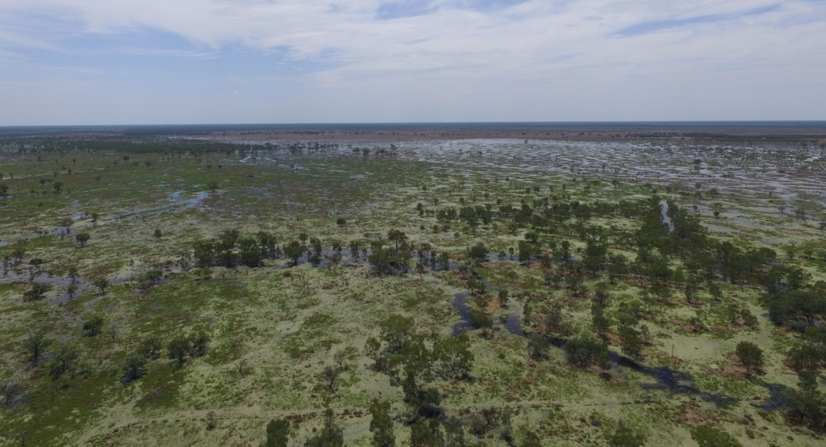
Figure 7 Zoo Paddock colony 26th Nov. 2016 (photo: J. McGann)

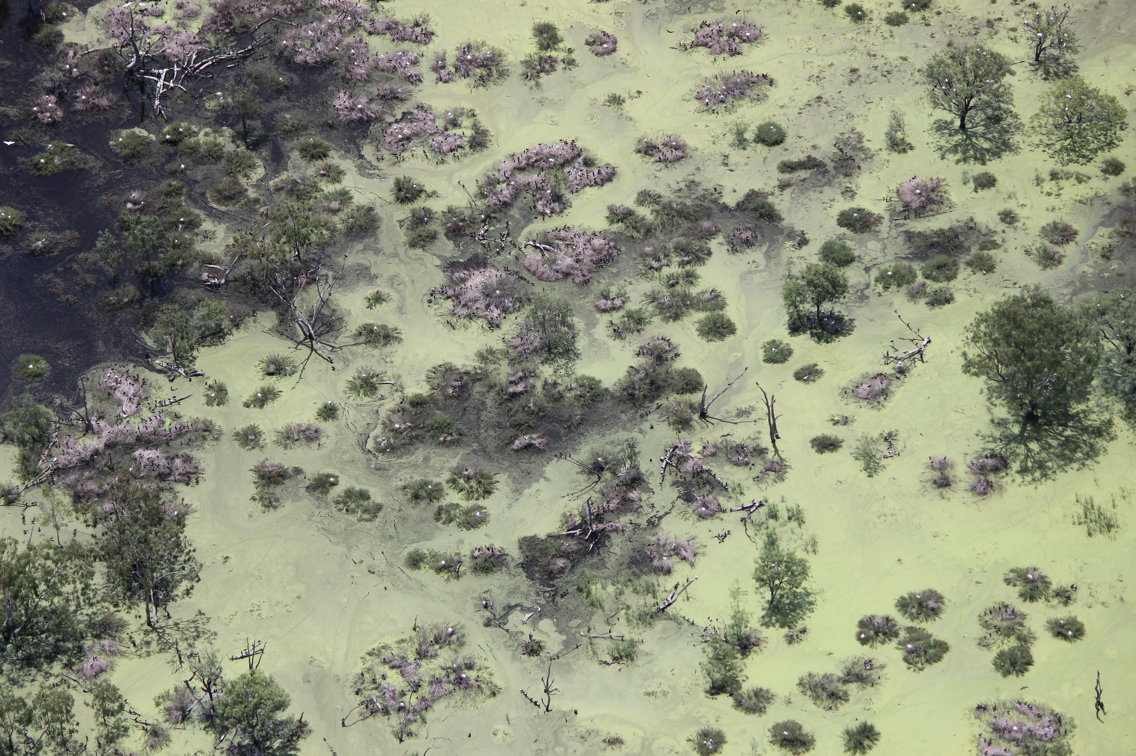
Figure 8 Aerial photo of ibis nesting in Zoo Paddock colony, 14th December 2016. (Photo: S. Suter, NSW OEH)

Colonial waterbird breeding

Straw-necked ibis
The average clutch size for eggs laid in October was 2.6 eggs per nest (range 1-5; n=203).
Figure 8 and Figure 16 show the age composition of chicks in the colonies during each survey. Notes from the 15th December indicated that the majority of chicks had fledged and left the nest. They were observed roosting and foraging in areas around the colonies. Juveniles remained in the Macquarie Marshes while conditions were suitable and food resources available. Mortality of young waterbirds is often highest in the first year of life (McKilligan 2005). Providing the best feeding opportunities to build up condition during this post fledging period may assist in increasing chances of survival during the first 12 months.
There were no individual nest counts after the 10th November. The majority of chicks were at runner or flapper stage (Figure 8) and could no longer be attributed to individual nests. Success rate was lowest (55.47%) between the 27th October and 10th November when there were eggs and/or young chicks in nests (Table 7). Eggs and chicks from October had fledged by early December (event 1) with an overall success rate of 65.81%. A very small cohort (<20 birds) of straw-necked ibis laid eggs in early December (event 2) with an overall success rate of 49% (Table 7). This additional laying may have coincided with a small rise in water levels at the colony (Figure 9).

Figure 9 Composition and total number of chicks and eggs at each survey of Zoo Paddock straw-necked ibis colony (total nest number = 207). Second egg laying event seen on 15/12/2016 with increase number in eggs compared to previous survey.

Water depths at nest clumps in Zoo Paddock varied both within the colony on each survey and between surveys (Figure 9). Average water depths at nests ranged from 10 cm – 41 cm (range 0 – 68 cm).

Figure 10 Mean, minimum and maximum water depths at straw-necked ibis nests each survey at Zoo Paddock.

Table 6 The number of straw-necked ibis nests and offspring (eggs and/or chicks) monitored for reproductive success between each survey. Interpretation of this table; of the 203 nests marked on 27/10/2016, 183 were still active on 10/11/2016. No new nests were added during this survey so the number of nests remained unchanged (n=183). On the 28/12/2106 4 new offspring (only eggs or day old chicks) were added to the monitoring data. Changes in offspring numbers may be due to chicks fledging or death. When chicks crèche the total number of offspring per nest clump is counted – taking into account movement of chicks out of their nest.
 | 27/10/2016 | 10/11/2016 | 22/11/2016 | 6/12/2016 | 15/12/2016 | 28/12/2016 | 8/01/2017
Nests | 203 | 183
Offspring | 530 | 294
Nests |  | 183
Offspring |  | 294 | 215
Offspring |  |  | 215 | 148 | 12 | 9 | 2
Offspring |  |  |  |  | 12 | 9
Offspring |  |  |  |  |  | 13 | 3

Table 7 Survival success rates for Zoo Paddock straw-necked ibis nests and offspring between each survey. Successful nests are those that raise/fledge at least one chick irrespective of total number of eggs laid into it. Offspring success is a measure of chicks raised/fledged compared to total number of eggs laid.
 | 27 Oct. - 10 Nov. 2016 | 10-22 Nov. 2016 | 22 Nov. - 6 Dec. | Event 1  overall success | 15 -28 Dec. 2016 | 28 Dec. - 8 Jan. 2017 | Event 2  overall success
Nests | 90.15%
Offspring | 55.47% | 73.13% | 68.84% | 65.81% | 75.00% | 23.08% | 49.04%

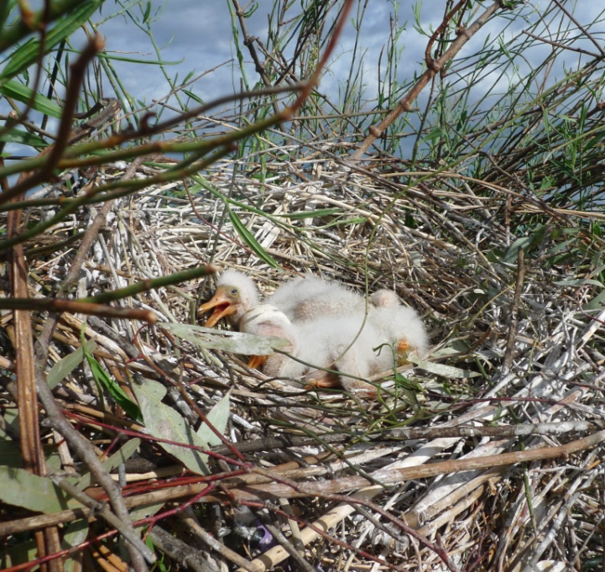
Figure 11 Royal spoonbill chicks at Zoo Paddock. (Photo: E. Webster)

Royal spoonbills
A small cohort of royal spoonbills began nesting at Zoo Paddock at the same time at the straw-necked ibis in early October. These nests were not consistently surveyed at this time. The larger royal spoonbill nesting event followed completion of nesting by straw-necked ibis in early December 2016. Average clutch size was 2.94 eggs per nest (range 1-4, n=35 nests). There was no survey of Zoo Paddock on the 31st January 2017 as there was only one chick still in the nest on the 8th January. It was expected that this chick would have fledged by the 31st January.

Figure 12 Composition and total number of chicks and eggs at each survey of Zoo Paddock royal spoonbill colony (n=40 nests).

Figure 13 Mean, minimum and maximum water depths at royal spoonbill nests each survey at Zoo Paddock.

Water depths at nests during royal spoonbill nesting were relatively stable between surveys with fluctuations between a mean depth at each survey of 32 -35 cm (range 24 – 41.5 cm) (Figure 12). These water depths were shallow allowing easy access to ground based predators such as feral pigs and foxes.

Table 8 The number of royal spoonbill nests and offspring monitored for reproductive success between each survey. Interpretation of this table; of the 35 nests marked on 15/12/2016, 6 were still active on 28/12/2016. On the 28/12/2016 new nests were marked for monitoring resulting in 9 nests that were monitored, 3 of which were still active on the 8/1/2016. Changes in offspring numbers may be due to chicks fledging or death. When chicks crèche the total number of offspring per nest clump is counted – taking into account movement of chicks out of their nest.
 | 15/12/2016 | 28/12/2016 | 8/01/2017
Nests | 35 | 6
Offspring | 103 | 17
Nests |  | 9 | 3
Offspring |  | 34 | 3

Table 9 Survival success rates for Zoo Paddock royal spoonbill nests and offspring. Successful nests are those that raise/fledge at least one chick irrespective of total number of eggs laid into it. Offspring success is a measure of chicks raised/fledged compared to total number of eggs laid.
 | 15-28 Dec. 2016 | 28th Dec. - 8th Jan 2017 | Overall success rate
Nests | 17.14% | 33.33% | 25.24%
Offspring | 16.50% | 8.82% | 12.66%

Glossy ibis
Glossy ibis bred at Zoo Paddock in two nesting events. The first small event (n=2 nests), coincided with straw-necked ibis nesting (27th October 2016), while the second, larger event (n= 95 nests) was with the larger royal spoonbill nesting event (15th December 2016). Glossy ibis have a short breeding period with chicks fledged within ~45 days. Average clutch size for the first nesting event was 4.5 eggs per nest (range- 4-5; n=2). Average clutch size for the second nesting event was 2.9 eggs per nest (range 2-4; n=91).

Figure 14 Composition of Zoo Paddock second glossy ibis colony at each survey.
Table 10 The number of glossy ibis nests and offspring monitored for reproductive success between each survey. A – glossy ibis nesting event 1, B – glossy ibis nesting event 2. Interpretation of this table; of the 9 nests marked on 27/10/2016, 8 were still active on 10/11/2016. Changes in offspring numbers may be due to chicks fledging or death. When chicks crèche the total number of offspring per nest clump is counted – taking into account movement of chicks out of their nest.
A.
 | 27/10/2016 | 10/11/2016 | 22/11/2016
nests | 2
offspring | 9 | 8 | 4

B.
 | 15/12/2016 | 28/12/2016 | 8/01/2017
nests | 91 | 10 | 3
offspring | 264 | 43 | 5

Table 11 Survival success for Zoo Paddock glossy ibis nests and offspring. Successful nests are those that raise/fledge at least one chick irrespective of total number of eggs laid into it. Offspring success is a measure of chicks raised/fledged compared to total number of eggs laid.
 | 27th Oct. – 10th Nov. 2016 | 10th -22nd Nov. 2016 | 15th-28th Dec. 2016 | 28th Dec. 2016- 8th Jan. 2017 | Overall success rate
Offspring* | 88.89% | 50.00% |  |  | 69.45%
Nests |  |  | 10.9% | 30.00% | 20.45%
Offspring# |  |  | 16.29% | 11.63% | 13.96%
*nesting event 1; # nesting event 2.

The survival rates for glossy ibis between survey 1 (15/12/16) and survey 2 (28/12/16) was 7.69% for nests and 16.29% for eggs and chicks combined (Table 11). It was not possible to determine survival rates between the second and third survey as surviving chicks had fledged with only 5 observed on nests. Nests were heavily predated with at least 14% of surveyed nests destroyed by feral pigs between surveys 1 and 2. Low water levels (Figure 14) would have made access to the colony easy for ground based predators. Feral pigs were observed in the colony while undertaking surveys on the 28th December 2016 and predation by feral pigs, due to their size and they trample nests to access nests typically destroying nests and consuming all eggs/chicks within each nest. Predation by other animals, such as crows, foxes, rats, snakes, other birds including birds of prey do not generally result in total nest destruction. They take eggs out of nests, or predate eggs/chicks in nests while leaving nest relatively intact (Brandis pers. obs.).

Figure 15 Mean, minimum and maximum water depths at glossy ibis nests each survey at Zoo Paddock.

Flow data
There is no formal measurement of water flows or levels for Zoo Paddock due to its position on the floodplain. Advice from NSW OEH is that flows at Zoo Paddock are a combination of Macquarie@Pillicawarrina and ungauged flows from the Long Plain Cowal but it is difficult to know volumes with certainty.

Monkeygar colony
Monkeygar is a wetland dominated by common reed (Phragmites australis). It is located on the floodplain adjacent to Monkeygar Creek and is more frequently inundated that Zoo Paddock. Ibis and spoonbill nested along the edges of phragmites along the main channel and in the open water areas. Colony area was 29 ha (Figure 15). The colony boundary is based on ground observations made by UNSW and NSW OEH staff. The eastern limits were derived from nest surveys and NSW OEH ground visits in October and December, while the western boundary incorporates data from aerial photos taken by NSW OEH aerial survey on the 14th December 2016. The boundary presented here may change following further air photo analyses by NSW OEH.
Nests chosen for monitoring at Monkeygar were located predominantly around the edge of the colony. This was done to avoid locations where camera traps had been set up by CSIRO to monitor reproductive success and predation. Camera trap locations were focused in the lagoon and main creek area (See McGinness et al. 2017 for details). Due to the non-random selection of nests monitored as part of this study they may not be representative of the entire colony.

Figure 16 Preliminary boundary of Monkeygar waterbird colony, 2016.
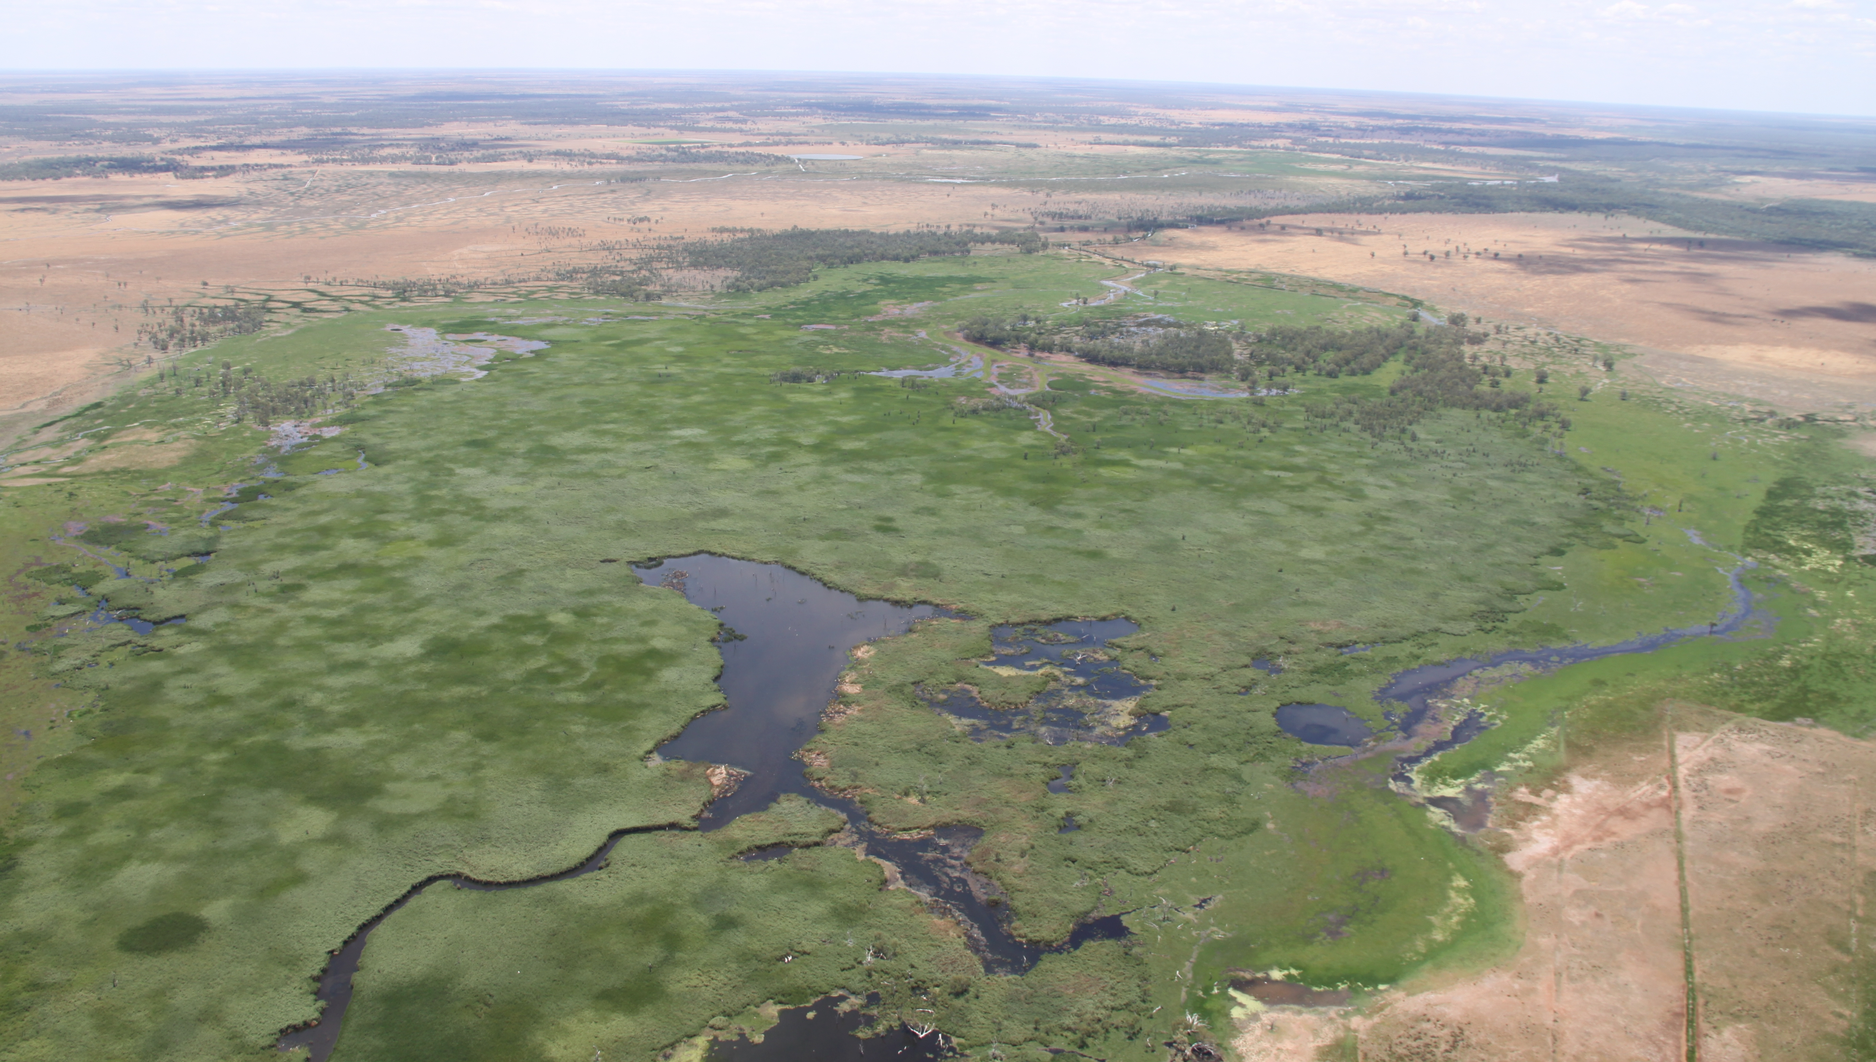
Figure 17 Aerial photo of Monkeygar wetland 14th December 2016. (Photo: N. Brookhouse, NSW OEH).

Colonial waterbird breeding

Straw-necked ibis
The average clutch size for eggs laid in October was 2.7 eggs per nest (range 1-3; n= 45).

Figure 18 Composition of the Monkeygar straw-necked ibis colony during each survey.

Figure 19 Mean, minimum and maximum water depths at straw-necked ibis nests each survey at Monkeygar colony.

Survival rates of chicks and eggs at Monkeygar colony between the 27th October and the 10th November 2016 was 85.07% (Table 13), but lower (41.49%) between the 10-23rd November. Water levels were also slightly lower during this period (Figure 19). The drop in water levels at nest clumps within the colony may be associated with an overall drying of the landscape and reduced areas of inundation.
Table 12 The number of straw-necked ibis nests and offspring monitored for reproductive success between each survey. Interpretation of this table; of the 25 nests marked on 27/10/2016, 19 were still active on 10/11/2016. By the 23 November chicks were off the nest at runner stage (Figure 16) so no individual nests were monitored on the 23 November. Changes in offspring numbers may be due to chicks fledging or death. When chicks crèche the total number of offspring per nest clump is counted – taking into account movement of chicks out of their nest.
 | 27 Oct. 2016 | 10 Nov. 2016 | 23 Nov. 2016
Nests | 25 | 19
Offspring | 67 | 57
Nests |  | 19
Offspring |  | 241 | 100

Table 13 Survival success rates for Monkeygar straw-necked ibis offspring. Successful nests are those that raise/fledge at least one chick irrespective of total number of eggs laid into it. Offspring success is a measure of chicks raised/fledged compared to total number of eggs laid.
 | 27 Oct. - 10 Nov. 2016 | 10 - 23 Nov. 2016 | Overall success rate
Nests | 76.00%
Offspring | 85.07% | 41.49% | 63.28%

Royal spoonbills

Figure 20 Composition of the Monkeygar royal spoonbill colony at each survey.

Table 14 The number of royal spoonbill nests and offspring monitored for reproductive success between each survey. Interpretation of this table; of the 20 nests marked on 15/12/2016, 10 were still active on 29/12/2016. On the 29/12/2016 new nests were marked for monitoring resulting in 14 nests that were monitored, 11 of which were still active on the 8/1/2016, and so on for the other survey dates. Changes in offspring numbers may be due to chicks fledging or death. When chicks crèche the total number of offspring per nest clump is counted – taking into account movement of chicks out of their nest.
 | 15/12/2016 | 29/12/2016 | 8/01/2017 | 31/01/2017
nests | 20 | 10
offspring | 66 | 48
nests |  | 14 | 11
offspring |  | 64 | 27
nests |  |  | 13 | 9
offspring |  |  | 36 | 45

Table 15 Survival success rates for royal spoonbill nests and offspring, Monkeygar. Successful nests are those that raise/fledge at least one chick irrespective of total number of eggs laid into it. Offspring success is a measure of chicks raised/fledged compared to total number of eggs laid.
 | 15-29 Dec. 2016 | 29th Dec. - 8th Jan. | 8th -31st Jan. | Overall average
Nests | 50% | 79% | 69% | 66%
Offspring | 73% | 42% | 100% | 72%

Success rates for offspring were lowest during the 29th December to the 8th January 2017. This coincided with lower water levels (Figure 21)
The data in Table 15 shows varying success rates for each stage of chick development. The lowest success rates were for offspring (chicks and eggs) between the 29th December and the 8th January. when many nests still contained eggs and/or young chicks. There was also a low success rates for nests between the 15th -29th December however most of the nests lost during this period were replaced with new nests resulting in a similar total number (Figure 20). The average success rate for royal spoonbill across the entire nesting period was 66% nest success i.e. 66% of nests fledged at least one chick, and 72% offspring (chicks and eggs) survived to fledging (Table 15).

Water levels
Average water levels ($\tilde{x}$ = 50 cm) in Monkeygar colony show fluctuations during the nesting period with a range of 34 cm – 58 cm at nests (Figure 21). Water depths were shallower when compared to other phragmites dominated nesting sites such as Barmah-Millewa (2016 water depth$\tilde{x}$ = 71cm - range 45 – 89cm 2016; 2015 $\tilde{x}$ = 57 cm range 55-58 cm). As noted monitored nests were located primarily around the edge of the colony which may not have been representative of depths across the entire colony. NSW OEH reports the water depth under nest clumps where cameras were installed in the main lagoon varied in depth from 28.9 -100 cm (mean 62cm) on installation 7 and 10/10/16, 26-95 cm (mean 59.7cm) on retrieval 14/12/16. While the range of water depth values is greater than measured along the edge of the colony the mean depths are not dissimilar on the 14/12/2016 (OEH $\tilde{x}=59.7cm, UNSW \tilde{x}$ =57 cm).

Figure 21 Mean, minimum and maximum water depths at royal spoonbill nests each survey at Monkeygar colony.

Water levels measured at Monkeygar Creek at upstream Western Arm Return (gauge 421129) show a slight decline in levels from late October (Figure 20) but remain above 2m for the duration of nesting.

Figure 22 Total daily flow discharge (ML/day) at 421129 - Monkeygar Creek U/S Western Arm Return and mean water depths at nests in Monkeygar colony on corresponding days.
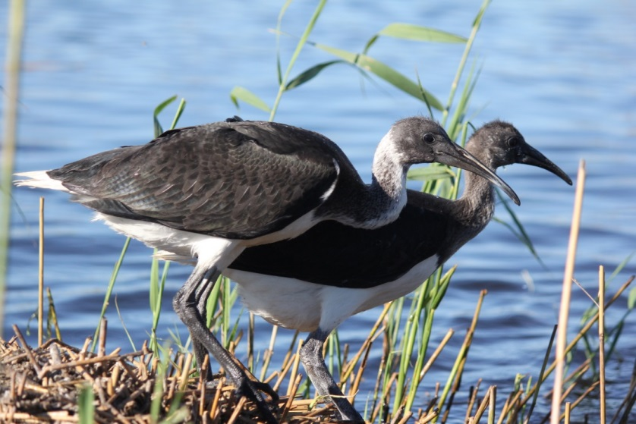
Figure 23 Juvenile (flapper stage) straw-necked ibis, Monkeygar colony 16th Nov. 2016. Photo: R. Kingsford

Species diversity
A total of 88 bird species were recorded in Monkeygar, Pillicawarrina and Zoo Paddock during nest monitoring surveys (Appendix 2). This included the Australasian bittern (Botaurus poiciloptilus) which is listed as endangered (EPBC Act 1999).

Nest counts
Using drone imagery of Zoo Paddock captured on the 26th November 2016 a total of 21,210 nests were counted (Figure 24). Accuracy assessment of these counts using ground surveys was 79%. The accuracy was slightly lower than optimal due to the timing of the image capture. At the time of image capture many of the nests contained chicks at runner stage. This meant that chicks were créching and nests were no longer discrete units, but rather a platform of nesting material. Also, adult birds were no longer attending eggs or small chicks. In optimal conditions image capture should occur when adults are sitting on eggs, or very young chicks. This makes nest identification much easier and counts more accurate.

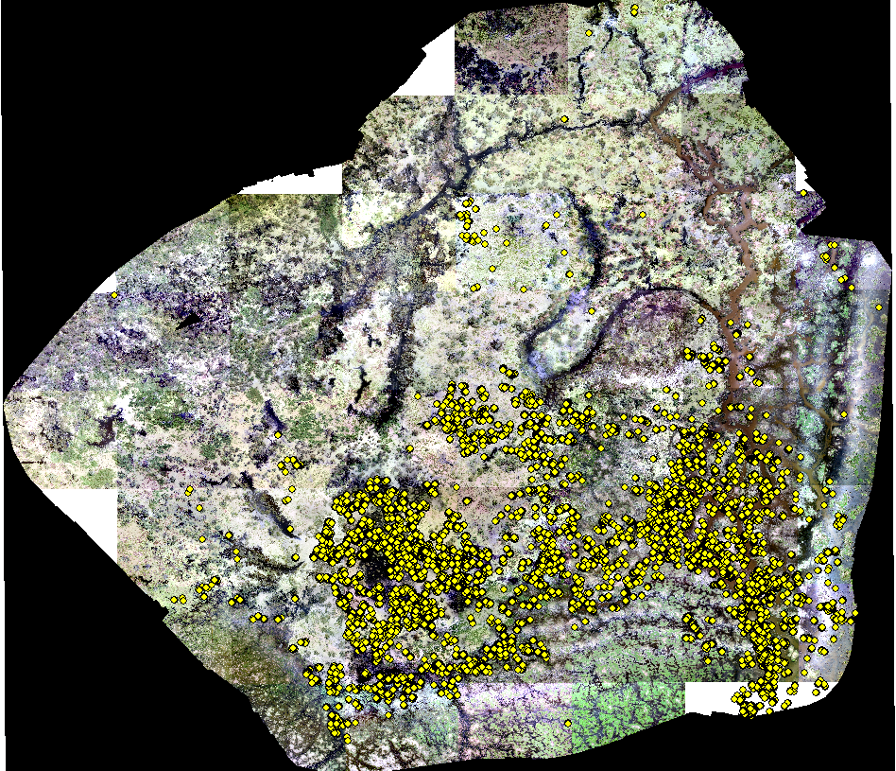
Figure 24 Drone imagery of Zoo Paddock (26th November 2016) with nests marked in yellow.

Aerial Survey
An aerial survey of the Macquarie Marshes was conducted on the 16th November 2016 as part of the annual Eastern Australia Waterbird Survey (UNSW). All known waterbird colonies were checked and 11 transects were flown east-west across the wetland (Table 16).
Table 16 Colonial waterbird colonies observed and counted during aerial survey 16th November 2016
Colony | Species and nest count
Ginghet 3 | Australian white ibis (70) | Magpie geese (50) | Straw-necked ibis (50)
Kiora colony | Egrets (220)
Oxley | Egrets (100)
Unnamed colony | Australian white ibis (30)
Unnamed colony | Royal spoonbill (980) | Australian white ibis (50)
Zoo Paddock | Straw-necked ibis 10,000-15,000
Monkeygar | Straw-necked ibis ~15,000

Further information can be found at https://www.ecosystem.unsw.edu.au/logs/eastern-australian-waterbird-survey/aerial-survey-16th-november-2016

Water quality
Water quality measures that have direct relevance for aquatic organisms include pH, total dissolved solids (TDS) and salinity. Some measures, such as TDS are highly correlated with other measures such conductivity and salinity. Water with a relatively high TDS will have a low resistivity and a high conductivity. Due to equipment limitations dissolved oxygen could not be measured.

Table 17 Mean water quality measures from Monkeygar colony.
 | 27/10/2016* | 23/11/2016* | 14/12/2016* | 29/12/2016 | 10/01/2017 | 31/01/2017
Temp (ºC) | 19.47 | 23.90 | 23.85 | 24.63 | 26.73 | 27.50
pH | 7.56 | 8.46 | 7.46 | 7.30 | 7.80 | 8.27
Conductivity | 0.35 | 0.07 | 0.48 | 0.36 | 0.38 | 0.33
Total Dissolved Solids (m/L) |  |  |  | 191.25 | 202.75 | 173.25
Resistance |  |  |  | 2.78 | 2.63 | 3.07
Salinity (ppt) |  |  |  | 0.20 | 0.20 | 0.20
*TDS, Resistance and Salinity not reported for these times due to calibration errors.

Table 18 Mean water quality measures from Zoo Paddock colony.
 | 22/11/2016* | 28/12/2016 | 08/01/2017
Temp (ºC) | 24.25 | 26.56 | 29.02
pH | 6.29 | 6.67 | 8.59
Conductivity | 0.06 | 0.47 | 0.44
Total Dissolved Solids (m/L) |  | 251.00 | 234.40
Resistance |  | 2.12 | 2.27
Salinity (ppt) |  | 0.20 | 0.20
*TDS, Resistance and Salinity not reported for these times due to calibration errors.

The values of pH were generally within an acceptable range (5.1-8.93). There were no significant differences in pH values between the colonies (p=0.0754). There was some variation in pH values at each colony throughout the breeding event; Monkeygar (5.1-8.44) and Zoo Paddock (5.7-8.93).
The majority of aquatic creatures prefer a pH range of 6.5-9.0, though some can live in water with pH levels outside of this range (http://www.fondriest.com/environmental-measurements/parameters/water-quality/ph/). As pH levels move away from this range (up or down) it can stress animal systems and reduce hatching and survival rates. The further outside of the optimum pH range a value is, the higher the mortality rates. The more sensitive a species, the more affected it is by changes in pH. In addition to biological effects, extreme pH levels usually increase the solubility of elements and compounds, making toxic chemicals more “mobile” and increasing the risk of absorption by aquatic life (http://www.fondriest.com/environmental-measurements/parameters/water-quality/ph/).
The implication for water quality measures outside the ranges preferred by aquatic organisms has implications for the availability and quality of aquatic food resources for waterbirds and other wetland fauna. In a wetland ecosystem pH can be affected by carbon dioxide (CO2) in the water. Higher levels of CO₂, as a result of plant photosynthesis, respiration and decomposition is a common cause of acidity in the water. The values measured at Monkeygar and Zoo Paddock would fall within the expected range of values for a wetland ecosystem, however while these values are “normal”, higher levels of acidity or alkalinity can be beyond the range of tolerance for some aquatic organisms (Figure 25).
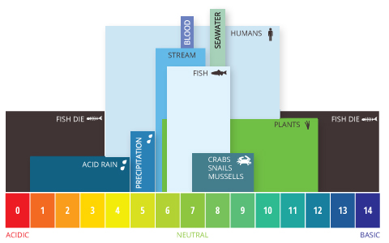
Figure 25 Aquatic pH levels. The optimum pH levels for fish are from 6.5 to 9.0. Outside of optimum ranges, organisms can become stressed or die. Source: http://www.fondriest.com/environmental-measurements/parameters/water-quality/ph/#p9.

While there was no significant difference between colonies for values of conductivity (p=0.5467, Monkeygar n=21, Zoo Paddock n=14), there was a significant difference between colonies for total dissolved solids (p=<0.0005, Monkeygar n=14, Zoo Paddock n=10). Total dissolved solids and conductivity are highly correlated with TDS measurements being derived from conductivity measures. The discrepancy in significance between these two values may be due to low sample numbers for TDS, and/or instrumentation error.
Dissolved solids are important to aquatic life by keeping cell density balanced. In distilled or deionized water, water will flow into an organism’s cells, causing them to swell. In water with a very high TDS concentration, cells will shrink. These changes can affect an organism’s ability to move in a water column, causing it to float or sink beyond its normal range (http://www.fondriest.com/environmental-measurements/parameters/water-quality/conductivity-salinity-tds/#cond9). The values measured for Monkeygar and Zoo Paddock are within the range normally attributed to ‘average tap water” (http://www.fondriest.com/environmental-measurements/parameters/water-quality/conductivity-salinity-tds/#cond9).
Conductivity is also closely correlated with salinity. Salinity is important in particular as it affects dissolved oxygen solubility. The higher the salinity level, the lower the dissolved oxygen concentration. The salinity levels measured at were low (0.2 ppt) this corresponds with freshwater values (0-0.5 ppt).
The full set of water quality measures is included in Appendix 1.

Bird Health
During December colony surveys dead or dying waterbirds were observed, including straw-necked ibis. These observations were reported to NSW OEH which also recorded 11 dead adult ducks including pacific black duck (Anas superciliosa), hardhead duck (Aythya australis) and grey teal (A. gracilis), one adult royal spoonbill and 61 juvenile straw-necked ibis on the 14th December 2016. NSW OEH collected a sample of three ducks which were sent to the Department of Primary Industries as per the notifiable diseases requirements. Blood tests excluded Avian influenza, Psitticosis and Newcastle disease. Although samples were too decomposed for botulism testing, the behaviour of sick waterfowl seen in the Zoo Paddock and Monkeygar colonies suggested botulism was impacting waterbirds at these sites. Veterinary advice is that the birds died from suspected botulism. This is consistent with bird deaths at other colonies in the Basin, including the Lowbidgee where autopsies were carried out on a Black Swan and Straw-necked ibis with the results showing the absence of significant (non-terminal) gross and histopathology was suggestive of a subacute toxicity such as botulism. Avian botulism is a naturally occurring disease that has been shown to cause major mortality in waterbirds in the northern hemisphere. The impact of this disease on Australian waterbirds is less understood and the full complements of Botulinum toxicity tests are not readily available in Australia as yet.
Extract from “Avian Botulism: Information Kit Feb. 2014”, Vic. DPEI (2014).
Avian botulism is a disease caused by several different strains of the bacterium Clostridium botulinum, which produces a toxin that acts on the neuromuscular system of animals and humans. The disease is characterised by paralysis leading to progressive muscle weakness and eventually respiratory arrest if left untreated.
Avian botulism has been linked to mortalities within marshes and wetlands. Dormant spores of this bacterium are naturally abundant in soils and fresh water body sediments, but are not always in the vegetative state, capable of producing the toxin.
These spores are not only found in soil and sediments of water bodies, but can also be found in the intestinal tracts of live, healthy animals. The spores are resistant to extreme temperatures and desiccation, and are therefore capable of surviving in the ecosystem for long periods of time (Domske 2003).
The botulinum toxin is produced only when spores germinate and the bacterium enters the vegetative growth stage. This change require certain conditions, including an oxygen-deprived environment containing a suitable nutrient source such as decaying plant or animal material, and when favourable, warm temperatures and higher pH levels occur (Brand et al.1988).
Once these factors lead to production of the botulinum toxin, it can enter the food chain. Animals, especially wild birds, can contract avian botulism when they prey on other animals that harbor the toxin such as sick or dead fish and birds or consume infected maggots derived from dead animals (CCWHC 2007).
Effects of toxin poisoning include paralysis, which often leads to death. Death can also result from secondary water deprivation, electrolyte imbalance, respiratory failure, or predation due to paralysis. Quick removal of dead birds (potential vectors) is important in dealing with an avian botulism outbreak.
Opportunity for rehabilitation of sick birds is limited, but it may be possible when the birds do not ingest an acute dose of the toxin and when electrolytes are administered immediately; however, even under these circumstances, rehabilitation is frequently unsuccessful.

Colonial waterbird breeding in the Murray-Darling Basin 2016-2017
In the twelve months from May 2016 to April 2017, the Murray-Darling Basin experienced either “above average” or “very much above average” rainfall conditions for much of its extent (Figure 24). This resulted in flooding in several catchments including the Lachlan and Murrumbidgee in the Southern Basin and the Macquarie in the Northern Basin. Widespread flooding an inundation of wetlands triggered several colonial waterbird breeding events. Seven colonies in four catchments were monitored for straw-necked ibis reproductive success as part of existing monitoring programs such as Long Term Intervention Monitoring (LTIM) in the Lachlan and Murrumbidgee and Environmental Water and Knowledge Research (EWKR) in the Goulburn-Broken or additional funding was sought (NSW OEH, CEWO).

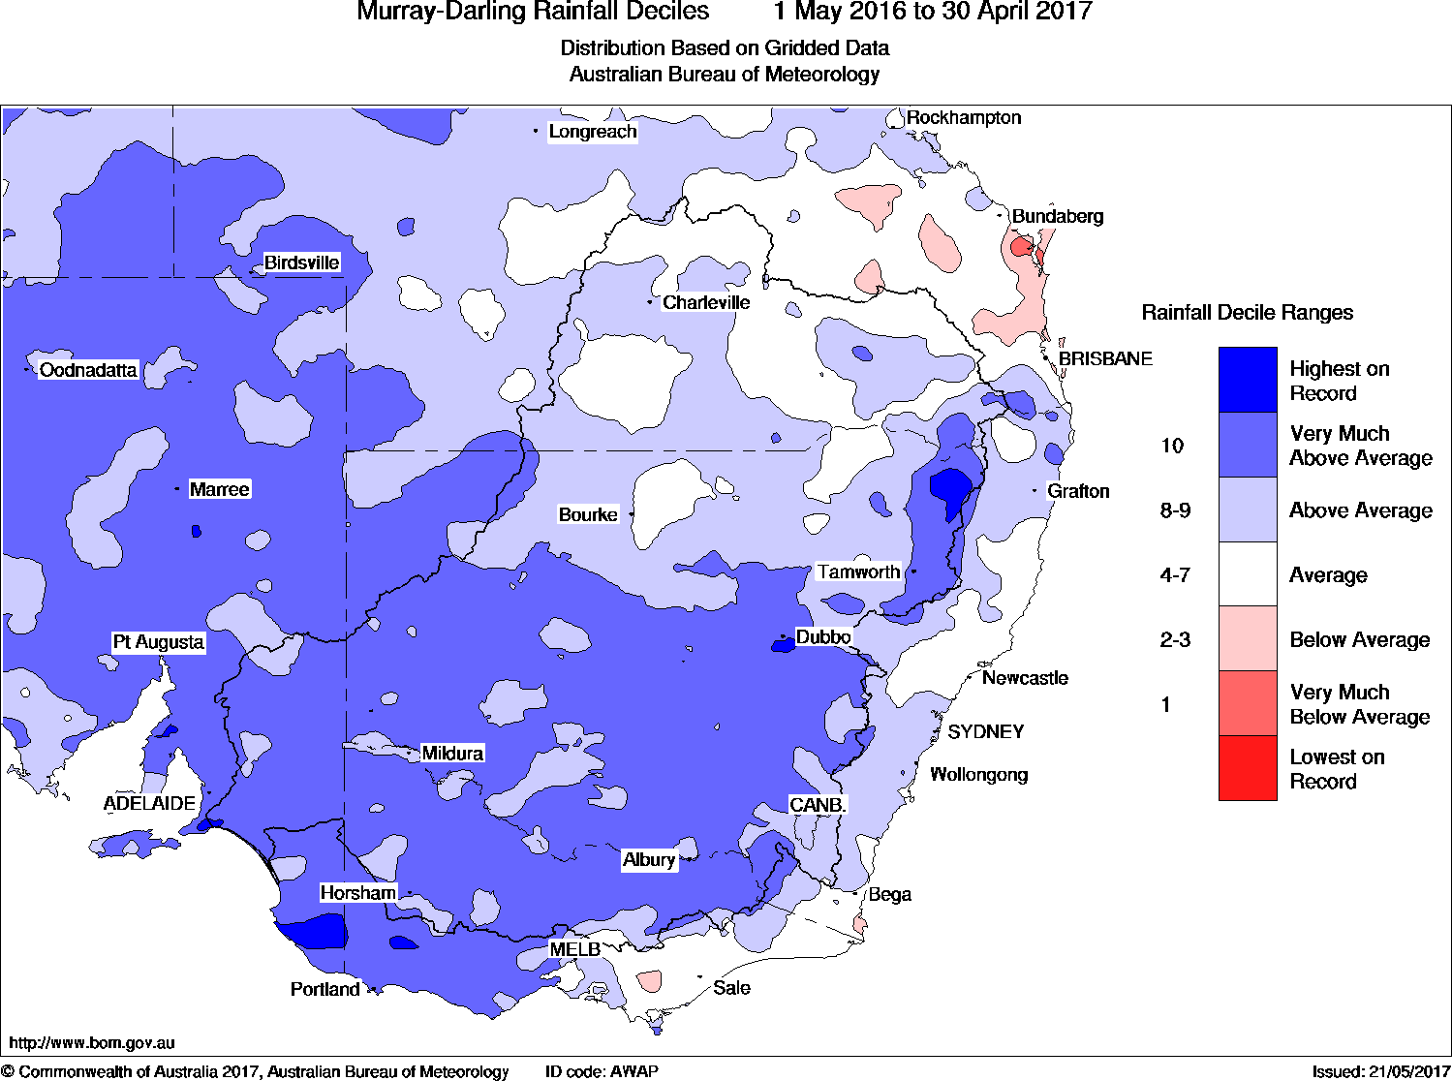
Figure 26 Murray-Darling Basin rainfall deciles 1st May 2016 – 30th April 2017. Source: Bureau of Meteorology.

Table 19 Details of UNSW colony monitoring, and straw-necked ibis reproductive success at key wetlands in the Murray-Darling Basin 2016-2017. Note these data are preliminary. Final reporting to relevant funding bodies has not yet been completed.
Catchment | Colony | Breeding period | Number of nests | Overall offspring success rate
Murrumbidgee | Eulimbah | Oct. 2016 – Jan. 2017 | 14,994 | 59.44%
 | Telephone Bank | December 2017 | 30,000 | #
 | Tori Swamp | Jan. – March 2017 | ~3,000 – 5,000 | 39.74%
Central Murray | Barmah-Millewa | Nov. 2016 – Jan. 2017 | 555 | 62.9%
Lachlan | Upper Merrimajeel | Sept. 2016 – Nov. 2017 | 101,360 | 77.07%
 | Booligal Block Bank | Jan. – March 2017 | 8,000 | 57.55%
Macquarie | Zoo Paddock | Oct. 2016 – Jan. 2017 | 21,210 | 65.81%
 | Monkeygar | Oct. 2016 – Jan. 2017 | ~15,000 | 63.28%
# Telephone Bank was not monitored for the duration of breeding due to lack of access during flooding. As a result there was no reproductive success rate measured.

Discussion
Overall success rates for straw-necked ibis offspring at Monkeygar (63.23%) and Zoo Paddock (65.81%) were similar (Table 20). Success rates for royal spoonbill were markedly different between Monkeygar (77%) and Zoo Paddock (12.66%), while success rates for glossy ibis were also low (13.96%) at Zoo Paddock for the same period of nesting.
Loss of nests and offspring were observed to be predominantly due to predation from ground based predators such as feral pigs and foxes. Feral pigs and foxes were frequently seen in the colonies during surveys and the destruction of nests and predation patterns on chicks suggested pig predation (J. Rees pers. comm.). Shallow water in the colony site at Zoo Paddock, sparse lignum coverage and drying of the floodplain, particularly during the royal spoonbill and glossy ibis nesting may have facilitated access for ground based predators to the colony site (Table 20). Water levels at Monkeygar were not as shallow as Zoo Paddock and the denser vegetation (Phragmites) may have assisted in limiting access to ground based predators. A study by Federick and Collopy (1989) found that small fluctuations of 5-10 cm of water substantially impacted on accessibility to nests by mammalian predators, including foxes.
Table 20 Summary of success rates for each species at each colony.
Colony | Species | Overall success rate (offspring) (%) | Mean water depth at nests range during nesting (cm)
Monkeygar | Straw-necked ibis | 63.28 | 38-58
 | Royal spoonbill | 77.00 | 35-77
Zoo Paddock | Straw-necked ibis | 65.81; 49.04 | 21-40
 | Royal spoonbill | 12.66 | 32-35
 | Glossy ibis | 13.96 | 32-35

Reproductive success rates for straw-necked ibis in the Macquarie Marshes were comparable to other colonies in The Basin. The small straw-necked ibis colony at Barmah-Millewa had a similar success rate of 62.9% (Table 20). The Booligal Block Bank colony had the lowest reproductive success (57.55%), while the large Upper Merrimajeel colony had the highest success rate (77.07%). A reproductive success rate of ~70% is potentially a ‘normal’ success rate for this species. Reproductive success rates of 100% in altricial birds are uncommon (Nice, 1957). Results of camera traps studies in the Lowbidgee in 2010 (Brandis et al. 2014) found that nests with clutch sizes of two eggs had a higher rate of producing two chicks (55%) than nests with clutch sizes of three eggs. Nests with three eggs had a 44% chance of producing three chicks. Similarly where three chicks did hatch, if there was a smaller chick, which is common in asynchronously hatching waterbird species (Fujioka, 1985; Ploger and Mock, 1986), the smaller chick always died (Brandis, unpublished data). While there is a natural mortality rate associated with breeding by colonial waterbirds this rate can be influenced by environmental conditions at the time of nesting. Factors that may impact on reproductive success include hydrological conditions during the breeding event (Brandis et al. 2011a), availability of food resources (Butler, 1994), timing of breeding (season) (Brandis and Bino, 2016), and experience and condition of parents (Weathers and Sullivan, 1989; Jakubas, 2004).

Reproductive success for royal spoonbills in the Macquarie Marshes was markedly different between colony sites (Table 20). Observations made during surveys link this to predation effects. While there are no published reproductive success rates for royal spoonbill, studies on closely related species such as the roseate spoonbill record an average nest success rate of 87% (White et al. 1982).
Glossy ibis reproductive success rates were not monitored anywhere else in The Basin during October 2016 – January 2017.However, breeding by glossy ibis was reported at Booligal, Upper Merrimajeel and Telephone Bank. Reproductive success rates for glossy ibis in the Macquarie Marshes were low (20.45%) when compared to previous studies. Lowe (1983) reported a nest success rate of 88% for a breeding event near Balranald, while breeding data from the Lowbidgee in 2010-2011, reported a 93% nest success rate (Brandis et al., 2011b). Possible reasons for the low success rates, based on observations made in the colony include high rates of predation, the timing of egg laying (Table 11), after the straw-necked ibis had finished, when water levels were low (Figure 14) allowing access to ground based predators, and potential food items not as abundant may also have contributed.

Recommendations for water management
Colonial waterbirds began nesting in September 2016 following extensive flooding resulting from dam releases, tributary flows and local rainfall. The subsequent provision of environmental flows, both NSW and Commonwealth, aimed to maintain water levels at waterbird colony sites. This was most successful at the Monkeygar colony site due to its location on the floodplain and proximity to the creek where water levels could be more easily regulated and kept at depths commensurate with successful breeding. Zoo Paddock was a more difficult site to deliver water to due to its location on the floodplain and no direct link to the river. Zoo Paddock receives water from overbank flows rather than a distributary of the river. This makes it difficult to provide adequate volumes of water to have a significant impact on water levels at this site.
Acknowledging the difficulty in managing water levels at Zoo Paddock during this flooding event, recommendations for future water management would include maintaining water levels at a depth that prohibits the access of ground based predators. While there is no data available on the water depth threshold that is critical for ground based predators, observations of these and other colonies would suggest that depths >50 cm can limit access to ground based predators. This is relevant for both colony sites, but particularly for Zoo Paddock where the greatest impact of predation was recorded. This recommendation is applicable to all future colonies in the Macquarie Marshes. Deeper water levels would help reduce ground based predator access to nests and chicks, particularly during the early nesting stages when chicks are too young to escape.
In addition to maintaining water levels during the nesting period the extension of flooding post fledging stages may result in improved juvenile survival rates. Observations made during nest surveys in the Macquarie Marshes and at other key breeding sites suggest that if wetland conditions remain suitable then juvenile birds will remain in the wetland even if adults have left. Suitable conditions may include shallowly flooded vegetated areas where ibis can forage. The provision of these conditions may allow juvenile birds to build up body condition prior to dispersal and may assist in increasing chances of survival during the first 12 months.
The colonial waterbird monitoring reported in this report was the result of natural flooding and operational dam releases. Environmental flows (NSW and Commonwealth water) were delivered in late January through to mid-February 2017. Colonial waterbird monitoring by UNSW was completed on the 31st January. The anticipated impacts of the environmental flow releases would have included prolonging flooding, maintaining or increasing water levels at colony sites and providing a fresh flush of water through the wetland. The impact of these flows on waterbirds may have included the provision of habitat suitable for foraging by juvenile ibis, acted as a deterrent or barrier to ground based predators accessing colony sites, and extended the nesting period, and potentially increased reproductive success rates for late nesting species such as royal spoonbill and glossy ibis. It would be anticipated that the fresh flush of water through the wetland would have positive impacts on water quality resulting in healthy aquatic fauna and hence maintenance of food webs to support foraging waterbirds.
Without the provision of the environmental flows it could be anticipated that the success rate for royal spoonbills nesting at Monkeygar would have been lower, similar to that experienced at Zoo Paddock. This water maintained water levels, deterring predators, and prolonged flooding allowing for the completion of nesting by royal spoonbills. It also provided foraging areas for other waterbird species including ibis.
The response of colonial waterbirds to suitable breeding conditions in the Macquarie Marshes during 2016-2017 demonstrates that this wetland system continues to be an important site for colonial waterbird breeding. However breeding success is influenced by a number of factors including, hydrological conditions (timing, duration), water depth at the colony site, and availability of nesting habitat, availability of foraging habitat and sufficient food resources and predation. The results of this monitoring have shown that during this breeding event, predation played a significant role in influencing reproductive success. Predator deterrents through deeper water levels at colony sites may have improved reproductive success at Zoo Paddock for later nesting birds including straw-necked ibis, glossy ibis and royal spoonbill (Table 20).

Acknowledgments
Many thanks are due to UNSW staff and students including James Rees, Emily Webster, Bill Johnson, Justin McGann and Tessa Goosens for ground surveys and Richard Kingsford ,Terry Korn and Richard Byrne for aerial survey. Many thanks to the landholders John Stuart “Willancorah”, Gary and Leanne Hall “The Mole”, Willie Retreat. Lloyd Johnson “Pillicawarrina”, and Jack “Zoo Paddock” who generously allowed access to and through their land. And thanks to NSW OEH and NPWS staff including Jenny Spencer, Tim Hosking, Paul Keyte, Joanne O’cock, Stephanie Suter and Nicola Brookhouse.

References
Brandis, K. J., Kingsford, R., Ren, S., & Ramp, D. (2011a). Crisis water management and Ibis breeding at Narran Lakes in arid Australia. Environmental Management, 48(3), 489-498
Brandis, K., Ryall, S., Kingsford, R. (2011b). Lowbidgee 2010/2011 Colonial Waterbird Breeding, Australian Wetlands and Rivers Centre, UNSW. Final report to the Lowbidgee League.
Brandis, K., and Bino, G. (2016). A review of the relationship between flow and waterbird ecology in the Condamine-Balonne and Barwon-Darling River.
Butler, R.W. (1984) Population regulation of wading Ciconiiform birds. Colonial waterbirds 17(2): 189-199.
Frederick, P.C. and Collopy, M.W. (1989) The role of predation in determining reproductive success of colonially nesting wading birds in the Florida Everglades. The Condor 91:860-867.
Fujioka, M. (1985) Sibling competition and siblicide in asynchronously-hatching broods of the cattle egret Bubulcus ibis. Animal Behaviour 33(4); 1228-1242.
Jakubas, D. Factors affecting the breeding success of the grey heron (Ardea cinerea) in northern Poland. Journal of Ornithology146(1): 27-33.
Kingsford, R. T., Auld, K. (2003). Waterbird breeding in the Macquarie Marshes - a guide to river health. Final report to the Natural Heritage Trust, NSW National Parks and Wildlife Service.
Lyons, M., Brandis, K., Callaghan, C., McCann, J., Mills, C., Ryall, S., Kingsford, R. (2017) Bird interactions with drone, from individuals to large colonies. In review.
Lowe, K. (1983) Egg size, clutch size and breeding success of the glossy ibis Plegadis falcinellus. The Emu 83(1); 31-34.
McKilligan, N. (2005). Herons, Egrets and Bitterns. Their biology and conservation in Australia, CSIRO Publishing.
NSW OEH (2017) http://www.environment.nsw.gov.au/environmentalwater/macquarie-news.htm
Nice, M.M. (1957) Nesting success in altricial birds. The Auk 74(3); 305-321.
Ploger, B.J., Mock, D.W. (1986) Role of sibling aggression in food distribution to nestling cattle egrets (Bubulcus ibis). The Auk 103(4); 768-776.
Ramsar (1986). Macquarie Marshes Ramsar Information Sheet. http://www.environment.gov.au/cgi-bin/wetlands/ramsardetails.pl?refcode=28
Vas, E., Lescroël, A., Duriez, O., Boguszewski, G., and Grémillet, D. (2015). Approaching birds with drones: first experiments and ethical guidelines. Biology letters, 11(2):20140754.
Victorian Government Department of Environment and Primary Industries (2014) Avian Botulism Information Kit Feb. 2014. Victorian Government Department of Environment and Primary Industries Melbourne February 2014. www.depi.vic.gov.au
Weathers, W.W., and Sullivan, K.A. (1989) Juvenile foraging proficiency, parental effort, and avian reproductive success. Ecological Monographs 59(3): 223-246.
White, D.H., Mitchell, C.S., Cromartie, E. (1982) Nesting ecology of roseate spoonbills at Nueces Bay, Texas. The Auk 99(2); 275-284.

Appendix 1: Water quality data
Colony | Date | Sample | Temp | pH | Conductivity | TDS m/L | Resistance | Salinity ppt
Monkeygar | 27/10/2016 | 1 | 19.8 | 7.63 | 0.351
Monkeygar | 27/10/2016 | 2 | 19.2 | 7.46 | 0.353
Monkeygar | 27/10/2016 | 3 | 19.4 | 7.58 | 0.354
Monkeygar | 23/11/2016 | 1 | 23.3 | 8.66 | 0.061
Monkeygar | 23/11/2016 | 2 | 23.3 | 8.5 | 0.062
Monkeygar | 23/11/2016 | 3 | 24.4 | 8.4 | 0.069
Monkeygar | 23/11/2016 | 4 | 24 | 8.48 | 0.066
Monkeygar | 14/12/2016 | 1 | 24.8 | 7.84 | 0.478 | 254 | 2.09 | 0.2
Monkeygar | 14/12/2016 | 2 | 22.9 | 7.07 | 0.48 | 254 | 2.1 | 0.2
Monkeygar | 29/12/2016 | 1 | 24.1 | 5.1 | 0.367 | 196 | 2.71 | 0.2
Monkeygar | 29/12/2016 | 2 | 24.4 | 8 | 0.359 | 191 | 2.79 | 0.2
Monkeygar | 29/12/2016 | 3 | 25.4 | 8.15 | 0.353 | 186 | 2.86 | 0.2
Monkeygar | 29/12/2016 | 4 | 24.6 | 7.96 | 0.361 | 192 | 2.77 | 0.2
Monkeygar | 10/01/2017 | 1 | 25.9 | 8.36 | 0.374 | 199 | 2.68 | 0.2
Monkeygar | 10/01/2017 | 2 | 26.2 | 7.75 | 0.383 | 203 | 2.62 | 0.2
Monkeygar | 10/01/2017 | 3 | 27 | 7.65 | 0.375 | 200 | 2.66 | 0.2
Monkeygar | 10/01/2017 | 4 | 27.8 | 7.44 | 0.394 | 209 | 2.55 | 0.2
Monkeygar | 31/01/2017 | 1 | 27 | 8.33 | 0.324 | 172 | 3.1 | 0.2
Monkeygar | 31/01/2017 | 2 | 27.6 | 8.44 | 0.331 | 176 | 3.02 | 0.2
Monkeygar | 31/01/2017 | 3 | 26.9 | 8.17 | 0.328 | 173 | 3.06 | 0.2
Monkeygar | 31/01/2017 | 4 | 28.5 | 8.13 | 0.325 | 172 | 3.09 | 0.2
Zoo | 22/11/2016 | 1 | 24.3 | 7.1 | 0.064
Zoo | 22/11/2016 | 2 | 24.4 | 6.43 | 0.066
Zoo | 22/11/2016 | 3 | 24.6 | 5.7 | 0.064
Zoo | 22/11/2016 | 4 | 23.7 | 5.92 | 0.063
Zoo | 28/12/2016 | 1 | 26.8 | 8.09 | 0.496 | 264 | 2.02 | 0.2
Zoo | 28/12/2016 | 2 | 26.4 | 6.36 | 0.469 | 250 | 2.13 | 0.2
Zoo | 28/12/2016 | 3 | 26.1 | 6.55 | 0.461 | 245 | 2.176 | 0.2
Zoo | 28/12/2016 | 4 | 26.6 | 6.88 | 0.453 | 241 | 2.2 | 0.2
Zoo | 28/12/2016 | 5 | 26.9 | 5.49 | 0.479 | 255 | 2.09 | 0.2
Zoo | 8/01/2017 | 1 | 29.4 | 8.93 | 0.443 | 236 | 2.26 | 0.2
Zoo | 8/01/2017 | 2 | 29.6 | 8.52 | 0.444 | 236 | 2.25 | 0.2
Zoo | 8/01/2017 | 3 | 29.8 | 8.6 | 0.45 | 239 | 2.22 | 0.2
Zoo | 8/01/2017 | 4 | 28.5 | 8.54 | 0.439 | 234 | 2.28 | 0.2
Zoo | 8/01/2017 | 5 | 27.8 | 8.38 | 0.426 | 227 | 2.35 | 0.2

Appendix 2: List of bird species observed in the Macquarie Marshes at Monkeygar, Pilllicawarrina and Zoo Paddock.
Common name | Scientific name | Monkeygar |  |  | Pillicawarrina and Zoo Paddock
 |  | 27/10/2016 | 7/12/2016 | 14/12/2016 | 28/10/216 | 9/11/2016 | 6/12/2016
Apostlebird | Struthidea cinerea |  |  |  | x |  | x
Australasian bittern | Botaurus poiciloptilus |  | x | x | x
Australasian darter | Anhinga novaehollandiae | x | x | x | x | x | x
Australasian grebe | Tachybaptus novaehollandiae | x |  | x | x
Australasian pipit | Anthus novaeseelandiae |  |  |  |  |  | x
Australasian shoveller | Anas rhynchotis | x
Australian magpie | Cracticus tibicen |  |  |  | x | x | x
Australian maned duck | Chenonetta jubata |  | x |  |  | x | x
Australian pelican | Pelecanus conspicillatus |  | x | x | x |  | x
Australian raven | Corvus coronoides |  | x |  |  | x | x
Australian ringneck parrot | Barnardius zonarius | x
Australian shelduck | Tadorna tadornoides | x | x
Australian white ibis | Threskiornis moluccus | x | x | x | x | x | x
Black fronted dotterel | Elseyornis melanops |  |  |  | x |  | x
Black swan | Cygnus atratus | x | x | x | x
Black winged stilt | Himantopus himantopus | x | x | x | x | x | x
Brolga | Grus rubicunda | x |  |  |  |  | x
Brown songlark | Megalurus cruralis | x |  |  | x | x | x
Cattle egret | Bubulcus ibis |  |  | x
Clamorous reed warbler | ‎Acrocephalus australis | x | x | x |  | x | x
Cockatiel | Nymphicus hollandicus | x |  |  |  |  | x
Crested pigeon | Ocyphaps lophotes |  | x |  | x | x | x
Dusky moorhen | Gallinula tenebrosa |  | x | x |  |  | x
Eastern great egret | Ardea modesta |  | x | x | x | x | x
Emu | Dromaius novaehollandiae | x |  |  | x | x | x
Eurasian coot | Fulica atra | x | x | x | x | x | x
European starling | Sturnus vulgaris | x | x |  | x
Fairy martin | Petrochelidon ariel |  | x |  | x
Galah | Eolophus roseicapilla |  |  |  | x |  | x
Glossy ibis | Plegadis falcinellus | x | x | x | x | x | x
Golden headed cisticola | Cisticola exilis |  |  |  |  | x
Great cormorant | Phalacrocorax carbo | x | x |  | x | x
Great crested grebe | Podiceps cristatus | x |  | x
Grey teal | Anas gracilis | x | x | x | x | x | x
Hardhead | Aythya australis | x |  | x | x | x | x
Hoary-headed grebe | Poliocephalus poliocephalus | x | x |  |  | x
Horsfield's bronze cuckoo | Chrysococcyx basalis | x |  |  | x | x
Intermediate egret | Ardea intermedia | x | x | x | x | x | x
Lathams snipe (?) | Gallinago hardwickii |  |  |  |  |  | x
Laughing kookaburra | Dacelo novaeguineae |  |  |  |  | x
Little bittern | Ixobrychus minutus |  | x | x
Little black comorant | Phalacrocorax sulcirostris |  | x | x |  | x | x
Little egret | Egretta garzetta | x | x |  | x | x | x
Little grassbird | Megalurus gramineus | x | x
Little pied cormorant | Microcarbo melanoleucos |  |  | x | x
Magpie goose | Anseranas semipalmata | x | x | x
Magpie-lark | Grallina cyanoleuca | x | x |  | x | x | x
Masked lapwing | Vanellus miles | x | x |  | x | x | x
Mulga parrot (?) | Psephotus varius |  |  |  |  | x
Musk duck | Biziura lobata | x | x | x
Nankeen kestrel | Falco cenchroides | x |  |  | x | x
Pacific black duck | Anas superciliosa | x | x | x |  | x | x
Peaceful dove | Geopelia placida |  | x |  | x | x | x
Peregrine falcon | Falco peregrinus |  |  | x
Pied butcherbird | Cracticus nigrogularis |  |  |  |  | x
Pied cormorant | Phalacrocorax varius |  |  | x
Pied heron | Ardea picata |  |  |  | x
Pink-eared duck | Malacorhynchus membranaceus |  | x | x | x | x | x
Plumed whistling duck | Dendrocygna eytoni |  |  |  | x | x
Purple swamphen | Porphyrio porphyrio | x | x | x | x | x
Red-kneed dotterel | Erythrogonys cinctus |  | x |  |  |  | x
Red-rumped parrot | Psephotus haematonotus |  | x |  | x |  | x
Restless flycatcher | Myiagra inquieta |  | x |  |  |  | x
Royal spoonbill | Platalea regia |  | x | x | x | x | x
Rufous night heron | Nycticorax caledonicus | x | x | x | x | x
Sacred kingfisher | Todiramphus sanctus |  | x |  | x | x | x
Sharp-tailed sandpiper | Calidris acuminata |  |  | x
Silver gull | Chroicocephalus novaehollandiae |  | x
Singing bushlark | Mirafra cantillans |  |  |  | x | x
Straw-necked ibis | Threskiornis spinicollis | x | x | x | x | x | x
Stubble quail | Coturnix pectoralis |  |  |  |  |  | x
Sulphur-crested cockatoo | Cacatua galerita |  |  |  |  | x
Superb fairy-wren | Malurus cyaneus | x | x |  |  | x
Swamp harrier | Circus approximans | x |  | x |  |  | x
Variegated fairywren | Malurus lamberti |  |  |  |  |  | x
Wedge-tailed eagle | Aquila audax |  |  |  |  |  | x
Weebill | Smicrornis brevirostris |  | x | x
Welcome swallow | Hirundo neoxena | x | x | x | x | x
Whiskered tern | Chlidonias hybrida | x |  | x |  |  | x
Whistling kite | Haliastur sphenurus | x | x |  | x | x | x
White-bellied sea eagle | Haliaeetus leucogaster | x
White-breasted woodswallow | Artamus leucorynchus | x | x | x
White-faced heron | Egretta novaehollandiae | x | x |  |  | x | x
White-necked heron | Ardea pacifica | x | x | x | x | x | x
White-winged fairywren | Merion leucoptere | x |  |  |  | x
Willie wagtail | Rhipidura leucophrys |  |  |  | x | x | x
Yellow-billed spoonbill | Platalea flavipes |  | x |  |  |  | x
Yellow-throated miner | Manorina flavigula |  |  |  |  | x
(?) unconfirmed sighting

