**Assessment of the hazard that the *Hisstory®* bait for feral cats presents to a non-target species; northern quoll (*Dasyurus hallucatus*)**

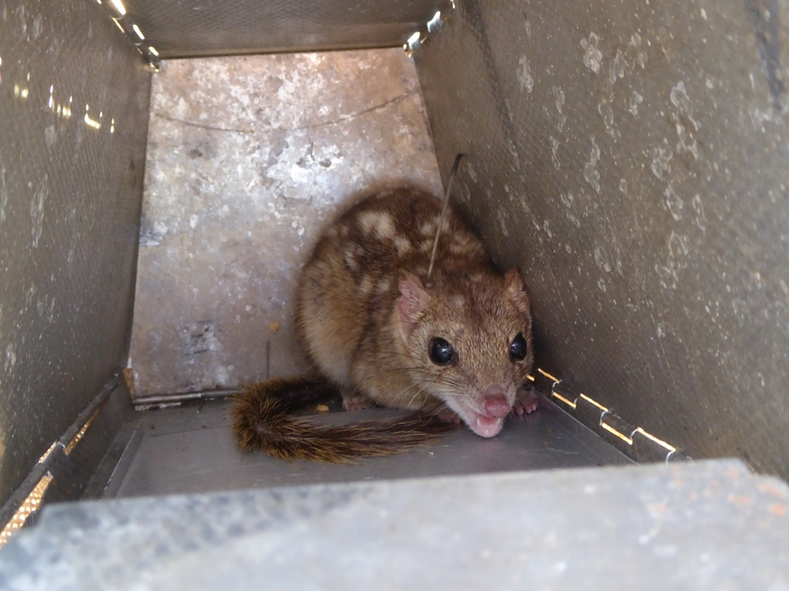

**King Leopold Ranges**

**Conservation Park, 2017**

Report to: Australian Government, Department of the Environment and Energy

December 2017

**Prepared by**

**David Algar1, Michael Johnston², Lucy Clausen3, Michael O’Donoghue4 and Julie Quinn5**

1Principal Research Scientist, Animal Science

Science and Conservation Division

Locked Bag 104, Bentley Delivery Centre, WA 6983

[Dave.Algar@dbca.wa.gov.au](mailto:Dave.Algar@dbca.wa.gov.au)

2Senior Project Officer,

Science and Conservation Division

Locked Bag 104, Bentley Delivery Centre, WA 6983

Michael.Johnston@dbca.wa.gov.au

3Conservation Officer,

South Coast Region, Parks and Wildlife Service

120 Albany Highway, Albany WA

[Lucy.Clausen@dbca.wa.gov.au](mailto:Lucy.Clausen@dbca.wa.gov.au)

4Director,

Scientec Research Pty. Ltd.

71 Yarra Street, Warrandyte, VIC, 3113.

[modon@scientec-research.com](mailto:modon@scientec-research.com)

5Assistant Director

Environmental Biosecurity Section

Department of the Environment and Energy

Julie.Quinn@environment.gov.au

**Plate 1. (Front cover) northern quoll (*Dasyurus hallucatus*) at Mount Hart Photo: L. Clausen/DBCA**

**Acknowledgements**

The authors would like to thank the Wiliniggin Aboriginal Corporation for access to their land held under Native Title. We would also like to acknowledge the Department of Biodiversity, Conservation and Attractions, Kimberley West District Nature Conservation staff: Tracy Sonneman; Phil De Bruyn and Bruce Greatwich who supported the field staff in implementing this trial. Abby Thomas, Johnny Divilli, Salicia Nulgit, Philip ‘Crackers’ Duckhole and Jeff Pinder who were involved in the field work. Jim Morris and Jo Handley manufactured the baits. We also thank Veronica Blazely (Australian Government, Department of Environment and Energy) for supporting the work. The work was funded by the Australian Government National Landcare Programme.

The following permits were obtained to conduct this work:

* Capture and radio-collaring of northern quolls was conducted under Department of Biodiversity, Conservation and Attractions Animal Ethics Committee permit AEC 2017/11 ‘Assessment of the hazard of the “*Hisstory*” feral cat bait on free-ranging Northern Quolls (*Dasyurus hallucatus*)’;
* The Department of Environment and Energy (Australian Government) determined that the project (EPBC2017/8012) was not a controlled action under the *Environment Protection and Biodiversity Conservation Act 1999*;
* The Australian Pesticides and Veterinary Medicines Authority granted a permit to allow research use and supply of an AgVet chemical product (PER82602);
* The Department of Biodiversity, Conservation and Attractions approved the use of meat baits containing ‘1080’ to be used on Crown land (Ref: *Hisstory* 001/2017).

**Contents**

Acknowledgements 3

Summary 5

1 Background 6

2 Methodology 8

2.1 Study area 8

2.2 Northern quoll trapping and VHF radio-collaring 9

2.3 Monitoring and recovery of radio-collars 10

2.3.1 Pre-baiting monitoring 10

2.3.2 Post-baiting collar recovery 11

2.4 Bait preparation and application 11

2.5 Bait delivery 12

3 Results 13

3.1 Northern quoll trapping and VHF radio-collaring 13

3.2 Monitoring and recovery of radio-collars 14

4 Discussion 18

5 References 22

6 Appendices 25

Appendix 6.1 Reconnaissance at Yampi Sound Defence Training Area 25

Appendix 6.2. Northern quoll captures at Mt Hart, 2017. 27

**List of Tables, Figures and Plates**

**List of Tables**

Table 1. Works program.

Table 2. Area of individual *Hisstory* bait clusters.

Table 3. Summary of August northern quoll trapping results at Matthew Gorge, Mount Hart.

Table 4. Summary of individuals radio-collared at Matthew Gorge, Mount Hart.

Table 5. Mortality mode and recovery of northern quoll collars.

Table 6. Summary of September northern quoll trapping results at Matthew Gorge, Mount Hart.

Table 7. Reconnaissance camera trap data at Yampi Sound Defence Training Area.

**List of Figures**

Fig. 1. Study area within the King Leopold Ranges Conservation Park.

Fig. 2. The three northern quoll trapping transects operated for three nights in early August for capture and radio-collaring and Transects T (red) and R (blue) for three and two nights respectively in mid-September to the remove radio-collars.

Fig. 3. Location of *Hisstory* bait clusters.

Fig. 4. Locations where quolls were collared and subsequent mortality mode recoveries.

Fig. 5. Locations of closest *Hisstory* bait cluster in relation to northern quoll 503.

**List of Plates**

Plate 1. (Front cover) northern quoll (*Dasyurus hallucatus*) at Mount Hart.

Plate 2. Feral cat bait medium and acid-soluble polymer HSDV that encapsulates the poison.

Plate 3. Elevated locations used for daily radio-tracking checks.

Plate 4. Carcass of northern quoll 241 *in situ* and withdrawn from boulder pile.

Plate 5. Skull and collar from northern quoll 281. Note the perching branch above site.

Plate 6. Fur remnants on rock from carcass of northern quoll 402.

Plate 7. Location of collar from northern quoll 503 following switch to mortality mode.

Plate 8. Potential predators of northern quolls at Matthew Gorge, king brown snake and brown goshawk.

Plate 9. Feral cat captured on camera at Yampi Sound Defence Training Area.

**Summary**

Feral cats (*Felis catus*) are a serious vertebrate pest having severe to catastrophic effects on native wildlife species. The broad-scale control of feral cats is difficult as they are found in very low densities and have large home ranges, making them difficult to locate. They are also extremely cautious in nature, making them hard to cost-effectively control with traditional measures such as shooting and trapping. Baiting for feral cats is a broad-scale technique that has potential to reduce feral cat population over larger areas. Three broad-scale baits have been developed for the control of feral cats; *Eradicat®* that is registered for use in south-western Western Australia; *Curiosity®* and *Hisstory®* (both yet to be registered).

Baits for feral cats must be laid on the surface and this presents a potential hazard for non-target wildlife species. The *Hisstory* bait offers a degree of protection to some wildlife species by exploiting differences in feeding behaviour between feral cats and non-target species by presenting the toxicant, 1080, in an encapsulated pellet.

The primary objective of the study was to understand the hazard that the *Hisstory* bait presents to northern quolls. A secondary objective was to demonstrate that feral cats would consume the bait.

Three hundred *Hisstory* baits were hand-laid in a 6 km2 area of the King Leopold Ranges Conservation Park located in the west of the Kimberley region on 10 September 2017. Monitoring of the northern quoll uptake of *Hisstory* baits was conducted using VHF telemetry collars attached to 20 northern quolls prior to baiting. Of the eight northern quolls alive at the time of baiting, seven were confirmed as alive post-baiting and one had died of unknown reasons. In conjunction with the results achieved in earlier studies with captive northern quolls, and despite the small sample size, this study demonstrates the *Hisstory* bait for feral cats is unlikely to present a significant hazard to free-ranging northern quolls.

Several problems were encountered during the planning and preparation phase of the project, resulting in the secondary objective - demonstrating field efficacy of the *Hisstory* baits on feral cats - not being achieved:

1. The trial site had to be moved at a late stage due to logistical problems;
2. Delays on provisions of necessary permits affected the timing of baiting. This meant baiting aircraft were unavailable so the size of the trial area was reduced from 100 km2 to 6 km2 and refocused on northern quoll only.

**Background**

Predation by feral cats has led to major declines in native wildlife populations including many threatened species. The Australian Government has declared the impacts of feral cats as a key threatening process on native wildlife species through predation under the *Environment Protection and Biodiversity Conservation Act 1999* (Commonwealth of Australia 2015). This is particularly the case in northern Australia where the combined impacts of inappropriate fire regimes and invasive species are implicated as causal factors (Woinarski *et al*. 2015). The management of feral cats in northern Australia is limited by the absence of a technique that facilitates broad-scale control. Current control techniques such as trapping and shooting can only be effective across areas of limited size. Poison baiting is recognized, by most practitioners, as the most effective broad-scale method for controlling feral cats and reducing their impacts on native wildlife throughout southern Australia, using the *Eradicat* or *Curiosity* bait products (Algar and Burrows 2004; Algar *et al*. 2007; Johnston 2010; Johnston *et al*. 2011; Johnston *et al*. 2014). However, in their current form, these two bait products may present a hazard to northern wildlife species due to sensitivities to the toxicants used or form of presentation of the toxins.

The “Threat Abatement Plan for predation by feral cats” (Commonwealth of Australia 2015) recommends that ‘broad-scale toxic baits targeting feral cats are developed, registered and available for use across all of Australia, including northern Australia’. In Western Australia, the *Eradicat* feral cat bait has been registered for the broad-scale control of feral cats but there are potential concerns about the use of this bait in areas where northern quolls (*Dasyurus hallucatus*) are present. The bait label prohibits the use in areas where northern quoll or their habitat may be present. The *Eradicat* bait is directly injected with 4.5 mg of the poison sodium monofluoroacetate (compound 1080) which could be accessed by the northern quolls. The Approximate Lethal Dose50 data (LD50), where LD50 is the amount of toxin theoretically required to kill 50% of test animals (standardized to mg pure 1080 kg-1), for northern quolls is reported to be 7.1 mg/kg (Twigg *et al*. 2003) which suggests that consumption of one entire *Eradicat* bait would form a lethal dose. The *Curiosity* bait, like *Eradicat*, is a small meat sausage but houses the poison in a tough acid-soluble plastic pellet known as a Hard Shell Delivery Vehicle or HSDV (see Plate 2). The delivery of the poison in the HSDV has been found to limit the exposure of native wildlife species to the poison. The HSDV exploits different feeding behaviours between feral cats and native wildlife. Feral cats do not chew their food but rather swallow large food items (Leyhausen and Tonkin 1979) and will reliably consume the HSDV. The acid-soluble polymer dissolves in their stomach and the poison is then absorbed. However, captive and field studies have demonstrated that most native mammal and bird species more thoroughly process food items and avoid exposure to the toxin by rejecting the HSDV when consuming the meat attractant (Marks *et al*. 2006; Hetherington *et al*. 2007; Forster 2009; Buckmaster *et al*. 2014). Included within these studies are captive trials with dasyurid species, such as eastern quoll (*Dasyurus viverrinus*), northern quoll, spotted-tailed quoll (*D. maculatus*) and brush-tailed phascogale (*Phascogale tapoatafa*) (Forster 2009; Robinson 2010; Gigliotti 2011). The *Curiosity* bait contains the toxin para-aminopropiophenone (PAPP), to which many native species are tolerant. However, there are certain wildlife species that are highly susceptible to PAPP, such as varanids (Eason *et al.* 2014), and these species are not expected to reject the HSDV when eating. This potential hazard is mitigated in southern Australia by limiting baiting to cooler months when reptiles are in torpor. This practice is not transferable to northern Australia where reptiles are typically active all year round. However, while reptiles are particularly susceptible to PAPP (Eason *et al*. 2014), they are reported to have a higher tolerance for 1080 than mammals (McIlroy 1984; McIlroy *et* *al*. 1985: Calver *et* *al*. 1989; King 1990).

By using an alternate poison in the HSDV, it should be possible to minimise the impact on varanid populations and simultaneously avoid exposure of mammal species such as northern quolls. If successful, this would allow land managers to undertake large-scale cat baiting programs without impacting native species populations in northern Australia. Replacement of the PAPP toxicant with 1080 might be a viable alternative that limits the exposure of native mammals by virtue of the HSDV but also minimises impact on varanid populations as they have a greater tolerance for this compound. This bait type is called *Hisstory* and is essentially the same as *Curiosity*, i.e. a 20 g kangaroo meat/chicken fat skinless sausage that includes a HSDV containing 4.5 mg of the toxicant 1080.

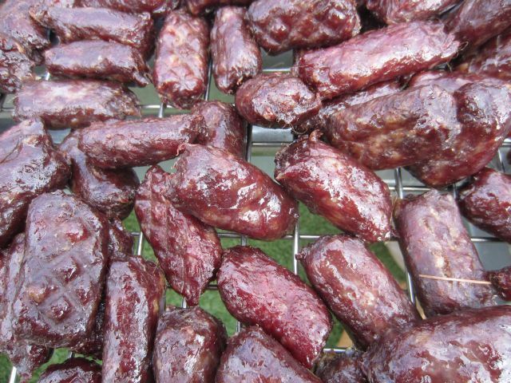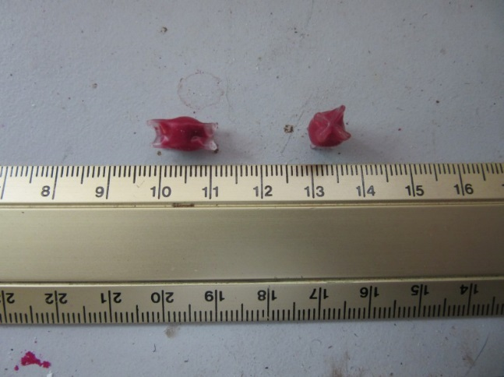

**Plate 2. Feral cat bait medium and acid-soluble polymer HSDV that encapsulates the poison.**

A desktop study by Buckmaster *et al*. (2014) identified that there are relatively few non-target vertebrate species in Australia that likely to consume both the cat bait and HSDV. Amongst the threatened vertebrate species present in the Kimberley, they identified that northern quolls were potentially able to consume baits containing the HSDV. Preliminary tests, to assess the validity of the concept, were conducted in trials with a number of captive northern mammal species including northern quoll; northern brown bandicoot (*Isoodon macrourus*) and black-footed tree-rat (*Mesembriomys gouldii*) (Gigliotti 2011). These trials indicated that the HSDV was reliably rejected by these species. Twenty-one northern quolls were presented with a bait into which was placed a HSDV, containing the biomarker Rhodamine B rather than the toxin. Video cameras were used to monitor activity of the quolls in the pens without disturbing them. The northern quolls consumed the 21 baits presented. Searches of the pens resulted in the recovery of 20 HSDVs (one was not found), which shows that it is unlikely that northern quolls will consume the HSDV. However, it was still considered important to validate the results of these earlier trials with free-ranging northern quolls as the feeding behaviour of captive animals may be different. Field efficacy trials are also required to inform an application to register the bait with the Australian Pesticides and Veterinary Medicines Authority.

This project sought to quantify the potential risks to free-ranging northern quolls on a small-scale simulated aerial deployment of an encapsulated 1080 HSDV in a *Hisstory* cat bait. The field study was undertaken in August through to early-October 2017 (see Table 1), during the end of the dry season in the Kimberley. This is the optimal time of the year, in this area, to bait feral cats because feral cats are most likely to consume a bait when the abundance of food resources is generally at its lowest.

**Table 1. Works program.**

|  |  |  |  |  |
| --- | --- | --- | --- | --- |
| **Activity** | **Proposed Date** | **Staff** | **Actual Date** | **Comments** |
| Reconnaissance – gain broad understanding of species of interest presence and logistical requirements | April | x2 | Late June | Very late due to unusually wet seasonal conditions and difficulties in securing original project site (Yampi Sound) |
| Trap and fit radio-collars to northern quolls | August | x2 & Willingen Aboriginal Corporation | 1–11 August | 20 individuals collared |
| Radio-track collared northern quolls before and after application of *Hisstory* baits. | Late August | x2 | 5–18 September | Later than intended due to delays in bait use approvals |
| Re-trap live northern quolls and remove radio-collars | Late September | x2 | 19–26 September | All remaining live collared northern quolls were re-captured and radio-collars removed |

**Methodology**

**Study area**

The King Leopold Ranges Conservation Park (KLRCP) is located in the west of the Kimberley region, approximately 130 km east of Derby, Western Australia. The Ranges separate the main Kimberley plateau from the southern Fitzroy plains and consist of quartz sandstone intruded by dolerite (Burbidge *et al*. 1991). Elevations are up to 950 m above sea level and relief is up to 300 m.

Mount Hart is located in the north-west corner of the Conservation Park (16°47’8” S, 124°55’16” E) where a number of rainforest gorges are surrounded by low ridges of rocky woodlands and open savannah grasslands. The Barker River passes through Matthew Gorge and is lined with dolerite boulders on both banks. The river exits the gorge and into savannah with the riparian zone. The Ranges support a low open woodland with eucalypt species dominant, especially Woollybutt (*E. miniata)* and *E. tectifica* (Burbidge *et al*. 1991)*.* In sheltered or watered valleys and along creeks the open-forest vegetation becomes more diverse, including *Eucalyptus* sp., screw pines *(Pandanus* sp.) fan palms *(Livistona s*p.), *Albizia lebbeck* (ibid).

The study area at Mount Hart (Fig. 1) was chosen for the known presence of northern quolls and logistical suitability for the field work. The size of the study site was 6 km2 centred on the Matthew Gorge as sufficient northern quolls were trapped in this area to provide for a statistically rigorous result.

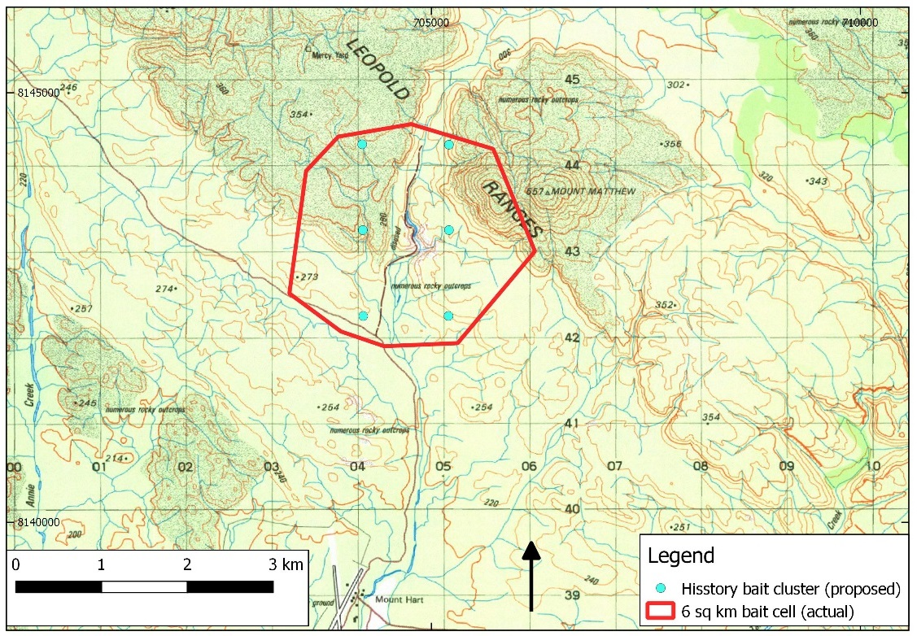

Fig. 1. Study area within the King Leopold Ranges Conservation Park.

The Mount Hart Wilderness Lodge maintains a weather station that is installed adjacent to the resort. Data are automatically published to the [Weather Underground website](https://www.wunderground.com/personal-weather-station/dashboard?ID=IWESTERN728) (station ID: IWESTERN728).

**Northern quoll trapping and VHF radio-collaring**

Northern quoll trapping was conducted using large Elliott traps (15x15.5x46 cm) (Elliott Scientific, Melbourne, Australia) and Hawkeye cage traps (Woodstream Corp., Lititz, Pa.; U.S.A.), with “universal bait[1]” with either sardines or fish oil added as the lure. Traps were set in the vicinity of Landscape Conservation Initiative (LCI) northern quoll monitoring sites that were established by Ian Radford (DBCA) in 2016. The transects were near rocky outcrops and spaced at intervals of 20–30 m with up to 20 traps in a transect as per Morris *et al.* (2016). Only three transects were required, two running parallel along rocky outcrops and a third in a gully tributary of Matthew Gorge (Fig. 2), due to the high capture rate on day two at two of the transects. Field inspection of other accessible areas to set traps were conducted on the afternoon of the first day and were deemed unsuitable due to their high risk potential exposure to feral pigs (*Sus scrofa*) and wild dog/dingo hybrids (*Canis lupus familiaris*) which, were found to be active in the area.

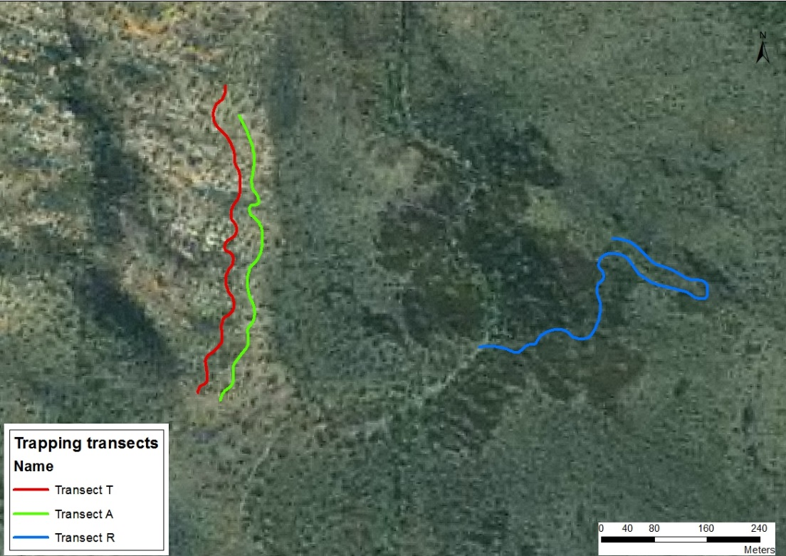

Fig. 2. The three northern quoll trapping transects operated for three nights in early August for capture and radio-collaring and Transects T (red) and R (blue) for three and two nights respectively in mid-September to the remove radio-collars.

Trapped northern quolls were weighed, collared, sexed, microchipped with a Trovan transponder (Microchips Australia, Victoria, Australia) and when possible, morphometric measurements were taken. A VHF radio-telemetry collar series M1720 with mortality signal (ATS, Minnesota, USA) was fitted to each northern quoll caught that was mature and had a weight over 240 g. The collars weighed 9 g and were programmed with mortality mode following 12 hours of inactivity, i.e. switching from 40 to 80 ppm. All northern quolls were released at the site of capture.

**Monitoring and recovery of radio-collars**

Monitoring of collars was conducted opportunistically during the capture and collar fitting process, between 2–4 August 2017. A R1000 VHF receiver (Communication Specialists Inc., California, USA) fitted with a omni-directional whip antenna was used to determine the status of collared northern quolls, i.e. alive/dead.

**Pre-baiting monitoring**

Daily monitoring of all collars was conducted from elevated locations (Plate 3) over the period 9–18 September using the R1000 receiver as well as Australia 26K receivers and three element yagi antenna (Titley Electronics, Ballina, Australia). An audio recording was made of collars to provide a permanent record of the status of individual northern quolls. The collars that had switched to mortality mode were recovered progressively using radio-tracking techniques during the period 10–16 September. When the location of the collar had been discovered, the surrounding area was searched for traces of northern quoll bones and fur. Photographs and notes were also taken of the site with observations about the potential cause of death recorded where possible. An endoscope USB drain inspection camera (Logan Arms Pty Ltd, Dandenong, Australia) was used to attempt to view and recover collars 361, 402 and 503 that were in mortality mode but could not be accessed.

Collars that remained in ‘alive’ mode were not approached to avoid disturbing the animal.

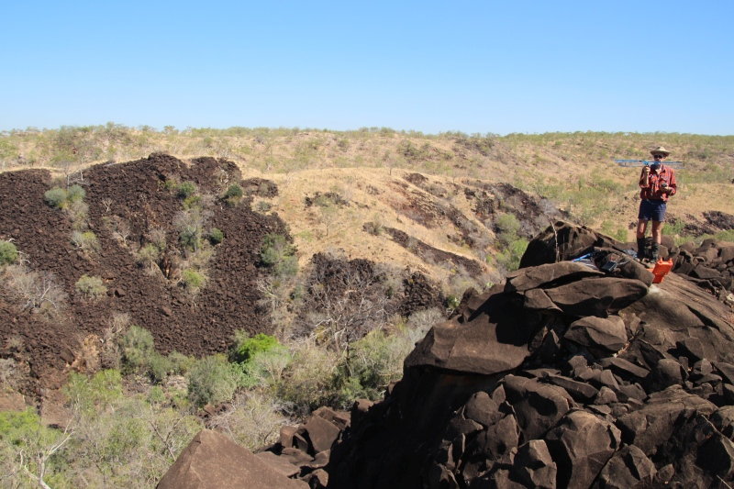

**Plate 3. Elevated locations used for daily radio-tracking checks.**

**Post-baiting collar recovery**

Recovery of collars from alive northern quolls was conducted through recapture trapping of Transects T and R using large Elliott traps (Fig. 2). Traps were set 19–24 September 2017 with a maximum of ten traps set at any one time. This low trap set was to ensure there would be minimal time spent in traps for females that were assumed to be carrying young. On re-capture, individuals were weighed, the radio-collar was removed and an assessment of any impacts from wearing the collar was conducted. Females were checked for pouch young. Any new individuals were microchipped and basic morphometrics were recorded.

**Bait preparation and application**

Immediately prior to being deployed, the *Hisstory* baits for feral cats were thawed and placed in direct sunlight. This process, termed ‘sweating’, causes the oils and lipid-soluble digest material to exude from the surface of the bait. All feral cat baits were sprayed, during the sweating process, with a permethrin-based residual insecticide (Coopex®, Bayer Crop Science, Australia) at a concentration of 12.5 g l-1 as per the manufacturer's instructions. This process is aimed at preventing bait degradation by ant consumption, which may also deter bait acceptance by feral cats because of the physical presence of ants on and around the bait medium. Three hundred *Hisstory* baits were prepared by manually implanting a single HSDV containing 4.5 mg 1080. A central void was created lengthwise to the middle of bait by pushing a trochar device in from one end. The trochar plunger was then withdrawn, a HSDV inserted and the plunger refitted and used to press the HSDV into the bait. The complete trochar was then withdrawn and the bait gently squeezed to close the void.

A study by Cook (2010) of northern quolls on the Mitchell Plateau suggested that they remain within 1 km of their den sites. Based on den locations the mean home-range area estimate for males was <54.2 ha (SE ± 36.7 ha; range 2.4–421.4 ha). Females had smaller home ranges,with a mean area of 6.8 ha (SE ± 1.6 ha; range 0.8–15.3 ha). Ranges of males overlapped extensivelywith thoseof other northern quollsof both sexes during thewet seasonbut only with thoseof females in the dry season. The mean maximum distance between denswas 1,193 m for males and 440 m for females. However, not knowing where their dens were, capture points were used as the centroid for the 1 km radius. This resulted in a 6 km2 (558 ha) baiting cell.

Previous aerial baiting exercises using *Eradicat* baits have demonstrated that a rate of 50 baits/km2 provides optimal an encounter rate for feral cats (Algar and Burrows 2004). The 50 baits fall within a 200 x 40 m area (Algar *et al*. 2013). The small size, 6 km2, of the bait cell meant in this study that the charter of an aircraft was not warranted. As such, baits were distributed by hand in a manner attempting to simulate the aerial baiting pattern across the site. Six points were projected onto site mapping as a QGIS layer with these positions then transferred onto handheld GPS devices (Rino 650, Garmin Ltd, USA). Fifty baits were distributed by hand on 10 September by ground crew at each of the six sites while walking throughout this area. A GPS waypoint was created when each bait was dropped. The waypoint data were subsequently entered into QGIS and a Convex Hull was calculated to provide a measure of the distribution area at each cluster.

**Bait delivery**

The area of spread of the *Hisstory* baits at KLRCP varied (5,555–14,556 m2) between the six clusters reflecting the procedure, topography and vegetation at each site (see Table 2). The location of the bait clusters is presented in Fig.3. Meteorological conditions following bait delivery varied little daily over the period 10–24 September with a maximum temperature of 37.0 °C (SE ± 0.3 °C), minimum temperature of 15.3 °C (SE ± 0.8 °C) and 0 mm rainfall.

**Table 2. Area of individual *Hisstory* bait clusters.**

|  |  |
| --- | --- |
| **Bait cluster No.** | **Area (m2)** |
| 1 | 6,438 |
| 2 | 14,556 |
| 3 | 8,259 |
| 4 | 5,555 |
| 5 | 13,573 |
| 6 | 9,276 |

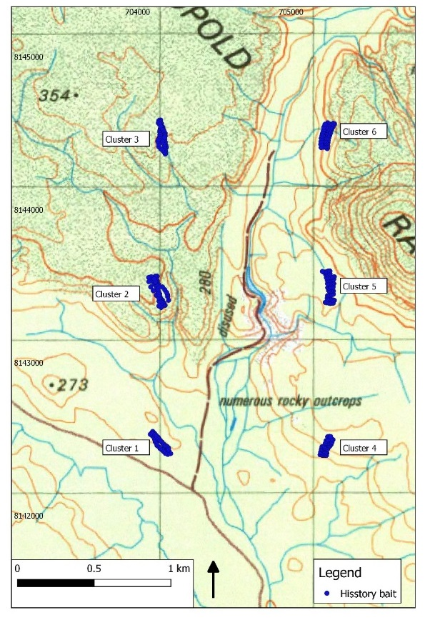

**Fig. 3. Location of *Hisstory* bait clusters.**

**Results**

**Northern quoll trapping and VHF radio-collaring**

Trapping was conducted from 2–4 August 2017 (102 trap-nights) with 27 individuals (16M, 11F) captured at a capture success rate of 32% (Table 3). The location chosen for capture is an LCI study site which had last been trapped in April, and five individuals (2M, 3F) were re-captures from this work. Mean bodyweight for males was 432 g (SE ± 24 g) and females 308 g (SE ± 19 g) (see Appendix 6.2). All captures were on Transect T and R with the only capture on Transect A being a golden-backed tree-rat (*Mesembriomys macrurus*). Other non-target captures were two house mice (*Mus musculus*) and a Kimberley rock-rat (*Zyzomys woodwardi*).

**Table 3. Summary of August northern quoll (nq) trapping results at Matthew Gorge, Mount Hart.** Re-traps are defined as individuals caught previously during this trapping session and re-captures are individuals that have been caught and marked on other trapping trips.

|  |  |  |  |  |
| --- | --- | --- | --- | --- |
|  |  | | | |
| **Date** | **2/08** | **3/08** | **4/08** | **Total** |
| **Trap-nights** | 19 | 51 | 32 | 102 |
|  |  |  |  |  |
| **nq captures** | 2 | 14 | 17 | 33 |
| **capture success** | 11% | 27% | 53% | 32% |
|  |  |  |  |  |
| **nq (excluding re-traps)** | 2 | 12 | 13 | 27 |
| **capture success** | 11% | 24% | 41% | 26% |
|  |  |  |  |  |
| **nq (excluding re-traps and re-captures)** | 1 | 10 | 11 | 22 |
| **capture success** | 5% | 20% | 34% | 22% |
|  |  |  |  |  |
| **Sex ratios** |  |  | **Total individuals** | **27** |
| male |  |  | 59% | 16 |
| female |  |  | 41% | 11 |

Of the 27 northern quolls, all but three females were suitable for collaring, two were too small for the weight of the collar and the other had a large lesion on the back of her neck. Proportional to the captured population, 13 males and seven females were collared with VHF radio-collars (Table 4).

**Table 4. Summary of northern quolls radio-collared at Matthew Gorge.**

Individuals alive for the baiting component of the study are shown in grey rows.

|  |  |  |
| --- | --- | --- |
| **Date trapped** | **Collar Freq. (151.xxx MHz)** | **Morphometric (sex, mass g)** |
| 2 Aug | 542 | F, 280 |
| 2 Aug | 223 | M,550 |
| 3 Aug | 381 | M, 370 |
| 3 Aug | 443 | F, 240 |
| 3 Aug | 262 | F, 300 |
| 3 Aug | 563 | M, 370 |
| 3 Aug | 361 | F, 420 |
| 3 Aug | 421 | M, 520 |
| 3 Aug | 343 | M, 600 |
| 3 Aug | 301 | M, 340 |
| 3 Aug | 462 | M, 480 |
| 3 Aug | 604 | M, 280 |
| 3 Aug | 582 | F, 350 |
| 4 Aug | 323 | M, 460 |
| 4 Aug | 241 | M, 590 |
| 4 Aug | 402 | M, 350 |
| 4 Aug | 281 | M, 530 |
| 4 Aug | 503 | F, 340 |
| 4 Aug | 524 | M, 390 |
| 4 Aug | 483 | F, 330 |

**Monitoring and recovery of radio-collars**

The collar fitted to a female northern quoll trapped on 4 August (151.361) had switched to mortality mode when re-checked the second day after capture. All but two (Male 604 and Male 421) of the remaining 19 collars were detected transmitting in ‘alive’ mode on either 5 or 6 August. These two collars were subsequently detected during the next site visit suggesting that the animals had temporarily moved to a location where the VHF signal was obscured. The next status check was undertaken on the 9 September. A further 11 collars had switched to mortality mode (Table 4) leaving eight northern quolls (all six females and two males) considered to be alive prior to baiting (see highlighted individuals in Table 4). The locations where northern quolls were collared, and subsequent mortality mode recoveries are shown in Fig. 4 and described in Table 5.

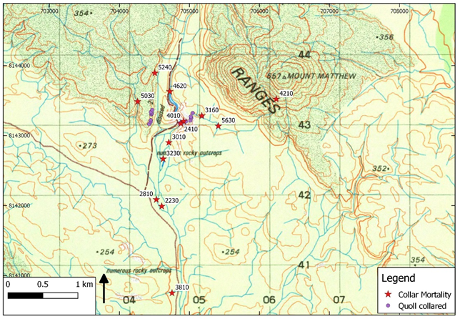

**Fig. 4. Locations where northern quolls were collared and subsequent mortality mode recoveries.**

**Table 5. Mortality mode and recovery of northern quoll collars.**

|  |  |  |  |  |  |  |
| --- | --- | --- | --- | --- | --- | --- |
| **Date that mortality mode was detected** | **Collar Freq. (151.xxx MHz)** | **Recovered date** | **Location** | **Description** | **Northern quoll traces** | **Possible cause of death** |
| 5 Aug | 361 | 5 Aug | 705176 8143284 | Boulder field | Not accessible | unknown |
| 9 Sep | 381 | 11 Sep | 704751 8140751 | Savannah grassland | Nil | unknown |
| 9 Sep | 323 | 13 Sep | 704624 8142667 | Riparian vegetation. 30 cm from river. | Nil | Bird? |
| 9 Sep | 241 | 10 Sep | 704877 8143172 | Boulder field | Entire desiccated carcass. | Die-off? |
| 9 Sep | 563 | 11 Sep | 705412 8143137 | Grassland. 3 m from dry creek | Collar harness chewed and broken | Bird? |
| 9 Sep | 402 | 10 Sep | 704916 8143207 | Boulder field | Desiccated carcass w/o head | Die-off? |
| 9 Sep | 421 | 14 Sep | 706239 8143521 | Under boulder, Mt Matthew | Small amount loose northern quoll fur | unknown |
| 9 Sep | 223 | 12 Sep | 704604 8141991 | Riparian vegetation | 1 rib bone | Bird? |
| 9 Sep | 301 | 13 Sep | 704705 8142901 | In river | Nil | Bird? |
| 9 Sep | 462 | 16 Sep | 704719 8143629 | In river | Nil | unknown |
| 9 Sep | 281 | 12 Sep | 704527 8142087 | Riparian vegetation | Skull | Bird |
| 9 Sep | 524 | 14 Sep | 704506 8143894 | South facing slope | Loose northern quoll fur | Bird |
| 15 Sep | 503 | 15 Sep | 704259 8143487 | Under bedrock of waterfall | Nil | unknown |

Additional observations about the recovery of specific collars are as follows:

Northern quoll 241 – This entire carcass was readily removed from under the boulder (see Plate 4).

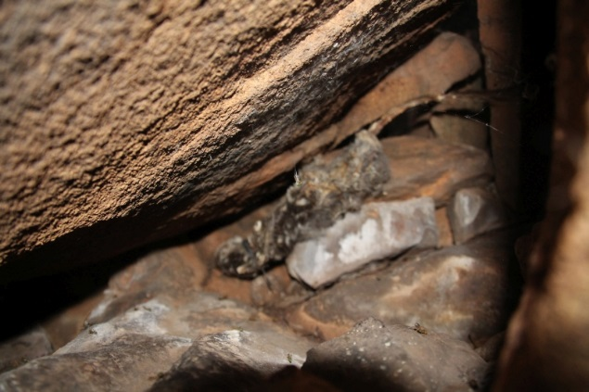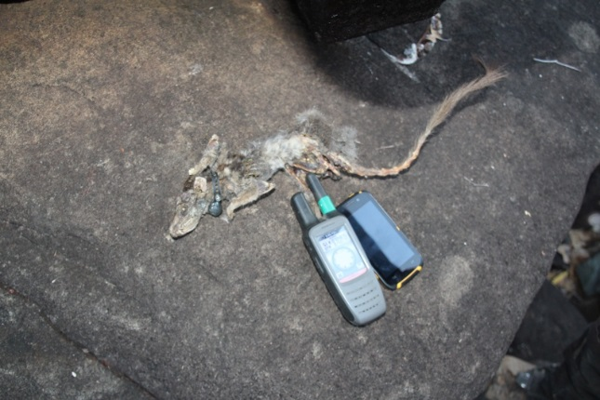

**Plate 4. Carcass of northern quoll 241 *in situ* and withdrawn from boulder pile.**

Northern quoll 281 – A ‘perching’ branch was directly above the collar and was scratched suggesting a bird with talons had been gripping it. A small amount of meat and northern quoll fur was stuck to this branch (Plate 5).

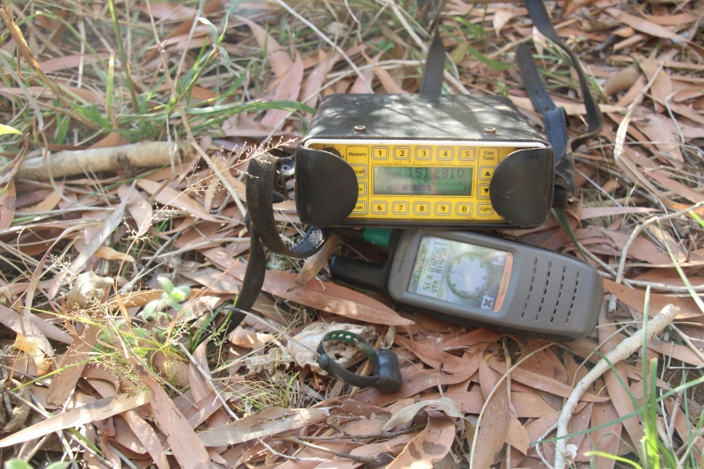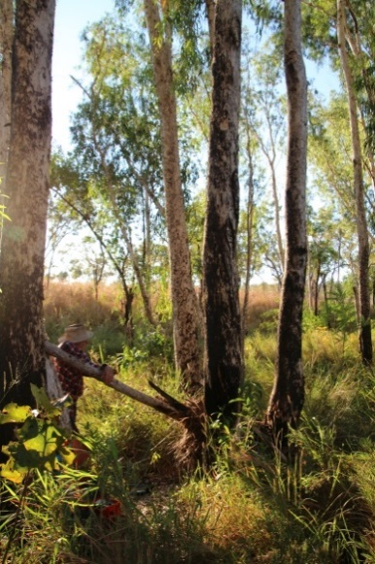

**Plate 5. Skull and collar from northern quoll 281. Note the perching branch above site.**

Northern quoll 402 – A live northern quoll was observed from a distance of 10 m at the rock where this collar was located. This animal retreated under boulders when approached. A desiccated carcass without head or collar was located on a flat rock where the alive northern quoll had been sighted. The carcass was left *in situ* while a camera was retrieved. On return, some 20 minutes later, the carcass had been removed leaving a small amount of hair (Plate 6). It was not possible to recover the collar from location under a boulder. It is speculated that the live northern quoll dragged the carcass out from under the boulder and subsequently removed it while the camera was being retrieved.

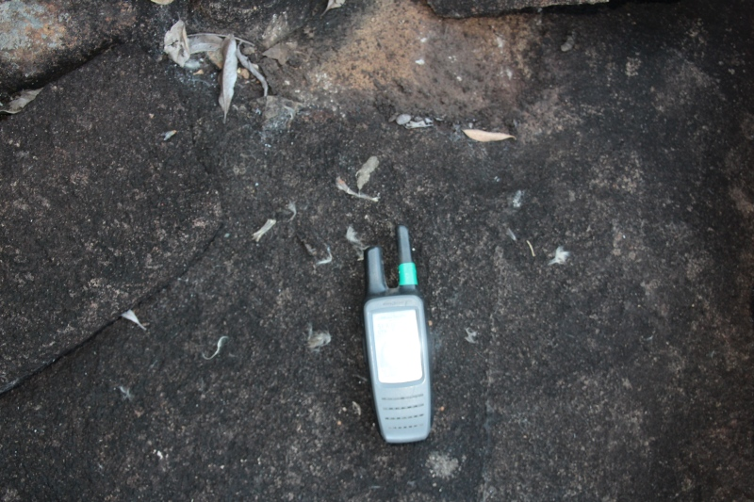

**Plate 6. Fur remnants on rock from carcass of northern quoll 402.**

Northern quoll 503 – The collar (and presumably northern quoll carcass) was not recoverable being located in rock under a dry waterfall (strongest signal indicated by arrows in Plate 7). The collar switched to mortality mode on 15 September with recovery attempted the same day. The site was revisited on 24 September and the collar appeared to be in the same position. The endoscope camera was slotted into small caves and crevices in the rock to try and obtain confirmation of a carcass. The full length (approximately 2 m) was extended into a small diameter cave but the camera did not make the full extent. This cave appeared to extend towards the point on the ground that the signal was coming from, suggesting that perhaps the collar/northern quoll was deep within this cavity. It is possible that this animal consumed a *Hisstory* bait as there was a bait cluster 100 m distant from this location (see Fig. 5).

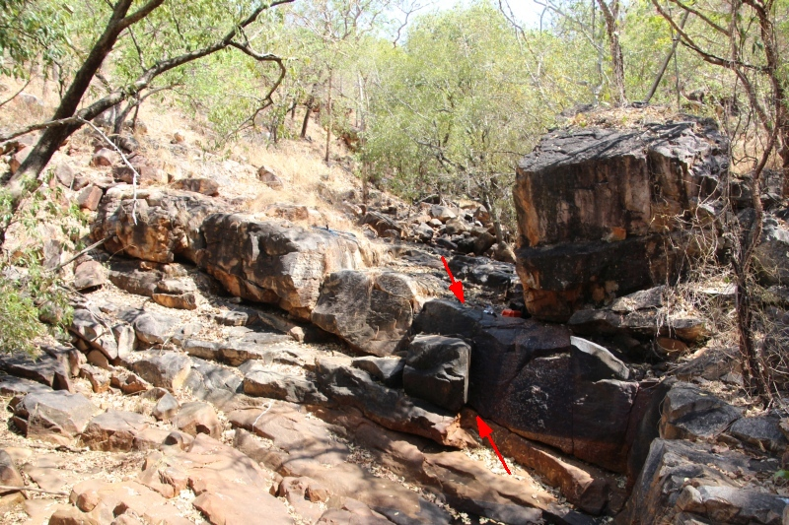

**Plate 7. Location of collar from northern quoll 503 following switch to mortality mode.**

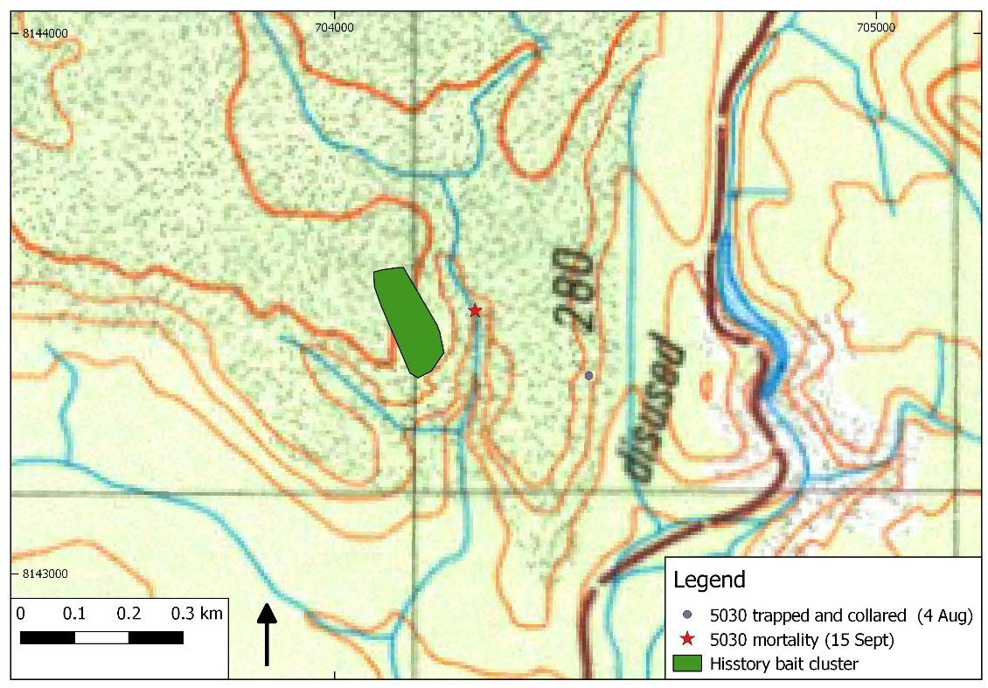

**Fig. 5. Locations of closest *Hisstory* bait cluster in relation to northern quoll 503.**

Re-capture of the seven alive quolls was conducted 19–24 September 2017. Eleven individuals (4M, 7F) were captured including all collared animals within five nights of targeted trapping on Transects T and R (Appendix 6.2). Collars were removed and assessments were made of any irritation caused by collars. One individual (M 604) had a wound because of the collar however, when he was re-captured two days after collar removal the wound had scabbed and appeared to be healing well. Mean bodyweight for males was 420 g (SE ± 87 g) and females 305 g (SE ± 17 g) (see Appendix 6.2).

Two common rock-rats (*Zyzomys argurus*) and a shaded litter rainbow-skink (*Carlia munda*) were the only other captures.

**Table 6. Summary of northern quoll trapping (nq) results during September at Matthew Gorge, Mount Hart.**

|  |  |  |  |  |  |  |
| --- | --- | --- | --- | --- | --- | --- |
|  |  | | | | | |
|  | **20** | **21** | **22** | **23** | **24** | **Total** |
| **Trap-nights** | 5 | 10 | 10 | 10 | 10 | 45 |
|  |  |  |  |  |  |  |
| **nq captures** | 3 | 3 | 3 | 4 | 4 | 17 |
| **Capture success** | 60% | 30% | 30% | 40% | 40% | 38% |
|  |  |  |  |  |  |  |
| **nq (excluding re-traps)** | 3 | 2 | 2 | 3 | 1 | 11 |
| **capture success** | 60% | 20% | 20% | 30% | 10% | 24% |
|  |  |  |  |  |  |  |
| **nq (excluding re-traps and re-captures)** | 1 | 0 | 0 | 1 | 0 | 2 |
| **capture success** | 20% | 0% | 0% | 10% | 0% | 4% |
|  |  |  |  |  |  |  |
| **Sex ratios** |  |  |  |  | **Total individuals** | **11** |
| male |  |  | (includes 2 new males) | | 36% | 4 |
| female |  |  |  |  | 64% | 7 |

All the females that had been collared were carrying their maximum of eight pouch young. These ranged from 11–21 mm for crown rump measurements or approximately 15–40 days old. The one other female that was captured was not carrying any young but based on the condition of her pouch (well developed and clean) it is assumed she would give birth this season.

**Discussion**

Management of feral cats over broad-scale areas can be undertaken cost-effectively using poison baits when deployed strategically to coincide with periods of food stress. In southern Australia, baiting is conventionally undertaken in late autumn/early winter using *Eradicat* in the south-west of Western Australia. Considerable research and development has been expended on this bait to optimise the attractiveness and palatability to feral cats but, equally, the baits are still expected to be consumed by non-target wildlife species. Various measures are employed to mitigate the hazard that baits present to wildlife species. In the case of *Eradicat*, the direct injection of 1080 into the meat matrix, will lead to exposure of all species that consume the bait. This does not present a hazard to most native wildlife species in south-west Western Australia given their tolerance to this compound (Twigg 1994). However, there are fewer 1080-bearing plants in northern Australia and as such the tolerance of wildlife species to this compound is expected to be lower (ibid).

The *Curiosity* bait employs a robust encapsulated toxicant to exploit differential masticatory behaviour between feral cats and wildlife species (Marks *et al.* 2006) and, hence, reduce the hazard to wildlife species. Numerous wildlife species are expected to consume the bait however, the size and hardness of the HSDV has been demonstrated to lead to rejection, i.e. spitting out, of the pellet in many species. The polymer coating on the *Curiosity* HSDV disintegrates in the stomach and releases the PAPP toxicant. However, *Curiosity* bait containing the PAPP toxin is not transferrable to northern Australia due to the potential for impact on non-target wildlife species. By combining the toxicant type of *Eradicat* and delivery mechanism of *Curiosity*, that is, encapsulating 1080 within the *Curiosity* bait medium to produce the variant feral cat bait *Hisstory*, it should be possible to minimise the impact on non-target wildlife species including varanids and northern quolls.

This small-scale study was intended to assess the hazard that the *Hisstory* bait presents to a free-ranging northern quoll population. The trial was undertaken in the King Leopold Ranges Conservation Park in northern quoll natural habitat using a pattern typical of aerial baiting programs. Twenty northern quolls were trapped and fitted with radio-collars prior to application of *Hisstory* baits. The northern quolls were then monitored for 14 days subsequent to baiting to determine whether any of the northern quolls died as a result of baiting. Unfortunately, only eight collared northern quolls were known to be alive when *Hisstory* baits were distributed in the aerial baiting simulation. Of these, seven northern quolls were re-trapped and at the conclusion of the study along with a further three non-collared northern quolls. However, a female northern quoll died five days following application of the baits. The cause of death for this individual could not be identified as the collar was tracked to an inaccessible position in a rock cavity under a dry waterfall. Two hypotheses are posed: (i) it is possible that this animal consumed a *Hisstory* bait as there was a bait cluster at 100 m distance from the collar location; and (ii) the northern quoll could have died from natural causes as a result of injury, pregnancy, disease and/or predation. Although the final sample size is small the study, in conjunction with earlier captive trials, was able to demonstrate that the *Hisstory* bait for feral cats is unlikely to present a significant hazard to free-ranging northern quolls.

The breeding season of northern quolls in the Kimberley is predicted to occur in May but will vary according to climatic conditions in the preceding wet season with late rainfall delaying breeding (K. Tuft pers. comm.). Data from the Mitchell Plateau in the Kimberley indicate that female northern quolls give birth to a single litter of young in July or August (Schmitt *et al*. 1989). Births were earlier on near coastal sites than on inland sites and by September all females were either carrying pouch young or were lactating (Schmidt *et al*. 1989). Further east, a three-year study in Kakadu suggests breeding occurs in May–June with 90% of all females with pouch young present in July and all females with young in August (Oakwood 2000). The amount of rainfall in the 2016/17 wet season was above average in the Kimberley, particularly in the west however, rainfall occurred in the typical cyclone season of November–March but with intense storm fronts causing high levels of rainfall in January. This timing of rainfall was expected to have had no influence on the onset of breeding yet, as field observations determined, breeding occurred up to two months later than expected. The age of pouch young in this study suggests that the earliest birth date was about 12 August. With gestation being approximately three weeks, mating would have commenced mid-July which is more in line with data from further south in the Pilbara (K. Morris pers. comm.; cited in Woinarski *et al*. 2014).

The level of male die-off in northern quolls appears to be highly variable and often site-specific. For example, observations of populations at highly productive sites such as rivers have been shown to have relatively low male die-off rates (Begg 1981). In the present study, male die-off could have occurred approximately two weeks post-mating, potentially occurring as soon as they were collared. All radio-collars that were identified to be in mortality mode on 9 September, that is prior to baiting, were from male northern quolls. This suggests that a significant male die-off occurred this year, which unfortunately caused an unforeseen and dramatic reduction in northern quoll sample size. In hindsight it may have been prudent to only collar females but, with an unpredictable level of die-off, a sex-biased sample could also be criticised in a bait uptake study.

Whether those animals that died were predated as they became weaker or were scavenged as carcasses could not be determined. Predators, such as raptors, obviously played a role given the locations where collars were recovered and the presence of scattered fur and scratches on branches used as perches. Snakes have also been recorded predating northern quolls previously (Oakwood and Miles 1998) and we were confident that an adult king brown snake (*Pseudechis australis*) observed foraging amongst the boulder pile was of sufficient size to predate northern quolls. A brown goshawk (*Accipiter fasciatus*), itself a potential predator of northern quolls, was observed to make two swoops on this snake before retreating to cover (Plate 8).

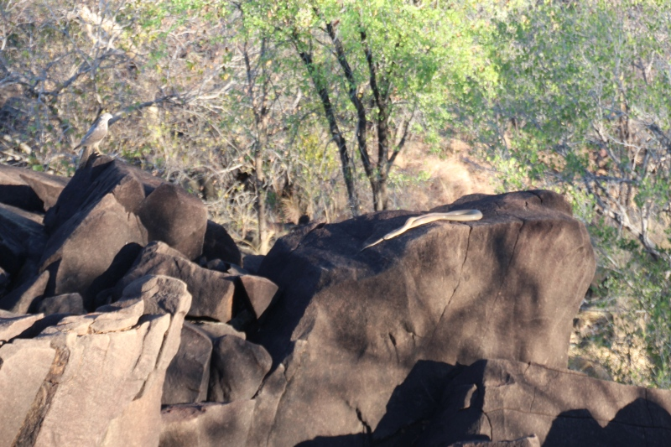

**Plate 8. Potential predators of northern quolls at Matthew Gorge, king brown snake (*Pseudechris australis*)** **and brown goshawk (*Accipiter fasciatus didimus*).**

The northern quoll is listed as ‘’Endangered’’ (under the *Environment Protection and Biodiversity Conservation Act 1999*) and is declining at a rapid rate mostly in association with the spread of the introduced cane toad (*Rhinella marina*), which poisons northern quolls when they attempt to eat it (Woinarski *et al*. 2014). Other factors causing a severe impact on northern quoll populations are inappropriate fire regimes and predation by feral cats (Woinarski *et al*. 2014). Feral cats have established populations across northern Australia and are implicated in contributing to the decline of a range of wildlife species along with altered habitat, cane toads and possibly also disease (Woinarski *et al.* 2010). The expansion of the cane toad into Western Australia is expected to lead to rapid decline of northern quoll populations as the invasion front progresses (O’Donnell *et al*. 2010). The development of the *Hisstory* bait is expected to assist in the broad-scale control of feral cats, which may also allow northern quolls to better cope with other pending threats such as the arrival of the cane toad in the King Leopold Ranges and other northern quoll habitat in the western Kimberley.

The successful trialling of the *Hisstory* cat bait in the Kimberley is likely to benefit many other native species across northern Australia. Rare and threatened species apart from the endangered northern quoll, that are likely to benefit from the control of feral cats include: golden bandicoot (*Isoodon auratus*); golden-backed tree-rat; black-footed tree-rat; brush-tailed phascogale (*Phascogale tapoatafa kimberleyensis*) and nabarlek (*Petrogale concinna monastria*).

Woinarski *et al*. (2014) suggest that one of the specific management actions required in their ‘’Management Plan for the northern quoll’’ is to implement cost-effective control measures to reduce the abundance of feral cats and dogs. Wild dog/dingo hybrids’ predation of northern quolls has been reported in ‘natural’ and ‘translocated’ populations (Oakwood 2000; Cremona *et al*. 2017; Jolly *et al*. 2017). Recently, a study in Kakadu National Park found that dingoes killed a quarter of the northern quoll population that had been fitted with radio-collars (Cremona *et al.* 2017). In a similar study that involved northern quolls translocated from an island to a mainland site, at least seven of the 29 northern quolls were killed by dingoes (Jolly *et al*. 2017). While wild dog/dingo hybrids are present within our project site, we do not consider that they were responsible for death of northern quolls in this study population given that none of the collars were found within dog scats or with canine bite marks on the collars.

The ‘1080’ poison used in the *Hisstory* bait is highly toxic to canids as well as feral cats. It is likely that a technique that provides for broad-scale and effective control of feral cats will also have impacts on canid populations using existing tools given the required bait density and similar sensitivity to the 1080 compound. Public response to the proposed trial both from a number of Aboriginal Traditional Owners and non-Aboriginal people, in particular to the fate of wild dog/dingo hybrids in the baited area, has highlighted the need to develop a bait type that can be used in specific areas, that will minimise the risk to native species and also canids yet still provide effective control of feral cats. Although not originally designed for this purpose, the *Hisstory* bait provides a potential solution now that it has been demonstrated to pose no significant hazard to northern quolls. There are several methods that could be used, individually or in concert, that would reduce bait consumption by canids. There are several additives that could be incorporated into the bait medium that would reduce its palatability to canids yet remain attractive to felids. There are also several rapid-acting emetics that cause dogs to vomit but have no effect on cats; that could be used to coat the HSDV and provide a potential solution. Development of such a bait is essential if we are to effectively control feral cats across northern Australia without public opposition, particularly on lands where wild dog/dingo hybrids are considered an essential component of the ecosystem.

**References**

Algar, D. and Burrows, N.D. (2004). A review of Western Shield: feral cat control research. *Conservation Science Western Australia* **5**, 131–163.

Algar, D., Angus, G.J., Williams, M.R. and Mellican, A.E. (2007). Influence of bait type, weather and prey abundance on bait uptake by feral cats (*Felis catus*) on Peron Peninsula, Western Australia. *Conservation Science Western Australia* **6**, 109–149.

Algar, D., Bell, L., Cowen, S., Onus, M. and Rasmussen, D. (2013). *Eradicat*® Bait distribution from an aircraft. Unpublished Report to Western Shield. Western Australian Department of Parks and Wildlife. 5 pp.

Begg, R.J. (1981). The small mammals of Little Nourlangie Rock, N.T., III, Ecology of *Dasyurus hallucatus*, the northern quoll (Marsupialia: Dasyuridae) *Australian Wildlife Research* **8**, 73–85.

Buckmaster, T., Dickman, C.R. and Johnston, M.J. (2014) Assessing risks to non-target species during poison baiting programs for feral cats. PLoS ONE 9(9) e107788. <https://doi.org/10.1371/journal.pone.0107788>

Burbidge, A.A., McKenzie, N.L. and Kenneally (1991). Nature Conservation Reserves in the Kimberley Western Australia. Unpublished Report, Department of Conservation and Land Management, Western Australia.

Calver, M.C., King, D.R., Bradley, J.S., Gardner, J.L., and Martin G.R. (1989). Assessment of the potential target specificity of 1080 predator baiting in Western Australia. *Australian Wildlife Research* **16**, 625–638.

Commonwealth of Australia (2015) Threat Abatement Plan for predation by feral cats. Canberra, ACT.

Cremona, T., Crowther, M.S. and Webb, J.K. (2017). High mortality and small population size prevents population recovery of a reintroduced mesopredator. *Animal Conservation*. doi:10.1111/acv.12358

Eason, C.T., Miller, A., MacMorran, D.B. and Murphy, E.C. (2014). Toxicology and ecotoxicology of para-aminopropiophenone (PAPP)–a new predator control tool for stoats and feral cats in New Zealand. *New Zealand Journal of Ecology*, **38(2)**, 177–188.

Forster, G. (2009). Non-target species uptake of feral cat baits containing Rhodamine B. B. Sci. (Hons) thesis. Department of Agricultural Sciences, Latrobe University, Bundoora, Victoria, Australia.

Hetherington, C.A., Algar, D., Mills, H. and Bencini, R. (2007). Increasing the target-specificity of ERADICAT® for feral cat (*Felis catus*) control by encapsulating a toxicant. *Wildlife Research* **34**, 467–471.

Gigliotti, F. (2011). Response of northern Australian wildlife species to non-toxic *Curiosity* baits. Unpublished report for the Department of Sustainability and Environment. DOI: 10.13140/RG.2.2.29846.45125

Johnston M. (2010). The development of a humane felid-specific toxin and bait delivery system for feral cat control - final report 2008–10. Heidelberg, Victoria: Arthur Rylah Institute for Environmental Research Client Report, Department of Sustainability and Environment.

Johnston, M., Algar, D., O’Donoghue, M. and Morris, J. (2011). Field efficacy of the Curiosity feral cat bait on three Australian islands. In: Veitch, C.R., Clout, M.N. and Towns, D.R. (eds). Island Invasives: eradication and management. IUCN, Gland, Switzerland, pp 182–187.

Johnston, M., Bould, L., O’Donoghue, M., Holdsworth, M., Marmion, P., Bilney, R., Reside, A.E., Caldwell, D., Gaborov, R. and Gentles, T. (2014). Field efficacy of the Curiosity® bait for management of a feral cat population at Roxby Downs, South Australia. Arthur Rylah Institute for Environmental Research Technical Report Series No. 253. Department of Environment and Primary Industries, Heidelberg, Victoria.

Jolly, C.J., Kelly, E., Gillespie, G.R., Phillips, B. and Webb, J.K. (2017). Out of the frying pan: Reintroduction of toad‐smart northern quolls to southern Kakadu National Park. *Austral Ecology*. 10.1111/aec.12551

King, D.R. (1989). An assessment of the hazard posed to Northern Quoll (*Dasyurus hallucatus*) by aerial baiting with 1080 to control dingoes. *Wildlife Research* **16(5)**, 569–574.

King, D.R. (1990). 1080 and Australian fauna. Agriculture Protection Board Technical Series No. 8.

Leyhausen, P. and Tonkin, B.A. (1979). *Cat behaviour*. *The Predatory and Social Behaviour of Domestic and Wild Cats*. Garland STPM Press.

Marks, C.A., Johnston, M.J., Fisher, P.M., Pontin, K. and Shaw, M.J. (2006). Differential particle size ingestion: promoting target-specific baiting of feral cats. *Journal of Wildlife Management* **70(4)**, 1119–1124

McIlroy, J.C. (1984). The sensitivity of Australian animals to 1080 poison. VII. Native and introduced birds. *Australian Wildlife Research* **11**, 373–385.

Mcllroy, J.C., King, D.R., and Oliver, A.J. (1985). The sensitivity of Australian animals to 1080 poison. VIII. Amphibians and reptiles. *Australian Wildlife Research* **12**, 113–118.

Morris, K., Cowan, M., Angus, J., Anderson, H., Garretson, S., Palmer, R., Williams, M. and Pearson, D. (2016) Baseline monitoring for northern quoll and Rothschild’s rock-wallaby at *Eradicat®* baited and unbaited sites, Pilbara Region WA. Department of Parks and Wildlife, Perth.

Oakwood, M. (2000). Reproduction and demography of the northern quoll, *Dasyurus hallucatus*, in the lowland savanna of northern Australia. *Australian Journal of Zoology*, ***48*(5)**, 519–539.

Oakwood, M. (2002). Spatial and social organization of a carnivorous marsupial *Dasyurus hallucatus* (Marsupialia: Dasyuridae). *Journal of Zoology* **257**, 237–248.

Oakwood, M. and Miles, G.L. (1998) Predation of a marsupial carnivore by an olive python (*Liasis olivaceus*)and a king brown snake (*Pseudechis australis*). Herpetofauna **28(1)**, 19–21.

O’Donnell, S., Webb, J.K. and Shine, R. (2010). Conditioned taste aversion enhances the survival of an endangered predator imperilled by a toxic invader. *Journal of Applied Ecology* ***47*(3)**, 558–565.

Robinson, S. (2010). Assessment of the potential of wildlife species to a bait delivered toxicant developed for feral cat control using a non-toxic bait marker. Appendix 2 in Johnston, M (2010). The development of a humane toxin and bait delivery system for feral cat control - final report 2008–10. Arthur Rylah Institute for Environmental Research client report, Report to the feral cat toxicant and bait development team. Heidelberg, Victoria: Department of Sustainability and Environment.

Schmitt, L.H., Bradley, A.J., Kemper, C.M., Kitchener, D.J., Humphreys, W.F. and How, R.A. (1989). Ecology and physiology of the northern quoll, *Dasyurus hallucatus* (Marsupialia, Dasyuridae), at Mitchell Plateau, Kimberley, Western Australia. *Journal of Zoology*, **217**, 539–558.

Twigg, L.E. (1994). The occurrence of fluoroacetate in Australian plants and tolerance to 1080 in indigenous Australian animals. In: Seawright, A.A. and Eason, C.T. (eds.) Proceedings of the science workshop on 1080. The Royal Society of New Zealand, Miscellaneous Series 28. 178 pp.

Twigg, L.E., Martin, G.R., Eastman, A.F., King, D.R. and Kirkpatrick, W.E. (2003). Sensitivity of some Australian animals to sodium fluoroacetate (1080): additional species and populations, and some ecological considerations. *Australian Journal of Zoology* **51**, 515–531.

Woinarski, J.C.Z., Armstrong, M., Brennan. K., Fisher, A., Griffiths, A.D., Hill, B., Milne, D.J., Palmer, C., Ward, S., Watson, M. and Winderlich, S. (2010). Monitoring indicates rapid and severe decline of native small mammals in Kakadu National Park, northern Australia. *Wildlife Research* **37(2),** 116–126.

Woinarski, J.C.Z., Burbidge, A.A. and Harrison, P.L. (2014). *The Action Plan for Australian Mammals 2012*. CSIRO Publishing Australia.

Woinarski, J.C.Z., Burbidge, A.A. and Harrison, P.L. (2015). Ongoing unraveling of a continental fauna: decline and extinction of Australian mammals since European settlement. *Proceedings of the National Academy of Sciences of the United States of America* **112**, 4531–4540.

**Appendices**

**Appendix 6.1. Reconnaissance at Yampi Sound Defence Training Area**

The field efficacy trial was planned to be conducted at the Australian Government Department of Defence property Yampi Sound Defence Training Area (YSTDA) where there was plenty of evidence that northern quolls existed, ranging from historic surveys to recent studies. It was proposed to assess the hazard posed to the non-target northern quoll at the site and, at an adjacent site on the same property, a non-toxic field efficacy assessment measuring bait uptake by feral cats. The latter was proposed to be non-toxic to minimise the impact on wild dog/dingo hybrids. A trapping program was to be conducted post-baiting, with captured animals assessed for the presence/absence of a Rhodamine-B biomarker included in the HSDV.

Prior to logistical issues requiring the trial site to be moved, preliminary work had commenced at YSTDA. A site reconnaissance was conducted and confirmed that sufficient northern quolls were likely to be present in the proposed monitoring site. Trail cameras set across the area detected northern quolls over three nights at 10 of 18 sites during the reconnaissance trip and at another six sites following another 40 nights of survey.

A range of species, in addition to northern quolls, were photographed by cameras at YSDTA (see Table 7). Notably, a pale-coloured feral cat (see Plate 9) was detected at one site located 20 km north of the Robinson River crossing. Information provided by Defence and Dambimangari Aboriginal Corporation indicated that no cats have previously been detected on the site and suggested that this was because of the presence of dingoes. We believe this is may be the first record of cats within the YSTDA. In addition to the cat captured on camera, staff observed prints on the main track through the proposed survey site and Rio Tinto exploration staff also reported seeing a black-coloured cat to DBCA staff when they recovered cameras during September.

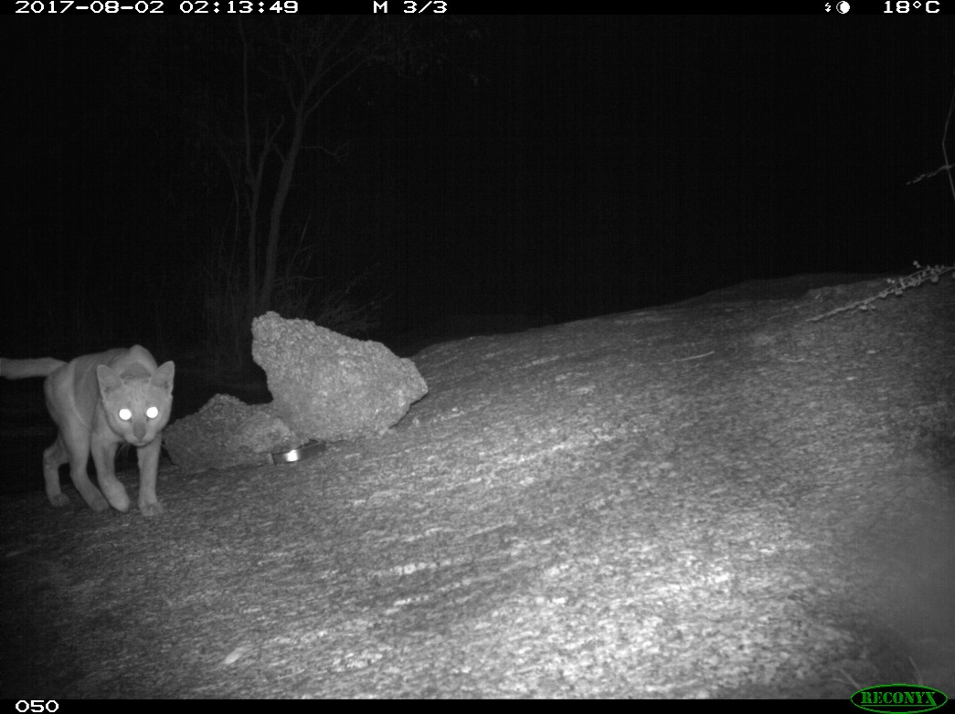

**Plate 9. Feral cat captured on camera at Yampi Sound Defence Training Area.**

**Table 7. Reconnaissance camera trap data at** **Yampi Sound Defence Training Area.**

|  |  |  |  |
| --- | --- | --- | --- |
| **Common Name** | **Scientific Name** | **Photos** | **\*Events** |
| echidna | *Tachyglossus aculeatus* | 31 | 5 |
| euro | *Osphranter robustus* | 118 | 4 |
| golden-backed tree-rat | *Mesembriomys macrurus* | 9 | 2 |
| monjon | *Petrogale burbidgei* | 206 | 13 |
| northern brown bandicoot | *Isoodon macrourus* | 51 | 5 |
| northern quoll | *Dasyurus hallucatus* | 2995 | 276 |
| scaly-tailed possum | *Wyulda squamicaudata* | 67 | 11 |
| short-eared rock-wallaby | *Petrogale brachyotis* | 473 | 34 |
| common rock-rat | *Zyzomys argurus* | 96 | 23 |
| red kangaroo | *Osothranter rufus* | 219 | 15 |
| wild dog/dingo hybrid | *Canis lupus familiaris* | 155 | 10 |
| feral cat | *Felis catus* | 15 | 1 |
| feral pig | *Sus scrofa* | 78 | 1 |
|  |  |  |  |
| black-palmed monitor | *Varanus glebopalma* | 12 | 3 |
| yellow-spotted monitor | *Varanus panoptes* | 12 | 3 |
|  |  |  |  |
| bar-shouldered dove | *Geopelia humeralis* | 40 | 2 |
| brown honeyeater | *Lichmera indistincta* | 2 | 1 |
| diamond dove | *Geopelia cuneata* | 9 | 4 |
| double-barred finch | *Taeniopygia bichenovii* | 9 | 2 |
| great bowerbird | *Chlamydera nuchalis* | 12 | 2 |
| peaceful dove | *Geopelia placida* | 6 | 2 |
| red breasted babbler | *Pomatostomus rubeculus* | 158 | 14 |
| red-backed fairy-wren | *Malurus melanocephalus* | 1 | 1 |
| sandstone shrike-thrush | *Colluricincla woodwardi* | 10 | 2 |
| variegated fairy-wren | *Malurus lamberti* | 8 | 3 |
| willie wagtail | *Rhipidura leucophrys* | 7 | 3 |
|  |  |  |  |
| unknown |  | 15 | 7 |

*An event is defined as continuous activity of an individual with no more than a five minute absence between images.

**Appendix 6.2. Northern quoll captures at Mt Hart, 2017.**

|  |  |  |  |  |  |  |  |  |  |  |
| --- | --- | --- | --- | --- | --- | --- | --- | --- | --- | --- |
| **Date** | **Trap No.** | **Northing** | **Easting** | **Collar Frequency** | **Trap Type** | **Sex** | **\*New/ Re-capture/ Re-trap** | **Personal Identification Transponder** | **Weight (g)** | **Pouch comments** |
| 2-Aug | T02 | 8143165 | 704425 | 151.542 | Elliott | F | R | 6000139526 | 280 |  |
| 2-Aug | T09 | 8143367 | 704469 | 151.223 | Elliott | M | N | 00076ff384 | 550 |  |
| 3-Aug | T02 | 8143165 | 704425 | 151.343 | Elliott | M | N | 000769b94b | 600 |  |
| 3-Aug | T03 | 8143196 | 704446 | 151.542 | Elliott | F | RT | 6000139526 | 320 |  |
| 3-Aug | T04 | 8143220 | 704447 | 151.223 | Elliott | M | RT | 00076ff384 | 530 |  |
| 3-Aug | T06a | 8143303 | 704454 | 151.301 | Cage | M | R | 6000142584 | 340 |  |
| 3-Aug | T07 | 8143313 | 704463 | 151.462 | Elliott | M | N |  | 480 |  |
| 3-Aug | T07a | 8143329 | 704459 | 151.604 | Cage | M | N | 000768a9dc | 280 |  |
| 3-Aug | T08 | 8143337 | 704449 | 151.582 | Elliott | F | R | 6000138850 | 350 |  |
| 3-Aug | R01 | 8143181 | 704861 | 151.381 | Cage | M | N | 000769bbec | 370 |  |
| 3-Aug | R03 | 8143199 | 704919 | 151.443 | Cage | F | N | 00076fefdd | 240 |  |
| 3-Aug | R05 | 8143202 | 704984 |  | Cage | F | N | 000768aa12 | 240 |  |
| 3-Aug | R06 | 8143218 | 705014 | 151.262 | Cage | F | N | 000769b7c5 | 300 |  |
| 3-Aug | R07 | 8143251 | 705023 | 151.563 | Cage | M | N | 000769b345 | 370 |  |
| 3-Aug | R14 | 8143280 | 705179 | 151.361 | Cage | F | N | 00076ff475 | 420 |  |
| 3-Aug | R20 | 8143272 | 705019 | 151.421 | Cage | M | N |  | 520 |  |
| 4-Aug | T07a | 8143329 | 704459 | 151.301 | Cage | M | RT | 6000142584 | 320 |  |
| 4-Aug | T08 | 8143337 | 704449 | 151.281 | Elliott | M | N | 000769900a | 530 |  |
| 4-Aug | T09 | 8143367 | 704469 | 151.503 | Elliott | F | N | 0007696ce2 | 340 |  |
| 4-Aug | T11 | 8143439 | 704472 |  | Elliott | F | R | 6000137885 | 390 |  |
| 4-Aug | T14 | 8143543 | 704439 | 151.524 | Elliott | M | N | 000768B2aa | 390 |  |
| 4-Aug | T15 | 8143572 | 704452 | 151.483 | Elliott | F | N | 000768ac05 | 330 |  |
| 4-Aug | R01 | 8143181 | 704861 |  | Cage | F | N | 000769b927 | 230 |  |
| 4-Aug | R02 | 8143180 | 704887 | 151.323 | Cage | M | R | 6000143821 | 460 |  |
| 4-Aug | R03 | 8143199 | 704919 | 151.381 | Cage | M | RT | 000769bbec | 430 |  |
| 4-Aug | R04 | 8143204 | 704950 | 151.241 | Cage | M | N | 000768a6a7 | 590 |  |
| 4-Aug | R07 | 8143251 | 705023 |  | Cage | F | RT | 000768aa12 | 210 |  |
| 4-Aug | R08 | 8143284 | 705027 | 151.421 | Cage | M | RT |  | 630 |  |
| 4-Aug | R09 | 8143323 | 705046 | 151.402 | Cage | M | N | 00076961b4 | 350 |  |
| 4-Aug | R13 | 8143259 | 705174 |  | Cage | M | N | 000769af6a | 370 |  |
| 4-Aug | R14 | 8143280 | 705179 |  | Cage | F | N | 000769b6cc | 270 |  |
| 4-Aug | R16 | 8143306 | 705113 |  | Cage | M | N |  | 390 |  |
| 4-Aug | R19 | 8143309 | 705017 |  | Cage | M | N | 0007699078 | 460 |  |
| 20-Sep | Q03 | 8143226 | 704464 | 151.542 | Elliott | F | R | 6000139526 | 340 | 8PY; CR 15 mm |
| 20-Sep | Q03 | 8143226 | 704464 |  | Elliott | M | N | 000769c330 | 300 |  |
| 20-Sep | Q04 | 8143251 | 704466 | 151.582 | Elliott | F | R | 6000138850 | 280 | 8PY; CR 19 mm |
| 21-Sep | Q03 | 8143226 | 704464 | 151.343 | Elliott | M | R | 000769694b | 650 |  |
| 21-Sep | T06a | 8143303 | 704454 |  | Elliott | F | RT | 6000138850 | 290 |  |
| 21-Sep | T07 | 8143313 | 704463 | 151.604 | Elliott | M | R | 000768a9dc | 270 |  |
| 22-Sep | T07 | 8143313 | 704463 |  | Elliott | F | R | 6000137885 | 370 | no PY; small red teats |
| 22-Sep | T09 | 8143367 | 704469 |  | Elliott | F | RT | 6000138850 | 340 |  |
| 22-Sep | T13 | 8143504 | 704456 | 151.483 | Elliott | F | R | 000768ac05 | 350 | 8PY; CR 11 mm |
| 23-Sep | R01 | 8143181 | 704861 |  | Elliott | F | R | 000768aa12 | 240 | 8PY; CR 18 mm |
| 23-Sep | R03 | 8143199 | 704919 | 151.443 | Elliott | F | R | 00076fefdd | 280 | 8PY; CR 21 mm |
| 23-Sep | R04 | 8143204 | 704950 |  | Elliott | M | RT | 000769b94b | 620 |  |
| 23-Sep | R09 | 8143323 | 705046 |  | Elliott | M | N | 000769b677 | 460 |  |
| 24-Sep | R01 | 8143181 | 704861 |  | Elliott | M | RT | 000769b94b | 610 |  |
| 24-Sep | R05 | 8143202 | 704984 | 151.262 | Elliott | F | R | 000769b7c5 | 280 | 8PY;CR 20 mm |
| 24-Sep | R07 | 8143251 | 705023 |  | Elliott | M | RT | 000769b677 | 430 |  |
| 24-Sep | R20 | 8143272 | 705019 |  | Elliott | F | RT | 00076fefdd | 320 |  |

**\*New** is defined as an individually not previously caught, **Re-trap** is an individual that has been caught previously during this trapping session and **Re-capture** is an individual that has been caught on a previous trapping trip, (i.e. in April I. Radford).

1. A mixture of oats and peanut butter. See appendix 1 of DBCA Standard Operating Procedure Cage traps for live capture of terrestrial vertebrates. https://www.dpaw.wa.gov.au/images/documents/plants-animals/monitoring/sop/sop09.2_cagetraps_v1.1.pdf