June 2023

# Outcomes of the Historical Soil Data Capture Payments Program

The Historical Soil Data Capture Payments Program (the program) (1 April 2022 to 31 December 2022) aimed to support the implementation of the National Soil Strategy and contribute to increasing soil data availability and supporting the understanding of soil condition and trends across Australia.

The program was delivered via four data brokers selected through an open competitive tender. The program was restricted to soil data acquired through private funds and required data owners to agree to share, with their permission, soil data through the Australian National Soil Information System ([ANSIS](https://www.csiro.au/en/research/natural-environment/land/soil/ansis)), and complete a survey about their soil management practices.

Eligible soil data captured under the program had to be tested in a certified laboratory before 2022, collected at any depths from the surface and needed to include metadata including time/date of collection and analysis, testing method codes, sample depth (and horizon), testing soil laboratory details, and geolocation. Data owners could receive up to $10,000 (GST incl) to participate in the program with the payment based upon the number of eligible soil properties tested per sample.

## Results

For the purposes of the program, a sample was defined to a single site location and one depth measurement (within a range of 10cm). A soil profile tested at different depths counted as providing multiple samples. Key program statistics include:

* 553 data owners participated in the program and submitted a total of 291,203 soil data results
* soil samples were mainly collected from WA, VIC, SA, NSW, QLD and TAS (refer to map)
* most of the data owners that participated in the program described their current land management practices mainly as either precision agriculture or conventional high input
* soil data results submitted were predominantly generated from 2017 to 2021. There was no soil data submitted collected prior to 1980 or from 1990 to 2000
* pH, extractable phosphorous and exchangeable bases of calcium, potassium, magnesium, and sodium were the most submitted soil data results. Other soil data results submitted included electrical conductivity, extractable potassium, total organic carbon, ammonium nitrogen, phosphorous buffer index, extractable sulfur and nitrate nitrogen
* the average payment received by a data owner for their data was about $7,500 (GST incl.)
* data owners mainly considered that soil nutrient levels, soil pH and soil organic matter were important when testing their soil.

## Map: Geographical spread of soil data results submitted under the program

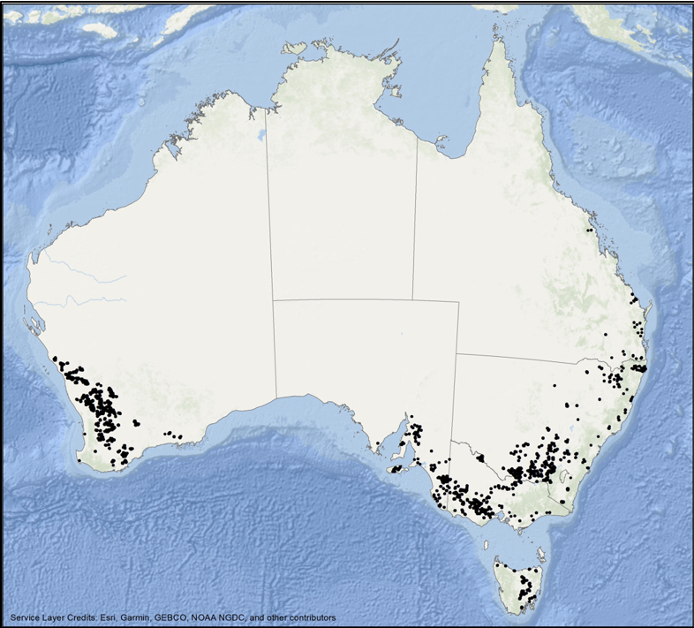

## More information

Learn more about: [National Soil Strategy - DAFF (agriculture.gov.au)](https://www.agriculture.gov.au/agriculture-land/farm-food-drought/natural-resources/soils)

[ANSIS - Australian National Soil Information System - CSIRO](https://www.csiro.au/en/research/natural-environment/land/soil/ansis)

**Acknowledgement of Country**

We acknowledge the Traditional Custodians of Australia and their continuing connection to land and sea, waters, environment and community. We pay our respects to the Traditional Custodians of the lands we live and work on, their culture, and their Elders past and present.

© Commonwealth of Australia 2023

Unless otherwise noted, copyright (and any other intellectual property rights) in this publication is owned by the Commonwealth of Australia (referred to as the Commonwealth).

All material in this publication is licensed under a [Creative Commons Attribution 4.0 International Licence](https://creativecommons.org/licenses/by/4.0/legalcode) except content supplied by third parties, logos and the Commonwealth Coat of Arms.

The Australian Government acting through the Department of Agriculture, Fisheries and Forestry has exercised due care and skill in preparing and compiling the information and data in this publication. Notwithstanding, the Department of Agriculture, Fisheries and Forestry, its employees and advisers disclaim all liability, including liability for negligence and for any loss, damage, injury, expense or cost incurred by any person as a result of accessing, using or relying on any of the information or data in this publication to the maximum extent permitted by law.