Oceans and atmosphere

Historical context and causes of water quality decline in the Whitsunday region



Mark Baird1, 2,Nugzar Margvelashvili1, Neal Cantin2

1CSIRO Oceans and Atmosphere; 2Australian Institute of Marine Science

2mark.baird@csiro.au

17 June 2019

Contents

Contents 2

List of Figures 2

1 Introduction 4

2 Executive Summary 4

3 Comparison of Ba / Ca ratios in coral cores with the model river plumes 7

3.1 Introduction 7

3.2 Method 8

3.2.1 Hydrodynamic modelling 8

3.2.2 Calculation of simulated Ba/Ca ratios 9

3.3 Results 9

3.3.1 Model river tracer outputs 9

3.3.2 Direct comparison of simulated and observed coral Ba/Ca ratios. 18

3.4 Conclusions 20

4 Additional information 21

4.1 Relative contribution of different sources of suspended sediment. 21

4.2 Regional sediment budget – resuspended vs. riverine sediment 22

4.3 Fine fraction of catchment-derived sediments. 23

4.4 Discussion of uncertainties in satellite-derived estimates of water quality. 23

4.5 Further discussion of the comparison between in situ observations, satellite retrievals and model outputs. 24

5 References 25

List of Figures

Figure 1 Mean surface river tracer concentration for 2011 (left) and time-series of the individual river tracers (right) at six coring sites. The colours on the left show only the river with the greatest concentration at the surface, while the time-series shows all 4 rivers. The top left of each site panel lists the predicted peak (and mean) Ba/Ca anomaly assuming conservative transport from the river mouth. 10

Figure 2 Mean surface river tracer concentration for 2012 (left) and time-series of the individual river tracers (right) at six coring sites. See Figure 1. 11

Figure 3 Mean surface river tracer concentration for 2013 (left) and time-series of the individual river tracers (right) at six coring sites. See Figure 1 12

Figure 4 Mean surface river tracer concentration for 2014 (left) and time-series of the individual river tracers (right) at six coring sites. See Figure 1. 13

Figure 5 Mean surface river tracer concentration for 2015 (left) and time-series of the individual river tracers (right) at six coring sites. See Figure 1. 14

Figure 6 Mean surface river tracer concentration for 2016 (left) and time-series of the individual river tracers (right) at six coring sites. See Figure 1. 15

Figure 7 Mean surface river tracer concentration for 2017 (left) and time-series of the individual river tracers (right) at six coring sites. See Figure 1. 16

Figure 8 Mean surface river tracer concentration for 2018 (left) and time-series of the individual river tracers (right) at six coring sites. See Figure 1. 17

Figure 9 Mean surface river tracer concentration for 2019 (left) and time-series of the individual river tracers (right) at six coring sites. See Figure 1. 18

Figure 10 Comparison of observed and simulated Ba / Ca ratio in coral cores, distinguished by colour for site, and marker by year. The grey lines is a 1:1 agreement between observed and modelled Ba / Ca ratios. The displacement factor for Ba / Ca is 0.82. 20

# Introduction

This is the final report of the DoEE-funded project: “Scoping study to address poor water quality in the Whitsunday Region”. The project provides new observations, model output and analysis in order to address the following project objectives:

• Provide greater understanding of the causes of the water quality decline in the Whitsunday Region through application and analysis of existing models coupled with field observations

• Provide greater understanding of the contribution of different pollutant sources, such as (but not limited to) urban runoff, dredging and disposal activities, to the regional sediment budget

In addition to this Final Report, the project has produced three documents:

1. Mark Baird and Nugzar Margvelashvili (2018) Scoping study to address poor water quality in the Whitsunday Region: interim report. Report submitted to DoEE in 2018.
2. Mark Baird and Emlyn Jones (2018). Observation System Simulation Experiment for the Mackay-Whitsunday region: application of the eReefs marine biogeochemical model. Report submitted to DoEE in 2018.
3. Neal Cantin, Yang Wu, Stewart Fallon & Janice Lough (2019) Historical records of terrestrial sediment & flood plumes inputs to the Whitsunday Island region from coral skeletons: 1861-2017. Report submitted to DoEE with the Final Report on 17 May 2019.

This Final Report provides an Executive Summary of the entire project, as well as a new analysis (in Section 3) that integrates the findings from the modelling by CSIRO described in Report 1 and the observations by AIMS in Report 3.

# Executive Summary

To provide a greater understanding of the factors affecting water quality in the Whitsundays region, this project took a multi-disciplinary, multi-agency approach. Mineralogical geochemistry and luminescence analysis of coral cores undertaken provided an historical context for the impact of river plumes on corals at 7 reef sites in the region. Analysis of trends in remote-sensing retrievals provided a more detailed, but shorter historical record. Finally, analysis of the eReefs coupled physical-biological model provided insights from the last 8 years as to the processes affecting water quality and transport throughout the Whitsunday Islands. The Executive Summary is organised by specific questions asked of the project in the proposal.

1. **Provide greater understanding of the causes of the water quality decline in the Whitsunday Region through application and analysis of existing models coupled with field observations.**

Anecdotal evidence suggests that water quality in the Whitsundays has been worse since 2011. To investigate this assertion, we have analysed remotely-sensed ocean colour observations, *in situ* sensors readings and water column sampling (Baird and Margvelashvili, 2018), and elemental ratios in coral cores (Cantin et al., 2019).

Analysis of remotely-sensed observations from NASA’s MODIS Aqua sensor during the years 2002-2010 and 2011-2017 reveals a small increase in the vertical attenuation of light of 26 %, 9.0 % and 7.4 % at Pine Island, west of Whitsunday Islands, west of Hook Island respectively. These are relatively small changes in a data set that has inherent biases due to, for example, including only cloud-free days (when storm activity is less). Analysis of the nearby Australian Institute of Marine Sciences Marine Monitoring Program (AIMS MMP) sites does not show a similar decline in water quality. The MMP sites are situated in 6 m deep water, with sensors positioned 1 m off the bottom, and will therefore struggle to distinguish long term trends in water quality from resuspension-driven short-term variability. Nonetheless, the satellite and MMP observations data sets essentially agree – there was no large change water quality since 2011.

The most likely cause of the relatively small change in water quality between 2002-2010 and 2011-2017 is the greater riverflow due to a wetter climatic period, following the most severe drought phase from 1992-2006. The coral coring study (Cantin et al., 2019) confirms through geochemical proxies that the greater rainfall of 2011-2017 resulted in more terrestrial influence at inshore sites. However, the coring study concluded that the terrestrial influences are no more significant from 2011-2017 than earlier periods with similar rainfall patterns.

1. **Provide greater understanding of the contribution of different pollutant sources, such as (but not limited to) urban runoff, dredging and disposal activities, to the regional sediment budget.**

A second anecdotal observation is that water quality in the wet tropics improved faster after the wet years of 2011-2012 than it did in the Whitsundays. To investigate, CSIRO ran the eReefs coupled hydrodynamic, sediment and biogeochemical model and looked for unique properties of the Whitsundays.

The model simulations show that wind and tide-driven resuspension processes dominate suspended sediment concentrations on day – monthly time-scales, yet the sediment modelling shows persistent effects of the 2011 big wet year over longer time-scales. It was shown that fine catchment-derived sediment that remains suspended near the seabed forms a benthic (or fluffy) layer in the Whitsundays / GBR lagoon that persists for a number of years after the 2011 floods. The greater persistence is a result of the fluffy layer acting more like a dissolved tracer than a particle. Circulation in the Whitsundays / GBR region has relatively long residence time for dissolved tracers. Thus, reducing fine sediments from the rivers impacting the Whitsundays region is likely, over time, to result in an improvement in water clarity over the long-term.

1. **Provide greater understanding of the priority management responses required to sustain the very significant commercial GBR tourism opportunities through actions that build the resilience of the Reef.**

The modelling work described in Point 2. demonstrates that due to the residence time of the water in the Whitsundays region, an emphasis on the finest size class of land-derived sediments is more important in the Whitsundays than it is in more northern regions of the GBR.

The hydrodynamic modelling of tracers in Section 3 of this document also reminds the reader that the Fitzroy, especially during wet years, has a bigger influence on the region than the Pioneer and O’Connell, and therefore land management practices in the Fitzroy catchment should be considered to improve the Whitsundays water quality.

As part of the Reef 2050 Water Quality Improvement Plan 2017–2022, the eReefs marine biogeochemical model (Baird and Margvelashvili, 2018) was used to determine basin-specific Ecologically Relevant Targets (ERTs) for reducing pollutant loads. The recommended reduction of anthropogenic loads for the major rivers influencing the Whitsundays region were: O’Connell (40, 70, 40 and 40 % for fine sediment, Dissolved Inorganic Nitrogen (DIN), Particulate Nitrogen (PN), and particulate phosphorus (PP) respectively), the Pioneer (20, 70, 20, 20 %) and the Fitzroy (30, 0, 30, 30 %). Given the findings of this project, it would be recommended that the reductions in anthropogenic sediment loads are concentrated on the ultrafine sediment compartment in the rivers impacting on the Whitsundays region.

1. **Using coral core methods provide historical context that will improve the Department's understanding of the reduced water quality in the Whitsunday Region and the processes driving water quality issues on decadal and longer time scales.**

AIMS undertook an analysis of the coral cores from 7 sites in the Whitsundays using luminescence and element ratios of barium to calcium (Ba/Ca) in the annually dated coral skeletons (Cantin et al., 2019). The key findings of this analysis were:

* 1. *Porites* cores from South Molle Island and Shaw Island consistently capture annual flood plumes as luminescent lines and positive anomalies in skeletal Ba/Ca ratios, which are positively correlated with major river flow events through time from the Pioneer and Fitzroy Rivers.
  2. Geochemical signals of Ba/Ca within the skeletons of long-lived Porites corals at South Molle Island provide strong signals of river flow and possible associated increase in sediment inputs to the region that correlate with decadal variations in drought and flood phases. The Ba/Ca ratios indicate significant inputs of new terrestrial material only during major flood years (e.g. 2007-2011, 2017, 1991, 1974).
  3. The recent period of concern, from 2007-2017, represents a wet phase which follows the driest two decades (1992-2006) over the period examined, 1853-2017.
  4. Ba/Ca ratios within the coral skeleton at South Molle Island, which is influenced by river flow events, from 2007-2017 have not increased compared to past flooding events dating back to 1861. Recent observations of high turbidity and concerns of degrading water quality are likely the result of increased flood plume inputs during this time period, not dramatic changes to sediment transport into the region.
  5. Ba/Ca time series at South Molle Island is the only positively correlated location within the region with both luminescence and river flows.
  6. Ba/Ca concentrations from 1956-2017 at Scawfell Island indicate that a significant change in terrestrial Ba to this location from 2011-2015 has occurred with maximum annual skeletal Ba/Ca concentrations during this recent decade.
  7. Complex hydrodynamics throughout the Whitsunday Islands indicate that all of the sites except South Molle Island, appear to be influenced more strongly by marine resuspension events than direct flood plume inputs, similar to the long retention time of dissolved tracers observed in the CSIRO modelling results.
  8. Three measures of coral health: calcification rate, skeleton density and depth of the living tissue layer, all indicate that the 7 corals sampled were all at, or above, average condition compared to corals from other GBR and Indo-Pacific sites.

The coring analysis alone is unable to determine which rivers contributed to the observed elemental ratios. To provide further information, the eReefs hydrodynamic model was used to track river plumes. By assuming a river concentration of barium (Lewis et al., 2018), the analysis was able to predict the Ba/Ca ratio would be at the coring sites (Section 3 of this document).

Further analysis of the eReefs tracer outputs demonstrate the importance of the Fitzroy River plumes for the water quality of the Whitsundays, with the Pioneer being the second most important. Interestingly the influence of the Pioneer (and O’Connell) are generally inshore of Whitsunday Island, with the offshore coastline of the Whitsunday Island impacted primarily by the Fitzroy.

1. **Make recommendations about the monitoring requirements in the Whitsundays Region and enhancement options for the regional report card.**

To assess the best locations for observing water quality in the Whitsundays region, an Observation System Simulation Experiment (OSSE) was undertaken (Baird and Jones, 2018). This technique is common in the oceanographic literature and has been applied in Australia waters for hydrodynamic (Oke and Sakov 2012) and biogeochemical (Jones et al., 2015) quantities. The OSSE assumes that the spatial correlations in physical and biogeochemical quantities in the model will be similar to those in the real world. The spatial correlations for each variable in the model are then used to determine over what temporal and spatial scales an observation will be useful. In general, the larger the observational footprint of a site, the more valuable it is. From this analysis (Baird and Jones, 2018) we were able to conclude:

* 1. The two most important observation sites in the Mackay-Whitsundays region are Double Cone Island and Mackay (Baird and Jones, 2018), as they capture large, and significantly different regions, namely the GBR lagoon and Broad Sound – Repulse Bay inshore respectively.
  2. Observations at Pine, Daydream and Repulse Bay are useful close to the site at the weekly time-scale in important regions of the Mackay-Whitsundays region.
  3. The observations at O’Connell and Seaforth are representative of quite small regions and/or are covered by nearby sites.
  4. Of the variables considered, sea surface temperature (SST) has the greatest spatial correlation, Dissolved Inorganic Nitrogen (DIN), chlorophyll and salinity have characteristic footprints that can be ascribed to well-defined regional processes, while suspended sediment has the patchiest footprints, and is therefore the hardest variable for which to design an effective observation network.

The results of the OSSE experiment in the Whitsundays region were included in the Reef 2050 Integrated Monitoring and Reporting Program (RIMReP) analysis of physical and chemical environment in the GBR (Brinkman et al., 2018).

# Comparison of Ba / Ca ratios in coral cores with the model river plumes

## Introduction

A significant determinant of water quality in the Whitsundays region is the extent of the river plume and pollutant loads, of the major rivers affecting the region. In this project the temporal and spatial extent of river plumes has been considering using both observations and numerical modelling. The eReefs hydrodynamic model has previously been used to quantify what are referred to as the freshwater, sediment and optical plumes (Baird et al., 2017). Although the model represents a simplification of reality, such as that the ocean is composed of 1 km2 grid cells, it captures many of the key properties that drives the dynamics of river plumes, such as their relative density to the ocean water into which they discharge, and the effect of the Earth’s rotation and surface winds on their movement. The modelling approach also has the significant advantage that individual plumes can be tracked.

A second method of determining the river influence at offshore sites is to measure barium from freshwater sources that is incorporated in the skeletons of corals (Lewis et al., 2018). This technique has the advantage that cores includes records for 100s of years. Although the barium signal is useful for distinguishing freshwater signals, we are not able at present to distinguish between individual rivers using coral cores because (1) we do not have individual river mouth barium concentrations or a unique tracer to distinguish individual catchments, and (2) the flow from the two major rivers in the region, the Pioneer and Fitzroy, are highly correlated (0.82 for 1949-2015).

This section provides a comparison of the estimates of freshwater influence on corals from the eReefs model and from coral cores. In particular, we use mixing of oceanic and river water in the eReefs model to calculate the Ba/Ca ratios that the water overlying the corals would have experienced through each growing season. Thus we are not simply correlating predicted river flow with observed Ba/Ca ratios, but rather using a process based model to simulate the Ba/Ca observations. As a result, Ba/Ca becomes a quantification of the skill of the model in predicting plume extents.

## Method

### Hydrodynamic modelling

The eReefs Project has two configurations of the hydrodynamic model: a 1 km resolution configuration (GBR1), and a 4 km resolution model (GBR4). GBR1 extends from the Queensland coast to just past the shelf break, while GBR4 extends 500 km into the Coral Sea. The most recent versions of these two configurations is version 2p0, so the models are referred to as versions GBR1_H2p0 and GBR4_H2p0 respectively. The configurations have the same number of rivers inputs (25), and the same atmospheric forcing. The ocean forcing for GBR4 comes from a global model, while the oceanic forcing of GBR1 is from GBR4. For more information on the hydrodynamic models see Herzfeld et al. (2016). GBR4 has been run since Sept. 1, 2010, while GBR1 has been run since Dec. 1, 2014. For 2015 onwards we will use the GBR1 configuration because it is superior for river plume tracking. For 2011-2014 we need to use GBR4.

River plumes were quantified using a spatially- and temporally-resolved tracer approach following Baird et al. (2017). In this scheme, a model variable for each river is given a value of 1 in the flow of river. As the plume moves away from the mouth, entrainment of surrounding water dilutes the plume, while the model’s calculation of velocity advects the river tracer. This method of calculation of advection and diffusion of the river tracer is the same as undertaken for other dissolved constituents such as salinity or nutrients. One variation from Baird et al. (2017) is that the ungauged components of the river flows were included by multiplying the river tracer concentrations by 1/0.8760, 1/0.8702, 1/0.2343 and 1/1 for the Fitzroy, Pioneer, O’Connell and Burdekin respectively) based on estimates of the fraction of ungauged catchments (D. Waters, pers. comm.). Other rivers in the region were either much smaller (e.g. Don) and were calculated but are not included in the results, or were not resolved by the model (e.g. Plane Creek, Proserpine). The error of not including these rivers is small because they have smaller flows.

For interest, the river tracer model outputs are archived at:

GBR1: <http://dapds00.nci.org.au/thredds/catalog/fx3/gbr1_2.0_rivers/catalog.html>

GBR4: <http://dapds00.nci.org.au/thredds/catalog/fx3/gbr4_2.0_rivers/catalog.html>

and can be visualised through the eReefs data portal: <http://portal.ereefs.info/> (try browsing for a river name like ‘burdekin’ to get started).

### Calculation of simulated Ba/Ca ratios

Corals precipitate their skeletons from the dissolved constituents in the overlying sea water, most important is calcium (Ca) and carbonate ions (CO32-). The surface ocean contains ~ 412 g Ca m-3, or ~ 10.28 mol m-3 (MW Ca = 40.078 g mol-1). The surface coastal ocean barium concentration is ~ 50 nmol kg−1 (MW Ba= 137.327 g mol-1), while based on Fig. 2 of Lewis et al. (2018) we assume that undiluted river water contains Ba of 500 μmol m-3. When freshwater and ocean water mix, the ratio of Ba / Ca is given by:

$${\left(\frac{Ba}{Ca}\right)}_{w}= \frac{R {Ba}_{r}+(1-R) {Ba}_{o}}{R {Ca}_{r}+(1-R) {Ca}_{o}}≈\frac{R {Ba}_{r}+(1-R) {Ba}_{o}}{(1-R) {Ca}_{o}}$$

where *R* is the fraction of river water, subscripts *o* and *r* refer to ocean and river. The simplification shown above is based on $R {Ca}_{r}≪(1-R) {Ca}_{o}$, where freshwater contains less calcium than seawater, and *R* is less than 0.15 in locations of high enough salinity for corals to survive.

For seawater (R = 0), Ba/Ca ratio is 50.0 x 10-9 / 10.28 x 10-3 ~ 4.86 x 10-6, and for 15 % river water (the maximum a coral is likely to survive) the value is 13.48 x10-6.

A further consideration is the differential rate of incorporation of the Ba and Ca molecules into the coral skeleton during calcification, call the distribution coefficient, D. Thus the Ba / Ca ratio in the corals is given by:

$${\left(\frac{Ba}{Ca}\right)}_{coral}= {D\left(\frac{Ba}{Ca}\right)}_{w}$$

The distribution coefficient has literatures values that range from 0.2 – 2 (Gonneea et al., 2017). For D > 1, barium is incorporated faster per unit of concentration in the water. The uncertainty in D is the largest error in comparing model and observed coral. [For interested, ratio of the diffusion coefficients of BaCl to CaCl in seawater is 1.09 (Johnson, 1981), suggesting the control of D is often physiological].

One means to constrain the distribution coefficient is to use the observations of Lewis et al. (2018). They have an ocean end-member of (Ba/Ca)sw of 4.86 x 10-6, but an observed (Ba/Ca)coral of ~ 4 x 10-6 during no flow periods, suggesting an distribution coefficient of 0.82. We use this number to calculate simulated (Ba/Ca)coral for the river tracer determined (Ba/Ca)w.

## Results

This section first shows the eReefs model tracer outputs in a format than can be easily compared to the Ba/Ca coral observations, and then undertakes a direct comparison of the model predicted Ba/Ca ratios versus observations.

### Model river tracer outputs

The figures below show for 2011-2018 the annual river plume extends, and predicted river plume concentrations at the 6 core sites, as a well as the annual and peak (Ba/Ca)w ratios.

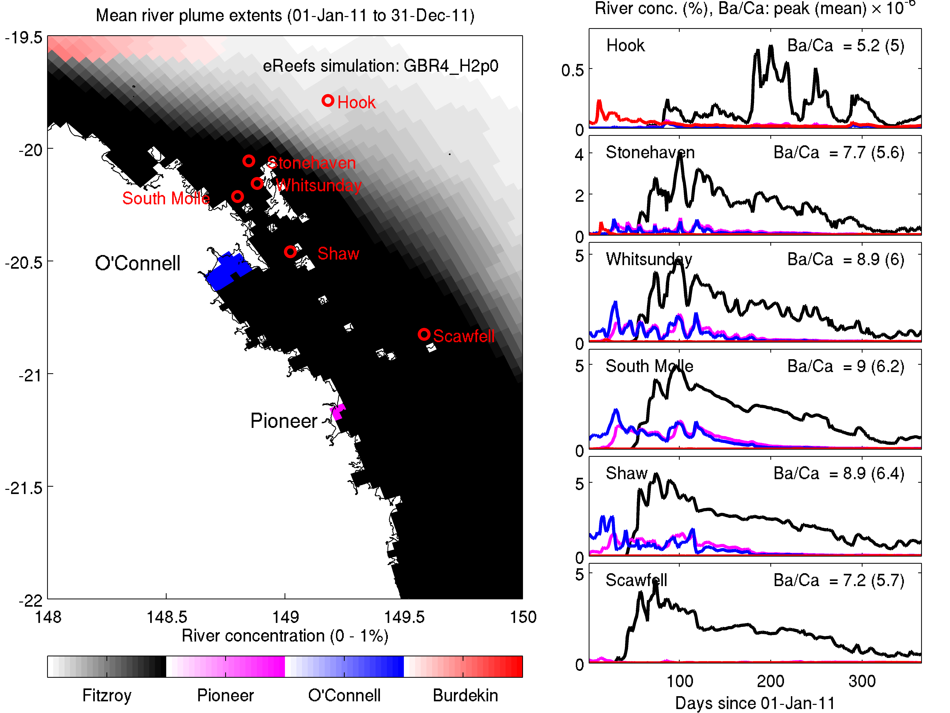

Figure 1 Mean surface river tracer concentration for 2011 (left) and time-series of the individual river tracers (right) at six coring sites. The colours on the left show only the river with the greatest concentration at the surface, while the time-series shows all 4 rivers. The top left of each site panel lists the predicted peak (and mean) Ba/Ca anomaly assuming conservative transport from the river mouth.

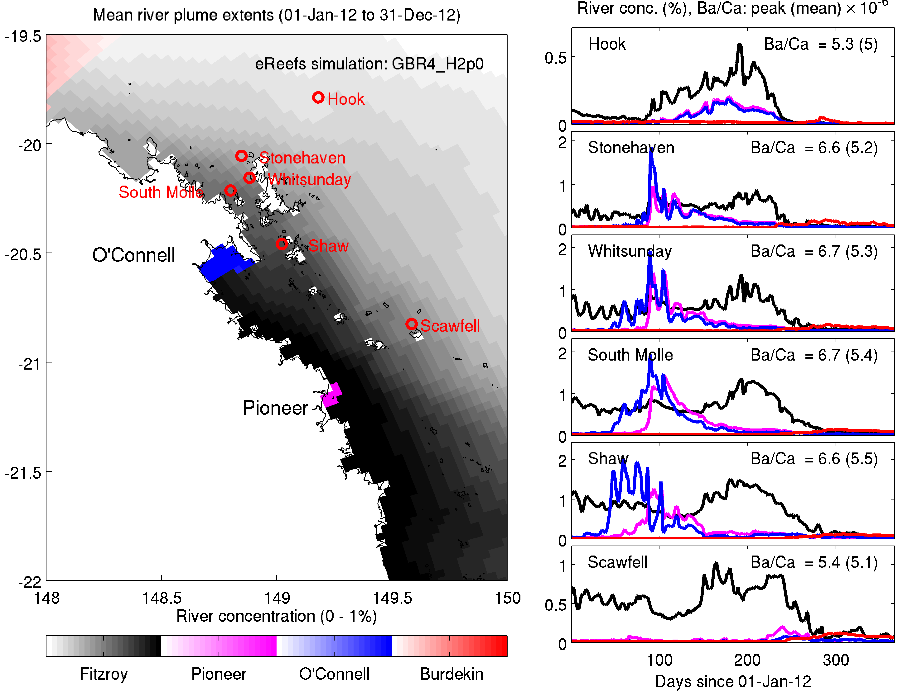

Figure 2 Mean surface river tracer concentration for 2012 (left) and time-series of the individual river tracers (right) at six coring sites. See Figure 1.

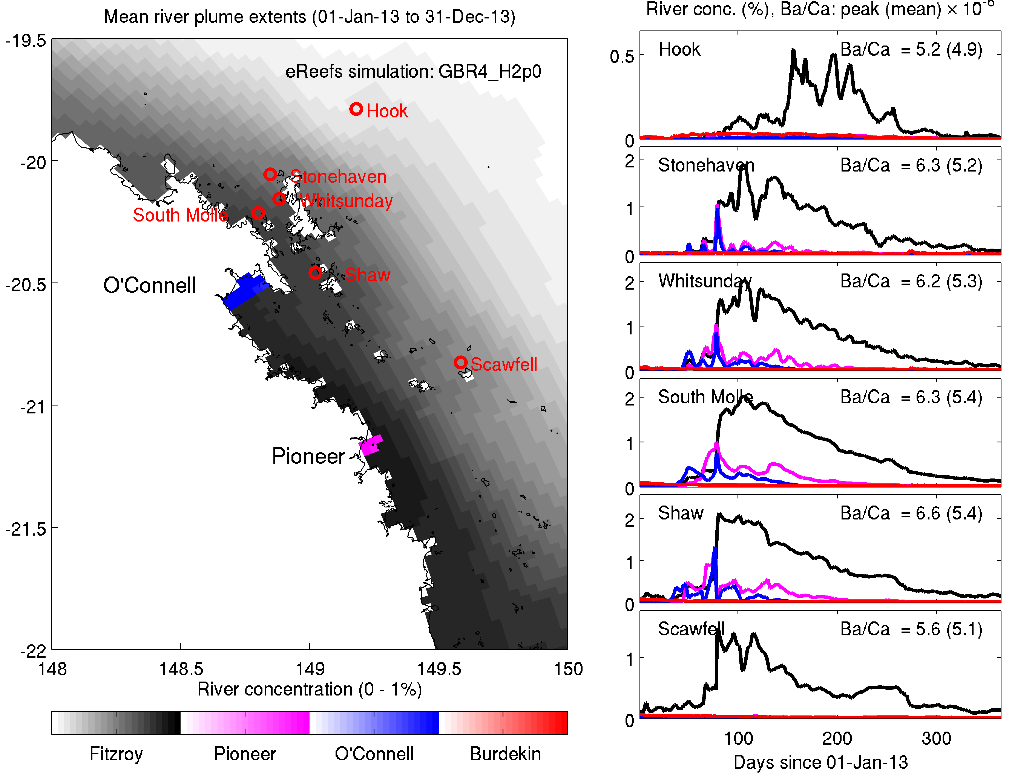

Figure 3 Mean surface river tracer concentration for 2013 (left) and time-series of the individual river tracers (right) at six coring sites. See Figure 1

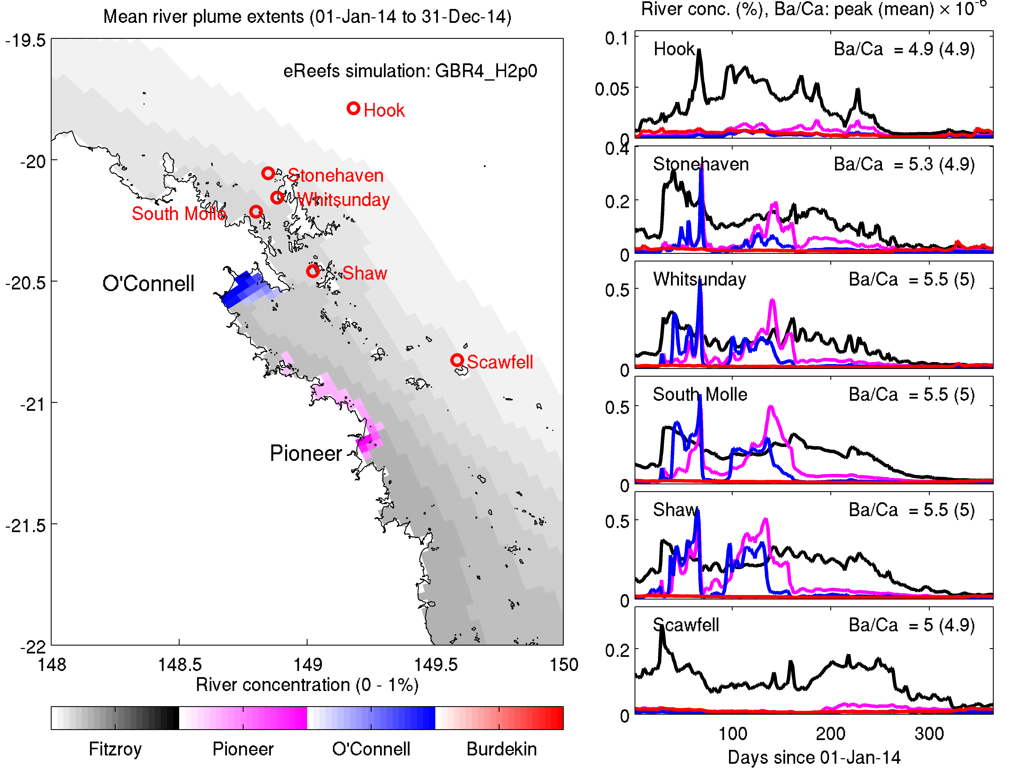

Figure 4 Mean surface river tracer concentration for 2014 (left) and time-series of the individual river tracers (right) at six coring sites. See Figure 1.

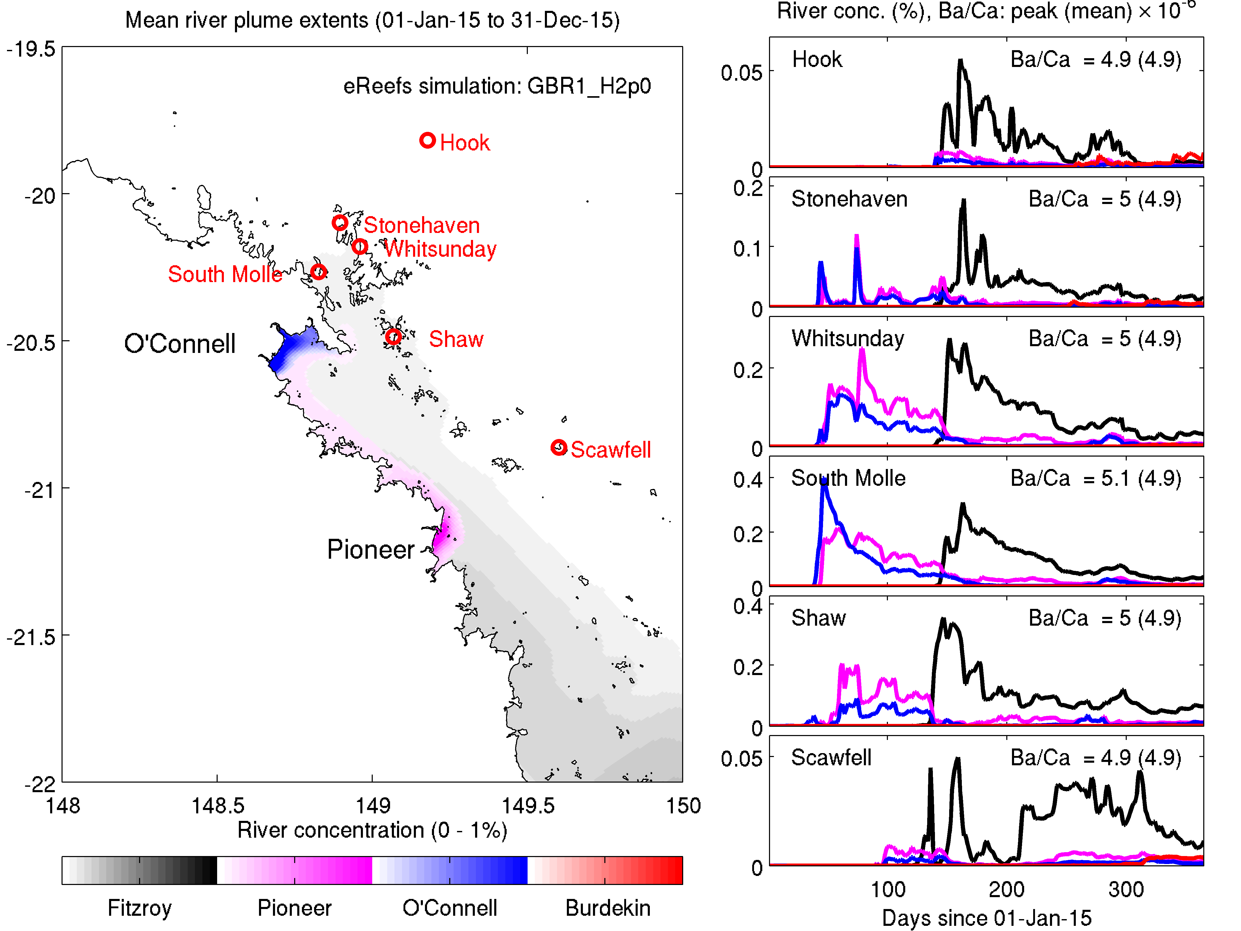

Figure 5 Mean surface river tracer concentration for 2015 (left) and time-series of the individual river tracers (right) at six coring sites. See Figure 1.

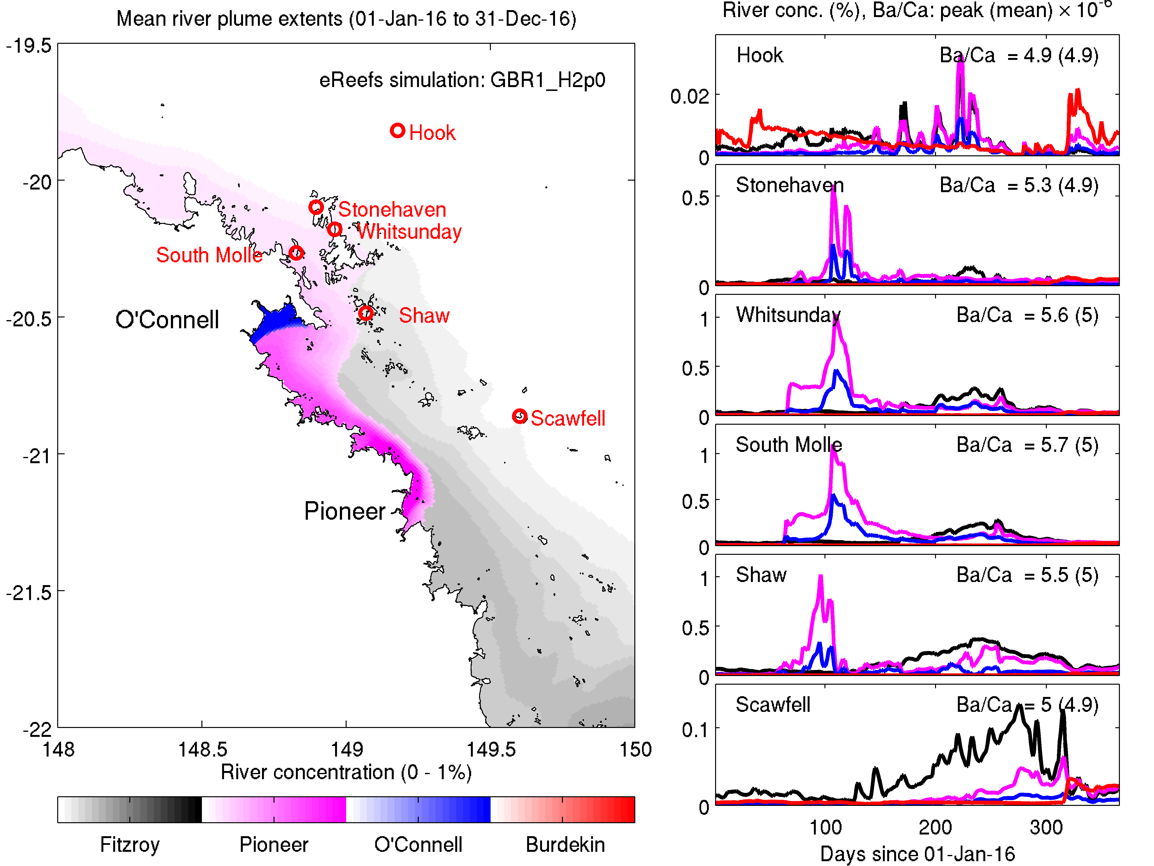

Figure 6 Mean surface river tracer concentration for 2016 (left) and time-series of the individual river tracers (right) at six coring sites. See Figure 1.

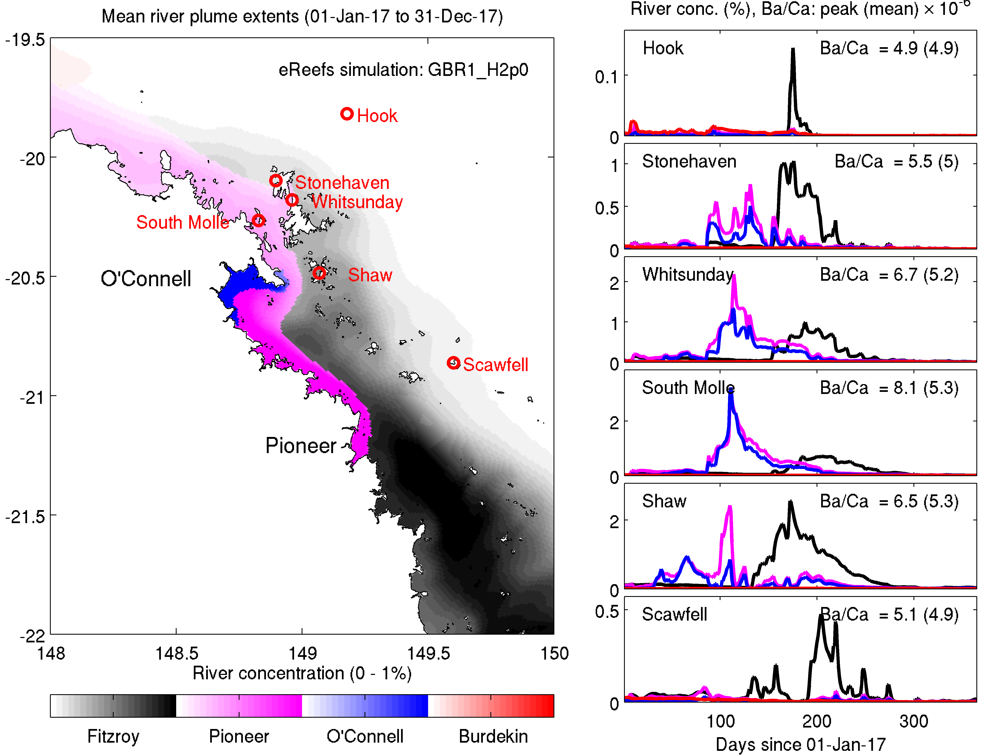

Figure 7 Mean surface river tracer concentration for 2017 (left) and time-series of the individual river tracers (right) at six coring sites. See Figure 1.

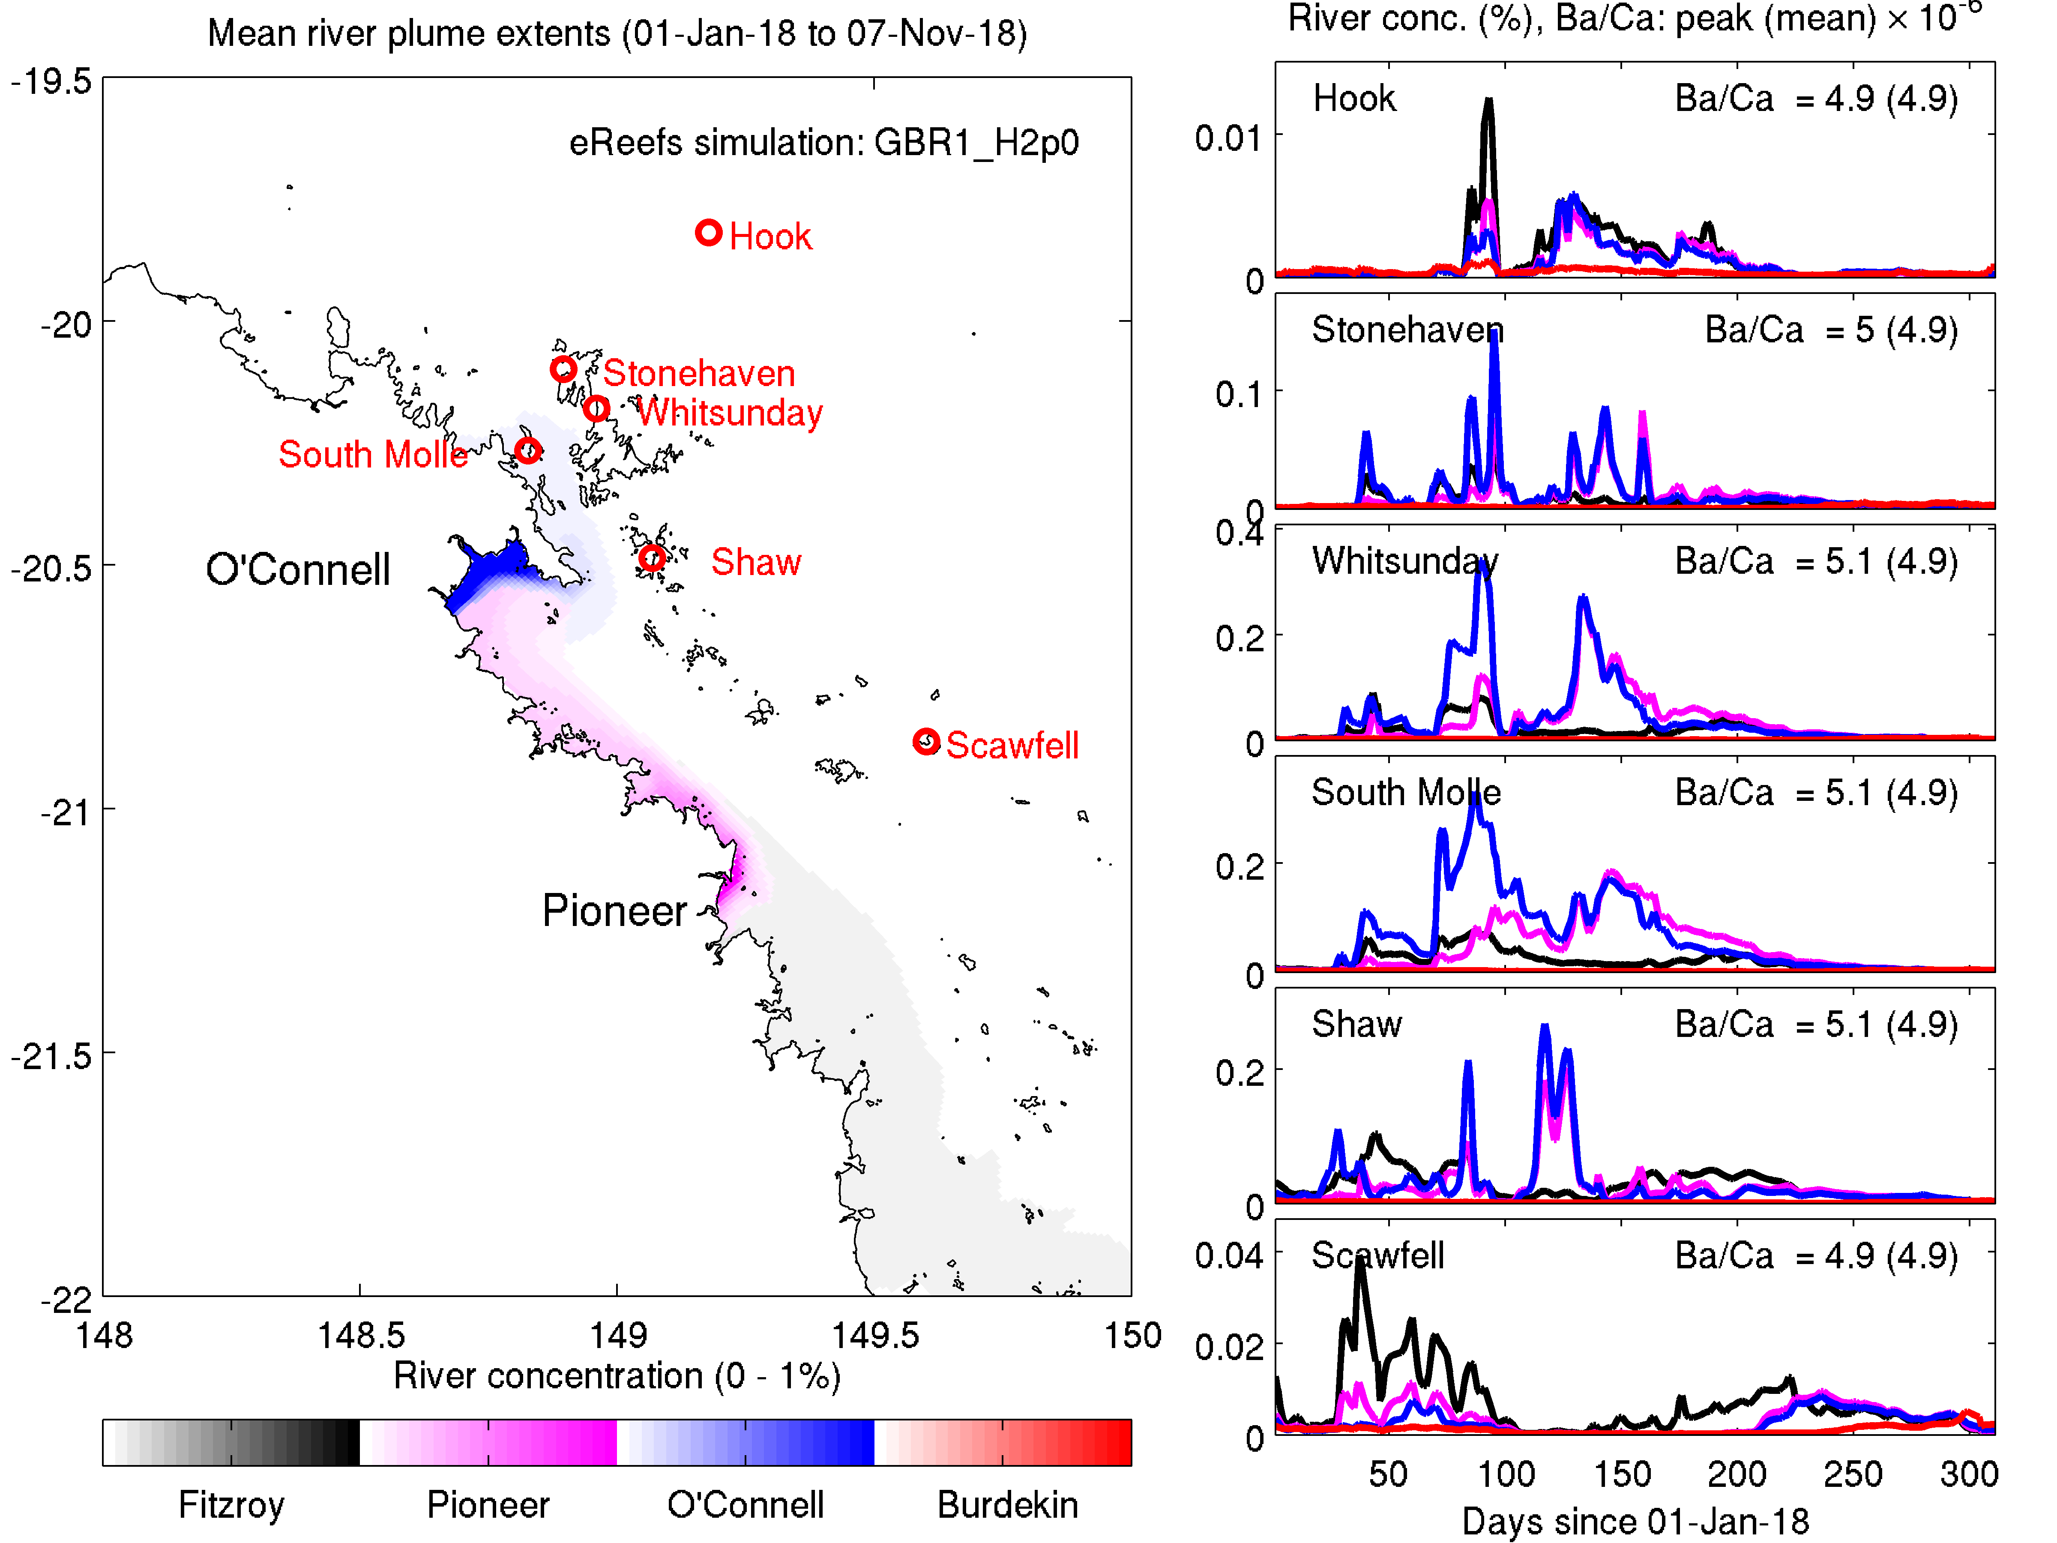

Figure 8 Mean surface river tracer concentration for 2018 (left) and time-series of the individual river tracers (right) at six coring sites. See Figure 1.

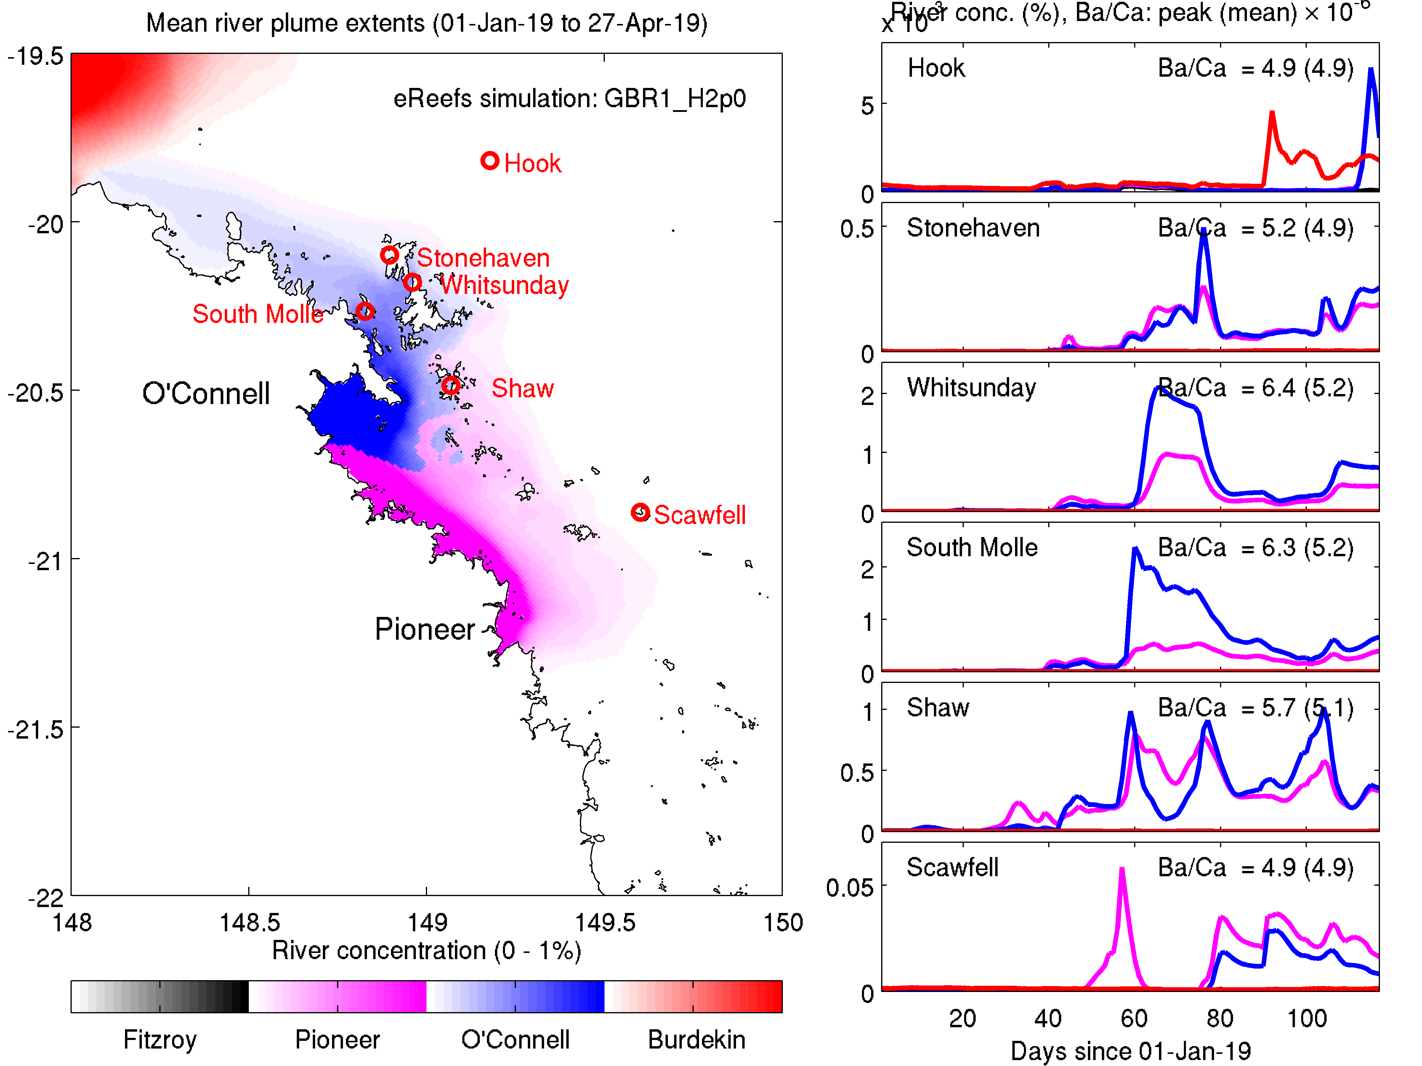

Figure 9 Mean surface river tracer concentration for 2019 (left) and time-series of the individual river tracers (right) at six coring sites. See Figure 1.

### Direct comparison of simulated and observed coral Ba/Ca ratios.

The annual averaged and peak simulated Ba/Ca ratios in the overlying water for each of the sites are shown in the top right hand corner of for each of the sites, for each of the years (Figure 2-Figure 9). The corresponding annual observations are shown in Table 1. To directly compare ratios, simulated Ba/Ca in the water are multiplied by D = 0.82 and plotted against observed values (Figure 10).

The most interesting site is South Molle, where there was an excellent match-up between observed and simulated Ba/Ca ratios (Figure 10). To obtain the match-up shown, the river plumes (here primarily the Pioneer) must be well predicted from their temporally-varying flow at the mouth, the direction they take, and the entrainment of surrounding waters. Thus, it is a more comprehensive assessment than simply correlating Ba/Ca ratios at a site with the river discharge. Rather, the model has accurately transported the correct quantity of Ba from the river mouth to the coral site. Why is South Molle so well predicted? Firstly, it is the site with the strongest river signal, so other confounding factors have less relative influence. Secondly, the Pioneer is steered through the passage between the mainland and Whitsundays Island. With the width of the plume constrained by the coastline, errors in concentration estimates due to errors in entrainment of waters from offshore of the plume are eliminated.

We leave the rest of the result to reader to draw out from Figure 2-Figure 9 the important points for their location of interest. Some of the most significant points are given in point form in the next section.

Table 1. Annual observed Ba/Ca ratios (x 10-6) at the 6 sites from 2011 – 2014 (using GBR4) and 2015 – 2018 (using GBR1) from accompanying report (Cantin et al., 2019).

|  |  |  |  |  |  |  |
| --- | --- | --- | --- | --- | --- | --- |
|  | Hook | Stonehaven | Whitsunday | South Molle | Shaw | Scawfell |
| 2011 | 2.6 | 3.6 | 2.3 | 5.0 | 2.9 | 7.0 |
| 2012 | 2.6 | 3.2 | 2.8 | 4.4 | 3.4 | 7.3 |
| 2013 | 2.7 | 3.7 | 2.3 | 4.8 | 3.1 | 8.2 |
| 2014 | 2.3 | 3.6 | 2.2 | 4.2 | 3.4 | 6.8 |
| 2015 | 2.5 | 3.6 | 2.0 | 3.9 | 3.6 | 7.9 |
| 2016 | 2.8 | 3.5 | 2.4 | 4.0 | 2.9 | 5.7 |
| 2017 | 1.5 | 2.6 | 0.8 | 4.1 |  | 3.8 |
| 2018 |  |  |  |  |  |  |

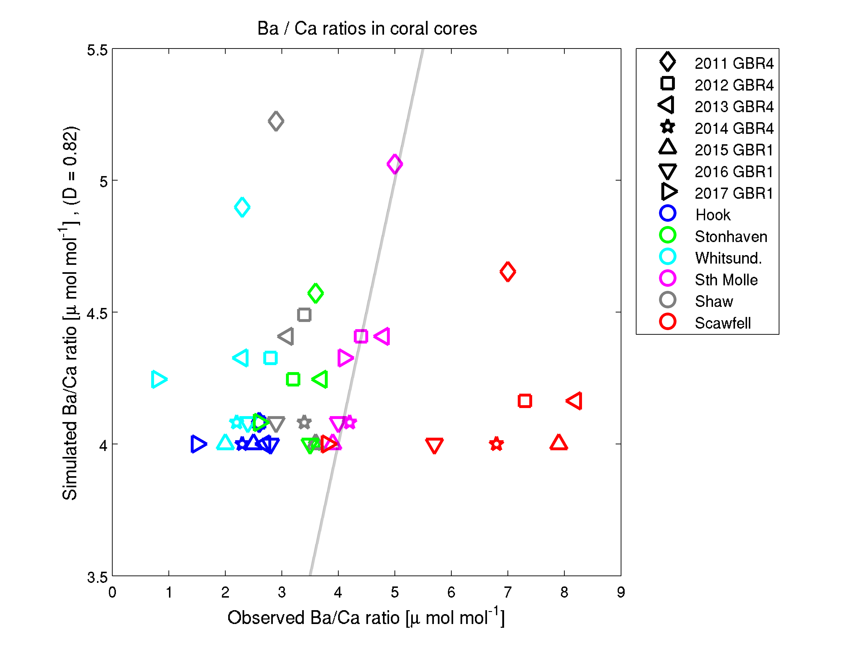

Figure 10 Comparison of observed and simulated Ba / Ca ratio in coral cores, distinguished by colour for site, and marker by year. The grey lines is a 1:1 agreement between observed and modelled Ba / Ca ratios. The displacement factor for Ba / Ca is 0.82.

## Conclusions

As described in an accompany report (Cantin et al., 2019), the measurements of Ba/Ca ratios in coral cores provided a good means to quantify the influence of river plumes at 6 sites, and to assess the river plume dynamics in the eReefs model. From this analysis we conclude:

* The Ba / Ca ratios vary within sites and across sites in a manner that cannot be entirely explained by river plume dynamics. Physiological and sediment transport processes may add variability.
* The site most influenced by river plumes was South Molle. At this site there was excellent agreement between simulated and observed Ba/Ca ratios.
* The simulated Ba/Ca ratios at the Stonehaven, Whitsundays and Shaw sites showed a similar trend between years as the observations but were offset to higher Ba/Ca ratios.
* The anonymously high observed Ba/Ca ratios at Scawfell cannot be easily explained, and don’t seem to relate to freshwater discharge of the Fitzroy.

Given that we are relatively happy with the performance of the eReefs model at capturing plume dynamics, further conclusion on plume dynamics and extent in the region can be inferred from the model outputs:

* The river with the largest, and longest lasting, influence on the Whitsundays region is the Fitzroy River, and this is especially true for the 2nd half of the year. An exception is 2019, which as of April 27, 2019, is yet to be influenced by the Fitzroy.
* The Pioneer has the second biggest influence, although this is generally restricted to the western side of Whitsundays Island.
* The O’Connell was generally the dominant plume only in northern Repulse Bay, but in the relatively low flow year of 2018 it had a relatively larger influence.
* Despite its size, the Burdekin generally flows northward from its mouth and only impacts slightly on the midshelf region of the Whitsundays (such as Hook Island).
* The annual average plume extent in 2017 shows that if the Pioneer is discharging strongly, that it dominates the waters inshore of Whitsundays Island, but does not dominant the water quality on the offshore coast of Whitsundays Island, which is most strongly influenced by the Fitzroy.
* At each of the sites, the influence of the Fitzroy is relatively smooth in time while the Pioneer and O’Connell provide a more variable, and generally shorter lasting, influence.

# Additional information

Review of the project reports received on 11 June 2019 requested further information. This has been packaged into topics for readability.

## Relative contribution of different sources of suspended sediment.

The numerical modelling investigations undertaken in this project are composed of analysis of existing simulations of the eReefs coupled physical-biogeochemical model and the running of new simulations in which the catchment loads are altered. The input of suspended sediments from the catchments is determined using the SOURCE Catchment model that has been run by the QLD government. SOURCE Catchments includes loads generated from land runoff and typical urban discharges.

This project has not attempted to consider any further additional catchment-derived sediment loads beyond those captured in the SOURCE Catchments model, or anthropogenically-driven in-water impacts such as resuspension due to dredging projects. Analysis of individual impacts is typically undertaken as a part of the approvals processes. One development of concern in the Whitsundays region is the port at Hay Point. While we have not included resuspension from Hay Point in the model simulations, a comparison of the relocated volumes of sediment with the catchment loads is possible.

It has been estimated that 550,000 m3 of sediment will be relocated for proposed future developments at Hay Point (ERA Port of Hay, 2018). This will have a mass of ~1,000,000 T, although only a fraction of the mass extracted will be released into the water column, with the rest setting at the dump site. The fate of the sediment will then depend on erosion / deposition dynamics at the release site, as well as downstream of the release site.

For comparison, according to the SOURCE catchments 2019 simulation, the 1986-2018 mean sediment discharge for the Pioneer and Fitzroy rivers are 168,000 and 2,430,900 T yr-1 respectively.

## Regional sediment budget – resuspended vs. riverine sediment

Following on from Section 4.1, we have not undertaken a complete regional sediment budget (meaning a sum of all stores and fluxes within a volume of the model). In part this is due to a large fraction of the inorganic particles in the model being stored in the sediments. The model has an approximately 1 m deep sediment. For a region such as the Whitsundays (say 500 km x 50 km), this is mass of 5 x 1010 T of sediment, or 4 orders of magnitude greater than the yearly fluxes into the region. The catchment-derived sediments delivered during the simulation that we are interested in make up only a tiny fraction of the budget. Thus, rather than a sediment budget, we have chosen to undertake simulations with altered processes to quantify sediment dynamics.

The key two processes that stakeholders are likely to want to understand are the relative importance of direct riverine loads of sediment versus resuspended sediments. This is a somewhat problematic calculation, because river loads of sediment will themselves settle and become part of the sediment, to be potentially resuspended later. Nonetheless, simple scenarios altering catchments loads can provide insights.

Our first numerical experiments included primarily a large size fraction of sediment (with sinking rate of 17 m/d). We also ran these experiments without catchment-derived sediment loads. In the bottom panel in Figure 8 of Baird and Margvelashvili (2018), we plot mean total suspended solids for the Whitsundays region with (red) and without (green) catchment loads. The lines are almost on top of each other, demonstrating that for the larger particle sizes, mean suspended solids is dominated by resuspension processes.

As the project progressed we identified the need for ultra-fine particles (called dust and forming a fluffy or nepheloid layer) that sink slowly (1 m/d) and do no deposit into the sediments, but rather stay suspended in the bottom water column layer. The dynamics of this sediment type is determined only by catchment input and ocean circulation. Looking at our publication in Marine Pollution Bulletin, Figure 7 (Margvelashvili et al., 2018), we can see that the riverine ultra-fine sediment that does not deposit decreased the optical depth (averaged over several years) by up to 1 m, representing about a 10 % decrease in the optical depth. And further, that this fraction is largest in the Whitsundays regions, as per described in Section 5 of Baird and Margvelashvili (2018). Thus, as an impact on vertical attenuation of light, resuspension is still responsible for ~90% of the attenuation due to inorganic particles, but that ultra-fine particles from rivers are responsible for the remaining 10%, and that this fraction is most important in the Whitsundays region.

As a final point on constructing a sediment budget, the analysis undertaken does illustrate accumulation of particles in pelagic and benthic layers and net erosion deposition (Figs. 8 and 10 of Baird and Margvelashvili, 2018), the most important components of a sediment budget (missing only fluxes the at the open lateral boundaries).

## Fine fraction of catchment-derived sediments.

During this project the critical role of very fine fractions of catchment sediments has been realised (see above). Several numerical experiments have been carried out to assess the volume of such particles and test updated models against observations. This work is on-going in the eReefs Project. New data became available in March 2019 on size-resolved suspended sediments in estuaries (per. Comm. Ryan Turner. Furthermore, the eReefs Project is now using the 2019 SOURCE Catchments loads (per comm. Dave Waters, May 2019).

## Discussion of uncertainties in satellite-derived estimates of water quality.

The report uses satellite estimates of vertical attenuation, Secchi depth and Coloured dissolved Organic Matter (CDOM) absorption, as well as estimates of in-water concentrations of individual constituents of chlorophyll concentration and non-algal particulates (NAPs). Ocean colour satellites such as MODIS Aqua generally have small errors in the measurement of normalised spectrally-resolved water-leaving radiance (~ 5 %, Melin et al., 2016).

When water-leaving radiance is correlated to in-water properties, such as chlorophyll concentration, more significant errors are introduced. For example, when using NASA’s three-band ocean colour algorithm for MODIS Aqua (OC3M) to fitted radiance to in situ measured chlorophyll concentrations, the global average error (mean absolute percent error) is 35 %. The errors are even greater in coastal waters for chlorophyll, where CDOM absorption leads to an overprediction of chlorophyll concentration. So further discussion of the errors in satellite estimates of water quality are warranted.

Because of these issues in coastal waters, we (Thomas Schroeder, CSIRO) converted the normalised water leaving irradiances into in-water properties using a neural network based atmospheric correction (Schroeder et al., 2007) and a bespoke inversion technique described in Section 2 of Baird and Margvelashvili (2018). A similar study (Thompson et al., 2014) was undertaken for an earlier time, and the study contains an extensive discussion of the uncertainties in satellite-derived estimates of water quality described. In summary, Thompson et al. (2014) state: ”validation results across the entire GBR using ground observations collected within ±3 h to the satellite measurements showed that for individual points, the error for the retrieval of Chl and TSS from the regionally adapted algorithm was ±90 and 70 %, respectively”.

The errors in estimating Chl and TSS quoted in Thompson et al. (2014) represent instantaneous state comparisons. For example, a comparison of the measured mass of suspended sediments compared to the satellite estimate at the same time. Two factors should be considered. Instantaneous state comparisons of highly variable phenomena can have large errors while the mean values, what we are looking for to determine a shift between two 8-year time periods, are small. Furthermore, the normalised water-leaving irradiances are essentially a measure of the sun light failing to return to the satellite sensor. Vertical attenuation coefficients and Secchi depth are similar measures, and generally have smaller errors. In contrast, properties such as the mass of TSS effect normalised water leaving irradiances as a function of the mass-specific absorption and scattering properties of the suspended sediments, which vary with particle size, shape and minerology. Similarly, mass-specific absorption and scattering by phytoplankton varies with cell type, size and physiological status. Thus remotely-sensed Secchi depth and vertical attenuation can be accurate, while Chl and TSS are less so.

The satellite retrievals at near shore Pine Island and the mid-shelf Whitsundays and Hook sites showed the expected large-scale changes: a decrease in chlorophyll concentration and NAP at the offshore sites, with reduced light attenuation and greater Secchi depth. Furthermore, the signals also showed annual variability (poorer water quality in the wet seasons) and interannual (poorer water quality following large wet seasons, especially at Pine). Thus, there is useful information in these retrievals.

To avoid issues with changing between satellites, we have used only the MODIS Aqua sensor. This sensor is periodically re-processed to account for drift in the retrieval of remote-sensing reflectance. We calculate the in-water water quality estimates from an atmospheric correction and inversion model that was applied across the whole time-series. While the drift in the sensor is accounted for, a trend in atmospheric conditions, or in the in-water constituents (i.e. finer particles with greater mass-specific scattering) are not.

## Further discussion of the comparison between in situ observations, satellite retrievals and model outputs.

This project has used in situ water samples and mooring-deployed sensors maintained by AIMS and IMOS, CSIRO processed satellite data obtained from NASA sensors and numerical models from the eReefs Project. Each of these sources of information have their limitations. It is not even easy to directly compare these data streams. As an example, in the case of chlorophyll concentration, water samples are a measure of the mass of chlorophyll, fluorometers measure the excitation of photosystems that contain chlorophyll, and satellite algorithms are based on the ratio of blue to green light.

To improve the comparisons of model and observations, Section 3.1 of Baird and Margvelashvili (2018) investigates the generating simulated observations. By this we mean that we generate model quantities that are more like the observations. As an example, simulated Secchi depth is based on the depth at which light at 488 nm reaches 37 % of surface value. Normal human vision best sees contrast at 488 nm, so this is the chosen wavelength. By bringing the observation to the model we eliminate a mis-match of types, allowing a fairer comparison.

In any case, for the purposes of determining chlorophyll concentration, we have assumed that water-sample-obtained mass of chlorophyll a is the point of truth – but these observations are rare. The other measures that we are comparing: satellite retrievals, model outputs or optically-sensed (such as fluorometers) have greater spatial and temporal resolutions but are assumed to be approximations of the “truth”.

# References

Baird, M. E., J. Andrewartha, M. Herzfeld, E. Jones, N. Margvelashvili, M. Mongin, F. Rizwi, J. Skerratt, M. Soja-Wozniak, K. Wild-Allen, T. Schroeder, B. Robson, E. da Silva, M. Devlin (2017) River plumes of the Great Barrier Reef: freshwater, sediment and optical footprints quantified by the eReefs modelling system. In Syme, G., Hatton MacDonald, D., Fulton, B. and Piantadosi, J. (eds) MODSIM2017, 22nd International Congress on Modelling and Simulation. Modelling and Simulation Society of Australia and New Zealand, December 2017, pp.1892-1898. ISBN: 978-0-9872143-7-9. <https://www.mssanz.org.au/modsim2017/L22/baird.pdf>.

Brinkman et al., 2018 Monitoring the Physical and Chemical Environment within the Reef 2050 Integrated Monitoring and Reporting Program: Final Report of the Physical and Chemical environment Expert Group.

Brodie, J., M. Baird, M. Mongin, J. Skerratt, C. Robillot and J. Waterhouse (2017) Pollutant target setting for the Great Barrier Reef: Using the eReefs framework. In Syme, G., Hatton MacDonald, D., Fulton, B. and Piantadosi, J. (eds) MODSIM2017, 22nd International Congress on Modelling and Simulation. Modelling and Simulation Society of Australia and New Zealand, December 2017, pp. 1913-1919. ISBN: 978-0-9872143-7-9. <https://www.mssanz.org.au/modsim2017/L22/brodie.pdf>

Brodie, J., Baird, M., Waterhouse, J., Mongin, M., Skerratt, J., Robillot, C., Smith, R., Mann, R., Warne, M., 2017. Development of basin-specific ecologically relevant water quality targets for the Great Barrier Reef. TropWATER Report No. 17/38, James Cook University, Published by the State of Queensland, Brisbane, Australia. 68 pp.

Herzfeld, M. (2015). Methods for freshwater riverine input into regional ocean models. Ocean Model. 90, 1 – 15.

Herzfeld, M., J. Andrewartha, M. Baird, R. Brinkman, M. Furnas, P. Gillibrand, M. Hemer, K. Joehnk, E. Jones, D. McKinnon, N. Margvelashvili, M. Mongin, P. Oke, F. Rizwi, B. Robson, S. Seaton, J. Skerratt, H. Tonin, and K. Wild-Allen (2016). eReefs Marine Modelling: Final Report, CSIRO, Hobart 497 pp. http://www.marine.csiro.au/cem/gbr4/eReefs Marine Modelling.pdf. Technical report.

Jones, EM; Doblin, MA; Matear, R; King, E. (2015) Assessing and evaluating the ocean-colour footprint of a regional observing system. J. Mar. Sys.143:49-61.

Lewis SE, Lough JM, Cantin NE, Matson EG, Kinsley L, Bainbridge ZT, Brodie JE (2018) A critical evaluation of coral Ba/Ca, Mn/Ca and Y/Ca ratios as indicators of terrestrial input: New data from the Great Barrier Reef, Australia. Geochemica et Cosmochimica Acta 237: 131-154.

Gonneea, Meagan Eagle, Anne L. Cohen, Thomas M. DeCarlo, Matthew A. Charette (2017) Relationship between water and aragonite barium concentrations in aquaria reared juvenile corals, Geochimica et Cosmochimica Acta, 209, 123-134.

Kenneth S. Johnson (1981) The calculation of ion pair diffusion coefficients: A comment, Marine Chemistry,10, 195-208.

Margvelashvili, N. M., J. Andrewartha, M. Baird, M. Herzfeld, E Jones, M. Mongin, F. Rizwi, B. Robson, J. Skerratt, K. Wild-Allen and A. Steven (2018) Simulated fate of catchment-derived sediment on the Great Barrier Reef shelf. Mar. Poll. Bull. 135: 954-962.

Mélin F., G. Sclep, T. Jackson, S. Sathyendranath (2016) Uncertainty estimates of remote sensing reflectance derived from comparison of ocean color satellite data sets, Remote Sensing of Environment,177,107-124.

Oke, Peter; Sakov, Pavel. Assessing the footprint of a regional ocean observing system. Journal of Marine Systems. 2012; 105-108:30-51.

Schroeder T, Behnert I, Schaale M, Fischer J, Doerffer R (2007) Atmospheric correction algorithm for MERIS above case-2 waters. Int J Remote Sens 28:1469–1486.

Thompson A, Schroeder T, Brando VE, Schaffelke B (2014) Coral community responses to declining water quality: Whitsunday Islands, Great Barrier Reef, Australia. Coral Reefs 33(4): 923-938.

Environmental Risk Assessment PORT OF HAY 2018. North Queensland Bulk Ports Corporation.