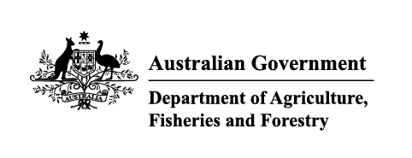

# Imported food holding order—failing food

Section 15(1) of the *Imported Food Control Act 1992* (the Act)

| Holding order number: | 19883 | Date: | June 2025 |
| --- | --- | --- | --- |

## Section A: The basis for this order

| Section 15(1)(a) of the Act | X |
| --- | --- |

An inspection, or inspection and analysis, of examinable food of a particular kind indicates the food, or a part of the food, to be failing food.

or

| Section 15(1)(b) of the Act |  |
| --- | --- |

The secretary (or delegate) is satisfied that there are reasonable grounds for believing that food of a particular kind would, on inspection, or inspection and analysis, be failing food.

## Section B: Food that this order covers

This order covers the food of a particular kind identified in this table:

| Country of origin | India |
| --- | --- |
| Product description | Mung dal |
| Producer name | Adarsh Global |

Until this order is revoked, food imported into Australia that is covered by this order must be held in a place to be approved by an authorised officer in writing, until an inspection, or inspection and analysis, required under the Imported Food Inspection Scheme has been completed.

## Section C: The circumstances under which this order will be revoked

This order remains in force until the secretary (or delegate) revokes it. The secretary (or delegate) will immediately revoke this order if satisfied that the basis for the order no longer applies.

| Delegate position number | Date |
| --- | --- |
| 100091 | 4/07/2025 |

Delegate of the secretary appointed under Section 41 of the Act for the purposes of Section 15 of the Act.