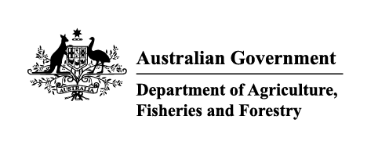

Imported food holding order—failing food
Section 15(1) of the Imported Food Control Act 1992 (the Act)
Holding order number: | 20006 | Date: | October 2025

Section A: The basis for this order
Section 15(1)(a) of the Act | X
An inspection, or inspection and analysis, of examinable food of a particular kind indicates the food, or a part of the food, to be failing food.
or
Section 15(1)(b) of the Act
The secretary (or delegate) is satisfied that there are reasonable grounds for believing that food of a particular kind would, on inspection, or inspection and analysis, be failing food.

Section B: Food that this order covers
This order covers the food of a particular kind identified in this table:
Country of origin | Thailand
Product description | Rice
Producer name | Uthai Produce Co Ltd
Until this order is revoked, food imported into Australia that is covered by this order must be held in a place to be approved by an authorised officer in writing, until an inspection, or inspection and analysis, required under the Imported Food Inspection Scheme has been completed.

Section C: The circumstances under which this order will be revoked
This order remains in force until the secretary (or delegate) revokes it. The secretary (or delegate) will immediately revoke this order if satisfied that the basis for the order no longer applies.
Delegate position number | Date
100091 | 8/10/2025
Delegate of the secretary appointed under Section 41 of the Act for the purposes of Section 15 of the Act.

