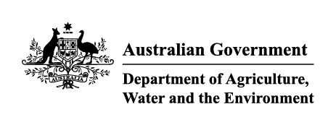

Instrument revoking a holding order under section 15(2) of the Imported Food Control Act 1992
The listed holding orders, having satisfied the circumstances under which the orders will be revoked, are revoked under section 15(2) of the Act. The circumstances being that the Secretary (or delegate) is satisfied that the basis for the order no longer applies.
Holding order number | Date revoked
17149 | 10/03/2022
16073 | 10/03/2022
17379 | 10/03/2022
16143 | 10/03/2022
16914 | 10/03/2022
16947 | 10/03/2022
16243 | 10/03/2022
17130 | 10/03/2022
17071 | 10/03/2022
16517 | 10/03/2022
17160 | 22/03/2022
17367 | 22/03/2022
16200 | 22/03/2022
17550 | 22/03/2022
16560 | 28/03/2022
10652 | 28/03/2022
13942 | 28/03/2022
15541 | 28/03/2022
17581 | 29/03/2022

Delegate position number Date
100091 | 08/06/2022
Delegate of the secretary for the purposes of section 15(2) of the Act.

