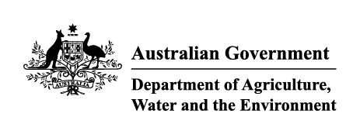

Instrument revoking a holding order 15(6)
Section 15(6) of the Imported Food Control Act 1992 (the Act)
The following holding order(s), having satisfied the circumstances specified for revocation, is/are revoked under section 15(6) of the Act.
Holding order number | Date revoked
THO19001 | 08/12/2020
Delegate position number Date
106453 | 07/12/2020
Delegate of the Secretary for the purposes of section 15(6) of the Act.

