Formatting guide for honey levy returns with levy payer information

Who must lodge the levy return? | - A producer who produced more than 1,500 kilograms of honey in a calendar year and exported, sold honey by designated sale (without going through an intermediary), or used honey in the production of other goods must lodge a return for each quarter. If application for exemption from lodging returns quarterly are granted, the producer can lodge annual return.  - An intermediary, including a first purchaser, buying agent, selling agent or exporting agent.
Who is the levy payer for this return? | - A producer of honey - the person who owned the honey immediately before sale, used honey in the production of other goods or exported honey.

All levy returns for honey transactions from 1 January 2023 onwards must include levy payer information in addition to information required under Schedule 21 of the Primary Industries Levies and Charges Collection Regulations 1991 (PILCC Regulations).
An upload template will be required from 1 January 2023 by Levies Online as part of your levy return. The upload template is required to calculate the levy amount payable and record levy payer information for each levy payer. The template captures levy payer information in accordance with subregulation 10(4B) of the PILCC Regulations.
The upload file must be completed in a particular way to allow the Levies Online to generate accurate information. You can use the upload template provided by the department or alternatively you can create your own report, as long as it contains the same information as per the upload template and is formatted according to the requirements identified below. Files must be a .csv file to be uploaded to Levies Online.
This formatting guide is specific to honey and provides guidance on data variations accepted by Levies Online.
Figure 1 below provides formatting requirements specific to the honey upload template. Item tag and value are specific to each commodity and enable identification of the leviable product that the levy payer is dealing with and to calculate the levy amount.
Figure 2 provides information on accepted formatting variations for levy payer information. The headers for all information in the upload template must be replicated with the exact spelling and spacing as provided by the template.
Figure 1: formatting requirements specific to the honey upload template
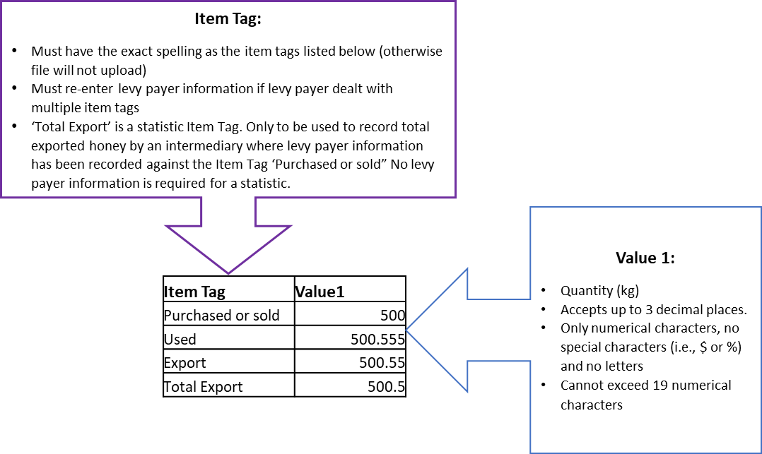

Figure 2: formatting requirements for levy payer information.
