Adding a TRACES exporter number
Please note that this guide is for exporters that wish to update their account and include their TRACES exporter number. For a first-time registration, please refer to Create and Manage your account user guide for instructions on how to complete this registration.

1 | Log into the Online Services Portal  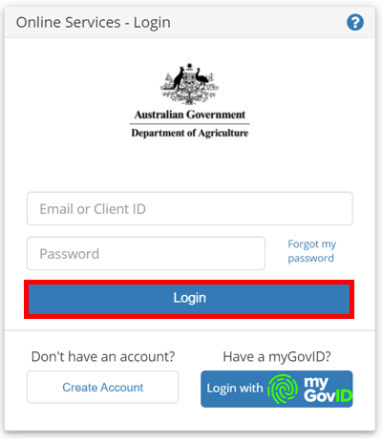
2 | Select Go to NEXDOC Homepage.  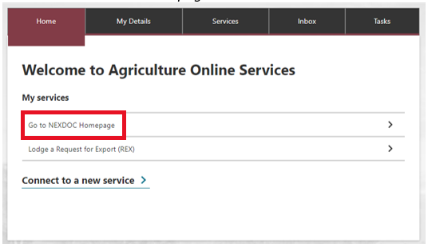  Note: The NEXDOC Homepage will display.
3 | Select the Account tab.  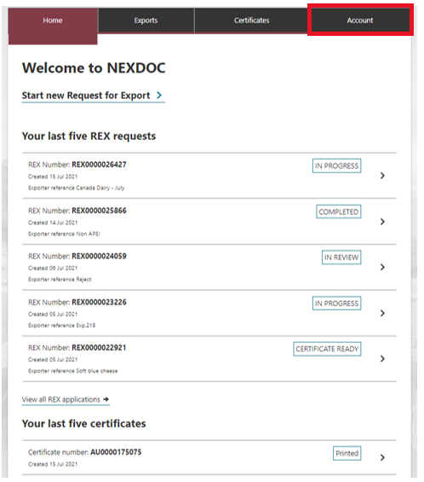  Note: The Account screen will display.
4 | Select NEXDOC services.  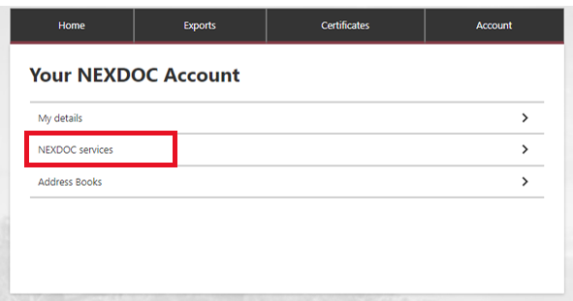  Note: The My details tab will redirect you back to the Online Service Portal detail screen. These details relate to your Online Service Portal account, not your NEXDOC account.
5 | Select Exporter Management.  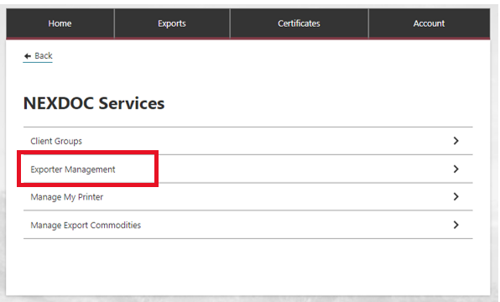  Note: The Manage Exporters screen will display.
6 | Select the exporter profile you wish to update.  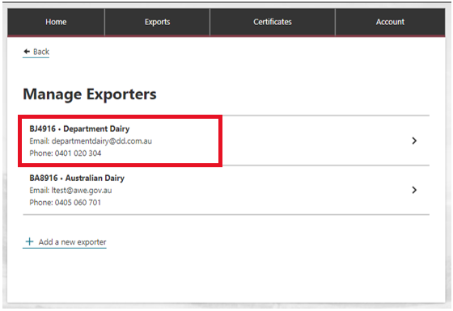  Note: The Exporter Profile screen will display.
7 | Enter your TRACES exporter number.  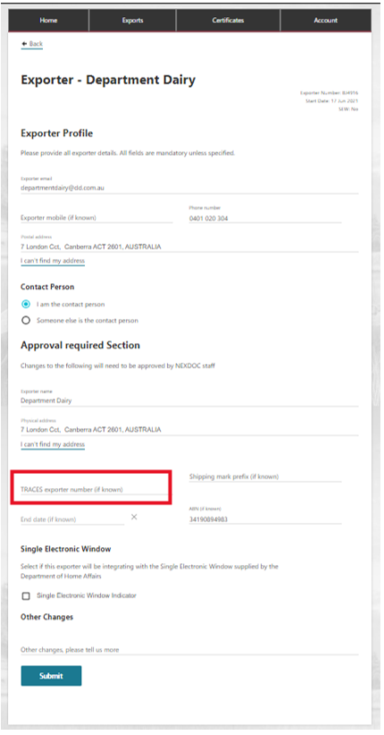
8 | Select Submit.  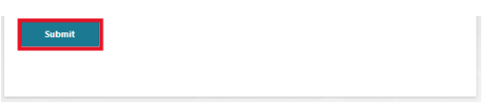
9 | Your TRACES exporter number update has now been lodged with the department.  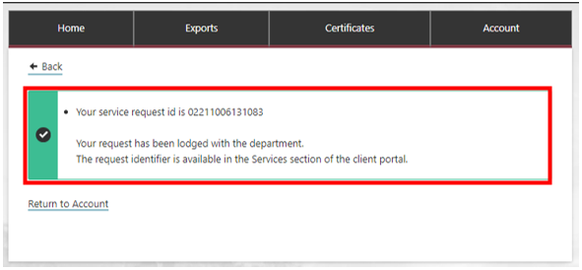
10 | Once your request has been actioned by the department, you will receive a notification in your NEXDOC inbox.  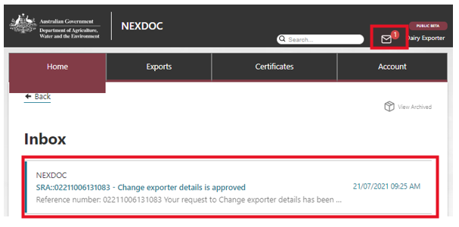

11 | If your TRACES exporter number is rejected, the notification will provide reasoning for this decision. Complete steps 3 to 8 to re-lodge.  