How do I Check the Status of My Lodgement or Enquiry?

This task card demonstrates how to check the status of your lodgement or enquiry online via the Cargo Online Lodgement System (COLS). You will receive real time progress advice on the status of your lodgement or enquiry.

Checking Lodgement or Enquiry Status in COLS

You can check the status of your lodgement or enquiry using your Lodgement Reference Number (LRN).

Go to **COLS** and enter your LRN into the field below the **Check Lodgement Status** icon.

*TIP: The LRN will be the number provided via email at the time of lodgement.*

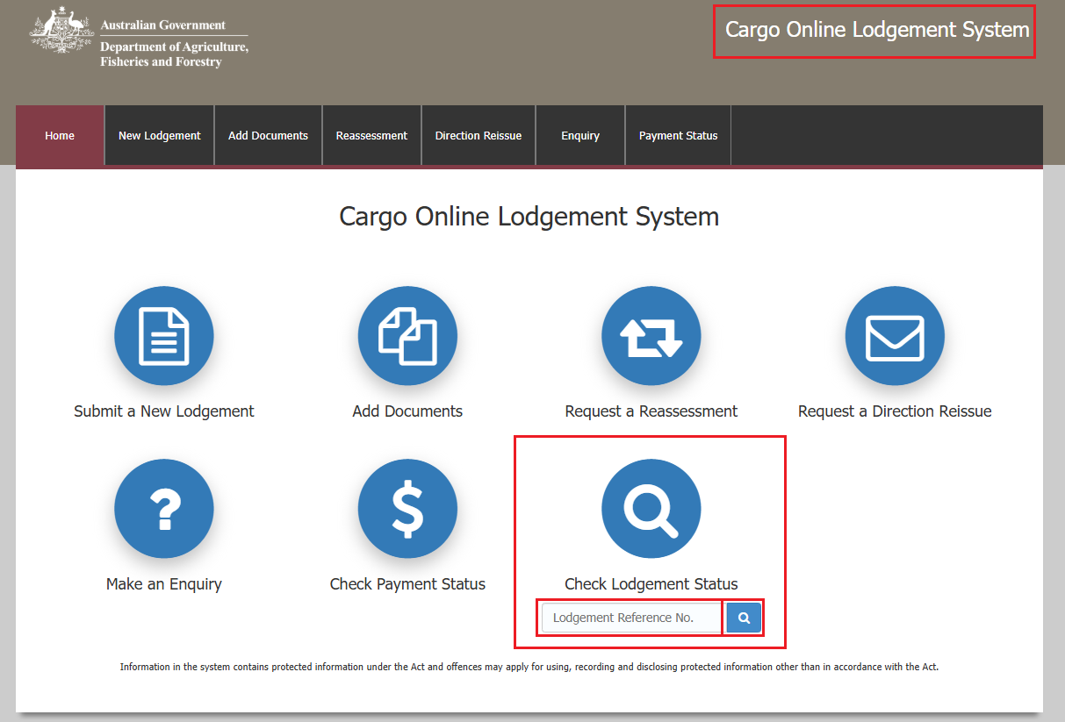Select the **magnifying glass** icon to search.

Here you will see the status of your lodgement or enquiry.

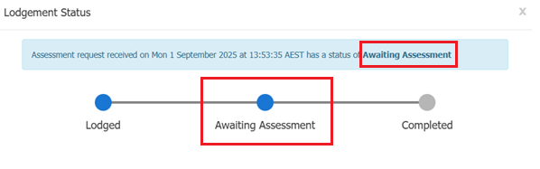

TIP: The status that the lodgement or enquiry has moved through to will be shown by a blue dot.

The statuses that can display are:

* Lodged
* Awaiting Assessment
* Assessment in progress
* Escalated
* Additional Information Requested
* Complete

Checking Lodgement or Enquiry Status in COLS via Email Link

Locate the confirmation email which was sent to the email address specified at the time of creating your lodgement or enquiry.

Within the email, select the **Check Lodgement Status** link.

Red highlighted box around the check lodgement status hyperlink from the email.

You will be navigated to the COLS website with the LRN automatically entered in the **Check Lodgement Status** field.

Select the **magnifying glass** icon to search.

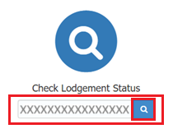

Here you will see the status of your lodgement or enquiry.



TIP: The status that the lodgement or enquiry has moved through to will be shown by a blue dot.