How do I Check the Status of my Reservation?

*This task card demonstrates how to check the status of your reservation(s) for the Post Entry Quarantine (PEQ) facility. After you have successfully created a reservation, you will be able to check the status of your reservation online via the Post Entry Biosecurity System (PEBS).*

Checking Reservation Status in PEBS

You can check the status of your reservation using the PEQ Reference Number (PRN).

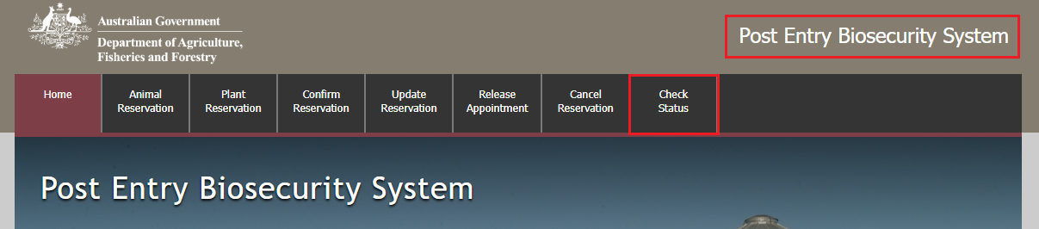Go to **PEBS** and select Check Status from the main toolbar.

Enter your PRN and select Check Status.

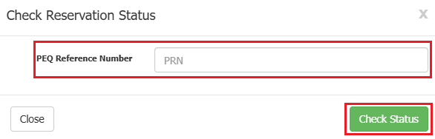

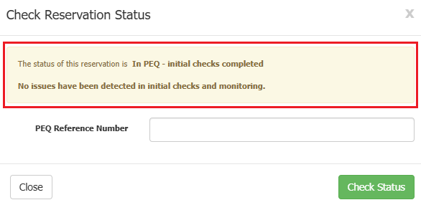Here you will see the status of your reservation before, during and after the consignments stay at PEQ.

Checking Reservation Status in PEBS via Email Link

Locate the confirmation email sent to the email address specified at the time of creating your reservation.

Within the email select the **check the status of your reservation** link.

Red highlighted box around the check the status of your reservation hyperlink from the email mentioned.

You will be navigated to the PEBS website with the PRN automatically entered in the **PEQ Reference Number** field, within the check reservation status pop-up.

Select Check Status.

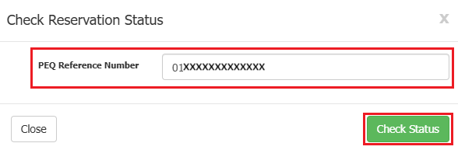

Here you will see the status of your reservation before, during and after the consignments stay at PEQ.

