How do I Confirm my Reservation?

This task card demonstrates how to confirm your reservation for your consignment to attend quarantine at the Post Entry Quarantine (PEQ) facility.

Confirm your Reservation

Once you receive a reservation approved email from the Department that the facility can house your consignment, you will be able to confirm your reservation online via the Post Entry Biosecurity System (PEBS).

*NOTE: You will need to confirm your reservation at least 14 days prior to your consignment’s arrival at PEQ. If your reservation is not confirmed and your consignment will arrive within 7 days, please email* [*PEQServices@aff.gov.au*](mailto:PEQServices@aff.gov.au) *for assistance*.

Go to **PEBS** and select **Confirm** within the **Confirm Reservation** box or **Confirm Reservation** from the main toolbar.

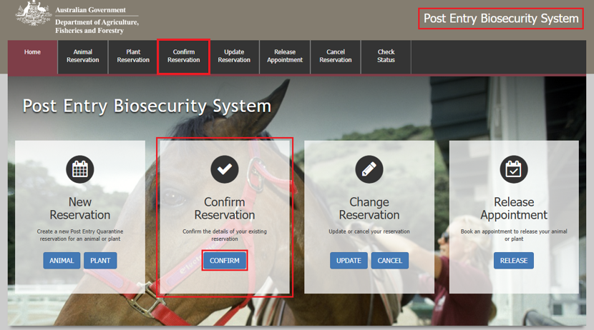

Reference Screen

Enter your **PEQ Reference Number (PRN)**, which was emailed to you at the time of creating your reservation.

Enter the **Reservation email** you specified at the time of creating your reservation.

Select **Next**.

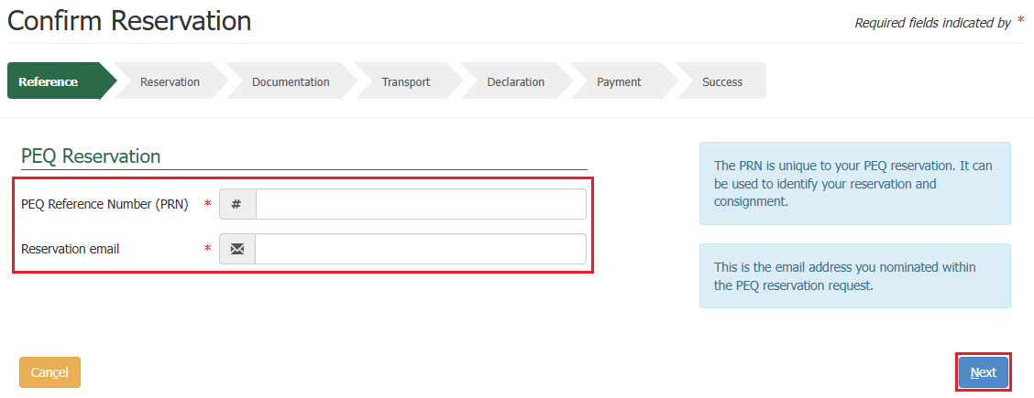

Reservation Screen

A summary of your reservation will be displayed.

Select **Next**.

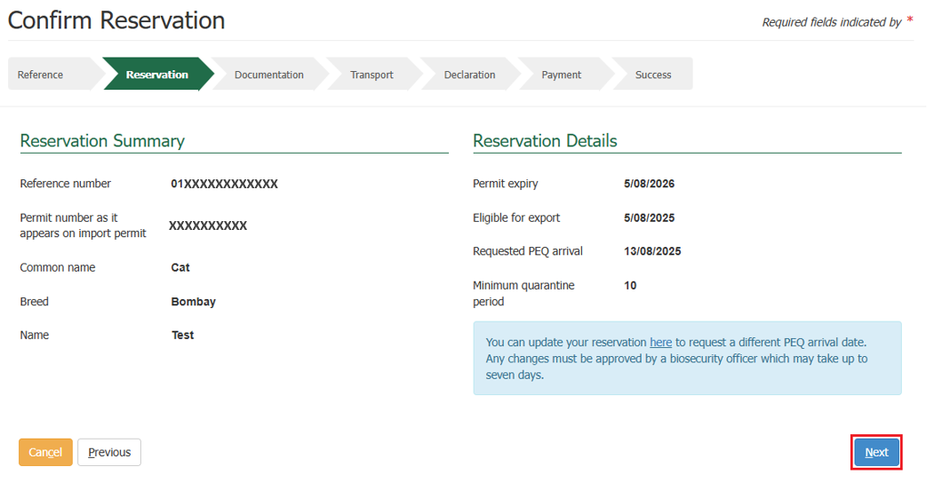

Documentation Screen

This section allows you to upload documents required for your reservation.

*TIP: You can upload as many files as required. The system supports the uploading of files and images with extensions of TIF, JPG, JPEG, PDF, DOC, DOCX, PNG, MSG, PST and OST. It is recommended that you upload readable images (e.g. 100dpi).*

*You will need to ensure each file is limited to 20MB.*

PEBS supports the drag and drop feature meaning you can drag a file from your computer and drop it into the **File Upload** section.

Alternatively, you can select the **Choose Files** option in the **File Upload** section to select a file to download.

Once your document is added, it will display in the **Document Details** section where you will have the option to select a **Type** from the drop down and add **Additional Information** against each document.

If you want to remove a file you have just uploaded, select the **bin** icon within the action’s column against that document.

Select **Next.**

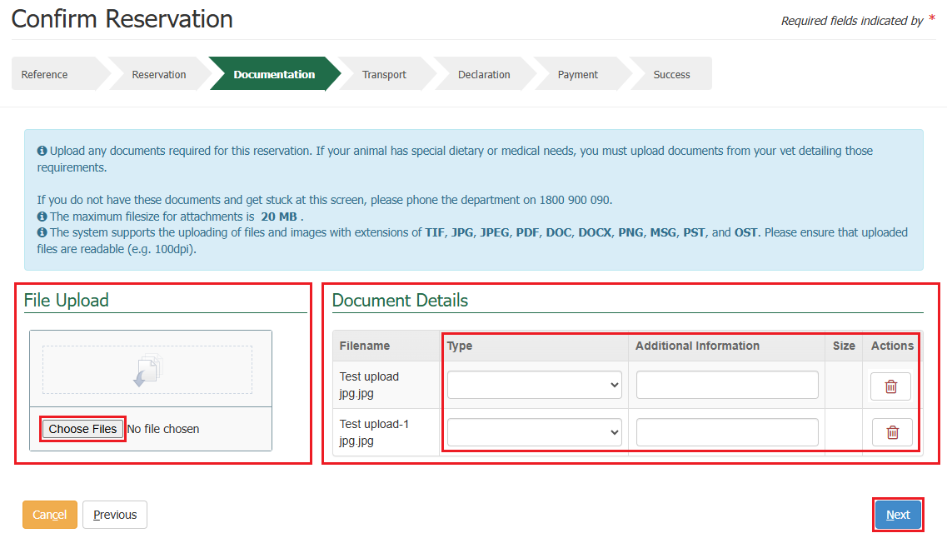

Transport Details

This section allows you to provide transport details for your consignment.

*TIP: If you do not have this information at this time, you can select* ***Next*** *without providing any details.*

If you have transport details you would like to add, fill in the details accordingly.

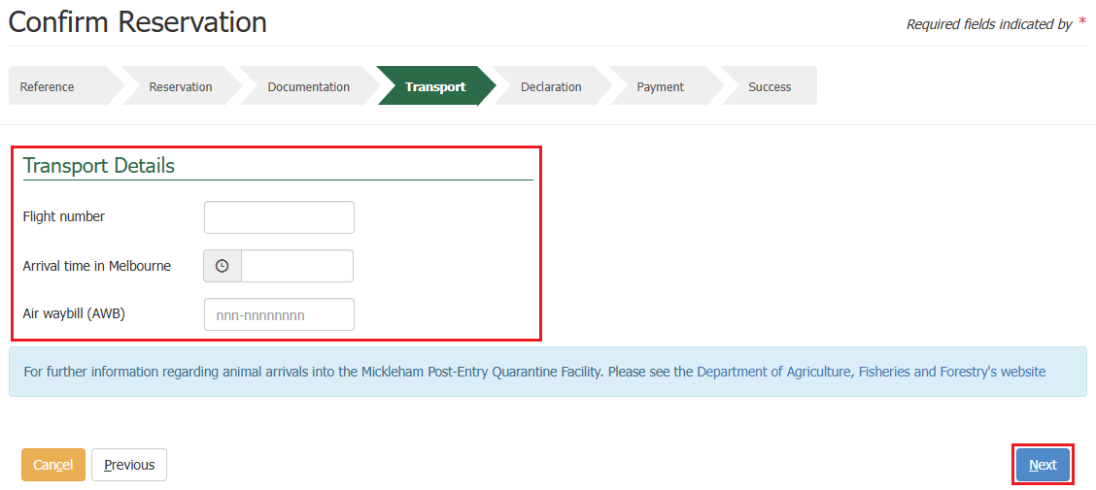Select **Next.**

Declaration Screen

This section allows you to provide any **Additional Information** related to your reservation, and to be added as a record to the reservation.

The general declaration checkbox will need to be ticked to proceed, if you agree to the declaration, select the **General Declaration checkbox** to proceed. If you do not agree, you cannot continue with the reservation.

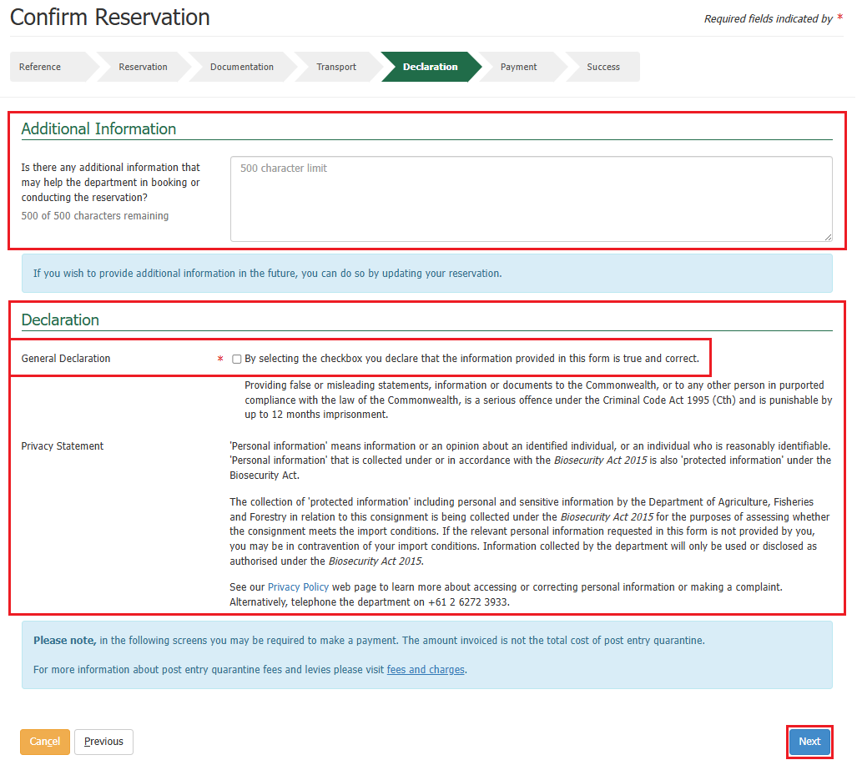Select **Next**.

Making a Payment

Services Screen

You will be expected to make a confirm reservation payment. The system will present you with a service summary screen containing:

* The **reference** which is the PRN that was created when creating your reservation.
* The **description** which includes your consignment type, what pathway is applicable to your consignment, the quantity, and the additional information which is based on what pathway is applicable to your consignment.
* The **service description** which outlines the services for the reservation that the charges are for, the quantity and pricing.

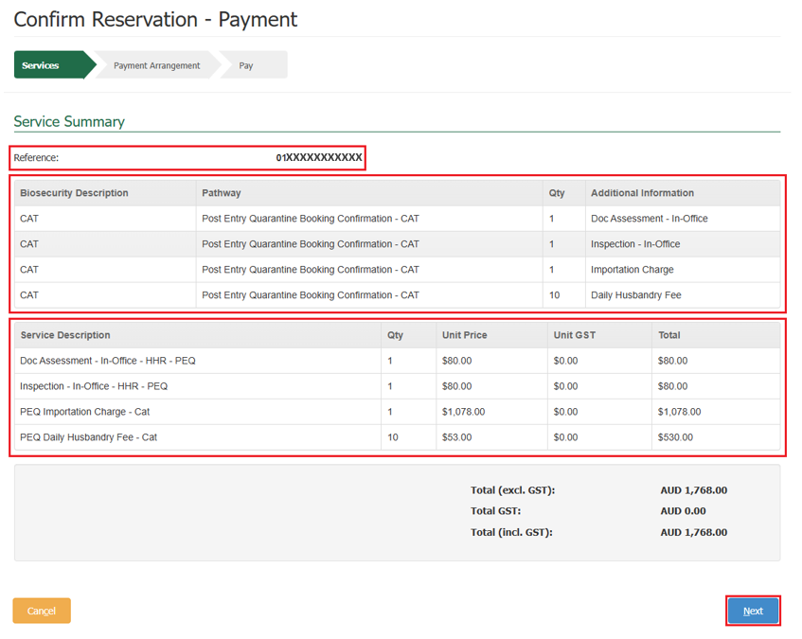 Select **Next.**

Payment Arrangement Screen

This section allows you to enter an account number if you have one.

*NOTE: If you are an AIMS account client with the Department of Agriculture, Fisheries and Forestry, you will still be required to pay via credit card for your reservation, but your invoice will be sent to the email address nominated against your account number. Questions regarding account clients can be directed to* [*ARhelpdesk@aff.gov.au*](mailto:ARhelpdesk@aff.gov.au)*.*

* If you have an account number, select **Yes**, provide the account number, and select **Continue to Payment.**
* If you do not have an account number, select **No** and select **Continue to Payment.**

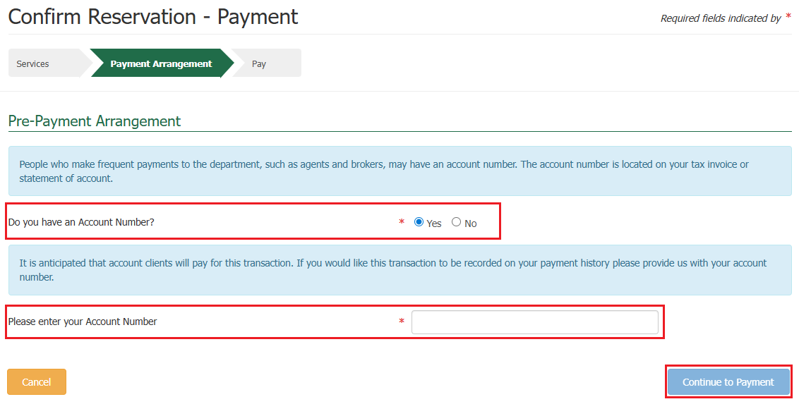

Pay Screen

Upon selecting continue to payment, you will be presented with the payment screen. You will be prompted for your card details.

Fill in the details as required and select **Pay Now**.

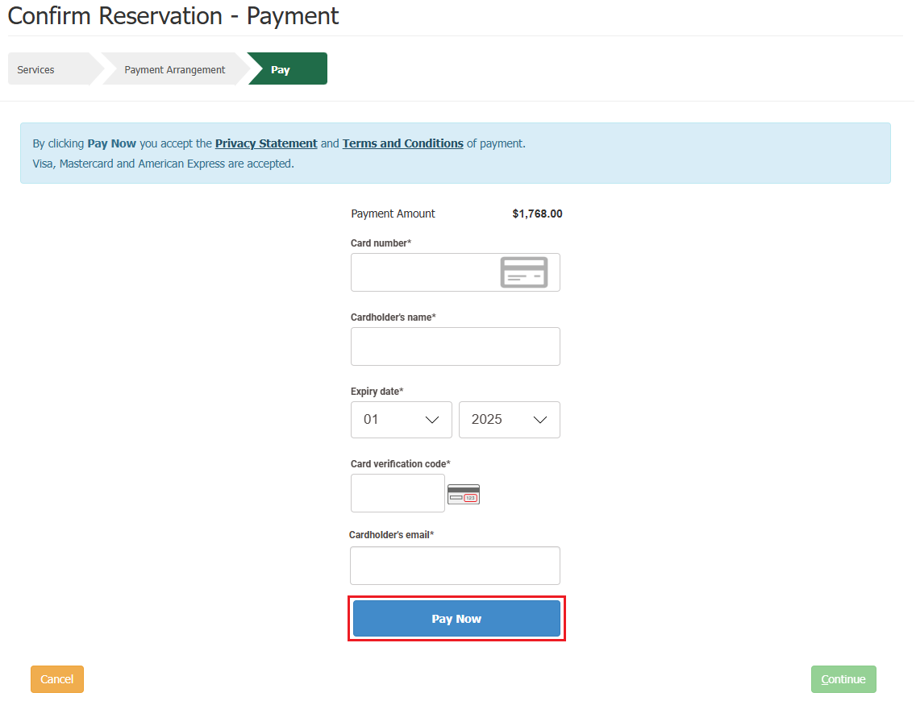

Upon selecting pay now, you will be presented with a payment confirmation screen.

Select **Continue**.

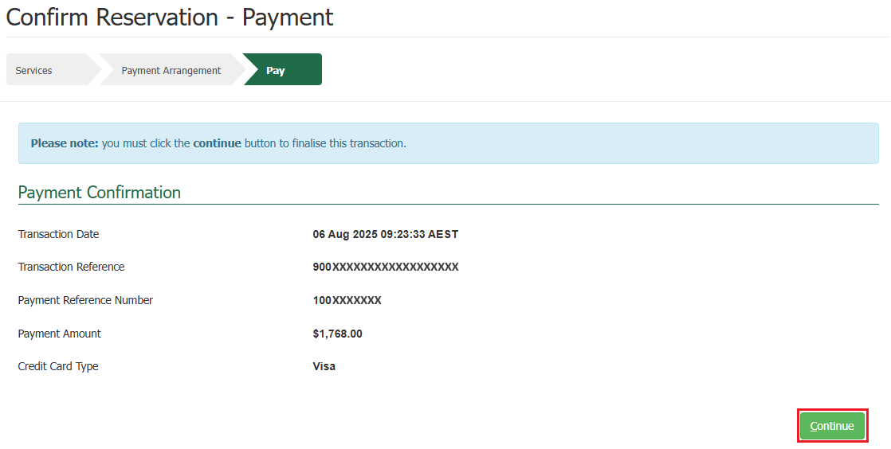

Success Screen

You will be presented with a success screen confirming your confirmation with your **PRN** listed.

*TIP: Please quote your PRN during your communications with the PEQ Services Team.*

An email advising your reservation is confirmed will be sent to the reservation email you specified at the time of creating your reservation.

The system will send you an automatic email containing a Tax Invoice / Receipt for this transaction.

* If you are an account client, the email will be sent to the email nominated against the account number.
* If you are not an account client, the email will be sent to the email you specified at the time of creating your reservation.

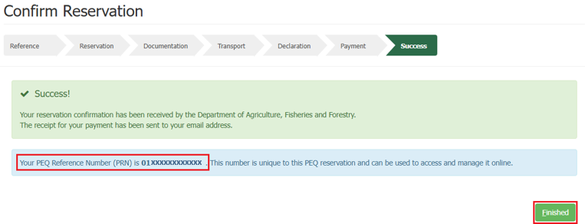Selecting **Finished** will take you back to the PEBS home screen.