How do I Create a Reservation?

*This task card demonstrates how to create a reservation online via the Post Entry Biosecurity System (PEBS), to notify the Department of your intention to reserve a space for your consignment to stay at the Post Entry Quarantine (PEQ) facility.*

Creating a Reservation

*You should create a reservation after you have obtained an import permit and ensure the requested PEQ arrival date is prior to the expiry of the permit. You will also need to create a reservation at least seven days prior to your commodities arrival date in Australia.*

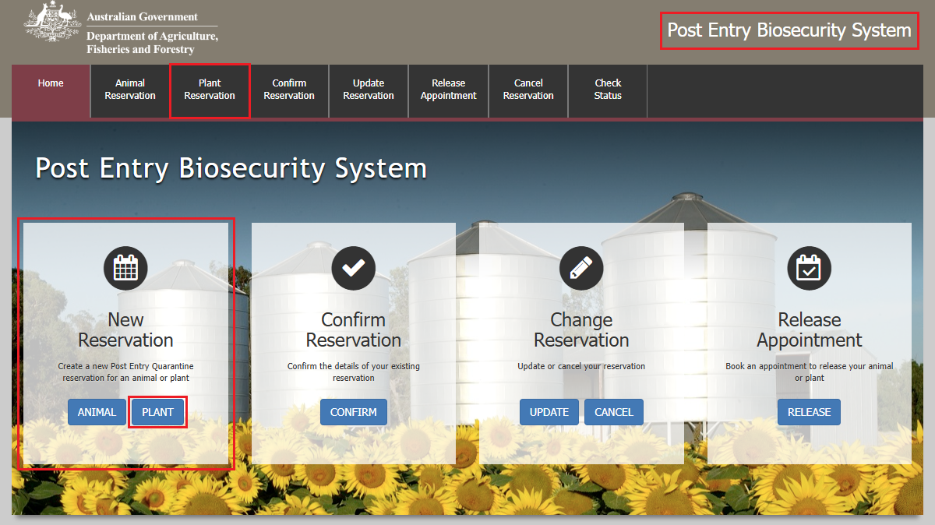Go to **PEBS** and select **Plant** within the **New Reservation** box or **Plant Reservation** from the main toolbar.

Importer Screen

This section allows you to enter your personal details if you are the owner of the consignment, or the agent details if you are an agent acting on behalf of the owner.

*NOTE: You will need to provide an account number to proceed with this reservation. If you do not have an account number, follow the prompt on the importer page to submit a request to create an account.*

*TIP: After filling in the details, you can select the save button at the top of the page. This will save the details to your browsers cache, so the next time you wish to create a reservation for PEQ, you can simply select the Load button to load the saved details. You will need to ensure that you have enabled caching on your browser for this function to work.*

Fill in the details as required and select **Next**.

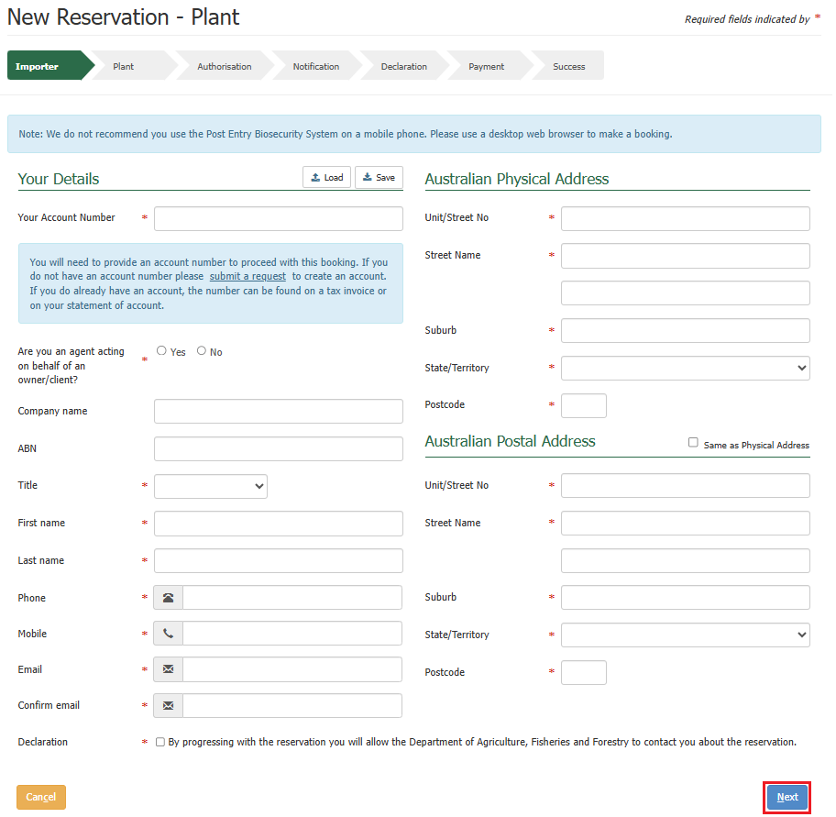

Plant Screen

This section allows you to enter multiple plant details.

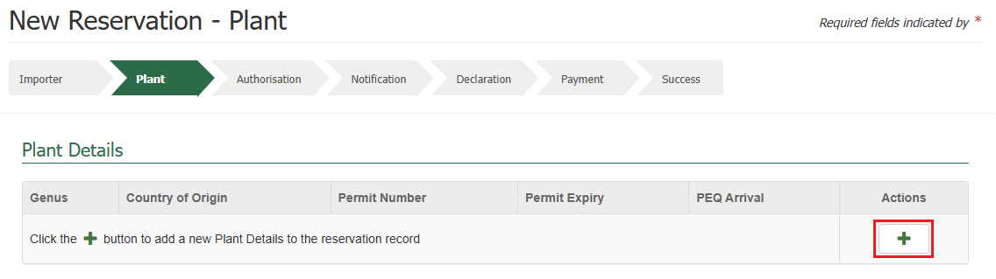To do so, select the **+ icon** within the action’s column.

Fill in the details as required and select the **+ icon** within the action’s column, to add the species details for your consignment.

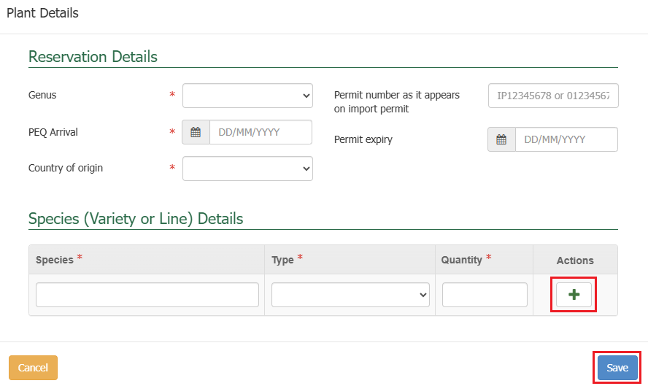Select **Save**.

Upon selecting save, the details will populate in a table on the screen.

Multiple icons will appear within the action’s column in the table for each row where new plant details are added. These icons indicate different actions that can be performed against each plants details row that you have added.

* The **+ icon** allows you to add multiple plant details.
* The **pencil** icon allows you to make edits to the current plant details that you have added.
* The **bin** icon allows you to remove that row if you would like to remove a row of plant details.

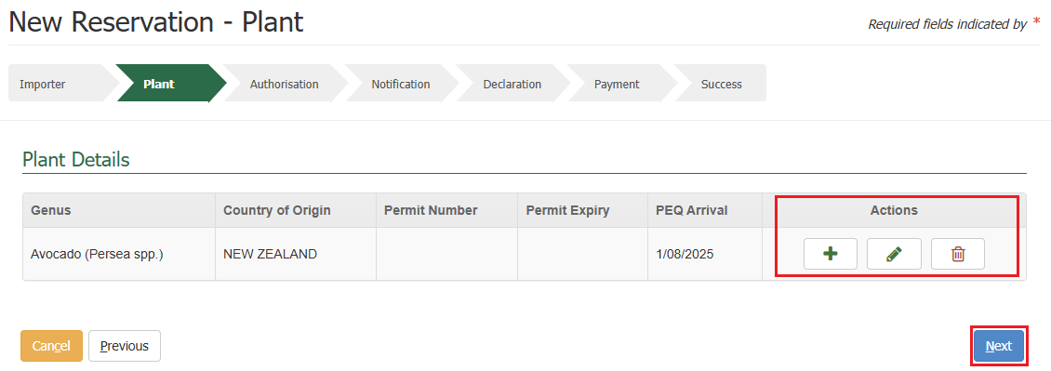Once you have finished adding all relevant plant details, select **Next**.

Authorisation Screen

This section allows you to add authorisation details of a third party, either a company or personnel to provide authorisation to act on behalf of the consignment while at the PEQ facility, and to allow collection of the consignment at the end of the quarantine period.

*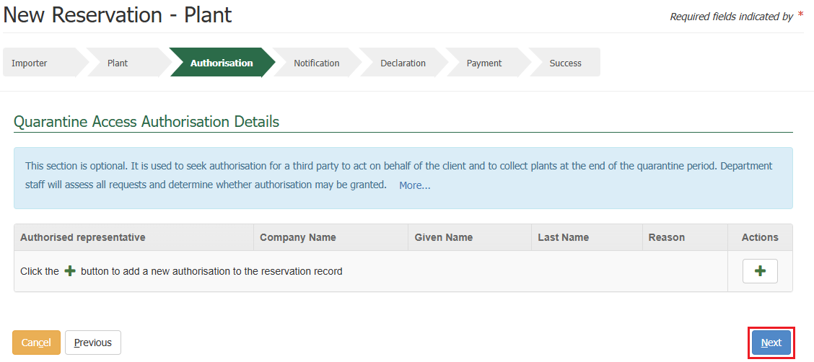TIP: If you do not wish to provide authorisation details, this step is optional, you can select* ***Next*** *without providing any details.*

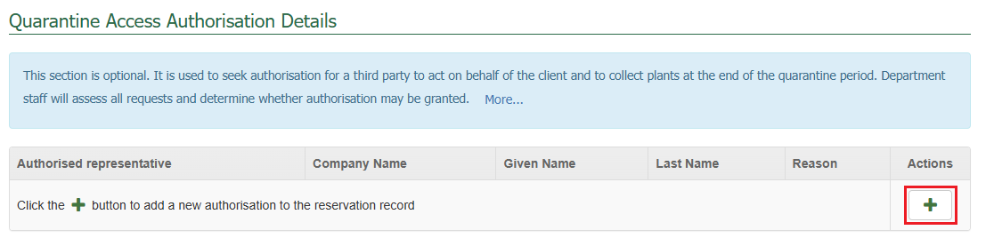If you wish to add any authorisation details, select the **+ icon** within the action’s column.

Fill in the details as required and select **Save**.

*NOTE: Based on the authorisation type, the details required will vary.*

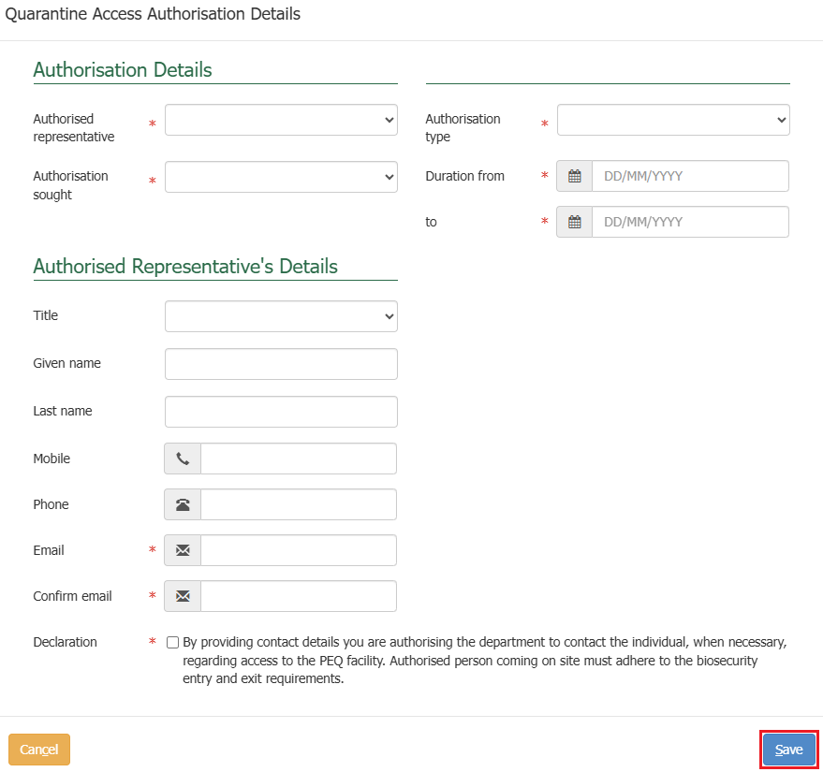

Upon selecting save, the details will populate in a table on the screen.

Multiple icons will appear within the action’s column in the table for each row where an authorisation is added. These icons indicate different actions that can be performed against each authorisation detail that you have added.

* The **+ icon** allows you to add multiple authorisation details.
* The **pencil** icon allows you to make edits to the current authorisation details that you have added.
* The **bin** icon allows you to remove that row if you would like to remove a row of authorisation details.

Once you have finished adding all relevant authorisation details, select **Next.**

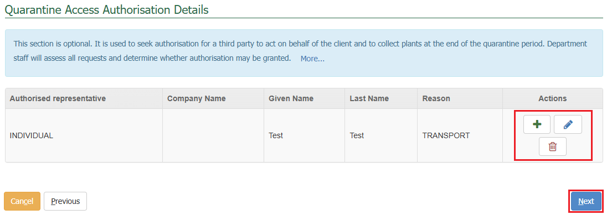

Notification Screen

This section allows you to nominate other parties to receive notifications about your reservation. The system generates automatic notifications at various stages of the reservation life cycle.

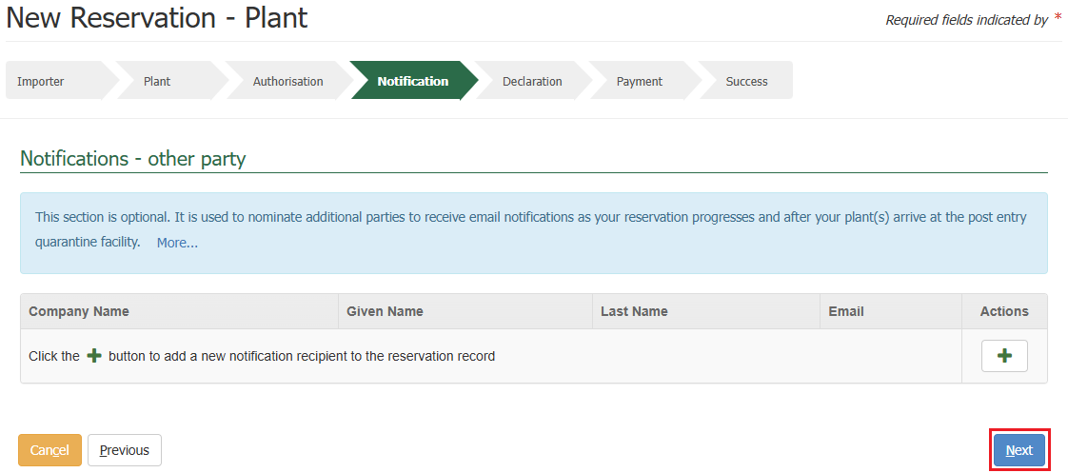*TIP: If you do not wish to provide notification details, this step is optional, you can select* ***Next*** *without providing any details.*

If you wish to add any notification details, select the **+ icon** within the action’s column.

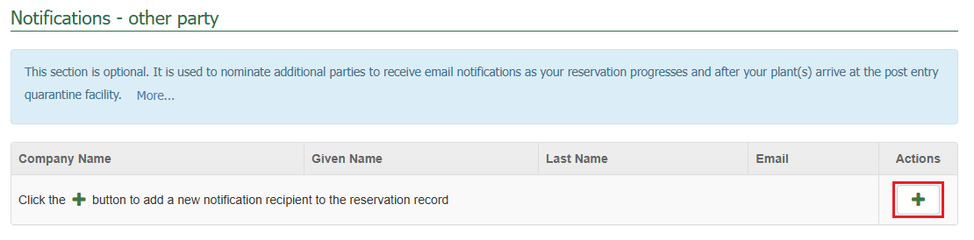

Fill in the details as required and select **Save**.

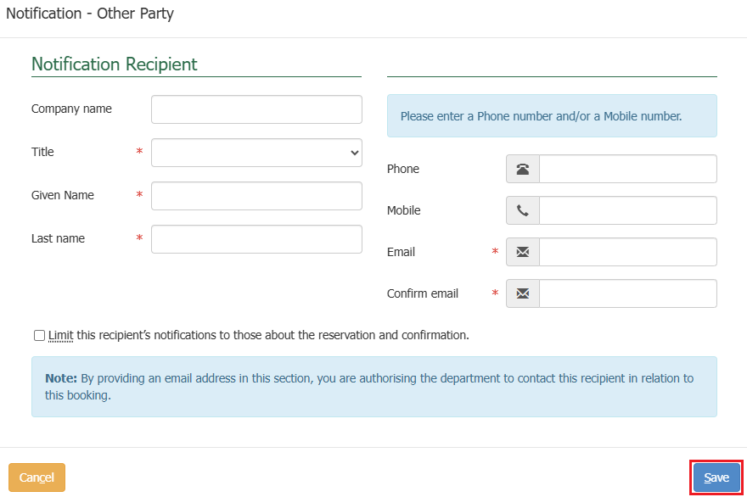

Upon selecting save, the details will populate in a table on the screen.

Multiple icons will appear within the action’s column in the table for each row where a notification recipient is added. These icons indicate different actions that can be performed against each notification recipient that you have added.

* The **+ icon** allows you to add multiple notification recipient details.
* The **pencil** icon allows you to make edits to the current notification recipient details that you have added.
* The **bin** icon allows you to remove that row if you would like to remove a row of notification recipient details.

Once you have finished adding all relevant notification recipient details, select **Next.**

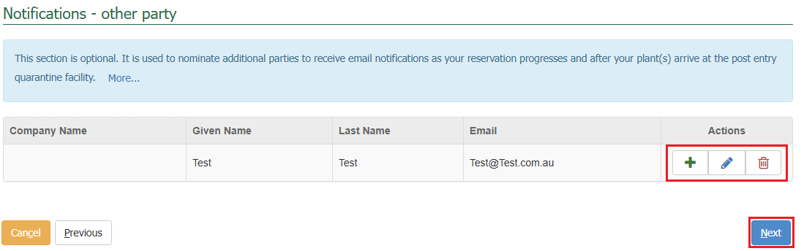

Declaration Screen

This section allows you to provide any **Additional Information** related to your consignment and to be added as a record to the reservation.

The general declaration checkbox will need to be ticked to proceed, if you agree to the declaration, select the **General Declaration checkbox** to proceed. If you do not agree, you cannot continue with the reservation.

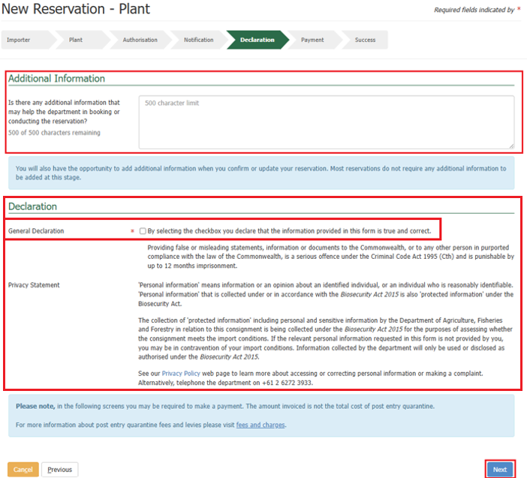Select **Next**.

Making a Payment

Services Screen

You will be expected to make a create reservation payment. The system will present you with a service summary screen containing:

* The **reference** which is the PEQ reference number (PRN) that has been created for your reservation.
* The **description** which includes your consignment type, what pathway is applicable to your consignment, the quantity of consignments you are bringing to Australia, and the additional information which is based on what pathway is applicable to your consignment.
* The **service description** which outlines the services for the reservation that the charges are for, the quantity and pricing.

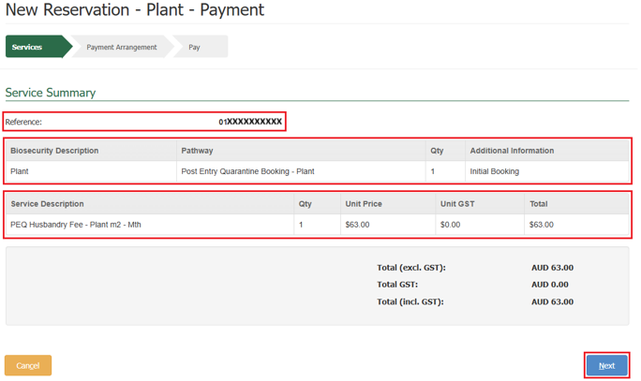Select **Next.**

Payment Arrangement Screen

This section allows you to view the account number you provided when adding in the importer details.

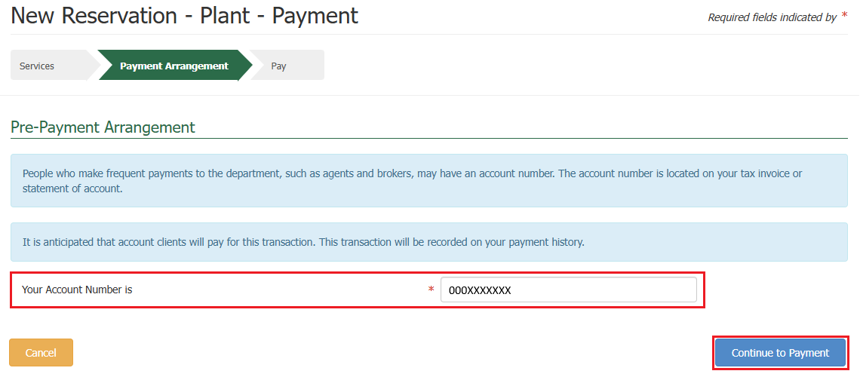Select **Continue to Payment**.

Pay Screen

Upon selecting continue to payment, you will be presented with the payment screen. You will be prompted for your card details.

Fill in the details as required and select **Pay Now**.

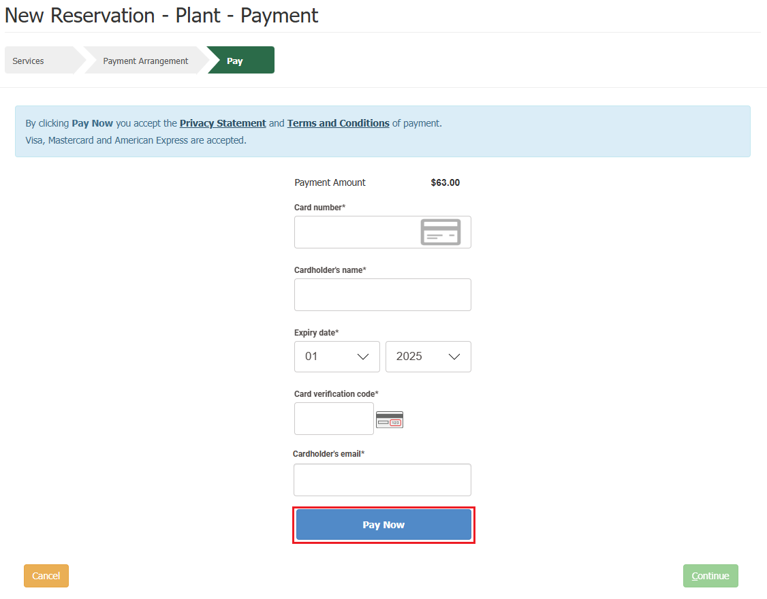

Upon selecting pay now, you will be presented with a payment confirmation screen.

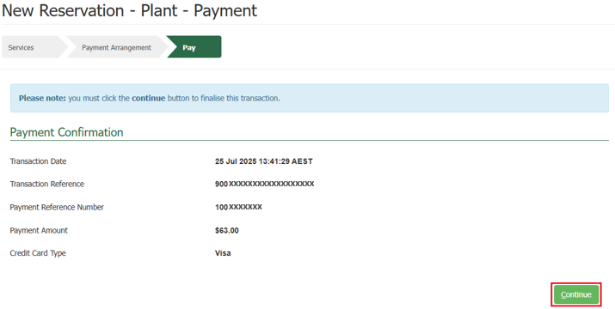Select **Continue**.

Success Screen

You will be presented with a success screen confirming the submission of your reservation.

You will be provided with your **PRN**. This number is a unique 14-digit number that identifies your reservation. It is used and will be active throughout your reservation’s lifecycle.

*TIP: Please quote your PRN during your communications with the PEQ Plant Team.*

An email confirming the reservation is received will be sent to the reservation email you specified at the time of creating your reservation.

The system will send you an automatic email containing a Tax Invoice / Receipt for this transaction. As you are an account client, the email will be sent to the email nominated against the account number.

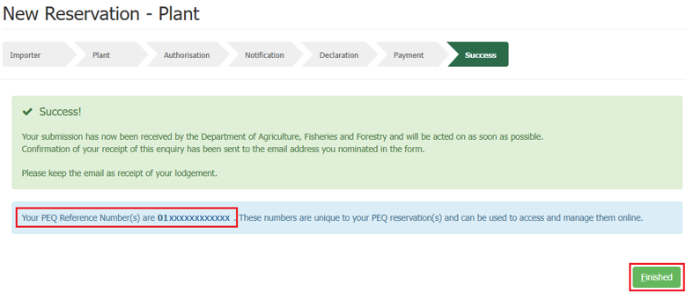Selecting **Finished** will take you back to the PEBS home screen.