How do I Create a Reservation?

*This task card demonstrates how to create a reservation online via the Post Entry Biosecurity System (PEBS), to notify the Department of your intention to reserve a space for your consignment to stay at the Post Entry Quarantine (PEQ) facility.*

Creating a Reservation

You can only create a reservation after you have obtained a valid import permit and must ensure the requested PEQ arrival date is after the eligible export date and prior to the permit expiry date.

Go to **PEBS** and select **Animal** within the **New Reservation** box or **Animal Reservation** from the main toolbar.

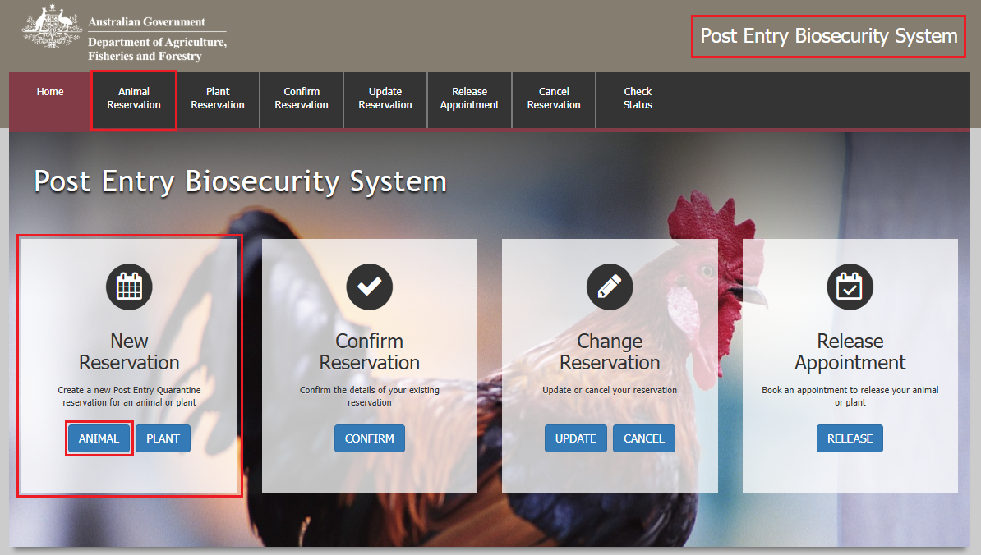

Importer Screen

This section allows you to enter the contact details of the consignment owner, and the details of the agent working on behalf of the owner/client if applicable.

*TIP: After filling in the details, you can select the save button at the top of the page. This will save the details to your browsers cache, so the next time you wish to create a reservation for PEQ, you can simply select the Load button to load the saved details. You will need to ensure that you have enabled caching on your browser for this function to work.*

*NOTE: The email address in Your Details section will be used to log into the reservation once created. Ensure there are no additional spaces on either side of the email address.*

* If you are an agent acting on behalf of an owner/client, you must select **Yes** to the first question on this screen and provide owner/client details in the **Importer Details** section that will appear at the bottom of the page. You must include the client’s details on the reservation within the importer details section, the reservation will not be assessed without these details.
* If you are not agent acting on behalf of an owner/client, proceed to the step: *Fill in the details as required.*

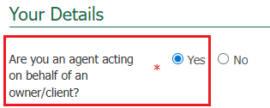

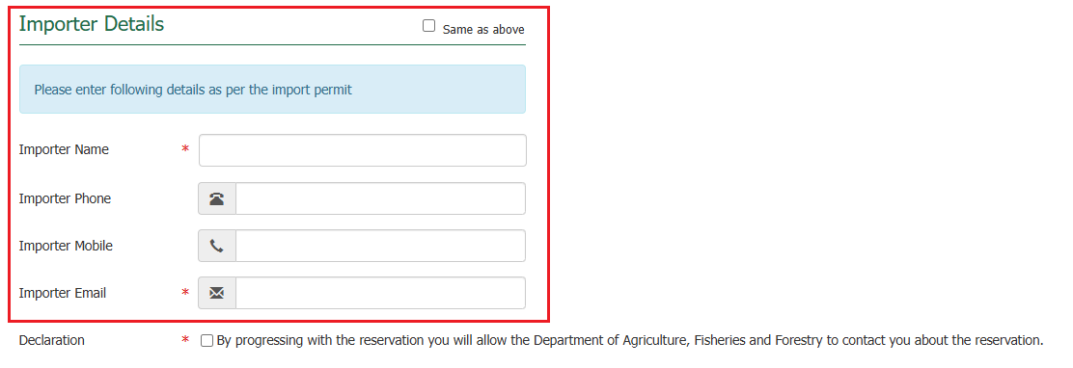

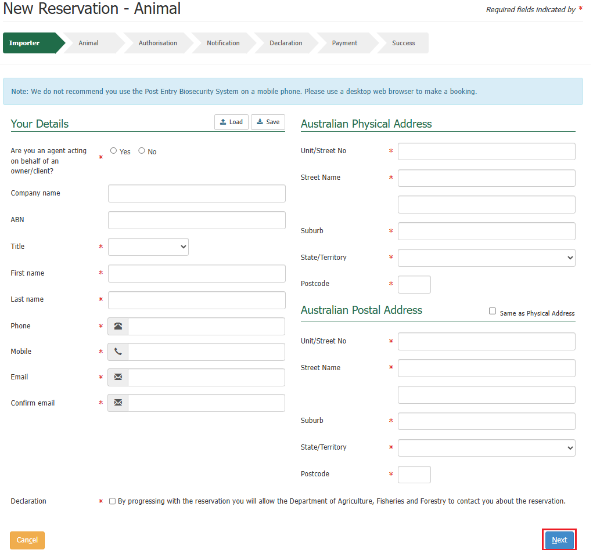Fill in the details as required and select **Next**.

Animal Screen

This section allows you to enter details for multiple animals

Select cat/dog from the **Select animal type** dropdown list.

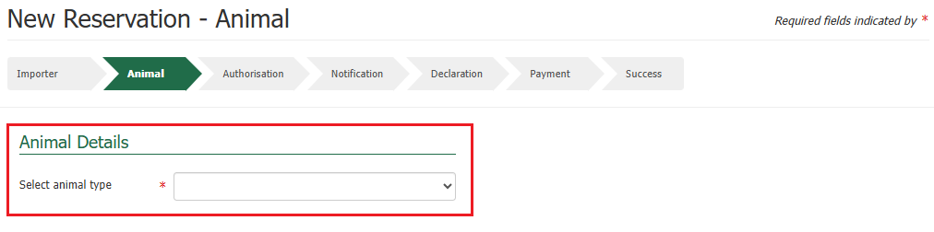

A table will be presented, select the **+ icon** within the action’s column.

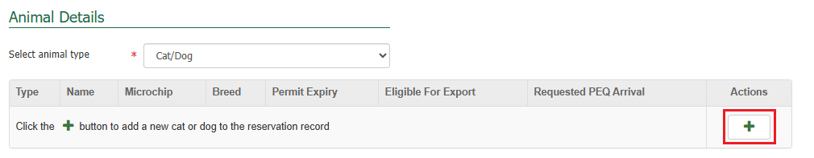

Fill in the details as required, and Select **Save**.

*NOTE: You can add animal details for each cat and/or dog you wish to bring to Australia.*

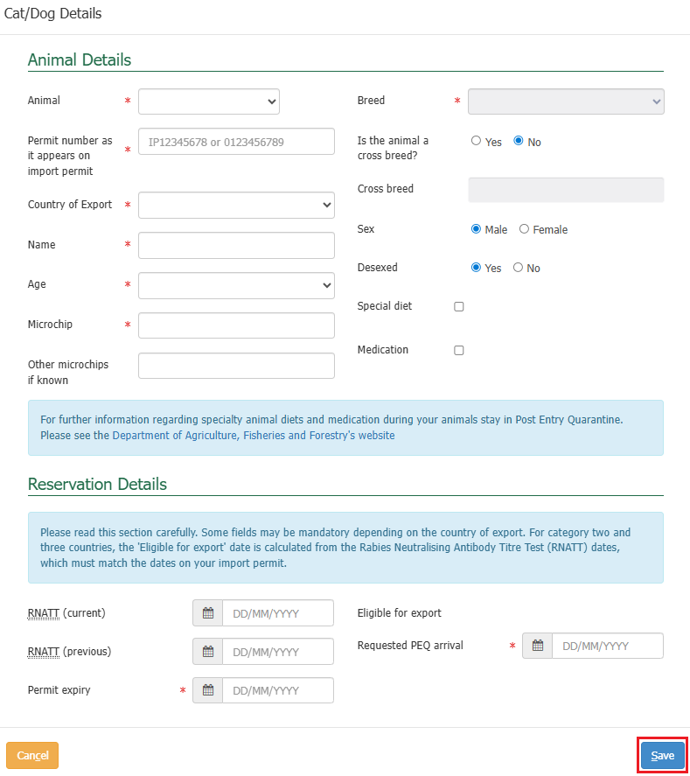

Upon selecting save, the details will populate into the table on the screen.

Multiple icons will appear within the action’s column in the table for each row where new animal details are added. These icons indicate different actions that can be performed against each animal details row that you have added.

* The **+ icon** allows you to add multiple different animal details if you are looking to reserve a space for multiple cats/and or dogs.
* The **pencil** icon allows you to make edits to the current animal details that you have added.
* The **bin** icon allows you to remove that row if you would like to remove a row of animal details.

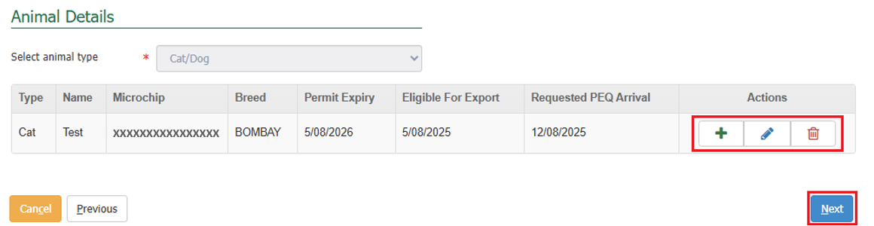Once you have finished adding all relevant animal details, select **Next**.

Authorisation Screen

This section allows you to add the authorisation details of a third party (either a company or individual). This third party will be able to receive information about your consignment and can be selected to collect your consignment at the end of the quarantine period.

*NOTE: By including an authorised third party they will be able to receive information and make amendments to the reservation.*

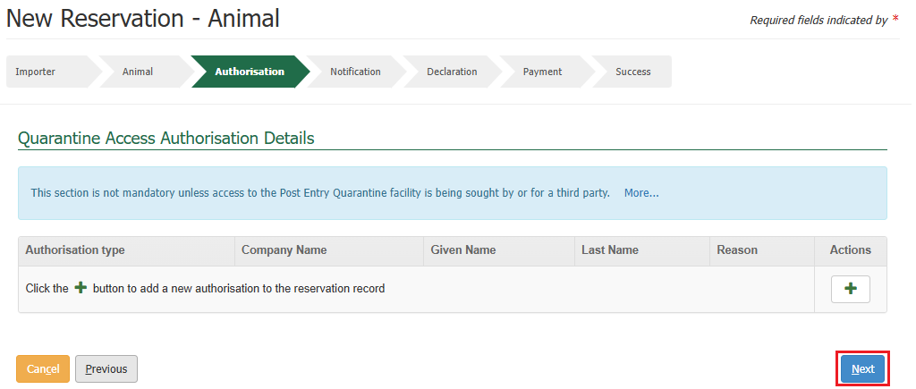*TIP: If you do not wish to provide authorisation details, this step is optional, you can select* ***Next*** *without providing any details.*

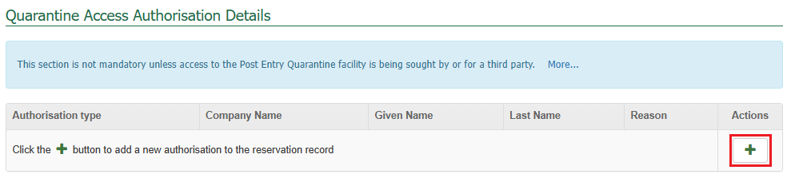If you wish to add any authorisation details, select the **+ icon** within the action’s column.

Fill in the details as required and select **Save**.

*NOTE: Based on the authorisation type, the details required will vary.*

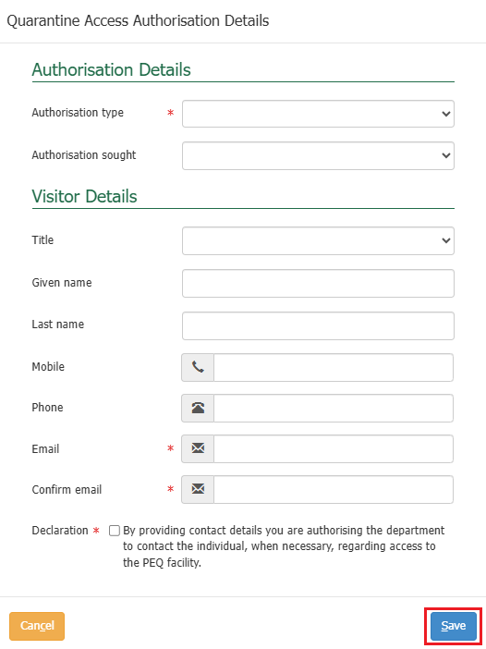

Upon selecting save, the details will populate in a table on the screen.

Multiple icons will appear within the action’s column in the table for each row where an authorisation is added. These icons indicate different actions that can be performed against each authorisation detail that you have added.

* The **+ icon** allows you to add multiple authorisation details.
* The **pencil** icon allows you to make edits to the current authorisation details that you have added.
* The **bin** icon allows you to remove that row if you would like to remove a row of authorisation details.

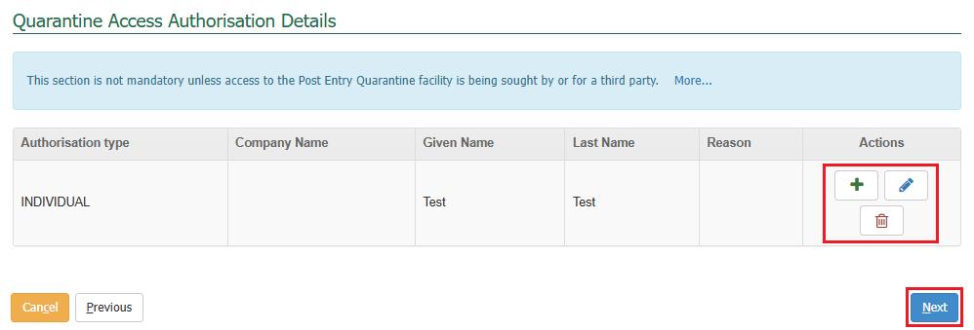Once you have finished adding all relevant authorisation details, select **Next.**

Notification Screen

This section allows you to nominate other parties to receive notifications about your reservation. The system generates automatic notifications at various stages of the reservation life cycle.

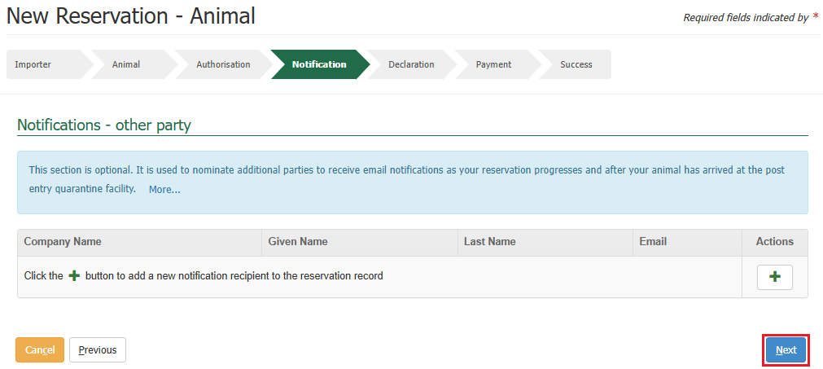*TIP: If you do not wish to provide notification details, this step is optional, you can select* ***Next*** *without providing any details.*

If you wish to add any notification details, select the **+ icon** within the action’s column.

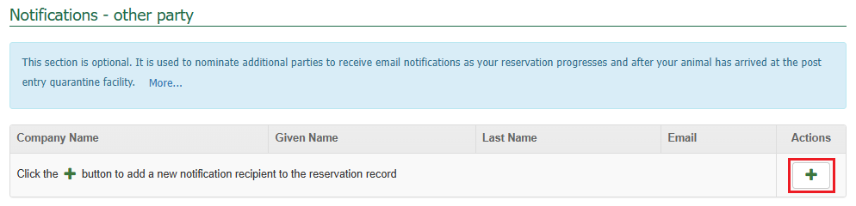

Fill in the details as required and select **Save**.

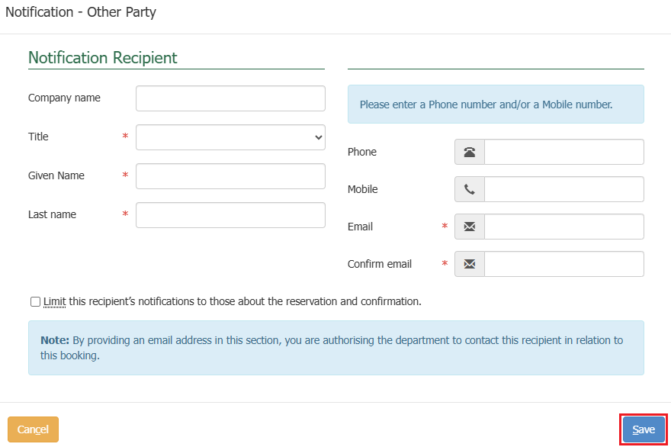

Upon selecting save, the details will populate in a table on the screen.

Multiple icons will appear within the action’s column in the table for each row where a notification recipient is added. These icons indicate different actions that can be performed against each notification recipient that you have added.

* The **+ icon** allows you to add multiple notification recipient details.
* The **pencil** icon allows you to make edits to the current notification recipient details that you have added.
* The **bin** icon allows you to remove that row if you would like to remove a row of notification recipient details.

Once you have finished adding all relevant notification recipient details, select **Next.**

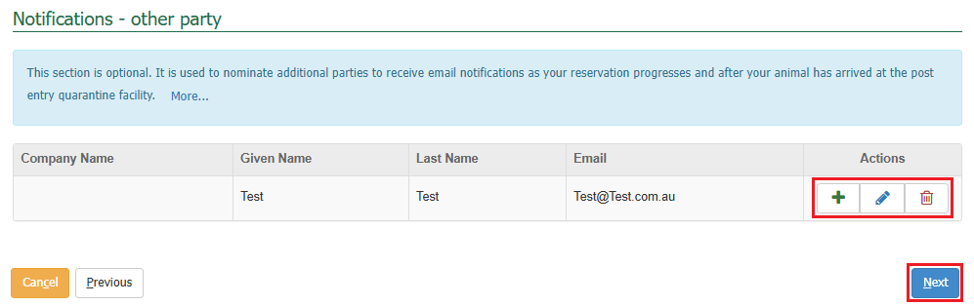

Declaration Screen

This section allows you to provide any **Additional Information** related to your consignment and to be added as a record to the reservation.

The general declaration checkbox will need to be ticked to proceed, if you agree to the declaration, select the **General Declaration checkbox** to proceed. If you do not agree, you cannot continue with the reservation.

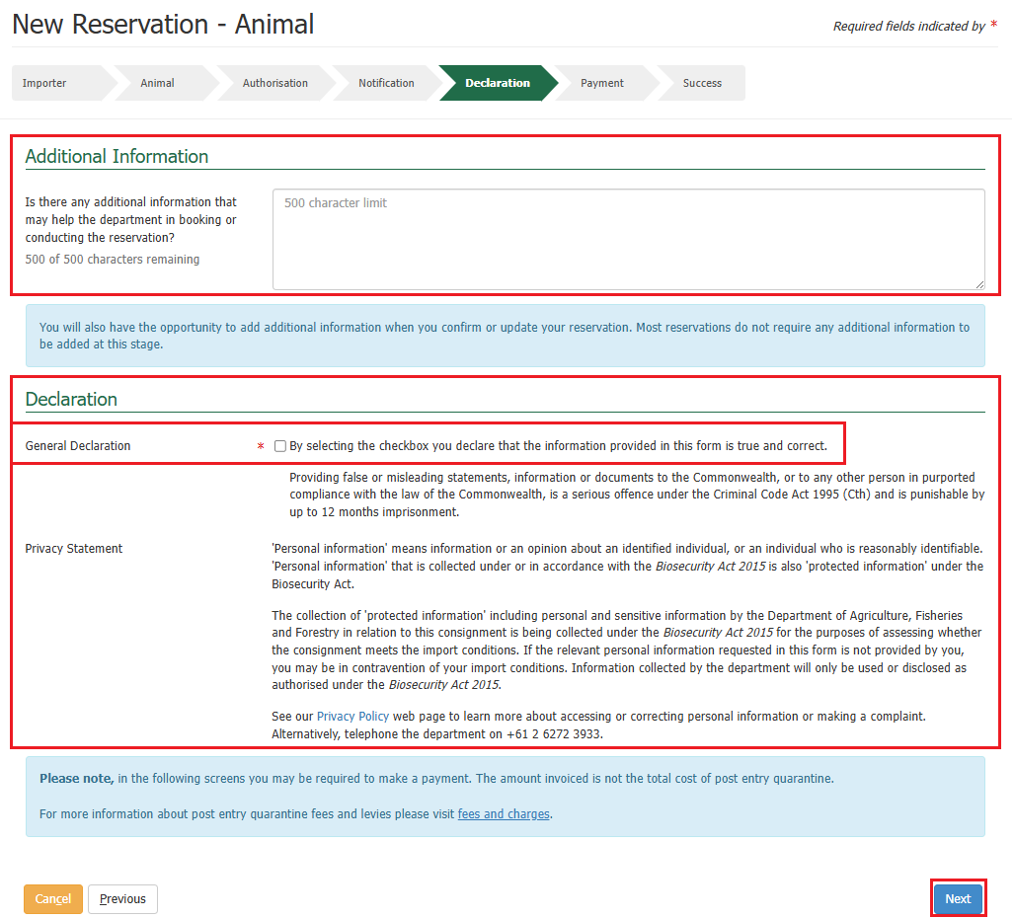Select **Next**.

Making a Payment

Services Screen

You will be expected to make a create reservation payment.

*NOTE: If payment is not made this reservation will be void and cannot be used.*

The system will present you with a service summary screen containing:

* The **reference** which is the PEQ reference number (PRN) that has been created for your reservation.
* The **description** which includes your consignment type, what pathway is applicable to your consignment, the quantity of consignments you are bringing to Australia, and the additional information which is based on what pathway is applicable to your consignment.
* The **service description** which outlines the services for the reservation that the charges are for, the quantity and pricing.

Select **Next.**

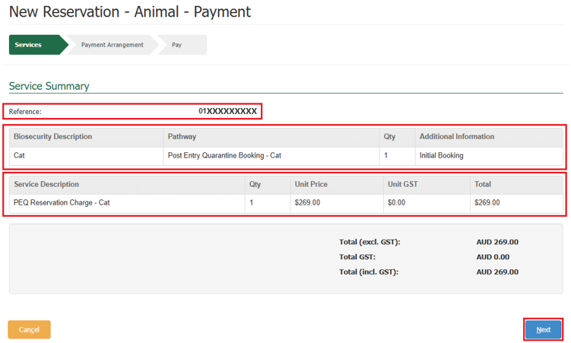

Payment Arrangement Screen

This section allows you to enter an account number if you have one.

*NOTE: If you are an AIMS account client with the Department of Agriculture, Fisheries and Forestry, you will still be required to pay via credit card for your reservation, but your invoice will be sent to the email address nominated against your account number. Questions regarding account clients can be directed to* [*ARhelpdesk@aff.gov.au*](mailto:ARhelpdesk@aff.gov.au)*.*

* If you have an account number, select **Yes**, provide the account number, and select **Continue to Payment.**
* If you do not have an account number, select **No** and select **Continue to Payment.**

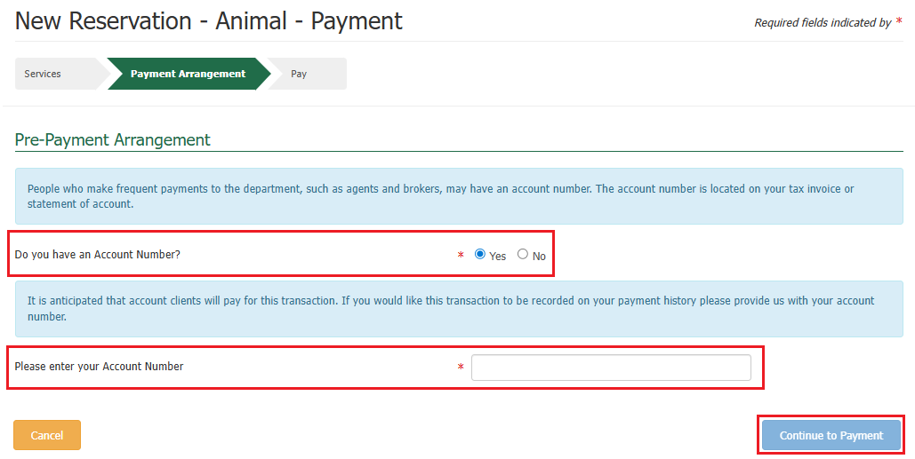

Pay Screen

Upon selecting continue to payment, you will be presented with the payment screen. You will be prompted for your card details.

Fill in the details as required and select **Pay Now**.

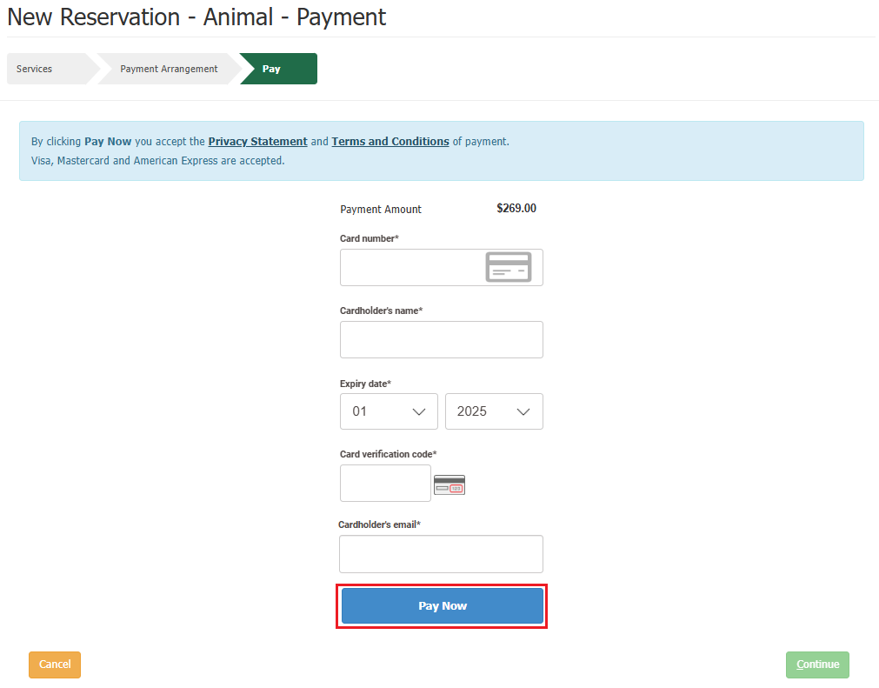

Upon selecting pay now, you will be presented with a payment confirmation screen.

Select **Continue**.

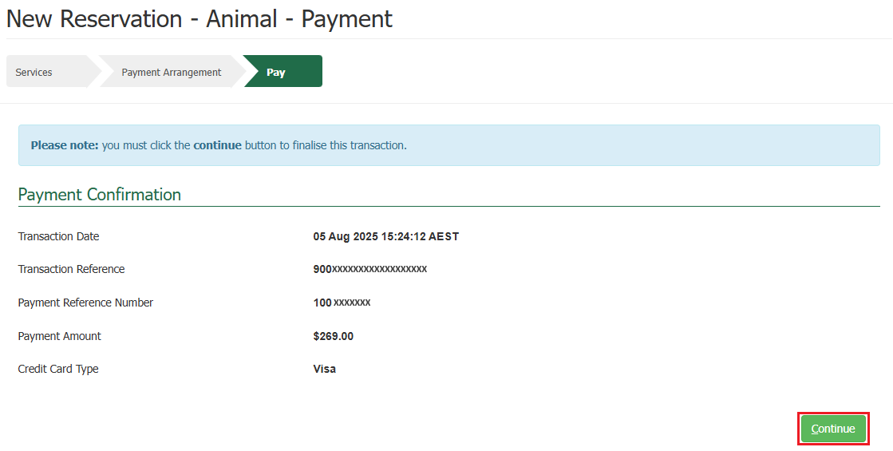

Success Screen

You will be presented with a success screen confirming the submission of your reservation.

You will be provided with your **PRN**. This number is a unique 14-digit number that identifies your reservation. It is used and will be active throughout your reservation’s lifecycle.

*NOTE: You will get multiple PRN’s if you have created reservations for multiple cats and/or dogs. The PRN is specific to each consignment in PEQ.*

*TIP: Please quote your PRN during your communications with the PEQ Services Team.*

An email confirming the reservation is received will be sent to the reservation email you specified at the time of creating your reservation.

The system will send you an automatic email containing a Tax Invoice / Receipt for this transaction.

* If you are an account client, the email will be sent to the email nominated against the account number.
* If you are not an account client, the email will be sent to the email you specified at the time of creating your reservation.

Selecting **Finished** will take you back to the PEBS home screen.

