How do I Schedule a Release Appointment?

This task card demonstrates how to schedule a release appointment online via the Post Entry Biosecurity System (PEBS), for your consignment to be released from the Post Entry Quarantine (PEQ) facility.

Scheduling an appointment

*NOTE: If the owner is not picking up the consignment, you will need to add the person or company who will be picking up the consignment as an authorisation to the reservation before scheduling the release appointment. To do this, you will need to update your reservation. For steps on how to do this, follow the task card: How do I update or cancel my reservation.*

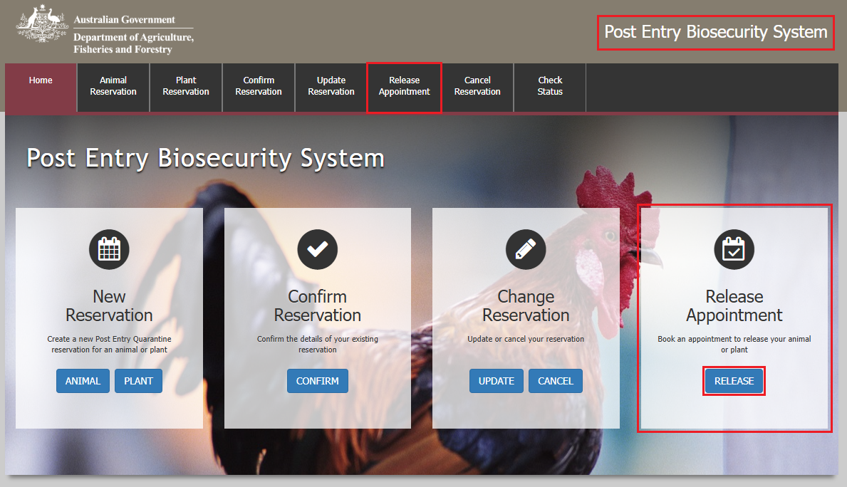Go to **PEBS** and select **Release** within the **Release Appointment** box or **Release Appointment** from the main toolbar.

Reference Screen

Enter your **PEQ Reference Number (PRN)**, which was emailed to you at the time of creating your reservation.

Enter the **Reservation email** you specified at the time of creating your reservation.

Select **Next**.

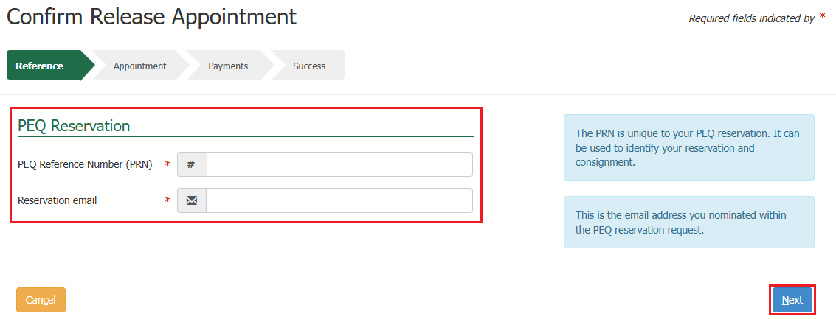

Appointment Screen

Your consignment will be released on the Proposed Release date unless otherwise advised.

Review the **Proposed Release** date, select your preferred **Pickup Time** and **who will pick up the commodity**.

*NOTE: If the owner is not picking up the consignment, you will need to add the person or company who will be picking up the consignment as an authorisation to the reservation before scheduling the release appointment. To do this, you will need to update your reservation. For steps on how to do this, follow the task card: How do I update or cancel my reservation.*

*You will then be able to restart the release appointment pathway and have the option to select the person or company authorised to pick up the consignment.*

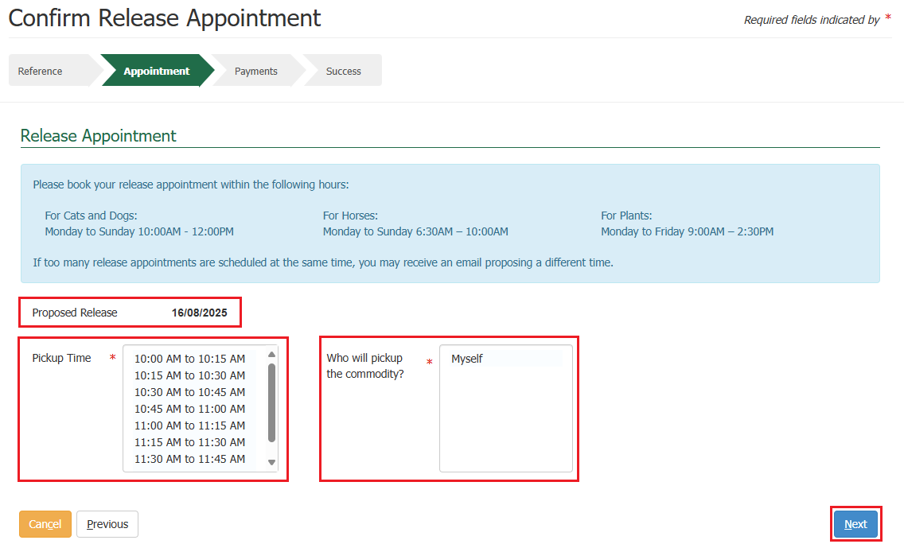If you are happy with the details you have selected, select **Next**.

Services Screen

If there are any outstanding fees, the system will present you with a service summary screen containing:

* The **reference** which is the PRN that was created when creating your reservation.
* The **description** which includes your consignment type, what pathway is applicable to your consignment, the quantity, and the additional information which is based on what pathway is applicable to your consignment.
* The **service description** which outlines the services for the reservation that the charges are for, the quantity and pricing.

Select **Next**.

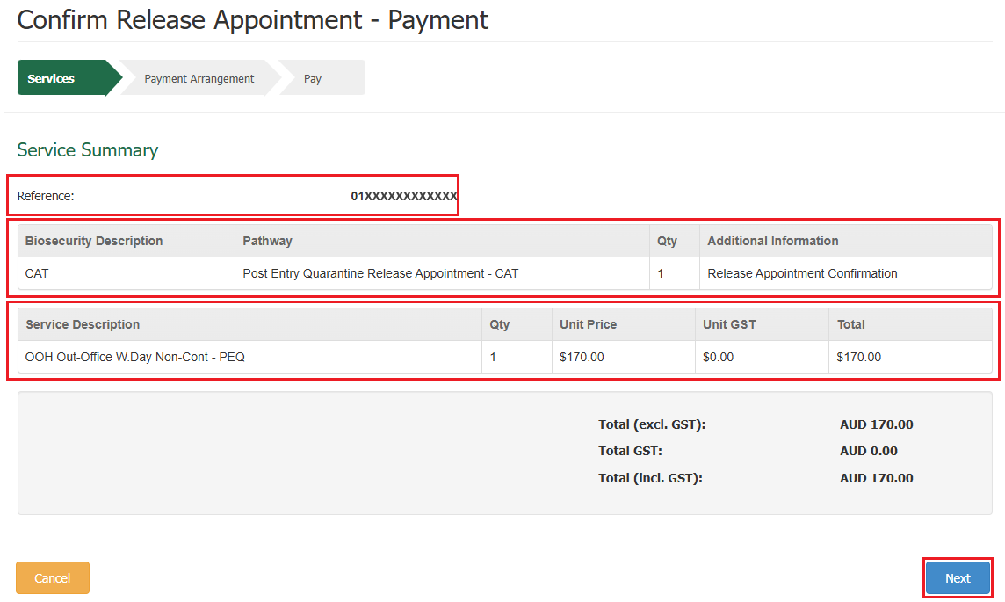*NOTE: You will not be able to progress with your release appointment booking until all fees are paid. If no outstanding fees are required, you will be presented with a success screen as seen in the last step towards the bottom of this task card.*

Payment Arrangement Screen

This section allows you to enter an account number if you have one.

*NOTE: If you are an AIMS account client with the Department of Agriculture, Fisheries and Forestry, you will still be required to pay via credit card for your reservation, but your invoice will be sent to the email address nominated against your account number. Questions regarding account clients can be directed to* [*ARhelpdesk@aff.gov.au*](mailto:ARhelpdesk@aff.gov.au)*.*

* If you have an account number, select **Yes**, provide the account number, and select **Continue to Payment.**
* 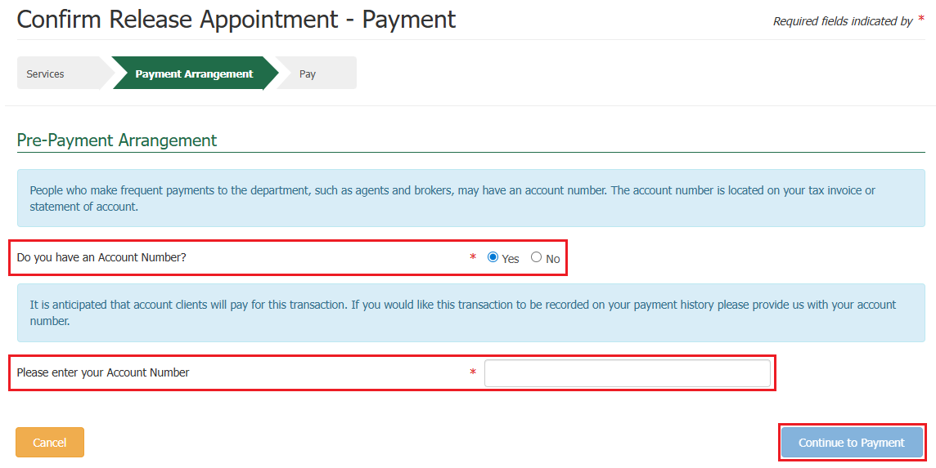If you do not have an account number, select **No,** and select **Continue to Payment.**

Pay Screen

Upon selecting continue to payment, you will be presented with the payment screen. You will be prompted for your card details.

Fill in the details as required and select **Pay Now**.

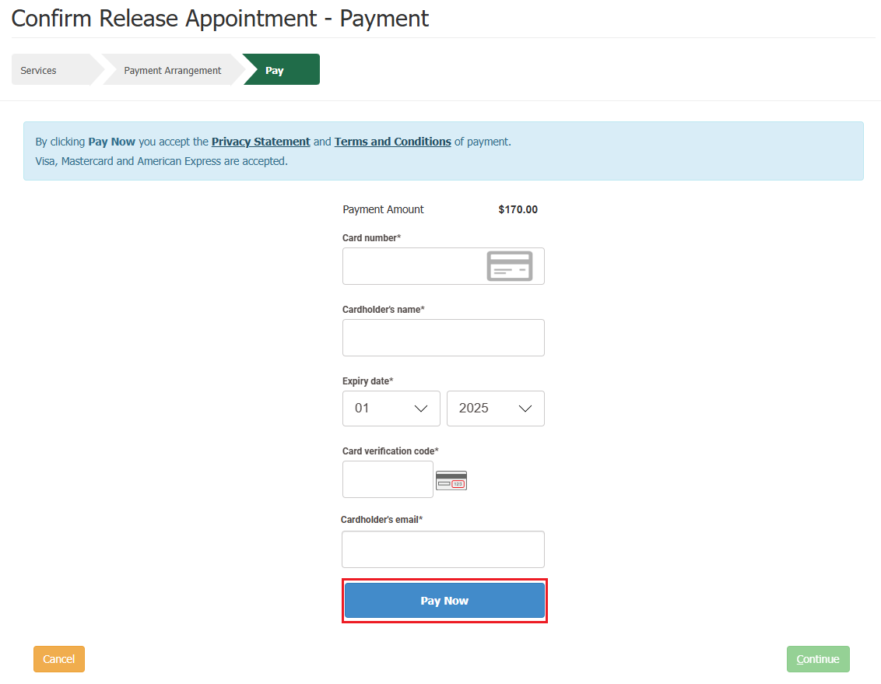

Upon selecting pay now, you will be presented with a payment confirmation screen.

Select **Continue**.

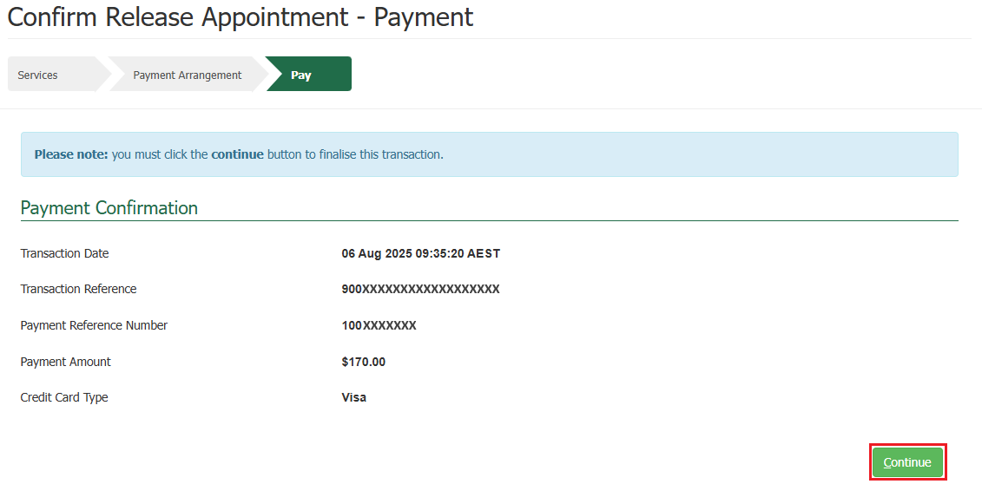

Success Screen

You will be presented with a success screen confirming the submission for your consignments release appointment with your **PRN** listed.

*TIP: Please quote your PRN during your communications with the PEQ Services Team.*

An email advising your consignments release appointment is received to the reservation email you specified at the time of creating your reservation.

If payment was required, the system will send you an automatic email containing a Tax Invoice / Receipt for this transaction.

* If you are an account client, the email will be sent to the email nominated against the account number.
* If you are not an account client, the email will be sent to the email you specified at the time of creating your reservation.

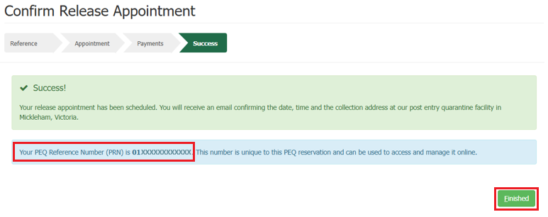Selecting **Finished** will take you back to the PEBS home screen.