How do I Schedule a Release Appointment?

This task card demonstrates how to schedule a release appointment online via the Post Entry Biosecurity System (PEBS), for your consignment to be released from the Post Entry Quarantine (PEQ) facility.

Scheduling an appointment

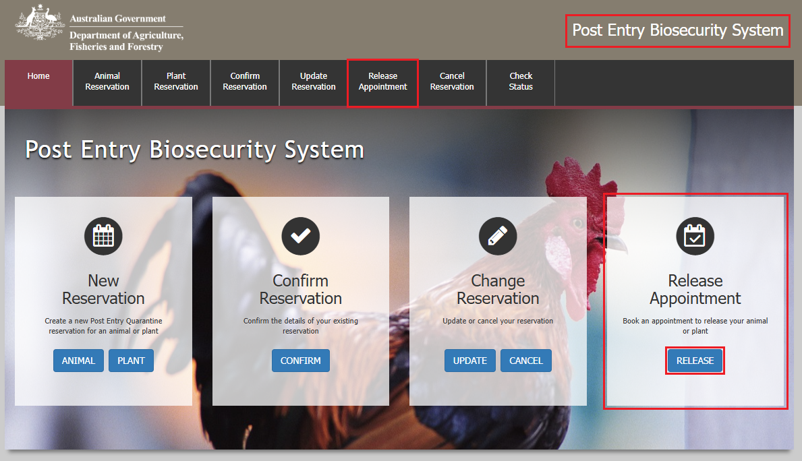Go to **PEBS** and select **Release** within the **Release Appointment** box or **Release Appointment** from the main toolbar.

Reference Screen

Enter your **PEQ Reference Number (PRN)**, which was emailed to you at the time of creating your reservation.

Enter the **Reservation email** you specified at the time of creating your reservation.

Select **Next**.

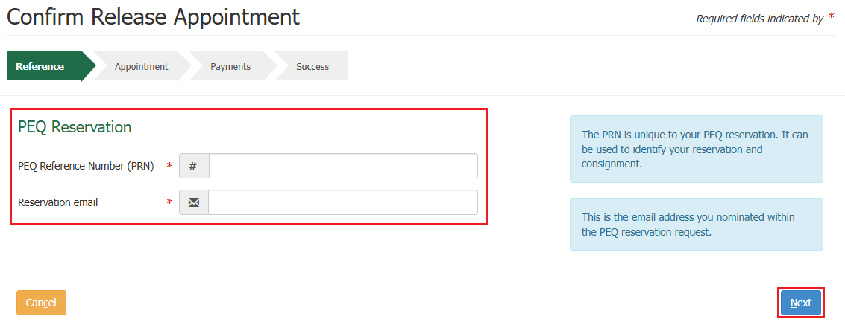

**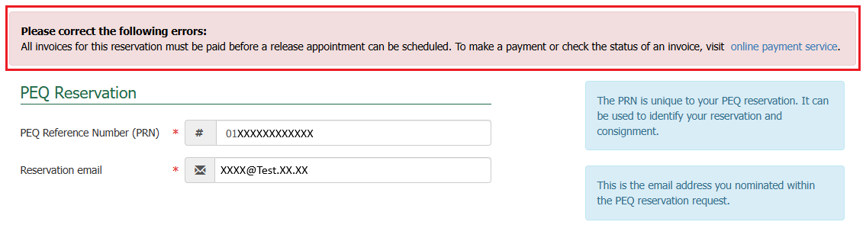***Note: If there are any outstanding PEBS monthly invoice payments alongside your reservation, you will be presented with an error message as seen below. These invoices will need to be paid before the commodity can be released.*

Outstanding Payments

Outstanding invoices should be paid online via the Departments online payment portal. It is recommended that you pay online as the payment will be processed in real time meaning you can immediately book a release appointment. PEBS monthly invoices are sent on the first of each month. The invoice is for the previous months square metre charges and husbandry fees, as well as any testing performed in that period.

*NOTE: If you have not paid this via an offline channel it will take a few days to process.*

Online Payments

If you have an outstanding invoice, a link to the **online payment service** is provided in the error message. This will direct you to the Department’s **Online Payments** page.

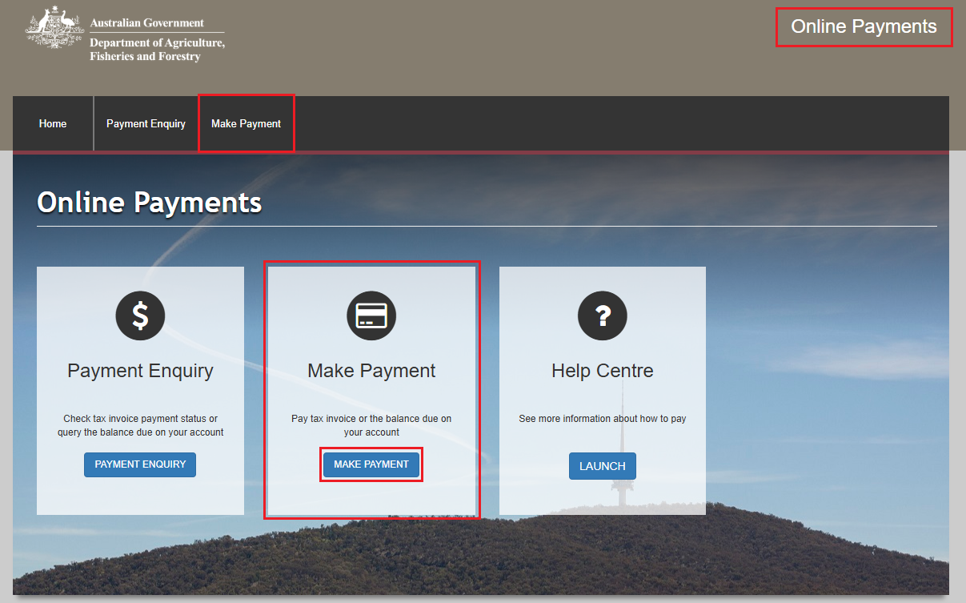From this page, select **Make Payment** within the **Make Payment** box or **Make payment** from the main toolbar.

Enquiry Screen

Enter the invoice number into the **Reference Number** field that you wish to pay.

Select **Check Status**.

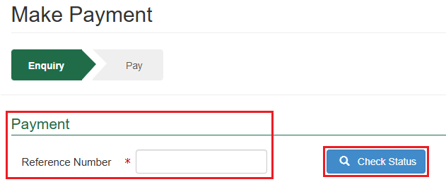

An **Invoice Status** section will display showing the invoice number and payment status.

Select **Make Payment**.

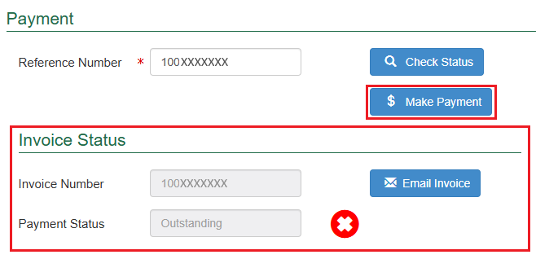

Pay Screen

Upon selecting make payment, you will be presented with the payment screen. You will be prompted for your card details.

Fill in the details as required and select **Pay Now**.

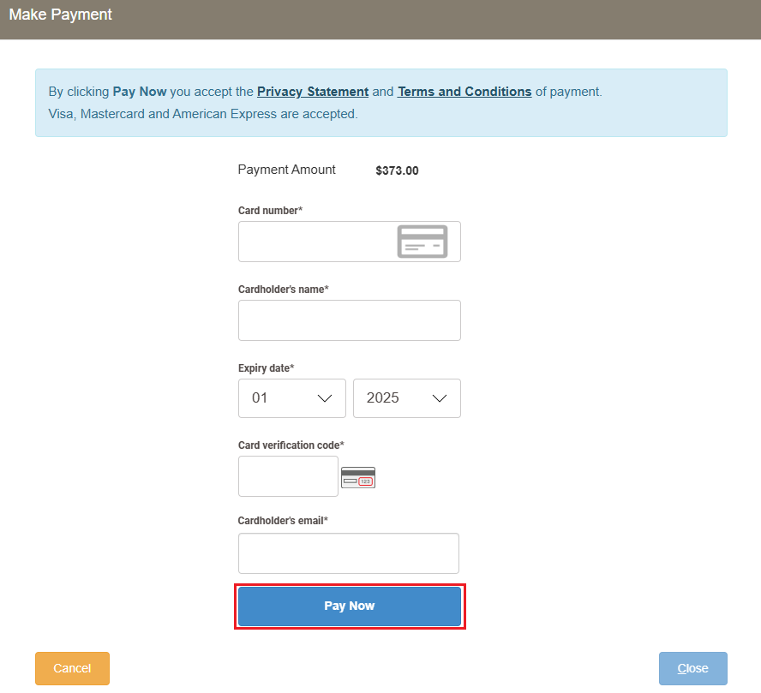

Upon selecting pay now, you will be presented with a payment confirmation screen.

Selecting **Close** will take you back to the online payments home screen.

*TIP: Once all monthly invoices have been paid for, repeat the first two steps for scheduling an appointment, then follow the below.*

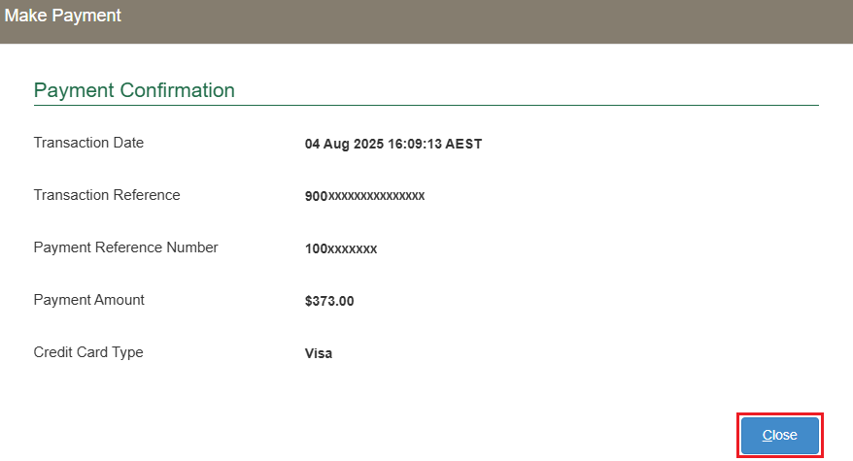

Appointment Screen

After all PEBS monthly invoices have been paid, you will be able to complete the release appoinment pathway.

Review the **Proposed Release** date, select your preferred **Pickup Time**, **who will pick up the commodity** and **Commodity Name**.

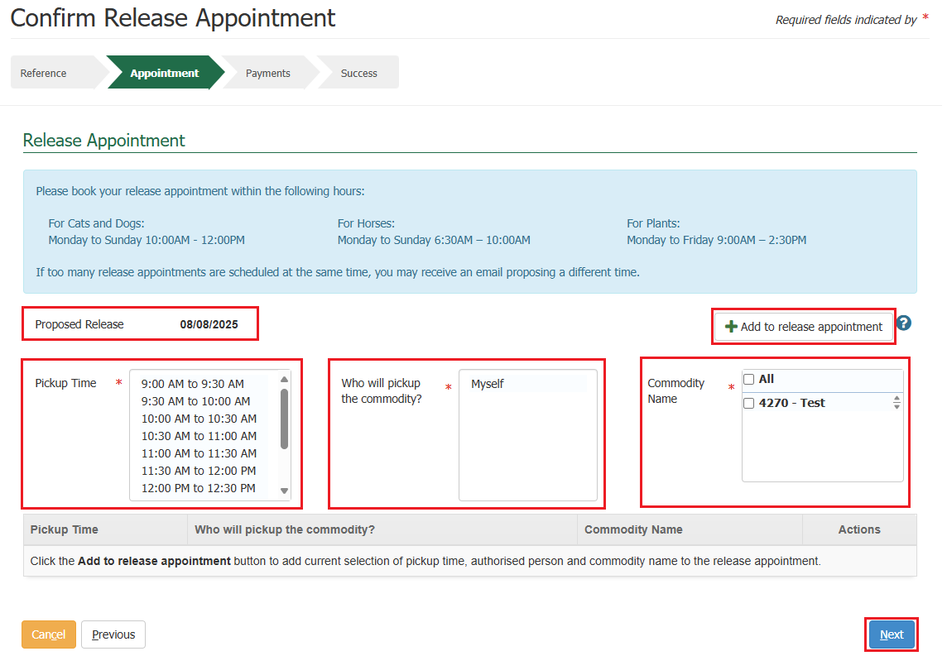Select the **+ Add to release appointment** button to add the release appointment details you have selected.

Upon selecting add to release appointment, the release appointment details will display in a table.

If you want to remove the release appointment details you have just added, select the **bin** icon within the action’s column against those release appointment details.

If you are happy with the details you have selected, select **Next**.

Services Screen

If there are any outstanding fees that have not been provided in a PEBS monthly invoice yet, the system will present you with a service summary screen containing:

* The **reference** which is the PRN that was created when creating your reservation.
* The **description** which includes your consignment type, what pathway is applicable to your consignment, the quantity of consignments you are bringing to Australia, and the additional information which is based on what pathway is applicable to your consignment.
* The **service description** which outlines the services for the reservation that the charges are for, the quantity and pricing.

Select **Next**.

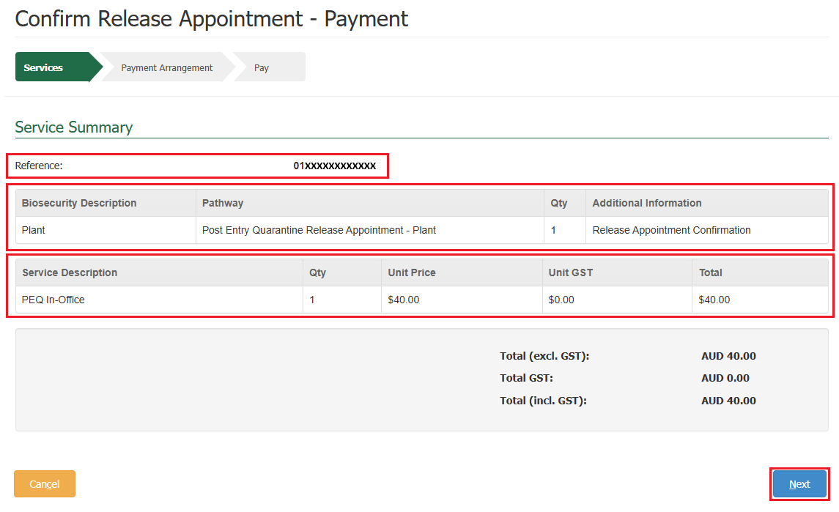*NOTE: You will not be able to progress to your release appointment booking until all fees are paid. If no outstanding fees are required, you will be presented with a success screen as seen in the last step towards the bottom of this task card.*

Payment Arrangement Screen

This section allows you to view the account number you provided when adding in the importer details upon creating your reservation.

Select **Continue to Payment**.

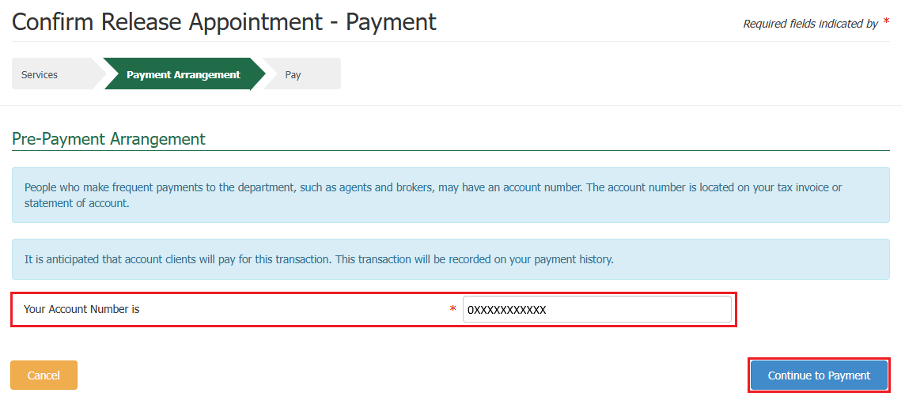

Pay Screen

Upon selecting continue to payment, you will be presented with the payment screen. You will be prompted for your card details.

Fill in the details as required and select **Pay Now**.

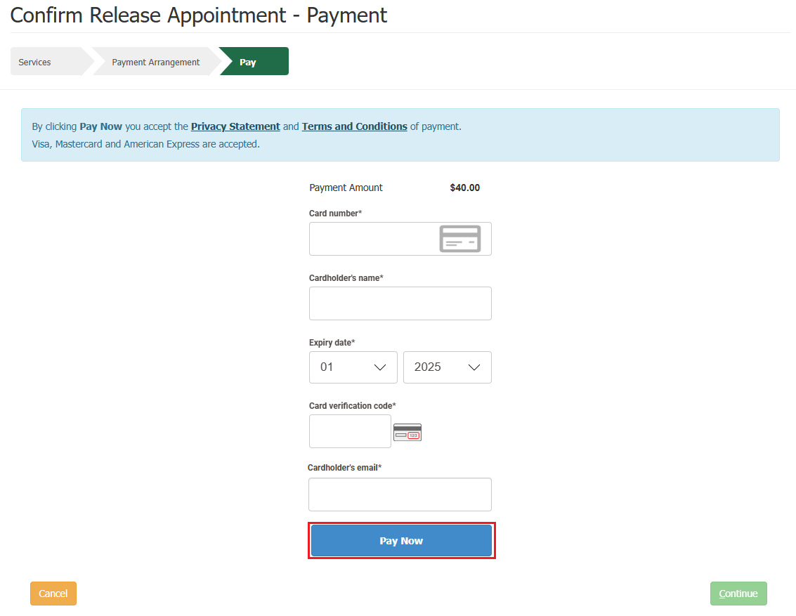

Upon selecting pay now, you will be presented with a payment confirmation screen.

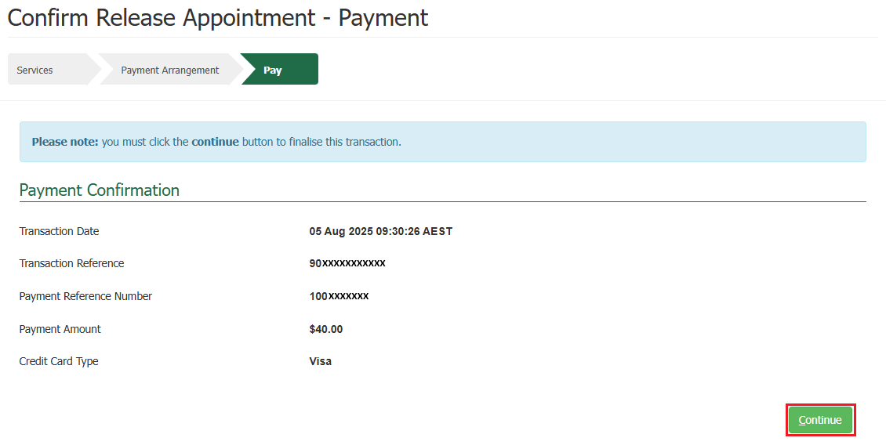Select **Continue**.

Success Screen

You will be presented with a success screen confirming the submission for your consignments release appointment with your **PRN** listed.

*TIP: Please quote your PRN during your communications with the PEQ Plant Team.*

An email advising your consignments release appointment is received to the reservation email you specified at the time of creating your reservation.

If payment was required, the system will send you an automatic email containing a Tax Invoice / Receipt for this transaction. As you are an account client, the email will be sent to the email nominated against the account number.

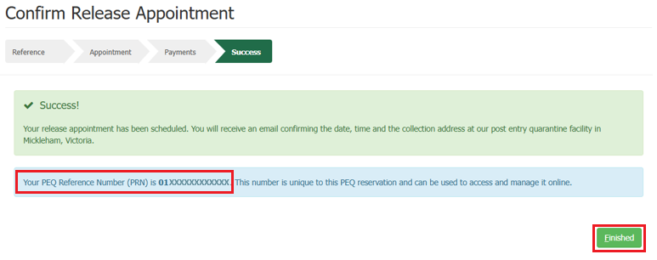Selecting **Finished** will take you back to the PEBS home screen.